Volume 25. Testing Validation and Benchmarking

Chapter 09. Certification and Compliance

09.01. Certification Process Overview by Robot Type
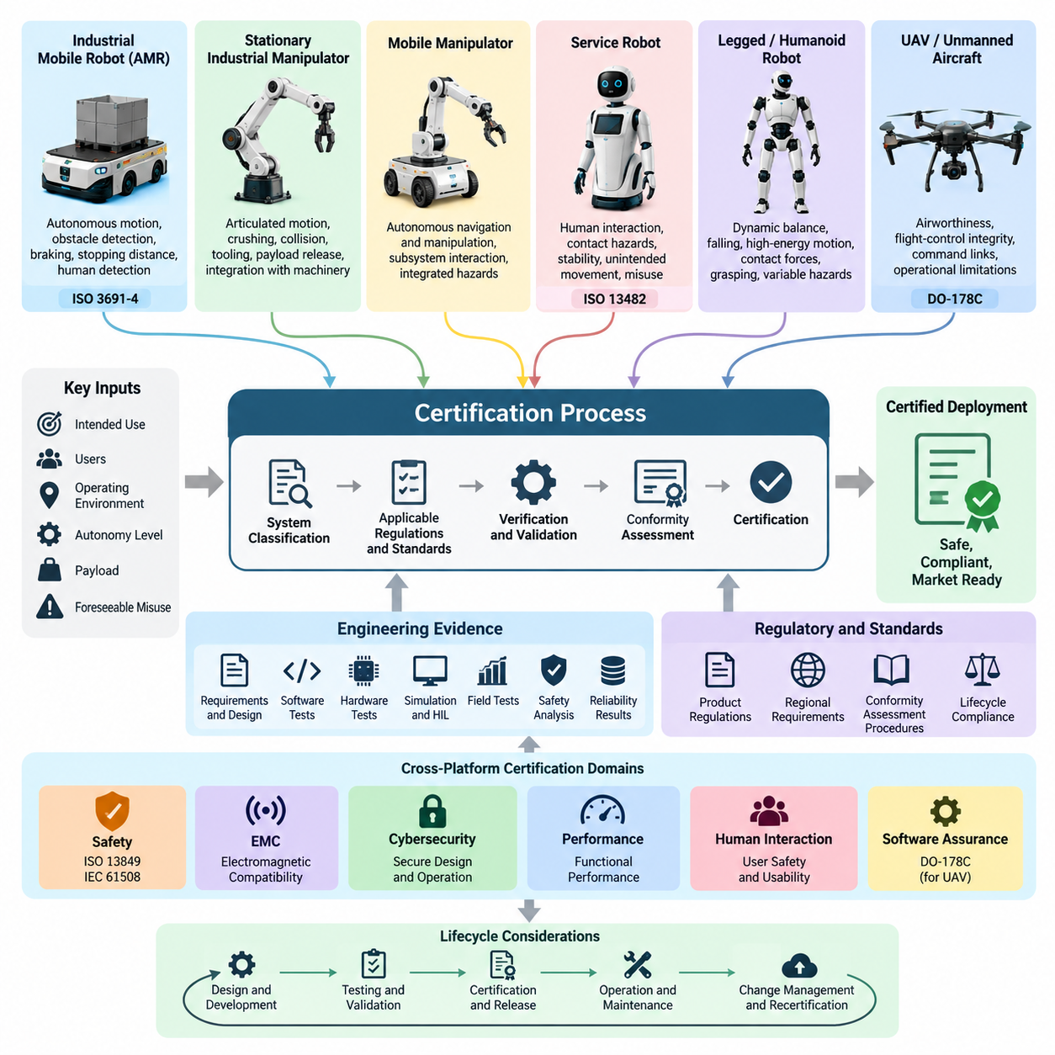
Robot certification is a structured process for demonstrating that a robotic system satisfies applicable safety, performance, electromagnetic compatibility, cybersecurity, and regulatory requirements before commercial deployment. The exact certification path depends strongly on robot type, operating environment, intended use, autonomy level, payload, interaction with people, and the jurisdiction in which the system will be placed into service.
Certification should therefore begin with system classification rather than with laboratory testing. A manufacturer first defines the robot's intended purpose, foreseeable operating conditions, boundaries of use, users, environmental constraints, and reasonably foreseeable misuse. These definitions determine which regulations, standards, conformity-assessment procedures, and technical evidence apply to the product throughout its lifecycle.
The certification program is closely connected to the broader verification and validation process. Requirements, design records, software tests, hardware tests, simulation results, HIL evidence, field-test data, safety analyses, and reliability results progressively form the evidence base used for compliance assessment. Certification is consequently most effective when compliance requirements are integrated into engineering activities from the beginning rather than assembled after development.
Industrial mobile robots and autonomous mobile robots require particular attention to hazards created by autonomous motion in shared workspaces. Certification activities typically evaluate protective fields, obstacle detection, braking behavior, stopping distances, speed control, emergency stopping, stability, load handling, human detection, and safety-related control functions. ISO 3691-4 is an important reference within the certification structure defined for AMR systems.
Stationary industrial manipulators follow a different safety model because hazards are dominated by articulated motion, crushing, trapping, collision, tooling, payload release, and interaction with surrounding machinery. The assessment must consider both the robot and the integrated robot application. Safety functions such as safe torque off, safe limited speed, protective stopping, interlocking, workspace restriction, and emergency stopping require traceable verification.
Mobile manipulators combine the certification challenges of autonomous navigation and manipulation. The mobile base may satisfy one set of safety requirements while the manipulator, end effector, and application introduce additional hazards. Certification must therefore evaluate interactions between subsystems rather than treating independently certified components as proof that the complete machine is safe. Integrated failure conditions and simultaneous motions become especially important.
Service robots and robots designed for operation near non-specialist users require strong consideration of human interaction. ISO 13482 provides an important safety framework for relevant personal care robot applications. Assessment may address contact hazards, accessible surfaces, stability, unintended movement, control failures, human detection, foreseeable misuse, energy limitations, and safe recovery behavior when sensing or control functions become unavailable.
Legged and humanoid robots introduce certification challenges that are not fully represented by traditional fixed-machine assumptions. Dynamic balance, falling, high-energy joint motion, contact forces, grasping, payload handling, and rapidly changing support conditions can create hazards that vary with robot state. Evidence must therefore characterize both normal task execution and transitions into degraded or emergency operating states.
For legged platforms, certification-oriented validation should include terrain-dependent stability, gait transitions, loss of foothold, actuator faults, sensor degradation, power anomalies, emergency stopping, and controlled fall or shutdown strategies where applicable. Humanoid systems require additional evaluation of whole-body interaction, manipulation near humans, balance recovery, and coordinated motion involving many joints. These concerns complement platform-specific field and benchmark testing.
Unmanned aircraft and cargo UAVs follow a substantially different assurance path because failures may affect people and property beyond the immediate operating area. Certification considerations can include aircraft airworthiness, flight-control integrity, command and communication links, navigation, redundancy, software assurance, operational limitations, and evidence from structured flight-test campaigns. The required rigor generally increases with aircraft risk and operational consequence.
Software used in safety-critical airborne functions may require development and verification evidence aligned with aviation assurance frameworks such as DO-178C. This changes the role of testing from general product-quality confirmation to disciplined lifecycle assurance with requirements traceability, verification independence where required, configuration control, structural coverage considerations, and controlled certification artifacts. The volume structure explicitly treats DO-178C certification for UAV software.
Functional safety provides another cross-platform certification dimension. Standards such as ISO 13849 and IEC 61508 establish approaches for demonstrating that safety-related control functions achieve required levels of risk reduction. Engineers identify hazards, define safety functions, determine required integrity or performance levels, design suitable architectures, evaluate diagnostic coverage and failure behavior, and verify that the implementation achieves its safety objectives.
Certification evidence therefore extends far beyond a final test report. A complete evidence package may include system definitions, applicable-standard matrices, hazard analyses, risk assessments, safety requirements, architecture descriptions, requirements traceability, source and configuration records, verification procedures, test results, calibration records, anomaly reports, cybersecurity evidence, user documentation, declarations, and records showing how unresolved issues were dispositioned.
Third-party assessment may be required or strategically desirable depending on the product, regulation, market, and certification scheme. Certification bodies and test laboratories review whether the submitted evidence is complete, consistent, reproducible, and traceable. Successful interaction requires configuration-controlled documentation and clear correspondence between requirements, hazards, mitigations, implementation, verification results, and the exact hardware and software versions submitted for assessment.
Regional market access adds another layer to the process. A robot intended for multiple jurisdictions may face overlapping requirements involving machinery safety, electrical safety, electromagnetic compatibility, radio equipment, batteries, environmental restrictions, and product cybersecurity. European market access, for example, can involve CE-related conformity obligations, while other markets apply their own regulatory structures and recognized standards.
AI-enabled robots introduce further assurance difficulties because system behavior may depend on learned models rather than exclusively deterministic software logic. Perception errors, out-of-distribution inputs, model updates, policy generalization, and interaction between AI decisions and conventional safety controls must be considered. AI evaluation should therefore remain connected to certification evidence through robustness tests, scenario coverage, latency measurements, human evaluation, and safety validation.
A practical certification strategy separates safety-critical functions from performance-oriented autonomy whenever possible. Deterministic safety mechanisms can supervise higher-level AI, navigation, manipulation, or planning components and force the system toward a defined safe state when operational limits are violated. This architectural separation helps establish explicit assurance boundaries while allowing advanced autonomy to evolve under controlled constraints.
The process does not end when a certificate, declaration, or market authorization is obtained. Software updates, hardware substitutions, sensor changes, AI model replacements, new operating environments, payload changes, and cybersecurity patches may alter previously assessed assumptions. Configuration and change management must determine whether each modification remains within the approved baseline or requires partial or complete reassessment.
Certification by robot type is therefore best understood as a lifecycle assurance framework rather than a single approval event. AMRs emphasize safe autonomous mobility, manipulators emphasize controlled mechanical interaction, service and humanoid robots emphasize human proximity, and UAVs emphasize airworthiness and high-integrity flight functions. Across all platforms, successful certification depends on traceable requirements, risk-based engineering, reproducible verification, controlled evidence, and continuous management of system change.

09.02. ISO 3691 4 AMR Certification Requirements [w/Code]
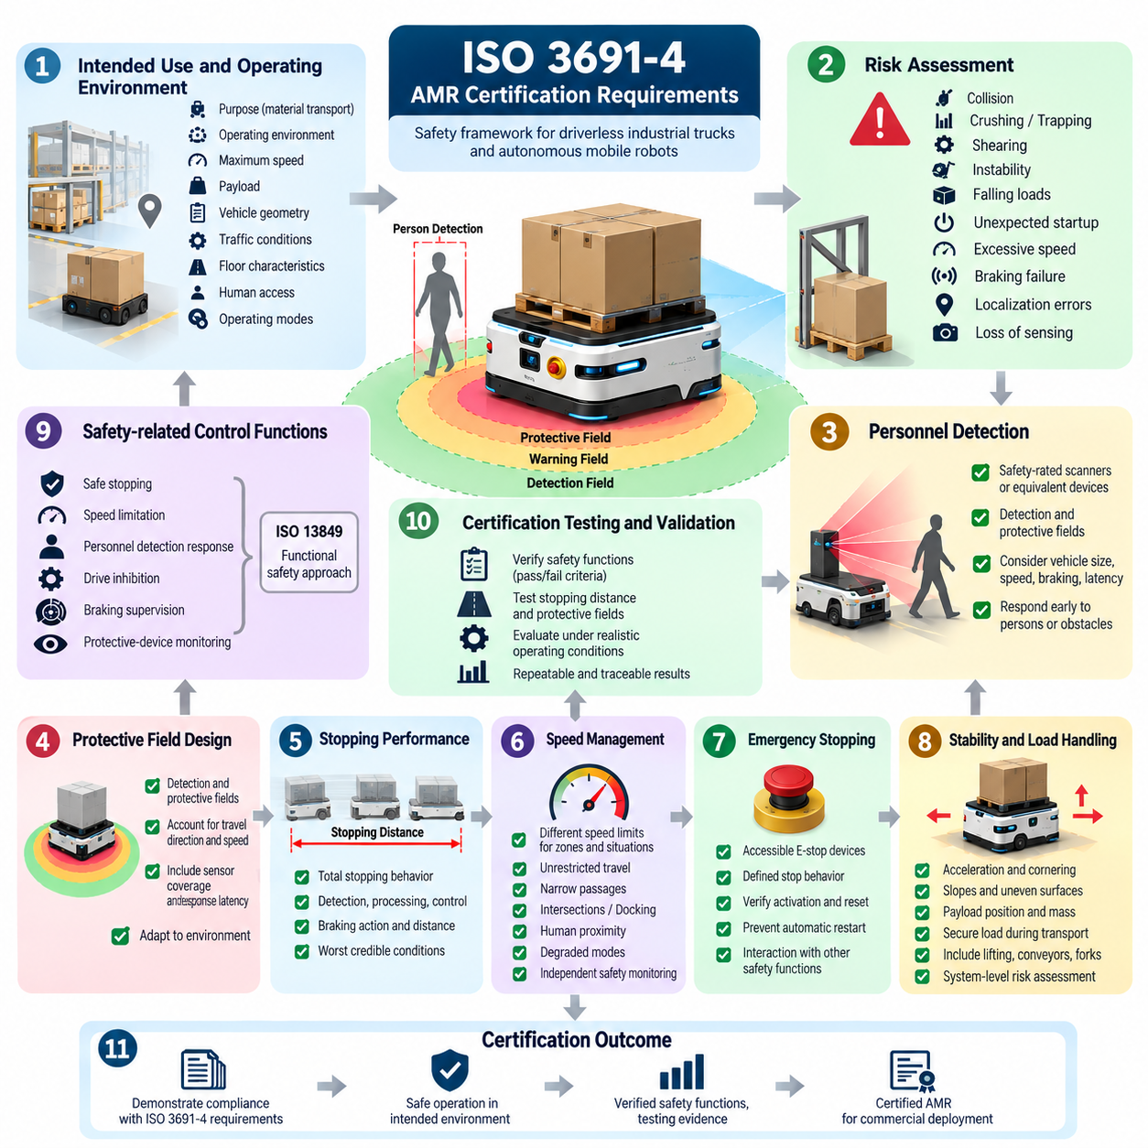
ISO 3691-4 provides a safety framework for driverless industrial trucks and their systems, making it particularly relevant to autonomous mobile robots used for material transport in factories, warehouses, and industrial facilities. Certification-oriented development must address not only normal navigation performance but also hazards created by autonomous movement, interaction with people, transported loads, infrastructure, and failures of safety-related functions.
The certification process begins by defining the AMR's intended use, operating environment, maximum speed, payload, vehicle geometry, traffic conditions, floor characteristics, human access, and expected operating modes. These assumptions establish the boundaries within which safety is demonstrated. Changes such as higher speed, heavier payloads, new attachments, steeper slopes, or operation in public-access areas may require additional risk assessment and validation.
Risk assessment connects the robot design to the required protective measures. Engineers identify hazards associated with collision, crushing, trapping, shearing, instability, falling loads, unexpected startup, excessive speed, braking failure, localization errors, and loss of sensing. Each hazardous situation is evaluated according to its severity and exposure, after which risk reduction measures are allocated to mechanical design, safety controls, operational procedures, or environmental restrictions.
Personnel detection is a central element of AMR safety. Safety-rated scanners or equivalent protective devices establish detection and protective fields around the moving vehicle. These fields must account for travel direction, vehicle dimensions, velocity, braking capability, sensor coverage, response latency, and environmental conditions. The AMR must respond early enough to detected persons or obstacles to prevent unacceptable contact or reduce motion to a defined safe condition.
Protective field design is closely related to stopping performance. A safe field cannot be established from sensor range alone because the robot continues moving while sensing, processing, control, and braking actions occur. Certification testing therefore considers total stopping behavior, including detection latency, safety-controller reaction time, communication delays, brake activation, mechanical deceleration, and the distance traveled before the vehicle reaches a safe state.
Stopping distance must be evaluated across representative operating conditions rather than only under ideal laboratory conditions. Vehicle speed, payload, floor friction, tire condition, gradient, battery state, and braking-system characteristics can change the resulting distance. Measurements should be repeatable and linked to defined configurations so that protective-field parameters can be justified against the worst credible stopping behavior within the approved operating envelope.
Speed management provides another important layer of risk reduction. The AMR may require different speed limits for unrestricted travel, narrow passages, intersections, docking, turning, human proximity, or degraded operating modes. Safety-related speed monitoring should ensure that commanded motion does not exceed the permitted limit. Violations must trigger an appropriate response independently of ordinary navigation or mission-planning software whenever the safety architecture requires such separation.
Emergency stopping must place the AMR into an appropriate safe condition when an operator detects an immediate hazard. Emergency-stop devices must be accessible and their effects clearly defined for the complete vehicle. Verification should evaluate activation, stopping response, reset behavior, restart prevention, and interaction with other safety functions. Resetting an emergency stop should not itself cause hazardous automatic motion without the required restart conditions being satisfied.
Braking and motion-control safety must also address unintended movement. Failures involving motor drives, steering, communication, encoders, power supplies, or control software can potentially create uncontrolled motion. Safety functions should detect relevant faults and transition the vehicle toward a defined safe state. Where required, independent or sufficiently fault-tolerant mechanisms are used so that a single failure does not silently eliminate the necessary protective capability.
AMR stability must be demonstrated for the configurations included within the intended operating envelope. Acceleration, deceleration, cornering, slopes, uneven surfaces, payload position, payload mass, and attachment geometry can affect stability. Certification evidence should therefore relate permitted velocity and maneuvering behavior to the physical configuration of the robot, particularly when high payloads or elevated load-handling mechanisms significantly change the center of gravity.
Load handling introduces hazards beyond vehicle navigation. Loads must remain sufficiently secure during acceleration, braking, turning, docking, and transfer operations. Lifting mechanisms, conveyors, forks, towing interfaces, or customized payload modules can create crushing and trapping zones. Their movements and interlocks should be included in the system-level risk assessment instead of treating the mobile platform and payload-handling equipment as unrelated machines.
Safety-related control functions require systematic verification. Functions such as safe stopping, speed limitation, personnel detection response, drive inhibition, braking supervision, and protective-device monitoring should have defined requirements and pass/fail criteria. Their implementation may also depend on functional-safety principles associated with standards such as ISO 13849, which is treated separately within the broader certification structure. Volume_25_Testing_Validation_an…
Navigation software and safety functions should have clearly defined responsibilities. A conventional autonomy stack may perform localization, mapping, path planning, obstacle avoidance, and mission execution, while the safety layer independently supervises conditions that can create unacceptable risk. Loss of localization or failure of an AI perception model must not automatically imply loss of the protective functions required to bring the robot into an appropriate safe condition.
Fault behavior must be deliberately tested rather than inferred from successful normal operation. Relevant scenarios can include blocked or contaminated sensors, communication loss, encoder faults, localization degradation, controller restart, power anomalies, actuator malfunction, and inconsistent safety signals. Hardware-in-the-loop testing and fault injection can complement physical testing by exercising abnormal conditions repeatedly before final certification-oriented tests are performed. Volume_25_Testing_Validation_an…
The operating environment forms part of the safety concept. Routes, intersections, blind corners, doors, elevators, charging stations, pedestrian crossings, transfer stations, and restricted areas can influence residual risk. Site design may therefore provide additional protective measures such as traffic separation, markings, access controls, warning devices, controlled crossings, or speed-restricted zones. Certification evidence should distinguish robot-level controls from installation-dependent safeguards.
Verification should combine component tests, integrated system tests, HIL tests, simulation where appropriate, and controlled field testing. Field tests are particularly important for confirming navigation safety, stopping behavior, endurance, environmental interaction, and repeatability under representative operating conditions. Test instrumentation and data logging should preserve enough information to reconstruct important events and demonstrate that predefined acceptance criteria were satisfied. Volume_25_Testing_Validation_an…
Certification evidence must remain traceable from hazards to requirements and from requirements to implementation and verification. A practical evidence package can include the intended-use definition, risk assessment, safety-function specification, electrical and control architecture, software configuration, sensor specifications, test procedures, calibration records, stopping-distance measurements, fault-test results, field-test reports, unresolved anomaly records, and operating instructions applicable to the certified configuration.
Compliance is not preserved automatically after certification. Changes to vehicle mass, maximum velocity, braking parameters, safety scanners, motor controllers, batteries, tires, payload modules, navigation software, safety firmware, or operating environments can invalidate assumptions used during assessment. Formal change management should determine whether regression testing, updated risk analysis, protective-field recalculation, or renewed conformity assessment is required. Volume_25_Testing_Validation_an…
ISO 3691-4-oriented AMR certification is therefore best approached as an integrated safety engineering process rather than a final compliance test. Safe autonomous mobility emerges from coordinated vehicle design, personnel detection, braking, speed supervision, functional safety, load management, installation controls, verification, and configuration management. Building these requirements into development from the beginning produces stronger evidence and reduces costly redesign late in certification.

09.03. ISO 13849 PL Assessment for Robot Safety SW [w/Code]
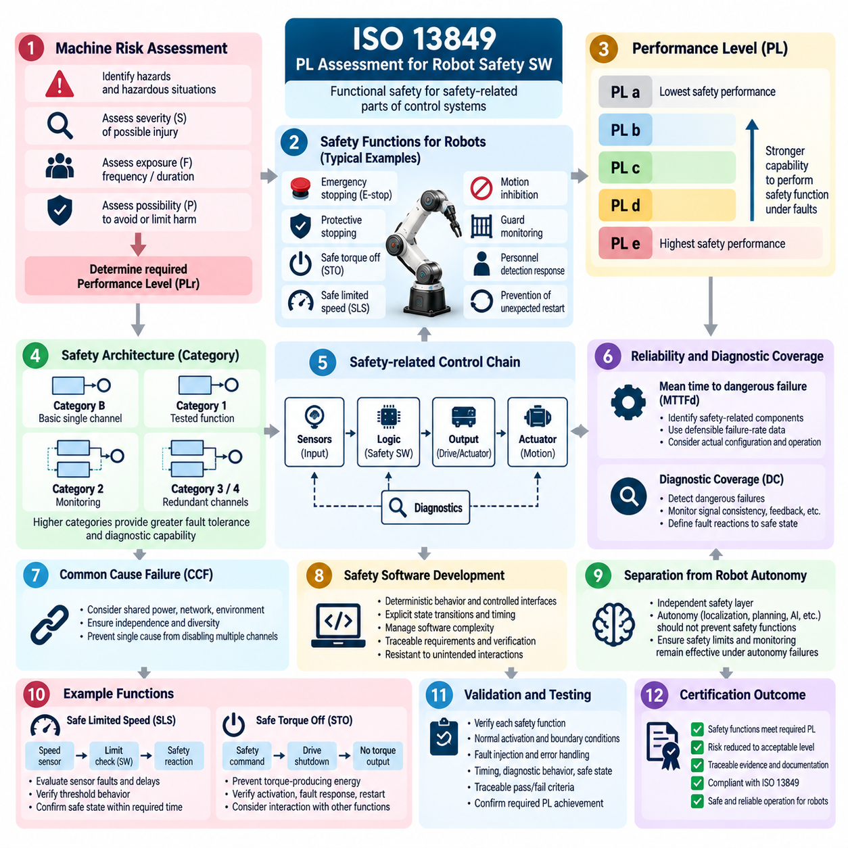
ISO 13849 provides a functional safety framework for safety-related parts of control systems used in machinery, including many industrial and mobile robot applications. For robot safety software, the central objective is to demonstrate that each safety-related control function achieves sufficient risk reduction through an appropriate Performance Level, while maintaining predictable behavior under faults and foreseeable operating conditions.
Performance Level assessment begins with identification of the safety functions derived from the machine risk assessment. Typical robotic functions include emergency stopping, protective stopping, safe torque off, safe limited speed, motion inhibition, guard monitoring, personnel detection response, and prevention of unexpected restart. Each function must be defined with clear inputs, required logic, outputs, response behavior, and safe-state conditions.
The required Performance Level, commonly expressed as PLr, is determined from the risk associated with the hazardous situation addressed by the safety function. Assessment considers factors such as severity of possible injury, frequency or duration of exposure to the hazard, and the possibility of avoiding or limiting harm. The resulting PLr establishes the minimum safety performance that the implemented control function must demonstrate.
ISO 13849 uses Performance Levels ranging from PL a through PL e, representing progressively stronger capability to perform a safety function under foreseeable conditions and faults. Achieving a particular PL is not determined by software quality alone. It depends on the complete safety-related control chain, including sensors, input interfaces, logic processing, communication, output stages, actuators, diagnostics, and the architecture connecting these elements.
Architecture is characterized through designated Categories that describe structural behavior under faults. Depending on the required safety performance, the design may use basic single-channel structures, tested architectures, redundant channels, monitoring, or combinations of redundancy and diagnostics. Higher safety requirements generally demand greater resistance to dangerous failures and stronger capability to detect faults before safety functionality is lost.
The probability of dangerous failure is a major quantitative element of Performance Level evaluation. Component reliability information contributes to estimation of the mean time to dangerous failure, commonly represented as MTTFd. Engineers must identify safety-related components, obtain defensible failure-rate data, determine relevant operating assumptions, and ensure that calculations correspond to the actual hardware configuration used in the robot.
Diagnostic Coverage, or DC, represents the effectiveness of diagnostics in detecting dangerous failures. Robot safety controllers may monitor signal consistency, communication integrity, actuator feedback, encoder disagreement, contactor state, brake response, sensor health, or redundant-channel consistency. Diagnostics must have defined fault reactions, because detecting a failure without transitioning the system toward an appropriate safe condition does not provide the intended risk reduction.
Common Cause Failure, or CCF, must also be considered when redundant channels are used. Two channels cannot be assumed independent merely because duplicate devices are installed. Shared power supplies, connectors, communication networks, environmental stresses, software defects, electromagnetic disturbances, or physical damage can defeat multiple channels simultaneously. Independence and diversity therefore become important parts of safety architecture assessment.
Robot safety software implements logic within this broader safety-related control system and must be developed with systematic fault avoidance in mind. Safety requirements should be translated into deterministic software behavior with controlled interfaces, explicit state transitions, defined timing constraints, and documented failure responses. Software complexity should be managed so that the safety function remains understandable, testable, traceable, and resistant to unintended interactions.
Separation between safety software and ordinary robot autonomy is particularly important for modern robotic systems. Localization, path planning, AI perception, manipulation policies, or mission software may provide operational decisions, while an independent safety layer supervises safety-critical limits. A failure or uncertainty in higher-level autonomy should not prevent required safety functions from detecting hazardous conditions and commanding a safe response.
Safe Limited Speed, or SLS, illustrates how software, sensors, and actuators form a complete safety function. Speed information must be acquired through an appropriate sensing path, evaluated against the permitted limit, and followed by a defined safety reaction if the limit is exceeded. Verification must consider sensor faults, inconsistent measurements, processing delays, communication failures, threshold behavior, and the time required for the physical system to reach its safe state.
Safe Torque Off, or STO, provides another representative function. A safety command must reliably prevent torque-producing energy from generating hazardous motion according to the defined safety concept. Software may initiate or supervise parts of the sequence, but certification evidence must address the entire signal path and final actuator behavior. Testing should confirm activation, fault response, restart conditions, and interaction with other operating states.
Validation must demonstrate that each implemented safety function satisfies its specified requirements and required Performance Level. Testing should cover normal activation, boundary conditions, timing, fault conditions, recovery, reset behavior, and combinations of relevant operating states. Functional safety verification therefore complements the broader safety-function testing strategy, including STO, SLS, SS1, emergency-stop response, and fault-injection testing. Volume_25_Testing_Validation_an…
Fault injection is especially valuable for validating diagnostic mechanisms and degraded behavior. Tests can introduce sensor disconnection, frozen values, communication interruption, corrupted signals, actuator feedback mismatch, controller restart, power anomalies, or loss of one redundant channel. The purpose is not merely to observe an error message but to verify that the safety-related control system detects the condition within the required time and performs the specified safety reaction.
Timing must be treated as part of the safety requirement. A logically correct safety function may still be unsafe if sensing, communication, software processing, output activation, or mechanical response takes too long. Response-time budgets should therefore connect software execution with communication and physical stopping behavior. Worst-case or suitably conservative timing evidence is more relevant to certification than average execution performance.
Software verification should maintain bidirectional traceability between hazards, safety requirements, software requirements, implementation, and test evidence. Each safety requirement should have corresponding verification criteria and results. Configuration management must identify the exact software version, compiler and build configuration, safety parameters, hardware dependencies, and test environment associated with the evidence submitted for assessment.
Tool qualification or confidence in software tools may become relevant when tools can introduce errors into safety-related artifacts or fail to detect defects. Development organizations should therefore control compilers, code generators, configuration tools, static-analysis tools, test frameworks, and automated build pipelines according to their role in the safety lifecycle. Automated testing is valuable, but automation does not eliminate the need to demonstrate integrity of the verification process.
Performance Level assessment must be performed for the complete safety function rather than assigning a PL label to an isolated software module. Sensor capability, logic architecture, communication integrity, output devices, diagnostic coverage, component reliability, common-cause defenses, systematic measures, and validation results collectively determine whether the safety function achieves its target. This system perspective prevents unsupported claims based solely on a safety PLC or certified component.
The resulting certification evidence should combine risk assessment, PLr determination, safety-function specifications, architecture descriptions, reliability calculations, diagnostic analysis, CCF measures, software lifecycle records, traceability, test procedures, fault-injection results, and validation reports. These artifacts establish an auditable chain from identified robot hazards through implemented risk reduction to objective verification evidence.
ISO 13849-oriented assessment is therefore an engineering lifecycle rather than a final numerical calculation. Successful robot safety software integrates risk analysis, architecture, reliable components, diagnostics, deterministic software behavior, systematic verification, and configuration control from the beginning of development. When these elements remain traceable as the robot evolves, Performance Level evidence can support both initial certification and controlled reassessment after system changes.

09.04. IEC 61508 SIL Certification Process
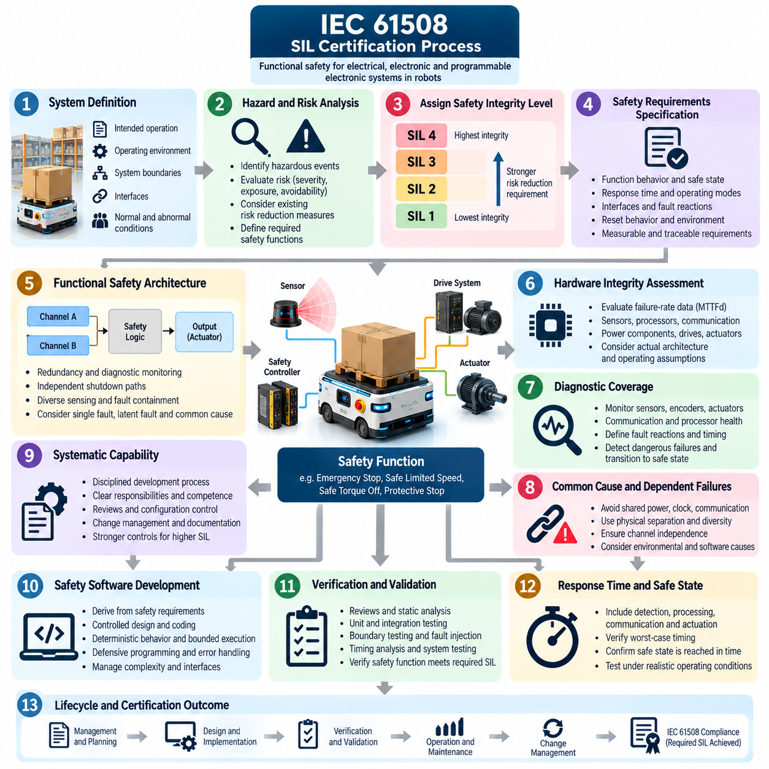
The IEC 61508 Safety Integrity Level certification process provides a systematic framework for demonstrating that electrical, electronic, and programmable electronic safety-related systems achieve the risk reduction required for their assigned safety functions. In robotics, it is particularly relevant when safety depends on programmable controllers, sensors, communication paths, drive systems, actuators, or software whose failure could create hazardous motion or loss of protection.
Certification begins with definition of the system, its intended operation, operating environment, interfaces, lifecycle boundaries, and reasonably foreseeable abnormal conditions. Engineers must understand which functions participate in safety and which belong only to ordinary operation. This boundary is essential because SIL claims apply to defined safety functions and their complete implementation rather than automatically applying to an entire robot, controller, or software product.
Hazard and risk analysis establishes the foundation for the functional safety process. Hazardous events involving unintended motion, excessive speed, loss of braking, actuator malfunction, sensor failure, control errors, or failure to enter a safe state are identified and evaluated. Existing risk reduction measures are considered, and additional safety functions are defined where necessary to reduce residual risk to a tolerable level.
Each safety function is assigned an integrity requirement based on the amount of risk reduction it must provide. IEC 61508 defines Safety Integrity Levels from SIL 1 through SIL 4, with progressively stronger integrity requirements. The selected SIL establishes quantitative and systematic expectations for the safety function, influencing architecture, component selection, diagnostics, development methods, verification rigor, independence, documentation, and lifecycle controls.
The Safety Requirements Specification translates risk-analysis results into implementable requirements. It describes what each safety function must detect, the conditions under which it must operate, the required safe state, response time, operating modes, interfaces, fault reactions, reset behavior, environmental assumptions, and integrity target. Requirements should be measurable and traceable so that later verification can demonstrate whether the intended risk reduction has actually been implemented.
Functional safety architecture is then developed to satisfy the allocated SIL. The design may incorporate redundancy, diagnostic monitoring, independent shutdown paths, diverse sensing, watchdogs, communication protection, or fault-containment mechanisms. Architectural decisions must consider whether a single component failure, latent fault, shared resource, or common cause can prevent the safety function from completing its required action.
Hardware integrity assessment addresses random hardware failures that could compromise safety. Failure-rate data for sensors, processors, communication interfaces, power components, output circuits, drives, and actuators are evaluated according to their role in the safety function. Quantitative analysis must represent the actual architecture and operating assumptions rather than relying only on the certification status of individual components.
Diagnostic mechanisms reduce risk by detecting faults before they develop into dangerous undetected conditions. Robot safety systems may monitor redundant sensors, encoder consistency, actuator feedback, communication integrity, processor execution, power conditions, brake status, or output behavior. Diagnostic coverage must be connected to explicit fault reactions and timing requirements so that detected faults cause an appropriate transition toward a defined safe state.
Common cause and dependent failures require particular attention in redundant designs. Two safety channels can fail together when they share power, clock sources, communication infrastructure, connectors, cooling, environmental exposure, or common software. Physical separation, electrical independence, diversity, defensive design, and controlled interfaces may therefore be necessary to ensure that apparent redundancy provides meaningful safety integrity.
Systematic capability addresses failures introduced through specification, design, implementation, configuration, integration, or maintenance rather than random hardware failure. Functional safety management therefore requires disciplined engineering processes, defined responsibilities, competent personnel, reviews, configuration control, change management, and documented verification activities. Higher integrity targets generally require stronger development controls and greater evidence of systematic fault avoidance.
Software is treated as an integral part of the safety lifecycle when programmable logic contributes to a safety function. Safety software requirements should be derived from system safety requirements and implemented using controlled design and coding practices. Deterministic behavior, bounded execution, defensive programming, interface validation, error handling, state management, and avoidance of unnecessary complexity help make safety behavior analyzable and verifiable.
Software verification should progressively confirm requirements, architecture, detailed design, implementation, integration, and final safety behavior. Reviews, static analysis, unit testing, integration testing, boundary testing, fault injection, timing analysis, and system testing can provide complementary evidence. Verification rigor should correspond to the assigned integrity requirement rather than being based solely on conventional software quality metrics.
Safety functions in robotic systems often depend strongly on response time. A controller may correctly detect excessive speed or personnel intrusion yet still fail to prevent harm if sensing, communication, processing, output activation, or mechanical stopping takes too long. Safety requirements should therefore establish end-to-end timing constraints, and validation should demonstrate that the complete physical system reaches its required safe state within those limits.
Hardware-in-the-loop testing can provide important evidence before potentially hazardous faults are introduced into a physical robot. Sensor failures, communication interruptions, actuator faults, controller resets, corrupted inputs, power anomalies, and safety-device failures can be injected repeatedly under controlled conditions. Such testing complements the broader fault-injection and safety-function verification activities defined within the validation structure. Volume_25_Testing_Validation_an…
Functional safety validation evaluates whether the integrated safety-related system satisfies the Safety Requirements Specification under representative conditions. Testing includes normal activation, boundary cases, degraded operation, detected and undetected fault scenarios, reset behavior, restart prevention, mode transitions, and interactions among safety functions. Evidence must show not merely that individual components operate correctly but that the complete safety function provides the required response.
Independence becomes increasingly important as assurance rigor increases. Verification, validation, review, or functional safety assessment may require personnel with appropriate independence from the development activity being evaluated. Independent assessment helps identify assumptions, incomplete evidence, systematic weaknesses, or conflicts that development teams may overlook and strengthens confidence that safety claims are supported objectively.
Certification evidence is assembled throughout the lifecycle rather than created only at the end. Typical evidence includes hazard and risk analyses, safety plans, Safety Requirements Specifications, architecture descriptions, SIL allocation records, hardware reliability analyses, software lifecycle records, verification procedures, test results, anomaly reports, configuration baselines, validation reports, and records demonstrating that identified deficiencies were resolved or formally accepted.
A functional safety assessment examines whether the lifecycle activities, technical implementation, verification evidence, and organizational controls collectively support the claimed safety integrity. Assessors review traceability from hazards through safety requirements to implementation and validation. They also examine configuration management and whether the evaluated hardware and software correspond exactly to the system configuration for which the safety claim is made.
Third-party certification may involve iterative interaction with an independent certification body rather than a single final audit. Early review of the safety concept, lifecycle plan, architecture, and proposed evidence can identify major gaps before detailed implementation is complete. Later assessments examine completed analyses, test records, software evidence, validation results, unresolved anomalies, and configuration records before a certification decision is reached. Volume_25_Testing_Validation_an…
Certification does not eliminate the need for lifecycle control after release. Changes to safety software, hardware, sensors, drives, communication networks, parameters, development tools, or operating assumptions must be assessed for their impact on existing safety claims. Significant modifications may require updated hazard analysis, renewed verification, regression testing, additional validation, or reassessment of the affected safety functions.
IEC 61508 SIL certification is therefore best understood as evidence-based lifecycle assurance rather than a final safety test or isolated reliability calculation. Successful certification connects hazard analysis, SIL allocation, architecture, hardware integrity, systematic capability, software engineering, verification, validation, independent assessment, and configuration management into one traceable process that demonstrates sustained functional safety throughout the robot system lifecycle.

09.05. ISO 13482 Service Robot Safety Compliance
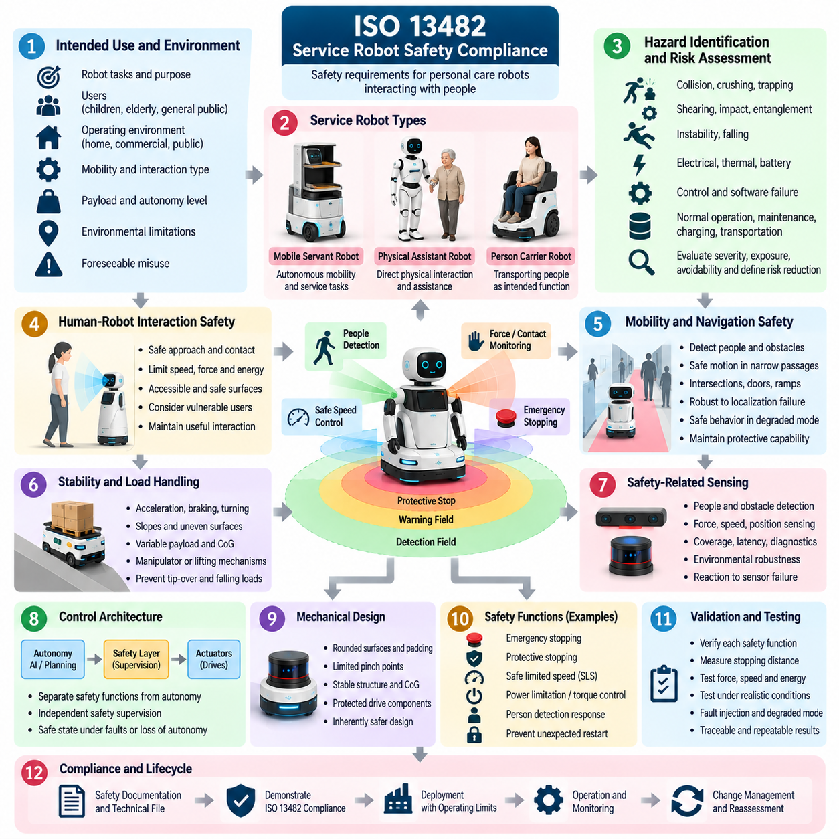
ISO 13482 establishes safety requirements for personal care robots intended to perform tasks involving close interaction with people outside conventional industrial robot environments. For service robot compliance, the standard provides a risk-based framework addressing mobile servant robots, physical assistant robots, and person carrier robots. Its purpose is to reduce hazards created by autonomous motion, physical contact, instability, control failures, and human interaction.
Compliance begins with a precise definition of intended use and reasonably foreseeable misuse. The manufacturer should describe the robot's tasks, users, operating environment, mobility characteristics, physical interaction, payload, autonomy, and environmental limitations. A robot intended for controlled commercial facilities may require different protective measures from a system operating near children, elderly users, visitors, or other people unfamiliar with robotic equipment.
Hazard identification and risk assessment form the foundation of the safety process. Mechanical motion can create collision, crushing, trapping, shearing, impact, entanglement, instability, and falling hazards. Electrical, thermal, battery, control, ergonomic, and environmental hazards must also be considered where applicable. Risk assessment should examine normal operation, foreseeable misuse, maintenance, charging, transportation, faults, recovery, and emergency conditions.
Human proximity makes service robot safety fundamentally different from safety concepts based primarily on physical separation. A service robot may intentionally approach, guide, support, transport, or physically interact with a person. Safety therefore depends on controlling speed, force, energy, geometry, stopping behavior, accessible surfaces, and contact conditions while preserving the functionality required for useful human-robot interaction.
Mobile service robots require safe motion throughout their operating envelope. Navigation functions should account for people, obstacles, narrow passages, intersections, doors, ramps, surface transitions, and dynamically changing environments. Safety measures must remain effective when localization, ordinary obstacle avoidance, or mission planning becomes degraded. Loss of a non-safety autonomy function should not automatically eliminate the protective capability needed to reach a safe condition.
Stability is particularly important for robots with elevated structures, manipulators, variable payloads, or person-carrying functions. Acceleration, braking, turning, slopes, uneven surfaces, external forces, payload displacement, and moving mechanisms can shift the center of gravity. Compliance evidence should demonstrate that permitted operating conditions maintain acceptable stability or that protective measures prevent operation when stability limits could be exceeded.
Physical assistant robots introduce direct contact as part of their intended function. Assistance may involve supporting movement, transferring forces, positioning limbs, or interacting with the user's body. Safety assessment must therefore consider excessive force, unexpected movement, loss of support, incorrect commands, sensor faults, actuator failures, and situations in which a user cannot quickly escape from hazardous contact.
Person carrier robots require additional attention because a failure can directly affect an occupant. Starting, stopping, turning, boarding, exiting, restraint where applicable, speed control, stability, and emergency behavior must be evaluated as an integrated system. The design should also consider foreseeable user actions and whether loss of power, sensing, communication, or control could leave the person in an unsafe or difficult-to-recover condition.
Protective stopping and emergency stopping provide different safety roles and should be specified accordingly. A protective stop may be initiated automatically when the robot detects a hazardous condition, while emergency stopping provides a means to respond to an immediate danger. Validation should evaluate activation, stopping performance, restart prevention, reset behavior, accessibility, and interactions with other robot operating modes.
Safety-related sensing is critical when the robot relies on detecting people, obstacles, contact, force, speed, position, or environmental conditions. Sensors must be evaluated as parts of complete safety functions rather than as isolated devices. Detection capability, coverage, latency, diagnostic behavior, environmental limitations, failure modes, and the control system's reaction to invalid or unavailable sensor information should all be addressed.
Robot control architecture should clearly distinguish ordinary functional control from safety-related supervision where appropriate. Navigation, AI perception, speech interaction, task planning, manipulation policies, or learned behaviors may determine what the robot attempts to do, while safety mechanisms constrain whether the requested action is permissible. This separation becomes increasingly important when probabilistic AI components influence physical behavior near people.
Mechanical design provides an important layer of inherent risk reduction. Rounded surfaces, controlled gaps, limited accessible pinch points, suitable padding, constrained joint motion, stable structures, protected drive components, and appropriate materials can reduce injury severity independently of software. Safety engineering should therefore prioritize inherently safer design before relying exclusively on sensing, control algorithms, warnings, or operating procedures.
Force, speed, and energy limitations may be necessary for robots designed to contact or operate close to people. Validation should consider not only commanded values but actual physical behavior during representative and abnormal conditions. Control latency, actuator dynamics, mechanical compliance, payload variation, and collision geometry can influence the forces generated during contact, requiring measurements that reflect the complete physical system.
Fault conditions must be deliberately evaluated. Relevant scenarios can include sensor loss, encoder disagreement, actuator malfunction, communication interruption, processor restart, battery faults, brake failure, corrupted commands, or loss of localization. Fault injection and hardware-in-the-loop testing can supplement physical testing by allowing abnormal conditions to be reproduced systematically before potentially hazardous tests are performed on the complete robot. Volume_25_Testing_Validation_an…
Safety validation should cover the robot across representative tasks, users, environments, and operating modes. Component testing alone is insufficient because hazards often emerge through interactions among perception, control, mechanics, software, humans, and the environment. Controlled field testing can therefore provide essential evidence concerning stopping behavior, human interaction, navigation safety, endurance, environmental effects, and recovery from abnormal situations. Volume_25_Testing_Validation_an…
Information for use is also part of the compliance strategy. Documentation should define intended applications, prohibited uses, operating limits, installation requirements, inspection procedures, maintenance intervals, charging precautions, emergency actions, residual risks, and required user competence. Warnings cannot substitute for feasible engineering controls, but clear instructions help ensure that assumptions used during risk assessment remain valid during deployment.
Verification evidence should maintain traceability from identified hazards through risk reduction measures to implementation and test results. The technical evidence package may contain system descriptions, risk assessments, safety requirements, architecture records, hardware and software configurations, test procedures, measurement results, fault-test evidence, calibration records, anomaly reports, operating instructions, and validation conclusions for the assessed configuration.
Changes after compliance assessment must be controlled because service robots often evolve through software, AI models, sensors, batteries, actuators, payload modules, or new applications. A change that modifies speed, force, stopping behavior, perception capability, operating environment, or human interaction can invalidate previous assumptions. Impact analysis should determine whether risk assessment, regression testing, validation, or conformity evidence requires revision.
ISO 13482 compliance is therefore best understood as lifecycle safety engineering for robots that share physical spaces and interactions with people. Effective compliance combines risk assessment, inherently safe mechanical design, controlled motion, safety-related sensing, fault response, functional safety, human factors, verification, documentation, and change management. These activities fit within the broader certification structure in which ISO 13482 service robot safety is treated alongside AMR, functional safety, and other robot certification requirements. Volume_25_Testing_Validation_an…

09.06. DO 178C Avionics SW Certification for UAV [w/Code]
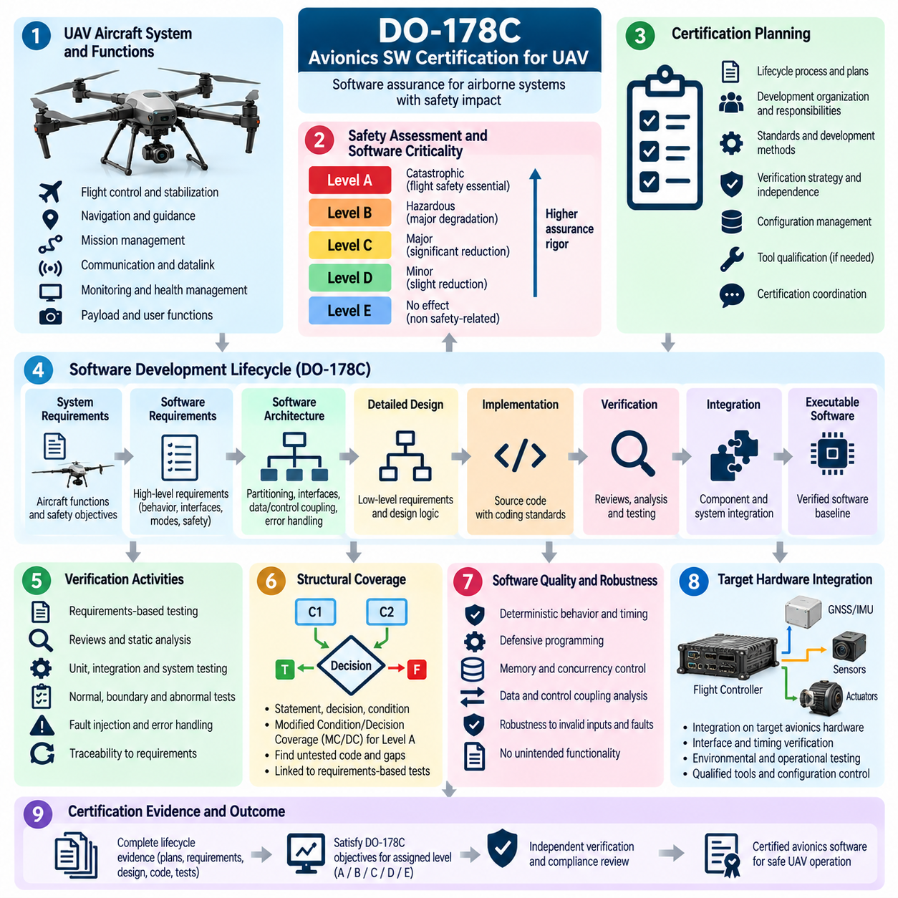
DO-178C provides a structured software assurance framework for airborne systems and equipment, making it relevant when UAV software performs functions whose failure could affect aircraft safety. For unmanned aircraft, certification-oriented application focuses on demonstrating that flight-critical software has been developed and verified with rigor proportional to its failure consequences, rather than attempting to prove software safety through final flight testing alone.
The process begins by defining the airborne system architecture and identifying the software functions that contribute to flight control, navigation, guidance, mission management, communication, monitoring, or safety. System safety assessment determines the consequences of functional failures and establishes the assurance objectives that flow into software development. Clear boundaries are required between safety-critical software and functions whose failures have lower operational consequences.
Software assurance rigor is associated with the failure condition of the aircraft-level function to which the software contributes. Higher-criticality functions require more demanding development, verification, independence, traceability, and structural coverage activities. For a UAV, functions affecting stabilization, propulsion control, flight termination, navigation integrity, or other essential flight behavior may therefore require substantially stronger evidence than non-critical payload or user-interface software.
Certification planning establishes how the development organization intends to satisfy applicable software assurance objectives. Plans describe lifecycle processes, standards, development methods, verification strategy, configuration management, quality assurance, tool usage, and certification coordination. Establishing these plans early prevents critical evidence from being reconstructed after implementation, when missing traceability or verification independence can become expensive to recover.
Software requirements are derived from system-level requirements and allocated functions. High-level requirements define externally observable software behavior, interfaces, modes, performance constraints, fault responses, and safety-related behavior. These requirements must be accurate, consistent, verifiable, and traceable to their source so that certification evidence can demonstrate why each implemented behavior exists and how it contributes to the intended aircraft function.
Low-level requirements and software architecture refine the high-level behavior into implementable logic. They describe algorithms, internal data relationships, state transitions, control logic, timing behavior, interfaces, and detailed processing needed by the source code. Architecture should also identify partitioning, resource sharing, data coupling, control coupling, and mechanisms that prevent failures in one software component from adversely affecting higher-criticality functions.
Implementation must conform to defined software design and coding standards. Source code should accurately implement the approved requirements without introducing unintended functionality. Complexity, language features, numerical behavior, concurrency, interrupt handling, memory use, and hardware interactions require disciplined control. For UAV flight software, deterministic execution and predictable timing are particularly important where software participates directly in closed-loop control.
Verification is performed throughout the software lifecycle rather than only after coding is complete. Reviews and analyses examine requirements, architecture, design, source code, and traceability, while executable tests confirm software behavior. Verification should demonstrate that requirements are correctly implemented, interfaces behave as specified, abnormal and boundary conditions are addressed, and unintended functionality has not been introduced into the certified software baseline.
Requirements-based testing is central to DO-178C-oriented assurance. Test cases and procedures are derived from software requirements rather than merely from source-code structure. Normal-range tests confirm expected operation, while robustness tests examine abnormal inputs, invalid conditions, boundary values, timing anomalies, and failure-related behavior. Each test should have defined expected results and be traceable to the requirement it verifies.
Structural coverage analysis complements requirements-based testing by examining which portions of the implemented code were exercised. The required coverage rigor depends on the software assurance level. Coverage analysis can reveal code that was not executed by requirements-based tests, prompting investigation into missing tests, incomplete requirements, defensive code, or unintended functionality rather than simply encouraging arbitrary tests to increase a numerical percentage.
Modified Condition/Decision Coverage, or MC/DC, becomes particularly significant for the highest assurance software levels. It provides evidence that individual Boolean conditions can independently affect decision outcomes. Achieving meaningful MC/DC requires disciplined requirements, implementation, instrumentation, and test design. Coverage evidence must remain connected to requirements-based verification rather than being treated as an isolated code-coverage objective.
Data coupling and control coupling analysis helps demonstrate that interactions between software components have been exercised appropriately. UAV flight software often contains tightly connected estimation, guidance, navigation, control, actuator, and monitoring functions. Verification must therefore consider not only isolated modules but also whether data flows, invocation relationships, mode transitions, and component interactions correspond to the approved software architecture.
Hardware/software integration testing verifies behavior when the software executes with its target processors, sensors, buses, I/O devices, and flight-control hardware. Timing, numerical precision, interrupt behavior, communication latency, scheduling, resource contention, and hardware faults may produce effects that are not visible in host-based testing. Hardware-in-the-loop environments can provide repeatable stimulation before higher-risk flight testing begins. Volume_25_Testing_Validation_an…
UAV flight testing remains important, but it serves a different role from software verification alone. Flight campaigns confirm integrated aircraft behavior under representative operational conditions, including navigation, control, communication, environmental disturbances, and mission transitions. Certification evidence should connect relevant flight-test results to system objectives while preserving lower-level software verification evidence generated through controlled and repeatable test environments. Volume_25_Testing_Validation_an…
Configuration management ensures that requirements, source code, executable object code, test procedures, test results, development tools, and supporting records remain associated with a controlled software baseline. Changes must be identified, reviewed, authorized, and traceable. Without strong configuration control, successful verification results cannot reliably demonstrate the behavior of the exact software version installed on the aircraft.
Software quality assurance provides independent confidence that approved lifecycle processes and standards are being followed. Audits and reviews examine compliance of development and verification activities, handling of problem reports, configuration status, and completion of required records. Quality assurance therefore evaluates the integrity of the engineering process in addition to the technical correctness of individual software outputs.
Development and verification tools can influence certification evidence. If a tool automates activities whose outputs are not otherwise independently verified, qualification considerations may arise according to the tool's role and potential impact. Compilers, code generators, model-based development environments, test generators, coverage tools, and verification automation must therefore be controlled so that reliance on automation does not create unsupported assurance claims.
Problem reports and anomalies must remain visible throughout certification. Failed tests, unexpected flight behavior, requirement inconsistencies, coverage gaps, timing violations, and software defects require documented analysis and disposition. A problem cannot be considered resolved merely because a subsequent test passes; its root cause, affected artifacts, corrective changes, regression impact, and verification status should be understood and traceable.
Certification evidence is accumulated across the lifecycle and assembled into an auditable package. It can include planning documents, requirements, design data, source code records, traceability matrices, verification procedures, test results, structural coverage evidence, configuration records, quality assurance records, problem reports, and software accomplishment summaries. The broader chapter structure explicitly places DO-178C UAV software certification within robot certification evidence and audit activities. Volume_25_Testing_Validation_an…
Software changes after an approved baseline require controlled impact analysis. Modifications to flight-control algorithms, navigation logic, sensor interfaces, communication protocols, operating parameters, compilers, hardware targets, or reusable software components can affect previously satisfied objectives. Regression analysis determines which requirements, tests, coverage results, integration evidence, and certification artifacts must be repeated or updated.
For autonomous and AI-enabled UAVs, conventional DO-178C software assurance must be carefully distinguished from assurance of learned behavior. Machine-learning models may introduce characteristics that are difficult to express through traditional deterministic requirements and source-code verification. Safety architectures may therefore need clearly bounded interfaces and independently assured protections so that experimental autonomy does not undermine established flight-safety functions.
DO-178C-oriented UAV certification is therefore a lifecycle assurance discipline connecting aircraft-level safety consequences to software planning, requirements, architecture, implementation, verification, structural coverage, configuration management, quality assurance, and controlled change. Within the testing framework, it complements UAV flight-test campaigns and provides the software evidence needed to support high-confidence operation of safety-relevant airborne functions. Volume_25_Testing_Validation_an…

09.07. CE Marking and EU Machinery Directive for Robots
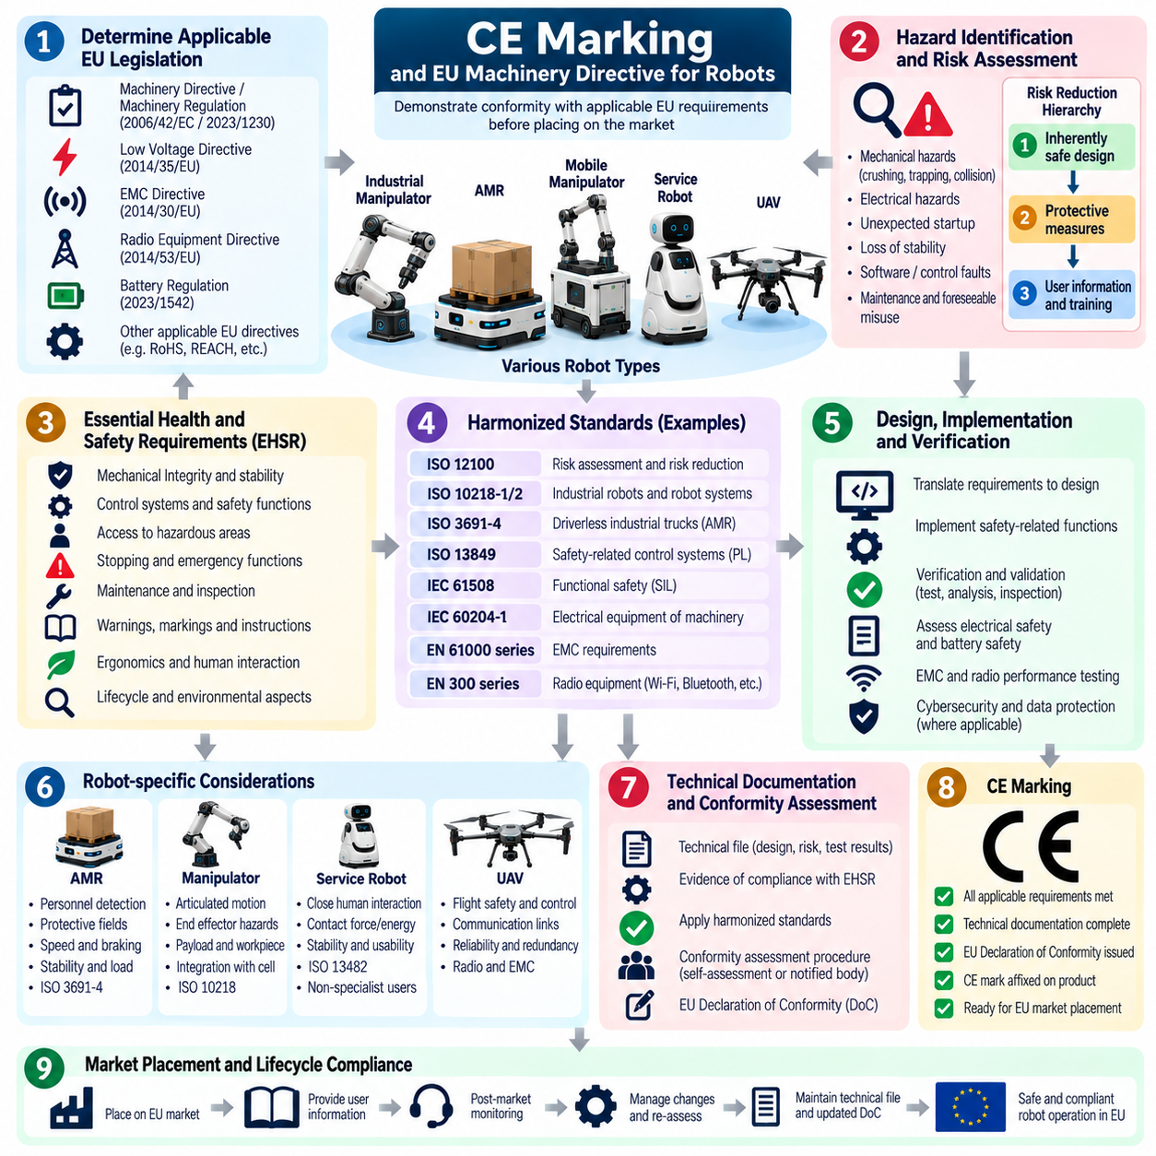
The CE marking process for robots placed on the European market is a conformity framework through which the manufacturer demonstrates that the product satisfies applicable European Union requirements before it is made available or put into service. For industrial robots, AMRs, mobile manipulators, and related machinery, compliance must address the complete machine and its intended use rather than treating CE marking as a simple label applied after development.
The regulatory process begins by determining which EU legislation applies to the robot and its configuration. Machinery requirements are central for many robotic systems, but additional obligations may arise from electrical safety, electromagnetic compatibility, radio equipment, batteries, pressure equipment, or other product characteristics. The manufacturer must therefore establish an applicability matrix that identifies relevant legislation and the corresponding conformity obligations.
For machinery, the regulatory framework requires manufacturers to identify hazards and evaluate risks throughout the foreseeable lifecycle of the product. Mechanical motion, crushing, trapping, collision, electrical energy, unexpected startup, loss of stability, control-system faults, maintenance activities, and foreseeable misuse must be considered. Risk reduction should follow a structured hierarchy beginning with inherently safe design before protective measures and user information are relied upon.
The transition from the EU Machinery Directive to the EU Machinery Regulation is also important for product planning. Manufacturers should identify which legal framework applies at the date the robot is placed on the market and maintain regulatory planning accordingly. Development organizations should avoid assuming that a historical compliance approach remains sufficient when the applicable legislation, conformity procedures, or documentation obligations change.
Essential health and safety requirements provide the regulatory foundation for machinery conformity. Robot designers must translate applicable requirements into engineering specifications covering mechanical integrity, control systems, stopping, stability, access to hazardous areas, human interaction, maintenance, warnings, and other relevant characteristics. These requirements should become traceable inputs to design verification and validation rather than remaining isolated legal statements.
Harmonized standards can provide an important technical route for demonstrating conformity with applicable requirements. Depending on the robot type and application, standards addressing machinery risk assessment, safety-related control systems, industrial robots, driverless industrial trucks, electrical equipment, or other technical domains may be relevant. The selected standards and their applicability should be recorded explicitly in the compliance strategy.
AMRs require particular attention because autonomous movement creates hazards across changing environments rather than within a permanently guarded workspace. Protective fields, personnel detection, speed control, braking, stopping distance, stability, emergency stopping, load handling, and site interaction must be evaluated. ISO 3691-4-related requirements therefore form an important technical element within the broader certification structure for mobile robot compliance. Volume_25_Testing_Validation_an…
Industrial manipulators and mobile manipulators require assessment of hazards associated with articulated motion, end effectors, payloads, workpieces, crushing zones, unexpected movement, and interaction with surrounding equipment. When a robot is integrated into a larger machine or production cell, conformity assessment must consider the integrated application. Compliance of individual components does not automatically demonstrate conformity of the complete assembled system.
Safety-related control functions require particular scrutiny because many robot hazards are controlled through programmable systems. Emergency stopping, protective stopping, safe torque off, safe limited speed, guard monitoring, motion inhibition, and personnel detection responses should have defined requirements and verification evidence. Functional safety assessment may use approaches associated with ISO 13849 or IEC 61508 where appropriate to the system architecture and safety functions.
Electrical safety must be addressed for power distribution, batteries, chargers, motor drives, controllers, wiring, connectors, protective bonding, insulation, and accessible electrical parts. Verification should consider both normal operation and reasonably foreseeable faults. For battery-powered mobile robots, charging interfaces and energy-storage systems can introduce additional thermal, electrical, fire, and maintenance hazards that must be integrated into the overall risk assessment.
Electromagnetic compatibility is also important because robots contain processors, motor drives, wireless interfaces, sensors, switching power electronics, and high-current actuators. The robot should neither generate unacceptable electromagnetic disturbance nor become unsafe when exposed to relevant interference. EMC testing therefore supports both regulatory compliance and confidence that safety-related control functions remain dependable in the intended electromagnetic environment.
Robots containing Wi-Fi, Bluetooth, cellular, GNSS-related radio functions, or other intentional radio transmitters may also fall within additional EU regulatory requirements. Radio performance, electromagnetic compatibility, electrical safety, and applicable cybersecurity-related obligations may therefore interact with machinery conformity. The final compliance plan should consider the complete commercial configuration rather than evaluating communication modules only as isolated components.
Technical documentation provides the evidence supporting the manufacturer's conformity claim. The technical file typically brings together product descriptions, drawings, architecture information, risk assessments, applicable requirements, standards used, calculations, component information, software configuration, verification results, test reports, and operating documentation. Evidence should correspond to the exact hardware and software configuration placed on the market.
Testing should be planned from the regulatory requirements and risk assessment rather than performed as a collection of unrelated laboratory activities. Component testing, software verification, HIL testing, integrated system testing, safety-function validation, EMC testing, and controlled field testing can contribute different evidence. Certification-oriented field evidence should preserve defined procedures, instrumentation, acceptance criteria, configurations, and reproducible results. Volume_25_Testing_Validation_an…
Software is increasingly significant in CE conformity for advanced robots because navigation, motion control, perception, safety supervision, diagnostics, and update mechanisms may affect machine behavior. Software requirements, configuration, interfaces, fault handling, and verification should therefore remain traceable. AI-based functionality requires particular care when probabilistic behavior can influence physical motion, although conventional safety mechanisms may provide independently controlled protection.
Instructions for use are an integral part of the conformity package. Documentation should define intended use, prohibited applications, installation requirements, operating limits, residual risks, inspection, maintenance, emergency procedures, required training, and environmental restrictions. Safety assumptions used during design must be communicated clearly enough that integrators and operators can preserve them during installation and operation.
Depending on the applicable legislation and conformity-assessment route, external laboratories, notified bodies, or other independent organizations may participate in testing or assessment. The manufacturer should clearly understand which activities can be performed through internal conformity assessment and which require third-party involvement. Early communication with external assessors can reduce late discovery of missing evidence or unsuitable test methods.
After the required conformity assessment has been completed, the manufacturer prepares the applicable EU declaration and applies the CE marking according to the governing requirements. The declaration identifies the product and relevant legislation and records the manufacturer's conformity claim. CE marking should therefore represent the conclusion of a documented engineering and legal conformity process, not the beginning of compliance activity.
Configuration management is essential because the conformity evidence applies to a defined product configuration. Changes to sensors, safety scanners, controllers, motor drives, batteries, radio modules, mechanical structures, software, AI models, operating parameters, or payload interfaces can affect the original assessment. Each significant modification should undergo impact analysis to determine whether technical documentation, testing, risk assessment, or conformity procedures must be updated.
Post-market information should also feed back into the compliance lifecycle. Field incidents, near misses, component failures, software anomalies, cybersecurity issues, and newly identified hazards may reveal assumptions that require reassessment. Corrective actions, software updates, safety notices, or design changes should be controlled so that risk reduction remains effective without creating new unassessed hazards elsewhere in the system.
CE marking and European machinery conformity are therefore best treated as lifecycle engineering activities connecting regulatory requirements with risk assessment, robot architecture, functional safety, verification, technical documentation, user information, and controlled change. Within the certification structure, this process complements robot-specific standards and provides the broader conformity framework required for placing applicable robotic products on the European market. Volume_25_Testing_Validation_an…

09.08. Certification Evidence Package Assembly [w/Code]
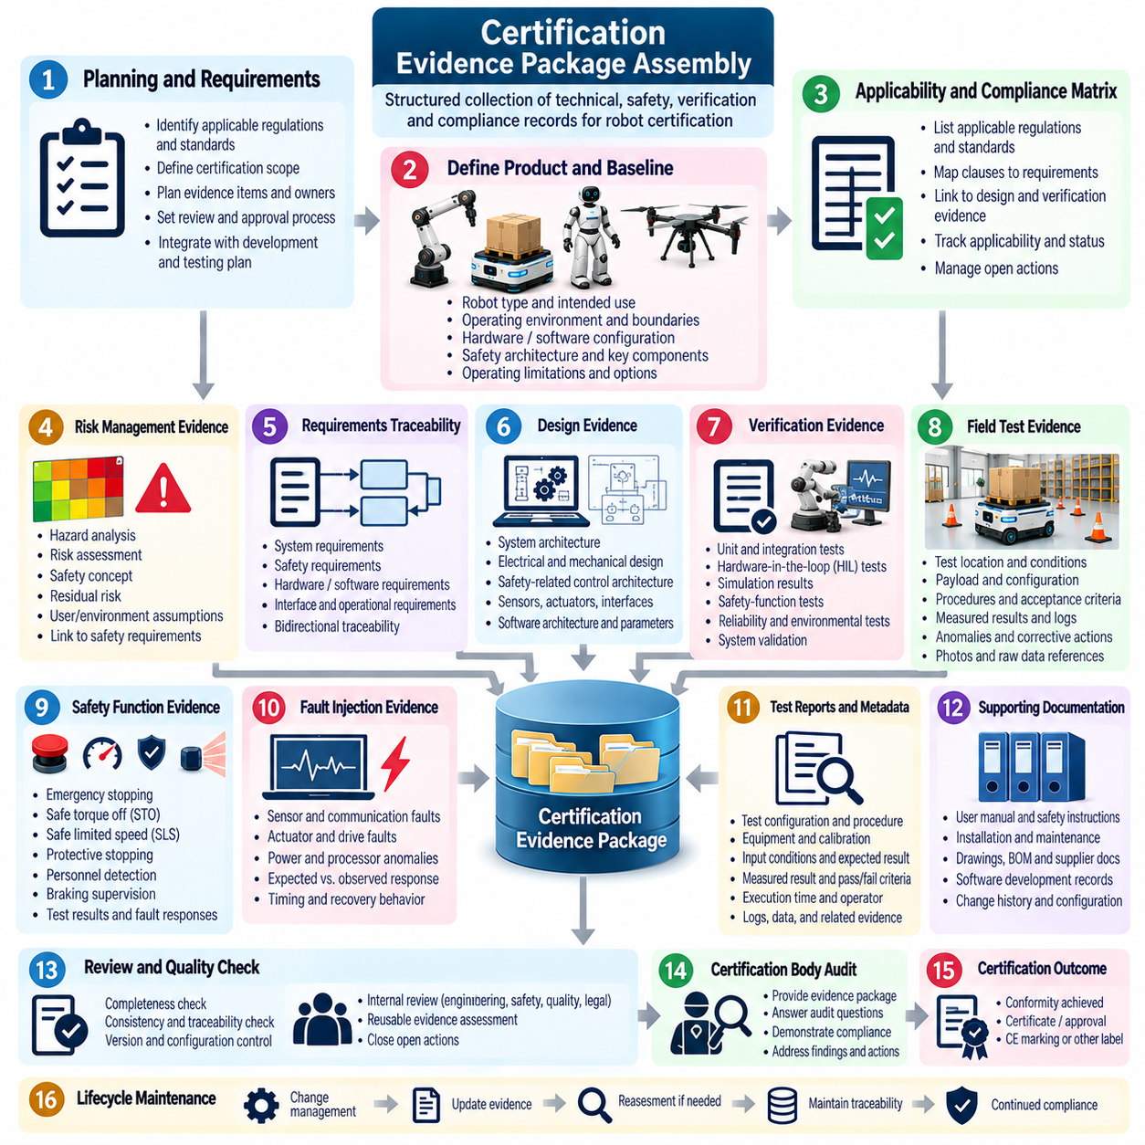
A certification evidence package is the controlled collection of technical, safety, verification, and compliance records used to demonstrate that a robot satisfies its applicable certification requirements. Within the certification structure, evidence assembly follows robot-specific compliance activities such as ISO 3691-4, ISO 13849, IEC 61508, ISO 13482, DO-178C, and European conformity assessment, and prepares the project for third-party audit and certification-body interaction.
Evidence assembly should begin during project planning rather than after verification is complete. Certification requirements must be translated into expected evidence items, responsible owners, review authorities, maturity states, and configuration identifiers. This approach allows development and test teams to generate evidence as engineering work progresses and prevents important records from being reconstructed retrospectively when certification review is already approaching.
The package should establish a clear description of the product being assessed. Robot type, intended use, operating environment, system boundaries, hardware configuration, software release, safety architecture, payload options, sensors, actuators, communication interfaces, and applicable operating limitations should be identified. Without an exact certification baseline, test results and safety analyses cannot reliably demonstrate conformity of the product submitted for assessment.
An applicability and compliance matrix provides the organizational backbone of the package. Applicable regulations, standards, clauses, safety requirements, and internal engineering requirements are mapped to corresponding design controls and verification evidence. Each entry should indicate whether the requirement is applicable, how it is satisfied, where objective evidence is stored, and whether unresolved actions remain before the certification baseline can be released.
Risk-management evidence connects identified hazards to implemented risk reduction. Hazard analyses, risk assessments, safety concepts, hazardous-event records, residual-risk evaluations, and assumptions about users or environments should remain mutually consistent. Each significant hazard should lead to identifiable protective measures, and those measures should lead to requirements and verification evidence demonstrating that the intended reduction has actually been achieved.
Requirements traceability provides the principal logical chain through the evidence package. System, safety, hardware, software, interface, and operational requirements should be linked to their sources and to the design elements that implement them. Verification procedures and results are then linked back to the requirements they evaluate, creating bidirectional traceability from certification obligations to implementation and from implementation back to justified requirements.
Design evidence explains how the robot architecture satisfies those requirements. Relevant records may include system architecture descriptions, safety-related control architecture, electrical design information, mechanical specifications, communication interfaces, sensor and actuator definitions, software architecture, safety parameters, and failure-response mechanisms. Design evidence should describe the assessed configuration accurately enough for reviewers to understand how safety and compliance claims are technically realized.
Verification evidence demonstrates that implementation conforms to specified requirements. Unit tests, integration tests, hardware-in-the-loop tests, simulation results, safety-function tests, reliability tests, environmental tests, and system validation can contribute to the package. The wider testing structure explicitly connects HIL, simulation, field testing, safety testing, and system validation with certification activities, making evidence continuity across these stages important.
Field-test evidence requires particularly careful control because operating conditions can strongly influence robot performance. Test location, environmental conditions, floor or terrain properties, payload, software version, hardware configuration, instrumentation, calibration state, procedures, acceptance criteria, anomalies, and raw measurement references should be preserved. The source structure specifically identifies certification field-test evidence collection as part of the field-testing methodology.
Safety-function evidence should demonstrate both successful operation and controlled response to failures. Emergency stopping, safe torque off, safe limited speed, protective stopping, personnel detection, braking supervision, and other applicable functions should be supported by requirements, procedures, measured results, and fault-response records. Safety Integrity Level achievement evidence and functional safety verification are explicitly positioned as preceding inputs within the overall testing and certification structure.
Fault-injection records strengthen the package by showing how the system behaves when expected assumptions no longer hold. Sensor faults, communication loss, actuator failures, processor resets, invalid signals, power anomalies, or degraded localization can be introduced under controlled conditions. Evidence should record the injected fault, detection mechanism, expected safety reaction, observed response, timing, recovery behavior, and final disposition of any deviation.
Test reports should preserve more than a pass or fail conclusion. They should identify the requirement under evaluation, test configuration, procedure revision, equipment, calibration information, input conditions, expected result, measured result, acceptance criterion, operator or automation identity, execution time, and relevant logs. This metadata allows an auditor to determine whether the evidence genuinely applies to the certification configuration rather than merely resembling the required test.
Anomalies and failed tests must remain visible within the evidence chain. A certification package that contains only successful results can conceal unresolved engineering risk. Each anomaly should have an identifier, technical description, severity or impact assessment, root-cause analysis where required, corrective action, affected artifacts, regression scope, verification result, and closure decision. Accepted deviations should include documented justification and approval by the responsible authority.
Configuration management binds all evidence to a reproducible baseline. Hardware revisions, firmware, operating-system images, middleware, safety-controller configuration, application software, AI models, calibration files, maps, parameters, test scripts, and verification tools may all influence results. Evidence should therefore identify exact versions and dependencies so that reviewers can reconstruct which configuration produced each certification result.
Automated evidence collection can reduce errors when certification artifacts are generated across CI pipelines, HIL systems, simulation farms, and physical test environments. Test automation may capture build identifiers, commit hashes, configuration files, timestamps, execution logs, coverage reports, and result summaries directly from controlled workflows. Automation is valuable only when provenance, access control, integrity, and links to approved requirements remain preserved.
Evidence quality should be reviewed before formal submission. Completeness checks determine whether all applicable requirements have corresponding evidence, while consistency checks detect conflicting versions, parameters, dates, or conclusions. Traceability checks identify orphan requirements and unreferenced test results. Reviewers should also confirm that referenced files are accessible, approved, legible, uniquely identified, and protected from uncontrolled modification.
A useful package distinguishes objective evidence from explanatory material. Objective evidence includes approved requirements, calculations, signed reviews, test data, logs, measurements, and controlled configuration records. Explanatory summaries help assessors navigate these artifacts but should not replace them. A concise evidence index can provide the certification body with a structured entry point into a much larger repository without duplicating every underlying engineering record.
Document control should preserve authorship, revision history, approval state, release date, and relationships between superseded and current artifacts. When an analysis or test report changes, dependent evidence should be reviewed for impact rather than silently replacing the previous file. Controlled revision history allows an auditor to understand how certification conclusions evolved and prevents obsolete evidence from being mistaken for the current approved baseline.
The final package should support efficient audit navigation. An assessor should be able to start from an applicable certification requirement, locate the corresponding system or safety requirement, identify the implementing architecture, inspect the verification method, review the measured result, and confirm closure of associated anomalies. This end-to-end navigation transforms a document repository into an auditable assurance case rather than a collection of disconnected files.
Evidence readiness should be assessed before engagement with a certification body. Internal reviews can identify missing approvals, incomplete traceability, unresolved anomalies, configuration mismatches, unsupported claims, or insufficient test coverage before they become external findings. This is particularly important because certification evidence package assembly is positioned immediately before third-party audit and certification-body interface in the chapter structure.
The package must remain maintainable after initial certification. Product changes, software updates, component substitutions, new payloads, revised operating environments, or safety parameter modifications can invalidate portions of the existing evidence. Impact analysis should identify affected requirements and artifacts so that only justified evidence is reused while necessary analyses, regression tests, validations, and approvals are regenerated under configuration control.
Certification evidence package assembly is therefore the integration point between engineering work and formal conformity demonstration. It converts risk analyses, requirements, architecture, test results, field evidence, functional safety records, configuration baselines, anomaly closures, and approvals into a coherent and traceable body of evidence. When assembled continuously, it supports efficient assessment, defensible certification claims, and controlled maintenance of compliance throughout the robot lifecycle.

09.09. Third Party Audit and Certification Body Interface
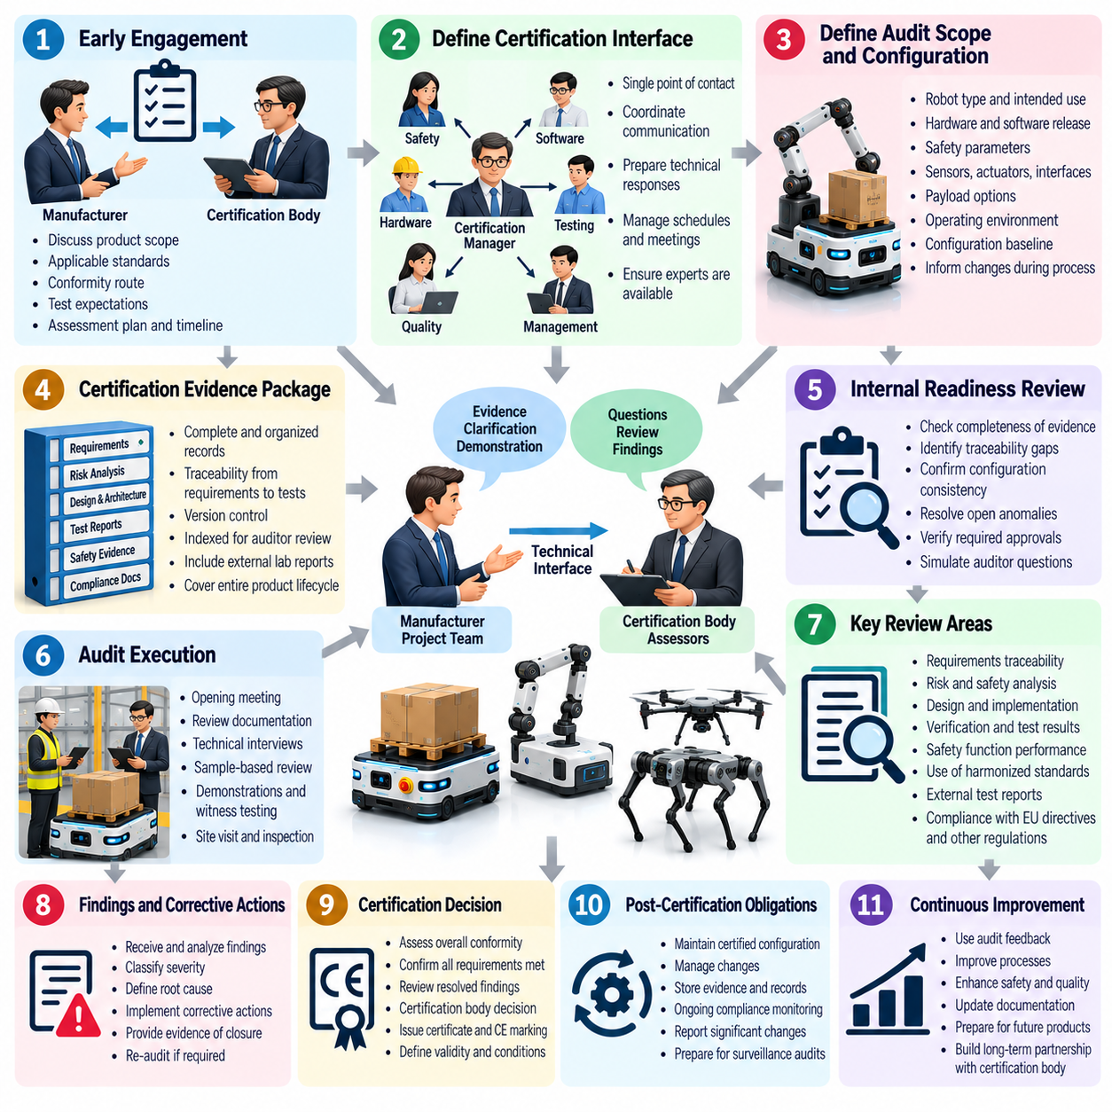
Third-party audit and certification-body interaction provide independent assurance that robot safety and compliance claims are supported by objective evidence. The process extends beyond submitting documents for approval. It establishes a controlled interface between the manufacturer, testing organizations, assessors, and certification authorities so that applicable requirements, product configurations, safety arguments, verification results, and unresolved issues can be evaluated consistently.
Engagement should begin before the final certification audit whenever possible. Early discussions allow the manufacturer and certification body to align on product scope, intended use, applicable standards, conformity routes, required evidence, test expectations, and assessment milestones. This reduces the risk that major architectural decisions or verification strategies are challenged only after development and testing have already been completed.
The manufacturer should designate a clear certification interface responsible for coordinating communication with external assessors. This role consolidates technical questions, evidence requests, schedules, meeting records, and formal responses while ensuring that subject-matter experts remain available when detailed engineering explanations are required. A controlled communication channel prevents inconsistent interpretations from emerging across safety, software, hardware, testing, and management teams.
Audit scope must be tied to a precisely defined product configuration. Hardware revisions, software releases, safety-controller parameters, sensors, actuators, communication interfaces, payload options, operating modes, and environmental assumptions should be identified before assessment. If the configuration changes during certification, the impact must be communicated because previously reviewed analyses or test results may no longer represent the product for which certification is sought.
The certification evidence package becomes the primary technical interface during the audit. Assessors should be able to navigate from applicable regulatory or standard requirements to system requirements, safety requirements, architecture, implementation records, verification procedures, measured results, anomaly dispositions, and approvals. Evidence should therefore be indexed, version-controlled, traceable, and organized to support efficient independent review rather than requiring assessors to reconstruct the engineering history.
Audit preparation should include an internal readiness review before formal external assessment. The project team should identify missing evidence, incomplete approvals, traceability gaps, configuration inconsistencies, unresolved anomalies, outdated documents, unsupported safety claims, and inaccessible records. Internal review should simulate likely assessor questions so that deficiencies can be corrected before they become formal audit findings that delay certification.
The opening phase of an audit establishes scope, responsibilities, assessment criteria, schedule, communication rules, and evidence access. The manufacturer should explain the robot architecture, intended use, safety concept, certification baseline, applicable standards, and major verification activities without overwhelming the assessor with unnecessary detail. A concise system overview helps reviewers understand how individual evidence artifacts fit into the complete safety and compliance argument.
Assessors commonly examine traceability because it reveals whether certification claims are supported systematically. A selected hazard may be traced to a safety requirement, architectural control, implementation, test procedure, measured result, and final acceptance decision. Conversely, a software or hardware safety mechanism may be traced backward to the requirement and hazard that justify its existence. Broken links can indicate incomplete engineering assurance even when individual tests have passed.
Technical interviews are an important part of third-party assessment. Safety engineers, software developers, hardware engineers, test engineers, configuration managers, and quality personnel may need to explain how requirements were interpreted and how evidence was generated. Responses should be based on controlled records rather than individual memory. When an answer is uncertain, the responsible team should verify the evidence before issuing a formal technical response.
Auditors may request samples rather than reviewing every artifact with equal depth. Sampling can focus on high-risk functions, complex requirements, safety-critical software, previous anomalies, configuration changes, or areas where evidence appears inconsistent. The organization should therefore maintain the entire evidence system at audit quality instead of preparing only a small collection of showcase documents expected to receive attention.
Demonstrations and witness testing may be required when documentary evidence alone is insufficient. Assessors may observe emergency stopping, protective stopping, safe limited speed, personnel detection, braking, fault response, restart prevention, or other safety functions. The demonstrated robot must correspond to the declared certification configuration, and the procedure, instrumentation, environmental conditions, expected results, and acceptance criteria should be controlled.
Independent laboratories may provide specialized evidence for electromagnetic compatibility, electrical safety, environmental testing, functional safety, or other regulated characteristics. Their reports should be incorporated into the overall evidence package with clear identification of the tested configuration and applicable requirements. External laboratory results do not remove the manufacturer's responsibility to demonstrate that the tested specimen represents the final product configuration.
Audit findings should be classified and managed through a controlled corrective-action process. A finding may identify missing evidence, inconsistent requirements, inadequate verification, configuration errors, incomplete risk analysis, or process nonconformance. Each finding should receive an owner, impact assessment, corrective action, required evidence, due date, and closure status so that resolution remains visible to both the manufacturer and certification body.
Corrective action should address the cause of a finding rather than only its visible symptom. If an assessor identifies a missing test result, the underlying problem may involve incomplete requirements allocation, inadequate configuration control, or a gap in the verification process. Root-cause analysis helps determine whether similar deficiencies exist elsewhere and whether broader regression or documentation updates are necessary before closure can be justified.
Responses to certification-body questions should be concise, technically defensible, and traceable to controlled evidence. Informal explanations should not contradict approved specifications or test records. When new analysis is required, it should be generated through the same configuration and review controls used for other certification artifacts. This preserves consistency between audit correspondence and the formal evidence baseline.
Changes requested during assessment must be carefully controlled. A seemingly minor modification to a safety parameter, sensor, software module, mechanical guard, braking configuration, or operating limitation can affect multiple requirements and test results. Change-impact analysis should identify affected hazards, requirements, architecture, verification evidence, documentation, and previously accepted findings before the modified configuration is presented for reassessment.
Audit closure requires more than completing meetings or submitting responses. Findings must be resolved to the satisfaction of the responsible assessment authority, required evidence must be accepted, and the final product configuration must match the reviewed baseline. Any remaining limitations, conditions, exclusions, or operational constraints should be documented clearly so that the resulting certification claim is not broader than the evidence supports.
Certification decisions and associated records should be retained as controlled lifecycle artifacts. Certificates, assessment reports, approved deviations, correspondence, witness-test records, final evidence indexes, and configuration baselines provide the historical basis for future modifications and recertification. These records help later engineering teams understand exactly what was assessed, what assumptions were accepted, and which conditions were attached to the original approval.
The relationship with a certification body continues to matter after initial approval. Significant product changes, newly discovered safety issues, field incidents, regulatory changes, or expanded operating conditions may require notification, reassessment, additional testing, or updated documentation. A defined post-certification interface ensures that changes affecting the original conformity basis are evaluated before an unsupported certification claim is extended to a modified product.
Third-party audit and certification-body interaction should therefore be managed as an engineering assurance process rather than an administrative inspection. Effective interaction combines early engagement, controlled communication, configuration discipline, evidence traceability, technical transparency, witness testing, corrective-action management, and formal closure. When these practices are established throughout development, independent assessment becomes a confirmation of accumulated evidence rather than a disruptive reconstruction of the project at its end.

09.10. Certification Maintenance and Change Management
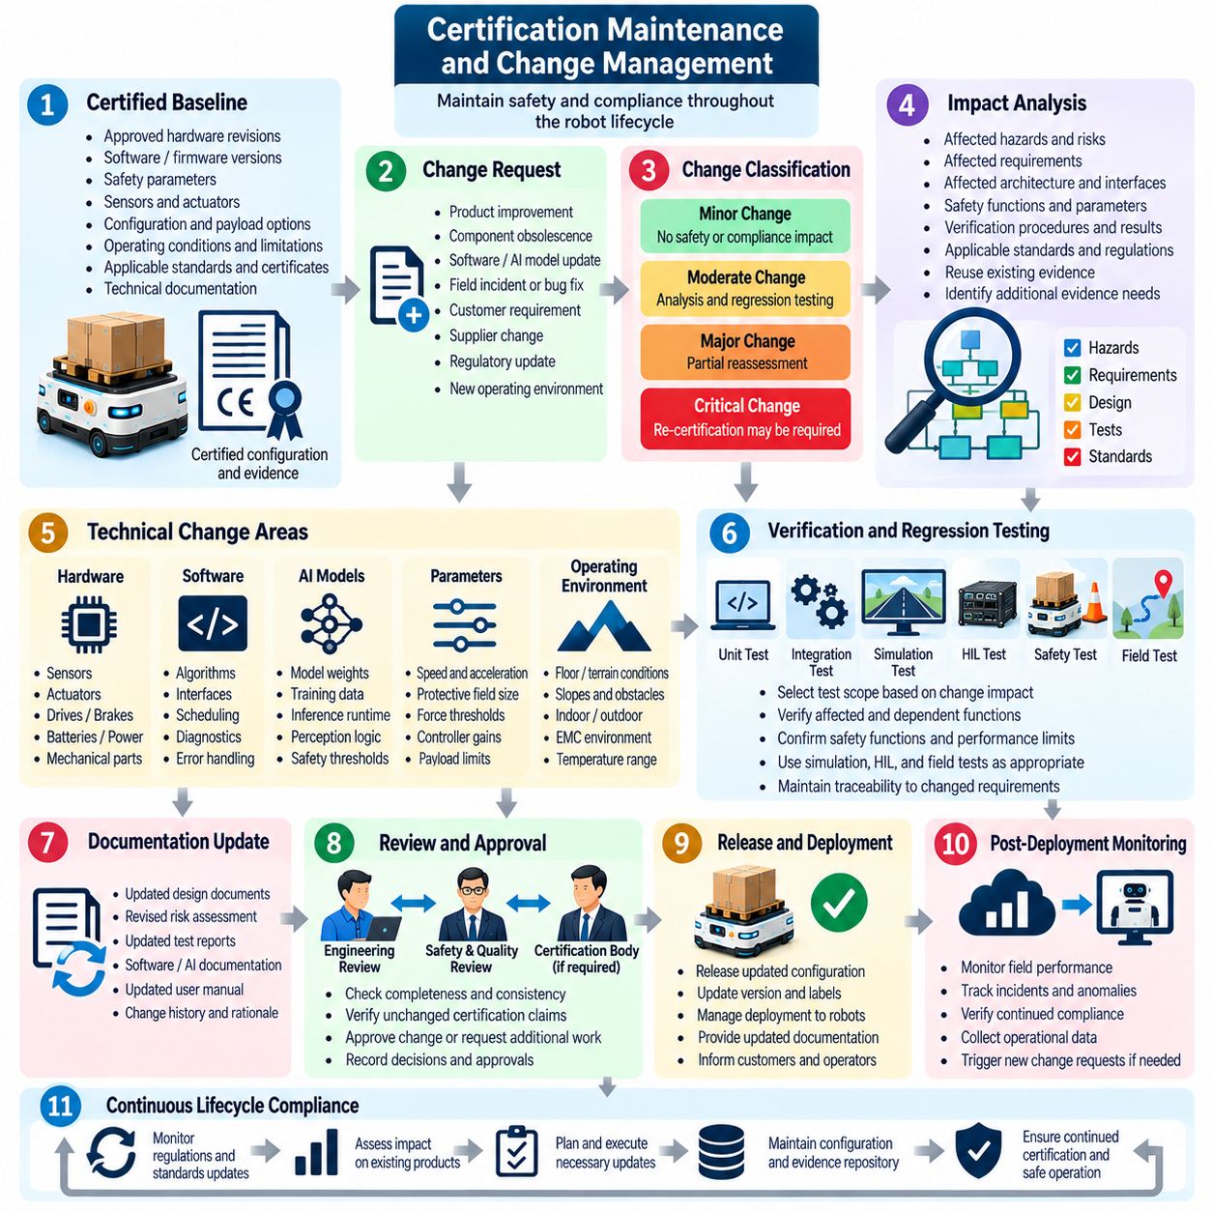
Certification does not end when a robot receives approval or enters commercial operation. The certified configuration, safety assumptions, technical evidence, operating limitations, and applicable regulatory obligations must remain controlled throughout the product lifecycle. Certification maintenance therefore establishes a continuous process for determining whether hardware, software, AI, operational, or environmental changes affect previously accepted safety and conformity claims.
The foundation of certification maintenance is a clearly defined certification baseline. This baseline identifies the approved hardware revisions, software and firmware versions, safety parameters, sensors, actuators, communication interfaces, mechanical configuration, payload options, documentation, and operating conditions. Every released robot configuration should be traceable to this baseline or to a formally assessed successor configuration.
Change management begins when a proposed modification is recorded through a controlled change request. The request should describe the reason for change, affected components, expected functional impact, implementation scope, responsible owners, and intended release. Changes may originate from product improvement, component obsolescence, field incidents, cybersecurity remediation, customer requirements, supplier changes, software defects, regulatory updates, or expansion of the intended operating environment.
Not every modification has the same certification significance. A structured change classification process should distinguish changes with no safety or compliance impact from those requiring analysis, regression testing, partial reassessment, or renewed certification activity. Classification criteria should consider whether the modification affects hazards, safety functions, performance limits, architecture, interfaces, reliability assumptions, operating conditions, or previously approved evidence.
Impact analysis connects the proposed change to the existing certification argument. Engineers should identify affected hazards, risk controls, requirements, architecture elements, safety functions, verification procedures, test results, technical documentation, user instructions, and regulatory obligations. Bidirectional traceability allows the organization to determine not only which artifacts must change but also which previously accepted claims remain valid and can be reused.
Hardware substitutions require careful assessment even when replacement components appear functionally equivalent. Changes to sensors, processors, motor drives, brakes, batteries, power supplies, communication devices, connectors, or mechanical structures can alter reliability, timing, electromagnetic compatibility, thermal behavior, stopping performance, or failure modes. Supplier declarations alone may therefore be insufficient to justify continued certification without system-level impact evaluation.
Software changes can affect certified behavior through algorithms, interfaces, scheduling, communication, diagnostics, configuration, or error handling. A small code modification may influence timing or state transitions beyond the modified module. Change assessment should therefore identify affected requirements and dependencies, determine the necessary regression scope, and preserve the exact relationship between source code, build configuration, executable software, and verification evidence.
Safety-related software requires particularly strict control because modifications can affect established Performance Level or Safety Integrity Level arguments. Changes to emergency stopping, safe torque off, safe limited speed, protective stopping, personnel detection, diagnostic logic, or fault reactions may require renewed functional safety analysis. Existing calculations and validation evidence should be reused only when the assumptions on which they depend remain demonstrably unchanged.
AI models introduce an additional configuration dimension because behavior may change without conventional source-code modification. Replacing model weights, training data, preprocessing logic, inference runtime, thresholds, or perception interfaces can alter robot decisions and physical behavior. Certification maintenance should therefore treat safety-relevant AI artifacts as controlled configuration items and define when model updates require regression testing or renewed system validation.
Parameter changes must also be treated as potential certification changes. Maximum velocity, acceleration, braking limits, protective-field dimensions, force thresholds, controller gains, payload limits, localization tolerances, or safety timeouts can directly alter risk. Parameter management should identify approved ranges, access permissions, validation status, and mechanisms preventing unauthorized values from being deployed to certified systems.
Operating-environment changes can invalidate certification assumptions even when the robot itself is unchanged. Deployment on steeper slopes, lower-friction floors, outdoor terrain, crowded public spaces, narrower passages, different electromagnetic environments, or new temperature ranges may affect stopping, stability, sensing, navigation, or human interaction. Site or application changes should therefore undergo impact assessment against the original intended-use and environmental boundaries.
Regression testing should be selected according to change impact rather than repeating every historical test automatically. Directly affected requirements require verification, while dependent functions should be examined for unintended consequences. Unit, integration, HIL, simulation, safety-function, field, and system-level tests may be combined to provide proportionate evidence that unchanged certification claims remain valid after modification.
A change can reveal that earlier risk assumptions require revision. New field data, failure experience, near misses, or changed usage patterns may identify hazards that were previously underestimated or not recognized. Risk assessment should therefore remain a living lifecycle artifact. When risk changes, corresponding safety requirements, protective measures, verification activities, residual-risk statements, and user documentation must be reviewed together.
Certification evidence must evolve under the same configuration discipline as the product. Updated requirements, analyses, drawings, source-code records, test reports, calibration records, risk assessments, and operating instructions should receive controlled revisions. Superseded evidence should remain identifiable rather than being silently overwritten, allowing reviewers to reconstruct which evidence supported each certified product baseline.
Change-control boards can provide multidisciplinary governance for significant modifications. Safety, systems, software, hardware, test, quality, regulatory, cybersecurity, and product representatives can jointly determine certification impact and required actions. Decisions should be documented with their technical rationale so that future auditors can understand why a change was classified as insignificant, regression-tested, reassessed, or submitted for external approval.
External certification bodies may need to be notified when changes affect the basis of an existing approval. The organization should understand notification conditions, certificate limitations, applicable conformity procedures, and any agreement established during the original assessment. Early communication is preferable when the significance of a change is uncertain, because implementing the modification before regulatory alignment can create costly rework.
Post-market monitoring provides essential input to certification maintenance. Field failures, safety events, near misses, customer complaints, diagnostic trends, maintenance records, software anomalies, and cybersecurity vulnerabilities can reveal emerging risks. These observations should feed into change management so that corrective actions are evaluated not only for operational effectiveness but also for their effect on the existing certification basis.
Corrective updates require the same discipline as planned product improvements. An urgent safety or cybersecurity fix may need rapid deployment, but urgency does not eliminate the need for impact assessment, controlled implementation, verification, approval, and traceability. Organizations should establish expedited change procedures that preserve essential assurance activities while supporting timely response to significant field risks.
Release management should prevent unapproved configurations from reaching certified products. Deployment pipelines should verify approved hardware compatibility, software versions, firmware, parameters, model artifacts, and configuration files before release. Where over-the-air updates are supported, authorization, integrity verification, rollback capability, deployment monitoring, and confirmation of the resulting configuration become part of maintaining the certified state.
Periodic certification reviews can confirm that accumulated changes have not gradually moved the product beyond its original approval basis. Reviews should examine configuration history, open anomalies, regulatory changes, field experience, supplier changes, evidence status, and certificate conditions. This is particularly important for long-lived robotic platforms that receive frequent software updates and hardware revisions over many years.
Regulatory and standards surveillance should operate alongside technical change management. New regulations, revised standards, transition periods, certification guidance, or changed market requirements may affect products even without an engineering modification. The organization should assess whether existing certifications remain valid, whether future production requires updated evidence, and whether planned product releases should adopt newer compliance requirements.
Recertification becomes necessary when the accumulated or individual change exceeds the scope supported by existing evidence or approval conditions. The objective is not to repeat the entire original certification unnecessarily, but to identify the affected assurance boundary and generate sufficient new evidence. A well-maintained traceability system enables focused reassessment while preserving valid evidence from unchanged parts of the system.
Certification maintenance and change management therefore form a continuous assurance loop connecting field operation, engineering changes, risk assessment, configuration control, regression testing, evidence maintenance, and certification-body interaction. When this loop is integrated into the robot development lifecycle, certification remains a controlled property of a defined product configuration rather than a one-time milestone that gradually loses validity as the system evolves.

