Volume 25. Testing Validation and Benchmarking

Chapter 10. Physical AI Evaluation

10.01. Physical AI Evaluation Unique Challenges
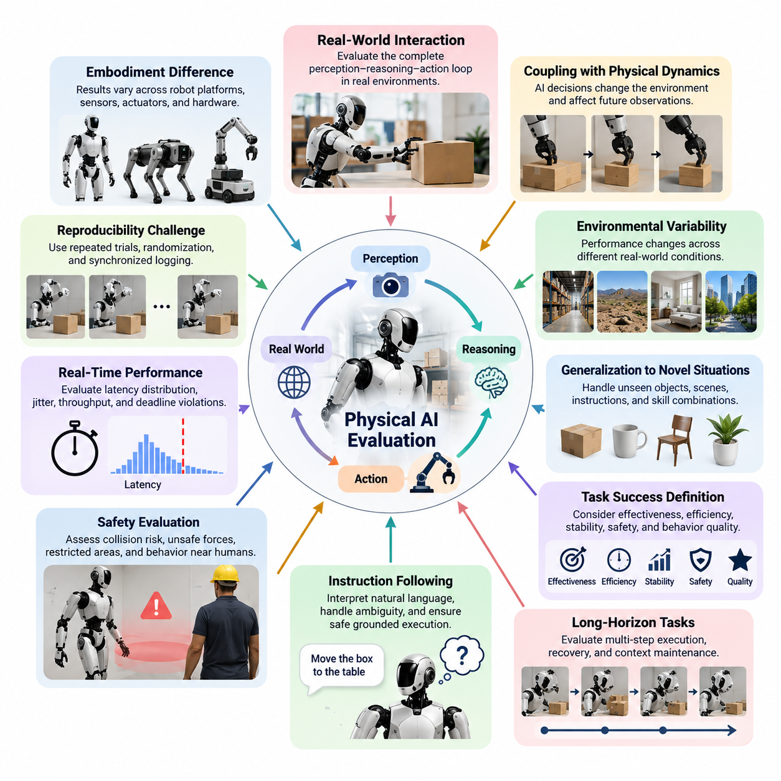
Physical AI evaluation differs fundamentally from conventional software or AI model testing because intelligence is expressed through physical interaction with the real world. A model may produce semantically correct predictions while the robot still fails because perception uncertainty, actuator dynamics, timing, contact conditions, or environmental disturbances alter the resulting behavior. Evaluation must therefore measure the complete perception–reasoning–action loop rather than model accuracy in isolation.
A central challenge is the coupling between AI decisions and physical dynamics. In conventional machine learning, an incorrect prediction can often be evaluated independently against a labeled target. In Physical AI, an incorrect action changes the environment and consequently changes every observation that follows. Small errors in object pose estimation, grasp selection, foot placement, steering, or force control can accumulate into task failure several seconds or minutes later, making causal attribution difficult.
Physical environments also contain substantially greater variability than controlled datasets. Lighting, surface friction, object geometry, payload, terrain, human motion, sensor noise, communication conditions, and mechanical wear may all influence performance. A robot that succeeds repeatedly in one laboratory configuration may fail when deployed in a warehouse, outdoor site, home, hospital, factory, or other operational domain. Evaluation must therefore characterize robustness across distributions rather than report performance from a single nominal environment.
Generalization is particularly important for Physical AI systems based on vision-language-action models, foundation models, and generalist policies. The system may encounter objects, layouts, instructions, viewpoints, and task combinations that were absent from training. Evaluation must determine whether learned representations support meaningful adaptation to such novelty without producing unsafe or arbitrary actions. This motivates explicit testing of novel objects, scenes, instructions, and combinations of previously learned skills.
Another difficulty is defining task success itself. Binary success and failure labels are useful but often conceal important differences in execution quality. A manipulation task may technically succeed while requiring excessive retries, forces, energy, or completion time. Navigation may reach the destination while violating preferred clearances. Humanoid locomotion may complete a route with unstable recovery behavior. Physical AI evaluation therefore requires multidimensional metrics covering effectiveness, efficiency, stability, safety, and behavioral quality.
Long-horizon tasks introduce additional complexity because they consist of dependent perception, reasoning, planning, and action stages. A robot may correctly execute nine steps and fail on the tenth, or recover from an early error and eventually complete the task. Simple per-action accuracy does not represent these behaviors adequately. Evaluation should capture completion rate, subtask progress, recovery capability, accumulated error, intervention frequency, and the ability to preserve task context over extended execution.
Instruction following presents another unique challenge when language is connected directly to physical behavior. Natural-language commands can be ambiguous, underspecified, context dependent, or incompatible with the current physical state. A capable system must interpret the intended goal while respecting physical feasibility and safety constraints. Evaluation must therefore distinguish language understanding from grounded execution and determine whether the robot appropriately requests clarification, rejects unsafe instructions, or selects reasonable actions under uncertainty.
Safety evaluation cannot be separated from capability evaluation. A Physical AI system that achieves a high task success rate but occasionally generates hazardous motion may be unsuitable for deployment. Tests must examine collision risk, unsafe contact forces, prohibited-region entry, unstable motion, unexpected actuator commands, human proximity behavior, and responses to uncertain perception. Safety constraints should remain effective not only during nominal operation but also during AI errors, sensor degradation, communication failures, and unfamiliar situations.
Real-time performance creates another evaluation dimension because correct decisions delivered too late can become incorrect physical actions. Perception inference, multimodal reasoning, trajectory generation, policy execution, communication, and actuator control contribute to end-to-end latency. Average latency alone is insufficient because rare timing spikes can destabilize control or invalidate environmental assumptions. Physical AI benchmarking should therefore consider latency distributions, jitter, throughput, deadline violations, and resource contention under realistic computational workloads.
Reproducibility is difficult because physical trials cannot perfectly recreate initial conditions. Object placement may differ by millimeters, battery state changes, motors heat up, surfaces wear, sensors drift, and humans behave differently between runs. Statistical evaluation consequently requires repeated trials, controlled randomization, synchronized logging, environmental metadata, and clearly defined confidence criteria. Simulation can improve repeatability, but simulation results must be interpreted together with the sim-to-real gap already recognized elsewhere in the validation structure.
Embodiment further complicates comparison between models. The same policy architecture may behave differently on robots with different cameras, manipulators, grippers, joint limits, control frequencies, compute platforms, or mobility systems. A benchmark result can therefore reflect both intelligence quality and embodiment characteristics. Meaningful evaluation should identify which metrics are model dependent, platform dependent, and system dependent, while documenting hardware and runtime configurations sufficiently for comparison.
Human interaction adds subjective and socially dependent criteria that cannot always be represented by automated metrics. Robots operating around people may need to exhibit predictable motion, understandable intent, appropriate response timing, comfortable interpersonal distance, and effective recovery from misunderstanding. Human-in-the-loop evaluation complements quantitative testing by measuring usability, trust calibration, perceived safety, intervention burden, and whether robot behavior corresponds to reasonable human expectations during shared tasks.
Data leakage and benchmark overfitting are additional concerns as Physical AI models are trained on increasingly large multimodal datasets. Objects, scenes, demonstrations, instructions, or simulation assets used in evaluation may have direct or indirect counterparts in training data. Apparently strong generalization can therefore reflect memorization or near-duplicate exposure. Evaluation protocols should maintain traceable dataset partitions and deliberately construct sufficiently distinct scenarios for measuring genuine transfer.
Failure analysis is also more difficult than reporting aggregate success rates. A failed task may originate from perception, semantic reasoning, world-state estimation, planning, policy generation, control, hardware execution, or interaction among several components. Comprehensive telemetry should preserve observations, model outputs, actions, robot states, timing information, safety events, and environmental context. Such evidence enables failures to be classified by mechanism rather than being treated as indistinguishable unsuccessful trials.
Evaluation must ultimately connect laboratory metrics to operational usefulness. High benchmark performance has limited value if the system requires frequent human intervention, consumes excessive compute resources, degrades under production latency, or fails unpredictably in uncommon situations. A practical framework therefore combines task success, generalization, instruction following, long-horizon completion, safety, production latency, human evaluation, and model comparison—the progression explicitly defined for this Physical AI evaluation chapter.
The defining challenge is consequently not discovering one universal Physical AI score, but constructing evidence that an embodied intelligent system remains capable, robust, safe, timely, and understandable across realistic operating conditions. Evaluation should progressively connect simulation, controlled laboratory experiments, hardware testing, field trials, and production monitoring. This system-level perspective aligns Physical AI evaluation with the broader testing, validation, benchmarking, safety, and continuous-production structure of the volume.

10.02. VLA Task Success Rate in Real World Protocol [w/Code]
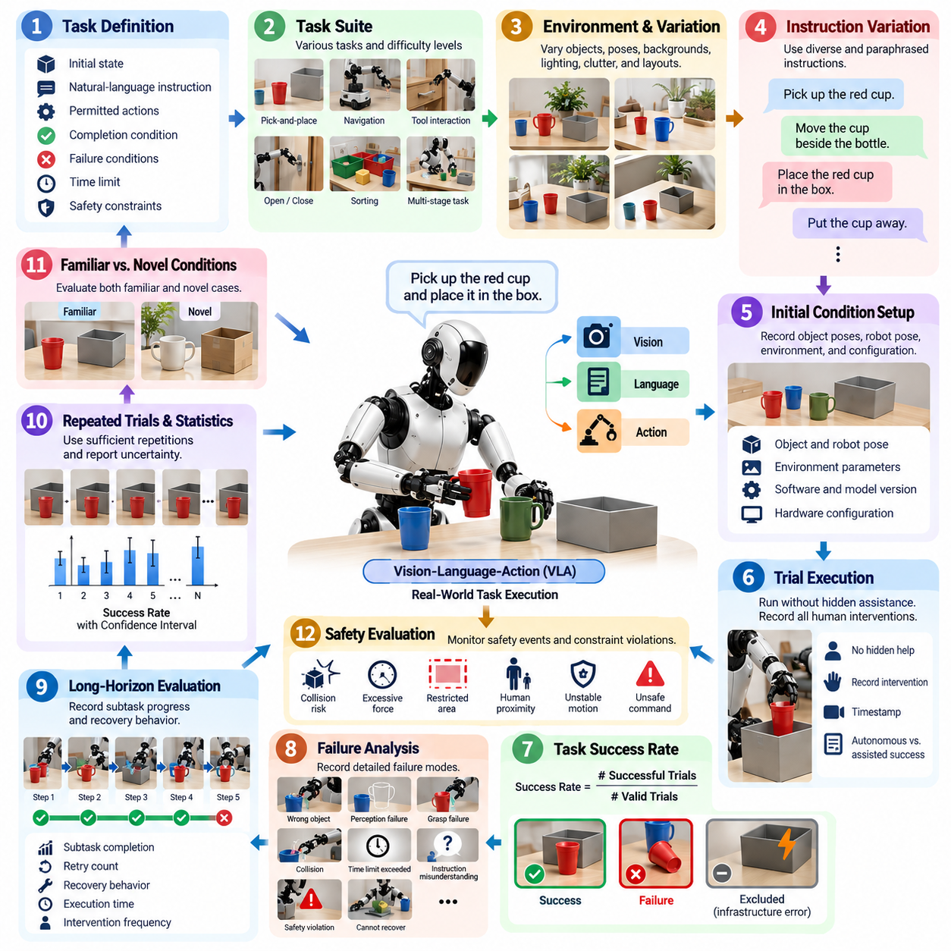
Real-world task success rate is a primary evaluation metric for Vision-Language-Action systems because it measures whether multimodal understanding is converted into effective physical behavior. Unlike offline VLA evaluation, which may score language outputs or predicted actions against reference data, a real-world protocol observes whether the robot actually completes the requested task under physical constraints, uncertainty, and environmental variation.
A rigorous protocol begins with an operational definition of success. Each task must specify the initial state, natural-language instruction, permitted actions, completion condition, failure conditions, time limit, and safety constraints before trials begin. Success criteria should be externally observable whenever possible. For example, “place the requested object in the target container” requires correct object selection, successful grasping, transport, release, and a valid final object state.
Task success rate is commonly expressed as the number of successful trials divided by the total number of valid trials. However, the denominator must be carefully controlled. Trials terminated by infrastructure failures, experimenter errors, or unrelated hardware faults should be distinguished from failures attributable to the VLA system. Exclusion rules must be defined before evaluation so that unsuccessful executions cannot be selectively removed after observing results.
The task suite should represent the intended operating domain rather than a collection of demonstrations that are unusually favorable to the model. Evaluation can include object retrieval, pick-and-place, navigation-to-object, tool interaction, opening or closing mechanisms, delivery, sorting, and multi-stage manipulation. Tasks should vary in semantic complexity and physical difficulty so that success rate reflects both instruction grounding and embodied execution capability.
Real-world evaluation should systematically vary objects, positions, orientations, backgrounds, lighting, clutter, and spatial configurations. Repeating an identical scene can measure execution consistency but provides limited evidence of robustness. Controlled variation makes it possible to determine whether a VLA policy has learned transferable relationships between language, perception, and action rather than memorizing a narrow arrangement encountered during training or calibration.
Instructions should also be varied while preserving equivalent task intent. A robot may receive direct commands such as “pick up the red cup,” relational instructions such as “move the cup beside the bottle,” or goal-oriented requests that leave intermediate actions unspecified. Paraphrased instructions help reveal whether performance depends on specific linguistic templates. Ambiguous instructions should be separated from clearly specified commands because they test different reasoning capabilities.
Each evaluation trial should begin from a documented initial condition. Object poses, robot pose, manipulator configuration, relevant environmental parameters, software version, model checkpoint, prompt configuration, and hardware configuration should be recorded. Where exact replication is impossible, the protocol should define acceptable initialization tolerances. This allows repeated experiments to distinguish policy variability from uncontrolled differences in the physical test setup.
Trial execution should proceed without hidden experimenter assistance unless intervention is explicitly part of the evaluation condition. Manual repositioning, verbal hints, teleoperation, emergency corrections, or task resets can substantially inflate apparent autonomy if they are not recorded. Every human intervention should therefore be timestamped and classified. Fully autonomous success and assisted completion should be reported separately rather than combined into a single success rate.
Failure categories provide essential context for the aggregate metric. A task may fail because the robot selects the wrong object, misunderstands the instruction, loses visual tracking, generates an infeasible action, misses a grasp, collides, exceeds the time limit, violates a safety rule, or cannot recover after an intermediate error. Recording these failure modes converts success-rate testing from a leaderboard metric into an engineering diagnostic process.
Longer tasks should additionally record partial progress. A VLA system that correctly completes four of five subtasks contains different capabilities from a system that fails at the first step, even though both receive a final task-success value of zero. Subtask completion, retry count, recovery behavior, execution time, and intervention frequency can therefore supplement the binary success metric while preserving final completion as the primary outcome.
Repeated trials are necessary because robotic behavior is stochastic and physical conditions vary between executions. The number of repetitions should be sufficient to estimate performance with meaningful uncertainty rather than reporting a success percentage from only a few attempts. Results should include the number of trials together with success rate and an appropriate confidence interval, enabling readers to distinguish genuine performance differences from sampling variation.
Evaluation should separate familiar and novel conditions. Familiar-condition trials measure reliability within environments and object categories close to development conditions, while novel-condition trials test generalization to changed objects, layouts, viewpoints, backgrounds, or instruction formulations. This separation is important because a single combined success rate can conceal severe degradation when the robot encounters conditions outside its routine operating distribution.
Safety events require special treatment. A trial that reaches the desired final state after a prohibited collision, excessive force, unsafe human approach, or other safety violation should not automatically be considered successful. The protocol should define safety-critical invalidation criteria before execution. Capability and safety metrics may be reported separately, but task success should never reward behavior that reaches the goal through explicitly prohibited actions.
Timing is another important constraint because an indefinitely slow system can achieve misleadingly high completion rates. Each task should therefore define a realistic completion window based on the intended application. The protocol should record total task duration and, where useful, perception-to-action latency, planning delay, manipulation duration, and idle time. Timeout failures must remain visible rather than being converted into incomplete or excluded trials.
Comprehensive logging is required for reproducibility and failure analysis. Synchronized camera streams, robot state, language instruction, VLA model outputs, selected actions, controller states, timestamps, safety events, and final task state should be retained for each trial. Trial identifiers should connect these records with model and software versions so that individual successes and failures can later be reconstructed and compared across system revisions.
Comparisons between VLA models require identical or equivalently randomized test conditions. Models should use the same robot embodiment, sensor configuration, task definitions, reset procedure, safety limits, and evaluation budget whenever technically possible. If models require different inference hardware or action interfaces, these differences should be documented because execution frequency, latency, and control architecture can materially affect real-world success.
A production-oriented VLA evaluation protocol should ultimately report more than one headline percentage. Overall task success should be accompanied by results across task categories, environmental conditions, instruction types, novelty levels, and failure classes. Together with completion time, intervention rate, safety violations, and recovery performance, these measurements establish whether a VLA system can transform multimodal intelligence into dependable real-world robotic behavior.

10.03. Generalization Evaluation Novel Objects Scenes [w/Code]
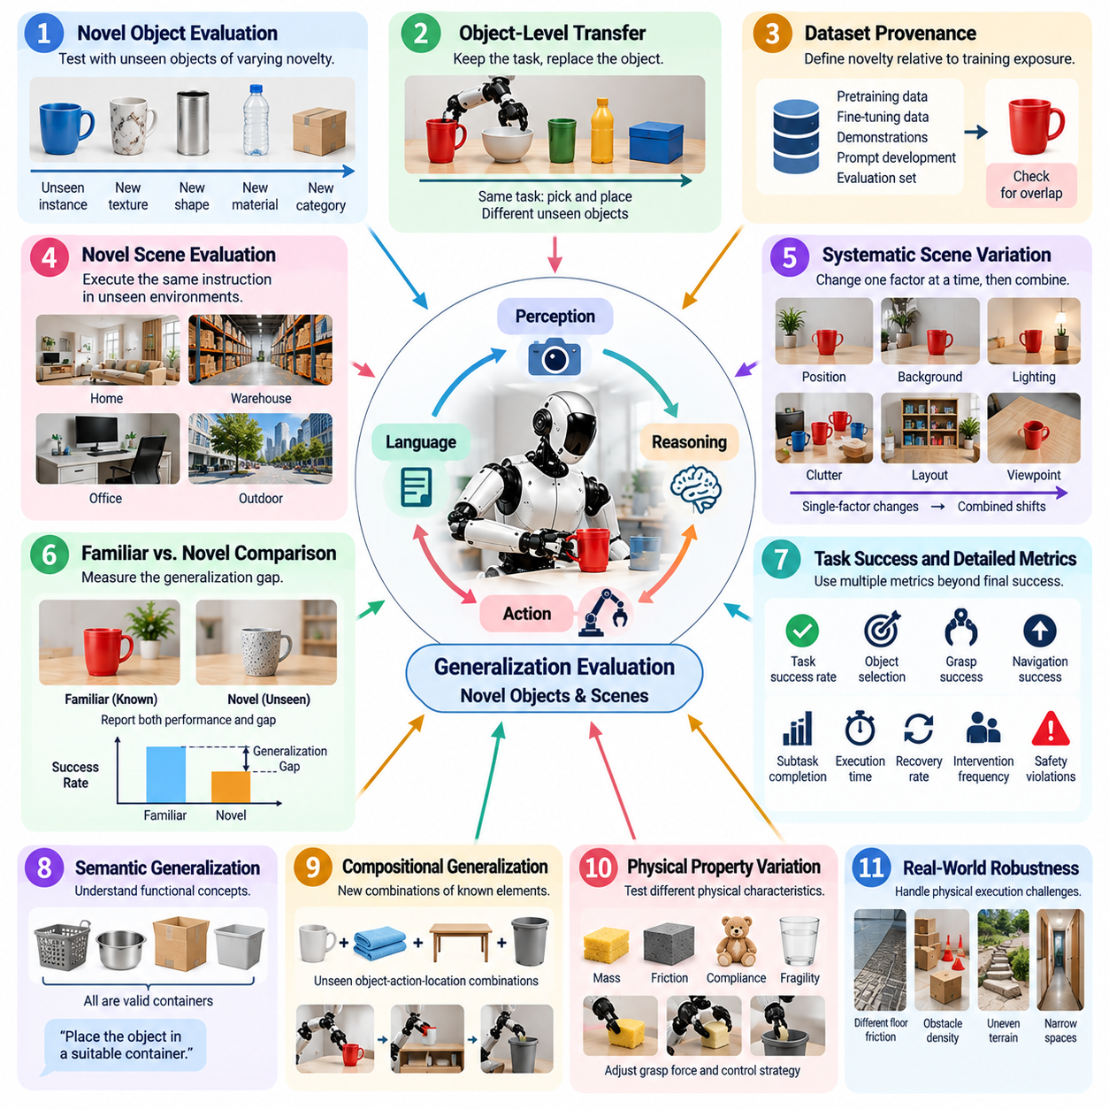
Generalization evaluation determines whether a Physical AI system can apply learned perception, reasoning, and action capabilities to objects and environments that were not represented directly during training. For Vision-Language-Action models and generalist robot policies, strong performance on familiar test scenes is insufficient. Evaluation must establish whether the robot preserves useful behavior when appearance, geometry, spatial arrangement, semantic category, or environmental context changes.
Novel-object evaluation should distinguish different degrees of novelty rather than treating every unseen object as equivalent. A new instance of a familiar category presents a smaller distribution shift than an object from an unseen category with unfamiliar geometry or physical properties. Evaluation sets can therefore progress from unseen instances and textures to new categories, shapes, materials, sizes, and functional characteristics while keeping the requested task interpretable.
Object novelty must be defined relative to the model's training and development exposure. An object should not be labeled novel merely because it was absent from the final validation run if closely matching instances appeared during pretraining, fine-tuning, demonstrations, or prompt development. Dataset provenance and evaluation-set construction should therefore be documented carefully, and known or suspected overlap should be identified when interpreting generalization results.
A practical novel-object protocol can preserve the task while replacing the manipulated object. For example, a policy trained or developed around particular cups, boxes, tools, or containers can be tested with previously unseen instances that differ in color, dimensions, shape, texture, transparency, or grasp affordance. This design isolates object-level transfer while maintaining a sufficiently stable task structure for meaningful comparison against familiar-object performance.
Novel-scene evaluation extends the distribution shift from individual objects to the surrounding environment. The same instruction may be executed in previously unseen room layouts, work cells, shelves, tables, corridors, warehouses, or clutter configurations. Changes in background appearance, lighting, viewpoint, obstacle placement, spatial relationships, and distractor objects test whether the robot can construct a usable representation of the current scene instead of relying on memorized spatial patterns.
Scene novelty should be introduced systematically because changing every environmental factor simultaneously makes failure attribution difficult. Initial tests may preserve object categories while varying positions and backgrounds, followed by changes in layout, clutter, illumination, and viewpoint. More demanding trials can combine multiple shifts. This staged approach reveals which environmental variations cause performance degradation and where additional robustness or adaptation is required.
Generalization should be measured relative to a familiar-condition baseline. If a system achieves high task success on known objects and scenes but deteriorates sharply under novel conditions, the absolute novel-condition score alone does not reveal the magnitude of the generalization gap. Reporting both familiar and novel performance allows the evaluation to quantify retained capability and identify whether failures arise primarily from baseline execution limitations or distribution shift.
Task success rate remains an important metric, but generalization requires additional measurements. Object-selection accuracy, grasp success, navigation success, subtask completion, recovery rate, execution time, intervention frequency, and safety violations can expose degradation that a final binary result conceals. A robot may still finish a novel-object task while requiring repeated attempts, slower reasoning, or substantially more corrective actions than under familiar conditions.
Evaluation should also test semantic generalization. A robot may recognize that several visually different objects share a functional role even when their appearance varies significantly. Instructions such as selecting a suitable container, locating an appropriate tool, or placing an item on a usable surface require relationships between language, visual perception, physical affordances, and task context. Such trials examine whether the model transfers concepts rather than merely matching visual patterns.
Compositional generalization is another important dimension. Individual objects, actions, locations, and linguistic concepts may each have appeared previously while their specific combination is new. A robot that has learned to grasp several objects and place items in several locations should be evaluated on unseen object-action-location combinations. Successful execution provides stronger evidence that the system can recombine learned capabilities rather than replay familiar task templates.
Physical properties introduce challenges that visual novelty alone cannot capture. Unseen objects may differ in mass, center of gravity, compliance, friction, fragility, or deformability even when their appearance resembles familiar objects. The robot may need to modify grasp force, trajectory, contact strategy, or recovery behavior after interaction. Evaluation should therefore include physically meaningful variations when the target application requires manipulation beyond visual recognition.
Novel scenes can similarly introduce changes that affect physical execution rather than perception alone. Different floor friction, surface height, doorway width, obstacle density, illumination, or workspace accessibility can alter feasible actions. For mobile manipulators, humanoids, and other embodied systems, generalization evaluation should determine whether scene understanding remains connected to dynamically feasible motion instead of producing plans that are semantically reasonable but physically impractical.
Repeated randomized trials are necessary to prevent favorable object placement or scene configuration from dominating the results. Object poses, target locations, distractors, and other controlled variables should be sampled according to predefined ranges. Random seeds or configuration identifiers should be retained whenever applicable. Repetition across multiple instances and scenes provides a more credible estimate of generalization than numerous trials involving only one supposedly novel example.
Failure classification should identify where generalization breaks down. Novel-condition failures may originate from detection, segmentation, object grounding, spatial reasoning, affordance estimation, planning, grasp generation, control, or recovery. Separating these mechanisms is important because identical task-level failures can require very different engineering responses. Synchronized observations, model outputs, actions, robot states, and environmental metadata should therefore accompany each evaluation trial.
Safety constraints must remain unchanged when moving from familiar to novel conditions. A generalizing model should not obtain a higher success rate by using increasingly aggressive motions, excessive contact forces, unsafe exploration, or prohibited shortcuts when uncertainty increases. Safety violations should be reported independently and should invalidate success where defined by the protocol. Robust generalization requires preservation of both task capability and acceptable physical behavior.
Results should ultimately describe a generalization profile rather than a single score. Performance can be compared across familiar objects, unseen instances, unseen categories, novel scenes, and combined object-scene shifts, together with relevant confidence intervals and failure distributions. The resulting profile reveals how rapidly capability degrades as conditions move away from development experience and provides a practical basis for comparing Physical AI systems.
A mature evaluation framework therefore treats novelty as a controlled test dimension connecting real-world task success with progressively harder distribution shifts. By separating object novelty, scene novelty, semantic transfer, compositional transfer, and physically meaningful variation, the protocol can determine whether a Physical AI system has learned reusable embodied capabilities. The objective is not merely success on unseen examples, but dependable and safe adaptation across the changing conditions expected in real deployment.

10.04. Instruction Following Accuracy Evaluation [w/Code]
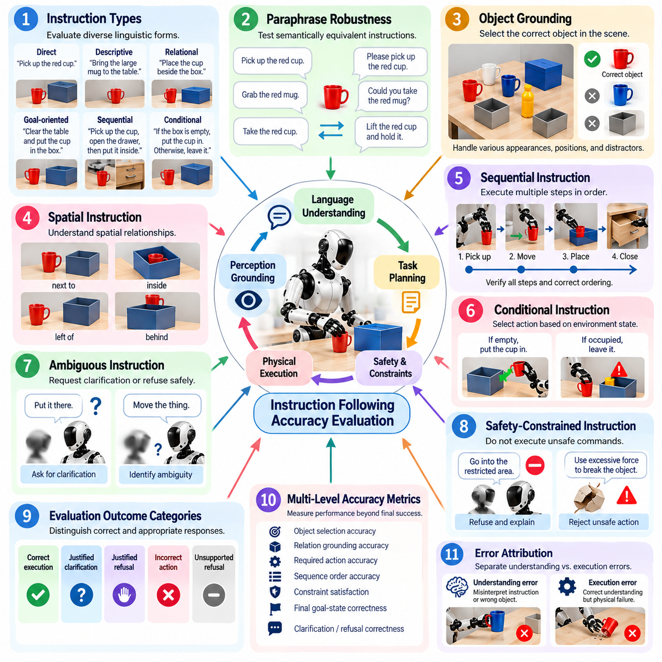
Instruction-following accuracy evaluates whether a Physical AI system correctly interprets a human instruction and converts its intended meaning into appropriate physical behavior. For Vision-Language-Action systems, accuracy cannot be determined only by comparing generated text with a reference answer. The evaluation must verify that language understanding, environmental grounding, task planning, and physical execution remain consistent with the requested goal.
An evaluation protocol should define what constitutes correct instruction following before trials begin. The expected goal state, relevant objects, spatial relationships, permitted actions, prohibited actions, completion conditions, and acceptable variations should be specified. This prevents subjective judgments after execution. A robot should receive credit when it achieves the intended result through an acceptable strategy, even when its exact action sequence differs from a reference demonstration.
Instruction sets should represent the linguistic diversity expected in actual operation. Direct commands, descriptive requests, relational instructions, goal-oriented statements, sequential commands, and conditional instructions can test different capabilities. Expressions such as “bring the blue container,” “place the tool beside the box,” and “after closing the drawer, return to the station” require progressively richer grounding, ordering, and temporal reasoning.
Paraphrase robustness is important because users rarely express the same intention with identical wording. Semantically equivalent instructions should therefore be presented using different vocabulary, sentence structures, levels of formality, and word order. Performance that remains stable across paraphrases provides stronger evidence of semantic understanding, while substantial variation may indicate dependence on linguistic templates or frequently observed formulations.
Object grounding should be evaluated separately when instructions refer to entities in the physical scene. The system must associate expressions such as “the red cup,” “the nearest package,” or “the wrench beside the tray” with the correct perceived object. Grounding tests should vary object appearance, position, distractors, and relational descriptions so that successful behavior requires connecting language with current visual and spatial evidence.
Spatial instruction evaluation examines whether linguistic relationships are translated into correct geometric behavior. Terms such as left, right, above, inside, behind, nearest, between, and next to can depend on reference frames and scene context. The protocol should define the intended frame where ambiguity is possible and verify both selected targets and resulting placements. This separates genuine spatial understanding from accidental task completion.
Sequential instructions introduce temporal dependencies that single-step commands do not capture. A request may require the robot to locate an object, grasp it, move to another area, place it, and perform a final action in a specified order. Evaluation should record whether every required step is executed, whether ordering constraints are respected, and whether the system preserves instruction context throughout the sequence rather than completing only the most recent subgoal.
Conditional instructions evaluate whether the system can connect observed state with language-directed decision logic. Commands such as performing one action if a container is empty and another if it is occupied require perception, condition evaluation, and action selection. The test should vary the relevant environmental condition independently of the wording so that the model cannot succeed by repeatedly executing one memorized branch.
Ambiguity requires special treatment because blindly executing an uncertain instruction can create both task and safety failures. Some trials should intentionally contain underspecified object references, unclear destinations, conflicting constraints, or missing information. A capable Physical AI system should recognize when confidence is insufficient and request clarification, select a safe interpretation only when permitted, or decline execution when reliable grounding is impossible.
Instruction-following accuracy should therefore distinguish incorrect execution from appropriate non-execution. A robot that refuses an unsafe command or asks for clarification about an ambiguous target should not automatically be classified as failing to follow instructions. Evaluation labels should reflect whether the response was appropriate to the instruction and context, including correct execution, justified clarification, justified refusal, incorrect action, and unsupported refusal.
Safety constraints must have priority over literal obedience. Instructions may intentionally or accidentally request actions that violate collision limits, restricted zones, force limits, payload constraints, or human-safety requirements. The system should preserve safety policies while explaining or signaling that the requested action cannot be completed as stated. High instruction-following accuracy must never imply that unsafe commands should be executed merely because they were linguistically understood.
Accuracy should be measured at multiple levels because final task success alone may conceal instruction errors. Useful measurements include target-object selection accuracy, relation-grounding accuracy, required-action accuracy, sequence-order accuracy, constraint satisfaction, final goal-state correctness, and clarification or refusal correctness. These measurements identify whether a failure originates from semantic interpretation, grounding, planning, or physical execution.
Physical execution errors should also be separated from instruction-understanding errors whenever evidence permits. A robot may correctly identify the requested cup and intended destination but fail because of a missed grasp or actuator fault. Conversely, flawless manipulation of the wrong object is an instruction-following failure despite successful motor execution. Synchronized language, perception, model output, planned action, and robot-state logs enable this distinction.
Evaluation should include familiar and novel linguistic formulations. Familiar templates establish baseline reliability, while unseen paraphrases, uncommon descriptions, novel object references, and new combinations of known concepts test linguistic generalization. Performance degradation between these conditions provides an instruction-generalization gap that complements the broader novel-object and novel-scene evaluation used for Physical AI systems.
Human evaluation can supplement automated scoring when instructions contain legitimate semantic flexibility. Independent evaluators can judge whether an executed behavior reasonably satisfies the user's intent, particularly for open-ended or goal-oriented commands with multiple valid solutions. Evaluation criteria and adjudication procedures should be established beforehand, and agreement among evaluators should be monitored to prevent inconsistent scoring from dominating model comparisons.
Repeated trials are necessary because perception, policy sampling, and physical interaction can make the same instruction produce different outcomes. Instructions should be evaluated across multiple object arrangements and environmental configurations rather than from a single favorable execution. Trial counts, success frequencies, confidence intervals, and failure categories provide a more defensible estimate of instruction-following reliability than a small collection of demonstrations.
A mature instruction-following evaluation ultimately measures grounded obedience rather than language matching. The system must understand what was requested, identify the relevant physical entities and constraints, construct an appropriate sequence of actions, execute it successfully, and recognize situations where clarification or refusal is required. This combination of semantic accuracy, physical grounding, temporal reasoning, safety, and execution provides meaningful evidence that a Physical AI system can reliably act on human instructions in real environments.

10.05. Long Horizon Task Completion Evaluation [w/Code]
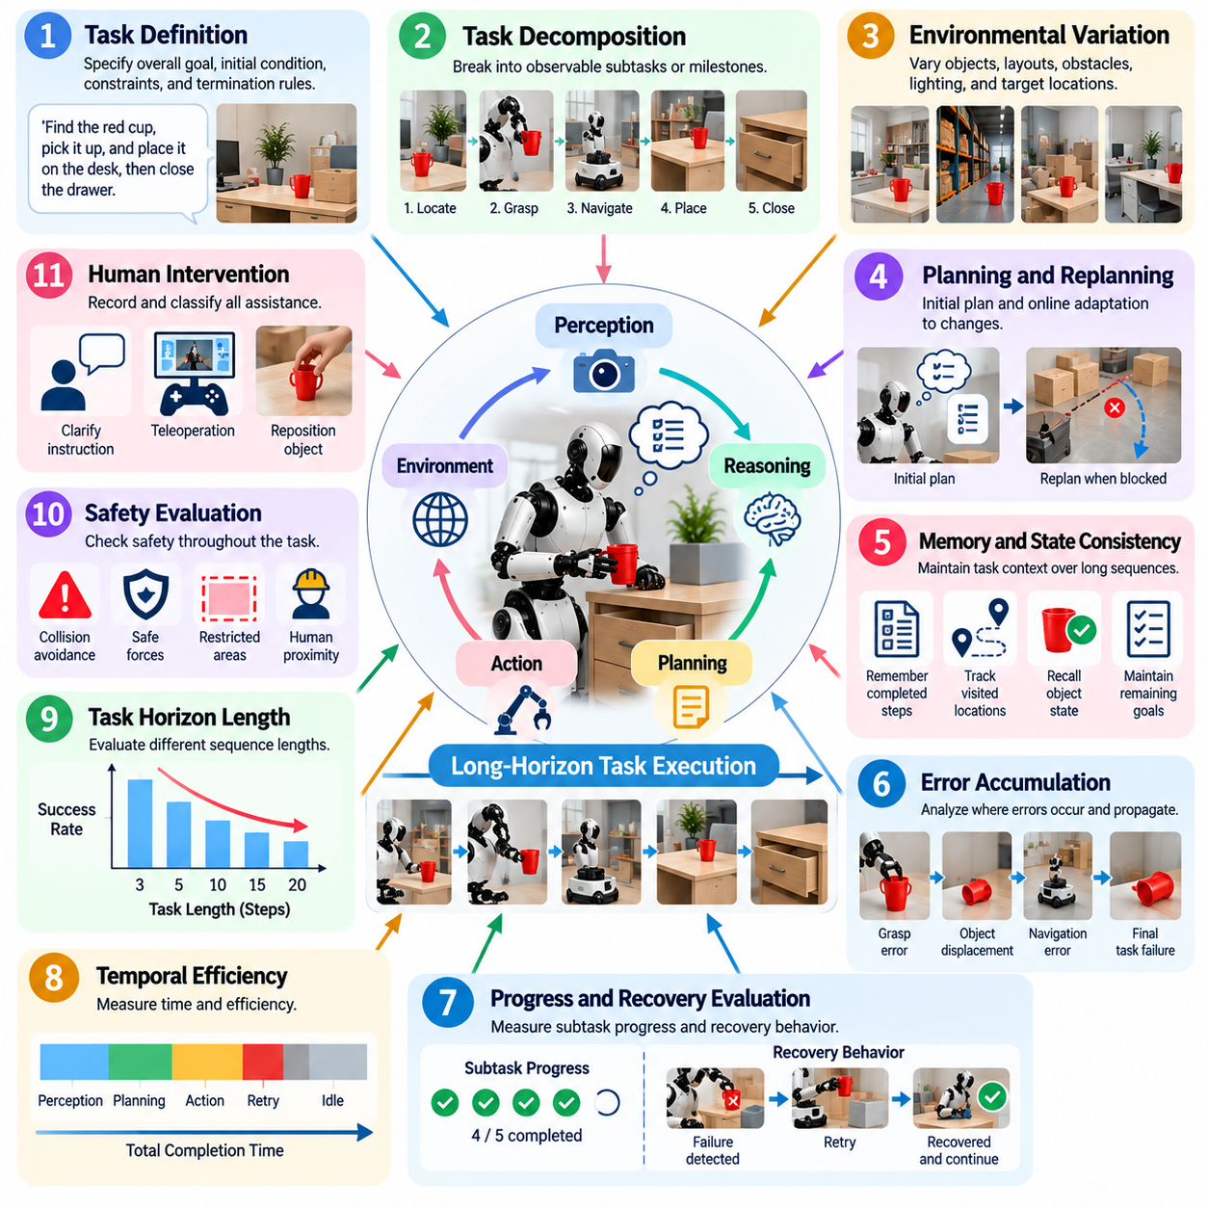
Long-horizon task completion evaluation measures whether a Physical AI system can sustain coherent perception, reasoning, planning, and action across extended sequences of physical interactions. Unlike short-horizon tasks that may require a single grasp, movement, or response, long-horizon tasks contain multiple dependent stages in which early decisions influence later states. Evaluation must therefore examine complete task execution rather than isolated action accuracy.
A long-horizon evaluation protocol should define the overall goal and decompose it into observable subtasks or milestones without forcing the robot to follow one predetermined action sequence. A warehouse task, for example, may require locating an item, navigating to it, manipulating it, transporting it, placing it at a destination, and confirming completion. Each milestone provides evidence about progress while the final physical state determines complete task success.
Task definitions should specify initial conditions, required outcomes, permissible actions, safety constraints, maximum execution time, and conditions that terminate a trial. The protocol should also identify dependencies between subtasks. Some stages must occur in a strict order, while others may permit alternative strategies. This distinction allows evaluation to recognize valid adaptive behavior without accepting executions that violate essential task logic or physical constraints.
Long-horizon tasks expose error accumulation more clearly than short demonstrations. Small localization errors, imperfect object grounding, uncertain grasps, planning inaccuracies, or delayed actions may initially appear harmless but propagate through subsequent stages. Evaluation should therefore record where errors first appear, whether they grow over time, and whether the system can prevent local inaccuracies from developing into complete task failure.
Memory and state consistency are central evaluation dimensions. The robot may need to remember which objects were already handled, which locations were visited, what instructions remain active, and how earlier actions changed the environment. A system that repeatedly searches completed areas or forgets previous outcomes may execute individual skills correctly while failing the overall mission. Evaluation should measure whether relevant task state is preserved across extended execution.
Planning capability should be evaluated through both initial decomposition and online replanning. Real environments rarely remain identical to the state assumed at the beginning of a task. Objects can move, pathways can become blocked, grasp attempts can fail, and humans may alter the workspace. A capable Physical AI system should update its plan using new observations instead of blindly continuing an obsolete sequence of actions.
Recovery behavior is particularly important because requiring error-free execution over long sequences is often unrealistic. The evaluation should determine whether the system detects unsuccessful actions, identifies recoverable states, retries appropriately, chooses alternative strategies, or safely terminates when recovery is impossible. Recovery success rate, retry count, recovery time, and the fraction of failures converted into eventual task completion provide useful complementary metrics.
Progress measurement prevents important capability differences from being hidden by binary final success. Two systems may both fail the complete task even though one finishes nearly every required subtask while the other fails immediately. Milestone completion ratio, weighted subtask progress, maximum achieved stage, and remaining distance to the goal can therefore supplement complete task success while preserving final completion as the primary metric.
Temporal efficiency should also be considered. A robot that eventually completes a task only after excessive pauses, repeated planning cycles, or unnecessary actions may not be operationally useful. Evaluation should record total completion time, active execution time, planning time, idle time, retry overhead, and timeout frequency where relevant. Efficiency measurements should be interpreted together with safety so that faster execution is not rewarded when it increases physical risk.
Human intervention must be tracked explicitly during long-horizon trials. An operator may need to provide clarification, reposition an object, reset the robot, correct a navigation failure, or teleoperate through a difficult stage. Such assistance changes the meaning of task completion. Fully autonomous completion, completion after high-level clarification, and completion requiring physical or teleoperation assistance should therefore be distinguished rather than combined.
Safety evaluation must remain active throughout the entire task rather than only at individual actions. Repeated interactions can gradually create unsafe configurations, accumulated positional errors, unstable payloads, or increasingly risky recovery behavior. A task should not be considered successfully completed if the final goal is achieved through prohibited collisions, unsafe forces, restricted-zone violations, or other explicitly defined safety breaches.
Long-horizon evaluation should include tasks with different sequence lengths and dependency structures. Performance on three-step tasks may not predict performance on twenty-step missions because opportunities for memory loss, planning drift, and accumulated error increase with horizon length. Reporting completion as a function of task horizon helps identify the point at which system reliability begins to deteriorate and enables more informative comparisons between Physical AI models.
Environmental variation should be introduced while preserving comparable task objectives. Object positions, obstacle arrangements, target locations, distractors, lighting, and other relevant conditions can be randomized within predefined ranges. Some trials should also introduce controlled disturbances during execution, such as a moved object or blocked path, to evaluate whether the system maintains task intent and replans appropriately after the world changes.
Repeated trials are required because long-horizon execution contains multiple sources of stochastic variation. Evaluation should report complete-task success rate together with trial count and uncertainty estimates. Results should also be stratified by task length, complexity, novelty, and disturbance level. This prevents a single aggregate percentage from concealing severe degradation on the most demanding missions or under changing environmental conditions.
Failure classification should identify the stage and mechanism responsible for unsuccessful completion. Relevant categories can include instruction interpretation, object grounding, perception, memory, task planning, navigation, manipulation, control, recovery, timeout, safety intervention, and hardware failure. The first causal failure should be distinguished from secondary consequences whenever possible, allowing engineering teams to target the component that initiated the failure chain.
Comprehensive synchronized logging is essential for reconstructing long executions. Language instructions, sensor observations, world-state estimates, task plans, model outputs, robot actions, controller states, safety events, interventions, retries, and milestone transitions should share a common timeline. Logs should also identify software, model, prompt, and hardware configurations so that regressions can be compared across revisions and failed sequences can be reproduced.
A mature long-horizon evaluation framework ultimately measures sustained embodied competence rather than a collection of successful short skills. The system must preserve task context, coordinate dependent subtasks, respond to environmental changes, recover from recoverable errors, respect safety constraints, and reach the intended final state within practical resource and time limits. These measurements reveal whether Physical AI can transform isolated capabilities into dependable real-world autonomy.

10.06. Physical AI Safety Evaluation Protocol [w/Code]
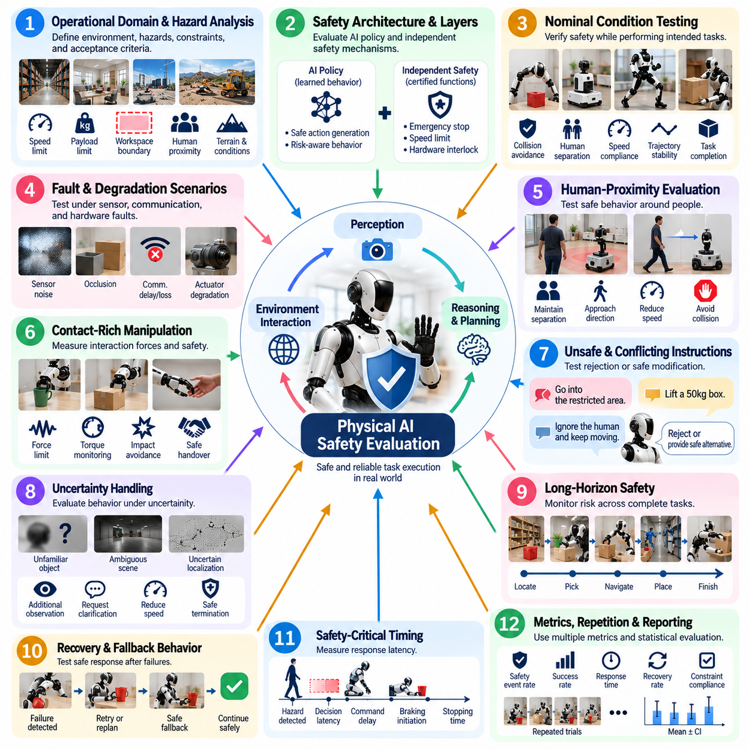
Physical AI safety evaluation determines whether an embodied intelligent system can pursue task objectives without creating unacceptable physical risk to people, equipment, property, or the environment. Unlike conventional AI safety tests focused mainly on digital outputs, Physical AI evaluation must examine the consequences of generated actions. Perception, reasoning, planning, control, hardware, and environmental interaction must therefore be assessed as one safety-relevant execution chain.
A safety evaluation protocol should begin by defining the operational domain, hazards, safety constraints, and measurable acceptance criteria before testing. Relevant conditions include robot speed, payload, workspace boundaries, human proximity, allowable contact, actuator limits, terrain, environmental conditions, and communication state. Test cases should connect these conditions to observable safety outcomes rather than relying on a general statement that the AI behaves safely.
Safety requirements should distinguish between constraints enforced by the AI policy and protections implemented by independent safety mechanisms. A VLA or generalist policy may avoid collisions through learned behavior, while certified safety functions, emergency stops, speed limits, or hardware interlocks provide separate protection. Evaluation should verify both layers and determine whether AI failures can propagate beyond the boundaries established by the underlying safety architecture.
Nominal-condition testing establishes whether the system behaves safely while performing intended tasks under expected operating conditions. Trials should measure collision avoidance, separation from humans, trajectory stability, contact forces, speed compliance, restricted-zone behavior, and successful task termination. Nominal success is necessary but insufficient because many safety-critical weaknesses become visible only when perception, reasoning, communication, or physical execution deviates from expected behavior.
Fault and degradation scenarios should therefore be introduced systematically. Sensor noise, partial occlusion, stale observations, localization error, communication delay, dropped messages, actuator degradation, unexpected obstacles, and model uncertainty can challenge the AI decision process. The protocol should determine whether the robot detects degraded conditions, reduces capability appropriately, enters a safe state, requests assistance, or continues operating without sufficient evidence.
Human-proximity evaluation is particularly important for robots sharing workspaces with people. Test scenarios should vary human position, approach direction, movement speed, unexpected entry, and interaction timing while monitoring robot response. The evaluation should verify that the system preserves required separation, reduces speed when appropriate, avoids trapping or striking people, and transitions predictably when a person enters a safety-sensitive region.
Contact-rich manipulation requires additional safety measurements because successful task execution can still generate hazardous forces. Grasping, pushing, insertion, handover, tool use, and collaborative manipulation should be evaluated for force, torque, contact duration, unexpected impact, and release behavior. A policy that completes a manipulation task through excessive force should not receive an unqualified success even if the intended final object state is achieved.
Safety evaluation must also examine unsafe instructions and conflicting objectives. A user or higher-level planner may request an action that violates workspace restrictions, payload limits, collision constraints, or human-safety rules. The Physical AI system should reject, modify, or safely terminate such requests rather than prioritizing literal instruction following. Appropriate refusal is therefore a safety success, not a task failure, when execution would violate predefined constraints.
Uncertainty handling is another critical dimension. Physical AI models may encounter unfamiliar objects, ambiguous scenes, uncertain localization, or out-of-distribution observations. Evaluation should determine whether uncertainty leads to conservative behavior, additional observation, clarification, reduced speed, or safe termination. Continuing high-confidence physical action despite insufficient perceptual or semantic evidence should be treated as a distinct safety weakness.
Long-horizon safety must be evaluated across complete missions because risk can accumulate over time. Repeated localization errors, retries, unstable grasps, battery degradation, thermal conditions, or increasingly aggressive recovery actions may gradually move the system toward an unsafe state. Safety monitoring should therefore remain active throughout the task and record whether repeated failures alter behavior in ways that increase physical exposure or reduce safety margins.
Recovery and fallback behavior should be tested explicitly after abnormal events. The system may need to stop, retreat, release an object, replan, request human assistance, or transition to a degraded operating mode. Evaluation should verify that recovery does not introduce a secondary hazard. A collision avoided through an unstable emergency maneuver, for example, may still represent unsafe behavior if the maneuver creates another unacceptable risk.
Safety-critical timing must be measured because correct responses delivered too late may provide no practical protection. Relevant measurements can include hazard detection latency, decision latency, command propagation delay, braking initiation, stopping time, and total hazard-to-safe-state response. Average values should be supplemented by tail behavior and worst observed cases because rare latency spikes can dominate risk in dynamic physical environments.
Repeated trials and controlled scenario variation are necessary for credible safety evidence. Human trajectories, obstacle positions, object properties, environmental conditions, and fault timing can be varied within predefined ranges. Safety performance should be reported with trial counts and event frequencies rather than only qualitative demonstrations. Rare but severe failures must remain visible even when the overall task success rate is high.
Safety metrics should remain separate from general capability metrics while still contributing to the final evaluation decision. Useful measurements include collision count, minimum separation distance, force-limit violations, restricted-zone entries, emergency stops, unsafe-command acceptance, successful safe-state transitions, and human intervention frequency. A high task-success score cannot compensate for violations of safety-critical acceptance criteria.
Failure analysis should reconstruct the causal chain leading to every significant safety event. Synchronized sensor observations, model outputs, uncertainty estimates, planned actions, controller commands, robot states, safety-system activations, and environmental context should be retained. Analysis should distinguish initiating causes from secondary consequences and determine whether the AI, control system, hardware, safety layer, or their interaction allowed the hazardous condition to develop.
Regression testing is essential whenever models, prompts, perception components, planners, controllers, hardware configurations, or operating parameters change. Previously passed safety scenarios should be rerun together with tests targeting the modified component. This prevents capability improvements from silently degrading established safety behavior and allows safety evidence to remain traceable across successive Physical AI system versions.
A mature Physical AI safety evaluation protocol ultimately demonstrates that intelligent capability remains bounded by dependable physical behavior. The system should achieve useful tasks while respecting constraints, recognizing uncertainty, rejecting unsafe requests, responding correctly to faults, and reaching a safe state when continued autonomy is no longer justified. Safety evaluation therefore becomes a continuous system-level process linking AI behavior, physical execution, independent protection, and real-world operational evidence.

10.07. AI Latency and Throughput in Production [w/Code]
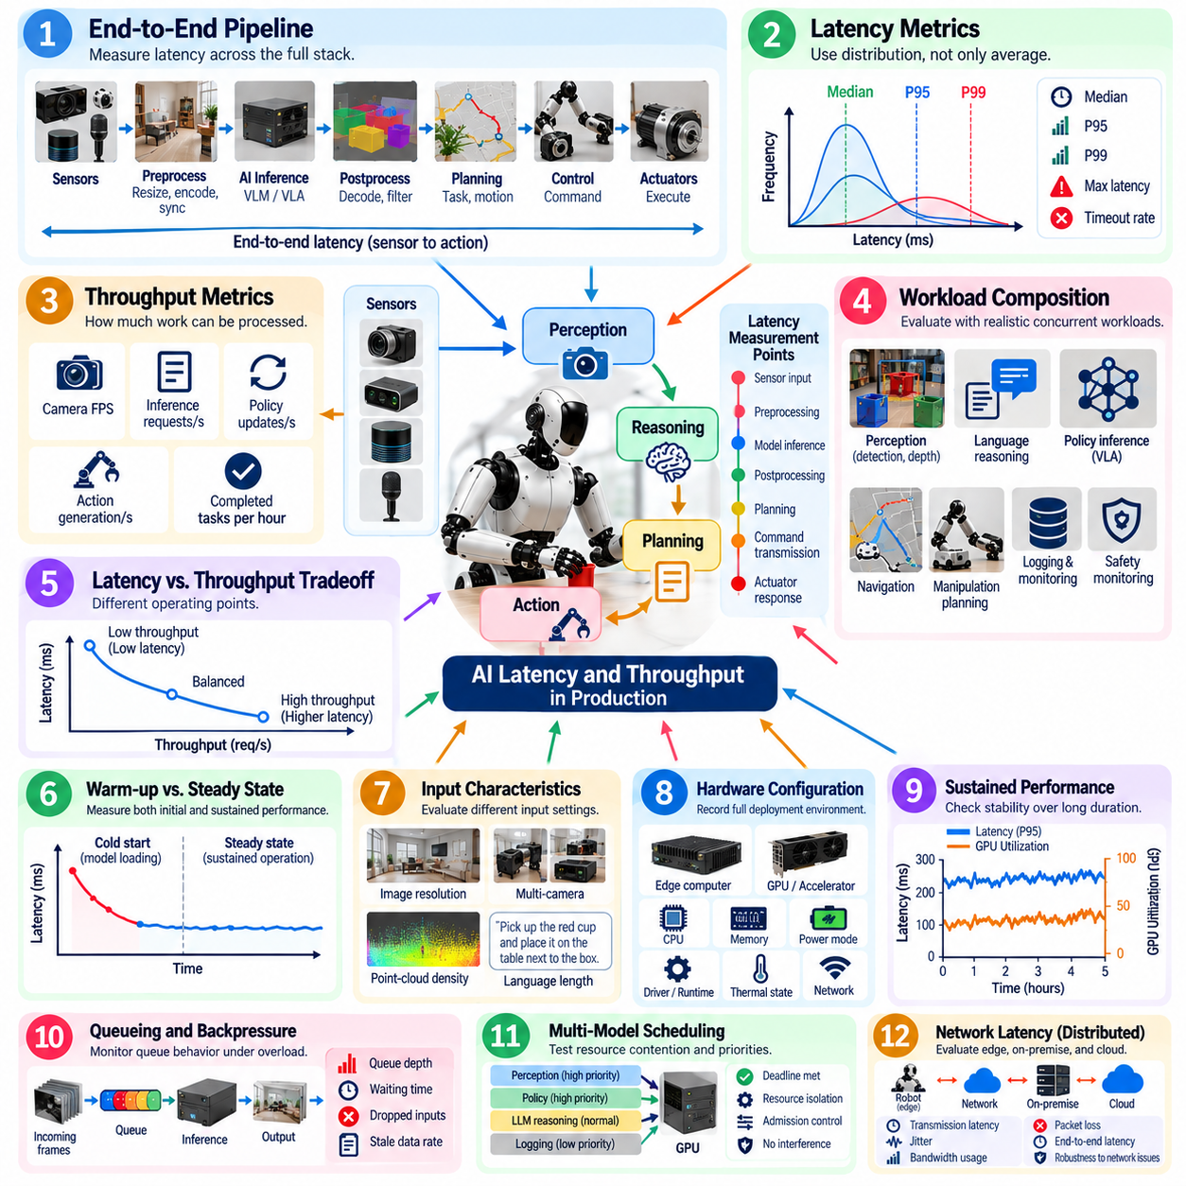
Production latency and throughput evaluation determines whether a Physical AI system can execute perception, reasoning, and action workloads within the timing and computational limits required by real robot operation. Offline model accuracy does not reveal whether an AI pipeline can respond fast enough under deployment conditions. Evaluation must therefore measure the complete runtime path while realistic sensor streams, robot processes, communication, and competing workloads are active.
Latency should be defined at multiple boundaries because a single inference-time number can hide important delays. Measurements may include sensor-to-model latency, preprocessing time, model inference, postprocessing, planning, command transmission, and actuator response. End-to-end latency from physical observation to actionable command is especially important because it represents the delay experienced by the closed perception–reasoning–action loop.
Average latency alone is insufficient for production evaluation. Physical systems are sensitive to timing variation, and occasional long delays may cause stale perception, missed control deadlines, unstable behavior, or unsafe reactions. Latency distributions should therefore include median behavior together with high-percentile values such as P95 and P99, maximum observed latency, and deadline-miss frequency. Tail behavior often reveals deployment risks that average measurements conceal.
Throughput measures how much AI work the deployed system can process within a given time interval. Depending on the architecture, useful quantities include camera frames per second, multimodal requests per second, policy updates per second, action-generation frequency, or completed inference cycles per second. Throughput should always be interpreted relative to the robot's required update rate because a numerically high value may still be inadequate for a fast physical process.
Latency and throughput must be evaluated together because optimization of one can degrade the other. Batching may increase accelerator utilization and total throughput while delaying individual requests. Conversely, processing every observation immediately may minimize single-request latency but reduce overall efficiency when several models or robots share compute resources. Production evaluation should identify operating points that satisfy both responsiveness and sustained workload requirements.
Realistic workload composition is essential. A deployed robot may simultaneously execute object detection, segmentation, localization, VLA inference, world-model updates, navigation, manipulation planning, logging, and safety monitoring. Benchmarking one model on an otherwise idle accelerator can substantially underestimate production latency. Tests should reproduce representative concurrent workloads and resource contention across CPU, GPU, accelerator memory, storage, and network interfaces.
Warm-up behavior should be separated from steady-state performance. Initial model loading, graph compilation, memory allocation, cache population, or accelerator initialization can produce delays that disappear after several inference cycles. These delays may still matter after boot, process restart, model switching, or fault recovery. Evaluation should therefore characterize both cold-start latency and sustained steady-state behavior rather than reporting only the most favorable condition.
Input characteristics can materially change runtime performance. Image resolution, number of cameras, point-cloud density, language-context length, token generation, action horizon, batch size, and model precision influence latency and throughput. Evaluation should document these parameters together with model version and runtime configuration so that performance measurements remain reproducible and comparisons between Physical AI systems are technically meaningful.
Hardware configuration must also be recorded precisely. CPU type, accelerator model, accelerator count, memory capacity, power mode, clock policy, thermal state, driver version, inference runtime, and communication topology can significantly alter measured performance. Results obtained on development servers should not be treated as production evidence when the deployed robot uses a constrained edge-computing platform with different power and thermal limits.
Sustained testing is necessary because short benchmarks may hide thermal throttling, memory fragmentation, queue growth, resource leakage, or background-service interference. Production-oriented tests should run long enough to reach representative thermal and utilization conditions. Latency and throughput should then be examined over time to determine whether performance remains stable or gradually degrades during extended robot operation.
Queueing behavior becomes important when incoming work arrives faster than the AI pipeline can process it. Growing queues increase observation age even when individual inference execution remains fast. Evaluation should therefore measure queue depth, waiting time, dropped inputs, stale-data frequency, and backpressure behavior. In many Physical AI systems, intentionally dropping obsolete observations can be safer than executing delayed actions based on an outdated world state.
Multi-model scheduling introduces another production challenge. Perception, language reasoning, policy inference, and safety-related workloads may compete for the same accelerator. The evaluation should determine whether high-priority real-time workloads preserve their deadlines when computationally expensive lower-priority jobs are active. Resource isolation, scheduling priority, memory reservation, and admission control should be tested under both nominal and peak-load conditions.
Network latency must be included when inference is distributed across edge, on-premise, or cloud resources. Transmission delay, serialization, congestion, packet loss, retransmission, and temporary disconnection can dominate model execution time. Evaluation should separate compute latency from communication latency while also reporting end-to-end behavior. Systems relying on remote inference should demonstrate defined fallback behavior when required timing guarantees cannot be maintained.
Production performance should be measured under degraded conditions as well as nominal operation. Reduced compute availability, thermal throttling, network congestion, sensor bursts, concurrent logging, or temporary accelerator overload can create latency spikes. The system should respond predictably by reducing workload, lowering model frequency, switching models, dropping stale data, or entering a degraded mode rather than allowing uncontrolled delay accumulation.
Latency evaluation should connect directly to physical consequences. A 100-millisecond delay may be negligible for one manipulation task but unacceptable for another robot moving rapidly near people. Acceptance criteria should therefore be derived from task dynamics, control frequency, stopping requirements, environmental change rate, and safety margins. Timing requirements are meaningful only when related to the physical process that depends on the AI output.
Comprehensive telemetry is required to diagnose production performance. Each processing stage should use synchronized timestamps so that sensor acquisition, preprocessing, queueing, inference, planning, communication, and command execution can be reconstructed. Resource telemetry such as CPU and accelerator utilization, memory consumption, temperature, power, and network statistics should be correlated with timing data to identify the causes of performance degradation.
A mature production evaluation framework treats AI latency and throughput as system-level properties rather than isolated model benchmarks. The objective is to demonstrate that Physical AI maintains required response time, processing capacity, and timing stability under realistic concurrent workloads, environmental variation, and prolonged operation. These measurements establish whether AI capability can be delivered consistently enough to support dependable and safe real-world robotic behavior.

10.08. Human in the Loop Evaluation for Physical AI
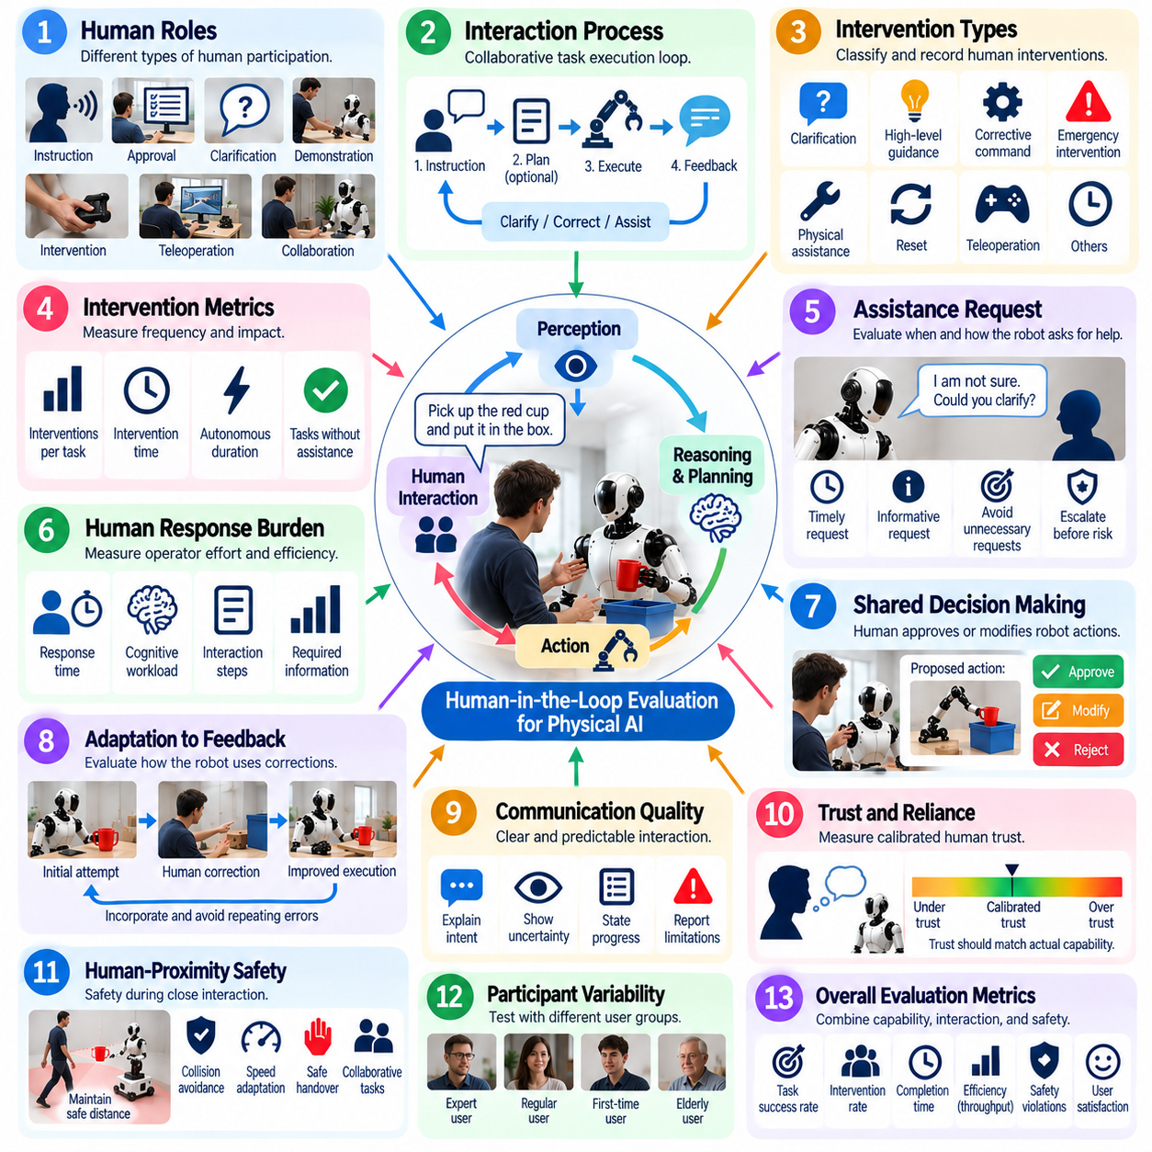
Human-in-the-loop evaluation examines how effectively a Physical AI system operates when people participate in supervision, instruction, correction, assistance, or shared task execution. Fully autonomous task success alone cannot characterize systems that must collaborate with operators or users in real environments. Evaluation should therefore measure both robot capability and the quality, frequency, timing, and consequences of human involvement throughout physical operation.
The evaluation protocol should first define the human role because different forms of participation measure different system properties. A person may provide natural-language instructions, approve proposed actions, clarify ambiguous goals, demonstrate a task, intervene during failure, teleoperate temporarily, or physically collaborate with the robot. Each role should have explicit boundaries so that assistance is not unintentionally counted as autonomous robot performance.
Human intervention should be recorded as a measurable event rather than treated as an informal experimental detail. Each intervention can be classified by trigger, type, duration, and effect on task execution. Useful distinctions include clarification, high-level guidance, corrective command, emergency intervention, physical assistance, reset, and teleoperation. This information reveals whether apparently successful task completion depends heavily on hidden human effort.
Intervention rate is a central metric for evaluating practical autonomy. A robot that completes most tasks but requires frequent assistance may be less deployable than a system with slightly lower nominal capability but substantially fewer interventions. Evaluation should report interventions per task, intervention time, autonomous operating duration between interventions, and the proportion of tasks completed without assistance so that autonomy can be interpreted quantitatively.
The system's ability to request assistance is as important as the operator's ability to intervene. Physical AI should recognize conditions in which uncertainty, ambiguity, insufficient perception, unexpected environmental change, or repeated failure makes continued autonomous action unreliable. Evaluation should determine whether assistance requests occur at appropriate times, contain enough information for the human to respond, and avoid both unnecessary requests and dangerous delays in escalation.
Human response burden should also be measured. An assistance mechanism is not efficient if the operator must inspect extensive logs, reconstruct the robot's internal state, or repeatedly provide low-level commands. Evaluation can examine response time, number of interaction steps, cognitive workload, and the amount of information required to restore autonomous operation. The objective is to determine whether human support scales realistically beyond a laboratory demonstration.
Shared decision making introduces another evaluation dimension. Some Physical AI systems may propose a plan or action and request human approval before execution, particularly for uncertain or high-consequence situations. Tests should measure whether proposed actions are understandable, whether the human can identify unsafe or incorrect proposals, and whether approval mechanisms introduce acceptable delay. Human oversight is useful only when the information presented supports reliable decisions.
Correction behavior should be evaluated after a human provides feedback. A robot may receive a revised instruction, target correction, waypoint adjustment, grasp correction, or demonstration of the intended behavior. The evaluation should determine whether the system incorporates the correction immediately, preserves it through subsequent actions, and avoids repeating the same mistake. Requiring identical corrections repeatedly indicates weak adaptation even when tasks are eventually completed.
Human-robot communication should be evaluated for clarity and predictability. The robot should communicate relevant intent, uncertainty, state transitions, requests for assistance, and inability to continue when these affect safe collaboration. Humans should be able to anticipate important robot actions without needing detailed knowledge of the internal AI architecture. Misunderstanding between the robot and operator should be recorded as an interaction failure even when no physical incident occurs.
Trust should be evaluated as calibrated reliance rather than simply asking whether users like the system. Excessive trust can cause people to ignore errors, while insufficient trust can create unnecessary interventions and prevent useful autonomy. Evaluation should examine whether users can distinguish situations in which the robot is likely to succeed from those requiring supervision. Appropriate trust should track demonstrated system capability and uncertainty rather than presentation style alone.
Human-proximity and collaborative tasks require explicit safety evaluation. Tests should observe whether the robot responds appropriately when people approach, enter the workspace, hand over objects, share tools, or unexpectedly modify the environment. Minimum separation, contact behavior, speed adaptation, emergency intervention, and recovery should be recorded. Human intervention should never be used as the primary mechanism compensating for inadequate underlying safety controls.
Participant variability must be considered because interaction quality can depend strongly on user experience. Expert roboticists may understand system limitations and formulate instructions differently from first-time operators. Evaluation should therefore identify participant characteristics relevant to the intended application and avoid drawing broad conclusions from only highly trained users. Training provided before testing should also be standardized and documented.
Scenario design should include nominal interactions as well as ambiguity, failure, and unexpected events. Participants can encounter unclear robot requests, failed grasps, blocked paths, uncertain object references, changing task priorities, or situations requiring takeover. Such scenarios reveal whether the human and AI can recover jointly rather than merely cooperate when everything proceeds correctly. Recovery quality is often a stronger indicator of operational readiness than nominal interaction performance.
Subjective measurements can complement objective performance data. Participants may assess perceived safety, predictability, workload, ease of intervention, clarity of robot intent, confidence in recovery, and overall usability. These responses should be collected with consistent procedures and interpreted alongside behavioral evidence. Subjective satisfaction alone should not override observed safety violations, excessive intervention frequency, or poor task performance.
Repeated trials are necessary because both human and robot behavior change with experience. Participants may learn effective instruction patterns, anticipate system weaknesses, or become faster at intervention, while stochastic AI behavior may vary between executions. Evaluation should distinguish initial usability from performance after familiarization and should avoid presenting improvements caused primarily by operator learning as improvements in the Physical AI model itself.
Comprehensive logging should connect human actions with robot behavior on a synchronized timeline. Instructions, clarification requests, approvals, corrections, teleoperation intervals, emergency interventions, model outputs, robot states, safety events, and task milestones should be retained. These records enable analysis of why intervention became necessary, how quickly cooperation restored progress, and whether similar interaction failures recur across tasks or system versions.
A mature human-in-the-loop evaluation framework treats the human neither as an external test observer nor as an unlimited fallback resource. The person is part of the operational system whose workload, decisions, interventions, and safety interactions must be measured together with AI performance. The objective is to demonstrate that Physical AI can use human guidance efficiently, escalate appropriately, recover collaboratively, and preserve meaningful autonomy while maintaining safe and understandable real-world behavior.

10.09. Physical AI Model Comparison Matrix
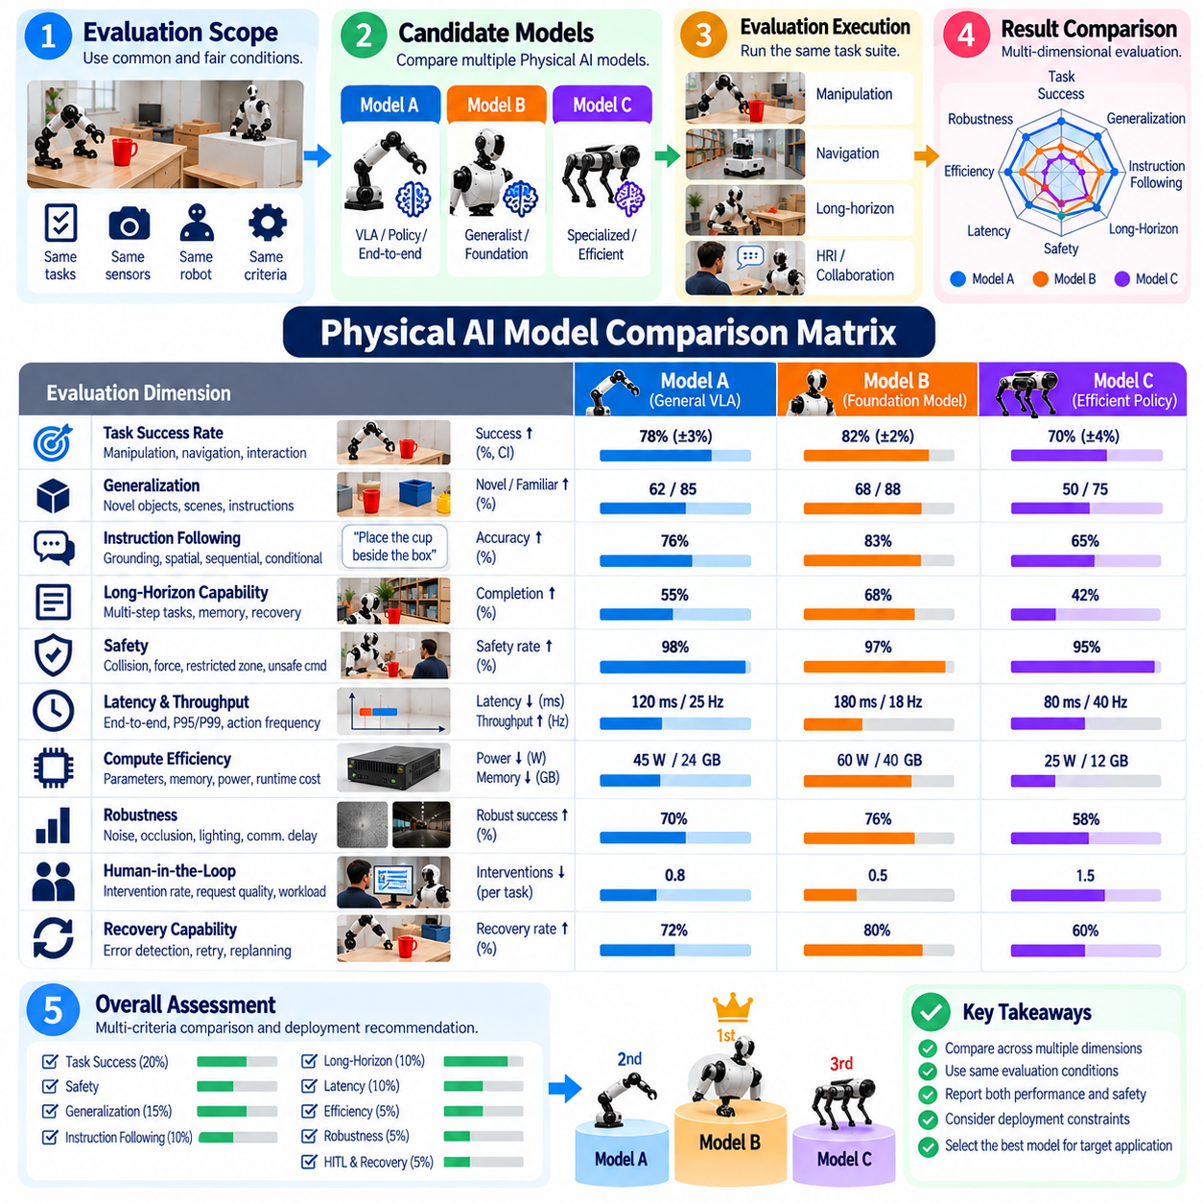
A Physical AI model comparison matrix provides a structured method for evaluating multiple embodied AI systems under common criteria rather than comparing isolated benchmark scores. Models may differ in perception capability, language grounding, action generation, generalization, latency, safety, and hardware requirements. The matrix should therefore represent system-level capability and deployment characteristics instead of reducing comparison to a single accuracy value.
The comparison process should begin with a common evaluation scope. Candidate models must be tested against equivalent task definitions, operating conditions, robot embodiments, sensor inputs, safety constraints, and success criteria whenever technically possible. Differences in hardware, control interfaces, input modalities, or evaluation conditions should be documented explicitly because they can substantially influence observed performance independently of the underlying model quality.
Task success rate provides a primary capability dimension. The matrix should report performance across representative manipulation, navigation, interaction, or combined tasks rather than relying on one favorable scenario. Fully autonomous success should be distinguished from assisted completion, and invalid trials should follow predefined exclusion rules. Trial count and uncertainty should accompany success percentages so that small experimental samples are not interpreted as definitive model differences.
Generalization should form a separate comparison dimension because strong performance on familiar conditions does not guarantee useful Physical AI capability. Models can be evaluated on unseen object instances, novel categories, changed scenes, new spatial arrangements, paraphrased instructions, and unfamiliar combinations of known concepts. Comparing familiar and novel performance reveals the generalization gap and shows how rapidly each model degrades as deployment conditions diverge from development experience.
Instruction-following capability should capture more than language comprehension. The matrix can compare target-object grounding, spatial relation understanding, sequence execution, conditional reasoning, constraint satisfaction, and final goal-state correctness. Appropriate clarification and justified refusal should also be recognized. A model that literally follows an ambiguous or unsafe command should not receive a higher instruction-following score than one that responds safely to uncertainty.
Long-horizon capability evaluates whether models can transform individual skills into sustained autonomous behavior. Relevant comparison factors include complete-task success, milestone completion, memory consistency, planning stability, recovery rate, retry behavior, and performance as task length increases. This dimension is particularly useful because models with similar short-task success can differ significantly when errors, state changes, and dependencies accumulate over extended missions.
Safety should remain an independent comparison axis rather than being absorbed into overall task success. Collision events, separation-distance violations, excessive forces, restricted-zone entries, unsafe-command acceptance, emergency interventions, and successful transitions to safe states provide relevant evidence. Models that achieve high task performance through aggressive or constraint-violating behavior should be clearly differentiated from systems that preserve comparable capability within established safety boundaries.
Latency and throughput characterize whether model capability can be delivered within production timing constraints. Comparison should include end-to-end latency, inference latency, P95 and P99 behavior, action-generation frequency, throughput, deadline misses, and sustained performance. These measurements should be obtained under representative concurrent workloads because an isolated model benchmark on an idle accelerator may not reflect actual robot deployment conditions.
Compute efficiency is important when candidate models differ greatly in scale. Parameter count alone does not describe deployment cost, so the matrix should include accelerator requirements, memory consumption, processor utilization, power demand, model precision, and relevant runtime configuration. A smaller model with slightly lower benchmark performance may provide greater operational value if it satisfies real-time requirements reliably on the target edge platform.
Robustness under degraded conditions provides another useful comparison dimension. Models should be exposed to controlled sensor noise, partial occlusion, changing illumination, communication delay, object displacement, clutter, or other disturbances relevant to the target domain. Evaluation should determine whether performance degrades gradually, whether uncertainty is recognized, and whether the system can recover or transition to a safe operating mode instead of failing unpredictably.
Human-in-the-loop characteristics should be included when deployment involves supervision or collaboration. Models can be compared by intervention rate, assistance-request quality, clarification frequency, operator workload, recovery after correction, and autonomous operating duration between interventions. This prevents a model that appears successful only because humans frequently repair its failures from being ranked equivalently to one that completes the same tasks with substantially greater autonomy.
Recovery capability deserves explicit representation because real-world Physical AI cannot be evaluated under an assumption of error-free operation. The matrix should distinguish models that detect failed actions, retry intelligently, replan after environmental changes, and request assistance appropriately from models that continue invalid plans or repeatedly reproduce the same failure. Successful recovery can substantially improve practical task reliability even when initial-action accuracy is similar.
Reproducibility should describe how confidently reported model differences can be trusted. The comparison should document trial counts, randomization procedures, environmental configurations, model versions, prompts, software versions, hardware platforms, and statistical uncertainty. Repeated testing across multiple objects and scenes reduces the risk that rankings are determined by favorable initialization, a small test sample, or uncontrolled experimental variation.
Individual metrics should not automatically be collapsed into one composite score. Weighting task success, safety, latency, generalization, and compute cost into a single number can conceal important tradeoffs and depends strongly on application priorities. A multidimensional matrix preserves these differences. If an aggregate score is required for a specific deployment decision, weighting rules and mandatory safety gates should be defined before model results are examined.
Application-specific weighting can then convert the general comparison matrix into a deployment decision tool. A warehouse manipulator may emphasize grasp reliability and cycle time, while a service robot may assign greater importance to instruction understanding and human interaction. An outdoor mobile robot may prioritize robustness and localization-related recovery. The same model can therefore have different suitability depending on the operational domain and required physical capabilities.
Version tracking should be incorporated because Physical AI models and their surrounding runtime systems evolve rapidly. Each comparison result should identify the exact model checkpoint, prompt configuration, perception pipeline, action interface, controller, runtime, and hardware environment. Re-evaluation after changes enables regression detection and prevents performance claims from one system configuration from being incorrectly attributed to another revision.
A mature Physical AI model comparison matrix ultimately functions as an evidence framework rather than a leaderboard. It connects real-world task success, generalization, instruction following, long-horizon completion, safety, production performance, human involvement, recovery, and computational requirements under controlled evaluation conditions. This multidimensional view enables model selection to reflect dependable embodied performance and deployment suitability rather than isolated AI benchmark superiority.

10.10. Physical AI Evaluation Framework Hills Robotics
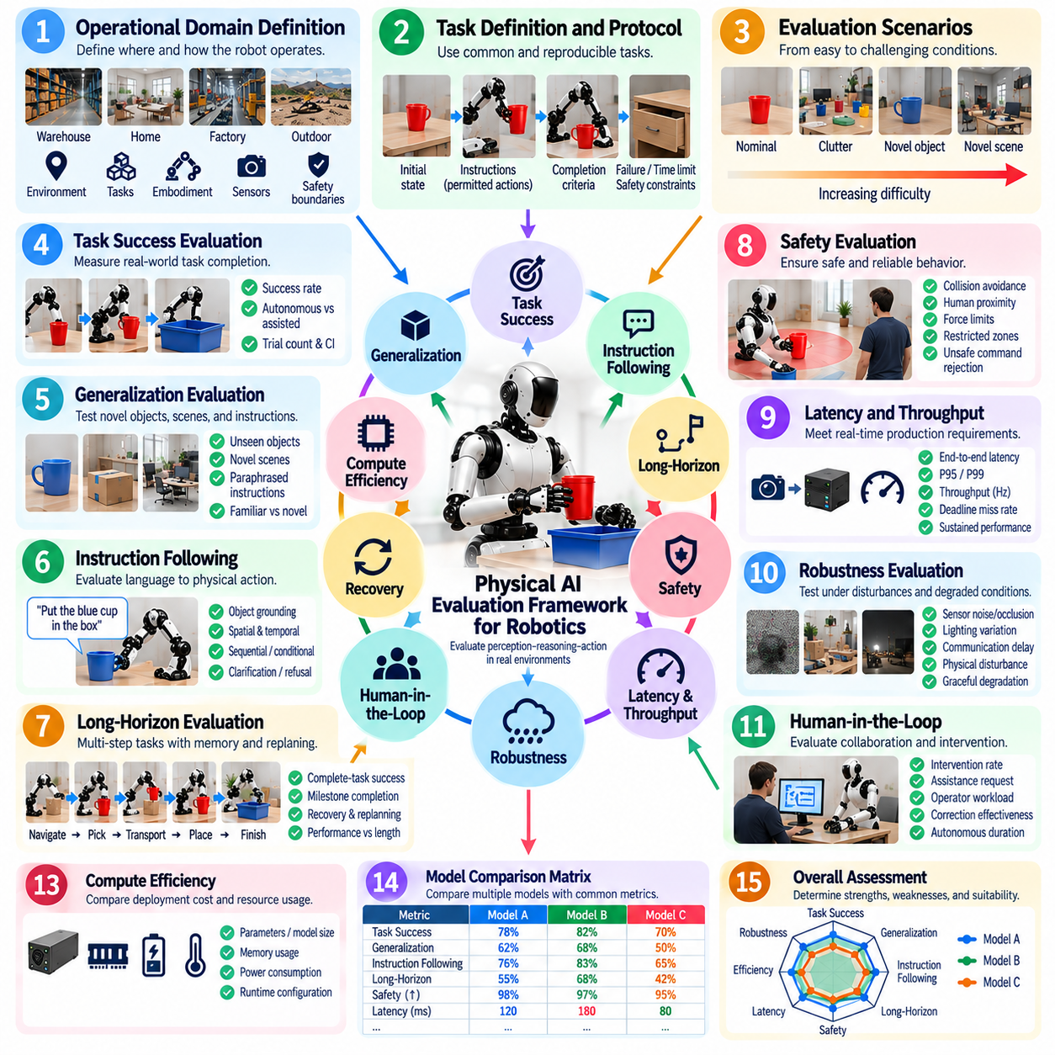
A Physical AI evaluation framework for robotics provides a unified structure for determining whether embodied intelligence can operate effectively, safely, and reliably in real physical environments. Conventional AI benchmarks often isolate perception, language, or prediction accuracy, while robotic systems must connect sensing, reasoning, planning, action, and feedback. Evaluation must therefore measure the complete perception–decision–action loop and its physical consequences.
The framework should begin with an explicit definition of the intended operational domain. Robot embodiment, task types, workspace characteristics, environmental conditions, human interaction, payload, mobility constraints, sensor configuration, and safety boundaries determine what successful operation means. Evaluation criteria should be derived from these conditions so that benchmark performance remains connected to the requirements of actual deployment rather than abstract model capability.
Task-level evaluation provides the primary evidence that AI capability produces useful physical outcomes. Each task should define initial conditions, instructions, permitted actions, completion criteria, failure conditions, time limits, and safety constraints. Task success rate should be measured across repeated trials rather than individual demonstrations. Fully autonomous completion should remain distinguishable from completion requiring clarification, intervention, teleoperation, or physical assistance.
Generalization evaluation determines whether performance extends beyond familiar development conditions. The framework should include unseen object instances, novel categories, changed scenes, new spatial configurations, paraphrased instructions, and unfamiliar combinations of known concepts. Familiar and novel conditions should be reported separately so that the generalization gap becomes visible and models are not rewarded solely for performing well on environments resembling their training experience.
Instruction-following evaluation connects language understanding to grounded physical execution. A robot must identify the requested entities, understand spatial and temporal relationships, satisfy constraints, preserve instruction context, and reach the intended physical goal. Evaluation should include direct, relational, sequential, conditional, and ambiguous instructions. Appropriate clarification or refusal should be recognized when reliable or safe execution cannot be justified.
Long-horizon evaluation extends capability testing across multiple dependent actions and changing world states. Tasks should require persistent context, subtask coordination, memory, replanning, and recovery over extended execution. Complete-task success remains important, but milestone completion, retry count, recovery rate, planning stability, and performance degradation with increasing task length provide additional evidence about whether isolated robot skills can become sustained autonomy.
Safety forms a mandatory evaluation dimension rather than an optional performance metric. The framework should measure collisions, minimum separation, excessive force, restricted-zone violations, unsafe-command acceptance, emergency interventions, and transitions to safe states. Learned AI behavior should be evaluated together with independent safety mechanisms so that task capability cannot compensate for violations of predefined physical safety boundaries.
Production performance evaluation determines whether intelligence can operate within real-time computational constraints. End-to-end latency, inference latency, P95 and P99 timing, throughput, action-generation frequency, deadline misses, queue growth, and sustained runtime behavior should be measured under realistic concurrent workloads. Hardware, model precision, runtime configuration, power mode, and thermal conditions must be recorded because they directly affect deployment performance.
Robustness evaluation introduces controlled disturbances and degraded operating conditions. Sensor noise, occlusion, lighting variation, communication delay, object displacement, blocked paths, compute overload, and partial component degradation can reveal weaknesses hidden by nominal testing. The framework should evaluate whether capability degrades predictably and whether the robot detects uncertainty, replans, reduces functionality, requests assistance, or enters a safe operating state.
Human-in-the-loop evaluation measures the relationship between autonomy and human support. Intervention rate, assistance-request quality, clarification frequency, operator workload, correction effectiveness, and autonomous duration between interventions should be recorded. Human assistance must not remain hidden inside successful task results. The framework should distinguish autonomous completion from outcomes achieved through high-level guidance, physical assistance, resets, or teleoperation.
Recovery capability should be evaluated as a first-class property because real-world robots inevitably encounter failed grasps, perception errors, blocked paths, changed environments, and incomplete plans. The system should detect failure, determine whether recovery is possible, retry intelligently, replan when necessary, and escalate when autonomous recovery is no longer justified. Repeated execution of the same unsuccessful behavior should be identified explicitly.
Evaluation scenarios should progress from controlled nominal conditions toward increasingly difficult combinations of novelty, disturbance, uncertainty, and task duration. This progression helps identify capability boundaries rather than producing only a final pass or fail result. Scenario difficulty should remain traceable so that performance degradation can be associated with specific environmental or task factors instead of uncontrolled changes between experiments.
Repeated and randomized trials are required for statistically meaningful evidence. Object poses, target locations, distractors, scene configurations, and relevant disturbances should vary within predefined ranges while preserving comparable objectives. Trial counts, success frequencies, confidence intervals, and failure distributions should accompany reported metrics. This reduces the likelihood that favorable initialization or a small sample determines conclusions about system capability.
Comprehensive synchronized logging provides the evidence required for reproducibility and diagnosis. Sensor observations, language instructions, world-state estimates, model outputs, planned actions, controller commands, robot states, interventions, safety events, latency measurements, and task milestones should share a traceable timeline. Model checkpoints, prompts, software versions, hardware configurations, and evaluation parameters should also be retained with each experiment.
Failure analysis should distinguish the initiating cause from downstream consequences. A final task failure may originate from perception, grounding, reasoning, planning, navigation, manipulation, control, communication, hardware, or safety intervention. Identifying the first causal failure prevents secondary symptoms from being mistaken for root causes. Aggregated failure distributions can then guide model improvement, system redesign, additional data collection, and targeted regression testing.
Model comparison should preserve multiple evaluation dimensions instead of reducing every result to a single leaderboard score. Task success, generalization, instruction following, long-horizon capability, safety, latency, robustness, human intervention, recovery, and compute efficiency represent different deployment properties. Application-specific weighting may support selection decisions, but mandatory safety gates and weighting rules should be established before candidate results are examined.
Continuous regression evaluation connects the framework to the robotics development lifecycle. Changes to models, prompts, datasets, perception pipelines, planners, controllers, runtimes, or hardware can improve one capability while degrading another. Previously validated scenarios should therefore be rerun after relevant modifications, with new tests added for changed functionality. Versioned evidence allows performance and safety regressions to be detected before deployment.
A mature Physical AI evaluation framework ultimately functions as an evidence system for embodied autonomy. It connects task achievement, generalization, grounded instruction following, long-horizon behavior, safety, production timing, robustness, human collaboration, recovery, and reproducibility within one consistent methodology. The objective is to demonstrate not merely that an AI model performs well, but that the complete robotic system can deliver dependable, measurable, and safe intelligence in the physical world.

