Volume 26. Industrial Robot Applications

Chapter 03. Towing AMR Applications

03.01. Towing AMR Design and Coupling Mechanism
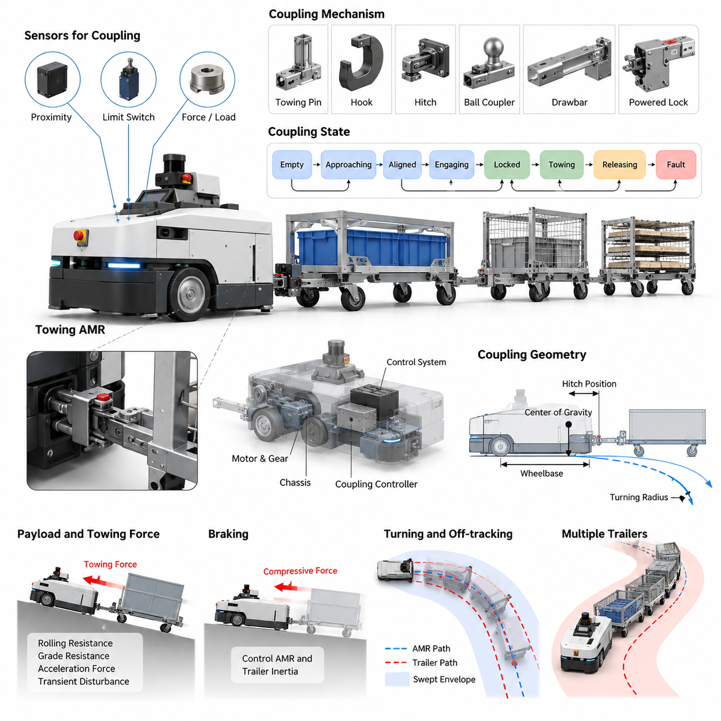
A towing AMR is an autonomous mobile robot designed to pull carts, dollies, racks, or trailer trains rather than carrying payloads directly on its chassis. This architecture is particularly effective in factories, warehouses, airports, and large logistics facilities where material already moves on wheeled carriers. Within the industrial robot application structure, towing AMRs form a dedicated application category that progresses from mechanical design through load-aware control, fleet operation, and interoperability. Volume_26_Industrial_Robot_Appl…
The mechanical design begins with a mobile base capable of generating sufficient traction and drawbar force for the intended payload. Designers must consider robot mass, wheel configuration, motor torque, gear ratio, tire friction, floor conditions, maximum towing speed, and expected gradients. Unlike a conventional payload-carrying AMR, the towing vehicle must remain dynamically stable while external forces from one or more trailers act on the coupling point during acceleration, braking, and turning.
The coupling mechanism provides the physical interface between the AMR and the transported cart. Common concepts include towing pins, hooks, hitches, ball-type couplers, drawbars, and powered locking mechanisms. The selected interface must tolerate longitudinal pulling and pushing forces as well as lateral loads generated during cornering. Mechanical clearances should be tightly controlled because excessive play can create oscillation, impact loading, inaccurate trailer tracking, and accelerated wear.
Coupling geometry strongly influences vehicle behavior. The hitch position relative to the drive axle determines how forces from the trailer affect steering response and stability. A coupling point positioned too far from the effective rotation center can amplify lateral forces during turns, while inappropriate hitch height can introduce undesirable pitching moments. Designers therefore coordinate hitch location, wheelbase, center of gravity, trailer drawbar geometry, and expected turning radius as one integrated mechanical system.
Automatic coupling allows the AMR to collect and release carts without manual intervention. A typical mechanism combines an electrically or mechanically actuated locking element with alignment structures that tolerate small positioning errors. Funnels, tapered guides, rollers, or compliant components can direct the cart toward the final locking position. The robot approaches at low speed, aligns the coupling interfaces, engages the locking device, and verifies that a secure mechanical connection has been established.
Sensors transform the coupling assembly from a passive mechanical device into a controllable robotic subsystem. Proximity sensors can detect the presence of a cart, while limit switches or position sensors confirm whether the locking pin or hook has reached its commanded position. Force, strain, or load sensing can provide additional evidence that a trailer is attached. Redundant confirmation is valuable because successful actuator motion alone does not guarantee that the cart has actually been captured.
The coupling controller should distinguish between states such as empty, approaching, aligned, engaging, locked, towing, releasing, and fault. Each transition depends on observable conditions rather than timing alone. For example, an engagement command may be considered successful only when cart presence, actuator position, and coupling confirmation satisfy predefined criteria. This state-based approach prevents navigation from resuming after incomplete engagement and provides clear recovery paths when coupling fails.
Mechanical design must also accommodate misalignment encountered during real industrial operation. Carts are rarely parked at perfectly repeatable positions, their caster wheels may rotate unpredictably, and worn floor markings or human handling can change their orientation. The AMR therefore requires an allowable capture envelope defining longitudinal, lateral, angular, and vertical alignment tolerances. Mechanical compliance can expand this envelope and reduce the precision demanded from localization and motion control.
The payload specification cannot be defined only by trailer mass. Rolling resistance, caster condition, wheel diameter, floor joints, ramps, acceleration, and the number of trailers all determine the actual towing force. Required drawbar force can be considered as the combination of rolling resistance, grade resistance, acceleration force, and transient disturbances. Engineering margins should then be applied so that normal operation does not continuously require the motors, drivetrain, or coupling components to operate near their limits.
Braking is particularly important because the AMR must control both its own inertia and that of the complete trailer system. During deceleration, trailers may generate compressive forces through the hitch and potentially push the robot forward. Emergency braking can produce substantially larger transient forces than steady towing. The chassis, coupling, drivetrain, brakes, and control parameters must consequently be designed according to the maximum permitted train mass rather than the mass of the AMR alone.
Turning introduces additional constraints because trailers do not follow the exact path of the towing vehicle. Their wheels generally cut inside the AMR trajectory, producing off-tracking that becomes larger with longer drawbars, greater wheelbases, multiple trailers, and tighter turns. Navigation clearance therefore has to represent the swept envelope of the complete vehicle train. A route that is collision-free for the towing robot itself may still cause a trailer to strike racks, columns, machinery, or pedestrians.
Multiple-trailer operation further changes the system dynamics. Each additional articulation point introduces another degree of freedom, increasing off-tracking and the possibility of oscillation or jackknifing. Trailer geometry should therefore be standardized whenever possible, and operational limits can specify maximum train length, trailer count, payload, curvature, acceleration, and velocity. These constraints provide the physical foundation for later train-formation and multiple-trailer control functions included in the towing AMR application architecture. Volume_26_Industrial_Robot_Appl…
The AMR chassis should provide structural load paths that transfer towing forces from the hitch into the main frame without excessive deformation. Mounting the coupler to thin covers or secondary brackets can produce fatigue failures under repeated industrial cycles. Structural analysis should consider normal towing, emergency stops, impacts during coupling, lateral cornering loads, and abnormal events. Replaceable bushings, pins, and wear plates can simplify maintenance of components exposed to repetitive mechanical contact.
Electrical and actuator design must support reliable coupling across thousands or millions of operating cycles. Electric linear actuators, solenoids, rotary motors, or electromechanical latches may be used depending on required force and stroke. The mechanism should preferably retain a safe state during power interruption and expose its physical position to the controller. Manual release provisions are also valuable so maintenance personnel can separate the robot and trailer when electrical or software faults prevent normal decoupling.
Safety requires the towing AMR to be treated as a moving system whose dimensions and dynamic behavior change after coupling. Protective sensing must cover not only the robot body but also hazards introduced by the trailer train. Speed limits may need to change according to payload, train length, turning condition, pedestrian proximity, and stopping distance. The broader chapter structure accordingly separates overload and anti-tip protection as a dedicated towing AMR safety topic following load-aware navigation and trailer control. Volume_26_Industrial_Robot_Appl…
A robust design also supports diagnostics and preventive maintenance. The system can record coupling attempts, failed engagements, actuator current, lock position, measured towing force, excessive-force events, and accumulated coupling cycles. Gradual increases in engagement force or repeated alignment failures may indicate mechanical wear, bent cart interfaces, contamination, or actuator degradation. Such information enables maintenance teams to address developing problems before they interrupt autonomous material-flow operations.
Standardization of the cart interface is often as important as the AMR itself. A fleet operating with inconsistent hitch heights, damaged drawbars, different caster configurations, or uncontrolled trailer dimensions will exhibit unpredictable coupling and navigation behavior. Industrial deployment should therefore define mechanical interface specifications for allowable cart geometry, coupling height, load capacity, wheel condition, identification, and inspection. Standard carts convert an uncertain physical environment into a repeatable automation interface.
The final design should integrate mechanics, sensing, actuation, control, navigation constraints, and safety as one towing system rather than treating the hitch as an accessory added to an existing AMR. Coupling geometry determines vehicle dynamics; payload changes stopping behavior; trailer dimensions alter navigation clearance; sensors determine whether autonomous engagement can be trusted. This systems perspective establishes the foundation for subsequent load detection, automatic coupling control, load-aware navigation, trailer-train control, mission dispatch, and industrial deployment. Volume_26_Industrial_Robot_Appl…

03.02. Towing AMR SW Architecture Load Detection [w/Code]
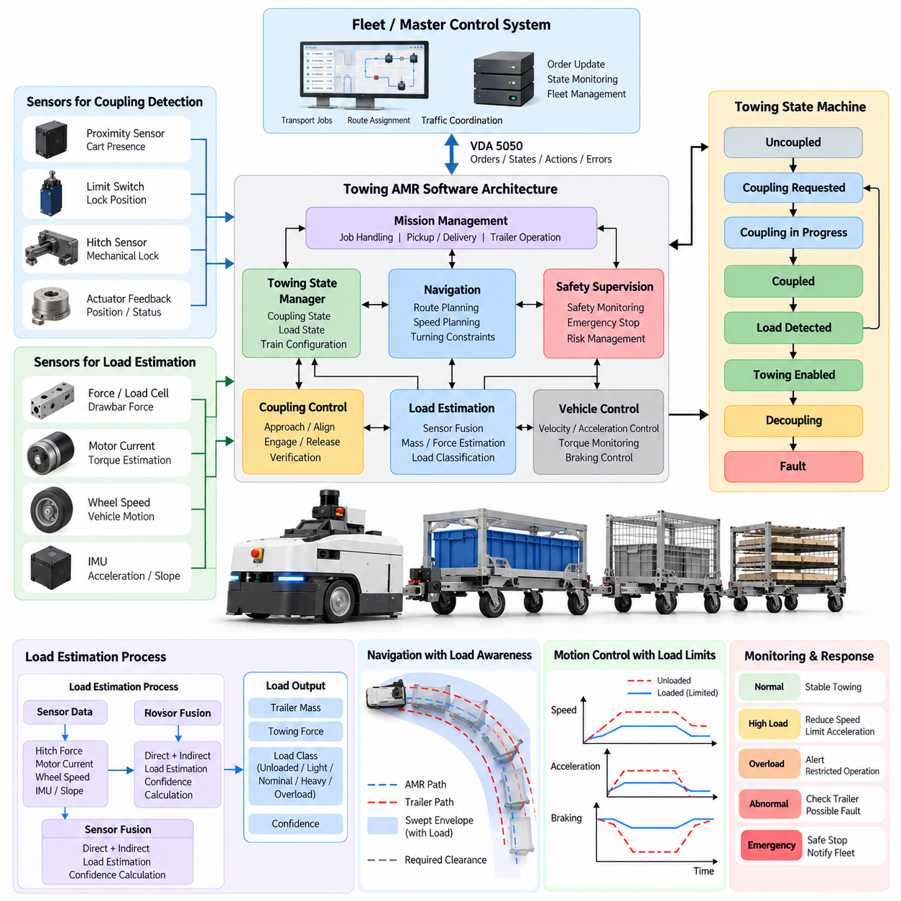
The software architecture of a towing AMR must coordinate autonomous navigation, vehicle control, coupling management, load detection, safety supervision, and fleet communication as a unified runtime system. Unlike a conventional AMR whose payload remains within a relatively fixed chassis envelope, a towing AMR changes its dynamic characteristics whenever a cart or trailer is attached. The software must therefore continuously represent both robot state and towing configuration.
A practical architecture separates high-level mission functions from real-time motion and safety functions. Mission management receives transport jobs, identifies pickup and delivery locations, and determines the required cart or trailer operation. Navigation generates feasible routes, while motion control converts trajectories into wheel commands. Coupling control, load estimation, diagnostics, and safety supervision operate alongside these layers and exchange validated state information through clearly defined interfaces.
The towing-state manager maintains the operational context required by the other software modules. It can represent conditions such as uncoupled, coupling requested, coupling in progress, coupled, load detected, towing enabled, decoupling, and fault. Transitions should depend on verified sensor conditions rather than a single command result. Navigation and propulsion are enabled only when the current towing state satisfies the safety and mission requirements associated with movement.
Load detection begins by determining whether a cart has actually been connected. Coupler position switches, proximity sensors, hitch sensors, actuator feedback, and mechanical lock signals can provide direct evidence of attachment. Because individual sensors can fail or produce ambiguous measurements, the software should combine multiple observations. A coupling command followed by actuator closure does not necessarily prove successful attachment unless independent evidence confirms the presence and secure locking of the trailer.
Once attachment is confirmed, the system must estimate the physical load being towed. Direct measurement can use force sensors, strain gauges, load cells, or instrumented coupling mechanisms. These sensors provide information about longitudinal drawbar force and, in more advanced configurations, lateral or vertical forces. Measurements require filtering, calibration, temperature compensation, plausibility checking, and zero-offset management before they can be used reliably by navigation and vehicle-control algorithms.
Load can also be estimated indirectly from drivetrain behavior. Motor current, commanded torque, wheel velocity, acceleration, vehicle mass, and road gradient provide observations from which towing resistance can be inferred. If significantly more torque is required to produce a given acceleration than during unloaded operation, the software can estimate additional resistance associated with the trailer. This approach reduces dedicated hardware requirements but depends strongly on drivetrain models and environmental conditions.
Sensor fusion improves load estimation when direct and indirect measurements are available simultaneously. A load estimator may combine hitch force, motor current, wheel speed, inertial measurements, and acceleration to produce a filtered estimate together with confidence information. Sudden disagreement between independent measurements can indicate sensor failure, wheel slip, mechanical binding, an abnormal trailer condition, or an incorrect coupling state rather than simply a change in payload.
The estimated load should be represented as more than a single payload value. Useful state variables include coupling status, estimated trailer mass, longitudinal towing force, load confidence, number of attached trailers, train length, maximum permitted velocity, acceleration limits, braking limits, and required turning constraints. Maintaining this information in a common towing-state representation allows navigation, control, safety, diagnostics, and fleet software to operate from consistent assumptions.
Load classification can simplify downstream control. Instead of requiring every subsystem to interpret a continuously varying mass estimate, the software may classify the towing condition as unloaded, light, nominal, heavy, or overload. Each class can reference predefined motion constraints validated during engineering tests. Continuous measurements remain available for monitoring, while deterministic operating profiles provide predictable behavior for speed planning, acceleration control, and safety supervision.
Navigation must consume the validated towing state before planning motion. A loaded robot may require lower velocity, reduced acceleration, longer stopping distance, larger turning radius, and wider obstacle clearance. The attached trailer also changes the physical footprint of the moving system. Consequently, the navigation interface should receive the current train geometry and load-dependent limits rather than assuming that the AMR has a constant footprint and fixed dynamic capabilities.
The motion-control layer applies these constraints at a faster control rate. Velocity and acceleration commands should be limited according to estimated load, while torque monitoring can detect unexpected towing resistance. During acceleration, excessive drawbar force may indicate overload or a blocked trailer wheel. During constant-speed motion, abnormal motor current can reveal increased rolling resistance. During braking, the controller must account for the additional momentum of the complete robot-trailer system.
Reliable load detection also requires temporal reasoning. A short force spike produced while crossing a floor joint should not immediately be classified as overload, while sustained excessive force requires intervention. Filtering, hysteresis, persistence timers, and state-dependent thresholds help distinguish normal transients from genuine faults. Thresholds may also differ between coupling, acceleration, cruising, turning, and braking because each operating phase produces different expected force signatures.
Fault handling should be integrated into the architecture rather than implemented as an independent afterthought. Implausible sensor values, disagreement between coupling sensors, unexpected load disappearance, excessive towing force, wheel slip, actuator faults, or loss of trailer identification should generate explicit fault states. Depending on severity, the AMR may reduce speed, stop safely, retry coupling, request operator assistance, or terminate the mission while preserving diagnostic information.
Safety supervision should remain logically independent from ordinary mission execution. Even if navigation requests motion, the safety layer must be capable of rejecting commands when the detected towing configuration violates validated limits. Overload, excessive train length, insecure coupling, abnormal hitch force, or insufficient braking capability can prevent movement. This separation ensures that mission completion never has higher authority than constraints intended to protect people, equipment, payloads, and the robot.
The architecture should also expose towing information to fleet-management software. Mission dispatch can use load capacity, coupling type, trailer compatibility, battery state, and current towing configuration when selecting a robot for a transport request. Fleet software can additionally record pickup success, measured loads, towing duration, coupling retries, abnormal resistance events, and delivery completion. These data support operational optimization and long-term reliability analysis.
Diagnostics benefit significantly from continuous load information. Increasing motor current for similar routes may reveal drivetrain wear, deteriorating cart wheels, bearing problems, or changing floor conditions. Repeated high hitch forces at one location can indicate an excessive ramp, damaged floor joint, or poorly designed turn. By associating measurements with route position, trailer identity, and mission history, the software can transform ordinary towing telemetry into useful maintenance evidence.
Real-time communication between modules should use explicit message definitions and bounded update rates. High-frequency motor and safety loops require deterministic local processing, whereas mission and fleet information can operate at lower frequencies. Load estimates should include timestamps, validity indicators, confidence values, and fault flags so consumers can reject stale or unreliable data. This prevents an old payload estimate from silently influencing control after the towing configuration has changed.
Startup and recovery behavior require equal attention. After rebooting, the robot should not assume that it is unloaded merely because software state has been reset. Physical coupling sensors and load observations must be evaluated to reconstruct the actual configuration before autonomous movement is permitted. Similarly, after emergency stops or communication failures, the software should reconcile physical trailer state, mission state, and navigation state before resuming operation.
The resulting software architecture forms the foundation for the later towing functions defined in the application sequence, including automatic coupling and decoupling, load-aware navigation, multiple-trailer control, overload protection, mission sequencing, fleet dispatch, and industrial integration. The central design principle is that load detection is not merely a sensor feature; it is shared operational knowledge that continuously changes how the complete towing AMR is allowed to plan, move, stop, and recover.

03.03. Automatic Coupling and Decoupling Control [w/Code]
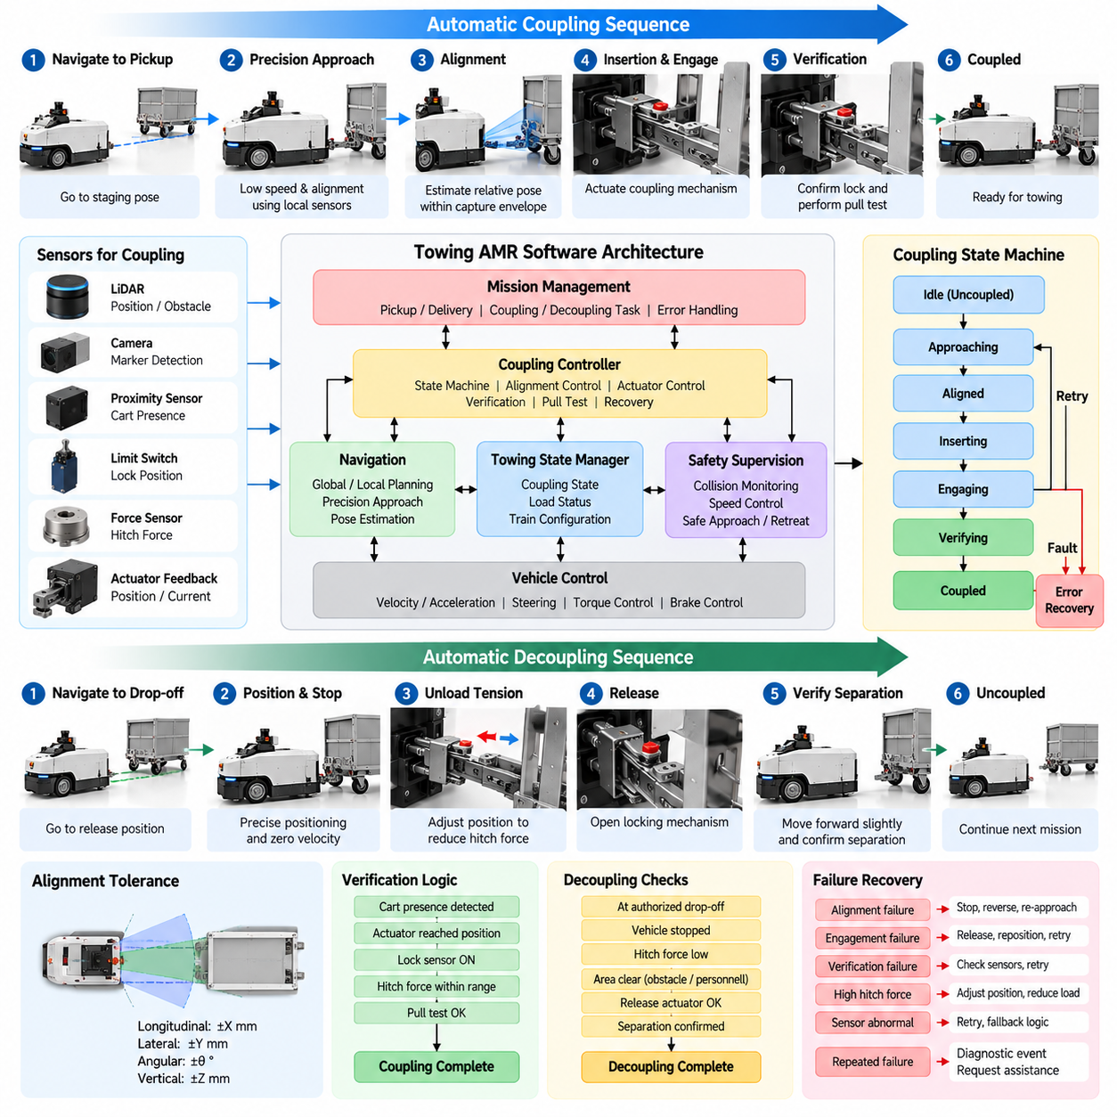
Automatic coupling and decoupling control enables a towing AMR to connect to and release carts or trailers without manual intervention. The function transforms a mechanical hitch into an autonomous robotic subsystem by coordinating localization, low-speed motion, coupling actuators, sensors, safety logic, and mission control. Reliable operation requires the controller to verify every physical transition instead of assuming that a commanded mechanical action has succeeded.
A coupling operation normally begins when mission management assigns a pickup task containing the target cart and coupling location. The AMR navigates toward a predefined staging pose and then changes from normal navigation to a precision approach mode. This separation is important because ordinary path following may provide sufficient accuracy for transportation but not for inserting a towing pin, hook, or locking mechanism into a relatively small mechanical interface.
During the final approach, the robot reduces velocity and uses local sensing to estimate the relative pose between the AMR and the cart. LiDAR, cameras, fiducial markers, proximity sensors, or dedicated docking sensors can refine longitudinal, lateral, and angular alignment. The controller continuously corrects the approach trajectory so that the coupling mechanism enters its allowable capture region without producing excessive contact forces or striking the cart structure.
The coupling controller can be implemented as a state machine representing approach, search, alignment, insertion, engagement, verification, and completion. Each state has explicit entry conditions, permitted actions, success criteria, timeout conditions, and recovery transitions. This structure prevents complex coupling behavior from becoming an uncontrolled sequence of actuator commands and makes abnormal situations easier to diagnose, test, and reproduce during validation.
Mechanical alignment tolerance should be represented directly in the control logic. The robot does not necessarily need to reach one mathematically exact pose if funnels, tapered guides, rollers, or compliant mechanisms can absorb small positioning errors. Instead, the controller can define an acceptable capture envelope for position and orientation. This reduces unnecessary corrective motion while still guaranteeing that engagement remains within mechanically validated limits.
After alignment is confirmed, the controller commands the coupling actuator. Depending on the mechanism, this action may raise a towing pin, rotate a hook, close a latch, extend a locking element, or engage another powered connector. Actuator motion should be monitored through position feedback, limit switches, motor current, or other available signals. A timeout prevents the system from indefinitely waiting for a mechanism that has become obstructed or failed.
Successful actuator movement alone is insufficient to declare coupling complete. The controller should verify that the cart is physically present, the locking mechanism reached the required position, and the resulting connection is mechanically secure. Independent sensors can provide redundant confirmation. When available, a small controlled motion or low-force pull test can further verify that the trailer follows the AMR and that the coupling does not immediately disengage under load.
The pull-test phase must remain tightly constrained because it intentionally applies force to the connection before normal transportation begins. The AMR can command a very small displacement or torque while monitoring hitch force, wheel motion, and coupling status. Expected resistance indicates that the cart is attached, whereas abnormal movement, insufficient force, excessive force, or loss of the lock signal can cause the verification procedure to fail and initiate recovery.
Failure recovery is essential because industrial carts are rarely positioned perfectly. If alignment fails, the AMR may stop, reverse a short distance, recompute the relative pose, and attempt another approach. If actuator engagement fails, the controller may release the mechanism and retry after repositioning. Retry counts should be limited so repeated mechanical impacts do not damage the hitch or cart. Persistent failures should generate a diagnostic event and request assistance.
Decoupling is the reverse physical process but should not simply execute the coupling sequence backward. Before release, the mission controller must confirm that the robot has reached an authorized drop-off location and that the cart can remain safely stationary after separation. Vehicle velocity must be zero, propulsion commands inhibited as necessary, and the coupling mechanism unloaded sufficiently to prevent stored mechanical forces from causing unexpected cart movement.
Residual force at the hitch can complicate decoupling. A trailer may push or pull against the coupling because of floor slope, caster orientation, braking forces, or tension accumulated in a multi-trailer train. The controller can monitor hitch force and perform a small positioning adjustment to reduce this load before opening the latch. Releasing a heavily loaded coupling can otherwise create sudden movement, mechanical wear, or incomplete actuator travel.
Once release conditions are satisfied, the controller commands the locking mechanism to its open position and verifies actuator feedback. It then confirms that the mechanical connection has actually disappeared. The AMR may move forward slowly by a short validated distance while monitoring coupling and load sensors. If the trailer remains attached, motion should stop immediately and the system should enter a decoupling fault or retry state rather than continuing the mission.
Coupling and decoupling operations require dedicated safety supervision because the robot intentionally approaches physical equipment at close range. Normal obstacle-avoidance behavior may need controlled adaptation within the coupling zone, but protective functions must not simply be disabled. The system should use validated low-speed behavior, restricted motion directions, bounded travel distances, force limits, and emergency-stop conditions while maintaining protection against people entering the hazardous area.
Cart identification should be associated with the coupling transaction whenever the application requires traceability. RFID, QR codes, visual identifiers, wireless tags, or fleet records can associate the detected cart with the mission request. The controller should distinguish successful mechanical coupling from successful identification because attaching the wrong cart can be mechanically valid but operationally incorrect. Both conditions may therefore be required before transportation is authorized.
Multiple-trailer applications add another layer of sequencing. The controller may need to couple the AMR to a preassembled trailer train or perform several coupling operations at different interfaces. Each additional articulation point increases uncertainty and mechanical interaction. The system should maintain the number and identity of connected trailers, expected train geometry, and validated load limits so subsequent navigation and motion control receive the correct towing configuration.
The coupling subsystem should exchange explicit status information with navigation and mission management. Navigation needs to know when precision approach control has ownership of robot motion, while mission management requires confirmed completion or failure before advancing the workflow. Useful status information includes current coupling state, target identifier, retry count, actuator position, sensor confirmation, measured hitch force, timeout condition, and fault reason.
Event logging is valuable for both reliability engineering and maintenance. The system can record approach error, coupling duration, number of retries, actuator current, engagement force, pull-test results, release force, and failure codes for every transaction. Gradual increases in coupling time or actuator effort may indicate worn mechanisms, damaged carts, sensor drift, poor parking accuracy, or contamination before these conditions become complete operational failures.
Recovery after interruption must reflect physical reality. If power is lost during coupling, software cannot assume whether the trailer is connected when the robot restarts. The controller should inspect actuator position, coupling sensors, cart presence, and load information before reconstructing its state. Ambiguous conditions should prevent normal movement until the connection is verified or safely released, avoiding dangerous disagreement between software state and the actual mechanism.
Automatic coupling and decoupling therefore connects mechanical design, load detection, navigation, motion control, safety, diagnostics, and mission execution into a single coordinated behavior. Within the towing AMR application sequence, it provides the transition between an independent mobile robot and a dynamically changing robot-trailer system, establishing the verified towing configuration required by subsequent load-aware navigation, multi-trailer control, overload protection, and fleet dispatch.

03.04. Load Aware Navigation Turning Radius Adjust [w/Code]
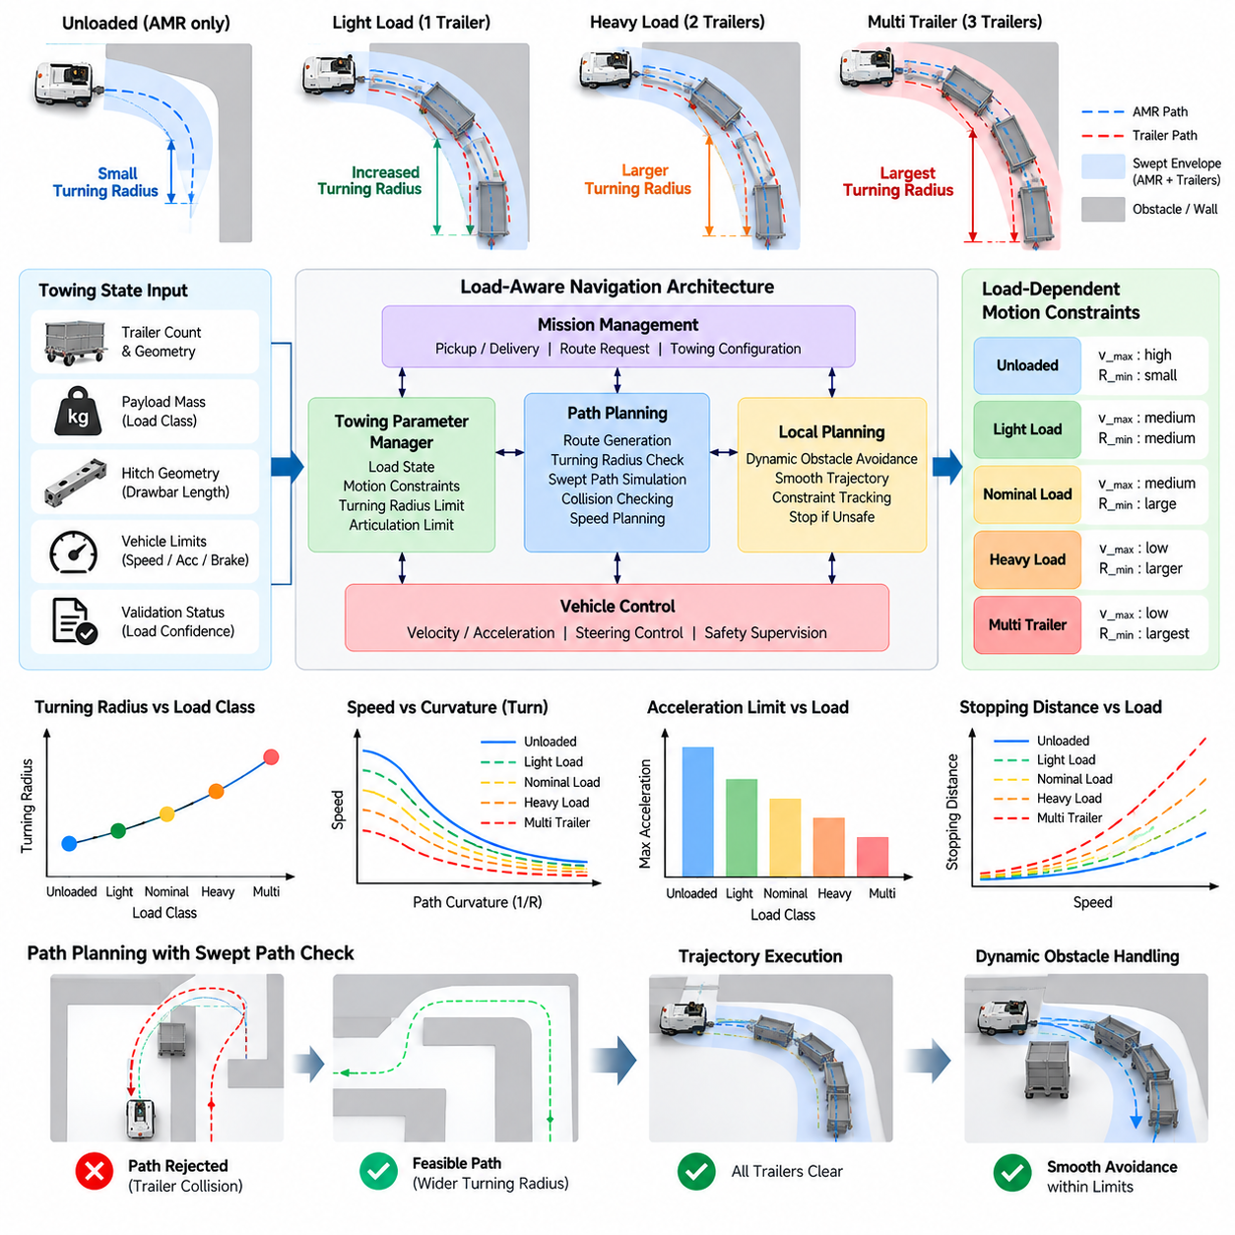
Load-aware navigation allows a towing AMR to adapt its route, velocity, acceleration, turning behavior, and safety margins according to the physical characteristics of the attached cart or trailer train. Unlike an unloaded mobile robot with a nearly constant footprint, a towing system changes dynamically after coupling. Navigation must therefore treat payload, train length, articulation geometry, and estimated towing resistance as active planning parameters.
The navigation process begins by receiving a validated towing state from the coupling and load-detection subsystems. This state can contain estimated payload mass, number of trailers, trailer dimensions, hitch geometry, load confidence, maximum allowable velocity, and braking constraints. Planning should not begin with towing assumptions that are stale or uncertain. If configuration validity cannot be established, the robot should remain stopped or use a predefined conservative operating profile.
A fundamental difference between ordinary AMR navigation and towing navigation is that the robot body no longer represents the complete collision geometry. Each trailer follows a different trajectory, particularly during turns, because its axle and articulation point are displaced from those of the towing vehicle. The navigation system must therefore model the complete robot-trailer configuration rather than simply enlarging the AMR footprint by a constant margin.
Trailer off-tracking occurs when a trailer follows a path inside the trajectory of the towing vehicle during a turn. The magnitude depends on wheelbase, drawbar length, articulation geometry, number of trailers, and path curvature. Tight turns can therefore be safe for the AMR itself while causing the trailer to collide with racks, columns, machinery, walls, or pedestrians. Swept-path prediction is necessary to evaluate the space occupied throughout the maneuver.
Turning-radius adjustment provides a practical mechanism for controlling this behavior. When the robot is unloaded, navigation may permit relatively tight curves that exploit the maneuverability of the mobile base. After coupling, the minimum permitted turning radius can be increased according to trailer geometry and payload conditions. The path planner then rejects curves that exceed articulation or clearance limits and generates smoother trajectories compatible with the complete towing configuration.
Payload mass also influences acceptable curvature because lateral forces increase during turning. A heavily loaded trailer may generate substantially greater forces at the hitch than a lightly loaded cart at the same speed and radius. Navigation can therefore combine curvature limits with velocity limits rather than treating them independently. Tight turns require lower speed, while high-speed segments require larger radii so that lateral force, wheel loading, and stability remain within validated limits.
The planner can represent these restrictions using configuration-dependent motion constraints. A towing profile may define maximum linear velocity, acceleration, deceleration, angular velocity, curvature, hitch angle, and permitted rate of steering change. Different profiles can be selected for unloaded, light, nominal, heavy, or multi-trailer conditions. This approach provides predictable behavior and simplifies validation because each operating envelope can be tested against known mechanical and safety limits.
Path planning should consider trailer geometry from the beginning instead of correcting an unsuitable path only during execution. Candidate paths can be simulated using a kinematic model of the towing vehicle and attached trailers. The predicted poses of all vehicle segments are checked against obstacles and restricted areas. A path is accepted only when the swept envelope maintains required clearance throughout the complete maneuver, including corner entry and exit.
Local planning remains responsible for adapting the trajectory to dynamic obstacles while preserving towing constraints. Sudden lateral maneuvers that are acceptable for an unloaded AMR may produce excessive articulation or unstable trailer motion. The local planner should therefore prefer gradual curvature changes and controlled deceleration. If an obstacle cannot be avoided without violating the towing envelope, stopping safely is preferable to executing an aggressive evasive maneuver.
Speed planning should be coupled to estimated stopping distance. Additional payload increases momentum and may reduce achievable deceleration, particularly on slopes or low-friction surfaces. The navigation system can reduce cruising speed when the detected load increases and begin deceleration earlier when approaching intersections, docking locations, pedestrian zones, or sharp turns. Safety margins should account for uncertainty in payload estimation and changing floor conditions.
Acceleration limits are equally important because rapid acceleration produces high longitudinal force through the coupling mechanism. Excessive drawbar force can stress the hitch, cause wheel slip, disturb loosely secured cargo, or create oscillation along a trailer train. A load-aware controller therefore limits acceleration according to estimated mass and measured towing resistance. Smooth velocity profiles reduce both mechanical stress and uncertainty in trailer behavior.
Articulation angle provides another useful navigation constraint. The relative angle between the towing vehicle and trailer increases during tight maneuvers and can approach mechanical or stability limits. The navigation system can predict this angle along candidate paths and reject trajectories that exceed a validated threshold. During execution, measured or estimated articulation can also trigger speed reduction, trajectory correction, or stopping before a jackknife condition develops.
Reverse motion requires particularly careful treatment. Many towing configurations that behave predictably while moving forward become difficult or unstable when reversing because articulation errors can grow rapidly. Industrial systems may therefore prohibit autonomous reverse towing except for short, validated maneuvers. When reverse motion is necessary, speed, distance, articulation angle, and environmental clearance should be tightly constrained and monitored throughout the operation.
Multi-trailer trains make path planning substantially more complex. Each additional trailer introduces another articulation point, and the rear trailers can experience progressively different trajectories. The complete train length may also block intersections or extend into adjacent traffic zones while the AMR has already completed a turn. Navigation must consequently account for all trailer segments and reserve sufficient spatial and temporal clearance for the entire train.
Route selection can incorporate these geometric restrictions at the map level. Narrow aisles, sharp corners, small intersections, steep ramps, or constrained docking areas may be suitable for an unloaded AMR but prohibited for specific towing configurations. Map edges or zones can therefore contain attributes describing maximum train length, payload, width, curvature, or velocity. The global planner uses these attributes to select routes compatible with the current configuration.
Dynamic load information can modify navigation during an active mission. If towing resistance rises unexpectedly because of a damaged caster, floor obstruction, or increasing slope, the controller can reduce speed and acceleration even though the nominal payload has not changed. Persistent abnormal resistance may cause the robot to stop and report a fault. Load-aware navigation therefore responds not only to initial payload classification but also to changing physical conditions.
Localization accuracy becomes especially important near constrained turns because small pose errors at the towing vehicle can produce larger clearance errors at the rear of a long trailer train. The planner should include localization uncertainty in its safety margins and avoid routes whose clearance is too close to the theoretical minimum. Reduced speed in narrow areas can also improve controllability and provide additional time for obstacle detection and trajectory correction.
Mission and fleet management should understand navigation feasibility before assigning a towing task. A robot may have sufficient rated towing capacity but still be unsuitable because the requested trailer train cannot negotiate the available route. Fleet software can evaluate robot capability, trailer geometry, payload class, and route restrictions together. This prevents assignments that would inevitably fail at a narrow aisle, tight corner, or restricted intersection.
Operational data can continuously improve route engineering. Logs containing payload estimates, turning radius, articulation, hitch force, motor current, localization error, and obstacle clearance can identify locations where towing performance approaches its limits. Repeated slowdowns or high coupling forces at the same corner may justify widening the route, changing traffic rules, reducing allowed train length, or modifying the planned curvature.
Load-aware navigation therefore extends conventional AMR path planning into configuration-aware motion planning for a changing robot-trailer system. Turning-radius adjustment is a central mechanism, but it must operate together with swept-path prediction, speed and acceleration limits, articulation constraints, stopping-distance management, and route eligibility. These capabilities provide the motion foundation required for safe multiple-trailer control, overload protection, mission sequencing, and large-scale towing AMR fleet operation.

03.05. Train Formation Multiple Trailer Control [w/Code]
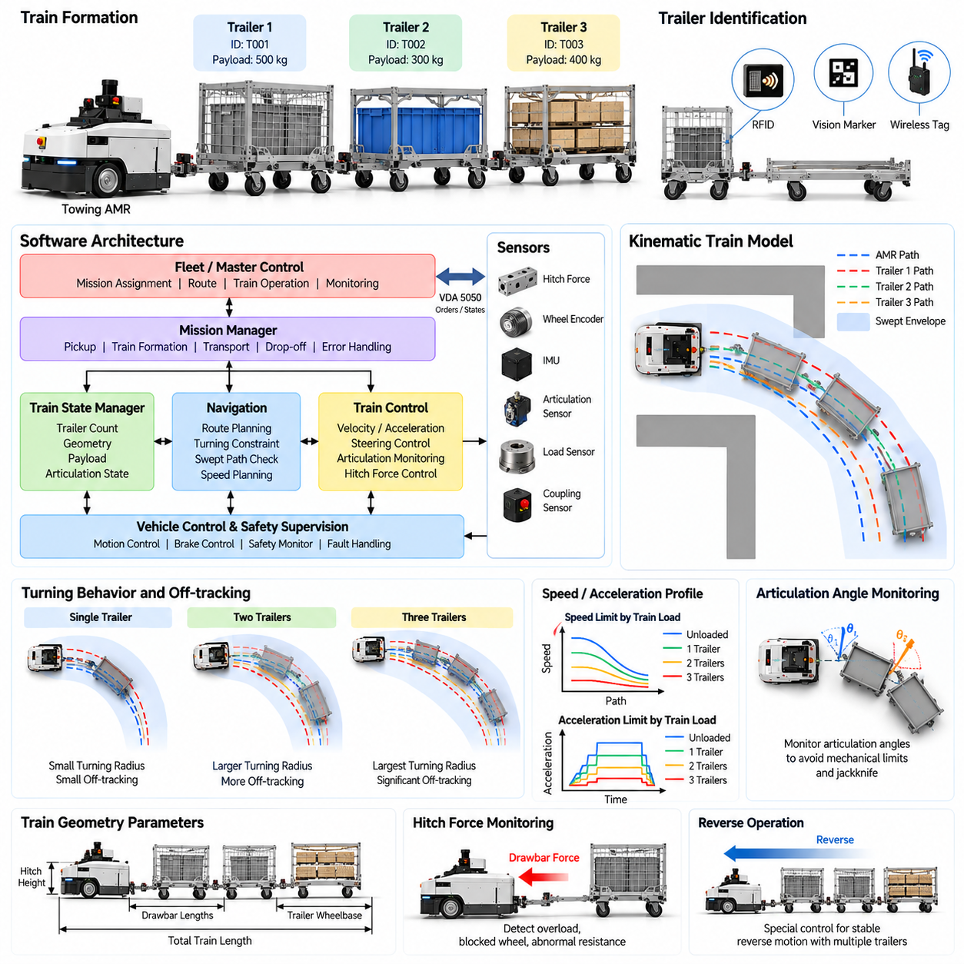
Train formation extends a towing AMR from a single robot-cart combination into an articulated transport system containing multiple trailers. Each additional trailer increases payload capacity but also introduces another mechanical joint, additional rolling resistance, longer stopping distance, and greater path deviation. Control must therefore represent the complete train as a connected dynamic system rather than treating trailers as passive objects following the AMR.
The train configuration should be established before autonomous transport begins. The controller maintains information about trailer count, individual trailer dimensions, drawbar lengths, axle locations, coupling states, payload estimates, and total train length. These parameters define the geometric and dynamic envelope used by navigation and motion control. Unknown or inconsistent configuration information should prevent unrestricted movement until the physical train has been verified.
Trailer identity can be obtained through RFID, visual markers, wireless tags, coupling sensors, or fleet-management records. Identification allows the controller to associate each trailer with known geometry, rated capacity, payload class, and maintenance status. This is especially useful in mixed fleets where carts have different dimensions or wheel characteristics. Correct train formation therefore includes both physical coupling verification and logical identification of each connected element.
A multiple-trailer system contains several articulation angles between consecutive vehicle segments. During straight travel these angles remain small, but they increase when the AMR turns. The first trailer responds to the towing vehicle trajectory, while each following trailer responds to the motion of the preceding trailer. Small trajectory differences can consequently propagate through the train and produce substantial displacement at the final trailer.
A kinematic train model provides the basis for predicting this behavior. The model represents the towing vehicle, hitch points, trailer wheelbases, drawbars, and articulation joints as a connected chain. Given the AMR velocity and steering trajectory, the controller can predict the position and orientation of every trailer. These predictions allow navigation to estimate off-tracking, swept area, articulation limits, and the clearance required around corners and intersections.
Off-tracking generally becomes more significant as train length increases. Rear trailers can cut substantially inside the path followed by the towing vehicle, particularly during tight turns. Simply checking the AMR footprint is therefore insufficient. The path planner should evaluate the swept envelope of every segment and reject trajectories that bring any trailer too close to racks, machines, columns, walls, safety barriers, or pedestrian areas.
Train formation also changes the minimum practical turning radius. A route that is feasible with one trailer may become unsuitable after additional trailers are attached. The navigation system should therefore derive turning constraints from the current formation rather than applying one fixed value to every mission. Longer trains typically require smoother curvature, larger intersection space, reduced cornering speed, and earlier trajectory preparation before entering a turn.
Articulation-angle monitoring provides an important control and safety mechanism. Each joint can have a validated operating range based on mechanical clearance and stability requirements. Predicted articulation is checked during planning, while estimated or measured articulation is monitored during execution. Approaching a limit can trigger reduced speed or trajectory correction, whereas exceeding a critical threshold should cause controlled stopping before jackknifing or mechanical interference occurs.
Velocity control must account for the total train rather than only the towing vehicle. Increasing trailer count and payload raises total inertia and usually increases rolling resistance. Acceleration should be limited to prevent excessive drawbar forces and oscillation between trailers. Deceleration should begin sufficiently early to control the complete train smoothly. Sudden commands can propagate through couplings and create repeated tension-compression cycles similar to longitudinal train oscillation.
Smooth trajectory generation is particularly valuable for suppressing these disturbances. The controller can limit acceleration, jerk, angular velocity, and curvature rate so that changes in towing force occur gradually. This reduces shock loading on coupling mechanisms and helps keep trailer motion predictable. Motion profiles can become progressively more conservative as train length, payload, measured towing resistance, or uncertainty in the configuration increases.
Force information at the primary hitch can provide useful evidence about train behavior even when individual trailers are not instrumented. Unexpectedly high drawbar force may indicate excessive payload, a blocked caster, mechanical binding, floor obstacles, or abnormal trailer alignment. Repeated force oscillations can indicate unstable train motion. The controller can reduce speed, limit acceleration, or stop the mission when measured behavior deviates significantly from the validated model.
More advanced systems may distribute sensing across the train. Trailer-mounted inertial sensors, wheel encoders, articulation sensors, load sensors, or wireless nodes can provide direct information about individual segments. This improves state estimation for long trains and allows faults to be localized more precisely. However, distributed sensing introduces communication, synchronization, power, maintenance, and reliability requirements that must be considered in the overall industrial architecture.
Reverse operation becomes increasingly difficult as trailers are added. Articulation errors that naturally decrease during forward towing can grow rapidly during reverse movement, creating jackknife instability. For this reason, many industrial towing missions should be designed around forward-only train movement whenever practical. If autonomous reversing is required, it should use low speed, short distances, strict articulation limits, accurate state estimation, and specifically validated control logic.
Train formation affects intersection and traffic management as well. The towing vehicle may leave an intersection while rear trailers still occupy it, so traffic-control systems cannot release the reserved zone based only on the AMR position. The fleet system should consider complete train length and predicted clearance time. Spatial reservations may need to remain active until the final trailer has exited the protected intersection or shared aisle.
Mission planning should verify that the selected formation is compatible with the complete transport route before departure. Constraints can include maximum train length, payload, trailer count, turning radius, aisle width, slope, doorway clearance, and intersection geometry. If the requested train cannot traverse the route safely, fleet management can reduce the number of trailers, divide the transport task, assign another vehicle, or select an alternative route.
Formation changes require explicit state transitions. When trailers are added or removed, the controller should suspend normal transportation, verify every relevant coupling, update the train model, recompute payload and geometry, and refresh navigation constraints. Motion should resume only after the new configuration has been validated. This prevents the navigation system from operating with dimensions or dynamic limits belonging to the previous formation.
Fault handling must consider failures anywhere along the train. A broken or unexpectedly released coupling, excessive articulation, abnormal drag, trailer identification loss, or inconsistent sensor state should generate a train-level fault. Continuing motion after losing a rear trailer could create severe operational and safety hazards. The AMR should therefore transition to a controlled stop and preserve enough diagnostic information to identify which formation element caused the problem.
Fleet software can use formation telemetry for operational optimization. Useful records include trailer count, payload, route, travel time, coupling events, maximum articulation, towing force, energy consumption, and abnormal resistance. Historical analysis can reveal whether longer trains actually improve throughput or instead create delays at corners and intersections. This supports evidence-based decisions about train size, route design, and dispatch strategy.
Simulation is particularly valuable before deploying multiple-trailer operation. Different trailer geometries, train lengths, payloads, routes, and motion profiles can be evaluated without risking physical equipment. Swept paths, articulation angles, clearance, force assumptions, and intersection occupancy can be studied across many scenarios. Results can then define validated operating envelopes that are transferred into navigation, control, and fleet-management configuration.
Train formation and multiple-trailer control therefore combine mechanical configuration, state estimation, kinematic modeling, navigation, motion control, safety, and fleet coordination. The central objective is not merely to make several trailers follow an AMR, but to ensure that the complete articulated system behaves as one predictable transport unit. This capability provides the foundation for subsequent overload protection, mission sequencing, factory intralogistics, and large-scale towing AMR operations.

03.06. Towing AMR Safety Overload Anti Tip [w/Code]
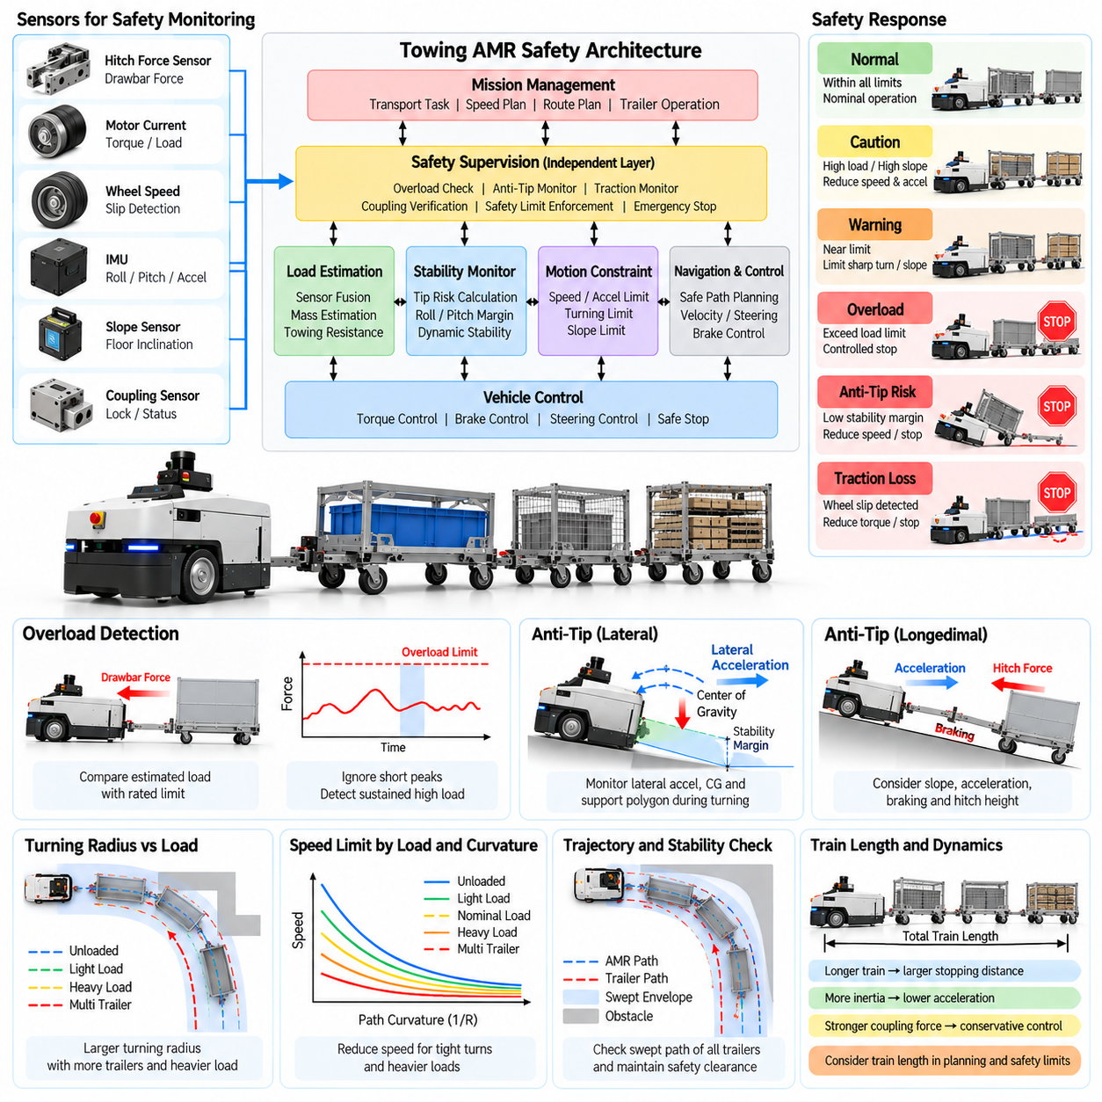
Safety management in a towing AMR must consider hazards created by the combined robot, coupling mechanism, payload, and trailer train rather than evaluating the mobile base alone. Towing changes inertia, stopping distance, traction demand, hitch forces, and stability during acceleration and turning. A safe system therefore continuously evaluates whether the current physical configuration remains inside a validated operating envelope.
Overload protection begins with determining the load applied to the towing system. Direct measurements can come from load cells, strain gauges, or force sensors integrated into the hitch, while indirect estimation can use motor torque, drive current, acceleration, wheel speed, and vehicle models. Combining several signals improves robustness because no single measurement perfectly represents trailer mass, rolling resistance, slope, and transient forces.
The controller should distinguish payload overload from abnormal towing resistance. A cart within its rated mass can still demand excessive force because of a damaged caster, seized bearing, floor obstruction, misalignment, or steep gradient. Conversely, a heavy but freely rolling trailer may initially produce moderate force. Safety logic should therefore evaluate estimated mass, sustained drawbar force, peak force, motor loading, and motion response together.
Load limits can be organized into progressive operating regions instead of using only one emergency threshold. Normal loading permits the validated motion profile, while an elevated-load region can reduce acceleration and speed. Approaching the maximum limit can prohibit steep routes or tight turns. A confirmed overload should prevent mission continuation and command a controlled stop while retaining enough diagnostic information to explain the event.
Transient force must be separated from persistent overload. Short hitch-force peaks can occur when motion starts, a caster changes orientation, or the train crosses a floor joint. Immediately stopping for every peak would reduce availability and create unnecessary interruptions. Filtering, persistence timers, hysteresis, and state-dependent thresholds allow the controller to recognize dangerous sustained loading without ignoring genuinely severe impact forces.
Anti-tip protection addresses loss of stability caused by acceleration, braking, cornering, slope, and load distribution. Although a towing AMR may have a low center of gravity, the coupled system can generate substantial forces at the hitch. A high hitch point, uneven trailer loading, lateral pulling force, or rapid direction change can produce pitch or roll moments that reduce the stability margin of the towing vehicle.
The stability model should consider vehicle mass, center-of-gravity location, wheel track, wheelbase, hitch height, towing force, lateral acceleration, and floor slope. These parameters define the relationship between the resultant force and the support polygon formed by the wheels. As operating conditions move the resultant force toward a stability boundary, the controller can reduce speed or acceleration before physical wheel unloading or tipping begins.
Turning is a critical anti-tip condition because lateral acceleration increases with speed and path curvature. The same corner that is safe at low speed can become unsafe when entered too quickly with a heavy train. Load-aware navigation should therefore couple velocity limits with turning radius and estimated load. High payload or uncertain load conditions should produce progressively more conservative cornering profiles.
Longitudinal stability must also be considered during acceleration and braking. Rapid acceleration can create high tensile force at the hitch, while strong braking can allow trailers to push against the towing vehicle. On a slope these effects combine with gravity and may significantly alter wheel loading. Controlled acceleration and deceleration reduce load transfer, wheel slip, coupling shock, and the possibility of instability during emergency or routine maneuvers.
Inertial measurement units can support real-time anti-tip supervision by monitoring roll angle, pitch angle, angular rate, and linear acceleration. Wheel-speed differences, motor torque, suspension information, and hitch-force measurements can provide additional evidence. Sensor fusion allows the controller to distinguish ordinary vehicle motion from developing instability and can detect abnormal behavior that a purely geometric model may not predict.
Traction loss is closely related to towing safety. Excessive towing force can cause drive-wheel slip before the mechanical towing limit is reached, especially on wet, dusty, polished, or inclined floors. Slip reduces controllability and makes stopping-distance predictions unreliable. The controller can detect disagreement between commanded motion, wheel speed, and inertial motion, then reduce torque or stop when adequate traction cannot be maintained.
Safety supervision should remain independent from ordinary mission progression. A mission controller may request transportation to continue, but a safety layer must be able to reject motion when overload, excessive hitch force, dangerous inclination, unstable articulation, insufficient traction, or insecure coupling is detected. Safety-critical limits should not be overridden merely to recover schedule performance or complete a delayed delivery.
Multiple trailers increase the importance of conservative safety limits because disturbances can propagate through several couplings. Oscillating tension and compression can create force peaks that are not apparent from nominal payload alone. Rear trailers may also encounter different slopes, obstacles, or corner geometry from the towing vehicle. The safety system should therefore consider train length and formation when selecting thresholds and permitted motion profiles.
Route restrictions provide preventive protection before hazardous motion occurs. Map regions can specify maximum payload, train length, slope, speed, or towing configuration. A heavily loaded train can then be prevented from entering steep ramps, narrow high-curvature passages, or surfaces with insufficient traction. Preventing an unsafe route is generally preferable to relying on emergency intervention after stability has already deteriorated.
When an overload or instability warning occurs, the response should match the severity of the condition. Moderate risk may cause speed and acceleration reduction, while a stronger warning can request controlled stopping at a safe location. Critical instability, coupling failure, or rapidly increasing force may require immediate protective stopping. Recovery should require verification that the hazardous condition has disappeared rather than automatically resuming movement.
Fault handling must account for sensor failures as well as physical hazards. A disconnected load sensor, drifting force measurement, failed IMU, inconsistent wheel-speed data, or implausible payload estimate can invalidate safety calculations. The controller should perform plausibility checks and use redundant information where available. When confidence becomes insufficient, the system should transition to a conservative mode or prevent towing until inspection is completed.
Safety events should be recorded with sufficient context for engineering analysis. Useful information includes payload estimate, hitch force, speed, acceleration, curvature, roll and pitch, articulation, motor current, wheel slip, route position, trailer count, and active safety thresholds. Correlating these values around an event helps distinguish excessive payload from route problems, mechanical degradation, poor traction, or inappropriate motion parameters.
Periodic validation should confirm that overload and anti-tip protections remain effective as hardware and software evolve. Tests can cover rated and excessive loads, different trailer formations, emergency braking, tight turns, slopes, reduced-friction surfaces, sensor faults, and abnormal rolling resistance. Simulation and controlled physical testing together can establish operating limits while reducing the risk associated with intentionally creating hazardous conditions.
Towing AMR safety therefore depends on continuously connecting load estimation, force monitoring, vehicle stability, traction, navigation, and independent safety supervision. Overload protection prevents the system from exceeding mechanical and dynamic capacity, while anti-tip control preserves stability as payload and motion conditions change. Together these mechanisms define a protected operating envelope for reliable factory and logistics towing operations.

03.07. Towing Mission Sequencing and Fleet Dispatch [w/Code]
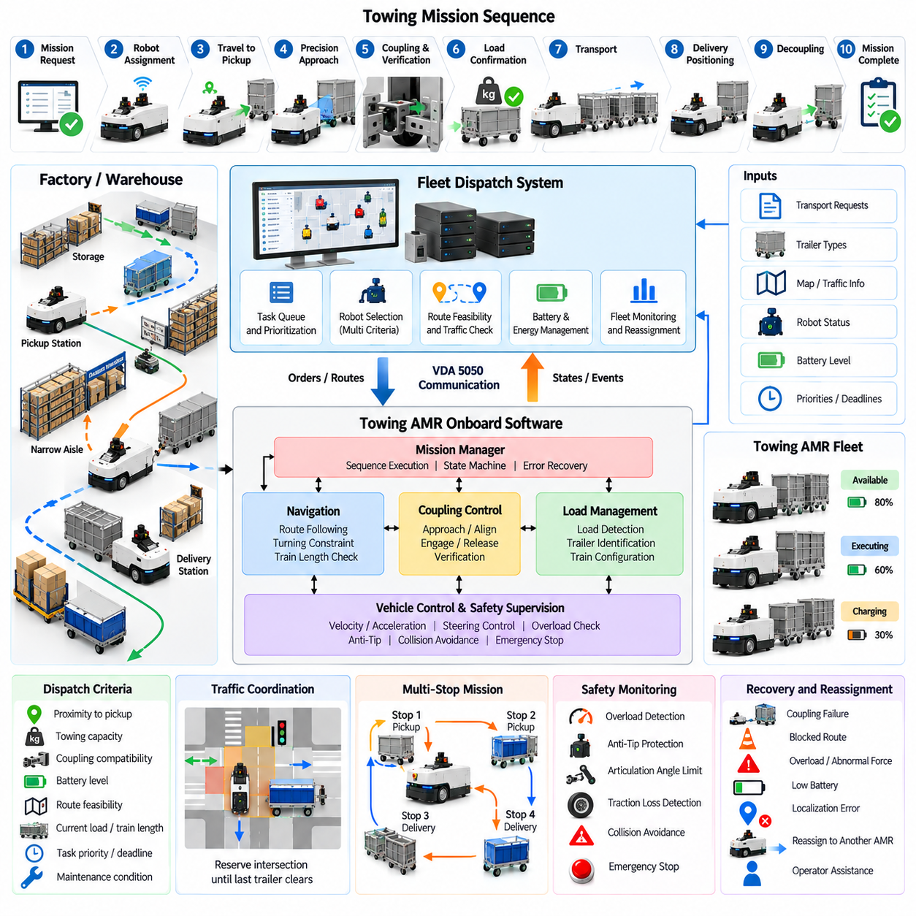
Towing mission sequencing coordinates the complete transport process from trailer pickup to delivery, decoupling, and preparation for the next assignment. Unlike a conventional AMR mission that mainly connects navigation waypoints, a towing mission contains physical configuration changes. Each transition must therefore verify coupling state, trailer identity, load condition, route feasibility, and safety readiness before the workflow advances.
A typical mission can be represented as a sequence of pickup request, robot assignment, travel to staging position, precision approach, coupling, connection verification, load confirmation, transport, destination positioning, decoupling, and completion reporting. Explicit sequencing prevents navigation from beginning before coupling is secure and prevents mission completion from being declared while the trailer remains physically attached.
Mission execution is best managed through a state machine or behavior-oriented workflow that provides clear entry conditions, success criteria, timeout handling, and recovery transitions. Each state owns only the actions appropriate to that phase. For example, precision coupling control can temporarily own vehicle motion near a cart, while normal navigation resumes only after the coupling subsystem reports a verified towing configuration.
Fleet dispatch determines which towing AMR should execute each transport request. Assignment should consider more than physical proximity. Relevant factors include towing capacity, coupling compatibility, current trailer configuration, battery state, payload class, route accessibility, localization quality, maintenance condition, and expected task duration. The nearest robot may therefore not be the most appropriate robot for a particular towing mission.
Trailer compatibility is a central dispatch constraint because industrial fleets may contain several cart types. Different trailers can require specific coupling mechanisms, dimensions, load limits, or navigation profiles. Fleet software should associate each transport request with the required trailer characteristics and reject assignments where the selected AMR cannot establish a validated mechanical and operational configuration.
Route feasibility should be evaluated before dispatch whenever possible. The fleet manager can combine trailer count, train length, payload, turning-radius requirements, aisle width, slope restrictions, and permitted traffic zones with map information. A robot capable of towing the requested mass may still be unsuitable if the resulting train cannot negotiate a narrow corner or restricted intersection along the required route.
Mission sequencing should also support multi-stop logistics. A towing AMR may collect carts from several stations, deliver a train to multiple destinations, or exchange empty and loaded carts along a production route. These operations require dependencies between stops because trailer configuration and payload can change after every coupling or decoupling event. The remaining route must be revalidated whenever the physical formation changes.
Priority management becomes important when many transport requests compete for a limited fleet. Production shortages, line-side replenishment, urgent material calls, empty-container removal, and routine transfers may have different service priorities. Dispatch logic can combine priority with request age, travel distance, robot availability, congestion, and deadline information so that urgent work is handled without indefinitely delaying lower-priority missions.
Traffic coordination must account for the complete trailer train rather than only the towing vehicle. Intersections, narrow aisles, doors, elevators, and shared work zones may require reservation before entry. A reservation should remain active until the final trailer clears the controlled area. This prevents another AMR from entering too early simply because the towing vehicle itself has already passed the conflict point.
Deadlock prevention is especially important for long towing formations. Two trains approaching a narrow bidirectional aisle may be unable to pass or reverse safely after entering. Fleet management can prevent this condition by reserving constrained segments in advance, controlling entry direction, defining waiting zones, and considering train length when granting traffic permissions. Prevention is generally easier than recovering an articulated vehicle from a blocked route.
Battery management should be integrated with dispatch rather than treated as an independent charging problem. Towing energy consumption depends on payload, trailer count, rolling resistance, route length, slope, and traffic delays. The fleet manager can estimate whether sufficient energy remains to complete the entire mission with reserve capacity. Heavily loaded or long missions may therefore be assigned to robots with greater available energy.
Mission recovery is required when normal sequencing is interrupted. Coupling failure, blocked routes, overload detection, traffic timeout, localization degradation, low battery, or mechanical faults can prevent progression. Recovery logic should identify whether the mission can retry locally, select another route, move to a safe waiting location, request operator assistance, or terminate while preserving the physical state of the attached trailers.
Reassignment is more complicated for towing missions because the payload may already be physically connected to the failed robot. Fleet software cannot simply send another AMR unless the trailer can be safely released, transferred, or recovered. The mission record should therefore distinguish task ownership from physical load ownership and maintain accurate information about which robot is currently connected to which trailer or train.
Fleet state synchronization prevents inconsistencies between robots and centralized management. Important information includes robot availability, mission state, coupling status, trailer identity, payload estimate, train length, current route, battery level, safety condition, and fault status. Updates should include timestamps and validity information so dispatch decisions are not based on stale configuration data after communication interruptions.
Communication loss requires defined autonomous behavior. A towing AMR that temporarily loses fleet connectivity should not immediately abandon a physically safe mission, but it should also avoid entering areas requiring centralized traffic coordination without authorization. Depending on system design, the robot may complete a reserved segment, stop at a safe location, or continue only within a locally validated operating scope until communication is restored.
Dispatch optimization can pursue throughput while respecting safety constraints. Useful objectives include reducing empty travel, balancing robot utilization, minimizing trailer waiting time, avoiding congestion, meeting production deadlines, and reducing unnecessary coupling operations. However, optimization should operate only within validated towing constraints. A shorter route or faster assignment must not override payload, turning, traffic, or safety limitations.
Operational telemetry provides the data required to improve dispatch policies. Mission records can include request time, assignment delay, pickup duration, coupling retries, loaded travel time, waiting time, route changes, decoupling duration, energy use, payload, trailer count, and fault events. Analysis can reveal whether delays originate from insufficient fleet capacity, poor cart staging, congestion, coupling reliability, or unsuitable route design.
Integration with manufacturing and warehouse systems allows towing missions to respond directly to material demand. A manufacturing execution system, warehouse management system, or production scheduler can generate transport requests containing source, destination, material identity, quantity, priority, and required delivery time. Fleet management converts these business-level requests into executable robot missions while preserving the operational constraints of the towing system.
Large fleets benefit from separating business scheduling, fleet optimization, and robot-local execution. Central software decides what should be transported and which resources should perform the work, while each AMR remains responsible for safe navigation, coupling control, load monitoring, and protective stopping. This separation allows fleet-level optimization without requiring centralized software to control every real-time actuator or safety decision.
Towing mission sequencing and fleet dispatch therefore connect individual robotic capabilities into an operational logistics system. Coupling, load detection, load-aware navigation, train formation, and safety become prerequisites that dispatch software must understand rather than isolated robot functions. Coordinating these capabilities enables towing AMRs to execute reliable material-flow missions while improving fleet utilization, traffic efficiency, traceability, and production responsiveness.

03.08. Towing AMR Factory Intralogistics Case [w/Code]
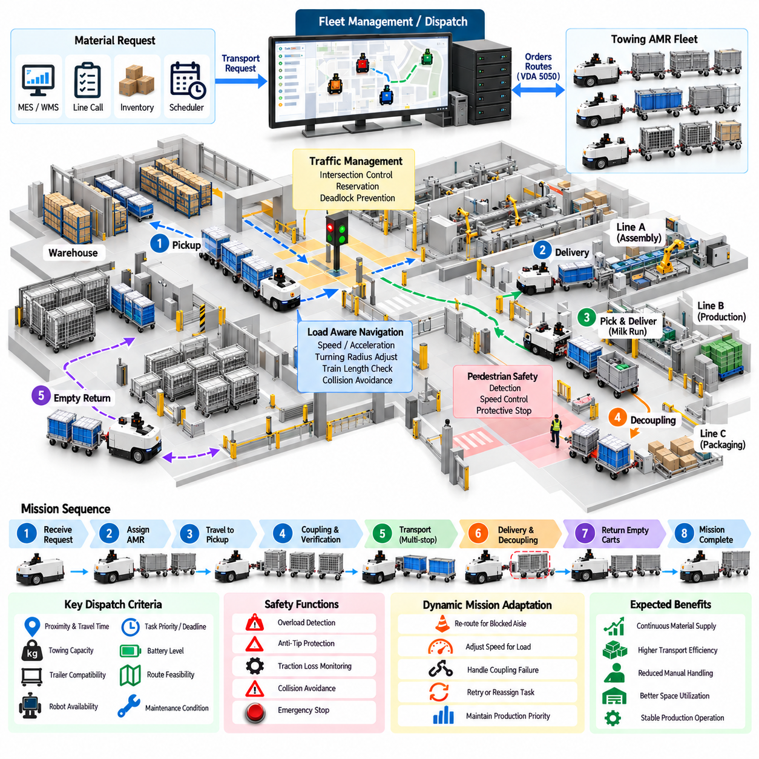
A factory intralogistics application demonstrates how towing AMRs can automate repetitive material movement between warehouses, supermarkets, production lines, assembly cells, and empty-container collection areas. Instead of transporting one pallet at a time, a towing AMR can move several carts as a train, making it suitable for milk-run logistics where materials must circulate repeatedly through predefined production zones.
A typical deployment begins by analyzing the existing manual logistics process. Engineers identify pickup stations, delivery points, material consumption rates, cart types, payloads, aisle widths, intersections, slopes, pedestrian zones, and traffic restrictions. This information is used to determine whether towing operation is feasible and to define suitable train lengths, coupling mechanisms, routes, speeds, and operating schedules.
Material requests can originate from a manufacturing execution system, warehouse management system, line-side call button, inventory sensor, or production scheduler. The fleet manager converts each request into a transport mission containing source, destination, material identity, priority, required trailer type, and delivery deadline. This allows AMR transportation to respond dynamically to production demand instead of following only a fixed timetable.
At the pickup area, the assigned AMR approaches the required cart or preassembled trailer train and performs automatic coupling. The system verifies mechanical engagement, trailer identity, load condition, and train configuration before departure. If the wrong cart is detected or the coupling cannot be verified, the mission remains in the pickup state rather than allowing an incorrectly configured train to enter production traffic.
After coupling, load-aware navigation selects motion constraints appropriate for the current train. A lightly loaded single trailer may permit relatively high speed and tighter turns, while a heavily loaded multi-trailer train requires lower acceleration, larger turning radii, longer stopping distance, and wider clearance. The complete swept path of the train must remain compatible with factory aisles, racks, machines, columns, doors, and safety barriers.
Factory intersections require coordinated traffic management because towing trains occupy more space and remain inside conflict zones longer than ordinary AMRs. The fleet system can reserve narrow aisles and intersections before entry and maintain the reservation until the final trailer has cleared the area. Priority rules can also coordinate towing AMRs with forklifts, autonomous robots, manually operated vehicles, and production equipment sharing the same logistics network.
Pedestrian interaction is another major design consideration. Material routes frequently cross operator walkways or pass close to assembly stations where workers cannot be completely separated from vehicle traffic. The towing system should combine speed-controlled zones, obstacle detection, protective stopping, warning devices, and clearly defined traffic rules. Longer trains require particular attention because a worker may encounter a trailer after the towing vehicle has already passed.
At a production station, positioning accuracy must be sufficient for safe cart delivery and subsequent manual or automated material access. The AMR may stop at a predefined release pose, verify that the destination is available, reduce residual hitch force, and execute automatic decoupling. The released cart must remain stable and must not obstruct the traffic lane. Successful separation is confirmed before the AMR departs for another task.
Multi-stop milk-run operation can improve transport efficiency when several production stations consume materials along a common route. The AMR may deliver loaded carts, collect empty containers, and modify its trailer formation at successive stops. Because each coupling or decoupling changes train length, mass, and geometry, navigation constraints and route feasibility should be updated after every formation change rather than remaining fixed for the entire mission.
Empty-cart return is an important part of the intralogistics cycle. A system that optimizes only loaded deliveries can gradually accumulate empty carts at production stations and disrupt material flow. Fleet management should therefore coordinate outbound material supply with return logistics. Empty trains may use different acceleration and speed profiles, but cart identity and train configuration still require verification to maintain traceability.
Production priority can influence dispatch decisions when several lines request materials simultaneously. A station approaching material shortage may receive higher priority than routine empty-cart removal, while critical production components may override less urgent replenishment tasks. Dispatch logic should combine production urgency with robot availability, travel time, train compatibility, congestion, and battery condition to avoid solving one shortage by creating another elsewhere.
Battery charging should be scheduled around the logistics workload. Towing missions can consume substantially different amounts of energy depending on payload, train length, rolling resistance, route distance, and traffic delays. The fleet system can use mission history and current battery state to assign work while maintaining sufficient reserve energy. Opportunity charging during low-demand periods can reduce the number of robots required for continuous operation.
Abnormal conditions must be handled without destabilizing production flow. A blocked aisle, failed coupling, excessive towing resistance, overload, localization problem, or low battery can interrupt a mission carrying time-sensitive materials. The fleet manager should determine whether to reroute the AMR, retry the operation, stop at a safe location, request operator assistance, or dispatch another robot while preserving accurate information about the affected carts.
Integration with factory information systems provides end-to-end material traceability. Each mission can associate a robot, trailer, material identifier, source, destination, pickup time, delivery time, and completion status. These records allow production systems to determine not only that a transport order was issued but also whether the required material was physically collected, transported, and delivered to the intended station.
Operational data can reveal bottlenecks that are difficult to identify during initial design. Repeated waiting at one intersection may indicate inadequate traffic capacity, while frequent coupling retries may indicate poor cart positioning. High towing force at a particular location may reveal floor damage or excessive slope. Mission logs therefore support continuous improvement of routes, stations, cart hardware, dispatch policies, and maintenance practices.
Performance should be evaluated using logistics-level metrics rather than robot speed alone. Relevant measures include transport throughput, request-to-delivery time, on-time delivery rate, empty travel ratio, AMR utilization, cart waiting time, coupling success rate, traffic delay, energy consumption, and mission completion rate. A slower but predictable towing system can provide better factory performance than a faster system that frequently causes congestion or requires manual recovery.
Deployment is commonly introduced in stages. Initial operation can use a small number of AMRs on a simple route with standardized carts and controlled traffic. After coupling reliability, navigation margins, safety behavior, and production integration are validated, additional routes, trailer types, and robots can be introduced. Staged expansion reduces commissioning risk and provides real operational data for refining the next deployment phase.
The factory case also highlights the importance of standardizing physical infrastructure. Consistent cart interfaces, designated parking positions, sufficient turning space, readable identifiers, predictable floor quality, and clearly defined pickup and delivery zones significantly improve autonomy. Software can compensate for moderate variation, but attempting to automate an uncontrolled material-handling environment usually increases complexity and reduces reliability.
A successful towing AMR deployment should be evaluated as a complete material-flow system rather than as an isolated mobile robot project. Mechanical coupling, load detection, train formation, load-aware navigation, overload protection, traffic management, fleet dispatch, and production-system integration must operate coherently. The value of the system ultimately comes from reliable material availability, reduced manual transport, improved traceability, and predictable factory flow.

03.09. Towing AMR Airport Ground Support Case
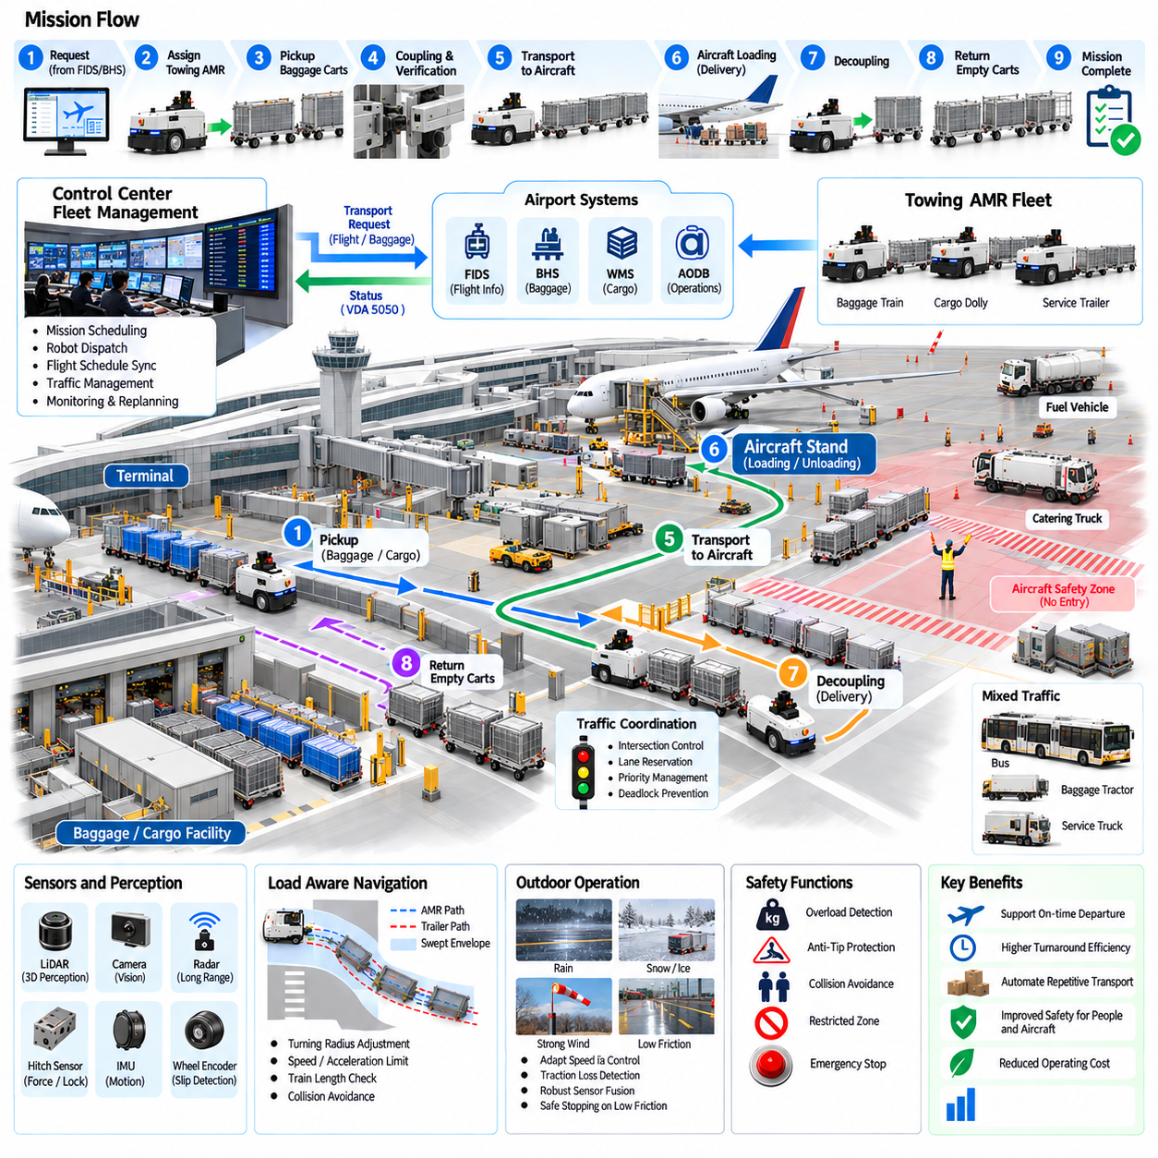
Airport ground support is a demanding application for towing AMRs because baggage carts, cargo dollies, service trailers, and equipment must move reliably between terminals, sorting facilities, warehouses, staging areas, and aircraft stands. Unlike controlled indoor factories, airport operations combine long travel distances, outdoor exposure, mixed traffic, strict turnaround schedules, and safety-critical zones around aircraft.
A typical application begins with transporting baggage or cargo trains from a handling facility to designated apron locations. The towing AMR receives a mission containing the pickup point, destination, required cart or dolly type, priority, and operational deadline. Because aircraft turnaround is highly time-sensitive, mission planning must coordinate vehicle availability with baggage processing, loading schedules, gate assignments, and changing flight operations.
Before departure, the AMR verifies the physical train configuration. Coupling sensors confirm mechanical engagement, while identification technologies can associate individual baggage carts or cargo dollies with the assigned mission. The controller also checks trailer count, train length, estimated load, coupling compatibility, and safety status. Incorrect or uncertain configuration should prevent movement into active airport traffic areas.
Airport towing requires load-aware motion control because train mass can vary substantially between empty and fully loaded baggage or cargo operations. Heavier trains require reduced acceleration, longer braking distance, and more conservative turning behavior. The navigation system should update speed and curvature limits according to estimated load, trailer count, surface conditions, and the geometry of the complete articulated train.
Turning geometry is especially important when long trains move through service roads, staging lanes, terminal corners, or restricted apron spaces. Rear trailers can track significantly inside the towing vehicle path and may approach fixed equipment or aircraft servicing infrastructure. Swept-path prediction should therefore evaluate every trailer segment, and routes should provide sufficient clearance for both normal turns and operational positioning.
Outdoor operation introduces environmental conditions that are less predictable than factory floors. Rain, snow, ice, standing water, dust, strong wind, and temperature variation can influence traction, braking, sensors, and mechanical couplings. The AMR should adapt speed and acceleration when available traction decreases and detect wheel slip or abnormal stopping behavior before continuing with a heavily loaded train.
Airport surfaces can also contain slopes, drainage transitions, pavement joints, and irregular areas that change towing resistance. Monitoring motor current, wheel motion, inertial data, and hitch force helps identify abnormal drag or a cart that is no longer rolling correctly. A persistent increase in resistance may indicate a damaged wheel, obstructed dolly, excessive load, or surface problem requiring controlled stopping and inspection.
Mixed traffic is one of the most important operational challenges. Towing AMRs may share service roads with manually driven baggage tractors, buses, fuel vehicles, catering trucks, maintenance vehicles, and personnel. Autonomous navigation must therefore use conservative interaction policies, predictable trajectories, controlled speeds, obstacle detection, and clearly defined right-of-way rules rather than assuming that surrounding traffic will behave cooperatively.
Operations near aircraft require particularly strict spatial constraints. The AMR must respect exclusion zones around engines, wings, landing gear, ground equipment, and other protected structures. Route maps can encode restricted regions and authorized approach corridors. Position uncertainty should be included in safety margins so that localization error cannot place a trailer inside a prohibited aircraft-clearance zone.
Personnel safety remains critical because ramp workers frequently move between vehicles and equipment. The towing vehicle may pass a worker before the final trailer reaches the same location, creating hazards that cannot be assessed from the AMR body alone. Protective sensing and path supervision should therefore consider the complete train envelope, with reduced speeds and enhanced caution in areas with frequent human activity.
Traffic coordination can reserve narrow lanes, crossings, or congested service areas for long towing trains. Reservations should remain active until the last trailer clears the controlled region. This is important because releasing a traffic zone when only the towing vehicle has exited can allow another vehicle to enter while rear trailers still occupy the conflict area. Train length must therefore be visible to traffic management.
Flight schedule changes can require dynamic mission replanning. A gate reassignment, delayed arrival, priority transfer baggage, or changed cargo destination may invalidate an existing transport plan. Fleet management should be able to update mission priorities and routes while considering the physical location and current load ownership of each train. Replanning must avoid unsafe mid-route configuration changes or unauthorized apron movements.
Battery and energy management are also affected by airport scale. Long routes, heavy trains, outdoor temperature, waiting time, and repeated acceleration can produce large variations in energy consumption. Dispatch software should estimate the energy required for the complete assignment and preserve sufficient reserve for reaching a safe stopping or charging location. Charging schedules should be coordinated with periods of lower transport demand.
Communication infrastructure must support operation across large and sometimes partially obstructed airport environments. Temporary network degradation should lead to predefined behavior rather than unpredictable mission continuation. Depending on the operational concept, an AMR may complete an already authorized segment, stop at a designated safe location, or restrict movement until fleet communication is restored, particularly near centrally coordinated traffic zones.
Fault recovery requires special attention because a stopped train can obstruct an important service route or delay aircraft turnaround. Coupling failure, localization degradation, excessive towing resistance, overload, sensor faults, or loss of traction should generate clear recovery actions. Fleet management may reroute other vehicles, dispatch assistance, or transfer the load, while maintaining accurate information about the location and identity of affected carts.
Traceability is valuable for baggage and cargo operations. Mission records can associate the towing AMR, trailer identifiers, source location, destination, timestamps, load state, route, and completion result. When integrated with airport logistics systems, this information can help determine whether a baggage or cargo train was collected, transported, delayed, redirected, or delivered to the intended operational area.
Operational performance should be evaluated using both robotic and airport logistics metrics. Useful measures include mission completion rate, on-time delivery, transport cycle time, coupling success, average train length, waiting time, energy use, manual intervention frequency, traffic delay, and fault recovery time. High vehicle speed alone is not a meaningful objective if it reduces predictability or creates additional risk around aircraft and personnel.
Deployment should normally progress from controlled routes toward more complex operational areas. Initial trials can use predictable baggage or cargo corridors with limited interaction, followed by broader mixed-traffic and apron operation after navigation, coupling, environmental robustness, and recovery procedures are validated. Simulation and controlled field testing can expose rare traffic and safety scenarios before full operational deployment.
The airport ground-support case demonstrates that towing AMR autonomy must extend beyond basic vehicle navigation. Reliable operation depends on verified train formation, load-aware control, environmental adaptation, complete-train collision checking, traffic coordination, personnel protection, fleet dispatch, and logistics integration. Together these capabilities allow autonomous towing to support time-critical airport material movement while maintaining predictable and safety-oriented operation.

03.10. Towing AMR VDA 5050 Integration Case
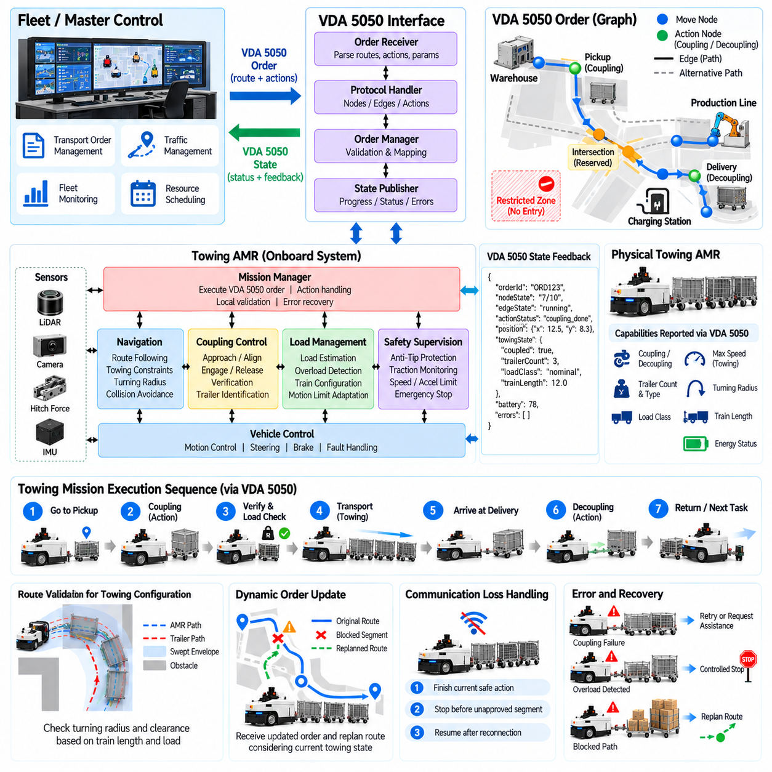
VDA 5050 integration provides a standardized communication layer between towing AMRs and a higher-level fleet or master control system. For towing applications, the interface must represent more than simple point-to-point vehicle movement because missions include coupling, trailer verification, load-dependent navigation, decoupling, and recovery. The integration therefore connects standardized fleet commands with towing-specific robot capabilities.
A practical architecture separates the master control, VDA 5050 communication interface, AMR mission manager, navigation system, coupling controller, load monitor, and safety functions. The master control determines transport intent and traffic coordination, while the AMR converts received orders into locally executable behavior. Real-time motion control and safety supervision remain on the vehicle rather than being performed through fleet communication.
VDA 5050 represents transport orders through graph-oriented routes containing nodes and edges. Nodes describe relevant positions where actions or state transitions can occur, while edges describe movement between them. For a towing mission, the graph can guide the AMR from its current position to a pickup station, through the transport route, and finally to a delivery location while preserving the ordered sequence required by the logistics process.
Towing-specific operations can be associated with actions executed at appropriate points in the mission. A pickup node may trigger precision positioning and coupling, while a delivery node may initiate controlled decoupling after destination conditions are verified. The VDA 5050 interface should translate these high-level actions into internal robot procedures rather than exposing individual actuator commands to the master control system.
Action execution requires clear validation because coupling changes the physical configuration of the vehicle. Before accepting a towing action, the AMR should confirm that the requested coupling type, trailer class, operating mode, and local conditions are supported. After execution, the robot reports whether the action is running, completed, failed, or rejected so that the master control can maintain an accurate representation of mission progress.
State reporting is particularly important for towing AMRs because vehicle capability changes after a trailer is connected. The robot can report its order progress, current node and edge, operating condition, action status, errors, and other standardized state information while internal software maintains detailed trailer and load data. Relevant towing information can be mapped into supported interfaces without weakening interoperability with other vehicles.
A useful integration pattern treats VDA 5050 as the coordination boundary and preserves towing intelligence inside the AMR. The master control does not need to calculate hitch forces, articulation angles, swept paths, or motor torque limits. Instead, it provides transport objectives and route authorization, while the robot determines whether the commanded movement is safe for its current payload, train length, and physical configuration.
Route validation remains necessary even when a valid order has been received. A route suitable for an unloaded AMR may become infeasible after coupling several trailers because turning radius, clearance, stopping distance, or restricted-zone requirements have changed. The AMR should therefore evaluate the received route against its current towing configuration and reject, pause, or request replanning when local constraints cannot be satisfied.
Traffic management also needs awareness of towing geometry. The master control may release route segments progressively as the vehicle advances, but a long train remains inside a controlled region after the towing unit has passed its boundary. Integration logic should ensure that node and edge progression does not cause shared resources to be released prematurely. Train length and clearance behavior must be reflected in traffic coordination policies.
Order updates are valuable when operational conditions change during execution. A blocked aisle, destination change, production priority change, or traffic restriction may require the remaining route to be modified. Updates should preserve the already executed portion of the mission and maintain consistency between master control and vehicle state. Changes that conflict with an active coupling or other noninterruptible operation should be delayed or rejected safely.
Communication reliability must be handled independently from physical safety. If communication with the master control is temporarily lost, the AMR should follow a defined local policy based on its current mission phase and authorized route. It may finish a locally safe action, stop before entering an unapproved segment, or move to a designated safe state. Communication recovery should resynchronize order and state information before normal execution resumes.
Error reporting allows towing-specific failures to become visible at fleet level without requiring the master control to understand every internal diagnostic signal. Coupling failure, overload, abnormal towing resistance, localization degradation, blocked motion, or trailer verification failure can be converted into meaningful error states. Internal diagnostics may remain more detailed, while external reporting provides enough information for mission recovery and operator intervention.
Recovery procedures should maintain consistency between logical mission state and physical trailer state. If a coupling action succeeds mechanically but communication is interrupted before confirmation reaches the master control, blindly repeating the command could create an unsafe condition. The AMR should therefore use persistent local state and physical verification to determine the actual configuration before accepting repeated, updated, or recovered orders.
Fleet interoperability is one of the main reasons for adopting VDA 5050. A facility may operate towing AMRs, pallet transport robots, forklifts, and other automated guided vehicles from different suppliers. A standardized interface reduces the need for a unique fleet protocol for every vehicle type. Vehicle-specific capabilities remain local, while common order, state, action, and error concepts provide a shared coordination mechanism.
Capability negotiation and configuration management become important in heterogeneous fleets. The master control should know whether a particular AMR supports towing, automatic coupling, specific trailer classes, required actions, and relevant operating constraints before assigning a mission. Software or configuration changes should also be managed carefully so that the master control does not request an action or parameter combination unsupported by the deployed vehicle version.
Testing should verify both protocol behavior and physical mission behavior. Interface tests can examine message structure, order handling, state transitions, action status, error reporting, update behavior, and communication recovery. System-level tests should additionally confirm that protocol commands produce correct coupling, towing, traffic interaction, stopping, and decoupling behavior under realistic payload and trailer configurations.
Logging across the integration boundary improves troubleshooting and traceability. VDA 5050 messages, internal mission transitions, coupling events, load estimates, navigation decisions, safety events, and timestamps can be correlated into a single execution history. This allows engineers to distinguish communication problems from robot-control failures and provides evidence for analyzing delays, rejected orders, repeated actions, and recovery sequences.
A successful VDA 5050 towing integration therefore does not replace the AMR's autonomous control architecture. It provides a standardized mechanism through which a master control can assign, coordinate, observe, and update transport missions while the robot retains responsibility for real-time execution and safety. This separation supports multi-vendor fleet interoperability while preserving the specialized intelligence required for reliable towing operation.

