Volume 26. Industrial Robot Applications

Chapter 02. Hospital and Service Robot Applications

02.01. Hospital Robot Use Cases Delivery Disinfection Guide
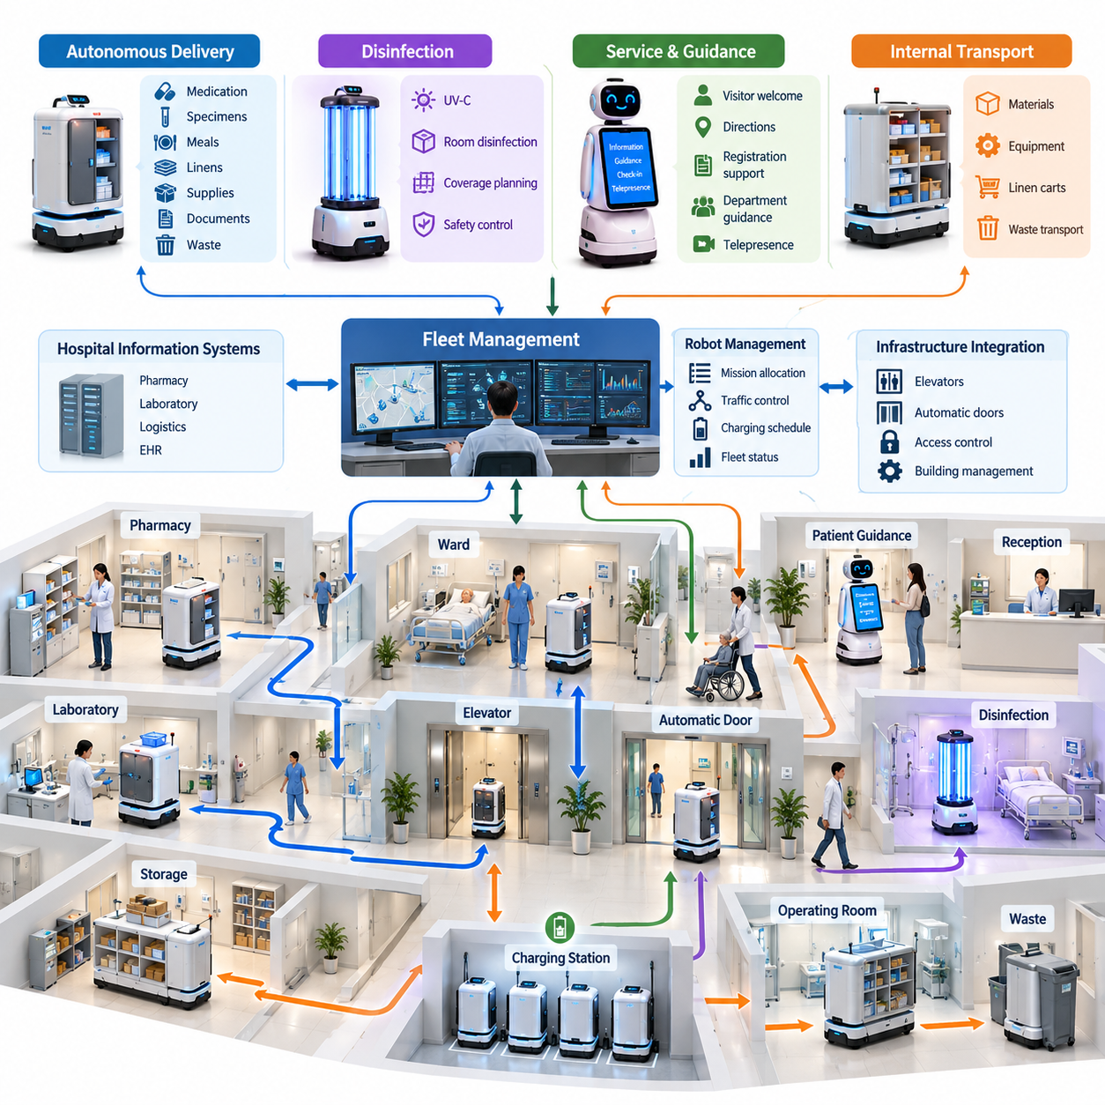
Hospital robots are increasingly deployed as operational infrastructure rather than isolated technology demonstrations. Their primary purpose is to reduce repetitive staff workload, improve the consistency of logistics and infection-control processes, and extend services into areas where continuous human staffing is difficult. Common applications include autonomous delivery, environmental disinfection, patient guidance, information assistance, telepresence, and internal material transportation. Volume_26_Industrial_Robot_Appl…
Autonomous delivery is one of the most mature hospital robot applications. Mobile robots can transport medications, laboratory specimens, meals, linens, medical supplies, documents, and waste between pharmacies, laboratories, wards, operating rooms, storage areas, and other departments. By automating predictable transportation tasks, hospitals can reduce unnecessary walking by clinical staff and allow nurses and technicians to spend more time on activities directly related to patient care.
Hospital delivery differs significantly from warehouse transportation because the environment is shared continuously with patients, visitors, wheelchairs, stretchers, carts, and medical personnel. Corridors may become congested without warning, temporary equipment may block previously valid routes, and people may behave unpredictably. The robot therefore requires robust localization, dynamic obstacle detection, socially acceptable motion planning, safe stopping behavior, and mechanisms for recovering from blocked paths without creating additional congestion.
A typical delivery mission begins when a hospital information system, logistics application, or authorized staff member generates a transportation request. A fleet-management service assigns an appropriate robot according to location, payload capacity, battery state, mission priority, and availability. The robot navigates to the pickup station, verifies loading, travels to the destination, authenticates the recipient when necessary, confirms delivery, and records the mission result for operational traceability.
Payload security is especially important when robots transport medication, specimens, or sensitive materials. Compartments may incorporate electronic locks, access authentication, door sensors, temperature monitoring, and tamper detection. Software should associate every payload with a mission identifier and maintain a clear chain of custody from loading to unloading. Failed authentication, unexpected compartment opening, excessive delivery delay, or environmental deviations should generate controlled exceptions rather than allowing the robot to continue silently.
Disinfection robots address a different hospital requirement: reducing microbial contamination in rooms and shared spaces. Ultraviolet-C systems are commonly designed to expose selected surfaces to germicidal radiation after appropriate safety conditions have been established. Unlike transportation missions, effective disinfection depends not only on reaching a destination but also on achieving adequate spatial coverage, exposure duration, radiation intensity, and line-of-sight conditions while preventing unsafe human exposure.
A disinfection mission can therefore be modeled as a coverage-planning problem. The robot receives a room or zone definition, identifies reachable treatment positions, estimates areas affected by occlusion, and executes a sequence of exposure points or trajectories. Sensors can monitor doors, human presence, robot position, lamp state, and operating conditions. If a person enters the controlled area or a safety condition is violated, ultraviolet emission must be interrupted independently of the higher-level mission objective.
Service and guidance robots focus more strongly on human-robot interaction. They may welcome visitors, provide directions, explain registration procedures, guide users to departments, support check-in workflows, or connect patients with remote personnel. Such systems require understandable interfaces and predictable behavior because users may include children, older adults, people with disabilities, international visitors, or patients unfamiliar with robotic technology. Speech, touch displays, visual cues, and physical guidance can therefore be combined.
Physical guidance requires the conversational interface to cooperate closely with navigation. A robot cannot simply calculate the shortest route and move at maximum efficiency. It must maintain a comfortable speed, determine whether the person is still following, stop at appropriate locations, avoid separating from the user in crowds, and provide understandable explanations at intersections or elevators. Human-aware navigation therefore becomes an essential component of the service rather than merely an optimization feature.
Elevators and automatic doors are particularly important infrastructure interfaces because hospitals are usually multi-floor environments divided by controlled access zones. A delivery robot may need to request an elevator, wait safely, identify the assigned car, enter without obstructing people, select a destination floor through an integration interface, and exit correctly. Door controllers, access-control systems, and building-management infrastructure similarly become part of the end-to-end robotic application. Volume_26_Industrial_Robot_Appl…
Hospital robots should also be considered as a coordinated fleet rather than independent mobile machines. Multiple delivery, disinfection, and service robots may compete for corridors, elevators, charging stations, and staging areas. Fleet software can allocate missions, prioritize urgent transportation, balance workload, manage charging schedules, prevent traffic conflicts, and maintain operational status. Integration with hospital information systems allows robotic missions to become part of established clinical and logistical workflows instead of requiring separate manual procedures.
Safety requirements extend beyond collision avoidance. Robots operate close to vulnerable people and expensive medical equipment, so systems should combine speed and separation monitoring, emergency stopping, obstacle detection, controlled acceleration, safe docking, fault monitoring, and degraded operating modes. A localization failure, sensor obstruction, communication loss, motor fault, unexpected payload condition, or blocked route should move the system toward a defined safe state and trigger appropriate recovery or human assistance.
Service-robot safety also depends on understanding the limits of autonomy. The robot should not improvise actions outside its authorized operational domain simply because a route or task appears technically achievable. Restricted clinical zones, isolation areas, sterile environments, emergency routes, and temporary hazard zones may impose contextual constraints. Mission planning should therefore combine geometric maps with semantic information describing where the robot may travel, what activities are permitted, and under which operating conditions.
Infection control introduces requirements that are uncommon in conventional industrial AMRs. Robot surfaces, touch interfaces, payload compartments, wheels, and frequently handled components can become contamination vectors if cleaning procedures are poorly designed. Hardware should support practical cleaning, while software can schedule hygiene procedures, record sanitation events, restrict movement between contamination zones, and prevent a robot from immediately transferring between incompatible areas without completing required decontamination workflows. Volume_26_Industrial_Robot_Appl…
Data protection is another critical design dimension. Hospital robots may process navigation maps, camera streams, voice interactions, patient-related delivery information, access credentials, and operational logs. The system should minimize collection of unnecessary information, separate operational telemetry from sensitive records where possible, encrypt protected communications, enforce role-based access, maintain audit trails, and define retention policies. Privacy requirements must be incorporated into architecture and fleet operations rather than added only after deployment.
Reliable operation also requires continuous observability. Fleet dashboards should expose robot position, mission state, battery level, charging status, localization confidence, sensor health, payload state, communication quality, and active faults. Operational metrics such as mission completion rate, average delivery time, intervention frequency, blocked-path events, charging utilization, downtime, and recovery time help engineers determine whether automation is actually improving hospital operations instead of merely demonstrating technical autonomy.
Deployment should begin with detailed workflow analysis rather than immediate robot installation. Engineers need to observe transportation demand, corridor traffic, elevator usage, charging opportunities, access restrictions, infection-control boundaries, wireless coverage, and staff interactions. Candidate workflows can then be evaluated according to frequency, labor burden, predictability, safety risk, integration complexity, and expected operational value. Stable repetitive tasks usually provide a better initial automation target than rare or highly variable activities.
Pilot deployment should validate complete workflows under realistic conditions. Testing should include normal missions as well as crowded corridors, blocked passages, elevator delays, unavailable destinations, failed authentication, low battery, communication interruptions, sensor degradation, emergency traffic, and manual intervention. Successful operation is measured not simply by whether a robot can navigate from one point to another, but by whether the entire service remains safe, understandable, recoverable, and compatible with hospital procedures.
Ultimately, delivery, disinfection, and guidance represent complementary forms of hospital automation. Delivery robots automate physical logistics, disinfection robots automate environmental treatment, and guidance robots automate selected human-facing services. Their underlying capabilities—navigation, perception, fleet coordination, infrastructure integration, human interaction, safety supervision, cybersecurity, and data management—form a reusable service-robot platform that can support progressively broader hospital applications as operational experience grows.

02.02. Hospital AMR Autonomous Delivery SW [w/Code]
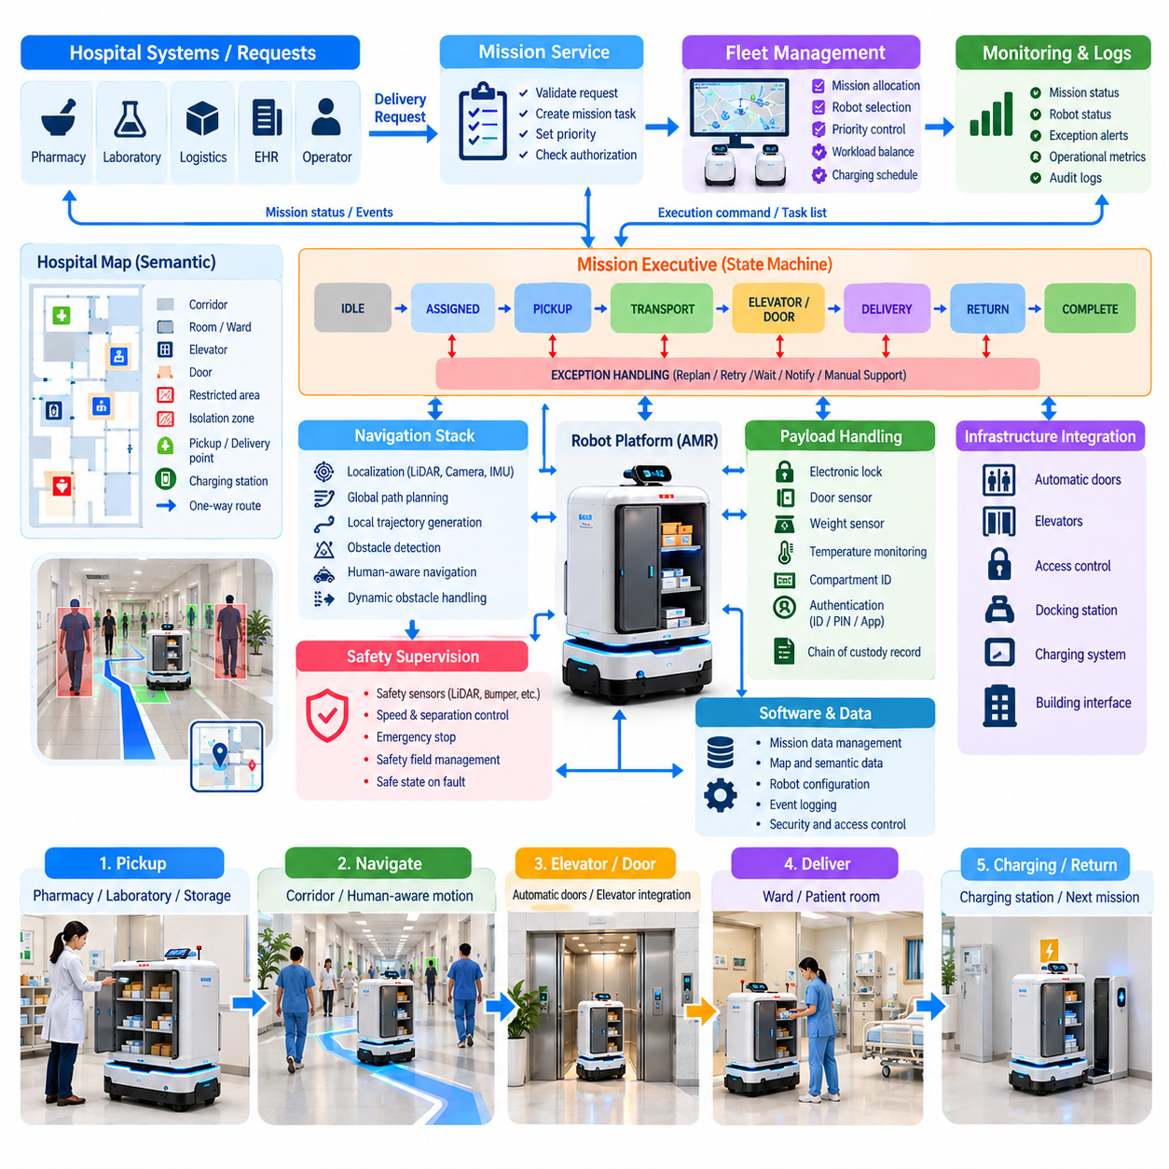
Hospital autonomous mobile robot software converts clinical and logistical delivery requests into safe, traceable physical transportation missions. Unlike a warehouse AMR, a hospital AMR operates continuously among patients, visitors, nurses, carts, wheelchairs, and emergency traffic. Its software must therefore combine mission execution, navigation, human-aware motion, payload security, infrastructure integration, safety supervision, and operational monitoring within one coordinated architecture.
The delivery workflow normally begins when a request is generated by a hospital information system, pharmacy application, laboratory system, logistics platform, or authorized operator. The request specifies pickup and destination locations, payload characteristics, priority, timing constraints, and required authorization. A mission service validates these parameters and converts the business-level request into executable robot tasks such as pickup, transport, waiting, authentication, unloading, and return.
Mission allocation is typically performed by a fleet-management layer rather than by individual robots. The dispatcher evaluates robot position, availability, battery state, payload capacity, compartment configuration, current workload, and mission priority before assigning a task. Emergency or time-sensitive deliveries may receive higher priority than routine material transport. Dynamic reassignment is also necessary when a robot becomes unavailable, a destination is blocked, or operational conditions change during execution.
Once assigned, the robot transforms semantic destinations such as “Pharmacy A” or “Ward 5 Medication Station” into navigation goals associated with the hospital map. The navigation stack combines localization, global path planning, local trajectory generation, obstacle detection, and motion control. Hospital maps should contain not only geometric information but also semantic constraints including restricted rooms, staff-only corridors, isolation zones, elevator waiting areas, docking stations, and one-way passages.
Localization must remain reliable despite repetitive corridors, moving people, glass surfaces, temporary equipment, and frequent environmental changes. LiDAR, cameras, wheel odometry, and inertial measurements can be fused to estimate robot pose. Software should continuously monitor localization confidence rather than assuming that every estimated pose is valid. When confidence falls below an acceptable threshold, the robot can reduce speed, stop safely, attempt relocalization, or request operator assistance instead of continuing with uncertain positioning.
Human-aware navigation is essential because the shortest geometric path is not always the safest or most socially acceptable route. The local planner must detect pedestrians and other moving obstacles, estimate available free space, maintain appropriate separation, and generate smooth trajectories. Motion parameters can be adapted for narrow corridors, crowded waiting areas, intersections, patient rooms, and open halls so that the robot behaves predictably without producing excessive stops or aggressive avoidance maneuvers.
Dynamic obstacle handling requires more than immediate collision avoidance. A temporary obstacle may disappear within seconds, while a parked cart can block a corridor for hours. The software should distinguish short-term waiting from conditions requiring replanning. After a configurable timeout, the navigation manager can search for an alternate route, notify fleet management, or request human intervention. Repeated failures should be recorded so persistent operational bottlenecks can be identified and corrected.
Payload handling forms another major software subsystem. Delivery compartments can include electronic locks, door-state sensors, weight sensors, temperature monitoring, and identification devices. The robot verifies that the correct compartment is available before pickup and confirms that loading has been completed before departure. At the destination, unloading can require staff authentication through an ID badge, PIN, mobile application, or integration with an institutional access-control service.
For medications, specimens, and other controlled materials, delivery software should maintain an electronic chain of custody. Important events such as request creation, robot assignment, compartment opening, pickup confirmation, departure, arrival, recipient authentication, unloading, and mission completion are timestamped. Unexpected compartment access, temperature excursions, excessive delays, or authentication failures become explicit exceptions that can be reported to authorized hospital systems and personnel.
Hospital infrastructure integration is particularly important for autonomous delivery because a useful robot must operate across more than a single corridor. Automatic doors, secure access points, elevators, docking stations, and charging systems become software-controlled resources. Instead of manipulating physical buttons whenever possible, the robot or fleet platform can exchange authenticated requests with building interfaces, allowing controlled door opening and coordinated elevator calls while preserving existing access policies.
Elevator execution is naturally represented as a state machine. The robot requests service, navigates to an assigned waiting position, confirms elevator arrival, verifies that entry is safe, enters the car, requests the target floor, monitors travel, and exits after arrival. Timeouts and recovery transitions are required at every stage because elevators may be occupied, doors may close unexpectedly, passengers may block entry, or communication with the building interface may fail.
A mission executive coordinates these subsystems through explicit operational states. A typical sequence may progress through IDLE, ASSIGNED, NAVIGATING_TO_PICKUP, LOADING, NAVIGATING_TO_DESTINATION, WAITING_FOR_RECIPIENT, UNLOADING, and COMPLETED. Additional states such as BLOCKED, LOW_BATTERY, AUTHENTICATION_FAILED, INFRASTRUCTURE_ERROR, SAFETY_STOP, and MANUAL_ASSISTANCE make abnormal situations visible and prevent complex failures from being hidden inside navigation logic.
Battery management must also participate in mission planning. The fleet system estimates whether sufficient energy remains to complete a delivery with an appropriate safety margin. Charging can be scheduled between missions, during low-demand periods, or whenever predicted energy falls below operational thresholds. If battery state deteriorates unexpectedly during a mission, software must decide whether safe completion, task transfer, or controlled charging is preferable rather than allowing uncontrolled shutdown.
Safety supervision should remain logically separated from ordinary mission optimization. Emergency-stop inputs, protective sensor events, drive faults, excessive speed, bumper activation, localization loss, and other critical conditions can override mission execution. After a safety stop, the system should not automatically resume merely because the original delivery remains incomplete. Recovery requires verification that the triggering condition has disappeared and that continued movement is permitted by the defined safety policy.
Communication between robot, fleet server, hospital systems, and infrastructure controllers should tolerate temporary network disruption. Essential navigation and immediate safety functions remain local to the robot, while higher-level dispatch and enterprise integration may depend on network services. Commands should include identifiers, timestamps, authorization information, and acknowledgement mechanisms so that reconnection does not accidentally duplicate deliveries or execute stale mission requests.
Observability is necessary for operating an AMR fleet as a hospital service. Telemetry can report pose, velocity, mission state, battery level, compartment status, localization confidence, network condition, safety events, and active faults. Centralized logs correlate robot events with fleet decisions and external system requests. Operators can then distinguish navigation problems from infrastructure failures, workflow errors, communication faults, and user-related exceptions.
Software recovery should follow predefined escalation policies. Minor conditions can be handled autonomously through retry, local replanning, relocalization, or resource re-request. Persistent failures can be escalated to remote operators, while situations involving payload security or physical safety may require local staff intervention. Each recovery action should preserve mission context so that the robot can resume safely or terminate the task without losing traceability.
Deployment testing must validate complete delivery workflows rather than navigation performance alone. Tests should reproduce crowded corridors, crossing pedestrians, blocked routes, elevator congestion, automatic-door failures, unavailable recipients, incorrect authentication, compartment faults, network interruptions, localization degradation, low battery, and emergency traffic. Successful testing demonstrates that normal operation and abnormal recovery both produce deterministic and understandable system behavior.
The resulting software architecture makes the hospital AMR more than an autonomous vehicle. It becomes a distributed cyber-physical delivery service connecting robots, fleet intelligence, building infrastructure, hospital applications, staff, and physical payloads. Reliable deployment depends on treating navigation, mission orchestration, security, safety, recovery, and enterprise integration as parts of the same operational system, providing the foundation for scalable hospital robot fleets.

02.03. UV Disinfection Robot Path Coverage Planning [w/Code]
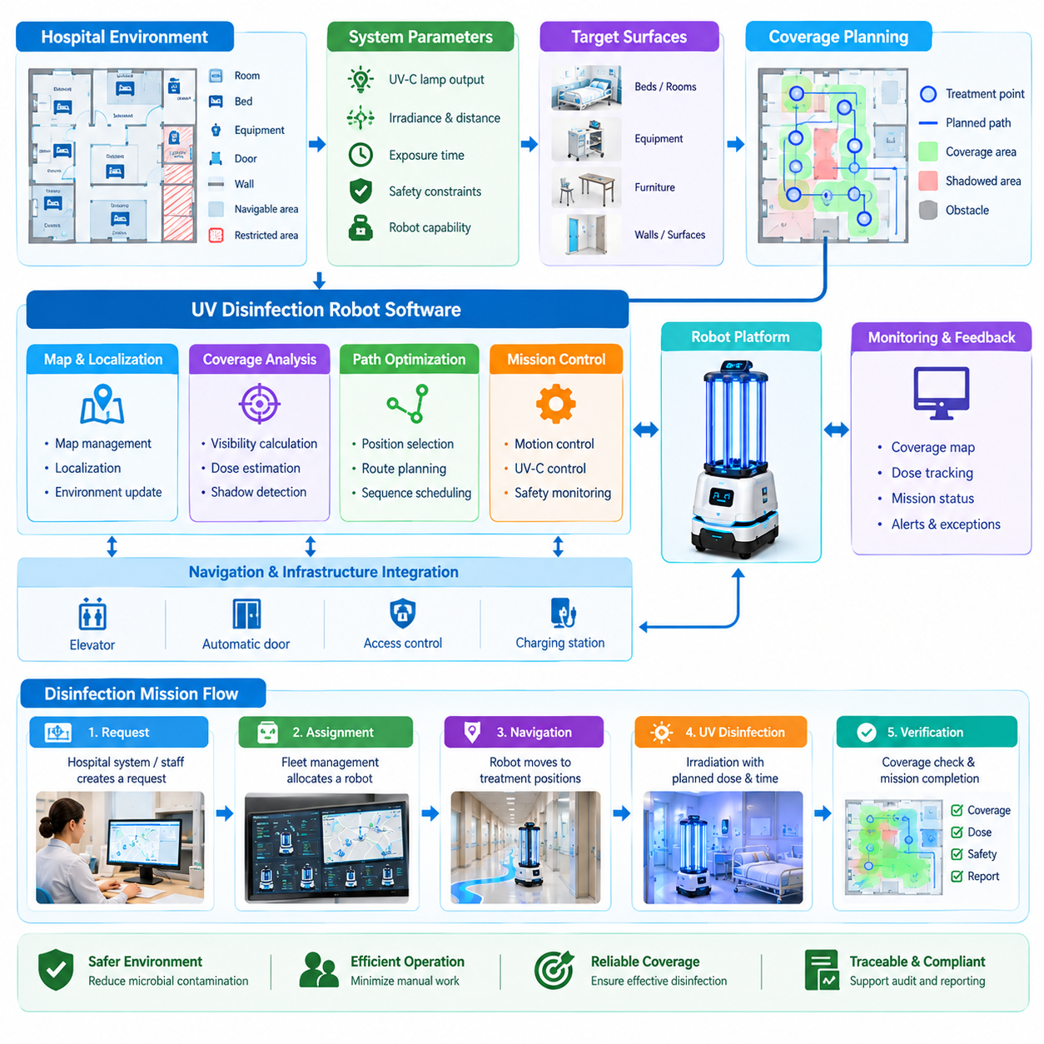
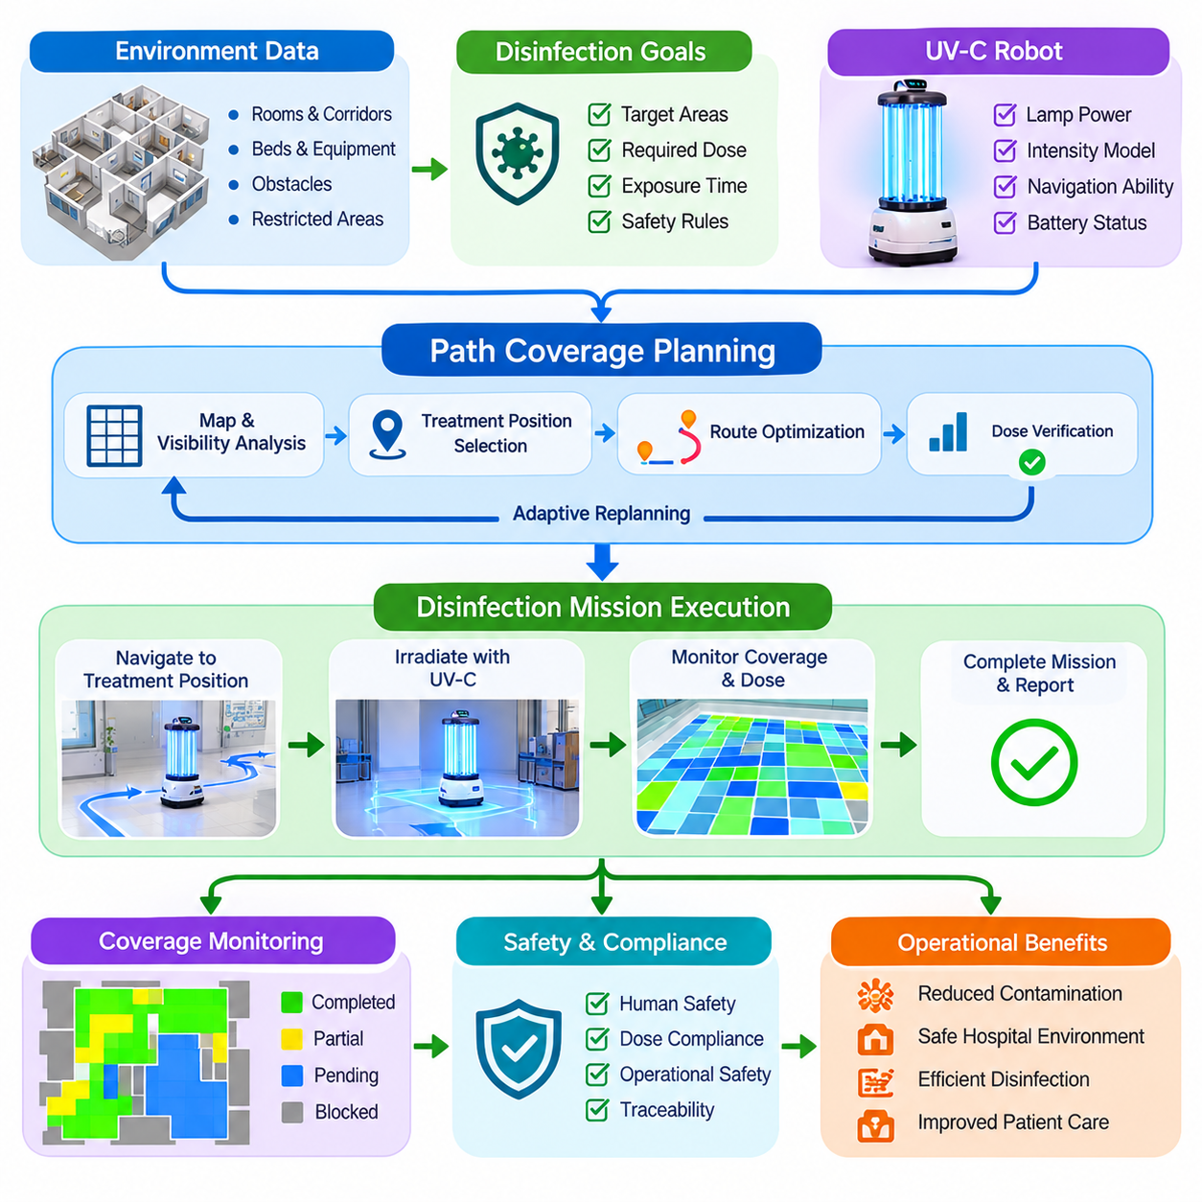
Ultraviolet disinfection robots combine autonomous mobility with controlled UV-C irradiation to reduce microbial contamination in hospital rooms and shared spaces. Their effectiveness depends not simply on moving through an area, but on delivering an adequate radiation dose to relevant surfaces. Path coverage planning must therefore coordinate geometric coverage, exposure time, lamp characteristics, obstacle geometry, localization accuracy, and human-safety constraints throughout the disinfection mission.
The planning problem begins with a representation of the treatment environment. A hospital map provides walls, doors, beds, cabinets, equipment, and navigable free space, while semantic information identifies rooms, treatment zones, restricted areas, and locations requiring special attention. The planner transforms this environmental model into candidate robot positions and trajectories from which UV-C radiation can reach targeted surfaces with acceptable distance and incidence geometry.
Conventional coverage path planning focuses primarily on ensuring that a mobile robot physically traverses an entire accessible region. UV disinfection requires a different interpretation of coverage because the robot does not need to drive over every surface. Instead, the planner must determine whether surfaces receive sufficient irradiation. A location can be geometrically visible yet receive an inadequate dose because it is too far from the lamp, exposed for too little time, or partially shadowed by surrounding objects.
Radiation dose can be modeled conceptually as the accumulation of irradiance over exposure time. If E represents the effective irradiance reaching a surface and t represents exposure duration, the delivered dose can be approximated as D = E × t under simplified conditions. In practical planning, E varies with lamp output, distance, orientation, occlusion, reflection, and environmental geometry, so the robot must continuously relate spatial configuration to the expected disinfection effectiveness.
Distance has a strong influence on irradiation planning. As the robot moves farther from a target surface, the available UV intensity generally decreases, requiring longer exposure to achieve the same target dose. A planner can therefore trade movement against dwell time. Stopping closer to several important surfaces may reduce irradiation duration, while fewer treatment positions may simplify motion but require longer exposure and potentially leave difficult shadow regions insufficiently treated.
Occlusion is one of the central challenges of UV coverage planning. Beds, carts, tables, medical devices, partitions, and other objects can block direct radiation and create shadowed regions. A planner can use occupancy or three-dimensional environmental information to estimate line-of-sight visibility between lamp locations and target surfaces. Multiple irradiation positions are then selected so that surfaces hidden from one position can potentially be exposed from another direction.
Candidate treatment positions can be generated from the navigable map and filtered according to clearance, accessibility, lamp range, and safety requirements. Each candidate is associated with a set of visible target regions and an estimated irradiation contribution. The planning problem then resembles a coverage optimization task: select a practical subset of positions that collectively satisfy treatment requirements while minimizing unnecessary travel, repeated exposure, and total mission duration.
After selecting treatment positions, the system must determine their visiting sequence. This creates a route-optimization problem related to the traveling salesperson problem, but with additional robotic constraints. Travel distance, turning cost, narrow passages, battery consumption, room boundaries, and required treatment order may influence the sequence. The resulting plan combines navigation segments with stationary or slow-moving irradiation phases into one executable disinfection mission.
Continuous-motion disinfection is another possible strategy. Instead of stopping at fixed treatment points, the robot follows a planned trajectory while controlling velocity according to the required exposure. Regions requiring a higher dose can be traversed more slowly, whereas open areas with favorable geometry can permit faster motion. This approach converts velocity into an additional planning variable and requires accurate synchronization among robot pose, UV output, trajectory progression, and accumulated dose estimates.
A coverage map can represent treatment progress during mission execution. The environment is divided into cells, surface elements, or semantic regions, and each element stores an estimated accumulated dose or coverage state. As the robot moves and operates its lamps, the software updates this map according to robot position and irradiation geometry. The mission controller can then distinguish untreated, partially treated, adequately treated, and inaccessible regions instead of relying only on traveled distance.
Coverage monitoring also enables adaptive replanning. Hospital environments rarely remain identical to their original maps because beds, carts, chairs, and equipment can be moved between missions. Sensor observations may reveal newly blocked regions or previously unknown obstacles. The planner can update the local environmental representation, recompute visibility, select additional irradiation positions, or modify the remaining route so that environmental changes do not silently create untreated areas.
Navigation and disinfection planning should remain coordinated but logically separable. The coverage planner determines where irradiation should occur and how much treatment is required, while the navigation stack determines how the robot can safely reach those locations. If a planned treatment position becomes unreachable, navigation reports the failure to the mission layer, which can select an alternative position rather than repeatedly attempting an impossible path.
Human safety has higher priority than coverage completion. UV-C exposure can be hazardous, so the system must ensure that irradiation occurs only under defined safety conditions. Door sensors, presence detectors, cameras, LiDAR, safety scanners, access-control interfaces, or external room signals may contribute to occupancy monitoring. Detection of a person or violation of a controlled-area condition should immediately disable UV emission even if doing so interrupts the planned dose.
The mission software can represent disinfection as a state machine containing preparation, room verification, navigation, occupancy checking, UV activation, irradiation, coverage verification, and completion states. Safety interruption, door opening, human detection, localization failure, lamp fault, and navigation blockage become explicit exception states. This architecture prevents irradiation control from being treated as an incidental function of ordinary autonomous navigation.
Localization accuracy directly affects dose estimation because the planner assumes that radiation originates from a known robot position. Significant pose error can cause the software to overestimate treatment of surfaces that were not actually exposed as expected. The system should therefore monitor localization confidence during irradiation and suspend or invalidate uncertain treatment segments when position quality falls below the level required for reliable coverage estimation.
Lamp monitoring is equally important. A commanded UV state does not necessarily prove that the expected radiation was produced. The robot can monitor lamp current, operating time, temperature, UV intensity sensors, or other available health indicators. Coverage accounting should preferably depend on verified lamp operation rather than command state alone, preventing failed or degraded emitters from producing misleading records that indicate successful disinfection.
Mission completion should be determined by treatment criteria rather than simply by reaching the final waypoint. The software evaluates whether required regions have achieved their target coverage or estimated dose and identifies areas that remain untreated or uncertain. Depending on policy, incomplete areas may trigger additional treatment positions, operator notification, mission failure, or a report explaining why full coverage could not be achieved.
Operational records provide traceability for hospital infection-control workflows. A completed mission can store the room identifier, robot identifier, start and completion times, executed trajectory, treatment positions, lamp operating periods, coverage estimate, interruptions, safety events, and detected exceptions. These records allow operators to distinguish a successfully completed treatment from a mission that merely traveled through the assigned room.
Testing should include both geometric and operational validation. Engineers can construct scenarios with beds, tables, movable carts, partitions, narrow spaces, and representative shadow regions, then compare planned coverage with measured or independently estimated UV exposure. Additional tests should introduce door openings, human entry, localization degradation, blocked treatment positions, lamp faults, and communication interruptions to verify safe and deterministic recovery behavior.
The resulting path coverage planner transforms a UV robot from a mobile lamp into a controlled disinfection system. Navigation determines where the platform can move, visibility analysis determines which surfaces can be reached by radiation, dose estimation determines how long treatment is required, and safety supervision determines when irradiation is permitted. Their integration enables measurable, repeatable, traceable, and adaptable autonomous disinfection within complex hospital environments.

02.04. Elevator and Automatic Door Integration [w/Code]
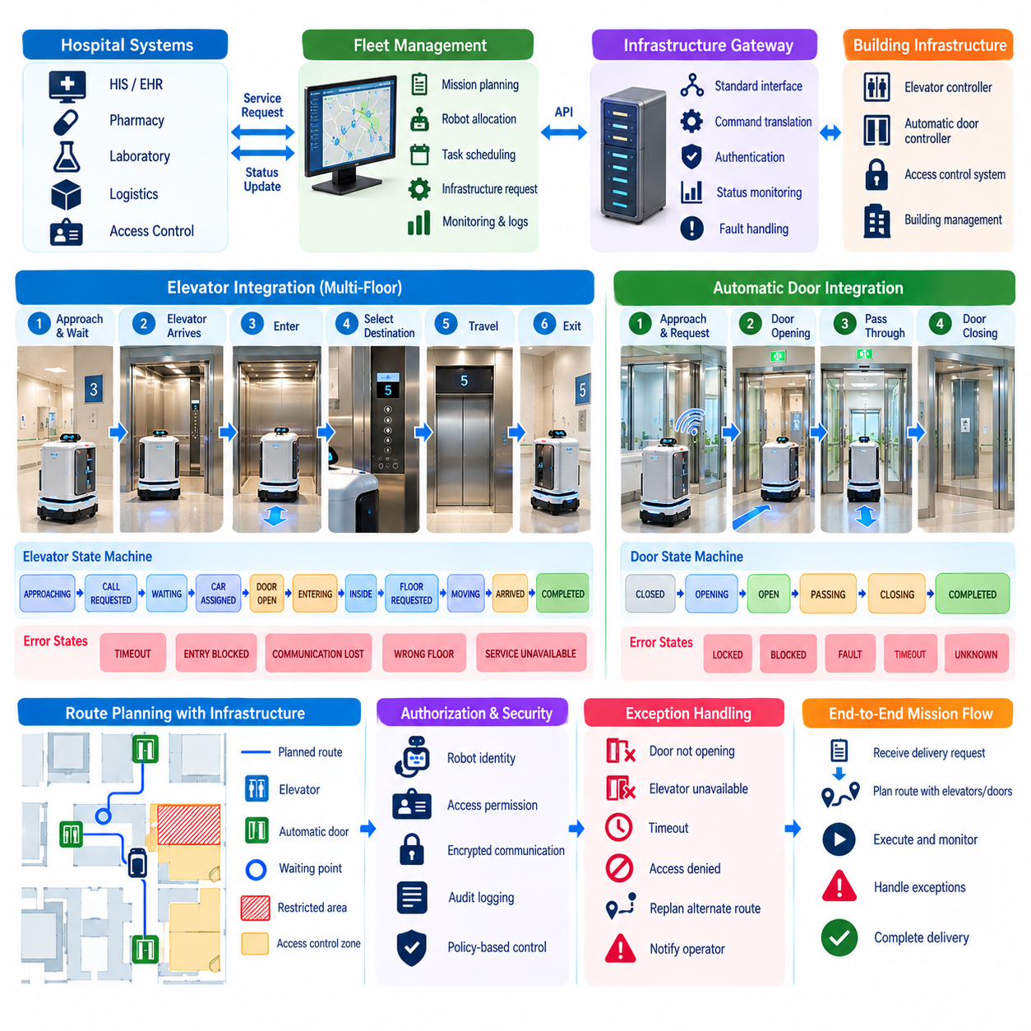
Elevator and automatic door integration is essential for hospital autonomous mobile robots that must operate across multiple floors and controlled zones. Navigation alone cannot provide end-to-end autonomy when physical infrastructure blocks movement between areas. The robot software must therefore coordinate mobility with elevators, automatic doors, access-control systems, and building interfaces while maintaining safety, authorization, mission continuity, and predictable recovery behavior.
A typical integration architecture separates robot navigation from infrastructure control. The robot or fleet manager sends service requests to an infrastructure gateway, which communicates with elevator controllers, door controllers, or building-management systems through supported interfaces. This abstraction prevents navigation software from depending directly on vendor-specific hardware and allows different elevator or door technologies to be represented through standardized commands, states, acknowledgements, and fault information.
When a mission requires movement between floors, the route planner identifies an elevator transition as part of the semantic route. Instead of treating the elevator as ordinary free space, the mission executive creates a sequence of infrastructure-dependent actions. These actions include traveling to a waiting point, requesting an elevator, receiving assignment information, entering the correct car, requesting the destination floor, monitoring movement, and exiting safely before normal navigation resumes.
Elevator operation can be implemented as an explicit state machine. Representative states include APPROACHING, CALL_REQUESTED, WAITING, CAR_ASSIGNED, DOOR_OPEN, ENTERING, INSIDE, FLOOR_REQUESTED, MOVING, ARRIVED, EXITING, and COMPLETED. Error states such as TIMEOUT, ENTRY_BLOCKED, COMMUNICATION_LOST, WRONG_FLOOR, or SERVICE_UNAVAILABLE make abnormal conditions visible and allow the mission controller to execute controlled recovery instead of hiding failures inside navigation logic.
The robot should wait at a predefined staging position rather than directly in front of elevator doors. This prevents interference with passengers who must exit before the robot enters and provides sufficient space for perception and maneuvering. When the assigned elevator arrives, the robot verifies door state and entry conditions. If people, wheelchairs, stretchers, or carts occupy the entrance, the robot can wait for clearance or abandon the current boarding attempt according to configured timing and safety policies.
Entering an elevator introduces localization challenges because the environment differs from normal corridors. Metallic surfaces, mirrors, narrow geometry, moving doors, and limited sensor visibility can reduce localization quality. The navigation system may therefore use a dedicated elevator behavior with predefined entry trajectories, reduced speed, local odometry, short-range sensing, or temporarily modified localization strategies. The objective is controlled movement rather than ordinary map-based navigation performance.
Once inside the elevator, the robot must determine that it is completely within the car before allowing door closure or requesting travel. Position, range sensing, wheel odometry, and infrastructure status can contribute to this verification. The robot then requests the destination floor through the elevator integration service. During travel, drive commands are normally inhibited so that unexpected localization changes or apparent motion caused by elevator movement do not cause the robot to move unnecessarily.
Arrival must be confirmed using infrastructure information and robot-side observations whenever possible. The elevator controller can report the current floor and door status, while the robot verifies that an exit path is available. After the doors open, the robot leaves using a controlled trajectory, reaches a known localization area, and confirms its pose on the destination-floor map. Normal autonomous navigation resumes only after successful relocalization and completion of the elevator transition.
Automatic door integration follows a similar resource-oriented model. A semantic map identifies doors that require electronic activation, authentication, or special handling. As the robot approaches a configured request point, it sends an open request containing its identity and relevant authorization information. The door-control service verifies permission, activates the door, and reports its state. The robot proceeds only after confirming that the opening is sufficient for safe passage.
Door states should be modeled explicitly rather than assuming that an open command succeeded. Useful states include CLOSED, OPENING, OPEN, CLOSING, LOCKED, BLOCKED, FAULT, and UNKNOWN. The navigation system uses these states to decide whether passage is permitted. If the door remains closed, reports a fault, or loses communication, the robot stops at a safe location and invokes recovery instead of repeatedly approaching the physical barrier.
Timing is particularly important because automatic doors may close before a slow-moving robot has completely passed through them. Integration software should coordinate opening duration with the robot's approach and traversal state. Presence sensors, robot position, and door-controller feedback can be used to keep the passage available until clearance is confirmed. The robot should also maintain conservative speed and clearance margins because patients or staff may simultaneously use the doorway.
Access-controlled doors introduce authorization requirements beyond simple opening. A hospital may contain pharmacies, laboratories, staff-only areas, isolation zones, operating departments, or other restricted spaces. Infrastructure requests should therefore be evaluated according to robot identity, assigned mission, destination, time, and access policy. A robot authorized for one delivery should not automatically receive unrestricted access to every controlled zone merely because it possesses network connectivity.
Security is critical because elevator and door interfaces connect robots with building infrastructure. Communication should use authenticated endpoints, encrypted channels where appropriate, authorization policies, request identifiers, timestamps, and audit logging. Commands should be resistant to replay and duplication so that an old request cannot unexpectedly open a door or call an elevator. Infrastructure credentials should also be managed separately from ordinary application configuration.
Multiple robots create an additional coordination problem. Several AMRs may request the same elevator simultaneously, causing congestion if each behaves independently. Fleet management can serialize requests, reserve elevator resources, assign staging positions, and prioritize missions according to operational requirements. The same concept applies to narrow secure doors, where coordinated access prevents robots traveling in opposite directions from blocking each other at the passage.
Resource reservation allows infrastructure interactions to become part of route planning. The planner can estimate elevator waiting time, service availability, congestion, and alternative routes when selecting a mission path. If several elevator banks connect the same floors, fleet software can distribute traffic among them. Infrastructure-aware planning therefore optimizes not only geometric distance but also expected mission duration, traffic conditions, and availability of shared building resources.
Failure recovery must be designed for each stage of an infrastructure interaction. If an elevator does not arrive, the robot can retry, request another car, use an alternative elevator, or notify the fleet manager. If entry becomes blocked, it can return to the staging point and wait. If a door fails to open, the system can retry authorization, select another route, or request human assistance while preserving the original delivery mission and payload state.
Communication loss requires particularly careful handling. The robot should never assume that an infrastructure command succeeded simply because it was transmitted. Requests and responses should use acknowledgements and unique transaction identifiers so that the system can determine the actual state after reconnection. Idempotent command handling is valuable because repeating a request should not create unsafe or inconsistent infrastructure behavior when network messages are delayed or duplicated.
Emergency operation must override normal autonomous infrastructure usage. Fire alarms, evacuation modes, emergency medical transport, elevator maintenance, or building safety systems may temporarily prohibit robot access. The robot must recognize such conditions and yield to hospital emergency procedures. Fleet software can suspend missions, move robots to designated safe locations, prevent new elevator requests, or require manual authorization before infrastructure-dependent operation resumes.
Testing should cover more than successful elevator rides and door passages. Validation scenarios should include delayed elevators, crowded cars, blocked entrances, unexpected door closure, wrong-floor indications, communication interruption, access denial, controller faults, localization degradation, multiple competing robots, and emergency overrides. Each scenario should produce a defined state transition, safe robot behavior, useful diagnostic information, and a deterministic escalation path.
Operational monitoring should record infrastructure requests, acknowledgements, waiting times, entry and exit events, access decisions, retries, timeouts, and faults. These records help identify whether delivery delays originate from robot navigation or building infrastructure. Long-term analysis can reveal congested elevators, unreliable doors, inappropriate staging locations, or scheduling patterns that reduce fleet efficiency and can therefore guide both software and facility improvements.
Elevator and automatic door integration ultimately extends autonomous navigation from a single-floor mobility function into a building-scale transportation service. The robot no longer plans only through geometric space but through physical and digital resources governed by access, availability, timing, and safety constraints. Coordinating navigation, fleet management, infrastructure APIs, security, state machines, and failure recovery enables hospital AMRs to execute reliable multi-floor missions across complex clinical facilities.

02.05. Hospital Fleet Management HIS Integration [w/Code]
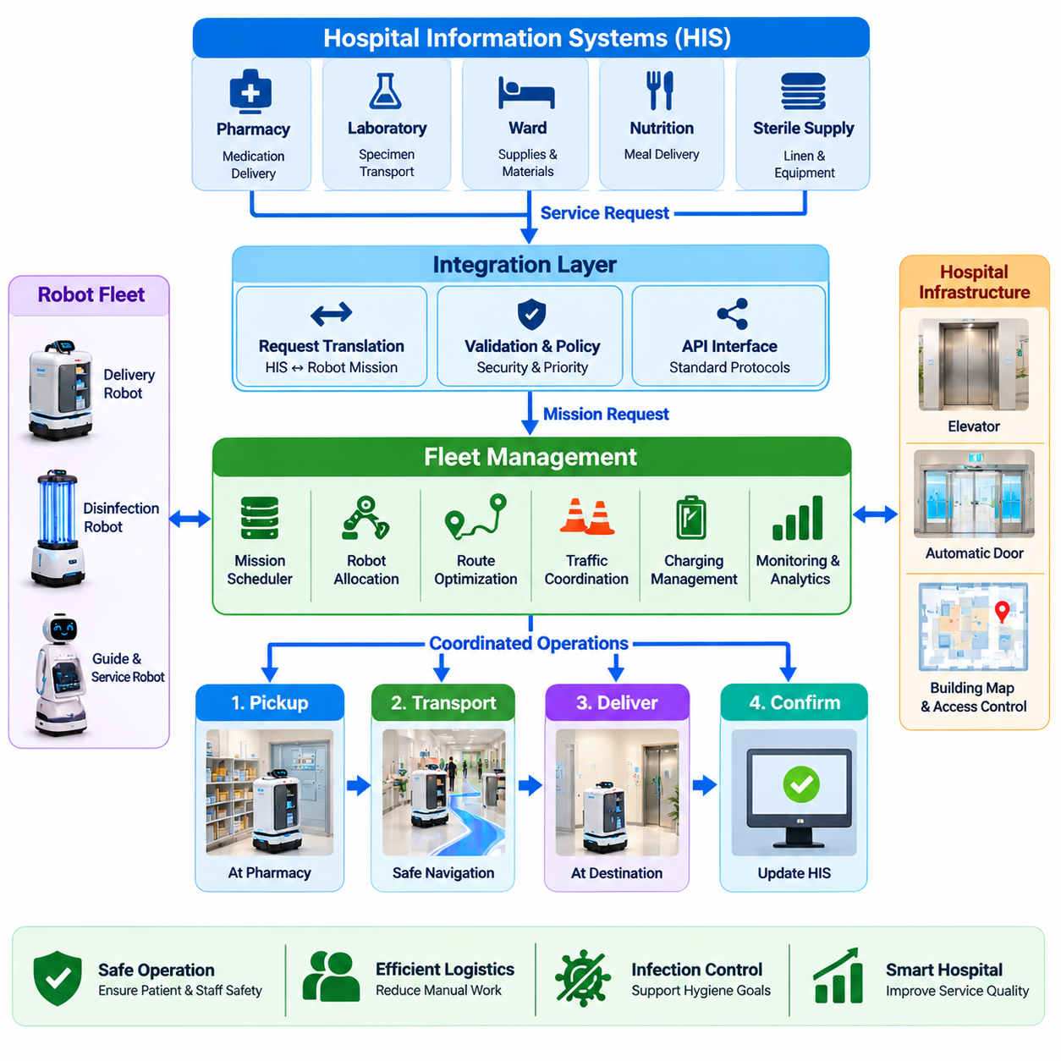
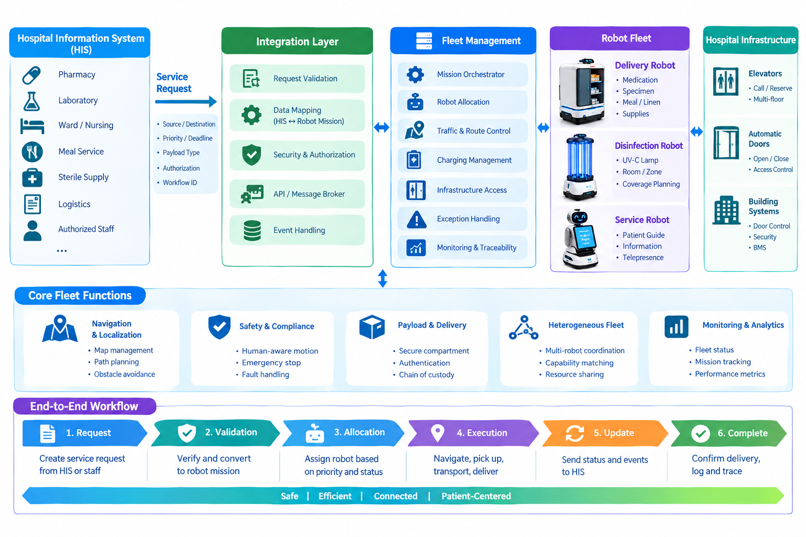
Hospital fleet management integrates multiple autonomous robots with clinical and logistical workflows so that robots operate as a coordinated hospital service rather than independent machines. The fleet layer manages delivery robots, disinfection robots, and other service platforms while connecting their missions to hospital information systems. Its responsibilities include task intake, robot allocation, traffic coordination, charging, infrastructure access, exception handling, monitoring, and operational traceability.
Hospital Information System integration provides the connection between institutional workflows and physical robot actions. A request may originate from pharmacy, laboratory, ward logistics, meal distribution, sterile supply, or another authorized application. Instead of directly commanding a robot, the hospital system submits a service request containing source, destination, priority, timing, payload type, authorization requirements, and workflow identifiers to an integration layer.
The integration layer converts hospital-level requests into a normalized robot mission model. This abstraction is important because clinical systems describe work using healthcare concepts, while robots require executable actions such as navigate, dock, wait, authenticate, load, transport, unload, and return. Mapping between these two domains allows hospital applications to remain independent of individual robot vendors and enables different robot types to participate in common workflows.
A mission orchestrator validates each request before execution. It verifies that pickup and destination locations exist, the requested service is permitted, an appropriate robot type is available, and relevant operational constraints can be satisfied. Invalid or incomplete requests are rejected or returned for correction rather than becoming partially executable missions. Valid requests are assigned identifiers that support end-to-end tracking from hospital workflow creation through physical completion.
Robot allocation requires more than selecting the nearest available platform. The fleet scheduler considers current location, mission queue, payload capacity, compartment configuration, battery level, charging requirements, access permissions, robot health, estimated travel time, and task priority. A medication delivery robot with a secure compartment may be preferred over a closer general-purpose robot, while urgent laboratory transport may preempt lower-priority logistics according to defined policies.
Priority management must remain explicit because hospital workflows have different operational importance. Routine linen transportation, meal delivery, pharmacy replenishment, laboratory specimen movement, and urgent clinical logistics should not necessarily receive equal scheduling treatment. The fleet system can assign priority classes and deadlines while preventing low-priority missions from being indefinitely delayed through starvation-control policies and workload balancing.
Mission execution is represented through well-defined states shared between the fleet platform and hospital systems. Typical states include REQUESTED, VALIDATED, QUEUED, ASSIGNED, PICKUP_IN_PROGRESS, IN_TRANSIT, ARRIVED, DELIVERY_IN_PROGRESS, COMPLETED, FAILED, and CANCELLED. These states allow external applications to understand progress without requiring detailed knowledge of localization, path planning, motor control, or other robot-specific internal functions.
Event-driven integration is useful because hospital systems frequently need asynchronous status updates. Rather than repeatedly polling every robot, applications can receive events when a mission is accepted, assigned, delayed, picked up, delivered, cancelled, or failed. A message broker or integration service can distribute these events to authorized consumers. Correlation identifiers ensure that asynchronous robot events are associated with the correct clinical or logistical workflow.
Traffic management becomes increasingly important as fleet size grows. Multiple robots may share narrow corridors, intersections, elevators, automatic doors, docking stations, and charging areas. The fleet system can reserve critical resources, control entry into constrained zones, assign directional priorities, and prevent deadlock. Route planning can also incorporate congestion estimates so that robots avoid heavily occupied areas even when those routes are geometrically shorter.
Elevators and automatic doors become shared fleet resources rather than isolated navigation obstacles. The fleet manager can coordinate elevator reservations, staging positions, access requests, and robot sequencing. If several robots require the same elevator, requests can be scheduled according to mission priority and estimated arrival time. Infrastructure-aware coordination reduces congestion and prevents multiple robots from independently competing for limited building resources.
Battery and charging management should be optimized at fleet level because sending every robot to charge at the same threshold can reduce service capacity. The scheduler predicts energy requirements from mission queues, robot state, travel distance, and expected demand. Charging can then be distributed across available stations and low-demand periods. Robots with sufficient energy remain available while others receive opportunistic or scheduled charging without compromising critical missions.
Heterogeneous fleets require a common capability model. Different robots may support secure delivery compartments, refrigeration, heavy payloads, UV disinfection, human interaction, or specialized docking. The fleet platform describes these characteristics as capabilities and matches mission requirements against them. This allows applications to request a service such as secure medication transport without needing to specify a particular robot model or manufacturer.
HIS integration also requires careful management of identifiers and semantic locations. A hospital application may refer to a ward, laboratory, pharmacy, room, or service point using institutional identifiers, while navigation software uses maps and coordinates. A location service maps business-level identifiers to robot-accessible destinations, floors, docking poses, access zones, and infrastructure transitions so that physical routing remains synchronized with hospital organizational data.
Security and authorization must be enforced across every integration boundary. Hospital applications, fleet services, robots, operators, and infrastructure controllers should authenticate before exchanging commands or sensitive data. Role-based permissions determine which systems may create, modify, cancel, or inspect missions. Sensitive payload information should be minimized, protected during transmission and storage, and separated from ordinary robot telemetry whenever practical.
Reliable integration requires protection against duplicate and inconsistent requests. Network retries can cause the same delivery command to arrive more than once, potentially creating multiple physical missions for one hospital order. Unique request identifiers and idempotent processing allow the fleet service to recognize repeated submissions. Transaction status should remain queryable so external systems can recover safely after communication interruptions without guessing whether a mission was created.
Exception handling connects autonomous recovery with hospital operations. A blocked corridor may be resolved through replanning, while an unavailable elevator may require resource reassignment. An absent recipient, failed authentication, compartment problem, or damaged payload may require escalation to staff. The fleet platform classifies exceptions and determines whether to retry automatically, reassign the mission, return the payload, request assistance, or report failure to the originating hospital system.
Human operators remain part of the fleet architecture even when normal missions are highly autonomous. A control interface presents robot positions, mission queues, battery states, infrastructure conditions, active alerts, and unresolved exceptions. Operators can investigate problems, authorize defined recovery actions, or remove robots from service. Manual intervention should be logged as part of mission history so that automated and human actions remain equally traceable.
Observability combines telemetry, mission events, infrastructure events, and HIS transactions into a coherent operational view. Metrics such as mission completion rate, average delivery duration, queue waiting time, robot utilization, intervention frequency, elevator delay, charging utilization, and failure rate reveal system-level performance. Analysis of these metrics helps determine whether delays originate from robots, scheduling policies, building infrastructure, or hospital workflows.
Auditability is especially important when robots transport controlled or clinically significant materials. The system can record request creation, authorization, robot assignment, pickup confirmation, compartment access, transport events, recipient authentication, delivery confirmation, exceptions, and final status. These records create an electronic chain of custody and allow administrators to reconstruct how a physical delivery was executed without relying on isolated robot logs.
Scalability requires the fleet platform to remain stable as robot count, mission volume, connected departments, and infrastructure interfaces increase. Mission services, scheduling, telemetry ingestion, event processing, and external integration can be separated into modular services with clearly defined interfaces. This prevents growth in one subsystem from forcing redesign of the entire platform and allows additional robot applications to reuse the same hospital integration foundation.
Validation should test complete cross-system workflows rather than individual APIs alone. Scenarios should include simultaneous requests, priority changes, duplicate messages, cancelled missions, robot failures, blocked routes, unavailable elevators, access denial, low battery, communication loss, delayed recipients, and HIS reconnection. Each case should preserve consistent mission state across hospital applications, fleet services, infrastructure systems, and the physical robot.
The resulting architecture makes fleet management the operational bridge between digital hospital processes and physical robotic execution. HIS integration defines what service is required, fleet intelligence determines which robot should perform it and when, infrastructure coordination enables movement through the facility, and robots execute the physical task. Together these layers provide the foundation for scalable, traceable, secure, and continuously available multi-robot hospital operations.

02.06. Patient Service Humanoid HRI Design [w/Code]
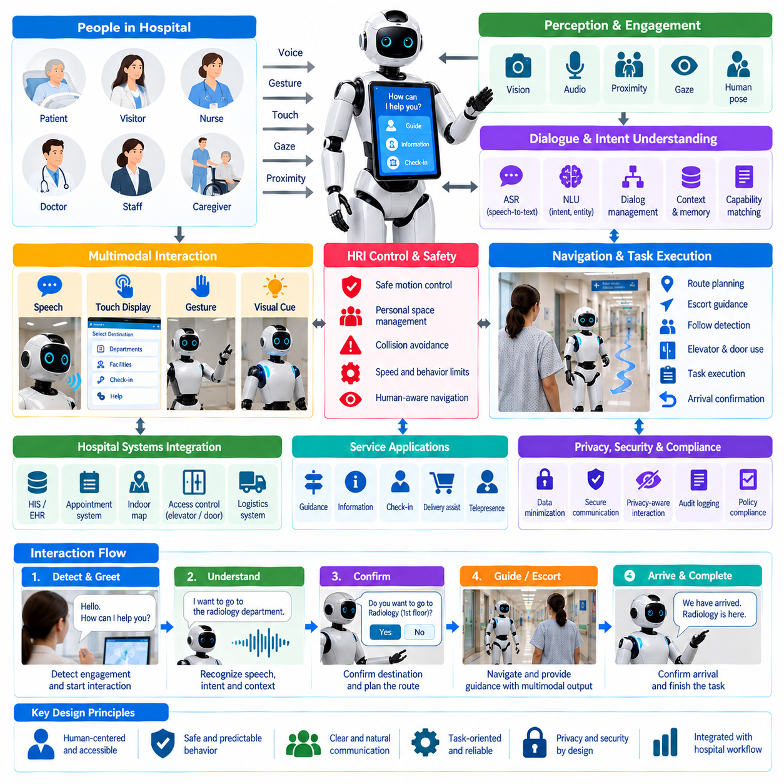
Patient-service humanoid robots require a human-robot interaction architecture designed around safety, clarity, accessibility, and predictable behavior. Unlike industrial robots operating in restricted workspaces, hospital humanoids may interact directly with patients, visitors, nurses, caregivers, and administrative staff. Their HRI design must combine perception, dialogue, gesture, navigation, task execution, privacy protection, and continuous safety supervision.
The interaction process begins with recognizing whether a person intends to communicate with the robot. Cameras, microphones, proximity sensing, body orientation, gaze direction, speech activity, and explicit interface inputs can contribute to engagement detection. The robot should avoid assuming that every nearby person wants assistance. An interaction manager therefore estimates engagement confidence and initiates communication only when appropriate, reducing unwanted interruptions in sensitive clinical environments.
Speech interaction provides a natural interface for guidance and service tasks, but hospital environments introduce substantial acoustic challenges. Conversations, alarms, carts, ventilation systems, medical equipment, and public announcements can interfere with automatic speech recognition. The robot should combine microphone-array processing, speech activity detection, noise suppression, and contextual language interpretation while providing visual or touch-based alternatives when reliable speech communication is not possible.
Dialogue management converts recognized language into structured interaction states. A request such as asking for a department location may require intent recognition, destination resolution, confirmation, route generation, and guidance execution. More complex requests can involve several conversational turns. The dialogue manager should maintain short-term context, detect ambiguous expressions, request clarification when necessary, and explicitly confirm important actions instead of executing uncertain interpretations.
Natural-language understanding must remain connected to the robot's actual capabilities. A humanoid should not imply that it can perform actions unavailable to its hardware, software, authorization level, or hospital workflow. A capability service can expose permitted functions to the dialogue system, allowing responses to reflect current operational state. When a request exceeds available capabilities, the robot should explain the limitation and redirect the person to an appropriate human or service channel.
Multimodal interaction improves communication when speech alone is insufficient. The robot can combine spoken language with display content, head orientation, arm gestures, pointing, lights, and simple body motion. For example, directional guidance can include a spoken instruction, a map on the display, and a pointing gesture toward the correct corridor. Multiple coordinated channels reduce ambiguity and improve accessibility for users with different communication preferences or environmental constraints.
Gesture design should emphasize functional clarity rather than human imitation for its own sake. Movements need to be slow enough to remain understandable and predictable while avoiding sudden arm or body motion near patients. Pointing, greeting, confirmation, and attention-directing gestures can be represented as parameterized motion primitives. The HRI controller selects appropriate gestures while a safety layer limits joint speed, workspace, proximity, and allowed motion according to the surrounding context.
Patient-facing robots must account for wide differences in age, mobility, vision, hearing, language proficiency, cognitive ability, and familiarity with robots. Interface elements should use readable text, understandable speech, simple choices, sufficient response time, and consistent interaction patterns. The system can support multiple modalities without assuming that every patient can use a touchscreen, hear spoken instructions clearly, or understand complex menus and technical terminology.
Personal-space management connects social interaction with navigation. A humanoid approaching a patient should maintain an appropriate distance and avoid blocking beds, wheelchairs, doors, or clinical work areas. Human-aware navigation can represent personal zones around people and adapt approach direction, speed, and stopping position. The robot should remain close enough for communication while preserving physical comfort and allowing healthcare workers to move without obstruction.
Guidance tasks require coordination between dialogue and mobility. After confirming a destination, the robot can determine whether to provide verbal directions, display a route, or physically escort the user. During escorting, it must monitor whether the person is still following, adjust walking speed, wait when separation becomes excessive, and stop at intersections when necessary. The interaction remains active throughout navigation rather than ending when the robot begins moving.
A patient-service humanoid may also support check-in, queue guidance, facility information, appointment navigation, delivery assistance, or connection to remote staff. These workflows should be implemented as explicit service processes rather than unrestricted conversation. Each process defines required inputs, permitted actions, completion conditions, and escalation rules. Structured workflows make behavior easier to validate and prevent conversational flexibility from bypassing hospital operational controls.
Privacy must be considered from the beginning of HRI design because conversations may contain sensitive personal or clinical information. The robot should collect only information necessary for the requested service and avoid exposing private content through loud speech or publicly visible displays. Authentication may be required before accessing protected information. Audio, images, transcripts, and interaction logs should follow defined retention, access, and security policies.
Identity recognition requires particular caution. Recognizing that a person is present is different from determining who that person is. Many service interactions can operate without identifying an individual. When identity is genuinely required, the robot should use an authorized authentication mechanism rather than inferring identity unnecessarily from biometric data. Separating presence detection, user engagement, authentication, and identity management reduces privacy risk and simplifies system responsibilities.
Safety supervision must remain independent of conversational intent. A spoken command should never override collision avoidance, emergency stopping, joint limits, restricted-area policies, or other safety functions. If a user asks the robot to perform an unsafe action, the task layer rejects the command even when language understanding is confident. This separation ensures that natural-language flexibility cannot directly bypass physical safety constraints.
Physical interaction introduces additional requirements when the humanoid hands objects to patients or receives items from them. The robot must coordinate arm trajectory, grasp state, force limits, user proximity, and transfer confirmation. Object handover should proceed through explicit states such as approach, presentation, readiness detection, release, and completion. Unexpected contact or uncertain grasp conditions should cause a controlled pause or safe withdrawal rather than continued motion.
Uncertainty should be treated as an explicit system state. Speech recognition confidence, intent confidence, person tracking quality, localization confidence, and task status may all become uncertain during interaction. Instead of hiding this uncertainty, the robot can ask the user to repeat a request, move to a better communication position, offer selectable options, or request human assistance. Conservative handling of uncertainty is especially important when actions affect patients or clinical workflows.
Human escalation is a fundamental HRI capability rather than evidence of system failure. The robot should recognize situations requiring nurses, reception staff, security personnel, interpreters, technicians, or remote operators. Escalation can occur because of repeated misunderstanding, emotional distress, medical questions, inaccessible destinations, system faults, or requests outside authorized capabilities. The robot should preserve relevant task context so users do not need to restart the entire interaction.
Interaction state can be represented through a hierarchical state machine or task-oriented behavior architecture. States may include IDLE, ENGAGEMENT_DETECTED, GREETING, LISTENING, INTERPRETING, CONFIRMING, EXECUTING, WAITING_FOR_USER, COMPLETED, ESCALATING, and SAFETY_STOP. Separating conversational state from navigation and manipulation state allows each subsystem to evolve independently while the HRI coordinator maintains consistent overall behavior.
Observability helps developers and hospital operators understand why an interaction succeeded or failed. Logs can capture anonymized interaction states, recognition confidence, task transitions, user cancellations, clarification requests, escalation events, navigation interruptions, and safety interventions. Performance metrics may include task completion rate, interaction duration, clarification frequency, abandonment rate, human-assistance rate, and successful guidance completion rather than relying only on speech-recognition accuracy.
Testing should reproduce realistic hospital interactions rather than ideal laboratory conversations. Evaluation scenarios should include background noise, accents, elderly users, wheelchairs, masks, interrupted dialogue, ambiguous requests, crowded corridors, users who walk slowly, communication failures, and safety interruptions. Usability studies can measure comprehension, task success, perceived clarity, response time, comfort, and operator workload while technical testing verifies deterministic safety and recovery behavior.
The resulting HRI architecture treats a patient-service humanoid as a coordinated service system rather than a conversational character. Perception determines who is available for interaction, dialogue determines what service is requested, multimodal communication makes behavior understandable, navigation and manipulation execute physical tasks, and safety and privacy layers constrain every action. This integration enables humanoid robots to provide useful, predictable, and accountable assistance within hospital environments.

02.07. Infection Control Robot Hygiene Protocol SW
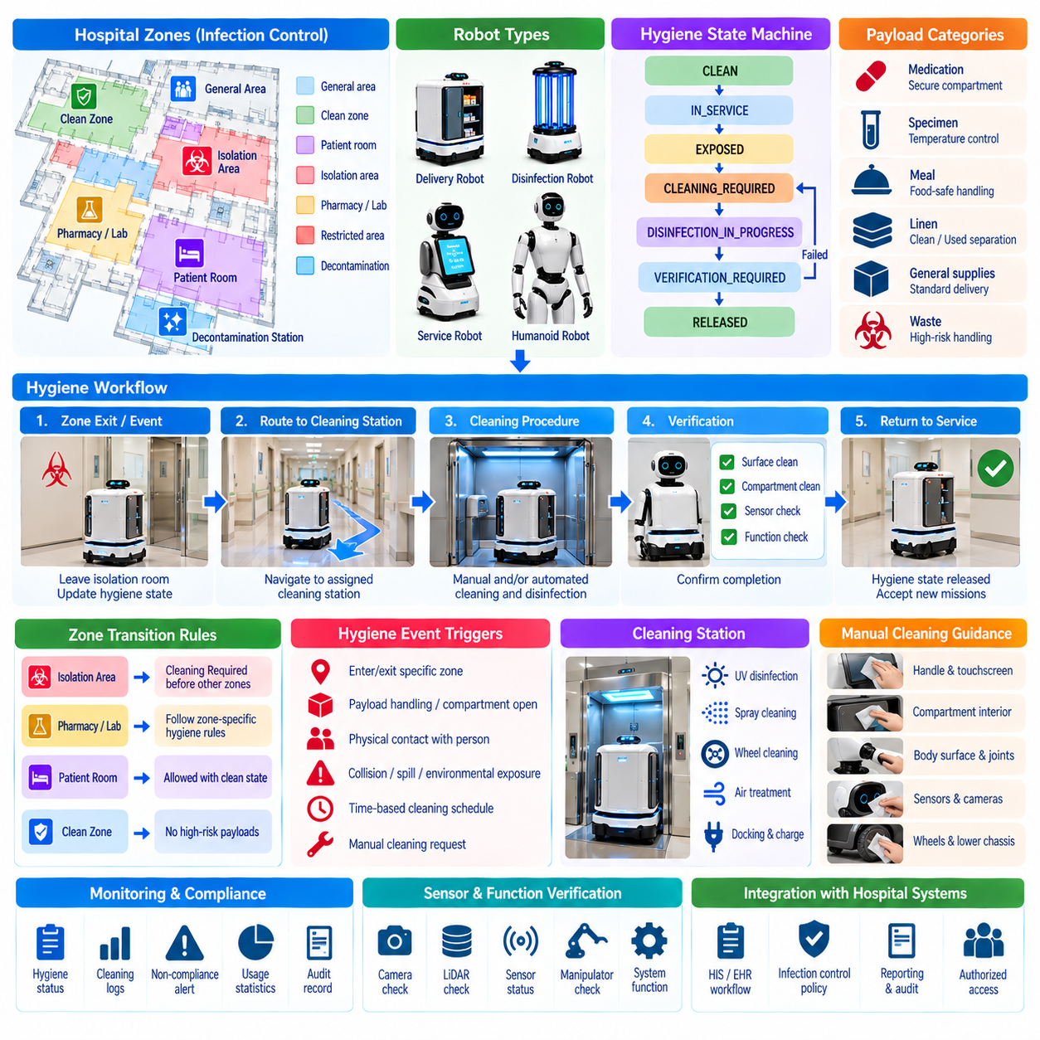
Infection-control robot software must treat robot hygiene as part of mission execution rather than as a separate maintenance activity. A hospital robot can move between wards, patient rooms, laboratories, pharmacies, and common areas, potentially carrying contamination on wheels, covers, handles, compartments, sensors, or manipulators. The software therefore needs explicit hygiene states, cleaning rules, zone restrictions, contamination tracking, and auditable protocol execution.
A hygiene protocol begins by classifying operational environments according to infection-control requirements. Hospital maps can contain semantic zones representing general areas, clean zones, isolation areas, high-risk clinical spaces, decontamination stations, and restricted transitions. These classifications allow the mission planner to determine whether a robot may enter a location directly, whether additional precautions are required, or whether cleaning must occur before crossing a defined hygiene boundary.
The robot should maintain a software representation of its current hygiene state. Instead of assuming that the platform is always clean, the system can represent conditions such as CLEAN, IN_SERVICE, EXPOSED, CONTAMINATION_SUSPECTED, CLEANING_REQUIRED, DISINFECTION_IN_PROGRESS, VERIFICATION_REQUIRED, and RELEASED. State transitions are triggered by mission history, visited zones, payload type, detected events, elapsed operating time, or explicit instructions from authorized staff.
Zone-transition rules can prevent inappropriate movement between areas with different hygiene requirements. A robot leaving an isolation room, for example, may be prohibited from immediately entering another patient-care area. The mission executive can redirect it to a designated cleaning station and block new assignments until the required protocol is completed. Hygiene constraints therefore become part of route and task planning rather than relying entirely on operators to remember procedural requirements.
Payload handling should also participate in infection-control logic. Delivery compartments may carry medications, specimens, meals, linens, waste, or general supplies, and each category can require different handling rules. Software can associate payload classes with permitted compartments, destination zones, cleaning requirements, and post-delivery actions. This prevents a compartment recently used for a higher-risk material from being reassigned without the required sanitation procedure.
Cleaning procedures can be encoded as executable workflows rather than informal instructions. A workflow may require the robot to enter a cleaning station, stop propulsion, unlock designated access panels, notify staff, wait for manual surface cleaning, initiate an automated disinfection cycle, and verify completion before release. Explicit workflow states ensure that skipped steps, interrupted cleaning, or premature mission assignment can be detected by the system.
Manual cleaning remains important because many robot surfaces cannot be reliably disinfected through autonomous mechanisms alone. The software can present operators with surface-specific instructions for handles, touchscreens, payload compartments, external covers, manipulators, bumpers, and other contact areas. Confirmation interfaces can record that required actions were performed, while timers and workflow controls prevent the robot from returning to service before specified procedures are completed.
Automated hygiene functions may complement manual procedures. Depending on robot design, these can include compartment UV treatment, controlled spraying, internal air treatment, docking-station sanitation, or automated wheel-cleaning mechanisms. The hygiene controller should treat each mechanism as a monitored subsystem with activation conditions, operating duration, completion criteria, and fault states rather than assuming that issuing an activation command proves successful disinfection.
Cleaning-agent compatibility must be represented in operational procedures because disinfectants can affect plastics, seals, displays, optical sensors, adhesives, coatings, and electronic components. Software instructions should reference approved procedures for each robot surface instead of allowing arbitrary chemical use. Maintenance configuration can associate robot components with permitted cleaning methods, helping prevent infection-control activities from unintentionally degrading sensors or safety equipment.
Sensor hygiene requires special consideration because cameras, LiDAR windows, depth sensors, touchscreens, microphones, and proximity sensors must remain functional after cleaning. Residue, moisture, covers, or surface damage can reduce sensing performance even when a robot appears physically clean. A post-cleaning verification routine can therefore check sensor availability, visibility, calibration status, protective scanner operation, and communication before the robot is released.
Wheels and lower chassis components can contact contaminated floors and move between hospital zones. The software can track floor-zone exposure separately from payload or upper-body contact when required by the operating protocol. Routes may direct the robot through wheel-cleaning stations or restrict transitions from designated areas. This distinction allows hygiene policies to reflect different contamination pathways rather than representing the entire robot with only one binary clean-or-dirty flag.
Contact events can influence hygiene status when robots interact physically with people or the environment. A humanoid that receives an object, a delivery robot whose compartment is opened, or a service robot that contacts a contaminated surface may require additional cleaning. The task system can generate hygiene events from manipulation, compartment access, collision, spill detection, or operator reports and use them to update the robot's sanitation requirements.
Time-based hygiene policies can supplement event-based rules. A robot may require routine cleaning after a defined operating interval, after a number of missions, at shift boundaries, or before scheduled maintenance. The fleet platform can predict upcoming sanitation requirements and avoid assigning long missions to robots approaching a mandatory cleaning deadline. This reduces unexpected service interruptions while ensuring that routine protocols are not indefinitely postponed.
Fleet management should include hygiene status when selecting robots for missions. A robot marked CLEAN may be eligible for sensitive deliveries, while one marked CLEANING_REQUIRED should remain unavailable until the protocol is completed. When several robots are available, the scheduler can consider hygiene compatibility together with location, battery level, payload capability, mission priority, and workload, preventing operational optimization from overriding infection-control constraints.
Isolation-room workflows require particularly controlled transitions. Before entry, the system can verify that the robot is authorized for the zone and that its hygiene state satisfies the entry policy. During the mission, access and compartment events are recorded. After exit, the robot can automatically receive a cleaning-required status and navigate to an appropriate decontamination location, while fleet software prevents reassignment to incompatible areas until release conditions are satisfied.
Unexpected contamination must be handled as an exception rather than as a normal mission completion. Spills, damaged specimen containers, contact with bodily fluids, or contamination reported by staff may require immediate withdrawal from service. The robot should stop or move to an approved safe location according to policy, mark itself unavailable, preserve the incident context, and notify authorized personnel instead of autonomously continuing ordinary deliveries.
Hygiene-related safety interlocks prevent conflicting operations. A robot undergoing cleaning should not begin navigation unexpectedly, while automated UV or chemical processes should not activate when human exposure conditions are unsafe. Door states, docking confirmation, presence sensing, maintenance mode, and operator acknowledgement can participate in interlocks. The hygiene workflow proceeds only when required safety conditions are satisfied and returns to a safe state when they are violated.
Traceability is essential for demonstrating that infection-control procedures were actually performed. Hygiene logs can record robot identity, mission history, visited zones, payload class, cleaning requirement, protocol version, start and completion times, operator confirmation, automated cycle results, verification status, faults, and final release. These records allow infection-control teams to reconstruct robot activity when investigating procedural deviations or contamination concerns.
Protocol version management is important because hospital infection-control policies can change over time. Cleaning rules, approved agents, required durations, zone classifications, and verification procedures should be configurable without embedding every policy directly into navigation code. Each completed hygiene record can reference the protocol version used, making it possible to determine which requirements governed robot operation at a particular time.
Monitoring across the fleet can reveal hygiene-related operational patterns. Metrics may include cleaning frequency, average sanitation duration, robots waiting for decontamination, protocol failures, repeated contamination events, station utilization, and time unavailable because of hygiene requirements. These measurements help hospitals determine whether cleaning resources, robot quantities, station placement, or mission scheduling need adjustment to maintain both infection control and service availability.
Validation should test the complete hygiene state machine rather than only successful cleaning cycles. Scenarios should include isolation-zone entry and exit, skipped operator confirmation, interrupted sanitation, sensor failure after cleaning, unavailable decontamination stations, incorrect payload classification, expired cleaning intervals, contamination reports, communication loss, and unsafe human presence during automated treatment. Each condition should lead to a defined and conservative recovery path.
The resulting software architecture makes infection control a continuous property of robot operation. Semantic zones describe environmental risk, mission history records potential exposure, hygiene states represent robot readiness, executable protocols control cleaning, verification determines release, and fleet management prevents incompatible assignments. By integrating these functions, hospital robots can support repeatable, traceable, and enforceable hygiene practices throughout their operational lifecycle.

02.08. Hospital Robot Safety ISO 13482 Compliance [w/Code]
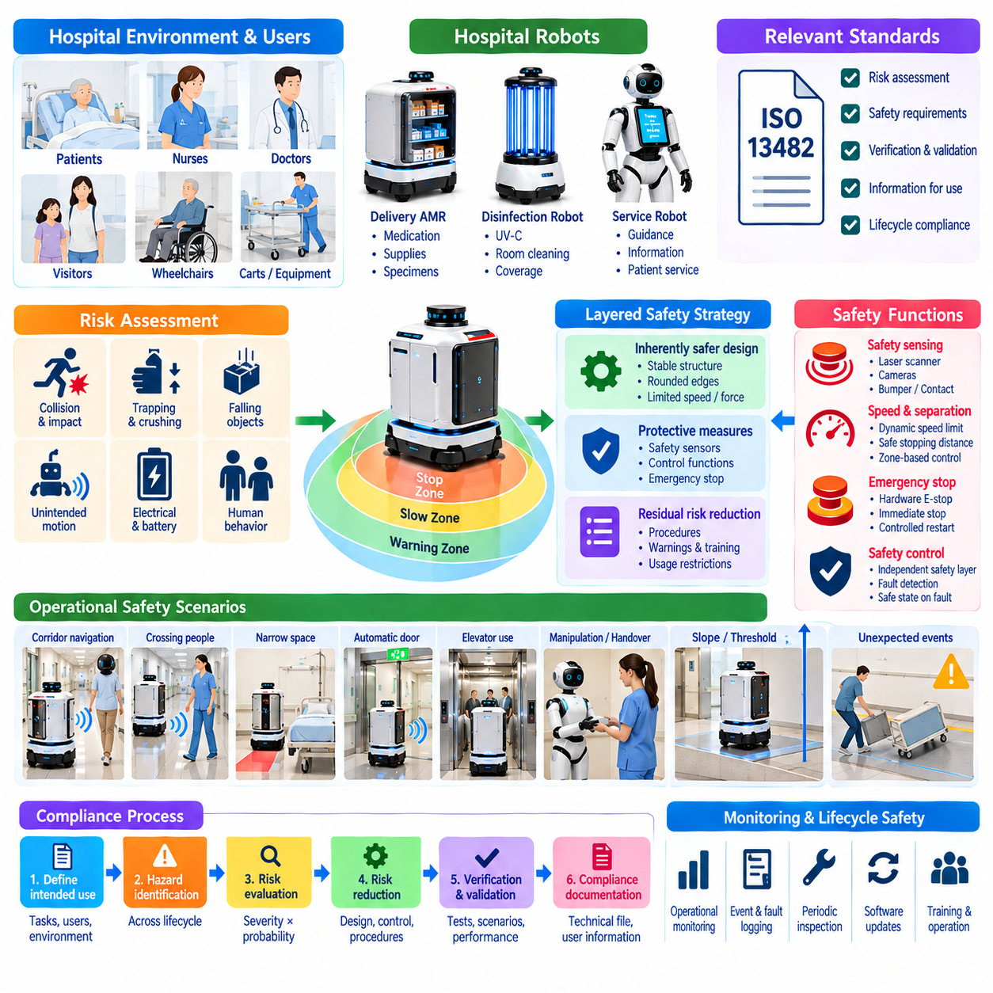
Hospital robot safety requires a systematic engineering process that connects risk assessment, mechanical design, sensing, control software, operational procedures, and verification. ISO 13482 provides a safety framework for personal care robots and is particularly relevant when service robots operate near people outside conventional industrial robot cells. Hospital applications must translate these safety principles into concrete requirements for autonomous mobility, human interaction, and service execution.
Safety engineering begins with defining the robot's intended use and reasonably foreseeable misuse. The specification describes operating environments, supported tasks, payloads, users, speed ranges, interaction modes, and prohibited conditions. A delivery AMR, guidance robot, or patient-service platform can present different hazards even inside the same hospital. Clear operational boundaries are therefore necessary before hazards can be identified and protective measures can be evaluated.
Risk assessment identifies hazardous situations arising throughout the robot lifecycle. Relevant hazards may include collision, crushing, trapping, impact, instability, unintended motion, excessive speed, falling objects, electrical faults, battery failures, control errors, sensor degradation, and unexpected human behavior. Each hazard is evaluated according to factors such as severity and probability so that risk-reduction measures can be prioritized and documented.
Risk reduction should follow a layered strategy rather than depending on a single protective sensor. Hazards should first be reduced through inherently safer design where practical, followed by protective measures implemented through hardware and control functions. Residual risks that cannot be eliminated are addressed through operational procedures, warnings, training, and usage restrictions. This hierarchy prevents software behavior alone from becoming the only barrier against significant physical hazards.
Autonomous mobility requires protective sensing around the robot's travel envelope. Safety laser scanners, bumpers, contact sensors, speed monitoring, and other protective devices can detect conditions requiring reduced motion or stopping. Protective fields may change according to speed, direction, or operating mode. The safety architecture must ensure that failure of ordinary navigation perception does not automatically eliminate the independent protection required to prevent hazardous contact.
Speed and separation behavior is especially important in crowded hospital environments. A robot may encounter patients with limited mobility, children, wheelchairs, staff pushing equipment, or people who behave unpredictably. Motion control should maintain appropriate speed and stopping distance according to available clearance and sensing capability. Narrow corridors, blind intersections, doorways, elevators, and dense waiting areas may require more conservative motion limits than open spaces.
Emergency stopping provides a means to bring hazardous robot motion to a controlled safe condition. Emergency-stop devices should be accessible where required and integrated with the safety-related control architecture rather than treated as ordinary software commands. Activation should override mission execution, navigation, and productivity objectives. Restart should require defined conditions so that releasing an emergency stop does not automatically cause unexpected robot movement.
Safety-related control functions should remain logically separated from normal mission software whenever appropriate. Fleet commands, route planners, dialogue systems, and application software may request motion, but safety supervision determines whether that motion is permitted. Safety functions can monitor protective sensors, drive status, speed, braking, emergency-stop circuits, and critical faults. A failure in a high-level application should therefore not directly disable essential protective behavior.
Functional safety design requires attention to faults as well as normal operation. A sensor can fail, communication can be interrupted, a controller can restart, or inconsistent signals can appear. The system should define how safety-related functions respond to these conditions and whether the robot enters a reduced-speed state, performs a controlled stop, disables drive power, or requires manual recovery. Fault detection must lead to predictable behavior rather than uncontrolled continuation.
Hospital robots frequently operate around automatic doors and elevators, creating safety conditions that extend beyond the mobile platform itself. The robot should verify sufficient clearance before entering or leaving these resources and should not assume that an infrastructure command guarantees a safe passage. Door movement, elevator occupancy, communication loss, and blocked exits must be incorporated into mission and safety logic so infrastructure integration does not introduce new hazards.
Manipulation adds another category of risk for robots equipped with arms or humanoid mechanisms. Joint motion, pinch points, grasped objects, and object handover can create hazards near patients and staff. Motion limits, force constraints, collision detection, workspace restrictions, and controlled handover states can reduce these risks. Safety requirements should reflect both intended manipulation and foreseeable contact that may occur when users move unexpectedly.
Stability must be evaluated for mobile and humanoid platforms because acceleration, braking, slopes, thresholds, payload changes, or external contact can cause loss of balance or tipping. Software can enforce limits on speed, acceleration, turning, payload configuration, and allowable terrain. Mechanical stability and control stability should be considered together, since a navigation command that is acceptable on a flat corridor may become unsafe on a ramp or irregular transition.
Battery and electrical safety also contribute to overall robot compliance. Charging faults, damaged batteries, overheating, electrical insulation failures, and unexpected power loss can create hazards independent of navigation. Battery-management and charging systems should monitor relevant operating conditions and transition to safe states when abnormalities are detected. Charging stations should also be integrated into operational risk assessment because they are part of the deployed robot system.
Human-robot interaction must communicate robot intent clearly enough for nearby people to anticipate behavior. Displays, lights, sounds, speech, and motion cues can indicate yielding, turning, waiting, fault conditions, or requests for assistance. These interfaces supplement rather than replace protective safety functions. A patient misunderstanding a display or spoken message should not be able to place the robot immediately into a hazardous physical state.
Operational modes require explicit safety behavior. Autonomous operation, manual control, maintenance, docking, cleaning, recovery, and diagnostic modes may permit different functions and motion limits. Mode transitions should be controlled so that maintenance personnel are not exposed to unexpected autonomous motion. The system should clearly indicate the active mode, and functions unavailable or unsafe in that mode should remain inhibited until valid transition conditions are satisfied.
Software supporting safety compliance should maintain clear requirements and traceability. Safety requirements can be linked to identified hazards, risk-reduction measures, software functions, test cases, and verification evidence. Configuration and version control are important because changes to navigation, speed limits, sensor processing, or recovery behavior may affect previously evaluated risks. Safety impact analysis should therefore be part of significant software modification.
Verification must demonstrate that protective functions behave correctly under both expected and fault conditions. Tests can evaluate stopping performance, protective-field activation, emergency stopping, speed limits, sensor obstruction, communication loss, localization failure, drive faults, blocked paths, and recovery behavior. Testing should include realistic hospital configurations because floor surfaces, corridor geometry, payloads, crowds, and infrastructure interactions can affect actual safety performance.
Validation addresses whether the complete robot system is acceptably safe for its intended hospital use rather than whether individual components merely pass isolated tests. Representative scenarios should include patients crossing the route, wheelchairs entering from blind areas, crowded elevators, staff pushing carts, automatic-door transitions, interaction interruptions, and emergency situations. The objective is to confirm that integrated system behavior remains consistent with the defined risk controls.
Residual risk must be documented when hazards cannot be completely eliminated through design and protective measures. Operating instructions can define prohibited uses, required clearances, environmental restrictions, inspection procedures, staff responsibilities, and responses to faults. Training and signage may be necessary for particular deployments, but administrative controls should not be used as substitutes for feasible engineering protections against significant hazards.
Compliance evidence should be organized as a coherent safety case rather than as disconnected test results. Documentation can include intended-use definitions, hazard analyses, risk assessments, safety requirements, architecture descriptions, component information, software traceability, verification reports, validation results, residual-risk documentation, and change records. This evidence allows reviewers to understand how identified hazards are controlled throughout the system.
Post-deployment monitoring extends safety engineering into actual hospital operation. Fleet logs can capture safety stops, bumper events, protective-field activations, emergency stops, localization failures, intervention requests, and infrastructure-related incidents. Repeated events may reveal hazards or operating conditions that were underestimated during development. Operational evidence should feed back into risk assessment, software improvement, maintenance, and deployment procedures.
ISO 13482-oriented compliance is therefore not a single certification feature implemented at the end of development. It is a lifecycle process connecting intended use, hazard identification, risk reduction, safety-related control, verification, validation, documentation, and operational monitoring. For hospital robots, this approach creates a structured foundation for deploying autonomous systems near patients and staff while maintaining traceable and continuously managed safety.

02.09. Hospital Robot Fleet Data Privacy HIPAA
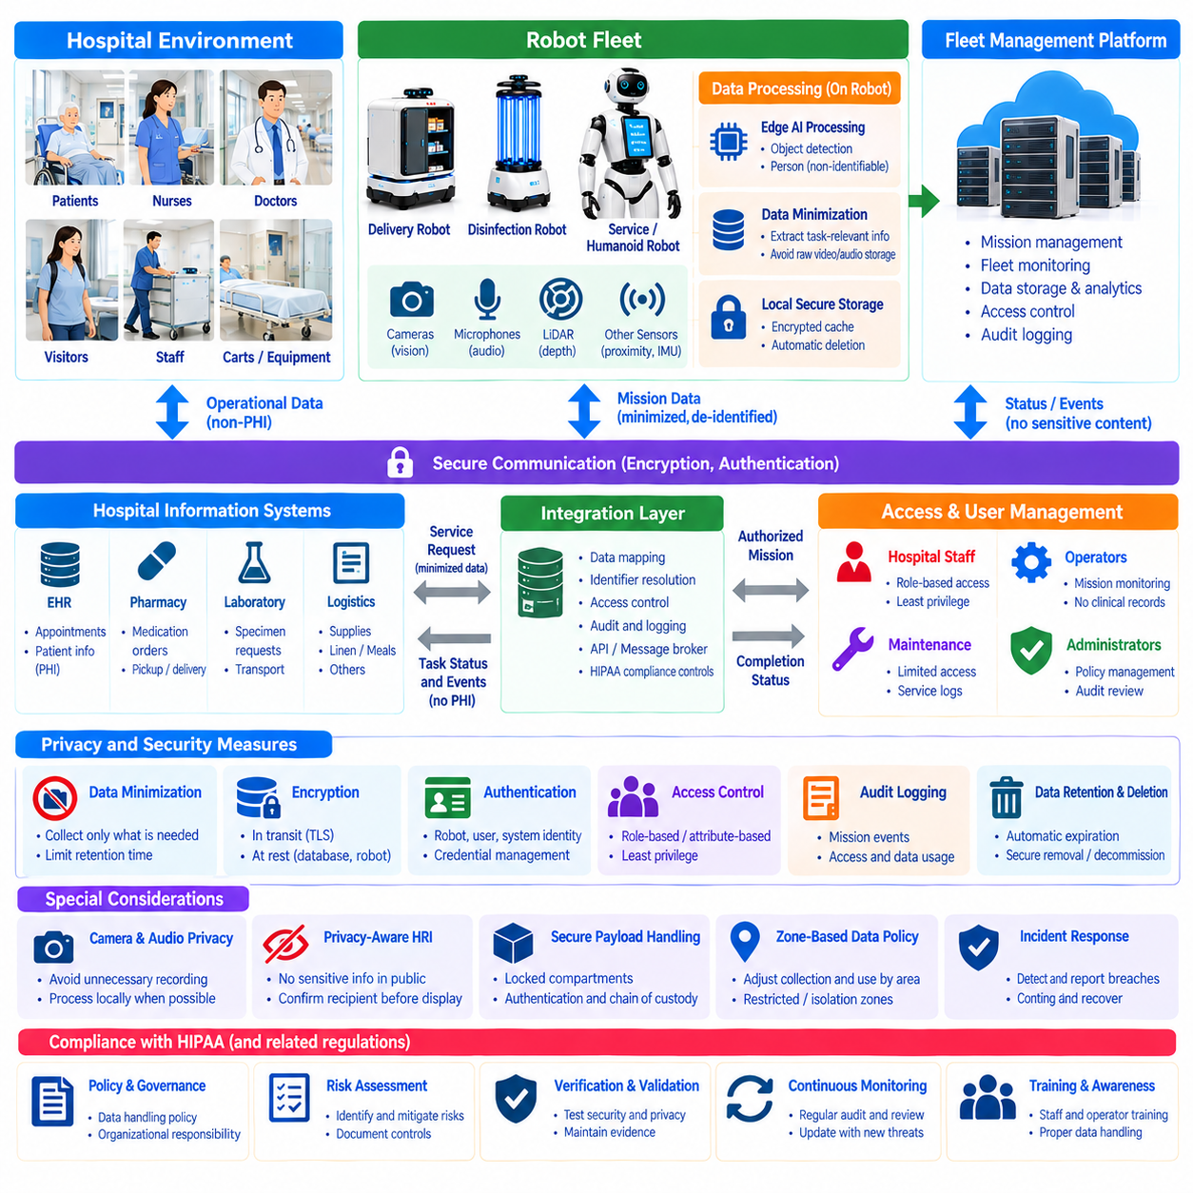
Hospital robot fleets generate operational data while moving through environments where sensitive healthcare information may be present. Cameras, microphones, navigation sensors, mission records, access events, user interactions, and hospital-system interfaces can create privacy risks even when the robot is not designed primarily to process clinical information. Privacy engineering must therefore be integrated into fleet architecture, data flows, software design, and operational governance.
HIPAA-related considerations become important when robot systems create, receive, maintain, or transmit protected health information within applicable healthcare workflows. A robot platform should not assume that every sensor stream is automatically protected health information, nor that operational telemetry is automatically exempt. Data classification must consider content, context, identifiers, workflow association, and how information can be linked to an individual.
Data minimization is one of the most effective architectural controls. A robot should collect only the information required to perform its authorized task and retain it only as long as necessary for the defined purpose. Navigation may require temporary perception of people without requiring long-term storage of identifiable video. Similarly, a delivery mission may require a destination and authorization token without exposing detailed patient records to the robot.
Fleet architecture should separate operational robotics data from sensitive healthcare data whenever possible. Localization, battery state, motor status, route progress, and generic fault telemetry can often be processed independently from patient identity, appointment information, medication details, or clinical records. Logical separation reduces the number of robot components, databases, services, and operators that require access to sensitive information.
Mission interfaces can use indirect identifiers instead of transferring unnecessary clinical context. A fleet manager may receive a task identifier, pickup location, delivery destination, priority, payload category, and authorization requirement while the hospital information system retains detailed patient information. The integration service resolves only the information required for execution, limiting disclosure across the robotic infrastructure.
Access control should follow the principle of least privilege. Robots, fleet servers, operators, maintenance personnel, clinical applications, and analytics services should receive only permissions necessary for their assigned roles. Role-based or attribute-based authorization can restrict who may create missions, view sensitive delivery information, access interaction records, retrieve logs, modify configurations, or perform administrative actions.
Authentication is required to establish the identity of systems and authorized users before protected operations are permitted. Robot-to-server connections, hospital applications, operator consoles, infrastructure gateways, and administrative interfaces should use managed credentials and secure authentication mechanisms. Credential lifecycle management must include provisioning, rotation, expiration, revocation, and recovery when a robot or account is removed from service.
Encryption protects information when data moves across hospital networks or is stored within fleet infrastructure. Communication channels between robots, fleet services, hospital systems, and management consoles should protect confidentiality and integrity. Sensitive records stored in databases, backups, removable storage, or robot-local caches may also require protection. Encryption keys should be managed separately from the data they protect and controlled through defined security processes.
Robot-local storage requires special attention because mobile platforms can be physically accessed, removed for maintenance, or temporarily disconnected from central services. Local caches should contain the minimum data necessary for resilient operation and should have explicit expiration policies. Sensitive information should not remain indefinitely after mission completion. Device decommissioning or storage replacement should include secure data removal procedures.
Cameras and microphones create distinctive privacy challenges in hospitals because they may capture patients, visitors, staff conversations, screens, room information, or clinical activities unrelated to the robot's mission. Processing should be designed to avoid unnecessary recording where real-time inference is sufficient. Raw audio or video retention should require a defined purpose, authorization, retention period, and access policy rather than being enabled by default.
Privacy-aware perception can reduce exposure by transforming raw sensor data into task-relevant information as early as possible. For example, navigation may need obstacle position and motion rather than identifiable imagery, while engagement detection may require the presence of a person rather than persistent identity recognition. Edge processing can generate these derived features locally and avoid transmitting unnecessary raw data to centralized fleet services.
Human-robot interaction must prevent accidental disclosure through visible or audible interfaces. A service robot should avoid announcing sensitive patient information in a public corridor or displaying protected details where nearby people can read them. Interaction software can adapt presentation according to location, authentication state, and information sensitivity, using generic notifications until the intended recipient has been appropriately verified.
Delivery workflows require careful handling when medications, specimens, documents, or other sensitive items are transported. Secure compartments, access authentication, electronic locks, and delivery confirmation can protect both physical payloads and associated information. Fleet records should document custody events without unnecessarily duplicating clinical content. The robotic system needs enough information to prove authorized transfer while minimizing exposure of the underlying healthcare record.
Audit logging provides accountability for access to sensitive data and protected operations. Logs can record authentication events, mission creation, data access, configuration changes, compartment opening, administrative actions, exports, and security failures. Audit records should identify the relevant actor, action, time, resource, and outcome while avoiding unnecessary reproduction of sensitive content inside the log itself.
Retention policies should distinguish between data categories rather than applying one duration to every robot record. Safety events, mission histories, security audits, diagnostic telemetry, raw sensor data, and patient-related transaction records may have different operational and regulatory purposes. Automated lifecycle management can archive, anonymize, or delete records according to policy and prevent temporary debugging data from becoming permanent information repositories.
Fleet observability should preserve operational usefulness without exposing unnecessary personal information. Dashboards can report mission completion rate, robot utilization, charging status, traffic congestion, failures, and service latency using aggregated or de-identified data where individual identity is unnecessary. Engineering teams can diagnose many fleet problems from technical metadata without receiving unrestricted access to patient-related information.
Cloud connectivity requires explicit control over what information leaves the hospital environment. Remote monitoring, analytics, software support, and fleet optimization may involve external services, but data flows should be documented and restricted according to approved architecture. Organizations must understand which systems store or process sensitive information, where those systems operate, and which parties have authorized access to the information.
Third-party components and service providers expand the privacy and security boundary. Robot manufacturers, cloud platforms, remote-support systems, analytics tools, and integration vendors may interact with hospital data or infrastructure. Their access should be evaluated according to the actual information and functions involved. Interfaces should avoid granting broad access merely because a vendor component participates in the robot deployment.
Security incidents must be detectable and containable. Unexpected login attempts, unusual data exports, compromised credentials, unauthorized configuration changes, abnormal robot connections, or suspicious access patterns should generate security events. The system should support credential revocation, robot isolation, service disabling, evidence preservation, and controlled recovery so that a suspected compromise does not automatically affect the entire fleet.
Software updates and configuration changes can alter privacy behavior even when navigation functionality remains unchanged. A new logging feature, cloud interface, perception model, or diagnostic service may create additional data flows. Change management should therefore include privacy and security impact analysis, configuration review, testing, approval, deployment tracking, and rollback capability rather than evaluating only functional performance.
Privacy validation should test complete workflows and failure conditions. Scenarios can include unauthorized mission queries, expired credentials, intercepted communications, lost connectivity, unintended video retention, public display of sensitive information, incorrect user authentication, excessive log access, compromised robots, and delayed data deletion. Testing should verify both technical controls and operational procedures used by hospital personnel.
The resulting architecture treats privacy as a fleet-wide system property rather than a feature attached to a database or user interface. Data classification determines sensitivity, minimization limits collection, separation reduces exposure, authentication and authorization control access, encryption protects data, auditing creates accountability, and lifecycle policies govern retention. Together, these mechanisms support hospital robot services while reducing unnecessary handling of protected healthcare information.

02.10. Hospital AMR Fleet Deployment Case
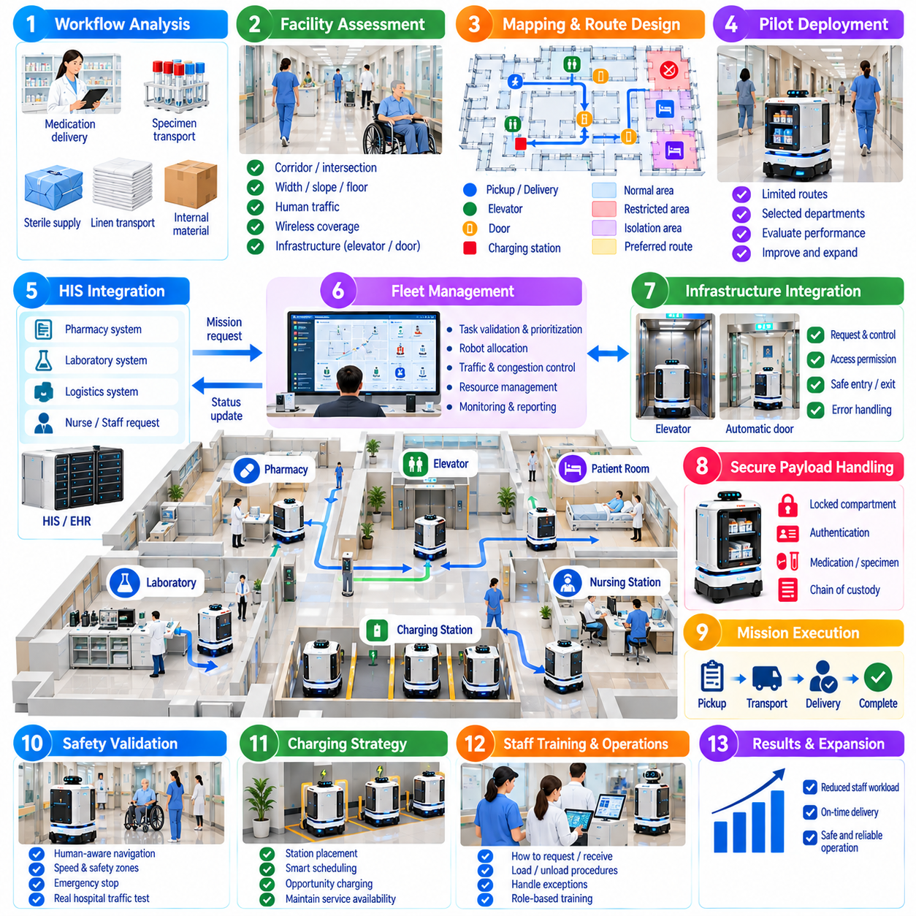
A hospital AMR fleet deployment begins with analyzing real clinical and logistical workflows rather than selecting robots first. The deployment team identifies repetitive transport activities such as medication delivery, laboratory specimen movement, sterile supply distribution, linen transport, and internal material transfer. Mission frequency, travel distance, delivery deadlines, payload characteristics, staffing patterns, and current process delays are measured to determine where autonomous transport can provide operational value.
The facility is then evaluated as a robotic operating environment. Corridors, intersections, elevators, automatic doors, nursing stations, pharmacies, laboratories, storage rooms, charging areas, and restricted zones are mapped and classified. Engineers measure passage widths, floor transitions, slopes, congestion patterns, wireless coverage, and human traffic. These observations determine whether infrastructure modifications or specialized navigation behaviors are required before fleet deployment.
Initial deployment typically focuses on a limited number of well-defined routes and mission types. Instead of attempting hospital-wide automation immediately, the project can begin with transportation between a pharmacy and selected wards or between a laboratory and specimen collection points. A constrained pilot reduces integration complexity and allows navigation reliability, delivery time, staff interaction, and exception handling to be evaluated before the operational area is expanded.
The hospital map becomes more than a geometric representation of corridors. Semantic information identifies pickup stations, delivery points, waiting areas, elevators, doors, charging stations, restricted regions, isolation areas, and preferred robot routes. Locations used by hospital applications are mapped to robot navigation goals so that a request referring to a ward or laboratory can be converted into a physically reachable and operationally valid destination.
Infrastructure integration is introduced where missions cross floors or controlled boundaries. Elevator interfaces allow robots to request service, enter assigned cars, select destination floors, verify arrival, and exit safely. Automatic doors and access-control systems provide coordinated passage through restricted areas. These resources are managed as part of the mission workflow because failure of an elevator or door can prevent completion even when robot navigation itself remains functional.
Fleet management coordinates multiple AMRs as shared hospital resources. Incoming missions are validated, prioritized, queued, and assigned according to robot location, battery state, payload capability, current workload, access permissions, and expected completion time. The scheduler also prevents excessive concentration of robots in narrow corridors, elevators, docking locations, and other shared resources where independent route planning could otherwise create congestion.
Hospital information system integration connects autonomous transport with existing operational processes. A pharmacy, laboratory, logistics application, or authorized staff interface can generate a service request without directly controlling robot motion. The integration layer converts the request into a mission containing pickup, destination, priority, payload requirements, and authorization conditions while returning mission status to the originating workflow as execution progresses.
Secure payload handling becomes important when the fleet transports medications, specimens, documents, or controlled supplies. Compartments can remain electronically locked during transportation and open only after authorized authentication at the destination. Pickup and delivery events are recorded with mission identifiers and timestamps, creating an electronic chain of custody while avoiding unnecessary exposure of detailed clinical information within general fleet telemetry.
Safety validation is performed under realistic hospital traffic rather than only in an empty test corridor. Engineers evaluate pedestrian crossings, wheelchairs, beds, carts, blind intersections, crowded waiting areas, elevator entry, automatic doors, blocked routes, emergency stops, and unexpected human behavior. Speed limits and protective fields can be adjusted by location so that the robot operates conservatively in dense clinical areas while maintaining practical performance elsewhere.
Operational exceptions become a major focus during pilot deployment. A corridor may be blocked by equipment, an elevator may become unavailable, a recipient may not be present, a compartment may fail to open, or wireless communication may temporarily disappear. The mission software classifies these conditions and selects appropriate responses such as waiting, replanning, retrying, returning the payload, requesting assistance, or escalating the problem to an operator.
Charging strategy is evaluated at fleet level because service availability depends on more than individual battery capacity. Charging stations are positioned where robots can reach them without obstructing hospital traffic, and the scheduler distributes charging periods according to predicted mission demand. Opportunity charging can be used during low-demand intervals, while sufficient robots remain available to handle critical transport requests during peak operating periods.
Human operational procedures are developed alongside autonomous software. Nurses, pharmacy staff, laboratory personnel, logistics operators, security teams, maintenance technicians, and infection-control personnel may interact with the fleet in different ways. Training explains how to request missions, load and receive payloads, respond to robot notifications, report problems, perform approved recovery procedures, and avoid interfering with safety devices or autonomous navigation.
Infection-control requirements are incorporated into deployment workflows. Robots entering designated clinical or isolation areas can acquire hygiene states that determine whether they may accept another mission immediately or must first visit a cleaning location. Cleaning procedures, compartment sanitation, surface handling, and verification steps are coordinated with fleet availability so that operational scheduling does not bypass required hygiene controls.
Privacy and cybersecurity controls are also validated before broader deployment. Robot accounts, operator access, hospital interfaces, fleet servers, infrastructure gateways, and remote-support connections receive defined authentication and authorization policies. Sensitive data is minimized, communications are protected, access events are audited, and local robot storage is controlled. Security testing includes failed authentication, credential revocation, communication loss, and unauthorized mission access.
Pilot performance is measured using operational indicators rather than robot demonstrations alone. Useful metrics include mission completion rate, average transport time, queue delay, intervention frequency, navigation blockage rate, elevator waiting time, charging utilization, fleet availability, failed deliveries, and staff response time. Baseline measurements from the previous manual workflow allow the hospital to determine whether automation produces measurable service improvement.
Logs from robots, fleet services, infrastructure interfaces, and hospital applications are correlated to investigate performance problems. A delayed mission may originate from navigation congestion, an unavailable elevator, slow recipient response, charging policy, or scheduling logic rather than from robot speed. End-to-end observability allows engineers to identify the actual bottleneck and prevents optimization of one subsystem from degrading the overall hospital workflow.
Expansion occurs after pilot acceptance criteria are satisfied. Additional wards, floors, mission types, and robots are introduced incrementally so that each change can be evaluated against established operational baselines. Fleet capacity planning considers mission growth, peak demand, charging availability, elevator capacity, cleaning requirements, and maintenance downtime. This staged approach reduces the risk of scaling unresolved problems across the entire facility.
Software and operational changes continue after deployment. Updated navigation algorithms, new hospital interfaces, revised hygiene procedures, infrastructure modifications, or additional robot types can affect previously validated behavior. Change management therefore includes configuration control, regression testing, safety impact analysis, deployment approval, and rollback capability. The production fleet is treated as an evolving operational system rather than a completed installation.
Maintenance data is integrated with fleet scheduling so robots with detected faults or overdue inspections are removed from mission eligibility. Repeated bumper events, localization degradation, battery abnormalities, sensor faults, or docking failures can trigger preventive maintenance. Scheduling maintenance according to operational demand helps preserve fleet availability while preventing degraded robots from remaining in service simply because they can still complete some missions.
Successful deployment also requires organizational ownership. Responsibilities for fleet operation, clinical workflow integration, IT infrastructure, cybersecurity, safety, maintenance, infection control, and vendor support must be clearly assigned. Escalation paths define who responds when a robot cannot recover autonomously. Without this governance structure, technically capable robots can still fail to become reliable components of routine hospital operations.
The completed deployment transforms individual AMRs into a coordinated hospital logistics service. Hospital systems generate authorized transport demand, fleet software allocates and supervises resources, building interfaces enable multi-floor mobility, robots execute physical transportation, and monitoring systems measure outcomes. Incremental validation, safety controls, hygiene protocols, privacy protection, and continuous operational improvement allow the fleet to evolve from a limited pilot into dependable hospital infrastructure.

