Volume 26. Industrial Robot Applications

Chapter 07. Manufacturing and Assembly Robots

07.01. Manufacturing Robot Application Overview SW Focus
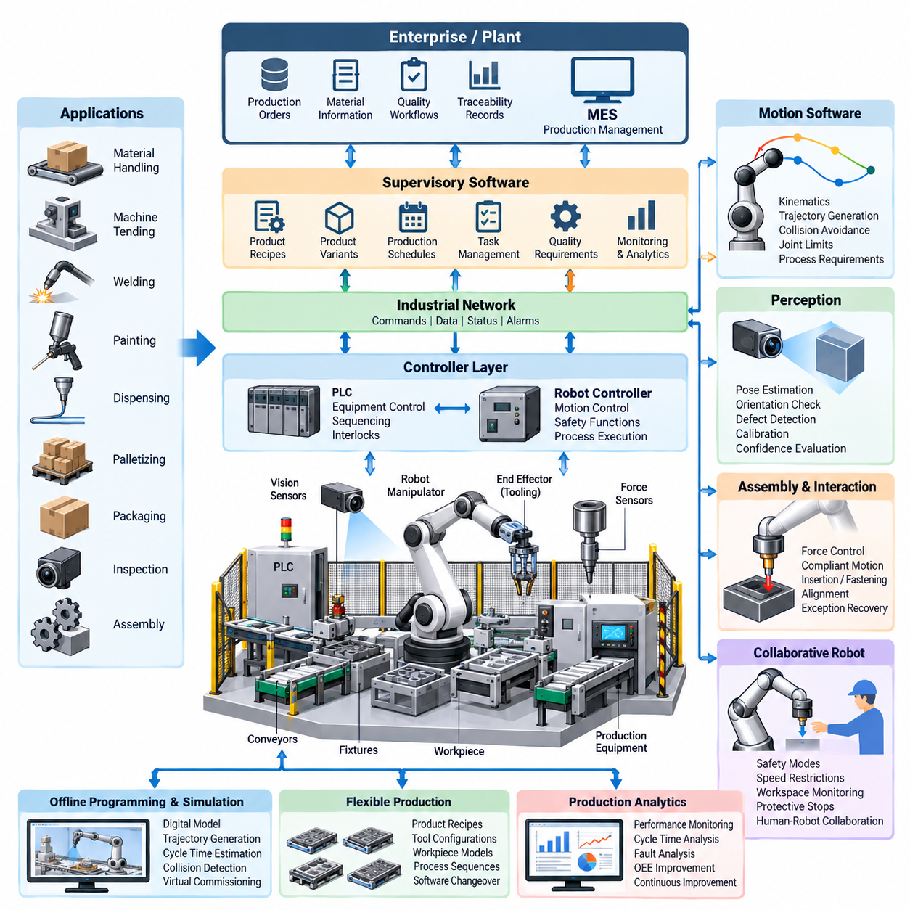
Manufacturing robots form the programmable execution layer of modern production systems, connecting mechanical equipment, sensors, controllers, industrial networks, and enterprise software. Their role extends far beyond repetitive motion. A manufacturing robot must interpret production commands, coordinate tools and fixtures, execute precise trajectories, respond to process conditions, and continuously report operational status to surrounding automation systems.
From a software perspective, manufacturing robotics is fundamentally a real-time cyber-physical integration problem. Robot controllers execute deterministic motion and safety functions while higher-level software manages tasks, recipes, product variants, quality requirements, and production schedules. This layered architecture allows fast control loops to remain isolated from slower supervisory functions while still exchanging state, commands, alarms, and production data through controlled interfaces.
Industrial applications include material handling, machine tending, welding, painting, dispensing, palletizing, packaging, inspection, and assembly. Each application places different demands on the software stack. A welding robot emphasizes trajectory consistency and process synchronization, while an assembly robot requires accurate pose estimation, force interaction, sequence management, and exception recovery. Software therefore converts a general robot platform into an application-specific production resource.
A typical robot cell combines robot manipulators, end effectors, programmable logic controllers, safety controllers, machine vision, force sensors, conveyors, fixtures, and production equipment. Cell software coordinates these components as one operational system rather than treating the robot as an isolated machine. State machines or behavior-oriented task logic commonly represent production sequences and determine when operations may start, continue, pause, retry, or terminate.
Robot motion software transforms application objectives into executable joint movement. Kinematic models convert between Cartesian tool poses and joint configurations, trajectory generators produce smooth motion profiles, and servo controllers maintain the commanded position, velocity, or torque. Collision constraints, joint limits, singularities, payload characteristics, tool geometry, and process requirements must be considered before motion is accepted for production execution.
Modern manufacturing increasingly requires flexible production rather than fixed automation dedicated to one product. Software manages product recipes, robot parameters, tool configurations, workpiece models, and process sequences so that the same cell can manufacture multiple variants. Changeover can therefore become a controlled software operation in which validated configurations are loaded automatically instead of requiring extensive mechanical adjustment and manual robot reprogramming.
Perception adds another layer of flexibility. Cameras and three-dimensional sensors can locate randomly positioned parts, estimate object poses, verify component orientation, inspect assembly states, and detect defects. Perception results must be transformed into the coordinate frames used by the robot controller. Calibration, timestamp consistency, confidence evaluation, and error handling are therefore as important as the underlying computer vision algorithm in a production system.
Assembly applications introduce physical interaction between the robot and workpiece. Position control alone may be insufficient for connector insertion, press fitting, fastening, alignment, or mating operations. Force and torque sensing allows software to detect contact, regulate interaction forces, identify abnormal resistance, and execute compliant search motions. These capabilities enable robots to handle tolerance variations that cannot be represented by ideal geometric coordinates alone.
Collaborative robots extend manufacturing automation into workspaces shared with people. Their software must integrate production behavior with safety-related operating modes, speed restrictions, workspace supervision, protective stops, and recovery procedures. Collaboration should therefore be considered a system-level property involving robot control, tooling, sensors, layout, task design, and risk assessment rather than a capability provided solely by the manipulator.
Manufacturing robot cells also depend on integration with programmable logic controllers and factory automation networks. PLCs frequently control conveyors, clamps, pneumatic devices, process machines, and interlocks while exchanging commands with robot controllers. Reliable interfaces require explicit handshake states, timeout rules, command acknowledgements, fault codes, and recovery transitions so that asynchronous equipment behavior cannot leave the production cell in an ambiguous state.
At the supervisory level, Manufacturing Execution Systems connect robot cells to production orders, material information, traceability records, and quality workflows. A robot may receive a product identifier and associated recipe, execute the required process, and return completion status and measured process values. This connection transforms robotic execution into a traceable element of the broader manufacturing information architecture rather than an independent automation island.
Offline programming and simulation reduce dependence on physical production equipment during development. Engineers can construct digital representations of robots, fixtures, tools, and workpieces, generate trajectories, estimate cycle times, evaluate reachability, and detect potential collisions before deployment. Virtual commissioning extends this concept by testing control logic and interfaces against simulated equipment, reducing commissioning time and production disruption.
Production software must address abnormal conditions as carefully as nominal operation. Missing parts, failed grasps, vision uncertainty, fixture faults, communication timeouts, tool wear, excessive force, and blocked equipment can interrupt a sequence. Robust systems classify these events and select controlled responses such as retrying, repositioning, requesting operator assistance, rejecting a workpiece, entering a safe state, or stopping the cell when recovery cannot be guaranteed.
Observability is therefore essential for industrial robot operation. Robot state, cycle time, controller alarms, process parameters, sensor measurements, quality results, and recovery events can be collected as structured telemetry. These data support troubleshooting and production analytics while also enabling calculation of availability, performance, quality, downtime, and Overall Equipment Effectiveness. The robot cell becomes both a production asset and a continuous source of operational evidence.
Software lifecycle management becomes increasingly important as robot cells grow more connected. Robot programs, PLC logic, perception models, configuration files, calibration parameters, and production recipes should be versioned and associated with validated releases. Controlled deployment, rollback, access management, change history, and backup procedures reduce the risk that an undocumented software modification will alter production behavior or invalidate a previously qualified process.
Artificial intelligence expands manufacturing robotics beyond explicitly programmed conditions. Learning-based perception can classify components and defects, predictive models can identify abnormal process patterns, and adaptive manipulation can improve performance under variation. However, AI outputs must be integrated with deterministic constraints, confidence thresholds, fallback behaviors, and validation procedures. Production robustness remains more important than maximizing model capability under ideal benchmark conditions.
The resulting manufacturing robot is best understood as a software-defined production system whose physical behavior emerges from coordinated control, perception, planning, safety, communication, and production-management functions. This software-centered perspective provides the foundation for flexible assembly cells, vision-guided manipulation, force-controlled insertion, collaborative operation, MES and PLC integration, offline programming, AI quality inspection, and production analytics developed throughout this chapter.
Within the broader robotics software structure, these manufacturing capabilities reuse technologies developed across control software, ROS 2 and middleware, robot communication, data architecture, cloud and edge computing, DevOps, simulation, perception, planning, and manipulation. Manufacturing applications therefore represent an integration layer in which previously separated robotics technologies must operate together under the timing, safety, availability, maintainability, and traceability requirements of real production environments.

07.02. Flexible Assembly Cell SW Architecture [w/Code]
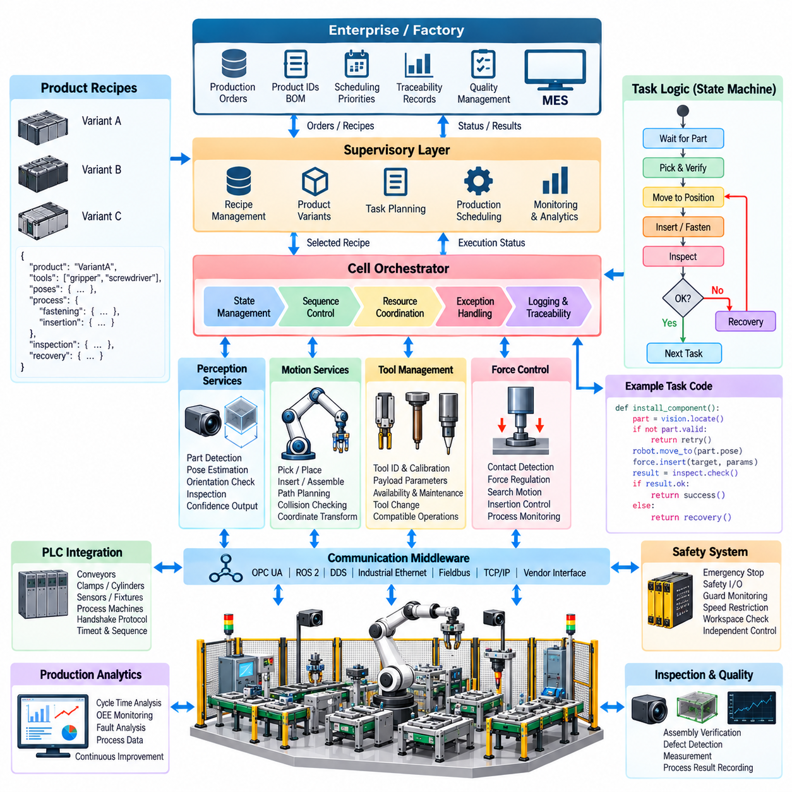
A flexible assembly cell is a software-coordinated manufacturing system designed to execute multiple product variants without rebuilding the automation architecture for every change. Instead of binding robot programs directly to one fixed sequence, the cell separates production recipes, task logic, motion execution, perception, equipment control, and safety. This separation allows manufacturing behavior to be reconfigured while preserving validated control functions.
The software architecture is typically organized into hierarchical layers with different timing and responsibility boundaries. A supervisory layer interprets production orders and selects product recipes, while a cell orchestration layer coordinates assembly tasks. Robot and equipment control layers execute motion and device commands, and real-time controllers close servo and process loops. Safety functions operate independently where required to prevent production logic from overriding protective behavior.
At the center of the architecture is the cell orchestrator, which converts a production request into an executable sequence of operations. It determines when parts should be supplied, when fixtures should be locked, when robots may enter shared workspaces, and when inspection should occur. Rather than embedding every condition inside robot programs, orchestration software maintains the overall process state and coordinates distributed equipment through explicit commands and acknowledgements.
Production recipes provide the configuration required for product variation. A recipe can reference component types, assembly sequences, robot programs, tool selections, target poses, process parameters, inspection criteria, and recovery policies. Separating this information from executable control code reduces duplication and allows validated software components to be reused. Recipe versions should be traceable so that every manufactured unit can be associated with the configuration used during production.
Task execution is commonly represented using state machines, hierarchical state machines, behavior trees, or workflow engines. A high-level task such as installing a component can be decomposed into acquiring the part, verifying identity, moving to an approach pose, performing insertion, confirming completion, and releasing the tool. Each step defines entry conditions, success criteria, timeout behavior, and failure transitions so that execution remains deterministic and observable.
Robot motion services translate task-level requests into physical trajectories. They manage coordinate transformations, inverse kinematics, collision checking, trajectory generation, velocity limits, and controller interfaces. Application logic should request meaningful actions such as pick, place, insert, or inspect rather than directly controlling individual joints whenever possible. This abstraction improves portability when robot models, tooling, or cell geometry change during the production lifecycle.
Flexible assembly depends heavily on perception because physical components rarely appear at mathematically perfect nominal positions. Vision systems detect parts, estimate poses, verify orientation, identify product variants, and inspect intermediate assembly states. Perception software must provide confidence values and coordinate-frame information together with detection results. The task layer can then decide whether to proceed, repeat sensing, reposition the camera, or request operator intervention.
Tool management is another important architectural service. A single robot may use grippers, screwdrivers, dispensing heads, welding tools, cameras, or specialized assembly fixtures during different production steps. Software maintains tool identifiers, calibration information, payload parameters, availability, maintenance state, and compatible operations. Automatic tool changing therefore becomes a managed production transaction rather than merely a mechanical coupling operation.
Assembly processes involving contact require force-aware execution services. Force and torque measurements can be used to detect initial contact, regulate insertion force, perform spiral or linear search patterns, and recognize abnormal resistance. These functions should expose controlled parameters such as force limits, search distance, velocity, and termination conditions. Higher-level task logic can invoke them without implementing low-level force-control algorithms for every product recipe.
PLC integration connects robotic software with conventional factory automation. Conveyors, clamps, cylinders, sensors, fixtures, process machines, and safety-related devices frequently remain under PLC control. The robot cell therefore requires well-defined handshake protocols specifying command, busy, complete, fault, reset, and permission states. Timeouts and sequence numbers can prevent stale or lost signals from being interpreted as valid production commands.
Communication middleware provides the transport layer between distributed software components. Depending on the equipment and timing requirements, the architecture may combine industrial Ethernet, fieldbus protocols, OPC UA, ROS 2, DDS, TCP/IP services, or vendor-specific robot interfaces. The important architectural principle is to isolate protocol-specific communication behind stable service interfaces so that application logic does not depend unnecessarily on one hardware vendor or network technology.
Manufacturing Execution System integration connects the flexible cell with factory-level production management. The MES can provide work orders, product identifiers, bill-of-process information, recipe references, and scheduling priorities. The cell returns production status, timestamps, quality results, process measurements, and failure information. This bidirectional interface allows flexible robotic execution to remain synchronized with material flow, traceability, and production planning.
A shared data model is essential when multiple robots and devices collaborate. The model should represent workpieces, tools, fixtures, coordinate frames, operations, equipment states, quality results, and production identifiers consistently. Without common semantics, each subsystem may interpret the same physical object differently. Standardized identifiers and timestamps also allow events from robots, PLCs, vision systems, and MES applications to be correlated during troubleshooting.
Exception handling must be designed as part of the architecture rather than added after commissioning. A flexible cell may encounter missing parts, failed grasps, pose uncertainty, insertion resistance, tool faults, blocked fixtures, or communication loss. Recovery logic determines whether the operation can be retried locally, whether an alternative strategy is available, whether the workpiece should be rejected, or whether human intervention and controlled cell shutdown are required.
Safety architecture remains separated from ordinary production optimization. Emergency stops, protective stops, interlocks, safe speed functions, workspace monitoring, and access control must maintain their required behavior even if supervisory software fails. Production software consumes safety state and coordinates recovery, but it should not bypass safety decisions. Restart logic must verify that equipment, workpieces, tools, and process states remain consistent before automatic operation resumes.
Simulation and digital twin technologies support development of flexible cells before physical equipment becomes available. Robot reachability, collisions, cycle time, fixture placement, and task sequences can be evaluated in a virtual environment. Virtual commissioning can connect simulated devices to actual orchestration or PLC software, allowing engineers to test interfaces and abnormal conditions before deployment and reducing debugging time on the production floor.
Observability services collect events, robot states, cycle times, process parameters, perception confidence, equipment faults, and recovery actions. Structured logs and time-synchronized telemetry allow engineers to reconstruct the sequence leading to a production problem. Metrics can also reveal recurring delays, unstable process steps, excessive retries, or bottlenecks. This information supports continuous optimization without changing the fundamental execution architecture.
Configuration and software lifecycle management are particularly important because flexibility creates many combinations of products, tools, programs, and parameters. Robot programs, PLC logic, recipes, perception models, calibration files, and orchestration software should therefore be version controlled and deployed as compatible releases. A known production configuration must be reproducible, and rollback should restore a previously validated combination when an update introduces unexpected behavior.
A mature flexible assembly cell ultimately behaves as a modular software-defined manufacturing platform. New product variants can be introduced primarily by adding recipes, task configurations, perception definitions, and validated process parameters rather than rewriting the entire control system. This architecture establishes the foundation for vision-guided pick and place, force-controlled insertion, collaborative robotics, MES and PLC integration, offline programming, AI inspection, and production analytics addressed in subsequent manufacturing applications.

07.03. Vision Guided Pick and Place for Manufacturing [w/Code]
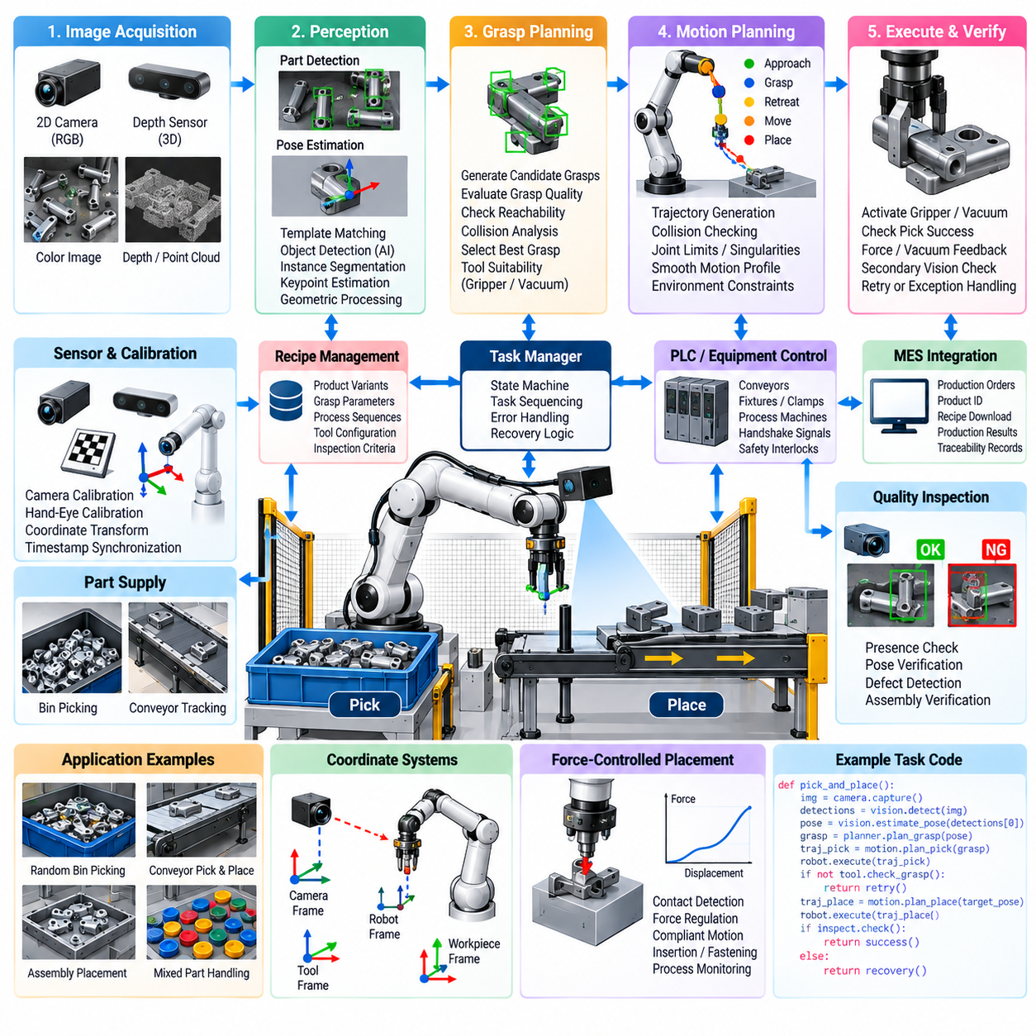
Vision-guided pick and place combines robotic manipulation with machine perception so that parts can be detected, localized, selected, grasped, transported, and placed without relying entirely on fixed mechanical positioning. In manufacturing, this capability enables robots to handle variable part locations, mixed components, moving workpieces, and flexible production layouts while reducing dependence on precision feeders and dedicated fixtures.
The software pipeline begins with image or three-dimensional sensor acquisition. Cameras may be mounted above the workspace, attached to the robot, or positioned around a conveyor or bin. RGB cameras provide appearance information, while stereo, structured-light, time-of-flight, or other depth sensors provide geometric measurements. Sensor selection depends on part size, surface properties, required accuracy, working distance, cycle time, and environmental conditions.
Reliable perception requires calibration between the camera, robot, tool, and workspace coordinate systems. Eye-to-hand configurations use a fixed camera observing the robot workspace, whereas eye-in-hand configurations mount the camera on the robot. Calibration software estimates the transformations connecting camera coordinates to robot coordinates so that an object detected in an image can be converted into a physically meaningful target pose for manipulation.
The perception stage identifies candidate objects and determines where they are located. Traditional systems may use template matching, geometric features, contours, or color segmentation, while AI-based systems can apply object detection, instance segmentation, keypoint estimation, or learned feature representations. Manufacturing systems often combine these approaches because deterministic geometric processing can complement learning-based recognition when accuracy and repeatability are required.
Object detection alone is insufficient for robotic manipulation because the robot must understand the position and orientation of the target in physical space. Pose estimation software determines the object's translation and rotation relative to the camera or workspace. Depending on the application, this may range from planar position and orientation for conveyor picking to full six-degree-of-freedom pose estimation for randomly oriented components inside a bin.
Depth information becomes particularly important for three-dimensional picking. Point clouds generated from depth sensors can represent visible surfaces and support plane removal, clustering, surface-normal estimation, geometric matching, and collision analysis. When objects overlap or occlude one another, the perception system must estimate which surfaces belong to each candidate object and whether sufficient geometry is visible to support a reliable grasp.
Grasp planning converts perception results into possible robot-tool interactions. The planner evaluates candidate grasp poses according to object geometry, gripper characteristics, approach direction, collision risk, reachability, and expected grasp stability. A parallel gripper may require accessible opposing surfaces, while vacuum tooling requires suitable contact regions. The selected grasp must therefore satisfy both perception confidence and physical manipulation constraints.
Motion planning connects the current robot configuration to the selected grasp pose. The software typically generates an approach trajectory, a final grasp motion, a retreat trajectory, and subsequent transport and placement motions. Collision checking considers the robot, tool, workpiece, fixtures, containers, and surrounding equipment. Joint limits and singular configurations must also be evaluated before the trajectory is released for execution.
The pick operation should be treated as a monitored process rather than an open-loop movement. After reaching the target, the robot activates the gripper or vacuum tool and verifies successful acquisition using available feedback. Vacuum pressure, gripper position, motor current, force sensing, or secondary vision can provide confirmation. If verification fails, the task manager can retry the grasp, choose another candidate, or trigger an exception-handling procedure.
Placement requires similar coordination between perception, planning, and process constraints. Some applications place components into fixed fixtures, while others require vision to identify an available destination or estimate the pose of another component. Assembly-oriented placement may require tighter tolerances than picking and can therefore combine visual alignment with force-controlled final insertion. The software architecture should support these different placement strategies through reusable task primitives.
Conveyor applications introduce motion into the perception and manipulation problem. The vision system detects a workpiece and estimates its position while conveyor tracking predicts how that position changes over time. Robot execution must account for detection latency, communication delay, conveyor velocity, and controller timing. Accurate timestamping and synchronization are therefore essential when the robot must intercept a moving target rather than wait for a stationary part.
Bin picking represents a more difficult manufacturing case because objects may be randomly stacked, partially hidden, and physically constrained by neighboring parts. The software repeatedly acquires three-dimensional data, identifies graspable candidates, evaluates collision-free approaches, and selects a target that can be removed safely. After each successful pick, the scene changes and perception must be updated before the next manipulation decision is made.
Confidence management is essential when AI perception is used in production. A detection or pose estimate should include a confidence measure that can be evaluated by downstream task logic. Low-confidence results may trigger another image acquisition, a different viewpoint, additional sensing, or operator review. This prevents uncertain AI predictions from being converted directly into physical robot motion without appropriate validation and operational safeguards.
Lighting, reflective surfaces, transparent components, shadows, vibration, contamination, and changing backgrounds can significantly affect vision performance. Industrial deployments therefore require controlled illumination where practical and systematic testing across expected environmental variation. Image-quality monitoring can detect conditions such as overexposure, blur, sensor obstruction, or loss of depth information before unreliable perception results propagate into manipulation commands.
Exception recovery is a core part of the pick-and-place software architecture. Failures may include missing objects, unreachable poses, collisions in planned paths, unsuccessful grasps, dropped components, incorrect part identities, or placement verification errors. Recovery policies can request new perception data, select an alternative grasp, move to a safe observation pose, reject a component, or escalate the problem to an operator depending on the production context.
Traceability connects robotic perception with manufacturing quality management. The system can record object identifiers, detection results, estimated poses, selected grasp configurations, robot trajectories, tool states, timestamps, and final verification results. When a production defect occurs later, these records help engineers reconstruct how the component was handled and determine whether perception, manipulation, tooling, or upstream material presentation contributed to the problem.
Performance evaluation should consider the complete robotic task rather than only computer vision accuracy. Relevant measures include detection success, pose error, grasp success rate, placement accuracy, cycle time, retry frequency, collision-free planning success, and recovery effectiveness. A perception model with excellent benchmark accuracy may still be unsuitable if inference latency or unstable pose estimates reduce the overall throughput and reliability of the manufacturing cell.
A production-ready vision-guided pick-and-place system therefore operates as a closed perception-planning-action-verification loop. Sensors observe the workspace, perception estimates object state, grasp and motion planners determine feasible actions, robot controllers execute them, and verification determines whether the intended physical result occurred. Failures return the system to perception or recovery rather than allowing uncertain state to propagate through the production sequence.
Within a flexible manufacturing cell, this closed-loop capability reduces dependence on precisely constrained part presentation and allows software to absorb a larger portion of physical variation. Vision-guided manipulation can consequently support mixed-product assembly, flexible machine tending, random bin picking, conveyor tracking, packaging, sorting, and inspection-linked handling while providing the perception foundation required for more advanced force-controlled assembly operations.

07.04. Force Controlled Assembly Insertion Tasks [w/Code]
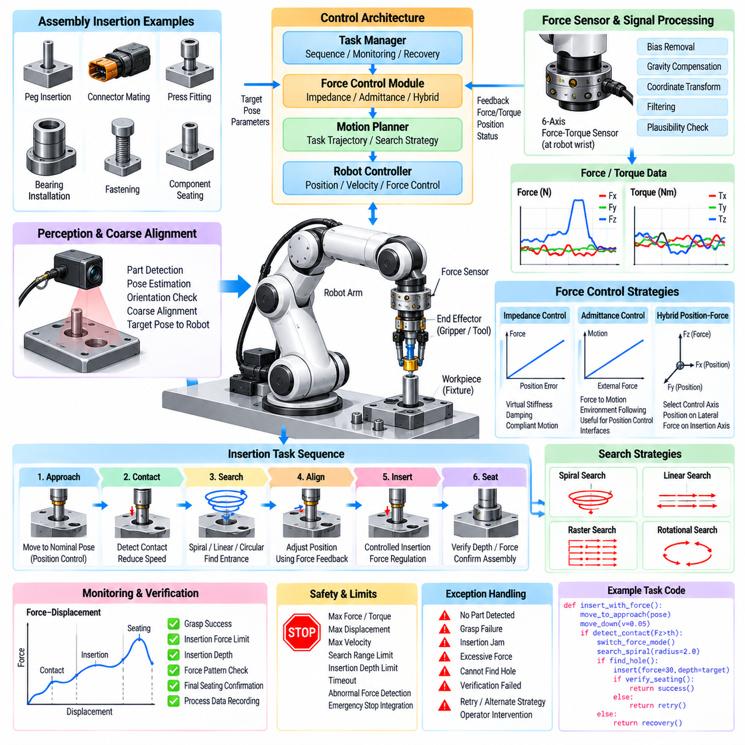
Force-controlled assembly enables robots to perform insertion and mating operations in which geometric position control alone cannot reliably handle physical contact, tolerance variation, or alignment error. Typical tasks include peg insertion, connector mating, press fitting, bearing installation, fastening, and component seating. The robot uses measured interaction forces and torques to modify motion while the assembly operation is being executed.
A conventional position-controlled robot attempts to follow a commanded trajectory even when the physical workpiece differs slightly from its nominal model. During insertion, a small lateral or angular error can therefore create contact forces, jamming, wedging, component damage, or emergency stops. Force control introduces physical feedback so that the robot can recognize contact and adapt its motion instead of treating every deviation as a positioning error.
The sensing layer commonly relies on a six-axis force-torque sensor located near the robot wrist, although joint torque sensing, motor-current estimation, tactile sensors, or instrumented tools can also provide interaction information. Measurements represent forces and moments generated between the robot, tool, and workpiece. Software must transform these values into an appropriate coordinate frame before they can be interpreted for assembly control.
Raw force measurements are rarely suitable for direct control. Sensor bias, payload gravity, vibration, cable forces, acceleration, and electrical noise can distort the measured signal. The software pipeline therefore performs zeroing, gravity compensation, coordinate transformation, filtering, and plausibility checks. Excessive filtering must be avoided because additional delay can reduce control stability and make rapid contact events more difficult to detect.
Contact detection represents the transition from free-space motion to physical interaction. The controller monitors force, torque, displacement, or combinations of these signals and compares them with defined thresholds. Once contact is confirmed, the robot can reduce velocity and switch from position-dominant motion to a compliant operating mode. Reliable state transitions prevent transient sensor noise from being interpreted incorrectly as meaningful contact.
Impedance control is widely used to regulate the relationship between position deviation and interaction force. Rather than commanding an infinitely rigid trajectory, the robot behaves like a configurable mechanical system with virtual stiffness, damping, and sometimes inertia. High stiffness can preserve positioning accuracy in selected directions, while lower stiffness allows compliant movement along directions where the workpiece must guide the robot toward alignment.
Admittance control provides a complementary strategy in which measured external force is converted into a motion correction. The robot can move away from excessive contact or follow the geometry imposed by the environment. This approach is particularly useful when the underlying industrial controller primarily exposes position or velocity commands. Software must carefully select gains and limits so that compliance does not introduce oscillation or uncontrolled motion.
Insertion tasks are often decomposed into approach, contact, search, alignment, insertion, seating, and verification states. During approach, the robot moves toward the nominal assembly pose using position control. After contact, force feedback determines whether alignment is acceptable. Search motion then identifies a feasible entrance, controlled insertion advances the component, and final seating verifies that the required depth and force characteristics have been achieved.
Search strategies compensate for uncertainty between the nominal and actual mating geometry. A robot can execute spiral, raster, circular, linear, or small rotational motions while monitoring interaction forces. When the component enters the intended opening, the force pattern and displacement behavior change. The controller detects this transition and terminates the search, preventing unnecessary motion after successful alignment has been achieved.
Peg-in-hole assembly illustrates the interaction between geometric error and force feedback. If the peg is laterally displaced, contact occurs at the edge of the hole and generates characteristic forces. Angular misalignment can produce moments and multi-point contact. By interpreting these signals, the controller can adjust lateral position or orientation until insertion becomes possible instead of increasing downward force and creating a jammed condition.
Connector insertion introduces additional challenges because electrical and mechanical connectors may have asymmetric geometry, latches, seals, or fragile pins. The software can combine vision-based coarse alignment with force-controlled final mating. Vision brings the connector near the expected pose, while force feedback manages the last millimeters of physical interaction. Force-distance signatures can also help determine whether the connector has seated correctly.
Hybrid position-force control separates motion dimensions according to their physical roles. Position may be controlled tightly along directions requiring geometric accuracy, while force is regulated along the contact direction. For example, a robot can maintain lateral alignment while commanding a limited axial insertion force. The selection of controlled axes can change between task states as the mechanical constraints evolve during the assembly sequence.
Safety limits must remain active throughout force-controlled execution. The software defines maximum force, torque, displacement, velocity, search radius, insertion depth, and operation time. Exceeding these limits indicates that the observed physical interaction no longer matches the expected process. The controller should stop or retreat before the robot damages the workpiece, tool, fixture, or itself, rather than continuing to pursue the nominal assembly target.
Failure classification improves recovery behavior. High axial force with little displacement may indicate obstruction, increasing lateral force may indicate misalignment, and unexpected torque may indicate angular interference. Instead of treating every event as a generic robot fault, the task manager can associate measured patterns with probable assembly conditions and select an appropriate response such as retracting, realigning, searching again, or rejecting the component.
Force-controlled assembly benefits from integration with machine vision and pose estimation. Vision provides global information about part identity, location, and orientation, while force sensing provides local information after physical contact occurs. These modalities therefore complement one another. Perception reduces initial pose uncertainty, and force feedback compensates for residual calibration errors, mechanical tolerances, fixture variation, and deformation during final assembly.
Process verification should evaluate both final geometry and the interaction history. Successful insertion may require the expected depth, acceptable final force, correct tool position, and a characteristic force-displacement profile. Recording this profile provides evidence about how the assembly occurred rather than merely whether the robot reached its commanded endpoint. Abnormal signatures can identify incomplete insertion or excessive friction even when the final pose appears correct.
The task software should expose force-controlled operations as reusable assembly primitives rather than embedding low-level control logic inside every product program. Functions such as move-until-contact, compliant-search, insert-with-force-limit, maintain-contact, and verify-seating can be parameterized for different components. Product recipes then specify target poses, limits, search patterns, and acceptance criteria while validated control functions remain reusable.
Simulation can support development, but contact-rich assembly is difficult to reproduce perfectly because friction, compliance, backlash, material deformation, and sensor noise strongly influence real behavior. Simulation is valuable for sequence logic, collision analysis, and initial controller tuning, while final validation requires physical testing. Parameters should therefore progress through controlled commissioning rather than being transferred directly from an idealized simulation to production.
Production monitoring can collect peak force, insertion time, search duration, insertion depth, retry count, final pose, and force-displacement curves for each operation. Statistical analysis of these measurements can reveal tool wear, fixture drift, component tolerance changes, lubrication problems, or emerging process instability. Force sensing consequently becomes not only a control mechanism but also an important source of manufacturing quality information.
A production-ready force-controlled assembly system ultimately operates as a closed interaction loop connecting sensing, interpretation, compliant motion, verification, and recovery. The robot does not merely move to a predetermined coordinate; it continuously evaluates how the physical environment responds to its action. This capability allows flexible assembly cells to handle real manufacturing variation while maintaining controlled forces, protecting components, and producing traceable evidence of assembly quality.

07.05. Collaborative Robot Cobot SW and ISO 10218 [w/Code]
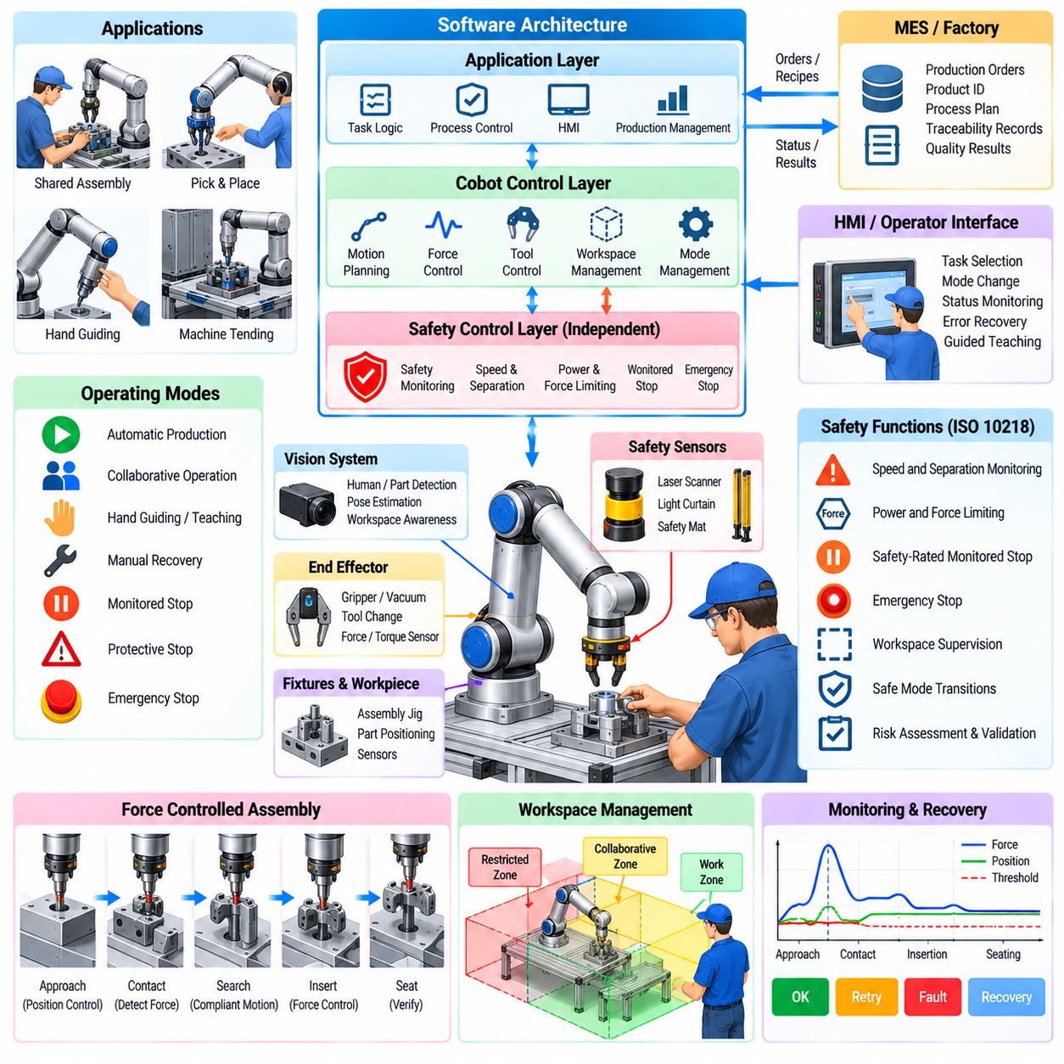
Collaborative robots, commonly called cobots, are industrial robot systems designed to support applications in which people and robots may work within closely connected production environments. Their software must coordinate productivity with safety-related behavior, task execution, sensing, motion constraints, and controlled recovery. Collaboration is therefore not a property of the robot alone but a characteristic of the complete robot application and its operating conditions.
A collaborative application may combine the robot, end effector, workpiece, fixtures, sensors, safety devices, control software, and human operator within one production process. The software architecture must understand when automatic operation is permitted, which workspace regions are available, and what motion restrictions apply. A robot that supports collaborative functions does not automatically make every application safe; system-level risk assessment remains essential.
ISO 10218 provides an important safety framework for industrial robots and robot applications. From a software perspective, its relevance extends beyond emergency stopping to the design of operating modes, safety-related control functions, integration interfaces, validation, and predictable responses to faults. Collaborative operation must therefore be engineered as part of the overall industrial robot system rather than implemented as an optional application feature.
The control architecture typically separates standard production logic from safety-related control. Production software determines assembly sequences, trajectories, tool operations, and process parameters, while certified or safety-rated functions supervise conditions that can affect people. This separation prevents ordinary application code from becoming the sole mechanism responsible for protective behavior and establishes a defined boundary between productivity functions and safety functions.
Safety-rated monitored stop is useful when human access and robot motion must occur at different times within a shared workspace. When the defined condition for human entry is detected, robot motion is brought to and maintained in the required stopped state. Production software can preserve task context while the safety system supervises the stop. After authorized recovery conditions are satisfied, execution can resume through a controlled restart sequence.
Hand-guided operation allows an operator to intentionally command robot movement through an appropriate guiding interface. Software supporting this mode must manage transitions between automatic operation and guided movement while respecting applicable safety functions and motion constraints. Hand guiding can simplify teaching, positioning, or specialized manufacturing tasks, but activation, enabling conditions, speed behavior, and return to automatic execution require explicit state management.
Speed and separation monitoring coordinates robot motion with the distance between people and hazardous robot movement. Safety sensors can monitor protected regions or separation conditions, while safety-related logic adjusts or stops robot operation when required. Application software should treat the resulting safety state as an authoritative constraint. Production optimization may choose alternative behavior, but it must never override a safety-related reduction or stop command.
Power and force limiting addresses applications where physical contact may be possible under defined conditions. Robot mechanical design, control behavior, tool geometry, payload, speed, and application configuration all influence the resulting contact. Software can restrict velocity, acceleration, torque, momentum, and workspace behavior, but acceptable operation cannot be established from a software parameter alone. The complete application and potential contact scenarios require evaluation.
Workspace management is particularly important in collaborative cells. Software can represent regions assigned to robots, operators, tools, or specific process states and modify allowable motion according to the active production phase. Safety-rated workspace supervision may provide independent enforcement where required. Separating logical workspace planning from safety enforcement allows flexible task coordination without confusing ordinary collision avoidance with personnel protection.
Human detection may use safety laser scanners, light curtains, pressure-sensitive devices, vision systems, or other appropriate sensors depending on the application. The software must distinguish safety-related sensing from perception used only for productivity. A conventional AI camera may estimate human pose for task coordination, for example, while an independent safety function determines whether hazardous robot motion is permitted. The two information paths should not be treated as equivalent.
Collaborative task software can use human-state information to improve workflow without assigning unsupported safety responsibility to AI. A robot may wait while an operator performs manual assembly, present a component when the workspace becomes available, or choose another task while a shared station is occupied. Such behavior improves cooperation and throughput, while safety-related control continues to determine whether robot motion is permissible under the configured operating mode.
Mode management should be explicit and observable. Typical system states can include automatic production, collaborative operation, teaching, manual recovery, protective stop, emergency stop, and maintenance conditions. Each transition should define authorization, entry conditions, permitted commands, motion limits, and exit requirements. Ambiguous transitions are dangerous because different subsystems may otherwise hold inconsistent assumptions about whether robot motion is currently allowed.
Restart behavior deserves the same attention as stopping behavior. After a protective event, the system should not simply continue from the interrupted program counter without evaluating physical state. A person may have moved a component, the robot may have released a part, or a fixture may have changed. Recovery software should verify robot position, tool state, workpiece state, safety conditions, and process consistency before deciding whether execution can resume or must return to an earlier task state.
Tooling can significantly alter collaborative risk. A low-payload robot equipped with a sharp, hot, heavy, or powered end effector may create hazards not apparent from the robot arm itself. Software should therefore associate tool identity with payload data, permitted speeds, operating zones, task permissions, and process restrictions. Automatic tool changing must update the active configuration so that motion and safety assumptions remain consistent with the physically attached tool.
Communication between the robot controller, safety controller, PLC, and cell orchestrator must use clearly defined states. Signals such as safety ready, protective stop, operation permitted, reset request, mode selection, and fault status should have unambiguous semantics. Application software should fail conservatively when required state information is unavailable rather than assuming that missing communication represents permission to continue collaborative motion.
Fault handling must distinguish production failures from safety-related events. A failed grasp or missing component may permit an automatic retry, while loss of a safety sensor or inconsistency in safety state may require robot motion to remain inhibited. The software architecture should prevent generic exception handlers from resetting safety conditions automatically. Recovery actions must respect the authority and reset requirements of the safety-related control system.
Validation should verify both individual functions and complete collaborative scenarios. Testing can examine operating-mode transitions, protective stops, restart behavior, workspace restrictions, speed limits, sensor responses, communication failures, and foreseeable operator interactions. Software logs can provide evidence showing which states and commands were active during validation, supporting traceability between risk controls, implementation, test procedures, and observed results.
Configuration management is essential because changes to robot programs, tools, payloads, safety parameters, cell layouts, or production sequences can alter the assumptions underlying the application. Software releases should therefore identify compatible safety configurations and validated operating conditions. A change that appears minor from a production perspective may require renewed assessment when it modifies robot speed, reachable space, contact conditions, or human interaction.
Operational monitoring can record mode changes, protective stops, safety-related state transitions, collaborative cycle times, operator interventions, and recovery events. These records help engineers distinguish productivity problems from repeated protective events and identify workflows that encourage unnecessary human-robot interference. Monitoring should support improvement without weakening safety functions merely to increase throughput.
The resulting cobot system is best understood as a safety-constrained software-defined manufacturing application. Production orchestration, perception, motion planning, force control, PLC integration, and human interaction operate inside boundaries established by the robot system's safety architecture and validated application conditions. This approach allows collaborative automation to remain flexible while preserving explicit responsibility for motion permission, stopping, recovery, configuration, and verification.

07.06. MES PLC Integration with Robot Cell [w/Code]
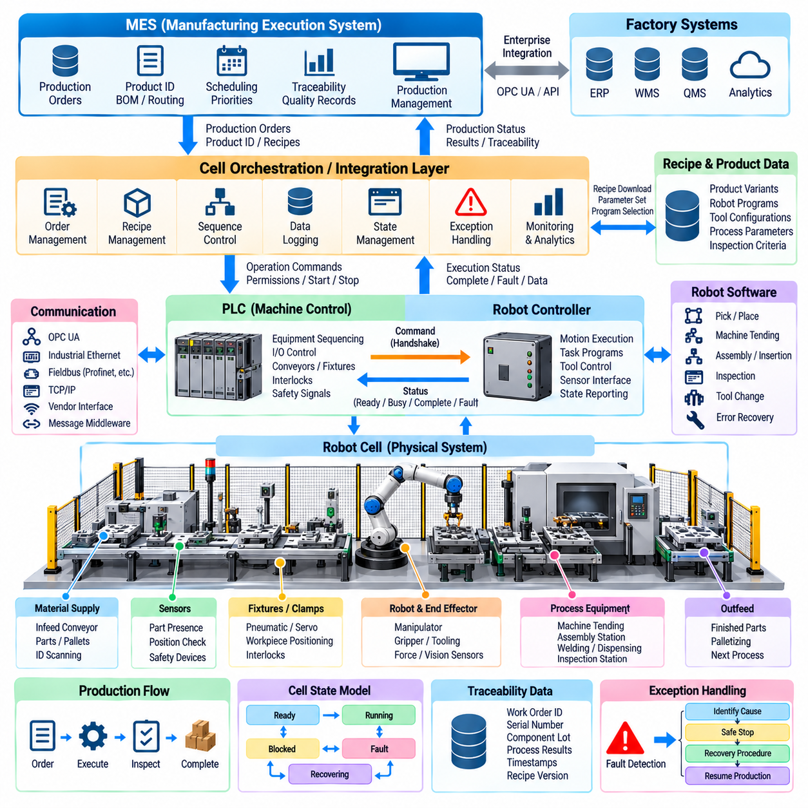
Integration between a Manufacturing Execution System, programmable logic controllers, and robot cells connects enterprise production decisions with real-time physical automation. The MES manages production orders, product identity, routing, recipes, scheduling, and traceability, while PLCs coordinate deterministic machine-level sequences. Robot controllers execute manipulation tasks, creating a layered architecture from production intent to physical action.
The MES normally operates at a higher abstraction level than individual robot programs. Instead of commanding robot joints or individual actuators, it communicates information such as work-order identifiers, product variants, quantities, priorities, process routes, and recipe references. The cell control layer translates this production information into executable operations and coordinates the resources required to manufacture each unit.
The PLC commonly acts as the deterministic coordination point for equipment surrounding the robot. Conveyors, clamps, cylinders, fixtures, sensors, doors, process machines, and material-handling devices may all exchange signals with the PLC. The robot controller receives commands and permissions from this control layer and returns execution states, allowing robot motion to remain synchronized with the broader machine sequence.
A well-defined handshake protocol prevents ambiguous interactions between the PLC and robot controller. Typical states include command requested, command accepted, robot busy, operation complete, fault, reset, and ready. Each signal should have a precise meaning and expected transition sequence. Timeouts and invalid-state detection are important because a missing acknowledgement can otherwise leave the PLC and robot waiting indefinitely for one another.
Robot programs should preferably expose manufacturing operations rather than low-level motion details to the PLC. Commands such as load machine, unload machine, pick component, place component, inspect part, or execute assembly operation provide stable interfaces even when internal robot trajectories change. This abstraction reduces coupling between PLC logic and robot programming and simplifies future optimization of robot motion without redesigning the entire cell sequence.
Product variants can be managed through recipe-driven execution. The MES identifies the product or work order and provides the appropriate manufacturing context, while the cell controller selects validated robot programs, tool configurations, target positions, process parameters, and inspection criteria. Separating recipe data from executable control logic allows one robot cell to support multiple products without maintaining completely independent automation software for every variant.
Production identity should propagate consistently through the complete control hierarchy. A work-order identifier, serial number, lot number, or carrier identifier received from the MES can be associated with the corresponding robot operation and process results. This association enables the system to determine which robot program, tool, parameters, inspection results, and timestamps were used for a particular manufactured component.
Communication architecture may combine industrial Ethernet, fieldbus protocols, OPC UA, TCP/IP, vendor-specific robot interfaces, and message-oriented middleware. Different interfaces serve different timing requirements. Deterministic equipment coordination remains close to PLC and robot controllers, while MES transactions generally tolerate longer communication intervals. The architecture should avoid placing time-critical motion dependencies on non-real-time enterprise communication.
OPC UA can provide structured interoperability between manufacturing software and automation equipment by exposing states, commands, parameters, and production information through defined information models. A gateway or cell orchestration service can isolate MES software from vendor-specific robot and PLC interfaces. This separation reduces integration complexity and allows equipment to be replaced or upgraded without forcing extensive changes to higher-level production systems.
State models are essential because MES, PLC, and robot controllers operate on different time scales and maintain different views of production. A cell may be ready, executing, blocked, starved, faulted, recovering, or under maintenance, while the robot itself has more detailed motion states. The integration layer should map these conditions into consistent production states so that the MES does not interpret a temporary robot transition as completion or failure of an entire manufacturing operation.
Buffering is necessary when enterprise communication and real-time automation operate asynchronously. A temporary MES network interruption should not automatically stop a robot in the middle of a safe, already authorized operation. The cell controller can retain active production context and queue completed results for later transmission. However, new production execution should not proceed when required identity, recipe, authorization, or traceability information cannot be established reliably.
Fault handling should identify the subsystem in which a problem originates. A robot collision, PLC I/O fault, missing component, MES communication timeout, recipe mismatch, and quality rejection require different recovery procedures. Integration software should preserve fault codes and context rather than converting every event into a generic cell failure. Accurate classification enables operators and maintenance personnel to identify the appropriate recovery action more quickly.
Recovery requires synchronization of both physical and digital state. After a fault, the robot may hold a component, a fixture may remain clamped, a conveyor pallet may have moved, or the MES may still consider the operation active. Restart logic must reconcile these conditions before continuing production. Simply resetting individual controllers without restoring a consistent cell state can create duplicate operations, skipped processing, incorrect traceability, or equipment interference.
Quality information can flow from the robot cell back to the MES together with production completion data. Vision inspection results, measured assembly forces, process values, dimensional checks, torque measurements, retry counts, and pass-fail decisions can be associated with the manufactured unit. This transforms the robot cell from an isolated automation device into a source of structured manufacturing evidence that supports genealogy and quality analysis.
Time synchronization improves event correlation across MES servers, PLCs, robot controllers, vision computers, and other cell devices. Consistent timestamps allow engineers to reconstruct sequences when faults or quality problems occur. Although every subsystem may not require hard real-time synchronization, a common time reference significantly improves traceability, log analysis, performance measurement, and diagnosis of intermittent communication or sequence problems.
Cybersecurity must be considered because MES integration creates communication paths between information technology and operational technology. Network segmentation, authenticated communication, role-based access, controlled remote connections, configuration protection, and software update procedures reduce exposure. Robot and PLC control networks should not accept unrestricted commands simply because a device can communicate with the manufacturing network.
Change management should cover MES mappings, PLC logic, robot programs, recipes, interface definitions, and cell orchestration software as one coordinated system. Version incompatibility can cause subtle production failures even when each subsystem operates correctly by itself. Release records should therefore identify validated combinations of software, configuration, communication schemas, robot programs, and product recipes used in production.
Performance monitoring can combine MES production information with PLC and robot telemetry to calculate cycle time, utilization, downtime, waiting time, fault frequency, and production throughput. Detailed states reveal whether lost production originates from robot motion, upstream material supply, downstream blocking, operator intervention, equipment faults, or scheduling. This information provides the foundation for OEE-oriented analysis and systematic cell improvement.
A mature integration architecture therefore treats the robot cell as a managed manufacturing service rather than an isolated machine. MES communicates what should be produced and records the resulting manufacturing history, the PLC coordinates deterministic equipment behavior, and robot software performs the required physical manipulation. Clearly defined interfaces, synchronized states, traceable data, and controlled recovery connect these layers into a reliable production system.
This layered integration also provides the foundation for increasingly flexible manufacturing. New products can be introduced through controlled recipes and program versions, production priorities can be communicated dynamically, and process results can return automatically to manufacturing information systems. The robot cell consequently becomes a software-integrated production resource capable of participating in coordinated, traceable, and data-driven factory operation.

07.07. Robot Program Management and OLP Offline [w/Code]
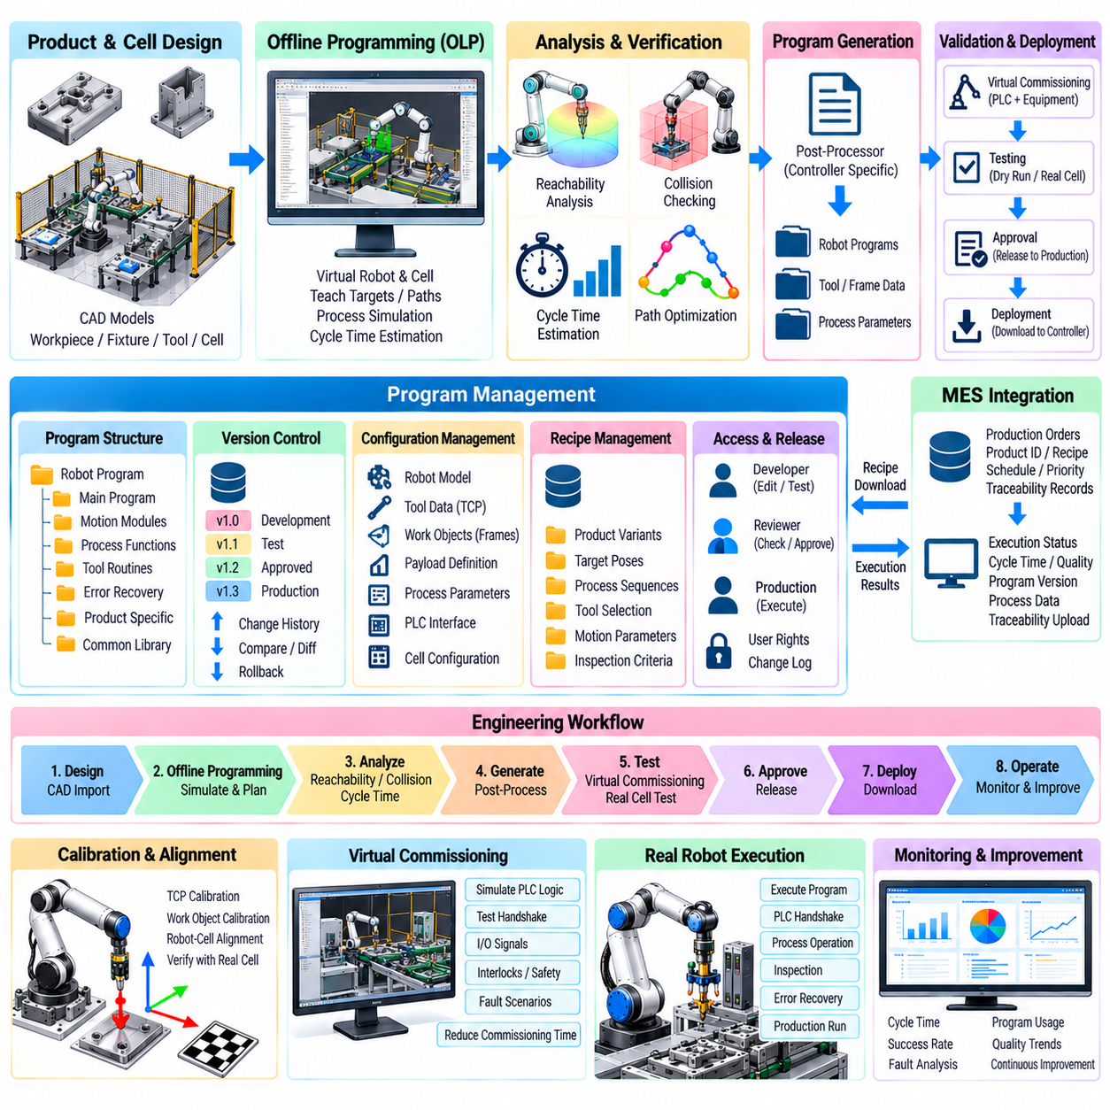
Robot program management provides the software discipline required to create, organize, validate, deploy, and maintain robot programs throughout the manufacturing lifecycle. As production cells support more products and variants, robot code can no longer be treated as isolated files stored only inside individual controllers. Programs, configurations, tool data, coordinate frames, process parameters, and release information must be managed as controlled production assets.
A robot program typically contains more than a sequence of motion points. It may reference tools, work objects, payload definitions, speed profiles, process commands, PLC handshakes, sensor operations, recovery routines, and product-specific parameters. These dependencies should be represented explicitly so that engineers understand which configuration is required for a program to execute correctly and can prevent incompatible combinations from reaching production.
Program organization benefits from separating reusable functions from product-specific task definitions. Common routines for homing, tool changing, picking, placing, machine loading, inspection, and fault recovery can be maintained as shared modules. Product programs then reference these validated functions while supplying target poses and process parameters. This structure reduces duplicated code and makes improvements easier to propagate across multiple manufacturing applications.
Version control establishes a traceable history of robot software changes. Each production release should identify the robot program version together with relevant PLC logic, recipes, tool definitions, calibration data, and cell configuration. Engineers can then determine which software was active when a product was manufactured. Controlled versioning also enables comparison, review, rollback, and investigation when a new release introduces unexpected behavior.
Change management should distinguish development programs from validated production programs. Engineers may create experimental trajectories or process parameters during commissioning, but these modifications should not automatically become production releases. A formal promotion process can move software through development, simulation, testing, approval, and deployment stages. This prevents temporary controller edits from silently becoming undocumented production dependencies.
Offline programming, commonly abbreviated as OLP, allows robot programs and manufacturing operations to be developed using a virtual representation of the production cell rather than teaching every operation directly on the physical robot. The virtual environment contains robot geometry, tooling, fixtures, workpieces, machines, and relevant workspace constraints. Engineers can therefore develop and evaluate tasks while the real production equipment remains available for manufacturing.
The OLP workflow usually begins with a three-dimensional model of the robot cell. CAD data for products, fixtures, tools, and surrounding equipment is imported and aligned with robot coordinate systems. The engineer defines targets, approach directions, process paths, tool orientations, and operation sequences. Robot-specific post-processing then converts the planned task into executable code compatible with the selected industrial robot controller.
Reachability analysis is one of the primary advantages of offline programming. Before equipment is installed or production is interrupted, software can determine whether required targets lie inside the robot's usable workspace. It can also identify joint-limit violations, difficult wrist configurations, and regions close to kinematic singularities. These results can influence robot placement, fixture design, tool length, and workpiece orientation early in the engineering process.
Collision analysis extends verification beyond simple reachability. The virtual robot can be checked against fixtures, machines, fences, workpieces, tools, and other moving equipment throughout the planned trajectory. Collision-free operation requires evaluation of intermediate motion rather than only programmed target points. Detecting interference offline reduces the risk of damaging equipment during commissioning and helps engineers optimize safe approach and retreat paths.
Cycle-time estimation allows alternative robot sequences and trajectories to be compared before deployment. OLP software can approximate joint motion, path length, velocity, acceleration, process dwell time, and tool operations to estimate production cycle time. Although simulated timing may differ from real equipment, it provides valuable guidance for identifying inefficient motion, comparing cell concepts, and evaluating whether the planned process can satisfy throughput targets.
Virtual commissioning expands offline engineering from robot motion into complete cell behavior. Robot programs can be evaluated together with simulated PLC sequences, sensors, actuators, conveyors, fixtures, and process equipment. Engineers can test command handshakes, state transitions, interlocks, timeouts, and recovery logic before physical commissioning. This reduces the amount of debugging that must be performed while expensive production equipment is occupied.
A critical challenge is maintaining correspondence between the virtual cell and the physical cell. Real robot bases, fixtures, tools, and workpieces inevitably contain installation and manufacturing tolerances. Calibration procedures therefore establish transformations between simulated coordinates and measured physical coordinates. Without accurate calibration, a trajectory that is correct in the virtual environment may produce unacceptable positional errors when downloaded to the actual robot.
Tool center point and work-object calibration are especially important when transferring offline-generated programs. The physical tool geometry must correspond to the tool model used during planning, and the workpiece coordinate frame must accurately represent the installed fixture. Calibration errors propagate through every programmed target. Program management should therefore associate calibration versions and validation status with the robot software that depends on them.
Deployment should be controlled rather than performed as an untracked file transfer. A release package can include robot code, checksums, configuration identifiers, compatible recipes, tool requirements, and validation records. Before activation, the system can verify robot model, controller software, cell identity, and required configuration. Such checks reduce the possibility that a valid program is accidentally installed on an incompatible production cell.
Online adjustment may still be necessary after an offline-generated program reaches the physical robot. Small corrections can compensate for real installation tolerances, process behavior, cable routing, compliance, or sensor characteristics that were not perfectly represented in simulation. These modifications should be captured and synchronized back into the managed source rather than remaining only inside the controller, otherwise the virtual model and production program gradually diverge.
Program verification should examine both software correctness and physical execution. Static checks can identify missing references, invalid parameters, or unsupported commands, while simulation evaluates reachability and collision risk. Physical validation then confirms trajectory accuracy, process quality, cycle time, safety-related conditions, and interaction with surrounding equipment. Production approval should occur only after the required validation evidence has been completed.
Backup and recovery are part of program management because robot controllers contain operational data that may change during production. Scheduled backups can preserve programs, system parameters, calibration values, tool definitions, frames, and configuration files. Following controller replacement or corruption, a known validated state can then be restored. Backup versions should remain connected to release records so that recovery does not unintentionally combine incompatible software and configuration.
Multi-robot factories require scalable distribution mechanisms. Instead of manually copying files to each controller, centralized management can associate approved program releases with specific cells, robot models, products, or production lines. Deployment status and active versions can be monitored across the factory. This approach reduces configuration drift and becomes increasingly important when similar manufacturing processes are replicated across many robot cells.
Security and access control should protect robot programs because unauthorized modifications can affect product quality, equipment behavior, and production availability. Engineering, maintenance, operators, and automated deployment services may require different permissions. Authentication, role-based access, change logs, signed packages, and controlled remote access help ensure that only authorized software modifications reach production equipment.
The combination of disciplined program management and offline programming transforms robot software from controller-local code into a managed manufacturing asset. OLP enables development, simulation, optimization, and early validation away from the physical cell, while lifecycle management controls versions, calibration, deployment, and recovery. Together they support faster product introduction, reduced commissioning downtime, reproducible automation, and scalable operation across flexible manufacturing systems.

07.08. Quality Inspection AI Vision in Manufacturing [w/Code]
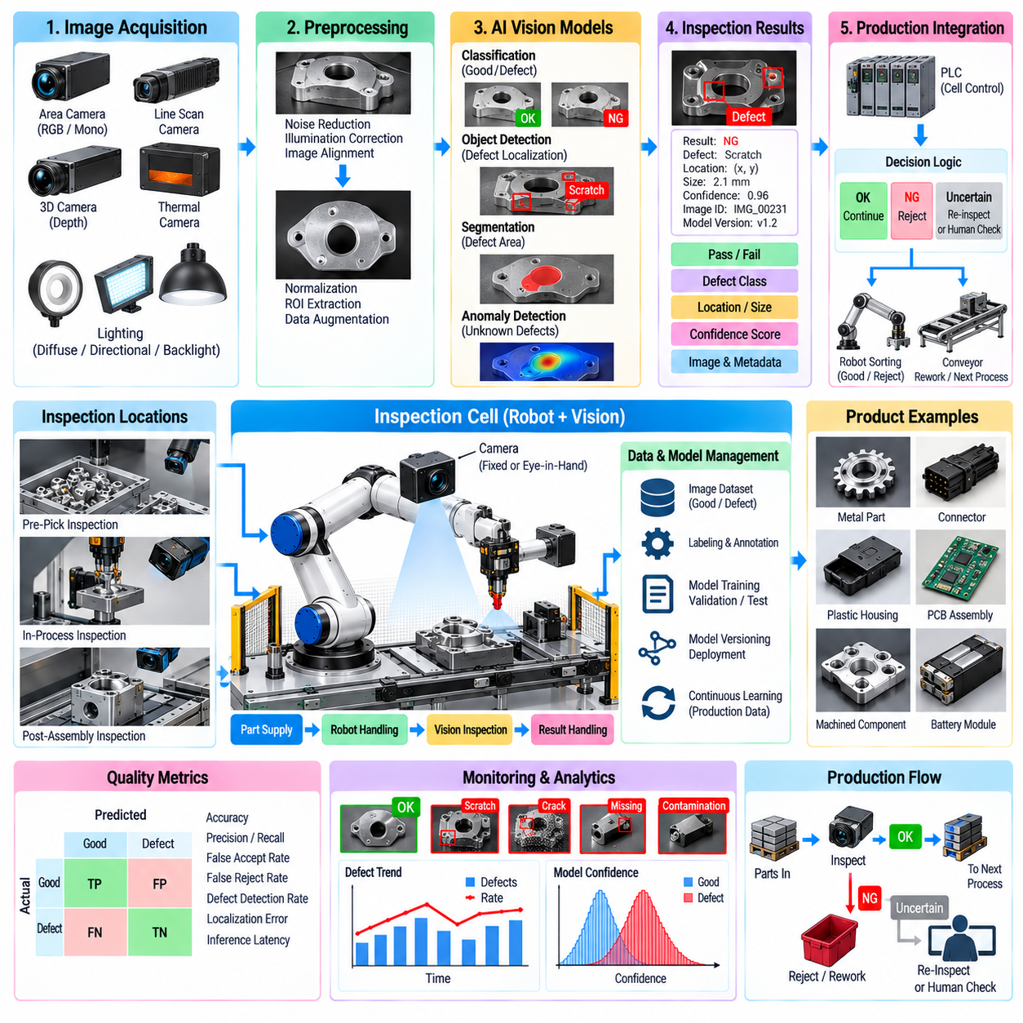
AI vision inspection combines industrial imaging with machine learning to evaluate product quality automatically during manufacturing. Instead of relying only on manually defined image-processing rules, AI models can learn visual patterns associated with acceptable products and defects. When integrated with robot cells, inspection can occur before, during, or after manipulation, allowing quality decisions to become part of the automated production sequence.
The inspection pipeline begins with controlled image acquisition because model performance depends strongly on the quality and consistency of sensor data. Cameras, lenses, illumination, exposure, working distance, and viewing geometry should be selected according to the target defect. RGB, monochrome, line-scan, depth, thermal, or specialized imaging sensors may be used depending on whether the system must inspect appearance, geometry, dimensions, surfaces, or assembly conditions.
Lighting design is particularly important because many manufacturing defects are expressed through small variations in texture, reflectance, shape, or color. Diffuse illumination can reduce reflections, while directional lighting can emphasize scratches and surface irregularities. Backlighting can reveal silhouettes and dimensional errors. The inspection software should monitor image quality so that lighting degradation or contamination is not mistakenly interpreted as a product defect.
Traditional machine vision remains useful for deterministic inspection tasks. Thresholding, edge detection, template matching, blob analysis, geometric measurement, and rule-based feature extraction can provide highly repeatable results when product appearance is controlled. AI vision becomes especially valuable when defect patterns vary substantially, boundaries are difficult to describe analytically, or the number of visual conditions makes manually engineered rules difficult to maintain.
Supervised classification can determine whether an image or region represents an acceptable or defective condition. More detailed systems use object detection to localize defect instances and semantic or instance segmentation to identify their exact spatial extent. The choice of model depends on the required quality decision. A simple pass-fail task may need classification, while repair, root-cause analysis, or quantitative defect measurement may require precise localization.
Anomaly detection is useful when defective samples are scarce or when all possible defect categories cannot be enumerated in advance. The model learns the appearance or feature distribution of acceptable products and identifies observations that deviate from this learned normal condition. This approach can reveal unusual scratches, contamination, missing features, deformation, or unexpected assembly states, although thresholds must be tuned carefully to control false alarms.
Training data should represent the variation expected in actual production. Product variants, acceptable cosmetic differences, material batches, illumination changes, camera variation, orientation, and manufacturing tolerances can influence appearance. Labels should distinguish true defects from acceptable variation. Poor or inconsistent labeling can teach the model incorrect quality boundaries, making data governance as important as neural network architecture for production inspection.
Class imbalance is common because a stable production process generates many good products and relatively few defective examples. Data augmentation, targeted defect collection, synthetic defect generation, transfer learning, or anomaly-detection methods can help address this imbalance. However, artificially generated samples should be validated against realistic defects because unrealistic synthetic patterns may improve benchmark metrics without improving actual factory performance.
Robot integration provides flexible camera positioning and allows inspection viewpoints to be selected according to product geometry. A robot can present a component to a fixed camera or move an eye-in-hand camera around the workpiece. Multiple viewpoints can reveal surfaces hidden from a single camera. The task planner must coordinate robot pose, camera triggering, focus, illumination, image acquisition, and inspection results without unnecessarily increasing production cycle time.
Inspection results should be expressed in a structured form that downstream automation can interpret. The output may include pass-fail status, defect class, location, dimensions, confidence score, image identifier, and model version. The PLC or cell orchestrator can use this information to continue production, reject a component, route it for rework, request another inspection, or stop the process when a critical quality condition is detected.
Confidence management prevents uncertain AI predictions from being treated as unquestionable production decisions. Results near a decision threshold can trigger additional imaging, another viewpoint, a secondary inspection algorithm, or human review. Different defect categories may require different thresholds according to their manufacturing risk. Critical defects generally require conservative decision policies, while minor cosmetic variation may tolerate a different balance between false rejection and false acceptance.
Measurement system performance must be evaluated using production-relevant metrics. Accuracy alone can be misleading when defects are rare. Precision, recall, false-accept rate, false-reject rate, defect-specific detection probability, localization error, and inference latency provide a more complete view. The cost of missing a safety-critical defect can be very different from the cost of incorrectly rejecting a good component, so acceptance criteria should reflect manufacturing consequences.
Model drift can occur when production conditions change after deployment. New suppliers, material finishes, tooling wear, camera replacement, illumination aging, seasonal environmental changes, or modified processes may shift the image distribution. Monitoring should therefore track confidence distributions, defect rates, image statistics, and disagreement with downstream quality results. Significant changes can trigger investigation, recalibration, or controlled model retraining.
Model lifecycle management should identify which dataset, training configuration, software version, and acceptance tests produced each deployed inspection model. A new model should pass offline evaluation and controlled production validation before replacing an approved version. Deployment should support rollback when unexpected behavior occurs. This discipline prevents untracked AI updates from changing product acceptance criteria without appropriate manufacturing authorization.
Traceability connects every inspection decision with the manufactured product. Images, inference outputs, confidence values, defect annotations, timestamps, robot pose, camera configuration, and model version can be associated with a serial number, lot, or work order. Complete retention of every high-resolution image may be impractical, so storage policies can preserve critical defects, representative samples, metadata, and selected evidence according to quality requirements.
AI inspection can also support process improvement rather than merely sorting good and defective products. Aggregated defect locations and categories may reveal fixture drift, tool wear, contamination, alignment problems, supplier variation, or unstable upstream processes. When inspection data is correlated with robot, PLC, and process telemetry, engineers can investigate why defects are occurring and adjust manufacturing conditions before rejection rates become severe.
Latency must be considered when inspection operates inside a robot cycle. Image transfer, preprocessing, AI inference, post-processing, database access, and PLC communication all contribute to decision time. Edge inference near the production cell can reduce network dependency and provide predictable response. The architecture should define maximum acceptable inspection latency so that quality processing does not unexpectedly become the bottleneck of the manufacturing line.
Failure handling should distinguish a detected product defect from failure of the inspection system itself. Camera disconnection, blocked lenses, illumination faults, invalid images, unavailable models, or inference-service timeouts should not automatically be interpreted as acceptable products. The cell should enter a defined recovery or hold state when inspection integrity cannot be guaranteed, preserving quality control even when the vision subsystem is unavailable.
Human review remains valuable for uncertain cases, new defect types, and continuous improvement of the inspection model. Review interfaces can present images, predicted defects, confidence values, and relevant production context to quality engineers. Confirmed results can later become curated training data. This creates a controlled feedback loop in which operational inspection generates evidence that can improve future models without allowing uncontrolled online learning to alter production behavior.
A mature AI vision inspection system therefore operates as a closed quality loop connecting sensing, inference, decision, automation, traceability, and improvement. Robot cells provide repeatable positioning and flexible viewpoints, AI models interpret complex visual variation, and manufacturing systems act on structured results. Together these capabilities transform inspection from an isolated end-of-line check into an integrated source of real-time quality control and manufacturing intelligence.

07.09. OEE and Production Analytics for Robot Cell [w/Code]
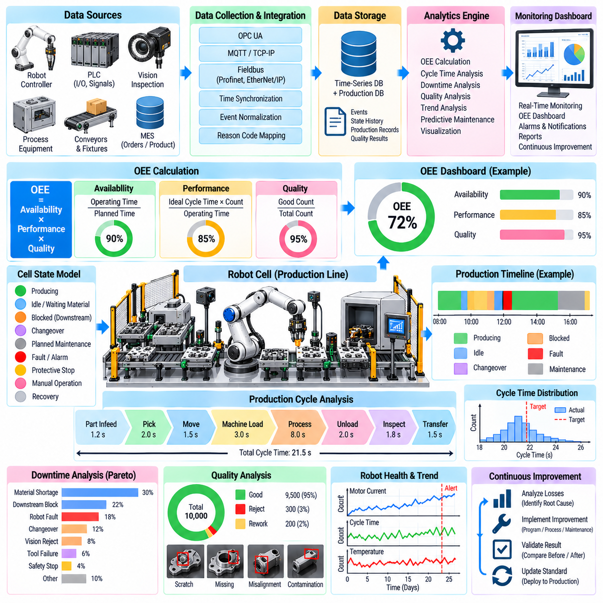
Overall Equipment Effectiveness, commonly abbreviated as OEE, provides a structured method for evaluating how effectively a robot cell converts scheduled production time into acceptable products. It combines availability, performance, and quality into a unified operational measure. For robot cells, meaningful OEE analysis requires more than controller uptime because losses can originate from robots, tooling, material flow, operators, inspection systems, or surrounding equipment.
Availability represents the proportion of planned production time during which the cell is capable of producing. Downtime may result from robot faults, tool failures, safety stops, PLC errors, missing materials, maintenance, changeovers, or upstream and downstream interruptions. Accurate availability calculation therefore requires explicit definitions of planned time, operating time, and downtime categories rather than treating every non-moving robot state as equipment failure.
Performance evaluates whether the cell produces at the expected rate while it is operating. The comparison is usually based on an ideal or validated cycle time for the relevant product. Performance losses can arise from reduced robot speed, excessive waiting, repeated vision acquisition, additional grasp attempts, slow operator interaction, process delays, or inefficient trajectories. Product-specific reference times are important when one cell manufactures multiple variants.
Quality represents the proportion of produced units that satisfy defined acceptance requirements. Robot cells can contribute quality information through vision inspection, force-controlled assembly results, torque measurements, dimensional checks, process sensors, and downstream test results. Rework and rejected products should be associated with the corresponding production cycle so that quality loss can be connected to the conditions under which the unit was manufactured.
OEE is commonly expressed as the product of availability, performance, and quality. The numerical value is useful as a summary indicator, but the three underlying components are more important for engineering diagnosis. Two cells can have similar OEE values while experiencing completely different losses. One may suffer frequent downtime, while another operates continuously but at reduced speed. Analytics should therefore preserve the loss structure behind the aggregate value.
Reliable analytics begins with a consistent robot-cell state model. States may include producing, idle, waiting for material, blocked by downstream equipment, changeover, planned maintenance, unplanned fault, protective stop, manual operation, and recovery. The state model should identify both what the cell is doing and why production is not occurring. Without reason information, a long idle period can be incorrectly attributed to robot inefficiency.
Event collection should integrate information from robot controllers, PLCs, MES, vision computers, process equipment, and safety systems. Robot states can reveal motion and program execution, while PLC data explains equipment sequences and interlocks. MES supplies work orders and product context, and quality systems provide acceptance results. Combining these sources creates a production timeline that is more informative than any individual controller log.
Time synchronization is critical when events from several devices are analyzed together. A robot fault may occur milliseconds before a PLC timeout, while the MES records only the later production interruption. If device clocks differ substantially, analytics may identify the wrong event as the root cause. A common time reference and consistent timestamping allow software to reconstruct the actual sequence of robot, equipment, communication, and process events.
Cycle-time analytics can decompose each production cycle into meaningful phases such as material arrival, robot pick, transport, machine loading, processing, unloading, inspection, and transfer. Comparing phase durations reveals where variation occurs. A stable total average can hide repeated local delays, while percentile distributions can expose occasional long cycles that reduce throughput and may indicate developing equipment or process problems.
Micro-stoppages deserve special attention because individually short interruptions can accumulate into significant production loss. Repeated grasp retries, sensor delays, communication handshakes, brief protective stops, or fixture confirmation failures may never appear as major downtime events. High-resolution event data allows these losses to be quantified and ranked, helping engineers improve conditions that conventional downtime reporting often overlooks.
Downtime classification should preserve the difference between robot-related and system-related causes. A robot waiting because no component has arrived should not be classified as robot failure, and a blocked conveyor should not be interpreted as slow robot performance. Reason codes can be generated automatically from machine states when possible and supplemented by operator input when context is unavailable. Consistent classification makes comparisons across shifts and cells meaningful.
Production analytics can extend beyond OEE into utilization, throughput, takt adherence, mean time between failures, mean time to repair, retry frequency, energy consumption, tool usage, and process stability. These measures provide different views of cell performance. OEE summarizes manufacturing effectiveness, while detailed operational metrics help engineers understand whether losses originate from reliability, scheduling, process design, maintenance, or automation behavior.
Robot telemetry can expose performance degradation before it becomes a complete production failure. Increasing cycle time, repeated path corrections, rising motor loads, abnormal joint temperatures, vacuum instability, or growing insertion forces may indicate developing mechanical or process problems. Trending these signals together with production events can support condition-based maintenance and provide earlier warning than fault-code monitoring alone.
Tool and fixture analytics are equally important because many apparent robot problems originate outside the robot arm. Gripper wear, vacuum leakage, misaligned fixtures, contaminated sensors, loose tooling, and changing part presentation can increase retries or cycle variation. Associating tool identity and fixture state with production results helps separate robot-controller performance from the physical process conditions surrounding the robot.
Dashboards should present information at an abstraction level appropriate to the user. Operators need current cell state, immediate losses, and actionable alarms, while production managers require throughput, OEE trends, and shift comparisons. Engineers need detailed cycle distributions, fault sequences, and telemetry. A shared data foundation can support these views without forcing every user to interpret raw robot-controller signals.
Analytics should preserve production context when comparing performance. Product variant, batch, recipe, tool configuration, shift, material source, and operating mode can all influence cycle time and quality. Comparing unlike conditions may produce misleading conclusions. Context-aware analysis allows engineers to determine whether a performance change represents actual degradation or simply reflects a different manufacturing requirement.
Statistical analysis can identify patterns that are difficult to recognize from individual events. Histograms, percentiles, moving averages, control limits, and correlation analysis can reveal cycle-time drift, abnormal quality variation, or relationships between process conditions and failures. Machine learning may assist anomaly detection or prediction, but its results should remain connected to interpretable manufacturing states and measurable production outcomes.
Data quality must be managed with the same discipline as production software. Missing timestamps, duplicated events, inconsistent reason codes, incorrect product identifiers, and changing signal definitions can distort OEE calculations. Data pipelines should validate incoming information, record schema versions, detect gaps, and preserve source identifiers. A sophisticated dashboard cannot compensate for unreliable or semantically inconsistent production data.
OEE should not be optimized in isolation from safety, quality, and equipment health. Increasing robot speed may improve short-term performance while increasing protective stops, tool wear, or assembly defects. Similarly, suppressing downtime categories can improve reported metrics without improving production. Analytics should support balanced engineering decisions by exposing the relationships among throughput, quality, reliability, safety-related events, and maintenance.
Continuous improvement becomes possible when analytics is connected to controlled engineering changes. A team can identify a dominant loss, modify robot motion, tooling, PLC logic, or material presentation, and then compare performance before and after the change. Version information should accompany the production data so that improvements or regressions can be associated with specific software, recipe, equipment, or configuration changes.
A mature robot-cell analytics system therefore transforms controller signals into contextual manufacturing knowledge. OEE provides the top-level view through availability, performance, and quality, while synchronized events and detailed telemetry explain the losses beneath that value. By connecting robot behavior with PLC states, MES context, quality results, and maintenance information, production analytics supports systematic improvement of flexible automated manufacturing.

07.10. EV Battery Assembly Robot SW Case
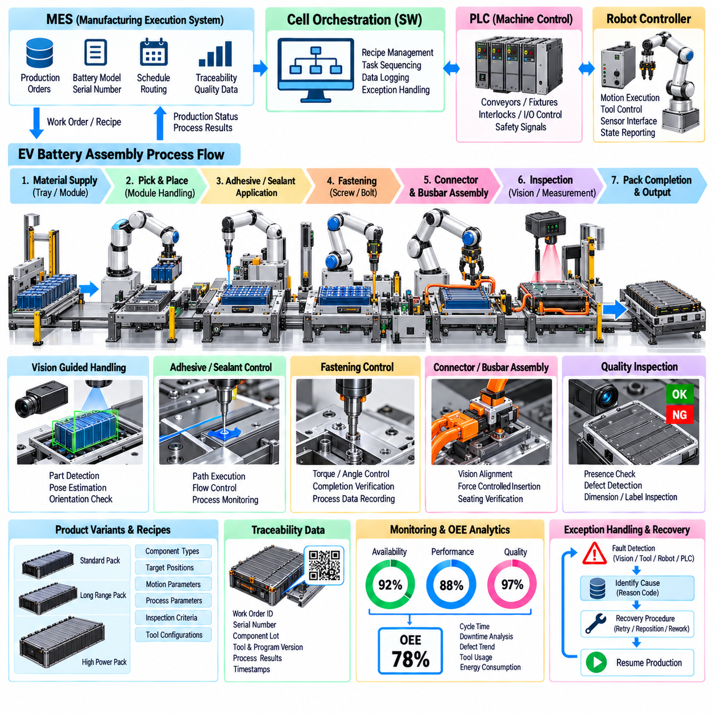
An EV battery assembly robot cell demonstrates how industrial robotics, perception, process control, traceability, and manufacturing software can operate as one coordinated production system. Battery module and pack assembly involves repeated handling, positioning, joining, inspection, and verification tasks. The robot software must therefore coordinate motion with tools, fixtures, PLC sequences, quality systems, and MES production information.
The cell architecture can use a PLC for deterministic equipment sequencing while robot controllers execute manipulation and process tasks. A cell orchestration layer manages product context, recipes, inspection results, and exception recovery. MES provides work orders, battery configuration, serial information, and production requirements. This layered structure separates enterprise decisions from real-time equipment control while maintaining traceability across the complete assembly process.
Material handling begins when trays, modules, structural components, or related parts arrive at the robot station. Sensors and identification systems verify that the expected component is present before manipulation starts. Robot software selects the appropriate tool, motion routine, and process parameters according to the active product recipe. This prevents a mechanically valid operation from being executed on the wrong product configuration.
Vision-guided manipulation can compensate for variation in component presentation and fixture position. Cameras locate parts, estimate relevant poses, verify orientation, and provide corrected coordinates to the robot. For large battery components, multiple visual features may be used to improve alignment confidence. Vision results should include validity and confidence information so that uncertain localization can trigger reinspection rather than an uncontrolled robot motion.
Handling software must account for payload, center of gravity, tool configuration, acceleration, and restricted workspace. Motion planning should avoid surrounding fixtures, cables, conveyors, and previously installed components. Approach and retreat trajectories are particularly important when placing components into confined pack structures. Product-specific motion limits can be included in recipes so that different battery configurations can share a common software framework.
Adhesive or sealant application is an example of a process that requires coordinated path execution rather than simple point-to-point motion. The robot follows a defined trajectory while the dispensing system controls material flow. Software can synchronize robot speed with dispensing commands and monitor process signals. Path completion, material availability, pressure conditions, and application status can be recorded as part of the manufacturing history.
Fastening operations require coordination among robot motion, fastening tools, and process verification. The robot positions the tool at the required fastener location while a controlled tightening system executes the specified operation. Torque, angle, completion state, and tool status can be returned to the cell software. Each result can be associated with the corresponding fastening position and product serial number to create detailed assembly traceability.
Connector and busbar-related assembly requires accurate positioning and confirmation that components reach the intended seated condition. Vision can provide coarse alignment while force or displacement sensing supports final engagement verification. The software should define acceptable interaction limits and terminate the operation when abnormal resistance occurs. Failed insertion should initiate a controlled recovery routine rather than repeated high-force attempts.
Force-controlled assembly can also support operations in which dimensional tolerances make pure position control unreliable. The robot may approach under position control, detect contact, and transition into compliant motion for final alignment or seating. Force-displacement behavior can be evaluated to distinguish successful assembly from obstruction or incomplete engagement. This provides process information that cannot be obtained from final robot position alone.
Inspection is distributed throughout the cell rather than limited to the end of the line. Vision systems can confirm component presence, orientation, fastening conditions, labels, connectors, and visible assembly features. Process tools provide additional quality evidence through measured signals. Combining inspection results with robot execution data allows the system to determine whether each required manufacturing operation was completed successfully.
Traceability is essential because a battery pack contains many components and assembly operations that must remain associated with a specific manufactured unit. The software can propagate work-order, serial, lot, component, tool, recipe, and program identifiers through each operation. Timestamps and measured process results provide additional context. This creates a digital production record that supports quality investigation and controlled manufacturing release.
Recipe management enables the same robot cell to support multiple battery variants without embedding every difference directly into robot code. A recipe may define component types, target positions, motion parameters, fastening requirements, inspection criteria, and process limits. The cell verifies recipe compatibility before execution. Separating configuration from reusable task logic reduces software duplication and simplifies introduction of new product variants.
Exception handling is designed around the physical state of the assembly. A failed vision result, missing component, fastening error, robot fault, or process timeout may leave the cell in different intermediate conditions. Recovery software must determine which operations were completed and which actions remain safe. Simply restarting the robot program from the beginning can duplicate assembly operations or damage a partially completed product.
Safety-related control remains independent from production optimization. Robot safety functions, guarded areas, interlocks, emergency stops, and access conditions must prevent hazardous motion when personnel enter controlled areas. Battery assembly also requires the production system to respect equipment-specific electrical, thermal, and handling constraints. Normal automation software may monitor these conditions, but safety-critical protection should rely on appropriately engineered safety functions.
PLC and robot communication can use explicit command and status handshakes for each manufacturing operation. The PLC requests a task, the robot confirms acceptance, executes the appropriate routine, and returns completion or fault information. Timeouts detect missing responses. This interface prevents ambiguous states and allows surrounding equipment to coordinate with the robot without depending on internal robot-program details.
MES integration connects the cell to factory production management. Before assembly begins, the cell can verify that the requested product, recipe, components, and software configuration are valid. After each operation, results can be returned to the manufacturing record. A unit with incomplete or failed critical operations can be placed on hold, while successfully completed units continue to downstream processes under controlled release conditions.
Program and configuration management are important because battery assembly cells evolve with product designs and manufacturing improvements. Robot programs, PLC logic, vision models, recipes, tool parameters, and calibration data should have identifiable versions. A production record can therefore show not only what was assembled but also which software configuration performed the work. Controlled deployment and rollback reduce the risk associated with automation updates.
Offline programming and digital simulation can reduce commissioning time when new battery variants or cell layouts are introduced. Engineers can evaluate robot reachability, collision risk, tool access, and approximate cycle time before changing the physical line. Virtual commissioning can extend this testing to PLC sequences and equipment interactions. Physical validation remains necessary because contact behavior, tolerances, and real process dynamics cannot be reproduced perfectly in simulation.
Production analytics can combine robot cycle time, tool results, quality measurements, faults, retries, and downtime events. Repeated insertion corrections may indicate fixture drift, increasing fastening time may reveal tool degradation, and rising vision failures may indicate contamination or lighting changes. Connecting these patterns with OEE and maintenance information allows the cell to support continuous improvement rather than simply executing repetitive automation.
The EV battery assembly case therefore illustrates a software-defined manufacturing cell in which robot motion is only one component of the complete system. Vision, force interaction, process tooling, PLC coordination, MES integration, traceability, program management, inspection, and analytics form a closed operational framework. This architecture enables flexible battery production while maintaining controlled execution, measurable quality, recoverable operation, and scalable automation.

