Volume 02. Physical AI Foundations and Definitions

Chapter 09. Standards and Definitions

09.01. Core Physical AI Terminology
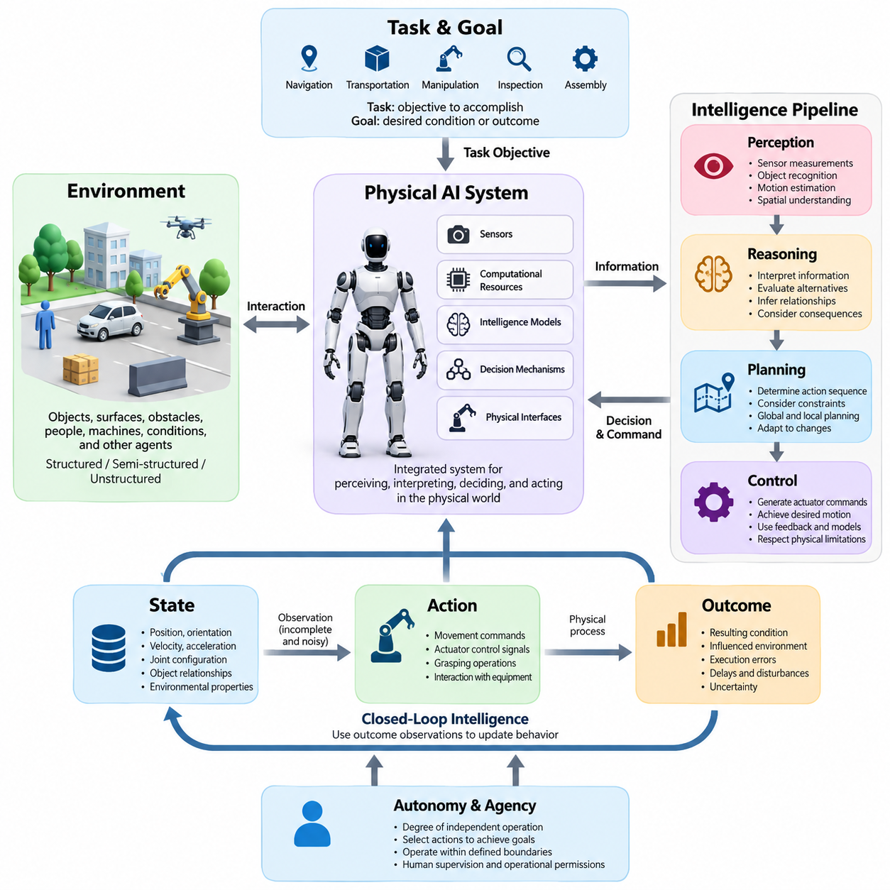
Physical AI refers to artificial intelligence systems capable of perceiving, interpreting, deciding, and acting within the physical world. Unlike intelligence confined to digital information processing, Physical AI operates through interactions with environments governed by physical laws. Its defining characteristic is the integration of computational intelligence with sensing, movement, physical constraints, and feedback-driven adaptation.
A Physical AI system is an integrated arrangement of sensors, computational resources, intelligence models, decision mechanisms, and physical interfaces. These components collectively transform environmental observations into meaningful actions. The term emphasizes system-level intelligence rather than an individual algorithm, recognizing that successful physical behavior depends on coordinated perception, reasoning, control, and interaction.
A physical agent is an autonomous or partially autonomous entity that observes its environment and performs actions intended to achieve defined objectives. The agent may be implemented as a mobile robot, industrial manipulator, autonomous vehicle, aerial platform, or intelligent machine. Its essential properties include environmental awareness, action selection, physical interaction, and the capacity to respond to changing operating conditions.
The environment represents the external physical context in which an agent operates. It includes objects, surfaces, obstacles, people, machines, environmental conditions, and other agents. Environments may be structured, semi-structured, or unstructured, depending on their predictability and organization. Physical AI must account for environmental changes, incomplete information, disturbances, and interactions that influence operational outcomes.
A task describes an objective that a Physical AI agent is expected to accomplish through physical behavior. Tasks may involve navigation, transportation, manipulation, inspection, assembly, monitoring, or coordinated operations. A goal specifies a desired condition or outcome, while task execution involves selecting and performing actions that move the system toward that condition under operational and safety constraints.
The state of a physical system describes the variables required to characterize its condition at a particular moment. State variables may include position, orientation, velocity, acceleration, joint configuration, object relationships, and environmental properties. An observation is information obtained through sensors or external sources. Because observations are incomplete or noisy, the true physical state may not be directly accessible.
An action is an operation initiated by an agent that can influence the physical environment or its own configuration. Actions include movement commands, actuator control signals, grasping operations, and interactions with external equipment. An outcome is the resulting condition following an action. Distinguishing intended actions from observed outcomes is fundamental because physical processes introduce uncertainty, delays, disturbances, and execution errors.
Perception is the process of converting sensor measurements into useful information about the surrounding world. Cameras, LiDAR, radar, inertial sensors, force sensors, and other instruments provide observations of physical conditions. Perception algorithms interpret these measurements to identify objects, estimate motion, recognize spatial relationships, and detect relevant events. Perception provides the informational foundation for intelligent physical behavior.
Reasoning refers to the computational processes used to interpret information, evaluate alternatives, infer relationships, and support decisions. In Physical AI, reasoning must account for physical feasibility, uncertainty, task objectives, and possible consequences. It may combine learned representations, logical constraints, probabilistic inference, and predictive models. Reasoning becomes operationally meaningful when its conclusions influence decisions and physical actions.
Planning is the process of determining a sequence of actions or intermediate objectives that can achieve a desired goal. Physical planning must consider environmental geometry, system dynamics, resource availability, and operational restrictions. Plans may be generated globally or revised locally as conditions change. Effective planning connects high-level objectives with executable behavior while anticipating obstacles, uncertainties, and possible failures.
Control is the process of regulating physical behavior by generating commands for actuators and other execution mechanisms. A controller attempts to achieve desired motion or operating conditions while respecting physical limitations. Control may use feedback, predictive models, optimization, or learned policies. It connects decisions produced by intelligence systems with the actual dynamics of machines and their environments.
Closed-loop intelligence describes a system that continuously uses observations of action outcomes to update its behavior. The agent perceives environmental conditions, selects an action, evaluates the resulting changes, and adjusts subsequent decisions. This feedback mechanism distinguishes adaptive physical operation from fixed execution sequences. Closed-loop behavior is essential when disturbances, uncertainty, or changing conditions make predetermined actions insufficient.
Autonomy describes the degree to which a system can accomplish assigned objectives without continuous human intervention. Autonomous operation may include independent perception, decision-making, planning, and execution within defined boundaries. Agency emphasizes the capacity to select actions in pursuit of goals. Neither concept necessarily implies unrestricted authority, because operational permissions, human supervision, and safety requirements can constrain system behavior.
Embodiment describes the relationship between intelligence and the physical form through which sensing and action occur. An embodiment may consist of wheels, legs, arms, grippers, aerial propulsion systems, or other physical mechanisms. Its geometry, sensors, actuators, and dynamics determine which interactions are possible. Consequently, identical intelligence models may exhibit different capabilities when deployed through different physical embodiments.
A policy is a decision mechanism that maps available information to actions or action distributions. Policies may be rule-based, optimization-based, learned from demonstrations, or developed through reinforcement learning. In Physical AI, a policy must produce behavior compatible with the agent's embodiment and operating environment. Its effectiveness depends on task performance, adaptability, physical feasibility, and compliance with safety constraints.
A world model is an internal representation used to describe or predict relevant aspects of the physical environment. It may encode object states, spatial relationships, motion patterns, physical dynamics, and possible future conditions. Predictive world models estimate how states may evolve under particular actions. Such representations support planning, anticipation, uncertainty management, and decisions that extend beyond immediate sensor observations.
Learning refers to the process through which an intelligence system improves its models, policies, or representations using experience or data. Adaptation describes adjustments that improve behavior under changing conditions. Generalization is the ability to perform effectively in situations not encountered exactly during training. These concepts are related but distinct, because a system can learn particular behaviors without demonstrating reliable transfer to unfamiliar environments.
Uncertainty represents incomplete knowledge about system states, environmental conditions, model predictions, or action outcomes. Partial observability occurs when available observations cannot fully determine the underlying state. Physical AI systems address these limitations through sensor fusion, probabilistic estimation, memory, prediction, and information-gathering actions. Explicit uncertainty management helps prevent decisions based on unjustified confidence in incomplete observations.
Real-time operation means that computational and physical responses must satisfy timing requirements associated with the task. Latency is the delay between an event, observation, computation, or command and its corresponding response. Timing requirements vary across perception, planning, and control functions. Physical AI must therefore coordinate computational performance with physical dynamics, communication delays, actuator response, and the consequences of missed deadlines.
Safety is the property of limiting unacceptable risks associated with physical operation. Reliability concerns the ability of a system to perform required functions consistently under specified conditions. Robustness describes resistance to disturbances, uncertainty, and variations in operating conditions. Although closely related, these properties are not interchangeable. A reliable intelligence model does not automatically guarantee safe physical behavior across every operational scenario.
The operational design domain defines the conditions under which a Physical AI system is intended to function. These conditions may include environmental characteristics, operating locations, allowable tasks, speed ranges, human proximity, and infrastructure requirements. Defining operational boundaries establishes the context for performance evaluation and safety assessment. Capabilities demonstrated within one domain should not automatically be assumed valid in another.
Physical AI capability is best understood as a multidimensional property rather than a single measure of intelligence. Relevant dimensions include perception quality, reasoning competence, planning capability, action precision, autonomy, adaptability, safety, and environmental coverage. A system may perform strongly in one dimension while remaining limited in another. Consistent terminology helps distinguish demonstrated capabilities from broader claims about general intelligence.
A specialist Physical AI system is designed or optimized for a relatively narrow set of tasks and operating conditions. A generalist system aims to perform across a broader range of tasks, environments, or embodiments. Generality does not eliminate physical constraints or guarantee universal competence. Evaluating specialist and generalist systems requires clearly defined task distributions, environmental variations, performance measures, and acceptable operating boundaries.
Physical AI also distinguishes individual intelligence from collective intelligence. An individual agent makes decisions using its own observations, models, and available resources. A multi-agent system coordinates several agents through communication, shared information, or distributed decision-making. Collective intelligence emerges when coordinated capabilities provide benefits beyond isolated operation. Such benefits depend on communication reliability, task allocation, coordination mechanisms, and shared environmental understanding.
A Physical AI architecture defines how sensing, intelligence, computation, communication, and actuation functions are organized. Edge computing places processing near sensors and physical equipment, supporting low-latency responses. On-premise computing provides shared resources within a local operational infrastructure, while cloud computing can support large-scale learning, analysis, and coordination. Their appropriate distribution depends on timing, connectivity, privacy, reliability, and computational requirements.
Standardized terminology is essential for communicating Physical AI requirements, capabilities, limitations, and evaluation results. Terms such as autonomy, intelligence, prediction, adaptation, and safety must be associated with explicit operational meanings rather than promotional descriptions. Consistent definitions enable comparisons across robotic platforms, research methods, and industrial applications while reducing ambiguity between system objectives, implementation mechanisms, and demonstrated performance.
Core Physical AI terminology ultimately establishes a common conceptual language for understanding intelligent interaction with the physical world. The central concepts connect agents, environments, states, observations, actions, models, policies, and outcomes within a unified operational framework. Their relationships provide the foundation for more specialized definitions concerning machine learning, robotics, world models, foundation models, simulation, safety standards, and performance evaluation.

09.02. AI and Machine Learning Terminology
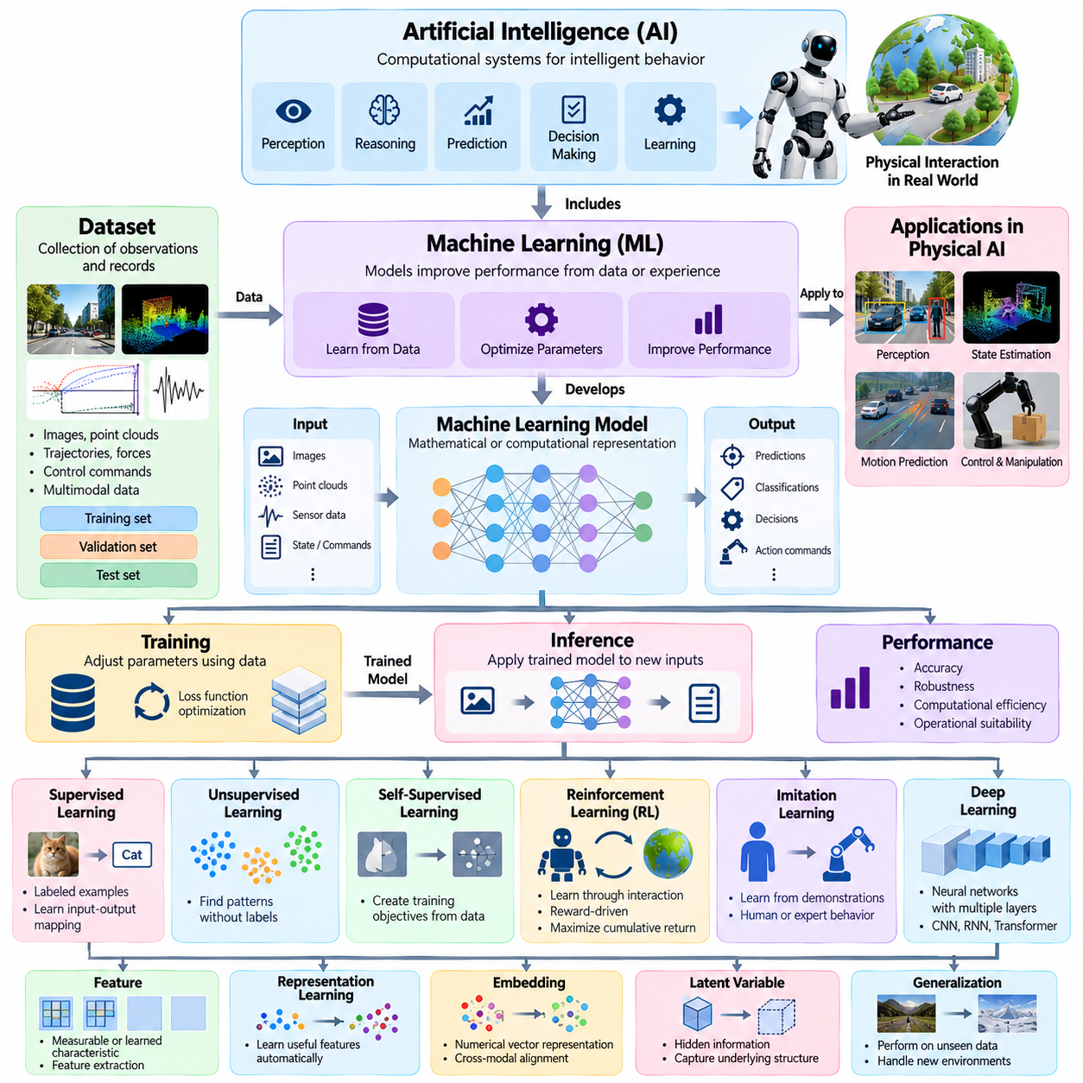
Artificial intelligence, or AI, refers to computational systems designed to perform functions associated with intelligent behavior, including perception, reasoning, prediction, decision-making, and learning. In Physical AI, these capabilities are connected to physical interaction rather than limited to information processing. AI provides the computational foundation through which machines interpret observations, select actions, and pursue objectives within changing environments.
Machine learning, or ML, is a branch of artificial intelligence in which computational models improve their performance by identifying patterns in data or experience. Instead of requiring every behavior to be explicitly programmed, machine learning develops representations and decision functions through optimization. Physical AI applies machine learning to perception, state estimation, motion prediction, control, and adaptation under real-world constraints.
A machine learning model is a mathematical or computational representation that transforms input information into predictions, classifications, decisions, or generated outputs. Models contain parameters adjusted during training to capture useful relationships within data. In Physical AI, models may estimate object positions, predict environmental changes, or generate action commands. Their practical value depends on accuracy, robustness, computational efficiency, and operational suitability.
Training is the process of adjusting model parameters using data, feedback, or interaction experience. A training algorithm typically minimizes a loss function or maximizes an objective through repeated updates. Inference is the application of a trained model to new inputs without performing the same parameter optimization. Physical AI distinguishes training and inference because deployed systems often require predictable response times and limited computational resources.
A dataset is an organized collection of observations, measurements, demonstrations, or interaction records used to develop and evaluate machine learning systems. Training datasets support parameter optimization, validation datasets guide model selection, and test datasets provide independent performance assessment. Physical AI datasets may contain images, point clouds, trajectories, force measurements, control commands, and synchronized multimodal observations.
Supervised learning uses examples containing input data and corresponding target outputs. The model learns relationships that support predictions on previously unseen inputs. Common applications include object classification, semantic segmentation, pose estimation, and defect detection. In Physical AI, supervised learning depends on representative training data and reliable annotations because labeling errors and environmental differences can influence operational performance.
Unsupervised learning identifies patterns or structures in data without requiring explicit target labels for every example. Methods may discover clusters, latent representations, or statistical relationships. Self-supervised learning constructs training objectives from the data itself, such as predicting missing observations or future states. These approaches are valuable for Physical AI because large quantities of sensor recordings and interaction data may be available without manual annotation.
Reinforcement learning, or RL, develops decision-making policies through interactions between an agent and an environment. The agent selects actions, receives rewards or other feedback, and learns behavior intended to maximize expected cumulative return. Physical AI applications include locomotion, manipulation, navigation, and adaptive control. Practical reinforcement learning must address exploration risks, sample efficiency, reward design, and transfer from simulation to physical systems.
Imitation learning trains a policy using demonstrations of desired behavior rather than relying exclusively on reward-driven exploration. Demonstrations may originate from human operators, expert controllers, or previously successful autonomous systems. Behavior cloning directly learns mappings from observations to demonstrated actions. More advanced approaches address distribution shifts and compounding errors that occur when a learned policy encounters unfamiliar states.
Deep learning employs neural networks containing multiple computational layers to learn representations and complex input-output relationships. Neural networks consist of interconnected computational units whose parameters are adjusted during training. Architectures such as convolutional networks, recurrent networks, and transformers support different forms of information processing. Their use in Physical AI depends on the characteristics of sensor data, temporal relationships, and deployment constraints.
A feature is a measurable or learned characteristic used by a model to represent relevant information. Feature extraction converts raw observations into representations suitable for prediction or decision-making. Representation learning allows models to discover useful features automatically rather than depending entirely on handcrafted descriptions. Physical AI representations may encode geometry, motion, object identity, spatial relationships, or physical properties.
An embedding is a numerical representation that places information within a structured vector space. Embeddings can encode images, language, sensor observations, actions, or combinations of modalities. Similar information may occupy nearby regions when the representation is trained for that purpose. In Physical AI, embeddings can support object recognition, task interpretation, cross-modal alignment, and the transfer of knowledge between related observations or activities.
A latent variable represents information that is not directly observed but helps explain or predict observable behavior. Latent spaces provide compact representations of complex inputs and environmental dynamics. Physical AI models may use latent states to summarize motion history, object interactions, or hidden environmental conditions. Their usefulness depends on whether the compressed information preserves properties required for prediction, planning, and control.
Optimization is the process of finding model parameters or decisions that improve a defined objective. A loss function measures disagreement between model outputs and desired targets, while an optimizer determines how parameters are updated. Gradient descent and its variants are widely used in neural network training. Physical AI optimization may additionally incorporate constraints related to energy consumption, collision avoidance, timing, and mechanical feasibility.
Generalization describes a model's ability to perform effectively on inputs or situations not encountered exactly during training. Overfitting occurs when a model learns training-specific patterns that do not transfer reliably to new conditions. Underfitting occurs when a model fails to capture important relationships even within available data. Physical AI requires careful evaluation because environmental changes can expose weaknesses that remain hidden in conventional offline testing.
Distribution shift occurs when operational data differs from the data used during model development. Changes in lighting, sensor characteristics, object appearance, terrain, or human behavior can alter model performance. Domain adaptation attempts to reduce differences between source and target environments. Domain generalization seeks representations that remain effective across previously unseen conditions without requiring adaptation to each specific target domain.
Transfer learning reuses knowledge acquired from one task, dataset, or environment to improve performance in another. Fine-tuning adjusts an existing model using additional data associated with a target application. In Physical AI, transfer learning can reduce training costs and accelerate deployment across related robotic systems. However, differences in morphology, actuator capabilities, sensor configurations, and operating conditions can limit successful transfer.
Multimodal learning combines information from different data types, such as images, language, depth measurements, tactile signals, and proprioceptive observations. Sensor fusion integrates complementary measurements to improve state estimation or environmental understanding. Although related, multimodal learning and sensor fusion are not identical. Their combination can provide Physical AI systems with richer representations of physical situations and more reliable decision-making capabilities.
A predictive model estimates future values, states, or events from available information. Temporal modeling captures relationships across successive observations rather than treating each measurement independently. Sequence models can represent motion histories, action dependencies, and evolving environmental conditions. In Physical AI, prediction supports anticipatory behavior, trajectory forecasting, collision avoidance, and planning under changing physical circumstances.
Probabilistic modeling represents uncertainty through probability distributions rather than single deterministic estimates. Bayesian inference updates beliefs about unknown quantities as new evidence becomes available. Confidence estimates describe aspects of predictive certainty, while calibration concerns agreement between predicted probabilities and observed frequencies. Physical AI benefits from uncertainty-aware models because incorrect confidence can lead to unsafe decisions during physical interaction.
A policy model maps observations, estimated states, or contextual information to actions. A value function estimates expected future return associated with states or actions, while a reward function defines the feedback used in reinforcement learning. These concepts serve different purposes within decision-making systems. Physical AI policies must translate learned behavior into executable commands while accounting for actuator limitations and environmental constraints.
Online learning updates a model using information obtained during operation, whereas offline learning relies on previously collected datasets or experiences. Continual learning aims to acquire new capabilities while retaining useful previously learned knowledge. Catastrophic forgetting occurs when updates degrade earlier capabilities. Physical AI requires controlled learning procedures because unrestricted changes to deployed models can introduce unexpected behavior and compromise validated performance.
Model evaluation measures how effectively a trained system satisfies defined objectives under specified conditions. Metrics may include accuracy, precision, recall, prediction error, task success rate, and computational latency. Physical AI evaluation must also consider action quality, reliability, safety, and environmental diversity. Benchmark results are meaningful only when datasets, testing protocols, operating conditions, and evaluation assumptions are clearly documented.
Robustness refers to the ability of a machine learning model to maintain acceptable performance under disturbances, noise, or variations in input conditions. Interpretability concerns understanding the factors influencing model behavior, while explainability concerns communicating reasons or evidence associated with outputs. These properties support debugging, validation, and operational trust, but neither interpretability nor explainability alone establishes physical safety.
A foundation model is a broadly trained model that can be adapted to multiple downstream tasks. Pretraining develops reusable representations or capabilities from large and diverse datasets, while task-specific adaptation aligns those capabilities with particular applications. In Physical AI, foundation models may support perception, language understanding, planning, and action generation. Their deployment still requires embodiment-specific interfaces and physical validation.
AI and machine learning terminology provides a common foundation for describing how Physical AI systems acquire knowledge, represent information, make predictions, and generate decisions. Clear distinctions between models, policies, learning methods, inference, uncertainty, and evaluation prevent conceptual ambiguity. These definitions establish the basis for more specialized discussions of robotics, embodied intelligence, world models, foundation models, and safety-critical physical autonomy.

09.03. Robotics and Autonomy Terminology
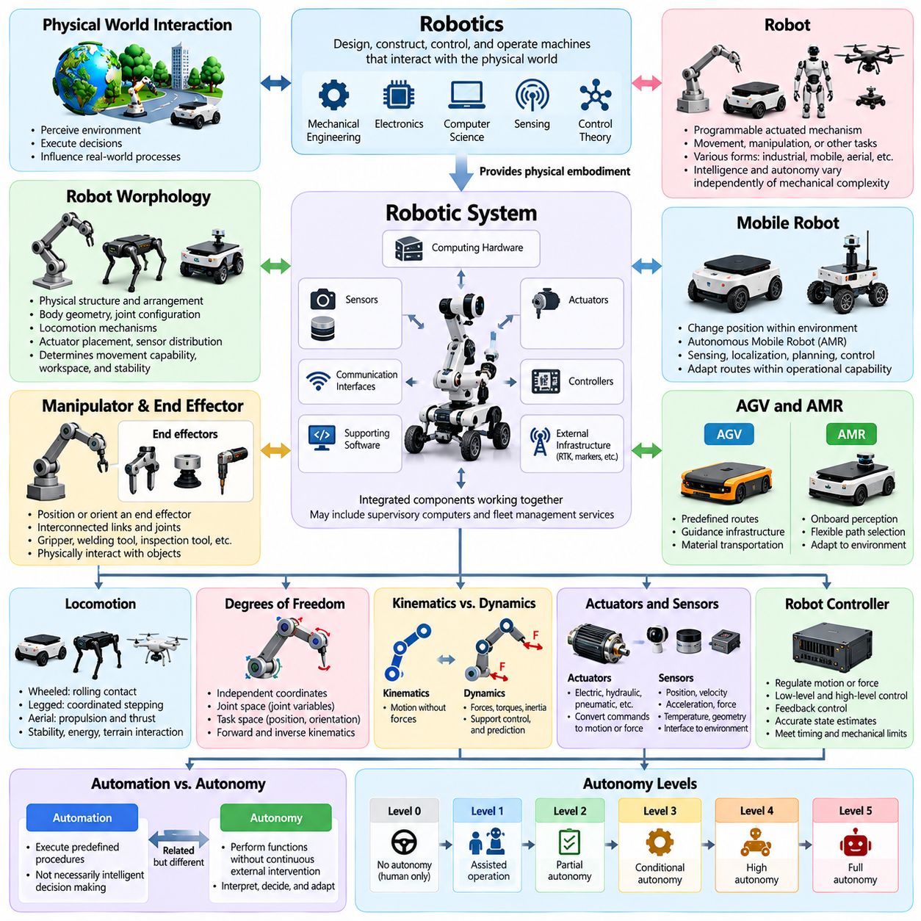
Robotics is the interdisciplinary field concerned with designing, constructing, controlling, and operating machines capable of interacting with the physical world. It integrates mechanical engineering, electronics, computer science, sensing, and control theory. Within Physical AI, robotics provides the physical embodiment through which intelligent systems perceive environmental conditions, execute decisions, and influence real-world processes.
A robot is a programmable actuated mechanism with a degree of autonomy that performs movement, manipulation, or other physical tasks. Robots may operate in industrial facilities, warehouses, hospitals, homes, outdoor environments, or remote locations. Their configurations range from fixed manipulators to mobile platforms and aerial systems. Intelligence and autonomy vary independently of mechanical complexity.
A robotic system includes the physical robot, its sensors, actuators, controllers, computing hardware, communication interfaces, and supporting software. Depending on its application, the system may also include external localization infrastructure, supervisory computers, and fleet management services. System boundaries must be defined clearly because operational performance depends on interactions among these components.
Robot morphology describes the physical structure and arrangement of a robot's components. Important characteristics include body geometry, joint configuration, locomotion mechanisms, actuator placement, and sensor distribution. Morphology determines movement capabilities, reachable workspaces, stability, and interaction possibilities. Physical AI must account for these characteristics when translating intelligent decisions into executable actions.
A manipulator is a robotic mechanism designed to position or orient an end effector within a workspace. It typically consists of interconnected links and joints controlled by actuators. An end effector is the device attached to the manipulator's terminal structure, such as a gripper, welding tool, or inspection instrument. Manipulation involves physically interacting with objects through controlled motion and force.
A mobile robot is a robotic platform capable of changing its position within an environment. An autonomous mobile robot, or AMR, uses sensing, localization, planning, and control to navigate with varying degrees of independence. Unlike systems restricted to fixed guidance infrastructure, AMRs can adapt routes within their operational capabilities. Their autonomy remains bounded by environmental conditions and safety requirements.
An automated guided vehicle, or AGV, is generally associated with material transportation along predefined routes or guidance infrastructure. An AMR typically uses onboard perception and navigation capabilities to select or adjust paths more flexibly. The distinction describes common architectural approaches rather than an absolute technical boundary. Both platforms may incorporate autonomous functions and external supervisory control.
Locomotion refers to the mechanisms and processes through which robots move within their environments. Wheeled locomotion emphasizes rolling contact, while legged locomotion relies on coordinated support and stepping. Aerial locomotion uses propulsion and aerodynamic or thrust-based control. Each mechanism introduces distinct requirements concerning stability, energy consumption, terrain interaction, and motion planning.
Degrees of freedom describe the independent coordinates required to specify a robot's configuration or movement. Joint space represents configurations through joint variables, whereas task space describes positions, orientations, or motions associated with operational objectives. Forward kinematics calculates the resulting geometry from joint configurations. Inverse kinematics determines joint configurations capable of achieving specified task-space targets.
Robot dynamics describes relationships among forces, torques, motion, inertia, and external interactions. Kinematics describes motion without directly considering the forces producing it. Dynamic models support control, simulation, and prediction of physical behavior. Their accuracy depends on mechanical parameters, contact conditions, payload variations, and environmental effects that may change during operation.
An actuator converts control commands and available energy into physical motion or force. Actuators may be electric, hydraulic, pneumatic, or based on specialized mechanisms. Sensors measure physical quantities such as position, velocity, acceleration, force, temperature, and environmental geometry. Together, sensors and actuators establish the interface between computational intelligence and physical execution.
A robot controller generates commands intended to regulate motion, force, or other operating variables. Low-level control typically addresses actuator behavior and stabilization, while higher-level control coordinates trajectories and task objectives. Feedback control uses measured outcomes to correct deviations from desired conditions. Effective control requires suitable timing, accurate state estimates, and compliance with mechanical limitations.
Autonomy refers to the capability of a robotic system to perform assigned functions without continuous external intervention. Automation refers more broadly to executing functions through predefined mechanisms or procedures. An automated system does not necessarily possess substantial decision-making autonomy. Autonomous robots generally require some capacity to interpret conditions, select actions, and respond to operational changes.
Autonomy levels describe differences in responsibility between human operators and robotic systems. These differences may involve perception, decision authority, execution, supervision, and intervention requirements. There is no universally applicable autonomy scale covering every robotic domain. Consequently, autonomy classifications should identify their underlying framework, operating assumptions, and specific functions rather than relying on level numbers alone.
Teleoperation refers to controlling a robot remotely through commands issued by a human operator. Direct teleoperation may require continuous human control, while supervisory control allows operators to assign objectives and monitor autonomous execution. Shared autonomy combines human guidance with machine-generated assistance. These operating modes differ in how authority, responsibility, and control are distributed.
Human-robot interaction describes communication and coordinated behavior between humans and robotic systems. Interfaces may include displays, voice commands, gestures, physical controls, or direct physical interaction. Human-robot collaboration involves coordinated activities directed toward shared operational objectives. Effective interaction requires understandable system behavior, appropriate authority allocation, and mechanisms for managing uncertainty and safety.
Localization is the process of estimating a robot's position and orientation relative to a reference frame or map. Mapping constructs representations of environmental geometry or other relevant properties. Simultaneous localization and mapping, or SLAM, estimates robot pose while developing or updating a map. These capabilities provide essential spatial information for navigation and autonomous operation.
Navigation is the process of moving a robot toward a destination while considering environmental conditions and operational constraints. Path planning determines a geometric route, while trajectory planning additionally considers motion over time. Motion planning addresses feasible transitions between configurations or states. Obstacle avoidance modifies behavior to reduce collision risk during execution.
A robotic task defines a desired operational result, while a behavior describes the actions or control patterns used to pursue that result. Skills are reusable capabilities such as grasping, docking, following a route, or opening a door. Task planning coordinates multiple skills or actions into purposeful sequences. Physical AI may combine learned skills with symbolic planning and conventional control mechanisms.
A robot operating environment includes physical geometry, surfaces, obstacles, people, equipment, and relevant environmental conditions. Structured environments provide relatively predictable arrangements, while unstructured environments contain greater variability. Dynamic environments include moving objects or changing conditions. Operational design domains specify the conditions under which particular autonomous functions are intended to perform.
A robot fleet is a collection of robotic systems managed or coordinated to achieve operational objectives. Fleet management includes task assignment, scheduling, traffic coordination, monitoring, and resource allocation. Multi-robot coordination addresses interactions among individual agents. Heterogeneous fleets combine platforms with different capabilities, such as mobile robots, manipulators, and aerial systems.
Interoperability refers to the ability of robotic components or systems to exchange information and use it meaningfully. Interfaces define communication methods, data structures, commands, and operational expectations. Modularity allows components to be developed or replaced with limited effects on the overall architecture. Standardized interfaces can improve integration, maintainability, and compatibility across robotic platforms.
Robot safety concerns the identification and reduction of unacceptable risks associated with mechanical motion, energy, interaction, and autonomous decisions. Emergency stopping, protective stopping, speed limitation, and collision monitoring are examples of safety-related functions. Functional safety addresses safety functions implemented through control systems. AI-based decision-making does not eliminate the need for independently justified safety measures.
Reliability describes the ability of a robotic system to perform required functions under specified conditions over a defined period. Availability concerns whether the system is operational when required, while maintainability describes the ease and effectiveness of restoring functionality. Robustness concerns continued acceptable behavior despite disturbances or uncertainty. These properties collectively influence practical deployment and operational sustainability.
Robotics and autonomy terminology establishes a common language for describing physical mechanisms, intelligent behavior, operational responsibility, and system performance. Clear distinctions between automation, autonomy, control, navigation, manipulation, and coordination support consistent engineering communication. Within Physical AI, these definitions connect computational intelligence with embodied operation and provide a foundation for evaluating increasingly capable autonomous systems.

09.04. Perception Localization Planning and Control Terms
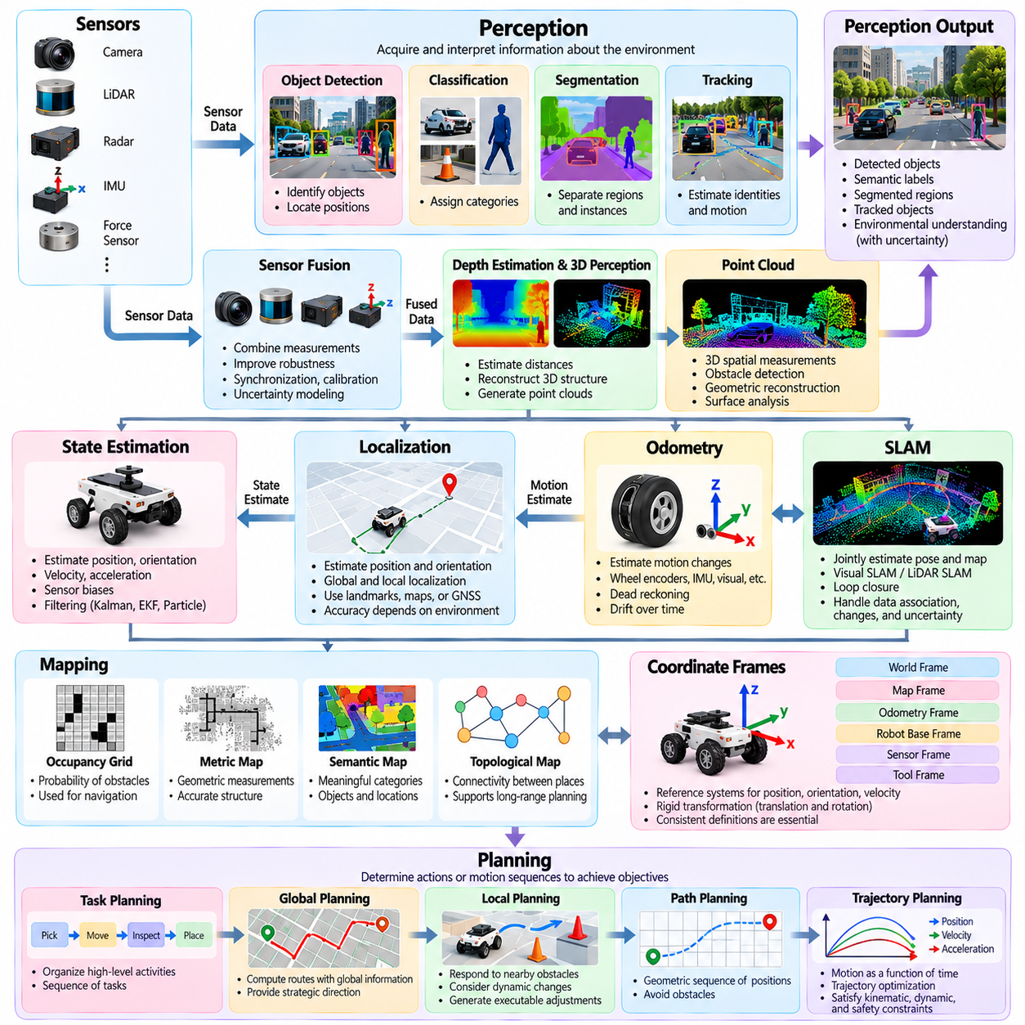
Perception is the process through which a Physical AI system acquires and interprets information about its environment using sensors and computational models. It transforms raw measurements into representations of objects, surfaces, motion, and spatial relationships. Perception supports localization, planning, and control by providing information about current conditions, although its outputs remain subject to uncertainty and measurement errors.
Sensor data refers to measurements collected from devices such as cameras, LiDAR, radar, inertial measurement units, and force sensors. Sensor fusion combines complementary measurements to improve environmental understanding and state estimation. Fusion may occur at raw-data, feature, or decision levels. Accurate synchronization, calibration, and uncertainty modeling are essential when integrating observations from multiple sensing modalities.
Object detection identifies the presence and location of objects within sensor observations. Classification assigns semantic categories, while segmentation separates observations into meaningful regions or individual instances. Object tracking estimates object identities and motion across time. These functions support environmental awareness by distinguishing static structures, movable objects, people, and other entities relevant to autonomous operation.
Depth estimation determines distances between sensing devices and observed surfaces or objects. Three-dimensional perception reconstructs spatial relationships using depth cameras, stereo vision, LiDAR, or learned geometric models. Point clouds represent collections of spatial measurements in three-dimensional coordinates. Their interpretation enables obstacle detection, geometric reconstruction, surface analysis, and spatial reasoning for physical interaction.
State estimation determines the probable condition of a system from incomplete or noisy observations. Estimated variables may include position, orientation, velocity, acceleration, and sensor biases. Filtering techniques combine measurements with mathematical models to maintain consistent estimates over time. Kalman filters, extended Kalman filters, and particle filters represent established approaches for handling different estimation assumptions.
Localization estimates the position and orientation of a robot relative to a reference coordinate system. Global localization determines pose without assuming a known initial position, while local localization tracks changes from an established estimate. Localization may rely on landmarks, maps, satellite navigation, or motion measurements. Accuracy and reliability depend on environmental structure, sensor quality, and estimation uncertainty.
Odometry estimates changes in robot motion using wheel encoders, inertial measurements, visual observations, or other motion-related information. Dead reckoning integrates successive motion estimates to approximate the current pose. Because measurement errors accumulate, odometry typically experiences drift over time. External references, map matching, or sensor fusion can reduce accumulated uncertainty and improve long-term localization.
Simultaneous localization and mapping, or SLAM, jointly estimates robot pose and constructs or updates an environmental map. Visual SLAM uses camera observations, while LiDAR SLAM relies primarily on laser measurements. Loop closure recognizes previously visited locations to reduce accumulated mapping errors. SLAM systems must address data association, environmental changes, computational limitations, and uncertainty in both maps and trajectories.
Mapping creates representations of environmental structure and relevant properties. Occupancy grids describe the probability that spatial cells contain obstacles, while metric maps preserve geometric measurements. Semantic maps associate locations or objects with meaningful categories. Topological maps represent connectivity between places. Different map representations support different requirements for navigation, planning, and environmental understanding.
Coordinate frames provide reference systems for expressing positions, orientations, velocities, and transformations. Common frames include world, map, odometry, robot base, sensor, and tool coordinates. A rigid transformation describes the relative translation and rotation between frames. Consistent frame definitions are essential because incorrect transformations can produce substantial localization, perception, and control errors.
Planning determines actions or motion sequences that can achieve objectives under defined constraints. Task planning organizes high-level activities, while motion planning determines physically feasible movements. Path planning identifies routes through geometric space, and trajectory planning incorporates timing and dynamic requirements. These planning functions operate at different abstraction levels but must remain consistent during execution.
Global planning computes routes using broader environmental information and task objectives. Local planning responds to nearby obstacles, dynamic changes, and immediate motion constraints. Global plans may provide strategic direction, while local planners generate executable adjustments. Their coordination enables robots to pursue long-distance objectives without ignoring rapidly changing conditions or unexpected environmental disturbances.
A path is a geometric sequence connecting configurations or locations without necessarily specifying execution time. A trajectory describes motion as a function of time and may include position, velocity, and acceleration. Trajectory optimization improves candidate motions according to objectives such as duration, energy consumption, smoothness, or clearance. Feasible trajectories must satisfy kinematic, dynamic, and safety constraints.
Collision detection determines whether geometric representations of objects intersect or violate specified separation conditions. Collision avoidance selects or modifies actions to reduce collision risk. Configuration space represents robot configurations and associated obstacles for planning purposes. Safety margins account for uncertainty, object dimensions, localization errors, and limitations in sensing or control performance.
Behavior planning selects operational actions according to goals, environmental context, and system rules. A behavior may involve yielding, stopping, following, approaching, docking, or manipulating an object. Decision-making mechanisms can include finite-state machines, behavior trees, optimization methods, or learned policies. Behavior planning connects abstract task objectives with motion generation and execution.
Control regulates physical system behavior by generating commands that influence actuators and mechanical dynamics. Open-loop control applies commands without using measured outcomes for correction, while closed-loop control incorporates feedback. A reference signal specifies desired behavior, and control error measures deviation from that reference. Feedback enables compensation for disturbances and modeling inaccuracies within operational limits.
Proportional-integral-derivative control, or PID control, generates corrective commands from present, accumulated, and changing control errors. Model predictive control, or MPC, optimizes future control actions over a finite prediction horizon while considering system dynamics and constraints. These methods differ in complexity and modeling requirements. Their suitability depends on response time, available computation, and physical operating conditions.
Motion control regulates variables such as position, velocity, acceleration, and orientation. Force control regulates interaction forces, while impedance control establishes a desired dynamic relationship between motion and applied force. These approaches are especially relevant when robots contact objects or interact with people. Effective interaction control must account for mechanical compliance, contact uncertainty, and actuator limitations.
A control policy maps observations or estimated states into executable actions. Classical controllers typically use explicit mathematical models or engineered rules, while learned controllers derive behavior from data or experience. Hybrid approaches combine model-based control with machine learning. Regardless of implementation, control policies must respect physical constraints, timing requirements, and operational safety boundaries.
Real-time constraints specify when perception, estimation, planning, and control computations must produce usable results. Latency describes processing or communication delay, while update frequency describes how often information or commands are refreshed. Jitter represents variation in execution timing. Excessive delays or inconsistent timing can reduce control stability, degrade tracking accuracy, and compromise coordinated autonomous behavior.
Uncertainty propagation describes how errors in sensing and estimation influence subsequent predictions, plans, and control actions. A localization error may distort obstacle positions, while inaccurate motion predictions may reduce trajectory feasibility. Robust Physical AI architectures account for these dependencies through confidence estimates, conservative constraints, monitoring, and corrective feedback rather than assuming perfect information.
Perception, localization, planning, and control form an interconnected operational framework rather than isolated computational functions. Perception interprets environmental observations, localization establishes spatial context, planning determines intended behavior, and control executes physical actions. Feedback from execution updates subsequent estimates and decisions, creating a continuous cycle of intelligent interaction with the physical world.
Consistent terminology across these functions is essential for system integration, technical documentation, and performance evaluation. Terms such as pose, state, path, trajectory, policy, controller, and uncertainty must retain precise meanings across engineering disciplines. Clear definitions enable developers to identify system boundaries, trace errors, establish interfaces, and evaluate Physical AI capabilities under reproducible operating conditions.

09.05. Embodied AI and World Model Terms
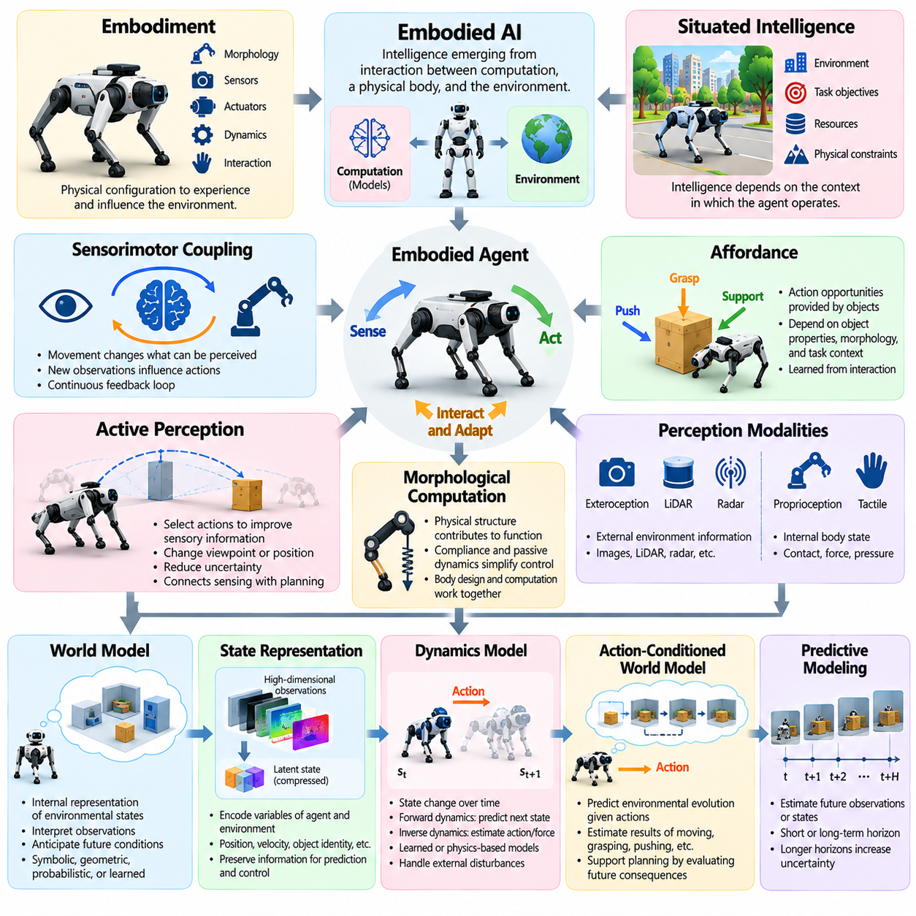
Embodied AI refers to artificial intelligence whose capabilities emerge through interaction between computational processes, a physical body, and the surrounding environment. Unlike purely symbolic or digital intelligence, embodied intelligence depends on sensing, movement, and physical constraints. The body is not merely an execution mechanism but an integral component influencing perception, learning, reasoning, and action.
Embodiment describes the physical configuration through which an intelligent agent experiences and influences its environment. It includes morphology, sensors, actuators, mechanical dynamics, and interaction capabilities. Different embodiments provide different opportunities and limitations for learning and behavior. Consequently, intelligence developed for one robotic platform may require adaptation before operating effectively through another physical form.
Situated intelligence emphasizes that intelligent behavior depends on the context in which an agent operates. Environmental structure, task objectives, available resources, and physical constraints influence decision-making. An embodied agent cannot be fully understood independently of its operating conditions. Situated approaches therefore examine intelligence as an ongoing relationship between the agent, its environment, and the activities being performed.
Sensorimotor coupling describes the continuous relationship between sensory observations and motor actions. Movements change what an agent can perceive, while new observations influence subsequent movements. This reciprocal process enables active exploration, feedback-based control, and adaptive interaction. In embodied systems, perception and action are interconnected processes rather than independent stages of computation.
An affordance represents an action opportunity that an environment or object provides relative to an agent's capabilities. A handle may afford pulling, while a flat surface may afford support or placement. Affordances depend on object properties, robot morphology, and task context. Affordance learning allows Physical AI systems to infer possible interactions instead of relying exclusively on predefined object categories.
Active perception refers to selecting actions specifically to improve the quality or usefulness of sensory information. A robot may reposition a camera, approach an object, or change its viewpoint to reduce uncertainty. These actions are valuable even when they do not directly advance the immediate physical task. Active perception connects information gathering with planning and demonstrates that sensing can be an intentional component of intelligent behavior.
Proprioception refers to sensing an agent's internal physical condition, including joint positions, velocities, and body orientation. Exteroception concerns information obtained about the external environment through cameras, LiDAR, radar, and related sensors. Tactile perception measures contact-related properties such as pressure, force, or surface interaction. Combining these modalities supports body awareness and reliable physical interaction.
Morphological computation describes situations in which physical structure and mechanical properties contribute to functions that might otherwise require explicit computation. Compliance, passive dynamics, and body geometry can simplify stabilization or manipulation. This concept does not imply that the body independently performs all intelligent reasoning. Instead, it emphasizes how physical design and computational control jointly determine embodied behavior.
A world model is an internal representation of environmental states, relationships, and dynamics used to interpret observations or anticipate future conditions. World models may be symbolic, geometric, probabilistic, or learned through neural networks. Their purpose is to capture information relevant to prediction and decision-making. A world model need not reproduce every physical detail, but it should preserve properties important to the intended tasks.
A state representation encodes variables describing the condition of an agent and its environment. These variables may include position, velocity, object identity, spatial relationships, and interaction status. A latent state is a compressed internal representation inferred from observations. Latent representations are useful when raw sensory data is high-dimensional, although compression must preserve information necessary for accurate prediction and effective control.
A dynamics model describes how a system's state changes over time, potentially in response to actions and external disturbances. Forward dynamics predicts future states from current conditions and applied actions. Inverse dynamics estimates actions or forces associated with desired transitions. Learned dynamics models approximate these relationships from experience, while physics-based models derive them from mathematical descriptions of physical processes.
An action-conditioned world model predicts environmental evolution while accounting for actions selected by an agent. It can estimate how moving, grasping, pushing, or interacting with objects may change future states. This capability distinguishes action-aware prediction from passive forecasting. Action conditioning supports planning because candidate decisions can be evaluated according to their expected physical consequences.
Predictive world modeling estimates future observations, states, or latent representations from available information. Predictions may cover short control intervals or longer planning horizons. A prediction horizon specifies how far into the future a model attempts to estimate system evolution. Longer horizons introduce greater uncertainty because small modeling errors, environmental disturbances, and unknown future interactions can accumulate.
Model-based planning uses a representation of environmental dynamics to evaluate possible actions before execution. A system may simulate candidate trajectories, compare predicted outcomes, and select actions that satisfy objectives and constraints. Model predictive control repeatedly performs this process over a moving horizon. World-model-based planning extends this principle to learned representations of complex environments and interactions.
Imagination in model-based reinforcement learning refers to generating hypothetical future experiences using an internal dynamics model. An agent can evaluate potential action sequences without physically executing every alternative. Imagined trajectories may support policy learning, value estimation, or planning. Their usefulness depends on model fidelity, uncertainty management, and the relationship between simulated predictions and actual physical outcomes.
A belief state represents an agent's probability distribution over possible environmental states when the true state is not fully observable. Partial observability arises because sensors provide incomplete, noisy, or obstructed measurements. Belief updating incorporates new observations and action information to revise state estimates. This probabilistic perspective is important for embodied agents operating under uncertainty and limited visibility.
Object-centric world models represent environments through entities and their relationships rather than treating observations only as undifferentiated signals. Objects may possess attributes such as position, geometry, velocity, and interaction properties. Relational representations describe connections and dependencies among entities. Such models can support structured reasoning, compositional prediction, and planning involving multiple interacting objects.
Spatial world models encode geometric and topological relationships within an environment. Occupancy representations estimate which regions contain obstacles, while semantic representations associate spaces and objects with meaningful categories. Bird's-eye-view representations organize information in a common spatial perspective. These models support navigation, collision avoidance, environmental understanding, and prediction of movement through physical spaces.
Temporal world models represent how environmental conditions and interactions evolve across time. They may incorporate memory, recurrent computation, attention mechanisms, or learned state transitions. Temporal consistency is essential when predicting motion, contact events, or multi-step interactions. A model that accurately interprets individual observations may still perform poorly when predicting sequences of physically dependent events.
Causal world models attempt to represent relationships in which interventions influence subsequent physical outcomes. Causal reasoning differs from statistical association because it considers how changing an action or condition affects future states. Counterfactual reasoning evaluates hypothetical alternatives to events that occurred. These capabilities can support decision analysis, failure investigation, and planning, although reliable causal identification remains challenging.
Physics-informed world models incorporate physical knowledge into learned representations or predictive mechanisms. Constraints involving motion, contact, conservation principles, and system dynamics can improve consistency with physical behavior. Hybrid approaches combine analytical models with neural networks to capture effects that are difficult to describe explicitly. Their effectiveness depends on the validity of physical assumptions and the quality of available observations.
Uncertainty in world models arises from incomplete observations, stochastic processes, and limitations in learned representations. Aleatoric uncertainty concerns variability inherent in observations or outcomes, while epistemic uncertainty concerns incomplete model knowledge. Reliable prediction requires recognizing both forms where applicable. Uncertainty-aware planning can reduce dependence on predictions that extend beyond the model's demonstrated competence.
Embodied learning refers to acquiring knowledge or skills through physical or simulated interaction. Experience may include exploration, demonstrations, task execution, and feedback from environmental outcomes. Sim-to-real transfer applies capabilities developed in simulation to physical systems. Differences in dynamics, sensing, contact behavior, and environmental conditions can limit transfer, requiring adaptation and validation before deployment.
Embodied AI and world-model terminology establishes a conceptual foundation for intelligence grounded in physical interaction and predictive understanding. Embodiment defines how an agent experiences and acts, while world models represent how its environment may evolve. Their integration enables perception, anticipation, planning, and adaptive control to operate as a coordinated system, supporting increasingly capable Physical AI agents.

09.06. Foundation Model VLM VLA and Agent Terms
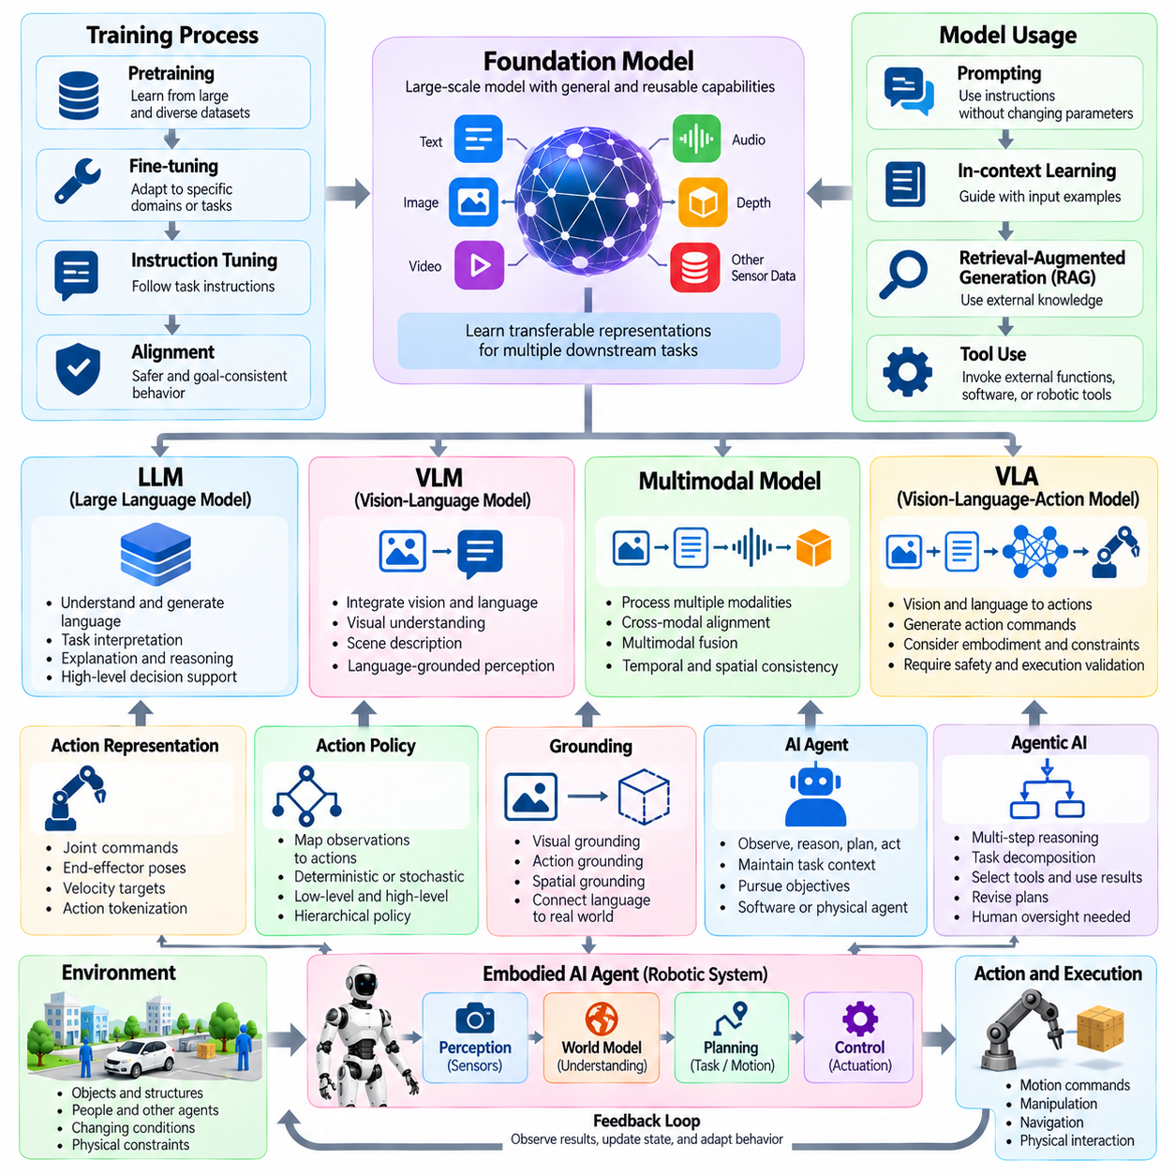
A foundation model is a large-scale artificial intelligence model trained on broad datasets to support multiple downstream tasks. Rather than being developed exclusively for one application, it learns reusable representations that can be adapted through prompting, fine-tuning, or additional training. In Physical AI, foundation models may provide general perception, reasoning, planning, and interaction capabilities, although physical reliability requires further validation.
Pretraining refers to the initial learning process through which a foundation model acquires broadly transferable knowledge from large datasets. Fine-tuning adapts a pretrained model to specific tasks, environments, or operational requirements. Instruction tuning improves responsiveness to task descriptions, while alignment methods encourage behavior consistent with defined objectives and constraints. These processes influence capability but do not independently guarantee safety.
A large language model, or LLM, is a neural network trained to process and generate language-based sequences. LLMs can interpret instructions, produce explanations, organize plans, and support symbolic reasoning. Within robotic systems, they may serve as high-level interfaces for task interpretation and decision support. However, linguistic competence does not necessarily imply accurate physical understanding or reliable execution.
A vision-language model, or VLM, integrates visual information and natural language within a shared computational framework. It can associate images with descriptions, answer visual questions, identify semantic relationships, and interpret scene context. In Physical AI, VLMs support language-grounded perception and task understanding. Their outputs require verification when precise geometry, object state, or safety-critical decisions are involved.
Multimodal foundation models process information from multiple modalities, including text, images, video, audio, depth, and structured sensor measurements. Cross-modal alignment establishes relationships between representations originating from different information sources. Multimodal fusion combines complementary signals for interpretation or prediction. Effective physical applications require temporal synchronization, spatial consistency, and appropriate treatment of uncertainty.
A vision-language-action model, or VLA, connects visual observations and language instructions with action generation. Unlike a VLM primarily designed for interpretation, a VLA produces outputs intended to influence physical behavior. These outputs may represent discrete actions, motion commands, or continuous control variables. VLA systems therefore require explicit consideration of embodiment, actuator constraints, execution timing, and operational safety.
Action representation defines how physical decisions are encoded for learning and execution. Representations may include joint commands, end-effector poses, velocity targets, or higher-level robotic skills. Action tokenization converts action information into discrete units suitable for sequence models. The selected representation influences generalization, precision, computational requirements, and compatibility with different robotic platforms.
An action policy maps observations, instructions, or estimated states into actions intended to achieve objectives. Policies may be deterministic or stochastic and can operate at different temporal and functional levels. Low-level policies regulate immediate movements, while high-level policies select tasks or skills. Hierarchical policies coordinate these levels to connect abstract instructions with physically executable behavior.
An AI agent is a system that observes relevant information, maintains task context, selects actions, and pursues objectives through interaction with an environment. Agency refers to the capacity for goal-directed decision-making and action. An agent may operate entirely in software or through a physical robot. Physical agents additionally face sensing uncertainty, mechanical constraints, environmental disturbances, and consequences arising from real-world execution.
Agentic AI describes systems that coordinate reasoning, planning, memory, and action selection to pursue objectives across multiple steps. Agentic behavior may involve decomposing tasks, selecting tools, evaluating results, and revising plans. This term describes an architectural or behavioral characteristic rather than a guaranteed autonomy level. Human oversight and execution boundaries remain necessary according to application risk.
Tool use refers to an AI system invoking external functions, software services, databases, or robotic capabilities to complete tasks. A tool interface specifies available operations, required inputs, and expected outputs. In Physical AI, tools may include navigation services, manipulation planners, perception modules, and fleet interfaces. Tool invocation must be distinguished from verified physical execution because commands may fail or produce unexpected outcomes.
Grounding connects abstract representations, particularly language, to observable entities, actions, and conditions in the physical environment. Visual grounding associates descriptions with image regions or objects, while action grounding links instructions to executable behaviors. Spatial grounding establishes relationships among locations and reference frames. Reliable grounding reduces ambiguity between linguistic intentions and physical operational requirements.
Prompting provides instructions or contextual information that influence model outputs without necessarily changing model parameters. In-context learning uses examples supplied within an input sequence to guide behavior. Retrieval-augmented generation incorporates externally retrieved information into model responses. These techniques can improve task interpretation, but retrieved content and generated instructions must be checked against current physical conditions.
Memory in AI agents refers to information retained or retrieved to support decisions across interactions. Short-term memory maintains recent observations and task context, while long-term memory preserves reusable knowledge or experience. Episodic memory represents particular events, whereas semantic memory organizes general concepts and relationships. Robotic memory systems must account for outdated information, environmental changes, and uncertain observations.
Embodied foundation models extend general-purpose learning toward tasks involving physical states, actions, and interactions. Their training may incorporate robot demonstrations, sensor streams, trajectories, simulation data, and language instructions. Cross-embodiment learning seeks transferable capabilities across robots with different morphologies. Transfer remains difficult because action spaces, dynamics, sensor configurations, and operating conditions vary substantially.

09.07. Simulation and Digital Twin Terms
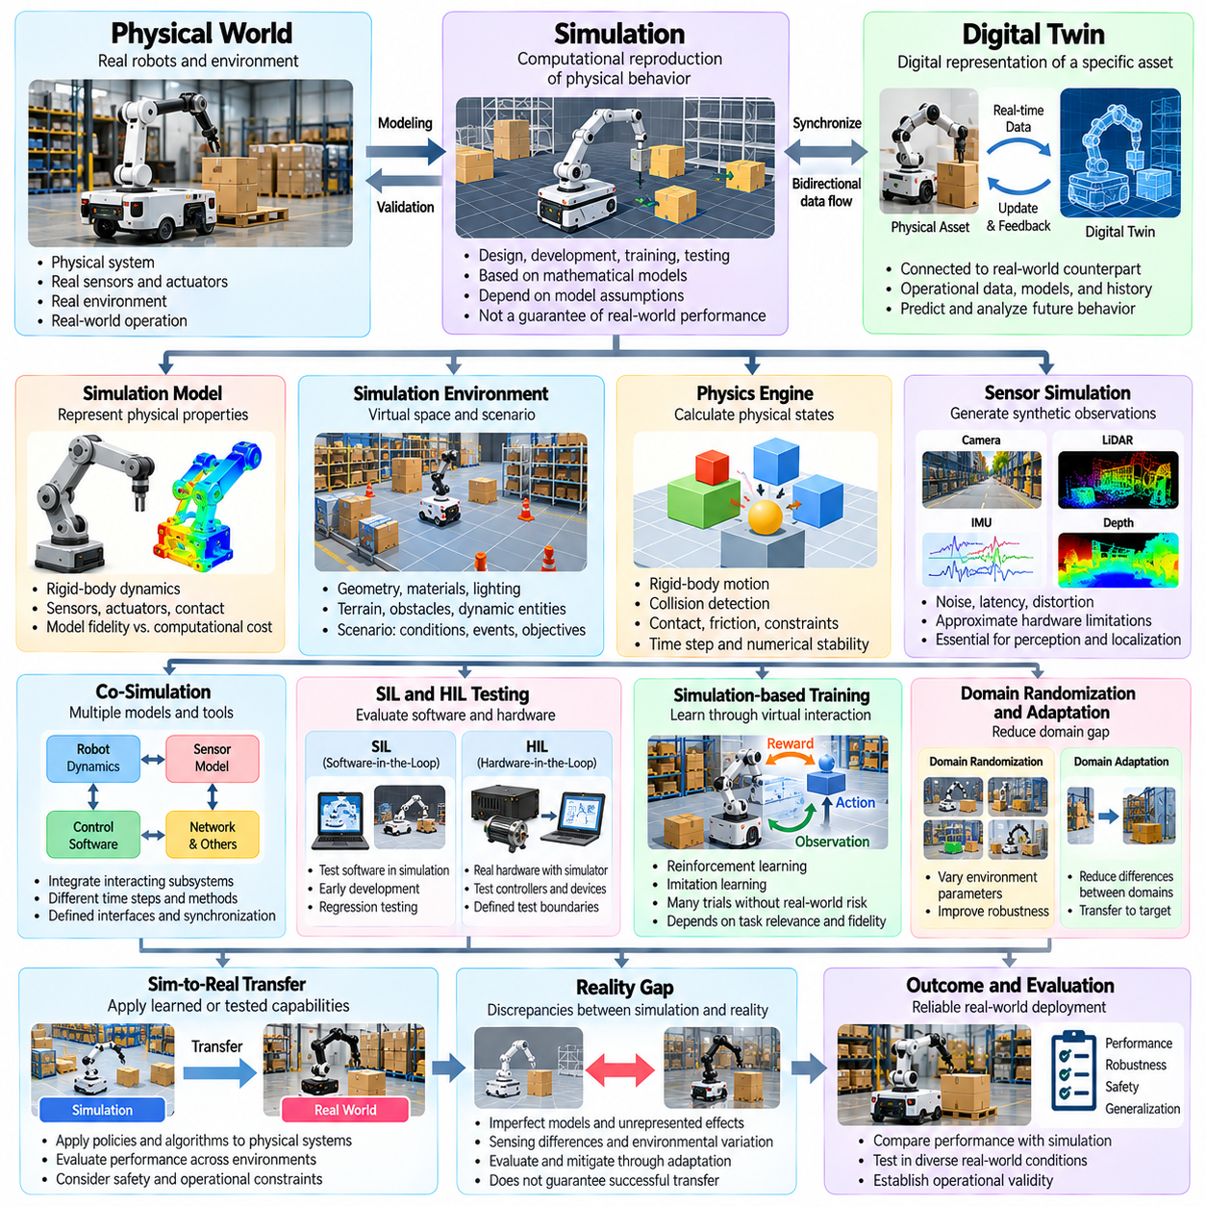
Simulation is the computational reproduction of selected behaviors of a physical system or environment using mathematical models and software. In robotics, simulation supports design, algorithm development, training, and testing without requiring every experiment to occur on physical hardware. Simulation results depend on model assumptions, numerical methods, and environmental representations, and therefore cannot automatically establish real-world performance.
A simulation model represents the properties and processes relevant to a particular engineering objective. Models may describe rigid-body dynamics, sensors, actuators, contact interactions, communication, or environmental conditions. Model fidelity indicates how closely simulated behavior corresponds to the intended physical system. Higher fidelity can improve realism but often increases computational cost and does not guarantee greater predictive accuracy.
A simulation environment defines the virtual space in which agents, objects, and physical processes interact. It may include geometry, materials, lighting, terrain, obstacles, and dynamic entities. A scenario specifies particular initial conditions, events, objectives, and environmental constraints within that environment. Separating environments from scenarios enables systematic testing of multiple operational situations using shared virtual assets.
A physics engine calculates changes in physical states according to implemented mechanical models and numerical algorithms. Common functions include rigid-body motion, collision detection, contact resolution, friction, and joint constraints. Simulation time steps determine how frequently states are updated. Numerical stability, integration accuracy, and contact modeling influence whether simulated trajectories adequately approximate physical behavior.
Sensor simulation generates synthetic observations corresponding to virtual environmental conditions. Camera simulation may represent image formation, lighting, and optical effects, while LiDAR simulation models range measurements and geometric visibility. Noise, latency, distortion, and missing observations can be introduced to approximate hardware limitations. Sensor realism is essential when evaluating perception and localization algorithms intended for physical deployment.
A digital twin is a digital representation of a specific physical entity or system that maintains an appropriate connection with its real-world counterpart. It may incorporate operational data, models, historical records, and predictive capabilities. Unlike a standalone simulation, a digital twin emphasizes correspondence with an identifiable physical asset. The required update frequency and degree of synchronization depend on its intended purpose.
A digital model represents a physical system digitally without necessarily exchanging operational data automatically. A digital shadow generally describes a representation updated through data flowing from the physical system toward its digital counterpart. A digital twin may support bidirectional information exchange and operational feedback. These distinctions depend on the adopted framework and should be defined explicitly rather than assumed to be universal.
Synchronization refers to maintaining consistency between physical observations and digital representations. State synchronization updates variables such as position, velocity, equipment status, and environmental conditions. Temporal synchronization aligns measurements and events across data sources. Inaccurate timestamps, communication delays, or inconsistent coordinate frames can undermine digital twin reliability even when individual models are accurate.
Co-simulation combines multiple simulation models or software tools to represent interacting subsystems. A robotic application may integrate mechanical dynamics, sensor processing, control software, networking, and operational workflows. Each subsystem may operate with different time steps or numerical methods. Co-simulation requires defined interfaces, synchronization strategies, and procedures for exchanging state information without introducing unacceptable errors.
Software-in-the-loop testing, or SIL, evaluates software components within a simulated execution environment. Hardware-in-the-loop testing, or HIL, connects actual hardware components to simulated systems or signals. SIL supports early development and regression testing, while HIL examines interactions involving real controllers or devices. Neither approach alone establishes complete system safety, and both require clearly defined test boundaries.
Simulation-based training allows robotic policies to acquire experience through repeated virtual interaction. Reinforcement learning agents can explore actions, receive rewards, and improve behavior without exposing physical equipment to every experimental risk. Imitation learning may use simulated demonstrations or trajectories. Training effectiveness depends on task relevance, environment diversity, model fidelity, and the quality of learning signals.
Domain randomization varies simulation parameters such as lighting, textures, friction, mass, sensor noise, and object placement during training. Its purpose is to expose learning systems to diverse conditions and improve robustness to real-world variation. Domain adaptation instead seeks to reduce differences between source and target domains. Both approaches address transfer limitations, but neither guarantees successful operation outside validated conditions.
Sim-to-real transfer refers to applying capabilities developed or evaluated in simulation to physical systems. The reality gap describes discrepancies between simulated and actual behavior arising from imperfect models, sensing differences, and unrepresented interactions. Transfer evaluation compares performance across virtual and physical environments. Successful deployment requires evidence that critical behaviors remain acceptable under real operating conditions.
Synthetic data consists of artificially generated observations, annotations, or trajectories used for training and evaluation. Simulation can produce labeled images, depth maps, segmentation masks, object poses, and interaction records at scale. Synthetic datasets can reduce annotation costs and expose rare situations. Their usefulness depends on representativeness, diversity, and the extent to which generated patterns correspond to physical observations.
Scenario-based testing evaluates system behavior under specified operating situations rather than relying only on aggregate performance metrics. Scenarios may involve moving obstacles, sensor degradation, unexpected human motion, or restricted navigation spaces. Parameterized scenarios allow systematic variation of conditions. Scenario coverage describes the extent to which a defined set of operational situations has been exercised.
Verification determines whether a simulation model or implementation satisfies specified requirements and mathematical expectations. Validation evaluates whether the model adequately represents the intended physical system for a particular use. Calibration adjusts model parameters using measurements or reference data. These activities are related but distinct, and a verified implementation may still produce misleading results if its underlying assumptions are inappropriate.
A digital twin for Physical AI can support monitoring, prediction, planning, and operational optimization throughout a robotic system's lifecycle. Fleet-level twins may represent multiple robots, shared infrastructure, and environmental resources. Predictive simulations can examine congestion, equipment degradation, or alternative task assignments. Their operational value depends on trustworthy data integration, maintained model accuracy, and clearly defined decision authority.

09.08. Robot and Mobile Robot Safety Standards
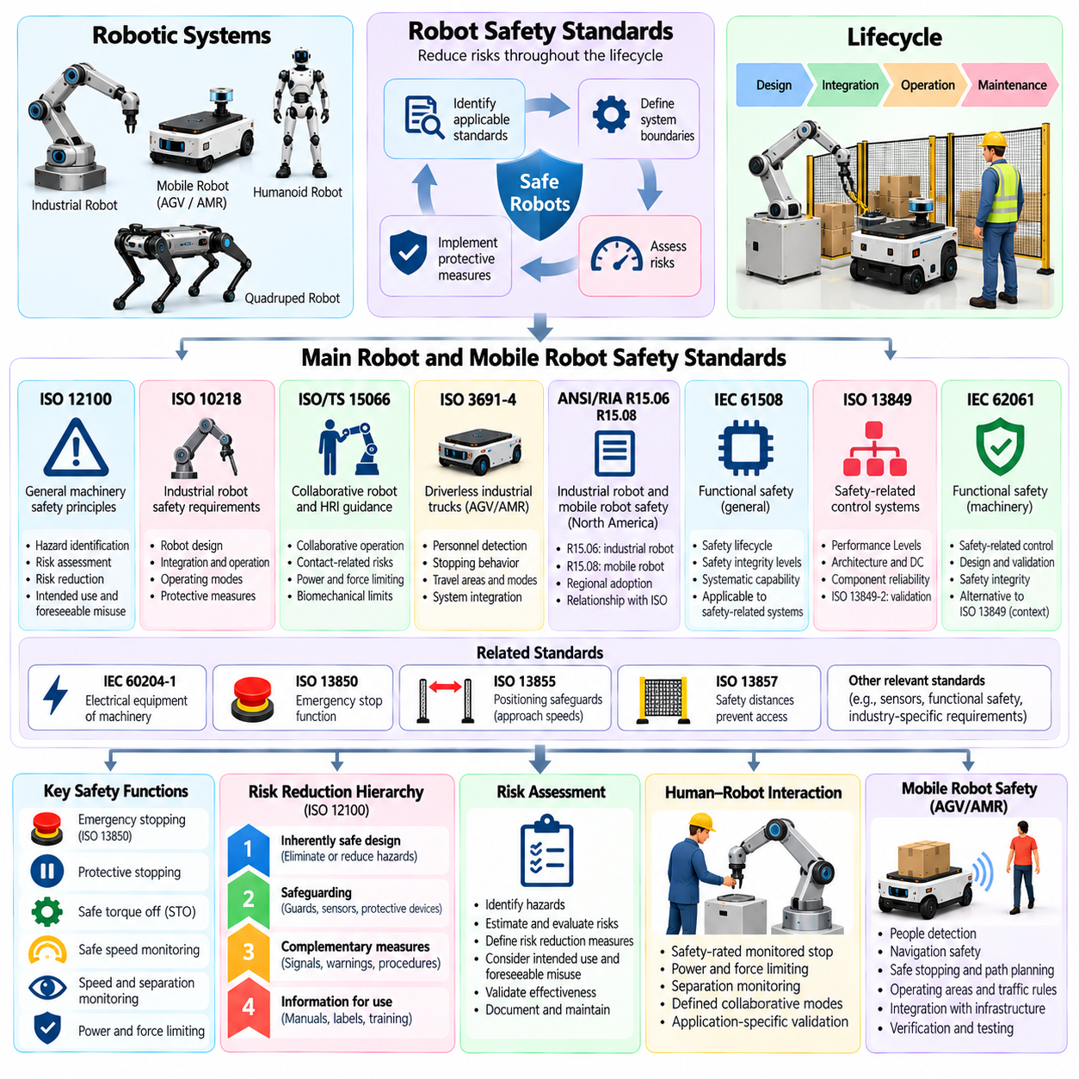
Robot safety standards establish requirements and engineering principles for reducing risks associated with robotic systems throughout their lifecycle. They address hazards arising from mechanical motion, electrical energy, control failures, human interaction, and environmental conditions. Safety compliance requires identifying applicable standards, defining system boundaries, assessing foreseeable risks, and demonstrating that protective measures achieve acceptable performance.
ISO 12100 provides general principles for machinery safety through hazard identification, risk assessment, and risk reduction. It establishes a structured process for examining intended use and reasonably foreseeable misuse. Risk reduction prioritizes inherently safe design, followed by safeguarding and complementary protective measures, and finally information for use. This framework supports systematic safety engineering across robotic applications.
ISO 10218 addresses safety requirements for industrial robots and industrial robot applications. Its framework distinguishes requirements associated with robot design from those involving integration and operation. Safety considerations include operating modes, protective measures, control functions, and interactions within robotic cells. The applicable edition and jurisdiction must be identified because requirements and referenced documents can change.
ISO/TS 15066 provides guidance concerning collaborative industrial robot applications and human-robot interaction. It discusses collaborative operating methods and considerations for contact-related risk reduction. Power and force limiting requires evaluating potential contact conditions and relevant biomechanical limits. Collaborative operation does not eliminate the need for application-specific risk assessment or appropriate protective measures.
ISO 3691-4 addresses safety requirements and verification for driverless industrial trucks and their systems, including relevant automated guided vehicles and autonomous mobile robots. Its application depends on the vehicle's classification, intended use, and operating environment. Important considerations include personnel detection, stopping behavior, travel areas, operating modes, and system integration. The standard should not be assumed to cover every type of mobile robot.
ANSI/RIA R15.06 provides an industrial robot safety framework used in relevant North American contexts. ANSI/RIA R15.08 addresses industrial mobile robot safety, including requirements associated with mobile platforms and applications. These documents must be interpreted according to their specific parts, editions, and scopes. Regional adoption, regulatory expectations, and relationships with ISO standards require examination during compliance planning.
IEC 61508 establishes a general functional safety framework for electrical, electronic, and programmable electronic safety-related systems. It addresses safety lifecycle activities, systematic capability, and safety integrity requirements. Safety Integrity Levels represent defined integrity targets within this framework. Applying IEC 61508 to robotics requires identifying relevant safety functions and determining whether sector-specific standards provide more appropriate requirements.
ISO 13849-1 specifies principles for designing safety-related parts of machinery control systems. Performance Levels express the ability of these systems to perform safety functions under foreseeable conditions. Evaluation considers architecture, component reliability, diagnostic coverage, and common-cause failures. ISO 13849-2 addresses validation, supporting evidence that implemented safety-related control functions satisfy their specified requirements.
IEC 62061 addresses functional safety of safety-related control systems for machinery. It provides methods for specifying, designing, integrating, and validating safety-related control functions. Its safety integrity approach differs in structure from the Performance Level framework of ISO 13849. Selection between applicable frameworks depends on regulatory context, system architecture, engineering requirements, and accepted conformity practices.
IEC 60204-1 addresses electrical equipment of machinery, including protective measures, control circuits, wiring, and electrical interfaces. ISO 13850 establishes principles for emergency stop functions, while ISO 13855 addresses positioning safeguards relative to approach speeds. ISO 13857 concerns safety distances intended to prevent access to hazard zones. These standards complement robot-specific requirements rather than replacing system-level risk assessment.
A safety function is a protective function intended to achieve or maintain a safe condition when specified hazardous circumstances occur. Examples include emergency stopping, protective stopping, safe speed monitoring, and prevention of unexpected motion. Each function requires defined triggering conditions, response behavior, and performance requirements. Safety functions must be verified against their intended operating conditions and foreseeable failure modes.
Emergency stopping is a complementary protective measure intended to avert or reduce an existing or impending hazard. Protective stopping may be initiated automatically by safeguarding systems or operating conditions. Safe torque off prevents torque-producing power from being supplied to a motor, but does not necessarily guarantee immediate mechanical stopping. Stopping behavior must account for inertia, gravity, stored energy, and mechanical configuration.
Speed and separation monitoring maintains protective separation between humans and moving robotic equipment. Safety-rated monitored stopping maintains a monitored stopped condition during defined collaborative activities. Power and force limiting constrains potential interaction forces and pressures. These concepts require application-specific implementation, appropriate sensing, validated control behavior, and consideration of foreseeable human movement.
Mobile robot safety introduces challenges involving changing routes, shared workspaces, moving obstacles, and variable surface conditions. Protective fields and personnel detection systems must reflect vehicle speed, stopping distance, direction, and operating context. Localization and navigation errors may affect hazardous situations. Safety-related obstacle detection must be distinguished from ordinary perception functions unless the latter meet applicable safety requirements.
Risk assessment identifies hazards, estimates associated risks, evaluates their acceptability, and determines necessary risk reduction measures. Relevant factors include severity of harm, exposure frequency, and possibilities for avoiding hazardous events. Residual risk remains after protective measures have been implemented. Documentation should record assumptions, decisions, verification evidence, and information communicated to operators and maintainers.
Conformity assessment demonstrates whether robotic equipment satisfies applicable legal and technical requirements. Depending on jurisdiction, this may involve machinery legislation, harmonized or designated standards, technical documentation, testing, and declarations of conformity. Certification and compliance are not interchangeable concepts. A valid safety case must address the actual configuration, intended application, and conditions of deployment.

09.09. AI Safety and Governance Frameworks
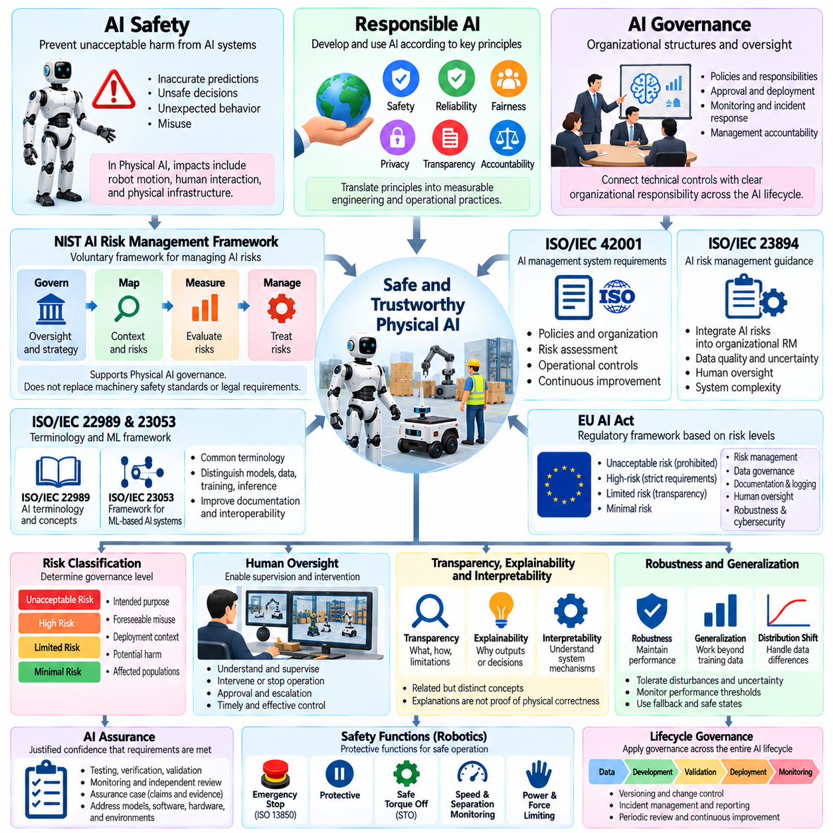
AI safety refers to the principles, methods, and controls used to prevent artificial intelligence systems from causing unacceptable harm. It addresses failures arising from inaccurate predictions, unsafe decisions, unexpected behavior, and inappropriate system use. In Physical AI, safety considerations extend beyond digital outputs because intelligent decisions may directly influence mechanical motion, human interaction, and physical infrastructure.
AI governance establishes organizational structures, responsibilities, policies, and oversight mechanisms for developing and operating artificial intelligence systems. It defines who can approve models, authorize deployment, monitor performance, and respond to incidents. Effective governance connects technical controls with management accountability. It also requires documented decision processes and clear responsibility across the AI system lifecycle.
Responsible AI describes the development and use of artificial intelligence according to principles such as safety, reliability, transparency, fairness, privacy, and accountability. These principles require translation into measurable engineering and operational practices. In robotic applications, responsible AI also considers physical accessibility, human autonomy, worker protection, and the consequences of decisions affecting shared environments.
The NIST AI Risk Management Framework provides a voluntary structure for identifying, assessing, and managing risks associated with AI systems. Its core functions are Govern, Map, Measure, and Manage. These functions address organizational oversight, system context, risk evaluation, and risk treatment. The framework can support Physical AI governance, although it does not replace machinery safety standards or applicable legal requirements.
ISO/IEC 42001 specifies requirements for establishing, implementing, maintaining, and continually improving an artificial intelligence management system. It connects organizational policies, risk assessment, responsibilities, and operational controls within a management framework. Certification may demonstrate conformity with the management system standard, but it does not independently establish that every deployed AI model or robotic application is safe.
ISO/IEC 23894 provides guidance for managing risks related to artificial intelligence. It supports integrating AI-specific considerations into broader organizational risk management activities. Relevant concerns include data quality, model uncertainty, human oversight, system complexity, and changing operating conditions. For Physical AI, risk management must connect these concerns with hazards arising from physical actions and environmental interactions.
ISO/IEC 22989 establishes terminology and concepts for artificial intelligence, supporting consistent communication across technical and organizational contexts. ISO/IEC 23053 describes a framework for AI systems using machine learning. Shared terminology helps distinguish models, data, training, inference, and system functions. Such conceptual standards improve documentation and interoperability but do not themselves provide complete safety assurance.
The European Union AI Act establishes a regulatory framework based on categories of AI-related risk and corresponding obligations. Certain AI systems associated with regulated products or safety functions may fall within high-risk requirements when applicable legal conditions are satisfied. Obligations can concern risk management, data governance, documentation, logging, transparency, human oversight, robustness, and cybersecurity.
AI risk classification determines the level and nature of governance required for particular applications. Classification should consider intended purpose, foreseeable misuse, deployment context, potential harm, and affected populations. A model used for noncritical reporting may require different controls from one influencing robot navigation or manipulation. Risk classification must reflect the complete application rather than model architecture alone.
Human oversight refers to arrangements enabling authorized people to understand, supervise, intervene in, or stop AI-supported operations. Oversight may involve approval workflows, operational monitoring, escalation procedures, and defined intervention authority. Effective oversight requires meaningful information and practical control capabilities. Merely placing a human in a workflow does not guarantee that intervention will be timely or effective.
Transparency concerns the availability of relevant information about an AI system's purpose, capabilities, limitations, and operating conditions. Explainability concerns methods for communicating why particular outputs or decisions occur. Interpretability concerns the extent to which system mechanisms or representations can be understood. These concepts are related but distinct, and explanations should not be mistaken for evidence of physical correctness.
AI assurance is the process of developing justified confidence that an AI system satisfies specified requirements and acceptable risk criteria. Assurance activities may include testing, verification, validation, monitoring, independent review, and structured evidence collection. An assurance case organizes claims, arguments, and supporting evidence. In Physical AI, assurance must address interactions among learned models, conventional software, hardware, and operating environments.
Robustness describes an AI system's ability to maintain acceptable performance despite disturbances, uncertainty, or variations in input conditions. Generalization concerns performance beyond the specific examples encountered during training. Distribution shift occurs when operational data differs from the training distribution. Governance processes should establish monitoring thresholds, evaluation procedures, and responses when model performance deteriorates.
Data governance establishes policies for collecting, labeling, storing, accessing, retaining, and using information throughout the AI lifecycle. Dataset documentation records provenance, intended use, limitations, and relevant quality characteristics. Model documentation describes training assumptions, evaluation results, and known constraints. Traceability connects datasets, model versions, software releases, test evidence, and deployment decisions.
Continuous monitoring evaluates AI behavior after deployment to detect performance degradation, unexpected conditions, or emerging risks. Incident management defines procedures for reporting, investigating, containing, and correcting harmful or unsafe behavior. Change management evaluates modifications to models, datasets, prompts, or system configurations. Significant changes may require renewed validation before operational release.
AI safety and governance frameworks provide complementary foundations for managing intelligent systems throughout development, deployment, and operation. Technical safety measures reduce specific hazards, while governance establishes accountability, evidence requirements, and oversight. For Physical AI, effective assurance requires integrating AI risk management with robotics safety engineering, cybersecurity, human factors, and continuous operational evaluation.

09.10. Data Cybersecurity and Privacy Frameworks
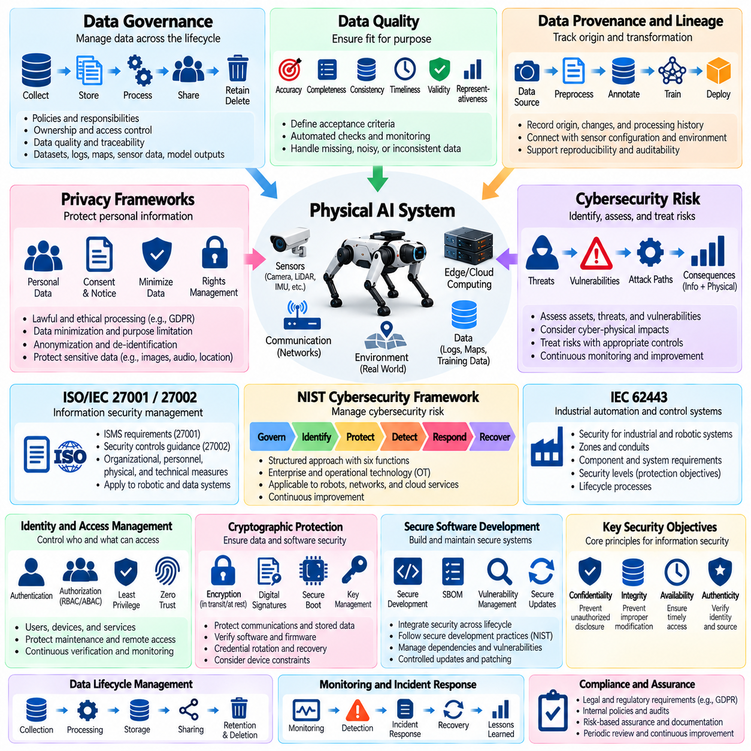
Data governance, cybersecurity, and privacy frameworks establish complementary controls for managing information and protecting connected intelligent systems. Data governance addresses information quality, ownership, and lifecycle management, while cybersecurity protects systems against unauthorized access and disruption. Privacy focuses on the appropriate processing of personal information. Physical AI requires integrating these disciplines because data failures can produce physical consequences.
Data governance defines policies, responsibilities, and procedures for collecting, storing, transforming, sharing, retaining, and deleting information. In robotic systems, governed assets may include sensor recordings, localization maps, operational logs, training datasets, and model outputs. Effective governance establishes data ownership, access permissions, quality requirements, and traceability. These controls support reliable AI development and accountable operational decisions.
Data quality describes the suitability of information for its intended purpose. Relevant dimensions include accuracy, completeness, consistency, timeliness, validity, and representativeness. Sensor datasets may contain missing timestamps, calibration errors, duplicated observations, or inconsistent coordinate frames. Quality management requires defined acceptance criteria, automated checks, and documented corrective actions before data enters training or operational pipelines.
Data provenance identifies the origins, transformations, and processing history of information. Data lineage traces how records move through collection, preprocessing, annotation, training, and deployment workflows. These concepts support reproducibility, auditability, and investigation of unexpected model behavior. In Physical AI, provenance records should connect datasets with sensor configurations, environmental conditions, software versions, and applicable usage restrictions.
ISO/IEC 27001 specifies requirements for establishing, implementing, maintaining, and improving an information security management system. ISO/IEC 27002 provides guidance on information security controls. These standards support risk-based protection of information assets through organizational, personnel, physical, and technological measures. Their application to robotics requires identifying both conventional information risks and cyber-physical dependencies.
The NIST Cybersecurity Framework provides a structured approach to managing cybersecurity risk through the functions Govern, Identify, Protect, Detect, Respond, and Recover. These functions connect organizational policy with asset management, preventive controls, threat detection, incident handling, and operational restoration. For robotic fleets, the framework can support consistent cybersecurity governance across edge devices, local infrastructure, and cloud services.
IEC 62443 addresses cybersecurity for industrial automation and control systems. Its framework considers system architecture, security zones, communication conduits, component requirements, and lifecycle processes. Security levels express protection objectives against defined attacker capabilities within the applicable framework. Industrial robots and connected manufacturing systems may use IEC 62443 concepts when establishing defensible operational technology environments.
Cybersecurity risk assessment identifies assets, threats, vulnerabilities, attack paths, and potential consequences. Threat modeling examines how adversaries could compromise sensors, communication channels, control software, or management interfaces. In Physical AI, consequences may include unauthorized motion, corrupted perception, service interruption, or loss of operational visibility. Risk treatment should reflect both information security impact and physical safety implications.
The confidentiality, integrity, and availability model defines three fundamental information security objectives. Confidentiality restricts unauthorized disclosure, integrity protects against improper modification, and availability supports timely access to required services. Robotic systems also require attention to authenticity and operational resilience. A compromised command or manipulated sensor message can undermine safe behavior even when communication remains available.
Identity and access management establishes mechanisms for authenticating users, devices, and services and authorizing permitted operations. Least privilege limits access to necessary functions, while role-based and attribute-based access controls organize permissions. Zero Trust principles emphasize continuous verification rather than implicit network trust. Robotic deployments should protect maintenance interfaces, remote commands, service accounts, and machine identities.
Cryptographic protection supports secure communication, stored-data protection, and software authenticity. Transport encryption can protect telemetry and commands, while digital signatures help verify firmware and software packages. Secure boot establishes trust in selected startup components, and key management governs cryptographic credentials. Effective implementation must consider computational constraints, credential rotation, recovery procedures, and device lifecycle management.
Secure software development integrates cybersecurity controls throughout requirements definition, design, implementation, testing, and maintenance. The NIST Secure Software Development Framework provides practices for reducing software vulnerabilities. Software bills of materials identify included components and dependencies, supporting vulnerability management. Robotic software assurance also requires controlled updates, dependency evaluation, and protection against unauthorized code execution.
Privacy frameworks address the lawful and responsible processing of personal data collected through intelligent systems. The European Union General Data Protection Regulation establishes requirements concerning lawful processing, transparency, individual rights, and accountability when applicable. ISO/IEC 27701 provides a privacy information management framework. Applicable obligations depend on jurisdiction, processing activities, organizational roles, and data characteristics.
Privacy by design integrates privacy requirements into system architecture and operational procedures from the beginning. Data minimization limits collection to information necessary for defined purposes, while purpose limitation restricts incompatible reuse. Retention controls establish appropriate storage periods and deletion procedures. Mobile robots equipped with cameras, microphones, or localization systems require particular attention when observing people in shared spaces.
Anonymization seeks to prevent individuals from being identified, while pseudonymization replaces direct identifiers but may still permit reidentification under certain conditions. Encryption protects data confidentiality without necessarily making information anonymous. Privacy impact assessments evaluate processing risks and appropriate safeguards. Robotics datasets require careful consideration of faces, voices, movement patterns, location histories, and indirectly identifying information.
Cybersecurity incident response establishes procedures for detecting, analyzing, containing, recovering from, and learning from security events. Robotic operations must coordinate technical response with physical safety procedures when compromised systems can affect movement or machinery. Backup, restoration, and disaster recovery support operational continuity. Post-incident analysis should identify root causes, affected assets, corrective measures, and residual risks.
Data, cybersecurity, and privacy frameworks must operate together throughout the Physical AI lifecycle. Governance establishes information responsibilities, cybersecurity protects connected infrastructure, and privacy controls personal data processing. Effective implementation requires documented requirements, continuous monitoring, periodic audits, and coordinated incident management. Their integration supports trustworthy robotic autonomy without replacing dedicated functional safety engineering.

09.11. Performance Evaluation and Benchmark Definitions
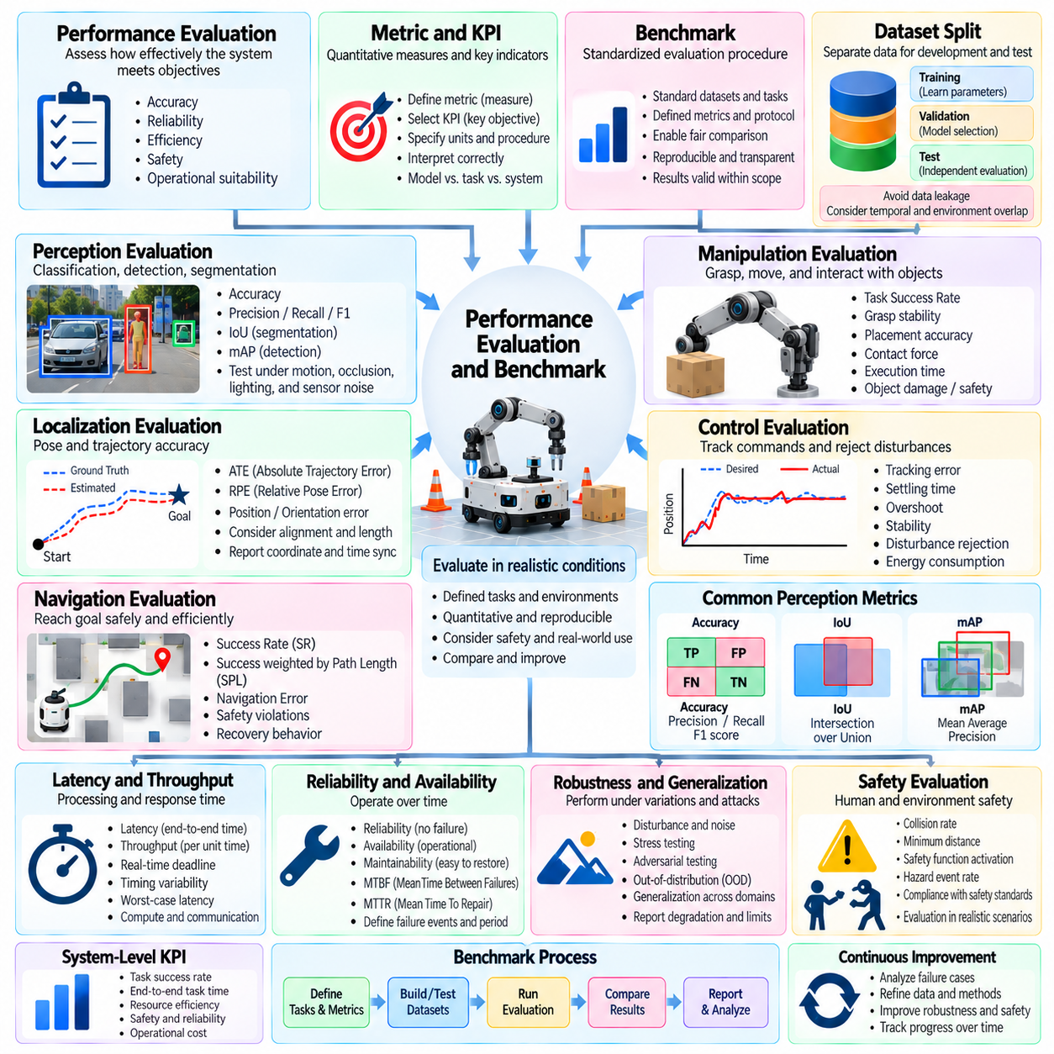
Performance evaluation is the systematic assessment of how effectively an artificial intelligence or robotic system satisfies defined objectives under specified conditions. Evaluation considers accuracy, reliability, efficiency, safety, and operational suitability. In Physical AI, performance cannot be determined solely from model predictions because intelligent decisions must produce acceptable outcomes through physical actions and environmental interactions.
A performance metric is a quantitative measure used to describe a particular aspect of system behavior. A key performance indicator, or KPI, is a selected metric associated with an important operational objective. Metrics require precise definitions, measurement procedures, units, and interpretation rules. A meaningful evaluation framework distinguishes technical model performance from task-level effectiveness and overall system performance.
A benchmark is a standardized evaluation procedure designed to support consistent comparison among algorithms, models, or systems. It typically specifies datasets, tasks, environmental conditions, metrics, and reporting requirements. Benchmark reproducibility depends on controlled configurations and transparent methodology. Benchmark results indicate performance within defined evaluation boundaries rather than universal superiority across all deployment situations.
A dataset split separates available observations into subsets used for training, validation, and testing. Training data supports parameter optimization, validation data guides model selection, and test data provides an independent performance estimate. Data leakage occurs when information from evaluation subsets improperly influences development. Robotic datasets must also account for temporal correlation, repeated environments, and overlapping trajectories.
Accuracy measures the proportion of correct predictions under a specified classification procedure. Precision describes the fraction of predicted positive instances that are correct, while recall measures the fraction of actual positive instances successfully detected. The F1 score combines precision and recall through their harmonic mean. These metrics provide different perspectives and must be interpreted alongside class distributions and error consequences.
Intersection over Union, or IoU, measures overlap between predicted and reference regions. Mean Average Precision, or mAP, summarizes detection performance across defined classes and evaluation thresholds. Object detection benchmarks must specify matching rules, confidence thresholds, and averaging procedures. In robotic perception, detection quality should also be assessed under motion, occlusion, lighting variation, and sensor degradation.
Localization performance evaluates how accurately a robot estimates its position and orientation within a reference frame. Absolute Trajectory Error, or ATE, measures differences between estimated and reference trajectories after an explicitly defined alignment procedure. Relative Pose Error, or RPE, evaluates local motion estimation consistency. Results depend on coordinate conventions, temporal alignment, trajectory length, and reference measurement quality.
Navigation performance measures whether a robot reaches intended destinations while satisfying operational constraints. Success Rate, or SR, describes the proportion of completed navigation tasks. Success weighted by Path Length, or SPL, combines task success with path efficiency relative to a reference shortest path. Navigation Error measures deviation from a target or reference, depending on its definition. Safety violations and recovery behavior require separate reporting.
Manipulation evaluation examines the ability to grasp, move, position, assemble, or otherwise interact with physical objects. Task Success Rate measures completion against defined acceptance criteria. Additional metrics include grasp stability, placement accuracy, contact force, execution time, and object damage. Manipulation benchmarks should distinguish successful task completion from temporary contact, partial progress, and unsafe execution.
Control performance describes how effectively a controller regulates system behavior in response to commands and disturbances. Tracking error measures deviation between desired and actual trajectories, while settling time and overshoot characterize transient responses. Stability and disturbance rejection are important evaluation dimensions. Physical systems also require consideration of actuator saturation, energy consumption, mechanical limits, and control latency.
Latency measures elapsed time between a defined initiating event and its corresponding system response. Throughput describes the amount of processing or completed work per unit time. Real-time performance depends on meeting specified deadlines, not merely achieving low average latency. Evaluation should report timing variability, worst-case behavior where justified, computational utilization, and the influence of communication delays.
Reliability describes the ability of a system to perform required functions under stated conditions over a specified period. Availability concerns whether the system is operational when required, while maintainability describes how effectively it can be restored or serviced. Mean Time Between Failures and Mean Time To Repair are commonly used maintenance metrics. Their interpretation requires clearly defined failure events, observation periods, and operating assumptions.
Robustness evaluation examines system behavior under disturbances, uncertainty, and changing environmental conditions. Stress testing deliberately exposes systems to demanding situations, while adversarial testing investigates vulnerabilities to strategically selected inputs or conditions. Out-of-distribution evaluation measures behavior beyond the training distribution. Physical AI assessment must distinguish degraded performance from hazardous failure and uncontrolled behavior.
Simulation benchmarks enable repeated experiments with controlled scenarios, known reference states, and scalable test execution. Real-world benchmarks capture physical effects that simulation may omit or approximate incorrectly. Sim-to-real evaluation compares outcomes across these settings to identify transfer limitations. Credible benchmarking requires representative scenarios, documented assumptions, and evidence that evaluation conditions reflect intended operations.
Statistical evaluation determines whether observed performance differences are meaningful rather than consequences of random variation. Repeated trials, confidence intervals, and appropriate significance testing support more reliable comparisons. Experimental protocols should control random seeds, hardware configurations, software versions, and environmental factors. Reporting distributions and failure cases is often more informative than presenting only average scores.
Safety-oriented evaluation measures hazardous events, protective responses, and compliance with defined operating constraints. Relevant indicators may include collision frequency, minimum separation distance, emergency stopping performance, and safety intervention rates. These metrics must be connected to a documented hazard analysis and appropriate acceptance criteria. Strong benchmark scores cannot substitute for functional safety validation or regulatory compliance.
A comprehensive Physical AI benchmark framework combines perception, localization, planning, control, task success, reliability, efficiency, and safety into a coordinated evaluation process. Results should remain traceable to datasets, scenarios, software versions, and test conditions. Standardized definitions improve comparability, while operational validation establishes practical relevance. Effective evaluation supports engineering decisions without reducing complex robotic capability to a single score.

09.12. Toward Physical AI Standardization
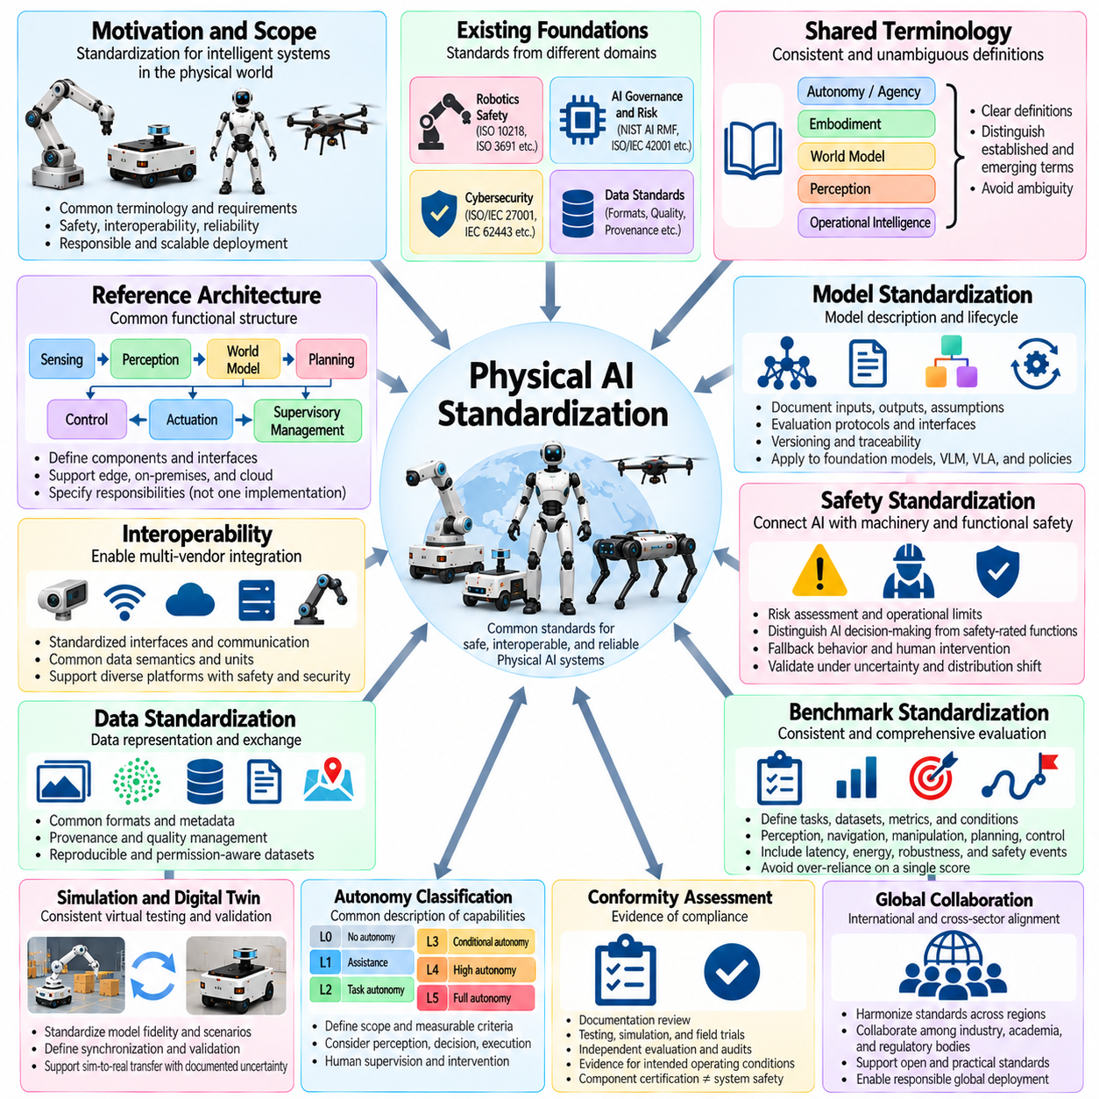
Physical AI standardization seeks to establish common terminology, technical requirements, evaluation methods, and assurance practices for intelligent systems operating in the physical world. Unlike conventional digital AI, Physical AI combines perception, reasoning, decision-making, and physical action. Standardization must therefore address both computational intelligence and physical consequences, creating a foundation for safety, interoperability, reliability, and responsible deployment.
Existing standards provide important foundations, but they originate from different engineering disciplines. Robotics standards address machinery hazards and operational safety, while AI frameworks emphasize model risks, governance, and trustworthy behavior. Cybersecurity standards protect connected infrastructure, and data standards support information quality. Physical AI standardization requires coordinating these domains without assuming that any single framework provides complete coverage.
A shared terminology framework is essential for consistent communication among researchers, manufacturers, integrators, regulators, and operators. Terms such as autonomy, agency, embodiment, world model, perception, and operational intelligence require clear definitions and boundaries. Standard terminology should distinguish established engineering concepts from emerging research terminology. Ambiguous definitions can produce inconsistent requirements, misleading comparisons, and incomplete safety assessments.
A reference architecture describes the major functional components of Physical AI systems and the relationships among them. Typical components include sensing, perception, state estimation, world modeling, planning, control, actuation, and supervisory management. Architectures may distribute these functions across robots, edge infrastructure, on-premises computing, and cloud services. Standardization should define interfaces and responsibilities without prescribing a single implementation.
Interoperability enables components and systems from different suppliers to exchange information and coordinate operations. Standardized interfaces can support sensor integration, robot communication, task assignment, mapping, and fleet management. Semantic interoperability additionally requires agreement on data meanings, units, coordinate systems, and operational states. Interoperability standards should accommodate diverse hardware platforms while preserving safety and security boundaries.
Data standardization addresses representation, metadata, provenance, quality, and exchange across Physical AI development pipelines. Robotics datasets may combine images, point clouds, trajectories, actions, force measurements, and environmental descriptions. Common schemas can improve reproducibility and cross-platform learning. However, standard formats alone cannot guarantee dataset representativeness, annotation correctness, or permission for downstream use.
Model standardization concerns documentation, interfaces, evaluation protocols, and lifecycle management rather than imposing one universal AI architecture. Foundation models, vision-language models, vision-language-action models, and specialized control policies have different capabilities and limitations. Common model descriptions should identify inputs, outputs, assumptions, training context, and operating constraints. Versioning and traceability are essential for controlled deployment.
Safety standardization must connect learned decision-making with established machinery and functional safety principles. AI-driven behavior may change under unfamiliar observations, distribution shifts, or unexpected interactions. Safety requirements should distinguish non-safety-rated intelligence from verified protective functions. Risk assessment, operational limits, fallback behavior, and human intervention must remain explicit even when autonomy increases.
Benchmark standardization provides consistent methods for comparing perception, navigation, manipulation, planning, and control performance. Evaluation protocols should define tasks, datasets, environmental conditions, metrics, and acceptance criteria. Physical AI benchmarks also need to address latency, energy consumption, robustness, recovery, and safety-related events. A single aggregate score cannot adequately represent performance across every operational dimension.
Simulation and digital twin standardization can improve consistency between virtual testing and physical deployment. Shared definitions are needed for model fidelity, scenario representation, synchronization, validation, and simulation-to-reality transfer. Digital twins also require clear relationships between physical assets and digital representations. Standardized evidence should document assumptions and uncertainty rather than treating simulated success as proof of real-world safety.
Autonomy classification provides a common language for describing the capabilities and responsibilities of intelligent physical systems. Meaningful classifications should consider perception, decision authority, environmental adaptability, task execution, and human supervision. Autonomy is not necessarily a single linear property because systems may exhibit different capabilities across functions. Classification schemes should remain measurable, application-aware, and explicitly scoped.
Conformity assessment translates technical requirements into evidence that systems satisfy applicable standards and regulations. Assessment may involve documentation reviews, laboratory testing, simulation, field trials, audits, and independent evaluation. Evidence must correspond to the actual system configuration and intended operating conditions. Certification of an individual component does not automatically establish the safety or compliance of the integrated Physical AI system.
Lifecycle standardization addresses development, deployment, monitoring, maintenance, updating, and retirement. Physical AI systems may change through model retraining, software updates, sensor replacement, or environmental adaptation. Change control should determine when modifications require additional testing or renewed approval. Operational monitoring must identify performance deterioration, emerging hazards, cybersecurity vulnerabilities, and deviations from validated conditions.
International standardization requires cooperation among standards organizations, industry groups, academic institutions, regulators, and technology providers. ISO, IEC, IEEE, and other organizations contribute complementary technical frameworks within their respective scopes. Coordination can reduce duplicated requirements and conflicting terminology. Open technical participation and transparent evidence are important for ensuring that standards remain practical across regions and industries.
Future Physical AI standards must balance innovation with predictable engineering assurance. Overly rigid specifications may restrict emerging architectures, while vague principles may provide insufficient protection or comparability. A layered approach can combine foundational terminology, reference architectures, interface specifications, performance benchmarks, and application-specific safety requirements. Such an approach supports technical evolution without abandoning accountability.
The long-term objective of Physical AI standardization is not to enforce identical robots or intelligence models, but to establish common expectations for trustworthy physical behavior. Successful standards should make capabilities understandable, risks assessable, interfaces interoperable, and performance verifiable. As intelligent systems become more autonomous and interconnected, standardization will provide a shared engineering foundation for responsible deployment at scale.

