Volume 02. Physical AI Foundations and Definitions

Chapter 04. Physical AI Industry Landscape

04.01. Global Physical AI Ecosystem
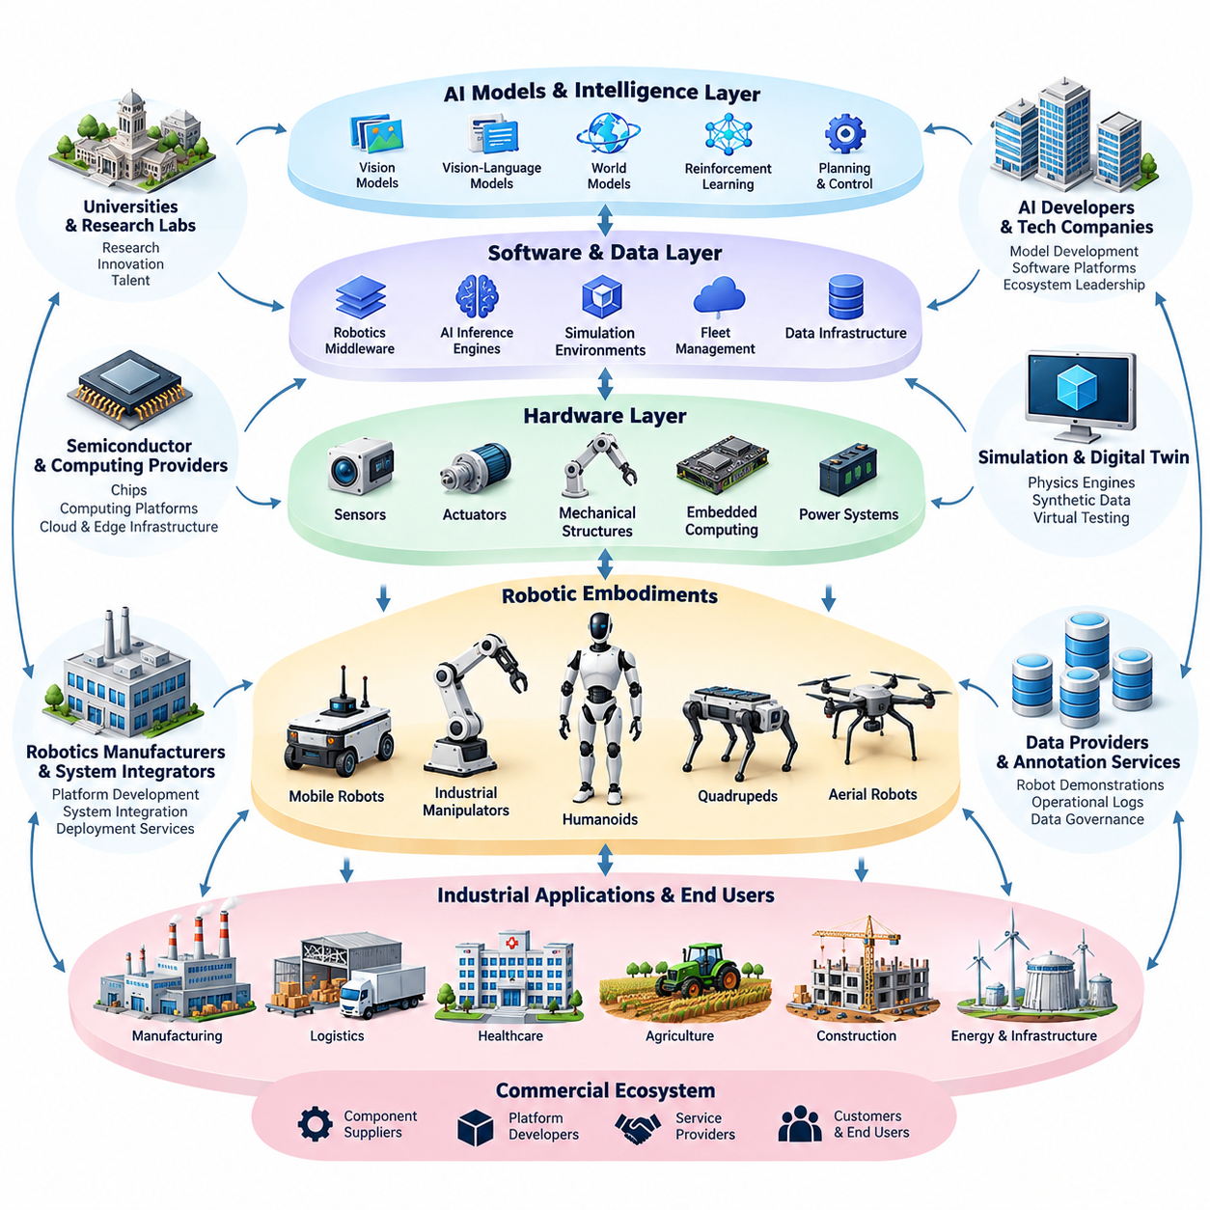
The global Physical AI ecosystem represents an interconnected network of artificial intelligence developers, robotics manufacturers, semiconductor suppliers, research institutions, infrastructure providers, and industrial customers. Unlike conventional digital AI markets, this ecosystem integrates computational intelligence with physical machines, enabling autonomous systems to perceive environments, make decisions, and execute actions under real-world constraints.
The ecosystem extends across multiple technological layers, beginning with sensors, actuators, mechanical structures, and embedded computing hardware. These components support perception, localization, motion planning, manipulation, and feedback control. Above the hardware layer, software platforms integrate robotics middleware, AI inference engines, simulation environments, and fleet management systems into operational architectures.
At the intelligence layer, AI research organizations and technology companies develop machine learning models capable of interpreting multimodal information and generating physical actions. Vision-language models, vision-language-action models, world models, and reinforcement learning policies increasingly influence robot intelligence. Their practical value depends on integration with reliable control systems and physical embodiments.
Robotics manufacturers transform these technologies into autonomous mobile robots, industrial manipulators, humanoids, quadrupeds, aerial robots, and specialized autonomous machines. Each embodiment addresses different operational requirements, including mobility, dexterity, payload capacity, environmental adaptability, and human interaction. This diversity creates distinct markets while encouraging shared intelligence architectures.
Semiconductor and computing platform providers form another essential ecosystem layer. GPUs, neural processing units, embedded processors, and real-time controllers enable AI workloads to operate within physical machines. Cloud infrastructure supports large-scale training and data processing, while edge computing provides low-latency inference and local autonomy when network connectivity is limited or unavailable.
Simulation and digital twin technologies connect research environments with physical deployment. Physics engines, synthetic data generators, and virtual testing platforms allow developers to train and evaluate autonomous behavior before operating real machines. Simulation reduces some development costs and risks, although differences between simulated and physical environments require systematic validation and adaptation.
Data infrastructure plays a central role in ecosystem development because physical intelligence depends on interaction experience. Robot demonstrations, sensor recordings, teleoperation sessions, operational logs, and simulation-generated trajectories provide training material for intelligent policies. Data quality, task diversity, annotation consistency, and governance strongly influence model performance and generalization.
The global ecosystem includes geographically distributed innovation centers with different industrial strengths. The United States has significant capabilities in AI research, computing platforms, and robotics startups. China combines extensive manufacturing capacity with robotics development and deployment. Japan, South Korea, and European countries contribute substantial expertise in industrial automation, precision engineering, mobility, and robotic systems.
Universities and public research laboratories provide foundational technologies that commercial organizations later incorporate into products. Their contributions include robot learning, manipulation, perception, planning, locomotion, and human-robot interaction. Open research publications, benchmark datasets, and collaborative software frameworks accelerate knowledge transfer between academic institutions and industrial development teams.
Open-source communities also influence the global Physical AI ecosystem by reducing development barriers and promoting interoperability. Robotics middleware, machine learning libraries, simulation tools, and reusable software components allow organizations to build upon shared technical foundations. However, production deployment still requires substantial engineering for reliability, cybersecurity, safety assurance, and hardware compatibility.
Industrial customers are essential participants because they define the operational problems that Physical AI must solve. Manufacturing plants require flexible automation, logistics operators seek efficient material handling, and healthcare organizations investigate assistive robotic capabilities. Agriculture, construction, energy, and infrastructure sectors introduce additional requirements related to environmental uncertainty, equipment durability, and autonomous operation.
The ecosystem's commercial structure involves component suppliers, platform developers, system integrators, robot manufacturers, service providers, and end users. Value creation depends on the coordination of these participants rather than on AI model performance alone. Integration complexity, installation costs, maintenance requirements, and operational support frequently determine whether promising technologies achieve sustainable commercialization.
Physical AI business models increasingly combine hardware sales with software subscriptions, maintenance contracts, fleet management services, and usage-based automation offerings. Robotics-as-a-Service can reduce initial capital requirements for customers while transferring equipment ownership and some operational responsibilities to providers. Economic viability nevertheless depends on utilization, service costs, reliability, and measurable productivity improvements.
Strategic partnerships are particularly important because few organizations possess all the capabilities required for advanced autonomous systems. AI model developers collaborate with robot manufacturers, semiconductor companies, simulation providers, and industrial operators. These relationships accelerate experimentation and commercialization, but they also introduce dependencies involving intellectual property, interfaces, data access, and technology supply chains.
Safety, regulation, and standardization shape the ecosystem differently from conventional software markets. Physical AI systems can interact directly with workers, infrastructure, vehicles, and potentially hazardous equipment. Consequently, manufacturers must address functional safety, operational risk assessment, cybersecurity, human oversight, and regulatory compliance throughout the product lifecycle rather than treating these concerns as final deployment activities.
Global competition is influenced by access to computing resources, robotics talent, manufacturing infrastructure, specialized components, and operational data. Organizations with extensive robot deployments may accumulate valuable experience for improving autonomous behavior. However, large data volumes do not automatically produce superior intelligence; representative environments, reliable measurements, and effective learning pipelines remain necessary.
The distinction between specialized and general-purpose Physical AI also shapes industry development. Specialized systems can achieve strong performance within controlled operational domains, making them attractive for near-term commercialization. General-purpose systems seek broader task adaptability and cross-environment transfer, but face greater challenges involving data coverage, physical reasoning, manipulation, and dependable execution.
Emerging robot foundation models may gradually alter relationships between hardware manufacturers and intelligence providers. If reusable policies can operate across multiple embodiments, some intelligence capabilities could become shared platform services. Nevertheless, differences in robot morphology, actuator dynamics, sensing configurations, and safety requirements will continue to demand embodiment-specific adaptation and verification.
The long-term development of the ecosystem depends on closing the gap between laboratory demonstrations and sustained industrial operation. Successful systems must demonstrate repeatable task completion, predictable maintenance, acceptable energy consumption, safe failure behavior, and favorable total cost of ownership. Performance evaluation must therefore include operational reliability and economic outcomes alongside conventional AI benchmarks.
Ultimately, the global Physical AI ecosystem should be understood as a cyber-physical industrial network rather than a collection of robotics companies. Its evolution depends on coordinated advances in intelligence, embodiment, computing, simulation, data infrastructure, safety, and commercialization. The organizations that integrate these capabilities into dependable and economically useful systems will play a defining role in the expansion of Physical AI.

04.02. AI and Robotics Research Ecosystem
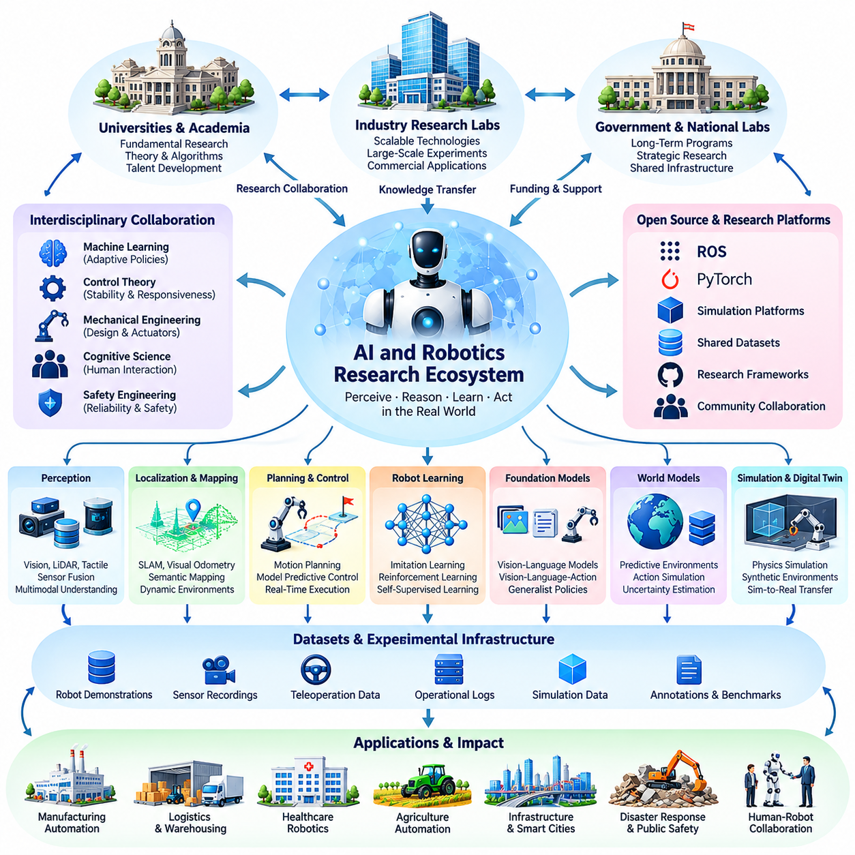
The AI and robotics research ecosystem forms the scientific foundation of Physical AI by connecting artificial intelligence, robotics, control theory, cognitive science, and mechanical engineering. Its central objective is to develop intelligent systems capable of perceiving, reasoning, learning, and acting within physical environments. Progress requires collaboration across disciplines because intelligent behavior emerges from interactions between algorithms, hardware, and the surrounding world.
Universities and academic laboratories play a fundamental role in advancing theoretical understanding and experimental methods. Researchers investigate perception, localization, planning, manipulation, locomotion, and autonomous decision-making. Academic environments support exploratory research that may not produce immediate commercial outcomes but establishes mathematical principles, computational architectures, and experimental evidence for future Physical AI systems.
Industrial research laboratories complement academic research by connecting scientific discoveries with scalable technologies and commercial applications. Major technology companies investigate robot foundation models, multimodal learning, autonomous navigation, and general-purpose robotic intelligence. Their access to computing infrastructure, engineering resources, and large datasets enables experiments that may exceed the capabilities of smaller research institutions.
Government-funded research organizations and national laboratories contribute through long-term programs addressing strategic technological challenges. These programs often support advanced manufacturing, autonomous mobility, disaster response, healthcare robotics, and human-machine collaboration. Public investment can provide shared research infrastructure and encourage projects whose scientific or societal benefits extend beyond immediate commercial returns.
Interdisciplinary collaboration is essential because robotics research cannot be separated from physical embodiment. Machine learning specialists develop adaptive policies, control engineers establish stability and responsiveness, and mechanical engineers design structures and actuators. Researchers in human factors, safety engineering, and cognitive science contribute knowledge about interaction, uncertainty, and intelligent behavior in complex environments.
Robot perception remains a major research domain within the ecosystem. Computer vision, depth sensing, LiDAR processing, tactile sensing, and sensor fusion enable machines to estimate environmental states. Research increasingly emphasizes multimodal representations that combine geometric, semantic, and temporal information, allowing robots to interpret objects, surfaces, obstacles, and human activities under changing conditions.
Localization, mapping, and spatial understanding provide another critical research foundation. Simultaneous localization and mapping, visual odometry, geometric reconstruction, and semantic mapping allow robots to establish relationships between their own states and surrounding environments. Current research explores dynamic environments, long-term map consistency, uncertainty estimation, and shared spatial representations across multiple autonomous agents.
Planning and control research connects environmental understanding with physical execution. Motion planning determines feasible trajectories, while feedback control compensates for disturbances and modeling errors. Model predictive control, trajectory optimization, reinforcement learning, and hybrid control architectures are investigated to improve adaptability while maintaining stability, constraint satisfaction, and predictable real-time behavior.
Robot learning has become an increasingly influential component of the research ecosystem. Imitation learning allows robots to acquire behaviors from demonstrations, while reinforcement learning improves policies through interaction and reward feedback. Self-supervised learning and offline learning investigate how large collections of observations and experiences can support skill acquisition without requiring extensive manual labeling or continuous physical experimentation.
Foundation model research is expanding the relationship between artificial intelligence and robotics. Vision-language models provide semantic interpretation and instruction understanding, while vision-language-action models connect multimodal observations with robot actions. Researchers investigate whether pretrained representations and generalist policies can transfer knowledge across tasks, environments, and embodiments without requiring complete retraining.
World model research introduces predictive representations of physical environments into robot intelligence. These models attempt to estimate how objects, agents, and environmental states may evolve following particular actions. By supporting imagined outcomes and action-conditioned predictions, world models can contribute to planning, decision-making, and risk assessment, although prediction accuracy and uncertainty remain significant research challenges.
Simulation research provides essential infrastructure for developing and evaluating Physical AI systems. Physics simulators, digital twins, synthetic environments, and procedural scenario generators support repeatable experiments and large-scale policy training. Researchers study domain randomization, system identification, and simulation-to-reality transfer to reduce discrepancies between virtual experience and actual robot behavior.
Open-source software and shared research platforms accelerate scientific progress by enabling reproducibility and collaborative development. Frameworks such as ROS, PyTorch, and widely used simulation environments provide reusable components for experimentation. Shared implementations reduce duplicated engineering effort, but differences in hardware configurations, software versions, and evaluation procedures can still complicate independent reproduction.
Public datasets and benchmark environments establish common foundations for comparing research methods. Robot demonstrations, manipulation trajectories, navigation recordings, human activity datasets, and multimodal sensor observations support model development. Effective benchmarks must evaluate not only average task success but also robustness, generalization, safety, recovery behavior, and performance under unfamiliar environmental conditions.
International research conferences and scientific journals facilitate the exchange of new algorithms, experimental results, and theoretical insights. Communities associated with robotics, machine learning, computer vision, and control systems increasingly overlap. Peer review, open technical discussions, and independent replication help distinguish meaningful scientific advances from results that depend heavily on restricted experimental conditions.
Research collaboration also extends into industry-academia partnerships and multinational development programs. Companies may provide robotic platforms, computing resources, operational environments, and engineering expertise, while universities contribute specialized research capabilities. These partnerships create opportunities for practical validation, although publication restrictions, intellectual property arrangements, and unequal resource access can influence research openness.
A persistent challenge within the research ecosystem is the gap between laboratory performance and reliable real-world deployment. Robots trained under controlled conditions may encounter unexpected objects, sensor degradation, mechanical variation, or changing human behavior. Addressing these limitations requires systematic robustness evaluation, uncertainty-aware decision-making, continuous monitoring, and carefully designed recovery mechanisms.
Safety and responsible innovation are increasingly important research priorities because Physical AI systems can directly affect people and infrastructure. Researchers investigate safe reinforcement learning, runtime assurance, interpretable decision-making, human oversight, and verification of autonomous behavior. These efforts seek to ensure that improvements in learning capability do not compromise operational reliability, accountability, or acceptable risk boundaries.
The research ecosystem must also address resource efficiency and accessibility. Training advanced robotic models can require substantial computational capacity, specialized hardware, and extensive interaction data. Efficient learning algorithms, compact models, distributed experimentation, and accessible research platforms can help smaller laboratories participate while supporting deployment on power-constrained edge computing systems.
Ultimately, the AI and robotics research ecosystem advances Physical AI through continuous interaction between scientific theory, experimental validation, shared infrastructure, and industrial experience. Its long-term success depends on translating isolated algorithmic achievements into integrated physical intelligence. Strong collaboration, reproducible evaluation, interdisciplinary engineering, and responsible deployment will determine how effectively research progress becomes dependable autonomous capability.

04.03. AMR and Autonomous Mobility
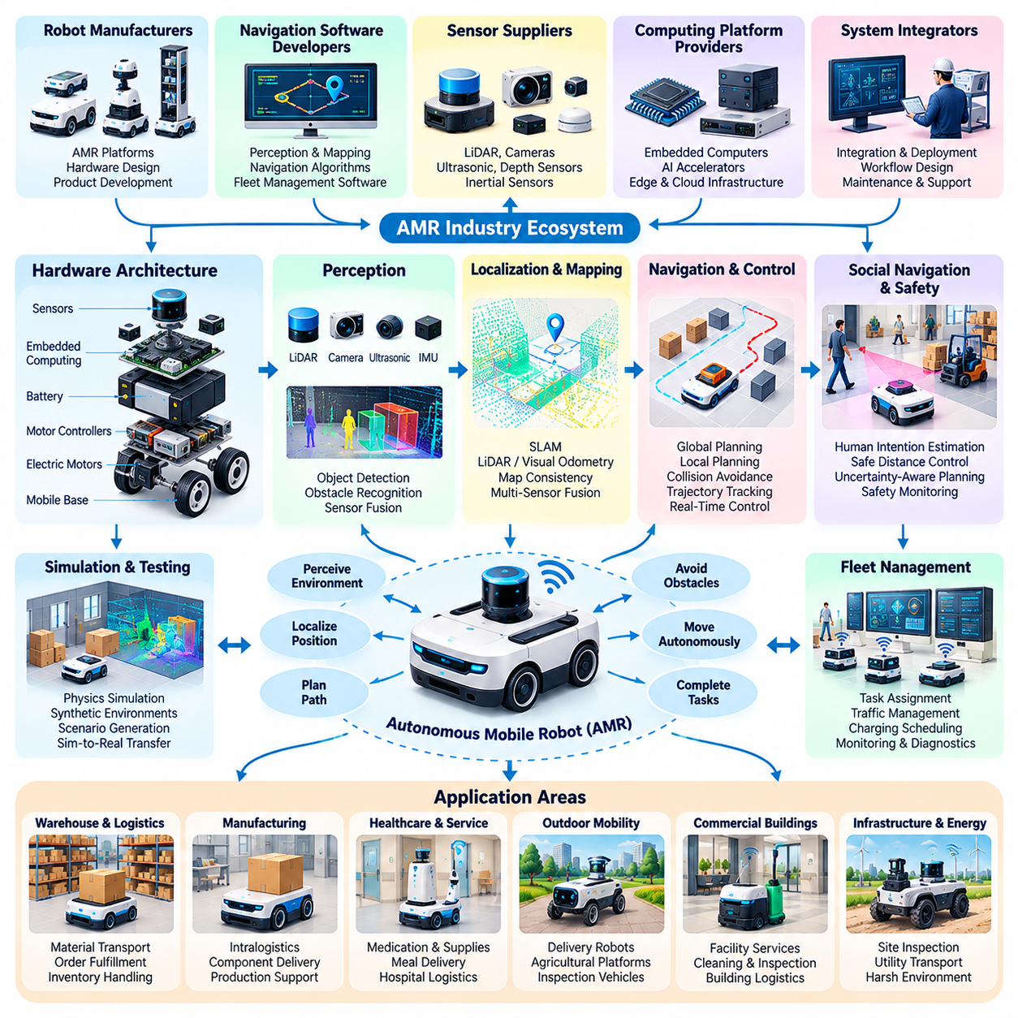
Autonomous Mobile Robots (AMRs) and autonomous mobility systems represent a major application domain of Physical AI, combining perception, localization, planning, control, and adaptive decision-making. Unlike conventional automated guided vehicles that primarily follow predefined routes, AMRs can navigate changing environments using onboard sensing and computational intelligence. Their capabilities support flexible transportation, material handling, inspection, and service operations.
The global AMR industry includes robot manufacturers, navigation software developers, sensor suppliers, computing platform providers, and system integrators. These participants collaborate to deliver autonomous mobility solutions for warehouses, factories, hospitals, commercial buildings, and outdoor facilities. Industry development increasingly emphasizes integrated platforms that combine robotic hardware, intelligent navigation, fleet coordination, and operational management.
AMR hardware architectures typically integrate mobile bases, electric motors, motor controllers, batteries, sensors, and embedded computers. Differential-drive, omnidirectional, and steering-based configurations provide different mobility characteristics. Platform selection depends on payload requirements, turning radius, floor conditions, energy efficiency, and operating environments, making mechanical design an essential component of autonomous intelligence.
Perception technologies allow AMRs to recognize obstacles, detect people, identify traversable surfaces, and interpret surrounding structures. LiDAR, cameras, ultrasonic sensors, depth sensors, and inertial measurement units provide complementary environmental information. Sensor fusion improves situational awareness by combining measurements with different uncertainty characteristics, although performance remains sensitive to lighting, reflective materials, occlusion, and sensor degradation.
Localization and mapping provide the spatial foundation for autonomous navigation. Simultaneous localization and mapping enables robots to construct environmental representations while estimating their positions. Industrial systems may combine LiDAR localization, visual odometry, wheel encoders, and inertial sensing. Robust localization requires continuous evaluation of map consistency, environmental changes, accumulated estimation errors, and sensor reliability.
Navigation systems transform environmental understanding into feasible robot movement. Global planning determines routes toward destinations, while local planning responds to nearby obstacles and changing conditions. Motion controllers translate planned trajectories into motor commands while respecting kinematic and dynamic constraints. Reliable navigation requires coordination among perception updates, collision avoidance, trajectory tracking, and real-time feedback.
Autonomous mobility becomes particularly challenging in environments shared with people and other machines. Pedestrians, forklifts, carts, doors, and temporary obstacles introduce unpredictable interactions. AMRs must estimate movement intentions, maintain appropriate separation distances, and adapt their trajectories without creating unsafe or disruptive behavior. Social navigation and uncertainty-aware planning remain important areas of research and development.
Warehouse and logistics automation constitute prominent commercial applications of AMR technology. Robots transport inventory, move containers, support order fulfillment, and connect storage areas with packing or shipping stations. Their operational value depends on throughput, task completion rates, traffic efficiency, and integration with warehouse management systems. Successful deployments require coordinated workflow design rather than isolated robot navigation performance.
Manufacturing facilities increasingly adopt AMRs for intralogistics and flexible production support. Mobile robots deliver components, transport work-in-progress materials, and connect production stations without requiring permanently fixed conveyor systems. Integration with manufacturing execution systems enables task synchronization and material traceability. However, industrial environments impose strict requirements for reliability, safety, uptime, and predictable operational behavior.
Healthcare and service environments introduce additional mobility requirements involving human interaction and operational sensitivity. AMRs may transport medications, laboratory samples, meals, linens, and other supplies within hospitals or institutional facilities. Navigation must accommodate crowded corridors, elevators, restricted areas, and changing schedules. Deployment also requires attention to hygiene, privacy, accessibility, and continuity of essential services.
Outdoor autonomous mobility extends Physical AI into environments with greater geometric and environmental uncertainty. Delivery robots, agricultural platforms, inspection vehicles, and industrial transport systems must handle uneven terrain, weather conditions, variable illumination, and changing surface properties. Localization may combine GNSS, inertial navigation, LiDAR, and visual perception, while motion planning must account for terrain traversability and vehicle stability.
Fleet management systems coordinate multiple AMRs operating within shared facilities. Centralized or distributed orchestration assigns tasks, manages traffic, schedules charging, and monitors robot status. Effective coordination reduces congestion and improves resource utilization. Fleet intelligence also requires handling communication interruptions, robot failures, task priorities, and heterogeneous platforms with different capabilities.
Interoperability is an increasingly important issue as facilities deploy robots from multiple manufacturers. Standardized communication interfaces and fleet integration frameworks can reduce dependence on proprietary systems. Protocols such as VDA 5050 address aspects of communication between mobile robots and fleet control systems. Nevertheless, differences in navigation behavior, safety configurations, and operational capabilities complicate universal interoperability.
Artificial intelligence is expanding AMR capabilities beyond conventional navigation algorithms. Learning-based perception improves environmental interpretation, while reinforcement learning and imitation learning provide methods for acquiring navigation behaviors. Predictive world models may help anticipate environmental changes and agent interactions. These approaches must be integrated with deterministic safety mechanisms and validated against real-world operational constraints.
Edge computing plays a critical role in autonomous mobility because perception, planning, and control frequently require low-latency execution. Embedded GPUs and specialized AI accelerators support onboard inference without continuous cloud connectivity. On-premises infrastructure can coordinate multiple robots and maintain shared operational information, while cloud platforms support analytics, software distribution, and large-scale model training.
Simulation and digital twins enable AMR developers to evaluate navigation strategies before deployment. Virtual environments can reproduce warehouse layouts, pedestrian interactions, traffic congestion, and sensor conditions. Simulation supports regression testing, scenario generation, and fleet-scale optimization. However, physical validation remains necessary because real-world friction, sensor noise, human behavior, and environmental variability cannot be reproduced perfectly.
Safety engineering is fundamental to commercial AMR deployment. Systems must address collision risks, emergency stopping, protective sensing, speed limitations, and foreseeable operational failures. Relevant safety standards, including ISO 3691-4 for applicable driverless industrial trucks, provide important engineering guidance. Compliance depends on the robot's intended application, operating environment, and applicable regulatory requirements.
The commercial success of AMR systems depends on measurable operational performance rather than autonomy demonstrations alone. Important considerations include fleet availability, navigation success, intervention frequency, battery utilization, maintenance requirements, and total cost of ownership. Organizations must evaluate integration expenses, infrastructure modifications, workforce interaction, and long-term serviceability when assessing deployment feasibility.
The AMR industry is evolving toward more adaptive and collaborative mobility systems. Emerging capabilities include semantic navigation, predictive traffic management, heterogeneous fleet coordination, and integration with robotic manipulation. These developments may enable mobile robots to participate in increasingly complex workflows while sharing environmental knowledge and coordinating actions across distributed operational environments.
Ultimately, AMRs demonstrate how Physical AI transforms computational intelligence into sustained physical operations. Their evolution reflects the convergence of robotics engineering, artificial intelligence, embedded computing, industrial integration, and safety assurance. Continued progress will depend on reliable autonomy, scalable fleet coordination, interoperability, and the ability to deliver measurable value across diverse real-world environments.

04.04. Mobile Manipulators and Industrial Robots
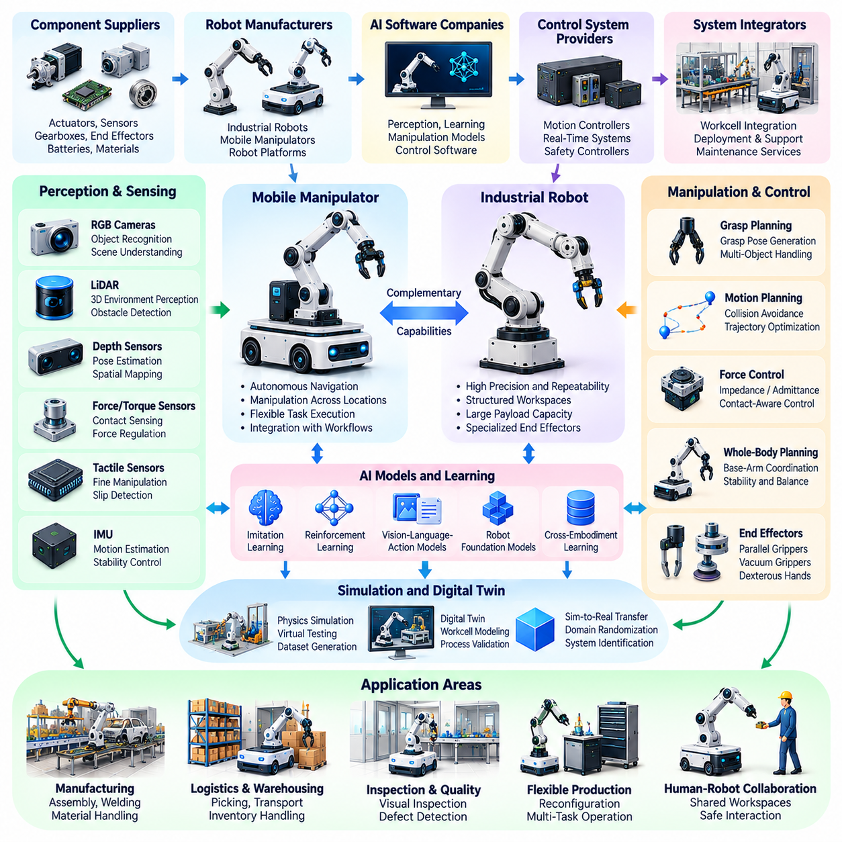
Mobile manipulators and industrial robots represent essential components of the Physical AI ecosystem, combining mechanical precision, intelligent perception, motion planning, and autonomous task execution. Traditional industrial robots operate primarily within structured workspaces, while mobile manipulators integrate robotic arms with autonomous mobile platforms. This combination extends manipulation capabilities across larger and more dynamic environments.
The industrial robotics ecosystem includes robot manufacturers, actuator suppliers, sensor developers, control system providers, AI software companies, and system integrators. These organizations develop technologies for manufacturing, logistics, assembly, inspection, and material handling. Increasing integration between robotics hardware and artificial intelligence is transforming industrial automation from fixed repetitive operations toward adaptive and context-aware physical systems.
Conventional industrial robots typically employ articulated arms with multiple degrees of freedom, enabling precise positioning and controlled interaction with objects. Their architectures integrate electric actuators, gear transmissions, joint encoders, controllers, and specialized end effectors. High repeatability, mechanical stiffness, payload capacity, and predictable motion remain important requirements for industrial applications.
Mobile manipulators extend industrial robotic capabilities by combining locomotion and manipulation within a unified platform. An autonomous mobile base transports one or more robotic arms between workstations, allowing the system to perform tasks across distributed locations. This architecture supports flexible production environments where fixed robotic installations may be economically inefficient or operationally restrictive.
The integration of mobility and manipulation introduces complex coordination challenges. Robot navigation must account for arm configuration, payload distribution, center of gravity, and collision boundaries. Manipulation planning must consider mobile base positioning and environmental accessibility. Whole-body planning and coordinated control enable the mobile platform and robotic arm to operate as an integrated physical system.
Perception systems provide the environmental understanding required for intelligent manipulation. RGB cameras, depth sensors, LiDAR, force sensors, and tactile sensing devices allow robots to identify objects, estimate poses, detect contact, and interpret workspace conditions. Multimodal sensor fusion improves robustness when objects are partially occluded, geometrically ambiguous, or subject to changing illumination and surface properties.
Object recognition and pose estimation are central to manipulation intelligence. Robots must identify target objects and determine their positions, orientations, and geometric relationships with surrounding structures. Six-degree-of-freedom pose estimation supports grasp planning, assembly alignment, and tool positioning. Reliable performance requires handling unfamiliar objects, cluttered scenes, reflective surfaces, and uncertainty in sensor measurements.
Grasp planning transforms object perception into executable manipulation actions. Algorithms evaluate candidate contact points, gripper configurations, friction conditions, and object stability. Parallel-jaw grippers, vacuum systems, and dexterous robotic hands provide different manipulation capabilities. Learning-based grasping approaches increasingly complement geometric and analytical methods, particularly when handling diverse objects with uncertain physical properties.
Industrial manipulation frequently requires accurate force regulation and contact-aware control. Force-torque sensors, impedance control, admittance control, and compliant actuators allow robots to interact with objects and surfaces while limiting excessive contact forces. These capabilities are particularly important for insertion, polishing, assembly, and delicate handling tasks where purely position-based control may be insufficient.
Motion planning and trajectory optimization determine how robotic manipulators move between configurations while respecting physical constraints. Collision avoidance, joint limits, velocity restrictions, and dynamic feasibility must be considered simultaneously. In mobile manipulation, planners must also coordinate base movement and arm reachability, ensuring that target objects remain accessible throughout task execution.
Artificial intelligence is expanding manipulation beyond manually programmed motion sequences. Imitation learning enables robots to acquire skills from human demonstrations, while reinforcement learning supports policy improvement through interaction. Vision-language-action models investigate instruction-conditioned manipulation across multiple tasks. However, learned policies require careful validation because small perception errors can produce significant physical consequences.
Robot foundation models introduce the possibility of transferring manipulation knowledge across different platforms and applications. Large-scale datasets containing demonstrations, visual observations, and action trajectories support the development of reusable representations. Cross-embodiment learning may reduce task-specific programming requirements, although differences in kinematics, actuators, grippers, and control interfaces remain substantial challenges.
Simulation environments play an important role in industrial robot development. Physics-based simulators allow researchers to evaluate grasping, assembly, collision avoidance, and coordinated motion without exposing physical equipment to unnecessary risk. Digital twins can reproduce production layouts and robotic workcells. Nevertheless, accurate contact modeling, friction estimation, and simulation-to-reality transfer remain difficult engineering problems.
Collaborative robots, commonly called cobots, represent another important segment of industrial robotics. These systems are designed for applications involving closer interaction between human workers and robotic equipment. Their deployment requires appropriate risk assessment, protective measures, and operating limits. Collaboration does not eliminate safety requirements, particularly when mobile bases, sharp tools, heavy payloads, or unexpected contact are involved.
Manufacturing applications include machine tending, component assembly, welding, packaging, palletizing, and quality inspection. Mobile manipulators can extend these operations across multiple workstations, reducing dependence on permanently installed robotic cells. Their effectiveness depends on positioning accuracy, cycle time, task flexibility, and integration with manufacturing execution systems and production scheduling infrastructure.
Logistics and warehouse operations increasingly explore mobile manipulation for picking, sorting, loading, unloading, and inventory handling. Combining autonomous navigation with robotic grasping enables systems to interact directly with stored goods rather than merely transporting containers. However, object diversity, deformable packaging, dense storage configurations, and variable grasp conditions introduce substantial perception and manipulation challenges.
Industrial robot architectures increasingly distribute intelligence across embedded controllers, edge computing platforms, on-premises infrastructure, and cloud services. Local controllers maintain deterministic motion and safety functions, while AI accelerators support perception and learned policy inference. Higher-level systems coordinate tasks, manage production information, and analyze operational data without requiring every control decision to depend on remote connectivity.
Safety and reliability remain fundamental requirements for industrial manipulation systems. Relevant standards, including ISO 10218 and ISO/TS 15066 where applicable, inform robot safety engineering and collaborative application design. Mobile manipulators may also require consideration of mobile robot safety requirements. Risk assessment must address combined hazards arising from navigation, arm motion, payload handling, and human interaction.
Commercial adoption depends on demonstrating productivity improvements and sustainable operational economics. Important evaluation criteria include task success rate, cycle time, positioning accuracy, intervention frequency, equipment availability, and total cost of ownership. System integration, maintenance, operator training, and workflow redesign can significantly influence deployment outcomes, making operational engineering as important as algorithmic performance.
Ultimately, mobile manipulators and industrial robots illustrate the convergence of autonomous mobility, physical interaction, and intelligent control. Their evolution is moving industrial automation toward more flexible and adaptive systems capable of operating across changing tasks and environments. Continued progress will depend on robust perception, coordinated motion, transferable manipulation skills, dependable safety mechanisms, and scalable industrial integration.

04.05. Humanoid Robotics
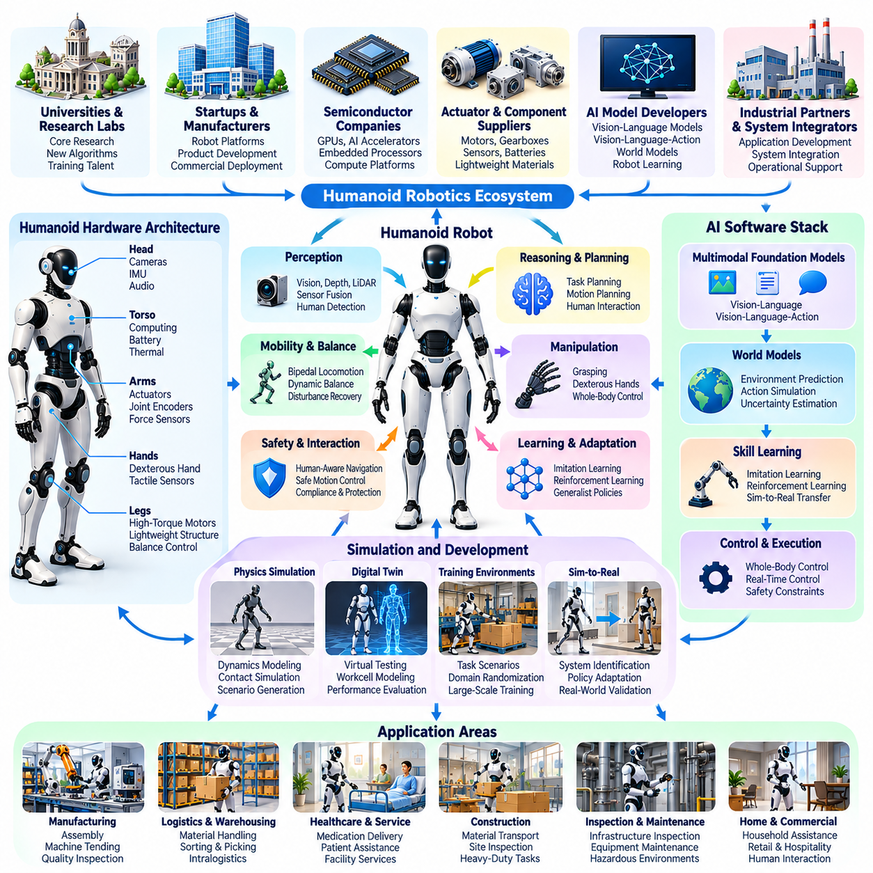
Humanoid robotics represents an emerging domain of Physical AI that seeks to develop intelligent machines with human-inspired body structures and movement capabilities. Humanoid robots typically combine articulated limbs, sensory systems, actuators, and computational intelligence to operate in environments designed for people. Their development requires advances in perception, locomotion, manipulation, reasoning, and coordinated whole-body control.
The global humanoid robotics ecosystem includes research universities, robotics startups, established manufacturers, semiconductor companies, actuator suppliers, and AI model developers. These participants contribute complementary technologies ranging from mechanical structures to foundation models. Growing collaboration between hardware engineering and artificial intelligence research is accelerating experimentation with increasingly capable humanoid platforms.
Humanoid morphology generally incorporates a torso, articulated arms, hands, and legs arranged to approximate important aspects of human physical functionality. This configuration can potentially support interaction with existing tools, furniture, workstations, and infrastructure. However, human-inspired morphology introduces mechanical complexity, balance requirements, and energy constraints that simpler robotic embodiments may avoid.
Bipedal locomotion remains one of the defining technical challenges of humanoid robotics. Walking requires continuous coordination of joint movements, ground contact forces, body momentum, and balance recovery. Researchers employ model predictive control, whole-body optimization, reinforcement learning, and hybrid control methods to develop stable movement across varying surfaces and environmental conditions.
Dynamic balance is particularly important because humanoid robots operate with relatively high centers of mass and changing support configurations. Controllers must maintain stability during walking, turning, reaching, and object manipulation. Disturbance rejection, contact estimation, and recovery planning help prevent falls, while safe stopping and protective responses reduce the consequences of unavoidable instability.
Humanoid manipulation requires coordinated interaction between arms, hands, torso, and locomotion systems. Robots must identify objects, estimate their geometry, select grasp configurations, and execute controlled movements. Dexterous hands may provide adaptable manipulation, but they also introduce additional actuators, sensing requirements, and control complexity. Reliable manipulation remains challenging when objects are unfamiliar or physically variable.
Perception systems enable humanoid robots to understand environments containing people, equipment, furniture, and moving obstacles. Cameras, depth sensors, inertial measurement units, force-torque sensors, and tactile devices provide complementary observations. Multimodal sensor fusion supports spatial awareness, object recognition, contact estimation, and human interaction, although uncertainty and sensor limitations remain significant challenges.
Whole-body control integrates locomotion and manipulation into a unified decision-making process. Reaching for an object may require coordinated adjustments of the feet, torso, arms, and hands. Optimization-based controllers balance task objectives against stability, joint limits, contact forces, and actuator constraints. Such coordination is essential for performing useful actions without compromising physical equilibrium.
Artificial intelligence increasingly influences humanoid behavior through learning-based perception, motion generation, and task planning. Imitation learning allows robots to acquire skills from human demonstrations, while reinforcement learning supports locomotion and manipulation policy development. Combining learned policies with conventional control methods can improve adaptability while preserving essential stability and safety constraints.
Vision-language models and vision-language-action architectures are expanding research into instruction-driven humanoid behavior. These models connect visual observations and natural-language commands with task representations or physical actions. Researchers investigate generalist policies capable of handling multiple activities, although long-horizon execution, physical grounding, uncertainty management, and dependable task completion remain unresolved challenges.
World models may provide humanoid robots with predictive representations of physical interactions. By estimating how objects, people, and robot states could evolve following actions, these models can support planning and anticipation. Their effectiveness depends on representing contact dynamics, environmental uncertainty, and changing constraints accurately enough to inform safe decisions in real time.
Simulation environments play an important role in humanoid development because physical experimentation can be expensive and potentially damaging. Physics simulators enable repeated training of walking, balancing, grasping, and recovery behaviors. Domain randomization and system identification help improve simulation-to-reality transfer, but differences in contact dynamics, actuator response, and mechanical wear remain difficult to eliminate.
Hardware development focuses on actuators, transmissions, lightweight structures, batteries, embedded computing, and thermal management. Humanoid platforms require sufficient torque, power density, mechanical durability, and control responsiveness to execute coordinated movements. Engineering tradeoffs among weight, strength, operating duration, and manufacturing cost strongly influence practical deployment capabilities.
The humanoid robotics industry is exploring applications in manufacturing, logistics, inspection, and service operations. Potential tasks include material transportation, machine tending, component handling, and repetitive activities in human-designed workspaces. Nevertheless, many proposed applications remain experimental, and commercially useful deployment requires evidence of sustained reliability, acceptable productivity, and manageable operating costs.
Humanoid robots face competition from specialized robotic systems that may perform individual tasks more efficiently. Fixed manipulators, mobile robots, and purpose-built automation often provide simpler mechanical architectures and established operational performance. The potential advantage of humanoids lies in their adaptability to existing human infrastructure and multiple tasks, rather than guaranteed superiority in every application.
Human-robot interaction introduces additional requirements involving communication, behavioral predictability, and physical safety. Humanoids operating near workers must recognize human presence, maintain appropriate distances, and respond safely to unexpected contact. Natural-language interfaces may improve usability, but safety-critical decisions require dependable sensing, validated control mechanisms, and clearly defined operational boundaries.
Safety engineering must address falls, collisions, joint motion, gripping forces, battery hazards, and unexpected autonomous behavior. Risk assessment should consider the complete robot system, intended tasks, and operating environment. Existing machinery and robotics safety frameworks provide relevant guidance, although application-specific requirements and evolving standards must be evaluated carefully for humanoid deployments.
Commercial evaluation requires more than demonstrating visually impressive locomotion or manipulation. Important measures include task success rate, intervention frequency, energy consumption, maintenance intervals, recovery performance, and total cost of ownership. Industrial customers must determine whether humanoid systems deliver measurable advantages over conventional automation while maintaining acceptable safety and operational availability.
The future humanoid ecosystem will likely depend on stronger integration among robot foundation models, transferable motor skills, simulation infrastructure, and scalable manufacturing. Shared learning architectures may reduce the need to program every behavior independently. However, differences in hardware morphology, actuator performance, sensing, and physical constraints will continue to require platform-specific adaptation and validation.
Ultimately, humanoid robotics illustrates both the ambition and difficulty of creating general-purpose Physical AI. Human-inspired embodiment offers opportunities to operate within existing environments, but useful autonomy demands reliable integration of intelligence, mechanics, control, and safety. Long-term progress will be measured by sustained real-world performance rather than isolated demonstrations of humanlike movement.

04.06. Quadruped and Legged Robotics
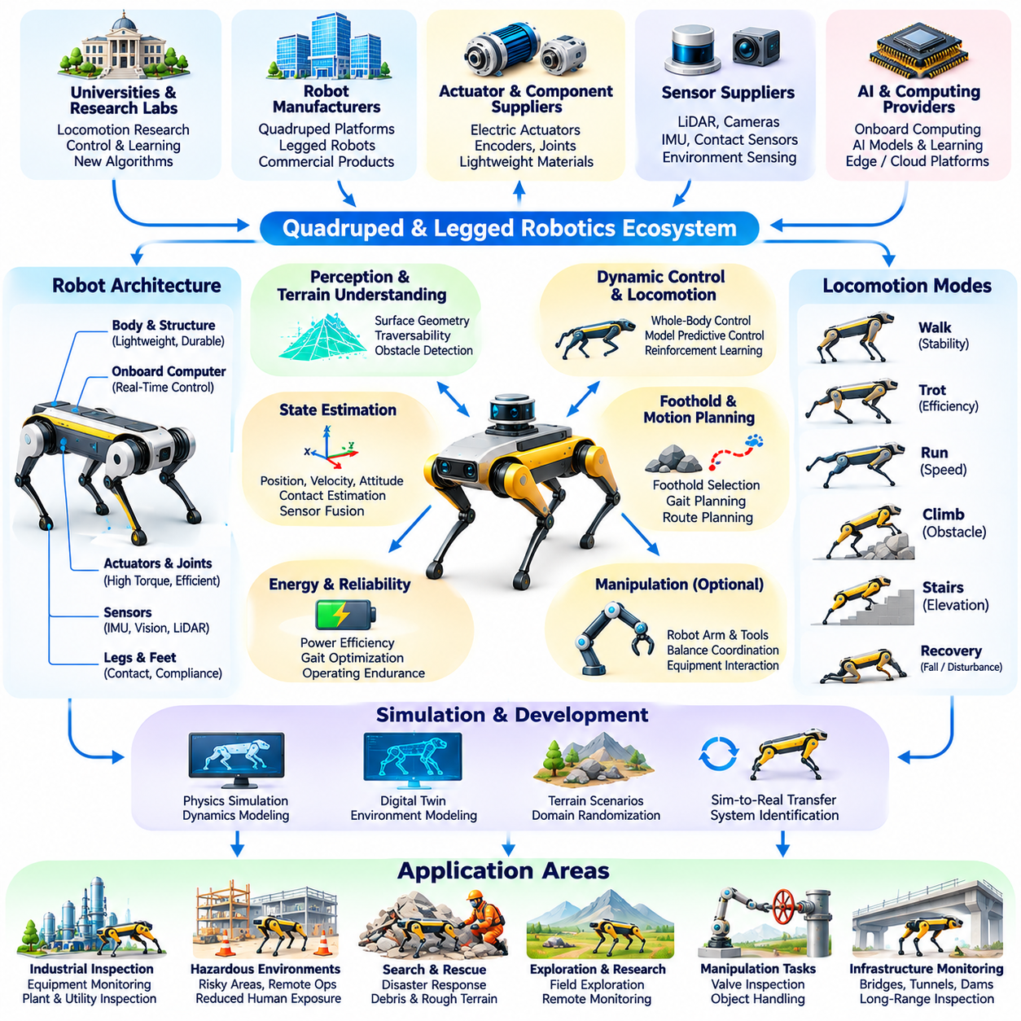
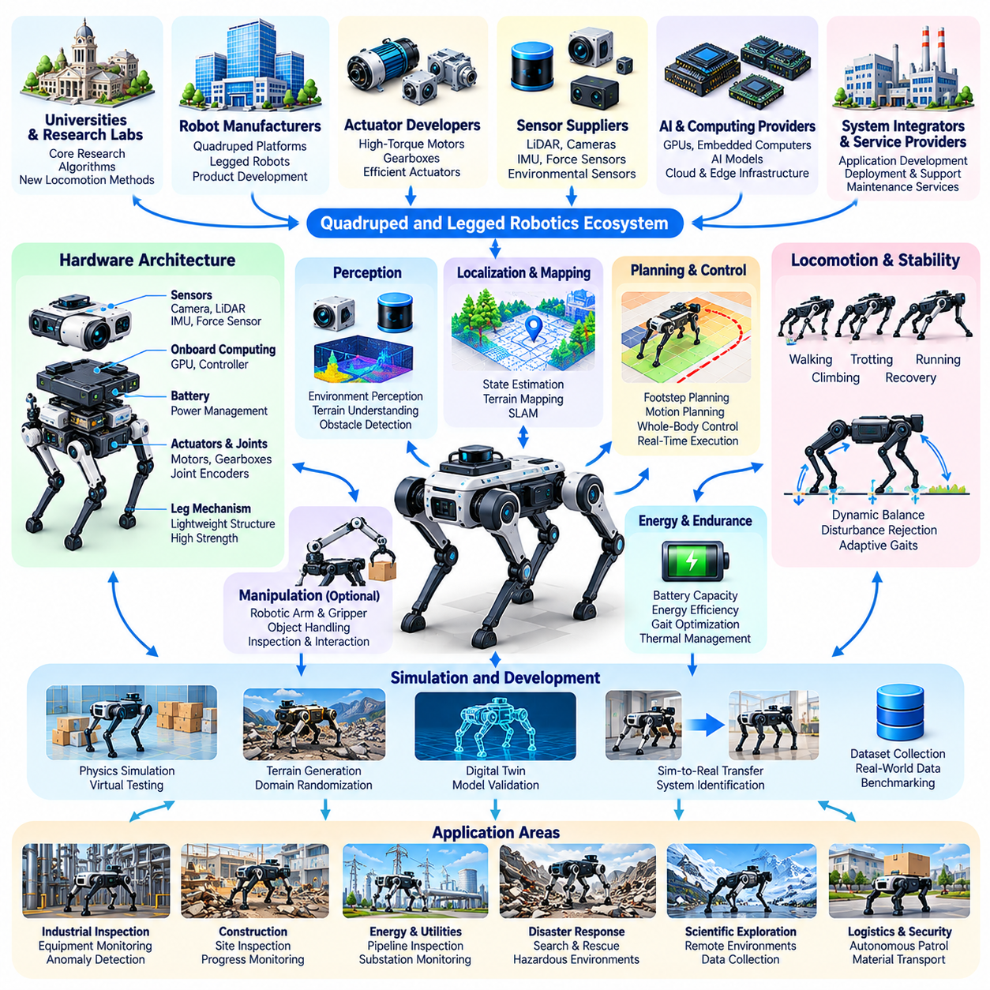
Quadruped and legged robotics represent an important domain of Physical AI focused on autonomous machines that move through coordinated limb motion rather than relying exclusively on wheels or tracks. These robots combine mechanical design, dynamic control, environmental perception, and intelligent planning to navigate complex terrain. Their capabilities are particularly relevant where conventional mobile platforms face limitations in accessibility or surface conditions.
The legged robotics ecosystem includes research institutions, specialized robot manufacturers, actuator developers, sensor suppliers, and AI computing providers. Industry participants develop platforms for inspection, exploration, logistics, research, and hazardous environment operations. Commercial progress depends on transforming laboratory demonstrations of dynamic locomotion into reliable systems capable of sustained operation under practical field conditions.
Quadruped robots employ four articulated legs to provide adaptable ground contact and dynamic stability. Their mechanical architectures commonly integrate electric actuators, joint encoders, inertial measurement units, onboard computers, and structural components designed for repeated loading. Leg geometry, actuator torque, transmission efficiency, and body mass distribution strongly influence locomotion performance, payload capacity, and energy consumption.
Legged locomotion differs fundamentally from wheeled navigation because ground contact changes continuously during movement. Robots must coordinate foot placement, joint trajectories, contact forces, and body momentum while maintaining stability. Walking, trotting, climbing, and recovery behaviors require different control strategies. Successful locomotion depends on accurately estimating the robot's physical state and responding to environmental disturbances.
Dynamic control is central to quadruped performance, particularly during rapid movement or traversal of irregular terrain. Model predictive control, whole-body control, and optimization-based methods generate feasible motions under physical constraints. Reinforcement learning provides complementary approaches for acquiring adaptive locomotion policies. Hybrid architectures may combine learned behaviors with model-based controllers to improve robustness.
Terrain perception enables legged robots to distinguish traversable surfaces from obstacles and hazardous regions. LiDAR, stereo cameras, depth sensors, and inertial sensing provide information about surface geometry and robot motion. Elevation maps and local terrain representations support foothold selection and route planning. Reliable perception remains difficult when surfaces are reflective, deformable, slippery, or partially obscured.
Foothold planning determines where a robot should place its feet to maintain balance and achieve desired movement. Planning algorithms consider terrain geometry, friction, reachability, body posture, and expected contact forces. Unlike wheeled platforms, legged robots can sometimes step over gaps or obstacles without requiring continuous ground support. However, these advantages depend on accurate contact estimation and sufficient mechanical capability.
State estimation is essential because legged robots experience frequent changes in contact conditions and body orientation. Inertial measurements, joint encoders, foot contact sensors, and visual or LiDAR odometry contribute to estimating position, velocity, and attitude. Estimation errors can directly affect balance and locomotion safety. Robust systems must detect unreliable contacts, sensor drift, and unexpected external disturbances.
Energy efficiency remains a significant limitation of legged mobility. Repeated lifting, acceleration, and stabilization of articulated limbs can require substantial electrical power. Battery capacity, actuator efficiency, mechanical compliance, and gait selection influence operating duration. Although legged platforms offer advantages on difficult terrain, wheeled systems often remain more efficient for transportation across smooth and predictable surfaces.
Industrial inspection is a prominent application of commercial quadruped robotics. Robots can traverse industrial plants, utility corridors, construction sites, and energy facilities while collecting visual, thermal, acoustic, and environmental measurements. Autonomous inspection workflows may support equipment monitoring and anomaly detection. Operational value depends on measurement quality, navigation reliability, repeatability, and integration with maintenance systems.
Hazardous environment operations provide another motivation for developing legged robots. Platforms may enter areas involving unstable surfaces, confined passages, or potentially dangerous industrial conditions. Remote supervision and autonomous navigation can reduce the need for direct human exposure during selected inspection tasks. Nevertheless, deployment requires careful evaluation of communication reliability, environmental protection, and mission-specific safety constraints.
Legged robots are also investigated for search and rescue, scientific exploration, and remote monitoring. Their ability to negotiate stairs, debris, slopes, and discontinuous terrain can expand access to difficult locations. However, unpredictable ground conditions, limited operating endurance, and restricted payload capacity complicate practical missions. Robust recovery behavior and reliable communication remain essential for field deployment.
Manipulation capabilities are increasingly being integrated into quadruped platforms through robotic arms, grippers, and specialized tools. These systems may perform valve inspection, equipment interaction, object handling, or limited maintenance operations. Coordinating manipulation with legged balance introduces additional challenges because arm movement and payload changes alter body dynamics. Whole-body planning is therefore critical for stable task execution.
Artificial intelligence is improving legged robotics through learned locomotion, terrain classification, and adaptive behavior selection. Reinforcement learning in simulation can expose control policies to varied terrain, disturbances, and actuator conditions. Domain randomization and system identification help transfer these behaviors to physical robots. However, learned policies must be evaluated against real-world uncertainty and operational safety requirements.
Simulation environments provide essential infrastructure for developing and testing legged robots. Physics engines reproduce rigid-body dynamics, contact interactions, actuator behavior, and terrain geometry. Developers can generate large collections of locomotion scenarios without repeatedly risking expensive hardware. Simulation fidelity remains limited by uncertain friction, deformable terrain, mechanical wear, and imperfect actuator models.
Edge computing supports real-time perception, locomotion control, and autonomous navigation on legged platforms. Embedded processors and AI accelerators execute sensor processing and learned policies locally, reducing dependence on continuous network connectivity. Remote infrastructure can provide mission planning, data analytics, and fleet coordination. Safety-critical balance and motion control generally require dependable onboard execution.
Safety engineering must consider falls, unexpected movements, collisions, actuator failures, and unstable contact conditions. Legged robots operating near people or valuable equipment require appropriate operational boundaries and protective responses. Emergency stopping may itself create stability challenges, making controlled transitions to safe postures important. Risk assessment should reflect the platform, environment, payload, and intended tasks.
Commercial evaluation requires examining performance beyond maximum speed or impressive obstacle demonstrations. Important measures include terrain traversal success, mission completion rate, operating endurance, intervention frequency, inspection accuracy, and total cost of ownership. Maintenance demands and component durability strongly affect economic viability. Industrial customers must compare legged systems against wheeled robots and conventional inspection methods.
The future of legged robotics will involve advances in actuator technology, energy management, multimodal perception, and generalizable locomotion policies. Improved terrain understanding and predictive control may enable more reliable operation across changing environments. Integration with manipulation and fleet orchestration could expand application opportunities, although mechanical complexity and energy constraints will remain significant considerations.
Ultimately, quadruped and legged robotics demonstrate how Physical AI extends autonomous mobility into environments that challenge conventional navigation systems. Their development requires close integration of mechanical engineering, intelligent control, perception, and safety assurance. Long-term success will depend on dependable field performance, efficient operation, scalable deployment, and clearly demonstrated value in applications where legged mobility offers genuine advantages.

04.07. Autonomous Vehicles and Aerial Robotics
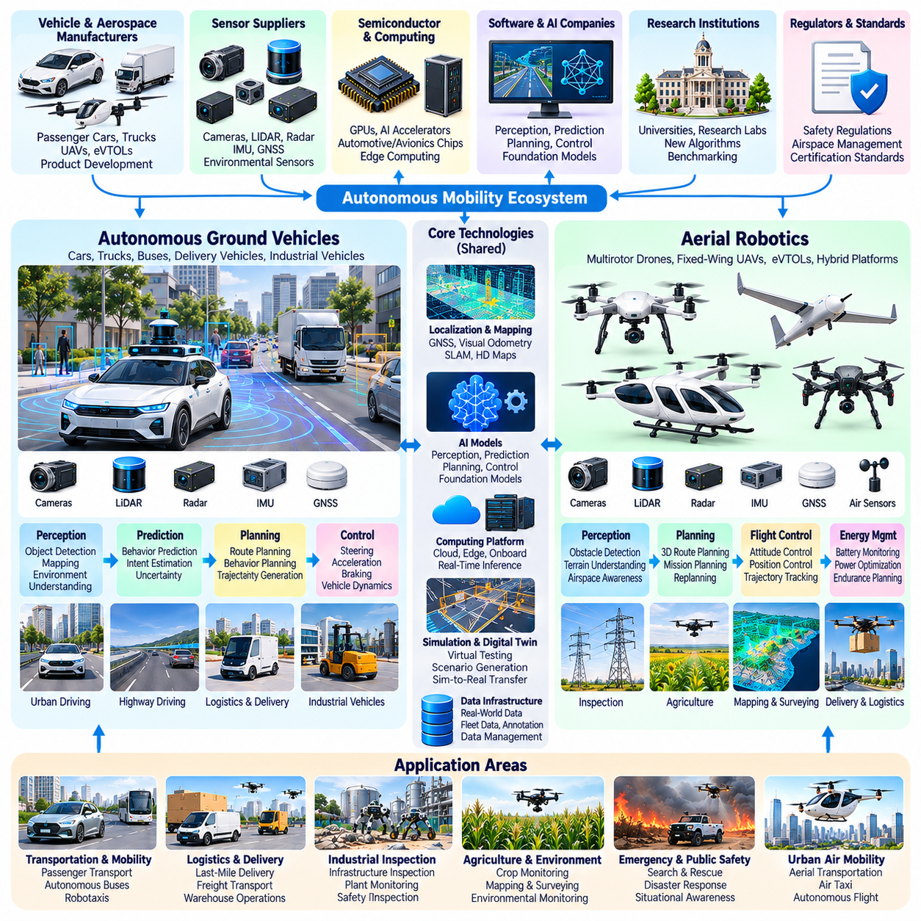
Autonomous vehicles and aerial robotics represent major domains of Physical AI that extend intelligent decision-making into road transportation and three-dimensional flight. These systems combine environmental perception, localization, motion planning, and feedback control to operate within dynamic physical environments. Their development requires close integration of artificial intelligence, robotics engineering, embedded computing, and safety-critical system design.
The autonomous mobility ecosystem includes vehicle manufacturers, aerospace companies, robotics developers, sensor suppliers, semiconductor providers, and software organizations. Research institutions and regulatory authorities also influence technological progress and deployment conditions. Commercial development spans passenger transportation, industrial logistics, delivery services, infrastructure inspection, agricultural operations, and specialized autonomous missions.
Autonomous ground vehicles integrate cameras, radar, LiDAR, satellite navigation, inertial sensors, and onboard computing platforms. These components provide information about road geometry, surrounding traffic, obstacles, and vehicle motion. Sensor configurations vary according to operating conditions and system objectives. Robust perception requires handling occlusion, adverse weather, changing illumination, and uncertainty in environmental measurements.
Vehicle localization combines positioning technologies with environmental observations to estimate location and orientation. Global navigation satellite systems provide geographic references, while inertial navigation, visual odometry, and LiDAR-based methods support localization when satellite signals become unreliable. High-definition maps may provide additional contextual information, although map dependence introduces maintenance and scalability challenges.
Autonomous driving systems typically organize decision-making into perception, prediction, planning, and control functions. Perception identifies relevant objects and environmental structures, while prediction estimates possible movements of nearby agents. Planning determines appropriate vehicle behavior and feasible trajectories. Control systems translate these trajectories into steering, acceleration, and braking commands while respecting vehicle dynamics.
Motion prediction is particularly important in road environments containing pedestrians, cyclists, human-driven vehicles, and unpredictable interactions. Autonomous systems must evaluate multiple possible future behaviors rather than assuming that surrounding agents will follow fixed trajectories. Probabilistic prediction and uncertainty-aware planning support safer decisions, although unusual situations and ambiguous intentions remain difficult to interpret.
Operational design domains define the conditions under which an autonomous driving system is intended to function. These conditions may include geographic areas, road types, weather restrictions, traffic characteristics, and speed limits. Clearly specified operational boundaries support system validation and risk management. Expanding autonomy beyond established conditions requires additional evidence of reliable performance and appropriate fallback behavior.
Aerial robotics extends autonomous mobility into three-dimensional environments where vehicles must continuously manage flight stability, navigation, and energy consumption. Uncrewed aerial vehicles include multirotor platforms, fixed-wing aircraft, and hybrid configurations. Each architecture offers different tradeoffs involving maneuverability, endurance, payload capacity, and operating range, making platform selection strongly dependent on mission requirements.
Flight control systems coordinate propulsion, attitude stabilization, altitude regulation, and trajectory tracking. Multirotor aircraft adjust rotor thrust to maintain balance and generate movement, while fixed-wing platforms rely on aerodynamic forces and control surfaces. Model-based controllers and adaptive techniques support stable flight under changing conditions. Wind disturbances, actuator limitations, and payload variation complicate reliable operation.
Aerial perception combines cameras, depth sensing, LiDAR, inertial measurements, and positioning systems to interpret surrounding airspace and terrain. Autonomous drones may identify obstacles, estimate distances, and construct spatial representations during flight. Visual-inertial odometry and simultaneous localization and mapping can support navigation where satellite positioning is limited. Reliable obstacle avoidance remains challenging around wires, reflective surfaces, and complex structures.
Autonomous mission planning determines how aerial robots accomplish tasks while respecting physical and operational constraints. Flight trajectories must account for obstacles, restricted areas, battery reserves, and vehicle capabilities. Inspection missions may prioritize sensor coverage and measurement consistency, while delivery missions emphasize route efficiency and destination accessibility. Replanning becomes necessary when environmental conditions or mission priorities change.
Industrial inspection is an important application of aerial robotics. Drones can examine bridges, power infrastructure, industrial facilities, pipelines, and large construction sites using visual, thermal, or specialized sensing equipment. Automated inspection can improve access to difficult locations and support repeatable data collection. However, measurement accuracy, flight reliability, environmental conditions, and data integration determine practical operational value.
Agricultural and environmental applications employ aerial robots for crop observation, mapping, vegetation assessment, and environmental monitoring. Multispectral imaging and geospatial analysis can reveal spatial patterns that support resource management. Autonomous flight planning enables systematic coverage of large areas. Nevertheless, sensor calibration, weather sensitivity, regulatory restrictions, and interpretation uncertainty influence deployment effectiveness.
Delivery and logistics applications investigate autonomous aircraft for transporting lightweight goods across selected routes. Potential advantages include direct aerial access and reduced dependence on ground infrastructure. Commercial feasibility depends on payload limitations, energy efficiency, landing infrastructure, airspace authorization, and operational economics. Reliable operation also requires appropriate contingency procedures and coordination with surrounding air traffic.
Artificial intelligence is expanding vehicle and aerial autonomy through learned perception, behavior prediction, and adaptive planning. Deep neural networks support object detection, semantic understanding, and environmental interpretation. Reinforcement learning and imitation learning offer approaches for developing control and decision policies. However, learning-based components require systematic validation because distribution shifts and unexpected conditions can undermine reliability.
Simulation and digital twins provide essential development infrastructure for autonomous vehicles and aerial robots. Virtual environments support testing of traffic interactions, weather disturbances, sensor degradation, and rare hazardous scenarios. Scenario-based evaluation can expose weaknesses before physical deployment. Simulation-to-reality differences nevertheless require extensive testing with actual hardware and representative operating conditions.
Edge computing enables time-sensitive perception, planning, and control without requiring continuous cloud connectivity. Embedded AI accelerators process sensor data and execute inference close to the physical system. Remote infrastructure supports fleet monitoring, software management, analytics, and large-scale training. Communication architectures must ensure that temporary network interruptions do not compromise essential autonomous functions.
Safety assurance and regulatory compliance are central to deployment. Road vehicles must address functional safety, intended-functionality limitations, cybersecurity, and applicable transportation regulations. Aerial robots face additional requirements involving airspace access, flight authorization, collision avoidance, and operational oversight. Standards and certification frameworks vary by jurisdiction, vehicle category, and intended operating conditions.
Commercial evaluation emphasizes sustained operational capability rather than isolated autonomy demonstrations. Important measures include mission completion, intervention frequency, energy consumption, system availability, safety performance, and total cost of ownership. Infrastructure requirements, maintenance, insurance, and regulatory compliance also influence economic viability. Scalable deployment requires repeatable performance across realistic operating scenarios.
Ultimately, autonomous vehicles and aerial robotics demonstrate how Physical AI enables intelligent mobility across ground and air environments. Their evolution depends on integrating robust perception, predictive reasoning, reliable control, and responsible operational governance. Long-term progress will be determined by validated safety, efficient infrastructure integration, and measurable benefits in applications where autonomous mobility provides meaningful advantages.

04.08. Robot Foundation Model Ecosystem
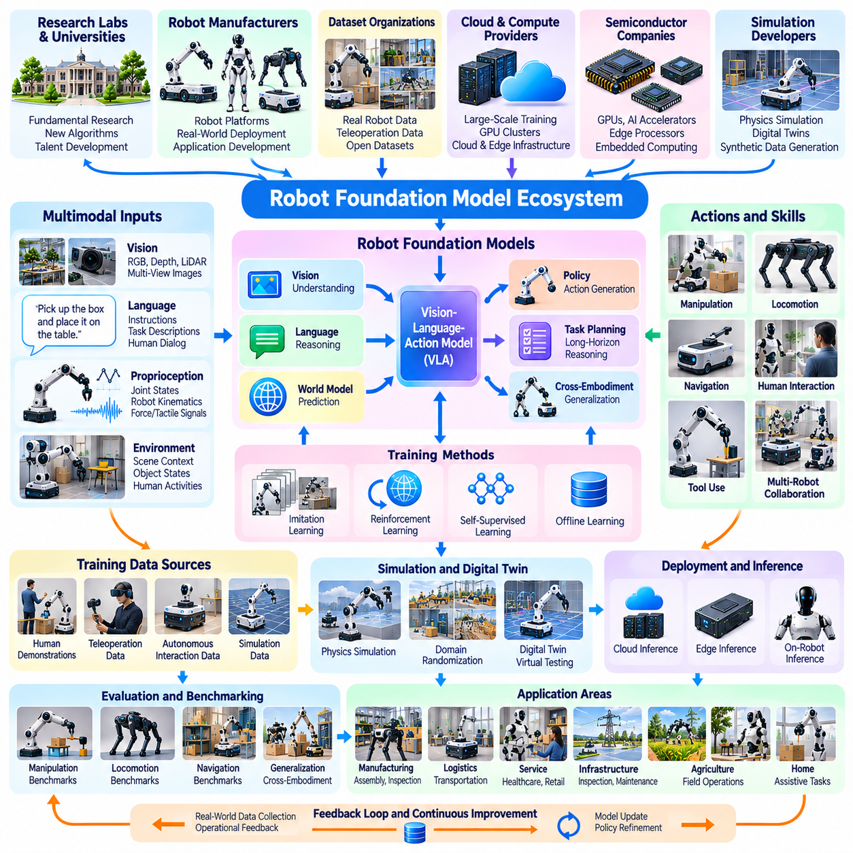
Robot foundation models represent an emerging layer of the Physical AI ecosystem that seeks to develop reusable intelligence across robotic tasks, environments, and embodiments. Unlike conventional systems trained for narrowly defined operations, foundation models learn general representations from diverse datasets. Their objective is to reduce task-specific programming while enabling robots to perceive, reason, plan, and act in changing physical environments.
The robot foundation model ecosystem includes AI research laboratories, robotics manufacturers, cloud providers, semiconductor companies, simulation developers, and dataset organizations. These participants contribute training infrastructure, robotic platforms, algorithms, and evaluation methods. Collaboration is essential because developing generalizable physical intelligence requires substantial computational resources and diverse real-world interaction data.
Robot foundation models build upon advances in large language models, vision-language models, and multimodal representation learning. Language provides semantic understanding and task descriptions, while visual information supplies environmental context. Robotic action data connects these representations to physical behavior. Integrating these modalities enables systems to interpret instructions and generate actions grounded in observable physical conditions.
Vision-language-action models extend multimodal intelligence by directly incorporating robotic actions into learning architectures. Such models may process camera observations, natural-language instructions, proprioceptive measurements, and action histories. Their outputs can represent joint commands, end-effector movements, or intermediate action targets. Model design must accommodate differences in robot morphology, control frequency, and physical constraints.
Training data is a central resource within the robot foundation model ecosystem. Datasets may contain human demonstrations, teleoperated robot trajectories, autonomous interaction records, and simulated experiences. Observations are commonly paired with actions, timestamps, and task information. Dataset quality depends on synchronization, calibration, annotation consistency, behavioral diversity, and the reliability of recorded physical interactions.
Cross-embodiment learning investigates how knowledge acquired from one robotic platform can transfer to another. Different robots may possess distinct joint structures, grippers, sensors, and action spaces. Shared representations can encode task objectives and environmental relationships independently of particular hardware configurations. However, transferring learned behavior requires adaptation to platform-specific kinematics, dynamics, and operational limitations.
Action representation strongly influences the generalization capabilities of robot foundation models. Policies may predict low-level motor commands, joint-space trajectories, Cartesian end-effector targets, or higher-level skills. Each representation introduces tradeoffs involving precision, transferability, control complexity, and computational cost. Hierarchical architectures can separate semantic task planning from time-sensitive physical execution.
Imitation learning remains an important training approach because demonstrations provide examples of successful physical behavior. Behavioral cloning enables policies to reproduce observed actions, while more advanced methods address multimodal action distributions and sequential dependencies. Nevertheless, imitation-based systems may struggle when encountering states absent from training data. Interactive correction and additional experience can improve robustness.
Reinforcement learning complements demonstration-based training by optimizing behavior through environmental interaction and feedback. Simulated environments can generate large volumes of experience for locomotion, manipulation, and navigation. Reward design, exploration, and computational efficiency influence training outcomes. Combining reinforcement learning with pretrained representations may improve adaptation, although transferring learned policies into physical systems remains challenging.
World models provide predictive representations of how physical environments evolve under different actions. These models may estimate future observations, object movements, contact events, and robot states. Predictive capabilities can support planning, risk assessment, and long-horizon task execution. Their practical effectiveness depends on maintaining physical consistency and representing uncertainty, especially during complex contact interactions.
Large-scale simulation plays an important role in foundation model development by expanding the diversity of training experiences. Synthetic environments can vary object geometry, lighting, materials, terrain, and interaction conditions. Domain randomization helps expose models to broader distributions than individual laboratories can collect. However, simulated experience cannot fully replace real-world data because physical dynamics and human behavior are difficult to reproduce accurately.
Compute infrastructure forms another essential component of the ecosystem. Distributed GPU clusters support large-scale pretraining, multimodal data processing, and policy optimization. Edge processors execute inference near physical robots, where latency and power constraints are critical. Cloud, on-premises, and embedded computing resources therefore serve complementary roles throughout model development, deployment, and continuous improvement.
Open research initiatives and shared datasets can accelerate progress by lowering barriers to experimentation. Public model checkpoints, standardized data formats, simulation environments, and reproducible evaluation protocols enable broader participation. However, dataset licensing, redistribution restrictions, privacy requirements, and differences in hardware interfaces complicate open collaboration. Transparent documentation is necessary for responsible reuse.
Commercial robot foundation model platforms increasingly seek to provide reusable intelligence through software development kits, model services, and robot integration frameworks. Their potential value lies in reducing application development time and expanding the range of supported tasks. Yet practical deployment requires compatibility with existing controllers, sensors, safety mechanisms, and operational workflows. Model capabilities alone do not guarantee successful industrial integration.
Evaluation remains a major challenge because performance on isolated benchmarks may not predict reliability in real environments. Important measures include task success, generalization to unfamiliar objects, recovery from errors, intervention frequency, and execution efficiency. Testing should cover environmental variation, embodiment differences, and long-horizon behavior. Reproducible physical evaluation is particularly difficult when laboratories use different equipment and procedures.
Safety and reliability require explicit attention when foundation models generate physical actions. Errors in perception, language interpretation, or policy execution can produce collisions, unstable movements, or unintended manipulation. Safety architectures may combine learned policies with constrained controllers, runtime monitoring, and independent protective functions. Validation must address uncertainty, failure recovery, and operating conditions beyond the training distribution.
Data governance and model lifecycle management are increasingly important as robotic learning systems expand. Organizations must track dataset provenance, training configurations, model versions, evaluation results, and deployment histories. Continuous data collection can support adaptation to changing environments, but updates require regression testing and controlled release procedures. Reliable operations depend on maintaining traceability between learned behavior and supporting evidence.
The economic structure of the robot foundation model ecosystem involves substantial training investment and recurring deployment costs. Model developers must balance computational expense, data acquisition, licensing, inference efficiency, and integration requirements. Robot manufacturers may pursue proprietary intelligence or adopt external platforms. Sustainable business models will depend on demonstrable improvements in productivity, adaptability, and operational reliability.
Future development may emphasize unified models capable of combining language reasoning, visual understanding, predictive world modeling, and physical action generation. Advances in cross-embodiment learning could allow knowledge sharing among mobile robots, manipulators, humanoids, and other platforms. Nevertheless, differences in mechanical capabilities and environmental constraints will continue to limit universal transfer without additional adaptation.
Ultimately, the robot foundation model ecosystem illustrates the transition from individually programmed robotic behaviors toward reusable and transferable physical intelligence. Its progress depends on high-quality data, scalable computing, robust learning architectures, and rigorous real-world validation. Long-term success will be determined by whether generalized models deliver dependable, safe, and economically valuable behavior across diverse robotic applications.

04.09. AI Compute and Edge Platforms
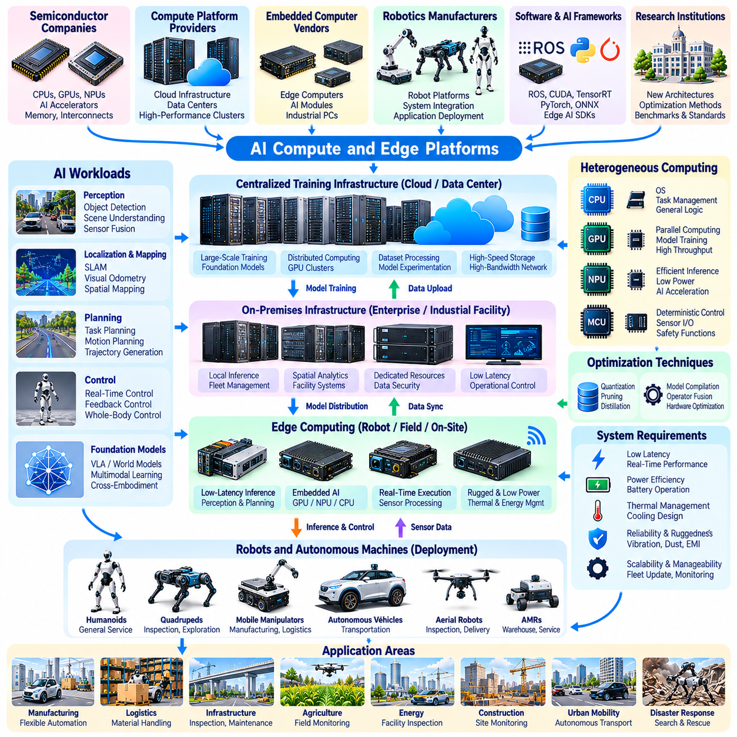
AI compute and edge platforms form the computational foundation of Physical AI, enabling robots and autonomous machines to perceive environments, execute intelligent policies, and control physical actions. Unlike conventional cloud applications, Physical AI systems must often operate under strict latency, power, and reliability constraints. Their computing architectures therefore combine high-performance processing, embedded acceleration, real-time control, and distributed infrastructure.
The AI computing ecosystem includes semiconductor manufacturers, accelerator developers, embedded computer vendors, cloud providers, robotics companies, and software framework organizations. These participants supply processors, development tools, communication technologies, and deployment platforms. Industry competition increasingly concerns not only computational throughput but also energy efficiency, software compatibility, system integration, and long-term operational support.
Centralized AI infrastructure provides the computational capacity required for training large perception models, robot foundation models, and predictive world models. GPU clusters and specialized accelerators execute distributed learning workloads across extensive datasets. High-bandwidth interconnects and storage systems support efficient data movement. Training performance depends on memory capacity, communication overhead, numerical precision, and workload parallelization.
Cloud computing enables organizations to access scalable resources without maintaining all training infrastructure locally. Cloud platforms support dataset processing, model experimentation, distributed optimization, and collaborative development. However, recurring computing costs, network dependencies, data governance requirements, and intellectual property concerns influence deployment decisions. Hybrid architectures can balance flexibility with organizational control.
On-premises computing provides dedicated infrastructure for organizations requiring local data processing, predictable resource availability, and operational independence. Industrial facilities may deploy AI servers for model inference, fleet coordination, spatial analytics, and collective decision support. Local infrastructure can reduce external network dependencies, although installation, cooling, maintenance, and capacity planning remain important considerations.
Edge computing places computational resources near sensors, robots, and physical processes. Edge platforms execute perception, localization, planning, and inference with reduced communication delays. This proximity supports applications requiring immediate responses to changing environmental conditions. Edge deployment also limits the need to transmit continuous high-volume sensor streams, potentially improving bandwidth efficiency and data control.
Embedded AI platforms integrate CPUs, GPUs, neural processing units, and dedicated accelerators within compact computing modules. These devices support neural network inference, sensor fusion, image processing, and autonomous navigation. Hardware selection depends on computational performance, memory bandwidth, power consumption, thermal limits, and supported software environments. Physical dimensions and environmental durability also influence integration.
Heterogeneous computing architectures distribute workloads across different processing units according to their characteristics. CPUs commonly handle operating systems, task coordination, and general-purpose logic, while GPUs accelerate parallel numerical computation. Neural accelerators execute optimized inference workloads, and microcontrollers manage deterministic low-level functions. Effective scheduling and data exchange are essential for overall performance.
Real-time requirements distinguish Physical AI computing from many conventional AI applications. Perception and planning pipelines must deliver results within deadlines determined by robot dynamics and operating conditions. Excessive latency or unpredictable execution times can degrade control quality and safety. System designers therefore evaluate worst-case response times, scheduling behavior, communication delays, and end-to-end processing consistency.
AI inference optimization enables complex models to operate within limited edge resources. Quantization, pruning, knowledge distillation, operator fusion, and hardware-specific compilation can reduce computational requirements. These techniques introduce tradeoffs involving accuracy, latency, memory consumption, and development complexity. Optimization must be validated against representative workloads because benchmark throughput alone may not reflect operational performance.
Memory architecture is a critical factor in deploying multimodal and foundation models. Visual observations, temporal histories, model parameters, and intermediate activations can require substantial memory capacity and bandwidth. Efficient buffering, memory sharing, and data movement influence achievable inference speed. Systems must also account for concurrent workloads, including perception, mapping, planning, and communication.
Thermal management and power efficiency strongly influence embedded deployment. Robots operate with finite battery capacity, restricted cooling space, and changing environmental temperatures. Sustained AI computation can cause thermal throttling, reducing predictable performance. Designers must balance processing capability with energy budgets, cooling methods, enclosure design, and mechanical reliability throughout expected operating conditions.
Industrial edge computers often require greater environmental resilience than conventional office computing equipment. Deployment conditions may involve vibration, dust, electromagnetic interference, temperature variation, and limited maintenance access. Ruggedized platforms can incorporate protected connectors, industrial communication interfaces, and specialized cooling arrangements. Hardware reliability must be evaluated alongside computational specifications.
Distributed Physical AI architectures connect robot-level intelligence with nearby edge nodes and on-premises infrastructure. Individual robots retain essential motion control and safety functions, while shared computing resources can support spatial perception, task allocation, and coordination. Cloud systems provide broader analytics and model development capabilities. Functional partitioning must reflect communication reliability, latency budgets, and failure consequences.
Networking technologies enable data exchange among sensors, robots, edge servers, and centralized infrastructure. Ethernet, industrial networks, wireless communication, and time-sensitive networking may support different operational requirements. Bandwidth, synchronization, packet loss, and communication jitter influence distributed performance. Critical functions should maintain appropriate local autonomy when connectivity becomes degraded or unavailable.
Software ecosystems are essential to practical AI hardware adoption. Robotics middleware, inference runtimes, accelerator libraries, operating systems, and container technologies provide the interfaces required for development and deployment. Compatibility between hardware drivers, model formats, and application frameworks affects integration costs. Long-term maintainability requires version management, security updates, and reproducible software environments.
Security and operational governance must extend across the computing infrastructure. Edge devices may process sensitive sensor data and issue commands affecting physical equipment. Secure boot, authenticated updates, access controls, network segmentation, and runtime monitoring help reduce cyber-physical risks. Organizations also require asset inventories, vulnerability management, and recovery procedures appropriate to distributed autonomous systems.
Evaluation of AI computing platforms requires more than comparing theoretical processing performance. Relevant metrics include application latency, sustained throughput, power efficiency, memory utilization, thermal stability, reliability, and total cost of ownership. Benchmark results should reflect actual model architectures and concurrent workloads. Integration effort, software maturity, and component availability also influence platform selection.
Future AI compute platforms will increasingly support multimodal perception, predictive world modeling, and large-scale robotic policy execution. Advances in accelerator architectures, memory systems, interconnects, and model compression may improve performance per watt. Distributed inference could enable closer cooperation between robots and shared infrastructure. Nevertheless, deterministic control, cybersecurity, and energy limitations will remain central engineering concerns.
Ultimately, AI compute and edge platforms determine how effectively learned intelligence becomes reliable physical behavior. Successful architectures combine centralized training capacity, shared local intelligence, and dependable onboard execution. Their long-term value depends on balancing computational capability with latency, energy efficiency, safety, maintainability, and scalable deployment across diverse Physical AI applications.

04.10. Simulation Data and Development Ecosystem
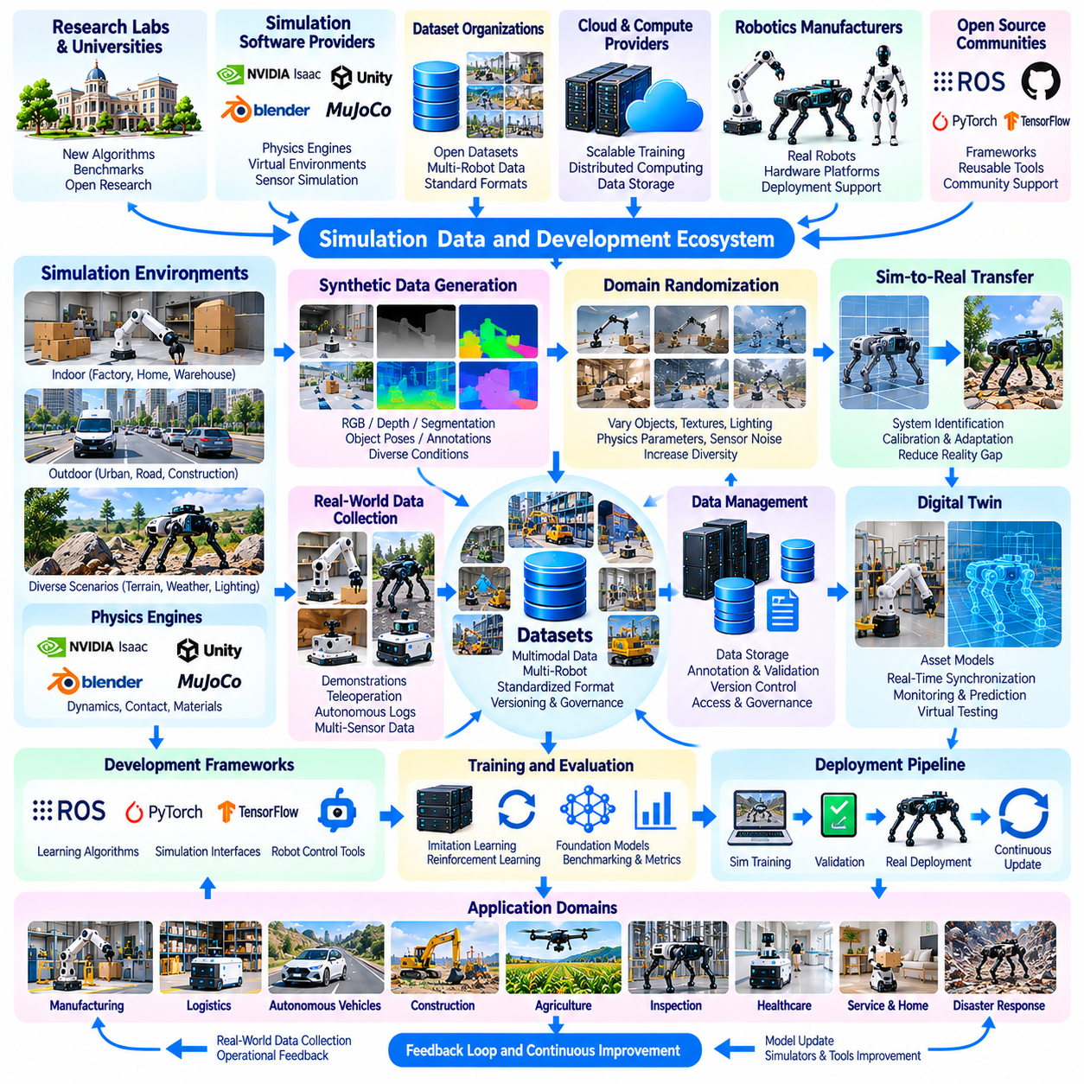
Simulation, data, and development infrastructure form a critical foundation of the Physical AI ecosystem by enabling intelligent machines to learn, experiment, and improve before deployment. Physical robots operate under mechanical constraints and environmental uncertainty, making direct experimentation costly and potentially hazardous. Simulation platforms, structured datasets, and integrated development tools reduce these barriers while supporting systematic engineering and validation.
The development ecosystem includes robotics laboratories, simulation software providers, dataset organizations, cloud infrastructure companies, hardware manufacturers, and open-source communities. These participants contribute physics engines, digital environments, robotic interfaces, learning frameworks, and evaluation tools. Their combined capabilities determine how efficiently research prototypes can progress toward reliable and commercially deployable Physical AI systems.
Robotics simulation reproduces selected aspects of physical environments through mathematical models of motion, forces, collisions, and sensor behavior. Physics engines calculate interactions among rigid bodies, articulated mechanisms, and surrounding objects. Simulation accuracy depends on contact modeling, numerical integration, material properties, and actuator representations. No simulator perfectly reproduces every physical phenomenon encountered during real-world operation.
Simulation environments support multiple stages of robot development, including mechanical design, control engineering, perception training, and system integration. Engineers can test alternative configurations before manufacturing expensive prototypes. Virtual experiments also enable controlled comparison of algorithms under repeatable conditions. This approach accelerates iteration while reducing hardware wear, operational disruption, and the risks associated with early-stage testing.
Digital twins extend simulation by maintaining structured representations of physical assets, operating conditions, and system behavior. A digital twin may incorporate geometry, equipment configuration, sensor measurements, and historical operational data. Connections with physical systems enable monitoring and predictive analysis. However, the accuracy and usefulness of digital twins depend on model maintenance, data synchronization, and clearly defined operational objectives.
Synthetic data generation provides scalable training resources for perception and robotic learning. Virtual environments can produce annotated images, depth maps, segmentation masks, object poses, and simulated sensor measurements. Developers can vary lighting, object arrangements, materials, and camera viewpoints to increase diversity. Synthetic datasets are particularly valuable when real-world annotation is expensive or rare scenarios are difficult to capture.
Domain randomization helps improve transfer from simulated environments to physical robots by varying parameters during training. These variations may include friction, mass, illumination, actuator response, sensor noise, and object geometry. Models exposed to diverse conditions may become less dependent on specific simulation assumptions. Nevertheless, randomization cannot guarantee reliable transfer when important physical effects are missing or inaccurately represented.
Sim-to-real transfer remains a central challenge because simulated dynamics and observations differ from real operating conditions. Errors in contact forces, material deformation, sensor calibration, and communication timing can degrade learned behavior. System identification and real-world calibration help narrow these differences. Successful transfer requires testing under representative physical conditions rather than relying exclusively on simulation performance.
Real-world robotic datasets provide evidence of physical interactions that simulations cannot fully reproduce. Data may include camera streams, LiDAR measurements, joint states, force signals, navigation trajectories, and operator demonstrations. Temporal synchronization and consistent coordinate frames are essential for multimodal learning. Dataset reliability also depends on calibration records, task definitions, environmental context, and documentation quality.
Large-scale dataset ecosystems increasingly combine information from different robots, laboratories, and operating environments. Shared data formats and standardized task descriptions can support cross-platform learning and broader model generalization. However, differences in sensor configurations, action spaces, control frequencies, and hardware capabilities complicate integration. Data harmonization must preserve meaningful physical relationships rather than merely standardizing file structures.
Data collection infrastructure connects physical robots with storage, annotation, and model training pipelines. Logging systems capture observations, actions, system events, and execution outcomes during experiments or deployment. Automated validation can identify missing timestamps, corrupted measurements, and inconsistent metadata. Effective data management also requires version control, provenance tracking, access policies, and reproducible preprocessing procedures.
Robot learning frameworks provide reusable components for imitation learning, reinforcement learning, perception training, and policy evaluation. These frameworks connect datasets, simulation environments, neural network libraries, and robot interfaces. Modular development reduces duplicated engineering effort and supports controlled experimentation. Compatibility between learning software and physical controllers remains essential when transferring trained policies into operational systems.
Development workflows increasingly incorporate continuous integration, automated testing, and reproducible deployment practices. Software changes can trigger unit tests, simulation scenarios, regression evaluations, and hardware-in-the-loop experiments. These processes help detect unintended behavioral changes before field deployment. However, automated testing must include realistic failure conditions and cannot replace comprehensive physical validation.
Benchmarking provides common reference points for comparing robotic algorithms and system capabilities. Evaluation environments may measure navigation success, manipulation completion, collision frequency, energy consumption, or recovery performance. Standardized benchmarks support reproducibility and scientific comparison. Yet strong benchmark performance does not necessarily demonstrate reliability across unfamiliar environments, hardware platforms, or long-duration missions.
Scenario generation expands evaluation beyond fixed benchmark tasks by creating varied environmental conditions and operational disturbances. Developers can introduce moving obstacles, sensor failures, unexpected contacts, and communication interruptions. Rare but consequential events deserve particular attention in safety-critical systems. Scenario coverage should reflect identified hazards and operating requirements rather than relying only on random variation.
Cloud and on-premises infrastructure support large-scale simulation, dataset processing, and distributed model training. GPU clusters can execute parallel simulation instances and accelerate learning workloads. Local computing resources may provide greater control over sensitive data and specialized hardware interfaces. Hybrid development architectures balance scalability, cost, data governance, and the practical requirements of robotic experimentation.
Open-source software and collaborative research communities accelerate ecosystem development through shared tools, datasets, and reproducible implementations. Common middleware and simulation interfaces can reduce integration barriers among research groups and manufacturers. However, software dependencies, licensing restrictions, hardware compatibility, and maintenance responsibilities require careful management. Sustainable collaboration depends on transparent documentation and reliable project governance.
Safety, security, and data governance must be integrated throughout the development lifecycle. Simulation assets and datasets may contain proprietary facility information, personal observations, or sensitive operational records. Access controls, licensing compliance, and secure storage protect these resources. Safety validation must also distinguish simulated evidence from physical test results and maintain traceability between requirements, experiments, and deployment decisions.
Commercial development platforms are evaluated according to more than simulation realism or dataset volume. Important considerations include integration effort, computational cost, supported robot architectures, development productivity, and long-term maintainability. Organizations must assess whether tools improve deployment reliability and reduce engineering risk. Interoperability and repeatable validation workflows are particularly important for scaling beyond laboratory demonstrations.
Ultimately, the simulation, data, and development ecosystem determines how effectively Physical AI research becomes dependable real-world capability. Simulation expands experimentation, datasets provide learning evidence, and engineering tools connect algorithms with physical platforms. Continued progress requires stronger physical fidelity, interoperable data infrastructure, reproducible evaluation, and disciplined validation across the complete robot development lifecycle.

04.11. Physical AI Value Chain and Industry Structure
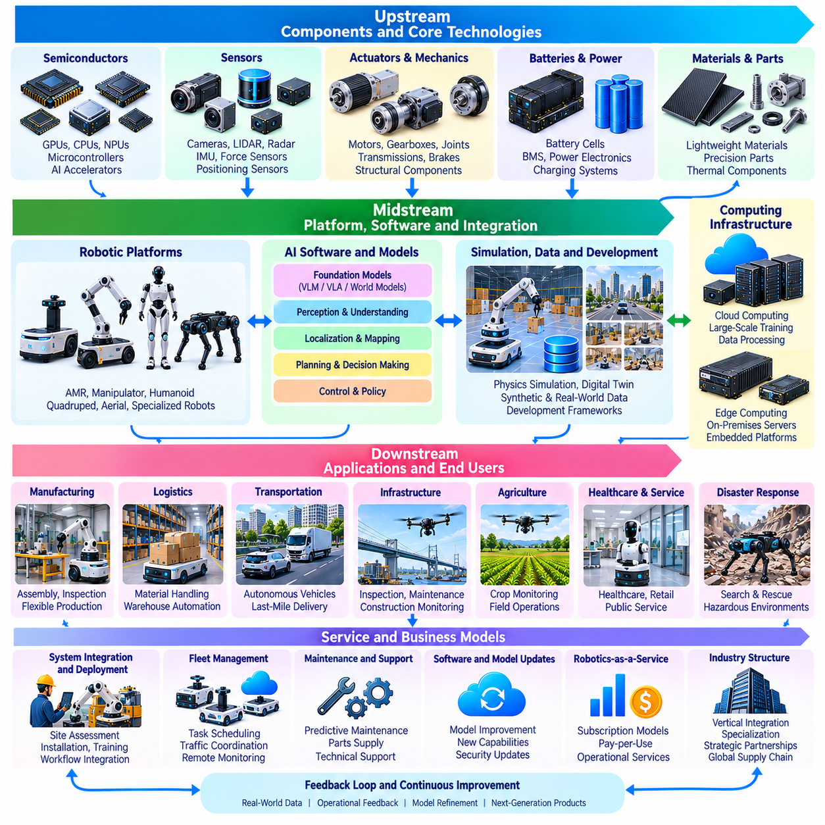
The Physical AI value chain describes the interconnected activities, technologies, and organizations required to transform intelligent algorithms into operational physical systems. Unlike purely digital AI industries, Physical AI depends on the coordinated development of hardware, software, data, infrastructure, and field services. Its industrial structure reflects the complexity of integrating computational intelligence with mechanical systems operating under real-world constraints.
The upstream segment of the value chain includes semiconductor manufacturers, sensor suppliers, actuator developers, battery producers, and specialized material providers. These organizations supply the foundational components required for perception, computation, movement, and energy delivery. Component performance influences system cost, reliability, and capability. Supply availability and manufacturing capacity also affect the scalability of Physical AI products.
Semiconductors occupy a strategic position because intelligent machines require substantial computing capability within constrained power and thermal environments. GPUs, CPUs, neural accelerators, and microcontrollers support different processing functions. Semiconductor vendors increasingly provide software libraries, development environments, and reference architectures alongside hardware. This integration can influence platform selection and create long-term ecosystem dependencies.
Sensor manufacturers provide the technologies that connect intelligent systems with physical environments. Cameras, LiDAR, radar, inertial sensors, force sensors, and positioning devices generate complementary observations. Their commercial value depends on measurement accuracy, environmental robustness, calibration stability, and integration compatibility. Sensor suppliers increasingly compete through reliability, embedded processing, and application-specific capabilities.
Actuators, transmissions, and mechanical components convert computational decisions into physical movement. Motors, gearboxes, brakes, joints, and structural assemblies determine payload capacity, precision, durability, and energy consumption. Their importance varies across mobile robots, manipulators, humanoids, and aerial platforms. Manufacturing quality and maintenance requirements strongly influence lifecycle economics and operational availability.
The middle segment includes robotic platform manufacturers and system integrators that combine components into functional machines. Manufacturers develop mechanical architectures, embedded electronics, control systems, and safety mechanisms. Integrators adapt these platforms to specific facilities and workflows. Successful integration requires compatibility among sensors, computing hardware, communication interfaces, and operational software.
AI software developers contribute perception models, localization algorithms, planning systems, control policies, and robot foundation models. Their technologies determine how robots interpret environments and select appropriate actions. Software differentiation increasingly depends on generalization, reliability, computational efficiency, and integration flexibility. However, learned intelligence must operate within the physical limitations and safety boundaries of deployed machines.
Simulation, data, and development platforms form a supporting layer across the entire value chain. Simulation providers enable virtual testing, while dataset organizations and annotation services supply training resources. Development frameworks connect algorithms with hardware interfaces and evaluation procedures. These capabilities reduce experimentation costs and accelerate iteration, although reliable deployment still requires physical testing and operational evidence.
Computing infrastructure providers supply cloud resources, on-premises servers, and edge platforms for model development and execution. Centralized infrastructure supports large-scale training and analytics, while local computing enables low-latency perception and coordination. Embedded processors execute essential functions onboard robots. The distribution of computing responsibilities affects operating cost, communication requirements, data governance, and system resilience.
Downstream participants include industrial customers, logistics operators, manufacturers, infrastructure owners, agricultural organizations, and service providers. These users adopt Physical AI to improve productivity, safety, quality, and operational flexibility. Their purchasing decisions depend on measurable outcomes rather than technical demonstrations alone. Integration with existing equipment, workforce procedures, and enterprise systems often determines adoption success.
System integration and deployment services represent an important source of commercial value. Physical AI installations require site assessment, mapping, network configuration, workflow adaptation, safety evaluation, and operator training. Deployment complexity varies with environmental conditions and organizational requirements. Service providers that reduce installation time and operational disruption can create substantial differentiation beyond the capabilities of individual robots.
Recurring services increasingly influence business models throughout the industry. Fleet management, remote monitoring, predictive maintenance, software updates, and technical support generate ongoing customer relationships. Robotics-as-a-Service models can convert upfront capital expenditure into recurring operational payments. Their sustainability depends on equipment utilization, maintenance cost, financing conditions, and clearly defined service responsibilities.
The industry contains multiple forms of vertical integration and specialization. Some companies develop complete robotic systems, including hardware, AI software, and operational services. Others concentrate on components, foundation models, middleware, or specialized applications. Vertical integration can improve system optimization and accountability, while specialization can accelerate innovation and reduce development costs through shared technologies.
Platform ecosystems create additional economic relationships through application interfaces, development tools, partner networks, and compatibility standards. A widely adopted platform may attract software developers, component suppliers, and system integrators. Network effects can increase the value of shared infrastructure and reusable applications. However, proprietary interfaces and restrictive licensing may create vendor lock-in and limit interoperability.
Standards, certification, and regulatory institutions influence the industry's development by establishing expectations for safety, cybersecurity, communication, and operational accountability. Requirements differ across industrial robots, autonomous vehicles, aerial systems, and collaborative applications. Compliance creates engineering and documentation costs but can also support customer confidence. Regulatory uncertainty may delay commercialization in emerging application areas.
Supply chain resilience is especially important because Physical AI products combine components with different manufacturing cycles and availability constraints. Semiconductor shortages, specialized actuator lead times, and dependence on limited suppliers can disrupt production. Organizations must consider component substitution, lifecycle support, inventory planning, and geographic concentration. Long-term deployment requires stable access to replacement parts and maintenance resources.
Commercial competitiveness depends on the relationship between system performance and total cost of ownership. Acquisition cost represents only one component of economic value. Integration, energy consumption, maintenance, software licensing, downtime, and human supervision contribute to lifecycle expenses. Customers evaluate whether automation improves throughput, quality, safety, or service availability sufficiently to justify these costs.
Investment and market development are shaped by the capital-intensive nature of robotic hardware and the uncertain pace of customer adoption. Research, prototyping, certification, manufacturing, and field support require sustained funding. Investors increasingly examine deployment evidence, recurring revenue, unit economics, and customer retention. Technical breakthroughs alone may not establish viable businesses without repeatable commercialization processes.
Future industry development may involve greater standardization of hardware interfaces, shared AI models, interoperable fleet platforms, and specialized deployment services. Foundation models could reduce software development costs, while modular components may accelerate product differentiation. Nevertheless, physical integration, safety assurance, and application-specific engineering will remain important sources of competitive advantage.
Ultimately, the Physical AI value chain is an interconnected industrial system rather than a simple sequence of hardware and software suppliers. Sustainable growth requires coordination among component producers, AI developers, platform manufacturers, integrators, and end users. Long-term industry leadership will depend on reliable deployment, economic scalability, ecosystem cooperation, and the ability to translate physical intelligence into measurable operational value.

