Volume 02. Physical AI Foundations and Definitions

Chapter 03. History and Origins

03.01. Cybernetics and Feedback Control
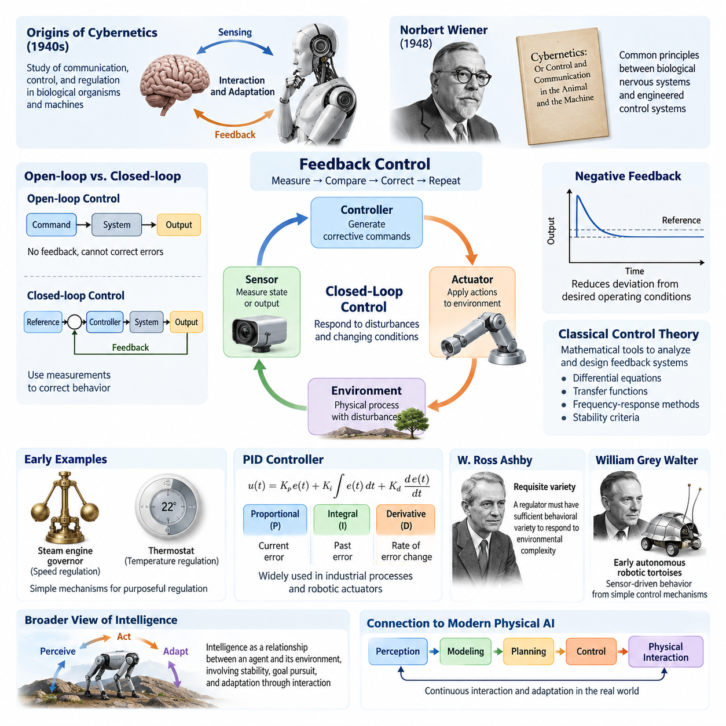
The intellectual foundations of Physical AI can be traced to cybernetics, a field that emerged during the 1940s to investigate communication, control, and regulation in biological organisms and machines. Cybernetics introduced the idea that intelligent behavior could arise from continuous interaction between a system and its environment. Rather than treating machines as isolated mechanisms executing predetermined commands, it emphasized sensing, feedback, correction, and adaptation as fundamental properties of purposeful behavior.
Norbert Wiener played a central role in establishing cybernetics through his 1948 book, Cybernetics: Or Control and Communication in the Animal and the Machine. Wiener recognized that biological nervous systems and engineered control systems shared important organizational principles. Both could receive information about environmental conditions, compare observed behavior with desired outcomes, and adjust their actions accordingly. This perspective provided an early conceptual foundation for autonomous machines and intelligent physical systems.
Feedback control is the central engineering mechanism connecting cybernetics to modern Physical AI. A feedback controller continuously measures the state or output of a physical process, compares the measurement with a desired reference, and generates corrective commands. The resulting actions influence the environment, producing new measurements that initiate another control cycle. This closed-loop structure allows a system to respond to disturbances and changing conditions instead of relying entirely on predetermined action sequences.
The distinction between open-loop and closed-loop control was especially important in the historical development of intelligent machines. Open-loop systems execute commands without using measured outcomes to correct their behavior. Closed-loop systems continuously incorporate observations into subsequent actions. A robot arm operating without feedback may accumulate positioning errors, while a feedback-controlled arm can detect deviations and adjust motor commands. This distinction remains fundamental to reliable physical interaction and autonomous operation.
Negative feedback became a foundational principle because it enables systems to reduce deviations from desired operating conditions. When a measured variable exceeds its reference, the controller produces an action intended to decrease the error. When the variable falls below the reference, the corrective action changes accordingly. Under suitable stability conditions, this process supports accurate regulation, disturbance rejection, and consistent behavior despite uncertainty in the physical environment.
Early feedback mechanisms existed long before cybernetics became a formal discipline. Mechanical governors used in steam engines regulated rotational speed by adjusting energy input according to measured motion. Thermostats similarly maintained temperature by responding to deviations from a target value. These devices demonstrated that purposeful regulation could emerge from relatively simple physical mechanisms, establishing an important technological precedent for increasingly sophisticated autonomous systems.
Classical control theory provided the mathematical tools needed to analyze feedback systems systematically. Differential equations, transfer functions, frequency-response methods, and stability criteria enabled engineers to predict how systems would react to commands and disturbances. Developments associated with James Clerk Maxwell, Harry Nyquist, Hendrik Bode, and other researchers established techniques for understanding dynamic behavior and designing controllers with predictable performance.
The proportional-integral-derivative controller became one of the most influential practical implementations of feedback regulation. Proportional control responds to the current error, integral control accumulates past error, and derivative control responds to the rate of error change. By combining these mechanisms, PID controllers can achieve effective regulation across many industrial processes. Their continued use in robotic actuators illustrates how classical control principles remain essential even when higher-level intelligence is provided by advanced AI models.
Cybernetics also introduced a broader interpretation of intelligence as a relationship between an agent and its environment. Intelligence was not limited to symbolic reasoning or abstract computation but could involve maintaining stability, pursuing goals, and adapting behavior through interaction. This interpretation anticipated later developments in embodied intelligence, autonomous robotics, and situated artificial intelligence, where cognition is understood partly through the consequences of physical action.
The work of W. Ross Ashby further expanded cybernetic thinking by examining adaptation, regulation, and the organization of complex systems. His concept of requisite variety suggested that an effective regulator must possess sufficient behavioral variety to respond to relevant environmental disturbances. For Physical AI, this principle highlights the relationship between environmental complexity and the capabilities required for autonomous adaptation, although practical performance also depends on sensing, modeling, and computational limitations.
Another influential contribution came from William Grey Walter, whose early autonomous robotic tortoises demonstrated simple forms of sensor-driven behavior. These machines used relatively modest electronic circuits to respond to light and environmental conditions. Their behavior suggested that apparently complex interactions could emerge from the coupling of simple control mechanisms with physical surroundings, foreshadowing later approaches to behavior-based robotics and embodied autonomous agents.
The emergence of state-space control during the mid-twentieth century provided a more general framework for describing dynamic systems. Instead of representing a system only through input-output relationships, state-space models describe internal variables that determine future behavior. This formulation enabled the analysis of multivariable systems and supported the development of controllability, observability, optimal control, and estimation methods that became indispensable in advanced robotics.
Rudolf Kalman's contributions to modern control theory were particularly important for systems operating with incomplete and noisy measurements. The Kalman filter, introduced in 1960, provided a recursive method for estimating hidden system states from uncertain observations and mathematical models. This approach became fundamental to navigation, tracking, and sensor fusion, establishing a direct connection between classical feedback theory and modern robotic perception and localization.
Optimal control extended feedback design by introducing explicit performance objectives. Instead of merely reducing instantaneous error, a controller could minimize accumulated costs associated with tracking accuracy, energy consumption, control effort, or other operating requirements. Techniques such as linear quadratic regulation demonstrated how mathematical optimization could determine effective control policies, creating conceptual links to planning, decision-making, and reinforcement learning.
Model predictive control introduced another important development by using a mathematical model to forecast future system behavior over a limited planning horizon. At each control cycle, the controller solves an optimization problem, applies an initial action, and updates its plan using new measurements. This repeated prediction-and-correction process resembles the architecture of modern Physical AI systems that combine world modeling, planning, and real-time execution.
The relationship between cybernetics and artificial intelligence developed through both cooperation and intellectual divergence. Classical AI increasingly emphasized symbolic representation, logical reasoning, and abstract problem solving, while cybernetics focused on feedback, dynamics, and interaction. These approaches addressed different aspects of intelligent behavior. Modern Physical AI increasingly reconnects them by combining learned representations and reasoning mechanisms with continuous sensorimotor control.
Feedback control also established the importance of time in intelligent physical systems. Physical processes evolve continuously, and delayed corrective actions may produce instability, oscillation, or degraded performance. Consequently, sensing frequency, computation latency, communication delay, and actuator response must be considered together. Unlike many purely digital inference tasks, Physical AI must generate decisions within temporal constraints imposed by the dynamics of the environment.
The historical progression from mechanical regulation to adaptive control illustrates how feedback systems gradually acquired more sophisticated capabilities. Adaptive controllers can update selected parameters when operating conditions or system characteristics change. Robust controllers address bounded uncertainty and disturbances, while learning-based controllers can improve behavior using accumulated experience. These developments represent successive extensions of the cybernetic principle that action should be informed by observed consequences.
Modern robotics applies feedback at multiple levels of abstraction. Low-level controllers regulate motor current, torque, velocity, and position, while higher-level systems estimate robot state, maintain balance, avoid obstacles, and coordinate complex movements. Autonomous mobile robots continuously correct their trajectories, manipulators regulate contact forces, and legged robots adjust body motion to preserve stability. Each application depends on feedback mechanisms operating within a broader intelligent architecture.
Physical AI extends these principles by integrating learned perception, predictive models, goal-directed reasoning, and adaptive decision-making into the feedback process. Neural networks may estimate environmental states, learned dynamics models may anticipate action consequences, and planning algorithms may select appropriate behaviors. Nevertheless, the system must still observe the physical effects of its decisions and revise subsequent actions, preserving the fundamental closed-loop structure inherited from cybernetics.
A critical distinction is that feedback alone does not constitute comprehensive artificial intelligence. A conventional thermostat exhibits goal-directed regulation but does not necessarily possess semantic understanding, general reasoning, or transferable learning capabilities. Physical AI builds upon feedback control while introducing richer representations, task-level autonomy, and adaptation across changing situations. Cybernetics therefore provides a necessary historical foundation rather than a complete explanation of contemporary intelligent machines.
The cybernetic tradition also helps explain why safety and reliability are inseparable from intelligent physical operation. A controller must remain stable despite disturbances, measurement errors, uncertain dynamics, and actuator limitations. Modern Physical AI introduces additional uncertainties associated with learned models and unfamiliar environments. Feedback monitoring, constrained control, fault detection, and independent safety mechanisms help ensure that intelligent decisions remain compatible with physical operating limits.
Ultimately, cybernetics transformed the understanding of machines from passive mechanisms into systems capable of regulating their behavior through environmental interaction. Its emphasis on communication, feedback, adaptation, and purposeful action established principles that continue to shape robotics and autonomous technology. Contemporary Physical AI represents an expansion of this tradition, combining classical control with machine learning and predictive intelligence to create systems that perceive, reason, act, and continuously adapt in the physical world.

03.02. Early AI and Intelligent Machines
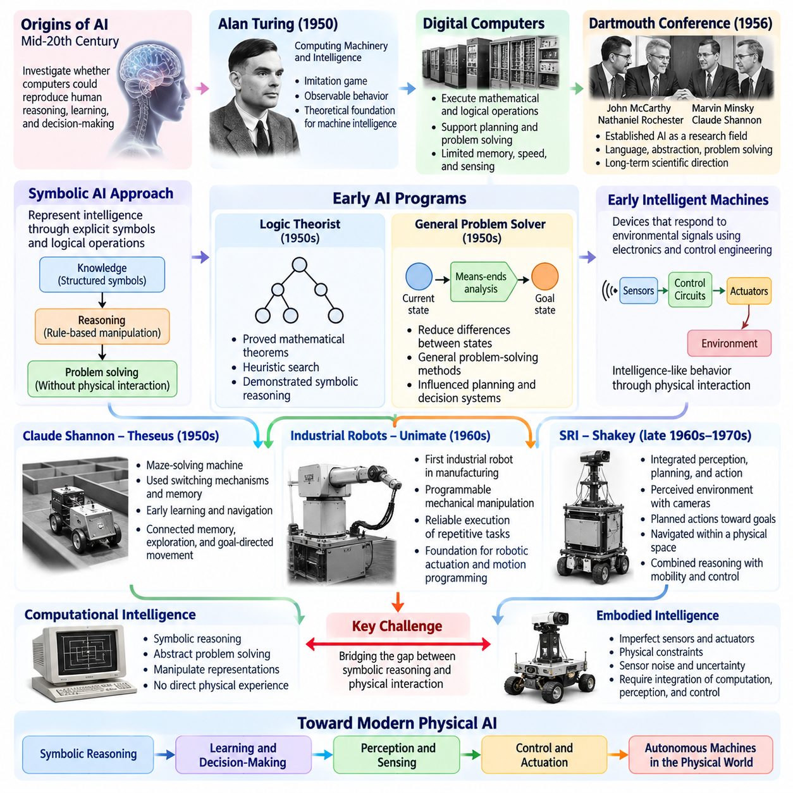
The emergence of artificial intelligence during the mid-twentieth century marked a turning point in the development of intelligent machines. Researchers began investigating whether computational systems could reproduce aspects of human reasoning, learning, and decision-making. While early AI primarily focused on abstract problem solving, its underlying ambition extended toward machines capable of understanding their surroundings and acting autonomously within the physical world.
Alan Turing provided one of the earliest theoretical foundations for machine intelligence through his work on computation and intelligent behavior. His 1950 paper, Computing Machinery and Intelligence, questioned whether machines could exhibit behavior comparable to human intelligence. The imitation game introduced a behavioral perspective on intelligence, emphasizing observable capabilities rather than internal mechanisms. This perspective influenced later discussions about evaluating intelligent autonomous systems.
The development of electronic digital computers created the technological foundation for implementing artificial intelligence. Early programmable machines demonstrated that mathematical operations, logical procedures, and symbolic transformations could be executed automatically. Researchers recognized that computation might support more sophisticated cognitive functions, including planning and problem solving. However, limited memory, processing speed, and sensing technologies constrained practical interaction with physical environments.
The Dartmouth Summer Research Project on Artificial Intelligence in 1956 established artificial intelligence as a recognizable research field. John McCarthy, Marvin Minsky, Nathaniel Rochester, and Claude Shannon proposed investigating how machines might simulate aspects of intelligence. Their research agenda included language, abstraction, problem solving, and self-improvement. Although early ambitions exceeded available technological capabilities, the project established an enduring scientific direction.
Early AI research frequently assumed that intelligence could be represented through explicit symbols and logical operations. Under this approach, knowledge was encoded as structured representations, while reasoning involved manipulating those representations according to defined rules. Systems could solve mathematical problems or perform logical deductions without directly experiencing the physical world. This separation between symbolic intelligence and physical interaction later became an important limitation.
The Logic Theorist, developed by Allen Newell, Herbert Simon, and Cliff Shaw during the 1950s, demonstrated that computers could perform selected forms of symbolic reasoning. The program searched for proofs of mathematical theorems using heuristic strategies. Its success suggested that intelligent problem solving could be formulated as computational search through possible states. These ideas subsequently influenced automated planning, decision systems, and task-level reasoning in robotics.
The General Problem Solver extended this direction by attempting to represent problem-solving processes through general computational principles. Newell, Simon, and Shaw explored methods for reducing differences between current and desired states. Means-ends analysis became an influential strategy for selecting intermediate operations toward a goal. Although these methods struggled with complex real environments, they introduced concepts that remain relevant to goal-directed autonomous behavior.
Early intelligent machines also emerged from developments in electronics, control engineering, and experimental robotics. Researchers constructed devices that could respond to environmental signals and exhibit apparently purposeful behavior. These machines often relied on relatively simple sensors and control circuits rather than sophisticated symbolic reasoning. Their significance lay in demonstrating that intelligence-like behavior could emerge through direct interaction between physical mechanisms and environmental conditions.
Claude Shannon's experimental work on maze-solving machines illustrated how electromechanical systems could perform elementary learning and navigation. His maze-solving mouse, commonly known as Theseus, used switching mechanisms and memory to discover routes through a maze. Although limited compared with modern autonomous robots, the demonstration connected memory, environmental exploration, and goal-directed movement within a physical machine.
The distinction between computational intelligence and embodied intelligence became increasingly visible as researchers attempted to transfer abstract reasoning into physical systems. A program could manipulate symbolic descriptions of objects without encountering friction, sensor noise, or unpredictable motion. A physical robot, however, had to operate through imperfect sensors and actuators. This difference revealed that successful autonomous behavior required integrating computation with perception and control.
The development of industrial robots introduced another important dimension to the history of intelligent machines. Unimate, installed in an industrial setting during the early 1960s, demonstrated programmable mechanical manipulation for repetitive manufacturing tasks. These systems emphasized reliable execution rather than autonomous reasoning. Nevertheless, they established practical foundations for robotic actuation, motion programming, and the integration of computational commands with physical machinery.
Research laboratories subsequently began combining computer-based reasoning with mobile robotic platforms. The Stanford Research Institute developed Shakey during the late 1960s and early 1970s as an experimental robot integrating perception, planning, and action. Shakey could interpret simplified environmental information, construct symbolic descriptions, and execute planned movements. It became an influential demonstration of how artificial intelligence could control physical behavior.
Shakey's architecture connected several capabilities that later became central to autonomous robotics. Visual perception supplied information about the environment, symbolic representations supported reasoning, and planning algorithms generated action sequences. Low-level control mechanisms translated these plans into movement. Although operation was slow and required highly structured environments, the system demonstrated an early integrated approach to perception, reasoning, and physical action.
The STRIPS planning system emerged from research associated with Shakey and provided a formal method for representing actions through preconditions and effects. A planning algorithm could determine which operations were required to transform an initial state into a desired goal state. This approach became foundational in classical automated planning. Its assumptions about discrete states and predictable actions, however, limited its direct applicability to uncertain and continuously changing environments.
Early machine vision research attempted to provide intelligent systems with meaningful descriptions of visual scenes. Researchers investigated edge detection, geometric interpretation, object recognition, and three-dimensional structure. Initial methods frequently assumed simplified shapes, controlled lighting, and restricted environments. These assumptions made computational interpretation manageable but highlighted the difficulty of developing perception systems capable of functioning reliably in unconstrained physical settings.
Natural language understanding and knowledge representation also shaped early visions of intelligent machines. Researchers imagined robots that could receive human instructions, interpret goals, and perform corresponding actions. Systems operating in restricted symbolic environments demonstrated aspects of language-based reasoning. However, translating linguistic descriptions into reliable physical behavior required grounding words and concepts in observable objects, spatial relationships, and executable actions.
The limitations of early AI became increasingly apparent as researchers confronted computational complexity and environmental uncertainty. Symbolic reasoning systems often depended on carefully constructed knowledge representations and predefined operating assumptions. Real-world environments introduced incomplete information, ambiguous observations, and unexpected events. These challenges revealed that general intelligent behavior could not be achieved simply by expanding collections of logical rules.
Computational resources also imposed substantial restrictions on early intelligent machines. Processors were slow, memory was expensive, and sensing equipment was bulky or unreliable. Planning operations could require considerable computation, while physical robots needed timely responses to environmental changes. These constraints encouraged simplified environments and carefully controlled demonstrations, delaying the development of autonomous systems capable of sustained real-world operation.
Despite these limitations, early AI established several concepts that remain fundamental to Physical AI. State representation, heuristic search, goal-directed planning, knowledge organization, and computational decision-making provided mechanisms for reasoning about possible actions. Early robotics contributed practical understanding of sensing, actuation, and environmental interaction. Together, these developments created the foundations for integrating cognitive computation with physical autonomy.
An important historical lesson was that intelligence cannot be evaluated solely through success in abstract reasoning tasks. Physical systems must translate decisions into actions that produce appropriate outcomes under uncertainty and dynamic constraints. A robot may generate a logically valid plan yet fail because an object moves, a sensor produces incorrect measurements, or an actuator behaves unexpectedly. Effective intelligence therefore requires continuous coordination between reasoning and physical feedback.
The early history of intelligent machines ultimately established two complementary research traditions: computational approaches emphasizing representation and reasoning, and physical approaches emphasizing sensing, control, and interaction. Modern Physical AI brings these traditions together through machine learning, predictive modeling, planning, and real-time feedback. The pioneering work of early AI researchers and robotic engineers remains essential to understanding how autonomous machines evolved toward integrated physical intelligence.

03.03. Symbolic AI and Classical Robotics
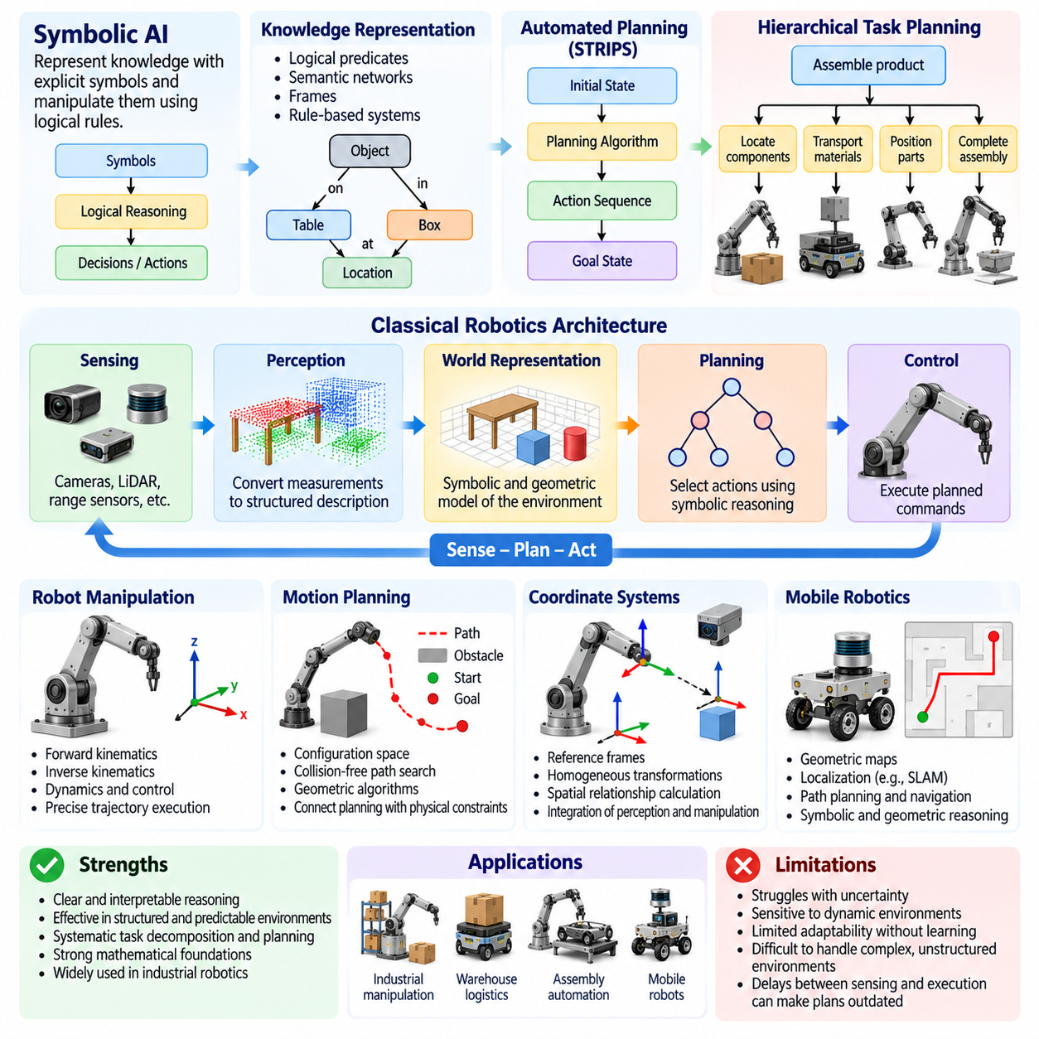
Symbolic artificial intelligence emerged as a dominant approach to machine intelligence during the early decades of AI research. It proposed that intelligent behavior could be produced by representing knowledge through explicit symbols and manipulating those symbols according to logical rules. This perspective strongly influenced classical robotics, where machines were designed to perceive structured environments, construct internal representations, generate plans, and execute actions through predefined computational procedures.
The central assumption of symbolic AI was that reasoning could be expressed as operations over meaningful representations. Objects, locations, relationships, and goals were encoded using symbols that a computer could process systematically. Logical inference mechanisms transformed these representations into conclusions or decisions. In robotics, this approach enabled machines to reason about spatial arrangements, task dependencies, and action sequences without requiring direct learning from extensive physical experience.
Knowledge representation became a fundamental component of symbolic intelligent systems. Researchers developed logical predicates, semantic networks, frames, and rule-based structures to describe objects and their relationships. A robot operating in a warehouse, for example, could represent shelves, containers, and destinations as symbolic entities. Such representations supported explicit reasoning about where objects belonged, which actions were permitted, and how tasks could be organized into executable procedures.
Classical robotics adopted a hierarchical approach in which perception, planning, and control were organized into distinct functional stages. Sensors collected environmental information, perception algorithms converted measurements into structured descriptions, and planning modules selected appropriate actions. Controllers then translated planned commands into physical movement. This sequential architecture provided a clear engineering framework but often struggled when environments changed faster than the system could update its internal model.
The sense-plan-act paradigm became one of the defining architectures of classical intelligent robotics. A robot first observed its surroundings, then constructed or updated a world representation, and finally calculated an action sequence intended to achieve its objectives. This architecture was effective when environments were predictable and sufficiently structured. However, delays between sensing and execution could make plans outdated when obstacles moved or unexpected interactions occurred.
Automated planning provided the computational foundation for converting symbolic goals into sequences of executable actions. Planning systems represented each action through conditions that had to be satisfied before execution and effects expected afterward. Algorithms searched for action sequences capable of transforming an initial state into a desired goal state. These methods introduced systematic task reasoning but frequently assumed that actions produced predictable outcomes within a simplified environment.
The STRIPS framework became particularly influential in symbolic planning for robotics. It described actions through preconditions, addition effects, and deletion effects, allowing planners to reason about discrete state transitions. A robot could determine that moving an object required first reaching its location and establishing an appropriate grasp. Although STRIPS enabled formal reasoning, its simplified assumptions made uncertainty, continuous motion, and unexpected physical interactions difficult to represent directly.
Hierarchical task planning extended symbolic reasoning by decomposing complex objectives into smaller, manageable operations. A high-level instruction such as assembling a product could be divided into locating components, transporting materials, positioning parts, and completing assembly steps. This decomposition improved the organization of complex robotic tasks. It also established conceptual foundations for modern task planners that coordinate multiple skills and low-level controllers.
Classical robotic manipulation developed alongside symbolic planning through advances in kinematics, dynamics, and motion control. Forward kinematics described how joint configurations determine an end-effector position, while inverse kinematics calculated joint configurations required to reach a desired pose. Dynamic models described forces and motion. These mathematical foundations allowed industrial manipulators to execute precise trajectories, although their effectiveness depended on accurate models and controlled operating conditions.
Motion planning introduced methods for determining collision-free paths through geometric environments. Configuration space represented possible robot configurations, while obstacles defined regions that could not be occupied safely. Algorithms searched for feasible paths connecting initial and target configurations. These techniques connected abstract planning with physical constraints, demonstrating that intelligent robotic action required both logical reasoning and mathematical descriptions of geometry and motion.
The development of robotic coordinate systems and geometric transformations was essential for integrating perception with manipulation. Robots needed consistent representations of object positions, sensor measurements, and actuator configurations. Homogeneous transformations and reference frames enabled spatial relationships to be calculated systematically. These methods remain fundamental to robot localization, manipulation, navigation, and the coordination of multiple mechanical components.
Classical mobile robotics similarly relied on geometric maps, localization methods, and path-planning algorithms. Robots represented their environments through landmarks, occupancy descriptions, or structured geometric models. Navigation systems estimated current position and calculated routes toward designated destinations. Early approaches frequently assumed that maps were sufficiently accurate and environmental conditions remained stable, creating difficulties when robots encountered unexpected obstacles or localization errors.
Expert systems contributed another important dimension to symbolic robotics by encoding specialized knowledge as explicit rules. Such systems could represent operational procedures, diagnostic relationships, and decision conditions. In industrial automation, rule-based reasoning supported fault diagnosis, process monitoring, and supervisory control. However, maintaining large rule collections became increasingly difficult as operating environments and system interactions grew more complex.
A major limitation of symbolic AI was the knowledge acquisition bottleneck. Engineers had to define relevant objects, relationships, rules, and exceptions before a system could reason effectively. Real physical environments contain enormous numbers of possible states and interactions, making complete symbolic descriptions impractical. As complexity increased, maintaining accurate knowledge bases required substantial effort and frequently failed to capture unexpected environmental variations.
The symbol grounding problem exposed a deeper challenge in connecting abstract representations with physical experience. A symbolic system might manipulate the concept of a chair without understanding how chairs appear under different lighting conditions or how they can be physically approached. Grounding requires connecting symbols to sensory observations, physical properties, and actionable interactions. This problem became central to later developments in embodied intelligence and learning-based robotic perception.
Classical robotics also faced difficulties associated with uncertainty and partial observability. Sensors generated noisy measurements, objects could become occluded, and physical actions did not always produce their expected effects. Traditional symbolic planning often treated states as discrete and sufficiently known, while real-world operation required continuous estimation and correction. These limitations encouraged the development of probabilistic robotics, feedback-driven architectures, and more adaptive decision-making methods.
Computational complexity further restricted the scalability of symbolic planning. As the number of objects, possible actions, and environmental conditions increased, the search space could grow rapidly. Finding an optimal action sequence became computationally expensive, especially for long-horizon tasks. Heuristic search, abstraction, and hierarchical decomposition reduced some difficulties but did not eliminate the fundamental challenges of planning in large, dynamic physical environments.
Despite these limitations, symbolic AI provided important advantages through interpretability and explicit structure. Rules, goals, and planning assumptions could be inspected and modified by human engineers. Logical constraints could represent operational requirements, while task plans could be analyzed before execution. These characteristics remain valuable in safety-sensitive applications where system behavior must be understandable, auditable, and consistent with defined operating procedures.
The transition toward modern robotics did not eliminate symbolic methods but increasingly combined them with reactive control, probabilistic estimation, and machine learning. Symbolic planners could define high-level objectives while lower-level controllers responded continuously to environmental feedback. Learned perception models supplied structured observations, and adaptive policies handled situations that were difficult to describe through fixed rules. This integration addressed weaknesses of purely sequential reasoning architectures.
Modern Physical AI continues to benefit from the conceptual foundations established by symbolic AI and classical robotics. Task decomposition, logical constraints, geometric reasoning, and structured planning remain important for organizing complex autonomous behavior. However, these capabilities must operate alongside learned representations, predictive world models, uncertainty estimation, and real-time control. Physical intelligence therefore emerges from the integration of explicit reasoning with adaptive interaction rather than from symbolic computation alone.
The historical significance of symbolic AI and classical robotics lies in their systematic treatment of intelligence as a process involving representation, reasoning, planning, and action. They established formal methods for translating abstract objectives into physical operations and clarified the limitations of purely model-driven autonomy. Contemporary Physical AI builds upon these achievements by combining structured reasoning with perception, learning, prediction, and continuous feedback to support increasingly capable autonomous systems.

03.04. Behavior Based Robotics
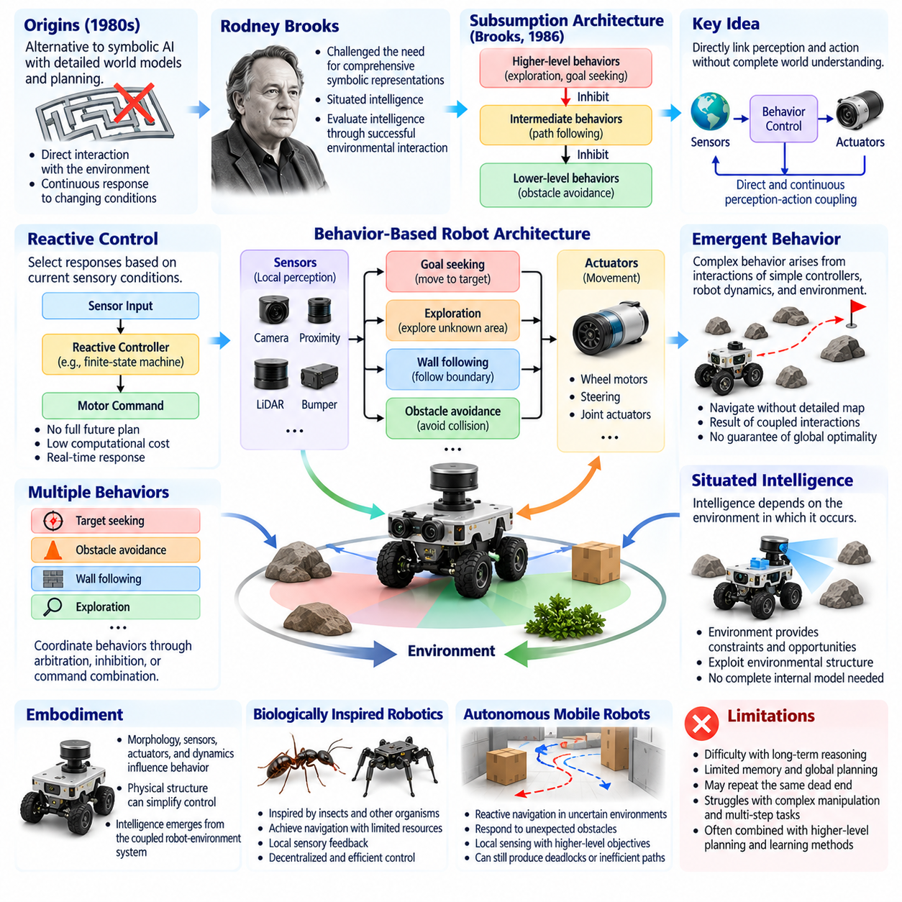
Behavior-based robotics emerged during the 1980s as an alternative to traditional symbolic approaches that depended on detailed world models and sequential planning. Researchers argued that intelligent behavior could arise from direct interactions between sensors, control mechanisms, and the environment. Instead of requiring complete environmental understanding before acting, robots could respond continuously to changing conditions through relatively simple behavioral mechanisms.
Rodney Brooks became a central figure in behavior-based robotics by challenging the assumption that intelligent machines required comprehensive symbolic representations. His research emphasized situated intelligence, where meaningful behavior emerges through continuous engagement with the physical world. This perspective suggested that intelligence should be evaluated through successful environmental interaction rather than exclusively through abstract reasoning or internal computational complexity.
The subsumption architecture, introduced by Brooks in 1986, provided a practical framework for organizing behavior-based robotic systems. It arranged control capabilities into layers that could operate concurrently, with higher layers able to suppress or inhibit selected lower-layer signals. Basic behaviors such as obstacle avoidance remained available while more sophisticated behaviors supported exploration and goal-directed movement. This organization reduced dependence on centralized planning.
A fundamental principle of behavior-based robotics is the close coupling between perception and action. Sensor measurements can directly influence motor commands without requiring complete symbolic interpretation. A mobile robot detecting an obstacle may immediately adjust its steering direction while continuing toward a destination. This rapid response is particularly valuable in dynamic environments where delays associated with extensive planning could reduce safety or operational effectiveness.
Reactive control forms the operational foundation of many behavior-based systems. Rather than calculating an entire future action sequence, a reactive controller selects responses according to current sensory conditions. Such controllers can be implemented through finite-state machines, simple control laws, or sensor-driven rules. Their limited computational requirements make them suitable for robots operating with constrained processors and demanding real-time response requirements.
Behavior-based architectures frequently distribute control responsibilities among multiple specialized behaviors. Obstacle avoidance, wall following, target seeking, and exploration may operate as independent modules. Their outputs must be coordinated through arbitration, inhibition, prioritization, or command combination. This modular organization simplifies individual behaviors but introduces challenges when competing behaviors produce incompatible commands or conflicting objectives.
The concept of emergence became closely associated with behavior-based robotics. Complex system-level behavior can arise from interactions among simple controllers, physical dynamics, and environmental structures. A robot may navigate around obstacles without maintaining a detailed geometric map if local avoidance and goal-seeking mechanisms are appropriately coordinated. However, emergent behavior does not automatically guarantee global efficiency, task completion, or safety under unfamiliar conditions.
Situated intelligence emphasizes that intelligent behavior cannot be understood independently of the environment in which it occurs. The physical world supplies constraints, opportunities, and information that shape an agent's actions. Rather than reproducing every environmental detail internally, a robot can exploit environmental structure through direct sensing and interaction. This principle challenged the assumption that comprehensive internal modeling was always necessary for effective autonomy.
Embodiment further strengthened the theoretical foundations of behavior-based robotics. A robot's morphology, sensors, actuators, and mechanical dynamics influence which behaviors are possible and how they emerge. Physical structure can simplify control by naturally constraining movement or stabilizing interactions. Consequently, intelligence becomes a property of the coupled robot-environment system rather than an isolated computational process operating independently of physical embodiment.
Biologically inspired robotics provided important examples of behavior-based design. Researchers examined how insects and other organisms achieve navigation, obstacle avoidance, and coordinated movement with limited neural resources. These observations motivated compact control architectures that relied on local sensory feedback. Although biological behavior cannot always be reproduced through simple engineering rules, such approaches demonstrated the potential of decentralized and efficient sensorimotor coordination.
Behavior-based robotics also influenced the development of autonomous mobile robots capable of operating in uncertain environments. Reactive navigation allowed robots to respond to unexpected obstacles without reconstructing complete plans after every environmental change. Local sensing supported immediate movement adjustments, while higher-level behaviors maintained broader objectives. This combination improved practical responsiveness but could still produce deadlocks, oscillations, or inefficient trajectories.
One limitation of purely reactive systems is their difficulty handling tasks that require long-term reasoning or memory. A robot relying exclusively on immediate sensor measurements may repeatedly enter the same dead end or fail to recognize that a temporary detour is necessary. Complex manipulation, multi-step assembly, and strategic navigation often require internal state representations and planning. These limitations encouraged hybrid architectures combining reactive behaviors with deliberative reasoning.
Hybrid deliberative-reactive architectures attempted to preserve the responsiveness of behavior-based control while incorporating structured planning. A deliberative layer could select destinations or task objectives, while reactive modules handled immediate obstacle avoidance and motion correction. Intermediate coordination mechanisms translated abstract goals into executable behaviors. This arrangement became influential in practical autonomous robotics because it balanced strategic reasoning with real-time environmental adaptation.
Behavior-based robotics contributed significantly to the understanding of robustness in autonomous systems. Local feedback can allow a robot to continue functioning when environmental assumptions change or some measurements become unreliable. Modular behaviors may also support graceful degradation when individual capabilities fail. Nevertheless, robustness depends on appropriate behavior coordination, sensor coverage, and system design rather than emerging automatically from decentralization.
The approach also revealed important challenges in verification and performance evaluation. Because behavior emerges through interactions among multiple controllers and environmental conditions, predicting every possible outcome can be difficult. Testing individual modules does not necessarily establish the correctness of the complete system. Reliable deployment therefore requires integrated testing, scenario coverage, safety constraints, and systematic evaluation under realistic operating conditions.
Modern reinforcement learning and robot learning share several conceptual connections with behavior-based robotics. Learned policies frequently map sensory observations directly to actions, resembling reactive sensorimotor control. However, neural policies may encode complex internal representations and exploit experience accumulated across many training episodes. The historical connection lies in emphasizing interaction-driven behavior, while modern learning methods extend the approach through data-driven adaptation and generalization.
Behavior-based principles remain important in contemporary Physical AI architectures. Low-level safety reactions, collision avoidance, balance recovery, and emergency responses often require rapid action without waiting for extensive high-level reasoning. These capabilities can operate alongside learned perception, predictive world models, and task planners. The resulting systems combine immediate responsiveness with more sophisticated anticipation, reasoning, and coordinated decision-making.
The relationship between behavior-based robotics and predictive intelligence illustrates an important architectural distinction. Reactive systems primarily respond to current observations, whereas predictive systems estimate possible future states before selecting actions. Neither approach is universally sufficient. Effective Physical AI frequently requires reactive mechanisms for immediate stabilization and predictive reasoning for anticipating hazards, managing uncertainty, and accomplishing longer-horizon objectives.
Behavior-based robotics also influenced distributed and multi-robot systems by demonstrating how coordinated outcomes can emerge from relatively simple local interactions. Multiple robots may follow local collision-avoidance, spacing, and movement rules while collectively producing organized behavior. Such approaches can reduce centralized coordination requirements, although communication, shared objectives, and conflict resolution remain important for reliable collective operation.
The historical significance of behavior-based robotics lies in its rejection of the assumption that intelligence must begin with complete symbolic understanding. It demonstrated that meaningful autonomous behavior can emerge through continuous sensing, physical interaction, and coordinated control mechanisms. Modern Physical AI extends this foundation by integrating reactive behavior with learning, memory, prediction, and planning, creating systems capable of both immediate adaptation and increasingly sophisticated goal-directed physical intelligence.

03.05. Probabilistic Robotics and SLAM
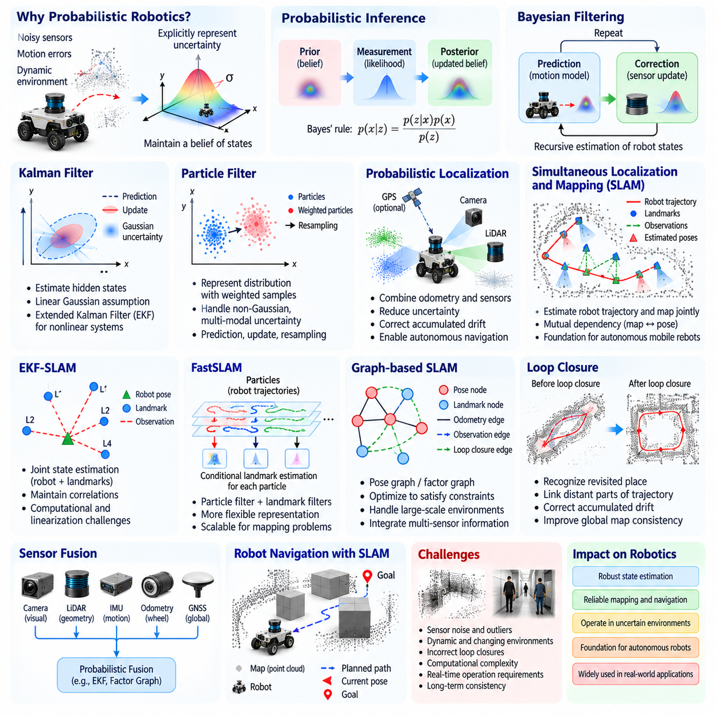
Probabilistic robotics emerged as a major development in autonomous systems by recognizing that physical environments cannot be understood through perfectly accurate measurements or deterministic models. Sensors produce noisy observations, actuators introduce motion errors, and environmental conditions change unpredictably. Instead of assuming complete knowledge, probabilistic robotics represents uncertainty explicitly and uses mathematical inference to estimate the most plausible states of robots and their surroundings.
The theoretical foundation of probabilistic robotics lies in probability theory, Bayesian inference, and stochastic state estimation. A robot maintains a belief about its possible states rather than relying exclusively on a single assumed position or configuration. As new sensor measurements arrive, this belief is updated according to the likelihood of observations and predictions from motion models. Such reasoning enables autonomous systems to operate despite incomplete, ambiguous, or unreliable information.
Bayesian filtering became a central framework for estimating robot states over time. The prediction stage uses a motion model to estimate how the robot's state may evolve after an action. The correction stage incorporates sensor observations to revise the predicted distribution. Repeating these operations produces a continuously updated belief state. This recursive structure connects probabilistic inference with the feedback principles that historically shaped autonomous robotics.
The Kalman filter provided an important early foundation for probabilistic state estimation. It combines predictions and measurements to estimate hidden states while accounting for uncertainty under linear Gaussian assumptions. Extended Kalman filters later enabled approximate estimation for nonlinear robotic systems through local linearization. These methods became widely used in navigation, tracking, and sensor fusion, although strong nonlinearities and non-Gaussian uncertainty can limit their accuracy.
Particle filters introduced a more flexible approach by representing probability distributions through collections of weighted samples. Each particle describes a possible robot state, and its weight reflects consistency with available observations. Prediction, measurement updating, and resampling allow the distribution to evolve as the robot moves. Particle filtering is especially useful when uncertainty is multimodal, such as when a robot may occupy several plausible locations.
Probabilistic localization transformed mobile robotics by allowing robots to estimate their positions despite uncertain motion and sensing. Wheel odometry accumulates errors as a robot travels, while cameras, LiDAR, and other sensors provide observations of surrounding structures. By combining these information sources, localization algorithms can reduce uncertainty and correct accumulated drift. Reliable localization became a prerequisite for autonomous navigation in large or changing environments.
Simultaneous Localization and Mapping, commonly called SLAM, addressed the interconnected problem of estimating a robot's trajectory while constructing a map of an initially unknown environment. Localization requires a map, while mapping requires knowledge of the robot's position. SLAM resolves this dependency by estimating both quantities jointly from motion information and environmental observations. This capability became a foundational technology for autonomous mobile robots and spatial intelligence.
Early SLAM research developed from probabilistic estimation and geometric mapping during the 1980s and 1990s. Researchers recognized that uncertainty in robot position and landmark locations must be considered together. Measurements of shared landmarks create statistical relationships between different estimated states. Maintaining these relationships allows later observations to correct earlier errors, supporting globally consistent maps rather than collections of disconnected local measurements.
Extended Kalman Filter SLAM represented robot poses and landmark positions within a joint probabilistic state estimate. As the robot observed landmarks, the filter updated both their estimated locations and associated uncertainty. This approach demonstrated the importance of preserving correlations between robot and map states. However, increasing map size introduced computational and linearization challenges, motivating alternative formulations for larger environments.
FastSLAM combined particle filtering with conditional landmark estimation to improve flexibility in certain mapping problems. Particles represented possible robot trajectories, while individual landmark estimates were maintained conditionally on those trajectories. This factorization reduced some computational difficulties associated with traditional joint-state filtering. Its development illustrated how probabilistic graphical structure could be exploited to improve robotic estimation algorithms.
Graph-based SLAM introduced another influential representation by expressing robot poses and environmental measurements as a network of constraints. Nodes describe unknown poses or landmarks, while edges represent relative observations and motion relationships. Optimization algorithms seek configurations that best satisfy these constraints. This formulation supports large-scale mapping and provides a natural mechanism for incorporating information collected across extended trajectories.
Loop closure became a critical capability in practical SLAM systems. When a robot revisits a previously observed location, recognizing that place provides constraints linking distant portions of its trajectory. These constraints can correct accumulated drift and improve overall map consistency. Incorrect loop closures, however, may distort an entire map, making reliable place recognition and robust estimation essential components of autonomous spatial understanding.
Visual SLAM expanded mapping capabilities by using cameras to estimate motion and reconstruct environmental structure. Feature-based methods track distinctive image elements across frames, while direct methods exploit image intensity information. Monocular, stereo, and RGB-D cameras offer different tradeoffs in scale estimation, depth measurement, and computational requirements. Visual SLAM became particularly important for compact robots and platforms where cameras provide rich environmental information.
LiDAR-based SLAM uses laser range measurements to estimate geometric structure and robot movement. Scan matching aligns observations collected at different positions, while mapping algorithms accumulate spatial information into consistent representations. LiDAR often provides accurate geometric measurements, although reflective surfaces, sparse features, and dynamic objects introduce challenges. Combining LiDAR with inertial measurements can improve motion estimation and operational robustness.
Sensor fusion became increasingly important because no individual sensor provides complete and reliable environmental information. Cameras offer appearance and semantic cues, LiDAR provides geometric measurements, inertial sensors capture short-term motion, and wheel encoders estimate displacement. Probabilistic fusion combines complementary observations while accounting for their uncertainty. This approach improves localization and mapping when individual sensing modalities become degraded or temporarily unavailable.
Occupancy grid mapping introduced a practical probabilistic representation of free and occupied space. The environment is divided into cells, each associated with an estimated occupancy probability. Sensor observations update these probabilities as the robot explores. Such maps support collision avoidance and path planning without requiring complete semantic understanding of every object. Their probabilistic structure also accommodates uncertainty in measurements and partially observed regions.
Probabilistic robotics changed how autonomous systems interpreted environmental knowledge. Instead of treating a map as an unquestionable description of reality, a robot could maintain estimates with varying confidence. Uncertain regions might require additional observations, while reliable landmarks could support navigation decisions. This perspective established an important connection between perception, uncertainty estimation, and active information gathering.
Active SLAM extended conventional mapping by allowing robots to choose movements that improve both task progress and environmental knowledge. A robot may explore an unfamiliar corridor to reduce map uncertainty or revisit a known landmark to improve localization. Such decisions balance information gain, travel cost, and operational risk. Active SLAM therefore connects probabilistic perception with planning and introduces an early form of uncertainty-aware physical decision-making.
Despite major advances, probabilistic localization and mapping remain sensitive to assumptions about sensor noise, environmental structure, and data association. Dynamic objects can violate static-world assumptions, repetitive environments can confuse place recognition, and long-term environmental changes can invalidate stored maps. Robust systems must therefore detect inconsistent observations, manage uncertainty, and update spatial representations as operating conditions evolve.
The historical significance of probabilistic robotics lies in its replacement of deterministic environmental assumptions with explicit uncertainty-aware inference. SLAM demonstrated that robots could construct useful spatial knowledge while simultaneously estimating their own movement. Modern Physical AI extends these foundations through learned perception, semantic mapping, predictive world models, and adaptive planning. Probabilistic reasoning remains essential for connecting imperfect observations with reliable autonomous action.

03.06. Machine Learning for Robotics
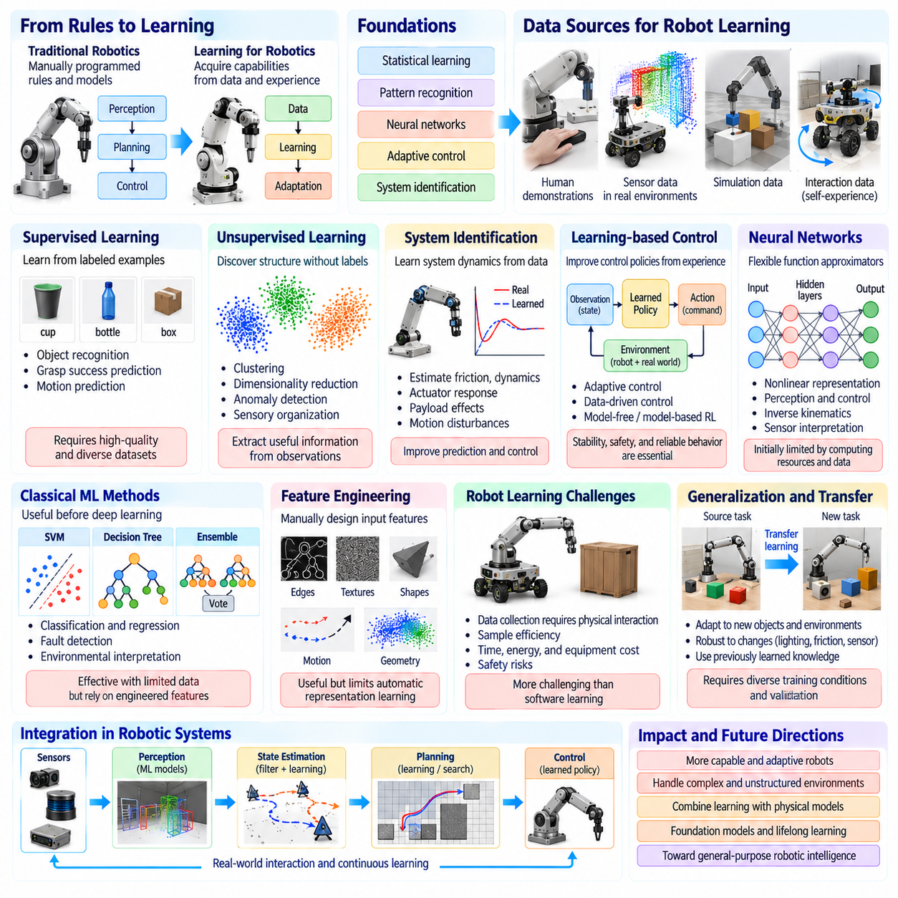
Machine learning introduced a major transformation in robotics by enabling machines to acquire capabilities from data rather than relying entirely on manually programmed rules and mathematical models. Traditional robotic systems required engineers to specify perception algorithms, decision procedures, and control strategies explicitly. Learning-based approaches allowed robots to discover useful patterns from observations, demonstrations, and interactions, creating new opportunities for adaptation in complex physical environments.
The foundations of machine learning for robotics emerged from developments in statistical learning, pattern recognition, neural networks, and adaptive control. Early researchers explored how computational systems could improve performance through experience rather than fixed instructions. In robotics, these ideas were applied to object recognition, motion prediction, system identification, and control optimization. The resulting methods gradually connected statistical inference with physical action and autonomous decision-making.
Supervised learning became an important approach for training robotic perception and prediction systems. Algorithms learned relationships between input measurements and labeled outputs using examples collected from sensors or experimental environments. A robot could learn to classify objects, estimate grasp success, or predict mechanical responses from recorded data. However, supervised learning depended heavily on the quality, diversity, and representativeness of available training datasets.
Unsupervised learning offered methods for discovering structure in robotic data without requiring explicit labels. Clustering algorithms could identify recurring environmental patterns, while dimensionality reduction techniques compressed high-dimensional sensor measurements into manageable representations. These capabilities supported anomaly detection, sensory organization, and exploratory analysis. They also demonstrated how robots could extract useful information from observations without complete human supervision.
System identification became a particularly important application of machine learning in robotics. Instead of assuming that every mechanical parameter was known precisely, researchers estimated dynamic relationships from measured inputs and outputs. Learned models could describe friction, actuator response, payload effects, or motion disturbances. Such models improved prediction and control, although their reliability depended on sufficient excitation, representative operating conditions, and appropriate uncertainty management.
Learning-based control extended classical control theory by allowing control policies or model parameters to improve through experience. Adaptive methods adjusted controller behavior when system dynamics changed, while data-driven approaches learned relationships between observations and suitable actions. These techniques were especially useful when accurate analytical models were unavailable. Nevertheless, stability, safety, and predictable behavior remained essential requirements during learning and deployment.
Artificial neural networks provided flexible function approximators for robotic applications. By combining interconnected computational units, neural networks could represent nonlinear relationships that were difficult to describe through conventional equations. Early robotic applications included sensor interpretation, inverse kinematics approximation, and motor control. Their practical effectiveness was initially constrained by limited computing resources, relatively small datasets, and difficulties in training complex models.
Support vector machines, decision trees, and ensemble learning methods also contributed to robotic intelligence before deep learning became dominant. These algorithms supported classification, regression, fault detection, and environmental interpretation using engineered features. Their comparatively structured training procedures made them useful for applications with limited data. However, performance often depended on careful feature selection and assumptions about the underlying data distribution.
Feature engineering played a central role in early machine-learning-based robotics. Engineers manually designed descriptors representing edges, textures, shapes, motion patterns, or geometric relationships. Learning algorithms then used these features to recognize objects or predict environmental conditions. This separation between feature construction and statistical learning provided practical results but limited the ability of systems to discover complex representations automatically.
Robot learning introduced the additional challenge that data collection frequently requires physical interaction. Unlike software systems that can process stored examples repeatedly, robots may need to move, manipulate objects, or contact surfaces to acquire useful experience. These activities consume time, energy, and equipment resources while introducing safety risks. Consequently, sample efficiency became a fundamental concern in developing practical learning algorithms for physical systems.
Generalization emerged as another central challenge because robots must operate beyond the exact conditions represented in their training data. Changes in lighting, object geometry, surface friction, payload, or sensor placement can reduce model accuracy. A system that performs successfully in a laboratory may fail in an unfamiliar operating environment. Robust robot learning therefore requires diverse training conditions, careful validation, and mechanisms for detecting distribution shifts.
Transfer learning offered a strategy for reusing previously acquired knowledge across related robotic tasks. A model trained on one collection of objects or environments could provide useful representations for another application. Fine-tuning adapted existing parameters using additional task-specific data, reducing the need to train every capability from the beginning. However, differences between robot platforms, sensing configurations, and physical dynamics could limit successful transfer.
Learning from demonstration provided an alternative to manually specifying every robotic behavior. Human operators or expert controllers generated examples of successful actions, which learning algorithms used to construct policies. This approach was particularly attractive for manipulation tasks where precise rules were difficult to formulate. Demonstrations supplied practical knowledge about task execution, although limited coverage and accumulated imitation errors could restrict performance.
Machine learning also strengthened probabilistic robotics by improving perception models, measurement interpretation, and environmental prediction. Learned classifiers could identify landmarks, distinguish objects, or estimate observation reliability. Statistical models could complement geometric localization and mapping algorithms by providing additional semantic information. This integration connected data-driven pattern recognition with uncertainty-aware state estimation and traditional robotic navigation.
The historical importance of machine learning for robotics lies in its transition from explicitly engineered intelligence toward capabilities acquired through experience. It established methods for learning perception, prediction, and control while revealing challenges involving data efficiency, generalization, and physical safety. Modern Physical AI extends these foundations through deep learning, reinforcement learning, foundation models, and world models, integrating learned intelligence with reliable real-world interaction.

03.07. Deep Learning and Robot Perception
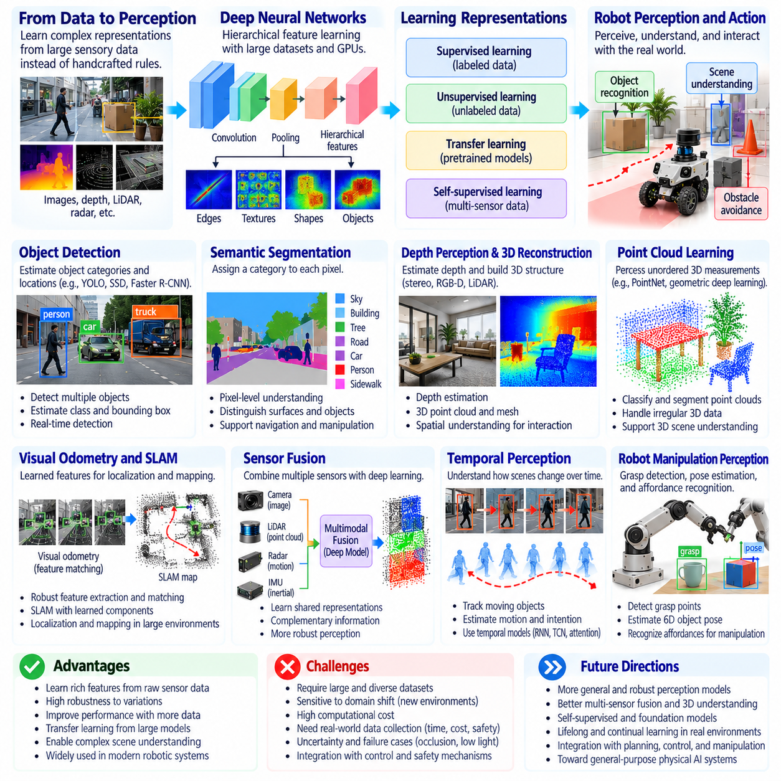
Deep learning transformed robot perception by enabling machines to learn complex representations directly from large collections of sensory data. Earlier robotic systems relied heavily on manually designed features and predefined recognition rules. Deep neural networks instead learned hierarchical patterns from images, depth measurements, and other sensor signals. This transition improved the ability of robots to interpret complex environments and established perception as a central capability of modern Physical AI.
The foundations of deep learning emerged from artificial neural networks, backpropagation, and advances in statistical optimization. Although multilayer neural networks had been investigated for decades, practical progress accelerated with larger datasets, improved algorithms, and graphics processing units. These developments made it possible to train models containing millions of parameters. Robotics benefited from this computational progress as perception systems became increasingly capable of learning from diverse environmental observations.
Convolutional neural networks became particularly influential in visual perception because they exploit spatial relationships within images. Convolutional layers learn local patterns such as edges, textures, and shapes, while deeper layers combine these patterns into more abstract representations. Pooling and hierarchical feature extraction help models recognize objects despite variations in position and appearance. These capabilities reduced dependence on handcrafted visual descriptors in robotic applications.
The success of deep convolutional networks in large-scale image recognition accelerated their adoption in robotics. Models trained on extensive visual datasets demonstrated that learned representations could outperform many traditional feature-engineering approaches. Transfer learning allowed robotic systems to reuse pretrained visual features and adapt them to specialized environments. This strategy reduced training requirements for applications involving industrial objects, warehouse inventory, and service robotics.
Object detection became a major application of deep learning in robotic perception. Detection networks estimate both object categories and their locations within images, providing information needed for navigation and manipulation. Architectures such as Faster R-CNN, SSD, and YOLO introduced different tradeoffs between recognition accuracy and computational speed. Real-time detection became especially important for mobile robots that must identify obstacles, people, and operational targets while moving.
Semantic segmentation extended visual recognition by assigning meaningful categories to individual image pixels. Instead of identifying only object boundaries through rectangular boxes, segmentation models describe the spatial distribution of surfaces and objects. A robot can distinguish floors, walls, machinery, and pedestrians at finer resolution. Instance segmentation further separates individual objects belonging to the same category, supporting grasp planning and scene interpretation.
Depth perception and three-dimensional reconstruction became increasingly important as robots required spatial understanding beyond two-dimensional images. Stereo cameras, RGB-D sensors, and LiDAR provide geometric information that can be processed through learned models. Neural networks estimate depth, reconstruct surfaces, and infer three-dimensional object structure. These capabilities support collision avoidance, manipulation, and navigation, although accuracy remains sensitive to sensor limitations and environmental conditions.
Point cloud learning introduced neural architectures designed to process unordered collections of three-dimensional measurements. Methods such as PointNet and subsequent geometric learning approaches enabled classification and segmentation directly from point clouds. Unlike conventional image networks, these models must account for irregular spatial sampling and geometric relationships. Their development expanded deep perception into autonomous driving, robotic inspection, and three-dimensional scene understanding.
Visual odometry and SLAM also benefited from deep learning through improved feature extraction, matching, and environmental interpretation. Learned visual descriptors can identify correspondences across changing viewpoints and illumination conditions. Neural depth estimation and semantic segmentation provide additional constraints for localization and mapping. However, learned components must still address geometric consistency, uncertainty, and accumulated drift to support reliable long-term navigation.
Sensor fusion became more powerful as deep learning enabled information from cameras, LiDAR, radar, and inertial sensors to be combined within shared representations. Multimodal networks learn complementary patterns across different sensing modalities. Visual information contributes appearance and semantic meaning, while range and motion measurements provide geometric and dynamic constraints. Effective fusion improves robustness, but synchronization errors and sensor failures remain significant engineering challenges.
Temporal perception extended deep learning beyond individual observations by modeling how scenes evolve over time. Recurrent neural networks, temporal convolutional models, and attention mechanisms can integrate sequences of sensory measurements. These approaches help robots track moving objects, estimate motion, and recognize activities. Temporal understanding is particularly important when a single observation cannot reveal an object's velocity, intention, or interaction history.
Robot manipulation benefited from deep visual perception through learned grasp detection, object pose estimation, and affordance recognition. Rather than relying exclusively on predefined geometric models, robots could infer suitable grasp locations and interaction possibilities from visual observations. Learned perception supported handling unfamiliar objects and variable arrangements. Nevertheless, reliable manipulation still required accurate calibration, contact feedback, and coordination between perception and control.
Dataset development became a critical factor in advancing deep robotic perception. Large annotated image collections supported object recognition, while specialized datasets provided depth, segmentation, tracking, and three-dimensional labels. Synthetic environments supplemented real-world recordings by generating diverse scenes and controlled variations. However, dataset bias, annotation errors, and differences between simulated and physical environments continued to affect model generalization.
Robustness and safety emerged as major concerns because high recognition accuracy on benchmark datasets does not guarantee dependable operation in physical environments. Lighting changes, motion blur, occlusion, reflective materials, and unfamiliar objects can degrade perception performance. Errors may propagate into planning and control, creating physical risks. Reliable systems therefore require uncertainty estimation, continuous monitoring, validation, and appropriate fallback mechanisms.
The historical significance of deep learning in robot perception lies in its ability to replace many manually engineered representations with learned hierarchical features. It expanded robotic understanding from basic object recognition toward semantic, geometric, and temporal interpretation of complex scenes. Modern Physical AI builds upon these advances by integrating deep perception with multimodal reasoning, world models, and action policies, connecting sensory understanding with adaptive physical behavior.

03.08. Deep Reinforcement Learning
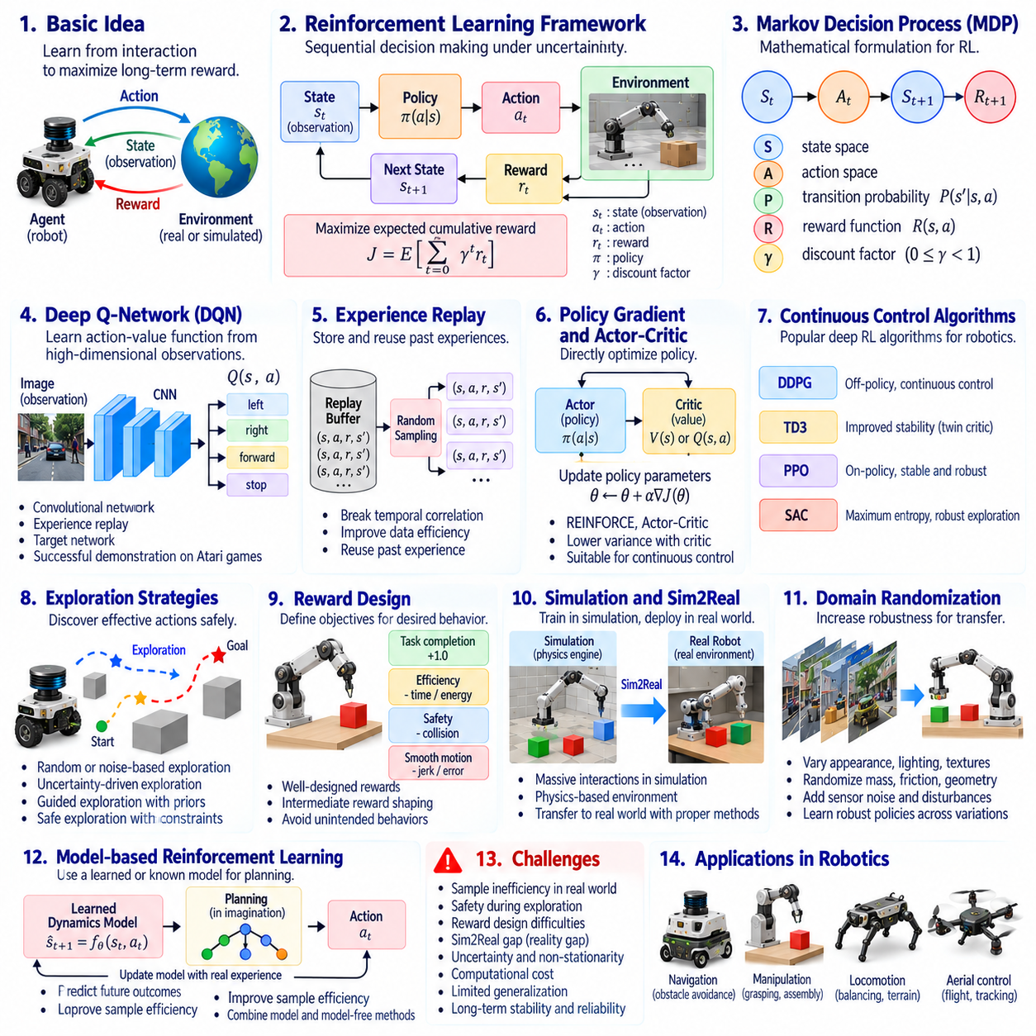
Deep reinforcement learning emerged as a major advancement in artificial intelligence by combining reinforcement learning with deep neural networks. Traditional reinforcement learning enabled agents to improve behavior through rewards and penalties, but struggled with large or continuous state spaces. Deep learning provided powerful function approximation, allowing agents to learn policies directly from complex observations. This integration opened new possibilities for autonomous robotic decision-making.
The theoretical foundations of reinforcement learning originate from sequential decision theory, dynamic programming, and behavioral learning. An agent interacts with an environment by observing its current state, selecting an action, and receiving a reward. The objective is to maximize expected cumulative reward over time rather than optimize each immediate action independently. This formulation established a framework for learning behavior through repeated interaction and delayed consequences.
Markov decision processes provide the mathematical foundation for many reinforcement learning algorithms. A process defines states, actions, transition probabilities, rewards, and a discount factor for future outcomes. The agent learns a policy that determines which actions should be selected under different conditions. Value functions estimate expected future returns, enabling algorithms to compare alternative decisions and improve behavior through experience.
Deep Q-Networks demonstrated that neural networks could approximate action-value functions from high-dimensional sensory inputs. The influential DQN approach combined convolutional networks with experience replay and target networks to improve training stability. Its success on Atari games demonstrated that agents could learn effective control policies from visual observations. Although these environments were simulated, the results encouraged research into learning robotic behavior from raw sensor data.
Experience replay became an important mechanism for improving the efficiency of deep reinforcement learning. Instead of learning exclusively from consecutive interactions, agents store transitions containing observations, actions, rewards, and subsequent states. Randomly sampled experiences reduce temporal correlations and allow previously collected data to support repeated updates. However, replay-based methods must account for changes in data distributions and limitations in exploration coverage.
Policy gradient methods introduced a different approach by optimizing parameterized policies directly. Rather than estimating only the value of individual actions, these algorithms adjust policy parameters according to expected performance improvements. Actor-critic architectures combine a policy model with a value estimator to reduce learning variance. These methods became important for robotic systems requiring continuous control over joint positions, velocities, and actuator commands.
Algorithms such as DDPG, TD3, PPO, and Soft Actor-Critic expanded the practical application of deep reinforcement learning. They introduced different mechanisms for stabilizing optimization, improving exploration, and managing continuous action spaces. Off-policy approaches can reuse stored experience, while on-policy methods generally require newly collected trajectories. Selecting an algorithm involves balancing sample efficiency, stability, computational requirements, and task characteristics.
Exploration remains a fundamental challenge because robots must discover effective actions without exposing themselves to unacceptable risks. Random exploration can be useful in simulation but dangerous when transferred directly to physical machines. Exploration strategies may incorporate uncertainty estimates, action constraints, or previously learned behaviors. Safe reinforcement learning therefore attempts to improve policies while respecting operational limits and avoiding hazardous states.
Reward design strongly influences the behavior acquired through reinforcement learning. A poorly specified reward function may encourage unintended strategies that achieve numerical objectives without satisfying the actual task. Reward shaping can accelerate training by providing intermediate guidance, but may also introduce undesirable incentives. Successful robotic applications require reward definitions that reflect task completion, efficiency, safety, and physical constraints.
Simulation environments became essential for scaling deep reinforcement learning in robotics. Virtual robots can execute millions of interactions without consuming physical equipment or exposing operators to repeated training hazards. Physics engines approximate contact, friction, gravity, and actuator dynamics. Although simulation accelerates experimentation, differences between simulated and real environments create transfer challenges that must be addressed before deployment.
Domain randomization emerged as a strategy for improving transfer from simulation to physical robots. During training, environmental properties such as lighting, mass, friction, geometry, and sensor noise are varied systematically. The resulting policy encounters diverse conditions and may become less dependent on specific simulation assumptions. Nevertheless, randomization cannot guarantee successful transfer when important physical phenomena are missing or inaccurately modeled.
Model-based reinforcement learning seeks to improve sample efficiency by learning or using a predictive model of environmental dynamics. Instead of relying entirely on trial-and-error interaction, an agent can evaluate possible future outcomes before selecting actions. Learned dynamics models support planning and imagined trajectories, potentially reducing physical experimentation. Their effectiveness depends on prediction accuracy, uncertainty management, and the prevention of accumulated model errors.
Deep reinforcement learning has demonstrated promising results in robotic locomotion, manipulation, and navigation. Legged robots can learn balance and movement strategies, while manipulators can optimize grasping or object interaction. Mobile robots can acquire navigation policies adapted to environmental feedback. However, successful demonstrations often depend on carefully designed training conditions, extensive simulation, and additional safety mechanisms during real-world operation.
Hierarchical reinforcement learning addresses complex tasks by organizing decision-making across different temporal scales. High-level policies select objectives or reusable skills, while low-level controllers execute specific movements. This decomposition can improve learning efficiency and support long-horizon behavior. It also creates opportunities to combine learned motor skills with symbolic planning, task scheduling, and structured reasoning within larger robotic architectures.
The historical significance of deep reinforcement learning lies in demonstrating that sophisticated behavior can emerge through interaction-driven optimization rather than explicit programming alone. It expanded machine learning from perception and prediction toward autonomous action selection and control. Modern Physical AI builds upon these foundations by integrating learned policies with world models, multimodal perception, safety constraints, and hierarchical planning to support increasingly adaptive physical intelligence.

03.09. Imitation Learning and Robot Demonstrations
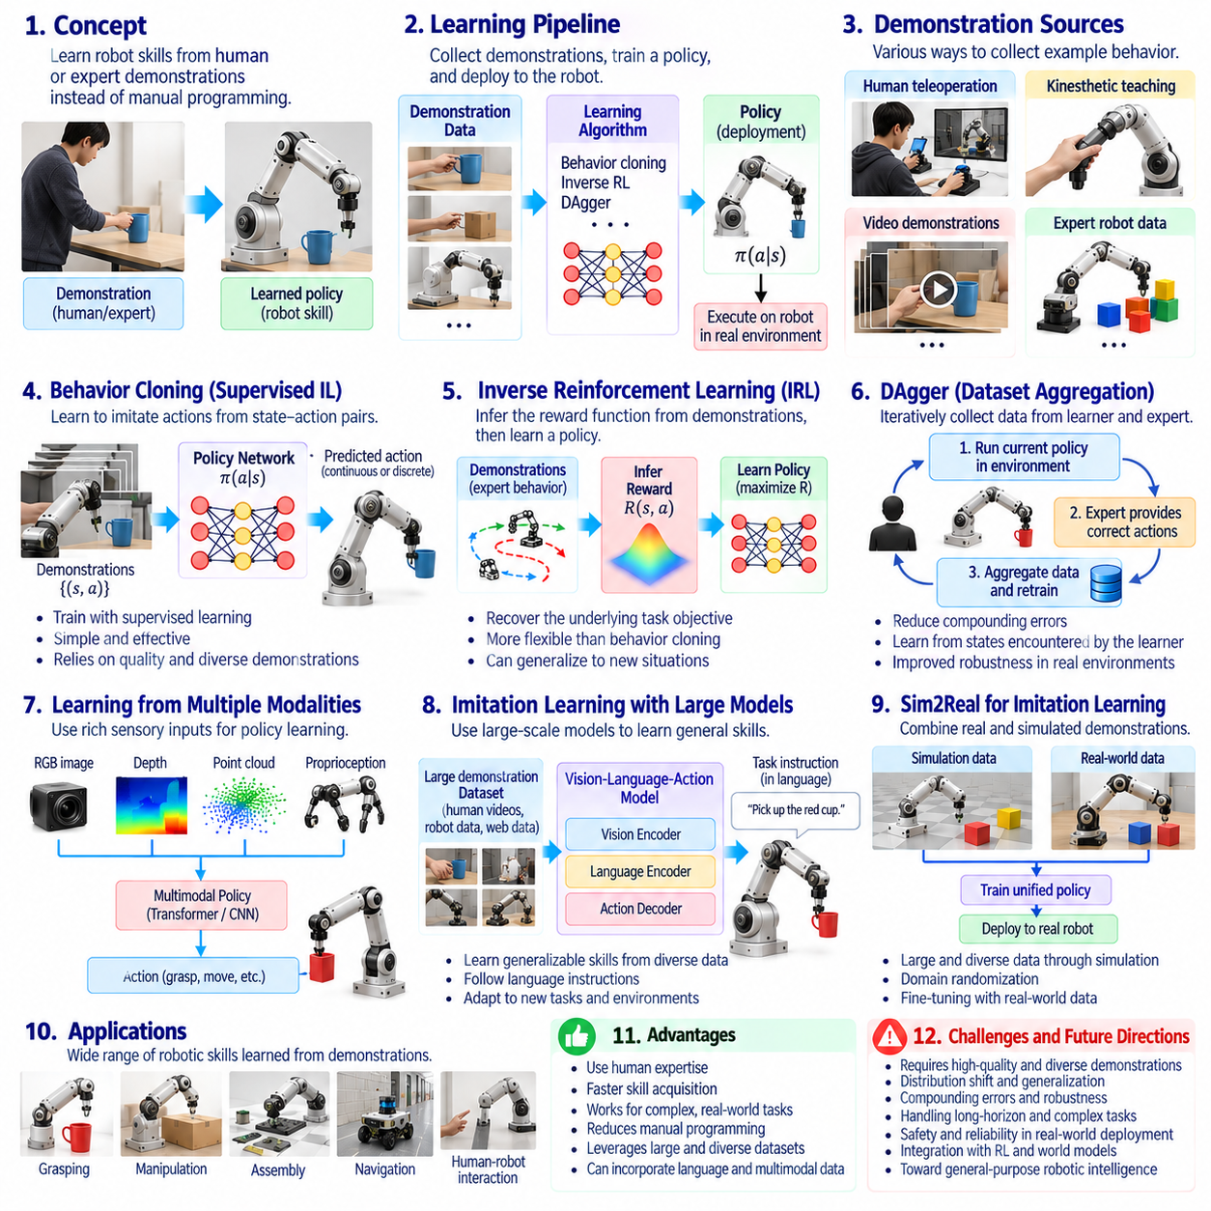
Imitation learning emerged as an important approach to robot intelligence by enabling machines to acquire behaviors from demonstrations rather than relying entirely on manually programmed rules or trial-and-error exploration. Human operators and expert controllers provide examples of successful task execution, allowing robots to learn relationships between observations and actions. This approach reduces the need for explicit behavioral programming and provides a practical foundation for acquiring complex physical skills.
The conceptual foundations of imitation learning originate from observational learning, statistical pattern recognition, and supervised machine learning. Instead of discovering every action independently, a robot observes how an expert responds to particular situations. Demonstrations contain information about task objectives, movement strategies, and environmental interactions. Learning algorithms extract these patterns and construct policies that approximate expert behavior under similar operating conditions.
Behavioral cloning became one of the earliest and most direct methods of imitation learning. It treats demonstrations as supervised training data, where sensory observations serve as inputs and expert actions serve as target outputs. A neural network or statistical model learns to predict appropriate actions from observed states. This method is relatively simple to implement, but its performance depends strongly on demonstration quality and coverage of relevant operating situations.
A major limitation of behavioral cloning is covariate shift, which occurs when a learned policy encounters states that differ from those represented in expert demonstrations. Small prediction errors may cause the robot to enter unfamiliar situations, leading to additional errors that accumulate over time. This problem is especially important in long-horizon tasks. Effective imitation learning therefore requires methods that improve recovery behavior and reduce dependence on ideal demonstration trajectories.
Dataset Aggregation, commonly known as DAgger, addressed distribution mismatch by repeatedly collecting states encountered by the learning policy and obtaining expert actions for those states. The resulting dataset gradually includes situations that the robot is likely to experience during actual execution. This iterative procedure improves robustness compared with purely offline behavioral cloning. However, it requires continued access to expert supervision and careful management of potentially unsafe exploration.
Inverse reinforcement learning introduced a different perspective by attempting to infer the underlying objectives that explain expert demonstrations. Rather than copying individual actions directly, the system estimates a reward function consistent with observed behavior. A policy can then be optimized using the inferred objective. This approach offers potential advantages when multiple action sequences can accomplish the same task, although reward ambiguity and computational complexity remain significant challenges.
Robot demonstrations can be collected through several forms of human-machine interaction. Teleoperation allows an operator to control robot movements remotely, while kinesthetic teaching involves physically guiding a robot through desired motions. Motion capture and wearable sensing systems can record human movements for later adaptation. Each method provides different levels of precision, accessibility, and correspondence between human actions and robot capabilities.
Demonstration quality plays a central role in the performance of imitation learning systems. Recorded trajectories must capture relevant observations, actions, timing, and task outcomes with sufficient accuracy. Inconsistent demonstrations may introduce conflicting behavioral patterns, while narrow datasets can limit generalization. Effective data collection therefore requires attention to calibration, synchronization, environmental diversity, and the representation of successful and unsuccessful task conditions.
Learning from human demonstrations introduces the challenge of embodiment differences between humans and robots. Human hands, joints, sensory capabilities, and movement constraints often differ substantially from robotic mechanisms. Directly reproducing human motion may therefore be impossible or inefficient. Retargeting methods transform demonstrated movements into robot-compatible trajectories, while task-space representations focus on functional objectives rather than exact anatomical correspondence.
Deep learning expanded imitation learning by enabling policies to process high-dimensional observations such as camera images, depth maps, and proprioceptive measurements. Neural networks can learn relationships between visual scenes and motor commands without requiring complete handcrafted representations. Recurrent models and attention mechanisms further support temporal dependencies across demonstrations. These developments enabled more complex visuomotor policies for robotic manipulation and navigation.
Learning from demonstrations became particularly influential in robotic manipulation because grasping and object interaction involve complicated contact dynamics. Human demonstrations provide examples of approach direction, grasp selection, object placement, and corrective movement. Imitation policies can acquire these patterns from recorded trajectories. Nevertheless, successful manipulation still depends on accurate perception, force control, and the ability to recover when physical interactions differ from training examples.
Offline imitation learning allows robots to acquire initial policies from previously collected datasets without repeatedly interacting with physical environments. Large demonstration collections can support training across multiple tasks, objects, and robot platforms. This approach improves data reuse and reduces some physical experimentation costs. However, differences in hardware, control interfaces, and environmental conditions can complicate transferring policies between datasets and deployed robots.
Combining imitation learning with reinforcement learning provides a practical strategy for improving robot performance. Demonstrations can initialize a policy with useful behaviors, reducing the need for extensive random exploration. Reinforcement learning can subsequently refine the policy through interaction and task-specific feedback. This combination is especially valuable when demonstrations provide reasonable starting behaviors but do not fully capture the precision, adaptability, or efficiency required for deployment.
Multitask imitation learning extends individual skill acquisition by training policies across diverse demonstrations and objectives. Shared representations can capture common structures among tasks such as reaching, grasping, transporting, and placing objects. Language instructions and task identifiers can condition policy behavior, enabling a single model to perform multiple operations. These developments contributed to the emergence of generalist robotic policies and large-scale robot foundation models.
The historical significance of imitation learning lies in establishing demonstrations as a direct source of robotic intelligence. It demonstrated that complex physical behaviors could be transferred from human expertise and recorded experience into autonomous control policies. Modern Physical AI extends this foundation through large-scale datasets, multimodal learning, reinforcement learning, and predictive world models, enabling robots to acquire increasingly diverse skills while maintaining the need for safety, generalization, and reliable physical execution.

03.10. Simulation and Sim2Real
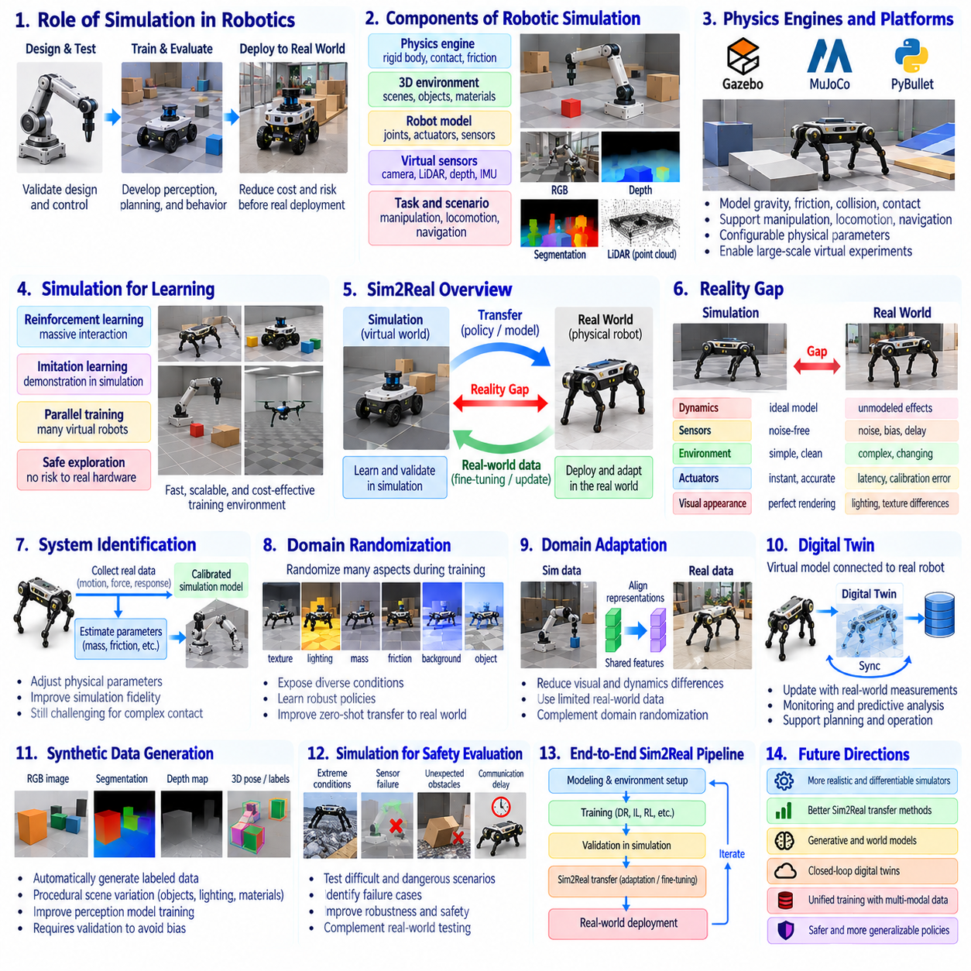
Simulation has played a fundamental role in robotics by providing controlled environments where machines can be designed, tested, and trained before operating in the physical world. Early simulation tools focused on mechanical motion, kinematics, and control-system verification. As computational capabilities improved, simulation evolved into a platform for developing perception, planning, and autonomous behavior. This progression established virtual experimentation as an essential foundation of Physical AI.
The historical foundations of robotic simulation emerged from numerical mechanics, computer graphics, and control engineering. Mathematical models represented rigid-body motion, joint constraints, actuator forces, and environmental interactions. Engineers used these models to predict system responses and identify design limitations before constructing physical prototypes. Simulation consequently reduced development costs while supporting systematic investigation of robotic dynamics and control stability.
Physics engines expanded simulation capabilities by modeling gravity, friction, collisions, and contact interactions. Platforms such as Gazebo, MuJoCo, and PyBullet enabled researchers to investigate complex robotic behaviors under configurable physical conditions. These environments supported manipulation, locomotion, and mobile navigation experiments. However, numerical approximations and incomplete physical models introduced discrepancies between simulated behavior and actual robot performance.
The development of three-dimensional rendering and virtual sensors transformed simulation into a tool for robotic perception research. Simulated cameras, LiDAR systems, depth sensors, and inertial measurement units could generate observations resembling physical sensor outputs. Researchers could construct virtual warehouses, factories, and outdoor environments containing diverse objects and obstacles. This capability enabled perception algorithms to be evaluated before physical deployment.
Simulation became particularly important for reinforcement learning because autonomous agents often require extensive interaction to acquire effective policies. Training directly on physical robots can be expensive, slow, and potentially hazardous. Virtual environments allow repeated experimentation, accelerated execution, and parallel training across multiple simulated robots. These advantages made simulation a practical foundation for learning locomotion, manipulation, and navigation behaviors.
The simulation-to-reality problem, commonly called Sim2Real, arises when models or policies trained in virtual environments perform differently on physical hardware. This discrepancy is known as the reality gap and reflects differences in dynamics, sensing, environmental complexity, and computational execution. A policy that performs reliably in simulation may fail when exposed to unexpected friction, sensor noise, actuator delays, or imperfect mechanical calibration.
System identification provides one approach to reducing the reality gap by estimating physical parameters from measured robot behavior. Engineers collect observations of motion, forces, and actuator responses to calibrate simulated dynamics. Parameters such as mass, inertia, friction coefficients, and motor characteristics can then be adjusted. Accurate identification improves simulation fidelity, although complex contact phenomena and changing operating conditions remain difficult to reproduce.
Domain randomization became a widely adopted strategy for improving the robustness of policies trained in simulation. Instead of representing only one fixed environment, training introduces variations in physical parameters, visual appearance, sensor noise, and object arrangements. A policy learns to operate across diverse simulated conditions rather than memorizing a particular configuration. This approach can improve transfer, but its effectiveness depends on whether training variations cover relevant real-world conditions.
Domain adaptation addresses differences between simulated and real data distributions by transforming representations or learning features that remain useful across environments. Visual adaptation may reduce differences in textures, illumination, and image characteristics, while dynamics adaptation targets discrepancies in physical responses. Some approaches use limited real-world observations to refine simulation-trained models. These methods complement domain randomization but do not eliminate every source of transfer error.
Digital twins introduced a broader relationship between simulation and physical robotic systems. A digital twin represents a physical asset or operational environment and may be updated using measurements from deployed equipment. Unlike an isolated simulation, a connected digital twin can support monitoring, predictive analysis, and operational planning. Its usefulness depends on model accuracy, data synchronization, and the extent to which physical changes are reflected in the virtual representation.
Synthetic data generation expanded the role of simulation in training perception models. Virtual environments can produce annotated images, segmentation masks, depth maps, and object poses without requiring equivalent manual labeling effort. Procedural scene generation introduces variations in lighting, geometry, materials, and object placement. Synthetic datasets can improve training diversity, although realistic validation remains necessary to identify distribution bias and perception failures.
Simulation also supports systematic safety evaluation by reproducing scenarios that would be difficult or dangerous to create physically. Robots can be exposed to sensor failures, unexpected obstacles, communication delays, and abnormal environmental conditions. Scenario-based testing helps identify weaknesses in perception, planning, and control before deployment. Nevertheless, simulated success cannot independently establish physical safety because modeled scenarios never capture every real-world hazard.
Hardware-in-the-loop testing connects real controllers, processors, or communication interfaces to simulated environments. This arrangement allows engineers to evaluate software execution and hardware behavior without requiring a complete physical robot. Timing constraints, communication delays, and controller responses can be examined under repeatable conditions. Hardware-in-the-loop methods therefore bridge purely virtual testing and physical experimentation, although they cannot reproduce all mechanical interactions.
Modern simulation platforms increasingly integrate physics, photorealistic rendering, sensor modeling, and large-scale parallel computation. GPU-accelerated environments support rapid policy training, while standardized robotic interfaces simplify experimentation across different platforms. These developments enable closer integration between perception learning, reinforcement learning, and system validation. However, simulation fidelity must be balanced against computational cost and the requirements of real-time execution.
The historical significance of simulation and Sim2Real lies in transforming virtual experimentation into a central component of robotic intelligence development. Simulation enables scalable learning and controlled evaluation, while Sim2Real methods address the challenges of transferring acquired capabilities into physical environments. Modern Physical AI combines simulation, synthetic data, system identification, domain adaptation, and real-world feedback to develop more reliable autonomous systems grounded in physical interaction.

03.11. Transformers and Multimodal AI
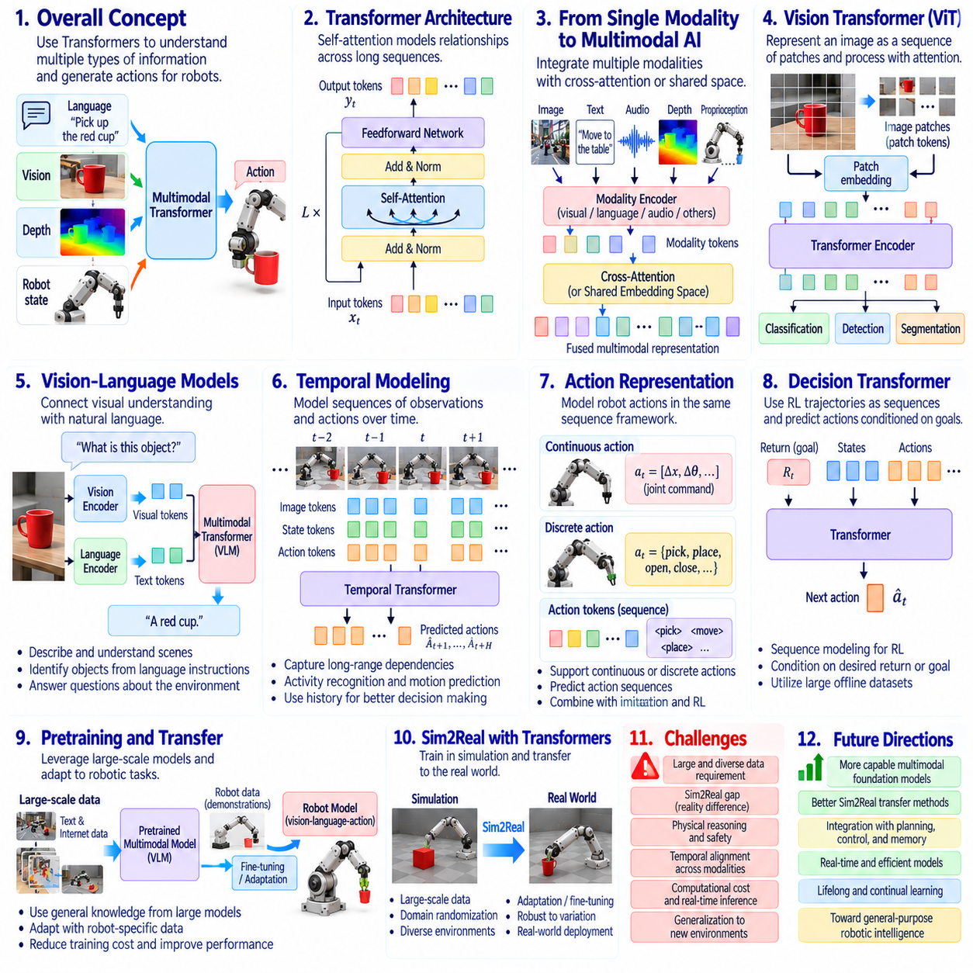
Transformers introduced a major architectural shift in artificial intelligence by enabling neural networks to model relationships across long sequences of information. Earlier recurrent networks processed observations sequentially, often encountering difficulties with long-range dependencies. Transformer architectures use attention mechanisms to identify relevant relationships across inputs. This capability established a foundation for language understanding, visual reasoning, and multimodal intelligence in robotics.
The introduction of the Transformer architecture in 2017 demonstrated that attention-based computation could replace recurrence in many sequence modeling tasks. Self-attention allows each element of an input sequence to incorporate information from other elements according to learned relevance. Positional encoding preserves information about ordering, while feedforward layers transform contextual representations. These mechanisms enabled scalable training and increasingly powerful representation learning.
The success of Transformers in natural language processing accelerated the development of large language models capable of generating, interpreting, and organizing complex information. Training on extensive text collections enabled models to acquire statistical representations of language structure and relationships. For robotics, these capabilities offered new approaches to interpreting instructions, decomposing tasks, and expressing operational knowledge. However, linguistic competence alone does not guarantee physical understanding.
Vision Transformers extended attention-based architectures into image processing by representing images as sequences of patches or visual tokens. Instead of relying exclusively on convolutional operations, these models learn relationships between spatial regions through attention. This approach supports image classification, object recognition, and scene interpretation. Its relevance to robotics increased as visual perception became integrated with language understanding and action-oriented reasoning.
Multimodal artificial intelligence emerged from efforts to combine information across different sensory and symbolic representations. Images, language, audio, depth measurements, and motion signals contain complementary descriptions of environmental conditions. Multimodal models learn relationships between these information sources, allowing one modality to provide context for another. In robotics, this integration supports richer interpretation of objects, activities, and human instructions.
Cross-attention mechanisms provide an important method for connecting information from different modalities. A language representation can attend to visual features, while visual processing can incorporate task-specific linguistic context. Shared embedding spaces offer another approach by positioning related concepts from different modalities near one another. These mechanisms enable models to associate object descriptions with visual observations and support instruction-guided perception.
Vision-language models expanded robotic capabilities by connecting visual recognition with natural language understanding. Such models can describe scenes, identify objects referenced by instructions, and answer questions about observed environments. A robot may use these capabilities to interpret commands involving spatial relationships or object properties. Nevertheless, reliable physical execution requires geometric reasoning, state estimation, and control mechanisms beyond language-based interpretation.
Transformers also influenced temporal modeling by enabling attention across sequences of observations and actions. Robotic behavior depends on how environmental states evolve, not merely on individual sensor readings. Temporal attention can identify relationships among earlier observations, current conditions, and possible future actions. This capability supports activity recognition, motion prediction, and the representation of interaction histories within robotic decision-making systems.
Action representation became an important research direction as Transformer models were adapted from language and vision to robotic control. Robot actions may be represented as continuous vectors, discrete tokens, or structured sequences describing movements and commands. Sequence models can predict actions conditioned on previous observations, goals, and recorded trajectories. This formulation connects imitation learning with scalable architectures originally developed for sequence prediction.
Decision Transformers demonstrated that reinforcement learning trajectories could be modeled through sequence prediction. Instead of learning a conventional value function, these models condition action generation on previous states, actions, and desired returns. This approach illustrates how supervised sequence modeling can contribute to sequential decision-making. However, successful performance depends on dataset coverage, conditioning quality, and the availability of relevant behavioral examples.
Multimodal robotic learning requires careful alignment between sensory observations and physical actions. Camera frames, language instructions, joint measurements, and control commands often operate at different frequencies and resolutions. Temporal synchronization and coordinate consistency are therefore essential for meaningful integration. Without reliable alignment, a model may associate observations with incorrect actions or misunderstand the physical consequences of movement.
Large-scale pretraining introduced opportunities to transfer general visual and linguistic knowledge into robotic systems. Models trained on broad datasets can provide reusable representations that reduce the amount of task-specific training required. Robotic demonstrations and interaction data can subsequently adapt these representations to physical tasks. However, differences between internet-scale data and embodied experience limit the direct transfer of abstract knowledge into reliable motor behavior.
Computational requirements became a central consideration when deploying Transformer-based models on physical robots. Attention processing, memory consumption, and model inference latency can conflict with real-time control constraints. Edge computing platforms must balance model capacity against power consumption, thermal limitations, and response deadlines. Practical architectures may separate high-level multimodal reasoning from low-level control loops that require deterministic execution.
Safety and reliability remain essential because multimodal models can generate plausible interpretations that are inconsistent with physical reality. Visual ambiguity, incomplete observations, and language misunderstandings may produce inappropriate actions. Robotic systems therefore require independent safety constraints, uncertainty monitoring, and continuous environmental feedback. Multimodal intelligence must operate within validated physical control architectures rather than replace essential safety mechanisms.
The historical significance of Transformers and multimodal AI lies in their ability to connect previously separate domains of perception, language, and sequential decision-making. They established architectural foundations for models that interpret instructions, integrate sensory information, and generate action-related representations. Modern Physical AI builds upon these advances by combining multimodal reasoning with world models, robot demonstrations, adaptive policies, and closed-loop control to support increasingly general physical intelligence.

03.12. Foundation Models and Generalist Policies
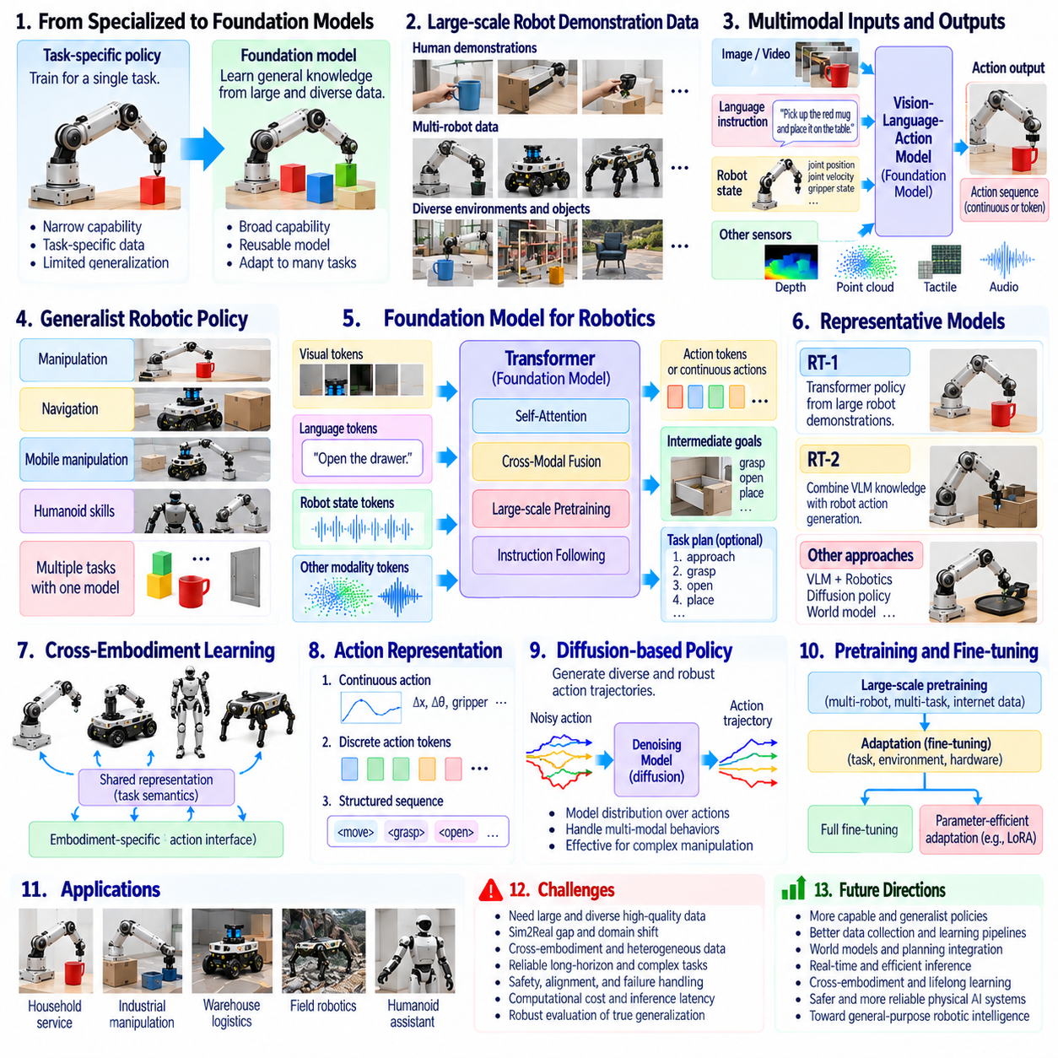
Foundation models represent a major transition in artificial intelligence from narrowly specialized systems toward broadly reusable learning architectures. Traditional robotic policies were usually trained for particular tasks, environments, or hardware configurations. Foundation models instead acquire general representations from large and diverse datasets before adaptation to specific applications. This approach established a pathway toward robotic intelligence capable of supporting multiple tasks through shared knowledge.
The emergence of foundation models was driven by advances in deep learning, Transformer architectures, large-scale pretraining, and computational infrastructure. Language and vision models demonstrated that representations learned from extensive datasets could transfer across many downstream tasks. Robotics researchers began investigating whether similar principles could support physical interaction. The central challenge was extending general representation learning into reliable action generation.
A generalist robotic policy is designed to perform multiple tasks rather than optimize behavior for a single narrowly defined objective. Such policies may accept visual observations, language instructions, robot states, and task descriptions as inputs. Their outputs can include movement commands, action sequences, or intermediate goals. Generalization depends on learning reusable relationships between environmental conditions, task intentions, and physical actions.
Large-scale robot demonstration datasets became essential for developing generalist policies. Data collected from multiple operators, environments, objects, and robot platforms provide examples of diverse physical interactions. These datasets allow models to identify common behavioral structures across tasks. However, differences in sensor configurations, coordinate systems, action representations, and control frequencies complicate the integration of heterogeneous robotic experiences.
Robot foundation models increasingly combine visual perception, language understanding, and action prediction within unified architectures. Vision-language-action models extend multimodal representations by producing actions conditioned on sensory observations and instructions. Such systems can connect semantic task descriptions with physical control objectives. Nevertheless, translating abstract instructions into reliable movements requires geometric awareness, temporal consistency, and accurate state estimation.
The RT-1 research direction demonstrated how Transformer-based architectures could learn diverse manipulation behaviors from large collections of real robotic demonstrations. By representing observations and actions within a sequence-learning framework, these models supported multiple language-conditioned tasks. Their significance was not universal robotic competence, but evidence that scalable policy learning could improve task diversity and instruction responsiveness.
RT-2 extended this direction by incorporating knowledge from vision-language models into robotic action generation. The approach explored whether semantic information learned from broad visual and textual datasets could improve responses to unfamiliar instructions and objects. This development illustrated the potential value of combining internet-scale knowledge with embodied demonstrations. However, physical competence remained dependent on robotic training data and operational constraints.
Cross-embodiment learning emerged as an important objective because robotic platforms differ substantially in mechanical structure and control interfaces. A mobile manipulator, humanoid robot, and industrial arm may share task concepts while requiring different motor commands. Generalist architectures therefore investigate shared task representations and embodiment-specific action interfaces. Effective transfer requires preserving functional meaning without assuming identical physical capabilities.
Action tokenization provides one method for connecting robotic control with sequence-based foundation models. Continuous movement commands can be discretized or represented through structured action sequences compatible with neural architectures. Alternative approaches predict continuous action trajectories directly or employ generative action models. Each representation introduces tradeoffs involving precision, temporal resolution, computational efficiency, and compatibility with low-level controllers.
Diffusion-based policies introduced generative modeling techniques into robot action prediction. Instead of producing only a single deterministic command, these models can learn distributions over possible action trajectories. Iterative denoising supports the generation of complex and multimodal behaviors from demonstrations. Such methods have shown promise in manipulation tasks, although inference latency and closed-loop responsiveness remain important deployment considerations.
Pretraining and fine-tuning became central strategies for adapting foundation models to practical robotic applications. A broadly trained model may provide general visual, linguistic, and behavioral representations, while specialized training improves performance on particular hardware or tasks. Parameter-efficient adaptation can reduce computational requirements. Nevertheless, successful adaptation depends on representative data, appropriate objectives, and rigorous evaluation under physical operating conditions.
Generalist policies introduce significant challenges in measuring performance because success on familiar tasks does not establish reliable generalization. Evaluation must distinguish training-task proficiency from performance on unfamiliar objects, environments, instructions, and embodiments. Robust benchmarks should examine task completion, recovery behavior, safety violations, and sensitivity to distribution shifts. Physical validation remains essential because simulation and offline metrics cannot fully predict real-world reliability.
Computational deployment creates additional constraints for large robotic foundation models. High-capacity architectures may require substantial memory, processing power, and communication bandwidth. Real-time robotic systems must also satisfy strict latency and power requirements. Practical implementations may distribute computation across edge devices, on-premises servers, and cloud infrastructure while retaining safety-critical control locally and managing communication failures.
Safety and controllability remain fundamental limitations of generalist robotic policies. Broad training does not guarantee that a model will recognize every hazardous situation or respect physical constraints. Learned actions must therefore operate within validated motion limits, collision avoidance mechanisms, and independent safety supervision. Uncertainty estimation, monitoring, and fallback procedures are necessary to prevent general-purpose intelligence from compromising dependable operation.
The historical importance of foundation models and generalist policies lies in shifting robotics from isolated task-specific learning toward reusable, scalable behavioral intelligence. They connect perception, language, demonstrations, and action generation within increasingly unified learning systems. Modern Physical AI builds upon these advances by integrating generalist policies with world models, hierarchical planning, closed-loop feedback, and physical safety mechanisms to pursue adaptable intelligence across diverse robotic environments.

03.13. World Models VLM and VLA
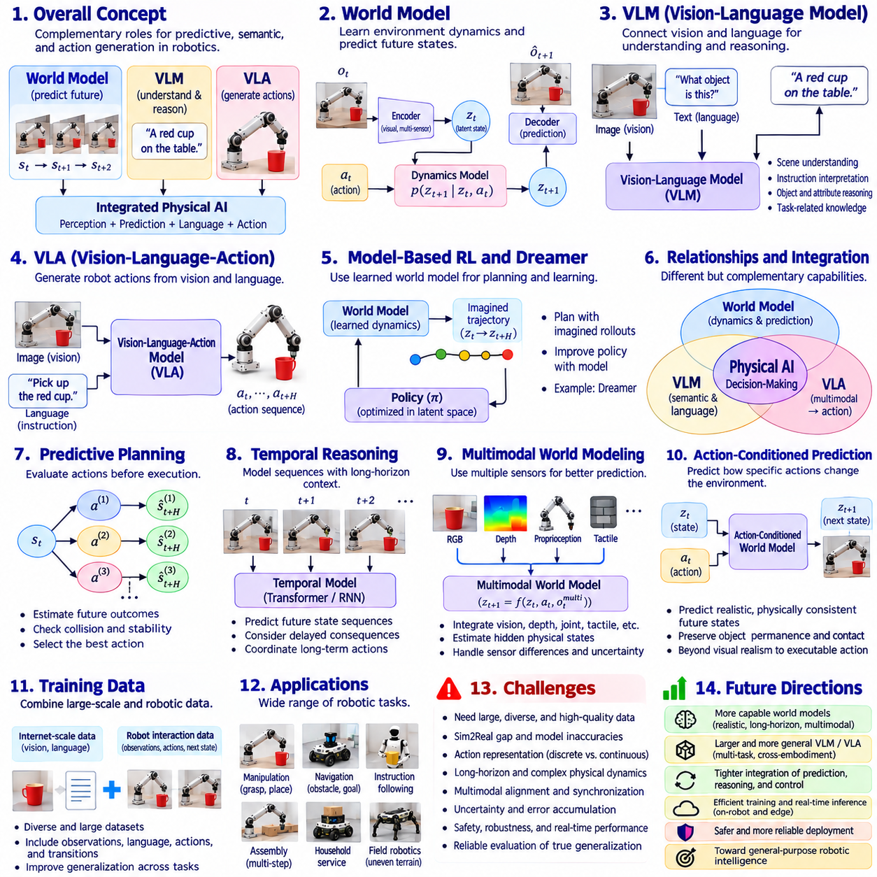
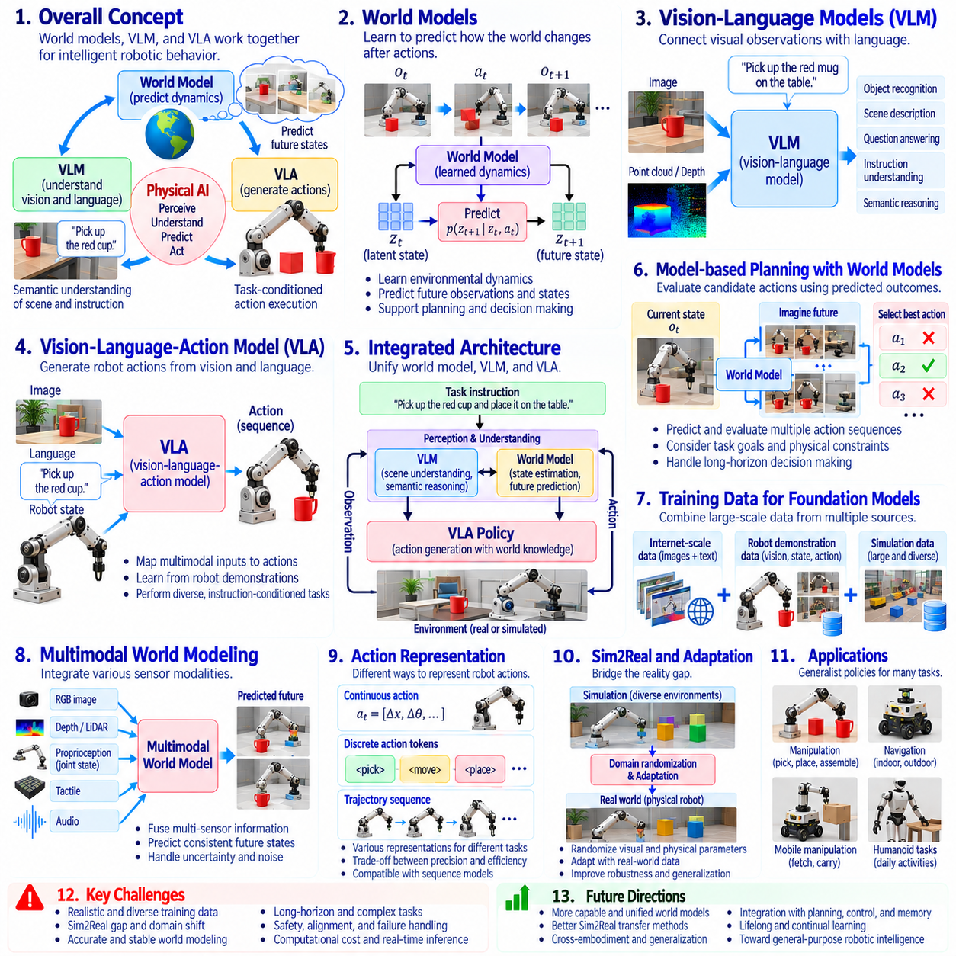
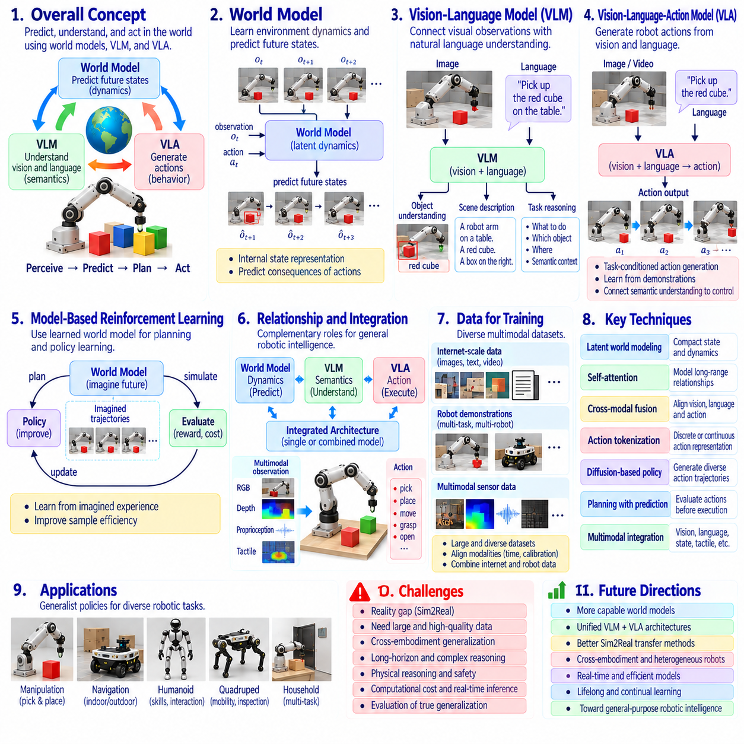
World models represent an important development in Physical AI by enabling intelligent systems to predict how environments may change in response to actions. Traditional perception models primarily recognize objects and estimate current conditions, while world models attempt to represent environmental dynamics and future states. This predictive capability connects perception with planning, allowing robots to evaluate possible outcomes before interacting with the physical world.
The conceptual foundations of world models originate from model-based control, state estimation, reinforcement learning, and predictive simulation. A world model learns relationships among observations, actions, hidden states, and subsequent outcomes. Instead of responding only to immediate sensory inputs, an agent can maintain an internal representation of environmental conditions. This representation supports reasoning about uncertainty, temporal dependencies, and the consequences of alternative actions.
Early learned world models combined visual encoders, recurrent dynamics models, and compact latent representations. Images were transformed into lower-dimensional states, while predictive networks estimated how those states would evolve under different actions. This approach demonstrated that agents could learn useful environmental dynamics from interaction data. Latent-space prediction also reduced the computational burden of reasoning directly over high-dimensional sensory observations.
Model-based reinforcement learning expanded these ideas by using learned dynamics to support policy optimization and planning. Architectures such as Dreamer demonstrated how agents could improve behavior through imagined trajectories generated within learned latent dynamics models. Rather than requiring every learning experience to occur in the physical environment, agents could evaluate hypothetical transitions internally. However, inaccurate predictions may accumulate and degrade decisions over extended horizons.
Vision-language models, commonly called VLMs, introduced another major capability by connecting visual observations with natural language representations. These models learn relationships between images, objects, scenes, and textual descriptions. In robotics, VLMs can interpret instructions, identify relevant objects, and describe environmental conditions. Their semantic understanding supports task reasoning, but does not independently provide the precise motor commands required for physical execution.
Vision-language-action models, or VLAs, extend multimodal learning by connecting visual perception and language instructions directly with robotic actions. A VLA policy receives sensory observations and task descriptions, then predicts movements or action sequences. This architecture links semantic understanding with physical behavior through learned representations. Its effectiveness depends on robotic demonstrations, appropriate action representations, and compatibility with the target robot's control system.
The relationship between world models, VLMs, and VLAs reflects three complementary functions within emerging Physical AI architectures. World models estimate environmental dynamics and possible future outcomes, VLMs provide semantic interpretation of observations and instructions, and VLAs generate task-conditioned actions. These capabilities may be integrated into a single model or distributed across specialized components. Their combination supports more informed and adaptable robotic decision-making.
Predictive world models can improve robotic planning by evaluating candidate actions before execution. A robot may estimate whether a movement will cause a collision, whether an object will remain stable, or whether a planned trajectory can reach its intended goal. Predictions can be compared against task objectives and physical constraints. Nevertheless, reliable planning requires uncertainty awareness because learned models cannot perfectly represent every environmental interaction.
Temporal reasoning is essential because physical environments evolve continuously and robot actions have delayed consequences. World models may predict sequences of future states rather than isolated outcomes, while VLA policies generate coordinated action trajectories. VLMs can provide contextual information about objects, activities, and task intentions. Combining these representations enables decisions that account for both semantic goals and expected physical developments over time.
Multimodal world modeling extends prediction beyond images by incorporating depth measurements, proprioception, tactile feedback, and other sensor signals. These modalities describe complementary aspects of geometry, motion, and contact. A model that integrates them may better estimate hidden physical states and interaction dynamics. However, differences in sensor frequency, calibration, and measurement uncertainty create challenges for consistent multimodal prediction.
Action-conditioned prediction distinguishes physical world models from systems that merely generate plausible visual sequences. A useful robotic model must represent how specific actions influence future observations and physical states. Predictions should preserve relevant constraints such as object permanence, contact behavior, and motion feasibility. Visual realism alone is insufficient if generated outcomes violate physical dynamics or fail to correspond to executable robot actions.
Training these systems requires diverse datasets containing sensory observations, language descriptions, actions, and resulting state transitions. Internet-scale visual and textual data can provide broad semantic knowledge, while robotic interaction datasets supply evidence about physical consequences. Combining these sources supports generalization across tasks and environments. However, inconsistent action formats, embodiment differences, and limited coverage of rare events remain major obstacles.
Computational architecture becomes important when integrating world models, VLMs, and VLAs into operational robots. Predictive simulation and multimodal inference may require substantial processing resources, while motor control demands timely and reliable responses. Hierarchical systems can separate high-level reasoning from fast local control. Edge and on-premises computation may support different workloads, provided communication delays and failures do not compromise physical safety.
Safety and validation remain fundamental because learned predictions and generated actions can be incorrect even when their outputs appear convincing. World models may underestimate hazards, VLMs may misinterpret scenes, and VLAs may produce unsuitable movements. Reliable deployment therefore requires independent safety constraints, physical feedback, uncertainty monitoring, and systematic testing. Learned intelligence must remain compatible with verified control and emergency-response mechanisms.
The historical significance of world models, VLMs, and VLAs lies in bringing prediction, semantic understanding, and action generation into a more unified framework for embodied intelligence. Together, they extend robotics beyond recognizing present conditions toward anticipating consequences and selecting purposeful physical actions. Modern Physical AI builds upon this convergence to develop adaptive systems that perceive, predict, reason, act, and continuously correct their behavior through interaction with the real world.

03.14. Emergence of Physical AI
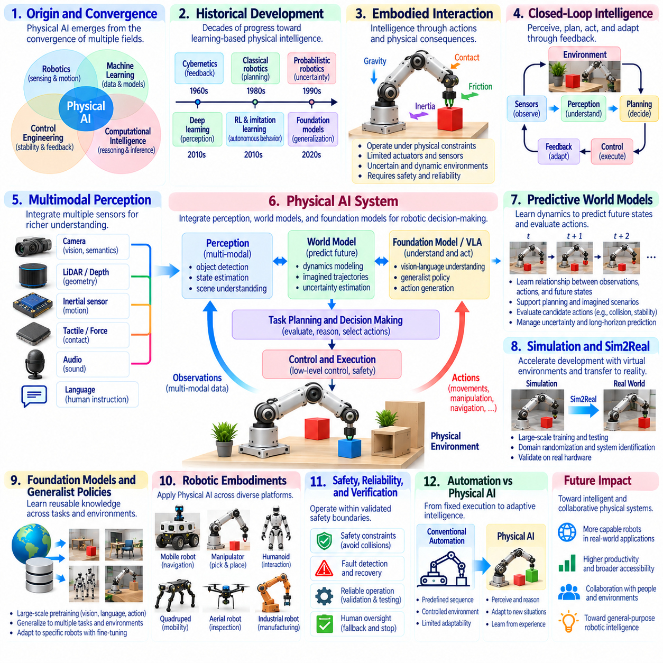
Physical AI emerged from the convergence of robotics, machine learning, control engineering, and computational intelligence. Earlier artificial intelligence systems primarily processed symbolic information or digital data, while robotic systems focused on sensing, motion, and physical control. Physical AI connects these traditions by enabling intelligent machines to perceive environments, reason about physical conditions, select actions, and adapt through continuous interaction with the real world.
The historical development of Physical AI reflects decades of progress across several technological disciplines. Cybernetics established feedback principles, classical robotics introduced geometric planning, and probabilistic robotics addressed uncertainty. Deep learning improved perception, while reinforcement learning and imitation learning expanded autonomous behavior acquisition. These developments gradually transformed robotics from predefined automation toward learning-based physical intelligence.
A defining characteristic of Physical AI is its dependence on embodied interaction. Intelligence is not expressed solely through symbolic reasoning or information generation but through actions that produce measurable physical consequences. A robot must account for gravity, friction, contact, inertia, and environmental uncertainty. Its decisions are constrained by actuator capabilities, sensor limitations, and operational safety requirements, making physical intelligence fundamentally different from purely digital computation.
Closed-loop intelligence provides the operational foundation for Physical AI systems. Sensors observe environmental conditions, perception models interpret incoming information, and planning mechanisms determine appropriate actions. Controllers translate decisions into physical commands, while subsequent observations reveal the consequences of execution. This repeated perception-action-feedback cycle enables continuous correction and adaptation when actual outcomes differ from predicted behavior.
The integration of multimodal perception significantly expanded the environmental understanding available to intelligent robots. Cameras provide visual and semantic information, LiDAR and depth sensors describe geometry, and inertial sensors measure motion. Tactile and force sensors reveal physical contact, while language interfaces communicate human intentions. Combining these modalities enables richer state estimation and supports decisions that cannot be derived reliably from a single information source.
World models introduced predictive capabilities that extend Physical AI beyond reactive behavior. By learning relationships between observations, actions, and future states, these models support reasoning about possible physical outcomes. Robots can evaluate candidate movements, anticipate obstacles, and estimate interaction consequences before execution. However, predictive accuracy depends on training coverage, physical modeling quality, and the management of uncertainty across extended planning horizons.
Foundation models and generalist policies contributed another important transition by introducing reusable knowledge across tasks and environments. Large-scale pretraining allows models to acquire shared representations from diverse visual, linguistic, and robotic experiences. Vision-language-action architectures connect task instructions with physical action generation. Although these approaches improve adaptability, reliable execution still requires robot-specific calibration, feedback control, and validated operational constraints.
Simulation and Sim2Real technologies accelerated the development of Physical AI by supporting large-scale experimentation without requiring every interaction to occur on physical hardware. Virtual environments provide controlled conditions for training policies, evaluating perception, and testing hazardous scenarios. Domain randomization and system identification help reduce differences between simulated and real environments. Physical validation remains necessary because simulation cannot reproduce every contact condition or environmental disturbance.
The emergence of Physical AI also reflects advances in computational infrastructure. Graphics processors, specialized accelerators, and embedded computing platforms support increasingly complex perception and decision models. Edge computing enables time-sensitive inference near physical devices, while on-premises and cloud resources support larger workloads. Effective deployment requires balancing model complexity, communication latency, power consumption, and deterministic control requirements.
Physical AI extends across multiple robotic embodiments, including autonomous mobile robots, industrial manipulators, humanoids, quadrupeds, and unmanned aerial vehicles. These platforms differ in mechanical design, mobility, sensing, and control requirements, yet share common principles of perception, prediction, planning, and feedback. General intelligence architectures must therefore distinguish transferable task knowledge from embodiment-specific movement constraints and actuator capabilities.
Safety, reliability, and verification became central concerns as learning-based systems gained greater physical autonomy. Incorrect perception, uncertain predictions, or unsuitable actions can produce collisions, equipment damage, and risks to people. Physical AI must operate within validated safety boundaries and support fault detection, emergency responses, and controlled fallback behavior. Learning-based intelligence complements rather than replaces established safety engineering and dependable control mechanisms.
The distinction between autonomous automation and Physical AI is particularly important. Conventional automation executes predefined sequences under relatively controlled conditions, while Physical AI aims to interpret changing situations and adapt its behavior accordingly. The distinction is not absolute because advanced automation already incorporates feedback and adaptive control. Physical AI emphasizes broader learning, predictive reasoning, and transferable decision-making grounded in physical interaction.
Human-robot collaboration provides an important application context for emerging Physical AI. Intelligent robots must interpret human instructions, recognize nearby activities, and coordinate actions without compromising safety. Language understanding can support task communication, while perception and motion planning maintain awareness of shared workspaces. Effective collaboration requires predictable behavior, transparent operational boundaries, and mechanisms for human supervision and intervention.
The broader significance of Physical AI lies in transforming artificial intelligence from primarily information-centered computation into systems capable of purposeful physical interaction. Its emergence is not attributable to a single algorithm or platform but to the convergence of sensing, learning, prediction, planning, control, and embodied experience. Future progress depends on integrating these capabilities into reliable closed-loop architectures that operate safely across diverse environments and physical tasks.

