Volume 02. Physical AI Foundations and Definitions

Chapter 00. Introduction

00.01. Why Physical AI Matters
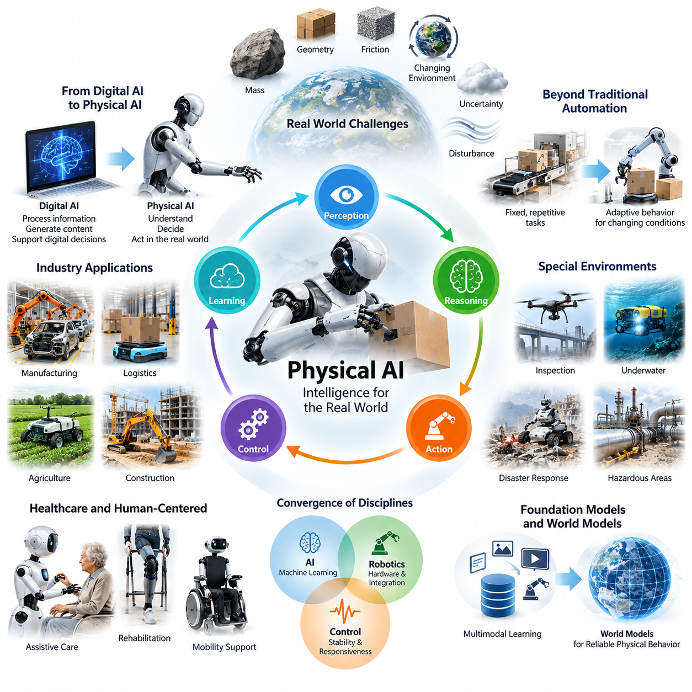
Physical AI represents a fundamental transformation in how artificial intelligence interacts with the world. While conventional AI primarily processes information, generates content, and supports digital decisions, Physical AI connects intelligence with physical environments, machines, and actions. Its significance lies in enabling intelligent systems not only to understand information but also to perceive, predict, decide, and act within the real world.
The physical world introduces challenges that cannot be fully addressed through digital intelligence alone. Objects have mass, environments change continuously, and actions are constrained by geometry, friction, gravity, and energy. Intelligent machines must operate despite uncertainty, incomplete observations, and unpredictable disturbances. Physical AI matters because it provides a framework for integrating computational intelligence with these unavoidable physical realities.
Traditional automation has achieved remarkable productivity through predefined instructions, structured environments, and repetitive operations. However, such systems often struggle when tasks, objects, or operating conditions change unexpectedly. Physical AI extends automation toward adaptive behavior by combining perception, reasoning, learning, and feedback control, allowing machines to respond more effectively to variations that cannot be completely anticipated during system design.
The importance of Physical AI becomes particularly clear when intelligence must produce measurable physical outcomes. A digital model may correctly identify an object, but a robotic system must additionally determine its location, estimate its physical properties, plan a feasible movement, and execute an action safely. Successful intelligence therefore depends on the complete relationship between observation, decision, physical interaction, and the resulting environmental state.
Physical AI also changes the meaning of autonomy. An autonomous system must do more than execute a sequence of commands without human intervention. It must continuously evaluate environmental conditions, recognize operational limitations, adjust behavior, and determine when assistance or protective intervention is necessary. This combination of goal-directed behavior, environmental awareness, and operational responsibility distinguishes meaningful physical autonomy from simple automated execution.
One major reason Physical AI matters is its potential to address persistent labor and productivity challenges. Manufacturing, logistics, agriculture, construction, and infrastructure maintenance involve physically demanding activities that are difficult to automate using rigid procedures. Intelligent machines capable of adapting to diverse objects, environments, and workflows could support human workers, improve operational consistency, and expand automation into previously inaccessible applications.
In manufacturing environments, Physical AI can support flexible production systems that accommodate product variation, changing assembly sequences, and unpredictable material conditions. Instead of relying exclusively on fixed programming, intelligent robotic systems can use sensor observations and learned representations to adjust their actions. Such capabilities may reduce reconfiguration effort and improve responsiveness, although deployment still requires rigorous engineering and validation.
Logistics and warehouse operations demonstrate another important application. Autonomous mobile robots must navigate dynamic spaces, interact with human workers, avoid obstacles, and coordinate transportation tasks. Mobile manipulators extend these capabilities by combining navigation with object handling. Physical AI provides a common intelligence framework for integrating these functions into adaptive systems that can respond to changing operational requirements.
Physical AI is equally relevant to environments where human access is difficult, hazardous, or expensive. Inspection robots, aerial vehicles, underwater systems, and remote manipulators can perform tasks in industrial facilities, disaster areas, and challenging terrain. Their value increases when they can interpret unfamiliar conditions and make constrained decisions locally rather than depending entirely on continuous human supervision or remote connectivity.
Healthcare and human-centered applications further illustrate the importance of physical intelligence. Assistive robots, rehabilitation systems, and intelligent mobility devices must operate in close proximity to people while accounting for individual differences and changing physical conditions. These applications demand more than accurate perception or sophisticated algorithms. They require predictable interaction, appropriate force control, reliable monitoring, and safety mechanisms designed around human needs.
The convergence of artificial intelligence, robotics, and control engineering is central to this transformation. Machine learning contributes pattern recognition and adaptation, robotics provides physical mechanisms and system integration, and control theory establishes methods for maintaining stable and responsive behavior. Physical AI brings these disciplines together, treating intelligent behavior as a property of the complete system rather than an isolated software model.
Advances in foundation models and multimodal learning create additional opportunities for Physical AI. Models trained on language, images, video, and action-related information may provide reusable representations for interpreting instructions and understanding environments. However, translating these representations into reliable physical behavior requires grounding in sensor observations, robot capabilities, task constraints, and the consequences of actual movements.
World models are especially important because physical agents must anticipate how environments may evolve. A robot approaching an obstacle, manipulating a deformable object, or interacting with a moving person benefits from predicting possible future states. Such predictions can support planning and risk assessment. Their usefulness depends on representing uncertainty and updating predictions when observations reveal differences between expected and actual outcomes.
The relationship between perception and action also makes Physical AI fundamentally interactive. An intelligent agent does not simply observe an environment and produce a final answer. Its actions change the environment, creating new observations that influence subsequent decisions. This continuous feedback process enables correction, adaptation, and learning, while also introducing the possibility that an incorrect decision may cause an irreversible physical consequence.
Safety therefore occupies a foundational position in Physical AI. Errors in digital applications may result in incorrect information or unsuccessful transactions, whereas errors in physical systems can damage equipment, disrupt operations, or injure people. Physical intelligence must operate within appropriate safety constraints, combining reliable sensing, bounded actions, protective control mechanisms, and procedures for detecting and responding to abnormal conditions.
Real-time operation introduces another essential distinction. Physical systems often require decisions within strict timing limits because objects continue moving and environmental conditions evolve while computations are performed. An intelligent controller must balance model complexity, prediction accuracy, communication delays, and available processing resources. Consequently, computational performance must be evaluated together with timing guarantees and physical system behavior.
Energy efficiency and hardware limitations also influence the practical importance of Physical AI. Robots and autonomous machines frequently operate with restricted battery capacity, thermal budgets, and onboard computing resources. Sophisticated intelligence cannot be considered operationally effective if its computational demands prevent sustained deployment. Physical AI therefore encourages coordinated design across algorithms, sensors, processors, actuators, communication systems, and power management.
Simulation and digital twins provide important development capabilities by allowing physical interactions to be studied before deployment. Virtual environments can generate training experiences, expose systems to unusual conditions, and support repeated evaluation. Nevertheless, differences between simulated and real environments remain significant. Physical AI development must address these differences through validation, adaptation, and carefully controlled real-world experimentation.
Data acquisition presents another fundamental challenge. Digital AI can often learn from large collections of existing text, images, and online interactions. Physical AI additionally requires information about motion, forces, actions, environmental changes, and task outcomes. Collecting such data can be expensive and time-consuming. Efficient demonstrations, simulation-generated experiences, and operational feedback become important resources for developing adaptable physical intelligence.
The economic significance of Physical AI extends beyond replacing individual manual tasks. Intelligent physical systems may enable new operational models involving continuous inspection, flexible manufacturing, distributed logistics, and coordinated robotic services. Their commercial value depends on measurable improvements in productivity, reliability, safety, and lifecycle cost. Successful adoption therefore requires alignment between technical capabilities, application requirements, and sustainable business models.
Physical AI also encourages a transition from isolated machines toward interconnected intelligent systems. Multiple robots can share observations, coordinate activities, and improve operational decisions through fleet-level information. Edge computing can support immediate local responses, while cloud infrastructure can assist with large-scale learning and management. This distributed architecture creates opportunities for collective improvement while introducing communication, cybersecurity, and governance challenges.
The broader significance of Physical AI lies in expanding the relationship between human intelligence and machine capability. Rather than limiting artificial intelligence to digital interfaces, Physical AI introduces systems that can participate directly in physical work and environmental interaction. Their development may reshape industrial processes, transportation, public infrastructure, and everyday services, provided that technical progress is accompanied by responsible deployment and human oversight.
Understanding why Physical AI matters requires viewing it as a system-level paradigm rather than a single algorithm, robot category, or technological trend. Its defining opportunity is the integration of perception, reasoning, prediction, learning, and controlled action under real-world constraints. Its long-term importance will be determined not merely by increasingly capable AI models, but by whether complete physical systems can deliver useful, safe, reliable, and adaptable behavior at scale.

00.02. From Digital AI to Physical AI
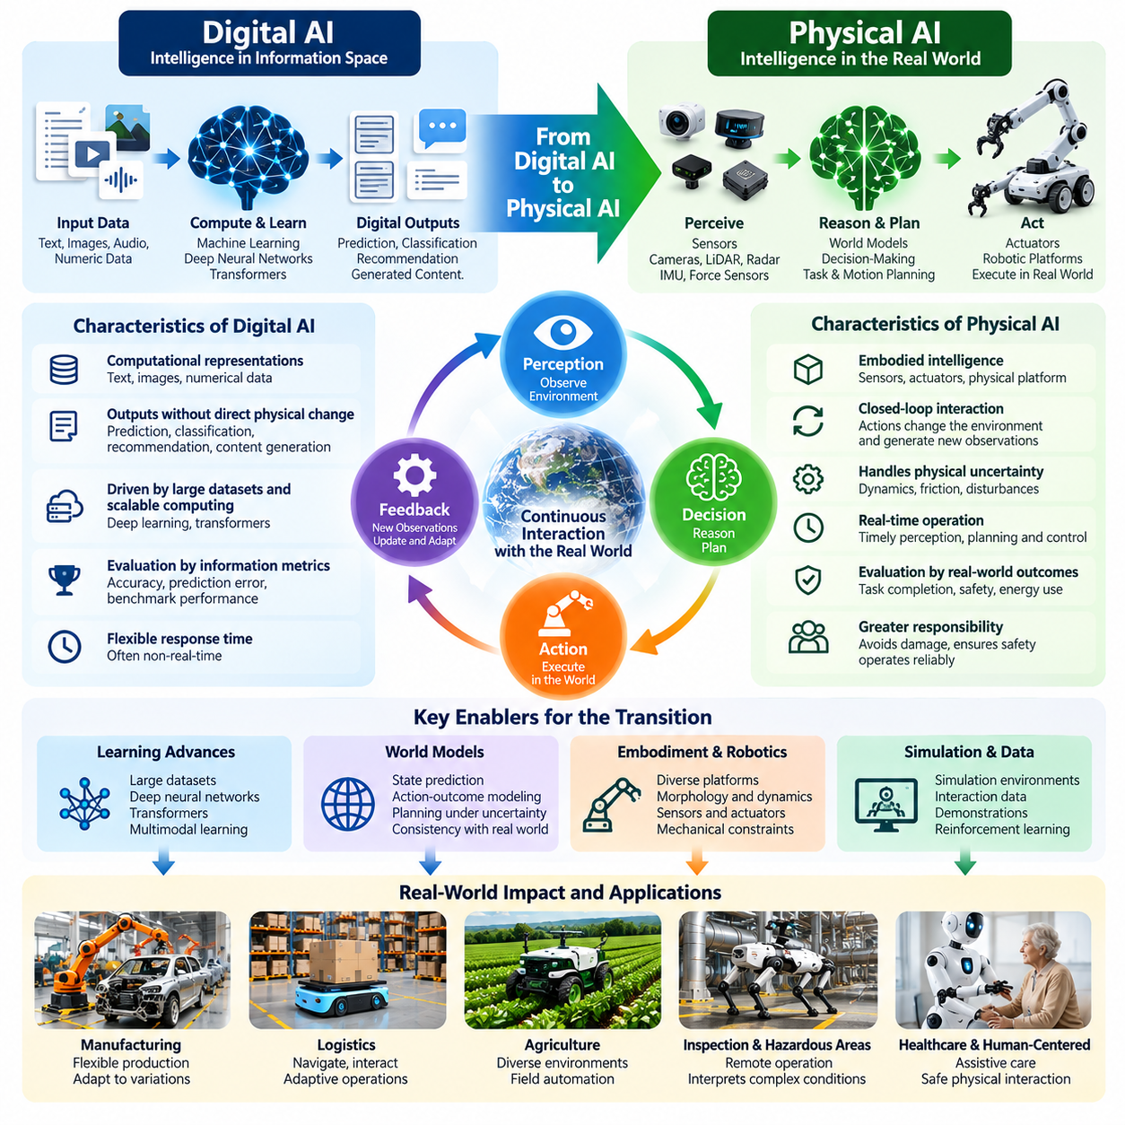
The transition from Digital AI to Physical AI represents a fundamental expansion of artificial intelligence from information processing toward intelligent interaction with the physical world. Digital AI has demonstrated remarkable capabilities in language understanding, image recognition, prediction, and content generation. Physical AI extends these capabilities into environments where decisions must influence real objects, physical processes, and continuously changing conditions.
Digital AI traditionally operates through computational representations such as text, images, numerical data, and structured information. Its outputs are commonly predictions, classifications, recommendations, or generated content. Although these outputs may influence physical activities indirectly, the intelligence itself often remains separated from physical execution. Physical AI closes this separation by connecting computational decisions to sensors, actuators, and environmental feedback.
The distinction becomes clearer when considering the consequences of an AI decision. An incorrect digital prediction may produce misleading information or an unsuitable recommendation. An incorrect physical action may cause collisions, equipment damage, operational disruption, or human injury. Physical AI must therefore consider not only prediction accuracy but also action feasibility, environmental uncertainty, system stability, and the safety of resulting physical behavior.
The development of Digital AI was accelerated by large datasets, scalable computing infrastructure, and increasingly capable machine learning architectures. Deep neural networks enabled major improvements in perception and pattern recognition, while transformers expanded capabilities in language and multimodal reasoning. These advances created important foundations for Physical AI, but computational intelligence alone does not guarantee successful interaction with real environments.
Physical AI introduces embodiment as a central consideration. Intelligence must operate through a physical platform possessing particular sensors, actuators, mechanical structures, and movement capabilities. A wheeled robot, industrial manipulator, humanoid, and aerial vehicle may share computational models while requiring different physical actions. Their intelligence must account for morphology, dynamics, operating constraints, and the relationship between the body and its surroundings.
Another major transition concerns the relationship between observation and action. Digital AI frequently processes existing datasets or user-provided inputs without directly changing the observed environment. Physical AI operates through continuous interaction, where each action modifies the environment and generates new observations. This creates a closed-loop process in which perception, decision-making, execution, and feedback must remain coordinated throughout system operation.
Closed-loop intelligence is essential because physical environments rarely behave exactly as predicted. A mobile robot may encounter unexpected obstacles, a manipulator may experience object slippage, and an autonomous vehicle may face changing road conditions. Physical AI must detect deviations between expected and observed states, update its internal understanding, and modify subsequent actions. This continuous correction distinguishes adaptive physical behavior from fixed execution sequences.
The transition also changes the role of time in intelligent computation. Many digital applications tolerate variable response times because their outputs do not immediately influence moving physical systems. Physical AI frequently operates under real-time constraints, where delayed decisions can reduce performance or compromise safety. Perception, planning, and control must therefore be coordinated with the timing requirements of the physical process being managed.
Digital AI commonly evaluates success through metrics such as classification accuracy, prediction error, language quality, or benchmark performance. Physical AI requires additional evaluation dimensions that reflect real-world outcomes. Task completion, trajectory accuracy, energy consumption, collision avoidance, recovery behavior, and operational reliability become essential measures. A computationally accurate model may still be unsuitable if its physical execution is unstable or unsafe.
The evolution from passive inference to active interaction introduces new learning requirements. Digital AI can often improve through training on previously collected information, while Physical AI must also learn how actions affect future environmental states. Interaction data, demonstrations, reinforcement learning, and simulation experiences become important resources. These approaches help intelligent agents acquire behaviors that cannot be fully specified through static examples or predefined instructions.
World models provide an important conceptual bridge between Digital AI and Physical AI. Instead of representing only current observations, an intelligent system can learn relationships between states, actions, and possible future outcomes. Such models support prediction, planning, and decision-making under uncertainty. Their effectiveness depends on capturing relevant physical dynamics and maintaining consistency with observations collected during actual interaction.
The emergence of foundation models creates opportunities to transfer knowledge from digital representations into physical intelligence. Vision-language models can support scene interpretation and instruction understanding, while vision-language-action models attempt to connect multimodal information with executable behavior. However, successful physical deployment requires additional mechanisms for grounding, motion generation, feedback control, and verification of actions against environmental constraints.
Physical AI also requires closer integration between software intelligence and hardware design. Sensor placement influences observability, actuator characteristics determine feasible movements, and computational resources constrain decision-making speed. Unlike applications where software can be deployed independently of physical machinery, intelligent robotic systems must coordinate mechanical design, electronics, embedded computing, communication, and learning algorithms as interconnected components.
The computing architecture of Physical AI frequently extends beyond a centralized processing model. Onboard processors and edge computing platforms can provide low-latency perception and control, while on-premises infrastructure can coordinate multiple machines and maintain shared operational information. Cloud systems may support large-scale training, model distribution, and fleet analytics. These functions must be distributed according to timing, connectivity, security, and reliability requirements.
Simulation becomes increasingly important during this transition because learning directly through physical experimentation can be costly, slow, or hazardous. Simulated environments allow agents to practice tasks, experience variations, and evaluate candidate behaviors before deployment. Nevertheless, differences in dynamics, sensing, contact, and environmental complexity create a simulation-to-reality gap that must be addressed through adaptation and real-world validation.
Safety and reliability must evolve alongside intelligence. Digital models are often assessed primarily through statistical performance, but Physical AI systems require protective mechanisms that remain effective when learned models produce uncertain or incorrect outputs. Runtime monitoring, operational limits, emergency stopping, fallback procedures, and human intervention mechanisms help prevent individual prediction errors from becoming unacceptable physical failures.
The transition from Digital AI to Physical AI also transforms system development practices. Training an accurate model is only one part of creating a functioning physical agent. Engineers must integrate perception, localization, planning, control, communication, and actuation into a coherent operational architecture. Testing must cover component behavior, subsystem interactions, environmental disturbances, and complete task execution under realistic conditions.
Industrial applications demonstrate how digital intelligence becomes physically consequential. An AI system that analyzes manufacturing data may recommend improvements, whereas a Physical AI system can perceive production conditions and adjust robotic operations accordingly. Similarly, warehouse intelligence can evolve from predicting inventory demand to coordinating autonomous transportation and manipulation. The distinction lies in connecting intelligent decisions to controlled physical execution.
This transformation does not imply that Physical AI replaces Digital AI. Instead, Physical AI builds upon digital capabilities while introducing additional requirements associated with embodiment, interaction, and physical constraints. Language understanding, visual recognition, probabilistic reasoning, and learned representations remain valuable components. Their contribution becomes more powerful when integrated with mechanisms that translate abstract intelligence into reliable physical behavior.
The long-term transition toward Physical AI reflects a broader movement from intelligence that describes the world toward intelligence that can participate in it. Achieving this transition requires advances in learning, world modeling, robotics, real-time computing, and safety engineering. Its success will depend on developing complete systems that combine digital reasoning with physically grounded perception, adaptive control, and dependable action in complex environments.

00.03. AI Robotics and Control Convergence
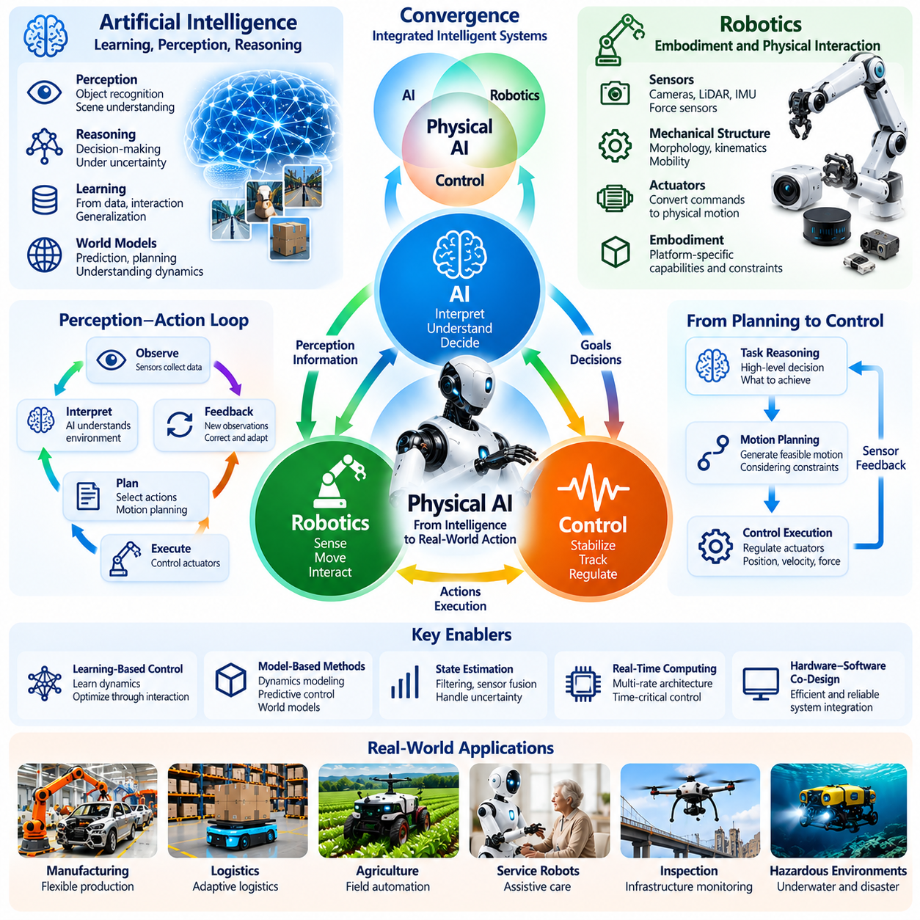
The convergence of artificial intelligence, robotics, and control engineering forms the technological foundation of Physical AI. Artificial intelligence provides learning, perception, and reasoning capabilities, while robotics supplies the physical mechanisms required for interaction. Control engineering ensures that planned actions can be executed with stability, precision, and responsiveness. Their integration enables machines to transform computational intelligence into purposeful physical behavior.
Historically, these disciplines developed through partially independent research traditions. Artificial intelligence emphasized symbolic reasoning, knowledge representation, and statistical learning. Robotics concentrated on mechanisms, kinematics, sensing, and motion generation, while control engineering developed mathematical methods for regulating dynamic systems. Physical AI emerges from their increasing integration into unified intelligent machines.
Artificial intelligence contributes the ability to interpret complex observations and make decisions under uncertainty. Machine learning models can identify objects, estimate environmental conditions, recognize patterns, and predict possible outcomes. These capabilities help robotic systems operate beyond rigidly programmed scenarios. However, intelligent predictions become physically meaningful only when they are connected to executable actions and continuously updated environmental information.
Robotics provides the embodiment through which artificial intelligence interacts with the physical world. Sensors capture information about the environment, mechanical structures determine movement capabilities, and actuators convert control commands into physical motion. Robot morphology influences which actions are possible and how effectively they can be performed. Consequently, intelligent behavior must be designed with the physical characteristics of the robotic platform in mind.
Control engineering establishes the mathematical and operational principles required to regulate physical behavior. Feedback controllers compare desired states with measured states and adjust actuator commands to reduce deviations. Techniques such as proportional-integral-derivative control, state estimation, and model predictive control provide mechanisms for maintaining stability and tracking desired trajectories despite disturbances and modeling errors.
The convergence becomes particularly important when high-level reasoning must interact with low-level control. An AI model may determine that a robot should grasp an object, but the robotic system must calculate feasible motions and coordinate its actuators. Control algorithms then regulate position, velocity, and force during execution. Successful operation requires consistent information exchange between task reasoning, motion planning, and physical control.
A central principle of this integration is the perception-action feedback loop. Sensors observe environmental conditions, AI models interpret observations, planning modules select actions, and controllers execute the resulting commands. Subsequent sensor measurements reveal how the environment responded. This continuous cycle allows intelligent machines to correct errors, adapt to disturbances, and maintain goal-directed behavior as operating conditions evolve.
Traditional robotic systems often separate planning and control into distinct processing stages. Planning generates trajectories based on environmental models, while controllers attempt to follow those trajectories. Physical AI increasingly connects these functions through adaptive planning and learned representations. Such integration can improve responsiveness when environmental conditions change, although it also increases requirements for verification and system-level coordination.
Learning-based control illustrates the growing interaction between artificial intelligence and control theory. Neural networks can approximate complex dynamics, estimate unknown parameters, or generate control policies from experience. Reinforcement learning can optimize behavior through interaction with simulated or physical environments. Nevertheless, learned policies require appropriate constraints, monitoring, and validation before deployment in safety-critical applications.
Model-based approaches provide another important connection. Control engineering traditionally uses mathematical representations of system dynamics to predict responses to control inputs. Modern AI can extend these methods by learning dynamics from data and constructing predictive world models. Combining learned representations with model predictive control may support planning under uncertainty while retaining explicit consideration of physical constraints and future system behavior.
State estimation is essential because physical systems rarely provide complete information about their internal conditions. Sensors introduce noise, measurements may be delayed, and important variables can remain unobserved. Robotics and control engineering use filtering, sensor fusion, and probabilistic estimation to reconstruct relevant states. AI methods can complement these techniques by extracting useful representations from complex visual and multimodal observations.
Real-time computing creates a practical boundary between intelligent reasoning and physical execution. High-level AI models may require substantial computational resources, while low-level controllers often operate at much higher update frequencies. A Physical AI architecture must coordinate these different timescales without compromising stability or responsiveness. This requires careful scheduling, communication design, and separation of time-critical functions.
Hardware and software co-design becomes increasingly important as intelligence moves closer to physical actuation. Sensor selection determines available observations, actuator bandwidth influences control performance, and processor capabilities affect inference latency. Mechanical design also changes the complexity of planning and control. Effective Physical AI development therefore requires coordinated optimization across learning algorithms, robotic hardware, and control architecture.
The convergence also supports hierarchical intelligence architectures. High-level reasoning can interpret objectives and select tasks, intermediate planning can generate feasible trajectories, and low-level controllers can regulate motion and contact forces. Feedback flows upward to update environmental understanding and operational decisions. Such architectures allow complex behavior to be organized across different levels of abstraction and temporal resolution.
Autonomous mobile robots demonstrate the practical value of this integration. AI-based perception identifies obstacles and interprets surrounding activity, robotics provides locomotion and sensing hardware, and control algorithms regulate navigation and motion. Localization, path planning, obstacle avoidance, and trajectory tracking must operate together. Failure in any component can affect the performance and safety of the complete autonomous system.
Manipulation tasks provide another example of tightly coupled intelligence. A robotic arm must recognize an object, estimate its pose, select an appropriate grasp, and execute contact-rich movements. AI contributes visual understanding and grasp prediction, robotics defines kinematic and mechanical capabilities, and control engineering regulates forces and trajectories. Their integration enables more adaptable manipulation across objects with different properties.
The same convergence extends to humanoid robots, quadrupeds, aerial vehicles, and autonomous industrial machines. Each platform introduces different dynamics, actuation requirements, and environmental interactions. Although perception and reasoning models may share common foundations, control strategies must respect embodiment-specific constraints. Physical AI therefore combines reusable intelligence with specialized mechanisms for reliable physical execution.
Safety engineering introduces an additional requirement for coordinated design. AI models can produce uncertain predictions, robotic hardware may experience failures, and controllers can encounter operating conditions outside their assumptions. Protective constraints, fault detection, emergency stopping, and fallback behavior must be integrated across the system. Reliable Physical AI requires that intelligent adaptation remain compatible with independently enforced safety mechanisms.
Simulation provides a shared development environment for artificial intelligence, robotics, and control engineering. Robotic mechanisms, environmental dynamics, sensors, and control algorithms can be evaluated together before physical deployment. Learning methods can generate candidate behaviors, while control analysis examines stability and constraint satisfaction. Real-world testing remains necessary because simulation cannot perfectly reproduce every physical interaction or operational disturbance.
The convergence of these disciplines changes how intelligent machines are evaluated and engineered. Individual model accuracy, mechanical capability, or controller performance cannot independently establish overall system quality. Physical AI must be assessed through complete task execution, robustness, efficiency, adaptability, and safety. Its defining achievement is the coordinated operation of learning, embodiment, and feedback control as a unified system capable of reliable action in the physical world.

00.04. Physical AI as a System Paradigm
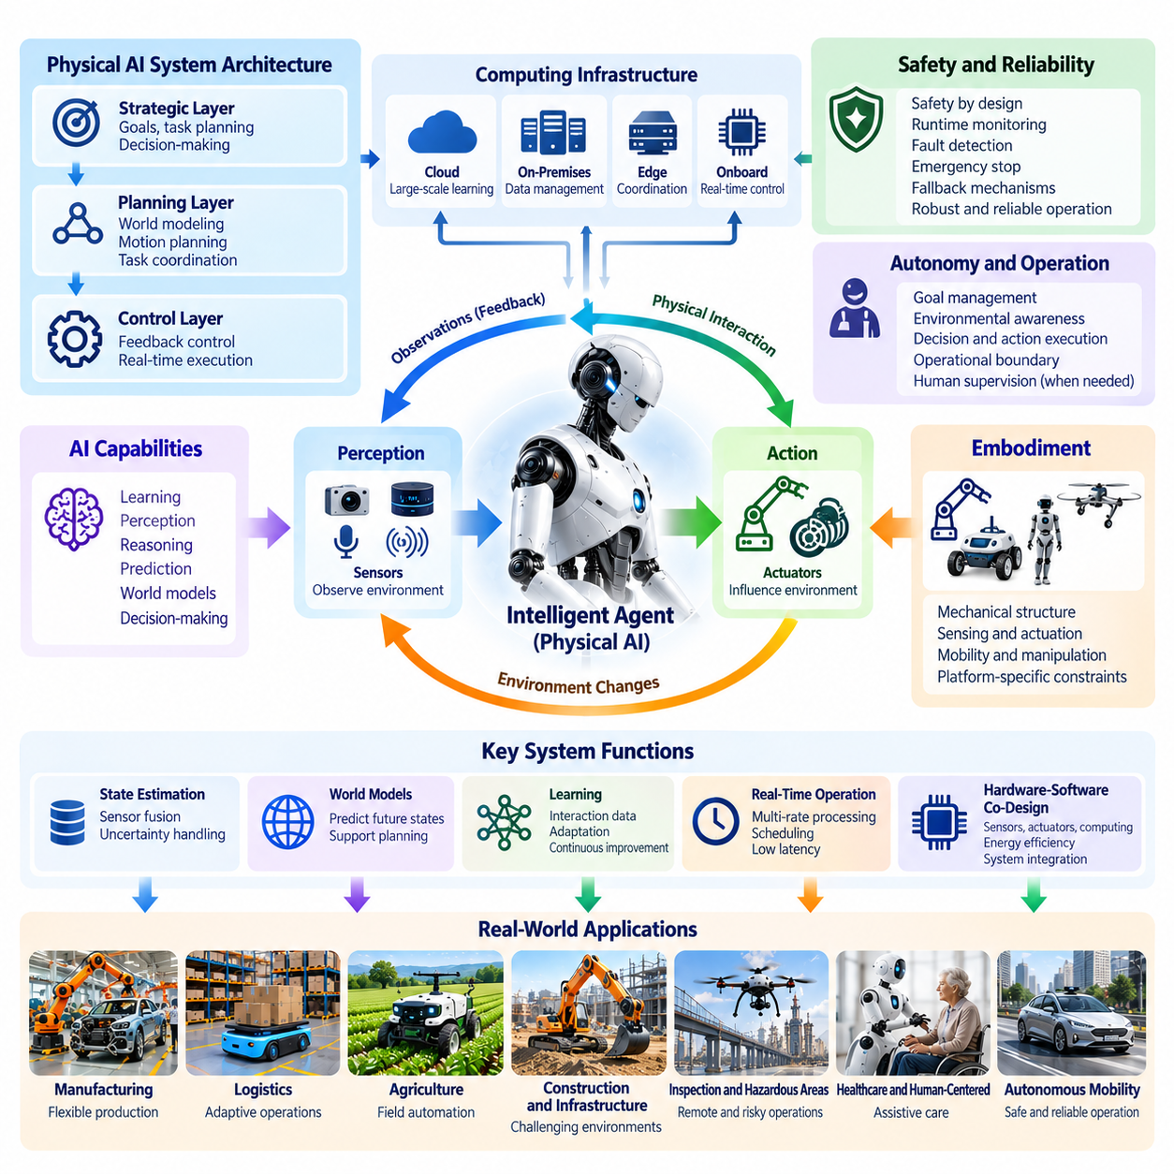
Physical AI is best understood as a system paradigm rather than an isolated artificial intelligence model or robotic technology. Its intelligence emerges from the coordinated operation of perception, reasoning, prediction, planning, control, and physical interaction. Each capability contributes to a larger operational process in which information becomes action and action generates new information. System-level integration is therefore fundamental to meaningful physical intelligence.
A system paradigm emphasizes relationships among components rather than evaluating individual technologies independently. An advanced perception model cannot guarantee successful operation without reliable localization, planning, and control. Similarly, precise actuators cannot produce intelligent behavior without appropriate environmental understanding. Physical AI requires these capabilities to function as an integrated architecture whose performance depends on their continuous coordination.
The fundamental structure of Physical AI involves an intelligent agent interacting with a physical environment to accomplish defined objectives. Sensors provide observations, computational models estimate relevant states, decision mechanisms select actions, and actuators influence the environment. The resulting changes are observed again, creating a continuous feedback process. This closed-loop relationship establishes the operational foundation of the entire system.
Physical AI architectures must account for multiple levels of abstraction and decision-making. High-level intelligence interprets goals, evaluates task priorities, and selects strategies. Intermediate mechanisms generate motion plans and coordinate activities, while low-level controllers regulate physical movement. Information must flow across these levels so that strategic decisions remain consistent with immediate environmental conditions and mechanical limitations.
The system perspective also requires explicit consideration of embodiment. A physical agent operates through a particular mechanical structure with defined sensing, movement, and interaction capabilities. The same computational objective may require different implementations across wheeled robots, manipulators, humanoids, or aerial platforms. Intelligence must therefore be interpreted in relation to the physical capabilities and constraints of the system executing it.
Environmental interaction introduces uncertainty that cannot be eliminated through model accuracy alone. Sensor measurements contain noise, physical dynamics may be incompletely understood, and external disturbances can alter expected outcomes. A Physical AI system must combine estimation, prediction, feedback, and adaptation to maintain effective operation. Robustness emerges from coordinated responses to uncertainty rather than from reliance on any single perfect component.
World models provide an important organizing mechanism within this system paradigm. By representing relationships among environmental states, actions, and possible future outcomes, they can support prediction and planning. However, world models must remain connected to current observations and executable control mechanisms. Their practical value depends on how effectively predictions influence decisions and how subsequent feedback corrects inaccurate expectations.
Physical AI also requires coordination across different temporal scales. Strategic planning may consider objectives extending over minutes or hours, while motion planning operates over shorter intervals and control loops respond within milliseconds. These processes cannot operate independently because delayed or inconsistent information can undermine physical performance. System architecture must therefore manage timing, scheduling, and communication between interconnected functions.
Hardware and software are inseparable elements of Physical AI system design. Sensor placement determines observable information, actuator characteristics constrain available movements, and computing platforms influence inference latency and energy consumption. Software algorithms must accommodate these limitations, while hardware configurations should support required intelligence capabilities. This relationship makes hardware-software co-design essential for practical deployment.
The computing structure of Physical AI may extend across onboard processors, edge infrastructure, on-premises systems, and cloud platforms. Time-critical perception and control typically require local execution, while broader coordination and computationally intensive learning may use distributed resources. Effective system design assigns functions according to latency, bandwidth, reliability, privacy, and safety requirements rather than assuming that all intelligence belongs in one location.
Safety must be treated as an architectural property rather than an additional feature introduced after development. Learned models may produce uncertain outputs, sensors may fail, and actuators may behave unexpectedly. Protective constraints, fault detection, runtime monitoring, emergency stopping, and fallback mechanisms must operate across system boundaries. Safe physical intelligence depends on coordinated prevention, detection, and recovery capabilities.
The system paradigm changes how autonomy is defined and evaluated. Autonomy is not simply the ability to execute commands without human intervention. It includes environmental awareness, goal management, decision-making, action execution, and recognition of operational limitations. A system may demonstrate strong autonomy within a defined operating domain while requiring supervision in unfamiliar conditions. Autonomy must therefore be evaluated within explicit operational boundaries.
Learning is another system-level capability because improvements must influence physical behavior without undermining established constraints. Data collected during operation can reveal environmental patterns, control limitations, and recurring failures. Models may be updated through offline training or carefully managed adaptation. However, deployment of updated intelligence requires validation, compatibility checks, and mechanisms that preserve operational reliability.
Simulation and digital twins support system-level development by representing interactions among physical mechanisms, sensors, environmental dynamics, and software components. They enable engineers to examine complete task execution rather than isolated algorithm performance. Nevertheless, simulated success cannot independently establish real-world reliability. Physical validation remains necessary to assess modeling differences, environmental variation, and unexpected interactions.
The integration of multiple physical agents extends the system paradigm beyond individual machines. Robots may exchange observations, coordinate tasks, share environmental representations, and optimize collective operations. Fleet-level intelligence introduces additional requirements for communication, synchronization, resource allocation, and distributed decision-making. The overall system must remain functional even when individual agents or network connections become temporarily unavailable.
A system-level perspective also transforms performance evaluation. High perception accuracy or planning efficiency does not necessarily imply successful physical operation. Evaluation must examine task completion, stability, safety, energy efficiency, recovery behavior, and long-term reliability. These measures reveal interactions among components and expose failures that isolated benchmarks may overlook. The complete operational outcome becomes the primary measure of intelligence.
Physical AI development therefore requires interdisciplinary engineering practices. Artificial intelligence researchers, roboticists, control engineers, embedded software developers, mechanical designers, and safety specialists must coordinate requirements and interfaces. Decisions made in one discipline can affect the feasibility of another. Effective development processes establish shared specifications, integration procedures, verification methods, and traceable system requirements.
The system paradigm also influences product strategy and deployment. A successful Physical AI product requires more than a capable model or impressive demonstration. It must operate consistently within a defined environment, integrate with existing workflows, support maintenance, and deliver measurable operational value. Lifecycle management, cybersecurity, reliability engineering, and continuous improvement become essential elements of the product architecture.
Physical AI can consequently be viewed as an architecture for transforming information into reliable physical outcomes. Perception establishes environmental awareness, reasoning interprets objectives, prediction anticipates consequences, planning selects feasible actions, and control executes them under physical constraints. Feedback connects these functions into a continuous operational process. Their collective behavior determines whether the system demonstrates practical intelligence.
Understanding Physical AI as a system paradigm provides a foundation for its definitions, classifications, architectures, and future development. It shifts attention from isolated algorithmic achievements toward the coordinated performance of complete intelligent machines. The defining objective is not merely to make artificial intelligence more capable, but to create integrated systems that perceive, reason, act, adapt, and remain dependable within the complexity of the physical world.

00.05. Scope and Boundaries of Physical AI
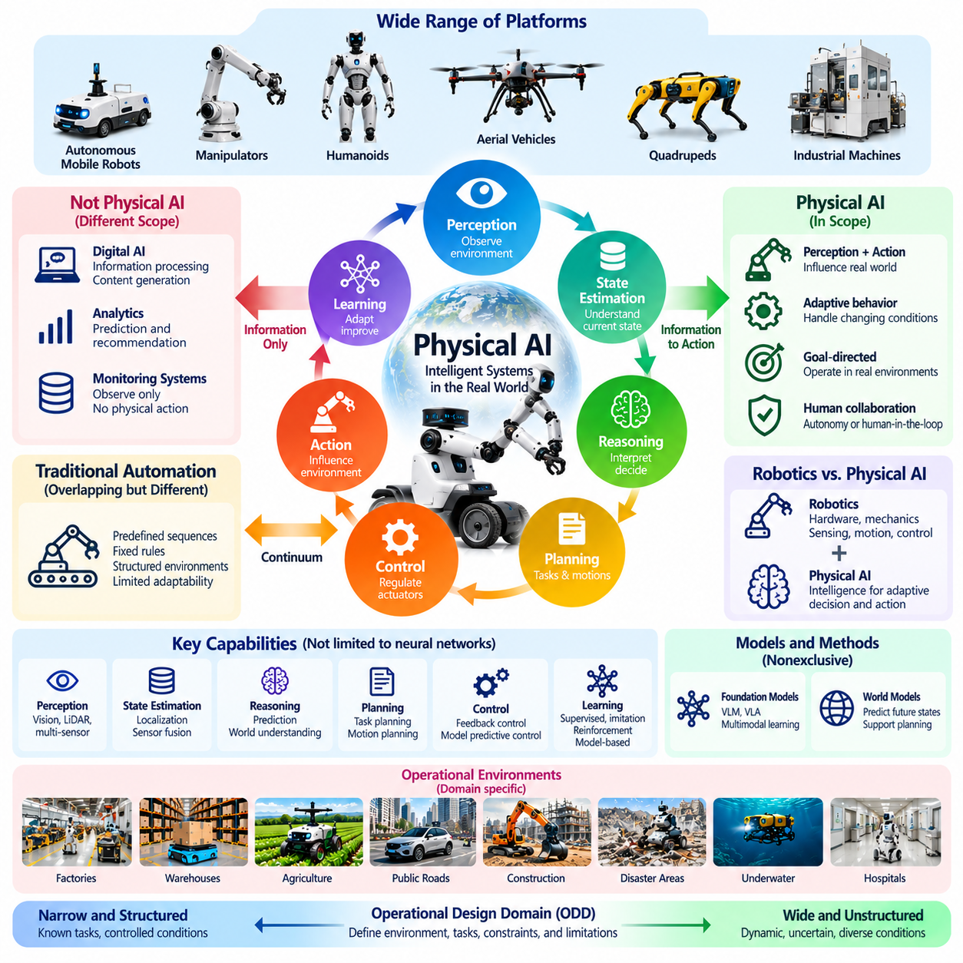
The scope of Physical AI encompasses intelligent systems that perceive, reason about, and interact with the physical world through actions that influence real environments. It extends beyond conventional software intelligence by connecting computational decisions with physical processes. Defining its boundaries is essential for distinguishing genuine physical intelligence from automation, digital analytics, and systems that merely observe the world without actively influencing it.
Physical AI is not limited to a particular robot morphology, industry, or computing architecture. Autonomous mobile robots, manipulators, humanoids, aerial vehicles, and intelligent industrial machines may all embody Physical AI capabilities. Their common characteristic is the integration of environmental perception, decision-making, and physically consequential action. The specific mechanisms differ, but the underlying relationship between intelligence and physical interaction remains central.
A defining boundary concerns the distinction between information processing and physical agency. A digital model that classifies images or predicts equipment failures does not automatically constitute a complete Physical AI system. Its outputs may support physical operations, but direct physical intelligence requires integration with mechanisms that select, execute, or regulate actions affecting the environment. This distinction separates enabling AI components from operational physical agents.
Physical AI also differs from conventional automation, although their boundaries can overlap. Traditional automation often follows predefined sequences or fixed control rules within structured operating conditions. Physical AI introduces capabilities for interpreting changing environments, selecting context-dependent actions, and adapting behavior through feedback or learning. Nevertheless, sophisticated automation may incorporate intelligent functions, making the distinction a continuum rather than an absolute division.
The relationship between Physical AI and robotics requires similar clarification. Robotics concerns the design, construction, sensing, movement, and control of physical machines. Physical AI focuses on the intelligence that enables such machines to interpret conditions and perform adaptive actions. A robot can operate without advanced AI, while Physical AI principles can also apply to intelligent physical infrastructure and automated equipment beyond conventional robotic platforms.
Embodied AI is closely related to Physical AI because both emphasize intelligence grounded in interaction with an environment. Embodied AI frequently examines how an agent's body, sensory capabilities, and actions influence learning and cognition. Physical AI adopts these principles while emphasizing complete operational systems, physical constraints, engineering integration, and real-world deployment. Their conceptual boundaries overlap substantially rather than forming entirely separate categories.
The scope of Physical AI includes perception, state estimation, environmental understanding, reasoning, prediction, planning, control, and learning. These capabilities need not all rely on neural networks or operate within a single computational model. Classical algorithms, probabilistic methods, learned representations, and feedback controllers may coexist within one architecture. What matters is their coordinated contribution to physically grounded, goal-directed behavior.
Physical interaction provides an important criterion for determining system boundaries. Actions may involve locomotion, manipulation, force application, vehicle steering, or regulation of physical processes. The action need not resemble human movement, but it must have meaningful consequences for the physical environment. Systems that only generate descriptions or recommendations generally remain supporting technologies unless connected to an operational mechanism for physical action.
Autonomy represents another dimension of scope rather than a strict entry requirement. Some Physical AI systems operate independently within defined environments, while others share decision-making responsibilities with human operators. Teleoperation, supervisory control, and human-in-the-loop architectures may incorporate substantial physical intelligence. The degree of autonomy should therefore be described explicitly instead of assuming that every Physical AI system must operate without human involvement.
The operational environment further influences how Physical AI is classified and evaluated. Structured factories, warehouses, hospitals, public roads, agricultural fields, and unstructured outdoor environments impose different requirements. A system designed for one environment may not generalize reliably to another. Physical AI capabilities must therefore be interpreted within an operational design domain that specifies expected conditions, tasks, constraints, and limitations.
Physical AI does not require a particular learning paradigm. Supervised learning, imitation learning, reinforcement learning, self-supervised learning, and model-based methods can contribute to physical intelligence. Some systems may rely on pretrained models without updating during operation, while others incorporate controlled adaptation. Continuous online learning is therefore not a universal requirement, although learning and generalization remain important dimensions of advanced capabilities.
Foundation models and world models occupy significant but nonexclusive positions within Physical AI. Vision-language models can interpret scenes and instructions, while vision-language-action models can connect multimodal observations with action generation. World models may predict environmental changes and support planning. However, no single model family defines the entire field, and successful deployment still depends on control, sensing, safety, and system integration.
The computing boundary of Physical AI extends across embedded processors, edge devices, on-premises infrastructure, and cloud platforms. Intelligence may be distributed according to latency, computational demand, communication reliability, and security requirements. Real-time control commonly remains close to physical hardware, while training and broader coordination may occur remotely. Physical AI is consequently defined by functional integration rather than the physical location of computation.
Simulation introduces another important boundary. Virtual robots and simulated environments provide valuable settings for training, experimentation, and evaluation. However, performance demonstrated exclusively in simulation does not establish reliable operation in the physical world. Simulation-based intelligence can be considered part of Physical AI research, while claims about deployed physical capability require evidence from relevant real-world interactions and validation procedures.
Safety, reliability, and physical constraints are integral to the scope of Physical AI rather than optional engineering concerns. Intelligent decisions must respect mechanical limits, energy budgets, timing requirements, and acceptable operational risks. A system that generates sophisticated actions without mechanisms for controlling their consequences remains incomplete for dependable deployment. Physical intelligence must therefore be evaluated through both computational capability and physical execution quality.
The boundaries of Physical AI also extend to multi-agent and collective systems. Individual robots may share observations, coordinate tasks, and use distributed intelligence to improve operational performance. Such systems introduce fleet management, communication, synchronization, and shared environmental representations. Their inclusion reflects the fact that physical intelligence may emerge from coordinated interactions among multiple machines rather than residing entirely within one autonomous agent.
Human participation remains an important consideration when defining the field. Physical AI can support collaborative robots, assistive devices, supervised autonomous machines, and systems that augment human capabilities. Human oversight may remain necessary for safety, ethical judgment, or exceptional situations. The presence of human supervision does not eliminate physical intelligence, provided the system performs meaningful perception, reasoning, or adaptive control in physical operations.
Physical AI should also be distinguished from general artificial intelligence. A system may demonstrate advanced physical competence within a narrow operational domain without possessing broad human-level reasoning or universal problem-solving capabilities. Conversely, a powerful general-purpose digital model may lack the embodiment and control mechanisms required for physical execution. Physical intelligence and general intelligence are related research directions, but neither automatically implies the other.
From an engineering perspective, the practical boundary of a Physical AI system is established through its objectives, components, interfaces, operational domain, and responsibility for physical outcomes. These boundaries determine what the system can observe, which actions it can perform, how decisions are validated, and when external intervention is required. Explicit system boundaries enable meaningful comparisons, reproducible evaluation, and accountable deployment.
Defining the scope and boundaries of Physical AI provides a foundation for consistent terminology, taxonomy, architecture, and product development. The field encompasses diverse embodiments, algorithms, autonomy levels, and deployment environments, but its central principle remains the integration of intelligence with physically consequential interaction. Clear boundaries prevent the term from becoming an unrestricted label while preserving the breadth required to describe evolving intelligent physical systems.

00.06. Core Concepts and Terminology
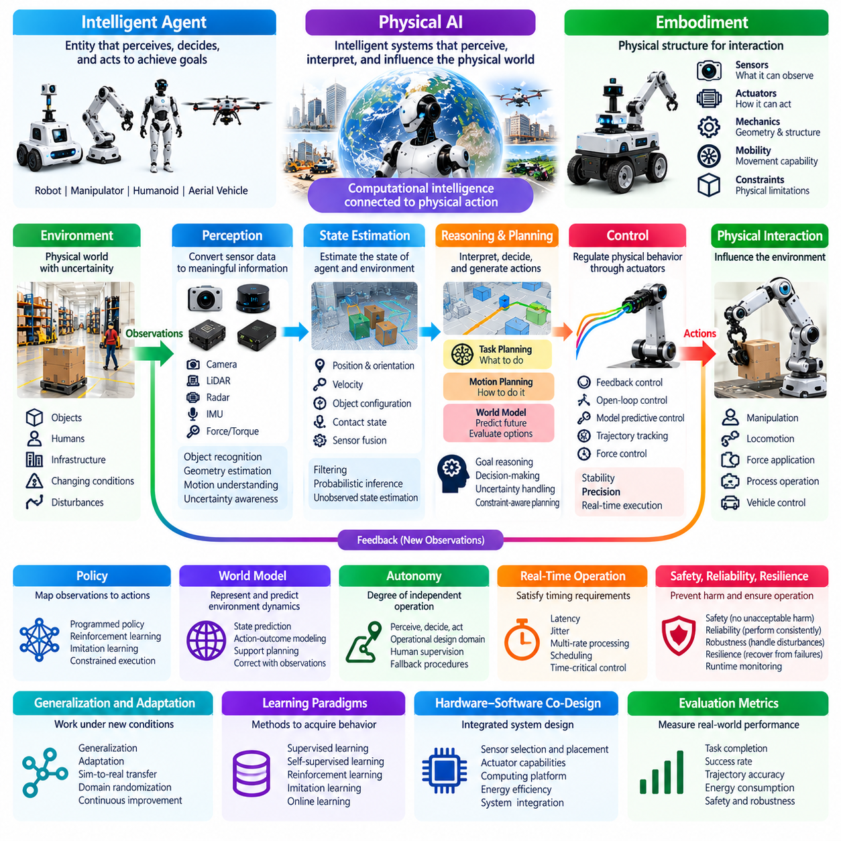
Physical AI refers to intelligent systems that perceive, interpret, and influence the physical world through coordinated computational and mechanical processes. Unlike purely digital intelligence, Physical AI connects reasoning and decision-making with actions that produce observable physical consequences. Its terminology must therefore describe not only artificial intelligence capabilities but also embodiment, environmental interaction, feedback, and operational constraints.
An intelligent agent is an entity capable of receiving information, selecting actions, and pursuing objectives within an environment. In Physical AI, the agent may be a robot, autonomous vehicle, industrial machine, or distributed physical system. The agent concept emphasizes functional behavior rather than a particular mechanical form. Its intelligence is evaluated through its ability to achieve goals while responding appropriately to changing physical conditions.
Embodiment describes the relationship between intelligence and the physical structure through which an agent interacts with its environment. Sensors, actuators, mechanical geometry, and mobility mechanisms determine what the agent can perceive and accomplish. Embodiment influences learning, planning, and control because physical capabilities constrain possible actions. Identical algorithms may therefore produce different behaviors when deployed on different robotic platforms.
Perception is the process of transforming sensor measurements into meaningful information about the environment. Cameras, LiDAR, radar, inertial sensors, and force sensors provide observations with different characteristics and limitations. Perception algorithms identify objects, estimate geometry, recognize motion, and interpret surrounding conditions. Reliable perception requires uncertainty awareness because sensor information may be incomplete, noisy, or delayed.
State estimation determines the probable condition of a system or environment from available observations and prior information. Relevant states may include position, orientation, velocity, object configuration, and contact conditions. Techniques such as filtering, sensor fusion, and probabilistic inference help reconstruct variables that cannot be measured directly. Accurate state estimation supports navigation, manipulation, prediction, and feedback control.
Reasoning involves interpreting information, evaluating relationships, and selecting conclusions or decisions consistent with system objectives. Planning converts those decisions into sequences of feasible actions. Task planning addresses what should be accomplished, while motion planning determines how physical movement can achieve the intended result. Both must consider environmental uncertainty, mechanical limitations, and available resources.
Control is the process of regulating physical behavior through commands applied to actuators or other operational mechanisms. Feedback control compares desired behavior with measured outcomes and continuously corrects deviations. Open-loop control executes commands without using resulting measurements for correction. Physical AI commonly combines predictive planning with closed-loop control to achieve dependable operation under changing conditions.
A policy is a decision mechanism that maps observations or estimated states to actions. Policies may be explicitly programmed, optimized through control methods, or learned from data. Reinforcement learning improves policies through interaction and reward-based evaluation, while imitation learning derives behavior from demonstrations. Policy performance depends on the quality of observations, training conditions, and constraints imposed during execution.
A world model represents aspects of the environment and predicts how states may evolve under different actions. It may use physical equations, probabilistic representations, neural networks, or combinations of these approaches. World models support anticipation, planning, and evaluation of alternative behaviors. Their predictions remain approximations and must be corrected through observations and real-world feedback.
Autonomy describes the degree to which a system can perceive conditions, make decisions, and execute actions without continuous human direction. It does not necessarily imply complete independence or unrestricted decision-making. Operational design domains define the environments and conditions under which autonomous capabilities are intended to function. Human supervision, remote intervention, and fallback procedures may remain necessary.
Real-time operation refers to computing and control processes that must satisfy defined timing requirements. Perception, planning, and control often operate at different frequencies, creating challenges for scheduling and synchronization. Latency measures the delay between an event and its corresponding response, while jitter describes variations in timing. Physical AI must manage these properties because delayed actions can reduce stability or safety.
Robustness is the ability to maintain acceptable performance despite disturbances, uncertainty, and environmental variation. Reliability concerns the probability of performing required functions over specified conditions and periods. Safety focuses on preventing unacceptable harm, while resilience includes the capacity to recover from disruptions. These concepts are related but distinct and require different evaluation methods and engineering evidence.
Generalization describes the ability to perform effectively under conditions not identical to those encountered during development. Adaptation refers to changes in system behavior or internal parameters in response to new circumstances. Sim-to-real transfer applies capabilities developed in simulation to physical environments. Successful transfer requires accounting for differences in dynamics, sensing, contact behavior, and environmental complexity.
Foundation models are large pretrained models intended to support multiple downstream tasks. Vision-language models connect visual observations with linguistic understanding, while vision-language-action models extend multimodal processing toward action generation. These models may improve instruction following and task flexibility. However, their outputs still require grounding in physical states, feasible actions, and appropriate safety constraints.
A Physical AI architecture organizes sensing, computation, decision-making, communication, and actuation into a coordinated system. Embedded processors and edge devices support local responsiveness, while on-premises and cloud resources may provide broader coordination or training capabilities. The allocation of functions depends on latency, bandwidth, computational capacity, security, and operational reliability.
Together, these concepts establish a consistent vocabulary for describing Physical AI systems. Perception supplies environmental information, state estimation reconstructs relevant conditions, reasoning and planning determine actions, and control produces physical execution. Learning and world models extend adaptability and prediction, while safety and reliability constrain operation. Their integration defines Physical AI as a complete intelligent physical system.

00.07. Key Challenges of Physical AI
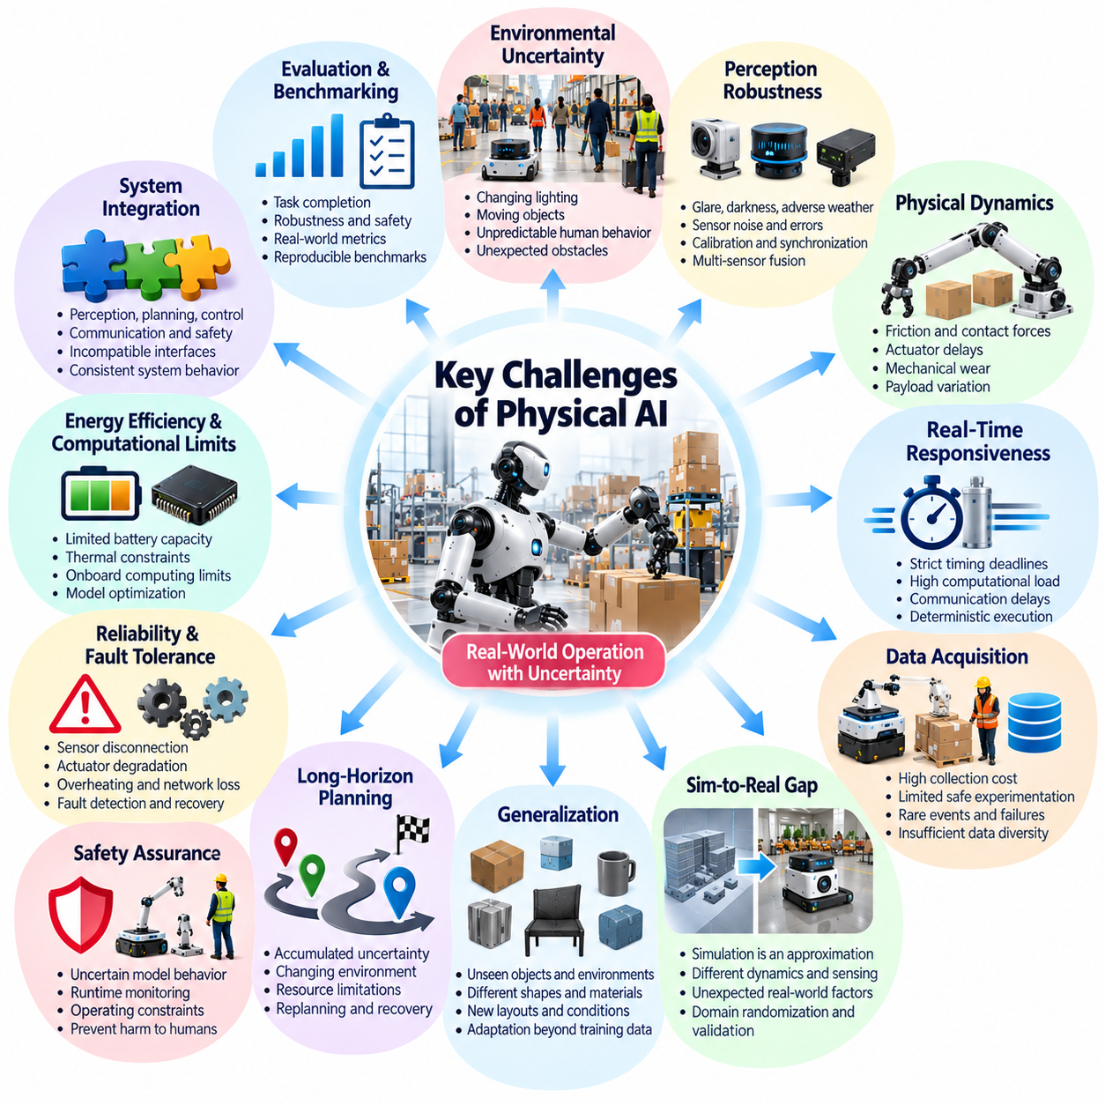
Physical AI faces challenges that extend beyond those encountered in conventional digital intelligence because its decisions directly influence physical environments. Errors may cause collisions, equipment damage, operational disruption, or human injury. Consequently, successful development requires more than accurate algorithms. It demands coordinated solutions for perception, reasoning, control, safety, reliability, and continuous operation under uncertain real-world conditions.
Environmental uncertainty represents one of the most fundamental challenges. Physical environments contain changing lighting, moving objects, unpredictable human behavior, and unexpected obstacles. Sensors provide incomplete or noisy observations, while environmental conditions may differ from training assumptions. Physical AI systems must maintain useful environmental understanding despite these variations and recognize when available information is insufficient for reliable action.
Perception robustness remains difficult because sensor performance depends on environmental and operational conditions. Cameras may struggle with glare or darkness, LiDAR measurements may deteriorate in adverse weather, and inertial sensors accumulate estimation errors. Combining multiple sensors can improve coverage, but introduces calibration, synchronization, and fusion challenges. Reliable perception requires both accurate measurements and explicit management of uncertainty.
Physical dynamics create additional complexity because real systems do not always behave according to simplified mathematical models. Friction, contact forces, actuator delays, mechanical wear, and payload variation can alter expected movements. Learning-based predictions may also become inaccurate outside familiar conditions. Physical AI must combine predictive models with feedback control and adaptive estimation to compensate for changing dynamics and disturbances.
Real-time responsiveness is essential when intelligent decisions must influence rapidly evolving physical situations. Complex neural networks can require substantial computation, while control systems may operate under strict timing deadlines. Communication delays, scheduling conflicts, and variable inference latency can reduce performance. System designers must balance model complexity with deterministic execution, computational efficiency, and timely physical responses.
Data acquisition presents another major obstacle. Physical interaction data is expensive to collect because robots require equipment, operating space, supervision, and maintenance. Some important events, including collisions and rare failures, cannot be gathered safely through unrestricted experimentation. Datasets may also lack sufficient diversity across environments and hardware platforms. These limitations complicate training, benchmarking, and generalization.
The simulation-to-reality gap remains a persistent challenge for Physical AI development. Simulators approximate dynamics, sensing, materials, and environmental interactions, but cannot reproduce every real-world condition. Policies that perform well in simulation may fail when exposed to unexpected friction, sensor noise, or object properties. Domain randomization, system identification, and physical validation help reduce this gap without eliminating it entirely.
Generalization is difficult because physical tasks involve combinations of objects, environments, and operating conditions that may not appear in training data. A robot trained to manipulate familiar objects may struggle with unfamiliar shapes, materials, or contact configurations. Similarly, navigation policies may degrade in new layouts. Physical AI requires representations and adaptation mechanisms that support reliable performance beyond narrowly defined examples.
Long-horizon planning introduces uncertainty that accumulates across sequences of actions. Small prediction errors can become significant when tasks require many coordinated steps. Environmental changes may invalidate earlier assumptions, while resource limitations constrain feasible decisions. World models and hierarchical planning can improve anticipation, but successful execution still requires frequent observation, replanning, and recovery from unexpected outcomes.
Safety assurance is especially challenging when learned models influence physical actions. Neural networks may behave unpredictably outside their training distributions, and their internal decision processes can be difficult to interpret. Conventional safety analysis must therefore be combined with runtime monitoring, operating constraints, and independent protective mechanisms. Demonstrating acceptable safety requires evidence across realistic hazards and operating conditions.
Reliability and fault tolerance are equally important for sustained deployment. Sensors can disconnect, actuators can degrade, processors may overheat, and communication networks can become unavailable. A Physical AI system must detect faults, isolate affected functions, and transition toward safe operating states when necessary. Recovery mechanisms should preserve essential capabilities without allowing degraded intelligence to create unacceptable physical risks.
Energy efficiency and computational limitations constrain practical system architectures. Mobile robots often operate with limited battery capacity, thermal budgets, and onboard processing resources. Larger models may improve reasoning capabilities but increase power consumption and inference delays. Effective deployment requires model optimization, hardware-aware scheduling, and appropriate distribution of computation across onboard, edge, and remote infrastructure.
System integration becomes difficult as perception, planning, control, communication, and safety functions evolve independently. Components may use incompatible data representations, timing assumptions, or coordinate systems. Even individually accurate modules can produce unstable behavior when connected incorrectly. Interface specifications, synchronization, integration testing, and end-to-end validation are essential for maintaining consistent system behavior.
Evaluation and benchmarking remain challenging because algorithm accuracy does not fully describe physical intelligence. A model may achieve strong perception scores while the complete robot fails to accomplish tasks reliably. Meaningful evaluation must consider task completion, execution time, robustness, safety, energy use, and recovery behavior. Reproducible benchmarks also require clearly defined environments, operating conditions, and failure criteria.
Human interaction introduces additional technical and operational requirements. Physical AI systems must interpret human intentions, respect personal space, and respond safely to unpredictable movements. Shared workspaces require understandable behavior and effective communication between people and machines. Human oversight must also remain practical, particularly when operators need to intervene during abnormal situations or uncertain autonomous decisions.
Cybersecurity and data governance become critical when physical machines depend on networked intelligence. Unauthorized commands, compromised sensors, manipulated models, or disrupted communication can produce physical consequences. Distributed architectures also introduce concerns involving access control, software updates, and sensitive environmental data. Security must be integrated with safety engineering rather than treated as an unrelated software function.
Scalability presents difficulties when Physical AI expands from isolated demonstrations to fleets and industrial deployments. Coordinating multiple machines requires communication, task allocation, shared environmental awareness, and resource management. Network interruptions and inconsistent observations can undermine collective performance. Large-scale operation also demands maintainable software, standardized interfaces, and effective lifecycle management.
The economic challenge involves converting technical capabilities into sustainable operational value. Development requires substantial investment in hardware, datasets, computing infrastructure, integration, and field testing. Maintenance costs and deployment complexity can outweigh benefits when systems are insufficiently reliable. Practical adoption depends on measurable improvements in productivity, safety, flexibility, or service quality across realistic operating conditions.
Addressing these challenges requires interdisciplinary cooperation among artificial intelligence, robotics, control engineering, systems engineering, and safety disciplines. No individual model or algorithm can resolve every limitation of physical interaction. Progress depends on combining learning with physical modeling, reliable hardware, rigorous validation, and operational feedback. Physical AI must be developed as an integrated engineering system rather than an isolated intelligence capability.

00.08. Roadmap of This Volume
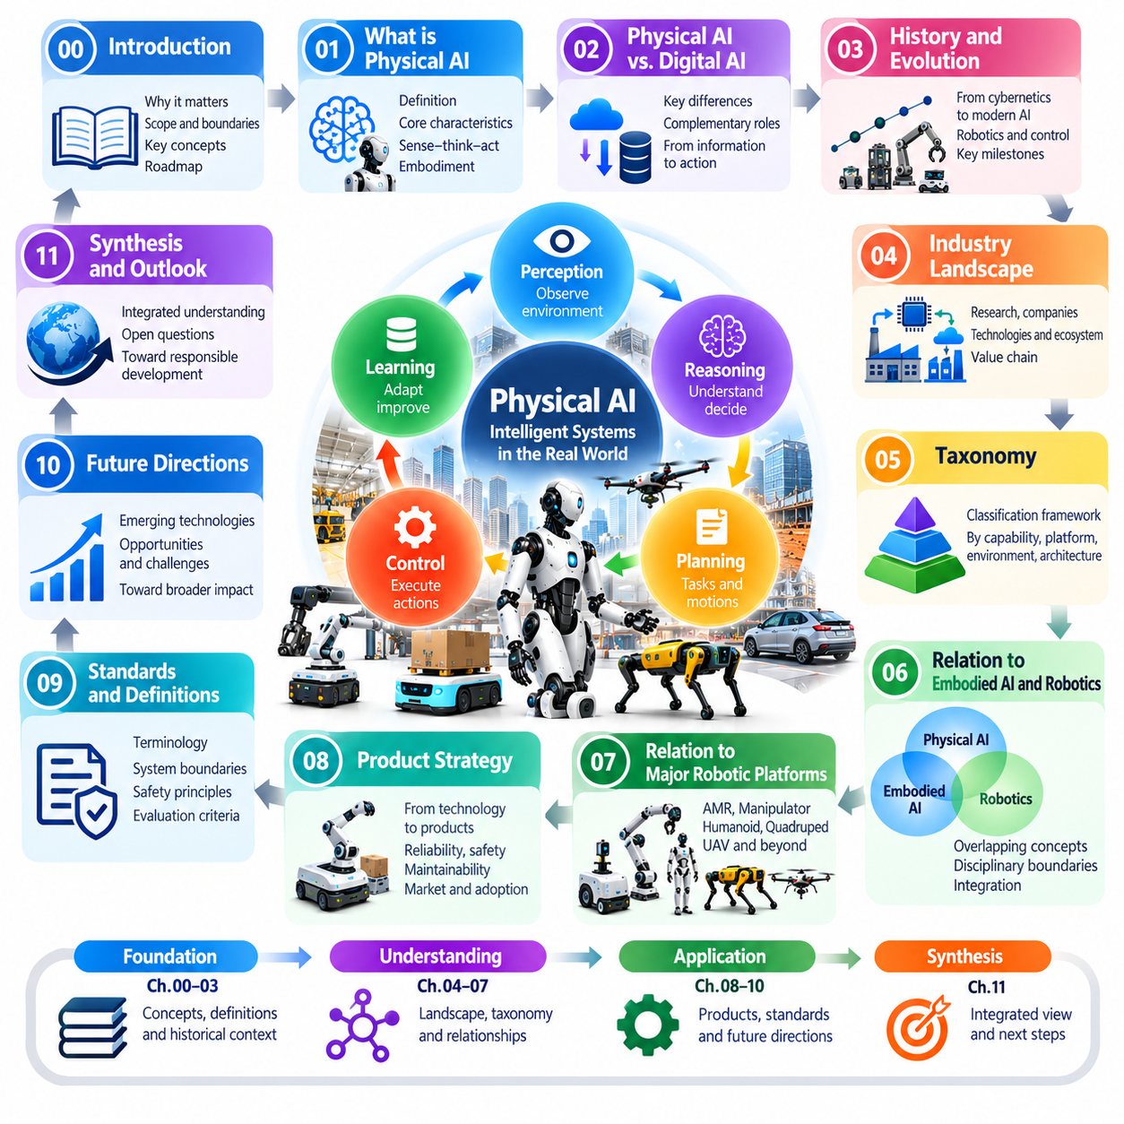
This volume establishes the conceptual foundations, definitions, and organizational framework required to understand Physical AI as an emerging field of intelligent physical systems. Rather than concentrating on individual algorithms or robotic products, it examines the principles connecting intelligence with perception, embodiment, decision-making, and action. Its progression moves from fundamental definitions toward historical context, taxonomy, applications, standards, and future directions.
The introductory chapter establishes why Physical AI matters and explains the transition from digital intelligence toward systems capable of interacting with physical environments. It examines the convergence of artificial intelligence, robotics, and control engineering while presenting Physical AI as a system paradigm. The introduction also defines the field's scope, introduces essential terminology, and identifies major technical and operational challenges.
The following chapter addresses the fundamental question of what constitutes Physical AI. It examines the relationship between intelligent computation and physically consequential action, emphasizing perception, reasoning, planning, and feedback. Particular attention is given to embodiment and environmental interaction as defining characteristics. These concepts establish a common basis for distinguishing complete Physical AI systems from isolated enabling technologies.
The comparison between Physical AI and Digital AI provides a deeper explanation of their differences and complementary capabilities. Digital AI primarily operates through information processing and computational representations, whereas Physical AI must account for physical dynamics, execution constraints, and real-world consequences. This comparison clarifies why model accuracy alone cannot establish physical competence and why feedback, timing, and safety become essential.
The historical chapter traces the intellectual and technological origins of Physical AI. It connects developments in cybernetics, feedback control, artificial intelligence, and robotics with later advances in machine learning and autonomous systems. Understanding this progression reveals how previously separate disciplines converged into increasingly integrated architectures. Historical context also helps distinguish enduring engineering principles from recent technological developments.
The industry landscape chapter examines how Physical AI is developing across research institutions, technology companies, robotics manufacturers, and industrial sectors. It considers the roles of computing platforms, sensing technologies, robotic hardware, and intelligent software. The chapter also explores the relationships among technology providers, system integrators, and application developers, providing context for understanding the broader Physical AI ecosystem.
A dedicated taxonomy chapter introduces the need for systematic classification within Physical AI. Because the field includes diverse machines, intelligence capabilities, operating environments, and architectural approaches, consistent categories are essential. The taxonomy provides a conceptual structure for comparing systems without confusing hardware morphology with intelligence or autonomy. It also supports clearer communication, evaluation, and technology development.
The relationship between Physical AI, Embodied AI, and robotics is examined to clarify overlapping concepts and disciplinary boundaries. Embodied AI emphasizes intelligence shaped by physical interaction, while robotics provides the mechanical and computational foundations for autonomous machines. Physical AI integrates these perspectives within operational systems. This discussion helps prevent the interchangeable use of related terms that describe different aspects of intelligent behavior.
The volume then explores how Physical AI relates to major robotic platforms, including autonomous mobile robots, manipulators, humanoids, quadrupeds, and unmanned aerial vehicles. Each platform introduces distinct sensing, actuation, mobility, and control requirements. The discussion distinguishes general intelligence principles from embodiment-specific implementation challenges, demonstrating how common Physical AI capabilities can support different forms of physical interaction.
The product strategy chapter extends the discussion from technological capabilities to practical deployment and operational value. It examines how Physical AI systems can be developed into products that satisfy real-world requirements for reliability, safety, maintainability, and integration. Attention is given to the relationship between technical performance and application needs. This perspective connects conceptual foundations with engineering decisions and sustainable adoption.
Standards and definitions receive separate attention because consistent terminology and evaluation criteria are essential for a developing technological field. The relevant chapter considers how definitions, system boundaries, safety principles, and technical standards support interoperability and accountable deployment. It also explains why terminology must distinguish established engineering concepts from emerging classifications and why claims about capability require explicit evidence.
The future directions chapter considers how Physical AI may evolve as learning algorithms, world models, computing infrastructure, and robotic platforms improve. It explores the potential for more adaptive, generalizable, and collaborative physical systems while recognizing unresolved limitations. Rather than assuming that increasing model scale automatically produces physical intelligence, the discussion emphasizes progress in system integration, reliable execution, and real-world validation.
Across these chapters, the volume follows a progression from conceptual understanding toward technological interpretation and practical application. Definitions establish the language, historical analysis explains the origins, taxonomy organizes the field, and platform comparisons reveal implementation differences. Industry, product, and standards discussions connect these foundations with deployment. Future directions then identify opportunities and questions arising from the combined framework.
An important objective is to distinguish capabilities belonging to individual components from properties emerging at the complete system level. Perception accuracy, planning sophistication, and control precision are valuable, but none independently guarantees successful physical behavior. The reader is encouraged to evaluate how these capabilities interact under environmental uncertainty, computational limitations, and operational constraints rather than treating them as isolated achievements.
The volume also establishes a basis for interpreting subsequent technical studies of intelligent physical systems. Concepts such as autonomy, embodiment, state estimation, world modeling, real-time control, and safety provide recurring reference points for more specialized discussions. A consistent conceptual foundation makes it possible to examine different algorithms, robotic architectures, and applications without losing sight of their common system-level requirements.
Ultimately, this volume aims to provide a coherent understanding of Physical AI as both a technological discipline and an engineering paradigm. Its chapters collectively explain what Physical AI is, how it emerged, how it differs from related fields, and how its capabilities can be classified and applied. This foundation prepares the reader to assess intelligent physical systems through their integrated ability to perceive, reason, act, adapt, and operate reliably in the physical world.

