Volume 02. Physical AI Foundations and Definitions

Chapter 01. What is Physical AI

01.01. Definition of Physical AI
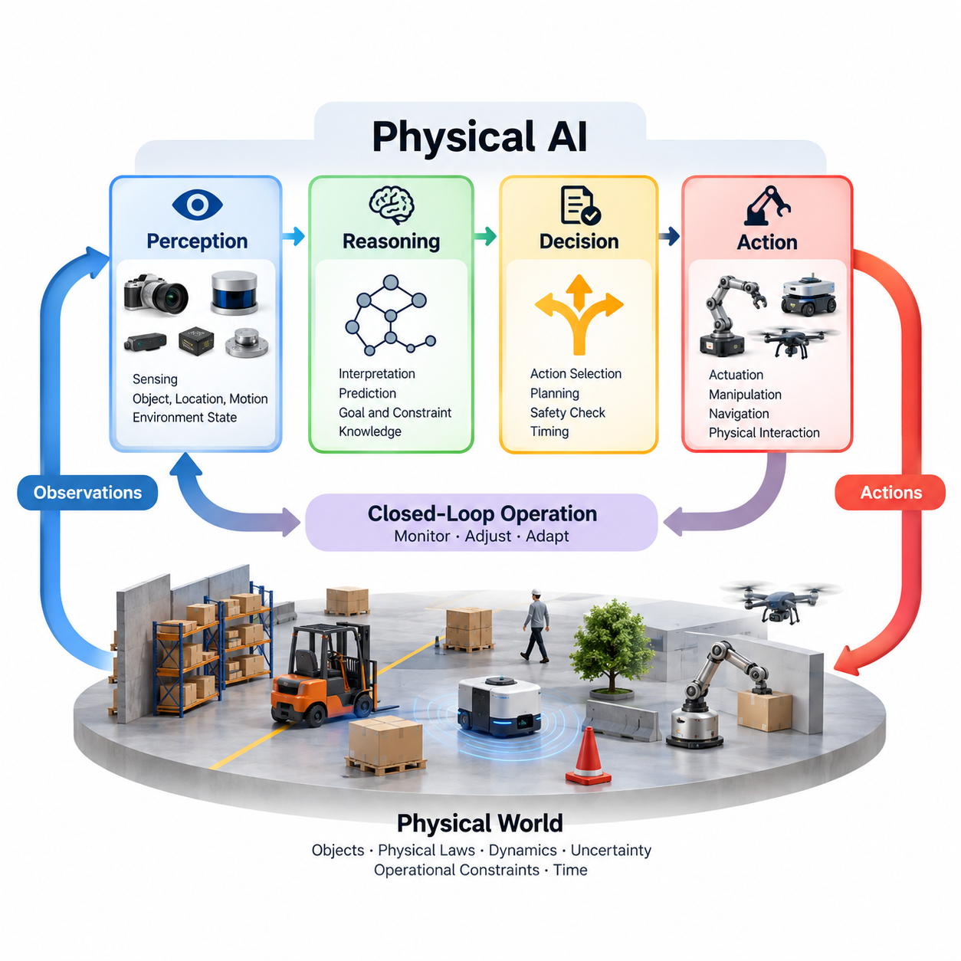
Physical Artificial Intelligence (Physical AI) refers to artificial intelligence systems capable of perceiving, interpreting, reasoning about, and interacting with the physical world through sensing and action. Unlike intelligence confined to digital information processing, Physical AI operates within environments governed by physical laws, spatial relationships, temporal dynamics, and material constraints. Its defining characteristic is the integration of computational intelligence with real-world interaction.
Physical AI can be understood as a system-level paradigm in which perception, reasoning, decision-making, control, and learning are coordinated to achieve goals in physical environments. Intelligence is not evaluated solely by the accuracy of predictions or the quality of generated information. It is also demonstrated through the ability to produce appropriate physical outcomes while responding to environmental changes, operational constraints, and uncertainty.
A Physical AI system typically consists of an intelligent agent, an environment, and a task or objective. The agent receives observations through sensors or other information channels, constructs an interpretation of its surroundings, selects actions, and influences the environment through actuators or connected physical mechanisms. The consequences of these actions generate new observations, establishing an ongoing interaction between the agent and the physical world.
The physical environment introduces characteristics that fundamentally influence intelligent behavior. Objects possess geometry, mass, friction, inertia, and mechanical properties, while actions unfold over time and may produce irreversible consequences. A robot moving through a warehouse, for example, must account for obstacles, moving workers, traction conditions, and stopping distances. Successful intelligence therefore requires awareness of both computational objectives and physical feasibility.
Perception provides the connection between the physical world and the computational representation maintained by an intelligent system. Cameras, LiDAR, radar, inertial sensors, force sensors, and other sensing technologies provide measurements of environmental conditions. These measurements are often incomplete, noisy, or ambiguous. Physical AI must transform them into useful estimates of objects, locations, motion, contact conditions, and other properties relevant to action.
Reasoning enables a Physical AI agent to interpret observations in relation to goals, constraints, and possible future outcomes. Rather than responding only to isolated sensor measurements, an intelligent system may evaluate alternative actions, estimate consequences, and select behavior consistent with task requirements. Reasoning can involve geometric relationships, physical dynamics, causal dependencies, uncertainty, and knowledge acquired through previous interactions.
Action distinguishes Physical AI from systems that merely describe or classify physical phenomena. An intelligent agent must translate decisions into commands that can influence its environment through motion, manipulation, navigation, or other physical processes. These commands must respect actuator limitations, mechanical capabilities, timing requirements, and safety boundaries. The effectiveness of intelligence ultimately depends on whether selected actions produce the intended physical results.
A central property of Physical AI is closed-loop operation, in which observations continuously influence subsequent decisions and actions. The agent monitors the consequences of its behavior and adjusts its response when conditions change. This feedback structure allows the system to compensate for disturbances, modeling errors, and unexpected events. Closed-loop intelligence is particularly important because real environments rarely behave exactly as predicted by an initial plan.
Physical AI also requires an understanding of time and dynamic behavior. Objects move, environmental conditions evolve, and opportunities for action may disappear within short intervals. Decisions must therefore consider not only what should happen but also when actions must occur. Sensor acquisition, computational processing, communication, and actuator response introduce delays that can directly affect stability, task performance, and operational safety.
Embodiment describes the relationship between intelligence and the physical structure through which an agent interacts with its environment. A mobile robot, robotic arm, humanoid, quadruped, and unmanned aerial vehicle possess different movement capabilities, sensing arrangements, and mechanical constraints. These differences shape the actions available to each system and influence how perception, reasoning, planning, and control must be implemented.
Physical AI is closely related to robotics, but the two concepts are not identical. Robotics encompasses the design, construction, control, and operation of robotic machines, including systems that execute fixed programs without adaptive intelligence. Physical AI emphasizes intelligent behavior grounded in physical interaction and may be incorporated into many robotic platforms. Robotics provides important embodiments through which Physical AI capabilities can be realized and evaluated.
The relationship between Physical AI and Embodied AI is similarly close. Embodied AI emphasizes how intelligence emerges from or is shaped by interaction between an agent's body and its environment. Physical AI adopts a broader systems perspective that includes sensing, computation, physical modeling, planning, control, and operational deployment. Both perspectives recognize that intelligent behavior cannot be fully understood independently of physical interaction.
Learning and adaptation extend Physical AI beyond predetermined responses. Through experience, a system may improve object recognition, estimate unknown dynamics, refine manipulation strategies, or adapt navigation behavior to changing conditions. Learning can occur through demonstrations, supervised training, reinforcement learning, simulation, or operational data. However, online learning is not mandatory for every Physical AI system, and adaptation must remain compatible with safety requirements.
World models provide a mechanism for representing the structure and dynamics of physical environments. Such models may encode object relationships, spatial occupancy, motion patterns, contact interactions, or predictions of future states. By estimating how the environment may evolve under different actions, a Physical AI agent can evaluate alternatives before execution. World models may be explicitly engineered, learned from data, or constructed through hybrid approaches.
Uncertainty is an unavoidable characteristic of physical intelligence because sensors cannot observe every relevant property and environmental behavior cannot be predicted perfectly. An agent may be uncertain about object locations, material characteristics, human intentions, or the consequences of an action. Physical AI must therefore combine available evidence with uncertainty-aware estimation, robust planning, and corrective feedback rather than assuming complete and accurate knowledge.
Autonomy represents the degree to which a Physical AI system can pursue assigned objectives without continuous human intervention. Autonomous behavior may include selecting actions, adjusting plans, detecting failures, and recovering from disturbances. However, autonomy does not imply unrestricted decision-making. Operational boundaries, supervisory controls, human authorization, and predefined safety constraints remain essential components of responsible physical system operation.
Safety is a fundamental requirement because Physical AI actions can affect people, equipment, infrastructure, and the surrounding environment. Errors may cause collisions, unstable motion, damaged objects, or other hazardous outcomes. Consequently, intelligent decision-making must operate alongside risk assessment, safety monitoring, protective control, and fallback mechanisms. High task performance alone is insufficient if the system cannot maintain acceptable physical risk.
Physical AI systems also operate under computational and resource constraints. Embedded processors, edge accelerators, communication networks, batteries, and thermal management systems impose practical limits on model complexity and execution speed. An intelligent algorithm that performs well in offline experiments may be unsuitable for real deployment if it cannot satisfy real-time requirements. System architecture must balance intelligence, reliability, energy consumption, and responsiveness.
The scope of Physical AI extends across autonomous mobile robots, industrial manipulators, humanoid robots, legged platforms, aerial vehicles, and intelligent mobility systems. Applications include manufacturing, logistics, agriculture, healthcare, infrastructure inspection, and autonomous transportation. Although these platforms differ significantly in morphology and operational purpose, they share the need to connect environmental understanding with physically meaningful decisions and actions.
Physical AI should not be defined simply by the presence of advanced machine learning models or powerful computing hardware. A sophisticated model that produces descriptions without influencing a physical process remains primarily an information-processing system. Conversely, a physical machine executing rigid commands without meaningful environmental interpretation does not necessarily demonstrate substantial physical intelligence. The defining consideration is the integration of intelligence with situated physical behavior.
The distinction between intelligence and automation is particularly important. Conventional automation often follows predetermined sequences under relatively stable operating conditions, while Physical AI seeks to handle variability through perception, contextual decision-making, and adaptive action. Nevertheless, the boundary is gradual rather than absolute. Modern industrial systems may combine deterministic automation, model-based control, machine learning, and autonomous decision-making within a unified architecture.
Physical AI can therefore be characterized through several complementary capabilities: perceiving physical conditions, maintaining useful representations, reasoning about possible outcomes, selecting feasible actions, executing those actions, and evaluating their consequences. These capabilities need not rely on a single algorithm or unified neural network. They may emerge from coordinated subsystems whose collective behavior supports reliable and goal-directed interaction with the environment.
Ultimately, Physical AI represents the convergence of artificial intelligence, robotics, control engineering, physical modeling, and intelligent system design. Its objective is to transform computational understanding into effective behavior within the material world. The maturity of a Physical AI system is reflected not merely in what it can recognize or predict, but in how reliably, safely, and autonomously it can accomplish meaningful tasks under real physical conditions.

01.02. Intelligence in the Physical World
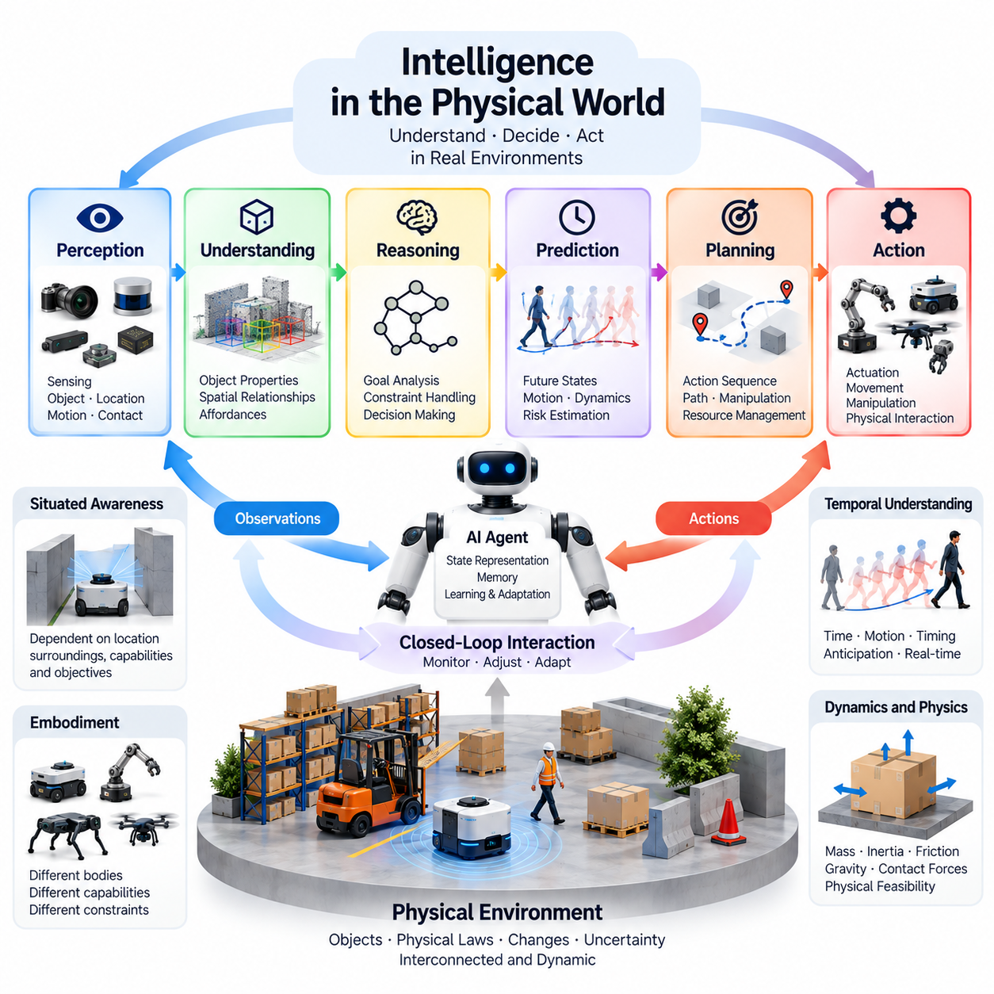
Intelligence in the physical world refers to the capacity of an agent to understand its surroundings, make context-sensitive decisions, and produce effective actions within environments governed by physical laws. Unlike intelligence expressed only through symbolic manipulation or digital information processing, physical intelligence must operate through continuous interaction with matter, space, and time. Its effectiveness is demonstrated by observable outcomes in real environments.
The physical world presents a fundamentally dynamic and interconnected operating environment. Objects move, forces interact, surfaces deform, and environmental conditions change independently of an intelligent agent's intentions. A successful Physical AI system must recognize these changes and adjust its behavior accordingly. Intelligence therefore involves more than identifying objects or predicting events; it requires maintaining useful relationships between environmental understanding and physical action.
Physical intelligence emerges from the interaction between an agent's internal computational processes and the external environment. Sensors provide observations, computational models interpret relevant conditions, and actuators transform decisions into physical effects. These effects modify the environment and influence subsequent observations. Through this recurring interaction, the agent develops behavior that is responsive to changing conditions rather than limited to predetermined commands.
An essential characteristic of physical intelligence is situated awareness, meaning that decisions depend on the agent's current location, surroundings, capabilities, and objectives. An autonomous mobile robot approaching a narrow passage must consider its dimensions, nearby obstacles, available clearance, and movement constraints. The same passage may be traversable for one robot but inaccessible to another. Intelligent behavior must therefore reflect the relationship between environmental conditions and embodiment.
Physical intelligence requires the ability to interpret spatial relationships and geometric structure. Objects occupy positions, possess orientations, and maintain distances from surrounding surfaces and obstacles. Understanding these relationships enables navigation, manipulation, collision avoidance, and coordinated movement. Spatial intelligence also involves recognizing free space, estimating reachable configurations, and identifying physical arrangements that support or prevent particular actions.
Temporal understanding is equally important because physical environments evolve continuously. A moving obstacle may become hazardous even when its current position appears safe, while a manipulation opportunity may disappear as an object changes orientation. Intelligent agents must reason about motion, timing, and future states rather than relying exclusively on static observations. Effective physical behavior therefore depends on anticipating environmental developments and responding within appropriate time intervals.
Physical intelligence also requires sensitivity to dynamics, including mass, inertia, friction, gravity, and contact forces. A robotic manipulator handling a fragile object must regulate gripping force and acceleration, while a mobile platform must account for traction and stopping distance. These requirements demonstrate that correct action selection depends on physical feasibility. An apparently reasonable plan may fail when it violates mechanical limitations or environmental constraints.
Perception is the foundation through which physical intelligence acquires information about its environment. Cameras, depth sensors, LiDAR, radar, inertial sensors, and tactile devices provide complementary measurements of physical conditions. However, sensor observations are rarely complete or perfectly accurate. Intelligent systems must integrate measurements, estimate hidden properties, and distinguish meaningful environmental changes from noise, ambiguity, and temporary sensing failures.
The distinction between observation and understanding is particularly important. Detecting an object does not necessarily reveal whether it is movable, fragile, dangerous, or relevant to the current task. Physical intelligence requires interpreting objects in terms of their properties, relationships, and possible interactions. This interpretation connects perception with action by identifying what an agent can accomplish under the conditions currently observed.
Affordances provide a useful concept for understanding action possibilities in physical environments. A handle may afford grasping, an open corridor may afford navigation, and a stable surface may afford object placement. These possibilities depend not only on environmental properties but also on the agent's embodiment and capabilities. Physical intelligence therefore involves recognizing actionable opportunities rather than treating the environment as a passive collection of objects.
Reasoning in physical environments must connect goals with feasible sequences of actions. An intelligent system may need to determine whether an object can be reached, whether a route remains safe, or whether a manipulation strategy will produce the desired result. Such reasoning combines environmental representations, physical constraints, and predictions of possible outcomes. Its purpose is to support decisions that remain meaningful when translated into real-world behavior.
Prediction strengthens physical intelligence by allowing an agent to anticipate the consequences of its actions. A world model may estimate how objects will move, how obstacles will affect navigation, or how contact forces will change during manipulation. These predictions support planning and risk reduction, although they remain approximations of actual physical behavior. Intelligent operation requires comparing predicted outcomes with observations and correcting discrepancies.
Closed-loop feedback is essential because physical actions rarely produce perfectly predictable results. Wheel slip, sensor uncertainty, mechanical compliance, and unexpected human movement can cause deviations from planned behavior. A Physical AI system must monitor these deviations and adjust its commands accordingly. Feedback transforms intelligence from a sequence of isolated decisions into a continuous process of observation, evaluation, correction, and action.
Uncertainty and partial observability impose additional requirements on physical intelligence. An agent may not know the exact position of an occluded obstacle, the weight of an unfamiliar object, or the intentions of a nearby person. Intelligent behavior must therefore account for incomplete knowledge and potential consequences. Conservative actions, additional sensing, uncertainty-aware planning, and safe fallback behavior can help maintain reliable operation under ambiguous conditions.
Learning enables physical intelligence to improve through experience rather than relying exclusively on predefined models. Repeated interactions can reveal environmental regularities, actuator characteristics, and effective action strategies. Learning may involve supervised data, human demonstrations, reinforcement learning, or simulation-based experience. Nevertheless, acquired knowledge must be evaluated against physical constraints because improved task performance does not automatically guarantee safe behavior.
Generalization is a central challenge because real environments differ from the conditions represented in training data. Lighting, object geometry, surface friction, human behavior, and spatial layouts may change substantially between deployments. A physically intelligent system should maintain useful performance across such variations without requiring complete redesign. Generalization therefore depends on robust representations, adaptive control, appropriate training diversity, and continuous evaluation.
Embodiment influences how intelligence is expressed and what physical tasks are achievable. A wheeled robot, robotic arm, humanoid, quadruped, and aerial vehicle interact with the environment through different mechanical structures. Their sensing requirements, control strategies, and available actions consequently differ. Physical intelligence must account for these distinctions while allowing transferable principles of perception, prediction, reasoning, and learning to support diverse platforms.
Physical intelligence is also constrained by real-time computational requirements. Environmental changes may demand immediate responses, while perception and planning algorithms require processing resources and communication time. Delayed decisions can reduce performance or introduce hazards even when their logical content is correct. Effective systems must coordinate computational complexity, sensing frequency, control responsiveness, and hardware capabilities to satisfy operational deadlines.
Safety forms an inseparable part of intelligence in the physical world because actions can directly affect people, equipment, and infrastructure. A decision that achieves a task objective but creates unacceptable collision risk cannot be considered operationally successful. Intelligent systems must recognize hazards, respect physical boundaries, and maintain protective mechanisms. Safety monitoring, constrained planning, emergency responses, and human supervision support responsible physical autonomy.
Autonomy describes the ability to pursue physical objectives while managing environmental variation without continuous external direction. Autonomous agents may select routes, manipulate objects, respond to disturbances, and recover from certain failures. However, meaningful autonomy requires awareness of operational limits and the ability to request assistance when necessary. Physical intelligence is therefore associated with responsible decision-making rather than unrestricted independence.
The evaluation of physical intelligence must extend beyond conventional prediction accuracy or computational benchmarks. Relevant measures include task completion, navigation efficiency, manipulation reliability, response latency, robustness, energy consumption, and safety performance. Testing must consider changing environments, unexpected disturbances, and interactions with people. The central question is whether the system consistently produces appropriate physical outcomes under realistic operating conditions.
Ultimately, intelligence in the physical world represents the integration of perception, spatial understanding, temporal reasoning, physical prediction, adaptive control, and goal-directed action. These capabilities operate as an interconnected process shaped by embodiment, uncertainty, and environmental feedback. Physical AI becomes meaningful when computational intelligence can reliably transform observations and decisions into safe, effective, and contextually appropriate behavior in the real world.

01.03. Agent Environment and Task
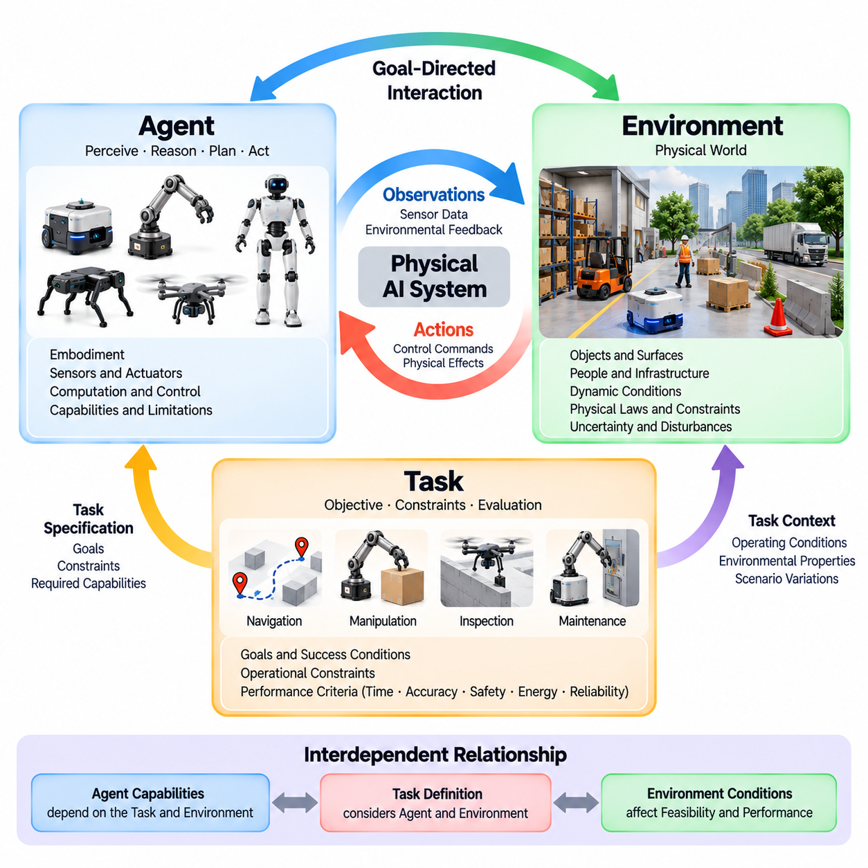
A Physical AI system can be understood through three fundamental elements: the agent, the environment, and the task. The agent represents the entity capable of perceiving and acting, the environment defines the physical conditions in which interaction occurs, and the task establishes the objective that guides behavior. Together, these elements provide a conceptual framework for describing intelligent physical systems and evaluating their ability to achieve meaningful outcomes.
An agent is an autonomous or partially autonomous entity that receives information about its surroundings and selects actions intended to influence the environment. In Physical AI, agents may include mobile robots, manipulators, humanoids, aerial vehicles, or intelligent machines integrated into larger infrastructures. Their intelligence depends not simply on computational capability but on how effectively perception, reasoning, planning, and control are connected to physical interaction.
The environment encompasses everything external to the agent that may influence its observations, decisions, and actions. It includes physical objects, surfaces, obstacles, people, infrastructure, environmental conditions, and other intelligent agents. The environment is not necessarily static or predictable. Its properties may change continuously, creating situations in which the agent must revise its understanding and adapt its behavior while pursuing assigned objectives.
A task defines the desired outcome of interaction between an agent and its environment. Tasks may involve reaching a destination, transporting materials, manipulating objects, inspecting equipment, or maintaining specified operating conditions. A meaningful task description identifies success conditions, relevant constraints, and acceptable behavior. Without a clearly defined task, an agent may exhibit sophisticated computational capabilities without demonstrating useful goal-directed physical intelligence.
The relationship between agent, environment, and task is inherently interdependent. An action that is appropriate for one agent may be impossible for another because of differences in mechanical structure, sensing capabilities, or computational resources. Similarly, a task that is straightforward in a controlled environment may become difficult under uncertainty or disturbance. Physical intelligence must therefore be evaluated in relation to specific agents, operating conditions, and objectives.
Agent capabilities are shaped by embodiment, including mechanical morphology, actuator characteristics, sensor placement, and available computational resources. A wheeled robot may efficiently navigate smooth floors but struggle with stairs, while a legged robot may traverse irregular terrain at greater energy cost. A manipulator may precisely position objects within its workspace but cannot reach arbitrary locations. These physical characteristics determine the range of feasible actions available to an intelligent agent.
The environment determines the conditions under which those capabilities can be exercised. Indoor warehouses, outdoor roads, industrial facilities, hospitals, and agricultural fields present different spatial layouts, surface properties, lighting conditions, and operational hazards. Environmental characteristics influence sensing reliability, movement feasibility, communication quality, and task complexity. An effective Physical AI architecture must account for these conditions rather than assume a universally predictable world.
Tasks provide the criteria by which agent behavior becomes purposeful. A warehouse robot transporting a package must reach the correct destination while respecting collision constraints, operational schedules, and payload limitations. Completing the journey alone may be insufficient if the package is damaged or safety boundaries are violated. Task success therefore requires evaluating the quality and consequences of actions, not merely whether a final position or state has been reached.
Interaction between an agent and its environment occurs through observations and actions. Sensors produce measurements that represent selected aspects of the environment, while actuators execute commands that modify physical conditions. The agent uses observations to estimate its current situation and determine appropriate responses. Each action changes the conditions for subsequent decisions, creating a recurring process through which intelligent behavior emerges over time.
The distinction between the true environmental state and the agent's observations is essential. Physical environments contain properties that cannot always be measured directly, including hidden obstacles, uncertain friction coefficients, and unobserved human intentions. Sensors provide incomplete and potentially noisy information about these conditions. Consequently, an agent must maintain estimates or beliefs about the environment rather than assume that every relevant physical property is immediately available.
A task can be represented through goals, constraints, and performance criteria. Goals describe desired states or outcomes, constraints establish limits on permissible actions, and performance criteria measure the quality of execution. These elements may include completion time, energy consumption, positional accuracy, safety margins, and reliability. Their relative importance depends on the application, making task specification a central part of Physical AI system design.
Agent behavior may be reactive, predictive, or deliberative depending on task requirements and environmental complexity. Reactive behavior responds directly to immediate observations, while predictive behavior anticipates future conditions. Deliberative behavior evaluates alternative action sequences before execution. Practical Physical AI systems often combine these approaches, allowing rapid responses to immediate hazards while maintaining longer-term plans for accomplishing assigned tasks.
Environmental dynamics create additional challenges because the consequences of actions unfold over time. A robot approaching a moving person must consider future positions rather than current distance alone. A manipulator lifting an object must account for acceleration, gravity, and contact forces throughout the movement. Intelligent task execution therefore requires understanding how agent actions and environmental processes jointly influence future physical states.
The agent must also distinguish between controllable and uncontrollable aspects of its environment. Motor commands and actuator forces may be directly controlled, while human movement, external disturbances, and unexpected equipment behavior remain outside the agent's authority. Effective planning accounts for this distinction by selecting actions that remain useful despite uncertainty. Robust behavior depends on adapting to conditions that cannot be completely predicted or controlled.
Task execution often requires decomposing a complex objective into smaller actions or intermediate goals. A delivery robot may need to localize itself, plan a route, avoid obstacles, approach a destination, and confirm successful delivery. Each stage depends on information acquired during previous interactions. Hierarchical task organization helps coordinate long-term objectives with short-term control requirements while preserving the ability to revise plans when conditions change.
The relationship among agent, environment, and task also determines the appropriate level of autonomy. Some tasks can be performed independently within clearly defined operating conditions, while others require human supervision or intervention. Autonomy should therefore be understood as a capability exercised within operational boundaries rather than unrestricted independence. An intelligent agent must recognize situations in which its available knowledge or capabilities are insufficient.
Multiple agents introduce additional relationships into the physical environment. Robots may cooperate, compete for shared resources, exchange observations, or coordinate movement through common spaces. In such situations, one agent's actions become part of another agent's environment. Multi-agent Physical AI must address communication, coordination, resource allocation, and interaction safety while maintaining the objectives and constraints of individual participants.
The definition of an agent may also extend beyond a single robotic machine. Distributed sensing systems, edge computing infrastructure, and coordinated actuators can collectively support intelligent physical behavior. In these architectures, perception and decision-making may be distributed across multiple computational nodes. The essential requirement is that the overall system maintains a meaningful connection between environmental observations, goal-directed decisions, and physical actions.
Evaluation of Physical AI requires considering the complete agent-environment-task relationship. Performance measured in simulation may differ from results obtained in actual operating environments because of sensor noise, physical disturbances, and unexpected interactions. Meaningful evaluation should examine task completion, robustness, efficiency, safety, and adaptability under representative conditions. A system cannot be considered generally capable solely because it succeeds in one narrowly controlled scenario.
Ultimately, the agent-environment-task framework provides a foundation for understanding intelligence as situated, goal-directed physical interaction. The agent supplies sensing, reasoning, and action capabilities; the environment establishes opportunities and constraints; and the task defines what successful behavior means. Physical AI emerges when these elements are integrated into a coherent process that produces reliable, adaptive, and safe outcomes in the physical world.

01.04. Perception Reasoning Action Loop
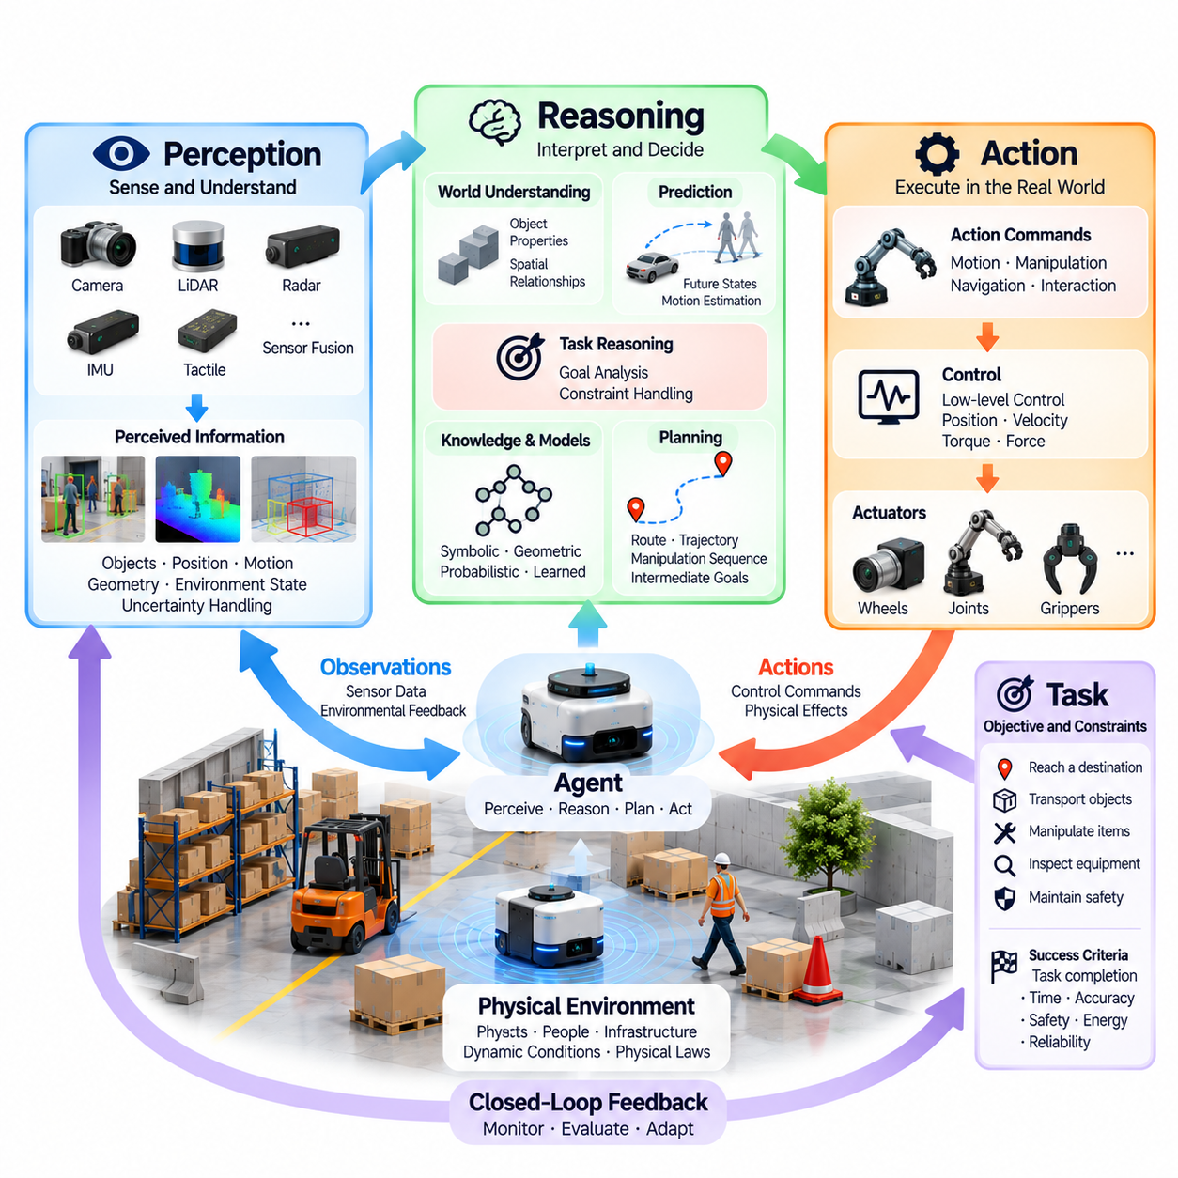
The Perception-Reasoning-Action Loop is a fundamental operating principle of Physical AI, connecting environmental sensing with intelligent decisions and physical behavior. Through this continuous cycle, an agent observes its surroundings, interprets relevant information, determines appropriate actions, and evaluates their consequences. The loop enables intelligent systems to remain responsive to changing conditions rather than depending entirely on predetermined commands.
Perception establishes the connection between an intelligent agent and its physical environment. Sensors acquire information about objects, surfaces, motion, obstacles, and environmental conditions. Cameras, LiDAR, radar, inertial sensors, and tactile devices provide complementary measurements that support situational understanding. These observations form the initial evidence from which the agent estimates its current circumstances and identifies information relevant to assigned tasks.
Raw sensor measurements do not automatically provide meaningful environmental understanding. Images contain pixel intensities, LiDAR produces spatial measurements, and inertial sensors report motion-related signals. Perception algorithms transform these measurements into representations of objects, positions, velocities, geometry, and interactions. The resulting information must be sufficiently accurate and timely to support decisions that affect real physical systems.
Sensor fusion improves perception by combining information from multiple measurement sources. A camera may identify an object while LiDAR estimates its distance and an inertial sensor provides information about the agent's movement. Integrating these measurements can reduce ambiguity and improve environmental estimates. However, fusion must account for calibration errors, synchronization differences, sensor uncertainty, and possible inconsistencies between observations.
Reasoning transforms perceived information into decisions that support the agent's objectives. It connects current environmental estimates with task requirements, physical constraints, and available actions. An autonomous robot may determine whether a passage is traversable, whether an obstacle requires avoidance, or whether a target object can be safely manipulated. Reasoning therefore extends beyond recognizing conditions to evaluating their significance for future behavior.
The reasoning process may involve symbolic knowledge, geometric calculations, probabilistic inference, learned models, or combinations of these approaches. Different methods provide complementary capabilities for understanding relationships and evaluating alternatives. A practical Physical AI system may use geometric reasoning for collision avoidance, probabilistic reasoning for uncertain observations, and learned representations for interpreting complex environments.
Planning connects reasoning with the selection of executable actions. It determines how an agent can progress from its estimated current state toward a desired objective while respecting constraints. Plans may describe routes, motion trajectories, manipulation sequences, or intermediate goals. Their usefulness depends on whether they remain feasible under the agent's mechanical limitations, environmental conditions, and operational requirements.
Prediction strengthens the reasoning process by estimating how the environment may evolve and how candidate actions may affect future states. A mobile robot may predict pedestrian motion, while a manipulator may anticipate object displacement during contact. Such predictions help the agent compare alternatives before acting. Because predictions are imperfect, they must be continuously revised as new observations become available.
Action converts selected decisions into commands that influence the physical environment. These commands may control motors, robotic joints, steering systems, grippers, or other actuators. The execution process must account for actuator limits, mechanical dynamics, response delays, and physical interactions. A logically appropriate decision is insufficient unless it can be translated into feasible and controlled physical behavior.
Control mechanisms ensure that selected actions are executed with appropriate precision and stability. Low-level controllers regulate quantities such as position, velocity, torque, and force, while higher-level systems coordinate task objectives and movement strategies. This separation allows intelligent reasoning to operate alongside fast control processes. Effective integration requires consistent communication between planning decisions and actuator-level execution.
The loop becomes closed when the agent observes the consequences of its actions and uses the resulting information to update subsequent decisions. A robot following a planned path may detect wheel slip or an unexpected obstacle and adjust its movement. Feedback enables correction of deviations between intended and actual behavior. Without this feedback, errors can accumulate and planned actions may become inappropriate as environmental conditions change.
Closed-loop operation is particularly important because physical environments are uncertain and continuously evolving. Sensor measurements may be noisy, objects may move unexpectedly, and mechanical systems may respond differently from theoretical predictions. Repeated perception, reasoning, and action allow the agent to compensate for these differences. The quality of intelligent behavior depends on how effectively the cycle maintains alignment between objectives and actual outcomes.
The Perception-Reasoning-Action Loop does not necessarily operate as a rigid sequence in which each stage waits for the previous stage to finish. Practical systems often execute perception, planning, and control concurrently at different frequencies. Fast control loops may respond within milliseconds, while complex reasoning processes operate over longer intervals. Coordinating these asynchronous processes is essential for maintaining responsiveness and consistent system behavior.
Latency represents a critical constraint because information and decisions lose relevance as physical conditions change. Delays may arise during sensor acquisition, data transmission, model inference, planning, or actuator execution. An obstacle detected too late may no longer be avoidable, even when the reasoning algorithm selects the correct response. Physical AI architectures must therefore manage end-to-end timing rather than optimize computational accuracy alone.
Uncertainty influences every stage of the loop. Perception produces imperfect estimates, reasoning evaluates incomplete knowledge, and actions generate outcomes that may differ from predictions. Intelligent systems must represent uncertainty and account for its consequences when selecting behavior. Additional sensing, conservative planning, robust control, and safe fallback strategies help maintain reliable operation when environmental information is ambiguous.
Memory provides continuity across successive iterations of the loop. An agent may retain previous observations, estimated object trajectories, completed actions, and task progress. This information supports reasoning about conditions that are temporarily unobservable and prevents unnecessary repetition of decisions. Memory also enables the agent to connect immediate sensory information with longer-term objectives and accumulated experience.
Learning allows the loop to improve through repeated interaction. Differences between predicted and observed outcomes can reveal limitations in perception models, environmental assumptions, or control strategies. These experiences may support model refinement, policy adaptation, and improved task execution. However, learning mechanisms must be evaluated carefully because changes in intelligent behavior can introduce unexpected physical risks.
Safety mechanisms must operate throughout the Perception-Reasoning-Action Loop rather than appearing only after an action has been selected. Perception should identify hazards, reasoning should respect safety constraints, and action execution should remain within permissible operating limits. Independent monitoring and protective control can intervene when unsafe conditions arise. This layered approach helps prevent failures in one component from producing unacceptable physical consequences.
The loop can be extended across distributed Physical AI architectures. Sensors, edge processors, on-premise computing systems, and cloud services may contribute different functions to perception, reasoning, and learning. Time-critical decisions generally require sufficiently local processing, while less urgent computation may use shared infrastructure. The architecture must preserve feedback continuity and predictable response behavior despite communication delays or temporary network failures.
Evaluating the Perception-Reasoning-Action Loop requires examining the integrated system rather than isolated algorithm performance. Relevant measures include perception accuracy, decision quality, action precision, response latency, task completion, robustness, and safety. A system with excellent object detection may still perform poorly if planning is delayed or control is unstable. Successful Physical AI depends on coordinated performance across the complete interaction cycle.
Ultimately, the Perception-Reasoning-Action Loop provides the operational foundation through which computational intelligence becomes physical behavior. Perception establishes awareness, reasoning determines meaningful responses, and action changes the environment. Feedback connects these capabilities into a continuous adaptive process. Physical AI achieves reliable autonomy when this loop consistently transforms uncertain observations into timely, feasible, and safe actions aligned with defined objectives.

01.05. Sense Model Predict Plan Act Learn
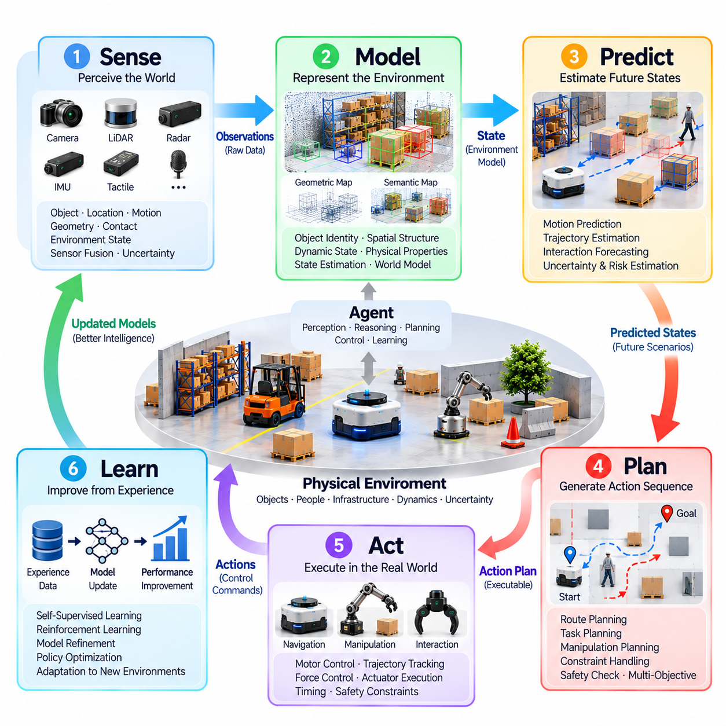
The Sense-Model-Predict-Plan-Act-Learn framework describes a continuous intelligence cycle through which Physical AI systems transform environmental observations into purposeful physical behavior. It extends basic perception-action feedback by incorporating environmental representation, future-state prediction, structured planning, and experience-driven improvement. These interconnected capabilities enable intelligent agents to operate under uncertainty while adapting to changing physical conditions.
Sensing establishes the foundation of the intelligence cycle by collecting information about the agent and its surrounding environment. Cameras, LiDAR, radar, inertial sensors, tactile sensors, and other measurement devices capture complementary aspects of physical reality. Their outputs provide evidence about object locations, motion, geometry, contact conditions, and environmental changes. Reliable sensing requires appropriate calibration, synchronization, and measurement quality.
The sensing process must account for limitations inherent in physical measurement. Sensors may produce noisy readings, experience temporary failures, or lose visibility because of occlusion and environmental interference. An intelligent system cannot assume that observations perfectly describe the world. Instead, it must evaluate measurement confidence, combine complementary information sources, and recognize when additional observations are necessary before selecting consequential actions.
Modeling transforms sensor observations into structured representations that support environmental understanding and decision-making. These representations may describe spatial geometry, object identities, dynamic states, physical properties, and relationships between entities. A model provides continuity beyond individual measurements by maintaining an estimate of the current environment. Its structure depends on the task, available sensors, computational resources, and required level of detail.
Environmental models may combine geometric maps, semantic information, probabilistic state estimates, and learned representations. A mobile robot may maintain an occupancy map and estimated pose, while a manipulator may represent object geometry, contact states, and reachable configurations. More advanced systems may employ learned world models to capture relationships between actions and environmental changes. No single representation is universally optimal for every physical task.
Prediction uses environmental models to estimate how physical conditions may evolve over time. It considers the motion of objects, changes in spatial relationships, and potential consequences of candidate actions. A robot navigating near pedestrians may estimate future trajectories, while a manipulator may predict object movement during grasping. Prediction enables proactive behavior by identifying potential outcomes before they become directly observable.
Predictive models may incorporate physical equations, probabilistic dynamics, neural networks, or combinations of these approaches. Physics-based methods represent known mechanical relationships, while learned models can approximate complex interactions from experience. Their effectiveness depends on the quality of available information and the validity of underlying assumptions. Predictions should therefore include appropriate treatment of uncertainty and modeling error.
Planning converts estimated states and predicted outcomes into feasible sequences of actions. It determines how an agent can progress toward a goal while respecting physical, operational, and safety constraints. Planning may involve selecting navigation routes, generating motion trajectories, scheduling manipulation steps, or coordinating multiple objectives. A useful plan must balance task success with execution time, energy consumption, robustness, and risk.
Effective planning requires evaluating alternatives rather than relying exclusively on a fixed action sequence. A mobile robot may compare routes based on congestion, obstacle movement, and travel cost. A manipulator may assess different grasp configurations according to stability and collision risk. Predictive planning allows an agent to anticipate consequences, but plans must remain adjustable because actual environmental behavior may differ from modeled expectations.
Action translates selected plans into physical commands executed through motors, joints, grippers, steering mechanisms, or other actuators. The execution process must account for mechanical limits, force requirements, timing constraints, and actuator dynamics. High-level decisions are typically converted into lower-level control references that regulate position, velocity, torque, or force. Successful action requires consistency between planned behavior and physical capabilities.
Physical action inevitably changes the conditions under which subsequent decisions are made. A robot's movement alters its viewpoint, a grasp changes object contact relationships, and an interaction may influence nearby people or machines. These consequences create new observations and potentially new uncertainties. The intelligence cycle therefore cannot terminate after command execution; it must continually evaluate whether actual outcomes match intended results.
Learning improves the system by using accumulated experience to refine perception, models, predictions, planning strategies, or control policies. Differences between predicted and observed outcomes provide information about environmental dynamics and system limitations. Learning may occur through supervised training, imitation learning, reinforcement learning, or self-supervised methods. The objective is to improve future behavior through evidence obtained from previous interactions.
Learning does not necessarily require unrestricted online modification of deployed models. Safety-critical systems may collect operational experience while performing model updates through controlled offline training and validation. This separation helps prevent unverified changes from affecting physical behavior. Continuous improvement can therefore involve data collection, model evaluation, controlled deployment, and monitoring rather than immediate autonomous parameter updates.
The six capabilities form an interconnected cycle rather than six completely independent processing stages. Sensing supplies information for modeling, models support prediction, predictions inform planning, plans guide action, and observed outcomes provide evidence for learning. Improvements in one stage can influence the effectiveness of the others. Weaknesses in sensing or modeling may propagate through the entire process and reduce overall task reliability.
Feedback connects the stages by comparing expected and observed physical outcomes. When a robot encounters wheel slip, unexpected contact, or a moving obstacle, new sensor measurements reveal deviations from its previous model. The system can update its state estimate, revise predictions, and generate a modified plan. This repeated correction enables robust operation despite disturbances, imperfect models, and changing environmental conditions.
Uncertainty must be managed throughout the complete cycle. Sensing introduces measurement uncertainty, modeling introduces representation error, prediction involves future-state uncertainty, and action produces execution variability. Planning must account for these uncertainties when selecting feasible behavior. Learning may reduce some uncertainty over time, but unfamiliar environments and unexpected events require continuing caution and adaptive responses.
Temporal coordination is essential because different capabilities operate at different computational frequencies. Sensor acquisition and low-level control may require rapid updates, while world-model refinement and strategic planning can operate over longer intervals. Learning processes may occur asynchronously or outside active deployment. A practical architecture must coordinate these timing differences while ensuring that safety-critical decisions receive sufficiently current information.
Computational architecture influences how the intelligence cycle is implemented. Embedded processors and edge computing platforms commonly support time-sensitive perception, planning, and control. On-premise infrastructure may provide shared environmental models, coordination, and additional computational capacity, while cloud systems may support large-scale training and fleet-wide learning. Functional placement should reflect latency, reliability, communication, and resource requirements.
Memory provides continuity across successive cycles by preserving relevant observations, environmental states, previous actions, and task outcomes. Short-term memory supports tracking and immediate decision-making, while longer-term memory can preserve experience useful for adaptation. Without suitable memory mechanisms, an agent may repeatedly rediscover information or lose awareness of temporarily hidden conditions. Memory therefore strengthens modeling, prediction, planning, and learning.
Safety must remain integrated into every capability of the framework. Sensing should detect hazards, models should represent relevant constraints, prediction should identify dangerous outcomes, and planning should reject unacceptable actions. Execution requires protective control and emergency responses, while learning must avoid introducing unvalidated behavior. Independent safety mechanisms may be necessary when intelligent components cannot guarantee acceptable physical risk.
The framework also supports evaluation of integrated Physical AI performance. Sensing accuracy, model consistency, prediction error, planning feasibility, execution precision, and learning effectiveness provide complementary measures of system capability. However, isolated metrics cannot fully establish operational success. Evaluation must examine task completion, robustness, latency, resource efficiency, and safety under realistic environmental conditions.
Ultimately, Sense-Model-Predict-Plan-Act-Learn provides a unified description of how Physical AI systems perceive reality, construct understanding, anticipate consequences, select actions, interact with the environment, and improve through experience. Its strength lies in the continuous connection between knowledge and physical outcomes. Reliable Physical AI emerges when these capabilities operate together as an adaptive, feedback-driven process aligned with meaningful goals and safety constraints.

01.06. Embodiment and Physical Interaction
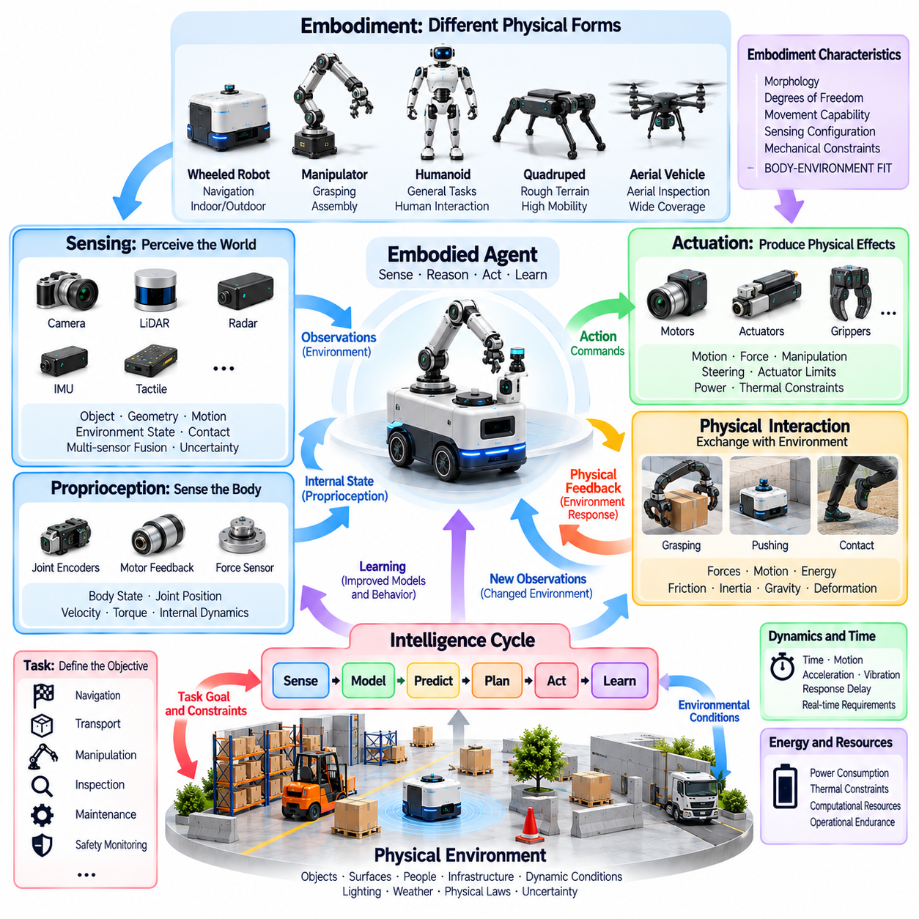
Embodiment is a defining characteristic of Physical AI because intelligence operates through physical structures that interact with the environment. An embodied agent possesses sensing, actuation, and mechanical capabilities that determine how it experiences and influences the world. Intelligence is therefore not confined to abstract computation but emerges through the relationship between physical form, environmental conditions, and goal-directed behavior.
The physical body of an intelligent agent determines its available actions and perceptual opportunities. A wheeled robot, humanoid, robotic arm, and aerial vehicle possess different movement capabilities, sensing configurations, and operational limitations. These differences influence how each system interprets its surroundings and accomplishes tasks. Embodiment establishes the practical boundaries within which perception, reasoning, and control must operate.
Physical interaction occurs whenever an agent exchanges forces, motion, energy, or information with its environment. A manipulator applies contact forces to grasp an object, while a mobile robot generates traction against the ground to move. Even apparently simple actions depend on friction, inertia, gravity, and mechanical constraints. Successful interaction requires intelligent systems to account for these physical relationships rather than treating actions as purely symbolic commands.
The morphology of an embodied agent influences its computational requirements and behavioral possibilities. Joint arrangements, wheel configurations, actuator placement, structural compliance, and body dimensions determine which movements are feasible. Mechanical design can simplify certain tasks while making others more difficult. Consequently, physical intelligence depends partly on how effectively body design and computational control complement one another.
Sensors connect embodiment with environmental awareness by measuring conditions relevant to physical interaction. Cameras and depth sensors provide information about visible geometry, while inertial sensors estimate movement and orientation. Force and tactile sensors reveal contact conditions that visual perception alone may not capture. Sensor placement, field of view, measurement accuracy, and physical accessibility influence the quality of information available to an embodied agent.
Actuators convert computational decisions into mechanical effects. Motors, hydraulic systems, pneumatic devices, and specialized mechanisms produce motion or force according to control commands. Their capabilities are limited by torque, speed, power, thermal conditions, and structural strength. An intelligent controller must consider these limits when planning behavior because a theoretically desirable action may be physically impossible or unsafe to execute.
Contact is a central feature of embodied intelligence because many tasks require controlled interaction with objects and surfaces. Grasping, pushing, walking, docking, and assembly depend on contact geometry and force distribution. Contact conditions may change abruptly, producing nonlinear behavior and uncertainty. Physical AI must therefore coordinate sensing and control to maintain stable interactions while responding to unexpected changes in mechanical conditions.
Embodiment also introduces proprioception, the ability to estimate the agent's own physical configuration and motion. Joint encoders, inertial measurement units, motor feedback, and force sensors provide information about internal states. This awareness supports balance, coordinated movement, and accurate manipulation. Combining proprioceptive information with external perception enables an agent to relate its body configuration to surrounding objects and environmental constraints.
The relationship between body and environment creates affordances, or opportunities for action determined by physical properties and agent capabilities. A surface may support walking but not wheeled movement, while an object may be graspable by one manipulator and inaccessible to another. Affordances are therefore relational rather than fixed object characteristics. Recognizing them allows Physical AI systems to identify actions that are both meaningful and physically achievable.
Embodied interaction unfolds through continuous feedback between action and environmental response. When a robot pushes an object, the resulting displacement reveals information about friction, mass, and resistance. When a legged robot contacts uneven terrain, force feedback supports adjustments in balance and posture. Such interactions allow agents to refine their understanding while acting, demonstrating that perception and physical behavior are closely coupled processes.
Physical dynamics impose temporal requirements on embodied intelligence. Momentum, acceleration, vibration, and actuator response delays influence how quickly an agent must react. A balancing robot may require rapid stabilization, while a mobile platform must account for braking distance and turning limitations. These requirements make real-time coordination between sensing, computation, and control essential for maintaining effective physical interaction.
Compliance and mechanical adaptability can improve interaction with uncertain environments. Flexible joints, compliant grippers, and force-controlled mechanisms may reduce damage during contact and accommodate variations in object geometry. However, compliance also introduces additional dynamics that must be modeled or controlled. Effective embodied intelligence balances mechanical adaptability with sufficient precision, stability, and predictability for the intended task.
Embodied agents must also manage energy and thermal constraints during physical operation. Movement, sensing, computation, and communication consume limited resources, while actuators and processors generate heat. Task planning may need to consider battery capacity, payload, terrain, operating duration, and cooling requirements. Physical intelligence therefore includes selecting behaviors that remain feasible throughout the available operational period.
Learning through physical interaction enables agents to improve their understanding of objects, surfaces, and movement consequences. Repeated grasping attempts may reveal suitable contact configurations, while navigation experience may improve estimates of traction and terrain difficulty. These experiences can refine predictive models and control policies. However, physical learning must consider equipment wear, operational cost, and the possibility of unsafe exploration.
Simulation provides an important environment for developing embodied intelligence before deployment. Physics engines can approximate rigid-body motion, contact forces, actuator behavior, and sensor observations. Simulated interaction supports controlled experimentation and repeated evaluation. Nevertheless, differences in friction, compliance, sensing, and environmental variability create a simulation-to-reality gap that requires validation through physical testing.
Embodiment is not restricted to humanoid or animal-inspired robots. Industrial manipulators, autonomous mobile robots, drones, intelligent vehicles, and stationary robotic systems all possess physical structures through which they interact with their environments. Distributed sensing and actuation infrastructures may also support embodied behavior when their components collectively influence physical processes. The essential property is meaningful coupling between intelligence and physical action.
The distinction between embodiment and autonomy is important. A robot may possess a sophisticated physical body while relying entirely on remote commands, whereas another system may independently select actions within limited mechanical capabilities. Embodiment describes the physical means of interaction, while autonomy concerns decision-making authority and operational independence. Physical AI integrates these dimensions without assuming that one automatically guarantees the other.
Safety is inseparable from embodiment because physical actions can create forces, collisions, instability, and environmental damage. Mechanical limits, collision monitoring, force restrictions, protective control, and emergency stopping mechanisms help manage these risks. Safety requirements depend on body structure, operating environment, and interaction type. Intelligent behavior must remain consistent with physical constraints even when perception or reasoning produces incorrect decisions.
Evaluating embodied Physical AI requires examining the complete relationship between mechanical capabilities, intelligent control, and environmental interaction. Relevant measures include task success, motion accuracy, contact stability, energy efficiency, robustness, and safety. Performance should be tested across representative physical conditions rather than inferred solely from computational benchmarks. Effective embodiment is demonstrated through reliable interaction with real environments.
Ultimately, embodiment transforms Physical AI from abstract decision-making into situated physical intelligence. Body morphology determines possible actions, sensors establish environmental awareness, actuators produce physical effects, and feedback connects behavior with its consequences. Intelligence develops through the coordinated operation of these elements under real-world constraints. Reliable Physical AI emerges when computational reasoning and physical embodiment function as an integrated adaptive system.

01.07. Autonomy Agency and Goal Directed Behavior
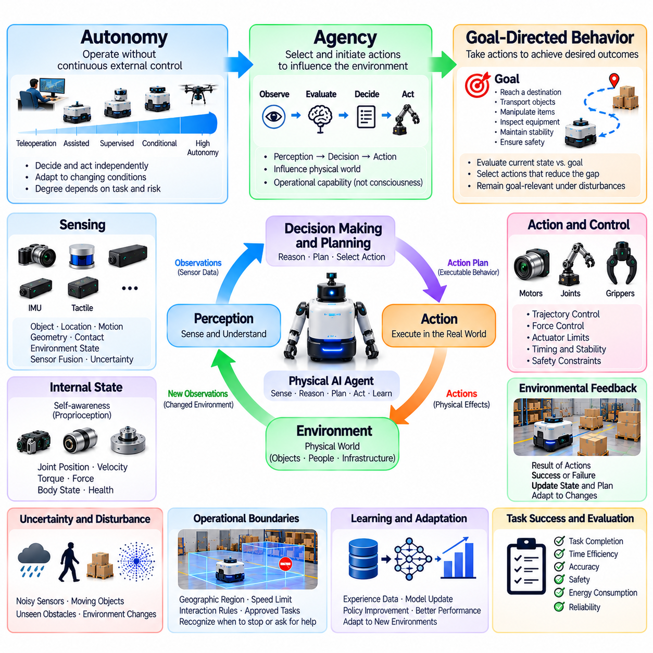
Autonomy, agency, and goal-directed behavior are fundamental concepts that explain how Physical AI systems make decisions and act within the physical world. Autonomy describes the ability to operate without continuous external control, agency concerns the capacity to select and initiate actions, and goal-directed behavior connects those actions to desired outcomes. Together, these properties distinguish intelligent physical systems from machines that merely execute fixed instructions.
Autonomy exists along a spectrum rather than representing a single universal capability. Some systems perform predefined actions under human supervision, while others independently perceive conditions, select strategies, and adapt to environmental changes. The appropriate degree of autonomy depends on task complexity, operational risk, and system reliability. A robot may demonstrate substantial autonomy in one environment while requiring assistance in another.
Agency refers to the functional ability of an intelligent system to influence its environment through selected actions. An agent receives observations, evaluates available alternatives, and produces behavior that changes physical conditions. Agency does not necessarily imply consciousness, subjective experience, or unrestricted independence. In Physical AI, it primarily describes an operational relationship between decision-making capability, action selection, and environmental consequences.
Goal-directed behavior provides purpose and direction to autonomous action. A goal specifies a desired condition, such as reaching a destination, positioning an object, completing an inspection, or maintaining environmental stability. The agent evaluates its current situation relative to this objective and selects actions intended to reduce the difference. Effective behavior requires maintaining goal relevance while responding to disturbances and changing conditions.
Goals may be represented as target states, task specifications, performance objectives, or constraints on acceptable outcomes. A mobile robot may seek to reach a location within a specified time, while a manipulator may need to position an object within a defined tolerance. Goal representations must be sufficiently precise to support planning and evaluation. Ambiguous objectives can produce behavior that appears successful locally but fails to satisfy actual task requirements.
Autonomous behavior requires an agent to connect observations with decisions through an internal representation of its situation. This representation may include position, motion, nearby objects, task progress, and estimated environmental conditions. The agent compares available information with its objectives and selects appropriate responses. Because observations are incomplete, autonomous decisions must account for uncertainty rather than assume perfect environmental knowledge.
Decision-making authority is an important dimension of autonomy. A system may independently execute low-level control while relying on a human operator to select destinations or approve major actions. Another system may generate task plans but require authorization before interacting with hazardous equipment. These distinctions clarify which decisions are delegated to the agent and which remain under external supervision.
Operational boundaries define the conditions under which autonomous behavior is permitted. Such boundaries may specify geographic regions, speed limits, environmental requirements, interaction restrictions, and approved task categories. An autonomous agent should recognize when these conditions are violated or no longer satisfied. Remaining within an operational design domain is often more important than maximizing independence across unfamiliar situations.
Goal-directed behavior involves selecting actions based on their expected contribution to task completion. A robot navigating toward a destination must consider obstacles, available routes, and movement constraints rather than simply moving toward the target. A manipulator must evaluate grasp feasibility before attempting object transfer. This relationship between goals and feasible actions distinguishes purposeful behavior from uncontrolled physical activity.
Planning provides a mechanism for organizing goal-directed behavior over time. Complex objectives may require intermediate states, coordinated action sequences, and continuous progress evaluation. A delivery robot may navigate to a pickup location, acquire an item, transport it, and confirm delivery. Planning connects these stages while allowing revisions when environmental conditions or task requirements change.
Reactive behavior and deliberative behavior contribute different capabilities to autonomy. Reactive control supports rapid responses to immediate disturbances, while deliberative reasoning evaluates longer-term consequences and alternative strategies. Effective autonomous systems combine these mechanisms according to task requirements. Immediate collision avoidance may override a planned route without requiring the agent to abandon its overall objective.
Agency becomes meaningful when an agent can evaluate the consequences of its own actions. Feedback from sensors reveals whether a selected movement achieved the intended effect or produced an unexpected result. The system can then modify its behavior, update its internal state, or reconsider its plan. This connection between action and consequence supports adaptive decision-making rather than simple repetition of predetermined commands.
Autonomy must account for uncertainty in perception, environmental dynamics, and action execution. A robot may encounter unfamiliar objects, changing terrain, sensor degradation, or unexpected human behavior. Reliable autonomy requires estimating confidence and selecting actions appropriate to available knowledge. When uncertainty exceeds acceptable limits, slowing down, requesting assistance, or entering a safe state may be preferable to continued independent operation.
Learning can strengthen autonomous behavior by improving environmental models, action policies, and task strategies through experience. Repeated interactions may reveal more efficient routes, reliable grasp configurations, or recurring operational disturbances. However, learning does not automatically increase safe autonomy. Changes to deployed behavior require appropriate validation, monitoring, and control to ensure continued compliance with operational constraints.
The distinction between autonomy and automation is particularly important. Automation executes predefined procedures according to established rules, whereas autonomy generally involves selecting or adapting actions in response to changing conditions. A conventional machine may repeat a fixed sequence accurately without understanding environmental variation. An autonomous Physical AI system must adjust its behavior when observations indicate that the original sequence is no longer appropriate.
Autonomy also differs from intelligence because advanced reasoning does not necessarily imply independent action. A system may generate sophisticated plans while remaining entirely dependent on human approval. Conversely, a simple controller may operate independently within a narrowly defined task. Evaluating Physical AI therefore requires examining both the quality of decisions and the authority granted to execute them in the physical environment.
Human interaction remains essential in many autonomous systems. Operators may define objectives, establish restrictions, supervise performance, or intervene during exceptional conditions. Shared autonomy allows humans and machines to contribute complementary capabilities to task execution. Effective interfaces should communicate system intentions, operational status, uncertainty, and intervention requirements so that human oversight remains meaningful.
Multiple autonomous agents introduce coordination challenges because individual goals may interact or conflict. Robots sharing a workspace must account for one another's movements, resource requirements, and operational priorities. Cooperative behavior may involve task allocation, trajectory coordination, and information exchange. Collective performance depends on achieving shared objectives without compromising individual safety constraints or creating unstable interactions.
Safety places fundamental limits on agency and autonomous decision-making. An agent should not treat task completion as justification for violating collision limits, force restrictions, or human protection requirements. Safety constraints must influence planning, action selection, and execution. Protective mechanisms may need authority to override autonomous decisions when unacceptable physical risks are detected, regardless of the agent's intended goal.
Evaluating autonomy requires more than measuring whether a robot completes assigned tasks. Relevant considerations include intervention frequency, decision reliability, operational coverage, recovery capability, adaptability, and safety performance. Evaluation should identify the conditions under which independent operation remains effective and those requiring supervision. High autonomy is valuable only when accompanied by predictable behavior and acceptable physical risk.
Ultimately, autonomy, agency, and goal-directed behavior describe complementary dimensions of intelligent physical operation. Autonomy establishes the degree of independent decision-making, agency connects decisions with environmental effects, and goals provide criteria for purposeful action. Their integration enables Physical AI systems to pursue meaningful objectives while adapting to uncertainty, respecting operational boundaries, and maintaining responsible human oversight.

01.08. State Observation Action and Outcome
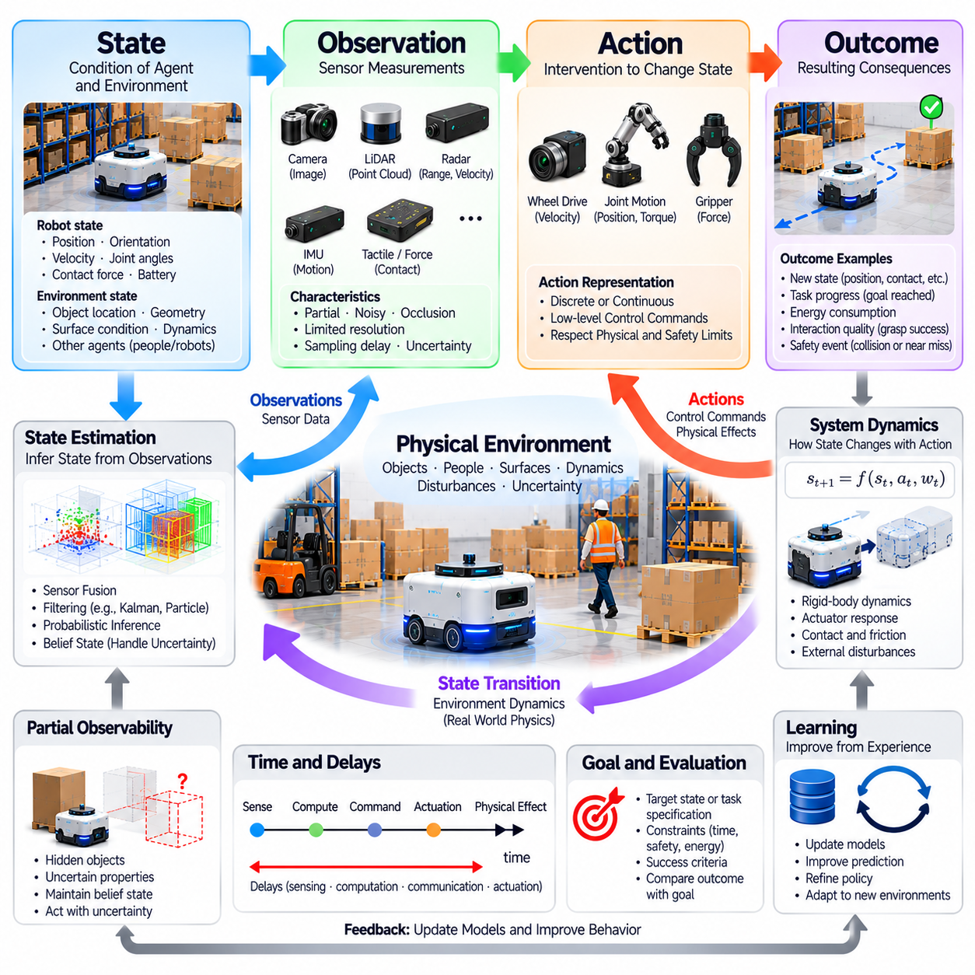
State, observation, action, and outcome are fundamental concepts for describing how Physical AI systems interact with the physical world. State represents the condition of an agent and its environment, observation provides measurable information about that condition, action describes an intervention, and outcome captures its consequences. Together, these elements establish a framework for understanding decision-making, environmental dynamics, and goal-directed physical behavior.
A state describes the relevant properties of a physical system at a particular moment. It may include robot position, orientation, velocity, joint configuration, object locations, contact conditions, and environmental variables. The appropriate state representation depends on the task and required precision. A navigation system may emphasize spatial position and motion, while a manipulation system may require detailed information about object geometry and contact forces.
The complete physical state is rarely available directly to an intelligent agent. Some properties are hidden, difficult to measure, or affected by sensor limitations. A robot may know its approximate location without knowing the precise friction coefficient of the floor. Similarly, a manipulator may observe an object without knowing its internal mass distribution. Physical AI must therefore distinguish between the actual state of the world and the information available for decision-making.
Observation refers to information obtained through sensors or other measurement mechanisms. Cameras produce images, LiDAR provides spatial measurements, inertial sensors report motion-related quantities, and force sensors measure mechanical interactions. Observations are generated from physical states but do not necessarily reveal those states completely. Measurement noise, occlusion, limited resolution, and sampling delays can create differences between reality and observed information.
State estimation transforms observations into an inferred representation of the current physical situation. Algorithms may combine measurements from multiple sensors with motion models and previous estimates. Techniques such as filtering, sensor fusion, and probabilistic inference help reduce ambiguity and improve consistency. The resulting estimate supports planning and control, but its accuracy depends on sensor quality, modeling assumptions, and environmental conditions.
The distinction between state and observation becomes especially important under partial observability. An agent may need to act while relevant objects are temporarily hidden or environmental properties remain uncertain. Maintaining a belief state allows the system to represent possible conditions and their associated confidence. This approach supports decisions that account for incomplete knowledge rather than treating uncertain measurements as unquestionable facts.
An action represents a decision that can influence the physical state of an agent or its environment. Actions may include commanding wheel velocities, moving robotic joints, applying gripping forces, adjusting steering angles, or changing operational settings. Their representation may be discrete, continuous, or hierarchical. The appropriate action space depends on mechanical capabilities, control architecture, task objectives, and operational constraints.
Actions are not identical to their physical consequences. A commanded movement may produce a different displacement because of friction, actuator limitations, unexpected contact, or external disturbances. A grasp command may fail if the object slips or its geometry differs from expectations. Physical AI must therefore distinguish between intended actions, executed control signals, and actual environmental changes when evaluating system behavior.
The relationship between state and action is described through system dynamics. Dynamics determine how a physical system evolves when actions and external influences are applied. These relationships may involve rigid-body mechanics, actuator response, contact forces, and environmental interactions. Mathematical models can approximate state transitions, but real-world uncertainty means that identical commands may not always produce identical outcomes.
An outcome represents the observed or evaluated consequence of an action or sequence of actions. It may describe a new physical state, task progress, energy consumption, interaction quality, or safety-related event. Outcomes provide evidence about whether the selected behavior achieved its intended purpose. A successful outcome must be assessed against task requirements rather than inferred solely from whether an actuator executed its command.
State transitions connect successive moments of physical interaction. At each step, an agent begins with an estimated state, selects an action, and encounters a resulting state influenced by system dynamics and disturbances. New observations provide evidence about the transition that actually occurred. This recurring relationship forms the foundation of feedback control, sequential decision-making, and adaptive Physical AI behavior.
Time is an essential dimension of state, observation, action, and outcome. Sensor measurements may describe conditions from different moments, while commands require time to reach actuators and produce effects. An agent must account for sampling intervals, communication delays, computation time, and mechanical response. Without temporal consistency, even accurate measurements may lead to inappropriate decisions because the represented conditions are already outdated.
State representations must balance completeness with computational efficiency. Including every measurable variable may create unnecessary complexity, while excluding important information can undermine prediction and control. A practical representation should preserve properties that materially influence task decisions and physical outcomes. Different processing layers may therefore maintain distinct representations suited to immediate control, local planning, or long-term reasoning.
Observations can also be actively influenced by an agent's behavior. A robot may move its camera to inspect an occluded object, reposition itself to improve localization, or apply a small force to estimate surface resistance. Such actions gather information while changing physical conditions. Active perception demonstrates that sensing and action are interconnected processes rather than completely separate stages of intelligent operation.
Prediction uses estimated states and candidate actions to anticipate possible outcomes. A navigation system may estimate future positions and collision risks, while a manipulator may predict contact forces and object motion. These predictions allow an agent to compare alternatives before execution. Because model accuracy is limited, predicted outcomes should be updated continuously using newly observed evidence and appropriate uncertainty estimates.
Planning selects actions according to desired outcomes and available constraints. A robot may prefer a longer route when it offers greater safety, or reduce movement speed when localization uncertainty increases. The relationship between state, action, and outcome allows planning algorithms to evaluate tradeoffs among progress, efficiency, and risk. Effective planning must consider both immediate consequences and longer-term effects on task completion.
Feedback closes the relationship between intended and actual outcomes. After an action is executed, the agent compares new observations with expected changes and identifies relevant deviations. These differences may trigger corrections to control commands, state estimates, or future plans. Repeated feedback enables the system to remain aligned with its objectives despite imperfect models, changing environments, and disturbances.
Learning can use sequences of states, observations, actions, and outcomes to improve future decisions. Recorded experiences reveal relationships between commands and physical consequences, including cases where predictions fail. Such data may support system identification, model refinement, imitation learning, or reinforcement learning. However, learned relationships must be validated before they are trusted in safety-critical physical operations.
Safety requires explicit consideration of which states, actions, and outcomes are acceptable. Unsafe states may involve excessive speed, unstable configurations, or hazardous proximity to people. Unsafe actions may exceed force limits or violate operational boundaries. Safety mechanisms should prevent prohibited transitions where possible and provide protective responses when unexpected conditions arise, independently of ordinary task optimization.
Evaluating Physical AI requires measuring more than isolated action accuracy. State-estimation error, observation quality, transition prediction error, execution reliability, and outcome consistency all contribute to system performance. Task completion and safety must also be assessed under realistic operating conditions. A system that issues correct commands but repeatedly produces unacceptable outcomes cannot be considered reliably intelligent.
Ultimately, state, observation, action, and outcome provide a common language for describing intelligent physical interaction. State captures relevant physical conditions, observation supplies evidence, action introduces purposeful intervention, and outcome reveals what actually happened. Their continuous relationship supports perception, prediction, planning, control, and learning. Physical AI becomes effective when these elements remain coherently connected through reliable feedback and goal-directed adaptation.

01.09. Closed Loop Intelligence
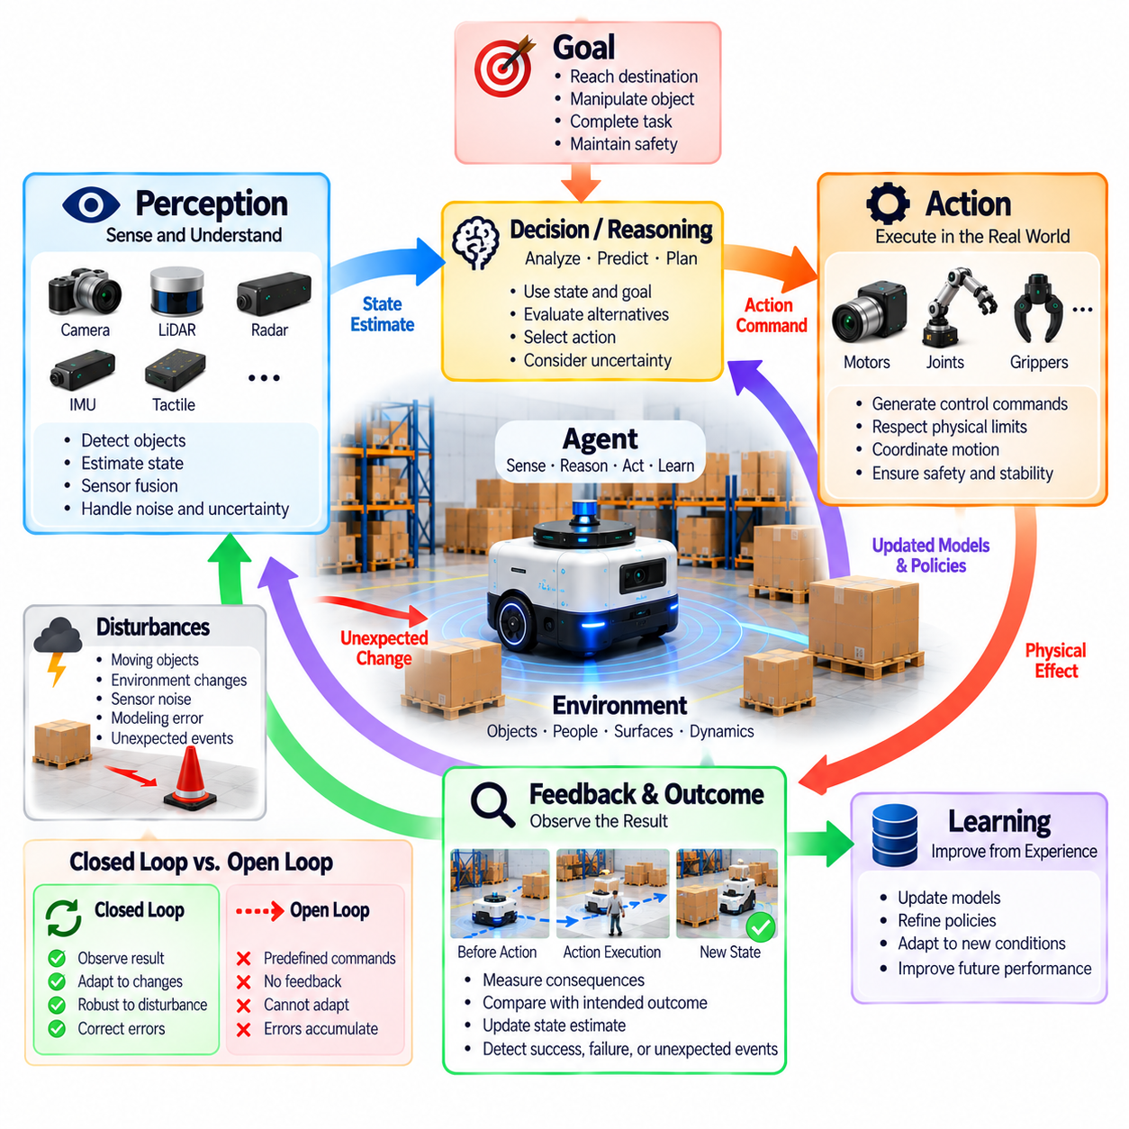
Closed-loop intelligence is a defining principle of Physical AI because intelligent behavior depends on continuously connecting perception, decision-making, action, and environmental feedback. Unlike systems that execute commands without evaluating their consequences, closed-loop agents observe the effects of their actions and adjust subsequent behavior. This recurring process enables physical systems to pursue objectives despite uncertainty, disturbances, and changing operating conditions.
A closed loop begins when an agent measures its environment and estimates the current state of the physical system. Sensors provide observations about position, motion, objects, contact conditions, and operational status. These observations are interpreted relative to a desired state or task objective. The agent then selects an action, executes it through physical actuators, and measures the resulting changes to determine whether correction is necessary.
Open-loop operation provides an important contrast. An open-loop controller executes predetermined commands without using measured outcomes to modify its behavior during execution. Such control may work when environmental conditions and system dynamics are highly predictable. However, variations in friction, payload, actuator response, or external forces can produce unexpected results. Closed-loop operation compensates for these deviations by incorporating measured feedback.
Feedback is the mechanism that connects intended behavior with actual physical consequences. When a robot moves toward a target, position measurements reveal whether its trajectory matches the planned path. When a manipulator grasps an object, force and tactile measurements indicate whether contact remains stable. These observations allow the controller to identify deviations and generate corrective actions before small errors develop into task failures.
Closed-loop intelligence extends beyond conventional feedback control by integrating perception, prediction, reasoning, and adaptation. A traditional controller may regulate velocity or position using predefined mathematical relationships. An intelligent agent can additionally interpret complex scenes, estimate hidden conditions, reconsider goals, and modify strategies. The defining feature is not algorithmic complexity alone but the continuous use of environmental evidence to guide physical behavior.
State estimation is essential because feedback measurements rarely provide a complete description of reality. Sensor noise, occlusion, latency, and calibration errors can distort observations. An agent combines available measurements with previous estimates and models of system dynamics to infer its current condition. Reliable closed-loop behavior depends on maintaining sufficiently accurate estimates while recognizing uncertainty that may affect subsequent decisions.
The temporal structure of feedback strongly influences system performance. Sensors sample physical conditions at finite intervals, computation requires processing time, and actuators respond with mechanical delays. Excessive latency can cause corrections to arrive after the relevant conditions have changed. Consequently, closed-loop intelligence requires coordinated timing across sensing, communication, computation, and actuation to maintain stable and responsive behavior.
Different physical processes require different feedback rates. Motor current and joint torque may need rapid regulation, while route planning or task scheduling can operate at slower intervals. A robot may therefore contain multiple interconnected control loops operating at different frequencies. Fast loops maintain immediate physical stability, while slower loops update environmental understanding, revise plans, and coordinate longer-term objectives.
Prediction strengthens closed-loop intelligence by allowing an agent to anticipate the consequences of candidate actions. A mobile robot may estimate braking distance before approaching an obstacle, while a manipulator may predict object motion during contact. Predictive models support proactive decisions rather than purely reactive corrections. Their usefulness depends on comparing predicted outcomes with actual observations and updating assumptions when discrepancies emerge.
Model predictive control illustrates how prediction and feedback can operate together. At each decision step, the controller estimates the current state, predicts possible future trajectories, and selects an action according to objectives and constraints. After executing part of the plan, it obtains new measurements and repeats the optimization. This repeated replanning helps accommodate disturbances, although its effectiveness depends on model quality and computational feasibility.
Closed-loop intelligence also supports active perception, in which actions are selected partly to improve future observations. A robot may reposition its camera to inspect an occluded object or move closer to a landmark to reduce localization uncertainty. These actions influence both the environment and the information available for subsequent decisions. Perception and control consequently become mutually dependent components of an integrated intelligent process.
Disturbance rejection is a central capability of closed-loop physical systems. External forces, changing terrain, unexpected obstacles, and variations in object properties may interfere with planned actions. Feedback allows the agent to detect deviations and adjust its behavior within available mechanical limits. Effective disturbance rejection requires distinguishing recoverable variations from conditions that exceed the system's safe operating capabilities.
Learning can improve closed-loop behavior by refining models, policies, and feedback responses through experience. Repeated interactions reveal systematic prediction errors, actuator characteristics, and environmental patterns. An agent may adapt control parameters or improve action selection based on observed outcomes. However, learning mechanisms must remain compatible with stability requirements and safety constraints, especially during real-world deployment.
Robustness depends on the ability to maintain acceptable performance when models and measurements are imperfect. A closed-loop system should tolerate reasonable uncertainty without producing unstable or excessive corrections. Robust control methods, uncertainty-aware planning, and protective limits can support this objective. Feedback alone does not guarantee reliability because incorrect measurements or poorly designed controllers can amplify disturbances.
Safety monitoring forms an essential part of closed-loop intelligence. The agent must evaluate whether its actions remain within permitted speed, force, distance, and stability limits. When hazardous conditions are detected, protective control may reduce motion, modify the plan, or initiate a safe stop. Safety-critical responses should not depend exclusively on high-level reasoning, particularly when rapid intervention is required to prevent physical harm.
Human supervision can also participate in a closed-loop architecture. Operators may observe system status, revise objectives, approve sensitive actions, or intervene when autonomy becomes unreliable. Information returned to the operator closes a supervisory feedback loop above the robot's internal control processes. Effective integration requires clear communication of system intentions, uncertainty, operating boundaries, and intervention authority.
Distributed Physical AI systems may establish feedback loops across individual robots, edge computers, and shared infrastructure. Local controllers manage immediate physical responses, while higher-level services coordinate tasks and interpret broader environmental information. Communication delays and network interruptions require careful allocation of responsibilities. Safety-critical control should remain effective even when remote coordination becomes temporarily unavailable.
Evaluating closed-loop intelligence requires examining how consistently a system detects errors and corrects behavior under realistic conditions. Relevant measures include tracking accuracy, response time, stability, recovery success, disturbance tolerance, and task completion. Testing should introduce representative uncertainty, sensor degradation, and environmental variation. Reliable performance must be demonstrated through physical outcomes rather than inferred from algorithmic sophistication alone.
Ultimately, closed-loop intelligence transforms Physical AI into an adaptive relationship between an agent and its environment. Perception supplies evidence, state estimation establishes context, reasoning selects actions, and feedback reveals their consequences. Prediction and learning improve this process over time, while safety constraints define acceptable behavior. Effective Physical AI continuously reconciles intended objectives with observed physical reality through coordinated, reliable feedback.

01.10. Uncertainty and Partial Observability
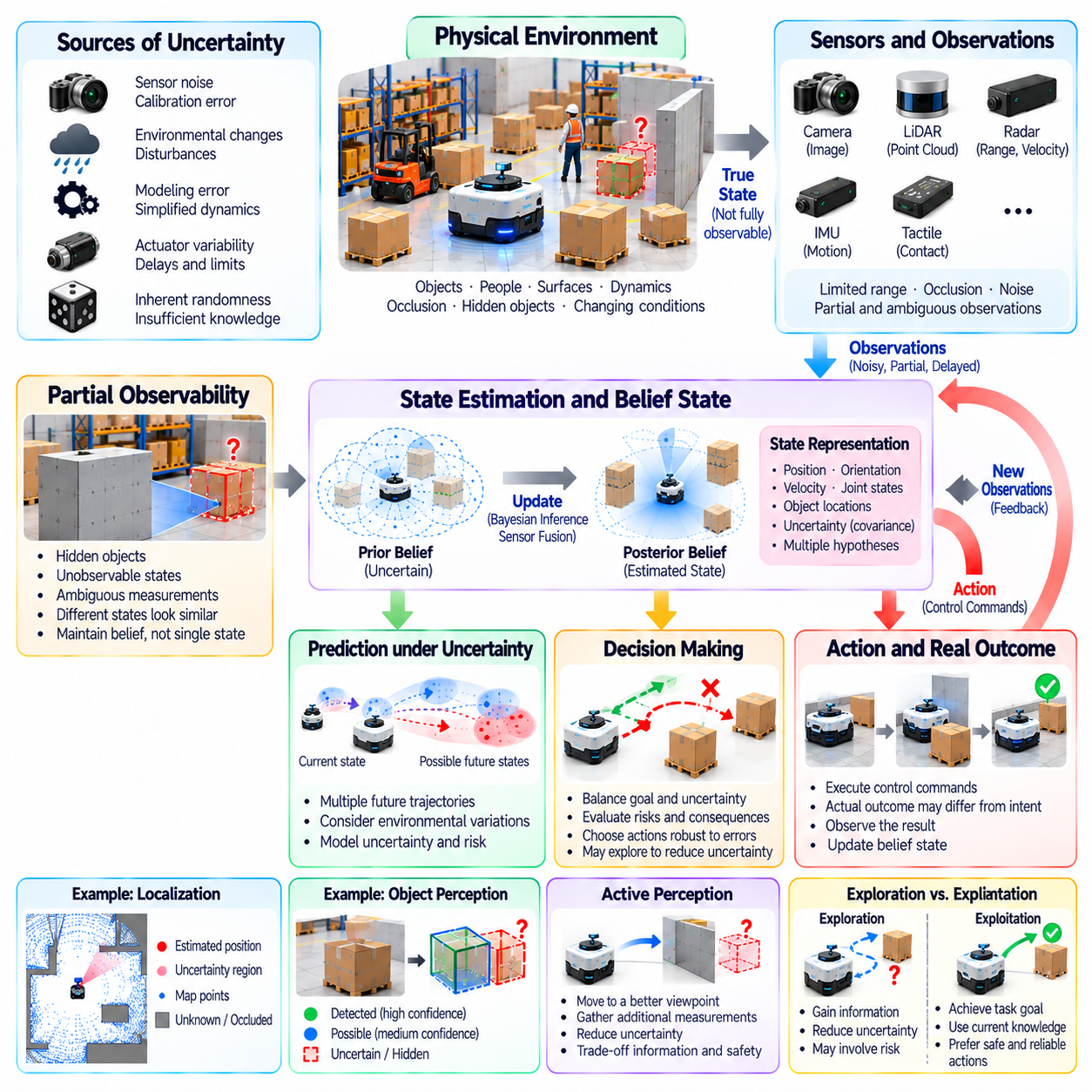
Uncertainty and partial observability are fundamental conditions of Physical AI because intelligent agents rarely possess complete and perfectly accurate knowledge of their environments. Sensors provide limited measurements, physical processes contain unpredictable variations, and actions may produce unexpected consequences. Reliable intelligence therefore requires representing what is known, identifying what remains uncertain, and selecting behavior that remains appropriate despite incomplete information.
Uncertainty arises from multiple sources throughout physical interaction. Measurement noise, sensor calibration errors, environmental disturbances, imperfect models, and actuator variability can affect system behavior. Some uncertainty results from inherent randomness, while other uncertainty reflects insufficient knowledge. Distinguishing these sources helps determine whether improved sensing, better modeling, additional observations, or more conservative control can reduce their effects.
Partial observability describes situations in which an agent cannot directly observe every variable relevant to its decisions. A mobile robot may detect visible obstacles while remaining unaware of objects behind walls. A manipulator may estimate an object's shape without knowing its internal mass distribution. Even with sophisticated sensors, occlusion, limited range, and inaccessible physical properties prevent complete environmental understanding.
The distinction between physical state and observation is essential for reasoning under uncertainty. The true state includes all relevant environmental and internal conditions, whereas observations contain only information available through measurement. Different physical states may produce similar sensor readings, making direct interpretation ambiguous. An intelligent agent must therefore infer possible states rather than assume that observations perfectly describe reality.
Sensor uncertainty can be represented through measurement distributions, confidence intervals, or estimated error bounds. A camera may provide uncertain object classifications, while a localization system may report a position estimate with associated covariance. These representations communicate the reliability of available information. Their usefulness depends on calibration, since numerical confidence that does not correspond to actual error can mislead downstream decisions.
A belief state provides a probabilistic representation of possible physical states given available observations and previous actions. Rather than maintaining only one assumed condition, an agent tracks uncertainty across alternative explanations. New measurements update this representation as evidence becomes available. Belief-state reasoning is especially valuable when observations are ambiguous, intermittent, or insufficient to determine the current situation uniquely.
Bayesian inference provides a mathematical foundation for updating uncertain knowledge. Prior estimates describe existing beliefs, observation models describe the likelihood of measurements, and posterior estimates incorporate new evidence. Recursive estimation techniques apply this principle repeatedly during operation. However, their accuracy depends on appropriate probability models and assumptions about sensor behavior, system dynamics, and environmental conditions.
State estimation methods such as Kalman filtering, particle filtering, and probabilistic sensor fusion support decision-making under incomplete information. Different techniques accommodate different assumptions about linearity, noise, and state distributions. Combining camera, inertial, wheel-encoder, and LiDAR measurements can improve localization robustness. Nevertheless, correlated errors or incorrect models may produce misleading confidence even when multiple sensors agree.
Uncertainty also affects predictions of future physical states. Friction changes, actuator delays, moving obstacles, and unpredictable human actions can cause actual trajectories to differ from expected trajectories. Predictive models should therefore describe plausible ranges of outcomes rather than only a single nominal future. Considering multiple possibilities helps an agent identify actions that remain acceptable when environmental conditions deviate from expectations.
Decision-making under partial observability requires balancing progress toward goals with the consequences of uncertainty. A robot may choose a slower route when localization confidence is low or delay manipulation until an object's pose is better estimated. Such decisions depend on both expected task performance and the risk of incorrect assumptions. Effective autonomy considers what may happen when the agent's current interpretation is wrong.
Partially observable Markov decision processes provide a formal framework for sequential decisions with hidden states. They describe state transitions, observations, actions, and rewards while representing uncertainty through belief states. A policy selects actions based on available beliefs rather than direct access to the true state. Exact solutions can be computationally expensive, so practical Physical AI systems often use approximations and hierarchical decision-making.
Active perception allows agents to reduce uncertainty through purposeful physical actions. A robot may change its viewpoint to reveal an occluded object, approach a landmark to improve localization, or gently probe a surface to estimate resistance. These actions may not immediately advance the primary task, but they improve information for later decisions. Intelligent behavior therefore includes deciding when acquiring knowledge is more valuable than immediate progress.
Exploration introduces a tradeoff between obtaining information and maintaining safety. Testing an unfamiliar surface may improve estimates of traction, but aggressive exploration could cause slipping or collision. A manipulator may learn object properties through contact, although excessive force can damage the object. Safe exploration requires bounded actions, uncertainty monitoring, and protective mechanisms that limit unacceptable physical consequences.
Robust planning considers uncertainty explicitly when selecting actions. Instead of optimizing only for the most likely conditions, an agent may evaluate alternative scenarios, uncertainty bounds, or worst-case outcomes. A navigation planner can maintain additional clearance around obstacles when position estimates are unreliable. Such conservative decisions may reduce immediate efficiency while improving the probability of successful and safe task completion.
Uncertainty-aware control adjusts physical behavior according to confidence in state estimates and predictions. When observations become unreliable, a controller may reduce speed, increase safety margins, or switch to a more conservative operating mode. Feedback measurements then determine whether normal operation can resume. These adaptations should be proportional to uncertainty and operational risk rather than based on arbitrary thresholds alone.
Unknown conditions differ from ordinary measurement uncertainty because the agent may encounter situations absent from its models or training experience. Unfamiliar objects, damaged sensors, unexpected terrain, and novel interactions can invalidate established assumptions. Detecting out-of-distribution observations or inconsistent predictions helps identify such situations. Recognition of model limitations is essential for preventing unjustified confidence in autonomous behavior.
Human supervision becomes important when uncertainty exceeds the system's ability to make reliable decisions. An agent may request clarification, transfer control, or enter a safe state when observations cannot support acceptable action selection. Effective supervision requires communicating what is uncertain, why it matters, and which decisions require assistance. Uncertainty reporting should support informed intervention rather than overwhelm operators with unstructured warnings.
Learning can reduce uncertainty by improving perception models, system identification, and predictions through accumulated experience. Repeated observations reveal recurring patterns and help distinguish systematic errors from random variation. However, learning may introduce new uncertainty when deployed environments differ from training conditions. Continuous evaluation and controlled updates are necessary to prevent adaptation from degrading previously reliable behavior.
Safety evaluation must examine how uncertainty propagates through perception, prediction, planning, and control. Small estimation errors may become significant when combined with delayed feedback or aggressive motion. Testing should include sensor degradation, occlusion, environmental disturbances, and unexpected interactions. Reliable systems demonstrate not only accurate behavior under nominal conditions but also predictable responses when information becomes incomplete or misleading.
Ultimately, uncertainty and partial observability are permanent characteristics of intelligent physical operation rather than temporary problems that can be eliminated completely. Physical AI must continuously estimate hidden conditions, evaluate confidence, anticipate alternative outcomes, and revise decisions using new evidence. Effective intelligence emerges when agents recognize the limits of their knowledge and maintain purposeful, adaptive, and safe behavior despite those limits.

01.11. Memory Prediction and Planning
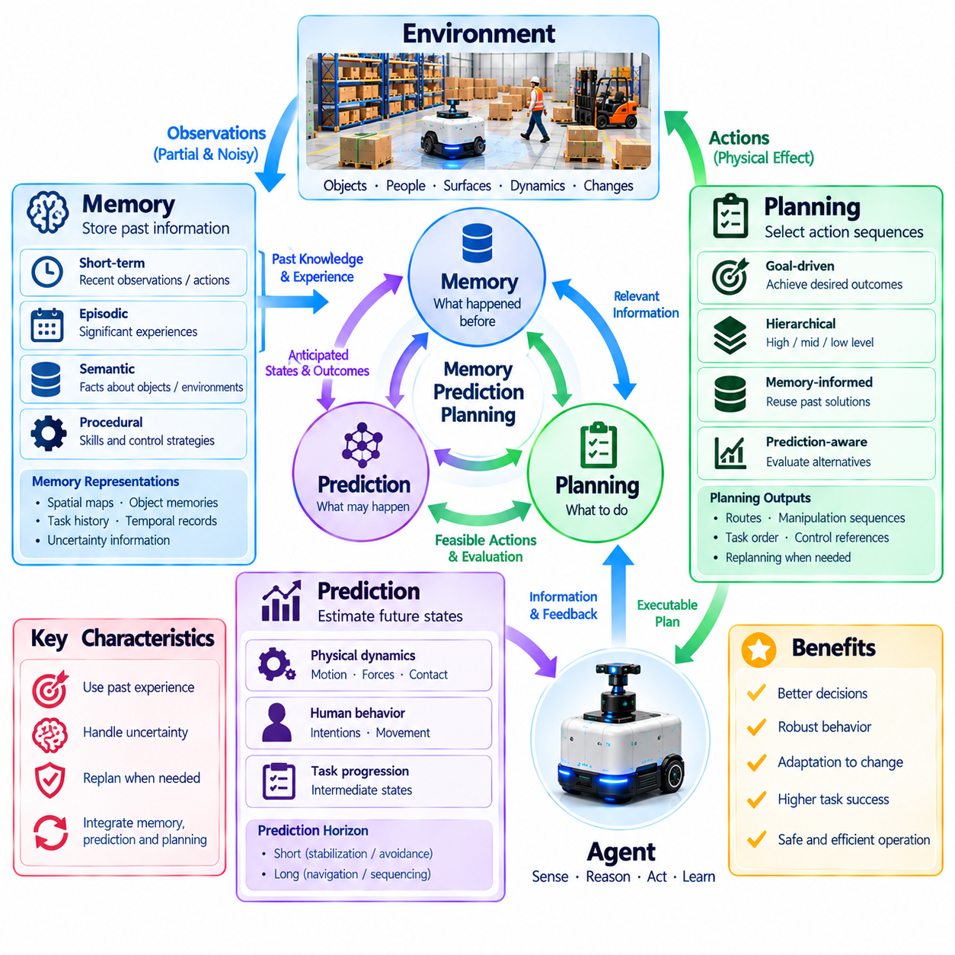
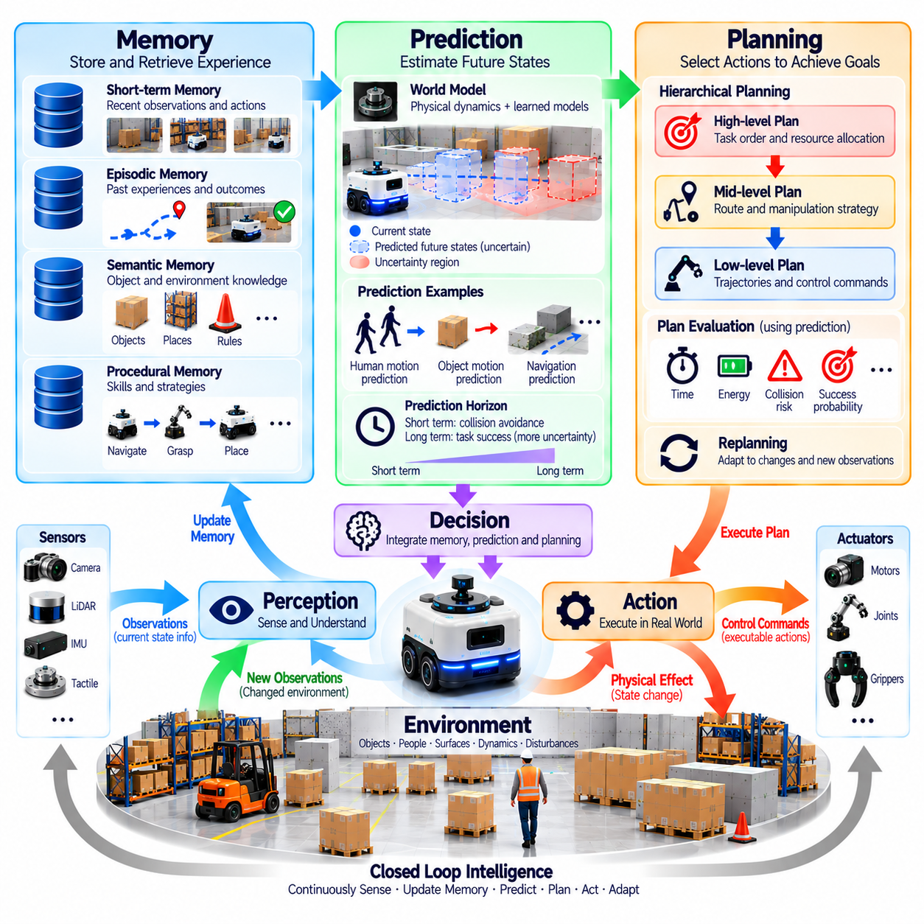
Memory, prediction, and planning are essential capabilities of Physical AI because intelligent agents must connect past experiences, present conditions, and future consequences. Memory preserves information beyond immediate observations, prediction estimates how physical situations may evolve, and planning organizes actions toward desired objectives. Their integration enables agents to make coherent decisions across time rather than respond independently to each incoming sensor measurement.
Memory provides continuity when environmental information is incomplete or temporarily unavailable. A mobile robot may remember the location of an obstacle after it leaves the camera's field of view, while a manipulator may retain information about an object's previous position. Such information supports consistent state estimation and decision-making. Without memory, an agent may repeatedly rediscover familiar conditions or lose track of partially completed tasks.
Physical AI systems use different forms of memory for different purposes. Short-term memory retains recent observations and actions, episodic memory records significant experiences, and semantic memory represents learned facts about objects and environments. Procedural memory may encode reusable skills and control strategies. These categories are functional distinctions rather than requirements for separate storage mechanisms, and practical systems may combine them.
Memory representations must preserve information relevant to physical behavior. Spatial maps describe environmental geometry, object memories record identities and properties, and task histories capture completed or pending operations. Temporal records associate observations with the conditions under which they occurred. Effective memory management must also consider uncertainty, since stored information can become inaccurate when objects move or environments change.
Prediction estimates future states and outcomes based on current knowledge, previous experiences, and candidate actions. A navigation system may anticipate the movement of nearby people, while a robotic arm may estimate how an object will respond to applied force. These forecasts support decisions before physical consequences occur. Prediction is especially important when delayed reactions could produce collisions, unstable motion, or failed manipulation.
Predictive models may represent physical dynamics, object interactions, human behavior, or task progression. Some models rely on established mechanical relationships, while others learn patterns from recorded experience. Hybrid approaches combine physical constraints with data-driven estimates. Regardless of implementation, a predictive model must be evaluated against observed outcomes because inaccurate forecasts can undermine otherwise reasonable plans.
The prediction horizon determines how far into the future an agent attempts to anticipate conditions. Short horizons support immediate stabilization and collision avoidance, while longer horizons assist navigation and task sequencing. Increasing the horizon generally introduces greater uncertainty and computational demands. Practical systems therefore balance predictive detail, available processing resources, and the time scale of relevant decisions.
Planning uses memory and prediction to select sequences of actions that advance a goal. An autonomous robot may need to identify a destination, evaluate routes, avoid obstacles, and coordinate arrival with other operations. Planning considers not only whether an action is feasible but also how it affects subsequent opportunities. This distinguishes deliberate task execution from isolated responses to immediate observations.
Hierarchical planning organizes complex objectives into manageable levels of abstraction. High-level planning determines task order and resource allocation, while intermediate planning selects routes or manipulation strategies. Low-level planning generates executable trajectories and control references. These levels must exchange information because physical constraints can invalidate decisions made at more abstract levels.
Memory improves planning by providing information about previously encountered conditions and successful strategies. A robot may reuse a known route, avoid a location associated with repeated failures, or retrieve a grasp configuration that worked for a similar object. However, remembered solutions must be checked against current observations. Past success does not guarantee present feasibility when environmental conditions or task requirements differ.
Prediction enables planning algorithms to compare alternative actions before execution. Candidate trajectories may be evaluated for travel time, energy consumption, collision risk, and task completion probability. A manipulator may compare grasp approaches based on expected contact stability and object displacement. Such evaluation supports informed tradeoffs, although predictions must reflect uncertainty rather than assume a single guaranteed outcome.
Model-based planning explicitly uses representations of system dynamics to simulate possible future transitions. Search algorithms, trajectory optimization, and model predictive control can identify actions that satisfy objectives and constraints. Model-free policies may instead select actions directly from learned experience. Physical AI architectures can combine these approaches when different tasks require different balances of adaptability, computational efficiency, and interpretability.
Replanning is necessary because physical environments rarely evolve exactly as predicted. Moving obstacles, actuator delays, unexpected contact, and changes in task priorities can invalidate an existing plan. An agent must compare expected progress with new observations and revise its strategy when significant deviations occur. Effective replanning preserves useful previous decisions while adapting to newly available information.
Memory and prediction interact through continuous model updating. Recorded outcomes reveal whether earlier expectations were accurate, while prediction errors identify weaknesses in stored assumptions. Repeated discrepancies may indicate changing friction, sensor degradation, or previously unknown object properties. Updating models from such evidence improves future decisions, provided the system distinguishes persistent changes from temporary disturbances.
Uncertainty affects all three capabilities. Memories may be outdated, predictions may be probabilistic, and plans may depend on incomplete knowledge. An intelligent agent should therefore maintain confidence estimates and consider alternative scenarios. When uncertainty is high, information-gathering actions or conservative plans may be preferable to immediate execution. Reliable reasoning requires recognizing that stored knowledge is not necessarily current truth.
Computational and timing constraints shape practical memory, prediction, and planning architectures. Large memories require efficient retrieval, detailed predictions consume processing resources, and complex planning may exceed available decision time. Edge systems must prioritize information and calculations relevant to immediate safety and task performance. Hierarchical processing, selective updates, and bounded planning horizons help maintain real-time responsiveness.
Safety imposes additional requirements on future-oriented intelligence. Plans must respect mechanical limits, collision constraints, human proximity, and operational boundaries. Predictions should identify hazardous possibilities even when their estimated probability is low. Memory may retain prior incidents and known restricted regions. Safety mechanisms must remain capable of interrupting planned behavior when unexpected physical risks emerge.
Multi-agent Physical AI introduces shared memory, coordinated prediction, and collaborative planning. Robots operating in common spaces may exchange maps, task status, and intended trajectories. Shared information can reduce redundant exploration and improve resource allocation. However, communication delays and inconsistent observations can produce conflicting representations, requiring synchronization and local safeguards against outdated information.
Evaluating these capabilities requires examining their combined effect on physical performance. Memory accuracy, prediction error, planning success, computational latency, recovery efficiency, and safety outcomes provide complementary evidence. Testing should include changing environments, incomplete observations, and unexpected disturbances. A system demonstrates effective future-oriented intelligence when it can revise expectations and maintain reliable task progress.
Ultimately, memory connects Physical AI with its past, prediction establishes expectations about possible futures, and planning transforms those expectations into purposeful action. Feedback links the resulting outcomes to subsequent memory updates and decisions. These capabilities form a continuous cycle of remembering, anticipating, acting, and learning. Their coordinated operation allows intelligent physical agents to pursue long-term objectives while remaining responsive to present reality.

01.12. Learning Adaptation and Generalization
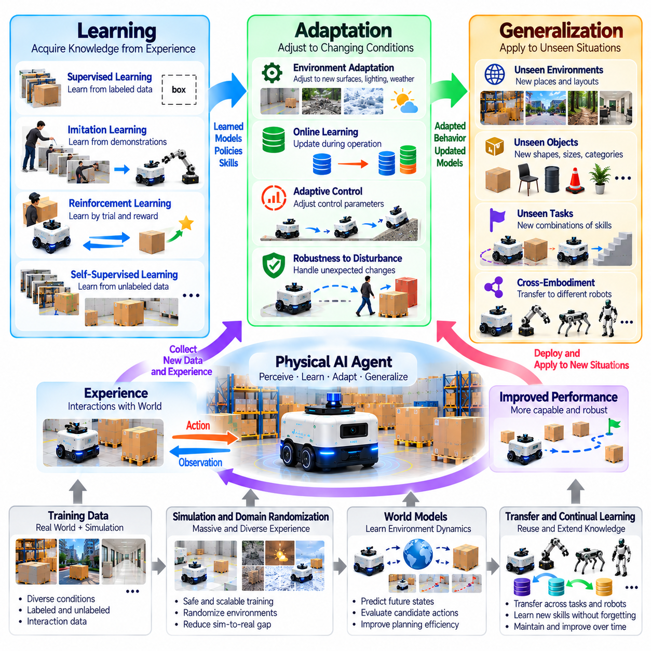
Learning, adaptation, and generalization enable Physical AI systems to improve behavior through experience and operate beyond narrowly predefined conditions. Learning extracts useful patterns from observations and actions, adaptation adjusts behavior when circumstances change, and generalization applies acquired capabilities to unfamiliar situations. Together, these processes transform physical intelligence from fixed automation into a system capable of progressive improvement.
Learning in Physical AI differs from purely digital learning because actions produce real physical consequences. A robot may acquire knowledge through movement, contact, manipulation, and environmental interaction. Each experience provides information about system dynamics, object properties, and task outcomes. However, physical experimentation consumes energy, introduces mechanical wear, and may create safety risks that constrain the learning process.
Supervised learning develops models from examples containing observations and corresponding target labels or values. In robotics, it supports object recognition, pose estimation, terrain classification, and prediction of physical properties. Model performance depends on training data quality and coverage. Accurate predictions on recorded datasets do not automatically guarantee reliable behavior when sensors, lighting, viewpoints, or environments change.
Imitation learning enables agents to acquire behavior from expert demonstrations. A human operator or established controller provides examples of actions under particular conditions. The agent learns a policy that approximates demonstrated behavior, potentially reducing the need for costly exploration. However, errors can accumulate when the learned policy encounters states absent from demonstrations, making recovery behavior and evaluation essential.
Reinforcement learning develops action policies through interaction and feedback about task performance. An agent selects actions, observes resulting states, and receives rewards associated with desired outcomes. Repeated experience can improve navigation, manipulation, locomotion, and coordinated control. Reward design must reflect actual task objectives because poorly specified rewards may encourage unintended or unsafe behavior.
Self-supervised learning extracts useful representations from sensor observations without requiring extensive manual labeling. A robot may learn relationships between consecutive images, movement commands, and resulting environmental changes. Predicting missing information or future observations can improve representations of physical structure and dynamics. These learned features may support multiple downstream tasks, although their practical value requires validation.
Adaptation refers to modifying behavior or internal models in response to changing operating conditions. A mobile robot may adjust motion control when floor friction changes, while a manipulator may alter gripping force for unfamiliar objects. Adaptation may involve parameter updates, policy selection, or changes in planning strategy. Its effectiveness depends on detecting meaningful changes without overreacting to temporary disturbances.
Online learning updates models during operation using newly collected experiences. This capability may improve performance when environments differ from initial training conditions. However, uncontrolled updates can introduce instability, degrade previously reliable behavior, or violate safety constraints. Practical systems often separate rapid operational adjustment from slower model updates that require evaluation and authorization before deployment.
Generalization describes the ability to apply learned knowledge to conditions not encountered during training. A robot trained to recognize several object shapes may identify related unfamiliar objects, while a navigation policy may operate in previously unseen layouts. Successful generalization depends on learning transferable relationships rather than memorizing specific examples. Its limits must be measured across meaningful variations in tasks and environments.
Transfer learning reuses knowledge acquired from one task, environment, or embodiment to accelerate learning in another. Perception models trained on broad image collections may support robotic vision, while control representations learned in simulation may assist physical deployment. Transfer effectiveness depends on similarities between source and target conditions. Differences in dynamics, sensing, or mechanical capabilities can reduce performance.
Simulation provides an efficient environment for generating experiences before physical deployment. Agents can explore diverse scenarios, repeat rare events, and evaluate policies without exposing real equipment to every failure. Domain randomization varies simulated properties to encourage robustness across conditions. Nevertheless, the simulation-to-reality gap requires physical validation because simulated contact, sensing, and dynamics remain imperfect approximations.
World models support learning by representing how environments evolve in response to actions. An agent may use learned dynamics to predict future observations, evaluate candidate behaviors, and improve planning efficiency. Such models can reduce the number of physical trials required for decision-making. Their usefulness depends on maintaining accuracy under changing conditions and recognizing situations where predictions become unreliable.
Continual learning addresses the challenge of acquiring new capabilities without losing previously learned knowledge. Physical AI systems may encounter new objects, environments, and tasks throughout their operational lifetime. Updating models for these experiences can cause catastrophic forgetting, where earlier performance deteriorates. Replay mechanisms, parameter constraints, and modular architectures may help preserve established capabilities.
Few-shot adaptation seeks to adjust behavior using limited examples or interactions. This capability is valuable when physical trials are expensive or operational conditions change unexpectedly. A robot may infer an unfamiliar object's handling requirements from a small number of observations. However, limited evidence increases uncertainty, requiring cautious action selection and explicit verification before attempting demanding physical operations.
Embodiment influences which learned capabilities can transfer between systems. A wheeled robot and a legged robot may share environmental representations but require different movement policies. Manipulators with different joint configurations may need distinct control mappings even when performing similar tasks. Generalization across embodiments therefore requires separating transferable task knowledge from platform-specific mechanical constraints.
Learning efficiency is especially important because physical experience has measurable costs. Training may consume battery energy, equipment lifetime, operator attention, and valuable operational time. Sample-efficient methods seek useful improvements from fewer interactions. Offline datasets, demonstrations, simulation, and model-based learning can reduce experimentation requirements, although collected data must adequately represent relevant physical conditions.
Robust adaptation requires distinguishing environmental change from sensor failure or model error. Unexpected observations may reflect genuine changes in terrain or object properties, but they may also result from calibration drift or damaged hardware. Incorrect adaptation can amplify existing problems. Diagnostic monitoring and uncertainty estimation help determine whether the system should update behavior, request assistance, or enter a safe state.
Safety must constrain learning throughout development and deployment. Exploration policies should respect collision boundaries, force limits, and operational restrictions. Newly learned behaviors require testing against representative hazards before receiving execution authority. Safety monitoring should remain independent of experimental policies when possible, ensuring that performance improvement does not override fundamental physical protection requirements.
Evaluating learning, adaptation, and generalization requires more than measuring training accuracy or cumulative reward. Relevant evidence includes task success on unseen conditions, adaptation speed, sample efficiency, retention of previous skills, robustness, and safety performance. Evaluation should distinguish familiar scenarios from genuinely novel conditions. Repeated physical trials help establish whether improvements remain reliable beyond controlled benchmarks.
Ultimately, learning provides Physical AI with accumulated experience, adaptation enables responses to changing conditions, and generalization extends capabilities beyond original training situations. These functions operate through perception, action, prediction, memory, and feedback. Their coordinated development enables progressively capable physical agents, provided that improvement remains measurable, computationally feasible, and consistent with safety requirements.

01.13. Real Time and Physical Constraints
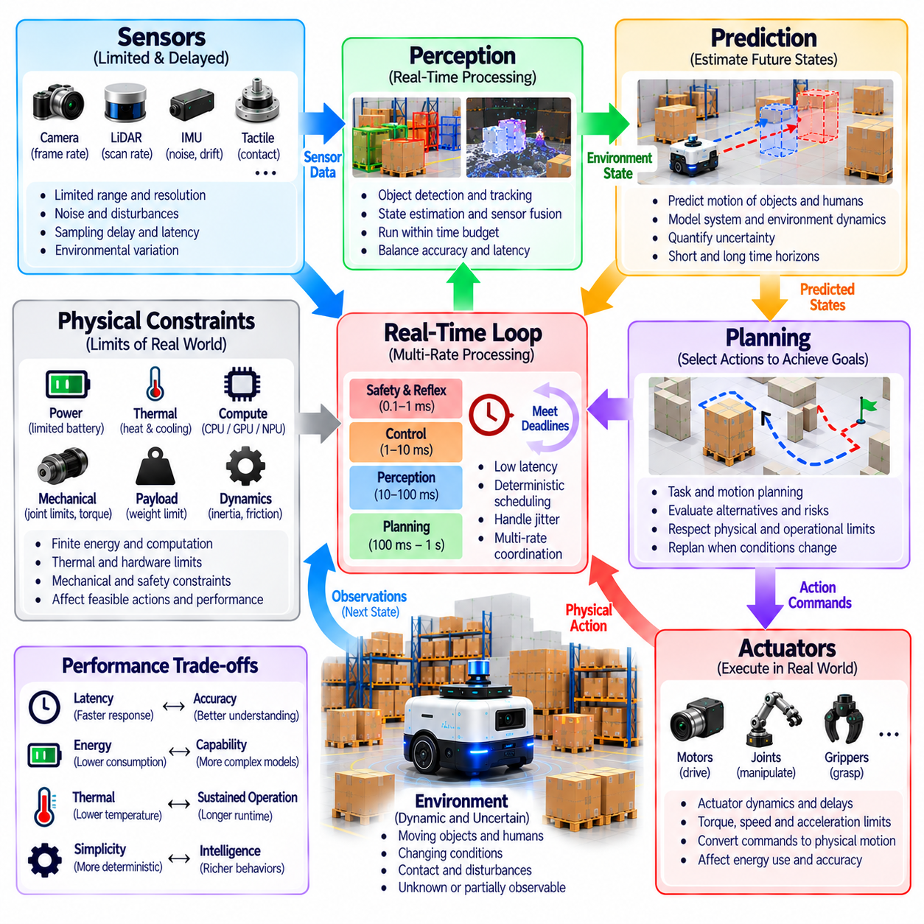
Real-time operation and physical constraints are fundamental characteristics of Physical AI because intelligent agents must act within the timing and resource limits of the physical world. Unlike digital systems that may tolerate delayed responses, physical agents interact with continuously evolving environments. Decisions must therefore be produced quickly enough to influence events while remaining consistent with mechanical, electrical, computational, and safety limitations.
Real-time intelligence requires more than high computational speed. A system must deliver appropriate results within deadlines determined by physical processes and operational requirements. A navigation controller may need frequent updates to maintain stable motion, while an emergency protection mechanism may require a much shorter response interval. Missing a critical deadline can compromise safety even when the eventual computational result is correct.
Physical AI systems operate across multiple time scales. Motor control may require rapid periodic updates, perception algorithms may process observations at lower frequencies, and task planners may operate over longer intervals. These processes must remain coordinated despite different execution rates. Hierarchical scheduling and asynchronous communication help distribute computational responsibilities while preserving the timing relationships required for reliable physical behavior.
Latency represents the delay between an event and the system's corresponding response. It may include sensor acquisition, data transmission, preprocessing, inference, planning, command delivery, and actuator response. End-to-end latency is therefore more important than the execution time of any single algorithm. A fast neural network cannot guarantee timely behavior when communication delays or mechanical response times dominate the overall process.
Timing variability, commonly described as jitter, introduces additional challenges for physical control. Even when average latency is acceptable, inconsistent execution intervals can degrade trajectory tracking and destabilize feedback loops. Real-time systems must therefore consider worst-case execution time, deadline compliance, and scheduling predictability. Deterministic behavior is especially important when delayed actions could produce collisions or excessive mechanical forces.
Hard real-time and soft real-time requirements differ according to the consequences of missing deadlines. Hard real-time functions must satisfy specified timing constraints to preserve correctness or safety, while soft real-time functions may tolerate occasional delays with reduced performance. Emergency protection and certain low-level control functions may require strict guarantees. Higher-level planning or noncritical analytics can often accept more flexible execution schedules.
Computational resources impose practical limits on perception, prediction, and decision-making. Neural networks, geometric reasoning, optimization algorithms, and world models compete for processing capacity and memory bandwidth. Increasing model complexity may improve accuracy but also increase inference latency and energy consumption. System design must balance intelligence quality with predictable execution under available hardware constraints.
Edge computing places intelligence near sensors and actuators to reduce dependence on remote infrastructure. Local processing can support rapid feedback, preserve operation during network interruptions, and limit communication overhead. However, embedded processors and edge accelerators have finite computational capacity, memory, and thermal headroom. Effective architectures distribute workloads according to latency sensitivity, resource availability, and operational criticality.
Power consumption is a major physical constraint for mobile and autonomous systems. Computation, sensing, communication, locomotion, and manipulation draw energy from limited supplies. High-performance inference may reduce available operating time, while aggressive movement can increase both energy consumption and thermal stress. Energy-aware intelligence considers battery condition, task urgency, and the expected value of additional computation before allocating resources.
Thermal constraints influence sustained performance and hardware reliability. Processors, accelerators, motors, and power electronics generate heat during operation. Excessive temperature may trigger frequency reduction, reduced actuator output, or protective shutdown. A system that meets timing requirements during short demonstrations may fail under sustained workloads. Thermal-aware scheduling and realistic endurance testing are therefore essential for deployment.
Mechanical constraints define which actions are physically feasible. Joint limits, actuator torque, acceleration, payload capacity, friction, and structural strength restrict motion and manipulation. Planning algorithms must respect these boundaries rather than generate trajectories that are mathematically valid but mechanically impossible. Accurate physical models help translate abstract objectives into executable behavior while accounting for equipment wear and operational margins.
Actuator dynamics introduce delays and limitations between commanded and realized motion. Motors cannot change speed instantaneously, braking requires finite distance, and compliant mechanisms may deform under load. Controllers must account for inertia, backlash, saturation, and contact forces. Ignoring these properties can produce unstable movement or inaccurate manipulation, even when perception and high-level planning are otherwise correct.
Sensor limitations also shape real-time intelligence. Cameras have exposure and frame-rate constraints, LiDAR systems have scanning intervals, and inertial sensors experience noise and drift. Measurements may arrive asynchronously or represent different moments in time. Accurate timestamping, synchronization, and state estimation are necessary to prevent outdated or misaligned observations from producing incorrect control decisions.
Communication networks introduce bandwidth limits, packet loss, and variable transmission delays. Distributed robots may exchange sensor data, trajectories, and coordination messages across wireless or wired connections. Network congestion can disrupt time-sensitive information exchange, while connectivity failures may isolate individual agents. Robust systems prioritize critical messages and maintain safe local behavior when remote coordination becomes unavailable.
Real-time planning must produce useful actions before the available decision window closes. Complex optimization may identify high-quality solutions but consume more time than physical conditions permit. Anytime algorithms, bounded search, hierarchical planning, and simplified fallback policies can provide practical alternatives. The appropriate solution is not necessarily the mathematically optimal plan, but one that remains feasible, timely, and sufficiently safe.
Prediction helps compensate for sensing and execution delays by estimating how the environment may change before an action takes effect. A robot approaching a moving obstacle must consider the obstacle's anticipated position rather than only its last observed location. Predictive control can improve responsiveness, but forecasting errors increase with uncertainty and horizon length. Feedback remains necessary to correct deviations between expected and actual motion.
Resource management becomes more complex when several intelligent functions operate simultaneously. Perception, localization, mapping, planning, and learning may compete for shared accelerators and memory. Uncontrolled contention can produce unpredictable delays in critical tasks. Priority scheduling, workload isolation, model compression, and selective computation help preserve responsiveness while preventing nonessential processing from interfering with safety-related functions.
Safety constraints must remain effective even when computational resources are exhausted or communication fails. Independent protection mechanisms, watchdog timers, bounded commands, and safe-state transitions can limit hazardous behavior. Degraded operating modes may reduce speed or suspend complex tasks while retaining essential control. Such mechanisms recognize that advanced intelligence cannot replace dependable protection against physical failure.
Evaluating real-time Physical AI requires measuring performance under realistic operating conditions rather than relying only on average inference benchmarks. Relevant metrics include end-to-end latency, deadline misses, jitter, energy consumption, thermal stability, control accuracy, and recovery behavior. Stress tests should combine peak workloads, sensor degradation, communication interruptions, and prolonged operation to reveal failures hidden by nominal testing.
Ultimately, real-time and physical constraints determine whether intelligence can operate effectively in the real world. Perception, prediction, planning, and control must function within finite time, energy, computation, and mechanical capacity. Reliable Physical AI emerges when these limitations are treated as architectural requirements rather than secondary optimization concerns. Intelligent behavior must be not only accurate and adaptive, but also timely, executable, and safe.

01.14. Safety as a Core Property
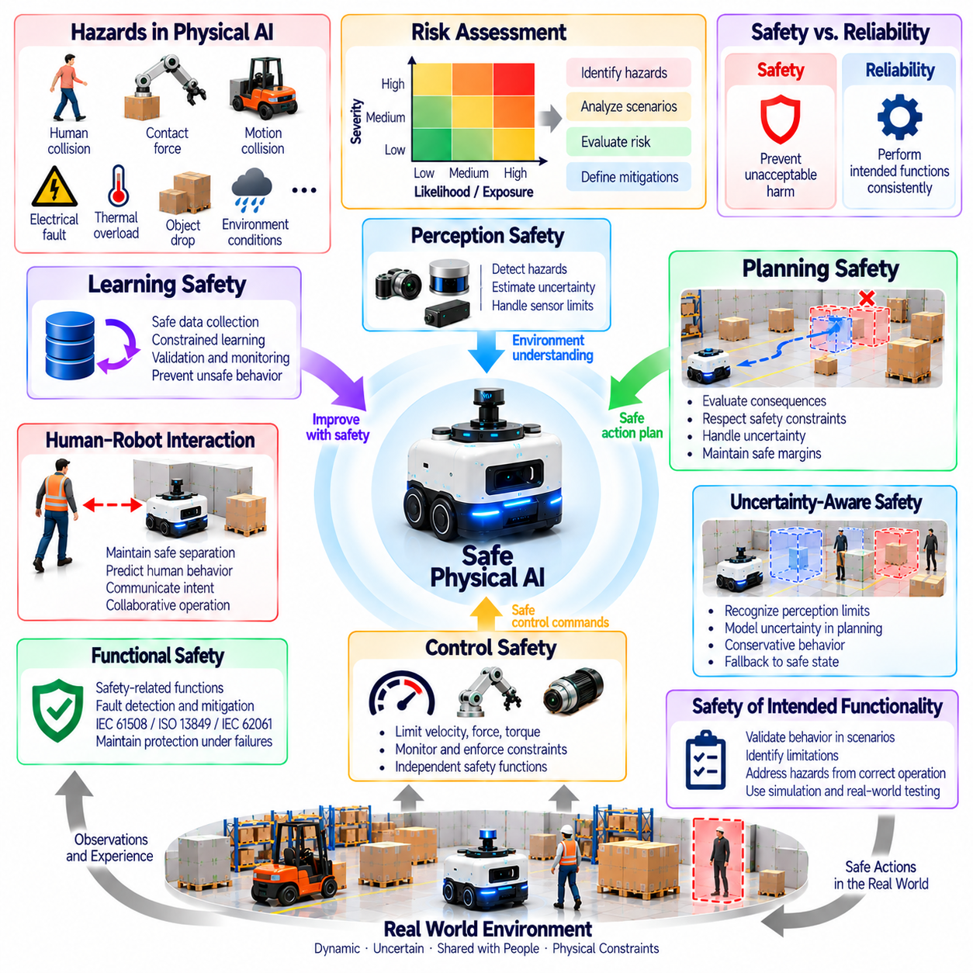
Safety is a core property of Physical AI because intelligent actions can directly affect people, equipment, infrastructure, and the surrounding environment. Unlike purely digital errors, physical failures may cause injury, property damage, or irreversible consequences. Safety must therefore influence perception, decision-making, planning, control, and learning from the beginning of system development. It cannot be treated as an optional feature added after autonomous capabilities are implemented.
Physical AI safety begins with recognizing hazards associated with motion, contact, energy, and environmental interaction. A mobile robot may collide with a pedestrian, while a manipulator may apply excessive force or release an object unexpectedly. Electrical faults, thermal overload, and communication failures introduce additional risks. Hazard identification must consider normal operation, foreseeable misuse, degraded conditions, and interactions between system components.
Safety differs from reliability, although the two properties are closely related. Reliability concerns whether a system performs its intended functions consistently, while safety concerns whether unacceptable harm is prevented. A robot may execute a dangerous command reliably, or experience a component failure without creating a hazardous situation. Effective engineering must evaluate both functional correctness and the physical consequences of incorrect or unexpected behavior.
Risk assessment combines the severity of potential harm with the likelihood or exposure conditions associated with hazardous events. Engineers examine operational scenarios, failure mechanisms, human proximity, and environmental characteristics to determine appropriate protective measures. Risk cannot always be eliminated, but it can be reduced through inherently safer design, protective systems, operational restrictions, and validated procedures.
Safety-by-design integrates protective requirements into system architecture rather than relying exclusively on external emergency mechanisms. Mechanical limits, controlled acceleration, restricted operating regions, and predictable motion profiles can reduce inherent hazards. Hardware and software should be organized so that failures in advanced intelligence do not automatically disable essential protection. Safety requirements must remain traceable throughout development and deployment.
Functional safety addresses hazards arising from malfunctioning electrical, electronic, and programmable systems. Safety-related functions may monitor speed, separation distance, actuator torque, or emergency-stop conditions. Their required integrity depends on the application and risk assessment. Standards such as IEC 61508, ISO 13849, and IEC 62061 provide relevant frameworks, although applicability and compliance requirements vary by machine and operating context.
Safety of the intended functionality addresses hazards that can occur even when components operate as designed. A perception system may misinterpret an unfamiliar object, or a planner may select an unsafe action because its environmental assumptions are incomplete. These problems cannot be addressed solely through hardware fault detection. Scenario analysis, uncertainty evaluation, and validation of intended behavior are necessary to identify limitations that may lead to harm.
Perception safety requires recognizing both environmental hazards and limitations in available observations. Cameras, LiDAR, radar, and other sensors may fail to detect objects because of occlusion, interference, weather, or unfavorable geometry. Confidence estimates and sensor fusion can improve awareness, but agreement between sensors does not guarantee correctness. Systems should identify degraded perception and adjust behavior before uncertainty creates unacceptable risk.
Planning safety requires evaluating the consequences of candidate actions before execution. A navigation planner must consider collision boundaries, stopping distance, human movement, and accessible escape paths. Manipulation planning must account for payload limits, contact forces, and object stability. Safe planning may sacrifice efficiency to preserve protective margins, particularly when predictions are uncertain or environmental conditions are changing.
Control safety translates protective requirements into enforceable physical behavior. Controllers may impose limits on velocity, acceleration, torque, force, and workspace boundaries. Monitoring functions compare commanded actions with permitted operating conditions and intervene when constraints are violated. Independent protective mechanisms are especially important when learning-based policies or complex planners cannot provide sufficient guarantees about every possible output.
Human-robot interaction introduces additional safety responsibilities because human behavior is difficult to predict precisely. People may enter restricted areas, move unexpectedly, or misunderstand robot intentions. Safe interaction requires appropriate separation, speed control, visibility, and communication of system status. Collaborative operation must consider the actual application, contact conditions, and applicable safety requirements rather than assume that low speed alone ensures protection.
Learning-based systems introduce safety challenges because model behavior may change across training, adaptation, and deployment. A policy that performs well in familiar scenarios may produce unexpected actions when encountering unfamiliar conditions. Exploration can also create physical hazards. Safety-constrained learning, controlled updates, independent monitoring, and validation against representative scenarios help prevent performance optimization from overriding protective requirements.
Uncertainty-aware safety recognizes that incomplete information can make apparently reasonable decisions dangerous. When localization confidence decreases or object properties remain unknown, an agent may reduce speed, increase clearance, request assistance, or suspend an operation. Such responses should reflect the severity of possible consequences. A safe system must recognize when available evidence is insufficient to justify continued autonomous action.
Fault tolerance enables Physical AI systems to maintain protection when individual components fail. Redundant sensors, diagnostic monitoring, watchdog mechanisms, and controlled fallback modes can reduce dependence on single components. However, redundancy must account for common-cause failures and shared design assumptions. A fallback strategy should define which functions remain available, which operations must stop, and how the system reaches a safe condition.
Emergency stopping is an important protective function, but it does not replace comprehensive safety engineering. Stopping behavior must account for mechanical inertia, braking distance, load stability, and the possibility that immediate power removal could introduce additional hazards. Different applications may require controlled stopping or maintained power to selected functions. Emergency measures must be designed and validated for the actual physical system.
Safety verification determines whether implemented functions satisfy specified requirements, while validation examines whether the overall system is sufficiently safe for its intended use. Testing may include fault injection, sensor degradation, unexpected obstacles, communication interruptions, and abnormal actuator behavior. Simulation supports broad scenario coverage, but physical testing remains necessary to assess real contact dynamics and hardware limitations.
Operational safety continues after deployment through inspection, maintenance, monitoring, and incident analysis. Sensors may drift, mechanical components may wear, and environments may change beyond original assumptions. Logs and diagnostic records support investigation of failures and near misses. Software updates and learned model changes should undergo appropriate review because modifications can invalidate previously established safety evidence.
Safety governance assigns responsibility for requirements, risk acceptance, change control, and operational oversight. Developers, integrators, operators, and maintenance personnel contribute different forms of evidence and accountability. Documentation should connect identified hazards with protective measures and verification results. Clear authority for stopping operation or rejecting unsafe changes helps ensure that commercial or performance objectives do not override essential protection.
Safety performance must be evaluated using evidence beyond the absence of reported accidents. Relevant indicators include hazardous-event frequency, protective response time, constraint violations, diagnostic coverage, and performance under degraded conditions. Rare but severe scenarios require deliberate examination because ordinary operational statistics may not reveal them. Continuous evaluation should identify emerging risks before they produce physical harm.
Ultimately, safety is not separate from intelligence but a defining requirement for responsible physical autonomy. Perception must recognize limitations, prediction must consider hazardous outcomes, planning must respect constraints, and control must enforce protective boundaries. Learning and adaptation must preserve these properties as capabilities evolve. Physical AI becomes trustworthy when purposeful action remains consistently bounded by demonstrable protection of people and the physical world.

01.15. Minimal Physical AI Agent [w/Code]
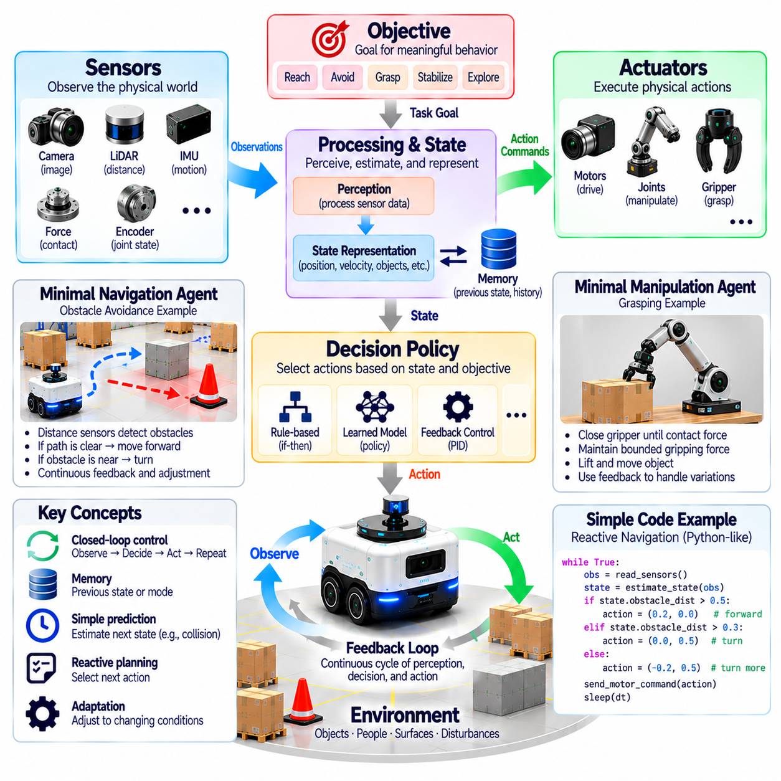
A minimal Physical AI agent is the simplest functional system capable of perceiving physical conditions, selecting purposeful actions, and influencing its environment through feedback. It does not require human-level reasoning, extensive language understanding, or large foundation models. Its defining characteristic is the integration of sensing, decision-making, and physical action within a closed interaction loop. This minimal structure provides the conceptual foundation for more advanced autonomous systems.
The essential components of a minimal agent include an environment, sensors, an internal processing mechanism, a decision policy, and actuators. Sensors acquire information about physical conditions, processing converts measurements into usable representations, and the policy determines appropriate actions. Actuators execute commands that change the environment or the agent's physical state. Subsequent observations reveal the consequences of those actions.
A minimal Physical AI agent must have an objective that gives meaning to its behavior. The objective may involve reaching a destination, maintaining a safe distance, stabilizing a mechanism, or positioning an object. Without an objective, sensing and movement remain disconnected activities rather than purposeful intelligence. The objective does not need to be complex, but it must provide a basis for evaluating whether selected actions contribute to the intended outcome.
Perception provides the agent with information required to distinguish relevant physical conditions. A simple mobile robot may use distance sensors to detect nearby obstacles, while a robotic gripper may use force measurements to recognize contact. Perception does not necessarily require detailed scene understanding. A compact representation containing distance, velocity, contact state, or position may be sufficient when it supports the decisions required by the task.
State representation transforms raw observations into variables useful for decision-making. A minimal navigation agent might maintain its estimated position, heading, obstacle distance, and movement status. These variables summarize the conditions needed to select actions. The representation may be incomplete or uncertain, but it should preserve information relevant to the objective. More elaborate representations become necessary only when task complexity demands them.
A decision policy maps available information to actions. In a simple agent, this policy may consist of conditional rules, a finite-state machine, a feedback controller, or a compact learned model. For example, a robot may move forward when its path is clear and turn when an obstacle enters a defined safety region. The policy becomes intelligent in a functional sense when its decisions consistently support an objective under changing conditions.
Physical action distinguishes a Physical AI agent from a system that only analyzes information. Motors, wheels, joints, grippers, or other actuators translate commands into physical effects. These effects depend on mechanical dynamics, energy availability, and environmental interaction. A commanded movement may not produce the expected displacement because of friction, load variation, or obstacles. The agent must therefore observe actual outcomes rather than assume perfect execution.
Closed-loop feedback is the central operating principle of a minimal Physical AI agent. The agent observes its environment, estimates relevant conditions, selects an action, and measures the resulting change. Each cycle provides information for the next decision. Unlike open-loop automation, which executes predetermined commands without considering their effects, closed-loop operation allows behavior to respond to disturbances and unexpected physical outcomes.
A simple obstacle-avoidance robot illustrates this architecture. Distance sensors measure nearby objects, a controller compares measurements with safety thresholds, and wheel motors adjust movement direction. As the robot moves, new measurements determine whether it should continue, slow down, or turn. Although the behavior may be simple, the system demonstrates physical perception, action selection, environmental influence, and continuous feedback.
A minimal manipulation agent provides another example. A gripper may close until a force sensor detects sufficient contact, then maintain a bounded gripping force while lifting an object. Feedback compensates for differences in object dimensions or mechanical compliance. The system does not need to understand every property of the object. It requires only enough information to execute the intended manipulation while respecting physical constraints.
Memory is useful but need not be extensive in a minimal agent. The system may retain a previous sensor reading, movement direction, or operating state to support stable decisions. A finite-state controller can remember whether it is approaching, turning, grasping, or releasing. Such limited memory prevents contradictory actions and supports continuity. More sophisticated episodic or semantic memory becomes valuable as tasks require longer histories and broader environmental knowledge.
Prediction may also be implemented in a minimal form. A controller can estimate whether continued movement will reduce obstacle clearance or whether applied force will exceed a safe limit. These predictions may rely on simple physical relationships rather than complex learned world models. Even limited anticipation improves action selection when physical responses are delayed. Predictive sophistication should increase according to the demands of the environment.
Planning in a minimal agent may consist of selecting the next action rather than generating an extended sequence. A reactive controller can achieve useful behavior when local observations provide sufficient guidance. More complex tasks require intermediate goals, route selection, or coordinated action sequences. The distinction is architectural rather than absolute: a minimal agent may operate with simple rules, while advanced agents integrate increasingly sophisticated planning mechanisms.
Learning is not necessarily required for every minimal closed-loop controller. Fixed policies can perform useful tasks in constrained environments, but they should not automatically be considered adaptive intelligence. A learning-capable minimal agent may adjust a control parameter, improve an obstacle threshold, or update an estimate from repeated experience. These mechanisms introduce adaptation without requiring large-scale training infrastructure or extensive neural networks.
Uncertainty remains relevant even in simple systems. Distance measurements contain noise, actuators respond imperfectly, and environmental conditions may change unexpectedly. A minimal agent can manage uncertainty through filtering, conservative thresholds, repeated observations, and bounded actions. It does not need a complete probabilistic model to behave cautiously. However, its limitations must be recognized when interpreting performance or extending operation to unfamiliar conditions.
Real-time constraints determine whether the minimal agent can maintain effective interaction. Sensor updates, processing, decisions, and actuator commands must occur quickly enough for the physical task. A slow obstacle detector may be adequate for a stationary platform but unsafe for a rapidly moving robot. Computational simplicity can therefore be advantageous when it reduces latency and improves predictable execution without sacrificing necessary functionality.
Safety must be incorporated even when the agent performs only elementary tasks. Movement limits, emergency stopping, force restrictions, and protective operating boundaries prevent simple decisions from producing unacceptable consequences. A minimal agent should respond predictably to sensor failures, invalid measurements, and unavailable commands. Basic intelligence does not justify weak protection because even uncomplicated mechanisms can cause physical harm.
The distinction between a minimal Physical AI agent and ordinary automation depends on the capabilities being claimed. A fixed sequence controller may perform physical actions without interpreting environmental feedback, while a reactive agent adjusts behavior according to observed conditions. However, feedback control alone does not establish learning, generalization, or advanced reasoning. Classification should therefore describe demonstrated capabilities rather than imply intelligence from the presence of sensors or motors.
Evaluating a minimal agent requires measuring whether it achieves its objective under relevant physical conditions. Task success, response time, control stability, constraint compliance, and recovery from disturbances provide practical evidence. Testing should include variations in sensor readings, environmental geometry, and actuator behavior. A minimal system is successful when its limited architecture produces repeatable, purposeful, and sufficiently safe physical behavior.
Ultimately, the minimal Physical AI agent establishes a foundation for understanding increasingly capable autonomous systems. Perception supplies information, state representation organizes it, decision-making selects behavior, and actuation produces physical consequences. Feedback connects these functions into a continuous cycle. Memory, prediction, planning, and learning can then be expanded according to task requirements, while physical constraints and safety remain fundamental to every level of capability.

