Volume 02. Physical AI Foundations and Definitions

Chapter 10. Future Directions

10.01. From Reactive to Predictive Physical AI
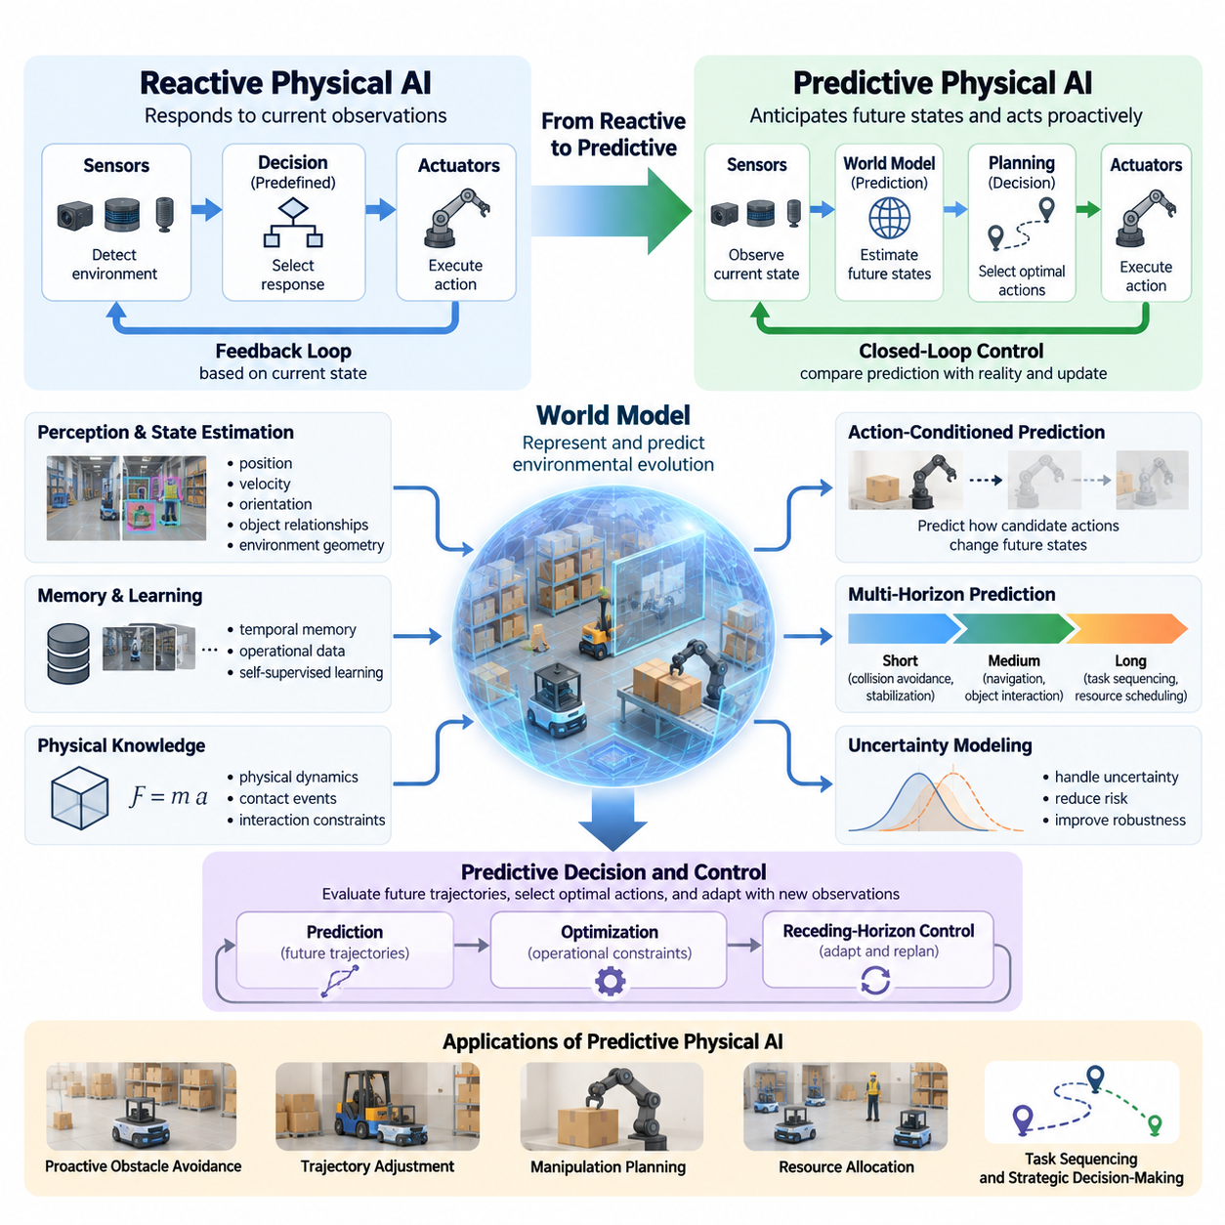
Physical AI is evolving from systems that respond to immediate sensory inputs toward systems capable of anticipating future environmental states and acting before critical events occur. Reactive intelligence relies primarily on current observations and predefined responses, while predictive intelligence combines perception, memory, learned dynamics, and planning to estimate how the physical world may change. This transition represents a fundamental advancement in autonomous behavior.
Reactive Physical AI operates through a continuous feedback loop in which sensors detect environmental conditions, decision mechanisms select responses, and actuators execute corresponding actions. This approach is effective when environmental changes are observable, response times are sufficiently short, and task requirements are relatively predictable. However, reactive behavior becomes insufficient when delayed observations, moving obstacles, uncertain interactions, or complex physical dependencies require anticipation.
Predictive Physical AI extends conventional feedback control by incorporating estimates of future states into the decision-making process. Rather than asking only what action should be performed under current conditions, a predictive agent evaluates what may happen after different actions are executed. This capability enables proactive obstacle avoidance, trajectory adjustment, manipulation planning, and resource allocation while maintaining continuous interaction with the physical environment.
The transition from reactive to predictive intelligence does not eliminate feedback control. Instead, prediction becomes an additional capability within a closed-loop architecture that continuously compares expected outcomes with actual observations. When predictions differ from reality, the system updates its internal estimates and adjusts subsequent actions. This integration preserves the responsiveness of reactive systems while introducing the foresight necessary for more complex autonomous operations.
A fundamental requirement of predictive Physical AI is the representation of physical state over time. The system must estimate relevant properties such as position, velocity, orientation, object relationships, environmental geometry, and interaction constraints. These estimates are often incomplete because sensors provide noisy and partial observations. Predictive intelligence therefore depends on state estimation, temporal memory, uncertainty modeling, and mechanisms for incorporating new evidence.
World models provide an important foundation for predictive Physical AI by representing how environmental states evolve under physical dynamics and agent actions. A world model may predict object motion, contact events, changes in occupancy, or the consequences of manipulation. Such models can combine analytical physical principles with learned representations derived from operational experience, allowing agents to anticipate outcomes that cannot be determined from immediate sensory measurements alone.
Prediction can operate at multiple temporal scales depending on the physical task. Short-horizon prediction supports collision avoidance, stabilization, and dynamic control, while medium-horizon prediction assists navigation, object interaction, and coordinated motion. Longer prediction horizons support task sequencing, resource scheduling, and strategic decision-making. Each horizon requires an appropriate balance between computational complexity, uncertainty, physical accuracy, and operational relevance.
Action-conditioned prediction is particularly important because physical agents influence the environments they observe. A robot moving through a warehouse changes its position relative to workers and obstacles, while a manipulator alters object configurations through contact. Predictive models must therefore estimate not only how the environment evolves independently but also how candidate actions affect future states. This distinction connects environmental forecasting directly to intelligent decision-making.
Model predictive control illustrates how prediction can improve physical autonomy. The controller evaluates possible future trajectories over a limited horizon, selects an action sequence satisfying operational constraints, and executes an initial portion of that sequence. As new observations become available, the optimization process is repeated. This receding-horizon strategy allows predictive behavior to remain adaptable despite imperfect models and continuously changing environmental conditions.
Learning-based prediction expands these capabilities beyond environments that can be described accurately using conventional mathematical models. Neural networks can learn temporal relationships from sensor recordings, demonstrations, simulations, and interaction histories. Recurrent architectures, transformers, and latent dynamics models provide different mechanisms for capturing environmental evolution. Their usefulness depends on whether learned representations preserve the information required for reliable physical decisions.
Self-supervised learning offers a scalable approach to developing predictive representations from large volumes of operational data. By predicting future observations, latent states, object relationships, or action consequences, models can learn temporal structure without requiring detailed manual labels for every event. Nevertheless, accurate prediction of recorded data does not automatically guarantee safe control, making physical validation and task-specific evaluation essential.
Uncertainty becomes increasingly important as prediction horizons expand. Small errors in estimated velocity, object behavior, contact dynamics, or environmental conditions may accumulate into substantial differences between predicted and actual outcomes. Predictive Physical AI must therefore represent uncertainty rather than treating every forecast as certain. Probabilistic models, ensembles, confidence estimates, and conservative planning constraints help agents distinguish reliable predictions from speculative possibilities.
Predictive safety mechanisms use anticipated future conditions to identify hazards before they become immediate threats. An autonomous mobile robot may estimate whether its current trajectory could intersect with a moving worker, while an industrial manipulator may anticipate excessive contact forces during assembly. By evaluating future safety margins, the system can reduce speed, modify its trajectory, request assistance, or enter a safe operating state before a hazardous condition develops.
Predictive perception also changes how robots allocate sensing and computational resources. Instead of processing all observations with equal priority, an agent may focus attention on objects or regions expected to influence upcoming decisions. Anticipated occlusions, moving obstacles, and uncertain object locations can guide active perception. This creates a reciprocal relationship in which perception supports prediction and prediction determines which additional observations are most valuable.
Physical reasoning extends predictive intelligence beyond numerical trajectory forecasting. An agent may need to infer whether an object will fall, whether a surface can support a load, or whether a grasp will remain stable during movement. These predictions depend on geometry, material properties, contact relationships, and causal interactions. Combining learned representations with physical constraints can improve reasoning about situations that differ from previously observed examples.
Predictive capabilities are particularly valuable for autonomous mobile robots operating in dynamic environments. Warehouse robots must anticipate pedestrian movement, vehicle interactions, temporary obstructions, and changing traffic patterns. Outdoor robots face additional uncertainty from terrain conditions, weather, and unpredictable agents. Predictive navigation allows these systems to evaluate future traversability and collision risks instead of relying exclusively on immediate obstacle detection.
Manipulation tasks introduce additional challenges because contact interactions can produce discontinuous changes in physical state. Grasping, pushing, inserting, and assembling objects require predictions about friction, deformation, force transmission, and object stability. Predictive manipulation systems can evaluate alternative actions before execution and adjust their strategies when observed contact behavior differs from expectations. Reliable force feedback remains essential throughout these operations.
The computational architecture of predictive Physical AI must account for strict latency, power, and reliability constraints. High-frequency control generally requires local processing, while more computationally intensive forecasting and planning may operate at slower rates. Edge computing can support immediate prediction and action selection, whereas on-premise and cloud resources may assist with model training, large-scale simulation, and shared environmental knowledge when communication conditions permit.
Multi-robot environments create opportunities for predictive intelligence beyond individual agents. Robots can exchange observations, anticipated trajectories, and task intentions to reduce uncertainty and improve coordination. Shared predictive representations may support traffic management, cooperative manipulation, and fleet scheduling. However, communication delays, inconsistent state estimates, and conflicting predictions require robust coordination mechanisms that preserve local safety and autonomy.
Evaluation of predictive Physical AI must examine both forecasting quality and operational consequences. Prediction errors can be measured through trajectory deviation, state estimation accuracy, uncertainty calibration, and event forecasting performance. Yet a highly accurate predictive model may still produce ineffective actions if its outputs are poorly integrated with planning. Evaluation must therefore include task success, safety violations, intervention frequency, computational latency, and robustness under changing conditions.
The development of predictive intelligence also requires careful management of the simulation-to-reality gap. Models trained in simulated environments may learn useful physical relationships while failing to capture real-world friction, sensor noise, actuator limitations, or human behavior. Domain randomization, system identification, real-world calibration, and continuous validation can improve transfer. Operational data should be used to identify prediction failures and refine models within controlled learning processes.
A practical transition strategy begins by strengthening state estimation and temporal awareness within existing reactive architectures. Predictive modules can then be introduced for narrowly defined functions such as collision forecasting, motion planning, or equipment condition monitoring. As reliability improves, these modules can support increasingly integrated decision-making. Incremental deployment enables measurable improvements without prematurely replacing proven control and safety mechanisms.
The long-term direction of Physical AI is toward systems that continuously sense, model, predict, plan, act, and learn within the physical world. Predictive intelligence provides a foundation for greater autonomy, but its effectiveness depends on reliable perception, grounded physical models, uncertainty awareness, and safe execution. The central objective is not perfect knowledge of the future, but the ability to make better decisions by anticipating plausible consequences while remaining responsive to reality.

10.02. World Model Centric Physical AI
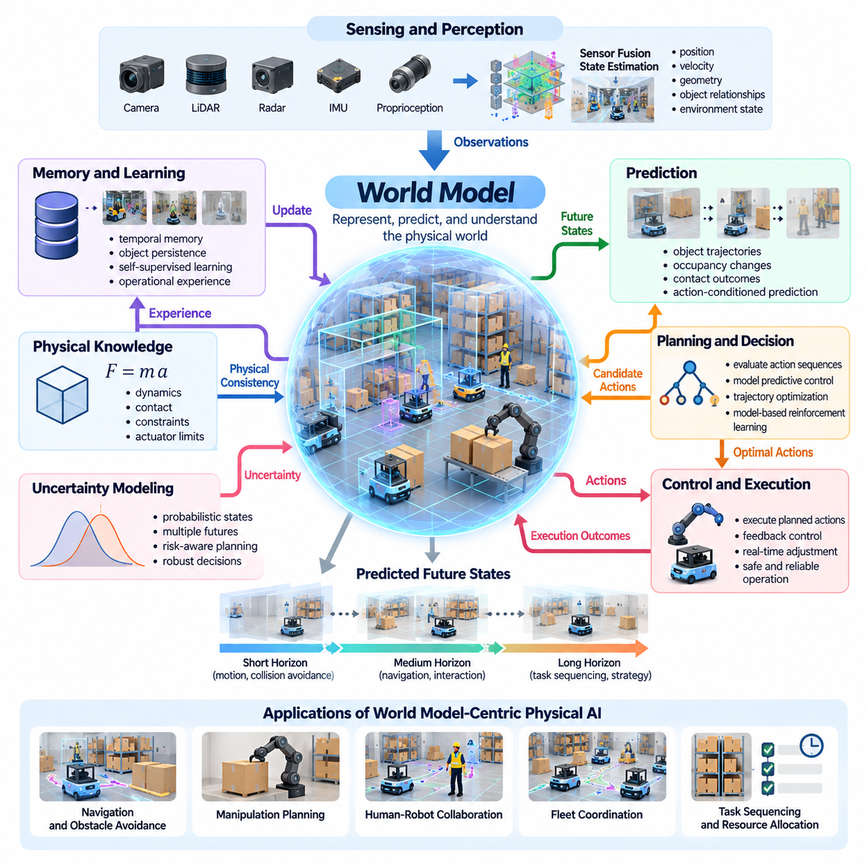
World model-centric Physical AI represents a transition from systems that primarily react to observations toward architectures that maintain internal representations of the physical world and predict its evolution. A world model enables an intelligent agent to estimate environmental states, understand physical relationships, and anticipate the consequences of actions. This capability provides a foundation for integrating perception, reasoning, planning, control, and learning into a coherent autonomous system.
Traditional robotic architectures often organize perception, localization, planning, and control into separate functional modules. Although this modular structure supports engineering clarity, information may become fragmented across components. A world model-centric architecture introduces a shared representation that connects these functions through consistent estimates of environmental state, physical dynamics, and anticipated outcomes, while preserving specialized modules where necessary.
The central purpose of a world model is to represent how the physical environment behaves over time. It captures relevant information about objects, spatial relationships, motion, interactions, and environmental constraints. Unlike a static map or a single sensor observation, a dynamic world model describes both current conditions and possible future developments. Its usefulness depends on whether these representations support reliable decisions rather than merely reconstructing sensory information.
World models may operate through explicit physical states, learned latent representations, or hybrid combinations of both. Explicit representations describe quantities such as position, velocity, geometry, and contact conditions, while latent models encode complex relationships in learned feature spaces. Hybrid architectures combine interpretable physical variables with flexible learned dynamics, potentially improving predictive capability while retaining useful structural constraints.
A world model-centric agent continuously updates its internal representation through observations and interactions. Cameras, LiDAR, inertial sensors, proprioceptive measurements, and other sensing modalities provide complementary information about the environment. Sensor fusion and state estimation transform these observations into coherent estimates. Temporal memory helps maintain information about objects and conditions that are temporarily hidden or only partially observable.
Prediction is a defining capability of world model-centric intelligence. Given an estimated current state and candidate actions, the model forecasts possible future states and interaction outcomes. These predictions may include object trajectories, occupancy changes, contact events, and environmental transformations. By comparing alternative futures, the agent can evaluate actions before execution and select behaviors that better satisfy task objectives and operational constraints.
Action-conditioned world models are particularly important because physical agents actively modify their surroundings. A mobile robot changes its spatial relationships through navigation, while a manipulator alters object configurations through grasping and contact. The model must therefore distinguish environmental evolution from changes caused by the agent's own actions. This relationship between action and predicted consequence forms a foundation for model-based planning and adaptive control.
World model-centric planning uses predicted state transitions to evaluate candidate action sequences. Rather than selecting an action solely from immediate observations, the planner considers how different choices may influence future conditions. Model predictive control, trajectory optimization, and model-based reinforcement learning provide complementary approaches. Each combines predictive representations with decision mechanisms while balancing computational cost, uncertainty, and physical constraints.
Hierarchical prediction allows world models to support decisions across different temporal and spatial scales. Short-horizon models can estimate immediate motion and contact dynamics, while longer-horizon models can represent task progression, environmental changes, and strategic objectives. A hierarchical architecture may combine fast local predictions with slower abstract reasoning, enabling physical agents to coordinate immediate control with longer-term behavioral goals.
Memory is essential because the physical world cannot always be reconstructed from current observations alone. Objects may become occluded, environmental conditions may change gradually, and previous interactions may influence future outcomes. World models can incorporate temporal histories, persistent object representations, and learned environmental regularities. Such memory supports continuity of reasoning and improves decision-making under partial observability.
Physical consistency is a critical requirement for useful world models. Predictions should respect relevant constraints involving geometry, motion, contact, conservation principles, and actuator capabilities. Purely data-driven models may produce visually plausible but physically inconsistent outcomes. Physics-informed learning and hybrid modeling can introduce structural knowledge that improves generalization, although their effectiveness must be established through task-specific evaluation.
Uncertainty modeling is equally important because predictions become less reliable as environmental complexity and forecasting horizons increase. Sensor noise, unknown object properties, unpredictable human behavior, and imperfect dynamics can produce multiple plausible futures. Probabilistic world models represent this ambiguity through distributions or alternative hypotheses. Planning mechanisms can then consider uncertainty when evaluating safety margins and selecting actions.
Learning world models requires diverse experience covering environmental states, actions, and resulting transitions. Real-world interaction data provides physical grounding, while simulation can expand coverage of rare events and controlled variations. Self-supervised objectives allow models to learn temporal structure without exhaustive manual annotation. However, training data must include meaningful action consequences to support reliable planning rather than passive visual prediction alone.
Simulation environments and digital twins provide valuable infrastructure for world model development. They enable repeated experiments, controlled interventions, and evaluation of alternative actions without exposing physical equipment to unnecessary risks. Synthetic trajectories can supplement operational data and support systematic testing. Nevertheless, discrepancies between simulated and real dynamics require calibration, domain adaptation, and validation before deployment.
World models can also support counterfactual reasoning by estimating what might happen under actions that have not yet been executed. A robot may compare alternative navigation routes, manipulation strategies, or recovery procedures using simulated internal rollouts. Such reasoning helps agents anticipate undesirable consequences and evaluate tradeoffs. Its reliability depends on whether the model accurately represents causal relationships within the relevant operating conditions.
The integration of world models with vision-language models and vision-language-action architectures creates opportunities for combining semantic understanding with physical prediction. Language can describe goals and constraints, while visual observations provide environmental evidence. The world model estimates physical consequences, and action policies translate selected plans into executable behavior. These components must remain grounded in actual robot capabilities and observable environmental conditions.
World model-centric Physical AI is particularly relevant to autonomous mobile robots operating in dynamic environments. Predictive occupancy representations can estimate how surrounding spaces may change as workers, vehicles, and obstacles move. A navigation system can evaluate future collision risks and traversability before selecting a trajectory. Continuous model updates allow the robot to revise predictions when actual environmental behavior differs from expectations.
Manipulation systems benefit from world models that represent object geometry, contact dynamics, grasp stability, and material interactions. Before executing an action, a robot may predict whether an object will move, rotate, deform, or become unstable. These capabilities support grasp selection, insertion planning, and coordinated manipulation. Reliable execution still requires force sensing, feedback control, and mechanisms for detecting prediction failures.
World models can extend beyond individual robots through shared environmental representations and collective learning. Multiple agents may contribute observations, update common maps, and exchange predicted trajectories or task intentions. Shared models can improve fleet coordination and environmental awareness, especially when individual robots have limited visibility. Maintaining consistency requires attention to communication latency, conflicting observations, and synchronization.
Computational deployment presents important architectural challenges. Detailed predictive models may demand substantial processing power, memory bandwidth, and energy. Edge systems must prioritize low-latency inference and immediate safety decisions, while on-premise or cloud resources can support more intensive training, simulation, and model refinement. Distributed architectures should maintain local autonomy when communication becomes unreliable or unavailable.
Evaluation of world model-centric systems must extend beyond visual reconstruction or prediction accuracy. Useful metrics include state forecasting error, uncertainty calibration, planning performance, task completion, safety violations, and computational latency. Models should also be tested under distribution shifts, unfamiliar objects, unexpected interactions, and sensor degradation. The decisive criterion is whether the world model improves reliable physical behavior under realistic operating conditions.
Safety assurance requires continuous comparison between predicted and observed outcomes. When model confidence decreases or physical behavior diverges from expectations, the system should revise its estimates, constrain actions, or activate an appropriate fallback mechanism. Runtime monitoring and independent safety controls remain necessary because learned predictions cannot guarantee correctness. World models should strengthen safety decisions without becoming a single point of failure.
The long-term significance of world model-centric Physical AI lies in establishing predictive representations as a foundation for autonomous physical intelligence. As perception, memory, physical reasoning, and action-conditioned learning become more integrated, robots may develop increasingly transferable capabilities across tasks and environments. Progress will depend not only on larger models, but also on physical grounding, efficient computation, trustworthy evaluation, and continuous adaptation through real-world experience.

10.03. Robot Foundation Models and Generalist Policies
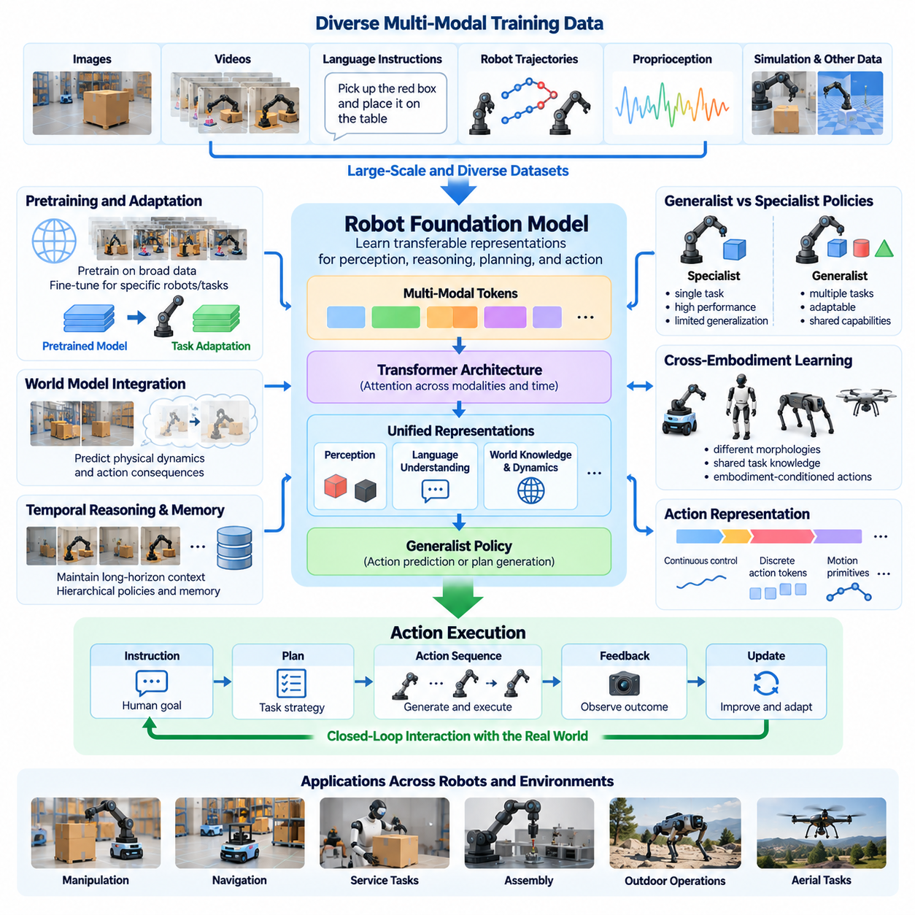
Robot foundation models represent an emerging direction in Physical AI that seeks to develop broadly reusable intelligence across robotic tasks, environments, and embodiments. Unlike conventional models designed for narrowly defined operations, foundation models learn transferable representations from diverse datasets and interaction experiences. Their objective is to provide a common basis for perception, reasoning, planning, and action, reducing the need to develop separate intelligence systems for every application.
Traditional robot learning frequently relies on specialized policies trained for individual tasks, such as object grasping, navigation, or assembly. These policies can achieve high performance within carefully defined operating conditions but often struggle when objects, environments, or task requirements change. Generalist policies aim to overcome this limitation by learning shared behavioral capabilities that can be adapted to multiple tasks without requiring complete retraining.
A robot foundation model typically learns from heterogeneous information sources, including images, videos, language instructions, robot trajectories, proprioceptive measurements, and action sequences. These modalities provide complementary descriptions of physical interactions. Visual information captures environmental structure, language expresses goals and constraints, and action data connects observations to executable behavior. Their integration enables models to learn relationships between perception, intention, and physical consequences.
The development of generalist robot policies depends heavily on large-scale and diverse training data. Demonstrations collected through teleoperation, autonomous exploration, simulation, and human activity recordings contribute different forms of experience. However, combining these sources introduces challenges involving inconsistent sensor configurations, action definitions, coordinate systems, and task annotations. Effective data normalization and representation alignment are therefore essential.
Pretraining provides a mechanism for learning reusable representations before adapting models to specific robotic applications. A foundation model may first learn visual structure, object relationships, temporal dynamics, or language-conditioned behavior from broad datasets. Subsequent fine-tuning can specialize these capabilities for particular robots or environments. This approach potentially reduces task-specific data requirements, although adaptation quality depends on the relevance of pretrained knowledge.
Generalist policies differ from specialist policies primarily in the breadth of their intended operating capabilities. A specialist may optimize performance for a single manipulation procedure, while a generalist attempts to execute multiple instructions involving different objects and environments. Generality does not automatically imply superior performance. Specialized controllers may remain preferable when precision, deterministic timing, or stringent safety requirements dominate operational objectives.
Transformer architectures have become important components of robot foundation models because they can process sequences containing observations, instructions, and actions. Attention mechanisms allow models to represent relationships across modalities and temporal contexts. Depending on the architecture, the model may predict actions directly, generate intermediate plans, or estimate future representations. Architectural effectiveness must ultimately be evaluated through physical execution rather than prediction accuracy alone.
Vision-language-action models provide one approach to integrating foundation models with robotic control. These systems combine visual observations and language instructions with action prediction, allowing a robot to translate task descriptions into physical behavior. Action representations may include continuous control commands, discrete action tokens, or temporally extended action chunks. Each approach introduces different tradeoffs involving expressiveness, latency, precision, and compatibility with robot hardware.
Cross-embodiment learning is a central research challenge because robots differ in morphology, sensing, actuation, and physical capabilities. A mobile manipulator, humanoid, quadruped, and aerial robot cannot execute identical motor commands even when pursuing related objectives. Generalist models must distinguish transferable task knowledge from embodiment-specific control requirements. Shared semantic representations and embodiment-conditioned action interfaces offer potential mechanisms for achieving this separation.
Action tokenization provides a possible bridge between general-purpose sequence modeling and continuous physical control. Robot movements can be represented through discretized commands, learned motion primitives, or structured action sequences. Such representations may facilitate training across heterogeneous datasets, but discretization can reduce precision or introduce additional decoding complexity. The appropriate action representation depends on control frequency, task characteristics, and actuator constraints.
Temporal reasoning is essential for generalist policies because many physical tasks require coordinated actions over extended periods. A robot preparing a workspace, retrieving an object, and completing an assembly operation must preserve task context across multiple intermediate steps. Hierarchical policies can separate high-level objectives from low-level control, while memory mechanisms maintain relevant interaction histories. Reliable execution also requires detecting failures and revising plans.
World models may strengthen robot foundation models by providing predictions about physical dynamics and action consequences. A generalist policy can propose candidate actions, while a predictive world model evaluates their likely outcomes before execution. This combination connects broad task understanding with physically grounded planning. However, inaccurate predictions can mislead decision-making, making continuous observation and feedback-based correction necessary.
Simulation plays an important role in scaling generalist robot learning because collecting physical interaction data can be expensive, slow, and potentially hazardous. Simulated environments enable repeated demonstrations, randomized conditions, and controlled experimentation across many tasks. Synthetic experience can expand behavioral coverage, but differences in contact dynamics, sensing, and actuator behavior create transfer challenges that require real-world validation.
Imitation learning remains a practical foundation for training generalist robot policies. By learning from demonstrations, models can acquire behavioral patterns without extensive online exploration. Demonstration quality, task diversity, and coverage of recovery situations strongly influence resulting performance. Because demonstrations may contain inconsistent or suboptimal behavior, data filtering and policy evaluation are necessary to prevent undesirable patterns from becoming embedded in learned policies.
Reinforcement learning can complement imitation learning by improving behaviors through interaction and task-based feedback. A pretrained policy may provide an initial behavioral prior, while reinforcement learning optimizes performance under defined objectives and constraints. Nevertheless, physical exploration must be carefully controlled because unsafe actions can damage equipment or endanger people. Simulation, constrained optimization, and supervised deployment provide important safeguards.
Generalist policies must address uncertainty and unfamiliar situations rather than assuming that every instruction falls within their learned capabilities. Novel objects, unexpected contacts, sensor degradation, and ambiguous commands can cause failures. Confidence estimation, out-of-distribution detection, and fallback mechanisms help identify situations requiring additional perception, conservative behavior, or human assistance. Reliable generalization includes recognizing when autonomous execution is inappropriate.
The deployment of robot foundation models introduces substantial computational challenges. Large multimodal architectures may require significant memory, processing capacity, and energy, while robotic control demands predictable latency. Model compression, quantization, distillation, and efficient inference can reduce deployment costs. Hybrid architectures may assign high-level reasoning to larger models while retaining lightweight local controllers for immediate physical interaction.
Edge, on-premise, and cloud computing can support different functions within a distributed robot intelligence architecture. Edge devices handle time-sensitive perception, control, and safety responses, while on-premise systems may coordinate multiple robots and maintain shared operational knowledge. Cloud infrastructure can support large-scale training, simulation, and model updates. Communication failures must not compromise essential local safety functions.
Continuous learning offers a pathway for foundation models to improve through accumulated operational experience. Robot fleets can collect interaction trajectories, identify recurring failures, and contribute validated examples to shared training datasets. Updated models may then transfer improvements across compatible platforms. However, uncontrolled online adaptation can introduce unexpected behavior, requiring version management, regression testing, and carefully governed deployment procedures.
Evaluation of generalist robot policies requires broader benchmarks than conventional single-task testing. Relevant dimensions include task diversity, success rate, adaptation efficiency, robustness, recovery capability, and performance under unfamiliar conditions. Cross-embodiment evaluation should distinguish genuine knowledge transfer from performance gains caused by task-specific tuning. Safety, latency, energy consumption, and operational reliability must also be measured.
The distinction between foundation model capability and complete robotic autonomy remains important. A model may understand instructions and generate plausible action sequences without possessing accurate physical state estimates, reliable manipulation skills, or sufficient safety mechanisms. Practical Physical AI therefore requires integration with sensing, localization, planning, feedback control, and runtime assurance. Foundation models provide reusable intelligence components rather than replacing the entire robotic system.
The long-term significance of robot foundation models lies in the possibility of shifting robotics development from individually programmed behaviors toward adaptable, reusable physical intelligence. Generalist policies may progressively support broader task repertoires and faster adaptation across environments and embodiments. Achieving this vision will require advances in data diversity, physical grounding, efficient computation, generalization, safety assurance, and systematic evaluation under real-world operating conditions.

10.04. VLA and Multimodal Action Models
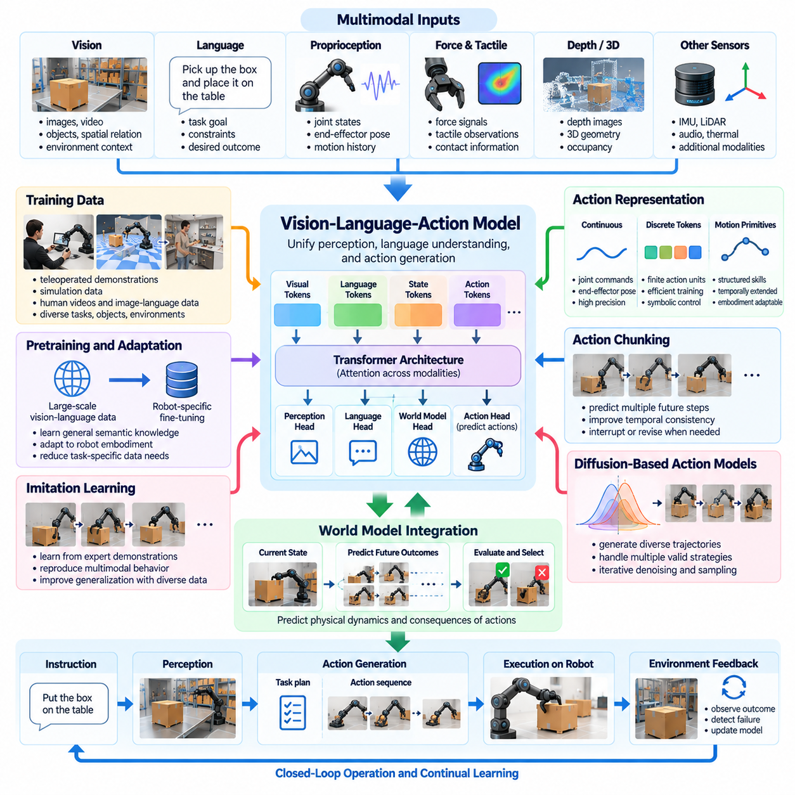
Vision-Language-Action models represent an important direction in Physical AI by connecting visual perception, language understanding, and executable physical actions within a unified learning framework. Unlike systems that interpret images or instructions without directly controlling physical devices, VLA models translate multimodal observations and task intentions into robot behavior. Their development aims to establish reusable action intelligence capable of operating across different tasks, objects, and environments.
The fundamental architecture of a VLA model combines visual observations, language instructions, and action representations. Cameras provide information about objects, spatial relationships, and environmental conditions, while language specifies goals, constraints, and desired outcomes. An integrated model processes these inputs to generate actions appropriate to the robot's capabilities. This connection transforms semantic understanding into physically grounded behavior.
Multimodal action models extend this concept by incorporating additional sensory information beyond vision and language. Proprioceptive measurements, joint states, force signals, tactile observations, depth measurements, and motion histories provide complementary evidence about physical interactions. Combining these modalities enables more informed decisions, particularly during manipulation tasks where visual information alone cannot reliably describe contact conditions or object stability.
A central challenge in VLA development is aligning information represented in different modalities. Language describes intentions through symbolic expressions, images encode spatial and semantic information, and robot actions operate through numerical control variables. Multimodal alignment mechanisms must establish meaningful relationships among these representations. Successful alignment allows the model to connect abstract instructions with concrete physical states and executable movements.
Transformer architectures provide a common foundation for many VLA systems because attention mechanisms can integrate heterogeneous information within shared computational representations. Visual features, language tokens, proprioceptive states, and action histories may be processed through interconnected encoders or unified token sequences. The resulting representations support action prediction while preserving contextual relationships between instructions, observations, and previous behavior.
Action representation is a defining design decision in multimodal action models. Continuous actions can express joint positions, velocities, end-effector poses, or actuator commands directly, while discrete action tokens encode movements into finite symbolic units. Alternative approaches use learned motion primitives or structured action chunks. Each representation affects control precision, training efficiency, temporal consistency, and compatibility with different robotic embodiments.
Action chunking enables a model to predict multiple future control steps rather than generating each command independently. This approach can improve temporal consistency and reduce repeated inference overhead during continuous operation. However, longer action chunks may reduce responsiveness when environmental conditions change unexpectedly. Practical systems therefore require mechanisms for interrupting, revising, or replacing predicted action sequences using updated sensory feedback.
Training VLA models requires datasets that connect observations, instructions, actions, and resulting environmental changes. Teleoperated demonstrations provide direct examples of robot behavior, while simulation can generate additional task variations. Human videos and image-language datasets may contribute semantic knowledge, although they do not necessarily provide executable robot actions. Effective training must account for differences in embodiment, sensor configuration, coordinate systems, and action frequency.
Pretraining on broad visual and linguistic datasets can provide VLA models with useful semantic representations before robot-specific adaptation. Such representations may improve object recognition, instruction interpretation, and contextual understanding. However, knowledge acquired from passive observations does not automatically translate into reliable physical control. Robot interaction data and physically grounded optimization remain necessary to connect semantic capabilities with actuator-level execution.
Imitation learning provides a practical method for teaching multimodal action models to reproduce demonstrated behaviors. The model learns relationships between observations, task instructions, and expert actions through supervised objectives. Diverse demonstrations can improve generalization across objects and environments. Nevertheless, imitation learning may struggle when execution deviates from demonstrated trajectories, making recovery data and feedback-based adaptation particularly valuable.
Diffusion-based action models offer an alternative approach to predicting continuous robot behavior. Instead of generating a single deterministic action, these models can represent complex distributions over possible movements and iteratively produce candidate action sequences. This capability is useful when multiple manipulation strategies may satisfy the same objective. Computational cost and inference latency remain important considerations for real-time deployment.
World models can complement VLA architectures by predicting the consequences of proposed actions before physical execution. A VLA policy may generate candidate movements from multimodal observations, while a predictive model evaluates their effects on objects, robot state, and environmental conditions. This combination introduces an additional layer of physical reasoning. Its effectiveness depends on prediction accuracy, computational efficiency, and continuous correction through real observations.
Long-horizon task execution requires multimodal action models to preserve context across multiple decisions. A robot instructed to retrieve a component, prepare a workspace, and complete an assembly operation must coordinate several intermediate actions. Hierarchical architectures can separate semantic task planning from low-level motion generation. Memory mechanisms help maintain task progress, object relationships, and previous execution outcomes throughout extended operations.
Cross-embodiment generalization is a major objective because different robots possess different kinematic structures, sensors, and actuator capabilities. A humanoid, mobile manipulator, and industrial robot may interpret the same instruction but require different physical movements. Embodiment-conditioned policies and shared action abstractions can separate transferable task knowledge from hardware-specific execution. Reliable transfer still requires calibration and platform-specific validation.
Uncertainty awareness is essential because multimodal inputs may be incomplete, contradictory, or unreliable. Visual occlusion, ambiguous language, noisy force measurements, and unfamiliar objects can lead to inappropriate action predictions. A robust VLA system should recognize uncertain conditions and respond through additional sensing, conservative execution, or human assistance. Confidence estimates alone are insufficient unless they are evaluated against actual operational failures.
Safety constraints must remain explicit when VLA models generate physical actions. Learned policies may produce plausible movements that violate joint limits, collision boundaries, force restrictions, or operational procedures. Independent safety monitors, constrained controllers, and runtime validation can prevent unsafe commands from reaching actuators. High-level model outputs should therefore operate within a control architecture that enforces physical and operational limitations.
Real-time deployment introduces significant computational challenges because multimodal models may require substantial memory, processing power, and energy. Visual encoding, language processing, and action generation must operate within task-specific latency budgets. Quantization, model distillation, efficient attention mechanisms, and optimized inference pipelines can reduce computational demands. Local controllers remain necessary for high-frequency stabilization and immediate safety responses.
Distributed computing architectures can allocate VLA functions across edge, on-premise, and cloud resources. Edge processors handle time-sensitive inference and physical control, while on-premise systems may support coordination and shared environmental representations. Cloud infrastructure can provide large-scale training and model refinement. Such partitioning must account for communication delays and ensure that essential safety functions remain operational during network interruptions.
Evaluation of VLA models must extend beyond language understanding and offline action prediction. Relevant measures include physical task success, manipulation precision, generalization across objects, robustness to disturbances, recovery capability, and execution latency. Tests should examine unfamiliar instructions, changing environments, and sensor degradation. Benchmark results must distinguish successful semantic interpretation from reliable completion of the intended physical task.
Continuous improvement depends on collecting operational evidence about successful actions, failed attempts, and recovery behaviors. Robot fleets can contribute diverse interaction trajectories that reveal weaknesses in learned policies. Curated datasets and controlled retraining can improve future model versions. However, updates require regression testing, version tracking, and deployment governance to prevent performance improvements in one task from introducing failures elsewhere.
The long-term significance of VLA and multimodal action models lies in their potential to establish a common interface between human intentions and robotic capabilities. By combining semantic understanding, multimodal perception, predictive reasoning, and action generation, these systems may support increasingly adaptable physical agents. Their progress will depend on reliable physical grounding, diverse training experience, efficient execution, safety assurance, and demonstrated generalization in real-world environments.

10.05. Physical Reasoning and Test Time Compute
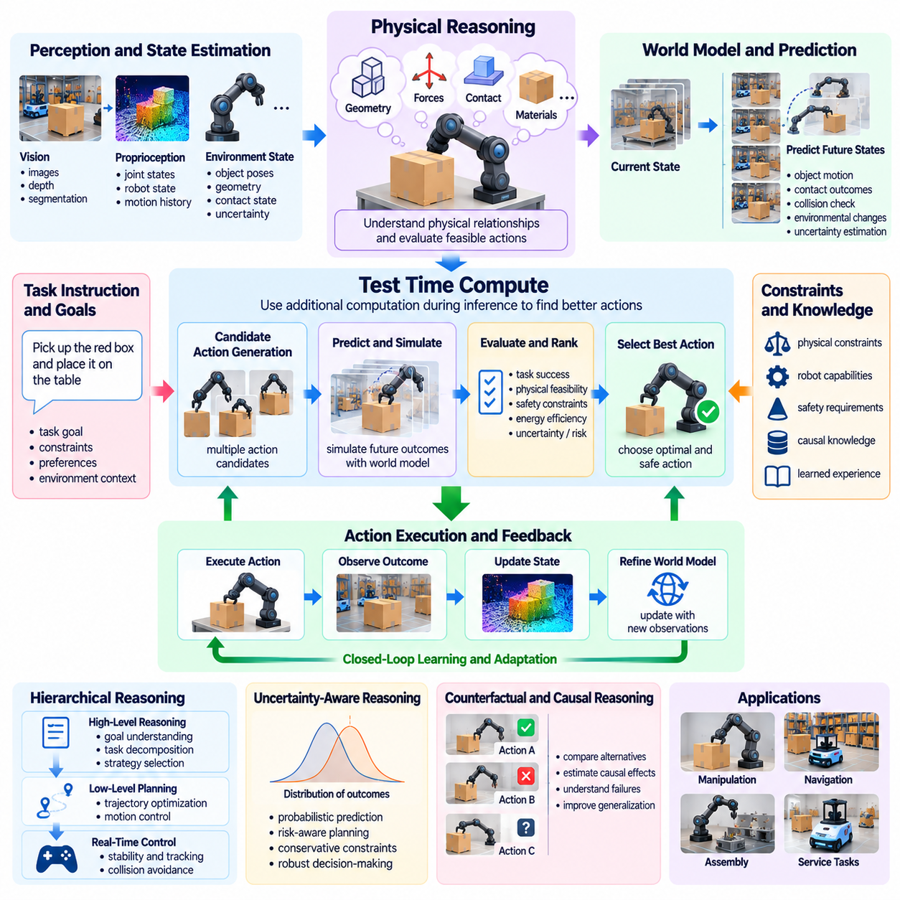
Physical reasoning represents the ability of an intelligent agent to understand physical relationships, anticipate consequences, and select actions consistent with the constraints of the real world. Unlike purely semantic reasoning, physical reasoning must account for geometry, motion, forces, contact, material properties, and environmental uncertainty. It enables Physical AI systems to evaluate not only what an action means, but also whether that action can be executed safely and effectively.
Test-time compute refers to computational resources allocated during inference to improve decisions beyond an immediate model response. In Physical AI, additional computation may support candidate action generation, predictive simulation, trajectory optimization, or uncertainty evaluation. Rather than relying exclusively on a single policy output, an agent can examine alternative actions before execution. The practical value of this approach depends on available time, processing capacity, and task complexity.
Physical reasoning begins with an internal representation of the current environment and the agent's capabilities. Relevant information includes object positions, velocities, spatial relationships, contact conditions, and actuator limitations. Because observations are incomplete, the system must estimate hidden states and maintain uncertainty about unknown properties. Reasoning then connects these estimates with physical principles and learned experience to determine feasible actions.
A central challenge is distinguishing semantic plausibility from physical feasibility. A language-based model may correctly interpret an instruction to move a heavy object but fail to recognize insufficient gripping force or unstable support conditions. Physical reasoning evaluates whether the intended operation satisfies mechanical and environmental constraints. This distinction is essential when translating abstract goals into actions that interact directly with physical objects.
World models provide a computational foundation for physical reasoning by estimating how environmental states evolve under different actions. An agent can use a learned or physics-based dynamics model to predict object movement, collisions, deformation, and contact outcomes. These predictions support internal evaluation of candidate behaviors. However, the usefulness of simulated outcomes depends on model fidelity, uncertainty awareness, and consistency with actual physical observations.
Test-time computation can be organized as a sequence of candidate generation, evaluation, selection, and execution. A policy first proposes possible actions or trajectories, after which predictive models estimate their consequences. Planning mechanisms compare alternatives against task objectives, safety constraints, and resource limitations. The selected action is executed under feedback control, allowing subsequent observations to correct errors in the original reasoning.
The amount of computation required for physical reasoning varies substantially across tasks. Simple obstacle avoidance may require rapid geometric evaluation, while complex manipulation can demand repeated simulation of contact interactions. Long-horizon planning may involve searching through many possible action sequences. Adaptive computation allows a system to allocate greater reasoning effort to difficult or uncertain decisions while preserving responsiveness during routine operations.
Real-time constraints fundamentally distinguish physical test-time compute from unrestricted digital reasoning. A robot cannot indefinitely delay a control decision while evaluating alternatives because the physical environment continues to evolve. Moving obstacles, unstable objects, and actuator dynamics impose strict deadlines. Consequently, reasoning mechanisms must operate within bounded latency budgets and provide safe fallback behavior when additional computation cannot be completed.
Hierarchical reasoning offers a practical approach to balancing computational depth and execution speed. High-level reasoning interprets goals, evaluates task dependencies, and selects behavioral strategies, while lower-level planning determines trajectories and control parameters. Fast controllers maintain immediate stability and collision avoidance. This separation allows computationally intensive reasoning to support complex decisions without interrupting time-critical physical control.
Counterfactual physical reasoning enables an agent to consider what would happen if different actions were performed. A robot may compare alternative grasp locations, navigation routes, or object placement strategies before acting. Each hypothetical outcome can be evaluated for feasibility, safety, and expected task success. Counterfactual evaluation becomes particularly useful when mistakes are costly, irreversible, or likely to produce hazardous physical interactions.
Causal reasoning complements prediction by identifying relationships between actions and physical outcomes. Observing that an object moves after contact does not necessarily reveal which forces or constraints caused the movement. Causal models attempt to represent mechanisms such as support, friction, momentum transfer, and contact transitions. These representations can improve reasoning about unfamiliar situations, although causal validity must be established through appropriate evidence and experimentation.
Uncertainty-aware reasoning is essential because physical predictions are rarely exact. Sensor noise, unknown material properties, model approximation, and unpredictable environmental changes can produce multiple plausible outcomes. A robust system evaluates not only expected performance but also the risks associated with unfavorable possibilities. Probabilistic forecasting, conservative constraints, and risk-sensitive planning help prevent excessive confidence in uncertain predictions.
Test-time compute may also support active information gathering when uncertainty cannot be resolved through internal reasoning alone. An agent can reposition a camera, inspect an object, perform a cautious probing action, or request additional sensor measurements. Such actions improve the information available for subsequent decisions. This creates a relationship between reasoning and active perception in which computation determines whether further observation is more valuable than immediate execution.
Multimodal foundation models can contribute semantic knowledge and contextual understanding to physical reasoning. Visual observations identify objects and spatial configurations, language instructions express goals, and proprioceptive or tactile signals describe interaction conditions. These inputs can guide candidate action generation and task interpretation. Nevertheless, semantic understanding must be connected to physical state estimation and verified constraints before actions are executed.
Vision-language-action models may benefit from test-time reasoning when direct action predictions are insufficient. Instead of immediately executing a generated command, the system can evaluate multiple action proposals using predictive models, feasibility checks, or constrained optimization. This architecture combines the broad behavioral knowledge of learned policies with explicit physical evaluation. Its effectiveness depends on whether additional reasoning improves execution enough to justify its computational cost.
Manipulation provides a demanding application because contact dynamics introduce discontinuities and uncertainty. A robot inserting a component must consider alignment, friction, applied force, and possible jamming. Test-time reasoning can compare alternative insertion trajectories or contact strategies before execution. During operation, force feedback and observed deviations remain necessary to update predictions and prevent excessive loads or mechanical damage.
Autonomous navigation also benefits from physical reasoning and adaptive computation. A mobile robot may evaluate whether a narrow passage is traversable, whether a moving obstacle will intersect its trajectory, or whether terrain conditions exceed its mobility capabilities. Additional planning effort can be allocated to congested or uncertain regions. Routine movement through familiar environments can use faster policies, provided safety constraints remain continuously enforced.
Simulation-based reasoning allows agents to evaluate hypothetical actions without immediately exposing physical equipment to their consequences. Internal rollouts may estimate future states over several time steps, while more detailed simulators can examine complex interactions. However, extensive simulation does not guarantee reliable decisions when model assumptions are incorrect. Effective systems must balance simulation depth against model accuracy, computational cost, and available decision time.
The deployment architecture determines where physical reasoning computations can be performed. Edge processors are responsible for latency-sensitive inference, local planning, and immediate safety responses. On-premise resources may support more demanding predictive evaluations and coordination across multiple robots. Cloud infrastructure can assist with model development and large-scale analysis, but communication delays make remote computation unsuitable for essential high-frequency safety control.
Safety assurance must remain independent of the reasoning model's apparent confidence or computational sophistication. A system that evaluates many candidate actions can still select an unsafe behavior if its world model or objective function is incorrect. Runtime monitors, actuator limits, collision constraints, and emergency mechanisms provide additional protection. Test-time reasoning should operate within verified safety boundaries rather than replacing established safety controls.
Evaluation of physical reasoning should measure both decision quality and computational efficiency. Relevant metrics include task success, constraint satisfaction, prediction error, collision frequency, recovery capability, inference latency, and energy consumption. Comparisons should examine whether additional computation produces measurable improvements over simpler policies. Testing must also include unfamiliar objects, unexpected disturbances, incomplete observations, and strict real-time deadlines.
A major future direction is adaptive test-time computation that dynamically adjusts reasoning depth according to task difficulty, uncertainty, and potential consequences. Straightforward decisions may require minimal processing, while high-risk interactions justify more extensive evaluation. Such systems could combine learned policies, world models, planning algorithms, and uncertainty estimators within a unified decision framework. The objective is efficient intelligence rather than unrestricted computational expansion.
Physical reasoning and test-time compute together provide a pathway toward more deliberate and capable Physical AI systems. Their significance lies in connecting abstract understanding with physically feasible decisions through prediction, evaluation, and feedback. Progress will depend on reliable world models, grounded multimodal representations, bounded computation, and rigorous safety validation. The ultimate goal is to enable autonomous agents to reason before acting while remaining responsive to the continuously changing physical world.

10.06. Long Horizon Planning and Memory
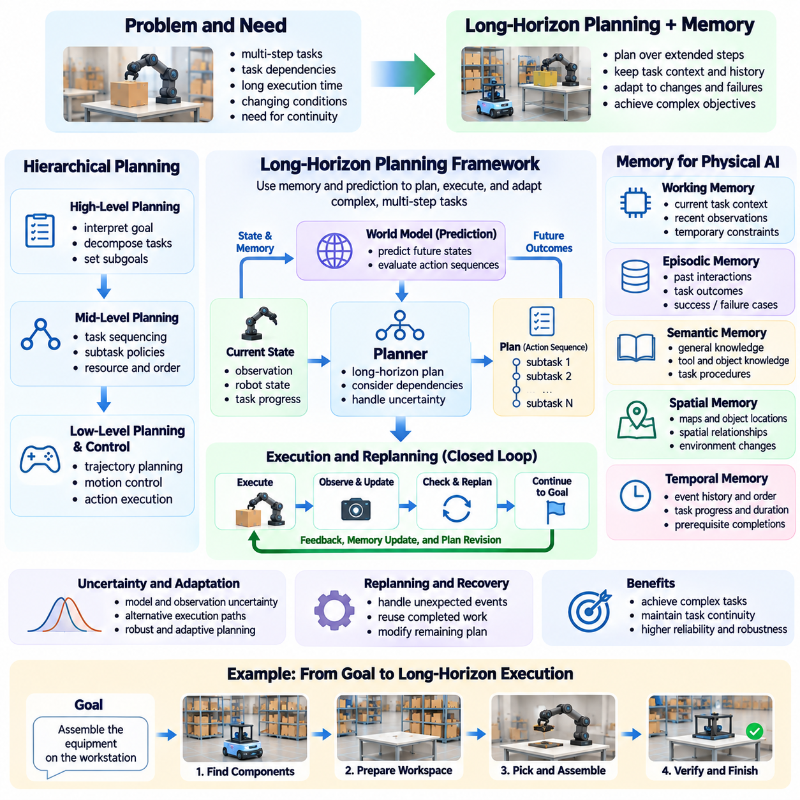
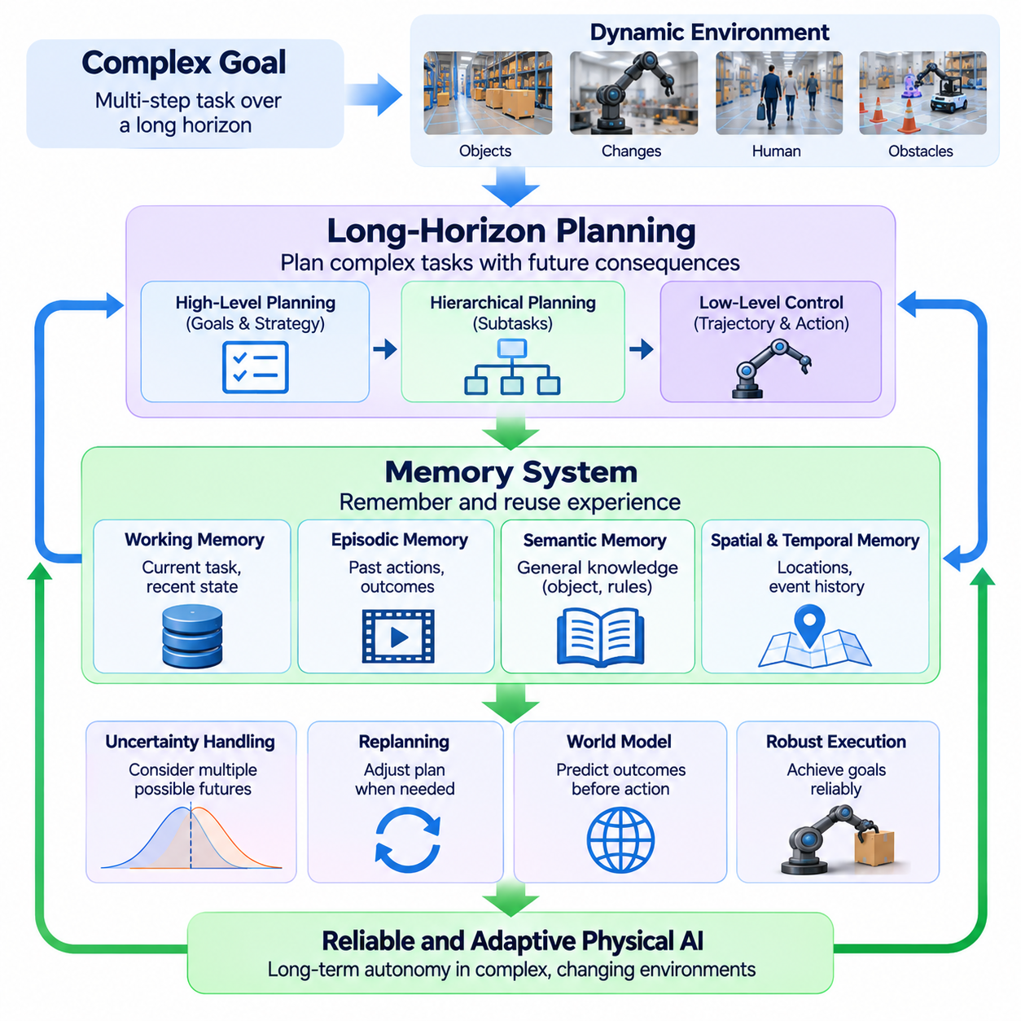
Long-horizon planning enables Physical AI systems to pursue objectives that require multiple coordinated actions over extended periods. Unlike reactive control, which responds primarily to immediate observations, long-horizon planning considers task dependencies, future consequences, and intermediate objectives. Memory provides the continuity needed to maintain context across these decisions. Together, planning and memory allow robots to organize complex behavior beyond isolated movements or short action sequences.
Physical tasks often involve dependencies that cannot be resolved through immediate action selection alone. A robot assembling equipment may need to locate components, prepare tools, clear workspace obstacles, and verify intermediate results before completing the operation. Long-horizon planning represents these dependencies as structured sequences or hierarchical objectives. Successful execution requires the system to understand which actions must precede others and which conditions indicate progress.
Hierarchical planning provides a practical architecture for managing complexity across different temporal scales. High-level planners interpret goals and divide them into meaningful subtasks, while lower-level planners generate trajectories and executable control commands. Intermediate policies connect semantic objectives with physical operations. This separation reduces the complexity of individual decisions while allowing the overall system to maintain coherence across extended task execution.
Memory is essential because a robot cannot reconstruct every relevant aspect of its operating history from current sensor observations. Objects may become occluded, instructions may refer to previous events, and completed subtasks may no longer be directly observable. Memory mechanisms preserve information about environmental states, task progress, previous actions, and interaction outcomes. Such continuity supports decisions that depend on events occurring beyond the immediate observation window.
Working memory maintains information needed for current decisions and near-term execution. It may include the active task objective, recently observed objects, current robot state, and temporary constraints. Because computational resources are limited, working memory must prioritize relevant information rather than retaining every observation. Effective memory management balances contextual richness against inference latency, storage requirements, and the risk of outdated information.
Episodic memory stores records of previous interactions, including actions performed, environmental conditions, and resulting outcomes. These records allow a robot to retrieve examples of similar situations and evaluate previously successful or unsuccessful strategies. Episodic memory can support recovery planning and adaptation to recurring tasks. However, stored experiences must retain sufficient contextual information to prevent inappropriate reuse under different physical conditions.
Semantic memory represents more general knowledge about objects, environments, procedures, and physical relationships. A robot may retain knowledge about tool functions, workspace organization, or common task dependencies without storing every original observation. This information can guide planning across multiple episodes. Separating semantic knowledge from episodic records enables systems to combine reusable understanding with specific operational experience.
Spatial memory is particularly important for mobile robots and manipulators operating in changing environments. Maps, object locations, occupancy estimates, and spatial relationships provide continuity when objects leave the sensor field of view. Dynamic spatial memory must account for movement, environmental changes, and uncertainty. A robot should distinguish confirmed observations from outdated assumptions when using stored spatial information to generate actions.
Temporal memory connects events across time and supports reasoning about action order, duration, and task progress. Many operations require recognizing that a prerequisite has been completed or that a waiting condition remains unresolved. Temporal representations may include event histories, timestamps, state transitions, and predicted completion conditions. These mechanisms help prevent repeated actions, premature execution, and loss of coordination during extended operations.
Long-horizon planning must account for uncertainty because future environmental conditions cannot be predicted perfectly. Objects may move, human operators may intervene, and equipment may behave differently from expectations. Plans should therefore represent assumptions, dependencies, and alternative execution paths. Maintaining uncertainty estimates allows the system to revise decisions when observations contradict earlier predictions rather than continuing an increasingly invalid plan.
Replanning is a fundamental requirement for reliable long-horizon autonomy. A robot may encounter a blocked route, missing component, failed grasp, or unexpected task interruption. Instead of restarting the entire procedure, the planner should identify which objectives remain valid and which actions require modification. Memory supports this process by preserving completed work and previous failure information, enabling efficient recovery without unnecessary repetition.
World models can strengthen long-horizon planning by predicting how actions influence future physical states. Candidate plans may be evaluated through simulated trajectories or learned state transitions before execution. Such predictions help identify infeasible sequences and potential conflicts between subtasks. However, prediction errors accumulate over longer horizons, making periodic observation, model correction, and replanning necessary for reliable operation.
Task and motion planning must be integrated because abstract objectives depend on physical feasibility. A high-level plan may specify placing an object on a shelf, but the robot must determine whether the target is reachable and whether the object can be grasped safely. Geometric planning, collision checking, and manipulation constraints provide feedback to the task planner. This interaction prevents semantic plans from becoming disconnected from physical execution capabilities.
Foundation models may support long-horizon planning by interpreting complex instructions and generating structured task decompositions. Language-based reasoning can identify goals, dependencies, and possible strategies, while perception models provide environmental context. Nevertheless, generated plans require validation against robot capabilities, physical constraints, and actual task states. Reliable autonomy depends on combining learned reasoning with explicit execution monitoring.
Memory retrieval introduces additional design challenges because large operational histories cannot always be processed directly. Retrieval mechanisms must identify experiences relevant to the current task, environment, and robot embodiment. Similarity-based search, structured indexing, and contextual filtering can reduce unnecessary information. Retrieved memories should be evaluated for relevance and reliability before influencing current decisions.
Multi-robot systems extend long-horizon planning through shared task allocation and collective memory. Robots may coordinate deliveries, inspections, or manipulation operations while maintaining a common representation of task progress. Shared memory can reduce duplicated effort and support recovery when individual robots become unavailable. However, synchronization delays, inconsistent observations, and conflicting updates require careful management of distributed state.
Distributed Physical AI architectures can allocate planning and memory functions across edge, on-premise, and cloud resources. Edge systems maintain immediate task context and execute time-sensitive actions, while on-premise infrastructure may coordinate shared plans and operational memory. Cloud resources can support long-term knowledge consolidation and model improvement. Essential execution and safety functions must remain available when communication is interrupted.
Persistent memory creates important requirements for data integrity, privacy, and operational governance. Stored observations may contain sensitive environmental information, while incorrect memories can produce unsafe decisions. Systems need mechanisms for access control, version tracking, memory expiration, and correction of invalid records. Provenance information helps distinguish direct observations, inferred states, and externally supplied instructions.
Evaluation of long-horizon planning should examine complete task execution rather than isolated action accuracy. Relevant metrics include overall success rate, subtask completion, planning efficiency, recovery performance, unnecessary action frequency, and execution duration. Memory quality can be assessed through retrieval relevance, state consistency, and resistance to outdated information. Testing should include interruptions, environmental changes, and extended sequences with dependent objectives.
Continual learning can improve planning and memory by converting accumulated operational experience into more effective future behavior. Repeated failures may reveal missing prerequisites, inefficient action sequences, or unreliable environmental assumptions. Validated experiences can update procedural knowledge and planning strategies. However, uncontrolled modifications risk introducing inconsistent memories or degrading previously reliable behaviors, making evaluation and version management essential.
A major future direction is the development of agents that maintain coherent goals and operational knowledge across tasks, environments, and extended periods. Such systems may combine hierarchical planning, predictive world models, episodic memory, semantic knowledge, and adaptive retrieval. Their effectiveness will depend on distinguishing relevant experience from obsolete information and balancing long-term objectives with immediate physical constraints.
Long-horizon planning and memory together establish the foundations for persistent, goal-directed Physical AI behavior. Their significance extends beyond remembering previous observations or generating longer action sequences. They enable autonomous systems to preserve intent, track progress, recover from failures, and adapt plans as physical conditions evolve. Reliable implementation requires grounded state representations, efficient memory mechanisms, continual feedback, and systematic validation under realistic operating conditions.

10.07. Causal and Counterfactual Physical Reasoning
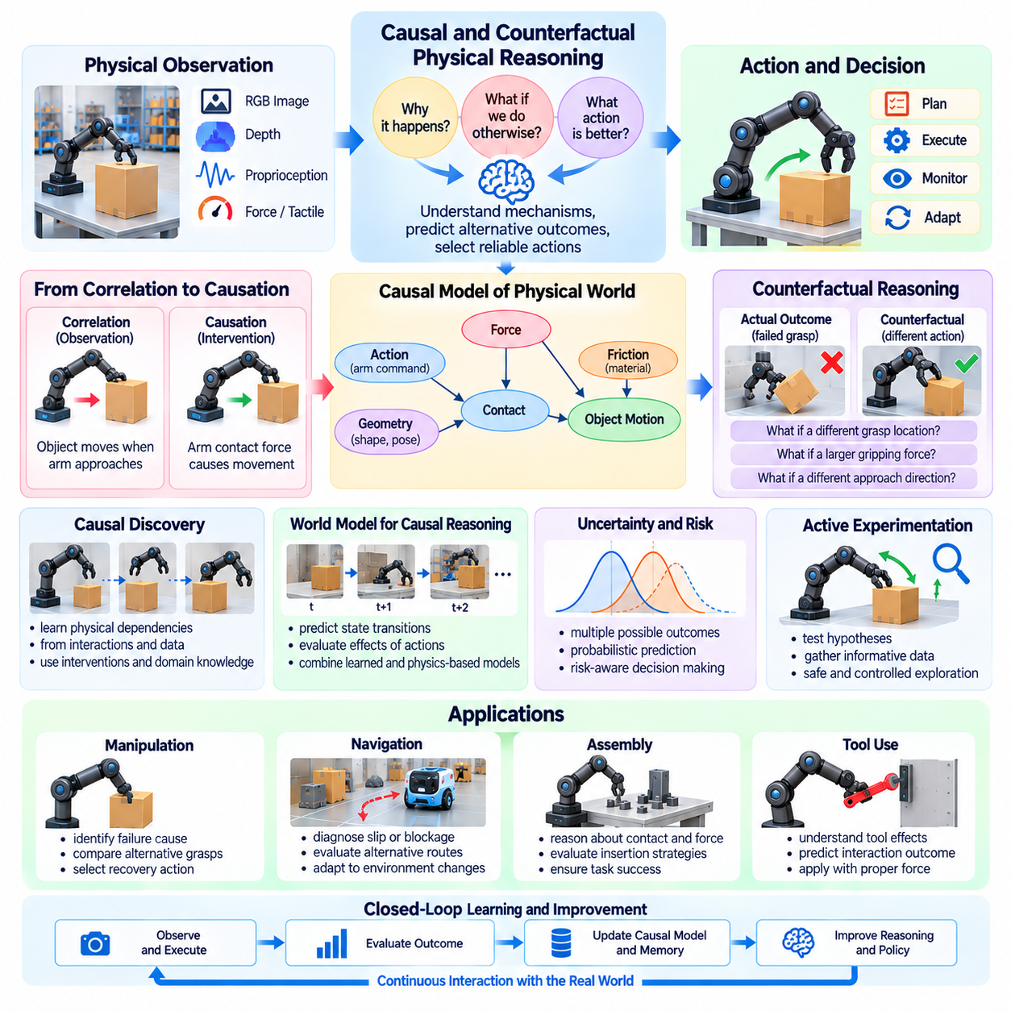
Causal and counterfactual physical reasoning enables Physical AI systems to understand why physical events occur and predict how outcomes would change under alternative actions. Unlike conventional prediction, which identifies statistical relationships between observations and future states, causal reasoning investigates the mechanisms connecting actions, forces, objects, and environmental conditions. This capability supports more reliable planning, diagnosis, adaptation, and decision-making in unfamiliar physical situations.
Causal reasoning distinguishes correlation from intervention. A robot may observe that an object moves whenever another object approaches, but this association does not establish the mechanism responsible for movement. Contact forces, magnetic interactions, airflow, or external disturbances may explain the observation. Identifying causal relationships requires reasoning about physical mechanisms and determining how outcomes change when specific variables are deliberately modified.
Counterfactual reasoning considers hypothetical outcomes that differ from events actually observed. After a failed grasp, a robot may ask whether a different contact location, gripping force, or approach direction would have prevented the failure. Such reasoning compares the observed outcome with alternative possibilities under modified conditions. It provides a foundation for learning from mistakes without requiring every alternative action to be physically executed.
Physical causality depends on relationships among geometry, dynamics, materials, and environmental constraints. Object movement may result from applied forces, gravity, friction, collision, or changes in support conditions. A causal representation should distinguish these mechanisms rather than treating every observed transition as an arbitrary pattern. This distinction helps agents transfer physical knowledge across objects and situations that differ visually but share underlying dynamics.
Structural causal models provide a formal approach to representing dependencies between physical variables. Variables may describe object positions, velocities, contact states, applied forces, or actuator commands, while structural relationships express how these quantities influence one another. Interventions modify selected variables to estimate resulting changes. However, causal conclusions depend on the validity of the assumed structure and the evidence supporting its relationships.
Causal discovery attempts to infer physical dependencies from observational and experimental data. Repeated interactions can reveal how changes in force, orientation, or contact location affect outcomes. Nevertheless, observational data alone may not identify unique causal structures because hidden variables can produce misleading associations. Controlled interventions, domain knowledge, and physical constraints are therefore important for establishing reliable causal explanations.
Counterfactual analysis generally requires reconstructing the conditions surrounding an observed event before evaluating alternative actions. A robot investigating a dropped object must consider its estimated grasp state, object properties, motion history, and environmental conditions. The system then modifies a selected action or assumption while preserving relevant contextual factors. This process distinguishes meaningful counterfactual evaluation from unconstrained speculation.
World models can support causal and counterfactual reasoning by simulating how physical states evolve under interventions. Action-conditioned models estimate future outcomes for alternative control commands, while physics-based simulators represent known mechanical relationships. Hybrid approaches combine learned dynamics with explicit physical constraints. Their usefulness depends on whether the models reproduce causal mechanisms rather than merely generating visually plausible predictions.
Manipulation tasks provide clear examples of causal reasoning requirements. During object insertion, excessive force may result from misalignment, friction, deformation, or an unexpected obstruction. A robot that identifies the cause can select an appropriate correction rather than repeatedly applying the same action. Counterfactual evaluation may compare alternative insertion angles, contact forces, and motion trajectories before attempting recovery.
Autonomous navigation also requires causal understanding when environmental conditions change. A mobile robot encountering unexpected wheel slip must distinguish reduced traction from localization error, actuator malfunction, or terrain deformation. These causes imply different corrective actions. Counterfactual reasoning can evaluate whether reducing speed, changing direction, or selecting another route would improve stability and navigation success.
Causal representations can improve generalization by separating invariant physical relationships from superficial environmental characteristics. A robot may encounter unfamiliar containers, tools, or surfaces while recognizing familiar mechanisms involving support, friction, and gravity. Such knowledge can guide behavior when training examples are limited. However, causal invariance should be treated as a hypothesis requiring validation under changed operating conditions.
Active experimentation allows robots to gather information about uncertain causal relationships. An agent may apply a small force to estimate object mobility, adjust its viewpoint to inspect contact geometry, or perform a controlled movement to test a mechanical hypothesis. These interventions should balance information gain against operational risk. Safe experimentation is especially important when object properties are unknown or physical mistakes could cause damage.
Uncertainty is unavoidable because physical systems often contain hidden states and imperfect measurements. Unknown friction coefficients, internal object structures, sensor noise, and unobserved external forces can produce competing causal explanations. Probabilistic causal models may represent these alternatives and estimate their relative plausibility. Robust decisions should consider uncertainty in both the causal structure and the predicted consequences of interventions.
Causal reasoning can complement reinforcement learning by improving the interpretation of action outcomes. Instead of treating rewards as isolated feedback, an agent can investigate which behavioral choices produced success or failure. Counterfactual estimates may help compare unexecuted alternatives and guide future exploration. Nevertheless, incorrect causal assumptions can bias learning, making experimental validation and reliable uncertainty estimates essential.
Vision-language-action models may use causal reasoning to connect semantic instructions with physical mechanisms. A language instruction such as securing an unstable object requires understanding support, balance, and contact conditions rather than recognizing words alone. Multimodal observations provide evidence about these mechanisms, while action models generate possible interventions. Physical feasibility checks remain necessary before executing causally motivated actions.
Long-horizon planning benefits from causal representations because complex tasks contain dependencies between intermediate states and future outcomes. Removing an obstacle may enable access to a component, while changing object placement may affect later manipulation steps. Causal task models can identify prerequisites and predict consequences that extend beyond immediate actions. Counterfactual planning helps compare alternative task sequences and anticipate downstream failures.
Multi-robot systems introduce additional causal relationships involving shared environments and coordinated actions. One robot's movement may obstruct another robot, alter object availability, or change the conditions of a collaborative task. Shared causal representations can support conflict prediction and coordinated planning. However, communication delays and inconsistent observations may complicate causal attribution, requiring synchronized evidence and explicit uncertainty management.
Test-time computation can strengthen counterfactual reasoning by allocating additional resources to evaluate alternative interventions. A system may generate several hypotheses, simulate possible outcomes, and compare their safety and expected effectiveness. Greater computational effort is particularly valuable when actions are irreversible or potentially hazardous. Real-time constraints nevertheless require bounded reasoning time and safe fallback strategies when evaluation remains inconclusive.
Safety assurance is a critical application of causal physical reasoning. Identifying mechanisms that could produce collisions, excessive forces, unstable loads, or equipment failures supports preventive action selection. Counterfactual analysis can also examine whether alternative decisions would have avoided hazardous events. However, learned causal explanations must not replace verified safety constraints, independent monitoring, or established protective control mechanisms.
Evaluation should distinguish causal understanding from ordinary predictive accuracy. A model may forecast familiar outcomes correctly while failing when an intervention changes the underlying relationships. Suitable tests examine intervention prediction, counterfactual consistency, causal transfer, failure diagnosis, and recovery effectiveness. Evaluation environments should include hidden variables, unfamiliar materials, changed dynamics, and scenarios requiring explanations of observed physical outcomes.
Continual learning can improve causal knowledge through accumulated interaction experience. Repeated observations and controlled interventions may refine estimates of physical mechanisms, reveal previously unknown dependencies, and correct inaccurate assumptions. Robot fleets can contribute diverse evidence across environments and embodiments. Updates should preserve provenance, experimental conditions, and uncertainty so that unsupported conclusions do not propagate into shared operational models.
A major research direction involves integrating causal models with learned world models, multimodal foundation models, and hierarchical planning systems. Such architectures could combine semantic understanding with explicit representations of physical mechanisms and intervention outcomes. Progress requires better causal identification, efficient experimentation, reliable simulation, and transfer across unfamiliar environments. The objective is not simply predicting what happens next, but understanding which actions can change what happens.
Causal and counterfactual physical reasoning provide a pathway toward autonomous agents capable of explaining failures, evaluating alternatives, and adapting intelligently to changing physical conditions. Their long-term significance lies in transforming experience into actionable knowledge about physical mechanisms. Reliable implementation requires grounded observations, validated causal assumptions, uncertainty-aware prediction, safe intervention strategies, and continuous feedback from real-world execution.

10.08. Self Supervised and Continual Robot Learning
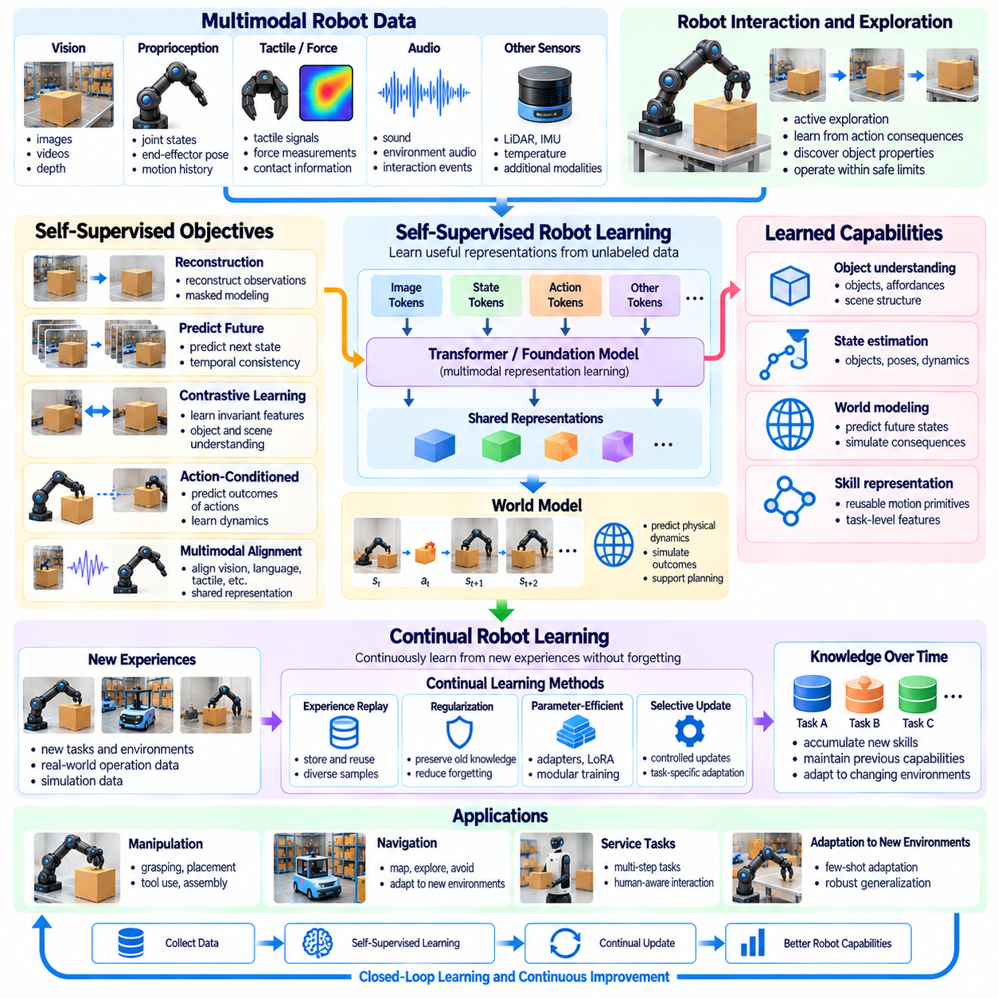
Self-supervised and continual robot learning represent essential directions for developing Physical AI systems that improve through experience rather than depending entirely on manually labeled datasets and fixed training procedures. Self-supervised learning extracts training signals from observations and interactions, while continual learning updates knowledge across successive experiences. Together, these approaches support more adaptable robotic intelligence in changing physical environments.
Conventional robot learning often requires carefully annotated demonstrations, predefined task objectives, and extensive supervision. Collecting such data can be expensive because physical interactions involve hardware limitations, operational time, and safety constraints. Self-supervised learning reduces dependence on manual annotation by constructing learning objectives from the structure of sensory data, temporal relationships, and observable consequences of robot actions.
Self-supervised learning relies on prediction, reconstruction, consistency, or representation learning objectives derived from available data. A robot may predict future observations, reconstruct missing sensor measurements, or learn relationships between successive states. These objectives encourage models to capture useful environmental structure without requiring explicit labels for every interaction. However, successful pretraining does not automatically guarantee effective downstream control.
Visual self-supervised learning enables robots to develop representations of objects, scenes, motion, and spatial relationships from large collections of images and videos. Contrastive learning, masked reconstruction, and predictive representation learning can identify meaningful patterns across observations. Such representations may support object recognition, scene understanding, and navigation. Their practical value depends on whether learned features remain relevant under real operating conditions.
Temporal prediction provides an important learning signal because physical environments evolve according to structured dynamics. A robot can observe how objects move, how contacts change, and how environmental states respond to actions. Predicting future representations encourages the model to capture relationships between current conditions and subsequent outcomes. Action-conditioned prediction further connects learned dynamics with decision-making and planning.
Multimodal self-supervised learning combines visual, tactile, proprioceptive, auditory, and other sensor measurements to construct richer representations of physical interactions. Different modalities can provide complementary evidence about object properties and environmental conditions. Cross-modal prediction and alignment help models associate visual observations with contact forces, movement, and physical outcomes. This integration is particularly valuable when individual sensors provide incomplete information.
Robot interaction offers learning opportunities beyond passive observation because actions reveal properties that cannot always be inferred from images. Pushing an object can expose friction and mobility, while controlled grasping can reveal stability and contact behavior. Self-supervised objectives can use the resulting state changes as training signals. Such exploration must remain within verified operational limits because information gathering can introduce physical risks.
Continual learning addresses the challenge of maintaining and improving model capabilities as new tasks, environments, and experiences become available. Unlike conventional training, which often assumes a fixed dataset followed by deployment, continual learning considers successive updates throughout a system's operational lifetime. The objective is to acquire useful new knowledge without unnecessarily degrading capabilities learned from earlier experiences.
Catastrophic forgetting is a major obstacle in continual robot learning. When a model adapts to recent tasks, parameter updates may interfere with representations supporting previously learned behaviors. A robot that improves performance in one environment may consequently become less reliable elsewhere. Replay buffers, parameter regularization, modular architectures, and selective adaptation provide possible mechanisms for reducing this interference.
Experience replay preserves selected observations, actions, and outcomes from previous learning stages. During subsequent updates, historical examples can be combined with new data to maintain earlier capabilities. Replay selection must consider task diversity, environmental coverage, failure cases, and storage limitations. Poorly curated replay data may reinforce outdated assumptions or fail to represent the operational conditions that matter most.
Parameter-efficient adaptation offers another approach to continual learning by modifying limited portions of a pretrained model. Adapters, low-rank updates, and specialized modules can introduce new capabilities while preserving much of the original representation. Such methods may reduce computational costs and simplify model version management. However, restricted adaptation capacity can limit performance when new tasks differ substantially from previous experience.
Online learning enables robots to incorporate new observations during operation, but unrestricted parameter updates can create unpredictable behavior. Sensor noise, unusual events, and incorrect feedback may contaminate learning signals. Practical systems often separate operational data collection from controlled model updates. Candidate models can be trained and validated independently before replacing deployed versions, reducing the risk of uncontrolled behavioral changes.
World models provide a natural connection between self-supervised learning and continual adaptation. By predicting state transitions and action consequences, a robot can identify discrepancies between expected and observed outcomes. These prediction errors may reveal changes in object dynamics, environmental conditions, or sensor behavior. Updated world models can improve planning, provided that new estimates are validated against reliable observations.
Continual learning also benefits from structured memory systems that preserve relevant operational experience. Episodic memory stores specific interactions, while semantic memory consolidates reusable knowledge about objects, environments, and procedures. Retrieval mechanisms can identify experiences related to current tasks and support adaptation without immediate parameter updates. Memory quality depends on accurate context, provenance, and appropriate handling of outdated information.
Simulated environments can accelerate self-supervised learning by providing repeated interactions and diverse physical conditions. Domain randomization exposes models to variations in appearance, dynamics, and sensor characteristics. Simulation can also generate rare failure scenarios that would be costly or hazardous to reproduce physically. Nevertheless, simulation-based learning must account for differences between synthetic dynamics and actual robotic systems.
Active learning and curiosity-driven exploration can help robots select experiences that are particularly informative. Rather than collecting observations uniformly, an agent may prioritize uncertain objects, unfamiliar interactions, or situations where predictive models disagree. Information gain can guide exploration toward knowledge gaps. Safety constraints and task priorities must prevent curiosity-driven behavior from interfering with essential operations.
Fleet learning extends continual improvement across multiple robots by aggregating experiences from distributed deployments. Robots operating in different environments can contribute observations, task outcomes, and failure examples to shared datasets. Centralized or federated learning procedures may use these experiences to improve common models. Differences in hardware, operating conditions, and data quality require careful normalization and validation before knowledge is transferred.
Cross-embodiment learning introduces additional challenges because robots may have different sensors, kinematics, and action spaces. Shared representations can capture transferable knowledge about objects and task structure, while embodiment-specific modules handle physical execution. Continual learning mechanisms must avoid assuming that successful behavior on one platform transfers directly to another. Platform-specific evaluation remains necessary before deploying updated policies.
Evaluation of self-supervised learning should examine downstream robotic performance rather than relying exclusively on representation loss or prediction accuracy. Relevant measures include sample efficiency, task success, robustness, transfer capability, and adaptation speed. Continual learning additionally requires measuring retained performance on earlier tasks. Evaluation protocols should include changing environments, sequential task introduction, and realistic operational disturbances.
Safety assurance is particularly important when learning systems modify their behavior over time. Updated models may introduce previously unseen failure modes even when average task performance improves. Regression testing, runtime monitoring, rollback mechanisms, and controlled deployment procedures provide protection against unintended changes. Safety-critical control functions should remain subject to independently verified constraints throughout the learning process.
Data governance influences the reliability of continual robot learning because operational datasets may contain inconsistent observations, sensitive information, or unverified labels. Effective pipelines require provenance tracking, quality assessment, dataset versioning, and access controls. Failure cases should be preserved with sufficient context for later analysis. Transparent data management helps distinguish genuine model improvements from changes caused by biased or incomplete training evidence.
The long-term direction is toward robots that continuously accumulate useful physical experience while preserving reliable previously acquired capabilities. Self-supervised learning can provide broad representations from sensory interaction, while continual learning adapts those representations to evolving tasks and environments. Achieving dependable self-improvement will require stable learning objectives, selective memory, safe exploration, efficient adaptation, and systematic real-world validation.

10.09. Cross Embodiment Generalization
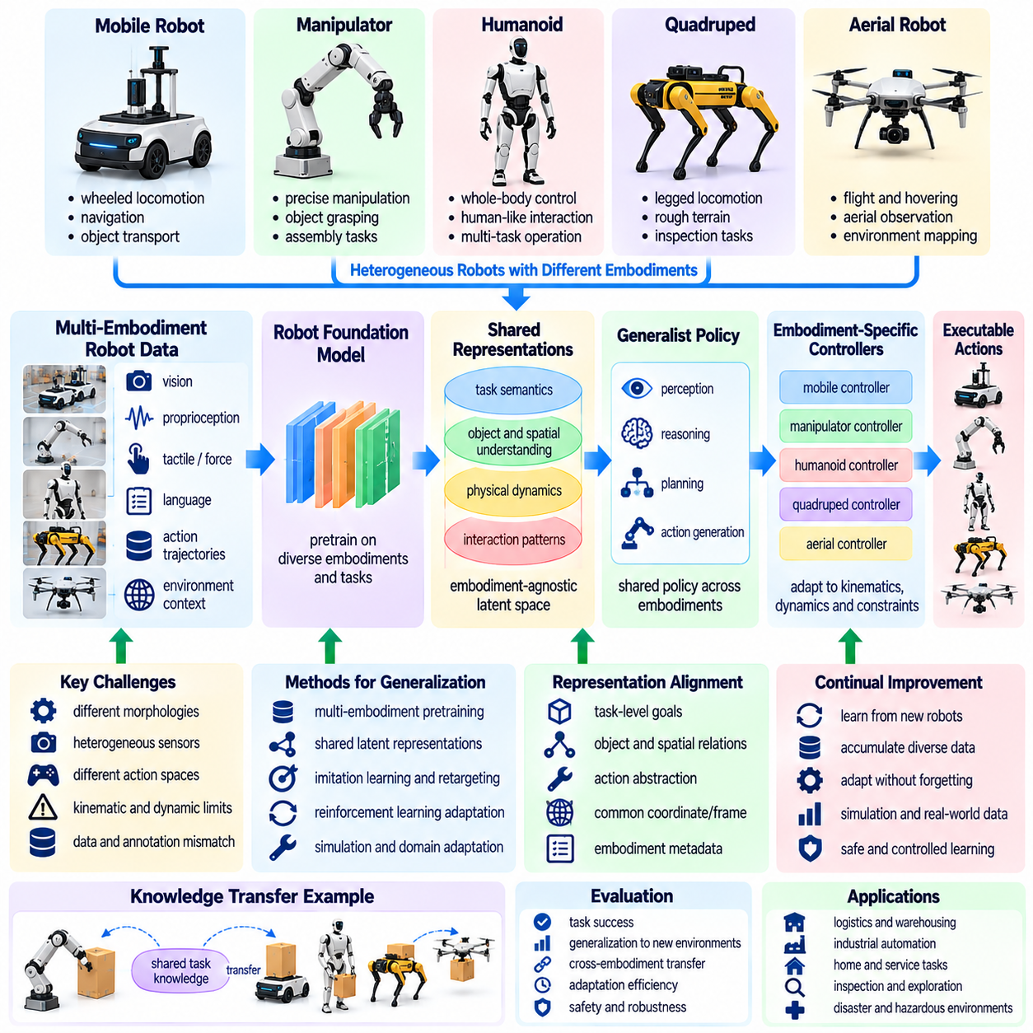
Cross-embodiment generalization enables Physical AI systems to transfer knowledge and capabilities across robots with different mechanical structures, sensors, actuators, and control interfaces. A policy trained on one robotic platform should ideally contribute to performance on another without requiring complete retraining. This objective addresses a fundamental limitation of conventional robotics, where learned behaviors are often tightly coupled to particular hardware configurations and operating conditions.
Robot embodiment determines how an intelligent agent perceives and interacts with the physical world. Mobile robots, manipulators, humanoids, quadrupeds, and aerial vehicles possess different degrees of freedom, movement constraints, sensing capabilities, and action spaces. These differences influence which tasks can be performed and how actions must be executed. Cross-embodiment learning therefore requires distinguishing transferable task knowledge from platform-specific physical capabilities.
A central challenge is developing representations that preserve task meaning while accommodating differences in robot morphology. Moving an object to a destination may express the same objective for a wheeled robot with an arm and a humanoid, but the required movements differ substantially. Shared representations can encode goals, object relationships, and desired outcomes independently of specific joint commands. Embodiment-specific controllers then translate these objectives into feasible actions.
Observation spaces differ across robotic platforms because sensor types, mounting positions, resolutions, and calibration procedures vary. One robot may rely on stereo cameras and LiDAR, while another combines monocular vision, tactile sensing, and proprioception. Cross-embodiment systems must align information from these heterogeneous sources without assuming identical measurements. Common spatial, geometric, and semantic representations can reduce observation differences.
Action-space alignment presents an even greater challenge because identical commands may have different physical meanings across robots. Joint angles, end-effector poses, wheel velocities, and aerial thrust commands cannot be exchanged directly. An intermediate action representation may describe desired motion, contact conditions, or task-level effects. Platform-specific control modules can subsequently map these descriptions to valid actuator commands and enforce physical constraints.
Kinematic and dynamic differences determine whether transferred behaviors remain physically executable. Robots vary in reachability, payload capacity, joint limits, stability, acceleration, and contact mechanics. A manipulation strategy successful on a powerful industrial arm may be unsuitable for a lightweight mobile manipulator. Generalization must therefore incorporate feasibility checks and adapt motion generation to the physical limits of each target platform.
Robot foundation models offer a potential mechanism for learning shared capabilities from heterogeneous robotic datasets. Training across multiple embodiments can expose models to diverse observations, actions, and task outcomes. The objective is to discover reusable patterns that support perception, planning, and control beyond individual platforms. However, increased dataset diversity alone does not guarantee effective transfer unless embodiment differences are represented explicitly.
Dataset standardization is essential for combining experiences collected from different robotic systems. Recorded trajectories may use incompatible coordinate frames, action frequencies, sensor conventions, and task descriptions. Common metadata should identify robot morphology, sensor configurations, calibration, control interfaces, and environmental conditions. Accurate normalization preserves the meaning of recorded actions while preventing misleading comparisons across platforms.
Cross-embodiment generalization can be approached through shared latent representations that encode common physical relationships. Models may learn object motion, contact transitions, spatial goals, and task progress in a representation that is less dependent on robot-specific coordinates. Such latent spaces can support policy adaptation and knowledge transfer. Nevertheless, their usefulness must be demonstrated through successful execution rather than representation similarity alone.
Hierarchical policies provide a practical separation between transferable reasoning and embodiment-dependent execution. High-level policies select objectives, subtasks, or desired state changes, while low-level controllers handle locomotion, manipulation, and stabilization. This structure allows different robots to share planning knowledge while retaining specialized motor skills. The effectiveness of the hierarchy depends on well-defined interfaces and accurate feedback between levels.
Imitation learning can transfer behavioral knowledge when demonstrations are available from different embodiments. A model may infer shared task intentions from trajectories that contain different movements but achieve similar outcomes. Retargeting methods can translate demonstrations into target robot configurations when sufficient geometric and kinematic information is available. However, retargeted trajectories require validation because mechanically similar movements may produce different contact forces or stability conditions.
Reinforcement learning supports cross-embodiment adaptation by optimizing policies under the dynamics of each target robot. Shared policies may provide initialization, while platform-specific training adjusts control parameters and action strategies. Simulation can accelerate this process through repeated trials across different robot models. Yet transfer quality depends on simulation fidelity, exploration safety, and the compatibility of the underlying task representations.
World models may improve cross-embodiment learning by separating environmental dynamics from robot-specific action effects. A shared model can represent object behavior and task consequences, while embodiment-conditioned components predict how particular robots influence the environment. This distinction can support planning across heterogeneous platforms. Accurate transfer requires accounting for differences in contact mechanics, actuation limits, and sensing uncertainty.
Language-conditioned policies can provide a common semantic interface across robotic embodiments. Instructions such as inspecting equipment or transporting an object describe intended outcomes without specifying detailed motor commands. Vision-language-action models may combine these instructions with observations and embodiment information to generate suitable actions. However, language-level similarity does not establish physical feasibility, and generated commands require platform-specific validation.
Cross-embodiment transfer is particularly valuable for collaborative robot fleets containing complementary capabilities. A mobile robot may transport materials, a manipulator may perform precision assembly, and a quadruped may inspect difficult terrain. Shared task representations allow these platforms to coordinate around common objectives. Task allocation must still account for each robot's reachability, sensing capabilities, payload limits, and operational availability.
Continual learning can extend cross-embodiment generalization as new platforms and experiences become available. Knowledge acquired by one robot may improve shared representations, while embodiment-specific modules preserve specialized execution capabilities. Replay mechanisms and selective parameter updates can reduce interference between platforms. Careful validation is necessary to prevent improvements for one robot from degrading previously reliable behavior on another.
Uncertainty-aware transfer is necessary because a target embodiment may encounter physical conditions absent from the original training distribution. Differences in actuator response, sensor placement, terrain interaction, or object handling can create unexpected failures. Models should estimate when transferred knowledge is unreliable and request additional observations or adaptation. Conservative fallback behavior is preferable when execution confidence is insufficient.
Evaluation should distinguish task-level generalization from successful reproduction of particular movements. Relevant measures include zero-shot transfer performance, adaptation efficiency, task success, safety violations, and robustness across robot morphologies. Testing should cover previously unseen platforms, sensor configurations, and environmental conditions. Results must identify which capabilities transfer directly and which require additional training or specialized control.
Safety assurance remains essential because transferred policies may generate actions incompatible with the target robot's mechanical limits. Independent constraint checking, collision avoidance, stability monitoring, and emergency stopping should remain effective regardless of policy origin. Deployment procedures should include simulation evaluation, controlled physical testing, and staged operational validation. Shared intelligence must not bypass platform-specific safety requirements.
Distributed Physical AI architectures can support cross-embodiment learning through shared knowledge services and local execution modules. Cloud infrastructure may consolidate experiences across platforms, while on-premise systems coordinate tasks and distribute validated model updates. Edge controllers maintain embodiment-specific perception and real-time control. This arrangement enables knowledge sharing without requiring every robot to use identical hardware or control software.
The long-term objective is to develop Physical AI systems that understand tasks and physical relationships independently of any single robot design. Such systems could adapt common knowledge to newly introduced embodiments through limited calibration, targeted learning, and platform-specific control. Achieving this capability requires standardized data, transferable representations, reliable world models, and systematic validation. Cross-embodiment generalization is therefore a foundation for scalable and reusable robotic intelligence.

10.10. Fleet and Collective Intelligence
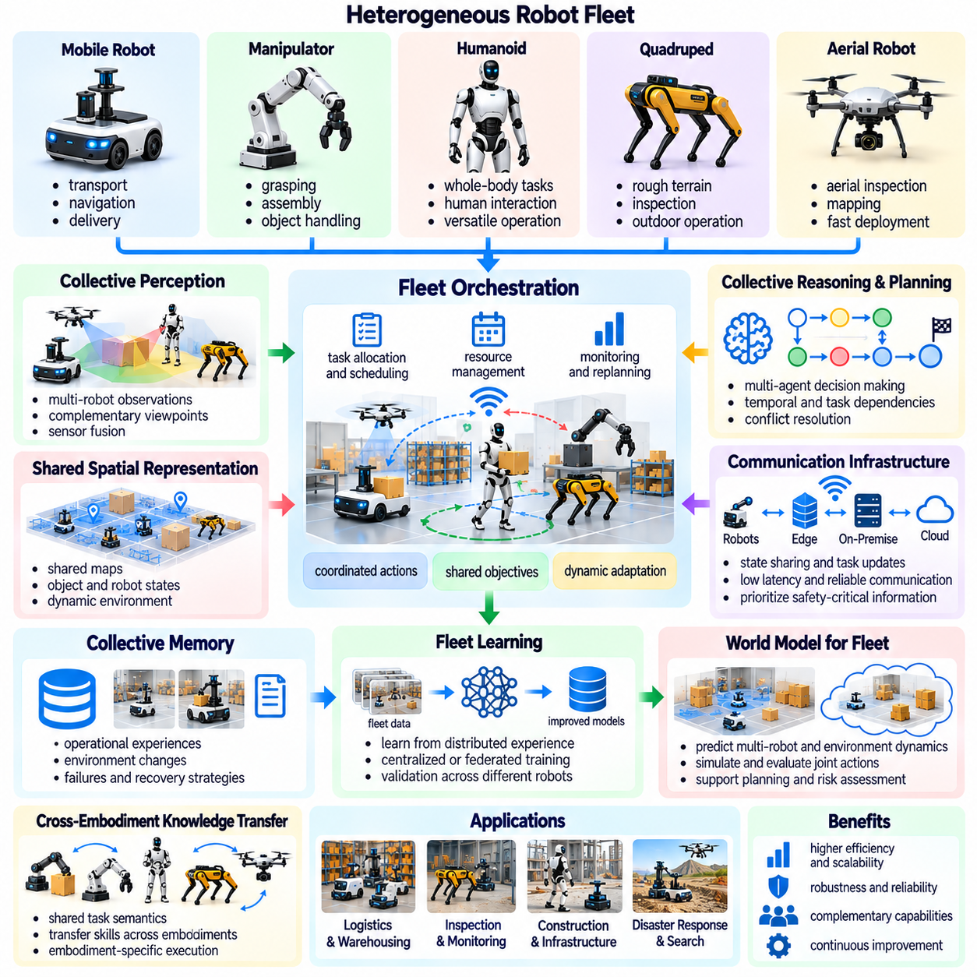
Fleet and collective intelligence extend Physical AI beyond individual robots by enabling multiple autonomous systems to coordinate actions, exchange knowledge, and pursue shared objectives. Fleet intelligence emphasizes operational coordination across deployed robots, while collective intelligence concerns capabilities emerging from distributed perception, reasoning, and learning. Together, they provide a foundation for scalable autonomy in environments where isolated robots cannot efficiently manage complex tasks.
A robotic fleet may include mobile robots, manipulators, humanoids, quadrupeds, and specialized inspection platforms. Each robot contributes different sensing, mobility, and manipulation capabilities. Collective operation requires representing these differences while maintaining common task objectives and environmental understanding. The resulting system must coordinate heterogeneous capabilities rather than assuming that every robot can perform identical actions.
Fleet orchestration manages task allocation, scheduling, resource availability, and execution priorities across multiple robots. A coordination system may assign transportation, inspection, or manipulation tasks according to robot capability, location, workload, and battery state. Effective orchestration considers dependencies between tasks and changing operational conditions. Dynamic reassignment becomes necessary when robots fail, become unavailable, or encounter unexpected obstacles.
Collective perception combines observations from multiple robots and environmental sensors to improve situational awareness. Individual robots may experience occlusion, restricted viewpoints, or limited sensor coverage. Shared observations can provide complementary information about object locations, obstacles, and environmental changes. However, effective fusion requires consistent coordinate frames, accurate timestamps, calibration, and explicit treatment of conflicting measurements.
Shared spatial representations allow distributed robots to coordinate within common environments. Maps may contain occupancy information, semantic landmarks, dynamic objects, and navigational constraints. Robots can contribute local observations to a shared environmental model while maintaining independent localization estimates. Map synchronization must account for delayed updates, uncertain observations, and changes that occur between successive measurements.
Collective reasoning extends shared perception into coordinated interpretation and decision-making. Robots may combine observations to infer task progress, identify operational risks, or determine which agent is best positioned to act. Distributed reasoning can improve coverage of complex environments and reduce duplicated effort. Nevertheless, collective conclusions must remain traceable to observations and assumptions so that inconsistent information does not propagate unnoticed.
Multi-agent planning coordinates actions whose consequences depend on the behavior of other robots. A delivery robot may need to wait for a manipulator to finish loading, while inspection robots may divide a facility into complementary regions. Plans must represent shared resources, temporal dependencies, and possible conflicts. Coordination becomes more challenging as fleet size increases and interactions between independently operating agents become less predictable.
Communication infrastructure provides the information exchange required for collective operation. Robots may transmit state estimates, task assignments, map updates, alerts, and learned experience. Network latency, bandwidth limitations, packet loss, and intermittent connectivity influence coordination reliability. Communication policies should prioritize safety-critical information and essential operational updates rather than assuming unrestricted continuous data exchange.
Distributed architectures can allocate intelligence across robot-level edge computing, on-premise coordination infrastructure, and cloud services. Edge systems execute time-sensitive perception and control, while on-premise resources maintain shared operational context and coordinate nearby agents. Cloud infrastructure can support fleet-wide analytics, long-term learning, and model distribution. This separation helps balance responsiveness, computational efficiency, and system scalability.
Collective memory preserves information generated across multiple robots and operational episodes. Shared records may describe environmental changes, completed tasks, recurring failures, and successful recovery strategies. Individual robots can retrieve relevant experiences without independently rediscovering every condition. Memory systems must preserve source identity, timestamps, environmental context, and confidence estimates to prevent inappropriate reuse of outdated knowledge.
Fleet learning converts distributed operational experience into improvements that benefit multiple robots. Data from different environments can reveal recurring failure patterns, navigation difficulties, or manipulation limitations. Centralized training may consolidate these experiences into updated models, while federated approaches can exchange model information without transferring all raw data. Validation remains necessary because robots may differ in hardware, operating conditions, and data quality.
Cross-embodiment generalization strengthens collective intelligence by allowing heterogeneous robots to share task knowledge. A mobile platform and a humanoid may interpret the same delivery objective while using different movement and manipulation strategies. Shared semantic representations can support common planning, while embodiment-specific controllers handle execution. Knowledge transfer must respect differences in sensing, reachability, payload, and physical dynamics.
World models can provide predictive capabilities for coordinated fleet operation. Shared models may estimate future robot positions, task completion states, traffic congestion, and environmental changes. Predictive planning can identify potential conflicts before they occur and support proactive resource allocation. However, prediction errors increase with uncertainty and planning horizon, making continuous observation and replanning essential.
Collective intelligence may emerge from local cooperation without requiring every decision to be centrally controlled. Decentralized agents can negotiate task assignments, exchange intentions, or coordinate movement through shared protocols. Such approaches may improve resilience and reduce dependence on a single coordinator. However, local decisions can produce global inefficiencies or conflicts unless coordination rules and system-level objectives are clearly defined.
Human supervision remains important in fleet operations, particularly when tasks involve safety, uncertain environments, or operational exceptions. Supervisors may establish priorities, approve high-risk actions, and intervene when automated coordination fails. Human-machine interfaces should present fleet status, task progress, alerts, and explanations of major decisions. Effective supervision requires balancing operator awareness with manageable information complexity.
Safety coordination must address hazards arising from interactions among multiple autonomous systems. Individually safe robot actions can become dangerous when trajectories intersect, resources are shared, or unexpected movements occur nearby. Fleet-level safety mechanisms should complement independent onboard protection. Collision avoidance, emergency procedures, traffic management, and operational zoning require consistent enforcement across participating robots.
Cybersecurity becomes increasingly important as robots exchange operational data and control information. Compromised communication, unauthorized commands, or manipulated shared maps can affect multiple agents simultaneously. Secure authentication, encrypted communication, access control, and software integrity verification help protect distributed operations. Security monitoring should distinguish legitimate coordination changes from suspicious or inconsistent system behavior.
Fleet reliability depends on graceful degradation when individual robots, network connections, or coordination services become unavailable. A robust system should preserve essential local autonomy and transition to safe operating modes during communication failures. Task reassignment and recovery procedures can restore collective performance when resources return. Resilience must be evaluated under realistic failures rather than assuming continuously available infrastructure.
Evaluation of collective intelligence should extend beyond individual robot success rates. Relevant measures include fleet throughput, task completion time, resource utilization, coordination overhead, safety incidents, recovery effectiveness, and scalability. Collective learning can be assessed through improvement across robots and environments. Testing should examine communication failures, conflicting observations, heterogeneous capabilities, and changing fleet membership.
A major future direction involves integrating shared world models, distributed memory, multi-agent planning, and continual learning into unified Physical AI infrastructures. Such systems could coordinate diverse robotic platforms while accumulating operational knowledge across facilities and deployments. Progress requires interoperable interfaces, reliable communication, uncertainty-aware reasoning, and validated model updates. Governance must define responsibility for shared decisions and system-wide behavior.
Fleet and collective intelligence transform robotics from isolated autonomous machines into coordinated physical systems capable of sharing perception, experience, and decision-making. Their long-term value lies in improving adaptability, operational efficiency, and knowledge reuse across heterogeneous environments. Reliable realization requires balancing centralized coordination with local autonomy, preserving safety under uncertainty, and continuously validating collective behavior during real-world operation.

10.11. Edge and Distributed Physical AI
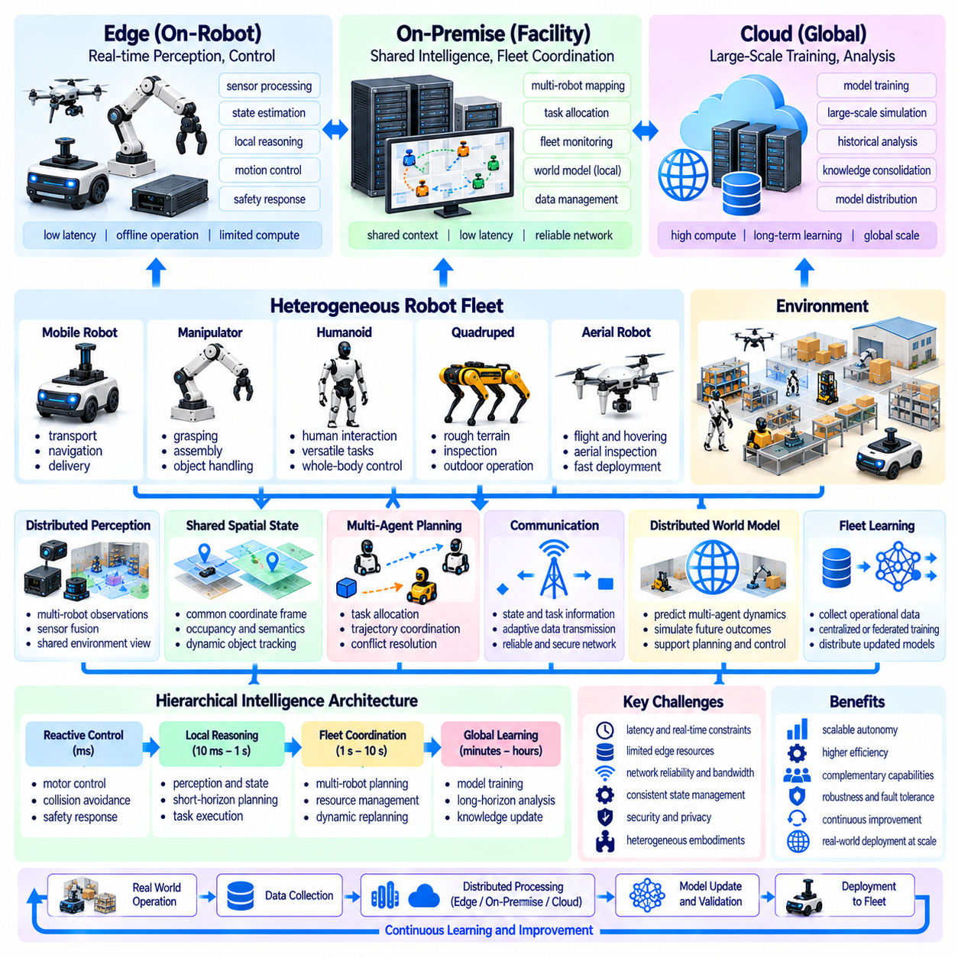
Edge and distributed Physical AI represent an architectural direction in which perception, reasoning, planning, and control are distributed across robotic devices and interconnected computing resources. Rather than concentrating all intelligence in a single processor or remote cloud, these systems allocate computation according to latency, reliability, and resource requirements. This approach supports scalable autonomy while preserving responsiveness to rapidly changing physical conditions.
Edge Physical AI places computational intelligence close to sensors, actuators, and physical processes. Local processors can interpret observations, estimate robot states, and execute control policies without depending on continuous remote communication. Such proximity reduces communication delays and supports deterministic execution where timing constraints are critical. However, edge devices operate under limitations involving processing capacity, memory, power consumption, and thermal management.
Distributed Physical AI extends local intelligence through coordinated computing resources deployed across robots, facilities, and cloud infrastructure. Different computational nodes may perform specialized functions while exchanging state estimates, task information, and learned representations. Effective distribution requires explicit definitions of responsibilities, communication interfaces, and operational dependencies. The architecture must remain functional when individual nodes or network connections become unavailable.
Real-time requirements strongly influence the placement of Physical AI functions. Motor control, collision avoidance, and immediate safety responses generally require execution near the physical system. Higher-level planning, fleet coordination, and large-scale model analysis may tolerate longer processing delays. Computational placement should therefore reflect the consequences of latency rather than relying exclusively on available processing power or centralized infrastructure.
Edge computing supports local perception by processing camera, LiDAR, radar, inertial, and proprioceptive measurements near their sources. Sensor fusion can generate estimates of object positions, robot motion, and environmental conditions without transmitting every raw measurement. This reduces network traffic and improves response times. Nevertheless, accurate fusion requires synchronization, calibration, uncertainty estimation, and appropriate handling of incomplete sensor observations.
On-premise computing provides an intermediate intelligence layer between individual robots and remote cloud services. Facility-level servers may maintain shared maps, coordinate robot fleets, execute predictive models, and manage operational memory. This infrastructure can combine observations from multiple robots and fixed sensors to improve environmental understanding. Its value depends on reliable local networking and clear separation between shared intelligence and safety-critical onboard functions.
Cloud infrastructure contributes computational resources for large-scale training, model evaluation, historical analysis, and knowledge consolidation. Models trained from accumulated operational experience can be validated and distributed to edge or on-premise systems. Cloud resources may also support computationally expensive simulations and long-horizon planning. However, essential physical control should not depend on unpredictable wide-area network latency or continuous cloud availability.
Hierarchical intelligence architectures organize computation according to temporal and functional requirements. Fast control loops operate near actuators, intermediate reasoning processes coordinate local tasks, and slower services manage long-term knowledge and optimization. Information moves between these layers through defined interfaces and feedback mechanisms. This organization can reduce unnecessary computation while maintaining consistency between immediate actions and strategic objectives.
Communication is a fundamental design constraint because distributed intelligence depends on timely and trustworthy information exchange. Bandwidth limitations, packet loss, network congestion, and variable latency can degrade shared perception and coordinated planning. Systems should prioritize critical messages and avoid transmitting unnecessary high-volume data. Communication-aware algorithms can adapt update frequencies and information content according to current network conditions.
Distributed state management ensures that different computing nodes maintain sufficiently consistent representations of the physical environment. Robots may hold local estimates while facility servers maintain shared maps and task states. Because observations arrive asynchronously, temporary disagreements are unavoidable. Timestamping, version control, uncertainty tracking, and conflict resolution help prevent outdated or contradictory information from producing unsafe coordinated behavior.
World models can be distributed according to prediction horizon, computational complexity, and operational scope. Lightweight models may estimate immediate motion and contact outcomes at the edge, while larger models evaluate multi-agent interactions and longer-term environmental changes. Shared predictions can improve coordinated planning when synchronized with current observations. Model uncertainty and communication delays must be considered before predictions influence physical actions.
Distributed inference allows complex AI workloads to be partitioned across available computing resources. Model components may execute locally, on nearby accelerators, or within remote services depending on computational demand. Such partitioning can reduce device requirements but introduces communication overhead and synchronization costs. Effective scheduling must evaluate end-to-end latency, data movement, memory availability, and the consequences of interrupted execution.
Adaptive computation enables Physical AI systems to allocate processing resources according to task difficulty and operational urgency. Routine navigation may require lightweight inference, while uncertain manipulation or complex planning may benefit from additional computation. Resource managers can adjust model selection, inference frequency, and workload placement. Adaptation must preserve bounded response times for functions that directly influence physical safety.
Energy efficiency is especially important for battery-powered robots and embedded computing devices. High-performance perception and reasoning models can increase power consumption, reduce operating time, and create thermal constraints. Quantization, pruning, efficient model architectures, and selective inference can reduce computational demand. Energy-aware scheduling should balance intelligence quality against battery availability, cooling capacity, and mission duration.
Distributed Physical AI also creates opportunities for cooperative perception and collective intelligence. Multiple robots and environmental sensors can contribute observations to shared representations that extend beyond individual sensor coverage. Facility-level intelligence may identify obstacles, predict traffic conflicts, and coordinate complementary robotic capabilities. However, collective decisions must account for observation uncertainty, synchronization errors, and differences in robot embodiment.
Reliability requires graceful degradation when computing nodes, communication links, or shared services fail. Robots should preserve essential local capabilities and enter safe operating states when external intelligence becomes unavailable. Cached maps, local policies, and bounded fallback procedures can support continued operation under restricted conditions. Recovery mechanisms must reconcile local and shared states before normal distributed coordination resumes.
Cybersecurity becomes a system-level requirement because distributed components exchange operational information and sometimes influence physical control. Authentication, encrypted communication, access control, and software integrity checks protect against unauthorized manipulation. Compromised shared models or falsified sensor information can affect multiple robots simultaneously. Security architecture should therefore isolate critical functions and support monitoring, incident response, and controlled recovery.
Model lifecycle management coordinates training, validation, deployment, and monitoring across heterogeneous computing nodes. Updated perception or planning models should be tested against representative operating conditions before distribution. Version compatibility and rollback procedures help prevent inconsistent behavior across robot fleets. Deployment policies must distinguish experimental capabilities from validated functions that are permitted to influence physical operations.
Scalability depends on more than increasing computational capacity. As robot populations expand, communication traffic, shared state complexity, scheduling conflicts, and infrastructure dependencies also increase. Distributed architectures should support modular services, localized decision-making, and selective information sharing. Performance evaluation must examine whether additional robots and computing nodes improve overall productivity without creating disproportionate coordination overhead.
Evaluation of edge and distributed Physical AI should measure end-to-end system behavior rather than isolated model throughput. Relevant metrics include perception latency, control response time, communication overhead, energy consumption, task success, reliability, and recovery performance. Testing should introduce network failures, resource contention, delayed observations, and computational overload. Results must demonstrate that architectural complexity produces measurable operational benefits.
Future Physical AI infrastructures may combine specialized edge accelerators, facility-level intelligence services, shared world models, and cloud-based learning systems. Such environments could coordinate heterogeneous robots while adapting computational placement to changing workloads and operational conditions. Progress requires interoperable interfaces, efficient distributed inference, reliable synchronization, and validated safety boundaries. Architectural flexibility must remain compatible with predictable physical execution.
Edge and distributed Physical AI provide a foundation for intelligent physical systems that combine local responsiveness with shared computational knowledge. Their significance lies in allocating intelligence where it can contribute most effectively to perception, reasoning, planning, and action. Reliable implementation requires careful management of latency, energy, communication, security, and uncertainty. The ultimate objective is scalable collective autonomy without sacrificing the safety and reliability of individual physical agents.

10.12. Self Improving Physical AI Systems
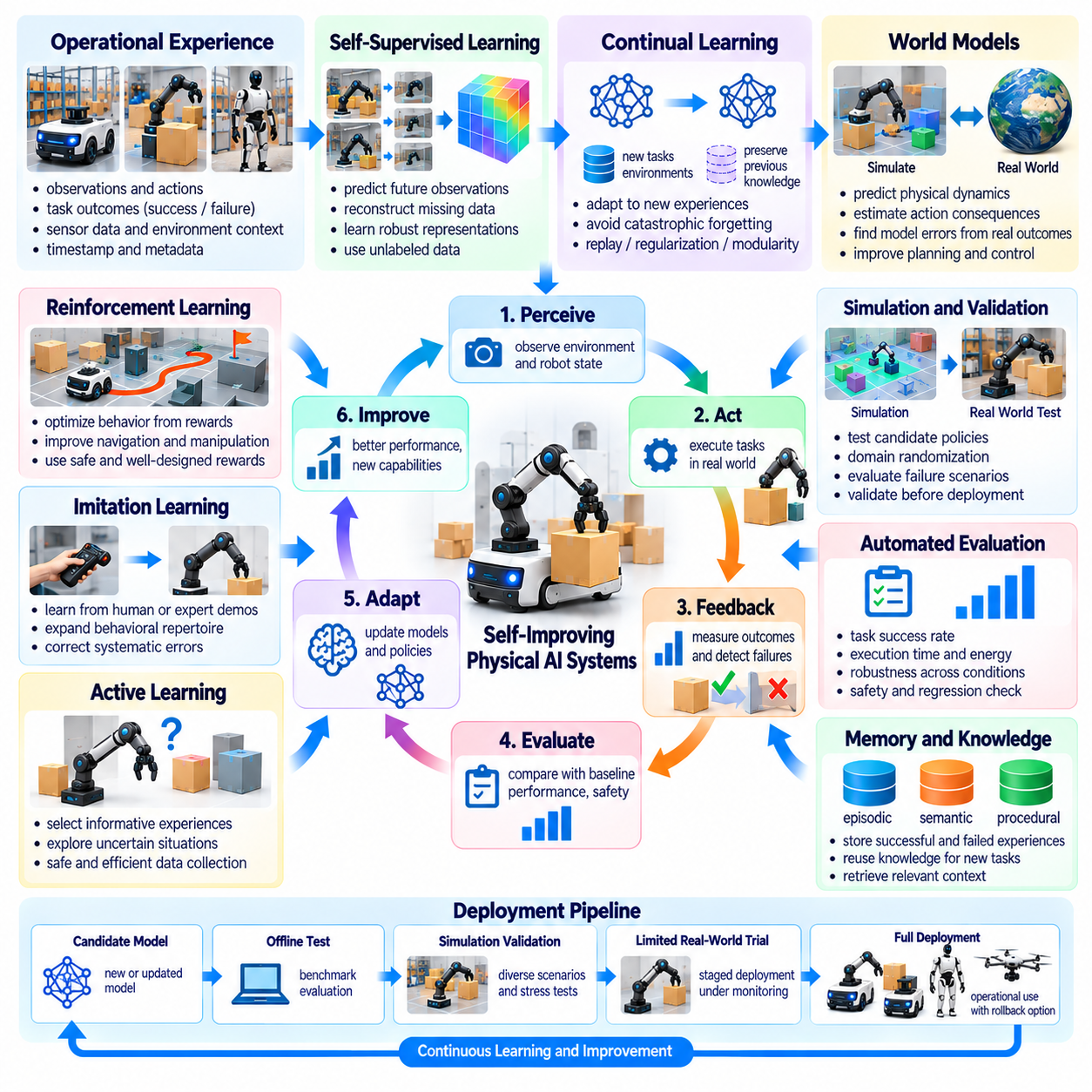
Self-improving Physical AI systems represent a transition from robots with fixed capabilities toward autonomous systems that progressively enhance their performance through experience. These systems observe operational outcomes, identify limitations, acquire new knowledge, and refine their behavior over time. Unlike conventional software updates, self-improvement involves continuous interaction between learning algorithms, physical environments, and mechanisms that evaluate whether proposed changes are beneficial and safe.
The foundation of self-improvement is a closed learning loop connecting perception, action, feedback, evaluation, and adaptation. A robot performs tasks, measures the consequences of its actions, and compares observed outcomes with expected results. Performance differences provide evidence for updating internal models or control strategies. Effective learning loops must distinguish genuine improvement from temporary environmental advantages, measurement errors, and accidental success.
Operational experience provides the primary data source for self-improving Physical AI. Robots generate observations, action trajectories, task outcomes, failure records, and environmental measurements during normal operation. These records can reveal recurring limitations that were absent from initial training datasets. However, useful experience requires accurate timestamps, contextual metadata, sensor calibration, and consistent descriptions of actions and outcomes.
Self-supervised learning enables robots to extract knowledge from large volumes of unlabeled operational data. Predictive objectives can train models to estimate future observations, object motion, or contact outcomes from preceding states and actions. Representation learning can improve perception without requiring continuous human annotation. Nevertheless, predictive accuracy alone does not guarantee that learned representations will improve physical task execution.
Continual learning allows Physical AI systems to incorporate new experiences without repeatedly rebuilding models from their original training data. Robots may adapt to changing lighting, unfamiliar objects, modified workspaces, or gradual mechanical wear. A central challenge is catastrophic forgetting, where adaptation reduces performance on previously mastered tasks. Replay mechanisms, parameter isolation, and regularization can help preserve established capabilities.
World models provide a structured mechanism for self-improvement by predicting how environments evolve under different actions. Robots can compare predicted state transitions with actual observations to identify modeling errors. These discrepancies reveal opportunities to refine representations of motion, contact, and object dynamics. Improved models can subsequently support more accurate planning, but their predictions must remain calibrated to real physical conditions.
Reinforcement learning contributes to self-improvement by optimizing behavior according to task outcomes and reward signals. Robots may refine navigation strategies, manipulation trajectories, or resource allocation policies through repeated experience. However, poorly specified rewards can encourage undesirable shortcuts or unsafe behavior. Reward design must reflect operational objectives, physical constraints, and long-term consequences rather than narrow performance indicators.
Imitation learning and corrective demonstrations provide another pathway for improving robotic behavior. Human operators or more capable systems may demonstrate successful task execution when autonomous policies encounter difficulties. These demonstrations can expand the robot's behavioral repertoire and correct systematic errors. The learning process should preserve information about demonstration quality, task context, and differences between the teacher and target robot.
Active learning improves data efficiency by selecting experiences that provide the greatest potential learning value. A robot may prioritize uncertain observations, unfamiliar objects, or situations where competing models disagree. Rather than collecting every possible interaction, the system concentrates learning resources on informative cases. Exploration must remain bounded by safety requirements because highly uncertain situations may also involve elevated physical risk.
Simulation provides a controlled environment for evaluating proposed improvements before physical deployment. Candidate policies can be tested across varied objects, terrain conditions, sensor disturbances, and failure scenarios. Domain randomization and adversarial scenario generation can expose weaknesses that routine testing might miss. Nevertheless, simulation-to-reality differences require physical validation before improvements are accepted as operationally reliable.
Automated evaluation is essential for determining whether a model update genuinely improves system performance. Candidate models should be compared against established baselines using task success, execution time, energy consumption, robustness, and safety metrics. Evaluation must include previously mastered tasks to detect regression. Statistical uncertainty and variation across operating conditions should be considered before declaring an improvement successful.
A self-improving system requires controlled mechanisms for deploying learned capabilities. Model updates can progress through offline testing, simulation validation, limited physical trials, and staged operational release. Version management and rollback procedures allow systems to recover from unexpected performance degradation. Safety-critical functions should remain protected by independent constraints rather than being modified automatically through unrestricted learning.
Memory architectures support improvement by preserving experiences that remain useful across operational episodes. Episodic memory stores specific events, while semantic memory captures generalized knowledge about objects, environments, and procedures. Retrieval mechanisms can provide relevant context for future decisions. Memory maintenance must address outdated information, conflicting observations, storage limitations, and the risk of reinforcing incorrect assumptions.
Fleet learning extends self-improvement from individual robots to distributed robotic populations. Experiences collected across multiple facilities and platforms can reveal recurring failures and transferable solutions. Shared training infrastructure may consolidate validated knowledge and distribute improved models to compatible robots. However, heterogeneous hardware, environmental differences, and inconsistent data quality require careful evaluation before fleet-wide deployment.
Self-improvement can also involve adaptation of computational strategies rather than only behavioral policies. Physical AI systems may adjust inference frequency, model selection, planning depth, or workload placement according to task complexity. Such changes can improve responsiveness and energy efficiency. Computational adaptation must preserve predictable execution times for control functions and avoid resource contention that could compromise safety.
Uncertainty estimation provides an important safeguard during autonomous adaptation. Robots should recognize when observations differ substantially from training conditions or when model predictions become unreliable. High uncertainty may trigger additional sensing, conservative actions, or requests for human assistance. Confidence estimates must be calibrated against observed outcomes because excessive confidence can conceal serious weaknesses in learned behavior.
Causal reasoning can make self-improvement more systematic by distinguishing genuine causes of failure from correlated observations. A robot that repeatedly fails to grasp an object should investigate whether the problem arises from geometry, friction, perception, or control timing. Counterfactual evaluation can compare alternative actions under similar conditions. Such reasoning helps direct learning toward mechanisms that are more likely to generalize.
Human oversight remains necessary because autonomous learning can alter behavior in ways that are difficult to predict. Operators may establish learning boundaries, approve important updates, review failure cases, and define acceptable operational risks. Transparent records should explain what changed, why the update was proposed, and how its effects were evaluated. Accountability requires preserving human authority over safety-critical deployment decisions.
Security and data governance become increasingly important when robots modify models using accumulated operational experience. Manipulated training data, compromised update pipelines, or unauthorized parameter changes can introduce persistent vulnerabilities. Secure data provenance, authenticated updates, access control, and integrity verification help protect the learning process. Privacy requirements and data ownership constraints must also govern how operational experiences are retained and shared.
The long-term objective of self-improving Physical AI is to establish reliable systems that accumulate knowledge while maintaining stable operational performance. Progress will depend on integrating continual learning, world models, active exploration, automated evaluation, and controlled deployment into unified learning architectures. Genuine autonomy requires more than the ability to update parameters; it requires evidence that each accepted improvement remains effective, transferable, and safe under real-world conditions.

10.13. Physical AI and AGI Convergence
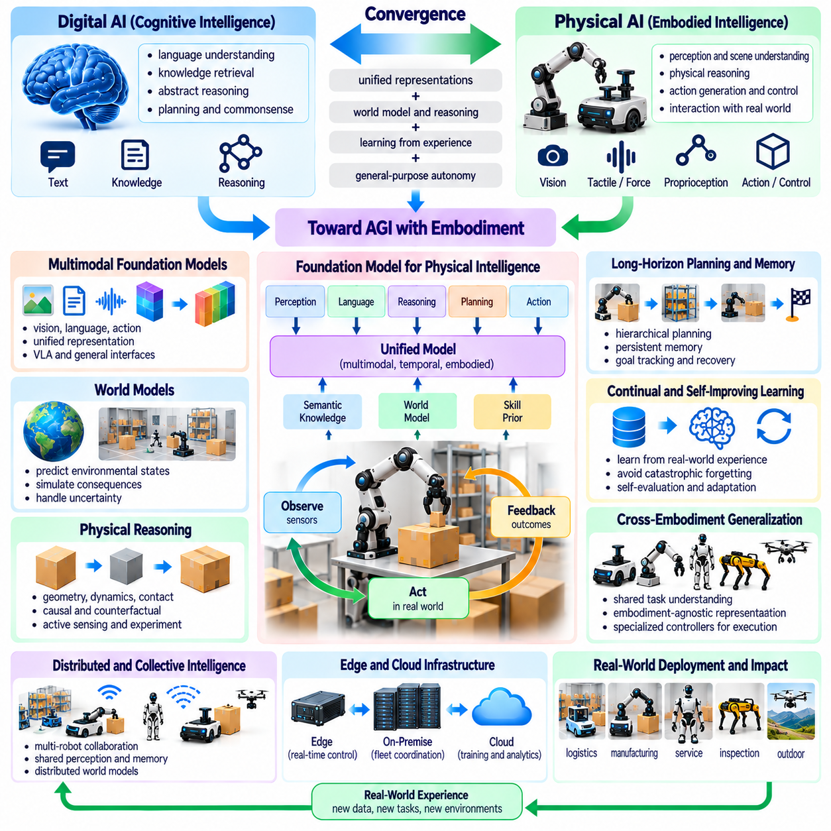
The convergence of Physical AI and Artificial General Intelligence (AGI) represents a potential transition toward intelligent systems capable of reasoning, learning, and acting across diverse physical environments. AGI generally refers to broad cognitive competence across many tasks, while Physical AI emphasizes perception, interaction, and control in the real world. Their convergence could connect general-purpose reasoning with embodied capabilities, although neither concept has a universally accepted operational definition.
Digital intelligence has demonstrated substantial capabilities in language processing, knowledge retrieval, and abstract problem solving. Physical environments introduce additional requirements involving uncertainty, continuous motion, contact dynamics, and irreversible consequences. An intelligent system must translate symbolic objectives into physically executable actions. This transition requires integrating cognitive representations with perception, planning, control, and feedback from the environment.
Embodiment may contribute to general intelligence by grounding abstract concepts in physical experience. Understanding containment, support, force, distance, and causality can benefit from observing how objects interact under different conditions. Robots can acquire such knowledge through sensing and controlled experimentation. However, physical embodiment should not be assumed to be a necessary condition for every form of general intelligence.
World models provide a potential connection between general reasoning and physical action. These models represent environmental states, predict future developments, and estimate the consequences of alternative decisions. When combined with abstract reasoning, world models may support planning beyond immediate observations. Their effectiveness depends on representing uncertainty, maintaining consistency with physical evidence, and adapting predictions when environmental conditions change.
Multimodal foundation models may serve as interfaces between language, vision, spatial information, and robotic actions. A system could interpret human instructions, identify relevant objects, reason about task constraints, and generate action plans. Vision-language-action models extend this approach by connecting multimodal understanding with motor behavior. Nevertheless, successful language interpretation does not automatically establish reliable physical execution.
Physical reasoning requires understanding relationships that are not fully captured by linguistic descriptions. Manipulating an unfamiliar object may demand estimates of mass, friction, stability, and contact geometry. These properties can be inferred through observation and interaction, but uncertainty remains significant. General-purpose physical intelligence must therefore combine prior knowledge with active sensing, experimentation, and continual correction of internal assumptions.
Long-horizon planning is another important capability at the intersection of Physical AI and AGI. Complex objectives may involve numerous dependent actions, changing environments, and unexpected failures. An intelligent robot must maintain goals, track progress, revise plans, and recover from unsuccessful operations. Hierarchical planning and persistent memory can support these requirements while separating strategic reasoning from time-sensitive control.
Causal and counterfactual reasoning may improve the ability of intelligent systems to understand physical consequences. Rather than learning only correlations between observations and actions, systems can investigate why events occur and what might happen under alternative interventions. This capability is valuable for diagnosis, planning, and recovery. Reliable causal reasoning requires evidence from physical interactions and careful treatment of hidden variables.
Continual learning is essential for systems expected to operate across changing environments and unfamiliar tasks. Physical agents encounter new objects, altered layouts, mechanical wear, and unexpected human behavior. They must incorporate useful experience without destroying previously acquired capabilities. A convergence toward general intelligence would require balancing adaptation, knowledge retention, uncertainty estimation, and protection against unsafe behavioral changes.
Cross-embodiment generalization could allow shared intelligence to operate through robots with different mechanical structures. A common reasoning system might support mobile robots, manipulators, humanoids, and other platforms while relying on specialized controllers for execution. Such transfer requires representations of goals and physical relationships that are not tied to specific actuators. Differences in reachability, dynamics, and sensing remain fundamental constraints.
Collective intelligence introduces another possible direction for convergence. Multiple robots can exchange observations, learned experiences, and task information to improve coordinated decisions. Shared memory and distributed world models may provide capabilities beyond those available to individual agents. However, collective performance does not necessarily imply general intelligence, and distributed coordination introduces additional challenges involving consistency, communication, and accountability.
Edge and distributed computing architectures will influence how advanced physical intelligence can be deployed. Time-critical control must remain responsive near the physical system, while computationally intensive reasoning and learning may use on-premise or cloud resources. Workload allocation must consider latency, energy, reliability, and communication availability. Greater reasoning capability cannot compensate for unpredictable control delays or insufficient safety protection.
Autonomous experimentation may enable Physical AI systems to refine their understanding of unfamiliar environments. A robot could formulate hypotheses, select informative interactions, observe outcomes, and update its models. Such processes resemble aspects of scientific reasoning, but physical exploration creates real operational risks. Experimentation must therefore remain bounded by safety constraints, uncertainty thresholds, and controlled evaluation procedures.
The relationship between general intelligence and robotic competence requires careful interpretation. A system may demonstrate broad linguistic or analytical capabilities while failing at simple physical manipulation. Conversely, a specialized robot may perform demanding motor tasks without possessing broad reasoning abilities. General intelligence and physical competence should therefore be evaluated through distinct but complementary measures rather than treated as interchangeable achievements.
Evaluation frameworks must test whether intelligent systems can transfer knowledge across unfamiliar tasks, environments, and embodiments. Relevant criteria include adaptation efficiency, physical task success, causal understanding, planning robustness, safety, and recovery from failure. Benchmark performance alone is insufficient when success depends on memorized environments or narrow task distributions. Real-world evaluation should examine uncertainty, distribution shifts, and long-term reliability.
Safety and alignment become increasingly important as physical systems acquire broader autonomy. Incorrect decisions can cause collisions, equipment damage, or harm to people. General-purpose agents must operate within enforceable physical constraints and respect human instructions, operational boundaries, and authorization requirements. Independent safety mechanisms, transparent decision records, and human intervention capabilities remain necessary even as reasoning performance improves.
Governance must address responsibility when intelligent systems make decisions across multiple operational domains. Organizations need procedures for validating capabilities, authorizing deployments, monitoring behavior, and investigating incidents. Model updates and autonomous adaptation should remain traceable and reversible where technically feasible. The increasing generality of intelligent systems strengthens the need for explicit accountability rather than reducing human oversight.
Important scientific uncertainties remain regarding the relationship between embodiment, world modeling, and general intelligence. It is not established whether physical interaction is necessary for AGI, whether current foundation model architectures can achieve robust physical generalization, or how broad competence should be measured. Progress requires controlled experiments, reproducible benchmarks, and transparent reporting of limitations. Claims of convergence should be distinguished from demonstrated capabilities.
Future research may combine multimodal reasoning, world models, hierarchical control, continual learning, and distributed intelligence within increasingly capable robotic systems. Such integration could support flexible task execution and more effective transfer of knowledge between physical environments. However, architectural integration alone does not guarantee general intelligence. Success depends on demonstrable robustness, adaptability, causal understanding, and safe behavior under unfamiliar conditions.
The convergence of Physical AI and AGI is best understood as an evolving research direction rather than an inevitable technological endpoint. Physical AI can provide mechanisms for grounding intelligence in perception and action, while advances in general reasoning may expand robotic adaptability. Their combined development could produce more versatile autonomous systems. The central challenge is ensuring that broader cognitive capability translates into reliable, verifiable, and responsible physical behavior.

10.14. 2030 and Long Term Physical AI Roadmap
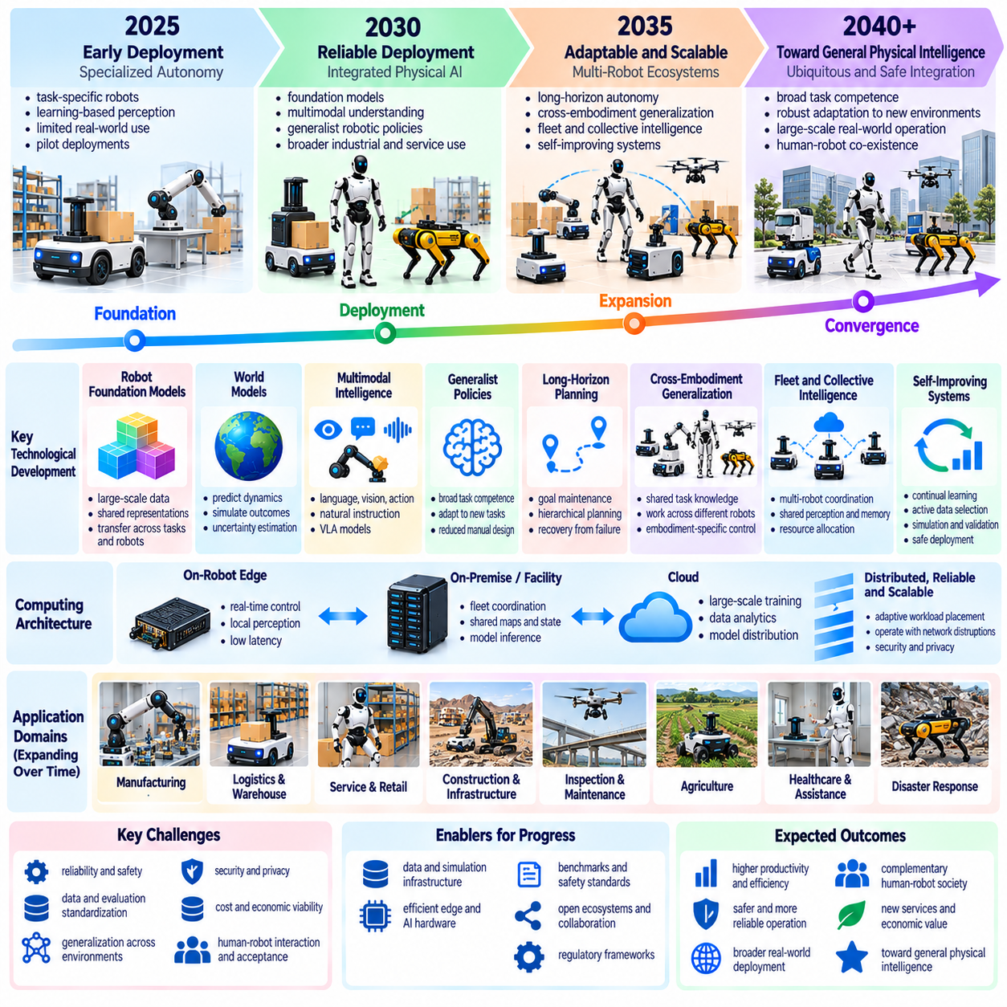
The roadmap toward 2030 and beyond describes the expected evolution of Physical AI from specialized robotic autonomy toward adaptable, interconnected, and increasingly intelligent physical systems. Progress will depend on advances in perception, world modeling, planning, learning, and embodied control. Rather than representing a predetermined technological schedule, the roadmap provides a framework for identifying research priorities, engineering dependencies, and measurable milestones.
By 2030, Physical AI development is expected to emphasize more reliable deployment of learning-based capabilities in structured and semi-structured environments. Industrial facilities, logistics centers, and service environments may increasingly adopt robots that combine conventional control with learned perception and decision-making. Progress should be measured through sustained task performance, operational availability, safety, and economic viability rather than demonstrations alone.
Robot foundation models are likely to become an important component of future Physical AI architectures. Training across diverse robotic datasets may improve the transfer of perception, task understanding, and behavioral knowledge between platforms. However, generalization across unfamiliar objects, environments, and embodiments remains a significant challenge. Future systems will need standardized datasets, consistent evaluation procedures, and mechanisms for adapting shared models to specific hardware.
World models are expected to play a growing role in predictive Physical AI. Robots may increasingly simulate possible environmental changes and evaluate alternative actions before execution. Such capabilities could improve manipulation, navigation, and long-horizon planning under uncertainty. Achieving reliable performance requires accurate representations of physical dynamics, calibrated uncertainty estimates, and continuous correction using real-world observations.
Multimodal intelligence will connect language, vision, spatial understanding, and action more closely. Future robots may interpret high-level instructions and translate them into executable sequences while accounting for physical constraints. Vision-language-action models could provide reusable interfaces between human intentions and robotic behavior. Nevertheless, reliable execution will still require specialized control, feedback mechanisms, and independent safety validation.
The development of generalist robotic policies may reduce dependence on separately engineered solutions for every task. Shared policies could support navigation, object interaction, inspection, and manipulation across related environments. Their effectiveness will depend on training diversity, embodiment conditioning, and adaptation efficiency. A realistic roadmap must distinguish broad task competence from universal physical capability, which remains an unresolved research objective.
Long-horizon autonomy will require systems that maintain goals and operational context across extended sequences of actions. Robots must recognize dependencies, recover from unexpected events, and revise plans when environmental conditions change. Persistent memory, hierarchical planning, and causal reasoning may improve these capabilities. Evaluation should include multi-stage tasks, interruption recovery, and reliability over prolonged operating periods.
Cross-embodiment generalization will become increasingly important as robotic platforms diversify. Shared intelligence may support mobile robots, manipulators, humanoids, quadrupeds, and specialized autonomous machines. Common representations of goals and physical relationships can facilitate knowledge transfer, while platform-specific controllers preserve execution feasibility. Progress must be demonstrated across genuinely different morphologies rather than closely related hardware configurations.
Fleet and collective intelligence may transform isolated robotic deployments into coordinated operational ecosystems. Multiple robots could share observations, environmental models, task information, and validated experiences. Facility-level coordination may improve resource allocation, traffic management, and recovery from operational failures. However, collective intelligence requires dependable communication, consistent shared state, cybersecurity protection, and clear responsibility for distributed decisions.
Edge and distributed Physical AI will provide the computational infrastructure needed for increasingly capable robotic systems. Time-critical perception and control will remain close to physical devices, while on-premise and cloud resources support coordination, advanced reasoning, and large-scale learning. Adaptive workload placement may improve energy efficiency and responsiveness. Architectural progress must preserve predictable latency and essential local autonomy during network disruptions.
Self-improving Physical AI systems may gradually incorporate operational experience into validated model updates. Continual learning, active data selection, simulation, and automated evaluation could reduce the need for repeated manual engineering. However, unrestricted online adaptation introduces risks involving catastrophic forgetting, unsafe exploration, and unexpected behavior. Improvement pipelines must include regression testing, deployment controls, traceability, and reliable rollback procedures.
Between 2030 and 2035, a plausible development direction is broader deployment of adaptable robots across multiple operational domains. Systems may acquire new task capabilities through limited demonstrations, targeted training, and shared knowledge services. More capable coordination could support mixed fleets operating in dynamic facilities. These possibilities remain conditional on advances in reliability, cost efficiency, interoperability, and regulatory acceptance.
Beyond 2035, research may increasingly explore persistent physical intelligence that integrates long-term memory, causal world models, and autonomous learning across diverse environments. Robots could develop more flexible strategies for unfamiliar tasks and transfer knowledge between different embodiments. Such progress would require substantial advances in physical reasoning and generalization. The emergence of these capabilities should not be assumed to follow a fixed timetable.
Hardware evolution will strongly influence the pace of Physical AI development. Improvements in embedded accelerators, sensing systems, actuators, batteries, and communication technologies may expand the complexity of tasks robots can perform. Energy efficiency and thermal management will remain important constraints, particularly for mobile platforms. Hardware and software must advance together because computational intelligence cannot overcome every limitation of physical mechanisms.
Simulation and digital twins will continue to support training, validation, and operational optimization. More accurate simulations may represent contact dynamics, sensor disturbances, environmental changes, and multi-robot interactions. Synthetic experience could accelerate learning and expose systems to rare scenarios. Nevertheless, the simulation-to-reality gap will remain a critical concern, requiring systematic physical testing and continuous model calibration.
Safety engineering will become increasingly central as robots acquire broader decision-making authority. Future systems must combine learned intelligence with enforceable operational constraints, independent protection mechanisms, and transparent incident analysis. Validation will need to address uncertain environments, changing policies, and interactions between multiple autonomous agents. Trustworthy autonomy requires evidence of safety throughout the system lifecycle rather than certification of isolated components.
Standardization and interoperability will determine whether Physical AI can scale across manufacturers, facilities, and application domains. Common conventions for sensor data, robot capabilities, task descriptions, model interfaces, and evaluation results can reduce integration complexity. Open benchmarks and reproducible testing may improve technical comparability. Standards should support innovation while preserving compatibility, security, and verifiable operational requirements.
Economic and organizational factors will shape adoption as strongly as technical breakthroughs. Deployment decisions depend on total ownership cost, maintenance requirements, productivity improvements, workforce integration, and operational risk. Organizations must develop capabilities for robot supervision, data management, model validation, and incident response. Sustainable adoption requires clear business value and responsible integration with human work rather than automation for its own sake.
The relationship between Physical AI and Artificial General Intelligence will remain an important research question throughout the long-term roadmap. Advances in multimodal reasoning and world models may improve robotic adaptability, but general cognitive competence does not automatically imply reliable physical capability. Physical intelligence must be assessed through interaction, task execution, and recovery under uncertainty. Claims of convergence should remain grounded in demonstrated evidence.
Roadmap evaluation should use measurable capability milestones instead of relying solely on calendar dates. Relevant indicators include task generalization, adaptation time, physical reasoning accuracy, operational reliability, energy efficiency, safety performance, and fleet scalability. Progress should be assessed across representative environments and previously unseen conditions. Transparent reporting of failures and limitations is essential for distinguishing genuine advancement from benchmark-specific optimization.
The long-term vision of Physical AI is an ecosystem of intelligent physical agents that can perceive, reason, collaborate, and improve while remaining accountable to human objectives. Achieving this vision requires coordinated progress in algorithms, hardware, distributed infrastructure, safety, governance, and economic deployment. The roadmap should remain adaptable as scientific evidence and operational experience accumulate. Its ultimate measure of success is reliable and beneficial intelligence acting responsibly in the physical world.

