Volume 02. Physical AI Foundations and Definitions

Chapter 02. Physical AI vs Digital AI

02.01. Digital AI and Physical AI
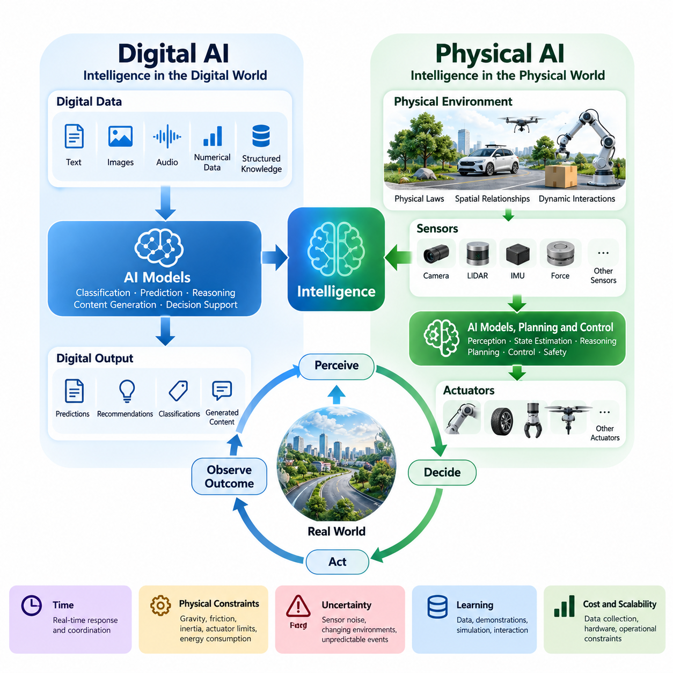
Digital Artificial Intelligence (Digital AI) refers to intelligent computational systems that primarily process, interpret, generate, and transform information within digital environments. These systems operate on representations such as text, images, audio, numerical data, and structured knowledge. Their principal functions include classification, prediction, reasoning, content generation, and decision support, typically without directly controlling physical processes.
Physical Artificial Intelligence (Physical AI) extends artificial intelligence into environments governed by physical laws, spatial relationships, and dynamic interactions. It enables machines to perceive their surroundings, interpret environmental conditions, make decisions, and execute actions through physical mechanisms. Unlike systems confined to information processing, Physical AI must account for motion, forces, contact, uncertainty, and the consequences of actions in the real world.
The fundamental distinction between Digital AI and Physical AI concerns the relationship between intelligence and its operating environment. Digital AI generally transforms information into other forms of information, whereas Physical AI connects computational intelligence with physical states and actions. A language model may generate instructions for moving an object, but a robotic system must translate those instructions into feasible movements while observing the actual results.
Digital AI commonly operates through software applications, cloud platforms, databases, and computational services. Its inputs are represented as digital signals or data structures, and its outputs are usually predictions, recommendations, classifications, or generated content. Although these outputs may influence physical activities through human decisions or external automation, the AI system itself does not necessarily maintain direct control over physical interactions.
Physical AI requires an integrated architecture connecting sensing, computation, decision-making, and actuation. Cameras, LiDAR sensors, inertial measurement units, force sensors, and other devices provide observations of the environment. AI models interpret these observations, while planning and control algorithms determine appropriate responses. Actuators then transform computational decisions into mechanical movement or other physical effects.
A defining characteristic of Physical AI is its continuous interaction with changing environments. Physical conditions evolve independently of the computational system, and actions can alter the environment in unexpected ways. Consequently, an intelligent physical agent must repeatedly observe its surroundings, estimate relevant states, select actions, and evaluate outcomes. This recurring process establishes a closed-loop relationship between intelligence and physical reality.
Digital AI systems frequently perform inference on predefined datasets or user-provided inputs. A model may analyze a document, recognize objects in an image, or answer questions without changing the underlying environment. Physical AI, however, often acquires information through its own movements and interactions. A robot may reposition a camera, approach an unfamiliar object, or manipulate an item to obtain observations that were previously unavailable.
The distinction also involves the representation of states and actions. Digital AI frequently uses tokens, embeddings, feature vectors, and symbolic structures to represent information. Physical AI additionally requires representations of position, orientation, velocity, acceleration, contact, and spatial relationships. These representations must connect to measurable physical quantities and support decisions that remain feasible under the constraints of the operating system.
Physical AI must reason about time as an essential property of intelligence. A delayed response in a conversational application may reduce user satisfaction, but a delayed braking command in an autonomous vehicle can create immediate danger. Robotic systems therefore require coordination between AI inference, communication, sensing, and control. Their computational architecture must satisfy operational deadlines while maintaining acceptable accuracy and reliability.
The physical world introduces constraints that are absent or less prominent in many digital applications. Gravity, friction, inertia, mechanical compliance, actuator limits, and energy consumption directly influence achievable behavior. An AI-generated motion plan cannot be executed successfully merely because it is logically consistent. The plan must also respect the mechanical capabilities of the platform and the physical properties of its environment.
Uncertainty affects both Digital AI and Physical AI, but its operational consequences differ significantly. Digital systems may encounter ambiguous language, incomplete information, or distribution shifts. Physical systems additionally experience sensor noise, calibration errors, changing illumination, unpredictable obstacles, and uncertain contact conditions. These disturbances can propagate through perception, planning, and control, potentially producing unsafe or ineffective behavior.
Learning mechanisms provide another important point of comparison. Digital AI commonly benefits from large datasets collected from documents, websites, images, and other information sources. Physical AI may additionally learn from demonstrations, teleoperation, simulation, and direct interaction. Its training data can include observations, robot states, actions, rewards, and physical outcomes, allowing models to associate decisions with their consequences.
The acquisition of physical experience is often more expensive and operationally constrained than collecting digital information. Real-world experiments require hardware, controlled environments, maintenance, supervision, and safety precautions. Repeated actions can consume energy, damage equipment, or create hazards. Consequently, Physical AI development frequently combines recorded datasets, simulated environments, and carefully controlled real-world experimentation.
Simulation provides an important connection between Digital AI methodologies and Physical AI development. Physics engines and virtual environments allow robotic agents to practice perception, navigation, manipulation, and control without immediately exposing physical equipment to risk. However, simulated environments cannot perfectly reproduce every real-world condition. Differences in dynamics, sensing, contact, and environmental variability create challenges for simulation-to-reality transfer.
Foundation models illustrate the increasing convergence of Digital AI and Physical AI. Large language models and multimodal models can provide semantic understanding, instruction interpretation, and high-level reasoning. When integrated into robotic architectures, these capabilities can support task planning and contextual decision-making. Nevertheless, language understanding alone does not guarantee physically executable actions or reliable control under real-world conditions.
Vision-Language-Action (VLA) models represent one approach to connecting digital representations with physical behavior. These models associate visual observations and language instructions with action representations that can guide robotic systems. Their objective is to transfer broad perceptual and semantic capabilities into physical tasks. Successful deployment still depends on embodiment compatibility, action constraints, feedback mechanisms, and system-level safety assurance.
Embodiment introduces an additional dimension that distinguishes Physical AI from purely informational intelligence. The physical structure of an agent determines how it can observe, move, manipulate, and interact with its environment. A mobile robot, industrial manipulator, humanoid, quadruped, and unmanned aerial vehicle possess different mechanical capabilities. Their intelligence must therefore account for the relationship between computational decisions and embodiment-specific constraints.
Safety requirements further distinguish the engineering priorities of Physical AI. Errors in Digital AI may produce inaccurate information, inappropriate recommendations, or other consequential outcomes. Physical AI failures can additionally result in collisions, mechanical damage, injury, or environmental disruption. Safe operation requires hazard analysis, operational limits, fault detection, emergency responses, and mechanisms that constrain unsafe behavior independently of model predictions.
Computational resources also impose different practical requirements. Digital AI applications may use large cloud infrastructures with substantial processing capacity, although interactive services still face latency and cost constraints. Physical AI often relies on embedded processors, edge accelerators, and distributed computing architectures. These platforms must balance model performance with power consumption, thermal limitations, communication reliability, and real-time execution requirements.
The evaluation of Digital AI typically emphasizes metrics such as prediction accuracy, classification performance, reasoning quality, and task-specific output correctness. Physical AI evaluation must additionally measure task completion, trajectory accuracy, physical stability, collision avoidance, energy efficiency, and operational robustness. Performance must be assessed under realistic environmental variation because successful computation does not necessarily imply successful physical execution.
Digital AI and Physical AI should not be understood as mutually exclusive technological categories. Many physical systems depend extensively on digital intelligence for perception, language understanding, forecasting, and planning. Conversely, digital systems may influence physical processes through connected infrastructure and automated services. The meaningful distinction lies in whether intelligence is integrated into an operational loop that directly influences and responds to physical states.
An autonomous mobile robot provides a practical illustration of this relationship. Digital AI capabilities may interpret delivery instructions, identify objects, and optimize task priorities. Physical AI capabilities integrate these functions with localization, obstacle detection, motion planning, and motor control. The complete system must continuously reconcile high-level objectives with changing physical conditions, demonstrating how digital reasoning becomes physically situated intelligence.
Industrial manipulation offers another example of the transition from information processing to physical execution. An AI model may recognize components and determine an assembly sequence, but the robotic system must estimate object poses, generate feasible trajectories, regulate contact forces, and verify successful placement. Small errors in perception or calibration can affect task outcomes, requiring continuous feedback and coordinated operation across software and hardware.
The development of Physical AI therefore represents more than the installation of an AI model inside a robot. It requires a system-level integration of perception, reasoning, prediction, planning, control, hardware, and safety engineering. Each component contributes to intelligent behavior, but overall performance depends on their coordinated interaction. Physical intelligence emerges from the ability to convert computational understanding into reliable actions under real-world constraints.
As artificial intelligence advances, the boundary between digital reasoning and physical interaction is becoming increasingly interconnected. Multimodal foundation models, learned world models, adaptive control, and robot learning are creating opportunities for more general physical capabilities. Nevertheless, the physical world continues to impose fundamental requirements for causality, timing, embodiment, robustness, and safety that cannot be resolved through computational scale alone.
Ultimately, Digital AI and Physical AI represent complementary dimensions of intelligent systems. Digital AI emphasizes the interpretation and transformation of information, while Physical AI emphasizes intelligent interaction with environments governed by physical dynamics. Their convergence enables machines not only to understand and describe the world but also to act within it, evaluate the consequences of their actions, and adapt their behavior to achieve meaningful physical objectives.

02.02. Digital World vs Physical World
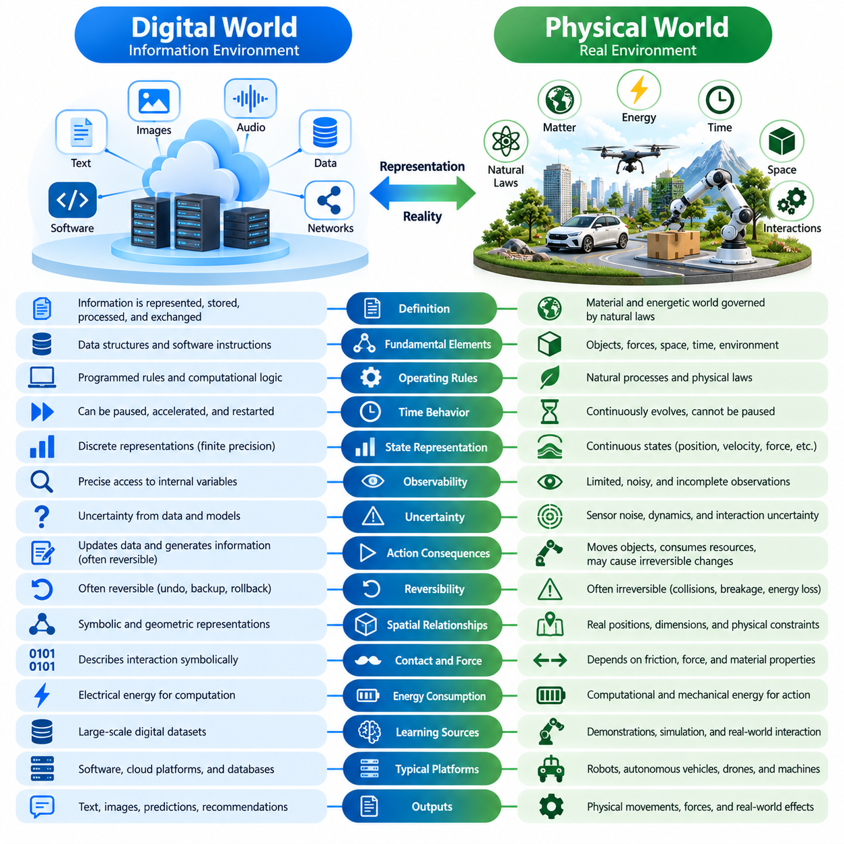
The digital world is an environment in which information is represented, stored, processed, and exchanged through computational systems. Its fundamental elements include data structures, software instructions, communication protocols, and virtual representations. Operations occur according to programmed rules and computational logic, allowing information to be manipulated without necessarily producing direct changes in physical objects or environments.
The physical world consists of matter, energy, space, time, and interactions governed by natural laws. Objects possess measurable properties such as mass, position, velocity, temperature, and mechanical resistance. Unlike digital representations, physical entities cannot be modified merely by changing symbolic descriptions. Their behavior depends on forces, environmental conditions, material properties, and the dynamics of surrounding systems.
A central difference between these environments concerns the relationship between representation and reality. In the digital world, a variable may represent an object's position, but modifying that variable does not necessarily move the object. In the physical world, changing position requires actual motion, energy expenditure, and interaction with physical constraints. Physical AI must connect internal representations with observable changes in external reality.
Digital environments are generally constructed from explicitly defined computational rules. Software developers determine how variables change, how information is accessed, and how operations are executed. Although complex digital systems can exhibit unpredictable behavior, their underlying execution follows implemented mechanisms. Physical environments instead operate according to natural processes that cannot be suspended or redefined by software instructions.
Time behaves differently across digital and physical operations. A digital simulation may be paused, accelerated, restarted, or executed repeatedly under identical initial conditions. Physical processes continue evolving even when an intelligent system stops computing. A moving obstacle does not wait for a robot to complete its calculations, making temporal awareness and timely responses essential requirements for Physical AI.
The physical world is characterized by continuous states and dynamic transitions. Position, velocity, force, and temperature may vary continuously, although sensors and computers observe them through discrete measurements. Digital systems typically represent information using finite numerical precision and discrete computational operations. Physical AI must reconcile these representations with continuous environmental changes and unavoidable measurement limitations.
Observability provides another fundamental distinction. Digital systems can often access precisely defined internal variables, databases, and computational states when appropriate interfaces and permissions exist. Physical systems rarely provide complete access to their true environmental states. Sensors capture limited, noisy, and sometimes ambiguous observations, requiring intelligent agents to estimate hidden conditions from incomplete information.
Physical environments introduce uncertainty through sensing, dynamics, and interaction. A camera may fail to detect an object because of occlusion, while a mobile robot may experience wheel slip or unexpected friction. Digital environments can also contain uncertainty, particularly in distributed systems and probabilistic models. However, Physical AI must explicitly address uncertainty arising from material behavior and imperfect physical measurements.
The consequences of actions differ significantly between digital and physical environments. A digital operation may update a database, modify a document, or generate a prediction, often allowing correction through software mechanisms. A physical action can move equipment, deform materials, consume resources, or create irreversible damage. Physical AI must therefore evaluate not only whether an action achieves its objective but also whether its consequences remain acceptable.
Reversibility is especially important when comparing these environments. Digital systems may support undo operations, backups, snapshots, and transaction rollback, although not every digital action is reversible. Physical processes frequently involve irreversible changes, including collisions, breakage, chemical reactions, and energy dissipation. Intelligent physical systems must anticipate such outcomes before executing potentially hazardous actions.
Spatial relationships are fundamental to physical intelligence. Objects occupy locations, possess dimensions, and interact through geometric and mechanical constraints. A robot navigating a warehouse must consider distances, obstacle boundaries, available clearance, and feasible trajectories. Digital systems may represent these relationships mathematically, but Physical AI must ensure that calculated spatial arrangements correspond to actual environmental conditions.
Physical interaction also requires understanding contact and force. A digital model may describe a robotic gripper closing around an object, but successful grasping depends on friction, contact geometry, applied force, and object properties. Excessive force may damage an object, while insufficient force may cause slipping. These relationships demonstrate why physical intelligence requires more than accurate symbolic or visual representations.
Energy consumption creates another important difference. Digital computation requires electrical energy, but its information-processing objectives are often evaluated separately from the energy required to change the physical environment. Physical AI must account for both computational and mechanical energy. Mobile robots, manipulators, and aerial vehicles operate under battery, actuator, thermal, and power limitations that directly influence their available actions.
Environmental variability further complicates physical operations. Lighting conditions, surface characteristics, weather, human behavior, and unexpected obstacles may change during task execution. Digital environments can reproduce selected variations through simulation or procedural generation, but real environments contain combinations that may not have been anticipated. Physical AI must maintain useful performance when operating conditions differ from those encountered during development.
Simulation provides a bridge between digital and physical environments by representing physical processes through computational models. Physics engines approximate motion, collision, friction, and other interactions, enabling virtual experimentation. However, every simulation depends on assumptions and approximations. Differences between simulated and actual conditions create a reality gap that must be addressed through validation, adaptation, and real-world testing.
Digital twins extend this relationship by maintaining computational representations of physical assets, processes, or environments. Sensor observations can update these representations, while analytical models support monitoring, prediction, and planning. Nevertheless, a digital twin remains an approximation of the physical system. Its reliability depends on data quality, synchronization, model accuracy, and the ability to represent relevant environmental changes.
Causality is essential for understanding the physical world. An action may produce effects that propagate through mechanical, electrical, thermal, or environmental processes. Physical AI must distinguish correlations observed in data from relationships that determine actual outcomes. Understanding how forces, actions, and environmental conditions influence future states supports more reliable planning and reduces dependence on superficial statistical patterns.
The digital world often permits large-scale replication of information and computational experiments. Models, datasets, and software environments can be duplicated across machines with relatively low marginal effort. Physical experimentation requires equipment, space, maintenance, and operational resources. This difference influences how Physical AI systems collect experience, evaluate alternative actions, and improve their capabilities through learning.
Interaction with humans introduces additional complexity into physical environments. Human movements, intentions, and reactions are difficult to predict precisely, particularly in shared workspaces. A service robot must account for personal space, changing pedestrian trajectories, and unexpected behavior. Unlike a purely digital interface, physical interaction involves immediate spatial and mechanical consequences that demand continuous monitoring and adaptive responses.
Real-time operation connects environmental dynamics with computational requirements. A physical agent must complete perception, state estimation, planning, and control within deadlines determined by the speed of environmental changes. Excessive processing delays can make previously valid decisions obsolete. Consequently, Physical AI architectures must coordinate computational performance with sensing frequency, communication latency, and actuator response characteristics.
Safety becomes a defining requirement when intelligence operates in physical environments. Incorrect digital outputs can cause serious informational, financial, or operational harm, but physical actions introduce additional risks involving collision, injury, and equipment damage. Physical AI therefore requires protective mechanisms, operational boundaries, fault detection, and recovery strategies that remain effective even when learned models behave unexpectedly.
The relationship between the digital and physical worlds is increasingly bidirectional. Sensors transform physical phenomena into digital observations, while actuators convert computational commands into physical effects. This continuous exchange enables intelligent machines to maintain internal representations, predict environmental changes, and adjust their actions. Reliable Physical AI depends on preserving consistency between computational understanding and actual physical conditions.
Ultimately, the distinction between the digital world and the physical world establishes the fundamental engineering challenge of Physical AI. Digital intelligence manipulates representations, whereas physical intelligence must operate through real interactions governed by natural laws. Bridging these environments requires perception, state estimation, predictive modeling, planning, control, and safety mechanisms that transform computational decisions into effective and reliable physical behavior.

02.03. Static Data vs Interactive Experience
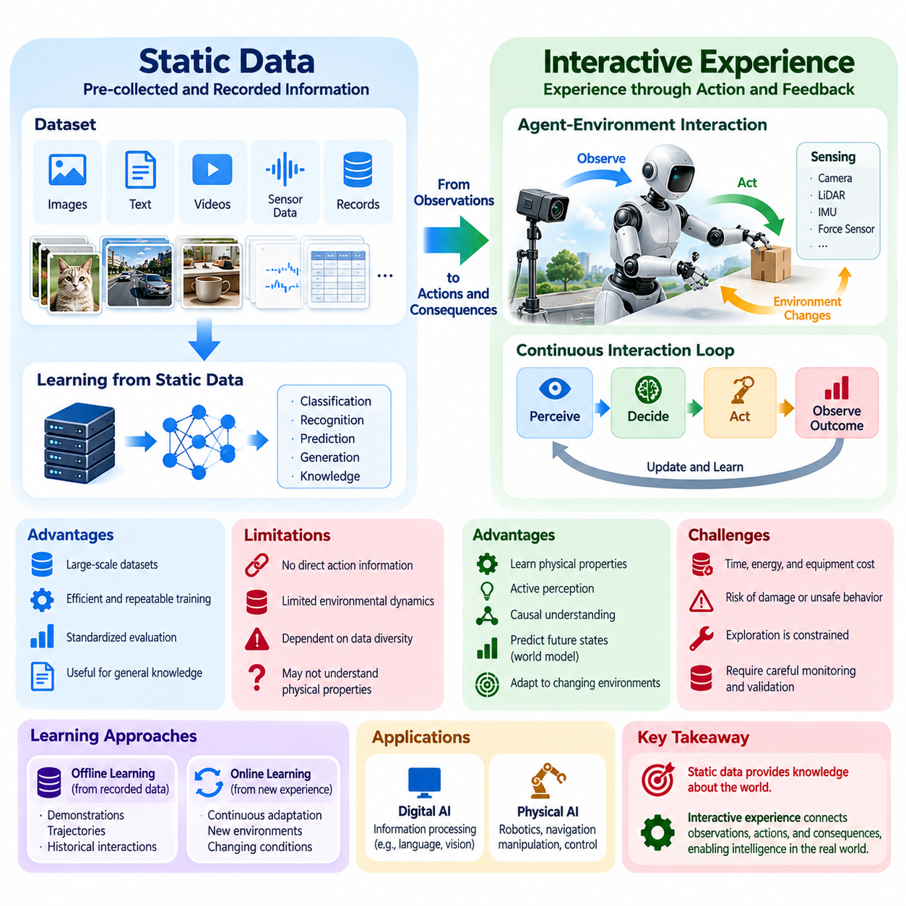
Static data refers to information collected, recorded, and stored before an artificial intelligence system performs learning or inference. Such data may include images, text, videos, sensor measurements, and structured records. Traditional machine learning frequently relies on predefined datasets in which observations are separated from the actions that originally produced them, limiting direct access to the dynamics of the environment.
Interactive experience represents information acquired through an agent's ongoing engagement with its environment. Instead of receiving observations passively, an intelligent system selects actions, observes resulting changes, and updates its understanding. This interaction creates a continuous relationship between perception, decision-making, and environmental feedback, allowing intelligence to develop through the consequences of its own behavior.
The distinction between static data and interactive experience is particularly important in Physical AI. A digital model trained on recorded images may recognize objects accurately without understanding how those objects respond to physical manipulation. A robotic agent, however, can push, lift, rotate, or grasp objects and observe the resulting motion. These experiences provide information about physical properties that visual appearance alone may not reveal.
Static datasets provide significant advantages for scalable learning. Large collections of examples can be processed repeatedly, enabling efficient optimization, reproducible experiments, and standardized evaluation. Researchers can compare algorithms using identical training and testing conditions. However, the resulting models remain dependent on the diversity, accuracy, and representativeness of the recorded observations.
Interactive learning introduces a different relationship between data and behavior. An agent's actions influence which observations become available and which situations it encounters. A mobile robot that approaches an unfamiliar obstacle obtains different information from one that remains stationary. Consequently, the learning process involves not only interpreting available data but also deciding which experiences are useful to acquire.
This ability to influence future observations is closely related to active perception. An intelligent agent may move a camera, change its viewing angle, or reposition its body to reduce uncertainty. Such behavior transforms perception from passive information reception into goal-directed information gathering. Physical AI systems can therefore improve their understanding by deliberately changing their relationship with the surrounding environment.
Interactive experience also supports learning about causality. Static observations may reveal correlations between objects, actions, and outcomes, but they do not always establish why particular events occur. Through controlled interaction, an agent can investigate how actions influence physical states. Repeated experiments involving pushing, pulling, or applying force can reveal relationships between interventions and environmental responses.
Physical interaction generates temporally connected sequences of observations, actions, and outcomes. These sequences provide information about how environmental states evolve over time. A robot learning to manipulate a container may observe its initial position, apply a force, and measure the resulting displacement. Such experience supports the development of predictive models that connect current states and selected actions with possible future states.
World models provide a framework for transforming interactive experience into predictive intelligence. A world model estimates how an environment may change under different actions and conditions. Training data may include recorded trajectories, simulated interactions, and real-world observations. By learning action-dependent transitions, Physical AI systems can evaluate potential consequences before executing actions in the physical environment.
Reinforcement learning illustrates the importance of interactive experience in intelligent behavior. An agent selects actions, receives observations and rewards, and adjusts its policy according to accumulated experience. Unlike supervised learning based primarily on fixed input-output examples, reinforcement learning explicitly considers how decisions influence future states and rewards. This makes it relevant to navigation, manipulation, locomotion, and adaptive control.
Nevertheless, interactive learning introduces substantial practical challenges. Physical experiments consume time, energy, and equipment resources, while unsuccessful actions may damage objects or create safety hazards. A robot cannot explore every possible behavior without considering operational constraints. Consequently, effective Physical AI development must balance the informational benefits of interaction against the cost and risk of obtaining new experience.
Offline learning provides an important mechanism for reducing these costs. Robotic systems can learn from previously collected demonstrations, trajectories, and interaction records without continuously operating physical hardware. Offline reinforcement learning and imitation learning can extract useful behavior from historical experience. However, their performance may deteriorate when deployed in situations that differ substantially from the available training data.
Online learning allows an intelligent system to update its behavior using newly acquired experience during operation. This capability can support adaptation to changing environments, unfamiliar objects, and variations in physical dynamics. However, continuous adaptation must be carefully controlled because unverified model updates may introduce unexpected behavior. Safe deployment requires monitoring, validation, and restrictions on potentially hazardous exploration.
Simulation offers a practical environment for generating interactive experience at scale. Virtual agents can execute large numbers of actions, encounter varied conditions, and collect state-transition data without exposing physical equipment to immediate risk. Parallel simulation can accelerate learning and support systematic exploration. Nevertheless, differences between simulated dynamics and real-world behavior must be addressed before transferring learned policies.
The combination of static datasets and interactive experience creates a more comprehensive learning strategy. Static data provides broad coverage of previously observed situations, while interaction supplies targeted evidence about uncertain or unfamiliar conditions. A robot may initially learn object recognition from recorded images and subsequently refine its manipulation strategy through physical trials. These learning processes are complementary rather than mutually exclusive.
Human demonstrations represent another bridge between recorded data and interactive intelligence. Teleoperation and direct demonstrations provide examples of successful actions in realistic environments. Such records contain relationships between observations, decisions, and physical outcomes. A robot can use these examples to initialize its behavior, reducing the amount of exploration required before performing useful tasks independently.
Interactive experience is especially valuable when an environment contains hidden physical properties. Visual observations may not reveal an object's mass, friction coefficient, stiffness, or stability. A robot may need to apply a small controlled force to estimate whether an object can be moved safely. These interactions demonstrate how physical intelligence depends on gathering information through action rather than relying exclusively on appearance.
Exploration strategies determine how an agent acquires informative experience. Random exploration may reveal unfamiliar conditions but can be inefficient or unsafe in physical environments. Goal-directed exploration selects actions that reduce uncertainty or improve expected task performance. Active learning and uncertainty-aware planning can help prioritize interactions that provide useful information while respecting operational and safety constraints.
Experience also supports adaptation to differences between individual robotic platforms. Two robots with similar mechanical designs may exhibit variations in actuator response, sensor calibration, friction, or payload characteristics. Recorded training data may not fully represent these differences. Through controlled interaction, each platform can estimate relevant operating characteristics and adjust its behavior to improve accuracy and reliability.
Long-term autonomy requires more than collecting isolated experiences. Physical AI systems must organize observations and outcomes into representations that support memory, prediction, and future decision-making. Experience accumulated across repeated tasks can reveal persistent environmental patterns and recurring failures. Effective memory mechanisms allow an agent to reuse relevant knowledge instead of repeatedly rediscovering the same physical relationships.
Fleet-scale learning extends interactive experience beyond a single robot. Multiple robotic systems can collect observations and action outcomes across different environments, tasks, and operating conditions. Aggregating these experiences may improve the robustness and generalization of shared models. However, differences in hardware, data quality, environmental context, and operational policies must be considered when transferring knowledge between platforms.
Evaluation methods must also distinguish performance on static datasets from competence during physical interaction. High prediction accuracy on recorded observations does not guarantee successful behavior when an agent changes its environment. Interactive evaluation examines task completion, adaptation, recovery from disturbances, and the consequences of actions over time. These measurements provide a more direct assessment of whether learned intelligence supports reliable physical operation.
The transition from static data toward interactive experience reflects a broader evolution in artificial intelligence. Rather than treating intelligence solely as the extraction of patterns from recorded information, Physical AI emphasizes learning through observation, intervention, feedback, and adaptation. Static datasets remain essential for scalable training, but interactive experience connects learned representations with the causal and dynamic properties of physical environments.
Ultimately, static data and interactive experience form complementary foundations for Physical AI. Static data enables broad knowledge acquisition and efficient model development, while interactive experience enables agents to discover how their actions influence the world. Their integration supports systems that can recognize conditions, predict outcomes, adapt to uncertainty, and improve through controlled physical interaction, transforming passive pattern recognition into increasingly capable embodied intelligence.

02.04. Passive Inference vs Active Interaction
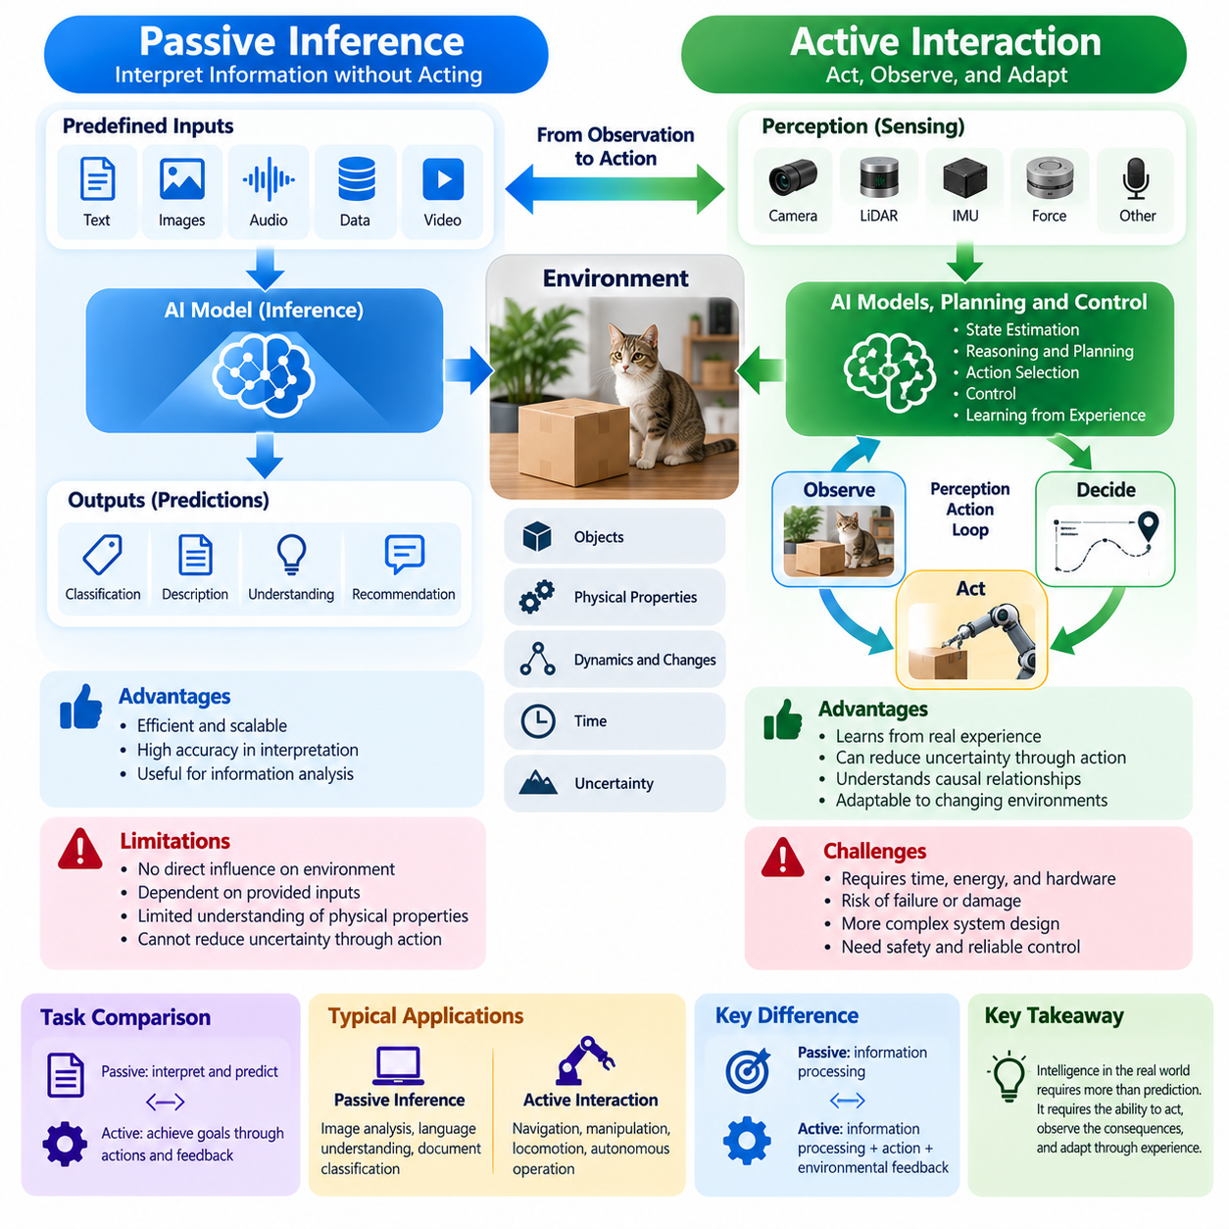
Passive inference refers to an artificial intelligence system's ability to interpret information and generate predictions without directly influencing the environment from which the information originates. The system receives predefined inputs, processes them through computational models, and produces outputs such as classifications, descriptions, or recommendations. Its intelligence is primarily expressed through information processing rather than environmental intervention.
Active interaction extends intelligence beyond observation and prediction by enabling an agent to perform actions that influence its surroundings. The agent selects behaviors, observes their consequences, and adjusts subsequent decisions according to environmental feedback. This process establishes a continuous relationship between perception, reasoning, action, and learning, allowing intelligence to operate within changing physical conditions.
The distinction between passive inference and active interaction is fundamental to Physical AI. A vision model may identify a door, estimate its location, and classify whether it appears open or closed. A robotic agent must additionally determine how to approach the door, manipulate its handle, apply appropriate force, and verify the resulting movement. Physical competence therefore requires connecting perceptual understanding with executable actions.
Passive inference commonly assumes that observations are provided independently of the model's immediate decisions. Images, documents, and sensor recordings may be analyzed without modifying their original sources. Active interaction introduces a different dependency because an agent's actions influence future observations. Moving toward an object, changing a camera angle, or touching a surface can reveal information that was previously unavailable.
This relationship between action and observation is central to active perception. An intelligent agent may deliberately reposition its sensors or body to improve visibility, resolve ambiguity, or reduce uncertainty. A mobile robot encountering a partially occluded obstacle can move sideways to obtain a clearer view. Instead of accepting incomplete observations, the system actively changes its sensing conditions to support better decisions.
Active interaction also requires reasoning about action consequences. A passive model may predict that an object is fragile based on its appearance, while a physical agent must consider how much force can safely be applied. The agent may use tactile sensing, controlled motion, and feedback to refine its estimate. Such interactions connect abstract predictions with measurable physical responses and operational constraints.
The perception-action loop provides the basic operational structure for active Physical AI. Sensors collect observations, computational models estimate environmental states, and decision-making mechanisms select actions. Actuators execute these decisions, producing changes that generate new observations. Repeated execution of this loop allows the system to correct errors, respond to disturbances, and maintain goal-directed behavior.
Passive inference can be highly effective when the task requires interpretation rather than intervention. Medical image analysis, document classification, language translation, and visual recognition can produce valuable results without direct physical control. However, tasks involving navigation, manipulation, locomotion, and autonomous operation require decisions to be evaluated through their effects on the environment rather than through predictions alone.
Active interaction introduces temporal dependencies that are less prominent in isolated inference tasks. An action changes the conditions under which subsequent decisions are made, creating sequences of interconnected states and outcomes. A robot navigating around an obstacle must continuously update its trajectory as new information becomes available. Earlier actions influence both the agent's current position and its future opportunities.
Uncertainty further differentiates passive inference from active interaction. Passive systems typically estimate uncertainty from available observations and learned statistical relationships. Active agents can sometimes reduce uncertainty through purposeful actions. A robot may approach an unfamiliar object to inspect its geometry or apply a small force to estimate its mobility, transforming uncertainty reduction into an explicit behavioral objective.
This capability is closely related to information-gathering actions and exploration. An agent may select an action not because it immediately advances the primary task, but because it improves knowledge needed for later decisions. Such behavior requires balancing task progress against information value, execution cost, and safety. Active Physical AI therefore integrates decision-making about both physical objectives and the acquisition of useful observations.
Causal understanding becomes increasingly important when intelligence directly influences the environment. Passive inference may identify correlations between observed conditions and outcomes without establishing how interventions produce changes. Active interaction allows agents to examine the effects of selected actions. Controlled experiments can reveal how applied forces, movements, or environmental modifications influence subsequent physical states.
World models support active interaction by predicting possible environmental responses to candidate actions. Rather than evaluating only the current observation, an agent can estimate how alternative behaviors may change future states. These predictions support planning, risk assessment, and action selection. Their reliability depends on accurate representations of physical dynamics, uncertainty, and the relationship between actions and outcomes.
Reinforcement learning provides a framework for developing policies through interaction. An agent executes actions, observes state transitions, receives rewards, and adjusts its behavior to improve expected long-term performance. Unlike isolated prediction tasks, reinforcement learning evaluates decisions partly through their consequences. Its application to physical systems requires careful management of exploration, safety, and the cost of real-world experience.
Imitation learning offers another approach to acquiring interactive capabilities. A robot can learn from demonstrations containing observations and corresponding actions performed by humans or other controllers. These examples provide an initial relationship between perceived conditions and appropriate behavior. However, successful deployment still requires feedback and adaptation when the robot encounters situations that differ from those represented in demonstrations.
Active interaction is strongly influenced by embodiment. The physical structure of a robot determines which actions are possible and how those actions affect its surroundings. A wheeled robot can reposition itself to improve visibility, while a manipulator can rotate an object to inspect hidden surfaces. Aerial robots can change altitude and viewing direction. Each embodiment creates different opportunities for gathering information and influencing physical states.
Physical constraints also limit the actions available to an intelligent agent. Actuator capabilities, mechanical geometry, friction, inertia, energy availability, and environmental obstacles determine whether a proposed action can be executed. An AI model may recommend a movement that appears beneficial in an abstract representation but is mechanically infeasible. Active Physical AI must therefore integrate learned decision-making with feasible motion generation and control.
Real-time feedback is essential because physical environments evolve during action execution. A robot grasping an object may detect slipping and increase grip force within safe limits. A mobile platform may encounter an unexpected pedestrian and adjust its path. These responses require timely sensing, state estimation, and control. Delayed feedback can make an otherwise reasonable decision ineffective or hazardous.
Safety considerations become particularly significant when an agent actively changes its environment. Incorrect passive predictions can cause serious downstream consequences, but inappropriate physical actions may directly produce collisions, injuries, or equipment damage. Active Physical AI requires operational boundaries, collision avoidance, fault detection, and recovery mechanisms. Exploration and adaptation must remain subject to appropriate safety constraints.
Simulation enables active interaction to be studied without exposing physical equipment to every experimental risk. Virtual agents can execute candidate actions, observe simulated consequences, and learn policies across diverse conditions. Nevertheless, simulated interactions depend on approximations of physical reality. Policies developed in simulation require validation and adaptation before their behavior can be trusted in actual environments.
Evaluation must distinguish predictive accuracy from interactive competence. A system may correctly recognize obstacles yet fail to navigate around them safely. Similarly, identifying a graspable object does not guarantee successful manipulation. Interactive evaluation considers task completion, response to disturbances, action efficiency, recovery capability, and safety. These measures reveal whether perceptual intelligence translates into reliable physical performance.
Passive inference and active interaction should be understood as complementary capabilities rather than competing approaches. Active agents depend on inference to interpret observations, estimate states, and predict outcomes. Inference becomes part of a broader decision process when its results guide actions that subsequently modify the environment. The integration of these capabilities transforms information processing into situated, adaptive, and goal-directed physical intelligence.
Ultimately, the transition from passive inference to active interaction represents a defining characteristic of Physical AI. Intelligence is no longer evaluated solely by the accuracy of its interpretations but also by its ability to influence the world responsibly and effectively. Through continuous perception, prediction, action, and feedback, Physical AI systems can acquire information, adapt to changing conditions, and accomplish objectives that require direct engagement with physical reality.

02.05. Open Loop vs Closed Loop Intelligence
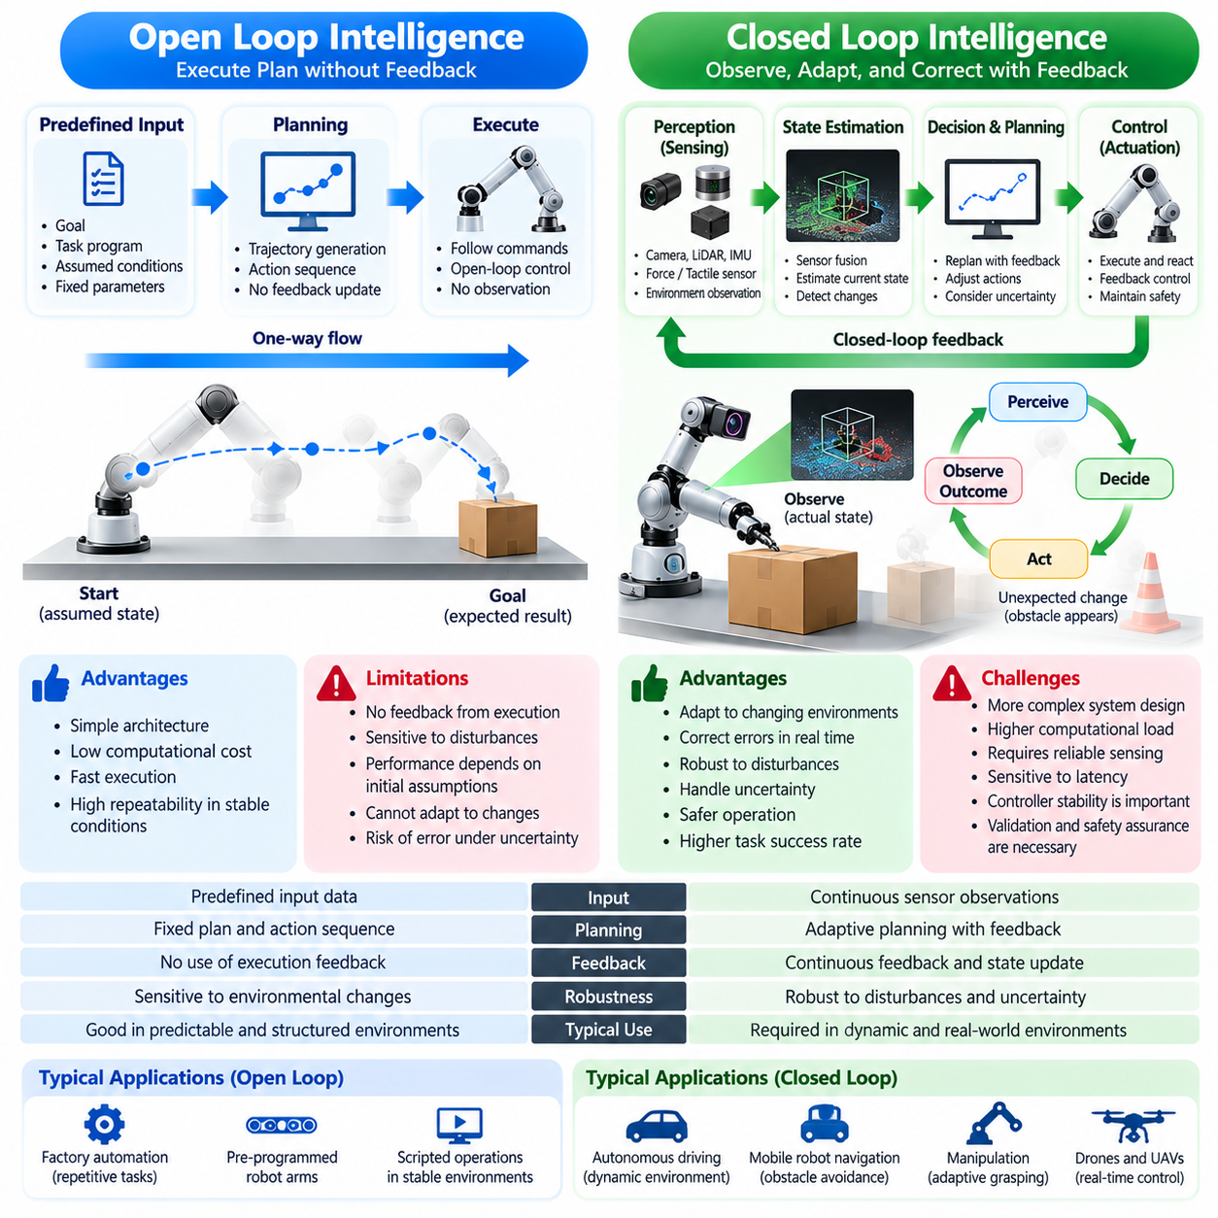
Open-loop intelligence refers to a system that generates decisions or actions without continuously using feedback from their execution to modify subsequent behavior. Once a command or action sequence is determined, the system proceeds according to its predefined plan. This approach can be effective in predictable environments, but its performance depends heavily on the accuracy of initial assumptions and the stability of operating conditions.
Closed-loop intelligence continuously incorporates observations of the environment and the consequences of previous actions into ongoing decision-making. Instead of relying exclusively on an initial plan, the system repeatedly measures relevant conditions, estimates its current state, and adjusts its behavior. This feedback-driven process enables intelligent agents to respond to disturbances, correct deviations, and adapt to changing physical circumstances.
The distinction between open-loop and closed-loop intelligence is fundamental to Physical AI because physical environments rarely remain perfectly predictable. Objects move, surfaces change, sensors produce imperfect measurements, and actuators exhibit variations in performance. A system that cannot observe the consequences of its actions may continue executing inappropriate commands, whereas feedback allows corrective behavior before deviations become excessive.
Open-loop operation commonly appears in systems that execute predetermined instructions under controlled conditions. A robotic manipulator may follow a programmed trajectory based on assumed object positions and calibrated equipment. If the environment remains consistent, the operation can achieve high repeatability. However, unexpected displacement, mechanical wear, or variations in payload characteristics may reduce accuracy without feedback-based correction.
Closed-loop operation addresses these limitations by comparing desired outcomes with measured conditions. A controller may calculate the difference between a target position and the observed position of a robotic joint. This difference, commonly described as an error signal, guides subsequent control commands. Repeated measurement and correction help the system maintain accurate behavior despite disturbances and modeling inaccuracies.
In Physical AI, feedback extends beyond conventional mechanical control. Intelligent systems may incorporate camera images, LiDAR measurements, force sensing, tactile observations, and environmental predictions into their decision-making processes. These information sources allow agents to update their understanding of objects, obstacles, and task progress. Closed-loop intelligence therefore connects perception, reasoning, planning, and action within a continuous operational cycle.
A mobile robot illustrates the practical difference between these approaches. Under open-loop navigation, the robot may execute a predetermined movement sequence without adjusting for unexpected obstacles or localization errors. Under closed-loop navigation, sensor observations continuously update its estimated position and surrounding map. The robot can then modify its trajectory, reduce speed, or stop when environmental conditions require intervention.
Manipulation tasks provide another important example. An open-loop grasping sequence may position a gripper and close its fingers according to previously calculated coordinates. A closed-loop manipulation system can monitor contact forces, finger positions, and object movement during execution. If slipping or misalignment occurs, the robot may adjust its grip or reposition the object while remaining within established safety limits.
Feedback is particularly valuable when physical systems encounter uncertainty. Sensor noise, friction variations, actuator delays, and unexpected contact can cause actual outcomes to differ from predictions. Closed-loop intelligence does not eliminate these uncertainties, but it provides mechanisms for detecting their effects and responding appropriately. Its effectiveness depends on observation quality, state estimation accuracy, and the stability of corrective actions.
State estimation is a central component of closed-loop intelligence. Physical agents rarely observe every relevant variable directly, so they must infer hidden states from available measurements and prior knowledge. Techniques such as sensor fusion, probabilistic filtering, and learned estimation models combine observations over time. The resulting state estimates provide the information required for planning and control under partial observability.
The timing of feedback strongly influences closed-loop performance. Physical environments continue evolving while measurements are collected, processed, and converted into commands. Excessive latency can cause corrective actions to arrive too late or respond to outdated conditions. Consequently, Physical AI systems must coordinate sensing frequency, computational execution, communication delays, and actuator response to maintain reliable real-time behavior.
Closed-loop systems also require careful attention to stability. Aggressive corrections may cause oscillation, overshoot, or undesirable interactions with mechanical dynamics. Feedback does not automatically guarantee better performance, particularly when measurements are noisy or control parameters are poorly selected. Reliable operation requires appropriate controller design, system identification, uncertainty management, and validation across expected operating conditions.
Predictive models can improve closed-loop intelligence by anticipating future environmental states rather than reacting only to current errors. Model predictive control evaluates possible action sequences over a limited future horizon and repeatedly updates its decisions using new observations. This approach combines prediction with feedback, enabling physical agents to consider constraints and expected consequences while adapting to changing conditions.
World models extend predictive feedback into more complex intelligent behavior. A learned world model can estimate how objects, agents, and environmental conditions may evolve in response to selected actions. By comparing predicted outcomes with subsequent observations, the system can identify discrepancies and refine future decisions. Such prediction-error feedback supports adaptive planning, although model uncertainty must remain explicitly considered.
Hierarchical architectures often combine open-loop and closed-loop processes at different levels. A high-level planner may generate a sequence of tasks, while lower-level controllers continuously regulate movement and contact. The overall task sequence may remain unchanged for a period even as individual actions are corrected through feedback. This separation supports efficient planning without sacrificing responsiveness to immediate physical conditions.
Not every action requires continuous feedback at the same frequency. Some operations can be executed reliably using predetermined commands when their dynamics and environmental conditions are sufficiently controlled. Other tasks require rapid feedback because disturbances or errors can develop quickly. Effective Physical AI architectures select appropriate feedback mechanisms according to task complexity, physical dynamics, uncertainty, and safety requirements.
Learning introduces another dimension to closed-loop intelligence. A physical agent can use differences between predicted and observed outcomes to improve its models and policies over time. Repeated interaction provides information about actuator behavior, environmental dynamics, and task effectiveness. However, immediate feedback control and long-term learning are distinct processes, and model updates must be validated before affecting safety-critical behavior.
Reinforcement learning provides a framework for developing feedback-dependent policies through interaction. An agent observes environmental states, selects actions, receives subsequent observations and rewards, and improves its policy using accumulated experience. During deployment, a learned policy may operate in closed loop by repeatedly selecting actions from updated observations. Its reliability still depends on training coverage, robustness, and appropriate safety mechanisms.
Closed-loop intelligence is essential for recovery from unexpected events. A robot may encounter a blocked passage, lose localization confidence, or fail to grasp an object successfully. Feedback allows the system to recognize that its intended outcome was not achieved and initiate corrective behavior. Depending on the situation, recovery may involve replanning, repeating a controlled action, requesting assistance, or transitioning to a safe state.
Safety considerations highlight the importance of feedback in physical systems. Monitoring sensors and runtime assurance mechanisms can detect deviations from operational boundaries and trigger protective responses. However, feedback alone cannot guarantee safety, particularly when sensors fail or control actions become unavailable. Physical AI must therefore combine closed-loop intelligence with independent safeguards, fault detection, emergency stopping, and fail-safe design.
Evaluation of open-loop and closed-loop intelligence requires examining behavior under disturbances and changing conditions. Open-loop performance may be assessed through execution accuracy under predefined assumptions, while closed-loop performance additionally considers tracking error, disturbance rejection, recovery time, stability, and task completion. Real-world testing is necessary to determine whether feedback mechanisms improve reliability across representative operating conditions.
Digital AI and Physical AI can both employ feedback, but their operational requirements frequently differ. Digital systems may revise outputs through iterative reasoning, user interaction, or software monitoring. Physical AI must additionally respond to continuously evolving environmental states and the consequences of mechanical actions. This requirement makes feedback integration a central architectural property rather than merely an optional refinement of computational outputs.
Ultimately, open-loop and closed-loop intelligence represent different relationships between decision-making and environmental feedback. Open-loop approaches execute actions primarily from prior assumptions, while closed-loop approaches continually reconcile intended outcomes with observed reality. Their appropriate integration enables Physical AI systems to combine planning efficiency with adaptability, supporting reliable, responsive, and goal-directed behavior in dynamic physical environments.

02.06. Tokens vs Physical States and Actions
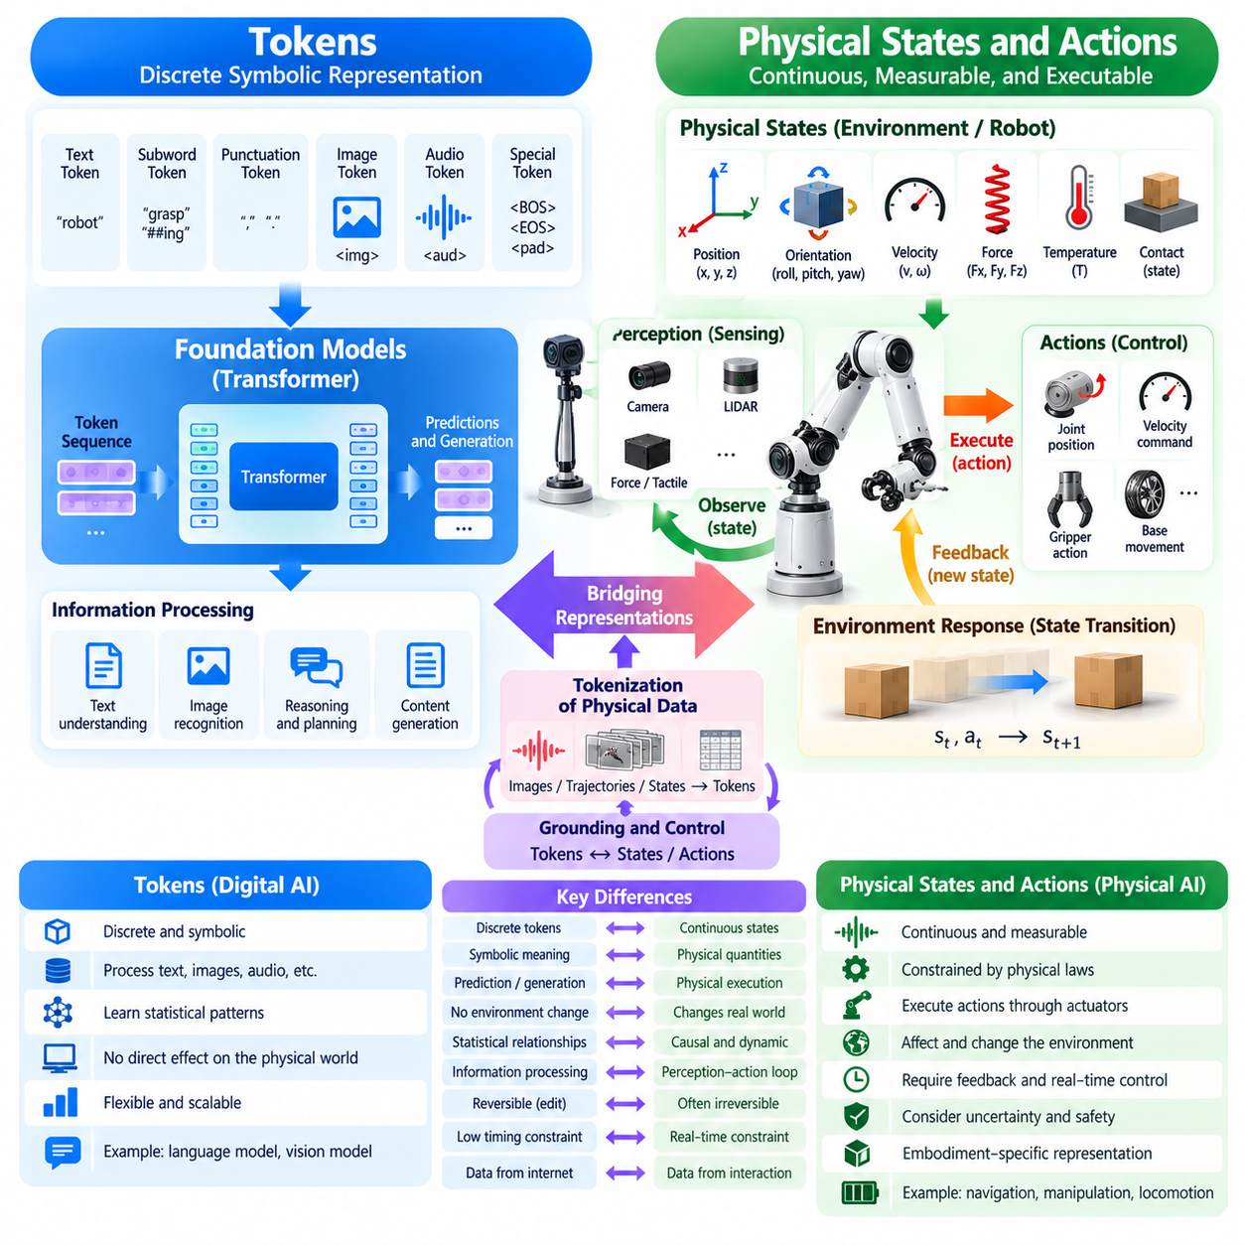
Tokens are discrete units of information used by many digital artificial intelligence systems to represent and process data. In language models, tokens may correspond to words, word fragments, punctuation, or other encoded elements. Their primary function is to transform symbolic information into computational representations that support prediction, generation, and reasoning within a digital processing environment.
Physical states describe measurable or estimated conditions of objects, agents, and environments at particular moments. These conditions may include position, orientation, velocity, acceleration, force, temperature, and contact relationships. Unlike symbolic tokens, physical states represent quantities governed by physical laws and environmental constraints. Their interpretation requires attention to measurement units, reference frames, uncertainty, and temporal evolution.
Physical actions represent interventions that change the state of an environment through mechanical or other physical processes. A robotic action may involve applying torque, moving a joint, adjusting velocity, or controlling a gripper. Actions differ from descriptive tokens because they can produce immediate consequences in the external world. Their execution depends on actuator capabilities, system dynamics, and the conditions encountered during operation.
The distinction between tokens and physical states is fundamental to understanding the transition from Digital AI to Physical AI. A language model may generate a description of how a robot should grasp an object, but that description does not itself perform the grasp. Physical execution requires translating symbolic intentions into spatially grounded commands while accounting for geometry, contact, friction, and the limitations of the robotic platform.
Token-based models typically learn statistical relationships among encoded sequences. Their predictions may represent linguistic meaning, visual patterns, or other abstract structures. Physical AI must additionally model relationships between observations, actions, and resulting environmental changes. These relationships are constrained by causality and dynamics, meaning that an action must be evaluated according to what it can physically accomplish.
A physical state is often represented mathematically as a vector containing variables relevant to a particular task. For a mobile robot, this representation may include position, heading, linear velocity, and angular velocity. For a manipulator, it may include joint angles, joint velocities, and end-effector pose. The appropriate state representation depends on the system's embodiment, available sensors, and control objectives.
Physical actions can similarly be expressed as structured control variables. A robot may receive desired joint positions, target velocities, torque commands, or end-effector trajectories. These commands must satisfy kinematic and dynamic constraints before execution. Even when actions are represented digitally, their significance comes from their relationship to physical mechanisms rather than from their symbolic encoding alone.
Temporal structure creates another important distinction. Token sequences commonly express relationships through ordering and contextual dependencies, while physical states evolve according to elapsed time and system dynamics. A robot's position and velocity change continuously between observations. Physical AI must therefore account for sampling intervals, control frequency, latency, and the duration of actions when interpreting or generating behavior.
Coordinate systems and measurement units are essential for physically meaningful representations. A predicted displacement has little operational value unless its direction, scale, and reference frame are defined. Similarly, a force command must correspond to appropriate units and actuator characteristics. Physical AI systems require consistent transformations between sensor coordinates, robot coordinates, and environmental reference frames to execute actions reliably.
Uncertainty affects both symbolic and physical representations, but its consequences differ. A token prediction may express uncertainty about the next element in a sequence, while a physical state estimate may contain uncertainty about an object's location or velocity. Such uncertainty directly influences collision risk, control accuracy, and task feasibility. Physical AI must propagate and manage uncertainty when selecting actions under imperfect observations.
The relationship between physical states and actions is commonly described through state-transition models. These models estimate how an environment changes when an action is applied under particular conditions. A robot pushing an object may predict its future position using information about applied force, friction, and contact geometry. Such predictions connect computational representations with the causal structure of physical interaction.
World models provide a mechanism for learning these transitions from observations and experience. A learned world model can predict possible future states conditioned on current states and candidate actions. This enables an intelligent agent to compare alternative behaviors before executing them. However, predictive accuracy depends on the model's coverage of relevant dynamics, contact conditions, and unfamiliar environmental situations.
Tokens can also encode physical information when appropriate representations are designed. Robot trajectories, joint configurations, and action commands may be discretized into sequences that transformer-based models can process. Such representations support the integration of language, vision, and action within shared computational architectures. Nevertheless, converting physical variables into tokens does not remove the underlying requirements of physical consistency and control.
Vision-language-action models illustrate the connection between symbolic and physical representations. These models combine visual observations and language instructions to generate actions or action representations for robotic systems. A command such as placing an object on a shelf must be translated into spatial reasoning, motion planning, and executable control. Successful behavior requires grounding learned representations in the robot's actual environment and capabilities.
Action tokenization introduces important design tradeoffs. Discrete action representations may simplify sequence modeling and support large-scale training, but quantization can reduce precision or obscure continuous relationships. Continuous action representations can preserve numerical detail but may require different prediction and optimization mechanisms. The appropriate approach depends on task requirements, actuator resolution, model architecture, and feedback availability.
Embodiment determines how abstract action representations become executable behavior. The same instruction may require different joint movements for a wheeled manipulator, a humanoid robot, or a quadruped equipped with an arm. Each platform has distinct kinematic structures, workspace limitations, and control characteristics. Physical AI must therefore map high-level intentions into platform-specific actions that remain feasible and safe.
Closed-loop control connects generated actions with observed physical states. After an action is executed, sensors measure the resulting conditions and provide information for subsequent decisions. This process allows the system to correct deviations between intended and actual outcomes. Without feedback, a sequence of plausible action tokens may produce unreliable behavior when real-world dynamics differ from the assumptions used during generation.
Physical constraints must be considered throughout action generation. Collision boundaries, joint limits, maximum torque, payload capacity, and environmental obstacles restrict the set of permissible behaviors. A model may generate an action sequence that appears logically consistent but violates mechanical feasibility. Constraint-aware planning and control are therefore necessary to convert computational predictions into physically valid execution.
Safety further distinguishes physical actions from ordinary symbolic outputs. An incorrect textual prediction may misinform a user, while an inappropriate actuator command can directly cause collision, instability, or equipment damage. Physical AI requires mechanisms for validating proposed actions, monitoring execution, and transitioning to safe states when necessary. These safeguards must operate independently of the apparent confidence of a generative model.
Training Physical AI requires datasets that preserve relationships among observations, states, actions, and outcomes. Static images or textual descriptions alone may not contain sufficient information about the consequences of physical intervention. Robotic demonstrations, sensor trajectories, and interaction recordings provide richer supervision. Their usefulness depends on accurate synchronization, calibration, action definitions, and representation of environmental context.
Evaluation must also move beyond conventional token prediction accuracy. A model may predict plausible action sequences while failing to complete physical tasks reliably. Physical AI evaluation considers task success, trajectory accuracy, contact stability, execution efficiency, and recovery from disturbances. These measurements establish whether generated representations correspond to effective behavior rather than merely statistically likely outputs.
The integration of tokens with physical states and actions enables a broader form of machine intelligence. Symbolic representations support language understanding, abstract reasoning, and high-level task specification, while physical representations support spatial awareness, dynamic prediction, and executable control. Connecting these capabilities allows intelligent systems to translate human intentions into actions grounded in measurable environmental conditions.
Ultimately, the distinction is not that tokens belong exclusively to Digital AI while physical states and actions belong exclusively to Physical AI. Tokens can encode physical variables, and physical agents routinely use digital representations. The defining difference is whether computational outputs remain symbolic predictions or become grounded decisions whose consequences must satisfy physical laws, operational constraints, and real-world feedback.

02.07. Offline Inference vs Real Time Operation
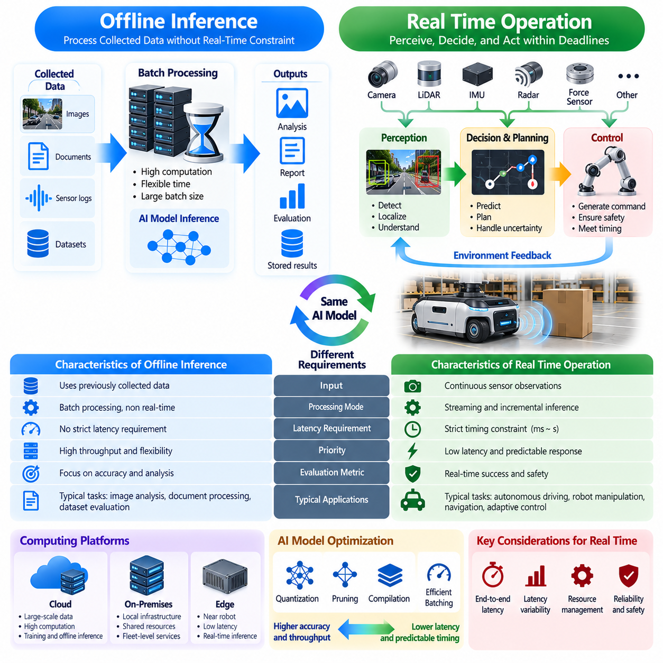
Offline inference refers to the execution of artificial intelligence models on previously collected inputs without requiring immediate responses to a continuously changing environment. Data can be processed in batches, and computational resources may be allocated according to throughput or analytical requirements. This approach supports extensive reasoning and evaluation, but its outputs are not necessarily constrained by strict operational deadlines.
Real-time operation requires an intelligent system to perceive conditions, make decisions, and execute actions within defined timing constraints. In Physical AI, delayed decisions can become ineffective because objects, robots, and environmental conditions continue changing. The usefulness of an output therefore depends not only on its accuracy but also on whether it arrives early enough to influence the physical process safely.
Offline inference commonly supports image analysis, document processing, dataset evaluation, and retrospective sensor interpretation. These applications may tolerate variable processing times because their inputs remain available for repeated examination. A model can analyze complex information without directly controlling an ongoing physical process. Consequently, computational accuracy and throughput often receive greater emphasis than immediate response timing.
Physical AI introduces operational requirements that cannot be satisfied through computational accuracy alone. A mobile robot approaching an obstacle must identify the hazard and initiate an appropriate response before reaching it. A manipulator handling a fragile object must adjust contact forces before damage occurs. These situations require sensing, inference, planning, and control to operate within deadlines established by physical dynamics.
Real-time computing distinguishes between producing a correct result and producing that result within an acceptable time interval. A late control command may be functionally incorrect even when its numerical value is accurate. Hard real-time systems require deadlines to be met under specified assumptions, while soft real-time systems tolerate occasional delays with reduced performance. Physical AI architectures may contain both categories.
Latency represents the elapsed time between an event, observation, or request and the corresponding system response. In robotic systems, total latency may include sensor acquisition, data transmission, preprocessing, model inference, planning, communication, and actuator execution. Each stage contributes to the delay between environmental change and physical reaction, making end-to-end latency more important than inference time alone.
Throughput and latency describe different computational properties. Throughput measures the quantity of work completed over time, while latency measures the delay associated with an individual operation. Batch processing can improve accelerator utilization and overall throughput but may increase waiting time for individual observations. Real-time Physical AI must balance these properties according to task deadlines and available computational resources.
Timing variability is another critical consideration. A model may exhibit acceptable average inference latency while occasionally producing unusually slow responses. Such variations can disrupt control cycles and reduce operational predictability. Evaluating real-time performance therefore requires examining worst-case execution time, latency distributions, scheduling interference, and deadline violations rather than relying exclusively on average benchmark results.
Physical AI systems frequently employ multiple computational rates because different functions have different timing requirements. Motor control may require rapid periodic updates, while object recognition, semantic mapping, and task planning may operate less frequently. These functions must exchange information without allowing slower computations to block time-sensitive control. Appropriate scheduling and architectural separation help maintain predictable operation.
Edge computing plays an important role in reducing communication delays and dependence on remote infrastructure. Processing sensor observations near the robotic platform can support faster responses and continued operation during network disruptions. Cloud resources remain valuable for large-scale training, historical analysis, and computationally intensive planning. However, functions requiring immediate physical intervention should not depend on unpredictable network round trips.
On-premises computing provides an intermediate deployment option between embedded devices and remote cloud infrastructure. Local servers can support shared perception, coordination, and computationally demanding models across multiple robots. Nevertheless, local networking still introduces communication delays and potential failures. System designers must determine which decisions can be centralized and which require independent execution near the actuators.
Real-time inference also depends on predictable memory and computational behavior. Dynamic memory allocation, resource contention, excessive data copying, and unpredictable accelerator scheduling can introduce delays. Model optimization techniques such as quantization, pruning, compilation, and efficient batching may reduce computational requirements. Their benefits must be evaluated against possible changes in accuracy, numerical stability, and execution predictability.
Hardware acceleration can improve the responsiveness of complex perception and decision models. GPUs, neural processing units, and specialized inference accelerators enable parallel execution of computationally intensive operations. However, accelerator performance depends on memory bandwidth, model structure, kernel scheduling, and concurrent workloads. High peak computational capability does not automatically guarantee deterministic real-time execution.
Closed-loop control makes timing constraints particularly important because each action depends on updated observations. A delayed state estimate may cause the controller to respond to conditions that no longer exist. Prediction can partially compensate for known delays by estimating the system's state at the expected execution time. Nevertheless, excessive or unpredictable latency can undermine stability, tracking accuracy, and disturbance rejection.
World models and predictive planning can improve real-time decision-making by anticipating future physical states. Instead of waiting for an event to occur, a robot may estimate possible trajectories and prepare suitable responses. Model predictive control repeatedly evaluates candidate actions over a finite horizon. Practical implementations must limit computational complexity so that planning completes before the next required control decision.
Real-time operation often requires graceful degradation when computational resources become insufficient. A robot may reduce perception resolution, switch to a smaller model, simplify planning, or temporarily restrict movement. These adaptations should preserve essential safety functions while reducing computational demand. Critical protective mechanisms must remain available even when advanced intelligence components experience delays or failures.
Sensor synchronization is essential when observations originate from devices operating at different frequencies. Cameras, LiDAR, inertial sensors, and joint encoders may produce measurements with distinct timestamps and communication delays. Combining inconsistent observations can create inaccurate state estimates. Time synchronization, buffering, interpolation, and timestamp-aware sensor fusion help maintain coherent representations of the physical environment.
Real-time systems must also address stale information. An object location estimated several hundred milliseconds earlier may no longer represent its current position. Physical AI should track the age and validity of observations, predictions, and commands. When information exceeds acceptable freshness limits, the system may need to request updated measurements, reduce operating speed, or transition to a safer control mode.
Power and thermal constraints further complicate real-time inference on embedded robotic platforms. Sustained computation consumes energy and generates heat, potentially causing frequency throttling or reduced operating duration. Model selection must therefore consider sustained performance rather than short benchmark peaks. Efficient architectures balance inference quality, response time, power consumption, and thermal stability under realistic workloads.
Safety-critical operation requires timing failures to be treated as operational hazards rather than merely performance problems. Missing a deadline may prevent collision avoidance, force limitation, or emergency response from functioning as intended. Runtime monitoring can detect excessive latency and trigger predefined protective actions. Safety functions should be designed with appropriate independence from computationally intensive AI components.
Testing real-time Physical AI requires representative workloads and realistic operating conditions. Laboratory benchmarks should measure end-to-end response times, deadline compliance, scheduling jitter, and behavior under computational overload. Hardware-in-the-loop testing can expose interactions among software, sensors, controllers, and actuators. Field validation remains necessary because environmental complexity and concurrent workloads can reveal delays absent from isolated tests.
Offline inference and real-time operation are complementary rather than mutually exclusive. Offline processing can support model development, dataset analysis, policy optimization, and retrospective failure investigation. Real-time execution applies validated intelligence to continuously evolving physical situations. A practical Physical AI architecture may use offline computation to improve models while maintaining predictable online control through carefully managed deployment mechanisms.
Ultimately, the transition from offline inference to real-time operation changes how artificial intelligence performance must be evaluated. Prediction quality remains important, but timely execution, computational predictability, feedback responsiveness, and operational safety become equally essential. Physical AI achieves reliable autonomy when its intelligence can generate appropriate decisions within the time available for those decisions to produce meaningful physical effects.

02.08. Digital Error vs Physical Failure
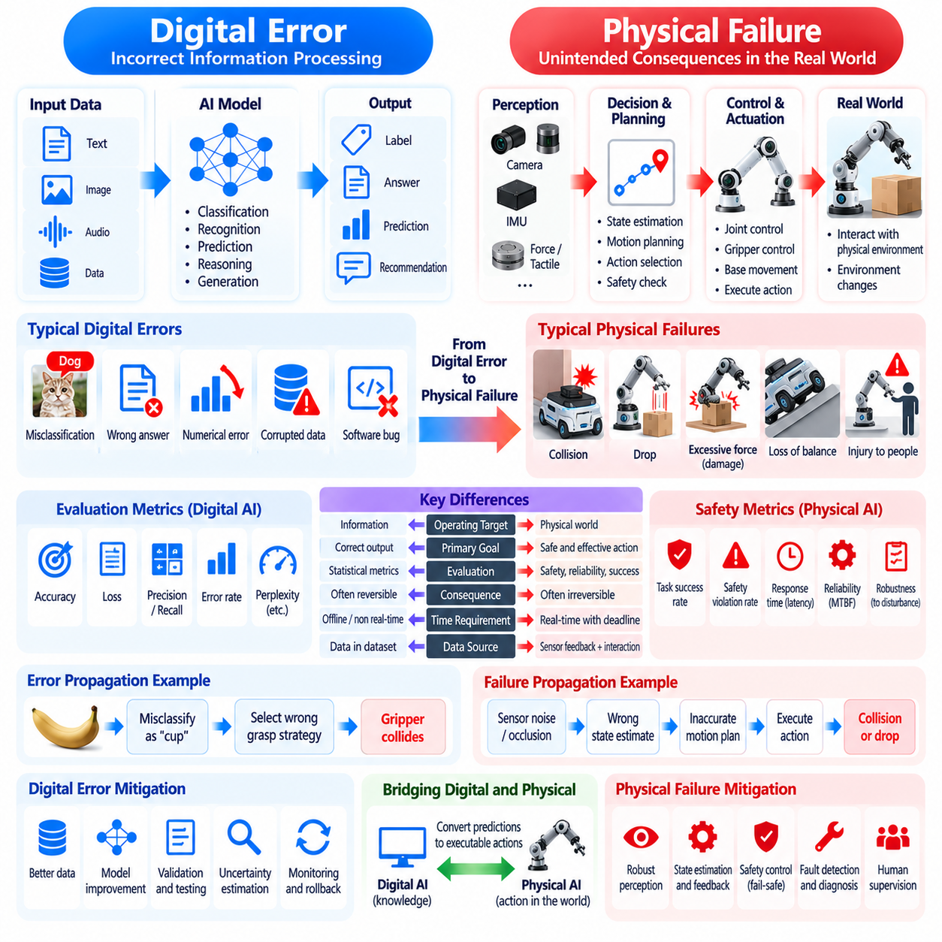
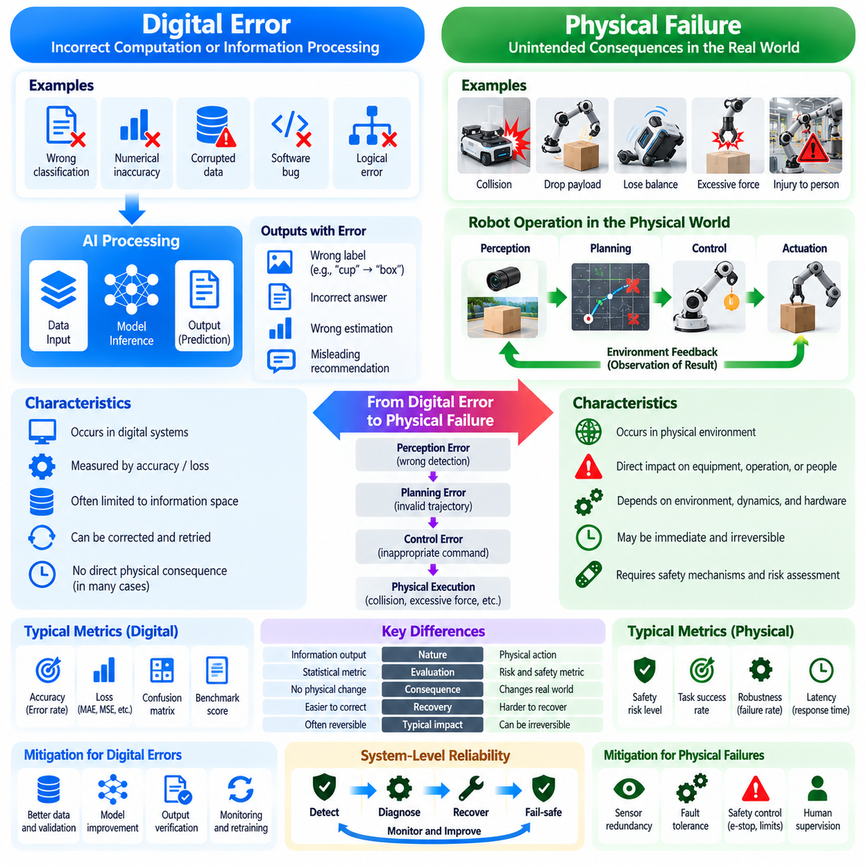
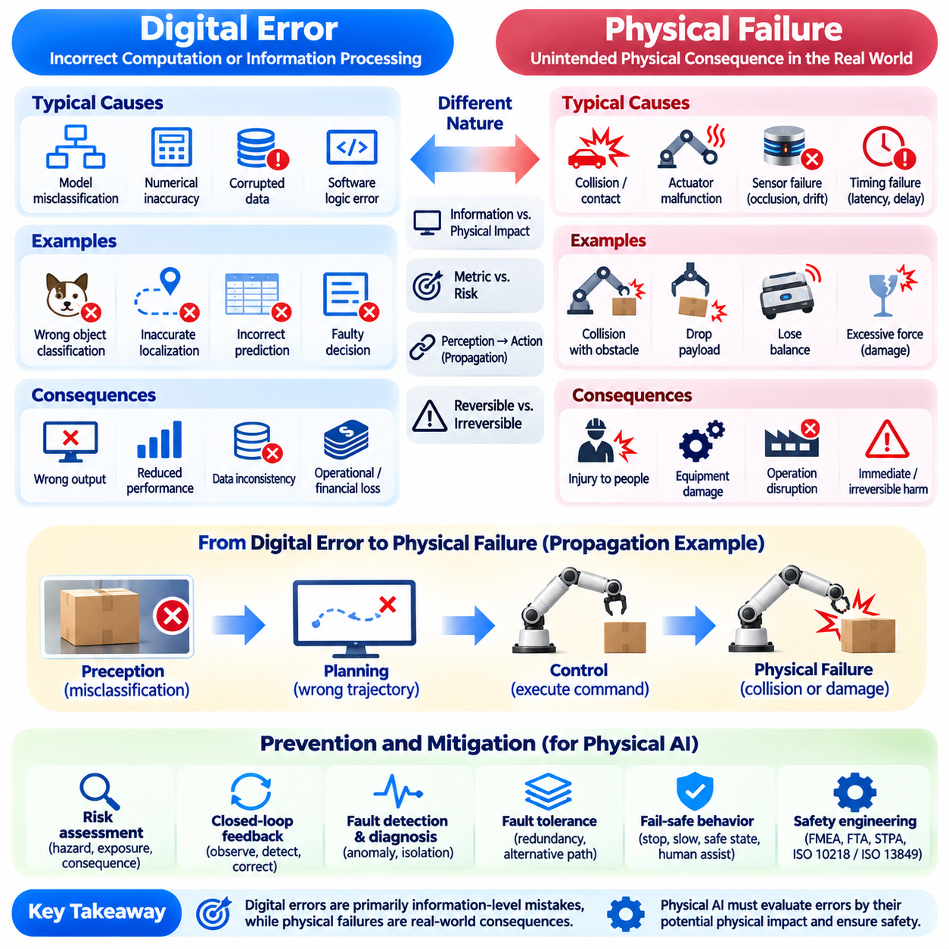
Digital errors occur when computational systems produce incorrect outputs, process information inaccurately, or fail to execute intended software operations. Such errors may involve classification mistakes, numerical inaccuracies, corrupted data, or faulty logical decisions. Their consequences often remain within digital environments, although errors in critical information systems can also cause substantial financial, operational, or societal harm.
Physical failures arise when an intelligent system's actions or component malfunctions produce unintended consequences in the physical world. A robot may collide with an obstacle, drop a payload, lose balance, or apply excessive force. Unlike purely informational errors, these events can directly damage equipment, disrupt operations, or injure people. Their consequences may be immediate, irreversible, and difficult to contain.
The distinction between digital error and physical failure is fundamental to Physical AI because computational decisions become connected to real-world mechanisms. An incorrect object classification may remain a prediction error in an offline dataset. However, if the same classification guides a robotic gripper, it may cause an inappropriate grasp or collision. Physical AI therefore requires evaluating errors according to their potential operational consequences.
Digital AI systems are commonly evaluated using prediction accuracy, loss functions, and statistical error metrics. These measures quantify differences between model outputs and expected results. Although useful, they do not directly express the severity of physical consequences. Two predictions with similar numerical errors may create dramatically different risks when translated into robotic actions under different environmental conditions.
Physical failure analysis must consider the relationship between hazards, exposure, and consequences. A minor localization error may be harmless in an open workspace but dangerous near a person or an unprotected edge. Similarly, a small force estimation error may be tolerable when handling robust objects but unacceptable during delicate manipulation. Risk assessment must therefore incorporate operating context rather than prediction error alone.
Errors can propagate through interconnected Physical AI components. A camera calibration error may distort object localization, causing a planner to generate an inaccurate trajectory. A controller may then execute commands that produce unintended contact. This sequence demonstrates how an initially small computational discrepancy can develop into a physical failure when perception, planning, and control operate without adequate verification.
Sensor failures introduce another important source of risk. Cameras may experience occlusion, LiDAR measurements may become unreliable, and inertial sensors may develop bias or drift. These conditions can produce inaccurate estimates of environmental states. A robust Physical AI system must detect inconsistent measurements, estimate uncertainty, and avoid treating unreliable sensor information as unquestionable evidence.
Actuator and mechanical failures create hazards that cannot be explained solely through model accuracy. Motors may overheat, brakes may malfunction, joints may become obstructed, and mechanical components may wear over time. Even a correct AI decision can fail when physical execution mechanisms behave unexpectedly. Reliable autonomy therefore depends on monitoring hardware health and coordinating intelligence with mechanical protection systems.
Timing failures can also transform otherwise valid decisions into dangerous actions. A collision avoidance command may be correct when generated but ineffective if it reaches the actuator too late. Network delays, overloaded processors, and scheduling interruptions can cause such failures. Physical AI must evaluate deadline compliance and end-to-end response time alongside the logical correctness of its decisions.
Closed-loop feedback helps reduce the consequences of computational errors by comparing intended outcomes with observed physical behavior. A robot may detect unexpected motion, excessive force, or trajectory deviation and initiate corrective action. However, feedback cannot eliminate every failure, particularly when sensors are unavailable or disturbances evolve faster than the system can respond. Independent protective mechanisms remain necessary.
Fault detection and diagnosis provide mechanisms for identifying abnormal system behavior. Monitoring algorithms may compare sensor measurements, model predictions, and expected actuator responses to identify inconsistencies. Once a fault is detected, the system can isolate affected components or modify its operating mode. Effective diagnosis must distinguish genuine failures from normal environmental variation and measurement noise.
Fault tolerance enables a system to maintain essential functions despite certain component failures. Redundant sensors, alternative communication paths, and backup control mechanisms can improve resilience. Nevertheless, redundancy is effective only when failures are sufficiently independent. Shared power supplies, common software defects, or environmental disturbances may disable multiple redundant components simultaneously.
Fail-safe behavior is particularly important when continued operation cannot be guaranteed. A robot may reduce speed, stop movement, release or retain a payload according to the hazard, or request human assistance. The appropriate response depends on the system's mechanical configuration and operating environment. A safe state must be defined through hazard analysis rather than assuming that immediate shutdown is always harmless.
Safety engineering provides structured methods for understanding how failures may occur and how their consequences can be controlled. Hazard analysis, failure mode and effects analysis, and fault tree analysis examine potential failure mechanisms and their relationships. These approaches complement AI model evaluation by addressing system-level risks that may not be visible through prediction benchmarks or software testing alone.
Functional safety focuses on safety-related functions that respond correctly to hazardous conditions and specified failures. Relevant engineering frameworks include IEC 61508 and application-specific standards where applicable. However, standards compliance cannot be inferred from model performance alone. Safety claims require documented requirements, appropriate architectural measures, verification evidence, and validation under defined operating conditions.
Physical AI also encounters hazards arising from intended functionality rather than component malfunction. A perception system may operate as designed but fail to recognize an unfamiliar object under unusual lighting. An autonomous planner may choose a technically feasible maneuver that is unsafe in an unexpected scenario. Safety of the intended functionality therefore requires examining performance limitations, foreseeable misuse, and insufficient environmental understanding.
Uncertainty management is essential for preventing computational mistakes from becoming physical failures. Confidence estimates, uncertainty-aware planning, and operational restrictions can reduce exposure to poorly understood situations. A robot may slow down when localization confidence decreases or avoid manipulating an object whose properties remain uncertain. Such responses connect model uncertainty with explicit operational risk controls.
Simulation supports failure analysis by allowing engineers to examine hazardous scenarios without exposing people or equipment to every experimental risk. Disturbances, sensor faults, actuator limitations, and unexpected obstacles can be introduced systematically. However, simulated environments cannot perfectly reproduce all real-world failure mechanisms. Physical testing remains necessary to establish confidence in system behavior.
Hardware-in-the-loop testing connects actual control hardware with simulated physical processes. This approach can reveal communication faults, timing problems, controller instability, and integration errors before full deployment. Fault injection can further evaluate whether monitoring and recovery mechanisms respond appropriately. Test coverage should reflect identified hazards, expected operating conditions, and credible failure combinations.
Operational monitoring extends safety assurance beyond initial deployment. Physical AI systems may encounter changing environments, hardware degradation, software updates, and unfamiliar interactions. Continuous collection of diagnostic information can reveal emerging failure patterns and support preventive maintenance. However, operational data must be interpreted carefully because the absence of recorded incidents does not establish the absence of risk.
Human oversight remains important when automated recovery cannot resolve uncertain or hazardous situations. Operators may need to review abnormal events, authorize restricted actions, or intervene when system confidence becomes insufficient. Effective human-machine interaction requires clear status information and predictable escalation procedures. Human intervention must also be designed around realistic response times and operator capabilities.
Evaluation of Physical AI should distinguish computational correctness, task reliability, and operational safety. Prediction accuracy measures one aspect of intelligence, while task success evaluates whether intended objectives are achieved. Safety assessment examines whether unacceptable consequences are prevented or adequately controlled. These dimensions are related but cannot be substituted for one another.
Ultimately, digital errors and physical failures differ primarily in how computational imperfections interact with real-world consequences. A Physical AI system must not only generate accurate predictions but also prevent errors from propagating into hazardous actions. Integrating robust perception, dependable control, fault management, and systematic safety engineering enables intelligent machines to operate responsibly in environments where mistakes have tangible consequences.

02.09. Latency Power and Compute Constraints
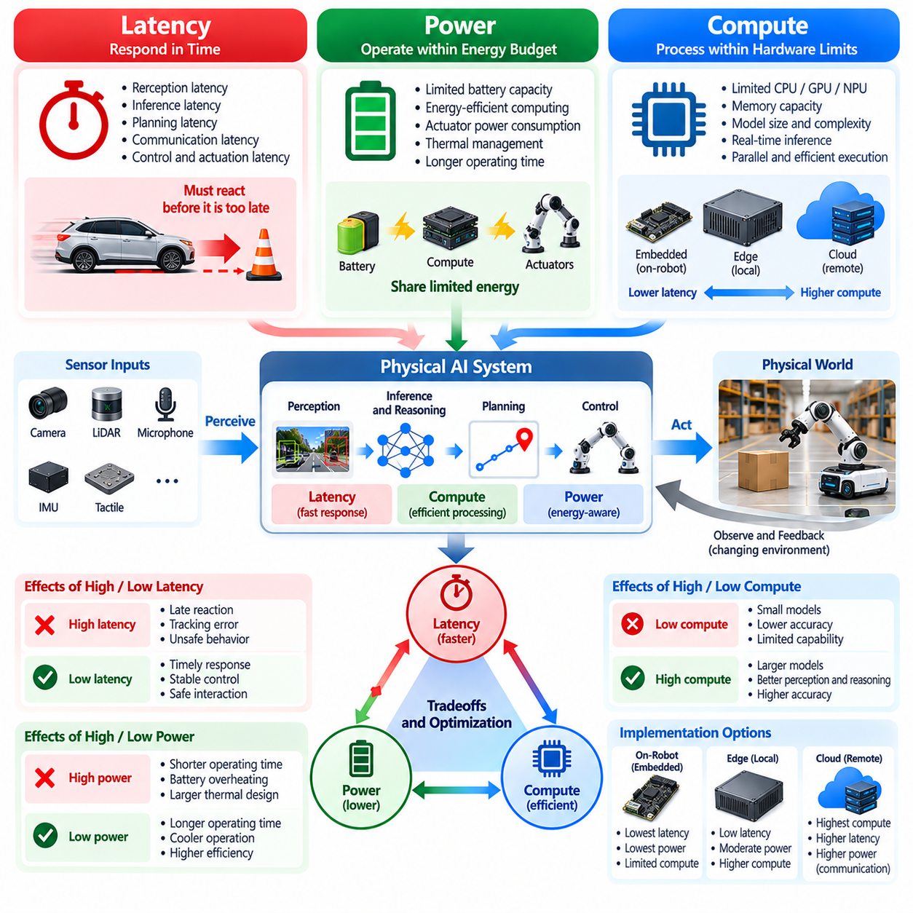
Latency, power consumption, and computational capacity are fundamental constraints that distinguish Physical AI from many conventional Digital AI applications. A digital model may prioritize prediction accuracy while operating on remote servers with substantial resources. Physical AI must generate useful decisions within limited time, energy, and hardware budgets while interacting with a continuously changing physical environment.
Latency describes the delay between observing an event and producing an appropriate response. In robotics, this delay includes sensor acquisition, preprocessing, inference, planning, communication, and actuator execution. Each stage contributes to the total reaction time. Even highly accurate predictions can become ineffective when the environment changes faster than the system can respond.
Power consumption determines how long an autonomous machine can operate and how much computation it can sustain. Mobile robots, drones, and wearable devices frequently depend on batteries with limited energy capacity. Computing hardware competes with motors, sensors, communication modules, and auxiliary equipment for available power. Energy efficiency is therefore an architectural requirement rather than merely an optimization preference.
Computational constraints arise from limitations in processing throughput, memory capacity, memory bandwidth, and accelerator availability. Physical AI systems may simultaneously execute perception, localization, mapping, prediction, planning, and control. These workloads compete for shared resources and may interfere with one another. Effective system design requires allocating computational capacity according to operational priorities and timing requirements.
Latency and computational complexity are closely related but are not interchangeable. A model requiring fewer operations may still respond slowly because of memory transfers, inefficient kernels, or scheduling delays. Conversely, a larger model may achieve acceptable latency through parallel processing and specialized acceleration. Performance evaluation must therefore consider complete execution pipelines rather than theoretical operation counts alone.
Real-time control introduces deadlines that constrain how computational resources can be used. A robot may need to update motor commands at a fixed frequency while running slower perception and planning processes. Missing a control deadline can degrade stability or tracking performance. Physical AI architectures must isolate time-critical functions from workloads whose execution times vary significantly.
Power and latency often create competing design objectives. Increasing processor frequency or accelerator utilization may reduce inference time while increasing energy consumption and heat generation. Lowering power consumption can extend battery life but may reduce computational responsiveness. The optimal configuration depends on operating duration, task complexity, safety requirements, and available thermal capacity.
Thermal constraints are particularly important in compact robotic platforms. High-performance processors and accelerators generate heat during sustained inference workloads. Limited cooling capacity can trigger thermal throttling, reducing processing speed and increasing latency. Consequently, short benchmark results may overestimate practical performance. Sustained operation must be evaluated under realistic environmental temperatures and mechanical configurations.
Edge computing reduces dependence on remote infrastructure by placing computational resources near sensors and actuators. Local processing can decrease communication latency and maintain essential functionality during network disruptions. However, embedded edge devices have limited power and cooling budgets. Selecting appropriate models requires balancing local inference capability with energy efficiency and dependable response timing.
On-premises infrastructure can provide additional computational capacity for groups of robots operating within a facility. Shared servers may support semantic mapping, fleet coordination, and complex environmental reasoning. Nevertheless, communication introduces delays and possible service interruptions. Immediate safety responses and essential low-level control should remain available independently of centralized computing resources.
Cloud computing offers scalable resources for model training, simulation, large-scale optimization, and historical data analysis. It can also support noncritical planning functions that tolerate communication delays. However, network round-trip time and service availability may vary unpredictably. Physical AI systems must distinguish computations suitable for remote execution from those requiring local, time-bounded processing.
Model compression provides one approach to reducing computational demands. Quantization decreases numerical precision, pruning removes selected parameters or structures, and knowledge distillation transfers capabilities into smaller models. These methods can reduce memory requirements and inference costs. Their practical value depends on preserving sufficient accuracy, numerical stability, and robustness for the intended physical tasks.
Adaptive computation allows intelligent systems to allocate resources according to environmental complexity. A robot navigating an empty corridor may require less intensive perception than one operating in a crowded workspace. Dynamic model selection, adjustable sensor resolution, and conditional processing can reduce unnecessary computation. Such adaptations must avoid compromising essential safety functions or introducing unpredictable delays.
Memory bandwidth and data movement can become significant bottlenecks even when processing units provide substantial arithmetic capability. High-resolution cameras, LiDAR sensors, and multimodal models generate large volumes of intermediate data. Repeated transfers between processors and accelerators increase latency and energy consumption. Efficient memory layouts, data reuse, and minimized copying can improve overall system responsiveness.
The relationship between sensing frequency and computational demand requires careful coordination. Increasing sensor resolution or update frequency may improve environmental awareness but also increases processing and communication workloads. Excessive data generation can overwhelm inference pipelines without providing proportional operational benefits. Sensor configurations should reflect the spatial and temporal information actually required by each task.
Energy-aware planning extends computational efficiency into physical behavior. A robot can reduce total energy consumption by selecting efficient trajectories, avoiding unnecessary acceleration, and coordinating motion with sensing and computation. The shortest geometric path is not always the most energy-efficient route. Physical AI must consider mechanical energy, computational energy, task duration, and environmental constraints together.
Resource scheduling becomes increasingly complex when multiple AI models operate concurrently. Perception networks, world models, language interfaces, and motion planners may share GPUs or other accelerators. Uncontrolled contention can cause unpredictable execution delays. Priority-aware scheduling, workload isolation, and resource reservation can help preserve the responsiveness of functions with strict timing requirements.
Reliability requires evaluating worst-case conditions rather than relying only on average performance. A system may operate efficiently under normal workloads but fail when multiple sensors generate demanding inputs simultaneously. Peak memory consumption, latency variation, thermal throttling, and power limitations must be examined together. Predictable degradation is often more valuable than occasional maximum computational performance.
Safety mechanisms must remain effective when computing resources become constrained. If an advanced perception model exceeds its processing budget, the robot may need to reduce speed or enter a restricted operating mode. Independent monitoring can detect deadline violations, resource exhaustion, or abnormal thermal conditions. Protective control functions should not depend entirely on the same overloaded components they supervise.
Hardware-software co-design provides a systematic approach to balancing computational capability and physical limitations. Model architecture, accelerator selection, sensor configuration, communication interfaces, and control software should be developed as interconnected elements. Optimizing a single component may shift bottlenecks elsewhere. System-level evaluation is necessary to achieve meaningful improvements in responsiveness and efficiency.
Benchmarking Physical AI requires measurements that reflect actual deployment conditions. Relevant metrics include end-to-end latency, sustained inference throughput, energy per inference, peak power, memory utilization, and deadline compliance. Measurements should account for concurrent workloads and actuator activity. Comparing models solely through offline accuracy or accelerator performance may produce misleading conclusions about robotic suitability.
Scalability introduces additional challenges as individual robots become part of coordinated fleets. Shared communication networks, centralized services, and distributed computing resources can experience congestion as fleet size increases. Resource allocation must accommodate both local autonomy and collective coordination. A scalable architecture should prevent increasing system complexity from undermining the responsiveness of individual machines.
Ultimately, latency, power, and compute constraints shape the practical boundaries of Physical AI intelligence. Larger models and greater computational capability do not automatically produce better physical behavior. Effective autonomy emerges when perception, reasoning, planning, and control are matched to available resources and operational deadlines. The objective is not maximum computation, but sufficient intelligence delivered reliably within physical constraints.

02.10. Safety Critical Decision Making
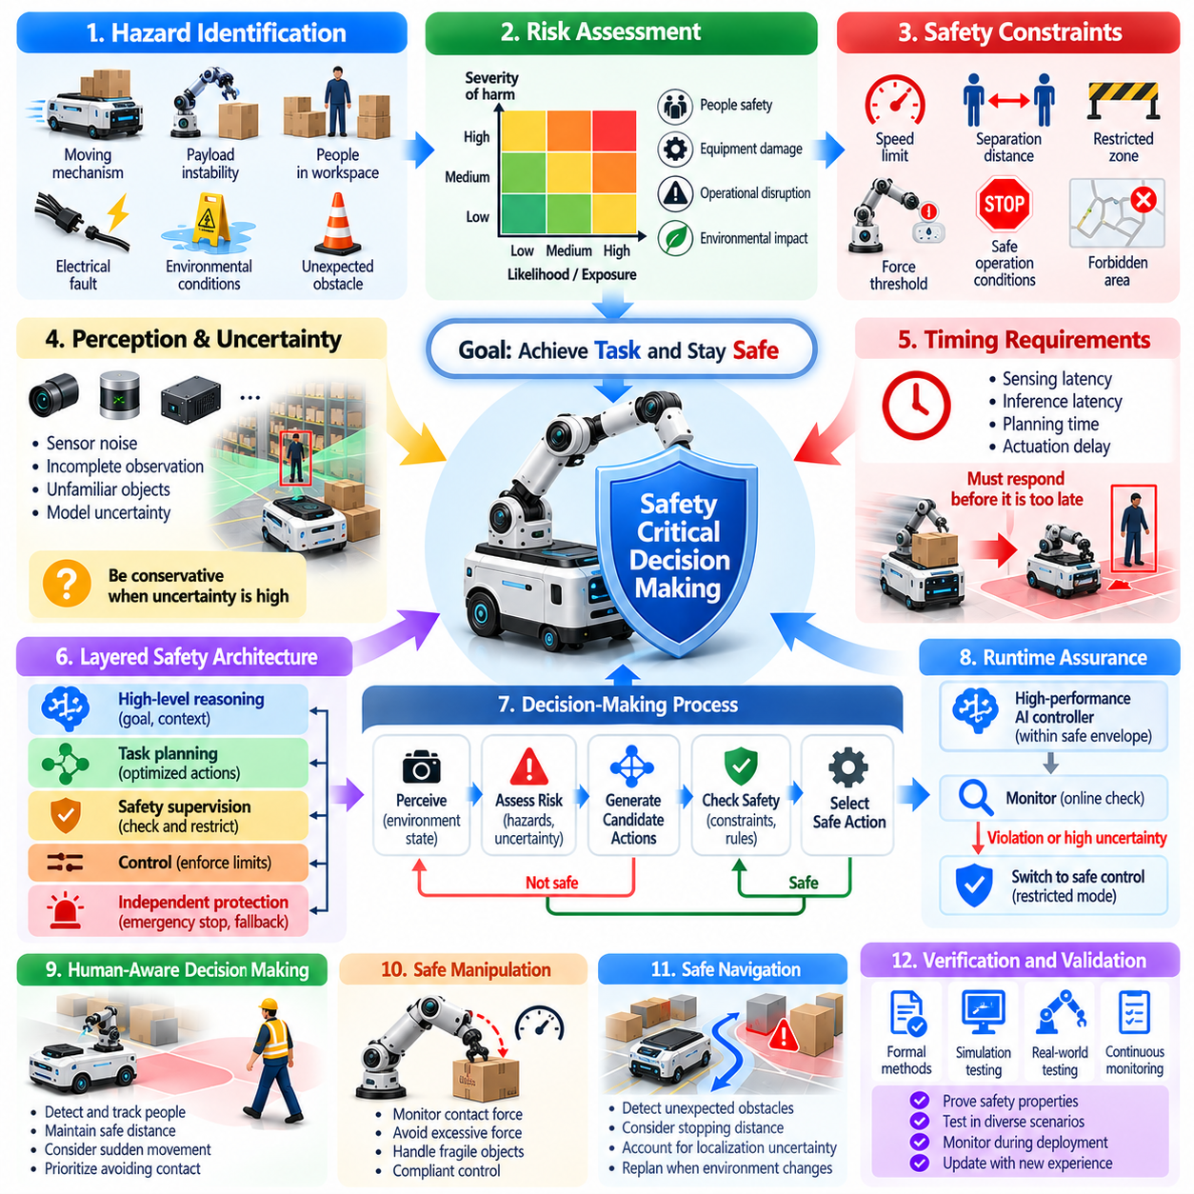
Safety-critical decision-making refers to the process of selecting actions whose consequences may affect human safety, equipment integrity, or environmental stability. In conventional Digital AI, incorrect decisions may produce inaccurate information or operational disruption. In Physical AI, decisions can directly influence moving machines and physical processes, making safety an essential requirement of intelligent behavior.
A safety-critical decision must consider not only whether an action achieves its intended objective but also whether it introduces unacceptable risk. A robot may identify an efficient route that passes dangerously close to a person. Although the route may satisfy navigation objectives, it may violate safety requirements. Physical AI must therefore evaluate task performance and safety constraints as distinct but interconnected considerations.
Hazard identification provides the foundation for safety-aware decision-making. Hazards may arise from moving mechanisms, unstable payloads, unexpected obstacles, electrical faults, or environmental conditions. Identifying these hazards requires understanding the robot's capabilities and operational context. The decision-making system must recognize situations in which otherwise normal actions could produce harmful consequences.
Risk assessment examines the potential severity of harm and the likelihood or exposure conditions associated with hazardous situations. A collision involving a lightweight robot moving slowly may present different risks from one involving a heavy industrial platform. The same action can therefore require different safeguards depending on operating speed, payload, proximity to people, and environmental characteristics.
Safety constraints define boundaries within which autonomous decisions must remain. These boundaries may include speed limits, separation distances, restricted zones, force thresholds, and permitted operating conditions. Such constraints can be incorporated into planning and control algorithms. However, their enforcement should not depend exclusively on the reliability of a single learned model.
Uncertainty is particularly important when decisions have physical consequences. Sensor noise, incomplete observations, unfamiliar objects, and imperfect models can reduce confidence in environmental understanding. A safety-aware robot should respond conservatively when uncertainty increases. It may reduce speed, enlarge obstacle margins, request additional observations, or suspend actions until conditions become sufficiently clear.
Safety-critical decisions are strongly influenced by timing requirements. An appropriate response may become ineffective if it is generated after a hazard has developed beyond the available reaction window. Emergency braking, collision avoidance, and force limitation require predictable execution times. Consequently, decision quality must be evaluated together with sensing delays, computational latency, and actuator response.
The distinction between task planning and safety supervision is central to dependable Physical AI architectures. An intelligent planner may generate actions that optimize efficiency, productivity, or task completion. A separate safety mechanism can monitor proposed commands and operating conditions. When an action violates defined constraints, the supervisory mechanism may restrict, modify, or reject its execution.
Layered safety architectures reduce dependence on individual components. High-level reasoning can evaluate goals and environmental context, while motion controllers enforce dynamic limits. Independent protective functions can monitor critical hazards and initiate predefined responses. These layers should be designed to minimize common-cause failures and preserve essential protection when advanced AI functions become unavailable.
Formal methods can support the specification and verification of safety properties. Mathematical constraints may describe allowable states, transitions, and control actions. Reachability analysis can examine whether dangerous states are accessible under particular assumptions. Such methods provide structured evidence, but their conclusions depend on the accuracy of the system models and environmental assumptions.
Runtime assurance connects intelligent decision-making with continuous safety monitoring. A high-performance AI controller may operate while its proposed actions remain within a verified operating envelope. If monitoring detects a violation or excessive uncertainty, control can transfer to a simpler, trusted mechanism. This approach allows advanced autonomy while maintaining explicit boundaries around unacceptable behavior.
Safe decision-making must account for interactions between robots and humans. Human movement is difficult to predict perfectly, particularly in shared workspaces. Robots should consider separation distance, relative velocity, visibility, and the possibility of sudden behavioral changes. Human-aware planning must prioritize avoiding harmful contact rather than assuming that predicted human trajectories will always be accurate.
Manipulation tasks introduce additional safety considerations because robots physically contact objects and their surroundings. Excessive gripping force can damage fragile materials, while insufficient force can cause dropped objects. Contact with people requires particularly careful control of force and motion. Safety-aware manipulation combines object understanding, force monitoring, compliant control, and task-specific constraints.
Mobile robots must evaluate safety in relation to changing spatial conditions. Obstacles may appear unexpectedly, pathways may become blocked, and localization uncertainty may increase. A safe navigation policy should account for stopping distance, available clearance, and feasible escape maneuvers. Route efficiency becomes secondary when continued motion would violate established safety margins.
Safety-critical decision-making also requires anticipating failures rather than responding only after they occur. Predictive models can estimate future collisions, loss of stability, or excessive actuator loading. These predictions allow preventive action before hazardous conditions become unavoidable. Nevertheless, prediction errors must be considered, and protective decisions should remain robust under plausible deviations.
Fail-safe behavior provides a response when the system cannot maintain acceptable operating conditions. Depending on the application, the robot may stop, reduce energy, engage brakes, or enter a restricted operating mode. Immediate shutdown is not universally safe, especially when supporting loads or maintaining balance. Appropriate fallback behavior must be established through system-specific hazard analysis.
Human oversight remains necessary for decisions involving ambiguous conditions or consequences beyond the system's authorized capabilities. A robot may request confirmation before entering a restricted area or manipulating an unfamiliar hazardous object. Effective oversight requires clear explanations of system status and proposed actions. Human intervention must also account for realistic operator response times.
Training safety-aware AI models requires more than demonstrations of successful task execution. Datasets should represent disturbances, near misses, uncertain observations, and operational boundaries where feasible and appropriate. Simulation can expose models to hazardous scenarios without repeatedly creating physical danger. However, training coverage alone cannot establish that unsafe actions are impossible.
Evaluation must distinguish task success from safety performance. A robot may complete an assignment while repeatedly approaching hazardous conditions. Relevant safety measures include constraint violations, minimum separation, excessive contact force, emergency interventions, and failure recovery behavior. Testing should examine rare but credible scenarios rather than relying exclusively on average operational performance.
Safety engineering frameworks provide systematic processes for defining requirements, identifying hazards, and validating protective functions. Standards such as IEC 61508 and relevant robotics-specific standards may guide particular applications. Their applicability depends on the system and operating domain. Compliance requires engineering evidence and cannot be established solely through model accuracy or successful demonstrations.
Operational safety must continue after deployment because environments, hardware conditions, and software configurations evolve. Monitoring can identify unexpected behaviors, degraded sensors, and emerging hazards. Software updates or model replacements should undergo appropriate regression testing before unrestricted operation. Safety assurance is therefore a continuing lifecycle activity rather than a one-time certification exercise.
A fundamental challenge is balancing autonomy with acceptable risk. Excessively restrictive behavior may prevent useful task execution, while aggressive optimization may expose people and equipment to unnecessary danger. Effective decision-making seeks actions that accomplish objectives within justified safety boundaries. These boundaries must reflect foreseeable hazards, operational requirements, and the consequences of failure.
Ultimately, safety-critical decision-making transforms intelligence from a capability focused on selecting effective actions into a discipline of selecting actions that are both effective and acceptably safe. Physical AI must integrate uncertainty management, predictive reasoning, constrained control, independent protection, and systematic validation. Reliable autonomy emerges when safety is embedded throughout perception, planning, execution, and operational supervision.

02.11. Embodiment as the Key Difference
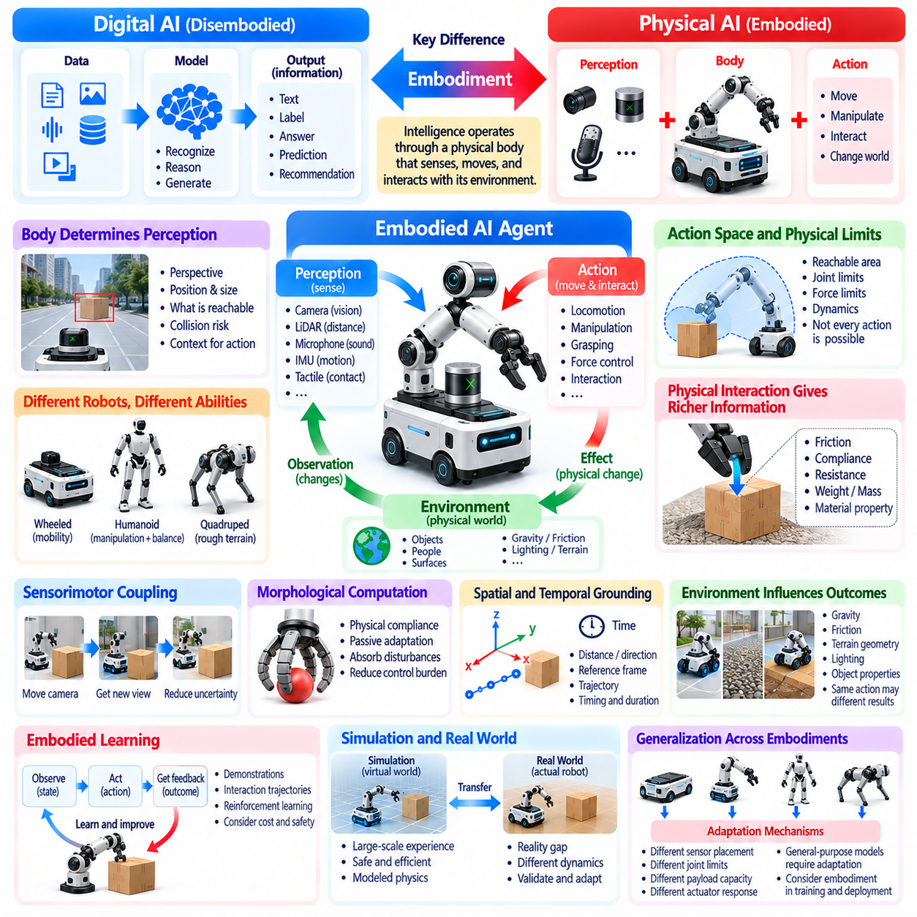
Embodiment is the condition in which intelligence operates through a physical body that senses, moves, and interacts with its environment. It represents a fundamental distinction between many Digital AI systems and Physical AI. While digital models primarily manipulate information, embodied systems must connect perception and reasoning to physical capabilities, environmental constraints, and the consequences of real-world actions.
A physical body determines how an intelligent agent can perceive and influence its surroundings. Sensors provide information about environmental conditions, while actuators enable movement and manipulation. The arrangement of these components establishes the agent's operational capabilities. Intelligence therefore cannot be considered entirely independent of the physical mechanisms through which actions are performed.
Embodiment influences the meaning of perception. A camera image may represent visual information for a digital recognition model, but an embodied robot must interpret that information relative to its own position, dimensions, and movement capabilities. An obstacle is not merely an identified object; it is a physical condition that may restrict motion, create collision risk, or require an alternative action.
The relationship between body structure and intelligence becomes evident when comparing different robotic platforms. A wheeled mobile robot, a humanoid, and a quadruped may receive identical navigation instructions but require different movement strategies. Their kinematic structures, stability characteristics, and actuator configurations determine which actions are physically feasible and how those actions must be controlled.
Embodiment also shapes the action space available to an intelligent system. A manipulator with limited joint mobility cannot execute every theoretically desirable trajectory. A mobile platform cannot traverse every surface, regardless of its planning capability. Physical AI must generate decisions within the reachable configurations, force limits, and dynamic capabilities established by the robot's mechanical design.
Physical interaction provides information that passive observation cannot always reveal. A robot may estimate an object's material or weight from visual appearance, but direct contact can reveal friction, compliance, resistance, and mass-related behavior. These properties influence how the object should be manipulated. Embodied intelligence learns not only by observing the world but also by acting upon it.
Sensorimotor coupling describes the continuous relationship between sensing and movement. An action changes the environment or the agent's viewpoint, producing new observations that influence subsequent decisions. Turning a camera, approaching an object, or adjusting a gripper can reduce uncertainty. This interaction creates a feedback process in which perception and action jointly support intelligent behavior.
The body can simplify or complicate computational reasoning through its physical characteristics. Mechanical compliance may absorb small disturbances without requiring complex corrective commands. Conversely, unstable structures may demand rapid feedback and sophisticated control. Embodied intelligence therefore emerges from the interaction of software, mechanical design, sensing, and environmental dynamics rather than computation alone.
Morphological computation describes situations in which physical structure contributes directly to useful behavior. Flexible materials, passive joints, and compliant mechanisms can distribute forces or adapt to contact through their inherent properties. Such mechanisms may reduce the burden on explicit control algorithms. However, physical adaptation does not eliminate the need for sensing, planning, and safety supervision.
Embodiment introduces spatial and temporal grounding into artificial intelligence. Concepts such as distance, direction, contact, and movement must correspond to measurable physical relationships. A command to move closer requires a reference frame, an achievable trajectory, and an understanding of obstacles. The meaning of an instruction is therefore linked to the body's ability to execute it under actual conditions.
The environment also participates in embodied intelligence by shaping the consequences of actions. Gravity, friction, terrain geometry, lighting, and object properties affect perception and movement. An action that succeeds on a smooth laboratory floor may fail on an uneven surface. Physical AI must account for these interactions instead of assuming that the same computational decision produces identical results everywhere.
Embodied learning relies on experiences connecting observations, actions, and outcomes. Robotic demonstrations and interaction trajectories provide information about how behavior changes physical states. Reinforcement learning can further associate actions with task outcomes and environmental feedback. These learning methods require careful consideration of exploration costs, equipment limitations, and the safety of physical experimentation.
Simulation offers a practical environment for developing embodied intelligence before deployment. Virtual robots can interact with modeled objects, surfaces, and forces while generating large amounts of training experience. However, differences in contact dynamics, sensor characteristics, and mechanical behavior create simulation-to-reality gaps. Successful transfer requires validation against the actual embodied system.
The same AI model may behave differently when deployed on robots with distinct physical configurations. Differences in sensor placement, joint limits, payload capacity, and actuator response affect the interpretation and execution of generated actions. General-purpose Physical AI therefore requires mechanisms for adapting learned capabilities to different embodiments without assuming identical mechanical behavior.
Embodiment also influences how robots represent their own internal states. Joint positions, velocities, actuator temperatures, battery levels, and contact forces provide information about physical capability and operating condition. An intelligent system must consider these internal variables alongside external observations. Effective decisions depend on understanding both what the environment requires and what the body can safely perform.
Human embodiment offers useful insights into the relationship between intelligence and physical experience. Human understanding of objects and spaces develops partly through movement, touch, and interaction. Robotic systems can similarly acquire task-relevant knowledge through sensorimotor experience. Nevertheless, artificial embodiment differs substantially from biological embodiment in sensing, morphology, learning mechanisms, and physical limitations.
Embodiment affects safety because actions transmit energy and forces into the environment. A robot's mass, speed, reach, and mechanical stiffness influence the consequences of unintended contact. Identical control errors may create different hazards across platforms. Safety requirements must therefore reflect physical configuration and operating context rather than relying exclusively on the quality of an AI model.
Embodied autonomy requires coordination across multiple levels of intelligence. High-level reasoning establishes goals, task planning determines feasible sequences, and low-level control produces executable commands. Sensor feedback continuously informs these processes. The physical body connects these computational levels to real-world outcomes, making integration essential for dependable autonomous operation.
Language-based intelligence can contribute to embodied systems by interpreting instructions and expressing task knowledge. However, linguistic understanding does not automatically provide motor competence or physical awareness. A robot must translate abstract commands into grounded objectives, feasible motions, and appropriate contact behavior. This translation is central to integrating foundation models with robotic execution.
Embodiment should not be understood as requiring a particular humanoid shape. Wheeled vehicles, robotic arms, quadrupeds, aerial robots, and industrial machines can all support embodied intelligence. Their bodies differ, but each establishes a specific relationship between perception, action, and environmental interaction. Physical AI encompasses this diversity rather than privileging one mechanical form.
The design of embodied systems consequently requires collaboration between artificial intelligence, robotics, mechanical engineering, and control theory. Improvements in algorithms may be ineffective if sensors cannot observe relevant conditions or actuators cannot execute required movements. Likewise, improved hardware may remain underutilized without suitable intelligence. Effective performance depends on coordinated system-level design.
Evaluating embodied intelligence requires examining actual interaction outcomes rather than abstract prediction quality alone. Relevant measures include task completion, movement accuracy, contact stability, adaptability, energy consumption, and recovery from disturbances. These outcomes reveal whether perception and reasoning translate into competent physical behavior. Evaluation must account for the characteristics of the body and its environment.
Ultimately, embodiment is a defining difference because it transforms intelligence from information processing into situated physical agency. The body determines what can be sensed, which actions are possible, and how the environment responds. Physical AI becomes meaningful when computation, perception, action, and physical structure operate as an integrated system capable of learning from and acting within the real world.

02.12. From Digital Foundation Models to Physical AI
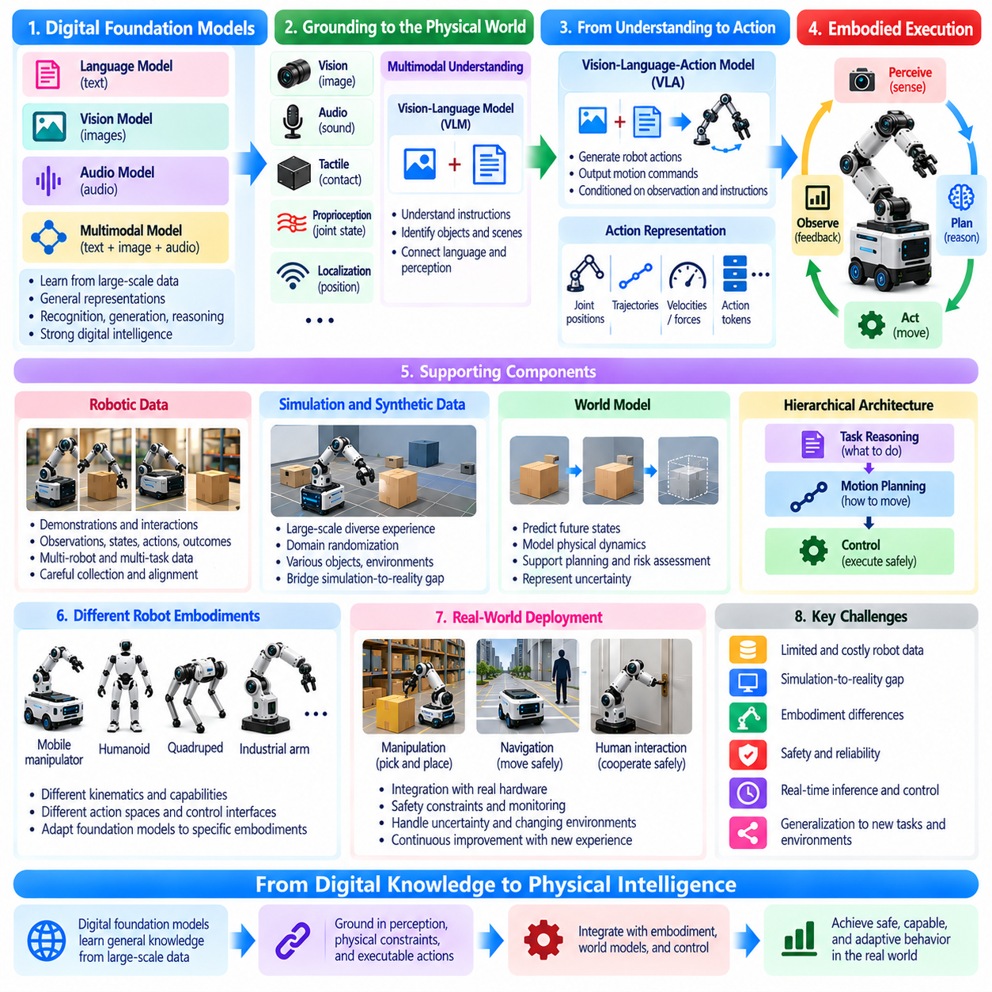
Digital foundation models have transformed artificial intelligence by learning general representations from large-scale datasets. Language models, vision models, and multimodal architectures can interpret complex information and perform diverse reasoning tasks. However, extending these capabilities into Physical AI requires more than connecting a model to a robot. Digital knowledge must become grounded in perception, physical constraints, executable actions, and environmental feedback.
Digital foundation models primarily learn statistical relationships among text, images, audio, and other information representations. These relationships support recognition, generation, classification, and abstract reasoning. Physical AI requires models to connect such representations with measurable states and physical consequences. Understanding the description of an action is fundamentally different from executing that action safely in an unpredictable environment.
The transition begins with grounding abstract concepts in sensor observations and physical states. A foundation model may recognize the phrase “pick up the object,” but a robot must identify the target, estimate its position, determine grasp feasibility, and evaluate surrounding obstacles. The command becomes meaningful only when translated into operational conditions that the robot can observe, predict, and influence through its available actuators.
Multimodal foundation models provide an important bridge between digital intelligence and physical interaction. By combining visual, linguistic, spatial, and potentially tactile information, these models can develop representations relevant to robotic tasks. Nevertheless, multimodal understanding does not automatically guarantee physical competence. The representations must support reliable state estimation, action selection, and adaptation to changing environmental conditions.
Vision-language models can associate visual observations with semantic instructions, enabling robots to interpret objects, scenes, and task objectives. A robot may use such a model to identify a requested tool or understand the intended destination of an object. However, semantic recognition alone cannot determine whether an object is reachable, whether a grasp is stable, or whether a proposed motion satisfies physical safety constraints.
Vision-language-action models extend multimodal reasoning toward the generation of robotic actions. These architectures learn relationships between observations, instructions, and action trajectories from robotic demonstrations or interaction data. Their outputs may represent motion commands, target poses, or structured action sequences. Successful deployment requires aligning these representations with specific robot embodiments and control interfaces.
Action representation is a central challenge in transferring foundation-model capabilities into physical systems. Digital models commonly operate on discrete tokens, whereas robots interact through continuous positions, velocities, forces, and actuator commands. Action tokenization, trajectory prediction, and hierarchical control provide possible interfaces between these domains. Each approach introduces tradeoffs involving precision, responsiveness, and generalization.
Embodiment creates additional requirements because different robots possess different physical capabilities. A mobile manipulator, humanoid, and industrial arm may share semantic task knowledge but cannot necessarily execute identical actions. Joint configurations, reachable workspaces, payload limits, and actuator dynamics affect execution. Foundation models must therefore distinguish transferable task understanding from embodiment-specific control.
Robotic datasets play a critical role in connecting digital representations with physical behavior. Demonstrations can provide synchronized observations, instructions, robot states, actions, and task outcomes. Such data allow models to learn relationships between environmental conditions and successful manipulation or navigation. However, dataset quality depends on temporal alignment, action consistency, sensor calibration, and coverage of relevant operating conditions.
Large-scale robotic learning faces challenges that differ from those of internet-scale language training. Physical demonstrations require equipment, operational time, maintenance, and appropriate safety precautions. Data collected from different robots may also use incompatible coordinate systems and action definitions. Effective training pipelines must normalize representations while preserving information about embodiment, dynamics, and task context.
Simulation and synthetic data can expand the diversity of experiences available to Physical AI models. Simulated environments allow repeated interaction with objects, obstacles, and physical processes without continuously operating real hardware. Domain randomization can expose models to variations in appearance, friction, geometry, and sensor characteristics. Nevertheless, simulation-to-reality differences require systematic evaluation before deployment.
World models offer another connection between foundation-model reasoning and physical intelligence. By learning representations of environmental dynamics, a world model can predict how states may evolve following candidate actions. These predictions can support planning, risk assessment, and anticipation of future outcomes. Their usefulness depends on temporal accuracy, physical consistency, and the ability to represent uncertainty under unfamiliar conditions.
Hierarchical architectures can separate abstract task reasoning from time-sensitive physical control. A foundation model may determine what objective should be achieved, while a motion planner generates feasible trajectories and a controller executes them. This separation allows semantic intelligence to operate at a different frequency from motor control. Reliable coordination requires clear interfaces, state feedback, and explicit execution constraints.
Closed-loop interaction is essential because generated plans cannot assume that the physical environment remains unchanged. Objects may move, grasp attempts may fail, and unexpected obstacles may appear. A Physical AI system must observe the consequences of its actions and revise subsequent decisions accordingly. This feedback transforms foundation-model outputs from static predictions into components of adaptive, goal-directed behavior.
Real-time constraints influence how foundation models can participate in robotic operation. Large models may require substantial computation and introduce variable inference delays. Their reasoning capabilities can be valuable for task interpretation and strategic planning, but immediate control functions require predictable timing. Efficient inference, model compression, edge acceleration, and asynchronous execution can help balance intelligence with responsiveness.
Safety remains a fundamental limitation of directly transferring digital model outputs into physical actions. A linguistically plausible instruction may correspond to an infeasible or hazardous maneuver. Physical AI architectures should validate proposed actions against geometric, dynamic, and operational constraints. Independent protective mechanisms are necessary when model uncertainty, environmental disturbances, or execution failures could produce unacceptable consequences.
Generalization is a major motivation for developing foundation models for robotics. Instead of training a separate model for every task, researchers seek reusable representations that transfer across objects, environments, and behaviors. However, success on familiar demonstrations does not establish reliability under unfamiliar physical conditions. Generalization must be evaluated through actual interaction, including disturbances, variations, and previously unseen situations.
Adaptation mechanisms can help connect general pretrained knowledge with particular robotic applications. Fine-tuning, parameter-efficient adaptation, imitation learning, and reinforcement learning can improve performance on specific tasks. These methods may incorporate demonstrations, simulation experience, or carefully controlled physical interaction. Adaptation must preserve useful general capabilities while respecting the constraints of the target platform.
Memory and persistent environmental representations can improve continuity across extended robotic tasks. A robot may need to remember object locations, completed actions, previous failures, and changing workspace conditions. Combining foundation-model reasoning with spatial memory and state tracking supports decisions that extend beyond individual observations. Such representations must be updated when new evidence contradicts earlier assumptions.
Evaluation of foundation-model-based Physical AI requires metrics beyond language accuracy or visual recognition. Task success, trajectory feasibility, contact stability, recovery behavior, latency, energy consumption, and safety violations provide evidence of practical competence. Testing should include unfamiliar environments and realistic disturbances. A model's apparent reasoning ability is insufficient unless it consistently produces appropriate physical outcomes.
The development of Physical AI foundation models also requires integration across computational infrastructure. Cloud resources can support large-scale training and simulation, while on-premises systems may coordinate shared reasoning and fleet-level services. Edge processors provide local perception and inference near robotic hardware. The allocation of responsibilities must reflect communication reliability, operational deadlines, privacy, and safety requirements.
The transition from Digital AI to Physical AI should therefore be understood as an architectural and scientific transformation rather than a simple expansion of model size. Language, vision, action, dynamics, control, and safety must become coordinated elements of a unified system. Digital foundation models provide valuable knowledge and reasoning capabilities, but physical intelligence requires those capabilities to be grounded in real-world interaction.
Ultimately, the goal is to develop systems that can understand instructions, perceive changing environments, predict physical consequences, and execute appropriate actions with dependable feedback. Foundation models may provide a common basis for increasingly general robotic intelligence. Their practical success will depend on combining learned representations with embodiment, real-time control, safety assurance, and continuous interaction with the physical world.

