Volume 03. Embodiment and Morphology

Chapter 00. Introduction

00.01. Why Embodiment Matters
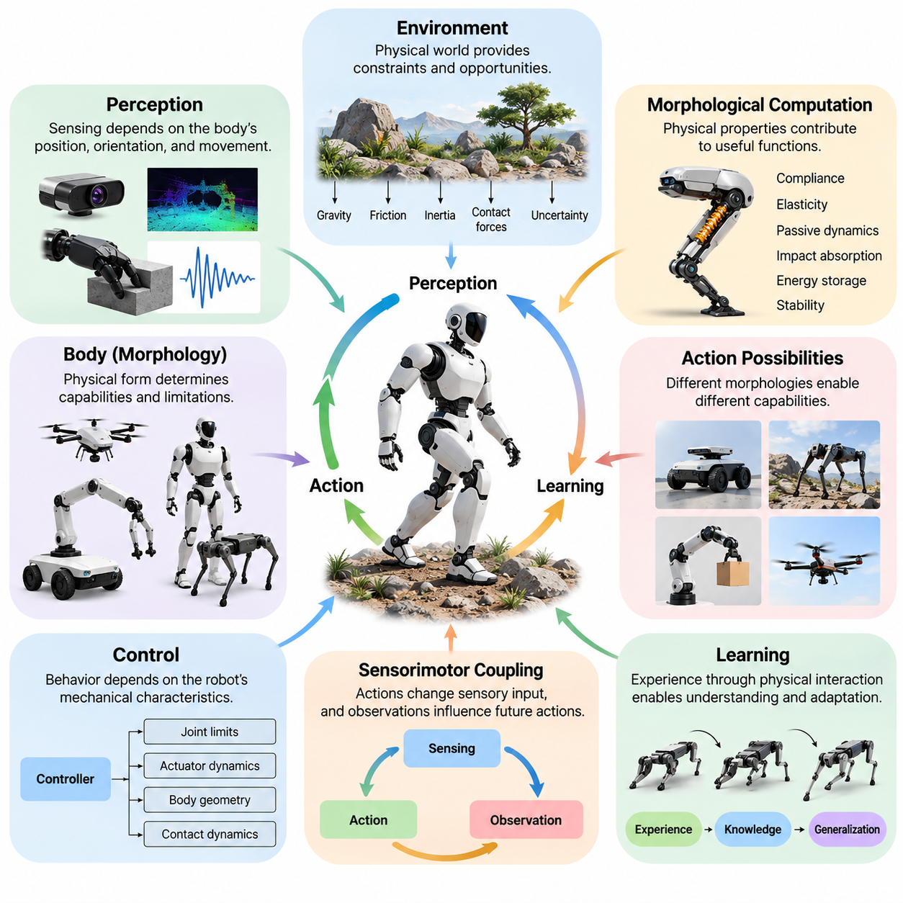
Embodiment is a fundamental principle of Physical AI because intelligence operating in the physical world cannot be separated from the body through which it perceives, acts, and interacts. Unlike purely digital systems that manipulate information within computational environments, embodied systems must continuously respond to physical constraints, environmental uncertainty, and the consequences of their actions. The body therefore becomes an essential component of intelligent behavior rather than a passive mechanism executing commands.
Traditional artificial intelligence has often treated intelligence primarily as information processing, reasoning, prediction, and decision-making. Although these capabilities remain important, physical interaction introduces additional requirements involving motion, force, balance, contact, and energy consumption. An intelligent robot must translate abstract decisions into physically feasible actions while accounting for the limitations of its mechanical structure. Embodiment connects computational intelligence with the practical realities of the physical world.
The significance of embodiment becomes apparent when considering how physical systems acquire information. Sensors do not observe the environment independently of the robot's position, orientation, and movement. A camera mounted on a mobile platform produces different observations as the platform moves, while tactile sensors reveal object properties through contact. Consequently, perception depends on the body's configuration and actions, creating a continuous relationship between sensing, movement, and environmental understanding.
Embodied intelligence emerges through the interaction of computational processes, physical structures, and environmental dynamics. A robot's behavior is influenced not only by its algorithms but also by its geometry, mass distribution, joint arrangement, actuator characteristics, and material properties. These characteristics determine which movements are possible, how forces propagate, and how effectively the system responds to disturbances. Intelligence must therefore be understood as a property of the integrated physical system.
The physical environment also contributes directly to intelligent behavior. Gravity, friction, inertia, elasticity, and contact forces influence every movement performed by an embodied agent. Rather than treating these phenomena exclusively as disturbances requiring compensation, intelligent systems can exploit them to simplify control and improve efficiency. A walking mechanism, for example, may use natural pendulum dynamics to reduce the amount of active computation and actuation required during locomotion.
This relationship introduces the concept of morphological computation, in which the body's physical properties contribute to functions that would otherwise require explicit computational control. Compliant structures can absorb impacts, elastic elements can store and release mechanical energy, and passive mechanical arrangements can stabilize movement. Such characteristics demonstrate that useful aspects of intelligent behavior may emerge from physical design rather than software alone, although active control remains essential for many tasks.
Embodiment also determines the action possibilities available to an intelligent agent. A wheeled mobile robot can efficiently navigate relatively smooth surfaces, while a quadruped can negotiate irregular terrain through coordinated leg movements. A manipulator can grasp and reposition objects within its reachable workspace, whereas an aerial robot can access locations unavailable to ground platforms. These differences illustrate how physical form shapes the operational capabilities and limitations of intelligent systems.
The relationship between morphology and behavior is particularly important because different physical configurations require different control strategies. A humanoid robot must coordinate balance, posture, and manipulation through interconnected joints, while a multirotor aircraft regulates motion by controlling aerodynamic forces and moments. Even when two robots pursue identical objectives, their feasible actions may differ substantially. Effective intelligence must therefore account for the specific mechanical characteristics of each embodiment.
Physical embodiment influences learning because the experiences available to an agent depend on its sensors, actuators, and interaction capabilities. A robot learns about surfaces through locomotion, object properties through manipulation, and environmental constraints through repeated physical encounters. These experiences provide information that cannot always be obtained through passive observation alone. Learning becomes a process of discovering relationships between actions, sensory consequences, and the physical dynamics governing interaction.
Sensorimotor coupling provides an important foundation for this learning process. When a robot moves, its actions alter the sensory information it receives, and the resulting observations influence subsequent decisions. This continuous feedback relationship enables adaptation to changing environments and uncertain conditions. Effective behavior therefore depends on coordinating perception and action over time rather than treating sensing, planning, and execution as completely independent computational stages.
Embodiment further affects the ability of intelligent systems to generalize across tasks and environments. A policy learned for one robot may not transfer directly to another robot with different joint configurations, actuator limits, or physical dimensions. Even relatively small morphological differences can alter movement dynamics and contact behavior. Cross-embodiment generalization consequently requires representations and learning methods that distinguish transferable task knowledge from platform-specific physical constraints.
The importance of embodiment becomes especially clear in manipulation tasks involving contact-rich interactions. Grasping an unfamiliar object requires coordination between perception, hand geometry, finger compliance, applied force, and feedback from contact sensors. A mechanically adaptive gripper may accommodate variations in object shape without requiring exact geometric reconstruction. This illustrates how appropriate physical design can complement intelligent control and improve robustness under uncertainty.
Embodiment also introduces important tradeoffs between flexibility, efficiency, stability, and mechanical complexity. Increasing the number of joints may expand a robot's movement capabilities while introducing additional control requirements, weight, and energy consumption. Greater structural compliance can improve impact tolerance but may reduce positioning precision. Designing an intelligent physical system therefore involves balancing competing objectives rather than maximizing a single measure of computational or mechanical performance.
Energy efficiency provides another reason why embodiment matters. Every physical action consumes resources through actuator operation, mechanical losses, sensing, and computation. Body geometry, transmission mechanisms, mass distribution, and elastic elements influence the energy required to perform a task. An appropriately designed morphology can reduce unnecessary movement and exploit passive dynamics, allowing an intelligent agent to achieve its objectives with lower power consumption and improved operational endurance.
Safety and reliability are similarly influenced by physical embodiment. Robots operating near people must manage contact forces, unexpected collisions, mechanical failures, and unstable movements. Compliant materials, suitable joint arrangements, controlled inertia, and protective structures can reduce certain physical risks. However, these features must be integrated with sensing, control, and safety mechanisms because mechanical design alone cannot guarantee safe operation in unpredictable environments.
Embodiment also provides a foundation for understanding biological intelligence. Animals demonstrate how nervous systems, musculoskeletal structures, sensory organs, and environmental interactions jointly produce adaptive behavior. Tendons store mechanical energy, flexible limbs accommodate uneven terrain, and specialized body structures support efficient movement. These biological examples inspire robotic designs that distribute functional responsibilities across computation, mechanical structure, and environmental interaction.
For Physical AI, the central implication is that intelligent behavior should not be designed exclusively at the algorithmic level. Sensors, actuators, mechanical structures, computational architectures, and control policies must be considered as interconnected elements. A change in morphology can alter perception quality, control requirements, learning efficiency, and task performance. Integrated design therefore provides a more complete engineering framework than approaches that optimize software and hardware independently.
Embodiment ultimately transforms intelligence from an abstract computational capability into an operational capacity grounded in physical interaction. A successful Physical AI system must not only interpret its environment and select appropriate actions but also execute those actions through a body governed by physical laws. Understanding embodiment is therefore essential for developing robots that are adaptive, efficient, robust, and capable of meaningful autonomous behavior across diverse real-world environments.

00.02. From Disembodied AI to Embodied Intelligence
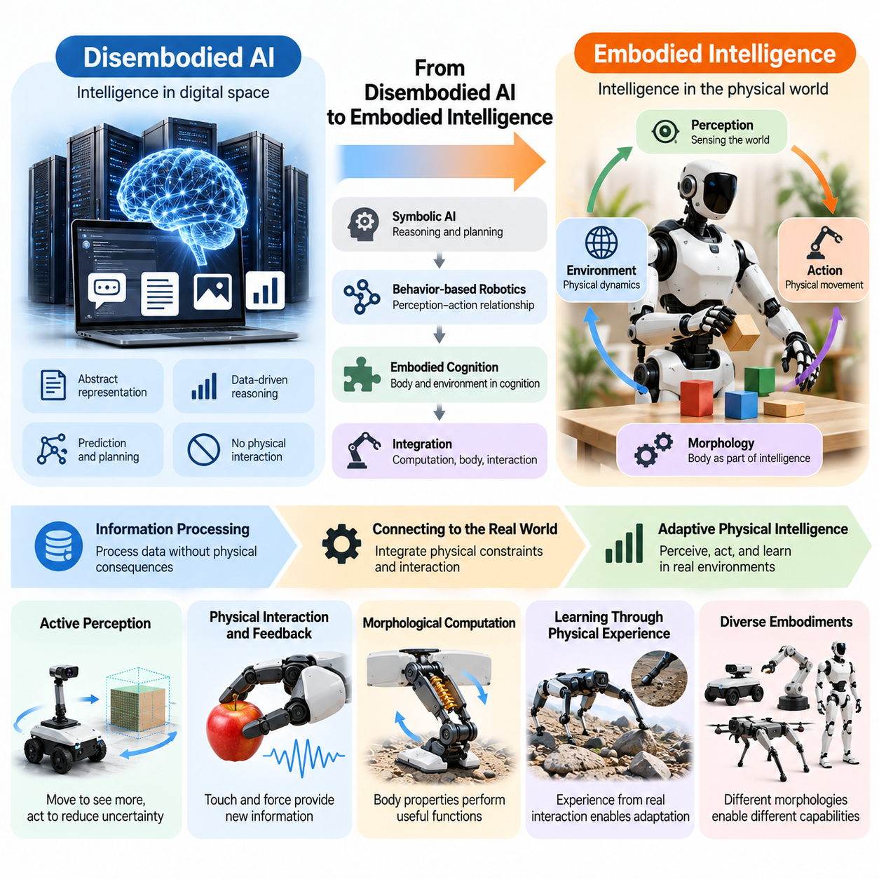
The transition from disembodied artificial intelligence to embodied intelligence represents a fundamental change in how intelligent systems are understood and developed. Traditional AI primarily operates on abstract representations, digital information, and computational reasoning. Embodied intelligence extends these capabilities into the physical world, where perception, action, mechanical structure, and environmental interaction jointly determine intelligent behavior.
Disembodied AI systems typically process information without directly experiencing the physical consequences of their decisions. Language models, recommendation systems, and conventional analytical algorithms operate through symbolic representations, statistical patterns, or digital data. Although these systems can demonstrate sophisticated reasoning and prediction, their computational processes do not inherently require a physical body or continuous interaction with real-world dynamics.
The limitations of disembodied intelligence become apparent when computational decisions must produce reliable physical actions. A system may correctly identify an object or generate a manipulation plan while remaining unable to execute the required movement. Physical execution introduces constraints involving geometry, force, friction, inertia, and uncertainty. Intelligence operating in the real world must therefore connect abstract knowledge with the capabilities and limitations of a physical body.
Embodied intelligence addresses this challenge by treating the body as an integral part of the intelligent system. Sensors provide information about the environment, actuators produce physical actions, and mechanical structures determine how those actions affect the surrounding world. Computational processes continuously interpret sensory feedback and adjust behavior. Intelligence consequently emerges through coordinated interactions among perception, control, morphology, and environmental dynamics.
Historically, artificial intelligence research emphasized symbolic reasoning, knowledge representation, planning, and logical inference. These approaches often assumed that intelligence could be modeled independently of the physical mechanisms used to perform actions. Robotics research gradually demonstrated that successful real-world behavior also depends on continuous sensing, reactive control, mechanical design, and adaptation to uncertain environmental conditions.
Behavior-based robotics contributed significantly to this conceptual transition by emphasizing direct relationships between perception and action. Rather than requiring every behavior to emerge from a complete internal representation of the world, reactive systems demonstrated that useful capabilities could arise through relatively simple sensorimotor interactions. This perspective highlighted the importance of situated behavior and challenged purely centralized models of intelligent control.
Embodied cognition further expanded this perspective by proposing that cognitive processes are influenced by bodily structure and environmental interaction. Perception, reasoning, and action are not necessarily independent stages operating within an isolated computational system. Instead, cognitive capabilities can depend on how an agent moves, senses, and physically engages with its surroundings. The body becomes an active participant in information processing and behavioral organization.
The transition also changes the meaning of perception in intelligent systems. Disembodied AI often processes previously collected images, text, or sensor recordings as fixed inputs. An embodied agent can actively change its viewpoint, reposition sensors, approach objects, and manipulate environmental conditions to obtain additional information. Perception therefore becomes an interactive process in which actions influence what the system can observe and understand.
Active perception illustrates how embodiment creates new opportunities for intelligent behavior. A mobile robot may move around an obstacle to resolve uncertainty about its shape, while a manipulator may rotate an object to inspect previously hidden surfaces. These actions are not merely consequences of perception but mechanisms for improving it. Intelligent behavior involves selecting movements that simultaneously support information gathering and task execution.
Physical interaction also introduces feedback mechanisms that are absent from many purely digital AI applications. When a robot grasps an object, tactile measurements and force responses reveal whether the grasp is stable. When a legged robot encounters uneven terrain, changes in contact forces provide information about ground conditions. Such feedback enables continuous correction and adaptation, linking decision-making directly to the physical consequences of action.
The importance of morphology becomes increasingly apparent as intelligence moves into physical systems. Body geometry, joint configuration, mass distribution, actuator placement, and material compliance influence the actions available to an agent. Two robots equipped with similar computational models may behave differently because their mechanical structures interact differently with the environment. Embodied intelligence must therefore account for physical form as a determinant of capability.
Morphological computation provides a particularly important example of how physical embodiment changes the organization of intelligence. Elastic structures, compliant mechanisms, and passive dynamics can perform useful functions without requiring explicit computational instructions for every mechanical response. A compliant gripper can adapt to object geometry, while passive mechanical elements can assist stabilization. These properties allow physical design to complement software-based intelligence.
Learning also changes when an intelligent agent possesses a body capable of interacting with the environment. Instead of relying exclusively on static datasets, embodied systems can acquire knowledge through exploration, manipulation, locomotion, and repeated experimentation. Actions generate observations that reveal physical relationships, including object resistance, surface friction, and movement constraints. Learning becomes grounded in the consequences of physical interaction.
Reinforcement learning and imitation learning provide computational approaches for developing embodied behavior. Reinforcement learning can optimize action policies through interaction and feedback, while imitation learning can transfer behavioral patterns from demonstrations. However, successful deployment requires attention to physical dynamics, actuator limitations, safety constraints, and differences between training environments and actual robotic platforms.
Simulation has become an important bridge between disembodied computation and embodied deployment. Physics-based simulators allow intelligent agents to experience approximate mechanical interactions, environmental disturbances, and contact dynamics within controlled virtual environments. These tools support large-scale experimentation and policy development, although differences between simulated and real-world conditions can limit direct transfer without additional adaptation.
Modern foundation models introduce another dimension to this transition. Language models and vision-language models provide powerful capabilities for semantic understanding, reasoning, and task interpretation. When integrated with robotic perception, planning, and control systems, these models can contribute to embodied intelligence. However, semantic competence alone does not guarantee physical competence, because reliable action requires grounding in geometry, dynamics, and real-time feedback.
Vision-language-action models represent an emerging approach to connecting high-level understanding with physical behavior. These systems attempt to map visual observations and language instructions into robot actions, often using data collected from physical demonstrations. Their effectiveness depends on the relationship between learned representations, robot morphology, available actions, and environmental conditions. Generalization across different embodiments remains an important research challenge.
The movement toward embodied intelligence also changes system evaluation. Traditional AI benchmarks frequently emphasize prediction accuracy, reasoning performance, or information retrieval. Embodied systems must additionally be evaluated through task completion, physical robustness, energy efficiency, interaction safety, and adaptation to environmental variation. Performance must be measured through actual behavior rather than computational outputs alone.
Ultimately, the transition from disembodied AI to embodied intelligence does not eliminate the importance of abstract reasoning or digital computation. Instead, it integrates these capabilities with physical structures, sensorimotor processes, and environmental dynamics. This integration provides the foundation for Physical AI systems capable of transforming knowledge into meaningful real-world actions while adapting to the constraints and opportunities created by their embodiment.

00.03. Body Brain Environment Coupling
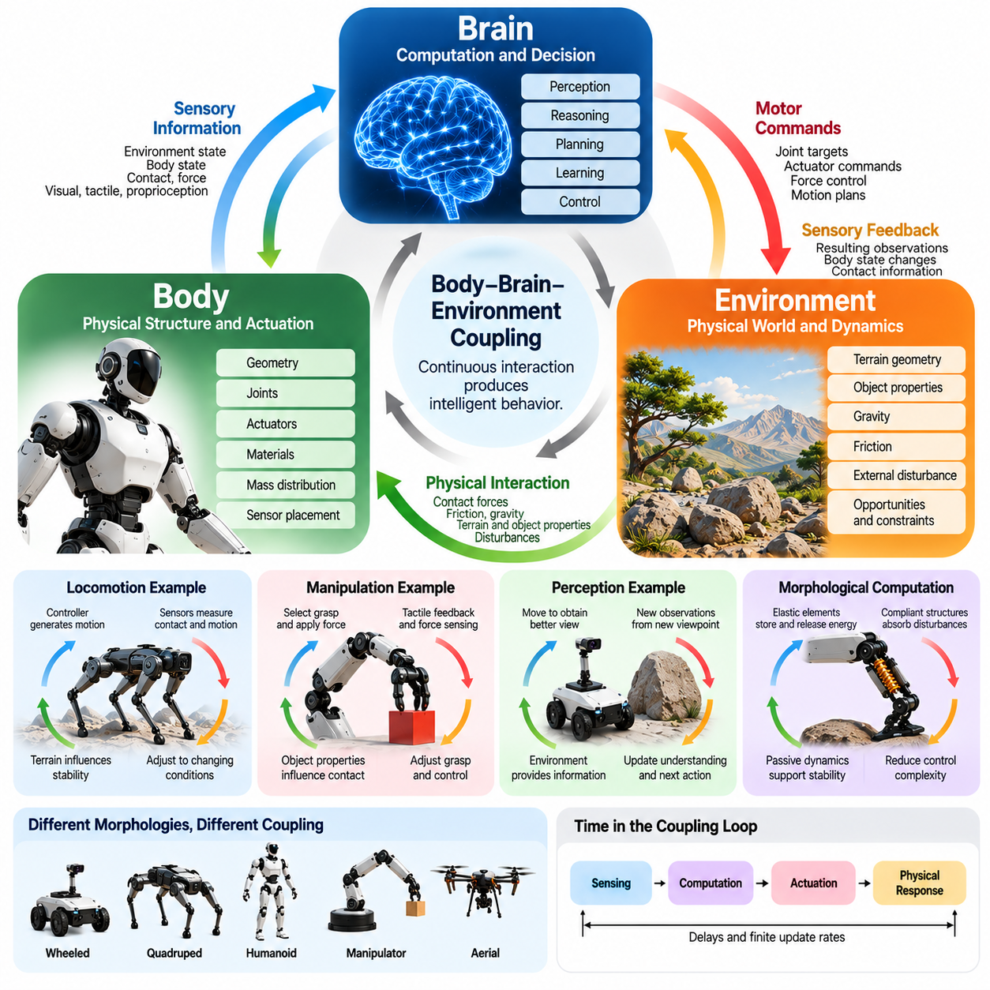
Body-brain-environment coupling is a foundational principle of embodied intelligence, describing how physical structure, computational control, and environmental dynamics continuously influence one another. Intelligent behavior does not arise exclusively from a central processing system but emerges through interactions among these components. The body executes actions, the brain processes information and coordinates behavior, and the environment provides physical constraints, sensory feedback, and opportunities for adaptation.
The brain in an embodied system represents the computational mechanisms responsible for perception, reasoning, planning, learning, and control. These mechanisms interpret sensory information and generate commands that influence physical behavior. However, computational decisions cannot be understood independently of the body executing them. Joint configurations, actuator capabilities, mechanical limitations, and sensor placement determine how effectively abstract decisions can be translated into meaningful physical actions.
The body provides the physical interface through which an intelligent agent interacts with its surroundings. Its geometry, mass distribution, material properties, and mechanical architecture determine the range of possible movements and interactions. A robot with compliant joints responds differently to external forces than a rigid robot, even when both use similar control algorithms. Physical morphology therefore influences behavior before computational control is applied and continues to shape the consequences of every action.
The environment forms the third essential component of this coupled system. Gravity, friction, terrain geometry, object properties, and external disturbances influence how actions unfold. Environmental conditions also determine which behaviors are effective or feasible. A locomotion strategy suitable for a smooth indoor floor may perform poorly on loose gravel or uneven ground. Intelligent control must therefore account for the continuously changing relationship between the robot's body and its surroundings.
Coupling occurs through continuous feedback loops connecting perception and action. Sensors measure environmental conditions and internal body states, while control algorithms generate commands for actuators. These commands produce movement, contact, and force interactions that modify the robot's state and surrounding conditions. New sensory observations then influence subsequent decisions, creating an ongoing cycle through which intelligent behavior is regulated and adapted.
This feedback relationship is inherently bidirectional. The brain influences the body by generating motor commands, but the body's physical response also influences subsequent computation through sensory feedback. Similarly, the environment affects the body through contact forces and disturbances, while the robot modifies its environment through movement and manipulation. Intelligence therefore emerges from reciprocal interactions rather than a strictly one-directional sequence of sensing, reasoning, and acting.
A practical example can be observed in robotic walking. The controller generates joint movements intended to maintain balance and produce forward motion, while the robot's mechanical structure determines how those commands translate into forces. Ground contact introduces friction, impact, and support reactions that influence stability. Sensors measure resulting motion and contact conditions, allowing the controller to adjust its commands as the robot encounters changing terrain.
Manipulation provides another illustration of body-brain-environment coupling. When a robot grasps an object, the controller selects a grasp configuration and applies force through the hand or gripper. The object's shape, mass, surface friction, and compliance influence the resulting contact behavior. Tactile and force measurements provide feedback about grasp stability, enabling the controller to modify finger positions or gripping forces when necessary.
The coupling principle also explains why perception cannot always be separated from movement. A robot's observations depend on sensor placement, body orientation, and the actions it performs. Moving closer to an object can improve visual resolution, while changing viewpoint can reveal previously hidden surfaces. The brain selects actions that alter the body's configuration, and these changes modify the sensory information available for subsequent interpretation.
Mechanical properties can contribute directly to feedback regulation without requiring explicit computational intervention. Elastic elements store and release energy, compliant structures absorb disturbances, and passive mechanical dynamics can support stable movement. These effects represent forms of morphological computation in which the body's physical characteristics perform useful regulatory functions. Such mechanisms can reduce control complexity while improving responsiveness to environmental interactions.
The strength and structure of coupling depend on robot morphology. Wheeled platforms interact with terrain through rolling contact, quadrupeds distribute support forces across multiple legs, and aerial robots rely on aerodynamic forces for motion and stability. Humanoid robots must coordinate whole-body balance with manipulation and locomotion. Each morphology creates distinct relationships among sensory information, control decisions, physical dynamics, and environmental constraints.
Time is another important dimension of body-brain-environment coupling. Physical processes evolve continuously, while sensing, computation, and actuation introduce delays and operate at finite update rates. A controller that responds too slowly may fail to compensate for disturbances, particularly during dynamic locomotion or contact-rich manipulation. Effective embodied intelligence therefore requires temporal coordination between physical dynamics and computational decision-making.
Learning within a coupled system involves adapting behavior to the interaction between the body and environment. Reinforcement learning can discover policies through repeated physical or simulated experiences, while adaptive control can adjust parameters when dynamics change. These methods must account for how morphology affects observations, available actions, and resulting rewards. Learning is therefore shaped by the physical system rather than occurring independently of embodiment.
The coupling relationship also creates challenges for modeling and prediction. A robot's behavior depends on nonlinear dynamics, uncertain contact conditions, actuator characteristics, and environmental variation. Simplified mathematical models may not capture every interaction accurately, while purely data-driven models may struggle with unfamiliar conditions. Combining physical models, sensory feedback, and learned representations can improve prediction and control under uncertainty.
Simulation provides a useful environment for studying these interactions because it allows researchers to vary body parameters, controller designs, and environmental conditions systematically. Changes in mass distribution, joint stiffness, friction, or terrain can reveal how different components influence overall behavior. However, simulation models remain approximations, and real-world experiments are necessary to evaluate whether learned or designed coupling mechanisms transfer reliably.
Body-brain-environment coupling has important implications for hardware-software co-design. Mechanical structures, sensor configurations, actuator capabilities, and control algorithms should be developed as interconnected elements rather than independently optimized components. A change in body geometry may alter control requirements, while improved sensing can enable different mechanical designs. Integrated development allows designers to exploit complementary capabilities across the entire system.
Safety and robustness also depend on the quality of coupling. Unexpected collisions, changing payloads, uncertain surfaces, and actuator disturbances can alter the relationship between control commands and physical outcomes. Reliable robots must detect these changes and respond within appropriate physical and computational limits. Mechanical compliance, feedback control, state estimation, and protective mechanisms collectively contribute to safe behavior in dynamic environments.
Ultimately, body-brain-environment coupling provides a unified framework for understanding embodied intelligence and Physical AI. The brain supplies computational capabilities, the body transforms decisions into physical interactions, and the environment continuously influences the results. None of these components can be fully understood in isolation when evaluating real-world behavior. Effective Physical AI emerges from their coordinated operation, enabling intelligent systems to perceive, act, learn, and adapt within the physical world.

00.04. Physical Form as Part of Intelligence
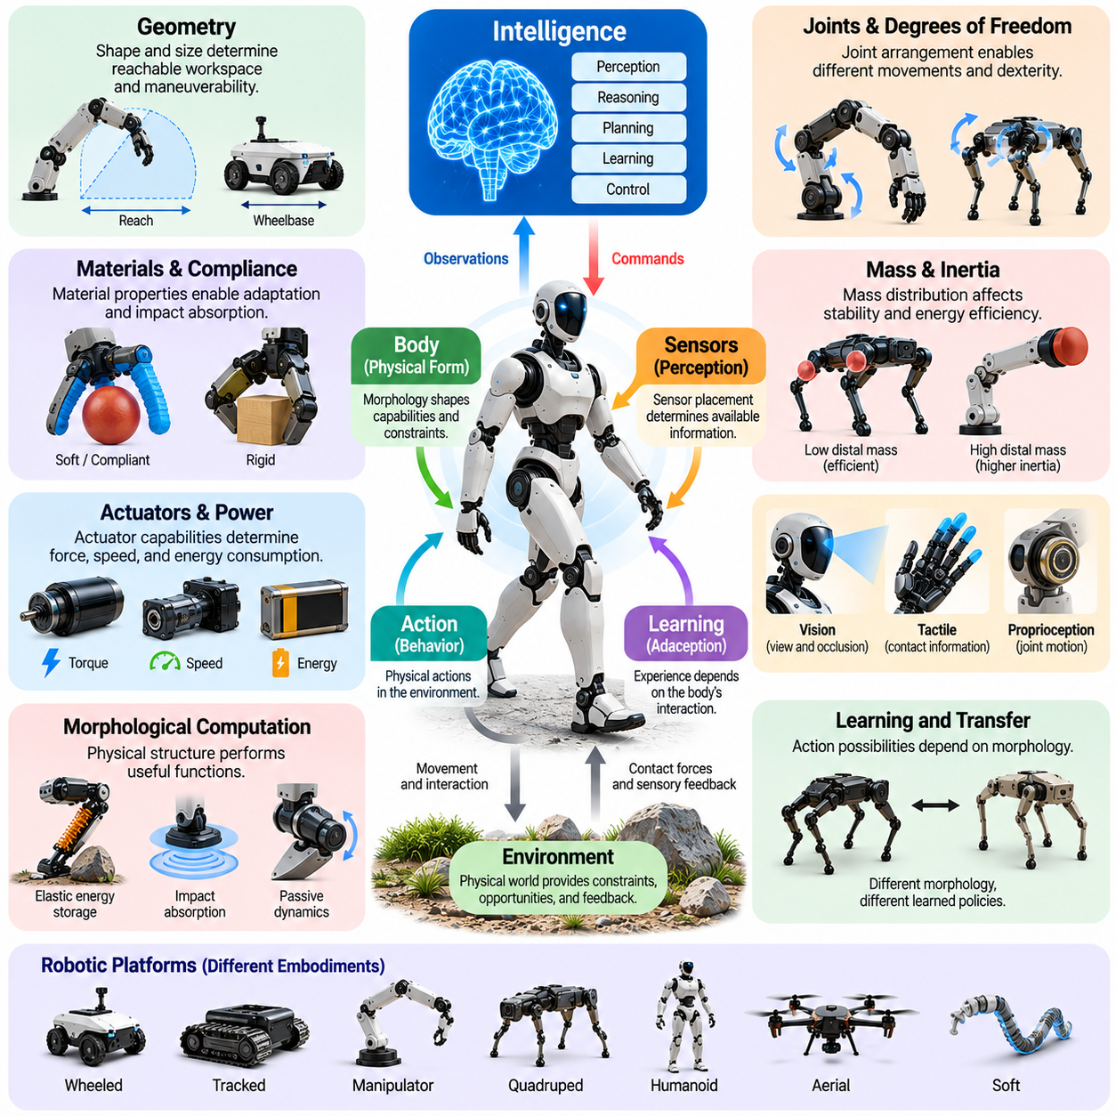
Physical form is an essential component of intelligence in embodied systems because the structure of a body determines how an agent perceives, moves, and interacts with its environment. Intelligence cannot be understood solely as computation performed by a processor or neural network. The geometry, materials, joints, actuators, and mechanical properties of a robot influence the behaviors it can produce and the strategies required to accomplish physical tasks.
Traditional artificial intelligence often separates computational reasoning from the mechanisms responsible for executing decisions. In physical systems, however, this separation becomes incomplete because mechanical structure directly influences action feasibility and performance. A robot may generate an optimal movement plan mathematically, yet its actual execution depends on joint limits, actuator capabilities, structural stiffness, and environmental contact conditions.
The concept of physical form as part of intelligence emphasizes that morphology is not merely a passive container for computational components. Instead, morphology shapes the information available to an agent and determines how control commands are transformed into physical behavior. Body proportions, sensor placement, degrees of freedom, and material compliance establish the possibilities and limitations within which intelligent algorithms must operate.
A robot's geometry determines its reachable workspace, maneuverability, and ability to interact with objects. Long manipulator links may extend reach but increase inertia and positioning sensitivity, while compact structures can improve stability and reduce mechanical loading. Similarly, the wheelbase and track width of a mobile robot influence turning behavior and resistance to tipping. These relationships demonstrate that physical dimensions directly affect operational capabilities.
Joint configuration provides another important connection between morphology and intelligence. The number, arrangement, and type of joints determine the available degrees of freedom and the range of achievable movements. A manipulator with redundant joints can approach objects from multiple configurations, while a simpler mechanism may provide greater stiffness and easier control. Intelligent planning must account for these structural differences when selecting feasible actions.
Mass distribution and inertia influence how efficiently and safely a robot can move. Concentrating heavy components near the body center can reduce rotational inertia in some movements, while excessive mass at the ends of limbs increases actuator demands during acceleration. In legged robots, distal limb mass strongly affects dynamic performance and energy consumption. These mechanical characteristics influence the control strategies required for stable and efficient locomotion.
Material properties also contribute to intelligent physical behavior. Rigid structures provide predictable geometry and precise force transmission, whereas compliant materials can accommodate uncertainty, absorb impacts, and adapt to irregular surfaces. A soft robotic gripper can conform to differently shaped objects without requiring exact geometric alignment. In such cases, the physical properties of the mechanism perform functions that would otherwise demand additional sensing and control.
Morphological computation describes how mechanical structures can contribute to information processing and behavioral regulation. Elastic elements can store and release energy, passive dynamics can assist locomotion, and compliant mechanisms can distribute contact forces automatically. These effects do not replace computational intelligence, but they can reduce the complexity of control problems and improve responsiveness by exploiting the natural dynamics of the physical system.
Biological organisms provide compelling examples of intelligence supported by physical form. Animal limbs, tendons, skeletal structures, and sensory organs have evolved to support particular interactions with their environments. Birds exploit wing geometry and aerodynamic forces, while mammals use musculoskeletal compliance to absorb impacts and maintain mobility. These examples demonstrate how physical structures can support adaptive behavior without requiring centralized computation for every mechanical response.
The relationship between morphology and intelligence becomes especially apparent when comparing different robotic platforms. Wheeled robots achieve efficient movement on suitable surfaces, quadrupeds negotiate uneven terrain through coordinated foot placement, and aerial robots exploit aerodynamic forces to move through three-dimensional space. Humanoid robots combine manipulation and locomotion capabilities within a human-like structure. Each embodiment enables particular behaviors while introducing distinct physical constraints.
Physical form also determines how sensors collect information. Camera placement influences visibility and occlusion, tactile sensor distribution determines which contacts can be detected, and proprioceptive sensors provide information about joint motion and body configuration. A robot's morphology therefore shapes its sensory experience before any learning algorithm processes observations. Intelligent perception must account for the relationship between sensor geometry, body movement, and environmental interaction.
The relationship between physical form and learning is equally significant. A learning algorithm explores behaviors through the action possibilities provided by the body. Different joint configurations, actuator limits, and contact properties create different learning environments even when the external task remains unchanged. Consequently, policies learned on one morphology may not transfer directly to another, making body-aware representations important for cross-embodiment learning.
Physical form influences the difficulty of control as well as the range of possible behaviors. A mechanically stable platform may require relatively simple feedback control, while an inherently unstable configuration demands rapid sensing and continuous correction. Passive stability, compliant joints, and appropriate mass distribution can simplify control requirements. Conversely, excessive mechanical complexity may increase computational demands and introduce additional sources of uncertainty.
The importance of physical form extends to energy efficiency and operational endurance. Mechanical transmission design, actuator placement, structural weight, and elastic energy storage determine how much energy is required to execute movements. Efficient morphology can reduce unnecessary actuation and exploit passive mechanical effects. This relationship is particularly important for battery-powered mobile robots, legged platforms, and aerial systems operating under strict energy constraints.
Safety and reliability are also influenced by morphological design. Rounded structures, compliant surfaces, controlled inertia, and mechanically limited joint motion can reduce certain risks during human-robot interaction. Physical design can provide protective behavior even before software-based safety mechanisms respond. Nevertheless, safe operation requires coordination among mechanical safeguards, sensing, control algorithms, and operational constraints.
Morphology optimization treats physical form as a design variable that can be systematically improved for specific objectives. Parameters such as link lengths, joint placement, mass distribution, stiffness, and actuator configuration can be adjusted to balance mobility, dexterity, stability, payload capacity, and energy efficiency. Computational optimization and simulation allow designers to explore these tradeoffs and identify structures that complement intelligent control policies.
Hardware-software co-design extends this principle by optimizing mechanical structures and computational strategies together. Rather than developing a fixed body and subsequently designing a controller, integrated approaches consider how changes in morphology influence perception, learning, planning, and control. A compliant mechanism may simplify manipulation, while improved sensing may enable a lighter or more flexible structure. Such coordination can produce capabilities unavailable through isolated optimization.
Ultimately, physical form should be understood as an active contributor to intelligence rather than a passive platform supporting computation. Morphology determines the possibilities of action, shapes sensory information, influences learning, and participates in the regulation of physical behavior. Effective Physical AI therefore requires the integrated design of body, computation, and environmental interaction, allowing intelligent capabilities to emerge from the coordinated operation of the entire embodied system.

00.05. Morphology Behavior and Learning
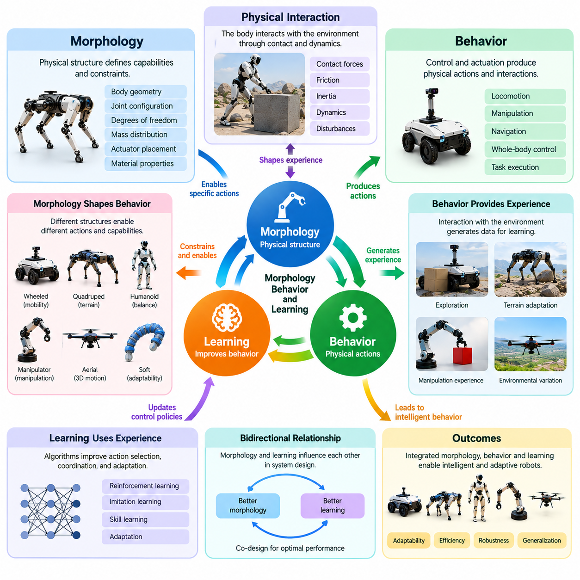
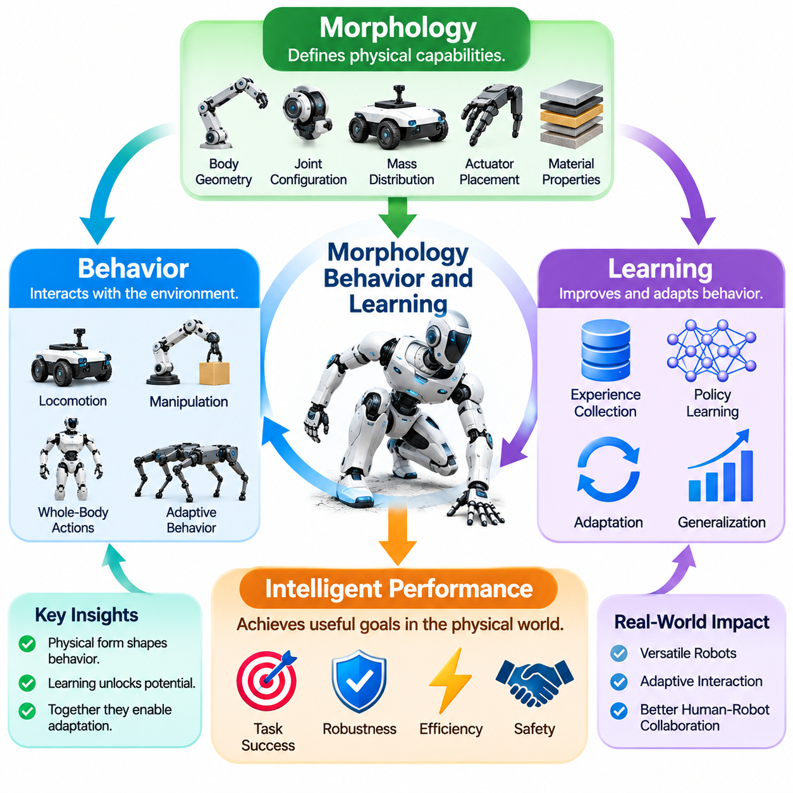
Morphology, behavior, and learning are closely interconnected in embodied intelligence because the physical structure of an agent determines the actions it can perform and the experiences it can acquire. Morphology defines mechanical capabilities, behavior represents the resulting interactions with the environment, and learning modifies how those capabilities are used. Intelligent performance therefore emerges from the continuous relationship between physical design, action selection, and adaptation.
Robot morphology includes body geometry, joint configuration, degrees of freedom, mass distribution, actuator placement, and material properties. These characteristics establish the physical constraints within which behavior develops. A robot with long limbs may achieve greater reach but experience higher inertia, while a compact platform may provide improved stability. Learning algorithms must operate within these morphological boundaries rather than assuming unlimited movement capabilities.
Behavior emerges when computational control interacts with the mechanical characteristics of the body and the dynamics of the environment. Identical control commands can produce different outcomes when applied to robots with different masses, joint arrangements, or compliance. Consequently, behavior cannot be attributed exclusively to software or control policies. It reflects the combined influence of morphology, actuator dynamics, environmental contact, and feedback regulation.
The relationship between morphology and behavior is particularly evident in locomotion. Wheeled robots exploit rolling contact for efficient movement, quadrupeds coordinate multiple legs to maintain support, and humanoids regulate whole-body balance during walking. Each morphology creates a different set of feasible movement patterns. Learning systems must discover strategies compatible with these structures while adapting to terrain conditions, disturbances, and task requirements.
Manipulation provides another example of morphology-dependent behavior. A rigid parallel gripper relies on accurate positioning and force control, while a compliant gripper can mechanically accommodate variations in object geometry. Multi-fingered robotic hands offer additional manipulation possibilities but introduce greater coordination complexity. The learning process must account for these structural characteristics when developing reliable grasping and object-handling strategies.
Morphology also determines the information available for learning. Sensor placement, body orientation, joint motion, and contact surfaces influence the observations collected during interaction. A mobile robot with elevated cameras may perceive obstacles differently from a low-profile platform, while tactile sensors distributed across a robotic hand provide information about contact forces. The body's structure therefore shapes both the action space and the observation space of a learning system.
Learning modifies behavior by using experience to improve action selection, coordination, and adaptation. Reinforcement learning can discover control policies through interaction and reward feedback, while imitation learning can reproduce useful patterns from demonstrations. However, the effectiveness of these methods depends on whether the training experiences reflect the robot's actual morphology and physical constraints. A learned policy must remain feasible within the mechanical capabilities of its embodiment.
The interaction between morphology and learning is bidirectional at the system-design level. Physical structure influences which behaviors are easy to learn, while learning outcomes reveal strengths and weaknesses in the chosen morphology. If a robot consistently struggles with a particular movement, the problem may arise from inadequate control, insufficient training, or unfavorable mechanical design. Effective development therefore requires evaluating body structure and learning performance together.
Morphological computation can reduce the burden placed on learning algorithms by allowing physical structures to perform useful regulatory functions. Elastic joints can store and release energy, compliant materials can absorb contact disturbances, and passive mechanical dynamics can support stable movement. These effects may simplify the control policy required for successful behavior. Learning can then focus on higher-level coordination rather than compensating for every mechanical interaction.
The concept of affordances further connects morphology, behavior, and learning. An affordance represents an action possibility arising from the relationship between an agent's capabilities and environmental properties. A step may be traversable for a quadruped but inaccessible to a wheeled robot, while an object may be graspable by one end effector but not another. Learning systems must discover affordances relative to their own physical capabilities rather than treating environmental properties as universally actionable.
Exploration is strongly influenced by morphological design because the body determines which experiences an agent can safely and effectively generate. A robot with limited joint mobility may explore a smaller range of postures, while a highly articulated system can investigate more complex interactions. Sensor coverage and mechanical compliance also affect exploration quality. Learning efficiency consequently depends on the diversity, accessibility, and safety of experiences enabled by the body.
Morphology influences the complexity of the learning problem through its effects on action dimensionality and dynamic behavior. Additional degrees of freedom expand the space of possible movements but may increase the amount of training required to discover effective coordination. Mechanically stable designs can simplify policy learning, whereas highly unstable configurations demand precise timing and rapid feedback. Greater physical flexibility does not automatically produce greater learning efficiency.
Simulation-based learning makes it possible to investigate how morphological parameters influence behavioral performance. Researchers can vary link lengths, joint stiffness, mass distribution, actuator strength, and contact properties while training control policies. Comparing the resulting behaviors helps identify which physical characteristics support efficient learning and robust execution. However, simulation accuracy and transfer to real hardware remain essential considerations.
Cross-morphology transfer is an important challenge because policies developed for one physical configuration may not operate effectively on another. Differences in joint structure, actuator limits, body proportions, and sensor placement alter the relationship between observations and actions. Transfer methods may use shared task representations, morphology-conditioned policies, or adaptable control architectures. Their objective is to preserve useful knowledge while accommodating embodiment-specific constraints.
Morphology-aware learning explicitly incorporates physical characteristics into policy development. Instead of treating the robot as an unspecified action-producing system, the learning process may use information about joint topology, link dimensions, actuator capabilities, and body dynamics. Such representations can support adaptation across robot configurations and improve the consistency of learned behavior. They also provide a foundation for generalization across heterogeneous robotic platforms.
The joint optimization of morphology and control extends these ideas by treating physical design and learned behavior as interconnected optimization variables. A candidate body structure can be evaluated together with a controller trained for that structure, allowing performance differences to reflect their interaction. Evolutionary optimization, simulation-based search, and differentiable methods can explore these relationships. Practical optimization must also consider manufacturing constraints, durability, safety, and computational cost.
Behavioral robustness depends on how morphology and learning jointly respond to environmental uncertainty. A compliant structure may tolerate small positioning errors, while an adaptive controller compensates for changing payloads or terrain conditions. Neither mechanical adaptability nor learned control alone guarantees reliable operation. Robust performance requires appropriate physical characteristics, informative feedback, and policies capable of responding to disturbances without exceeding operational limits.
Ultimately, morphology, behavior, and learning form an integrated foundation for Physical AI. Morphology establishes the possibilities and constraints of interaction, behavior expresses how the agent operates within those constraints, and learning improves its ability to select and coordinate actions. Their relationship suggests that intelligent robots should be developed through coordinated physical and computational design, enabling adaptive capabilities that reflect the properties of the entire embodied system.

00.06. Embodiment Across Robot Platforms
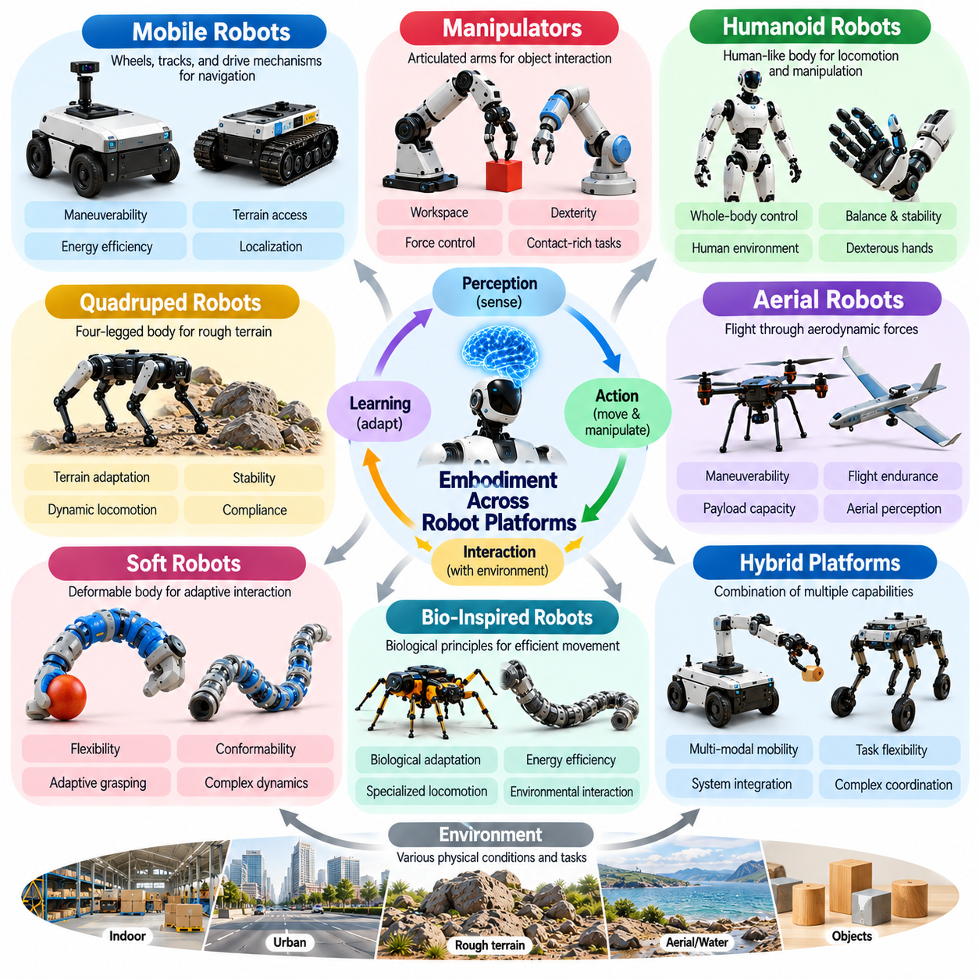
Embodiment varies across robotic platforms because each physical architecture establishes different relationships among perception, movement, manipulation, and environmental interaction. A robot's body determines how it generates forces, maintains stability, and responds to external conditions. Although different platforms may share computational algorithms, their physical structures create distinct capabilities and constraints that shape intelligent behavior.
Mobile robots represent a common form of embodiment in which locomotion is primarily achieved through wheels, tracks, or specialized drive mechanisms. Their morphology influences maneuverability, traction, energy efficiency, and terrain accessibility. Differential-drive robots provide mechanically simple navigation, while omnidirectional platforms support lateral movement. These differences affect motion planning, localization, obstacle avoidance, and operational performance.
Autonomous mobile robots operate through continuous interaction between their mechanical configuration and surrounding environments. Wheel diameter, wheelbase, suspension, and ground clearance determine which surfaces can be traversed reliably. Sensors provide information about obstacles and vehicle motion, while controllers adjust trajectories and velocities. Effective navigation therefore depends on integrating physical mobility constraints with perception and decision-making.
Robotic manipulators demonstrate embodiment through articulated mechanical structures designed for positioning and interacting with objects. Link lengths, joint arrangements, actuator characteristics, and end-effector geometry determine workspace and dexterity. Industrial arms often prioritize repeatability and stiffness, whereas collaborative manipulators may incorporate force sensing and compliance. Their physical design directly influences manipulation strategies and control requirements.
The embodiment of a manipulator becomes especially important during contact-rich tasks such as assembly, insertion, polishing, and grasping. Object geometry, surface friction, joint compliance, and force transmission determine the outcome of physical interactions. A rigid manipulator may require precise force regulation, while a compliant mechanism can accommodate small alignment errors. Intelligent manipulation must exploit these characteristics while maintaining accuracy and safety.
Humanoid robots combine locomotion, manipulation, and whole-body coordination within a human-inspired physical structure. Their morphology includes articulated legs, arms, torso, and often dexterous hands. This configuration provides opportunities to interact with environments designed for human activities. However, balancing a tall articulated body introduces complex stability, coordination, and energy-management challenges that influence control and learning.
Humanoid embodiment requires continuous coordination between posture, contact forces, and task execution. Reaching for an object can shift the center of mass and alter balance requirements, while carrying a payload changes joint loading and movement dynamics. Walking and manipulation cannot always be controlled independently. Whole-body control integrates these activities by accounting for joint limits, support contacts, and dynamic stability.
Quadruped robots embody intelligence through four-legged mechanical architectures that distribute support forces across multiple contact points. Their morphology supports movement over irregular terrain where wheels may encounter limitations. Leg length, joint configuration, foot geometry, and body mass distribution influence stride patterns and stability. Intelligent locomotion requires adapting foot placement, gait timing, and force distribution to changing environmental conditions.
Quadruped embodiment also illustrates the importance of mechanical compliance and dynamic interaction. During running or climbing, the legs experience repeated impacts, variable contact forces, and changing support conditions. Elastic components and controlled joint impedance can absorb disturbances and improve terrain adaptation. Learning-based controllers may discover efficient gait patterns, but successful behavior remains constrained by actuator capacity and physical morphology.
Aerial robots provide a fundamentally different embodiment because they generate motion and support through aerodynamic forces rather than continuous ground contact. Multirotor platforms control position and orientation by adjusting rotor thrust, while fixed-wing aircraft rely on lift generated through forward motion. Airframe geometry, propulsion layout, mass distribution, and aerodynamic characteristics determine stability, maneuverability, and energy consumption.
Aerial embodiment imposes strict constraints on sensing, computation, and control. Limited payload capacity restricts sensor and processor selection, while battery capacity influences flight endurance. Rapid attitude changes require timely state estimation and responsive control. Wind disturbances and aerodynamic uncertainty further complicate navigation. Intelligent flight therefore depends on close integration between mechanical design, onboard perception, and dynamic control.
Soft robots represent an alternative embodiment based on deformable materials and compliant structures rather than predominantly rigid links. Their bodies can bend, stretch, twist, and conform to surrounding objects or surfaces. This flexibility enables adaptive grasping and interaction with irregular environments. However, deformation introduces complex dynamics and makes accurate state estimation difficult, requiring specialized sensing, modeling, and control methods.
Bio-inspired robotic platforms extend embodiment principles by adopting structural and functional characteristics observed in living organisms. Snake robots use distributed articulation for movement through confined spaces, while insect-inspired systems exploit lightweight structures and specialized locomotion mechanisms. Such designs demonstrate how morphology can enable behaviors that are difficult to reproduce using conventional architectures.
Hybrid robotic systems combine multiple forms of embodiment to address tasks requiring diverse physical capabilities. Mobile manipulators integrate a locomotion base with an articulated arm, enabling navigation and object handling within the same platform. Wheeled-legged robots combine rolling efficiency with stepping capability. These architectures expand operational flexibility but introduce additional challenges in stability, coordination, and system-level planning.
Embodiment also influences how learning algorithms transfer across robotic platforms. Policies trained for a wheeled robot cannot directly control a quadruped because their action spaces and physical dynamics differ. Similarly, manipulation strategies depend on gripper geometry and joint capabilities. Cross-embodiment learning seeks reusable representations while accounting for platform-specific morphology, sensing arrangements, and control constraints.
Platform selection must consider the relationship between morphology and operational environments. Warehouses may favor wheeled mobile robots for efficient transport, while uneven outdoor terrain may require legged mobility. Industrial assembly benefits from precise manipulators, and aerial inspection requires flight-capable systems. The most appropriate embodiment depends on task requirements, environmental conditions, safety constraints, and lifecycle costs.
Despite their structural differences, robotic platforms share fundamental principles of embodied intelligence. Each must perceive environmental conditions, generate physically feasible actions, and adapt to disturbances through feedback. Mechanical design shapes available behaviors, while computational intelligence coordinates and improves their execution. Understanding both common principles and platform-specific constraints is essential for developing transferable Physical AI architectures.
Ultimately, embodiment across robotic platforms demonstrates that intelligence is expressed through diverse physical forms rather than a single universal body architecture. Mobile robots, manipulators, humanoids, quadrupeds, aerial systems, and soft robots exploit different mechanical principles to interact with the world. Effective Physical AI emerges when morphology, perception, learning, and control are integrated according to the capabilities and limitations of each platform.

00.07. Roadmap of Embodiment and Morphology
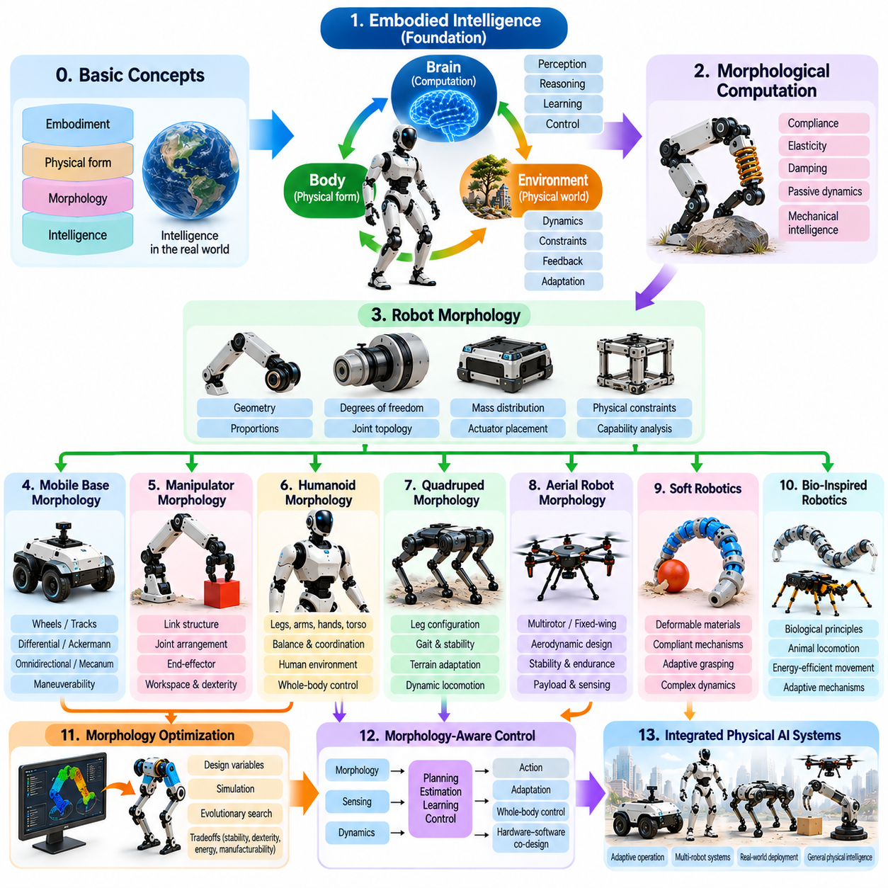
The roadmap of embodiment and morphology provides a structured foundation for understanding how physical form contributes to intelligent behavior in robotic systems. It connects the principles of embodied intelligence with mechanical design, environmental interaction, learning, and control. The progression begins with fundamental concepts and advances toward specialized robot architectures, optimization methods, and integrated Physical AI systems capable of adaptive operation.
The first stage establishes embodied intelligence as a framework in which cognition, physical structure, and environmental dynamics interact continuously. Rather than treating the body as a passive mechanism, this perspective recognizes morphology as an active contributor to perception and action. Understanding body-brain-environment coupling provides the conceptual basis for explaining how mechanical properties influence computational decisions and behavioral outcomes.
Morphological computation forms the next foundation by examining how physical structures perform useful functions without requiring explicit computational commands for every response. Compliance, elasticity, damping, and passive dynamics can regulate contact forces, absorb disturbances, and support movement. These mechanisms demonstrate how mechanical intelligence can complement software-based control and reduce the computational complexity of physical interaction.
The study of robot morphology then introduces the structural parameters that determine physical capabilities. Body geometry, proportions, degrees of freedom, joint topology, mass distribution, and actuator placement influence reachability, stability, mobility, and manipulation. Understanding these relationships allows designers to evaluate how physical architecture constrains possible behaviors and how structural decisions affect overall system performance.
Mobile base morphology extends these principles to robots that navigate environments using wheels, tracks, or specialized locomotion mechanisms. Differential-drive, Ackermann-steered, omnidirectional, and mecanum platforms provide different combinations of maneuverability, mechanical simplicity, and terrain compatibility. Their physical configurations determine kinematic constraints and influence navigation, motion planning, localization, and energy efficiency.
Manipulator morphology focuses on articulated mechanisms designed to position tools and interact with objects. Link structures, joint arrangements, wrist architectures, and end-effector configurations determine workspace, dexterity, and force transmission. The relationship between mechanical design and control becomes particularly important during precision assembly, grasping, and contact-rich operations, where geometry and compliance strongly influence task success.
Humanoid morphology introduces a more integrated form of embodiment by combining articulated legs, arms, hands, and torso structures. Human-inspired proportions enable interaction with environments designed around human dimensions, but they also create demanding balance and coordination requirements. Whole-body movement, mass distribution, joint placement, and hand dexterity must be considered together to support locomotion and manipulation.
Quadruped morphology examines how four-legged architectures enable mobility across uneven and uncertain terrain. Leg configurations, body proportions, joint arrangements, and foot structures influence gait selection, stability, and contact force distribution. Dynamic locomotion requires coordination between mechanical compliance and active control. This platform demonstrates how morphology shapes the relationship between movement efficiency, terrain adaptation, and robustness.
Aerial robot morphology introduces physical architectures governed by aerodynamic forces and flight dynamics. Multirotor configurations, fixed-wing structures, and hybrid aerial systems differ in propulsion arrangements, stability characteristics, payload capacity, and energy requirements. Airframe geometry and mass distribution directly influence controllability. Understanding these relationships is essential for designing flight systems that balance maneuverability, endurance, and sensing capabilities.
Soft robotics expands the morphological design space through deformable materials, compliant mechanisms, and distributed actuation. Unlike predominantly rigid robots, soft systems can adapt their shapes during interaction and exploit material properties to accommodate uncertainty. Their flexibility supports delicate manipulation and environmental conformity, while introducing challenges in modeling, sensing, and precise control of continuously deforming structures.
Bio-inspired robotics examines how biological structures and movement strategies can inform robotic design. Animal locomotion, musculoskeletal arrangements, compliant tissues, and specialized sensory structures provide examples of effective physical adaptation. Translating these principles into engineered systems can support new locomotion mechanisms, energy-efficient movements, and adaptable manipulation strategies without requiring exact biological replication.
Morphology optimization provides methods for systematically improving physical structures according to operational objectives. Link dimensions, joint placement, stiffness, actuator configuration, and mass distribution can be treated as design variables. Simulation, evolutionary search, and numerical optimization help evaluate tradeoffs among stability, dexterity, mobility, energy efficiency, and manufacturing feasibility. Optimization becomes especially valuable when mechanical and computational performance must be balanced.
Morphology-aware control completes the progression by integrating physical structure directly into planning, estimation, learning, and feedback regulation. Controllers must account for joint topology, actuator limitations, contact dynamics, and body-specific movement capabilities. Morphology-conditioned learning and adaptive control can improve performance across changing configurations. Hardware-software co-design further aligns physical mechanisms with computational strategies.
These topics are connected through a common principle: morphology determines the physical possibilities available to an intelligent system, while control and learning determine how effectively those possibilities are used. Mechanical structure influences sensory information, action feasibility, energy consumption, and environmental adaptation. Consequently, robot design should be approached as an integrated problem involving geometry, materials, dynamics, computation, and operational requirements.
The roadmap also establishes a progression from individual mechanical components toward complete robotic platforms and coordinated intelligent behavior. Understanding joints, links, compliance, and body geometry provides the basis for analyzing manipulators, mobile robots, humanoids, quadrupeds, and aerial systems. Platform-level analysis then reveals how physical constraints influence learning and control. This layered approach supports systematic development without separating hardware from intelligence.
Practical implementation requires connecting theoretical morphology principles with engineering evaluation. Simulation can explore candidate structures and control strategies, while physical prototypes reveal manufacturing tolerances, actuator limitations, sensor uncertainty, and environmental disturbances. Experimental validation is necessary to determine whether predicted advantages translate into reliable performance. Iterative development allows morphology and control to improve together through measured evidence.
Future developments in Physical AI are likely to strengthen the integration of morphology design, machine learning, and automated engineering workflows. Generative design, differentiable simulation, adaptive materials, and morphology-conditioned foundation models may enable more systematic exploration of physical architectures. However, practical deployment will continue to require attention to safety, durability, energy consumption, maintainability, and real-world generalization.
Ultimately, the roadmap of embodiment and morphology establishes physical form as a central dimension of intelligent robotic system design. It connects foundational theories of embodied intelligence with platform-specific architectures, mechanical optimization, and morphology-aware control. By understanding how bodies shape perception, action, and learning, engineers can develop Physical AI systems whose computational intelligence and physical capabilities operate as a coordinated whole.

