Volume 03. Embodiment and Morphology

Chapter 04. Mobile Base Morphology

04.01. Mobile Base Morphology Overview
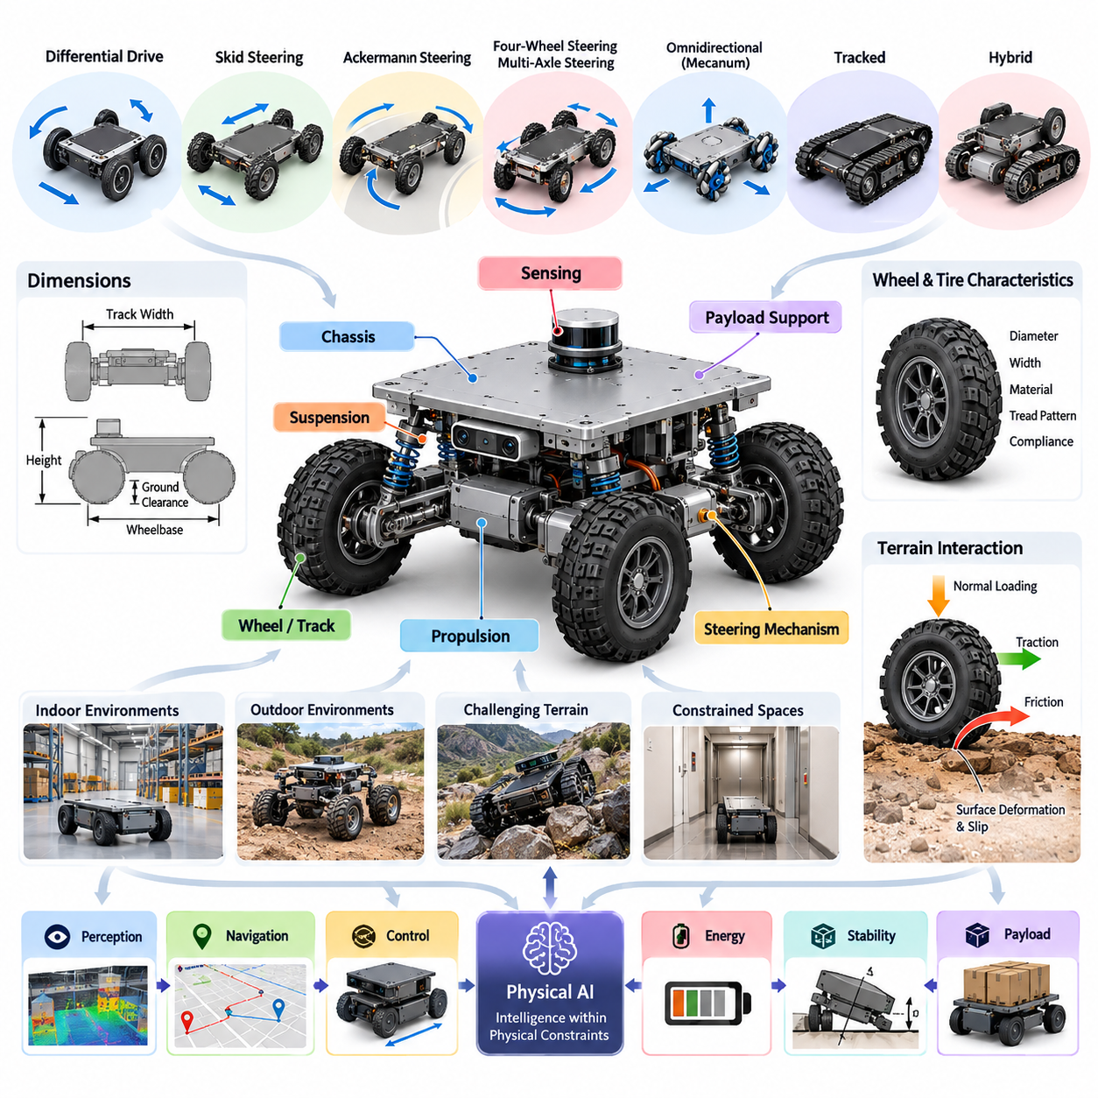
Mobile base morphology refers to the physical configuration, structural arrangement, and locomotion architecture of a robotic platform designed to move through its environment. It encompasses the chassis, wheels or tracks, steering mechanisms, suspension, propulsion components, and payload-supporting structures. These elements collectively determine how a robot generates motion, maintains stability, and interacts with different surfaces.
In Physical AI, mobile base morphology is more than a mechanical design consideration. The physical structure directly influences perception, navigation, control, energy consumption, and autonomous behavior. A robot's intelligence must operate within the capabilities and limitations of its body. Consequently, mobile base design establishes the physical foundation upon which sensing, planning, learning, and intelligent motion are implemented.
The morphology of a mobile platform determines its available degrees of freedom, motion constraints, turning capabilities, and interaction with obstacles. Some platforms can move laterally without changing orientation, while others must follow curved trajectories to reach a destination. These differences affect path planning, trajectory generation, obstacle avoidance, and the computational complexity of autonomous navigation.
Mobile robotic platforms are commonly categorized according to their locomotion and steering mechanisms. Differential-drive systems use independently controlled wheels to generate forward motion and rotation. Skid-steering platforms create turning motion through differences in wheel or track velocities. Ackermann-steering systems employ coordinated steering geometry to produce vehicle-like motion with reduced lateral tire slip.
Four-wheel steering and multi-axle steering architectures provide additional flexibility in maneuvering and load distribution. These configurations can reduce turning radius, improve directional control, and support larger robotic vehicles. However, increased steering complexity introduces additional actuators, mechanical linkages, calibration requirements, and control coordination challenges that must be considered during system design.
Omnidirectional mobile bases provide enhanced maneuverability by allowing motion in multiple planar directions. Mecanum wheels and specialized omnidirectional wheel arrangements can generate lateral, longitudinal, and rotational movement through coordinated wheel velocities. Such platforms are particularly useful in constrained indoor environments, although their performance depends strongly on surface conditions and wheel-ground contact characteristics.
Tracked mobile platforms distribute vehicle weight across a relatively large contact area and can provide effective traction on deformable or irregular terrain. They are frequently considered for construction, agriculture, inspection, and outdoor robotic applications. Their advantages in obstacle negotiation and ground pressure must be balanced against steering losses, mechanical wear, energy consumption, and potential surface damage.
Hybrid mobile bases combine different locomotion mechanisms to address environments that cannot be efficiently traversed using a single architecture. Examples include wheel-track combinations, articulated wheel assemblies, and platforms capable of changing their ground-contact configuration. These systems expand operational versatility but require additional mechanical integration, sensing, and coordinated control.
Wheel and tire characteristics are fundamental components of mobile base morphology because they define the immediate mechanical interface between the robot and its environment. Wheel diameter, width, material, tread pattern, and compliance influence traction, rolling resistance, vibration, and obstacle-crossing capability. Appropriate wheel selection must therefore reflect terrain properties, payload requirements, speed, and durability expectations.
The interaction between wheels and terrain determines whether commanded motion can be translated into reliable physical displacement. Friction, normal loading, surface deformation, and wheel slip influence both locomotion efficiency and localization accuracy. On smooth industrial floors, predictable contact conditions support precise movement, whereas loose soil, gravel, wet surfaces, and uneven terrain introduce substantial uncertainty.
Geometric dimensions such as wheelbase, track width, ground clearance, and overall chassis height strongly influence mobility performance. A longer wheelbase can improve longitudinal stability but may increase turning requirements and reduce breakover capability. Greater track width can improve lateral stability while increasing the space required for navigation. Ground clearance determines the ability to pass over obstacles without chassis interference.
The relationship between platform dimensions and environmental constraints is especially important for autonomous mobile robots operating in warehouses, factories, hospitals, and commercial buildings. Door widths, corridor dimensions, elevator capacities, floor transitions, and turning spaces impose practical morphological limitations. A mechanically capable platform may still be unsuitable if its geometry prevents reliable access to the intended workspace.
Suspension architecture determines how the mobile base accommodates terrain irregularities while maintaining wheel contact and protecting onboard components. Passive suspension systems use springs, dampers, and mechanical linkages to absorb disturbances. Articulated chassis structures allow different sections of the platform to follow uneven terrain, while active suspension systems can adjust body posture or wheel loading in response to operating conditions.
Mass distribution is another essential morphological consideration because it affects traction, braking, acceleration, and resistance to tipping. The placement of batteries, motors, computing hardware, sensors, and payloads determines the center of gravity and rotational inertia of the platform. Poor mass distribution can reduce stability, overload individual wheels, and limit the robot's ability to negotiate slopes or execute rapid maneuvers.
Payload capacity must be evaluated together with the location and variability of the payload's center of gravity. A mobile base carrying a fixed industrial container experiences different stability conditions from one supporting a robotic manipulator or vertically moving lifting mechanism. Payload movement can alter wheel loads and tipping margins, requiring coordinated consideration of structural geometry, suspension behavior, and motion control.
Indoor and outdoor operating environments impose fundamentally different morphological priorities. Indoor platforms generally emphasize compact dimensions, precise maneuverability, low noise, predictable floor contact, and compatibility with human environments. Outdoor platforms often prioritize ground clearance, weather resistance, traction, suspension travel, and tolerance to uncertain terrain conditions. These requirements frequently lead to different design choices.
Heavy-payload mobile bases require structural reinforcement, suitable drive mechanisms, and careful management of load transfer. Increased mass raises demands on motors, transmissions, brakes, bearings, and chassis components. It also influences stopping distance, thermal behavior, energy consumption, and floor loading. The resulting morphology must balance payload capacity against maneuverability, operational safety, and mechanical efficiency.
Rough-terrain mobile robots face additional challenges associated with irregular ground geometry, variable friction, steep slopes, and intermittent contact. Their morphology must support obstacle negotiation without excessive loss of stability or traction. Larger wheels, articulated structures, suspension mechanisms, and appropriate weight distribution can improve mobility, although every modification introduces tradeoffs in size, complexity, and energy efficiency.
Energy efficiency is closely coupled to mobile base morphology. Wheel configuration, drivetrain efficiency, vehicle mass, rolling resistance, and steering behavior determine the mechanical work required for movement. A platform optimized for precise lateral positioning may consume more energy than a conventional wheeled configuration under equivalent transport conditions. Morphological decisions therefore affect battery sizing, operating duration, and charging infrastructure.
Mobile base morphology also influences the effectiveness of onboard sensing and localization. Chassis height, vibration characteristics, sensor mounting locations, and wheel-ground interaction affect measurement quality and motion estimation. Wheel slip can introduce odometry errors, while mechanical vibration can degrade inertial measurements and visual observations. Mechanical design and perception architecture must consequently be considered together.
The relationship between morphology and control is particularly important when designing intelligent mobile platforms. Differential-drive, Ackermann-steering, and omnidirectional systems possess different kinematic constraints and dynamic responses. Controllers must account for these properties when converting desired trajectories into actuator commands. Ignoring physical constraints can produce infeasible motions, excessive wheel slip, or unstable behavior.
Morphological computation provides an additional perspective on mobile base design by recognizing that mechanical structures can simplify control through their inherent physical behavior. Passive suspension, compliant tires, and appropriately distributed mass can absorb disturbances without requiring continuous corrective computation. Effective mechanical design can therefore reduce control effort and improve robustness through the natural dynamics of the platform.
Mobile base morphology must also accommodate functional safety requirements. Braking architecture, mechanical stability, protective structures, and the arrangement of moving components influence operational hazards. Robots sharing environments with humans require predictable stopping behavior, controlled contact forces, and sufficient stability under foreseeable disturbances. Safety must be addressed through integrated mechanical, electrical, sensing, and control design.
The selection of a mobile base morphology is ultimately a multi-objective engineering problem involving mobility, stability, payload, energy efficiency, cost, maintainability, and environmental compatibility. No single architecture provides optimal performance across every operating condition. Designers must evaluate mission requirements and physical constraints before selecting a locomotion configuration, geometric arrangement, and supporting mechanical architecture.
Simulation and physical testing are essential for evaluating competing morphological configurations. Kinematic models characterize feasible motion, while dynamic models estimate acceleration, load transfer, traction, and stability. Terrain simulations and prototype experiments reveal limitations that simplified models may overlook. Combining these methods supports systematic comparison and reduces uncertainty before deployment in real operating environments.
For Physical AI systems, the mobile base should be understood as an active component of embodied intelligence rather than a passive transportation mechanism. Its geometry, contact mechanics, and dynamic properties shape the observations and actions available to the autonomous controller. Effective mobile robot development therefore requires coordinated optimization of morphology, perception, planning, learning, and control to achieve reliable physical intelligence.

04.02. Differential Skid and Ackermann Drive
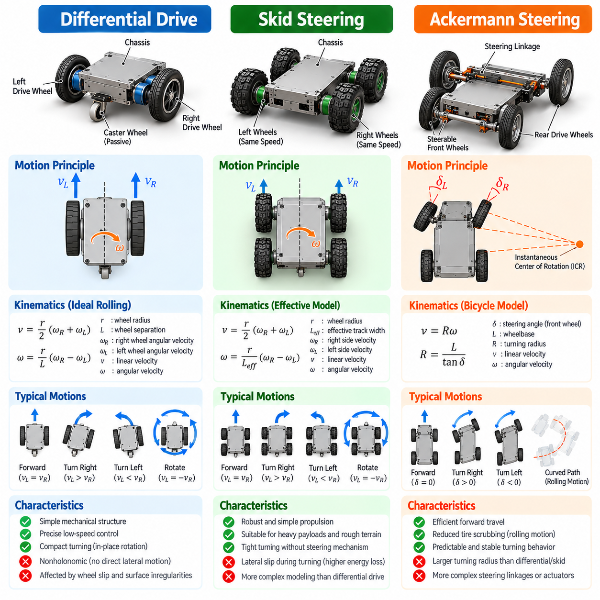
Differential drive, skid steering, and Ackermann steering represent three fundamental locomotion architectures used in wheeled mobile robots. Each configuration determines how actuator forces are converted into translational and rotational motion. Their mechanical structures establish different kinematic constraints, turning capabilities, energy requirements, and terrain interactions, making drive selection a central decision in mobile robot morphology.
Differential-drive systems typically employ two independently driven wheels positioned on opposite sides of a chassis. Additional passive caster wheels or support mechanisms maintain balance without directly generating propulsion. By controlling the relative rotational velocities of the driven wheels, the robot can move forward, reverse, follow curved trajectories, or rotate around its vertical axis.
The fundamental principle of differential drive is that the robot's linear velocity depends on the average tangential velocity of its driven wheels, while angular velocity depends on their velocity difference. Equal wheel speeds produce straight motion, whereas unequal speeds generate turning. When the wheels rotate at equal speeds in opposite directions, the robot can perform an approximately stationary rotation around the midpoint of its drive axle.
Differential-drive kinematics are commonly represented using wheel radius, wheel separation, and individual wheel angular velocities. Under ideal rolling conditions, forward velocity equals the wheel radius multiplied by the average wheel angular velocity. Angular velocity equals the wheel radius multiplied by the difference between right and left wheel angular velocities, divided by the distance separating the wheels.
A defining characteristic of differential-drive morphology is its nonholonomic motion constraint. The platform cannot directly generate lateral translation without first changing its orientation. Although the robot can reach many planar configurations through sequences of forward movement and rotation, its instantaneous motion remains constrained by wheel alignment and rolling contact with the ground.
Differential-drive platforms are widely used in autonomous mobile robots, educational robotics, indoor delivery systems, and compact service robots. Their popularity results from mechanical simplicity, relatively low component count, straightforward control, and excellent maneuverability in confined spaces. However, wheel slip, caster behavior, uneven loading, and surface irregularities can reduce motion accuracy.
Skid-steering systems generate directional changes by imposing different longitudinal velocities on the left and right sides of a vehicle. Unlike conventional steering systems, the wheels or tracks generally remain aligned with the chassis during turning. Rotation occurs because the ground-contact elements experience lateral sliding, producing the forces and moments necessary to change vehicle orientation.
Skid-steering morphology commonly employs four or more wheels, with multiple wheels mechanically or electronically coordinated on each side. Tracked vehicles use a similar principle by controlling the relative velocities of their left and right tracks. These configurations provide mechanically robust propulsion architectures suitable for heavy payloads, industrial environments, agricultural machinery, and rough-terrain robotic platforms.
Although skid steering resembles differential drive at the command level, its physical behavior is significantly more complex. Differential-drive models generally assume ideal rolling without lateral slip, whereas skid-steering vehicles depend on lateral sliding during turns. Consequently, turning behavior varies with friction, normal force distribution, wheel configuration, terrain deformation, and vehicle mass.
The instantaneous center of rotation in skid-steering vehicles may shift according to operating conditions. Effective track width, which describes the relationship between side velocity differences and yaw motion, can differ from the physical separation between wheel groups. Accurate prediction therefore often requires experimentally identified parameters, empirical correction models, or dynamic representations of wheel-ground interaction.
Skid-steering platforms offer several practical advantages, including the elimination of complex steering linkages and the ability to execute tight turns. Their distributed ground contact can support substantial loads and improve mobility over uneven surfaces. However, turning introduces lateral friction, tire wear, soil disturbance, and additional energy losses that may become significant during frequent maneuvering.
Ackermann steering employs a fundamentally different mechanism in which steerable wheels change their orientation to follow curved paths. The geometry is designed so that, during ideal low-speed turning, the rolling directions of the wheels intersect at a common instantaneous center of rotation. This arrangement reduces lateral tire scrubbing and supports efficient vehicle-like motion.
In a conventional Ackermann-steered platform, the front wheels provide steering while the rear wheels deliver propulsion, although alternative drivetrain arrangements are possible. The inner front wheel must generally turn through a greater steering angle than the outer wheel because it follows a smaller turning radius. Mechanical linkages or independently controlled steering actuators establish this geometric relationship.
Ackermann kinematics are frequently approximated using a bicycle model that combines the two front wheels into one equivalent steering wheel and the rear wheels into another. In this representation, turning curvature depends on the steering angle and wheelbase. The approximation is particularly useful for low-speed trajectory planning, vehicle localization, and model-based control.
Unlike differential-drive robots, conventional Ackermann-steered vehicles cannot rotate in place. Their minimum turning radius is constrained by wheelbase, steering angle limits, and mechanical geometry. This limitation affects navigation through narrow corridors, loading areas, and densely occupied environments. Nevertheless, Ackermann steering generally provides efficient and predictable motion for vehicles traveling along continuous curved trajectories.
The selection between differential drive, skid steering, and Ackermann steering depends strongly on the intended operational environment. Differential drive favors compact indoor navigation and frequent orientation changes. Skid steering emphasizes mechanical robustness, distributed traction, and terrain adaptability. Ackermann steering is particularly suitable for efficient directional travel, smoother turning, and vehicle-scale transportation tasks.
Energy consumption provides another important basis for comparing these architectures. Differential-drive platforms can turn efficiently under suitable rolling conditions, although caster friction and wheel slip may introduce losses. Skid-steering systems generally experience substantial lateral friction during turning. Ackermann steering reduces tire scrubbing during ideal rolling but requires additional steering mechanisms and sufficient space for curved motion.
Stability characteristics also differ across the three configurations. Differential-drive robots depend on wheel placement, supporting casters, chassis geometry, and payload distribution. Skid-steering vehicles often benefit from multiple ground-contact points and relatively broad support geometry. Ackermann-steered platforms must additionally account for steering-induced lateral acceleration and load transfer, particularly at higher speeds.
Control architecture must reflect the underlying morphology rather than treating all wheeled robots as interchangeable platforms. Differential-drive control maps desired linear and angular velocities into individual wheel speeds. Skid-steering control must compensate for uncertain slip and variable turning response. Ackermann control converts desired path curvature into steering commands while coordinating propulsion and braking.
Odometry and localization performance are closely related to the selected drive mechanism. Differential-drive odometry integrates wheel encoder measurements under assumptions about rolling contact. Skid-steering odometry can accumulate substantial errors because commanded wheel motion does not uniquely determine ground displacement. Ackermann odometry uses wheel motion and steering geometry but remains sensitive to tire slip and calibration errors.
Physical AI systems can improve these platforms through adaptive estimation, terrain awareness, and learning-based control. Sensor fusion involving wheel encoders, inertial measurement units, cameras, and LiDAR can estimate actual vehicle motion despite imperfect mechanical models. Learned dynamics models may further compensate for variations in friction, payload, tire condition, and environmental disturbances.
Morphology-aware planning is essential because identical navigation objectives may require different feasible trajectories for each drive architecture. A differential-drive robot can reorient within a compact footprint, whereas an Ackermann vehicle may require a multi-stage maneuver. A skid-steering robot may execute a tight turn but incur substantial traction losses or surface damage, requiring the planner to consider terrain-sensitive motion costs.
Simulation and experimental validation should therefore incorporate the distinctive contact mechanics and motion constraints of each architecture. Ideal kinematic models provide efficient approximations for preliminary design, but realistic evaluation requires consideration of slip, actuator limits, mass distribution, friction, and terrain conditions. Hardware testing is necessary to identify discrepancies between predicted and actual vehicle behavior.
Ultimately, differential drive, skid steering, and Ackermann steering illustrate how mechanical morphology shapes the intelligence and operational capabilities of mobile robots. Their differences extend beyond steering geometry to influence perception, localization, planning, control, efficiency, and safety. Selecting an appropriate architecture requires integrated consideration of physical design, environmental interaction, and autonomous system requirements.

04.03. Four Wheel and Multi Axle Steering
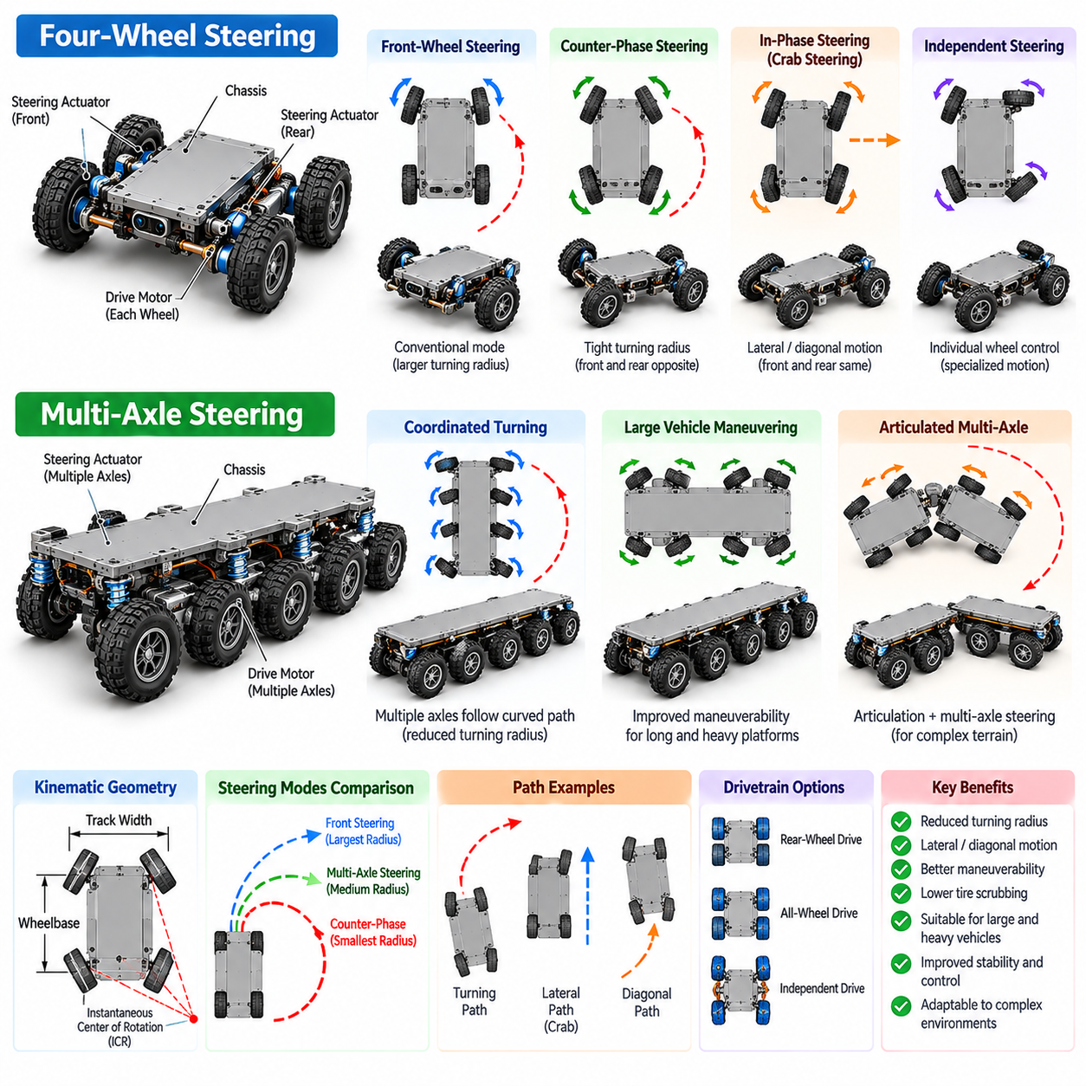
Four-wheel steering and multi-axle steering are advanced mobile base morphologies designed to improve maneuverability, directional control, and mobility under demanding operating conditions. Unlike conventional front-wheel steering, these architectures coordinate steering angles across multiple wheels or axles. Their mechanical configurations influence turning radius, lateral motion, tire-ground interaction, stability, and the ability to navigate constrained environments.
Four-wheel steering allows both front and rear wheels to change their orientation relative to the vehicle chassis. Steering commands may be mechanically linked or independently generated through dedicated actuators. By distributing steering functions across both axles, the platform can achieve motion patterns unavailable to conventional two-wheel steering systems, including tighter turning trajectories and coordinated lateral displacement.
One fundamental operating mode is counter-phase steering, in which the front and rear wheels turn in opposite directions. This configuration reduces the effective turning radius and enables large platforms to negotiate relatively confined spaces. Counter-phase steering is particularly valuable for autonomous industrial vehicles, warehouse transport platforms, and mobile robots requiring precise maneuvering around obstacles.
Another operating mode is in-phase steering, where front and rear wheels turn in the same direction. When steering angles are appropriately coordinated, the vehicle can execute approximately diagonal or lateral translation while maintaining a nearly constant heading. This motion is commonly described as crab steering and is useful for positioning vehicles beside structures, aligning payloads, and navigating narrow passages.
Four-wheel steering systems may also operate in conventional front-wheel steering mode when additional maneuverability is unnecessary. Some architectures transition between steering modes according to vehicle speed, operating conditions, or navigation objectives. Low-speed operation may prioritize reduced turning radius, while higher-speed operation can emphasize directional stability and smoother lateral response.
The kinematic behavior of four-wheel steering depends on wheelbase, track width, steering angles, and the geometric arrangement of the steering axes. Under ideal rolling conditions, wheel orientations should be coordinated so their rolling directions are compatible with a common instantaneous center of rotation. Incorrect steering coordination introduces lateral tire forces, mechanical stress, and unnecessary energy consumption.
Independent wheel steering extends these capabilities by allowing each wheel to receive a separate steering command. Such systems can accommodate specialized motion patterns, asymmetric configurations, and complex maneuvering requirements. However, independent steering increases actuator count, sensor requirements, calibration complexity, and the computational effort needed to maintain consistent wheel motion.
Multi-axle steering generalizes coordinated steering beyond two axles. Vehicles with three or more axles may distribute steering authority across several wheel groups to improve maneuverability and reduce tire scrubbing. This architecture is especially relevant to heavy-duty autonomous transporters, large agricultural machines, construction vehicles, and specialized robotic platforms carrying substantial or unusually shaped payloads.
In long-wheelbase vehicles, conventional steering can produce large turning radii and substantial lateral tire forces. Multi-axle steering addresses these limitations by adjusting the orientations of additional axles according to the desired vehicle trajectory. Properly coordinated steering enables long platforms to follow curved paths more efficiently while reducing unnecessary deformation and sliding at the tire-ground interface.
The steering geometry of multi-axle platforms becomes increasingly complex as the number of steerable axles grows. Each wheel may follow a different turning radius, requiring steering angles that satisfy the intended motion constraints. Geometric steering models provide an initial framework, but realistic implementations must also account for compliance, steering offsets, mechanical tolerances, and dynamic loading.
Articulated multi-axle vehicles introduce additional morphological considerations because chassis sections may rotate relative to one another. Articulation joints can improve terrain adaptation and maneuverability, particularly for long or heavy platforms. However, articulation changes the relationship between wheel orientation, vehicle geometry, and trajectory tracking, requiring coordinated modeling of the entire mechanical structure.
Steering architecture is closely related to drivetrain configuration. A four-wheel-steering platform may employ rear-wheel drive, all-wheel drive, or independently driven wheels. Coordinating propulsion and steering is essential because each wheel follows a different path during turning. Appropriate wheel-speed allocation helps maintain rolling compatibility, reduce slip, and distribute traction demands across the vehicle.
The relationship between steering and traction becomes particularly important on low-friction or deformable surfaces. Unequal wheel loading, changing friction coefficients, and terrain irregularities can cause deviations from ideal kinematic behavior. Multi-axle systems must therefore account for the interaction between steering commands, tire forces, suspension behavior, and the distribution of normal loads.
Vehicle stability is another central consideration in four-wheel and multi-axle steering design. Steering commands generate lateral acceleration and influence load transfer between wheels. Although coordinated steering can improve maneuverability, aggressive steering at elevated speeds may increase rollover risk or produce unstable transient responses. Safe operation requires appropriate limits on steering rate, speed, acceleration, and vehicle motion.
Payload distribution significantly affects the performance of these steering architectures. Heavy or elevated payloads alter the center of gravity, rotational inertia, and wheel loading. For autonomous transport platforms, steering geometry must be evaluated together with payload dimensions and placement. A configuration suitable for an unloaded vehicle may exhibit substantially different handling characteristics when carrying its maximum rated load.
Suspension design also interacts with multi-axle steering morphology. Independent suspension, rigid axles, and articulated chassis structures produce different wheel-contact conditions during turning and terrain traversal. Suspension movement can change steering geometry and wheel alignment, affecting tire forces and trajectory accuracy. Integrated mechanical design is necessary to maintain predictable steering behavior across operating conditions.
Four-wheel and multi-axle steering require control algorithms that translate desired vehicle motion into coordinated wheel orientations. Kinematic controllers calculate steering angles from target curvature, vehicle geometry, and selected steering mode. More advanced controllers incorporate dynamic models, actuator constraints, tire behavior, and predicted vehicle responses to maintain accuracy during acceleration, braking, and complex maneuvers.
Model predictive control is particularly relevant because it can consider future vehicle trajectories while respecting steering limits and motion constraints. For multi-axle platforms, the controller may optimize steering angles, wheel velocities, and trajectory tracking errors simultaneously. Such methods can improve maneuverability and reduce tire wear, although their effectiveness depends on model accuracy and available computational resources.
Accurate localization and state estimation are essential for coordinated steering. Wheel encoders, steering-angle sensors, inertial measurement units, and external perception systems provide information about vehicle motion. Sensor fusion helps distinguish intended steering behavior from actual movement, especially when wheel slip, actuator delays, or uneven terrain cause deviations from ideal geometric predictions.
Morphology-aware navigation must incorporate the complete swept volume of the vehicle rather than considering only its reference point. During complex turns, different chassis sections and payload extremities may follow substantially different paths. Path planners must therefore account for vehicle length, steering geometry, obstacle clearance, and the motion of all relevant structural components.
Four-wheel steering and multi-axle steering introduce important engineering tradeoffs. Additional steering mechanisms improve maneuverability but increase mechanical complexity, cost, maintenance requirements, and potential failure points. Designers must evaluate whether the operational benefits justify these penalties, particularly when simpler differential-drive, skid-steering, or conventional Ackermann configurations can satisfy mission requirements.
Simulation and physical testing provide essential evidence for selecting and validating these architectures. Kinematic simulation evaluates turning geometry and path feasibility, while dynamic simulation examines tire forces, stability, and load transfer. Prototype testing should assess steering accuracy, actuator synchronization, terrain interaction, payload sensitivity, and performance under representative operational disturbances.
In Physical AI, four-wheel and multi-axle steering demonstrate how coordinated mechanical degrees of freedom expand the available action space of autonomous systems. Their effectiveness depends on the integration of morphology, sensing, planning, and control. By aligning steering architecture with environmental constraints and operational objectives, intelligent mobile platforms can achieve greater maneuverability, precision, and adaptability while maintaining safe and efficient physical behavior.

04.04. Omnidirectional and Mecanum Platforms
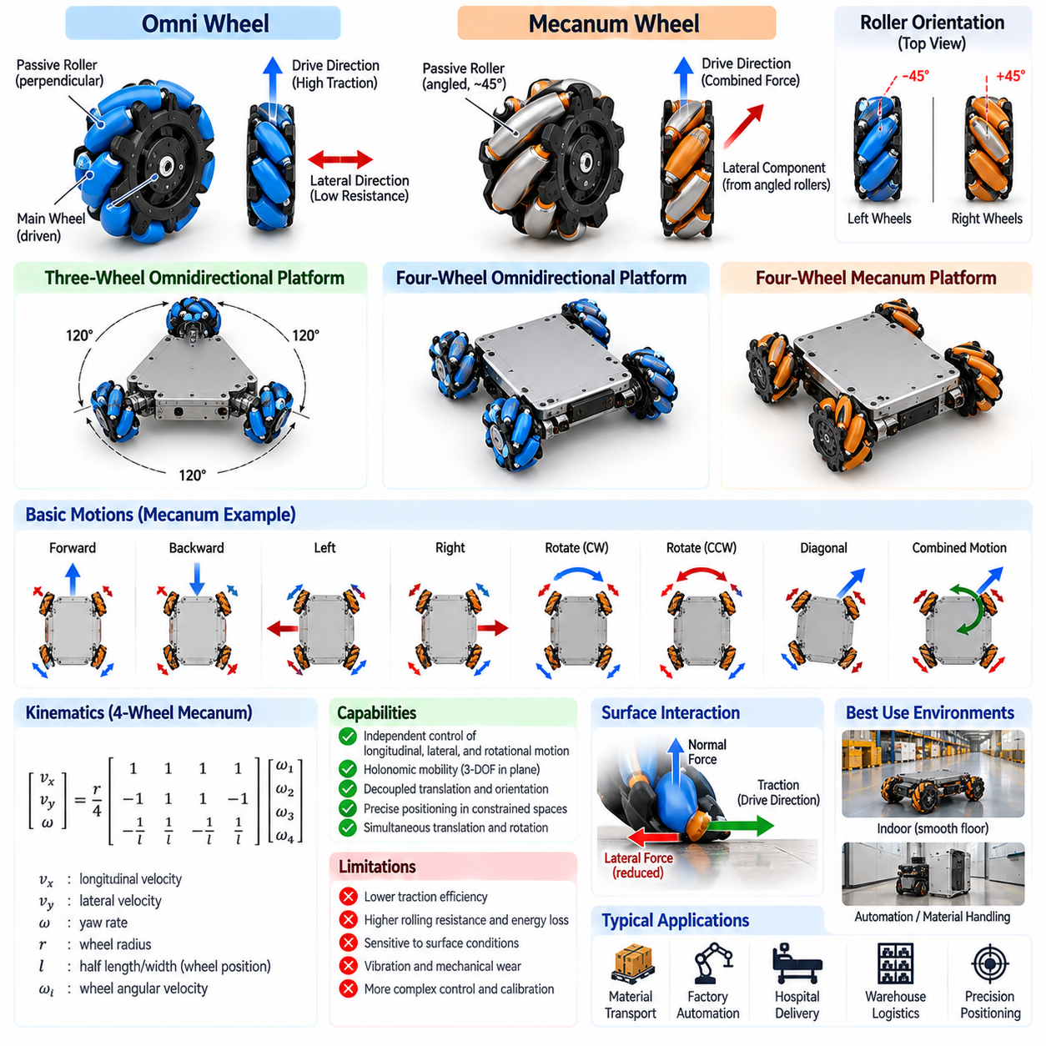
Omnidirectional mobile platforms represent a class of robotic locomotion architectures capable of generating motion in multiple planar directions without requiring conventional vehicle-like steering. Unlike differential-drive or Ackermann-steered robots, these platforms can independently control longitudinal translation, lateral translation, and rotation. This mobility expands the available motion space and improves maneuverability in constrained environments.
The fundamental advantage of omnidirectional morphology is its ability to decouple translational movement from body orientation. A robot can move sideways while maintaining its heading, rotate while translating, or follow complex trajectories without first aligning its chassis with the direction of travel. These capabilities are particularly valuable for precise positioning, automated material handling, and navigation through densely occupied workspaces.
Omnidirectional locomotion is commonly implemented using specialized wheel mechanisms that permit controlled motion along one direction while allowing passive movement along another. Omni wheels and Mecanum wheels achieve this behavior through rollers mounted around the wheel circumference. The arrangement of these rollers determines the directions in which traction forces can be generated and how individual wheel motions combine.
Conventional omnidirectional wheels typically contain passive rollers positioned perpendicular to the main wheel's rolling direction. These rollers reduce resistance to lateral movement while the primary wheel rotation generates traction along its driven direction. By arranging several such wheels at appropriate orientations, a mobile base can produce independent planar translations and rotational motion through coordinated wheel velocities.
Three-wheel omnidirectional platforms often position their wheels symmetrically around the chassis, with wheel driving directions arranged to provide full planar mobility. Their compact geometry supports precise maneuvering and relatively simple mechanical integration. However, load distribution, wheel contact consistency, and traction limitations must be carefully managed to maintain reliable movement under changing operating conditions.
Four-wheel omnidirectional platforms provide additional contact points and may offer improved payload support and mechanical redundancy. Their wheel arrangements can be configured to generate translation and rotation through combinations of individual wheel speeds. Although additional wheels can improve load distribution, unequal ground contact or geometric misalignment may introduce internal forces and reduce motion accuracy.
Mecanum wheels are a widely used omnidirectional mechanism characterized by passive rollers mounted at an angle, commonly approximately 45 degrees, relative to the wheel's primary rolling plane. When the wheel rotates, the angled rollers produce an effective traction direction determined by wheel orientation and contact geometry. Coordinating multiple Mecanum wheels enables motion along different planar directions.
A typical Mecanum platform employs four independently driven wheels arranged around a rectangular chassis. The roller orientations are selected so that longitudinal, lateral, and rotational motion can be generated through appropriate wheel-speed combinations. Correct wheel placement and roller orientation are essential because reversing an individual wheel configuration can substantially alter the resulting motion behavior.
During forward or backward motion, the wheel velocities are coordinated so that lateral force contributions approximately cancel while longitudinal components combine. For sideways movement, the wheel rotation directions are selected to reinforce lateral motion while canceling unwanted longitudinal and rotational components. Rotational movement is generated through wheel-speed patterns that create a net yaw moment around the platform.
Mecanum platforms can also combine translation and rotation simultaneously, allowing complex planar trajectories. This capability is especially useful when a robot must maintain sensor orientation, align with equipment, or transport objects through narrow spaces. However, the commanded motion depends on accurate wheel-speed coordination and sufficient traction at each wheel-ground contact point.
The kinematics of omnidirectional platforms are commonly expressed through a transformation between chassis velocity and individual wheel angular velocities. The chassis velocity includes longitudinal speed, lateral speed, and yaw rate. Wheel radius, wheel placement, roller geometry, and chassis dimensions determine the transformation matrix used for forward and inverse kinematic calculations.
Under ideal conditions, omnidirectional platforms can provide three independently controllable planar degrees of freedom. This property is often described as holonomic mobility at the chassis level. Nevertheless, the actual system remains subject to actuator limits, wheel-contact constraints, friction, and mechanical imperfections that may prevent the commanded motion from being achieved precisely.
Wheel-ground interaction is a major determinant of omnidirectional mobility performance. Passive rollers introduce additional contact interfaces that can generate vibration, rolling resistance, and uneven traction. Surface roughness, debris, floor joints, and changes in friction can affect roller engagement. Consequently, omnidirectional platforms generally perform best on relatively smooth, firm, and predictable surfaces.
Mecanum wheels often exhibit reduced traction efficiency compared with conventional wheels because their angled rollers distribute contact forces across multiple directions. Some actuator effort contributes to force components that cancel at the chassis level. This behavior can increase energy consumption and reduce effective acceleration or payload capability, particularly during lateral movement or operation on low-friction surfaces.
The mechanical geometry of an omnidirectional base strongly influences stability and payload performance. Wheel spacing, chassis dimensions, center-of-gravity height, and mass distribution determine resistance to tipping and load transfer during acceleration. Platforms carrying heavy or elevated payloads require careful structural design to maintain sufficient wheel contact and predictable movement across all directions.
Suspension and wheel mounting arrangements are particularly important because omnidirectional motion depends on consistent contact among multiple wheels. Small variations in floor height, wheel diameter, or chassis alignment can redistribute normal forces and alter traction. Compliant mounting structures or carefully designed suspension mechanisms may improve contact consistency, although excessive compliance can reduce positioning accuracy.
Control systems for omnidirectional platforms must coordinate wheel velocities while compensating for actuator differences, friction, and external disturbances. Basic kinematic controllers convert desired chassis velocities into individual motor commands. More advanced approaches incorporate feedback from wheel encoders, inertial sensors, and external localization systems to correct motion errors and improve trajectory tracking.
Accurate odometry is challenging because roller slip and uneven contact can cause discrepancies between wheel rotation and actual chassis displacement. Errors may become especially noticeable during lateral movement or combined translation and rotation. Sensor fusion involving inertial measurement units, cameras, LiDAR, and other localization sources can improve state estimation and reduce accumulated positioning errors.
Omnidirectional mobility changes the requirements of path planning and obstacle avoidance. Because the robot can translate laterally without changing orientation, planners can exploit a broader range of feasible motions than conventional nonholonomic platforms. However, planning must still account for chassis dimensions, obstacle clearance, wheel-speed limits, acceleration constraints, and the physical cost of different movement directions.
In Physical AI applications, omnidirectional platforms provide useful opportunities for morphology-aware control and learning. Intelligent controllers can adapt wheel-speed allocation to changing payloads, surface friction, and actuator performance. Learning-based methods may identify motion errors and improve control policies, while physics-based models preserve consistency with the platform's mechanical and contact constraints.
The choice between conventional omni wheels and Mecanum wheels depends on payload requirements, chassis geometry, available space, surface conditions, and mechanical complexity. Omni-wheel arrangements can offer efficient motion along their designed traction directions, while Mecanum configurations provide a convenient rectangular platform architecture. Neither mechanism is universally superior across all operating environments.
Industrial applications include autonomous mobile robots, robotic transport carts, manufacturing platforms, hospital logistics systems, and precision positioning vehicles. These applications benefit from sideways movement, compact maneuvering, and accurate alignment with workstations. Nevertheless, operational suitability must be evaluated against floor quality, maintenance requirements, energy efficiency, safety constraints, and expected payload variation.
Ultimately, omnidirectional and Mecanum platforms demonstrate how specialized wheel morphology can expand the motion capabilities of mobile robots. Their advantages arise from the coordinated interaction of wheel geometry, actuator control, and ground contact. Successful Physical AI deployment requires integrating these mechanical characteristics with perception, localization, planning, and adaptive control to achieve reliable, efficient, and precise autonomous mobility.

04.05. Tracked and Hybrid Platforms
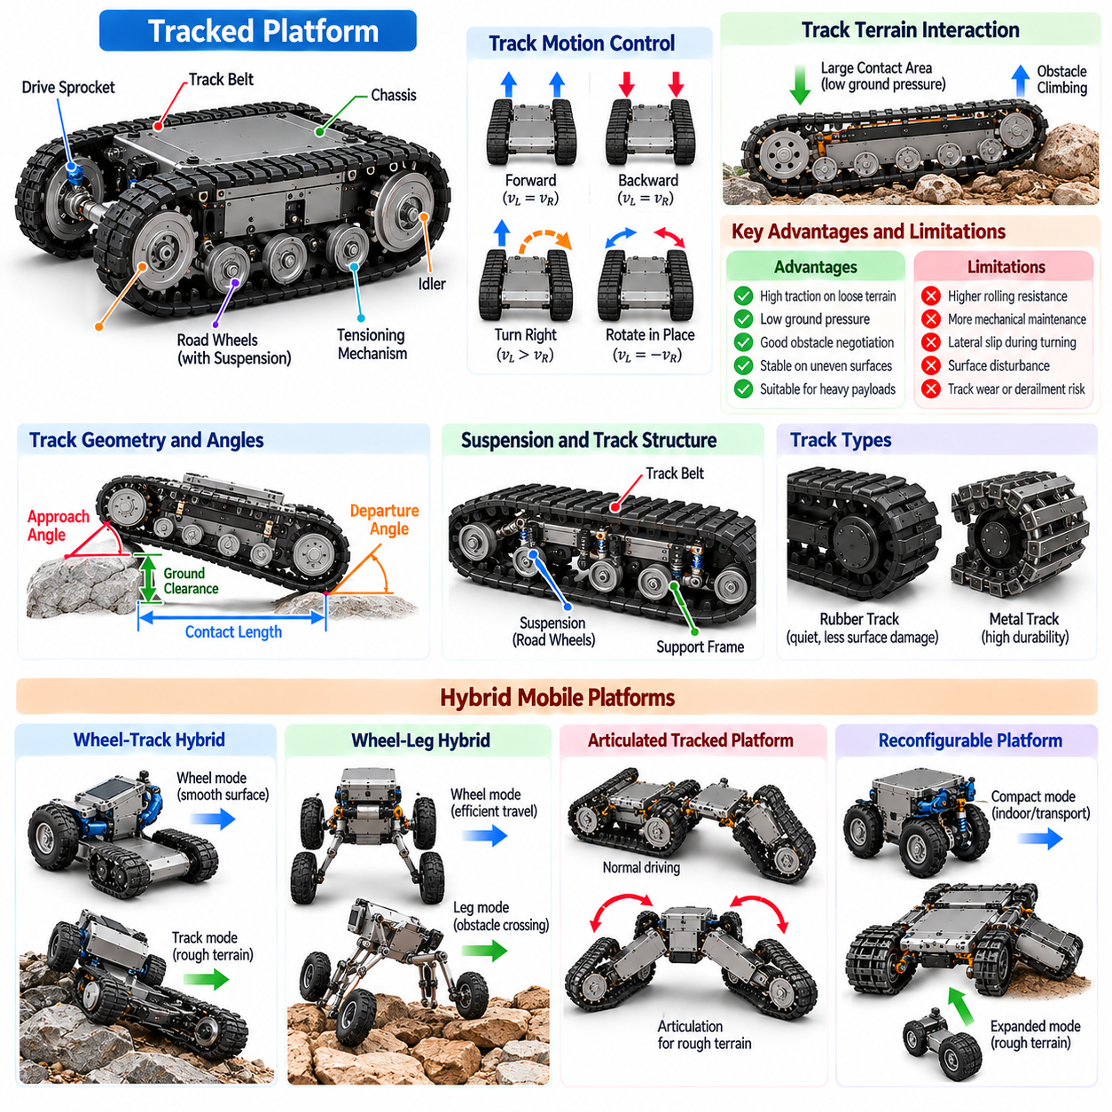
Tracked and hybrid mobile platforms represent specialized locomotion architectures designed to operate in environments where conventional wheeled systems may experience limited traction, insufficient obstacle-crossing capability, or unstable ground contact. Their morphology emphasizes terrain adaptability, load distribution, and mechanical robustness. These platforms are particularly relevant to outdoor robotics, industrial inspection, construction, agriculture, and emergency response.
Tracked locomotion uses continuous belts or linked track assemblies that circulate around drive sprockets, idlers, and supporting rollers. Unlike conventional wheels, tracks establish an extended contact region between the vehicle and the terrain. This arrangement distributes vehicle weight across a larger surface area, potentially reducing ground pressure and improving mobility on soft, loose, or irregular ground.
The mechanical architecture of a tracked platform typically includes drive sprockets, track belts, tensioning mechanisms, road wheels, and structural support frames. Drive sprockets transmit propulsion forces to the tracks, while idlers guide their circulation and maintain alignment. Track tension and support geometry influence traction, vibration, wear, and the reliability of movement under varying loads.
Tracked platforms commonly employ differential track-speed control to generate forward movement, reverse movement, and turning. When both tracks move at equal speeds, the vehicle travels approximately straight. Different track velocities produce curved motion, while opposite track directions can generate near-stationary rotation. However, turning generally involves lateral sliding between the tracks and the ground.
The kinematics of tracked vehicles resemble those of skid-steering platforms, but their dynamics are strongly influenced by distributed ground contact. Track deformation, terrain friction, contact length, and soil resistance affect turning behavior. Consequently, ideal differential-drive equations provide only approximate descriptions, and accurate prediction may require experimentally calibrated or terrain-dependent models.
A major advantage of tracked morphology is the ability to distribute normal forces over an extended contact patch. This can improve flotation on deformable terrain and reduce localized ground loading. However, actual performance depends on track width, contact length, vehicle mass, soil properties, and pressure distribution. Tracks do not automatically guarantee superior traction or mobility under every surface condition.
Track geometry plays an important role in obstacle negotiation. The arrangement of front idlers, rear sprockets, and supporting rollers determines approach angle, departure angle, and effective ground clearance. Elevated front track sections can help a vehicle engage obstacles, while longer contact regions may improve stability but increase turning resistance and maneuvering difficulty.
Suspension systems in tracked platforms help maintain contact with uneven terrain and reduce shocks transmitted to onboard equipment. Road-wheel suspension, articulated track assemblies, and compliant mounting structures allow the track system to accommodate ground irregularities. Appropriate suspension design improves traction consistency, mechanical durability, and sensor stability during rough-terrain operation.
Track materials and construction significantly influence platform performance. Rubber tracks generally offer relatively quiet operation and can reduce damage to finished surfaces, while metal-linked tracks may provide greater durability in abrasive environments. Reinforcement structures, tread patterns, and track flexibility affect wear resistance, traction, rolling losses, and compatibility with different terrain conditions.
Despite their mobility advantages, tracked platforms introduce important limitations. Continuous track systems may require greater mechanical maintenance than simple wheeled architectures because of belt tension, alignment, debris accumulation, and component wear. Turning can produce substantial frictional losses and surface disturbance, while track damage or derailment may significantly reduce operational availability.
Hybrid mobile platforms combine multiple locomotion mechanisms to extend mobility across environments with different physical constraints. Common examples include wheel-track systems, wheel-leg configurations, articulated tracked platforms, and reconfigurable ground-contact mechanisms. Their objective is to combine the efficiency of one locomotion mode with the terrain adaptability or obstacle-crossing capability of another.
Wheel-track hybrid platforms may operate primarily on wheels over smooth surfaces and engage tracks when additional ground contact or terrain capability is required. Some designs use deployable track modules, while others integrate wheels and tracks into a shared mechanical assembly. Such configurations can improve operational versatility, although transition mechanisms add mass, complexity, and potential failure points.
Wheel-leg hybrid systems combine continuous rolling motion with articulated limb structures. Wheels provide efficient transportation on relatively smooth ground, while articulated legs can adjust body height, negotiate obstacles, or maintain contact on irregular terrain. These platforms illustrate how combining locomotion principles can expand the reachable workspace and improve adaptation to uncertain environments.
Articulated tracked robots use movable track modules or interconnected chassis sections to change their effective geometry. Front and rear flippers, adjustable track arms, and articulated body segments can assist with climbing obstacles, crossing gaps, and traversing uneven surfaces. Their effectiveness depends on coordinated joint control, contact estimation, and management of the vehicle's center of gravity.
Reconfigurable morphology allows hybrid platforms to modify their physical structure according to terrain conditions and task requirements. Changes in track deployment, wheel position, chassis height, or articulation angle alter the robot's contact geometry and dynamic behavior. This adaptability increases operational flexibility but introduces additional sensing, actuation, and control requirements.
The transition between locomotion modes is a critical design challenge for hybrid robots. Switching from wheels to tracks or adjusting articulated modules changes the distribution of contact forces and available motion constraints. Poorly coordinated transitions can produce instability, excessive actuator loading, or temporary loss of traction. Reliable transitions require appropriate mechanical sequencing and feedback control.
Mass distribution and center-of-gravity placement are essential considerations for both tracked and hybrid platforms. Heavy drive components, batteries, payloads, and articulated mechanisms influence stability during climbing, descending, and turning. Low center-of-gravity placement generally improves resistance to tipping, while movable components may require dynamic stability evaluation as their configurations change.
Energy efficiency varies substantially across tracked and hybrid locomotion modes. Tracks can provide useful traction on difficult terrain but may experience higher rolling and steering losses than conventional wheels on firm surfaces. Hybrid platforms can potentially reduce energy consumption by selecting efficient locomotion modes, although added actuators, transmissions, and structural mass may offset some benefits.
Control systems must account for complex interactions among propulsion, steering, terrain contact, and morphological configuration. Basic tracked platforms may use differential track-speed commands, while articulated and hybrid systems require coordinated control of additional joints or mechanisms. Model-based control and adaptive feedback can improve stability and motion accuracy under changing terrain conditions.
Accurate localization is challenging because track slip, soil deformation, and irregular contact can produce significant odometry errors. Wheel or track encoder measurements may not directly represent actual ground displacement. Combining inertial measurement units, visual odometry, LiDAR, and terrain-aware estimation methods can improve localization reliability and support autonomous navigation in unstructured environments.
Terrain perception plays a particularly important role in intelligent tracked and hybrid robots. Cameras, depth sensors, and LiDAR can estimate obstacle geometry, slope, surface roughness, and potential traversability. Physical AI systems can use this information to select locomotion modes, adjust articulation, regulate speed, and anticipate situations where the current morphology may become ineffective or unsafe.
Morphology-aware planning must consider not only the path through an environment but also the physical configuration required to traverse it. A hybrid robot may need to deploy tracks before entering soft terrain or reposition articulated modules before climbing an obstacle. Planning therefore involves coordinating spatial trajectories with configuration changes while respecting stability, clearance, and actuator constraints.
Safety and reliability are especially important because tracked and hybrid platforms frequently operate in hazardous or unpredictable environments. Mechanical protection, emergency stopping, actuator monitoring, and fault detection must account for terrain-induced loads and possible mobility failures. Reconfigurable mechanisms also introduce pinch points and additional failure modes that require appropriate protective design.
Simulation and experimental validation should incorporate realistic track-ground interaction, terrain deformation, friction, suspension dynamics, and configuration-dependent stability. Simplified models are useful for early development, but field testing remains essential for identifying unexpected contact behavior and mechanical limitations. Representative terrain trials help establish safe operating boundaries and reliable control strategies.
Ultimately, tracked and hybrid platforms demonstrate how mobile base morphology can be adapted to overcome limitations of conventional wheeled locomotion. Their value arises from extended ground contact, specialized obstacle-negotiation geometry, and configurable mechanical structures. Successful Physical AI integration requires coordinated design of morphology, perception, planning, control, and energy management to achieve reliable mobility across diverse environments.

04.06. Wheel Tire and Terrain Interaction
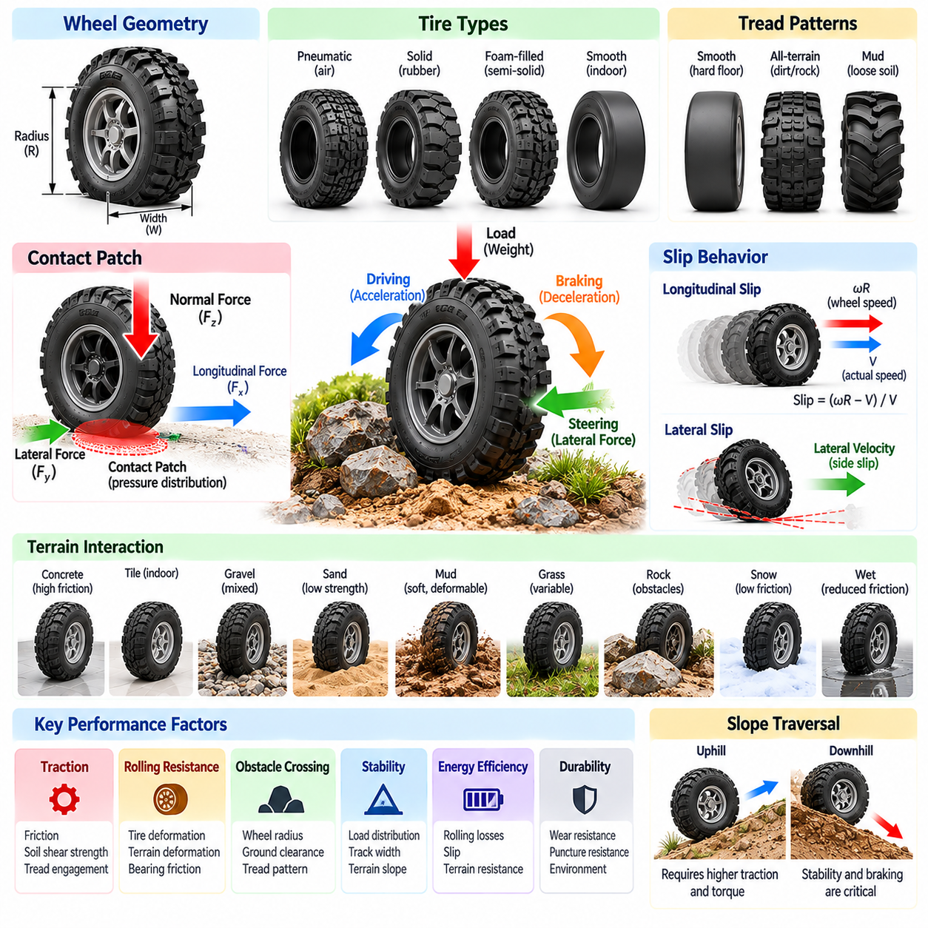
Wheel, tire, and terrain interaction is a fundamental aspect of mobile robot morphology because it determines how mechanical forces are transmitted between the platform and its operating environment. Wheel geometry, tire materials, surface conditions, and contact mechanics collectively influence traction, stability, energy efficiency, and mobility. Understanding these relationships is essential for designing reliable autonomous platforms across diverse terrain conditions.
The wheel serves as the primary mechanical interface between a wheeled robot and the ground. Its radius, width, structural stiffness, and surface profile influence rolling resistance, obstacle negotiation, and load distribution. Larger wheels generally improve the ability to cross small obstacles, while smaller wheels support compact platform designs. However, wheel dimensions must be evaluated together with motor torque, vehicle mass, and available installation space.
Tire construction introduces additional mechanical properties that strongly affect mobility. Pneumatic tires provide compliance through internal air pressure and flexible sidewalls, allowing deformation around surface irregularities. Solid tires offer puncture resistance and reduced maintenance requirements but may transmit greater vibration. Foam-filled and semi-solid designs provide intermediate characteristics depending on their construction and operating conditions.
The tire-ground contact patch is the region through which normal forces, longitudinal forces, and lateral forces are transmitted. Its size and pressure distribution depend on tire stiffness, inflation pressure, applied load, and terrain properties. Contact conditions influence braking, acceleration, steering, and vibration. Accurate modeling requires consideration of both the tire's deformation and the mechanical response of the supporting surface.
Traction describes the ability of a wheel to generate useful forces without excessive slipping. On firm surfaces, available traction is strongly influenced by friction and normal loading. On deformable terrain, soil shear strength, compaction, and tread penetration also become important. Consequently, identical tires may exhibit substantially different traction characteristics on concrete, gravel, sand, mud, or wet surfaces.
Longitudinal slip occurs when the wheel's circumferential speed differs from its actual forward motion relative to the ground. During acceleration, excessive drive torque can cause wheel spin, while aggressive braking may produce wheel lockup. A controlled amount of slip may be necessary to generate traction, but excessive slip wastes energy, increases wear, and reduces the accuracy of wheel-based motion estimation.
Lateral slip develops when a wheel moves sideways relative to its intended rolling direction. This phenomenon is particularly important during steering, cornering, and operation on low-friction surfaces. Tire deformation and lateral contact forces determine the relationship between steering input and actual trajectory. Excessive lateral slip can increase path-tracking errors and compromise directional stability.
Rolling resistance represents the energy dissipated as a wheel travels across a surface. Tire deformation, internal material hysteresis, bearing friction, and terrain deformation contribute to this resistance. Soft tires and deformable ground can increase energy losses, while rigid wheels on smooth surfaces may roll more efficiently. However, minimizing rolling resistance alone does not guarantee adequate traction or ride quality.
Wheel radius influences both mobility and drivetrain requirements. Increasing wheel radius can improve obstacle-crossing capability and reduce the relative severity of small surface irregularities. However, producing the same ground force requires proportionally greater wheel torque. Larger wheels may also increase rotational inertia, mass, and packaging constraints, creating tradeoffs between mobility, acceleration, and mechanical efficiency.
Wheel width affects ground pressure, contact geometry, and resistance to sinking into soft terrain. Wider tires can distribute loads across a larger area, potentially improving mobility on sand or loose soil. However, wider contact regions may increase steering resistance, mass, and rolling losses. Optimal width depends on terrain strength, payload distribution, and the expected balance between straight-line travel and turning.
Tread patterns influence how tires interact with different surfaces. Smooth treads can provide consistent contact on clean, hard floors, while aggressive tread blocks may improve mechanical engagement with loose soil or mud. Grooves can assist with water displacement, although performance depends on speed, load, and surface conditions. Tread selection must balance traction, noise, vibration, wear, and floor compatibility.
Terrain properties introduce substantial uncertainty into wheel-ground interaction. Surface roughness, slope, moisture, particle size, and soil cohesion affect the forces available for propulsion and steering. Even apparently uniform terrain may contain localized changes in friction or bearing strength. Autonomous robots must therefore treat terrain characteristics as variable environmental conditions rather than fixed mechanical parameters.
On deformable terrain, wheel performance is closely related to terramechanics, which examines the interaction between vehicles and soil. Wheel loading causes sinkage and soil deformation, while propulsion depends partly on shear forces developed within the ground. Excessive sinkage increases motion resistance and can immobilize the vehicle. Tire dimensions, inflation pressure, tread geometry, and vehicle weight jointly influence these effects.
Slope traversal introduces additional traction and stability requirements. During uphill movement, gravity increases the longitudinal force needed for propulsion, while downhill movement requires controlled braking. Cross-slope operation produces lateral load transfer and may increase sliding or rollover risk. Safe mobility depends on available friction, center-of-gravity location, wheel placement, and the distribution of contact forces.
Dynamic load transfer changes the normal forces acting on individual wheels during acceleration, braking, and turning. These changes alter the traction available at each contact point and influence the effectiveness of propulsion and steering commands. Unequal wheel loading can cause some wheels to slip while others retain substantial traction. Coordinated drivetrain control can help distribute forces more effectively.
Suspension and tire compliance interact to determine how consistently wheels remain in contact with uneven ground. Suspension mechanisms accommodate larger terrain variations, while tire deformation absorbs smaller irregularities. Appropriate combinations improve traction continuity, reduce shock transmission, and protect onboard sensors. Excessive compliance, however, may introduce oscillations and reduce precise motion control.
Wheel material selection also affects durability and environmental compatibility. Rubber compounds provide different combinations of friction, elasticity, and wear resistance, while polyurethane wheels are frequently used on indoor industrial platforms. Metal or highly rigid wheels may suit specialized environments but can increase surface damage and vibration. Material selection should reflect temperature, chemical exposure, floor conditions, and maintenance requirements.
Wheel-ground interaction directly influences odometry and localization accuracy. Conventional wheel encoders estimate displacement from rotational motion, assuming a predictable relationship between wheel rotation and ground travel. Slip, tire deformation, changing effective radius, and uneven terrain violate this assumption. Integrating inertial sensing, visual odometry, and external localization measurements can reduce accumulated positioning errors.
Terrain-aware control systems adapt propulsion and steering commands to changing contact conditions. Traction control can limit excessive wheel spin, while slip estimation helps identify discrepancies between commanded and actual motion. More advanced controllers adjust torque allocation, acceleration limits, and trajectory selection according to estimated surface properties. Such adaptation improves mobility without requiring a complete change in mechanical architecture.
Physical AI extends terrain interaction beyond conventional feedback control by integrating perception, prediction, and adaptive decision-making. Cameras, depth sensors, and other sensing systems can identify surface characteristics before contact occurs. Learned models may estimate traversability or predict slip from previous experience, while physics-based constraints help maintain safe operation when predictions are uncertain.
Morphology-aware planning must consider whether a proposed path is physically traversable by the selected wheel and tire configuration. A geometrically clear route may still be unsuitable because of insufficient traction, excessive sinkage, steep slopes, or surface irregularities. Planning systems should incorporate ground clearance, wheel dimensions, estimated friction, and terrain strength when evaluating candidate trajectories.
Experimental characterization is essential because simplified friction models cannot capture every interaction between tires and real terrain. Testing should examine traction, slip, rolling resistance, vibration, wear, and obstacle traversal under representative loads and environmental conditions. Measurements across multiple surfaces provide evidence for selecting tire designs and calibrating simulation models used during development.
Ultimately, wheel, tire, and terrain interaction demonstrates that mobile robot performance emerges from the coupling between mechanical morphology and environmental physics. Effective design requires balancing traction, rolling efficiency, durability, stability, and control accuracy rather than optimizing a single property. Integrating contact mechanics with perception, planning, and adaptive control enables Physical AI platforms to operate more reliably across diverse and uncertain environments.

04.07. Wheelbase Track Width and Ground Clearance
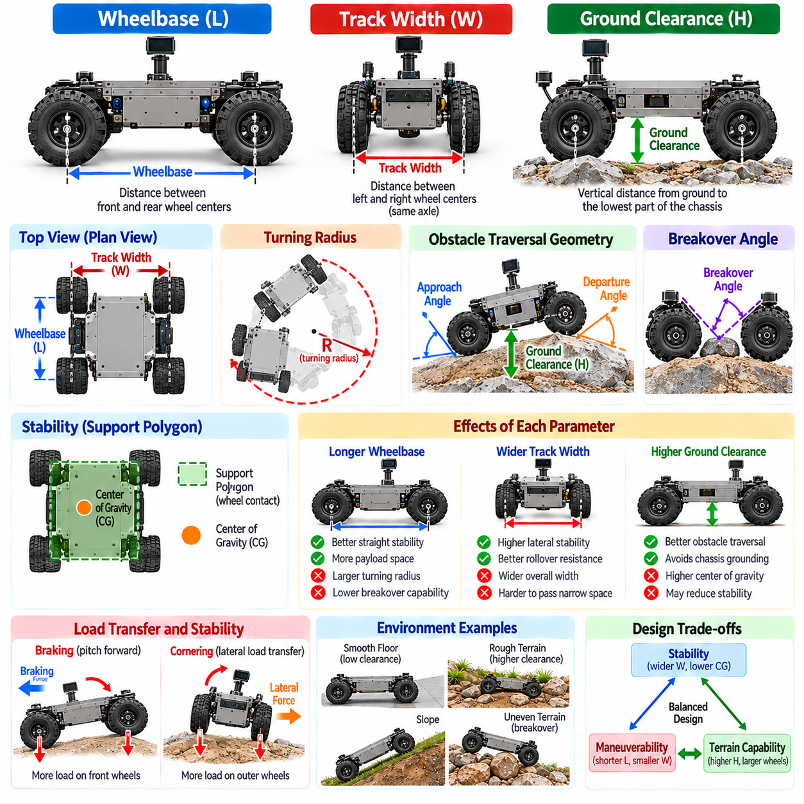
Wheelbase, track width, and ground clearance are fundamental geometric parameters that define the mechanical proportions and mobility characteristics of a wheeled robotic platform. These dimensions influence maneuverability, stability, obstacle traversal, and terrain compatibility. Their selection must reflect the intended operating environment, payload requirements, steering architecture, and the physical constraints imposed by the robot's mission.
Wheelbase is the longitudinal distance between the centers of the front and rear wheel axles. It determines important aspects of turning geometry, pitch stability, and load distribution. A longer wheelbase generally improves directional stability and provides more space for components and payloads. However, it can increase turning radius and make navigation through confined environments more difficult, particularly for conventional steering systems.
A shorter wheelbase supports compact vehicle construction and can improve maneuverability in narrow spaces. It may allow tighter turns and reduce the longitudinal space required for docking or repositioning. Nevertheless, shorter wheelbases can increase sensitivity to acceleration-induced pitch motion and uneven terrain. Designers must therefore balance compactness against stability, suspension behavior, and payload positioning requirements.
Track width is the lateral distance between the centerlines of the left and right wheels on the same axle. It strongly influences resistance to lateral tipping and the distribution of loads during cornering. A wider track generally improves lateral stability by increasing the support base. However, it also increases overall vehicle width, potentially restricting access to narrow corridors, doorways, and industrial workspaces.
The relationship between wheelbase and track width determines the overall footprint and geometric proportions of the mobile base. A long, narrow platform may provide substantial longitudinal support but exhibit limited lateral stability. A short, wide platform may resist sideways tipping while presenting different pitch and maneuvering characteristics. Balanced proportions depend on the expected motion patterns and environmental constraints.
Ground clearance is the vertical distance between the ground surface and the lowest relevant structural component of the vehicle under specified loading conditions. It determines whether the platform can pass over obstacles without contacting its underside. Ground clearance must account for chassis structures, battery enclosures, drive components, suspension elements, and other parts that may extend below the main frame.
Higher ground clearance improves the ability to traverse uneven terrain, small rocks, surface transitions, and certain obstacles. It can also reduce the likelihood of chassis grounding when crossing irregular surfaces. However, increasing clearance may raise the center of gravity and reduce stability unless the internal mass distribution is carefully managed. The benefits therefore depend on the entire vehicle geometry.
Low ground clearance is often appropriate for indoor autonomous mobile robots operating on smooth industrial floors. It supports compact packaging, low payload placement, and potentially improved stability. However, low-clearance platforms may struggle with floor joints, thresholds, ramps, cables, or unexpected debris. Even indoor environments require careful evaluation of minimum obstacle and clearance requirements.
Wheelbase and ground clearance jointly influence the breakover capability of a mobile robot. Breakover occurs when the vehicle crosses a raised obstacle or terrain crest that may contact the underside between its wheels. A longer wheelbase generally increases the risk of grounding for a given clearance. Increasing clearance or modifying the chassis underside can improve the ability to cross such obstacles.
Approach angle and departure angle complement ground clearance when evaluating obstacle traversal. Approach angle describes the steepest obstacle geometry that the front of the vehicle can engage without structural interference. Departure angle represents the corresponding condition at the rear. These angles depend on wheel placement, overhang dimensions, tire radius, and the shape of the chassis.
The front and rear overhangs of a platform influence its effective mobility envelope. Excessive overhang can cause structural contact during ramp entry, obstacle crossing, or transitions between surfaces. Reducing overhang improves clearance geometry but may constrain packaging space and component placement. Designers must coordinate wheelbase, wheel position, and chassis boundaries rather than optimizing each dimension independently.
Vehicle stability depends on the relationship between its center of gravity and the support polygon formed by wheel-ground contact points. During static operation, the projected center of gravity should remain within the support region to avoid tipping. Wheelbase and track width determine the longitudinal and lateral extent of this region, while ground clearance can indirectly influence the height of the center of gravity.
Dynamic operation introduces additional stability considerations because acceleration, braking, and turning generate inertial forces and load transfer. A narrow track width can increase rollover susceptibility during aggressive lateral maneuvers, especially with elevated payloads. A short wheelbase may increase pitch sensitivity during braking or acceleration. Safe operation requires geometric design and appropriate motion limits.
Payload characteristics are central to selecting these geometric parameters. Heavy loads change wheel loading, structural deformation, and center-of-gravity position. Elevated or asymmetrically positioned payloads may reduce stability margins even when the unloaded platform appears well balanced. Designers should evaluate wheelbase, track width, and clearance under both nominal and maximum payload configurations.
Steering architecture changes how wheelbase and track width affect maneuverability. In Ackermann-steered vehicles, wheelbase strongly influences achievable turning radius for a given steering angle. Differential-drive and skid-steering platforms can rotate more tightly, but their footprint and swept volume still constrain movement. Four-wheel steering and omnidirectional mechanisms provide additional flexibility without eliminating geometric limitations.
The effective swept volume of a mobile base is determined by more than its nominal footprint. During turning, chassis corners, mounted sensors, payload extensions, and protective structures may occupy regions outside the wheel trajectories. A longer or wider vehicle may require additional clearance around obstacles. Motion planners must therefore consider the complete body geometry when evaluating feasible paths.
Wheel diameter interacts with ground clearance and overall chassis proportions. Larger wheels can improve obstacle engagement and permit greater clearance without excessive suspension travel. However, they require additional packaging space and may increase drivetrain torque requirements. Smaller wheels support low-profile designs but can become trapped by relatively minor surface discontinuities.
Suspension geometry can alter effective wheelbase, track width, and ground clearance during operation. Wheel travel, suspension compression, and articulated motion change the relative positions of contact points and structural components. A platform that satisfies clearance requirements when unloaded may experience reduced clearance under heavy payloads or dynamic loading. Design evaluation must include these configuration-dependent variations.
Terrain slope also changes the relationship between geometry and stability. During uphill or downhill travel, the projected center of gravity moves relative to the support region. Cross-slope travel reduces lateral stability margins and may increase the risk of sliding or tipping. Wheelbase, track width, clearance, tire traction, and payload height must therefore be evaluated together for outdoor mobility.
For heavy-duty platforms, increasing wheelbase or track width can improve load distribution and provide space for additional axles or structural reinforcement. However, larger dimensions introduce challenges related to turning, transportability, and operation in restricted areas. Multi-axle steering, articulated chassis structures, and adjustable suspension systems may compensate for some of these geometric limitations.
Morphology optimization involves selecting geometric parameters according to measurable performance objectives rather than relying on isolated design preferences. Candidate configurations can be evaluated for turning radius, obstacle clearance, tipping resistance, payload capacity, and energy consumption. Multi-objective optimization helps identify balanced solutions because improving one geometric property may negatively affect another.
Simulation provides an effective method for exploring geometric tradeoffs before physical prototypes are constructed. Kinematic models estimate turning behavior and path feasibility, while dynamic models evaluate load transfer and stability. Terrain simulations can assess grounding, obstacle negotiation, and suspension movement. Experimental validation remains necessary because real contact conditions and structural deformation may differ from ideal models.
Physical AI systems can incorporate these geometric characteristics into perception, planning, and control. A robot can estimate whether an opening is wide enough, whether an obstacle exceeds its clearance capability, or whether a slope threatens stability. Morphology-aware decision-making connects fixed mechanical dimensions with adaptive behavior, allowing autonomous systems to select routes and motion strategies consistent with their physical limitations.
Ultimately, wheelbase, track width, and ground clearance form an interconnected geometric foundation for mobile robot morphology. Their combined effects determine how effectively a platform balances compactness, stability, payload support, and terrain accessibility. Successful design requires integrating geometric proportions with steering, suspension, wheel selection, sensing, and intelligent control to achieve safe and reliable autonomous mobility.

04.08. Suspension and Articulated Morphology
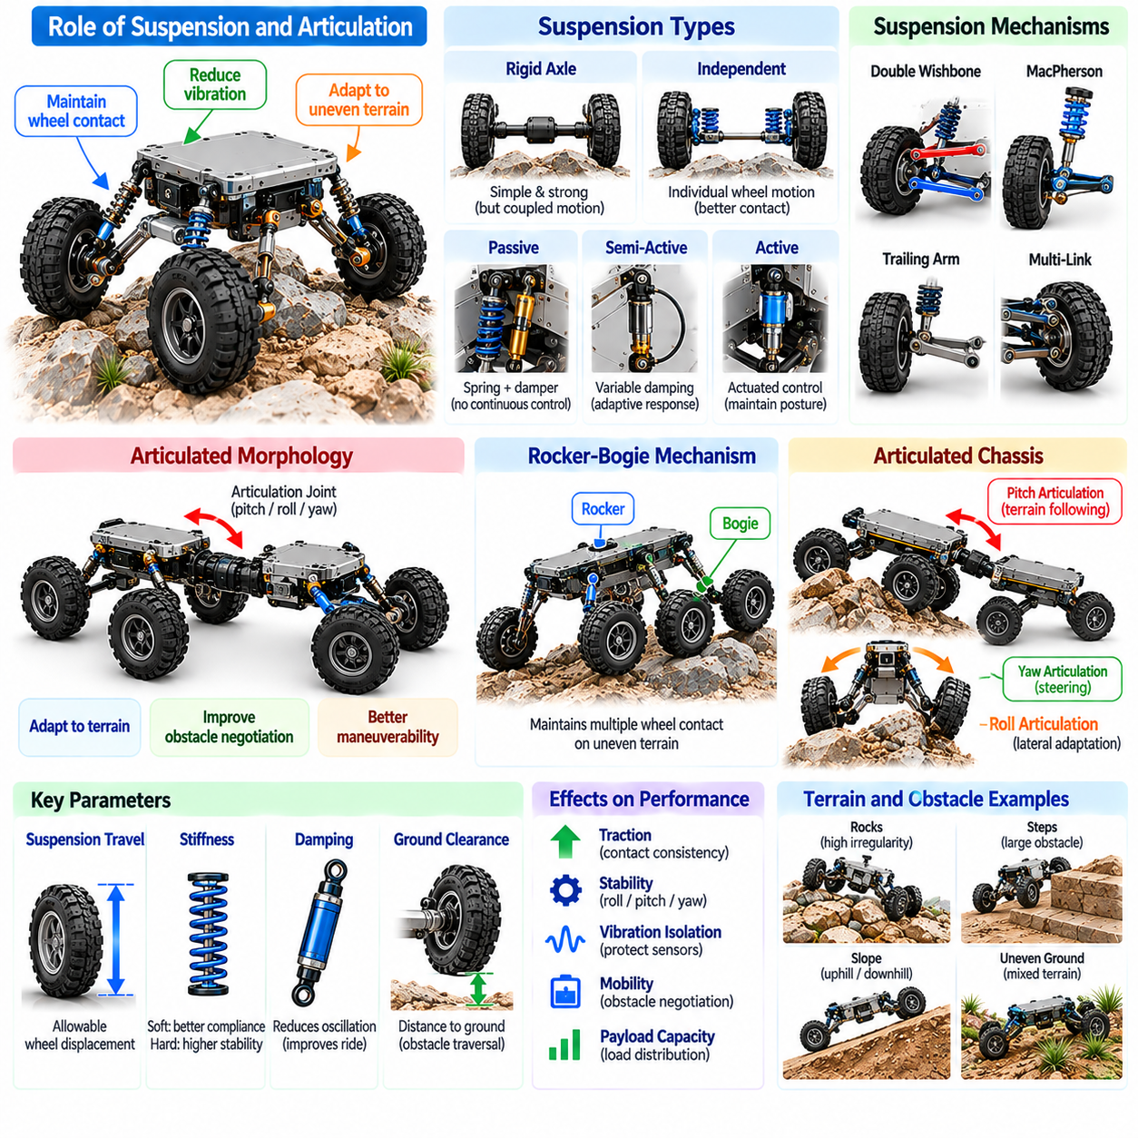
Suspension and articulated morphology are essential elements of mobile robot design because they determine how a platform accommodates uneven terrain, distributes mechanical loads, and maintains stable ground contact. Suspension systems manage relative motion between wheels and chassis, while articulated structures introduce controlled movement between body segments. Together, they influence mobility, traction, stability, vibration isolation, and operational reliability.
The primary function of suspension is to maintain effective wheel-ground contact while reducing shocks transmitted to the robot's chassis. When a vehicle encounters bumps, depressions, or irregular surfaces, suspension mechanisms allow individual wheels or wheel groups to move relative to the main body. This movement helps preserve traction and protects sensors, batteries, actuators, and computing equipment from excessive mechanical disturbances.
Suspension morphology can be classified according to mechanical arrangement, compliance characteristics, and available degrees of freedom. Common configurations include rigid axle suspension, independent suspension, rocker-bogie mechanisms, and articulated wheel assemblies. Each architecture produces different relationships between wheel displacement, chassis motion, and load transfer, making its suitability dependent on terrain conditions and mission requirements.
Rigid axle suspension connects wheels through a common structural member, causing their movements to become mechanically coupled. This arrangement can provide structural strength, predictable alignment, and relatively simple maintenance. However, displacement of one wheel may influence the opposite wheel and transmit disturbances to the chassis, potentially reducing contact consistency on highly irregular terrain.
Independent suspension allows individual wheels to move vertically with reduced mechanical coupling to neighboring wheels. Control arms, linkages, springs, and dampers determine the wheel trajectory and response to terrain disturbances. This architecture can improve contact consistency and reduce chassis vibration, although it introduces additional components, alignment requirements, and maintenance complexity.
Passive suspension relies on mechanical properties rather than continuous actuator commands to respond to terrain variations. Springs store and release elastic energy, while dampers dissipate energy and reduce oscillations. Properly selected stiffness and damping characteristics allow a platform to accommodate surface irregularities without excessive body motion. Their effectiveness depends on vehicle mass, payload distribution, and operating speed.
Active suspension uses controlled actuators to modify wheel position, suspension force, or chassis attitude in response to measured conditions. Sensors provide information about body motion, wheel displacement, and terrain geometry. Control algorithms can adjust suspension behavior to improve stability, ride quality, or payload orientation. However, active systems require additional energy, sensing, computation, and fault management.
Semi-active suspension provides an intermediate approach by adjusting damping or other controllable mechanical properties without continuously supplying the full force required for active suspension. Variable dampers can respond to changing operating conditions while retaining comparatively modest energy requirements. Such systems offer useful adaptability, although their performance remains constrained by the available passive mechanical structure.
Articulated morphology introduces joints that permit relative rotation or displacement between chassis sections, wheel modules, or structural segments. These joints allow a mobile robot to modify its effective geometry as terrain conditions change. Articulation can improve obstacle negotiation, ground contact, and maneuverability, but it also changes the platform's kinematic relationships and introduces additional stability considerations.
The rocker-bogie mechanism is a well-known example of articulated suspension used in planetary exploration rovers. Rocker arms and bogie linkages distribute wheel motion across connected mechanical structures, allowing multiple wheels to remain engaged with uneven terrain. This arrangement supports low-speed obstacle traversal and reduces dependence on conventional springs, although its behavior depends on linkage geometry and loading.
Articulated chassis systems may divide a mobile robot into front and rear sections connected through rotational joints. These joints can accommodate terrain height differences, enable steering through body articulation, or improve maneuverability around obstacles. Depending on the design, articulation may be passive, actively controlled, or mechanically constrained to specific axes of movement.
The location and orientation of articulation joints strongly influence mobility performance. Pitch articulation helps accommodate longitudinal terrain variations, while roll articulation can improve wheel contact across uneven lateral surfaces. Yaw articulation may provide steering capability. Combining multiple articulation axes increases adaptability but also complicates mechanical design, state estimation, and coordinated control.
Suspension travel describes the allowable displacement of a wheel or suspension mechanism relative to the chassis. Greater travel can accommodate larger terrain irregularities and improve contact continuity. However, excessive travel may increase structural dimensions, alter steering geometry, or create undesirable body motion. Suspension travel must therefore be coordinated with wheel diameter, ground clearance, and expected obstacle geometry.
Suspension stiffness influences how the platform responds to static loads and dynamic disturbances. High stiffness can support precise positioning and reduce body deflection, but may transmit greater impact forces. Low stiffness improves compliance and shock absorption but can increase oscillation and attitude variation. Appropriate stiffness selection requires balancing payload stability, terrain adaptation, and motion-control accuracy.
Damping determines how quickly suspension oscillations decay after a disturbance. Insufficient damping allows prolonged vibration, while excessive damping can restrict suspension response and increase transmitted forces during rapid terrain changes. The desired damping characteristics depend on platform mass, suspension geometry, operating velocity, and excitation frequency. Proper tuning improves mechanical stability and sensor measurement quality.
Load distribution is closely connected to suspension and articulated morphology. Uneven terrain can redistribute normal forces among wheels, causing some contact points to lose traction while others become overloaded. Suspension mechanisms and articulated linkages help accommodate these variations. Their geometry and compliance determine how effectively loads are shared and whether sufficient traction remains available for propulsion.
The center of gravity changes its relationship to the support region as suspension and articulation configurations vary. Body roll, pitch, and joint motion can alter stability margins during climbing, turning, or crossing uneven ground. Elevated payloads amplify these effects. Stability analysis must therefore consider configuration-dependent geometry rather than relying exclusively on the vehicle's nominal static dimensions.
Suspension behavior also influences perception and localization. Chassis vibration and attitude changes affect camera images, LiDAR measurements, and inertial sensor readings. Excessive motion can degrade mapping and obstacle detection, while predictable suspension dynamics can support more accurate sensor compensation. State estimation should account for the relative movement between the chassis, wheels, and articulated components.
Control systems for articulated platforms must coordinate propulsion, steering, and joint motion while respecting mechanical constraints. Kinematic models describe how articulation changes vehicle geometry, while dynamic models capture forces, inertia, and terrain interaction. Advanced controllers can adjust joint positions or suspension responses to maintain contact, improve stability, and negotiate obstacles without exceeding actuator limits.
Morphology-aware planning extends conventional navigation by considering suspension travel and articulation configurations along a proposed route. A path may be geometrically accessible but require specific joint angles or body orientations to avoid grounding or instability. Planning algorithms can evaluate terrain profiles, contact conditions, and configuration feasibility before selecting motion sequences for difficult passages.
Energy efficiency introduces further design tradeoffs. Passive suspension generally requires little direct control energy, whereas active articulation and suspension consume power during adjustment. However, improved terrain contact may reduce wheel slip, unnecessary acceleration, and mechanical losses. Evaluating total energy consumption requires considering propulsion, actuation, structural mass, and the frequency of configuration changes.
Reliability and maintainability are important because suspension joints, bearings, dampers, and articulated mechanisms experience repeated loading and environmental exposure. Dust, moisture, impacts, and fatigue can degrade mechanical performance. Protective sealing, appropriate lubrication, accessible components, and condition monitoring help maintain functionality. Additional degrees of freedom should be justified by measurable mobility benefits.
Simulation and experimental testing are essential for validating suspension and articulated morphology. Multibody dynamics models can predict wheel contact, load transfer, body attitude, and joint forces across representative terrain. Physical tests should evaluate obstacle traversal, vibration isolation, traction continuity, structural durability, and behavior under varying payloads. Results support refinement of geometry, compliance, and control parameters.
Ultimately, suspension and articulated morphology demonstrate how mechanical structure contributes directly to the adaptive intelligence of mobile robots. By managing contact forces, absorbing disturbances, and changing body configuration, these mechanisms extend the environments a platform can traverse. Their successful integration with perception, planning, state estimation, and control enables Physical AI systems to achieve more stable, reliable, and terrain-adaptive autonomous mobility.

04.09. Payload Center of Gravity and Stability
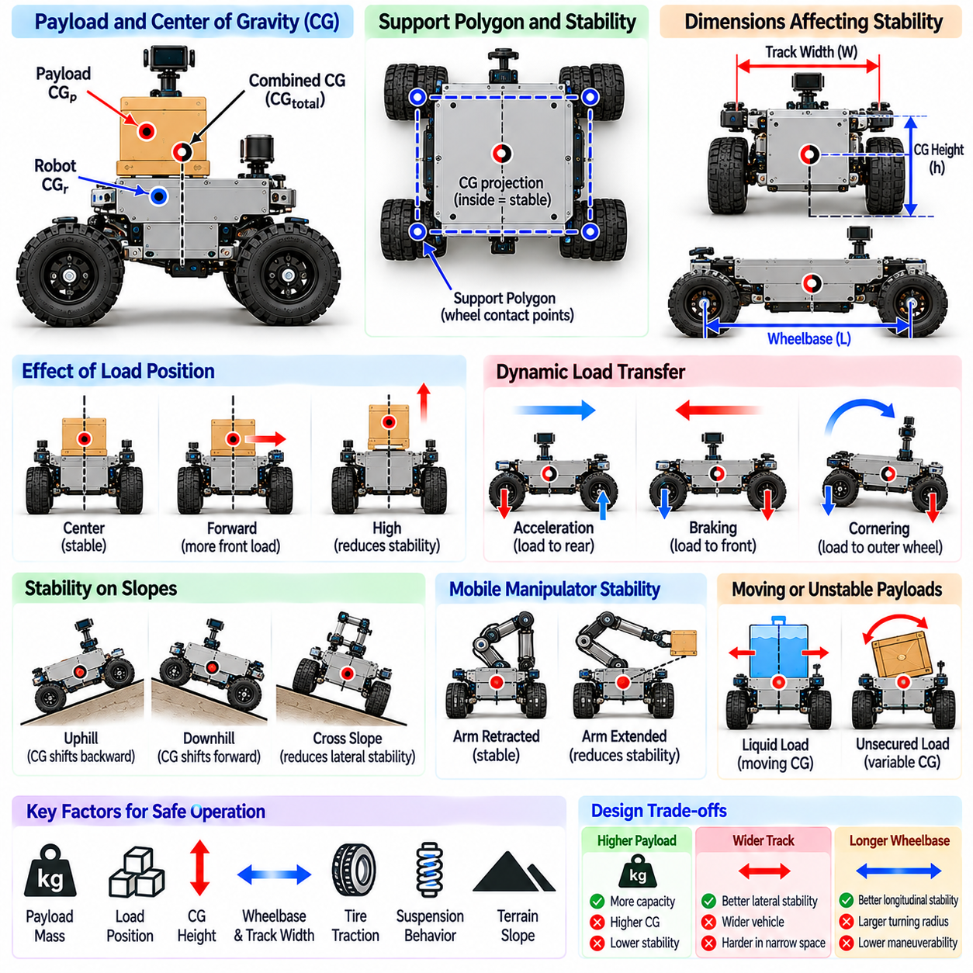
Payload, center of gravity, and stability are closely interconnected aspects of mobile robot morphology that determine how safely a platform supports and transports loads. Payload mass and placement influence wheel loading, traction, braking, and resistance to tipping. Effective design requires evaluating the robot and its payload as one mechanical system, including changes that occur during loading, movement, and unloading.
Payload capacity describes the maximum load a mobile platform can carry within specified structural, stability, and performance limits. It is not determined solely by motor torque or chassis strength. Wheel ratings, suspension capacity, braking capability, battery performance, and terrain conditions also impose restrictions. A platform rated for a particular payload on level ground may require a lower limit on slopes or uneven surfaces.
The center of gravity is the effective point through which the combined gravitational force of the robot and its payload acts. Its position depends on the masses and locations of batteries, motors, structural components, sensors, and transported objects. When payloads are added or repositioned, the combined center of gravity shifts. This change can significantly affect stability even when total vehicle mass remains within allowable limits.
Center-of-gravity height is particularly important because it determines how strongly acceleration and lateral forces influence tipping behavior. A low center of gravity generally improves stability by reducing overturning moments. Elevated payloads increase the leverage of inertial forces during turning and braking. Designers often position heavy batteries and drivetrain components near the chassis base to improve the overall mass distribution.
The support polygon is formed by connecting the effective ground-contact points supporting the vehicle. On level terrain under static conditions, stability requires the vertical projection of the center of gravity to remain inside this region. The distance between the projected center of gravity and the polygon boundary provides a useful indication of static stability margin. Approaching the boundary increases tipping susceptibility.
Wheelbase and track width determine the dimensions of the support region and influence longitudinal and lateral stability. A longer wheelbase can improve resistance to forward or backward tipping, while a wider track generally increases resistance to sideways tipping. However, increasing these dimensions also affects maneuverability and packaging. Stability improvements must therefore be evaluated alongside operational space constraints.
Longitudinal load distribution determines how much normal force acts on the front and rear wheels. Moving a payload forward increases front-wheel loading, while moving it backward increases rear-wheel loading. Unequal loading can change braking performance, traction availability, and steering behavior. Excessive concentration of weight may overload individual wheels or suspension components despite acceptable total payload mass.
Lateral load imbalance occurs when a payload is positioned away from the vehicle's longitudinal centerline. This shifts the center of gravity toward one side and reduces the available stability margin in that direction. Asymmetric loading becomes particularly hazardous during turning or cross-slope travel. Payload placement guidelines should therefore specify acceptable lateral offsets and loading configurations.
Dynamic stability differs from static stability because vehicle acceleration produces inertial effects and changes wheel contact forces. During acceleration, load tends to transfer toward the rear, while braking transfers load toward the front. Cornering creates lateral load transfer that can unload the inner wheels. These effects depend on center-of-gravity height, acceleration magnitude, suspension behavior, and platform geometry.
Rollover risk increases when the overturning moment exceeds the restoring moment generated by gravity and the available support geometry. High payload placement, narrow track width, sharp turning, and elevated speed can contribute to this condition. Sliding may occur before tipping on low-friction surfaces, but sufficient traction does not guarantee rollover prevention. Both contact mechanics and body dynamics must be considered.
Slope operation introduces additional stability challenges because the direction of gravity changes relative to the robot's support geometry. During uphill travel, the center-of-gravity projection moves toward the rear support boundary, while downhill travel shifts it toward the front. Cross-slope movement reduces lateral stability margins. Safe slope limits depend on payload configuration, surface traction, and suspension response.
Suspension and articulated morphology can alter load distribution and the effective support region during operation. Compression, wheel travel, and body articulation change contact-point positions and chassis attitude. These variations may improve terrain contact but also shift stability margins. Stability assessment should therefore include realistic suspension configurations rather than relying exclusively on nominal chassis geometry.
Payload movement introduces additional uncertainty when transported objects are not rigidly secured. Liquid containers, suspended loads, and loosely constrained materials may shift during acceleration or turning. Their motion can generate transient forces and change the combined center of gravity. Mechanical restraints, controlled acceleration profiles, and appropriate payload fixtures reduce these risks.
Mobile manipulators face additional stability challenges because robotic arms change the distribution of mass and generate reaction forces during operation. Extending an arm beyond the chassis footprint can move the combined center of gravity toward a support boundary. Lifting or accelerating an object introduces additional moments. Coordinated base and manipulator control is therefore necessary for safe mobile manipulation.
Braking performance must be evaluated under the maximum permitted payload and representative terrain conditions. Increased mass raises the kinetic energy that must be dissipated during stopping, while load transfer changes the available traction at individual wheels. Braking distance depends on speed, tire-ground interaction, braking capability, and control response. Emergency stopping requirements should account for unfavorable loading conditions.
Payload stability also affects structural design and component durability. Concentrated loads may create localized stresses in chassis members, mounting brackets, and suspension joints. Repeated acceleration and vibration can produce fatigue damage even when static loads remain within rated limits. Structural analysis should examine load paths, attachment points, and dynamic amplification under representative operating conditions.
Mass distribution influences energy consumption because heavier payloads increase rolling resistance, acceleration demands, and climbing effort. Poorly balanced loads can also increase tire deformation, uneven wear, and steering losses. Although moving heavy components downward improves stability, it may complicate maintenance or reduce ground clearance. Efficient morphology requires balancing energy performance with mechanical accessibility and safety.
Stability monitoring can combine inertial measurements, wheel-load estimates, suspension displacement, and payload information. Inertial measurement units provide acceleration and angular-motion data, while additional sensors may estimate chassis inclination or contact forces. Sensor fusion can identify changing stability conditions, although acceleration, vibration, and uncertain payload properties complicate interpretation.
Model-based stability assessment uses geometric and dynamic representations to estimate tipping margins and allowable motion. Static models evaluate center-of-gravity projection relative to support boundaries, while dynamic models account for acceleration, load transfer, and changing contact conditions. These models can support speed limits, trajectory constraints, and emergency responses tailored to the current payload.
Physical AI enables adaptive stability management by integrating payload perception, state estimation, and predictive control. Vision systems or load sensors may estimate payload dimensions, placement, and mass distribution. Learned models can assist in predicting stability risks across unfamiliar operating conditions. Safety-critical decisions should nevertheless remain constrained by validated physical models and conservative operating limits.
Morphology-aware motion planning incorporates payload configuration into route and trajectory selection. A heavily loaded robot may require lower cornering speeds, gentler acceleration, or alternative paths around steep slopes. Narrow passages may restrict vehicle orientation, while uneven terrain may reduce stability margins. Planning should consider both geometric accessibility and the dynamic consequences of transporting the current load.
Validation testing should examine empty, nominal, maximum, elevated, and asymmetrically distributed payload configurations. Representative procedures include braking, cornering, slope traversal, obstacle crossing, and emergency stopping. Measurements of wheel loading, chassis attitude, stopping distance, and structural response help establish safe operating envelopes. Testing must also account for uncertainty in real-world loading conditions.
Ultimately, payload, center of gravity, and stability demonstrate that mobile robot morphology cannot be separated from operational loading. A mechanically capable platform may become unsafe when mass is positioned poorly or dynamic conditions exceed its stability margins. Integrating structural design, load management, sensing, planning, and adaptive control allows Physical AI systems to transport diverse payloads with greater reliability and safety.

04.10. Indoor vs Outdoor Morphology
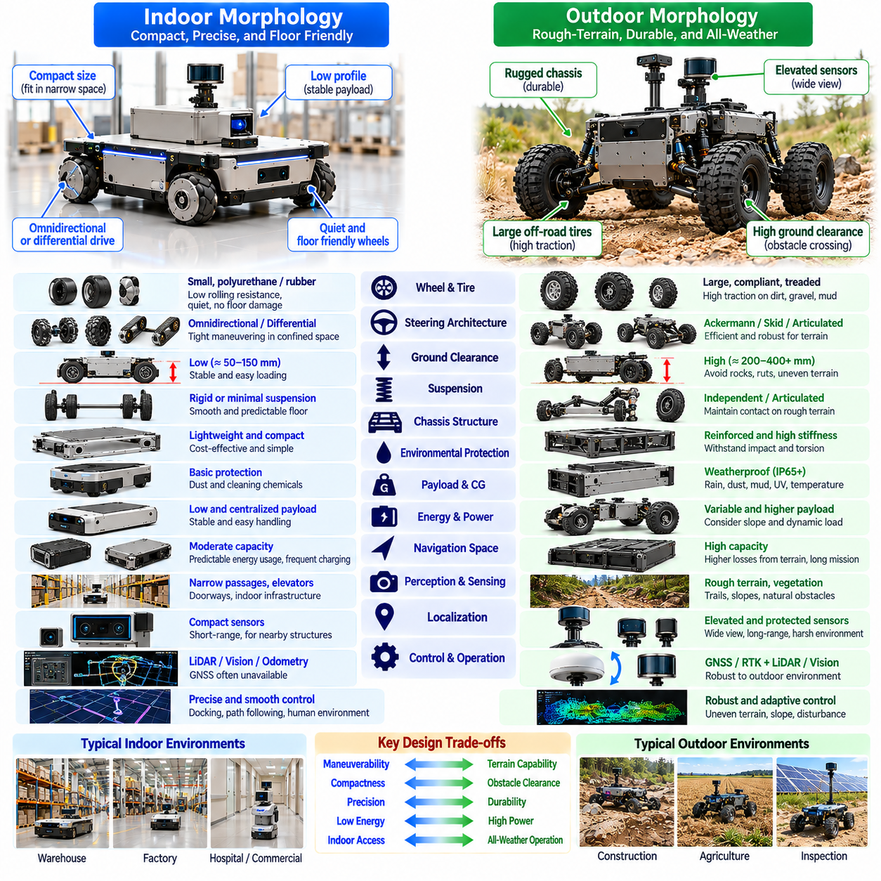
Indoor and outdoor mobile robot morphology reflects the different physical demands imposed by controlled facilities and open environments. Indoor platforms typically prioritize compactness, maneuverability, precision, and floor compatibility, while outdoor robots emphasize terrain adaptability, durability, and environmental protection. These distinctions influence chassis geometry, locomotion mechanisms, suspension, sensing, power systems, and control strategies.
Indoor mobile robots commonly operate on relatively smooth and predictable surfaces such as warehouse floors, factory corridors, and commercial buildings. Their morphology can therefore emphasize low ground clearance, compact wheel assemblies, and efficient load support. Outdoor robots encounter irregular ground, vegetation, gravel, mud, and changing slopes, requiring greater attention to traction, obstacle clearance, and mechanical resilience.
Wheel selection illustrates the contrast between indoor and outdoor requirements. Indoor platforms frequently use small polyurethane or rubber wheels designed for low rolling resistance, quiet operation, and minimal floor damage. Outdoor platforms generally benefit from larger wheels with compliant tires and terrain-appropriate tread patterns. Wheel diameter, width, and material must reflect the expected surface conditions and payload demands.
Steering architecture also depends on environmental geometry. Differential-drive and omnidirectional systems are useful indoors because they support tight maneuvering around shelves, equipment, and pedestrians. Outdoor platforms may favor Ackermann steering, skid steering, or articulated mechanisms depending on terrain and mission requirements. The preferred configuration balances turning capability, traction efficiency, mechanical complexity, and operational speed.
Ground clearance represents another important morphological difference. Indoor robots often maintain a low chassis to support stable payload placement and efficient navigation through confined spaces. Outdoor robots require sufficient clearance to avoid grounding on rocks, ruts, and uneven terrain. Increasing clearance improves obstacle accessibility but can raise the center of gravity, creating additional stability challenges during turning or slope traversal.
Suspension requirements vary substantially between operating environments. Smooth indoor floors may permit rigid or minimally suspended chassis structures, reducing cost and maintenance. Outdoor mobility often requires independent suspension, articulated linkages, or compliant wheel assemblies to preserve ground contact. Suspension travel and damping must be selected according to obstacle dimensions, travel speed, payload sensitivity, and terrain variability.
Chassis construction must address different mechanical loading conditions. Indoor platforms generally experience repetitive acceleration, braking, docking, and payload-handling cycles. Outdoor robots must additionally withstand impacts, torsional loading, vibration, and irregular wheel contact. Structural stiffness, material selection, joint design, and protective reinforcement should reflect the expected load spectrum rather than simply maximizing chassis mass.
Environmental protection is particularly important for outdoor morphology. Rain, dust, mud, humidity, ultraviolet radiation, and temperature fluctuations can degrade mechanical and electronic components. Protective enclosures, seals, drainage paths, corrosion-resistant materials, and appropriate thermal management improve durability. Indoor robots may require less extensive weather protection, although cleaning chemicals and industrial dust remain relevant.
Payload placement influences both indoor and outdoor stability. Indoor transport robots often carry standardized containers or pallets on low, flat platforms to simplify loading and reduce tipping risk. Outdoor robots may transport irregular equipment or operate with changing payload orientations. Their designs must account for dynamic load transfer, slope-induced instability, and the interaction between suspension motion and center-of-gravity position.
Energy efficiency is shaped by terrain and locomotion morphology. Indoor robots benefit from predictable rolling resistance, frequent charging opportunities, and relatively stable operating conditions. Outdoor platforms experience additional losses from soil deformation, wheel slip, climbing, and suspension movement. Battery capacity, drivetrain gearing, tire selection, and power management must therefore be matched to the expected mission duration and environmental resistance.
Indoor navigation environments frequently contain narrow passages, elevators, doorways, and fixed infrastructure. Robot width, height, turning radius, and swept volume must remain compatible with these constraints. Outdoor environments impose different geometric limitations, including trail width, vegetation clearance, terrain discontinuities, and natural obstacles. Morphology selection must account for the complete operational envelope rather than nominal vehicle dimensions alone.
Perception systems interact with morphology because sensor placement determines visibility and vulnerability. Indoor robots often use compact LiDAR, cameras, and proximity sensors positioned for reliable obstacle detection around nearby structures. Outdoor robots may require elevated or protected sensing assemblies to observe uneven terrain and distant obstacles. Sensor mounting must balance field of view, vibration isolation, environmental exposure, and vehicle stability.
Localization requirements also differ between indoor and outdoor deployment. Indoor robots commonly operate where GNSS signals are unavailable, relying on LiDAR mapping, visual localization, wheel odometry, and infrastructure references. Outdoor platforms may integrate GNSS with inertial and visual sensing, although signal blockage remains possible. Wheel slip, suspension motion, and chassis articulation influence localization accuracy in both environments.
Human interaction imposes significant design requirements, particularly in shared indoor facilities. Compact profiles, rounded chassis edges, protective bumpers, visible status indicators, and controlled stopping behavior support safer operation around workers and visitors. Outdoor robots may also encounter pedestrians, vehicles, and animals, but must additionally manage longer stopping distances and less predictable terrain. Safety depends on both physical morphology and validated control behavior.
Operating speed influences the appropriate balance between compactness and stability. Indoor robots frequently prioritize controlled low-speed maneuvering and precise docking over high-speed travel. Outdoor platforms may need greater travel speed across open areas, increasing demands on suspension response, braking, and directional stability. Wheelbase, track width, center-of-gravity height, and tire characteristics should be coordinated with the intended speed envelope.
Maintenance considerations further distinguish indoor and outdoor designs. Indoor platforms benefit from modular wheels, accessible batteries, replaceable protective elements, and standardized service procedures. Outdoor systems require additional attention to sealing, contamination removal, lubrication, corrosion prevention, and mechanical wear. Serviceability should be considered during initial morphology design because difficult access can increase downtime and operating costs.
Indoor-outdoor transitional robots introduce a more complex design challenge because they must function across both controlled floors and irregular exterior surfaces. Such platforms may require moderate ground clearance, adaptable tires, weather-resistant enclosures, and suspension that preserves indoor precision. Their dimensions must remain compatible with doors and ramps while providing sufficient traction and clearance for outdoor pathways.
Hybrid operating environments highlight the limitations of optimizing morphology for a single surface type. Large aggressive tires may improve outdoor traction but increase noise, vibration, and floor wear indoors. Low-profile indoor chassis may provide excellent payload stability but become immobilized on outdoor obstacles. Balanced designs require explicit evaluation of mission priorities, environmental frequency, and acceptable performance compromises.
Morphology-aware control helps compensate for environmental differences without requiring continuous mechanical reconfiguration. A robot can adjust acceleration, steering, braking, and trajectory selection according to estimated surface conditions. Terrain classification, slip estimation, and stability monitoring support these adaptations. However, software cannot eliminate fundamental limitations imposed by insufficient clearance, unsuitable tires, or inadequate structural strength.
Physical AI extends this capability through integrated perception, prediction, and decision-making. A platform can recognize transitions from polished floors to rough pavement, estimate traversability, and modify its operating strategy before encountering difficult terrain. Learned models may improve environmental interpretation, while physics-based constraints preserve mechanical safety limits. The result is adaptive behavior grounded in the robot's actual morphology.
Morphology optimization should evaluate indoor and outdoor requirements using measurable criteria. Relevant metrics include turning radius, obstacle-crossing capability, traction, payload stability, energy consumption, vibration exposure, and environmental durability. Simulation can compare candidate architectures under representative conditions, while physical testing reveals unexpected contact behavior, contamination effects, and structural limitations.
Validation procedures should reproduce the conditions most likely to challenge each platform. Indoor testing may emphasize doorway clearance, docking precision, floor transitions, pedestrian interaction, and repetitive transport cycles. Outdoor testing should examine slopes, loose terrain, water exposure, obstacles, and variable temperatures. Transitional platforms require combined tests that evaluate performance and safety across environmental boundaries.
Ultimately, indoor and outdoor morphology represents a system-level design decision rather than a simple distinction between small and large robots. Each environment imposes interconnected requirements on geometry, locomotion, structure, sensing, energy, and reliability. Integrating these requirements with morphology-aware planning and adaptive control enables Physical AI platforms to operate safely and effectively within their intended environmental domains.

04.11. Heavy Payload and Rough Terrain Morphology
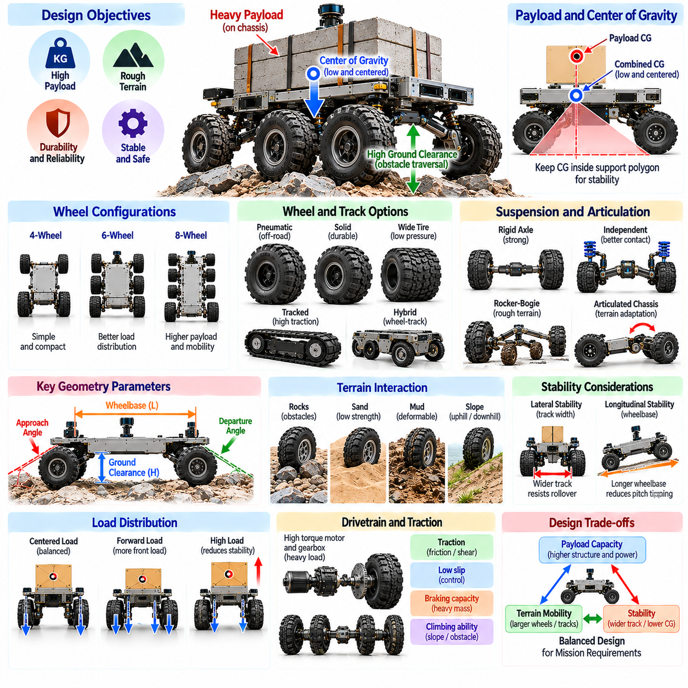
Heavy-payload and rough-terrain morphology addresses the structural and locomotion requirements of mobile robots operating under demanding mechanical and environmental conditions. These platforms must support substantial loads while maintaining traction, stability, and mobility across irregular surfaces. Their design requires coordinated consideration of chassis strength, wheel configuration, suspension, drivetrain capacity, ground clearance, and terrain interaction.
Heavy-payload mobility introduces challenges beyond simply increasing motor power or structural dimensions. Greater mass raises wheel loads, rolling resistance, braking demands, and the forces transmitted through the chassis. Rough terrain adds uneven contact conditions, impact loading, and unpredictable traction. A successful morphology must accommodate these combined effects without excessive deformation, instability, or premature mechanical failure.
Chassis architecture provides the structural foundation for heavy-duty mobile platforms. Reinforced frames, appropriately sized cross-members, and efficient load paths distribute forces from payload mounting points toward wheels or tracks. Structural design must resist bending, torsion, and repeated dynamic loading. Excessive reinforcement increases mass, so stiffness and strength should be optimized rather than maximized without regard to mobility.
Payload distribution is particularly important because concentrated or elevated loads can reduce stability and overload individual contact points. Positioning heavy components near the geometric center and close to the ground generally improves load balance. However, terrain obstacles and suspension motion continuously alter wheel loading. Designers must evaluate the combined center of gravity under representative payload configurations and articulation states.
Wheel configuration strongly influences load-carrying capability and terrain accessibility. Four-wheel platforms offer relatively simple construction, while six-wheel and eight-wheel arrangements can distribute loads across additional contact points. Multi-axle designs may improve obstacle negotiation and reduce individual wheel loading. However, they introduce additional drivetrain components, steering constraints, mechanical complexity, and maintenance requirements.
Wheel diameter and width must be selected according to obstacle dimensions, soil properties, and expected contact forces. Larger wheels can cross greater surface irregularities and reduce the relative severity of obstacles. Wider tires may lower ground pressure on deformable terrain, depending on tire construction and inflation. These benefits must be balanced against rotational inertia, steering resistance, packaging requirements, and drivetrain torque.
Tracked locomotion provides an alternative for platforms operating on loose or highly deformable ground. Continuous tracks can distribute vehicle weight across an extended contact region, potentially reducing sinkage and improving traction. However, tracks introduce frictional losses, wear, and substantial steering resistance during skid turns. Their suitability depends on terrain characteristics, vehicle mass, operating speed, and maintenance constraints.
Hybrid wheel-track or wheel-leg architectures may extend mobility across environments containing both firm surfaces and difficult obstacles. Reconfigurable mechanisms can change contact geometry or locomotion mode to accommodate terrain transitions. Such adaptability introduces additional actuators, joints, sensors, and control requirements. The mobility benefits must justify the resulting increases in mass, energy consumption, and system complexity.
Suspension is essential for maintaining contact and distributing forces across uneven terrain. Independent suspension, walking beams, rocker-bogie mechanisms, and articulated axles offer different approaches to accommodating wheel displacement. Adequate suspension travel helps prevent individual wheels from becoming unloaded. However, compliance and articulation must be coordinated with payload stability, structural durability, and vehicle attitude control.
Articulated chassis morphology can improve terrain conformity by allowing body sections to rotate relative to one another. Pitch and roll articulation help accommodate surface height differences, while yaw articulation may support steering. These mechanisms can reduce chassis twisting and maintain contact across irregular ground. Nevertheless, articulation changes the support geometry and requires careful evaluation of joint loads and stability margins.
Ground clearance and obstacle geometry determine whether a heavy-duty platform can traverse rocks, ruts, ridges, and uneven transitions without grounding. Wheelbase, approach angle, departure angle, and breakover angle interact with clearance to define traversal capability. Increasing clearance may improve accessibility but can raise the center of gravity. Heavy-payload platforms must therefore balance obstacle negotiation against rollover resistance.
Traction depends on the interaction between normal loading, tire or track properties, and terrain strength. On firm ground, friction strongly influences available propulsion and braking forces. On loose soil, shear strength, compaction, and sinkage become important. Heavy platforms may experience substantial resistance when terrain deforms beneath their contact surfaces, requiring careful evaluation of ground pressure and mobility limits.
Drivetrain sizing must account for payload mass, rolling resistance, slope climbing, acceleration, and obstacle traversal. Motors, gearboxes, shafts, and wheel hubs must withstand both continuous operating loads and short-duration peak demands. Torque distribution across multiple driven wheels can improve traction utilization. However, drivetrain capacity alone cannot overcome insufficient ground contact or unstable vehicle geometry.
Braking systems require particular attention because increased mass raises the kinetic energy that must be dissipated during stopping. Downhill operation introduces additional gravitational loading, while loose terrain may limit available braking traction. Mechanical brakes, regenerative braking, and controlled deceleration can contribute to stopping performance. Safety analysis must consider worst-case payload, slope, speed, and surface conditions.
Stability is governed by the relationship between the combined center of gravity and the effective support region. Elevated payloads, narrow track width, and steep cross-slopes can increase rollover susceptibility. Suspension compression and articulation may further change contact-point geometry. Static tipping analysis provides useful initial limits, but dynamic load transfer and terrain-induced disturbances must also be considered.
Energy consumption increases when heavy loads must be accelerated, lifted against gravity, or transported across deformable terrain. Wheel slip, soil compaction, suspension losses, and inefficient gearing can further reduce operating endurance. Battery capacity and power electronics must support sustained torque demands without excessive thermal stress. Energy-efficient morphology seeks to reduce unnecessary resistance while preserving traction and structural strength.
Environmental durability is critical because rough-terrain robots encounter dust, moisture, impacts, vibration, and abrasive materials. Bearings, joints, seals, cables, and exposed drivetrain components require protection against contamination and repeated mechanical loading. Corrosion-resistant materials and accessible service points improve maintainability. Reliability depends on controlling fatigue, wear, and environmental degradation throughout the operating lifecycle.
Terrain perception enables a heavy-duty robot to estimate whether the surrounding environment can support its mass and intended motion. Cameras, LiDAR, inertial sensors, and wheel-motion measurements provide information about obstacles, slopes, and contact behavior. Visual appearance alone may not reveal soil bearing strength or hidden hazards. Perception should therefore be combined with conservative assumptions and contact-based feedback.
Morphology-aware planning evaluates routes according to the physical capabilities of the loaded platform. A geometrically open path may be unsuitable because of insufficient ground support, excessive slope, limited clearance, or rollover risk. Planning systems should incorporate vehicle dimensions, payload distribution, traction estimates, and suspension limits. Safer alternatives may require longer routes or reduced operating speeds.
Adaptive control can improve performance by adjusting torque allocation, steering commands, acceleration limits, and articulation behavior in response to changing terrain. Slip estimation helps detect traction loss, while inertial measurements reveal excessive body motion. Controllers may reduce speed or redistribute driving effort when instability develops. Such adaptation must operate within validated structural, actuator, and stability constraints.
Physical AI can integrate terrain understanding, payload estimation, and predictive mobility models into a unified decision process. Learned representations may help classify traversability and anticipate difficult contact conditions, while physics-based models provide interpretable safety boundaries. The objective is not merely to move heavy loads, but to select actions that remain mechanically feasible under uncertainty.
Simulation and testing should reproduce representative combinations of maximum payload, uneven ground, obstacles, and environmental exposure. Multibody dynamics and terramechanics models can estimate contact forces, suspension travel, and drivetrain loads. Physical validation must assess climbing, braking, structural fatigue, traction, and emergency behavior. Results establish realistic operating envelopes and reveal weaknesses that simplified models may overlook.
Ultimately, heavy-payload and rough-terrain morphology requires an integrated balance of load capacity, terrain adaptability, stability, durability, and energy efficiency. No single wheel, track, suspension, or chassis configuration is optimal for every environment. Combining robust mechanical design with terrain-aware perception, morphology-aware planning, and adaptive control enables Physical AI platforms to transport demanding payloads more safely and reliably.

04.12. Mobile Base Morphology Selection [w/Code]
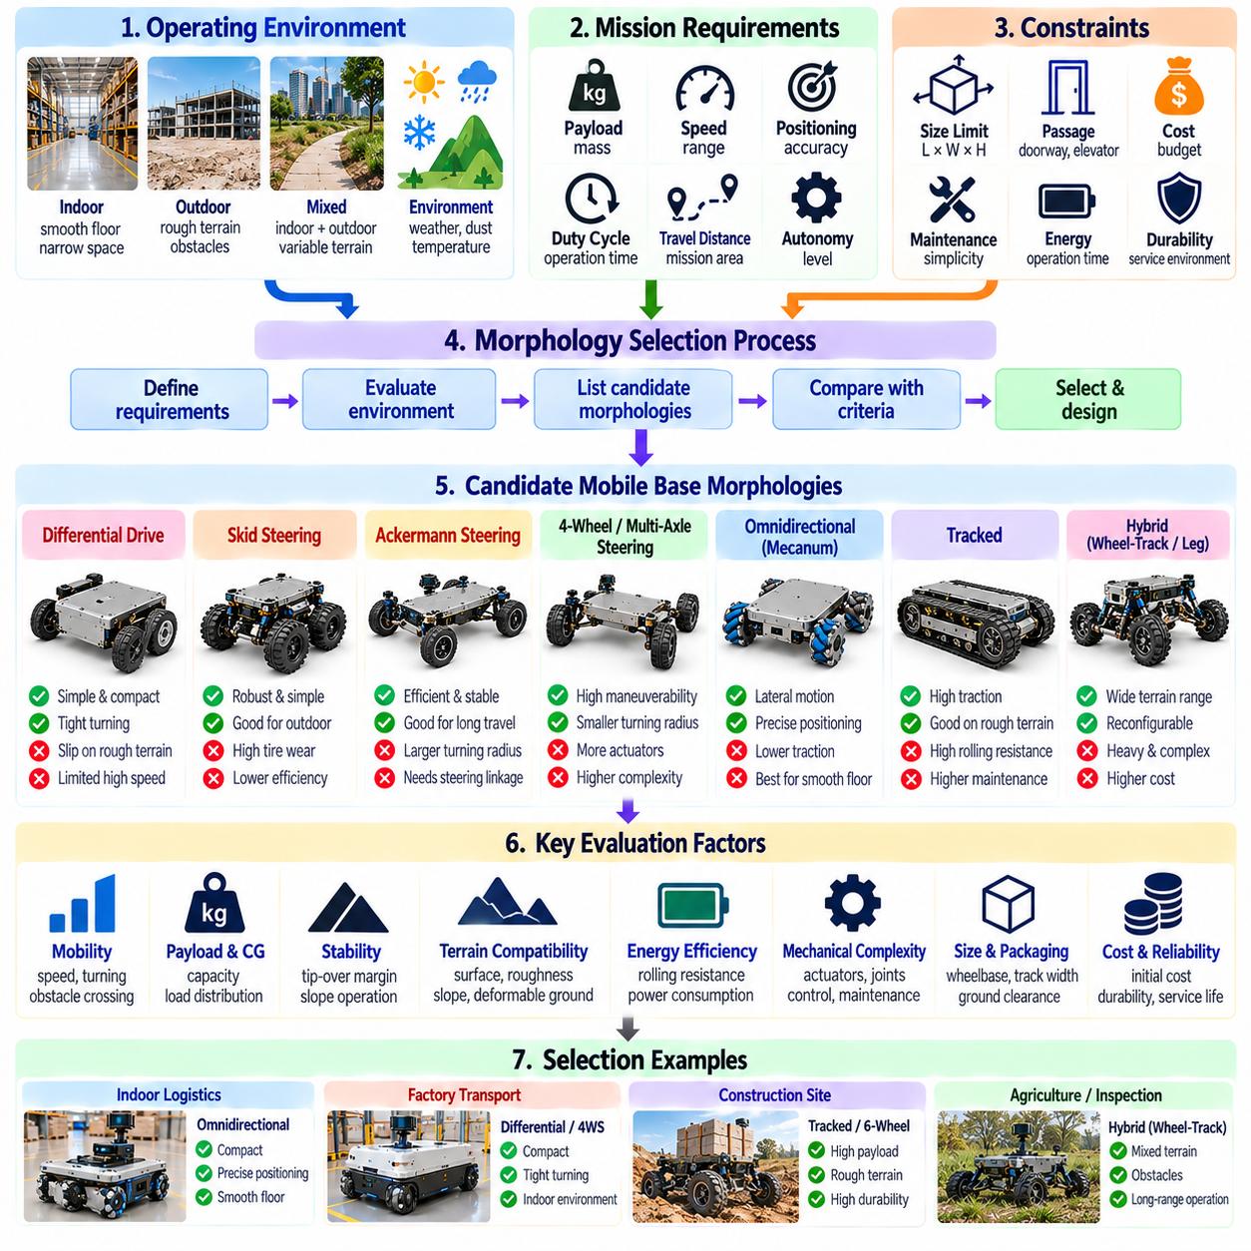
Mobile base morphology selection is a fundamental engineering decision that determines how effectively a robot interacts with its operating environment. The selection process must consider locomotion capability, payload requirements, terrain conditions, stability, energy efficiency, and operational constraints. Rather than choosing a platform based on a single performance metric, designers should evaluate how mechanical architecture supports the complete mission.
The selection process begins with a clear definition of the operational design domain, including expected surfaces, slopes, obstacles, available space, and environmental exposure. Indoor warehouses, outdoor construction sites, agricultural fields, and mixed environments impose different mobility requirements. Defining representative operating conditions helps prevent selecting a morphology that performs well in demonstrations but poorly during deployment.
Mission requirements establish the functional boundaries of morphology selection. Payload mass, transport distance, operating speed, positioning accuracy, duty cycle, and required autonomy influence chassis dimensions and drivetrain architecture. A compact inspection robot has different priorities from a heavy-duty logistics platform. These requirements should be translated into measurable engineering specifications before evaluating candidate configurations.
Differential-drive morphology is often suitable for indoor robots requiring simple construction, precise low-speed motion, and compact turning capability. Independent wheel-speed control enables rotation within a small footprint, reducing steering complexity. However, differential-drive platforms may experience wheel slip during turning and can face limitations on uneven terrain. Their suitability depends on traction conditions and required maneuverability.
Skid-steering morphology offers mechanical simplicity and robust directional control for certain outdoor and industrial platforms. Steering is achieved through differential motion between opposing wheels or tracks, eliminating conventional steering linkages. However, turning generates lateral tire or track slip, increasing energy losses and surface wear. Designers must consider ground friction, payload mass, and steering torque when evaluating this architecture.
Ackermann steering is appropriate for platforms requiring efficient forward travel, predictable turning behavior, and reduced tire scrubbing. Its geometry supports rolling motion with relatively low lateral slip during normal steering. However, conventional Ackermann vehicles generally require larger turning spaces than differential-drive robots. This morphology is especially relevant when travel speed, directional stability, and long-distance efficiency outweigh extreme maneuverability.
Four-wheel steering and multi-axle steering extend maneuverability by controlling additional wheel orientations. Coordinated steering can reduce turning radius, improve path tracking, and support specialized motion modes. These advantages require additional actuators, sensors, and control coordination. Selection should consider whether the improvement in mobility justifies greater mechanical complexity, calibration effort, and maintenance requirements.
Omnidirectional and mecanum platforms provide lateral translation and flexible positioning without requiring conventional vehicle reorientation. They are valuable for precision docking, material handling, and navigation through constrained indoor layouts. Their performance depends on suitable floor conditions and reliable wheel-ground contact. Roller losses, vibration, reduced traction on irregular surfaces, and payload limitations must be evaluated carefully.
Tracked platforms are attractive when terrain includes loose soil, mud, or surfaces where distributed contact can improve mobility. Their extended contact region may reduce ground pressure and support traction on deformable terrain. However, tracks can increase rolling losses, mechanical wear, and steering resistance. They should be selected according to measured terrain demands rather than assuming that tracks always outperform wheels.
Hybrid and reconfigurable morphologies combine different locomotion mechanisms to address environments with highly variable obstacles. Wheel-track systems, wheel-leg platforms, and articulated configurations can extend traversability beyond conventional fixed architectures. However, additional joints and actuators increase mass, cost, and failure opportunities. Their benefits must be demonstrated against simpler alternatives under realistic mission conditions.
Wheelbase, track width, and ground clearance establish important geometric constraints. A long wheelbase can improve longitudinal stability but reduce maneuverability, while a wider track increases lateral stability at the expense of passage accessibility. Greater ground clearance improves obstacle negotiation but may raise the center of gravity. These dimensions should be selected together rather than optimized independently.
Suspension architecture should reflect terrain irregularity, vehicle speed, payload sensitivity, and required contact consistency. Rigid chassis structures may be sufficient for smooth indoor floors, while outdoor platforms often benefit from compliant suspension or articulated mechanisms. Suspension improves terrain conformity but can introduce body motion and stability changes. Its selection requires balancing contact maintenance, mechanical simplicity, and load control.
Payload distribution and center-of-gravity position are central to evaluating candidate morphologies. Heavy or elevated payloads increase overturning moments during acceleration, braking, and turning. Designers should estimate wheel loading and tipping margins across expected payload configurations. Morphology selection must also account for loading mechanisms, manipulator motion, and the possibility of asymmetric or shifting loads.
Terrain interaction should be evaluated through traction, rolling resistance, sinkage, obstacle-crossing capability, and expected wheel slip. Surface appearance alone cannot reliably indicate mechanical support conditions. Candidate platforms should therefore be assessed using representative terrain measurements and contact models. A morphology that performs efficiently on firm pavement may become ineffective on loose or deformable ground.
Energy efficiency influences both operating cost and mission endurance. Wheel configuration, drivetrain gearing, steering losses, vehicle mass, and suspension behavior affect energy consumption. A mechanically capable platform may still be unsuitable if its power demand exceeds available battery capacity. Designers should compare candidate morphologies using realistic duty cycles, including acceleration, turning, climbing, and payload transport.
Environmental durability and maintainability must be considered alongside mobility performance. Outdoor platforms may require sealed enclosures, corrosion protection, and components resistant to contamination and impact. Indoor robots may prioritize quiet operation, floor protection, and convenient servicing. Modular construction and accessible components reduce maintenance time, while unnecessary mechanical complexity can increase lifecycle costs.
Safety requirements influence chassis geometry, braking capability, stability margins, and interaction with surrounding people or equipment. A morphology must support predictable stopping, controlled motion, and safe operation under expected disturbances. Emergency behavior should be evaluated at maximum payload and unfavorable terrain conditions. Safety cannot be established solely through software when mechanical limitations remain unresolved.
Morphology selection also affects sensing and localization performance. Chassis vibration, wheel slip, articulation, and sensor placement influence measurement quality and state estimation. Indoor platforms may depend on LiDAR and visual localization, while outdoor systems may integrate GNSS and inertial sensing. Sensor configurations should be evaluated as part of the mechanical architecture rather than added after the platform is finalized.
A systematic selection framework compares candidate architectures against weighted mission criteria. Mobility, payload capacity, stability, energy efficiency, cost, reliability, and maintainability can be assessed using common performance measures. Weighting should reflect operational priorities, but critical safety constraints must remain mandatory. Trade-off analysis helps identify designs that provide balanced performance instead of isolated advantages.
Simulation supports early evaluation by comparing kinematics, dynamics, wheel loading, obstacle traversal, and energy consumption. Representative scenarios should include nominal operation and difficult boundary conditions. Sensitivity analysis can reveal how changes in payload, friction, geometry, or suspension parameters affect performance. Simulation results guide design refinement but cannot replace physical validation.
Prototype testing provides evidence of real-world behavior that simplified models may overlook. Turning radius, braking distance, climbing capability, wheel slip, vibration, and power consumption should be measured under representative conditions. Repeated testing also reveals structural wear and maintenance concerns. Candidate morphologies can then be compared using validated measurements rather than assumptions or manufacturer specifications alone.
Physical AI introduces opportunities for morphology-aware adaptation by linking perception, planning, and control to the robot's mechanical capabilities. Terrain classification, payload estimation, and stability prediction can guide speed selection and route planning. Learned models may improve performance across variable conditions, while validated physical constraints maintain safety boundaries. Adaptive intelligence enhances a suitable morphology but cannot fully compensate for poor mechanical selection.
Ultimately, mobile base morphology selection is a multidisciplinary optimization problem connecting mechanical design, environmental interaction, sensing, control, and operational economics. The most appropriate architecture is not necessarily the most complex or maneuverable, but the one that satisfies mission requirements with acceptable risk and lifecycle cost. A disciplined selection process enables Physical AI platforms to achieve reliable, efficient, and safe mobility.

