Volume 03. Embodiment and Morphology

Chapter 06. Humanoid Morphology

06.01. Why Human Like Morphology
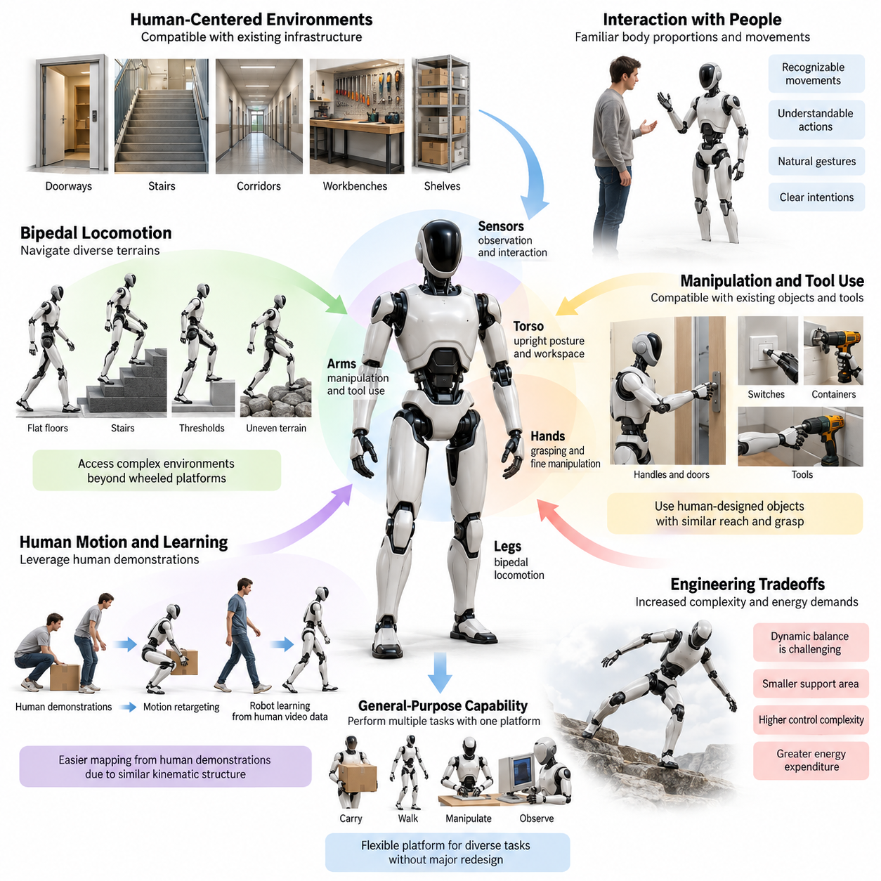
Human-like morphology in robotics is motivated by the relationship between physical embodiment and the environments designed for human activity. Buildings, tools, furniture, transportation systems, and industrial workspaces are largely organized around human body dimensions and movement capabilities. A robot with a comparable physical structure can potentially operate within these environments without requiring extensive infrastructure modifications.
The fundamental advantage of humanoid morphology is not visual resemblance to humans but functional compatibility with human-centered environments. A humanoid robot typically combines an upright torso, two articulated arms, two legs, and an elevated sensory system. This configuration provides opportunities for locomotion, manipulation, observation, and interaction through a unified physical architecture.
Human environments impose geometric constraints that influence robot design. Doorways, staircases, corridors, workbenches, shelves, and control panels assume particular ranges of human height, reach, and mobility. A humanoid platform can approximate these spatial relationships, allowing its hands, feet, and sensory systems to access locations that might otherwise require specialized mechanical adaptations.
Bipedal locomotion represents an important motivation for human-like morphology. Two articulated legs can support movement across stairs, thresholds, uneven surfaces, and narrow passages when appropriate control and contact conditions are available. Unlike conventional wheeled platforms, legged systems can selectively establish footholds and adjust body posture to accommodate discontinuous terrain.
However, bipedal locomotion introduces significant engineering challenges. Maintaining dynamic balance requires continuous coordination among joint motion, ground reaction forces, body inertia, and external disturbances. The relatively small support area of two feet increases sensitivity to perturbations. Consequently, humanoid mobility often demands more sophisticated control and greater energy expenditure than wheeled locomotion on smooth surfaces.
Human-like upper-body morphology provides another major advantage through compatibility with existing objects and tools. Doors, handles, switches, containers, handrails, and many industrial instruments are designed for human arms and hands. A humanoid robot equipped with suitable manipulators can potentially interact with these objects using similar reach directions, grasp configurations, and operational sequences.
The presence of two arms also enables coordinated manipulation that extends beyond the capabilities of many single-arm systems. One hand may stabilize an object while the other performs an operation, or both hands may cooperate to transport bulky materials. Such tasks require coordinated motion of the shoulders, elbows, wrists, torso, and supporting lower body, demonstrating the importance of integrated morphology.
Anthropomorphic hands are particularly relevant when robots must manipulate diverse objects without replacing existing interfaces. Multiple fingers, articulated joints, and compliant contact surfaces can support grasping, repositioning, and fine manipulation. Nevertheless, reproducing human hand complexity increases actuator requirements, mechanical packaging difficulty, sensing demands, and control complexity.
The upright torso contributes to human-like functionality by positioning manipulators and sensors within familiar working regions. A standing humanoid can approach elevated surfaces, inspect objects at approximately human eye level, and perform tasks at conventional workstations. Torso articulation further expands reachable workspace and allows coordinated adjustments between balance, perception, and manipulation.
Human-like morphology can also improve interaction between robots and people. Familiar body proportions and recognizable movement patterns may help observers interpret a robot's intended actions. Head orientation, arm gestures, body posture, and approach direction can communicate attention or movement intentions, although effective communication depends on behavioral design rather than morphology alone.
The relationship between human motion and robot learning provides an additional motivation for anthropomorphic embodiment. Human demonstrations contain valuable information about object manipulation, locomotion, coordination, and task execution. Robots with comparable kinematic structures may find it easier to map selected aspects of these demonstrations into executable actions than platforms with fundamentally different body configurations.
Motion retargeting translates demonstrated human movements into robot-compatible trajectories while respecting differences in joint limits, proportions, dynamics, and actuator capabilities. Similarity between human and robot morphology can simplify portions of this mapping, but direct reproduction is rarely sufficient. Robot controllers must account for distinct mass distributions, contact mechanics, available degrees of freedom, and stability constraints.
Human video data offers a potentially scalable source of behavioral information for humanoid learning. Everyday recordings contain examples of reaching, grasping, walking, lifting, and interacting with objects. Vision-based learning systems can extract task relationships and motion patterns from these observations, although translating visual behavior into physically feasible robot actions remains a substantial research challenge.
Human-like morphology also supports research into general-purpose robotic systems. A platform capable of walking, manipulating, observing, and interacting may perform multiple task categories without changing its fundamental mechanical architecture. This flexibility is particularly valuable in environments where task requirements vary over time and deploying a dedicated robot for every operation would be impractical.
Nevertheless, morphological generality does not automatically produce functional generality. A humanoid may possess the necessary limbs and joints while lacking sufficient strength, precision, endurance, or control capability for a particular task. General-purpose performance depends on the integration of mechanical design, sensing, actuation, planning, learning, and reliable physical interaction.
The choice of human-like morphology involves important tradeoffs between adaptability and engineering efficiency. Additional joints expand potential movement capabilities but increase mechanical complexity, cost, maintenance requirements, and failure opportunities. Highly articulated bodies also introduce larger control spaces and more complicated dynamic interactions, requiring careful coordination between hardware architecture and intelligent control.
Energy efficiency is another critical consideration. Human locomotion benefits from biological muscle properties, elastic tendons, coordinated neural control, and evolved body mechanics. Robotic systems using electric motors, transmissions, and rigid structural elements cannot automatically reproduce these advantages. Achieving efficient humanoid movement requires deliberate optimization of actuator placement, joint compliance, mass distribution, and gait dynamics.
Morphological computation provides a useful perspective on these design decisions. Mechanical compliance, passive joint dynamics, elastic energy storage, and appropriately distributed inertia can reduce the burden placed on active controllers. Rather than treating the humanoid body as a passive mechanism, designers can exploit physical properties that naturally support stabilization, impact absorption, and coordinated movement.
Human-like body proportions should therefore be interpreted as engineering variables rather than fixed biological requirements. Arm length, leg length, shoulder width, torso dimensions, and foot geometry can be adjusted to match operational objectives. A warehouse humanoid may prioritize payload capacity and reach, while a service robot may emphasize compact dimensions, safe interaction, and maneuverability.
The distinction between anthropomorphic appearance and anthropomorphic functionality is especially important. A robot does not require a realistic face, human skin, or exact anatomical proportions to benefit from human-compatible manipulation and mobility. Functional humanoid morphology instead focuses on the physical structures necessary to perform useful tasks within environments originally designed around human capabilities.
Safety considerations further influence the value and limitations of humanoid design. Operating near people requires predictable movement, controlled contact forces, stable posture, and reliable responses to disturbances. Human-like dimensions may improve environmental compatibility, but a tall, heavy, dynamically balancing robot can introduce substantial collision and fall hazards unless appropriate safeguards are incorporated.
Economic considerations ultimately determine whether humanoid morphology is justified in practical deployment. In structured facilities with repetitive operations, wheeled robots or fixed manipulators may offer greater reliability, lower energy consumption, and reduced cost. Humanoid platforms become more attractive when environmental variability, human-oriented infrastructure, and diverse manipulation requirements outweigh their mechanical disadvantages.
A useful design principle is to evaluate humanoid morphology according to task coverage rather than anatomical similarity. Engineers should examine which environmental constraints require legs, which manipulation tasks benefit from two arms, and which interactions demand human-compatible reach. These requirements establish whether a complete humanoid body, a mobile manipulator, or a hybrid configuration offers the most appropriate solution.
Within Physical AI, human-like morphology represents a strategy for connecting intelligent computation with the physical structure of human environments. Its value emerges from the interaction between body geometry, mechanical dynamics, perception, learning, and control. The central objective is not to reproduce human anatomy for its own sake, but to create embodied systems capable of performing useful, adaptable, and safe physical actions.

06.02. Anthropomorphic Body Architecture
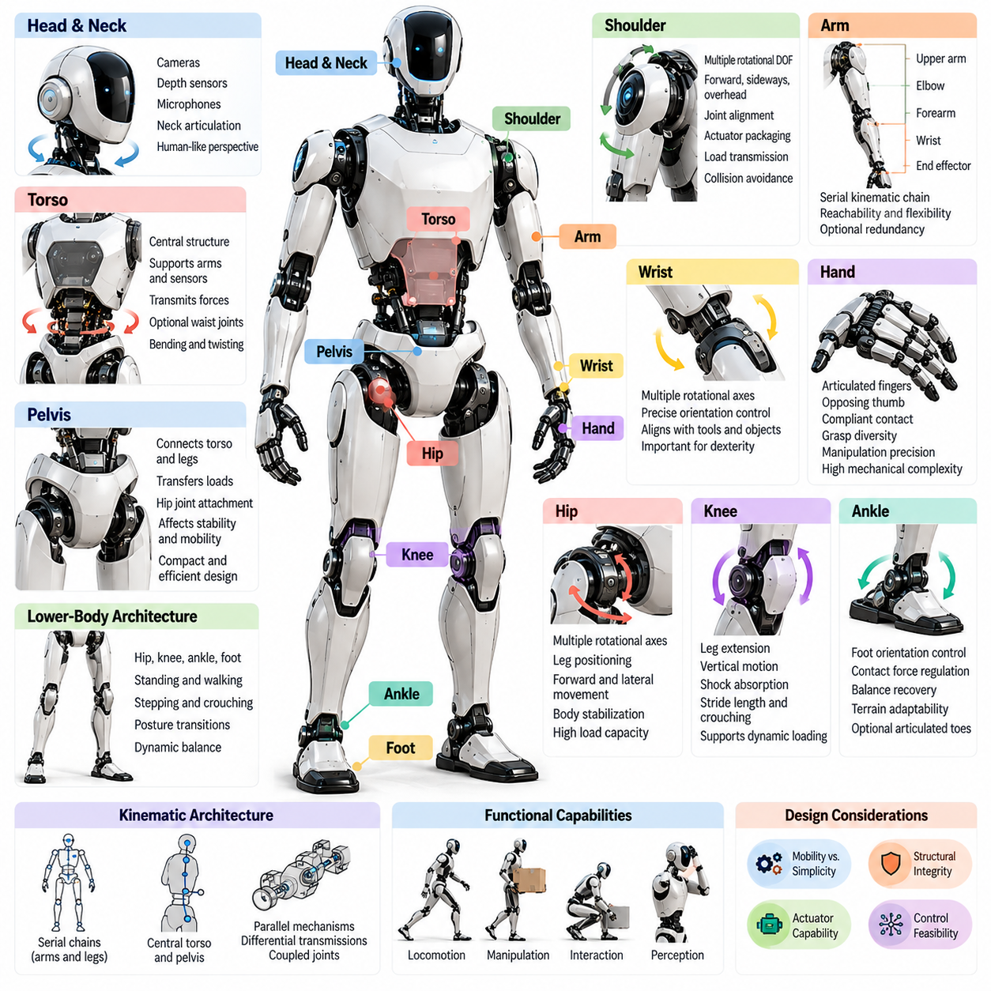
Anthropomorphic body architecture refers to the structural organization of a robot whose physical configuration resembles the human body. It typically integrates a head, torso, pelvis, two arms, and two legs into a coordinated mechanical system. The purpose is not exact anatomical reproduction but the creation of a functional arrangement that supports human-compatible movement, manipulation, perception, and environmental interaction.
The architectural foundation of a humanoid robot is its kinematic structure, which defines how rigid or compliant body segments connect through joints. These connections establish the robot's available degrees of freedom, movement constraints, and reachable configurations. A well-designed anthropomorphic architecture must balance human-like mobility with mechanical simplicity, structural integrity, actuator capability, and control feasibility.
The torso forms the central structural framework connecting the upper and lower body. It supports the shoulders, neck, arms, and internal components while transmitting forces between the pelvis and upper extremities. Depending on the design, the torso may be rigid or include articulated waist joints that enable bending, twisting, and posture adjustment during locomotion and manipulation.
The pelvis serves as the mechanical interface between the torso and legs. It transfers gravitational and dynamic loads to the supporting limbs while providing attachment points for the hip joints. Its geometry, stiffness, and mass distribution influence walking stability, joint range of motion, and whole-body coordination. A compact pelvis can improve packaging efficiency but may restrict actuator placement and hip mobility.
The head and neck provide an elevated platform for perception and interaction. Cameras, depth sensors, microphones, and other sensing devices can be positioned to observe objects and people from a human-compatible perspective. Neck articulation enables independent adjustment of sensor orientation, supporting active perception while reducing the need to reposition the entire body during observation.
The shoulder architecture connects each arm to the torso and determines the range of upper-limb movement. Human-inspired shoulders typically provide multiple rotational degrees of freedom, allowing arms to reach forward, sideways, and overhead. Their mechanical implementation requires careful consideration of joint alignment, actuator packaging, load transmission, and collision avoidance around the torso.
Each anthropomorphic arm generally consists of an upper arm, elbow, forearm, wrist, and end effector. These segments form a serial kinematic chain capable of positioning and orienting the hand within a three-dimensional workspace. Additional joint redundancy can improve obstacle avoidance and manipulation flexibility, although it increases control complexity and introduces more possible configurations for equivalent hand poses.
The wrist provides the final orientation adjustment between the forearm and hand. Multiple rotational axes allow the end effector to align with tools, handles, and objects without requiring large movements of the shoulder or torso. Wrist architecture strongly influences dexterity, particularly in confined environments where precise orientation control is necessary for insertion, assembly, or object repositioning.
Anthropomorphic hands represent the most mechanically intricate components of many humanoid architectures. They may include articulated fingers, opposing thumbs, tendon-driven mechanisms, and compliant contact surfaces. Their design determines grasp diversity, manipulation precision, and adaptability to object geometry. However, high finger articulation increases actuator count, sensing requirements, mechanical complexity, and maintenance demands.
The lower-body architecture is organized around the hip, knee, ankle, and foot. These components collectively support standing, walking, stepping, and posture transitions. Hip joints position the legs relative to the pelvis, knees adjust leg extension, and ankles regulate foot orientation and ground contact. Their coordinated operation establishes the mechanical foundation for bipedal mobility and dynamic balance.
Hip architecture is particularly important because it connects body stabilization with leg positioning. Multiple rotational axes enable forward stepping, lateral movement, and changes in body orientation. Joint placement and mechanical interference determine the achievable leg workspace. Designers must also consider the substantial torques generated when the robot supports its body weight or accelerates during locomotion.
The knee primarily controls leg extension and contributes to vertical body motion, shock absorption, and walking dynamics. Many humanoid designs use a dominant flexion-extension axis, although alternative mechanisms may provide additional capabilities. Knee geometry influences stride length, crouching depth, and mechanical leverage, while actuator characteristics determine the joint's ability to support dynamic loading.
Ankle and foot architecture governs the interaction between the humanoid body and supporting surfaces. Ankle articulation adjusts foot orientation and redistributes contact forces during balance recovery. Foot dimensions, sole compliance, friction characteristics, and contact geometry affect stability and terrain adaptability. Some architectures incorporate articulated toes to improve rolling contact and selected locomotion behaviors.
The arrangement of joints throughout the body determines the overall kinematic topology of the humanoid. A common configuration uses serial chains for arms and legs connected through a central torso and pelvis. However, parallel mechanisms, differential transmissions, and coupled joints may be introduced to improve stiffness, reduce actuator mass, or optimize force transmission within specific body regions.
Degrees of freedom must be allocated according to functional requirements rather than anatomical resemblance alone. Increasing joint count can expand dexterity, mobility, and redundancy, but also increases weight, energy consumption, computational demand, and failure opportunities. An effective architecture provides sufficient motion capability for intended tasks while avoiding unnecessary mechanical complexity.
Actuator placement is another fundamental architectural decision. Motors and transmissions may be located directly at joints or positioned remotely through belts, cables, gears, and linkage mechanisms. Proximal actuator placement can reduce distal limb inertia, improving dynamic responsiveness. However, remote actuation introduces transmission compliance, friction, routing constraints, and additional mechanical design challenges.
Mass distribution significantly influences anthropomorphic body performance. Heavy components positioned far from joint axes increase rotational inertia and actuator torque requirements. Concentrating batteries, computing hardware, and other substantial masses near the torso or pelvis can improve dynamic efficiency. Nevertheless, thermal management, maintenance access, and structural constraints may limit ideal component placement.
Structural stiffness and compliance must be coordinated across the body. Rigid segments support accurate positioning and efficient load transmission, while compliant elements can absorb impacts and accommodate uncertain contacts. Excessive flexibility may reduce precision or introduce oscillations. The appropriate combination depends on locomotion dynamics, manipulation requirements, expected contact forces, and the robot's operating environment.
Whole-body coordination is a defining characteristic of anthropomorphic architecture. Reaching for a distant object may require simultaneous adjustments of the arm, torso, pelvis, and supporting legs. These movements are mechanically coupled through shared mass, momentum, and contact constraints. Consequently, individual limb performance cannot be evaluated independently of the complete body configuration.
Sensor integration must reflect the mechanical organization of the humanoid. Joint encoders provide position measurements, inertial sensors estimate body motion, and force or torque sensors characterize physical interaction. Tactile sensors may provide localized contact information in hands and feet. Combining these measurements enables estimation of body configuration, balance conditions, and interaction forces.
Internal packaging creates additional architectural constraints. Electrical wiring, communication networks, cooling channels, power distribution, and mechanical transmissions must pass through moving structures without interfering with joint motion. Compact anthropomorphic proportions make this integration challenging. Modular components and accessible interfaces can improve maintainability, replacement efficiency, and long-term system reliability.
Human-compatible proportions provide useful starting points for body architecture, but exact biological dimensions are not mandatory. Designers may modify arm length, shoulder width, torso height, leg proportions, and foot geometry to satisfy application requirements. Industrial humanoids may prioritize strength and reach, whereas service-oriented platforms may emphasize compactness, maneuverability, and safe interaction.
Architectural evaluation must consider mobility, manipulation, stability, payload, energy efficiency, and mechanical reliability together. Improvements in one subsystem may create disadvantages elsewhere. Larger actuators increase available torque but also add mass, while additional joints improve flexibility but complicate control. Effective humanoid design therefore requires integrated optimization across the complete mechanical system.
Anthropomorphic body architecture ultimately provides the physical foundation for embodied intelligence in humanoid robots. Its organization determines how sensing, actuation, control, and environmental interaction can be coordinated. Successful designs translate selected principles of human anatomy into practical engineering structures, enabling versatile physical behavior without requiring exact replication of biological complexity.

06.03. Torso Head and Neck Morphology
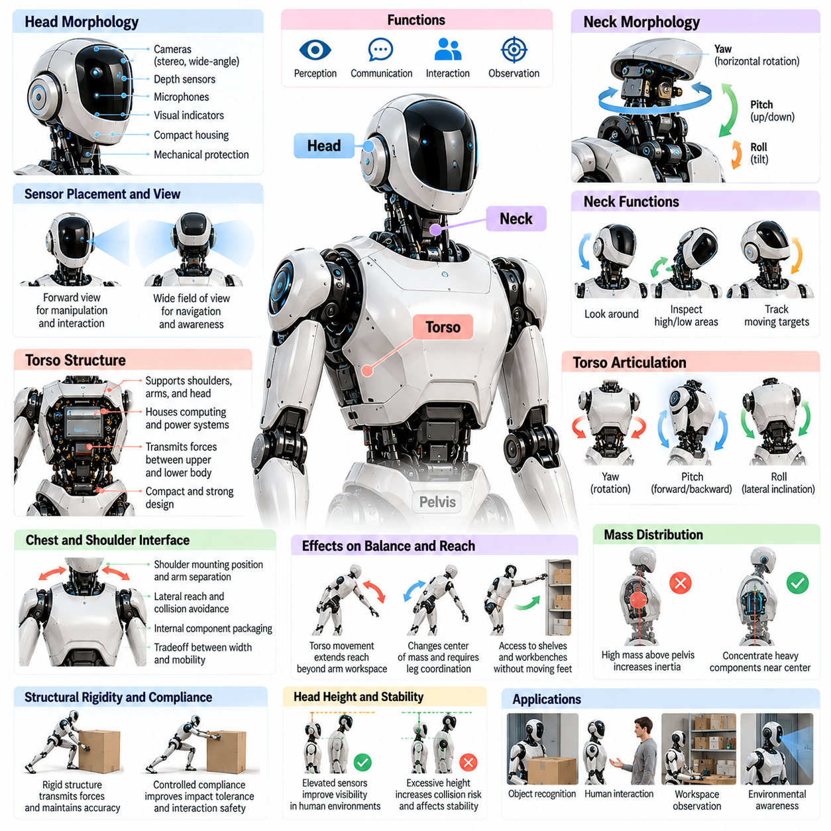
The torso, head, and neck form the central upper-body architecture of a humanoid robot, providing structural support, sensory positioning, and coordinated movement. These components connect perception with manipulation and locomotion while influencing balance, reach, and interaction. Their morphology determines how effectively the robot maintains posture, observes its surroundings, and adjusts its body during physical tasks.
The torso functions as the primary structural framework between the pelvis and shoulder assemblies. It supports the arms, head, computing hardware, power distribution components, and mechanical interfaces. Its geometry and stiffness determine how loads are transmitted throughout the body. A well-designed torso must provide sufficient structural strength while maintaining compact dimensions, manageable mass, and appropriate mobility.
Human-inspired torso morphology generally follows the organization of the chest, abdomen, and waist. However, robotic implementations often simplify biological anatomy into rigid segments connected by articulated joints. This approach provides predictable mechanical behavior and simplifies manufacturing. The resulting structure must accommodate shoulder movement, internal components, and the transmission of forces between the upper and lower body.
Torso articulation determines how independently the upper body can move relative to the pelvis. Common configurations provide rotation around the vertical axis, forward and backward bending, and lateral inclination. These movements correspond approximately to yaw, pitch, and roll. Additional torso degrees of freedom expand the reachable workspace but increase actuator requirements, mechanical complexity, and dynamic coupling.
Waist joints are particularly important for extending manipulation capability beyond the workspace of the arms alone. Rotating or bending the torso allows a humanoid to reach objects without repositioning its feet. This capability is valuable when operating near shelves, workbenches, or confined structures. However, large torso movements shift the center of mass and require coordinated adjustments of the supporting legs.
Torso morphology also influences whole-body balance through mass distribution and rotational inertia. Heavy components positioned high above the pelvis can increase the mechanical effort required for stabilization. Concentrating batteries, computing units, and other substantial masses near the body's central region may reduce rotational inertia. Nevertheless, component placement must also satisfy thermal, structural, and maintenance requirements.
The chest and shoulder interface represents a critical connection between torso morphology and upper-limb functionality. Shoulder mounting positions determine arm separation, lateral reach, and potential collisions with the body. A wider torso may improve internal packaging and shoulder clearance but increase overall dimensions. Narrower configurations improve access to confined spaces while potentially restricting arm movement.
Structural rigidity is essential for transmitting manipulation forces through the torso. When a humanoid lifts, pushes, or carries an object, external forces propagate through the arms, shoulders, torso, pelvis, and supporting feet. Excessive structural deformation can reduce positioning accuracy and complicate control. Carefully introduced compliance, however, may improve impact tolerance and physical interaction safety.
The head serves primarily as a platform for perception, communication, and environmental awareness. Unlike the human head, a robotic head does not need to reproduce biological anatomy. Its geometry is determined by sensor placement, field-of-view requirements, mechanical protection, and interaction objectives. Cameras, depth sensors, microphones, and visual indicators may be integrated into a compact housing.
Head positioning strongly influences the quality of visual perception. Elevated sensors provide a perspective suitable for observing human-scale workspaces, recognizing objects, and monitoring nearby people. However, greater head height may increase vulnerability to collisions and introduce unfavorable mass distribution. Sensor placement must balance visibility, environmental coverage, protection, and overall body stability.
Stereo cameras and depth-sensing systems may be arranged within the head to estimate object distance and three-dimensional structure. The spacing and orientation of sensors influence depth accuracy and field-of-view overlap. Wide-angle cameras improve peripheral awareness, while narrower fields of view may provide greater detail. The selected configuration depends on navigation, manipulation, and interaction requirements.
The neck forms the articulated connection between the head and torso. Its principal function is to control sensor orientation independently of large body movements. A basic neck may provide yaw and pitch rotation, while more complex configurations include roll or additional coupled motion. These degrees of freedom enable the robot to direct attention toward objects, inspect elevated surfaces, and track moving targets.
Neck yaw allows horizontal rotation of the head, supporting visual scanning and attention shifts between different regions. Pitch movement enables upward and downward observation, which is useful for inspecting floor-level objects or overhead equipment. Roll adjustment can support camera orientation and compensate for selected body movements. The required angular ranges depend on sensor coverage and operational tasks.
Active perception is a major functional advantage of articulated head and neck morphology. Instead of relying exclusively on fixed sensors, a humanoid can deliberately redirect its sensing system toward uncertain or important regions. This capability supports object recognition, scene exploration, and manipulation planning. Coordinating head motion with torso and arm movements can improve visibility during complex tasks.
The mechanical design of the neck must balance motion capability with payload, stiffness, and compactness. Sensors, protective housings, communication devices, and wiring contribute to head mass. Neck actuators must overcome gravitational and inertial loads while maintaining accurate orientation. Excessive head inertia can reduce responsiveness and introduce vibrations that degrade visual measurements.
Head and neck motion also contribute to human-robot interaction by providing recognizable attention cues. Orienting the head toward a person or object can communicate the robot's current focus. Such movements may improve the predictability of robot behavior in shared environments. Nevertheless, head orientation alone does not guarantee reliable communication, and explicit indicators may be necessary for safety-critical situations.
Sensor stabilization is another important consideration in head and neck architecture. Walking generates oscillations and impacts that propagate through the torso toward the head. Mechanical damping, compliant mounting, and active stabilization can reduce unwanted sensor motion. These techniques improve image quality and support more reliable perception during locomotion, particularly when the robot operates on uneven terrain.
The interaction between torso, head, and neck morphology creates a coordinated perception-action system. A humanoid may rotate its torso to extend reach while turning its head to maintain visual contact with a manipulated object. Such behavior requires synchronized joint control and awareness of body geometry. Mechanical interference, sensor occlusion, and balance constraints must be considered simultaneously.
Internal integration presents significant challenges because these structures accommodate sensors, actuators, processors, communication interfaces, and power connections. Electrical cables and data lines must pass through moving joints without excessive bending or abrasion. Thermal management becomes important when computing components are concentrated inside enclosed structures. Modular packaging can simplify inspection, repair, and component replacement.
Human-like proportions provide useful references for torso, head, and neck dimensions, but exact anatomical similarity is not required. A robot designed for industrial manipulation may use a broad torso and compact head, while a service humanoid may prioritize a narrow body and expressive head movements. Morphological decisions should reflect workspace geometry, payload requirements, sensor coverage, and interaction objectives.
Safety requirements influence the dimensions, materials, and movement limits of upper-body structures. Rounded surfaces and compliant coverings may reduce injury risks during incidental contact. Controlled neck and torso motion can prevent unexpected collisions with nearby people or objects. Mechanical stops, torque limitations, and reliable fault responses are important when articulated upper-body components operate in shared spaces.
Energy efficiency and dynamic performance must also be considered during morphology selection. Additional torso and neck joints improve flexibility but increase actuator count, mass, and power consumption. Heavy head assemblies require greater stabilization effort during walking. Designers therefore seek configurations that provide sufficient perception and manipulation capability without introducing unnecessary mechanical complexity.
The morphology of the torso, head, and neck ultimately determines how a humanoid integrates structural support, perception, and coordinated upper-body motion. Successful architectures balance rigidity, articulation, mass distribution, sensor placement, and interaction requirements. By optimizing these elements together, humanoid robots can achieve more effective environmental awareness, whole-body coordination, and adaptable physical behavior.

06.04. Arm Hand and Upper Body Morphology
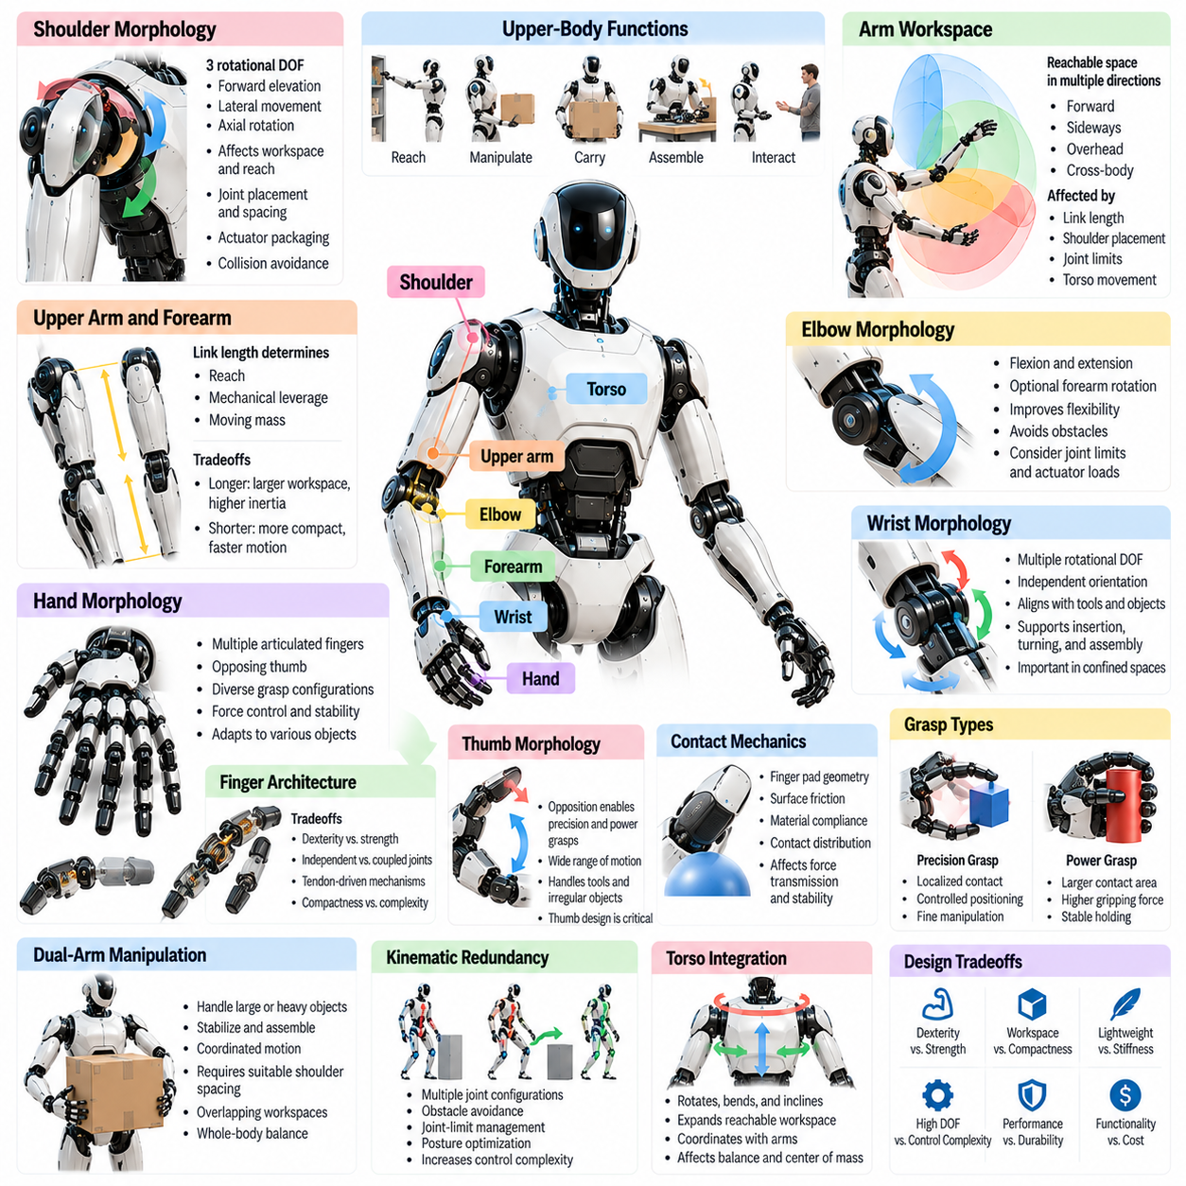
Arm, hand, and upper-body morphology defines the mechanical architecture through which humanoid robots perform manipulation, object handling, and physical interaction. These structures integrate shoulders, upper arms, elbows, forearms, wrists, hands, and torso connections into coordinated kinematic systems. Their design determines reachable workspace, dexterity, payload capacity, and the ability to execute tasks within human-oriented environments.
The upper body of a humanoid robot must support both independent arm movement and coordinated manipulation involving multiple body segments. Unlike fixed industrial manipulators, humanoid arms operate on a mobile and dynamically constrained platform. Consequently, their morphology must account for balance, body inertia, joint loading, and interaction forces while preserving sufficient flexibility for diverse manipulation tasks.
Shoulder morphology establishes the foundation of upper-limb mobility by connecting the arms to the torso. Human-inspired shoulder mechanisms commonly provide three rotational degrees of freedom, enabling forward elevation, lateral movement, and axial rotation. The arrangement of these axes influences arm workspace, mechanical interference, and the ability to reach objects above, beside, or behind the robot.
Shoulder joint placement strongly affects the relationship between body proportions and manipulation capability. Wider shoulder spacing may improve access to large objects and facilitate dual-arm carrying, while narrower configurations can support operation in confined spaces. Designers must balance these advantages against torso dimensions, actuator packaging, structural stiffness, and collision risks between the arms and body.
The upper arm and forearm form the principal structural links of the humanoid manipulation chain. Their lengths determine reach, mechanical leverage, and the distribution of moving mass. Longer links expand workspace but increase rotational inertia and joint torque requirements. Shorter links improve compactness and may support faster motion, although they restrict access to distant objects and work surfaces.
Elbow morphology primarily supports flexion and extension, allowing the hand to approach objects at different distances and orientations. Some humanoid arms incorporate additional rotational capability through the forearm or neighboring joints. These configurations improve manipulation flexibility and help avoid obstacles, but they require careful management of joint limits, mechanical clearances, and actuator loads.
The wrist provides the final orientation adjustment required for precise manipulation. Multiple rotational degrees of freedom allow the hand to align with tools, handles, and object surfaces independently of larger arm movements. Wrist geometry influences the ability to perform insertion, turning, grasp adjustment, and assembly operations, particularly when the surrounding workspace restricts shoulder or elbow motion.
Kinematic redundancy is a defining feature of dexterous humanoid arms. An arm with more degrees of freedom than strictly necessary for a specified end-effector pose can achieve that pose through multiple joint configurations. This redundancy supports obstacle avoidance, joint-limit management, and posture optimization. However, it also increases the complexity of inverse kinematics and motion planning.
Hand morphology determines how effectively a humanoid can grasp, stabilize, and manipulate objects. Anthropomorphic hands generally combine multiple articulated fingers with an opposing thumb to support diverse grasp configurations. Their mechanical structure must accommodate objects with different dimensions, shapes, weights, and surface properties while maintaining adequate force control and contact stability.
Finger architecture involves tradeoffs among dexterity, strength, compactness, and mechanical complexity. Independently actuated joints provide greater control flexibility, whereas mechanically coupled or underactuated fingers can simplify hardware and improve adaptive grasping. Tendon-driven mechanisms may reduce distal mass, but introduce transmission friction, compliance, and maintenance considerations.
Thumb morphology is particularly important because opposition enables a broad range of precision and power grasps. The thumb must move relative to the fingers to establish stable contact configurations around objects. Its joint arrangement, range of motion, and available force influence the ability to handle tools, small components, and irregular objects. Effective thumb design often matters more than simply increasing finger count.
Contact mechanics plays a central role in hand performance. Finger pad geometry, surface friction, material compliance, and contact distribution determine how forces are transmitted to manipulated objects. Compliant surfaces can accommodate geometric uncertainty and reduce localized pressure, while rigid contact structures may support precise positioning. Appropriate material selection depends on the expected manipulation tasks.
The distinction between precision grasping and power grasping influences anthropomorphic hand design. Precision grasps use localized fingertip contacts for controlled object positioning, while power grasps distribute forces across larger contact regions. A general-purpose humanoid hand should support both modes when required, although achieving high precision and substantial gripping force within compact dimensions remains challenging.
Dual-arm morphology expands manipulation capability by enabling coordinated interaction with large, heavy, or constrained objects. One arm may stabilize a component while the other performs assembly, or both arms may cooperate during lifting and transport. Successful coordination depends on shoulder spacing, overlapping workspaces, arm reach, and the ability to distribute forces through the torso and supporting body.
Upper-body morphology also determines how manipulation forces affect whole-body stability. Reaching forward, lifting objects, or applying lateral forces changes the robot's center of mass and generates reaction moments. These effects must be compensated through coordinated torso, pelvis, and leg movements. Consequently, arm design cannot be separated from the mechanical and dynamic characteristics of the complete humanoid.
Torso articulation extends the effective workspace of the arms by allowing rotation, bending, and lateral adjustment. A humanoid can approach objects through combinations of shoulder motion and torso movement rather than relying exclusively on arm extension. This capability is valuable in narrow environments and during whole-body manipulation, but introduces additional coupling between upper-body movement and balance control.
Actuator placement strongly influences upper-limb dynamics. Motors positioned near the shoulder or torso can reduce distal inertia, potentially improving responsiveness and energy efficiency. Remote transmissions using cables, belts, or linkages may achieve compact joints, although they introduce friction, elasticity, and routing constraints. Direct-drive and geared configurations offer different compromises among torque, mass, precision, and backdrivability.
Structural stiffness and compliance must be distributed according to manipulation requirements. High stiffness supports accurate positioning and efficient force transmission, while controlled compliance can improve contact tolerance and interaction safety. Excessive flexibility may introduce oscillations or reduce precision. Designers must therefore coordinate link materials, transmission properties, and actuator control characteristics.
Sensor integration is essential for transforming upper-body morphology into reliable manipulation capability. Joint encoders provide configuration measurements, force and torque sensors estimate interaction loads, and tactile sensors characterize local contacts. Vision systems contribute object pose and scene information. Combining these measurements enables closed-loop grasping, contact detection, and adaptive manipulation.
Upper-body mass distribution influences locomotion as well as manipulation. Heavy hands and forearms increase shoulder torque requirements and create substantial inertial effects during rapid movements. Lightweight distal components reduce these penalties but may limit payload and structural strength. Effective design requires balancing actuator capacity, material selection, component placement, and dynamic performance.
Human-compatible dimensions provide useful references for arm length, shoulder width, wrist mobility, and hand size. However, exact anatomical replication is not always advantageous. Industrial humanoids may require stronger wrists and simplified grippers, while service-oriented platforms may benefit from smaller hands and compliant mechanisms. Morphology should reflect task requirements rather than appearance alone.
Safety considerations influence every level of upper-body architecture. Rounded surfaces, controlled joint torque, compliant contacts, and predictable movement can reduce risks during human-robot interaction. Mechanical stops and fault-responsive control systems help limit hazardous motion. Nevertheless, safe operation requires evaluating the complete interaction between body geometry, actuator capability, control behavior, and environmental conditions.
Arm, hand, and upper-body morphology ultimately determines the manipulation potential of humanoid robots within Physical AI systems. Effective architectures integrate reach, dexterity, strength, sensing, compliance, and whole-body coordination into a coherent mechanical design. The objective is to create versatile manipulation capabilities that exploit human-compatible environments while maintaining efficiency, reliability, and safe physical interaction.

06.05. Pelvis Leg and Foot Morphology
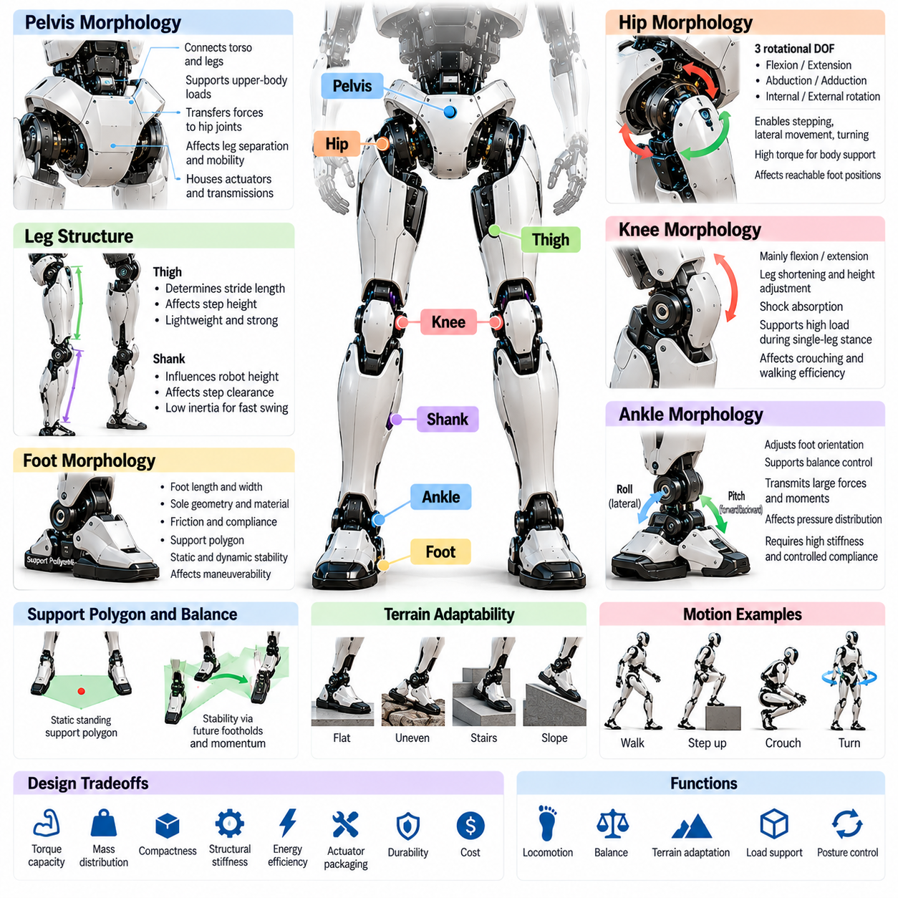
Pelvis, leg, and foot morphology forms the mechanical foundation of humanoid locomotion, balance, and ground interaction. These structures connect the upper body to supporting surfaces through articulated load-bearing mechanisms. Their geometry, mass distribution, joint arrangement, and compliance determine how effectively a humanoid robot can stand, walk, climb, absorb impacts, and maintain stability under changing environmental conditions.
The pelvis serves as the central structural interface between the torso and both legs. It supports upper-body loads while transferring gravitational and dynamic forces through the hip joints. Pelvic width, stiffness, and geometry influence leg separation, joint mobility, and balance control. Its design must accommodate powerful actuators, mechanical transmissions, and structural connections without introducing excessive mass or restricting movement.
Human-inspired pelvic architecture provides bilateral attachment points for the legs while supporting coordinated movement of the lower body. Unlike biological anatomy, robotic pelvis structures often use rigid frames and simplified joint assemblies. These arrangements improve manufacturing consistency and load transmission. However, they must preserve sufficient clearance for hip rotation, leg crossing, crouching, and dynamic stepping.
Hip morphology determines the primary orientation and positioning capabilities of each leg relative to the pelvis. Many humanoid designs incorporate three rotational degrees of freedom corresponding to flexion-extension, abduction-adduction, and internal-external rotation. These movements enable forward stepping, lateral displacement, turning, and posture adjustment. Joint-axis arrangement strongly influences reachable foot positions and mechanical interference.
Hip actuator placement presents important tradeoffs between torque capacity, mass distribution, and mechanical packaging. Powerful actuators are required to support body weight and generate acceleration during walking. Locating heavy components near the pelvis can reduce distal leg inertia, improving dynamic responsiveness. Nevertheless, compact hip assemblies must manage heat, transmission loads, and overlapping joint movement.
The thigh forms the primary structural link between the hip and knee. Its length influences stride geometry, achievable step height, and the range of body postures. Longer thighs can increase reach but also increase rotational inertia and bending moments. Structural materials must provide sufficient stiffness and fatigue resistance while minimizing mass, particularly because the thigh experiences repeated loading during locomotion.
Knee morphology primarily provides flexion and extension, enabling leg shortening, body height adjustment, and shock absorption. Most humanoid knees employ a dominant rotational axis, although alternative linkage mechanisms may modify torque transmission and joint motion. Knee geometry influences crouching capability, walking efficiency, and obstacle negotiation. Its design must support high loads during single-leg stance and dynamic transitions.
The knee also plays a critical role in controlling vertical body motion during walking. Coordinated knee flexion can reduce impact forces during landing and regulate the center-of-mass trajectory. Excessive bending, however, increases actuator torque and energy consumption. Effective morphology balances mechanical leverage, joint range, transmission efficiency, and the ability to maintain stable support throughout locomotion.
The shank connects the knee to the ankle and contributes significantly to leg inertia and foot placement dynamics. Its length affects overall robot height, step clearance, and the geometry of the walking mechanism. Lightweight shank construction can improve swing-leg acceleration and reduce energy requirements. However, structural rigidity remains essential for transmitting ground reaction forces during stance and maintaining accurate foot positioning.
Ankle morphology governs the orientation of the foot relative to the lower leg. Humanoid ankles commonly provide pitch and roll motion to accommodate changes in ground contact and balance requirements. Pitch supports forward-backward adjustment, while roll assists lateral stabilization. Additional articulation may improve adaptability, but increases mechanical complexity, actuator demand, and potential structural weakness.
The ankle must transmit substantial forces and moments during standing, walking, and balance recovery. Ground reaction forces acting through the foot generate torques that depend on contact location and body posture. Ankle actuator capacity therefore influences the robot's ability to regulate pressure distribution and recover from disturbances. Mechanical stiffness and controlled compliance must be selected according to expected loading conditions.
Foot morphology establishes the physical interface between the humanoid and the terrain. Foot length, width, sole geometry, and contact materials determine the available support region and friction characteristics. Larger feet can improve static stability by expanding the support polygon, but may restrict maneuverability in narrow spaces. Smaller feet increase placement flexibility while demanding more precise balance control.
The support polygon represents the region bounded by active ground contacts under appropriate contact assumptions. During static standing, maintaining the projected center of mass within this region supports equilibrium. During dynamic walking, stability depends additionally on momentum, contact forces, and future footholds. Foot geometry therefore influences balance without independently guaranteeing stability under motion.
Foot-ground interaction involves friction, compliance, pressure distribution, and impact dynamics. High-friction sole materials can reduce unwanted slipping, while compliant layers accommodate small surface irregularities and attenuate landing shocks. Excessive softness may introduce deformation and reduce positioning precision. Effective sole design balances traction, durability, mechanical efficiency, and reliable contact sensing.
Articulated toes provide an additional morphological option for humanoid feet. Toe joints can support rolling contact, modify effective foot length, and influence push-off behavior during selected gaits. However, their benefits depend on actuation, control strategy, and walking speed. Additional joints also increase mechanical complexity and maintenance requirements, making rigid feet preferable for some applications.
Leg proportions influence the relationship between mobility, stability, and energy efficiency. The relative lengths of the thigh, shank, and foot determine reachable footholds, obstacle clearance, and achievable postures. Human anatomical proportions provide useful references but are not universally optimal. Designers may modify these dimensions to accommodate actuator technology, target environments, payload requirements, and locomotion objectives.
Lower-body mass distribution strongly affects the energy required for walking. Heavy distal components increase swing-leg inertia and demand greater acceleration torque. Concentrating motors and transmissions near the hips can reduce these effects, although remote actuation introduces friction, elasticity, and routing constraints. Morphological optimization must consider total mass, inertia, structural strength, and transmission efficiency together.
Compliance and elasticity can improve the mechanical behavior of humanoid legs during repeated ground contact. Elastic elements may store and release energy, absorb impacts, and reduce peak loading. Series elastic actuators and compliant structures can support force regulation, but introduce additional dynamics that controllers must manage. Their effectiveness depends on stiffness selection, damping, and task-specific operating conditions.
Pelvis, leg, and foot morphology must support both single-support and double-support phases of walking. During single support, one leg carries the body while the other moves toward a new foothold. Double support allows load transfer between the feet. Joint range, foot geometry, and actuator strength determine how smoothly these transitions occur and whether the robot can maintain balance under external disturbances.
The interaction between lower-body morphology and whole-body manipulation is equally important. Carrying an object or extending the arms changes the center of mass and the distribution of ground reaction forces. The pelvis and legs must compensate through posture adjustments and contact-force regulation. Consequently, lower-body design must account for upper-body tasks rather than optimizing walking performance in isolation.
Sensor integration provides essential information for controlling the lower-body mechanical system. Joint encoders measure configuration, inertial measurement units estimate body motion, and foot force sensors characterize ground contact. Distributed pressure or tactile sensors may detect contact transitions and uneven loading. These measurements support state estimation, gait adaptation, slip detection, and balance recovery.
Terrain adaptability depends on the combined capabilities of joint articulation, foot geometry, sensing, and control. Stairs, ramps, thresholds, and irregular surfaces require sufficient leg workspace and reliable foothold selection. Greater joint mobility can improve access to difficult terrain but increases complexity. The optimal configuration depends on expected surface conditions, required speed, payload, and acceptable energy consumption.
Mechanical reliability and safety are critical because lower-body failures can cause the entire humanoid to fall. Joint structures must tolerate repeated cyclic loads, impacts, and unexpected disturbances. Mechanical stops, protective coverings, and appropriate torque limits can reduce hazardous motion. Robust designs also consider actuator faults, contact loss, thermal limitations, and controlled recovery or shutdown behavior.
Pelvis, leg, and foot morphology ultimately determines how a humanoid converts actuator forces into stable and adaptable physical movement. Successful architectures integrate joint mobility, structural strength, mass distribution, contact mechanics, and sensing within a coordinated lower-body system. Their purpose is to provide reliable locomotion and support for whole-body tasks while balancing efficiency, robustness, and safe interaction with the environment.

06.06. Humanoid Degrees of Freedom
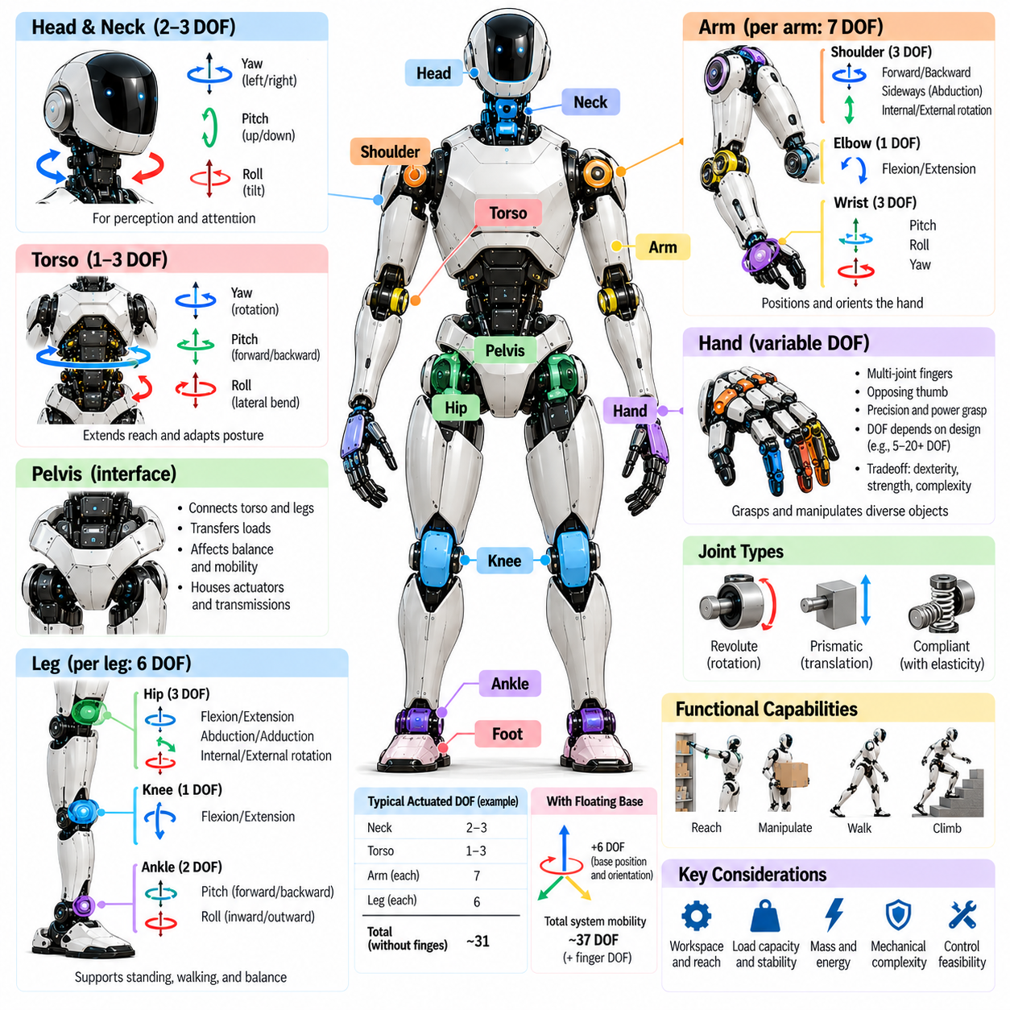
Degrees of freedom define the independent motions available to a humanoid robot through its joints and mechanical structure. They determine how the robot positions its limbs, adjusts posture, manipulates objects, and maintains balance. Humanoid morphology typically distributes rotational degrees of freedom across the neck, torso, arms, hands, pelvis, and legs, creating a coordinated articulated system capable of diverse physical behaviors.
A degree of freedom represents an independent variable required to describe a mechanical configuration. In robotic joints, this variable commonly corresponds to rotation around an axis or translation along a direction. Most humanoid joints are rotational because revolute mechanisms provide compact articulation. The total number of degrees of freedom depends on joint architecture, mechanical coupling, and the configuration being modeled.
Humanoid degrees of freedom must be distinguished from actuator count and control dimensions. A robot may contain passive joints, mechanically coupled joints, or underactuated mechanisms that reduce the number of independently controlled motions. Conversely, multiple actuators may cooperate to drive a single joint coordinate. Accurate morphological descriptions therefore separate mechanical mobility, actuation capability, and controllable motion.
The neck commonly provides two or three rotational degrees of freedom, allowing the head to perform yaw, pitch, and sometimes roll movements. These motions support visual attention, environmental scanning, and sensor orientation. Additional neck articulation can expand observation coverage but increases mass, wiring complexity, and control requirements. The selected configuration should reflect perception needs rather than anatomical similarity alone.
Torso degrees of freedom enable relative movement between the upper body and pelvis. Typical designs include waist yaw, torso pitch, and lateral bending, although simpler humanoids may use fewer joints. These movements extend manipulation reach and improve posture adaptation. However, torso articulation also changes mass distribution and introduces dynamic coupling between upper-body tasks and lower-body balance.
Each humanoid arm commonly includes shoulder rotation, elbow flexion, and wrist orientation joints. A seven-degree-of-freedom arm often provides three shoulder rotations, one elbow flexion, and three wrist rotations. This arrangement supports flexible end-effector positioning and orientation. Alternative designs distribute rotational axes differently or incorporate forearm rotation to achieve comparable manipulation capabilities.
Arm redundancy arises when the available joint degrees of freedom exceed those required to specify an end-effector pose. In three-dimensional space, a freely positioned rigid end effector has six pose coordinates. A seven-degree-of-freedom arm therefore possesses one local redundant dimension under regular conditions. This flexibility supports obstacle avoidance, joint-limit management, and manipulation posture optimization.
Hand degrees of freedom vary considerably according to finger architecture and manipulation objectives. Anthropomorphic hands may include several joints per finger, together with specialized thumb articulation. Fully actuated designs offer detailed control of finger configuration, while underactuated hands coordinate multiple joints through fewer actuators. The appropriate arrangement depends on required dexterity, grasp strength, reliability, and mechanical complexity.
Finger mobility should not be evaluated solely by counting joints. Joint-axis orientation, finger proportions, thumb opposition, and mechanical coupling strongly influence practical grasping capability. A hand with fewer independently controlled degrees of freedom may perform robust power grasps, while a more articulated hand can support precise in-hand manipulation. Functional performance depends on morphology, sensing, and control together.
The pelvis and hip joints establish the primary connection between the torso and lower limbs. Each hip commonly provides three rotational degrees of freedom corresponding to flexion-extension, abduction-adduction, and axial rotation. These movements enable forward stepping, lateral foot placement, and turning. Hip-axis arrangement affects leg workspace, mechanical interference, and the ability to maintain stable postures.
Humanoid knees usually provide one principal rotational degree of freedom for flexion and extension. This joint controls leg shortening, body height adjustment, and movement during stepping. More complex mechanisms may introduce additional passive or coupled motion without increasing independent actuation. Knee mobility must be evaluated together with joint torque capacity, transmission geometry, and structural load requirements.
Ankle joints commonly provide two rotational degrees of freedom for pitch and roll. These movements help regulate foot orientation and ground contact during walking and standing. Some designs incorporate additional yaw mobility or passive compliance. The required ankle configuration depends on terrain adaptability, balance strategy, actuator capacity, and foot geometry, rather than on a universal humanoid standard.
A representative humanoid lower body may contain six actuated degrees of freedom per leg, consisting of three at the hip, one at the knee, and two at the ankle. Two such legs provide twelve degrees of freedom. Adding seven degrees of freedom per arm, three at the torso, and two at the neck produces thirty-one actuated degrees of freedom before counting fingers or other mechanisms.
Total humanoid mobility is not determined exclusively by actuated joints. A freely moving robot base can be represented by six additional floating-base coordinates describing global position and orientation. These coordinates are not directly actuated in a legged humanoid. Instead, their evolution depends on joint motion, gravity, contact forces, and environmental constraints, making floating-base modeling essential for dynamic analysis.
Contact conditions change the effective mobility of a humanoid during operation. When both feet remain firmly planted, ground constraints restrict possible body movements. During single-support walking, the supporting foot constrains motion while the swing leg moves toward another foothold. Contact transitions modify the system's kinematic and dynamic constraints, even though the physical joint count remains unchanged.
The relationship between degrees of freedom and workspace is nonlinear. Adding a joint does not automatically produce a proportional increase in reachable positions or orientations. Joint limits, link dimensions, self-collision, singular configurations, and actuator capabilities restrict usable movement. Morphological evaluation must therefore consider the geometry and arrangement of joints rather than relying on numerical counts alone.
Kinematic singularities occur when certain motion directions become unavailable or require disproportionately large joint velocities. Their locations depend on joint-axis arrangement and mechanical geometry. Additional degrees of freedom can provide alternative configurations that avoid some singularities, but cannot eliminate every limitation. Effective design combines suitable morphology with motion planning and numerical control methods.
Higher degrees of freedom increase behavioral flexibility but also introduce significant engineering costs. Each additional actuated joint may require motors, transmissions, bearings, sensors, wiring, and structural reinforcement. These components increase mass, energy consumption, maintenance demands, and potential failure points. The design objective is therefore sufficient functional mobility rather than maximizing joint count.
Degrees of freedom also influence whole-body coordination and control complexity. Manipulation, locomotion, and balance may require simultaneous adjustment of numerous joints. Whole-body controllers often organize these motions according to task priorities and physical constraints. Redundant joints can support secondary objectives such as energy reduction or collision avoidance while maintaining primary task performance.
Mechanical coupling and underactuation offer alternatives to independently driving every available motion. Tendon mechanisms, differential transmissions, and passive elastic elements can coordinate several joints through fewer actuators. Such architectures may reduce mass and improve mechanical adaptability. However, they can restrict independent positioning and complicate force estimation, especially during changing contact conditions.
Morphological optimization requires selecting degrees of freedom according to expected tasks and environments. A warehouse humanoid may prioritize reliable walking, lifting, and reaching, while a service robot may require more dexterous hands and expressive head motion. Increasing articulation in one body region can reduce available mass or power budgets elsewhere. Joint allocation should therefore follow system-level performance requirements.
Safety and reliability are closely connected to degrees-of-freedom architecture. More joints create additional movement possibilities and potential collision configurations. Joint limits, torque monitoring, compliant mechanisms, and fault detection help control these risks. A mechanically simpler configuration may be preferable when it satisfies operational requirements with fewer failure modes and more predictable behavior.
Humanoid degrees of freedom ultimately define the mechanical possibilities available for embodied intelligence and physical interaction. Their effectiveness depends on joint placement, actuation, sensing, mass distribution, and coordinated control rather than numerical quantity alone. A well-designed humanoid allocates mobility where it provides meaningful functional value, achieving adaptable behavior without unnecessary mechanical complexity.

06.07. Body Proportions and Mass Distribution
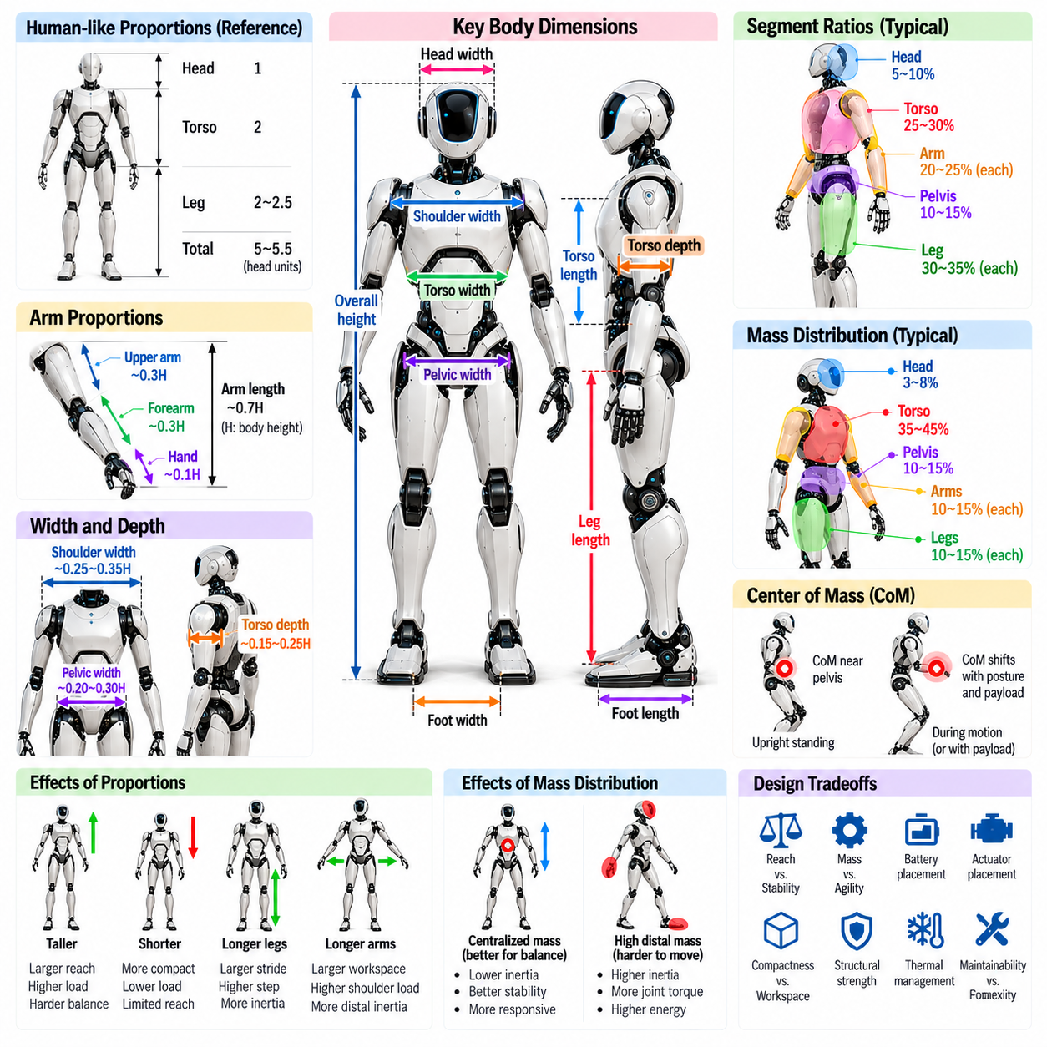
Body proportions and mass distribution are fundamental morphological parameters that determine the mechanical behavior, stability, and functional capabilities of humanoid robots. Proportions describe the relative dimensions of body segments, while mass distribution defines how weight is allocated throughout the structure. Together, these characteristics influence locomotion, manipulation, balance, energy consumption, and interaction with human environments.
Human anatomical proportions provide useful references for humanoid design because buildings, furniture, tools, and workspaces are generally organized around human dimensions. However, direct anatomical replication does not guarantee optimal robotic performance. Differences in actuator technology, structural materials, energy storage, and control capabilities require proportions to be adapted according to engineering constraints and operational objectives.
Overall body height influences environmental accessibility, workspace compatibility, and mechanical loading. Taller humanoids may reach elevated shelves and interact with standard human equipment more easily, but increased height can amplify gravitational moments and stability challenges. Shorter robots may offer improved compactness and reduced structural loads, although their reach and ability to operate human-scale infrastructure can become limited.
The relationship between torso length and leg length strongly affects posture and locomotion. Longer legs can increase stride length and improve access to elevated surfaces, but they may also increase rotational inertia and joint torque demands. A relatively longer torso can provide additional internal packaging space, although it changes the position of the center of mass and the mechanical requirements for maintaining upright balance.
Arm length relative to torso dimensions determines manipulation reach and the ability to access objects without repositioning the feet. Longer arms expand the reachable workspace but increase shoulder loading and distal inertia. Shorter arms can improve compactness and dynamic responsiveness. Appropriate proportions depend on target workspaces, expected payloads, and the degree of torso mobility available for coordinated manipulation.
Shoulder width, pelvic width, and body depth influence both stability and maneuverability. Wider shoulders can improve dual-arm workspace coverage, while a wider pelvis may provide additional clearance for hip mechanisms. However, increased body width can restrict passage through narrow spaces. Morphological design must therefore balance mechanical packaging, joint mobility, collision avoidance, and compatibility with human environments.
Mass distribution describes the location of individual component masses relative to the robot's body coordinate system. Major contributors include actuators, batteries, computing hardware, structural links, transmissions, and payloads. Their placement determines the overall center of mass and inertia properties. Two humanoids with similar external proportions can exhibit substantially different dynamic behavior because of internal component arrangements.
The center of mass represents the weighted average position of the robot's distributed mass. Its location changes as joints move, objects are carried, or body segments change orientation. During standing and walking, center-of-mass motion must be coordinated with available ground contacts. Morphological decisions that influence its nominal location affect posture control, balance recovery, and the effort required to maintain stability.
A lower center of mass can improve certain aspects of static stability and reduce gravitational moments under selected conditions. However, placing excessive mass near the feet or lower legs may increase swing-leg inertia and walking energy consumption. Consequently, lowering the center of mass is not universally beneficial. Designers must consider the competing effects of mass placement on stability, joint torque, and dynamic efficiency.
The distribution of mass also determines the inertia tensor, which describes resistance to angular acceleration about different axes. Components positioned far from the body's rotational axes contribute disproportionately to rotational inertia. Heavy hands, feet, and head assemblies can therefore increase the effort required for rapid movement. Concentrating substantial masses near central body regions often improves responsiveness, subject to packaging constraints.
Distal mass is particularly important in the arms and legs because these segments repeatedly accelerate and decelerate during manipulation and locomotion. Lightweight forearms and hands reduce shoulder and elbow torque demands, while lightweight shanks and feet improve swing-leg dynamics. Remote actuation can relocate motors toward proximal joints, although transmissions introduce additional friction, elasticity, and mechanical complexity.
Battery placement presents a major system-level tradeoff because energy storage can represent a substantial fraction of total robot mass. Batteries located near the pelvis or torso may support centralized mass distribution and simplify electrical integration. However, available volume, thermal management, structural protection, and maintenance access constrain placement. Battery configuration must also account for changes in mass distribution when modules are replaced.
Actuator placement affects both joint performance and whole-body inertia. High-torque motors concentrated around the hips and torso can reduce distal loading, but may increase central structural requirements and thermal density. Distributed actuators simplify some joint transmissions while adding mass to moving links. Selecting an architecture requires evaluating actuator efficiency, transmission losses, mechanical stiffness, and expected motion patterns.
Mass distribution influences the relationship between the center of mass and the support region during standing. Under static conditions, equilibrium requires the resultant ground reaction forces and moments to balance gravity and other applied loads. During dynamic movement, momentum and contact constraints become equally important. Consequently, morphological stability cannot be evaluated solely by projecting the center of mass onto the ground.
Body proportions also affect the location and size of the reachable workspace for hands and feet. Arm and leg lengths interact with joint ranges to determine feasible configurations. Longer segments may extend reach but create greater collision risks and unfavorable leverage near workspace boundaries. Effective design evaluates usable workspace, joint limits, self-collision, and structural loading rather than relying on dimensions alone.
The relationship between body proportions and actuator torque becomes especially important during crouching, lifting, and stair climbing. Longer links can increase moment arms, requiring greater joint torque for comparable external loads. Shorter links may reduce mechanical demand but limit obstacle clearance and movement range. Joint-axis placement and transmission ratios must therefore be optimized together with segment dimensions.
Anthropometric scaling introduces additional challenges because mass, strength, and inertia do not change proportionally with linear dimensions. Under geometric similarity and constant material density, mass scales approximately with the cube of characteristic length. Structural cross-sectional area scales with its square, creating changing load relationships as robot size increases. Actuator capability and structural strength must be reconsidered at each scale.
Payload handling alters mass distribution and can significantly change humanoid dynamics. Carrying an object forward shifts the combined center of mass and increases moments about supporting joints. Holding a load close to the torso generally reduces external moment arms, although task geometry may prevent this configuration. Whole-body control must accommodate changing payload mass, position, and inertia during manipulation.
Symmetry is a common starting principle for humanoid morphology because bilateral structures simplify certain mechanical and control assumptions. Nevertheless, actual mass distribution may become asymmetric because of component packaging, tools, or carried objects. Asymmetric loading affects posture and joint torque requirements. Accurate dynamic models must therefore represent measured component masses rather than assuming perfect left-right symmetry.
Energy efficiency depends on the interaction between segment proportions, mass distribution, and movement patterns. High distal inertia increases the work required to accelerate limbs, while unfavorable center-of-mass trajectories can increase support demands. Mechanical design can reduce these penalties through lightweight materials, appropriate link lengths, and centralized heavy components. However, energy performance must be assessed across representative tasks.
Structural strength and mass reduction must be balanced carefully. Lightweight links can improve agility but may introduce deformation, vibration, or fatigue problems under repeated loading. Reinforcement increases stiffness and durability but also changes inertia properties. Material selection, cross-sectional geometry, and load paths should be optimized jointly to achieve reliable performance without unnecessary structural weight.
Body proportions and mass distribution ultimately establish the physical conditions under which humanoid intelligence and control systems operate. Effective morphology integrates human-environment compatibility, reachable workspace, dynamic stability, actuator capability, and energy efficiency. Rather than reproducing human anatomy exactly, successful humanoid design allocates dimensions and mass according to the mechanical demands of intended tasks.

06.08. Bipedal Stability and Locomotion Morphology
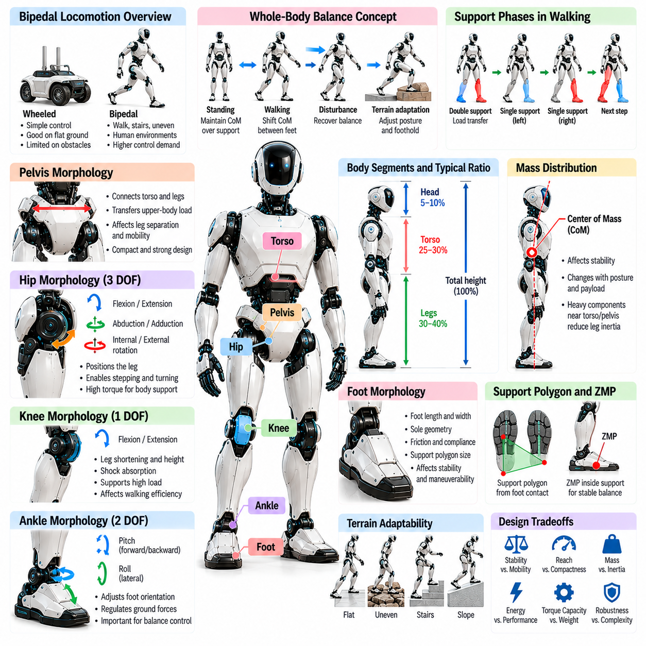
Bipedal stability and locomotion morphology defines how humanoid robots maintain upright posture and generate movement through two articulated legs. Unlike wheeled platforms, bipeds must continuously manage gravitational forces, momentum, and changing ground contacts. Their mechanical architecture determines feasible walking patterns, balance recovery capabilities, terrain adaptability, and the energetic cost of moving through human environments.
Bipedal stability emerges from the interaction between body geometry, mass distribution, joint articulation, and foot-ground contact. During standing, the robot must regulate forces and moments to maintain equilibrium. During walking, stability becomes a dynamic process involving repeated transitions between supporting feet. Morphological design therefore establishes the physical constraints within which balance controllers and locomotion algorithms operate.
The pelvis provides the structural foundation for coordinating the two legs and supporting the upper body. Its width influences lateral foot placement, hip clearance, and the range of feasible walking postures. A wider pelvis may improve mechanical packaging and certain lateral movements, while excessive width can increase leg separation and energetic demands. Pelvic geometry must balance mobility, structural strength, and compactness.
Hip articulation enables forward stepping, lateral movement, and rotational adjustment of the legs. Three rotational degrees of freedom commonly provide flexion-extension, abduction-adduction, and axial rotation. These movements allow the robot to position its feet relative to the pelvis and adapt its stance. Joint-axis arrangement and motion limits determine the available foothold workspace and influence recovery from disturbances.
Leg length and segment proportions strongly influence walking mechanics. Longer legs can support greater stride lengths and improved obstacle clearance, but may increase rotational inertia and joint torque requirements. Shorter legs can improve compactness and reduce some mechanical loads while limiting reachable footholds. Effective proportions depend on walking speed, target terrain, payload requirements, and actuator capabilities.
Knee morphology influences vertical body motion, leg shortening, and impact absorption. Flexion during walking enables foot clearance and supports controlled landing, while extension provides structural support during stance. Excessive knee bending can increase actuator effort and energy consumption. Joint range, mechanical leverage, and transmission efficiency must therefore be coordinated with the desired walking strategy.
Ankle articulation is essential for regulating foot orientation and distributing ground reaction forces. Pitch motion supports forward-backward balance adjustments, while roll motion contributes to lateral stabilization. Adequate ankle torque capacity enables the robot to modify contact moments during standing and walking. Limited ankle mobility may require greater compensation through hip movement or foot placement adjustments.
Foot geometry directly affects the support region available for maintaining balance. Longer and wider feet can increase the support polygon during flat-ground contact, potentially improving static stability. However, oversized feet may complicate stepping in confined environments and negotiating obstacles. Foot dimensions must be selected according to expected terrain, gait characteristics, and the required balance strategy.
The support polygon describes the region enclosed by active ground contacts under suitable contact assumptions. During static equilibrium, the projected center of mass must remain consistent with the available support and external loading. Dynamic locomotion requires additional consideration of momentum and contact-force limits. Consequently, foot dimensions alone cannot guarantee stability during accelerated movement.
The zero moment point is a useful concept for analyzing balance under certain contact conditions. It represents a ground-plane location where the relevant tipping moments vanish in a specified model. Keeping this point within the feasible support region can support dynamically balanced motion. However, its interpretation depends on contact geometry and assumptions, and it does not replace full momentum-based analysis.
The center of mass and its trajectory are central to bipedal locomotion. As the robot walks, its mass moves relative to alternating support contacts, creating gravitational and inertial effects. Lower-body proportions and component placement influence these dynamics. Concentrating heavy components near the pelvis can reduce swing-leg inertia, although overall stability also depends on posture, contact forces, and control actions.
Walking typically alternates between single-support and double-support phases. During single support, one foot carries the body while the opposite leg advances toward a new foothold. Double support enables load transfer between the legs. Hip mobility, knee range, ankle articulation, and foot dimensions influence the smoothness of these transitions and the robot's ability to maintain controlled ground contact.
Swing-leg morphology determines how efficiently the robot moves its foot between successive contacts. Heavy shanks and feet increase rotational inertia and require greater acceleration torque. Lightweight distal structures improve responsiveness and can reduce energy consumption. Nevertheless, sufficient structural strength and impact tolerance are necessary because the leg must withstand repeated loading during touchdown and stance.
Foot-ground contact mechanics strongly influences locomotion reliability. Friction determines the available resistance to slipping, while sole compliance affects pressure distribution and impact attenuation. Excessively rigid contact may transmit large shocks, whereas excessive softness can reduce positioning accuracy. Appropriate sole materials and mechanical damping improve adaptation to surface irregularities without eliminating the need for active control.
Passive mechanical properties can contribute to walking efficiency and stability. Elastic elements may store energy during loading and return part of it during subsequent movement. Compliant joints and flexible structures can reduce peak impact forces and accommodate uncertain contacts. Their benefits depend on stiffness, damping, gait timing, and control strategy, since poorly matched compliance can introduce oscillations or instability.
Balance recovery requires the ability to generate corrective joint torques, modify angular momentum, or reposition the feet. Ankle strategies regulate contact moments, while hip strategies alter upper-body and leg motion. Stepping strategies establish new support locations when existing contacts are insufficient. Morphology determines the available joint ranges, actuator authority, and reachable footholds for these responses.
Upper-body morphology also contributes to bipedal stability. Arm movements and torso rotation can redistribute angular momentum and influence the overall center of mass. These effects may assist disturbance recovery or complicate walking when manipulation tasks impose additional loads. Whole-body coordination is therefore necessary to manage interactions between locomotion, balance, and upper-limb activity.
Terrain adaptability depends on the combined capabilities of leg articulation, foot design, and body proportions. Stairs require adequate foot clearance and joint range, while slopes demand suitable ankle orientation and contact friction. Uneven terrain introduces uncertainty in contact location and loading. Morphological flexibility expands the range of negotiable surfaces but increases mechanical and control complexity.
Locomotion efficiency depends on the interaction between actuator placement, limb inertia, joint transmission, and gait dynamics. Heavy distal components increase the effort required for repeated leg acceleration. Efficient transmissions reduce mechanical losses, while appropriate link proportions can improve stride mechanics. Energy performance must be evaluated across realistic walking speeds, terrain conditions, and payload configurations.
Sensor integration supports the control of bipedal morphology during movement. Joint encoders measure articulation, inertial sensors estimate body orientation and motion, and foot sensors characterize ground reaction forces. Vision and depth sensing provide information about upcoming terrain. Combining these measurements enables contact estimation, foothold planning, disturbance detection, and adaptive gait control.
Mechanical reliability is especially important because loss of lower-body support can cause a complete robot fall. Hip, knee, and ankle structures must tolerate cyclic loading, impacts, and unexpected contact forces. Actuator torque limits, joint stops, and protective mechanisms can reduce damage during abnormal events. Reliable locomotion requires both durable mechanical architecture and appropriate fault-responsive behavior.
Bipedal stability and locomotion morphology ultimately determines the physical capabilities available for upright movement in humanoid robots. Successful designs integrate body proportions, mass distribution, joint mobility, foot contact mechanics, and compliant structures into a coordinated system. The objective is not merely to reproduce human walking, but to achieve efficient, adaptable, and reliable locomotion under practical environmental constraints.

06.09. Whole Body Manipulation Morphology
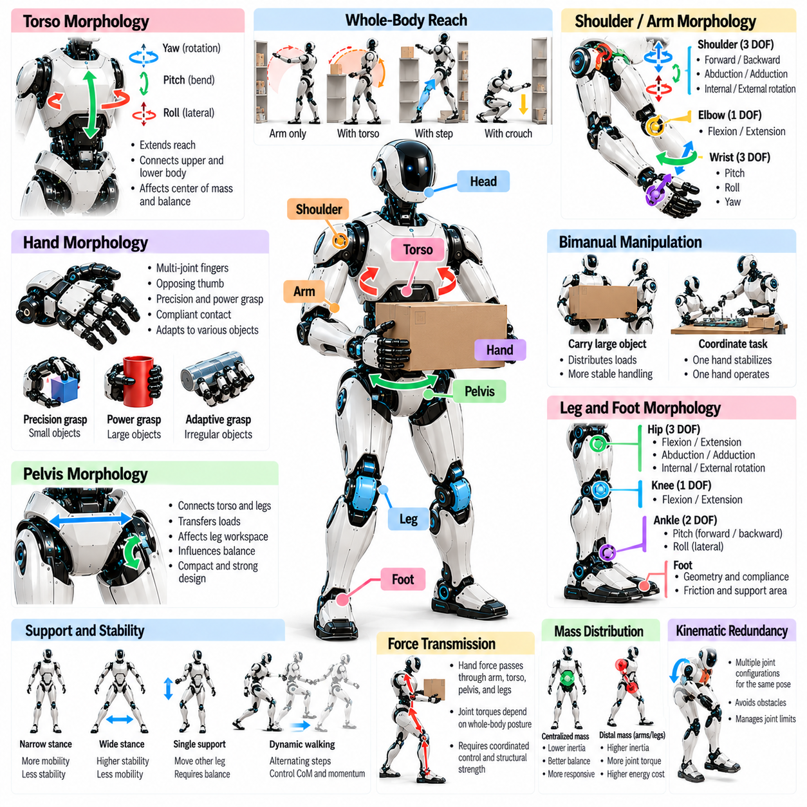
Whole-body manipulation morphology describes how a humanoid robot coordinates its arms, hands, torso, pelvis, and legs to interact with objects while maintaining physical stability. Unlike isolated arm manipulation, whole-body manipulation uses the entire articulated structure to generate motion and distribute forces. Its effectiveness depends on joint arrangement, body proportions, mass distribution, contact geometry, and the mechanical integration of multiple limbs.
The fundamental objective of whole-body manipulation is to extend the robot's functional workspace beyond the reach of individual arms. By adjusting torso orientation, bending the knees, shifting the pelvis, or repositioning the feet, a humanoid can access objects that would otherwise remain unreachable. These coordinated movements transform the body into a unified manipulation mechanism rather than a collection of independently operating joints.
The torso provides an important mechanical connection between upper-limb manipulation and lower-body support. Waist rotation, forward bending, and lateral flexion expand the reachable workspace of the hands. However, torso movement also changes the center of mass and redistributes gravitational loading. Torso morphology must therefore balance manipulation flexibility with structural stiffness, actuator capacity, and postural stability.
Shoulder placement determines the spatial relationship between the arms, torso, and surrounding workspace. Wider shoulder separation may improve access to large objects and support dual-arm operations, while narrower configurations can reduce body width and improve maneuverability. Shoulder joint orientation and available motion ranges influence overhead reaching, cross-body manipulation, and the ability to operate near environmental obstacles.
Arm morphology determines how effectively the robot positions its hands while accommodating changing body posture. Multi-joint arms provide alternative configurations for reaching the same target, allowing the robot to avoid collisions and unfavorable joint positions. Seven-degree-of-freedom arms commonly provide useful kinematic redundancy, although practical dexterity also depends on joint limits, actuator torque, and mechanical interference.
Elbow and wrist architecture strongly influence manipulation in constrained environments. Elbow positioning determines how the arm approaches an object, while wrist articulation adjusts the orientation of tools and grasped items. Compact wrist mechanisms can improve access to narrow spaces, but limited torque capacity may restrict payload handling. Joint placement must balance reachability, orientation flexibility, structural strength, and actuator packaging.
Hand morphology establishes the final physical interface between the humanoid and manipulated objects. Finger arrangement, thumb opposition, palm geometry, and joint compliance determine available grasp configurations. Dexterous hands support precision manipulation and object reorientation, while simpler grippers may provide stronger and more reliable grasping. The appropriate end-effector structure depends on expected object geometry and manipulation requirements.
Bimanual manipulation uses both arms to handle objects that are large, heavy, or difficult to stabilize with one hand. Coordinated dual-arm movement can distribute loads and create multiple contact points around an object. However, successful bimanual operation requires sufficient shoulder workspace, compatible arm lengths, and controlled relative hand motion. Torso mobility and stance geometry further influence the available manipulation configurations.
The pelvis and lower limbs form the mechanical foundation for whole-body manipulation. Hip, knee, and ankle articulation allows the robot to adjust body height, shift its center of mass, and establish stable support configurations. Crouching can improve access to low objects, while stepping expands the manipulation workspace. Lower-body morphology therefore determines how effectively the robot can reposition its upper body without losing balance.
Foot placement and support geometry impose important constraints on manipulation. During stationary tasks, the robot must generate appropriate ground reaction forces and contact moments while applying forces through its hands. Wider stances may improve resistance to certain disturbances but can reduce mobility in confined spaces. Foot dimensions, friction properties, and ankle torque capacity influence the feasible range of manipulation forces.
Whole-body manipulation introduces coupled force transmission throughout the robot. A force applied at the hand generates reactions through the wrist, elbow, shoulder, torso, pelvis, and supporting legs. Joint torque requirements depend on the configuration of this entire kinematic chain. Consequently, manipulation capacity cannot be determined solely from arm strength or gripper force, but must include whole-body structural and actuation limits.
Mass distribution influences the stability and responsiveness of manipulation movements. Extending the arms forward shifts the combined center of mass and increases gravitational moments at supporting joints. Carrying a heavy object amplifies these effects. Centralized actuator placement and lightweight distal limbs can reduce unnecessary inertia, while coordinated posture adjustments help maintain feasible loading conditions during demanding tasks.
Kinematic redundancy enables the humanoid to satisfy manipulation objectives while adjusting its remaining joints for secondary purposes. A robot may maintain a desired hand pose while modifying elbow orientation, torso posture, or leg configuration. This flexibility supports collision avoidance, joint-limit management, and balance preservation. The available redundancy depends on contact constraints and the number of independently controlled joints.
Whole-body manipulation often requires simultaneous consideration of multiple contact points. The feet establish support contacts, while one or both hands interact with objects or environmental surfaces. Additional contacts can increase stability and expand force-generation capabilities, but they also introduce mechanical constraints. Contact geometry, friction, and structural compliance determine which force distributions are physically achievable.
Closed-chain manipulation occurs when the robot and environment form a constrained mechanical loop. Examples include holding an object with both hands or pushing against a fixed surface while standing. These configurations restrict independent joint motion and create internal forces that must be regulated. Morphological compatibility between arm reach, joint alignment, and contact locations is essential for avoiding excessive mechanical stress.
Mechanical compliance plays an important role in safe and reliable whole-body interaction. Elastic joints, compliant transmissions, and adaptable contact surfaces can absorb small positioning errors and reduce peak interaction forces. However, excessive compliance may decrease positioning accuracy and introduce oscillations. Appropriate stiffness and damping must be selected according to the expected balance between precision, impact tolerance, and force regulation.
Manipulation involving heavy objects requires careful coordination between grasp geometry and whole-body posture. Keeping a load close to the torso generally reduces moment arms and joint torque demands. Lifting from the floor may require coordinated knee and hip extension rather than relying primarily on the arms. Morphological design should support mechanically favorable postures throughout the lifting trajectory, not only at its endpoints.
Whole-body reachability depends on the combined workspaces of the arms, torso, and legs. A target may be reachable by an individual arm but inaccessible when balance, collision avoidance, and contact constraints are considered. Conversely, a target outside the stationary arm workspace may become accessible through stepping or body repositioning. Functional workspace evaluation must therefore incorporate whole-body configurations and environmental restrictions.
Sensor placement and mechanical integration support coordinated manipulation. Joint encoders provide configuration measurements, force and torque sensors estimate interaction loads, and tactile sensors characterize grasp contacts. Inertial sensing supports body-state estimation, while visual sensors identify objects and surrounding obstacles. These measurements enable controllers to coordinate physical interaction with balance and contact management.
Whole-body control relies on the morphological structure to distribute motion and forces among available joints. Task-space controllers may prioritize hand trajectories while enforcing balance, contact, and actuator constraints. Optimization-based methods can allocate joint velocities or torques according to competing objectives. Their effectiveness depends on accurate kinematic models, inertial parameters, joint limits, and contact descriptions.
Safety and reliability become particularly important when manipulation occurs near people or fragile objects. Unexpected contact forces can propagate through the entire body and disturb balance. Mechanical joint limits, torque monitoring, compliant interfaces, and protective control strategies reduce these risks. A robust humanoid must maintain predictable behavior even when grasp conditions, payload properties, or environmental contacts change.
Whole-body manipulation morphology ultimately determines how effectively a humanoid converts its complete mechanical structure into coordinated physical action. Successful designs integrate dexterous arms, adaptable hands, mobile torso joints, stable lower limbs, and suitable mass distribution. The objective is to achieve versatile manipulation while preserving balance, mechanical efficiency, structural reliability, and compatibility with human environments.

06.10. Human Environment Compatibility
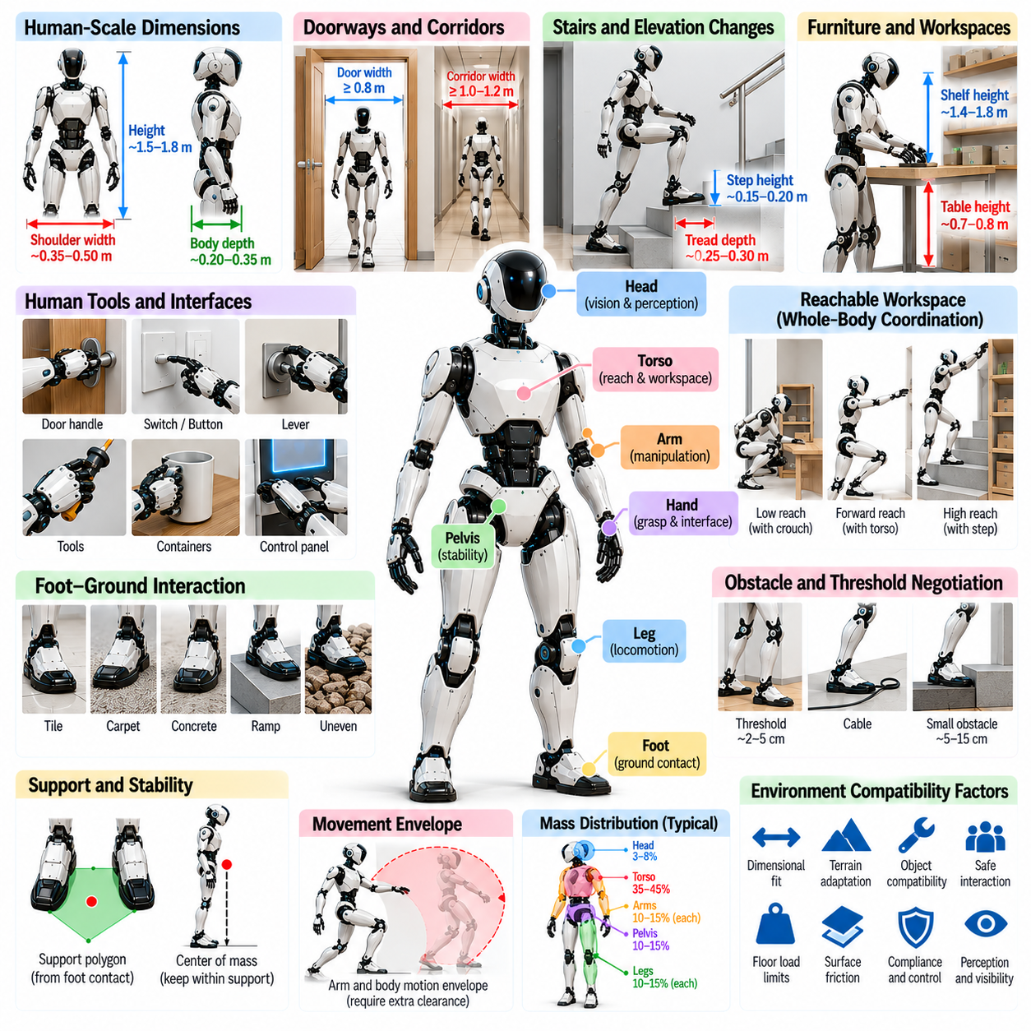
Human-environment compatibility describes how effectively a humanoid robot can operate within spaces, infrastructure, and workflows originally designed for people. Unlike specialized industrial robots, humanoids must navigate doors, corridors, stairs, furniture, and workstations without extensive environmental modification. Their morphology must therefore balance human-scale accessibility with mechanical efficiency, safety, and reliable physical interaction.
Human environments impose dimensional constraints that directly influence humanoid body proportions. Overall height, shoulder width, torso depth, and limb length determine whether the robot can pass through doorways, reach shelves, and work near furniture. Anthropometric references provide useful starting points, but robotic dimensions must also accommodate actuators, batteries, sensors, and protective structures without compromising mobility.
Doorways and corridors establish important requirements for body width and maneuverability. A humanoid must account for its shoulder envelope, arm posture, and carried objects when passing through restricted spaces. Narrow body configurations improve clearance, while articulated shoulders and torso rotation can reduce effective width during movement. Collision avoidance must consider the entire moving body rather than a fixed geometric footprint.
Stairs and elevation changes present challenges that depend on leg length, joint mobility, and foot geometry. Human staircases typically assume particular ranges of step height and tread depth, but actual dimensions vary across buildings. Humanoid knees and hips must provide sufficient clearance, while ankle articulation supports stable contact. Reliable stair negotiation also requires perception, balance control, and adequate actuator torque.
Furniture compatibility influences the robot's ability to perform everyday manipulation tasks. Tables, desks, cabinets, and countertops establish working heights and access restrictions. Arm reach, torso mobility, and body depth determine whether a humanoid can interact with these surfaces without excessive bending or repositioning. Functional workspace analysis should include realistic obstacles and contact constraints rather than idealized reach alone.
Human tools and interfaces introduce additional morphological requirements. Door handles, switches, buttons, levers, and handheld equipment assume particular grasp shapes and operating forces. Humanoid hands must provide appropriate finger geometry, contact surfaces, and force capability to manipulate these interfaces. However, functional compatibility does not always require fully anthropomorphic hands when simpler end effectors can accomplish the intended tasks.
Hand size and finger articulation influence compatibility with objects designed for human grasping. Tool handles, containers, and control devices may require precision pinching, cylindrical grasping, or controlled force application. Thumb opposition and wrist mobility expand the range of accessible interactions. Designers must balance dexterity with durability, actuator packaging, tactile sensing, and maintenance requirements.
Workspace accessibility depends on the combined movement of the arms, torso, and lower body. A humanoid may need to crouch to retrieve an object, extend its arms toward an elevated shelf, or step sideways to approach a workstation. These tasks require coordinated joint mobility and stable support. Human-environment compatibility is therefore a whole-body property rather than a characteristic of individual limbs.
Ground surfaces vary considerably across human environments, including tiles, carpets, concrete, ramps, and irregular outdoor paths. Foot morphology must accommodate differences in friction, compliance, and surface geometry. Sole materials influence traction and contact stability, while ankle mobility supports orientation adjustments. Excessively specialized feet may perform well on one surface but become unreliable under changing conditions.
Thresholds, cables, floor transitions, and small obstacles create additional mobility constraints. Foot clearance depends on knee flexion, hip articulation, and leg proportions. Larger feet may improve some aspects of support but increase the risk of catching environmental obstacles. Morphological design must therefore balance contact stability, obstacle clearance, and compact movement within cluttered human spaces.
Human environments also contain objects and structures that cannot tolerate large interaction forces. Doors, furniture, electronic equipment, and fragile items require controlled contact and predictable motion. Mechanical compliance can reduce peak forces during unexpected contact, while torque sensing supports force regulation. Safe interaction depends on combining suitable physical design with responsive control and accurate environmental perception.
The distribution of robot mass affects compatibility with floors, platforms, and supporting structures. Heavy humanoids generate substantial contact loads, especially during dynamic stepping or impact. Foot area and contact compliance influence pressure distribution, while gait behavior determines transient loading. Designers must evaluate surface load limits and operational conditions rather than assuming that human-accessible structures automatically support robotic loads.
Spatial compatibility also includes the robot's dynamic movement envelope. Arms may extend beyond the torso during turning, manipulation, or balance recovery. A configuration that fits through a passage while stationary may require additional clearance during motion. Motion planning must account for joint trajectories, carried objects, and possible corrective movements, particularly in confined environments shared with people.
Visual and sensor placement influences how effectively humanoids interpret human environments. Head-mounted cameras provide useful perspectives for navigation and manipulation, while torso and wrist sensors can reduce occlusion near working surfaces. Sensor height and orientation affect visibility of stairs, handles, and obstacles. Morphological integration must preserve useful sensing coverage throughout changing postures and manipulation configurations.
Human-centered infrastructure frequently requires interaction at multiple vertical levels. Objects may be located near the floor, at waist height, above the shoulders, or inside enclosed storage spaces. Leg articulation, torso bending, and arm reach jointly determine accessibility. Designing only for comfortable standing-height manipulation can leave substantial portions of the environment functionally inaccessible.
Social compatibility introduces requirements beyond purely geometric access. A humanoid operating near people should maintain predictable movement, avoid unnecessary intrusion into personal space, and communicate physical intentions through understandable behavior. Body proportions and joint arrangements influence perceived movement and collision risk. However, humanlike appearance alone does not establish safe or socially appropriate interaction.
Maintenance and deployment constraints also influence environmental compatibility. Robots may need to enter elevators, pass through service corridors, use charging stations, and access storage areas. Component accessibility, modular construction, and compact resting postures can simplify operation. Morphology should support not only task execution but also transportation, inspection, recovery, and routine maintenance within existing facilities.
Environmental compatibility must be evaluated under realistic payload conditions. Carrying boxes, tools, or equipment changes the robot's effective dimensions, center of mass, and collision envelope. Large objects may obstruct sensors or restrict arm movement, while heavy loads reduce available balance margins. Practical evaluation should include representative objects, walking routes, and manipulation sequences rather than unloaded movement alone.
Accessibility requirements vary across homes, hospitals, offices, factories, and public infrastructure. A morphology optimized for wide industrial aisles may struggle in compact residential spaces, while a small service humanoid may lack the reach or strength required for warehouse operations. Designers should identify target environments and operational constraints before selecting body dimensions, joint ranges, and manipulation capabilities.
Standardization can support compatibility by defining measurable requirements for physical interfaces, safety, and performance. Relevant dimensions include robot clearance, reachable workspace, contact forces, and operating envelopes. Existing building and equipment standards provide contextual constraints, but they do not automatically establish complete humanoid design requirements. Validation must connect morphological specifications to actual deployment conditions.
Human-environment compatibility ultimately depends on the integration of body geometry, articulation, sensing, contact mechanics, and safe control. A successful humanoid should navigate existing infrastructure, manipulate common objects, and adapt to environmental variation without extensive reconstruction. The central objective is functional interoperability with human spaces, achieved through task-oriented morphology rather than anatomical imitation alone.

06.11. General Purpose Humanoid Morphology
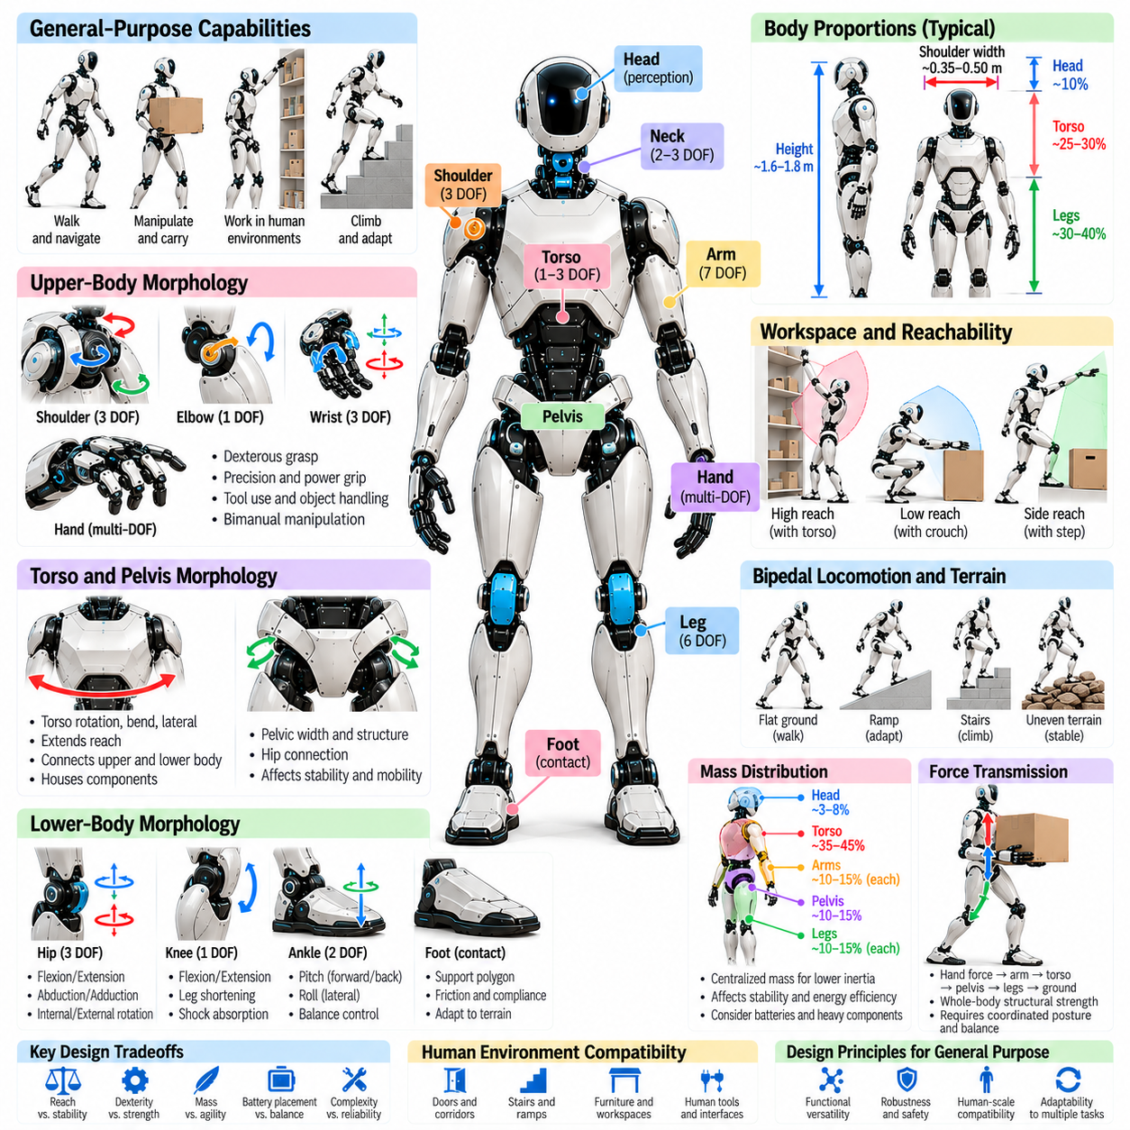
General-purpose humanoid morphology describes a robotic body architecture designed to perform diverse physical tasks across multiple environments without extensive mechanical redesign. Unlike specialized robots optimized for narrow operations, general-purpose humanoids must balance locomotion, manipulation, perception, and physical interaction. Their morphology emphasizes functional versatility, adaptability, and reliable operation rather than maximum performance in a single task.
The central challenge is selecting a body configuration that supports many activities while avoiding unnecessary mechanical complexity. A humanoid must reach objects, navigate human spaces, carry loads, and maintain balance under changing conditions. Each capability imposes different requirements on joint mobility, actuator strength, body proportions, and structural design. General-purpose morphology therefore emerges from carefully managed engineering tradeoffs.
Anthropomorphic body architecture provides a practical foundation because many environments and tools are designed around human dimensions. Two legs enable navigation through stairs and narrow passages, while two arms support manipulation and object transportation. However, anatomical similarity is not sufficient for general-purpose performance. Robotic proportions and mechanisms should be selected according to functional requirements rather than biological imitation alone.
Body proportions determine compatibility with workspaces, furniture, tools, and infrastructure. Overall height influences reach and environmental access, while shoulder width affects passage clearance and dual-arm manipulation. Leg length determines stepping capabilities, and torso dimensions constrain component packaging. Effective proportions should accommodate representative tasks without creating excessive mass, unfavorable leverage, or unnecessary collision risks.
Degrees of freedom establish the range of movements available to the humanoid. Multiple shoulder, hip, and wrist joints support flexible manipulation and locomotion, while torso articulation extends whole-body reachability. Additional joints increase adaptability but also introduce weight, cost, and control complexity. General-purpose design requires sufficient mobility to perform diverse tasks without maximizing articulation indiscriminately.
Arm and hand morphology strongly influences the range of useful manipulation behaviors. Multi-joint arms provide reachability and posture flexibility, while hands establish physical contact with objects and tools. Dexterous fingers support complex grasping, but simpler grippers may offer greater strength and reliability. A general-purpose humanoid must balance manipulation versatility with durability, payload capability, and maintainability.
Bimanual manipulation is particularly important for handling large, irregular, or heavy objects. Two coordinated arms can distribute loads, stabilize objects, and perform complementary actions. Shoulder placement, arm length, wrist mobility, and torso articulation determine the available dual-arm workspace. Morphological design must support coordinated manipulation without creating excessive interference between the arms or compromising balance.
Lower-body morphology determines whether the humanoid can reposition itself and maintain stable support during physical tasks. Hip, knee, and ankle joints enable stepping, crouching, turning, and posture adjustment. Foot geometry influences ground contact and balance recovery. General-purpose designs must accommodate flat floors, ramps, stairs, and moderate surface irregularities while preserving reliable locomotion and manageable energy consumption.
The pelvis and torso connect locomotion with manipulation through a shared mechanical structure. Torso rotation and bending expand the reachable workspace, while pelvic motion changes body position and load distribution. These movements also affect the center of mass and joint loading. Effective whole-body morphology enables coordinated repositioning without requiring every manipulation task to depend on extensive foot movement.
Mass distribution is a major determinant of dynamic performance. Heavy components positioned near the torso or pelvis can reduce distal limb inertia, improving movement efficiency and responsiveness. However, centralized packaging introduces thermal, structural, and maintenance constraints. Battery placement, actuator architecture, and computing hardware must be integrated to achieve suitable balance, inertia, and service accessibility.
Actuation architecture must support different operating modes, including walking, lifting, reaching, and compliant interaction. High-torque joints are necessary for load-bearing movements, while precise low-force control is important during delicate manipulation. Electric actuators, transmissions, and elastic elements offer different combinations of torque density, efficiency, stiffness, and backdrivability. No single configuration optimizes every requirement.
Mechanical compliance improves adaptability when the humanoid encounters uncertain surfaces, objects, or external forces. Compliant joints and contact interfaces can reduce impact loads and tolerate small positioning errors. However, excessive flexibility may reduce precision and complicate dynamic control. General-purpose morphology requires carefully selected stiffness and damping characteristics suited to both robust movement and controlled interaction.
Whole-body coordination depends on the mechanical compatibility of the arms, torso, pelvis, and legs. A humanoid lifting an object must distribute forces through the entire structure while maintaining feasible ground contacts. Redundant joints provide alternative postures for collision avoidance and load management. Morphological design should therefore evaluate combined movement capabilities rather than treating locomotion and manipulation as independent functions.
Perception hardware must be integrated without obstructing mobility or manipulation. Head-mounted cameras can support navigation and object recognition, while wrist and torso sensors provide complementary viewpoints. Inertial sensors and joint encoders support body-state estimation, and tactile sensors improve contact awareness. Sensor placement should preserve useful observation coverage across different postures and environmental conditions.
Modularity supports general-purpose deployment by allowing components to be maintained, replaced, or adapted without redesigning the entire robot. Interchangeable hands, serviceable joint modules, and accessible battery systems can improve operational flexibility. However, modular interfaces introduce additional mass, volume, and mechanical constraints. Their benefits must be evaluated against structural integrity and overall system complexity.
Energy capacity and thermal management impose important limitations on morphology. Batteries occupy valuable internal volume and contribute substantial mass, while actuators and computing systems generate heat. Compact structures may restrict cooling pathways and maintenance access. A practical humanoid must distribute these components to support sustained operation without compromising balance, mechanical strength, or environmental compatibility.
Safety is a fundamental morphological requirement because general-purpose humanoids operate near people, equipment, and unpredictable obstacles. Rounded structures, protected joints, compliant contact surfaces, and controlled actuator behavior can reduce interaction hazards. Mechanical stops and protective coverings help limit damage during abnormal events. Safety must be integrated into body architecture rather than treated exclusively as a software function.
Reliability becomes more difficult as mechanical versatility increases. Numerous joints, transmissions, sensors, and electrical connections introduce additional failure opportunities. Durable structures, accessible components, and fault-tolerant operating strategies improve maintainability. General-purpose morphology should prioritize predictable behavior and recoverability, especially when the robot must operate for extended periods without continuous technical supervision.
Task diversity requires evaluating morphology across representative operational scenarios. Walking through a doorway, climbing stairs, lifting a container, opening a cabinet, and manipulating a small tool impose different physical demands. A design that performs well in one scenario may struggle in another. Evaluation should therefore consider workspace coverage, joint loading, stability, energy consumption, and interaction reliability across multiple tasks.
Morphological optimization can be formulated as a multi-objective design problem involving reachability, payload capacity, stability, efficiency, cost, and maintainability. Simulation and physical testing help reveal tradeoffs between body dimensions, joint arrangements, and actuator placement. The objective is not a universally optimal humanoid shape, but a configuration that achieves balanced performance across a defined operational domain.
General-purpose capability also depends on the relationship between morphology and control intelligence. Learning-based controllers may exploit redundancy and adaptable contact behavior, but they remain constrained by physical joint limits, actuator capacity, and structural geometry. Mechanical design establishes the feasible action space within which intelligent control operates. Effective development therefore requires coordinated optimization of embodiment and control.
General-purpose humanoid morphology ultimately represents a compromise between specialization and adaptability. Successful architectures integrate human-compatible proportions, articulated limbs, stable locomotion, dexterous manipulation, appropriate mass distribution, and maintainable mechanical systems. Their defining achievement is not anatomical realism, but the ability to perform varied physical tasks safely, efficiently, and reliably across practical human environments.

