Volume 03. Embodiment and Morphology

Chapter 09. Soft Robotics

09.01. Soft Robotics and Compliant Morphology
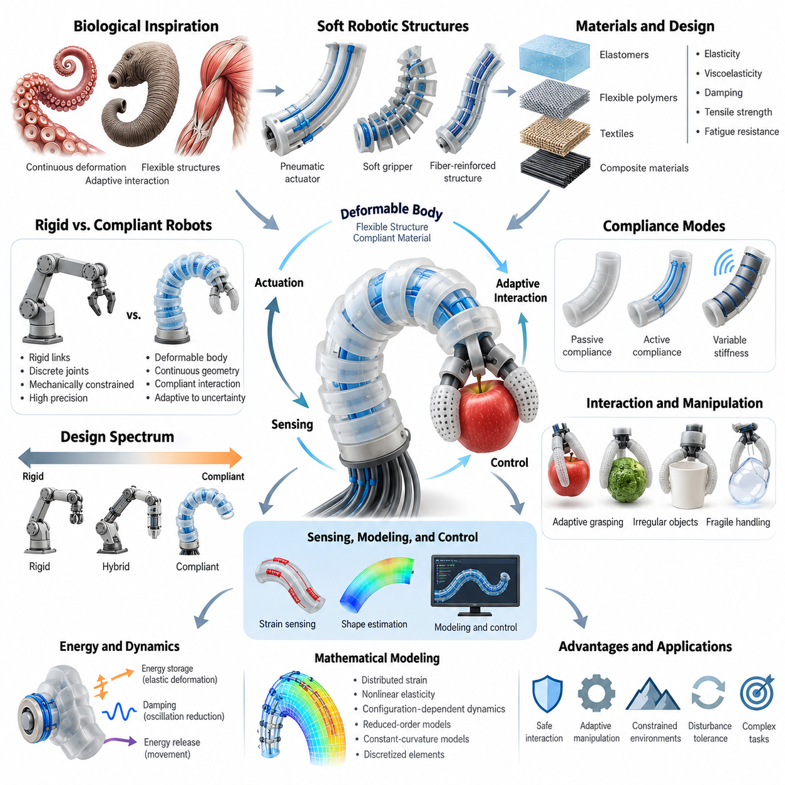
Soft robotics represents a fundamental departure from conventional robotic engineering by using deformable bodies, flexible structures, and compliant materials to achieve physical interaction. Unlike rigid robots that rely on fixed links and discrete joints, soft robots continuously change their geometry under applied forces. Their morphology becomes an active contributor to movement, adaptation, and environmental interaction.
Compliant morphology refers to the physical organization of a robotic body that permits controlled deformation when subjected to external loads or internal actuation. Compliance allows structures to bend, stretch, compress, and recover without requiring every movement to be generated through rigid mechanical joints. This characteristic creates new opportunities for safe interaction, adaptive manipulation, and movement through constrained environments.
Traditional rigid robots generally achieve precision through mechanically constrained motion and carefully regulated actuator positions. Soft robots instead exploit distributed deformation and material elasticity to accommodate uncertainty in contact geometry. Their physical structures can naturally conform to irregular surfaces, distribute interaction forces, and absorb disturbances, reducing the need for exact geometric alignment during many manipulation tasks.
The distinction between rigidity and compliance is not absolute. Robotic systems occupy a continuous design spectrum ranging from highly rigid mechanisms to fully deformable structures. Hybrid architectures combine rigid frames, flexible joints, elastic transmissions, and soft contact surfaces to balance precision with adaptability. Selecting an appropriate compliance distribution is therefore a central problem in robotic morphology design.
Biological organisms provide important inspiration for compliant robotic systems. Muscles, tendons, connective tissues, and flexible skeletal structures enable animals to generate movement while accommodating environmental uncertainty. Octopus arms, elephant trunks, and muscular hydrostats demonstrate how continuous deformation can support complex manipulation without conventional articulated joints. Soft robotics translates these principles into engineered embodiments.
Material properties fundamentally determine the behavior of compliant morphology. Elastic modulus, viscoelasticity, damping, tensile strength, and fatigue resistance influence how a robotic body responds to loading. Low-stiffness materials enable large deformation, while reinforcing fibers and embedded structures constrain motion along selected directions. Consequently, material selection and geometric design must be considered together rather than independently.
Soft robotic structures frequently employ elastomers, flexible polymers, textiles, and composite materials to create distributed mechanical responses. Their geometry may incorporate chambers, channels, ribs, or anisotropic reinforcements that produce predictable deformation patterns. By controlling material arrangement and structural constraints, engineers can transform simple actuator inputs into bending, twisting, elongation, or complex spatial movements.
Compliance can be passive, actively controlled, or mechanically adjustable. Passive compliance emerges from inherent material properties and structural geometry, allowing the robot to deform without additional control commands. Active compliance uses actuators and feedback to regulate interaction behavior, while variable-stiffness mechanisms modify resistance to deformation. These approaches provide different balances among simplicity, adaptability, and controllability.
A defining advantage of compliant morphology is its ability to accommodate uncertain contact conditions. When a soft gripper encounters an object with an unfamiliar shape, its fingers can deform around the surface and establish multiple contact regions. This adaptation reduces dependence on precise object models and exact finger trajectories. However, reliable grasping still requires appropriate force generation, friction, and stability.
Compliant structures also influence how mechanical energy is stored and dissipated. Elastic deformation can temporarily store energy that is subsequently released during movement, while damping reduces oscillations and impact transmission. These properties are useful in repetitive locomotion, collision tolerance, and dynamic interaction. Nevertheless, excessive deformation or energy dissipation may reduce positioning accuracy and overall mechanical efficiency.
Soft morphology changes the relationship between sensing, actuation, and control. In rigid mechanisms, joint encoders often provide a relatively direct description of configuration. A deformable body possesses many possible shapes that cannot be represented adequately by a small number of joint coordinates. Estimating its configuration may therefore require distributed strain measurements, embedded sensors, visual observations, and physics-based models.
The mathematical description of soft robotic motion differs substantially from conventional rigid-body kinematics. Continuously deformable structures exhibit distributed strain, nonlinear elasticity, and configuration-dependent dynamics. Their effective degrees of freedom can be extremely large, making direct modeling computationally expensive. Practical representations often approximate deformation using reduced-order models, constant-curvature assumptions, or discretized mechanical elements.
The interaction between morphology and control is particularly important in soft robotics. A well-designed compliant body can automatically accommodate disturbances through its mechanical response, reducing the amount of explicit corrective control required. This phenomenon illustrates morphological computation, where physical structure contributes to behavior normally associated with computation. However, mechanical adaptation cannot replace feedback and planning in every operating condition.
Safety is another major motivation for compliant robotic morphology. Deformable surfaces can distribute contact forces across larger areas and reduce localized pressure during certain interactions. Such properties are valuable in human-centered robotics, assistive devices, rehabilitation systems, and collaborative manipulation. Nevertheless, softness alone does not guarantee safety, because actuator force, stored energy, contact geometry, and operating speed remain important.
Soft robotic morphology also introduces engineering limitations that differ from those of rigid systems. Flexible materials may experience creep, hysteresis, fatigue, and permanent deformation after repeated loading. Environmental temperature, aging, and manufacturing variability can alter mechanical properties over time. These effects complicate calibration, repeatability, and long-term reliability, particularly when precise manipulation or continuous industrial operation is required.
The design of compliant robots therefore requires simultaneous consideration of geometry, materials, actuation, sensing, and control. Increasing flexibility may improve environmental adaptation but reduce load-bearing capacity and positional stability. Greater stiffness can improve precision while limiting conformability. Effective morphology emerges from balancing these competing requirements according to the intended task, operating environment, and acceptable performance limits.
Soft robotics extends the concept of embodiment by demonstrating that intelligence is not confined to computational algorithms. Physical properties determine which movements are naturally available, how disturbances are absorbed, and how environmental contacts influence behavior. The body participates directly in the perception-action loop, shaping the information available to the controller and the physical consequences of its decisions.
In Physical AI systems, compliant morphology offers a pathway toward robots that interact more naturally with complex and uncertain environments. Soft structures can complement learned perception, adaptive control, and predictive world models by providing mechanical tolerance to modeling errors. Their value is especially significant when interaction involves delicate objects, irregular surfaces, confined spaces, or environments where rigid contact would be undesirable.
The integration of soft and rigid components is likely to remain an important architectural strategy. Rigid elements provide structural support, accurate transmission, and stable sensor placement, while compliant elements enable adaptation and contact tolerance. Such hybrid embodiments can exploit the strengths of both approaches. The central design objective is not maximum softness, but an appropriate distribution of mechanical properties throughout the robot.
Understanding soft robotics and compliant morphology establishes a foundation for examining soft materials, actuation principles, continuum structures, deformable manipulation, and adaptive locomotion. It also provides a conceptual bridge between morphological computation and intelligent physical interaction. Ultimately, compliant morphology demonstrates how robotic capability emerges from coordinated relationships among body structure, material behavior, control, and environment.

09.02. Soft Materials and Structures
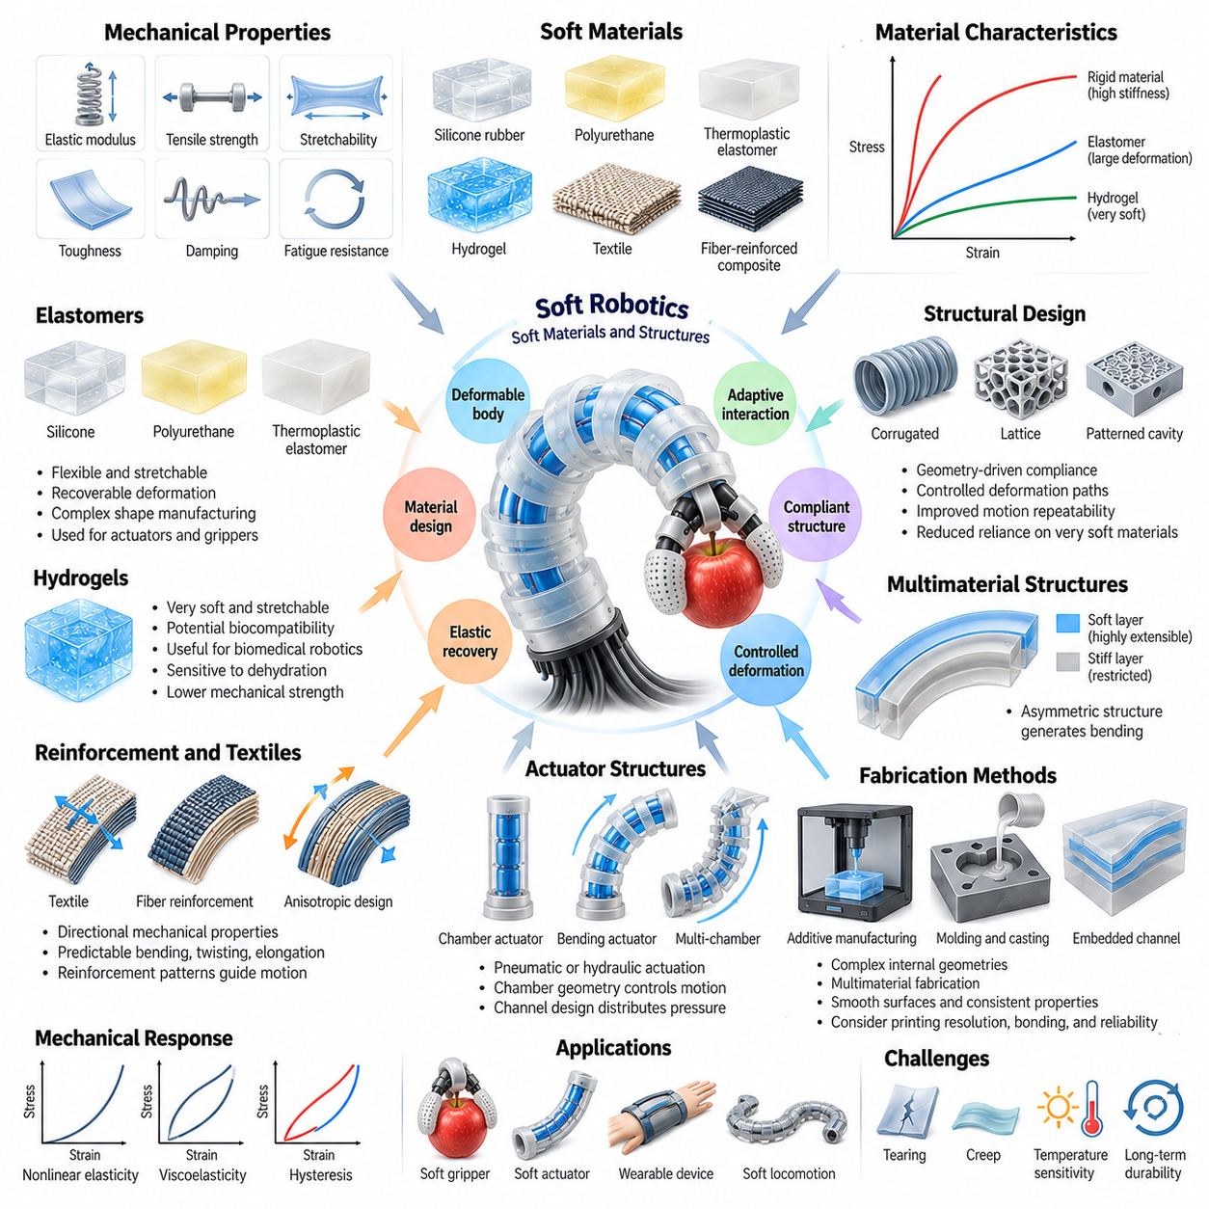
Soft materials and structures form the physical foundation of soft robotics by enabling controlled deformation, elastic recovery, and adaptive interaction with the environment. Unlike rigid engineering materials, soft materials can undergo substantial changes in shape under relatively small forces. Their mechanical behavior directly influences robotic motion, contact stability, energy storage, and the ability to accommodate uncertain environmental conditions.
The selection of soft materials begins with understanding their mechanical properties and deformation characteristics. Elastic modulus describes resistance to elastic deformation, while tensile strength indicates the maximum stress a material can withstand before failure. Stretchability, toughness, damping, and fatigue resistance further determine operational suitability. These properties must be evaluated together because high flexibility does not necessarily imply durability or mechanical reliability.
Elastomers are among the most widely used materials in soft robotic systems because they combine flexibility with recoverable deformation. Silicone rubber, polyurethane elastomers, and thermoplastic elastomers can be manufactured into complex shapes and integrated with internal actuation chambers. Their mechanical characteristics depend on chemical composition, curing conditions, geometry, and environmental exposure, requiring careful characterization before deployment.
Silicone-based materials are particularly useful for soft grippers, pneumatic actuators, and flexible robotic skins. Their relatively low stiffness and substantial elastic deformation enable structures to conform to irregular surfaces without requiring complicated mechanical joints. However, silicone components may exhibit tearing, hysteresis, and long-term material degradation, making reinforcement and appropriate operating limits important design considerations.
Thermoplastic elastomers provide alternative manufacturing possibilities through extrusion, molding, and additive manufacturing. Their processing characteristics support rapid prototyping and the production of complex flexible components. Depending on material formulation, they can offer useful combinations of elasticity, toughness, and manufacturability. Nevertheless, temperature sensitivity, creep, and repeated loading can influence dimensional stability and long-term performance.
Hydrogels represent another class of soft materials characterized by polymer networks containing substantial quantities of water. Their softness and potential biocompatibility make them attractive for biomedical robotics, tissue-interfacing devices, and adaptive sensing structures. However, dehydration, limited mechanical strength, and environmental sensitivity can restrict practical applications. Their successful integration often requires protective encapsulation and careful control of operating conditions.
Textiles and fiber-reinforced composites extend the capabilities of soft robotic structures by introducing directional mechanical properties. Embedded fibers can limit expansion along selected axes while allowing deformation in other directions. This anisotropic behavior enables predictable bending, twisting, and elongation under relatively simple actuation inputs. Reinforcement patterns therefore become important design variables that determine the resulting movement.
Soft robotic structures frequently combine materials with different stiffness levels to generate controlled deformation. A flexible actuator may incorporate a highly extensible upper layer and a relatively stiff lower layer, causing bending when internal pressure increases. Such asymmetric construction transforms distributed material strain into useful mechanical motion. The resulting behavior depends on layer thickness, material properties, bonding quality, and actuator geometry.
Internal chambers and fluidic networks are common structural features in soft robotic actuators. Pneumatic or hydraulic pressure causes chamber walls to expand, producing motion determined by chamber geometry and surrounding constraints. Repeated chambers can create coordinated bending, while carefully designed channels distribute pressure throughout the structure. Chamber dimensions and wall thickness strongly influence achievable displacement, generated force, and mechanical durability.
Structural geometry can be as important as material composition in determining robotic behavior. Corrugated surfaces, bellows, lattice structures, and patterned cavities modify local stiffness and deformation pathways. These features allow engineers to create flexible mechanisms without relying exclusively on extremely soft materials. Geometry-driven compliance can also improve motion repeatability by encouraging deformation along preferred directions while restricting unwanted movements.
Additive manufacturing has expanded the design possibilities for soft robotic structures by enabling complex internal geometries and multimaterial fabrication. Flexible polymers can be printed into chambers, compliant joints, and integrated mechanical networks that would be difficult to produce through conventional assembly. However, printing resolution, interlayer adhesion, material compatibility, and manufacturing variability can significantly affect structural integrity.
Molding and casting remain important fabrication techniques for producing elastomeric robotic components. Liquid polymers are introduced into molds, cured, and assembled into structures containing channels, cavities, or embedded reinforcement. These processes can provide smooth surfaces and relatively consistent material properties when properly controlled. Reliable bonding between layers is essential because leakage and delamination can compromise actuator performance.
The mechanical response of soft materials is often nonlinear, meaning deformation does not increase proportionally with applied force. Large strains can change effective stiffness and produce complex stress distributions throughout the structure. Hyperelastic constitutive models are frequently used to approximate this behavior. Accurate modeling requires experimentally determined material parameters and consideration of the deformation ranges expected during operation.
Viscoelasticity introduces time-dependent behavior into soft robotic structures. Under sustained loading, a material may gradually deform through creep, while its recovery after unloading may depend on the duration and history of applied stress. Hysteresis causes loading and unloading paths to differ, producing energy losses and reduced repeatability. These effects become particularly important during cyclic actuation and precision manipulation.
Durability is a major concern because soft structures repeatedly experience stretching, compression, bending, and contact forces. Fatigue damage can accumulate around sharp geometric transitions, bonded interfaces, and highly strained regions. Small cracks may propagate during repeated operation, eventually causing leakage or structural failure. Design strategies include reducing stress concentrations, incorporating reinforcement, and establishing appropriate inspection intervals.
Soft structures can also incorporate embedded sensing materials to provide information about deformation and contact. Conductive elastomers, flexible resistive elements, capacitive layers, and optical fibers can respond to stretching or pressure. Integrating these sensing elements into the body enables distributed measurements without relying entirely on external sensors. However, sensor calibration must account for material hysteresis, temperature variation, and mechanical coupling.
Variable-stiffness structures provide a means of changing mechanical behavior during operation. Layer jamming, granular jamming, phase-changing materials, and mechanically constrained reinforcements can increase resistance to deformation when needed. A robot may remain flexible while approaching an object and become stiffer when supporting a load. Such systems extend the functional range of soft morphology but introduce additional complexity, energy requirements, and response-time constraints.
Environmental compatibility strongly influences material selection for practical applications. Temperature changes can alter elasticity, while moisture, ultraviolet radiation, chemicals, and repeated sterilization may accelerate degradation. Biomedical systems require attention to biocompatibility and cleaning procedures, whereas industrial systems may prioritize abrasion resistance and chemical stability. Material qualification must therefore reflect actual operating environments rather than laboratory conditions alone.
The design of soft materials and structures requires balancing compliance, strength, manufacturability, sensing integration, and service life. Excessive softness may improve conformability while reducing payload capacity and positional accuracy. Additional reinforcement can increase force transmission but restrict deformation and increase mass. Effective designs optimize material distribution and structural geometry according to task requirements instead of maximizing any single property.
For Physical AI, soft materials and structures provide a mechanical interface through which intelligent systems interact with uncertain physical environments. Their deformation characteristics influence perception, control, manipulation, and learning by determining how forces and contacts are physically expressed. Understanding these material and structural principles establishes the foundation for soft actuation, continuum robotics, adaptive grasping, and morphology-aware intelligent control.

09.03. Soft Actuation Principles
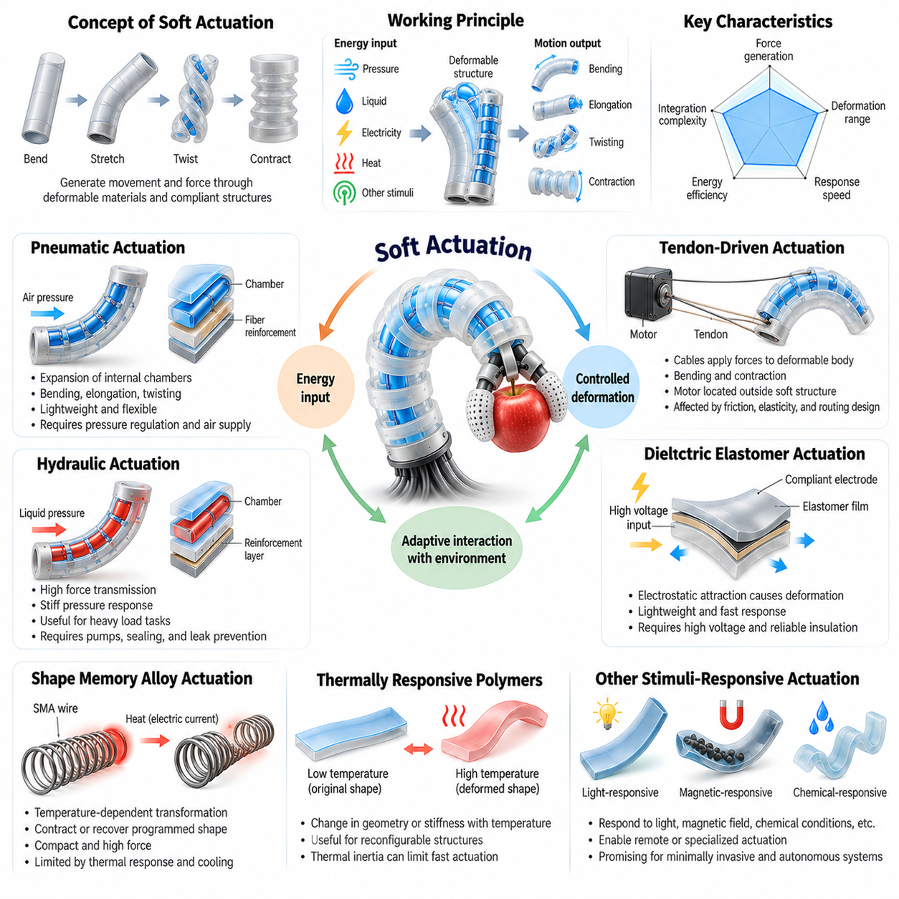
Soft actuation is the process of generating movement and mechanical force through deformable materials and compliant structures rather than relying exclusively on rigid motors and articulated joints. It enables robotic bodies to bend, stretch, contract, twist, and change shape continuously. The underlying actuation principles determine how energy is converted into deformation and how effectively a soft robot interacts with its environment.
Unlike conventional actuators that primarily generate rotational or linear displacement, soft actuators distribute deformation across flexible structures. Their motion emerges from interactions among material properties, internal geometry, applied energy, and external constraints. This distributed behavior enables adaptive movement but introduces challenges in force prediction, position control, and repeatability under changing environmental conditions.
Soft actuation technologies can be classified according to their energy sources and physical conversion mechanisms. Common approaches include pneumatic and hydraulic actuation, tendon-driven mechanisms, dielectric elastomers, shape memory alloys, thermal actuation, and stimuli-responsive materials. Each mechanism provides different characteristics in terms of force generation, deformation range, response speed, energy efficiency, and integration complexity.
Pneumatic actuation is widely used in soft robotics because compressed air can produce substantial deformation in flexible chambers. When internal pressure increases, the chamber walls expand according to their geometry and mechanical constraints. By incorporating asymmetric layers or fiber reinforcement, designers can convert expansion into controlled bending, elongation, or twisting motions suitable for gripping and locomotion.
Pneumatic networks often consist of interconnected chambers embedded within elastomeric bodies. Pressure changes propagate through these networks, producing coordinated deformation across multiple structural regions. Chamber dimensions, wall thickness, and reinforcement patterns determine the resulting movement. Although pneumatic systems offer flexibility and relatively simple mechanical construction, they require pressure regulation and a reliable air supply.
Hydraulic actuation operates through pressurized liquids rather than compressed gases. Because liquids are comparatively incompressible, hydraulic systems can provide high force transmission and relatively stiff pressure responses. Hydraulic soft actuators are useful when substantial gripping or lifting forces are required. However, fluid leakage, system weight, pumping requirements, and sealing reliability must be considered during design.
The distinction between pneumatic and hydraulic actuation involves more than the working fluid. Pneumatic systems generally provide lightweight compliant behavior but can exhibit delayed responses associated with air compressibility and flow restrictions. Hydraulic systems can deliver greater force density in suitable configurations but may increase mechanical complexity. Selecting between them requires evaluating task loads, response requirements, and available infrastructure.
Tendon-driven soft actuation uses cables, fibers, or flexible transmission elements to apply forces along deformable structures. A motor pulls a tendon routed through or around the robot body, generating bending or contraction through distributed mechanical constraints. This approach allows conventional motors to remain outside flexible regions, reducing local actuator mass while preserving substantial control authority over deformation.
Tendon routing strongly influences the resulting movement and force distribution. Tendons positioned away from a neutral bending axis generate bending moments, while multiple tendons arranged around a continuum structure can provide multidirectional motion. Friction, cable elasticity, routing curvature, and backlash affect transmission accuracy. These effects require careful mechanical design and compensation during closed-loop control.
Dielectric elastomer actuators generate deformation through electrostatic forces applied across flexible insulating materials. When voltage is applied between compliant electrodes, electrostatic attraction compresses the elastomer thickness and can produce expansion in other directions. These actuators offer lightweight construction and potentially rapid response. However, high operating voltages, electrical breakdown, and material durability present significant engineering challenges.
Shape memory alloys provide another actuation mechanism through temperature-dependent material transformations. When electrically heated, specially processed alloy elements can contract or recover a programmed shape, generating mechanical motion. Their compact construction makes them attractive for small robotic devices and embedded mechanisms. Nevertheless, thermal response limitations, cooling requirements, hysteresis, and fatigue can restrict operating frequency and control precision.
Thermally responsive polymers and shape memory polymers can also produce controlled changes in geometry or stiffness. Their mechanical behavior changes when temperature crosses specific transition regions, enabling programmed deformation or shape recovery. These materials are particularly useful for reconfigurable structures and variable-stiffness components. However, thermal inertia and environmental temperature sensitivity may limit rapid repetitive actuation.
Stimuli-responsive actuation extends beyond pressure, electricity, and temperature. Certain materials deform in response to light, magnetic fields, chemical conditions, or changes in humidity. Magnetic particles embedded within flexible polymers can enable remote deformation under externally applied magnetic fields. Such mechanisms are promising for miniature robots and specialized environments, although achievable forces and external equipment requirements vary considerably.
The mechanical performance of a soft actuator depends on the relationship between input energy and resulting deformation. Important characteristics include displacement, generated force, blocked force, actuation bandwidth, response time, and energy consumption. A large deformation range does not necessarily imply high output force. Designers must therefore evaluate actuator performance under realistic loading conditions rather than relying only on unloaded motion.
Actuator geometry plays a fundamental role in transforming input energy into useful movement. Chamber orientation, wall thickness, tendon placement, and reinforcement distribution determine how internal forces produce deformation. Geometric asymmetry can direct bending, while symmetric configurations may produce extension or contraction. Consequently, soft actuator design requires coordinated optimization of materials, structures, and energy conversion mechanisms.
Nonlinear material behavior introduces significant challenges in soft actuator control. Elastic stiffness may change with deformation, while viscoelasticity produces time-dependent responses and hysteresis. Pressure, voltage, or tendon displacement may therefore have nonlinear relationships with actuator position and force. Accurate control often requires experimental characterization, nonlinear models, feedback sensing, and adaptive compensation strategies.
Soft actuators also interact strongly with external mechanical loads. Contact with an object can restrict deformation, redistribute internal stress, and change the relationship between actuator input and output force. This interaction is beneficial for adaptive grasping because the body can conform to unfamiliar geometry. However, it complicates precise force regulation and requires controllers to account for changing contact conditions.
Energy efficiency and thermal management are important considerations when selecting actuation technologies. Pneumatic systems may incur substantial losses through compression and air leakage, while hydraulic systems consume energy through pumping and fluid resistance. Electrical and thermal actuators introduce different conversion losses and heating constraints. System-level efficiency must include supporting equipment rather than considering the actuator alone.
Reliability depends on both the actuation mechanism and the durability of the surrounding soft structure. Repeated inflation can fatigue elastomeric chambers, while tendon systems may experience cable wear and friction changes. Electrical actuators require insulation integrity, and thermally activated materials must withstand repeated temperature cycles. Long-term performance therefore requires appropriate operating limits, monitoring, and maintenance strategies.
Hybrid actuation architectures combine multiple mechanisms to overcome the limitations of individual technologies. A robot may use pneumatic chambers for compliant movement, tendons for directional control, and variable-stiffness elements for load support. Such combinations can improve functional versatility but introduce additional control variables and integration requirements. Their effectiveness depends on coordinating mechanical behavior with sensing and control.
For Physical AI, soft actuation provides a direct connection between intelligent decision-making and adaptable physical behavior. Learned policies and model-based controllers can exploit compliant deformation to manipulate unfamiliar objects and interact with uncertain environments. The central design objective is to coordinate energy conversion, material response, morphology, and feedback so that physical adaptation supports reliable intelligent action.

09.04. Continuum and Deformable Robots
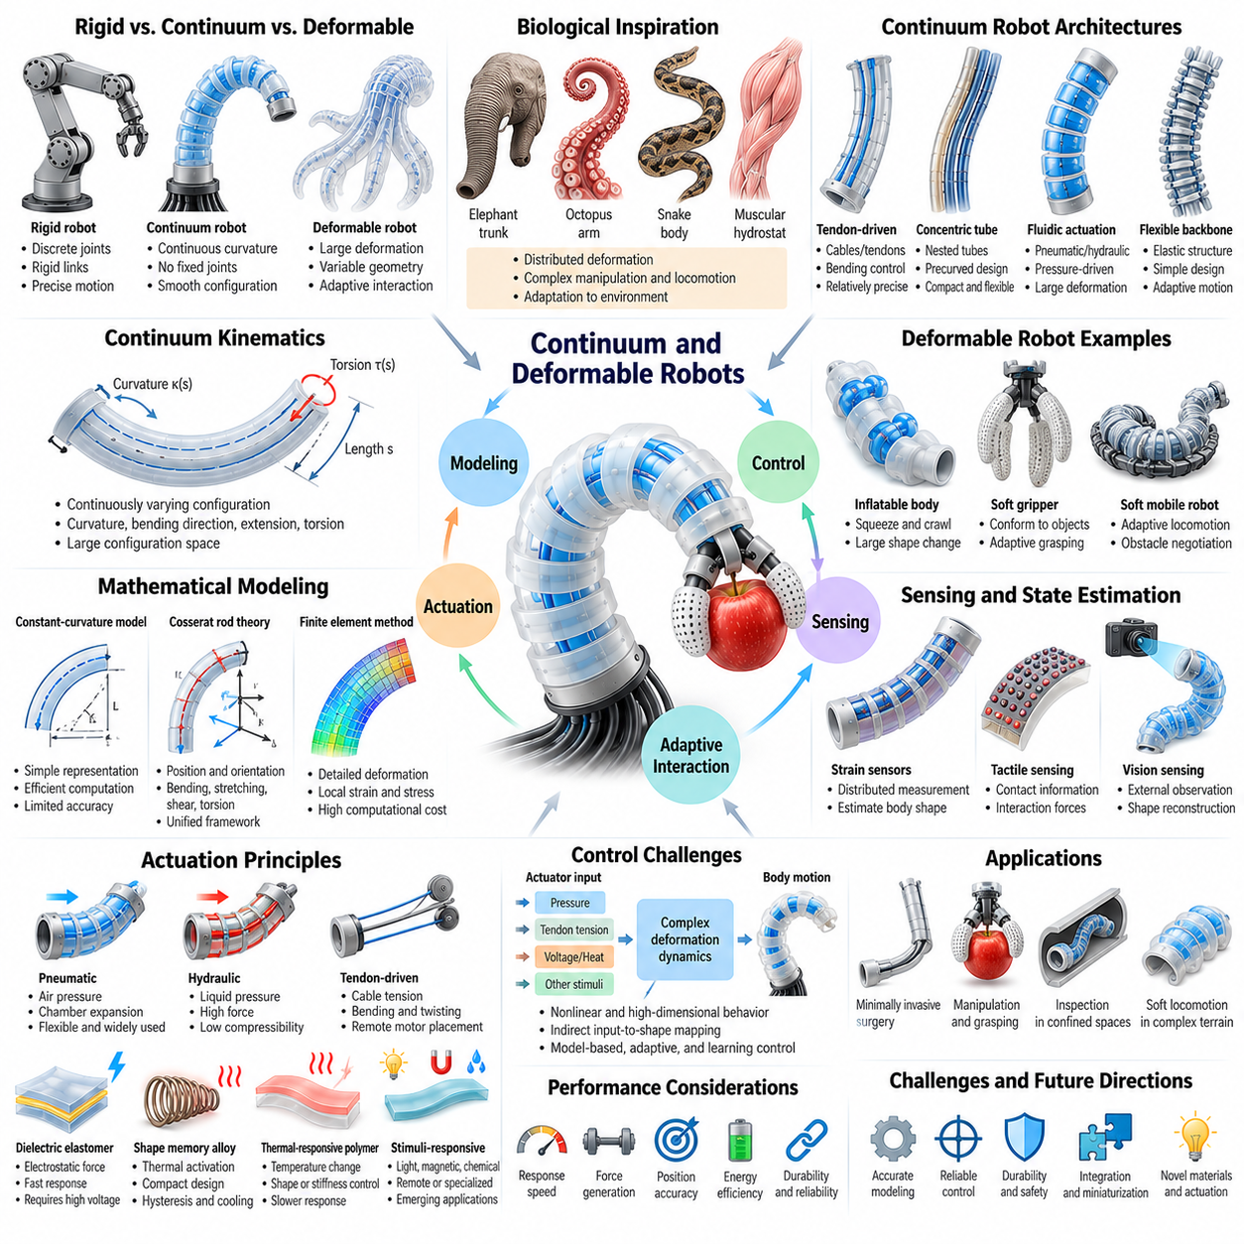
Continuum and deformable robots represent a class of robotic systems whose bodies can bend, twist, stretch, and change shape continuously rather than moving exclusively through discrete mechanical joints. Their structures distribute deformation along flexible segments, creating motion patterns that resemble biological organisms. This morphology enables adaptive interaction with complex environments and expands the capabilities of conventional robotic mechanisms.
Traditional articulated robots are modeled as rigid links connected by joints with defined degrees of freedom. Continuum robots instead exhibit continuously varying curvature along their bodies, allowing smooth spatial configurations without conventional joint boundaries. Deformable robots encompass a broader category in which substantial structural deformation contributes to motion. The distinction is important because not every deformable robot behaves as a continuum mechanism.
Biological structures provide important inspiration for continuum robotics. Elephant trunks, octopus arms, snake bodies, and muscular hydrostats demonstrate how distributed deformation supports manipulation and locomotion. These organisms achieve complex movements through coordinated interactions among muscles, connective tissues, and environmental forces. Engineered continuum robots reproduce selected principles using flexible backbones, elastic materials, and distributed actuation.
The fundamental mechanical characteristic of continuum robots is their ability to assume continuously changing configurations along a flexible structure. Instead of describing motion through a finite sequence of joint angles, engineers characterize body shape using curvature, bending direction, extension, and torsion. These variables may vary along the robot's length, producing a large configuration space that requires specialized modeling and control methods.
Continuum robot architectures include tendon-driven structures, concentric tube robots, fluidically actuated bodies, and flexible backbone mechanisms. Tendon-driven designs generate bending by applying tension through cables routed along compliant segments. Concentric tube robots exploit elastic interactions among nested precurved tubes, while pneumatic and hydraulic designs use internal pressure to create distributed deformation. Each architecture offers different tradeoffs in precision, force, and flexibility.
Tendon-driven continuum robots commonly incorporate a flexible central backbone surrounded by multiple tendons. Pulling selected tendons generates bending moments that change the structure's curvature and orientation. Tendon placement, backbone stiffness, friction, and routing geometry influence achievable motion. These systems can provide relatively precise directional control, although transmission losses and nonlinear deformation complicate accurate positioning.
Concentric tube robots consist of nested elastic tubes with predefined curvature profiles. Relative rotation and translation of the tubes alter their combined equilibrium shape, allowing the robot to navigate narrow and curved pathways. Their compact geometry is particularly valuable in minimally invasive medical procedures. However, elastic coupling, friction, and potential instability require careful mechanical modeling and controlled operation.
Fluidically actuated continuum robots use pressurized chambers distributed along flexible bodies to generate bending, extension, or twisting. Pressure differences between chambers create asymmetric deformation, allowing the structure to move in multiple directions. These systems provide compliant interaction and potentially large deformation ranges. Their performance depends on chamber geometry, material elasticity, pressure regulation, and external loading conditions.
Deformable robots may also employ inflatable bodies, flexible sheets, articulated elastic structures, or distributed soft actuators. Unlike continuum manipulators designed primarily for controlled bending, these robots may change their overall geometry to crawl, squeeze, grasp, or adapt to obstacles. Their functional capabilities emerge from the interaction between material deformation and environmental constraints rather than from predefined joint trajectories alone.
The kinematics of continuum robots requires mathematical descriptions that account for distributed curvature and deformation. Constant-curvature models approximate each flexible segment as a circular arc, reducing the complexity of shape estimation and motion planning. Although computationally efficient, this approximation becomes less accurate under uneven loading, complex contact, or significant torsion. More detailed models are necessary when deformation varies substantially along the body.
Cosserat rod theory provides a more general framework for representing slender continuum structures. It describes the spatial evolution of position, orientation, internal forces, and moments along a deformable rod. This approach can incorporate bending, stretching, shear, and torsion within a unified mechanical representation. However, solving the resulting equations may require numerical methods and substantial computational resources.
Finite element methods offer another approach for analyzing complex deformable robotic structures. By dividing a body into smaller elements, engineers can approximate local strain, stress, and displacement under applied forces. These models support material selection, actuator design, and structural optimization. Their computational expense can limit direct application in high-frequency control, motivating reduced-order approximations and efficient simulation techniques.
Control of continuum robots is challenging because actuator inputs do not map directly to fixed joint coordinates. Tendon tension, fluid pressure, and material deformation interact through nonlinear mechanical relationships. External contacts can further modify the resulting configuration. Effective control therefore combines mechanical models, feedback measurements, and compensation for uncertainty to achieve reliable positioning and interaction.
Shape sensing is essential for estimating the configuration of deformable robotic bodies. Conventional joint encoders cannot fully describe distributed deformation, so additional sensing approaches are often required. Fiber optic sensors, embedded strain gauges, magnetic tracking, and vision-based reconstruction can provide information about curvature and spatial shape. Combining multiple sensing modalities improves observability but introduces calibration and integration challenges.
Interaction with the environment is a defining advantage of continuum and deformable robots. Their bodies can conform to irregular surfaces, navigate confined passages, and distribute contact forces over extended regions. This capability is valuable for delicate manipulation, inspection, and human-centered applications. Nevertheless, excessive compliance may reduce load capacity, positional accuracy, and resistance to external disturbances.
Continuum manipulators are particularly suitable for environments where conventional rigid arms cannot operate effectively. Their slender and flexible structures can reach around obstacles, follow curved pathways, and access constrained workspaces. Applications include minimally invasive surgery, industrial inspection, and manipulation in cluttered environments. Successful deployment requires balancing flexibility with sufficient stiffness, force transmission, and controllability.
Deformable locomotion systems exploit continuous body shape changes to generate movement. Snake-like robots use traveling curvature patterns, while soft crawling robots employ sequential contraction and extension. Other designs use inflation, friction modulation, or distributed contact to move through confined spaces. Their locomotion performance depends strongly on the coupling between body deformation, surface friction, and environmental geometry.
The mechanical properties of continuum and deformable robots create important performance tradeoffs. Increased flexibility improves geometric adaptability but may reduce structural stability and force transmission. Higher stiffness supports payload handling and accurate positioning but limits deformation. Variable-stiffness mechanisms and hybrid rigid-soft architectures can help reconcile these competing requirements by adapting mechanical behavior to different operational phases.
Learning-based methods are increasingly relevant for controlling deformable robotic systems with complex dynamics. Neural networks and reinforcement learning can approximate relationships between actuator commands, body configurations, and task outcomes. Simulation-based training can reduce experimental requirements, but discrepancies between simulated and physical deformation remain challenging. Reliable learning requires representative data, robust sensing, and appropriate safety constraints.
For Physical AI, continuum and deformable robots demonstrate how body morphology directly shapes perception, action, and intelligent adaptation. Their distributed deformation enables behaviors that rigid mechanisms cannot easily reproduce, while introducing new requirements for modeling, sensing, and control. Integrating compliant structures with predictive models and adaptive policies provides a foundation for robotic systems capable of interacting with complex physical environments.

09.05. Soft Grippers and Manipulation
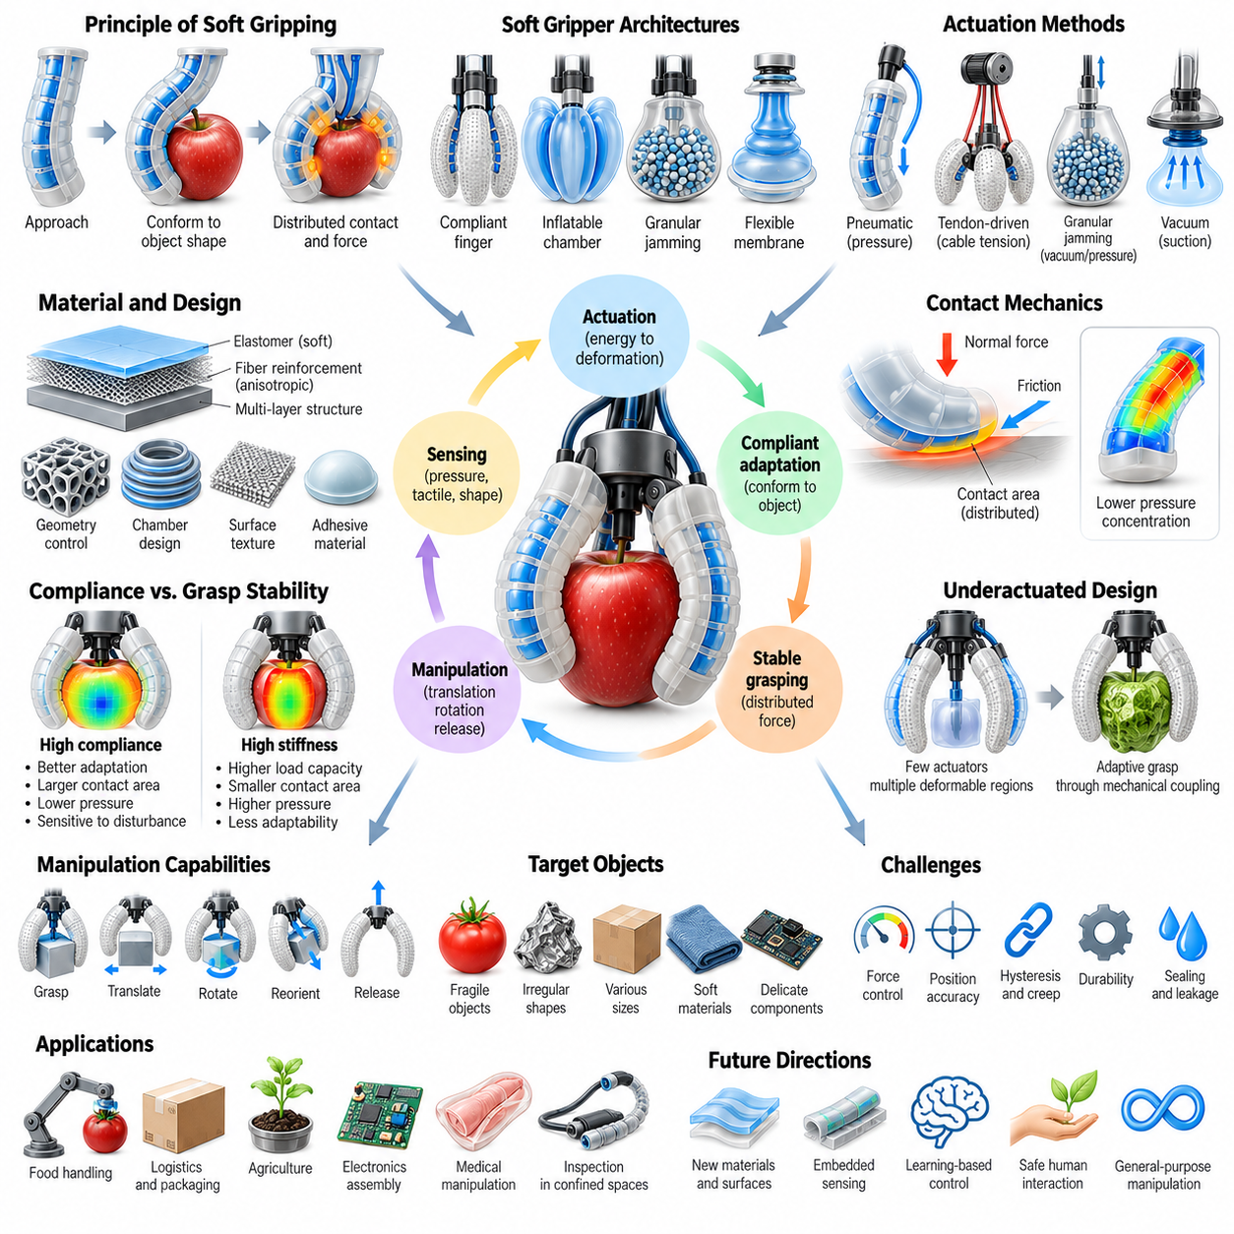
Soft grippers represent an important application of compliant robotics, enabling manipulation through deformable contact surfaces and adaptive mechanical structures. Unlike rigid grippers that depend on precisely controlled finger positions, soft grippers conform to object geometry during contact. This adaptability supports the handling of fragile, irregular, and unfamiliar objects while reducing the need for exact geometric models and highly constrained grasp planning.
The fundamental principle of soft gripping is the redistribution of contact forces through compliant deformation. When a flexible finger encounters an object, its structure bends or compresses to accommodate the local surface geometry. This creates extended contact regions rather than isolated contact points. Distributed contact can reduce pressure concentrations, improve frictional engagement, and increase tolerance to positioning errors during grasp acquisition.
Soft grippers employ several mechanical architectures, including compliant fingers, inflatable chambers, granular jamming structures, and flexible membrane mechanisms. Each architecture generates gripping forces through a different combination of actuation and material response. Finger-based designs emphasize adaptive enclosure, while membrane and jamming systems can conform around complex surfaces before developing resistance to object movement.
Pneumatically actuated soft grippers commonly use elastomeric fingers containing internal pressure chambers. Increasing chamber pressure produces asymmetric expansion that bends the fingers toward an object. Their geometry and reinforcement patterns determine the relationship between pressure, curvature, and gripping force. These grippers can accommodate variations in object dimensions, although pressure regulation and material hysteresis complicate precise force control.
Tendon-driven soft grippers use cables or flexible transmission elements to deform compliant fingers. Motor-generated tension produces bending along the finger structure, allowing grasp configuration to emerge from mechanical interaction with the object. Tendon routing, finger stiffness, and contact friction influence performance. This approach can integrate conventional electric motors with compliant end effectors while retaining compact and adaptable gripping mechanisms.
Granular jamming grippers use flexible membranes filled with particles that transition between deformable and mechanically resistant states. Before activation, the membrane conforms to the object's surface. Applying a pressure differential compacts the particles and increases resistance to deformation, creating a grasp through geometric interlocking and friction. Their effectiveness depends on object shape, membrane properties, particle characteristics, and available contact area.
Vacuum-based soft gripping mechanisms use suction and compliant sealing surfaces to generate holding forces. Flexible suction cups can accommodate moderate surface irregularities and establish seals on objects that rigid suction devices may handle poorly. However, performance depends on surface porosity, roughness, contamination, and pressure differential. Reliable operation requires detecting seal quality and avoiding excessive loads that could cause detachment.
Soft grippers can also exploit adhesive contact, frictional surfaces, and passive mechanical wrapping. Geometrically patterned pads may increase friction, while specialized adhesive materials enable gripping under suitable surface conditions. Passive wrapping structures use object contact to redirect deformation and establish enclosure. These approaches illustrate how material selection and structural geometry can reduce the complexity of active grasp control.
The relationship between compliance and grasp stability is central to soft manipulation. Increased compliance improves geometric adaptation but may reduce resistance to external disturbances. Greater stiffness supports load-bearing capacity but can concentrate contact forces and reduce conformability. Effective gripper design therefore requires balancing deformation capability, friction, gripping force, and structural stability according to object characteristics and task requirements.
Contact mechanics provides a foundation for understanding soft grasp performance. Normal forces, tangential forces, friction coefficients, and contact area influence whether an object remains securely held. Deformable materials produce contact distributions that change with applied load and finger configuration. Accurate analysis must account for nonlinear elasticity, surface friction, and the possibility of local slipping or rolling during manipulation.
Soft gripping is especially valuable when manipulating objects with uncertain geometry or mechanical properties. Fruits, packaged products, textiles, and delicate components may vary substantially in size, stiffness, and surface condition. Compliant fingers accommodate some of this variation without requiring a separate grasp configuration for every object. Nevertheless, excessive deformation or poorly regulated forces can still damage fragile items.
Underactuation is a common design strategy in adaptive soft grippers. A limited number of actuators drive multiple deformable regions, allowing mechanical constraints and environmental contact to determine the final grasp configuration. This reduces actuator count and control complexity while supporting shape adaptation. However, underactuated mechanisms may provide limited independent control over individual contact forces and finger positions.
Soft manipulation extends beyond establishing and maintaining a stable grasp. Dexterous tasks may require controlled object translation, rotation, reorientation, and release within the gripper. These operations depend on coordinated deformation, changing contact locations, and regulated friction. Achieving precise in-hand manipulation remains challenging because compliant fingers introduce coupled motion and nonlinear interactions between actuation and object movement.
Sensing is essential for improving the reliability of soft gripping systems. Embedded strain sensors can estimate finger deformation, while tactile sensors measure contact pressure and detect interaction changes. Capacitive, resistive, optical, and fluidic sensing technologies can be integrated into compliant structures. Combining tactile information with visual perception enables more reliable object localization, grasp verification, and adaptive force regulation.
Closed-loop control allows soft grippers to respond to changing object conditions during manipulation. A controller may adjust pneumatic pressure or tendon tension according to measured deformation, contact force, or detected slip. Model-based approaches estimate mechanical behavior using simplified deformation models, while learning-based methods approximate complex input-output relationships. Both approaches benefit from accurate sensing and systematic calibration.
Learning-based grasp planning is particularly relevant when objects have unfamiliar shapes or uncertain physical properties. Neural networks can predict suitable grasp regions and actuator commands from visual and tactile observations. Reinforcement learning can optimize manipulation policies through repeated interaction, while imitation learning can transfer demonstrated behaviors. Reliable deployment requires training across diverse objects, contact conditions, and material variations.
Morphological computation contributes directly to soft gripping by allowing physical structures to perform part of the adaptation process. A compliant finger naturally bends around an object, reducing the need for explicit calculation of every contact location. Mechanical deformation therefore acts as a form of physical information processing. However, morphology alone cannot guarantee successful grasping, particularly when object motion, friction, or loading conditions change unexpectedly.
Industrial applications of soft grippers include food handling, agricultural harvesting, warehouse picking, and assembly of delicate components. Their adaptive contact properties can reduce mechanical damage and support handling of product variations. However, industrial deployment also requires sufficient cycle speed, repeatability, cleaning compatibility, and component durability. These operational requirements often motivate hybrid designs combining rigid supports with compliant contact elements.
Performance evaluation should consider grasp success rate, allowable object variation, maximum payload, contact pressure, and resistance to disturbances. Additional measures include cycle time, energy consumption, positioning tolerance, and durability under repeated operation. Testing should include objects with different geometries, masses, friction coefficients, and fragility levels. Such evaluation reveals whether mechanical adaptability translates into reliable task performance.
For Physical AI, soft grippers provide an interface between intelligent perception, decision-making, and physical manipulation. Their compliant morphology reduces sensitivity to geometric uncertainty while creating opportunities for tactile learning and adaptive interaction. Integrating soft structures with predictive models, multimodal sensing, and intelligent control enables robotic systems to manipulate diverse objects more robustly in complex real-world environments.

09.06. Soft Robot Locomotion
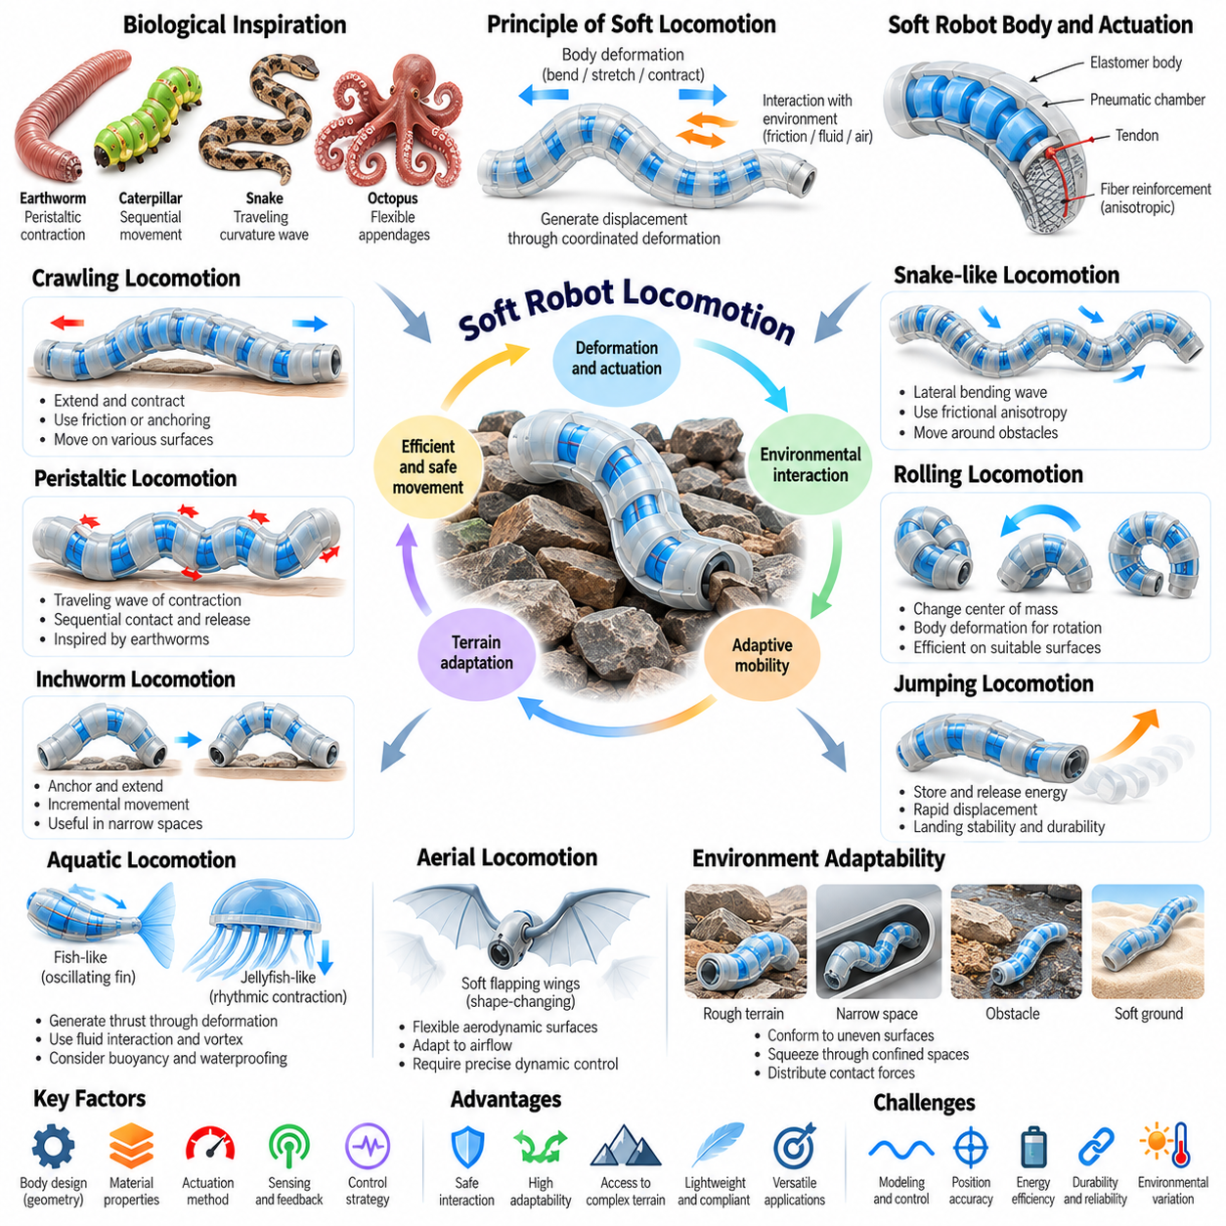
Soft robot locomotion refers to the generation of movement through continuous deformation of compliant bodies rather than relying exclusively on rigid wheels, tracks, or articulated legs. Soft robots exploit bending, stretching, contraction, and changes in body shape to interact with surrounding surfaces. Their locomotion mechanisms often resemble biological organisms and enable movement through irregular, confined, or mechanically sensitive environments.
The fundamental principle of soft locomotion is the coordinated interaction between body deformation and environmental forces. Internal actuation generates changes in geometry, while friction, adhesion, contact pressure, and fluid resistance determine how these changes produce displacement. Unlike rigid robots with predefined joint trajectories, soft robots frequently rely on distributed mechanical responses that adapt naturally to local terrain conditions.
Biological locomotion provides important inspiration for soft robotic movement. Earthworms use sequential muscular contractions, caterpillars coordinate body segments, snakes generate traveling curvature waves, and octopuses exploit flexible appendages. These organisms demonstrate how compliant structures can achieve mobility without conventional rigid joints. Robotic implementations reproduce selected principles through pneumatic chambers, flexible actuators, and programmable deformation patterns.
Crawling locomotion is one of the most common movement strategies in soft robotics. A crawling robot alternates between extending and contracting its body while controlling contact with the ground. Directional friction or temporary anchoring prevents backward slipping during selected phases of motion. The resulting displacement depends on the timing of deformation, surface properties, and the effectiveness of the anchoring mechanism.
Peristaltic locomotion uses traveling waves of contraction and expansion along a deformable body. Inspired by earthworms and other elongated organisms, this mechanism generates forward movement through sequential contact and release. Pneumatic chambers or distributed actuators can create coordinated deformation waves. Locomotion efficiency depends on wave speed, contraction amplitude, contact friction, and the relationship between actuator timing and body compliance.
Inchworm-inspired locomotion uses alternating anchoring and body extension to produce incremental movement. One region of the robot establishes stable contact while another extends forward, followed by a transfer of support and contraction. This strategy is particularly useful in narrow channels, pipes, and constrained passages. Reliable movement requires synchronization between anchoring forces and deformation to prevent unwanted slipping.
Snake-like soft robots generate locomotion through coordinated lateral bending or traveling body waves. Their flexible structures distribute curvature along the body, allowing movement around obstacles and through irregular spaces. Frictional anisotropy, in which resistance differs with movement direction, can help convert body oscillation into forward displacement. Control must account for surface conditions, body stiffness, and the propagation of deformation patterns.
Soft rolling locomotion uses controlled deformation to shift the robot's center of mass or modify contact geometry. Inflatable chambers, shape-changing structures, and internal actuation can produce sequential body rotations. Rolling robots may achieve relatively efficient movement on suitable surfaces while maintaining compliant external contact. However, directional control and obstacle negotiation depend strongly on structural symmetry and terrain characteristics.
Soft jumping robots store and release mechanical energy to generate rapid displacement. Elastic structures can accumulate energy through pneumatic inflation, tendon tension, or mechanical loading before releasing it suddenly. This approach can produce movements that exceed the speed of continuously driven crawling systems. Nevertheless, landing stability, impact absorption, actuator durability, and repeatable energy release remain significant engineering challenges.
Aquatic soft locomotion exploits deformation to generate thrust through interaction with water. Fish-inspired robots use oscillating tails and flexible fins, while jellyfish-inspired systems employ rhythmic contraction and expansion. The resulting propulsion depends on body geometry, deformation frequency, fluid dynamics, and vortex formation. Compliant structures can support efficient fluid interaction when their mechanical properties are appropriately matched to operating conditions.
Underwater soft robots may also use pulsed jet propulsion, undulating membranes, or distributed fin actuation. Their flexible bodies can reduce impact forces during contact with marine organisms and delicate structures. However, buoyancy, hydrodynamic drag, pressure variations, and waterproofing requirements influence performance. Effective aquatic locomotion requires coordinated design of actuation, body compliance, and fluid interaction.
Aerial movement using deformable structures includes soft flapping wings and shape-changing aerodynamic surfaces. Flexible wings can modify their geometry under aerodynamic loads, potentially improving maneuverability or adapting to changing flight conditions. However, maintaining stable flight requires precise coordination between structural deformation and aerodynamic forces. These systems illustrate the importance of coupling soft morphology with dynamic control.
Terrain adaptability is a defining advantage of soft robot locomotion. Compliant bodies can conform to uneven surfaces, squeeze through restricted openings, and distribute contact forces across obstacles. This capability supports exploration in environments where rigid mechanisms may become trapped or cause damage. Nevertheless, excessive deformation can reduce traction, compromise directional control, or increase energy consumption.
Contact mechanics strongly influences locomotion performance because movement emerges from repeated interactions between the body and its surroundings. Friction coefficients, normal forces, surface roughness, and contact area determine whether deformation produces useful displacement. Some designs incorporate directional textures or controllable adhesion to regulate traction. Accurate locomotion models must therefore represent both body dynamics and environmental contact.
Actuation selection determines the achievable movement patterns and operating constraints of soft locomotion systems. Pneumatic actuators provide substantial deformation but may require external compressors or onboard pressure sources. Tendon-driven systems offer compact transmission arrangements, while electroactive and thermally responsive materials introduce different speed and efficiency characteristics. Each mechanism must be evaluated against mobility, autonomy, and payload requirements.
Modeling soft locomotion is difficult because deformation, contact, and actuator dynamics interact nonlinearly. Simplified kinematic models can describe repetitive gait patterns, while continuum mechanics and finite element methods provide more detailed structural representations. High-fidelity simulation may be computationally expensive, particularly when contact conditions change frequently. Reduced-order models offer practical alternatives for real-time control.
Gait generation involves coordinating actuator inputs to create repeatable patterns of deformation and displacement. Open-loop control can work in predictable environments but becomes unreliable when friction, obstacles, or loading conditions vary. Feedback control uses body deformation, contact measurements, and motion estimates to adjust gait timing and amplitude. Adaptive control improves robustness by responding to unexpected environmental interactions.
Learning-based approaches can discover locomotion strategies that are difficult to derive analytically. Reinforcement learning may optimize actuator sequences for speed, stability, energy consumption, or obstacle traversal. Simulation-based training enables extensive exploration, although discrepancies between simulated and physical material behavior can reduce transfer performance. Combining learned policies with mechanical models and feedback improves practical reliability.
Energy efficiency and durability are critical for autonomous soft locomotion. Repeated deformation can produce material fatigue, hysteresis losses, and heating, while pneumatic or hydraulic support equipment increases system energy demand. Performance evaluation should consider travel speed, cost of transport, terrain traversal success, payload capacity, and operating lifetime. Reliable deployment requires balancing adaptability with mechanical endurance and onboard energy availability.
For Physical AI, soft robot locomotion demonstrates how morphology, actuation, perception, and control jointly produce intelligent movement. Compliant structures provide passive adaptation, while sensing and learned policies enable active responses to unfamiliar terrain. Integrating these capabilities supports robots that can navigate complex environments through continuous physical interaction, extending autonomous mobility beyond the limitations of conventional rigid robotic platforms.

09.07. Soft Sensing and Proprioception
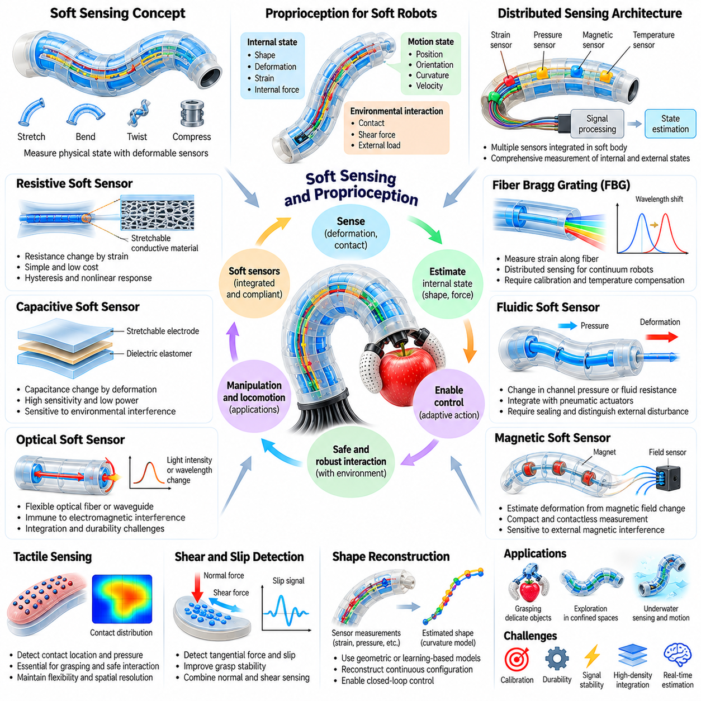
Soft sensing refers to the measurement of physical states and environmental interactions using deformable sensors integrated into compliant robotic structures. Unlike rigid sensing devices, soft sensors can stretch, bend, and conform to changing body geometries. This capability enables continuous monitoring of deformation, contact, and mechanical loading without substantially restricting the natural movement of soft robotic systems.
Proprioception is the ability of a robot to estimate its internal configuration, movement, and mechanical state through sensory feedback. In conventional robots, joint encoders and inertial sensors provide information about rigid-body motion. Soft robots require additional measurements because their bodies deform continuously across distributed regions. Accurate proprioception therefore depends on reconstructing body shape and internal forces from incomplete sensory observations.
Soft sensing technologies must accommodate large strains, nonlinear deformation, and repeated mechanical loading. Their sensing elements are commonly embedded within elastomers, flexible substrates, or stretchable conductive materials. Mechanical compatibility between sensors and surrounding structures is essential because excessive sensor stiffness can alter the robot's deformation. Successful integration preserves compliance while providing reliable electrical or optical measurements.
Resistive soft sensors measure changes in electrical resistance caused by mechanical deformation. Stretchable conductive composites, liquid-metal channels, and conductive polymer networks can convert strain into measurable resistance variations. These sensors are relatively simple to manufacture and integrate into flexible structures. However, hysteresis, temperature sensitivity, material fatigue, and nonlinear responses can complicate calibration and long-term accuracy.
Capacitive soft sensors detect deformation through changes in electrical capacitance between compliant electrodes. Stretching or compression modifies electrode geometry and dielectric thickness, producing measurable electrical signals. Capacitive designs can offer high sensitivity and relatively low power consumption. Nevertheless, electromagnetic interference, parasitic capacitance, and variations in environmental conditions require careful circuit design and signal processing.
Optical sensing provides an alternative approach for measuring deformation without relying exclusively on electrical resistance or capacitance. Flexible optical fibers and embedded waveguides respond to bending, stretching, or pressure through changes in transmitted light. Optical systems can offer immunity to electromagnetic interference and support distributed measurements. Their limitations include integration complexity, optical coupling losses, and mechanical durability.
Fiber Bragg grating sensors are particularly relevant for continuum robots and deformable manipulators. These sensors detect strain through wavelength shifts in reflected light, enabling measurements along slender flexible structures. Multiple sensing locations can provide information about distributed curvature and deformation. However, temperature compensation, fiber routing, and calibration are necessary to obtain reliable shape estimates under changing operating conditions.
Fluidic soft sensors use deformable channels containing conductive liquids, gases, or other sensing media. Mechanical deformation changes channel geometry, fluid resistance, pressure, or electrical properties. Such sensors can be integrated directly into pneumatic actuators and compliant bodies. Their performance depends on channel dimensions, fluid properties, sealing reliability, and the ability to distinguish intended deformation from environmental disturbances.
Magnetic sensing can estimate deformation by measuring changes in the relative positions of embedded magnets and magnetic field sensors. As a soft structure bends or stretches, the magnetic field distribution changes, providing information about local configuration. This approach supports compact sensing arrangements and can operate without direct mechanical contact. However, external magnetic interference and nonlinear field relationships complicate accurate reconstruction.
Tactile sensing enables soft robots to perceive physical contact with objects and surrounding surfaces. Distributed pressure sensors, strain-sensitive layers, and compliant sensing skins can detect contact location, pressure distribution, and interaction changes. This information is essential for grasping, manipulation, and safe human-robot interaction. Effective tactile sensing requires sufficient spatial resolution while preserving flexibility and mechanical robustness.
Shear sensing and slip detection extend tactile perception beyond normal contact pressure. During manipulation, tangential forces can cause local deformation and indicate impending object movement. Sensors capable of detecting shear strain or high-frequency contact changes help identify unstable grasps. Combining normal pressure and shear information enables controllers to regulate gripping forces while reducing the risk of dropping or damaging objects.
Distributed sensing architectures place multiple sensing elements throughout a soft robot's body. These networks provide measurements of local strain, curvature, pressure, and contact across different structural regions. Their spatial coverage improves state estimation compared with isolated sensors. However, increasing sensor density also introduces wiring complexity, signal interference, calibration requirements, and additional computational demands.
Shape reconstruction transforms distributed sensor measurements into estimates of the robot's overall configuration. Simplified geometric models may infer curvature from strain measurements, while more advanced methods incorporate continuum mechanics and nonlinear material behavior. Reconstruction accuracy depends on sensor placement, measurement quality, and model assumptions. External loading and complex contact can create ambiguities that require additional sensory information.
Sensor fusion combines complementary measurements to improve proprioceptive accuracy and robustness. Strain sensors may provide local deformation information, while inertial sensors estimate orientation and cameras observe external geometry. Combining these signals can reduce uncertainty and compensate for individual sensor limitations. Effective fusion requires temporal synchronization, coordinate calibration, and estimation methods capable of handling nonlinear dynamics.
State estimation methods translate noisy sensor signals into useful descriptions of robot motion and mechanical condition. Kalman filtering, nonlinear observers, and learning-based estimators can infer hidden states from incomplete measurements. Soft robots present particular challenges because their configuration spaces are large and material properties may change over time. Reliable estimation therefore requires appropriate models and continuous correction using feedback.
Calibration is a major challenge in soft sensing because sensor responses can depend on strain history, temperature, loading rate, and environmental exposure. Repeated deformation may produce drift, hysteresis, or permanent changes in sensing characteristics. Calibration procedures must characterize these effects across representative operating conditions. Adaptive compensation and periodic recalibration can improve measurement consistency during extended deployment.
Machine learning provides useful tools for interpreting complex soft sensor signals. Neural networks can learn relationships between distributed measurements and body shape, contact conditions, or applied forces. Data-driven models may capture nonlinear effects that simplified analytical models cannot represent accurately. However, their reliability depends on representative training data, validation across operating conditions, and robustness to sensor degradation.
Soft sensing and proprioception are closely connected to closed-loop control. Feedback about deformation, contact, and internal loading allows controllers to adjust actuator commands during movement and manipulation. This reduces dependence on predetermined actuation sequences and supports adaptation to uncertain environments. The effectiveness of feedback control depends on sensing bandwidth, measurement latency, estimation accuracy, and actuator responsiveness.
Practical sensing systems must balance measurement quality with mechanical integration, durability, and energy consumption. Embedded sensors should tolerate repeated stretching, compression, and contact without significantly altering the robot's compliance. Wiring, connectors, and electronic interfaces may become failure points during prolonged operation. System-level design must therefore consider sensor placement, packaging, maintainability, and long-term reliability.
For Physical AI, soft sensing and proprioception provide the feedback necessary to connect compliant morphology with intelligent behavior. Distributed measurements allow robotic systems to estimate their changing physical state and recognize interactions that cannot be inferred from vision alone. Integrating tactile perception, shape estimation, and learning-based control enables more adaptive manipulation and locomotion in uncertain real-world environments.

09.08. Modeling and Control Challenges
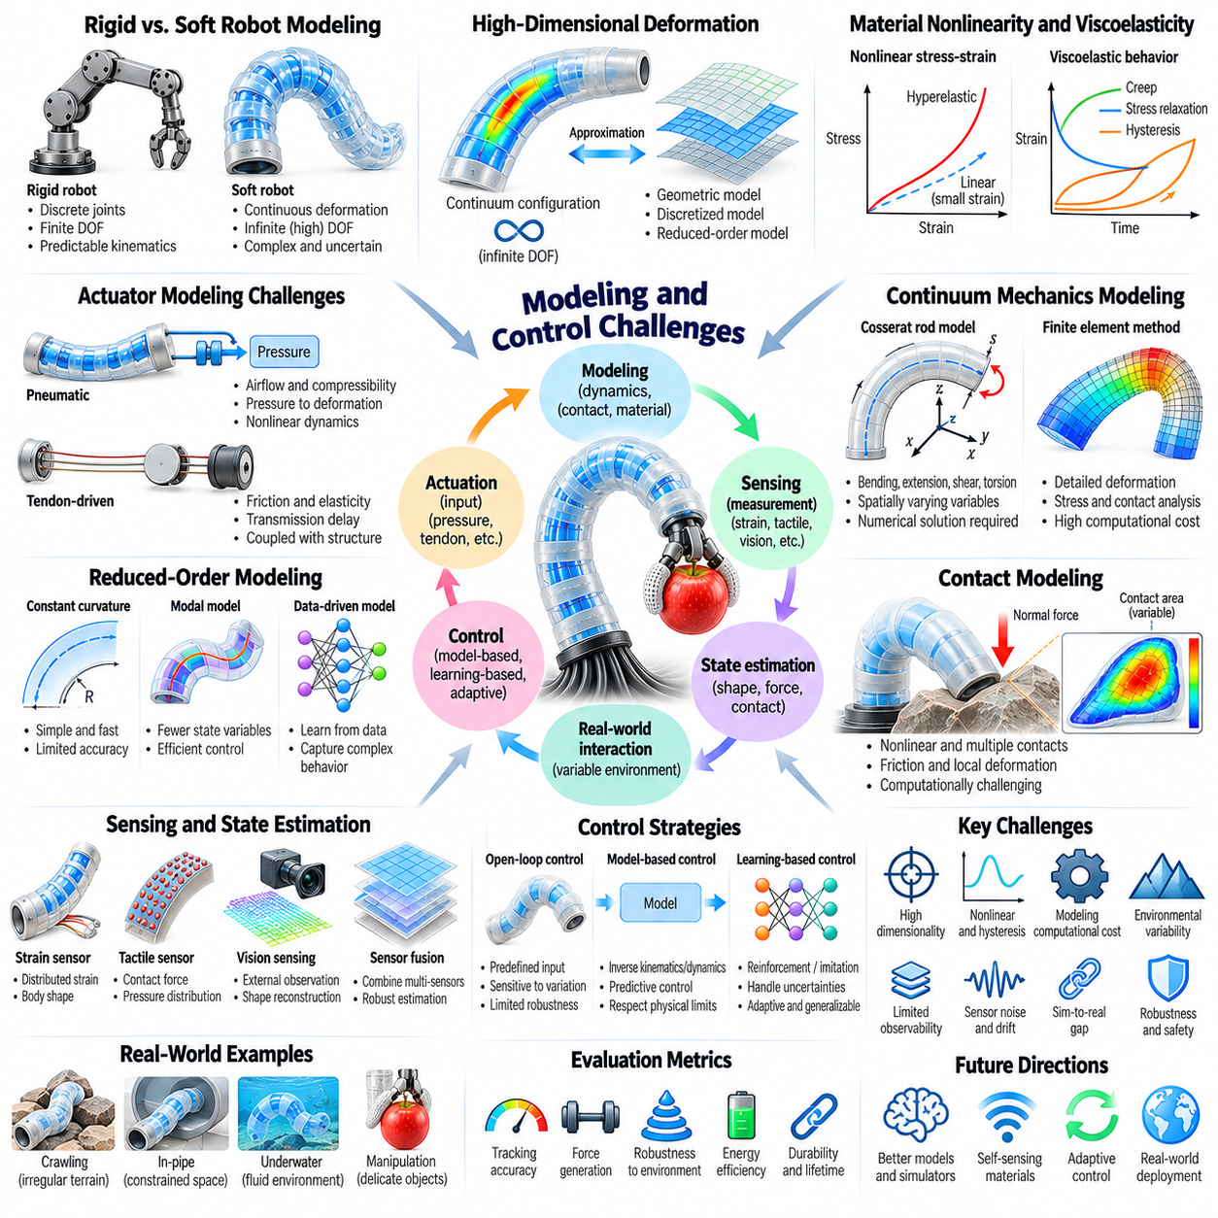
Modeling and controlling soft robots presents fundamental challenges because their bodies deform continuously and exhibit complex mechanical behavior. Unlike rigid robots with well-defined joints and predictable kinematics, soft robots distribute motion across flexible materials and structures. Their configurations depend on actuation, material properties, external loads, and environmental contact, making accurate prediction and control difficult.
The high-dimensional nature of soft robot deformation is a primary modeling challenge. A rigid manipulator can often be represented by a finite set of joint coordinates, whereas a deformable body theoretically possesses infinitely many degrees of freedom. Practical models must approximate this continuous configuration space using simplified geometric descriptions or discretized mechanical representations while preserving the behaviors relevant to control.
Material nonlinearity significantly complicates the mathematical description of soft robotic systems. Elastomers and flexible composites often exhibit large strains, nonlinear stress-strain relationships, and deformation-dependent stiffness. Linear elastic models may provide reasonable approximations for small movements but become inaccurate under substantial deformation. Hyperelastic constitutive models are therefore frequently used to represent large elastic responses.
Viscoelasticity introduces time-dependent behavior that cannot be captured by purely elastic models. Soft materials may exhibit creep, stress relaxation, and hysteresis during repeated loading and unloading. Consequently, identical actuator commands can produce different responses depending on deformation history and operating conditions. Accurate prediction requires models that incorporate both instantaneous elasticity and time-dependent material effects.
Actuator dynamics create additional complexity because input commands do not directly determine body configuration. Pneumatic systems involve pressure regulation, airflow, chamber expansion, and compressibility, while tendon-driven mechanisms introduce friction and transmission elasticity. These effects interact with structural deformation and external loading. Control models must therefore describe the coupled behavior of actuators and compliant bodies.
Continuum mechanics provides a rigorous foundation for representing distributed deformation. Cosserat rod models describe slender flexible structures through spatially varying position, orientation, strain, internal forces, and moments. They can represent bending, extension, shear, and torsion within a unified framework. However, their governing equations often require numerical solutions and careful treatment of boundary conditions.
Finite element methods provide detailed representations of soft robotic bodies by dividing deformable structures into interconnected elements. These models can predict stress distributions, local strain, contact deformation, and actuator-induced movement. Their accuracy depends on material characterization, mesh resolution, and boundary conditions. High computational cost limits their direct use in many real-time control applications.
Reduced-order modeling addresses computational limitations by approximating deformation with fewer state variables. Constant-curvature assumptions, modal representations, and data-driven reductions can simplify complex mechanical behavior. Such models enable faster prediction and control optimization but may lose accuracy under irregular contact or nonuniform deformation. Model selection therefore requires balancing computational efficiency against physical fidelity.
Contact modeling is especially difficult because soft robots interact with objects through continuously changing surfaces. Contact regions, normal forces, friction, and local deformation evolve as the robot moves. Multiple simultaneous contacts can introduce discontinuities and complex mechanical constraints. Reliable simulation must account for these interactions without making computational requirements impractical for control.
State estimation presents another major challenge because conventional joint encoders cannot describe distributed body deformation. Soft robots often require embedded strain sensors, tactile sensing, optical measurements, and external vision to reconstruct their configurations. Sensor signals may be nonlinear, noisy, and affected by hysteresis. Estimation algorithms must combine incomplete measurements with mechanical models to infer the robot's physical state.
Observability is a central consideration when designing sensing systems for soft robot control. A limited number of sensors may not uniquely determine the configuration of a highly deformable body. Different deformation patterns can produce similar local measurements, especially under external loading. Sensor placement, measurement diversity, and model constraints must therefore be optimized to reduce ambiguity and improve reconstruction accuracy.
Open-loop control is often insufficient for soft robots because their responses vary with loading conditions and environmental interactions. Predetermined pressure or tendon commands may produce acceptable movement in controlled settings but fail when objects or surfaces change. Closed-loop control compensates for these variations by adjusting actuation according to measured deformation, contact forces, and task performance.
Model-based control uses mathematical predictions to calculate actuator commands that achieve desired configurations or forces. Inverse kinematics and inverse dynamics become challenging because soft robot behavior is nonlinear and frequently underactuated. Multiple actuator combinations may produce similar configurations, while some desired shapes may be physically unreachable. Effective controllers must respect material limits and actuator constraints.
Model predictive control offers a systematic approach to handling nonlinear dynamics and operational constraints. It repeatedly predicts future robot behavior, optimizes a sequence of control inputs, and applies the first command before updating its predictions. This framework can incorporate force limits, obstacle avoidance, and task objectives. However, computational expense and model uncertainty remain obstacles to high-frequency implementation.
Adaptive control methods address uncertainty in material properties and actuator responses. Parameters such as stiffness, damping, and friction may vary with temperature, aging, and repeated deformation. Adaptive controllers update their estimates using feedback to maintain performance despite these changes. Their effectiveness depends on sufficient excitation, reliable measurements, and mechanisms that prevent unstable parameter adjustments.
Learning-based control provides alternatives when accurate analytical models are difficult to construct. Neural networks can approximate actuator-to-deformation relationships, while reinforcement learning can discover policies for manipulation and locomotion. These methods may capture complex nonlinear behavior but require representative training data. Generalization to unfamiliar objects, loads, and environments remains a significant challenge.
Simulation-to-reality transfer is particularly difficult for soft robotics because small modeling errors can produce substantial differences in deformation and contact behavior. Material variability, actuator imperfections, and uncertain friction reduce the predictive accuracy of simulation. Domain randomization, system identification, and online adaptation can improve transfer. Nevertheless, physical validation remains essential for reliable deployment.
Hybrid modeling approaches combine analytical mechanics with data-driven learning to exploit their complementary strengths. Physics-based models provide structural consistency and interpretable constraints, while learned components compensate for unmodeled nonlinearities. Residual learning and physics-informed estimation can improve prediction without requiring fully detailed simulations. Such approaches are promising for real-time control under changing conditions.
Safety and stability are important because soft robots may operate in close contact with humans or fragile objects. Compliance reduces some impact risks but does not eliminate excessive force, unexpected deformation, or actuator failures. Controllers must account for pressure limits, material strain, contact forces, and recovery behavior. Safety-oriented control requires validated constraints, reliable sensing, and appropriate fault responses.
For Physical AI, modeling and control challenges reveal the importance of integrating morphology, sensing, prediction, and learning. Soft robot intelligence cannot rely exclusively on abstract motion planning because physical deformation directly influences achievable behavior. Combining efficient mechanical models, multimodal feedback, adaptive control, and learned policies enables more reliable interaction with uncertain environments and supports increasingly capable embodied intelligence.

09.09. Soft Robotics and Morphological Computation
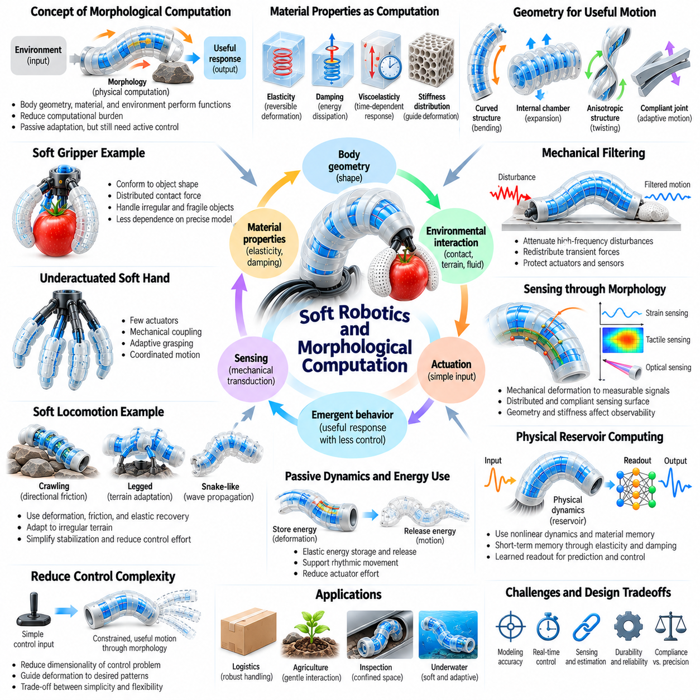
Soft robotics and morphological computation are closely connected because the physical structure of a robot can contribute directly to sensing, control, and intelligent behavior. Morphological computation describes how body geometry, material properties, and environmental interactions perform functions otherwise assigned to explicit computation. Soft robots provide particularly useful examples because their compliant structures naturally respond to forces and constraints.
In conventional robotics, control systems often calculate precise movements and compensate for mechanical disturbances through continuous feedback. Soft robots can redistribute part of this responsibility to their physical bodies. Elastic deformation, passive compliance, and distributed contact allow structures to accommodate environmental variation without requiring every adjustment to be explicitly calculated by a controller.
The central principle of morphological computation is that physical dynamics can transform inputs into useful responses. When a compliant structure encounters an obstacle, its geometry and material stiffness determine how it bends or redistributes forces. This response can simplify control by reducing the number of decisions required for successful interaction. However, passive mechanical adaptation does not eliminate the need for active sensing and control.
Material properties play a fundamental role in determining computational behavior. Elasticity governs reversible deformation, damping dissipates mechanical energy, and viscoelasticity introduces time-dependent responses. By selecting and distributing these properties, designers can influence how a robot reacts to contact and actuation. Mechanical behavior therefore becomes part of the functional architecture rather than merely a structural constraint.
Body geometry also determines how environmental forces are converted into movement. Curved surfaces, compliant joints, internal chambers, and flexible appendages shape the direction and magnitude of deformation. A properly designed morphology can produce useful motion from relatively simple actuator commands. This relationship demonstrates how mechanical design can reduce the complexity of motion planning and low-level control.
Soft grippers illustrate morphological computation through passive adaptation to object geometry. When compliant fingers close around an irregular object, their deformation distributes contact forces across the surface. The gripper can accommodate differences in size and shape without requiring exact geometric reconstruction. This reduces dependence on detailed perception, although grasp stability still depends on friction, material stiffness, and applied forces.
Underactuated soft hands extend this principle by coordinating multiple degrees of freedom through fewer actuators. Tendons, elastic elements, and compliant joints distribute motion according to contact conditions. When one finger region encounters an object, other regions may continue moving and conforming. Mechanical coupling creates coordinated grasping behavior that would otherwise require more elaborate actuator control.
Soft locomotion provides another example of computation embedded in morphology. Flexible bodies interact with terrain through deformation, friction, and elastic recovery. Crawling robots can exploit directional friction, while compliant legs absorb irregularities during ground contact. These mechanical responses simplify certain aspects of stabilization and terrain adaptation, although coordinated actuation remains necessary for reliable movement.
Passive dynamic behavior demonstrates how physical structures can support movement without continuous detailed intervention. Elastic elements store energy during one phase of motion and release it during another. Properly tuned compliance can improve rhythmic movement and reduce actuator effort. However, these advantages depend on operating speed, loading conditions, and the relationship between structural dynamics and environmental forces.
Mechanical filtering is an important mechanism through which morphology influences control. Compliant structures can attenuate high-frequency disturbances and redistribute transient forces before they reach actuators or sensors. This physical filtering may reduce control effort and protect delicate components. Nevertheless, excessive compliance can introduce oscillations, delays, and reduced positional accuracy.
Morphological computation also affects sensing because mechanical deformation transforms environmental interactions into measurable patterns. A compliant sensing surface can distribute localized contact across multiple embedded sensors. Its geometry and stiffness influence the resulting signals. Consequently, sensor placement and material design jointly determine which physical information becomes observable and how easily it can be interpreted.
The concept of physical reservoir computing extends morphological computation into temporal information processing. A deformable body can exhibit nonlinear dynamics and short-term memory through elasticity, damping, and material relaxation. Sensor measurements of these evolving states may be used to reconstruct or predict input patterns. Such systems exploit physical dynamics as computational resources, although performance depends on suitable readout and training methods.
Morphological design can reduce the dimensionality of control problems by constraining possible movements to useful patterns. Mechanical coupling, anisotropic stiffness, and geometric restrictions guide deformation toward desired configurations. Rather than independently controlling every local degree of freedom, a controller can command a smaller number of coordinated motions. This simplifies actuation but may reduce flexibility outside the intended task.
Anisotropic materials and structures provide directional mechanical responses that support specialized behavior. Fiber reinforcement can restrict expansion along selected directions, causing pneumatic actuators to bend or twist predictably. Similarly, directional surface textures can influence traction during crawling. These examples show how desired movement patterns can be encoded through physical structure instead of relying exclusively on software commands.
Morphological computation is especially valuable when robots operate in uncertain environments. Passive compliance allows immediate local responses to unexpected contact without waiting for sensing, communication, and control calculations. This can improve robustness during manipulation and locomotion. However, the resulting behavior is not necessarily optimal, and mechanical adaptation must be evaluated against task-specific performance requirements.
The effectiveness of morphological computation depends on matching body design to the intended environment and task. A highly compliant gripper may handle fragile objects effectively but struggle with heavy loads requiring precise force transmission. A flexible locomotion mechanism may traverse irregular terrain while sacrificing speed or efficiency on smooth surfaces. Morphological optimization must therefore consider operating conditions and performance tradeoffs.
Co-design approaches optimize morphology and control together rather than treating mechanical structure as a fixed platform. Design variables may include geometry, material stiffness, actuator placement, sensor distribution, and control parameters. Simulation and experimental optimization can identify combinations that improve task performance. However, computational complexity and inaccurate material models can limit the reliability of automated design.
Learning-based methods can exploit morphological computation by discovering control policies suited to a robot's physical dynamics. Reinforcement learning may identify actuator sequences that take advantage of elastic recovery, contact mechanics, and passive stabilization. The learned policy and physical structure jointly determine behavior. Effective training must account for material variability and differences between simulation and real-world operation.
Morphological computation should not be interpreted as replacing digital computation entirely. Mechanical structures perform useful transformations, but they generally lack the flexibility of programmable controllers for changing goals and complex reasoning. A practical architecture combines passive mechanical responses with active perception, planning, and feedback. The appropriate division of responsibility depends on safety, adaptability, and task complexity.
For Physical AI, soft robotics demonstrates that intelligence emerges from interactions among morphology, materials, actuation, sensing, control, and the environment. By embedding useful responses into physical structure, robots can reduce selected computational demands while improving adaptability. Integrating morphological computation with learning and feedback supports embodied systems that exploit their physical properties as active resources for intelligent behavior.

09.10. Soft Robotics for Physical AI
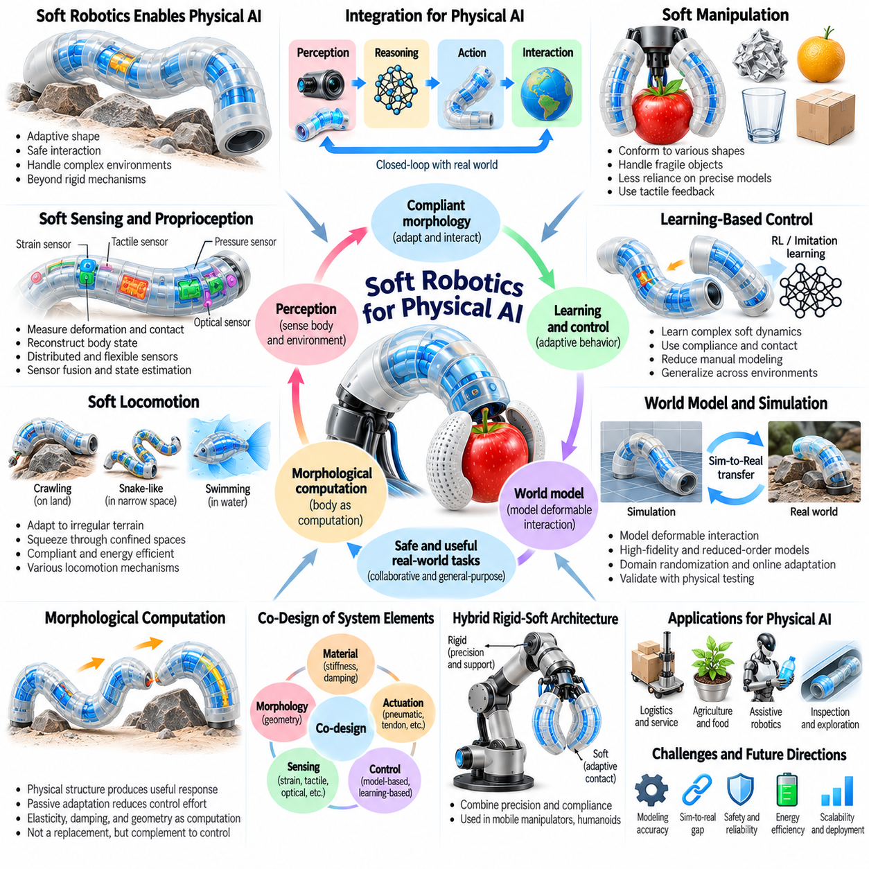
Soft robotics provides an important foundation for Physical AI by enabling intelligent systems to interact with the world through compliant and deformable bodies. Unlike rigid robots that depend on precisely constrained mechanisms, soft robots adapt their shapes to external forces and environmental geometry. This physical adaptability supports safer contact, flexible manipulation, and movement through complex environments.
Physical AI requires intelligence to emerge from the integration of perception, reasoning, action, and physical interaction. Soft robotics contributes by making body morphology an active component of this process. Deformation, elasticity, and distributed contact influence how robots perceive and respond to their surroundings. Consequently, intelligent behavior depends not only on computational models but also on the mechanical properties of the body.
Compliance is particularly valuable when Physical AI systems operate near humans or fragile objects. Soft structures can distribute contact forces and reduce certain impact loads during unexpected interactions. This capability supports collaborative manipulation, assistive robotics, and service applications. However, compliance alone does not guarantee safety, making force monitoring, actuator limits, and validated control strategies essential.
Soft manipulation expands the range of objects that Physical AI systems can handle. Deformable grippers conform to irregular surfaces and accommodate variations in shape without requiring exact geometric models. This reduces some demands on perception and motion planning while improving contact adaptability. Reliable manipulation nevertheless requires tactile feedback, grasp stability estimation, and appropriate control of interaction forces.
Soft robotic hands also offer opportunities for dexterous manipulation through distributed deformation and underactuated mechanisms. Flexible fingers can coordinate multiple contact points using relatively few actuators. Their mechanical properties help distribute forces during grasping and object adjustment. Integrating tactile sensing and learned control policies can extend these capabilities toward more complex in-hand manipulation tasks.
Locomotion is another area where soft robotics can extend Physical AI capabilities. Compliant bodies can squeeze through narrow openings, conform to irregular terrain, and absorb disturbances during movement. Crawling, peristaltic, swimming, and hybrid locomotion mechanisms demonstrate different approaches to environmental adaptation. Their effectiveness depends on matching morphology and actuation to the intended operating conditions.
Soft sensing and proprioception are essential for connecting compliant morphology with intelligent control. Embedded strain sensors, flexible tactile arrays, and optical sensing systems provide information about deformation, contact, and internal configuration. These measurements help reconstruct body state despite the absence of conventional rigid joints. Sensor fusion and state estimation convert distributed signals into information suitable for planning and feedback.
Morphological computation allows Physical AI systems to exploit mechanical structure as part of their information-processing architecture. Elasticity, damping, and geometry can produce useful responses without requiring every adjustment to be digitally calculated. Passive adaptation may reduce control complexity and improve reaction to local disturbances. Nevertheless, active perception and planning remain necessary for changing goals and unfamiliar tasks.
Learning-based control provides a mechanism for exploiting the complex dynamics of soft robots. Reinforcement learning and imitation learning can discover actuator policies that use compliance, contact mechanics, and elastic recovery. These methods may reduce reliance on manually derived control laws. However, learned behaviors must generalize across material variation, external loads, and environments that differ from training conditions.
World models for Physical AI must represent interactions between deformable bodies and their surroundings. Predicting soft robot behavior requires information about material properties, actuator dynamics, contact conditions, and environmental constraints. High-fidelity simulations can provide detailed predictions but are often computationally expensive. Reduced-order and learned dynamics models offer practical alternatives for real-time reasoning and control.
Simulation-to-reality transfer remains a significant challenge because soft materials exhibit nonlinear deformation, hysteresis, fatigue, and manufacturing variability. Small errors in stiffness or friction can produce substantial differences between simulated and physical behavior. Domain randomization, system identification, and online adaptation can improve transfer reliability. Physical testing remains necessary to validate performance under representative conditions.
Co-design of morphology, sensing, actuation, and control is especially important for soft Physical AI systems. Material stiffness, chamber geometry, actuator placement, and sensor distribution jointly determine achievable behavior. Optimizing these elements together can improve adaptability, energy efficiency, and task performance. This approach treats the robotic body as an integrated computational and mechanical system rather than a passive platform.
Hybrid rigid-soft architectures provide a practical path toward deploying soft robotics in general-purpose machines. Rigid components can supply structural support, accurate positioning, and efficient force transmission, while compliant elements enable adaptive contact and deformation. Such combinations are relevant to mobile manipulators, humanoid hands, and assistive robots. Their design requires careful management of mechanical interfaces and control coordination.
Energy efficiency is a critical consideration for autonomous soft Physical AI platforms. Pneumatic and hydraulic systems may require pumps, valves, reservoirs, and pressure regulation equipment. Repeated deformation can also introduce hysteresis losses and material heating. Efficient deployment requires evaluating total system energy consumption rather than actuator performance alone, including sensing, computation, and supporting hardware.
Durability and maintainability influence whether soft robotic technologies can operate reliably outside laboratories. Elastomers may experience fatigue, punctures, creep, and changes in mechanical properties during repeated use. Embedded sensors and fluidic channels can introduce additional failure mechanisms. Practical systems need protective designs, replaceable components, condition monitoring, and validation of performance over expected operating lifetimes.
Soft robotics also introduces challenges for safety assurance and performance evaluation. Deformable bodies can exhibit unpredictable contact patterns, making force estimation and collision analysis more complicated. Evaluation must consider contact pressure, deformation limits, recovery behavior, task success, and failure responses. Safety validation should address both passive mechanical characteristics and active control under realistic operating conditions.
Human-centered applications demonstrate the potential of soft Physical AI. Wearable assistive devices, rehabilitation robots, and compliant interfaces can adapt to body movement and distribute interaction forces. Their effectiveness depends on comfort, controllability, anatomical compatibility, and reliable sensing. Because these systems interact closely with people, careful evaluation of safety, usability, and individual variation is essential.
Soft robotics can also support exploration and inspection in environments that are difficult for rigid machines. Deformable mechanisms may navigate confined passages, interact with delicate infrastructure, or move through irregular natural spaces. Physical AI can improve these capabilities through adaptive perception and autonomous decision-making. Successful deployment requires robustness against environmental hazards and uncertainty in contact conditions.
The future of soft robotics for Physical AI will depend on advances in materials, embedded sensing, compact actuation, modeling, and learning. Self-sensing materials, variable-stiffness structures, and integrated fabrication may enable more capable autonomous systems. Progress will also require standardized evaluation and reproducible design methods. These developments can improve the practical integration of soft mechanisms into intelligent robotic platforms.
Ultimately, soft robotics expands Physical AI by demonstrating that intelligence is shaped by the interaction between computational processes and physical embodiment. Compliant morphology provides passive adaptation, while sensing, predictive models, and learned policies support deliberate action. Combining these capabilities enables robots to interact with uncertain environments more flexibly and extends embodied intelligence beyond conventional rigid mechanical designs.

