Volume 03. Embodiment and Morphology

Chapter 10. Bio Inspired Robotics

10.01. Bio Inspired Robotics and Biomimicry
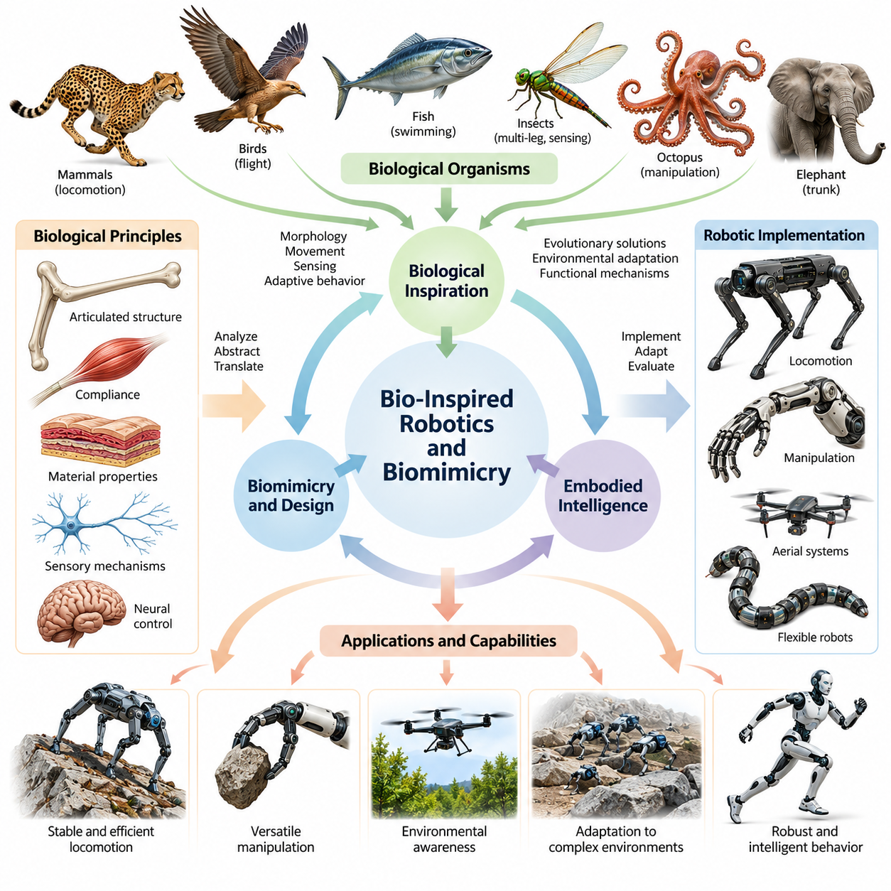
Bio-inspired robotics is an interdisciplinary field that applies principles observed in biological organisms to the design, construction, and control of robotic systems. Rather than treating living organisms as templates for direct mechanical replication, it investigates how biological structures, movements, sensory mechanisms, and adaptive behaviors solve physical problems. These insights provide engineering strategies for developing robots that interact efficiently with complex environments.
Biomimicry refers to the systematic study and adaptation of biological solutions for technological applications. In robotics, biomimicry involves identifying useful mechanisms in nature, understanding their functional principles, and translating those principles into artificial systems. A biomimetic robot does not necessarily resemble the organism that inspired it. Its design may reproduce a particular mechanical function while using entirely different materials, actuators, and computational architectures.
The relationship between bio-inspired robotics and biomimicry is closely connected to embodied intelligence. Biological organisms achieve intelligent behavior through continuous interactions among their nervous systems, physical structures, and surrounding environments. Their bodies contribute directly to perception, locomotion, manipulation, and stabilization. Bio-inspired robotics investigates how similar interactions can be engineered to distribute intelligent behavior across mechanical structures and computational controllers.
Biological evolution provides an extensive collection of morphological solutions developed under environmental and functional constraints. Animals have evolved specialized limbs, flexible bodies, sensory organs, and locomotion mechanisms that support survival in different habitats. Engineers can examine these adaptations to identify design principles associated with stability, energy efficiency, maneuverability, and robustness. However, biological optimization does not necessarily correspond to engineering optimization.
A central principle of bio-inspired design is the distinction between biological appearance and functional abstraction. Reproducing the external shape of an animal does not guarantee that a robot will reproduce its performance. Effective biomimicry requires understanding the underlying physical mechanisms responsible for biological capabilities. Engineers therefore analyze force transmission, structural compliance, material properties, sensory feedback, and movement coordination before selecting an artificial implementation.
Biological locomotion offers important examples of morphology-dependent intelligence. Mammals coordinate articulated limbs to walk, run, and recover from disturbances, while insects exploit multiple contact points for stable movement. Fish generate propulsion through coordinated body deformation, and birds combine aerodynamic structures with active wing control. These mechanisms demonstrate how locomotion emerges from interactions between body geometry, mechanical dynamics, and environmental forces.
Bio-inspired robotics also emphasizes the role of passive mechanical properties in reducing control complexity. Biological tendons, elastic tissues, flexible joints, and compliant appendages store energy, absorb impacts, and regulate physical interactions. Similar properties can be incorporated into robotic structures to support passive stabilization and energy-efficient movement. This approach connects biomimetic engineering with morphological computation, where physical dynamics perform functions otherwise requiring explicit computation.
The integration of biological principles into robotic manipulation extends beyond locomotion. Human hands, elephant trunks, octopus arms, and insect appendages demonstrate different strategies for grasping, reaching, and adapting to irregular objects. Their structures illustrate how distributed compliance, redundant motion, and coordinated contact can support versatile interaction. Robotic manipulators can adopt selected principles without reproducing the complete anatomical complexity of biological systems.
Biological sensing provides another important source of inspiration. Animals combine vision, touch, proprioception, hearing, and specialized sensory mechanisms to interpret their surroundings. Insects use antennae and compound eyes, fish detect water movement through lateral-line systems, and mammals integrate tactile feedback with limb position sensing. Bio-inspired sensing architectures investigate how these mechanisms can improve environmental awareness and physical interaction.
The relationship between sensing and movement is especially important in biological intelligence. Organisms actively move their sensory structures and bodies to acquire information relevant to immediate tasks. This process creates a continuous perception-action loop in which sensory observations influence movement and movement changes subsequent observations. Bio-inspired robots can employ similar principles through active perception, adaptive exploration, and sensorimotor feedback.
Biological control systems frequently rely on hierarchical and distributed organization rather than centralized computation alone. Reflex pathways produce rapid responses to disturbances, while neural circuits coordinate rhythmic activities such as walking and swimming. Higher-level processes regulate goals, movement transitions, and environmental adaptation. Robotic control architectures can incorporate analogous mechanisms to improve responsiveness while reducing the computational demands of continuous motion planning.
Central pattern generators represent a particularly influential biological concept in robotic locomotion. These neural circuits can generate coordinated rhythmic activity without requiring an independent external command for every movement cycle. Artificial central pattern generators use coupled oscillators or neural models to produce locomotion patterns. Their outputs can be modified through sensory feedback, allowing robots to adjust gait frequency, phase relationships, and movement coordination.
Biomimetic engineering also involves significant differences between biological and artificial materials. Biological tissues often combine elasticity, strength, self-repair, and complex hierarchical organization within lightweight structures. Conventional robotic systems generally depend on manufactured components with different mechanical properties and durability characteristics. Consequently, translating biological mechanisms into robotics requires careful consideration of fabrication methods, actuator limitations, maintenance requirements, and structural reliability.
Soft robotics provides a particularly close connection between biological inspiration and artificial embodiment. Flexible materials, deformable actuators, and continuum structures enable robots to interact with their surroundings through distributed deformation. Such systems can approximate selected characteristics of muscles, tentacles, and soft-bodied organisms. Their compliance may improve adaptability and contact safety, although accurate sensing, dynamic modeling, and precise control remain challenging engineering problems.
Bio-inspired robotics does not imply that biological solutions are universally superior to conventional engineering designs. Wheels may outperform legs on smooth surfaces, rigid industrial manipulators may provide greater positioning precision than compliant biological structures, and propellers may offer simpler propulsion than artificial fins. The appropriate design depends on operating conditions, performance requirements, manufacturing constraints, and system-level objectives rather than biological similarity alone.
A systematic biomimetic design process begins by identifying a functional engineering problem and searching for biological systems that address comparable challenges. Researchers then examine relevant anatomical structures, physical mechanisms, and behavioral strategies. These observations are converted into simplified models that can be evaluated through simulation and experimentation. The resulting robotic implementation is refined according to measurable engineering objectives rather than biological resemblance.
Quantitative evaluation is essential for determining whether biological inspiration provides meaningful advantages. Locomotion systems can be assessed through speed, energy consumption, stability, and terrain adaptability, while manipulators can be evaluated through grasp reliability, dexterity, and contact-force regulation. Comparative experiments should account for robot size, mass, operating conditions, and control capabilities. Such evaluations distinguish demonstrated functional improvements from visually convincing imitation.
Bio-inspired robotics increasingly intersects with artificial intelligence, reinforcement learning, and automated morphology optimization. Learning algorithms can discover control strategies that exploit compliant structures, while evolutionary optimization can explore alternative body geometries and actuator arrangements. Simulation environments allow researchers to evaluate combinations of morphology and behavior before constructing physical prototypes. These methods extend biological inspiration into computationally assisted robotic design.
The development of Physical AI further strengthens the relevance of biological inspiration by emphasizing intelligence grounded in physical interaction. Bio-inspired robots provide platforms for investigating how body structure influences learning, adaptation, and generalization. Their mechanical properties can constrain possible actions while enabling useful behaviors through natural dynamics. Effective Physical AI systems therefore require coordinated design of morphology, sensing, actuation, control, and learning.
The broader significance of bio-inspired robotics lies in transforming biological observations into reusable engineering knowledge. Nature demonstrates numerous ways to achieve movement, perception, adaptation, and physical interaction under limited resources. By extracting functional principles rather than copying organisms literally, engineers can develop robotic systems with improved versatility and environmental compatibility. Biomimicry thus serves as a foundation for exploring new forms of artificial embodiment and intelligent physical behavior.

10.02. Biological Morphology as Design Knowledge
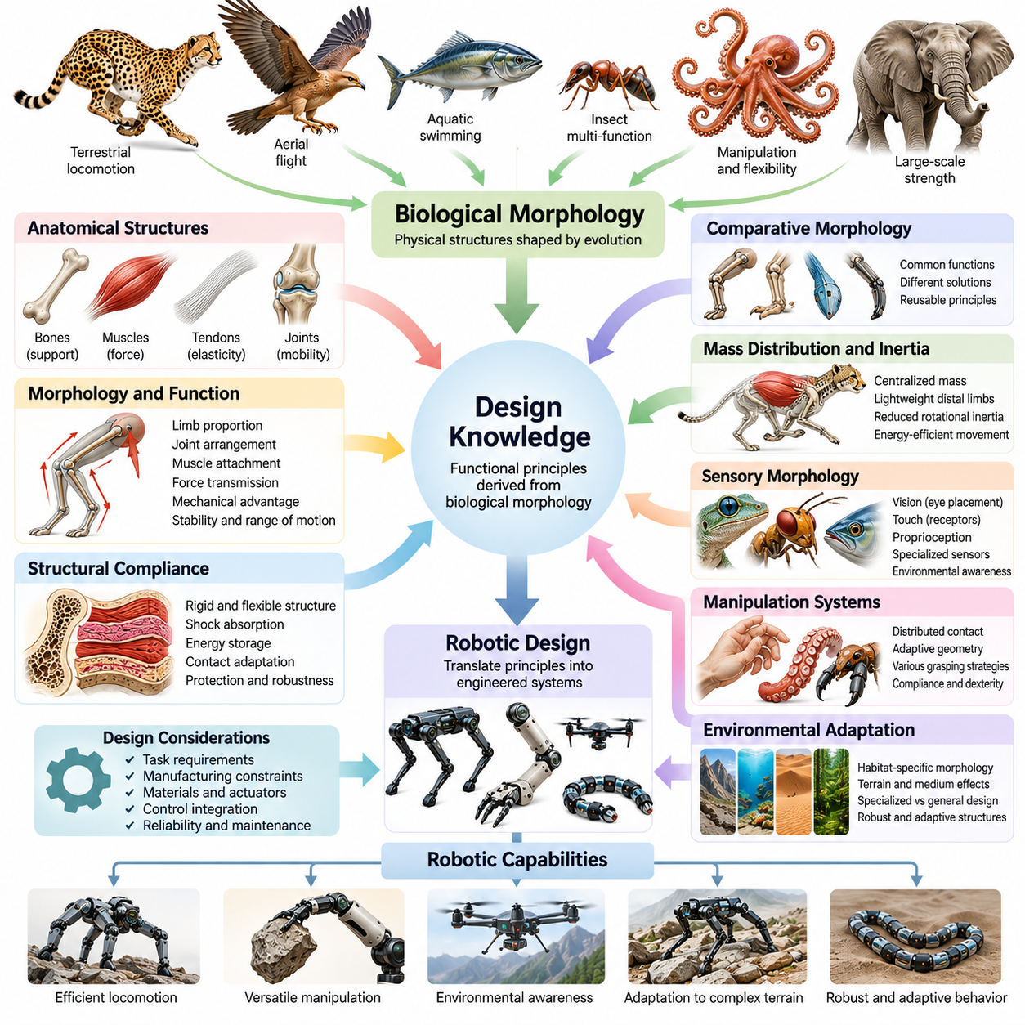
Biological morphology provides a rich source of design knowledge for robotics by revealing how physical structures support movement, sensing, manipulation, and adaptation. The geometry, proportions, material composition, and mechanical organization of living organisms reflect interactions between functional demands and environmental conditions. Engineers can study these relationships to derive principles for designing robotic bodies that achieve useful behavior through their physical characteristics.
Unlike conventional engineering approaches that often begin with predefined mechanisms, biological morphology offers examples of integrated systems shaped by evolutionary processes. Bones, muscles, tendons, joints, and sensory structures operate as interconnected components rather than isolated devices. Their collective organization demonstrates how mechanical performance emerges from coordinated structural properties, providing valuable insights for robotic morphology and system-level design.
Biological structures should be interpreted as functional knowledge rather than exact blueprints for artificial construction. Evolutionary adaptations reflect multiple constraints, including survival, reproduction, development, and environmental history. These constraints differ from engineering requirements such as manufacturing cost, precision, reliability, and maintenance. Consequently, effective bio-inspired design extracts transferable principles while avoiding unnecessary biological complexity.
The study of biological morphology begins with identifying relationships between anatomical structures and their functional roles. Researchers examine limb proportions, joint arrangements, body segmentation, muscle attachment locations, and structural flexibility. These characteristics influence force transmission, movement range, mechanical advantage, and stability. Understanding such relationships helps engineers translate biological observations into measurable robotic design parameters.
Comparative morphology provides a systematic method for discovering reusable design principles across different organisms. By examining species that perform similar functions using different anatomical structures, researchers can distinguish essential mechanisms from species-specific adaptations. Conversely, comparing related organisms operating in different environments reveals how morphological variations influence performance under changing physical constraints.
The relationship between morphology and locomotion illustrates the engineering value of biological design knowledge. Terrestrial animals exhibit different limb configurations, body proportions, and contact strategies depending on their habitats and movement requirements. Long limbs may support efficient movement over suitable terrain, while compact structures can improve maneuverability in confined environments. These observations guide robotic decisions concerning leg length, joint placement, stance geometry, and body clearance.
Biological morphology also reveals important principles of mass distribution and inertia management. Many animals concentrate substantial muscle mass near the torso while maintaining relatively lightweight distal limbs. This arrangement can reduce rotational inertia and the energetic demands of rapid limb movement. Robotic designers apply related principles by placing heavy actuators closer to the body and transmitting mechanical power through linkages, cables, or tendon-like mechanisms.
Structural compliance represents another important form of biological design knowledge. Living organisms combine rigid skeletal elements with flexible tissues that deform under external forces. This combination supports shock absorption, energy storage, contact adaptation, and mechanical protection. Robots can incorporate similar properties through elastic joints, compliant mechanisms, and flexible structural components, allowing physical interactions to contribute directly to stability and control.
Biological joints demonstrate how mobility and stability can coexist within constrained mechanical structures. Joint geometry, ligament arrangements, and surrounding tissues restrict certain motions while enabling others. These physical constraints reduce the range of mechanically possible movements and can simplify coordination. Robotic joint design can adopt comparable principles by integrating mechanical stops, passive alignment mechanisms, and task-specific degrees of freedom.
The morphology of biological appendages provides insights into force generation and mechanical advantage. Muscle attachment locations, lever-arm lengths, and joint configurations determine how muscular forces produce movement. Different anatomical arrangements favor strength, speed, or movement range. Engineers can use these relationships to select actuator positions, transmission ratios, and linkage geometries that match the intended operating requirements of robotic systems.
Biological manipulation systems demonstrate the importance of distributed contact and adaptive geometry. Human fingers coordinate articulated joints and compliant tissues to grasp objects with varying shapes and surface properties. Octopus arms achieve manipulation through continuous deformation, while specialized animal appendages provide alternative grasping strategies. These examples inspire robotic end effectors that exploit structural adaptability rather than relying exclusively on precise position control.
Morphological specialization also influences sensory performance. The location and orientation of biological sensory organs determine which environmental information can be acquired efficiently. Eye placement affects visual coverage, tactile receptor distribution influences contact sensitivity, and proprioceptive structures support internal body awareness. Robotic designers can use these principles to coordinate sensor placement with body geometry, movement patterns, and expected interaction conditions.
Biological morphology frequently supports passive mechanical intelligence through interactions with environmental forces. Flexible appendages can conform to surfaces, elastic tissues can return stored energy, and body geometry can stabilize movement without continuous corrective commands. These effects illustrate morphological computation, in which physical properties contribute to information processing and behavioral regulation. Such mechanisms can reduce the burden placed on active robotic controllers.
The relationship between biological morphology and environmental adaptation is especially relevant to robots operating outside structured industrial settings. Animals exhibit specialized feet, claws, pads, fins, and body coverings that improve interaction with particular surfaces or media. These adaptations reveal how contact geometry, friction, compliance, and surface texture affect mobility. Engineers can translate these observations into terrain-specific locomotion mechanisms and adaptive contact interfaces.
Biological systems also demonstrate modularity and functional integration at multiple structural scales. Repeated body segments, paired limbs, and coordinated appendages provide organizational patterns that support movement and adaptation. At the same time, biological components often perform several functions simultaneously. Robotic morphology can benefit from modular architectures while incorporating multifunctional structures that combine support, sensing, actuation, and mechanical protection.
An important challenge in translating biological morphology into engineering knowledge is identifying the appropriate level of abstraction. Detailed anatomical replication may introduce unnecessary complexity, while excessive simplification may eliminate the mechanism responsible for useful behavior. Engineers must determine which geometric relationships, material properties, and dynamic characteristics are essential. This process requires mechanical analysis, mathematical modeling, and experimental validation.
Computational modeling enables biological morphology to be represented as engineering design variables. Geometric parameters describe body dimensions and joint locations, while dynamic parameters capture mass, inertia, stiffness, and damping. Simulation can then evaluate how these characteristics influence locomotion, manipulation, stability, and energy consumption. Such representations convert qualitative biological observations into testable hypotheses for robotic design.
Advances in imaging, motion capture, and biomechanical analysis provide increasingly detailed information about biological structures and their behavior. Three-dimensional anatomical models reveal internal geometry, while motion measurements characterize coordination and movement dynamics. Force measurements and material testing further clarify mechanical interactions. Combining these observations allows researchers to identify functional relationships that are difficult to infer from external appearance alone.
Biological morphology can also inform automated robot design and evolutionary optimization. Engineers may define design spaces using biologically inspired joint configurations, limb proportions, or structural arrangements. Optimization algorithms then explore alternatives according to robotic performance objectives. This approach combines biological design knowledge with computational search, allowing artificial systems to depart from natural anatomy when different configurations provide superior engineering performance.
The value of biological morphology ultimately depends on measurable improvements in robotic capabilities. Candidate designs should be evaluated through stability, energy efficiency, maneuverability, payload capacity, adaptability, and robustness. Comparative testing must account for operating conditions and implementation constraints. Biological inspiration becomes engineering knowledge when the underlying principles can be explained, reproduced, and validated through systematic experimentation.
Within Physical AI, biological morphology serves as a foundation for understanding how intelligence depends on physical embodiment. Body structure influences the actions available to a robot, the sensory information it receives, and the complexity of its control problem. By transforming biological observations into functional design principles, engineers can develop robotic systems whose mechanical structures actively support perception, learning, and adaptive behavior.

10.03. Human and Mammalian Inspiration
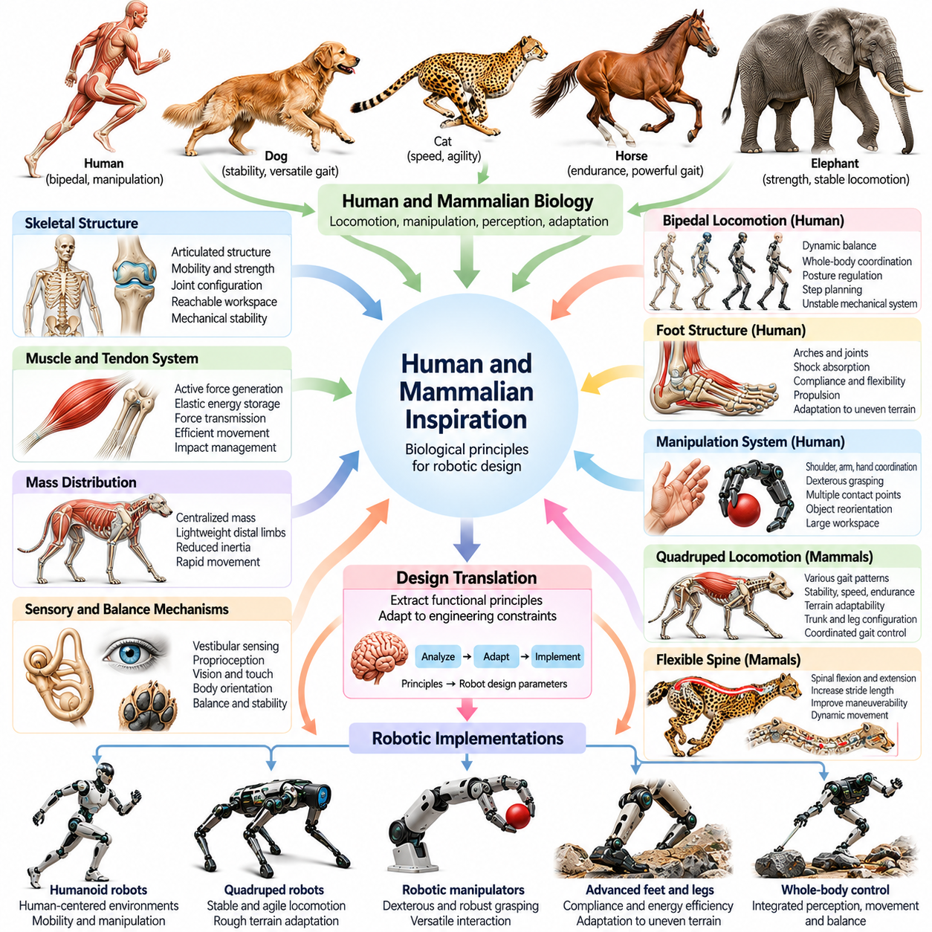
Human and mammalian biology provides valuable inspiration for robotic systems because mammals demonstrate sophisticated locomotion, manipulation, perception, and physical adaptation. Their bodies integrate articulated skeletons, muscles, tendons, sensory organs, and distributed neural control into coordinated mechanical systems. Studying these relationships helps engineers develop robots capable of stable movement, dexterous interaction, and adaptive behavior in complex environments.
Human morphology is particularly relevant to robotics because many artificial environments are designed around human dimensions and capabilities. Doors, stairs, tools, furniture, and workstations assume particular ranges of reach, mobility, and manipulation. Humanoid robots can exploit anthropomorphic body structures to operate within these environments. However, reproducing human appearance is less important than achieving functional compatibility with human-centered infrastructure.
The human skeletal system illustrates how articulated structures balance mobility, strength, and mechanical stability. The pelvis, spine, shoulders, arms, and legs form interconnected kinematic chains that support coordinated whole-body movement. Joint configurations determine reachable workspaces and available motion patterns. Robotic designers study these arrangements to develop manipulators and humanoid platforms with appropriate degrees of freedom and mechanical redundancy.
Human bipedal locomotion provides important principles for balancing dynamically unstable mechanical systems. Walking involves coordinated interactions among the legs, pelvis, torso, and arms while the body continuously transfers support between the feet. Balance depends on body geometry, mass distribution, ground reaction forces, and active control. Humanoid robots apply these insights through coordinated stepping, posture regulation, and whole-body stabilization.
The human foot demonstrates how morphology supports efficient interaction with the ground. Its arches, joints, tendons, and compliant tissues distribute contact forces while providing flexibility and structural support. During walking, the foot transitions between shock absorption and propulsion. Robotic feet can incorporate articulated toes, elastic structures, and compliant contact surfaces to improve stability, energy efficiency, and adaptation to uneven terrain.
Human arms and hands provide a foundation for designing dexterous robotic manipulation systems. The shoulder and elbow position the hand within a large workspace, while the wrist adjusts orientation and the fingers establish multiple contact points. Opposable thumbs enable precision grasping and object reorientation. Robotic manipulators can adopt selected anatomical principles to improve grasp versatility, coordinated motion, and interaction with everyday objects.
Human upper-body morphology also demonstrates the importance of coordinated movement across multiple joints. Reaching, lifting, and carrying involve interactions among the spine, shoulders, elbows, wrists, and lower body. These movements distribute mechanical loads and maintain balance while accomplishing manipulation tasks. Humanoid robots can apply similar whole-body coordination to perform operations that exceed the capabilities of isolated robotic arms.
Mammalian quadrupeds provide another major source of inspiration for robotic locomotion. Dogs, cats, horses, and other four-legged animals demonstrate different combinations of stability, speed, endurance, and terrain adaptability. Their limb arrangements and body proportions reflect distinct locomotion requirements. Quadruped robots use these observations to guide trunk geometry, leg configuration, joint placement, and coordinated gait generation.
Mammalian gait patterns illustrate how movement strategies change with speed and environmental conditions. Walking, trotting, pacing, cantering, and galloping involve different timing relationships among the limbs. These patterns influence support distribution, body oscillation, and energy expenditure. Robotic gait controllers can reproduce selected coordination principles while adapting timing, stride length, and contact forces to mechanical constraints.
The flexible spine of many mammals provides important insights into dynamic locomotion. During running, spinal extension and flexion can contribute to stride length and body propulsion. Cats and other agile mammals also use torso flexibility to adjust posture during rapid movement. Robotic systems with articulated or compliant trunks can exploit similar mechanisms to improve maneuverability, obstacle negotiation, and dynamic movement.
Mammalian muscle and tendon systems demonstrate how active force generation interacts with passive mechanical elasticity. Muscles generate controllable forces, while tendons transmit loads and can temporarily store mechanical energy. This arrangement supports movement efficiency and impact management. Robotic designers investigate tendon-driven actuation, elastic transmissions, and compliant joints to reproduce selected functional advantages of biological musculoskeletal systems.
The distribution of muscle mass in mammalian limbs offers useful principles for actuator placement. Many mammals position substantial muscle mass closer to the torso while transmitting forces toward distal joints through tendons. This configuration can reduce limb inertia and support rapid movement. Robots can apply similar arrangements through remote actuation, cable transmissions, and lightweight distal structures, although transmission losses and mechanical complexity must be considered.
Mammalian balance mechanisms combine mechanical structure with continuous sensory feedback. Vestibular sensing, proprioception, vision, and tactile information contribute to estimates of body orientation and movement. These signals support posture correction and coordinated responses to disturbances. Robotic systems use analogous sensing principles through inertial measurement units, joint encoders, force sensors, and visual perception to maintain stability.
Human and mammalian reflexes provide inspiration for rapid responses that do not require extensive high-level planning. Stretch reflexes, withdrawal responses, and postural adjustments demonstrate how local sensorimotor pathways can regulate movement. Robotic controllers can implement comparable feedback mechanisms to respond to unexpected contact or disturbances. Such architectures complement higher-level planning by supporting fast and predictable physical reactions.
Mammalian locomotion also reveals the importance of adapting contact behavior to different surfaces. Paws, hooves, and specialized foot structures provide different combinations of traction, compliance, and load distribution. Cats use flexible paws for precise placement, while hoofed mammals employ structures suited to efficient movement under particular conditions. Robotic feet can adopt analogous contact geometries to improve performance on selected terrains.
The manipulation capabilities of mammals extend beyond human hands. Primates use coordinated fingers and arms for object handling, while elephants manipulate objects using muscular trunks. These biological systems demonstrate different approaches to dexterity, reach, and distributed deformation. Their functional principles inspire articulated robotic hands, continuum manipulators, and compliant grasping mechanisms designed for varied interaction requirements.
Human motor learning provides additional inspiration for intelligent robotic behavior. People improve movement through practice, sensory feedback, and adaptation to changing physical conditions. Learned coordination allows familiar actions to remain effective despite variations in objects, loads, and environments. Robotic learning systems can incorporate similar principles through reinforcement learning, imitation learning, and adaptive control while respecting mechanical and safety constraints.
Mammalian behavior also demonstrates how morphology and control develop together. Young animals gradually acquire coordinated movement as their bodies grow and their nervous systems mature. Changes in limb proportions, strength, and sensory capabilities influence the control strategies available during development. Robotics research can use this relationship to investigate developmental learning, progressive skill acquisition, and adaptation to changing body parameters.
Biological inspiration must be translated carefully because artificial actuators, sensors, materials, and energy systems differ substantially from their biological counterparts. A robot that reproduces human or mammalian anatomy may still exhibit different dynamic behavior because its mechanical properties are not equivalent. Effective engineering therefore emphasizes functional abstraction, quantitative modeling, and experimental validation rather than anatomical similarity alone.
Within Physical AI, human and mammalian inspiration provides a framework for integrating morphology, perception, control, and learning into embodied systems. Biological examples demonstrate how mechanical structures contribute to balance, movement efficiency, dexterity, and environmental adaptation. By extracting transferable principles from mammalian bodies and behavior, engineers can develop robotic platforms that interact more effectively with complex physical environments.

10.04. Insect and Arthropod Inspiration
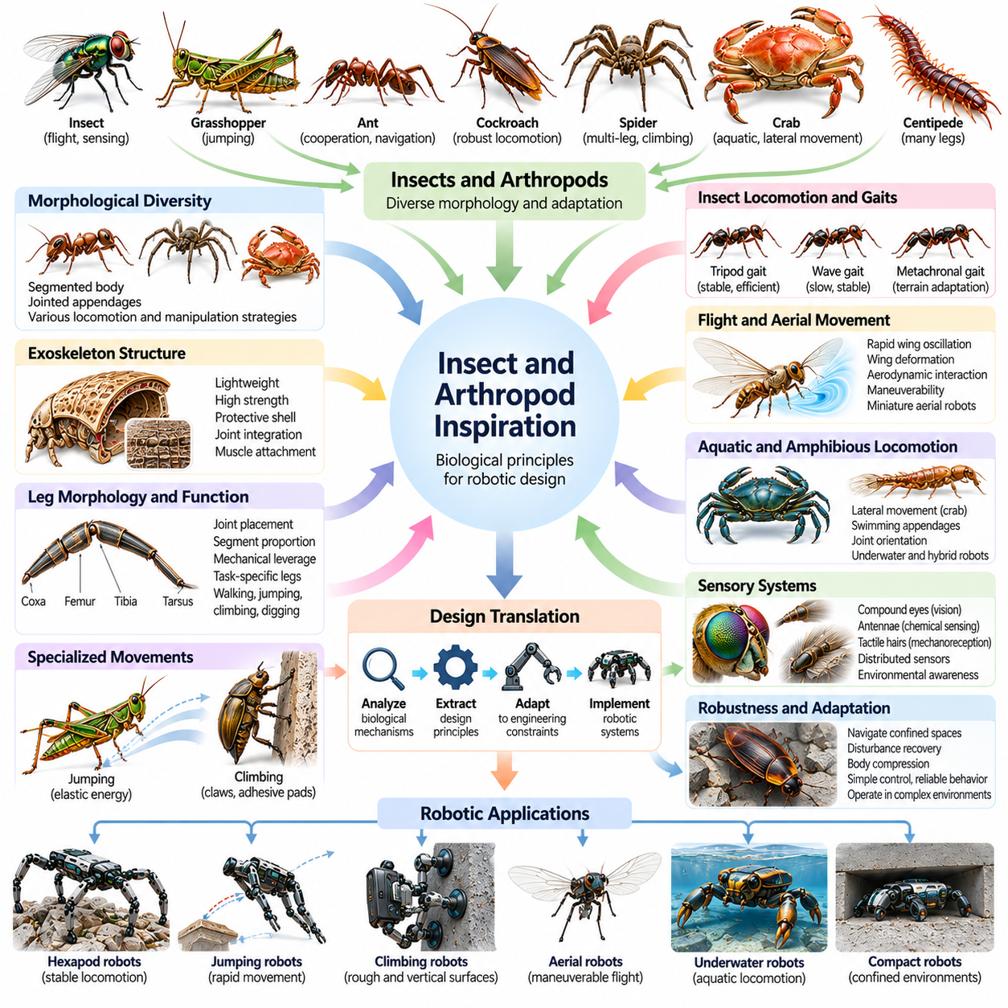
Insects and arthropods provide important biological inspiration for robotics because they demonstrate efficient locomotion, distributed sensing, structural adaptability, and robust behavior despite relatively small nervous systems. Their segmented bodies, articulated appendages, and specialized sensory organs support movement across diverse environments. Studying these mechanisms helps engineers develop compact robots that combine mechanical simplicity with effective physical interaction.
Arthropods include insects, spiders, crustaceans, and related organisms characterized by segmented bodies, jointed appendages, and external skeletons. Their morphological diversity demonstrates how variations in body architecture support different locomotion and manipulation strategies. Engineers investigate these structures to identify reusable principles for legged mobility, mechanical protection, sensor placement, and coordinated movement.
The exoskeleton is a defining feature of arthropod morphology and provides valuable lessons for robotic structural design. Unlike vertebrate skeletons, arthropod exoskeletons surround and protect internal tissues while providing attachment points for muscles. Their geometry and material organization influence stiffness, flexibility, and load transmission. Robotic structures can adopt similar principles through lightweight shells, integrated joints, and protective load-bearing frames.
Insect locomotion demonstrates how multiple articulated legs can provide stability without requiring continuous high-level coordination. Six-legged insects distribute body weight across several contact points and adjust their support patterns during movement. This arrangement enables stable locomotion over irregular surfaces and provides redundancy when individual legs encounter obstacles. Hexapod robots apply comparable principles to achieve reliable movement across challenging terrain.
The alternating tripod gait is a widely studied example of insect-inspired locomotion. During this gait, three legs form a support group while the remaining three advance, with the groups alternating their roles. This coordination can provide stable support when the center of mass remains appropriately positioned relative to the supporting contacts. Robotic hexapods use tripod patterns to achieve efficient walking, while modifying gait timing when terrain conditions require greater caution.
Insects also employ alternative gait patterns when speed, stability, or environmental conditions change. Wave gaits and metachronal coordination allow legs to move in sequences that maintain multiple supporting contacts. These strategies can improve stability during slow movement or obstacle negotiation. Robotic gait controllers can adapt the number and timing of supporting legs to balance locomotion speed, energy consumption, and terrain adaptability.
Arthropod leg morphology illustrates the importance of joint placement, segment proportions, and mechanical leverage. Different species possess specialized appendages for walking, jumping, climbing, digging, or swimming. The arrangement of leg segments determines reachable workspaces and force transmission characteristics. Engineers translate these observations into robotic linkage geometries, actuator configurations, and task-specific leg architectures.
Jumping insects provide valuable examples of rapid energy release through specialized mechanical structures. Grasshoppers and fleas employ elastic mechanisms that store energy before releasing it to generate powerful movements. This strategy allows rapid acceleration without requiring muscles to deliver all the mechanical power instantaneously. Jumping robots can incorporate springs, latches, and elastic transmissions to reproduce similar energy-storage principles.
Climbing insects demonstrate sophisticated interactions between appendage morphology and surface properties. Claws, adhesive pads, and specialized contact structures enable movement across rough, smooth, or inclined surfaces. These mechanisms depend on contact geometry, friction, adhesion, and controlled force distribution. Climbing robots can incorporate analogous structures to improve attachment reliability and mobility on selected surfaces.
Cockroaches provide important inspiration for robots operating in confined and cluttered environments. Their flattened bodies, flexible joints, and rapid locomotion allow them to navigate narrow passages and recover from mechanical disturbances. Some species can compress their bodies to pass through restricted openings. Bio-inspired robots can exploit compliant shells, articulated structures, and low-profile geometries to improve movement through constrained spaces.
Spiders offer another perspective on multi-legged locomotion and distributed mechanical control. Their eight-legged morphology supports diverse movement strategies, including walking, climbing, and maneuvering across complex surfaces. Many spiders use hydraulic pressure to assist leg extension, complementing muscular mechanisms. Robotic researchers investigate these principles when developing fluid-powered actuation systems and mechanically adaptive legged platforms.
Crustaceans demonstrate how arthropod morphology adapts to aquatic and amphibious environments. Crabs use laterally oriented appendages for sideways movement, while swimming crustaceans coordinate specialized limbs to generate propulsion. Their structures reveal how joint orientation and appendage geometry influence movement through water and across substrates. These observations support the development of underwater walking robots and hybrid locomotion systems.
Insect wings provide important inspiration for miniature aerial robots. Flying insects generate aerodynamic forces through rapid wing oscillations, complex wing deformation, and interactions with surrounding airflow. Their flight mechanisms differ substantially from conventional fixed-wing aircraft and rotary-wing systems. Engineers study these principles to develop flapping-wing micro aerial vehicles capable of maneuvering in confined environments.
The small size of many insects introduces distinctive aerodynamic and mechanical constraints. At insect scales, viscous effects and unsteady aerodynamic phenomena can strongly influence flight performance. Wing flexibility, stroke timing, and rotational motion contribute to lift generation and maneuverability. Robotic designers must consider these scaling relationships when translating insect flight mechanisms into artificial platforms with different materials and actuator capabilities.
Insect sensory systems provide valuable models for compact and efficient perception. Compound eyes support wide-field visual sensing, antennae detect mechanical and chemical signals, and specialized receptors measure airflow, vibration, and body movement. These sensory mechanisms often operate with limited neural processing resources. Robotic systems can adopt analogous sensing strategies to support navigation, obstacle avoidance, and rapid environmental responses.
Optic flow is particularly important in insect-inspired robotic navigation. Flying insects use patterns of apparent visual motion to estimate relative movement and environmental proximity. Such information supports obstacle avoidance, speed regulation, and landing behavior without requiring complete geometric reconstruction of the surroundings. Robotic navigation systems can exploit optic-flow measurements to achieve responsive control using comparatively lightweight perception architectures.
Insect nervous systems demonstrate how distributed control and local feedback can generate coordinated behavior. Neural circuits associated with individual limbs regulate movement while exchanging information with neighboring segments and higher-level control centers. This organization reduces dependence on centralized planning for every motor action. Robotic controllers can adopt similar architectures through local reflex loops, coupled oscillators, and distributed coordination mechanisms.
Central pattern generators and sensory reflexes are particularly relevant to arthropod-inspired locomotion. Rhythmic neural activity can coordinate repeated limb movements, while sensory feedback modifies those patterns in response to contact and disturbances. Artificial implementations use oscillator networks and feedback controllers to produce adaptive gait behavior. These mechanisms can improve responsiveness when robots encounter unexpected terrain variations.
Arthropod morphology also illustrates how mechanical design and behavior cooperate to produce robustness. Segmented bodies, compliant connections, protective shells, and redundant appendages can help organisms tolerate disturbances and maintain mobility. Robotic systems can apply these principles through modular structures, fault-tolerant gait strategies, and mechanically resilient components. Effective robustness nevertheless depends on the complete integration of body design and control.
Within Physical AI, insect and arthropod inspiration demonstrates how sophisticated physical behavior can emerge from compact bodies, specialized morphology, and distributed sensorimotor coordination. These organisms provide engineering principles for efficient locomotion, adaptive sensing, mechanical resilience, and decentralized control. Translating these principles into artificial systems supports the development of small, agile, and environmentally adaptive robotic platforms.

10.05. Bird and Aerial Inspiration
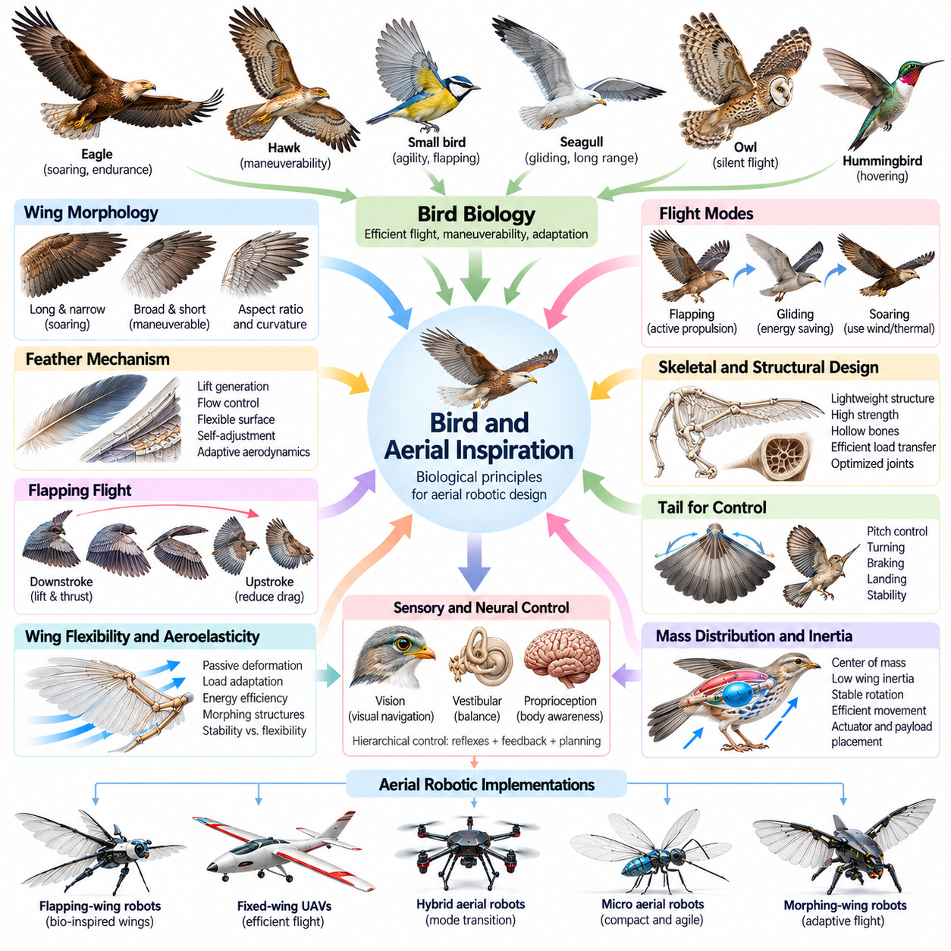
Birds provide important biological inspiration for aerial robotics because they demonstrate efficient flight, exceptional maneuverability, and adaptive control across diverse atmospheric conditions. Their wings, feathers, skeletal structures, muscles, and sensory systems operate as integrated mechanisms for generating aerodynamic forces. Studying these relationships helps engineers develop aerial robots that combine propulsion, stability, energy efficiency, and environmental adaptability.
Avian flight differs from conventional aircraft operation because birds continuously modify their wing geometry and movement patterns. Wing extension, folding, twisting, and feather adjustments influence lift, drag, and maneuverability. These transformations allow birds to adapt their aerodynamic configuration to changing flight requirements. Bio-inspired aerial robots investigate similar morphing structures to improve performance across multiple operating conditions.
Bird wing morphology provides valuable design knowledge concerning aerodynamic efficiency and functional specialization. Long, narrow wings are associated with efficient soaring and sustained flight, while shorter, broader wings can support maneuverability in constrained environments. Wing aspect ratio, surface curvature, and structural flexibility influence aerodynamic performance. Engineers translate these observations into wing geometries optimized for particular robotic flight missions.
The feather system represents a distinctive biological mechanism for controlling aerodynamic surfaces. Flight feathers contribute to lift generation, airflow regulation, and localized deformation of the wing. Their overlapping arrangement permits controlled changes in surface geometry while maintaining aerodynamic continuity. Artificial feather-like structures and segmented wing surfaces can provide adaptive aerodynamic characteristics without requiring conventional rigid control surfaces.
Flapping flight illustrates how propulsion and lift generation can be integrated into coordinated wing movement. Birds generate aerodynamic forces through combinations of wing translation, rotation, and deformation during repeated stroke cycles. The relative contributions of these mechanisms vary with species, flight speed, and environmental conditions. Flapping-wing robots investigate these principles to develop propulsion systems capable of producing controlled aerodynamic forces through periodic motion.
The distinction between downstroke and upstroke is important for understanding bird-inspired propulsion. During the downstroke, many birds generate substantial lift and forward thrust, while the upstroke may reduce resistance or contribute additional aerodynamic forces depending on flight conditions. Wing folding and feather adjustments modify these interactions. Robotic flapping mechanisms can exploit asymmetric stroke trajectories to improve propulsion efficiency and flight control.
Birds demonstrate several flight modes that reveal different relationships between morphology and energy consumption. Flapping flight provides active propulsion, gliding converts altitude into forward movement, and soaring exploits atmospheric energy to maintain or gain altitude. Some species transition between these modes according to environmental conditions. Aerial robots can incorporate comparable mode-switching strategies to extend endurance and reduce propulsion demands.
Soaring birds provide particularly useful examples of energy-efficient flight. Eagles, vultures, and albatrosses exploit atmospheric motion through thermal soaring, slope soaring, or dynamic soaring. Their wing configurations and control strategies enable sustained flight with limited flapping. Autonomous aerial systems can investigate similar techniques by estimating wind conditions and planning trajectories that take advantage of available atmospheric energy.
Bird skeletal morphology demonstrates how lightweight structures can support demanding aerodynamic loads. Hollow or air-filled bones, reinforced structural arrangements, and specialized joints contribute to favorable strength-to-weight characteristics. Wing bones and associated tissues transmit aerodynamic and muscular forces during flight. Robotic designers can adopt analogous principles through lightweight composite structures, optimized load paths, and mechanically efficient joint architectures.
The distribution of mass within a bird's body also influences flight stability and maneuverability. Wing inertia affects the energetic cost of flapping, while the placement of body mass influences rotational dynamics and control authority. Birds coordinate wing motion, body posture, and tail adjustments to manage these effects. Robotic aircraft can apply related principles by minimizing distal wing mass and carefully positioning actuators, batteries, and payloads.
Bird tails provide important inspiration for aerodynamic stabilization and maneuvering. Tail spreading, folding, and orientation changes modify aerodynamic forces and moments during flight. These adjustments can contribute to pitch control, turning, braking, and landing. Bio-inspired aerial robots can incorporate articulated tails or deformable aerodynamic surfaces to improve maneuverability, particularly when conventional control surfaces become less effective.
The interaction between wing flexibility and aerodynamic loading illustrates the importance of passive structural adaptation. Bird wings deform under aerodynamic forces, and this deformation can influence force distribution and flight efficiency. Carefully designed compliant structures may provide beneficial passive responses without requiring continuous active adjustment. Robotic morphing wings can exploit similar aeroelastic behavior, although excessive flexibility may introduce instability or control difficulties.
Bird flight control depends on continuous integration of visual, vestibular, and proprioceptive information. Visual observations support navigation and obstacle avoidance, while vestibular sensing contributes to orientation and balance. Proprioceptive feedback provides information about wing configuration and muscular activity. Aerial robots employ analogous sensing architectures through cameras, inertial measurement units, joint sensors, and aerodynamic measurements.
Visual guidance is particularly important during bird navigation and landing. Birds use visual motion, environmental landmarks, and spatial relationships to regulate flight trajectories. Optic flow provides information about relative movement and proximity to surrounding surfaces. Robotic aerial systems can use comparable visual feedback to support obstacle avoidance, precision landing, and navigation in environments where external positioning signals are limited.
Bird-inspired aerial robotics also investigates rapid maneuvering and disturbance rejection. Birds adjust wing shape, stroke amplitude, body posture, and tail orientation in response to gusts or unexpected obstacles. These adjustments combine aerodynamic control with mechanical flexibility and sensory feedback. Robotic controllers can integrate adaptive wing actuation and feedback regulation to improve stability during turbulent or constrained flight.
Perching provides a distinctive example of coordination between aerial locomotion and physical interaction. Birds transition from flight to stable contact by coordinating wing braking, body orientation, leg extension, and grasping. This behavior requires accurate perception and precise timing of multiple mechanical systems. Perching robots can apply similar principles to land on branches, rails, or other structures, potentially reducing energy consumption during stationary observation.
The development of bird-inspired aerial robots requires careful consideration of scaling effects. Aerodynamic behavior changes with size, flight speed, Reynolds number, and wingbeat frequency. Mechanisms effective in large birds may not perform identically in miniature robotic aircraft. Engineers must therefore evaluate biological principles using appropriate aerodynamic models, material properties, and actuator capabilities rather than assuming direct performance equivalence.
Artificial flapping-wing systems also face challenges involving mechanical complexity, structural fatigue, and power transmission. Repeated wing oscillations impose cyclic loads on joints, actuators, and flexible components. Lightweight construction must be balanced against durability and controllability. Effective designs require coordinated optimization of wing geometry, transmission mechanisms, actuator placement, and flight-control algorithms.
Computational simulation and experimental testing are essential for translating avian flight principles into reliable robotic systems. Aerodynamic models, fluid-structure interaction simulations, and physical flight experiments reveal how wing deformation and control inputs influence performance. Evaluation metrics include lift generation, propulsion efficiency, maneuverability, endurance, and disturbance tolerance. These methods distinguish functional aerodynamic advantages from superficial biological resemblance.
Within Physical AI, bird and aerial inspiration demonstrates how morphology, aerodynamic interaction, sensing, and control jointly produce intelligent movement. Biological flight systems reveal that physical structures can actively contribute to stability, propulsion, and environmental adaptation. By extracting transferable principles from avian morphology and behavior, engineers can develop aerial robots with improved efficiency, versatility, and autonomy in complex physical environments.

10.06. Fish Snake and Undulatory Locomotion
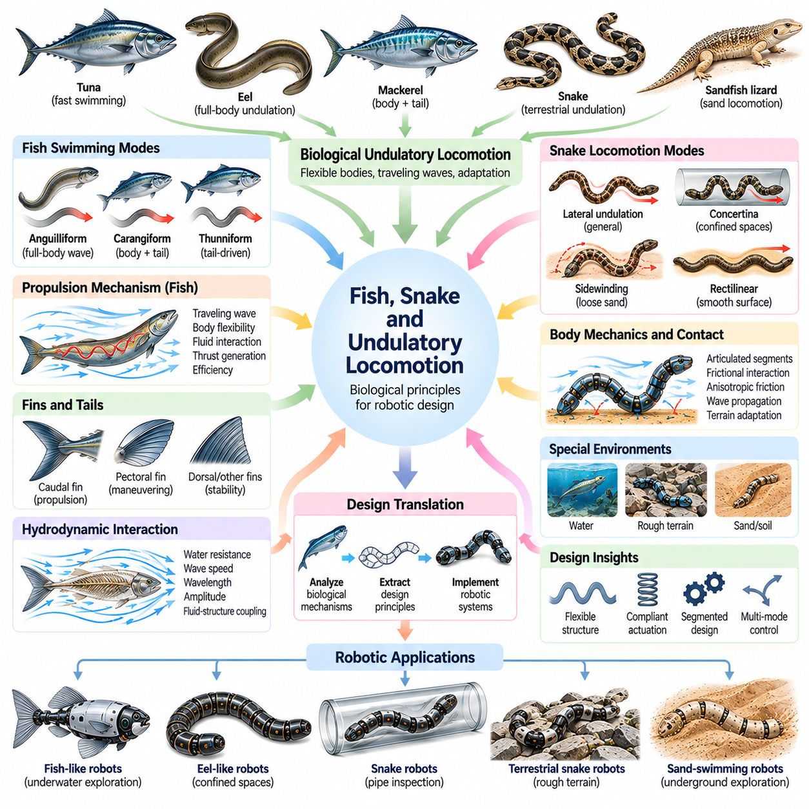
Fish, snakes, and other undulatory animals provide valuable inspiration for robotic locomotion because they move through coordinated waves of body deformation rather than relying exclusively on articulated limbs. Their flexible bodies generate propulsion through interactions with water, soil, or surrounding surfaces. Studying these mechanisms helps engineers develop robots capable of navigating confined spaces, complex terrain, and fluid environments.
Undulatory locomotion involves the propagation of bending waves along an elongated body. These waves create distributed forces through interactions between the body and its environment, producing forward movement or directional changes. The resulting motion depends on body flexibility, wave amplitude, frequency, and environmental resistance. Robotic systems reproduce these principles using articulated segments, compliant structures, and coordinated actuation.
Fish demonstrate how body morphology and fluid interaction cooperate to generate efficient underwater propulsion. Many species produce traveling waves along their bodies while using fins to regulate stability and direction. The distribution of flexibility and muscle activity influences the resulting swimming motion. Fish-inspired robots investigate these relationships to develop propulsion mechanisms that reduce dependence on conventional rotating propellers.
Fish swimming strategies vary according to body geometry, habitat, and locomotion requirements. Anguilliform swimmers, such as eels, generate substantial bending along much of their bodies, while carangiform swimmers concentrate larger movements toward the posterior region. Thunniform swimmers emphasize tail-driven propulsion with relatively limited body bending. These distinctions provide alternative design principles for underwater robotic platforms.
The traveling wave in fish locomotion transfers mechanical energy through the body toward the surrounding fluid. Coordinated muscle activation produces lateral deformation, while fluid forces influence the resulting movement and propulsion. Wave speed, wavelength, and amplitude affect thrust generation and swimming efficiency. Robotic designers adjust these parameters through actuator coordination and mechanical compliance to achieve desired performance.
Fish tails and fins illustrate how specialized surfaces contribute to propulsion, maneuvering, and stabilization. Caudal fins generate substantial propulsive forces in many species, while pectoral and other fins support turning, braking, and posture regulation. Flexible fin surfaces deform under fluid loading and modify force distribution. Underwater robots can incorporate articulated or compliant fins to improve maneuverability and low-speed control.
The interaction between body flexibility and hydrodynamic loading is central to fish-inspired robotic design. Excessively rigid bodies may restrict useful deformation, while overly compliant structures can reduce motion precision or waste energy. Appropriate stiffness distributions allow passive deformation to complement active control. Engineers investigate variable-stiffness structures and compliant transmissions to balance propulsion efficiency, stability, and controllability.
Snake locomotion provides a contrasting example of undulatory movement through contact with solid environments. Snakes coordinate lateral body bending with distributed frictional forces to generate propulsion across the ground. Their elongated morphology allows them to navigate narrow passages and irregular obstacles. Snake-inspired robots adopt serially articulated bodies to achieve mobility in environments inaccessible to conventional wheeled platforms.
Lateral undulation is a common snake locomotion mode in which bending waves travel along the body while contact forces generate forward movement. Effective propulsion depends on anisotropic friction, surface irregularities, and appropriate body coordination. Robotic implementations use repeated joint movements to produce traveling curvature patterns. Their performance depends strongly on terrain properties and the mechanical characteristics of body contact.
Snakes also employ alternative locomotion modes when environmental conditions change. Concertina locomotion alternates between anchoring and extending body sections, supporting movement through narrow passages. Sidewinding uses coordinated lifting and contact patterns to move across loose substrates. Rectilinear locomotion involves relatively straight body movement through specialized muscular and skin interactions. These strategies inspire adaptable robotic gait libraries.
Sidewinding is particularly relevant to robots operating on sand or other yielding terrain. By coordinating horizontal and vertical body waves, snakes create localized contact regions while lifting other sections away from the ground. This movement can reduce unwanted slipping and improve locomotion on difficult substrates. Robotic sidewinders reproduce related patterns through spatially coordinated joint trajectories and controlled ground contact.
Snake-inspired robots offer advantages for inspection, exploration, and search operations in constrained environments. Their narrow bodies can enter pipes, rubble gaps, and confined industrial spaces while distributing contact across multiple segments. Articulated structures permit bending around obstacles and adjusting posture within restricted passages. However, mechanical complexity, friction management, and reliable sensing remain significant engineering challenges.
Undulatory locomotion also appears in organisms that move through soil or other deformable media. Sandfish lizards, for example, use body undulation to move beneath granular surfaces, where surrounding particles exhibit complex resistance behavior. Their movement demonstrates how locomotion mechanisms must adapt to environmental mechanics. Robotic systems inspired by such organisms investigate subsurface mobility and interaction with granular materials.
Central pattern generators provide a useful control principle for coordinating rhythmic undulatory motion. Coupled oscillators can produce traveling phase relationships across successive body segments, generating continuous bending waves. Sensory feedback modifies these patterns in response to contact, resistance, or environmental disturbances. Robotic controllers combine rhythmic coordination with adaptive feedback to improve movement across changing conditions.
The mechanical architecture of an undulatory robot strongly influences its available locomotion patterns. Joint spacing, rotational axes, segment lengths, actuator placement, and body compliance determine achievable curvature and force transmission. Robots with multiple degrees of freedom can generate three-dimensional body waves, while simpler planar mechanisms support restricted motion patterns. Morphological design must therefore match the intended environment and movement strategy.
Environmental sensing is essential for effective undulatory locomotion because propulsion depends on distributed physical interaction. Joint encoders, force sensors, inertial measurements, and external perception systems provide information about body configuration and contact conditions. Controllers use these observations to adjust wave parameters and movement direction. This integration supports adaptive locomotion when environmental resistance cannot be predicted accurately.
Energy efficiency in undulatory robots depends on the relationship between mechanical design, actuation, and environmental forces. Repeated bending requires energy, but elastic structures can temporarily store and return mechanical energy during motion. Properly coordinated deformation may reduce unnecessary resistance and improve propulsion. Engineers evaluate efficiency through power consumption, forward speed, transport cost, and mechanical losses.
Computational modeling helps explain the complex interactions underlying fish- and snake-inspired locomotion. Hydrodynamic simulations describe fluid forces around swimming bodies, while frictional contact models characterize terrestrial movement. Granular interaction models support analysis of motion through sand or soil. These tools enable systematic investigation of morphology, control parameters, and environmental conditions before physical experimentation.
Experimental validation remains necessary because biological locomotion involves nonlinear interactions that simplified models may not fully capture. Robotic prototypes are evaluated through swimming trials, terrain traversal, obstacle negotiation, and disturbance-response experiments. Performance measurements include speed, maneuverability, stability, energy consumption, and environmental adaptability. Such testing reveals whether biological principles provide practical engineering advantages.
Within Physical AI, fish, snake, and undulatory locomotion demonstrate how distributed body deformation can function as an integrated mechanism for propulsion and environmental interaction. These systems emphasize the relationship between morphology, material properties, rhythmic control, and physical feedback. Translating their principles into robotics enables adaptable platforms for underwater exploration, confined-space inspection, and movement through challenging terrain.

10.07. Muscle Tendon and Compliance Inspiration
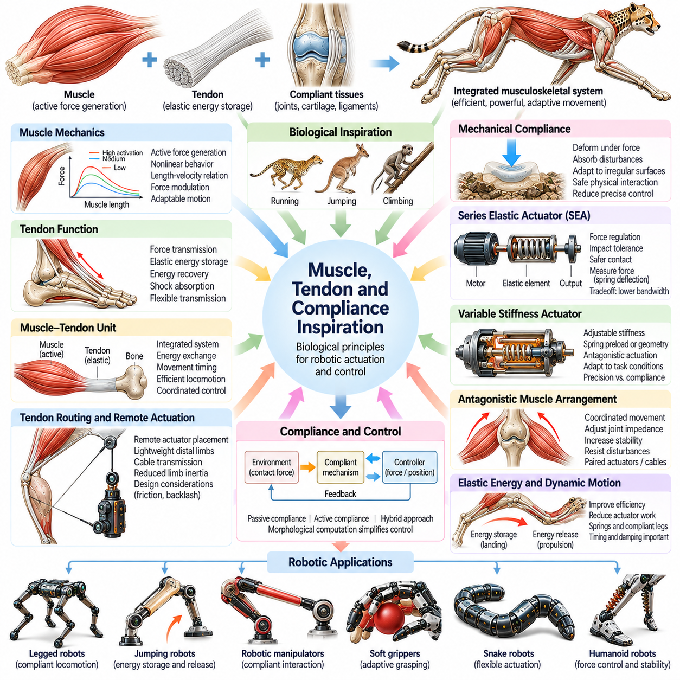
Biological muscles, tendons, and compliant tissues provide essential inspiration for robotic actuation because they combine force generation, energy storage, shock absorption, and mechanical adaptability. Unlike rigid transmission systems, biological structures continuously deform under changing loads. Their mechanical properties contribute directly to movement control. Understanding these relationships helps engineers develop robots that interact safely and efficiently with uncertain physical environments.
Skeletal muscles generate movement by converting chemical energy into mechanical force through coordinated contraction. Their force output depends on activation, muscle length, and contraction velocity. These relationships produce nonlinear behavior that differs from conventional electric motors. Robotic designers study muscle mechanics to develop actuators and controllers that reproduce useful force modulation, adaptable motion, and dynamic interaction capabilities.
Tendons connect muscles to skeletal structures and transmit forces across joints. Although tendons do not actively generate mechanical power, their elasticity allows temporary storage and release of strain energy. This behavior contributes to efficient locomotion and dynamic movement. Tendon-inspired robotic mechanisms employ elastic elements and flexible transmissions to improve force distribution, reduce impact loading, and support energy recovery.
The muscle-tendon unit operates as an integrated mechanical system rather than two independent components. Muscle contraction controls force production, while tendon deformation influences movement timing and energy exchange. During locomotion, elastic tendons can stretch under load and recoil during propulsion. Robotic actuation systems can reproduce selected aspects of this interaction through coordinated motor control and carefully designed elastic transmissions.
Mechanical compliance describes the ability of a structure to deform in response to applied forces. In biological organisms, compliance emerges from muscles, tendons, ligaments, cartilage, and soft tissues. These components influence how contact forces propagate through the body. Robotic systems incorporate compliance to accommodate geometric uncertainty, absorb disturbances, and reduce the need for extremely precise position control during physical interaction.
Compliance can be implemented through passive mechanical elements or actively controlled actuator behavior. Passive compliance uses springs, flexible materials, and elastic structures to produce deformation without continuous computation. Active compliance modifies actuator response through force feedback and control algorithms. Hybrid approaches combine both mechanisms, allowing robots to exploit predictable mechanical behavior while adjusting interaction characteristics to changing tasks.
Series elastic actuators provide a prominent example of biologically inspired robotic actuation. An elastic element is positioned between the motor transmission and the output load, enabling controlled deformation under external forces. Measuring this deformation allows estimation of transmitted force when spring characteristics are known. Such actuators support force regulation, impact tolerance, and safer contact, although elasticity can limit bandwidth and positioning precision.
Variable stiffness actuators extend compliant actuation by allowing mechanical stiffness to change during operation. Biological muscles achieve related functionality through activation patterns and interactions among opposing muscle groups. Robotic mechanisms can adjust spring preload, transmission geometry, or antagonistic actuator forces to modify joint stiffness. This adaptability supports different requirements for precision, energy efficiency, and disturbance resistance.
Antagonistic muscle arrangements provide another important principle for robotic joint design. In biological joints, opposing muscle groups coordinate to produce movement while regulating joint impedance. Simultaneous activation can increase resistance to disturbances without necessarily producing substantial net motion. Robotic systems reproduce aspects of this behavior through paired actuators, cable-driven mechanisms, and controllable elastic elements.
Biological tendon routing demonstrates how actuator placement and mechanical transmission influence morphology. Muscles can remain near the body while tendons transmit forces toward distal joints, reducing moving mass in the limbs. This arrangement supports rapid and efficient movement in many animals. Tendon-driven robots use cables and remote actuators to achieve similar benefits, while accounting for friction, backlash, cable stretch, and maintenance requirements.
Elastic energy storage is particularly important in running and jumping. During landing or stance, compliant structures absorb mechanical energy that may subsequently contribute to propulsion. This process can reduce actuator work under suitable movement conditions. Robotic legs incorporate springs, compliant feet, and elastic transmissions to exploit energy recovery, but actual efficiency depends on damping, timing, and the relationship between stiffness and gait dynamics.
Biological compliance also improves contact stability by accommodating irregular surfaces and unexpected obstacles. Soft tissues distribute loads across contact regions, reducing localized pressure and mechanical stress. In robotics, compliant grippers, flexible feet, and deformable contact pads provide similar advantages. These structures can improve grasp reliability, terrain adaptation, and physical interaction without requiring complete knowledge of environmental geometry.
The relationship between compliance and control is central to morphological computation. Appropriate mechanical properties can produce useful responses to disturbances before higher-level control systems react. Elastic structures may stabilize certain motions or distribute contact forces automatically. However, passive mechanics cannot replace sensing and feedback in every situation. Effective robotic designs coordinate mechanical behavior with active control to achieve reliable performance.
Muscle-inspired actuation also motivates research into artificial muscles and soft actuators. Pneumatic artificial muscles generate contraction through pressure-driven deformation, while dielectric elastomers and other smart materials can produce movement through electrical or physical stimulation. These technologies offer different combinations of flexibility, force, speed, and efficiency. Their practical application depends on power requirements, durability, controllability, and integration constraints.
Within Physical AI, muscle, tendon, and compliance inspiration demonstrates that intelligent physical behavior depends on more than computational control. Material properties, elastic transmissions, actuator arrangements, and mechanical geometry shape how robots respond to forces and environmental contact. Integrating these biological principles with sensing, learning, and feedback control supports robotic systems that are more adaptable, energy-aware, and physically resilient.

10.08. Reflexes and Central Pattern Generators
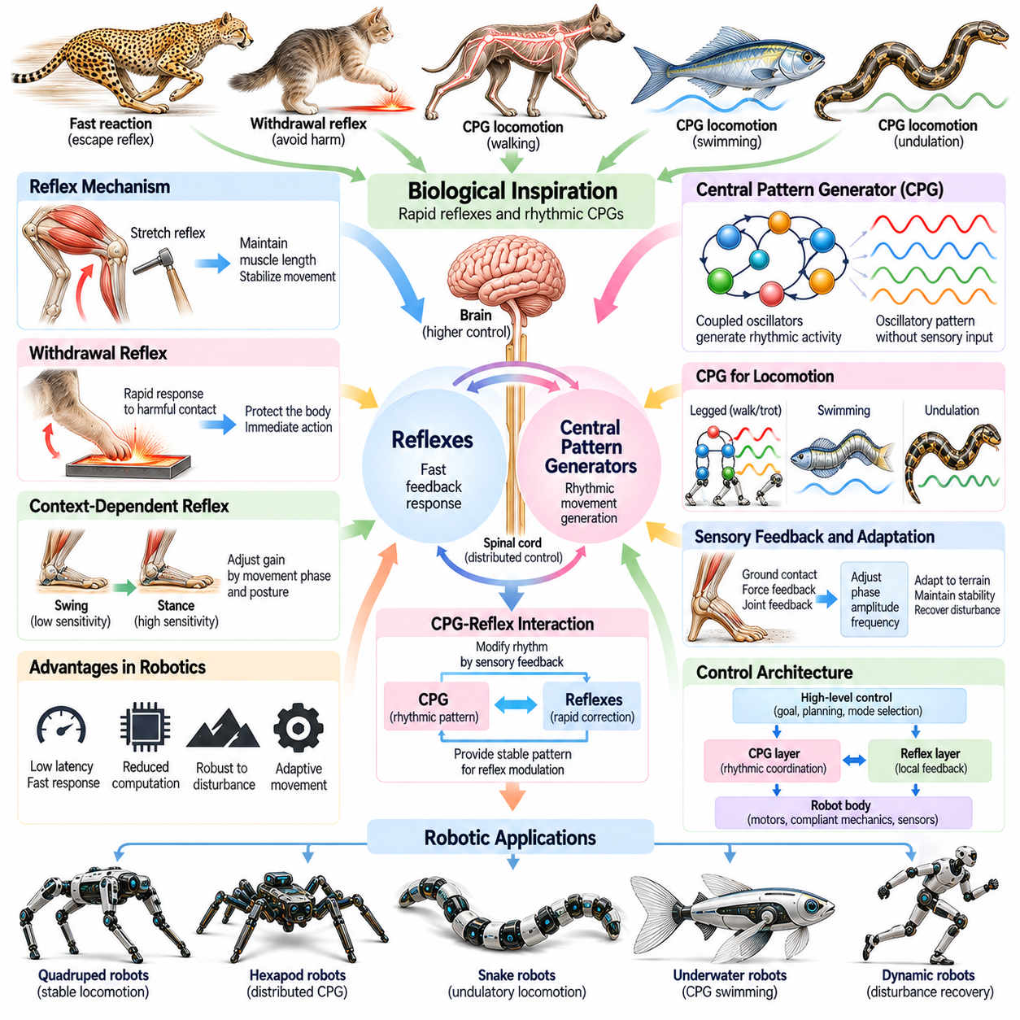
Biological reflexes and central pattern generators provide important inspiration for robotic control because they demonstrate how coordinated movement can emerge from distributed neural circuits. Animals perform rapid protective reactions and rhythmic locomotion without explicitly planning every muscle contraction. These mechanisms reveal how local feedback and internally generated patterns can support stable, adaptive behavior in complex physical environments.
Reflexes are rapid sensorimotor responses that connect sensory information to motor activity through relatively direct neural pathways. Stretch reflexes help regulate muscle length, while withdrawal reflexes protect the body from potentially harmful contact. Such responses operate alongside higher-level nervous system functions. Robotic reflex controllers apply comparable principles to produce immediate corrective actions when unexpected physical interactions occur.
The functional advantage of reflex control lies in reducing response delays and computational demands. Instead of waiting for a complete environmental model or complex motion plan, a robot can respond directly to selected sensory events. Contact forces, joint displacement, or sudden acceleration may trigger predefined corrective behavior. This approach is particularly useful for balance recovery, collision response, and maintaining stable physical interaction.
Biological reflexes are not simply fixed reactions independent of context. Their sensitivity and strength can change according to posture, movement phase, and behavioral objectives. During locomotion, the same sensory input may produce different responses depending on whether a limb is supporting body weight or moving forward. Robotic systems can reproduce this flexibility through state-dependent feedback gains and context-sensitive reflex policies.
Central pattern generators, commonly called CPGs, are neural circuits capable of producing rhythmic activity without requiring rhythmic sensory input. They contribute to repetitive biological movements such as walking, swimming, and certain respiratory motions. Their activity can organize coordinated muscle activation across multiple body segments. In robotics, artificial CPGs provide a structured mechanism for generating periodic joint trajectories and locomotion rhythms.
The fundamental operation of a CPG involves interacting neural elements that produce sustained oscillatory patterns. Biological networks may contain excitatory and inhibitory connections that establish alternating activity between muscle groups. Artificial implementations frequently use coupled mathematical oscillators or simplified neural models. These systems represent rhythmic behavior through variables such as phase, amplitude, frequency, and coupling strength.
Coupled oscillators are particularly useful for coordinating multiple robotic limbs or body segments. Each oscillator represents a local rhythmic process, while coupling relationships regulate timing differences between neighboring units. Appropriate phase relationships can generate walking, trotting, bounding, or traveling body waves. By modifying oscillator parameters, robotic controllers can transition between locomotion patterns without constructing every movement from individual commands.
The relationship between CPGs and sensory feedback is essential for adaptive locomotion. Although rhythmic activity can arise internally, biological movement is continuously modified by information from muscles, joints, and environmental contact. Sensory signals can adjust oscillation timing, amplitude, and phase. Robotic CPG controllers similarly integrate force measurements, joint feedback, and inertial sensing to adapt movement to terrain variations and disturbances.
Phase resetting illustrates how sensory information can synchronize rhythmic control with actual physical events. When a foot contacts the ground earlier or later than expected, feedback can modify the oscillator phase to maintain appropriate coordination. This mechanism reduces the mismatch between internally generated movement patterns and environmental conditions. Robotic locomotion systems use related strategies to improve contact timing and gait stability.
Reflexes and CPGs perform complementary functions within biological motor control. CPGs establish the underlying rhythm of repetitive movement, while reflex pathways provide rapid corrections to unexpected conditions. Their interaction enables rhythmic behavior to remain responsive rather than mechanically repetitive. Robotic controllers can combine oscillator-based trajectory generation with local feedback loops to achieve coordinated yet adaptable movement.
In legged robots, reflex-inspired mechanisms can regulate stance support, foot clearance, and recovery from disturbances. Load-sensitive feedback may strengthen support when a limb experiences increased contact force, while obstacle-related feedback can modify swing trajectories. These responses help maintain locomotion despite uncertain terrain geometry. Effective implementation requires careful tuning to avoid unstable interactions between reflex loops and global control objectives.
Quadruped and hexapod robots frequently benefit from distributed rhythmic coordination. Individual legs can follow locally generated movement patterns while exchanging timing information through oscillator coupling. This architecture supports coordinated gait generation without requiring a centralized controller to specify every joint movement. Nevertheless, global supervision remains important for selecting speed, direction, gait transitions, and operational safety constraints.
Undulatory robots provide another application of CPG-inspired control. Sequential phase differences between oscillators generate traveling bending waves along articulated bodies. These patterns can support fish-like swimming, snake-like crawling, and other continuous locomotion strategies. Adjusting phase relationships and oscillation amplitudes changes propulsion characteristics. Sensory feedback helps compensate for variations in fluid resistance or surface friction.
The morphology of a robot strongly influences the effectiveness of reflex and CPG control. Joint arrangement, body mass distribution, actuator dynamics, and mechanical compliance determine how rhythmic commands translate into physical movement. Elastic structures may reinforce useful oscillations or introduce unwanted resonance. Consequently, controller design should consider mechanical properties rather than treating the robot as an abstract collection of independently controlled joints.
Learning methods can extend biologically inspired motor control beyond fixed oscillator parameters and reflex thresholds. Reinforcement learning, adaptive optimization, and system identification can adjust gait frequency, coupling strength, and feedback sensitivity according to performance. Learned policies may supervise rhythmic controllers or modify their parameters online. Such combinations provide structured movement generation while retaining the capacity for experience-driven adaptation.
A major engineering challenge is ensuring stability when multiple feedback mechanisms interact. Reflex responses may conflict with rhythmic commands, while poorly tuned oscillator coupling can produce undesirable synchronization. Sensor delays, actuator saturation, and changing contact conditions further complicate control. Robust implementations require systematic analysis, parameter constraints, and testing across operating conditions rather than relying solely on biological analogy.
Computational simulation provides a useful environment for evaluating reflex and CPG architectures before physical deployment. Researchers can examine gait transitions, disturbance responses, energy consumption, and synchronization behavior under controlled conditions. Physical experiments then reveal effects that simplified models may overlook, including friction uncertainty and actuator limitations. Quantitative evaluation helps determine whether distributed rhythmic control improves practical robotic performance.
Reflex-based and CPG-based architectures also support hierarchical organization of robotic behavior. High-level planning can specify movement objectives, intermediate controllers can select rhythmic patterns, and local feedback mechanisms can regulate immediate physical interactions. This separation allows different control processes to operate at appropriate timescales. However, coordination between layers remains necessary to prevent contradictory commands and maintain task-level consistency.
Within Physical AI, reflexes and central pattern generators demonstrate how intelligent movement can emerge through interactions among neural-inspired control, body morphology, and environmental feedback. Their significance lies not in reproducing biological circuitry exactly, but in extracting principles of rhythmic coordination, rapid response, and distributed adaptation. Integrating these principles with perception, learning, and safety-aware control supports more responsive and resilient embodied robotic systems.

10.09. Evolutionary Morphology
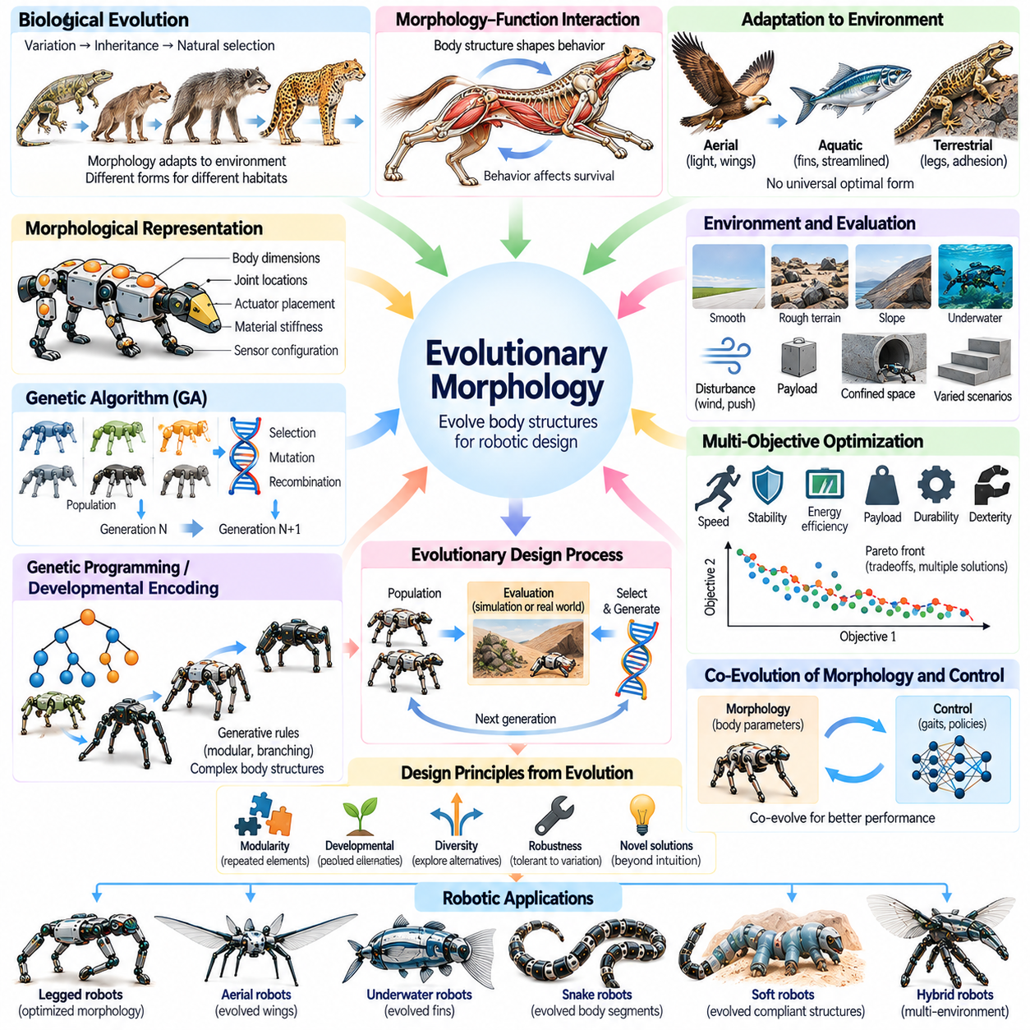
Evolutionary morphology examines how biological body structures emerge and change through variation, inheritance, and natural selection. Across generations, organisms develop morphological characteristics that influence survival and reproduction in particular environments. These processes provide inspiration for robotics by demonstrating how body geometry, materials, and movement mechanisms can adapt to functional demands rather than following a predetermined design.
Biological evolution does not produce universally optimal structures. Instead, it modifies existing organisms under environmental pressures, developmental constraints, and historical limitations. A morphology that performs effectively in one habitat may be unsuitable elsewhere. This principle is important for robotic engineering because successful body designs must be evaluated against specific tasks, operating conditions, and practical constraints rather than abstract ideals.
Evolutionary morphology reveals that biological form and function develop through continuous interaction. Limb proportions, joint arrangements, sensory structures, and tissue properties influence the behaviors available to an organism. These behaviors subsequently affect survival and reproductive success. Robotic designers can apply this perspective by treating morphology as an active contributor to performance rather than a fixed mechanical platform supporting an independent controller.
Natural selection provides a conceptual foundation for evolutionary optimization in robotics. Candidate designs can be evaluated according to performance objectives, and successful configurations can contribute characteristics to subsequent design generations. Computational evolutionary algorithms reproduce aspects of this process through selection, mutation, and recombination. These methods enable systematic exploration of complex morphological design spaces that may be difficult to optimize analytically.
A robotic morphology can be represented through parameters describing body dimensions, joint locations, actuator placement, material stiffness, and sensor configuration. Evolutionary search modifies these parameters to generate alternative physical designs. Each candidate is evaluated using simulation, analytical models, or experimental measurements. The resulting optimization process can reveal unexpected combinations of mechanical characteristics that improve task performance.
Genetic algorithms are commonly used to search morphological design spaces containing discrete and continuous variables. Candidate robots are encoded as parameter sets or structured representations, while fitness functions quantify relevant performance. Selection favors promising configurations, and variation operators introduce new alternatives. However, optimization results depend strongly on representation choices, evaluation accuracy, and the diversity maintained during search.
Genetic programming and developmental encodings offer alternative approaches to representing complex robot bodies. Instead of specifying every component independently, generative rules can describe repeated segments, branching structures, or modular arrangements. These representations can produce coordinated morphological variation with relatively compact descriptions. They are particularly relevant when exploring robots with variable numbers of limbs, joints, or structural modules.
The relationship between morphology and control is central to evolutionary robotics. A body configuration cannot be evaluated meaningfully without considering how it moves and interacts with its environment. Joint placement may improve mechanical leverage while requiring different control strategies. Co-evolutionary approaches therefore optimize physical structure and control parameters together, allowing useful combinations of embodiment and behavior to emerge through iterative evaluation.
Co-evolution can produce solutions that differ substantially from conventional engineering intuition. A robot may achieve effective locomotion through unusual limb proportions, asymmetric structures, or mechanically coupled movements. Such outcomes demonstrate the importance of exploring alternatives beyond familiar biological and industrial configurations. Nevertheless, discovered designs require physical validation because simulated advantages may depend on unrealistic assumptions.
Environmental diversity strongly influences the results of morphological evolution. A robot optimized exclusively for smooth terrain may perform poorly on slopes, loose substrates, or irregular obstacles. Evaluating candidates across multiple environments encourages designs with broader adaptability. Evolutionary robotics can therefore incorporate varied terrain conditions, disturbances, payloads, and operational scenarios when selecting robust morphological configurations.
Multi-objective optimization is particularly important because robotic morphology involves competing engineering requirements. Increasing structural strength may increase mass, while adding joints can improve dexterity but raise energy consumption and mechanical complexity. Evolutionary algorithms can explore tradeoffs among speed, stability, efficiency, payload capacity, and durability. Pareto-based methods identify configurations that represent different compromises rather than a single universal solution.
Biological evolution also demonstrates the importance of modularity and repeated structural patterns. Many organisms possess recurring anatomical elements that can be modified for different functions. Robotic systems can adopt modular architectures in which standardized components form diverse body configurations. Evolutionary search can investigate module arrangements, connectivity, and specialization while preserving manufacturing consistency and simplifying maintenance.
Developmental processes introduce another dimension to evolutionary morphology. Biological structures emerge through regulated growth rather than appearing as fully assembled final forms. Computational developmental models similarly transform compact design descriptions into complete robot geometries. This approach can support scalable complexity, coordinated structural patterns, and systematic variation, although developmental constraints may exclude potentially useful configurations.
Simulation plays a major role in evolutionary morphology because evaluating thousands of physical robot designs would be expensive and time-consuming. Physics-based environments estimate locomotion, structural loading, energy use, and interaction performance. Parallel computation allows large candidate populations to be examined efficiently. However, simulation fidelity must be balanced against computational cost, especially when flexible materials and complex contacts are involved.
The simulation-to-reality gap presents a major challenge for evolved robotic morphologies. Designs may exploit inaccuracies in friction models, actuator dynamics, material deformation, or collision handling. A configuration that performs exceptionally in simulation may fail when manufactured. Robust optimization, parameter randomization, and repeated physical testing help reduce this gap and identify designs whose advantages persist under real-world uncertainty.
Manufacturability is another essential constraint in evolutionary design. Algorithms may generate geometries that are difficult to fabricate, assemble, repair, or integrate with available actuators. Practical search procedures therefore incorporate limits on dimensions, material properties, component availability, and structural feasibility. Additive manufacturing and modular fabrication can expand the design space, but physical production requirements must remain part of the evaluation process.
Evolutionary morphology can also support adaptive and reconfigurable robotic systems. Modular robots may alter their structure to accommodate different tasks, while variable-stiffness mechanisms can modify mechanical behavior without changing overall geometry. Evolutionary optimization can identify useful configurations for particular environments and operating objectives. Such adaptation must account for reconfiguration time, energy consumption, reliability, and the complexity of mechanical transitions.
Within Physical AI, evolutionary morphology provides a framework for discovering relationships among embodiment, control, learning, and environmental interaction. It demonstrates that intelligent physical performance depends partly on selecting appropriate mechanical structures. By combining evolutionary search, physics-based simulation, multi-objective evaluation, and experimental validation, engineers can develop robotic morphologies that are increasingly specialized, adaptable, and effective in real-world tasks.

10.10. From Biological to Artificial Embodiment
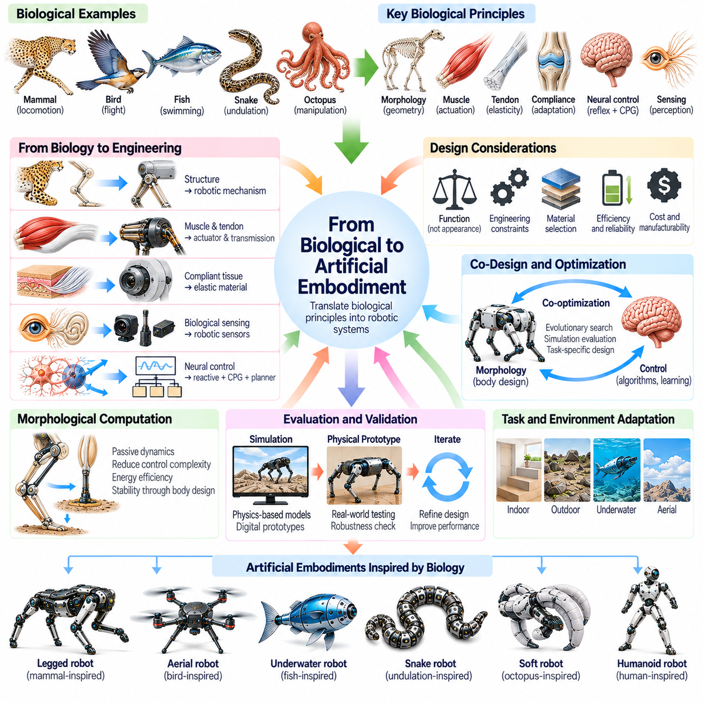
The transition from biological to artificial embodiment involves translating principles of living organisms into engineered systems capable of sensing, acting, and adapting within physical environments. Biological bodies integrate morphology, materials, neural control, and environmental interaction into functional systems. Artificial embodiment seeks to reproduce useful relationships among these elements without requiring exact anatomical replication or biological equivalence.
Biological inspiration begins with understanding the functional mechanisms underlying observable movement. Engineers examine how animals distribute forces, coordinate joints, exploit compliance, and respond to disturbances. The objective is to identify transferable principles rather than imitate external appearance. A successful robotic design may therefore differ significantly from its biological reference while preserving the mechanical or control advantages that motivated its development.
The distinction between biomimicry and bio-inspired engineering is important in artificial embodiment. Biomimicry emphasizes reproducing recognizable biological structures or mechanisms, whereas broader bio-inspired design extracts principles that can be implemented through different technologies. Both approaches can contribute to robotics, but engineering constraints determine their practical value. Biological similarity alone does not establish functional superiority.
Morphological translation requires mapping biological structures onto available robotic components. Muscles may correspond to electric, pneumatic, or artificial muscle actuators, while tendons may inspire cables and elastic transmissions. Biological joints can motivate articulated mechanisms, and compliant tissues can inform flexible structural materials. These mappings are functional approximations because artificial components rarely reproduce every property of their biological counterparts.
Material selection plays a fundamental role in translating biological embodiment into robotic systems. Living tissues combine elasticity, damping, strength, and adaptive remodeling in ways that conventional materials cannot fully duplicate. Engineers instead select metals, polymers, composites, and soft materials according to operational requirements. Hybrid structures can combine rigid load-bearing components with compliant interfaces to balance precision, durability, and adaptability.
Actuation architecture determines how artificial bodies generate and transmit mechanical power. Biological organisms use distributed muscles with complex force-length and force-velocity relationships, whereas robots often rely on motors and mechanical transmissions. Tendon-driven mechanisms, series elastic actuators, and variable stiffness systems bridge selected aspects of this difference. Their usefulness depends on controllability, energy efficiency, mechanical complexity, and maintenance requirements.
Artificial embodiment also requires translating biological sensing into engineered perception systems. Animals combine vision, touch, proprioception, vestibular information, and distributed mechanoreception to regulate movement. Robots approximate these functions through cameras, tactile sensors, encoders, force sensors, and inertial measurement units. Effective integration requires appropriate sensor placement, calibration, synchronization, and interpretation of uncertain measurements.
Biological nervous systems demonstrate how local reflexes and distributed coordination can complement higher-level decision-making. Robotic architectures can reproduce this functional hierarchy through low-level feedback loops, rhythmic controllers, motion planners, and learned policies. Central pattern generators may organize locomotion, while reflex-inspired responses handle immediate disturbances. Higher-level intelligence then selects objectives and adapts behavior to task conditions.
The body itself contributes to artificial intelligence through morphological computation. Appropriate geometry, elasticity, and mechanical coupling can simplify control by producing useful physical responses without explicit calculation. Passive dynamics may support efficient locomotion, while compliant contact surfaces can stabilize manipulation. These benefits depend on matching mechanical properties to the intended environment rather than assuming that greater compliance always improves performance.
Biological systems demonstrate that morphology and control cannot be optimized independently. Limb proportions influence joint torque requirements, actuator placement affects inertia, and material stiffness changes interaction dynamics. Consequently, artificial embodiment benefits from integrated design processes that consider mechanical structure, sensing, actuation, and control together. This approach is commonly described as hardware-software co-design or embodiment-control co-optimization.
Evolutionary morphology provides another route from biological inspiration to artificial embodiment. Computational search can explore alternative body geometries, joint configurations, and material distributions using task-specific performance criteria. Co-optimization of morphology and control can reveal effective combinations that conventional design methods overlook. However, evolutionary results must satisfy manufacturing constraints and remain reliable beyond simulated evaluation conditions.
Simulation is essential for evaluating artificial embodiments before physical construction. Physics-based models can estimate structural loading, contact behavior, actuator performance, and movement efficiency across operating scenarios. Digital prototypes support rapid comparison of biological design principles and engineering alternatives. Nevertheless, simulation errors in friction, compliance, and actuator dynamics require experimental validation before performance claims can be trusted.
The transition to physical hardware introduces constraints absent from many biological analogies. Robots must accommodate batteries, electronics, wiring, thermal management, and maintainable mechanical assemblies. Their structures must withstand repeated loading while meeting cost and manufacturing requirements. These considerations can justify departures from biological morphology, including simplified joints, modular components, and alternative locomotion mechanisms.
Artificial embodiment must also address safety and reliability during environmental interaction. Biological organisms possess sophisticated protective responses and adaptive tissue properties that robots cannot automatically reproduce. Engineered systems therefore require force limits, collision detection, fault monitoring, and controlled recovery behavior. Compliance can reduce some contact hazards, but it must be combined with appropriate sensing, control, and operational safeguards.
Learning expands the capabilities of bio-inspired robotic bodies by allowing behavior to adapt beyond manually specified control rules. Reinforcement learning, imitation learning, and adaptive control can exploit the mechanical characteristics of a particular embodiment. Training across varied environments may improve robustness to disturbances and uncertain contacts. However, learned behavior must be evaluated for stability, generalization, safety, and dependence on training conditions.
Different robotic platforms illustrate that biological inspiration supports multiple forms of artificial embodiment. Humanoids draw from human musculoskeletal organization, quadrupeds exploit mammalian locomotion principles, and aerial robots borrow concepts from birds and insects. Soft robots incorporate compliant biological structures, while swimming and snake-like robots employ traveling body waves. Each platform selectively translates biological principles according to its intended function.
A general-purpose robotic body should not be judged solely by its resemblance to a biological organism. Its effectiveness depends on task coverage, energy consumption, physical robustness, manipulation capability, and adaptability to unfamiliar environments. Specialized biological mechanisms may offer exceptional performance within narrow conditions but limited versatility elsewhere. Artificial embodiment therefore requires explicit evaluation of the tradeoffs between specialization and general-purpose capability.
Within Physical AI, the transition from biological to artificial embodiment represents a shift from copying natural forms toward engineering integrated physical intelligence. Biological principles provide hypotheses about effective morphology, actuation, sensing, and control, while computational models and experiments determine their practical value. Combining these insights with learning and system-level optimization supports robotic bodies that can interact with the world more efficiently, safely, and adaptively.

