Volume 03. Embodiment and Morphology

Chapter 01. Embodied Intelligence

01.01. Defining Embodied Intelligence
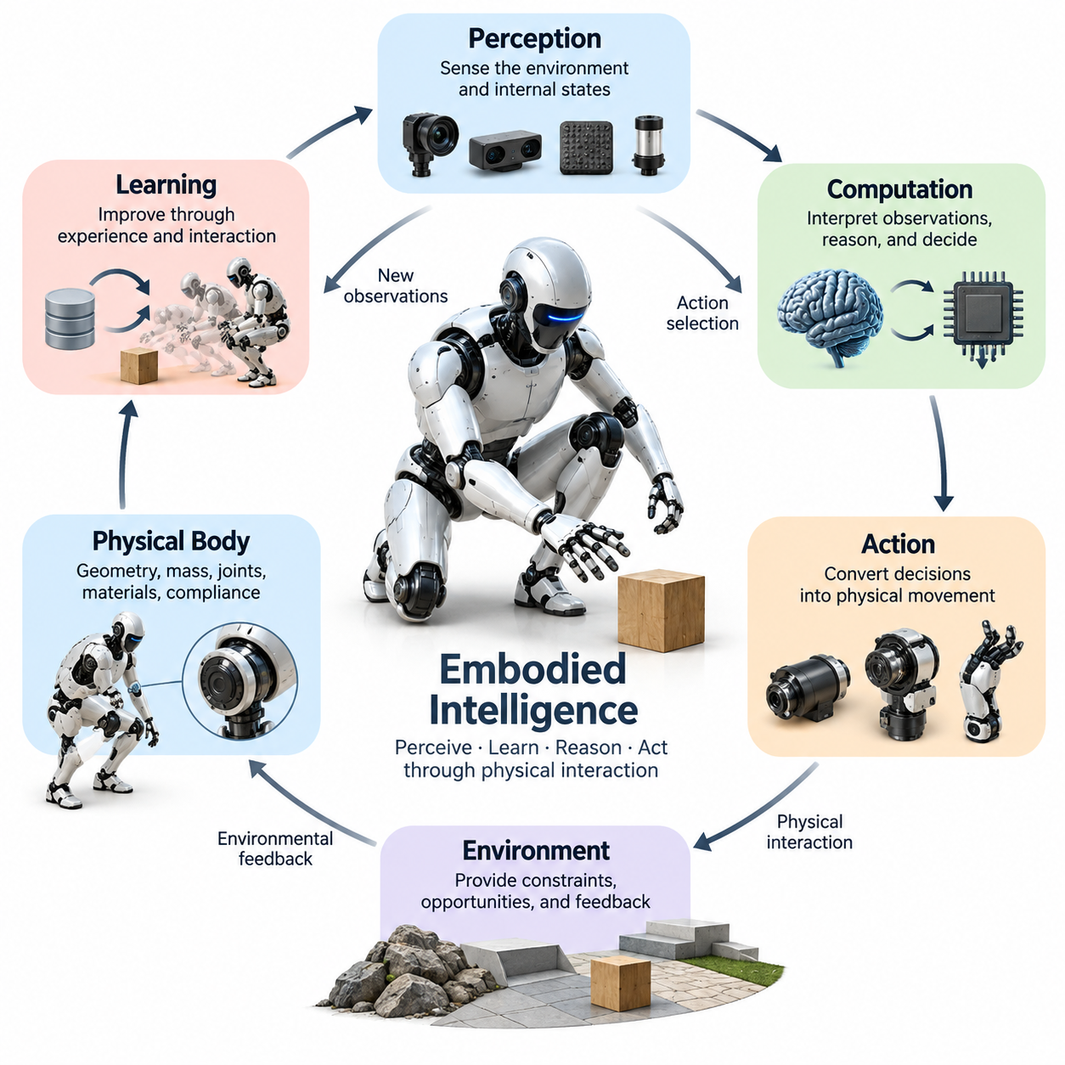
Embodied intelligence refers to the capacity of an intelligent agent to perceive, learn, reason, and act through continuous interaction between its physical body and the surrounding environment. Unlike intelligence understood primarily as abstract information processing, embodied intelligence emerges from the integration of computational processes, sensory experiences, mechanical structures, and physical actions within a dynamically changing world.
The central principle of embodied intelligence is that intelligent behavior cannot be fully understood by examining the computational system independently of its body. The physical structure determines how an agent receives information, produces movement, encounters constraints, and influences its environment. Consequently, intelligence is shaped not only by algorithms and learned representations but also by the physical conditions under which behavior occurs.
An embodied intelligent system consists of interconnected sensing, computation, actuation, and physical interaction capabilities. Sensors provide information about external conditions and internal states, while computational processes interpret observations and determine appropriate actions. Actuators transform control commands into physical movements, and the resulting environmental changes generate new sensory information that continuously influences subsequent decisions.
This continuous interaction establishes a perception-action loop in which sensing and movement operate as mutually dependent processes. Perception informs action selection, while actions determine what information becomes available through subsequent observations. An intelligent robot may reposition its camera to reduce visual uncertainty, adjust its grasp to evaluate contact stability, or move through an environment to improve its understanding of surrounding objects.
Embodied intelligence differs from conventional artificial intelligence approaches that treat perception, reasoning, and action as largely independent computational stages. Traditional architectures frequently assume that environmental information can be represented before decisions are executed. Embodied systems instead operate under incomplete observations, physical uncertainty, and continuously changing conditions, requiring perception and control to remain closely coordinated.
The physical body is therefore more than an execution mechanism for commands generated by an artificial intelligence model. Its geometry, mass distribution, joint configuration, material properties, and mechanical compliance directly influence the behaviors that can emerge. A robot equipped with flexible joints may absorb disturbances mechanically, while a rigid structure may require more explicit computational control to achieve comparable interaction stability.
The environment also participates in the generation of intelligent behavior by providing physical constraints, opportunities, and feedback. Gravity, friction, contact forces, terrain geometry, and object properties influence the outcomes of actions. An embodied agent must accommodate these conditions rather than treating them as irrelevant external variables, making environmental interaction a fundamental component of intelligent operation.
Biological organisms provide important examples of embodied intelligence because their nervous systems, sensory organs, muscles, and skeletal structures function as integrated systems. Human walking depends on neural control together with mechanical dynamics, balance responses, and environmental contact. Similarly, animals exploit body elasticity, distributed sensing, and physical adaptation to achieve complex behaviors without explicitly calculating every mechanical interaction.
The relationship between embodiment and intelligence becomes particularly evident in locomotion. A legged robot must coordinate its body configuration, joint torques, contact forces, and balance while moving across uneven terrain. Successful locomotion requires more than generating a sequence of joint commands because each movement changes the robot's physical state and alters the sensory conditions used to determine subsequent actions.
Manipulation provides another important illustration of embodied intelligence. When a robot grasps an unfamiliar object, visual information alone may be insufficient to determine its mass, friction, or mechanical properties. Through controlled contact, the robot can acquire tactile and force feedback, estimate interaction conditions, and modify its grasp. Knowledge about the object develops through physical engagement rather than passive observation alone.
Embodied intelligence also includes the ability to learn from the consequences of physical actions. By interacting with objects and environments, an agent can identify relationships between motor commands, sensory changes, and task outcomes. These experiences support the development of internal models, adaptive control strategies, and learned policies that improve performance under conditions not fully represented during initial training.
Learning in embodied systems is constrained by the physical characteristics of the agent. A wheeled mobile robot, a humanoid robot, a quadruped, and an aerial robot encounter different movement possibilities, sensing perspectives, and environmental limitations. Even when these platforms share similar computational architectures, their physical configurations produce distinct interaction experiences and require different strategies for achieving intelligent behavior.
This dependence on physical configuration introduces the concept of embodiment-specific intelligence. A behavior that is effective for one robotic morphology may be inefficient or physically impossible for another. For example, a humanoid robot can use articulated arms to manipulate elevated objects, whereas a mobile platform without manipulators cannot perform the same operation directly. Intelligent capability must therefore be evaluated relative to the body's available actions.
At the same time, embodied intelligence is not limited to a particular mechanical architecture or biological resemblance. Intelligent physical interaction can emerge in rigid industrial manipulators, autonomous mobile robots, compliant robotic hands, soft robotic structures, and aerial vehicles. The defining characteristic is the functional integration of perception, decision-making, physical action, and environmental feedback rather than any specific external appearance.
An important distinction exists between possessing a physical body and demonstrating embodied intelligence. A machine that repeatedly executes predetermined movements without adapting to changing conditions is physically embodied but may exhibit limited intelligent behavior. Embodied intelligence becomes more evident when the system uses sensory feedback, contextual understanding, and adaptive decision-making to respond appropriately to environmental uncertainty and task variation.
Autonomy represents a related but distinct dimension of embodied intelligence. An autonomous robot can select and execute actions without continuous human intervention, but the degree of autonomy depends on its perception, planning, learning, and control capabilities. Embodied intelligence provides mechanisms through which autonomy can become physically grounded, allowing decisions to reflect actual environmental conditions and the consequences of interaction.
The concept of situated intelligence further emphasizes that intelligent behavior occurs within a particular operational context. An action cannot always be evaluated independently of the environment in which it is performed. A grasping strategy suitable for a rigid industrial component may be inappropriate for a fragile object, while a locomotion policy effective on smooth flooring may fail on loose gravel or deformable terrain.
Embodied intelligence also challenges the assumption that increasingly sophisticated computation alone necessarily produces superior physical performance. Improvements in mechanical design, sensor placement, actuator characteristics, and material properties can substantially influence intelligent behavior. In some cases, appropriate physical structures simplify control requirements by naturally supporting stability, energy efficiency, or adaptation to environmental disturbances.
This observation establishes an important connection between embodied intelligence and morphological computation. Morphological computation describes how the physical characteristics and dynamics of a body can contribute to functions otherwise requiring explicit computational processing. Although the two concepts are not identical, morphological computation demonstrates why intelligent performance should be analyzed as a property of the complete physical system rather than its controller alone.
From an engineering perspective, embodied intelligence requires coordinated development across mechanical design, electronics, sensing, control theory, artificial intelligence, and environmental modeling. A high-performance learning algorithm cannot compensate for every limitation imposed by inadequate actuators or poorly positioned sensors. Likewise, advanced hardware cannot independently guarantee intelligent behavior without appropriate perception, reasoning, and feedback mechanisms.
Evaluating embodied intelligence consequently requires observing behavior under realistic physical conditions. Relevant measures include task completion, adaptability, interaction stability, energy consumption, robustness, and recovery from disturbances. Performance should be assessed across environmental variations because a system that succeeds only under narrowly controlled conditions may lack the adaptive capabilities associated with more general embodied intelligence.
A fundamental challenge is the transfer of learned behavior across tasks, environments, and robotic bodies. Physical differences alter sensor observations, action spaces, dynamics, and contact interactions, making direct transfer difficult. Generalization therefore requires representations and learning mechanisms that capture useful relationships while accounting for embodiment-specific constraints and the physical consequences of actions.
Embodied intelligence provides a conceptual foundation for Physical AI by explaining why artificial intelligence operating in the real world must integrate computational reasoning with physical embodiment. Physical AI extends these principles into engineered systems capable of sensing, understanding, and influencing their environments. Its effectiveness depends on how successfully perception, learning, decision-making, mechanical structure, and control operate as a unified system.
Ultimately, embodied intelligence should be understood as intelligence expressed and developed through physical interaction rather than intelligence merely installed inside a machine. The body shapes available actions, the environment determines their consequences, and computational processes adapt behavior through feedback and experience. This integrated perspective provides the foundation for understanding robot morphology, morphological computation, adaptive control, and increasingly capable Physical AI systems.

01.02. Embodied Cognition and Situated Intelligence
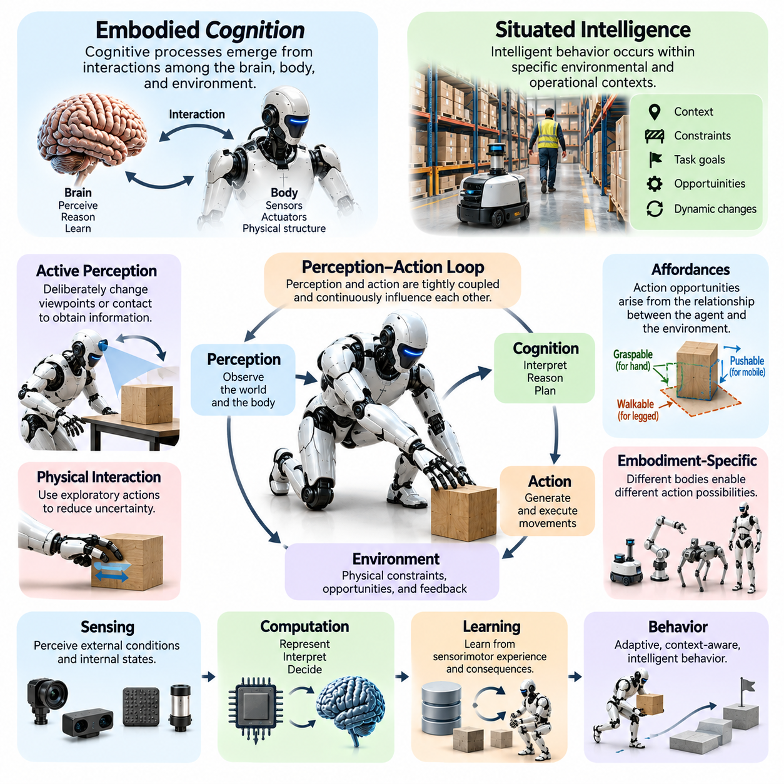
Embodied cognition is a theoretical perspective that explains cognitive processes as emerging from interactions among the brain, body, and environment. Rather than treating cognition as isolated symbolic computation, it emphasizes how perception, movement, bodily constraints, and physical experiences influence reasoning and learning. Intelligence is therefore understood as an activity grounded in the agent's capacity to interact with the world.
Situated intelligence extends this perspective by emphasizing that intelligent behavior occurs within specific environmental and operational contexts. An agent does not make decisions independently of its surroundings but responds to available information, physical constraints, task objectives, and interaction opportunities. The meaning and effectiveness of an action depend on the circumstances in which it is performed and the consequences it produces.
Traditional cognitive architectures often describe intelligence as a sequence of perception, internal representation, reasoning, and action. Embodied cognition challenges the assumption that these processes must always operate as separate stages. In many physical tasks, perception and action are tightly coupled, allowing an agent to respond continuously to environmental changes without constructing a complete internal representation before every movement.
The relationship between embodied cognition and situated intelligence becomes clear when considering how humans interact with everyday objects. Reaching for a cup involves visual perception, body positioning, motor coordination, and expectations about the object's physical properties. The surrounding environment influences the movement, while the body's capabilities determine which actions are practical and how they can be performed.
A fundamental concept in embodied cognition is that the body contributes directly to cognitive processing. Sensory systems, joint configurations, muscle dynamics, and physical feedback influence how information is acquired and interpreted. In robotics, the placement of cameras, the structure of manipulators, and the availability of tactile sensors shape the information accessible to learning algorithms and the strategies available for solving tasks.
Situated intelligence emphasizes the importance of environmental context in determining appropriate behavior. A mobile robot navigating a warehouse must consider moving workers, temporary obstacles, floor conditions, and operational priorities. A navigation strategy suitable for an empty corridor may become unsafe in a crowded workspace. Intelligent behavior therefore requires continuous adjustment to the conditions surrounding the agent.
The concept of affordances provides an important connection between embodied cognition and situated intelligence. An affordance represents an opportunity for action arising from the relationship between an agent's capabilities and environmental properties. A surface may support walking for a humanoid robot but remain inaccessible to a wheeled platform. The same physical object can therefore provide different action possibilities for different embodiments.
Affordances are not simply fixed properties of objects because they depend on the agent's morphology, capabilities, and current state. A handle may be graspable by a dexterous robotic hand but inaccessible to a large industrial gripper. Similarly, a narrow passage may be traversable by a compact mobile robot but unsuitable for a larger platform. Perception must therefore identify actionable relationships rather than merely classify environmental objects.
Embodied cognition also recognizes that physical interaction can simplify cognitive requirements. Instead of calculating every possible outcome internally, an agent may use exploratory movements to obtain additional information. A robot can gently push an unfamiliar object to estimate its mobility or adjust its fingers to determine grasp stability. These actions transform uncertainty into observable feedback and support more informed decisions.
This approach highlights the role of active perception, in which an intelligent agent deliberately changes its sensory conditions to improve understanding. A mobile robot may move around an obstacle to reveal hidden geometry, while a manipulator may rotate an object to inspect an occluded surface. Perception becomes an interactive process guided by task requirements, rather than passive reception of sensory measurements.
Situated intelligence is closely associated with real-time interaction because environmental conditions can change faster than extensive deliberative reasoning can be completed. Robots operating around people, vehicles, or moving machinery must frequently update their behavior using immediate sensory feedback. Reactive control mechanisms can complement higher-level planning by providing rapid responses to disturbances and unexpected events.
The interaction between reactive behavior and deliberative reasoning is particularly important in embodied systems. Reactive mechanisms support immediate responses, while deliberative processes enable prediction, planning, and long-term goal management. Effective embodied intelligence integrates these capabilities so that an agent can respond quickly to local conditions while maintaining consistency with broader task objectives and operational constraints.
Embodied cognition also influences how intelligent agents acquire knowledge. Physical experience provides information about object properties, movement consequences, spatial relationships, and causal interactions. Through repeated sensorimotor experiences, a robot can learn how its actions affect the environment. Such knowledge is grounded in observable consequences rather than relying exclusively on abstract descriptions or predefined symbolic rules.
The concept of sensorimotor contingencies further explains how perception depends on relationships between actions and sensory changes. When an agent moves its body or sensors, predictable transformations occur in the incoming observations. Learning these relationships allows the system to distinguish self-generated changes from external events and develop more reliable representations of environmental structure and physical interaction.
The physical morphology of an agent strongly influences its situated cognitive capabilities. A humanoid robot can exploit human-oriented infrastructure, including stairs, handles, and work surfaces, while a quadruped may achieve greater stability across irregular terrain. These differences affect not only mechanical performance but also the agent's available actions, perceptual experiences, and strategies for accomplishing tasks.
Environmental structure can also function as an external resource for cognition. Rather than maintaining every detail in internal memory, an agent may rely on stable landmarks, object arrangements, and environmental cues to guide behavior. A warehouse robot can use recognizable shelf locations to support navigation, while a manipulation system can exploit fixtures and work surfaces to simplify object positioning and assembly operations.
This perspective introduces the idea of distributed cognitive processing, where intelligent behavior depends on coordinated contributions from internal computation, bodily dynamics, and environmental structure. The environment does not necessarily perform explicit computation, but its physical organization can reduce planning complexity and constrain possible actions. Intelligence can therefore emerge through interactions extending beyond the computational controller.
Embodied cognition has important implications for artificial intelligence learning architectures. Models trained exclusively on static images or textual descriptions may acquire useful semantic knowledge but lack direct experience of physical consequences. Embodied learning introduces action-dependent observations, contact dynamics, and feedback from task execution, allowing learned representations to become more closely connected to real-world behavior.
Reinforcement learning provides one computational approach for studying situated intelligence because an agent improves its policy through interaction with an environment. However, successful learning depends on the relationship between observations, available actions, physical dynamics, and reward structures. A policy learned in simulation may require adaptation when deployed on hardware with different friction, latency, compliance, or sensing characteristics.
Generalization remains a major challenge because situated behavior is influenced by the specific conditions under which learning occurs. A robot trained to manipulate objects on a fixed workbench may struggle when object positions, lighting, materials, or contact conditions change. Robust embodied cognition requires learning representations and control strategies that preserve useful relationships across varying environments and physical configurations.
Embodied cognition also provides a framework for understanding human-robot interaction. Robots operating alongside people must interpret gestures, movements, spatial relationships, and social context while respecting physical safety constraints. Their behavior must account for how humans perceive robotic motion and how shared environments influence expectations. Intelligent interaction therefore involves both physical coordination and contextual interpretation.
Evaluating situated intelligence requires examining how effectively an agent adapts its behavior to changing circumstances. Task success alone may be insufficient if performance depends on narrowly controlled environmental conditions. Relevant evaluation dimensions include adaptability, robustness, response latency, interaction safety, recovery capability, and the ability to exploit environmental opportunities while respecting physical constraints.
For Physical AI, embodied cognition and situated intelligence establish complementary foundations for designing systems that operate meaningfully in the physical world. Embodied cognition explains how bodily structure and sensorimotor experience contribute to intelligence, while situated intelligence explains how environmental context shapes appropriate behavior. Together, they support architectures that integrate perception, reasoning, learning, and action.
Ultimately, embodied cognition and situated intelligence challenge the view that intelligence can be understood solely as computation performed independently of physical existence. Intelligent behavior develops through the continuous relationship between an agent's internal processes, bodily capabilities, and surrounding environment. This perspective provides a foundation for developing adaptive, context-aware, and physically grounded robotic systems capable of operating in complex real-world conditions.

01.03. Body as Part of the Intelligent System
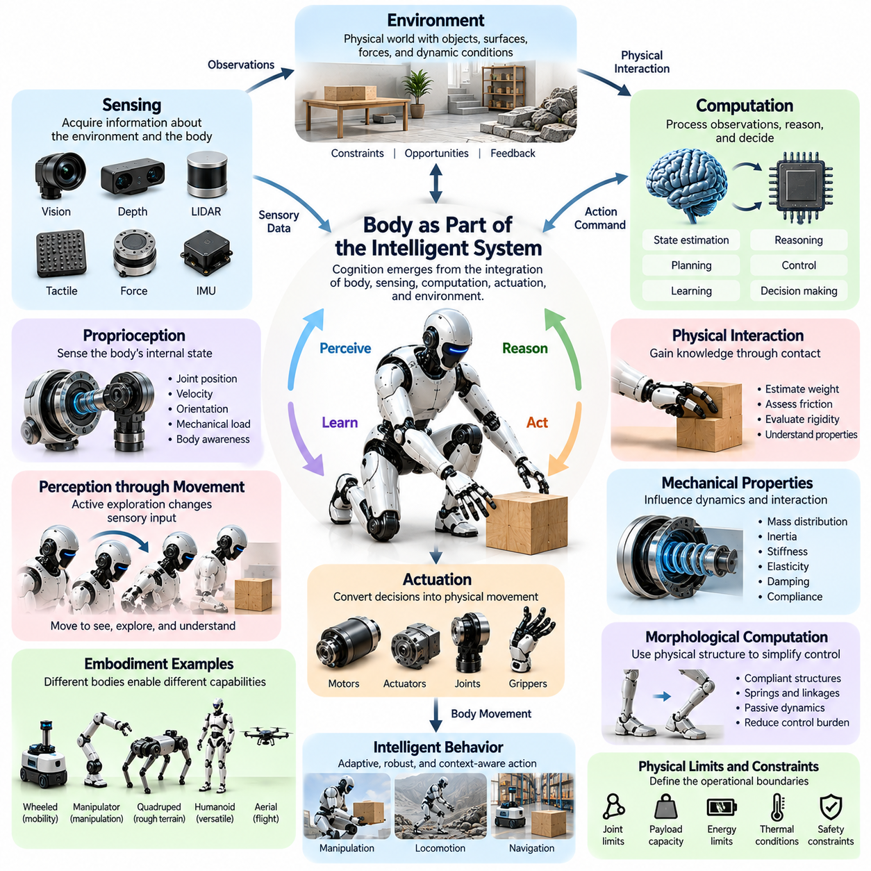
The physical body is an integral component of an intelligent system rather than a passive mechanism that executes computational commands. In embodied intelligence, cognition emerges through coordinated interactions among computational processes, sensory systems, actuators, mechanical structures, and the environment. The body's physical characteristics influence how information is acquired, how actions are performed, and how intelligent behavior develops through experience.
Traditional artificial intelligence architectures often distinguish the computational controller from the physical platform it operates. The controller processes observations, generates decisions, and sends commands to mechanical components. Although this separation simplifies system design, it can obscure the contribution of physical structure to intelligent behavior. Embodied intelligence instead treats the body and controller as interdependent elements of a unified system.
The body determines the range of actions available to an intelligent agent through its geometry, joint configuration, degrees of freedom, and actuator capabilities. A robotic manipulator can reach and grasp objects only within its mechanical workspace, while a mobile robot must operate within the movement constraints imposed by its locomotion mechanism. These physical limitations shape planning, learning, and decision-making before any computational policy is executed.
Mechanical properties also influence how the body responds to environmental forces. Mass distribution, inertia, stiffness, elasticity, damping, and compliance determine the dynamics of movement and contact. A compliant robotic arm may absorb unexpected contact forces through mechanical deformation, whereas a rigid manipulator may require active force control. The body's physical response therefore contributes directly to interaction stability and behavioral robustness.
The relationship between sensing and physical structure is equally important. Sensor placement, orientation, field of view, and mechanical integration determine which environmental information becomes observable. A camera mounted on a movable robotic head provides different perceptual opportunities from a fixed camera. Similarly, tactile sensors embedded in robotic fingers enable direct observation of contact conditions that cannot always be inferred from vision alone.
Proprioception allows an intelligent system to estimate its own physical configuration and movement. Joint encoders, inertial measurement units, force sensors, and other internal sensing mechanisms provide information about position, velocity, orientation, and mechanical loading. These measurements support body awareness, enabling the controller to relate external observations to the robot's current physical state and available movement capabilities.
The body also participates in perception by determining how sensory information changes during movement. When a robot rotates its head, extends an arm, or shifts its position, the resulting observations depend on its physical configuration. Such action-dependent sensory changes provide information about spatial relationships, object geometry, and environmental structure. Perception is therefore influenced by the body's ability to actively explore its surroundings.
Physical interaction creates opportunities for intelligence that cannot be achieved through passive observation alone. A robot manipulating an unfamiliar object can estimate its weight, friction, and rigidity through controlled contact. These measurements emerge from the interaction between the robot's mechanical structure and the object's physical properties. The body becomes an instrument for acquiring knowledge through direct experimentation with the environment.
The concept of morphological computation explains how physical structures can contribute to functions that would otherwise require explicit computational control. Springs, compliant joints, flexible materials, and mechanical linkages can naturally regulate forces, filter disturbances, or coordinate movement. Although these mechanisms do not replace intelligent control, they can reduce computational requirements by exploiting the physical dynamics of the body.
Passive dynamic walking illustrates how mechanical design can support intelligent movement. Appropriately configured leg structures may produce walking-like motion under suitable gravitational and contact conditions with limited active control. This demonstrates that locomotion behavior can arise partly from mechanical dynamics rather than exclusively from calculated joint trajectories. Active controllers can then exploit these natural dynamics to improve efficiency and stability.
The body's morphology also influences the complexity of learning. A robot with an appropriately designed mechanical structure may require fewer control adjustments to achieve stable behavior. Conversely, an unsuitable morphology may introduce difficult control problems even when sophisticated learning algorithms are available. The effectiveness of an intelligent policy therefore depends partly on whether the physical design supports the intended task.
Different robotic embodiments create distinct relationships between physical structure and intelligence. Wheeled robots exploit rolling contact for efficient movement on suitable surfaces, while quadrupeds use articulated legs to negotiate irregular terrain. Humanoid robots provide manipulation and locomotion capabilities compatible with many human environments. Aerial robots depend on aerodynamic forces and propulsion arrangements that impose different sensing and control requirements.
The body also establishes the physical boundaries within which an intelligent agent must operate. Joint limits, actuator torque, payload capacity, structural strength, thermal conditions, and energy availability constrain feasible actions. Intelligent planning must respect these boundaries to avoid unsafe or ineffective behavior. A controller that ignores the body's physical limitations may generate commands that are computationally valid but mechanically impossible.
Energy efficiency provides another example of the body's contribution to intelligent performance. Mechanical transmission, actuator placement, structural mass, and elastic energy storage influence the energy required for movement. A robot designed to exploit natural dynamics may accomplish a task with lower energy consumption than a mechanically inefficient platform using a more sophisticated controller. Intelligence and physical efficiency must therefore be considered together.
Body awareness becomes especially important when an agent interacts with external loads or changing environments. Carrying a payload modifies mass distribution, inertia, and balance requirements. Contact with uneven terrain changes the forces acting on the robot. An intelligent system must estimate these changes and adapt its control strategy accordingly, demonstrating that cognition depends on an evolving understanding of the body's physical condition.
The integration of body and intelligence also affects how robots recover from disturbances. Mechanical compliance may absorb part of an unexpected impact, while sensors detect the resulting motion and controllers generate corrective actions. Recovery emerges from the combined contribution of passive physical responses and active computational regulation. Robust behavior therefore depends on the coordination of mechanical design, sensing, and control.
In manipulation tasks, the geometry and compliance of an end effector can simplify grasp planning and execution. A soft gripper may conform to objects with different shapes, reducing the need for precise geometric reconstruction. A rigid multi-fingered hand may provide greater dexterity but require more detailed contact estimation and coordination. These examples demonstrate how physical design influences the computational complexity of intelligent manipulation.
The body can also serve as a medium through which learning algorithms discover effective behavior. Reinforcement learning and imitation learning generate control policies that interact with specific mechanical dynamics. The resulting behavior reflects both the learned policy and the robot's physical characteristics. Consequently, transferring a policy between different robotic platforms often requires adaptation to differences in morphology, actuation, and sensing.
Simulation-based development must represent the body's physical characteristics accurately enough to support meaningful learning and evaluation. Incorrect estimates of friction, inertia, joint compliance, or actuator response can produce policies that perform well in simulation but fail on real hardware. The relationship between physical modeling and intelligent behavior makes embodiment fidelity an important consideration in simulation-to-real transfer.
The body also influences the development of general-purpose robotic intelligence. A system intended to perform diverse tasks requires physical capabilities that support multiple forms of interaction. However, adding joints, sensors, or actuators does not automatically increase useful intelligence. Greater mechanical complexity introduces additional control, reliability, and energy challenges that must be balanced against improvements in versatility and task performance.
Hardware-software co-design provides a practical framework for treating the body as part of the intelligent system. Mechanical structures, sensors, actuators, control algorithms, and learning architectures are developed together rather than optimized independently. This approach allows physical characteristics to support computational objectives while ensuring that intelligent algorithms operate within realistic mechanical and operational constraints.
Evaluating the contribution of the body requires examining complete system performance rather than algorithmic accuracy alone. Relevant measures include task success, movement efficiency, contact stability, robustness, adaptability, and energy consumption. Comparing different morphologies under equivalent task conditions can reveal how mechanical design changes the computational effort and physical resources needed to achieve intelligent behavior.
For Physical AI, recognizing the body as part of the intelligent system changes the fundamental approach to system architecture. Intelligence is no longer located exclusively within a computational model but is expressed through the interaction of learned policies, sensing capabilities, mechanical dynamics, and environmental conditions. This perspective encourages integrated engineering methods that connect artificial intelligence development with physical system design.
Ultimately, the body is both a constraint on intelligence and a resource that enables it. Its structure determines available actions, its sensors shape perception, and its dynamics influence the consequences of movement. By exploiting these properties through coordinated learning and control, embodied systems can achieve adaptive and efficient behavior. Understanding this relationship is essential for designing intelligent robots capable of reliable physical interaction.

01.04. Brain Body Environment Coupling
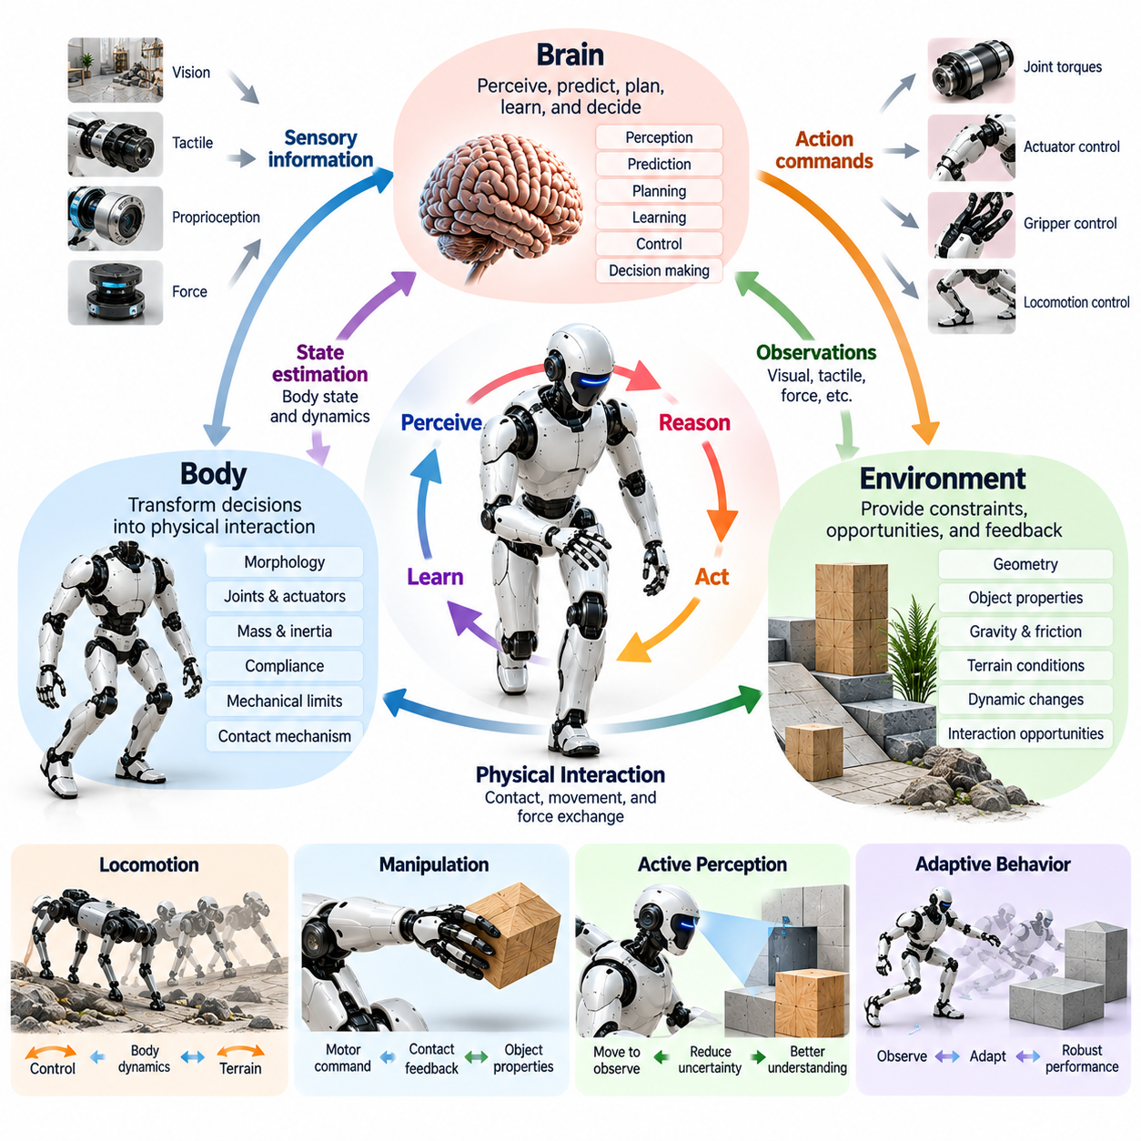
Brain-body-environment coupling describes the continuous and reciprocal interactions through which cognitive processes, physical structures, and environmental dynamics jointly produce intelligent behavior. In embodied intelligence, the brain represents the computational or neural mechanisms responsible for perception, learning, and decision-making, while the body provides the physical interface through which these processes influence and experience the surrounding world.
The central principle of this coupling is that intelligence cannot be fully explained by analyzing the brain, body, or environment independently. Each component influences the others through interconnected feedback processes. Computational decisions generate physical actions, bodily dynamics determine how those actions unfold, and environmental responses produce sensory information that modifies subsequent decisions and behavior.
The brain contributes perception, prediction, planning, learning, and adaptive control to the coupled system. In biological organisms, these functions involve distributed neural processes, while robotic systems implement them through computational models and control architectures. However, the effectiveness of these processes depends on the body's mechanical capabilities and the environmental conditions under which actions are performed.
The body transforms computational intentions into physical interactions through actuators, joints, structural elements, and contact mechanisms. Its geometry, mass distribution, inertia, compliance, and mechanical constraints influence the resulting movement. Consequently, identical control commands may produce different outcomes when applied to robots with different morphologies or when the same robot operates under changing physical conditions.
The environment completes the coupling by introducing external forces, geometric constraints, object properties, and interaction opportunities. Gravity, friction, terrain characteristics, and contact conditions determine how the body responds to actions. Environmental changes also influence sensory observations, creating a continuous feedback relationship in which the agent must update its internal estimates and adapt its behavior.
This relationship forms a closed-loop dynamical system in which perception and action continuously influence one another. Sensors measure the consequences of movement, computational processes interpret those measurements, and controllers generate new actions. The resulting physical interactions alter both the robot's state and its surroundings, ensuring that intelligent behavior develops through repeated cycles of observation, prediction, action, and correction.
Brain-body-environment coupling is fundamentally different from a purely sequential model in which perception is completed before reasoning begins and actions are executed afterward. Physical interaction often requires these processes to operate simultaneously. A robot maintaining balance must continuously estimate body orientation, adjust joint torques, and respond to ground contact without waiting for a complete reconstruction of the surrounding environment.
Locomotion provides a clear illustration of this dynamic coupling. During walking, a legged robot generates motor commands that interact with its mass distribution, joint dynamics, and ground contact conditions. Each foot placement changes the body's momentum and stability, while sensory feedback informs subsequent control adjustments. Stable walking emerges from coordinated interactions among control algorithms, mechanical dynamics, and terrain properties.
Manipulation demonstrates similar relationships at the level of object interaction. When a robotic hand grasps an object, the controller determines finger movements and gripping forces, but the outcome depends on finger geometry, surface friction, object stiffness, and contact distribution. Tactile and force feedback allow the system to adjust its grasp, illustrating how intelligence emerges through continuous coordination between computation and physical contact.
Mechanical compliance plays an important role in coupling because it influences how the body responds to unexpected forces. Flexible joints, elastic structures, and compliant materials can absorb impacts and redistribute contact loads before computational correction occurs. These passive physical responses interact with active control mechanisms, potentially improving stability while reducing the need for rapid corrective computation.
The temporal characteristics of coupling are equally important. Neural computation, actuator response, mechanical deformation, and environmental interaction operate at different timescales. A mechanical structure may respond almost immediately to contact, while perception and planning require additional processing time. Effective embodied systems coordinate these processes so that fast physical responses complement slower computational reasoning and decision-making.
Coupling also influences the development of internal representations and predictive models. A robot learns about its environment by observing how sensory measurements change following physical actions. Repeated interactions reveal relationships among motor commands, body dynamics, and environmental consequences. These experiences support the construction of models that predict future states and improve planning under uncertainty.
The relationship between action and perception is particularly important when environmental information is incomplete. An embodied agent can actively move to obtain observations that reduce uncertainty. A mobile robot may change its viewpoint to inspect an obstacle, while a manipulator may adjust contact to estimate an object's physical properties. Such actions demonstrate that perception is shaped by the body's capabilities and the environment's response.
Brain-body-environment coupling also explains why intelligent behavior is sensitive to morphological differences. A wheeled robot, quadruped, humanoid, and aerial robot experience different physical interactions even when pursuing similar objectives. Their locomotion mechanisms, sensor arrangements, and actuator capabilities determine how computational policies influence the environment and how environmental feedback becomes available.
Environmental structure can sometimes simplify the computational requirements of intelligent behavior. A robot may exploit a supporting surface to stabilize an object during manipulation or use mechanical guides to constrain movement. These interactions reduce the number of variables that must be actively controlled. The environment therefore contributes functional structure to the overall intelligent system rather than serving only as an external source of disturbances.
This principle is closely related to morphological computation, where the physical properties of the body contribute to functions otherwise requiring explicit computational processing. Elasticity, damping, passive dynamics, and structural geometry can regulate movement through mechanical interactions. Brain-body-environment coupling provides the broader framework within which such physical contributions interact with perception, learning, and active control.
Learning within a coupled system requires accounting for the consequences of actions across all three components. Reinforcement learning policies, for example, are shaped by observations, actuator capabilities, mechanical dynamics, and environmental rewards. A policy that performs effectively in one physical configuration may fail when payload, friction, compliance, or terrain conditions change, requiring adaptation to the altered coupling relationships.
The coupling perspective has important implications for simulation-based training and simulation-to-real transfer. A simulated environment must represent relevant body dynamics, sensor characteristics, actuator responses, and environmental interactions with sufficient fidelity. Differences between simulated and physical coupling can cause learned policies to behave unpredictably when deployed on real robots, even when their computational architectures remain unchanged.
Robustness emerges when the coupled system can maintain acceptable behavior despite disturbances and uncertainty. Mechanical structures may absorb part of an impact, sensors detect deviations, and controllers generate corrective responses. Successful recovery depends on the combined effectiveness of these processes. Robustness therefore cannot be attributed exclusively to computational intelligence or mechanical design.
Human-robot interaction introduces additional complexity because human behavior becomes part of the environment influencing the robot. A collaborative robot must interpret human movement, maintain safe separation, and adjust its actions according to changing intentions and physical proximity. Human responses are also influenced by the robot's movements, creating reciprocal interaction dynamics that require continuous perception and adaptation.
Engineering brain-body-environment coupling requires coordinated design across artificial intelligence, mechanical engineering, sensing, actuation, and control. Optimizing these components independently may produce a system with incompatible response characteristics or unnecessary complexity. Integrated design instead considers how computational capabilities, physical structures, and environmental conditions jointly determine task performance.
Evaluating coupled intelligence requires measurements that capture complete system behavior under realistic conditions. Task success, stability, energy efficiency, response latency, disturbance recovery, and adaptability provide complementary perspectives. Experiments involving changes in terrain, payload, object properties, or sensor conditions can reveal whether the system maintains effective coordination across different interaction scenarios.
For Physical AI, brain-body-environment coupling provides a foundational explanation of how computational intelligence becomes physically meaningful. Intelligent behavior results not simply from generating correct commands but from producing appropriate actions through a body operating within a changing environment. This perspective supports the development of morphology-aware control, adaptive learning, and integrated robotic architectures.
Ultimately, brain-body-environment coupling establishes intelligence as a dynamic property of an interacting physical system. Computational processes guide behavior, bodily structures shape its execution, and environmental dynamics determine its consequences. Understanding and engineering these reciprocal relationships is essential for creating Physical AI systems capable of adaptive, efficient, robust, and context-sensitive operation in the real world.

01.05. Perception Action Coupling
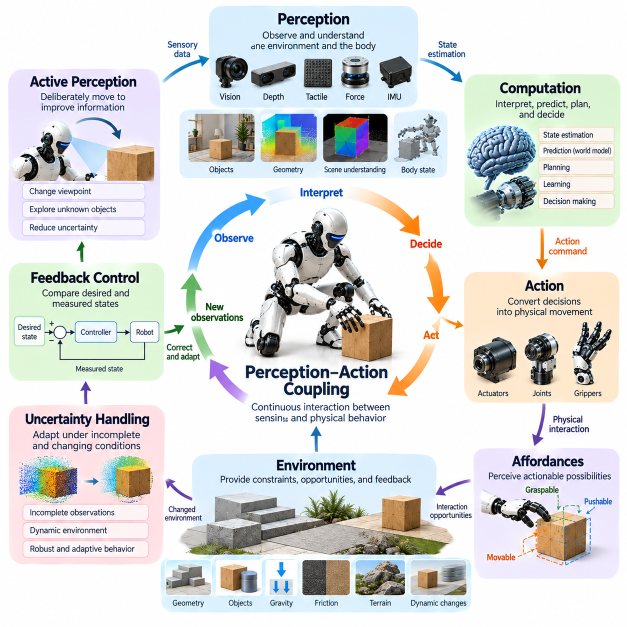
Perception-action coupling describes the continuous interaction between sensory information and physical behavior through which embodied agents understand and influence their environments. Perception provides information about external conditions and internal states, while action changes those conditions and determines subsequent observations. Intelligent behavior emerges from this reciprocal relationship rather than from perception and action operating as independent processes.
Traditional artificial intelligence architectures often organize perception, reasoning, planning, and action into sequential processing stages. Although this structure supports modular development, it may introduce delays when environmental conditions change rapidly. Perception-action coupling emphasizes continuous feedback, allowing an agent to adjust its movements while simultaneously updating its understanding of the surrounding world.
The perception-action loop begins when sensors acquire information about the environment and the agent's physical state. Cameras, depth sensors, tactile sensors, force sensors, and inertial measurement units provide complementary observations. Computational processes interpret these measurements and generate actions, while the resulting movements alter sensory inputs and initiate further adjustments through closed-loop control.
A defining characteristic of perception-action coupling is that perception influences action while action actively shapes perception. A robot approaching an unfamiliar object may reposition its camera to improve visibility before attempting manipulation. Similarly, a mobile robot may move around an obstacle to reveal previously hidden geometry. These examples demonstrate that sensing is not merely passive observation but an activity influenced by behavioral objectives.
The coupling relationship is particularly important because physical environments are dynamic and only partially observable. Moving objects, changing lighting conditions, contact forces, and unexpected disturbances continuously modify the information available to an agent. A robot must therefore update its internal estimates while acting, rather than relying exclusively on a static environmental representation constructed before movement begins.
Closed-loop control provides a practical implementation of perception-action coupling. The controller compares desired behavior with measured system states and generates corrective commands when deviations occur. In mobile robotics, wheel encoders and inertial sensors support velocity and orientation regulation. In manipulation, force and tactile feedback enable continuous adjustment of contact conditions and gripping forces.
Perception-action coupling also operates across multiple temporal scales. Low-level control loops respond rapidly to changes in joint position, force, or body orientation, while higher-level processes evaluate task progress and select future actions. Effective embodied systems coordinate these processes so that immediate physical corrections remain consistent with broader planning objectives and environmental constraints.
Locomotion illustrates how perception and action jointly maintain stability. A legged robot must continuously estimate its body orientation, contact state, and movement velocity while adjusting joint torques and foot placement. Each step changes the robot's momentum and contact conditions, producing new sensory information. Stable walking consequently depends on continuous coordination between sensing, mechanical dynamics, and motor control.
Manipulation demonstrates a similar relationship during physical contact with objects. When a robotic gripper closes around an object, tactile and force measurements reveal contact location, pressure distribution, and potential slippage. The controller modifies finger positions or gripping forces according to these observations. Successful grasping therefore develops through repeated interaction rather than relying solely on a predetermined motion sequence.
Active perception represents an important extension of perception-action coupling because actions can be selected specifically to improve information quality. A robot may rotate an object to inspect an occluded surface, change its viewing angle to reduce visual ambiguity, or probe a material to estimate stiffness. These exploratory actions reduce uncertainty and provide information needed for more reliable task execution.
The concept of affordances further connects perception with actionable possibilities. An affordance describes an opportunity for action arising from the relationship between an agent's capabilities and environmental properties. A handle may offer a grasping opportunity for a dexterous robotic hand, while a narrow opening may permit passage for a compact mobile platform. Perception must identify these relationships to support meaningful action selection.
Sensorimotor contingencies describe predictable relationships between an agent's movements and resulting sensory changes. When a robot moves its camera, the apparent positions of objects change according to viewpoint geometry. When it presses against a surface, tactile and force measurements vary with contact conditions. Learning these relationships helps the agent distinguish self-generated sensory changes from external environmental events.
Predictive models strengthen perception-action coupling by allowing an agent to anticipate the consequences of movement. A robot can estimate how a planned action will change its position, contact forces, or visual observations before execution. These predictions are compared with actual sensory feedback, enabling the system to identify modeling errors and adapt its behavior when physical outcomes differ from expectations.
Uncertainty plays a central role in determining how perception and action should interact. Sensor noise, occlusion, imperfect calibration, and unpredictable environmental dynamics limit the reliability of observations. An intelligent agent may respond by slowing its movement, gathering additional measurements, or selecting safer actions. Perception-action coupling therefore supports decisions that account for both task objectives and the confidence of available information.
The relationship between perception and action is strongly influenced by robot morphology. Sensor placement, joint configuration, actuator characteristics, and mechanical compliance determine which observations and movements are possible. A humanoid robot can coordinate head movements and hand manipulation, while an aerial robot may alter its flight trajectory to improve visibility. Different embodiments consequently produce distinct perception-action strategies.
Mechanical dynamics also affect the coupling process because physical responses can occur before computational updates are completed. Compliant joints and flexible structures may absorb disturbances while sensors and controllers prepare corrective actions. Such interactions demonstrate that perception-action coupling operates through the combined behavior of computational processes and physical mechanisms rather than through software control alone.
Learning-based control provides mechanisms for improving perception-action relationships through experience. Reinforcement learning can optimize policies that map observations to actions according to task outcomes, while imitation learning can acquire sensorimotor behavior from demonstrations. The effectiveness of these approaches depends on whether training experiences adequately represent the physical conditions encountered during deployment.
Perception-action coupling is especially important for transferring learned policies from simulation to real hardware. Differences in sensor noise, actuator latency, friction, and contact dynamics can alter the relationship between actions and observations. A policy that performs well in simulation may become unstable when these relationships change. Robust deployment therefore requires calibration, adaptation, and validation under realistic operating conditions.
Human-robot interaction introduces additional perception-action requirements because human movements and responses are continuously changing. A collaborative robot must observe human proximity, interpret movement intentions, and adjust its trajectory to maintain safe interaction. The robot's actions may also influence human behavior, creating reciprocal feedback that requires ongoing monitoring and context-sensitive control.
Engineering perception-action coupling requires coordinated development of sensing, computation, actuation, and control architectures. Sensor update rates, communication delays, processing latency, and actuator bandwidth determine how quickly the system can respond to environmental changes. Poor coordination may produce outdated decisions or unstable behavior, even when individual perception and control components perform accurately.
Evaluating perception-action coupling requires examining how effectively an agent maintains performance during changing physical conditions. Relevant measures include task success, response latency, tracking accuracy, disturbance recovery, contact stability, and adaptation to uncertainty. Experiments involving moving obstacles, sensor degradation, variable payloads, and unexpected contact can reveal weaknesses in the feedback relationship.
For Physical AI, perception-action coupling provides a fundamental mechanism through which computational intelligence becomes responsive physical behavior. Perception supplies information needed for decision-making, while action generates new experiences that refine environmental understanding. This continuous interaction supports adaptive locomotion, dexterous manipulation, autonomous navigation, and reliable operation in environments that cannot be completely predicted in advance.
Ultimately, perception-action coupling establishes sensing and movement as mutually dependent components of embodied intelligence. Intelligent agents do not simply observe the world and then act upon it; they continuously reshape their observations through physical interaction. Understanding and engineering this reciprocal process is essential for developing Physical AI systems capable of robust, adaptive, and context-aware behavior in complex real-world environments.

01.06. Sensorimotor Intelligence
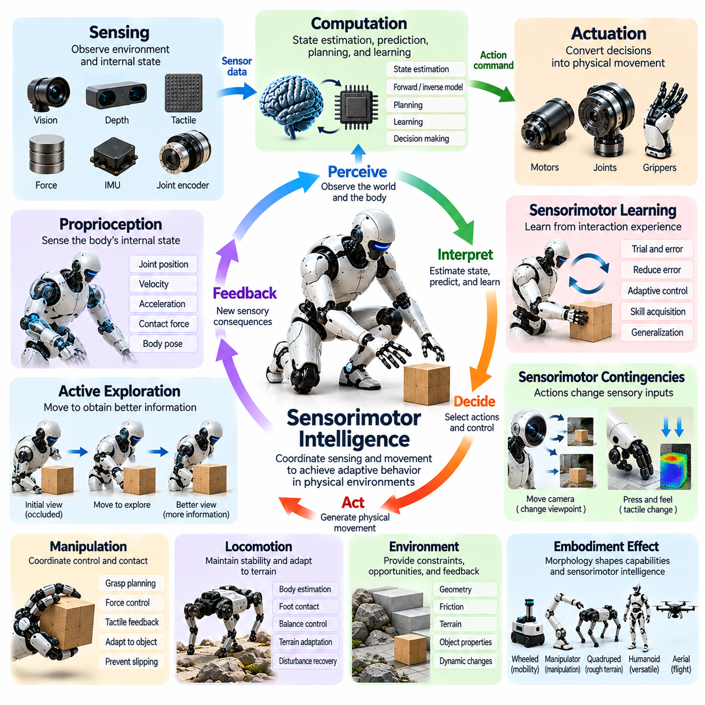
Sensorimotor intelligence refers to the ability of an embodied agent to coordinate sensory perception and motor activity to achieve adaptive behavior in physical environments. It emerges through continuous interactions among sensory signals, motor commands, bodily dynamics, and environmental responses. Rather than treating sensing and movement as separate functions, sensorimotor intelligence integrates them into a unified process of perception, action, learning, and adaptation.
The foundation of sensorimotor intelligence is the relationship between sensory inputs and motor outputs. Sensors provide information about the external environment and the agent's internal physical state, while motor systems generate movements that modify both. Each action produces new sensory consequences, establishing a feedback cycle through which the agent continuously adjusts its behavior according to changing physical conditions and task requirements.
Biological sensorimotor intelligence develops through repeated interactions between the nervous system, body, and environment. Humans and animals learn to coordinate vision, touch, proprioception, and movement through exploration and practice. Reaching, grasping, balancing, and walking gradually become coordinated behaviors as neural systems learn the relationships between motor activity and its sensory consequences.
In robotics, sensorimotor intelligence requires integrating perception algorithms, state estimation, control policies, and physical actuation. Cameras, tactile sensors, joint encoders, force sensors, and inertial measurement units provide complementary observations. These measurements support the estimation of body configuration, environmental conditions, and interaction forces, enabling controllers to generate movements appropriate to the current situation.
Proprioception is essential because intelligent movement depends on awareness of the body's configuration and dynamics. Joint positions, velocities, accelerations, and applied forces provide information about the robot's physical state. By combining proprioceptive measurements with external sensing, an embodied agent can distinguish changes caused by its own movements from those produced by environmental events or unexpected disturbances.
Sensorimotor coordination depends on temporal synchronization between perception and movement. Sensory measurements must be processed quickly enough to support appropriate motor responses, particularly during dynamic interactions. Communication delays, sensor sampling rates, actuator bandwidth, and computational latency influence the quality of coordination. Effective architectures align these processes across the timescales required by each task.
Sensorimotor learning allows agents to acquire movement skills through experience rather than relying entirely on predefined control rules. Repeated actions reveal how motor commands influence body motion and sensory observations. Learning algorithms use these relationships to improve coordination, reduce prediction errors, and refine control strategies. Over time, the agent develops behavioral capabilities adapted to its morphology and operating environment.
Internal models provide an important computational mechanism for sensorimotor intelligence. A forward model predicts the sensory or physical consequences of a motor command, while an inverse model estimates the actions needed to achieve a desired outcome. These models support anticipation, planning, and correction. Their predictions can be continuously updated using differences between expected and observed physical responses.
Sensorimotor contingencies describe systematic relationships between movement and resulting sensory changes. When a robot rotates its camera, visual observations change according to viewpoint geometry. When a robotic finger presses against an object, tactile signals vary with contact pressure and material properties. Learning these contingencies helps agents understand how their actions transform sensory information and reveal environmental structure.
Active exploration is a fundamental expression of sensorimotor intelligence. An agent may deliberately move its sensors, reposition its body, or manipulate an object to obtain information unavailable through passive observation. A robot can probe an unfamiliar surface to estimate stiffness or rotate an object to reveal hidden features. Such exploratory movements connect information acquisition directly with physical action.
Sensorimotor intelligence is particularly important for manipulation tasks requiring continuous contact regulation. A robotic hand must coordinate finger positions, contact forces, and tactile feedback while handling objects with different shapes and materials. Small changes in grip pressure may prevent slipping or excessive deformation. Successful manipulation therefore depends on adapting motor behavior to sensory evidence throughout the interaction.
Locomotion requires equally sophisticated sensorimotor coordination. A legged robot must estimate body orientation, foot contact, velocity, and terrain conditions while controlling joint movements. Unexpected ground irregularities can alter balance and momentum within a single step. Rapid sensory feedback and coordinated motor corrections allow the robot to maintain stability and continue moving despite uncertain environmental conditions.
Robot morphology strongly influences the development of sensorimotor capabilities. Joint arrangement, actuator characteristics, sensor placement, compliance, and mechanical constraints determine which movements and observations are available. A soft gripper may achieve stable contact through passive deformation, while a rigid robotic hand requires more precise force regulation. Sensorimotor intelligence consequently reflects the interaction between learning and physical design.
Reinforcement learning provides one approach to acquiring sensorimotor policies through interaction. Agents explore actions, observe their consequences, and improve behavior according to reward signals. Imitation learning offers another approach by transferring movement patterns from demonstrations. Both methods require appropriate sensory representations and training experiences that capture the physical dynamics relevant to successful deployment.
Robust sensorimotor intelligence must account for uncertainty, noise, and changing physical conditions. Sensor errors, actuator limitations, payload variations, and unexpected contact can disrupt previously learned coordination. Adaptive controllers and online estimation methods help compensate for these changes. The objective is not merely accurate movement under ideal conditions but reliable behavior when environmental and mechanical properties vary.
For Physical AI, sensorimotor intelligence provides the operational foundation for connecting learned representations with real-world action. It enables robots to transform sensory evidence into coordinated movement while using physical outcomes to improve future decisions. Integrating perception, prediction, motor control, and experiential learning is therefore essential for developing autonomous systems capable of adaptive manipulation, locomotion, and interaction.
Ultimately, sensorimotor intelligence demonstrates that intelligent physical behavior arises through the continuous integration of sensing and movement. Perception guides motor activity, actions generate new information, and learning progressively improves the relationship between them. This reciprocal process allows embodied agents to develop practical skills, respond to uncertainty, and operate effectively within complex and changing environments.

01.07. Active Perception and Affordances
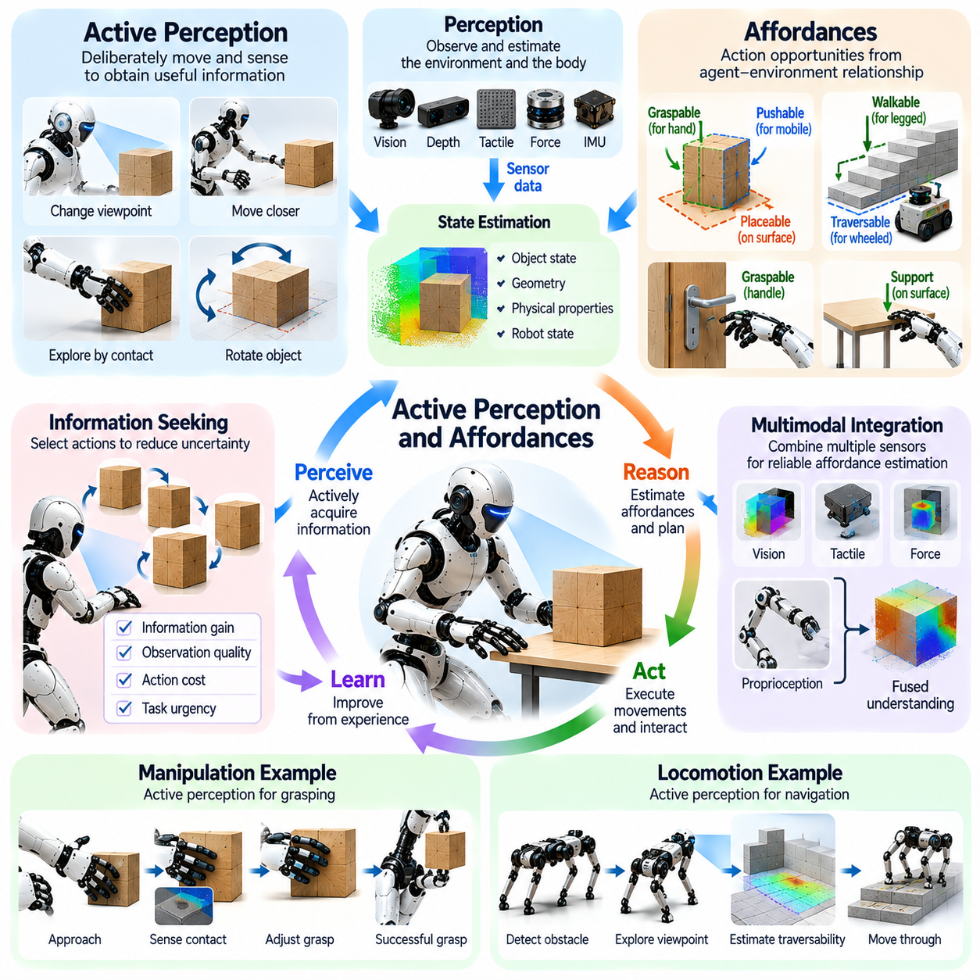
Active perception refers to the process through which an embodied agent deliberately selects movements and sensing strategies to acquire information relevant to its objectives. Unlike passive perception, which processes observations from a fixed viewpoint, active perception treats information gathering as an intentional behavior. The agent changes its position, sensor orientation, or interaction with objects to improve environmental understanding and support reliable decisions.
Affordances describe the opportunities for action that emerge from relationships between an agent's physical capabilities and environmental properties. An object does not possess the same actionable meaning for every agent. A handle may be graspable by a robotic hand, while a narrow passage may be traversable by a compact mobile robot. Affordance perception therefore connects environmental observations with the actions an embodied system can realistically perform.
Active perception and affordances are closely related because identifying an action opportunity often requires purposeful exploration. A robot may need to change its viewpoint to determine whether a handle is accessible or inspect a surface before deciding whether it can support locomotion. Perceptual actions reduce uncertainty about environmental properties, while affordance estimates guide the selection of movements that can achieve task objectives.
The theoretical foundation of active perception emphasizes that sensing and acting form an integrated feedback process. An agent generates actions that modify sensory inputs, interprets the resulting observations, and selects further actions according to its goals. This process challenges architectures that treat perception as a completed stage preceding action. Instead, environmental understanding develops continuously through interaction between the body and its surroundings.
Affordances are relational rather than purely geometric properties. Whether an object can be lifted depends not only on its shape but also on its mass, surface friction, and the robot's payload capacity. Similarly, whether terrain is traversable depends on ground conditions, robot morphology, and locomotion capabilities. Accurate affordance estimation therefore requires combining environmental information with knowledge of the agent's physical limitations.
Active vision provides a practical example of purposeful information acquisition. A robotic camera can change position or orientation to reduce occlusion, improve depth estimation, or reveal object surfaces. A mobile robot may approach an unfamiliar obstacle from multiple viewpoints to determine its geometry. These actions demonstrate that sensor placement and movement planning directly influence the quality of information available for decision-making.
Active tactile perception extends this principle to physical contact. A robotic manipulator may press, slide, or tap an object to estimate stiffness, texture, friction, or structural stability. Such information may be difficult to obtain reliably from visual observations alone. Controlled exploratory contact transforms the body into an information-gathering instrument, allowing the agent to infer properties that determine appropriate manipulation strategies.
The selection of perceptual actions can be formulated as an information-seeking problem. An intelligent agent estimates which movement is likely to reduce uncertainty about relevant environmental states. Information gain, observation quality, action cost, and task urgency may influence this selection. Effective active perception balances the value of additional knowledge against the time, energy, and physical risks associated with obtaining it.
Affordance learning enables robots to discover actionable relationships through experience. By attempting grasps, pushing objects, or traversing surfaces, an agent observes which interactions succeed under particular conditions. Learning algorithms associate sensory features and body states with possible action outcomes. These relationships support future decisions while remaining sensitive to changes in object properties and robot capabilities.
Perception of affordances often requires multimodal sensory integration. Vision provides information about shape, position, and visible surface characteristics, while tactile and force sensors reveal contact conditions and mechanical resistance. Proprioceptive measurements describe the robot's configuration and available movement range. Combining these sources produces more reliable estimates of whether a proposed action is physically feasible.
Uncertainty is unavoidable because environmental observations are incomplete and sensor measurements contain noise. An apparent grasping surface may be slippery, an object may be heavier than expected, or an obstacle may conceal additional geometry. Active perception addresses these uncertainties by acquiring targeted observations before or during execution. The agent can delay commitment, select exploratory actions, or revise its strategy when evidence is insufficient.
Affordances also depend on task context and intended outcomes. A surface may afford support during climbing, temporary placement during manipulation, or sliding during object transport. The same environmental feature can therefore support different actions depending on the robot's objective. Context-sensitive affordance reasoning connects physical opportunities with task planning and helps agents select interactions that are useful rather than merely possible.
Robot morphology strongly influences which affordances can be perceived and exploited. A dexterous robotic hand may manipulate small handles, while a soft gripper may conform to irregular objects. A quadruped can exploit footholds that are inaccessible to a wheeled platform. These differences demonstrate that affordance representations should incorporate embodiment-specific capabilities rather than assuming identical action opportunities across robotic systems.
Active perception and affordance reasoning also contribute to robust behavior under changing conditions. When an expected grasp fails or terrain becomes unstable, the robot can gather additional sensory evidence and reconsider available actions. This feedback process supports recovery without requiring a complete environmental model in advance. Adaptation emerges through repeated evaluation of action possibilities and their observed consequences.
In Physical AI, active perception and affordances provide complementary mechanisms for connecting environmental understanding with purposeful physical behavior. Active perception determines how an agent acquires task-relevant information, while affordance reasoning identifies what actions the environment permits relative to the agent's capabilities. Together, they support autonomous exploration, adaptive manipulation, navigation, and decision-making in uncertain environments.
Ultimately, intelligent interaction requires more than recognizing objects or reconstructing environmental geometry. An embodied agent must determine what information is missing, how to acquire it, and which actions are physically achievable and useful. Active perception transforms sensing into goal-directed exploration, while affordances transform observations into actionable possibilities. Their integration is fundamental to adaptive and context-aware robotic intelligence.

01.08. Physical Interaction and Learning
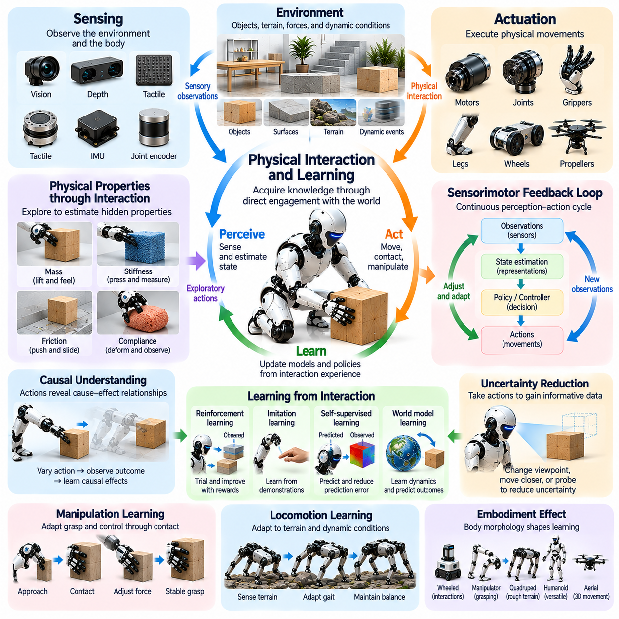
Physical interaction and learning describe how embodied agents acquire knowledge and develop intelligent behavior through direct engagement with the physical world. Unlike systems that learn exclusively from static datasets, embodied agents experience the consequences of their actions through movement, contact, and environmental feedback. These interactions generate information about physical properties, causal relationships, and task constraints that cannot always be obtained through passive observation.
Physical interaction transforms the environment into an active source of learning experiences. When a robot pushes an object, grasps a tool, or moves across unfamiliar terrain, its sensors capture the resulting changes in motion, force, and contact. These observations reveal relationships between actions and outcomes. By repeatedly interacting with its surroundings, the robot develops models that support prediction, planning, and adaptive control.
The foundation of interaction-based learning is the perception-action feedback loop. Sensory observations inform motor commands, while executed actions generate new observations that update the agent's understanding. This reciprocal process allows learning to occur continuously during task execution. Rather than separating knowledge acquisition from physical behavior, embodied intelligence treats both as interconnected aspects of adaptation.
Physical interaction provides access to properties that may remain hidden in visual information. Object mass, friction, stiffness, compliance, and surface resistance often require direct contact for reliable estimation. A robotic manipulator can lift an object to estimate its weight or press against a surface to evaluate deformation. Such exploratory actions allow the agent to construct physically grounded representations of its environment.
Learning through interaction also supports causal understanding. Passive observations may reveal correlations between events, but controlled actions can help determine how specific interventions influence physical outcomes. A robot that varies its applied force while pushing an object can observe changes in acceleration and displacement. These experiences provide evidence for learning causal relationships that support more reliable physical reasoning.
Sensorimotor learning enables robots to discover relationships between motor commands and resulting sensory changes. Repeated movements reveal how joint configurations, actuator forces, and contact conditions influence body motion. Learning algorithms use these experiences to refine control policies and predictive models. Over time, the robot develops coordinated movement skills that reflect both its mechanical characteristics and environmental constraints.
Exploration plays a central role because intelligent agents must encounter informative experiences before they can learn effective behaviors. Random exploration may reveal unexpected possibilities, while goal-directed exploration selects actions likely to reduce uncertainty. Effective strategies balance information acquisition with task progress, energy consumption, and safety. This balance becomes especially important when experiments involve physical hardware.
Reinforcement learning provides a computational framework for acquiring behavior through interaction. An agent executes actions, observes state transitions, and receives rewards associated with task outcomes. Through repeated experience, it improves policies that maximize expected cumulative reward. In physical robotics, however, exploration must account for actuator limitations, collision risks, equipment wear, and the cost of collecting real-world experience.
Self-supervised learning offers another mechanism for extracting knowledge from physical interaction. A robot can use its own actions and subsequent sensory observations to generate training signals without requiring manual labels. Predicting object motion, contact events, or future sensor measurements creates learning objectives grounded in physical experience. Prediction errors then provide information for refining internal representations and world models.
Imitation learning can accelerate physical skill acquisition by using demonstrations from humans or other robotic systems. Demonstrations provide examples of successful movement patterns and interaction strategies, reducing the need for extensive trial-and-error exploration. However, differences in morphology, sensing, and actuator capabilities may require adaptation before demonstrated behaviors can be transferred successfully.
Manipulation tasks illustrate the importance of learning through contact. A robot handling unfamiliar objects must adapt gripping forces, finger placement, and movement trajectories according to sensory feedback. Repeated interactions reveal which strategies prevent slipping, excessive deformation, or unstable grasping. These experiences support increasingly reliable manipulation across objects with different shapes, materials, and mechanical properties.
Locomotion learning similarly depends on interaction with environmental dynamics. A legged robot experiences changing ground reaction forces, friction, and body momentum while moving across different surfaces. These experiences can improve foot placement, balance regulation, and gait adaptation. Learning effective locomotion requires understanding how the robot's morphology and control actions interact with terrain characteristics.
Physical learning is strongly influenced by embodiment because the body determines which experiences are possible. Joint arrangements, sensor placement, actuator performance, and mechanical compliance shape the available action space and observable consequences. A soft robotic gripper may learn contact strategies through passive deformation, while a rigid manipulator may require more precise force regulation. Learned intelligence therefore remains connected to physical design.
Uncertainty and variability create major challenges for interaction-based learning. Sensor noise, changing payloads, unexpected contacts, and differences in environmental conditions can invalidate previously learned relationships. Adaptive estimation and online learning allow robots to revise internal models as new evidence becomes available. Robust systems must distinguish temporary disturbances from persistent changes that require behavioral adaptation.
Simulation can reduce the cost and risk of acquiring physical experience. Robots may practice manipulation, locomotion, and interaction strategies in simulated environments before deployment. However, discrepancies in friction, contact dynamics, actuator behavior, and sensing can limit transfer to real hardware. Combining simulation-based training with carefully controlled real-world interaction helps improve policy reliability and physical adaptability.
For Physical AI, physical interaction and learning establish a foundation for developing agents that improve through experience rather than relying exclusively on predefined knowledge. Actions generate observations, observations support model refinement, and updated models guide future behavior. This continuous learning process connects perception, control, embodiment, and environmental understanding into an adaptive intelligent system.
Ultimately, physical interaction is both a means of accomplishing tasks and a mechanism for acquiring intelligence. Through exploration, contact, feedback, and repeated experimentation, embodied agents discover how their actions influence the world. Integrating these experiences into predictive models and control policies enables more capable, robust, and adaptable robotic behavior in complex real-world environments.

01.09. Embodied Agency and Autonomy
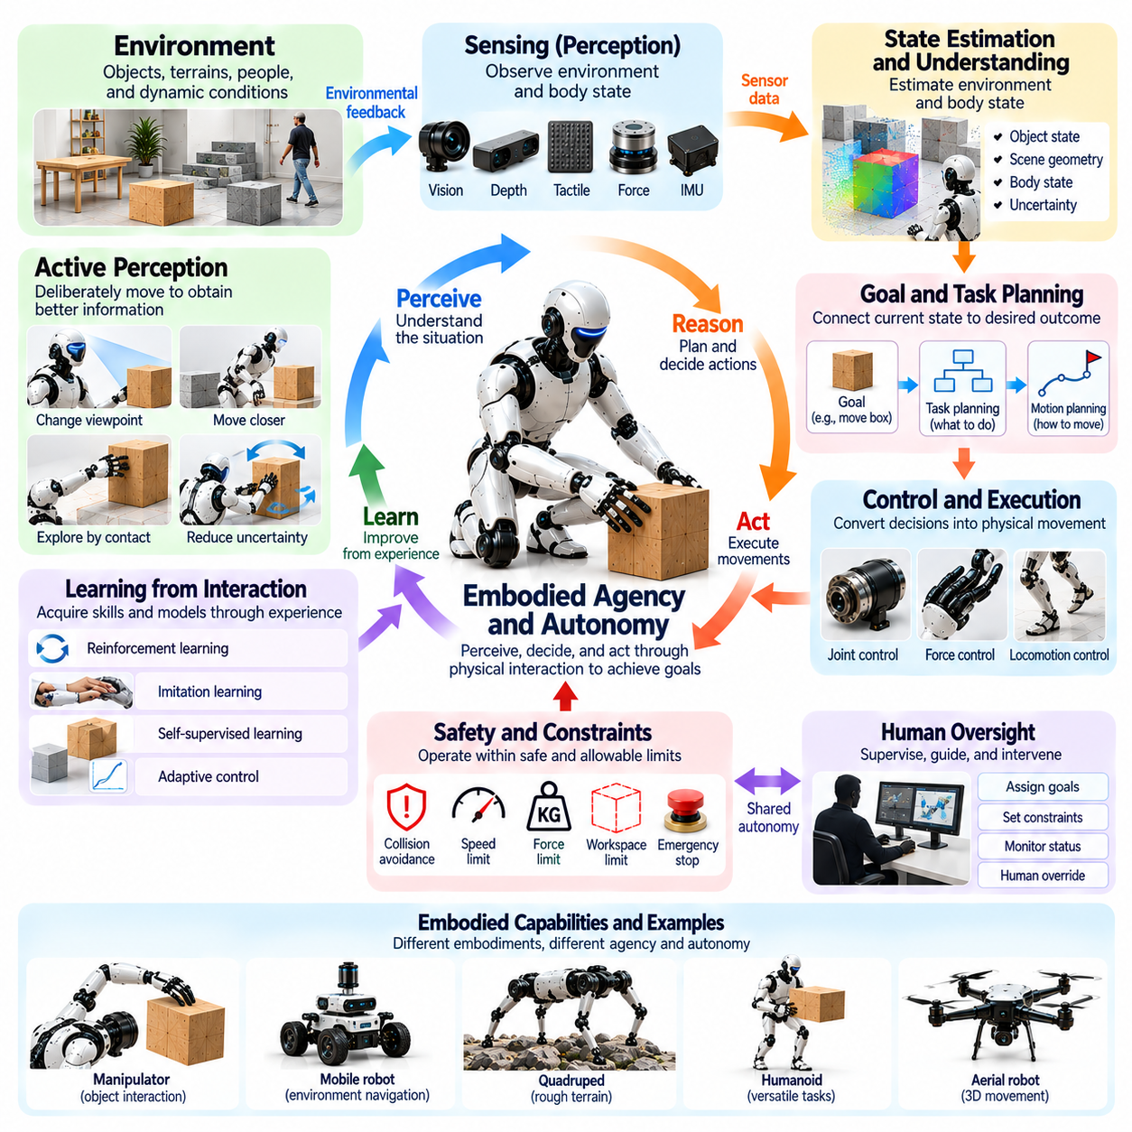
Embodied agency refers to the capacity of a physical agent to initiate, regulate, and adapt its actions through interactions with the environment. Unlike a passive machine that executes predetermined commands, an embodied agent uses sensory information, internal objectives, and physical capabilities to influence its surroundings. Agency emerges when perception, decision-making, and action form a coordinated process that produces purposeful behavior under changing conditions.
Autonomy describes the degree to which an embodied system can pursue objectives without continuous external intervention. An autonomous robot must perceive relevant conditions, select appropriate actions, monitor their consequences, and respond to unexpected events. Autonomy does not necessarily imply unrestricted independence. Practical systems operate within assigned goals, safety constraints, operational boundaries, and mechanisms for human supervision.
Embodied agency and autonomy are related but distinct concepts. Agency concerns the ability to generate actions that meaningfully influence the environment, whereas autonomy concerns the independence with which those actions are selected and managed. A remotely operated robot possesses physical agency through its actions but limited decision-making autonomy. A fully autonomous platform must additionally determine how to accomplish objectives within its permitted operating conditions.
The physical body plays a fundamental role in determining the scope of agency. Robot morphology, actuator capabilities, sensor placement, and mechanical constraints establish which actions can be performed and which environmental changes can be detected. A mobile robot can navigate accessible spaces, while a manipulator can alter object configurations through contact. These embodiment-specific capabilities define the practical boundaries of autonomous behavior.
Perception provides the information necessary for an agent to understand its operational situation. Cameras, depth sensors, tactile sensors, proprioceptive measurements, and other sensing mechanisms reveal environmental conditions and bodily states. However, sensory information is often incomplete or uncertain. Autonomous agents must combine observations with internal models to estimate relevant conditions and determine whether additional information is required.
Goal-directed behavior is a defining characteristic of embodied agency. An agent must connect its current physical state with a desired outcome and identify actions capable of reducing the difference between them. Task planning determines intermediate objectives, while motion planning and control translate those objectives into executable movements. Effective agency requires maintaining this relationship between intention, physical feasibility, and observed results.
Decision-making under uncertainty is essential because real environments cannot be predicted completely. Obstacles may move, objects may slip, and terrain conditions may change unexpectedly. An autonomous robot must evaluate available actions using incomplete information and revise its decisions as new evidence becomes available. Robust autonomy therefore depends on continuous estimation, prediction, feedback, and adaptation rather than fixed action sequences.
Embodied agency also requires the ability to initiate information-gathering actions. A robot may reposition its sensors to inspect an obstacle, probe an unfamiliar object, or explore an alternative route before committing to a task. These actions demonstrate that autonomous behavior includes purposeful perception as well as physical execution. The agent actively shapes the information available for subsequent decisions.
Learning expands agency by enabling robots to improve their behavior through experience. Reinforcement learning, imitation learning, and adaptive control can help agents acquire strategies for navigation, manipulation, and interaction. However, learned policies remain constrained by physical capabilities and training conditions. Reliable autonomy requires evaluating whether previously acquired behaviors remain appropriate when environmental or mechanical conditions change.
Self-monitoring allows an embodied agent to assess whether its actions are producing intended outcomes. Internal state estimation, task-progress tracking, and prediction-error analysis provide evidence of successful or unsuccessful execution. When deviations occur, the system may adjust control commands, revise its plan, or request assistance. Such monitoring transforms autonomy from independent action generation into sustained management of task execution.
Safety establishes essential boundaries for autonomous agency. Physical robots can exert forces, collide with obstacles, and affect people or equipment. Autonomous decisions must therefore respect limits on speed, force, workspace, energy, and contact conditions. Safety monitoring, emergency stopping, and human override mechanisms provide safeguards when learned or planned behavior becomes unreliable or exceeds authorized operating conditions.
Human oversight remains important even in highly autonomous systems. Supervisors may assign objectives, establish operational constraints, approve sensitive actions, or intervene during exceptional situations. Shared autonomy combines machine decision-making with human judgment, allowing responsibility to be distributed according to task complexity and risk. Effective human-robot collaboration requires transparent system status and predictable intervention mechanisms.
Autonomy can be organized hierarchically across different levels of decision-making. Low-level controllers regulate immediate physical behavior, while higher-level processes select tasks, plan routes, and manage priorities. Coordination between these levels allows a robot to respond rapidly to disturbances without losing sight of broader objectives. The resulting architecture connects reactive control with deliberative planning and long-term task management.
For Physical AI, embodied agency and autonomy represent the transition from intelligent computation to independent physical task execution. An autonomous embodied system must integrate perception, planning, learning, control, and safety within the capabilities of its physical platform. Its effectiveness depends not merely on selecting appropriate actions but on executing them reliably, evaluating their consequences, and adapting to changing real-world conditions.
Ultimately, embodied agency establishes the capacity to influence the physical world purposefully, while autonomy determines how independently that capacity can be exercised. Together, they enable robots to pursue objectives through continuous interaction with their environments. Developing reliable embodied autonomy requires coordinated advances in physical design, perception, decision-making, adaptive learning, safety engineering, and human supervision.

01.10. Embodiment Adaptation and Generalization
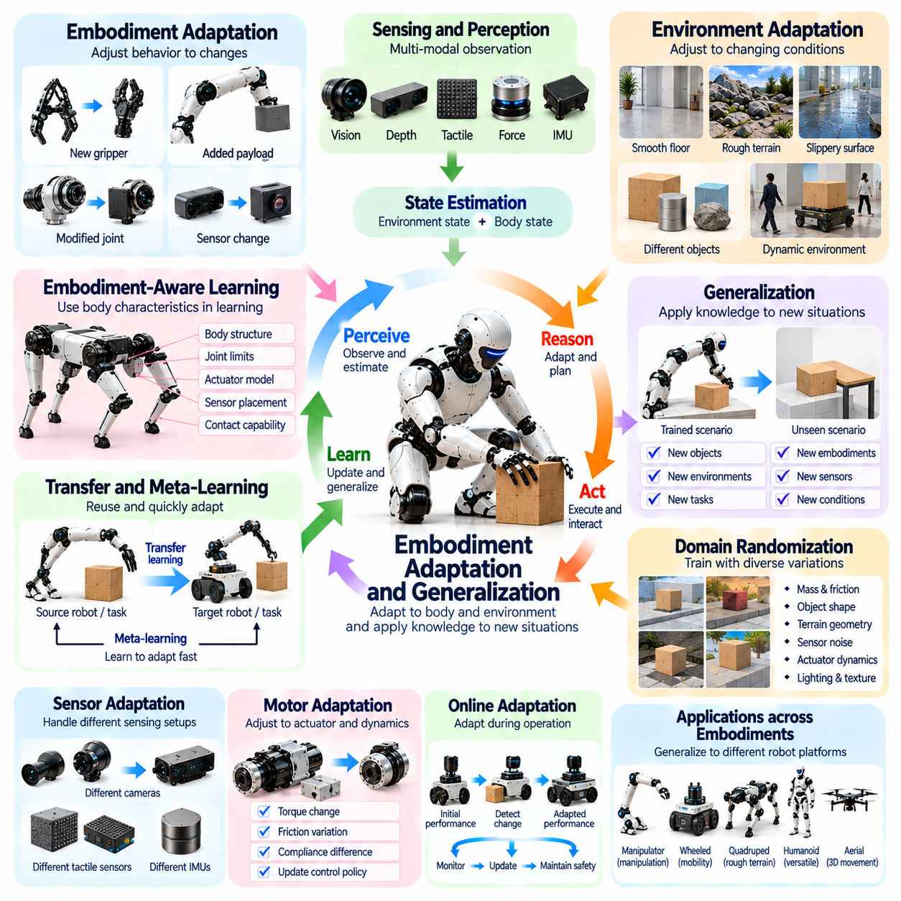
Embodiment adaptation refers to the ability of an intelligent agent to adjust its behavior according to changes in its physical body, sensory capabilities, and environmental conditions. Generalization describes the capacity to apply previously acquired knowledge to unfamiliar situations, tasks, or robotic platforms. Together, these capabilities enable embodied systems to operate beyond the specific configurations and experiences encountered during initial training.
The relationship between embodiment and intelligence creates distinctive challenges for adaptation. A robot's morphology, actuator dynamics, sensor placement, and mechanical constraints determine how actions produce physical consequences. When these characteristics change, previously learned control policies may become less effective. Successful adaptation requires recognizing such differences and adjusting perception, prediction, and motor coordination accordingly.
Embodiment adaptation can occur when a robot experiences changes in its own physical configuration. Replacing a gripper, modifying a joint mechanism, or attaching an additional payload alters the relationship between motor commands and resulting movements. An adaptive system must update its internal representations to account for these changes. This capability reduces dependence on manually redesigned controllers whenever hardware configurations are modified.
Environmental adaptation addresses changes in external operating conditions. A mobile robot trained on smooth indoor floors may encounter uneven terrain, slippery surfaces, or unexpected obstacles. Similarly, a manipulator may handle objects with unfamiliar shapes, weights, and friction properties. Adaptation enables the robot to revise movement strategies using sensory feedback and accumulated experience while maintaining task performance.
Generalization requires learning relationships that remain useful across different observations and operating conditions. Instead of memorizing individual movements, an agent can acquire representations of physical principles, object interactions, and task objectives. Such representations may support behavior in unfamiliar situations when the underlying relationships remain sufficiently similar. However, generalization is limited when new conditions differ substantially from previous experience.
Morphological generalization concerns transferring knowledge between robotic bodies with different physical structures. A manipulation strategy learned using one robotic arm may not directly apply to another arm with different joint arrangements or workspace limitations. Transfer requires identifying shared task relationships while accounting for embodiment-specific constraints. Common representations of end-effector motion and contact objectives can support this process.
Sensor adaptation is necessary when sensing configurations or measurement characteristics change. Different cameras, tactile sensors, and inertial measurement units may produce observations with different resolutions, noise levels, and coordinate systems. An embodied agent must align these measurements with its internal state representations. Calibration, sensor fusion, and representation learning help maintain reliable perception despite changes in sensing hardware.
Motor adaptation focuses on adjusting control behavior when actuator properties or mechanical dynamics vary. Changes in motor torque, joint friction, transmission efficiency, or structural compliance can alter the relationship between commands and motion. Adaptive controllers estimate these variations and modify control parameters accordingly. Learning-based approaches may additionally update policies using observed differences between predicted and actual responses.
Transfer learning provides a mechanism for reusing knowledge acquired from previous tasks or platforms. A robot may initialize a new policy using representations learned during related manipulation or locomotion activities. Fine-tuning then adjusts the policy to the new embodiment and environment. Effective transfer can reduce training time and physical experimentation, although inappropriate transferred assumptions may degrade performance or create safety risks.
Meta-learning extends adaptation by training agents to adjust rapidly when encountering new conditions. Rather than optimizing only for one task, meta-learning methods expose the system to multiple related tasks and variations during training. The resulting learning procedure can support faster adaptation using limited new experience. Its effectiveness depends on whether training variations adequately represent the challenges encountered during deployment.
Domain randomization is widely used to improve robustness across physical variations. During simulation training, parameters such as mass, friction, actuator response, sensor noise, and environmental geometry are varied. This exposes the agent to diverse operating conditions and discourages dependence on a single simulated configuration. However, randomization must cover relevant real-world differences without introducing unrealistic assumptions that undermine learning.
Online adaptation allows an embodied agent to update its behavior while operating in a changing environment. Continuous state estimation, prediction-error monitoring, and policy adjustment can compensate for gradual changes in physical dynamics. Such adaptation must remain computationally efficient and respect safety constraints. Unrestricted online learning may introduce instability, making bounded updates and performance monitoring essential for reliable deployment.
Embodiment-aware representations improve generalization by explicitly incorporating physical characteristics into learning models. Joint topology, actuator limits, body dimensions, sensor locations, and contact capabilities can be encoded as contextual information. A policy conditioned on these properties may support multiple robot configurations. This approach distinguishes transferable task knowledge from the physical constraints that determine how actions must be executed.
Evaluation of adaptation and generalization requires testing beyond familiar training conditions. Experiments should include unseen objects, altered payloads, sensor disturbances, different terrain properties, and modified robot configurations. Performance must be assessed through task success, recovery capability, safety, and adaptation efficiency. Reliable evaluation distinguishes genuine transferable competence from performance based on narrow environmental assumptions.
For Physical AI, embodiment adaptation and generalization are essential for deploying intelligent systems across diverse platforms and environments. Robots must retain useful knowledge while adjusting to differences in morphology, sensing, actuation, and physical interaction. Combining transferable representations, adaptive control, experiential learning, and systematic validation enables more flexible deployment without requiring complete retraining for every configuration.
Ultimately, embodiment adaptation and generalization demonstrate that physical intelligence must remain responsive to differences between bodies and environments. Adaptation modifies behavior when physical conditions change, while generalization extends learned capabilities to unfamiliar situations. Their integration supports robotic systems that can reuse experience, accommodate hardware variations, recover from disturbances, and perform reliably across increasingly diverse real-world tasks.

01.11. From Embodied Intelligence to Physical AI
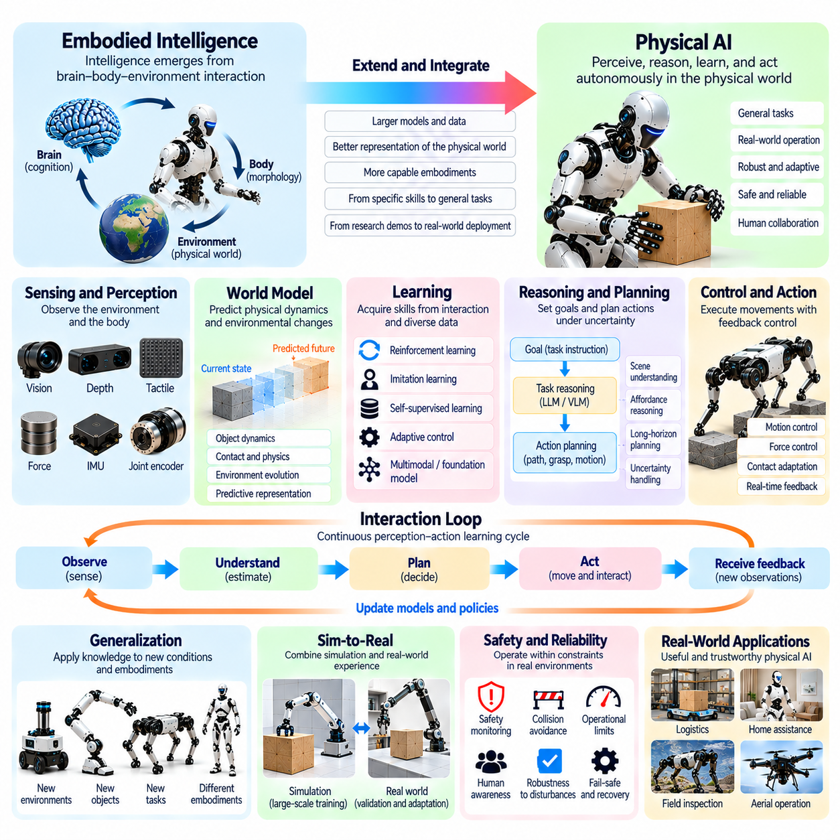
The transition from embodied intelligence to Physical AI represents the development of intelligent systems that can perceive, reason, learn, and act within the physical world. Embodied intelligence establishes that cognition emerges through interactions among the body, control processes, and environment. Physical AI extends this foundation into computational and engineering architectures capable of performing autonomous tasks under real-world physical constraints.
Embodied intelligence emphasizes the inseparable relationship between perception, action, and bodily dynamics. Intelligent behavior is not produced by computation alone but through continuous feedback between sensory observations and physical consequences. Physical AI builds upon this principle by integrating machine learning, robotics, control theory, and physical modeling into systems that transform environmental information into purposeful actions.
The body provides the physical foundation through which artificial intelligence interacts with its surroundings. Morphology, actuator capabilities, sensor placement, mechanical compliance, and structural constraints influence both perception and action. Physical AI must therefore treat embodiment as an integral part of intelligent system design rather than a passive mechanism for executing decisions generated independently of physical conditions.
Perception forms the connection between physical environments and computational representations. Cameras, depth sensors, tactile sensors, force sensors, and proprioceptive measurements provide complementary information about objects, motion, contact, and bodily states. Physical AI combines these observations through sensor fusion and state estimation, enabling agents to construct representations that support prediction, planning, and real-time control.
Action transforms intelligent predictions into measurable physical outcomes. A robot must convert task objectives into motion commands while respecting kinematic limits, dynamic constraints, contact forces, and environmental uncertainty. Successful execution requires continuous feedback rather than relying exclusively on predetermined trajectories. This interaction between planned actions and observed consequences provides the operational basis for adaptive physical intelligence.
Learning enables Physical AI systems to improve their capabilities through experience. Reinforcement learning, imitation learning, self-supervised learning, and adaptive control provide complementary mechanisms for acquiring physical skills. Interaction data reveals relationships between actions and outcomes, allowing models and policies to improve over time. However, learning must remain grounded in the physical capabilities and safety requirements of deployed systems.
World models extend embodied intelligence by representing how physical environments evolve in response to actions. These models may predict object motion, contact events, robot dynamics, and changes in environmental conditions. By evaluating possible future outcomes, Physical AI agents can select actions that better satisfy task objectives. Prediction errors provide additional information for refining models and adapting behavior when actual outcomes differ from expectations.
Foundation models introduce opportunities to connect broad semantic understanding with embodied physical capabilities. Vision-language models can support object recognition, instruction interpretation, and task reasoning, while vision-language-action models attempt to connect multimodal observations with executable actions. Their effectiveness depends on grounding abstract representations in robot-specific sensing, dynamics, and control constraints.
The transition toward Physical AI also requires integrating multiple timescales of intelligence. High-level reasoning identifies objectives and selects strategies, while intermediate planning determines feasible actions and low-level control regulates immediate physical behavior. These processes must exchange information continuously. A robot may revise its task plan when unexpected contact, environmental changes, or mechanical limitations invalidate previous assumptions.
Physical AI architectures must account for uncertainty throughout perception, planning, and execution. Sensor noise, incomplete observations, model inaccuracies, and changing environmental conditions can produce unexpected outcomes. Probabilistic estimation, feedback control, online adaptation, and uncertainty-aware planning help maintain reliable behavior. Robust physical intelligence requires recognizing limitations and responding appropriately when confidence in predicted outcomes decreases.
Generalization is essential for extending embodied capabilities beyond narrow training conditions. Robots must transfer useful knowledge across unfamiliar objects, environments, tasks, and sometimes different physical platforms. Embodiment-aware representations help distinguish shared task relationships from morphology-specific constraints. Successful transfer requires adapting learned policies to differences in sensing, actuation, contact dynamics, and available movement capabilities.
Simulation and real-world experimentation provide complementary environments for developing Physical AI. Simulation supports large-scale training, controlled evaluation, and exploration of potentially hazardous scenarios without exposing hardware to unnecessary risks. Physical deployment reveals discrepancies involving friction, compliance, sensing, and actuator behavior. Combining both approaches supports iterative refinement and more reliable transfer from virtual training to actual operation.
Safety and reliability distinguish deployable Physical AI from experimental demonstrations of embodied intelligence. Autonomous robots interact with people, equipment, and dynamic environments where incorrect actions can cause physical harm. Practical architectures therefore require operational limits, monitoring, fault detection, recovery mechanisms, and human intervention capabilities. Safety must remain integrated with learning and control rather than treated as an independent final requirement.
Physical AI can support diverse robotic embodiments, including autonomous mobile robots, manipulators, humanoids, quadrupeds, and aerial vehicles. Each platform presents different mobility, sensing, actuation, and interaction capabilities. Although common learning and reasoning principles may be shared, their implementation must reflect platform-specific constraints. This diversity highlights the importance of modular architectures and transferable representations.
The engineering development of Physical AI requires coordinated optimization across hardware, software, data, and operational processes. Improvements in algorithms alone cannot compensate for inadequate sensing, insufficient actuator performance, or unsuitable morphology. Likewise, advanced hardware cannot produce intelligent behavior without effective perception and control. System-level integration determines whether individual capabilities become reliable autonomous performance.
Ultimately, the progression from embodied intelligence to Physical AI transforms theoretical principles of body-environment interaction into practical intelligent machines. Embodied intelligence explains why physical experience, morphology, and sensorimotor coordination matter, while Physical AI provides methods for implementing these principles at operational scale. Their integration establishes a foundation for adaptive, autonomous, and physically grounded intelligence capable of meaningful real-world action.

