Volume 03. Embodiment and Morphology

Chapter 02. Morphological Computation

02.01. What is Morphological Computation
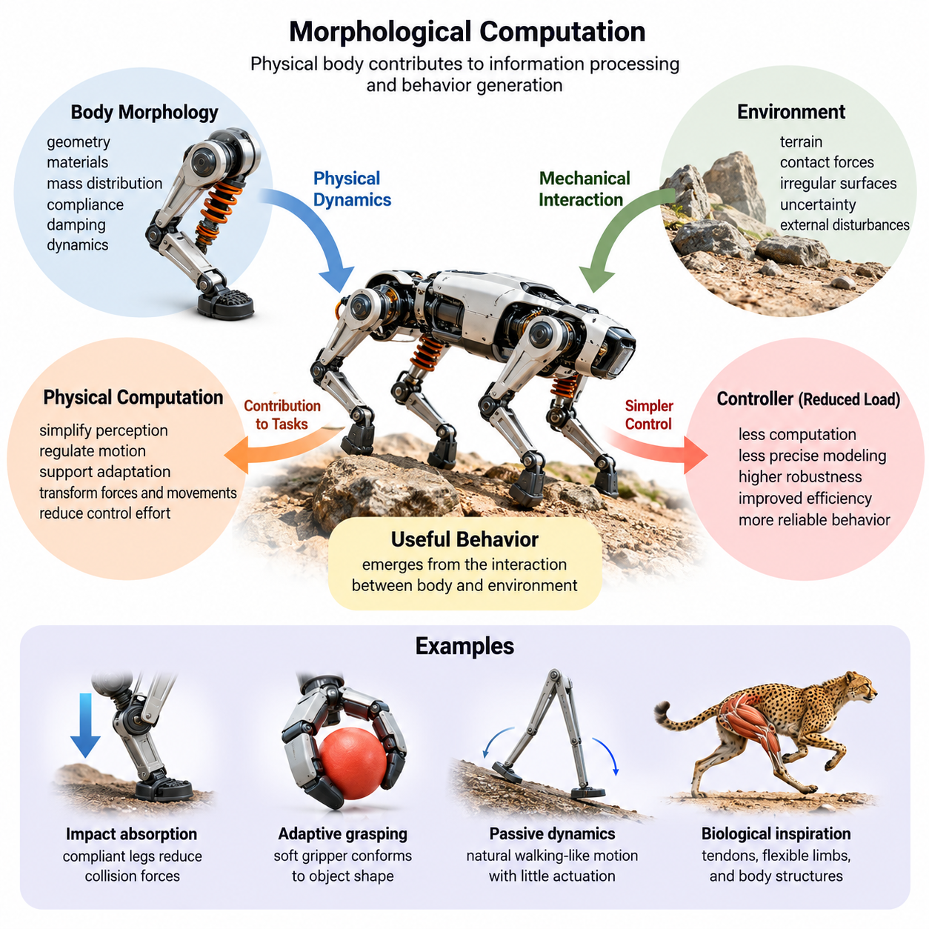
Morphological computation refers to the contribution of a physical body's structure, materials, and dynamics to processes that would otherwise require explicit computational control. In embodied intelligence, computation is not confined to processors or neural networks. Mechanical interactions between the body and environment can simplify perception, regulate motion, and support adaptive behavior without continuously calculating every response.
The central principle of morphological computation is that physical form can participate in information processing and behavioral regulation. A robot's geometry, joint arrangement, mass distribution, elasticity, and damping determine how it responds to external forces. When these characteristics naturally produce useful behavior, the mechanical system performs part of the functional work traditionally assigned to a digital controller.
Conventional robotic architectures often separate sensing, computation, and actuation into distinct functional stages. Sensors measure environmental conditions, controllers calculate appropriate commands, and actuators execute those commands. Morphological computation challenges this strict separation by recognizing that physical interactions can directly transform forces and movements into coordinated responses before digital control becomes necessary.
A simple example is a compliant robotic leg that absorbs impact during ground contact. Instead of requiring a controller to calculate every adjustment needed to manage the collision, elastic components deform and temporarily store mechanical energy. Their subsequent recovery helps restore motion. The body therefore contributes to impact management and dynamic regulation through its physical properties.
This concept is closely related to embodied intelligence, which considers cognition and behavior as products of interactions among the brain, body, and environment. Morphological computation emphasizes the body's specific contribution to these interactions. Intelligence emerges not only from abstract reasoning or learned policies but also from mechanical characteristics that shape how physical systems respond to changing conditions.
The term computation requires careful interpretation in this context. A spring does not execute software instructions or perform symbolic reasoning merely because it stores energy. However, its deformation can transform physical inputs into functionally useful outputs. Morphological computation describes such transformations when bodily dynamics contribute meaningfully to tasks involving control, coordination, adaptation, or information processing.
Mechanical compliance is one of the most recognizable mechanisms associated with morphological computation. Compliant structures deform under applied forces, allowing them to accommodate uncertainty in contact conditions. This property is particularly valuable in robotics because real environments contain irregular surfaces, unpredictable collisions, and objects whose exact geometry or mechanical properties may not be known beforehand.
Elasticity and damping provide complementary forms of physical regulation. Elastic elements store and release energy, while damping dissipates energy and suppresses unwanted oscillations. Their combined behavior can stabilize interactions without requiring continuous high-frequency corrective commands. Carefully selected mechanical properties can therefore reduce control effort while improving robustness during dynamic tasks.
Passive dynamics provide another important foundation. A mechanical system may exhibit useful movement patterns because of its geometry, inertia, gravity, and contact conditions. Passive dynamic walkers demonstrate how appropriately designed leg structures can generate walking-like motion on suitable slopes with little or no powered actuation. Such examples reveal that coordinated movement does not always require detailed centralized trajectory control.
Morphological computation also influences the relationship between physical design and control complexity. A poorly matched body may require sophisticated algorithms to compensate for unstable or inefficient dynamics. Conversely, a body designed around its intended task can naturally constrain motion toward desirable behaviors. This reduces the range of corrections that a controller must generate and can improve efficiency, responsiveness, and reliability.
In robotic locomotion, body morphology determines how forces propagate through legs, joints, feet, and supporting structures. Leg compliance can reduce impact loads, foot geometry can improve contact stability, and mass distribution can influence balance. These characteristics interact with terrain and movement speed, allowing physical dynamics to contribute to locomotion control rather than leaving every adjustment to software.
Morphological computation is equally relevant to robotic manipulation. A soft gripper can conform to objects with different shapes through material deformation, reducing the need for precise geometric reconstruction and individual finger positioning. Contact forces distribute across compliant surfaces, helping establish stable grasps. The mechanical design effectively handles part of the uncertainty that would otherwise require extensive sensing and control.
Biological organisms provide compelling examples of how morphology supports adaptive behavior. Tendons store and release energy during running, flexible limbs accommodate uneven terrain, and body structures distribute mechanical loads. These mechanisms work alongside neural control rather than replacing it. Their effectiveness demonstrates how biological intelligence depends on coordinated interactions between nervous systems and physical bodies.
The relationship between morphology and environmental interaction is especially important. A body's computational contribution cannot always be evaluated independently of the conditions in which it operates. A compliant structure may improve performance on irregular terrain but introduce unwanted oscillations during precision positioning. Consequently, morphological computation is task-dependent and must be understood within the complete body–environment system.
Physical filtering represents another useful interpretation of morphological computation. Mechanical structures can attenuate disturbances, smooth rapid fluctuations, and selectively transmit forces according to their dynamic characteristics. Suspension systems, compliant joints, and flexible contact surfaces can reduce the effect of environmental disturbances before those disturbances propagate to sensitive components or require active correction.
The computational role of morphology can also be understood through dynamical systems theory. A robot's physical state evolves according to interactions among forces, constraints, material properties, and environmental conditions. Appropriate mechanical design can create stable attractors, preferred movement patterns, or predictable responses. Controllers can exploit these natural dynamics instead of generating every aspect of behavior through explicit commands.
However, morphological computation should not be interpreted as eliminating the need for sensing, planning, or intelligent control. Passive mechanical responses cannot independently satisfy every task requirement, especially when goals change or environmental conditions exceed the body's design assumptions. Effective robotic systems combine mechanical intelligence with feedback control, perception, learning, and decision-making to achieve reliable behavior.
The distinction between morphological computation and conventional mechanical engineering is primarily functional and analytical. Mechanical engineers have long used springs, dampers, linkages, and compliant mechanisms to improve performance. Morphological computation extends this perspective by examining how these physical characteristics perform functions associated with information processing, behavioral coordination, and the reduction of computational control demands.
Quantifying morphological computation remains an important research challenge. Researchers investigate measures based on information theory, dynamical dependence, control effort, and relationships between physical states and future behavior. No single metric universally captures every interpretation of the concept. Meaningful evaluation therefore requires clearly defined tasks, system boundaries, and comparisons with alternative body–controller configurations.
Energy efficiency provides a practical motivation for incorporating morphological computation into robotic design. When mechanical structures naturally absorb impacts, recover energy, or stabilize movement, actuators may perform less corrective work. However, these benefits depend on operating conditions and design choices. Excessive compliance, inappropriate resonance, or mechanical losses can increase energy consumption rather than reduce it.
Morphological computation also introduces important engineering trade-offs. Mechanical responses are often fast because they arise directly from physical dynamics, but they may be difficult to modify after fabrication. A specialized morphology can perform exceptionally well under expected conditions while adapting poorly to unfamiliar tasks. Designers must therefore balance passive functionality, mechanical versatility, controllability, and the ability to accommodate changing requirements.
For Physical AI systems, morphological computation suggests that intelligence should be developed through coordinated hardware and software design. Robot bodies should not be treated merely as platforms that execute decisions produced elsewhere. Their geometry, materials, joints, and contact mechanisms can be selected to support the desired behavior, allowing learning algorithms and controllers to exploit favorable physical dynamics.
This perspective becomes increasingly important as robots operate in complex, uncertain, and human-centered environments. Mobile robots, manipulators, humanoids, quadrupeds, and soft robots encounter different mechanical challenges, making their morphological requirements fundamentally different. Understanding morphological computation provides a conceptual foundation for designing bodies that improve interaction, reduce unnecessary control effort, and support robust physical autonomy.
Ultimately, morphological computation reframes the relationship between intelligence and physical embodiment. Rather than viewing the body as a passive instrument controlled by a separate computational system, it recognizes physical structure as an active contributor to behavior. The resulting design philosophy integrates mechanics, materials, environmental interactions, and computational control into a unified approach to embodied intelligence and Physical AI.

02.02. Body as a Computational Resource
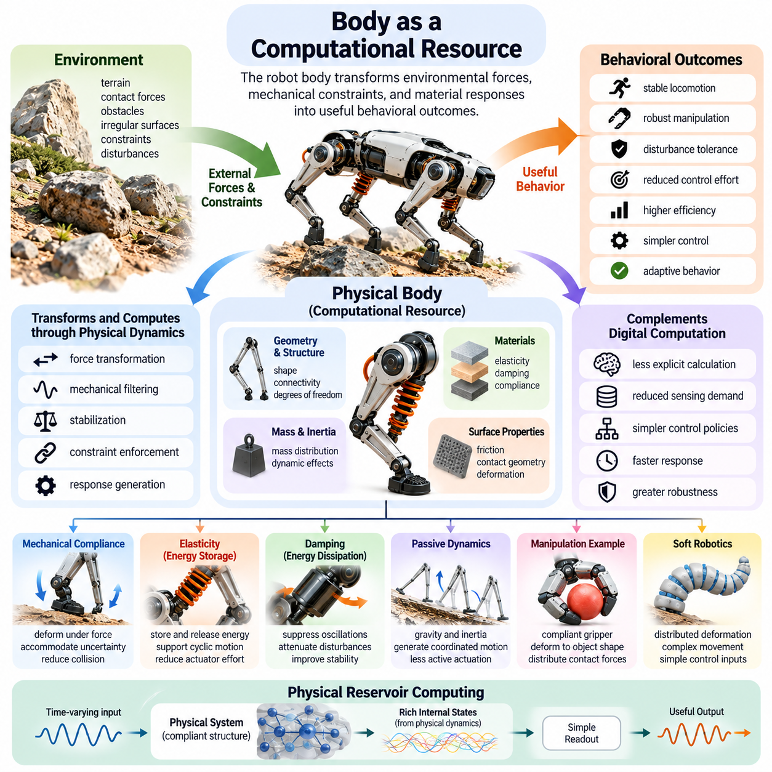
The physical body of a robot can function as a computational resource by transforming environmental forces, mechanical constraints, and material responses into useful behavioral outcomes. Rather than relying exclusively on digital processors, embodied systems exploit their physical structure to simplify control and interaction. This perspective recognizes that computation can be distributed across software, hardware, and the dynamics of the surrounding environment.
In conventional computing architectures, information is represented, processed, and transformed through electronic circuits and algorithms. A robotic body operates differently because its physical properties continuously influence movement and interaction. Joint stiffness, structural flexibility, inertia, and surface friction can shape responses without explicit numerical calculations. These properties provide task-relevant transformations that complement digital computation.
Treating the body as a computational resource does not imply that mechanical components perform symbolic reasoning or execute conventional software instructions. Instead, physical dynamics can implement functions analogous to filtering, stabilization, constraint enforcement, and response generation. When these functions contribute to a robot's objectives, they reduce the amount of processing or active intervention required from its controller.
A fundamental mechanism is the transformation of external forces into structured mechanical responses. When a compliant robotic limb contacts an obstacle, its deformation depends on geometry, stiffness, and applied force. The resulting movement automatically accommodates part of the disturbance. This physical transformation can replace some explicit calculations that would otherwise be necessary to determine corrective actuator commands.
The body's computational contribution is strongly influenced by its morphology, which includes geometry, connectivity, material distribution, and mechanical degrees of freedom. These characteristics establish how forces propagate through the system and how different components interact. A carefully designed morphology can produce predictable responses that support intended behaviors while restricting undesirable movements.
Mechanical compliance provides a particularly important example of physical computation. Elastic joints and flexible structures respond continuously to contact forces without waiting for sensor measurements or software decisions. Their deformation can accommodate positioning errors, distribute loads, and reduce collision severity. Such responses are especially useful when interaction conditions change faster than a digital controller can reliably react.
The storage and release of mechanical energy also illustrate how bodily dynamics support functional processing. Springs, tendons, and elastic structures temporarily store energy during deformation and return part of it during recovery. In locomotion, these mechanisms can support repeated movement cycles and reduce actuator effort. Their effectiveness depends on matching mechanical properties to operating conditions and movement frequencies.
Damping introduces another form of physically implemented regulation. Mechanical and material damping dissipate energy, reducing oscillations and limiting the propagation of disturbances. In a robotic manipulator, appropriate damping can suppress unwanted vibration during contact or rapid motion. This behavior resembles filtering because the mechanical structure attenuates certain dynamic responses before active control becomes necessary.
The relationship between body structure and environmental constraints is equally significant. Contact surfaces, joint limits, and mechanical linkages restrict the range of possible movements. These restrictions can simplify the control problem by eliminating physically undesirable configurations. Rather than calculating every constraint through software, the robot can exploit mechanical arrangements that naturally guide movement toward useful configurations.
A passive mechanical system can sometimes generate coordinated behavior through its intrinsic dynamics. Passive dynamic walking demonstrates how gravity, inertia, leg geometry, and ground contact can produce walking-like motion under suitable conditions. Although such systems have limited operating ranges, they reveal that some aspects of movement coordination can emerge from physical organization rather than continuous centralized computation.
In robotic manipulation, compliant grippers demonstrate how body geometry can simplify interactions with uncertain objects. Flexible fingers deform around object surfaces, allowing contact forces to distribute according to local geometry and material stiffness. This behavior reduces the need for exact object models and individually calculated contact positions. The gripper's physical structure performs part of the adaptation required for grasping.
Soft robotic systems extend this principle through distributed deformation. Their bodies contain many mechanically coupled degrees of freedom that respond collectively to actuation and environmental contact. Instead of commanding every deformation independently, a controller can exploit material properties and structural constraints. This enables complex movements with relatively simple control inputs, although precise modeling may remain challenging.
The concept of physical reservoir computing provides a more explicit connection between bodily dynamics and information processing. In this approach, a complex physical system transforms time-varying inputs into rich internal states. A comparatively simple readout mechanism can then extract useful information from those states. Compliant structures and soft materials have been investigated as physical reservoirs for processing temporal signals.
Physical reservoir computing illustrates how mechanical dynamics can provide memory-like behavior. Elastic deformation, damping, and coupled motion preserve traces of previous inputs over limited periods. These transient states can influence subsequent responses, allowing physical systems to encode aspects of recent interaction history. However, such memory is generally task-dependent and differs fundamentally from persistent digital data storage.
The computational value of a body depends on the relationship between its dynamics and the task being performed. A compliant structure optimized for impact absorption may perform poorly when precise positioning requires high stiffness. Similarly, passive stability mechanisms may be effective within a narrow operating range but inadequate under extreme disturbances. Physical computation is therefore beneficial only when morphological characteristics support relevant functional requirements.
This task dependence makes morphology selection an important component of intelligent system design. Engineers must consider not only strength, weight, and manufacturing constraints but also the control functions that physical structures can perform. Appropriate choices of elasticity, damping, geometry, and mass distribution can simplify feedback requirements. Poor choices may instead introduce instability, excessive oscillation, or difficult nonlinear behavior.
The body can also contribute to sensory processing by mechanically shaping incoming physical signals. Flexible coverings, compliant interfaces, and structural filters modify how external forces reach embedded sensors. These transformations may attenuate noise, distribute pressure, or emphasize particular interaction patterns. Consequently, sensing performance depends partly on the physical properties surrounding the sensing elements.
Mechanical preprocessing can be particularly useful in tactile perception. A compliant fingertip distributes contact pressure across its surface, producing deformation patterns that reflect object geometry and applied forces. Embedded tactile sensors measure the resulting physical states rather than directly observing every microscopic contact interaction. The fingertip's material and structure therefore influence the information available to perception algorithms.
The interaction between morphological computation and feedback control is complementary rather than competitive. Passive mechanical responses can handle rapid local disturbances, while digital controllers manage changing objectives, coordination, and higher-level decisions. This division of functionality may reduce control bandwidth requirements and computational workload. However, overall performance still depends on appropriate sensing, actuation, and system integration.
Morphological computation also has implications for energy efficiency and hardware reliability. When mechanical structures absorb disturbances or support movement naturally, actuators may require fewer corrective actions. Reduced actuator activity can lower energy consumption and thermal loading under suitable conditions. Nevertheless, mechanical losses, fatigue, and maintenance requirements must be considered when evaluating the overall benefits.
For learning-based robotics, bodily dynamics influence the policies that an artificial intelligence model must acquire. A morphology that naturally stabilizes contact can simplify the learning problem by reducing the number of corrective behaviors required. Conversely, highly flexible or strongly coupled structures may increase modeling uncertainty. Effective learning therefore depends on the interaction between physical design and the representation of control actions.
The relationship between physical computation and generalization is particularly important in unfamiliar environments. Passive compliance can accommodate variations in surface geometry or object position without requiring explicit retraining. However, these capabilities remain bounded by mechanical properties and operating conditions. Morphological computation supports certain forms of robustness but does not automatically provide general-purpose intelligence or unrestricted adaptability.
Evaluating the body as a computational resource requires comparing its functional contribution with alternative control architectures. Relevant measures include control effort, energy consumption, disturbance rejection, task accuracy, response time, and robustness. Information-theoretic approaches may additionally examine how physical dynamics influence state transitions. Such evaluations should distinguish genuine computational benefits from improvements caused simply by increased mechanical strength.
The broader significance of this perspective lies in redefining the architecture of Physical AI systems. Intelligence need not reside exclusively in software models that issue commands to passive mechanical devices. Instead, useful functionality can emerge through coordinated interactions among computation, morphology, actuation, and environmental dynamics. The body becomes an active participant in achieving adaptive and reliable behavior.
Ultimately, understanding the body as a computational resource encourages the joint design of mechanical structures and intelligent controllers. Physical properties can provide stabilization, filtering, adaptation, and energy management, while digital computation supplies flexibility, planning, and learned decision-making. Their integration offers a foundation for developing embodied systems that achieve complex physical tasks with greater efficiency, robustness, and functional coherence.

02.03. Passive Dynamics and Self Stabilization
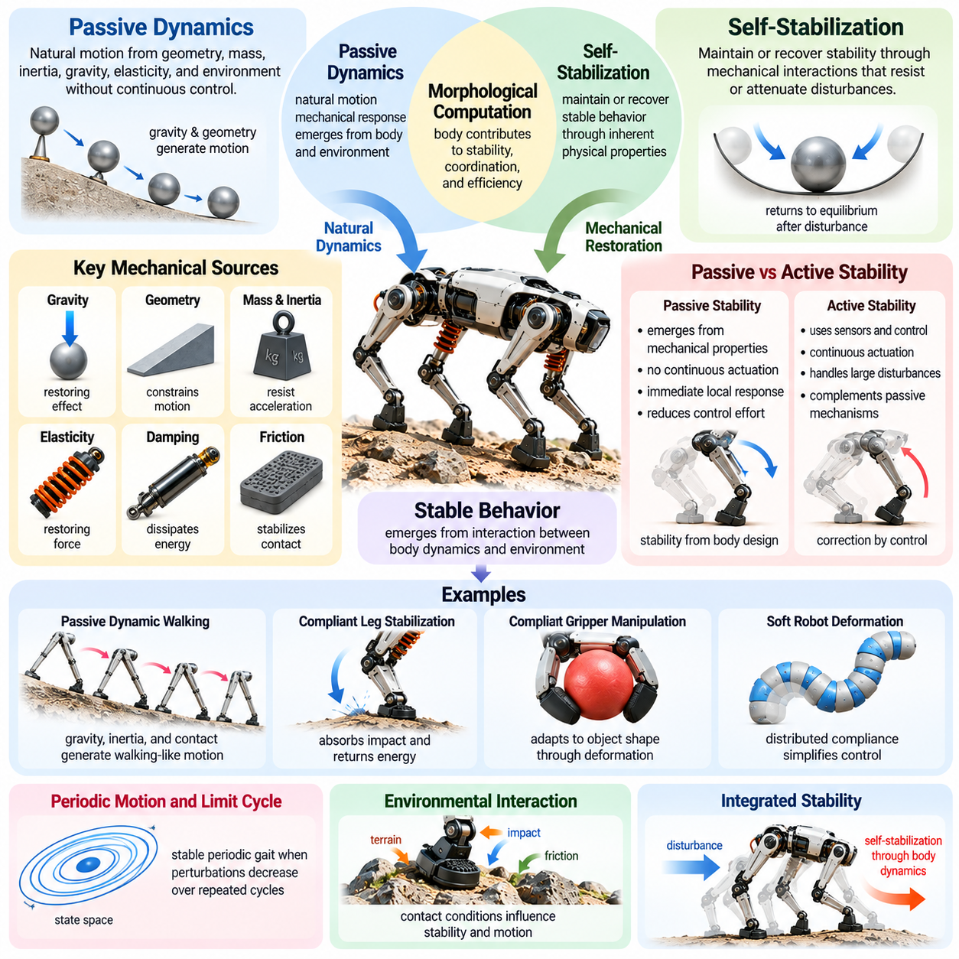
Passive dynamics refers to the natural motion and mechanical responses of a physical system arising from its geometry, mass distribution, inertia, gravity, elasticity, and environmental interactions. These behaviors occur without requiring continuous active control. In robotics, passive dynamics demonstrates that appropriately designed mechanical structures can contribute directly to movement coordination, stability, and energy efficiency.
Self-stabilization describes the tendency of a system to maintain or recover a stable operating condition through its inherent physical properties. Rather than depending entirely on feedback controllers, a self-stabilizing mechanism uses mechanical interactions to resist or attenuate disturbances. This capability is particularly valuable in embodied intelligence because it allows physical structures to participate directly in maintaining reliable behavior.
The relationship between passive dynamics and self-stabilization is central to morphological computation. A robot's body can transform external disturbances into restoring movements through its mechanical characteristics. When geometry, inertia, compliance, and contact conditions are appropriately coordinated, the resulting dynamics can reduce the need for explicit corrective commands. Stability therefore becomes partly a property of physical design.
A fundamental distinction exists between passive stability and actively controlled stability. Passive stability emerges from mechanical characteristics without continuous corrective actuation, whereas active stability depends on sensors, control algorithms, and actuators. Many practical robots combine both mechanisms. Passive structures provide immediate local responses, while active controllers regulate broader operating conditions and compensate for disturbances beyond mechanical limits.
The simplest examples of passive stabilization involve gravity and mechanical geometry. A suspended mass naturally tends toward a low-potential-energy configuration, while a properly shaped rocking structure can return toward equilibrium after small disturbances. These behaviors arise from gravitational restoring effects rather than calculated control commands. Their effectiveness depends on the system's geometry, energy dissipation, and disturbance magnitude.
Elasticity provides another important source of passive stabilization. Springs and compliant components generate restoring forces when displaced from their equilibrium configurations. In robotic joints and limbs, these forces can help recover desired positions after external disturbances. Appropriate stiffness allows the body to accommodate moderate deviations while resisting excessive deformation, thereby contributing to stable mechanical interaction.
Damping complements elasticity by dissipating mechanical energy and suppressing unwanted oscillations. Without sufficient damping, elastic systems may continue vibrating after disturbances, even when restoring forces are present. Mechanical dampers, material hysteresis, and friction can reduce these oscillations. The combination of restoring stiffness and energy dissipation often supports stable convergence toward equilibrium.
Passive dynamics becomes more complex when robots move through environments involving repeated contact. During locomotion, the interaction between feet and ground introduces impacts, friction, and changing support conditions. These interactions can either stabilize or destabilize movement depending on body geometry and mechanical parameters. Understanding contact dynamics is therefore essential when designing robots that exploit passive behavior.
Passive dynamic walking provides a particularly influential example of morphology-supported locomotion. Under suitable conditions, a legged mechanism can descend a gentle slope using gravity, inertia, and intermittent ground contact. Its mechanical configuration produces a repeatable walking pattern without continuously commanding each joint trajectory. This demonstrates that coordinated gait behavior can emerge from the natural dynamics of a physical system.
The stability of passive walking is often analyzed through periodic motion rather than static equilibrium. A walking robot repeatedly transitions between support phases, and small deviations may either diminish or grow across successive steps. Stable periodic walking occurs when disturbances near the nominal gait decrease over repeated cycles. This form of dynamic stability differs from simply remaining motionless in a balanced configuration.
Limit cycles provide a mathematical framework for understanding repeatable locomotion patterns. A limit cycle represents a periodic trajectory in a dynamical system's state space. When the cycle is locally attracting, nearby trajectories converge toward it after sufficiently small perturbations. Robot morphology and contact mechanics influence whether such stable cycles exist and how effectively they reject disturbances.
Mechanical self-stabilization can reduce the complexity of locomotion control by allowing the body to handle part of the coordination problem. Instead of calculating every joint movement independently, a controller can exploit natural oscillations and mechanical coupling. This approach may reduce control bandwidth and actuator effort. However, passive stability typically remains sensitive to operating speed, terrain conditions, and mechanical parameters.
Mass distribution and rotational inertia strongly influence passive stability. The location of a robot's center of mass affects gravitational moments, while the distribution of mass determines resistance to angular acceleration. Appropriate placement of heavy components can improve certain stability characteristics. Nevertheless, lowering the center of mass or increasing inertia does not universally improve dynamic performance across all movements.
Mechanical coupling between body segments can also support coordinated motion. Springs, linkages, and flexible structures transmit forces between joints, producing correlated responses without explicit communication between separate controllers. Such coupling may help synchronize movement or distribute disturbances. Its usefulness depends on whether the resulting natural motion aligns with the robot's intended task and operating environment.
Self-stabilization is particularly important in legged robots operating on uneven terrain. Compliant feet and limbs can accommodate variations in ground height while reducing impact forces. Passive mechanical responses occur immediately upon contact, providing local adaptation before higher-level control adjustments are completed. These properties can improve robustness when terrain uncertainty makes precise contact prediction difficult.
Quadruped robots illustrate how passive and active stability mechanisms can operate together. Leg compliance and body inertia influence the immediate response to disturbances, while feedback controllers adjust foot placement, joint torques, and body posture. Properly designed passive characteristics can simplify these corrections. However, reliable locomotion across diverse terrain generally requires coordinated sensing and active control.
Humanoid robots face additional stability challenges because bipedal locomotion involves changing support regions and frequent transitions between single-support and double-support phases. Passive compliance can reduce impact loads and moderate contact disturbances, but it cannot guarantee balance under arbitrary conditions. Active regulation of momentum, foot placement, and whole-body motion remains essential for robust humanoid operation.
Passive stabilization is also relevant to robotic manipulation. A compliant end effector can accommodate small alignment errors during insertion or grasping tasks. Mechanical restoring forces and contact geometry can guide components toward compatible configurations. This reduces the need for extremely precise positioning commands, although excessive compliance may compromise accuracy, force transmission, or manipulation speed.
The concept of mechanical intelligence emerges naturally from these examples. Physical structures can produce useful responses through geometry, elasticity, damping, and environmental contact without explicitly representing every disturbance in software. Such behavior resembles local feedback because mechanical forces change in response to displacement or motion. Nevertheless, mechanical regulation should be distinguished from sensor-based computational feedback.
Energy efficiency is an important motivation for exploiting passive dynamics. Elastic structures can temporarily store mechanical energy and return part of it during subsequent motion, potentially reducing actuator work. Passive walking mechanisms demonstrate how gravity and mechanical coordination can sustain movement under favorable conditions. However, friction, impacts, damping, and unsuitable resonance can dissipate energy and limit efficiency gains.
The effectiveness of passive stabilization depends strongly on operating conditions. A mechanism that remains stable under small disturbances may fail when perturbations exceed its region of attraction. Changes in payload, surface friction, movement speed, or structural stiffness can alter stability properties. Consequently, passive behavior must be evaluated across realistic environmental variations rather than only under nominal conditions.
Engineers analyze passive stability using mathematical models, numerical simulation, and physical experiments. Linearization around equilibrium points can reveal local stability characteristics, while nonlinear analysis addresses larger deviations and complex contact interactions. For periodic locomotion, Poincaré maps and Floquet multipliers help characterize whether perturbations grow or decay between successive movement cycles.
Designing for self-stabilization requires balancing mechanical responsiveness with adaptability. High stiffness may provide strong restoring forces but transmit excessive impacts, while low stiffness can improve compliance yet introduce unwanted oscillations. Damping suppresses vibration but also dissipates useful energy. Successful morphology design therefore depends on selecting mechanical parameters that support the intended movement and disturbance environment.
Within Physical AI, passive dynamics and self-stabilization provide a foundation for integrating morphology with intelligent control. The body can handle immediate mechanical disturbances, while learning-based or model-based controllers manage complex goals and changing conditions. This distribution of functionality can improve responsiveness and reduce unnecessary computation when the mechanical design is appropriately matched to the task.
Ultimately, passive dynamics demonstrates that stable behavior does not always originate from explicit digital calculations. Mechanical geometry, inertia, elasticity, damping, and environmental interaction can collectively generate restoring responses and coordinated movement. By treating these physical characteristics as functional resources, robotic designers can develop embodied systems that combine natural mechanical stability with adaptive computational intelligence.

02.04. Compliance Elasticity and Damping
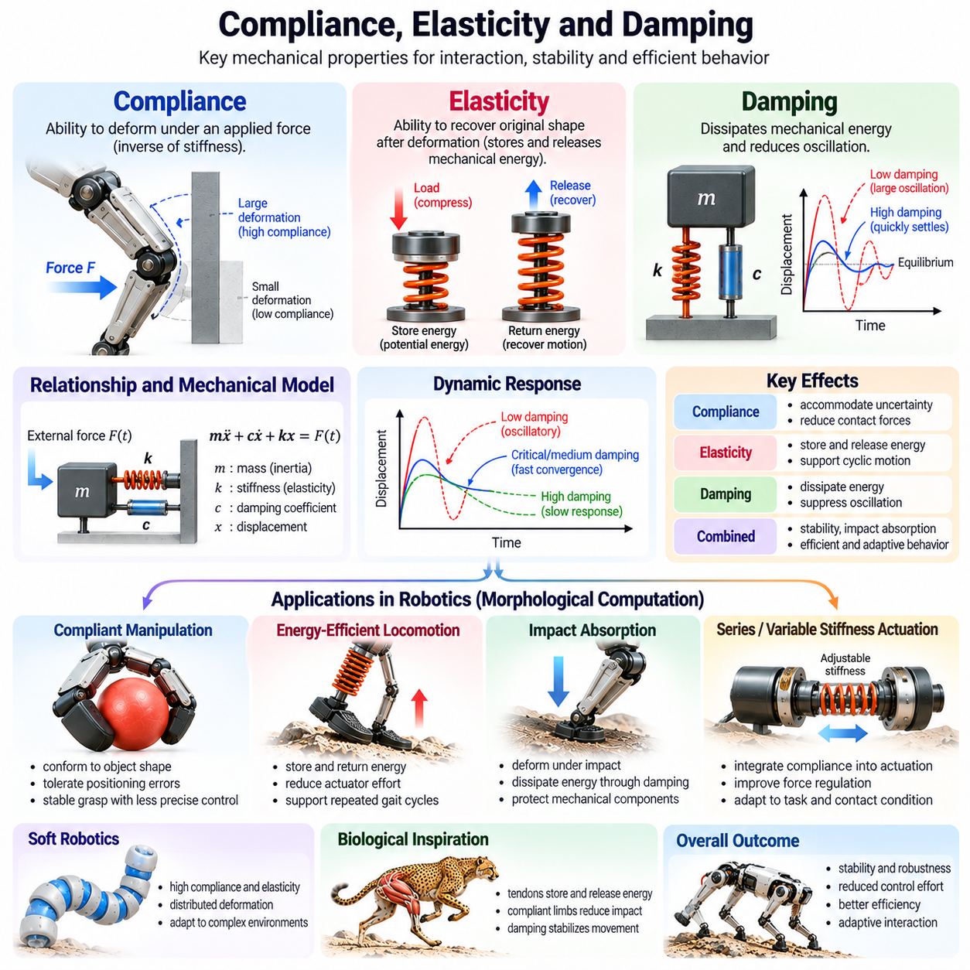
Compliance, elasticity, and damping are fundamental mechanical properties that determine how robotic bodies respond to external forces, deformation, and motion. Within morphological computation, these properties allow physical structures to regulate interactions without relying entirely on digital control. Their coordinated behavior influences stability, impact absorption, energy efficiency, and adaptability across different robotic platforms.
Compliance describes the ability of a mechanical system to deform in response to an applied force or torque. It is commonly understood as the inverse of stiffness under appropriate linear conditions. A highly compliant structure undergoes relatively large deformation under modest loading, while a stiff structure resists displacement. Compliance can arise from material properties, joint mechanisms, structural geometry, or dedicated elastic components.
Elasticity refers to the ability of a material or mechanical structure to recover its original configuration after deformation when the applied load is removed. Elastic elements store mechanical potential energy during deformation and release it during recovery. In robotics, springs, flexible beams, tendons, and elastomeric materials provide elastic responses that support impact absorption, energy recovery, and mechanically coordinated movement.
Damping describes mechanisms that dissipate mechanical energy and reduce oscillatory motion. Unlike ideal elastic elements, which store and return energy, damping elements convert mechanical energy into heat or other dissipative forms. Viscous damping, frictional damping, and material hysteresis represent common mechanisms. Their effects are essential for controlling vibration, suppressing unwanted movement, and stabilizing mechanical interactions.
Although compliance, elasticity, and damping are closely related, they represent distinct mechanical characteristics. Compliance determines the magnitude of deformation under loading, elasticity governs recoverable deformation and stored energy, and damping controls energy dissipation during motion. Their combined effects determine how a robot responds to disturbances, contact forces, and changing environmental conditions.
A simplified spring-damper system illustrates their interaction. When an external force displaces a compliant mechanism, elastic stiffness generates a restoring force proportional to displacement under linear assumptions. Damping produces an opposing force related to velocity. Together with inertia, these forces determine whether the system returns smoothly toward equilibrium, oscillates repeatedly, or responds too slowly to disturbances.
The balance among stiffness, damping, and inertia determines important dynamic characteristics, including natural frequency and damping ratio. Low damping can produce prolonged oscillations, while excessive damping may slow recovery. Appropriate parameter selection allows mechanical systems to absorb disturbances and return toward desired configurations. However, optimal values depend on the robot's task, geometry, loading, and operating environment.
In morphological computation, compliance enables physical structures to accommodate uncertainty without requiring explicit corrective commands for every interaction. A compliant robotic arm can yield slightly when encountering an unexpected obstacle, reducing contact forces. This mechanical response occurs directly through deformation, allowing the body to handle part of the interaction before higher-level control algorithms intervene.
Compliance is particularly valuable in contact-rich manipulation tasks. During insertion, assembly, or grasping, small positioning errors can produce substantial forces when rigid components interact. Compliant joints or end effectors accommodate these errors through controlled deformation. This behavior can reduce jamming, improve contact stability, and decrease the precision required from motion planning and positioning systems.
Elasticity contributes to robotic locomotion by storing and returning energy during repeated movement cycles. In legged robots, compliant elements may compress during ground contact and release stored energy during propulsion. When appropriately tuned, this process can reduce actuator work and support efficient movement. The benefit depends on gait timing, mechanical losses, terrain characteristics, and actuator coordination.
Damping is essential during foot-ground interactions because impacts can generate rapid force changes and structural vibrations. Mechanical damping dissipates part of the impact energy and reduces oscillations transmitted through the robot. Appropriate damping can improve contact consistency and protect mechanical components. Excessive damping, however, may waste energy that could otherwise contribute to locomotion.
Series elastic actuators demonstrate how compliance can be intentionally integrated into actuation systems. An elastic element is positioned between a motor-driven mechanism and its mechanical load, allowing force transmission through controlled deformation. Measuring this deformation can support force estimation and feedback control. Series elasticity can improve force regulation and impact tolerance, although it also introduces additional dynamics and bandwidth limitations.
Variable stiffness actuators extend this concept by allowing mechanical stiffness to change during operation. A robot may adopt relatively low stiffness during uncertain contact and higher stiffness when precise positioning or force transmission is required. This adaptability expands the range of mechanical behaviors available to the controller. However, variable stiffness mechanisms introduce additional design complexity, mass, and control requirements.
Soft robotics relies heavily on compliance and elasticity because deformable materials form substantial portions of the robot's structure. Silicone elastomers, flexible polymers, and pneumatic chambers allow distributed deformation during actuation and contact. These properties enable soft grippers and continuum robots to conform to irregular objects. Their mechanical adaptability reduces some control requirements while introducing nonlinear modeling challenges.
Material selection strongly influences compliance, elasticity, and damping. Metals generally provide relatively high stiffness, while elastomers and flexible polymers can support large deformation. Composite materials and engineered structures offer additional opportunities to tailor directional stiffness and energy dissipation. Designers must also consider fatigue, creep, temperature sensitivity, and long-term changes in mechanical properties.
Structural geometry can produce compliance even when the underlying material is relatively stiff. Thin beams, flexure hinges, lattice structures, and articulated mechanisms can deform predictably under applied loads. This distinction between material compliance and structural compliance is important because mechanical behavior depends on both material properties and geometry. Appropriate structural design can localize deformation and guide force transmission.
Anisotropic compliance describes mechanical behavior in which deformation depends on the direction of applied loading. A robotic mechanism may be designed to remain stiff along one axis while yielding along another. This directional behavior is useful in assembly, manipulation, and locomotion because it allows mechanical structures to accommodate selected disturbances while maintaining support or precision in critical directions.
Compliance and damping also influence the transmission of information through mechanical systems. Contact forces produce deformation patterns that can be measured by embedded sensors or inferred from actuator behavior. Mechanical structures may attenuate high-frequency disturbances while preserving slower interaction signals. Consequently, physical properties can perform preliminary filtering before information reaches digital perception and control algorithms.
The relationship between mechanical compliance and active impedance control is particularly important. Mechanical compliance arises from physical structure, whereas impedance control uses actuators and feedback to regulate the relationship between force and motion. Combining these approaches can improve interaction performance. Physical compliance provides immediate responses, while active control adjusts behavior according to changing objectives and environmental conditions.
Safety is another major consideration in selecting mechanical properties. Compliant structures can reduce peak contact forces and accommodate unexpected interactions with humans or objects. Damping can limit rebound and suppress oscillations after contact. Nevertheless, compliance alone does not guarantee safety, because stored elastic energy, actuator power, collision velocity, and system geometry also influence injury risk.
Mechanical design involves unavoidable trade-offs among compliance, precision, load capacity, and responsiveness. Excessive flexibility may reduce positioning accuracy and introduce structural oscillations, while excessive stiffness may increase impact forces and sensitivity to alignment errors. Similarly, insufficient damping can permit persistent vibration, whereas excessive damping can reduce efficiency and slow dynamic responses.
Simulation and experimental characterization are essential for selecting appropriate mechanical parameters. Engineers use stiffness measurements, force-displacement curves, vibration tests, and dynamic system identification to estimate relevant properties. Numerical models can predict deformation and contact behavior, but nonlinear materials and complex friction may introduce uncertainty. Physical testing remains necessary to validate performance under realistic operating conditions.
Within Physical AI, compliance, elasticity, and damping should be considered jointly with perception, learning, and control architecture. A morphology that naturally absorbs disturbances may simplify the behavior a learned controller must generate. Conversely, poorly selected mechanical properties can increase uncertainty and destabilize control. Effective system design therefore requires coordinated optimization of physical dynamics and computational intelligence.
Ultimately, compliance, elasticity, and damping demonstrate how mechanical properties can become functional resources for embodied intelligence. Compliance accommodates interaction uncertainty, elasticity provides restoring behavior and energy storage, and damping regulates energy dissipation and vibration. Their integration enables robotic bodies to contribute directly to stability, adaptability, and efficient physical interaction while complementing active intelligent control.

02.05. Mechanical Feedback and Physical Filtering
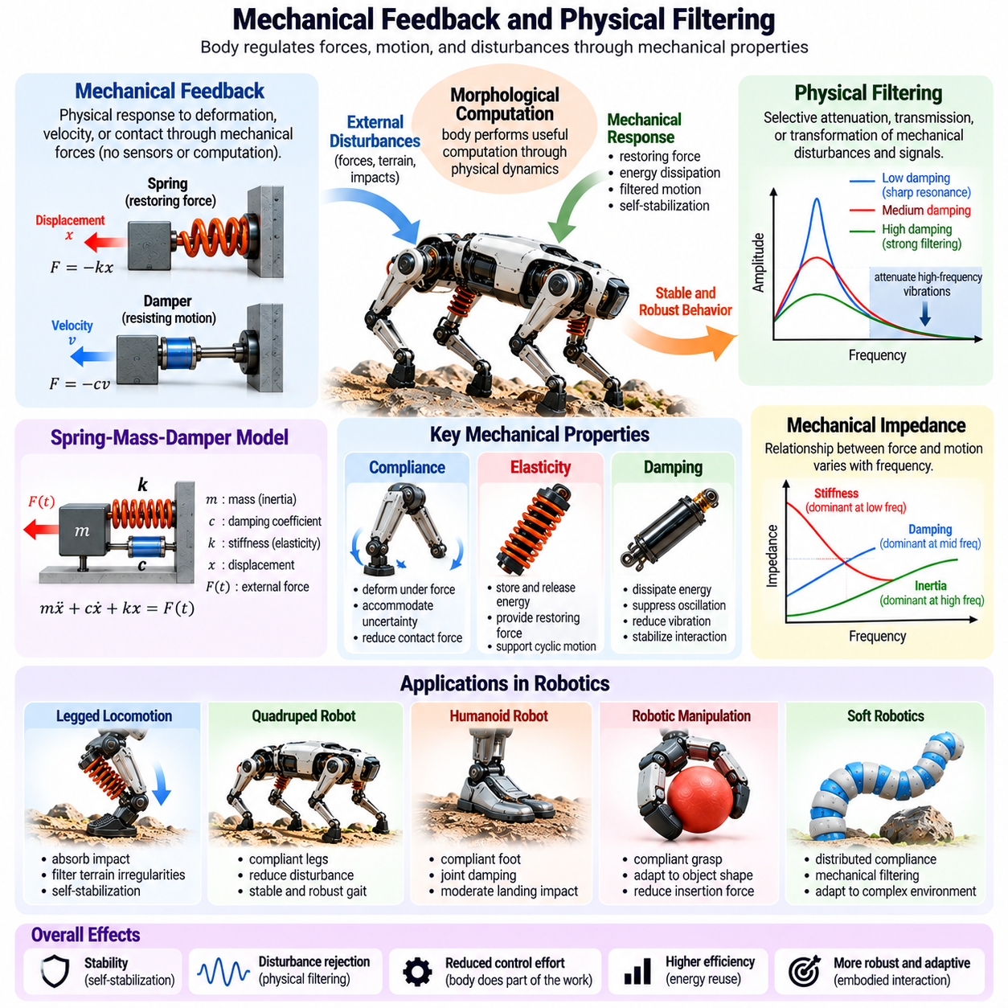
Mechanical feedback and physical filtering describe how robotic structures regulate forces, motion, and disturbances through their inherent mechanical properties. Within morphological computation, these mechanisms allow the body to perform functions that would otherwise require sensing and active control. By exploiting geometry, stiffness, damping, and inertia, robots can achieve immediate physical responses that support stability, robustness, and efficient interaction.
Mechanical feedback occurs when a physical system responds to its own displacement, velocity, or contact conditions through mechanically generated forces. A spring produces restoring force when displaced, while a damper resists relative motion. These responses form local feedback-like relationships without requiring digital measurement or computation. Their effectiveness depends on the mechanical configuration and the conditions under which interaction occurs.
Unlike conventional feedback control, mechanical feedback does not necessarily involve sensors, processors, or explicit control algorithms. The relationship between physical state and mechanical response is embedded directly in the system's structure. This enables rapid reactions to disturbances without computational communication delays. However, mechanical feedback is generally less programmable than active control and remains constrained by physical design.
Physical filtering refers to the selective attenuation, transmission, or transformation of mechanical disturbances and signals. A compliant structure may absorb high-frequency impacts while transmitting slower movements, depending on its dynamic characteristics. Mechanical filters therefore influence which forces and vibrations propagate through a robot. Their behavior is determined by mass, stiffness, damping, geometry, and contact conditions.
The spring-mass-damper system provides a basic model for understanding mechanical feedback and filtering. Elastic stiffness generates restoring forces, damping dissipates energy, and inertia resists acceleration. Together, these elements determine how the system responds to external excitation. Depending on their parameters, the resulting dynamics may suppress disturbances, amplify resonance, or delay force transmission.
Frequency response is an important concept in physical filtering because mechanical systems react differently to disturbances at different frequencies. A suspension mechanism may attenuate sufficiently high-frequency vibrations while responding to slower terrain variations. However, frequencies near mechanical resonance can produce amplified motion. Effective filtering therefore requires careful consideration of natural frequency, damping ratio, and operating conditions.
Mechanical impedance provides a useful framework for describing the relationship between applied forces and resulting motion. In dynamic systems, impedance depends on inertia, damping, and stiffness, with its behavior varying across frequencies. Appropriate impedance characteristics can improve interaction stability and reduce unwanted motion. Mechanical design therefore shapes how the body exchanges forces and energy with its environment.
Compliance plays a central role in mechanical feedback because deformation automatically changes contact forces. When a robotic arm encounters an obstacle, a compliant joint yields under loading and modifies the interaction force. This response can reduce sudden force peaks without waiting for controller intervention. Such behavior is especially valuable when contact conditions are uncertain or rapidly changing.
Damping contributes to physical filtering by dissipating energy associated with vibration and oscillation. Material hysteresis, viscous elements, and friction can suppress unwanted mechanical responses. In robotic joints and structures, damping may reduce residual vibration after rapid movement or impact. Excessive damping, however, can slow motion and dissipate energy that might otherwise be recovered.
Inertia also influences mechanical filtering by resisting rapid changes in velocity. A body with substantial inertia may respond less strongly to short-duration disturbances, although the resulting forces and recovery behavior depend on the complete system. Mass distribution affects rotational and translational responses differently. Consequently, inertia must be considered alongside stiffness and damping rather than treated as an independent stabilization mechanism.
Mechanical feedback becomes particularly important during robotic locomotion. Foot-ground contact generates rapidly changing forces that can exceed the response speed of higher-level control systems. Compliant feet, elastic joints, and damping elements provide immediate mechanical accommodation. These responses can reduce impact transmission and improve contact consistency, supporting more reliable movement over uneven terrain.
In quadruped robots, mechanically compliant legs can absorb terrain irregularities and distribute contact loads. Their passive responses complement active adjustments of joint torque, body posture, and foot placement. Appropriate mechanical filtering reduces the severity of disturbances reaching the main body. Nevertheless, stable locomotion across diverse terrain still requires sensing, coordination, and active control.
Humanoid robots benefit from mechanical filtering during walking, running, and physical interaction. Compliant foot structures can moderate landing impacts, while joint damping reduces unwanted oscillations. These mechanisms may improve the quality of contact transitions and reduce actuator stress. However, balance regulation remains dependent on whole-body dynamics, momentum management, and active feedback.
Mechanical feedback is equally valuable in robotic manipulation. During insertion or assembly, compliant mechanisms can redirect contact forces and accommodate small alignment errors. Remote center compliance devices demonstrate how mechanical geometry can guide corrective motion under contact loading. Such mechanisms simplify certain precision tasks by embedding useful force-displacement relationships directly into hardware.
Soft robotic grippers provide another example of distributed mechanical feedback. Flexible fingers deform according to object geometry and contact pressure, redistributing forces across the grasping surface. This adaptation occurs without individually controlling every contact point. The resulting physical interaction can improve grasp robustness, although object properties and material nonlinearities influence performance.
Physical filtering also contributes to tactile sensing by shaping how contact information reaches sensors. A compliant sensor covering distributes pressure and modifies deformation patterns before measurements are recorded. This mechanical preprocessing may attenuate unwanted vibrations or emphasize particular contact features. Sensor interpretation must therefore account for the filtering effects introduced by the surrounding material and structure.
Mechanical signal transmission is not always beneficial, because filtering can remove useful information as well as unwanted disturbances. Excessive compliance may obscure rapid contact events, while strong damping can suppress vibration signatures needed for slip detection. Designers must balance mechanical protection with sensing bandwidth and information preservation. The appropriate balance depends on the robot's perception and interaction objectives.
The relationship between mechanical feedback and active feedback control is complementary. Mechanical structures provide immediate local responses, while digital controllers estimate system states and adjust behavior according to task requirements. Active impedance control can further shape apparent stiffness and damping through actuator commands. Combining physical and computational feedback can improve performance when their dynamic interactions are properly coordinated.
Control-system stability requires particular attention when mechanical filtering is combined with active control. Structural flexibility introduces additional dynamic modes, while sensing delays and actuator bandwidth limitations affect feedback behavior. Poorly tuned controllers may excite mechanical resonance or produce unstable interactions. Integrated modeling of mechanical dynamics and control loops is therefore essential for reliable operation.
Energy efficiency is another motivation for using mechanical feedback and filtering. Passive structures can reduce unnecessary corrective actuator activity and absorb disturbances without continuous computational intervention. Elastic components may recover part of the energy stored during deformation. However, damping and friction dissipate energy, so improved disturbance rejection does not automatically imply lower total energy consumption.
Mechanical feedback can also improve safety by moderating contact forces during unexpected interactions. Compliant interfaces may reduce peak forces, while damping limits rebound and oscillation. These characteristics are valuable in collaborative robots and human-centered environments. Nevertheless, safety depends on collision speed, effective mass, stored energy, actuator behavior, and the complete system architecture.
Evaluating mechanical filtering requires measurements of force transmission, vibration attenuation, frequency response, and disturbance recovery. Experimental methods include impact testing, frequency sweeps, force-displacement characterization, and system identification. Simulation can support parameter selection, but contact nonlinearities and material variations must be validated experimentally under representative operating conditions.
Morphological computation provides a broader interpretation of these mechanisms by treating mechanical responses as functional contributions to intelligent behavior. The body does not merely transmit commands from a controller; it transforms physical interactions according to its structural properties. Appropriate morphology can reduce control complexity and support robust adaptation, although these benefits remain dependent on task requirements.
For Physical AI systems, mechanical feedback and physical filtering should be designed jointly with sensing, actuation, and learning algorithms. Mechanical structures can handle rapid local disturbances, while computational intelligence manages changing goals and complex environmental uncertainty. This coordinated architecture distributes functional responsibilities across physical and digital components, improving the potential for responsive and reliable behavior.
Ultimately, mechanical feedback and physical filtering demonstrate how robotic bodies can regulate interactions through their own dynamics. Stiffness, compliance, damping, inertia, and geometry determine how disturbances are transformed, transmitted, or attenuated. When carefully integrated with active control, these physical mechanisms provide a foundation for stable, efficient, and adaptable embodied intelligence.

02.06. Morphology and Control Complexity
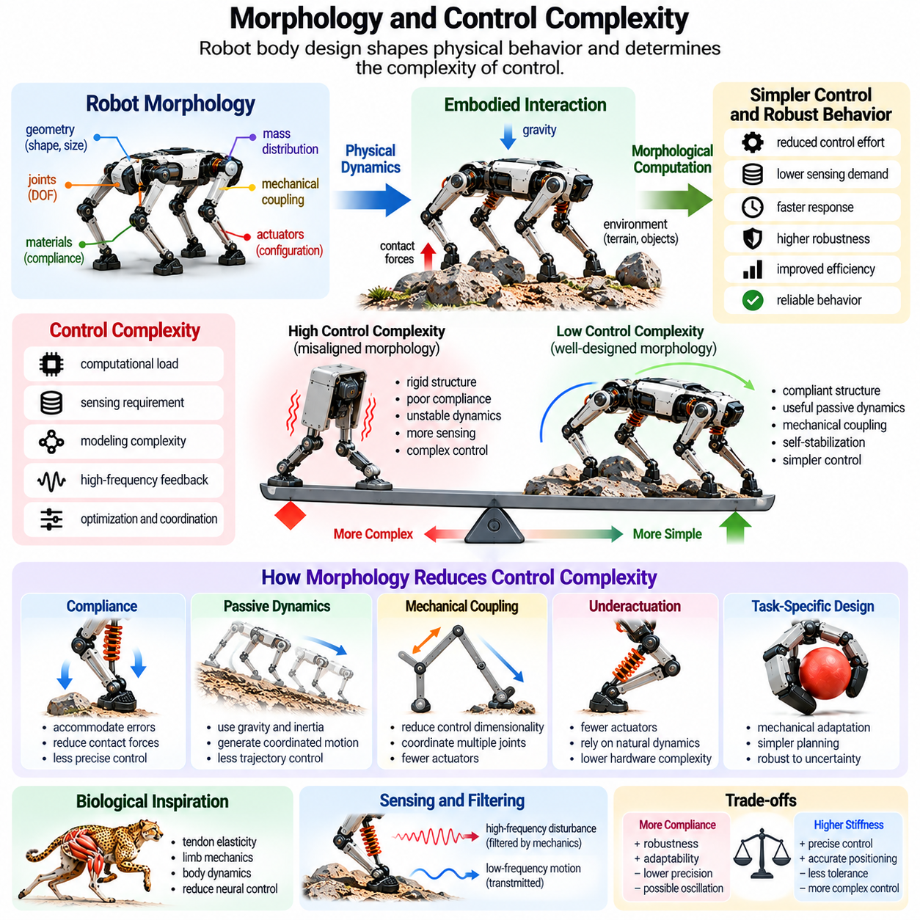
Robot morphology directly influences control complexity by determining how mechanical structures, joints, materials, and environmental interactions shape physical behavior. A well-designed body can simplify movement coordination and disturbance rejection through its natural dynamics. Within morphological computation, this relationship suggests that intelligent behavior emerges not only from algorithms but also from the physical organization of the robotic system.
Control complexity refers to the computational, sensing, modeling, and coordination requirements needed to achieve desired robotic behavior. Complex controllers may require detailed dynamic models, high-frequency feedback, extensive state estimation, and optimization. Morphology influences these requirements by determining the number of controllable variables, mechanical constraints, and natural responses available during physical interaction.
The relationship between morphology and control is not simply a matter of reducing the number of joints or actuators. A robot with fewer degrees of freedom may be easier to coordinate but less capable of adapting to diverse tasks. Conversely, additional joints can provide flexibility while increasing control demands. Effective morphology balances mechanical capability with the computational resources needed to exploit that capability.
Mechanical compliance can reduce control complexity by accommodating small positioning errors and external disturbances automatically. A compliant manipulator may adjust to contact conditions through deformation rather than requiring continuous corrective commands. This physical adaptation reduces certain sensing and control requirements, although excessive compliance can introduce oscillations and complicate precise positioning.
Passive dynamics provides another mechanism for simplifying control. A robot designed to exploit gravity, inertia, and mechanical coupling can generate coordinated movements without explicitly commanding every joint trajectory. Passive dynamic walkers demonstrate how gait patterns may arise from body geometry and environmental interaction. Active control can then focus on regulating speed, direction, and disturbances beyond passive stability limits.
Mechanical coupling can reduce the effective dimensionality of a control problem. Linkages, tendons, springs, and shared actuators coordinate multiple joints through physical constraints. Instead of independently controlling every movement, the system follows mechanically defined relationships. Such coupling can simplify command generation but may also restrict independent motion and reduce adaptability when tasks change.
Underactuated robots illustrate the relationship between mechanical structure and control requirements. These systems possess fewer independent actuators than mechanical degrees of freedom, relying on passive dynamics, contact constraints, or mechanical coupling to coordinate motion. Underactuation can reduce hardware complexity and energy consumption. However, it may also make planning, controllability, and disturbance recovery more challenging.
Morphology can simplify control by embedding task-specific behavior directly into mechanical design. A gripper with flexible fingers naturally conforms to objects of different shapes, reducing the need for precise contact-point planning. Similarly, a compliant insertion mechanism can accommodate small alignment errors. These examples demonstrate how mechanical adaptation can replace selected computational operations without eliminating the need for intelligent control.
The concept of control dimensionality is particularly important in high-degree-of-freedom robots. Humanoids and dexterous manipulators may contain many joints whose movements must be coordinated. Mechanical constraints and natural motion patterns can restrict the range of meaningful configurations. Controllers can exploit these relationships to operate within lower-dimensional movement representations rather than independently optimizing every joint.
Biological motor control provides inspiration for this approach. Animals coordinate complex bodies through interactions among neural commands, muscle properties, skeletal geometry, and environmental forces. Tendon elasticity and limb mechanics contribute to movement without requiring explicit neural regulation of every mechanical detail. Robotics applies similar principles by distributing functional responsibility between control algorithms and physical structures.
Mechanical synergies describe coordinated joint behaviors arising from structural coupling or shared actuation. In robotic hands, tendon routing and compliant joints can produce coordinated finger closure using relatively few motors. Such mechanisms simplify certain grasping operations by embedding relationships among joint movements. However, fixed mechanical synergies may limit independent finger manipulation and task versatility.
Control complexity is also influenced by the predictability of mechanical behavior. A structure with stable, repeatable dynamics may require less frequent corrective intervention than one exhibiting unpredictable oscillations or friction. Well-characterized compliance and damping can improve model reliability. Conversely, nonlinear deformation, backlash, and variable contact conditions may increase uncertainty and complicate control.
Morphological design can reduce the sensing burden by making certain physical states mechanically self-regulating. A compliant suspension can accommodate moderate surface irregularities without explicitly measuring every displacement. Mechanical damping can suppress high-frequency vibrations before they reach sensitive components. Nevertheless, passive regulation does not replace sensing when environmental interpretation or precise state estimation is required.
The computational advantages of morphology depend strongly on the intended task. A specialized robot can exploit carefully optimized mechanical structures to perform repetitive operations efficiently. A general-purpose robot must handle broader variations in objects, environments, and objectives. Consequently, highly specialized morphology may simplify control within a narrow operating range while increasing limitations outside that range.
Morphological complexity and control complexity therefore exhibit a task-dependent trade-off. Adding springs, compliant joints, or mechanical linkages may reduce software requirements but increase mechanical design, calibration, and maintenance demands. Simplifying hardware may shift complexity toward sensing and computation. System-level optimization must consider these costs together rather than evaluating control algorithms independently.
The distinction between open-loop and closed-loop control helps explain morphology's influence. Mechanically stable systems can sometimes perform useful movements with relatively simple open-loop commands. Less stable systems require more frequent feedback corrections. However, open-loop performance remains vulnerable to unmodeled disturbances, and reliable operation generally benefits from feedback even when passive dynamics are favorable.
Morphology also influences the bandwidth required from active controllers. Mechanical structures can respond immediately to contact forces, reducing the need for digital controllers to correct every rapid disturbance. Appropriate compliance and damping may attenuate high-frequency interactions. Yet flexible structures can introduce resonances that require careful control design, so lower bandwidth requirements are not guaranteed.
Learning-based robotic control can benefit from morphology that naturally supports desired behaviors. Reinforcement learning may require fewer corrective actions when passive mechanics already provide useful stability or contact adaptation. Mechanical constraints can also restrict exploration to physically meaningful movements. However, complex nonlinear morphology may increase learning difficulty by making action consequences harder to predict.
Co-design of morphology and control addresses these interactions by optimizing physical structures and control policies together. Instead of selecting hardware first and developing software afterward, engineers evaluate how changes in geometry, stiffness, actuation, and sensing affect achievable behavior. Simulation and physical experiments can guide this process. The resulting design seeks an effective distribution of complexity across mechanics and computation.
Energy consumption provides another perspective on morphology-aware control. Passive elastic elements may store and return energy, while mechanical coupling can reduce unnecessary actuator activity. Controllers can exploit natural frequencies and coordinated motion patterns to improve efficiency. Nevertheless, added mass, friction, damping losses, and unsuitable mechanical constraints can offset these benefits.
Robustness must also be considered when evaluating control simplification. A robot requiring fewer corrective commands under nominal conditions may still perform poorly when payloads, terrain, or contact properties change. Mechanical self-stabilization often operates within limited disturbance ranges. Effective designs therefore combine useful passive behavior with sufficient active control authority to handle unexpected conditions.
Evaluating morphology's effect on control complexity requires measurable criteria. Relevant indicators include computational load, control frequency, model complexity, sensing requirements, actuator effort, tracking accuracy, and disturbance recovery. Comparisons should use equivalent tasks and operating conditions. Reductions in computation are meaningful only when essential performance, adaptability, and safety requirements remain satisfied.
Physical AI architectures can exploit morphology by assigning rapid local regulation to mechanical structures and higher-level adaptation to computational intelligence. Mechanical compliance handles immediate contact variations, while perception and planning interpret complex environmental conditions. Learning-based controllers can refine behavior over time. This layered distribution supports efficient coordination between physical dynamics and intelligent decision-making.
Ultimately, morphology and control complexity are inseparable aspects of embodied robotic design. Appropriate mechanical structures can simplify selected control problems by embedding coordination, compliance, filtering, and stabilization into the body. However, physical simplification may introduce new constraints and uncertainties. Effective Physical AI therefore requires balancing mechanical intelligence, computational control, adaptability, and system-level performance.

02.07. Morphological Computation in Locomotion
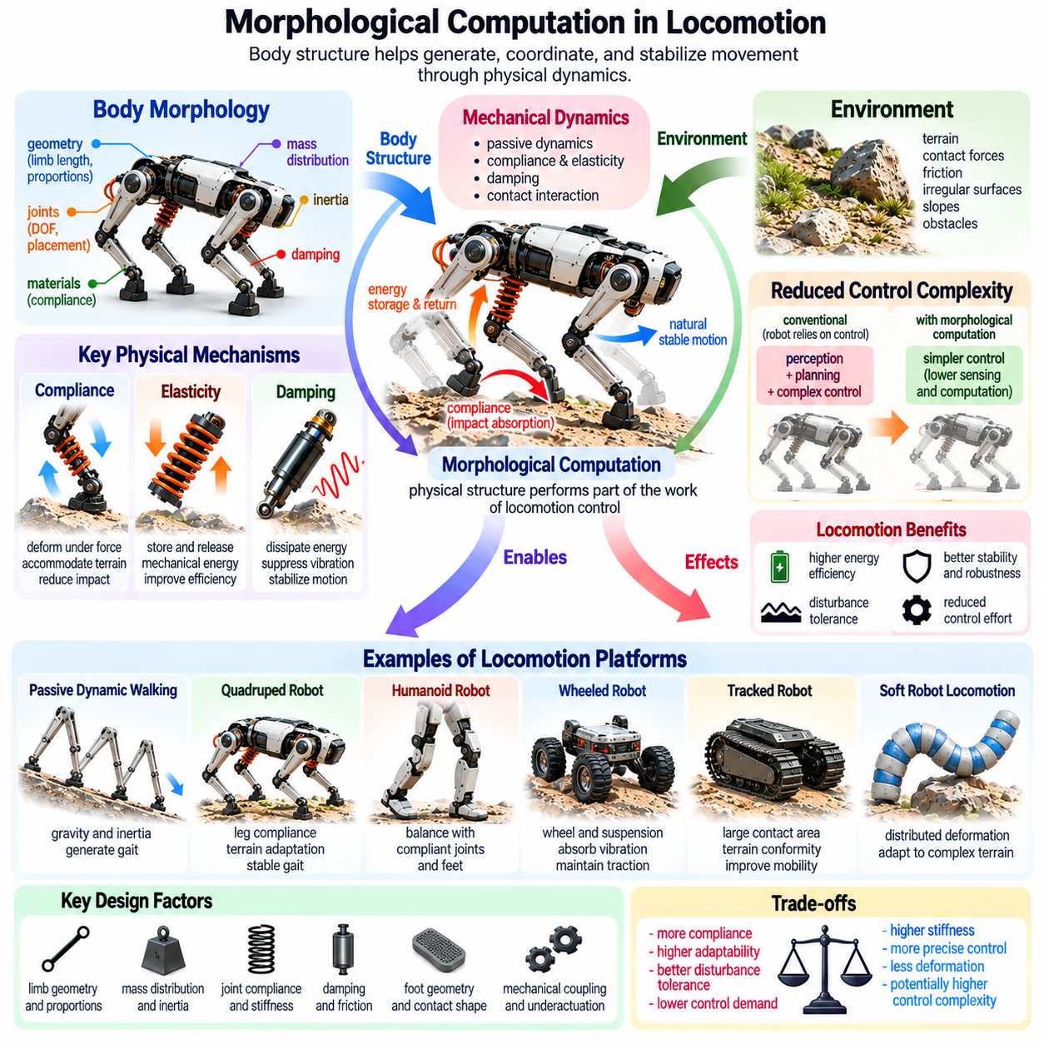
Morphological computation in locomotion describes how a robot's physical structure contributes to generating, coordinating, and stabilizing movement. Instead of relying exclusively on computational control, locomotion systems exploit body geometry, inertia, elasticity, damping, and environmental contact. These mechanical properties shape motion directly, allowing physical dynamics to perform functions that would otherwise require continuous sensing and control.
Locomotion involves repeated interactions between a robot and its environment, making morphology particularly influential. Every ground contact produces forces that depend on limb geometry, material properties, body mass, and movement speed. These forces affect acceleration, balance, and energy transfer. By designing the body to respond beneficially to contact, engineers can reduce certain control requirements while improving movement efficiency.
Passive dynamic walking provides a foundational example of morphological computation in locomotion. A suitably designed legged mechanism can walk down a gentle slope using gravity, inertia, and intermittent foot contact. Its geometry and mass distribution produce coordinated movements without continuously specifying joint trajectories. This demonstrates that recognizable gait patterns can emerge from mechanical dynamics rather than explicit computational commands.
The stability of passive walking depends on the relationship between body morphology and periodic motion. During each step, the robot undergoes continuous movement interrupted by discrete contact transitions. Stable walking occurs when sufficiently small disturbances diminish across successive cycles. Limb proportions, joint friction, foot curvature, and mass distribution influence whether the resulting gait remains stable.
Elastic elements extend passive locomotion by storing and releasing mechanical energy during movement. Springs, compliant tendons, and flexible joints can absorb energy during loading and return part of it during propulsion. This behavior resembles elastic energy exchange in biological locomotion. When properly tuned, elasticity can reduce actuator work and support efficient movement, although timing and mechanical losses remain important.
Damping regulates locomotion by dissipating energy associated with impacts and unwanted oscillations. During landing, mechanical damping can reduce vibration and moderate force transmission through the robot's structure. Appropriate damping improves contact consistency and disturbance recovery. Excessive damping, however, may dissipate useful elastic energy and increase the work required from actuators during repeated movement cycles.
Leg morphology strongly influences locomotion performance because limb length, segment proportions, joint placement, and mass distribution determine mechanical leverage and dynamic response. Long legs may increase stride length but also introduce greater rotational inertia or structural loading. Compact limbs may improve certain aspects of stability while limiting reach. Effective morphology depends on the intended gait, terrain, and operating speed.
Foot geometry provides another important mechanism for morphological computation. Curved feet can influence rolling contact and step transitions, while compliant soles distribute pressure across irregular surfaces. Contact shape affects the center of pressure, frictional interaction, and mechanical stability. Appropriate foot design can therefore guide movement and accommodate terrain variations without requiring detailed control of every contact event.
Spring-loaded inverted pendulum models illustrate how simplified mechanical structures can capture important features of running and hopping. A compliant leg behaves approximately like a spring supporting a moving body mass. During stance, energy transfers between kinetic and elastic forms. This mechanical relationship helps explain how repeated bouncing motion can emerge from coordinated body dynamics and periodic ground contact.
Quadruped locomotion benefits from morphological computation through leg compliance, body flexibility, and mechanically coupled movement. Compliant limbs accommodate moderate terrain irregularities, while body dynamics influence how forces are distributed among supporting legs. Passive mechanical responses complement active gait coordination. Their effectiveness depends on gait type, contact sequence, payload, and environmental conditions.
In bipedal and humanoid locomotion, morphology affects balance through center-of-mass placement, foot dimensions, joint compliance, and segment inertia. Passive mechanics can moderate impacts and contribute to natural movement patterns. However, dynamic balance generally requires active regulation of momentum and foot placement. Morphological computation therefore complements rather than replaces whole-body feedback control.
Wheeled robots also exploit morphology during locomotion. Wheel radius, tire compliance, suspension geometry, and mass distribution influence traction, vibration transmission, and obstacle traversal. Passive suspension mechanisms accommodate surface irregularities and reduce disturbances reaching the chassis. These physical responses can simplify certain aspects of motion regulation, although steering and navigation still require appropriate control.
Tracked locomotion illustrates how contact geometry can distribute loads across a larger ground area. Track flexibility and suspension characteristics influence terrain conformity and traction. These mechanical properties can improve movement over selected uneven or deformable surfaces. However, additional friction, turning resistance, and mechanical losses introduce trade-offs that must be considered during morphology selection.
Soft-bodied locomotion uses distributed deformation to generate movement through interactions among compliant materials, actuation, and environmental resistance. Soft crawling robots may exploit body bending, directional friction, or sequential deformation. Their physical structures can coordinate local motion without independently controlling every material element. Nevertheless, nonlinear deformation and contact behavior can complicate modeling and precise control.
Bio-inspired locomotion demonstrates how morphology can support efficient movement across different environments. Tendons, flexible spines, segmented bodies, and compliant feet contribute to movement in biological organisms. Robotic systems can adapt these principles to achieve useful mechanical coordination. The goal is not necessarily to reproduce biological anatomy exactly, but to identify physical mechanisms that support desired locomotion behavior.
Mechanical resonance can assist locomotion when actuation is coordinated with the natural frequencies of the robot's structure. Periodic excitation near an appropriate dynamic mode may produce substantial movement with relatively modest input. However, resonance can also amplify unwanted vibration and reduce stability. Designers must therefore distinguish beneficial rhythmic dynamics from potentially destructive oscillatory behavior.
Morphological computation can reduce the effective dimensionality of locomotion control. Mechanical linkages, compliant couplings, and natural dynamic relationships constrain how joints move together. Instead of commanding every degree of freedom independently, controllers may regulate a smaller set of meaningful variables. This approach can simplify coordination, although fixed mechanical relationships may restrict adaptation to unfamiliar terrain.
Terrain interaction is central to morphology-dependent locomotion because physical contact conditions continuously change. Surface stiffness, friction, slope, and obstacle geometry alter the forces acting on the robot. Compliant structures can accommodate some variations automatically, but their effectiveness is limited by mechanical range and loading conditions. Robust locomotion requires morphology and active control to address uncertainty together.
Energy efficiency provides an important motivation for exploiting morphological computation. Elastic energy recovery, favorable mass distribution, and mechanically coordinated motion can reduce unnecessary actuator effort. However, impacts, friction, damping, and structural deformation may also dissipate energy. Improvements must therefore be evaluated through complete movement cycles rather than assuming that passive mechanisms always reduce consumption.
Learning-based locomotion controllers can exploit mechanical structures that naturally support stable movement. Reinforcement learning may discover control policies that coordinate actuation with passive dynamics and environmental contact. Appropriate morphology can simplify some aspects of exploration and disturbance recovery. Conversely, poorly matched stiffness, inertia, or contact geometry can increase learning difficulty and limit achievable performance.
Co-design of morphology and locomotion control considers mechanical parameters and control policies as interacting design variables. Engineers can jointly optimize limb dimensions, joint stiffness, actuator placement, and movement strategies. Simulation provides opportunities to evaluate many configurations, while physical experiments reveal material nonlinearities and contact uncertainties. This integrated process seeks reliable performance across realistic operating conditions.
Evaluating morphological computation in locomotion requires examining stability, energy consumption, speed, terrain adaptability, and control effort. Relevant measurements include cost of transport, disturbance recovery, actuator power, gait variability, and contact-force distribution. Comparisons should preserve equivalent task conditions and performance requirements. Reduced computational effort is meaningful only when movement quality and safety remain acceptable.
For Physical AI, locomotion morphology provides a physical foundation upon which perception, planning, and adaptive control can operate. Mechanical structures handle immediate contact responses, while computational systems interpret terrain and adjust movement objectives. This division of responsibility can improve responsiveness and robustness when physical and digital mechanisms are appropriately coordinated.
Ultimately, morphological computation in locomotion demonstrates that movement intelligence is distributed across the robot's body, controller, and environment. Geometry, compliance, elasticity, damping, inertia, and contact mechanics collectively shape gait generation and stability. Integrating these physical resources with adaptive control enables embodied robotic systems to achieve more efficient, resilient, and versatile locomotion.

02.08. Morphological Computation in Manipulation
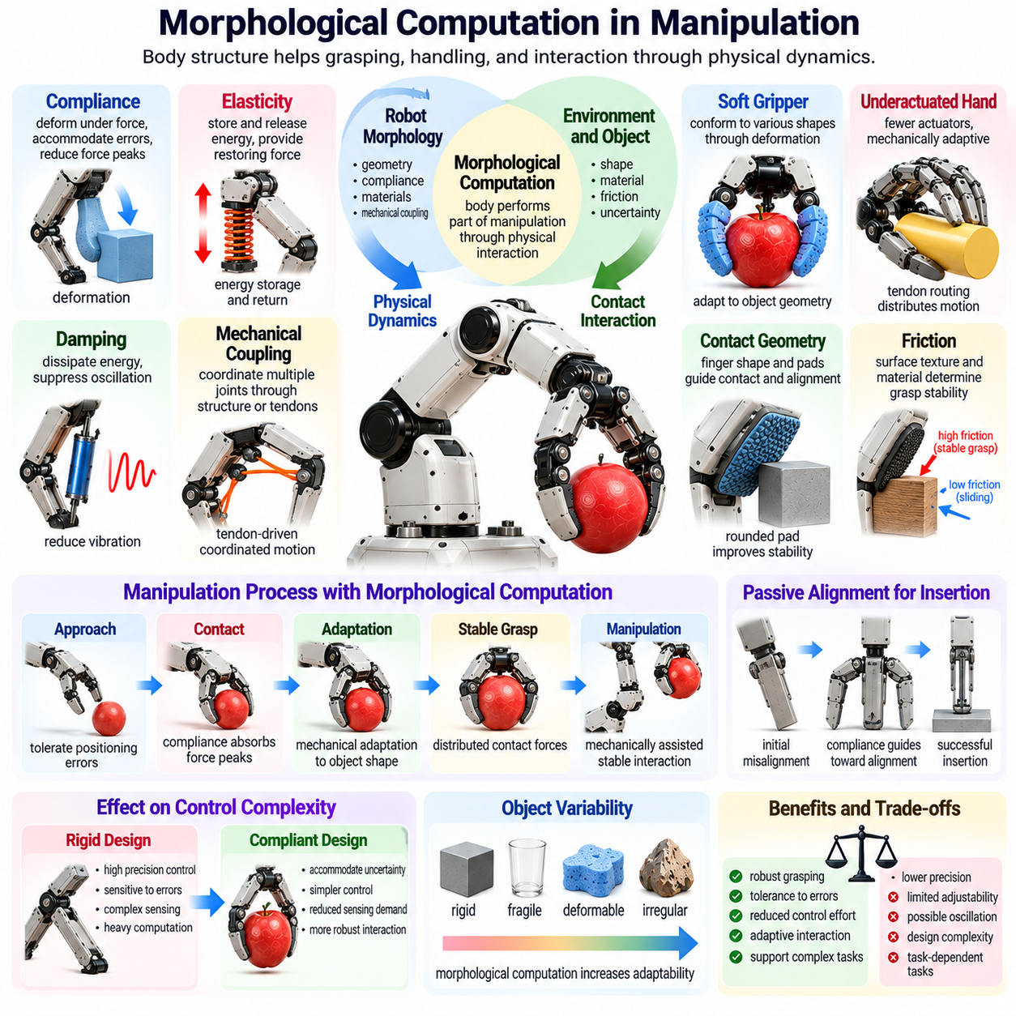
Morphological computation in manipulation describes how a robot's physical structure contributes to grasping, handling, positioning, and interacting with objects. Rather than relying entirely on precise sensing and computational control, manipulation systems exploit geometry, compliance, elasticity, friction, and mechanical coupling. These properties allow the body to accommodate contact uncertainty and generate useful behaviors through physical interaction.
Robotic manipulation involves complex relationships among the manipulator, object, and surrounding environment. Contact forces depend on surface geometry, material properties, joint configuration, and movement direction. Small positioning errors can produce significant forces when rigid components interact. Appropriate morphology transforms these interactions into mechanically guided responses, reducing selected demands on sensing, planning, and feedback control.
Compliance is a central mechanism of morphological computation in manipulation. Flexible joints, elastic tendons, and deformable contact surfaces allow a robot to accommodate small errors through physical deformation. When an end effector encounters an unexpected constraint, compliance can reduce force peaks and redirect motion. This immediate response helps protect components and supports stable interaction without requiring every adjustment to be calculated.
Soft robotic grippers demonstrate how mechanical properties can simplify grasping. Their deformable fingers conform to objects with different shapes, distributing contact pressure across multiple surfaces. Instead of calculating exact finger positions for every object, the gripper uses material deformation to establish contact. This adaptability can improve grasp robustness, although excessive softness may reduce positioning accuracy and load capacity.
Underactuated robotic hands provide another example of mechanically coordinated manipulation. These mechanisms contain fewer independently controlled actuators than joint degrees of freedom. Tendon routing, joint springs, and contact constraints allow fingers to adapt their configurations during grasping. Mechanical coupling distributes actuator forces among joints, reducing command complexity while limiting independent control of individual finger movements.
Mechanical synergies describe coordinated movements that arise from shared actuation or structural constraints. In robotic hands, one actuator may drive several finger joints through a tendon network. As contact occurs, compliant joints redistribute motion and force according to object geometry. Such mechanisms embed grasp coordination into hardware, enabling useful adaptation without independently computing every joint trajectory.
Contact geometry plays an important role in manipulation because the shape of interacting surfaces determines how forces produce motion. Rounded fingertips, compliant pads, and shaped guides can influence object alignment and force distribution. Appropriate geometry may encourage objects to settle into stable configurations. These mechanical effects can simplify grasp acquisition, insertion, and positioning when contact conditions remain within the intended operating range.
Friction is another essential component of morphology-dependent manipulation. Surface texture, contact pressure, and material composition influence resistance to sliding. High friction may improve grasp retention, while controlled sliding can support repositioning and assembly. Mechanical design must balance these effects because excessive friction can cause jamming, whereas insufficient friction can produce unintended object motion.
Passive mechanical alignment is especially useful in assembly operations. When components are slightly misaligned, rigid position control may generate large contact forces or insertion failure. Compliant mechanisms can allow the inserted component to rotate or translate toward a compatible configuration. Remote center compliance devices demonstrate how mechanical geometry and flexibility can support alignment during contact-rich insertion tasks.
Elasticity contributes to manipulation by generating restoring forces and storing mechanical energy. Springs can return fingers toward predefined configurations or maintain contact pressure within suitable displacement ranges. Elastic elements may also support rapid grasp closure and controlled release. However, stored energy can cause rebound or overshoot, making damping and appropriate stiffness selection important for predictable manipulation.
Damping regulates manipulation dynamics by suppressing vibration and reducing oscillations after contact. During grasping or object placement, sudden changes in force can excite flexible structures. Mechanical damping dissipates part of this energy, helping the system settle into stable configurations. Excessive damping may slow manipulation and increase energy losses, so its value must be matched to the intended task.
Object properties strongly influence the effectiveness of morphological computation. Rigid objects, deformable materials, fragile components, and irregular shapes require different mechanical responses. A compliant gripper may handle delicate objects effectively but struggle with heavy loads or precise orientation control. Consequently, morphology should be selected according to expected object variability, contact forces, and manipulation requirements.
Morphological computation can reduce the dimensionality of grasp planning by allowing mechanical structures to accommodate multiple possible contact configurations. A controller may specify a general closing motion while compliant fingers determine their final positions through contact. This reduces the need to predict every contact point in advance. Nevertheless, object recognition, grasp selection, and task-level planning may still require sophisticated computation.
Environmental constraints can also become useful resources during manipulation. A robot may push an object against a supporting surface to establish alignment or use a table to stabilize an item during reorientation. Such strategies exploit physical contact rather than relying solely on free-space control. Morphology determines whether these interactions are mechanically stable, controllable, and safe for the object and surrounding environment.
Tactile sensing interacts closely with morphological computation because compliant structures transform contact forces into measurable deformation. Flexible sensor coverings distribute pressure and shape tactile signals before electronic processing. This mechanical preprocessing can improve contact tolerance and reveal distributed pressure patterns. However, excessive filtering may obscure rapid events, including incipient slip or brief impacts.
Mechanical impedance provides a framework for understanding how manipulators exchange force and motion with objects. Stiffness, damping, and inertia determine the response to contact disturbances across different frequencies. Appropriate physical impedance can improve interaction stability and reduce sudden loading. Active impedance control can complement these properties by adjusting actuator behavior according to task requirements and environmental conditions.
Variable stiffness mechanisms allow manipulators to modify their mechanical behavior during operation. Lower stiffness may support safe contact and uncertain object acquisition, while higher stiffness can improve load support or positioning precision. This flexibility broadens the range of achievable manipulation behaviors. However, variable stiffness systems introduce additional mechanical complexity, calibration requirements, and control challenges.
Continuum and soft manipulators extend morphological computation through distributed deformation. Their flexible bodies bend and conform to obstacles or object surfaces, allowing interaction in confined or irregular spaces. Motion emerges from the combined effects of actuation, material elasticity, and environmental constraints. Although this adaptability is valuable, nonlinear deformation and complex contact dynamics can make accurate modeling difficult.
Morphology can improve manipulation safety by limiting peak contact forces and accommodating unexpected interactions. Compliant surfaces reduce local pressure concentrations, while mechanical damping moderates impacts and rebound. These characteristics are valuable in collaborative robotics and human-centered environments. However, safety also depends on actuator power, collision velocity, effective mass, and the energy stored within elastic components.
Energy efficiency in manipulation depends on how mechanical structures store, transmit, and dissipate energy. Passive springs can maintain certain forces without continuous actuator adjustment, while mechanically coupled fingers may reduce the number of motors required. Nevertheless, friction, damping, deformation losses, and actuator inefficiencies can offset these advantages. Energy benefits must therefore be evaluated across complete manipulation tasks.
Learning-based manipulation can exploit morphological properties that simplify contact interactions. Reinforcement learning policies may discover grasping and insertion strategies that use compliance, friction, and environmental constraints. Appropriate morphology can make some actions more tolerant of uncertainty and reduce the precision demanded from learned control. Conversely, complex material behavior may increase variability and complicate policy transfer.
Co-design of manipulation morphology and control involves optimizing finger geometry, joint compliance, actuator placement, tactile sensing, and control strategies together. Simulation can evaluate candidate structures, while physical experiments reveal frictional effects, material nonlinearities, and unexpected contact behavior. Effective co-design seeks mechanical properties that support the intended tasks without sacrificing necessary precision, adaptability, or reliability.
Evaluating morphological computation in manipulation requires measurements of grasp success, contact stability, positioning accuracy, force regulation, and disturbance tolerance. Additional indicators include actuator effort, computational load, object damage, and performance across different shapes and materials. Comparisons should maintain equivalent task conditions. Reduced control complexity is beneficial only when essential manipulation performance remains acceptable.
Within Physical AI, manipulation morphology provides an interface between intelligent decision-making and physical object interaction. Mechanical structures handle immediate contact adaptation, while perception, planning, and learning determine goals and action sequences. Their integration distributes functional responsibilities across hardware and software, enabling more responsive and robust manipulation under uncertain environmental conditions.
Ultimately, morphological computation in manipulation demonstrates that useful intelligence can be embedded in the mechanical properties of robotic hands and manipulators. Geometry, compliance, elasticity, damping, friction, and coupling shape how objects are grasped, aligned, and moved. When integrated with adaptive sensing and control, these physical resources support efficient, reliable, and versatile embodied manipulation.

02.09. Biological Examples and Inspiration
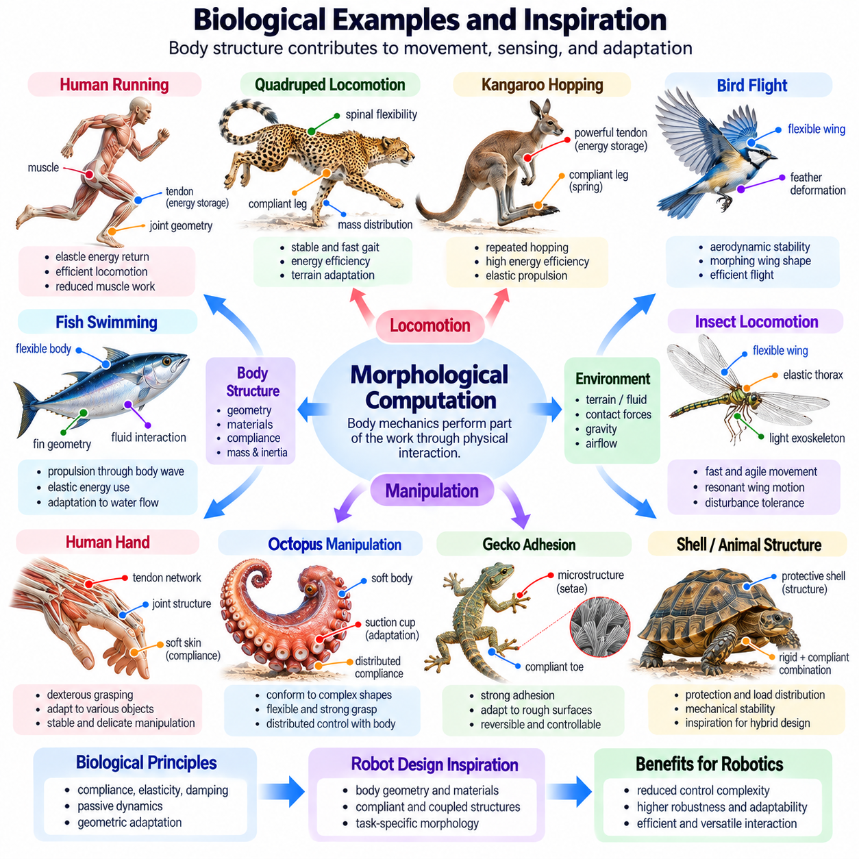
Biological organisms provide important examples of morphological computation because their bodies contribute directly to movement, sensing, adaptation, and environmental interaction. Muscles, tendons, skeletons, skin, and connective tissues possess mechanical properties that shape behavior before neural commands are fully processed. These structures demonstrate how intelligence can emerge from coordinated interactions among physical morphology, nervous systems, and environmental forces.
Morphological computation in biology does not imply that the body operates independently of neural control. Instead, mechanical structures and neural processes share responsibility for generating behavior. The nervous system establishes goals and adjusts activity, while body dynamics regulate many immediate physical responses. This distribution reduces the need for explicit neural control of every movement detail and supports rapid adaptation to changing conditions.
Human walking illustrates how morphology contributes to coordinated locomotion. Limb proportions, joint geometry, muscle elasticity, and tendon stiffness influence stride patterns and energy exchange. During walking, gravitational forces and pendulum-like limb motion contribute to forward progression. Neural control remains essential for balance and adaptation, but the body's mechanical properties help organize movement and reduce unnecessary muscular effort.
Human running demonstrates the importance of elastic energy storage and recovery. Tendons, particularly the Achilles tendon, stretch under loading and return part of their stored energy during propulsion. This mechanism can reduce the metabolic cost of repeated movement by limiting the amount of active muscle work required. Its effectiveness depends on movement speed, tendon stiffness, muscle activation, and coordination.
Animal locomotion provides additional examples of passive mechanical stabilization. During running, compliant limbs absorb impacts and generate restoring forces that influence body motion. Appropriate combinations of leg stiffness, geometry, and mass distribution can contribute to stable rhythmic movement. Neural feedback remains important, especially during large disturbances, but mechanical responses can act before slower sensory corrections are completed.
The spring-loaded inverted pendulum model captures several features of running animals. In this representation, a body mass is supported by a compliant leg that stores and releases energy during ground contact. Although simplified, the model explains how leg elasticity and forward momentum interact to produce repeated bouncing motion. It also provides a useful foundation for designing legged robots with mechanically assisted locomotion.
Quadrupedal mammals demonstrate how body morphology influences gait selection and coordination. Limb length, spinal flexibility, muscle arrangement, and body mass distribution affect walking, trotting, and galloping. Flexible spinal structures can contribute to stride extension and energy transfer during rapid locomotion. These observations inspire robotic designs that combine compliant limbs, articulated bodies, and adaptive gait controllers.
Kangaroo locomotion offers a distinctive example of elastic energy management. Long tendons and specialized hindlimb structures support repeated hopping by storing and returning energy across movement cycles. Mechanical elasticity contributes to efficient propulsion, although muscular activity and neural coordination remain necessary. Robotic hopping systems can exploit similar principles through compliant legs and appropriately tuned spring mechanisms.
Bird flight demonstrates how morphology and environmental forces interact to generate controlled movement. Wing shape, feather flexibility, and joint configuration influence lift, drag, and aerodynamic stability. Passive deformation can alter wing geometry in response to airflow, providing mechanical adaptation without continuous adjustment of every surface. These principles inspire morphing wings and flexible aerodynamic structures in robotic aircraft.
Fish locomotion illustrates the interaction between flexible bodies and surrounding fluid. Body curvature, fin geometry, muscle activation, and fluid resistance collectively determine propulsion. Flexible tails can store elastic energy and interact with hydrodynamic forces to shape swimming patterns. Bio-inspired underwater robots exploit these relationships through compliant fins and distributed actuation rather than relying exclusively on rigid propellers.
Insects demonstrate remarkable locomotion using relatively small nervous systems and mechanically specialized bodies. Their exoskeletons, compliant joints, and elastic structures contribute to rapid movement and disturbance tolerance. During running, mechanical leg responses can support stabilization over short timescales. Insect-inspired robots use similar structural principles to achieve fast leg coordination and robust movement with compact control architectures.
Insect flight also reveals how structural elasticity influences dynamic behavior. Flexible wings deform under aerodynamic loading, changing their effective shape during each stroke. Thoracic elasticity can store and return energy during oscillatory wing motion. These mechanical interactions influence aerodynamic force production and energetic requirements, inspiring flapping-wing robots that exploit resonant structures and compliant wing materials.
The human hand provides an important biological example of morphology supporting manipulation. Finger proportions, joint arrangements, tendon networks, and soft fingertip tissues contribute to grasp formation. Compliant skin distributes contact forces and accommodates small geometric differences between objects. Neural control determines grasp objectives, while mechanical structures assist contact adaptation and force transmission during manipulation.
Human tendon networks demonstrate how mechanical coupling can coordinate multiple joints. Tendons transmit muscle forces across anatomical structures, while ligaments and joint constraints influence allowable movements. These relationships reduce the independence of certain joint motions and create functional coordination patterns. Robotic hands apply related principles through tendon-driven actuation, compliant joints, and mechanically coupled fingers.
The octopus arm illustrates a different approach to embodied manipulation. Unlike rigid skeletal limbs, its muscular hydrostat structure generates movement through coordinated deformation of soft tissues. Local mechanical properties contribute to bending, extension, and object conformity. Distributed neural control interacts with these properties, inspiring continuum manipulators and soft robotic arms capable of adapting to complex environments.
Elephant trunks provide another example of flexible biological manipulation. Their muscular structures enable bending, extension, twisting, and grasping without conventional rigid joints. Distributed deformation allows the trunk to interact with objects across a wide range of shapes and sizes. Trunk-inspired robotic manipulators use compliant structures and continuous bending to achieve versatile movement, although precise control remains challenging.
Biological skin contributes to morphological computation through mechanical filtering and tactile interaction. Its layered structure distributes pressure, deforms around surface features, and influences friction during contact. Mechanoreceptors detect resulting deformation patterns, linking physical preprocessing with neural sensing. Robotic tactile skins can adopt similar principles to improve contact tolerance and provide richer information about object interactions.
Whisker-based sensing in mammals demonstrates how morphology can transform environmental contact into useful sensory information. Whisker length, stiffness, curvature, and mounting properties influence bending during contact. These mechanical responses encode aspects of object position and surface interaction before neural interpretation. Artificial whisker sensors exploit comparable mechanisms for proximity detection, contact localization, and surface exploration.
Biological morphology also contributes to protective responses. Soft tissues, cartilage, and joint structures absorb or redistribute mechanical loads during impact. These passive mechanisms can reduce peak forces before active corrective movement occurs. Robotic systems use compliant coverings, elastic joints, and mechanical damping to achieve related effects, particularly in applications involving uncertain contact or human interaction.
Evolution provides a broader perspective on morphology as an adaptive resource. Biological structures emerge through interactions among inherited variation, developmental processes, environmental pressures, and functional constraints. Features that improve movement, sensing, or survival may become established over generations. Robotics can draw inspiration from these outcomes without assuming that biological designs are universally optimal for engineered applications.
Development and learning further demonstrate the interaction between morphology and behavior. As an organism grows, changes in limb proportions, muscle strength, and tissue stiffness alter its movement dynamics. Neural control adapts to these changing physical properties through experience. Developmental robotics investigates related processes by allowing control strategies to adapt alongside changes in mechanical configuration or physical capability.
Biological inspiration is most effective when engineers identify functional principles rather than copying anatomy literally. Tendon elasticity suggests energy recovery, compliant skin suggests contact adaptation, and flexible limbs suggest passive disturbance tolerance. Translating these principles into robotics requires consideration of manufacturing methods, actuator characteristics, material durability, and control requirements. Biological similarity alone does not guarantee engineering performance.
Evaluating bio-inspired morphological computation requires examining how physical structures affect behavior under comparable conditions. Useful measurements include energy efficiency, disturbance recovery, contact stability, control effort, and adaptability. Experiments should distinguish contributions from mechanical properties and active control whenever possible. This distinction helps determine whether a biological principle provides a genuine advantage in robotic implementation.
Within Physical AI, biological examples encourage the integration of mechanical intelligence with perception, learning, and adaptive control. The body provides immediate physical responses, while computational systems interpret environmental conditions and regulate higher-level behavior. This relationship supports robotic architectures in which intelligence is distributed across materials, structures, sensors, controllers, and environmental interactions.
Ultimately, biological examples demonstrate that morphology is an active contributor to intelligent physical behavior rather than merely a passive support for neural computation. Elastic tendons, compliant limbs, flexible wings, soft manipulators, and tactile tissues all shape interactions with the environment. Understanding these mechanisms provides valuable guidance for developing efficient, adaptable, and robust embodied robotic systems.

02.10. Quantifying Morphological Computation
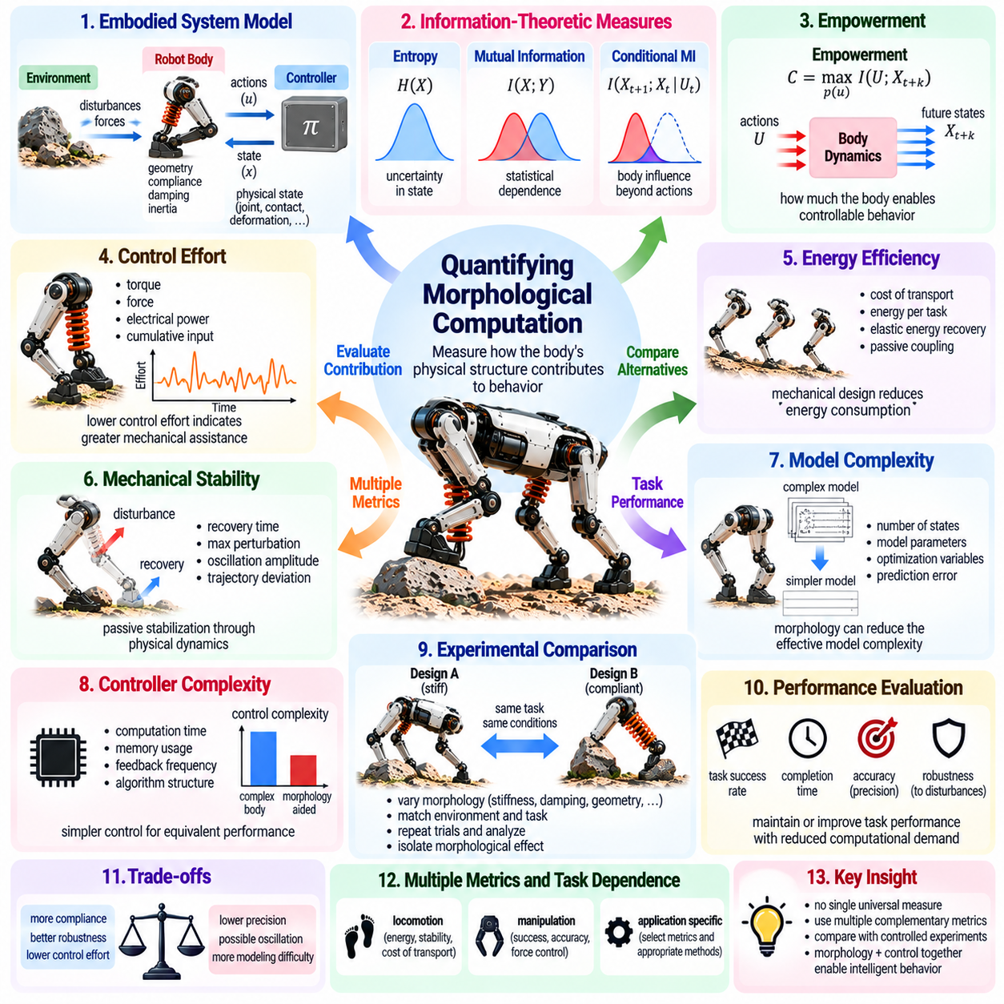
Quantifying morphological computation involves measuring how a robot's physical structure contributes to behavior that might otherwise require computational control. The central challenge is distinguishing the influence of body dynamics from that of controllers and environmental interactions. Quantitative methods seek to identify how mechanical properties shape movement, stabilize responses, and reduce the need for explicit information processing.
Morphological computation cannot be represented adequately by a single universal measurement. Its contribution depends on the task, physical system, operating conditions, and definition of computation. A compliant mechanism may simplify contact regulation while complicating precise positioning. Consequently, evaluation requires multiple complementary measures that capture information processing, control effort, mechanical behavior, and task performance.
A useful starting point is to model an embodied system through its state, control actions, and environmental interactions. The state may include joint positions, velocities, contact forces, and deformation variables. Control actions represent actuator commands, while external influences describe disturbances and environmental forces. Observing how these quantities evolve helps identify the contribution of physical dynamics to behavior.
Information theory provides one framework for examining morphological computation. Entropy measures uncertainty in a variable, while mutual information measures statistical dependence between variables. Researchers can investigate how strongly future physical states depend on current body states, actions, and environmental conditions. These relationships offer insight into how information is distributed across mechanical dynamics and active control.
Conditional mutual information can help separate different influences on state transitions. For example, the dependence of a future state on the current state can be examined while conditioning on the applied action. Strong dependence may indicate that existing physical dynamics contribute substantially to subsequent behavior. However, statistical dependence alone does not establish that the body performs useful computation or causes improved performance.
One information-theoretic approach measures the influence of physical state transitions relative to control inputs. If future states are highly predictable from previous physical states, even after accounting for actions, the system may exhibit substantial autonomous dynamics. Alternative formulations examine how strongly actions determine state transitions. These measures capture different aspects of embodiment and should not be treated as interchangeable.
The concept of empowerment offers another perspective on embodied information processing. Empowerment measures the potential influence of an agent's actions on its future states, commonly through a channel-capacity formulation. Morphology affects this quantity by constraining or enabling possible state transitions. A body with favorable mechanical properties may increase controllable possibilities, although empowerment is not itself a direct measure of morphological computation.
Control effort provides a practical measurement of mechanical assistance. Researchers may quantify actuator torque, force, electrical power, or cumulative control input during a task. If a morphological modification reduces actuator effort while preserving equivalent performance, it provides evidence of useful mechanical contribution. Such comparisons must account for differences in mass, friction, speed, and operating conditions.
Energy efficiency is especially relevant in locomotion and manipulation. Cost of transport relates energy expenditure to transported weight and distance, while manipulation efficiency may consider energy per completed task. Elastic energy recovery and passive mechanical coupling can improve these measures. Nevertheless, lower energy consumption does not necessarily imply greater morphological computation because actuator efficiency and control strategy also matter.
Mechanical stability offers another measurable dimension. Disturbance recovery time, maximum recoverable perturbation, oscillation amplitude, and trajectory deviation describe how a system responds to external influences. A morphology that attenuates disturbances without additional corrective commands may provide passive stabilization. Controlled experiments can distinguish these effects from improvements produced by active feedback.
Model complexity can reveal whether morphology simplifies the computational representation needed for control. Relevant indicators include the number of modeled states, required parameters, optimization variables, and prediction errors. Mechanical constraints may reduce the effective dimensionality of movement. However, compliant or nonlinear structures can increase modeling difficulty even when they simplify selected physical interactions.
Controller complexity can be evaluated through computational time, memory consumption, feedback frequency, and algorithmic structure. A robot that performs an equivalent task with simpler control may benefit from favorable morphology. Yet differences in controller implementation can distort comparisons. Reliable assessment requires comparable optimization procedures, sensing assumptions, hardware capabilities, and performance constraints.
Experimental isolation is essential for attributing performance differences to morphology. Researchers can compare robots with alternative stiffness, damping, geometry, or mechanical coupling while holding other variables as constant as possible. Repeated trials across matched disturbances and tasks help establish reproducibility. When hardware differences cannot be isolated completely, their influence should be documented rather than ignored.
Ultimately, quantifying morphological computation requires combining information-theoretic analysis with mechanical measurements and task-level evaluation. No individual metric can fully establish how much intelligence resides in a robot's body. Strong evidence comes from demonstrating that identifiable physical mechanisms improve behavior, reduce selected control demands, or increase robustness under controlled conditions.

02.11. Morphological Computation Example [w/Code]
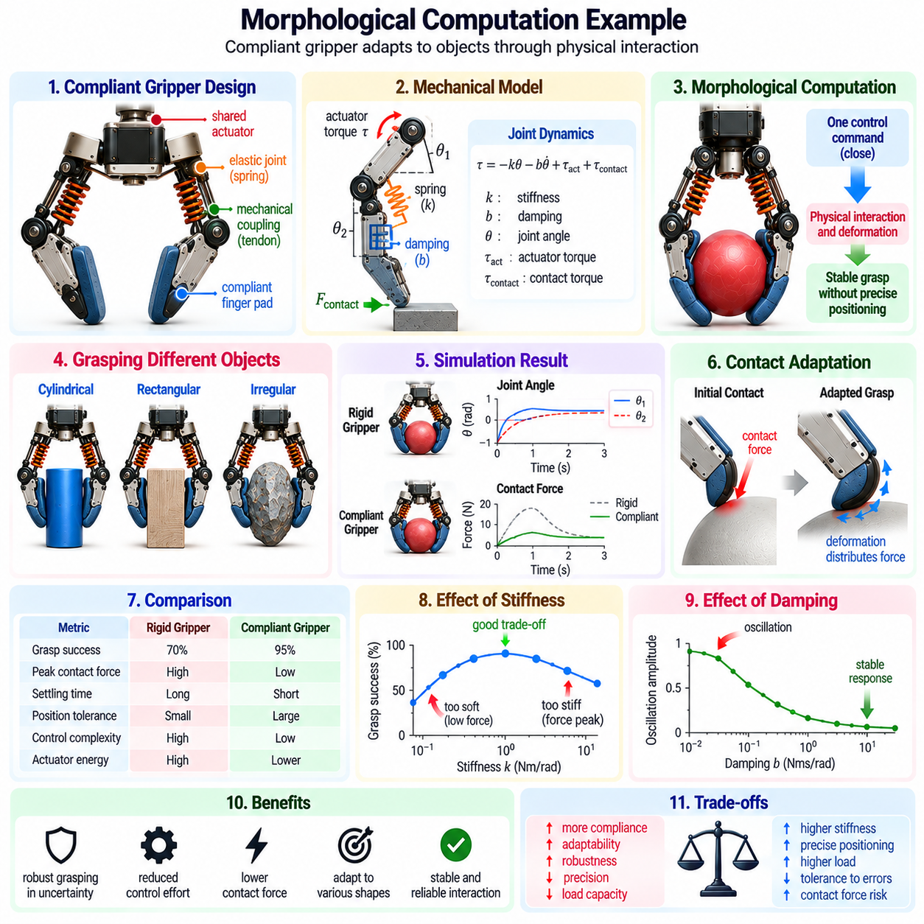
A practical example of morphological computation can be demonstrated through a compliant robotic gripper that adapts to objects without requiring precise finger positioning. The gripper uses flexible joints, elastic elements, and mechanically coupled fingers to distribute contact forces. Its physical structure performs part of the adaptation process, allowing a relatively simple controller to achieve stable grasps across different object geometries.
Consider a two-finger robotic gripper designed to handle cylindrical, rectangular, and irregular objects. Each finger contains two rotational joints connected through elastic elements, while a shared actuator produces closing motion. The fingers initially move toward the object under a common command. Once contact occurs, joint compliance allows the finger segments to adjust their positions according to the object's surface geometry.
In a conventional rigid gripper, accurate object geometry and contact locations may be necessary to determine suitable finger trajectories. Position errors can generate excessive forces or unstable contact. The compliant gripper reduces these requirements because deformation accommodates moderate geometric uncertainty. Instead of calculating every joint correction, the controller regulates actuator motion or force while mechanical properties determine local contact adaptation.
The example can be represented using a simplified mechanical model containing joint angles, stiffness coefficients, damping coefficients, and actuator inputs. Each finger joint experiences torque from actuation, elastic restoring forces, damping, and object contact. The resulting motion depends on the balance of these contributions. This formulation illustrates how mechanical dynamics participate directly in determining the gripper's configuration during interaction.
Joint elasticity can be modeled through a restoring torque proportional to angular displacement from an equilibrium position. For a linear torsional spring, the relationship is expressed as torque equals negative stiffness multiplied by angular displacement. This restoring action encourages the joint to return toward its preferred configuration. During grasping, contact forces oppose this motion and establish an equilibrium determined partly by object geometry.
Mechanical damping can be represented by a torque proportional to angular velocity and directed against movement. It reduces oscillation after contact and helps the fingers settle into stable configurations. Combining elastic and damping effects produces a compliant response that accommodates moderate disturbances. Appropriate parameter selection is important because excessive stiffness increases contact forces, while insufficient damping may cause prolonged vibration.
The shared actuator introduces mechanical coupling between finger movements. Before contact, both fingers may close in a relatively symmetric pattern. When one finger touches an object earlier, its motion becomes constrained while the remaining mechanism continues adapting. Depending on tendon routing and differential design, actuator displacement or force can be redistributed. This enables shape adaptation without independent position commands for every joint.
A simplified simulation can demonstrate these effects using numerical integration of joint dynamics. The model updates joint angles and velocities according to actuator torque, spring forces, damping, and contact reactions. Contact can be approximated through a compliant penalty model that generates restoring forces when finger surfaces penetrate an idealized object boundary. Such approximations support conceptual analysis but do not capture every aspect of real contact mechanics.
The simulation begins with an open gripper and an object positioned between its fingers. A closing command is applied while the system records joint trajectories, contact forces, and actuator effort. As the fingers approach the object, their movements follow the mechanical coupling. Once contact begins, elastic deformation redistributes the finger configuration until the mechanism reaches a stable grasp or a mechanical limit.
To evaluate morphological computation, the compliant gripper can be compared with a rigid or independently controlled reference design. Both systems should perform equivalent grasping tasks under matched object positions and loading conditions. Relevant measurements include grasp success, peak contact force, settling time, actuator energy, and control complexity. Differences must be interpreted carefully because the mechanisms may possess different capabilities.
One expected benefit of compliance is reduced sensitivity to small positioning errors. If the object is shifted slightly from its nominal location, the fingers can deform and maintain contact without requiring precise geometric correction. The controller may therefore operate with less detailed object information. However, this advantage is limited by available joint travel, contact friction, stiffness, and the gripper's ability to generate sufficient holding force.
A second benefit concerns force regulation during initial contact. Elastic elements can absorb part of the displacement that would otherwise produce large forces in a rigid mechanism. Damping can moderate transient responses and reduce oscillation. Nevertheless, compliant mechanisms do not automatically guarantee safe contact. Actuator commands, approach velocity, stored elastic energy, and mechanical stops remain important determinants of maximum force.
The experiment can also examine the trade-off between compliance and precision. Lower stiffness generally permits greater geometric adaptation but may increase object displacement or reduce positional repeatability. Higher stiffness improves resistance to deformation while potentially increasing sensitivity to alignment errors. By varying stiffness and damping, engineers can identify operating regions that balance grasp robustness, settling behavior, and positioning accuracy.
Information-theoretic analysis offers an additional way to examine the system. Joint states, actuator commands, and contact measurements can be recorded over repeated trials. Conditional mutual information may reveal how strongly future joint configurations depend on previous mechanical states after accounting for actuator input. Such results characterize statistical relationships but cannot independently establish that useful computation occurs within the morphology.
This example demonstrates that morphological computation emerges through the interaction of mechanical design, control, and environmental contact. The gripper's geometry, elasticity, damping, and coupling determine part of its grasping behavior before detailed computational corrections are required. Its effectiveness must still be validated through controlled comparisons. The broader lesson is that carefully designed physical structures can simplify selected robotic tasks while preserving the need for sensing, planning, and adaptive control.

