Volume 03. Embodiment and Morphology

Chapter 07. Quadruped Morphology

07.01. Quadruped Morphology Overview
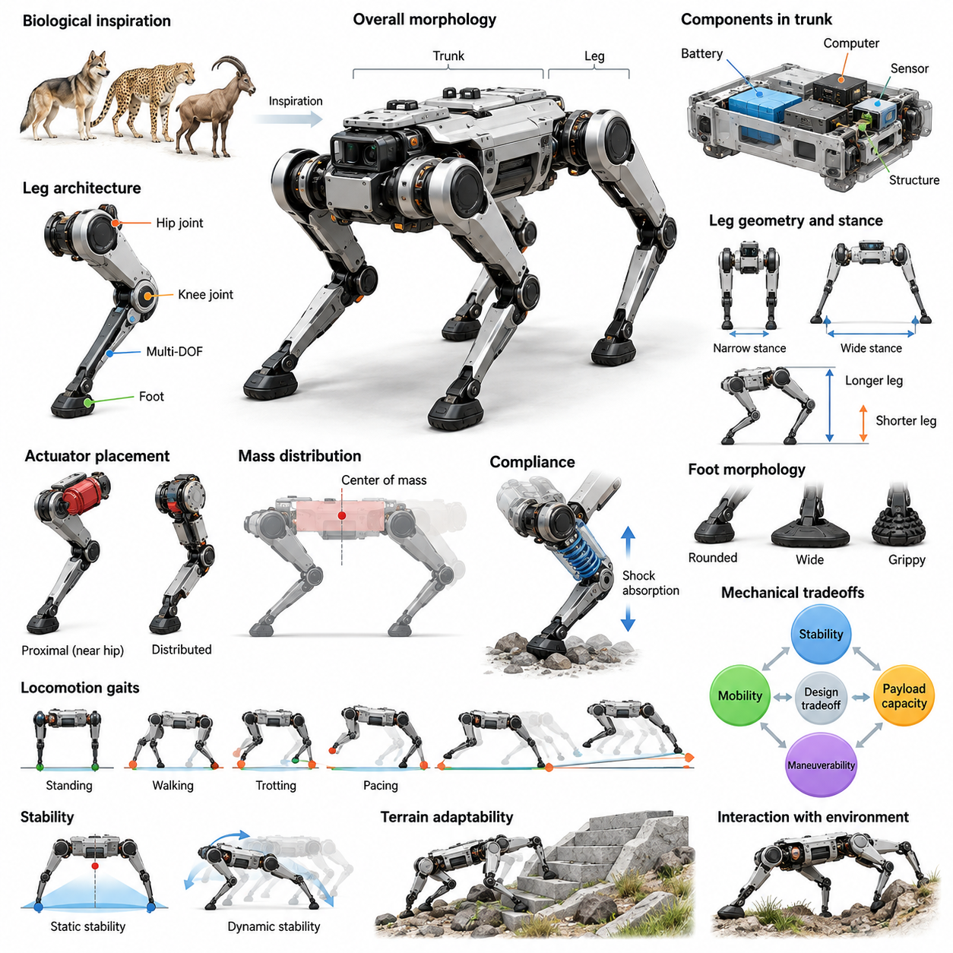
Quadruped morphology refers to the physical configuration of robots that use four articulated legs for locomotion, balance, and interaction with their surroundings. It encompasses the arrangement of the trunk, limbs, joints, actuators, and contact surfaces, together with their geometric and mechanical relationships. These structural characteristics determine how a quadruped supports its weight, generates motion, and responds to external forces.
Quadruped robots occupy an important position within embodied intelligence because their physical structure enables mobility across environments that challenge conventional wheeled platforms. Four independently controlled legs allow a robot to select footholds, adjust body posture, and negotiate uneven surfaces. Their capabilities emerge from continuous interactions among mechanical design, sensing, control algorithms, and environmental conditions.
Biological quadrupeds provide valuable inspiration for robotic morphology. Mammals demonstrate diverse limb proportions, joint arrangements, spinal structures, and locomotion strategies adapted to different ecological conditions. Robotic systems borrow selected principles from these biological examples while accommodating engineering constraints such as electric actuation, structural rigidity, manufacturing complexity, and computational control requirements.
The fundamental architecture of a quadruped consists of a central trunk connected to four articulated limbs. The trunk accommodates batteries, computing hardware, sensors, and supporting structures, while the legs generate forces required for standing and movement. The relative dimensions and mechanical properties of these components influence stability, maneuverability, payload capacity, and the ability to maintain reliable ground contact.
Leg architecture is a defining element of quadruped morphology. Each leg typically contains multiple joints that provide controlled movement in different directions, commonly including hip and knee articulation. Three actuated degrees of freedom per leg are frequently employed, although alternative configurations exist. Joint placement, rotational axes, link lengths, and mechanical limits collectively determine the reachable workspace of each foot.
The relationship between leg geometry and stance configuration strongly influences locomotion performance. A wider stance can increase the available support region, while a narrower configuration may improve passage through confined spaces. Longer legs can increase obstacle clearance and reachable foothold distance, but may introduce greater structural loading and control challenges. Morphological design must balance these competing requirements.
Mass distribution is another fundamental consideration in quadruped design. The position of the center of mass relative to the feet affects static stability, dynamic balance, and the distribution of ground reaction forces. Concentrating heavy components near the trunk can reduce limb inertia and improve responsiveness. However, packaging constraints, thermal requirements, and payload placement may complicate ideal mass distribution.
Actuator placement directly influences the mechanical behavior of the legs. Motors positioned near the hip can reduce distal limb mass, enabling faster leg movements and potentially lowering energy expenditure during swing phases. Alternatively, distributed actuation may simplify mechanical transmission or improve packaging flexibility. Each arrangement introduces tradeoffs involving torque delivery, efficiency, structural complexity, and maintenance accessibility.
Compliance plays an essential role in managing interactions between quadruped feet and the environment. Elastic components, compliant joints, and controlled actuator impedance can absorb impacts and reduce peak contact forces. Appropriate compliance may improve traction and tolerance to terrain irregularities, but excessive flexibility can reduce positioning accuracy. Effective designs coordinate mechanical compliance with feedback control.
Foot morphology determines how forces are transmitted between the robot and the ground. Small rounded feet may support agile movement over relatively firm surfaces, whereas broader contact areas can improve pressure distribution on softer terrain. Friction properties, contact geometry, and surface materials influence slipping, impact behavior, and foothold reliability. Foot design must therefore reflect anticipated operating environments.
Quadruped locomotion includes standing, walking, trotting, pacing, bounding, and other movement patterns. Different gaits produce distinct combinations of support phases, swing trajectories, and body dynamics. Morphology affects which gaits are mechanically feasible and energetically practical. Limb inertia, joint range, trunk proportions, and actuator capabilities jointly determine the achievable operating envelope.
Static and dynamic stability represent complementary aspects of quadruped performance. During slow walking, stability can often be evaluated using the relationship between the projected center of mass and the support polygon. During faster movement, momentum, contact timing, and force regulation become increasingly important. Consequently, quadruped morphology must support both geometrically stable postures and dynamically controlled motion.
Terrain adaptability is a major motivation for selecting quadruped architectures. Independently articulated legs can accommodate differences in ground elevation and reposition contact points around obstacles. This capability supports movement across stairs, rubble, slopes, and irregular outdoor surfaces. Nevertheless, successful traversal depends on sufficient joint workspace, available traction, accurate perception, and appropriate locomotion control.
Trunk geometry contributes to both mobility and functional integration. A compact body can improve maneuverability and reduce interference with nearby obstacles, while a longer trunk may provide additional space for payloads and equipment. Trunk width affects leg mounting positions and lateral stability. Structural stiffness must also be sufficient to withstand repeated loading without introducing excessive mass or undesirable deformation.
Payload carrying introduces additional morphological requirements. Increased payload mass changes the center of mass, joint loading, ground reaction forces, and energy consumption. Quadrupeds intended for logistics or inspection equipment may require reinforced trunks, higher-capacity actuators, and adjustable mounting interfaces. Payload integration must preserve sufficient stability and mobility throughout the intended operating conditions.
Quadrupeds can also incorporate robotic manipulators to perform tasks beyond locomotion. A mounted arm enables object handling, inspection, and interaction with infrastructure, but introduces additional mass and changing reaction forces. Manipulation may require coordinated body positioning, stance adjustment, and whole-body control. The resulting system combines locomotion and manipulation within a shared mechanical and dynamic architecture.
Energy efficiency remains a critical limitation of legged mobility. Repeated acceleration of limbs, support of body weight, and compensation for mechanical losses consume electrical energy. Morphological choices such as lightweight links, efficient transmissions, elastic energy storage, and favorable joint geometry can reduce these demands. However, improvements in efficiency must be evaluated against strength, controllability, and durability.
The distinction between rigid and compliant morphology also affects control complexity. Highly rigid structures support predictable kinematic relationships and precise force transmission, whereas compliant elements can passively accommodate impacts and disturbances. These passive mechanical responses represent forms of morphological computation. Appropriate physical design can therefore reduce some control demands without eliminating the need for active stabilization.
Quadruped morphology is closely connected to perception and state estimation. Joint encoders, inertial sensors, and contact measurements provide information about body posture, limb configuration, and environmental interaction. The placement of these sensors influences observability and measurement reliability. Mechanical vibration, structural deformation, and contact uncertainty must be considered when integrating sensing with the physical platform.
Morphological differences also influence learning-based locomotion. Policies trained for one quadruped may not transfer directly to another because of variations in joint limits, actuator dynamics, body proportions, and mass distribution. Morphology-aware learning can incorporate physical parameters into policy observations or training environments. Such approaches support adaptation while recognizing that mechanical capabilities impose fundamental constraints.
Simulation provides an important environment for evaluating quadruped designs before physical construction. Engineers can investigate link dimensions, actuator specifications, foot contact properties, and mass distribution under varied terrain conditions. Physics-based simulation enables comparison of stability, mobility, and energy requirements. However, simulation results must be validated against real hardware because contact and actuator models remain imperfect.
Safety and reliability are integral considerations in quadruped morphology. Mechanical joint limits, structural safety factors, protective enclosures, and controlled compliance help reduce damage during unexpected contact or falls. The robot must tolerate repeated impacts, vibration, and environmental exposure. Morphological robustness is particularly important when systems operate near people or in locations where recovery and maintenance are difficult.
Quadruped platforms are increasingly relevant to industrial inspection, infrastructure monitoring, research, emergency response, and mobile sensing. Each application imposes different physical requirements involving size, payload, terrain access, endurance, and environmental protection. A compact inspection robot and a heavy-duty transport quadruped may therefore share a four-legged architecture while requiring substantially different morphological configurations.
No single quadruped morphology optimizes every performance objective. Designs emphasizing high-speed locomotion may favor lightweight limbs and powerful actuators, while payload-oriented systems prioritize structural strength and sustained force production. Rough-terrain platforms may require larger joint workspaces and greater ground clearance. These competing objectives make morphology selection a multi-objective engineering problem.
The broader significance of quadruped morphology lies in its contribution to physical intelligence. Mechanical structure does not merely execute commands generated by software; it shapes the available actions, environmental interactions, and learning opportunities of the robot. Understanding quadruped morphology therefore provides a foundation for integrating mechanical design, locomotion control, perception, and adaptive behavior into capable Physical AI systems.

07.02. Trunk Leg and Joint Architecture (source skips 07.02)
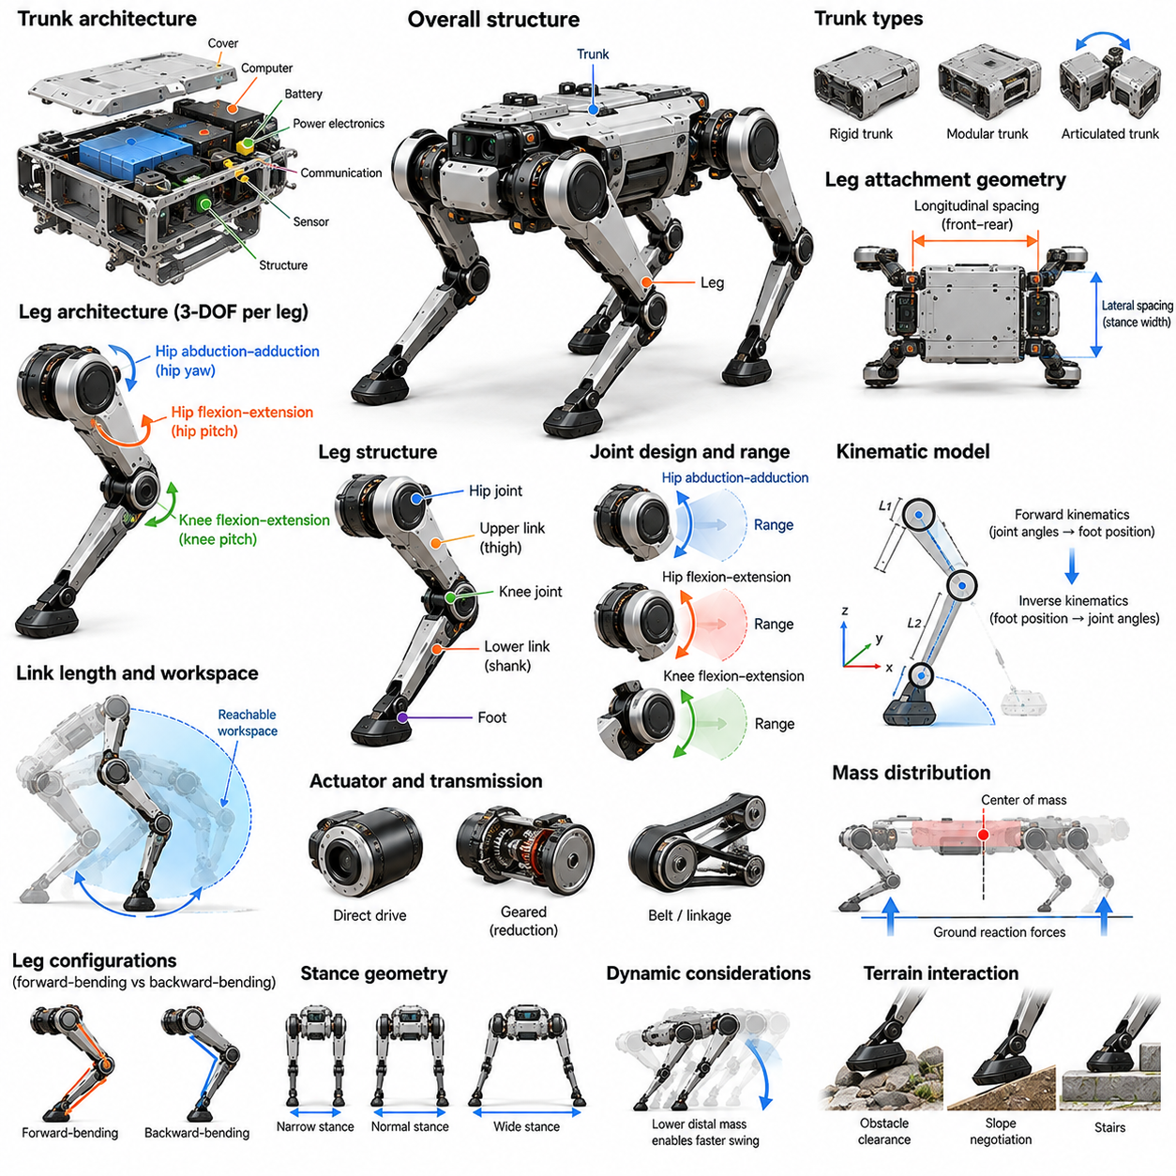
The trunk, leg, and joint architecture of a quadruped robot defines the mechanical foundation of its locomotion and physical interaction capabilities. These components form an interconnected kinematic and dynamic system that supports body weight, generates ground reaction forces, and enables controlled movement. Their geometric arrangement, structural properties, and mechanical interfaces determine stability, maneuverability, efficiency, and adaptability.
The trunk serves as the central structural platform connecting the four legs and supporting essential onboard components. It typically accommodates batteries, computing units, power electronics, communication hardware, and sensing systems. Its geometry influences the robot's overall proportions, center of mass, and available mounting space. Effective trunk design balances structural rigidity, compact packaging, accessibility, and resistance to mechanical loading.
Trunk architecture may employ rigid monolithic structures, modular assemblies, or articulated body segments. A rigid trunk simplifies mechanical modeling and provides predictable relationships between leg attachment points. Modular designs facilitate maintenance, component replacement, and platform customization. Articulated trunks can introduce additional mobility and posture adaptation, although they increase mechanical complexity and control requirements.
The spatial arrangement of leg attachment points establishes the quadruped's basic stance geometry. Front and rear hip locations determine longitudinal support dimensions, while lateral spacing influences the width of the support region. These dimensions affect turning capability, obstacle negotiation, and body stability. Designers must coordinate attachment geometry with leg reachability, actuator packaging, and expected terrain conditions.
Each leg forms a serial kinematic chain connecting the trunk to the foot. A typical electrically actuated quadruped uses three active degrees of freedom per leg, producing twelve actuated leg degrees of freedom across the platform. This configuration commonly includes hip abduction-adduction, hip flexion-extension, and knee flexion-extension. Alternative architectures may incorporate additional joints, passive elements, or mechanically coupled motions.
The hip abduction-adduction joint enables lateral positioning of the leg relative to the trunk. This motion supports stance-width adjustment, lateral balance regulation, and foothold selection on uneven terrain. Its rotational axis and mechanical range determine the available sideways workspace. Proper hip design must accommodate lateral ground reaction forces while maintaining sufficient structural stiffness and avoiding interference with adjacent components.
The hip flexion-extension joint primarily controls forward and backward leg movement. Together with the knee joint, it determines foot placement along the longitudinal direction and contributes to body height adjustment. Hip actuator torque requirements depend on limb geometry, contact loading, and locomotion dynamics. The placement of the hip rotation axis also influences achievable stride length, joint loading, and mechanical efficiency.
The knee joint provides additional articulation that allows the leg to extend, retract, and adjust its effective length. Knee geometry strongly influences foot clearance, obstacle traversal, and the ability to maintain ground contact during body motion. Mechanical configurations may use forward-bending or backward-bending arrangements. Each configuration produces different workspace boundaries, structural packaging requirements, and collision characteristics.
Leg links are commonly organized into upper and lower segments connected by rotational joints. Their lengths determine the reachable foot workspace and influence the relationship between joint motion and Cartesian foot displacement. Longer links may increase stride capability and ground clearance but can also increase bending loads and rotational inertia. Shorter links favor compact construction while potentially restricting obstacle negotiation.
The kinematic architecture establishes a mathematical relationship between joint angles and foot positions. Forward kinematics calculates the foot location from measured joint configurations, while inverse kinematics determines joint commands for desired foot positions. These relationships depend on link dimensions, joint axes, and coordinate-frame definitions. Accurate kinematic models are essential for coordinated stepping, stance regulation, and trajectory generation.
Joint range of motion determines the practical boundaries of leg movement. Mechanical stops, actuator limits, structural interference, and cable routing restrict the allowable joint configurations. A large theoretical workspace does not necessarily correspond to a fully usable locomotion workspace. Designers must account for singularities, torque limitations, self-collision, and contact constraints when defining operational joint ranges.
The mechanical arrangement of the legs also determines the robot's dynamic behavior. Link masses, rotational inertias, and joint positions influence the forces required for acceleration and deceleration. Heavy distal segments increase swing-leg inertia and may reduce achievable stepping frequency. Concentrating mass near proximal joints can improve dynamic responsiveness, although transmission mechanisms may introduce additional friction, compliance, or maintenance requirements.
Actuators may be mounted directly at joints or connected through gears, belts, linkages, and other transmission mechanisms. Direct-drive arrangements can provide favorable force transparency and reduced transmission complexity but may require larger motors. Geared systems increase available joint torque within compact packages while introducing friction and reflected inertia. Transmission selection must consider torque density, efficiency, backdrivability, and durability.
Structural stiffness is essential for maintaining predictable relationships between the trunk, joints, and feet. Excessive deformation can degrade positioning accuracy, alter load distribution, and complicate state estimation. However, completely rigid structures may transmit large impact forces during landing or unexpected contact. Effective mechanical architecture combines sufficient load-bearing stiffness with carefully selected compliance at appropriate locations.
Joint bearings, shafts, housings, and mechanical interfaces must withstand repeated multidirectional loading. During locomotion, each supporting leg experiences changing combinations of axial forces, bending moments, and torsional loads. These loads propagate through the joints into the trunk structure. Mechanical design must therefore address fatigue resistance, alignment accuracy, fastening reliability, and protection against contamination.
The relationship between trunk dimensions and leg proportions influences overall locomotion performance. A long trunk can provide greater longitudinal spacing between support contacts, while a compact trunk may improve turning agility and reduce structural mass. Wider hip placement can improve lateral support geometry but increase the robot's physical footprint. Appropriate proportions depend on intended gait patterns, environmental constraints, and payload requirements.
Symmetrical leg architectures simplify manufacturing, modeling, and control by using similar mechanical structures across multiple limbs. Mirrored left-right assemblies are particularly common, although joint orientation and actuator packaging may differ. Standardized components can reduce manufacturing cost and maintenance complexity. Nevertheless, task-specific quadrupeds may benefit from asymmetric arrangements when their operational requirements justify additional complexity.
The trunk-leg interface must transfer substantial mechanical loads while maintaining precise alignment between coordinate frames. Attachment brackets and structural joints experience repeated forces generated by locomotion, impacts, and payload changes. Their stiffness affects both structural integrity and control accuracy. Modular interfaces can support rapid replacement of damaged limbs, but must preserve reliable mechanical fastening and electrical connectivity.
Cable routing and electrical integration are important architectural considerations. Power cables, communication lines, and sensor connections must pass through moving joints without excessive bending, abrasion, or interference. Internal routing can improve protection and reduce external entanglement risks. However, it may complicate assembly and maintenance. Joint design must accommodate wiring motion throughout the complete operating range.
Joint sensing provides the information necessary to estimate limb configuration and support closed-loop control. Rotary encoders measure joint positions, while motor current measurements or dedicated torque sensors can support force estimation. Additional sensing may detect temperature, vibration, or mechanical abnormalities. Sensor placement and calibration must account for transmission compliance, backlash, and differences between motor-side and joint-side motion.
Trunk-mounted inertial sensors complement joint measurements by estimating body orientation and angular motion. Combining inertial information with leg kinematics and contact observations supports estimation of body movement relative to the environment. The physical rigidity between sensors and reference frames influences estimation accuracy. Consequently, mechanical architecture and sensing architecture must be developed as interconnected parts of the same system.
Quadruped joint architecture must also support safe operation under abnormal conditions. Mechanical limits prevent excessive articulation, while protective housings reduce exposure to moving components. Actuator torque limits and controlled impedance can reduce damage during unexpected collisions. Emergency shutdown behavior must consider whether joints remain mechanically supported, become backdrivable, or lose the ability to sustain body weight.
Manufacturing and maintenance requirements influence architectural decisions throughout development. Accessible fasteners, replaceable joint modules, standardized bearings, and serviceable transmission assemblies can reduce operational downtime. Structural components should provide repeatable alignment after disassembly. Designs intended for outdoor deployment additionally require appropriate sealing, corrosion resistance, thermal management, and protection against dust and moisture.
The architecture of a quadruped must ultimately be evaluated as an integrated system rather than a collection of independent components. Trunk stiffness, leg geometry, actuator placement, joint limits, and mass distribution interact to determine achievable locomotion performance. Improvements in one subsystem may introduce disadvantages elsewhere. System-level evaluation is therefore essential for balancing mobility, structural integrity, energy consumption, and controllability.
Within Physical AI, trunk, leg, and joint architecture establishes the physical action space available to intelligent control systems. Learning algorithms and motion planners can optimize behavior only within the mechanical capabilities provided by the body. A well-designed architecture supports reliable sensing, predictable dynamics, adaptable locomotion, and effective environmental interaction. It forms the foundation for morphology-aware control and increasingly autonomous quadruped operation.

07.03. Leg Workspace and Stance Geometry
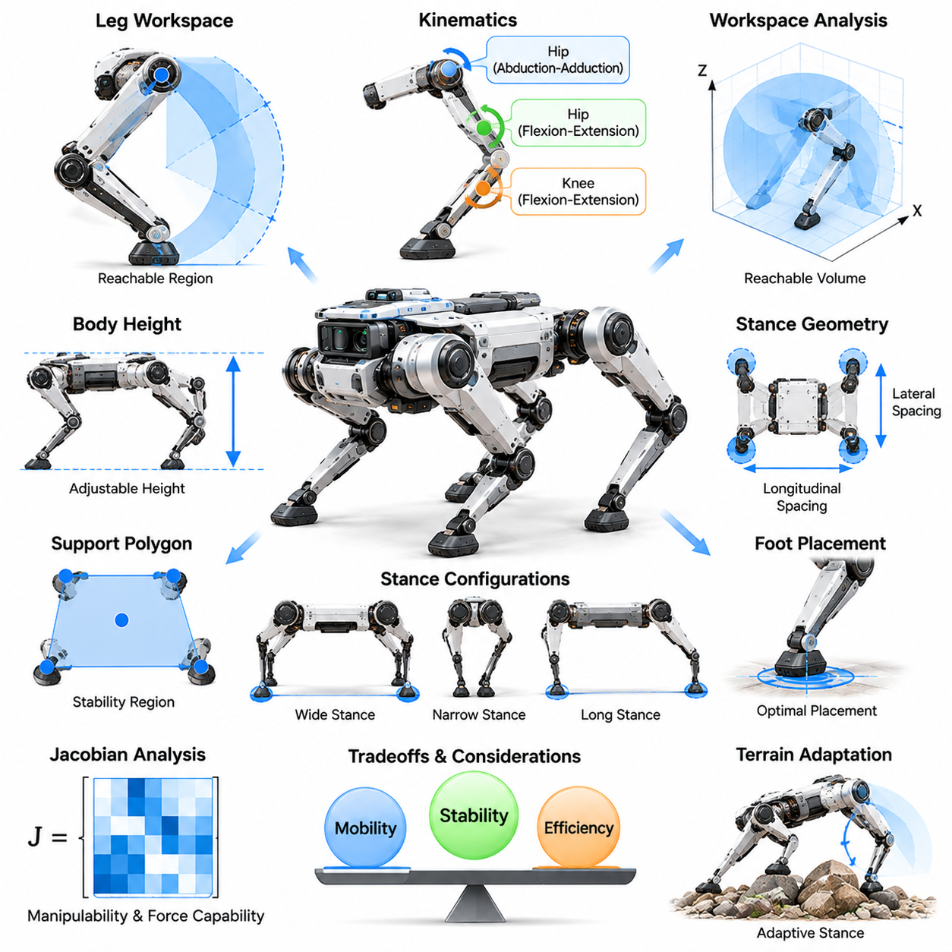
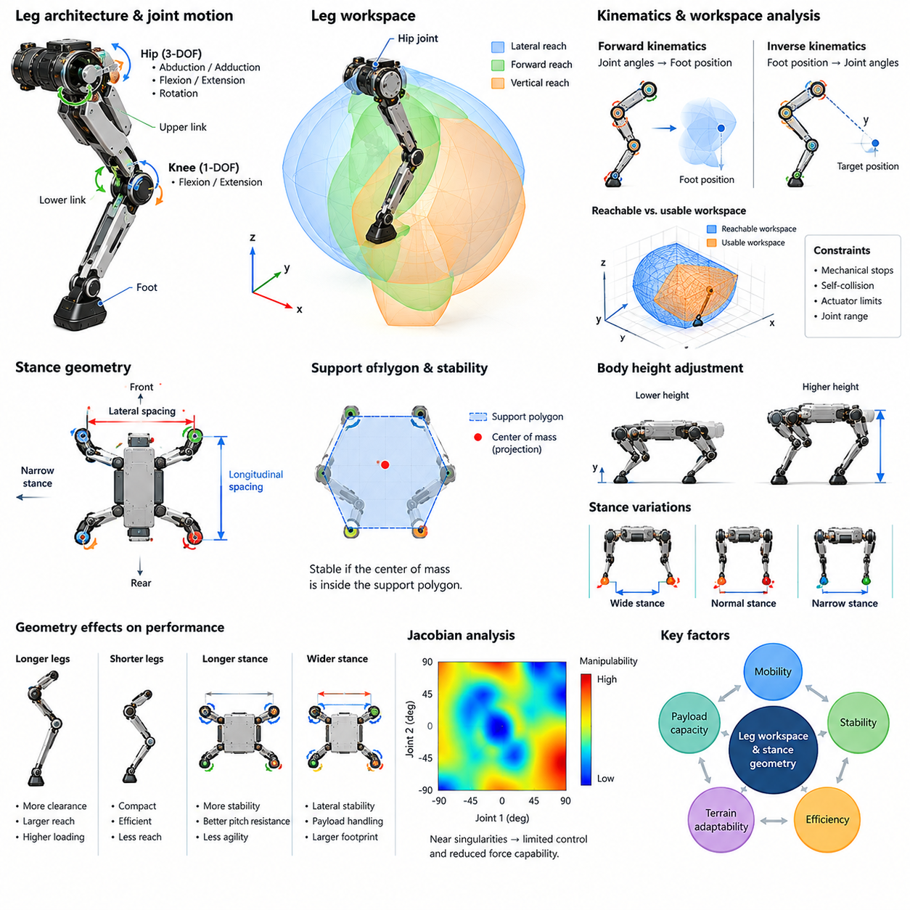
Leg workspace and stance geometry are fundamental characteristics of quadruped morphology that determine how a robot positions its feet, supports its body, and moves through different environments. Leg workspace describes the region each foot can reach through joint motion, while stance geometry defines the spatial arrangement of supporting feet. Together, these properties influence stability, mobility, obstacle clearance, and locomotion efficiency.
The reachable workspace of a quadruped leg depends on its kinematic architecture, link lengths, joint axes, and allowable joint ranges. A typical three-degree-of-freedom leg can position its foot within a three-dimensional region relative to the hip. However, this region is constrained by mechanical stops, self-collision, and actuator limitations. Workspace analysis therefore distinguishes theoretical reachability from practically usable configurations.
Leg workspace is commonly evaluated using forward kinematics and inverse kinematics. Forward kinematics maps joint angles into foot positions, allowing the reachable region to be explored across valid joint configurations. Inverse kinematics determines whether a desired foot position can be achieved and identifies suitable joint angles. These calculations provide the geometric foundation for foothold planning, trajectory generation, and posture control.
The shape of the reachable workspace is generally irregular because rotational joints produce nonlinear relationships between joint angles and foot coordinates. Hip abduction and adduction influence lateral reach, while hip and knee flexion determine much of the longitudinal and vertical workspace. Link proportions and joint orientation modify these boundaries. Designers must consider not only workspace volume but also the distribution of useful configurations.
A large reachable workspace does not automatically guarantee effective locomotion. Some foot positions may require extreme joint angles, produce unfavorable mechanical leverage, or approach kinematic singularities. These configurations can demand excessive actuator torque or reduce controllability. The operational workspace should therefore be defined as a subset of the reachable region that satisfies practical constraints on force, motion, and safety.
The relationship between leg workspace and body height is particularly important. Lowering the trunk changes the relative position of the feet within their reachable regions and may improve certain stability margins. Raising the trunk increases ground clearance but can reduce available leg extension margins or alter joint loading. The optimal body height depends on terrain geometry, desired movement speed, payload conditions, and actuator capabilities.
Stance geometry describes the relative positions of the feet when they support the robot. Its primary dimensions include longitudinal spacing between front and rear contacts and lateral spacing between left and right contacts. These dimensions establish the support polygon for static stability analysis. The shape and size of this polygon influence the robot's ability to resist gravitational moments and external disturbances.
During a four-leg support phase, the support polygon is formed by the convex hull of the ground contact points. Static equilibrium requires the projected center of mass to lie within this region under appropriate contact assumptions. A larger polygon can provide greater geometric stability margins, although contact forces and friction remain important. Stability evaluation must therefore consider both geometry and feasible force distribution.
A wide stance increases lateral separation between supporting feet and can improve resistance to sideways disturbances. This configuration may be useful during payload handling, manipulation, or operation on irregular surfaces. However, excessive stance width can increase joint torque requirements and reduce the available lateral workspace for stepping. Wide configurations may also restrict movement through narrow passages.
A narrow stance reduces the robot's lateral footprint and can improve access to confined environments. It may also support compact body configurations and certain dynamic locomotion patterns. However, reduced lateral support width decreases geometric stability margins during slow movement. Maintaining balance may then require more precise contact placement, faster corrective stepping, or greater reliance on dynamic stabilization.
Longitudinal stance length influences pitch stability, turning behavior, and the distribution of loads between front and rear legs. Increasing the distance between supporting contacts can improve resistance to forward and backward tipping. However, an excessively long stance may restrict stepping flexibility or increase the mechanical effort required for posture adjustments. Appropriate stance length must reflect trunk dimensions and available leg reach.
Foot placement relative to the hip affects joint loading and mechanical efficiency. When a supporting foot is positioned far from its associated hip, ground reaction forces may generate larger joint moments. Positions closer to favorable mechanical configurations can reduce torque requirements and improve force transmission. Efficient stance design therefore considers both contact geometry and the relationship between joint torques and endpoint forces.
The Jacobian matrix provides a mathematical connection between joint velocities and foot velocities, as well as between endpoint forces and joint torques. Its properties vary throughout the workspace and influence manipulability, force capability, and sensitivity to joint motion. Near singular configurations, certain movement or force directions become difficult to control. Workspace evaluation should therefore include Jacobian-based performance measures.
Stance geometry changes continuously during locomotion as individual feet alternate between support and swing phases. During walking, the robot may maintain three or more contacts for substantial portions of the gait. During trotting, diagonal leg pairs often support the body while the other pair swings. These changing contact patterns produce different support geometries and require coordinated adjustments in body motion and foot placement.
Static walking emphasizes maintaining suitable support relationships as legs are repositioned sequentially. The robot can shift its center of mass toward the remaining supporting feet before lifting a leg. This strategy reduces the likelihood of tipping during slow movement. However, the available stability margin depends on the geometry of the supporting contacts, terrain inclination, and the location of the center of mass.
Dynamic locomotion requires a broader interpretation of stance stability. During running or trotting, the center of mass projection may temporarily move outside the instantaneous support region without causing a fall. Momentum, contact impulses, and controlled body acceleration contribute to balance. Consequently, dynamic stability analysis must incorporate contact timing, inertial effects, and feasible ground reaction forces.
Terrain geometry imposes additional constraints on reachable footholds. On uneven ground, supporting feet may contact surfaces at different heights, changing the effective stance configuration. Obstacles can eliminate otherwise reachable positions, while slopes modify the relationship between gravity and the support region. Terrain-aware foothold planning must therefore combine leg workspace constraints with local surface geometry and contact feasibility.
Foot clearance during the swing phase depends on the available vertical workspace and the selected trajectory. Sufficient clearance reduces the risk of striking obstacles, but excessive foot lifting increases motion requirements and may consume additional energy. The robot must also preserve enough joint range for landing and subsequent stance motion. Swing trajectories should therefore balance obstacle avoidance, efficiency, and mechanical feasibility.
Stance geometry also influences turning and directional changes. Asymmetric foot placements can generate favorable contact arrangements for yaw rotation or lateral movement. However, the available turning motion depends on joint workspace, foot friction, and potential interference between the legs and trunk. Coordinated stance adjustment allows quadrupeds to adapt their support configuration to different maneuvering requirements.
Payload variations alter the relationship between stance geometry and stability. A shifted center of mass may require repositioning the feet to maintain adequate support margins and distribute contact forces. Heavy payloads can also reduce the usable workspace by increasing joint torque demands. Morphology-aware control must account for these changes when selecting body height, stance width, and foothold positions.
Leg workspace and stance geometry are closely related to energy consumption. Extreme leg configurations can increase actuator loading, while unnecessarily large stepping motions require additional acceleration and deceleration. Efficient locomotion often favors foot trajectories and support postures that avoid unfavorable joint configurations. Nevertheless, energy-optimal behavior must remain compatible with terrain clearance, stability, and task requirements.
Simulation-based evaluation enables systematic exploration of workspace and stance design. Engineers can sample joint configurations, calculate reachable foot positions, and evaluate support geometry under different body postures. Dynamic simulation further reveals how contact forces, actuator limits, and terrain conditions affect practical performance. These analyses help identify useful operating regions before physical prototypes are tested.
Physical experiments remain necessary because real-world performance depends on factors that geometric models cannot fully represent. Structural compliance, joint friction, actuator saturation, foot deformation, and uncertain terrain contact can reduce the usable workspace. Experimental measurements can validate kinematic models and identify configurations associated with excessive loading or unreliable contact. This feedback supports refinement of both morphology and control.
Leg workspace and stance geometry should ultimately be optimized together rather than treated as independent design variables. Larger reachability may improve obstacle negotiation but introduce unfavorable force characteristics, while wider support configurations may improve stability at the expense of agility. Effective quadruped morphology balances reachable motion, support geometry, actuator capability, and environmental requirements.
Within Physical AI, these geometric properties define the feasible foundation for intelligent locomotion. Perception systems identify potential footholds, planning algorithms select contact locations, and controllers execute movements within the robot's physical limits. A well-designed relationship between leg workspace and stance geometry enables stable movement, efficient adaptation, and reliable interaction with complex environments.

07.04. Mass Distribution and Center of Mass
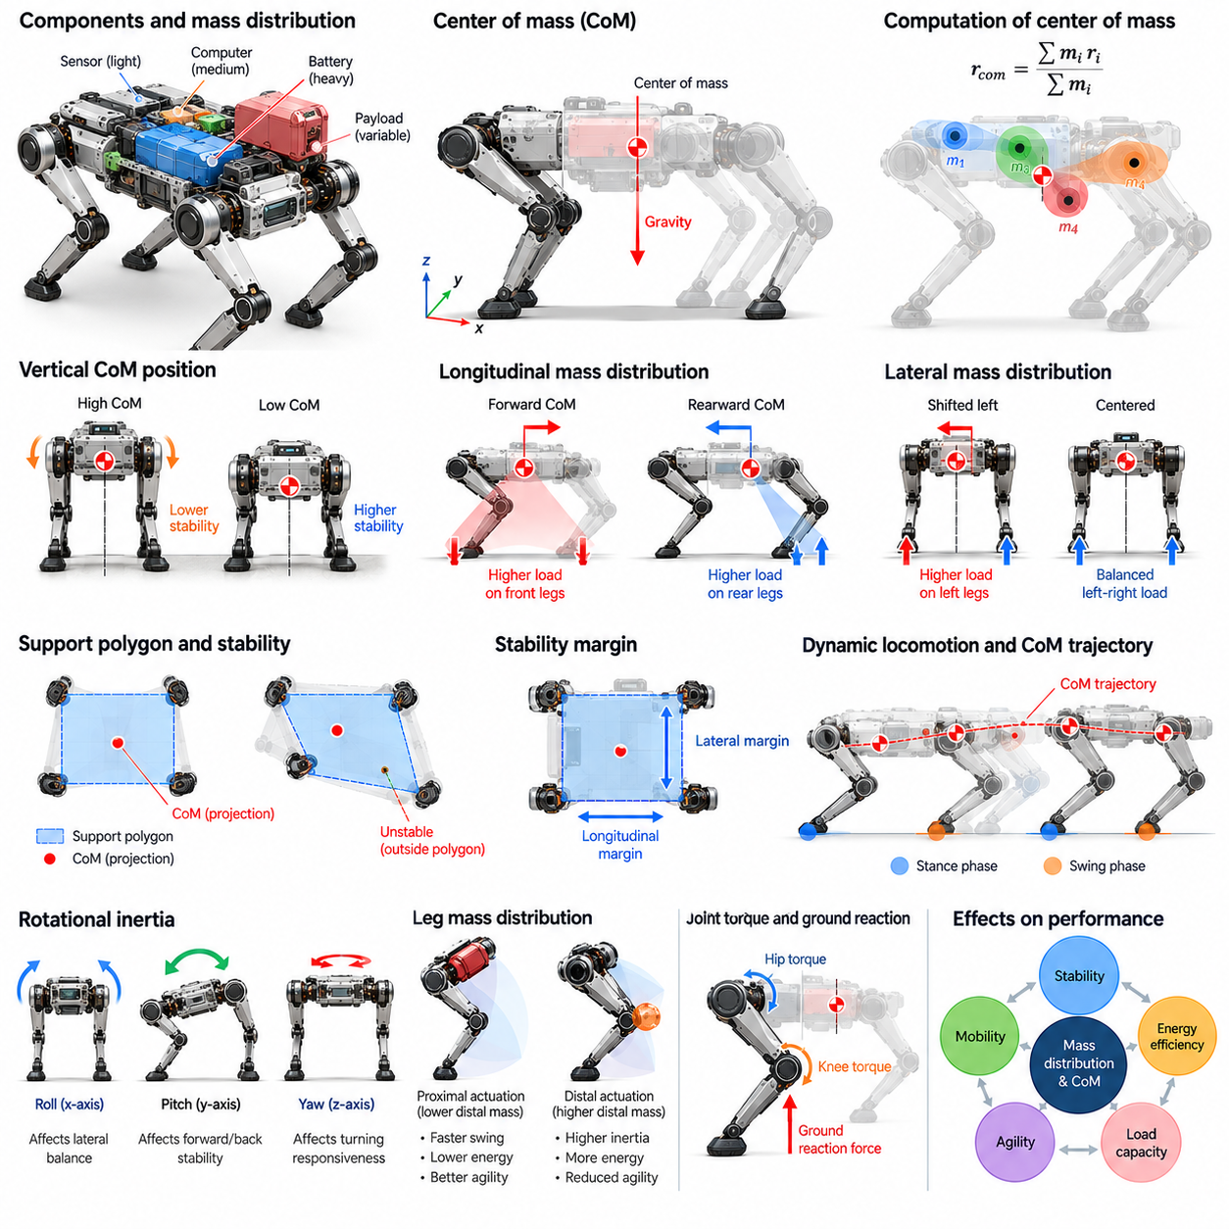
Mass distribution and center of mass are fundamental properties of quadruped morphology that influence stability, locomotion dynamics, actuator loading, and energy efficiency. Mass distribution describes how the robot's weight is allocated among the trunk, legs, actuators, batteries, and payloads. The center of mass represents the weighted average position of these components and provides a reference for analyzing gravitational forces and whole-body motion.
The center of mass is determined by the masses and spatial positions of all robot components. Its location changes as the legs move, the trunk changes orientation, or payloads are repositioned. Although the trunk often contains most of the robot's mass, limb configurations can still influence the overall center of mass. Accurate estimation therefore requires considering both fixed structural components and moving mechanical assemblies.
Trunk mass distribution is strongly influenced by the placement of batteries, computing hardware, actuators, and structural reinforcements. Concentrating heavy components near the geometric center of the body can simplify balance control and reduce undesirable loading asymmetries. However, the optimal arrangement depends on leg attachment positions, payload requirements, cooling systems, and maintenance accessibility rather than geometric symmetry alone.
The vertical position of the center of mass affects the robot's response to gravitational disturbances and tipping moments. A lower center of mass generally improves geometric resistance to overturning for a given support configuration. However, lowering heavy components may reduce ground clearance or complicate mechanical packaging. Designers must balance vertical mass placement against terrain accessibility, structural constraints, and required body height.
Longitudinal mass distribution determines how body weight is shared between the front and rear legs. A forward-shifted center of mass can increase loading on the front limbs, while a rearward shift places greater demands on the hind limbs. Uneven loading influences actuator torque, contact forces, and available stability margins. Appropriate component placement helps distribute mechanical demands according to the robot's intended tasks.
Lateral mass distribution is equally important because quadrupeds must maintain balance during turning, sideways motion, and asymmetric ground contact. Heavy components positioned away from the central longitudinal plane can create persistent loading differences between the left and right legs. These asymmetries may increase corrective control effort. Balanced lateral packaging supports predictable force distribution and reduces unnecessary compensation.
The center of mass must be evaluated relative to the support polygon formed by the feet in contact with the ground. During quasi-static locomotion, the projection of the center of mass should remain within the support region with an appropriate stability margin. As individual legs enter swing phases, the support polygon changes. Body positioning and foot placement must therefore be coordinated to maintain stable transitions between support configurations.
Static stability margins provide a useful geometric measure of how close the projected center of mass lies to the boundaries of the support polygon. Larger margins generally indicate greater tolerance to small disturbances under suitable contact conditions. However, geometric stability alone does not guarantee equilibrium. Friction limits, terrain inclination, external forces, and feasible contact-force distributions must also be considered.
During dynamic locomotion, the center of mass follows trajectories governed by acceleration, momentum, and ground reaction forces. Trotting, bounding, and running may involve temporary departures from conventional static stability conditions. The robot maintains balance through coordinated contact timing and force generation. Consequently, dynamic stability depends on both center-of-mass motion and the ability of the legs to generate appropriate forces.
Mass distribution also determines the robot's rotational inertia about its principal body axes. Concentrating mass near the center generally reduces moments of inertia, enabling faster angular acceleration for a given torque. Distributing heavy components farther from the center increases resistance to rotational motion. These characteristics influence pitch, roll, and yaw responses during locomotion, turning, and disturbance recovery.
Pitch inertia affects the robot's ability to regulate forward and backward body rotation. Roll inertia influences lateral balance correction, while yaw inertia affects turning responsiveness. Low rotational inertia can improve agility but may also allow external disturbances to produce faster angular motion. Morphological design must therefore coordinate inertia properties with actuator capabilities, control bandwidth, and expected environmental forces.
Leg mass distribution introduces additional dynamic considerations beyond trunk inertia. Heavy distal links increase the effort required to accelerate and decelerate swinging legs. This can restrict stepping frequency, increase energy consumption, and reduce rapid foothold adjustment capability. Locating heavier actuators near proximal joints can reduce limb inertia, although mechanical transmissions may introduce friction, compliance, and packaging complexity.
The relationship between mass distribution and joint torque is especially important during stance. Ground reaction forces generate moments about the hip and knee joints according to the geometry of each supporting leg. A shifted center of mass changes the force demands placed on individual limbs. Joint loading must therefore be evaluated together with stance geometry, actuator limits, and the expected distribution of support forces.
Payload integration can significantly alter the center of mass and inertia characteristics of a quadruped. Equipment mounted above the trunk raises the overall center of mass, while payloads positioned toward one end introduce longitudinal imbalance. Movable payloads create time-varying mass properties. Reliable operation requires appropriate mounting locations, structural support, and control strategies that accommodate these changes.
Quadrupeds equipped with manipulators face additional challenges because arm motion continuously changes the distribution of mass. Extending an arm can shift the combined center of mass and introduce reaction moments into the trunk. Object grasping further modifies the mechanical loading conditions. Whole-body coordination must account for these effects by adjusting stance, body posture, and contact-force allocation.
Battery placement presents a particularly important design opportunity because energy storage often contributes substantial mass. Positioning battery modules near the trunk center can support balanced loading and reduce rotational inertia. However, battery accessibility, thermal management, electrical safety, and structural protection impose additional constraints. Modular battery systems must also preserve acceptable mass properties across different configurations.
Mass distribution affects energy efficiency through its influence on mechanical work and actuator demand. Unfavorable weight allocation can increase joint torques and require additional corrective movements. High limb inertia raises the energy required for repeated swing motions, although some mechanical energy may be recovered. Efficient morphology seeks to minimize unnecessary motion and loading without compromising stability or payload functionality.
Terrain conditions modify the relationship between center-of-mass position and stability. On slopes, the direction of gravity relative to the robot changes, altering the projected center of mass within the support region. Uneven foothold heights introduce additional geometric complexity. Terrain-adaptive control may adjust body orientation, stance width, and foot placement to preserve feasible contact forces and adequate stability margins.
Mass properties must also be considered during acceleration, braking, and rapid directional changes. Inertial forces can produce substantial load transfers between supporting legs even when the geometric center of mass remains unchanged. These effects influence traction requirements, joint torques, and body rotation. Dynamic models must therefore distinguish gravitational loading from acceleration-induced force redistribution.
Accurate center-of-mass estimation supports model-based control and locomotion planning. Computer-aided design models can provide initial estimates using component masses and geometric locations. Joint encoder measurements allow the contribution of moving limbs to be updated during operation. Experimental identification may refine these estimates by accounting for manufacturing tolerances, wiring, and differences between nominal and actual components.
Inertial parameter identification extends beyond center-of-mass location to include total mass and the inertia tensor. These quantities determine how the robot responds to applied forces and moments. Errors in inertial parameters can degrade predictive control and contact-force allocation. Calibration procedures and experimental system identification help improve model accuracy, particularly after hardware modifications or payload changes.
Simulation provides a practical environment for evaluating alternative mass distributions before physical construction. Engineers can reposition batteries, actuators, and payloads within virtual models and compare stability, joint loading, and energy consumption. Dynamic simulations can examine turning, slope traversal, and disturbance recovery. Such evaluations help identify design tradeoffs that may not be apparent from static geometry alone.
Physical testing remains essential because real mass properties may differ from design estimates. Manufacturing variations, cable routing, accessories, and payload installation can introduce unexpected asymmetries. Controlled standing tests, force measurements, and dynamic identification experiments can reveal these differences. Experimental feedback allows mechanical layouts and control models to be refined for reliable operation.
Mass distribution and center-of-mass placement should ultimately be optimized together with leg geometry, actuator architecture, and intended operating conditions. A configuration that improves static stability may increase rotational inertia or restrict ground clearance. Reducing distal limb mass may require more complex transmissions. Effective quadruped design therefore balances stability, agility, energy efficiency, structural integrity, and payload capability.
Within Physical AI, mass distribution and center-of-mass awareness connect mechanical embodiment with intelligent control. Perception, planning, and learning systems must account for the robot's evolving mass properties when predicting motion and selecting actions. Morphology-aware controllers can adjust posture, contact forces, and locomotion strategies accordingly. This integration supports robust movement and adaptive physical interaction across diverse environments.

07.05. Actuator Placement and Distal Mass
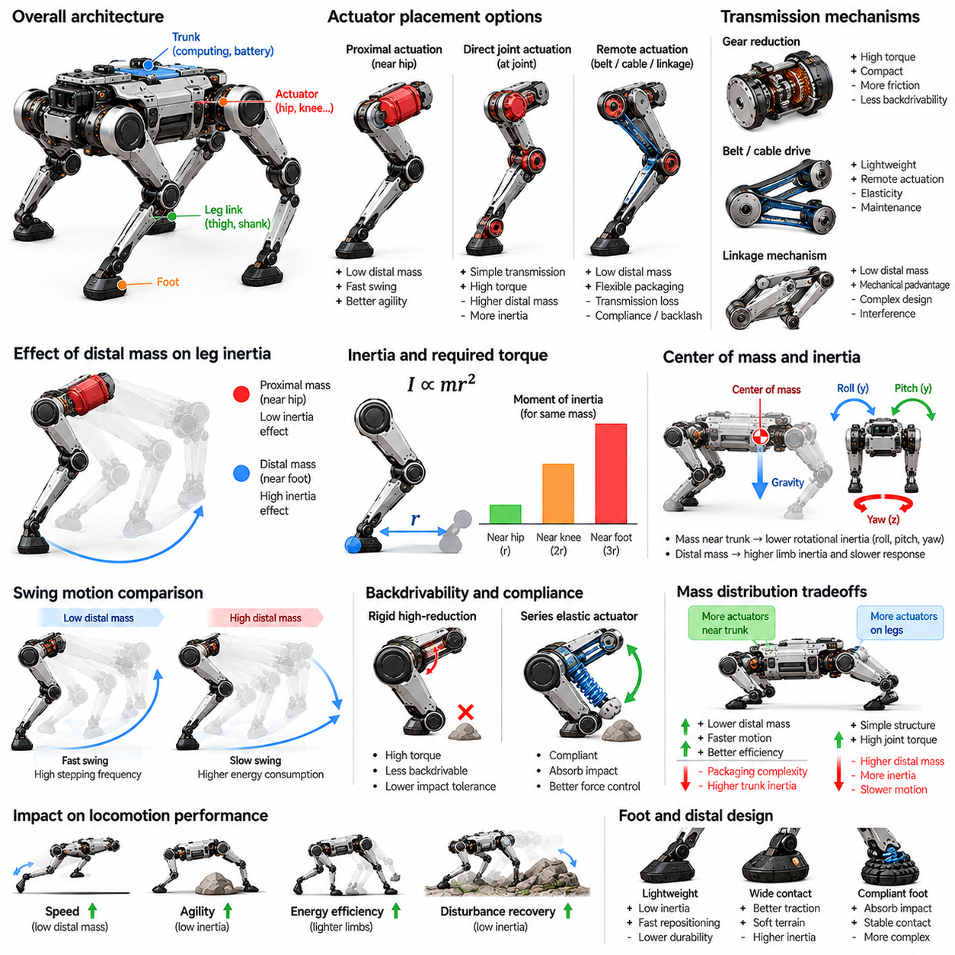
Actuator placement and distal mass are critical aspects of quadruped morphology that influence locomotion speed, energy efficiency, force generation, and mechanical responsiveness. Actuator placement determines where motors and transmissions are positioned relative to the trunk and leg joints. Distal mass refers to the mass located farther from the body, particularly within the lower leg and foot. Their interaction shapes limb inertia and dynamic performance.
The distribution of actuator mass along a leg directly affects the mechanical effort required for movement. Motors positioned near the hip contribute relatively little to the rotational inertia of the entire leg about the hip. Motors located near the knee or foot increase inertia because their mass acts at a greater distance from proximal joints. This relationship becomes especially important during rapid stepping and repeated swing motions.
Distal mass increases the moment of inertia of a swinging limb and therefore raises the torque required to achieve a given angular acceleration. Its contribution grows approximately with the square of its distance from the rotation axis. Consequently, relatively small masses near the foot can significantly affect dynamic performance. Minimizing distal mass is often a primary objective in quadrupeds designed for agile locomotion.
High swing-leg inertia can restrict achievable stepping frequency and increase the energy required for acceleration and deceleration. During rapid gait transitions, heavy distal segments may delay foot repositioning and reduce disturbance recovery capability. Lower limb inertia allows faster adjustments to unexpected terrain conditions. However, lightweight construction must still provide sufficient stiffness, impact resistance, and structural durability.
Proximal actuator placement concentrates heavy components near the trunk and upper leg. This arrangement reduces the inertia of moving distal segments and can improve the responsiveness of the leg. It may also simplify cooling and electrical integration because motors remain closer to the central body. Nevertheless, transmitting power to distant joints requires mechanical mechanisms that introduce additional design constraints.
Direct joint actuation places motors at or near the joints they control. This architecture can simplify power transmission and provide relatively direct relationships between motor motion and joint motion. However, knee-mounted motors add mass to the moving leg, increasing hip loading and swing inertia. The resulting tradeoff involves mechanical simplicity, torque capacity, packaging volume, and dynamic efficiency.
Remote actuation relocates motors away from the joints they drive, often toward the hip or trunk. Mechanical power is transferred through belts, cables, shafts, gears, or linkage mechanisms. This configuration can reduce distal mass while preserving joint functionality. However, transmission losses, elastic deformation, backlash, and maintenance requirements may offset some of the dynamic advantages.
Linkage-based transmission systems can transfer knee actuation from a proximal motor through mechanical connecting members. Properly designed linkages may reduce the mass carried by the lower leg while maintaining useful joint torque. Their geometry determines transmission ratios and force characteristics across the workspace. Designers must consider mechanical interference, joint limits, bearing loads, and structural complexity.
Belt and cable transmissions provide alternative approaches to remote actuation. Lightweight flexible elements can transfer motion across joints without requiring heavy distal motors. However, belt tension, cable stretch, pulley alignment, and fatigue influence accuracy and durability. These systems may require periodic adjustment and protection against contamination. Their suitability depends on loading conditions and environmental requirements.
Actuator placement also influences the robot's total center of mass and rotational inertia. Concentrating motors near the trunk can reduce body moments of inertia when their locations are close to the central mass. However, packaging several actuators around the hip may increase body width or create structural interference. Effective integration requires balancing compactness, thermal performance, maintenance accessibility, and mass distribution.
The relationship between actuator torque density and placement is central to mechanical design. High-torque-density actuators can deliver substantial output within relatively small packages, enabling compact joint integration. Nevertheless, motor selection must account for continuous torque, peak torque, thermal limits, and transmission efficiency. A lightweight actuator that overheats or saturates during operation may provide little practical benefit.
Gear reduction allows compact motors to generate higher joint torque but introduces reflected inertia, friction, and mechanical losses. High reduction ratios may reduce backdrivability and limit force transparency during ground contact. Lower reduction ratios can improve responsiveness and interaction control but require motors capable of producing greater torque. The appropriate ratio depends on locomotion dynamics and contact requirements.
Backdrivability is particularly important for quadrupeds operating on irregular terrain. A backdrivable joint can respond mechanically to external forces rather than behaving as a rigid, highly constrained mechanism. This characteristic can support impact tolerance and compliant interaction. However, high backdrivability may require continuous actuator effort to maintain posture, depending on the transmission and mechanical configuration.
Series elastic actuation introduces a compliant element between the motor and the driven joint. This elasticity can absorb impacts, improve force estimation, and support controlled interaction with the ground. However, additional compliance changes system dynamics and may limit high-frequency position tracking. The placement of elastic elements must therefore be coordinated with actuator bandwidth, control strategy, and expected contact forces.
Distal mass also influences impact behavior when the foot contacts the ground. A heavier moving lower leg can carry greater kinetic energy at a given velocity, potentially increasing collision forces during unexpected contact. Reducing distal inertia can improve the ability to stop or redirect a swinging foot. Nevertheless, impact severity also depends on joint compliance, control response, contact geometry, and effective mass.
The foot and lower-leg structure should be designed to minimize unnecessary mass while preserving contact reliability. Lightweight materials, hollow structural sections, and compact sensor integration can reduce inertia. However, excessive weight reduction may compromise fatigue resistance or protection against repeated impacts. The design objective is not minimum mass alone but an appropriate balance between mechanical robustness and dynamic capability.
Actuator placement affects cable routing, sensor integration, and environmental protection. Distally mounted motors require electrical connections that accommodate repeated joint movement and exposure to impacts. Proximally mounted motors may simplify electrical packaging but require more complex mechanical transmissions. Both approaches must address sealing, thermal management, connector reliability, and serviceability throughout the operating life.
Thermal management becomes particularly important when several high-power actuators are concentrated near the hip or trunk. Localized heat generation can affect motor efficiency, electronics reliability, and nearby structural components. Distributed actuator placement may improve heat separation but complicate wiring and protection. Mechanical architecture must provide adequate heat dissipation without introducing excessive weight or restricting movement.
The optimal actuator arrangement depends on the intended gait and operational environment. Fast-running quadrupeds benefit from low swing-leg inertia and rapid foot repositioning, while heavy-duty platforms may prioritize sustained torque and structural durability. Robots designed for rough terrain require impact tolerance and reliable joint force control. These different requirements can justify distinct actuator placement strategies.
Payload-carrying quadrupeds introduce additional constraints because higher body loads increase the torque required during stance. Larger actuators or stronger transmissions may be necessary, potentially increasing overall mass. Concentrating these components proximally can limit the resulting increase in swing inertia. However, actuator sizing must consider continuous support loads, dynamic peaks, and thermal operating limits.
Simulation can quantify the effects of actuator placement on joint torques, swing energy, and locomotion performance. Engineers can compare alternative motor locations and transmission architectures using multibody dynamic models. Parameter studies can reveal sensitivity to distal mass, gear ratio, and link inertia. Such analysis supports informed tradeoffs before expensive mechanical prototypes are manufactured.
Experimental validation is necessary because transmission friction, structural flexibility, thermal behavior, and manufacturing tolerances may differ from simulation assumptions. Swing-leg acceleration tests can reveal inertia-related limitations, while repeated gait trials provide evidence of energy consumption and actuator heating. Force measurements and disturbance tests help evaluate contact responsiveness. These results guide iterative refinement of actuator architecture.
Actuator placement and distal mass must ultimately be optimized as part of the complete quadruped system. Reducing distal inertia can improve agility, but remote transmissions may increase complexity and maintenance demands. Direct actuation can simplify mechanical integration while increasing moving mass. Successful morphology balances dynamic responsiveness, torque capability, energy efficiency, durability, and manufacturability.
Within Physical AI, actuator placement determines the mechanical limits within which intelligent locomotion policies operate. Learning-based controllers can adapt foot trajectories and contact forces, but they cannot eliminate the effects of excessive inertia or insufficient torque. Morphology-aware design aligns actuator architecture with perception, planning, and control. This integration enables efficient, responsive, and robust quadruped behavior in complex physical environments.

07.06. Compliance Shock and Foot Ground Interaction
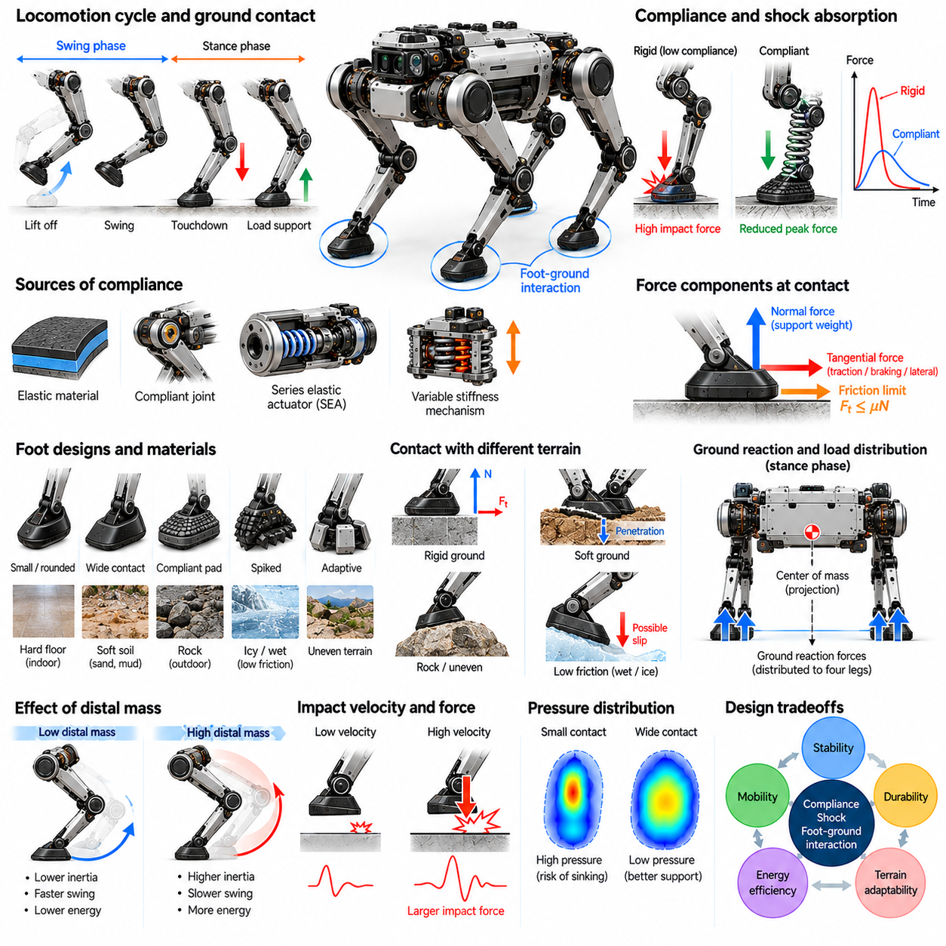
Compliance, shock absorption, and foot-ground interaction are essential elements of quadruped morphology that determine how a robot responds to contact with its environment. Compliance allows mechanical structures to deform under applied forces, while shock absorption reduces the transmission of impact energy. Foot-ground interaction governs traction, load transfer, and contact stability. Together, these properties influence locomotion efficiency, durability, and adaptability.
During quadruped locomotion, each foot repeatedly transitions between swing and stance phases. At touchdown, the foot establishes contact with the terrain and experiences a rapid change in velocity and loading. Without appropriate mechanical compliance or active control, this transition can generate large impact forces. These forces propagate through the leg joints and trunk, potentially affecting structural integrity, sensing accuracy, and motion stability.
Mechanical compliance describes the relationship between applied force and resulting deformation. It can originate from elastic materials, flexible structural elements, joint mechanisms, or dedicated suspension components. Controlled compliance allows a leg to accommodate small terrain irregularities without requiring immediate actuator corrections. However, excessive deformation can reduce positioning accuracy and introduce oscillations that complicate locomotion control.
Shock absorption involves dissipating or temporarily storing energy generated during impact. Elastic components store mechanical energy and may release it during subsequent motion, while damping mechanisms dissipate energy through friction or viscous resistance. Effective shock management combines appropriate stiffness and damping characteristics. The objective is to limit damaging impact loads while preserving responsive and efficient movement.
Joint compliance can be implemented through series elastic actuators, flexible couplings, or mechanically compliant transmissions. A series elastic actuator introduces an elastic element between the motor and the joint output, allowing controlled deflection under load. This arrangement can improve force estimation and impact tolerance. However, the added elasticity changes joint dynamics and requires suitable control strategies to maintain accurate movement.
Variable stiffness mechanisms provide an alternative approach by allowing mechanical compliance to change according to operating conditions. High stiffness may support precise positioning and heavy-load handling, while lower stiffness can improve impact tolerance during uncertain contact. Such systems may use adjustable springs, antagonistic actuators, or specialized transmissions. Their benefits must be weighed against additional mass, complexity, and energy requirements.
The foot is the primary interface between the quadruped and the terrain. Its geometry, material properties, and contact surface determine how forces are transmitted into the ground. Compact feet can simplify placement on narrow footholds, while larger contact areas may improve pressure distribution on deformable surfaces. Foot design must balance traction, durability, contact predictability, and compatibility with different terrain conditions.
Foot pads commonly use elastomeric materials to introduce localized compliance and increase friction under suitable surface conditions. Their deformation can distribute contact pressure and reduce concentrated impact loading. However, material hardness, temperature sensitivity, wear resistance, and contamination affect performance. A foot pad optimized for smooth indoor flooring may behave differently on wet rock, loose gravel, or uneven outdoor terrain.
Ground contact forces can be decomposed into normal and tangential components. Normal forces support body weight and contribute to vertical acceleration, while tangential forces generate propulsion, braking, and lateral stabilization. The maximum sustainable tangential force depends on contact conditions and available friction. Locomotion controllers must allocate forces within feasible contact limits to prevent unintended slipping.
The friction coefficient between the foot and ground is not a fixed property of the robot alone. It depends on the interacting materials, surface roughness, moisture, contamination, and contact dynamics. Low-friction terrain restricts the forces available for acceleration and turning. High-friction contact can improve traction but may increase structural loading during abrupt motion. Reliable locomotion therefore requires adaptation to uncertain surface properties.
Foot-ground interaction becomes more complex on deformable terrain such as sand, soil, snow, or soft vegetation. The foot may sink, compact the surface, or generate resistance through material displacement. Contact forces then depend on penetration depth, loading history, and local terrain mechanics. Rigid-ground assumptions may become inaccurate. Terrain-aware control must account for these effects when selecting footholds and regulating support forces.
Contact geometry also influences the distribution of pressure beneath the foot. A small contact region can generate high local pressure, potentially improving penetration into some surfaces while increasing sinking on soft terrain. Larger contact regions spread the load but may complicate placement on irregular obstacles. Appropriate foot morphology depends on whether the robot prioritizes precise foothold selection, low ground pressure, or secure traction.
Impact loading is strongly influenced by touchdown velocity and the effective mass participating in contact. Higher impact velocity generally increases the mechanical demands placed on the foot and leg. Lightweight distal structures can reduce collision energy, while compliant components can extend the duration of force transfer. Controlled landing trajectories further reduce impact severity by regulating foot velocity before contact.
Damping is necessary to prevent compliant structures from producing excessive oscillations after touchdown. Insufficient damping can cause repeated bouncing, unstable force measurements, and delayed settling. Excessive damping may waste energy and restrict rapid leg motion. The appropriate damping level depends on leg stiffness, body mass, gait frequency, and terrain characteristics. Mechanical and control-based damping can be combined to achieve suitable behavior.
Active compliance uses actuator control to regulate the apparent mechanical response of a joint or leg. Impedance control adjusts the relationship between motion errors and interaction forces, while admittance control generates motion responses from measured forces. These methods can complement passive elastic elements. Their effectiveness depends on sensing accuracy, actuator bandwidth, communication delays, and the stability of the control system.
Foot contact sensing provides information about touchdown timing, support loading, and potential slipping. Force sensors, torque estimation, tactile elements, and joint measurements can contribute to contact-state estimation. Accurate detection allows the controller to coordinate transitions between swing and stance. However, compliant structures and noisy measurements can introduce delays or uncertainty, requiring robust filtering and estimation methods.
Slip detection is important because loss of traction can destabilize the entire robot. Unexpected foot motion during stance may indicate insufficient friction, excessive tangential loading, or terrain deformation. Detection methods can compare predicted and observed foot motion using joint encoders, inertial sensors, and contact estimates. Once slipping is identified, the controller may redistribute forces, adjust posture, or select alternative footholds.
Compliance and contact behavior influence the efficiency of different gaits. During walking, controlled compliance can smooth load transfer between supporting legs. During trotting and running, elastic elements may temporarily store energy and return part of it during push-off. However, energy recovery depends on timing, stiffness, and mechanical losses. Poorly matched compliance can increase energy consumption or destabilize periodic locomotion.
The distribution of compliance across the leg affects how contact forces propagate through the mechanical structure. Compliance concentrated at the foot can absorb localized impacts without substantially altering joint behavior. Joint-level compliance can accommodate larger deflections and improve force regulation. Structural flexibility distributed through the links may reduce weight but complicate modeling. Each approach produces different tradeoffs between control accuracy and impact tolerance.
Repeated foot-ground impacts create fatigue and wear concerns for the entire locomotion system. Foot pads, bearings, joints, fasteners, and structural links experience cyclic loading during operation. Abrasive terrain can accelerate surface degradation, while contamination may damage moving components. Durable quadruped morphology requires replaceable contact elements, suitable material selection, protective sealing, and inspection procedures.
Simulation of compliant locomotion requires models of contact stiffness, damping, friction, and possible terrain deformation. These parameters are difficult to identify precisely because contact conditions vary between surfaces and over time. Simplified contact models support efficient development but may produce unrealistic impact or slip behavior. Experimental calibration is therefore necessary to improve simulation fidelity and reduce transfer errors.
Physical validation should include controlled drop tests, repeated touchdown experiments, traction measurements, and locomotion trials across representative surfaces. Engineers can evaluate peak impact forces, contact duration, settling behavior, slipping frequency, and component wear. These measurements reveal whether compliance improves performance without introducing unacceptable instability. Results can guide iterative refinement of foot materials, joint stiffness, and control parameters.
Compliance, shock absorption, and foot-ground interaction must be designed as an integrated mechanical and control system. Softer structures can improve impact tolerance but reduce positioning precision, while rigid configurations may improve response accuracy at the expense of contact robustness. Effective morphology balances stiffness, damping, traction, energy efficiency, and structural durability according to the robot's intended environment.
Within Physical AI, contact mechanics connects the robot's physical embodiment with perception, learning, and adaptive control. Intelligent locomotion systems must predict contact outcomes, detect changes in terrain properties, and adjust forces and trajectories accordingly. Mechanical compliance provides passive adaptation, while feedback control supplies active correction. Their integration enables safer, more efficient, and more robust quadruped locomotion in complex environments.

07.07. Terrain Adaptive Morphology
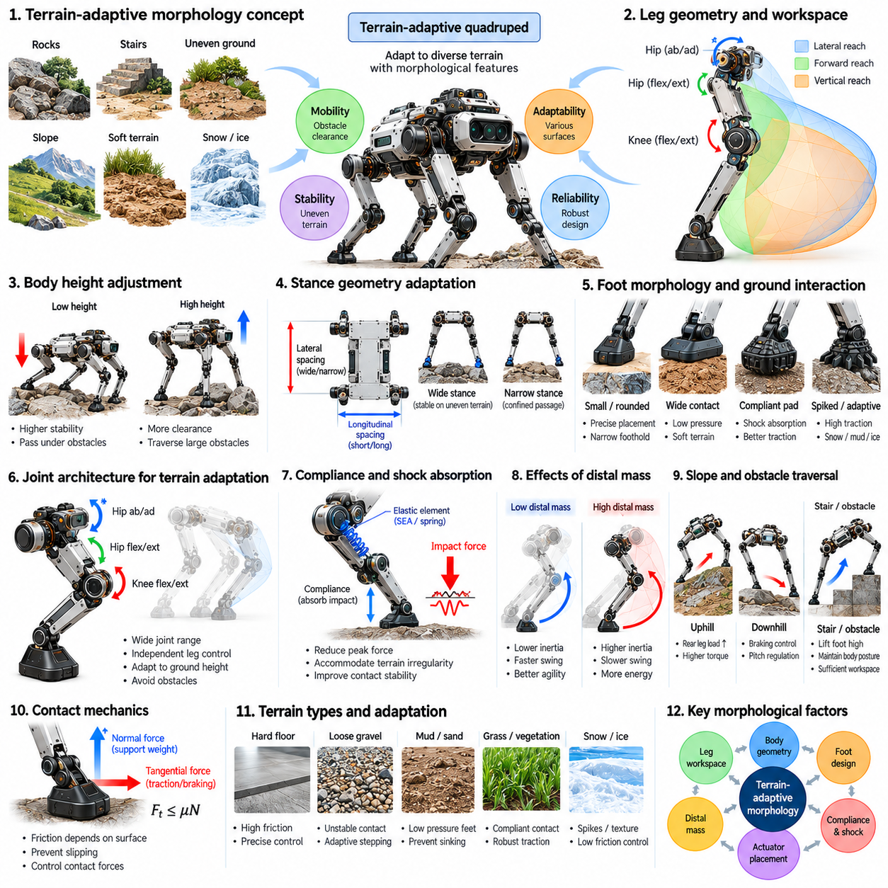
Terrain-adaptive morphology refers to the structural and mechanical characteristics that enable a quadruped robot to operate across diverse and unpredictable ground conditions. Unlike robots designed for uniform surfaces, terrain-adaptive quadrupeds must accommodate changes in elevation, slope, friction, compliance, and obstacle geometry. Their morphology determines the range of physical adaptations available to locomotion controllers and influences mobility, stability, and operational reliability.
The ability to traverse uneven terrain begins with leg geometry and reachable workspace. Sufficient joint articulation allows the robot to place its feet at different heights while maintaining a suitable body posture. Longer legs can increase obstacle clearance and stepping reach, but may introduce greater structural loads and rotational inertia. Effective terrain adaptation therefore requires balancing leg proportions, joint ranges, actuator capabilities, and mechanical robustness.
Body height adjustment is an important morphological capability for navigating irregular environments. Increasing trunk clearance can help the robot pass over rocks, vegetation, and raised obstacles, while lowering the body may improve stability on uncertain surfaces. However, changing body height alters joint configurations, torque requirements, and available workspace. Terrain-adaptive control must coordinate these effects to preserve feasible movement.
Stance geometry provides another mechanism for adapting to terrain conditions. A wider stance can improve lateral stability on uneven ground, while a narrower configuration may be necessary for confined passages. Longitudinal foot spacing can be adjusted to accommodate slopes and discontinuous support surfaces. These adaptations depend on sufficient lateral and longitudinal leg reach, as well as reliable coordination between body posture and foothold placement.
Foot morphology strongly influences the robot's ability to interact with different ground materials. Compact feet support precise placement on narrow rocks or structural edges, while larger contact surfaces distribute pressure across soft terrain. Elastomeric pads can improve contact compliance, whereas specialized tread patterns may enhance traction under suitable conditions. No single foot geometry performs optimally across every terrain category.
Terrain-dependent friction introduces significant challenges for quadruped locomotion. Smooth floors, wet stones, loose gravel, and compacted soil provide different traction characteristics. Foot materials and contact geometry determine how tangential forces are transmitted without slipping. Mechanical designs should provide sufficient grip while avoiding excessive wear or unwanted adhesion. Adaptive control must compensate when available friction changes unexpectedly.
Soft and deformable terrain requires particular attention to ground pressure and penetration. On sand, mud, snow, or loose soil, a concentrated foot load may cause sinking and unstable support. Increasing contact area can reduce pressure, although larger feet may interfere with obstacle negotiation. Terrain-adaptive morphology must balance surface penetration, traction generation, contact stability, and the energy required to withdraw the foot.
Mechanical compliance supports adaptation to terrain irregularities that cannot be predicted precisely. Elastic foot pads, compliant joints, and flexible structural elements allow local deformation during contact. This passive response can reduce impact loading and accommodate small height differences between footholds. However, excessive compliance may reduce positioning accuracy and introduce oscillations. Appropriate stiffness and damping depend on terrain characteristics and gait dynamics.
Joint architecture determines how effectively a quadruped can adjust individual legs to complex ground geometry. Hip abduction and adduction provide lateral foothold flexibility, while hip and knee flexion enable vertical and longitudinal positioning. Wide joint ranges increase potential adaptability but may create unfavorable leverage or collision risks. Usable workspace must therefore be evaluated under realistic loading and contact constraints.
Terrain-adaptive quadrupeds also benefit from low distal leg mass. Lightweight lower legs and feet can be repositioned rapidly when an intended foothold becomes unavailable. Reduced swing inertia supports obstacle avoidance and corrective stepping after unexpected contact. However, lightweight structures must remain resistant to impact, abrasion, and repeated loading. Actuator placement and transmission architecture are therefore important elements of terrain adaptation.
The trunk contributes to terrain adaptability through its geometry, rigidity, and mass distribution. A compact trunk can improve maneuverability around obstacles, while suitable ground clearance reduces the likelihood of body collisions. A relatively low center of mass may improve resistance to tipping, provided clearance remains adequate. Structural design must coordinate these competing requirements with payload capacity, sensing equipment, and thermal management.
Sloped terrain changes the relationship between gravity, body posture, and ground contact forces. During uphill movement, rear-leg loading and propulsion demands may increase, while downhill movement can require greater braking capability and careful pitch regulation. Side slopes introduce lateral load asymmetry and increased rollover risk. Terrain-adaptive morphology must provide sufficient joint torque, contact reach, and stability margins across these conditions.
Stair climbing and obstacle traversal impose additional workspace requirements. The robot must lift its feet above obstacle boundaries while preserving enough joint range for landing and support. Large vertical steps can require substantial knee articulation and hip torque. Body dimensions also determine whether the trunk can clear an obstacle without collision. Successful traversal depends on coordinated mechanical reach, force capability, and contact sequencing.
Irregular footholds may create situations in which the four feet contact surfaces at substantially different elevations. The resulting support configuration can produce asymmetric joint angles and uneven force distribution. Sufficient articulation allows the robot to accommodate these differences without excessive trunk rotation. However, extreme postures may reduce available torque or approach kinematic singularities. Mechanical feasibility must remain central to foothold selection.
Terrain-adaptive morphology can incorporate specialized feet for particular operating environments. Clawed structures may improve engagement with certain rough surfaces, while compliant pads support contact on hard irregular terrain. Broad feet may reduce sinking on snow or loose ground. Such adaptations introduce tradeoffs involving weight, complexity, surface compatibility, and maintenance. Application requirements determine whether specialized or general-purpose feet are preferable.
Some quadrupeds employ adjustable mechanical configurations to extend their terrain capabilities. Variable-stiffness joints, reconfigurable foot mechanisms, or adjustable leg elements can modify contact behavior and reachable geometry. These mechanisms provide additional adaptation beyond fixed morphology. However, they introduce actuators, sensors, control requirements, and potential failure points. Their benefits must justify the resulting mechanical and operational complexity.
Terrain perception and morphology are closely connected because physical reachability determines which perceived footholds can actually be used. Cameras, depth sensors, and proprioceptive measurements can identify obstacles, slopes, and potential contact regions. Planning systems must then evaluate these observations against leg workspace, joint limits, and stability constraints. A geometrically reachable foothold may still be unsuitable because of insufficient traction or excessive loading.
Contact sensing provides additional information when visual terrain estimates are uncertain. Joint torque measurements, foot force sensors, and body motion estimates can reveal unexpected compliance, slipping, or loss of support. These observations allow controllers to adjust contact forces and reposition feet. Mechanical compliance can provide immediate passive accommodation, while active control performs larger corrective movements. Their combination improves resilience to terrain uncertainty.
Adaptive gait selection enables a quadruped to exploit its morphology under changing conditions. Slow walking can maintain conservative support relationships on uncertain terrain, while trotting may provide efficient movement across sufficiently predictable surfaces. More demanding obstacles may require deliberate foot placement and extended support phases. The available gait repertoire depends on leg geometry, actuator bandwidth, contact capability, and body dynamics.
Energy efficiency remains an important consideration during terrain adaptation. Raising the body, increasing foot clearance, and using wide stances can improve obstacle negotiation but may increase joint torque and mechanical work. Frequent corrective stepping also consumes energy. Efficient terrain-adaptive behavior seeks configurations that provide sufficient safety margins without unnecessary motion. The preferred strategy depends on terrain difficulty and operational priorities.
Simulation enables systematic evaluation of quadruped morphology across representative terrain conditions. Virtual environments can include slopes, steps, scattered obstacles, uneven surfaces, and simplified deformable ground. Engineers can compare leg dimensions, foot designs, actuator placement, and compliance characteristics. However, simulated contact properties may not accurately reproduce real friction, soil deformation, or impact behavior, making experimental validation essential.
Physical testing should evaluate mobility across terrain categories that reflect the intended deployment environment. Relevant measurements include obstacle traversal success, slipping frequency, contact stability, energy consumption, actuator temperature, and structural wear. Repeated trials can reveal limitations that remain hidden during isolated demonstrations. These results support iterative refinement of mechanical design, locomotion planning, and contact control.
Terrain-adaptive morphology must ultimately be optimized as a complete system rather than through isolated mechanical improvements. Greater leg reach may increase obstacle capability while reducing stiffness, and larger feet may improve soft-ground support while restricting precise placement. Effective design balances workspace, stability, traction, compliance, structural durability, and energy requirements. The optimal configuration depends on the diversity and severity of expected terrain conditions.
Within Physical AI, terrain-adaptive morphology establishes the physical foundation for intelligent environmental interaction. Perception systems estimate terrain properties, planning algorithms select feasible footholds, and controllers coordinate forces and movements within mechanical limits. Passive structural adaptation complements learned and model-based control strategies. Together, these capabilities enable quadruped robots to navigate increasingly complex environments with greater robustness and autonomy.

07.08. Payload Carrying Quadrupeds
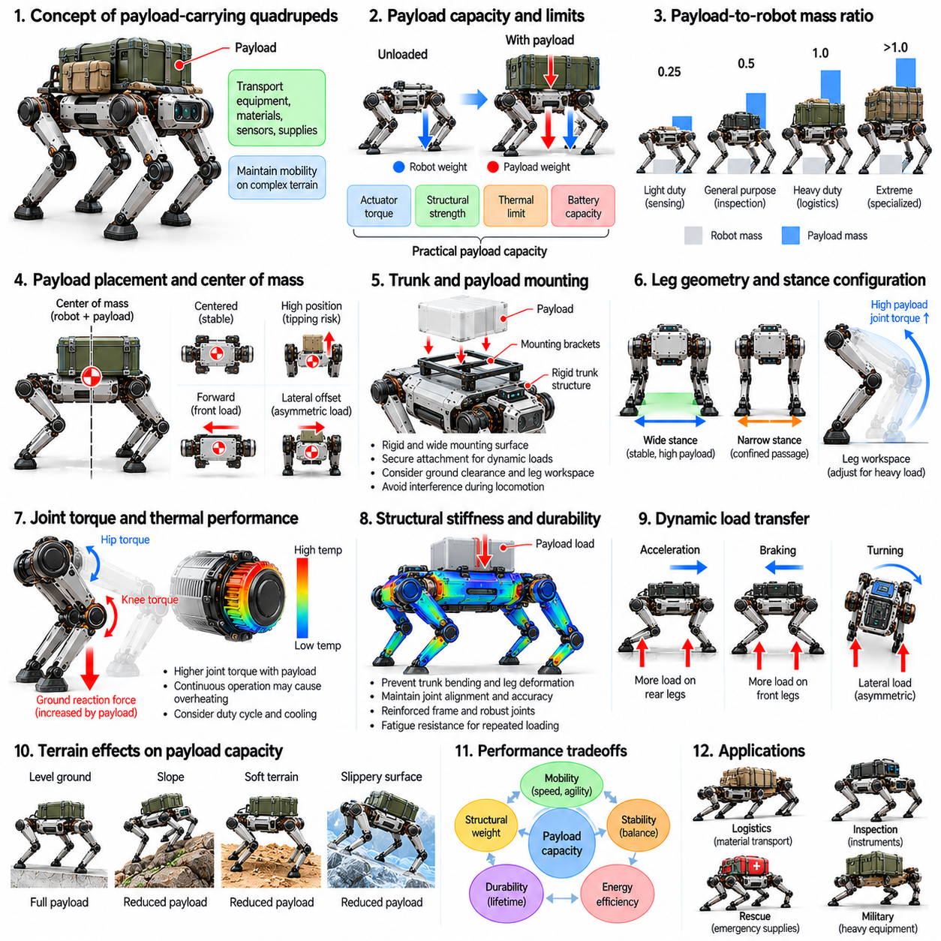
Payload-carrying quadrupeds are legged robots designed to transport equipment, materials, sensors, or supplies while maintaining mobility across complex terrain. Unlike unloaded quadrupeds, these systems must accommodate additional gravitational forces, altered mass distribution, and increased structural loading. Their morphology must balance payload capacity, locomotion stability, energy efficiency, and mechanical durability under changing operational conditions.
Payload capacity is determined by more than the maximum force available from the leg actuators. Structural strength, joint torque limits, thermal performance, battery capacity, and contact stability all constrain the usable load. A robot may support a heavy payload while stationary but fail to transport it safely during dynamic locomotion. Practical payload ratings must therefore reflect continuous operation, terrain difficulty, speed, and required safety margins.
The payload-to-robot mass ratio provides a useful measure of carrying efficiency. A high ratio indicates that a relatively lightweight platform can transport substantial additional mass. However, increasing this ratio may reduce structural reserves and available control authority. Heavy-duty quadrupeds often require reinforced frames, larger actuators, and stronger transmissions, which increase their own mass and influence the overall efficiency of the system.
Payload placement strongly affects the combined center of mass of the robot and its load. A payload positioned near the trunk center generally minimizes unwanted changes in balance and rotational inertia. Loads mounted high above the body can increase tipping susceptibility, particularly during turning or side-slope traversal. Longitudinally displaced loads alter front-to-rear support forces, while lateral offsets introduce asymmetric loading.
The geometry of the trunk determines how effectively payloads can be accommodated. A broad, rigid mounting surface provides attachment flexibility and distributes forces into the main structure. However, excessive trunk width can restrict movement through narrow passages and increase body inertia. Designers must coordinate payload dimensions, mounting locations, ground clearance, and leg workspace to avoid interference during locomotion.
Payload mounting systems must withstand both static weight and dynamic acceleration. Walking, trotting, braking, and obstacle traversal generate inertial forces that may exceed the payload's gravitational loading. Mounting brackets, fasteners, and structural interfaces require appropriate strength and fatigue resistance. Secure attachment also prevents relative movement that could produce unpredictable shifts in the combined center of mass.
Leg geometry and stance configuration influence the ability to support additional weight. A wider stance may increase resistance to lateral tipping, while suitable longitudinal spacing helps distribute loads between the front and rear legs. However, wider configurations can increase joint torque demands and restrict maneuverability. Payload-oriented morphology must preserve sufficient support stability without creating excessive mechanical effort.
Joint torque requirements increase when payload mass raises the ground reaction forces needed for support. Hip and knee actuators must generate sufficient torque across the expected range of leg configurations. Certain postures may create unfavorable moment arms and increase actuator loading. Consequently, payload capability should be evaluated throughout the usable workspace rather than at a single nominal standing position.
Continuous torque capability is particularly important because carrying a payload may require sustained joint effort over extended periods. Motors and transmissions that tolerate brief peak loads may overheat during prolonged support or slow climbing. Thermal limits can therefore restrict practical payload capacity before mechanical strength limits are reached. Actuator selection must consider duty cycles, cooling conditions, and expected operating duration.
Structural stiffness becomes increasingly important as payload mass rises. Excessive trunk bending or leg deformation can alter joint alignment, reduce positioning accuracy, and introduce undesirable oscillations. Reinforcement improves rigidity but adds mass that must also be supported and accelerated. Efficient structural design distributes loads through appropriate frame geometry, material selection, and mechanically robust connection points.
Payloads influence the robot's rotational inertia as well as its total mass. Heavy equipment mounted far from the body center increases resistance to pitch, roll, and yaw acceleration. This can slow posture correction and require greater actuator effort during rapid maneuvers. Compact and centrally located payload arrangements generally improve dynamic responsiveness, although application-specific equipment may impose unavoidable geometric constraints.
Dynamic load transfer must be considered during acceleration, braking, and turning. Forward acceleration can shift the effective support demand toward the rear legs, while braking can increase loading toward the front. Lateral acceleration introduces asymmetric contact forces and potential rollover risks. Payload-carrying quadrupeds require sufficient traction and control authority to manage these changing force distributions.
Terrain conditions significantly influence usable payload capacity. On steep slopes, gravitational forces create additional demands on propulsion, braking, and posture regulation. Soft ground may deform beneath heavily loaded feet, while slippery surfaces restrict available tangential forces. A payload that is manageable on level flooring may become unsafe on irregular terrain. Operational load limits should therefore account for environmental conditions.
Foot morphology affects the distribution of increased contact forces into the terrain. Larger contact areas can reduce ground pressure and improve support on deformable surfaces, while compact feet may provide more precise placement on narrow obstacles. Suitable materials and tread geometry help maintain traction. The optimal foot design depends on the relationship between payload mass, terrain mechanics, and required mobility.
Energy consumption generally increases when additional payload mass must be supported, accelerated, or lifted against gravity. The magnitude of this increase depends on gait, terrain, actuator efficiency, and mechanical configuration. Heavy loads can reduce operating range and increase battery discharge rates. Payload-oriented quadrupeds must therefore balance carrying capacity with mission duration, locomotion speed, and available energy reserves.
Battery placement presents a tradeoff between energy capacity and useful payload. Larger batteries extend operating time but increase the mass that the robot must carry. Positioning batteries near the trunk center can help preserve favorable mass distribution. Designers must evaluate whether additional battery capacity produces enough operational benefit to justify its weight, particularly during missions involving sustained payload transportation.
Gait selection can improve stability and efficiency under varying payload conditions. Slow walking provides opportunities for deliberate foot placement and controlled load transfer, while trotting may be suitable when terrain and actuator capabilities permit. Heavy payloads can reduce the margin available for rapid acceleration and disturbance recovery. Controllers should adjust gait timing, body posture, and contact forces according to estimated load conditions.
Payload uncertainty introduces additional challenges when transported objects differ in mass, shape, or mounting position. An inaccurate payload estimate can lead to incorrect torque predictions and uneven support loading. Joint measurements, inertial sensing, and force estimation can help identify changes in total mass and center of mass. Adaptive control can then update force allocation and posture regulation within the robot's mechanical limits.
Modular payload interfaces improve the flexibility of quadruped platforms across different applications. Standardized mounting structures can accommodate inspection sensors, communication equipment, logistics containers, or specialized tools. Electrical and data connections may support powered payloads, but their energy consumption must be included in mission planning. Modular integration must also preserve structural integrity and environmental protection.
Payload-carrying quadrupeds may operate in logistics, industrial inspection, emergency response, and remote field support. Each application imposes different requirements for payload dimensions, operating duration, terrain accessibility, and reliability. Industrial environments may prioritize repeatable transport and maintenance efficiency, while remote deployments may emphasize endurance and obstacle negotiation. Morphological optimization must reflect these mission-specific priorities.
Simulation provides a systematic method for evaluating payload effects before physical deployment. Engineers can vary payload mass, mounting position, terrain inclination, and gait parameters to estimate joint torques, contact forces, and stability margins. Multibody dynamic models reveal how load distribution affects movement. However, simulation assumptions must be validated against actual actuator behavior, structural deformation, and ground contact conditions.
Experimental payload testing should examine both stationary support and dynamic locomotion. Relevant measurements include actuator temperature, joint torque, energy consumption, structural deflection, slipping frequency, and recovery from disturbances. Tests should progressively explore realistic combinations of load, speed, slope, and terrain difficulty. Repeated operation is necessary to identify thermal limitations, fatigue risks, and long-term reliability concerns.
Payload capacity should ultimately be treated as a system-level performance characteristic rather than an isolated mechanical specification. Increasing actuator strength alone does not guarantee safe transportation if structural stiffness, traction, stability, or energy capacity remain insufficient. Successful payload-oriented morphology integrates trunk architecture, leg geometry, actuator sizing, foot design, and thermal management into a balanced configuration.
Within Physical AI, payload-carrying quadrupeds demonstrate how mechanical embodiment and intelligent control must operate together. Perception identifies terrain constraints, estimation systems track load-dependent dynamics, and locomotion controllers regulate posture and contact forces. Learning-based adaptation may improve performance across varying payload conditions, but physical limits remain fundamental. Integrated design enables reliable, efficient, and adaptable robotic transportation.

07.09. Quadruped with Manipulation
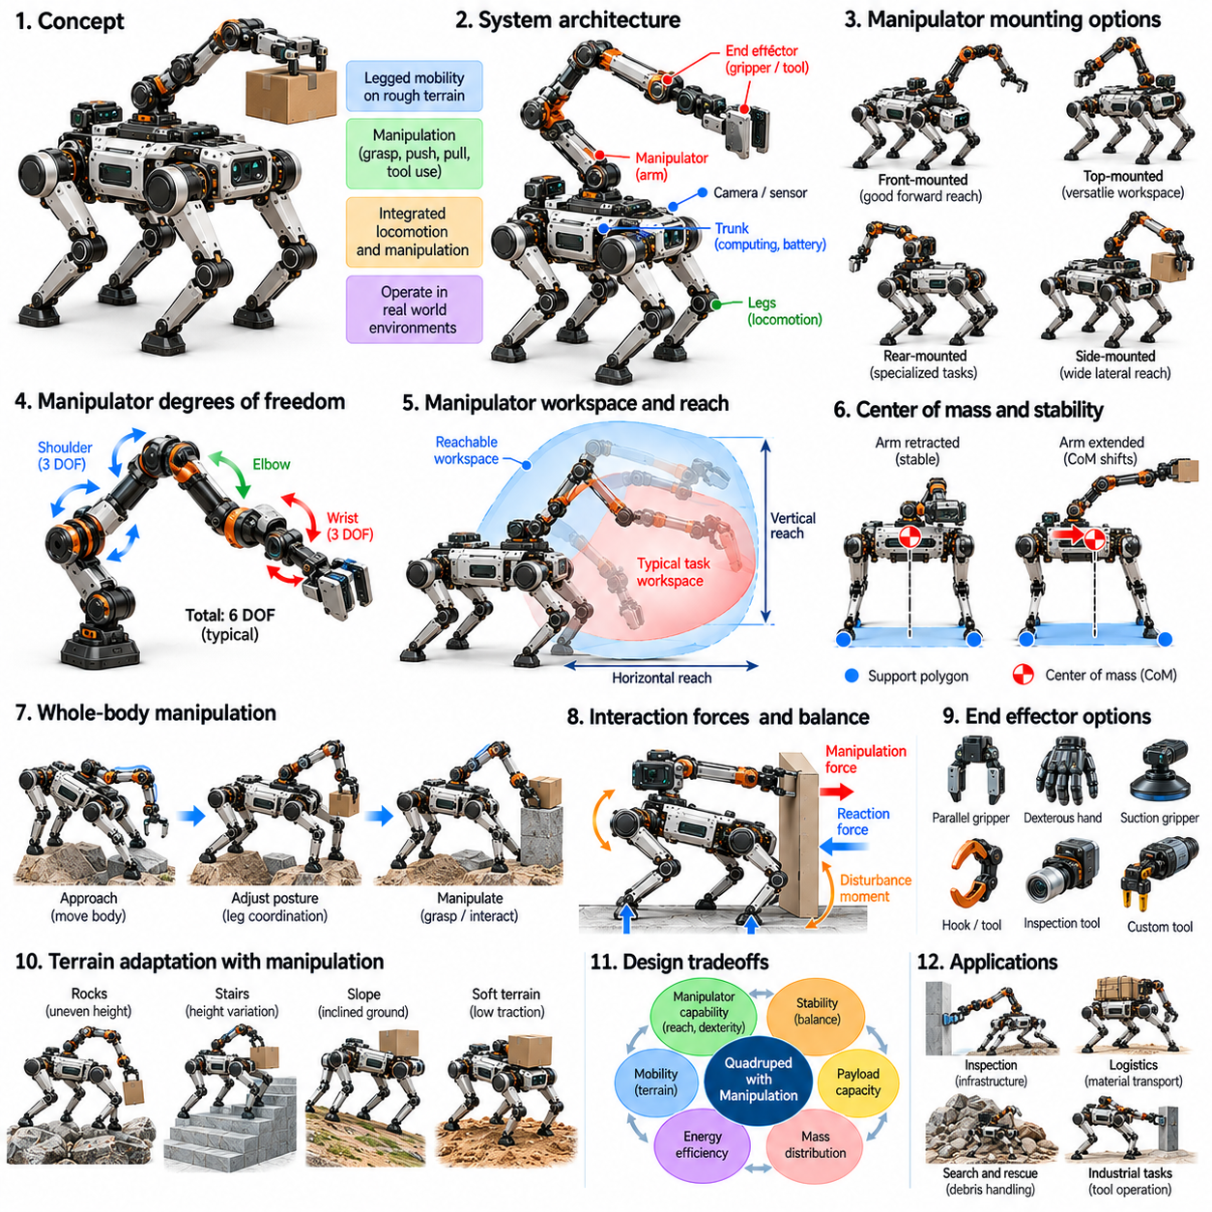
Quadrupeds with manipulation capabilities combine legged mobility with robotic arms or specialized end effectors to perform physical tasks beyond locomotion. These systems can navigate uneven terrain, approach objects, and interact with their surroundings through grasping, pushing, pulling, or tool operation. Their morphology must integrate locomotion and manipulation without compromising stability, structural integrity, or energy efficiency during coordinated physical interaction.
The integration of a manipulator changes the fundamental mechanical architecture of a quadruped. A conventional platform primarily distributes mass among the trunk, legs, and onboard equipment, whereas a mobile manipulator introduces additional links, joints, actuators, and payload forces. These components modify the robot's center of mass, rotational inertia, and structural loading. Effective design requires simultaneous consideration of locomotion and manipulation requirements.
Manipulator mounting position strongly influences workspace accessibility and balance. A centrally mounted arm may provide a broad operational region around the robot, while a front-mounted arm can improve access to objects directly ahead. However, forward mounting increases the potential for longitudinal mass imbalance and larger pitching moments. The selected configuration must balance reachable workspace, visibility, structural support, and whole-body stability.
Manipulator degrees of freedom determine the range of achievable end-effector positions and orientations. Additional joints can improve dexterity and obstacle avoidance but increase mass, actuator requirements, and control complexity. A six-degree-of-freedom arm can support general spatial positioning and orientation under suitable kinematic conditions. Nevertheless, practical manipulation capability also depends on joint limits, payload capacity, and collision-free workspace.
The manipulator's reach must be coordinated with the quadruped's stance geometry and body dimensions. Extended arm configurations increase the accessible workspace but can generate large moments around the support region. Retracted configurations generally reduce rotational inertia and improve balance during locomotion. Morphological design should therefore consider both manipulation postures and compact transportation configurations to maintain operational flexibility.
Center-of-mass variation becomes a major challenge when the arm moves or carries an object. Extending the manipulator forward shifts the combined center of mass and changes the distribution of ground reaction forces among the legs. Lateral arm motion can similarly introduce asymmetric loading. The robot must adjust body posture, foothold placement, and contact forces to maintain feasible support while completing manipulation tasks.
Whole-body manipulation treats the legs, trunk, and arm as components of a coordinated mechanical system. Rather than controlling the arm independently, the robot can reposition its body to extend reach, improve leverage, or avoid joint limits. The legs provide a mobile support structure while the manipulator performs the primary task. This coordination expands the effective workspace but requires accurate modeling of coupled dynamics and contact constraints.
Manipulation forces can significantly affect quadruped stability. Pushing against a wall, pulling an object, or operating a lever introduces reaction forces that propagate through the manipulator into the trunk and supporting legs. These forces may produce pitching, rolling, or yawing moments. Mechanical design must provide sufficient structural stiffness and actuator capacity, while control systems distribute support forces to resist unintended motion.
The support polygon provides a useful reference for evaluating quasi-static manipulation stability. When the combined center-of-mass projection remains within the support region, the robot may maintain balance under appropriate contact conditions. However, external manipulation forces can create tipping moments even when this geometric condition is satisfied. Reliable operation requires evaluating both gravitational loading and task-dependent interaction forces.
Manipulator actuator placement influences the overall mass distribution and energy requirements of the system. Heavy motors positioned near the arm base can reduce distal inertia and improve responsiveness. However, remote transmissions may increase mechanical complexity and introduce compliance or backlash. Compact actuators at individual joints simplify integration but increase moving mass. These tradeoffs become important when the quadruped must manipulate objects while maintaining balance.
End-effector morphology determines the range of objects and tools the robot can handle. Parallel grippers provide relatively simple grasping for compatible objects, while multi-fingered hands offer greater dexterity at the cost of complexity. Specialized tools may support inspection, sampling, or industrial operations. End-effector selection should reflect object geometry, required forces, environmental conditions, and the precision needed for reliable interaction.
Grasping introduces additional requirements for force control and contact sensing. Excessive gripping force can damage fragile objects, while insufficient force may allow slipping or loss of the payload. Tactile sensors, force-torque sensors, and actuator measurements can support grasp monitoring. The manipulator must coordinate local contact regulation with whole-body balance, particularly when object weight or interaction forces change unexpectedly.
The quadruped's trunk must provide a mechanically robust interface for manipulator attachment. Arm motion generates bending moments, torsional loads, and repeated dynamic stresses at the mounting structure. Reinforcement can improve rigidity but increases overall mass and energy demand. Designers must balance structural strength, compact packaging, serviceability, and protection of onboard electronics while preserving sufficient clearance for leg movement.
Leg geometry affects the ability to maintain stable support during manipulation. A wider stance can increase resistance to lateral tipping, while a longer stance may improve stability against forward or backward interaction forces. However, extreme stance configurations can increase joint torque demands and reduce available mobility. The optimal posture depends on manipulator reach, task direction, terrain conditions, and the location of external contacts.
Locomotion and manipulation can be performed sequentially or simultaneously. Sequential operation allows the quadruped to establish a stable stance before manipulating an object, reducing control complexity. Simultaneous operation enables tasks such as carrying objects while walking or interacting with moving targets. However, coordinated movement introduces dynamic coupling between arm motion, leg forces, and body acceleration, requiring more sophisticated planning and control.
Mobile manipulation on uneven terrain presents additional challenges because the support surface may be irregular or uncertain. Different foot heights create asymmetric joint configurations, while limited friction constrains the forces available to resist manipulation reactions. Compliant ground can deform under changing loads. Terrain-aware manipulation must therefore consider foothold quality, support geometry, joint torque limits, and the expected direction of task forces.
The manipulation workspace is not determined by arm reach alone. Body height adjustment, trunk orientation, and leg repositioning can substantially expand the set of reachable targets. A quadruped may lower its body to grasp objects near the ground or raise its trunk to access elevated equipment. Such adjustments must remain within feasible joint configurations and preserve stability. Coordinated morphology enables greater task flexibility without requiring an excessively long arm.
Energy consumption increases when manipulation is added to a quadruped platform. Additional actuators, sensors, and computing systems require electrical power, while arm movement introduces mechanical work and changing support loads. Sustained object holding may also consume energy depending on transmission characteristics. Efficient operation requires coordinated motion planning, appropriate actuator sizing, and task strategies that minimize unnecessary force and movement.
Perception is essential for identifying objects, estimating grasp poses, and understanding the surrounding terrain. Cameras, depth sensors, and proprioceptive measurements provide information for coordinated navigation and manipulation. However, sensor placement must account for occlusion by the arm, body motion, and changing viewpoints. Morphological integration should preserve useful visibility while protecting sensing equipment from impacts and environmental contamination.
Planning systems must jointly evaluate navigation paths, body configurations, arm trajectories, and contact feasibility. A target may be reachable by the manipulator but inaccessible because the quadruped cannot establish a stable stance nearby. Similarly, a favorable standing location may restrict arm movement through collisions or joint limits. Integrated planning selects configurations that satisfy both mobility and manipulation constraints before executing physical actions.
Simulation supports the evaluation of coupled quadruped-manipulator dynamics across different tasks. Engineers can investigate arm mounting positions, payload variations, stance configurations, and interaction forces using multibody models. Contact-rich scenarios reveal potential instability and actuator saturation. Nevertheless, real-world testing remains necessary because friction, compliance, object properties, and sensing uncertainty may differ substantially from simulated assumptions.
Experimental validation should include reaching, grasping, pushing, pulling, carrying, and tool-use tasks under representative environmental conditions. Relevant measurements include manipulation success, positioning accuracy, joint torque, stability margins, energy consumption, and recovery from disturbances. Tests should examine both stationary and moving configurations. Repeated trials help identify structural fatigue, thermal limitations, and failure modes associated with coordinated operation.
The design of quadrupeds with manipulation capabilities involves balancing mobility, dexterity, payload capacity, and system complexity. Larger manipulators increase reach and force capability but add mass and destabilizing moments. More capable legs can compensate through posture adjustment and force redistribution, although these improvements also introduce costs. Effective morphology integrates arm architecture, trunk structure, leg workspace, and contact mechanics into a coherent system.
Within Physical AI, quadruped manipulation represents an important step toward general-purpose physical interaction. Intelligent systems must combine terrain perception, object understanding, motion planning, force regulation, and whole-body coordination. Learning-based policies can improve adaptation to unfamiliar objects and environments, but their actions remain constrained by mechanical capabilities. Integrated embodiment enables quadrupeds to perform increasingly diverse tasks with greater autonomy and reliability.

07.10. Mobility Payload Energy Tradeoffs
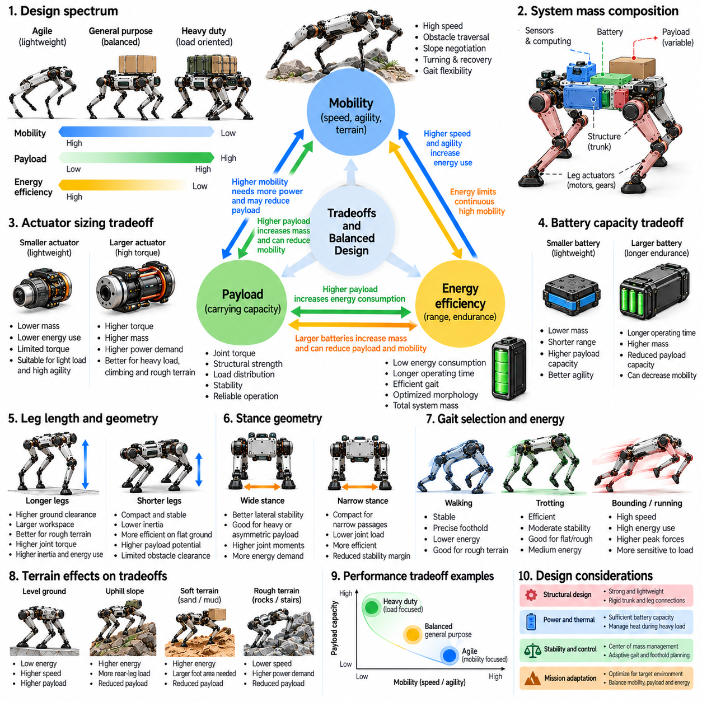
Mobility, payload capacity, and energy efficiency form a fundamental set of competing objectives in quadruped robot design. Improving one capability often imposes additional requirements on the others because structural mass, actuator power, battery capacity, and mechanical geometry are closely coupled. A quadruped optimized for rapid movement may not carry heavy equipment efficiently, while a load-oriented platform may sacrifice speed, agility, and operational endurance.
Mobility encompasses more than maximum locomotion speed. It includes obstacle traversal, slope negotiation, turning ability, gait flexibility, and recovery from disturbances. These capabilities depend on leg workspace, actuator bandwidth, structural proportions, and available traction. Increasing mobility often requires additional mechanical capability, but the associated mass and power consumption can reduce the payload and energy resources available for other tasks.
Payload capacity describes the additional mass a quadruped can transport while maintaining acceptable stability and performance. Increasing payload requires sufficient joint torque, structural strength, and ground contact capability. However, larger actuators and reinforced structures increase the robot's own weight. This creates a recursive design challenge in which components added to support greater payload also increase the load that the locomotion system must carry.
Energy efficiency determines how effectively stored electrical energy is converted into useful movement and task execution. A robot with low energy consumption can operate longer or travel farther with a given battery capacity. However, efficient locomotion depends on terrain, gait, speed, and loading conditions. An architecture optimized for level-ground walking may perform less efficiently during climbing, obstacle traversal, or repeated manipulation.
The relationship between robot mass and payload mass is central to these tradeoffs. Total system mass includes the trunk, legs, actuators, batteries, sensors, computing hardware, and transported equipment. Every additional component increases gravitational loading and potentially changes rotational inertia. Reducing structural mass can improve efficiency, but excessive weight reduction may compromise stiffness, fatigue resistance, and impact durability.
Actuator sizing creates a direct connection between mobility and payload capability. Larger motors can provide greater joint torque and improve acceleration, climbing, and load support. However, they also increase mass, cost, and electrical demand. Smaller actuators reduce weight but may operate closer to thermal or torque limits. Effective sizing requires evaluating peak demands, continuous operating conditions, and the expected distribution of locomotion tasks.
Transmission architecture further influences the balance between force capability and efficiency. High reduction ratios can increase output torque but may reduce backdrivability, introduce friction, and limit dynamic responsiveness. Lower reduction ratios can support compliant interaction and rapid joint movement but require motors capable of producing greater torque. The preferred configuration depends on whether the robot prioritizes dynamic agility, sustained support, or heavy-load transportation.
Leg length and geometry introduce additional mechanical tradeoffs. Longer legs can improve obstacle clearance and reachable workspace, supporting mobility across irregular terrain. However, longer segments may increase bending loads, rotational inertia, and joint torque requirements. Shorter legs can improve compactness and structural efficiency but restrict stepping reach. Morphological optimization must account for terrain demands alongside payload and energy constraints.
Stance geometry influences both stability and energetic cost. A wider stance may improve resistance to lateral tipping when carrying an elevated or asymmetric payload. However, extreme leg configurations can increase joint moments and require additional support effort. Narrower stances may reduce certain mechanical demands but provide smaller stability margins. Adaptive stance selection can balance these competing effects as terrain and payload conditions change.
Battery capacity presents one of the clearest system-level compromises. Adding battery cells increases available stored energy but also raises the mass that must be supported and accelerated. The resulting endurance improvement may diminish as additional weight increases locomotion consumption. Battery sizing should therefore be based on realistic mission energy requirements rather than assuming that larger batteries always produce proportionally longer operating time.
Locomotion speed affects energy consumption through changes in gait dynamics, actuator losses, and mechanical work. Higher speeds can increase inertial loading and require faster joint motion, while excessively slow movement may prolong electrical losses associated with sustained support. Consequently, the most energy-efficient speed is not necessarily the lowest speed. Its value depends on morphology, terrain, payload, and the selected gait.
Gait selection provides a mechanism for adapting the mobility-energy balance. Walking can offer conservative support and precise foothold placement on difficult terrain, while trotting may provide efficient progression on predictable surfaces. Dynamic gaits can reduce travel time but increase peak force demands and disturbance sensitivity. A payload-carrying quadruped should select gaits according to terrain difficulty, available actuator margins, and mission priorities.
Terrain conditions can shift the balance among mobility, payload, and energy requirements. Uphill locomotion increases the mechanical work required to raise the combined robot and payload mass. Soft terrain introduces additional losses through deformation and foot penetration, while slippery ground limits usable propulsion forces. A payload rating established on level flooring may therefore be unsuitable for steep or irregular environments.
Foot design contributes to these tradeoffs through contact pressure, traction, and distal mass. Larger feet can improve support on soft ground but increase swing inertia and complicate precise foothold placement. Lightweight feet reduce repositioning effort but must withstand repeated impacts and abrasion. Contact materials and compliance should be selected to provide sufficient traction without excessive deformation losses or maintenance requirements.
Dynamic stability imposes constraints that cannot be captured by payload mass alone. A high-mounted load raises the combined center of mass and can increase rollover risk during turning or side-slope traversal. An extended manipulator may introduce substantial moments even when the carried object is relatively light. Safe operation requires considering payload geometry, acceleration, support forces, and available corrective motion.
Thermal performance creates an additional boundary between theoretical and practical capability. A quadruped may briefly generate enough torque to climb with a heavy load but fail to sustain that effort because of motor or transmission heating. Higher temperatures can reduce allowable continuous torque and accelerate component degradation. Mission planning must therefore consider thermal accumulation alongside instantaneous force and energy limits.
Mechanical compliance can improve mobility and impact tolerance but also introduces efficiency tradeoffs. Elastic elements may store and return energy during suitable gait cycles, reducing some actuator demands. However, poorly matched stiffness or damping can increase oscillation, dissipate energy, or impair load control. The appropriate compliance depends on operating speed, terrain characteristics, payload variation, and desired stability.
Mission-level optimization requires evaluating the complete sequence of operations rather than a single locomotion condition. A robot may need to travel unloaded, collect equipment, climb a slope, and return while carrying additional mass. Each phase has different energy, torque, and stability requirements. A configuration optimized for one phase may perform poorly across the full mission, making representative duty-cycle analysis essential.
Performance metrics should distinguish mobility capability, transport productivity, and energy efficiency. Relevant measures include maximum traversable obstacle height, allowable payload, travel speed, operating duration, and energy consumed per distance. Cost of transport provides a normalized indicator of locomotion energy relative to system weight and distance. However, no single metric fully captures operational effectiveness across diverse missions.
Multi-objective optimization provides a structured method for exploring these competing design goals. Candidate morphologies can be evaluated using simulation and experimental data under common terrain and payload conditions. Pareto-optimal configurations represent designs in which improving one objective requires sacrificing another. This approach reveals practical design choices without assuming that a single morphology can maximize every performance characteristic.
Simulation supports early comparison of actuator sizes, leg dimensions, battery configurations, and payload distributions. Dynamic models can estimate joint torques, contact forces, energy consumption, and stability margins across representative tasks. However, predictions depend on accurate actuator efficiency, friction, terrain, and thermal models. Physical experiments are necessary to establish whether simulated advantages remain valid during sustained real-world operation.
Experimental evaluation should combine unloaded and loaded trials across multiple speeds, gaits, and terrain categories. Measurements of electrical energy, actuator temperature, joint torque, slipping, and task completion can reveal hidden performance limitations. Repeated trials are particularly important because thermal saturation and structural fatigue may not appear during short demonstrations. Results should inform iterative adjustments to both morphology and control.
Design priorities vary substantially across quadruped applications. Inspection robots may emphasize endurance and terrain accessibility while carrying relatively lightweight sensors. Logistics platforms may prioritize payload capacity and transport reliability, whereas emergency-response robots may require mobility reserves for unpredictable obstacles. Morphology should be selected according to measurable mission requirements rather than maximizing isolated specifications.
Within Physical AI, mobility-payload-energy tradeoffs demonstrate that intelligent behavior remains constrained by physical embodiment. Perception and planning can select routes, gaits, and body configurations that reduce energy demand while preserving stability and task performance. Adaptive control can exploit available mechanical capabilities but cannot eliminate structural, thermal, or energetic limits. Effective quadruped design therefore requires coordinated optimization of morphology, actuation, energy storage, and intelligent control.

