Volume 04. Data Engines and Scaling for Physical AI

Chapter 04. Simulation Generated Data

04.01. Simulation as a Data Generator
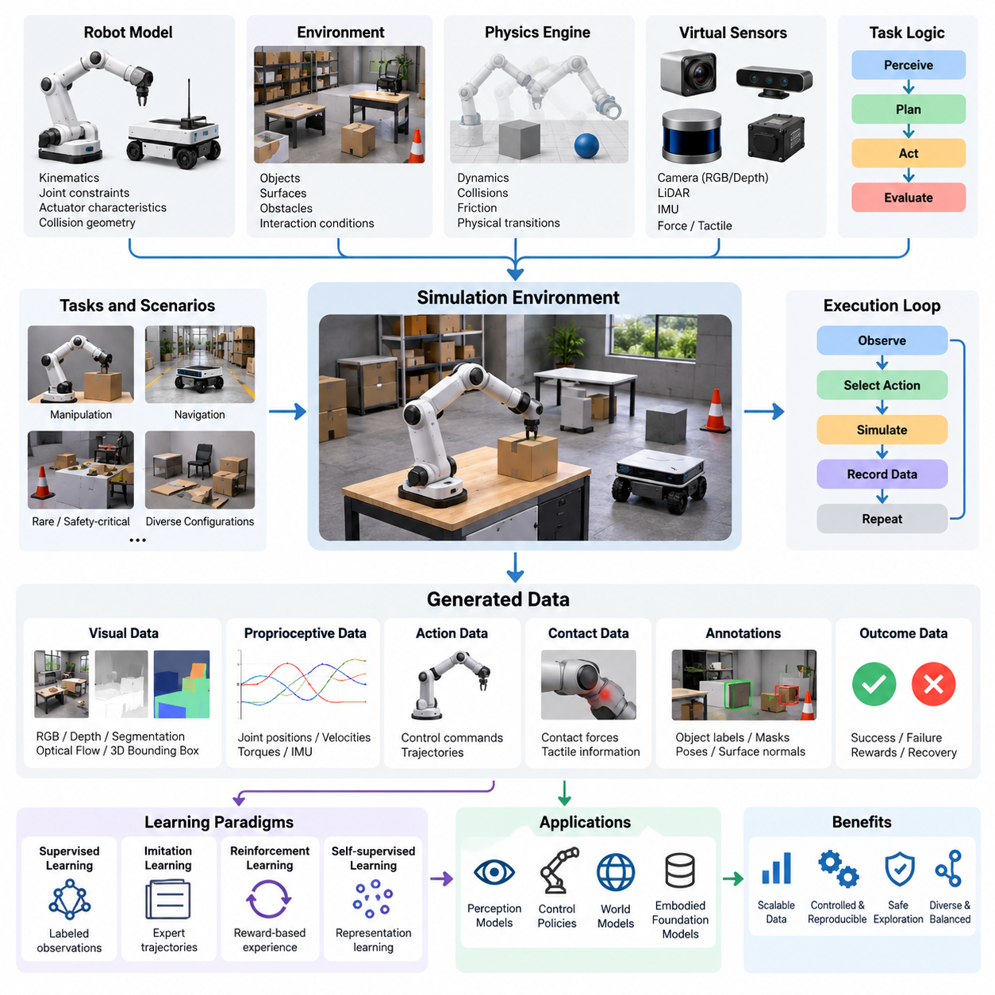
Simulation serves as a scalable data generator for Physical AI by creating controlled virtual environments in which robots can perceive, act, interact, and learn without requiring continuous access to physical hardware. Unlike conventional datasets collected from completed real-world operations, simulation-generated data can be produced on demand by systematically varying tasks, environments, objects, and robot behaviors.
The fundamental advantage of simulation is its ability to generate large quantities of structured observation-action-outcome data under reproducible conditions. A simulated robot can execute thousands of trajectories while recording sensor observations, internal states, control commands, contact events, and task outcomes. These records provide training material for perception models, control policies, world models, and embodied foundation models.
A simulation environment typically combines a robot model, a representation of the surrounding world, a physics engine, virtual sensors, and task execution logic. The robot model describes kinematic structures, joint constraints, actuator characteristics, and collision geometry. The environment defines objects, surfaces, obstacles, and interaction conditions, while the physics engine estimates how these elements evolve over time.
During simulated execution, the system generates sequences of observations, actions, and resulting states. At each time step, virtual sensors capture information about the environment, and a control policy selects an action based on available observations. The simulator then computes the resulting physical transition, producing temporally aligned trajectories that can be stored as complete learning episodes.
Simulation-generated data supports multiple learning paradigms, including supervised learning, imitation learning, reinforcement learning, and self-supervised representation learning. Supervised models can learn from automatically labeled observations, while imitation learning uses trajectories generated by expert controllers. Reinforcement learning collects experience through repeated interactions and evaluates actions using task-dependent rewards.
One important application is the generation of perception training data. Virtual cameras, depth sensors, LiDAR systems, and other sensing models can produce observations from precisely defined scenes. Because the simulator maintains access to object geometry, position, orientation, and semantic identity, it can generate corresponding annotations without requiring extensive manual labeling or physical measurement.
Synthetic perception datasets can include object detection labels, segmentation masks, depth maps, surface normals, optical flow, and three-dimensional bounding boxes. These annotations are especially valuable when training models that require geometric understanding. However, their practical usefulness depends on whether simulated sensing characteristics adequately represent the noise, occlusion, calibration errors, and environmental variations found in reality.
Simulation also generates proprioceptive and control data that are difficult to observe directly through external cameras. Joint positions, joint velocities, actuator torques, contact forces, inertial measurements, and commanded actions can be recorded with precise timestamps. Such information supports learning robot dynamics, estimating hidden states, identifying contact conditions, and developing feedback control policies.
For manipulation tasks, simulation can reproduce grasping, pushing, lifting, placing, and tool interaction across many object configurations. A robotic manipulator may attempt thousands of grasps while object mass, friction, shape, and initial position are varied. The resulting trajectories provide examples of successful manipulation, unstable contacts, failed grasps, and corrective actions that would be expensive to collect physically.
Mobile robots benefit from simulated navigation data covering corridors, warehouses, factories, construction sites, and outdoor environments. Virtual scenarios can introduce moving obstacles, narrow passages, uneven surfaces, and unexpected route blockages. By observing how navigation policies respond to these conditions, developers can generate training examples for obstacle avoidance, path planning, localization, and recovery behavior.
Simulation is particularly useful for generating rare and safety-critical scenarios. Physical experiments involving collisions, unstable loads, sensor failures, or hazardous environmental conditions may be impractical or unacceptable. Virtual environments allow these situations to be explored repeatedly while preserving detailed records of the events leading to failure and the actions required for recovery.
Another advantage is the ability to control the distribution of generated experiences. Real-world datasets often contain large quantities of routine behavior but relatively few difficult or unusual situations. Simulation can deliberately increase the frequency of challenging events, producing a more balanced collection of successful operations, failure cases, boundary conditions, and recovery trajectories.
Procedural generation extends this capability by automatically constructing diverse scenes and task configurations. Object arrangements, room layouts, obstacle positions, surface properties, and lighting conditions can be generated from parameterized rules. This approach reduces dependence on manually designed environments and allows training datasets to cover combinations of conditions that may never appear in a small collection of fixed scenarios.
Domain randomization further expands dataset diversity by varying visual and physical parameters during generation. Camera viewpoints, textures, illumination, friction coefficients, object dimensions, and actuator characteristics can change between episodes. The objective is to expose learning systems to sufficiently diverse conditions so that they become less dependent on incidental properties of individual simulated environments.
Expert policies and classical planners can also act as automated data producers. Motion planners, trajectory optimizers, and model-based controllers generate demonstrations by solving tasks inside virtual environments. These demonstrations can train neural policies to approximate complex planning behavior, although the quality of the resulting models remains dependent on the validity and coverage of the expert-generated trajectories.
Reinforcement learning introduces a different data generation mechanism because the learning agent actively determines which states and actions are explored. As a policy improves, the distribution of collected experiences changes. Early training may contain unsuccessful attempts and unstable behavior, while later stages increasingly capture effective strategies, making the history of policy development itself a valuable source of training information.
Curriculum-based simulation organizes data generation according to increasing task difficulty. A robot may initially learn navigation in an empty environment before encountering static obstacles, moving agents, and complex traffic patterns. By adjusting difficulty according to learning progress, the data engine can emphasize experiences that are informative without overwhelming the policy with tasks beyond its current capabilities.
Massively parallel simulation enables many independent environments to operate simultaneously, often using accelerated computing resources. Each environment may contain different robots, objects, or task conditions, allowing large collections of trajectories to be produced efficiently. Nevertheless, simulation throughput depends on model complexity, numerical stability, rendering requirements, and available computational resources.
The quality of simulation-generated data depends strongly on the fidelity of the underlying models. Inaccurate contact dynamics, unrealistic actuator responses, simplified sensor noise, or incorrect material properties can introduce systematic errors. A policy trained entirely on these assumptions may perform well virtually but fail when confronted with real-world friction, deformation, latency, or uncertainty.
This difference between simulated and real-world behavior is commonly described as the simulation-to-reality gap. It includes discrepancies in visual appearance, physical dynamics, sensor characteristics, environmental complexity, and operational timing. Effective data generation therefore requires more than increasing simulation volume; it requires understanding which discrepancies influence the learning task and reducing their effects through validation.
Real-world measurements play an important role in calibrating simulation models. Recorded robot trajectories, actuator responses, sensor observations, and object interactions can be compared with corresponding simulated results. Differences provide evidence for adjusting model parameters and identifying missing physical effects. This calibration process helps improve the relevance of subsequently generated synthetic data.
Combining real and synthetic data offers a practical approach to balancing realism, diversity, and collection cost. Real-world demonstrations provide examples of authentic physical interactions, while simulation expands coverage across controlled variations and rare scenarios. The mixture must be designed carefully because excessive reliance on unrealistic synthetic samples can introduce biases or reduce performance in actual deployment conditions.
A production-oriented simulation data engine requires systematic management of generated episodes. Each record should identify the simulator version, robot configuration, environment parameters, randomization settings, policy version, and task outcome. Preserving this metadata makes it possible to reproduce experiments, investigate unexpected model behavior, and distinguish improvements caused by data changes from those caused by software modifications.
Dataset validation is equally important because large-scale generation does not guarantee useful information. Automated checks can identify corrupted trajectories, invalid sensor readings, physically inconsistent states, incomplete episodes, and duplicated experiences. Additional analysis should measure task coverage, environmental diversity, success and failure distributions, and the relationship between generated data and downstream learning performance.
Simulation becomes especially powerful when connected to a closed-loop Physical AI data engine. Failures observed during real-world deployment can be converted into new simulation scenarios, allowing similar conditions to be reproduced and varied systematically. Models retrained on these targeted experiences can then be evaluated in simulation before undergoing controlled physical testing, creating a feedback mechanism between deployment and data generation.
The long-term value of simulation is not simply the production of more samples, but the ability to generate experiences that improve physical intelligence. A mature simulation data engine selects environments, tasks, and interactions according to identified learning needs, continuously evaluates synthetic data quality, and integrates real-world feedback. This transforms simulation from a testing environment into an adaptive source of training experience for scalable Physical AI systems.

04.02. Physics Based and Rendering Based Data
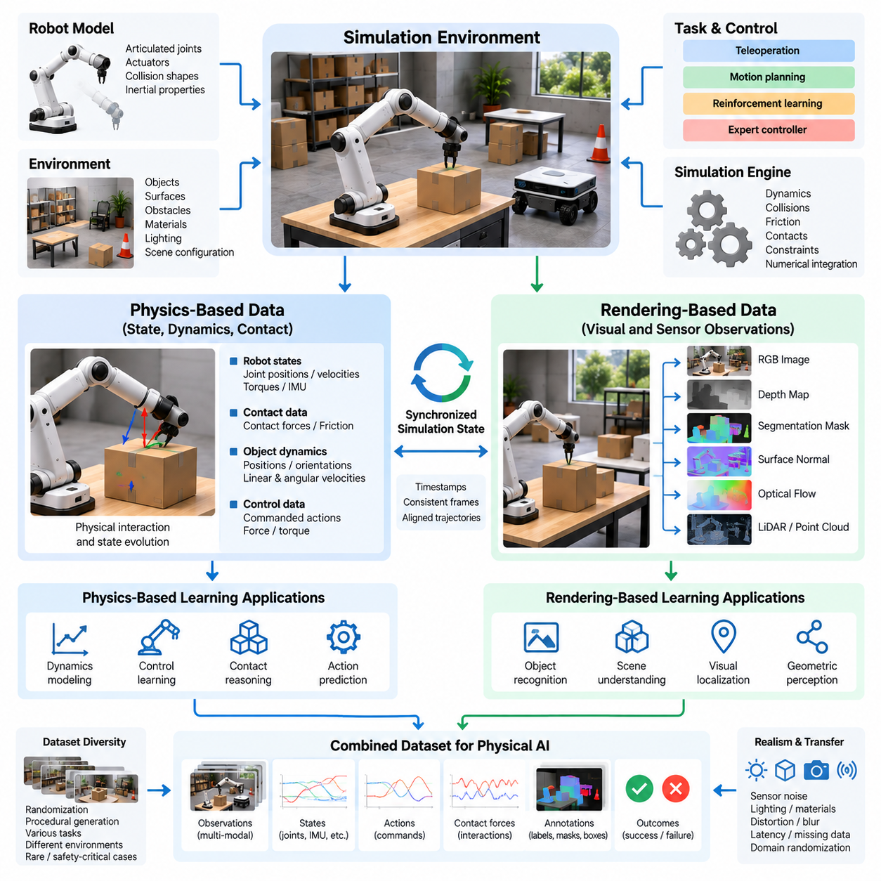
Physics-based data and rendering-based data represent two complementary foundations of simulation-generated datasets for Physical AI. Physics-based simulation produces information about motion, forces, contacts, and state transitions, while rendering-based simulation generates visual and sensor observations of virtual environments. Together, they connect physical behavior with perception, enabling robots to learn how actions influence the surrounding world.
Physics-based data originates from numerical models that approximate the dynamics of robots, objects, and environments. These models describe relationships among mass, inertia, gravity, friction, joint constraints, and external forces. During simulation, a physics engine calculates how the system evolves in response to applied actions, producing trajectories that represent the changing physical state of the robot and its environment.
Rendering-based data is generated by transforming virtual scene descriptions into sensor observations. A rendering engine uses object geometry, material properties, lighting, camera parameters, and scene composition to produce synthetic images. Depending on the rendering method, the output may include RGB images, depth maps, segmentation masks, surface normals, and other representations useful for robotic perception and spatial understanding.
The distinction between these data sources reflects different learning objectives. Physics-based datasets primarily support dynamics modeling, control learning, contact reasoning, and action prediction. Rendering-based datasets support object recognition, scene understanding, visual localization, and geometric perception. However, many Physical AI applications require both because successful behavior depends on interpreting sensory information and predicting physical consequences.
A physics simulator typically represents a robot through rigid bodies, articulated joints, collision shapes, and actuator models. The simulation state may include positions, orientations, linear velocities, angular velocities, and joint configurations. Control commands generate forces or desired motions, while numerical integration advances the system through time according to the modeled dynamics and constraint conditions.
Contact modeling is particularly important because many robotic tasks involve physical interaction with surrounding objects. When a gripper touches an object or a mobile robot wheel contacts the ground, the simulator estimates contact forces and frictional responses. These interactions generate valuable data for grasp stability, manipulation planning, locomotion control, and prediction of physical outcomes.
Physics-based simulation can also represent compliant materials, deformable objects, and articulated mechanisms, although their computational requirements are often greater than those of rigid-body models. Simulating cables, fabrics, flexible tools, or soft robotic structures requires approximations of deformation and material response. The resulting data can support learning tasks involving nonrigid interaction and complex physical manipulation.
Rendering systems operate through a different computational process. They project three-dimensional scene geometry into sensor coordinates while modeling visibility, illumination, surface appearance, and optical effects. Rasterization provides efficient image generation, while ray tracing can represent more detailed light transport and reflections. The selected rendering approach determines the balance between visual realism and generation throughput.
Photorealistic rendering attempts to reproduce the appearance of real environments by modeling materials, shadows, reflections, and lighting conditions. Such realism can be useful for training visual perception systems that must operate under complex illumination and surface characteristics. Nevertheless, visually convincing images do not automatically guarantee accurate sensor behavior or effective transfer to physical robots.
Rendering-based simulation can produce multiple synchronized observation modalities from the same virtual scene. An RGB camera provides appearance information, a depth camera estimates geometric distance, and a simulated LiDAR produces spatial measurements. Because these observations originate from a shared scene state, they can be associated with consistent object positions, camera poses, and semantic annotations.
The generation of ground-truth information is a major advantage of synthetic rendering. A simulator can directly access object identifiers, exact geometry, depth values, and camera transformations. It can therefore produce segmentation masks, bounding boxes, optical flow, and pose annotations automatically. This reduces the labeling burden associated with real-world datasets and supports large-scale supervised learning.
Temporal consistency is essential when combining physics-based and rendering-based data. The physics engine updates object positions and robot states, while the rendering engine generates observations corresponding to those states. Accurate synchronization ensures that recorded images, joint measurements, and control commands describe the same simulated events, enabling coherent observation-action trajectories for policy learning.
Different simulation frequencies may be required for physical dynamics and visual rendering. Contact-rich control systems often need relatively small integration time steps, while cameras operate at lower frame rates. A data generation pipeline must therefore manage timestamp alignment, interpolation, and sensor sampling carefully to avoid introducing artificial timing errors into training sequences.
Sensor realism presents another important challenge. Real cameras exhibit noise, motion blur, lens distortion, exposure variation, and rolling-shutter effects. Depth sensors and LiDAR systems may produce missing measurements, multipath effects, or range-dependent uncertainty. Rendering-based datasets become more representative when these characteristics are modeled according to the intended physical sensing hardware.
Physics-based datasets face corresponding challenges in actuator and interaction fidelity. Real motors exhibit torque limits, friction, backlash, delays, and thermal effects that simplified simulations may omit. Contact solvers can also introduce approximations that affect grasping and locomotion behavior. Policies trained on inaccurate dynamics may exploit simulation artifacts rather than learning strategies that remain reliable in reality.
The relationship between physical accuracy and visual realism is not necessarily proportional. A simulation may produce highly realistic images while representing object interactions inaccurately. Conversely, a simplified visual environment may contain sufficiently accurate dynamics for control training. Simulation design should therefore prioritize the characteristics most relevant to the target learning objective rather than maximizing every form of fidelity.
For robot manipulation, physics-based data describes grasp forces, contact locations, object trajectories, and joint torques, while rendering-based data provides visual observations of the same interaction. Combining these modalities enables learning systems to associate visible object configurations with feasible actions and expected outcomes. This relationship is fundamental to vision-based manipulation and embodied action prediction.
For autonomous mobile robots, physics simulation represents wheel-ground interaction, acceleration, braking, and collision response. Rendering simulation produces camera images, depth observations, and environmental geometry. Together, these data sources support navigation policies that must interpret obstacles, estimate traversability, and select physically executable motions under changing environmental conditions.
Domain randomization can be applied independently to physical and visual parameters. Physics randomization varies mass, friction, actuator strength, and contact properties, while visual randomization changes textures, illumination, camera viewpoints, and object appearance. Coordinating these variations helps generate datasets that expose models to uncertainty across both perception and physical interaction.
The computational cost of physics-based and rendering-based generation differs significantly across applications. Complex contact dynamics, deformable materials, and high-resolution photorealistic rendering may require substantial processing resources. Efficient data engines balance simulation fidelity, parallel execution, storage requirements, and generation speed according to the expected contribution of each dataset to model performance.
Data quality evaluation should examine physical validity and perceptual representativeness separately. Physics-based trajectories can be assessed through conservation behavior, constraint violations, contact stability, and comparison with measured robot dynamics. Rendering-based observations can be evaluated through sensor statistics, image characteristics, annotation consistency, and downstream perception performance on real-world data.
Combining physics-based and rendering-based data creates a unified representation of observation, action, and physical consequence. Such datasets are particularly valuable for learning world models that predict future states from sensory observations and candidate actions. By integrating visual information with dynamical transitions, Physical AI systems can develop representations that support planning, control, and interaction under uncertainty.
A scalable Physical AI data engine must treat physical simulation and rendering as coordinated but independently configurable components. Physics models determine how virtual systems behave, while rendering models determine how those behaviors are observed. Their integration enables the systematic production of multimodal, temporally consistent, and automatically annotated training experiences that can be refined through real-world validation.

04.03. Procedural Scene and Environment Generation
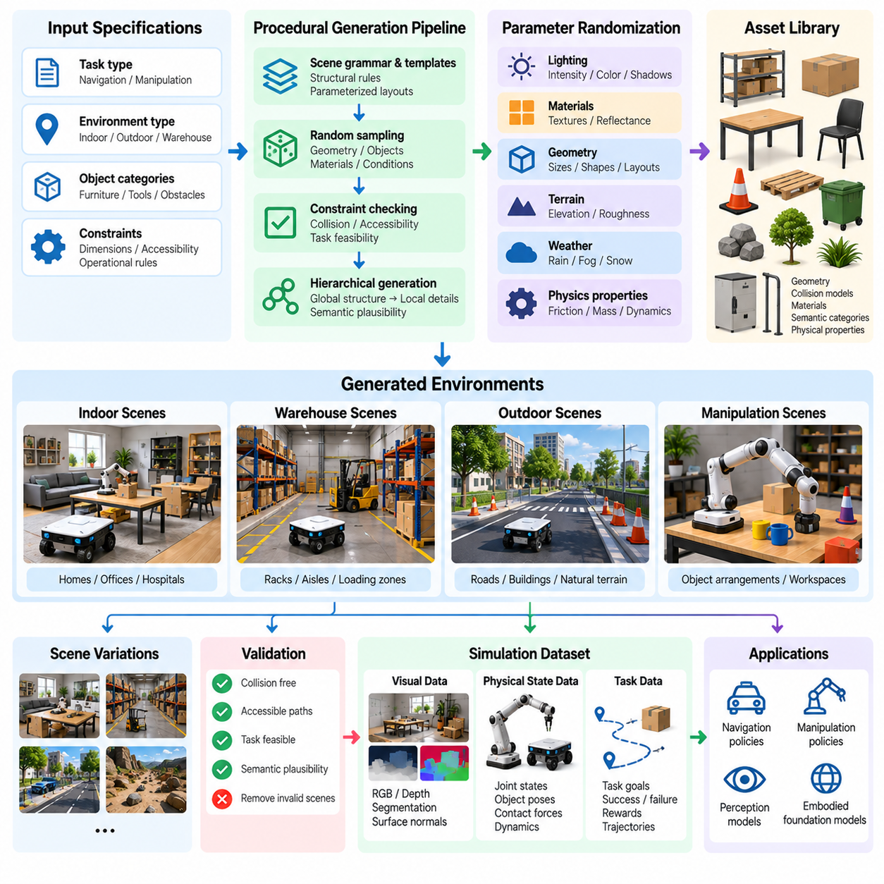
Procedural scene and environment generation is a fundamental capability of simulation-based data engines for Physical AI. Instead of manually constructing every virtual environment, procedural methods use algorithms, parameterized rules, and reusable assets to generate diverse scenes automatically. This approach expands the range of robot experiences while reducing the time and labor required to create large-scale simulation datasets.
A procedural generation system transforms high-level environment specifications into complete virtual worlds. These specifications may describe room dimensions, terrain characteristics, object categories, obstacle density, and operational constraints. Generation algorithms then determine spatial layouts, object placements, surface properties, and environmental conditions while maintaining consistency with the intended simulation tasks.
The primary objective is not simply to create visually different scenes but to produce meaningful variations in the situations robots encounter. A useful procedural dataset should contain differences in geometry, accessibility, object relationships, and task difficulty. These variations expose learning systems to conditions beyond a limited collection of manually designed environments and encourage broader behavioral generalization.
Procedural generation commonly begins with a scene grammar or parameterized environment template. A grammar defines relationships among structural elements, such as walls, doors, corridors, shelves, and workstations. Templates establish allowable dimensions and placement constraints. Random sampling then creates different configurations while preserving essential geometric and functional relationships.
Spatial validity is an important requirement because randomly generated environments may contain impossible or unusable arrangements. Objects must respect collision constraints, navigation paths must remain accessible when required, and task-relevant components must satisfy operational rules. Constraint checking and geometric validation prevent invalid scenes from consuming simulation resources or producing misleading training experiences.
For indoor mobile robots, procedural generation can produce warehouses, hospitals, offices, and residential spaces with varying floor plans. Corridor widths, doorway locations, furniture arrangements, and obstacle positions can change between episodes. Such diversity supports learning navigation policies that remain effective across unfamiliar layouts rather than memorizing a small number of fixed maps.
Warehouse environments provide a particularly useful example because their structural elements follow recognizable operational patterns. Procedural algorithms can vary rack spacing, aisle connectivity, pallet locations, loading zones, and temporary obstructions. The resulting scenes support training for autonomous mobile robots operating under changing inventory arrangements and dynamic logistics conditions.
For robotic manipulation, procedural generation focuses on object configurations and interaction opportunities. Objects can be placed on tables, shelves, conveyors, or inside containers with randomized positions and orientations. Their shapes, sizes, and material properties may also vary, creating diverse grasping and manipulation conditions that help policies learn relationships between object geometry and feasible actions.
Outdoor environments introduce additional generation requirements involving terrain, vegetation, weather, and infrastructure. Procedural terrain models can vary elevation, slope, roughness, and surface composition. Roads, pathways, buildings, and natural obstacles can be arranged according to geographic constraints, allowing mobile robots and autonomous vehicles to encounter diverse operating conditions.
Scene generation must distinguish between geometric diversity and semantic plausibility. A scene may satisfy collision constraints yet contain unrealistic object arrangements or operational relationships. For example, industrial equipment should be positioned according to functional access requirements, while household objects should follow plausible usage patterns. Semantic constraints improve the relevance of generated experiences.
Object libraries and asset repositories provide the reusable components needed for procedural generation. Each asset may contain geometry, collision representations, material definitions, semantic categories, and physical properties. Consistent metadata enables generation algorithms to select appropriate objects and place them according to environmental rules, supporting reproducible and automatically annotated simulation scenes.
Hierarchical generation improves scalability by separating environment structure from local details. A system may first generate a building layout, then assign room functions, place large equipment, and finally distribute smaller objects. This hierarchy preserves global organization while allowing substantial variation within individual regions, producing scenes that remain coherent across multiple levels of complexity.
Randomization strategies determine how procedural parameters are sampled. Uniform sampling provides broad coverage across predefined ranges, while weighted sampling emphasizes common or operationally important configurations. Conditional sampling maintains relationships among parameters, such as matching doorway dimensions to robot clearance requirements or selecting terrain characteristics appropriate for a particular environment.
Task-conditioned generation creates environments specifically designed around robot learning objectives. A navigation task may require a reachable destination with several possible routes, while a manipulation task may require objects positioned within a feasible workspace. By incorporating task constraints directly into generation, the system can produce scenes that provide meaningful learning opportunities rather than arbitrary visual variation.
Difficulty-controlled generation enables structured learning curricula. Simple scenes may contain open spaces, isolated objects, and predictable conditions. More challenging scenes introduce clutter, narrow passages, occlusion, moving obstacles, and complex object interactions. Adjusting these parameters according to policy performance allows simulation data engines to generate experiences matched to the robot's developing capabilities.
Procedural environments can also produce rare events and difficult edge cases. Algorithms may deliberately generate partially blocked routes, unstable object arrangements, unusual lighting conditions, or limited sensor visibility. These scenarios increase exposure to situations that are infrequent in ordinary data collection but important for robustness, recovery behavior, and safety-oriented evaluation.
Dynamic scene generation extends procedural methods beyond static geometry. Moving agents, pedestrians, vehicles, and robotic systems can follow parameterized behavior models. Their trajectories, speeds, and interaction patterns may change between episodes. This produces temporal diversity and enables learning systems to reason about motion, prediction, collision avoidance, and coordinated behavior.
Physical realism requires generated scenes to include appropriate material and interaction properties. Surface friction, object mass, contact stiffness, and environmental forces influence how robots behave. Procedural generation should therefore coordinate geometric construction with physics configuration so that generated environments support meaningful physical interactions rather than functioning only as visual backgrounds.
Visual diversity can be introduced through procedural textures, lighting configurations, material variations, and camera conditions. These parameters influence the appearance of generated scenes without necessarily changing their physical structure. Separating visual and geometric randomization allows developers to investigate whether learned policies depend on appearance, spatial relationships, or underlying physical behavior.
Large-scale procedural generation benefits from deterministic random seeds and explicit configuration records. A seed allows the same scene to be reconstructed, while parameter logs identify the conditions used during generation. Reproducibility is essential for debugging, comparing learning algorithms, investigating failures, and maintaining consistent evaluation environments across successive model versions.
Quality assurance must evaluate generated environments before their data enters the training pipeline. Automated checks can identify overlapping objects, inaccessible regions, invalid robot starting positions, unreachable goals, and inconsistent physical properties. Additional semantic validation can determine whether object arrangements and operational relationships remain plausible for the intended application.
Coverage analysis provides a way to measure the diversity achieved through procedural generation. Environment parameters, object categories, spatial relationships, and task outcomes can be summarized across generated scenes. Such analysis reveals underrepresented conditions and excessive repetition, allowing generation rules to be adjusted toward more informative and balanced training distributions.
Procedural generation becomes particularly effective when integrated with feedback from trained models. Failures observed during simulation or physical deployment can identify environmental configurations that require additional training data. The generator can then create related scenarios with controlled variations, establishing a targeted feedback loop between model evaluation and synthetic experience production.
A mature procedural environment generation system combines geometric rules, semantic constraints, physical properties, task objectives, and adaptive sampling. Its purpose is to create structured diversity that improves learning rather than merely increasing the number of virtual scenes. By producing reproducible, validated, and task-relevant environments at scale, procedural generation becomes a central component of Physical AI data engines.

04.04. Synthetic RGB Depth LiDAR and Radar
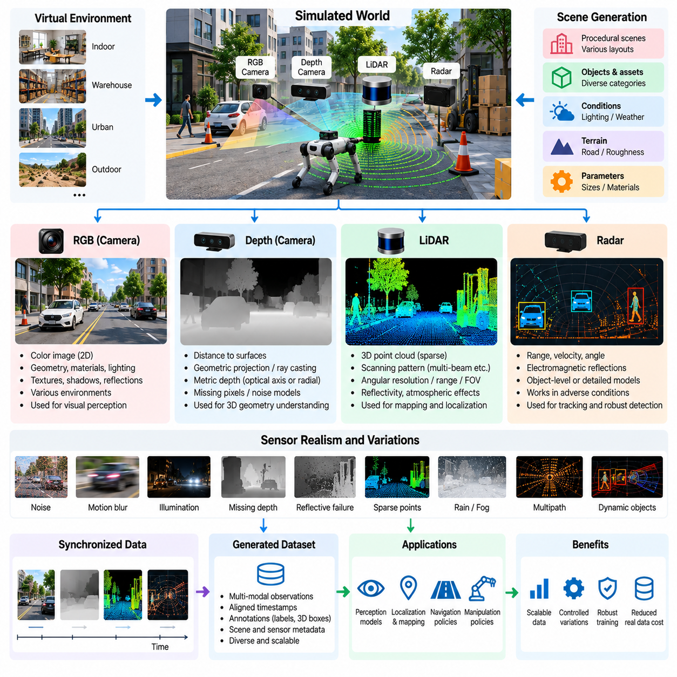
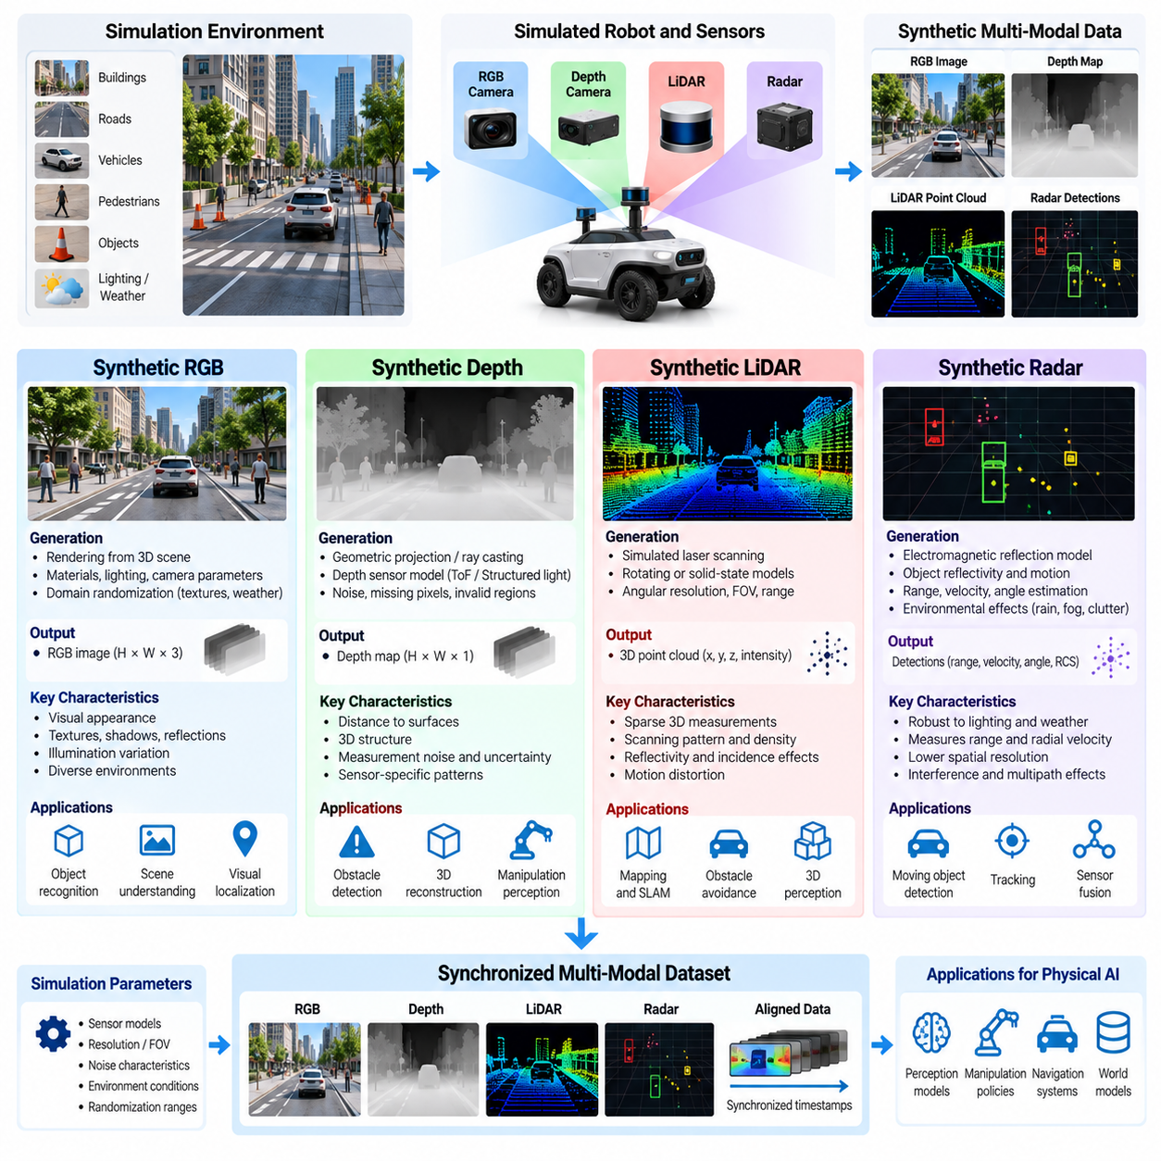
Synthetic RGB, depth, LiDAR, and radar data form a multimodal sensing foundation for Physical AI systems trained through simulation. Each modality captures different properties of the surrounding environment, including visual appearance, geometric distance, spatial structure, and object motion. Simulation enables these observations to be generated under controlled conditions, providing scalable datasets for perception, localization, navigation, and embodied decision-making.
Synthetic RGB data is produced by virtual cameras that transform three-dimensional scenes into two-dimensional color images. Rendering engines calculate how geometry, materials, lighting, and camera parameters influence pixel values. The resulting images can represent industrial facilities, warehouses, outdoor environments, and human-centered spaces, allowing perception models to encounter diverse visual conditions without requiring physical image collection.
The usefulness of synthetic RGB images depends on both scene diversity and rendering fidelity. Surface textures, illumination, shadows, reflections, transparency, and environmental effects influence visual appearance. Procedural scene generation can vary these properties across training episodes, helping models learn object characteristics and spatial relationships rather than relying excessively on particular textures or lighting configurations.
Synthetic depth data represents the distance between a virtual sensing device and visible surfaces. Depth images are generated through geometric projection, ray casting, or simulated depth-sensing processes. Unlike RGB images, depth observations emphasize three-dimensional structure and relative distance, making them valuable for obstacle detection, object manipulation, scene reconstruction, and geometric reasoning.
Depth sensors may represent distance along the camera optical axis or radial distance from the sensor origin, depending on their measurement convention. This distinction matters when converting depth images into three-dimensional point clouds. Accurate camera intrinsics, coordinate transformations, and measurement definitions are necessary to preserve geometric consistency between simulated depth observations and physical sensor outputs.
Real depth cameras introduce measurement errors that ideal geometric rendering does not reproduce automatically. Structured-light and time-of-flight sensors may exhibit missing pixels, reflective-surface failures, multipath interference, and distance-dependent uncertainty. Synthetic depth pipelines can incorporate calibrated noise models and invalid measurement patterns to improve the correspondence between generated observations and actual sensing hardware.
Synthetic LiDAR data is generated by simulating laser measurements across predefined scanning patterns. Virtual rays intersect scene geometry to estimate distances and produce point clouds representing surrounding surfaces. Depending on the sensor model, the simulation may reproduce rotating multi-beam scanners, solid-state LiDAR configurations, or other scanning geometries used in autonomous robots and vehicles.
LiDAR simulation requires careful representation of angular resolution, field of view, measurement range, scan frequency, and beam arrangement. These parameters determine point density and spatial coverage. A synthetic point cloud generated with unrealistic scanning geometry may provide misleading information to learning systems, even when the underlying virtual environment is geometrically accurate.
Advanced LiDAR models incorporate surface reflectivity, incidence angle, atmospheric attenuation, and measurement uncertainty. Transparent or highly reflective materials can create missing or ambiguous returns, while rain, fog, and dust may degrade sensing performance. Modeling such effects allows synthetic datasets to represent difficult operating conditions, although accurate reproduction requires sensor-specific calibration and validation.
Motion distortion is another important characteristic of LiDAR data. Many scanners acquire measurements sequentially while the robot or surrounding objects are moving. Consequently, points within a single scan may correspond to different acquisition times. Simulation can reproduce this behavior by sampling the evolving scene during the scan interval, generating data suitable for motion compensation and dynamic mapping research.
Synthetic radar data differs from optical sensing because radar measures electromagnetic reflections rather than visible appearance or laser-based distance alone. Automotive and robotic radar systems can estimate range, radial velocity, and angular information from reflected signals. Radar simulation therefore requires representations of target reflectivity, relative motion, propagation effects, and sensor measurement characteristics.
Radar data generation may use simplified object-level detection models or more detailed electromagnetic propagation approximations. Simplified models estimate detections from object position, velocity, and radar cross-section, while higher-fidelity methods consider multipath reflections, interference, and scattering behavior. The appropriate approach depends on whether the training objective concerns object tracking, sensor fusion, or detailed signal interpretation.
Synthetic radar datasets can include range measurements, Doppler velocity, azimuth estimates, detection confidence, and radar point clouds. More detailed simulation may generate range-Doppler maps or intermediate signal representations. These outputs support learning systems that must detect moving objects under conditions where cameras and LiDAR sensors may experience reduced visibility.
Radar realism is challenging because electromagnetic interactions depend on material composition, object geometry, frequency, polarization, and environmental conditions. Multipath propagation can create ghost detections, while clutter and interference may obscure real targets. Simplified geometric simulators cannot reproduce every phenomenon, making empirical calibration essential when synthetic radar data is intended for real-world deployment.
The combination of RGB, depth, LiDAR, and radar provides complementary information about the same environment. RGB images describe appearance and semantic context, depth sensors provide dense local geometry, LiDAR captures broader spatial structure, and radar contributes motion-sensitive measurements. Multimodal datasets allow learning systems to exploit these complementary strengths while compensating for limitations of individual sensors.
Accurate multimodal generation requires a shared representation of scene geometry, object states, and sensor configurations. Each virtual sensor must have defined intrinsic parameters, extrinsic transformations, coordinate conventions, and acquisition timing. Without consistent calibration, observations from different modalities may describe incompatible spatial relationships, reducing the reliability of sensor fusion and cross-modal learning.
Temporal synchronization becomes especially important when simulated robots or surrounding objects move. Cameras may capture images at fixed frame intervals, LiDAR scanners collect points over time, and radar systems operate according to measurement cycles. A simulation data engine must associate these observations with appropriate timestamps and physical states to preserve consistency across observation sequences.
Automatic ground-truth generation is a major advantage of synthetic multimodal sensing. Because the simulator maintains access to object identities, geometry, trajectories, and physical states, it can generate segmentation labels, three-dimensional bounding boxes, velocity annotations, and object tracking identifiers. These annotations support supervised perception learning without the extensive manual labeling required for real sensor recordings.
Synthetic sensing pipelines can also generate controlled sensor failures and degraded observations. Camera overexposure, depth measurement dropout, LiDAR beam loss, and radar clutter can be introduced systematically. Such variations enable robustness testing and help train models to recognize unreliable measurements, adjust confidence estimates, and maintain operation when individual sensing modalities become degraded.
Domain randomization expands sensor data diversity by varying environmental appearance, sensor placement, calibration offsets, noise characteristics, and operating conditions. However, randomization should remain within physically plausible ranges when the objective is real-world transfer. Excessive or inconsistent perturbations can produce unrealistic observations that reduce the relevance of generated training experiences.
The computational requirements of synthetic sensing differ substantially across modalities. RGB rendering may require detailed lighting calculations, while depth and LiDAR generation often rely on geometric intersection operations. High-fidelity radar simulation can require expensive electromagnetic approximations. Efficient pipelines select appropriate fidelity levels and balance sensor realism against generation throughput and storage costs.
Quality evaluation should compare synthetic observations with representative measurements from physical sensors. RGB datasets can be assessed through visual statistics and downstream perception performance, while depth and LiDAR data require geometric and noise-distribution comparisons. Radar validation should consider detection characteristics, velocity estimation, clutter behavior, and signal statistics relevant to the intended application.
A scalable Physical AI data engine integrates synthetic RGB, depth, LiDAR, and radar generation into a coordinated simulation pipeline. Procedural environments provide scene diversity, physics simulation determines object behavior, and sensor models transform evolving states into synchronized observations. By combining calibrated sensing, automatic annotations, and real-world validation, synthetic multimodal data becomes a practical foundation for training robust Physical AI perception and decision-making systems.

04.05. Synthetic Proprioceptive and Action Data
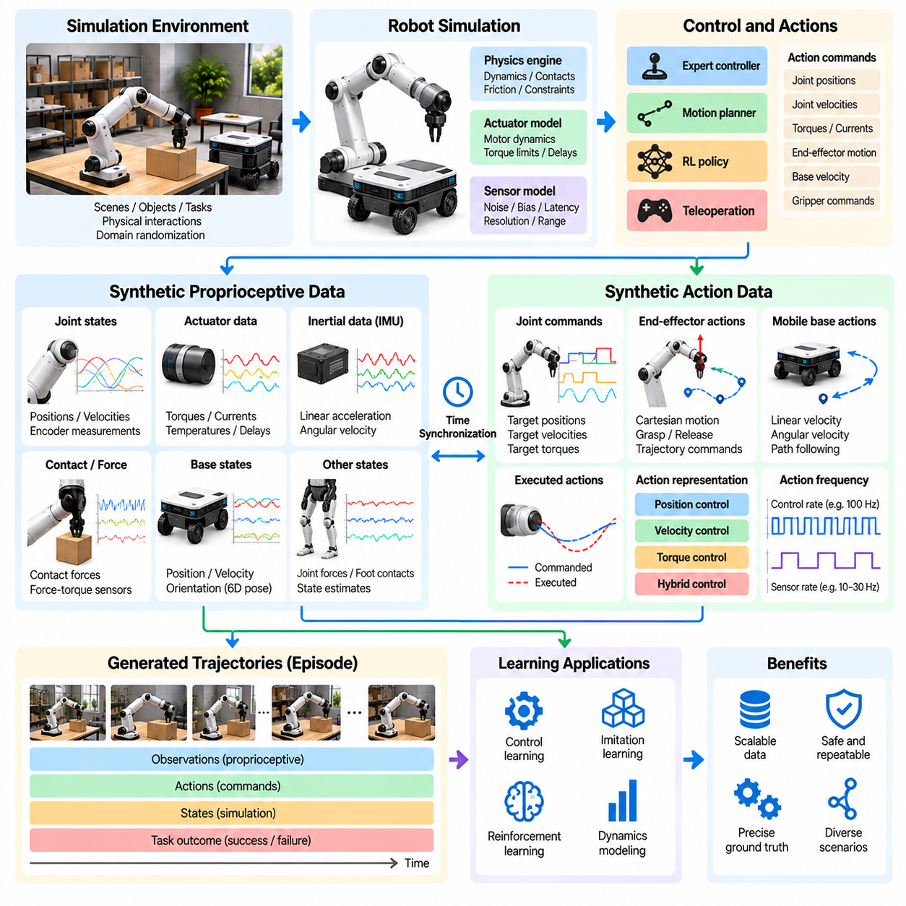
Synthetic proprioceptive and action data provide essential information about the internal state and physical behavior of robots operating in simulated environments. Unlike external perception data, which describes surrounding objects and scenes, proprioceptive data captures joint configurations, motion, forces, and actuator conditions. Action data records control commands and their consequences, enabling Physical AI systems to learn the relationship between internal states and physical interactions.
Proprioception refers to a robot's ability to estimate its own configuration and motion through internal sensing. Typical measurements include joint positions, joint velocities, motor currents, actuator torques, inertial acceleration, and angular velocity. Simulation can generate these signals directly from modeled robot states, creating synchronized records that support state estimation, feedback control, motion prediction, and learning of embodied behavior.
Synthetic proprioceptive data is commonly produced by physics engines that maintain detailed representations of robot dynamics. At each simulation step, the engine updates joint coordinates, rigid-body velocities, contact conditions, and actuator responses. These quantities can be recorded as ground-truth states or transformed through virtual sensor models to approximate measurements available from physical encoders, inertial sensors, and motor controllers.
A fundamental distinction exists between simulated ground truth and synthetic sensor measurements. Ground-truth data represents internal simulation variables, while sensor measurements approximate what a real robot could observe. Physical sensors introduce noise, bias, quantization, delay, and limited measurement ranges. Training pipelines should preserve this distinction to prevent learning policies from depending on information unavailable during actual deployment.
Joint position and velocity data form the foundation of many robot control systems. Encoders measure rotational or linear displacement, while velocity estimates describe how joint configurations change over time. Synthetic datasets can reproduce encoder resolution, measurement noise, and sampling frequency. These observations help train controllers that coordinate articulated mechanisms, manipulators, humanoids, and mobile robot platforms.
Actuator-related data provides additional information about how commanded motion is physically produced. Simulated motors can generate torque, current, speed, and temperature estimates according to actuator models. Incorporating torque limits, friction, backlash, saturation, and response delays improves the realism of generated trajectories. Such data supports learning actuator-aware policies that respect physical hardware constraints.
Inertial measurements are particularly important for mobile robots, humanoids, quadrupeds, and aerial systems. Synthetic inertial measurement units can produce acceleration and angular velocity signals derived from simulated rigid-body motion. Gravity compensation, sensor orientation, bias drift, and measurement noise must be considered when approximating real inertial sensors. These signals support balance control, localization, and dynamic state estimation.
Contact and force information is another valuable category of synthetic proprioceptive data. Physics simulators can estimate contact forces, joint reaction forces, and interaction impulses during manipulation or locomotion. Virtual force-torque sensors may transform these quantities into realistic measurements. Such data enables learning systems to recognize contact events, regulate interaction forces, and adapt behavior during uncertain physical interactions.
Action data describes the commands issued by a robot controller or learning policy. Depending on the control architecture, actions may represent desired joint positions, target velocities, actuator torques, Cartesian end-effector motions, or mobile base commands. Simulation records these commands together with resulting state transitions, establishing the observation-action-outcome relationships required for robot policy learning.
The distinction between commanded actions and executed actions is essential for accurate data generation. A controller may request a particular movement, but actuator limitations, environmental contacts, or safety constraints can prevent exact execution. Recording both intended commands and realized physical responses allows learning systems to understand actuator dynamics, control errors, and the consequences of interactions with the environment.
Temporal alignment determines whether synthetic proprioceptive and action sequences accurately represent robot behavior. Control commands, joint measurements, inertial observations, and contact events may operate at different frequencies. Simulation pipelines must associate these signals with consistent timestamps and sampling conventions. Incorrect alignment can distort cause-and-effect relationships and reduce the effectiveness of learned control policies.
Synthetic trajectories are commonly organized into episodes containing initial states, observation sequences, action commands, state transitions, and task outcomes. Each episode may also include reward signals, termination conditions, and contextual metadata. This structure supports imitation learning, reinforcement learning, system identification, and training of predictive models that estimate future robot states from previous observations and actions.
For robotic manipulation, synthetic proprioceptive data captures joint configurations, gripper states, applied forces, and contact events. Action records describe reaching, grasping, lifting, and object placement commands. Combining these signals enables policies to associate internal motion with manipulation outcomes, supporting precise control and recovery from unsuccessful grasps or unexpected object interactions.
For humanoid and legged robots, proprioceptive data is central to maintaining balance and coordinating whole-body movement. Joint measurements, inertial signals, and foot-contact information describe the robot's evolving physical state. Synthetic action trajectories can represent walking, turning, stepping, and recovery maneuvers, providing training experiences for locomotion policies operating under changing terrain and disturbance conditions.
Mobile robots use proprioceptive measurements to estimate wheel motion, body velocity, and vehicle dynamics. Synthetic wheel encoders, inertial sensors, and steering feedback can reproduce the information available to navigation controllers. Action data may include linear velocity, angular velocity, steering angle, and braking commands, allowing models to learn motion execution and predict deviations caused by surface conditions.
Domain randomization improves the diversity of synthetic proprioceptive and action datasets by varying robot mass, joint friction, actuator strength, sensor bias, and control latency. These variations expose learning systems to uncertainty in mechanical and sensing characteristics. Properly selected parameter ranges can improve robustness, although unrealistic combinations may produce behaviors that do not correspond to feasible physical systems.
Sensor noise modeling is necessary because ideal simulated measurements can create unrealistic learning conditions. Encoder quantization, inertial drift, communication delays, and intermittent measurement loss affect real control systems. Synthetic pipelines can introduce these effects using calibrated stochastic models, enabling policies and estimators to learn under observation uncertainty rather than assuming perfect internal state information.
Action-space design strongly influences the usefulness of generated datasets. Position-controlled actions are often suitable for manipulation tasks, while torque-controlled actions may provide greater flexibility for dynamic locomotion. Higher-level commands can simplify learning but conceal important actuator behavior. Dataset specifications should therefore document action representations, control frequencies, normalization methods, and physical limits.
Synthetic proprioceptive and action data also support system identification and dynamics learning. By observing how simulated robots respond to controlled inputs, models can learn relationships among forces, velocities, positions, and contact conditions. Comparing these relationships with physical measurements helps identify discrepancies in simulation parameters and provides a basis for refining robot dynamics models.
Data quality evaluation should examine physical consistency, temporal synchronization, sensor realism, and action validity. Automated checks can detect impossible joint configurations, excessive actuator commands, discontinuous trajectories, missing measurements, and inconsistent contact states. Validation against real robot recordings is particularly important because internally consistent simulation data may still represent inaccurate physical behavior.
A scalable Physical AI data engine integrates synthetic proprioceptive and action data with external sensor observations and task-level information. This integration creates complete multimodal trajectories linking perception, internal state, control decisions, and physical outcomes. When combined with calibrated dynamics, systematic randomization, and real-world validation, these datasets provide a foundation for robust control learning and generalizable embodied intelligence.

04.06. Expert Policy and Planner Generated Data
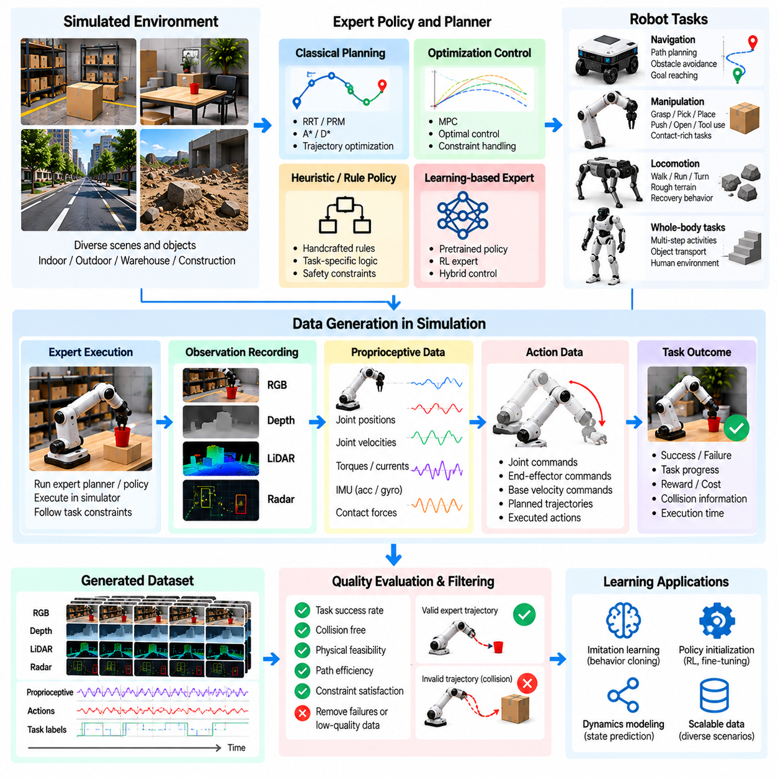
Expert policy and planner-generated data provide a structured source of high-quality demonstrations for training Physical AI systems. Instead of relying entirely on human teleoperation or random exploration, simulation environments can use algorithmic experts to produce purposeful robot behavior. These experts generate observation-action trajectories that demonstrate how robots can accomplish tasks while satisfying motion, safety, and operational constraints.
An expert policy is a decision-making mechanism designed to select effective actions under specified conditions. It may use handcrafted control rules, optimization algorithms, classical robotics methods, or previously trained models. A planner differs by explicitly evaluating possible future states or action sequences before execution. Both approaches can generate demonstrations that guide learning systems toward successful behaviors.
Expert-generated datasets commonly contain robot observations, internal states, selected actions, resulting transitions, and task outcomes. Additional records may include planned trajectories, intermediate goals, collision margins, and execution costs. Because simulation exposes detailed environment states, these datasets can include privileged information for training or evaluation while maintaining separate observations available to the deployed robot.
Classical motion planning algorithms are valuable sources of expert demonstrations. Sampling-based methods such as RRT and PRM explore feasible configurations, while optimization-based planners refine trajectories according to smoothness, collision avoidance, and dynamic constraints. Their solutions can be converted into sequences of control commands, creating training examples for manipulation, navigation, and whole-body motion.
For mobile robots, expert planners generate routes through simulated environments using geometric maps, occupancy grids, or semantic representations. Global planners identify feasible paths toward destinations, while local planners respond to obstacles and changing conditions. Recording their decisions across procedurally generated environments produces navigation datasets covering different layouts, obstacle configurations, and operational situations.
Manipulation tasks require expert policies that coordinate perception, grasp selection, motion planning, and contact interaction. A simulated expert may identify a suitable grasp pose, calculate a collision-free approach, close the gripper, and transport an object toward its target. Recording successful and unsuccessful executions provides information about feasible manipulation strategies and the conditions that influence task completion.
Optimization-based control methods can generate expert actions for systems requiring precise dynamic behavior. Model predictive control repeatedly predicts future states and selects actions that minimize a specified objective over a finite horizon. In simulation, such controllers can produce demonstrations for balancing, trajectory tracking, obstacle avoidance, and coordinated movement under actuator and contact constraints.
For legged and humanoid robots, expert trajectories may be generated through trajectory optimization, whole-body control, or model-based locomotion planners. These methods coordinate joint motion, contact timing, center-of-mass movement, and stability requirements. Their outputs provide structured examples of walking, stepping, turning, and recovery behaviors that can support imitation learning and policy initialization.
Task and motion planning combines symbolic reasoning with geometric and physical feasibility. A task planner determines the sequence of operations needed to achieve a goal, while motion planners calculate executable movements for individual steps. This integration can generate demonstrations of multi-stage activities such as retrieving an object, opening a container, transporting materials, or assembling components.
Expert policies can also be constructed using hierarchical control architectures. High-level policies select goals or behavioral modes, while lower-level controllers execute corresponding movements. Recording decisions at both levels creates datasets that connect task intent with physical actions. Such representations are useful for training systems that must reason over extended time horizons without directly predicting every low-level command.
A central advantage of expert-generated data is the ability to produce demonstrations at scale. Once an expert controller is integrated with a simulator, it can execute thousands of episodes across different environments, object arrangements, and robot configurations. Parallel simulation further increases throughput, allowing data engines to collect large numbers of task-relevant trajectories without continuous human supervision.
However, expert demonstrations are not automatically optimal or universally applicable. Classical planners may rely on simplified dynamics, accurate maps, or privileged state information unavailable in physical deployment. Optimization algorithms may converge to local solutions, and handcrafted policies may fail outside their designed conditions. Dataset generation must therefore evaluate expert reliability rather than assuming every demonstration is correct.
Demonstration quality can be assessed using task success, execution time, path efficiency, collision frequency, energy consumption, and constraint violations. Different applications require different performance priorities. A warehouse robot may emphasize safe and efficient navigation, while a manipulation system may prioritize grasp stability and placement accuracy. These metrics support filtering and ranking of generated trajectories.
Imitation learning converts expert demonstrations into trainable robot policies. Behavioral cloning directly maps observations to expert actions, while sequence-based methods learn relationships across extended trajectories. The resulting policy can execute actions without repeatedly invoking expensive planners. Nevertheless, supervised imitation may struggle when the robot encounters states that were rarely represented in the expert dataset.
Distribution shift is a major limitation of learning from fixed demonstrations. Small prediction errors can move a learned policy into unfamiliar states, causing additional errors to accumulate. Interactive data aggregation methods address this problem by allowing the learned policy to visit new states while an expert supplies corrective actions. Such approaches expand training coverage around the learner's actual behavior.
Expert data generation can deliberately include recovery demonstrations rather than recording only successful nominal trajectories. Simulation can introduce disturbances, blocked paths, misplaced objects, or inaccurate initial states. The expert then attempts to restore progress toward the task objective. These recovery examples help learned policies handle deviations and reduce dependence on perfectly controlled execution conditions.
Multiple experts can contribute complementary demonstrations within the same data engine. A geometric planner may provide efficient navigation paths, a model predictive controller may handle dynamic constraints, and a learned expert may demonstrate complex contact interactions. Combining their outputs increases behavioral diversity, although differences in action conventions and performance quality must be normalized and documented.
Expert selection can be adapted to task difficulty and computational cost. Simple scenarios may be solved using fast heuristic policies, while difficult configurations require trajectory optimization or more sophisticated planning. A generation pipeline can allocate expensive expert computation selectively, improving dataset throughput while preserving high-quality supervision for challenging states and interactions.
The relationship between expert planning and reinforcement learning is complementary. Expert trajectories can initialize policies, guide exploration, or provide offline training data before reward-driven optimization begins. Reinforcement learning may subsequently discover strategies that improve upon the original expert. Combining these methods reduces reliance on unguided exploration while allowing adaptation beyond predefined planning assumptions.
Dataset diversity remains essential even when demonstrations are generated by reliable experts. Procedural environments, randomized object properties, varying task objectives, and altered robot dynamics expose planners to different situations. The resulting demonstrations should represent multiple feasible strategies rather than a narrow collection of repeated solutions, supporting broader policy generalization.
A scalable expert-generated data pipeline coordinates scenario generation, expert execution, trajectory recording, quality evaluation, and dataset curation. Each trajectory should preserve observations, actions, timing information, task context, and relevant execution metrics. Reproducible simulation seeds and expert configurations enable developers to investigate failures, compare planning methods, and regenerate important training cases.
Expert policy and planner-generated data ultimately connect established robotics algorithms with data-driven Physical AI learning. Planners contribute structured reasoning and physically constrained behavior, while learned policies offer rapid execution and potential generalization across diverse conditions. By combining reliable demonstrations, targeted recovery examples, and continuous evaluation, data engines can transform expert knowledge into scalable training resources for embodied intelligence.

04.07. Reinforcement Learning Generated Data
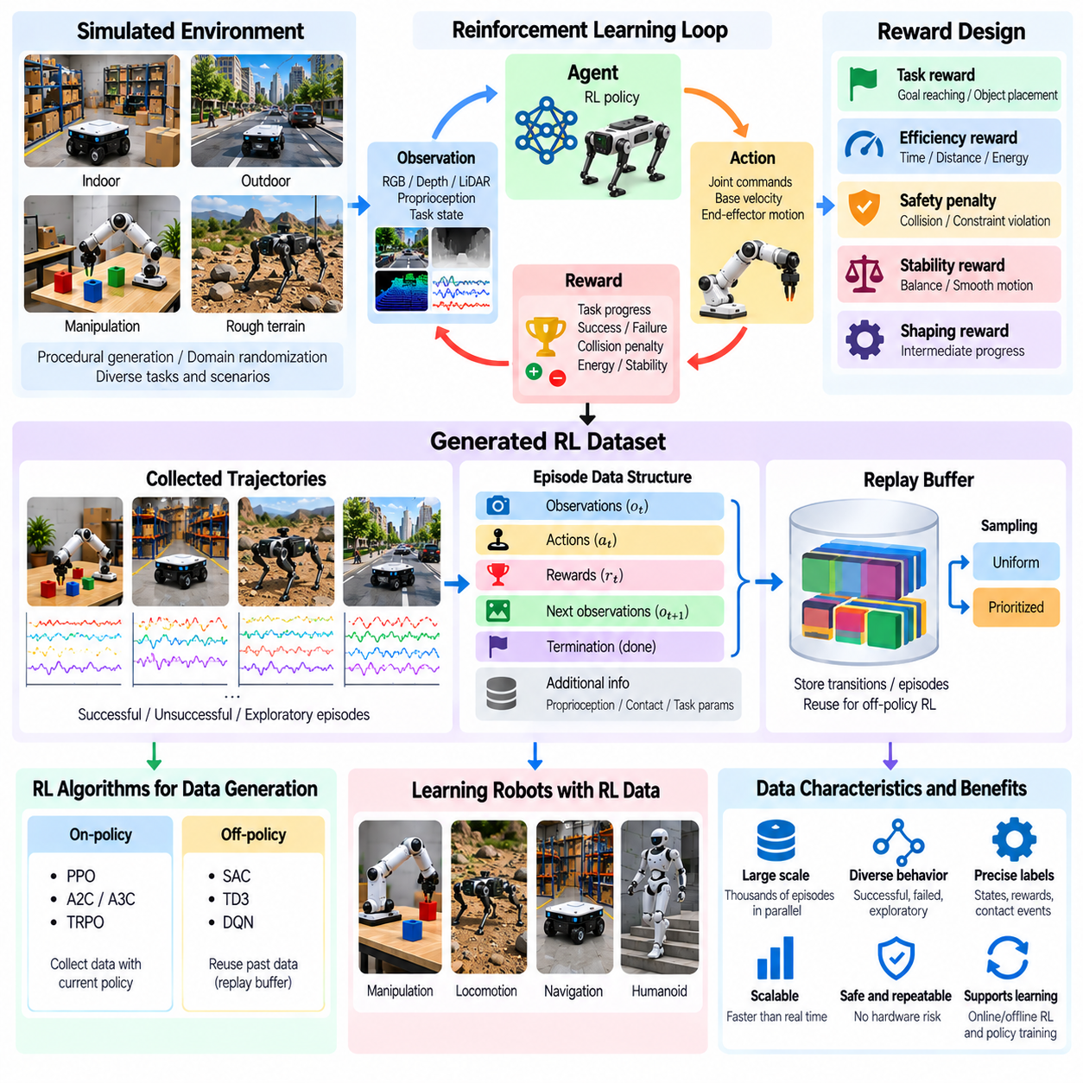
Reinforcement learning-generated data is a major component of simulation-driven data engines for Physical AI. Unlike expert demonstrations that provide predefined actions, reinforcement learning produces experience through interactions between an agent and its environment. The resulting datasets contain observations, actions, rewards, state transitions, and outcomes, capturing both successful behavior and the exploratory processes through which effective robot policies emerge.
In reinforcement learning, an agent repeatedly observes its environment, selects an action, and receives feedback through a reward signal. The environment transitions to a new state according to physical dynamics and interaction conditions. Each transition becomes a training sample that connects decisions with consequences. Simulation enables these interactions to occur repeatedly without exposing physical robots to excessive wear, damage, or operational risk.
A reinforcement learning dataset commonly consists of trajectories containing observations, actions, rewards, next observations, and termination indicators. Additional information may include privileged simulation states, task parameters, contact events, and policy identifiers. Recording these elements consistently supports policy optimization, offline reinforcement learning, behavioral analysis, and reproducible comparisons between training experiments.
Simulation provides a controlled environment for generating reinforcement learning experiences at scale. Thousands of robot instances can operate in parallel, each exploring different states and actions. Accelerated physics simulation may produce experience faster than real time, although achievable throughput depends on simulation fidelity and computational resources. This scalability makes reinforcement learning an important source of large-scale robot interaction data.
Reward design determines which behaviors the learning process encourages. Rewards may represent task completion, distance reduction, movement efficiency, stability, or successful object manipulation. Penalties may discourage collisions, excessive energy consumption, unsafe contact, or constraint violations. Poorly designed rewards can produce unintended strategies, making reward validation essential before collecting large datasets.
Sparse rewards provide feedback mainly when a task succeeds or fails, while dense rewards supply intermediate guidance during execution. Sparse rewards can preserve clear task objectives but often make exploration difficult. Dense rewards can accelerate learning but may introduce undesirable shortcuts. Simulation data engines should record reward components separately so that developers can investigate how individual incentives influence learned behavior.
Exploration is the mechanism through which reinforcement learning discovers unfamiliar states and potentially useful actions. Stochastic policies, action noise, entropy regularization, and structured exploration strategies encourage behavioral diversity. Generated data therefore includes both productive and unsuccessful experiences. These failures can be informative because they reveal unsafe configurations, ineffective actions, and regions where policy improvement is necessary.
On-policy reinforcement learning collects data using the current policy or a closely related version. Algorithms such as PPO repeatedly generate fresh trajectories and update the policy using recent experience. This approach supports stable policy improvement under appropriate conditions but can require substantial simulation interaction. Dataset records should preserve policy versions and collection conditions to maintain traceability.
Off-policy reinforcement learning can reuse transitions collected by earlier policies or other behavior-generating systems. Algorithms such as SAC and TD3 learn from replay buffers containing previous interactions. Reusing experience improves sample efficiency and allows data generated during different training stages to contribute to policy development. However, dataset coverage and behavior distribution strongly influence learning reliability.
Replay buffers are central storage components for reinforcement learning-generated data. They maintain transitions or trajectory segments that can be sampled during optimization. Uniform sampling provides broad reuse, while prioritized experience replay emphasizes transitions associated with larger learning errors. Effective buffer management must consider data freshness, diversity, storage capacity, and the risk of repeatedly sampling narrow experience distributions.
For robotic manipulation, reinforcement learning generates data through repeated attempts to reach, grasp, lift, move, and place objects. Policies experience different object configurations, contact conditions, and execution outcomes. These interactions can reveal manipulation strategies that are difficult to specify through handcrafted rules. Recording contact forces and failure events improves the usefulness of generated trajectories.
For legged and humanoid robots, reinforcement learning can generate extensive locomotion experiences involving balance, walking, turning, and disturbance recovery. Simulated agents encounter different terrain profiles, friction conditions, and external forces. Their trajectories contain joint states, actuator commands, contact patterns, and stability outcomes, supporting the development of policies capable of adapting to changing physical conditions.
Mobile robot reinforcement learning can generate navigation data involving obstacle avoidance, route selection, and local motion control. Procedurally generated environments expose policies to different corridor structures, moving obstacles, and destination configurations. Reward functions encourage progress while penalizing collisions or inefficient movement. These datasets help identify behaviors that remain effective under unfamiliar navigation conditions.
Curriculum learning can improve data generation by adjusting task difficulty according to policy performance. Initial episodes may involve simple environments and easily reachable objectives. As performance improves, the simulator introduces clutter, disturbances, tighter constraints, and more complex interactions. This progression increases the likelihood that collected experiences remain informative throughout different stages of learning.
Domain randomization expands reinforcement learning datasets by varying physical and environmental parameters. Robot mass, actuator strength, joint friction, sensor noise, terrain properties, and object characteristics may change across episodes. These variations encourage policies to tolerate uncertainty and reduce dependence on a single simulated configuration. Parameter ranges should be validated against plausible real-world conditions.
Reinforcement learning-generated data can include rare failures and recovery situations that are difficult to collect safely on physical hardware. Simulation can introduce sudden disturbances, unstable contacts, unexpected obstacles, or actuator degradation. The agent's responses provide information about recovery capabilities and failure boundaries. Safety constraints and evaluation procedures remain necessary before transferring such policies to real robots.
Multi-agent reinforcement learning extends experience generation to environments containing several interacting robots or autonomous entities. Agents may cooperate, compete, share resources, or navigate around one another. Their interactions create datasets describing coordination, communication, collision avoidance, and decentralized decision-making. Such data is valuable for warehouse fleets, traffic systems, and collaborative robotic operations.
Data quality cannot be measured solely by the number of simulated transitions. Large datasets may contain repetitive states, uninformative actions, or artifacts caused by unrealistic physics. Useful evaluation criteria include state-action coverage, task diversity, reward distributions, success rates, and failure characteristics. Filtering and balanced sampling can improve the information content of stored experiences.
The simulation-to-reality gap remains a major challenge for reinforcement learning-generated data. Policies may exploit numerical approximations, simplified contacts, or idealized sensing conditions that do not exist in physical environments. Real-world measurements should therefore guide simulator calibration, dynamics randomization, and policy evaluation. Successful simulated performance alone does not establish reliable physical deployment.
Offline reinforcement learning enables previously generated interaction datasets to train new policies without requiring continuous simulation access. This supports reuse of expensive experiences and comparisons among learning methods. However, policies may select actions poorly represented in the dataset, creating extrapolation errors. Dataset diversity, conservative learning methods, and careful evaluation are important for reliable offline policy development.
A scalable reinforcement learning data engine integrates environment generation, parallel simulation, policy execution, trajectory storage, reward analysis, and automated evaluation. Training outcomes can guide the creation of new scenarios that target weak behaviors or underrepresented states. By combining systematic exploration, physical realism, and feedback-driven data generation, reinforcement learning transforms simulated interaction into a continuously improving resource for Physical AI.

04.08. Random Exploration and Curriculum Data
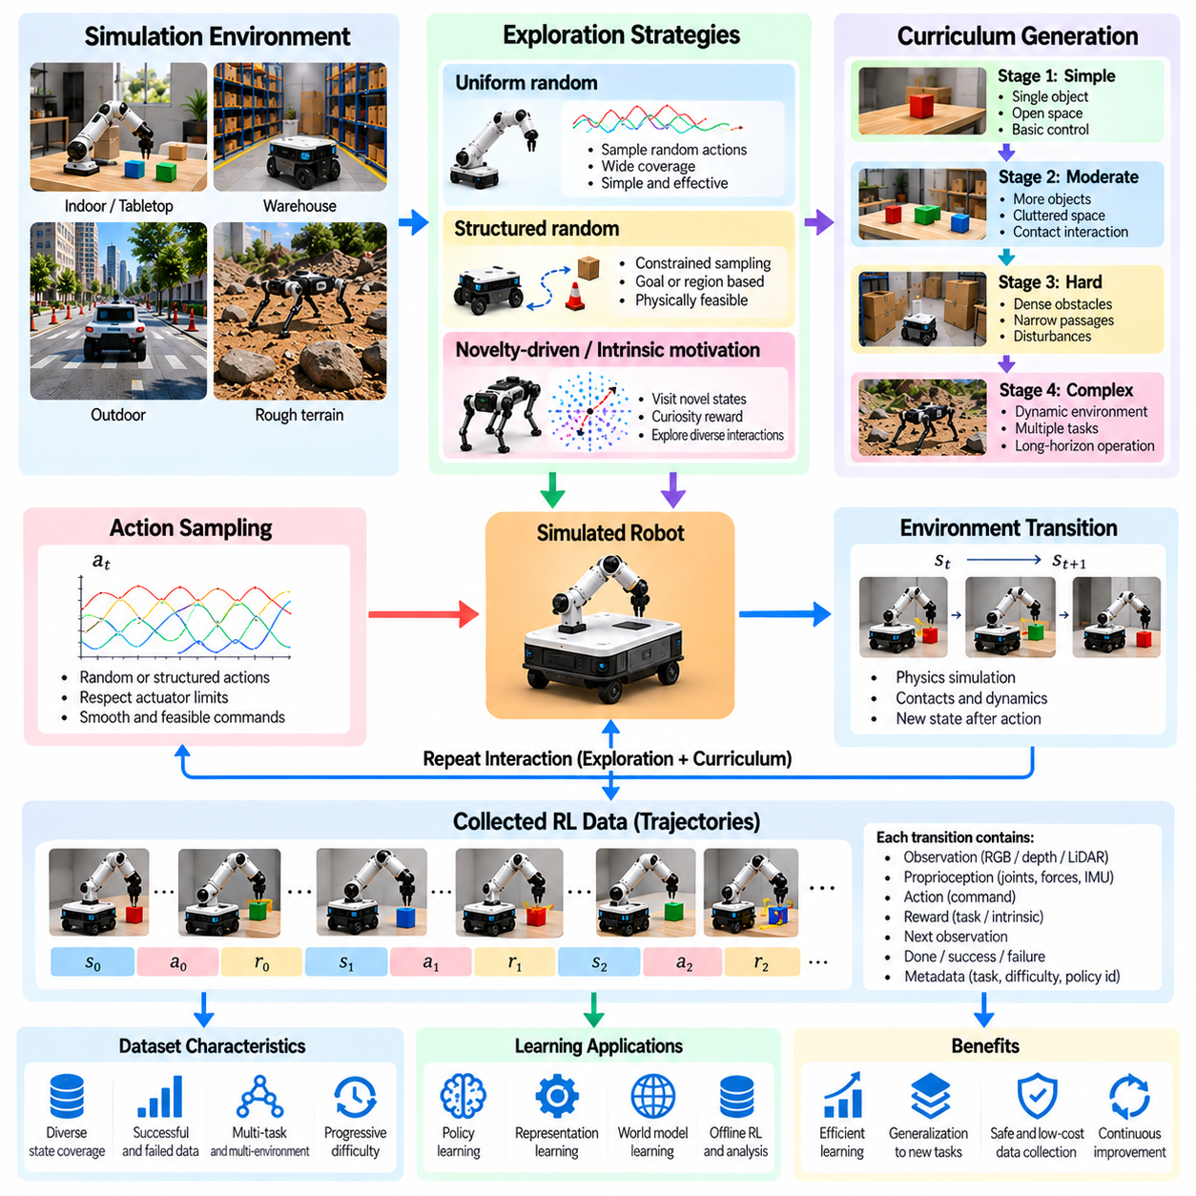
Random exploration and curriculum data generation are complementary approaches for expanding the diversity and learning value of simulation datasets in Physical AI. Random exploration exposes robots to unfamiliar states and interactions without requiring predefined expert behavior. Curriculum generation organizes experiences according to difficulty and learning progress. Together, these methods support broad behavioral coverage and more efficient acquisition of complex robotic skills.
Random exploration generates experience by selecting actions from predefined probability distributions or stochastic policies. The resulting trajectories contain observations, actions, state transitions, and interaction outcomes. Although many actions may not directly accomplish a task, they reveal how robot dynamics and environmental conditions influence behavior. Such data is valuable for learning general representations of physical interaction.
Uniform random action sampling is the simplest exploration strategy, but its effectiveness depends strongly on the action space. Independently sampling every actuator command may produce unstable or repetitive movements. For articulated robots, correlated action sequences and bounded control signals often generate more meaningful trajectories. Exploration policies should therefore consider actuator limits, motion continuity, and physical feasibility.
Structured random exploration introduces constraints that guide behavior without specifying complete solutions. A mobile robot may sample reachable navigation goals, while a manipulator may explore different end-effector positions or contact configurations. These strategies preserve behavioral diversity while increasing the probability of useful interactions. They also reduce the computational resources spent on physically impossible or uninformative actions.
Exploration data is particularly useful when task objectives are not fully defined. By collecting diverse interactions before training a specialized policy, data engines can construct reusable datasets for representation learning, dynamics prediction, and future task adaptation. This approach separates the acquisition of general physical experience from the optimization of individual tasks, potentially reducing repeated data collection.
State-space coverage is a central objective of random exploration. A useful dataset should represent different robot configurations, object relationships, contact states, and environmental conditions. However, uniform coverage of high-dimensional state spaces is generally impractical. Coverage metrics and novelty estimators can identify underexplored regions and guide subsequent sampling toward more informative experiences.
Novelty-driven exploration encourages agents to visit states that differ from previously observed experiences. Novelty may be estimated through state visitation counts, prediction errors, learned embeddings, or density models. Such methods can improve exploration efficiency compared with purely random actions. Nevertheless, novelty does not always imply usefulness, so exploration objectives should consider task relevance and physical validity.
Intrinsic motivation provides another mechanism for generating diverse experience. Curiosity-based agents receive internal rewards for encountering unpredictable or informative transitions. This encourages interaction with objects, surfaces, and dynamic environments even when external task rewards are unavailable. Careful design is necessary because unpredictable sensor noise or simulation artifacts may attract exploration without producing meaningful knowledge.
Curriculum learning organizes training experiences from relatively simple conditions toward more demanding situations. Initial scenarios may involve isolated objects, open navigation spaces, or stable robot configurations. Later stages introduce clutter, disturbances, contact complexity, and tighter task constraints. This progression allows learning systems to acquire foundational behaviors before confronting difficult combinations of physical challenges.
A curriculum can be defined manually using engineering knowledge or generated automatically from performance measurements. Manual curricula specify difficulty stages according to task characteristics. Adaptive curricula modify environment parameters based on observed success rates, learning progress, or failure patterns. Both approaches aim to maintain training experiences that are challenging enough to improve performance without becoming consistently unsolvable.
Difficulty is multidimensional rather than a single numerical property. Navigation difficulty may depend on obstacle density, passage width, route length, and moving-agent behavior. Manipulation difficulty may involve object geometry, grasp accessibility, friction, and placement tolerance. Effective curriculum generation changes these factors systematically while preserving the ability to identify which conditions influence learning outcomes.
Competence-based curriculum generation adjusts tasks according to the robot's demonstrated abilities. When a policy consistently succeeds, the system can increase complexity or introduce new variations. When performance declines substantially, the curriculum may temporarily reduce difficulty or revisit foundational skills. Such adaptation can improve learning efficiency, although overly restrictive progression may limit exposure to valuable challenging experiences.
Automatic curriculum generation may also use learning progress as a scheduling signal. Tasks producing measurable improvement receive greater sampling priority, while tasks that are already mastered or remain consistently impossible receive less emphasis. This creates a dynamic allocation of simulation resources. Reliable progress estimation requires sufficient evaluation data because short-term performance fluctuations can otherwise distort curriculum decisions.
Random exploration and curriculum learning can be integrated within the same generation pipeline. Randomized actions produce behavioral diversity inside environments selected by a curriculum controller. The controller determines which scenarios and difficulty levels should be sampled, while exploration policies determine how agents interact with them. This combination balances broad discovery with structured progression toward increasingly complex capabilities.
Procedural environment generation strengthens both approaches by creating controlled variations in geometry, object placement, and physical properties. A curriculum may gradually increase obstacle density while random exploration discovers different navigation behaviors within each environment. Similarly, manipulation scenarios may vary object orientation and contact conditions while preserving task feasibility. These combinations produce diverse yet interpretable training data.
Safety constraints remain important even when exploration occurs entirely in simulation. Unrestricted actions may generate physically meaningless states, numerical instability, or trajectories that cannot be executed on real hardware. Joint limits, actuator saturation, collision constraints, and stability conditions should be represented appropriately. Safety-aware exploration can preserve informative failures without relying on unrealistic physical behavior.
Failure data contributes significantly to learning because it identifies the boundaries of successful behavior. Random exploration may reveal unexpected collisions, unstable contacts, or ineffective control sequences. Curriculum generation can reproduce these situations with controlled variations to support recovery learning. Recording failure causes and subsequent actions helps distinguish useful challenging experiences from simulation errors or invalid scenarios.
Temporal diversity is another important consideration. Randomly sampled actions at every simulation step may create high-frequency command changes that are unsuitable for physical robots. Temporally correlated exploration, action smoothing, and variable-duration commands produce more realistic behavior. Curriculum schedules can also vary interaction duration, requiring policies to manage longer tasks and delayed consequences as their capabilities improve.
Dataset management should preserve the context under which exploration and curriculum experiences were generated. Records may include random seeds, policy versions, action distributions, environment parameters, difficulty levels, and performance metrics. This metadata enables reproducibility, supports analysis of training progression, and allows developers to distinguish changes caused by policy improvement from changes in scenario difficulty.
Data quality evaluation should examine state-action diversity, task coverage, physical validity, and learning utility. Large quantities of random transitions do not necessarily provide useful information if they repeatedly visit similar states. Curriculum datasets may also become biased toward frequently selected difficulty levels. Balanced sampling, coverage analysis, and periodic evaluation on fixed benchmark scenarios help identify these limitations.
A scalable Physical AI data engine combines random exploration, adaptive curricula, procedural environments, and feedback-driven sampling into a unified experience generation process. Exploration discovers unfamiliar interactions, curricula organize learning challenges, and evaluation identifies remaining weaknesses. By coordinating these mechanisms, simulation systems can generate diverse, physically meaningful data that supports efficient learning and generalization across robotic tasks.

04.09. Domain Randomization for Data Generation
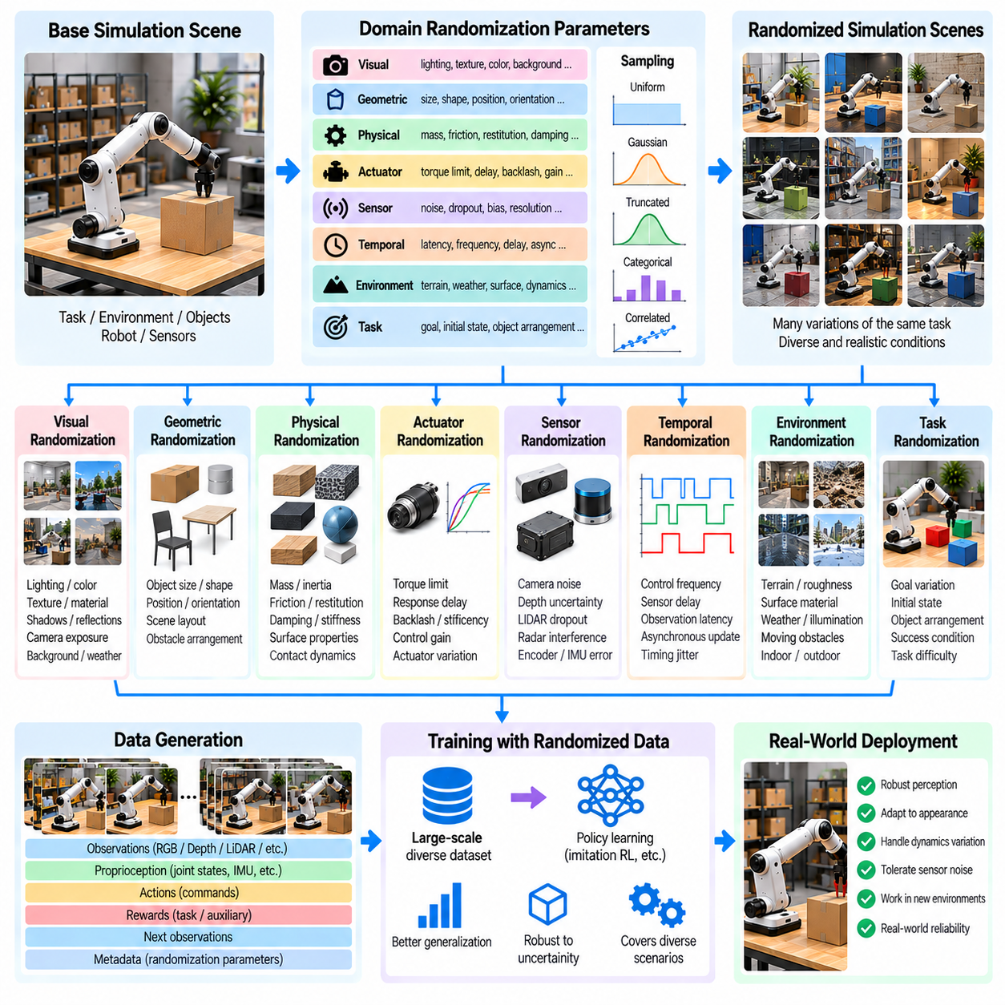
Domain randomization is a fundamental technique for generating diverse simulation datasets that improve the robustness and generalization of Physical AI systems. Instead of training robots under a single fixed environment configuration, domain randomization systematically varies visual, physical, and operational parameters. The resulting experiences expose learning algorithms to uncertainty and help reduce dependence on assumptions that may not hold in real-world deployment.
The central objective of domain randomization is to represent a distribution of plausible environments rather than reproduce one idealized scenario. Simulation parameters are sampled from predefined ranges or probability distributions before or during training episodes. These variations create multiple versions of similar tasks, allowing robots to experience changing conditions while preserving the underlying objectives and essential physical relationships.
Visual domain randomization modifies the appearance of simulated scenes without necessarily changing their physical structure. Lighting intensity, color, texture, material reflectance, shadows, and background appearance can vary between episodes. Camera exposure, white balance, and image noise may also be randomized. Such variations discourage vision models from relying on superficial visual features that are unlikely to remain consistent across environments.
Geometric randomization changes object dimensions, shapes, positions, orientations, and spatial arrangements. A manipulation dataset may contain objects with different sizes and graspable surfaces, while navigation datasets may include varying corridor widths and obstacle placements. These modifications broaden spatial experience and help learning systems recognize task-relevant relationships across different geometric configurations.
Physical domain randomization modifies parameters that determine how simulated objects and robots move or interact. Mass, inertia, friction, restitution, damping, and joint stiffness may be sampled across realistic ranges. Changes in these properties influence acceleration, contact behavior, and stability. Training under multiple physical configurations can improve tolerance to modeling uncertainty and variations between manufactured robot units.
Actuator randomization represents uncertainty in motors, transmissions, and control interfaces. Torque limits, response delays, backlash, control gains, and actuator efficiency may vary across simulated episodes. These factors influence how commanded actions translate into actual motion. Including actuator variability helps policies accommodate imperfect control execution, although sampled parameters must remain consistent with feasible hardware behavior.
Sensor randomization addresses differences between simulated observations and measurements from physical devices. Camera noise, depth uncertainty, LiDAR dropout, radar interference, encoder errors, and inertial measurement drift can be modeled. Sampling these disturbances prevents policies from assuming perfectly accurate observations. Sensor models should reflect relevant failure characteristics rather than simply introducing arbitrary noise.
Temporal randomization changes the timing characteristics of perception, communication, and control. Observation delays, actuator latency, sampling frequencies, and asynchronous sensor updates may vary during data generation. These effects are important because real robotic systems rarely operate with perfectly synchronized information. Policies trained under timing uncertainty may become more resilient to delayed observations and control execution.
Environmental randomization introduces variations in operating conditions such as terrain roughness, surface friction, weather, illumination, and obstacle movement. Outdoor robots may experience simulated rain, dust, slopes, and uneven ground, while indoor systems may encounter changing floor materials and clutter. These variations extend dataset coverage across operational conditions that cannot be represented by a single nominal environment.
Task randomization changes goals, initial conditions, target locations, object arrangements, and success requirements. A robot may repeatedly perform the same general operation while encountering different task configurations. This prevents memorization of fixed trajectories and encourages policies to infer appropriate behavior from observations. Task variations should remain aligned with the intended application and measurable completion criteria.
Domain randomization can be applied independently to individual parameters or jointly across multiple dimensions. Independent sampling is simple but may generate unrealistic combinations of physical properties. Correlated sampling preserves relationships between variables, such as object mass and dimensions or surface material and friction. Realistic parameter dependencies are important for generating data that supports reliable physical generalization.
The selection of randomization ranges strongly influences training outcomes. Narrow ranges may fail to represent actual deployment uncertainty, while excessively broad ranges can produce implausible environments and unnecessarily difficult learning problems. Engineering measurements, manufacturer specifications, and experimental observations provide useful constraints. Randomization distributions should be revised as additional real-world evidence becomes available.
Uniform randomization assigns equal sampling probability across a defined parameter interval, but real operating conditions are rarely distributed uniformly. Gaussian, truncated, categorical, and empirical distributions may better represent specific uncertainties. Distribution selection should reflect whether the objective is realistic frequency modeling, robustness against extreme conditions, or broad exploration of possible environments.
Adaptive domain randomization modifies parameter distributions according to policy performance. When a robot performs reliably under current variations, the training system can introduce more challenging conditions. If performance deteriorates, the system may concentrate on specific failure regions or adjust difficulty. This feedback-driven process allocates simulation resources toward conditions that contribute to measurable improvements in robustness.
Curriculum-based domain randomization gradually expands environmental variability during training. Initial stages may use limited sensor noise, moderate friction changes, and relatively simple geometry. Later stages introduce larger disturbances and combinations of uncertain parameters. This progression can improve learning stability while ultimately exposing policies to a broad distribution of operating conditions.
Domain randomization is particularly valuable for sim-to-real transfer, where policies trained in simulation must operate on physical hardware. Randomized training encourages behavior that remains effective despite discrepancies between simulated and actual dynamics. However, randomization alone cannot compensate for missing physical phenomena, incorrect contact models, or fundamentally inaccurate sensor representations. Simulator calibration remains essential.
For manipulation systems, domain randomization can vary object mass, friction, grasp geometry, contact stiffness, and visual appearance. These changes expose policies to different grasping and placement conditions. A policy trained on diverse simulated interactions may become less sensitive to individual object properties. Nevertheless, reliable manipulation requires realistic contact dynamics and validation using representative physical objects.
For mobile and legged robots, randomized terrain geometry, wheel slip, ground friction, actuator response, and external disturbances support robust mobility learning. These parameters affect traction, balance, path tracking, and recovery behavior. Combining physical and environmental variation helps policies respond to conditions that differ from nominal training scenarios, especially when deployment environments are difficult to characterize precisely.
Dataset generation pipelines should record the randomization parameters associated with every simulation episode. Metadata may include sampled physical properties, sensor configurations, visual settings, random seeds, and environment identifiers. These records support reproducibility, failure analysis, and controlled comparisons. They also allow developers to determine whether performance weaknesses are associated with particular parameter combinations.
Evaluation must distinguish robustness gained through randomization from performance measured only on familiar training distributions. Separate test environments should contain unseen parameter combinations and realistic operating conditions. Metrics may include task success, safety violations, control accuracy, recovery performance, and sensitivity to parameter changes. Physical experiments remain necessary to verify that simulated robustness transfers to actual robots.
A scalable Physical AI data engine integrates domain randomization with procedural scene generation, policy execution, automated evaluation, and dataset curation. Feedback from simulation and real-world testing guides the refinement of parameter distributions and scenario coverage. By systematically representing uncertainty while preserving physical plausibility, domain randomization transforms simulation into a powerful source of diverse training data for adaptable robotic intelligence.

04.10. Robot Morphology and Environment Randomization
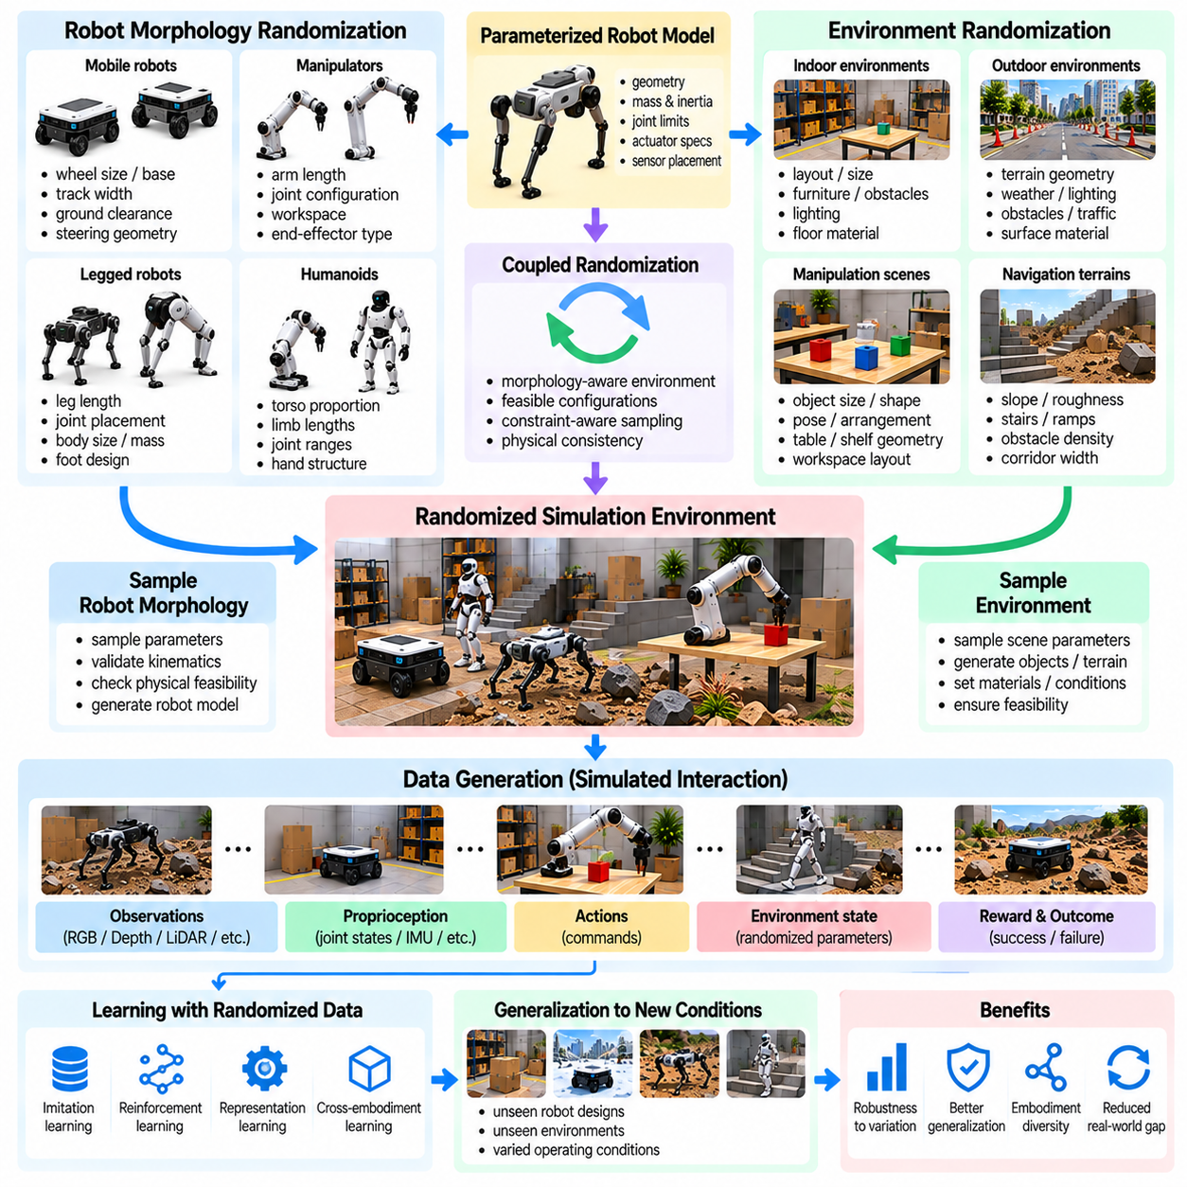
Robot morphology and environment randomization extend simulation data generation beyond variations in appearance and physical parameters. Robot morphology defines the structural arrangement of links, joints, actuators, and sensing components, while environment configuration determines the conditions under which these structures operate. Randomizing both dimensions exposes Physical AI systems to diverse embodiments and interaction conditions, supporting broader learning and generalization.
Morphology randomization modifies robot characteristics such as link lengths, joint locations, body proportions, actuator placement, and degrees of freedom. These changes influence reachability, mobility, stability, and control requirements. By generating data across different robot configurations, simulation environments can reveal which behaviors depend on specific mechanical structures and which strategies remain effective across multiple embodiments.
Parametric robot models provide a practical foundation for morphology randomization. A simulator can modify geometric dimensions, mass distributions, joint limits, and actuator specifications through configurable parameters. Each generated model must preserve physically consistent kinematic and dynamic relationships. Automated validation is necessary to reject configurations that violate mechanical constraints or produce unstable simulation behavior.
For mobile robots, morphology variations may include wheel diameter, wheelbase, track width, ground clearance, and steering geometry. These parameters influence turning radius, traction, obstacle traversal, and maneuverability. Randomized mobile platforms can generate navigation and control data representing different vehicle designs, helping learning systems distinguish general mobility principles from platform-specific behavior.
Manipulator morphology randomization changes arm length, joint arrangement, workspace geometry, and end-effector characteristics. Different configurations produce different reachable regions, collision constraints, and manipulation capabilities. Training across multiple manipulators can support adaptable motion planning and grasping policies, although differences in joint structure require consistent representations of actions and robot states.
Legged robot morphology introduces additional complexity because locomotion depends strongly on body geometry and contact structure. Leg length, joint placement, foot dimensions, and body mass distribution influence gait generation and balance. Randomizing these properties produces locomotion experiences across different mechanical designs, supporting the investigation of transferable movement strategies and morphology-dependent control requirements.
Humanoid morphology randomization may involve torso proportions, limb lengths, joint ranges, hand structures, and center-of-mass characteristics. Such variations affect whole-body coordination, manipulation reach, walking stability, and recovery behavior. Simulation datasets containing diverse humanoid configurations can support cross-embodiment learning, but anatomical feasibility and actuator capabilities must remain consistent with realistic engineering constraints.
Morphology randomization also changes the relationship between observations and actions. Robots with different numbers of joints or sensors cannot always share fixed-dimensional control representations. Graph-based models, structured joint descriptors, and embodiment-conditioned policies can represent varying robot structures. These approaches allow learning systems to associate mechanical configuration with appropriate control behavior.
Environment randomization complements morphology variation by changing the physical spaces in which robots operate. Terrain geometry, obstacle density, surface materials, object placement, and workspace dimensions can be sampled across episodes. These changes expose robots to different operational challenges and prevent policies from depending on a single environment layout or narrowly defined interaction pattern.
For navigation applications, randomized environments may include corridors, ramps, doorways, stairs, and uneven surfaces. Their dimensions and arrangements influence route feasibility and collision risk. A robot's morphology determines which environmental features it can traverse, making joint variation especially important. Dataset generation should therefore evaluate compatibility between platform dimensions and environmental geometry.
Manipulation environments can be randomized through object dimensions, fixture positions, shelf heights, table geometry, and workspace accessibility. Different robot arm configurations may succeed or fail depending on these conditions. Recording the relationship between morphology and task feasibility provides useful supervision for motion planning, grasp selection, and robot configuration selection.
Joint morphology-environment randomization explores interactions between robot design and operating conditions. A short-legged robot may perform well on flat terrain but struggle with large obstacles, while a longer-legged design may require different balance strategies. Similarly, manipulator reach and workspace geometry jointly determine accessible targets. These interactions reveal performance boundaries that cannot be identified by varying either dimension independently.
Randomization distributions should reflect meaningful engineering design spaces rather than arbitrary parameter combinations. Link dimensions, actuator torque, structural mass, and joint limits are physically related. Increasing limb length without adjusting inertia or actuator capacity may create unrealistic systems. Constraint-aware sampling preserves feasible relationships and prevents generated datasets from being dominated by invalid robot configurations.
Automated morphology generation can use robot description formats, procedural assembly rules, and parameterized mechanical templates. Each generated robot requires updated kinematic models, collision geometry, inertial properties, and control interfaces. Simulation pipelines should verify joint connectivity, collision consistency, and dynamic stability before collecting training trajectories. This validation supports reliable large-scale generation.
Curriculum strategies can gradually increase morphology and environment diversity during learning. Initial training may use closely related robot structures and simple environments. Later stages introduce larger geometric differences, unfamiliar joint configurations, and challenging terrain or workspaces. This progression helps policies acquire transferable control principles before encountering difficult combinations of embodiment and environmental variation.
Cross-embodiment learning aims to transfer knowledge between robots with different mechanical structures. Shared task representations, normalized observations, and morphology-aware policy architectures can support this objective. However, direct transfer is limited when robots have fundamentally different capabilities. Training datasets must distinguish universally applicable behaviors from actions that require particular joints, sensors, or locomotion mechanisms.
Morphology randomization can also support robot design optimization. Simulation data may reveal how structural choices affect energy consumption, task success, payload capacity, and movement efficiency. By evaluating multiple embodiments under comparable environmental conditions, developers can identify promising design regions. Such analysis connects policy learning with hardware configuration decisions and supports systematic robot development.
Dataset metadata must preserve the robot morphology and environment parameters associated with each trajectory. Relevant records include link dimensions, joint definitions, actuator properties, terrain characteristics, object configurations, and simulation seeds. This information enables reproducible experiments and helps explain performance differences. It also supports filtering datasets according to specific robot families or deployment conditions.
Evaluation should separate performance improvements caused by learning from advantages associated with particular robot designs. Benchmark environments can test familiar and unseen morphology-environment combinations while measuring task success, stability, energy use, and constraint violations. Physical validation remains essential because simulated mechanical configurations may overlook structural compliance, manufacturing tolerances, and complex contact effects.
A scalable Physical AI data engine integrates morphology generation, environment randomization, simulation execution, trajectory recording, and automated quality assessment. By exploring feasible combinations of robot structures and operating conditions, the system produces datasets that capture both shared behavioral principles and embodiment-specific limitations. This approach supports adaptable robot policies, cross-platform generalization, and data-informed mechanical design.

04.11. Automatic Ground Truth Generation
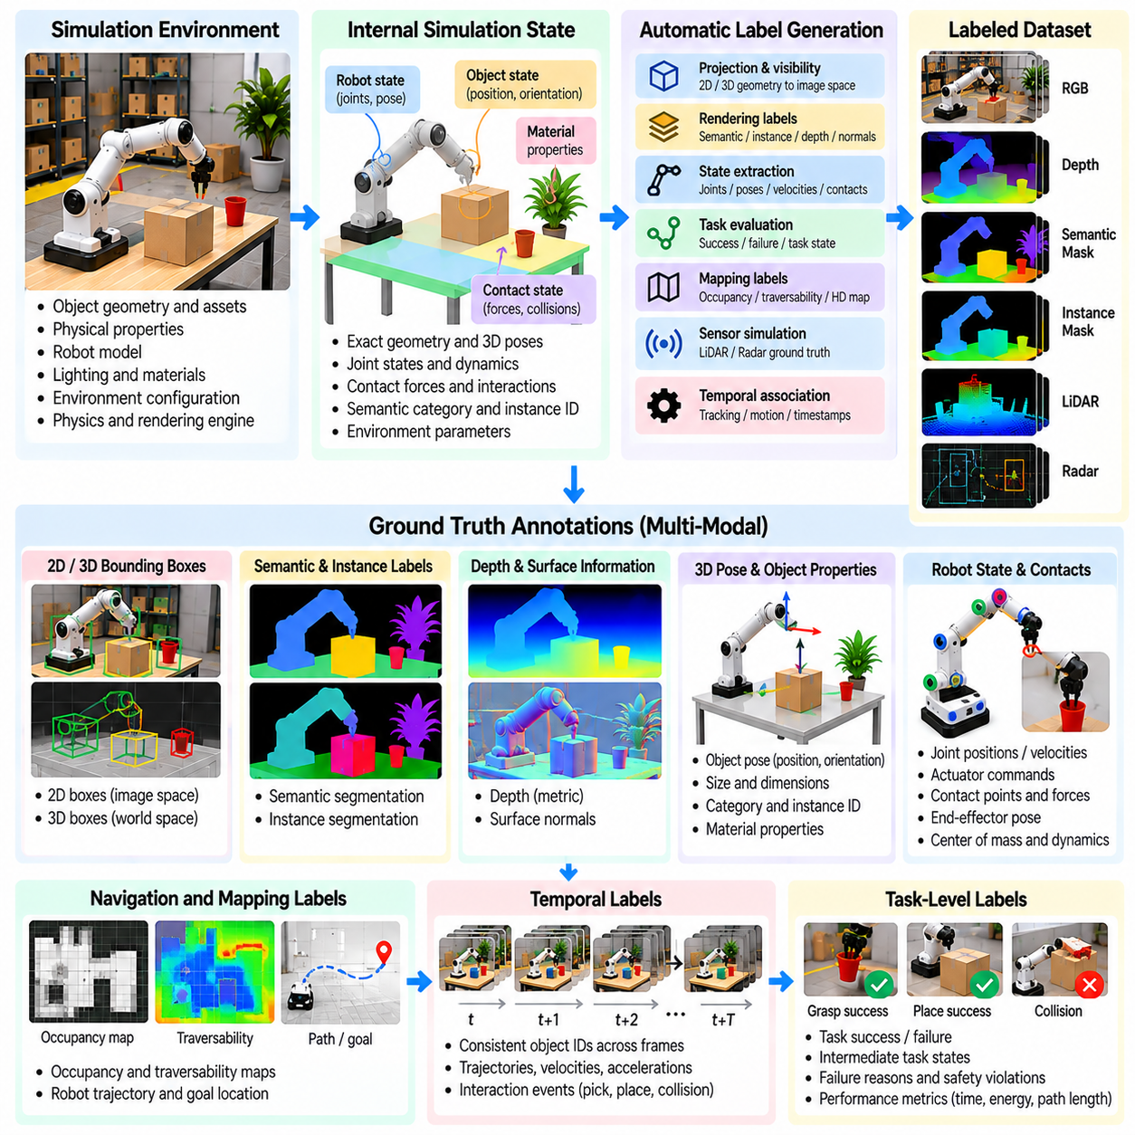
Automatic ground truth generation is a fundamental advantage of simulation-based data engines for Physical AI. Ground truth represents accurate reference information about objects, robot states, environmental properties, and interaction outcomes. Unlike real-world data collection, where annotations often require human effort or specialized measurement systems, simulation can directly expose internal states and generate structured labels during execution.
A simulation environment maintains detailed information about object geometry, spatial coordinates, physical properties, and dynamic states. These internal representations provide the foundation for automatic annotation. By extracting information from the simulation engine, data pipelines can associate sensor observations with corresponding reference labels. This process enables large-scale dataset generation with consistent annotation rules and reduced manual labeling requirements.
Automatic ground truth generation supports multiple perception tasks, including object detection, semantic segmentation, instance segmentation, depth estimation, and pose estimation. Each task requires a different representation of reference information. A single simulated scene can produce several synchronized annotation types, allowing the same observation to support multiple learning objectives and reducing the need to construct separate datasets.
For object detection, simulation engines can generate two-dimensional and three-dimensional bounding boxes directly from object geometry and camera parameters. Projected object coordinates determine image-space annotations, while world-space geometry provides spatial bounding volumes. Accurate labels must account for camera calibration, object visibility, image boundaries, and occlusion to remain consistent with the observations used during training.
Semantic segmentation assigns a category label to each visible image pixel. Simulation renderers can produce segmentation masks by associating rendered surfaces with predefined semantic classes. Instance segmentation extends this process by distinguishing individual objects belonging to the same category. These labels support scene understanding, object localization, and robotic manipulation, particularly when multiple similar objects appear together.
Depth ground truth can be generated from simulated camera geometry and rendering calculations. Each pixel may contain the distance to the visible surface according to the selected depth convention. However, optical-axis depth and Euclidean range are different quantities and must not be confused. Dataset specifications should document coordinate systems, measurement units, invalid pixels, and sensor modeling assumptions.
Three-dimensional ground truth includes object positions, orientations, dimensions, and spatial relationships. Simulators can export these values in world, robot, or sensor coordinate frames. Such information supports pose estimation, object tracking, mapping, and spatial reasoning. Consistent transformation conventions are essential because coordinate-frame errors can create systematic labeling mistakes even when the underlying simulation states are correct.
Robot state ground truth includes joint positions, joint velocities, actuator commands, body poses, and contact configurations. These values can be extracted directly from simulation state variables. Additional annotations may describe center-of-mass motion, end-effector trajectories, and stability conditions. Such labels are valuable for state estimation, imitation learning, motion prediction, and the evaluation of robot control algorithms.
Contact and interaction ground truth provide information that is difficult to measure comprehensively in physical environments. Simulation engines can record contact locations, collision events, normal forces, frictional interactions, and object motion. These records support grasp analysis, manipulation learning, and failure diagnosis. Their accuracy depends on the fidelity and numerical behavior of the underlying contact solver.
For navigation and autonomous mobility, ground truth may include robot trajectories, obstacle locations, occupancy maps, traversability labels, and collision-free paths. Simulated environments can generate reference maps from known geometry while recording the robot's actual movement. These annotations support localization, mapping, path planning, and navigation policy evaluation across procedurally generated environments.
Synthetic LiDAR and radar datasets can also contain automatically generated reference information. LiDAR annotations may include point-level semantic labels, object identifiers, surface normals, and range values. Radar annotations may include simulated target range, radial velocity, and object associations. Ground truth should remain distinct from sensor measurements, which may contain noise, missed detections, and modeling approximations.
Temporal ground truth describes how objects and robots evolve across simulation steps. Object identities, velocities, accelerations, trajectories, and interaction events can be recorded over time. These annotations support multi-object tracking, motion forecasting, and video-based learning. Persistent object identifiers and synchronized timestamps are necessary to preserve continuity across frames and avoid incorrect temporal associations.
Automatic task-level labeling extends beyond geometric and sensor information. Simulators can determine whether a grasp succeeds, an object reaches its target, a navigation goal is achieved, or a safety constraint is violated. Intermediate task states and failure reasons may also be recorded. These annotations connect low-level physical observations with high-level task outcomes, supporting policy learning and performance evaluation.
A major benefit of simulation-generated ground truth is the availability of privileged information that physical sensors cannot directly observe. Hidden object poses, exact friction coefficients, internal contact states, and complete environment maps may be accessible during generation. Such information can supervise learning or evaluate predictions, but training pipelines must distinguish privileged labels from observations available during real-world deployment.
Annotation consistency requires careful management of coordinate frames, object identifiers, semantic taxonomies, and measurement conventions. Different simulation engines may use different axis orientations, unit systems, and rendering definitions. Without explicit standardization, combined datasets may contain incompatible labels. A unified annotation schema helps preserve interoperability across simulation platforms and robot configurations.
Occlusion and visibility introduce important challenges for automatic labeling. An object may exist in the simulation state but be partially or completely hidden from a sensor. Ground truth generation must distinguish complete object geometry from visible regions and specify whether annotations include occluded objects. This distinction affects object detection, tracking, segmentation, and evaluation protocols.
Synchronization is essential when generating labels for multiple sensors and robot state streams. Cameras, LiDAR, inertial sensors, and control systems may operate at different frequencies. Annotation timestamps must correspond to the appropriate simulation states, particularly when objects are moving. Interpolation and temporal alignment procedures should be documented to prevent systematic errors in multimodal training datasets.
Ground truth accuracy should not be confused with physical realism. Simulation may provide exact labels for an internally modeled world while representing real-world phenomena imperfectly. Simplified geometry, approximate contact dynamics, and idealized rendering can produce precisely annotated but unrealistic examples. Therefore, annotation correctness and simulation fidelity must be evaluated as separate dimensions of dataset quality.
Automated quality assurance can identify missing labels, inconsistent identifiers, invalid coordinate transformations, and physically impossible values. Validation routines may compare projected geometry with segmentation masks, verify bounding-box dimensions, and check temporal continuity. Statistical analysis can detect unusual annotation distributions. Such procedures are important because automatic generation can propagate systematic errors across millions of samples.
A scalable ground truth pipeline integrates simulation state extraction, sensor rendering, annotation generation, validation, and dataset storage. Each sample should preserve observations, labels, timestamps, coordinate conventions, and relevant simulation metadata. Reproducible scene configurations and random seeds support debugging and regeneration. By combining accurate internal references with systematic quality control, automatic ground truth generation enables efficient development of large, richly annotated Physical AI datasets.

04.12. Synthetic vs Real Data Distribution
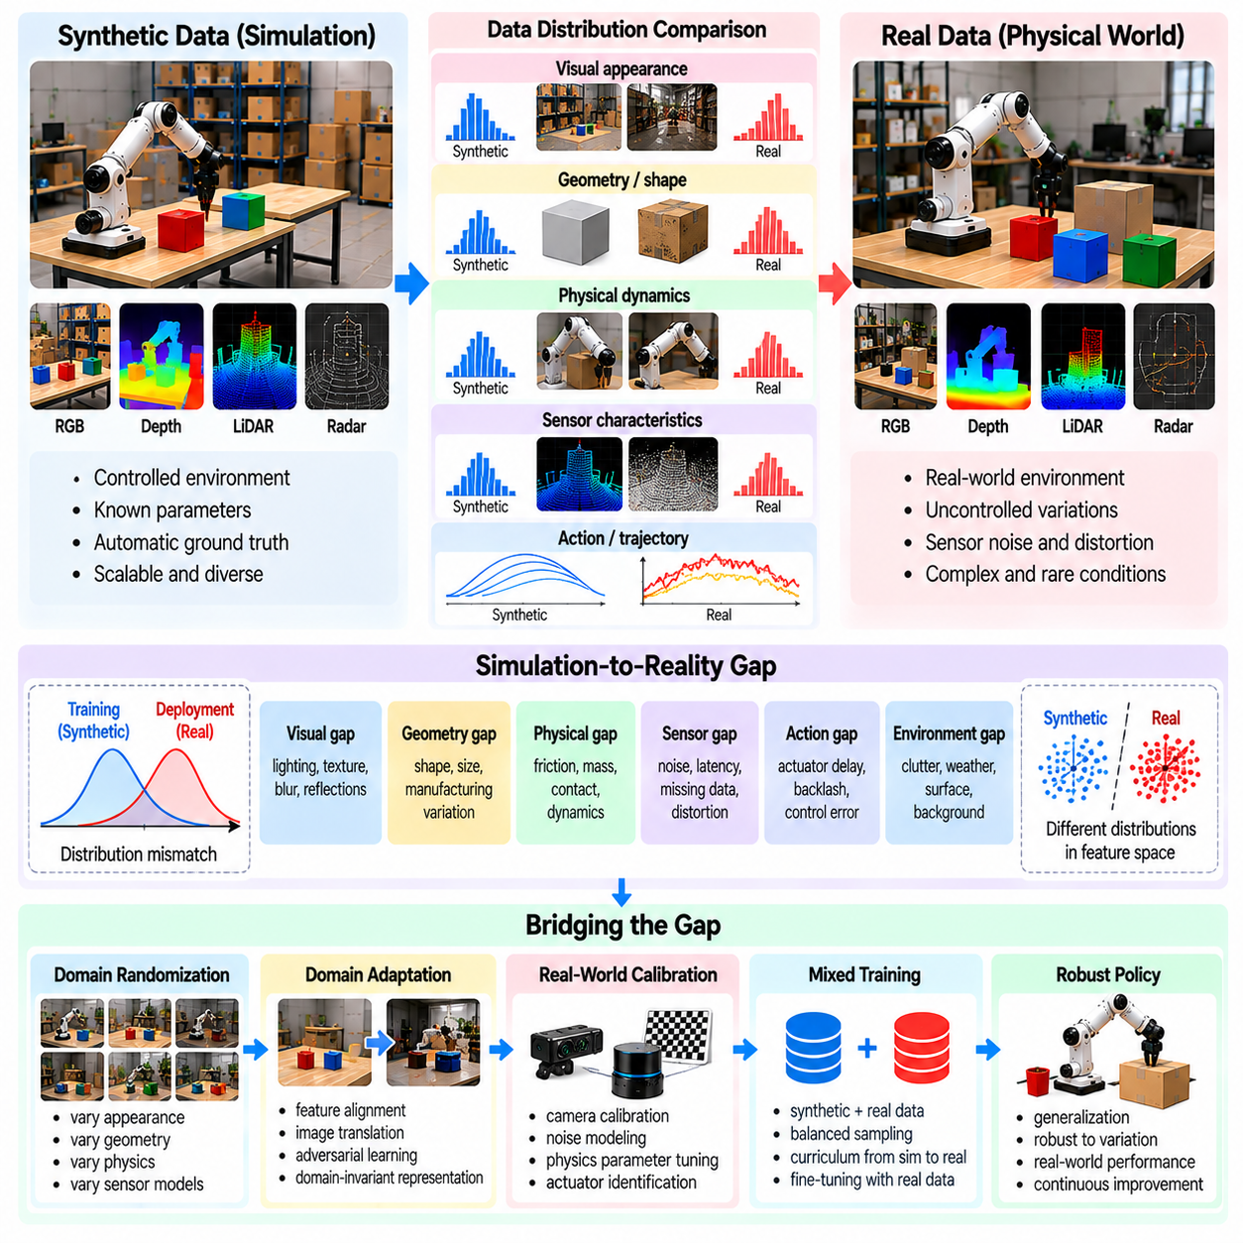
Synthetic and real data distributions represent a central challenge in developing reliable Physical AI systems. Synthetic data is generated through simulation using modeled environments, sensors, and physical interactions, while real data originates from physical robots operating in actual environments. Although both sources may describe similar tasks, their statistical properties often differ. Understanding these differences is essential for building models that generalize beyond simulation.
A data distribution describes the statistical patterns of observations, states, actions, and outcomes encountered during learning. In robotics, these patterns include visual appearance, object geometry, contact behavior, sensor noise, and environmental dynamics. Synthetic distributions are controlled by simulation parameters, whereas real distributions emerge from complex physical conditions that cannot always be modeled completely.
The simulation-to-reality gap arises when synthetic data fails to represent important characteristics of real-world observations or interactions. Differences may involve lighting, material appearance, friction, actuator response, sensor distortion, and contact dynamics. Models trained exclusively on synthetic data may perform well in simulation yet fail under physical conditions because they encounter unfamiliar combinations of these factors.
Visual distribution differences are especially important for perception-based robotic systems. Synthetic images may contain simplified textures, idealized lighting, unrealistic reflections, or limited background diversity. Real camera images include exposure variations, motion blur, optical distortion, and environmental interference. These discrepancies can cause perception models to rely on visual features that do not transfer reliably.
Geometric distribution differences arise when simulated objects and environments fail to represent the variety encountered in physical deployment. Synthetic datasets may use standardized object shapes, simplified surfaces, or limited spatial arrangements. Real environments contain manufacturing tolerances, irregular geometry, deformation, and unexpected clutter. Such differences influence object recognition, collision prediction, and manipulation planning.
Physical distribution differences involve discrepancies between simulated and actual dynamics. Friction coefficients, mass distributions, contact stiffness, damping, and actuator behavior may differ from their modeled values. Even small inaccuracies can accumulate during repeated interactions. These differences are particularly important for grasping, locomotion, balancing, and other tasks requiring precise physical contact.
Sensor distribution differences result from imperfect simulation of measurement processes. Real sensors experience calibration errors, nonlinear noise, missing measurements, latency, and environmental interference. Synthetic sensors may represent these effects through simplified statistical models. If simulated noise distributions do not match real measurements, learned policies may become overly dependent on observation quality that is unavailable during deployment.
Action and trajectory distributions can also differ substantially between simulation and reality. Simulated controllers may generate precise, repeatable motions, while physical robots experience actuator delays, backlash, mechanical compliance, and control errors. Consequently, identical action commands may produce different state transitions. This discrepancy affects imitation learning, reinforcement learning, and learned dynamics models.
Distribution shift can be categorized according to which statistical relationships change. Covariate shift occurs when input distributions differ while the conditional target relationship remains stable. Label shift involves changes in target frequencies, while concept shift changes the relationship between inputs and targets. In robotics, multiple forms of shift may occur simultaneously, making simple correction methods insufficient.
Measuring synthetic-real distribution differences requires representative datasets from both domains. Feature statistics, sensor noise characteristics, trajectory distributions, and task outcomes can be compared. Distance measures such as maximum mean discrepancy or Wasserstein distance may quantify differences in selected representations. However, low statistical distance does not automatically guarantee successful robot behavior.
Learned feature representations provide another way to compare synthetic and real datasets. Images, point clouds, or robot trajectories can be mapped into embedding spaces where similarity is measured. Clustering and domain classification may reveal systematic differences between sources. These methods are useful for diagnosing gaps, but their conclusions depend on whether the selected representations preserve task-relevant information.
Domain randomization attempts to reduce distribution mismatch by generating synthetic data across diverse parameter configurations. Lighting, textures, geometry, friction, sensor noise, and actuator characteristics may be varied. This broadens the training distribution and encourages models to tolerate uncertainty. Nevertheless, excessive randomization can introduce unrealistic samples and reduce learning efficiency.
Domain adaptation seeks to align representations or predictions across synthetic and real domains. Feature alignment, adversarial learning, image translation, and statistical normalization are possible approaches. Some methods transform synthetic observations toward realistic appearance, while others learn domain-invariant features. Adaptation must preserve task-relevant geometry and physical relationships to avoid introducing misleading training signals.
Real-world calibration improves synthetic data quality by constraining simulation parameters using measured physical behavior. Sensor characteristics, robot dynamics, contact properties, and environmental conditions can be estimated from experiments. The calibrated simulator provides a more representative starting distribution. Randomization around measured parameters can then account for residual uncertainty and variation between operating conditions.
Coverage is as important as similarity when evaluating synthetic datasets. A synthetic distribution may closely match average real-world conditions but omit rare events, extreme disturbances, or unusual object configurations. These missing cases can cause severe failures during deployment. Targeted scenario generation can increase coverage of safety-critical and low-frequency situations that are difficult to collect physically.
Dataset imbalance can create additional differences between synthetic and real distributions. Simulation pipelines may overproduce successful trajectories, simple environments, or easily generated object configurations. Real-world data may contain more failures, interruptions, and irregular conditions. Balanced sampling and targeted generation help correct these biases while preserving the statistical context needed for reliable evaluation.
The relationship between synthetic and real distributions changes as robot policies improve. A learned policy may visit states that were uncommon in the original training data, creating new distribution gaps. Closed-loop evaluation can identify these unfamiliar states and guide additional simulation generation. This feedback process connects policy development with continuous dataset refinement.
Evaluation should separate synthetic validation performance from real-world deployment performance. A model may achieve high accuracy on simulated test data while remaining sensitive to physical uncertainty. Representative real-world benchmarks should measure task success, robustness, safety violations, and recovery behavior. Performance comparisons across domains reveal which distribution differences have practical consequences.
Synthetic and real data should be treated as complementary rather than interchangeable resources. Synthetic data offers scalability, controlled variation, and automatic ground truth, while real data captures unmodeled physical complexity. Combining both sources can improve learning when sampling strategies account for their differences. The optimal balance depends on task complexity, simulator fidelity, and available physical data.
A scalable Physical AI data engine continuously compares synthetic and real distributions, identifies underrepresented conditions, and updates simulation generation accordingly. Statistical analysis, physical calibration, targeted randomization, and real-world validation form a feedback loop. By managing distribution differences systematically, developers can transform synthetic experience into training resources that support reliable behavior in physical environments.

04.13. Mixing Real and Synthetic Data
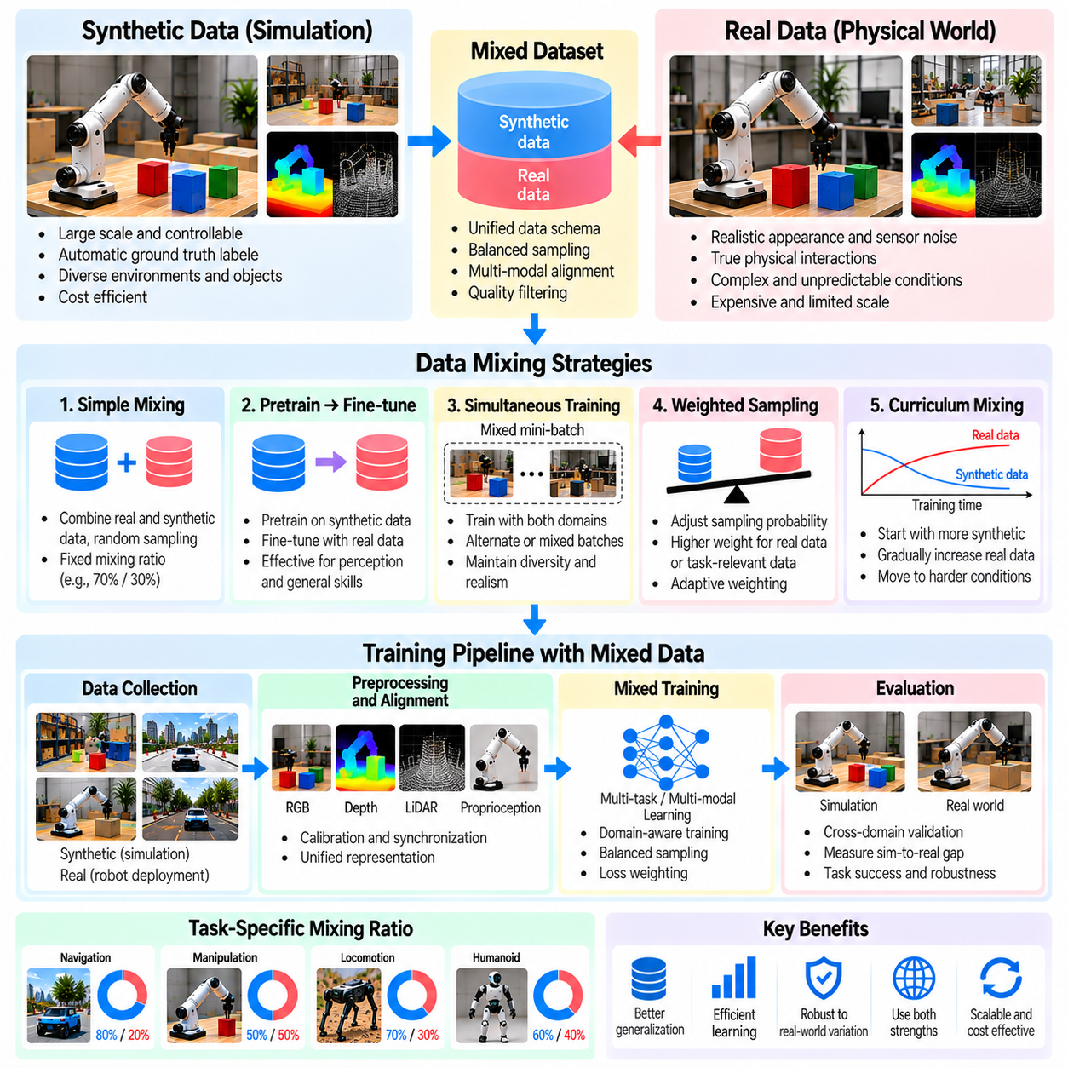
Mixing real and synthetic data is a fundamental strategy for building scalable and reliable Physical AI learning systems. Synthetic data provides large quantities of controlled experiences, while real data captures the complexity of physical environments and robot interactions. Combining these sources allows training pipelines to exploit simulation scalability without ignoring deployment conditions. The central challenge is determining how different data sources should contribute to learning.
Real-world robotic datasets are expensive because collecting demonstrations requires hardware, operators, maintenance, and controlled operating conditions. Synthetic datasets can be generated repeatedly with automated simulation pipelines and precise ground truth annotations. However, synthetic observations may contain unrealistic physical or visual characteristics. A mixed-data strategy attempts to balance the economic advantages of simulation with the representational value of physical experience.
The effectiveness of data mixing depends on the relationship between source distributions and target deployment conditions. Real and synthetic samples may describe identical tasks while differing in sensor noise, contact dynamics, object appearance, and action execution. Simply combining all samples does not guarantee better performance. Training procedures must consider domain differences, task relevance, data quality, and the relative contribution of each source.
A basic mixing strategy combines real and synthetic samples within a unified training dataset. A sampling ratio determines the proportion of examples drawn from each domain during optimization. This ratio influences the model's exposure to realistic conditions and simulated diversity. High synthetic proportions may improve coverage, while higher real-data proportions may strengthen adaptation to deployment-specific characteristics.
The optimal real-to-synthetic ratio is not universal. Perception models may benefit from extensive synthetic pretraining followed by smaller quantities of real images. Contact-intensive manipulation policies may require more physical interaction data because contact dynamics are difficult to reproduce accurately. The appropriate ratio depends on task complexity, simulation fidelity, model architecture, and the diversity of available real-world experiences.
Pretraining and fine-tuning provide a practical alternative to simultaneous data mixing. A model first learns general representations or behaviors from large synthetic datasets and subsequently adapts using real-world examples. Synthetic pretraining can establish useful perception, planning, or control capabilities before expensive physical data is introduced. Real-world fine-tuning then adjusts learned parameters toward deployment conditions.
Simultaneous mixed-domain training exposes a model to real and synthetic examples throughout optimization. Mini-batches may contain samples from both domains, or training may alternate between domain-specific batches. This approach can preserve synthetic diversity while maintaining regular exposure to physical observations. Careful sampling is necessary to prevent the larger synthetic dataset from overwhelming the smaller real dataset.
Weighted sampling assigns different probabilities or training importance to individual data sources. Real-world examples may receive greater weight when they represent deployment conditions more accurately. Synthetic samples may receive higher weight when they cover rare situations or difficult tasks. Importance weighting and adaptive sampling can refine this balance, although inaccurate weighting may amplify noise or reduce useful diversity.
Data mixing should account for differences in annotation quality and representation. Synthetic data may provide exact object poses, segmentation masks, contact states, and robot trajectories. Real data may contain incomplete annotations, measurement uncertainty, or inconsistent sensor calibration. Unified data schemas and explicit validity masks help models learn from available supervision without treating missing real-world labels as incorrect observations.
Multimodal alignment is especially important when mixing camera, LiDAR, proprioceptive, and action data. Synthetic and physical systems may use different coordinate frames, sensor frequencies, resolutions, and control interfaces. Standardized transformations and timestamp conventions are necessary for consistent training. Without alignment, models may learn artificial relationships caused by data processing rather than genuine physical behavior.
Domain-aware training can explicitly represent whether a sample originates from simulation or physical deployment. Domain identifiers, separate normalization statistics, or domain-specific model components may help manage distribution differences. Other approaches encourage shared representations that remain useful across both sources. The appropriate design depends on whether domain differences should be preserved, compensated for, or suppressed.
Curriculum-based mixing gradually changes the composition of training data. Early learning may emphasize abundant synthetic examples covering fundamental skills and simple environments. Later stages can introduce increasing amounts of real-world data and more challenging physical conditions. This progression allows models to acquire broad capabilities before adapting to the detailed constraints of deployment environments.
Task-aware mixing adjusts data proportions according to the capabilities being learned. Navigation training may emphasize synthetic obstacle configurations, while precision grasping may require additional physical contact demonstrations. Different tasks can therefore use different mixing schedules within a shared model. This strategy prevents a single global sampling ratio from dominating learning objectives with different data requirements.
Failure-driven data mixing prioritizes examples associated with poor real-world performance. Physical deployment may reveal slipping, missed grasps, localization errors, or unexpected collisions that were uncommon during simulation training. These failures can guide targeted synthetic scenario generation and additional real-world collection. Mixing newly generated examples with existing datasets creates a feedback loop focused on observed weaknesses.
Synthetic data can also compensate for rare or hazardous situations that are difficult to reproduce physically. Simulations may generate emergency stops, obstacle encounters, unstable contacts, or sensor degradation under controlled conditions. These examples can improve exposure to challenging events, but simulated safety performance cannot replace physical validation. Their contribution should be assessed through realistic testing and risk-aware evaluation.
Dataset balancing requires attention to more than the overall number of real and synthetic samples. Object categories, environments, robot embodiments, task outcomes, and difficulty levels may be distributed unevenly. A large synthetic dataset can still provide limited useful diversity if it repeatedly generates similar situations. Stratified sampling and coverage analysis help ensure that training examples represent meaningful operational variation.
Mixed-data learning can suffer from negative transfer when synthetic examples encourage behaviors that are unsuitable for physical deployment. Unrealistic friction, idealized sensing, or inaccurate actuator dynamics may produce misleading training signals. Monitoring performance on held-out real-world datasets helps identify these effects. Synthetic samples that consistently degrade deployment performance may require correction, filtering, or reduced sampling weight.
Evaluation must measure whether mixed training improves real-world performance rather than only synthetic benchmark accuracy. Controlled experiments can compare real-only, synthetic-only, and mixed-data training under matched model architectures and evaluation conditions. Task success, robustness, sample efficiency, and failure recovery provide complementary metrics. Ablation studies can identify which synthetic data categories contribute meaningful improvements.
A scalable mixing pipeline should preserve data provenance, collection conditions, simulation parameters, annotation confidence, and sampling history. These records enable reproducible experiments and support analysis of domain-specific performance. Automated monitoring can detect changes in real-world data distributions and adjust future generation priorities. Traceability is particularly important when multiple simulation engines and physical robot platforms contribute data.
An effective Physical AI data engine treats real and synthetic data as complementary components of a continuous learning process. Simulation supplies scalable exploration and structured supervision, while physical deployment provides evidence about actual operating conditions. Adaptive sampling, domain alignment, targeted generation, and real-world evaluation connect these resources. The resulting training strategy supports efficient learning while progressively improving reliability in physical environments.

04.14. Simulation Data Generation Pipeline [w/Code]
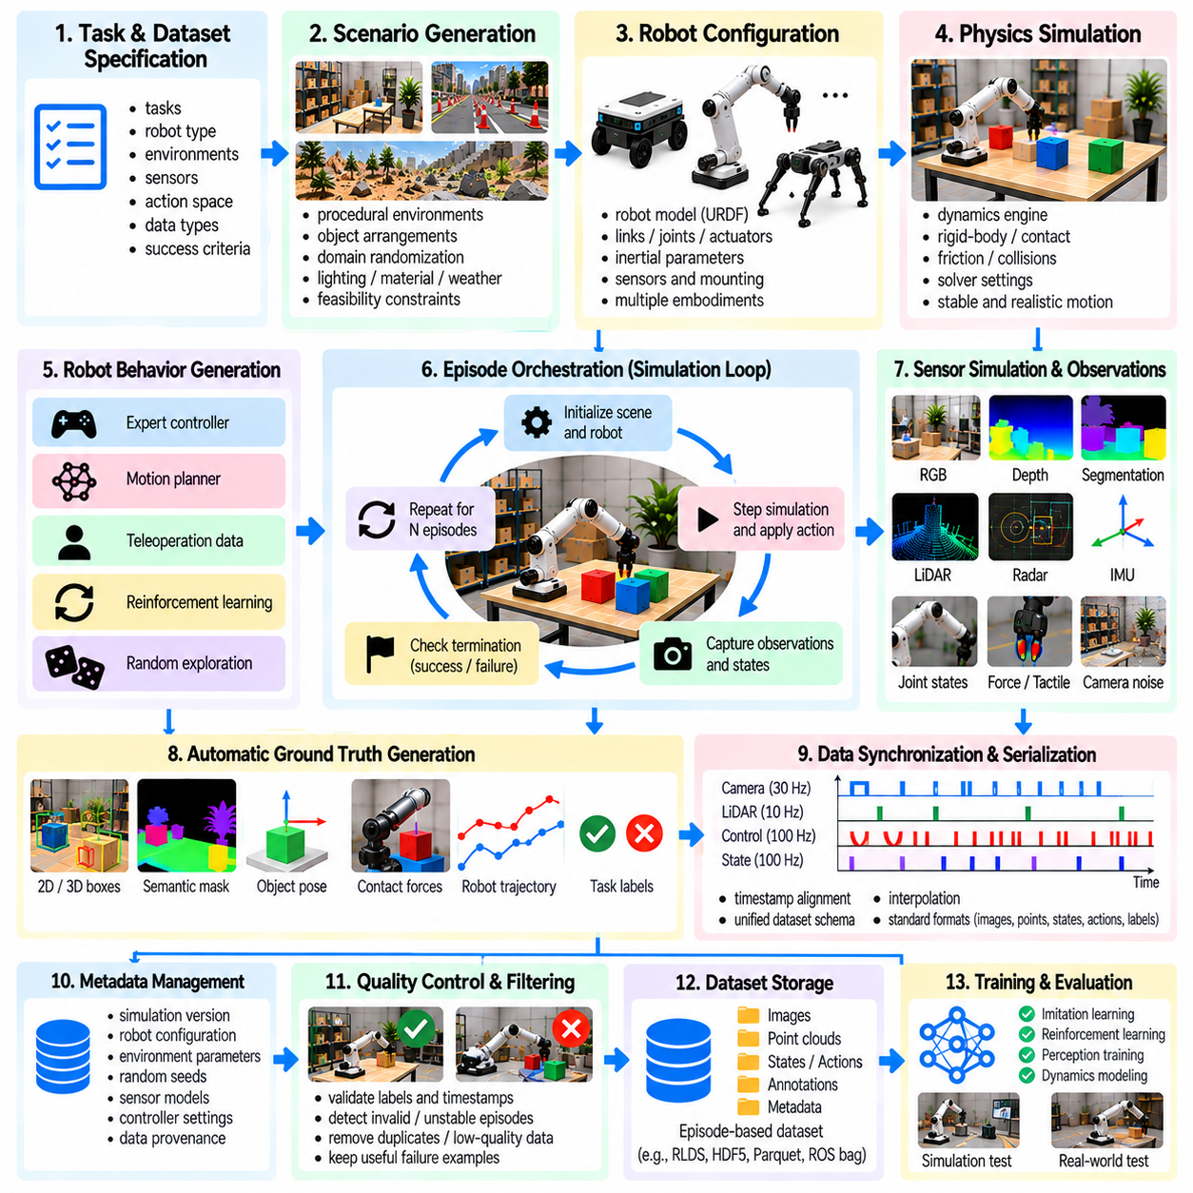
A simulation data generation pipeline is an integrated workflow that transforms virtual environments and robot behaviors into structured training datasets for Physical AI. It connects scenario configuration, physics simulation, sensor rendering, robot control, annotation, and storage. The primary objective is to generate diverse, reproducible, and physically meaningful experiences while reducing the cost and operational complexity of collecting data from real robots.
The pipeline begins with task and dataset specifications that define what information must be generated. These specifications identify robot capabilities, operating environments, sensor modalities, action representations, and expected learning objectives. Requirements may include navigation trajectories, manipulation demonstrations, contact events, or failure examples. Explicit specifications ensure that generated data supports intended training and evaluation tasks.
Scenario generation creates the virtual conditions under which robots operate. Procedural methods can construct rooms, corridors, terrain, workspaces, and object arrangements from configurable templates. Randomization controls geometry, lighting, materials, object placement, and environmental disturbances. Each generated scenario should satisfy feasibility constraints so that the resulting data represents meaningful robot interactions rather than arbitrary configurations.
Robot configuration establishes the mechanical and computational properties of the simulated platform. Robot description files define links, joints, collision geometry, inertial parameters, actuators, and sensor attachments. The pipeline loads these descriptions and initializes robot states before simulation. Parameterized configurations can support multiple robot embodiments, enabling data generation across different mobility and manipulation systems.
Physics simulation calculates how robots and environmental objects evolve under forces, constraints, and control inputs. Dynamics engines evaluate rigid-body motion, collisions, friction, and contact responses at discrete time steps. Numerical integration settings influence stability and computational cost. Appropriate solver configurations are necessary to generate trajectories that remain physically plausible across diverse tasks and operating conditions.
Sensor simulation converts virtual world states into observations resembling physical measurements. Cameras generate RGB, depth, and segmentation images, while LiDAR and radar models produce spatial measurements. Inertial sensors, encoders, and force sensors provide robot state information. Noise, distortion, latency, and missing measurements can be introduced to approximate deployment conditions and improve robustness against sensor uncertainty.
Robot behavior generation determines the actions performed during simulated episodes. Expert controllers, motion planners, teleoperation recordings, reinforcement learning policies, and exploratory strategies can produce trajectories. Different behavior sources provide complementary examples of successful execution, partial progress, and failure. The pipeline should record both commanded actions and resulting physical states to preserve causal relationships.
Episode orchestration coordinates scenario initialization, robot execution, sensor recording, and termination conditions. Each episode begins with a selected environment configuration and robot state. The system advances simulation, applies control commands, and captures observations at defined intervals. Episodes terminate when tasks succeed, failures occur, safety limits are reached, or maximum durations expire.
Automatic ground truth generation extracts reference information directly from simulation states. Object poses, bounding boxes, segmentation masks, depth maps, contact forces, and robot trajectories can be recorded without manual annotation. Task-level labels may identify success, failure, and intermediate progress. These annotations should remain synchronized with observations and use consistent coordinate frames, identifiers, and measurement units.
Data synchronization ensures that sensor observations, actions, and robot states correspond to compatible simulation times. Cameras, LiDAR, controllers, and physics solvers may operate at different frequencies. The pipeline must manage timestamps, sampling intervals, and interpolation where necessary. Incorrect synchronization can create misleading relationships between actions and outcomes, reducing the usefulness of generated training examples.
Data serialization converts simulation outputs into standardized storage representations. Images, point clouds, trajectories, annotations, and metadata may require different formats depending on their structure. A unified dataset schema should define episode identifiers, observation fields, action vectors, coordinate conventions, and label definitions. Consistent serialization enables efficient loading, filtering, and reuse across learning frameworks.
Metadata management preserves the conditions under which each sample was generated. Important records include simulation engine versions, robot configurations, environment parameters, random seeds, sensor models, and controller settings. These details support reproducibility, debugging, and comparisons between experiments. Data provenance also helps identify whether unexpected model behavior originates from simulation assumptions or training procedures.
Quality control validates generated datasets before they enter the training pipeline. Automated checks can identify missing sensor frames, invalid labels, unstable dynamics, inconsistent timestamps, and physically impossible states. Additional filters may remove duplicate trajectories or uninformative episodes. Quality assessment should preserve valuable failure examples while excluding corrupted data that could introduce misleading learning signals.
Dataset balancing controls the relative representation of tasks, environments, robot configurations, and outcomes. Unrestricted simulation may repeatedly generate easy scenarios or successful behaviors while underrepresenting difficult interactions. Stratified sampling and targeted scenario generation can improve coverage. Balanced datasets help learning systems encounter meaningful variations without becoming dominated by redundant or narrowly distributed experiences.
Parallel simulation enables large-scale generation by executing multiple environments simultaneously. Independent simulation instances can run on multicore processors, GPUs, or distributed computing clusters. Workload scheduling assigns scenarios and computational resources according to complexity. Efficient parallelization increases throughput, although rendering demands, physics computation, and data transfer can become significant bottlenecks.
Storage architecture must accommodate high-volume multimodal datasets generated by parallel simulation. RGB images, depth maps, point clouds, and continuous state trajectories can consume substantial capacity. Compression, chunked storage, and selective recording reduce unnecessary overhead. Data management systems should support efficient retrieval, dataset versioning, and reliable transfer between generation infrastructure and model training systems.
Pipeline monitoring tracks operational performance and dataset quality during generation. Useful metrics include episodes per hour, valid sample rate, simulation speed, storage consumption, and task outcome distributions. Monitoring can identify stalled simulations, abnormal physics behavior, or imbalanced scenario production. Automated alerts and recovery procedures improve reliability when generation workloads operate continuously.
A minimal implementation can organize the workflow around a repeated episode loop. The system samples scenario parameters, resets the simulator, executes a controller, records synchronized observations, and saves validated trajectories. A Python-based implementation may coordinate simulation APIs, sensor callbacks, and dataset writers. Separating configuration, execution, validation, and storage components makes the pipeline easier to test and extend.
Integration with real-world data improves the practical relevance of generated datasets. Physical robot observations can guide simulator calibration, randomization ranges, and scenario selection. Deployment failures may reveal missing environmental conditions or inaccurate dynamics models. The pipeline can then generate targeted synthetic examples and combine them with real demonstrations, creating a feedback mechanism for continuous improvement.
A production-ready simulation data engine integrates automated generation, validation, versioning, and feedback-driven refinement into a scalable system. Its effectiveness depends not only on the quantity of generated samples but also on physical fidelity, task coverage, annotation consistency, and real-world relevance. By connecting simulation infrastructure with learning and deployment evaluation, the pipeline becomes a foundation for continuous Physical AI development.

