Volume 04. Data Engines and Scaling for Physical AI

Chapter 03. Human Video Data

03.01. Human Video as Embodied Knowledge
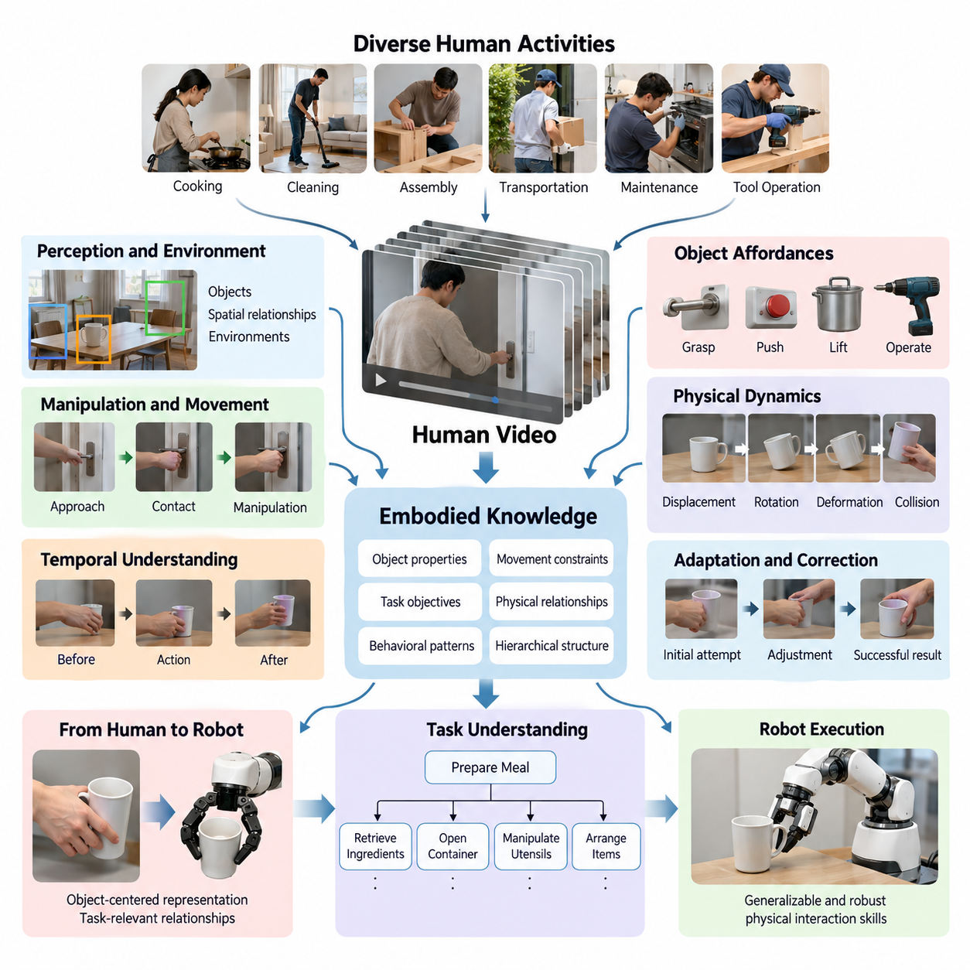
Human video represents one of the richest sources of embodied knowledge for Physical AI because it captures how people perceive environments, manipulate objects, coordinate movements, and accomplish practical goals. Unlike static images or symbolic instructions, video preserves temporal relationships between perception, action, and environmental change, providing valuable evidence of how intelligent behavior unfolds in the physical world.
Embodied knowledge refers to practical understanding acquired through interaction with the environment rather than through abstract descriptions alone. Human activities contain implicit information about object properties, spatial relationships, movement constraints, and task objectives. Video recordings preserve observable aspects of this knowledge, allowing learning systems to discover behavioral patterns without requiring every physical interaction to be explicitly programmed.
A person opening a door demonstrates more than a sequence of visible movements. The activity reveals how a handle is approached, where contact occurs, how the object moves, and how the person adjusts behavior as the door opens. Although forces and intentions may not be directly observable, temporal visual evidence provides useful clues about the physical relationships governing successful interaction.
Human video is particularly valuable because everyday human activities cover an enormous range of tasks, environments, objects, and interaction styles. Cooking, cleaning, assembly, transportation, maintenance, and tool operation provide examples of structured physical behavior. This diversity can help Physical AI systems develop representations that generalize beyond narrowly defined robot demonstrations and controlled laboratory environments.
Traditional robot learning frequently depends on demonstrations collected using specialized robotic hardware. Such demonstrations provide accurate observations and action measurements but can be expensive to acquire at scale. Human video offers a complementary source of experience that can be collected from existing recordings or purpose-built capture systems, potentially expanding training coverage without requiring equivalent amounts of robot operation.
The central distinction between human video and conventional robot trajectory data concerns the availability of action information. Robot demonstrations may contain joint positions, actuator commands, forces, and synchronized sensor measurements. Ordinary video primarily records visible consequences of movement, requiring learning algorithms to infer hidden actions, contact events, and physical states from incomplete observations.
Extracting embodied knowledge therefore requires more than recognizing objects or classifying activities. A learning system must identify relationships between agents, objects, and environmental changes over time. It should distinguish actions that produce meaningful physical effects from incidental movements and recognize how intermediate interactions contribute to an intended task outcome.
Temporal continuity is essential because individual frames rarely explain the complete meaning of an action. A hand approaching a cup might indicate grasping, repositioning, or preparing to pour. Observing the preceding and following frames helps resolve this ambiguity. Video models can use temporal context to estimate action boundaries, infer likely objectives, and identify changes associated with successful manipulation.
Human demonstrations also expose the hierarchical organization of physical tasks. Preparing a meal may involve retrieving ingredients, opening containers, manipulating utensils, and arranging completed items. Each activity contains smaller actions connected by dependencies and goals. Learning these relationships supports task planning by providing examples of how complex objectives can be decomposed into manageable behavioral sequences.
Another important contribution of human video is the representation of object affordances. An affordance describes a possible interaction between an agent and an object under particular conditions. Repeated observations of people grasping handles, pushing buttons, lifting containers, or operating tools help learning systems associate visual object features with potential actions and their observable consequences.
Video can additionally provide indirect evidence about physical dynamics. Object displacement, deformation, rotation, and collision reveal aspects of how the environment responds to interaction. Models trained on sufficiently diverse sequences may learn statistical regularities related to motion and contact, although reliable estimation of mass, friction, force, and other hidden physical properties generally requires additional assumptions or measurements.
Human behavior provides examples of adaptation when environmental conditions change. A person may adjust grip position when an object slips, change movement direction when an obstacle appears, or repeat an operation after an unsuccessful attempt. These observations are valuable because robust Physical AI requires understanding corrective behavior rather than learning only idealized demonstrations of successful tasks.
The relationship between human embodiment and robot embodiment introduces a fundamental challenge. Human hands, arms, joints, and sensory systems differ from robotic manipulators and mobile platforms. Consequently, visually observed human motion cannot always be converted directly into executable robot commands. Effective transfer requires identifying task-relevant relationships that remain meaningful across different physical structures.
Object-centered representations offer one approach to reducing this embodiment gap. Instead of reproducing the exact trajectory of a human hand, a robot may learn that an object must be grasped at an accessible location and moved toward a target configuration. This shifts the learning objective from anatomical imitation toward achieving equivalent physical outcomes within the robot's own capabilities.
Spatial representations further support this transfer by describing object poses, relative positions, motion trajectories, and contact relationships. Computer vision techniques can estimate human body landmarks, hand configurations, and object movement from video. However, occlusion, camera motion, perspective distortion, and limited depth information introduce uncertainty that must be considered when converting observations into robotic training signals.
Human video can support self-supervised learning because consecutive frames contain naturally occurring relationships between observations. Models may learn by predicting future visual features, identifying temporal consistency, or comparing representations of related action sequences. Such objectives can produce useful visual and temporal representations without requiring detailed manual annotation for every recorded activity.
Language can make embodied video representations more accessible and transferable. Descriptions such as placing an object on a shelf or tightening a fastener connect visual behavior with semantic task objectives. When language and video are aligned, models can associate instructions with observable action sequences, supporting the development of vision-language systems and potentially contributing to vision-language-action architectures.
Nevertheless, recognizing a task in video is not equivalent to possessing the motor skills required to execute it. A model may understand that a container must be lifted while lacking knowledge of the appropriate grip force, actuator trajectory, or stability constraints. Human video therefore provides valuable prior knowledge, but robot-specific demonstrations, interaction data, or simulation may still be necessary for reliable execution.
The quality of video data strongly influences the usefulness of learned representations. Clear visibility of hands, objects, contact regions, and task outcomes improves the extraction of interaction information. Camera placement, frame rate, lighting, motion blur, and temporal completeness all affect the reliability of inferred behavior. Recordings that omit critical interaction stages may provide misleading or insufficient evidence.
Diversity must also be balanced with relevance. Large video collections may contain repeated activities, unrelated scenes, editing artifacts, or demonstrations unsuitable for robotic execution. A practical data engine should prioritize recordings that reveal meaningful interactions, varied object configurations, distinct task strategies, and observable outcomes while preserving representative examples of difficult or unsuccessful behavior.
Human video introduces additional concerns involving privacy, consent, ownership, and data provenance. Recordings may reveal identities, workplaces, confidential procedures, or sensitive environments. Responsible data collection requires appropriate usage rights, access controls, and privacy protection. These considerations become increasingly important when large-scale video datasets are incorporated into commercial Physical AI training pipelines.
Within a Physical AI data engine, human video is most effective when combined with complementary data sources. Teleoperation provides robot-specific action trajectories, simulation supplies controlled physical interactions, and deployed robots generate real operational experience. Human video contributes broad behavioral coverage and task knowledge, creating opportunities for representation learning before adaptation to particular robotic embodiments.
The long-term importance of human video lies in its potential to connect large-scale observations of human activity with machine learning systems capable of physical interaction. By extracting task structure, object affordances, temporal dependencies, and observable action outcomes, Physical AI can acquire useful embodied priors. Transforming these priors into dependable robot behavior remains a central challenge in scalable embodied intelligence.

03.02. Egocentric and Exocentric Video
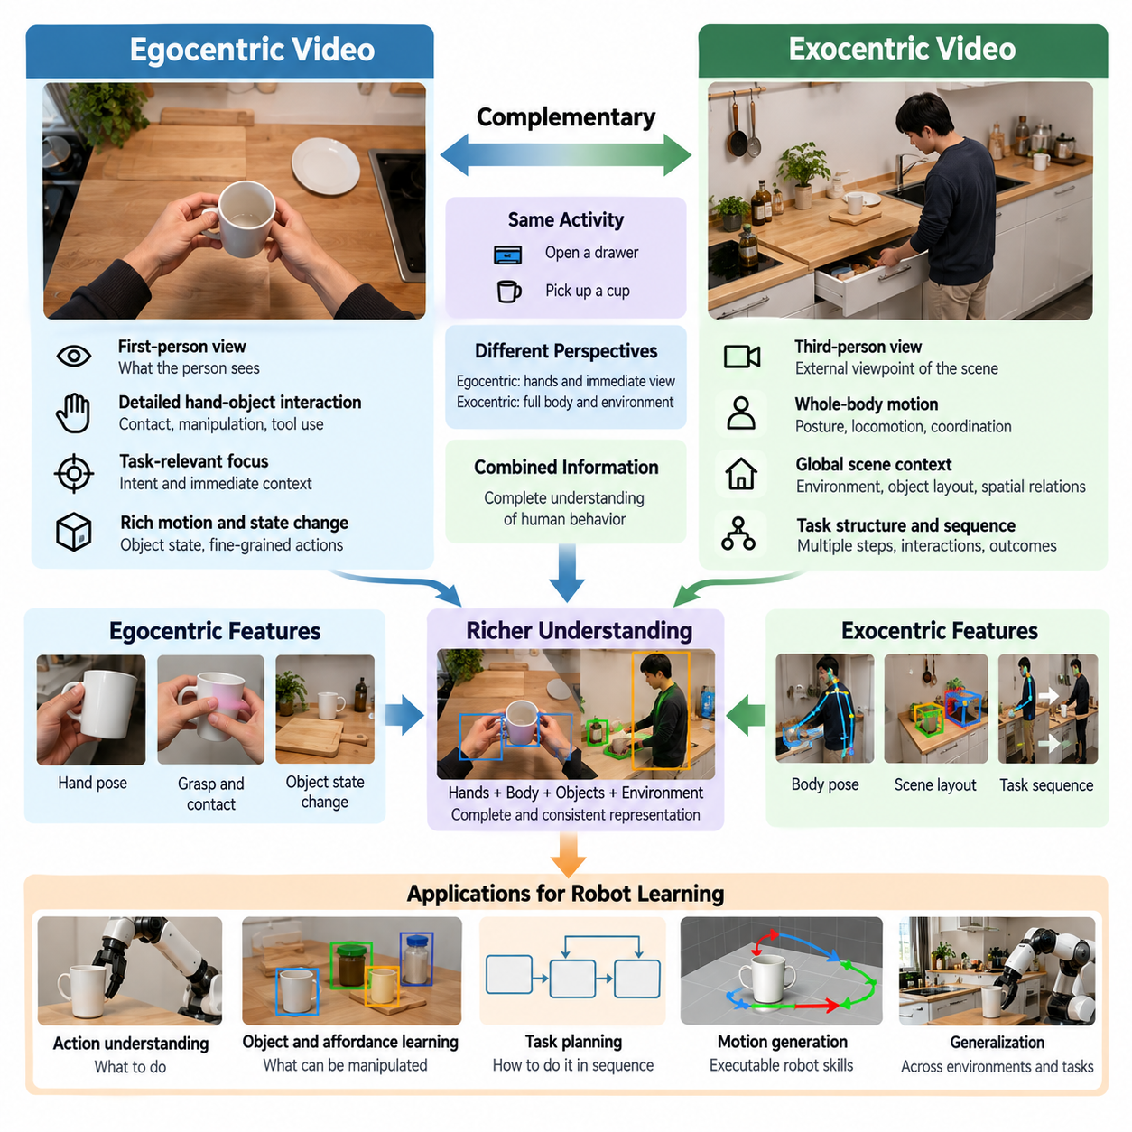
Egocentric and exocentric video represent two complementary perspectives for capturing human behavior and extracting embodied knowledge for Physical AI. Egocentric video records activities from the viewpoint of the person performing a task, while exocentric video observes the person from an external camera. These perspectives provide different information about perception, movement, object interaction, and environmental context.
Egocentric video is typically captured using head-mounted cameras, wearable devices, or cameras positioned near the operator's eyes. This viewpoint approximates the visual information available during task execution, including nearby objects, hand movements, and changing spatial relationships. It is particularly useful for understanding how an agent observes and interacts with its immediate environment.
A major advantage of egocentric video is its close relationship to action-oriented perception. When a person reaches toward an object, the camera often captures the target, approaching hands, and subsequent manipulation. This visual sequence helps learning systems associate observations with task progress and potential actions, supporting the development of representations relevant to robot control.
Egocentric recordings also reveal how visual attention and body movement influence task execution. Head rotation, viewpoint changes, and object-centered camera motion provide indirect evidence about the operator's focus. However, camera orientation does not necessarily indicate precise eye gaze, and attention must be inferred cautiously without additional measurements from eye-tracking sensors.
Exocentric video captures human activities from cameras positioned outside the performing agent. Fixed cameras, mobile observation systems, and multi-camera installations can record complete body movements and interactions within a wider environment. This perspective provides information about posture, locomotion, workspace organization, and relationships between people, objects, and surrounding structures.
The primary strength of exocentric video is its ability to describe movement within an external spatial reference frame. Observers can track body position, limb trajectories, and object displacement relative to the environment. These observations are valuable for learning motion patterns, analyzing task execution, and constructing representations that support robotic manipulation and navigation.
Exocentric recordings are especially useful for understanding coordinated whole-body behavior. Walking, lifting, carrying, reaching, and collaborative manipulation involve relationships among multiple body segments. An external viewpoint can reveal these relationships more clearly than a head-mounted camera, although visibility depends on camera placement, scene geometry, and occlusion.
The two perspectives differ significantly in their treatment of occlusion and visibility. Egocentric cameras may provide detailed views of nearby manipulation but frequently lose sight of the operator's body or objects outside the current field of view. Exocentric cameras can observe broader movement patterns but may fail to capture small contact regions when hands or tools are hidden behind other objects.
Camera motion introduces another important distinction. Egocentric video often contains rapid viewpoint changes caused by head and body movement, creating motion blur and unstable image coordinates. Exocentric cameras may provide more consistent visual references when mounted in fixed locations. Nevertheless, moving external cameras also require compensation for camera motion during geometric reconstruction.
For robot learning, egocentric video offers a natural connection to first-person visual policies. Robots equipped with onboard cameras similarly observe environments from perspectives linked to their physical configuration. Although camera height, field of view, and embodiment differ, first-person human recordings can provide useful training examples for visual representations and task-conditioned behavior.
Exocentric video supports learning from observation by emphasizing externally measurable behavior rather than the exact sensory experience of the demonstrator. A robot may observe how a person moves an object between locations and infer the intended transformation. This approach can be valuable when the robot's camera placement differs substantially from the human demonstrator's viewpoint.
Combining egocentric and exocentric video can reduce ambiguities that arise when either perspective is used independently. A head-mounted camera may clearly reveal a grasping interaction while an external camera captures the arm configuration and surrounding workspace. Together, these observations provide complementary evidence about local contact, global movement, and task progression.
Multi-view recording systems require careful temporal synchronization to preserve relationships between corresponding observations. Camera timestamps, frame rates, and recording delays must be aligned before integrating visual information. Without synchronization, the same physical event may appear at different times across recordings, producing inaccurate estimates of motion, contact, and action boundaries.
Spatial calibration is equally important when combining multiple perspectives. Camera intrinsics describe image formation, while extrinsic parameters describe camera position and orientation relative to a reference frame. Accurate calibration enables observations from different viewpoints to be related geometrically, supporting three-dimensional reconstruction, object tracking, and human motion analysis.
Three-dimensional understanding benefits from the complementary geometry of egocentric and exocentric observations. Multiple viewpoints can improve estimates of object pose, hand position, and movement trajectories by reducing depth ambiguity. However, reliable reconstruction still depends on image quality, camera calibration, temporal alignment, and the visibility of relevant scene features.
Egocentric and exocentric datasets also differ in their suitability for action recognition and task segmentation. First-person recordings emphasize interaction targets and local manipulation events, while external recordings provide broader contextual information about body movement and environmental changes. Models can exploit these differences to identify task phases and recognize meaningful transitions between actions.
Perspective differences create challenges for representation learning because the same activity may appear visually different across cameras. A grasping motion observed from a head-mounted camera may have little pixel-level resemblance to the same motion viewed from across a room. Learning viewpoint-invariant representations helps models identify shared action semantics despite changes in appearance and geometry.
Cross-view learning can align representations of corresponding activities using synchronized recordings, contrastive objectives, or shared task descriptions. The objective is to preserve meaningful information about actions and outcomes while reducing dependence on camera viewpoint. Such representations can improve transfer between human demonstrations, external observation systems, and robot-mounted cameras.
Human-to-robot transfer requires additional consideration because viewpoint alignment does not eliminate differences in physical embodiment. A humanoid robot, mobile manipulator, or industrial arm may observe and execute tasks differently from a human. Successful transfer therefore depends on extracting object-centered goals, contact relationships, and task constraints rather than directly reproducing human image-space motion.
Data collection strategies should reflect the intended learning objective. Fine manipulation tasks benefit from cameras that clearly capture hands, tools, and object contact regions. Locomotion and whole-body activities require wider views of body posture and environmental geometry. Complex tasks may justify synchronized first-person and external recordings to preserve both local interaction details and global context.
Large-scale video data engines must account for storage, bandwidth, and annotation costs when managing multiple perspectives. Recording several synchronized streams increases data volume and processing requirements. Efficient pipelines can prioritize informative segments, maintain consistent metadata, and preserve camera calibration and synchronization information needed for downstream learning.
Privacy and data governance are particularly important because different camera perspectives expose different information. Egocentric recordings may capture bystanders, private environments, and sensitive objects, while exocentric recordings may reveal identities and workplace activities. Appropriate consent, access controls, anonymization, and retention policies are necessary for responsible dataset development.
The value of each perspective should ultimately be evaluated through its contribution to robot learning performance. Relevant measures include action recognition accuracy, object pose estimation quality, task understanding, transfer efficiency, and downstream robot success rates. Comparing single-view and multi-view training helps determine whether additional camera perspectives justify their collection and processing costs.
Egocentric and exocentric video should therefore be understood as complementary components of a scalable Physical AI data engine. First-person observations emphasize perception and immediate interaction, while external observations reveal broader movement and spatial structure. Their integration can produce richer representations of human behavior and support the transfer of embodied knowledge into adaptable robotic intelligence.

03.03. Internet and Instructional Video
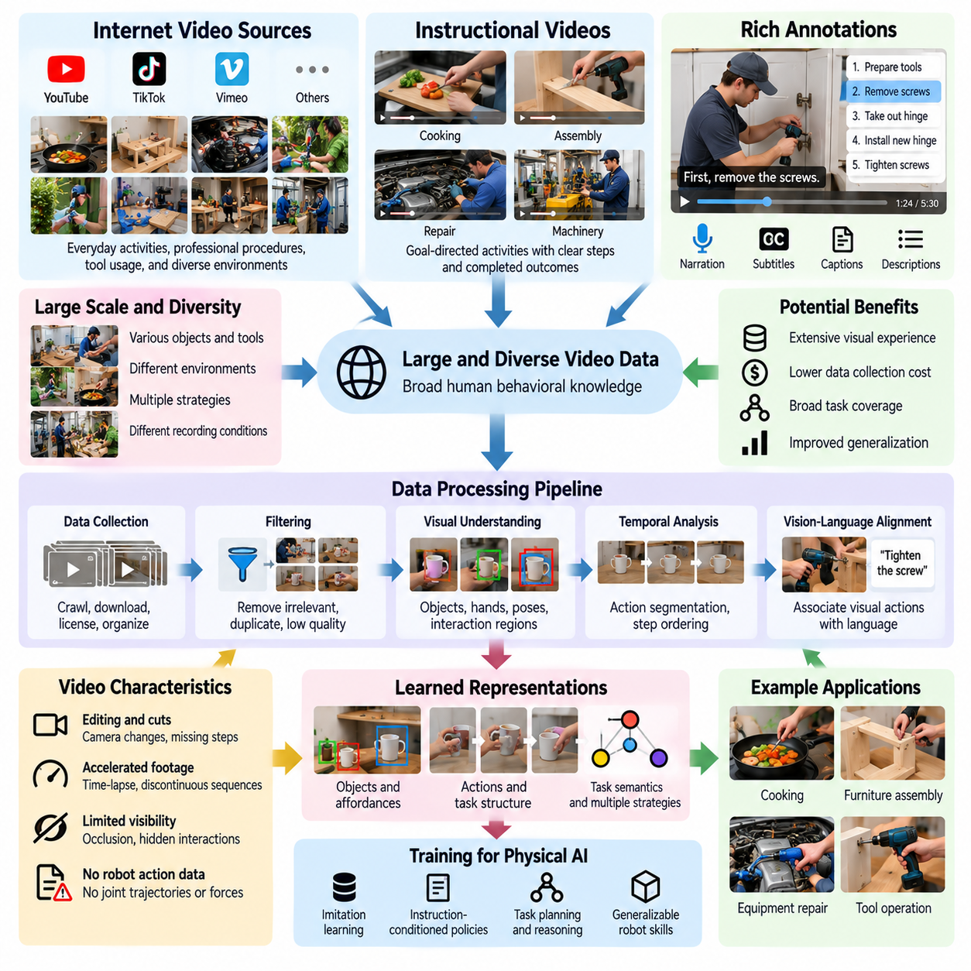
Internet and instructional videos represent a large and diverse source of human behavioral knowledge for Physical AI. Publicly available recordings capture everyday activities, professional procedures, tool usage, and complex task demonstrations across many environments. Unlike robot-specific datasets, these videos provide broad examples of human interaction with the physical world, making them valuable for learning general task concepts and behavioral patterns.
Instructional videos are particularly useful because they frequently demonstrate goal-directed activities with recognizable beginnings, intermediate steps, and completed outcomes. Examples include assembling furniture, preparing food, repairing equipment, and operating machinery. Their structured nature provides learning systems with evidence about task organization, object dependencies, and the temporal relationships connecting individual actions.
Internet videos offer substantial diversity in objects, environments, human behaviors, and recording conditions. The same task may be performed using different tools, strategies, and workspace configurations. This variation helps learning models distinguish essential task relationships from incidental visual details, potentially improving generalization when robots encounter unfamiliar objects or environments.
The primary advantage of internet video is its potential scale compared with robot demonstration data. Collecting robot trajectories requires specialized hardware, operators, and controlled recording procedures. Existing video collections can provide extensive visual experience without equivalent robotic data acquisition costs. However, identifying, licensing, processing, and validating useful recordings still requires substantial engineering effort.
Instructional content often includes narration, subtitles, captions, and textual descriptions that connect observed actions with language. A demonstration of replacing a mechanical component may explain the required tools, operational sequence, and intended result. These linguistic signals can support vision-language alignment, enabling models to associate natural language instructions with observable physical activities.
Temporal structure is a central property of instructional video. Complex procedures can be decomposed into subtasks such as preparation, object positioning, manipulation, verification, and completion. Learning these relationships helps Physical AI systems understand dependencies between actions and recognize that certain operations must occur before others for a task to succeed.
However, internet videos are rarely recorded specifically for machine learning. Camera angles may change abruptly, important interactions may be hidden, and editing may remove intermediate actions. Demonstrations can also contain accelerated footage or discontinuous sequences. Such characteristics complicate the reconstruction of continuous physical behavior and require careful interpretation of temporal information.
Another limitation is the absence of direct robot-compatible action measurements. Most internet recordings do not provide joint trajectories, contact forces, actuator commands, or calibrated three-dimensional object poses. Consequently, video-based learning must infer action-related representations from visual changes rather than assuming that recorded human movements directly specify executable robotic controls.
Computer vision models can extract useful intermediate information from these recordings, including object detections, human poses, hand trajectories, and estimated interaction regions. Temporal models can identify meaningful transitions and probable action boundaries. These extracted features provide structured representations that can support task understanding, imitation learning, and subsequent adaptation to robotic embodiments.
Instructional videos also provide valuable information about object affordances and tool functionality. Repeated demonstrations reveal how handles are grasped, fasteners are manipulated, containers are opened, and instruments are positioned. By observing interactions across different contexts, learning systems can associate object features with possible actions and expected environmental changes.
Learning from diverse instructional demonstrations can reveal multiple strategies for achieving similar objectives. One person may assemble a component using a particular tool sequence, while another follows a different procedure. Comparing these examples helps models identify common goals and essential constraints without assuming that every visible movement represents a universally optimal action.
Video-language models can use narrated demonstrations to develop representations of task semantics and action sequences. Contrastive learning, masked prediction, and temporal representation learning provide mechanisms for associating visual observations with textual descriptions. These approaches can support semantic understanding even when precise physical action labels are unavailable.
Weak supervision is particularly relevant because internet videos frequently contain incomplete or noisy annotations. Titles, captions, and descriptions may identify the overall task without specifying individual action boundaries. Learning systems can exploit these approximate labels while using temporal consistency and visual relationships to discover more detailed action structures.
Data filtering is essential when transforming internet video into useful Physical AI training resources. Large collections may include irrelevant content, duplicated recordings, misleading demonstrations, and scenes with limited physical interaction. Automated filtering can prioritize videos containing observable manipulation, meaningful object changes, and sufficiently continuous task execution.
Video quality must be evaluated in relation to the intended learning objective rather than visual resolution alone. A high-resolution recording may provide little useful information if critical interactions are obscured. Conversely, a lower-resolution video may clearly demonstrate task order and object relationships. Effective quality assessment therefore considers visibility, continuity, semantic relevance, and interaction completeness.
Instructional videos may contain demonstrations that are unsafe, inefficient, or physically unsuitable for robotic reproduction. A procedure performed by an experienced human may rely on dexterity, strength, or judgment unavailable to a robot. Training systems must distinguish descriptive observations from validated execution policies and avoid treating every demonstrated behavior as an appropriate robotic action.
The difference between human and robot embodiment creates additional challenges for transferring instructional knowledge. Human hands and tools may operate through motion patterns that cannot be reproduced by robotic manipulators. Object-centered task representations can reduce this gap by emphasizing desired object transformations, contact relationships, and operational constraints instead of exact human joint movements.
Internet video is especially valuable for pretraining visual and temporal representations before robot-specific adaptation. Models can first learn general concepts of objects, activities, and task progression from large video collections. Subsequent training with teleoperation trajectories, robot demonstrations, or simulation data can connect these representations to executable actions and physical constraints.
Combining internet video with robot data requires careful management of differences in observation and action distributions. Human demonstrations may contain viewpoints, motion speeds, and manipulation strategies that differ from robotic execution. Domain adaptation and representation alignment can help transfer relevant knowledge while reducing dependence on human-specific visual and behavioral characteristics.
Dataset provenance and licensing are fundamental requirements for responsible use of internet content. Public accessibility does not automatically grant permission for downloading, redistribution, or model training. Data engines must consider copyright, platform terms, consent, privacy, and permitted usage. Maintaining provenance records supports auditing and appropriate dataset governance.
Scalable processing pipelines can organize instructional videos into searchable collections using task descriptions, object categories, action embeddings, and temporal metadata. These representations allow developers to retrieve examples relevant to particular robotic capabilities or training deficiencies. Such indexing transforms unstructured video collections into reusable resources for iterative model development.
Evaluation should determine whether internet and instructional video improve downstream robotic performance rather than relying exclusively on video understanding benchmarks. Relevant outcomes include task recognition, planning accuracy, adaptation efficiency, and real-world execution success. Controlled comparisons can reveal which video categories, supervision methods, and data mixtures provide meaningful benefits.
Internet and instructional videos therefore serve as complementary sources of broad embodied knowledge within Physical AI data engines. They provide extensive observations of human goals, task organization, object interaction, and procedural variation. Their greatest value emerges when structured video understanding is combined with robot-specific experience, enabling general human knowledge to contribute to practical robotic intelligence.

03.04. Human Object and Tool Interaction
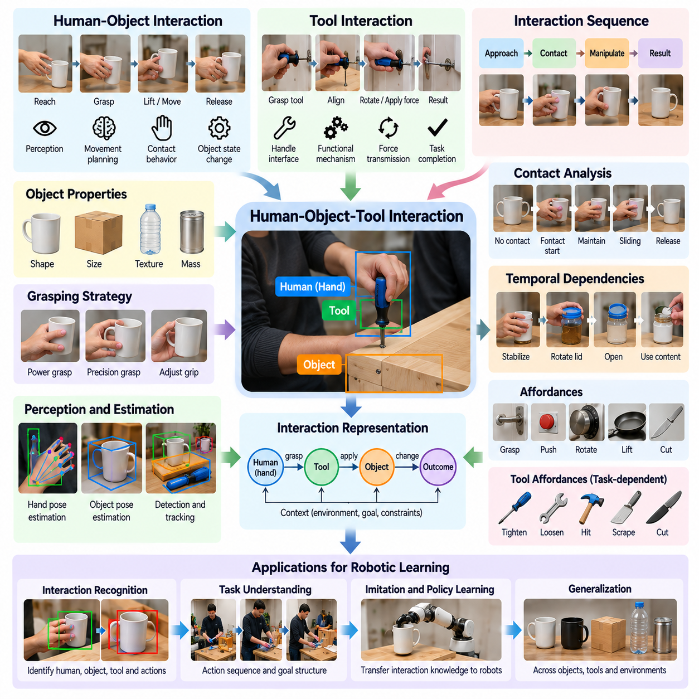
Human-object and tool interaction is a fundamental source of embodied knowledge for Physical AI because it reveals how humans manipulate physical objects to accomplish practical goals. Human video captures relationships among body movements, object properties, tool functions, and environmental changes. Understanding these interactions enables learning systems to identify meaningful actions and develop representations that support robotic manipulation.
Human-object interaction involves physical relationships established when people reach, grasp, lift, push, rotate, transport, or release objects. Each interaction combines perception, movement planning, and contact-dependent behavior. Video observations reveal how object configurations change over time, providing evidence about action objectives, manipulation strategies, and the physical constraints influencing task execution.
Tool interaction introduces an additional layer of complexity because tools extend human capabilities and modify how forces are transmitted to the environment. A screwdriver transfers rotational motion to a fastener, while a wrench applies torque through a mechanical interface. Learning from these examples requires understanding the functional relationship between the human hand, the tool, the target object, and the resulting transformation.
The structure of human-object interaction can be represented through relationships among agents, objects, actions, and outcomes. An agent initiates movement, establishes contact with an object, and produces a change in its physical state. These relationships form an interaction sequence that can be analyzed independently of the exact human motion, providing a foundation for transferring task knowledge to robotic systems.
Contact is particularly important because it connects visible motion with physical effects. A hand approaching an object does not necessarily indicate manipulation until contact occurs and the object's behavior changes. Identifying contact initiation, maintenance, sliding, and release helps distinguish meaningful manipulation from incidental movement. However, precise contact states are often difficult to infer from ordinary video alone.
Object properties strongly influence interaction strategies. Shape, size, surface texture, mass distribution, and mechanical constraints determine how objects can be approached and manipulated. Although some properties are visually observable, others must be inferred indirectly from movement and interaction outcomes. Physical AI models can learn useful statistical relationships between object appearance and observed manipulation behavior.
Grasping provides a representative example of how human-object interaction combines perception and physical control. Humans select contact locations, configure their fingers, and adjust grip during movement. Video can reveal approximate hand posture, grasp timing, and object displacement, but usually cannot directly measure grip force or tactile feedback. These limitations must be considered when constructing robot training representations.
Tool use requires understanding both the geometry and intended function of an instrument. The handle provides an interface for the operator, while the working end interacts with the target material or mechanism. Effective tool manipulation depends on maintaining suitable orientation, contact position, and movement direction. Video demonstrations can reveal these relationships through repeated examples of successful operations.
Human-object interactions also contain temporal dependencies that define task structure. Opening a container may require stabilizing its body before rotating a lid, while assembly may require aligning components before fastening them. Learning these dependencies enables models to recognize prerequisites and intermediate goals, supporting task planning and reducing errors caused by incorrect action ordering.
Interaction recognition requires identifying the participating entities and determining their relationships over time. Computer vision systems may detect hands, tools, objects, and relevant environmental structures. Tracking these entities across frames provides information about proximity, relative movement, and possible contact events. Temporal reasoning is then needed to distinguish actual interaction from visual coincidence.
Hand pose estimation and object pose estimation provide useful intermediate representations for interaction understanding. Hand landmarks approximate finger and wrist configurations, while object pose describes position and orientation. Combining these estimates can reveal approach trajectories and manipulation patterns. Nevertheless, occlusion, depth ambiguity, and camera perspective can introduce substantial estimation errors.
Interaction graphs offer a structured representation of relationships among humans, tools, objects, and environmental elements. Nodes may represent participating entities, while edges describe contact, proximity, support, or functional relationships. As actions progress, these relationships change, forming dynamic interaction structures that can support temporal reasoning, task recognition, and prediction of physical outcomes.
Affordance learning is closely connected to human-object and tool interaction. Observing a person grasp a handle, press a switch, or rotate a knob provides evidence about possible actions associated with specific object features. Repeated observations across different contexts help learning systems distinguish functional interaction regions from irrelevant visual details, supporting generalization to unfamiliar objects.
Tool affordances are often conditional on the intended task and surrounding environment. A flat surface may support pushing, scraping, or lifting depending on the tool orientation and target material. Consequently, affordances should not be treated as fixed labels attached to objects. They represent context-dependent opportunities for action that emerge from relationships among the agent, tool, object, and task.
Human demonstrations frequently reveal coordinated manipulation involving multiple objects or both hands. One hand may stabilize a component while the other operates a tool, or several objects may be positioned before assembly. These interactions require understanding support relationships, coordinated motion, and sequential dependencies. Such knowledge is valuable for robotic systems equipped with dual manipulators or specialized end effectors.
Failures and corrective actions provide additional information about physical interaction constraints. A slipping object may cause a person to adjust grip, while a misaligned tool may require repositioning before continuing. These examples reveal how humans respond to unexpected outcomes. Learning systems can use such observations to identify potential failure conditions and develop representations of recovery strategies.
Transferring human interaction knowledge to robots requires separating task objectives from human-specific movement patterns. Robotic grippers may have fewer degrees of freedom than human hands, and industrial manipulators may approach objects from different directions. Object-centered representations help preserve desired transformations and contact constraints while allowing robot-specific planners to generate feasible motions.
Human video can also support predictive models of interaction dynamics. By observing object motion before and after contact, models can learn relationships between visible actions and subsequent environmental changes. Such predictions may assist planning and evaluation, although video-derived models generally require additional physical measurements or robot experience to achieve reliable control-level accuracy.
Data quality is essential for extracting meaningful interaction knowledge. Videos should ideally preserve visibility of hands, tools, contact regions, and resulting object changes. Continuous recordings help distinguish preparation, contact, manipulation, and completion phases. Multi-view observations can reduce occlusion and improve geometric understanding, although synchronization and calibration introduce additional processing requirements.
A scalable Physical AI data engine can organize interaction videos using object categories, tool types, action descriptions, contact estimates, and task outcomes. Automated indexing enables retrieval of demonstrations relevant to specific manipulation skills. Combining these records with robot trajectories and simulation data creates opportunities to connect broad human experience with measurable robotic actions.
Evaluation must distinguish successful interaction recognition from reliable robotic execution. A model may correctly identify how a tool is used without generating feasible forces, trajectories, or contact configurations. Useful evaluation therefore includes interaction understanding, object-state prediction, task transfer, and physical execution success under varied environmental conditions.
Human-object and tool interaction provides a bridge between visual observation and physical intelligence. By learning how humans establish contact, exploit object affordances, coordinate tools, and achieve desired transformations, Physical AI systems can acquire transferable task knowledge. Integrating this knowledge with robot-specific control and physical feedback is essential for developing adaptable and reliable manipulation capabilities.

03.05. Hand Pose Object Pose and Action Understanding
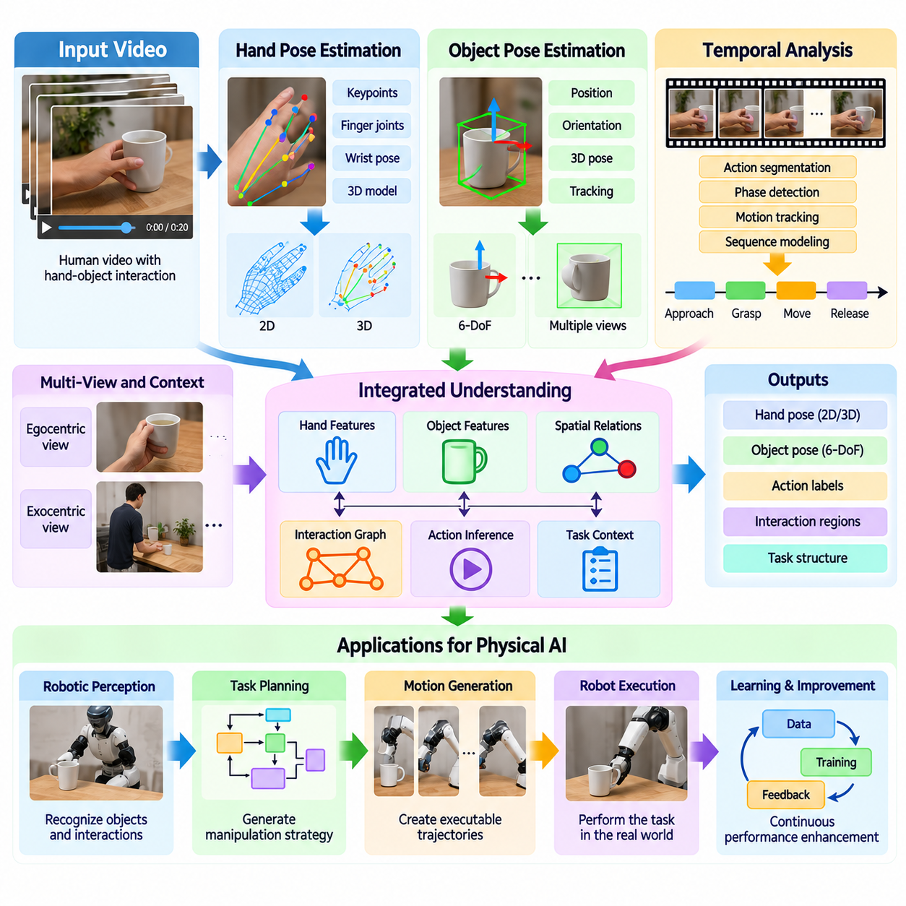
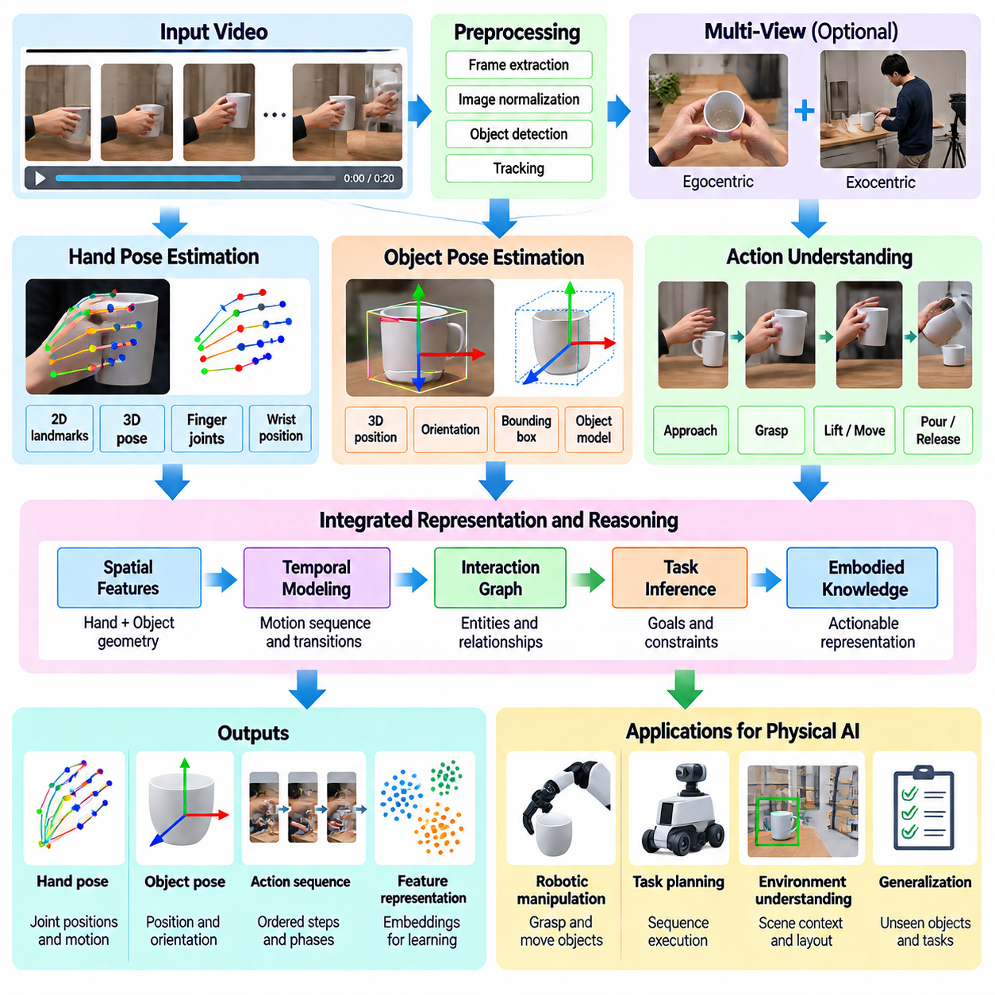
Hand pose estimation, object pose estimation, and action understanding are fundamental components of extracting embodied knowledge from human video for Physical AI. Together, they transform visual observations into structured information about human movement, object configuration, and physical interaction. These representations help learning systems understand not only what appears in a scene but also how actions change the physical environment.
Hand pose estimation identifies the spatial configuration of the human hand, including finger joints, wrist position, and overall articulation. Computer vision models typically represent the hand through anatomical landmarks or parameterized three-dimensional models. Tracking these configurations across video frames provides information about reaching, grasping, manipulation, and release, enabling the analysis of fine motor behavior.
Two-dimensional hand pose estimation predicts landmark positions within image coordinates, while three-dimensional estimation attempts to reconstruct the hand's spatial configuration. Three-dimensional representations are more useful for robotic manipulation because they describe joint geometry and relative finger positions. However, accurate depth recovery remains challenging when observations are limited to monocular video.
Hand pose estimation becomes particularly difficult during object manipulation because fingers frequently disappear behind grasped objects. Motion blur, lighting variation, camera perspective, and self-occlusion further reduce estimation reliability. Temporal models can improve consistency by combining observations across consecutive frames, although they cannot always recover information hidden throughout an interaction.
Object pose estimation determines the position and orientation of physical objects relative to a camera or reference coordinate system. For rigid objects, pose is commonly represented through three-dimensional translation and rotation, forming a six-degree-of-freedom configuration. Accurate object pose information supports tracking, grasp planning, spatial reasoning, and analysis of transformations caused by human actions.
Object pose estimation requires recognizing object geometry and establishing relationships between visible image features and three-dimensional structure. Model-based methods use known object shapes, while learning-based approaches estimate poses from visual examples. Unknown objects, reflective surfaces, textureless materials, and partial visibility create additional difficulties that require robust geometric and semantic representations.
The relationship between hand pose and object pose is especially important for understanding manipulation. A hand approaching an object may indicate preparation, while coordinated hand and object motion after contact suggests an active manipulation phase. Relative positions, orientations, and trajectories provide evidence about grasp formation, object transport, rotation, and release.
Contact estimation connects geometric observations with physical interaction. When fingertips approach an object's surface and the object subsequently moves, a model may infer contact and manipulation. However, visual proximity alone does not establish physical contact, and video rarely provides direct measurements of contact force. Reliable estimation therefore benefits from temporal reasoning, geometric constraints, and additional sensing when available.
Action understanding extends beyond pose estimation by interpreting the purpose and temporal structure of observed movements. A sequence of hand and object poses may correspond to opening, closing, lifting, pouring, assembling, or operating a tool. Recognizing these actions requires combining motion information with object identity, environmental context, and changes in physical state.
Temporal modeling is essential because individual frames rarely contain enough information to identify an action reliably. A stationary hand holding a container may represent preparation for pouring, completion of lifting, or a temporary pause. Observing movement before and after the frame helps distinguish these possibilities and supports the identification of meaningful action boundaries.
Human manipulation can be represented as a sequence of interaction phases, including approach, contact establishment, grasp stabilization, object movement, and release. These phases provide a useful structure for action segmentation and task understanding. Their boundaries may overlap or vary depending on the activity, requiring models to represent uncertainty rather than assuming rigid transitions.
Hand-object interaction models often combine visual features with geometric relationships between detected entities. Hand landmarks, object poses, relative distances, and motion vectors can be integrated into a shared representation. Graph-based models may describe hands and objects as connected entities, allowing learning systems to reason about changing contact relationships and coordinated manipulation.
Egocentric video provides detailed observations of nearby hand-object interactions from the operator's perspective. This viewpoint often captures manipulation targets and local motion clearly, but may obscure parts of the hand or object. Exocentric video offers broader information about body posture and workspace geometry. Combining perspectives can improve pose reconstruction and action interpretation.
Multi-view observations support three-dimensional estimation by reducing ambiguities associated with a single camera. Synchronized cameras can provide complementary views of fingers, objects, and contact regions. Geometric reconstruction depends on accurate camera calibration and temporal alignment. Without these conditions, combining observations may introduce inconsistent pose estimates rather than improving accuracy.
Pose estimation errors can propagate into action understanding systems. Incorrect finger positions may suggest an impossible grasp, while inaccurate object orientation may distort the inferred manipulation direction. Robust learning pipelines should therefore incorporate confidence estimates, temporal consistency checks, and mechanisms for handling missing or unreliable observations.
Action understanding also requires distinguishing visually similar movements that have different purposes. Rotating a cylindrical object may represent opening a container, adjusting a control, or inspecting a component. Object identity, task context, and resulting state changes help resolve these ambiguities. Semantic reasoning complements geometric tracking by connecting movement patterns with intended outcomes.
Learning object-centered action representations can improve transfer from human demonstrations to robotic systems. Instead of reproducing exact human finger trajectories, a robot can learn the desired object displacement, orientation change, and contact constraints. This abstraction is particularly important when robotic grippers differ substantially from human hands in geometry, dexterity, and available degrees of freedom.
Hand pose and object pose information can also support the discovery of manipulation affordances. Repeated observations of successful interactions reveal common contact regions, approach directions, and object transformations. Models can associate these patterns with object geometry and task context, helping robots identify feasible manipulation strategies for unfamiliar objects.
Weakly supervised and self-supervised learning methods reduce dependence on manually annotated pose and action datasets. Models may learn temporal correspondences, predict future object configurations, or align visual sequences with language descriptions. Nevertheless, high-quality labeled examples remain valuable for calibration, evaluation, and correcting systematic errors in inferred interaction representations.
Data annotation for hand-object interaction requires consistent definitions of landmarks, coordinate systems, contact states, and action categories. Ambiguous labels can produce incompatible training targets across datasets. Clear annotation protocols and quality checks improve reproducibility, while confidence scores help distinguish directly observed information from model-generated estimates.
A scalable Physical AI data engine can process human videos into synchronized sequences of hand poses, object poses, interaction events, and semantic action labels. These structured records enable efficient searching, filtering, and training. Integrating them with robot demonstrations and simulation data creates a pathway from human visual experience to robot-compatible learning representations.
Evaluation should consider both geometric accuracy and downstream task usefulness. Hand landmark error, object translation and rotation error, contact detection performance, and action recognition accuracy measure different aspects of the system. Ultimately, robot transfer experiments are necessary to determine whether improved video understanding produces more reliable physical manipulation.
Hand pose estimation, object pose estimation, and action understanding together establish a bridge between raw human video and structured embodied intelligence. By connecting geometric configurations, temporal interaction patterns, and semantic task objectives, Physical AI systems can extract knowledge relevant to robotic planning and control. Their integration is essential for transforming human demonstrations into scalable learning resources for adaptable robots.

03.06. Action Segmentation and Temporal Structure
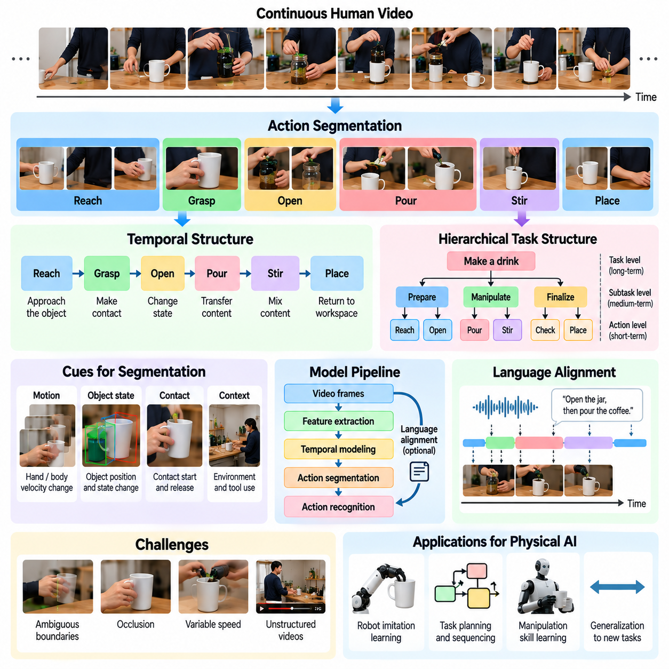
Action segmentation and temporal structure are essential for transforming continuous human video into meaningful representations of physical behavior. Human activities consist of interconnected movements, interactions, and intermediate goals rather than isolated actions. By identifying action boundaries and temporal relationships, Physical AI systems can convert unstructured recordings into organized knowledge suitable for task understanding, planning, and robotic learning.
Action segmentation divides a continuous video sequence into intervals corresponding to meaningful activities. A person preparing a beverage may reach for a container, grasp it, open it, pour liquid, and return it to the workspace. Each interval represents a distinct action with its own physical objective. Accurate segmentation allows learning systems to distinguish individual operations while preserving their relationships within the complete task.
Temporal structure describes how actions are ordered, connected, repeated, or performed concurrently. Many physical tasks require specific sequences because later operations depend on earlier changes in object states. For example, a component must be positioned before fastening, and a container must be opened before filling. Understanding these dependencies enables models to recognize valid procedures and anticipate subsequent actions.
Human activities naturally exhibit hierarchical organization across multiple temporal scales. Short movements such as finger adjustments occur within manipulation actions, which themselves form subtasks within larger procedures. A furniture assembly task may contain preparation, alignment, fastening, and verification stages. Hierarchical representations allow Physical AI models to connect low-level movements with high-level objectives.
Action boundaries are often ambiguous because human behavior is continuous rather than strictly divided into discrete events. Reaching may gradually transition into grasping, while object manipulation may overlap with repositioning. Different observers may assign slightly different boundaries to the same activity. Effective segmentation systems must therefore accommodate uncertainty and avoid assuming that every transition is instantaneous.
Visual motion provides an important signal for identifying temporal boundaries. Changes in hand velocity, body posture, object displacement, or interaction intensity may indicate the beginning or completion of an action. However, motion alone is insufficient because meaningful transitions can occur without large movements. Combining kinematic cues with object states and interaction context improves segmentation reliability.
Contact events offer additional evidence about action transitions. The establishment of hand-object contact may indicate the beginning of manipulation, while release may mark completion. Changes in contact configuration can distinguish grasping, pushing, sliding, and tool operation. Because contact is difficult to observe directly in ordinary video, models often infer these events from geometric relationships and temporal changes.
Temporal action recognition assigns semantic categories to observed intervals, such as reaching, lifting, rotating, pouring, or assembling. Unlike frame-level classification, segment-level recognition considers the progression of motion and its physical consequences. This distinction is important because similar hand configurations may correspond to different actions depending on preceding movements and subsequent object transformations.
Temporal modeling architectures capture dependencies across video frames and action intervals. Recurrent neural networks, temporal convolutional networks, and transformer-based models provide mechanisms for integrating observations over time. Attention mechanisms can emphasize informative frames and long-range relationships. Model selection depends on sequence length, computational constraints, annotation availability, and the required temporal resolution.
Long-duration instructional videos introduce additional challenges because important events may be separated by extended periods of preparation or inactivity. A task may also contain repeated operations, interruptions, and corrective movements. Models must preserve relevant historical context without treating every frame as equally important. Hierarchical temporal encoding and selective attention can improve efficiency and maintain meaningful task information.
Weakly supervised action segmentation addresses situations where videos have task descriptions or ordered action labels but lack precise temporal boundaries. Learning systems estimate where individual activities occur by combining visual evidence with approximate supervision. This reduces manual annotation requirements, although incorrect assumptions about action order or duration can introduce systematic segmentation errors.
Self-supervised temporal learning can discover meaningful representations without relying entirely on labeled action sequences. Models may predict future visual features, identify shuffled frame orders, or learn consistency between nearby observations. These objectives encourage recognition of temporal continuity and state transitions. However, useful temporal representations do not automatically guarantee accurate semantic action boundaries.
Language provides complementary information about temporal organization. Narration, subtitles, and procedural instructions may identify important actions and explain their relationships. Aligning language with video helps associate visual intervals with semantic descriptions. Nevertheless, spoken explanations may precede, follow, or omit visible actions, requiring flexible alignment rather than assuming exact synchronization.
Action segmentation also supports the discovery of reusable robotic skills. Repeated action intervals can reveal common manipulation patterns that appear across different tasks and environments. These patterns may form candidates for parameterized skills or hierarchical control options. Their robotic usefulness depends on whether the associated goals, preconditions, and termination conditions can be expressed in executable form.
Temporal reasoning is closely connected to predicting future object states and task outcomes. After observing a person align two components, a model may predict fastening as a likely next operation. Such predictions support anticipatory planning and task monitoring. However, statistical action sequences must be distinguished from necessary physical dependencies because humans can complete tasks through alternative procedures.
Errors in action segmentation can affect downstream learning by combining unrelated behaviors or dividing meaningful operations into incomplete fragments. Incorrect boundaries may obscure cause-and-effect relationships between actions and object changes. Confidence estimation, boundary refinement, and consistency checks can improve dataset quality. Human review remains valuable for ambiguous or safety-critical procedures.
Evaluation of temporal segmentation requires more than measuring frame-level classification accuracy. Segmental edit distance, boundary accuracy, and overlap-based measures can assess whether predicted action sequences match reference annotations. Different metrics emphasize different errors, including missed actions, fragmented segments, and incorrect ordering. Evaluation should reflect the intended robotic learning application.
For robotic imitation learning, segmented human video can provide a structured description of task progression even when direct control commands are unavailable. Each segment may be associated with an object-centered goal, relevant constraints, and expected state changes. Robot demonstrations or simulation can subsequently supply executable trajectories. This separation helps bridge human visual behavior and robot-specific control.
Temporal structure is also important for detecting deviations during robotic execution. A robot performing an assembly procedure can compare observed progress against expected action stages and object-state transitions. Missing steps, unexpected repetitions, or incorrect intermediate states may indicate execution problems. Such monitoring can support recovery planning, although reliable intervention requires additional physical feedback.
A scalable Physical AI data engine can automatically extract action intervals, temporal labels, task hierarchies, and interaction transitions from large video collections. These records support indexing, retrieval, filtering, and construction of structured training datasets. Consistent timestamp conventions and annotation schemas are necessary to integrate information across cameras, datasets, and robot platforms.
Temporal data quality depends on recording continuity, frame timing, and the visibility of relevant interactions. Edited videos may omit intermediate actions, while variable frame rates and dropped frames can distort estimated durations. Synchronization errors between video, audio, and sensor streams further complicate analysis. Data pipelines should preserve timing metadata and explicitly represent uncertain or missing intervals.
Cross-task learning benefits from recognizing temporal patterns shared across different activities. Preparation, approach, contact, manipulation, verification, and completion may recur in many physical procedures. Learning these patterns can support transfer to unfamiliar tasks while allowing variations in action duration and ordering. The objective is to capture meaningful structure without imposing an unnecessarily rigid procedural template.
Action segmentation and temporal structure ultimately provide the organizational foundation for learning from human video at scale. They connect continuous visual observations with discrete actions, hierarchical task representations, and causal relationships between physical events. When integrated with object understanding, language grounding, and robot-specific experience, temporal modeling helps transform human demonstrations into reusable knowledge for adaptable Physical AI systems.

03.07. Learning Affordances from Human Video
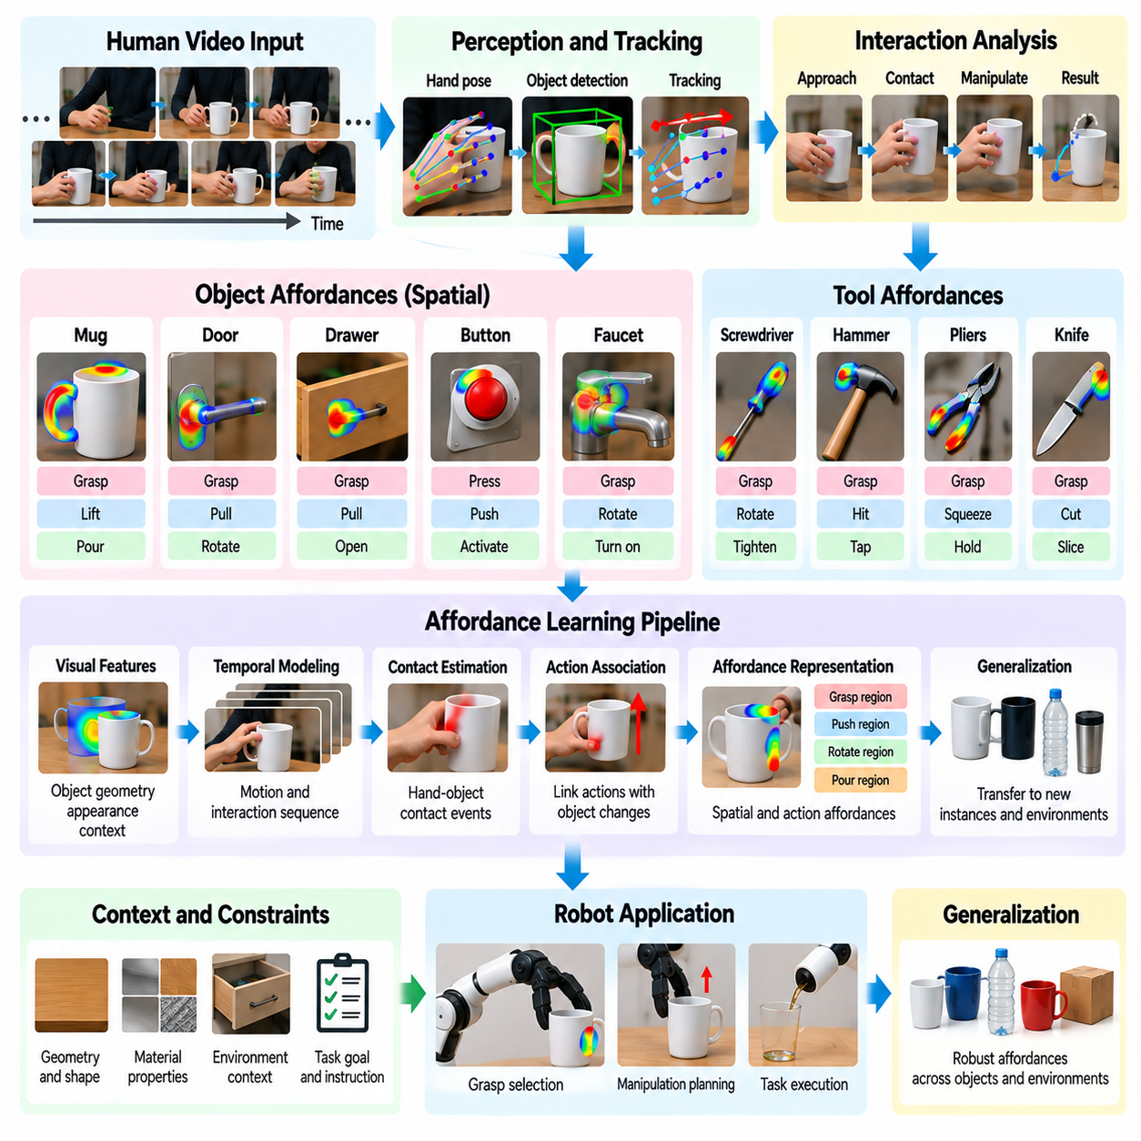
Affordance learning from human video enables Physical AI systems to understand how objects can be used to accomplish physical goals. An affordance represents an action opportunity arising from relationships among an agent, an object, and its environment. Human demonstrations reveal these opportunities through grasping, pushing, pulling, rotating, and tool use, providing behavioral evidence that extends beyond visual object recognition.
Unlike conventional object classification, affordance learning focuses on what actions are possible and under which conditions they can succeed. A handle may support grasping and pulling, while a flat surface may enable pushing or supporting another object. These possibilities depend on geometry, material properties, task objectives, and agent capabilities, making affordances inherently relational and context dependent.
Human video provides indirect supervision for affordance discovery because people naturally select functional regions when interacting with objects. Repeated observations of hands approaching handles, buttons, and movable components reveal likely interaction locations. By connecting contact patterns with resulting object changes, learning models can identify actionable regions without requiring exhaustive manual affordance annotations.
Visual affordance learning commonly combines object detection, segmentation, hand tracking, and temporal interaction analysis. Object segmentation identifies candidate surfaces, while hand trajectories reveal approach directions and potential contact points. Observed state changes provide evidence about interaction outcomes. Integrating these signals produces representations that connect visual appearance with possible physical operations.
Spatial affordances describe where interaction can occur, while action affordances characterize what operations an object supports. A door handle may provide a graspable region, but opening the door also requires appropriate pulling or rotation. Separating these dimensions helps learning systems distinguish contact feasibility from task completion, supporting more precise manipulation planning.
Affordance inference becomes more informative when human actions are observed over time rather than in isolated frames. A hand approaching a drawer handle suggests a possible grasp, but subsequent drawer movement provides stronger evidence of pulling functionality. Temporal observations connect candidate interaction regions with physical consequences, helping models distinguish genuine affordances from incidental proximity.
Contact estimation plays a central role in identifying affordances from video. Hand-object proximity, relative motion, and object displacement can indicate when meaningful interaction occurs. However, visual contact estimates remain uncertain because depth ambiguity and occlusion may conceal actual contact. Robust systems combine geometric reasoning with temporal consistency and confidence estimates.
Object geometry strongly influences available affordances. Cylindrical handles, flat panels, hinges, and articulated joints constrain how humans can interact with objects. Learning systems can associate recurring geometric patterns with observed actions, supporting generalization to unfamiliar objects. Nevertheless, visually similar objects may have different mechanical properties and operational constraints.
Material properties also determine whether an apparent affordance is physically feasible. A fragile handle may not tolerate substantial pulling force, while a slippery surface may prevent stable grasping. Such properties are often difficult to infer directly from video. Observed successes, failures, and corrective actions provide indirect evidence, but reliable robotic execution may require additional sensing.
Tool affordances extend beyond direct hand-object interaction because tools introduce functional relationships among multiple entities. A screwdriver enables rotational engagement with a fastener, while pliers support gripping and force transmission. Understanding tool affordances requires identifying grasp regions, working interfaces, target objects, and the transformations produced through coordinated manipulation.
Task context determines which affordances are relevant at a particular moment. A container may be grasped for transport, tilted for pouring, or stabilized during assembly. Although its geometry remains unchanged, the intended objective alters the preferred interaction strategy. Context-aware models therefore combine object features with task instructions, environmental conditions, and expected outcomes.
Affordance representations may be expressed as spatial heatmaps, interaction points, action categories, or object-centered transformations. Heatmaps identify promising contact regions, while transformation-based representations describe desired changes in object state. These alternatives support different robotic applications, ranging from grasp selection to long-horizon manipulation planning.
Learning affordances from diverse human demonstrations can improve generalization across object instances and environments. Multiple examples reveal which interaction patterns remain effective despite changes in size, shape, orientation, or workspace configuration. Models can learn shared functional characteristics while avoiding excessive dependence on particular object appearances or individual human movement styles.
Weakly supervised learning is valuable because most human videos lack explicit affordance labels. Action descriptions, object categories, and estimated contact events can provide approximate supervision. Models may discover functional regions by predicting interaction outcomes or associating repeated hand-object relationships. However, noisy labels and ambiguous interactions can introduce systematic errors.
Self-supervised video learning offers another mechanism for acquiring affordance-related representations. Predicting future object states, identifying interaction-induced changes, or comparing successful and unsuccessful sequences can encourage models to capture action-relevant features. Such objectives provide useful learning signals without requiring every affordance to be manually specified.
Negative examples are particularly important because observed interaction does not always imply successful functionality. A failed attempt to pull a locked drawer may indicate a mechanical constraint rather than an incorrect grasp location. Distinguishing unavailable actions, unsuitable contact strategies, and temporary environmental restrictions helps prevent models from learning misleading affordance relationships.
Affordance learning must also account for differences between human and robot embodiments. Human fingers can exploit narrow contact regions and complex grips that may be inaccessible to robotic grippers. An affordance demonstrated by a person is therefore not automatically executable by a robot. Transfer requires evaluating reachability, end-effector geometry, force limits, and control capabilities.
Object-centered affordance representations help bridge this embodiment gap by emphasizing interaction goals rather than exact human motions. Instead of reproducing a human hand trajectory, a robot may identify the appropriate contact region and desired object transformation. Robot-specific planning can then determine feasible grasp configurations and trajectories while respecting physical constraints.
Language grounding can connect affordance knowledge with task instructions. Expressions such as grasp the handle, rotate the knob, or press the switch identify relationships between objects and intended actions. Aligning these descriptions with human video enables models to associate linguistic goals with interaction regions and outcomes, supporting instruction-conditioned robotic manipulation.
A scalable Physical AI data engine can extract affordance candidates from large human video collections using object tracking, hand pose estimation, contact inference, and action recognition. Structured records may include object identities, functional regions, interaction types, confidence values, and observed outcomes. These records enable targeted retrieval and training for specific robotic manipulation capabilities.
Evaluation should distinguish affordance recognition from successful physical execution. A model may correctly identify a graspable region but fail because of unsuitable approach geometry or insufficient grip force. Relevant measures include contact localization accuracy, action feasibility prediction, object-state transformation success, and generalization across unfamiliar objects and environments.
Human video affordance learning ultimately connects visual experience with actionable physical knowledge. By observing how people select contact regions, exploit object functionality, and adapt interactions to changing conditions, Physical AI systems can develop transferable representations of possible actions. Combining these representations with robot-specific sensing, planning, and feedback is essential for reliable manipulation in real environments.

03.08. Learning Task Structure and Dynamics
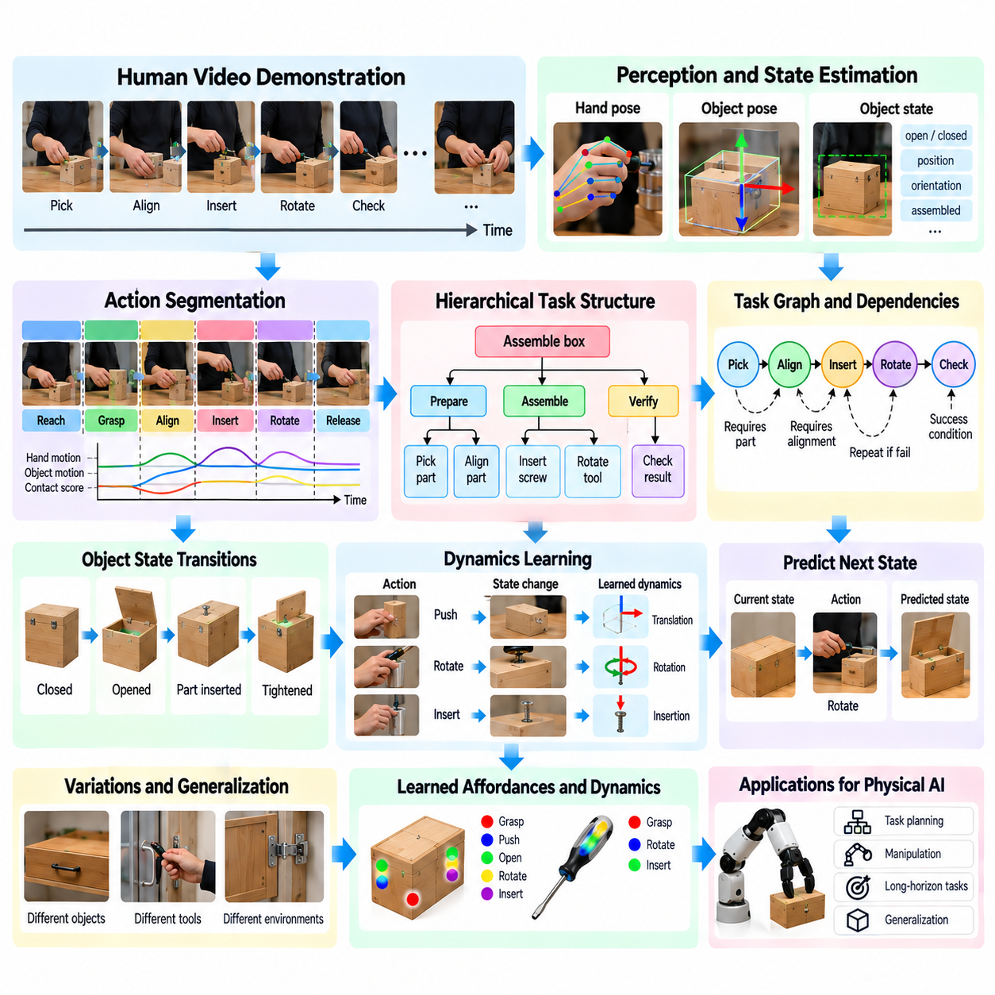
Learning task structure and dynamics from human video enables Physical AI systems to understand how complex activities are organized and how actions transform the physical environment. Task structure describes relationships among goals, subtasks, and dependencies, while dynamics describe how object states evolve through interaction. Combining these perspectives supports planning, prediction, and adaptation beyond simple action recognition.
Human demonstrations provide valuable evidence about the organization of goal-directed behavior. A person assembling equipment may prepare components, align parts, insert fasteners, and verify the result. These activities form a sequence of intermediate objectives connected to a final goal. By observing repeated demonstrations, learning systems can identify recurring task patterns and distinguish essential operations from optional movements.
Task representations can be organized hierarchically, connecting high-level objectives with increasingly detailed actions. A cleaning task may contain preparation, surface treatment, inspection, and completion stages, each consisting of smaller operations. Hierarchical learning allows models to reason across different temporal scales and supports the decomposition of complex instructions into manageable robotic skills.
Task dependencies specify which conditions must be satisfied before an action can be executed successfully. A component may require alignment before insertion, while a container must be opened before its contents can be removed. Learning these relationships from video helps models infer action preconditions and expected effects. Such knowledge supports valid task sequencing and reduces planning errors.
Physical dynamics describe how objects and environments respond to actions over time. Pushing changes an object's position, rotation changes its orientation, and tool operation may alter mechanical configurations. Human video captures these transitions indirectly through visual observations. Learning systems can use temporal changes to estimate relationships between actions, object properties, and resulting physical states.
Object-centric representations are particularly useful because they describe task progress through changes in relevant objects rather than exact human movements. A robot may need to understand that a drawer should become open without reproducing a person's hand trajectory. Representing desired object states and transformations makes learned knowledge more transferable across different robot embodiments and manipulation mechanisms.
State estimation provides the foundation for learning task dynamics. Models must identify relevant objects, their positions, orientations, relationships, and operational conditions. Some states are visually observable, while others, such as internal mechanical engagement or applied force, remain hidden. Consequently, video-based systems must reason under partial observability and maintain uncertainty about unmeasured physical variables.
Temporal prediction connects observed states with likely future developments. After watching a person position a tool against a fastener, a model may predict rotation and subsequent tightening. Predictive learning encourages representations that capture action consequences rather than isolated appearances. However, plausible visual predictions do not necessarily establish physically accurate models of force or contact dynamics.
Task structure can be represented using procedural graphs in which nodes describe actions or states and edges encode dependencies. Such graphs capture alternative execution paths, parallel operations, and conditional transitions. Unlike fixed action lists, graph-based representations accommodate different strategies for reaching the same goal and provide a foundation for flexible robotic task planning.
Learning task graphs from human video requires identifying meaningful state transitions and their relationships. Repeated observations can reveal that certain actions consistently precede others, suggesting potential dependencies. However, temporal ordering alone does not establish causality. Models must distinguish necessary physical prerequisites from habits, preferences, or incidental ordering in demonstrations.
Causal reasoning improves task understanding by connecting interventions with resulting changes. When a person releases a latch before opening a panel, the release may represent a necessary enabling action. Observing alternative demonstrations or failed attempts can strengthen this inference. Nevertheless, causal conclusions derived from passive video remain uncertain without interventions or additional physical evidence.
Human demonstrations also reveal variations in task execution. Different operators may use alternative tools, reverse independent steps, or select different manipulation strategies. Learning systems should identify which variations preserve task success and which violate essential constraints. This distinction enables flexible planning without reducing every task to a single memorized action sequence.
Task dynamics may involve contact, friction, gravity, deformation, and mechanical constraints that are not fully observable in video. A model can infer that an object resists movement, but it may not identify the underlying force accurately. Video-derived dynamics should therefore be treated as approximate predictive knowledge and refined using robotic interaction, simulation, or additional sensor measurements.
Latent dynamics models learn compact representations of physical state transitions from visual sequences. Rather than reconstructing every image pixel, these models can predict changes in object configuration and interaction relationships. Such abstractions may improve computational efficiency and planning relevance. Their usefulness depends on preserving the physical information required for downstream robotic decisions.
World models extend task dynamics learning by representing how an environment may evolve under different actions. A robot can use predicted state transitions to compare possible manipulation sequences before execution. Human video contributes examples of plausible physical changes, while robot-specific data provides information about executable controls and actual interaction constraints.
Long-horizon tasks require models to maintain context across many intermediate actions. Early preparation steps may determine whether later operations can succeed, even when separated by substantial time. Hierarchical memory and state tracking help preserve these dependencies. Effective representations focus on persistent task-relevant changes rather than retaining every visual detail from the recording.
Language descriptions can strengthen task structure learning by identifying goals, prerequisites, and intended outcomes. Instructional narration may explain why a component must be aligned before fastening or why a surface requires preparation. Aligning these explanations with observed state changes supports semantic task representations, although narration may omit steps or describe operations imprecisely.
Weakly supervised learning can extract task organization from videos containing only broad activity labels or procedural descriptions. Models may discover recurring subtasks by clustering interaction patterns and detecting object-state transitions. Self-supervised prediction provides complementary signals. However, automatically discovered structures require validation because visual similarity does not always imply functional equivalence.
Failures and recovery behaviors provide important information about task dynamics and constraints. A misaligned component may prevent insertion, prompting an operator to reposition it before continuing. Such examples reveal conditions associated with unsuccessful transitions. Learning from both successful and failed demonstrations can improve state prediction, error detection, and recovery planning.
Transferring learned task knowledge to robots requires mapping human-observed goals into feasible robot actions. Task graphs may specify desired state changes, while motion planners and controllers determine executable trajectories. Differences in reachability, dexterity, payload, and sensing must be considered. This separation allows task-level knowledge to remain useful across multiple robotic platforms.
A scalable Physical AI data engine can organize human videos into structured records containing task goals, subtask boundaries, object states, dependencies, and observed transitions. These records support retrieval, training, and evaluation across large demonstration collections. Combining them with robot trajectories and simulation data helps connect abstract task knowledge with measurable physical execution.
Evaluation should measure whether learned task structures and dynamics improve actual robotic performance. Relevant criteria include dependency prediction, state-transition accuracy, planning success, recovery effectiveness, and generalization to unfamiliar environments. Controlled robot experiments are particularly important because accurate video prediction alone does not guarantee successful physical interaction.
Learning task structure and dynamics transforms human video from passive visual information into organized knowledge about goals, dependencies, and physical consequences. By integrating hierarchical task representations, object-centered state models, and predictive dynamics, Physical AI systems can develop more adaptable planning capabilities. Robot-specific feedback and execution experience remain essential for converting this knowledge into reliable autonomous behavior.

03.09. Human to Robot Retargeting
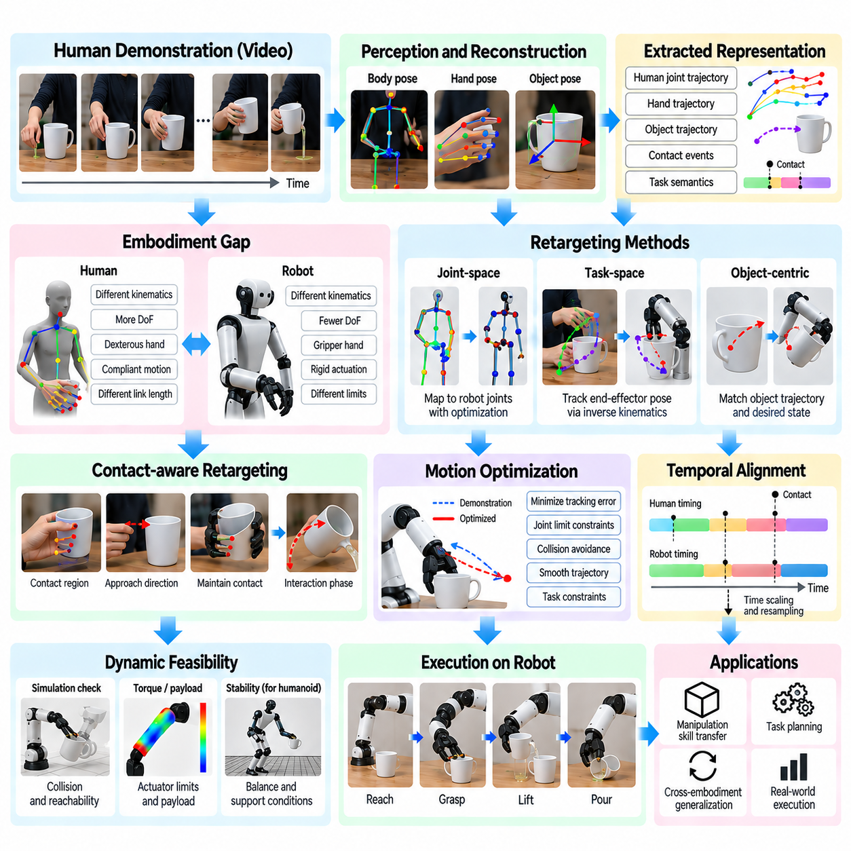
Human-to-robot retargeting transforms human demonstrations into representations that robots can execute despite differences in anatomy, kinematics, and control capabilities. Human video provides rich examples of purposeful movement, but directly copying human joint trajectories is rarely feasible. Retargeting therefore seeks to preserve task intent, interaction geometry, and physical outcomes while adapting motions to the constraints of a target robot.
The central challenge arises from embodiment differences between humans and robotic systems. Human arms possess complex shoulder mobility, compliant joints, and highly dexterous hands, while robots may have fewer degrees of freedom or different joint arrangements. Even when a robot resembles a human, differences in link lengths, joint limits, and actuation prevent direct motion transfer. Successful retargeting requires explicit correspondence between functional capabilities.
Human motion reconstruction is commonly the first stage of a retargeting pipeline. Computer vision models estimate body pose, hand pose, and movement trajectories from monocular or multiview video. These estimates provide approximate three-dimensional descriptions of demonstrated actions. However, depth ambiguity, occlusion, camera calibration errors, and rapid movements introduce uncertainty that must be considered before robotic execution.
Coordinate transformation establishes a common geometric reference between observed human movements and the robot workspace. Human poses estimated in camera coordinates must be related to object frames, environmental landmarks, and robot base coordinates. Accurate calibration is especially important for contact-rich manipulation. Small spatial errors may cause missed grasps, collisions, or incorrect tool alignment during execution.
Joint-space retargeting attempts to map human joint configurations into corresponding robot joint angles. This approach can preserve recognizable movement patterns when human and robot structures are sufficiently similar. However, direct joint correspondence becomes unreliable when kinematic chains differ. Optimization methods are therefore used to satisfy joint limits, maintain feasible configurations, and minimize deviations from important motion features.
Task-space retargeting emphasizes the position and orientation of relevant body parts or end effectors rather than exact joint configurations. A robot may reproduce the movement of a human wrist while using a different elbow posture. Inverse kinematics converts desired end-effector poses into feasible robot joint states. This approach supports broader embodiment transfer, although task-space targets must remain reachable and collision free.
Object-centric retargeting focuses on the intended transformation of manipulated objects. When a person opens a drawer, the essential objective is to move the drawer along its permitted direction rather than duplicate the person's arm motion. Representing object trajectories, contact regions, and desired final states allows robots with different manipulators to accomplish equivalent tasks through distinct movement strategies.
Contact-aware retargeting preserves relationships between the human hand, manipulated objects, and surrounding surfaces. Contact locations, approach directions, and interaction phases determine whether a motion can produce the intended effect. A grasping demonstration may require maintaining contact stability during lifting, while a pushing action requires appropriate force direction. Ignoring these relationships can produce visually similar but physically ineffective robot motions.
Human hand retargeting is particularly difficult because robotic grippers rarely reproduce the full dexterity of biological hands. Human demonstrations may involve fingertip precision, palm contact, coordinated finger motion, and continuous grip adjustment. Retargeting systems must translate these patterns into feasible grasp types supported by the robot. Functional grasp equivalence is often more important than anatomical similarity.
Motion optimization provides a mathematical framework for balancing competing retargeting objectives. An optimization problem may minimize end-effector tracking error, joint displacement, collision risk, and deviation from demonstrated object motion. Constraints enforce joint limits, workspace boundaries, and contact requirements. Objective weights determine which aspects of human behavior receive priority during robot motion generation.
Temporal alignment is necessary because human and robot movements may occur at different speeds. A robot with limited acceleration or slower actuators cannot always reproduce human timing. Time scaling and trajectory resampling adapt motion duration while preserving important action phases. Contact events and object-state transitions should remain correctly ordered, even when the overall execution speed changes.
Trajectory smoothing reduces abrupt changes introduced by noisy pose estimates or discontinuous optimization solutions. Filtering, spline interpolation, and constrained trajectory generation can improve motion continuity. However, excessive smoothing may remove intentional pauses or sharp transitions associated with contact. Effective retargeting preserves task-relevant motion structure while satisfying robot velocity, acceleration, and jerk constraints.
Dynamic feasibility extends retargeting beyond geometric motion matching. A kinematically reachable trajectory may still exceed actuator torque, payload, or balance limits. Humanoid and mobile manipulation systems must also consider stability and support conditions. Dynamic models and simulation can identify infeasible motions before execution, reducing the risk of mechanical overload or loss of balance.
Force and compliance are important when retargeting contact-rich tasks. Human operators naturally adjust applied force through tactile perception and muscular compliance, but ordinary video does not directly measure these quantities. Robot controllers must infer suitable interaction strategies and regulate contact through force sensing or compliant control. Pure position tracking may be unsafe when environmental stiffness or contact conditions are uncertain.
Retargeting from video often relies on estimated human motion rather than measured ground-truth trajectories. Errors in pose reconstruction can propagate into robot planning and execution. Confidence-aware optimization can reduce reliance on uncertain observations, while object tracking provides additional geometric constraints. Multiple demonstrations may help distinguish consistent task requirements from accidental human movements.
Learning-based retargeting can complement analytical kinematic methods by discovering correspondences from demonstration datasets. Neural models may predict robot end-effector targets, grasp configurations, or latent action representations from human observations. Training with robot interaction data improves embodiment compatibility. Nevertheless, learned mappings require validation because visually plausible predictions may violate physical constraints.
Simulation provides a controlled environment for testing retargeted behaviors before deployment. Candidate trajectories can be evaluated for reachability, collisions, contact stability, and task completion. Domain randomization exposes the system to variations in object geometry, friction, and positioning. Simulation results remain approximate, so successful virtual execution should be followed by cautious real-world validation.
Robot feedback enables iterative correction of retargeted actions. Visual servoing can compensate for object localization errors, while tactile and force feedback support grasp stabilization and contact adjustment. Closed-loop execution is particularly valuable when the environment differs from the original demonstration. Rather than replaying a fixed trajectory, the robot continuously adapts its actions to observed task progress.
Task-level retargeting separates what must be achieved from how the robot accomplishes it. A human demonstration may be converted into goals such as grasp the handle, open the cabinet, and place an object inside. A robot planner then selects feasible motions for its own embodiment. This abstraction supports transfer across manipulators, humanoids, and mobile robots without requiring identical physical structures.
Language and semantic task representations can improve retargeting by identifying the functional purpose of demonstrated movements. Instructions clarify whether a hand motion is intended to rotate, stabilize, transport, or inspect an object. Combining language grounding with object-state prediction helps prioritize meaningful transformations over incidental gestures. This is especially useful when human demonstrations contain unnecessary or ambiguous movements.
A scalable Physical AI data engine can convert human video collections into structured retargeting records. These records may contain estimated body poses, hand trajectories, object coordinate frames, contact events, task goals, and confidence measurements. Robot-specific processing can then generate feasible trajectories or policy training targets. Maintaining provenance and uncertainty metadata supports reproducibility and systematic quality control.
Evaluation should measure both motion correspondence and physical task success. Useful metrics include end-effector tracking error, object-state accuracy, collision frequency, constraint violations, execution stability, and completion rate. Cross-embodiment evaluation determines whether the same demonstration supports different robot platforms. Real-world experiments are essential because geometric similarity alone cannot establish reliable manipulation performance.
Human-to-robot retargeting provides a critical connection between abundant human video data and executable robotic behavior. By combining motion reconstruction, geometric correspondence, object-centered goals, constrained optimization, and feedback control, Physical AI systems can translate human experience into robot-compatible actions. Reliable transfer depends on preserving functional intent while respecting the target robot's physical capabilities and environmental constraints.

03.10. Cross Embodiment Correspondence
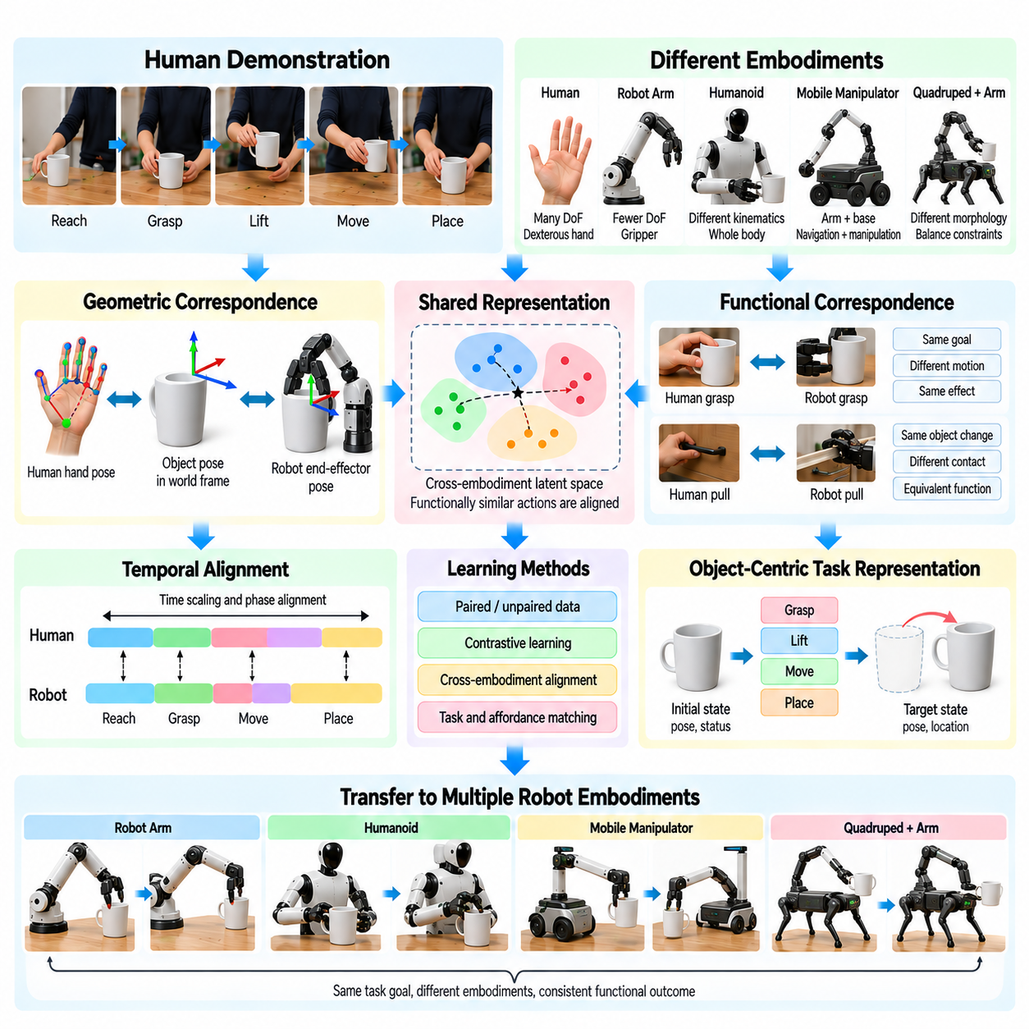
Cross-embodiment correspondence enables Physical AI systems to transfer knowledge between agents with different bodies, sensors, and control mechanisms. Human demonstrations contain valuable information about goals and interactions, but human movements cannot always be reproduced by robots. Correspondence learning identifies shared functional relationships that remain meaningful across different embodiments, allowing knowledge transfer without requiring identical physical structures.
Embodiment differences arise from variations in joint configurations, limb dimensions, degrees of freedom, actuator capabilities, and sensing arrangements. A human hand can manipulate objects through coordinated finger movements, while a parallel-jaw gripper provides more limited contact patterns. Even robots performing identical tasks may require different trajectories. Effective correspondence must therefore distinguish task-relevant behavior from embodiment-specific motion.
Geometric correspondence establishes relationships among body parts, end effectors, objects, and workspace coordinates. Human wrist trajectories may be associated with robotic gripper poses, while observed object positions provide common spatial references. Coordinate transformations and calibration enable consistent comparison. However, geometric alignment alone cannot guarantee that corresponding motions produce equivalent physical outcomes.
Functional correspondence focuses on what an action accomplishes rather than how the movement appears. A person may open a cabinet using a hand, while a robot uses a specialized gripper or mechanical tool. Although their joint motions differ, both actions achieve the same object-state transition. Representing interactions through goals, constraints, and outcomes provides a more transferable basis for cross-embodiment learning.
Object-centric representations offer a common interface between human and robotic behavior. Instead of encoding only joint angles, models describe object poses, contact regions, relative transformations, and desired final configurations. These variables often remain meaningful across different agents. Robot-specific controllers can then translate shared object-level objectives into feasible motions that satisfy each platform's physical constraints.
Action correspondence may be defined at multiple levels of abstraction. Low-level correspondence relates joint movements or end-effector trajectories, while higher-level correspondence connects grasping, pushing, lifting, and assembly operations. Task-level correspondence captures intended outcomes and procedural dependencies. Combining these levels allows systems to preserve useful details without assuming that every human movement has a direct robotic equivalent.
Contact relationships are especially important because manipulation depends on how forces are transmitted between agents and objects. A human may stabilize a component using several fingers, whereas a robot may employ a fixture or second manipulator. The physical contact configuration differs, but the functional requirement remains similar. Correspondence learning must preserve interaction effects rather than merely matching contact locations.
Affordance correspondence identifies action opportunities that are shared or transformed across embodiments. A handle graspable by a human may be inaccessible to a large robotic gripper, even though opening the associated door remains possible through another mechanism. Models must distinguish object functionality from agent-specific action feasibility. This distinction supports adaptive planning and prevents invalid transfers.
Human video provides observational evidence about functional actions, but it rarely contains complete measurements of forces, joint torques, or contact mechanics. Visual pose estimation can recover approximate movement geometry, while object tracking reveals state changes. Hidden physical variables remain uncertain. Cross-embodiment models therefore benefit from combining video-derived representations with robotic sensing and interaction data.
Learning a shared latent representation is one approach to correspondence discovery. Encoders transform human observations and robot trajectories into a common feature space where functionally similar actions are represented nearby. Contrastive learning can encourage alignment between corresponding demonstrations. However, shared embeddings must preserve task-relevant distinctions and avoid collapsing physically different actions into misleading similarities.
Paired demonstrations provide strong supervision when humans and robots perform equivalent tasks in comparable environments. Models can align object-state transitions, interaction phases, and successful outcomes across the two domains. Collecting such pairs is expensive, especially for diverse robot platforms. Weakly paired or unpaired learning methods attempt to exploit broader datasets while reducing direct correspondence requirements.
Temporal alignment is necessary because equivalent actions may have different durations and execution sequences. Humans can perform rapid coordinated movements, while robots may require slower approaches or additional stabilization steps. Dynamic time warping and learned sequence alignment can associate corresponding interaction phases. Alignment should emphasize meaningful state transitions rather than enforcing identical timing.
Cross-embodiment correspondence also depends on morphological differences between robotic platforms. A humanoid may reproduce human reaching patterns, while a mobile manipulator must coordinate navigation and arm motion. A quadruped with an attached arm introduces different balance and workspace constraints. Shared task representations can support these systems, but motion generation must remain specific to each morphology.
Kinematic feasibility determines whether a proposed correspondence can be executed within joint and workspace limits. Inverse kinematics and constrained optimization can map shared end-effector objectives into robot-specific configurations. Collision avoidance and singularity handling further restrict feasible solutions. Correspondence models should represent these limitations explicitly instead of assuming that visually similar actions are universally executable.
Dynamic feasibility introduces actuator torque, payload, inertia, balance, and contact stability into correspondence evaluation. A motion that is geometrically possible may still exceed a robot's physical capabilities. Human demonstrations may also exploit compliance or rapid force adjustments unavailable to the target platform. Dynamic models and simulation help determine whether transferred behaviors can be executed safely and effectively.
Language provides an additional bridge between different embodiments by describing actions through their functional meaning. Instructions such as open the drawer or place the component into the fixture can apply to humans and robots despite different movement strategies. Language-grounded representations connect task goals with visual observations and robot actions. Their reliability depends on resolving ambiguous instructions through environmental context.
Task graphs and hierarchical policies can express correspondence at the level of reusable skills. A shared task graph specifies required object-state transitions and dependencies, while platform-specific policies implement individual operations. This separation allows different robots to achieve equivalent objectives through distinct control strategies. It also supports recovery when a preferred action is infeasible for a particular embodiment.
Simulation environments provide opportunities to evaluate correspondence across multiple robotic bodies without repeatedly collecting real-world demonstrations. The same task can be executed using different manipulators, grippers, and mobile bases. Comparing successful trajectories reveals shared functional patterns and embodiment-specific constraints. Nevertheless, simulated contact and dynamics may differ from physical reality, requiring experimental validation.
Robot feedback is essential for refining correspondence after initial transfer. Vision systems can detect deviations in object pose, while tactile sensors and force measurements reveal contact conditions. Closed-loop controllers adjust execution when the transferred representation does not perfectly match the environment. Successful interaction data can subsequently improve correspondence models through iterative learning.
A scalable Physical AI data engine can organize cross-embodiment datasets around shared tasks, object states, action outcomes, and platform specifications. Human videos, teleoperation demonstrations, simulation trajectories, and autonomous robot experiences can be linked through common semantic identifiers. Metadata describing morphology, sensing, calibration, and execution success helps prevent inappropriate comparisons between incompatible platforms.
Evaluation should distinguish representational correspondence from practical transfer performance. Useful measures include object-state prediction accuracy, task completion rate, constraint violations, adaptation effort, and success on previously unseen embodiments. Testing across multiple robot morphologies reveals whether learned representations capture general functional knowledge or merely memorize platform-specific movement patterns.
Cross-embodiment correspondence ultimately provides a foundation for learning reusable physical skills from heterogeneous experience. By combining object-centered goals, functional action representations, temporal alignment, and robot-specific feasibility constraints, Physical AI systems can exploit human knowledge without directly imitating human anatomy. Reliable generalization requires continuous validation through physical interaction and feedback.

03.11. Language Grounded Human Video
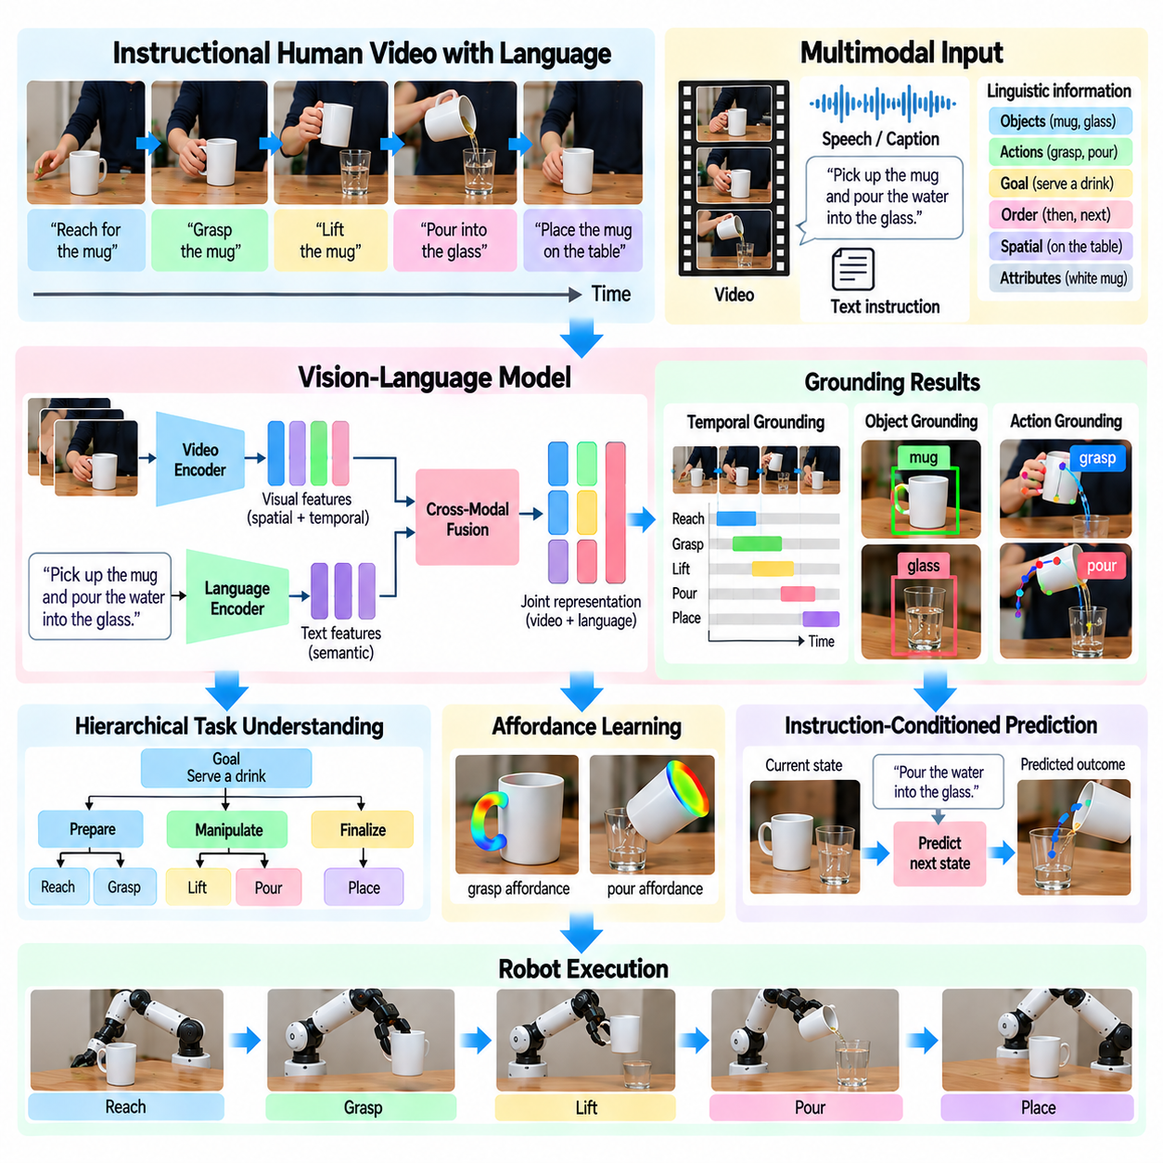
Language-grounded human video learning connects visual demonstrations with linguistic descriptions of actions, objects, goals, and physical relationships. Human videos reveal how tasks are performed, while language explains what participants intend to accomplish. Combining these modalities enables Physical AI systems to interpret demonstrations through semantic concepts and translate observed activities into representations suitable for instruction following and robotic planning.
Language grounding establishes correspondence between words and observable events in a video sequence. Expressions such as grasp the handle, rotate the knob, or place the component identify actions and their associated objects. Learning systems must determine which visual regions and temporal intervals correspond to these descriptions. Accurate grounding requires integrating object recognition, motion analysis, temporal reasoning, and contextual understanding.
Instructional videos provide particularly valuable training data because they often contain narration, subtitles, and procedural explanations. A demonstration of equipment assembly may describe component alignment, fastening, and inspection while showing the corresponding operations. These paired signals support multimodal learning, although spoken instructions frequently precede actions, summarize several steps, or omit visually obvious movements.
Temporal language alignment determines when a described action occurs within a continuous video. A sentence may refer to an operation lasting several seconds or to a sequence of related interactions. Models must associate linguistic expressions with appropriate action boundaries rather than assuming exact synchronization. Attention mechanisms and sequence alignment methods help identify relevant intervals despite narration delays and variable execution speeds.
Object grounding connects linguistic references with specific physical entities. Words such as container, handle, tool, or fastener must be associated with objects visible in the scene. Referring expressions may include spatial relationships, functional properties, or contextual descriptions. A model must distinguish the left container from the right container and maintain object identity even when camera motion or occlusion changes appearance.
Action grounding extends object identification by representing interactions and their consequences. The instruction open the drawer implies an action involving a drawer and a transition from a closed state to an open state. Recognizing this relationship requires more than matching verbs with hand movements. Models must infer contact events, object-state changes, and the functional meaning of observed motion.
Language also provides hierarchical information about task organization. High-level instructions describe objectives such as preparing a meal or assembling a mechanism, while lower-level statements specify individual operations. Grounding both levels enables models to connect overall goals with executable subtasks. Such representations support hierarchical planning and help robots determine which intermediate conditions must be achieved.
Vision-language models learn joint representations that associate visual observations with textual descriptions. Video encoders capture spatial and temporal features, while language encoders represent semantic information. Cross-modal attention or contrastive learning can align corresponding signals. The resulting representations support action retrieval, instruction interpretation, and semantic comparison across different demonstrations.
Large-scale pretraining on video-text collections can improve recognition of common activities and object interactions. However, internet video captions often describe broad events rather than precise physical actions. They may also contain incorrect timing or incomplete procedural details. Physical AI applications therefore require additional grounding that emphasizes contact, object transformations, and task-relevant temporal structure.
Weak supervision is common because language annotations rarely provide exact action boundaries or object correspondences. Narration transcripts, subtitles, and automatically generated descriptions can serve as approximate labels. Learning systems may use temporal consistency and visual evidence to refine these associations. Nevertheless, noisy descriptions can reinforce incorrect relationships unless confidence estimation and quality filtering are applied.
Self-supervised objectives complement language supervision by encouraging models to learn meaningful visual dynamics. Predicting future object states, reconstructing masked video features, or distinguishing correct temporal order can improve action representations. Language then provides semantic organization for these learned features. Combining the two approaches reduces dependence on densely annotated demonstrations.
Instruction-conditioned prediction enables models to estimate how the environment should change when a specified action is performed. Given a command to move a cup onto a tray, a system may predict the required object displacement and final spatial relationship. Such predictions support planning and progress monitoring. However, visually plausible outcomes must still be checked against physical feasibility and robot capabilities.
Language-grounded affordance learning connects action descriptions with functional regions of objects. Commands such as pull the handle or press the button identify both an intended operation and a likely interaction location. Human demonstrations reveal how these affordances are used. Models can combine textual goals with contact estimates and object geometry to identify candidate robot interaction strategies.
Ambiguity presents a major challenge because natural language frequently omits information assumed to be obvious to humans. Instructions such as put it there depend on conversational context and scene understanding. Multiple objects may satisfy the same description, while different actions may share similar verbal labels. Robust grounding requires maintaining contextual memory and representing uncertainty rather than making unsupported assumptions.
Language descriptions may express intent without specifying the exact physical trajectory required for execution. A human can demonstrate placing an object while using movements unsuitable for a robot. Object-centered grounding separates the desired result from the demonstrated body motion. Robot-specific planners can then generate feasible trajectories that satisfy the linguistic objective while respecting embodiment constraints.
Multilingual video collections introduce additional variation in terminology, grammatical structure, and task descriptions. Equivalent operations may be expressed differently across languages or technical domains. Shared semantic representations can help associate these expressions with common physical events. Consistent terminology and carefully validated translations are important when constructing specialized robotic training datasets.
Language grounding also supports failure interpretation and corrective behavior. Narration may explain that a component was misaligned or that a tool must be repositioned before continuing. These descriptions connect observed errors with possible recovery strategies. When combined with state tracking, language can help identify unmet preconditions and guide alternative actions during robotic execution.
Human video demonstrations often contain irrelevant gestures, conversational interruptions, or background activity. Language can help distinguish task-relevant interactions from incidental movement by identifying intended objectives. However, verbal descriptions may themselves be incomplete or misleading. Reliable systems must compare linguistic claims with observable object changes rather than treating narration as unquestionable ground truth.
A scalable Physical AI data engine can process human videos into synchronized visual, linguistic, and temporal records. These may include transcripts, object identities, action intervals, task descriptions, contact estimates, and observed outcomes. Structured multimodal annotations support targeted retrieval and model training. Provenance, alignment confidence, and annotation quality should remain available for downstream validation.
Evaluation of language grounding should consider both semantic accuracy and physical relevance. Useful criteria include text-video retrieval performance, temporal localization accuracy, object reference resolution, action understanding, and instruction-conditioned task completion. Robotic execution tests are especially important because a model may understand a sentence correctly while failing to produce a physically feasible action.
Language-grounded human video learning ultimately bridges semantic task understanding and embodied physical behavior. By connecting words with objects, actions, temporal structure, and observed consequences, Physical AI systems can acquire reusable knowledge from large demonstration collections. Integrating this knowledge with robot-specific perception, planning, and feedback enables more flexible instruction following and adaptive manipulation in real environments.

03.12. Weakly and Self Supervised Video Learning
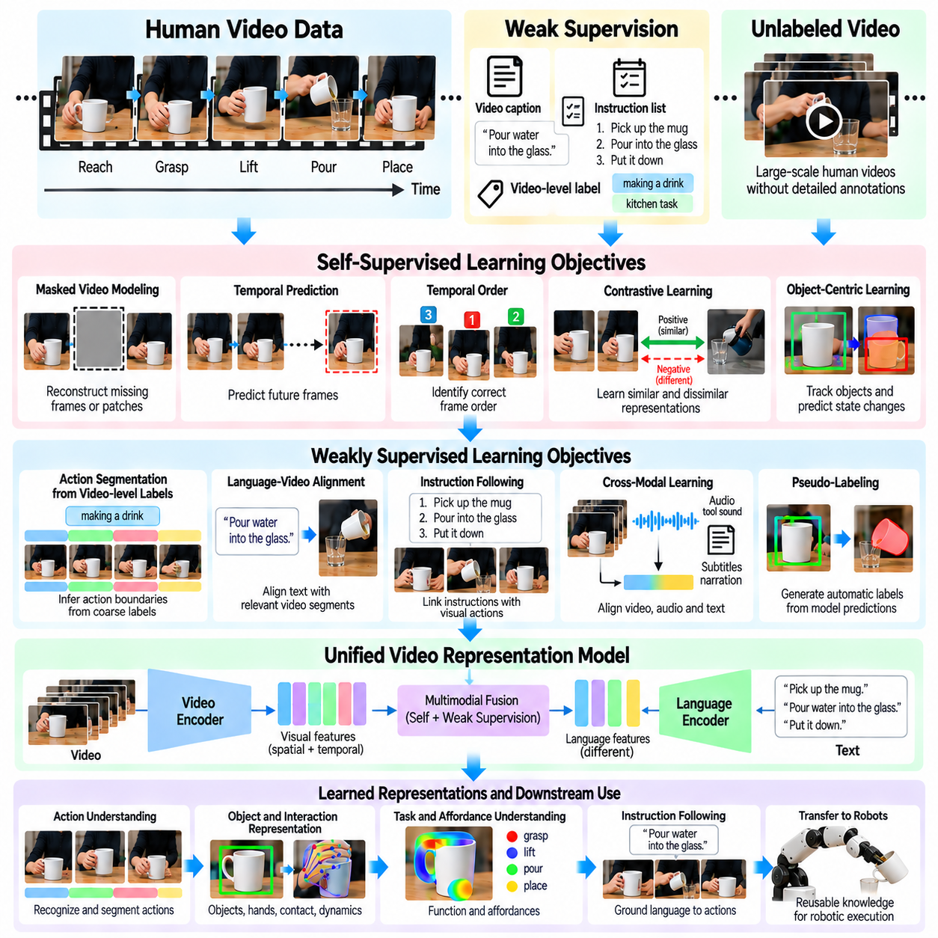
Weakly supervised and self-supervised video learning enable Physical AI systems to acquire useful representations from large collections of human demonstrations without requiring exhaustive manual annotations. Human videos contain rich information about actions, objects, interactions, and physical dynamics, but detailed labeling is expensive. These learning approaches exploit incomplete supervision and intrinsic video structure to transform abundant visual experience into reusable knowledge.
Weakly supervised learning uses approximate labels that describe video content without specifying every relevant event precisely. A recording may include an activity category, a short caption, or a sequence of instructions without exact temporal boundaries. Models must infer which frames correspond to particular actions and objects. This approach reduces annotation costs while introducing uncertainty that must be managed during training.
Self-supervised learning derives training signals directly from the structure of unlabeled video data. Instead of relying on human-provided action labels, models solve predictive or reconstruction tasks involving visual observations. Examples include predicting future frames, recovering masked features, and distinguishing correct temporal sequences. These objectives encourage representations that capture recurring patterns and relationships.
The distinction between weak supervision and self-supervision concerns the origin of learning signals. Weak supervision relies on imperfect external information such as captions, metadata, or automatically generated labels. Self-supervision constructs targets from the data itself. Both approaches can be combined within a common training pipeline, allowing semantic descriptions to complement learned visual and temporal regularities.
Masked video modeling trains networks to reconstruct missing portions of visual sequences from surrounding observations. Spatial masking removes image patches, while temporal masking hides selected frames or intervals. To recover missing information, the model must learn object appearance, motion continuity, and scene relationships. Predicting compact visual features rather than raw pixels can reduce computational demands.
Temporal prediction provides another self-supervised objective by requiring models to estimate future observations from preceding frames. Successful prediction depends on recognizing moving objects, interaction patterns, and likely state transitions. However, future images are not always uniquely determined because human behavior involves choices and uncertainty. Probabilistic or latent prediction methods can represent multiple plausible outcomes.
Contrastive learning encourages representations of related observations to remain similar while separating unrelated examples. Positive pairs may consist of nearby video segments, different camera views of the same event, or corresponding video and text descriptions. Negative sampling requires care because different recordings may depict functionally equivalent actions. Poor pair selection can weaken task-relevant representations.
Temporal order learning exploits the fact that physical actions often follow meaningful sequences. Models can be trained to recognize whether frames or segments appear in their original order. Reconstructing correct sequences encourages understanding of preparation, interaction, and completion stages. Nevertheless, some operations are reversible or interchangeable, so chronological order should not be confused with necessary causality.
Weakly supervised action segmentation attempts to locate individual actions using only coarse video-level labels or ordered transcripts. Models infer temporal boundaries through visual changes, repeated patterns, and alignment constraints. This enables large instructional datasets to support fine-grained learning. Errors arise when narration omits operations, when actions overlap, or when different demonstrations follow alternative procedures.
Object-centric self-supervision focuses on changes in objects rather than unrestricted pixel reconstruction. Models may track object positions, predict transformations, or identify interactions that cause state changes. These objectives encourage representations useful for robotic manipulation. Object tracking and segmentation quality remain important because incorrect object associations can introduce misleading training signals.
Hand-object interaction provides a valuable source of implicit supervision in human video. Hand trajectories, estimated contact events, and subsequent object motion reveal relationships between actions and outcomes. Models can learn to predict contact locations or interaction phases without manually labeling every frame. Occlusion, camera motion, and uncertain depth estimates nevertheless limit the reliability of these signals.
Language can supply weak supervision through narration, subtitles, instructional descriptions, and video captions. A sentence describing an operation provides semantic context even when its exact temporal alignment is unknown. Vision-language learning can associate these descriptions with relevant visual segments. Training must account for incomplete narration, ambiguous references, and captions that describe intentions rather than observed outcomes.
Cross-modal self-supervision aligns information from video, audio, and other synchronized signals. Tool sounds, object impacts, and spoken instructions may reveal events that are difficult to recognize visually. Predicting correspondence between modalities encourages models to learn shared event representations. However, synchronization errors and unrelated background audio can reduce alignment accuracy.
Human video datasets contain substantial variation in camera viewpoint, lighting, resolution, motion speed, and recording quality. Data augmentation can improve robustness by introducing controlled changes to visual appearance and temporal sampling. Augmentations must preserve task meaning because reversing a sequence or changing spatial orientation may alter the interpretation of physical actions.
Representation learning should emphasize features that remain useful across different people, objects, and environments. Models must distinguish task-relevant physical changes from background motion and incidental gestures. Object-centered objectives, temporal consistency, and interaction prediction can encourage this separation. Excessive invariance is undesirable when small geometric differences determine contact feasibility or manipulation success.
Pseudo-labeling provides a practical mechanism for expanding weakly supervised datasets. A trained model generates provisional action labels, object associations, or temporal boundaries for unlabeled videos. High-confidence predictions can be incorporated into subsequent training rounds. Confidence calibration and selective filtering are essential because repeated training on incorrect pseudo-labels can amplify systematic errors.
Curriculum learning can organize video training examples according to complexity and reliability. Models may begin with clear demonstrations involving visible objects and distinct actions before processing heavily occluded or long-duration recordings. Gradually increasing difficulty can stabilize learning. The curriculum should reflect meaningful learning challenges rather than assuming that video length alone determines task complexity.
Large-scale training requires efficient handling of long video sequences and redundant frames. Temporal subsampling, feature caching, hierarchical encoders, and selective attention can reduce computational costs. Important contact events and rapid state changes should receive sufficient temporal resolution. Efficient sampling must balance coverage of complete activities with preservation of physically meaningful details.
Combining weak supervision with robot-generated data can connect semantic understanding to executable behavior. Human videos provide broad coverage of tasks and interactions, while robot demonstrations supply action commands, proprioception, and measured outcomes. Joint training or adaptation can align these complementary sources. Differences in embodiment and sensing must be modeled rather than ignored.
Evaluation of learned video representations should extend beyond performance on pretraining objectives. Useful downstream tasks include action recognition, temporal localization, object-state prediction, affordance estimation, and robotic manipulation. Transfer to unfamiliar environments and robot platforms provides evidence of generalization. Strong reconstruction accuracy alone does not establish physical understanding.
Dataset quality strongly influences weakly supervised and self-supervised learning outcomes. Duplicate recordings, edited sequences, misleading captions, and corrupted timestamps can distort learned relationships. Automated filtering and targeted human review help improve reliability. Maintaining provenance, annotation confidence, and processing metadata supports reproducible training and systematic error analysis.
A scalable Physical AI data engine can integrate video ingestion, automatic annotation, self-supervised pretraining, pseudo-label refinement, and downstream validation into a continuous learning pipeline. Model predictions can identify uncertain examples for review and reveal missing task coverage. Newly collected human and robot experiences then improve future training, creating an iterative relationship between data quality and model capability.
Weakly supervised and self-supervised video learning provide a foundation for extracting embodied knowledge from human experience at scale. By exploiting temporal continuity, object interactions, multimodal signals, and approximate semantic descriptions, Physical AI systems can reduce dependence on costly annotations. Reliable robotic transfer still requires physical validation, embodiment-aware adaptation, and feedback from real-world execution.

03.13. Video Data Filtering and Quality
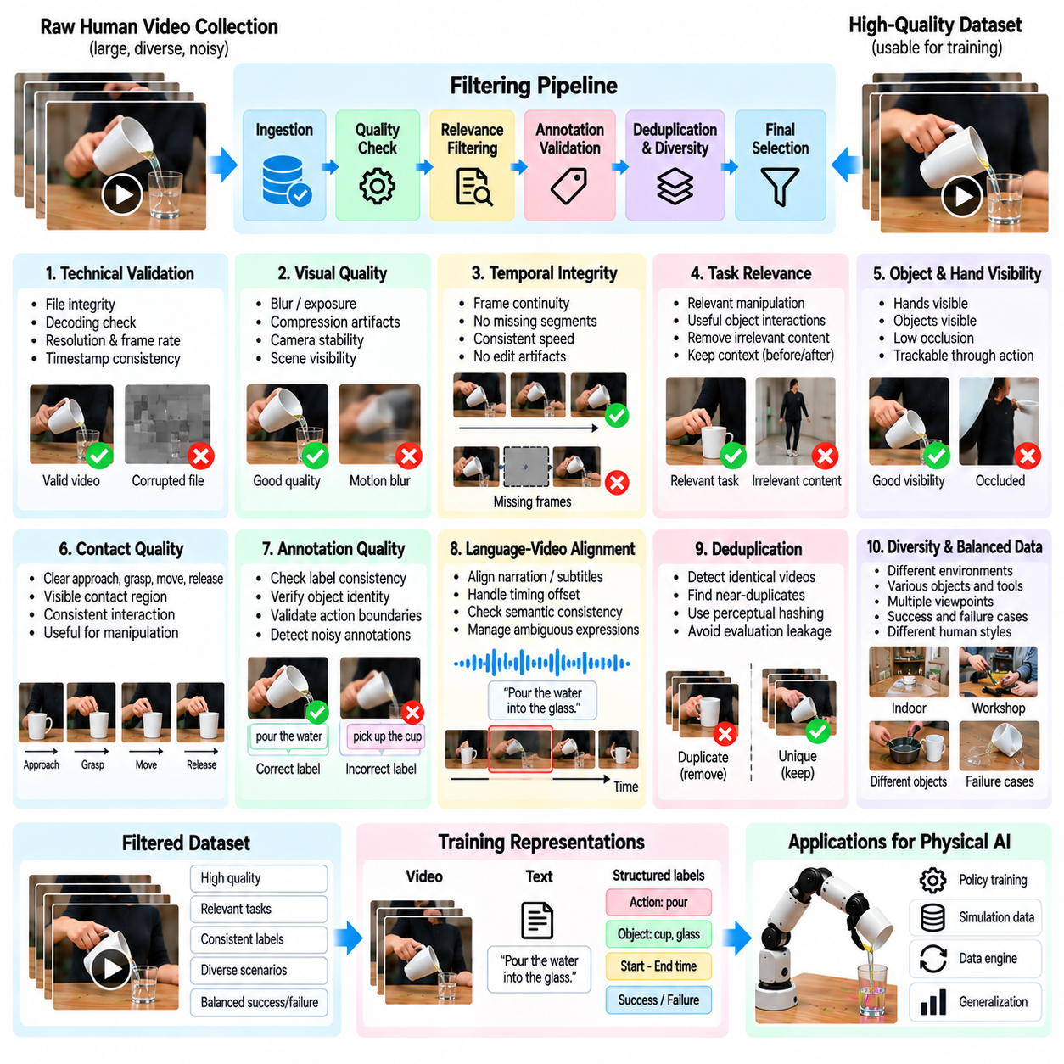
Video data filtering and quality management are essential components of scalable Physical AI data engines. Large human video collections contain valuable demonstrations of manipulation, tool use, and physical interaction, but their usefulness varies significantly. Poor visibility, irrelevant content, inconsistent annotations, and corrupted recordings can weaken learned representations. Systematic filtering transforms raw video collections into reliable training resources.
Video quality must be evaluated according to both visual characteristics and task relevance. A recording with high resolution may provide little useful information if important interactions occur outside the camera view. Conversely, lower-resolution footage may clearly reveal object movement and task completion. Effective quality assessment therefore considers whether the recording preserves the observations necessary for learning physical behavior.
Technical validation begins by examining file integrity, decoding reliability, frame rate, resolution, and timestamp consistency. Corrupted frames, missing segments, variable playback speed, and synchronization errors can distort motion patterns. Automated ingestion pipelines should detect these problems before expensive model training begins. Metadata validation also ensures that recordings can be processed consistently across storage and computing systems.
Visual quality filtering evaluates blur, exposure, compression artifacts, camera instability, and scene visibility. Severe motion blur can obscure contact events, while overexposure may eliminate important object boundaries. Automated image quality metrics can identify suspicious segments, but fixed thresholds are rarely sufficient. Quality decisions should consider whether the affected visual information is necessary for the intended learning objective.
Temporal integrity is particularly important because Physical AI models learn from sequences of actions and consequences. Missing frames or edited transitions may create misleading relationships between movement and object-state changes. Frame continuity analysis and timestamp inspection can identify discontinuities. Recordings with uncertain temporal structure may remain useful for recognition tasks but should be treated cautiously during dynamics learning.
Task relevance filtering determines whether a video contains interactions that contribute to the desired robotic capabilities. General human activity footage may include long periods of conversation, walking, or unrelated background motion. Semantic classifiers and action recognition models can identify potentially useful segments. However, filtering must preserve preparatory movements and recovery actions that provide important context for successful task execution.
Object and interaction visibility strongly influence the value of human demonstration videos. A task may be clearly narrated while the hands, tools, or manipulated objects remain hidden. Detection and tracking systems can estimate whether relevant entities are visible throughout critical intervals. Visibility scores should account for occlusion, camera perspective, and object scale rather than relying only on the presence of recognizable objects.
Hand-object contact quality is especially important for manipulation learning. Videos showing clear approach, grasp, movement, and release phases provide stronger evidence about interaction structure. Automated contact estimation can identify segments with potentially informative physical events. Nevertheless, visual contact does not directly reveal force magnitude or friction conditions, so filtering should distinguish observable evidence from inferred physical quantities.
Annotation quality introduces another dimension of data reliability. Captions, action labels, object identities, and temporal boundaries may contain inconsistencies or systematic errors. Automated checks can compare annotations against visual predictions and neighboring segments. Disagreements should trigger confidence reduction or targeted review rather than automatic rejection, because unusual demonstrations may represent valuable training examples.
Language-video alignment quality affects multimodal learning and instruction grounding. Narration may describe an operation before it occurs, summarize several actions, or reference objects outside the visible scene. Temporal alignment models can estimate correspondence between speech and visual events. Alignment confidence should be stored separately from linguistic correctness because an accurate description may still have uncertain timing.
Duplicate and near-duplicate detection prevents large datasets from becoming dominated by repeated recordings. Identical videos may appear with different resolutions, crops, subtitles, or compression settings. Perceptual hashing and learned video embeddings can identify these relationships. Deduplication reduces redundant computation and helps prevent evaluation leakage, but genuinely distinct demonstrations of the same task should remain available.
Dataset diversity must be considered alongside individual recording quality. Aggressive filtering can produce visually clean datasets that contain only familiar environments, common objects, and successful demonstrations. Such collections may perform poorly when robots encounter unfamiliar conditions. Diversity-aware selection should preserve meaningful variation in viewpoint, lighting, object geometry, human behavior, and task execution strategies.
Failure demonstrations provide important evidence about physical constraints and recovery behavior. A dropped object, unstable grasp, or unsuccessful insertion may reveal conditions that successful examples do not expose. Filtering pipelines should distinguish unusable recordings from informative failures. Failure labels and outcome descriptions allow models to learn risk-sensitive behavior without incorrectly treating unsuccessful actions as desirable examples.
Automated quality scoring can combine technical, semantic, temporal, and interaction-related indicators. Each recording or segment may receive scores for visibility, motion continuity, annotation confidence, task relevance, and novelty. These scores support prioritization rather than requiring a single universal acceptance threshold. Different learning objectives may select different subsets from the same underlying video collection.
Quality thresholds should reflect downstream model requirements. Action recognition can tolerate some spatial uncertainty, while contact prediction may require clear hand-object boundaries and accurate temporal resolution. Robot trajectory inference additionally depends on reliable geometry and camera calibration. Task-specific filtering policies therefore provide greater value than uniformly applying strict visual quality requirements to every dataset.
Human review remains important for cases where automated systems cannot reliably interpret physical events. Reviewers can examine ambiguous contacts, unusual tool interactions, inconsistent descriptions, and uncertain outcomes. Active learning can prioritize examples where model predictions disagree or confidence is low. Carefully targeted review improves annotation efficiency while preserving difficult examples that support generalization.
Data provenance and governance contribute directly to training quality. Each recording should retain information about its source, collection conditions, processing history, licensing status, and annotation revisions. Privacy-sensitive footage may require exclusion, anonymization, or restricted access. Maintaining traceable records supports reproducibility, compliance, and investigation when problematic training examples influence deployed robotic behavior.
Dataset splitting must prevent related recordings from appearing across training and evaluation partitions. Frames from the same demonstration, edited versions of identical videos, and closely related capture sessions can produce misleading evaluation results. Group-aware splitting should account for source identity, task instances, and recording relationships. Strong evaluation requires testing on genuinely distinct examples and relevant distribution shifts.
Continuous monitoring is necessary because dataset quality changes as new sources and automated annotations are introduced. Statistical dashboards can track rejection rates, duplicate frequency, action coverage, visibility distributions, and annotation uncertainty. Sudden changes may indicate sensor failures or processing defects. Monitoring should also identify underrepresented tasks and conditions rather than measuring quality only through aggregate averages.
Filtering policies should be evaluated through their effect on downstream learning performance. Removing low-quality recordings does not automatically improve robotic capabilities if the removed data contains rare interactions or valuable environmental variation. Controlled experiments can compare alternative filtering strategies using common training budgets. Task success, robustness, and transfer performance provide stronger evidence than visual quality scores alone.
A scalable Physical AI data engine integrates quality assessment into ingestion, annotation, training, and feedback workflows. Raw recordings undergo technical validation, semantic indexing, interaction analysis, deduplication, and confidence estimation. Selected datasets then support model training and evaluation, while observed model failures guide additional data collection and review. This closed-loop process continuously improves the relationship between data quality and robotic performance.
Video data filtering ultimately aims to preserve physically meaningful information rather than simply maximize visual cleanliness. High-quality datasets contain observable interactions, reliable temporal structure, trustworthy annotations, and sufficient diversity to support generalization. Combining automated assessment, selective human review, provenance tracking, and downstream validation enables Physical AI systems to learn more reliably from large-scale human video resources.

03.14. Human Video to Robot Data Pipeline [w/Code]
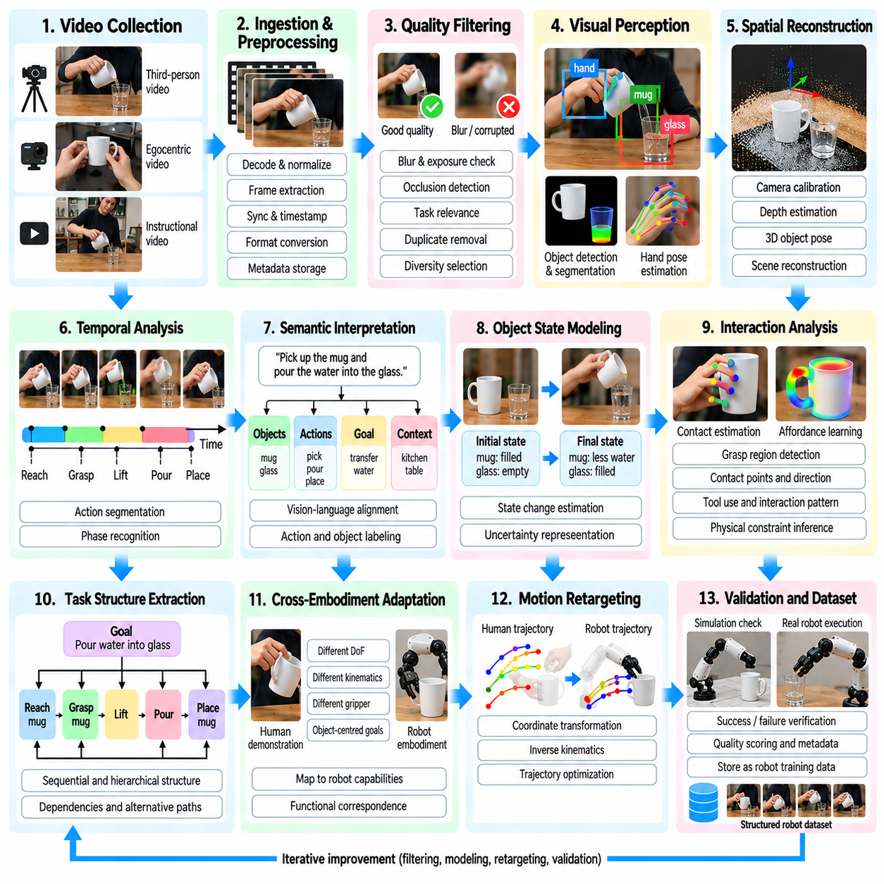
A human video-to-robot data pipeline transforms observations of human activity into structured information that supports robotic perception, planning, and control. Human demonstrations provide broad knowledge about object manipulation, task organization, and physical interactions, but they rarely contain executable robot commands. A reliable pipeline must bridge this gap through visual analysis, semantic interpretation, embodiment adaptation, and physical validation.
The pipeline begins with collecting videos from instructional recordings, egocentric cameras, workplace demonstrations, and controlled experiments. Each source offers different advantages in viewpoint, task diversity, and interaction visibility. Collection procedures should record available metadata, including camera characteristics, task descriptions, timestamps, and usage permissions. These records support traceability and consistent downstream processing.
Video ingestion converts heterogeneous recordings into standardized representations suitable for automated analysis. Decoding, frame-rate normalization, timestamp verification, and format conversion establish consistent processing conditions. Original recordings should remain available because normalization may remove useful details. A structured storage system links source files with extracted frames, metadata, processing versions, and quality indicators.
Quality filtering removes unusable recordings while preserving demonstrations that contain meaningful physical interactions. Automated checks examine blur, occlusion, corrupted frames, temporal discontinuities, and task relevance. Duplicate detection reduces redundant processing, while diversity-aware selection retains unusual environments and execution strategies. Failed demonstrations should remain available when they provide useful evidence about constraints or recovery behavior.
Visual perception extracts objects, hands, tools, and relevant scene structures from selected videos. Object detectors and segmentation models identify interaction targets, while tracking algorithms maintain identities across frames. Hand pose estimation provides approximate movement information. Combining these outputs creates a structured representation of the scene, although occlusion and uncertain depth can limit geometric accuracy.
Spatial reconstruction estimates relationships among hands, objects, tools, and environmental surfaces. Camera calibration and depth estimation can support the recovery of three-dimensional positions and orientations. Relative object transformations often remain more transferable than absolute human joint trajectories. Reconstruction uncertainty must be recorded because monocular video cannot uniquely determine every spatial configuration.
Temporal analysis divides continuous recordings into meaningful action segments. Models identify preparation, approach, contact, manipulation, release, and completion phases using motion and object-state changes. Temporal boundaries may remain uncertain when actions overlap or important events are hidden. Segment-level representations make long demonstrations easier to search, annotate, and transform into reusable robotic learning examples.
Semantic interpretation associates observed interactions with action labels, object functions, and task objectives. Narration, subtitles, and language models may help describe what the demonstrator intends to accomplish. Visual evidence should verify whether the described outcomes actually occur. The resulting semantic records connect low-level motion observations with higher-level instructions and procedural knowledge.
Object-state modeling represents how physical entities change during each interaction. A container may transition from closed to open, while a component may move from an unassembled to an installed configuration. These transitions provide task-relevant information that can remain valid across different robot embodiments. State representations should include uncertainty when contact, force, or hidden mechanisms cannot be directly observed.
Interaction analysis identifies potential grasp regions, contact points, tool-use patterns, and affordances. Human hand trajectories can indicate where manipulation begins, while object motion reveals the likely consequences of interaction. These observations provide candidate constraints for robot planning. However, estimated contact should not be treated as measured force, and visual demonstrations cannot establish complete physical dynamics.
Task structure extraction organizes individual actions into ordered or partially ordered operations. Dependencies indicate which conditions must be satisfied before subsequent steps can begin. Hierarchical task graphs can represent goals, subtasks, and alternative execution paths. This structure supports robotic planning because the robot can pursue equivalent task outcomes without reproducing every human movement.
Cross-embodiment adaptation converts human-centered information into robot-compatible objectives. Differences in joint structure, workspace, gripper geometry, and actuation prevent direct reproduction of many human motions. Object-centered goals and functional action representations provide a shared interface. Robot-specific planners then determine whether each proposed interaction is reachable, stable, and physically feasible.
Motion retargeting maps selected demonstration features into candidate robot trajectories. Coordinate transformations, inverse kinematics, collision checking, and trajectory optimization help satisfy geometric constraints. Dynamic feasibility checks consider actuator limits, payload, and contact stability. Retargeted trajectories should be treated as proposals rather than verified commands until their execution properties have been tested.
Simulation provides an intermediate environment for testing candidate behaviors before physical deployment. Robot models can execute proposed trajectories while recording collisions, object displacement, task completion, and constraint violations. Domain randomization can expose sensitivity to uncertain friction, geometry, and sensing conditions. Simulation results guide refinement, but they cannot fully replace real-world validation.
Robot execution closes the gap between observed human behavior and executable physical skills. Controllers use visual feedback, proprioception, and available force or tactile measurements to adjust movements during interaction. Successful executions provide robot-specific demonstrations containing commands and measured outcomes. Failed attempts reveal missing constraints, inaccurate assumptions, and opportunities for corrective learning.
The pipeline should preserve the distinction between observed data, inferred quantities, and validated robot actions. A video may directly show an object moving, while estimated hand contact and reconstructed depth remain uncertain. A generated trajectory is not equivalent to a successful execution record. Explicit confidence values and provenance links prevent downstream models from treating predictions as verified physical measurements.
Training dataset construction combines video observations, semantic annotations, object-state transitions, and validated robotic experiences. Samples can support action recognition, affordance prediction, imitation learning, and instruction-conditioned policy training. Dataset schemas should preserve temporal alignment and embodiment information. Training and evaluation splits must prevent leakage between related videos, demonstrations, and capture sessions.
Weakly supervised and self-supervised learning can expand the pipeline without requiring exhaustive manual annotation. Video encoders learn motion and interaction features from unlabeled recordings, while approximate captions provide semantic guidance. Pseudo-labeling generates provisional action boundaries and object associations. Confidence filtering and targeted human review help prevent systematic errors from spreading through subsequent training rounds.
A practical implementation may use modular software services for ingestion, perception, segmentation, semantic grounding, retargeting, and evaluation. Each module receives structured inputs and produces versioned outputs with confidence estimates. Message queues and distributed processing can support large collections, while reproducible configurations enable consistent experiments. Modular design allows individual models to improve without rebuilding the entire pipeline.
Quality assurance must measure both intermediate data accuracy and downstream robotic performance. Useful indicators include object tracking consistency, action segmentation accuracy, state-transition correctness, trajectory feasibility, and task success rate. Evaluation should include unfamiliar objects, environments, and robot platforms. Strong video understanding alone does not guarantee successful physical execution.
A closed-loop data engine uses deployment results to improve the human video-to-robot pipeline continuously. Robot failures identify missing interaction examples, uncertain state estimates, and incorrect retargeting assumptions. These findings guide additional video selection, annotation, and robot data collection. Repeated training and validation connect large-scale human demonstrations with increasingly reliable robotic capabilities.
The ultimate objective is not to convert every observed human movement into a corresponding robot command. Instead, the pipeline extracts transferable knowledge about goals, objects, interactions, and physical consequences. By combining structured video understanding with embodiment-aware planning and validated execution, Physical AI systems can transform diverse human experiences into reusable robotic skills while maintaining safety and traceability.

