Volume 04. Data Engines and Scaling for Physical AI

Chapter 08. Data Governance and Privacy

08.01. Data Governance for Physical AI
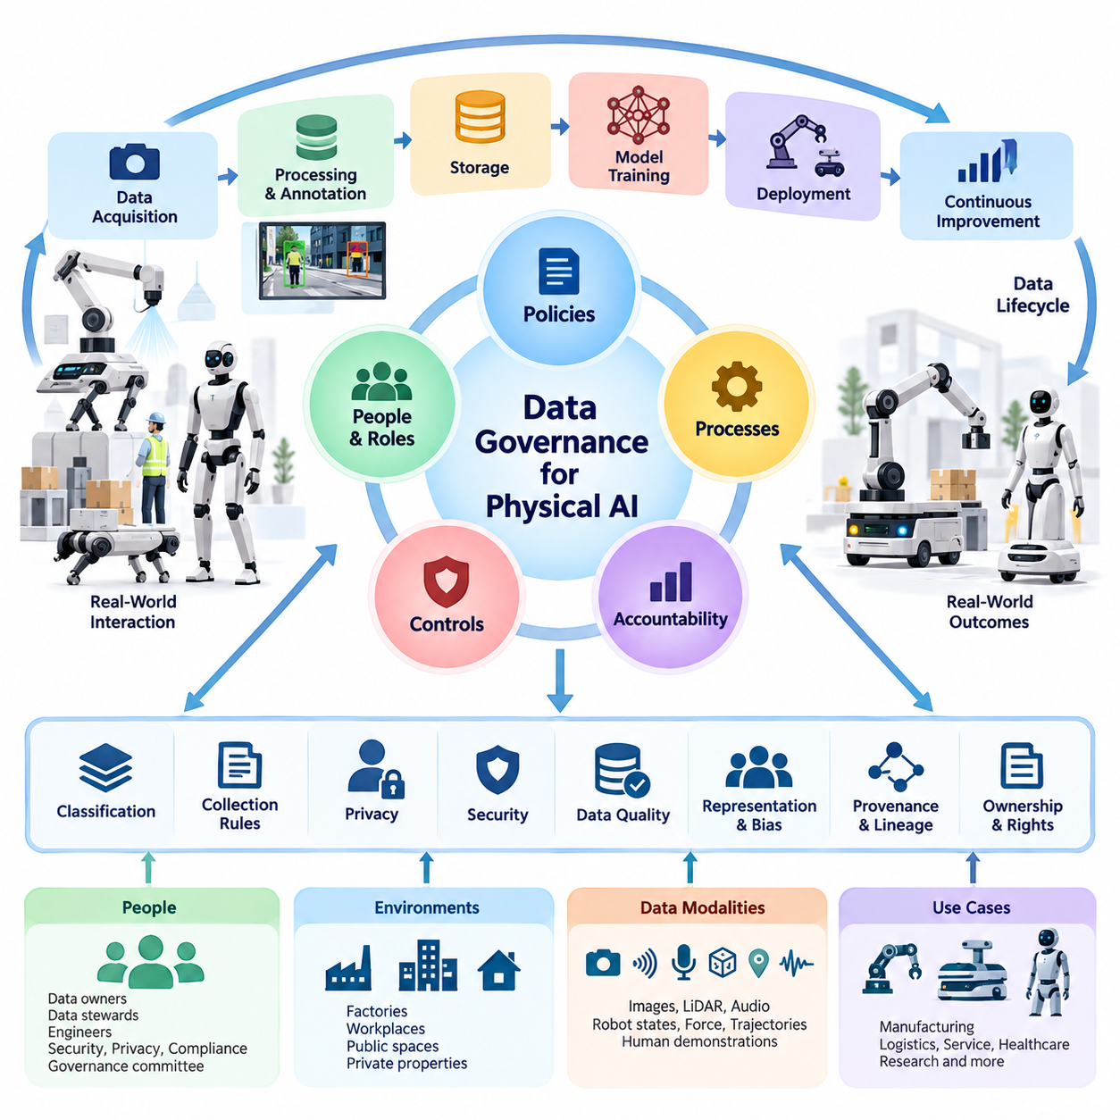
Data governance for Physical AI establishes the policies, responsibilities, technical controls, and operational processes required to manage data throughout its lifecycle. Unlike conventional digital AI, Physical AI collects information through robots interacting with real environments. These interactions generate sensitive observations about people, workplaces, objects, movements, and physical activities, making governance essential for responsible system development.
Physical AI data governance extends beyond database administration or regulatory compliance. It connects data acquisition, processing, annotation, storage, model training, deployment, and continuous improvement within a unified accountability framework. Every stage must define who can collect information, which purposes justify its use, how its integrity is maintained, and what conditions govern its sharing, retention, or deletion.
The distinctive challenge of Physical AI arises from the relationship between observation, action, and outcome. A robot may simultaneously record camera images, LiDAR measurements, audio, joint positions, force feedback, navigation trajectories, and operator commands. These synchronized streams can reveal information that individual measurements do not expose, requiring governance policies that consider combined datasets and their potential implications.
A governance framework begins by establishing clear organizational roles and decision-making authority. Data owners define permissible business uses, data stewards maintain quality and metadata, engineering teams implement technical safeguards, and security personnel manage threats and incidents. Privacy and compliance specialists evaluate applicable obligations, while governance committees resolve conflicts involving access, ownership, operational necessity, and responsible AI development.
Data classification provides the foundation for applying appropriate controls to different information categories. Physical AI datasets may contain public environmental observations, internal operational records, confidential industrial information, personal data, or highly sensitive biometric measurements. Classification should reflect both the original information and what can reasonably be inferred from it, since apparently harmless sensor recordings may reveal identities, behaviors, or protected operational details.
Data governance must begin before information enters the collection pipeline. Robot developers should establish legitimate collection purposes, determine whether permissions or other legal bases are required, and limit acquisition to information necessary for defined objectives. Collection policies should specify operating environments, permitted sensors, recording conditions, authorized personnel, and restrictions associated with public spaces, industrial facilities, and private properties.
Human demonstration and teleoperation datasets introduce additional governance responsibilities because they capture the behavior of operators performing physical tasks. Recorded movements, reaction times, intervention patterns, and task completion statistics may reveal individual performance characteristics. Governance policies should distinguish legitimate robot training requirements from employee monitoring and prevent secondary uses that exceed the original collection purpose.
Data provenance and lineage enable organizations to understand where information originated and how it evolved. Each robot episode should ideally contain metadata describing the collection device, sensor configuration, software version, timestamp, operating environment, task definition, and relevant permissions. Subsequent transformations, annotations, filtering operations, and dataset merges should remain traceable so that training inputs can be investigated and reproduced.
Ownership and usage rights become complicated when multiple organizations contribute to Physical AI development. Robot manufacturers, facility operators, teleoperation providers, annotation contractors, and cloud service companies may each possess different contractual interests. Governance agreements should explicitly define collection authority, intellectual property rights, permitted training activities, redistribution restrictions, derivative datasets, and responsibilities following contract termination.
Data quality governance ensures that collected information remains suitable for its intended engineering purpose. Inaccurate timestamps, inconsistent coordinate systems, missing sensor measurements, incorrect labels, and corrupted trajectories can undermine robot learning and evaluation. Organizations should establish measurable quality criteria, validation procedures, documented acceptance thresholds, and escalation mechanisms for datasets that fail to satisfy operational requirements.
Representation and coverage are equally important because governance must address the environments and populations represented in training data. A robot trained predominantly in controlled laboratories may perform poorly in crowded workplaces or unfamiliar physical conditions. Governance reviews should examine environmental diversity, object distributions, human interaction patterns, rare events, and potential biases that could produce unequal reliability across deployment scenarios.
Security governance protects robot datasets against unauthorized disclosure, alteration, destruction, and misuse. Role-based or attribute-based access controls can restrict sensitive information to approved personnel and services. Encryption during transmission and storage, secure credential management, network segmentation, and audit logging strengthen protection, while periodic access reviews help ensure that permissions remain appropriate as organizational responsibilities change.
Privacy engineering should be integrated into data processing rather than treated as a final compliance step. Techniques such as facial blurring, audio redaction, identifier removal, pseudonymization, and selective recording can reduce unnecessary exposure. However, anonymization is not always irreversible, particularly when movement trajectories, location histories, or multimodal observations allow individuals to be reidentified through additional information.
Physical AI systems often distribute data across robots, edge computers, on-premise servers, and cloud infrastructure. This architecture creates governance boundaries whenever information moves between devices, facilities, service providers, or jurisdictions. Organizations should define approved transfer paths, encryption requirements, processing locations, access conditions, and restrictions on cross-border movement, while maintaining consistent policies across distributed infrastructure.
Edge processing can reduce governance risks by filtering sensitive information before transmission to centralized systems. Robots may retain raw recordings locally while uploading selected events, anonymized observations, or compact learning representations. Nevertheless, local processing does not eliminate security responsibilities. Edge devices require secure storage, authenticated software updates, physical tamper protection, and reliable procedures for recovering or deleting information.
Retention and deletion policies should reflect the different operational purposes of robot data. Short-lived diagnostic recordings may require different retention periods from validated training datasets, safety incident evidence, or regulatory records. Governance systems should document retention schedules, deletion triggers, backup handling, and applicable legal preservation obligations, ensuring that information is not retained indefinitely merely because storage remains available.
Model training introduces additional governance questions because information may influence learned parameters even after original files are removed. Organizations should maintain relationships between dataset versions, training configurations, model checkpoints, and deployment releases. When data must be withdrawn, these records support impact assessments and decisions about retraining, model replacement, or other remediation, although removing specific learned information can remain technically difficult.
Synthetic data and simulation-generated datasets also require governance despite their artificial origins. Simulation assets may incorporate proprietary CAD models, confidential facility layouts, licensed textures, or measurements derived from real environments. Governance procedures should document asset origins, usage permissions, simulation configurations, and restrictions on redistribution, ensuring that synthetic generation does not unintentionally reproduce sensitive or unauthorized information.
Data sharing across robot fleets creates opportunities for collective learning while increasing governance complexity. A failure episode recorded at one industrial site may help improve robots operating elsewhere, but the recording could expose proprietary equipment or confidential workflows. Controlled sharing mechanisms should separate reusable behavioral information from site-specific sensitive content and enforce contractual boundaries between participating organizations.
Federated learning and privacy-preserving computation offer alternative approaches when centralized collection is undesirable. Participating robots or facilities may train local models and exchange selected updates instead of transferring raw observations. These approaches can reduce certain exposure risks, but model updates may still leak information, and additional protections such as secure aggregation, differential privacy, and update validation may be necessary.
Auditing provides evidence that governance policies are functioning as intended. Audit records should document data collection events, access requests, permission changes, processing activities, dataset exports, training usage, and deletion operations. Automated monitoring can identify unusual transfers, unauthorized access attempts, or policy violations, while independent reviews assess whether implemented safeguards remain effective as robot capabilities and operating environments evolve.
Incident management must address both cybersecurity failures and inappropriate data practices. A compromised robot may expose recorded video, navigation maps, or confidential operational information, while an incorrectly configured pipeline may distribute sensitive datasets to unauthorized recipients. Response procedures should include containment, evidence preservation, impact assessment, notification where required, remediation, and documented improvements to prevent recurrence.
Governance effectiveness can be evaluated through measurable operational indicators. Relevant metrics include dataset provenance completeness, classification coverage, unauthorized access incidents, unresolved privacy risks, deletion compliance, annotation quality, and the percentage of training data with verified usage rights. These indicators help organizations identify weaknesses, prioritize improvements, and demonstrate that governance requirements are implemented consistently.
A mature Physical AI governance program should operate as part of the continuous data engine rather than as a separate administrative function. Collection policies inform sensor configuration, metadata standards guide ingestion, quality rules influence curation, and access permissions control training workflows. Evaluation results and field incidents then feed back into governance decisions, allowing policies to evolve alongside robot capabilities and deployment conditions.
Ultimately, data governance enables Physical AI systems to scale without sacrificing accountability, privacy, security, or data reliability. As robots expand into factories, warehouses, hospitals, construction sites, and public environments, governance becomes a fundamental engineering capability. Organizations that integrate responsible data management into their technical architecture can develop more trustworthy learning systems while supporting sustainable innovation and operational growth.

08.02. Data Ownership Sovereignty and Provenance
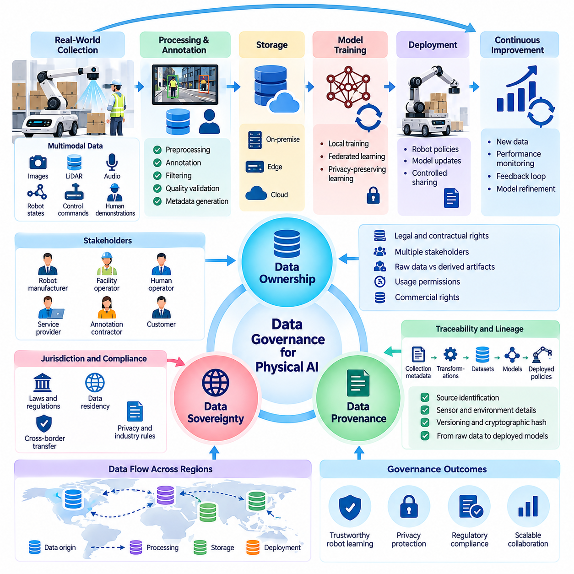
Data ownership, sovereignty, and provenance are fundamental principles governing how Physical AI systems collect, control, process, and reuse information generated through interactions with the physical world. Robot datasets often originate from multiple organizations, devices, operators, and environments. Establishing clear rights, jurisdictional responsibilities, and traceable origins is essential for developing trustworthy and scalable data engines.
Data ownership describes the legal, contractual, and operational rights associated with collected information. In Physical AI, ownership cannot always be assigned to the robot manufacturer or the organization operating the equipment. Facility owners, customers, human operators, software providers, and data processing contractors may hold different rights. Governance must distinguish ownership claims from permissions to access, process, train on, or distribute datasets.
A warehouse robot illustrates the complexity of ownership relationships. Its cameras may record customer inventory, employee movements, proprietary facility layouts, and operational procedures while navigation software generates trajectories and performance logs. The warehouse operator may control facility information, while the robotics provider may possess contractual rights to selected diagnostic records. These arrangements require explicit agreements rather than assumptions.
Data sovereignty concerns the legal authority and jurisdictional requirements governing information throughout its lifecycle. Robot observations collected in one country may be processed in another and incorporated into models deployed internationally. Such transfers can trigger privacy, industrial security, and sector-specific obligations. Sovereignty therefore requires understanding where information originates, where it is stored, who controls processing, and which laws apply.
Data residency and data sovereignty are related but distinct concepts. Residency identifies the physical or geographic location of stored information, while sovereignty concerns the legal and regulatory authority applicable to that information. Keeping datasets within national borders may satisfy certain residency requirements without resolving access by foreign service providers or conflicting legal obligations. Governance architectures must address both dimensions independently.
Physical AI data provenance establishes verifiable records of how observations and derived information were created. Provenance should identify the collecting robot, sensor configuration, operating environment, acquisition timestamp, software version, and relevant permissions. It should also document transformations applied during preprocessing, annotation, filtering, and aggregation. These records support reproducibility, accountability, and investigations into model behavior.
Provenance differs from data lineage, although the two concepts are closely connected. Provenance emphasizes origin, authenticity, and the circumstances under which information was obtained. Lineage tracks the subsequent movement and transformation of information across processing systems. Together, they establish a traceable relationship between raw sensor observations, curated datasets, training experiments, model checkpoints, and deployed robot policies.
Robot episodes provide a practical unit for implementing provenance management. Each episode may include synchronized camera frames, LiDAR measurements, proprioceptive states, control commands, task descriptions, and outcome labels. A unique episode identifier can connect these streams to collection metadata and governance records. Maintaining this association allows engineers to identify which observations contributed to particular training datasets.
Reliable provenance requires more than recording filenames or timestamps. Metadata should include stable dataset identifiers, sensor calibration versions, coordinate reference conventions, annotation revisions, and processing software configurations. Cryptographic hashes can help detect unauthorized modifications, while signed records can strengthen evidence of origin when signing keys and identity controls are properly managed. Versioned manifests preserve relationships between data artifacts.
Ownership becomes particularly complicated when human demonstrations are converted into robot learning datasets. Operators may contribute expertise, movements, verbal instructions, and task strategies, while employers provide equipment and facilities. Contracts must address permitted collection, compensation where applicable, intellectual property, and secondary training uses. Privacy rights and employment protections may remain relevant regardless of contractual dataset ownership.
Synthetic data introduces another layer of ownership and provenance requirements. Simulated robot trajectories may be generated using proprietary CAD assets, licensed textures, physics engines, and real-world calibration measurements. Although the resulting observations are synthetic, underlying assets may carry contractual restrictions. Provenance records should identify simulation versions, source assets, generation parameters, and permitted downstream uses.
Cross-organizational data sharing requires explicit governance boundaries. Robot manufacturers may seek to combine observations from several customer facilities to improve general-purpose policies. Customers may permit safety-related learning while prohibiting disclosure of confidential workflows or production layouts. Data-sharing agreements should specify permitted purposes, access restrictions, derivative model rights, retention periods, and responsibilities following termination.
A useful governance approach separates raw data ownership from rights over derived artifacts. Original sensor recordings, annotated episodes, learned representations, aggregated statistics, and trained models may be governed by different agreements. Derivation does not automatically eliminate privacy, confidentiality, or licensing restrictions. Organizations should assess whether downstream artifacts retain protected information and whether their intended uses remain authorized.
Data sovereignty also influences the design of distributed Physical AI infrastructure. Edge devices, on-premise servers, regional clouds, and centralized training clusters may operate under different legal conditions. Sensitive observations can remain within approved environments while selected features or model updates are transferred elsewhere. However, derived information must still be evaluated for confidentiality, reidentification risks, and applicable transfer restrictions.
Technical enforcement mechanisms translate ownership and sovereignty requirements into operational controls. Identity management, role-based permissions, encryption, geographic storage restrictions, and policy-aware data pipelines can limit unauthorized processing. Dataset catalogs may associate each artifact with permitted purposes and geographic constraints. Automated policy checks can prevent restricted data from entering incompatible training or sharing workflows.
Auditable provenance is particularly important when robot behavior causes safety incidents or operational failures. Investigators may need to determine whether a model learned from corrupted recordings, incorrectly labeled demonstrations, or unauthorized datasets. Traceable training records can connect deployed model versions to their source data and evaluation results. This evidence supports root-cause analysis, corrective action, and responsible accountability.
Dataset withdrawal and deletion demonstrate the practical importance of maintaining lineage. When a contributor revokes permission where legally or contractually applicable, organizations must identify affected copies, derivatives, and training workflows. Removing raw files may not remove their influence from existing model parameters. Provenance records enable impact assessment and help determine whether retraining, model replacement, or other remediation is necessary.
Provenance quality should be measured systematically rather than assumed. Useful indicators include the percentage of episodes with verified collection metadata, completeness of transformation histories, consistency of dataset identifiers, and coverage of documented usage rights. Missing or contradictory provenance records should trigger investigation before data enters production training pipelines. Automated validation can improve consistency across large robot fleets.
Fleet-scale Physical AI systems require governance mechanisms that remain effective across thousands of robots and multiple organizations. Standardized metadata schemas, interoperable identifiers, distributed audit records, and centralized policy definitions help maintain consistency. Each collection site may retain local authority while participating in shared learning. Such architectures must preserve the relationship between global model improvement and site-specific data restrictions.
Ultimately, ownership defines who possesses particular rights, sovereignty determines which legal authorities and jurisdictional obligations apply, and provenance establishes where information originated and how it evolved. These principles are complementary rather than interchangeable. Integrating them into Physical AI data engines enables responsible data sharing, reproducible learning, regulatory accountability, and sustainable development of increasingly capable robotic systems.

08.03. Data Licensing and Usage Rights
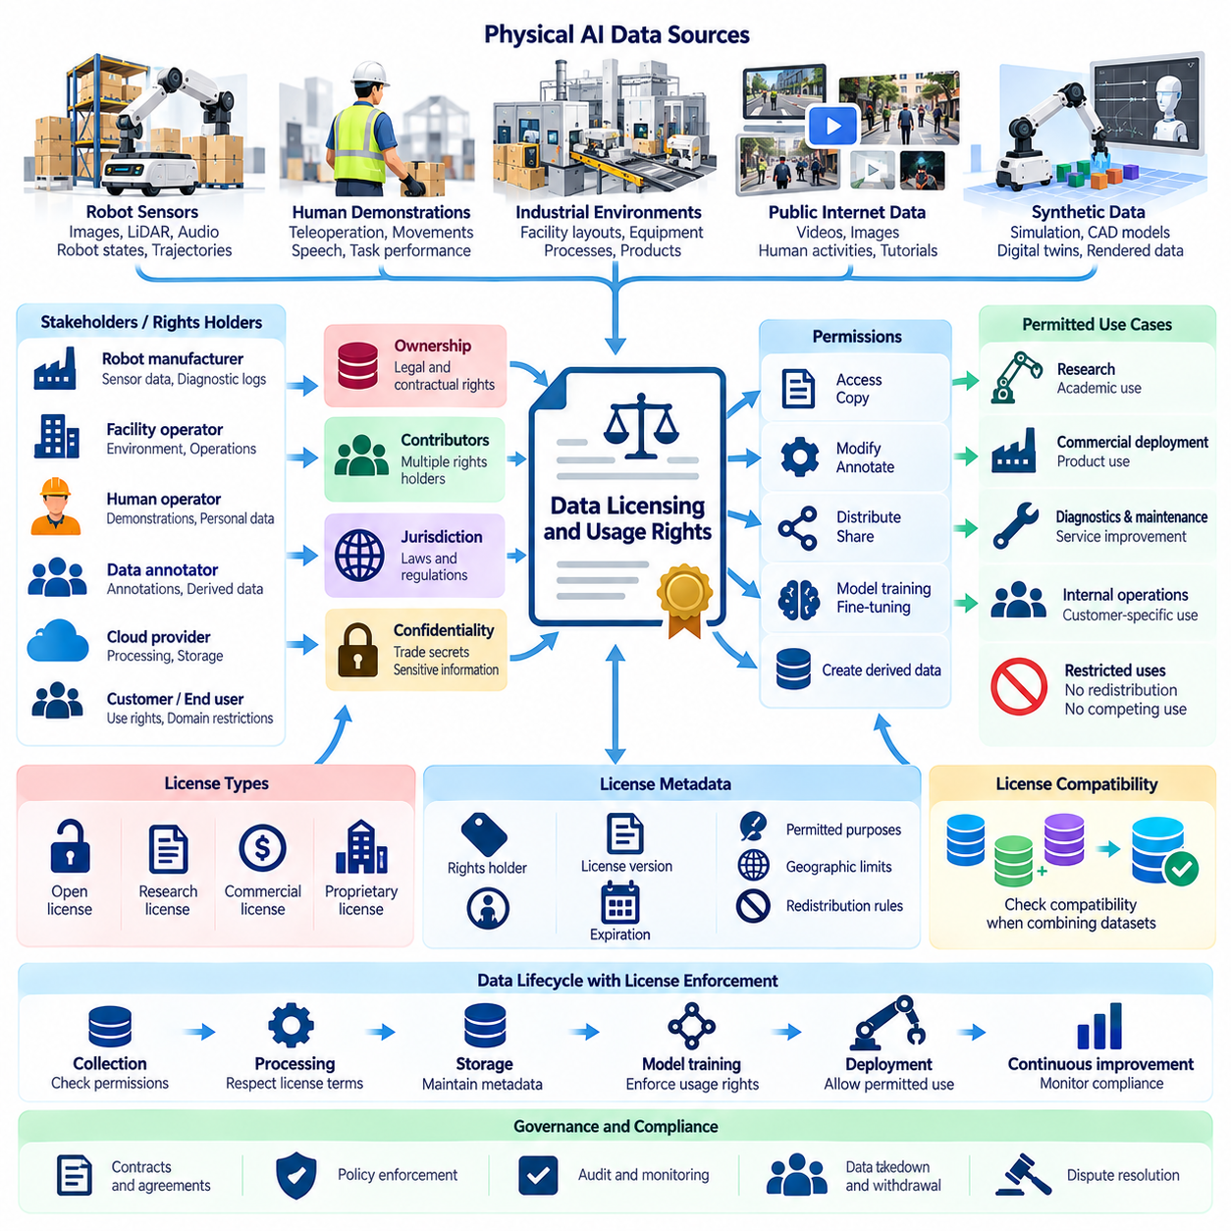
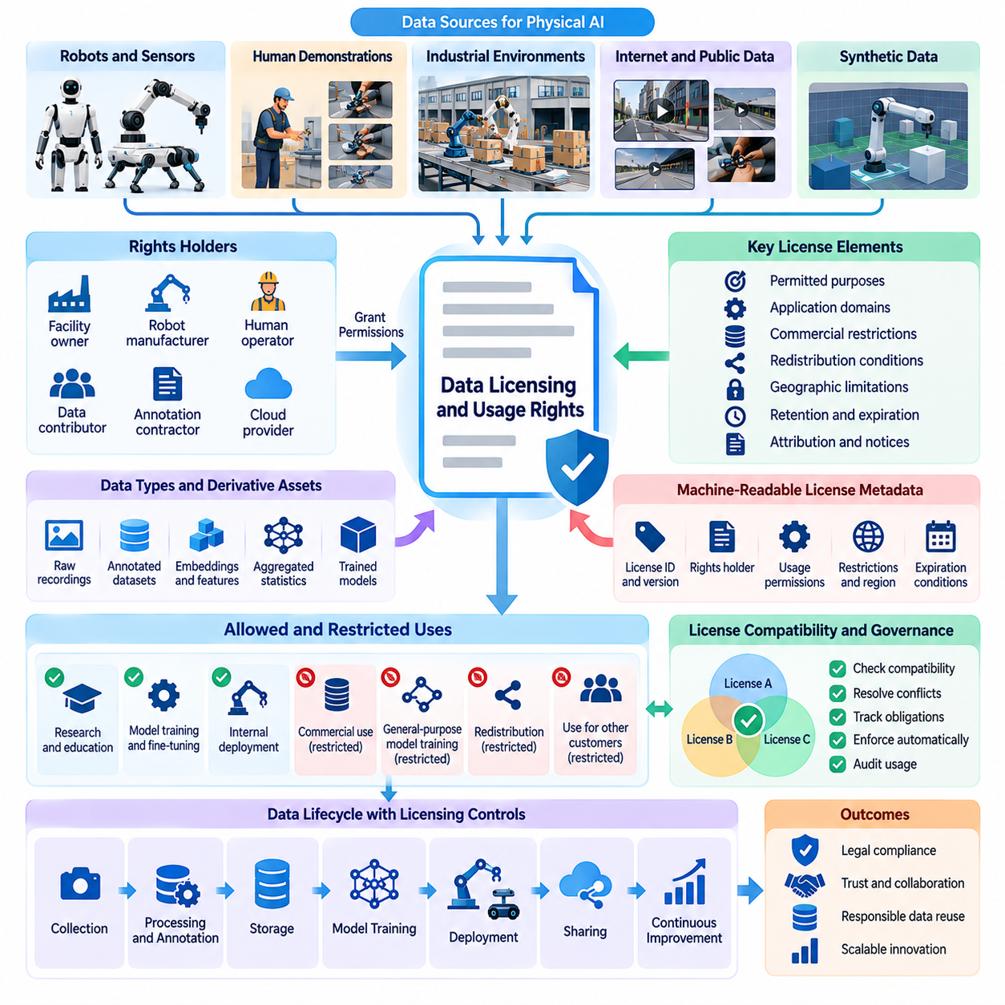
Data licensing and usage rights establish the legal and contractual conditions under which Physical AI datasets can be collected, processed, shared, and used for machine learning. Unlike conventional digital datasets, robot data frequently contains observations of people, industrial facilities, proprietary objects, and operational behaviors. Licensing frameworks must therefore address intellectual property, privacy, confidentiality, and permitted applications throughout the data lifecycle.
A data license defines the permissions granted by a rights holder to another organization or individual. These permissions may include accessing, copying, modifying, annotating, distributing, or using datasets for model training. Licensing does not necessarily transfer ownership, and possession of a dataset does not automatically authorize every form of exploitation. Physical AI developers must distinguish ownership, access privileges, and explicitly granted usage rights.
Physical AI datasets often involve multiple contributors with different legal interests. A robot manufacturer may provide sensing equipment, a factory operator may control the operating environment, and human workers may appear in recorded demonstrations. Annotation contractors and cloud providers may subsequently process the information. Effective licensing requires identifying relevant rights holders and establishing which permissions are necessary for each processing activity.
The scope of permitted use is a central element of data licensing. A dataset licensed for academic research may not be authorized for commercial robot deployment, while information collected for maintenance diagnostics may not be available for foundation model training. Agreements should define approved purposes, application domains, commercial restrictions, redistribution conditions, and whether data may contribute to general-purpose or customer-specific models.
Licensing arrangements should distinguish between raw observations and derived data products. Camera recordings, synchronized robot trajectories, annotated episodes, embeddings, aggregated statistics, and trained models may be subject to different contractual terms. Transforming raw data into a learned representation does not automatically eliminate underlying restrictions. Developers must evaluate whether derivative artifacts remain covered by source licenses or other legal obligations.
Open data licenses can accelerate Physical AI research by enabling shared benchmarks, reproducible experiments, and collaborative model development. However, the term open does not imply unrestricted use. Some licenses require attribution, preservation of notices, or distribution under compatible terms. Others restrict commercial applications or redistribution. Each dataset must be evaluated against its actual license rather than assumptions based on public availability.
Publicly accessible internet videos present particular licensing challenges for robot learning. Instructional recordings and human activity videos may provide valuable examples of manipulation, navigation, and tool use, but online accessibility does not establish permission for downloading, redistribution, or model training. Copyright, platform terms, privacy rights, and applicable exceptions must be assessed before incorporating such materials into Physical AI datasets.
Human demonstration datasets require agreements that address both intellectual property and personal information. Teleoperation recordings may capture operator movements, speech, reaction patterns, and task performance. Employment agreements or contributor contracts may establish certain usage permissions, but they do not automatically override privacy protections. Organizations should define collection purposes, permitted training activities, retention conditions, and applicable withdrawal procedures.
Industrial datasets introduce additional confidentiality requirements because robot observations may reveal production processes, equipment configurations, facility layouts, and proprietary products. A customer may permit data collection for improving robot reliability while prohibiting use for unrelated customers or competitors. Licensing agreements should establish confidentiality boundaries and clarify whether aggregated learning outcomes can be incorporated into shared commercial models.
Synthetic datasets are not necessarily free from licensing restrictions. Simulation environments may incorporate commercial CAD models, licensed textures, proprietary digital twins, and third-party software assets. Generated trajectories and rendered images may inherit contractual limitations depending on the applicable agreements. Developers should record source asset licenses, simulation dependencies, and permitted uses of resulting synthetic datasets.
Data licensing also influences the design of collaborative robot learning ecosystems. Multiple organizations may contribute datasets to a shared training repository while retaining different rights over their contributions. One participant may allow research training but prohibit commercial redistribution, while another may permit broad reuse. Dataset aggregation systems must preserve these distinctions and prevent incompatible licensing conditions from being overlooked.
Machine-readable licensing metadata can help enforce usage rights across automated data pipelines. Each dataset or episode can include identifiers describing the rights holder, license version, permitted purposes, geographic limitations, redistribution restrictions, and expiration conditions. Policy-aware ingestion and training systems can compare these attributes against intended operations before accepting data into a processing workflow.
License compatibility becomes especially important when combining datasets from multiple sources. Training mixtures may include public research collections, proprietary industrial recordings, licensed human videos, and synthetic simulations. Their terms may impose conflicting obligations concerning commercial use, attribution, modification, or redistribution. Compatibility reviews should occur before dataset integration rather than after expensive model training has been completed.
Usage rights should also address model outputs and derivative intellectual property. Contracts may specify whether trained models can be commercially deployed, transferred to customers, or incorporated into general-purpose robotic platforms. However, rights over trained parameters are not determined solely by dataset ownership. Applicable law, contractual provisions, confidentiality obligations, and the possibility of reproducing protected information must all be considered.
Time-limited licenses and revocable permissions introduce operational challenges for continuously learning robot systems. A dataset may become unavailable when a contract expires, a supplier relationship ends, or a legally valid withdrawal request occurs. Data management systems should track these conditions and identify affected copies, training runs, and model versions. Remediation may require deletion, restricted use, retraining, or replacement of affected artifacts.
Geographic restrictions may determine where licensed data can be stored, processed, or accessed. Industrial customers and public-sector organizations may require on-premise processing or prohibit transfers to particular jurisdictions. These conditions must be coordinated with data sovereignty and privacy requirements. Cloud training pipelines should verify that storage regions, processing services, and subcontractors comply with applicable contractual restrictions.
Licensing governance requires reliable provenance and auditability. Organizations should maintain records connecting each dataset to its source, rights holder, license agreement, collection authorization, and processing history. Training manifests can identify which licensed materials contributed to particular model versions. Such traceability supports compliance reviews, contractual reporting, dispute resolution, and investigations involving unauthorized data usage.
Technical controls can reduce dependence on manual interpretation of licensing obligations. Access management, dataset tagging, automated policy validation, and restricted training environments can enforce defined permissions. However, automated systems cannot independently resolve every legal ambiguity. Human review remains necessary when agreements contain unclear language, conflicting terms, unusual derivative rights, or complex jurisdictional requirements.
Licensing compliance should be evaluated throughout the Physical AI data engine rather than only during initial acquisition. New annotations, dataset merges, model fine-tuning, external sharing, and commercial deployment may introduce uses not covered by original permissions. Periodic reviews should examine whether actual processing activities remain consistent with contractual commitments and whether updated agreements are required.
A mature licensing framework combines legal clarity with engineering traceability and operational enforcement. Standardized agreements, machine-readable rights metadata, versioned provenance records, and automated policy checks can support large-scale data reuse. As Physical AI systems increasingly learn from diverse organizations and environments, effective licensing becomes essential for protecting contributors while enabling responsible innovation and sustainable robotic intelligence.

08.04. Human Demonstration and Operator Privacy
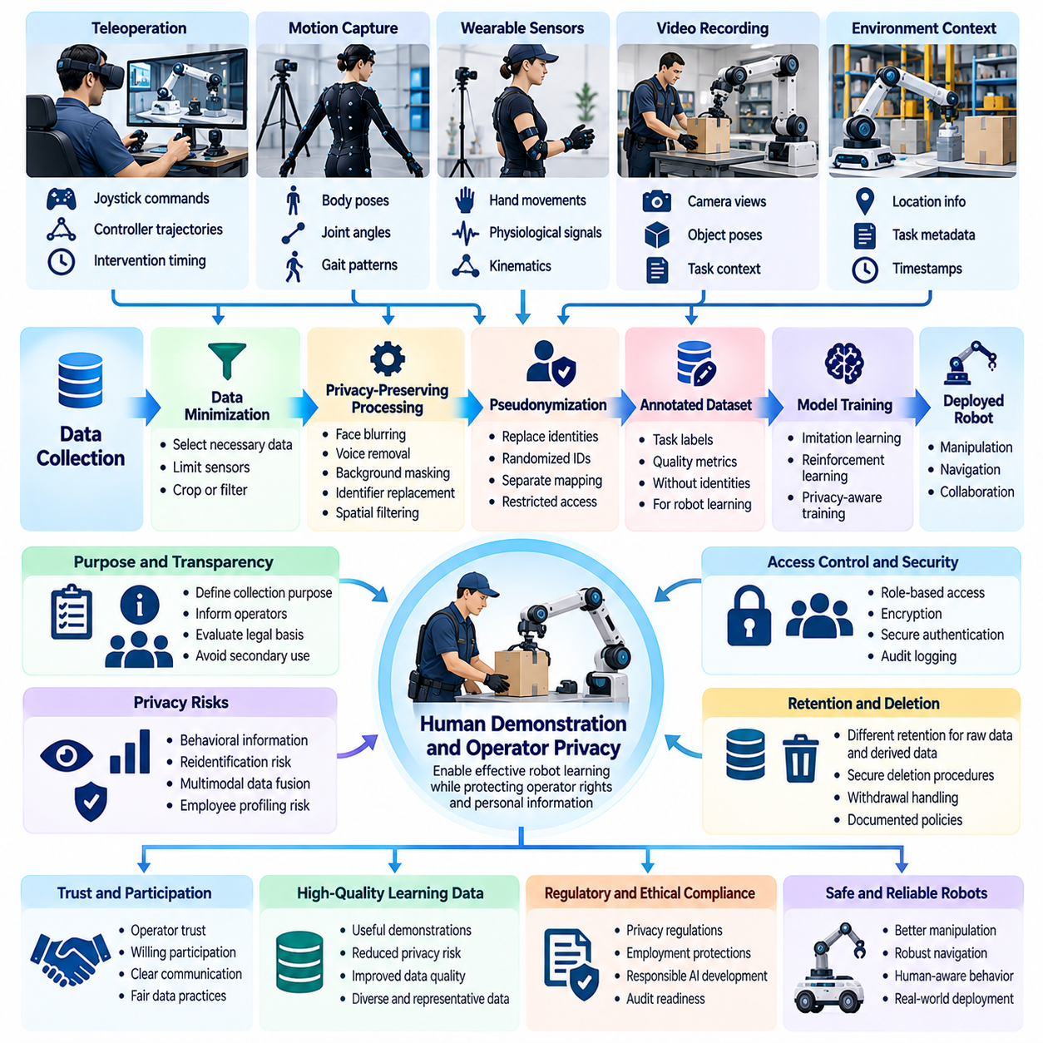
Human demonstration data is essential for training Physical AI systems to perform complex manipulation, navigation, and collaborative tasks. Teleoperation, motion capture, wearable sensors, and video recordings allow robots to learn from human expertise. However, these collection methods also capture information about operators themselves, creating privacy challenges that must be addressed throughout data acquisition, processing, training, and deployment.
Operator privacy concerns extend beyond conventional personally identifiable information. Demonstration datasets may reveal movement patterns, reaction times, physical capabilities, working habits, and individual decision-making strategies. When combined with timestamps, task assignments, or workplace records, these observations can potentially identify specific individuals. Privacy governance must therefore consider behavioral information as well as direct identifiers.
Teleoperation systems create particularly detailed records of human behavior because operator commands are synchronized with robot observations and outcomes. Joystick movements, virtual reality controller trajectories, hand poses, and intervention timing can reveal skill levels and response characteristics. Although such information improves imitation learning, it may also enable unintended employee profiling, productivity monitoring, or behavioral assessment.
Motion capture and wearable sensing introduce additional privacy considerations. Body tracking systems may record skeletal poses, joint angles, gait patterns, hand movements, and physiological measurements. Some of these signals can function as biometric identifiers when processed for identification purposes. Organizations must distinguish measurements necessary for robot learning from information that could expose sensitive personal characteristics or enable persistent identification.
Privacy protection begins with clearly defining the purpose of demonstration collection. Operators should understand whether recordings will support imitation learning, reinforcement learning, safety evaluation, or system diagnostics. Collection programs should specify which data streams are necessary and avoid gathering unrelated information. Purpose limitation reduces the possibility that demonstration datasets will later be reused for incompatible monitoring or commercial activities.
Meaningful transparency is especially important when demonstrations are collected in employment settings. Workers should receive understandable information about recording methods, data recipients, retention periods, and intended uses. Consent may not always provide an appropriate legal basis where employment relationships create power imbalances. Organizations should evaluate applicable legal requirements and provide appropriate safeguards rather than relying exclusively on consent forms.
Data minimization offers a practical way to reduce privacy risks without eliminating useful training information. A manipulation task may require hand trajectories, object poses, and robot actions but not facial images or unrelated background conversations. Collection systems can selectively disable unnecessary sensors, crop video regions, or extract task-relevant representations. These choices should be made before recording whenever possible.
Privacy-preserving preprocessing can further limit exposure after collection. Facial blurring, voice removal, background masking, identifier replacement, and spatial filtering can reduce the amount of recognizable information retained. However, these techniques have limitations because movement trajectories and behavioral signatures may remain distinctive. Anonymization claims should therefore be supported by reidentification risk assessments rather than visual inspection alone.
Pseudonymization separates operator identities from demonstration records while preserving selected relationships needed for research and quality evaluation. Randomized operator identifiers can support analysis of demonstration consistency without exposing names. The mapping between identifiers and real individuals should be stored separately with restricted access. Because reidentification remains possible, pseudonymized records generally require continued privacy protection.
Temporal and multimodal data fusion can increase privacy risks even when individual sensor streams appear harmless. Combining camera images, hand trajectories, voice recordings, location information, and task timestamps may reconstruct an operator's activities in considerable detail. Privacy reviews should evaluate the combined information available to downstream users and models rather than assessing each sensor independently.
Operator privacy must also be considered during demonstration labeling and quality assessment. Annotators may evaluate task success, intervention frequency, movement efficiency, or execution errors. These labels are valuable for training robust robot policies, but they can also become indicators of individual worker performance. Governance policies should prevent training-oriented quality metrics from being repurposed for employment decisions without an appropriate legal and organizational basis.
Access control is necessary because demonstration datasets often contain information that is more sensitive than ordinary robot telemetry. Engineers may need robot action trajectories without access to operator identities, while privacy administrators may require identity mappings for authorized requests. Role-based access control, encryption, secure authentication, and audit logging can enforce these distinctions across storage and processing environments.
Retention policies should distinguish between raw demonstration recordings and derived learning representations. High-resolution videos and identifiable operator records may be necessary during initial annotation but unnecessary after validated trajectories have been extracted. Organizations should establish retention periods based on legitimate operational needs and applicable obligations. Deletion procedures must also address backups, temporary files, exported datasets, and replicated storage.
Human demonstration datasets frequently move between robot manufacturers, research institutions, annotation vendors, and cloud training providers. Each transfer creates additional privacy and contractual responsibilities. Data-sharing agreements should define authorized processing purposes, confidentiality requirements, security safeguards, and restrictions on onward transfers. International transfers may require additional assessments under applicable data protection laws.
Privacy risks can persist after model training because learned representations may retain information about individual contributors. Memorization, membership inference, or reconstruction attacks can sometimes reveal properties of training data. Although these risks vary across architectures and training methods, organizations should evaluate them before distributing models trained on sensitive demonstrations. Model access restrictions and privacy testing can reduce exposure.
Privacy-preserving learning techniques provide additional safeguards when centralized demonstration storage is undesirable. Federated learning allows local training without routinely transferring raw recordings, while secure aggregation can protect selected model updates. Differential privacy may reduce information leakage under defined assumptions. These techniques involve utility, computational, and implementation tradeoffs and should complement rather than replace broader governance controls.
Operators should have accessible mechanisms for raising concerns about data collection and use. Depending on applicable law and contractual arrangements, individuals may possess rights to access information, request correction, object to certain processing, or seek deletion. Organizations need documented procedures for handling such requests and identifying affected datasets. Clear communication helps establish accountability and trust in demonstration collection programs.
Privacy impact assessments are particularly useful before deploying large-scale human demonstration programs. These assessments examine collection purposes, categories of personal information, potential harms, access arrangements, retention practices, and available safeguards. Higher-risk activities, such as continuous workplace recording or biometric identification, may require additional scrutiny. Assessment findings should influence system architecture and operational procedures.
Continuous monitoring ensures that privacy protections remain effective as Physical AI data engines evolve. New sensors, annotation tools, model architectures, and sharing arrangements can introduce risks not anticipated during initial collection. Periodic audits should examine access records, processing activities, retention compliance, and unauthorized secondary uses. Incident response procedures must address accidental disclosure, improper access, and misuse of operator information.
Responsible human demonstration governance balances the value of human expertise with the dignity, autonomy, and privacy of contributors. High-quality robot learning does not require unrestricted observation of the people providing demonstrations. By integrating transparency, minimization, technical safeguards, contractual protections, and ongoing oversight, Physical AI organizations can build scalable demonstration datasets while maintaining trustworthy relationships with human operators.

08.05. Public Space and Workplace Robot Data
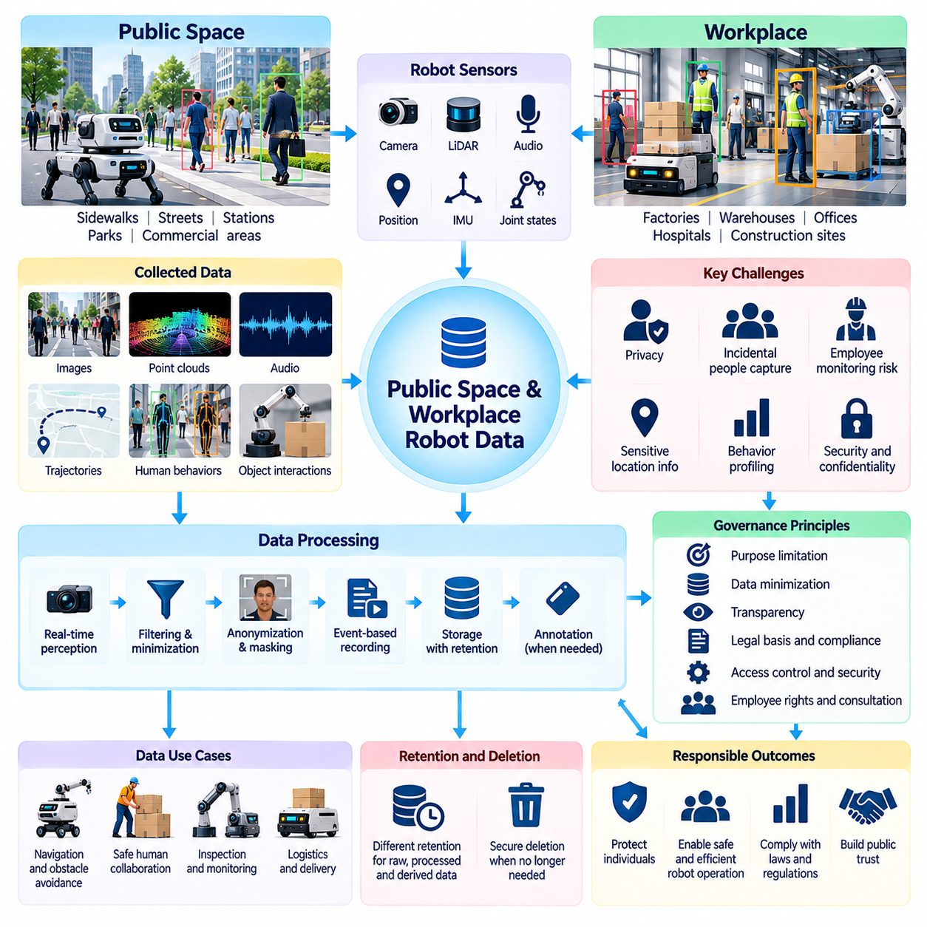
Public spaces and workplaces are important environments for Physical AI systems because robots must perceive, navigate, and interact with dynamic human surroundings. Autonomous mobile robots, delivery platforms, inspection systems, and collaborative machines continuously generate visual, spatial, and behavioral observations. These datasets support intelligent operation but also create privacy, security, and governance challenges involving individuals who may not directly participate in robot development.
Public-space robot data differs from conventional laboratory datasets because collection occurs in environments shared by many people. Cameras, LiDAR sensors, microphones, and positioning systems may capture pedestrians, vehicles, conversations, and surrounding infrastructure. Individuals may be recorded incidentally while robots perform legitimate tasks. Data governance must therefore distinguish operationally necessary observations from unnecessary collection of identifiable or sensitive information.
Workplace robot data introduces additional concerns because employees may be observed repeatedly during normal activities. Warehouse robots can record worker movements, manufacturing robots may capture assembly procedures, and inspection robots can document equipment interactions. Although these observations improve navigation, safety, and operational efficiency, they may also reveal productivity patterns, working habits, or individual performance characteristics.
The distinction between public and workplace environments influences expectations of privacy and organizational responsibility. Public spaces involve diverse individuals with limited awareness of robot sensing activities, while workplaces often contain established employment relationships and access controls. Neither environment automatically eliminates privacy protections. Appropriate governance depends on applicable laws, collection purposes, sensor capabilities, and the reasonable expectations of affected individuals.
Purpose limitation is a foundational requirement for responsible robot data collection. Information gathered for obstacle avoidance, localization, or collision prevention should not automatically become available for behavioral profiling or unrelated surveillance. Organizations must define why particular sensor streams are collected and which secondary uses are permitted. Changes in purpose should trigger renewed assessments of legal authority, proportionality, and potential privacy impacts.
Data minimization can reduce unnecessary exposure while preserving essential robotic capabilities. A navigation system may require obstacle geometry and movement trajectories without retaining recognizable facial images. Depth measurements, occupancy maps, semantic representations, and short-lived sensor buffers can sometimes replace continuous high-resolution video storage. Engineering teams should evaluate which representations provide sufficient operational information with the lowest practical privacy risk.
Real-time perception and persistent recording should be treated as distinct processing activities. Robots may need continuous camera input to operate safely, but this does not necessarily justify indefinite storage of every frame. Temporary processing, selective event recording, and configurable retention periods can reduce accumulated personal information. Safety investigations and regulatory obligations may justify retaining particular records under controlled conditions.
Transparency helps people understand when and why robots collect environmental information. Visible notices, accessible privacy explanations, and clear organizational contact channels can communicate sensing activities and data practices. In workplaces, employee communications should explain recording purposes, access permissions, and potential uses of collected information. Transparency measures must be adapted to practical environments without assuming that notification alone establishes lawful processing.
Public-space deployment creates challenges when obtaining individual consent is impractical. Delivery robots may encounter hundreds of pedestrians during routine operations, making individual authorization difficult. Organizations must determine an appropriate legal basis under applicable regulations rather than assuming public visibility permits unrestricted collection. Privacy impact assessments can help evaluate necessity, proportionality, and safeguards for incidental recording.
Workplace monitoring requires particular attention to power relationships and employee rights. Data collected to improve robot performance could also be used to measure worker speed, movement efficiency, or compliance with procedures. Such secondary uses may create legal, ethical, and organizational concerns. Governance policies should establish boundaries between legitimate robotic operations and employee surveillance, with appropriate consultation and oversight.
Spatial mapping data can reveal sensitive information even when recognizable people are absent. Robot-generated maps may expose building layouts, restricted entrances, security equipment, production lines, or emergency access routes. In public environments, detailed maps may capture infrastructure requiring additional protection. Access controls and classification policies should therefore cover geometric and semantic representations as well as images and audio.
Multimodal sensor fusion increases the possibility of reconstructing individual behavior. Combining camera observations, location histories, timestamps, and object interactions may reveal where people traveled, whom they encountered, or which activities they performed. Even pseudonymized trajectories can become identifiable when linked with external information. Privacy assessments should examine combined datasets and downstream analytical capabilities rather than evaluating each sensor independently.
Anonymization and redaction provide useful protections for recorded robot observations. Facial blurring, license plate masking, voice removal, and exclusion of private areas can reduce identifiable content. However, removing obvious identifiers does not guarantee anonymity when clothing, movement patterns, or location histories remain distinctive. Organizations should validate privacy transformations and account for reidentification risks before distributing datasets.
Edge computing can support privacy-preserving public and workplace robotics by processing sensitive observations near their source. Robots may extract obstacle positions, object categories, or navigation features locally while discarding unnecessary raw recordings. Only selected diagnostic events or approved representations need to reach centralized infrastructure. Nevertheless, edge devices require secure storage, authenticated software, and protection against unauthorized physical access.
Data sharing between robot manufacturers and facility operators requires explicit agreements. A warehouse customer may authorize operational logging but restrict the use of recordings for training models deployed at other facilities. Public-sector deployments may impose additional conditions on infrastructure information and cross-border transfers. Contracts should define permitted purposes, ownership arrangements, confidentiality obligations, retention limits, and authorized recipients.
Event-triggered recording offers a practical balance between operational learning and data minimization. Robots can preserve short observation windows surrounding collisions, emergency stops, navigation failures, or human interventions rather than continuously uploading all sensor streams. Recording policies should specify triggering conditions, buffer durations, access restrictions, and retention schedules. Sensitive events may require additional review before inclusion in shared training datasets.
Security controls are essential because public and workplace robot datasets can expose both personal information and operational vulnerabilities. Encryption, role-based access control, secure transmission, and audit logging help prevent unauthorized disclosure or modification. Dataset segmentation can separate safety evidence, navigation records, and confidential industrial observations. Access should reflect legitimate responsibilities rather than broad organizational convenience.
Retention and deletion policies should distinguish temporary perception data, routine operational logs, training datasets, and incident evidence. Different categories may require different storage periods based on their purposes and applicable obligations. Organizations should establish procedures for removing expired records, managing backups, and responding to valid deletion requests. Dataset lineage helps identify copies and derived artifacts affected by retention decisions.
Governance effectiveness depends on continuous evaluation as robots encounter new environments and operating conditions. Sensor upgrades, expanded service areas, new analytics functions, and additional data recipients can alter privacy risks. Periodic audits should examine collection scope, access histories, secondary uses, and compliance with established policies. Incident response procedures must address accidental recording, unauthorized sharing, and security breaches.
Responsible governance of public-space and workplace robot data enables Physical AI systems to learn from real environments without treating every observed person as an unrestricted data source. Privacy-aware sensing, purpose limitation, transparent practices, secure infrastructure, and accountable oversight should operate together. These principles support scalable robotic intelligence while respecting individual rights, organizational confidentiality, and public trust.

08.06. Biometric Audio and Location Privacy
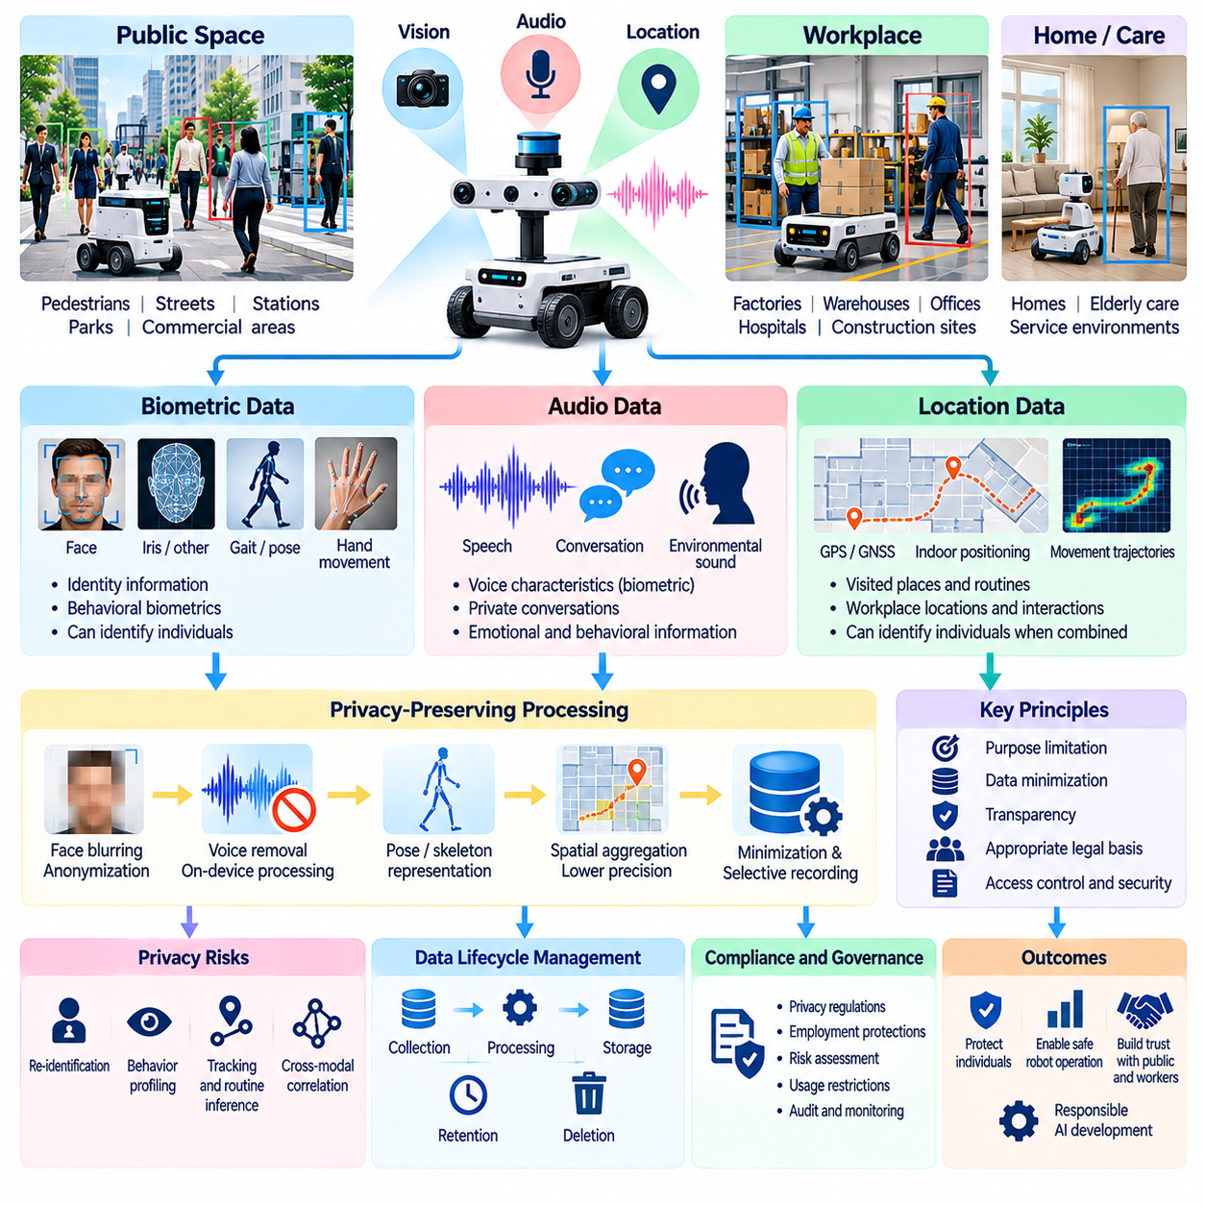
Biometric, audio, and location data introduce distinctive privacy challenges for Physical AI systems because these signals can reveal identity, behavior, and personal activities. Robots operating in homes, workplaces, hospitals, and public environments may collect facial images, voice recordings, movement patterns, and positioning information. Effective governance must address the sensitivity of these data types while preserving the perception and navigation capabilities required for safe operation.
Biometric data refers to information derived from physical, physiological, or behavioral characteristics that can support individual identification. Facial geometry, fingerprints, iris patterns, gait signatures, and voice characteristics are common examples. Not every recording of these characteristics constitutes biometric identification data under every law. The classification depends on processing methods, intended purposes, and applicable legal definitions.
Robot vision systems may capture recognizable faces even when facial identification is not required for the assigned task. A mobile robot navigating a crowded corridor needs to detect people and estimate their positions but may not need to establish their identities. Privacy-aware perception can prioritize human detection, pose estimation, and obstacle geometry while avoiding unnecessary facial recognition, identity matching, or persistent tracking.
Behavioral biometrics create additional risks because distinctive movement patterns may identify individuals without conventional identity records. Walking style, hand coordination, gesture timing, and teleoperation behavior can reveal recurring personal characteristics. These signals are particularly relevant to imitation learning and human-robot interaction. Their collection should be evaluated for identification potential, sensitivity, and the consequences of unauthorized reuse.
Audio sensing supports speech commands, acoustic event detection, environmental awareness, and human-robot communication. However, microphones may also capture private conversations, emotional expressions, background speech, and identifiable voice characteristics. Continuous audio recording can expose information unrelated to robotic operations. Data governance should distinguish real-time acoustic processing from persistent storage and secondary analysis.
Speech recognition systems can reduce privacy exposure by converting spoken commands into task-specific representations. A robot may require the recognized instruction and confidence score rather than retaining the complete waveform. On-device speech processing, wake-word activation, temporary buffering, and selective recording can limit unnecessary collection. Nevertheless, transcripts may still contain personal information and require appropriate protection.
Voice biometrics deserve special attention because vocal characteristics may support speaker recognition or verification. Acoustic features such as pitch, resonance, articulation, and speaking rhythm can contribute to individual identification. A system designed to recognize commands should not automatically create persistent speaker profiles. Where voice identification is necessary, its purpose, authorization, security controls, and retention conditions must be explicitly established.
Location privacy concerns extend beyond geographic coordinates. Robot sensors can reveal where individuals work, travel, gather, or spend time, particularly when observations are linked to timestamps. Indoor positioning systems may reconstruct movement between rooms, workstations, or restricted areas. Repeated observations can expose routines and relationships even when names and direct identifiers have been removed.
High-resolution location trajectories may be especially sensitive because combinations of frequently visited places can distinguish individuals. Robot-generated navigation logs, human tracking records, and facility maps may reveal patterns that were not apparent in isolated measurements. Spatial aggregation, reduced coordinate precision, and shorter retention periods can reduce exposure, although their effectiveness depends on operational requirements and external information.
Multimodal data fusion amplifies privacy risks when biometric, audio, and location signals are combined. A facial image associated with a voice recording and movement trajectory can establish a richer personal profile than any single source. Even datasets that appear pseudonymous may become identifiable through cross-modal correlations. Privacy assessments should therefore examine combined information flows and potential downstream inference capabilities.
Purpose limitation is essential when sensitive sensor data supports multiple robotic functions. Facial observations collected for collision avoidance should not automatically support employee identification, while audio captured for voice commands should not become material for behavioral profiling. Location histories gathered for navigation diagnostics should not be repurposed for unrelated surveillance. Secondary uses require independent assessment of their legal basis and proportionality.
Data minimization should be incorporated into sensor selection, processing architecture, and storage policies. Robots can sometimes replace identifiable images with human bounding boxes, skeletal representations, or occupancy estimates. Audio waveforms may be converted into command labels, while detailed trajectories may be reduced to aggregated movement statistics. These transformations should preserve task performance without retaining unnecessary personal details.
Anonymization techniques can reduce exposure but require careful validation. Facial blurring, voice transformation, identifier removal, and location generalization may conceal obvious personal attributes. However, gait signatures, distinctive voices, and repeated movement trajectories can remain identifying. Organizations should evaluate reidentification risks, linkage attacks, and residual information rather than assuming that removing names or faces guarantees anonymity.
Edge processing provides an important architectural safeguard for sensitive robotic perception. Facial detection, speech recognition, and localization can occur directly on the robot without routinely transmitting raw sensor streams to centralized servers. Local processing reduces exposure during transmission and aggregation, although it does not eliminate risks from device compromise. Secure boot, encryption, access controls, and authenticated updates remain necessary.
Access governance should reflect the differing sensitivity of biometric, audio, and location datasets. Navigation engineers may require anonymized trajectories, while speech developers may need limited acoustic samples for model evaluation. Identity-related processing should be restricted to specifically authorized personnel and systems. Role-based permissions, purpose-based access policies, audit trails, and separation of sensitive datasets can reduce unauthorized use.
Retention policies must account for the persistence and potential misuse of sensitive personal characteristics. Unlike passwords, biometric characteristics generally cannot be replaced easily after compromise. Raw facial recordings, voice samples, and detailed location histories should therefore be retained only for justified periods. Deletion procedures should cover original recordings, derived templates, backups, exported datasets, and relevant processing artifacts.
Training Physical AI models on sensitive data introduces risks that extend beyond conventional storage security. Models may memorize identifiable patterns or reveal information through membership inference and reconstruction attacks. Privacy testing should assess whether training outputs expose facial features, speaker characteristics, or individual trajectories. Differential privacy, controlled model access, and carefully designed training pipelines can reduce selected risks.
Legal requirements for biometric, audio, and location processing differ across jurisdictions and application contexts. Some activities may require specific consent, heightened safeguards, formal impact assessments, or restrictions on biometric identification. Workplace surveillance and public-space monitoring may face additional limitations. Organizations must evaluate applicable legal definitions and obligations rather than applying a single universal compliance assumption.
Privacy impact assessments should examine sensor necessity, collection frequency, identification capabilities, processing locations, retention schedules, and potential harms. Special attention is warranted when robots observe children, patients, employees, or other individuals in circumstances involving heightened vulnerability. Assessments should consider both intended functions and reasonably foreseeable misuse, including tracking, discrimination, unauthorized profiling, and sensitive information disclosure.
Responsible biometric, audio, and location privacy governance requires integrating technical safeguards with legal accountability and organizational oversight. Privacy-aware sensing, local processing, data minimization, restricted access, transparent policies, and continuous auditing can support effective robotic intelligence without unnecessary personal surveillance. As Physical AI expands into everyday environments, protecting these sensitive information streams becomes fundamental to safety, trust, and sustainable deployment.

08.07. Industrial and Confidential Data
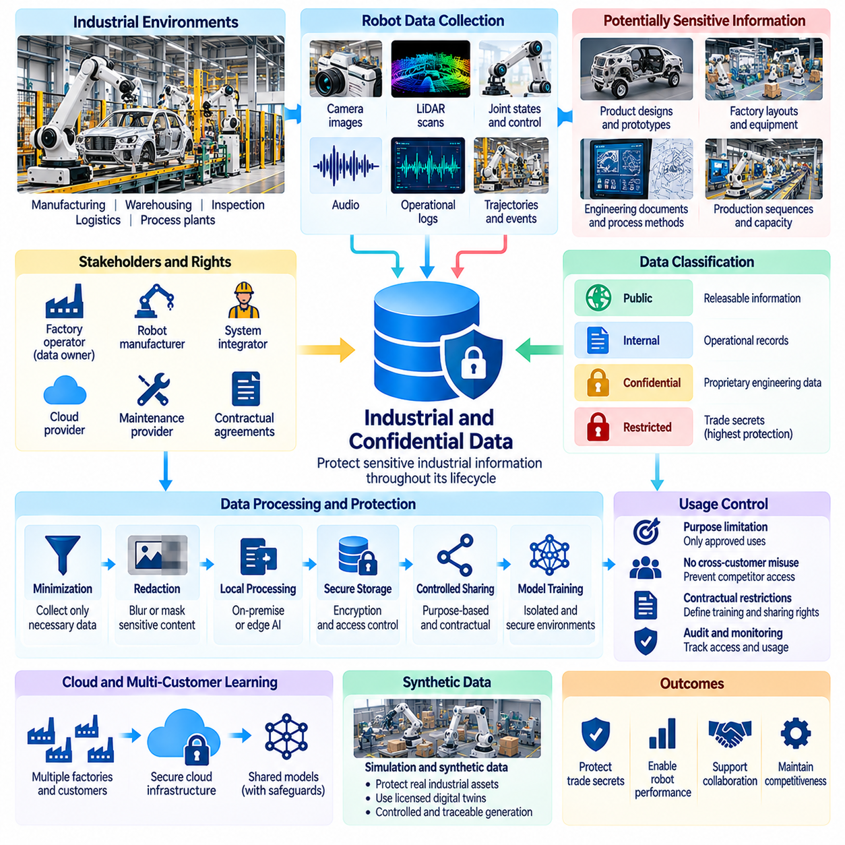
Industrial and confidential data represent critical assets in Physical AI systems because robots operate within environments containing proprietary processes, equipment configurations, and commercially sensitive information. Manufacturing robots, warehouse automation systems, and inspection platforms continuously observe operational activities. Their sensor recordings and execution logs can reveal valuable industrial knowledge that requires protection throughout collection, processing, training, and deployment.
Industrial robot datasets often contain information that extends beyond the immediate task being performed. Camera images may reveal product designs, LiDAR scans may reconstruct factory layouts, and robot trajectories may expose production sequences. Sensor timestamps and operational logs can indicate equipment utilization or manufacturing capacity. Consequently, seemingly ordinary robot telemetry may constitute confidential business information when combined with contextual knowledge.
Confidential industrial information includes trade secrets, proprietary manufacturing methods, product specifications, engineering drawings, and internal operational procedures. These materials may appear directly in robot observations or indirectly through learned patterns. A robot trained to perform assembly operations may acquire information about specialized tooling or production techniques. Governance must therefore consider both explicitly recorded information and knowledge inferred from datasets.
Data ownership and confidentiality obligations frequently involve multiple organizations. A robot manufacturer may own the hardware and software, while a factory operator controls the production environment and associated business information. System integrators, maintenance providers, and cloud vendors may also access operational records. Contracts should distinguish ownership of robot-generated data from confidentiality rights and permitted uses of customer-specific industrial information.
Industrial data classification provides a foundation for appropriate protection. Organizations can distinguish publicly releasable information, internal operational records, confidential engineering data, and highly restricted trade secrets. Classification should reflect potential commercial damage, contractual obligations, and security consequences. Dataset metadata can record sensitivity levels and determine which storage, processing, and sharing controls must be applied.
Industrial camera recordings require particular attention because visual observations can unintentionally capture confidential objects and documents. Product prototypes, production schedules, machine control panels, and engineering diagrams may appear in background regions. Privacy-oriented facial blurring does not protect these business assets. Industrial redaction systems should also detect and mask sensitive equipment, screens, documents, and restricted work areas.
Three-dimensional mapping data can expose industrial infrastructure even without conventional visual imagery. LiDAR point clouds, occupancy maps, and reconstructed digital twins may reveal facility geometry, production-line organization, access routes, and security boundaries. Such information can create competitive or physical security risks if disclosed. Access policies should therefore protect spatial representations according to their industrial sensitivity.
Operational logs and time-series sensor data may reveal commercially valuable production intelligence. Robot cycle times, equipment downtime, task completion rates, and material movement patterns can indicate throughput, process efficiency, or operational bottlenecks. Competitors may infer manufacturing capacity or business performance from aggregated telemetry. Data minimization and controlled aggregation should limit unnecessary exposure of these indicators.
Industrial data collection should follow clearly defined operational purposes. Information gathered for robot calibration, fault diagnosis, or safety monitoring should not automatically become available for unrelated model training or external analytics. Customer agreements may permit improvements to a specific installation while prohibiting reuse across competing facilities. Purpose-based policies must distinguish local optimization from broader commercial exploitation.
On-premise data processing can reduce confidentiality risks when industrial customers cannot permit unrestricted external transfers. Robot logs, images, and production observations may remain within factory-controlled infrastructure while selected diagnostic summaries are shared with vendors. Edge inference and local training can further limit exposure. However, local deployment still requires secure administration, encryption, access management, and vulnerability monitoring.
Cloud-based industrial robot learning introduces additional governance requirements. Centralized training systems may aggregate data from multiple factories, suppliers, or customers, increasing the consequences of unauthorized access. Tenant isolation, encryption, controlled processing regions, and contractual restrictions can reduce these risks. Cloud architecture should prevent confidential information from one customer becoming accessible to another customer or unrelated service.
Cross-customer training presents a difficult balance between improving general robot capabilities and protecting proprietary industrial knowledge. Shared models can benefit from diverse production experiences, but training data may encode customer-specific processes or product characteristics. Agreements should specify whether data can contribute to generalized models and whether resulting models may be deployed to competitors. Technical privacy testing should supplement contractual safeguards.
Synthetic data generation can support industrial learning without directly distributing confidential factory recordings. Simulated production cells, randomized equipment layouts, and artificial workpieces may reproduce useful task dynamics while concealing proprietary designs. Nevertheless, synthetic environments derived from confidential CAD models or digital twins may retain sensitive characteristics. Generated datasets require confidentiality review before external release.
Industrial dataset anonymization differs from conventional personal data anonymization. Removing employee names or faces does not conceal production methods, machinery configurations, or product geometry. Effective industrial deidentification may require geometric abstraction, equipment substitution, process generalization, and removal of proprietary labels. The resulting data must still preserve sufficient physical relationships for meaningful robot learning.
Access control should reflect operational roles and contractual responsibilities. Robot developers may require selected motion trajectories, maintenance engineers may need fault logs, and customer administrators may manage confidential production records. Role-based permissions, attribute-based policies, and approval workflows can restrict unnecessary access. Audit logs should record dataset retrieval, export, modification, and use in training pipelines.
Secure data transfer is essential when industrial datasets move between factories, robot vendors, research partners, and annotation contractors. Encryption in transit, authenticated endpoints, integrity verification, and controlled export procedures reduce unauthorized disclosure. Third-party agreements should establish confidentiality obligations and restrictions on onward sharing. Organizations should verify that external processors apply security controls appropriate to the sensitivity of the information.
Retention policies should account for industrial confidentiality as well as operational requirements. Raw factory recordings may be necessary for incident investigation or model debugging but inappropriate for indefinite storage. Derived features and aggregated performance statistics may support longer-term analysis under separate conditions. Deletion procedures should cover backups, temporary processing files, annotation exports, and replicated training datasets.
Model training creates additional confidentiality risks because proprietary information may persist in learned parameters. Memorization, reconstruction, and model extraction attacks can potentially reveal aspects of protected training data. Evaluations should examine whether models reproduce sensitive product designs, operational sequences, or customer-specific information. Controlled model distribution, privacy testing, and retraining procedures can reduce selected risks.
Industrial data governance also requires incident response and accountability mechanisms. Unauthorized exports, accidental publication, compromised credentials, or cross-tenant exposure may create contractual and commercial consequences. Organizations should maintain provenance records, access histories, and documented escalation procedures. Security incidents must be assessed against applicable contractual obligations, trade secret protections, and relevant reporting requirements.
Responsible management of industrial and confidential data enables Physical AI systems to improve through real operational experience without compromising the organizations that provide it. Effective governance combines classification, purpose limitation, contractual controls, secure infrastructure, restricted sharing, and continuous auditing. As industrial robot fleets expand, protecting proprietary knowledge becomes essential to sustainable data collaboration and trustworthy Physical AI development.

08.08. Anonymization Pseudonymization and Redaction
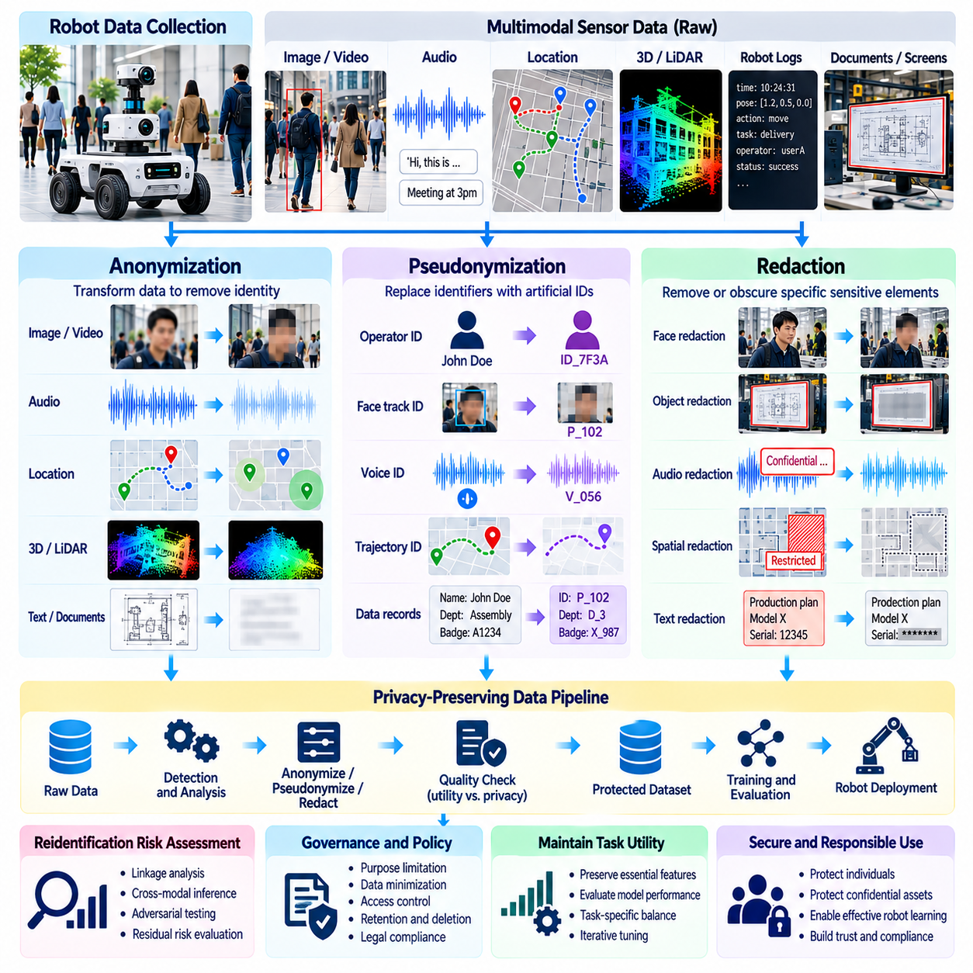
Anonymization, pseudonymization, and redaction are essential privacy protection techniques for Physical AI data engines. Robots continuously collect visual, audio, spatial, and behavioral information that may reveal personal identities or confidential industrial activities. These techniques reduce unnecessary exposure while preserving information needed for perception, imitation learning, navigation, and model evaluation. Their effectiveness depends on the data type, processing context, and potential for reidentification.
Anonymization transforms personal data so individuals are no longer identifiable by means reasonably likely to be used. This requires more than deleting names or replacing identifiers because robot observations often contain distinctive behavioral and environmental patterns. Facial appearance, gait, hand movements, and location histories may support identification through indirect inference. Anonymization must therefore be evaluated against realistic linkage and reconstruction risks.
Pseudonymization replaces direct identifiers with artificial identifiers while preserving controlled relationships between records. Operator names may be replaced with randomized codes, allowing researchers to analyze repeated demonstrations without directly exposing identities. The correspondence between codes and individuals must remain separately protected. Because reidentification remains possible through this mapping or other information, pseudonymized data generally remains personal data.
Redaction removes or obscures selected information within a dataset rather than necessarily transforming the entire dataset into anonymous information. In robot videos, redaction may conceal faces, identification badges, computer screens, or confidential documents. Audio redaction can remove names, conversations, or sensitive spoken content. Spatial redaction may exclude restricted rooms or proprietary equipment from maps and point clouds.
These three techniques serve different governance objectives and should not be treated as interchangeable. Anonymization aims to prevent identification, pseudonymization reduces direct identity exposure while retaining controlled linkability, and redaction suppresses particular sensitive elements. A dataset may use all three methods at different stages. The appropriate combination depends on intended uses, legal obligations, and the information required for robot learning.
Visual anonymization is particularly challenging because robotic cameras capture rich contextual information. Blurring faces may protect obvious identities while leaving recognizable clothing, tattoos, workplace badges, or background locations visible. Human pose estimation and silhouette extraction can reduce facial exposure, but distinctive movement patterns may remain. Privacy validation should examine the complete visual scene rather than isolated facial regions.
Automated video redaction systems commonly combine object detection, segmentation, tracking, and image transformation. Detection models identify sensitive regions, while tracking maintains consistent masking across consecutive frames. Temporal consistency is important because a single unmasked frame can reveal information concealed elsewhere. Processing pipelines should measure detection failures, missed objects, and the effects of redaction on downstream model performance.
Audio anonymization requires protection against both explicit speech content and speaker identification. Removing personal names from transcripts does not necessarily conceal identity when original voice recordings remain available. Voice transformation, speaker masking, speech removal, and conversion to task-level commands provide different levels of protection. The selected method must account for acoustic features needed by speech recognition and human-robot interaction systems.
Location anonymization involves reducing the precision or linkability of spatial observations. Robot navigation logs may contain detailed human trajectories, workstation visits, and timestamps that expose individual routines. Spatial aggregation, coordinate generalization, temporal coarsening, and trajectory truncation can reduce identification risks. However, repeated location patterns may remain distinctive even after names and exact coordinates are removed.
Industrial redaction must protect confidential business information in addition to personal data. Robot observations may capture product prototypes, engineering drawings, machine settings, production schedules, and facility layouts. Conventional facial blurring does not address these exposures. Industrial pipelines may require object masking, document detection, geometry abstraction, and exclusion of sensitive spatial regions before datasets are shared externally.
Privacy transformations must preserve the information required for legitimate Physical AI tasks. Excessive visual masking can remove object boundaries needed for grasp planning, while aggressive audio filtering may destroy command semantics. Spatial generalization may reduce localization accuracy or obscure collision hazards. Data engineers must balance privacy protection with training utility and safety requirements through task-specific evaluation.
Multimodal datasets complicate anonymization because information removed from one modality may remain recoverable from another. A masked face can be associated with a distinctive voice, while pseudonymous motion trajectories may align with identifiable location records. Cross-modal correlations can reconstruct identities or confidential activities. Privacy reviews must therefore evaluate synchronized sensor streams collectively rather than independently.
Reidentification risk assessment provides a practical foundation for evaluating anonymization claims. Analysts can examine whether transformed records remain linkable to known individuals using available auxiliary information. Membership inference, trajectory matching, behavioral recognition, and reconstruction tests may reveal residual vulnerabilities. Assessments should consider reasonably foreseeable attackers, available resources, and the consequences of successful identification.
Privacy-preserving data pipelines should integrate transformation steps as early as operationally feasible. On-robot processing can extract task-relevant features while discarding unnecessary raw images or audio. Edge redaction can reduce sensitive information before transmission to cloud infrastructure. When raw recordings are temporarily necessary, they should remain encrypted, access-restricted, and subject to short retention periods.
Pseudonymization systems require disciplined management of identity mappings and cryptographic secrets. Mapping tables should be stored separately from training datasets, with access limited to authorized administrators. Stable identifiers may support longitudinal analysis but can also enable behavioral profiling across sessions. Rotating identifiers or restricting linkage scope can reduce unnecessary tracking while retaining selected analytical capabilities.
Automated redaction is not infallible, especially in dynamic robotic environments. Motion blur, occlusion, unusual camera angles, reflective surfaces, and crowded scenes can cause detection failures. Privacy-sensitive pipelines should incorporate confidence thresholds, exception handling, and targeted human review. Quality assurance must verify both the removal of protected information and the preservation of task-relevant observations.
Dataset lineage and metadata are essential for managing privacy transformations at scale. Each processed dataset should record the transformation method, software version, parameters, validation results, and source relationship. This information supports reproducibility, compliance audits, and investigations of unexpected disclosures. Versioned records also help determine whether improved redaction methods should be reapplied to previously processed data.
Access policies should distinguish raw, pseudonymized, redacted, and sufficiently anonymized datasets according to their actual risks and applicable laws. Raw recordings may require highly restricted access, while transformed datasets may support broader research use under defined conditions. However, transformation labels alone do not guarantee safety. Sharing decisions should consider residual sensitivity, contractual restrictions, and downstream analytical capabilities.
Continuous monitoring is necessary because advances in recognition models and external data availability can change reidentification risks. A dataset considered difficult to identify today may become linkable through improved facial recognition, gait analysis, or multimodal inference. Periodic reassessment should examine emerging attack methods, changes in data sharing, and newly available auxiliary information. Updated safeguards may require further transformation or restricted access.
Effective anonymization, pseudonymization, and redaction enable Physical AI organizations to reuse valuable robot observations while reducing unnecessary exposure of individuals and industrial assets. No single transformation guarantees complete protection across every dataset and application. A mature data engine combines technical processing, measurable privacy evaluation, secure access controls, provenance tracking, and ongoing governance to support responsible, scalable robot learning.

08.09. Access Control and Data Security
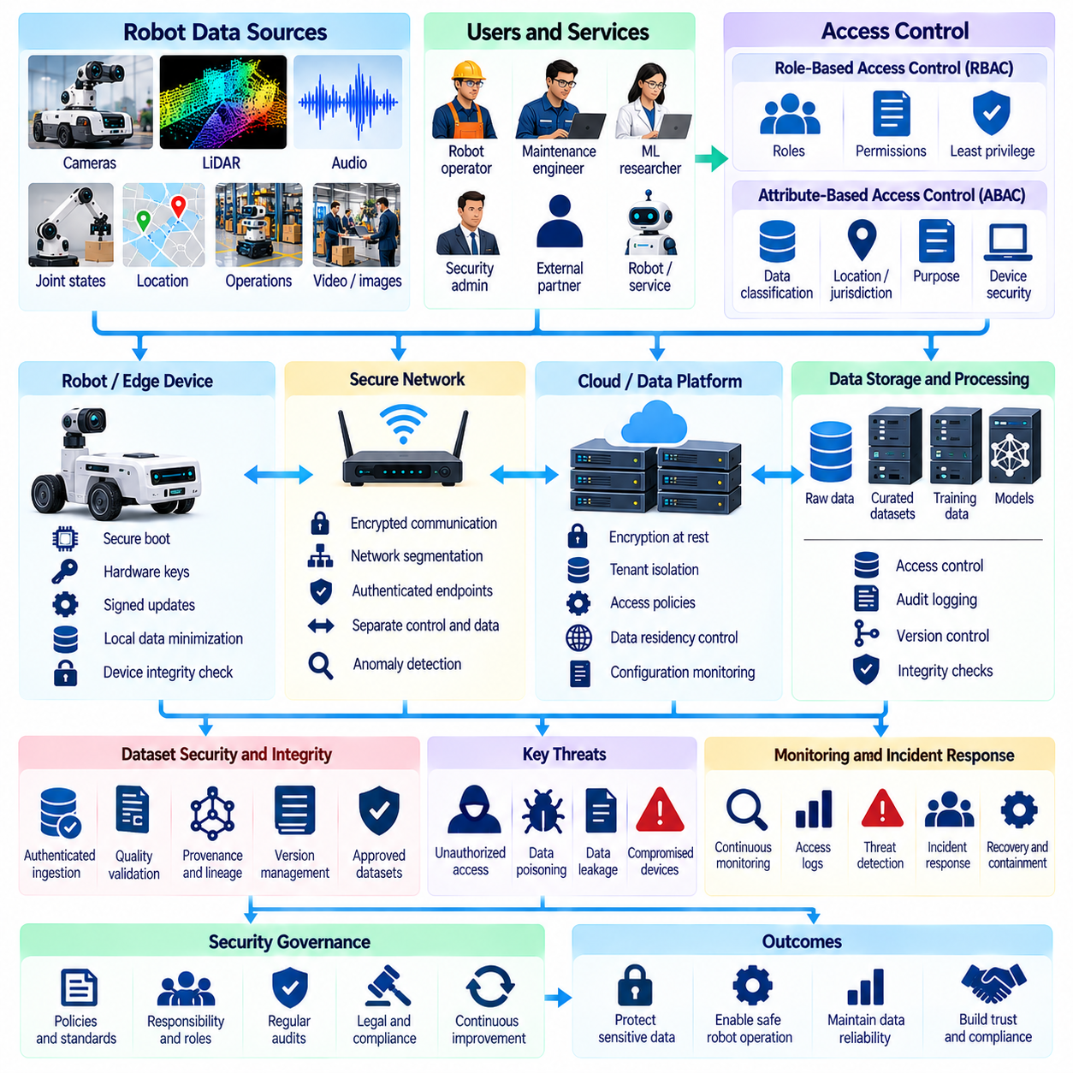
Access control and data security are fundamental requirements for Physical AI data engines because robotic systems continuously generate sensitive information about people, environments, and operational activities. Camera recordings, sensor streams, motion trajectories, and training datasets may contain personal or proprietary information. Protecting these assets requires coordinated security measures across robots, edge devices, communication networks, cloud infrastructure, and machine learning pipelines.
Access control determines which individuals, services, and automated processes can interact with specific data resources. Permissions may govern reading, modifying, exporting, deleting, or using datasets for model training. Physical AI platforms must distinguish authorized operational activities from unnecessary access. A secure architecture applies the principle of least privilege, ensuring that each user or component receives only the permissions required for legitimate responsibilities.
Role-based access control assigns permissions according to organizational responsibilities. Robot operators may access operational dashboards, maintenance engineers may inspect diagnostic logs, and machine learning researchers may use approved training datasets. Security administrators manage credentials and access policies without necessarily requiring unrestricted access to raw recordings. Clearly defined roles reduce accidental disclosure and simplify permission management across large robotic organizations.
Attribute-based access control provides greater flexibility when permissions depend on data sensitivity, location, purpose, or contractual conditions. A dataset may be accessible only to approved researchers working within a particular jurisdiction or secure computing environment. Access decisions can evaluate user identity, dataset classification, processing purpose, and device security status. Such policies are valuable when Physical AI platforms serve multiple customers and regulatory domains.
Identity and authentication systems establish whether users, robots, and services are trustworthy participants. Human access may require multifactor authentication, while robots and software services can use cryptographic certificates or managed machine identities. Credentials should be issued, rotated, revoked, and monitored through controlled processes. Shared accounts and permanently embedded secrets increase the risk of unauthorized access and complicate incident investigation.
Zero-trust security principles are particularly relevant to distributed robotic infrastructure. A robot operating inside a factory network should not automatically be trusted merely because it connects from an internal address. Each access request should be authenticated, authorized, and evaluated against current security conditions. Network segmentation and service-level authorization can limit the consequences of compromised devices or stolen credentials.
Encryption protects Physical AI data against unauthorized disclosure during transmission and storage. Transport encryption secures communication between robots, gateways, and cloud services, while encryption at rest protects stored recordings and datasets. Effective protection also requires secure key generation, distribution, rotation, and revocation. Encryption alone cannot prevent misuse by authorized users, so it must operate alongside access policies and monitoring.
Robotic edge devices introduce unique security challenges because they operate in physically accessible and sometimes uncontrolled environments. Attackers may attempt to extract storage media, modify firmware, or intercept sensor interfaces. Secure boot, hardware-backed key storage, signed software updates, and device integrity verification can reduce these risks. Sensitive raw data should be minimized locally, and compromised devices should be isolated from shared infrastructure.
Network security must account for the continuous exchange of telemetry, control messages, sensor recordings, and model updates. Secure communication protocols, authenticated endpoints, firewall rules, and network segmentation help protect these flows. Safety-critical control traffic should be separated from bulk data uploads when appropriate. Monitoring systems should detect unusual transfers, unexpected connections, and attempts to access unauthorized services.
Cloud-based robot data platforms require strong isolation between customers, projects, and operational environments. Shared storage and computing resources can create cross-tenant exposure risks if permissions are incorrectly configured. Tenant-specific access policies, encryption boundaries, isolated processing environments, and continuous configuration checks reduce these vulnerabilities. Data residency restrictions must also be reflected in cloud deployment and access arrangements.
Training datasets require protection throughout ingestion, annotation, curation, and model development. External contributors may upload corrupted or malicious samples, while unauthorized users may attempt to modify labels or replace training files. Dataset integrity checks, authenticated ingestion, version control, and provenance records can detect unexpected changes. Security governance must protect both confidentiality and the reliability of information used to train robot policies.
Data poisoning represents a distinctive threat because malicious modifications can influence learned robot behavior. Altered demonstrations, incorrect labels, or manipulated sensor observations may cause unsafe decisions or degraded performance. Secure data pipelines should validate source authenticity, inspect anomalous samples, and preserve reproducible training records. Independent evaluation and controlled dataset approval can reduce the likelihood that compromised data reaches production models.
Model artifacts and training infrastructure also require access protection. Learned parameters, checkpoints, evaluation results, and deployment packages may contain valuable intellectual property or information derived from sensitive datasets. Unauthorized modification can introduce malicious behavior, while uncontrolled distribution may expose proprietary capabilities. Signed model packages, artifact registries, access restrictions, and deployment verification support trustworthy model management.
Data loss prevention controls can limit unauthorized movement of sensitive robotic information. Large exports, unusual downloads, transfers to unapproved destinations, and unexpected dataset replication may indicate misuse or compromise. Monitoring should consider legitimate research workflows to avoid unnecessary disruption. Approval mechanisms, export restrictions, and automated alerts help organizations maintain visibility over confidential data movement.
Audit logging establishes accountability by recording who accessed data, what operations occurred, and which systems were involved. Logs should capture dataset retrieval, permission changes, exports, deletions, and training activities where appropriate. Protected timestamps and tamper-resistant storage improve evidentiary reliability. Audit records must themselves be secured because they may reveal sensitive operational information or personal activity patterns.
Security monitoring should combine identity events, network activity, storage access, and robotic operational signals. Unusual access times, repeated authentication failures, unexpected data transfers, or unauthorized model changes may indicate an incident. Automated detection can prioritize suspicious events, but investigations require contextual understanding. Monitoring policies should avoid creating unnecessary surveillance of employees while maintaining operational security.
Third-party access introduces risks when annotation vendors, research partners, cloud providers, or maintenance contractors process robot datasets. Contracts should specify permitted activities, confidentiality obligations, security requirements, and incident notification responsibilities. Temporary access credentials and isolated workspaces can limit exposure. Organizations should verify external security practices and promptly revoke access when contractual relationships end.
Backup and recovery mechanisms protect the availability and integrity of Physical AI data. Ransomware, storage failures, accidental deletion, and infrastructure outages can disrupt training and robot operations. Encrypted backups, immutable recovery copies, and regularly tested restoration procedures improve resilience. Recovery planning should consider dataset versions, metadata, access policies, and dependencies required to reproduce validated robot models.
Incident response procedures must address unauthorized disclosure, data tampering, credential compromise, and malicious model modification. Response teams should be able to isolate affected systems, preserve evidence, assess impacted datasets, and restore trusted operations. Security incidents involving deployed robots may also require immediate safety measures. Documented escalation paths and post-incident reviews help prevent repeated failures.
A mature Physical AI security architecture integrates identity management, least-privilege access, encryption, integrity verification, monitoring, and incident response into a unified governance framework. Security controls must evolve as robot fleets, data volumes, and collaborative learning environments expand. By protecting data confidentiality, integrity, and availability throughout the learning lifecycle, organizations can build scalable robotic intelligence without sacrificing safety, accountability, or trust.

08.10. Data Retention Deletion and Auditing
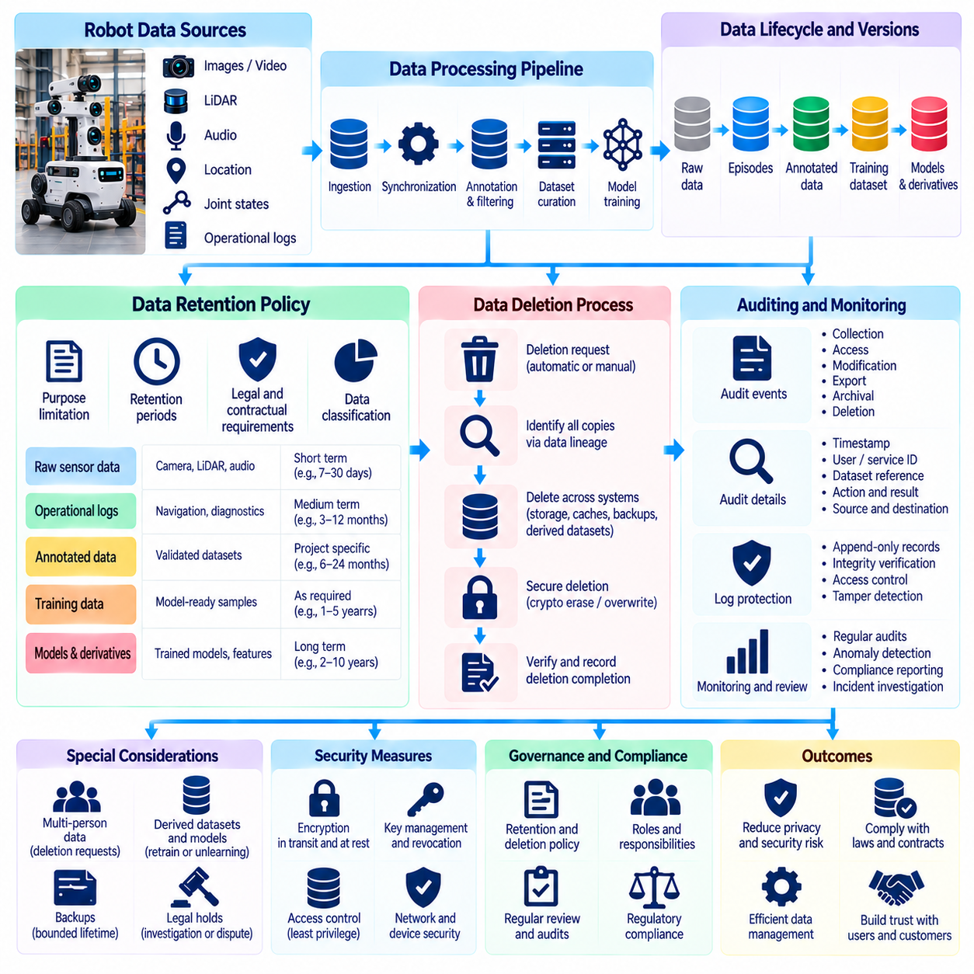
Data retention, deletion, and auditing are essential components of Physical AI data governance because robotic systems continuously generate large volumes of sensor recordings, operational logs, and training data. These records support learning, diagnostics, and safety investigations but may also contain personal or confidential information. Effective governance defines how long data remains available, when it must be removed, and how its lifecycle can be verified.
Data retention policies establish the conditions under which robotic information is stored for operational, research, legal, or contractual purposes. Retention periods should reflect the original collection purpose, data sensitivity, and legitimate business requirements. Raw camera recordings may require shorter retention than validated training features or aggregated performance statistics. Indefinite storage should not become the default simply because storage capacity is inexpensive.
Physical AI datasets often pass through multiple processing stages, creating distinct retention requirements. Raw sensor streams may be converted into synchronized episodes, annotated demonstrations, filtered datasets, and model-ready training samples. Each derivative can contain different levels of sensitive information. Retention schedules should identify which versions remain necessary and whether intermediate files can be deleted after validation.
Purpose limitation provides an important foundation for retention decisions. Information collected for immediate navigation or obstacle avoidance may not require long-term storage, while incident recordings may need preservation for investigation. Data gathered for maintenance diagnostics should not automatically be retained for unrelated model development. Organizations must periodically verify that continued storage remains justified by an approved purpose.
Retention periods should be determined through a combination of risk assessment, operational necessity, and applicable legal requirements. Different jurisdictions and contractual relationships may impose minimum preservation periods or maximum storage limits. A single universal retention duration is therefore inappropriate for every robot deployment. Governance frameworks should document the justification, responsible authority, and review conditions for each retention category.
Automated lifecycle management helps enforce retention policies across large robot fleets. Data management systems can assign expiration dates when recordings are created and trigger archival, transformation, or deletion workflows. Metadata should identify data owners, collection purposes, sensitivity classifications, and retention rules. Automated controls reduce dependence on manual administration while providing consistent enforcement across distributed infrastructure.
Data deletion must address more than removing a file from a visible directory. Robotic datasets may exist in object storage, edge caches, annotation systems, backups, and replicated training environments. Deleting a primary record does not necessarily eliminate its copies. Effective deletion workflows require dataset lineage, dependency tracking, and coordinated removal across systems where the information remains accessible.
Secure deletion techniques depend on the storage technology and the level of confidentiality involved. Cryptographic erasure can make encrypted information inaccessible by securely destroying the relevant encryption keys, provided no usable copies remain. Other systems may require verified overwrite procedures or physical media destruction. Organizations should account for solid-state storage behavior, immutable backups, and infrastructure limitations when selecting deletion methods.
Deletion requests introduce additional complexity when robotic observations contain information about multiple individuals or organizations. A workplace video may simultaneously record employees, equipment, and confidential production activities. Removing one person's information without destroying useful operational evidence may require selective redaction or dataset reconstruction. Requests must be evaluated against applicable rights, legal exceptions, and documented retention obligations.
Derived datasets and machine learning artifacts create difficult questions about the scope of deletion. Removing an original recording does not automatically remove information from feature stores, annotated samples, or trained models. Organizations should maintain traceability between source records and downstream derivatives. Where required and technically feasible, remediation may involve deleting derived records, retraining models, or applying validated machine unlearning techniques.
Backup systems require carefully designed deletion and retention procedures. Immutable recovery copies may preserve information beyond its expiration in primary storage. Organizations should establish bounded backup lifetimes, prevent expired records from being restored into active environments, and document exceptions. When immediate selective deletion is technically unavailable, compensating safeguards and scheduled expiration should be assessed against applicable obligations.
Auditing provides evidence that retention and deletion policies are implemented as intended. Audit records should document data collection, access, modification, export, archival, and deletion events. Each event may include timestamps, responsible identities, dataset references, and processing outcomes. Reliable audit trails allow organizations to reconstruct data histories, investigate incidents, and demonstrate compliance with approved governance procedures.
Audit logs require protection against unauthorized modification or deletion. Append-only recording mechanisms, integrity checks, restricted administrative permissions, and secure timestamping can improve evidentiary reliability. Centralized log collection may simplify analysis across distributed robots and cloud services. However, audit records can themselves reveal personal behavior or confidential operations and must therefore follow appropriate access and retention policies.
Data provenance strengthens auditing by connecting datasets to their origins and transformation histories. Provenance records can identify the robot, sensor configuration, collection session, annotation process, and processing software associated with each dataset. These relationships support reproducibility and help determine which downstream assets are affected by a deletion request. Provenance should remain accurate as datasets are filtered, merged, or redistributed.
Periodic retention audits examine whether stored data continues to satisfy approved purposes and policy requirements. Reviewers can identify expired recordings, unnecessary duplicates, excessive access permissions, and undocumented exports. Automated reports may compare actual storage inventories against retention schedules. Corrective actions should be assigned to accountable owners and verified after implementation.
Legal holds and incident investigations may require temporary suspension of routine deletion. Evidence related to safety failures, security incidents, litigation, or regulatory inquiries may need preservation despite ordinary expiration rules. Such exceptions should be authorized, narrowly scoped, documented, and periodically reviewed. Once the preservation requirement ends, normal retention and deletion procedures should resume.
Fleet-scale deployment makes consistent retention governance increasingly difficult because robots operate across facilities, customers, and jurisdictions. Connectivity interruptions may delay synchronization of deletion commands, while local storage may retain information after cloud records expire. Systems should support offline expiration policies, deletion acknowledgments, and reconciliation when connectivity returns. Central governance must remain enforceable without assuming permanent network availability.
Retention and deletion controls should be incorporated into data engineering workflows rather than added after deployment. Dataset registries, annotation platforms, training pipelines, and model repositories should inherit applicable lifecycle metadata. New derived assets should receive explicit retention classifications and documented dependencies. Design-stage integration reduces the risk of uncontrolled data accumulation and simplifies future compliance activities.
Governance effectiveness can be measured through operational indicators such as expired-data removal rates, deletion completion times, audit coverage, and unresolved retention exceptions. These metrics reveal whether written policies translate into practical controls. Independent reviews and simulated deletion exercises can identify hidden copies or broken workflows. Continuous improvement should address both technical failures and organizational accountability gaps.
Responsible retention, deletion, and auditing establish a verifiable lifecycle for Physical AI information from initial collection to final disposition. The objective is not simply to minimize storage but to preserve valuable data only while justified and securely eliminate unnecessary exposure. By combining purpose-based schedules, traceable transformations, enforceable deletion, and trustworthy audit evidence, organizations can support scalable robot learning while maintaining privacy, security, and accountability.

08.11. Bias Representation and Data Quality Governance
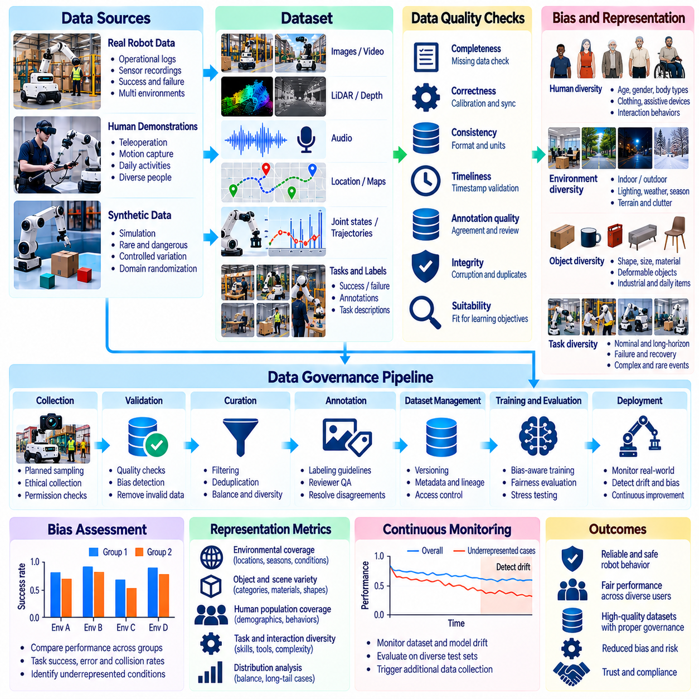
Bias, representation, and data quality governance are fundamental to developing reliable Physical AI systems because robot behavior depends on the environments, objects, people, and actions represented in training data. Datasets collected from limited operating conditions may produce models that perform well during testing but fail in unfamiliar situations. Effective governance must therefore evaluate not only dataset size but also coverage, diversity, accuracy, and the consequences of missing information.
Dataset bias occurs when collected observations systematically overrepresent certain conditions while underrepresenting others. Industrial robots may encounter mostly standardized workpieces, while service robots may be trained primarily in organized indoor environments. Such imbalances can create misleading expectations about real-world performance. Governance processes should identify sampling limitations before models are deployed into environments that differ from their training distributions.
Representation refers to how adequately a dataset captures the variation required for a robot's intended operating domain. Relevant dimensions include lighting, weather, object geometry, surface materials, human behavior, equipment configurations, and task complexity. A dataset may contain millions of observations yet provide poor representation of rare obstacles or unusual interactions. Coverage must be measured against operational requirements rather than raw sample counts.
Human representation is particularly important when robots interact with diverse populations. Differences in height, body proportions, mobility, clothing, movement patterns, and assistive devices can affect perception and navigation performance. Training data that excludes these variations may create unequal safety or service outcomes. Evaluation should examine whether relevant groups and interaction conditions receive adequate coverage without collecting unnecessary sensitive attributes.
Environmental bias can emerge when training data originates from a small number of facilities or geographic regions. Robots trained in clean laboratories may struggle with dust, reflections, clutter, uneven surfaces, or variable illumination. Outdoor systems face additional variation from precipitation, seasonal changes, and terrain conditions. Data governance should connect environmental coverage to the operational design domain and explicitly document unsupported conditions.
Task representation requires attention to both successful demonstrations and failure cases. Datasets containing only ideal executions may teach robots efficient nominal behavior without exposing recovery strategies. Failed grasps, interrupted trajectories, unexpected human interventions, and equipment malfunctions provide valuable learning signals. However, unsafe events must be collected and labeled responsibly, with controlled testing preferred when direct experimentation creates unacceptable risks.
Data quality encompasses correctness, completeness, consistency, timeliness, and suitability for intended learning objectives. Sensor calibration errors, missing timestamps, corrupted frames, and inconsistent coordinate systems can degrade model performance even when dataset coverage is broad. Quality governance establishes measurable acceptance criteria for each data source. Automated validation should identify technical defects before observations enter expensive training pipelines.
Annotation quality is a major source of uncertainty in robotic learning. Human annotators may disagree about object boundaries, action phases, contact events, or failure causes. Ambiguous instructions and inconsistent labeling conventions can introduce systematic errors. Governance should define annotation schemas, reviewer qualifications, disagreement resolution procedures, and periodic quality checks to ensure that labels remain interpretable across datasets.
Temporal and multimodal consistency are essential because Physical AI systems learn from synchronized observations and actions. Camera frames, force measurements, joint states, and control commands must refer to compatible moments in time. Synchronization errors may create false relationships between perception and behavior. Data validation should inspect clock drift, missing samples, coordinate transformations, and alignment errors before training sequential decision models.
Sampling strategies strongly influence dataset representation. Random sampling may preserve dominant operating conditions while excluding rare but safety-critical events. Stratified sampling, uncertainty-based selection, and targeted collection can improve coverage of underrepresented scenarios. Governance should document sampling decisions and their intended effects. Oversampling difficult cases must also be evaluated to avoid distorting estimates of normal operating frequencies.
Synthetic data can improve representation by generating conditions that are expensive, dangerous, or uncommon in physical deployments. Simulation environments can vary object arrangements, lighting, friction, sensor noise, and human motion. Nevertheless, synthetic datasets may introduce unrealistic dynamics or visual artifacts. Governance should measure simulation-to-reality gaps and verify that synthetic diversity translates into improved performance on independent real-world evaluations.
Bias assessment requires metrics linked to operational consequences rather than abstract dataset balance alone. Relevant measures may include task success rates, collision frequency, intervention rates, perception errors, and recovery performance across defined conditions. Performance differences should be examined by environment, task type, object category, and relevant human interaction scenarios. Aggregate accuracy can conceal serious weaknesses in small but important operational subsets.
Dataset documentation supports transparency and accountability by recording collection sources, intended uses, known limitations, and quality characteristics. Metadata should describe sensor configurations, geographic or facility coverage, sampling methods, annotation procedures, and validation results. Dataset versioning allows researchers to connect model behavior to specific training inputs. Documentation should also identify conditions where evidence is insufficient to support reliable performance claims.
Continuous quality monitoring is necessary because deployed robot environments evolve over time. New products, equipment modifications, changing human workflows, and seasonal conditions can alter incoming data distributions. Distribution shift detection can identify observations that differ substantially from training experience. Monitoring results should guide targeted data collection, model reevaluation, and controlled updates rather than automatically triggering unrestricted retraining.
Feedback from field failures provides an important mechanism for correcting representation gaps. Unexpected collisions, unsuccessful manipulation attempts, and repeated operator interventions can reveal missing scenarios or mislabeled examples. Incident records should be analyzed to distinguish data deficiencies from hardware, planning, or control failures. Corrective datasets must undergo validation before their incorporation into new training versions.
Governance must also address organizational incentives that influence dataset quality. Teams may prioritize collection volume, benchmark performance, or training speed while neglecting difficult environments and expensive annotation. Quality ownership, independent reviews, and explicit acceptance thresholds help counter these pressures. Data quality metrics should be included in development milestones alongside model performance and deployment readiness indicators.
Privacy and fairness considerations intersect with representation governance. Collecting sensitive personal characteristics solely to improve dataset balance may create unnecessary privacy risks. Organizations should use proportionate evaluation methods, protected access, and appropriate aggregation where sensitive information is genuinely required. Fairness objectives must be connected to measurable safety and service outcomes while respecting legal and contextual constraints.
A mature governance framework establishes accountability for identifying, documenting, and correcting bias and quality defects throughout the data lifecycle. Dataset owners, annotation teams, model developers, and safety reviewers should share clear responsibilities and escalation procedures. Independent validation should challenge assumptions about representativeness. Decisions to expand deployment must consider residual uncertainty and the consequences of failures in underrepresented conditions.
Responsible bias, representation, and data quality governance transforms dataset management from a storage activity into a continuous assurance process. The objective is not perfect statistical balance but sufficient evidence that robots can operate safely and reliably across their intended conditions. By combining systematic coverage analysis, rigorous validation, transparent documentation, and field-driven improvement, Physical AI organizations can develop more dependable and broadly applicable robotic intelligence.

08.12. Edge and On Premise Data Governance
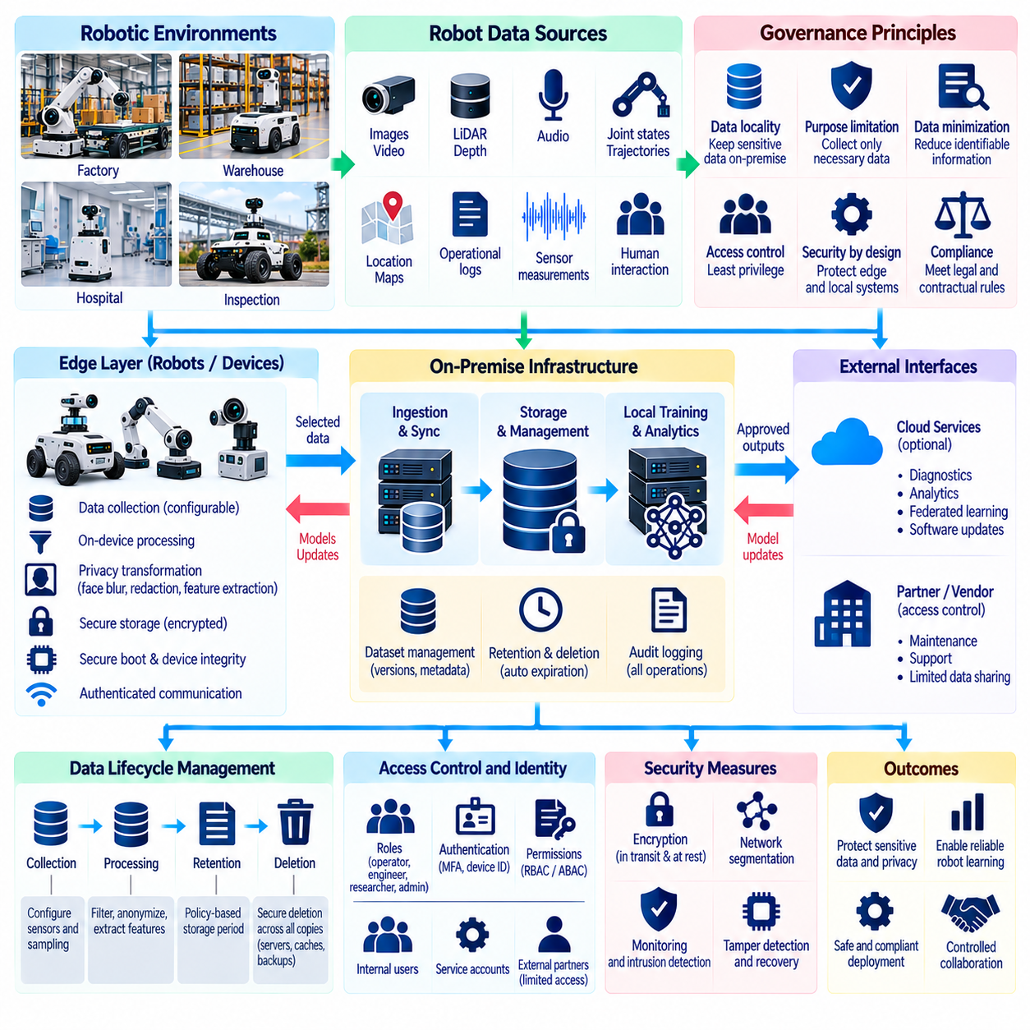
Edge and on-premise data governance is essential for Physical AI systems operating in factories, hospitals, warehouses, and other environments where sensitive information cannot be freely transferred to external infrastructure. Robots continuously generate camera recordings, sensor measurements, operational logs, and human interaction data. Local governance establishes how this information is collected, processed, stored, protected, and shared while maintaining organizational control over critical data assets.
Edge computing processes robotic information close to the sensors and machines that generate it, while on-premise infrastructure provides computing and storage resources within an organization's controlled facilities. These approaches reduce dependence on remote cloud services and can support low-latency operations. However, physical proximity does not automatically guarantee privacy or security. Effective governance requires explicit policies for data ownership, access, retention, and processing.
Data locality is a central principle of edge and on-premise governance. Organizations may require raw video, industrial telemetry, engineering drawings, or patient-related observations to remain within designated facilities. Local processing can extract task-relevant features without exporting complete recordings. Governance policies should distinguish data that must remain local from information permitted for external analytics, diagnostics, or collaborative model training.
Edge data collection should follow purpose limitation and data minimization principles. A navigation robot may need temporary visual observations for obstacle avoidance without retaining identifiable human footage. Industrial inspection systems may preserve defect measurements while discarding unnecessary background imagery. Collection policies should define which sensor streams are recorded, their sampling rates, retention periods, and authorized uses before deployment begins.
Local processing pipelines can incorporate privacy transformations before information enters shared storage or communication networks. Facial masking, document redaction, voice removal, and spatial abstraction may reduce exposure of sensitive content. Feature extraction can replace raw recordings when downstream tasks do not require full sensor detail. These transformations must be validated to ensure they preserve the physical information needed for reliable robot behavior.
On-premise architecture should separate operational control, data processing, model training, and administrative functions. Safety-critical robot controllers should not depend on unrestricted access to general-purpose data services. Network segmentation and isolated processing environments reduce the consequences of compromised components. Governance should define trusted communication paths and prohibit unnecessary movement of confidential information between operational zones.
Identity and access management remain necessary even when infrastructure is physically controlled by the customer. Robot operators, maintenance engineers, machine learning developers, and external service providers require different permissions. Role-based and attribute-based access policies can restrict sensitive datasets according to responsibility and purpose. Authentication, temporary credentials, and detailed audit records help prevent unauthorized access and support accountability.
Edge devices present distinctive security risks because they may be installed in publicly accessible or physically exposed locations. Attackers could attempt to remove storage devices, alter firmware, or intercept sensor connections. Secure boot, encrypted storage, hardware-backed credentials, and signed updates can strengthen device protection. Organizations should also establish procedures for detecting tampering, isolating compromised devices, and recovering trusted configurations.
Data synchronization between robots and local servers requires careful governance. Intermittent connectivity may cause delayed uploads, duplicate records, or inconsistent dataset versions. Synchronization protocols should verify authenticity, integrity, and transfer completion. Metadata must preserve collection timestamps, device identities, and processing histories. Conflict resolution procedures should prevent corrupted or outdated records from silently replacing validated information.
Local storage management becomes increasingly complex as robot fleets generate continuous multimodal observations. High-resolution video, LiDAR point clouds, force measurements, and execution traces can consume substantial capacity. Retention policies should prioritize operational value and sensitivity rather than preserving every recording indefinitely. Automated expiration, controlled archival, and secure deletion help prevent uncontrolled accumulation of confidential data.
On-premise learning infrastructure allows organizations to train or fine-tune robot models without transferring complete datasets to external providers. Local training can support customer-specific manipulation, navigation, and inspection capabilities. However, training jobs still require controlled access to sensitive records and computational resources. Dataset lineage, experiment tracking, and model artifact protection are necessary to maintain reproducibility and confidentiality.
Federated learning can extend local governance across multiple facilities while reducing direct exchange of raw observations. Participating sites train models locally and share selected parameter updates or other approved learning outputs. Nevertheless, these updates may reveal information about underlying datasets. Secure aggregation, privacy testing, and controlled participation policies are needed to reduce leakage risks and establish acceptable collaboration boundaries.
Edge inference introduces governance questions about model deployment and update authority. Robots may execute locally stored policies that influence navigation, manipulation, or human interaction. Unauthorized or unvalidated model changes can create safety and security consequences. Signed deployment packages, version approval, rollback capabilities, and staged validation should govern updates. Operational systems must maintain traceability between deployed models and their approved training sources.
Offline operation is a major design requirement for industrial and mobile robots. Devices may temporarily lose connectivity while continuing to collect information and perform authorized tasks. Local governance policies must remain enforceable during these periods. Expiration rules, access restrictions, and event logging should operate without continuous cloud communication. When connectivity returns, systems should reconcile pending changes without violating established data handling restrictions.
Backup and disaster recovery procedures are essential for protecting locally managed robotic information. Hardware failures, ransomware, power interruptions, or accidental deletion can disrupt operations and destroy valuable training records. Encrypted backups, isolated recovery copies, and regularly tested restoration procedures improve resilience. Recovery plans should include dataset metadata, security policies, model versions, and dependencies needed to restore validated system behavior.
Auditing across distributed edge devices requires reliable collection of access events, configuration changes, data exports, and model updates. Local logs should remain protected against tampering and unauthorized deletion. Centralized on-premise monitoring can consolidate evidence while preserving data locality requirements. Audit processes must also account for disconnected devices and verify that delayed event records are incorporated when communication resumes.
Operational governance must clearly assign responsibilities between robot manufacturers, system integrators, infrastructure administrators, and facility owners. The customer may control local data storage while vendors provide software maintenance and diagnostic support. Contracts should specify remote access conditions, data export permissions, incident notification duties, and ownership of derived models. Clear responsibility boundaries reduce uncertainty during failures, upgrades, and security investigations.
Scalable edge governance requires consistent policy enforcement across heterogeneous hardware and software environments. Different robots may use distinct operating systems, sensor formats, storage technologies, and communication protocols. Central policy definitions should be translated into device-specific controls without losing their intended meaning. Configuration management, compliance testing, and standardized metadata help maintain governance consistency as deployments expand.
A mature edge and on-premise governance framework combines local data control, privacy-preserving processing, secure infrastructure, lifecycle management, and continuous auditing. Its purpose is not to eliminate cloud collaboration but to establish explicit boundaries for when and how information may leave controlled environments. By integrating governance into robot architecture from the beginning, Physical AI organizations can support dependable learning and deployment while protecting privacy, industrial confidentiality, and operational autonomy.

08.13. Cloud and Cross Border Data Governance
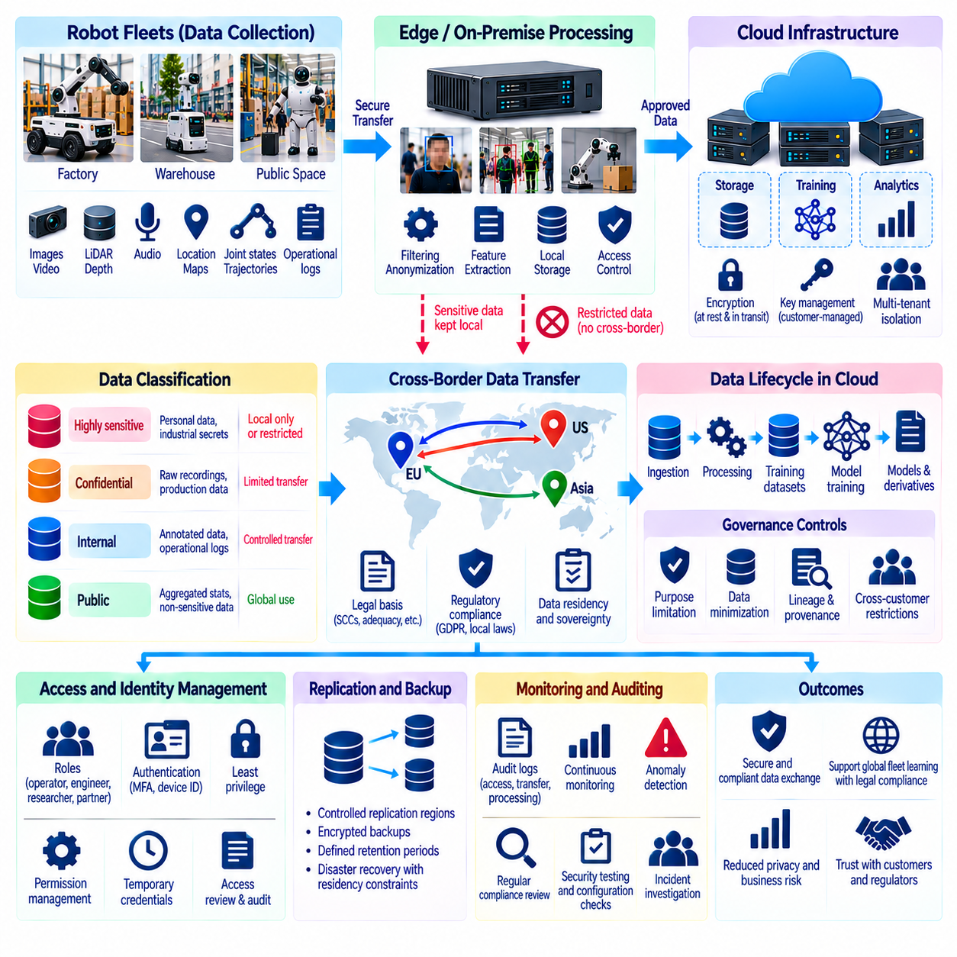
Cloud and cross-border data governance is a critical component of Physical AI because robotic systems increasingly depend on distributed infrastructure for data storage, model training, fleet monitoring, and continuous improvement. Sensor recordings, operational logs, and training datasets may move between robots, local facilities, and cloud regions. Effective governance must preserve security, privacy, accountability, and legal compliance throughout these distributed data flows.
Cloud infrastructure enables organizations to aggregate robotic observations from multiple facilities and geographic regions. Centralized storage and computing resources support large-scale model training, performance analysis, and collaborative development. However, combining datasets from different customers or jurisdictions can introduce conflicting requirements. Governance frameworks must distinguish technical accessibility from legal authorization and ensure that data sharing remains consistent with approved purposes.
Cross-border data transfers occur when information collected in one jurisdiction is stored, processed, accessed, or replicated in another. Such transfers may involve personal information, industrial secrets, or sensitive operational records. Different legal systems impose distinct requirements on international processing. Organizations must identify relevant jurisdictions, applicable transfer restrictions, and contractual obligations before enabling international robotic data exchange.
Data residency and data sovereignty establish important boundaries for cloud deployment. Residency concerns the geographic location where information is stored or processed, while sovereignty addresses the legal authority governing that information. A dataset stored within a particular country may still be accessible to foreign administrators or subject to external legal obligations. Governance must therefore evaluate access arrangements and jurisdictional exposure alongside physical storage locations.
Cloud architecture should classify robotic information according to sensitivity, ownership, and permitted processing locations. Raw camera recordings containing identifiable individuals may require stricter controls than aggregated equipment statistics. Industrial drawings, production parameters, and customer-specific models may also have contractual restrictions. Classification metadata should guide storage placement, encryption, access permissions, and approved transfer destinations.
International data transfers require an appropriate legal basis and applicable safeguards. Depending on the jurisdictions involved, organizations may need contractual transfer mechanisms, adequacy arrangements, regulatory approvals, or documented assessments. Privacy notices and customer agreements must accurately describe relevant processing activities. Governance teams should verify current legal requirements rather than assuming that technical encryption alone authorizes unrestricted transfers.
Data minimization can reduce cross-border exposure by limiting the information transmitted to cloud platforms. Robots may perform local preprocessing to remove unnecessary imagery, identifiers, audio, or precise location details. Only task-relevant features or aggregated metrics may need centralized analysis. However, supposedly anonymized outputs must be evaluated for reidentification risks, especially when multiple datasets can be linked through timestamps or operational context.
Encryption protects robotic information during transmission and storage, but it does not eliminate every governance concern. Transport encryption, storage encryption, and managed key services reduce unauthorized disclosure risks. Key ownership and administrative control determine who can ultimately access protected records. Highly sensitive deployments may require customer-managed keys, hardware security modules, and separation between cloud operators and data controllers.
Identity and access governance must extend across cloud services, robotic fleets, vendors, and geographic regions. Engineers, operators, researchers, and external partners should receive permissions based on documented responsibilities. Least-privilege access, strong authentication, and temporary credentials reduce unnecessary exposure. Cross-border remote access should be treated as a potential international data transfer when applicable regulations define it that way.
Cloud replication and disaster recovery create additional data residency challenges. Providers may distribute storage copies, backups, logs, and metadata across multiple regions to improve availability. These secondary records can fall outside intended geographic boundaries unless configurations are carefully controlled. Governance policies should specify permitted replication regions, backup locations, recovery procedures, and retention periods for both primary and derivative information.
Cloud-based training pipelines can transform customer data into datasets, checkpoints, embeddings, and deployed models. These derivatives may retain confidential patterns even after original recordings are removed. Dataset lineage and model provenance are therefore necessary to track downstream processing. Organizations should establish clear rules for whether customer observations may contribute to shared foundation models, specialized models, or cross-customer learning.
Multi-tenant cloud environments introduce risks when unrelated organizations share physical infrastructure or managed services. Logical isolation, tenant-specific access policies, encryption boundaries, and workload separation reduce unauthorized data exposure. Nevertheless, configuration errors and excessive privileges can undermine isolation. Governance should require regular security testing, configuration reviews, and documented responsibilities between cloud providers and robotic platform operators.
Cloud service agreements must clarify the roles of data controllers, processors, subcontractors, and technology vendors where applicable. Contracts should define authorized processing purposes, security obligations, breach notification procedures, data return rights, and deletion requirements. Subprocessor relationships require particular attention because information may pass through services not directly visible to customers. Contractual governance should reflect actual technical data flows.
Auditing and traceability are essential for demonstrating compliance across distributed cloud environments. Audit records should capture data uploads, downloads, transformations, access events, replication activities, and deletion operations. Logs must identify responsible identities, processing locations, and relevant dataset versions. Centralized monitoring can reveal unauthorized transfers or policy violations, while protected audit trails provide evidence for investigations and regulatory reviews.
International robotic deployments require governance policies that adapt to local legal and operational conditions. A global fleet may operate under different privacy laws, industrial confidentiality requirements, and customer agreements. Uniform technical standards can support consistency, but jurisdiction-specific restrictions may require separate storage regions or processing workflows. Policy engines should translate these requirements into enforceable controls without relying solely on manual decisions.
Incident response becomes more complex when cloud systems and robotic data span national boundaries. Security breaches may affect customers in multiple jurisdictions and trigger different reporting obligations. Response plans should identify responsible organizations, affected data categories, relevant locations, and notification procedures. Evidence preservation must respect legal requirements while supporting timely containment, forensic investigation, and recovery.
Cloud governance must also address service availability, vendor dependence, and operational continuity. Network outages or regional cloud failures should not disable safety-critical robot functions. Local controllers must retain essential autonomy and protective mechanisms when remote services become unavailable. Organizations should evaluate portability, recovery capabilities, and exit strategies to ensure that data and models remain manageable when providers or contractual relationships change.
Effective cloud and cross-border governance requires continuous reassessment because infrastructure, regulations, and robotic applications evolve. New cloud regions, model training services, international partnerships, and data processing techniques may change existing compliance assumptions. Periodic assessments should review transfer inventories, access permissions, contractual safeguards, and technical configurations. Identified gaps must lead to documented corrective actions and verified implementation.
Responsible cloud and cross-border data governance enables Physical AI organizations to benefit from distributed learning without surrendering control over sensitive information. Its objective is to establish transparent, enforceable boundaries for collection, transfer, processing, retention, and reuse. By combining jurisdiction-aware policies, secure cloud architecture, traceable data lineage, and continuous oversight, organizations can scale robotic intelligence while respecting privacy, sovereignty, and contractual trust.

08.14. Federated and Privacy Preserving Robot Learning
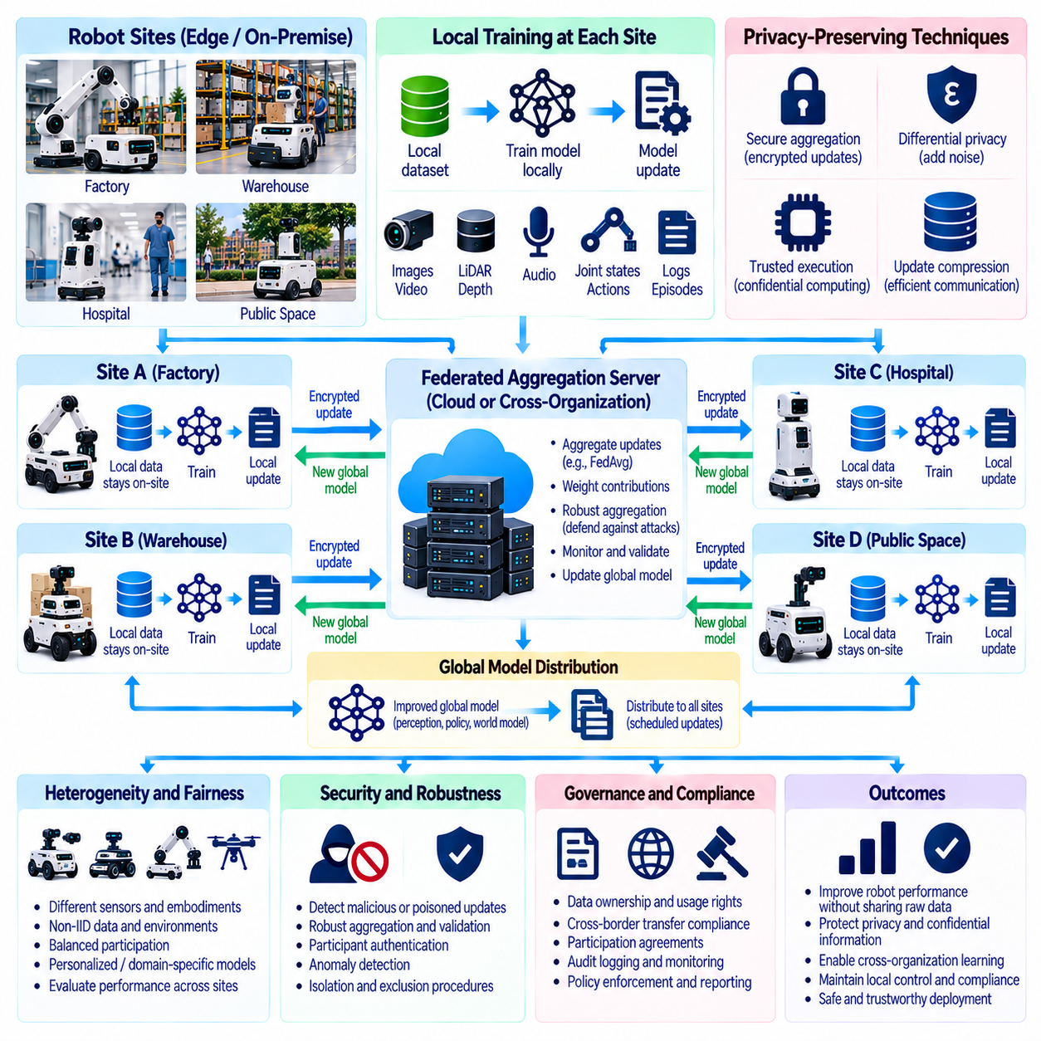
Federated and privacy-preserving robot learning enables Physical AI systems to improve through distributed experience without requiring every participant to transfer raw sensor recordings into a centralized repository. Robots operating in factories, hospitals, warehouses, and public environments generate valuable but potentially sensitive observations. Collaborative learning must therefore balance model improvement with privacy, confidentiality, security, and local control over data.
Federated learning distributes model training across robots, facilities, or organizations while keeping source datasets within their original environments. A coordinating server typically distributes a shared model, receives selected local updates, and combines them into an improved global model. This approach reduces direct exposure of raw information. However, retaining data locally does not automatically prevent sensitive information from leaking through training outputs.
Robotic federated learning differs from conventional distributed learning because participants operate under heterogeneous physical conditions. Robots may have different sensors, actuators, control frequencies, task objectives, and environmental constraints. Their datasets are often non-independent and non-identically distributed. Governance must account for these differences when evaluating whether a shared model improves performance consistently across participating systems.
Local training begins with approved datasets and models that satisfy each participant's operational and contractual requirements. A robot or facility computes parameter updates using locally collected demonstrations, sensor observations, or execution histories. Only authorized learning outputs are transmitted to the coordinating infrastructure. Policies should specify eligible datasets, permitted model architectures, training objectives, and restrictions on secondary data use.
Federated aggregation combines contributions from multiple participants to update shared model parameters. Techniques such as federated averaging can weight local updates according to participating sample counts or other criteria. However, unequal dataset sizes and hardware capabilities may cause dominant participants to shape the global model disproportionately. Governance should evaluate contribution weighting, representation balance, and performance across smaller or specialized deployments.
Privacy leakage remains possible because model gradients and parameter updates can reveal properties of training records. Gradient inversion and membership inference attacks may expose sensitive information even when raw observations never leave a facility. Privacy-preserving learning therefore requires explicit threat models rather than assuming that distributed training is inherently confidential. Attack simulations and privacy assessments should examine the actual information released during collaboration.
Secure aggregation reduces exposure by allowing a coordinating service to recover an aggregate update without directly inspecting each participant's individual contribution. Cryptographic protocols can protect updates during collection and aggregation. Their security depends on assumptions about participant collusion, dropout handling, and key management. Organizations should verify protocol limitations and avoid treating secure aggregation as protection against every inference attack.
Differential privacy provides a mathematical framework for limiting the influence of individual training records on released learning outputs. Noise can be introduced into clipped gradients or aggregated updates to reduce information leakage. Privacy parameters determine the tradeoff between protection and model utility. For robotics, excessive noise may degrade perception or control performance, so privacy guarantees must be evaluated alongside safety-critical accuracy requirements.
Trusted execution environments can provide additional isolation for selected training or aggregation operations. Hardware-supported protection may reduce exposure to compromised operating systems or cloud administrators. Nevertheless, implementation vulnerabilities, side channels, and configuration errors remain possible. Governance should assess hardware trust assumptions, attestation procedures, and residual risks before relying on confidential computing for sensitive robotic datasets.
Communication efficiency is important because robot fleets may have limited bandwidth, intermittent connectivity, and competing real-time control demands. Update compression, selective parameter sharing, and scheduled synchronization can reduce network overhead. Training traffic should not interfere with safety-critical communication. Governance policies must establish resource limits, update frequencies, and operational priorities so collaborative learning does not compromise robot availability.
Participant heterogeneity creates challenges for model convergence and fairness. A warehouse robot handling standardized packages may generate different experiences from a service robot navigating crowded corridors. Combining incompatible observations can produce negative transfer or unstable optimization. Personalized federated learning and domain-specific model components can preserve local specialization while allowing participants to benefit from shared representations.
Federated systems must defend against malicious or unreliable participants. Compromised robots may submit manipulated gradients, poisoned examples, or updates designed to introduce hidden behaviors. Robust aggregation, anomaly detection, participant authentication, and update validation can reduce these risks. No single defense guarantees protection under every attack scenario. Governance should define exclusion procedures, investigation responsibilities, and recovery mechanisms.
Privacy-preserving learning also requires careful management of metadata. Participant identifiers, update timestamps, communication patterns, and training statistics may reveal facility activity or operational schedules. Encryption of model parameters alone does not protect this contextual information. Systems should minimize metadata collection, restrict monitoring access, and establish retention limits that reflect both operational needs and confidentiality requirements.
Evaluation must measure global model quality and local deployment safety separately. An improvement in average benchmark performance does not guarantee acceptable results for every robot or facility. Validation should examine task success, collision rates, intervention frequency, recovery behavior, and performance under rare conditions. Participants should retain authority to reject updates that fail their approved safety or operational acceptance criteria.
Model versioning and provenance provide accountability throughout federated training. Records should identify participating model versions, aggregation configurations, validation outcomes, and authorized release decisions. Where confidentiality permits, contribution histories can support debugging and incident investigations. Governance must balance auditability with the need to avoid exposing participant-specific information through detailed training records.
Consent, contractual permissions, and data ownership remain relevant even when only model updates are exchanged. Organizations must determine whether collected demonstrations may contribute to shared models and whether resulting intellectual property can be reused commercially. Customer restrictions may prohibit cross-organization learning despite local data storage. Participation agreements should define permitted purposes, withdrawal procedures, model ownership, and responsibility for privacy incidents.
Withdrawal and deletion introduce difficult technical questions because previous contributions may already influence shared model parameters. Removing a participant's local dataset does not automatically eliminate its influence from a trained global model. Depending on legal obligations and technical feasibility, remediation may require retraining, checkpoint restoration, or validated machine unlearning. Governance should communicate these limitations before participation begins.
A mature federated learning program integrates privacy engineering, security controls, model validation, and organizational accountability. Participants need clear policies for joining, contributing, receiving updates, reporting incidents, and leaving collaborative training. Independent assessments should test privacy leakage, poisoning resistance, and performance consistency. Continuous monitoring must verify that technical safeguards remain effective as participants and environments change.
Federated and privacy-preserving robot learning offers a practical path toward collaborative Physical AI development without unrestricted centralization of sensitive data. Its value depends on measurable privacy protection, trustworthy aggregation, transparent governance, and verified robotic performance. By combining local autonomy with carefully controlled knowledge sharing, organizations can improve collective robot intelligence while respecting data sovereignty and operational safety.

