Volume 04. Data Engines and Scaling for Physical AI

Chapter 10. Case Studies

10.01. Autonomous Driving Data Engines
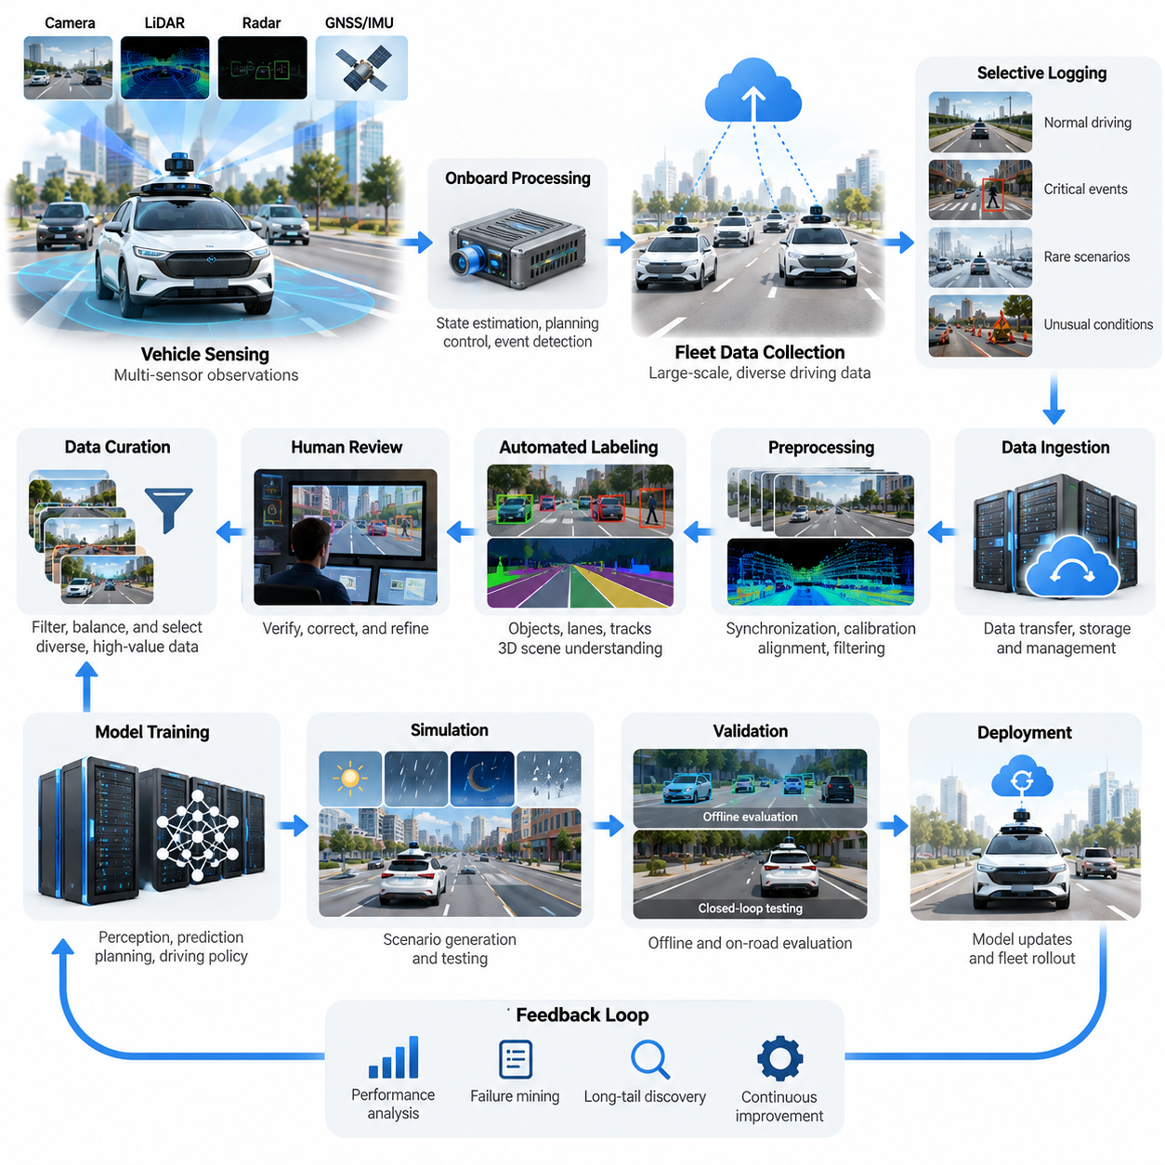
Autonomous driving represents one of the most mature applications of large-scale Physical AI data engines. Unlike conventional machine learning systems trained on static datasets, autonomous vehicles continuously generate observations, predictions, actions, and outcomes while interacting with dynamic road environments. Their data engines transform operational experience into reusable training information, enabling improvements in perception, prediction, planning, and driving behavior.
The fundamental architecture of an autonomous driving data engine connects vehicle sensing, onboard computation, fleet data collection, centralized processing, model training, validation, and deployment. Cameras, LiDAR, radar, GNSS, and inertial sensors provide complementary observations of the driving environment. Vehicle control signals, localization estimates, planned trajectories, and safety interventions provide additional information about decisions and their consequences.
A driving episode typically contains synchronized sensor measurements, vehicle states, surrounding traffic conditions, predicted object trajectories, and executed control commands. Temporal consistency is essential because driving decisions depend on how situations evolve rather than on isolated images. Accurate timestamps and coordinate transformations allow engineers to reconstruct interactions between vehicles, pedestrians, cyclists, road geometry, and traffic signals.
Fleet-scale data collection distinguishes autonomous driving from laboratory-scale robotics. Thousands of vehicles can encounter diverse road configurations, weather conditions, traffic behaviors, and infrastructure characteristics. However, recording every sensor stream continuously creates enormous storage and communication requirements. Practical data engines therefore combine selective logging, onboard compression, event-triggered recording, and prioritized data transmission.
Event-triggered collection concentrates resources on situations that provide high learning value. Examples include unexpected pedestrian crossings, aggressive vehicle merging, unusual construction zones, emergency braking, and uncertain object classifications. The system can preserve sensor observations before and after a triggering event, together with model predictions and control decisions, allowing engineers to investigate the complete sequence of events.
Long-tail scenario discovery is particularly important because rare situations can create disproportionate safety risks. Ordinary highway driving may generate millions of repetitive observations, while unusual combinations of weather, road geometry, and human behavior remain underrepresented. Automated mining systems search fleet logs for unusual motion patterns, prediction disagreements, safety interventions, and statistically uncommon environmental configurations.
Tesla provides a prominent example of a vision-centered autonomous driving development approach supported by fleet data. Its publicly described engineering methods include video-based perception, automated labeling, neural network training, and simulation. Fleet observations can help identify difficult scenarios and support model improvement, although the precise internal data selection algorithms, training mixtures, and deployment procedures are not fully public.
Waymo illustrates another approach in which multimodal sensing, detailed environmental understanding, simulation, and operational feedback contribute to autonomous driving development. Its publicly described systems integrate cameras, LiDAR, radar, and onboard computing. Real-world driving experience and simulated scenarios support testing and refinement, while operational design domains define the environmental conditions under which autonomous services are intended to operate.
Although their sensor strategies differ, these approaches share a central engineering principle: valuable training information must be selected, interpreted, and evaluated systematically. Raw driving distance alone is not a sufficient measure of data quality. A smaller collection of difficult, diverse, and accurately annotated episodes may contribute more to model improvement than a substantially larger collection of repetitive driving observations.
Automated labeling is essential for processing autonomous driving datasets at scale. Modern pipelines can generate object detections, semantic segmentation, lane geometry, motion tracks, depth estimates, and three-dimensional scene representations. Temporal information from multiple frames helps resolve ambiguities that cannot be addressed reliably using individual images, while sensor fusion provides additional geometric and motion constraints.
Offline reconstruction can improve label consistency by using observations collected after the original driving decision. For example, an object partially hidden behind another vehicle may become clearly visible several seconds later. A labeling pipeline can use the extended sequence to estimate earlier object positions and trajectories, provided uncertainty and visibility limitations are represented appropriately.
Human reviewers remain important when automated labels are uncertain, inconsistent, or safety critical. Human-in-the-loop workflows prioritize ambiguous intersections, unusual objects, complex traffic interactions, and conflicting model predictions. Reviewers correct annotations, establish consistent interpretation rules, and identify previously unknown scenario categories that automated systems may not recognize.
Data curation determines which collected episodes enter training, validation, and testing datasets. Filtering removes corrupted sensor recordings, synchronization errors, redundant observations, and unreliable annotations. Diversity-aware sampling balances geographic regions, lighting conditions, road types, weather, traffic density, and driving behaviors, reducing the risk that frequent operating conditions dominate the learning process.
Dataset partitioning requires particular attention because neighboring frames and repeated journeys are highly correlated. Randomly distributing individual frames across training and testing sets can produce misleading performance estimates. More reliable evaluation separates complete driving sequences and, when appropriate, geographic regions, collection periods, vehicles, or environmental conditions to measure generalization beyond previously observed situations.
Simulation expands the data engine by generating controlled scenarios that are difficult, dangerous, or expensive to collect repeatedly on public roads. Synthetic environments can vary pedestrian behavior, vehicle trajectories, visibility, road friction, and sensor characteristics. Simulation also provides automatically generated ground truth, although simulated results must be checked against real-world behavior because modeling inaccuracies can create misleading confidence.
Scenario replay connects real-world fleet observations with simulation-based evaluation. Engineers reconstruct difficult driving situations from recorded trajectories, map information, and environmental context, then modify selected parameters to create related test cases. This process enables systematic exploration of alternative behaviors and helps determine whether a revised model performs robustly across variations of the original event.
Model training uses curated driving data to improve perception networks, motion prediction systems, planning policies, and integrated driving models. Supervised learning can reproduce expert annotations or reference trajectories, while imitation learning derives behavior from demonstrated driving actions. Other approaches incorporate self-supervised representation learning, predictive world models, and optimization against defined driving objectives.
Closed-loop evaluation is necessary because accurate predictions do not automatically produce safe driving behavior. A planning model may generate trajectories that appear reasonable when compared with recorded examples but behave poorly when its own actions change subsequent traffic interactions. Interactive simulation and controlled vehicle testing reveal these feedback effects and expose failures that open-loop metrics cannot capture.
Evaluation metrics should cover perception accuracy, trajectory prediction, collision risk, traffic rule compliance, passenger comfort, route completion, and operational reliability. Safety-critical assessment also examines near misses, intervention frequency, uncertainty calibration, and performance under degraded sensing conditions. No single metric adequately represents driving capability, making scenario-specific and system-level evaluation essential.
Deployment closes the data engine feedback loop by introducing validated models into controlled operational environments. Shadow evaluation can compare a candidate model against an active system without granting it vehicle control. Limited deployments, staged rollouts, and monitored operational trials provide additional evidence before broader release, subject to the applicable safety case and regulatory requirements.
After deployment, monitoring systems detect changes in road environments, sensor performance, traffic patterns, and model behavior. Construction activity, new road layouts, seasonal weather, and unfamiliar vehicle types can shift the operational data distribution. Drift detection and uncertainty monitoring identify conditions requiring additional data collection, targeted retraining, or operational restrictions.
Data governance is another critical component because autonomous vehicles capture information about public spaces, pedestrians, license plates, and geographic movement. Responsible data engines incorporate access controls, retention policies, privacy protection, audit trails, and jurisdiction-specific compliance requirements. Dataset provenance and model versioning also support incident investigation, reproducibility, and traceability throughout the development lifecycle.
The economics of autonomous driving data engines depend on more than the number of vehicles or recorded kilometers. Sensor bandwidth, onboard storage, network transmission, annotation labor, computing infrastructure, simulation capacity, and validation effort all contribute to operational cost. Efficient systems allocate resources according to expected learning value while preserving the evidence required for safety evaluation.
A central lesson from autonomous driving is that scaling data volume must be accompanied by scaling data intelligence. Selective collection, automated labeling, long-tail mining, simulation, and systematic evaluation convert operational experience into measurable development progress. Increasing data quantity without improving coverage, reliability, and feedback quality can produce diminishing returns and leave important safety limitations unresolved.
Autonomous driving data engines also provide a reference architecture for broader Physical AI applications. Mobile robots, humanoids, industrial manipulators, and autonomous inspection systems face similar challenges involving multimodal sensing, rare events, action-outcome recording, and continuous learning. Their environments and control requirements differ, but the underlying process of collecting experience, discovering weaknesses, and improving policies remains closely related.
The long-term direction is toward increasingly automated, fleet-connected learning infrastructure that can identify performance gaps, request relevant data, generate evaluation scenarios, and recommend model updates. Nevertheless, autonomous driving demonstrates that self-improvement must remain constrained by rigorous validation and operational safety controls. The ultimate objective is not simply continuous learning, but a traceable and dependable process that converts real-world experience into safer and more capable Physical AI systems.

10.02. Robot Manipulation Data Engines
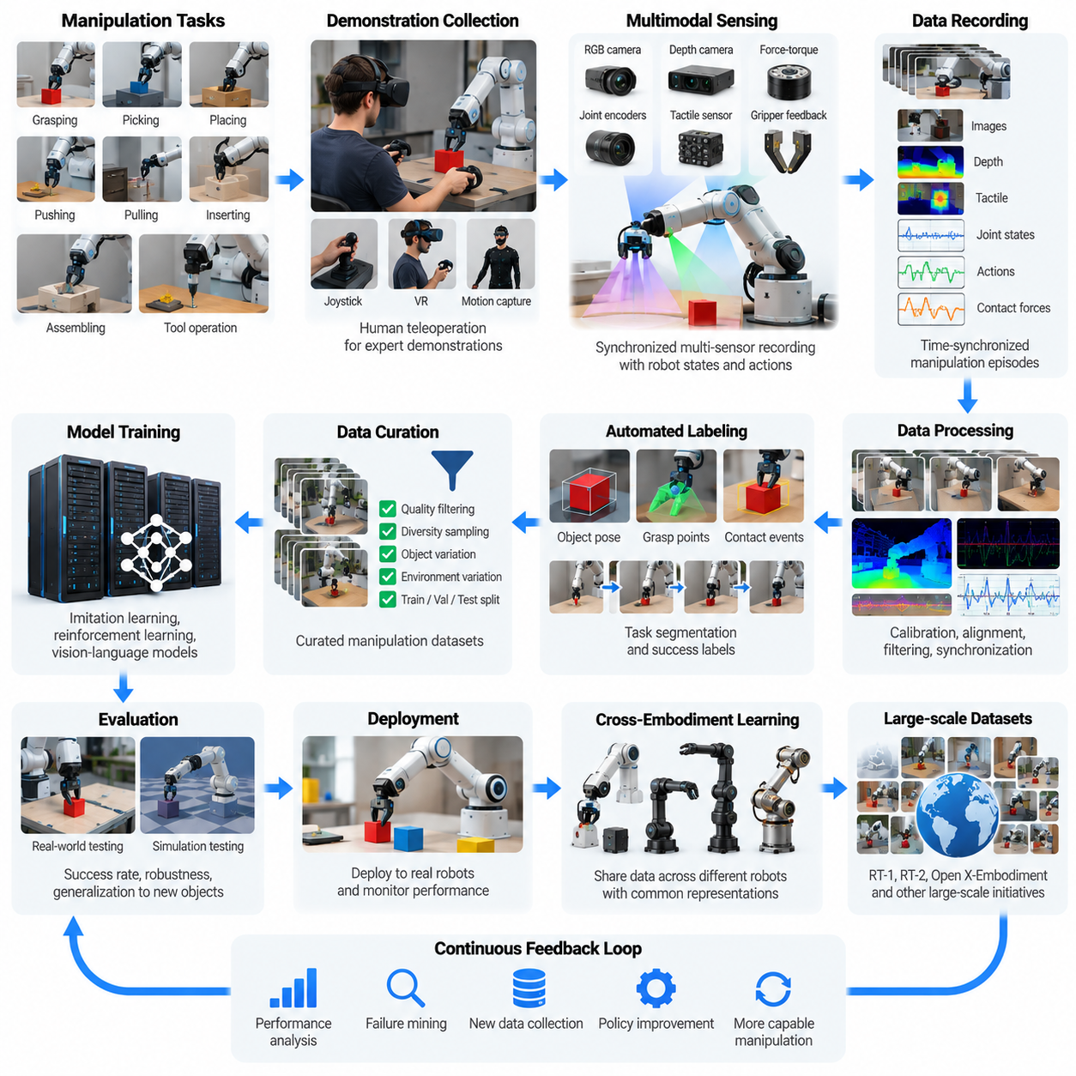
Robot manipulation data engines provide the infrastructure required to transform physical interaction experience into reusable learning resources. Unlike autonomous driving, manipulation involves direct contact with objects, complex force interactions, and precise motion control. A successful data engine must capture not only visual observations but also robot states, actions, contact conditions, task objectives, and outcomes across diverse manipulation environments.
Manipulation tasks include grasping, picking, placing, pushing, pulling, inserting, assembling, and tool operation. Each task introduces different geometric, dynamic, and contact constraints. A robot may successfully grasp a rigid object but fail when handling deformable materials or unfamiliar surfaces. Consequently, manipulation data engines must represent variations in object properties, environmental conditions, and interaction strategies.
A typical manipulation data engine integrates demonstration collection, multimodal recording, data synchronization, annotation, quality filtering, policy training, evaluation, and deployment feedback. These components form a closed learning loop in which robot execution generates new observations and failure cases. The collected experience is processed into training episodes that improve subsequent manipulation policies.
Teleoperation is a major source of manipulation demonstrations because human operators can guide robots through complex actions before autonomous policies become reliable. Interfaces may include joysticks, virtual reality controllers, motion capture systems, and bilateral master-slave manipulators. The resulting demonstrations provide coordinated sequences of observations, joint movements, end-effector trajectories, and gripper commands.
Demonstration quality depends on operator skill, interface responsiveness, robot morphology, and task complexity. Communication delays or poorly calibrated controllers can produce unnatural trajectories that are difficult for autonomous policies to imitate. Data engines therefore monitor motion smoothness, task completion, intervention frequency, and operator consistency while preserving useful corrective behaviors and recovery actions.
A manipulation episode generally begins with an initial scene configuration and a defined task objective. The robot observes its environment, executes a sequence of actions, and reaches a successful, unsuccessful, or interrupted outcome. Each episode should preserve initial conditions, object identities, robot configuration, action timestamps, and completion criteria so that training and evaluation remain reproducible.
Multimodal sensing is particularly important because visual information alone cannot fully describe physical contact. RGB cameras and depth sensors estimate object geometry and spatial relationships, while joint encoders provide proprioceptive measurements. Force-torque sensors, tactile arrays, and gripper feedback reveal contact forces, slip conditions, and interaction stability that may be invisible in camera images.
Temporal synchronization connects observations with the actions responsible for physical changes. A grasping policy must associate gripper closure with the object position and contact state observed at the corresponding moment. Even small timing errors can distort relationships between actions and outcomes, particularly during fast insertion, dynamic manipulation, or force-controlled assembly.
Action representation strongly influences how manipulation datasets support learning across robots. Joint-space commands describe individual actuator targets, while Cartesian-space actions represent end-effector positions, orientations, and relative movements. Gripper states, control frequencies, reference frames, and action horizons must be documented because identical numerical commands can produce different behaviors across hardware platforms.
Object diversity is a central requirement for manipulation generalization. Training collections should include variations in shape, size, texture, mass, friction, rigidity, and deformability. Environmental diversity introduces additional changes in lighting, background clutter, workspace geometry, and object arrangement. Without sufficient variation, policies may memorize familiar configurations rather than learn transferable manipulation skills.
Large-scale robot learning initiatives such as RT-1, RT-2, and Open X-Embodiment demonstrate different approaches to collecting and exploiting manipulation experience. RT-1 emphasized learning from large collections of real robot demonstrations, while RT-2 explored transferring vision-language knowledge into robotic actions. Open X-Embodiment investigated combining datasets collected from different robotic platforms to support broader policy generalization.
Cross-embodiment learning introduces challenges because manipulators differ in joint structures, reachability, gripper geometry, sensing capabilities, and control interfaces. A trajectory recorded on one robot cannot necessarily be executed directly on another. Data engines address this problem through standardized metadata, common task descriptions, coordinate transformations, and embodiment-aware action representations.
Automated labeling transforms raw manipulation recordings into structured information about objects, actions, and outcomes. Labels may describe object poses, grasp locations, contact events, task phases, and success conditions. Vision models can estimate geometric relationships, while robot telemetry provides direct measurements of joint motion and actuator behavior. Human review remains necessary when labels are uncertain.
Task segmentation divides long manipulation demonstrations into meaningful subtasks such as approaching an object, establishing contact, lifting, transporting, and releasing. These temporal boundaries support hierarchical policy learning and failure localization. Language annotations can additionally connect manipulation episodes with natural-language instructions, enabling vision-language-action models to associate goals with physical behavior.
Failure data is especially valuable because manipulation policies frequently encounter unexpected contact dynamics and object behavior. Examples include failed grasps, object slipping, collisions, unstable placement, and insertion misalignment. Rather than discarding unsuccessful episodes, advanced data engines preserve failure context and recovery attempts to improve robustness and support corrective policy learning.
Data curation must distinguish informative failures from corrupted or unusable recordings. Sensor dropouts, incorrect calibration, inconsistent coordinate frames, and incomplete trajectories can undermine learning quality. Automated validation checks identify these problems, while quality scoring evaluates task relevance, trajectory consistency, observation completeness, and the reliability of success annotations.
Dataset balancing prevents frequently demonstrated tasks from dominating model behavior. A collection containing thousands of simple pick-and-place episodes but few precision assembly demonstrations may produce strong basic grasping performance without comparable insertion capability. Task-aware sampling and diversity-based selection help allocate training resources across manipulation skills and environmental conditions.
Simulation provides an additional source of manipulation experience by generating object interactions under controlled physical conditions. Physics engines can model rigid-body motion, contact constraints, gravity, and friction while producing synchronized synthetic observations. Domain randomization varies object properties, sensor noise, and scene configurations to increase training diversity and reduce dependence on specific simulated environments.
However, contact-rich manipulation presents substantial simulation-to-reality challenges. Small inaccuracies in friction coefficients, object compliance, collision geometry, or actuator dynamics can change task outcomes. Deformable materials and complex tactile interactions are particularly difficult to reproduce faithfully. Effective data engines therefore combine synthetic experience with real-world demonstrations and targeted physical validation.
Policy learning may use behavioral cloning, diffusion-based action generation, reinforcement learning, or vision-language-action architectures. Behavioral cloning learns action patterns from demonstrations, while diffusion policies model complex distributions of possible action sequences. Reinforcement learning can optimize behavior through interaction, although reward design, exploration safety, and simulation fidelity influence practical effectiveness.
Evaluation must measure more than whether a robot completes a task once. Important metrics include success rate, execution time, positioning accuracy, contact stability, object damage, recovery capability, and performance under unfamiliar conditions. Repeated trials across varied objects and environments reveal whether improvements reflect genuine generalization or overfitting to familiar demonstrations.
Deployment feedback completes the manipulation data flywheel. Robots operating in warehouses, laboratories, and manufacturing facilities encounter new objects, workspace arrangements, and unexpected failures. Event-triggered recording captures difficult episodes, while uncertainty estimation identifies situations requiring human assistance. These observations can guide targeted data collection and subsequent policy updates.
Scaling manipulation data engines requires coordinated investment in robot hardware, teleoperation infrastructure, storage, annotation systems, simulation, and distributed training. Unlike passive internet data collection, physical demonstrations consume equipment time and operational resources. Improving data efficiency through active learning, automated quality assessment, and selective episode collection is therefore essential.
The broader significance of manipulation data engines lies in their ability to convert individual robot experiences into shared physical knowledge. Standardized episode formats, reusable task descriptions, cross-robot representations, and continuous evaluation support increasingly general manipulation policies. Their long-term objective is a reliable learning infrastructure through which robots progressively acquire transferable skills while maintaining safety, traceability, and operational robustness.

10.03. Generalist Robot and VLA Datasets
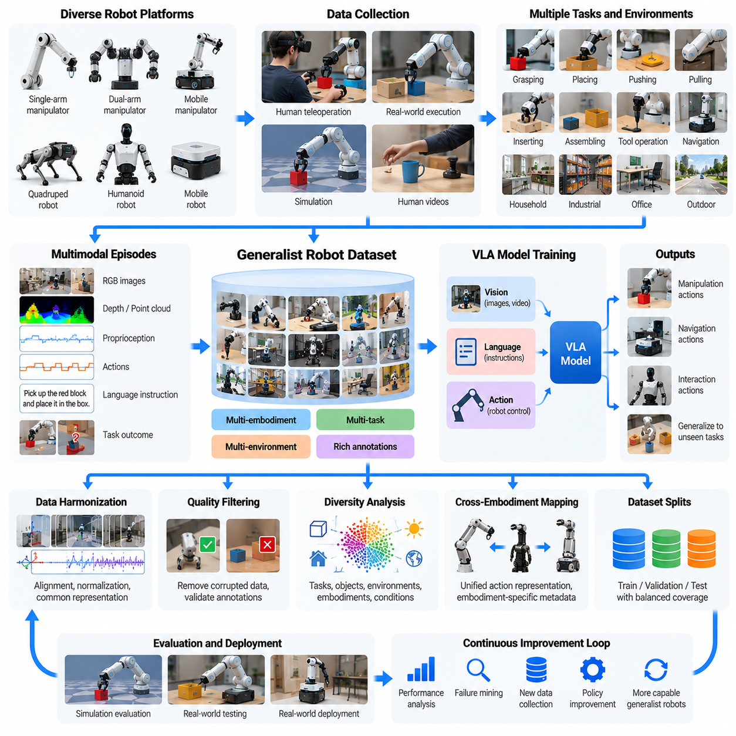
Generalist robot datasets represent a fundamental shift from task-specific robot learning toward broadly transferable physical intelligence. Traditional datasets focus on individual tasks, robots, or environments, while generalist datasets combine diverse experiences across manipulation, navigation, and interaction. Their objective is to support models that can interpret unfamiliar situations, understand instructions, and generate appropriate physical actions.
Vision-Language-Action models, commonly called VLA models, extend vision-language learning by connecting visual observations and natural-language instructions with executable robot actions. Their training datasets must represent relationships among perception, task intent, robot state, and physical behavior. Unlike image-text datasets, VLA datasets require temporally aligned action sequences that describe how robots interact with their environments.
A typical generalist robot dataset contains camera observations, language instructions, proprioceptive measurements, robot configurations, action trajectories, and task outcomes. Each episode describes a sequence of interactions rather than an isolated observation. Metadata identifies the robot platform, sensor configuration, coordinate frames, control frequency, task category, and environmental context required for meaningful interpretation.
The Open X-Embodiment initiative illustrates the importance of combining robotic experiences from heterogeneous platforms. Its dataset collection brought together demonstrations involving different robot embodiments, tasks, and research environments. This approach supports investigation of whether shared representations can transfer knowledge between robots, although differences in hardware, control interfaces, and data quality remain substantial challenges.
The RT-X research direction demonstrates how cross-embodiment datasets can support generalist policy development. Instead of training every robot exclusively on its own demonstrations, researchers investigate models trained on combined experience from multiple platforms. Such training may improve task transfer and robustness, but successful deployment still requires compatibility between learned actions and the target robot's physical capabilities.
RT-1 demonstrated the potential of large-scale real-world manipulation datasets for learning versatile robotic behaviors. Its training approach connected visual observations and language instructions with discretized robot actions. By learning from many task demonstrations, the model could perform multiple manipulation behaviors within its supported robot configuration, providing an influential reference for later generalist robot learning systems.
RT-2 extended this direction by investigating how vision-language models could incorporate robotic action generation. The central idea was to represent actions in a form compatible with language-model training, allowing knowledge acquired from visual and textual information to contribute to robot behavior. This approach highlighted the possibility of transferring semantic understanding into physical interaction capabilities.
The DROID dataset provides another important example of large-scale manipulation data collection across varied environments. Its collection strategy emphasizes real robot demonstrations gathered by multiple operators in diverse physical settings. Such datasets help researchers examine generalization across object arrangements, backgrounds, and task conditions, while also revealing the operational complexity of distributed robotic data collection.
Cross-embodiment dataset construction requires careful handling of differences in robot morphology and action spaces. Manipulators may have different joint counts, gripper mechanisms, reachability constraints, and coordinate conventions. A command expressed as joint positions on one platform cannot be transferred directly to another. Standardized action representations and embodiment-specific metadata are therefore essential.
Language annotation provides the connection between human task intent and robotic execution. Instructions may describe goals such as placing an object inside a container, opening a drawer, or arranging items on a surface. High-quality annotations should identify intended outcomes without introducing ambiguity or describing actions that are inconsistent with the recorded demonstration.
Temporal structure is equally important because generalist policies must understand how actions unfold over time. A manipulation episode may contain approach, grasp, transport, placement, and recovery phases. Accurate synchronization between video frames, proprioceptive measurements, and control commands enables models to associate observed changes with the actions that produced them.
Data harmonization transforms heterogeneous robot recordings into a common training representation. This process includes timestamp alignment, coordinate normalization, action conversion, camera calibration metadata, and consistent episode boundaries. However, normalization must preserve meaningful physical distinctions, because excessive standardization can remove information about robot dynamics or control limitations.
Dataset quality strongly influences the effectiveness of generalist robot training. Corrupted observations, inconsistent task descriptions, incomplete trajectories, and unreliable success labels can introduce conflicting learning signals. Automated validation and human review help identify these problems, while provenance tracking records how each episode was collected, processed, and incorporated into training.
Diversity is a central requirement for generalization, but diversity must be measured across meaningful dimensions. Task variety alone does not guarantee broad capability if object categories, environments, or action patterns remain repetitive. Effective datasets balance task complexity, object properties, robot embodiments, camera viewpoints, operator behavior, and environmental conditions.
Data mixture design determines how different sources contribute to generalist policy learning. Real robot demonstrations provide physically grounded action examples, while simulation offers scalable scenario generation. Human videos may contribute semantic and procedural knowledge, although they generally lack directly executable robot commands. Combining these sources requires careful treatment of differences in embodiment and supervision.
Large vision-language datasets can provide useful representations of objects, relationships, and instructions, but they cannot independently establish reliable motor control. Physical actions depend on contact dynamics, actuator constraints, timing, and feedback. Consequently, VLA training must integrate semantic knowledge with robot-specific experience and evaluation in interactive environments.
Action tokenization is an important design choice in VLA architectures. Continuous control commands may be discretized into tokens or represented through structured action vectors. The representation determines how the model expresses position, orientation, gripper state, and temporal action sequences. Quantization resolution and control frequency influence precision, smoothness, and compatibility across platforms.
Generalist models must also account for uncertainty when encountering unfamiliar tasks or environments. A language instruction may be clear while the corresponding physical action remains unsafe or infeasible. Training datasets should therefore include unsuccessful attempts, corrective demonstrations, intervention records, and explicit constraints that help models recognize limitations rather than blindly execute predicted actions.
Evaluation of generalist robot datasets requires separating memorization from genuine transfer. Models should be tested on unseen object combinations, novel instructions, unfamiliar environments, and, where appropriate, different robot platforms. Success rates should be accompanied by measures of safety, execution efficiency, recovery capability, and robustness to changes in observation conditions.
Dataset splitting is particularly challenging when demonstrations share objects, operators, environments, or repeated task configurations. Random episode splitting may allow closely related experiences to appear in both training and evaluation sets. More rigorous protocols isolate selected tasks, scenes, objects, or embodiments to provide stronger evidence of generalization beyond the training distribution.
Scaling generalist robot datasets introduces practical limitations that differ from conventional internet-scale machine learning. Physical demonstrations require robot hardware, trained operators, maintenance, calibration, and controlled workspaces. Data collection costs increase with task complexity and embodiment diversity, making automated curation, active learning, and targeted demonstration acquisition important for efficient scaling.
Governance becomes increasingly important when datasets combine contributions from multiple institutions and operational environments. Licensing conditions, data ownership, privacy requirements, and permitted model uses may differ between sources. Dataset documentation should preserve provenance, collection permissions, processing history, and access restrictions to support reproducibility and responsible reuse.
A sustainable generalist robot data engine extends beyond publishing a large dataset. It continuously identifies model weaknesses, collects targeted demonstrations, updates annotations, retrains policies, and evaluates improvements. Deployment feedback reveals new objects, unexpected failures, and previously unseen task conditions, transforming the dataset into an evolving learning infrastructure.
The long-term significance of generalist robot and VLA datasets lies in establishing shared foundations for transferable physical intelligence. Progress depends not only on increasing episode counts but also on improving task coverage, embodiment compatibility, action representations, and evaluation quality. Well-designed data engines can progressively connect semantic understanding with reliable physical execution across diverse robotic systems.

10.04. Humanoid Data Engines
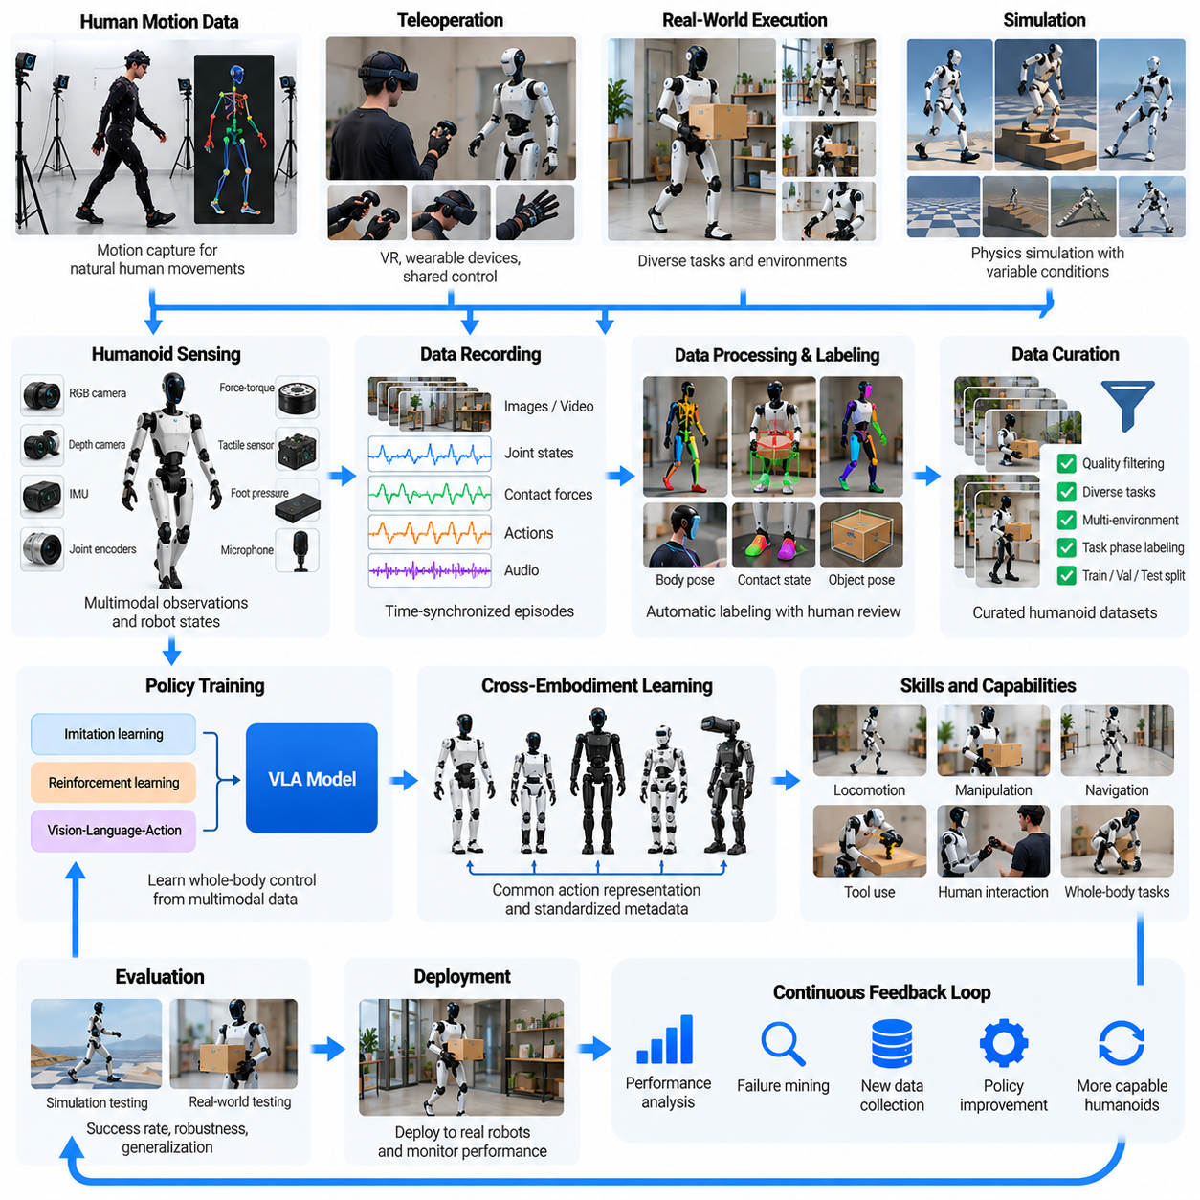
Humanoid data engines provide the infrastructure for collecting, processing, and transforming human-like robot experiences into scalable learning resources. Unlike fixed manipulators or wheeled robots, humanoids must coordinate locomotion, balance, manipulation, and whole-body interaction. Their data engines therefore capture synchronized observations, joint states, contact forces, actions, and outcomes across diverse tasks and environments.
Humanoid learning requires data that reflects the interaction between body morphology, physical dynamics, and environmental constraints. A reaching movement may change the robot's center of mass, while carrying an object can alter balance and walking stability. Consequently, humanoid datasets must represent coordinated whole-body behavior rather than treating arm manipulation and leg locomotion as completely independent activities.
A typical humanoid data engine integrates teleoperation, motion capture, onboard sensing, simulation, episode storage, automated labeling, policy training, and deployment feedback. These components form a continuous learning loop in which physical execution produces new training information. Successful demonstrations, failures, human interventions, and recovery behaviors all contribute to improving robot capabilities.
Human motion data represents an important source of humanoid learning information because humanoid bodies share certain structural similarities with humans. Motion capture systems can record walking, reaching, bending, lifting, and coordinated manipulation. However, differences in joint geometry, mass distribution, actuator characteristics, and balance constraints prevent direct reproduction of human movements without adaptation.
Motion retargeting transforms recorded human movements into trajectories compatible with humanoid robot morphology. This process maps human skeletal poses onto robot joints while respecting joint limits, collision constraints, contact conditions, and dynamic feasibility. High-quality retargeting preserves task-relevant movement patterns without assuming that human and robot bodies possess identical physical capabilities.
Teleoperation provides another major source of humanoid training data. Operators may control robot arms, hands, upper bodies, or whole-body motion through virtual reality interfaces, wearable devices, or motion capture systems. Shared-control architectures can combine human task guidance with autonomous balance stabilization, reducing operator workload while maintaining physically feasible robot behavior.
Humanoid teleoperation introduces challenges involving latency, operator embodiment, and control coordination. Human operators may issue movements that exceed robot joint limits or destabilize its posture. Safety controllers must constrain these commands while preserving useful task information. Recording both operator intentions and executed robot actions helps distinguish demonstration objectives from hardware-limited behavior.
Multimodal sensing is essential because humanoids interact with environments through multiple contact points. Cameras and depth sensors provide visual scene understanding, while joint encoders and inertial measurement units describe body configuration and motion. Foot pressure sensors, force-torque sensors, and tactile feedback reveal support conditions, grasp stability, and physical interactions that visual observations alone cannot explain.
Whole-body data representation must capture relationships among torso orientation, limb configurations, center of mass, contact locations, and external forces. Walking while carrying an object requires coordinated adjustments across the legs, trunk, and arms. Dataset formats should therefore preserve synchronized kinematic and dynamic information rather than reducing complex movements to isolated end-effector trajectories.
Humanoid episodes may involve locomotion, object manipulation, navigation, tool use, and human interaction within a single task sequence. For example, a robot may approach a shelf, stabilize its posture, grasp an object, turn, and transport it to another location. Such episodes require long-horizon temporal structure and explicit representations of task phases, transitions, and completion conditions.
Contact events are particularly important for humanoid learning because locomotion depends on repeated transitions between support configurations. Heel contact, toe-off, double support, and single-leg support influence stability and motion planning. Manipulation adds further contact relationships involving hands, objects, and surrounding surfaces, making accurate contact labeling essential for learning coordinated physical behavior.
Automated labeling pipelines can derive joint trajectories, body poses, contact states, object locations, and task outcomes from recorded sensor streams. Physics-based estimation and temporal reconstruction help infer quantities that are difficult to observe directly. However, labeling errors in contact timing, coordinate transformations, or force estimates can significantly affect the quality of learned locomotion and manipulation policies.
Simulation plays a central role in humanoid data generation because physical experimentation can be expensive and risky. Physics engines allow repeated training of walking, balancing, turning, recovering, and object interaction under controlled conditions. Parallel simulation environments can generate large quantities of experience while varying terrain, friction, disturbances, payloads, and actuator characteristics.
Reinforcement learning is frequently used to develop humanoid locomotion and stabilization policies in simulation. Reward functions may encourage velocity tracking, energy efficiency, balance preservation, and smooth movement. Domain randomization introduces variations in physical parameters to improve robustness, although successful simulation performance does not automatically guarantee reliable behavior on physical hardware.
Simulation-to-reality transfer remains challenging because humanoid systems exhibit complex contact dynamics and tightly coupled motion. Small differences in actuator response, joint friction, structural compliance, or ground contact can destabilize learned behaviors. Effective data engines combine simulated experience with real robot measurements, system identification, controlled testing, and targeted policy adaptation.
Failure and recovery data are especially valuable for humanoid robots because instability can propagate across the entire body. Slipping, stumbling, unexpected contact, object dropping, and failed grasping can produce cascading failures. Recording precursor conditions, corrective actions, and recovery outcomes helps learning systems distinguish recoverable disturbances from situations requiring protective shutdown.
Data curation must evaluate both task achievement and physical safety. A demonstration may complete an object transfer while producing excessive joint torque, unstable posture, or dangerous contact forces. Quality assessment should therefore consider success rate, motion smoothness, balance margins, actuator limits, energy consumption, and collision risk alongside conventional task performance metrics.
Cross-embodiment learning is difficult because humanoid platforms differ in height, mass, joint arrangements, hand dexterity, actuator strength, and sensing capabilities. A policy trained on one platform may not transfer directly to another. Embodiment-aware representations, morphology metadata, and standardized task descriptions can improve data reuse while preserving platform-specific physical constraints.
Vision-Language-Action models offer a pathway for connecting humanoid perception, natural-language instructions, and physical behavior. Language can specify high-level goals, while learned policies translate those goals into coordinated movement sequences. However, VLA-generated actions must remain compatible with real-time balance control, collision avoidance, and hardware safety constraints.
Hierarchical control architectures can separate task reasoning from high-frequency physical stabilization. A high-level policy may select navigation, grasping, or placement objectives, while lower-level controllers manage joint trajectories, contact forces, and balance. Humanoid data engines should record information across these control layers so that training can connect task intentions with physical execution.
Evaluation of humanoid data engines requires measuring generalization across tasks, objects, terrain, and environmental conditions. Important metrics include task completion, locomotion stability, manipulation precision, recovery success, energy efficiency, and intervention frequency. Long-horizon evaluations reveal whether individually successful skills remain reliable when combined into extended autonomous activities.
Fleet-scale deployment creates opportunities to collect humanoid experiences from factories, warehouses, laboratories, and service environments. Robots operating at different sites encounter variations in objects, layouts, surfaces, and human behavior. Event-triggered logging and uncertainty-based sampling can prioritize informative episodes while reducing unnecessary storage and communication costs.
Data governance becomes important because humanoids frequently operate near people and may record identifiable visual, audio, and behavioral information. Responsible collection systems require appropriate permissions, privacy safeguards, access controls, and retention policies. Operational datasets should also preserve provenance, hardware configuration, software versions, and intervention histories to support reproducibility and safety investigations.
Scaling humanoid data engines involves substantial hardware and operational costs. Physical demonstrations require robots, operators, maintenance, calibration, and safe testing facilities. Simulation can reduce some collection expenses, but real-world contact experience remains necessary. Efficient scaling therefore depends on combining human demonstrations, synthetic trajectories, active data selection, and automated quality assessment.
The long-term objective of humanoid data engines is to establish a continuous learning infrastructure that converts diverse whole-body experiences into transferable physical skills. Progress depends on integrating motion understanding, contact-rich interaction, multimodal sensing, simulation, and safety-aware evaluation. Such systems can support increasingly capable humanoid robots while maintaining the reliability required for operation in human environments.

10.05. Mobile Manipulator Data Engines
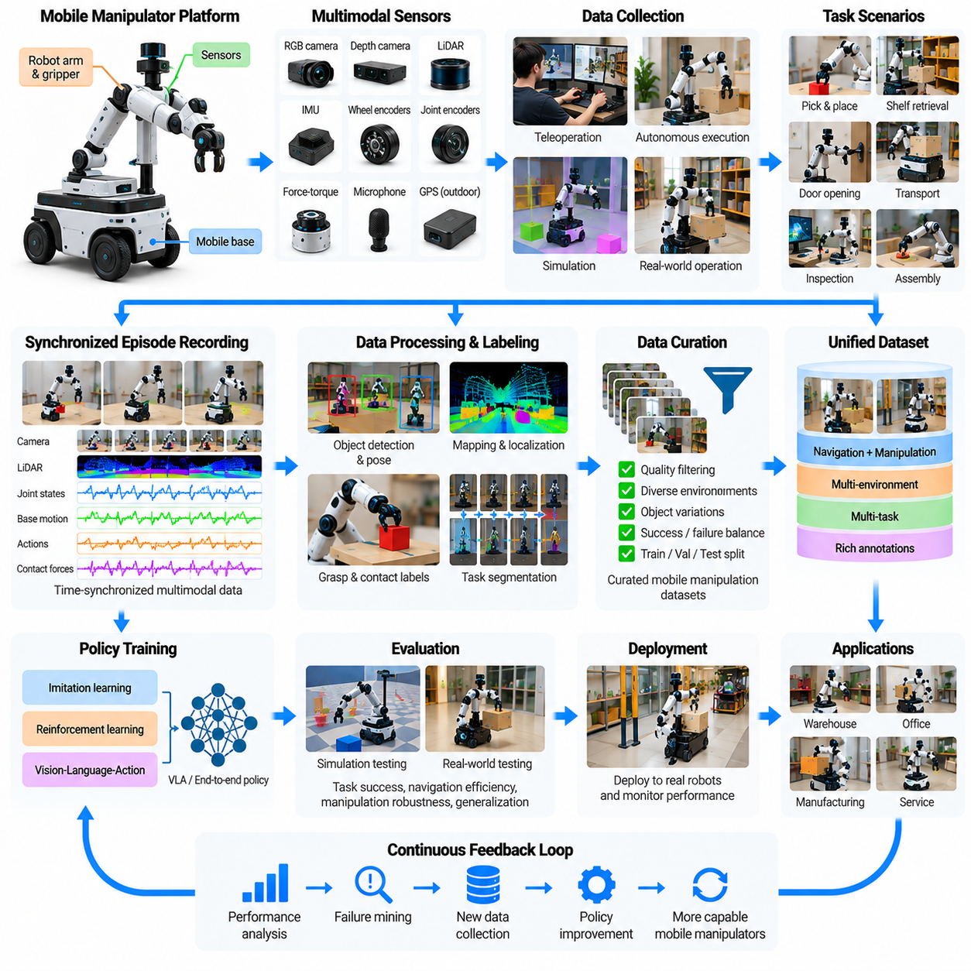
Mobile manipulator data engines provide the infrastructure for learning robotic behaviors that combine autonomous mobility with physical object manipulation. Unlike fixed robotic arms or navigation-only mobile robots, mobile manipulators must coordinate base movement, arm positioning, perception, and contact interactions. Their datasets capture how navigation decisions influence manipulation feasibility and how object interactions affect subsequent robot movement.
A mobile manipulator typically consists of a wheeled or tracked mobile base, one or more robotic arms, grippers, and multimodal sensors. Its operational tasks include approaching workstations, retrieving objects, opening doors, transporting materials, and performing inspection or assembly. Data engines must represent the complete relationship between environmental observations, robot configuration, task objectives, executed actions, and physical outcomes.
The fundamental data engine architecture integrates teleoperation, autonomous execution logging, simulation, multimodal synchronization, episode storage, labeling, policy training, and evaluation. These components establish a closed-loop learning process in which deployed robots continuously encounter new situations. Successful operations, failed attempts, human interventions, and recovery trajectories become reusable training information.
Mobile manipulation introduces a coupled decision problem because the robot must determine both where to position its base and how to execute manipulation. A base position that provides good visibility may produce poor arm reachability, while an optimal grasping pose may obstruct navigation. Training data must therefore preserve relationships among base pose, arm configuration, object geometry, and environmental constraints.
Teleoperation is an important source of mobile manipulation demonstrations. Human operators can control navigation and arm movements using joysticks, virtual reality interfaces, or shared-control systems. Demonstrations may include approaching an object, adjusting the base position, extending the arm, establishing contact, grasping, and transporting the object. Recording the complete sequence preserves coordination between mobility and manipulation.
Shared autonomy can reduce teleoperation complexity by assigning low-level stabilization and collision avoidance to autonomous controllers. Operators specify task goals or corrective actions while the robot manages feasible trajectories. Data engines should record operator commands, autonomous adjustments, and final executed actions separately so that learning systems can distinguish human intent from controller-generated corrections.
A mobile manipulation episode begins with a defined environment, robot state, and task objective. The robot navigates toward a target, establishes a suitable manipulation configuration, performs physical interaction, and completes or abandons the task. Episode records should include initial conditions, maps, localization estimates, joint states, gripper commands, object poses, timestamps, and outcome labels.
Multimodal sensing combines cameras, depth sensors, LiDAR, wheel encoders, inertial measurements, joint encoders, and force-torque feedback. These sensors provide complementary information about navigation, robot configuration, object geometry, and contact dynamics. Accurate calibration and synchronization are necessary because errors in localization or sensor alignment can produce incorrect grasp targets and unsafe manipulation trajectories.
Coordinate frame management is particularly important because mobile manipulators operate across multiple moving reference systems. Object positions may be estimated relative to cameras, robot bases, manipulators, or global maps. Data engines must preserve transformations among these frames and document their uncertainties. Without consistent spatial references, recorded demonstrations cannot reliably support policy training or cross-platform transfer.
Action representations must capture both mobile base commands and manipulator control. Base actions may describe linear and angular velocities or target poses, while arm actions may specify joint positions, Cartesian trajectories, or end-effector movements. Gripper commands and force-control parameters complete the action description. Unified representations enable models to learn coordinated behaviors across different control frequencies.
Temporal alignment is essential when base movement and arm motion occur simultaneously. A robot reaching toward an object while repositioning its base must continuously update the relationship between the target and end effector. Delayed observations or mismatched timestamps can distort this relationship. Synchronized recordings allow learning systems to reconstruct the causal sequence connecting perception, movement, contact, and task outcomes.
Navigation and manipulation datasets have traditionally been developed separately, but mobile manipulation requires their integration. Navigation data describes traversability, obstacle avoidance, and route selection, while manipulation data emphasizes object interaction and contact. A unified data engine connects these domains through task-centered episodes that represent transitions from movement to interaction and back to movement.
Task segmentation helps organize complex mobile manipulation demonstrations into meaningful phases. A warehouse retrieval episode may contain target identification, route planning, navigation, base alignment, grasp execution, object verification, and delivery. These phases support hierarchical learning and allow engineers to identify whether failures originate from perception, localization, navigation, grasping, or task coordination.
Object and environment diversity strongly influence generalization. Mobile manipulators encounter shelves, drawers, doors, carts, containers, and workstations with different dimensions and accessibility constraints. Training datasets should include variations in object geometry, placement, lighting, floor conditions, workspace clutter, and approach directions. Such diversity reduces dependence on fixed layouts and repetitive demonstrations.
Simulation enables scalable generation of mobile manipulation episodes under controlled conditions. Virtual environments can vary robot starting positions, obstacle configurations, object arrangements, and manipulation targets. Physics-based simulation supports contact interactions, while procedural scene generation creates diverse navigation challenges. Synthetic data can complement real demonstrations, particularly during early policy development.
Simulation-to-reality transfer remains difficult because both mobility and manipulation introduce physical uncertainties. Wheel slip, localization drift, actuator delays, object friction, and contact compliance can change task outcomes. A simulated grasp may succeed even when real-world positioning errors prevent contact. Effective data engines combine simulation with real robot measurements, calibration, and targeted physical testing.
Automated labeling pipelines generate information about objects, robot poses, navigation trajectories, grasp events, and task completion. Mapping systems provide environmental structure, while perception models estimate object locations and semantic categories. Contact sensors and gripper feedback help identify successful grasps. Human review remains valuable for ambiguous failures and complex interaction sequences.
Failure data provides important information about the coupling between navigation and manipulation. A robot may fail to grasp an object because its base stopped too far away, its localization estimate drifted, or an obstacle restricted arm movement. Recording these causal relationships helps distinguish manipulation policy failures from positioning and perception errors, enabling more targeted improvements.
Data curation evaluates episode completeness, sensor reliability, trajectory consistency, task relevance, and safety. Corrupted localization records, missing joint states, or inconsistent coordinate transformations can invalidate otherwise useful demonstrations. Quality scoring should also consider unnecessary base movement, excessive manipulation forces, collision risk, and recovery behavior rather than relying exclusively on task success.
Policy learning can combine imitation learning, reinforcement learning, hierarchical planning, and vision-language-action architectures. High-level policies select navigation and interaction objectives, while lower-level controllers execute feasible base and arm motions. Joint policies may learn coordinated whole-system actions, although training complexity increases with the combined mobility and manipulation action space.
Evaluation must consider complete task execution rather than isolated navigation or grasping performance. Important metrics include task completion rate, navigation efficiency, base positioning accuracy, grasp success, execution time, collision frequency, and recovery capability. Long-horizon tests reveal whether individual skills remain reliable when combined into extended operational sequences.
Fleet-scale deployment creates opportunities for collecting mobile manipulation experiences across warehouses, hospitals, laboratories, and industrial facilities. Different sites introduce new layouts, objects, obstacles, and operating procedures. Event-triggered logging and uncertainty-based sampling prioritize informative episodes, while centralized processing enables models to benefit from experiences collected by multiple robots.
Data governance is important because mobile manipulators may record sensitive workplace information, human activity, and proprietary industrial processes. Responsible systems require access controls, retention policies, privacy safeguards, and traceable dataset provenance. Hardware configurations, software versions, calibration parameters, and intervention histories should remain associated with recorded episodes to support reproducibility and operational accountability.
Scaling mobile manipulator data engines requires balancing physical collection costs against learning value. Teleoperation, robot maintenance, workspace preparation, simulation, labeling, and computing infrastructure all consume resources. Automated quality assessment, active learning, and selective collection can reduce redundant data while improving coverage of difficult tasks and previously unseen environmental conditions.
The long-term objective is to establish a continuous learning infrastructure that unifies mobility, manipulation, perception, and task reasoning. By connecting real-world experience with simulation, structured datasets, policy training, and deployment feedback, mobile manipulator data engines can support increasingly adaptable robots. Their success depends on reliable coordination, transferable representations, and systematic safety-aware evaluation across diverse physical environments.

10.06. AMR and Autonomous Mobility Data Engines
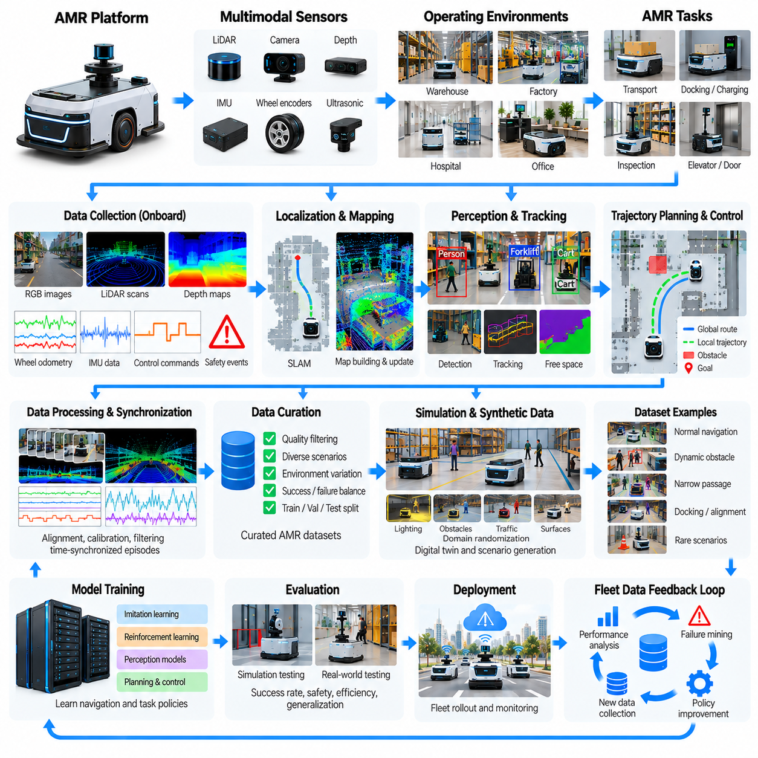
Autonomous Mobile Robot (AMR) data engines provide the infrastructure for collecting, processing, and transforming mobility experiences into reliable autonomous navigation capabilities. Unlike robots operating along fixed routes, AMRs must perceive changing environments, estimate their positions, plan safe trajectories, and respond to unexpected obstacles. Their data engines integrate sensor observations, motion commands, environmental maps, operational events, and navigation outcomes.
An AMR data engine connects onboard perception, localization, mapping, planning, control, and fleet management through a continuous learning pipeline. Each operational mission produces information about environmental conditions, robot behavior, and task performance. Successful navigation, localization failures, obstacle encounters, and human interventions become valuable data for improving autonomy across different facilities and operating conditions.
Typical AMR datasets contain LiDAR scans, camera images, depth measurements, inertial data, wheel odometry, localization estimates, planned paths, velocity commands, and safety events. Each recording must preserve timestamps, coordinate frames, calibration parameters, and robot configuration metadata. These relationships allow engineers to reconstruct navigation decisions and determine whether observed failures originated from sensing, estimation, planning, or control.
Localization and mapping data form the foundation of autonomous mobility learning. Simultaneous Localization and Mapping (SLAM) systems estimate robot trajectories while constructing representations of surrounding environments. Data engines store sensor measurements, pose estimates, map updates, and uncertainty information. These records support map maintenance, localization evaluation, and detection of environmental changes that affect navigation reliability.
Environmental maps may contain geometric occupancy information, traversability estimates, semantic labels, and operational restrictions. Warehouses, hospitals, and factories introduce different requirements for corridors, intersections, elevators, and restricted zones. Data engines should maintain map versions and document environmental changes so that navigation policies can distinguish temporary obstacles from permanent modifications to the operating environment.
Perception datasets describe how AMRs identify obstacles, free space, moving objects, and navigable surfaces. LiDAR provides geometric measurements, while cameras contribute semantic understanding of people, vehicles, signs, and environmental features. Combining these observations improves situational awareness, but sensor fusion requires accurate calibration and synchronization to prevent inconsistent interpretations of the surrounding scene.
Dynamic obstacle interaction is a major challenge because AMRs frequently operate near pedestrians, forklifts, carts, and other robots. Training data should capture object trajectories, relative velocities, predicted motion, and robot responses. Episodes involving crossing traffic, narrow passages, or sudden obstructions provide important examples for developing collision avoidance and socially appropriate navigation behaviors.
Trajectory planning datasets connect environmental perception with intended robot movement. Recorded information includes global routes, local trajectories, obstacle constraints, velocity profiles, and controller outputs. Comparing planned and executed trajectories reveals deviations caused by wheel slip, localization uncertainty, actuator limitations, or unexpected interactions. Such comparisons help improve planning consistency and motion control performance.
Wheel odometry and inertial measurements provide essential information about mobile robot motion, but their accuracy can deteriorate under challenging conditions. Slippery floors, uneven surfaces, payload changes, and wheel wear introduce estimation errors. Data engines should record these operating conditions alongside localization residuals and motion outcomes to support calibration, fault detection, and robust state estimation.
Navigation episodes should represent complete missions rather than isolated sensor frames. A warehouse delivery mission may include route assignment, departure, corridor navigation, intersection handling, obstacle avoidance, docking, and task completion. Recording the full sequence preserves relationships between local navigation decisions and mission-level objectives, enabling analysis of long-horizon reliability and operational efficiency.
Docking and precision positioning require specialized datasets because small localization errors can prevent successful charging, loading, or workstation alignment. Sensor observations, relative target poses, final positioning errors, and corrective movements should be recorded. These examples support learning and calibration of fine positioning behaviors that differ from ordinary corridor navigation.
Simulation provides scalable environments for generating AMR navigation data without interrupting physical operations. Digital twins can reproduce facility layouts, traffic patterns, sensor characteristics, and robot dynamics. Procedural scenario generation introduces obstacles, congestion, blocked routes, and changing environmental conditions. Synthetic episodes complement real-world recordings and support systematic testing of rare operational situations.
Domain randomization improves robustness by varying lighting, surface friction, sensor noise, obstacle placement, and pedestrian behavior during simulation. However, simulated navigation success does not automatically transfer to physical environments. Real-world data remains necessary to capture unmodeled sensor effects, wheel dynamics, human behavior, and operational constraints that influence autonomous mobility.
Automated labeling pipelines transform raw navigation logs into structured training and evaluation datasets. Perception models identify obstacles and semantic objects, while tracking algorithms estimate motion trajectories. Localization systems provide pose histories, and operational software supplies mission outcomes. Label validation must address sensor uncertainty, tracking discontinuities, and inconsistent event timestamps.
Failure data is especially important because navigation problems often emerge from interactions among multiple subsystems. A robot may stop unexpectedly because of localization drift, false obstacle detection, route blockage, or controller instability. Recording sensor evidence, system diagnostics, safety triggers, and recovery actions enables engineers to identify underlying causes rather than treating every unsuccessful mission as the same failure.
Event-triggered recording improves data collection efficiency by prioritizing informative situations. Robots may preserve high-resolution logs when localization confidence decreases, obstacle avoidance activates, emergency braking occurs, or a mission exceeds its expected duration. Normal operations can be summarized at lower resolution, reducing storage requirements while retaining the detailed evidence needed for failure analysis.
Data curation evaluates sensor completeness, timestamp consistency, localization quality, trajectory validity, and event relevance. Corrupted scans, missing odometry, outdated maps, or inconsistent coordinate transformations can produce misleading training signals. Quality assessment should also consider operational diversity so that frequently repeated routes do not overwhelm rare but safety-critical navigation scenarios.
Learning-based navigation can complement conventional SLAM, planning, and control architectures. Machine learning models may improve obstacle classification, traversability prediction, pedestrian motion estimation, and local policy selection. However, safety-critical motion should remain subject to validated constraints and independent protective mechanisms, particularly in environments shared with workers and other equipment.
Fleet-scale data engines combine experiences from multiple AMRs operating across facilities and shifts. Centralized analytics can identify recurring bottlenecks, difficult intersections, localization weaknesses, and inefficient routes. Fleet learning becomes more effective when robots share compatible data schemas while preserving hardware-specific characteristics, sensor configurations, and environmental differences.
Fleet management records provide operational context beyond onboard sensor data. Mission assignments, traffic coordination decisions, charging schedules, battery states, payload information, and robot availability influence navigation performance. Connecting these records with motion logs allows data engines to distinguish autonomy limitations from scheduling inefficiencies, infrastructure constraints, or fleet coordination problems.
Evaluation requires metrics that reflect both navigation capability and operational performance. Important measures include mission completion rate, localization accuracy, collision avoidance effectiveness, intervention frequency, travel time, path efficiency, docking precision, and energy consumption. Testing should cover unseen layouts, moving obstacles, degraded sensors, and changes in traffic density to assess generalization and robustness.
Safety evaluation must examine near misses, emergency stops, protective field activations, and interactions with vulnerable road users or facility personnel. Recorded safety events should be interpreted with appropriate environmental context and system configuration. Data-driven improvements must complement formal risk assessment, validated safety functions, and applicable operational safety requirements rather than replace them.
Data governance is necessary because AMRs may record identifiable people, sensitive facility layouts, and proprietary operational information. Collection policies should address privacy, access permissions, retention periods, and secure transmission. Dataset provenance must preserve robot identity, software versions, map revisions, sensor calibration, and processing history to support reproducibility and incident investigations.
Scaling AMR data engines requires balancing collection volume against information value. Large fleets can generate enormous quantities of repetitive navigation data, while critical failures may occur infrequently. Active data selection, event-based sampling, automated quality checks, and targeted simulation help prioritize difficult scenarios. Efficient scaling depends on improving environmental coverage and failure understanding rather than merely increasing stored data.
The long-term objective of AMR and autonomous mobility data engines is to establish a continuously improving navigation infrastructure. By integrating real-world fleet experience, simulation, structured datasets, learning-based perception, and systematic evaluation, these systems can improve autonomy across changing environments. Their effectiveness ultimately depends on reliable localization, safe motion, operational adaptability, and disciplined feedback from deployment to development.

10.07. Quadruped and Aerial Robot Data Engines
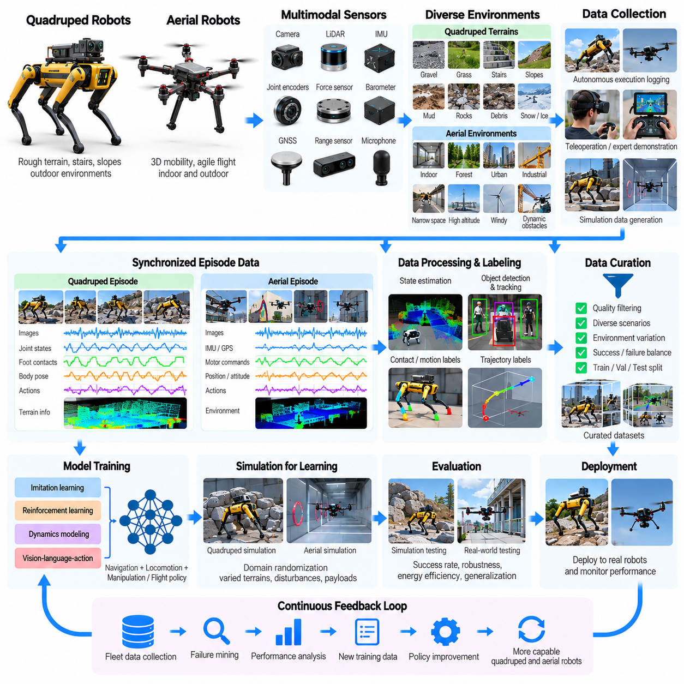
Quadruped and aerial robot data engines support the development of autonomous systems operating in environments that challenge conventional wheeled robots. Quadrupeds traverse uneven terrain through coordinated leg movements, while aerial robots navigate three-dimensional space using controlled flight. Their data engines transform sensor observations, motion trajectories, environmental interactions, and operational outcomes into reusable learning resources.
Although quadruped and aerial robots have different physical structures, their data engines share several fundamental requirements. Both platforms require accurate state estimation, dynamic control, environmental perception, and continuous adaptation to disturbances. Data pipelines must preserve relationships among robot dynamics, sensor measurements, control commands, and environmental conditions to support reliable autonomy.
Quadruped datasets typically contain joint positions, joint velocities, actuator torques, inertial measurements, foot contact states, body poses, and terrain observations. Cameras and LiDAR provide information about obstacles and traversability. These synchronized measurements allow learning systems to associate locomotion decisions with stability, energy consumption, and successful traversal across different surfaces.
Aerial robot datasets emphasize position, orientation, angular velocity, acceleration, motor commands, altitude, and flight trajectories. Cameras, inertial measurement units, GNSS receivers, barometers, and range sensors provide complementary navigation information. Accurate timestamp alignment is essential because small sensing or control delays can significantly affect high-speed flight stability and obstacle avoidance.
Quadruped locomotion depends on coordinated contact between multiple legs and the supporting terrain. Walking, trotting, climbing, and recovering from disturbances require different contact patterns and control strategies. Data engines must capture gait transitions, foot placement, ground reaction forces, and body stabilization to support learning policies capable of adapting to changing terrain conditions.
Terrain diversity is a critical factor in quadruped data collection. Robots may encounter gravel, grass, stairs, slopes, mud, debris, and slippery surfaces. Training datasets should represent variations in friction, surface compliance, elevation, and obstacle geometry. Recording terrain properties alongside locomotion outcomes helps models learn relationships between environmental conditions and feasible movement strategies.
Aerial robots face disturbances that differ fundamentally from terrestrial contact dynamics. Wind gusts, aerodynamic drag, payload variation, and changing air density can influence flight performance. Data engines should record environmental measurements and controller responses when available. Such information supports disturbance estimation, adaptive control, and improved trajectory tracking under uncertain flight conditions.
Teleoperation and expert demonstrations provide important training data for both robot categories. Quadruped operators may guide robots across difficult terrain, while aerial vehicle pilots demonstrate navigation through constrained spaces. Recording expert commands, autonomous corrections, and executed trajectories allows learning systems to distinguish intended motion from stabilization actions generated by onboard controllers.
Simulation is particularly valuable because physical experimentation can involve substantial equipment damage or safety risks. Physics engines generate quadruped locomotion experiences across randomized terrains, while flight simulators reproduce vehicle dynamics and environmental disturbances. Parallel environments support large-scale policy training, systematic scenario variation, and evaluation before physical deployment.
Reinforcement learning has demonstrated considerable potential for quadruped locomotion control. Policies can learn coordinated leg movements through rewards associated with velocity tracking, stability, energy efficiency, and terrain traversal. However, learned behaviors depend on simulator fidelity and reward design. Real-world validation remains necessary to identify unsafe strategies and unmodeled physical effects.
Aerial reinforcement learning and imitation learning can support trajectory tracking, obstacle avoidance, and agile flight maneuvers. Training environments may introduce randomized obstacles, disturbances, and sensor noise. Nevertheless, flight policies must respect actuator saturation, vehicle dynamics, battery limitations, and safety constraints. High simulation performance alone does not establish operational reliability.
Simulation-to-reality transfer requires careful treatment of platform-specific physical uncertainties. Quadrupeds experience variations in joint friction, actuator response, and ground contact, while aerial robots encounter aerodynamic modeling errors and propulsion differences. Domain randomization, system identification, and real-world calibration help reduce these gaps, although their effectiveness depends on representative physical testing.
Multimodal synchronization is essential for reconstructing dynamic robot behavior. Quadruped data pipelines align camera frames, joint states, contact events, and inertial measurements. Aerial pipelines synchronize visual observations, inertial signals, navigation estimates, and motor outputs. Accurate temporal alignment enables models to associate environmental changes with control decisions and resulting physical responses.
State estimation data is especially important when external positioning systems become unreliable. Quadrupeds may operate in tunnels or industrial structures where GNSS is unavailable, while aerial robots may fly indoors or near obstacles that interfere with positioning. Visual-inertial odometry, LiDAR-based localization, and sensor fusion provide alternative estimates whose uncertainties must be preserved.
Perception data supports terrain understanding for quadrupeds and free-space estimation for aerial robots. Semantic segmentation, depth estimation, obstacle detection, and traversability prediction can improve autonomous planning. However, perception errors can produce dangerous control decisions. Data engines should therefore retain confidence estimates, sensor quality indicators, and examples of degraded observation conditions.
Automated labeling pipelines convert raw recordings into structured episodes describing robot states, environmental features, motion phases, and task outcomes. Quadruped labels may identify gait modes, contact transitions, slips, and terrain categories. Aerial labels may describe flight phases, obstacle encounters, wind disturbances, and landing events. Consistent labeling supports training, debugging, and comparative evaluation.
Failure data provides valuable information about the boundaries of learned autonomy. Quadrupeds may slip, stumble, lose balance, or fail to climb obstacles. Aerial robots may experience tracking errors, unstable flight, localization loss, or unsuccessful landings. Recording precursor conditions, control responses, and recovery outcomes enables engineers to investigate failures and develop more robust behaviors.
Safety requirements differ between terrestrial and aerial platforms. Quadruped systems must consider falls, contact forces, and interactions with nearby people or equipment. Aerial systems additionally face risks involving altitude, uncontrolled descent, rotor contact, and airspace restrictions. Data-driven improvements must operate alongside independent safety mechanisms, operational procedures, and applicable regulatory requirements.
Task-oriented datasets extend beyond basic locomotion and flight control. Quadrupeds may perform industrial inspection, environmental monitoring, or autonomous patrols, while aerial robots conduct mapping, infrastructure inspection, and search operations. Data engines should connect navigation trajectories with task observations, mission objectives, and completion outcomes to support integrated autonomy.
Evaluation should measure both control performance and mission effectiveness. Quadruped metrics include traversal success, stability, slip frequency, energy consumption, and recovery capability. Aerial metrics include trajectory tracking error, flight endurance, obstacle clearance, landing precision, and disturbance rejection. Testing across unfamiliar environments helps distinguish genuine generalization from memorized behavior.
Fleet-scale deployment enables robots to gather diverse experiences across sites, terrain types, weather conditions, and mission profiles. Centralized data processing can identify recurring failures and environmental weaknesses. Event-triggered recording prioritizes informative situations such as slips, unexpected impacts, localization degradation, emergency maneuvers, and abnormal energy consumption.
Data governance must account for operational sensitivity, privacy, and platform-specific regulatory obligations. Aerial imagery may capture private property or identifiable individuals, while quadruped inspection logs may reveal sensitive industrial layouts. Dataset documentation should preserve collection permissions, provenance, hardware configurations, software versions, and access restrictions to support responsible reuse.
Scaling these data engines requires balancing simulation volume with the cost and risk of physical experimentation. Large synthetic datasets can improve scenario coverage, but they cannot fully reproduce complex terrain contacts or aerodynamic disturbances. Active learning, targeted field trials, automated quality assessment, and failure-driven collection help prioritize experiences with high learning value.
The long-term objective is to create continuously improving data infrastructures that connect perception, dynamics, control, and mission-level reasoning. Quadruped and aerial robots illustrate how physical embodiment determines data requirements and learning challenges. Their successful scaling depends on realistic simulation, representative field experience, reliable safety mechanisms, and systematic feedback from deployment into model development.

10.08. Teleoperation Data Factory Case Study
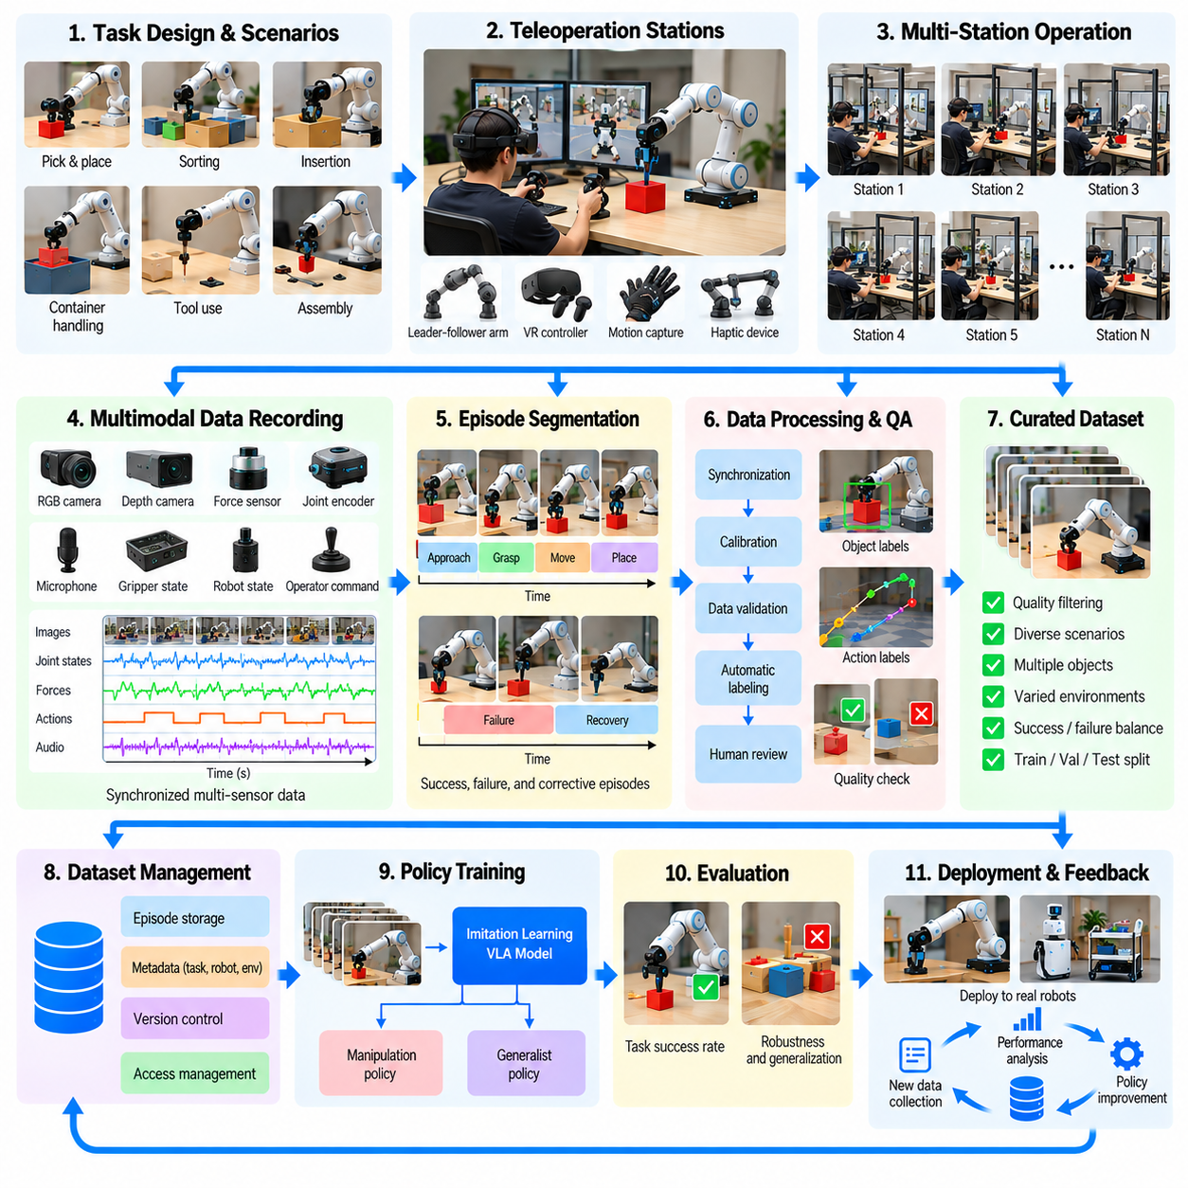
A teleoperation data factory is an organized infrastructure for producing large volumes of high-quality robot demonstrations through human-controlled physical interaction. Unlike conventional laboratory collection, a data factory treats demonstration acquisition as a repeatable production process. It integrates robot hardware, operator interfaces, standardized tasks, recording systems, quality assurance, and data management into a coordinated learning pipeline.
A representative teleoperation data factory may operate multiple robotic manipulation stations under centralized supervision. Each station includes a robot arm, gripper, cameras, force sensors, control interfaces, and a configurable workspace. Human operators execute predefined tasks while recording synchronized observations and actions. The resulting episodes become training resources for imitation learning and generalist robot policies.
The factory begins with task portfolio design, which determines the behaviors that robots must learn. Tasks may include object picking, sorting, insertion, container handling, tool manipulation, and multi-step assembly. Designers balance common operational activities with difficult edge cases. Task specifications define initial conditions, target outcomes, object configurations, acceptable behaviors, and failure criteria.
Workspace standardization improves data consistency while preserving environmental diversity. Collection stations use documented camera positions, coordinate frames, lighting conditions, and robot calibration procedures. However, identical workspaces can produce overfitted policies. Data factories therefore introduce controlled variations in object placement, backgrounds, materials, and task configurations to support generalization.
Operator interfaces strongly influence demonstration quality and collection throughput. Common interfaces include leader-follower robot arms, virtual reality controllers, motion capture systems, and haptic devices. The interface must provide intuitive control while respecting robot constraints. Ergonomic design, low communication latency, and reliable feedback reduce operator fatigue and improve trajectory consistency.
Leader-follower teleoperation enables operators to guide a leader device while a follower robot reproduces corresponding movements. This arrangement can generate precise manipulation demonstrations with natural human control. However, differences in kinematics, mechanical friction, and gripper response may introduce tracking errors. Recording both commanded and executed trajectories helps preserve these distinctions.
A standardized collection protocol ensures that operators produce comparable demonstrations across shifts and stations. Before each episode, the system verifies robot readiness, sensor synchronization, object placement, and task configuration. During execution, it records actions, observations, interventions, and abnormal events. After completion, the episode receives outcome labels and preliminary quality checks.
A typical recording pipeline captures RGB images, depth measurements, joint positions, joint velocities, end-effector poses, gripper states, force measurements, and operator commands. All streams require consistent timestamps and calibration metadata. The data schema should identify robot models, software versions, control frequencies, coordinate conventions, task identifiers, and environmental configurations.
Episode segmentation converts continuous operating sessions into meaningful training examples. Start and end markers may be generated through operator controls, task-state transitions, or automated event detection. Segmentation must preserve preparation movements, contact events, corrective actions, and task completion. Poor boundaries can remove important causal information or introduce unrelated behavior into training sequences.
Quality assurance is essential because large demonstration volumes do not automatically produce effective learning datasets. Automated checks identify missing sensor frames, timestamp drift, incomplete trajectories, inconsistent coordinate transformations, and invalid robot states. Additional checks examine task success, collision events, excessive forces, and unexpected control interruptions before accepting episodes into the curated dataset.
Human reviewers provide contextual judgments that automated validators may miss. A successful object placement might involve unnecessary movements, unstable grasping, or accidental contact with surrounding objects. Reviewers classify demonstrations according to task correctness, motion quality, safety, and instructional value. Consistent review guidelines reduce disagreement and improve annotation reliability.
Demonstration diversity must be deliberately managed rather than left to operator preference. Operators naturally develop efficient routines that can produce repetitive trajectories. Data factories counter this tendency through randomized object positions, varying grasp approaches, alternative task sequences, and different workspace conditions. Diversity targets help ensure coverage of behaviors required for unfamiliar situations.
Operator training and performance monitoring contribute directly to data quality. Training programs establish consistent task interpretation, interface operation, safety procedures, and recovery protocols. Performance indicators may include accepted episodes per hour, task success rate, intervention frequency, and quality rejection rate. These measures should guide process improvements rather than encourage unsafe collection speed.
Throughput analysis distinguishes raw demonstration volume from usable training output. A station may record many episodes, but calibration failures, incomplete tasks, or poor synchronization can reduce accepted yield. Effective throughput is measured through validated episodes and useful trajectory duration. Factory management should track rejection causes, operator utilization, station downtime, and processing delays.
Data storage architecture must support high-bandwidth multimodal recordings from many collection stations. Local buffers protect against temporary network interruptions, while centralized storage provides versioned access to validated episodes. Compression and selective retention reduce costs without discarding essential control information. Dataset manifests connect raw recordings, processed trajectories, labels, and provenance metadata.
Automated processing transforms raw demonstrations into standardized learning representations. Typical operations include timestamp alignment, coordinate conversion, image preprocessing, action normalization, episode indexing, and annotation generation. Processing pipelines must preserve original recordings for traceability. Versioned transformations allow engineers to reproduce datasets and identify errors introduced during preprocessing.
A teleoperation factory becomes more valuable when integrated with an active learning loop. Initial demonstrations train a robot policy, which is then evaluated on held-out tasks and physical test scenarios. Failure analysis identifies weak behaviors, uncertain states, and missing task variations. New collection requests target these deficiencies instead of repeatedly acquiring already well-represented demonstrations.
Human intervention during autonomous execution creates another important data source. When a robot encounters uncertainty or begins to fail, an operator can assume control and demonstrate corrective behavior. Recording the transition from autonomous action to human recovery provides information about policy limitations. These intervention episodes can support corrective imitation learning and improved recovery strategies.
Simulation can complement physical teleoperation by generating variations around recorded demonstrations. Object positions, camera viewpoints, lighting, friction, and environmental geometry may be modified in virtual environments. However, synthetic transformations must preserve physically meaningful actions and contact relationships. Real demonstrations remain necessary for validating simulated behavior and maintaining physical grounding.
A representative factory deployment may begin with a small number of manipulation stations and a limited task portfolio. Engineers first establish reliable synchronization, repeatable calibration, and clear acceptance criteria. Once collection quality stabilizes, additional stations and operators can increase capacity. Expansion should follow measured data yield and learning improvements rather than hardware count alone.
Operational economics depend on equipment costs, operator labor, maintenance, workspace preparation, storage, and processing infrastructure. Cost per accepted episode is more informative than cost per raw recording. Additional measures include cost per useful action hour and improvement in policy performance per collection budget. These metrics connect factory productivity with actual learning value.
Safety management is essential because operators and robots share physical workspaces. Emergency stops, force limits, collision monitoring, guarded operating zones, and documented recovery procedures reduce operational risks. Data collection software should preserve safety events and intervention records. Production targets must never override protective mechanisms or established safety procedures.
Data governance addresses ownership, privacy, licensing, and traceability across collection operations. Recorded scenes may contain proprietary objects, confidential processes, or identifiable personnel. Access controls, retention policies, consent procedures, and secure transfer mechanisms protect sensitive information. Provenance records connect each episode to its collection station, operator authorization, task specification, and processing history.
Scaling a teleoperation data factory requires coordinated improvements in hardware reliability, operator efficiency, automated validation, and dataset diversity. Simply adding stations can multiply defective recordings if quality processes remain weak. Centralized monitoring, standardized interfaces, predictive maintenance, and automated data selection help maintain consistent production quality across expanding operations.
The central lesson of the teleoperation data factory case study is that robot learning data must be engineered as a production system rather than collected as isolated demonstrations. Sustainable performance depends on measurable quality, repeatable operations, targeted diversity, and feedback from trained policies. A mature data factory continuously converts human expertise into structured robotic experience that supports increasingly reliable physical intelligence.

10.09. Human Video to Robot Learning Case Study
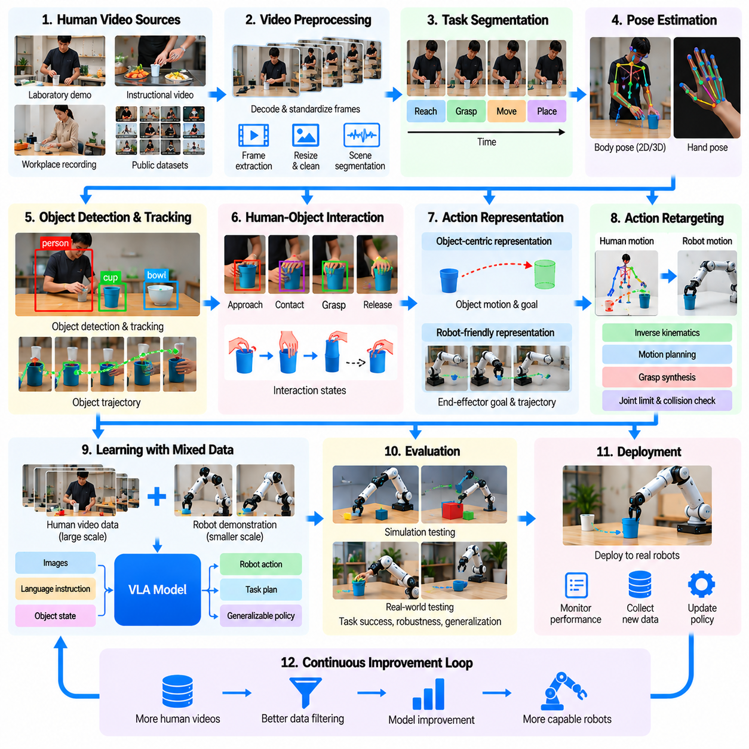
Human video-to-robot learning transforms recordings of human activities into training resources for robotic perception, planning, and manipulation. Unlike teleoperation datasets, human videos usually contain no direct robot commands, joint trajectories, or actuator measurements. A data engine must infer task structure, object interactions, and motion intentions from visual observations before transferring useful behaviors to robotic systems.
A representative case study involves teaching a robot to perform tabletop manipulation tasks using videos of people handling everyday objects. Demonstrations may include picking up containers, arranging tools, opening drawers, or placing objects into designated locations. The objective is not to reproduce human movements exactly, but to extract task knowledge that can guide robots with different physical structures.
Human video collection can draw from controlled laboratory demonstrations, workplace recordings, instructional videos, and appropriately licensed public datasets. Each source provides different levels of camera stability, visual quality, and task diversity. Collection policies must consider privacy, consent, copyright, and permitted usage. Source documentation helps determine which recordings are suitable for training and evaluation.
Video preprocessing establishes consistent representations from heterogeneous recordings. Pipelines decode frames, standardize resolution, estimate timestamps, identify scene boundaries, and remove unusable segments. Camera motion, occlusion, compression artifacts, and inconsistent frame rates complicate analysis. Preserving original videos alongside processed versions supports reproducibility and correction of preprocessing errors.
Task segmentation divides continuous human activities into meaningful behavioral units. A drawer-opening demonstration may contain reaching, grasping the handle, pulling, releasing, and repositioning. Temporal segmentation models identify action boundaries using changes in object motion, hand position, and contact patterns. These segments provide a structured basis for learning reusable manipulation skills.
Hand and body pose estimation reconstructs approximate human movement from visual observations. Models detect joints, estimate hand configurations, and track motion through time. However, monocular video introduces depth ambiguity, self-occlusion, and scale uncertainty. Multi-view recordings and calibrated cameras can improve reconstruction, but estimated poses should retain uncertainty rather than be treated as exact measurements.
Object detection and tracking identify the entities involved in each demonstration. Data engines estimate object positions, orientations, trajectories, and relationships with human hands. Semantic labels describe object categories and functional roles, while geometric representations support manipulation planning. Tracking errors must be detected because incorrect object histories can produce misleading action supervision.
Human-object interaction modeling connects observed movement with task meaning. Contact estimation identifies when hands touch, grasp, release, push, or support objects. Changes in object state reveal the consequences of these interactions. A successful grasp may be inferred from coordinated hand-object motion, although visual evidence alone cannot always establish contact forces or grasp stability.
A central challenge is converting human actions into robot-compatible representations. Human hands possess different joint structures, compliance, and manipulation capabilities from robotic grippers. Directly copying human joint trajectories is therefore often infeasible. Instead, learning systems extract object-relative movements, end-effector goals, contact sequences, and task constraints that can transfer across embodiments.
Action retargeting maps reconstructed demonstrations onto the robot's kinematic and mechanical capabilities. Inverse kinematics, motion planning, and grasp synthesis generate feasible robot actions from desired object interactions. Retargeting must respect joint limits, collision constraints, workspace reachability, and gripper geometry. Invalid mappings should be rejected or revised rather than introduced into training datasets.
Object-centric representations provide an important bridge between human and robotic behavior. Rather than describing every human joint movement, a model can represent how an object moves relative to a table, container, or target location. These relationships remain meaningful across different robot morphologies. Object-centric learning can therefore reduce embodiment mismatch while preserving essential task structure.
Visual affordance learning identifies how objects can be manipulated to achieve desired outcomes. A handle suggests pulling, a button suggests pressing, and an open container permits insertion. Video demonstrations provide evidence about these possibilities through observed interactions. However, affordances depend on geometry, material properties, and context, so models must avoid assuming that visually similar objects behave identically.
A practical data engine combines video-derived supervision with smaller amounts of robot demonstration data. Human recordings provide broad task diversity, while robot trajectories establish physically executable action patterns. Joint training can align visual task representations with robot observations and commands. This approach reduces dependence on extensive teleoperation while retaining grounding in robot dynamics.
Imitation learning can use reconstructed goals, object trajectories, or action sequences as supervision. Behavioral cloning learns mappings from observations to actions, while sequence models capture longer task dependencies. Diffusion-based policies may represent multiple feasible manipulation trajectories. Training objectives should account for uncertain labels and avoid treating inferred human actions as precise robot commands.
Simulation supports validation of transferred behaviors before physical execution. Reconstructed object configurations and task sequences can initialize virtual manipulation scenarios. Robot policies are tested for reachability, collision avoidance, grasp feasibility, and task completion. Simulation also enables controlled variations in object placement and geometry, although contact modeling errors may limit transfer accuracy.
Real-world deployment reveals limitations that may remain hidden in video reconstruction. Robots encounter friction, object deformation, grasp uncertainty, and actuator constraints that are not directly observable in human videos. Closed-loop execution must use current sensor feedback rather than replaying reconstructed trajectories blindly. Physical trials provide essential evidence for correcting learned behaviors.
Failure analysis links unsuccessful robot executions back to their originating video demonstrations. Errors may arise from incorrect depth estimation, object tracking failures, inaccurate contact inference, or unsuitable action retargeting. Data engines should preserve intermediate representations and transformation histories. This traceability allows engineers to determine whether failures originate from perception, representation, planning, or control.
Human correction can improve the quality of video-derived robot training data. Operators may verify object tracks, adjust contact labels, refine task boundaries, or demonstrate feasible robot alternatives. Active learning systems prioritize uncertain segments for review. Concentrating human effort on ambiguous or failure-prone examples can improve dataset quality without requiring exhaustive manual annotation.
Evaluation requires separating visual understanding from physical execution capability. Video interpretation metrics include pose estimation accuracy, object tracking consistency, temporal segmentation quality, and interaction recognition. Robot metrics include task completion, grasp success, trajectory feasibility, recovery performance, and generalization to unfamiliar objects. Strong video understanding does not automatically imply reliable robotic manipulation.
Dataset diversity determines whether learned behaviors transfer beyond the original demonstrations. Training collections should vary camera viewpoints, human demonstrators, object appearances, backgrounds, lighting, and task sequences. However, visual diversity alone is insufficient. Physical variation in object mass, friction, dimensions, and manipulation constraints must also be represented through robot data or validated simulation.
Scaling the pipeline requires automated video indexing, task discovery, annotation generation, quality filtering, and representation alignment. Large collections may contain repetitive, irrelevant, or misleading demonstrations. Semantic search and embedding-based clustering can identify useful task variations. Selection should prioritize behavioral coverage and physical relevance rather than total video duration.
Data governance is particularly important because human recordings may contain identifiable individuals, private environments, and copyrighted materials. Collection and processing must follow applicable permissions, privacy obligations, and licensing conditions. Provenance records should connect derived annotations and robot training examples to authorized source videos. Sensitive information may require restricted access or removal before reuse.
A representative deployment can begin with a limited set of tabletop tasks and carefully recorded human demonstrations. Engineers establish video quality requirements, validate pose and object tracking, and construct robot-compatible task representations. A small robot dataset then supports policy alignment and physical testing. Expansion follows measured improvements in task transfer rather than video collection volume alone.
The central lesson of human video-to-robot learning is that abundant human demonstrations provide valuable task knowledge but incomplete physical supervision. Reliable transfer requires reconstructing interactions, resolving embodiment differences, and validating executable actions. A mature data engine combines human video understanding, robot-grounded learning, simulation, and failure feedback to convert observed human behavior into increasingly capable robotic intelligence.

10.10. Synthetic Data Factory Case Study
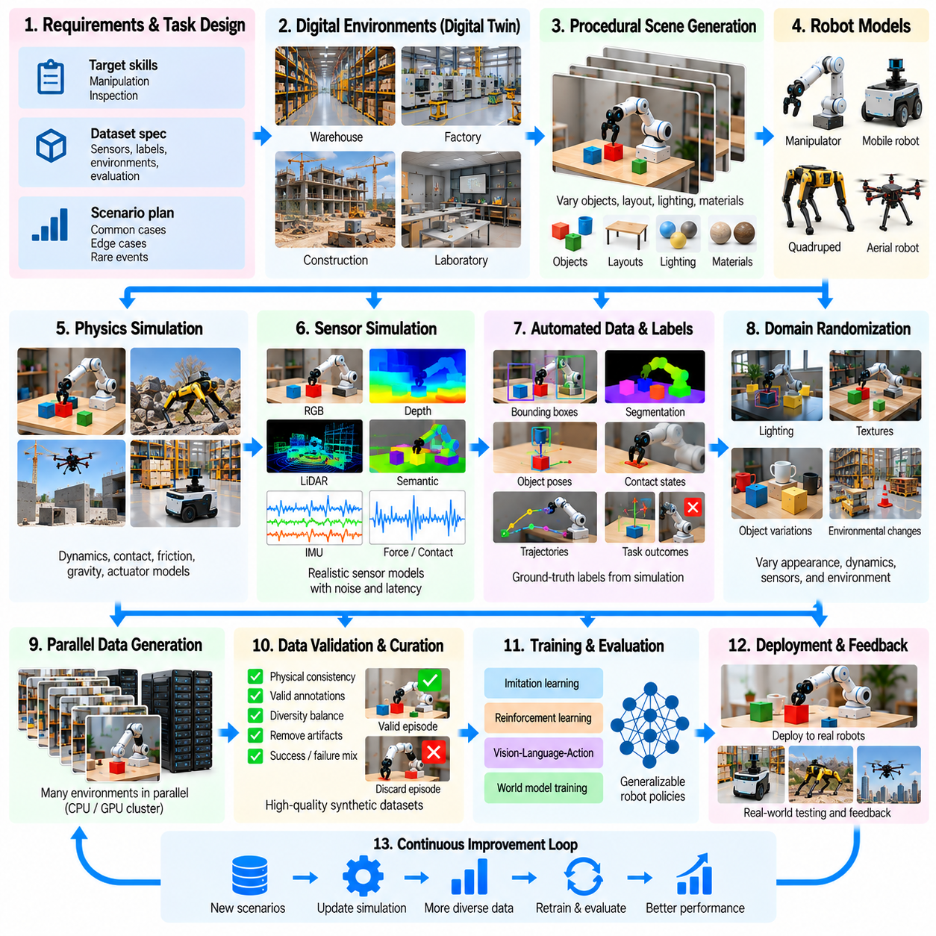
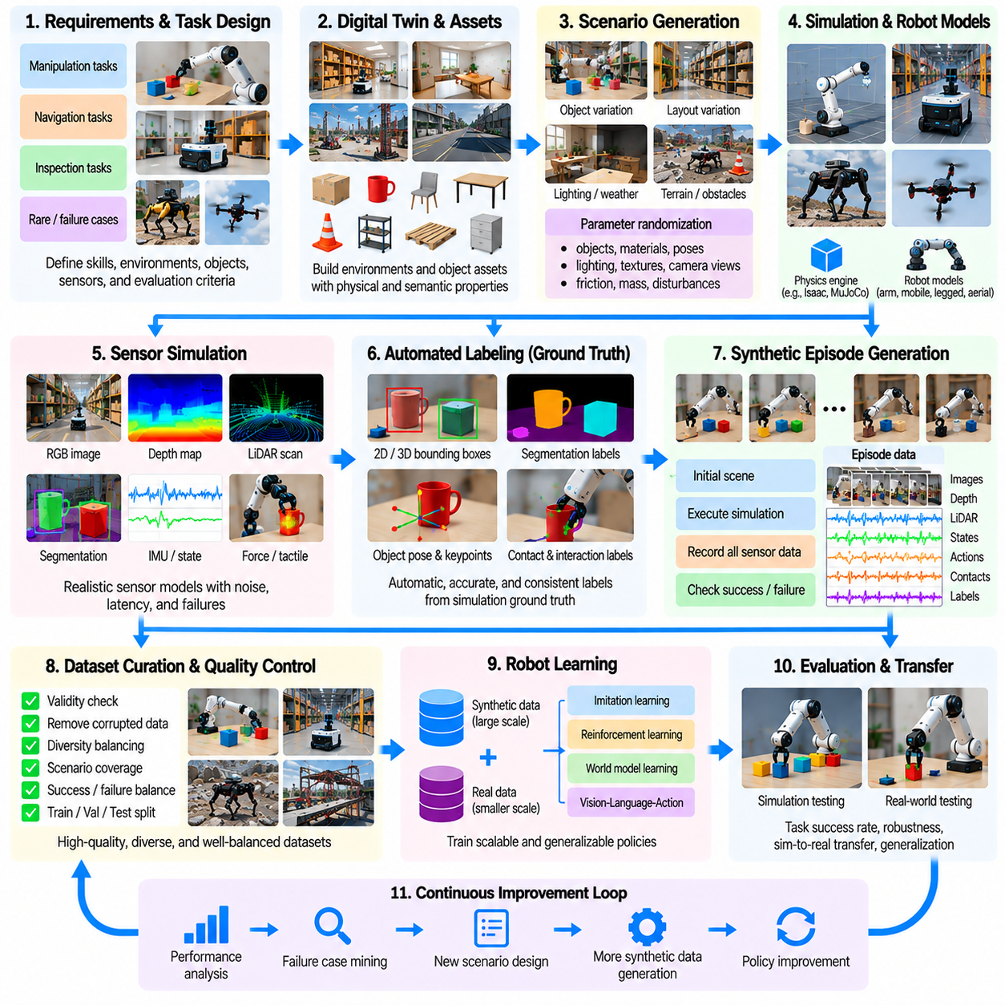
A synthetic data factory is an automated infrastructure that generates large-scale training datasets through simulation, procedural scene creation, and controlled physical modeling. Unlike conventional data collection, synthetic generation can systematically vary environments, objects, robot configurations, and task conditions. Its primary objective is to produce diverse, accurately labeled experiences that improve robot learning while reducing dependence on expensive physical experiments.
A representative synthetic data factory may support robotic manipulation, autonomous navigation, and industrial inspection. The system combines digital environments, physics engines, robot models, sensor simulators, scenario generators, and dataset processing services. Each component contributes to a repeatable production pipeline that converts configurable virtual experiments into structured training and evaluation resources.
Factory design begins with defining target learning capabilities and operational requirements. Engineers identify perception tasks, manipulation skills, navigation behaviors, and failure conditions that require additional data. Dataset specifications describe sensor modalities, annotation formats, environment categories, robot configurations, and evaluation criteria. These requirements determine which synthetic scenarios provide meaningful learning value.
Digital twin construction establishes the virtual environments used for data generation. Factories, warehouses, construction sites, and laboratories can be represented through geometric models, semantic maps, and physical properties. Accurate dimensions and spatial relationships support realistic interactions. However, digital twins must also represent uncertainty and operational variation rather than reproducing only idealized environments.
Procedural scene generation automatically creates variations in object placement, geometry, lighting, materials, and environmental layout. A warehouse scenario may contain different shelf arrangements, pallet locations, obstacles, and traffic patterns. Parameterized scene templates allow thousands of related but distinct environments to be generated. This diversity helps reduce overfitting to a limited set of virtual configurations.
Physics simulation provides the dynamic foundation for synthetic robot experiences. Rigid-body dynamics, contact forces, friction, gravity, and actuator behavior determine how robots interact with objects and surfaces. Manipulation tasks require accurate grasping and collision models, while mobile robots require realistic motion and terrain interactions. Simulation errors can introduce systematic biases into learned policies.
Sensor simulation converts virtual physical states into observations resembling real robot measurements. Rendered RGB images, depth maps, LiDAR scans, inertial signals, and force readings can be generated from the same simulated episode. Sensor models should include calibration characteristics, measurement noise, latency, and failure conditions. These variations help learning systems tolerate imperfections encountered during deployment.
Domain randomization is a central technique for improving transfer from synthetic to real environments. Randomized textures, illumination, camera viewpoints, object masses, friction coefficients, and sensor noise expose models to diverse conditions. However, excessive randomization may create unrealistic combinations. Parameter ranges should be informed by physical measurements and validated against representative real-world observations.
Synthetic data factories can generate labels directly from simulation ground truth. Object poses, segmentation masks, depth values, contact states, trajectories, and collision events are available without manual annotation. This capability reduces labeling costs and supports precise supervision. Nevertheless, generated labels remain dependent on the correctness of scene models, coordinate transformations, and simulation assumptions.
A typical generation pipeline begins by selecting a scenario template and sampling its configuration parameters. The system initializes virtual objects, robot states, environmental conditions, and sensor settings before executing a simulation. During execution, it records observations, actions, physical states, and task outcomes. Automated validation determines whether the episode satisfies dataset quality requirements.
Parallel simulation enables substantial increases in synthetic data production throughput. Multiple virtual environments can execute simultaneously across CPUs and GPUs, depending on simulation complexity. Lightweight scenarios may support large parallel batches, while detailed contact simulation and high-fidelity rendering require more resources. Scheduling systems must balance simulation speed, physical accuracy, and dataset diversity.
Synthetic manipulation datasets may contain object picking, insertion, stacking, assembly, and tool-use episodes. Each scenario varies grasp configurations, object geometry, initial poses, and contact conditions. Successful and unsuccessful attempts provide complementary supervision. Recording complete interaction sequences helps models learn not only intended actions but also the physical consequences of incorrect decisions.
Synthetic navigation datasets support autonomous mobile robots, quadrupeds, and aerial platforms. Generated environments introduce blocked routes, moving obstacles, uneven terrain, narrow passages, and environmental disturbances. Navigation episodes record localization estimates, planned paths, executed trajectories, and safety events. These datasets enable systematic evaluation of difficult situations that may be costly or dangerous to reproduce physically.
Rare-event generation is particularly valuable for safety-critical learning and evaluation. Scenarios can deliberately introduce sensor degradation, unexpected obstacles, actuator faults, or communication interruptions. Controlled simulation allows engineers to examine robot responses without exposing people or equipment to unnecessary risk. Such experiments complement, but cannot replace, validated physical safety testing.
Quality assurance must distinguish technically valid synthetic recordings from physically meaningful training examples. Automated checks examine simulation stability, sensor synchronization, annotation consistency, collision validity, and task outcome correctness. Episodes containing numerical instability, impossible geometry, or unrealistic contact behavior should be rejected. Quality filters prevent simulation artifacts from becoming misleading learning signals.
Data curation organizes generated episodes according to task type, environment characteristics, difficulty, and failure categories. Large-scale generation can produce redundant examples if sampling distributions remain poorly designed. Coverage analysis identifies underrepresented scenarios and excessive repetition. Balanced selection improves dataset efficiency and helps ensure that rare but important behaviors receive sufficient representation.
Real-world calibration connects the synthetic factory to physical robot measurements. Engineers compare simulated sensor outputs, motion trajectories, contact responses, and task outcomes with recorded physical experiments. Differences reveal modeling errors and missing environmental factors. System identification and parameter adjustment reduce discrepancies, while validation datasets measure whether synthetic improvements transfer to actual robots.
A closed-loop synthetic data factory uses trained model performance to guide subsequent generation. Initial synthetic datasets support policy training, followed by evaluation in simulation and physical environments. Failure analysis identifies weak object categories, difficult terrain, or unstable control conditions. Scenario generators then increase coverage of these deficiencies, creating a targeted data improvement cycle.
Active scenario selection improves efficiency by prioritizing examples that offer high expected learning value. Uncertainty estimates, failure frequency, model disagreement, and coverage gaps can guide generation requests. Instead of producing uniformly random episodes, the factory concentrates resources on challenging situations. This strategy is especially useful when detailed simulation and rendering are computationally expensive.
Dataset management requires consistent schemas, metadata, version control, and traceable generation configurations. Each episode should preserve simulator versions, random seeds, scene parameters, robot models, sensor settings, and processing histories. Reproducible configurations allow engineers to regenerate scenarios and investigate unexpected results. Dataset lineage also supports comparisons between simulation revisions and model releases.
Operational economics depend on compute infrastructure, rendering costs, simulation engineering, asset development, and validation effort. Cost per generated episode is useful but insufficient because many episodes may provide little learning value. More meaningful indicators include cost per validated episode, scenario coverage, and model performance improvement per compute budget. These measures connect production efficiency with downstream robotic capability.
A representative deployment can begin with a limited digital environment and a small portfolio of manipulation or navigation tasks. Engineers first verify physical parameters, sensor models, annotation accuracy, and generation reproducibility. The factory then expands scenario diversity and parallel execution capacity. Physical evaluation checkpoints determine whether additional synthetic production delivers measurable improvements.
Data governance remains important even when recordings are generated virtually. Digital assets may originate from proprietary CAD models, licensed textures, confidential facility layouts, or restricted simulation components. Dataset documentation should preserve asset permissions, generation provenance, access controls, and permitted reuse conditions. Synthetic origin does not automatically eliminate intellectual property or confidentiality obligations.
The central lesson of the synthetic data factory case study is that scalable simulation must be connected to physical evidence and learning outcomes. High generation volume alone cannot guarantee useful robotic intelligence. A mature factory combines procedural diversity, physics validation, automated labeling, quality filtering, and real-world feedback to produce synthetic experiences that systematically improve physical AI capabilities.

10.11. Fleet Data Flywheel Case Study
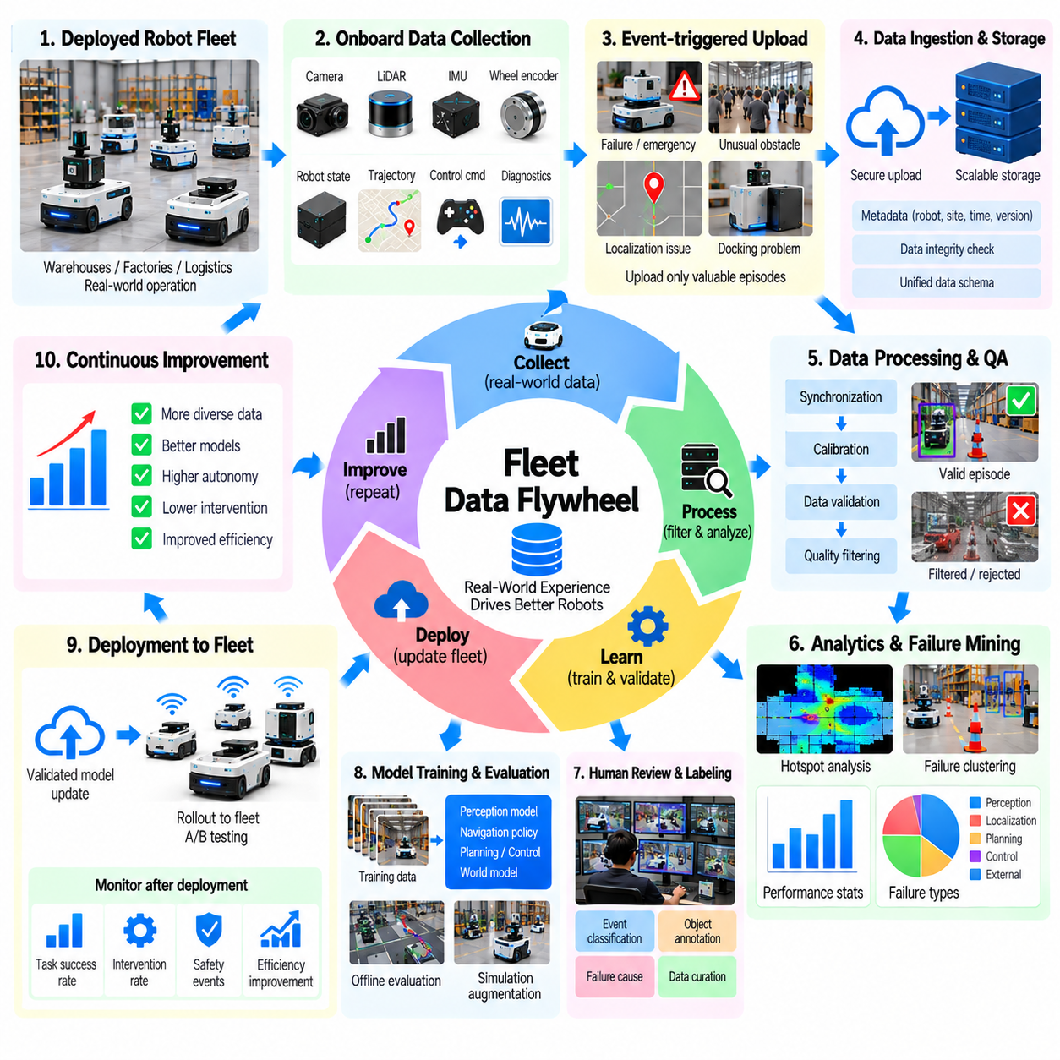
A fleet data flywheel is a continuous improvement mechanism that transforms operational experiences from deployed robots into better autonomous capabilities. As robots perform tasks across real environments, they generate observations, actions, failures, and performance measurements. A centralized data engine collects these experiences, identifies valuable learning opportunities, updates robot models, and returns validated improvements to the operating fleet.
A representative case study involves a fleet of autonomous mobile robots operating across warehouses, factories, and logistics facilities. Each robot performs transportation missions while encountering different layouts, obstacles, traffic patterns, and operating conditions. The fleet collectively produces a diverse stream of navigation data that would be difficult to obtain from a single robot or controlled laboratory environment.
The flywheel begins with standardized onboard data collection. Robots record camera images, LiDAR scans, localization estimates, planned trajectories, executed motions, control commands, and system diagnostics. Mission identifiers, robot configurations, software versions, and timestamps provide operational context. Consistent schemas allow recordings from different robots and facilities to be compared and combined reliably.
Fleet management systems contribute information that onboard sensors cannot capture independently. Mission assignments, route scheduling, charging operations, traffic coordination, and task completion records explain how robots interact with operational infrastructure. Integrating these records with navigation logs allows engineers to distinguish autonomy failures from scheduling inefficiencies, infrastructure limitations, or coordination problems.
Continuous data collection does not require uploading every sensor frame from every robot. Large fleets generate substantial quantities of repetitive information during normal operation. Event-triggered recording and selective transmission prioritize unusual conditions, safety interventions, localization degradation, and unexpected mission delays. This approach reduces communication and storage costs while preserving informative operational evidence.
Data ingestion infrastructure transfers selected recordings from robots to centralized storage and processing services. Edge buffers accommodate intermittent connectivity, while secure transmission protects operational information. Each uploaded episode receives identifiers, integrity checks, and provenance metadata. Ingestion services must handle different network conditions, recording formats, and software versions without compromising data consistency.
Automated quality assessment filters recordings before they enter the learning pipeline. Validation checks examine sensor completeness, timestamp alignment, coordinate transformations, calibration status, and trajectory continuity. Corrupted logs and inconsistent metadata are rejected or quarantined. Quality indicators help determine whether an episode is suitable for model training, evaluation, incident analysis, or further human review.
Fleet analytics converts large collections of operational logs into structured performance insights. Aggregated statistics reveal recurring navigation failures, difficult intersections, congestion hotspots, and inefficient routes. Engineers can compare mission completion rates, intervention frequencies, localization confidence, and travel efficiency across sites. These comparisons help identify problems that individual robot logs may not reveal.
Failure mining is a central component of the fleet data flywheel. Algorithms search for emergency stops, unexpected obstacles, localization loss, repeated replanning, excessive wheel slip, and unsuccessful docking. Candidate events are grouped by environmental context and failure characteristics. Clustering related failures helps engineers prioritize recurring weaknesses rather than investigating every isolated incident independently.
Uncertainty-based sampling identifies situations where deployed models exhibit limited confidence or inconsistent predictions. Perception uncertainty, localization covariance, planning disagreement, and unusual control responses may indicate informative episodes. However, uncertainty scores require calibration because high uncertainty does not always correspond to operational risk. Selected examples should be evaluated for relevance and diversity.
Human review complements automated failure discovery by providing contextual interpretation. Reviewers examine sensor evidence, system states, environmental conditions, and recovery actions. They determine whether incidents originate from perception errors, map inconsistencies, planning limitations, control instability, or external interference. Consistent failure taxonomies improve annotation quality and support targeted development.
The data engine converts selected episodes into curated training and evaluation datasets. Automated labeling generates obstacle tracks, semantic annotations, trajectory histories, and event classifications. Human verification addresses ambiguous situations and safety-critical examples. Dataset versions preserve the relationship between original recordings, derived labels, processing configurations, and intended learning objectives.
Active learning connects fleet observations with specific model improvement requests. When evaluation reveals poor performance in crowded intersections, the system searches existing logs for similar situations and requests additional targeted recordings. Rare events may be supplemented through simulation. Collection priorities therefore follow demonstrated model weaknesses rather than relying exclusively on uniform data accumulation.
Simulation expands fleet experience by generating controlled variations of observed failures. A recorded route blockage can become multiple scenarios with different obstacle positions, traffic densities, and sensor conditions. Digital twins reproduce relevant facility geometry and robot dynamics. Synthetic scenarios support systematic testing, but physical evidence remains necessary to verify that improvements transfer to deployed robots.
Model training integrates curated fleet data with existing robot learning resources. Updated perception models may improve obstacle classification, while navigation policies may learn better local decisions. Training procedures should prevent recent high-volume routes from overwhelming rare but important scenarios. Balanced sampling, dataset versioning, and reproducible experiments support meaningful comparisons between model generations.
Offline evaluation provides the first checkpoint before deploying updated models. Held-out datasets measure perception accuracy, localization performance, trajectory prediction, and navigation decision quality. Evaluation sets should include different facilities, environmental conditions, and failure categories. Improvements on training distributions alone are insufficient evidence of better operational autonomy.
Simulation-based regression testing examines whether new models introduce failures in previously successful scenarios. Test suites include normal missions, difficult intersections, sensor degradation, blocked paths, and recovery situations. Performance is compared against established baselines. Safety-critical regressions should prevent deployment even when aggregate learning metrics improve.
Physical validation introduces candidate models into controlled robot tests before fleet-wide release. Engineers evaluate mission success, intervention frequency, obstacle avoidance, docking precision, and recovery behavior. Hardware-specific differences must be considered because identical software can behave differently across robot configurations. Independent safety functions remain active throughout experimental testing.
Deployment management closes the loop between model development and fleet operations. Validated updates may be introduced through staged rollouts, beginning with limited robots or operating areas. Monitoring compares updated systems against existing baselines under comparable conditions. Rollback mechanisms restore previous versions when unexpected regressions, safety concerns, or reliability problems appear.
Fleet monitoring continues after deployment to measure whether model improvements persist under real operational conditions. Performance dashboards track mission completion, travel efficiency, intervention rates, fault frequency, and system availability. Changes must be interpreted alongside facility layouts, traffic density, robot utilization, and software configuration. This prevents operational variation from being mistaken for model improvement.
A mature flywheel also learns from successful operations rather than collecting only failures. Efficient routes, stable obstacle avoidance, accurate docking, and successful recovery episodes provide useful reference behaviors. Comparing successful and unsuccessful outcomes under similar conditions helps identify decisions associated with robust performance. Positive examples also reduce the risk of training datasets becoming dominated by abnormal situations.
Fleet diversity creates both opportunities and challenges for shared learning. Different robot models may use distinct sensors, actuators, payload capacities, and navigation architectures. Data normalization enables common analysis, but platform-specific characteristics must remain accessible. Transfer learning can reuse shared environmental knowledge while retaining specialized control models for different hardware configurations.
Data governance becomes increasingly important as fleet operations expand across organizations and facilities. Robot logs may contain identifiable individuals, sensitive maps, proprietary workflows, and operational schedules. Access permissions, encryption, retention policies, and dataset provenance protect these records. Cross-site learning must respect contractual boundaries and applicable privacy requirements.
The economic value of the flywheel depends on improvements in operational performance relative to collection and development costs. Useful measures include cost per informative episode, reduction in interventions, improvement in mission completion, and decreased robot downtime. Increasing data volume is not itself a business outcome. Investment should prioritize learning activities that deliver measurable reliability and productivity gains.
The central lesson of the fleet data flywheel case study is that deployed robots can become continuous sources of learning rather than static automation products. Operational data becomes valuable when systematic selection, validation, training, evaluation, and controlled deployment form a closed loop. A successful flywheel compounds fleet experience into safer, more adaptable, and increasingly reliable physical AI systems.

10.12. End to End Physical AI Data Engine [w/Code]
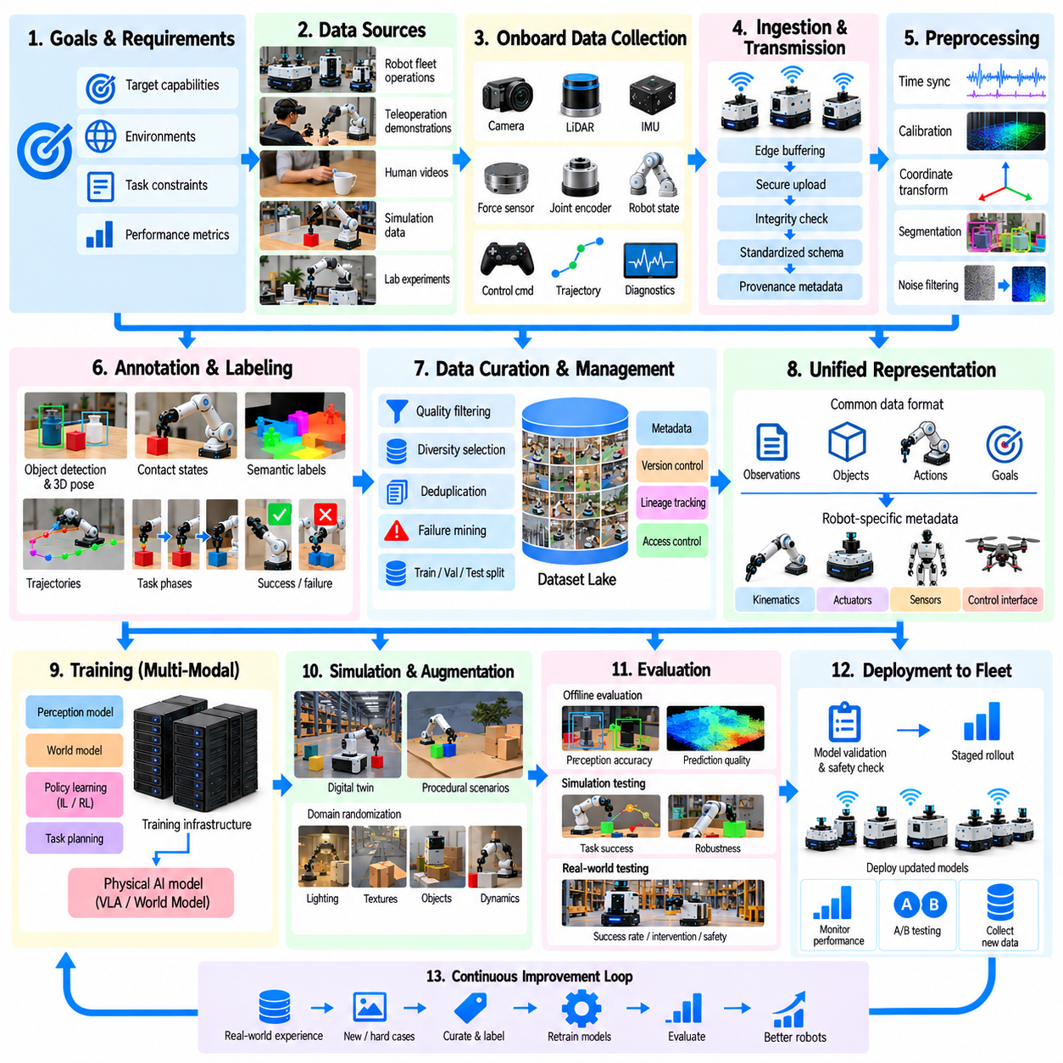
An end-to-end Physical AI data engine is an integrated system that transforms physical experiences into continuously improving robotic intelligence. It connects data collection, ingestion, processing, annotation, curation, training, evaluation, and deployment within a unified architecture. Rather than treating datasets as static resources, the engine manages information as a continuously evolving asset driven by real-world robot performance.
The architecture begins with clearly defined operational objectives and learning requirements. Engineers identify target robot capabilities, environmental conditions, task constraints, and measurable performance indicators. These specifications determine which experiences must be collected and how they should be represented. A well-designed data engine connects every collection activity to a learning objective or evaluation requirement.
Data acquisition combines complementary sources, including robot fleet logs, teleoperation demonstrations, human videos, simulation episodes, and controlled laboratory experiments. Each source contributes different information about perception, actions, dynamics, and task outcomes. Integrating these sources increases behavioral coverage, but their limitations and differences must remain explicit throughout the pipeline.
Onboard data collection captures synchronized observations and robot states during physical execution. Cameras, LiDAR, depth sensors, inertial units, force sensors, and joint encoders provide multimodal measurements. Control commands, planned trajectories, safety interventions, and task outcomes add behavioral context. Accurate timestamps and calibration records are essential for reconstructing relationships between perception and action.
The ingestion layer transfers collected information into a scalable data infrastructure. Edge buffering, secure communication, integrity verification, and standardized metadata support reliable operation across distributed robots. Data schemas identify sensor modalities, coordinate frames, robot configurations, and software versions. Provenance records preserve the origin and processing history of every dataset component.
Preprocessing converts heterogeneous raw recordings into consistent learning representations. Operations include timestamp alignment, sensor calibration, coordinate transformation, trajectory reconstruction, video segmentation, and noise filtering. Automated validation detects missing measurements, corrupted sequences, and inconsistent metadata. Raw observations should remain accessible so that processing errors can be investigated and corrected.
Annotation transforms sensor observations into structured supervision for machine learning. Object identities, semantic classes, poses, contact states, trajectories, task phases, and failure categories may be labeled automatically or through human review. Simulation provides ground-truth annotations, while physical recordings often require estimation. Label confidence and uncertainty should be preserved rather than hidden.
Data curation determines which examples deserve inclusion in training and evaluation datasets. Selection considers quality, diversity, task relevance, physical feasibility, and failure importance. Redundant recordings may be downsampled, while rare or difficult situations receive greater attention. Dataset composition should reflect intended operational coverage without simply reproducing the frequency of common events.
A unified representation layer connects different robots, environments, and data sources. Common descriptions of objects, spatial relationships, actions, goals, and task outcomes support cross-platform learning. However, robot-specific kinematics, actuator limits, sensor characteristics, and control interfaces must remain available. Standardization should enable transfer without erasing important physical differences.
Dataset management provides version control, reproducibility, and traceability throughout development. Each dataset release records source identifiers, annotation versions, filtering rules, sampling configurations, and permitted usage conditions. Training and evaluation partitions must prevent leakage between closely related episodes. Reliable lineage allows engineers to connect model behavior to the data that influenced it.
The training infrastructure converts curated datasets into perception models, world models, control policies, and task-planning capabilities. Supervised learning, imitation learning, reinforcement learning, and self-supervised learning may contribute complementary functions. Training configurations should preserve model architecture, initialization, optimization settings, and data versions to support reproducible comparisons.
Simulation provides an intermediate environment for expanding experience and testing candidate behaviors. Digital twins and procedural scenarios introduce variations in object geometry, lighting, friction, obstacles, and robot dynamics. Synthetic data can address gaps in physical recordings, while simulated evaluation exposes potential failures. Real-world calibration is necessary to prevent simulation artifacts from misleading learning.
Evaluation operates at multiple levels, from individual perception components to complete robotic tasks. Offline benchmarks measure prediction accuracy and representation quality, while simulation tests examine behavior under controlled conditions. Physical trials assess task success, intervention frequency, recovery performance, and safety. Improvements must generalize across environments rather than depend on narrow evaluation conditions.
Deployment connects validated models to operating robots through controlled software release processes. Candidate updates undergo compatibility checks, regression testing, safety verification, and staged rollout. Runtime monitoring records performance changes and unexpected failures. Rollback mechanisms protect operations when new models behave worse than established versions, ensuring that learning progress does not compromise reliability.
The feedback loop closes when deployed robot experiences influence future data collection and training. Failure mining identifies recurring weaknesses, uncertainty analysis highlights ambiguous situations, and fleet analytics reveals operational bottlenecks. These findings generate targeted collection requests or synthetic scenarios. The engine therefore prioritizes information according to demonstrated learning needs rather than collection volume.
Human expertise remains essential throughout the automated pipeline. Operators provide demonstrations, reviewers verify uncertain labels, engineers investigate failures, and safety specialists assess deployment readiness. Human intervention should focus on decisions requiring contextual judgment or physical understanding. Automation improves throughput, while structured human oversight helps maintain data integrity and operational accountability.
Data governance establishes the rules for responsible collection, processing, sharing, and retention. Robot recordings may contain identifiable individuals, confidential facility information, and proprietary operational data. Access controls, encryption, licensing checks, retention schedules, and deletion procedures protect these resources. Governance must extend to derived annotations, synthetic assets, trained models, and downstream datasets.
Scalability depends on coordinating computing, storage, networking, simulation, and robotic infrastructure. Distributed processing handles large sensor recordings, while parallel simulation generates additional experiences. Resource scheduling balances processing latency, dataset freshness, training throughput, and operating costs. Architectural modularity allows individual services to evolve without disrupting the entire data engine.
Operational observability measures the health and effectiveness of the data pipeline itself. Dashboards track ingestion reliability, annotation quality, processing failures, dataset coverage, training efficiency, and deployment outcomes. Monitoring should connect technical metrics with robot performance improvements. This makes it possible to identify whether bottlenecks originate in data availability, processing quality, or model capability.
Economic optimization requires evaluating the learning value produced by each stage of the engine. Cost per recorded hour or generated episode does not fully represent dataset usefulness. More meaningful measures include cost per validated example, reduction in robot interventions, and performance improvement per training cycle. Investment decisions should prioritize activities that deliver measurable operational benefits.
A practical implementation can begin with a limited robot fleet, a small set of tasks, and standardized data logging. Engineers establish ingestion, validation, annotation, dataset versioning, and baseline model evaluation before expanding automation. Simulation and active learning are introduced as specific data gaps emerge. Incremental development reduces integration risk and makes system improvements easier to measure.
As the engine matures, learning cycles become increasingly automated and responsive. Deployment failures trigger event extraction, similar examples are retrieved, and targeted datasets are assembled for retraining. Candidate models pass through reproducible evaluation and controlled release procedures. Human approval remains necessary where safety or operational consequences demand independent judgment.
The central principle of an end-to-end Physical AI data engine is that data quality, model capability, and physical deployment must form a single coordinated system. Effective intelligence emerges from repeated interaction between real experience, structured learning, and rigorous validation. A mature engine converts operational evidence into progressively safer, more adaptable, and more reliable robotic behavior.

