Volume 04. Data Engines and Scaling for Physical AI

Chapter 09. Fleet Scale Data Loops

09.01. From Single Robot Data to Fleet Data
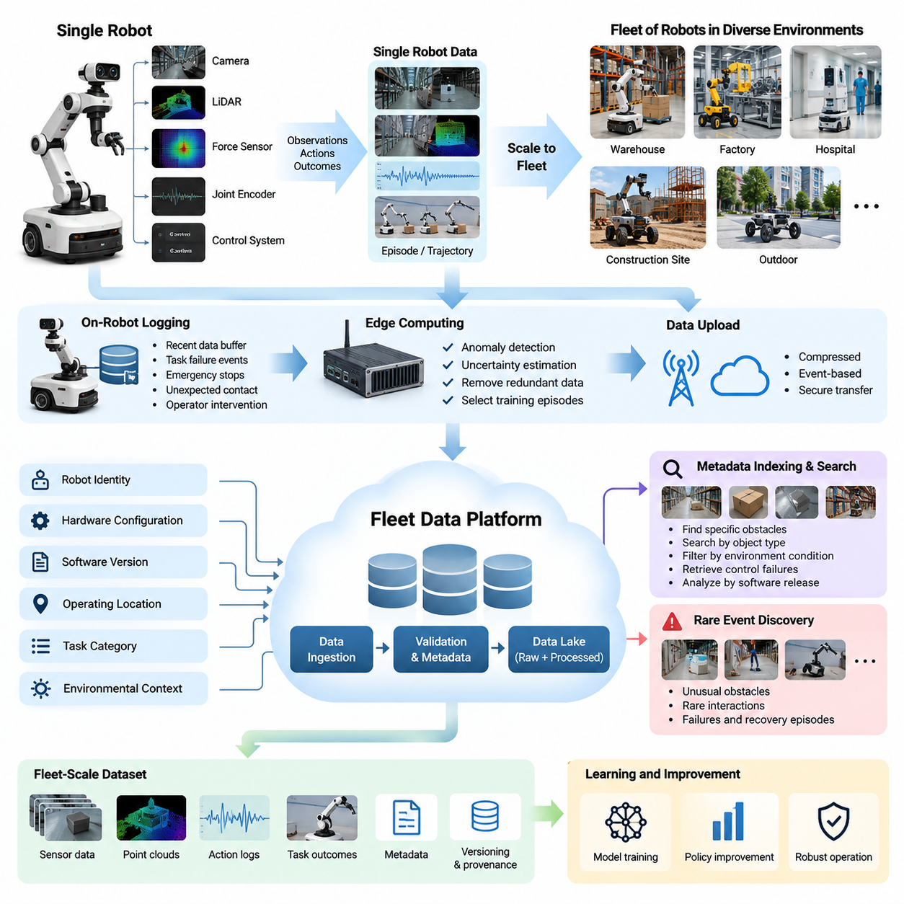
A single robot generates valuable operational data through its interactions with the physical environment. Cameras, LiDAR, force sensors, joint encoders, and control systems continuously record observations, actions, and outcomes. These records reveal how the robot perceives obstacles, executes tasks, responds to disturbances, and recovers from errors. However, the experience of one robot remains limited by its operating conditions and exposure to different situations.
Fleet-scale data collection extends this process across many robots operating in diverse environments. Instead of learning exclusively from isolated trajectories, a Physical AI system can aggregate experiences from warehouses, factories, hospitals, construction sites, and outdoor environments. Each robot contributes observations of different objects, lighting conditions, surfaces, human behaviors, and operational challenges, creating a broader foundation for learning.
The transition from single-robot data to fleet data is not simply an increase in storage capacity. It represents a fundamental change in how robotic intelligence is developed and improved. A single robot primarily provides information about its own operational history, while a fleet produces distributed evidence about recurring patterns, environmental variations, system limitations, and previously unseen situations across multiple deployments.
Individual robot datasets typically contain synchronized sensor measurements, estimated states, commanded actions, and task outcomes. These records are organized into episodes or trajectories representing meaningful periods of operation. At fleet scale, the same structure must be preserved while incorporating robot identity, hardware configuration, software version, operating location, task category, and environmental context for reliable interpretation.
Data standardization becomes essential when observations originate from different robots. Even identical models may use different sensor calibrations, firmware versions, sampling frequencies, or coordinate conventions. Without consistent schemas and synchronization rules, combining their recordings can introduce misleading relationships. Fleet data infrastructure therefore requires common representations while retaining the original measurements and configuration metadata.
Fleet diversity provides advantages that cannot be obtained merely by repeating the same task on one machine. Robots deployed at different sites encounter variations in floor friction, object placement, human traffic, illumination, and infrastructure. These differences help expose weaknesses in perception and control policies that might remain invisible during laboratory testing, allowing learning systems to develop broader operational robustness.
The value of fleet data depends on information diversity rather than raw volume alone. Thousands of robots repeating nearly identical successful trajectories may contribute less useful information than a smaller collection of unusual failures and recovery episodes. Effective fleet data engines therefore distinguish routine operation from informative experiences and prioritize observations that expand behavioral coverage or reveal previously unknown model limitations.
Fleet-scale collection also introduces significant communication and storage challenges. High-resolution video, depth measurements, point clouds, and control logs can generate substantial data volumes during continuous operation. Uploading every sensor stream to centralized infrastructure may be impractical. A scalable architecture must balance local recording, event-based selection, compression, network availability, and the importance of individual episodes.
On-robot logging provides the first stage of this distributed architecture. Each robot maintains local buffers containing recent observations, actions, diagnostic information, and system events. When significant conditions occur, such as task failure, emergency stopping, unexpected contact, or operator intervention, relevant data segments can be preserved. This approach captures important experiences without requiring uninterrupted transmission of all operational data.
Edge computing enables additional filtering before information leaves the robot or operating site. Local processing can detect anomalies, estimate uncertainty, remove redundant frames, and identify episodes suitable for training. Selected records may then be transferred through on-premise infrastructure or cloud services according to bandwidth, security, and operational requirements. Such processing reduces unnecessary communication while retaining valuable evidence.
A centralized fleet data platform provides a unified view of distributed robot experiences. Data ingestion services validate incoming records, associate them with operational metadata, and organize them into searchable collections. A fleet data lake can preserve raw recordings alongside processed episodes, labels, embeddings, and evaluation results. Dataset versioning and provenance tracking ensure that training examples remain traceable to their original sources.
Metadata indexing transforms large collections of robot recordings into accessible engineering resources. Developers can search for episodes involving specific obstacles, object types, environmental conditions, control failures, or software releases. For example, a query may retrieve navigation failures involving reflective surfaces across multiple warehouses. This capability connects field observations with targeted debugging, model evaluation, and dataset construction.
Fleet data also enables systematic identification of rare events. A single robot may encounter an unusual obstacle or interaction only occasionally, making such situations difficult to study. Across hundreds or thousands of deployments, similar events may appear frequently enough to support meaningful analysis. Aggregating these experiences helps reveal long-tail scenarios, unexpected failure modes, and environmental conditions requiring additional training.
Cross-robot comparison provides another important source of insight. When robots perform similar tasks under comparable conditions, differences in success rates, execution times, interventions, and recovery behavior can reveal hardware or software limitations. Analysts must account for differences in task difficulty and environment before interpreting these comparisons. Properly normalized fleet metrics support more reliable identification of performance bottlenecks.
Fleet-scale learning requires mechanisms for transforming collected experience into improved robot policies. Selected episodes undergo quality validation, temporal alignment, labeling, and curation before entering training datasets. Successful demonstrations can reinforce desirable behavior, while failures and corrective interventions provide examples of situations requiring improvement. The resulting datasets support supervised learning, imitation learning, reinforcement learning, and model adaptation.
Continuous evaluation connects model development with operational evidence. Newly trained models can be tested against representative fleet datasets containing common tasks, challenging environments, and previously observed failures. Evaluation should measure task success, safety, robustness, intervention frequency, and generalization across sites. Improvements on aggregate benchmarks must also be examined for regressions affecting particular robot configurations or operating conditions.
Deployment introduces another feedback stage in the fleet learning process. Candidate models may first operate in shadow mode, where predictions are evaluated without controlling the robot. Limited canary deployments can then expose selected robots to updated policies under controlled conditions. Monitoring operational performance, safety events, and unexpected behavior provides evidence for deciding whether broader deployment or rollback is appropriate.
Fleet-scale data systems must also detect changes in operating conditions over time. New equipment, altered layouts, seasonal lighting, sensor degradation, and changing human workflows can shift the distribution of incoming observations. Monitoring data drift and behavior drift helps identify when existing models no longer represent current environments adequately. These signals can trigger targeted data collection, retraining, or additional validation.
Sharing experience across robots creates opportunities for collective improvement, but heterogeneous platforms introduce additional complexity. Different manipulators, mobile bases, humanoids, and quadrupeds may have incompatible action spaces and mechanical capabilities. Shared representations can capture task intent, object relationships, environmental structure, and outcomes, while embodiment-specific transformations preserve the constraints necessary for executing actions safely.
Fleet data governance is essential because distributed robots may observe people, private facilities, proprietary processes, and sensitive operational information. Collection policies must define permissible recording, retention periods, access permissions, and data-sharing boundaries. Encryption, anonymization, auditing, and site-specific controls help protect information while maintaining its usefulness for model development and operational analysis.
A mature fleet data architecture ultimately creates a continuous relationship between deployment and learning. Robots generate experience, distributed systems identify informative events, centralized infrastructure organizes evidence, and learning pipelines produce improved models. Evaluated updates return to the fleet, where subsequent operation generates new feedback. This closed-loop process transforms ordinary robot deployment into an expanding source of practical intelligence.
The strategic importance of fleet-scale data lies in its ability to convert distributed physical experience into reusable knowledge. Increasing the number of robots does not automatically guarantee better intelligence; improvements depend on data quality, coverage, learning effectiveness, and safe deployment practices. When these elements operate together, fleet data becomes a foundation for increasingly adaptive, reliable, and self-improving Physical AI systems.

09.02. The Fleet Data Flywheel
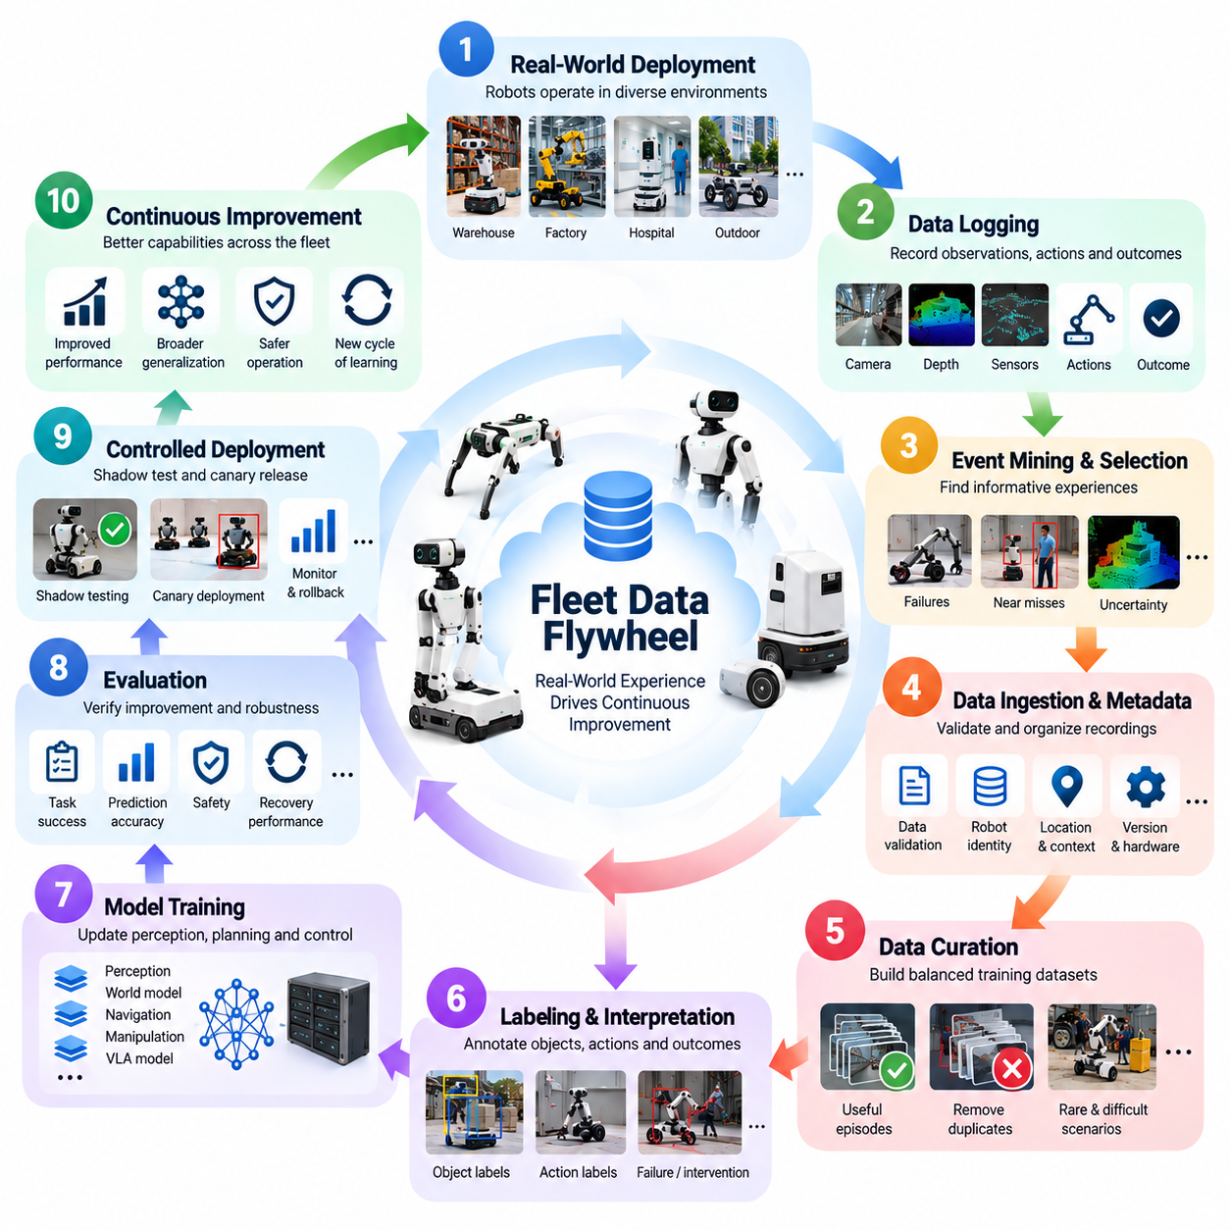
The fleet data flywheel is a continuous learning mechanism that transforms operational experience from many robots into progressively improved Physical AI capabilities. Unlike a static dataset collected before deployment, a fleet data flywheel connects real-world operation, data collection, model training, evaluation, and redeployment. Each cycle produces new evidence about robot behavior, allowing the entire fleet to benefit from experiences encountered by individual machines.
The fundamental principle of the fleet data flywheel is that deployment becomes an ongoing source of learning. Robots execute tasks in warehouses, factories, hospitals, and outdoor environments while generating observations, actions, and outcomes. These operational records reveal both successful behavior and unexpected limitations. When systematically collected and analyzed, they provide the information required to improve perception, planning, manipulation, and control policies.
A complete fleet data flywheel consists of interconnected processes rather than independent data pipelines. Operational robots generate experience, logging systems capture relevant events, data infrastructure organizes recordings, and curation systems identify valuable examples. Training pipelines transform these examples into updated models, while evaluation systems verify improvements before deployment. The resulting models return to the fleet and initiate another learning cycle.
The first stage begins with real-world robot deployment, where autonomous systems encounter conditions that cannot be fully anticipated during development. Variations in lighting, object geometry, human activity, floor conditions, and equipment configurations create diverse operational experiences. Each robot becomes a distributed sensing and experimentation platform, contributing evidence about how learned policies perform under actual physical constraints.
Continuous data logging provides the observational foundation of the flywheel. Robots record synchronized camera images, depth measurements, proprioceptive states, commanded actions, and execution outcomes. However, storing every measurement indefinitely is rarely practical. Event-triggered recording, local buffering, and selective upload mechanisms preserve informative episodes while controlling storage consumption, communication bandwidth, and processing costs.
The next stage identifies experiences that provide the greatest learning value. Routine successful operations establish baseline behavior, but unusual failures, operator interventions, near misses, and uncertain predictions often reveal more important limitations. Automated event detection and uncertainty estimation can identify these situations. Prioritizing informative episodes prevents the data engine from becoming dominated by repetitive examples with limited additional training value.
Data ingestion transforms distributed recordings into structured and traceable resources. Incoming episodes are validated for completeness, timestamp consistency, sensor integrity, and metadata correctness. Robot identity, software version, task context, operating site, and environmental conditions are associated with each recording. These attributes enable engineers to distinguish genuine model weaknesses from problems caused by hardware differences or inconsistent operating conditions.
Fleet-scale data curation determines which experiences should influence subsequent learning. Duplicate trajectories, corrupted recordings, and irrelevant segments may be removed, while rare events and difficult scenarios receive higher priority. Curators must also preserve representative successful examples to avoid creating a dataset dominated by failures. The objective is a balanced training collection that improves robustness without distorting normal operational behavior.
Labeling and interpretation convert selected episodes into meaningful learning signals. Human reviewers, automated perception models, and task-specific evaluators can identify objects, actions, contacts, failures, interventions, and successful outcomes. Temporal annotations connect decisions with their consequences. These labels support supervised learning, imitation learning, reward estimation, and evaluation of complex behaviors involving multiple sequential actions.
Model training forms the computational center of the flywheel. Curated fleet data is used to update perception networks, world models, navigation policies, manipulation controllers, and Vision-Language-Action models. Training may combine newly collected field episodes with historical datasets, simulation-generated experiences, and human demonstrations. Careful mixture design prevents recent observations from overwhelming previously learned capabilities.
Evaluation determines whether a new model represents a genuine improvement. Offline benchmarks measure task completion, prediction accuracy, collision risk, recovery performance, and generalization across environments. Previously observed failure scenarios are retained as regression tests. Models must demonstrate improvements across relevant operating conditions rather than merely achieving higher average performance on frequently encountered tasks.
Before broad deployment, updated models can be examined through shadow testing and controlled canary releases. Shadow models process real sensor inputs without commanding physical actions, allowing comparisons against the active policy. Canary deployments introduce updates to a limited robot population under monitored conditions. Safety constraints, rollback mechanisms, and operational acceptance criteria prevent unverified improvements from creating fleet-wide risks.
Once an updated model is deployed, the flywheel returns to its operational stage. Robots encounter familiar situations with improved capabilities while continuing to discover new environmental variations and failure modes. The distribution of collected data consequently changes as earlier weaknesses are resolved. This creates a moving learning target in which each generation of policies reveals different limitations requiring additional evidence.
The effectiveness of the flywheel depends on the relationship between data collection and model error. Rather than gathering information indiscriminately, the system can identify conditions associated with uncertainty, prediction disagreement, or poor task performance. These signals become targeted data queries that guide future collection. The process resembles active learning, where operational experience is selected according to its expected contribution to model improvement.
Fleet-wide deployment amplifies this mechanism by distributing data discovery across many locations. A navigation failure observed in one warehouse may reveal a weakness relevant to robots operating elsewhere. Once the corresponding model improvement is validated, it can potentially benefit the entire compatible fleet. This shared learning process reduces dependence on each robot independently encountering and overcoming the same operational difficulties.
The flywheel must also account for differences between robot embodiments and hardware configurations. Data collected from one mobile manipulator may not directly transfer to another platform with different sensors, actuators, or kinematic constraints. Shared task representations, normalized observations, and embodiment-specific adaptation can support knowledge transfer. Validation remains necessary because successful behavior on one platform does not guarantee equivalent performance on another.
Operational monitoring supplies feedback beyond conventional training metrics. Fleet dashboards can track task success rates, intervention frequency, mission completion time, energy consumption, safety events, and recovery effectiveness. Changes in these measurements may indicate model regressions, environmental drift, or hardware degradation. Connecting performance indicators to specific data episodes enables engineers to investigate problems and prioritize corrective learning.
Data governance establishes the boundaries within which the flywheel operates. Robots may capture people, confidential industrial processes, and location-sensitive information during routine operation. Privacy filtering, access control, encryption, retention policies, and audit trails must therefore be integrated into collection and processing workflows. Responsible data management enables fleet learning without assuming that all operational recordings can be freely centralized or reused.
Scaling the fleet data flywheel introduces economic and computational tradeoffs. More robots generate additional experience, but they also increase storage requirements, annotation workloads, training costs, and deployment complexity. The value of an additional episode depends on its quality, novelty, and relevance to unresolved model weaknesses. Efficient scaling therefore requires optimizing useful learning information rather than maximizing the total volume of collected data.
A mature flywheel is measured by how effectively operational evidence produces verified improvements. Important indicators include the time from failure discovery to model correction, the reduction in repeated incidents, the number of resolved long-tail scenarios, and the stability of deployed policies. Shorter learning cycles are valuable only when accompanied by reliable evaluation and safe deployment practices. Continuous improvement must remain measurable and controlled.
Ultimately, the fleet data flywheel transforms a robot fleet from a collection of deployed machines into a distributed learning infrastructure. Every robot contributes experience, centralized and edge systems extract useful knowledge, and validated model updates return improvements to operational environments. When data quality, model development, safety assurance, and deployment feedback are coordinated, the flywheel becomes a foundation for scalable, adaptive, and increasingly self-improving Physical AI.

09.03. On Robot Logging and Event Triggered Recording
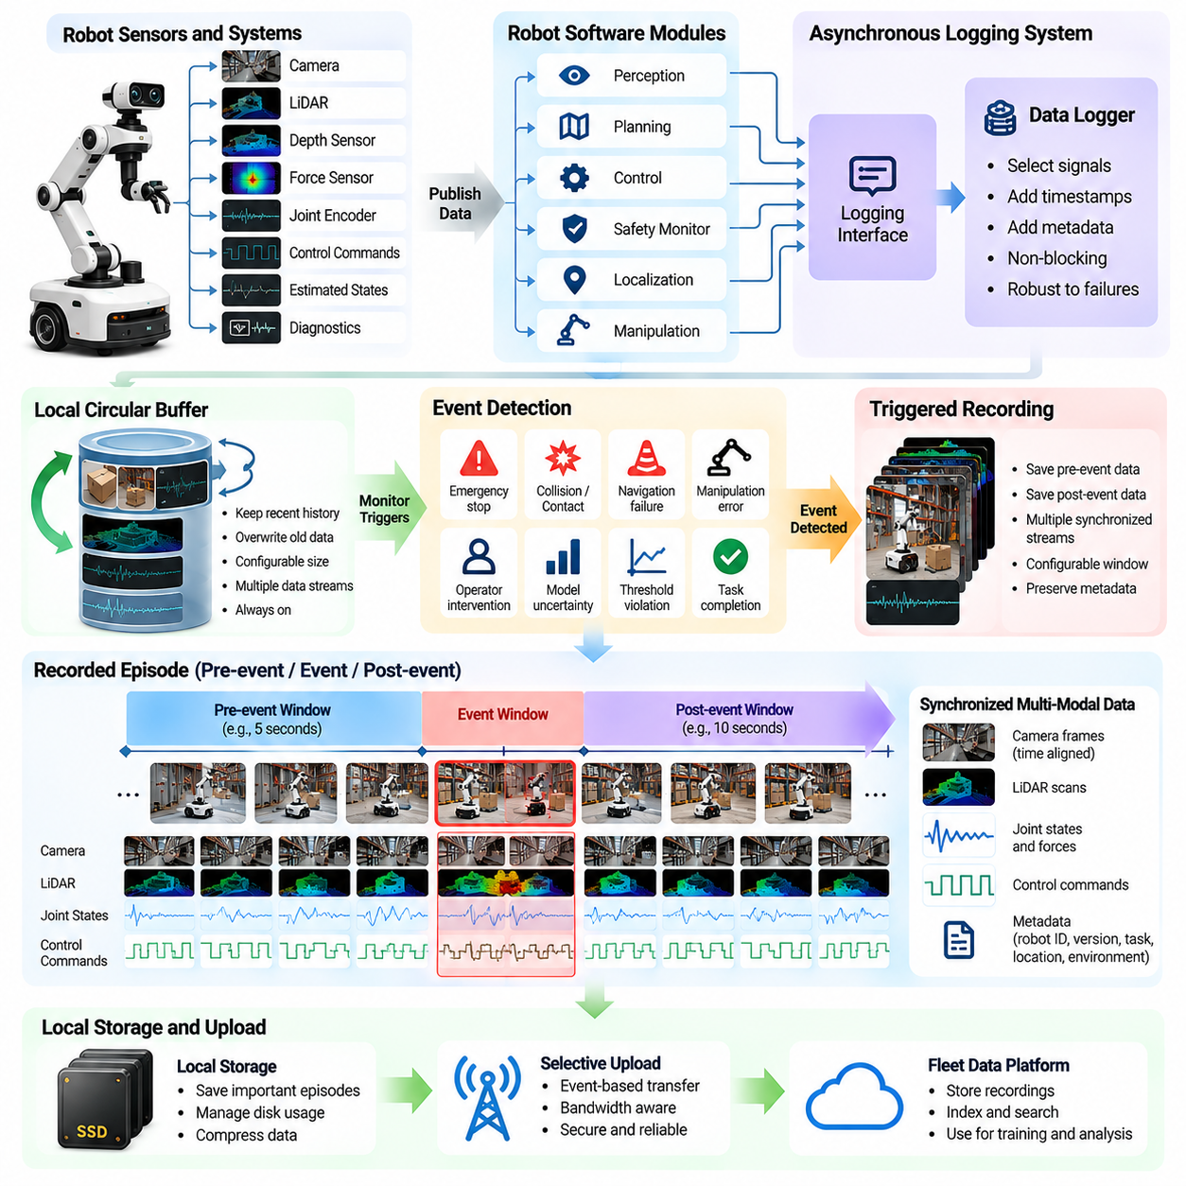
On-robot logging is the foundation of fleet-scale data collection, enabling autonomous systems to preserve operational evidence directly at the source. Every robot continuously produces sensor observations, control commands, estimated states, and diagnostic information during task execution. A structured logging system records these signals with consistent timestamps and contextual metadata, allowing engineers to reconstruct robot behavior and analyze the physical conditions surrounding important events.
Continuous recording of all available sensor streams is often impractical because modern robots generate substantial amounts of multimodal data. High-resolution cameras, LiDAR scanners, depth sensors, joint encoders, and force sensors operate at different sampling frequencies and data rates. Unrestricted recording increases storage requirements, processor utilization, and communication costs. On-robot logging architectures must therefore balance information completeness with limited computational and storage resources.
A typical logging architecture separates real-time robot operation from data recording activities. Perception, planning, and control modules publish observations and internal states through communication interfaces, while dedicated logging processes capture selected information asynchronously. This separation reduces interference with time-critical control loops. Logging systems must be designed so that storage delays or communication failures do not compromise the robot's operational safety.
Local buffering is a central mechanism for efficient recording. A circular buffer continuously retains a configurable window of recent sensor measurements, actions, and system states. When new information arrives, older records are overwritten unless a significant event requires preservation. This architecture maintains access to recent operational history without permanently storing every observation, making it particularly useful for robots operating continuously over extended periods.
Event-triggered recording extends local buffering by preserving data when predefined conditions occur. Triggers may include emergency stops, collisions, unexpected contacts, navigation failures, manipulation errors, or operator interventions. When an event is detected, the logger saves relevant information from both before and after the occurrence. This temporal context allows engineers to investigate not only the immediate failure but also the sequence of decisions that preceded it.
The recording window should reflect the dynamics of the monitored task. A mobile robot approaching an obstacle may require several seconds of preceding sensor and control history, while a high-speed manipulation event may require precise measurements over a much shorter interval. Configurable pre-event and post-event durations allow logging systems to capture meaningful causal context while avoiding unnecessary storage of unrelated operational activity.
Event detection can originate from multiple components of the robotic system. Safety controllers may report emergency conditions, navigation modules may detect localization failures, and manipulation controllers may identify excessive force or unsuccessful grasps. Perception models can signal low confidence or inconsistent observations. Combining these signals enables a broader understanding of operational anomalies than relying on a single error indicator.
Threshold-based triggering provides a straightforward method for identifying significant events. A recording may begin when localization uncertainty exceeds an acceptable limit, motor current rises unexpectedly, or obstacle clearance falls below a safety threshold. However, fixed thresholds can generate excessive recordings in noisy environments. Hysteresis, temporal filtering, and context-dependent thresholds help reduce false triggers while preserving sensitivity to meaningful deviations.
Model-based event detection introduces additional intelligence into the logging process. A robot can compare predicted observations or task outcomes against actual measurements to identify unexpected behavior. Large prediction errors, disagreement between perception models, or unusual state transitions may indicate informative situations. These triggers support data collection for improving learned policies, even when no explicit system failure has occurred.
Operator interventions are especially valuable recording triggers because they frequently indicate limitations in autonomous behavior. When a human takes control, modifies a planned trajectory, or corrects an unsuccessful manipulation, the system can preserve the preceding autonomous decisions and subsequent corrective actions. Such episodes provide useful examples for imitation learning, policy refinement, and analysis of situations where autonomous assistance remains insufficient.
Successful task execution should also contribute to the logging strategy. Recording only failures can create datasets that poorly represent normal robot behavior and operating conditions. Periodic sampling, randomized episode selection, and task-completion triggers preserve representative successful trajectories. Combining routine successes with difficult events produces a more balanced foundation for training, evaluation, and long-term fleet performance analysis.
Multimodal synchronization is essential for reconstructing recorded events accurately. Camera frames, LiDAR scans, joint states, force measurements, and action commands may originate from different clocks and communication pathways. Logging infrastructure should preserve acquisition timestamps and identify synchronization uncertainty. Accurate temporal alignment allows engineers to determine which observations were available when a robot selected an action and how the environment responded.
Recording metadata provides the context required to interpret stored sensor streams. Each event should be associated with robot identification, hardware configuration, software version, model version, task identifier, trigger category, and relevant environmental conditions. Calibration parameters and coordinate-frame definitions may also be necessary. Without this information, similar recordings from different robots can be difficult to compare or reproduce during debugging and model evaluation.
Storage management becomes critical when robots operate for long periods without reliable connectivity. Local systems must enforce capacity limits, retention policies, and priorities for preserved episodes. High-value safety events and rare failures may receive stronger retention guarantees than routine recordings. Storage health monitoring should detect capacity exhaustion, corrupted files, and write failures while ensuring that logging activities remain isolated from safety-critical control functions.
Compression reduces the resource requirements of on-robot data preservation. Video encoding, point-cloud compression, and efficient serialization can significantly reduce recording sizes. However, lossy compression may remove details required for perception analysis or precise reconstruction. Logging systems should select compression methods according to data type and intended use, preserving critical measurements at sufficient fidelity for downstream learning and verification.
Event-triggered logging must account for overlapping or repeated triggers. A navigation failure may generate simultaneous alerts from localization, obstacle avoidance, and safety monitoring modules. Recording every alert independently can produce redundant data and unnecessary storage consumption. Event aggregation mechanisms can merge related triggers into a single episode while retaining their individual causes, timestamps, severity levels, and diagnostic information.
Reliable logging also requires protection against unexpected power loss, process crashes, and network interruptions. Buffered records may be lost if they are not periodically committed to persistent storage. Transactional file writing, integrity checks, and recovery procedures improve the durability of important episodes. Logging failures should be observable through diagnostic monitoring, allowing maintenance systems to identify robots that are no longer collecting reliable evidence.
Fleet-scale operation introduces the challenge of coordinating logging policies across many robots. Central management systems can distribute recording configurations, trigger definitions, retention priorities, and sampling strategies. However, local autonomy remains important because connectivity may be intermittent. Robots should continue detecting and preserving important events independently, then synchronize selected recordings when communication becomes available.
Privacy and security requirements must be incorporated into on-robot recording from the beginning. Cameras and microphones may capture people, confidential facilities, or sensitive operational information. Access controls, encryption, selective recording, and appropriate retention limits help reduce unnecessary exposure. Where feasible, privacy filtering can occur locally before data is transferred to centralized infrastructure, reducing the movement of sensitive raw recordings.
The effectiveness of event-triggered recording can be evaluated through trigger precision, event recall, storage efficiency, and the usefulness of preserved episodes. Excessive false triggers increase processing costs, while missed events reduce the visibility of important failures. Engineers should periodically review recorded events and adjust trigger policies according to operational evidence, model weaknesses, and changing environmental conditions across the fleet.
Ultimately, on-robot logging and event-triggered recording transform continuous robot operation into a selective source of high-value learning data. By combining synchronized observations, contextual metadata, local buffering, intelligent triggers, and reliable storage, robots preserve experiences that support debugging, evaluation, and model improvement. At fleet scale, this capability provides the observational foundation for continuous learning and increasingly adaptive Physical AI systems.

09.04. Edge Filtering Compression and Prioritization
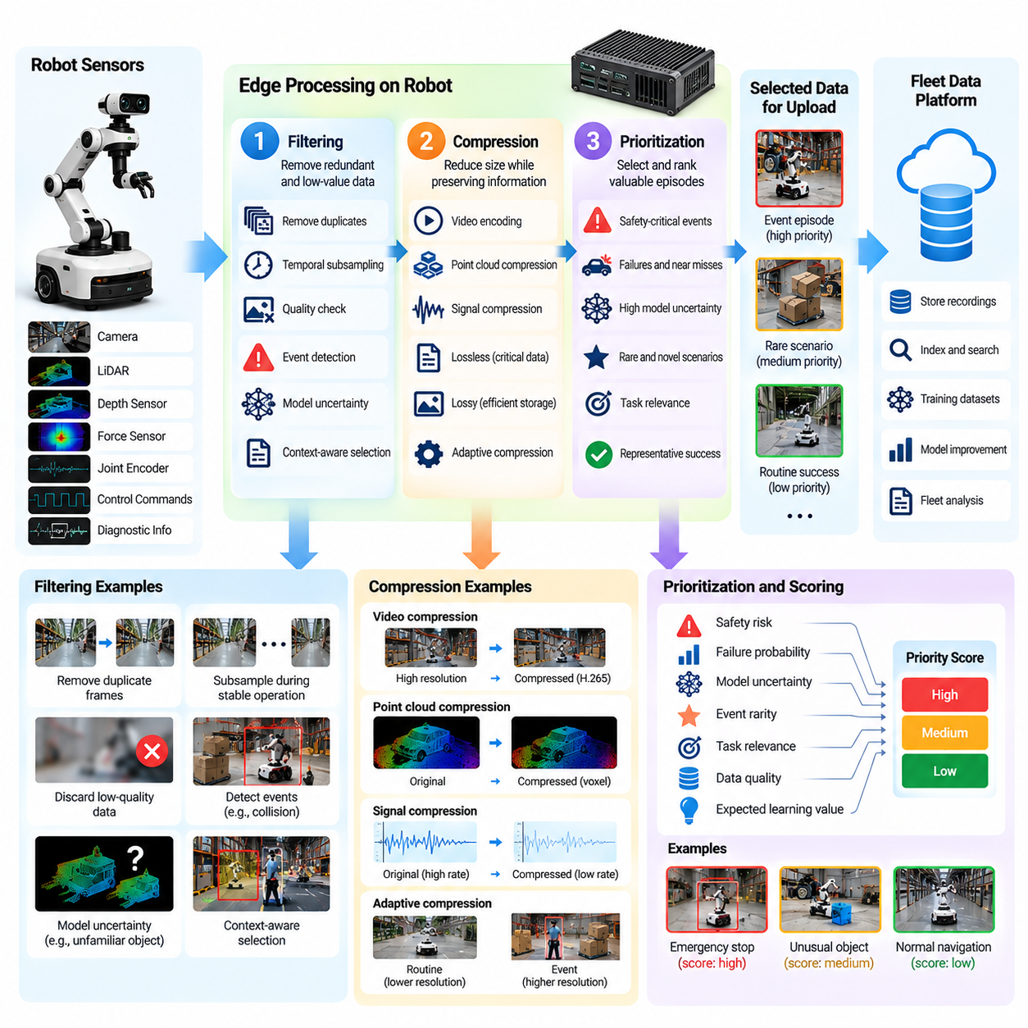
Edge filtering, compression, and prioritization are essential mechanisms for managing the enormous volume of data generated by large robot fleets. Autonomous robots continuously produce camera images, LiDAR scans, depth measurements, proprioceptive signals, and control logs. Transmitting every observation to centralized infrastructure is often impractical. Edge processing transforms raw sensor streams into selected, compact, and valuable information before transmission.
The primary objective of edge data processing is to maximize useful learning information while minimizing communication, storage, and computational costs. A robot must preserve evidence relevant to safety, failures, unusual environments, and model improvement without overwhelming local resources. This requires coordinated decisions about which data to retain, how much detail to preserve, and when information should be transferred to fleet infrastructure.
Edge filtering operates near the point of data generation, typically on embedded processors, onboard accelerators, or local computing gateways. Processing data before cloud transmission reduces network dependency and enables immediate selection of important observations. However, filtering workloads must remain isolated from safety-critical control functions. Data management should never introduce unacceptable latency into perception, planning, or actuator control.
Basic filtering removes information that contributes little additional value. Repeated camera frames, stationary sensor readings, duplicate messages, and corrupted packets can be detected before storage or upload. Temporal subsampling reduces recording frequency during predictable operation, while adaptive sampling increases detail during rapid environmental changes. These mechanisms reduce redundancy without necessarily discarding important operational transitions.
Quality-aware filtering evaluates whether recorded information is sufficiently reliable for downstream use. Blurred images, incomplete point clouds, invalid timestamps, and inconsistent sensor measurements may be marked or excluded according to application requirements. Nevertheless, unusual measurements should not automatically be discarded because they may indicate sensor failures or rare physical events. Diagnostic relevance must be considered alongside conventional data quality.
Event-aware filtering uses operational context to identify segments worth preserving. Emergency stops, navigation failures, unexpected contacts, failed grasps, and human interventions can trigger retention of surrounding sensor and action histories. Pre-event and post-event buffers capture the sequence leading to a problem and its consequences. This contextual preservation is more informative than retaining only the instant when an error was reported.
Model-driven filtering extends event selection beyond explicit failures. Prediction uncertainty, disagreement between models, unexpected state transitions, and deviations from planned trajectories can identify informative experiences. A robot may encounter an unfamiliar object without failing its task, yet the observation could be valuable for future learning. Such mechanisms support active data collection driven by unresolved model weaknesses.
Compression reduces the size of retained data while preserving information needed for analysis and training. Video streams may use efficient encoding, point clouds may exploit spatial redundancy, and numerical signals may use compact serialization. Compression strategies should reflect sensor characteristics and downstream requirements. The objective is not simply the smallest file size but an acceptable balance between fidelity, processing cost, and recoverability.
Lossless compression preserves the original information exactly and is suitable for measurements requiring precise reconstruction. Control commands, event timestamps, calibration parameters, and selected safety records may require this property. Lossy compression provides greater size reduction but can alter visual details, geometric boundaries, or subtle motion patterns. Its suitability depends on whether those changes affect intended learning and evaluation tasks.
Adaptive compression allows recording fidelity to change according to operational significance. Routine navigation may use reduced video resolution or lower sampling rates, while near-collision events may preserve higher-resolution images and detailed sensor histories. Manipulation tasks involving small objects may require greater spatial precision than ordinary transit. Context-sensitive settings improve resource efficiency while protecting information needed for difficult cases.
Multimodal compression introduces additional challenges because different sensors capture complementary aspects of physical behavior. Camera images describe appearance, LiDAR provides geometry, and proprioceptive measurements reveal internal motion. Aggressive reduction of one modality can weaken the interpretation of another. Edge processing should therefore preserve synchronization metadata, coordinate relationships, and sufficient cross-modal detail for reconstructing meaningful robot episodes.
Prioritization determines which recordings receive storage and transmission resources when capacity is limited. Safety-critical incidents, severe failures, and rare environmental conditions generally deserve higher priority than repetitive successful operation. However, representative normal trajectories remain necessary for balanced training datasets. Effective prioritization combines operational importance, novelty, data quality, and expected learning value rather than relying exclusively on event severity.
Priority scoring can incorporate several measurable signals, including model uncertainty, failure probability, event rarity, task relevance, and dataset coverage. These factors may be combined into a configurable ranking function. Scores should be calibrated against actual downstream usefulness because high uncertainty does not always indicate informative data. A poorly calibrated ranking system can repeatedly select noisy or irrelevant recordings while overlooking important operational patterns.
Storage-aware scheduling manages selected recordings according to available local capacity. High-priority episodes may be protected from automatic deletion, while lower-priority data can expire after shorter retention periods. Circular buffers, storage quotas, and episode-level retention policies prevent uncontrolled accumulation. When capacity becomes critically low, the system should degrade gracefully while preserving essential diagnostics and maintaining safe robot operation.
Bandwidth-aware transmission determines when selected data should leave the robot. Network conditions may vary significantly across warehouses, industrial facilities, underground structures, and outdoor environments. Upload scheduling can account for connectivity, available bandwidth, communication cost, and operational urgency. Critical event summaries may be transmitted immediately, while large sensor recordings can wait for reliable connections or scheduled synchronization windows.
Progressive upload provides a practical approach to limited connectivity. A robot can initially transmit compact metadata, event descriptions, thumbnails, or statistical summaries. Central systems then evaluate whether the complete episode is needed for investigation or training. Requested recordings can subsequently be uploaded at higher fidelity. This staged process reduces unnecessary transfers while preserving access to detailed evidence when required.
Edge prioritization should also consider fleet-wide data coverage. If many robots repeatedly encounter the same environment, uploading every similar episode creates substantial redundancy. Centralized dataset statistics can guide robots toward collecting underrepresented conditions, object categories, or failure modes. Such feedback transforms edge filtering from a purely local optimization process into a coordinated fleet-level data acquisition strategy.
Privacy-aware filtering can reduce sensitive information before recordings leave operational sites. Local processing may obscure identifiable faces, remove unnecessary audio, or exclude restricted spatial regions according to applicable policies. However, privacy transformations must be evaluated for their impact on downstream analysis and safety investigations. Access controls and retention rules remain necessary because filtering alone cannot guarantee privacy protection.
Reliability and observability are important requirements for edge data pipelines. Engineers need to know which recordings were preserved, compressed, discarded, or transmitted and why those decisions occurred. Processing logs, configuration versions, integrity checks, and transfer acknowledgments support troubleshooting and auditing. Monitoring dropped events, compression failures, queue backlogs, and storage pressure helps identify weaknesses in the data collection infrastructure.
The effectiveness of edge processing should be evaluated using both resource efficiency and learning outcomes. Relevant metrics include bandwidth reduction, storage utilization, compression ratio, event retention rate, processing latency, and downstream model improvement. High compression or aggressive filtering is not beneficial if it removes evidence required to understand failures. Evaluation must therefore connect data reduction decisions with actual training and diagnostic performance.
Ultimately, edge filtering, compression, and prioritization convert continuous multimodal robot streams into manageable, information-rich fleet datasets. Filtering selects meaningful observations, compression reduces their representation cost, and prioritization allocates limited resources according to operational and learning value. When these mechanisms operate together, robot fleets can scale data collection efficiently while preserving the evidence needed for reliable, adaptive, and continuously improving Physical AI systems.

09.05. Edge On Premise and Cloud Data Flow
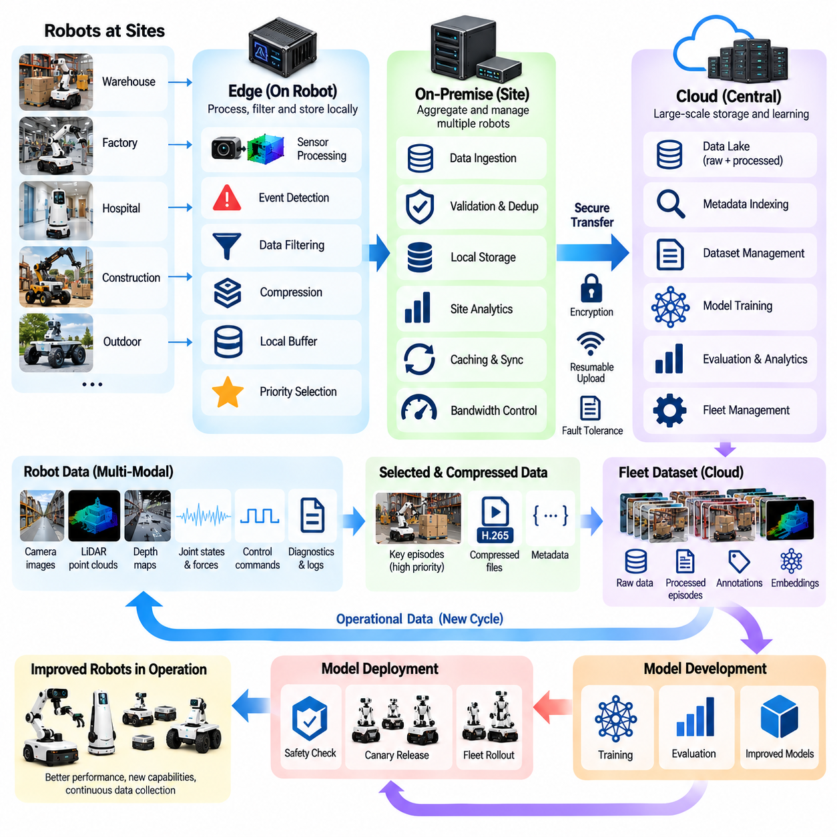
Edge, on-premise, and cloud data flow defines how information moves through a distributed Physical AI infrastructure. Robot fleets continuously generate sensor observations, control signals, diagnostic logs, and task outcomes across multiple operating sites. A scalable data architecture must determine where information is processed, temporarily stored, transferred, and permanently retained. These decisions directly influence learning efficiency, operational reliability, network utilization, and data security.
The edge layer represents the computing environment closest to physical robot operation. Embedded processors, onboard accelerators, and local controllers process sensor streams while supporting perception, planning, and control. Edge systems also perform event detection, data filtering, compression, and temporary storage. Their primary advantage is immediate access to operational information without depending on continuous communication with remote infrastructure.
On-premise infrastructure provides an intermediate processing and storage layer within factories, warehouses, hospitals, or other operating facilities. Local servers and gateways aggregate information from multiple robots, manage communication sessions, and maintain shared data repositories. This architecture reduces repeated wide-area transfers while allowing organizations to enforce site-specific security, retention, and operational policies.
Cloud infrastructure provides centralized resources for large-scale data aggregation, indexing, model training, evaluation, and fleet analytics. Data collected from geographically distributed sites can be organized into common datasets and processed using scalable computing services. Cloud platforms support collaboration between development teams and enable learning from experiences collected across different environments, provided that applicable data-sharing restrictions are respected.
The complete data flow typically begins when robot sensors generate observations during task execution. Onboard software associates these observations with timestamps, robot states, actions, and contextual metadata. Selected recordings are preserved in local buffers or persistent storage. Edge filtering identifies relevant episodes, while compression reduces transfer requirements. These operations prepare data for movement toward on-premise or cloud infrastructure.
Not every robot recording should follow the same transmission path. Time-critical safety information may require immediate local handling, while diagnostic summaries can be transmitted rapidly to site monitoring systems. Large video recordings and point clouds may be transferred later through scheduled uploads. Separating urgent operational messages from bulk learning data prevents high-volume transfers from interfering with essential robot communication.
An on-premise gateway can coordinate uploads from many robots sharing the same network. It may authenticate devices, validate incoming files, detect duplicate recordings, and organize episodes by robot identity and task context. Local caching reduces unnecessary retransmission when network connections are unstable. Gateways can also enforce bandwidth quotas and prioritize critical diagnostic information during periods of network congestion.
Local aggregation creates opportunities for site-level data processing before cloud transfer. Recordings from multiple robots can be compared to identify recurring failures, shared environmental conditions, or redundant experiences. Local indexing and preliminary analytics help determine which episodes provide new information. This approach reduces communication costs while preserving the ability to investigate operational problems within the facility.
Data movement between infrastructure layers requires reliable transport mechanisms. Network interruptions, packet loss, and temporary server failures can interrupt transfers, particularly in industrial environments. Resumable uploads, checksums, transfer acknowledgments, and retry policies improve delivery reliability. Each recording should retain a unique identifier so that interrupted transmissions can resume without creating duplicate dataset entries.
Store-and-forward communication is particularly useful when robots operate with intermittent connectivity. Data is retained locally until an appropriate network connection becomes available, then forwarded to the next infrastructure layer. Storage queues must account for available capacity, episode priority, and retention requirements. This mechanism enables continued data collection even when direct access to centralized services is temporarily unavailable.
Synchronization across edge, on-premise, and cloud systems requires consistent metadata and version management. Sensor acquisition timestamps should remain distinct from processing and upload timestamps. Robot configuration, calibration information, model versions, and event identifiers must accompany the data throughout its lifecycle. Preserving these relationships allows engineers to reconstruct operational events accurately after recordings pass through multiple processing stages.
Cloud ingestion services receive validated data packages and integrate them into fleet-scale storage systems. Raw recordings may be preserved in object storage, while structured metadata is indexed in searchable databases. Processed episodes, annotations, embeddings, and evaluation results can be linked to their source recordings. This separation supports efficient retrieval without requiring every analytical query to examine large raw sensor files.
The architecture should distinguish operational data from training data. Operational records support monitoring, debugging, incident investigation, and maintenance, while curated training datasets contain selected examples prepared for machine learning. These collections may overlap but have different retention, quality, and access requirements. Maintaining explicit relationships between them improves traceability and prevents uncontrolled reuse of operational information.
Data processing responsibilities should be distributed according to latency, computational demand, and security requirements. Immediate obstacle detection and actuator control belong close to the robot because they require predictable response times. Site-level aggregation and diagnostics can operate on local servers. Computationally intensive model training and large-scale dataset analysis are generally better suited to centralized infrastructure with sufficient resources.
Bidirectional data flow is necessary for continuous fleet learning. Operational recordings move from robots toward centralized learning systems, while validated model updates, configuration changes, and data collection policies move in the opposite direction. Deployment services distribute approved artifacts to compatible robots. Version checks, integrity verification, staged rollout, and rollback capabilities help ensure that updates do not introduce uncontrolled operational risks.
Feedback from centralized analytics can also influence future edge data collection. If cloud evaluation identifies failures involving reflective surfaces or unusual object geometries, new event triggers may be distributed to selected robots. These robots can then preserve additional observations relevant to the identified weakness. This targeted feedback connects distributed data acquisition with model development priorities and reduces unnecessary collection.
Security controls must remain effective across every infrastructure boundary. Robots, gateways, and cloud services should authenticate communicating systems and protect transferred information through encryption. Access permissions must distinguish operational personnel, data engineers, and model developers. Site-specific restrictions may require sensitive recordings to remain on-premise, with only approved summaries or derived representations transferred externally.
Privacy and data sovereignty requirements can strongly influence architecture selection. Hospitals, industrial facilities, and public environments may impose restrictions on images, audio, location information, and confidential processes. Local anonymization, selective extraction, and controlled retention can reduce exposure. Some deployments may prohibit raw data export entirely, requiring local processing or privacy-preserving learning approaches instead of conventional centralized collection.
System observability is essential for maintaining reliable data movement. Monitoring services should track queue lengths, upload latency, network utilization, storage capacity, transfer failures, and processing throughput. Data lineage records identify which transformations occurred at each infrastructure layer. These measurements help engineers locate bottlenecks, detect missing recordings, and distinguish communication failures from data processing problems.
Scalability depends on avoiding unnecessary movement and repeated processing of large datasets. Hierarchical storage, content-based deduplication, selective synchronization, and distributed caching can reduce infrastructure costs. Resource allocation should reflect the value and urgency of each data category. A successful architecture scales not only with the number of robots but also with increasing sensor resolution, operational diversity, and learning requirements.
Ultimately, edge, on-premise, and cloud data flow provides the communication and processing foundation for fleet-scale Physical AI data engines. Edge systems preserve immediate operational context, on-premise infrastructure coordinates site-level information, and cloud platforms support large-scale learning and analysis. When these layers are connected through reliable transport, consistent metadata, security controls, and bidirectional feedback, distributed robot experience becomes reusable knowledge that supports continuous improvement.

09.06. Fleet Data Lake and Episode Storage
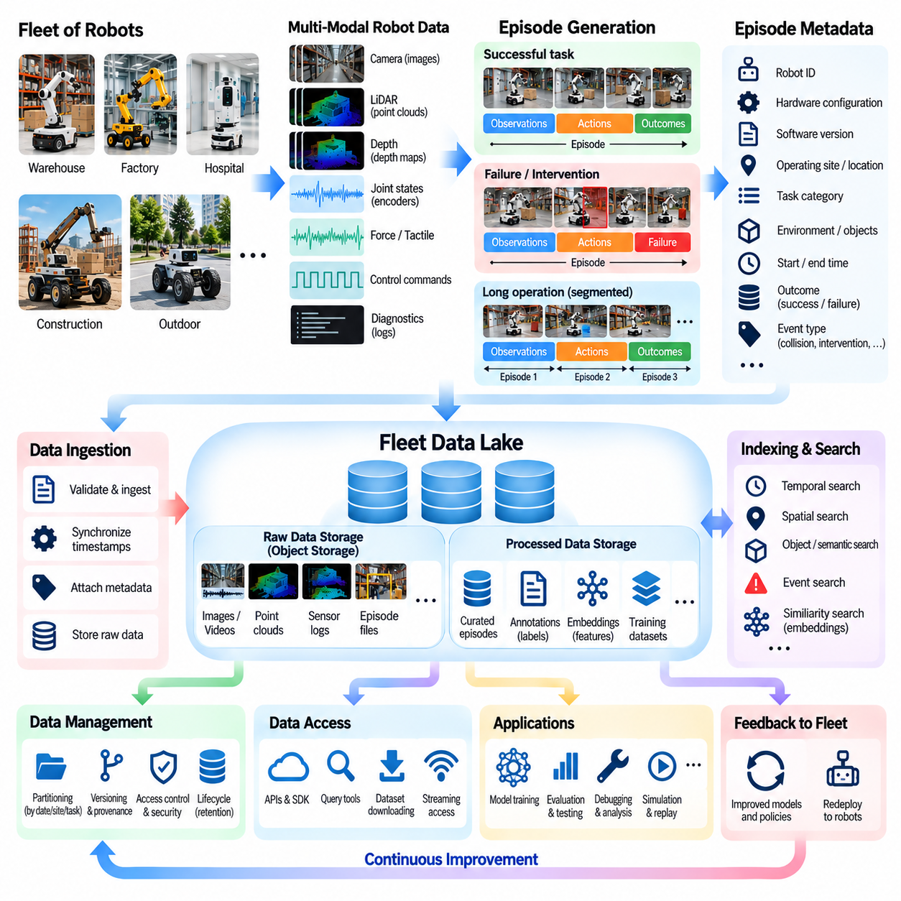
A fleet data lake provides the storage foundation for collecting, organizing, and reusing experiences generated by large populations of autonomous robots. Unlike conventional databases designed primarily for structured records, a data lake accommodates heterogeneous sensor streams, control logs, diagnostic events, and task outcomes. Its purpose is to preserve operational evidence at scale while making robot experiences accessible for training, evaluation, debugging, and continuous improvement.
Robot fleet data is inherently multimodal, temporal, and geographically distributed. Cameras generate image sequences, LiDAR sensors produce point clouds, and joint encoders capture mechanical motion. Control systems record commands, estimated states, and execution results. These signals differ in frequency, format, and volume, making conventional relational storage insufficient for raw observations. A fleet data lake must therefore support flexible storage structures and scalable retrieval.
The fundamental storage unit for robot learning is often an episode, representing a bounded sequence of observations, actions, and environmental interactions. An episode may describe a completed navigation task, a manipulation attempt, a human intervention, or a safety incident. Organizing recordings into episodes preserves temporal relationships and operational context. This structure enables learning systems to analyze complete behaviors rather than isolated sensor measurements.
Episode boundaries can be determined through task execution states, event triggers, time windows, or changes in operating conditions. A successful pick-and-place operation may form one episode, while an unexpected collision can initiate a separate diagnostic recording. Long-running activities may be divided into overlapping segments to preserve continuity. Boundary definitions should remain consistent enough to support comparison while accommodating different robot tasks.
Each episode should contain synchronized sensor observations, robot states, actions, and contextual metadata. Camera frames, point clouds, joint positions, force measurements, and controller outputs must remain temporally aligned. Metadata should identify the robot, hardware configuration, software version, task type, operating site, and recording conditions. These associations make stored experiences interpretable and reproducible across different systems and development cycles.
A practical fleet data lake separates raw recordings from processed representations. Raw data preserves original observations for future reprocessing, while processed layers contain cleaned trajectories, annotations, extracted features, and training-ready samples. Maintaining these layers prevents irreversible information loss and allows improved algorithms to revisit historical experiences. Relationships between raw and derived artifacts must remain traceable.
Object storage is commonly used for large sensor recordings because it supports scalable capacity and relatively inexpensive retention. Video files, point-cloud sequences, and serialized episode archives can be stored as immutable objects. Structured metadata is maintained separately in databases or searchable catalogs. This division allows engineers to locate relevant episodes without repeatedly scanning large binary files.
Episode identifiers provide stable references across the data infrastructure. Each recording should receive a globally unique identifier associated with its source robot, collection time, and operational context. Derived datasets, annotations, and evaluation results can reference this identifier. Stable identity also supports deduplication, integrity checking, and recovery after interrupted uploads, reducing confusion when data moves between edge devices and centralized storage.
Metadata schemas are essential for maintaining consistency across heterogeneous robot fleets. Common fields may describe sensor modalities, coordinate frames, calibration parameters, environment categories, task outcomes, failure types, and intervention status. Standardized schemas enable filtering and comparison across sites. However, extensible fields are necessary because different robot embodiments and applications generate specialized information.
Temporal indexing enables efficient access to events occurring within particular operating intervals. Engineers may search for episodes recorded before emergency stops, during localization failures, or immediately after human intervention. Time-based indexes should distinguish sensor acquisition timestamps from upload and processing times. Preserving this distinction prevents incorrect interpretations when recordings arrive late or pass through multiple infrastructure layers.
Spatial and semantic indexing further improve episode discovery. Location metadata can identify operating regions, while semantic labels describe encountered objects, tasks, and environmental conditions. Learned embeddings may support similarity searches for visually or behaviorally related experiences. Combining temporal, spatial, and semantic indexes allows engineers to retrieve informative episodes without manually examining extensive raw recordings.
Data partitioning improves storage organization and query performance. Episodes may be partitioned by collection date, robot platform, operating site, task category, or data lifecycle stage. However, excessive partitioning can create fragmented datasets and inefficient retrieval. Partition strategies should reflect common analytical queries and expected fleet growth while avoiding rigid structures that prevent cross-site or cross-robot analysis.
Episode storage must support both complete recordings and selected subsequences. Model training may require short action windows, while failure investigation may need several minutes of preceding history. Efficient systems provide references to temporal segments without unnecessarily duplicating entire recordings. Chunked storage and segment-level indexes enable selective access while preserving the relationship between subsequences and their original episodes.
Dataset versioning is necessary because training collections evolve continuously. New episodes are added, incorrect labels are corrected, and quality filters are refined. A reproducible training run must reference a stable dataset snapshot rather than an unspecified collection of changing files. Versioned manifests can identify the exact episodes, processing configurations, and annotation revisions used for model development and evaluation.
Data lineage connects each training example to its original recording and subsequent transformations. Engineers should be able to determine which robot collected an episode, which processing pipeline modified it, and which datasets incorporated the result. This traceability supports debugging, regulatory audits, and investigation of unexpected model behavior. It also helps identify whether training errors originate from raw observations, labeling, or preprocessing.
Storage lifecycle management balances long-term learning value against infrastructure costs. Frequently accessed datasets may remain in high-performance storage, while older recordings can move to lower-cost archival tiers. Routine episodes may receive shorter retention periods than rare failures or safety-critical evidence. Retention decisions should consider future reprocessing value, contractual obligations, and applicable privacy requirements.
Data integrity and reliability are fundamental to trustworthy fleet learning. Checksums, immutable recording objects, replication, and recovery procedures protect against corruption or accidental loss. Ingestion pipelines should validate file completeness, metadata consistency, and synchronization quality before making episodes available for training. Quarantining incomplete or suspicious recordings prevents damaged evidence from silently contaminating downstream datasets.
Access control and governance determine who may retrieve, modify, or reuse stored experiences. Industrial recordings can contain confidential layouts, proprietary processes, personal information, or sensitive operational details. Permissions should distinguish raw data access from access to anonymized or derived datasets. Encryption, audit logs, retention limits, and site-specific restrictions help ensure that centralized storage does not create uncontrolled information exposure.
Fleet-scale storage also requires continuous operational monitoring. Important metrics include ingestion throughput, storage growth, query latency, duplicate episode rates, retrieval failures, and dataset preparation time. Monitoring should identify bottlenecks as robot populations and sensor resolutions increase. Capacity forecasting and automated storage policies help prevent unexpected infrastructure limits from interrupting data collection or model development.
Ultimately, a fleet data lake transforms distributed robot recordings into a persistent and searchable repository of physical experience. Episode-based organization preserves behavioral context, while metadata, indexing, versioning, and lineage make stored information reusable and trustworthy. By connecting raw observations with curated training datasets and evaluation results, this infrastructure establishes the foundation for scalable learning and continuously improving Physical AI fleets.

09.07. Fleet Metadata Indexing and Search
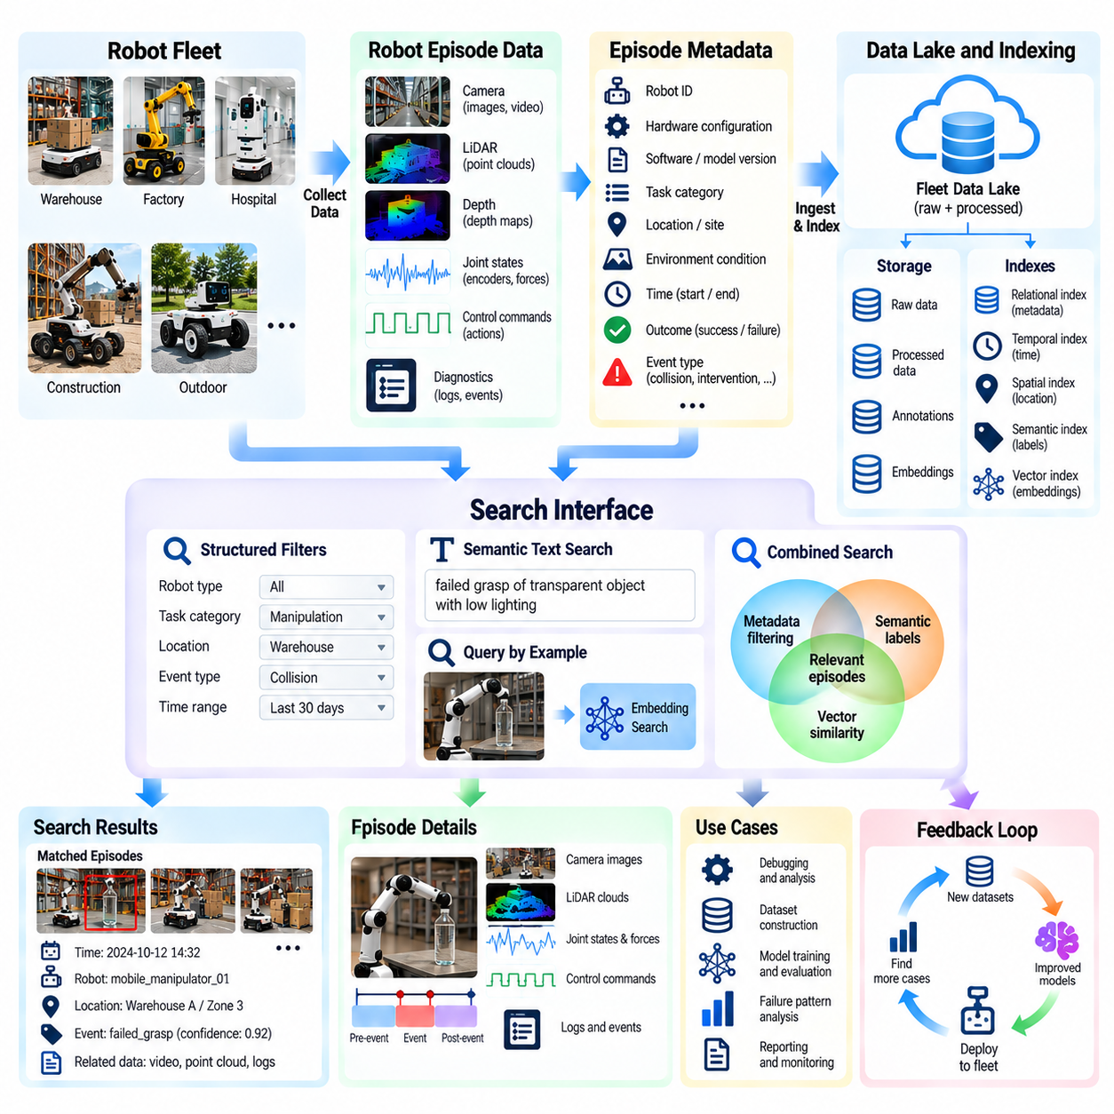
Fleet metadata indexing and search provide the discovery infrastructure needed to transform massive collections of robot recordings into accessible learning resources. As autonomous fleets expand, millions of episodes may accumulate across robots, tasks, and operating sites. Without structured metadata and efficient retrieval, valuable experiences remain difficult to locate. A searchable fleet catalog enables engineers to identify relevant failures, successful behaviors, and environmental conditions.
Metadata describes the operational context surrounding each recorded robot episode. Typical attributes include robot identity, hardware configuration, software version, model version, task identifier, timestamps, sensor modalities, and operating location. Additional fields may describe environmental conditions, task outcomes, safety events, and human interventions. These attributes connect raw sensor recordings to the circumstances under which physical interactions occurred.
A consistent metadata schema is essential for comparing experiences collected by heterogeneous robots. Different platforms may use distinct sensors, coordinate systems, actuator configurations, and task definitions. A common schema establishes shared concepts while allowing platform-specific extensions. Standardized terminology, units, timestamps, and event categories reduce ambiguity and enable meaningful searches across different robot embodiments and deployment sites.
Metadata collection should be automated whenever possible. Robot software can attach identifiers, configuration versions, timestamps, and execution states during recording. On-premise gateways may enrich records with site information, network conditions, or operational schedules. Cloud ingestion pipelines can validate required fields and detect inconsistent values. Automated generation improves consistency while reducing manual annotation effort and metadata omissions.
Each episode requires a stable identifier that remains unchanged throughout storage, processing, and dataset creation. The identifier connects raw recordings, derived trajectories, annotations, embeddings, and evaluation results. Parent-child relationships can represent episodes divided into smaller temporal segments. Maintaining these references allows search results to lead directly to the original evidence and supports reproducible investigations across the data lifecycle.
Metadata indexing converts descriptive attributes into structures optimized for retrieval. Relational databases support structured filtering, while inverted indexes accelerate searches across categorical fields and textual descriptions. Time-series indexes organize events chronologically, and spatial indexes support geographic or facility-level queries. The appropriate combination depends on fleet size, query patterns, metadata complexity, and expected retrieval latency.
Temporal search is particularly important because robot behavior unfolds as sequences of physical interactions. Engineers may request recordings from the seconds preceding an emergency stop or the interval surrounding a failed grasp. Indexes should distinguish sensor acquisition time, event occurrence time, and upload time. Accurate temporal references prevent delayed transmission or asynchronous processing from distorting the reconstruction of operational events.
Spatial indexing connects robot experiences to physical operating environments. Location attributes may include global coordinates, facility identifiers, floor levels, map regions, or local reference frames. Engineers can search for failures concentrated near narrow passages, loading stations, or reflective surfaces. Coordinate transformations and map versioning are necessary when comparing observations collected under different localization systems or changing site layouts.
Semantic metadata describes the meaning of recorded experiences rather than only their technical attributes. Labels may identify objects, activities, environmental properties, failure mechanisms, and human interactions. A manipulation episode might be tagged with object category, grasp type, contact outcome, and recovery behavior. Semantic indexing supports queries that reflect engineering questions and model weaknesses instead of requiring users to know specific file locations.
Vector embeddings extend search capabilities beyond exact metadata matches. Learned representations can encode visual scenes, motion trajectories, object interactions, or multimodal episode characteristics. Similarity search can then retrieve experiences resembling a reference failure or unfamiliar environment. However, embedding quality depends on the training domain, and similarity scores must be interpreted carefully when physical safety or causal relevance is important.
Hybrid search combines structured filters, semantic labels, and vector similarity to improve retrieval precision. An engineer might search for failed grasps involving transparent objects, performed by a particular robot platform, under low lighting conditions. Metadata filters narrow the candidate set, while embeddings rank behaviorally similar episodes. This combination supports targeted dataset construction without requiring exhaustive manual inspection of recordings.
Event-based indexing enables direct access to operational anomalies and interventions. Emergency stops, localization failures, excessive forces, collisions, and operator corrections can be represented as searchable events linked to episode identifiers. Severity, duration, triggering subsystem, and recovery outcome provide additional dimensions. Event catalogs help engineers distinguish recurring failure patterns from isolated incidents and identify informative cases for model improvement.
Search systems should support relationships between events rather than treating each record independently. A localization error may precede a navigation failure, followed by a safety stop and human recovery. Preserving event sequences enables queries involving temporal order and causal hypotheses. Although indexed correlations do not establish causation, they provide structured evidence for investigating how multiple subsystem behaviors contribute to operational failures.
Dataset discovery is another important application of fleet metadata search. Training engineers may need examples covering specific object types, environmental conditions, robot configurations, or task outcomes. Search queries can identify candidate episodes and reveal underrepresented categories. Coverage analysis helps determine whether existing datasets adequately represent deployment conditions and where additional data collection should be directed.
Metadata quality directly affects search reliability. Missing robot identifiers, inconsistent task labels, incorrect timestamps, and outdated calibration references can produce misleading results. Validation rules, controlled vocabularies, schema versioning, and automated consistency checks reduce these problems. Quality indicators should accompany search results so engineers can distinguish reliable records from incomplete or uncertain metadata.
Index maintenance becomes increasingly important as fleet datasets grow. New episodes arrive continuously, while annotations, model-generated labels, and derived representations may change after ingestion. Incremental indexing allows new information to become searchable without rebuilding the entire catalog. Versioned metadata and update histories preserve reproducibility when searches are repeated against evolving collections of robot experiences.
Scalable search architectures separate large sensor objects from compact searchable indexes. Distributed databases, partitioned indexes, caching, and query optimization can support increasing fleet sizes and complex analytical workloads. Frequently used queries may benefit from precomputed summaries or materialized views. Performance must be evaluated against ingestion rates, query latency, storage overhead, and the cost of maintaining multiple index types.
Security and governance requirements apply to metadata as well as raw recordings. Location identifiers, facility descriptions, operational schedules, and incident categories may reveal sensitive information even without sensor images. Role-based access controls, audit logs, and site-specific permissions should restrict unauthorized discovery. Search services must enforce the same data-sharing boundaries as the underlying storage systems to prevent indirect information exposure.
Search effectiveness should be evaluated through retrieval precision, recall, response latency, metadata completeness, and downstream usefulness. Engineers can measure how reliably queries retrieve known failure cases and how much manual effort is required to construct representative datasets. Search feedback can identify missing labels, weak embeddings, and ineffective indexing strategies. Continuous evaluation aligns retrieval infrastructure with practical robotics development needs.
Ultimately, fleet metadata indexing and search transform distributed robot recordings into a navigable knowledge resource. Structured attributes establish operational context, temporal and spatial indexes support precise retrieval, and semantic representations enable discovery of related experiences. By connecting searchable episodes with training datasets, failure analysis, and targeted data collection, this infrastructure strengthens the feedback loop that drives continuous improvement across Physical AI fleets.

09.08. Failure Intervention and Near Miss Mining
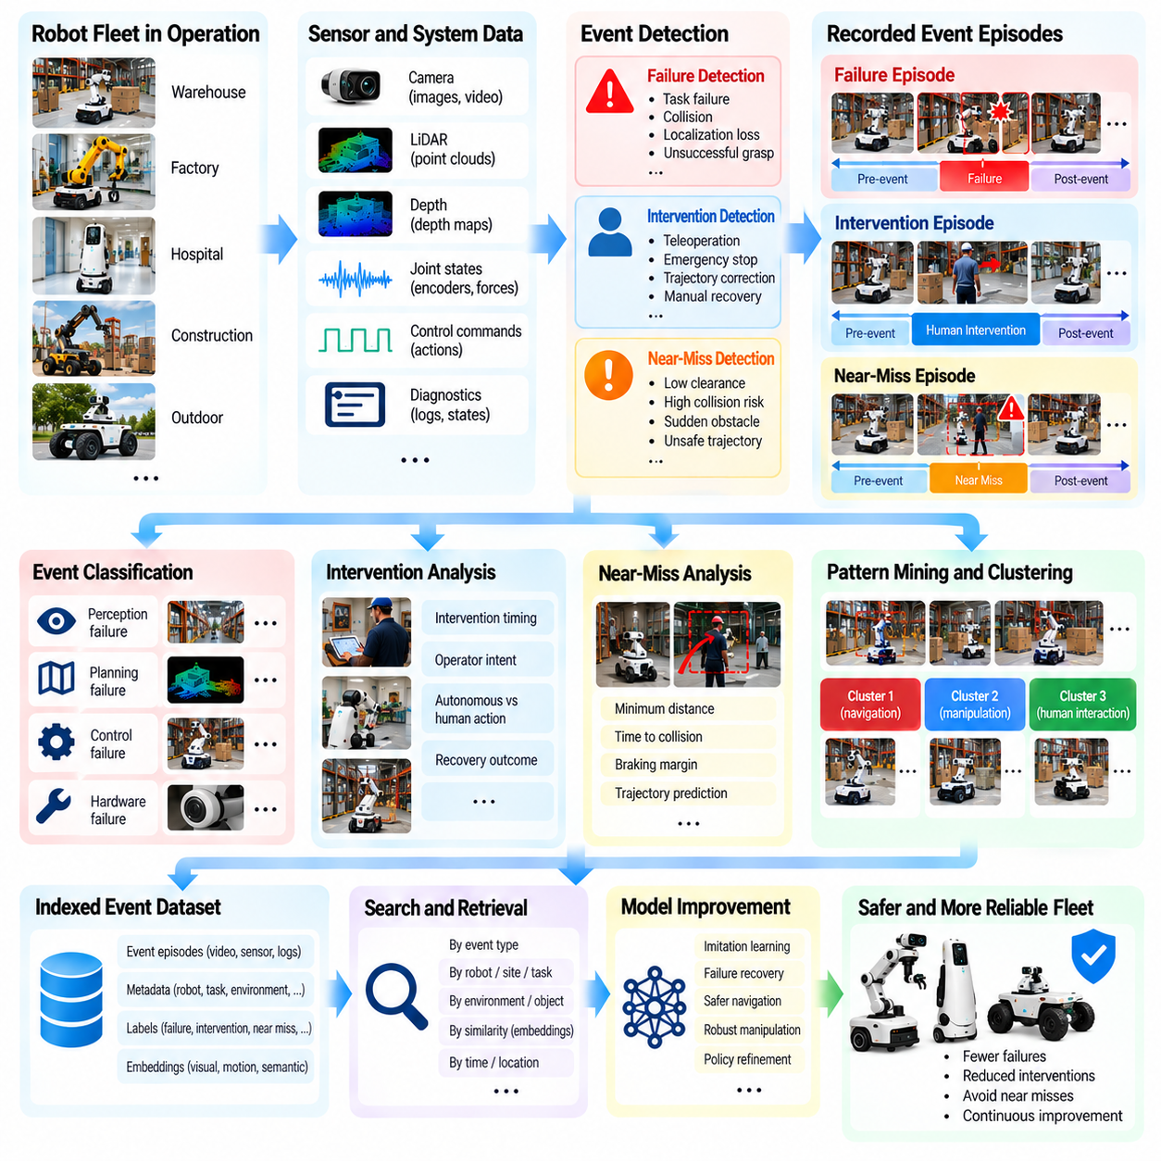
Failure, intervention, and near-miss mining transforms operational difficulties into valuable learning signals for autonomous robot fleets. Failures reveal situations where tasks cannot be completed, interventions expose limitations requiring human assistance, and near misses identify hazardous conditions that almost produce incidents. Together, these experiences provide information that routine successful operation rarely captures, making them essential for improving reliability, safety, and autonomy.
A failure occurs when a robot cannot achieve an intended task outcome or violates an operational requirement. Examples include unsuccessful grasps, navigation deadlocks, localization loss, dropped objects, and unexpected collisions. Failures may originate from perception errors, planning limitations, control instability, hardware degradation, or environmental changes. Effective mining requires distinguishing the observed failure from the underlying mechanism responsible for its occurrence.
Human interventions provide another important source of fleet learning data. An operator may take control when a robot becomes uncertain, approaches a hazardous condition, or repeatedly fails to complete a task. Teleoperation, emergency stopping, trajectory correction, and manual recovery all indicate situations requiring additional attention. Recording both the preceding autonomous behavior and the subsequent human response creates useful evidence for policy improvement.
Near misses are events in which a robot approaches an unsafe or undesirable outcome without experiencing a confirmed incident. A mobile robot may narrowly avoid a pedestrian, while a manipulator may nearly strike surrounding equipment. Such events can reveal weaknesses before actual damage occurs. Their detection requires careful interpretation because proximity alone does not necessarily indicate danger, particularly in tightly constrained industrial operations.
Fleet-scale mining begins with systematic event collection across deployed robots. Safety controllers, perception modules, navigation systems, manipulation controllers, and operator interfaces can generate event signals. Each event should be linked to synchronized observations, actions, estimated states, and contextual metadata. Standardized collection allows similar incidents from different robots and operating sites to be compared and analyzed consistently.
Event-triggered recording preserves the information needed to understand what happened before and after an anomaly. Circular buffers retain recent sensor histories, while triggers protect relevant segments from deletion. Recording windows should capture the robot's observations, decisions, actions, and environmental responses. Without preceding context, investigators may identify the final error but overlook the earlier conditions that caused the behavior to deteriorate.
Failure classification organizes operational events into categories that support engineering analysis. Perception failures may involve object misclassification or missed obstacles, while planning failures may involve infeasible trajectories or incorrect task sequencing. Control failures can include unstable motion or excessive contact forces. Classification systems should distinguish failure symptoms, contributing factors, and confirmed root causes rather than treating them as interchangeable labels.
Intervention mining examines when, why, and how humans correct autonomous behavior. Useful metadata includes intervention timing, operator intent, robot confidence, control mode, and recovery outcome. Comparing the robot's planned actions with the operator's corrections can reveal missing capabilities or inappropriate decisions. However, human actions are not automatically optimal, so demonstrations require quality assessment before they are used as training targets.
Near-miss detection often relies on geometric, temporal, and dynamic safety indicators. Minimum separation distance, time to collision, braking margin, contact force, and trajectory overlap can provide evidence of elevated risk. Thresholds must account for robot speed, stopping capability, uncertainty, and environmental context. Fixed distance rules alone may produce misleading classifications when operating conditions vary significantly.
Predictive models can identify near misses that conventional threshold rules overlook. By estimating future trajectories of robots, humans, and moving objects, a system can detect situations where small changes might have produced a collision. Counterfactual simulation can examine alternative actions or disturbances. Such predictions are useful for risk assessment, but their conclusions depend on model accuracy and should not be mistaken for observed incidents.
Rare failures are particularly important because their consequences may be severe despite low occurrence rates. A robot may operate successfully for thousands of hours before encountering an unusual obstacle configuration or unexpected mechanical interaction. Aggregating data across a fleet increases the opportunity to observe these events. Nevertheless, rare-event analysis must account for exposure frequency so that unusual conditions are not confused with inherently high-risk behavior.
Clustering helps identify recurring failure patterns within large event collections. Episodes can be grouped using metadata, visual embeddings, motion trajectories, or diagnostic signatures. Similar failures may reveal common environmental conditions, software defects, or hardware limitations. Engineers should verify clusters using original recordings because learned similarity measures may group visually related events that have different physical causes.
Failure mining should also identify relationships between sequential events. A perception error may cause an incorrect localization estimate, followed by a poor navigation decision and emergency stop. Treating the final stop as the sole failure hides the preceding chain of contributing factors. Temporal event graphs and synchronized episode reconstruction help engineers investigate these relationships while avoiding unsupported claims of causation.
Prioritization determines which mined events deserve immediate investigation or inclusion in training datasets. Safety severity, recurrence, operational disruption, model uncertainty, and expected learning value can contribute to event rankings. High-risk incidents require prompt attention, while frequent minor failures may reveal substantial productivity losses. A balanced strategy considers both the consequences of individual events and their prevalence across the fleet.
Mining results can guide targeted dataset construction. Failed grasps may be paired with successful attempts involving similar objects, while navigation failures can be compared with successful trajectories through equivalent environments. These contrasts help learning systems distinguish effective actions from problematic decisions. Dataset preparation should preserve temporal context and avoid introducing leakage between training and evaluation collections.
Intervention episodes are especially useful for imitation learning and corrective policy training. Human recovery trajectories can demonstrate alternatives to unsuccessful autonomous actions, while intervention timing can identify states where assistance becomes necessary. Training pipelines may combine these examples with successful autonomous episodes and simulation-generated variations. Evaluation must confirm that learned corrections improve behavior without creating new safety risks.
Near-miss episodes can support safety-oriented simulation and stress testing. Reconstructed scenarios may be replayed with varied robot speeds, obstacle motions, sensor noise, or environmental conditions. Controlled variations help estimate whether a system maintains safe margins under plausible disturbances. However, simulation fidelity and uncertainty must be assessed before results are used to support claims about real-world safety performance.
Reliable mining requires strong data quality and governance practices. Missing timestamps, incomplete recordings, inconsistent event labels, and outdated calibration information can distort analysis. Privacy-sensitive recordings may require restricted access or local anonymization. Incident evidence should retain provenance, processing history, and appropriate retention protections so that engineering conclusions remain traceable and auditable.
The effectiveness of mining can be evaluated through event detection recall, false-positive rates, investigation time, recurring failure frequency, intervention rate, and near-miss trends. Metrics should be normalized by operating hours, task volume, or relevant exposure conditions. A declining event count does not necessarily indicate improvement if logging coverage has decreased. Continuous validation is necessary to distinguish genuine progress from changes in measurement.
Ultimately, failure, intervention, and near-miss mining establishes a feedback mechanism between fleet operation and robot development. Operational anomalies become searchable episodes, engineering investigations identify weaknesses, and selected experiences inform training, testing, and deployment decisions. By systematically learning from both actual failures and narrowly avoided incidents, Physical AI fleets can improve autonomy while developing more reliable and safety-conscious behavior.

09.09. Rare and Long Tail Scenario Discovery
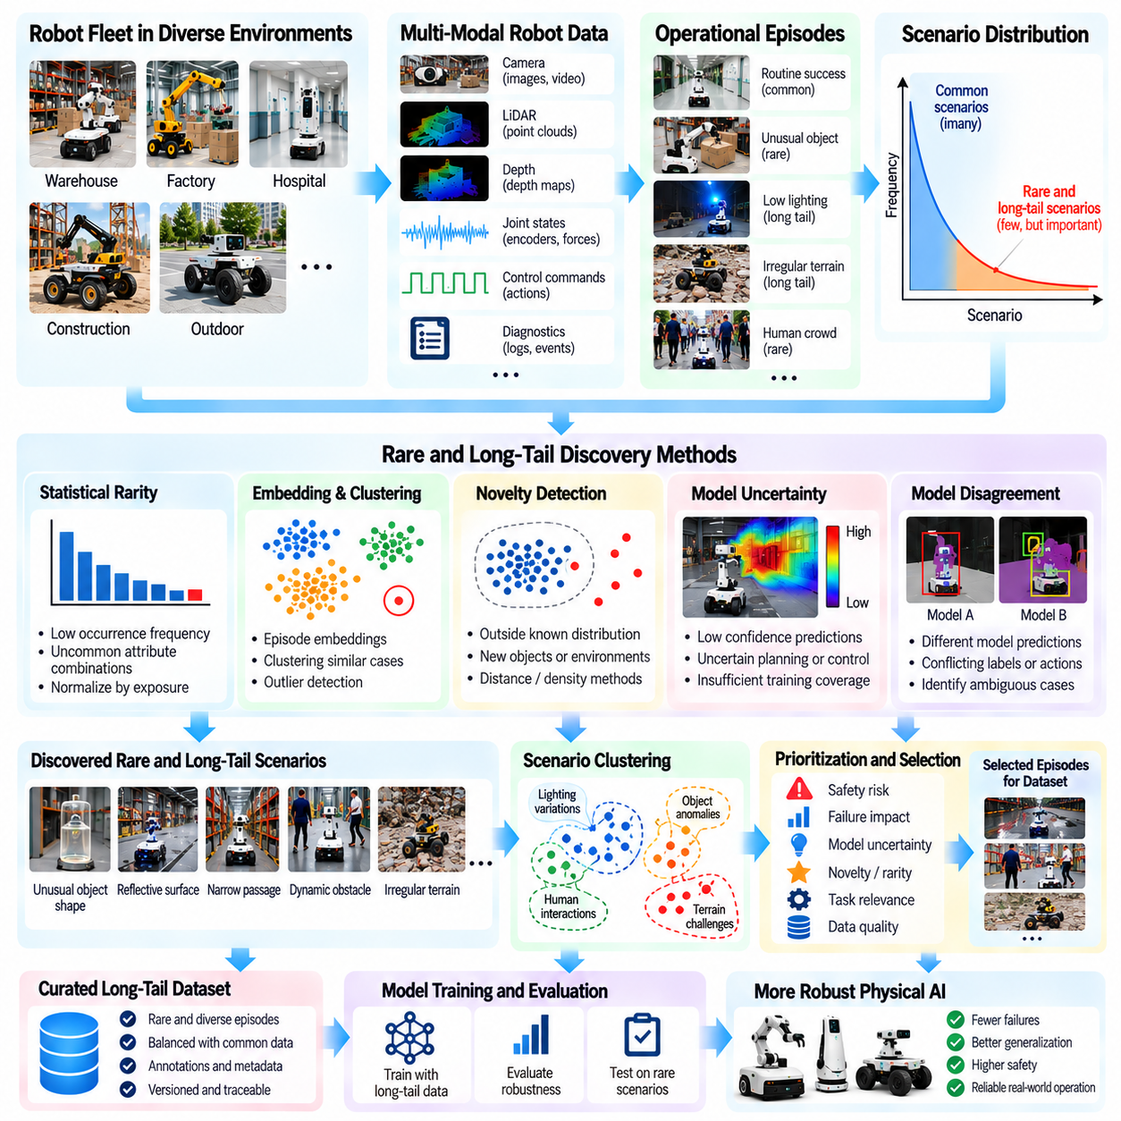
Rare and long-tail scenario discovery is essential for improving the robustness of Physical AI systems operating in unpredictable real-world environments. Most robot experiences involve familiar objects, repeated tasks, and common environmental conditions. However, a small fraction of encounters contain unusual combinations that expose limitations in perception, planning, or control. Discovering these uncommon experiences allows robot fleets to address weaknesses that conventional training datasets frequently overlook.
The long tail describes the large collection of individually infrequent situations that collectively represent substantial operational diversity. Examples include unexpected object arrangements, unusual lighting, irregular surfaces, unfamiliar obstacles, and rare human behaviors. Although each condition may occur infrequently, their combined probability can be significant. Reliable autonomy therefore requires learning beyond the most common scenarios represented in historical data.
Rare scenarios should not be confused with failures alone. A robot may successfully navigate an unfamiliar environment or manipulate an unusual object while encountering conditions absent from its training distribution. Such successful episodes can reveal emerging operational requirements and useful generalization capabilities. Conversely, an apparently routine task may contain subtle anomalies that become important only when combined with other environmental factors.
Fleet-scale deployment increases the opportunity to discover long-tail experiences. Robots operating across factories, warehouses, hospitals, and outdoor environments encounter different objects, layouts, lighting conditions, and human interactions. Aggregating observations across sites expands scenario coverage beyond what a single robot can experience. However, discovery systems must distinguish genuinely novel conditions from repeated recordings of familiar situations.
Scenario discovery begins with systematic collection of synchronized sensor observations, robot actions, task outcomes, and contextual metadata. Event-triggered logging preserves unusual interactions, while periodic sampling captures rare situations that do not produce explicit errors. Each episode should retain robot configuration, environment information, timestamps, and model versions. This context allows engineers to interpret whether an observation represents meaningful novelty or a recording artifact.
Statistical rarity provides one approach to identifying unusual experiences. Events with low occurrence frequencies, uncommon combinations of attributes, or low likelihood under reference distributions may be considered candidates. Frequency estimates should account for task exposure, operating hours, and deployment conditions. Without appropriate normalization, a scenario may appear rare simply because few robots have operated in the environment where it occurs.
Embedding-based discovery represents observations or complete episodes in learned feature spaces. Visual scenes, motion trajectories, contact interactions, and task outcomes can be encoded into compact vectors. Clustering identifies recurring patterns, while outlier detection highlights experiences distant from established groups. Nevertheless, embedding distances do not always correspond to physical significance, requiring validation against operational evidence.
Novelty detection compares incoming experiences with previously observed data. A robot encountering a new object geometry, unfamiliar surface material, or unusual interaction sequence may produce observations outside known distributions. Distance-based methods, density estimation, and learned novelty scores can support automated discovery. These methods should be calibrated carefully because sensor noise and calibration errors can resemble genuine environmental novelty.
Model uncertainty provides another signal for long-tail discovery. Perception models may produce low confidence, planning systems may generate inconsistent predictions, and control policies may encounter unfamiliar states. High uncertainty can indicate insufficient training coverage, but it may also reflect measurement noise or poorly calibrated models. Combining uncertainty with task context and repeated observations improves the reliability of scenario selection.
Disagreement between independently trained models can reveal regions where learned behavior is insufficiently constrained by available data. Different perception networks may assign conflicting object labels, or alternative policies may recommend different actions. Such disagreement identifies candidates for further investigation even when the robot completes its task. However, model agreement does not guarantee correctness, especially when models share similar training biases.
Temporal novelty is important because rare scenarios may emerge through sequences rather than isolated observations. A navigation system might encounter familiar obstacles arranged in an unfamiliar order, creating a difficult planning situation. Manipulation failures may arise from unusual combinations of object motion, contact timing, and grip adjustment. Sequence-aware representations help detect these patterns while preserving the causal context needed for engineering analysis.
Scenario clustering organizes discovered experiences into meaningful families. Episodes may be grouped by environmental appearance, task structure, robot behavior, or failure mechanism. Engineers can then identify recurring long-tail categories instead of reviewing every unusual recording individually. Clusters should be examined for hidden variation because visually similar scenes may require different control responses, while visually different scenes may share the same underlying challenge.
Rare-event discovery should incorporate safety and operational importance rather than relying exclusively on novelty scores. An unfamiliar but harmless visual pattern may have limited learning value, while an uncommon near-collision could reveal a critical safety weakness. Prioritization can combine rarity, severity, uncertainty, recurrence, and expected model improvement. This prevents data collection resources from being consumed primarily by unusual but irrelevant observations.
Coverage analysis determines which combinations of tasks, environments, robot configurations, and operating conditions are poorly represented. Metadata indexes and scenario taxonomies support comparisons between collected data and expected deployment distributions. Coverage gaps may involve particular object materials, lighting transitions, floor conditions, or human interaction patterns. Identifying these gaps enables targeted collection rather than indiscriminate accumulation of additional recordings.
Active data collection converts discovery results into new recording policies. When centralized analysis identifies underrepresented conditions, selected robots can receive updated triggers, sampling rates, or task-specific collection requests. Edge systems then preserve relevant episodes when those conditions occur naturally. This approach connects fleet-wide knowledge with local data acquisition while reducing unnecessary network transfers and storage consumption.
Simulation can complement physical collection by generating variations around discovered long-tail scenarios. A rare navigation event may be reconstructed with different obstacle positions, friction coefficients, or sensor disturbances. Manipulation scenarios can be expanded through changes in object geometry, mass, and contact properties. Synthetic variations improve coverage, but their usefulness depends on simulation fidelity and validation against real observations.
Human review remains important for distinguishing meaningful rare scenarios from technical artifacts. Engineers may inspect representative recordings to verify novelty, assess safety implications, and assign semantic labels. Review outcomes can refine clustering models, novelty thresholds, and collection priorities. Human expertise is especially valuable when unusual behavior involves complex physical interactions that automated similarity measures cannot reliably interpret.
Long-tail datasets require careful organization and evaluation design. Rare episodes should retain their original context, provenance, and relationships to related scenarios. Training and evaluation partitions must avoid leakage from nearly identical recordings or simulation variants. Dedicated challenge sets can measure performance on difficult conditions, while representative operational datasets remain necessary for assessing overall reliability and avoiding overfitting to exceptional cases.
Discovery effectiveness can be evaluated through novel scenario yield, validated rarity, coverage improvement, review cost, and downstream model performance. Engineers should measure whether newly collected episodes reveal previously unknown failure modes or improve performance on underrepresented conditions. Metrics must also account for changing deployment exposure and collection policies. Increasing the number of detected outliers does not automatically indicate better discovery.
Ultimately, rare and long-tail scenario discovery transforms distributed robot experience into a systematic process for identifying the limits of autonomous intelligence. Statistical analysis, embeddings, uncertainty estimation, temporal reasoning, and human validation reveal situations that ordinary datasets miss. By connecting discovery with targeted collection, simulation, evaluation, and model improvement, Physical AI fleets can progressively expand their operational competence and resilience.

09.10. Uncertainty Triggered Data Collection
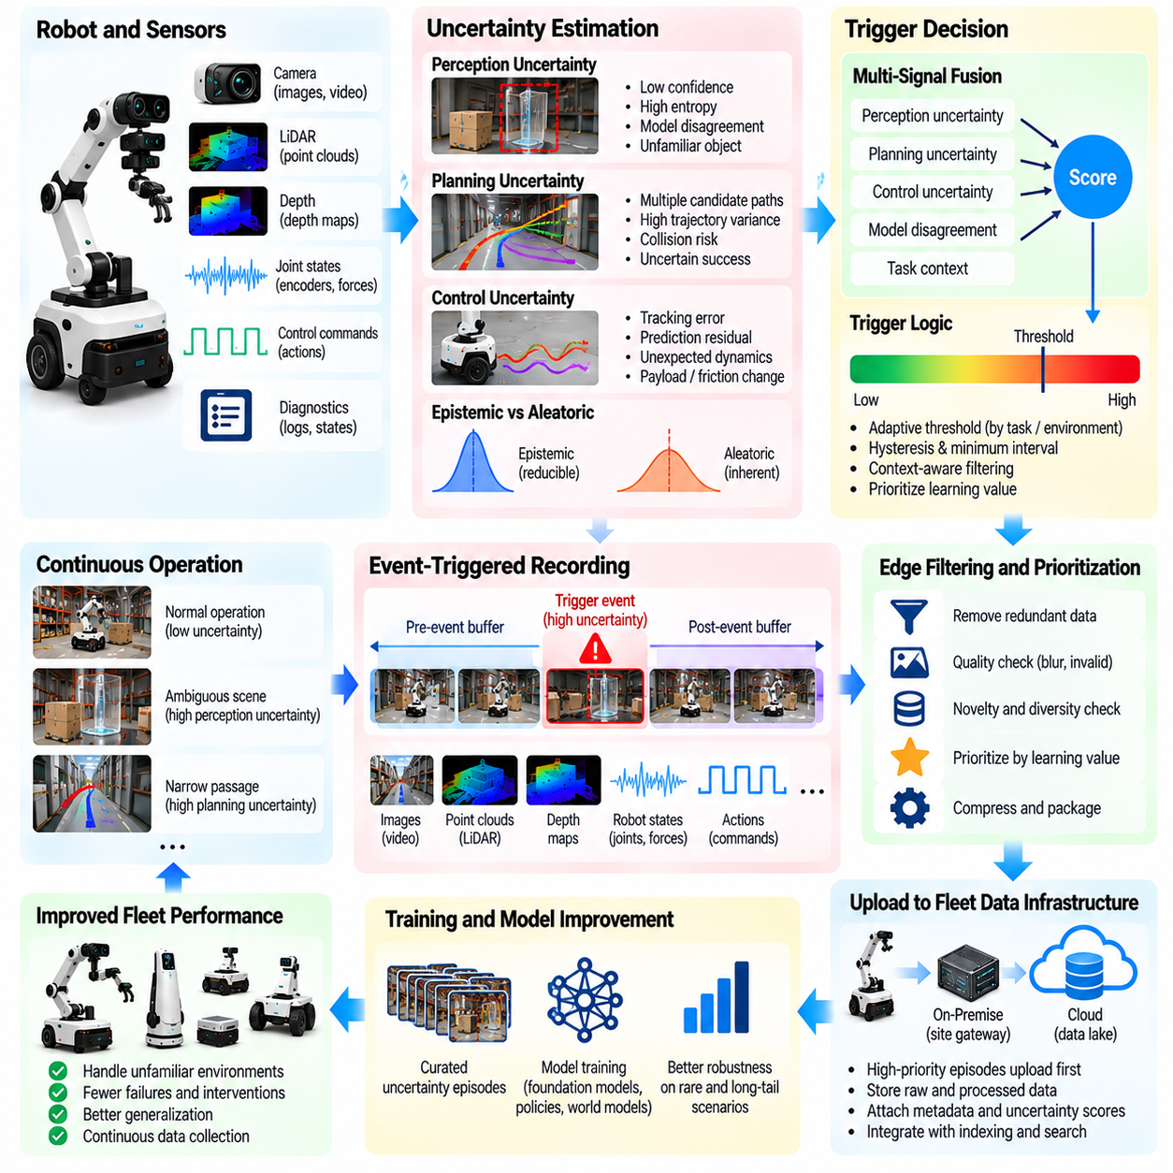
Uncertainty-triggered data collection enables Physical AI fleets to capture informative experiences when autonomous systems encounter unfamiliar or ambiguous conditions. Instead of recording every sensor stream continuously, robots use uncertainty estimates to identify moments when additional evidence may improve future learning. This approach concentrates collection resources on situations where perception, prediction, planning, or control models have limited confidence.
Uncertainty represents the degree to which a robot cannot reliably determine its environment, predict outcomes, or select appropriate actions. It may arise from incomplete observations, unfamiliar objects, ambiguous sensor measurements, or insufficient training coverage. Not all uncertainty indicates imminent failure, but persistent uncertainty can reveal weaknesses in learned representations and decision-making capabilities.
A fundamental distinction exists between epistemic and aleatoric uncertainty. Epistemic uncertainty reflects limitations in model knowledge and may decrease when relevant training examples become available. Aleatoric uncertainty arises from inherent randomness or measurement variability that additional data cannot necessarily eliminate. Distinguishing these sources helps determine whether collecting more examples is likely to improve model performance.
Perception uncertainty often appears when object detection, segmentation, localization, or scene understanding produces ambiguous predictions. A robot may encounter transparent objects, reflective surfaces, partial occlusions, or unfamiliar lighting conditions. Confidence scores, prediction entropy, and disagreement between models can indicate such situations. However, confidence values require calibration because neural networks may remain overconfident on unfamiliar inputs.
Planning uncertainty concerns the reliability of predicted action consequences and candidate trajectories. A navigation robot may struggle to estimate whether a narrow passage is traversable, while a manipulator may be uncertain about grasp stability. Variability across predicted outcomes or disagreement between planning models can provide useful signals. These uncertainties are especially informative when decisions involve irreversible actions or safety constraints.
Control uncertainty emerges when the relationship between commanded actions and observed physical responses becomes difficult to predict. Unexpected friction, payload changes, actuator wear, and contact dynamics can produce deviations from expected motion. Prediction residuals, state-estimation covariance, and abnormal tracking errors may indicate uncertain operating conditions. Such signals should be distinguished from confirmed hardware faults requiring immediate maintenance.
An uncertainty-triggered collection system continuously evaluates selected indicators during robot operation. When uncertainty exceeds a calibrated threshold, the system preserves relevant observations, actions, internal predictions, and environmental context. Circular buffers retain information preceding the trigger, while subsequent recording captures the outcome. This temporal context is necessary to understand how uncertainty developed and whether the robot recovered successfully.
Trigger design must balance learning value against computational, storage, and communication costs. Thresholds that are too sensitive generate excessive recordings, while thresholds that are too restrictive miss informative experiences. Adaptive thresholds can account for task complexity, environmental conditions, and available resources. Hysteresis and minimum trigger intervals help prevent repeated recordings caused by fluctuating uncertainty estimates.
Multiple uncertainty signals can be combined to improve collection decisions. Perception confidence, predicted collision probability, trajectory variance, and controller residuals may contribute to a composite score. Contextual information can determine whether an uncertain condition is operationally important. Combining signals requires careful calibration because different indicators may have incompatible scales or correlated errors.
Model ensembles provide one method for estimating uncertainty through prediction disagreement. Several independently trained models evaluate the same observations and produce alternative predictions or actions. Large disagreement can indicate insufficient knowledge in a particular region of the state space. Although ensembles increase computational requirements, smaller approximations or selective execution can make uncertainty estimation practical on resource-constrained robots.
Bayesian approximations and probabilistic prediction methods provide additional uncertainty estimates. Monte Carlo dropout, probabilistic neural networks, and predictive distributions can characterize variation in model outputs. These approaches offer useful indicators but depend on modeling assumptions and calibration quality. No single estimator reliably captures every form of uncertainty encountered in complex physical environments.
Uncertainty-triggered recording should prioritize experiences with potential learning value rather than simply selecting the highest numerical scores. Repeated observations of the same ambiguous surface may contribute little additional information after sufficient coverage is achieved. Novelty, diversity, task relevance, and expected model improvement can guide selection. This connects uncertainty-based collection with active learning and long-tail scenario discovery.
Edge processing is essential because uncertainty decisions must often occur before raw recordings can be uploaded. Onboard systems can calculate lightweight confidence indicators, preserve short sensor windows, and assign collection priorities. High-value episodes may be uploaded immediately, while less urgent recordings can wait for suitable network conditions. This reduces bandwidth consumption without losing important evidence.
Safety-critical uncertainty requires special treatment. When uncertainty affects collision avoidance, human proximity, or unstable manipulation, the robot should prioritize safe behavior rather than continued exploration. Collection mechanisms must remain separate from safety controllers and should never encourage hazardous actions merely to obtain informative data. Recording a risky situation is useful only when the system maintains appropriate operational safeguards.
Human intervention can provide valuable labels for uncertainty-triggered episodes. Operators may explain why a robot hesitated, identify misunderstood objects, or demonstrate corrective actions. Linking uncertainty estimates with intervention timing and recovery outcomes helps determine whether the original signals predicted meaningful difficulties. Human feedback also supports refinement of thresholds and validation of uncertainty calibration.
Centralized fleet analysis can identify recurring uncertainty patterns across robots and operating sites. Episodes may be grouped by object category, environmental condition, model version, or task phase. Engineers can distinguish platform-specific weaknesses from limitations shared across the fleet. These findings can inform targeted data collection policies, model retraining priorities, and changes to sensor configurations.
Collected episodes must be integrated into reproducible learning pipelines. Metadata should preserve trigger type, uncertainty score, model version, robot configuration, and recording conditions. Selected examples can be annotated, quality-filtered, and incorporated into training datasets. Evaluation datasets should remain appropriately separated to prevent repeated uncertainty-driven sampling from producing misleading performance improvements.
Uncertainty estimates can also guide simulation-based data generation. An unfamiliar physical interaction may be reconstructed in simulation and varied across object properties, contact conditions, or sensor disturbances. These variations can expand coverage around uncertain regions of the operating space. However, synthetic examples must be validated against real observations because inaccurate simulation may reinforce incorrect model assumptions.
Collection effectiveness should be measured through useful episode yield, uncertainty calibration, dataset diversity, storage efficiency, and downstream model improvement. Engineers should compare uncertainty-triggered sampling with random or periodic collection under similar resource budgets. Reduced uncertainty alone is insufficient evidence of progress if task success or safety performance does not improve. Evaluation must therefore include real operational outcomes.
Ultimately, uncertainty-triggered data collection creates a direct connection between what robots do not know and what their learning systems should observe next. By identifying uncertain states, preserving contextual evidence, and selecting informative experiences, fleets can improve data efficiency and model coverage. Integrated with safety controls, human feedback, and continuous evaluation, this mechanism supports increasingly capable and reliable Physical AI systems.

09.11. Model Error to Data Query
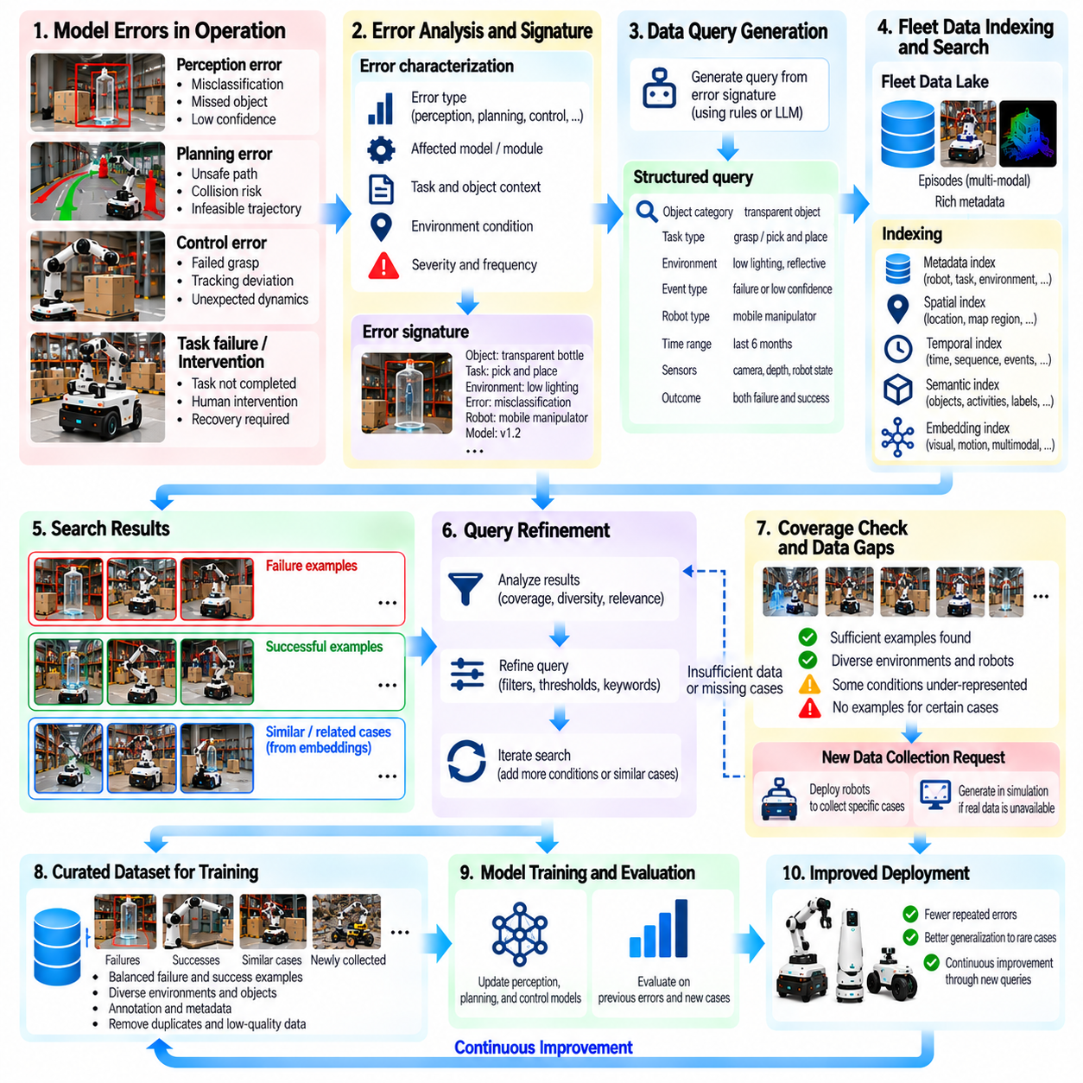
Model error-to-data query establishes a systematic connection between observed model weaknesses and the robot experiences needed to correct them. Instead of collecting additional data indiscriminately, Physical AI systems analyze prediction errors, execution failures, and evaluation gaps to formulate targeted retrieval requests. This process transforms model deficiencies into actionable data requirements, improving the efficiency of fleet-scale learning and continuous model development.
Model errors can originate from perception, state estimation, planning, control, or learned action policies. A perception model may misidentify transparent objects, while a navigation policy may select unsafe paths through unfamiliar layouts. Manipulation models may incorrectly predict contact forces or grasp stability. Each error contains information about the conditions under which learned representations or decision mechanisms become unreliable.
The first step is to characterize the error using measurable evidence. Prediction residuals, task success rates, trajectory deviations, classification mistakes, and intervention records provide useful indicators. Error analysis should identify the affected subsystem, operating context, severity, and frequency. Distinguishing systematic weaknesses from isolated noise prevents unnecessary collection requests and improves the relevance of retrieved episodes.
An error signature summarizes the characteristics associated with a recurring model deficiency. It may contain task type, object category, environmental conditions, robot configuration, model version, and observed failure behavior. For example, repeated grasp failures involving reflective objects under low illumination can form a recognizable signature. Structured signatures allow engineers to translate vague performance problems into searchable data specifications.
A data query converts an error signature into explicit retrieval conditions. Queries may specify sensor modalities, task outcomes, robot embodiments, environmental attributes, and temporal intervals. An engineer investigating localization failures might request episodes containing reflective corridors, rapid lighting transitions, and high pose-estimation uncertainty. Precise query conditions reduce irrelevant results while preserving useful variations.
Fleet metadata indexes provide the foundation for executing these queries efficiently. Structured databases filter episodes by robot identity, software version, task category, and operating site. Temporal indexes locate events surrounding failures, while semantic indexes identify relevant objects and activities. Combining these capabilities allows training pipelines to retrieve operational evidence without repeatedly scanning large collections of raw recordings.
Embedding-based retrieval extends data queries beyond manually defined labels. Model errors can be represented using visual features, motion trajectories, latent states, or multimodal embeddings. Similarity searches then identify episodes resembling known failure cases, including examples that lack explicit annotations. However, embedding similarity must be validated because visually similar situations may involve different physical mechanisms.
Error-driven queries should retrieve successful examples as well as failures. Comparing unsuccessful actions with successful executions under similar conditions helps distinguish problematic decisions from unavoidable environmental constraints. For grasping tasks, positive and negative examples may reveal differences in contact geometry, approach direction, or object motion. Such contrasts provide richer supervision than collections containing only failed attempts.
Temporal context is essential when retrieving data associated with model errors. A navigation failure may result from an incorrect perception estimate several seconds before the final stop. Queries should therefore support preceding observations, intermediate decisions, and subsequent recovery behavior. Episode-level retrieval preserves these relationships, enabling engineers to investigate error propagation rather than examining isolated frames.
Query generation can be partially automated using evaluation results and diagnostic logs. When a model repeatedly fails on a particular scenario category, analysis software can extract common metadata attributes and construct candidate queries. Language models or learned retrieval systems may help translate diagnostic descriptions into structured search expressions. Generated queries still require validation to prevent incorrect assumptions or irrelevant retrieval.
Query refinement improves results through iterative feedback. Initial searches may return excessive duplicates, unrelated episodes, or insufficient coverage of the target condition. Engineers can adjust metadata filters, similarity thresholds, temporal windows, and diversity constraints. Relevance feedback from reviewed examples helps improve subsequent searches, gradually aligning retrieved datasets with the underlying model weakness.
Fleet-scale retrieval must account for data redundancy and uneven operating distributions. Thousands of nearly identical episodes from one warehouse may provide less learning value than a smaller collection spanning multiple sites and robot configurations. Diversity-aware selection can balance task conditions, environments, embodiments, and failure mechanisms. This prevents large deployments from dominating datasets simply because they generate more recordings.
When existing fleet data cannot satisfy a query, the system should identify the missing coverage explicitly. A request for rare object interactions may reveal that relevant examples were never recorded or lack necessary sensor modalities. These gaps can generate new collection instructions for deployed robots or simulation environments. Thus, model error-to-data query connects historical retrieval with future targeted acquisition.
Active collection requests may specify recording triggers, environmental conditions, sensor configurations, or task categories. Robots can prioritize relevant experiences when matching conditions naturally occur during operation. Centralized coordination can distribute collection responsibilities across suitable fleet members. Safety constraints must remain independent of collection objectives, preventing robots from deliberately entering hazardous states to generate training examples.
Retrieved episodes require quality filtering before entering training pipelines. Corrupted sensor streams, inaccurate timestamps, incomplete action histories, and inconsistent labels can reinforce existing model errors. Automated checks should verify synchronization, metadata completeness, calibration validity, and recording integrity. Human review may be necessary when the error involves ambiguous physical interactions or uncertain ground-truth outcomes.
Dataset construction should preserve traceability from each model error to its associated query and selected training examples. Query identifiers, model checkpoints, retrieval configurations, annotation versions, and dataset manifests support reproducibility. Engineers can then determine which evidence motivated a dataset update and whether the selected examples addressed the intended weakness. This lineage is essential for reliable continuous learning.
Evaluation must determine whether error-driven data selection produces meaningful improvements. Updated models should be tested against the original failure category, related operating conditions, and representative general-purpose benchmarks. Improvements on targeted examples are insufficient if performance deteriorates elsewhere. Separate evaluation datasets and controlled comparisons help distinguish genuine generalization from memorization or data leakage.
The effectiveness of error-to-data querying can be measured through retrieval precision, useful example yield, coverage improvement, annotation cost, and downstream error reduction. Query latency and computational expense also matter when fleets operate at scale. Comparing targeted retrieval with random sampling under equivalent budgets reveals whether the approach delivers measurable data efficiency. Metrics should emphasize operational outcomes rather than retrieved volume alone.
Continuous deployment creates an iterative relationship between model errors and data requirements. Field monitoring identifies weaknesses, query systems retrieve relevant experiences, training pipelines update models, and evaluation determines whether performance improves. Remaining errors generate refined queries or additional collection requests. This closed-loop process allows fleet knowledge to evolve systematically as environments, tasks, and robot capabilities change.
Ultimately, model error-to-data query converts failures in learned intelligence into structured opportunities for improvement. By linking diagnostic evidence, metadata search, semantic retrieval, targeted collection, and reproducible evaluation, Physical AI fleets can acquire the experiences most relevant to their weaknesses. The result is a data engine that responds to demonstrated learning needs rather than relying primarily on uncontrolled accumulation of robot recordings.

09.12. Continuous Training and Evaluation
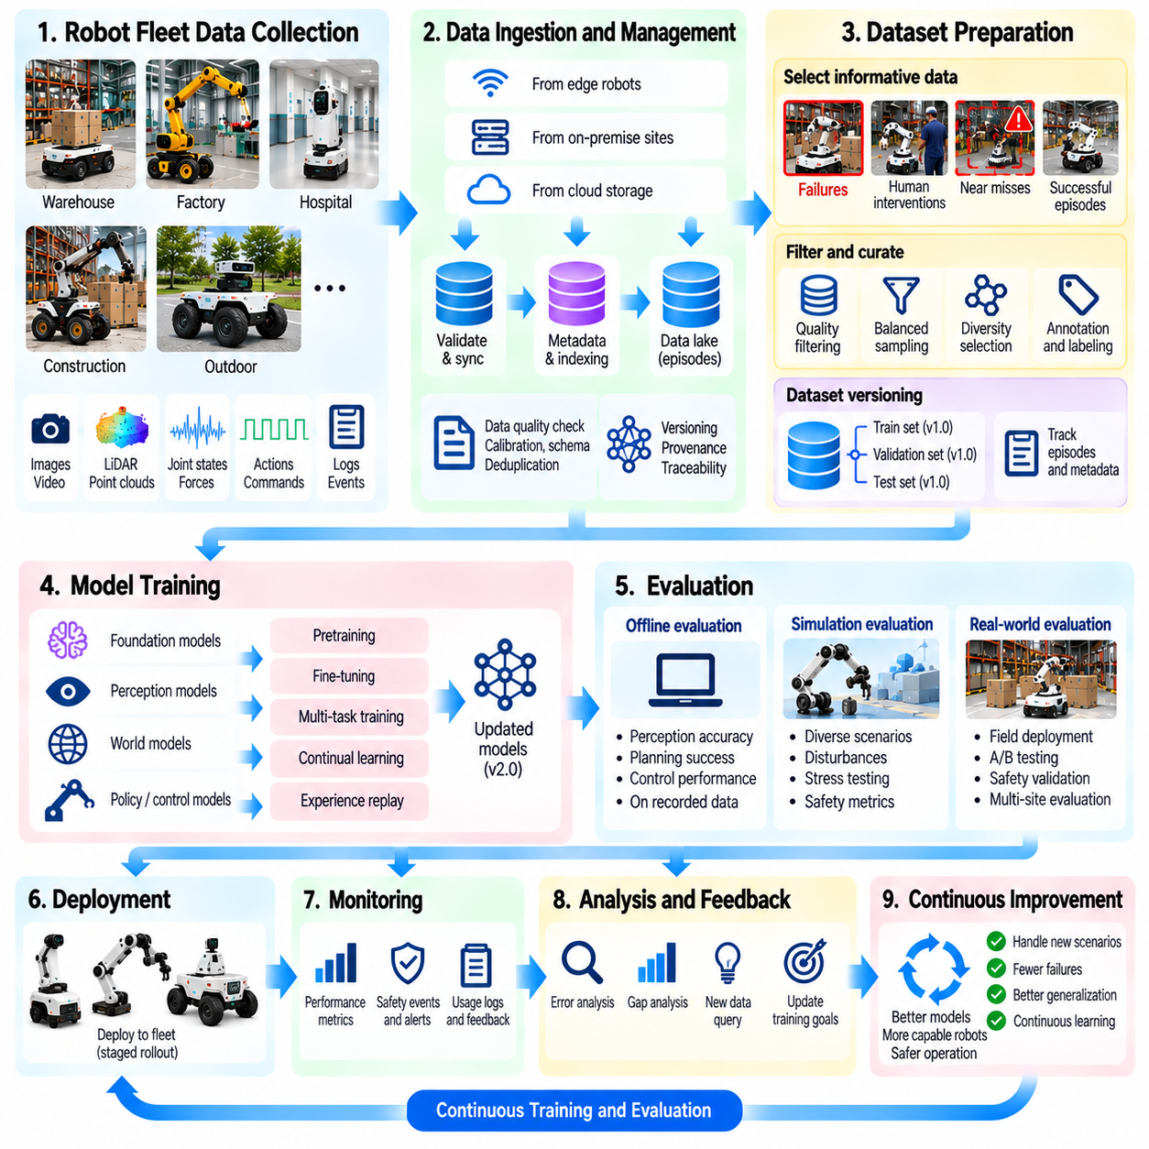
Continuous training and evaluation establish the learning infrastructure that enables Physical AI fleets to improve through accumulated operational experience. As robots encounter new environments, tasks, and failure conditions, their collected data provides opportunities to refine perception, planning, and control models. A continuous pipeline transforms selected fleet episodes into updated models while verifying that improvements remain reliable across diverse operating conditions.
Unlike conventional model development based on fixed datasets, continuous training incorporates newly collected experiences through repeated development cycles. Robot recordings, intervention episodes, rare scenarios, and model-error queries provide candidate training examples. These examples undergo validation, annotation, filtering, and dataset construction before training begins. The objective is not constant model modification but systematic improvement supported by measurable evidence.
Data ingestion connects deployed robot fleets with centralized learning infrastructure. Recorded episodes arrive from edge devices, on-premise gateways, and cloud storage systems with associated metadata and provenance. Ingestion pipelines verify recording integrity, timestamp synchronization, sensor calibration, and schema compatibility. Invalid or incomplete episodes are quarantined to prevent corrupted observations from influencing subsequent model updates.
Dataset preparation determines which experiences contribute to each training cycle. Selection mechanisms may prioritize rare failures, human interventions, uncertain predictions, or underrepresented operating conditions. Successful episodes remain important for preserving established capabilities and preventing training bias toward abnormal events. Balanced sampling combines informative new examples with representative historical data to support robust generalization.
Dataset versioning ensures that every training experiment can be reproduced. Each dataset snapshot identifies its constituent episodes, annotations, filtering rules, preprocessing configurations, and collection periods. Model checkpoints must reference the exact dataset versions used during training. This traceability allows engineers to investigate unexpected behavior and determine whether performance changes originate from data, algorithms, or configuration differences.
Continuous training can involve fine-tuning existing models, periodically retraining selected components, or rebuilding models using expanded datasets. Fine-tuning offers computational efficiency when new experiences resemble existing tasks, while broader retraining may be necessary after substantial distribution changes. Training strategies should consider model architecture, available computing resources, deployment constraints, and the risk of degrading previously learned capabilities.
Catastrophic forgetting represents a major challenge when models are repeatedly updated using recent experiences. A manipulation policy trained heavily on newly encountered objects may lose proficiency with previously mastered tasks. Experience replay, balanced historical sampling, regularization, and selective parameter updates can reduce this risk. Evaluation must measure both newly acquired capabilities and retention of established performance.
Training orchestration coordinates data preparation, computational resources, experiment execution, and artifact management. Automated pipelines can schedule training jobs when sufficient new data becomes available or specific performance thresholds are reached. Resource allocation should reflect model complexity, dataset size, and operational priorities. Reliable orchestration also requires failure recovery, checkpoint management, and monitoring of computational costs.
Evaluation must remain independent from the training process to provide trustworthy evidence of improvement. Validation datasets support model selection and hyperparameter tuning, while protected test datasets assess final performance. Fleet-derived evaluation sets should represent common tasks, rare scenarios, safety-critical events, and different operating environments. Careful separation prevents repeated exposure to evaluation examples from creating misleading results.
Offline evaluation provides the first assessment of updated models before physical deployment. Perception models can be tested for detection accuracy, calibration, and robustness, while planning and control policies can be evaluated using recorded trajectories or suitable simulation environments. Offline metrics offer efficient comparisons between model versions. However, recorded data cannot fully capture the consequences of actions that were never executed.
Simulation-based evaluation extends testing to interactive conditions and controlled disturbances. Digital environments can reproduce historical failures while varying object positions, friction, sensor noise, and human behavior. Repeated trials reveal performance distributions and sensitivity to environmental changes. Simulation results should be interpreted alongside fidelity limitations because successful virtual behavior does not guarantee equivalent physical performance.
Safety evaluation requires explicit criteria beyond average task success. Collision rates, unsafe proximity, excessive forces, emergency stops, and constraint violations may indicate unacceptable behavior even when productivity improves. Critical scenarios should be tested using conservative thresholds and appropriate safety procedures. A candidate model must satisfy defined safety requirements before being considered for controlled field deployment.
Evaluation should also examine performance across robot platforms, sites, and environmental conditions. An updated model may improve results in one warehouse while performing poorly in another with different lighting or floor characteristics. Stratified metrics reveal such differences rather than hiding them within fleet-wide averages. Cross-site and cross-embodiment testing helps determine whether improvements generalize beyond the data sources that motivated training.
Regression testing compares candidate models with previously validated baselines. Standardized test suites include established tasks, historical failures, edge cases, and operational safety requirements. Any significant degradation should trigger investigation before deployment. Automated regression gates can reject models that fail critical thresholds, ensuring that improvements in selected scenarios do not silently compromise existing robot capabilities.
Model promotion follows a controlled process after offline and simulation evaluations are completed. Candidate checkpoints are registered with their dataset lineage, configuration, evaluation results, and compatibility requirements. Deployment approval may require engineering review and safety validation. Versioned model registries support reproducibility, rollback, and comparison between production models and experimental alternatives.
Field evaluation introduces additional evidence from actual robot operation. Shadow testing can run candidate models without granting them control authority, allowing predictions to be compared with production behavior. Canary deployment exposes a limited robot population to approved updates under monitoring. Gradual expansion reduces the impact of unexpected regressions while collecting operational evidence about real-world performance.
Continuous monitoring closes the connection between deployment and subsequent training cycles. Task success, intervention frequency, uncertainty, safety events, latency, and resource consumption can be tracked by model version and operating context. Performance drift or recurring failures generate new data queries and collection priorities. These signals help determine whether additional training is necessary and which weaknesses should receive attention.
Operational metrics must account for changing exposure conditions. A reduction in failures may reflect easier tasks rather than a genuinely improved model, while increased interventions may result from stricter safety policies. Comparisons should consider operating hours, task distributions, robot configurations, and environmental differences. Statistical uncertainty and sufficient sample sizes are necessary before attributing observed changes to model updates.
Governance and reproducibility remain essential throughout continuous learning. Training records should preserve dataset versions, model artifacts, evaluation protocols, approval decisions, and deployment histories. Access controls protect sensitive operational data, while audit trails support investigation and accountability. Automated systems may accelerate development, but consequential deployment decisions should remain subject to appropriate verification and oversight.
Ultimately, continuous training and evaluation transform fleet data into a disciplined cycle of model improvement. New experiences are curated into reproducible datasets, training produces candidate capabilities, and layered evaluations determine whether updates are safe and beneficial. Controlled deployment and field monitoring return evidence to the data engine, enabling Physical AI fleets to evolve without sacrificing reliability, traceability, or operational safety.

09.13. Shadow Canary and Field Model Monitoring
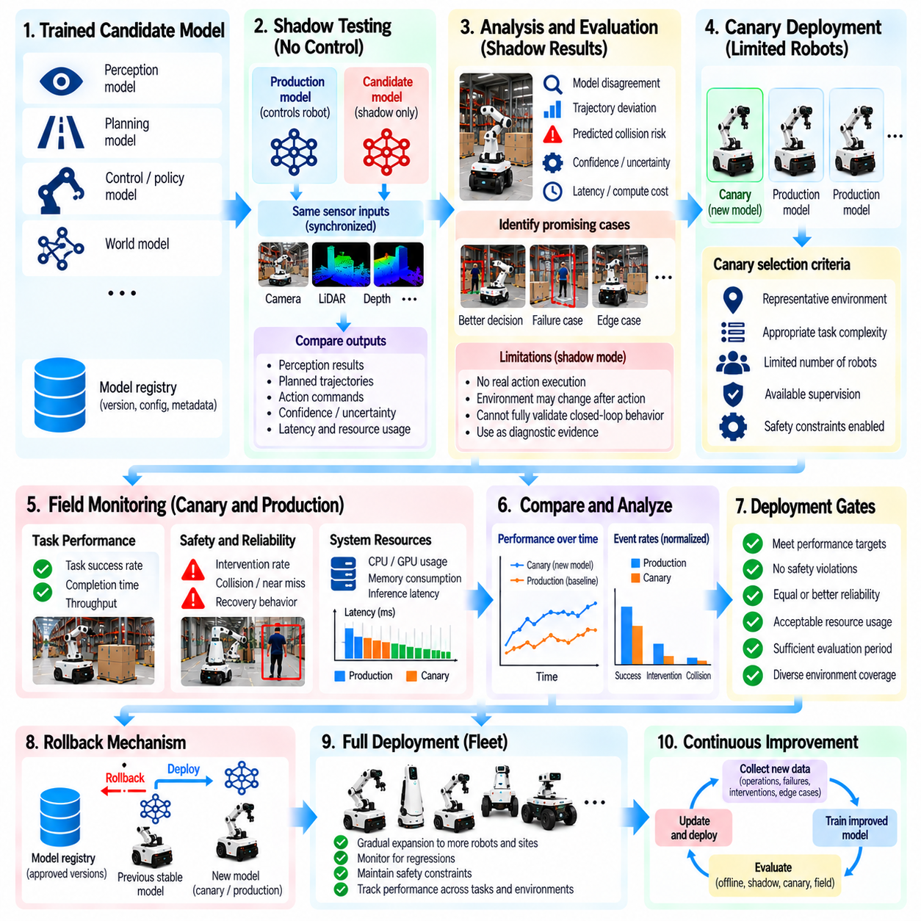
Shadow testing, canary deployment, and field model monitoring establish a controlled framework for introducing updated models into Physical AI fleets. These mechanisms connect offline evaluation with real-world operational evidence while limiting deployment risk. Rather than replacing production models across an entire fleet immediately, engineers observe candidate behavior, validate performance under actual conditions, and progressively expand deployment based on measurable safety and reliability criteria.
Shadow testing evaluates a candidate model alongside an active production model without granting the candidate authority over robot actions. Both models may receive equivalent sensor observations and operating context, but only the production model controls the physical system. Candidate predictions, proposed trajectories, and confidence estimates are recorded for comparison. This arrangement reveals behavioral differences without directly exposing the robot to unvalidated control decisions.
A shadow execution environment must reproduce the candidate model's intended input conditions as accurately as possible. Sensor timestamps, coordinate frames, preprocessing pipelines, and robot configuration parameters require consistent handling. Differences in input processing can create apparent model disagreements unrelated to actual intelligence improvements. Engineers should therefore verify data alignment and execution consistency before interpreting shadow evaluation results.
Shadow monitoring compares candidate outputs with production decisions and available ground-truth evidence. Relevant indicators include perception disagreement, trajectory deviation, predicted collision risk, action confidence, and computational latency. Large disagreements identify situations requiring additional investigation, but disagreement alone does not establish which model is correct. Human review, subsequent observations, and task-specific evaluation criteria help determine whether candidate behavior represents improvement.
Shadow testing has important limitations because candidate actions do not influence the physical environment. A proposed manipulation trajectory may appear successful in recorded observations but fail when contact dynamics change during execution. Likewise, navigation decisions can alter future sensor observations and available paths. Shadow results should therefore be interpreted as diagnostic evidence rather than complete proof of closed-loop control performance.
Canary deployment introduces a validated candidate model to a limited subset of robots under controlled operational conditions. Selected robots execute the updated model while the remaining fleet continues using the established production version. The initial deployment population should be small enough to contain unexpected failures yet representative enough to produce meaningful evidence. Expansion occurs only after predefined acceptance criteria are satisfied.
Canary selection should account for robot hardware, operating environment, task complexity, and available supervision. Deploying exclusively to unusually simple sites may produce misleading confidence about broader fleet performance. Conversely, introducing an experimental model into highly hazardous operations may create unacceptable risk. A balanced selection strategy combines representative conditions with operational safeguards and clearly defined deployment boundaries.
Safety mechanisms must remain independent of the candidate model during canary operation. Emergency stopping, collision prevention, speed limits, force constraints, and supervisory control should continue functioning even when model predictions become unreliable. Candidate models must not bypass certified safety functions or modify safety-critical parameters without appropriate authorization. These safeguards establish boundaries within which controlled field evaluation can occur.
Canary monitoring measures actual task execution rather than relying solely on predicted outcomes. Task success, intervention frequency, collision-related events, trajectory tracking, recovery behavior, and execution time provide operational indicators. Resource metrics such as memory consumption, processor utilization, power demand, and inference latency also matter. A model that improves decision accuracy but exceeds hardware limits may still be unsuitable for deployment.
Reliable canary evaluation requires comparison against a meaningful baseline. Performance should be normalized for operating hours, task exposure, environmental conditions, and robot configuration. Differences between deployment groups can otherwise be mistaken for model improvements or regressions. Matched comparisons, stratified reporting, and sufficient observation periods help engineers distinguish genuine model effects from operational variability.
Deployment gates define the conditions required for progression between evaluation stages. A candidate may advance from offline testing to shadow execution, limited canary operation, and progressively broader fleet deployment. Each transition requires evidence that relevant performance and safety thresholds are satisfied. Critical safety violations should block progression regardless of improvements in average productivity or task completion.
Rollback mechanisms provide a controlled response when deployed models exhibit unacceptable behavior. Model registries preserve previously validated checkpoints, compatibility information, and deployment configurations. Fleet management systems should support rapid restoration of approved versions without requiring complete software reconstruction. Rollback procedures must be tested in advance because recovery reliability cannot be assumed during an active incident.
Field model monitoring continues after a candidate becomes the primary production model. Real environments change through lighting variation, object replacement, floor wear, sensor degradation, and evolving task requirements. Monitoring systems track model behavior across these conditions to identify emerging weaknesses. Continuous observation is necessary because successful initial deployment does not guarantee reliable performance throughout the model's operational lifetime.
Monitoring architectures combine onboard diagnostics with centralized fleet analysis. Edge systems collect lightweight indicators, detect abnormal behavior, and preserve contextual records around significant events. Centralized services aggregate metrics across robots, software versions, tasks, and operating sites. This division reduces communication requirements while enabling engineers to identify fleet-wide trends that individual robots cannot observe.
Performance monitoring should distinguish model failures from hardware, calibration, and infrastructure problems. Increased localization error may result from sensor misalignment rather than a defective perception model. Delayed actions may originate from processor overload, network congestion, or actuator limitations. Correlating model predictions with system health indicators prevents unnecessary retraining and supports accurate root-cause analysis.
Statistical monitoring helps detect subtle degradation before it becomes operationally severe. Moving averages, control limits, change-point detection, and distribution comparisons can reveal changes in task success or intervention rates. Alert thresholds should account for normal operating variability and differences among deployment sites. Excessively sensitive alerts create unnecessary investigations, while insensitive thresholds delay recognition of meaningful problems.
Field observations should be linked to model versions and deployment histories. Each significant episode should preserve the active checkpoint, robot configuration, sensor status, operating context, and relevant decisions. This information allows engineers to reproduce incidents and compare behavior across software releases. Consistent provenance also supports auditability, regulatory review, and investigation of unexpected fleet behavior.
Shadow and canary observations can generate targeted data collection requests for subsequent training cycles. Prediction disagreements, recurring interventions, and newly discovered failure conditions identify experiences with potential learning value. Relevant episodes can be retrieved, annotated, and incorporated into updated datasets. This connection transforms deployment monitoring from passive reporting into an active component of the fleet data engine.
Monitoring effectiveness should be assessed through detection delay, false alert frequency, incident severity, rollback time, and downstream model improvement. Deployment processes should also measure the proportion of regressions detected before broad release. These metrics reveal whether staged evaluation genuinely reduces operational risk. Continuous refinement of monitoring policies is necessary as fleet size, task diversity, and model complexity increase.
Ultimately, shadow testing, canary deployment, and field model monitoring form a layered assurance process for continuously evolving Physical AI systems. Shadow execution identifies behavioral differences, canary operation validates controlled physical performance, and long-term monitoring detects emerging weaknesses. Combined with independent safety controls, reproducible model management, and feedback-driven learning, these mechanisms support reliable fleet-scale model evolution.

09.14. Data Behavior and Environment Drift
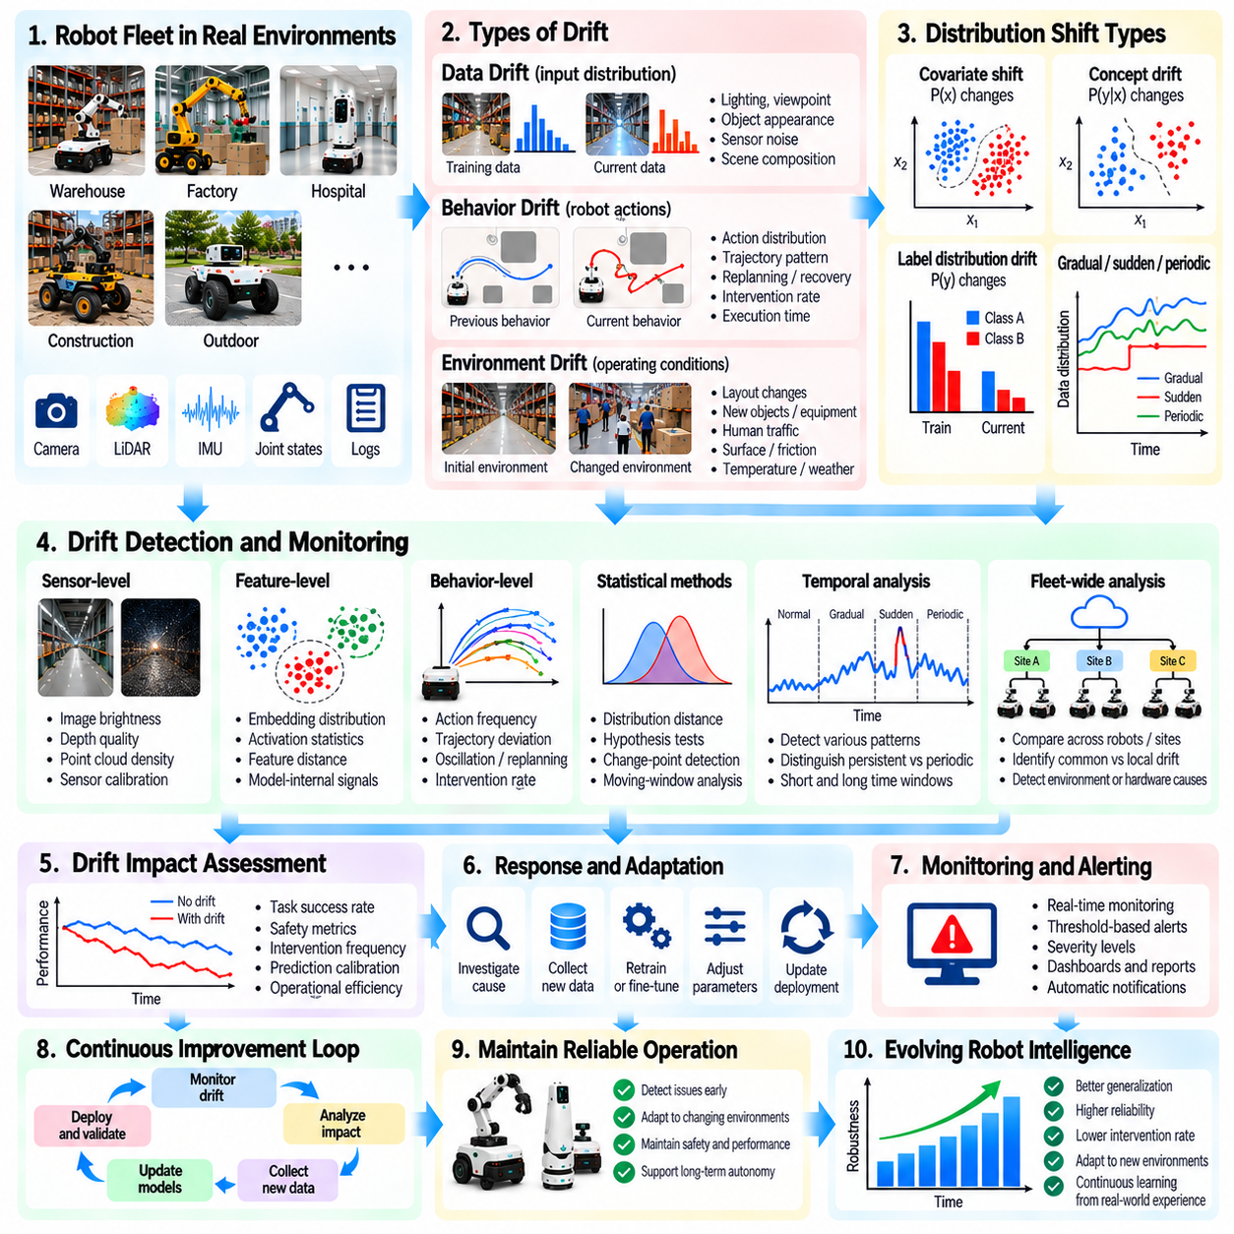
Data, behavior, and environment drift describe changes that gradually weaken the relationship between a Physical AI model's training experience and its operating conditions. As robot fleets expand across sites, tasks, and hardware configurations, previously reliable models may encounter unfamiliar distributions. Detecting these changes is essential for maintaining perception accuracy, decision quality, and control stability throughout continuous deployment.
Data drift occurs when the statistical properties of incoming observations differ from those represented in training datasets. Changes in lighting, camera viewpoints, object appearance, sensor noise, or scene composition can alter input distributions. A perception model trained in controlled warehouses may encounter unexpected visual patterns in outdoor facilities. Such differences can reduce reliability even when the underlying task remains unchanged.
Behavior drift concerns changes in how robots act, respond, or interact with their surroundings over time. Updated policies, actuator wear, altered payloads, and changing operational procedures may produce different action distributions. A mobile robot might gradually increase corrective steering movements despite maintaining acceptable navigation success. Monitoring behavior distributions can reveal emerging problems before they become obvious task failures.
Environment drift reflects changes in the physical and operational conditions surrounding deployed robots. Warehouses may introduce new shelving layouts, factories may replace production equipment, and construction sites may evolve daily. Temperature, surface friction, pedestrian traffic, and obstacle density can also change. These variations influence both sensor observations and the physical consequences of robot actions.
Several forms of distribution shift are relevant to Physical AI. Covariate shift changes the frequency of observed inputs, while concept drift changes relationships between observations and desired predictions or actions. Label distribution changes may also occur as task populations evolve. Distinguishing these mechanisms helps engineers determine whether problems require additional data, revised labels, model adaptation, or operational changes.
Drift detection begins with establishing reliable reference distributions. Training datasets, validated deployment periods, and representative operating environments provide baseline statistics. Reference data should capture normal variation across sites, robot configurations, and task categories. An overly narrow baseline may generate excessive alerts, while an overly broad baseline can conceal meaningful degradation in specific operating conditions.
Sensor-level monitoring identifies changes in image brightness, depth quality, point-cloud density, inertial measurements, and other observation characteristics. Statistical summaries and quality indicators can reveal calibration shifts, contamination, or environmental changes. However, raw sensor differences do not always imply model failure. Engineers must distinguish harmless variation from changes that affect task-relevant information.
Feature-level monitoring examines internal model representations rather than relying exclusively on raw measurements. Embedding distributions, activation statistics, and learned scene features may reveal unfamiliar operating conditions. Distances between current and reference feature distributions can provide early warnings. Feature-based indicators remain dependent on model architecture and should be validated against actual operational outcomes.
Behavioral monitoring evaluates action frequencies, trajectory characteristics, intervention rates, and controller responses. Increased oscillation, repeated replanning, longer completion times, or unusual recovery maneuvers may indicate behavioral drift. These patterns can emerge from changing environments or internal system degradation. Correlating behavior changes with perception and hardware diagnostics helps identify plausible causes.
Drift detection methods include distribution distance measures, statistical hypothesis tests, moving-window comparisons, and change-point detection. Population Stability Index, Wasserstein distance, and maximum mean discrepancy can quantify selected distribution differences. Sequential monitoring can identify gradual or abrupt changes. No single metric reliably captures every form of drift, so indicators should be chosen according to their operational relevance.
Temporal analysis is important because drift may occur gradually, suddenly, or periodically. Seasonal lighting changes can create recurring patterns, while sensor replacement may cause an abrupt distribution shift. Progressive actuator wear can generate slow behavioral changes that remain hidden in short observation windows. Monitoring systems should distinguish persistent degradation from expected daily or seasonal variability.
Fleet-wide drift analysis compares patterns across robots, locations, and model versions. A change affecting every robot at one site may indicate an environmental modification, while similar failures across multiple sites may suggest a shared model limitation. Drift restricted to one robot may indicate hardware deterioration or calibration problems. Hierarchical analysis helps prioritize corrective actions and avoid unnecessary fleet-wide retraining.
Drift severity should be evaluated according to operational consequences rather than statistical distance alone. A substantial change in background appearance may have little effect on navigation, while a small shift in obstacle perception can increase collision risk. Task success, safety margins, intervention frequency, and prediction calibration provide practical context. Drift alerts become more useful when connected to measurable changes in robot performance.
Uncertainty estimates can complement distribution monitoring by identifying observations outside familiar operating regions. Increased prediction entropy, model disagreement, or state-estimation covariance may indicate reduced confidence. However, some models remain overconfident under unfamiliar conditions. Combining calibrated uncertainty with distribution indicators and observed failures provides stronger evidence than relying on any single signal.
Drift monitoring must also account for changes introduced by the monitoring system itself. Updated sensor preprocessing, altered logging frequencies, annotation revisions, or new model architectures can create artificial differences between datasets. Versioned metadata and consistent measurement definitions help prevent false conclusions. Engineers should verify pipeline compatibility before attributing observed changes to physical environments or robot behavior.
When significant drift is detected, the data engine should generate targeted investigation and collection requests. Relevant episodes can be retrieved using environmental attributes, behavior signatures, uncertainty scores, and model versions. Additional recording may focus on newly introduced objects, unusual motion patterns, or changing surface conditions. This connects drift detection with active learning and model error-to-data querying.
Corrective responses depend on the source and consequences of drift. Sensor recalibration or hardware maintenance may resolve equipment-related changes, while revised operational procedures can address workflow modifications. Genuine model limitations may require targeted fine-tuning or broader retraining. Safety-critical degradation may require restricting tasks, reducing operating speeds, or reverting to a previously validated configuration.
Model updates intended to address drift must be evaluated for generalization and regression. Training heavily on recent environments can improve local performance while weakening capabilities in previously supported conditions. Historical replay, balanced sampling, and cross-site evaluation help preserve existing competence. Shadow testing and limited canary deployment provide additional evidence before updated models are released broadly.
Drift management effectiveness can be measured through detection delay, false alert rates, incident reduction, recovery time, and model performance after adaptation. Monitoring coverage across sites and operating conditions is equally important. Engineers should assess whether detected changes lead to useful corrective actions rather than simply generating more alerts. Continuous calibration of monitoring thresholds improves operational efficiency.
Ultimately, data, behavior, and environment drift monitoring allows Physical AI fleets to recognize when accumulated knowledge no longer matches changing physical reality. By combining statistical detection, operational diagnostics, targeted data collection, and controlled model adaptation, fleets can respond to evolving conditions systematically. This capability supports long-term reliability, safer deployment, and sustained learning across diverse real-world environments.

09.15. Cross Robot and Cross Site Experience Sharing
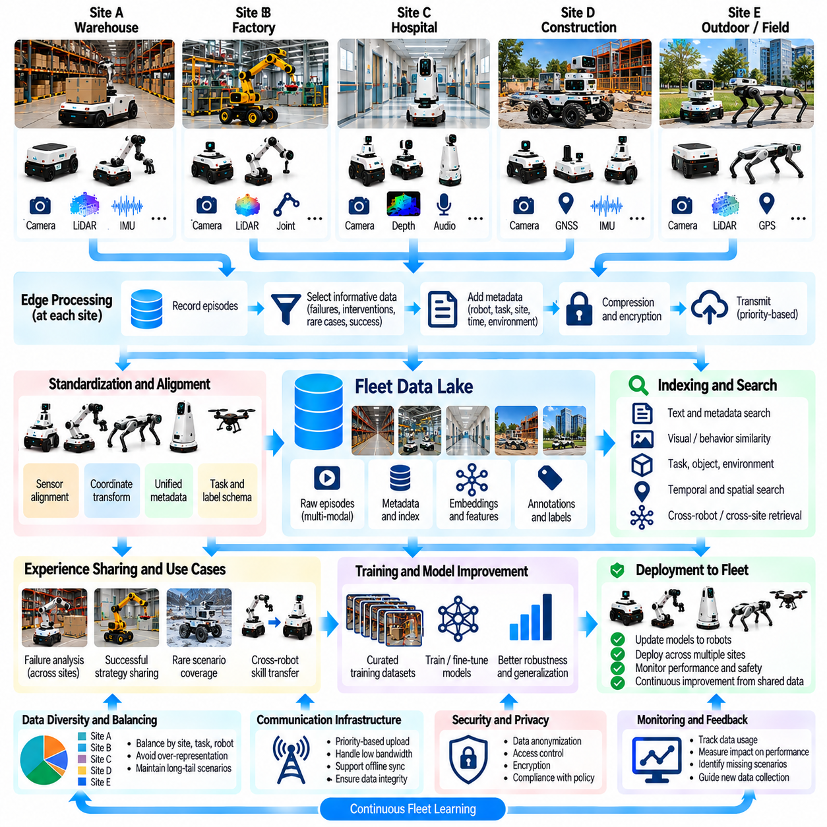
Cross-robot and cross-site experience sharing enables Physical AI fleets to learn collectively from operational events distributed across different robots and environments. Instead of treating each deployment as an isolated learning system, shared data infrastructure connects local observations, task outcomes, and recovery experiences. This approach expands the diversity of available training evidence and allows improvements discovered at one location to benefit other deployments.
Individual robots encounter only a limited portion of the conditions represented across a large fleet. One warehouse robot may experience reflective floors, while another encounters narrow passages or unusual obstacle configurations. Sharing these experiences creates broader coverage of operational variability. Fleet learning becomes more effective when rare but informative situations are preserved and made accessible beyond their original deployment locations.
Cross-robot sharing requires consistent representations of observations, actions, and task outcomes. Different robots may use distinct sensor configurations, coordinate frames, control frequencies, and software versions. Standardized metadata and transformation procedures help align these differences. Without sufficient normalization, combining recordings from multiple platforms can introduce inconsistencies that reduce training quality and obscure the physical meaning of recorded behavior.
Cross-site experience sharing introduces additional variation in environmental layouts, lighting, surface properties, operating procedures, and human activity. These differences provide opportunities to improve model robustness and generalization. However, site-specific characteristics should remain identifiable within shared datasets. Preserving environmental context allows learning systems to distinguish broadly transferable patterns from behaviors that depend on local conditions.
A shared fleet data architecture typically connects onboard recording systems, local storage gateways, and centralized data services. Robots capture sensor observations, executed actions, state estimates, and operational events. Edge processing selects relevant episodes and attaches contextual metadata before transmission. Centralized infrastructure indexes incoming experiences and makes them available for analysis, retrieval, annotation, and model training.
Experience packages should preserve sufficient information to reconstruct the circumstances surrounding an event. Robot identity, hardware configuration, model version, task description, timestamps, environmental attributes, and execution outcomes provide essential context. Sensor calibration and coordinate transformation information are also important. Complete provenance enables engineers to compare experiences without assuming that all robots observe or interact with the world identically.
Sharing mechanisms should prioritize informative experiences rather than indiscriminately transferring every recording. Rare failures, successful recoveries, uncertain predictions, and unfamiliar environmental conditions often provide substantial learning value. Selection policies can consider novelty, severity, diversity, and expected model improvement. This reduces communication and storage costs while preserving episodes that contribute meaningfully to collective fleet intelligence.
Semantic indexing allows robots and learning pipelines to retrieve experiences using task descriptions, object categories, environmental conditions, and behavioral signatures. Embedding-based search can identify similar situations even when explicit labels are incomplete. A navigation failure observed at one site may therefore reveal related episodes from several other facilities. Retrieval systems must retain physical context because semantic similarity does not always imply equivalent dynamics.
Experience sharing can support collaborative failure analysis across geographically distributed deployments. When several robots exhibit similar localization errors, engineers can compare sensor characteristics, environmental conditions, and model predictions. Shared evidence helps determine whether the problem originates from a common model limitation or site-specific infrastructure. This distinction guides targeted retraining, recalibration, maintenance, and operational changes.
Successful experiences are equally important because they reveal reliable strategies under challenging conditions. A robot that completes a difficult grasp or recovers from temporary localization uncertainty may provide useful demonstrations for other fleet members. Comparing successful and unsuccessful episodes supports contrastive learning and policy improvement. Nevertheless, transferred demonstrations must be evaluated for compatibility with the receiving robot's capabilities.
Fleet experience aggregation must account for uneven data production across robots and sites. High-traffic facilities may generate far more recordings than smaller deployments, causing shared datasets to overrepresent particular environments. Diversity-aware sampling and site-balanced weighting can reduce this bias. Engineers should measure coverage across tasks, environments, hardware configurations, and failure categories rather than relying on recording volume alone.
Communication infrastructure influences how rapidly experiences become available throughout the fleet. High-bandwidth sites may upload detailed recordings immediately, while remote deployments may require delayed synchronization or compressed summaries. Priority-based transmission can accelerate sharing of critical events. Reliable synchronization should tolerate intermittent connectivity and preserve data integrity without disrupting real-time robot control.
Privacy, security, and ownership constraints must be incorporated into cross-site sharing. Robot recordings may contain identifiable people, proprietary facility layouts, or commercially sensitive operational information. Access controls, encryption, retention policies, and selective anonymization help limit inappropriate exposure. Data-sharing agreements should specify permitted uses and responsibilities, particularly when fleets operate across different organizations or jurisdictions.
Not every experience should be transferred directly into a common training dataset. Differences in sensor quality, task definitions, action semantics, and hardware dynamics can create misleading supervision. Quality validation should identify corrupted recordings, incompatible schemas, and uncertain outcomes. Dataset construction may require domain-specific transformations or separate training subsets to preserve meaningful distinctions between deployment contexts.
Shared experiences can improve models through centralized training, distributed learning, or selective knowledge transfer. Centralized pipelines combine compatible datasets to update common perception and planning components. Federated learning may exchange model updates when raw data movement is restricted, although statistical heterogeneity and privacy risks remain. The appropriate approach depends on infrastructure, governance requirements, and model compatibility.
Cross-site evaluation is necessary to determine whether shared learning produces transferable improvements. A model trained with additional warehouse experiences should be tested at locations not represented in the latest training cycle. Evaluation should examine task success, safety margins, intervention rates, and performance across environmental variations. Improvements at contributing sites are insufficient if the updated model performs poorly elsewhere.
Experience sharing also supports rapid responses to newly discovered operational hazards. When one robot encounters an unfamiliar obstacle or recurring failure condition, the event can be distributed as a diagnostic pattern or collection priority. Other robots may monitor for similar conditions without immediately changing their control policies. Validated model updates can then be introduced through controlled deployment procedures rather than uncontrolled fleet-wide adaptation.
A fleet knowledge system should maintain relationships between shared experiences, resulting dataset updates, model versions, and observed performance changes. This traceability helps engineers identify which deployments contributed useful evidence and whether subsequent improvements generalized successfully. Feedback from receiving sites can refine future sharing priorities. The resulting learning loop connects distributed operational discovery with coordinated model development.
The effectiveness of experience sharing can be measured through useful episode reuse, cross-site coverage, retrieval relevance, transfer performance, and reduction in repeated failures. Communication cost, annotation effort, and time from discovery to validated improvement are also important. Evaluation should compare collective learning against isolated site-specific development. The objective is measurable improvement in fleet capability rather than maximizing the quantity of exchanged data.
Ultimately, cross-robot and cross-site experience sharing transforms geographically distributed deployments into a coordinated learning ecosystem. By preserving context, standardizing representations, selecting informative episodes, and validating transferability, Physical AI fleets can benefit from experiences beyond any individual robot's operating history. Combined with secure data governance and continuous evaluation, this approach supports scalable collective intelligence and more reliable autonomous operation.

09.16. Cross Embodiment Data Sharing
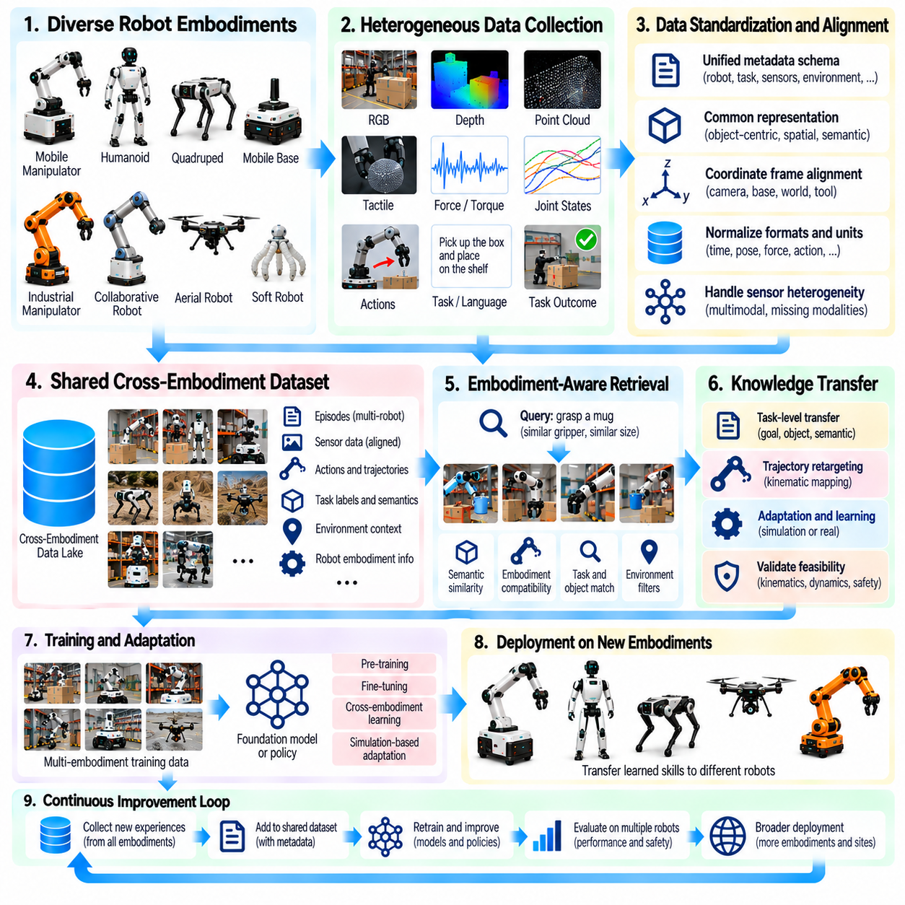
Cross-embodiment data sharing enables Physical AI systems with different mechanical structures, sensors, and actuation capabilities to benefit from common operational experiences. A mobile manipulator, humanoid robot, and industrial arm may perform related tasks despite having different physical configurations. Sharing knowledge across these platforms expands training diversity and reduces the need to collect every task demonstration independently for each robot design.
Robot embodiment describes the physical characteristics through which intelligence interacts with the environment. These characteristics include joint arrangements, degrees of freedom, actuator capabilities, sensor placement, body geometry, and mobility mechanisms. Embodiment determines which actions are physically achievable and how observations relate to movement. Consequently, data sharing must preserve both task meaning and the physical constraints of the originating robot.
Cross-embodiment learning begins by identifying information that remains useful across different robot morphologies. Object properties, scene geometry, task objectives, contact relationships, and successful manipulation strategies may contain transferable knowledge. In contrast, joint torques, actuator commands, and platform-specific trajectories are often tightly coupled to hardware. Separating transferable concepts from embodiment-dependent details is fundamental to reliable sharing.
A common representation provides an interface between heterogeneous robot datasets. Observations may be expressed through object-centric states, spatial relationships, semantic task descriptions, or three-dimensional scene representations. Actions can be represented as desired end-effector poses, object transformations, or task-level goals. These abstractions allow learning systems to compare experiences without requiring identical joint configurations or actuator interfaces.
Coordinate frame alignment is necessary when transferring geometric information between robots. Camera frames, robot base frames, world coordinates, and tool frames may differ significantly across platforms. Calibration records and transformation matrices help establish consistent spatial relationships. Incorrect transformations can produce misleading demonstrations or unsafe motion targets, making geometric validation essential before shared data enters training pipelines.
Action representation presents a major challenge because robots may accomplish the same objective through different physical movements. A humanoid may grasp an object using a multi-fingered hand, while an industrial arm uses a parallel gripper. Both actions may share an object-level goal but require different contact patterns and force control. Task-space representations help separate intended outcomes from embodiment-specific execution details.
Kinematic retargeting maps demonstrated movements from one robot structure to another. The process considers joint limits, reachable workspaces, link geometry, and end-effector constraints. Optimization methods may preserve important task-space trajectories while adjusting joint configurations for the receiving robot. However, a geometrically feasible motion does not guarantee dynamic feasibility, stable contact, or safe execution.
Dynamic differences further complicate experience transfer. Robots may vary in mass distribution, actuator bandwidth, payload capacity, friction characteristics, and compliance. A trajectory that succeeds on a powerful industrial manipulator may overload a smaller collaborative robot. Shared data should therefore include relevant force, velocity, acceleration, and contact information. Receiving platforms must validate transferred behaviors against their own physical limits.
Sensor heterogeneity also affects the interpretation of shared experiences. One robot may use stereo cameras and tactile sensors, while another relies on depth cameras and force-torque measurements. Missing modalities can prevent direct reproduction of the original policy inputs. Multimodal representations, sensor-independent scene features, and modality-specific encoders can support partial transfer, although information lost through absent sensors cannot always be recovered.
Task semantics provide another mechanism for sharing knowledge across embodiments. Instructions such as opening a drawer, transporting an object, or placing an item on a shelf describe goals that multiple robot types may understand. High-level task representations can capture preconditions, object relationships, and success criteria independently of hardware. Each robot then translates these shared goals into feasible local actions using its own planning and control systems.
Cross-embodiment datasets require metadata describing both the originating platform and the intended transfer context. Robot morphology, joint definitions, sensor configuration, controller frequency, payload limits, and task constraints should accompany recorded episodes. Standardized schemas make these properties searchable and interpretable. Without such metadata, training systems may incorrectly treat incompatible demonstrations as equivalent examples.
Embodiment-aware indexing improves retrieval by considering mechanical compatibility alongside semantic similarity. A robot searching for grasp demonstrations may prioritize examples involving similar gripper geometry, object dimensions, and contact requirements. More distant embodiments may still provide useful task-level information. Retrieval systems should distinguish directly executable demonstrations from experiences that require abstraction, adaptation, or simulation-based retargeting.
Shared datasets must avoid overrepresenting common robot configurations. Large fleets of identical manipulators may produce far more recordings than specialized mobile or humanoid platforms. Naive aggregation can bias foundation models toward dominant embodiments and reduce performance on less represented systems. Embodiment-balanced sampling, platform-specific weighting, and diversity-aware selection help preserve broader coverage of robot capabilities.
Learning architectures can combine shared representations with embodiment-specific components. A common perception encoder or task reasoning model may process experiences from multiple platforms, while specialized action decoders generate commands appropriate for each robot. Morphology tokens, robot descriptors, or structured kinematic parameters can condition model behavior. Such designs encourage knowledge sharing without assuming that all embodiments support identical actions.
Cross-embodiment transfer may also benefit from human demonstrations and simulation-generated experiences. Human motion provides examples of task intent and object interaction, but direct reproduction requires accounting for differences in anatomy and actuation. Simulation allows demonstrations to be retargeted across virtual robot configurations and tested under controlled conditions. Physical validation remains necessary because simulated feasibility does not establish reliable real-world performance.
Safety constraints must remain specific to the receiving embodiment. Transferred actions should be checked against joint limits, collision boundaries, actuator loads, stability requirements, and human proximity constraints. A successful demonstration from another platform is not evidence that the same movement is safe locally. Independent safety controllers and staged evaluation should govern execution, particularly when transferred knowledge affects physical contact or locomotion.
Evaluation should distinguish task-level knowledge transfer from successful low-level action transfer. Shared perception or planning knowledge may improve object recognition and task sequencing even when direct motion imitation is impossible. Metrics can include task success, adaptation data requirements, motion feasibility, contact stability, and safety violations. Testing across previously unseen robot configurations provides evidence of whether learned representations generalize beyond their training embodiments.
Negative transfer occurs when shared experiences introduce assumptions that are inappropriate for the receiving platform. A policy may learn contact strategies requiring unavailable degrees of freedom or force capabilities. Such failures can reduce performance despite increasing training data volume. Compatibility filtering, embodiment-conditioned learning, and controlled fine-tuning help limit negative transfer while preserving useful shared knowledge.
Cross-embodiment sharing effectiveness can be measured through reduced demonstration requirements, faster adaptation, improved task coverage, and performance on previously unseen platforms. Evaluation should compare shared training against embodiment-specific baselines under equivalent data and computing budgets. Communication costs, annotation requirements, and retargeting complexity also influence practical value. Successful transfer must demonstrate operational benefits rather than representation similarity alone.
Ultimately, cross-embodiment data sharing transforms heterogeneous robot fleets into a broader learning ecosystem. By separating task knowledge from hardware-specific execution, aligning representations, preserving morphology metadata, and validating transferred behaviors, Physical AI systems can reuse experiences across different physical designs. Combined with continuous evaluation and safety-aware adaptation, this approach supports more scalable and generalizable robot intelligence.

09.17. Fleet World Memory and Shared Experience
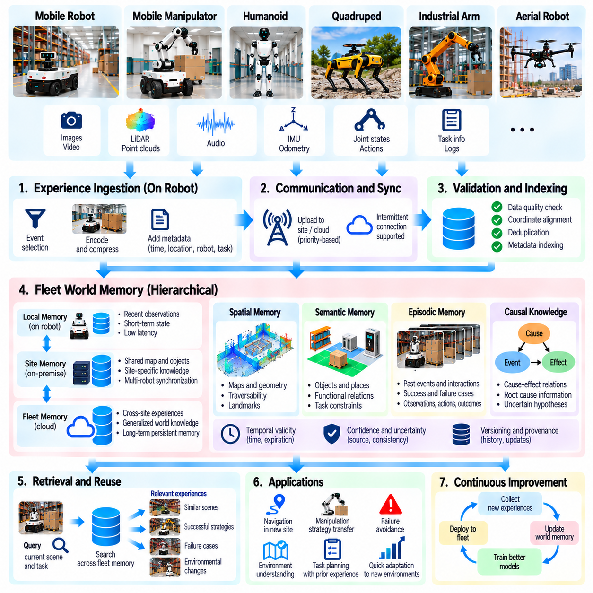
Fleet world memory provides a shared knowledge foundation through which distributed robots can retain and reuse information about environments, objects, tasks, and previous interactions. Unlike isolated robot memory, fleet memory integrates experiences collected across multiple locations and operating periods. This collective representation allows robots to benefit from observations made by other fleet members without directly experiencing every situation themselves.
A fleet world memory system must distinguish persistent knowledge from temporary observations. Building layouts, equipment locations, and object properties may remain stable for extended periods, while pedestrian positions and temporary obstacles change rapidly. Memory architectures should represent these different time scales explicitly. Separating stable structure from dynamic state reduces unnecessary updates and prevents outdated observations from influencing current decisions.
Spatial memory forms an important component of shared world knowledge. Robots can contribute maps, geometric landmarks, traversability estimates, and semantic descriptions of operational spaces. Local observations are aligned with common reference frames before integration into shared representations. Accurate localization and map registration are essential because inconsistent coordinate systems can introduce false obstacles, duplicated structures, or incorrect navigation guidance.
Semantic memory describes the meaning and functional relationships of objects, locations, and activities. A warehouse robot may identify loading zones, storage racks, charging stations, and restricted areas. Other robots can reuse these descriptions when planning tasks in the same facility. Semantic relationships also support queries about object accessibility, task dependencies, and operational constraints that cannot be represented adequately through geometry alone.
Episodic memory preserves records of specific events and interactions. A robot may remember an unsuccessful grasp, a blocked corridor, or a successful recovery from localization failure. Each episode includes relevant observations, actions, outcomes, and environmental context. When similar conditions arise elsewhere, retrieval mechanisms can identify useful precedents and support decision-making without requiring the robot to repeat the original trial.
Shared experience becomes more valuable when memories are organized around causal relationships rather than simple event similarity. A navigation failure may result from reflective surfaces, incorrect localization, or unexpected human movement. Recording diagnostic evidence alongside outcomes helps distinguish these causes. Causal interpretations should remain uncertain when evidence is incomplete, preventing fleet memory from turning speculative explanations into established operational facts.
Memory ingestion begins when robots detect events or observations worth retaining. Onboard systems may select unusual situations, newly discovered objects, environmental changes, and significant task outcomes. Local processing attaches timestamps, location estimates, robot configuration, and confidence information. These records are then transmitted to shared infrastructure, where validation and indexing determine how they contribute to collective knowledge.
A scalable memory architecture often combines local robot memory, site-level memory, and fleet-wide memory services. Local memory supports low-latency control and immediate context, while site memory maintains shared environmental information for nearby robots. Fleet-wide services aggregate transferable experiences and generalized knowledge. Hierarchical organization reduces communication requirements and keeps safety-critical decisions independent of remote connectivity.
Memory synchronization must handle delayed updates, conflicting observations, and intermittent communication. Two robots may report different states for the same location because observations were collected at different times. Versioning, timestamps, source reliability, and uncertainty estimates help reconcile these differences. When conflicts cannot be resolved confidently, the system should preserve competing hypotheses or request additional observations instead of forcing premature agreement.
Temporal validity is essential because physical environments continuously evolve. A previously accessible passage may become blocked, equipment may be relocated, or a temporary obstacle may disappear. Memory entries should therefore include observation times, expected persistence, and expiration or revalidation policies. Time-aware retrieval prevents robots from treating historical environmental states as guaranteed descriptions of present conditions.
Confidence-aware memory represents uncertainty associated with stored knowledge. Sensor noise, incomplete observations, ambiguous object identities, and inconsistent reports can reduce reliability. Confidence estimates may be updated when independent robots confirm or contradict existing records. However, repeated observations from correlated sensors should not automatically be treated as independent evidence. Reliable fusion requires attention to measurement dependencies.
Retrieval mechanisms connect stored experiences with current perception and task context. Robots may search for similar scenes, object interactions, environmental hazards, or recovery strategies. Spatial indexing, semantic search, and learned embeddings can support efficient retrieval from large memory collections. Retrieved information should be ranked by relevance, freshness, reliability, and compatibility with the requesting robot's capabilities.
Fleet world memory can support collaborative mapping and environmental change detection. When several robots traverse the same facility, their observations can improve coverage and identify discrepancies between stored maps and current conditions. Confirmed changes can update shared spatial representations and trigger local replanning. Robots operating elsewhere may receive relevant updates before entering affected areas, improving preparation without assuming that all reported changes remain valid.
Shared memory also supports task-level learning by preserving successful procedures and operational dependencies. A robot may discover an efficient sequence for inspecting equipment or transporting materials through a complex facility. Other robots can retrieve the procedure and adapt it to their capabilities. Task memories should describe goals, preconditions, required resources, and observed outcomes so that reuse remains grounded in the receiving environment.
Memory consolidation converts repeated experiences into more compact and reusable knowledge. Similar episodes may reveal stable environmental patterns, common failure mechanisms, or reliable task strategies. Summarization and clustering reduce storage demands while supporting broader generalization. Original evidence should remain traceable because compressed memories can omit important exceptions, uncertainty, or context needed for safety-critical decisions.
Privacy and security requirements influence what information can enter shared world memory. Environmental recordings may reveal personal activities, restricted facility layouts, or sensitive operational procedures. Access controls, encryption, data minimization, and retention policies should govern storage and retrieval. Memory sharing must respect organizational boundaries, ensuring that useful collective learning does not expose information beyond authorized purposes.
Memory quality requires continuous evaluation rather than assuming that accumulated information remains useful. Metrics may include retrieval accuracy, map consistency, temporal freshness, task improvement, and reduction in repeated failures. Engineers should also monitor false memories, duplicate entries, and outdated knowledge. Evaluation must determine whether retrieved experiences improve decisions compared with operation without shared memory.
Integration with model training creates a feedback loop between stored experiences and learned capabilities. Frequently retrieved failures can identify gaps in existing policies, while successful episodes provide candidate demonstrations for training. Updated models can generate new observations that further refine memory. Keeping memory updates separate from model parameter changes allows faster knowledge revision while preserving controlled validation of learned behavior.
Fleet world memory ultimately extends individual robot experience into a persistent collective representation of physical environments and operational knowledge. Its effectiveness depends on accurate context, temporal validity, uncertainty management, scalable retrieval, and secure governance. By combining local autonomy with carefully validated shared experience, Physical AI fleets can improve coordination, reduce repeated mistakes, and accumulate knowledge across deployments.

09.18. Event Mining and Drift Monitoring [w/Code]
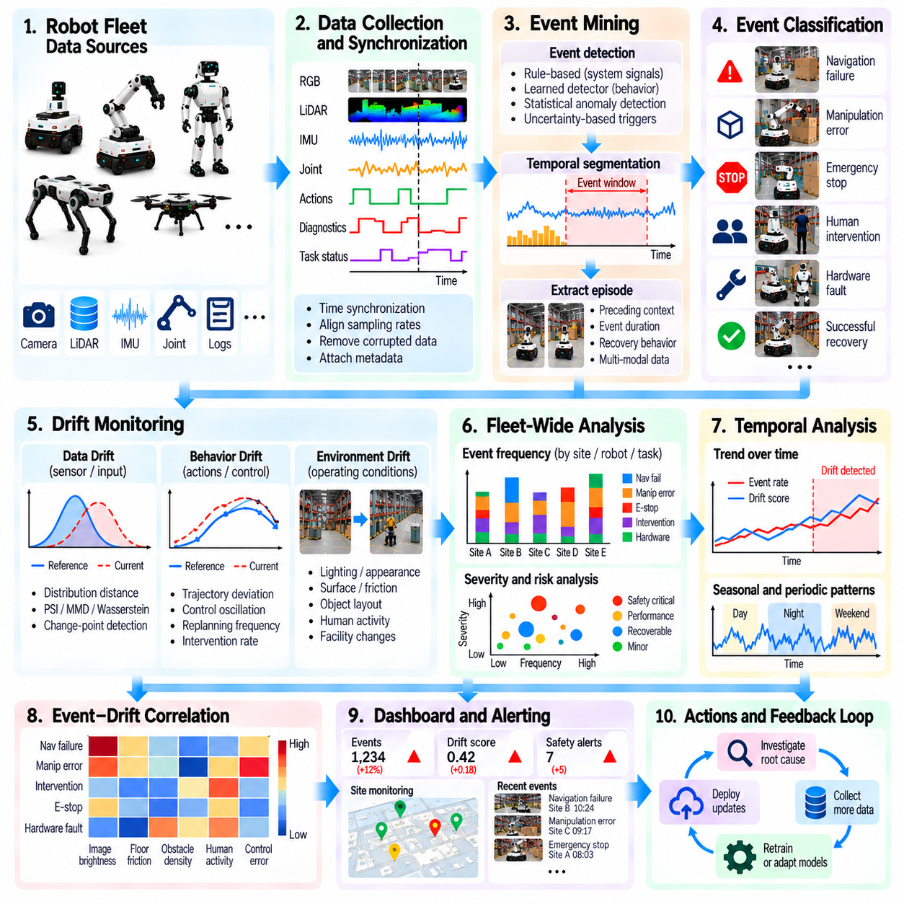
Event mining and drift monitoring enable Physical AI fleets to discover meaningful operational patterns and detect changes that may affect performance, safety, and reliability. Robots continuously generate sensor observations, action histories, system diagnostics, and task outcomes. Analyzing these records across deployments reveals recurring failures, emerging anomalies, and environmental changes. The objective is to transform large volumes of fleet data into actionable evidence for system improvement.
Event mining identifies significant occurrences within continuous robot operation. Events may include navigation failures, unexpected collisions, manipulation errors, emergency stops, human interventions, or successful recovery maneuvers. Many important events are hidden within otherwise routine recordings. Automated detection extracts relevant time intervals and contextual information, allowing engineers to investigate operational behavior without manually reviewing entire data streams.
An event mining pipeline begins with synchronized data collection from sensors, controllers, planning systems, and diagnostic modules. Timestamps connect observations with robot actions and execution outcomes. Preprocessing removes corrupted measurements, aligns sampling rates, and verifies metadata consistency. Reliable synchronization is essential because incorrect temporal relationships can produce misleading explanations of failures or unexpected behavior.
Event definitions may combine explicit system signals with learned behavioral indicators. Emergency stops and controller faults provide structured triggers, while unusual trajectories or uncertain predictions require statistical or machine learning methods. Rule-based detection offers interpretability but may miss unfamiliar failures. Learned detectors can discover complex patterns, although their outputs require validation against operational evidence.
Temporal segmentation determines the beginning, duration, and conclusion of an event. A navigation failure may involve several seconds of localization uncertainty before a robot stops. Capturing only the final error message can omit the conditions responsible for the failure. Event windows should therefore include relevant preceding observations, executed actions, and recovery attempts while avoiding unnecessary recording volume.
Event classification organizes detected episodes into meaningful operational categories. Labels may describe obstacle encounters, perception failures, control instability, hardware faults, or environmental disturbances. Hierarchical taxonomies allow broad analysis while preserving detailed failure mechanisms. Classification confidence and ambiguous cases should be retained because premature labeling can introduce systematic errors into downstream training datasets.
Fleet-wide event aggregation reveals patterns that isolated robot analysis may overlook. A rare failure on one robot may become statistically significant when similar events occur across hundreds of deployments. Aggregated analysis can compare event frequencies by location, task, robot model, and software version. These comparisons help identify shared weaknesses and distinguish widespread problems from localized operational disturbances.
Event frequency alone is insufficient for determining operational importance. A common recovery maneuver may have little safety impact, while a rare near-collision can indicate a serious hazard. Severity, exposure, recovery cost, and potential consequences should influence event prioritization. Risk-aware mining helps direct engineering attention toward situations where corrective action can produce the greatest operational benefit.
Drift monitoring complements event mining by detecting changes in data distributions, robot behavior, and environmental conditions over time. Sensor characteristics, action patterns, task completion times, and intervention frequencies may gradually diverge from validated baselines. Such changes can precede obvious failures. Continuous monitoring provides early evidence that operating conditions or system performance no longer match previous expectations.
Statistical drift indicators compare current observations with reference distributions established during training or validated deployment. Measures such as Wasserstein distance, population stability index, and maximum mean discrepancy can quantify selected changes. Moving windows and change-point detection identify gradual or abrupt shifts. Indicators must be calibrated against task outcomes because statistical differences do not necessarily imply operational degradation.
Behavioral drift analysis examines changes in trajectories, control corrections, replanning frequency, and recovery strategies. Increasing steering oscillation may indicate localization problems, mechanical wear, or altered floor conditions. Similar symptoms can arise from different causes. Combining behavioral signals with hardware diagnostics, environmental metadata, and model predictions improves interpretation and reduces unnecessary retraining.
Environmental drift monitoring identifies changes in lighting, surface properties, obstacle configurations, human activity, and facility layouts. A warehouse may introduce new equipment, while an outdoor robot may encounter seasonal weather patterns. Contextual monitoring helps distinguish expected environmental variation from unfamiliar conditions that threaten model reliability. Site-specific baselines are important because normal operating conditions differ across deployments.
Event mining and drift monitoring become especially powerful when analyzed together. A rising rate of manipulation failures may coincide with changes in object appearance or gripper force measurements. Temporal correlation can reveal plausible relationships between environmental shifts and operational outcomes. However, correlation alone does not establish causality, so diagnostic testing and controlled comparisons remain necessary.
Anomaly clustering groups related events using behavioral signatures, sensor features, task context, and failure outcomes. Embedding-based retrieval can discover previously unrecognized failure families across different robots and sites. Clusters should be inspected for misleading similarities caused by irrelevant background features. Validated clusters can become new event categories and guide targeted data collection or model evaluation.
Monitoring systems must manage false alerts and missed detections. Excessively sensitive thresholds can overwhelm engineers with harmless variation, while conservative thresholds may overlook emerging safety risks. Alert policies should account for event severity, persistence, confidence, and operational context. Feedback from investigations can refine thresholds and improve detector calibration as fleet conditions evolve.
Automated event-to-data pipelines connect monitoring results with the broader Physical AI data engine. High-value episodes can be extracted, anonymized when necessary, indexed, and routed for annotation or model evaluation. Repeated failures may trigger targeted collection requests, while novel events can become regression test cases. This process converts operational monitoring into a structured source of training and validation evidence.
Cross-site comparison helps determine whether detected changes require local maintenance or fleet-wide model improvement. Drift restricted to one robot may indicate sensor misalignment or actuator deterioration. Similar event patterns across different environments may expose limitations in shared perception or planning models. Hierarchical analysis prevents localized problems from automatically triggering expensive global retraining.
Monitoring infrastructure must preserve traceability across event definitions, detector versions, robot configurations, and model releases. Changes in logging pipelines or software updates can create artificial shifts that resemble environmental drift. Versioned records and consistent measurement definitions support reliable historical comparisons. Auditability also allows engineers to reconstruct why an alert was generated and which corrective actions followed.
The effectiveness of event mining and drift monitoring can be measured through detection latency, event classification accuracy, false alert rates, incident reduction, and recovery time. Additional metrics include useful episode yield, data collection efficiency, and improvement after corrective actions. Evaluation should determine whether monitoring produces measurable operational benefits rather than merely increasing the number of detected events.
Ultimately, event mining and drift monitoring transform fleet operation into a continuous source of structured learning signals. By combining synchronized event extraction, statistical change detection, contextual diagnosis, and targeted data collection, Physical AI systems can identify weaknesses before they spread across deployments. This integrated feedback mechanism supports safer autonomy, faster engineering response, and sustained improvement throughout the fleet lifecycle.

09.19. Toward Self Improving Physical AI Fleets
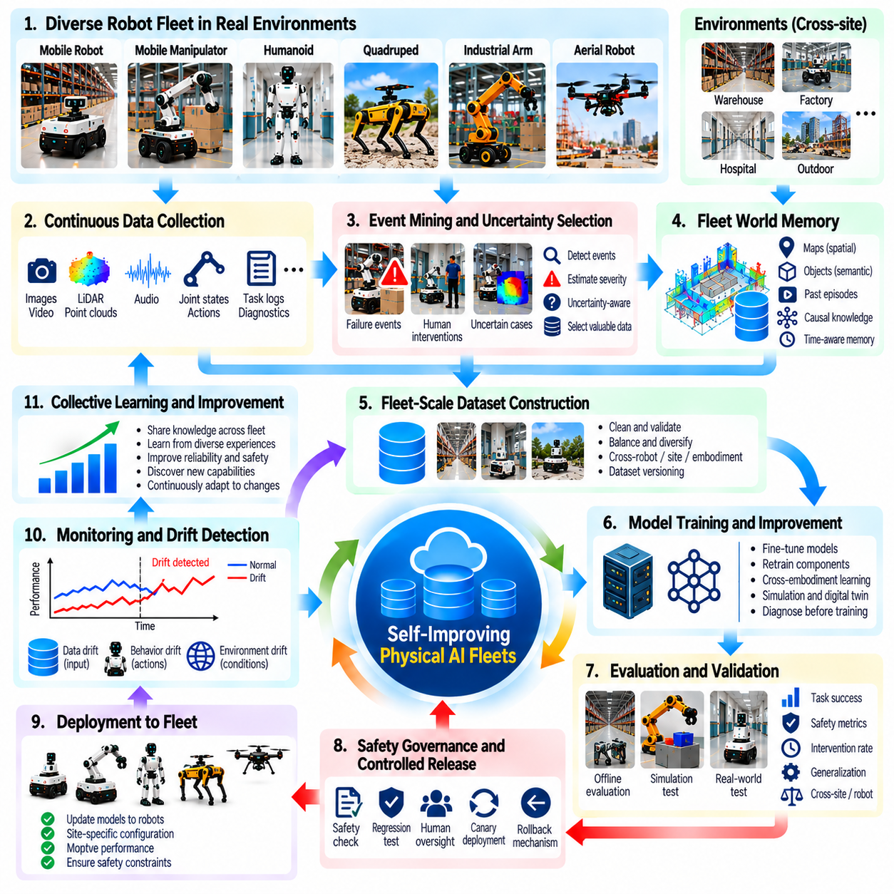
Self-improving Physical AI fleets represent a transition from individually programmed robots toward coordinated systems that continuously improve through operational experience. Each robot contributes observations, actions, failures, and successful recoveries to a shared learning process. The fleet becomes a distributed source of training evidence, allowing improvements discovered during deployment to influence future perception, planning, and control capabilities.
The foundation of self-improvement is a closed-loop relationship between deployment, data collection, model development, evaluation, and controlled release. Robots execute tasks and generate operational records, while data engines identify experiences that reveal weaknesses or new capabilities. Selected episodes become training and validation evidence. Updated models return to deployment only after demonstrating measurable improvements without unacceptable regressions.
Fleet-scale learning differs from isolated robot adaptation because knowledge can propagate across locations, tasks, and hardware configurations. A navigation failure discovered in one warehouse may expose a limitation affecting robots at other facilities. Shared analysis can identify related conditions before widespread failures occur. This collective learning mechanism reduces duplicated experimentation and increases the value of operational experience.
Continuous observation provides the evidence needed to guide improvement. Sensor measurements, state estimates, action histories, task outcomes, human interventions, and system diagnostics describe how robots interact with changing environments. Reliable timestamps and contextual metadata connect these records into meaningful episodes. Without accurate data provenance, engineers cannot confidently distinguish model limitations from hardware faults or environmental disturbances.
Automated event mining transforms continuous recordings into structured learning opportunities. Systems identify unexpected obstacles, manipulation failures, localization errors, near-collisions, and successful recovery strategies. Event classification and severity assessment help determine which episodes deserve further investigation. The objective is not to retain every recording but to preserve experiences that reveal important operational limitations or transferable knowledge.
Uncertainty-aware data selection directs collection toward situations where existing models have insufficient knowledge. Prediction disagreement, unfamiliar visual features, unstable control responses, and repeated replanning may indicate valuable learning opportunities. However, uncertainty alone does not guarantee useful information. Selection mechanisms should combine uncertainty with task relevance, safety impact, novelty, and expected improvement.
Shared fleet memory preserves operational knowledge beyond individual robot sessions. Spatial maps, semantic object relationships, successful procedures, and failure histories become accessible to authorized fleet members. Time-aware retrieval prevents outdated information from being treated as current reality. Memory systems can support immediate decision-making while also identifying recurring patterns that justify longer-term model updates.
Cross-robot and cross-site learning expands the diversity of training experience. Different facilities expose robots to variations in lighting, surfaces, obstacles, workflows, and human activity. Shared datasets help models generalize beyond the conditions represented at individual locations. Site-specific metadata and balanced sampling remain essential because indiscriminate aggregation can introduce bias or conceal localized performance degradation.
Cross-embodiment learning extends collective improvement to robots with different physical structures. Common task descriptions, object-centered representations, and spatial relationships can transfer between mobile manipulators, humanoids, and industrial arms. Hardware-specific commands cannot always transfer directly. Morphology-aware adaptation and physical feasibility checks are necessary before shared experiences influence execution on another platform.
Model improvement may involve targeted fine-tuning, broader retraining, policy adaptation, or updates to perception and planning components. The appropriate method depends on the underlying failure mechanism and available evidence. Sensor recalibration or mechanical maintenance may resolve problems that learning cannot fix. Effective self-improvement therefore requires diagnosis before training rather than assuming every operational failure demands a new model.
Simulation and digital twins provide controlled environments for evaluating candidate improvements. Recorded failures can be reconstructed, environmental conditions varied, and alternative policies tested without exposing physical robots to unnecessary risk. Domain randomization helps assess robustness across uncertain conditions. Nevertheless, simulation results must be confirmed through physical testing because modeling errors can hide real-world failure mechanisms.
Safety governance establishes boundaries around autonomous improvement. Robots should not independently deploy unvalidated policies merely because recent experiences suggest better performance. Candidate updates require safety checks, regression testing, operational constraints, and defined rollback procedures. Human oversight remains important for consequential changes, while independent safety controllers protect physical operation from uncertain learned behavior.
Evaluation must measure improvement across the entire fleet rather than a narrow collection of recent training examples. Task success, intervention frequency, safety margins, completion time, and recovery reliability provide complementary indicators. Cross-site and cross-embodiment testing reveal whether improvements transfer to unfamiliar conditions. Historical regression suites help ensure that newly learned capabilities do not compromise previously reliable behavior.
Controlled deployment connects validated development results with real operational feedback. Shadow evaluation allows candidate models to generate predictions without controlling robot actions. Limited canary deployment then exposes selected robots to updated policies under monitored conditions. Gradual rollout expands adoption when safety and performance requirements are satisfied. Rollback mechanisms restore previously validated versions if unexpected degradation appears.
Drift monitoring ensures that self-improving fleets remain responsive to changing environments and operating conditions. Sensor distributions, robot behavior, task requirements, and hardware performance may evolve over time. Statistical indicators and operational metrics detect deviations from validated baselines. Significant changes can trigger targeted data collection, diagnostic investigation, or model evaluation before reliability deteriorates across the fleet.
Learning priorities should reflect operational value rather than data volume alone. Rare safety-critical failures may deserve greater attention than frequently observed harmless variations. Engineers can estimate expected benefits through failure reduction, task coverage, adaptation cost, and deployment risk. Prioritization should also account for underrepresented sites and robot types so that improvements do not disproportionately benefit the largest data contributors.
Traceability connects collected experiences with dataset versions, training configurations, model releases, and operational outcomes. Engineers should be able to determine which evidence motivated an update and whether subsequent deployment confirmed its benefits. Reproducible pipelines support auditing and rollback. This accountability is particularly important when multiple teams and organizations contribute data to a shared fleet learning infrastructure.
The effectiveness of self-improvement can be measured through learning cycle time, useful data yield, reduction in repeated failures, adaptation efficiency, and sustained performance across deployments. Additional measures include model regression rates, intervention reduction, and the cost of achieving validated improvements. Evaluation should compare fleet learning against fixed-policy operation to establish whether continuous adaptation delivers meaningful benefits.
Practical limitations include communication costs, inconsistent data quality, heterogeneous hardware, privacy restrictions, and the computational expense of repeated training. Automated pipelines can reduce manual effort but cannot eliminate uncertainty or guarantee beneficial updates. Scalable systems must balance centralized coordination with local autonomy. Robust engineering processes are required to prevent feedback loops from amplifying errors or reinforcing biased experience distributions.
Ultimately, self-improving Physical AI fleets combine distributed experience collection, shared world memory, event mining, drift detection, model adaptation, and controlled deployment into a coordinated learning system. Their defining capability is not unrestricted autonomous modification but evidence-driven improvement under measurable safety and performance constraints. As these mechanisms mature, fleets can accumulate operational competence, adapt to changing environments, and support increasingly reliable physical intelligence.

