Volume 04. Data Engines and Scaling for Physical AI

Chapter 02. Teleoperation Data Collection

02.01. Teleoperation as a Data Source
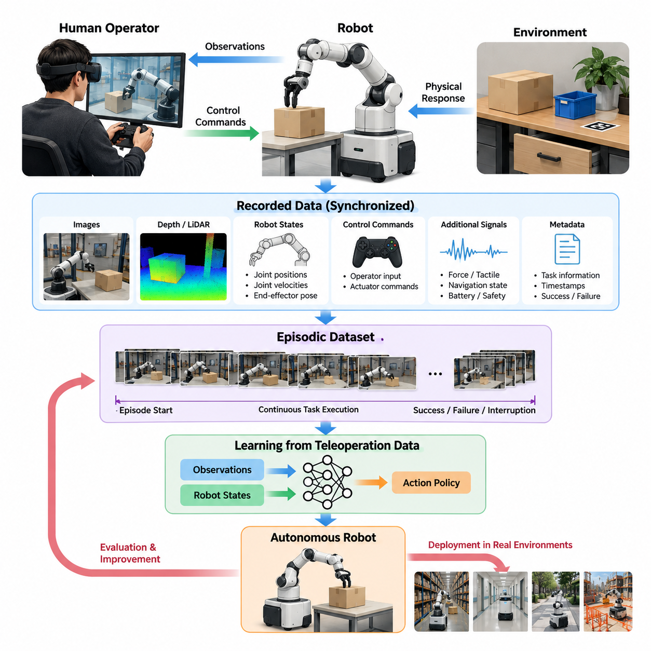
Teleoperation is a fundamental data source for Physical AI because it enables human operators to control robotic systems while generating structured records of perception, action, and environmental response. Unlike passive observation datasets, teleoperation captures decisions directly connected to physical execution. These records provide valuable supervision for training robots to perform complex tasks in real environments.
In a teleoperation system, a human operator observes the robot's surroundings through cameras, depth sensors, LiDAR, or other sensing devices and issues control commands through an interface. The robot executes these commands while recording its internal states and external observations. This process produces synchronized sequences that describe how human decisions translate into physical actions and measurable outcomes.
The primary value of teleoperation data lies in its ability to connect observations with meaningful actions. A camera image alone may reveal the position of an object, but it does not explain how the robot should approach, grasp, or manipulate that object. Teleoperated demonstrations provide the missing relationship between environmental conditions, operator decisions, actuator commands, and the resulting changes in the physical world.
A typical teleoperation dataset contains visual observations, robot joint positions, joint velocities, end-effector poses, control commands, timestamps, and task-related metadata. Depending on the robot platform, additional information may include force measurements, tactile signals, navigation states, battery conditions, and safety events. Together, these modalities form a comprehensive representation of robot behavior during task execution.
Teleoperation data is commonly organized into episodes, where each episode represents a continuous attempt to complete a particular task. An episode may begin when the operator receives a task instruction and end when the robot succeeds, fails, or encounters an interruption. This episodic structure preserves temporal relationships and supports learning algorithms that require complete trajectories rather than isolated observation-action pairs.
The relationship between human intention and robot action is particularly important in imitation learning. A learning model can use teleoperated trajectories to estimate a policy that maps robot observations to appropriate actions. Through behavior cloning, the model learns to reproduce demonstrated behavior without explicitly programming every movement. The resulting policy can subsequently be evaluated and improved through additional interaction.
Teleoperation provides a practical method for collecting demonstrations of manipulation tasks that are difficult to specify using conventional programming. Examples include grasping irregular objects, opening drawers, inserting components, folding materials, and operating tools. Human operators naturally adapt their movements to changing object positions, contact conditions, and task constraints, creating demonstrations of context-dependent physical behavior.
For mobile robots, teleoperation can capture navigation decisions in crowded warehouses, hospitals, construction sites, and outdoor environments. Operators may guide robots around temporary obstacles, negotiate narrow passages, or recover from localization uncertainty. These demonstrations contain useful information about traversability, obstacle avoidance, route selection, and interactions with dynamic environments that autonomous systems may not yet handle reliably.
Teleoperation also supports data collection for humanoid robots and mobile manipulators, where coordinated whole-body behavior is required. Human demonstrations can expose relationships between locomotion, balance, reaching, grasping, and object transportation. However, transferring human intentions into robot movements requires consideration of differences in kinematics, degrees of freedom, actuator limitations, and physical stability.
The effectiveness of teleoperation as a data source depends strongly on the control interface. Joysticks, game controllers, virtual reality devices, motion capture systems, and specialized master manipulators provide different levels of control precision and operator immersion. Each interface introduces characteristic limitations, including command resolution, response delay, fatigue, and differences between intended and executed motion.
Communication latency is another critical consideration because delayed feedback can alter operator behavior and reduce demonstration quality. When visual observations arrive late, operators may issue excessive corrections or adopt unusually slow movements. Such behavior can become embedded in training data. Recording communication delays and command execution timestamps helps distinguish genuine task strategies from artifacts introduced by the teleoperation system.
Reliable data collection requires accurate synchronization between observations, robot states, and operator commands. Even small timing discrepancies can cause a learning model to associate an action with the wrong environmental condition. Timestamp alignment, consistent sampling policies, calibrated sensors, and clearly defined command semantics are therefore essential for constructing datasets suitable for high-frequency robotic control.
Teleoperation demonstrations should preserve the distinction between commanded actions and executed actions. A requested joint movement may differ from the actual motion because of actuator saturation, collision constraints, controller filtering, or mechanical compliance. Recording both signals allows researchers to identify control limitations and prevents learning systems from incorrectly interpreting commands as physically achieved movements.
Data diversity is as important as demonstration accuracy. Repeatedly collecting successful trajectories in identical environments may produce models that perform well under familiar conditions but fail when objects, lighting, surfaces, or task arrangements change. Effective teleoperation campaigns therefore vary environmental configurations, object properties, initial robot states, and task difficulties to improve coverage of relevant operating conditions.
Operator diversity also influences the statistical characteristics of collected demonstrations. Experienced operators may execute tasks efficiently with smooth trajectories, while less experienced operators may introduce hesitation, corrections, or alternative strategies. These differences are not universally beneficial or harmful. Their usefulness depends on whether the learning objective prioritizes optimal execution, behavioral robustness, or recovery from imperfect actions.
Successful demonstrations provide examples of desirable behavior, but failed attempts can also contribute important learning signals. A failed grasp may reveal unsuitable contact geometry, while a navigation failure may expose an obstacle configuration that requires additional perception. When failures are recorded with clear outcome labels and surrounding context, they help identify limitations that successful trajectories alone cannot reveal.
Corrective demonstrations are particularly valuable when an autonomous policy encounters unfamiliar conditions. A human operator can temporarily assume control, resolve the situation, and return authority to the autonomous system. The resulting intervention sequence captures behavior near the model's operational boundary, providing targeted examples for improving future performance in similar situations.
This intervention-based approach connects teleoperation with closed-loop data engines. Autonomous robots generate operational experience, performance monitoring identifies difficult situations, and human operators supply corrective trajectories. These trajectories enter a processing and training pipeline, producing updated policies that can be evaluated and deployed. Repeating the cycle gradually concentrates data collection on weaknesses revealed by actual operation.
Teleoperation datasets can also support the development of Vision-Language-Action models. When demonstrations include natural-language task descriptions, visual observations, and robot actions, they establish relationships between semantic instructions and physical execution. A model can learn that commands such as placing an object into a container correspond to sequences of perception, reaching, grasping, transportation, and release.
However, collecting teleoperation data does not automatically guarantee generalizable robot intelligence. Demonstrations are constrained by the robot embodiment, control interface, operator expertise, and environments represented in the dataset. Models trained on a narrow distribution may imitate familiar behaviors without understanding broader physical constraints. Careful evaluation is necessary to determine whether learned capabilities transfer to unseen situations.
The cost of teleoperation is a major challenge for large-scale Physical AI development. Each demonstration requires robot hardware, an operational environment, human attention, and data infrastructure. Equipment failures, operator fatigue, maintenance requirements, and repeated task resets further increase collection costs. Scaling therefore requires improving the amount of useful learning information obtained from each hour of human operation.
Data collection efficiency can be improved through standardized task protocols, automated episode segmentation, continuous sensor logging, and streamlined environment resets. Remote operation facilities may allow trained operators to control multiple robot platforms across different sites, although simultaneous direct control remains limited by human attention. Shared control and supervisory interfaces can reduce manual effort when partial autonomy is available.
Quality assurance must be integrated into the collection process rather than postponed until model training. Automated checks can identify missing sensor streams, invalid timestamps, incomplete episodes, excessive communication delays, and inconsistent action representations. Human reviewers can assess task completion, demonstration clarity, and unusual behavior. Combining automated validation with selective review helps maintain dataset reliability.
Metadata provides the context necessary to interpret demonstrations correctly. Useful metadata includes task identifiers, robot configuration, operator interface, environment conditions, calibration versions, software versions, and episode outcomes. Without this information, visually similar trajectories may represent different tasks or operating constraints. Consistent metadata also supports dataset filtering, comparison, reproducibility, and future reuse.
Safety remains essential because teleoperation involves real physical systems capable of causing damage or injury. Emergency stopping, collision avoidance, workspace restrictions, and independent safety monitoring should remain effective even when the human operator has direct control. Demonstrations should distinguish actions performed under normal operating conditions from movements modified or interrupted by safety mechanisms.
Privacy and governance requirements also apply to teleoperation datasets. Camera recordings may capture workers, customers, confidential equipment, or sensitive facility layouts. Operator identifiers and performance records may introduce additional privacy concerns. Appropriate consent, access restrictions, retention policies, and data minimization procedures are necessary when demonstrations are collected in workplaces or publicly accessible environments.
As Physical AI systems expand across robot platforms, teleoperation data becomes an important resource for cross-embodiment learning. Demonstrations from different manipulators, mobile bases, and humanoid robots can reveal common task structures despite differences in action spaces. Shared representations of object interactions, task goals, and outcomes may support knowledge transfer, although embodiment-specific control constraints must still be respected.
Ultimately, teleoperation transforms human physical expertise into machine-readable experience. Its significance extends beyond producing examples for imitation learning because it establishes a systematic connection between human guidance, robotic execution, and continuous model improvement. When combined with rigorous synchronization, quality control, diverse task coverage, and closed-loop training, teleoperation becomes a foundational component of scalable Physical AI data engines.

02.02. Human Demonstration and Robot Learning
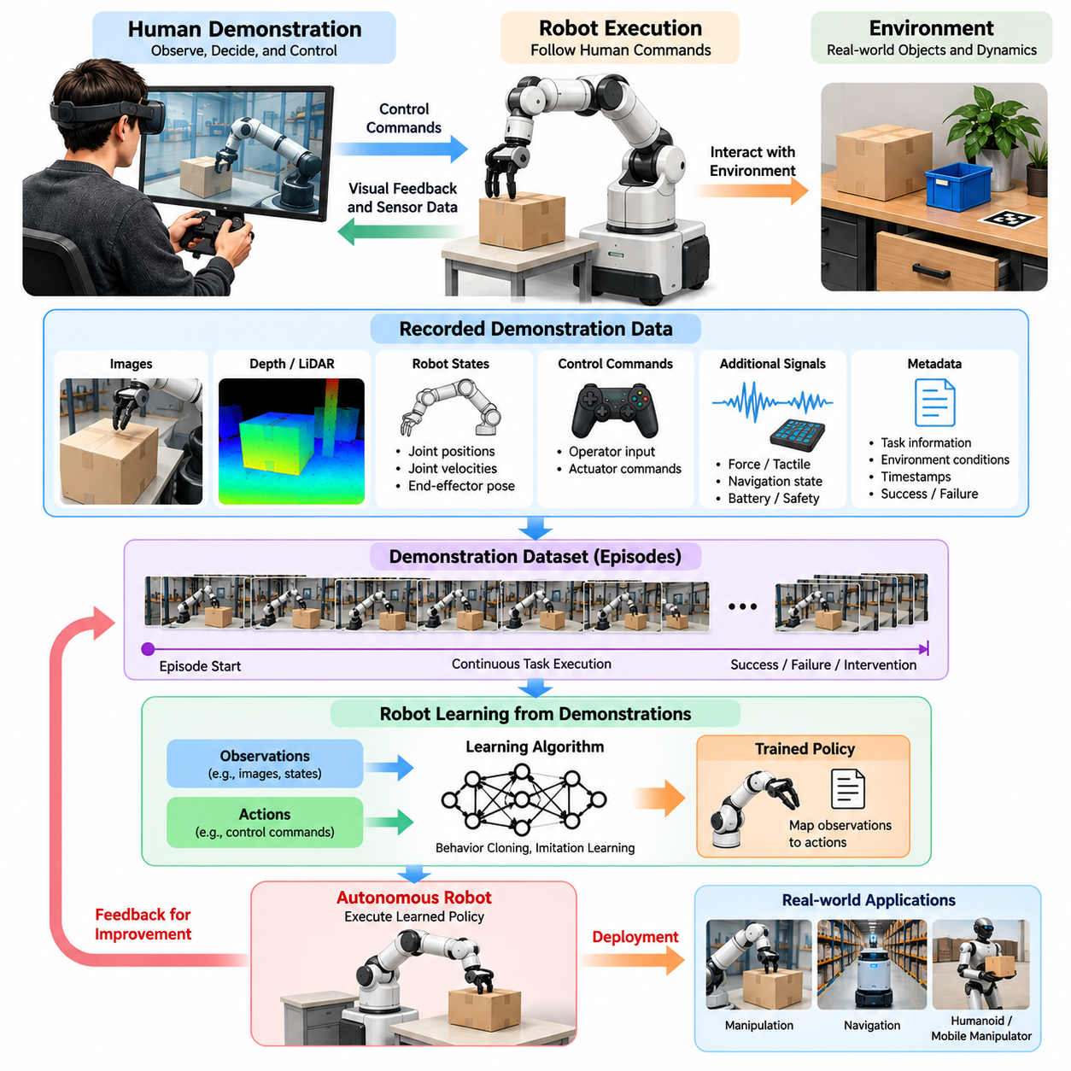
Human demonstration is a fundamental mechanism for transferring practical knowledge from people to robotic systems. Instead of requiring engineers to specify every movement through explicit programming, robots can learn from examples of human behavior. Demonstrations provide information about task objectives, action sequences, environmental constraints, and successful outcomes, establishing an important foundation for data-driven Physical AI.
Robot learning from human demonstration is commonly associated with imitation learning, also known as learning from demonstration. In this framework, a robot observes or records human-guided behavior and uses the resulting trajectories to develop an executable policy. The objective is not simply to reproduce individual movements but to acquire behavioral patterns that remain effective when environmental conditions change.
A demonstration typically consists of sequential observations, actions, robot states, and task outcomes. Observations describe the environment through cameras, depth sensors, or other perception devices, while actions represent commands applied to the robot. When these signals are synchronized, the dataset captures how particular decisions influence physical interactions and subsequent environmental states.
Human demonstrations can be collected through direct teleoperation, kinesthetic teaching, motion capture, wearable sensors, and immersive control interfaces. Each approach provides different relationships between human motion and robot execution. Teleoperation records commands executed through the robot itself, whereas human motion capture often requires additional transformation before the demonstrated behavior becomes executable.
The learning process begins by defining the task and identifying the information required for successful execution. For a robotic grasping task, demonstrations may include object observations, end-effector trajectories, gripper commands, and contact events. For mobile navigation, the relevant information may include obstacle positions, robot velocities, steering commands, and route decisions.
Behavior cloning is one of the most direct approaches to learning from demonstrations. A neural network is trained to predict an expert action from the corresponding observation or state. During training, the model minimizes differences between predicted actions and demonstrated actions. After training, the learned policy generates commands directly from incoming observations without requiring continuous human control.
Although behavior cloning is conceptually straightforward, it is vulnerable to distribution shift. Small prediction errors can move the robot into states that were rarely encountered during demonstration collection. Once the robot enters these unfamiliar states, additional prediction errors may accumulate. This problem becomes particularly serious during long-horizon manipulation or navigation tasks.
Interactive imitation learning addresses this limitation by incorporating feedback during policy execution. In approaches such as Dataset Aggregation, or DAgger, the learner visits states under its developing policy while an expert provides corrective action labels. The newly labeled states are added to the training dataset, helping the model learn appropriate responses beyond the original demonstration distribution.
Human demonstrations can also support inverse reinforcement learning, where the objective is to infer a reward function that explains expert behavior. Instead of directly copying demonstrated actions, the robot attempts to identify the underlying preferences or objectives. This approach can support adaptation when multiple action sequences achieve the same goal, although reward inference introduces additional computational complexity.
Demonstration quality strongly influences the resulting robot policy. Skilled operators generally provide precise, consistent, and efficient trajectories, while inexperienced operators may introduce unnecessary corrections or unstable movements. However, imperfect demonstrations can also reveal recovery strategies and alternative solutions. Dataset design must therefore distinguish undesirable noise from potentially valuable behavioral diversity.
Task diversity is another important factor in learning generalizable behavior. Repeated demonstrations under identical conditions may encourage memorization rather than robust adaptation. Varying object geometry, initial positions, lighting, workspace layouts, and environmental disturbances exposes the robot to broader operating conditions. Such diversity helps the learned policy respond to variations that arise during deployment.
Temporal structure plays a central role in human demonstration learning. Many robotic tasks require coordinated sequences of actions rather than isolated decisions. Opening a container, retrieving an object, and placing it elsewhere involves multiple dependent subtasks. Learning systems must capture these relationships to avoid locally reasonable actions that prevent successful completion of the overall objective.
Hierarchical imitation learning addresses long-horizon tasks by representing behavior at multiple levels of abstraction. High-level policies select goals or subtasks, while low-level controllers generate executable movements. Human demonstrations can provide supervision for both levels, allowing the robot to learn task organization alongside motor control. This separation can improve reuse of learned skills across related tasks.
The correspondence between human motion and robot embodiment introduces additional challenges. Human hands, arms, and bodies differ significantly from robotic mechanisms in joint structure, workspace, actuation, and physical constraints. Consequently, directly reproducing human motion may be impossible or unsafe. Motion retargeting and embodiment-aware representations are needed to translate demonstrations into feasible robot actions.
Contact-rich manipulation presents a particularly demanding learning problem because successful execution depends on forces, friction, compliance, and precise timing. Visual trajectories alone may not explain why an insertion or grasp succeeds. Combining demonstrations with tactile sensing, force measurements, and proprioceptive feedback allows learning systems to represent interactions that are otherwise difficult to infer.
Multimodal demonstrations can further improve learning by combining visual observations, robot states, language instructions, and action trajectories. Language provides semantic context describing what the robot should accomplish, while sensor and action data explain how the task is physically executed. This combination is especially relevant to Vision-Language-Action models that connect instructions with embodied behavior.
Learning from demonstration can also serve as an initialization strategy for reinforcement learning. An imitation-trained policy begins with useful behavior rather than relying entirely on random exploration. Reinforcement learning can then refine the policy through environmental feedback, potentially improving efficiency, robustness, or task success. This combination is particularly valuable when unrestricted physical exploration is expensive or unsafe.
Demonstrations should include information about success, failure, and corrective behavior whenever possible. Successful trajectories establish examples of desired execution, while failures reveal conditions associated with poor outcomes. Corrective demonstrations show how an operator recovers from unexpected states. Together, these examples provide a richer representation of task boundaries and operational uncertainty.
Human intervention during autonomous execution creates a continuous source of targeted training data. When a robot encounters a difficult situation, an operator can temporarily take control and demonstrate an appropriate response. Recording the preceding observations, intervention actions, and resulting outcomes enables subsequent training to address the specific weaknesses revealed during deployment.
A scalable demonstration-learning system requires consistent episode definitions, synchronized sensor streams, reliable timestamps, and standardized action representations. Metadata should identify the task, robot configuration, operator, environment, and execution outcome. These records support reproducibility, dataset filtering, model evaluation, and comparison across different collection campaigns or robotic platforms.
Data curation is necessary because collecting more demonstrations does not automatically produce better learning results. Redundant trajectories may contribute little new information, while corrupted or poorly synchronized episodes can degrade model performance. Quality assessment should consider task relevance, behavioral consistency, environmental coverage, and the presence of informative corrections or unusual situations.
Evaluation must measure whether a learned policy can execute tasks autonomously under conditions not represented directly in its training examples. Relevant measures include task success rate, completion time, intervention frequency, recovery performance, and safety violations. Testing across unfamiliar objects, environments, and initial states provides stronger evidence of generalization than performance on previously demonstrated scenarios.
The economic efficiency of human demonstration learning depends on how effectively human effort is converted into reusable robotic capability. Collecting demonstrations requires skilled operators, functioning hardware, and carefully managed environments. Active learning and uncertainty-based data collection can prioritize situations where additional demonstrations are most likely to improve the policy, reducing unnecessary collection effort.
Human demonstration learning also raises important safety and governance considerations. Robots must remain within appropriate physical operating limits during collection and autonomous execution. Recorded demonstrations may contain identifiable operator information or sensitive workplace observations. Responsible dataset management requires access controls, appropriate permissions, traceable provenance, and procedures for handling unsafe or unsuitable demonstrations.
Cross-embodiment learning expands the potential value of human demonstrations beyond a single robot platform. Shared representations of task goals, object relationships, and interaction outcomes may allow knowledge collected on one robot to benefit another. However, differences in morphology, sensing, and control capabilities require careful adaptation, and successful transfer must be established through physical evaluation.
Ultimately, human demonstration connects human expertise with autonomous robotic intelligence by transforming purposeful physical behavior into structured learning signals. Its effectiveness depends on demonstration quality, environmental diversity, temporal consistency, suitable learning algorithms, and rigorous evaluation. Integrated into a closed-loop data engine, demonstration learning provides a practical pathway toward increasingly capable, adaptable, and scalable Physical AI systems.

02.03. Teleoperation System Architectures
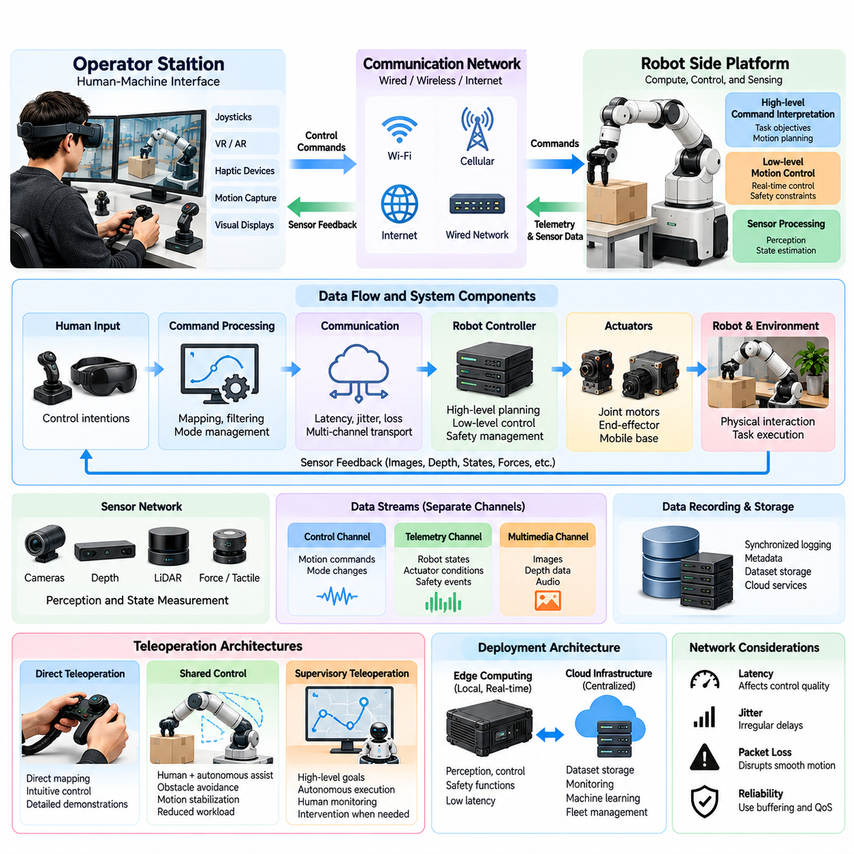
Teleoperation system architecture defines how human operators, communication networks, robotic controllers, and sensing devices interact to enable remote physical control. A well-designed architecture must support reliable command transmission, timely feedback, operational safety, and synchronized data collection. These capabilities are essential for both effective human control and the generation of high-quality Physical AI training datasets.
A typical teleoperation system consists of an operator station, communication infrastructure, robot-side computing platform, control subsystem, and sensor network. The operator station converts human inputs into control commands, while the robot-side platform interprets and executes them. Sensor feedback returns information about the robot and its environment, forming a continuous closed-loop interaction between human intention and physical execution.
The operator station serves as the human-machine interface through which remote control decisions are made. It may include joysticks, virtual reality headsets, motion capture devices, haptic controllers, and visual displays. Interface design determines how effectively operators perceive environmental conditions and express intended actions. Ergonomics, feedback quality, command precision, and cognitive workload directly influence operational performance.
The robot-side architecture typically separates high-level command interpretation from low-level motion control. High-level components translate operator instructions into target positions, velocities, or task-level objectives. Low-level controllers regulate actuators using sensor feedback and real-time control algorithms. This separation allows human commands to remain flexible while maintaining stable execution under physical constraints.
Communication architecture determines how control commands and sensor feedback travel between the operator and robot. Local wired networks generally provide predictable latency and high bandwidth, while wireless networks enable mobility and geographically distributed operation. Remote teleoperation may use Wi-Fi, private cellular networks, or internet connections, each introducing different characteristics in latency, jitter, packet loss, and availability.
Latency is a critical architectural constraint because teleoperation depends on timely feedback. Delays between operator commands and robot responses can produce overshoot, oscillation, hesitation, or unstable interactions. The acceptable delay depends on task dynamics and control frequency. Precision manipulation and contact-rich operations generally require more careful latency management than slow supervisory navigation.
Network jitter and packet loss introduce additional uncertainty into command execution. Irregular message arrival can disrupt smooth motion even when average latency remains acceptable. Communication systems therefore require sequence numbering, timestamps, buffering policies, and appropriate transport mechanisms. Safety-critical commands should be handled separately from bandwidth-intensive sensor streams whenever necessary.
Teleoperation systems commonly employ different communication channels for control, telemetry, and multimedia data. Control channels transmit motion commands and mode changes, while telemetry channels report robot states, actuator conditions, and safety events. Multimedia channels carry camera images, depth information, or audio. Separating these streams allows independent prioritization according to bandwidth, reliability, and timing requirements.
The choice between centralized and distributed architectures affects scalability and resilience. In centralized systems, a primary computing platform manages command processing, monitoring, and data recording. Distributed architectures allocate perception, control, safety, and communication functions across multiple processors. Distribution can reduce computational bottlenecks but introduces additional requirements for synchronization and fault management.
Edge computing plays an important role in modern teleoperation architectures. Processing visual observations, estimating robot states, and enforcing safety constraints close to the robot reduces dependence on remote communication. Edge controllers can continue essential stabilization and collision prevention even when network connectivity deteriorates. This separation is especially important for mobile robots and manipulators operating near people.
Cloud infrastructure can complement edge computing by providing centralized monitoring, dataset storage, operator coordination, and machine learning services. However, cloud systems should not be responsible for control functions that require deterministic real-time execution. A practical architecture assigns time-critical control and safety functions to local computing resources while using cloud services for scalable data processing and operational management.
Direct teleoperation architectures map operator inputs into robot commands with limited autonomous interpretation. This approach provides intuitive control and preserves detailed human decision-making behavior. However, operators must continuously manage the robot's movements and respond to environmental changes. Direct control is useful for collecting demonstrations but can become demanding during complex or prolonged operations.
Shared-control architectures combine human commands with autonomous assistance. The robot may provide obstacle avoidance, motion stabilization, grasp alignment, or workspace constraint enforcement while the operator specifies movement intentions. This arrangement can improve safety and reduce workload. Nevertheless, training datasets must distinguish human-generated commands from autonomous corrections to preserve accurate behavioral interpretation.
Supervisory teleoperation operates at a higher level of abstraction. Instead of continuously commanding individual movements, operators assign goals, approve plans, or intervene when autonomous execution encounters difficulties. The robot performs routine actions independently while maintaining communication with the operator. This architecture supports scalable fleet supervision but generates different forms of demonstration data than direct control.
Control authority management is essential when multiple control sources influence the same robot. Human commands, autonomous policies, safety controllers, and recovery mechanisms may issue conflicting instructions. The architecture must define explicit priorities, ownership transitions, and arbitration rules. Recording these transitions is also important for identifying whether observed actions originated from human decisions or autonomous control.
Sensor architecture determines the quality and completeness of feedback available to the operator. Cameras provide visual context, depth sensors estimate spatial geometry, and proprioceptive sensors report internal robot motion. Force and tactile sensors become important during contact-rich manipulation. Combining these modalities can improve situational awareness, although additional sensing increases bandwidth, processing, and synchronization requirements.
Visual feedback architecture must balance image quality against communication delay. High-resolution video improves object recognition and manipulation precision but requires substantial bandwidth. Compression, adaptive resolution, selective streaming, and region-of-interest processing can reduce transmission demands. However, aggressive compression may remove visual details needed for precise contact or obstacle assessment.
Haptic feedback introduces a bidirectional physical interaction channel between the operator and robot. Force measurements from the robot can be transformed into resistance or vibration at the operator interface. This improves perception of contact conditions but creates additional stability challenges when communication is delayed. Passivity-based control, local damping, and appropriate feedback filtering can help maintain stable interaction.
Real-time control architecture must distinguish between hard timing requirements and best-effort communication. Joint stabilization, actuator protection, and emergency responses may require deterministic execution, while video visualization and cloud logging can tolerate variable delays. Scheduling critical functions independently prevents communication congestion or data recording workloads from interfering with essential robot behavior.
Time synchronization is particularly important when teleoperation serves as a training data source. Sensor observations, operator inputs, controller outputs, and executed robot states must share a consistent temporal reference. Hardware timestamps, synchronized clocks, and calibrated communication delays help reconstruct the correct causal sequence. Without reliable alignment, collected trajectories may contain misleading observation-action relationships.
Data recording architecture should capture both the operator's intended commands and the robot's actual responses. Useful records include raw interface inputs, transformed control targets, actuator measurements, sensor observations, and task outcomes. Recording control modes and safety interventions provides additional context. These distinctions allow downstream learning systems to separate demonstrated intentions from execution limitations.
Safety architecture must remain operational independently of remote human supervision. Emergency stopping, collision monitoring, joint limits, velocity restrictions, and protective zones should be enforced locally. When communication fails, the robot should transition to a predefined safe behavior appropriate to its operating environment. A simple universal stop command may not be sufficient for dynamically unstable platforms.
Fault tolerance is necessary because teleoperation involves interconnected components that can fail independently. Network interruptions, sensor faults, operator interface failures, and controller crashes require explicit detection and recovery procedures. Heartbeat monitoring, watchdog timers, communication timeout policies, and controlled reconnection mechanisms can reduce operational risk while preserving information about failure events.
Cybersecurity is another architectural requirement because teleoperation exposes physical control systems to communication networks. Authentication, encrypted communication, access control, and command validation help prevent unauthorized operation. Software updates and remote maintenance interfaces require additional protection. Security incidents must be treated as potential physical safety risks rather than merely information technology failures.
Scalable teleoperation architectures must also support multiple robots, operators, and operational sites. Centralized scheduling can allocate available operators to robots requiring assistance, while fleet management systems track connectivity, task progress, and intervention requests. Standardized interfaces and common data formats simplify integration across heterogeneous platforms, although robot-specific control capabilities must remain explicitly represented.
Ultimately, teleoperation system architecture connects human intelligence, communication technology, robotic control, and data infrastructure into a coordinated operational framework. Its effectiveness depends on latency management, distributed computation, multimodal feedback, safety enforcement, and accurate recording. A carefully designed architecture enables reliable remote operation while producing structured, reusable data for continuous Physical AI learning.

02.04. Direct Shared and Supervisory Control
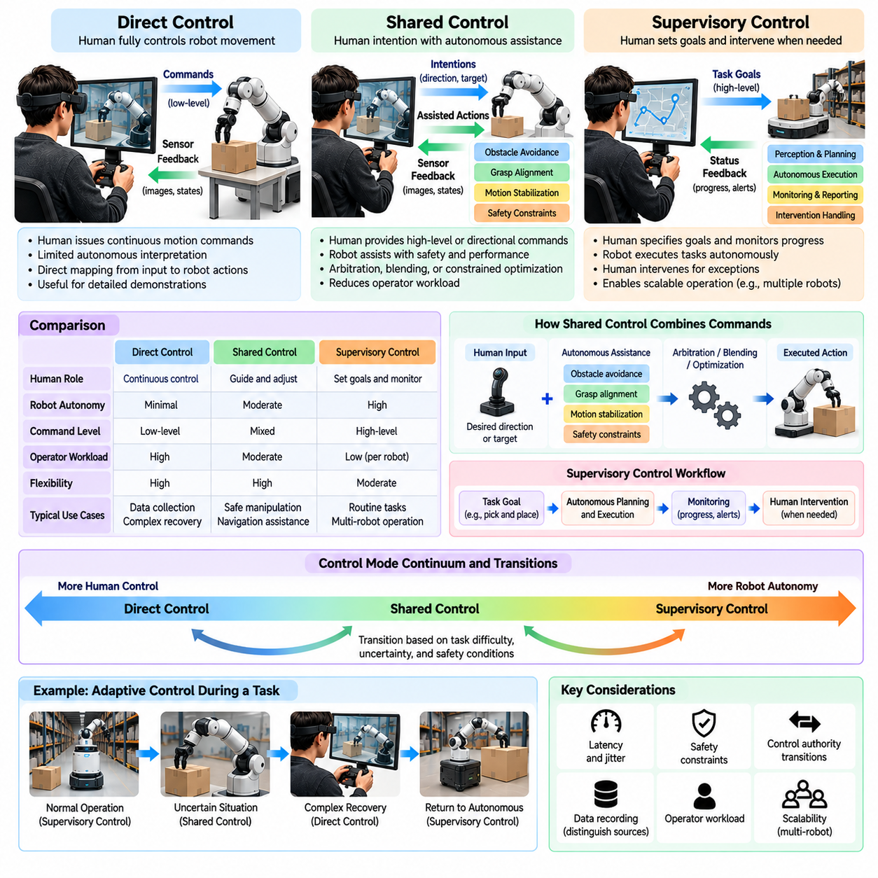
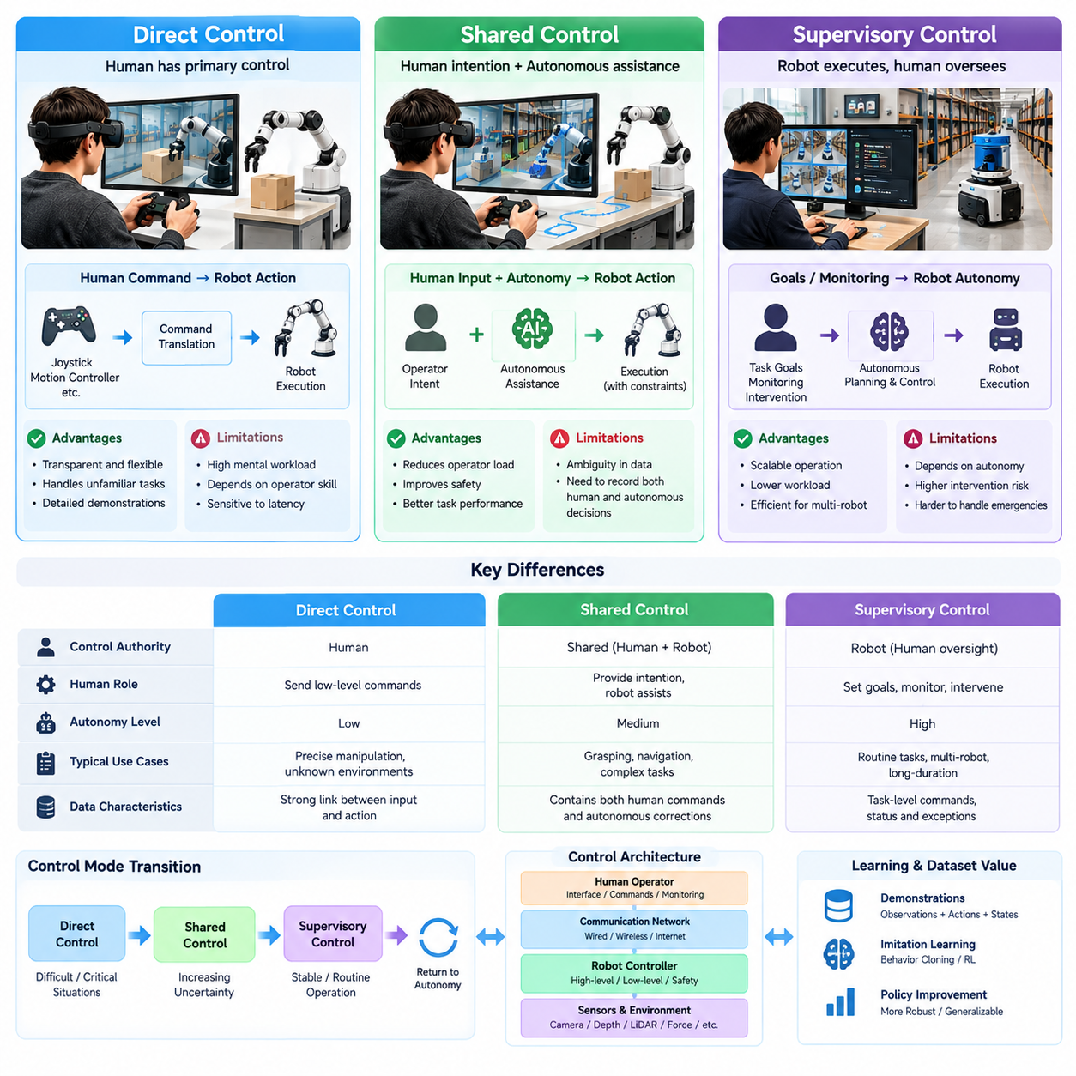
Direct, shared, and supervisory control represent three fundamental approaches to distributing decision-making authority between human operators and robotic systems. These control modes differ in the level of autonomy assigned to the robot, the frequency of human intervention, and the nature of operator commands. Understanding their characteristics is essential for designing teleoperation systems and collecting meaningful Physical AI training data.
Direct control places primary responsibility for robot movement and task execution on the human operator. Commands generated through joysticks, motion controllers, or other interfaces are translated into robot actions with limited autonomous interpretation. The operator continuously observes feedback and adjusts commands according to environmental conditions, creating a close relationship between human decisions and physical behavior.
In direct teleoperation, commands may specify joint positions, end-effector velocities, steering angles, or other motion variables. Low-level controllers still regulate actuators and enforce mechanical constraints, but the human determines the intended movement. This arrangement is especially valuable when collecting detailed demonstrations for imitation learning because operator decisions remain closely associated with executed actions.
The main advantage of direct control is its transparency and flexibility. Skilled operators can perform unfamiliar tasks without requiring a fully developed autonomous policy. They can respond to unusual object arrangements, unexpected obstacles, and changing contact conditions. However, continuous manual control increases cognitive workload and makes performance sensitive to operator expertise, interface quality, and communication latency.
Shared control distributes responsibility between human intention and autonomous assistance. The operator provides directional commands, movement targets, or task preferences, while the robot modifies execution to satisfy safety and performance constraints. Autonomous functions may include obstacle avoidance, grasp alignment, motion stabilization, and collision prevention, reducing the burden of precise low-level control.
A shared-control system commonly combines human input with autonomous control through arbitration, blending, or constrained optimization. Arbitration selects between competing commands, while blending combines them according to predefined or adaptive weights. Constrained optimization seeks actions that respect safety limits while remaining close to operator intentions. Each approach produces different relationships between requested and executed behavior.
Shared control is particularly useful when the operator understands the task objective but cannot reliably manage every physical detail. During robotic grasping, a human may identify the target object while autonomous assistance adjusts the gripper orientation. In mobile navigation, the operator may indicate a desired direction while local planning prevents collisions. Such cooperation improves usability without eliminating human guidance.
However, shared control introduces ambiguity into demonstration datasets. The executed robot action may differ significantly from the operator's original command because of autonomous corrections. If these differences are not recorded, learning algorithms may incorrectly attribute assisted behavior to human expertise. High-quality datasets should preserve operator inputs, autonomous proposals, arbitration decisions, and final executed commands.
Supervisory control assigns routine motion execution and local decision-making to the robot while retaining human oversight of objectives and exceptional situations. Instead of continuously commanding movement, the operator specifies goals, approves plans, monitors progress, and intervenes when necessary. This approach is suitable for robots with sufficient autonomy to execute meaningful task sequences independently.
In supervisory teleoperation, communication occurs primarily through task-level commands and status feedback. An operator may instruct a mobile robot to deliver materials, request inspection of a particular location, or authorize a manipulation sequence. The robot determines the detailed trajectory and executes the task using onboard perception, planning, and control, while reporting progress and exceptions.
Supervisory control can substantially improve operational scalability because one operator may monitor multiple robots when intervention demands are sufficiently low. However, the achievable supervision ratio depends on task complexity, autonomy reliability, intervention frequency, and human attention. Simultaneous emergencies can overwhelm a single operator, making workload prediction and intervention scheduling important architectural considerations.
The three control modes form a continuum rather than completely separate categories. A robot may operate autonomously under supervision, transition to shared control when uncertainty increases, and enter direct control during difficult recovery operations. After the problem is resolved, authority can return to the autonomous system. This flexibility enables efficient operation while preserving access to human expertise.
Control authority transitions require explicit rules to avoid conflicting commands or unsafe behavior. The system must identify which controller currently owns each motion function and establish conditions for requesting, granting, and releasing authority. Transitions should consider robot velocity, actuator state, environmental hazards, and operator readiness. Abrupt switching without appropriate synchronization can produce unstable motion.
Adaptive autonomy extends this concept by adjusting control allocation according to environmental difficulty, model confidence, and operator workload. When perception is reliable and the task is familiar, the robot can execute more independently. When uncertainty increases or safety margins decrease, additional human guidance may be requested. Such adaptation requires trustworthy monitoring rather than relying exclusively on model confidence scores.
Communication latency affects the three modes differently. Direct control is highly sensitive to delayed feedback because the operator continuously closes the control loop. Shared control can tolerate some delays when local autonomy maintains stabilization and obstacle avoidance. Supervisory control generally permits longer communication intervals, provided the robot can safely manage execution and unexpected conditions independently.
From a data collection perspective, direct control produces dense human-guided action trajectories that are useful for behavior cloning and low-level skill acquisition. Shared control generates interaction records showing how human intentions are transformed by autonomous assistance. Supervisory control produces task-level decisions, intervention events, and autonomous execution histories. These datasets support different learning objectives and should not be treated as interchangeable.
Direct-control demonstrations are particularly valuable when learning precise manipulation behaviors, coordinated joint movements, and unfamiliar motor skills. Their effectiveness depends on accurate synchronization between observations and operator commands. However, operator hesitation, communication artifacts, and control-interface limitations can introduce behavioral patterns that are undesirable for autonomous execution.
Shared-control demonstrations can support learning from human preferences and assisted task execution. By comparing operator requests with autonomous corrections, learning systems may identify situations where safety constraints or physical feasibility modify intended actions. Nevertheless, separating human intention from controller-generated behavior is necessary to avoid training policies on incorrectly attributed supervision signals.
Supervisory-control data is useful for learning task decomposition, goal selection, intervention timing, and recovery strategies. Records of operator decisions can reveal when autonomous execution should continue and when human assistance is appropriate. Such information supports higher-level policies that coordinate multiple skills over extended time horizons rather than predicting individual actuator commands.
Intervention data provides an important connection between these control modes and closed-loop Physical AI learning. When an autonomous robot encounters an unfamiliar condition, the system can request human assistance and record the transition into shared or direct control. The resulting corrective trajectory can be incorporated into training, allowing future policies to improve specifically where autonomous behavior was insufficient.
Reliable training data requires detailed records of control ownership and command transformation. Each episode should identify the active mode, operator input, autonomous controller output, safety modifications, executed robot state, and task outcome. Accurate timestamps and consistent action representations allow researchers to reconstruct how decisions were made and determine which components contributed to successful or failed execution.
Safety constraints must remain effective across every control mode. Direct human authority should not automatically override collision limits, actuator protection, or emergency stopping mechanisms. Shared-control arbitration must prioritize safety without creating unpredictable motion. Supervisory systems require local fallback behavior when communication fails or autonomous execution exceeds approved operational boundaries.
Human factors also influence the effectiveness of control allocation. Direct control can create sustained mental and physical workload, while supervisory control may produce reduced situational awareness during long periods of passive monitoring. Shared control can reduce effort but may create confusion when autonomous corrections conflict with operator expectations. Clear feedback about active control authority helps maintain operator understanding and trust.
The appropriate control strategy depends on robot capability, task difficulty, environmental uncertainty, communication quality, and operational objectives. Precision assembly may require direct or shared control during difficult contact operations, while warehouse transportation may rely primarily on supervisory control. Effective systems select control modes according to measurable requirements rather than assuming that greater autonomy is always preferable.
Ultimately, direct, shared, and supervisory control provide complementary mechanisms for integrating human intelligence with robotic autonomy. Their combined use supports reliable operation, efficient intervention, and diverse demonstration collection. By preserving control authority, operator intentions, autonomous corrections, and physical outcomes, teleoperation systems can transform human assistance into structured data that continuously improves Physical AI capabilities.

02.05. Joystick VR and Motion Capture Interfaces
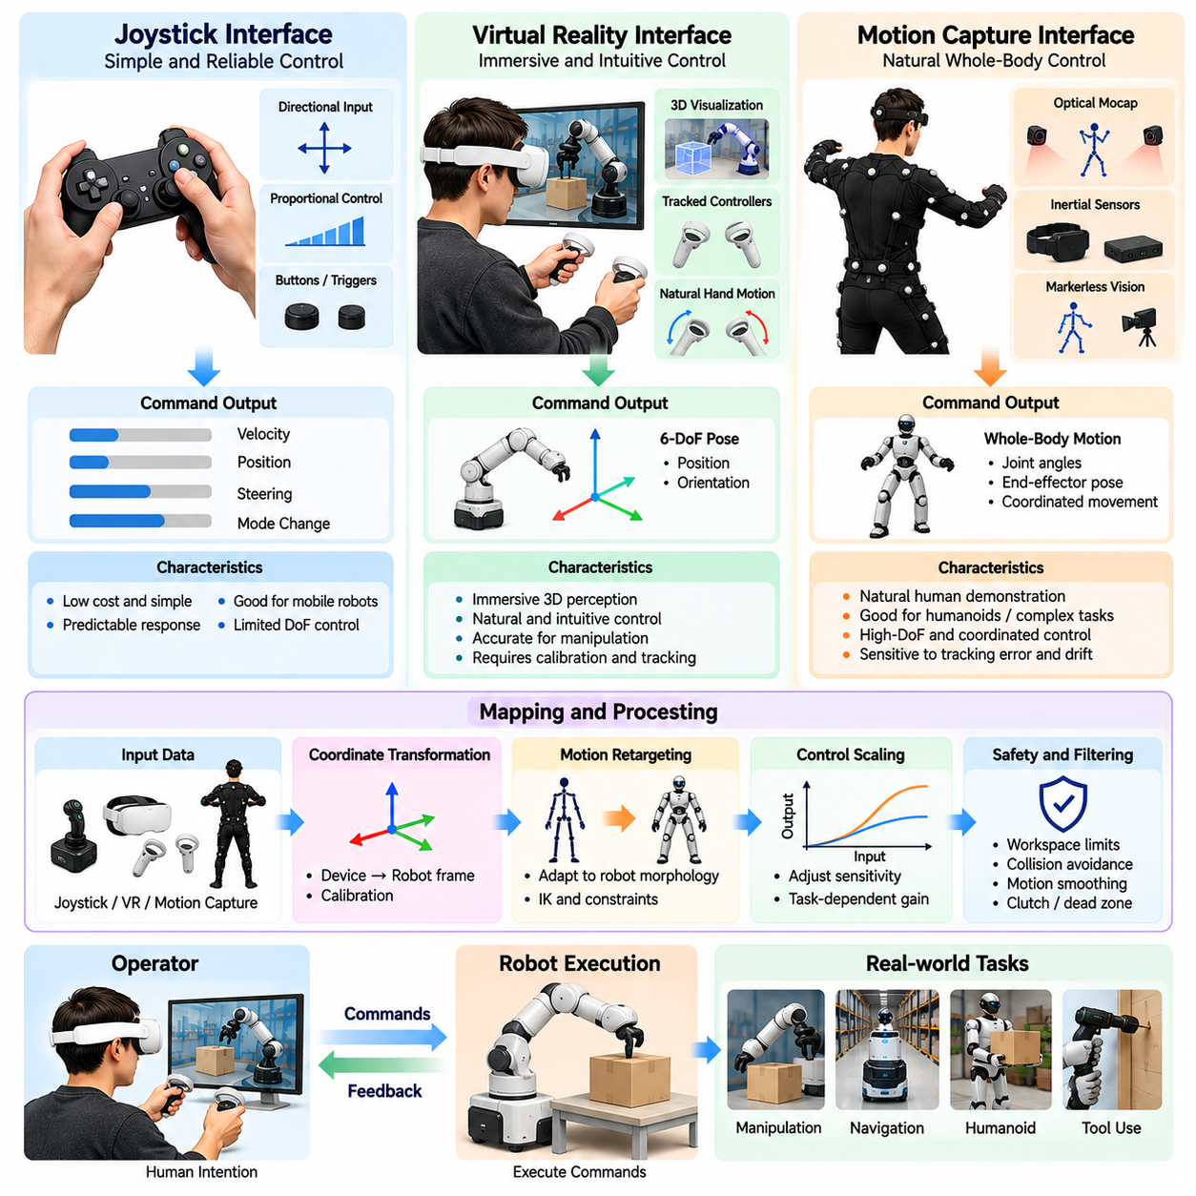
Joystick, virtual reality, and motion capture interfaces provide different mechanisms for translating human intentions into executable robot commands. Each interface offers distinct advantages in precision, intuitiveness, mobility, and data collection efficiency. Selecting an appropriate interface requires understanding robot morphology, task complexity, operator capabilities, and the quality of demonstrations needed for Physical AI learning.
Joystick interfaces represent one of the most established methods for controlling remote robotic systems. They convert directional movements, button presses, and trigger inputs into velocity, steering, or position commands. Their relatively simple hardware architecture, low cost, and predictable response make them suitable for mobile robots, inspection platforms, and basic manipulator operations in structured environments.
Joystick control commonly uses proportional mappings between input displacement and commanded robot motion. Small movements produce low velocities, while larger displacements generate faster responses. Dead zones prevent unintended motion near the neutral position, and nonlinear scaling improves precision during delicate tasks. Proper calibration is essential for maintaining consistent behavior across operators and devices.
Despite their simplicity, joysticks have limitations when controlling robots with many degrees of freedom. A two-axis joystick cannot directly express complex arm configurations or coordinated whole-body movements. Operators may need to switch control modes or combine multiple input devices. These additional interactions increase cognitive workload and can introduce discontinuities into recorded demonstration trajectories.
Virtual reality interfaces provide immersive control by combining head-mounted displays, tracked hand controllers, and three-dimensional visualization. Operators can perceive the robot's workspace from a spatial perspective and issue commands through natural hand movements. This approach is especially useful for manipulation tasks requiring accurate end-effector positioning, object orientation, and coordinated bimanual actions.
A VR teleoperation system typically tracks the position and orientation of operator controllers within a defined coordinate frame. These measurements are transformed into robot target poses using calibrated mappings. Inverse kinematics converts desired end-effector poses into feasible joint configurations. Workspace limits, collision constraints, and motion smoothing help prevent unsafe or physically impossible commands.
VR interfaces may display live stereo camera streams, reconstructed depth maps, or digital representations of the robot environment. Accurate visual registration is important because mismatches between displayed geometry and physical robot coordinates can produce positioning errors. Rendering latency, tracking drift, and limited camera coverage may also affect operator performance during precise manipulation.
Motion capture interfaces record human body movements using optical tracking systems, inertial measurement units, wearable sensors, or markerless computer vision. These systems estimate body poses and joint trajectories that can guide robotic motion. Unlike joystick control, motion capture allows operators to demonstrate coordinated movements naturally, making it attractive for humanoid robots and complex manipulation research.
Optical motion capture systems use cameras and tracked markers or visual features to reconstruct three-dimensional movement. They can provide detailed spatial measurements in calibrated environments but may suffer from occlusion and restricted capture volumes. Markerless approaches reduce equipment requirements but introduce uncertainty associated with pose estimation, lighting conditions, and unusual body configurations.
Inertial motion capture uses wearable inertial measurement units to estimate body orientation and movement. Such systems can operate without fixed external camera infrastructure, enabling more flexible collection environments. However, accumulated drift and imperfect position estimation can reduce long-duration accuracy. Combining inertial measurements with optical tracking or robot feedback can improve robustness.
Mapping human motion to robotic embodiment is a central challenge for motion capture teleoperation. Human and robot bodies differ in joint arrangements, limb lengths, reachable workspaces, and actuator capabilities. Motion retargeting algorithms must preserve task-relevant intentions while satisfying robot kinematic constraints. Directly copying human joint angles is rarely sufficient for reliable execution across different morphologies.
Coordinate transformation is equally important across joystick, VR, and motion capture interfaces. Operator inputs may be expressed in device, camera, world, or robot coordinate frames. Incorrect transformations can reverse movement directions or produce unintended rotations. Calibration procedures should establish consistent reference frames and verify that commanded movements correspond to operator expectations.
Control scaling determines how human input magnitude translates into robot movement. Precision manipulation may benefit from reduced motion gain, allowing large operator movements to produce small robot adjustments. Rapid navigation may require higher gain for efficient travel. Adaptive scaling can change sensitivity according to task context, but abrupt gain changes may confuse operators and degrade demonstration consistency.
Clutching mechanisms allow operators to temporarily disconnect interface movement from robot motion. This enables repositioning of hand controllers or body posture without generating unintended commands. Clutch states should be explicitly recorded because they alter the relationship between human movement and robot action. Similar considerations apply to mode switching, recentering, and interface recalibration.
Human factors strongly influence interface effectiveness. Joysticks are familiar and compact but may require substantial mental transformation between control axes and robot movements. VR interfaces improve spatial intuition but can introduce visual fatigue or simulator sickness. Motion capture supports natural movement but may cause physical fatigue during extended sessions. Interface selection should consider sustainable operator performance.
Feedback design is essential for maintaining situational awareness during teleoperation. Visual displays communicate robot pose, environmental geometry, and task progress, while audio and haptic signals can indicate contact events or warnings. Operators should also receive clear information about control modes, motion limits, and communication status. Ambiguous feedback increases the likelihood of incorrect commands.
Communication latency affects each interface differently. Joystick control can become difficult when delayed video causes operators to overcorrect steering or positioning. VR interfaces are particularly sensitive to inconsistencies between head motion and displayed imagery. Motion capture systems may generate high-frequency pose streams that require filtering and prediction. Local robot controllers should maintain safety independently of network timing.
Interface sampling frequency and signal filtering influence demonstration quality. High-frequency measurements preserve detailed movements but can contain sensor noise and operator tremor. Low-frequency sampling reduces data volume but may miss brief contact adjustments or rapid corrections. Appropriate filtering must balance smooth execution against the preservation of meaningful human actions and task dynamics.
For Physical AI training, raw interface signals should be recorded alongside transformed robot commands and measured execution states. This separation makes it possible to identify whether motion patterns originated from operator intention, interface mapping, controller limitations, or autonomous assistance. Without such records, learned policies may reproduce interface-specific artifacts rather than transferable task behavior.
Dataset consistency requires standardized calibration, coordinate conventions, action units, and metadata. Demonstrations collected using different joysticks, VR devices, or motion capture systems may otherwise have incompatible representations. Recording device characteristics, control gains, operator identity, and task configuration supports normalization and comparative evaluation across collection campaigns.
Interface choice also affects the diversity of behaviors represented in training datasets. Joysticks may encourage smooth directional navigation, while VR supports spatial manipulation and coordinated hand movements. Motion capture can provide whole-body trajectories and natural task sequencing. Combining complementary interfaces may increase coverage, provided differences in action representation are carefully managed.
Safety considerations extend beyond robot motion to operator interaction with control equipment. VR users may lose awareness of their physical surroundings, while motion capture participants require sufficient movement space. Emergency stopping, command validation, workspace limits, and operator monitoring should remain active. Human interface failures must not disable independent robot-side safety mechanisms.
Scalable data collection systems benefit from interfaces that are easy to calibrate, maintain, and operate consistently. Operator training, automated calibration checks, session diagnostics, and standardized recording procedures reduce variability. The most sophisticated interface is not necessarily the most productive; practical efficiency depends on demonstration throughput, task success, operator fatigue, and resulting data quality.
Ultimately, joystick, VR, and motion capture interfaces connect human motor intelligence with robotic execution through different control representations. Their effectiveness depends on accurate mapping, reliable feedback, manageable latency, ergonomic operation, and synchronized recording. A well-designed interface strategy improves teleoperation performance while generating diverse, high-quality demonstrations for scalable Physical AI learning.

02.06. Haptic and Force Feedback
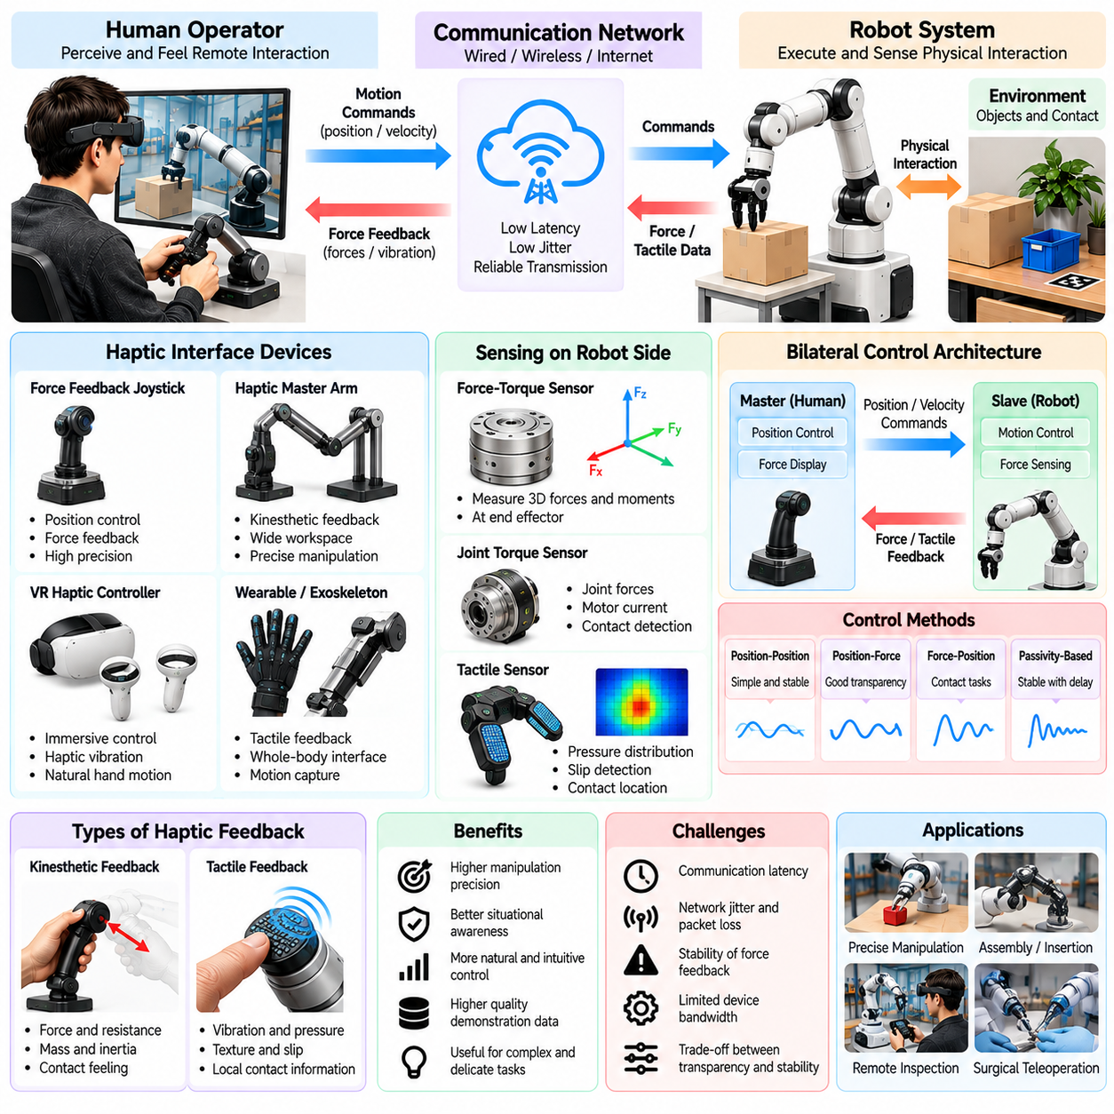
Haptic and force feedback are essential components of teleoperation systems that allow human operators to perceive physical interactions beyond visual observation. Haptic feedback communicates sensations such as vibration, resistance, and contact, while force feedback reproduces mechanical forces generated during robot interaction. Together, they improve manipulation precision, situational awareness, and the quality of demonstrations collected for Physical AI learning.
Conventional teleoperation often relies primarily on visual information, requiring operators to infer contact forces from object movement and robot behavior. This indirect perception becomes unreliable during delicate manipulation, insertion, or surface interaction. Haptic interfaces provide additional sensory information that helps operators recognize contact events, estimate resistance, and adjust movements before excessive forces damage objects or equipment.
A typical bilateral teleoperation architecture consists of a master interface operated by a human and a slave robotic system interacting with the environment. The master generates position or velocity commands, while the slave measures interaction forces through sensors. These measurements are transmitted back to the operator interface, creating a bidirectional control loop that connects human movement with remote physical contact.
Force feedback devices commonly use electric motors, cable mechanisms, or other actuators to generate resistance against operator movement. When the remote robot encounters an obstacle, the interface can reproduce an opposing force. This allows the operator to perceive environmental constraints directly. The accuracy of this sensation depends on actuator bandwidth, force resolution, mechanical friction, and control-loop stability.
Haptic feedback includes both kinesthetic and tactile sensations. Kinesthetic feedback communicates forces and movements associated with muscles and joints, while tactile feedback represents localized skin sensations such as pressure, vibration, or texture. These modalities provide complementary information. Kinesthetic feedback supports force regulation, whereas tactile feedback helps detect contact location, slipping, and surface characteristics.
Force and torque sensors are important sources of feedback in robotic manipulation. Six-axis force-torque sensors can measure forces and moments along multiple directions, providing information about contact conditions at the end effector. Joint torque sensors and motor current estimates may provide additional measurements. However, indirect force estimates require careful calibration because friction and actuator dynamics can introduce uncertainty.
Tactile sensing extends feedback beyond global contact forces by measuring pressure distributions across robotic fingers or contact surfaces. Sensor arrays can reveal whether an object is slipping, rotating, or being grasped unevenly. This information is particularly valuable for handling fragile or deformable objects. Translating high-dimensional tactile measurements into meaningful operator sensations remains an important interface design challenge.
Bilateral control architectures must coordinate the forward transmission of motion commands with the backward transmission of force information. Position-position, position-force, and force-position control structures provide different relationships between operator movement and robot response. Architecture selection depends on task requirements, robot dynamics, interface capabilities, and communication conditions.
Transparency describes how accurately a teleoperation system reproduces the remote environment's mechanical behavior at the operator interface. An ideally transparent system allows the operator to experience contact forces and motion resistance as though interacting directly with the environment. In practice, sensor noise, actuator limitations, communication delays, and controller dynamics reduce transparency and introduce perceptual distortions.
Stability is a fundamental challenge in force-reflecting teleoperation because delayed feedback can cause oscillations or excessive interaction forces. A control loop that behaves safely under local communication may become unstable when network latency increases. Passivity-based control, wave-variable transformations, energy monitoring, and damping mechanisms are commonly investigated to preserve stable bilateral interaction.
Passivity-based approaches limit the possibility that the teleoperation system generates uncontrolled energy during interaction. By monitoring energy exchange between the operator, robot, and environment, controllers can introduce damping when necessary. These techniques can improve robustness under communication delays, although additional damping may reduce the fidelity of force sensations and make remote manipulation feel less responsive.
Communication architecture strongly influences haptic performance. Force feedback often requires frequent updates and predictable timing, while visual streams can tolerate different transmission characteristics. Network jitter, packet loss, and asynchronous measurements may create discontinuities in perceived resistance. Local interpolation, predictive models, and carefully designed communication protocols can reduce these effects without guaranteeing perfect transparency.
Virtual fixtures provide software-generated haptic constraints that guide operator movement. A virtual fixture may create resistance near restricted regions, encourage alignment with a desired path, or prevent motion beyond a safe workspace boundary. These mechanisms are useful for precision assembly, surgical manipulation, and industrial inspection. They must be designed carefully to avoid masking important environmental forces.
Shared haptic control combines human intention with autonomous assistance through force-based guidance. Rather than directly overriding an operator's command, the system can generate directional cues or resistance that encourages safer movement. This approach preserves some human authority while reducing errors. However, operators must understand whether a sensation originates from physical contact or software-generated guidance.
Contact-rich manipulation benefits significantly from force feedback because successful execution often depends on maintaining appropriate contact pressure. Inserting a connector, turning a valve, or aligning a mechanical component may require subtle adjustments that are difficult to judge visually. Force feedback helps operators identify contact transitions and avoid excessive loading, potentially improving task completion and reducing mechanical damage.
Force control must account for the mechanical compliance of the robot, tool, and environment. Rigid position control can generate large contact forces when small alignment errors occur. Impedance control regulates the relationship between motion deviations and interaction forces, while admittance control converts measured forces into motion commands. Both approaches can support safer physical interaction when properly tuned.
Haptic interfaces introduce important ergonomic considerations. Continuous force resistance can produce operator fatigue, while poorly calibrated feedback may encourage excessive gripping or unnatural posture. Device workspace, maximum force output, comfort, and motion range should match the intended task. Long collection sessions require attention to repetitive strain, operator adaptation, and consistency of demonstrated behavior.
For Physical AI data collection, force and haptic signals provide information that visual demonstrations alone cannot capture. Recording contact forces, joint torques, tactile measurements, operator inputs, and robot actions enables learning systems to associate physical interaction conditions with appropriate responses. Such datasets are particularly useful for manipulation policies that must regulate contact rather than merely reproduce geometric trajectories.
Temporal synchronization is essential because contact events may occur over short intervals. Force measurements, tactile signals, camera observations, and actuator commands must be aligned accurately to reconstruct interaction sequences. Incorrect timestamps can associate a corrective movement with the wrong contact condition. Hardware synchronization and calibrated sensor delays help preserve meaningful observation-action relationships.
Haptic data quality depends on sensor calibration, sampling frequency, filtering, and mechanical consistency. Excessive filtering may remove brief impact events, while insufficient filtering can introduce noise into training signals. Sensor saturation and thermal drift may also distort measurements. Recording calibration parameters and uncertainty estimates supports reliable dataset curation and comparison across different robotic platforms.
Learning from force-rich demonstrations can improve contact-aware policies and multimodal robot foundation models. Neural networks may learn relationships between visual observations, proprioceptive states, tactile measurements, and force-regulated actions. However, successful learning requires sufficient diversity in object properties, contact geometry, and environmental conditions. Force feedback data alone does not guarantee robust physical generalization.
Safety remains essential because force-reflecting interfaces can transmit unexpected mechanical disturbances to human operators. Hardware force limits, emergency disengagement, velocity restrictions, and independent robot-side protection should remain active. Communication failures must trigger controlled fallback behavior rather than uncontrolled force generation. Safety requirements should consider both the remote robot and the human interface.
Scalable haptic data collection requires standardized force representations, calibrated coordinate frames, and consistent metadata. Different sensors and feedback devices may produce incompatible units, reference directions, or response characteristics. Recording device specifications, controller parameters, operator conditions, and task outcomes enables more meaningful comparisons and supports the development of reusable Physical AI datasets.
Ultimately, haptic and force feedback transform teleoperation from primarily visual remote control into a richer form of physical interaction. Their effectiveness depends on sensing accuracy, bilateral control stability, communication reliability, ergonomic design, and synchronized data recording. Properly integrated, these technologies improve human manipulation performance while supplying valuable contact-aware demonstrations for increasingly capable Physical AI systems.

02.07. Teleoperation for Mobile Robots
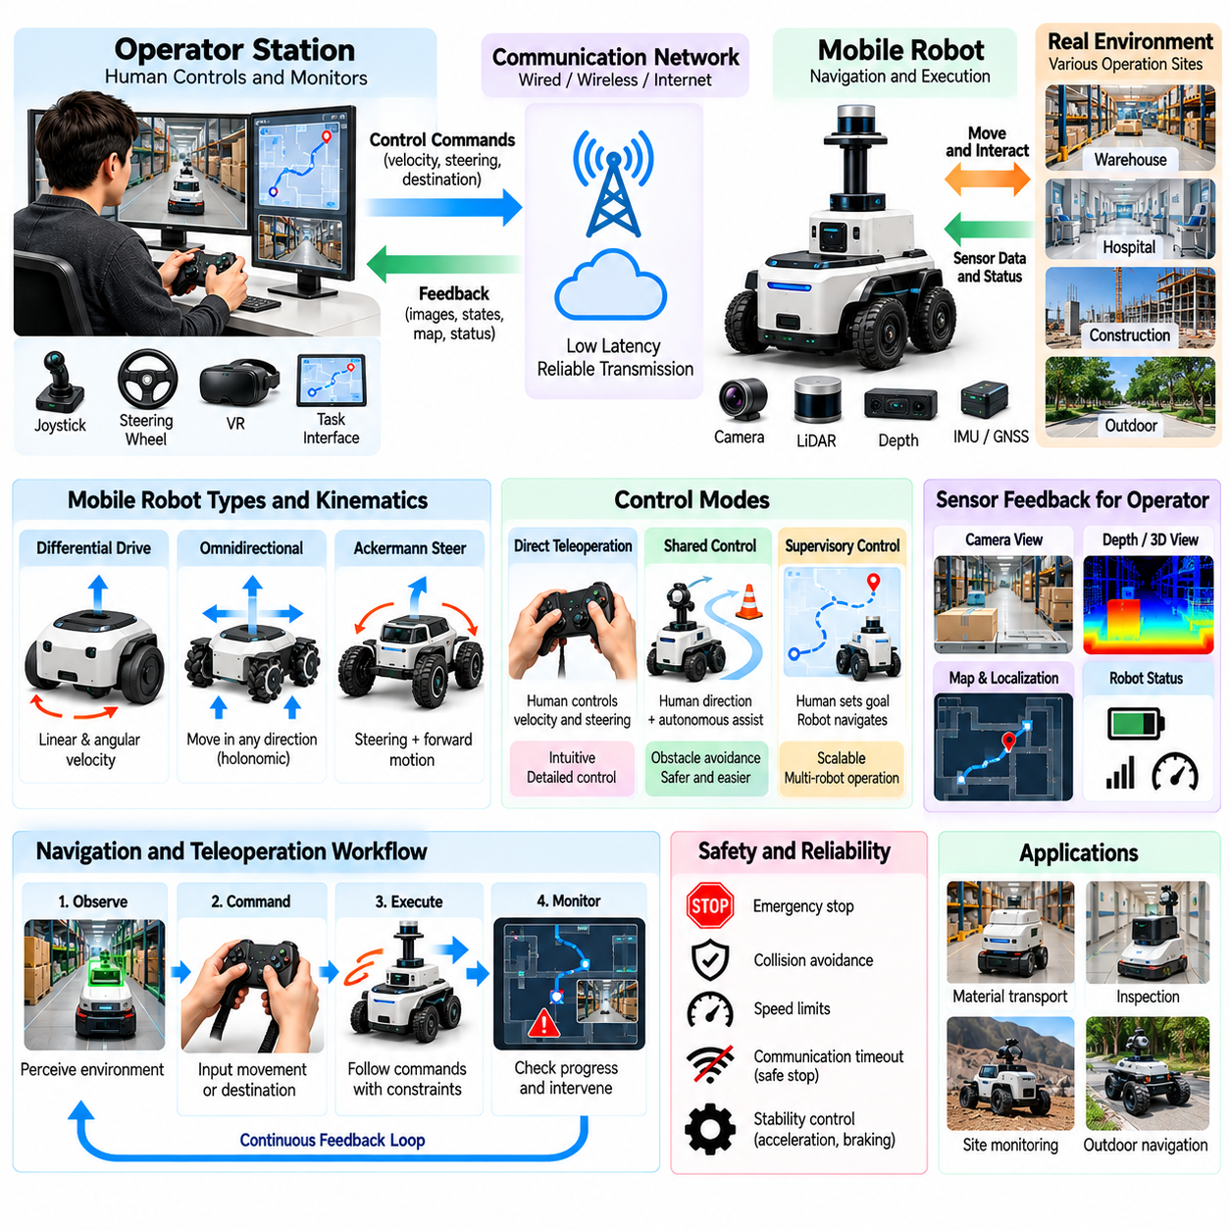
Teleoperation for mobile robots enables human operators to control robotic platforms across warehouses, factories, hospitals, construction sites, and outdoor environments. Unlike stationary manipulators, mobile robots must continuously navigate changing spatial conditions while maintaining safe movement. Teleoperation provides direct human guidance when autonomous navigation is unavailable, uncertain, or insufficient, while generating valuable demonstrations for Physical AI learning.
Mobile robot teleoperation typically combines an operator interface, wireless communication network, onboard navigation controller, and environmental sensors. Operators issue velocity, steering, or destination commands while receiving visual and positional feedback. The robot translates these inputs into executable motion through its drive system. Reliable integration between communication, perception, and control is essential for maintaining predictable movement.
Different mobile robot configurations require different teleoperation strategies. Differential-drive robots are controlled through linear and angular velocities, while omnidirectional platforms can move laterally without changing orientation. Ackermann-steered vehicles require coordinated steering and forward motion. Control interfaces must respect these kinematic constraints to prevent commands that cannot be physically executed.
Joystick control remains common because it provides intuitive directional commands and rapid operator response. Input displacement can be mapped to forward velocity, rotational speed, or steering angle. Adjustable speed limits and nonlinear response curves improve maneuverability in narrow spaces. However, excessive sensitivity can produce abrupt movements, making calibration and command smoothing important for safe operation.
Visual feedback allows operators to interpret obstacles, corridors, intersections, and dynamic objects. Forward-facing cameras provide navigation context, while panoramic or multiple-camera configurations reduce blind spots. Depth cameras and LiDAR can supplement video with geometric information. Combining these sources improves situational awareness, particularly when the robot operates beyond the operator's direct line of sight.
Localization feedback helps operators understand the robot's position relative to its environment. Maps generated through simultaneous localization and mapping can display robot pose, obstacles, and planned routes. However, localization estimates may become unreliable in repetitive corridors, reflective environments, or changing construction sites. Teleoperation interfaces should communicate uncertainty rather than presenting estimated positions as exact measurements.
Communication latency directly affects driving precision and operator confidence. Delayed camera images can cause overcorrection during steering, while delayed motion commands increase stopping distance. Wireless interference, network congestion, and temporary signal loss introduce additional uncertainty. Local velocity limits and collision prevention mechanisms help reduce risks when communication performance deteriorates.
Shared-control navigation combines human directional guidance with autonomous obstacle avoidance. Operators select the desired movement direction, while onboard planners modify trajectories to maintain clearance from obstacles. This reduces collision risk and operator workload. Nevertheless, excessive autonomous correction can make the robot feel unpredictable, requiring clear feedback about how operator commands are being modified.
Supervisory teleoperation allows operators to specify destinations or navigation goals rather than continuously controlling velocity. The robot uses onboard localization, global planning, and local obstacle avoidance to execute the route. Human intervention becomes necessary when navigation encounters blocked passages, localization failures, or unfamiliar conditions. This approach supports scalable operation across larger robot fleets.
Recovery from navigation failures is a particularly valuable application of teleoperation. Robots may become trapped near obstacles, encounter unexpected barriers, or fail to interpret temporary environmental changes. Human operators can identify alternative paths and guide the robot toward a recoverable state. Recording these interventions creates targeted training data for improving future autonomous navigation policies.
Safety architecture must account for both static and moving obstacles. Emergency stopping, protective sensing, speed restrictions, and local collision monitoring should operate independently of remote communication. A communication timeout should trigger an appropriate controlled response. Robots carrying heavy payloads or operating near pedestrians may require more conservative speed and stopping policies.
Mobile robot dynamics influence how teleoperation commands should be executed. Acceleration limits, braking performance, wheel slip, and payload distribution affect motion stability. Sudden commands may produce unsafe behavior on slippery floors or uneven terrain. Motion controllers should enforce feasible acceleration and turning rates while preserving the operator's intended navigation direction.
Outdoor mobile robot teleoperation introduces additional challenges associated with terrain, weather, lighting, and communication coverage. Gravel, slopes, mud, and uneven surfaces can reduce traction and alter vehicle response. Rain, dust, and strong sunlight may degrade sensors. Operators require feedback about terrain conditions and robot health to avoid commands that exceed the platform's mobility capabilities.
Teleoperation for autonomous mobile robots is often integrated with fleet management systems. A remote operator may assist multiple robots by responding to intervention requests rather than continuously driving a single platform. Task queues, robot status dashboards, and operator assignment mechanisms support efficient coordination. However, simultaneous failures can create workload peaks that must be considered during system design.
Human intervention policies determine when autonomous navigation should request assistance. Triggers may include localization uncertainty, repeated planning failures, prolonged obstacle blockage, or safety-related events. Appropriate thresholds balance autonomous independence against operational risk. Excessively frequent intervention reduces scalability, while delayed intervention may increase downtime or expose the robot to unsafe conditions.
Mobile robot demonstrations typically contain synchronized camera observations, LiDAR scans, robot poses, velocity commands, and navigation outcomes. Additional records may include operator inputs, planned trajectories, obstacle distances, and control-mode transitions. These signals provide the context needed to understand why particular navigation decisions were made and how they affected subsequent robot movement.
Accurate temporal alignment is essential when recording mobile navigation demonstrations. Sensor observations and control commands must correspond to the same physical events. Network delay can cause recorded operator inputs to appear associated with outdated images. Using synchronized timestamps and distinguishing command generation from execution time helps prevent misleading training examples.
Demonstration datasets should represent diverse navigation environments rather than repeating identical routes. Useful variation includes corridor width, obstacle placement, pedestrian movement, floor conditions, lighting, and initial robot orientation. Such diversity helps learning systems generalize beyond specific maps. However, safety-critical scenarios should be collected under controlled conditions with appropriate protective measures.
Human driving behavior introduces both useful expertise and potential bias into navigation datasets. Experienced operators may anticipate obstacles and select efficient paths, while inexperienced operators may oversteer or hesitate. Different joystick settings can also produce inconsistent trajectories. Data curation should preserve informative recovery behavior while identifying unnecessary oscillations and interface-induced artifacts.
Behavior cloning can use teleoperated navigation trajectories to train policies that predict velocity or steering commands from sensor observations. However, small control errors may accumulate and move the robot into unfamiliar states. Interactive imitation learning can address this limitation by collecting corrective demonstrations during policy execution. Evaluation must determine whether the learned behavior remains safe outside the original demonstration distribution.
Navigation learning can also benefit from hierarchical representations that separate destination selection from local movement control. Human demonstrations may reveal preferred routes, obstacle avoidance strategies, and recovery decisions. High-level policies can learn goal selection, while low-level policies generate feasible motion commands. This separation supports reuse across environments with different layouts and navigation objectives.
Data quality assessment should examine route completion, collision avoidance, command smoothness, intervention frequency, and environmental coverage. Successful trajectories alone may not reveal how robots should recover from blocked paths or localization errors. Including failure and corrective episodes provides more complete operational knowledge. Dataset labels should distinguish intentional operator decisions from autonomous safety interventions.
Privacy and security considerations arise when mobile robots collect video and spatial information in occupied environments. Recorded observations may contain identifiable individuals, sensitive facility layouts, or restricted operational details. Access controls, appropriate retention policies, and secure communication protect these datasets. Remote control authorization must also prevent unauthorized commands from affecting physical robot behavior.
Ultimately, mobile robot teleoperation combines human navigation expertise with onboard perception, motion control, and communication infrastructure. Its value extends beyond temporary manual driving to failure recovery, fleet supervision, and systematic demonstration collection. By recording diverse environments, control decisions, safety interventions, and execution outcomes, teleoperation becomes a scalable data source for increasingly autonomous Physical AI navigation systems.

02.08. Teleoperation for Manipulators and Humanoids
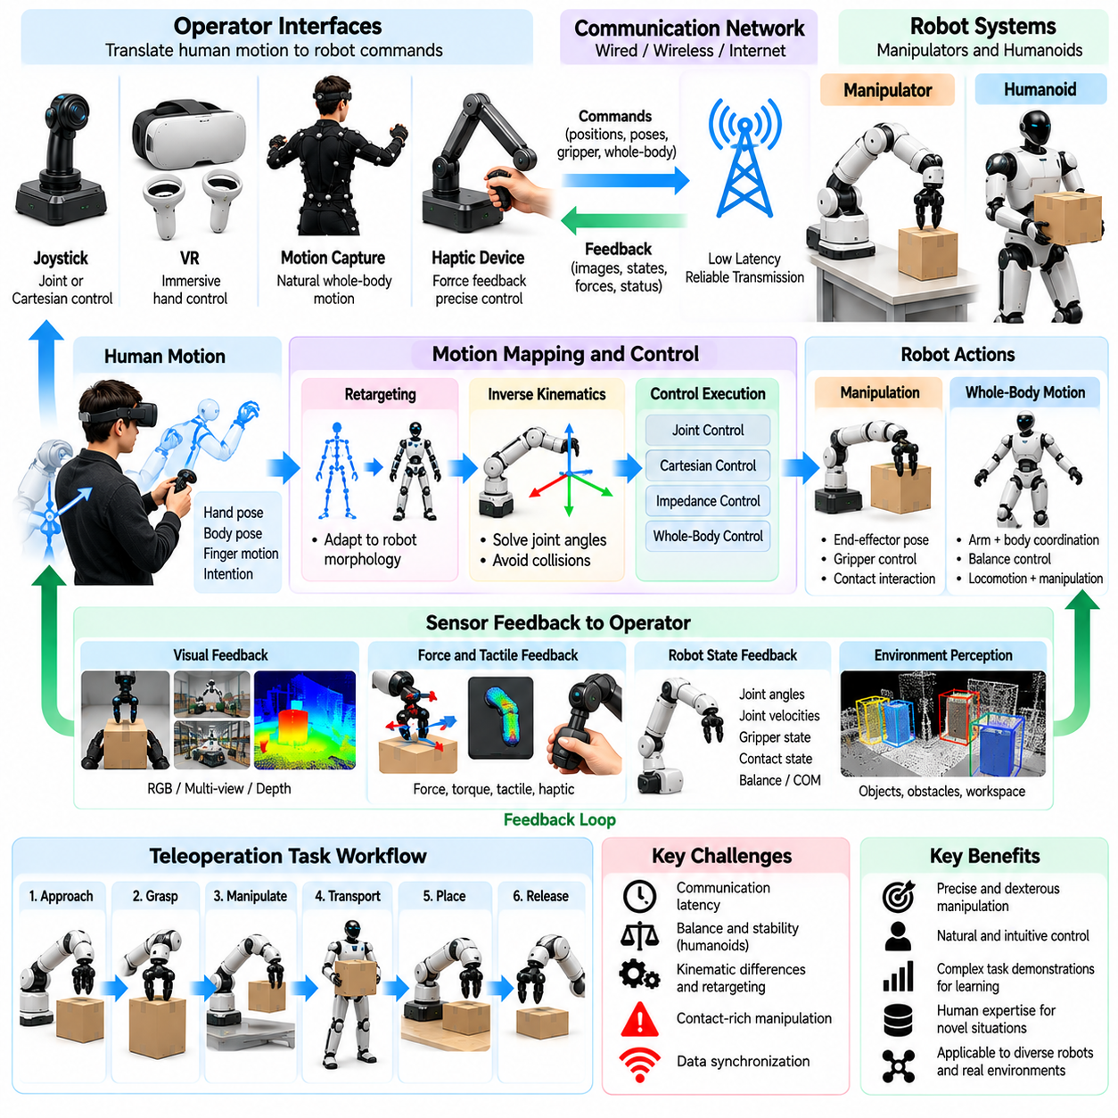
Teleoperation for manipulators and humanoid robots enables human operators to demonstrate complex physical skills through robotic systems with multiple degrees of freedom. Unlike mobile navigation, manipulation requires precise control of hand position, orientation, grasping force, and contact dynamics. Humanoid robots introduce additional challenges involving coordinated arm movements, whole-body balance, and interaction with environments designed for human activities.
Manipulator teleoperation commonly uses master devices, joysticks, virtual reality controllers, or motion capture systems to translate human movements into robot commands. Operators may control joint positions directly or specify desired end-effector poses. Cartesian control simplifies spatial manipulation, while joint-level control provides access to individual degrees of freedom. Interface selection depends on robot configuration, task requirements, and operator expertise.
Human-to-robot motion mapping is a central challenge because robotic arms rarely share the exact geometry of human limbs. Differences in link lengths, joint limits, and reachable workspaces require motion retargeting algorithms. These algorithms preserve task-relevant movements while satisfying robot kinematic constraints. Poor retargeting can produce unnatural trajectories, singular configurations, or unexpected contact with surrounding objects.
Inverse kinematics converts desired end-effector positions and orientations into feasible joint configurations. Redundant manipulators may have multiple solutions for the same target pose, requiring optimization of joint limits, collision avoidance, and motion smoothness. Humanoid robots introduce additional constraints because arm movements can influence balance. Whole-body inverse kinematics coordinates multiple joints while maintaining physically feasible postures.
Bimanual manipulation requires synchronized control of two robotic arms and their interaction with shared objects. Tasks such as folding fabric, assembling components, or carrying large items depend on coordinated motion and force distribution. Operators must understand the relative positions of both hands and the object. Independent arm control can introduce conflicting forces, making coordinated planning and feedback essential.
Grasping control involves more than opening and closing robotic fingers. Successful manipulation requires selecting contact points, regulating grip force, and adapting to object geometry and material properties. Parallel grippers provide relatively simple control, while dexterous robotic hands introduce many additional degrees of freedom. Teleoperation interfaces must balance expressive control with manageable operator workload.
Humanoid teleoperation extends manipulation to coordinated whole-body behavior. Reaching toward distant objects may require torso rotation, stepping, or repositioning the center of mass. The robot must maintain balance while executing the intended task. Human demonstrations therefore need to be transformed through controllers that respect support contacts, joint limits, and dynamic stability constraints.
Balance control is particularly important when humanoids manipulate heavy objects or interact with external forces. Changes in payload distribution can shift the center of mass and alter ground reaction forces. Local balance controllers should respond independently of communication delays. Teleoperation systems must distinguish operator intentions from autonomous stabilization actions to preserve accurate training records.
Visual feedback supports object localization, hand positioning, and spatial reasoning during remote manipulation. Wrist-mounted cameras provide detailed views of contact regions, while external cameras offer broader workspace awareness. Stereo vision and depth sensing can improve three-dimensional interpretation. However, occlusion, calibration errors, and delayed images may cause operators to misjudge object distances or contact conditions.
Force and tactile feedback provide additional information during contact-rich manipulation. Operators can use resistance cues to recognize insertion forces, grasp instability, or collisions. Tactile sensing helps identify slipping and uneven pressure distributions. When physical haptic devices are unavailable, visual force indicators may provide partial alternatives, although they cannot reproduce the complete sensation of physical interaction.
Communication latency affects precision manipulation differently from mobile navigation. Small delays can produce overshoot during insertion or contact adjustment, particularly when operators rely on force feedback. Local impedance control, motion filtering, and predictive displays can improve responsiveness. Safety-critical contact regulation should remain onboard rather than depending entirely on remote operator reactions.
Shared autonomy reduces the burden of controlling numerous joints simultaneously. Operators may specify object targets or desired grasp poses while autonomous controllers handle inverse kinematics, collision avoidance, and grip stabilization. This division allows humans to focus on task intent. However, excessive automation can obscure which actions originate from human decisions and which result from robotic assistance.
Task demonstrations should capture meaningful manipulation phases, including approach, grasp, transport, placement, release, and recovery. Each phase involves different control requirements and contact conditions. Segmenting demonstrations into interpretable stages supports hierarchical policy learning. Nevertheless, transitions between phases must remain synchronized because critical decisions often occur near contact events.
Humanoid demonstrations may additionally include locomotion, posture adjustment, and coordinated hand-object interaction. A robot might approach a workstation, reposition its feet, reach toward a tool, and manipulate an object. These actions require coordination across perception, navigation, and manipulation systems. Recording only hand trajectories would omit important whole-body decisions necessary for reproducing the task.
Sensor recording should include synchronized camera streams, joint positions, velocities, torques, end-effector poses, and gripper states. Humanoid systems may additionally require inertial measurements, foot contact information, and balance controller outputs. Operator inputs and transformed robot commands should be stored separately. This distinction helps identify whether observed behavior reflects human intention, control limitations, or autonomous corrections.
Contact events require particularly accurate temporal alignment because grasp transitions and insertion forces may change rapidly. Sensor delays can cause force measurements to appear associated with incorrect visual frames or motion commands. Hardware timestamps and calibrated synchronization improve consistency. Reliable alignment allows learning algorithms to associate observations, actions, and physical consequences correctly.
Operator skill strongly influences manipulation demonstration quality. Experienced operators may anticipate contact, minimize unnecessary motion, and recover efficiently from grasp failures. Less experienced operators may generate hesitation, repeated corrections, or excessive force. These differences should be documented rather than ignored. Dataset curation can preserve useful recovery behavior while identifying patterns caused by interface difficulty.
Demonstration diversity is necessary for robust manipulation learning. Training datasets should include variations in object size, shape, weight, surface friction, initial pose, and workspace arrangement. Humanoid tasks should also vary support conditions and approach configurations. Repeated demonstrations under identical conditions may improve local performance but provide limited generalization to unfamiliar environments.
Behavior cloning can train manipulation policies to predict robot actions from multimodal observations. However, small positioning errors may accumulate during long tasks, especially when contact changes the environment. Interactive imitation learning introduces corrective demonstrations when learned policies encounter unfamiliar states. Combining successful, failed, and recovery episodes improves coverage of realistic manipulation outcomes.
Learning from humanoid teleoperation requires distinguishing embodiment-specific movements from transferable task intentions. Joint trajectories collected on one humanoid may not execute correctly on another with different proportions or actuator capabilities. Representations based on object relationships, end-effector goals, and contact constraints may improve transfer. Nevertheless, robot-specific control adaptation remains necessary for safe execution.
Safety mechanisms must protect operators, nearby humans, robots, and manipulated objects. Joint limits, collision detection, force thresholds, emergency stopping, and workspace restrictions should remain active during teleoperation. Humanoids require additional protection against falls and unstable contact configurations. Remote communication failures must not disable local stabilization or protective control functions.
Scalable collection of manipulation demonstrations benefits from standardized task definitions, calibration procedures, and recording formats. Operator training and automated quality checks reduce inconsistencies between sessions. Dataset metadata should identify robot morphology, gripper type, control mode, object properties, and task outcomes. These records support comparison, filtering, and reuse across different Physical AI training pipelines.
Ultimately, manipulator and humanoid teleoperation connects human dexterity with robotic execution through motion mapping, feedback, and coordinated control. Its importance extends beyond completing individual tasks to generating structured demonstrations of grasping, contact regulation, bimanual coordination, and whole-body behavior. High-quality recordings provide essential foundations for scalable imitation learning and increasingly general-purpose Physical AI systems.

02.09. Teleoperation for Quadrupeds and Aerial Robots
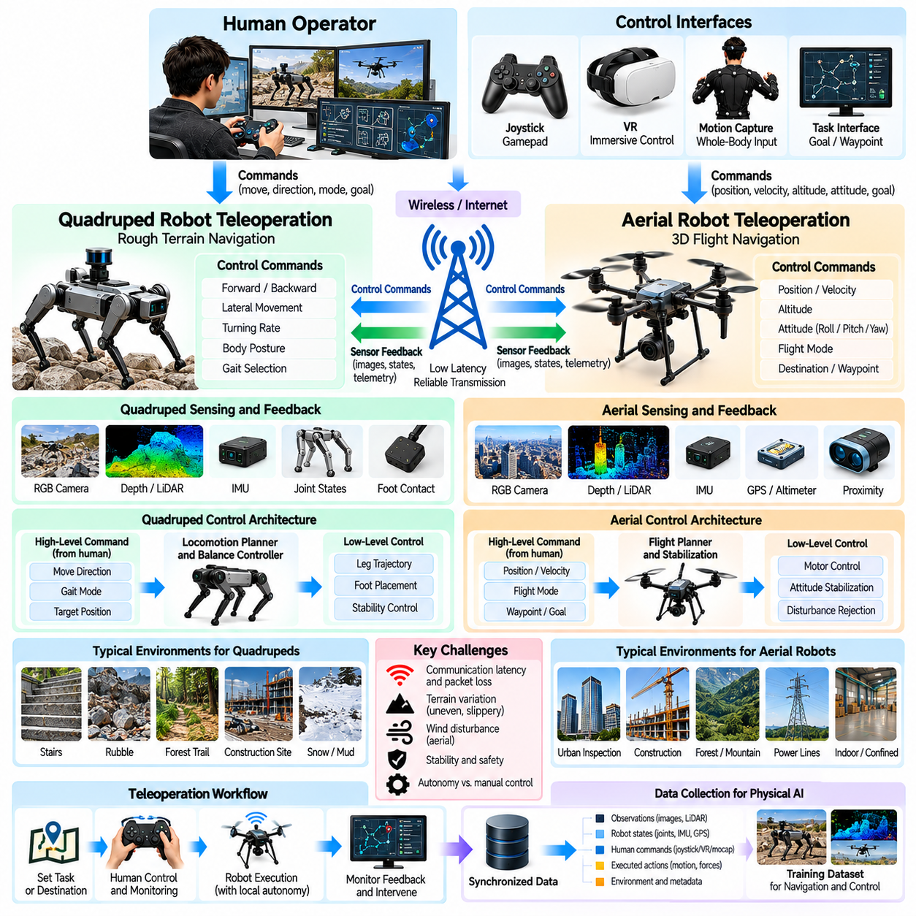
Teleoperation for quadruped and aerial robots enables human operators to guide robotic platforms through environments where conventional wheeled navigation is difficult or impossible. Quadrupeds traverse stairs, rubble, and uneven terrain, while aerial robots operate in three-dimensional spaces with continuous flight dynamics. Both platforms require specialized control interfaces, reliable feedback, and autonomous stabilization to support safe operation and high-quality Physical AI data collection.
Quadruped teleoperation commonly separates high-level movement commands from low-level locomotion control. Operators specify desired forward velocity, lateral movement, turning rate, or body orientation, while onboard controllers coordinate individual leg movements. This separation reduces the burden of controlling multiple joints simultaneously. It also allows human demonstrations to focus on navigation decisions rather than detailed gait execution.
Legged locomotion introduces challenges involving ground contact, balance, and terrain adaptation. Each step requires coordinated joint motion and appropriate force distribution across supporting legs. Uneven surfaces can change contact conditions unexpectedly, causing slipping or instability. Local locomotion controllers must respond rapidly to these disturbances because remote operators cannot reliably manage individual foot contacts through delayed communication.
Quadruped robots may support walking, trotting, climbing, and other locomotion modes depending on their mechanical capabilities. Teleoperation interfaces can expose gait selection and body posture adjustments alongside directional commands. However, inappropriate gait transitions may destabilize the robot. Recording selected gait modes, transition timing, and terrain conditions helps learning systems understand the relationship between movement strategy and environmental constraints.
Visual perception is essential when quadrupeds operate in cluttered or unfamiliar environments. Forward cameras, depth sensors, and LiDAR provide information about obstacles, slopes, stairs, and traversable surfaces. Operators may also receive terrain maps and estimated foothold locations. Combining geometric perception with robot posture information improves situational awareness and supports safer navigation decisions.
Proprioceptive feedback provides additional information about quadruped stability and movement execution. Joint encoders, inertial measurement units, foot contact sensors, and actuator torque estimates reveal body motion and interaction forces. These measurements help identify slipping, unexpected impacts, and unstable support conditions. Teleoperation systems should present critical stability information without overwhelming operators with excessive sensor details.
Shared autonomy is particularly valuable for quadrupeds because terrain negotiation requires rapid local decisions. Operators can select a destination or preferred direction while onboard systems choose footholds, regulate balance, and avoid unsafe terrain. This architecture combines human environmental understanding with robotic reaction speed. Nevertheless, autonomous modifications to commanded motion should be recorded to distinguish operator intent from stabilization behavior.
Aerial robot teleoperation presents different control challenges because flight requires continuous regulation of position, attitude, and thrust. Multirotor platforms generate motion by adjusting rotor speeds, while fixed-wing aircraft depend on aerodynamic lift and forward velocity. Control interfaces must reflect these physical differences. Commands that are appropriate for hovering drones may be unsuitable for aircraft that cannot remain stationary.
Multirotor teleoperation typically uses remote controllers, joysticks, or ground control stations to specify velocity, altitude, yaw, or attitude commands. Flight controllers convert these inputs into motor commands while maintaining stabilization. Position-hold and altitude-hold modes reduce operator workload. However, operators must understand the active flight mode because identical control inputs can produce different behavior under different control configurations.
Aerial navigation requires awareness of obstacles in three dimensions. Buildings, trees, power lines, and moving objects create hazards that may not be visible from a single camera perspective. Forward cameras, stereo vision, LiDAR, and proximity sensors can improve environmental perception. Operators benefit from altitude indicators, spatial maps, and collision warnings that complement live video feedback.
Communication reliability is especially important for aerial robots because loss of control may rapidly create hazardous conditions. Wireless interference, limited coverage, and network latency can delay commands or video feedback. Flight controllers should maintain independent stabilization and implement appropriate failsafe behavior. Depending on the operational context, communication loss may trigger controlled hovering, landing, or return-to-home procedures.
Wind disturbances introduce uncertainty into aerial teleoperation by changing vehicle motion independently of operator commands. Gusts can produce position errors, attitude changes, and increased energy consumption. Onboard estimators and flight controllers compensate for disturbances within their operating limits. Recording wind estimates, controller corrections, and actual trajectories helps distinguish environmental effects from human control decisions.
Quadruped and aerial teleoperation share a need for hierarchical control architectures. Human operators typically specify task-level goals or movement intentions, while onboard controllers execute fast stabilization loops. This separation is necessary because communication delays prevent reliable remote regulation of high-frequency dynamics. Training datasets should preserve both operator-level commands and robot-level execution signals.
Inspection tasks illustrate the complementary capabilities of quadruped and aerial robots. Quadrupeds can approach equipment through narrow passages or traverse uneven industrial surfaces, while aerial platforms can inspect elevated structures and inaccessible areas. Teleoperation allows operators to adapt viewpoints and movement strategies to changing conditions. Recorded demonstrations can support learning of inspection routes, observation poses, and safe approach behaviors.
Quadruped manipulation introduces additional complexity when a robotic arm or sensor mast is mounted on the body. Manipulator movements alter the center of mass and may affect locomotion stability. Operators must coordinate base positioning, body posture, and tool interaction. Shared-control systems can maintain balance while executing manipulation commands, but the resulting demonstrations should record these autonomous compensations.
Aerial manipulation and payload transport create similar coupling between task execution and platform dynamics. Carrying objects changes mass distribution, inertia, and flight response. Contact with external structures can introduce unexpected forces. Teleoperation systems should account for payload limitations and interaction risks. Specialized controllers may be necessary to maintain stability during grasping, delivery, or suspended-load transport.
Data collection for quadrupeds should capture camera observations, terrain geometry, body pose, joint states, foot contacts, commanded velocities, and locomotion outcomes. Gait modes, balance corrections, and intervention events provide additional context. These signals allow learning systems to associate terrain conditions with successful movement strategies and recognize circumstances that require changes in locomotion behavior.
Aerial robot datasets should include synchronized video, depth observations, vehicle position, attitude, velocity, angular rates, and control commands. Flight mode, battery condition, estimated wind, and safety interventions are also relevant. Recording both desired and executed trajectories reveals how onboard controllers respond to disturbances. Such information is important for learning navigation behavior that remains compatible with flight dynamics.
Temporal synchronization is essential because quadruped foot contacts and aerial stabilization responses occur rapidly. Delayed timestamps can associate corrective commands with incorrect terrain observations or flight states. Hardware-based timing, consistent clocks, and measured communication delays improve data integrity. Accurate alignment supports learning algorithms that model action consequences and dynamic transitions.
Demonstration diversity should reflect realistic operational conditions. Quadruped datasets benefit from variations in slope, surface friction, obstacle height, terrain compliance, and gait selection. Aerial datasets require variation in altitude, wind, lighting, obstacle density, and flight configuration. Collecting only smooth trajectories in controlled environments may produce policies that fail when encountering unfamiliar disturbances.
Human operator skill influences both locomotion and flight demonstration quality. Experienced operators anticipate hazards and select conservative movement strategies, while inexperienced operators may introduce oscillatory commands or unnecessary corrections. Interface sensitivity and control modes also affect behavior. Dataset metadata should document these factors so learning systems do not confuse interface artifacts with effective navigation strategies.
Safety requirements differ between terrestrial and aerial platforms. Quadrupeds must manage falls, unstable footholds, and collisions with nearby people or equipment. Aerial robots must additionally consider airspace restrictions, falling hazards, rotor contact, and emergency landing conditions. Independent safety controllers, operational boundaries, and emergency procedures should remain active throughout teleoperation and data collection.
Learning from teleoperated quadruped and aerial demonstrations can support imitation learning, reinforcement learning initialization, and world-model training. High-level policies may learn terrain selection, waypoint decisions, or inspection strategies, while low-level controllers maintain physical stability. Separating transferable task intentions from platform-specific dynamics improves the potential for reuse across different robotic embodiments.
Ultimately, teleoperation for quadrupeds and aerial robots combines human decision-making with autonomous control of complex physical dynamics. Its effectiveness depends on reliable perception, stable onboard controllers, communication resilience, safety mechanisms, and synchronized data recording. Well-designed collection pipelines transform operator demonstrations and recovery interventions into valuable datasets for scalable Physical AI mobility and autonomous operation.

02.10. Demonstration Episode Design
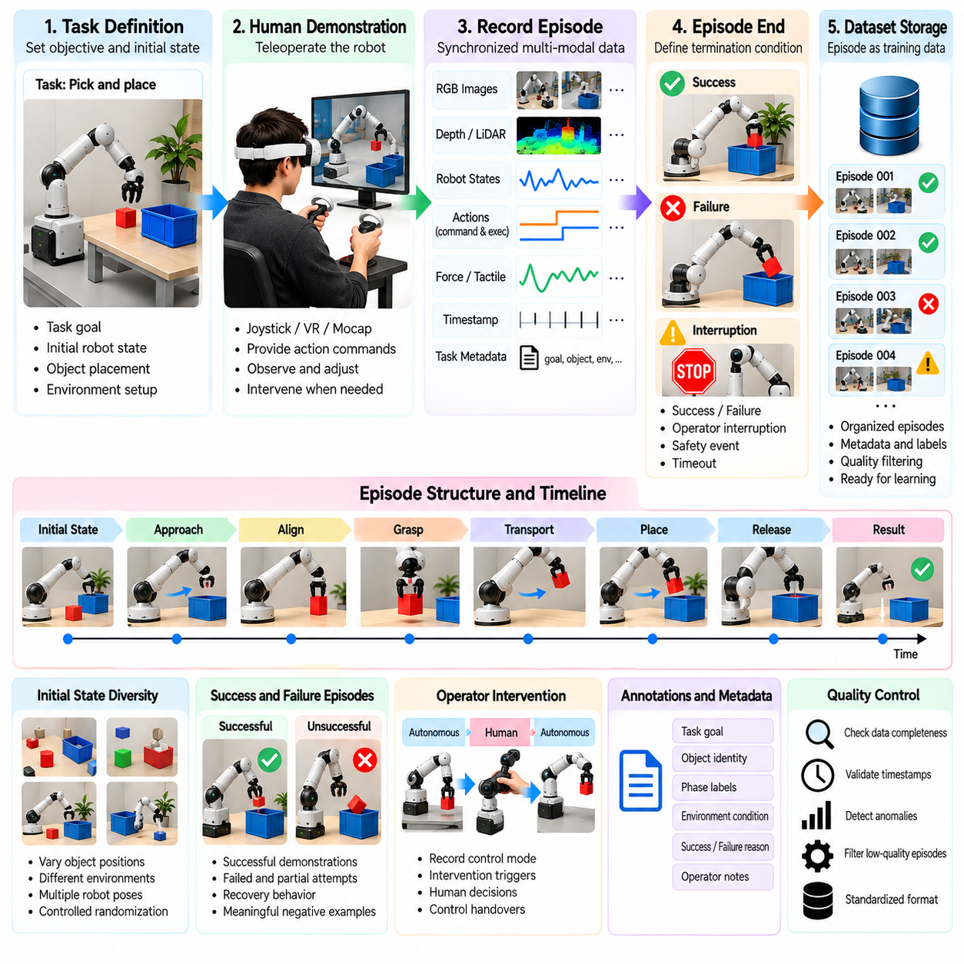
Demonstration episode design defines how human-guided robot interactions are organized into structured training examples for Physical AI systems. An episode represents a bounded sequence of observations, actions, and outcomes associated with a particular task objective. Careful design ensures that recorded demonstrations capture meaningful behavior rather than arbitrary motion fragments, supporting reliable imitation learning and scalable dataset construction.
An effective episode begins with a clearly defined task objective and an identifiable initial state. The objective may involve grasping an object, navigating to a destination, opening a door, or recovering from an unexpected obstacle. Initial conditions should specify robot configuration, object placement, environmental constraints, and relevant task parameters. These definitions establish the context needed to interpret subsequent actions.
Episode boundaries determine where a demonstration starts and ends. Recording may begin before the first intentional movement to capture perception and planning behavior. Termination can occur after successful completion, confirmed failure, operator interruption, or a safety event. Consistent boundary rules prevent important transitions from being omitted and make comparisons between demonstrations more meaningful.
Task decomposition provides a useful foundation for designing complex demonstration episodes. A manipulation task may include approach, alignment, grasp, transport, placement, and release phases. Navigation tasks may involve localization, route selection, obstacle avoidance, and goal confirmation. These phases should be represented without unnecessarily fragmenting continuous behavior, preserving the causal relationships between actions.
Episode duration influences both learning efficiency and data management. Short episodes simplify labeling and reduce the accumulation of unrelated behavior, but they may omit long-term dependencies. Extended episodes capture multi-stage planning and recovery but introduce greater variation in task progression. Duration limits should reflect task structure rather than arbitrary recording convenience.
Initial-state diversity is essential for preventing learned policies from depending on narrowly repeated configurations. Object positions, robot orientations, obstacle layouts, lighting, and environmental conditions can be varied systematically. However, variations must remain within feasible and safe operating boundaries. Controlled randomization helps distinguish task-relevant skills from incidental features of a particular demonstration setup.
Successful demonstrations provide examples of desired task execution, but success alone is insufficient for robust learning. Episodes should also capture unsuccessful attempts, partial completion, and corrective behavior when appropriate. These examples reveal the consequences of poor decisions and the strategies used to recover. Failure labels must distinguish task-level failure from recording errors or equipment malfunctions.
Recovery episodes deserve explicit design because autonomous robots frequently encounter states absent from ideal demonstrations. Operators may correct an unstable grasp, reposition a robot after localization failure, or select an alternative route around an obstruction. Recording the state before intervention, corrective commands, and resulting recovery outcome enables policies to learn how to return toward successful execution.
Operator intervention should be represented as a meaningful event rather than an unexplained change in robot behavior. Episode metadata can identify whether control was manual, autonomous, or shared at each stage. Intervention triggers, operator decisions, and control handovers should be recorded. This separation helps learning systems distinguish intentional demonstrations from autonomous controller corrections.
Observation design determines what information is available to the learning system at each step. Camera images, depth measurements, joint states, force readings, and task instructions may provide complementary context. Sensor selection should reflect the intended deployment configuration. Training policies on observations unavailable during actual operation can create unrealistic dependencies and poor transfer.
Action representation is equally important because teleoperation interfaces may generate commands in different coordinate frames and control spaces. Joint positions, Cartesian poses, velocities, and gripper commands describe different aspects of behavior. Episodes should preserve raw operator inputs and executed robot actions separately. Standardized units and coordinate conventions support consistent learning across devices.
Temporal structure determines how observations and actions are associated throughout an episode. Sensor streams may operate at different sampling rates, while commands experience processing and communication delays. Reliable timestamps allow reconstruction of action consequences and contact events. Resampling should preserve meaningful transitions rather than smoothing away brief but important corrections.
Episode annotations should describe task goals, object identities, environmental conditions, operator actions, and final outcomes. Phase labels can identify approach, contact, manipulation, and recovery segments. Additional annotations may describe unexpected obstacles or safety interventions. Annotation detail should be sufficient for training and evaluation without making large-scale collection prohibitively expensive.
Quality control begins during recording rather than after dataset completion. Automated checks can identify missing sensor frames, timestamp discontinuities, invalid robot states, and incomplete task metadata. Operators may receive immediate feedback when a session becomes unusable. Early detection reduces wasted collection effort and prevents corrupted demonstrations from entering training pipelines.
Episode acceptance criteria should combine technical validity with behavioral relevance. A technically complete recording may still contain ambiguous objectives, excessive hesitation, or uncontrolled motion. Conversely, a failed attempt may provide valuable recovery information. Quality assessment should therefore distinguish recording integrity, task performance, and learning usefulness rather than relying on a single success indicator.
Demonstration consistency requires standardized instructions and operator preparation. Different operators may interpret the same objective differently or choose incompatible completion criteria. Written task definitions, practice sessions, and calibrated interfaces reduce unnecessary variation. At the same time, useful diversity in execution strategies should be preserved rather than forcing all operators to reproduce identical trajectories.
Episode metadata should include robot morphology, sensor configuration, control mode, software version, task identifier, and environmental setup. Operator experience and calibration status may also influence behavior. These records support filtering, reproducibility, and comparisons across collection campaigns. Without adequate metadata, apparently similar demonstrations may represent substantially different operating conditions.
Balanced dataset construction requires attention to the distribution of episode types. Repeatedly collecting easy successful tasks may produce large datasets with limited behavioral coverage. Difficult initial states, unusual object configurations, and recoverable failures often provide additional learning value. Sampling strategies should prioritize informative variation while respecting operational safety and collection costs.
Curriculum-based episode design organizes demonstrations from simpler tasks toward more demanding interactions. Early episodes may use fixed object positions and predictable environments, while later episodes introduce clutter, disturbances, and longer action sequences. This progression supports systematic skill acquisition. Nevertheless, training curricula should include sufficient overlap between difficulty levels to avoid abrupt distribution changes.
Episode design should also support hierarchical learning by preserving relationships between high-level intentions and low-level motor actions. A long task can contain meaningful subgoals without losing its overall objective. Recording subgoal transitions allows models to learn task planning alongside execution. Such structure is especially valuable for humanoid manipulation and multi-stage mobile robot operations.
Evaluation episodes should be separated from training episodes according to clearly defined rules. Randomly splitting nearly identical trajectories may exaggerate generalization performance. More informative evaluations vary object instances, environments, initial conditions, or operators. Dataset provenance and episode identifiers help prevent accidental overlap between training and testing, supporting credible performance measurement.
Privacy and safety constraints must be integrated into episode design from the beginning. Recording boundaries may exclude unnecessary personal information or restricted environmental details. Safety events should trigger appropriate protective actions and be labeled accurately. Data retention, access permissions, and operator consent requirements should be reflected in collection procedures rather than addressed only after recording.
Scalable demonstration pipelines benefit from automated episode initialization, event marking, termination detection, and validation. Standardized schemas allow recordings from different robots and collection sites to enter shared storage and processing systems. Human review can then focus on ambiguous or high-value examples. This combination improves throughput while maintaining traceability and dataset quality.
Ultimately, demonstration episode design transforms continuous teleoperation activity into interpretable units of robot learning. Well-defined objectives, controlled initial conditions, reliable boundaries, synchronized observations, and meaningful outcome labels preserve the structure of physical behavior. By incorporating successful actions, failures, interventions, and recovery, episode design establishes a foundation for scalable and generalizable Physical AI training.

02.11. Sensor Action Time Alignment
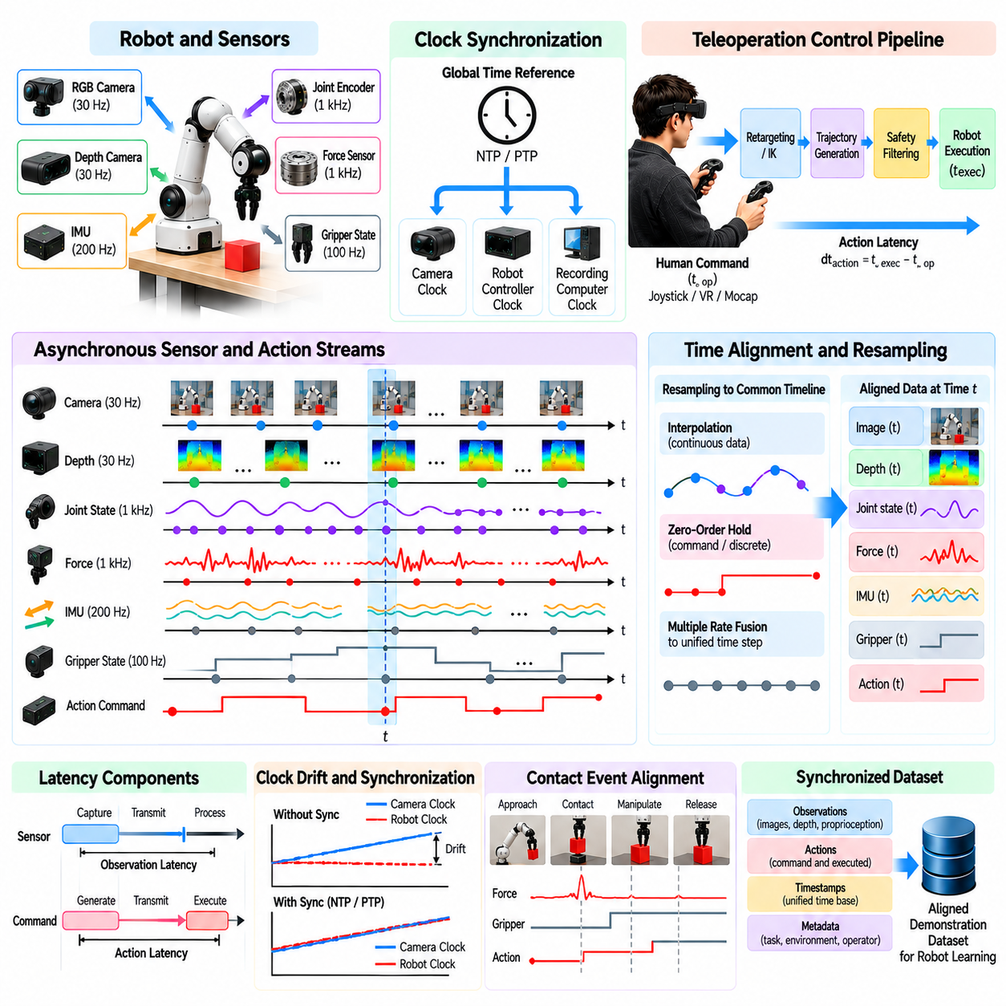
Sensor-action time alignment is a fundamental requirement for constructing reliable teleoperation datasets in Physical AI systems. Robot learning depends on correctly associating observations with the actions that produced subsequent changes in the environment. When sensor measurements and control commands are temporally misaligned, learning algorithms may infer incorrect causal relationships, reducing policy accuracy, stability, and generalization.
Teleoperation systems typically combine cameras, depth sensors, joint encoders, force sensors, inertial measurement units, and operator interfaces. These components operate at different frequencies and may use independent internal clocks. Camera streams may update at relatively low rates, while motor controllers execute commands at much higher frequencies. A unified temporal representation is therefore necessary to reconstruct robot behavior accurately.
Time alignment begins with a clear distinction between measurement time, transmission time, reception time, and processing time. A camera frame may represent a scene captured before the image reaches the recording computer. Similarly, a robot command may be generated before it is executed by an actuator. Recording only arrival timestamps can introduce systematic errors because communication and processing delays vary across devices.
Hardware timestamping provides a reliable foundation for synchronizing sensor and action streams. Sensors or interface controllers assign timestamps close to the moment of measurement or command generation. These timestamps reduce uncertainty introduced by operating system scheduling and communication buffers. However, hardware timestamps remain useful only when the clocks generating them share a known temporal reference.
Clock synchronization ensures that timestamps from different devices can be compared consistently. Network Time Protocol can provide approximate synchronization across networked computers, while Precision Time Protocol supports tighter synchronization when compatible hardware is available. Dedicated trigger signals may align camera exposures directly. The required synchronization accuracy depends on task dynamics and the timing sensitivity of relevant events.
Clock drift introduces gradual alignment errors when independent device clocks run at slightly different rates. Even when clocks are synchronized initially, their timestamps may diverge during extended recording sessions. Periodic synchronization and drift estimation help maintain consistency. Long-duration datasets should preserve synchronization diagnostics so downstream processing can identify intervals with unreliable timing.
Sensor sampling rates vary because different measurements have different physical requirements. Visual perception may operate at tens of frames per second, while joint feedback and force measurements may update hundreds or thousands of times per second. Aligning these streams requires careful treatment of missing intermediate samples. Simply matching observations by array index can create misleading relationships between robot states and actions.
Resampling converts asynchronous measurements into a common temporal structure suitable for model training. Continuous variables such as joint positions and velocities may be interpolated between valid measurements. Discrete signals such as gripper states or control modes often require different handling. Interpolation should not invent physical transitions or obscure sudden changes that are essential for understanding task execution.
Zero-order hold is commonly used for command signals that remain active until replaced by a new command. Under this representation, each command is associated with the interval during which it applies. Linear interpolation may be appropriate for selected continuous state variables but can distort discontinuities. Resampling methods should reflect the semantics of each signal rather than applying a universal procedure.
Action latency must be distinguished from observation latency because they affect learning in different ways. Observation latency delays information reaching the operator, while action latency delays the robot response to operator commands. Their combined effect can create apparent phase shifts between perception and movement. Accurate datasets should preserve both the operator-issued command and the actual robot execution timing.
Teleoperation control pipelines may introduce additional delays through motion retargeting, inverse kinematics, trajectory generation, and safety filtering. A human command may therefore differ from the action ultimately executed by the robot. Recording intermediate command stages improves traceability. It also allows learning systems to distinguish operator intention from transformations introduced by the control architecture.
Contact-rich manipulation requires particularly precise alignment because critical physical events occur over short intervals. During grasping, insertion, or surface interaction, forces can change rapidly while visual appearance changes only slightly. Misaligned force measurements may incorrectly associate contact with an earlier or later movement. High-resolution timestamps help preserve the sequence of approach, contact, force response, and release.
Mobile robots and legged platforms introduce timing challenges related to localization and stabilization. Wheel odometry, inertial measurements, camera observations, and control commands may arrive asynchronously. Quadruped foot contacts can change within individual gait cycles. Reliable alignment allows learning systems to associate terrain observations with movement decisions and the resulting balance corrections.
Aerial robots require accurate synchronization between flight commands, inertial states, and visual observations. Rapid attitude corrections may occur between consecutive camera frames. If control commands are aligned only with delayed images, learned policies may misunderstand the relationship between movement and stabilization. High-frequency flight telemetry should therefore be retained alongside lower-frequency perception data.
Temporal alignment also affects the construction of observation-action training pairs. In imitation learning, the target action should correspond to the information available when the decision was made. Pairing an action with observations captured after execution introduces future information into the training example. Such leakage can produce misleading evaluation results and policies that fail during real-time deployment.
Sequence-based learning models require consistent temporal ordering across extended observation and action histories. Transformer policies, recurrent networks, and diffusion-based action models may consume multiple frames and predict future action sequences. Irregular sampling and missing timestamps can distort these temporal patterns. Explicit time intervals and validity masks help models interpret asynchronous information.
Buffering strategies influence both real-time control and offline recording. Small buffers reduce delay but may expose the system to packet jitter or missing frames. Larger buffers improve ordering consistency but increase latency. Recording pipelines should preserve original timestamps before applying buffering or synchronization transformations. This enables later reconstruction without permanently embedding processing delays into the dataset.
Missing data requires explicit treatment because sensors may drop frames or temporarily lose communication. Repeating the last available observation can maintain fixed-size training inputs, but it may conceal important changes. Missing-data indicators and validity masks provide additional context. Long gaps should generally be identified separately from ordinary sampling intervals rather than silently interpolated.
Alignment validation should use measurable events shared across multiple signals. A commanded gripper closure may be compared with encoder motion and force onset. Camera-visible movements can be checked against joint trajectories, while synchronization pulses provide controlled references. Residual timing errors should be quantified because visually plausible alignment may still be inadequate for precision manipulation.
Quality metrics can characterize timestamp jitter, clock drift, missing samples, sensor latency, and command execution delay. These measurements help determine whether an episode meets the timing requirements of its intended learning task. Acceptance thresholds should reflect the robot platform and operational dynamics. A slow inspection task may tolerate errors that would be unacceptable for dynamic balancing or contact control.
Dataset storage formats should preserve original timestamps, synchronized timestamps, clock identifiers, and calibration metadata. Raw streams should remain accessible when practical so alignment procedures can be improved without repeating physical demonstrations. Versioned synchronization parameters support reproducibility. This separation between acquisition data and processed training samples is important for scalable data engineering.
Multi-robot and fleet-scale collection introduces further challenges because devices may operate across different computers, networks, and geographic locations. Local synchronization can preserve accurate timing within each robot, while shared references support comparisons across systems. Network outages and clock resets should be documented. Fleet datasets benefit from consistent timing conventions even when perfect global synchronization is unnecessary.
Automated alignment pipelines can estimate clock offsets, detect discontinuities, resample streams, and generate synchronized episode representations. However, automatic processing should not conceal uncertainty or replace invalid measurements with apparently precise values. Diagnostic reports and exception flags help identify problematic recordings. Human review can then focus on episodes containing ambiguous contact events or unusual timing behavior.
Ultimately, sensor-action time alignment preserves the causal structure of robotic experience. Accurate synchronization connects perception, operator intention, controller execution, physical interaction, and observed outcomes within a consistent temporal framework. By combining reliable timestamps, clock synchronization, latency measurement, appropriate resampling, and systematic validation, Physical AI data engines can produce trustworthy demonstrations for scalable robot learning.

02.12. Operator Skill Bias and Data Quality
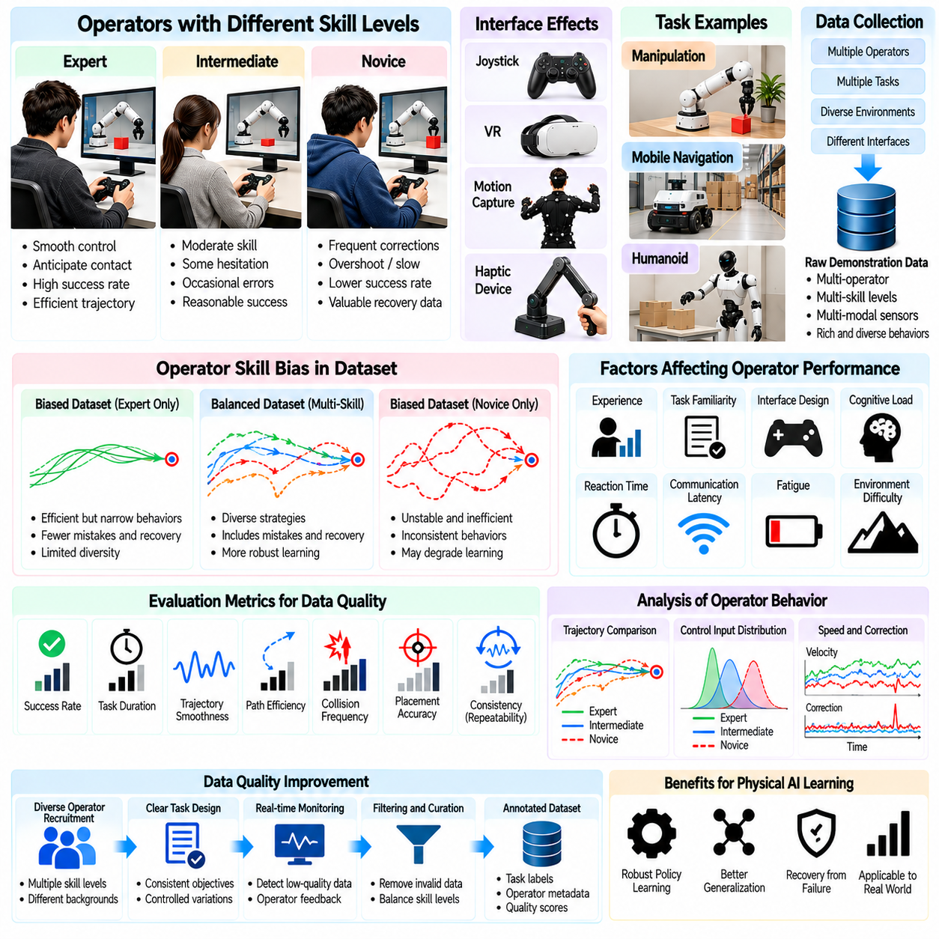
Operator skill bias is a major factor influencing the quality and representativeness of teleoperation datasets for Physical AI systems. Human operators differ in experience, coordination, reaction speed, spatial reasoning, and familiarity with robotic interfaces. These differences shape recorded actions and task outcomes. Without systematic evaluation, learning algorithms may reproduce individual operator habits rather than acquire robust and transferable robotic skills.
Operator expertise affects how efficiently demonstrations are executed. Experienced operators often produce smooth trajectories, anticipate contact events, and minimize unnecessary corrections. Novice operators may hesitate, overshoot targets, or repeatedly adjust movements. Although expert demonstrations can accelerate imitation learning, novice behavior may reveal useful recovery strategies and operational difficulties that expert-only datasets fail to capture.
Skill bias emerges when collected demonstrations disproportionately reflect particular operators or experience levels. A dataset dominated by highly trained specialists may contain efficient behavior but limited exposure to common mistakes. Conversely, excessive novice data may introduce unstable or inconsistent actions. Balanced collection strategies should consider the intended learning objective rather than assuming that all demonstrations contribute equal value.
Teleoperation interface design can amplify differences between operators. Joystick sensitivity, motion scaling, camera placement, control latency, and haptic feedback influence how users execute identical tasks. An operator who performs well with a virtual reality interface may struggle with direct joint control. Dataset metadata should therefore distinguish human skill differences from limitations introduced by interface configuration.
Individual operators often develop consistent movement preferences that create identifiable behavioral patterns. Some favor conservative approaches and slow contact transitions, while others use faster trajectories and larger corrections. These preferences can influence learned policies when demonstrations are treated as equally optimal. Capturing operator identifiers and behavioral statistics supports analysis of style diversity without requiring models to imitate personal habits.
Task familiarity is distinct from general teleoperation proficiency. An experienced operator may understand robotic controls but remain unfamiliar with a particular assembly sequence or object interaction. Repeated exposure to the same task can improve execution speed and reduce hesitation. Recording practice history and task-specific experience helps distinguish genuine skill differences from temporary learning effects.
Operator fatigue can gradually degrade demonstration quality during extended collection sessions. Reduced attention, slower reactions, and inconsistent control inputs may appear even among experienced operators. Long sessions can also introduce repetitive behavior or increased correction frequency. Collection procedures should include appropriate breaks, session-duration limits, and monitoring of performance trends without treating fatigue as a fixed personal characteristic.
Cognitive workload influences how operators allocate attention between perception, planning, and control. Complex tasks involving multiple cameras, robotic arms, or simultaneous navigation demands can exceed comfortable monitoring capacity. Operators may then prioritize immediate safety over optimal task execution. Interface simplification and shared autonomy can reduce workload, but their contributions should be documented when evaluating demonstration quality.
Reaction time and communication latency interact to shape teleoperation behavior. Operators may compensate for delayed feedback by slowing movements, anticipating future states, or issuing larger corrective commands. These adaptations are reasonable within a particular interface but may be undesirable when transferred to autonomous control. Training pipelines should distinguish delay-compensation behavior from task-essential movement strategies.
Skill assessment should use measurable indicators rather than subjective judgments alone. Completion rate, task duration, trajectory smoothness, collision frequency, intervention count, and recovery success provide complementary information. For manipulation, contact force and placement accuracy may be relevant. However, individual metrics should be interpreted within task context because faster execution does not necessarily indicate better performance.
Trajectory efficiency can reveal differences in operator control strategies. Excessive path length, repeated reversals, and unnecessary joint motion may indicate uncertainty or interface difficulty. Nevertheless, longer trajectories may be appropriate when operators avoid hazards or preserve stability. Quality evaluation should therefore consider safety margins, environmental constraints, and final outcomes rather than minimizing movement distance indiscriminately.
Demonstration consistency describes how reliably an operator reproduces successful behavior under comparable conditions. High consistency may indicate stable control skill, while substantial variation can reflect uncertainty or changing environmental conditions. Repeated trials with controlled initial states help estimate within-operator variability. Comparisons across operators require similar task difficulty and consistent measurement procedures.
Inter-operator variability can provide useful behavioral diversity when different strategies achieve the same objective safely. Multiple valid grasp approaches, navigation routes, or recovery sequences may improve policy generalization. However, conflicting demonstrations can also create ambiguous action targets. Learning systems may require task-conditioned representations or multimodal policies to model alternative successful behaviors.
Operator selection introduces sampling bias when participants are recruited from a narrow experience group. Laboratory researchers, professional robot operators, and occasional users may interact differently with identical systems. Datasets collected from only one population may not represent the broader operational environment. Recruitment and collection plans should reflect deployment requirements while maintaining consistent safety and training standards.
Demonstration quality should be separated into technical validity, task effectiveness, and learning usefulness. A recording may have accurate timestamps and complete sensor data but contain inefficient behavior. Another episode may fail its objective yet demonstrate valuable corrective actions. Multidimensional quality labels allow downstream training pipelines to select examples according to specific learning goals instead of applying simplistic success-only filtering.
Data filtering can improve average demonstration quality by removing corrupted recordings, uncontrolled collisions, or irrelevant movements. However, aggressive filtering may eliminate difficult situations and rare recovery behaviors. Such removal can produce overly idealized datasets that perform poorly outside controlled environments. Filtering policies should preserve informative failures while clearly identifying unsafe or invalid actions.
Quality weighting offers an alternative to treating every demonstration equally. Episodes may receive weights based on task completion, safety, precision, or confidence in the recorded labels. Expert demonstrations can receive greater influence for nominal task execution, while recovery examples remain available for robustness training. Weighting schemes require validation because poorly chosen scores can reinforce existing operator biases.
Dataset balancing should consider operator identity, skill level, task difficulty, and environmental variation simultaneously. Equal episode counts do not guarantee equal behavioral coverage if some operators repeatedly encounter easier conditions. Stratified sampling and controlled task assignments can reduce confounding factors. Distribution reports help reveal whether apparent performance differences arise from operators or collection conditions.
Learning algorithms can become sensitive to operator-specific action styles, particularly when training data is limited. Behavior cloning may reproduce hesitation, abrupt corrections, or unnecessarily cautious movement. Temporal smoothing can reduce some artifacts but may also remove meaningful contact adjustments. Robust policy learning requires distinguishing transferable task structure from incidental characteristics of human control.
Interactive imitation learning can reduce dependence on idealized expert demonstrations by collecting corrections in states visited by the learned policy. Operators intervene when the robot deviates from desirable behavior and demonstrate appropriate recovery. These interventions often provide highly informative examples. However, differences in intervention timing and operator judgment should be recorded to avoid introducing inconsistent supervision.
Operator calibration and training protocols improve data comparability across collection sessions. Standardized practice tasks, interface familiarization, and clear completion criteria reduce avoidable variation. Periodic calibration checks can detect changes in control sensitivity or sensor configuration. These procedures should establish a common baseline without suppressing legitimate diversity in safe and effective task strategies.
Quality assurance should monitor changes in demonstration statistics throughout data collection. Sudden increases in failure rate, command oscillation, or completion time may indicate fatigue, interface malfunction, or environmental changes. Automated dashboards can identify unusual patterns for investigation. Human reviewers should examine contextual evidence before attributing degraded performance to operator skill.
Privacy and fairness considerations are relevant when collecting operator performance information. Skill labels, behavioral statistics, and session histories may reveal individual work patterns. Access controls and appropriate anonymization can reduce unnecessary exposure. Evaluation procedures should focus on dataset suitability and training objectives rather than converting research metrics into unsupported judgments about individual capability.
Ultimately, managing operator skill bias requires balancing demonstration expertise, behavioral diversity, and systematic quality evaluation. Standardized interfaces, transparent metadata, multidimensional quality metrics, and carefully designed sampling strategies improve dataset reliability. By separating human-specific habits from transferable robotic competence, Physical AI data engines can transform heterogeneous teleoperation experiences into robust learning resources.

02.13. Success Failure and Corrective Demonstrations
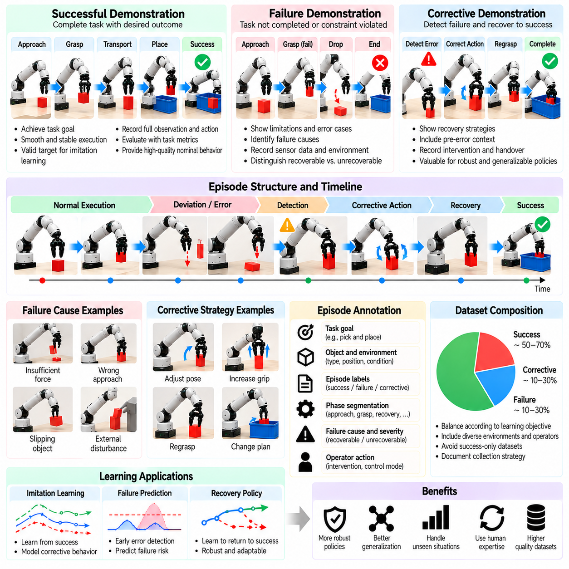
Successful, failed, and corrective demonstrations provide complementary forms of supervision for Physical AI learning. Successful episodes show how desired objectives can be achieved, while failures reveal limitations, unexpected conditions, and unsafe action patterns. Corrective demonstrations connect these experiences by showing how operators recognize deviations and restore progress. Together, they create richer training datasets than successful trajectories alone.
A successful demonstration represents an episode in which the robot satisfies predefined task completion criteria. Success may involve placing an object accurately, navigating to a destination, or completing an assembly operation. However, reaching the goal does not automatically imply optimal behavior. Execution time, energy consumption, contact forces, and safety margins provide additional information about demonstration quality.
Failure demonstrations capture situations where the intended objective is not achieved or operational constraints are violated. Examples include dropped objects, missed grasps, navigation collisions, unstable locomotion, and unsuccessful insertions. These episodes reveal conditions under which existing strategies become unreliable. Accurate failure classification helps learning systems distinguish recoverable errors from fundamental task limitations.
Failure causes should be documented separately from observable failure outcomes. A dropped object may result from insufficient grip force, incorrect contact geometry, delayed feedback, or unexpected acceleration. Identical outcomes can therefore arise through different mechanisms. Recording sensor evidence, operator commands, and environmental conditions supports causal analysis and prevents learning systems from treating every failure as equivalent.
Corrective demonstrations show how an operator responds after detecting an undesirable state. The operator may adjust a grasp, reposition a manipulator, modify a navigation route, or reduce movement speed. These corrections provide direct examples of actions that improve task progress from imperfect conditions. They are particularly valuable because autonomous policies frequently encounter states absent from ideal expert trajectories.
Corrective behavior can occur before or after an observable failure. Preventive corrections address emerging risks, such as object slipping or approaching an obstacle too closely. Reactive corrections begin after a failure has already occurred. Distinguishing these cases allows learning systems to separate early risk mitigation from recovery execution and supports more effective intervention policies.
Demonstration episodes should preserve the transition from normal execution to deviation detection and corrective action. Recording only the successful portion after recovery removes important information about why intervention became necessary. A complete sequence should include the preceding observations, the problematic action, the resulting state, and the correction. This continuity supports learning of error detection and recovery behavior.
Outcome labeling requires clearly defined task-specific criteria. Binary success and failure labels provide simple supervision but may conceal meaningful differences in partial completion. A robot may grasp an object successfully yet fail during placement. Phase-level labels and progress indicators reveal where execution diverged from the objective, enabling more precise evaluation and targeted learning.
Failure severity is another important dimension of demonstration annotation. Minor positioning errors may be recoverable without interrupting the task, while collisions or unstable movements can create significant safety risks. Severity labels should reflect physical consequences and operational constraints. Unsafe actions must be identified explicitly rather than treated as ordinary exploration examples.
Human intervention data provides a practical mechanism for collecting corrective demonstrations. During shared autonomy, an operator may take control when the robot approaches an unsafe or unfamiliar state. The intervention trigger, control handover, corrective commands, and recovery result should be recorded. This information supports learning when intervention is necessary and which actions can restore reliable operation.
Recovery demonstrations often contain greater learning value than repetitive successful episodes because they expose the policy to unusual states. A robot that only observes perfect grasps may struggle when an object shifts unexpectedly. Demonstrations of regrasping and repositioning expand the training distribution. However, recovery data should be selected for relevance rather than assuming every failure produces useful supervision.
Dataset construction should balance successful, failed, and corrective episodes according to the intended training objective. Excessive success-only data can produce brittle policies, while excessive failure data may distort action distributions. Task execution policies, failure predictors, and recovery controllers may require different sampling strategies. Dataset composition should therefore be documented and evaluated systematically.
Behavior cloning typically learns to reproduce actions observed in demonstration data. Successful trajectories provide direct targets for nominal task execution, but failed actions should not automatically receive identical imitation objectives. Corrective actions may be valuable when conditioned on the states that triggered them. Training pipelines must distinguish desirable recovery behavior from the preceding actions that caused the problem.
Preference-based learning can use comparisons between successful and unsuccessful trajectories to infer desirable behavior. Human evaluators or task metrics may identify which execution better satisfies safety, precision, and efficiency requirements. These comparisons provide supervision beyond direct action imitation. Nevertheless, preference labels should remain consistent with clearly specified objectives and operational constraints.
Reward learning can incorporate success, failure, and corrective demonstrations to estimate task progress and undesirable outcomes. Successful episodes identify goal-reaching behavior, while failures provide evidence about ineffective or unsafe transitions. Corrective demonstrations reveal transitions toward improved states. Learned reward models require careful validation because imperfect labels and biased sampling can produce misleading incentives.
Interactive imitation learning provides a structured approach to collecting corrections from states visited by a developing policy. The robot executes its current policy while an operator monitors performance and intervenes when necessary. Corrective demonstrations expand coverage of states induced by model errors. This process can reduce compounding mistakes that occur when a policy operates outside the distribution of its original training data.
Counterfactual analysis examines whether alternative actions could have prevented observed failures. A collision might have been avoided through earlier braking, while a failed grasp might have succeeded with different contact placement. Such alternatives can guide targeted data collection. However, counterfactual labels should be distinguished from physically executed demonstrations because hypothetical outcomes remain uncertain without validation.
Temporal alignment is essential for interpreting failure and correction sequences. Contact forces, visual observations, operator commands, and executed actions must be associated with their actual occurrence times. Misalignment can make a correction appear to precede the error it addresses. Accurate timestamps preserve the causal sequence required for learning intervention timing and recovery policies.
Operator expertise influences the quality of corrective demonstrations. Skilled operators may detect subtle deviations and intervene early, while less experienced operators may respond after errors become severe. Both behaviors reveal useful aspects of task difficulty, but their supervision quality differs. Recording operator experience and intervention context helps prevent inconsistent recovery strategies from being treated as interchangeable.
Automated failure detection can assist demonstration collection by identifying abnormal forces, trajectory deviations, unstable postures, or task progress interruptions. Detection systems may trigger event markers or request operator review. However, automated classifications can generate false positives and miss subtle failures. Combining sensor-based indicators with human validation improves the reliability of failure annotations.
Safety constraints must govern the collection of unsuccessful demonstrations. Deliberately inducing dangerous collisions, falls, or uncontrolled motions is unnecessary when safer alternatives can provide relevant information. Simulation, controlled disturbances, and naturally occurring failures can supply useful negative examples. Protective controllers and emergency stopping mechanisms should remain active throughout physical data collection.
Evaluation should measure not only nominal task success but also failure recognition, intervention timing, recovery success, and safety preservation. A policy that completes ideal tasks efficiently may still perform poorly when unexpected disturbances occur. Recovery benchmarks should introduce controlled deviations and measure whether the robot returns to acceptable operation. Separate metrics help identify weaknesses hidden by aggregate success rates.
Scalable data engines can prioritize informative failures and corrections through automated event detection, uncertainty estimation, and targeted episode selection. Rare but recoverable situations may receive higher collection priority than repeated routine successes. Metadata should preserve failure categories, intervention sources, and recovery outcomes. These records enable systematic filtering and reuse across imitation learning and policy improvement pipelines.
Ultimately, successful, failed, and corrective demonstrations describe different aspects of physical competence. Success teaches goal-directed execution, failure reveals limitations, and correction demonstrates adaptation when expectations are violated. Integrating these experiences through accurate labeling, temporal alignment, safety-aware collection, and balanced training enables Physical AI systems to develop more resilient and generalizable robotic behavior.

02.14. Intervention Recovery and Rare Event Data
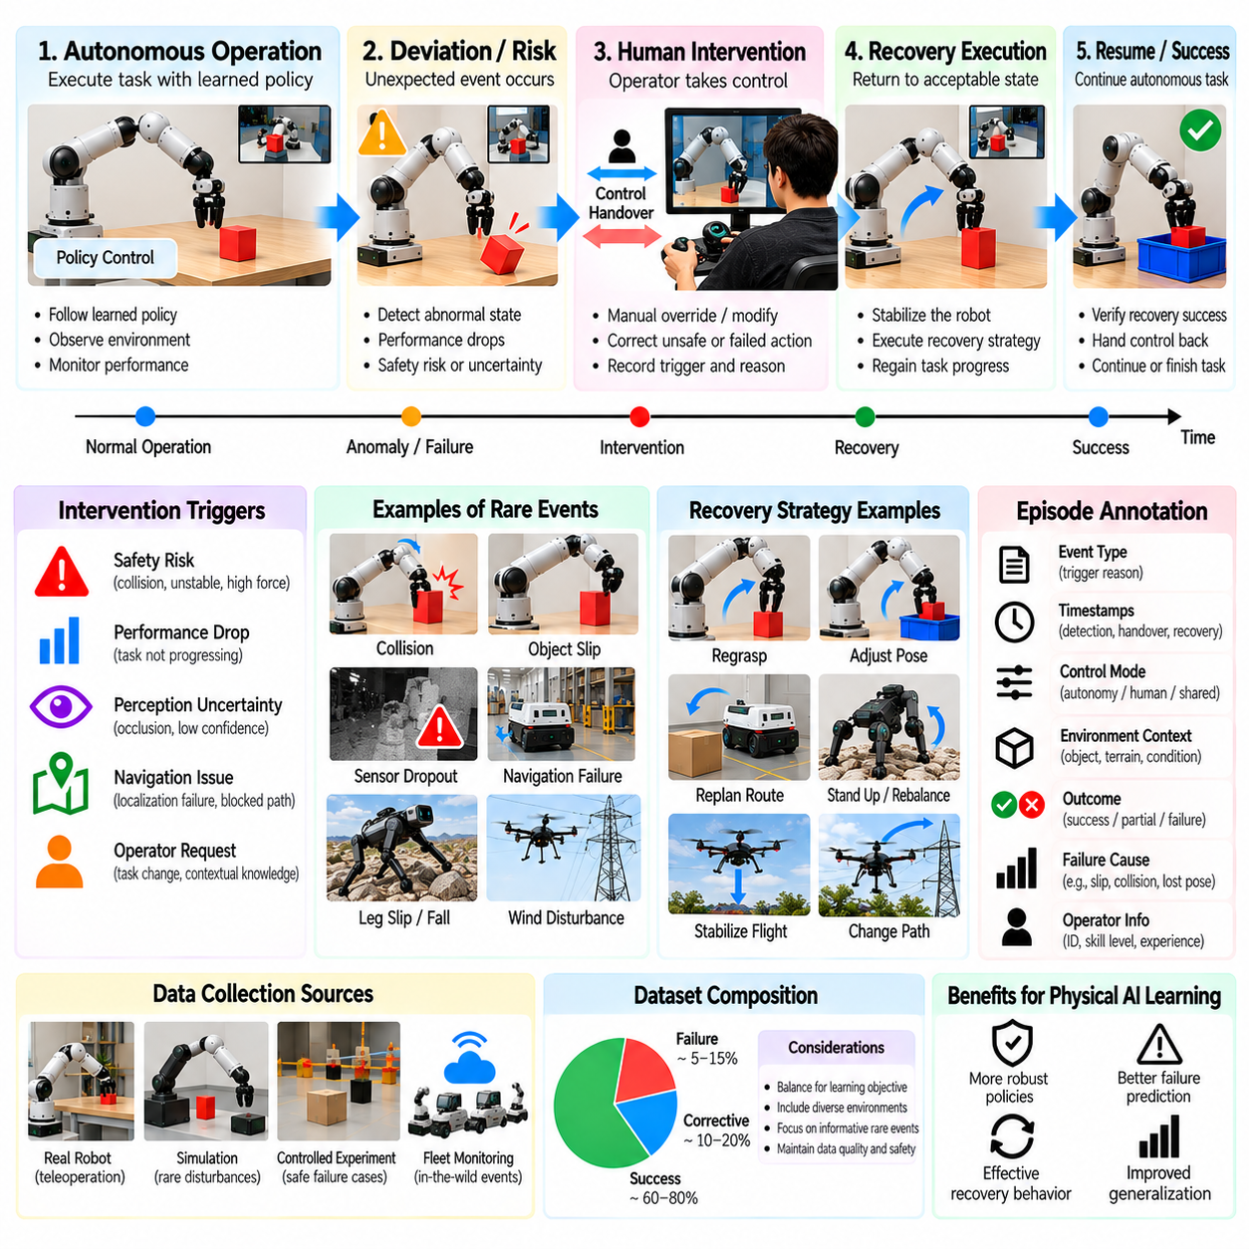
Intervention, recovery, and rare-event data are essential for developing Physical AI systems that operate reliably beyond ideal training conditions. Autonomous robots inevitably encounter unexpected obstacles, perception errors, unstable contacts, and unfamiliar environmental states. Teleoperation provides a mechanism for capturing human responses to these situations. Such recordings reveal how failures are detected, controlled, and resolved before normal operation resumes.
An intervention occurs when a human operator modifies, overrides, or temporarily replaces autonomous robot control. Interventions may be triggered by safety concerns, declining task performance, uncertain perception, or unexpected physical interactions. The resulting data contains information about both the autonomous policy's limitations and the operator's corrective decisions. Accurate intervention records should identify why control was transferred and what changed afterward.
Recovery refers to the process of returning a robot from an undesirable or degraded state to acceptable operation. A manipulator may need to regrasp a displaced object, while a mobile robot may need to escape a blocked passage. Legged robots may require balance restoration after slipping. Recovery demonstrations are especially valuable because they describe state transitions that successful nominal trajectories rarely contain.
Rare events are situations that occur infrequently during ordinary operation but may have significant consequences. Examples include unexpected collisions, sensor dropouts, sudden object movement, localization failures, and unusual contact dynamics. Their low frequency makes random data collection inefficient. Targeted recording strategies are therefore necessary to obtain sufficient examples without exposing physical systems to unnecessary danger.
Intervention data should preserve the conditions preceding human takeover. Observations, policy predictions, confidence estimates, control commands, and safety indicators provide context for understanding why intervention became necessary. Recording only the human-controlled recovery segment removes information about the developing problem. Complete temporal histories enable models to learn early warning signals rather than reacting after failure occurs.
Intervention triggers can be classified according to their underlying causes. Safety interventions prevent hazardous motion, performance interventions address declining task progress, and uncertainty interventions respond to unreliable perception or planning. Operator-requested interventions may reflect contextual knowledge unavailable to the robot. Distinguishing these categories supports targeted training and more interpretable autonomy evaluation.
Control handover introduces technical challenges because autonomous and human commands may differ substantially. Abrupt switching can produce discontinuous velocities, unexpected forces, or unstable robot behavior. Shared-control systems may use command blending, motion limits, and transition controllers to maintain stability. Recording handover timestamps and control authority helps separate intervention decisions from the dynamics of the transition itself.
Recovery episodes should capture the complete sequence from deviation detection to restored operation. Important stages include recognizing the abnormal state, stabilizing the robot, selecting a corrective strategy, executing recovery actions, and verifying success. Some recoveries require returning to an earlier task phase rather than continuing immediately. These distinctions support hierarchical policies that coordinate task execution and recovery.
Recovery success must be evaluated using explicit operational criteria. A robot that avoids a collision but remains immobilized has not necessarily recovered. Similarly, a manipulator that regains contact with an object may still fail to restore a stable grasp. Evaluation should consider safety, task progress, state stability, and readiness to resume autonomous execution. Partial recovery outcomes should remain distinguishable from complete recovery.
Rare-event datasets often suffer from severe class imbalance because normal operation generates far more examples than exceptional conditions. A model trained without appropriate balancing may achieve high average accuracy while missing critical failures. Event-focused sampling, importance weighting, and stratified evaluation can improve coverage. However, artificial balancing should not conceal the actual frequency of events in deployment environments.
Active data collection can prioritize situations where current policies exhibit uncertainty or repeated errors. Fleet monitoring systems may identify unusual sensor patterns, intervention clusters, or frequently unsuccessful recovery attempts. These signals can guide additional teleoperation sessions. The objective is to increase information gained per demonstration rather than maximize recording volume without considering learning value.
Simulation provides a controlled environment for generating rare disturbances that would be unsafe or expensive to reproduce physically. Object slips, sensor interruptions, actuator limitations, and unusual terrain conditions can be introduced systematically. Human operators can demonstrate recovery responses under these conditions. Nevertheless, simulated examples require validation because physical contact, latency, and sensor behavior may differ from reality.
Controlled physical experiments can complement simulation when realistic recovery behavior is essential. Low-speed disturbances, compliant objects, restricted workspaces, and protective mechanisms allow selected failure conditions to be studied safely. Experimental limits should be established before collection begins. The goal is to observe meaningful corrective behavior without deliberately creating uncontrolled collisions or hazardous robot states.
Temporal synchronization is particularly important for intervention and rare-event analysis. Sensor measurements, autonomous commands, operator inputs, and executed actions must share a consistent time reference. Small timing errors can reverse the apparent order of failure detection and corrective response. High-resolution timestamps and latency measurements help determine whether interventions occurred before, during, or after critical events.
Rare-event annotation should describe both observable outcomes and probable contributing factors. Useful labels include event onset, affected subsystem, severity, intervention type, recovery strategy, and final operational state. Causal explanations should be distinguished from directly observed evidence. This separation prevents uncertain interpretations from becoming misleading ground-truth labels in downstream learning pipelines.
Intervention timing provides supervision for learning when autonomous control should request assistance. Early interventions may prevent dangerous states, while delayed interventions reveal the consequences of insufficient monitoring. Training a takeover predictor requires distinguishing justified interventions from unnecessary operator overrides. Decision thresholds should reflect task-specific risk and the reliability of available perception and control signals.
Recovery policy learning uses corrective demonstrations to map degraded states into actions that restore acceptable conditions. Behavior cloning can reproduce demonstrated recovery sequences, while reinforcement learning may refine strategies through controlled interaction. Hierarchical architectures can select between nominal execution, stabilization, and recovery modes. Reliable switching requires explicit conditions for entering and leaving each mode.
Learning from interventions also presents selection bias because operators typically intervene only when they recognize a problem. Undetected failures and successful autonomous recoveries may be underrepresented. Operator expertise, workload, and interface latency further influence intervention frequency. Dataset analysis should therefore consider the observation process that determines which exceptional situations are actually recorded.
Quality assurance must verify that recovery demonstrations contain valid sensor streams, accurate control labels, and complete event boundaries. Missing observations during an intervention can obscure the cause of a corrective action. Automated checks may detect timestamp discontinuities, incomplete handovers, and inconsistent recovery outcomes. Human review remains important for ambiguous events involving contact, safety, or task intent.
Safety constraints must remain active throughout rare-event collection. Emergency stops, speed limits, collision monitoring, and workspace restrictions reduce the consequences of unexpected behavior. Human intervention should not be treated as a substitute for independent protective systems. Collection procedures should define escalation paths for situations that cannot be recovered safely through ordinary teleoperation.
Evaluation frameworks should test both the ability to avoid failures and the ability to recover after disturbances. Relevant metrics include intervention frequency, detection delay, recovery duration, recovery success rate, and residual safety risk. Rare-event performance should be reported separately from average task success. Controlled scenario testing helps reveal weaknesses that routine demonstrations may not expose.
Fleet-scale data engines can aggregate intervention and recovery experiences across robots operating in different environments. Event metadata enables clustering of recurring failure modes and identification of emerging operational risks. Selected episodes can be reviewed, relabeled, and incorporated into updated training datasets. Version tracking is necessary to determine whether policy changes reduce previously observed intervention requirements.
Ultimately, intervention, recovery, and rare-event data extend robot learning from routine task execution toward resilient autonomy. They reveal how systems approach operational boundaries, how humans recognize developing problems, and which actions restore safe behavior. Through targeted collection, accurate event annotation, controlled experimentation, and systematic evaluation, Physical AI data engines can transform exceptional experiences into transferable robotic competence.

02.15. Teleoperation Data Recording Pipeline [w/Code]
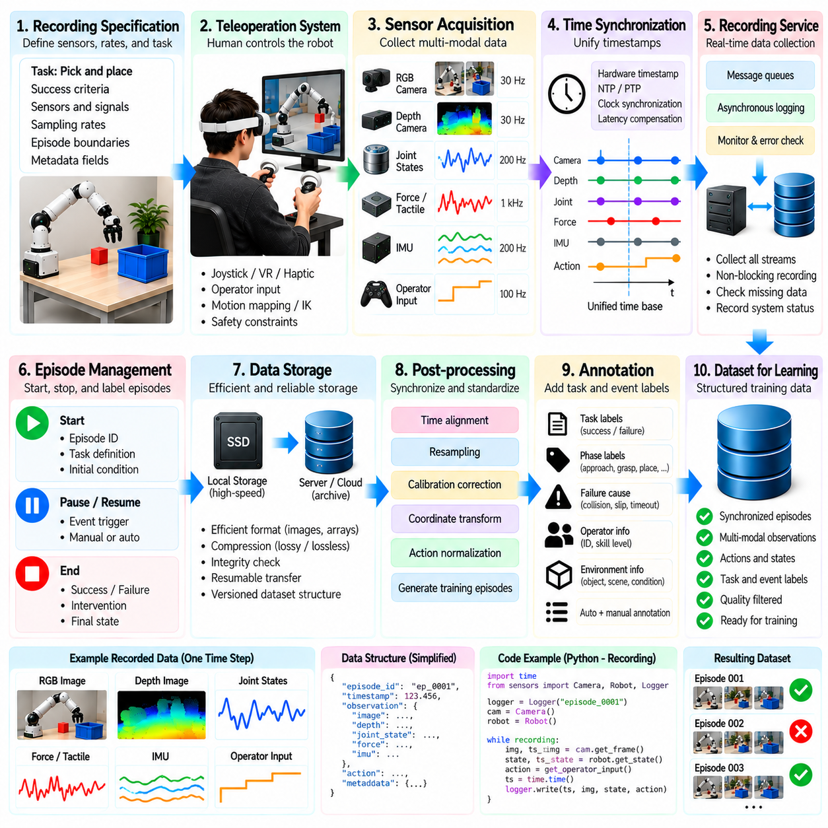
A teleoperation data recording pipeline transforms human-controlled robot activity into structured datasets suitable for Physical AI training. The pipeline must capture observations, operator commands, robot states, and task outcomes while preserving their temporal relationships. Reliable recording requires coordinated acquisition, synchronization, validation, storage, and quality control. Each stage contributes to the reproducibility and learning value of collected demonstrations.
The pipeline begins with a recording specification that defines required sensors, control signals, sampling rates, and episode boundaries. Camera images, depth measurements, joint positions, force readings, and operator inputs may be collected simultaneously. Task objectives and success criteria should also be documented. A consistent specification prevents different recording sessions from producing incompatible data representations.
Sensor acquisition modules connect individual devices to a common recording infrastructure. Each module receives measurements, attaches timestamps, and forwards data to a collection service. Devices may operate at different frequencies and communication rates. Acquisition software should preserve native measurement timing while monitoring packet loss, communication failures, and sensor availability throughout each demonstration.
Action recording must distinguish operator intention from commands executed by the robot. A joystick movement or virtual reality controller pose may first pass through motion mapping, inverse kinematics, and safety constraints. The resulting actuator commands can differ from the original input. Recording these stages enables learning systems to reconstruct control decisions and identify transformations introduced by the teleoperation architecture.
Time synchronization establishes a consistent relationship between asynchronous sensor and action streams. Hardware timestamps, synchronized device clocks, and communication latency measurements support accurate alignment. Raw timestamps should remain available even when data is resampled for training. This allows future processing pipelines to reconstruct the original sequence of events and investigate timing errors.
A central recording service aggregates sensor measurements and control messages without unnecessarily delaying robot operation. Real-time control loops should remain independent from expensive disk writing or data compression tasks. Asynchronous queues and bounded buffers can isolate recording workloads. Monitoring queue occupancy and dropped messages helps identify situations where acquisition exceeds available processing capacity.
Episode management determines when a demonstration begins, pauses, resumes, and ends. Each episode should contain a unique identifier, task definition, initial conditions, and completion status. Recording triggers may originate from an operator interface or automated task controller. Explicit episode boundaries prevent unrelated actions from being mixed into training sequences and simplify later dataset indexing.
Metadata provides the context needed to interpret recorded trajectories. Relevant fields include robot configuration, sensor calibration, software versions, operator identifiers, environment conditions, and control modes. Task-specific metadata may describe object properties or workspace arrangements. Structured metadata supports reproducibility, dataset filtering, and comparisons across collection sessions and robot platforms.
Data serialization converts acquired streams into persistent representations while retaining their original meaning. Images may use compressed formats, whereas numerical states and actions can be stored as structured arrays. Storage choices should balance fidelity, throughput, and accessibility. Versioned schemas and documented units prevent ambiguity when datasets are processed by different learning frameworks.
Storage architecture must accommodate high-bandwidth sensor streams and long recording sessions. Local solid-state storage can reduce dependence on network connectivity during collection. Completed episodes may subsequently be transferred to centralized repositories or object storage. Integrity checks and resumable transfers help prevent corrupted or incomplete recordings from entering the training dataset.
Compression reduces storage and transfer requirements but can alter information important for learning. Lossy image compression may remove subtle visual features, while aggressive temporal reduction can obscure contact events. Numerical measurements may require lossless preservation when precision is critical. Compression policies should therefore reflect task dynamics, sensor characteristics, and intended model requirements.
Quality validation should begin during acquisition rather than after an entire recording campaign. Automated checks can detect missing frames, invalid timestamps, disconnected sensors, and abnormal measurement ranges. Operator interfaces may display recording health indicators and warnings. Early detection allows defective sessions to be repeated before valuable environmental conditions or demonstration opportunities are lost.
Post-processing converts raw recordings into synchronized and standardized training episodes. Processing may include timestamp alignment, coordinate transformations, sensor calibration correction, and action normalization. Each transformation should be reproducible and documented. Preserving raw data separately from processed outputs allows improved algorithms to regenerate training datasets without repeating physical collection.
Annotation connects recorded behavior to task meaning and learning objectives. Episode labels may describe success, failure, corrective intervention, task phases, and unusual events. Some annotations can be generated automatically from controller states or task measurements. Human review remains necessary when outcomes depend on ambiguous visual evidence or complex physical interactions.
Dataset indexing enables efficient retrieval of demonstrations by task, robot, operator, environment, and quality attributes. Searchable metadata allows engineers to identify underrepresented conditions and construct balanced training subsets. Indexes should also reference recording locations and processing versions. This organization becomes increasingly important as data collection expands across multiple robots and facilities.
Privacy and security controls must protect sensitive information captured during teleoperation. Cameras may record people, confidential workspaces, or proprietary equipment. Operator identifiers and performance histories may also require protection. Access permissions, encryption, retention policies, and selective anonymization should be incorporated into the recording pipeline rather than added after deployment.
Operational reliability requires explicit handling of recording failures. Disk exhaustion, network interruptions, process crashes, and sensor resets can produce incomplete episodes. Transactional file writing, periodic checkpoints, and recovery logs reduce the risk of losing entire sessions. The system should clearly distinguish valid partial recordings from corrupted data that cannot support reliable training.
Scalable collection systems benefit from automated configuration and standardized deployment procedures. Robot-specific adapters can translate different hardware interfaces into a common dataset schema. Centralized configuration management helps maintain consistent sampling and metadata conventions. Automated diagnostics reduce operator workload and support repeatable recording quality across geographically distributed installations.
Pipeline performance should be measured using acquisition completeness, timestamp accuracy, recording throughput, storage efficiency, and episode acceptance rates. These indicators reveal whether infrastructure limitations are affecting dataset quality. Metrics should be monitored across individual sessions and longer collection campaigns. Quality trends can guide hardware upgrades, software optimization, and operational improvements.
Training dataset generation should preserve traceability between processed samples and their original demonstrations. Each training example should reference its source episode, preprocessing configuration, and annotation version. This lineage supports debugging when a learned policy exhibits unexpected behavior. It also allows engineers to remove defective source recordings and regenerate affected datasets systematically.
Integration with learning workflows closes the loop between teleoperation and autonomous policy improvement. Training results can identify tasks, states, or failure modes requiring additional demonstrations. These findings inform new recording campaigns and targeted operator interventions. The resulting feedback loop converts data collection from a one-time activity into a continuously improving engineering process.
A minimal implementation can begin with synchronized sensor capture, command logging, episode identifiers, and reliable local storage. Subsequent stages can introduce automated validation, metadata indexing, centralized repositories, and dataset versioning. This incremental approach limits early infrastructure complexity while preserving essential data integrity. Expansion should follow demonstrated learning needs and collection bottlenecks.
Ultimately, a teleoperation data recording pipeline is the operational foundation of demonstration-driven Physical AI development. Its value depends not only on recording large amounts of information but also on preserving timing, meaning, quality, and provenance. By integrating reliable acquisition, structured storage, automated validation, and learning feedback, the pipeline converts human robot interaction into reusable assets for scalable autonomous intelligence.

