Volume 04. Data Engines and Scaling for Physical AI

Chapter 07. Scaling Laws for Physical AI

07.01. Introduction to Scaling Laws
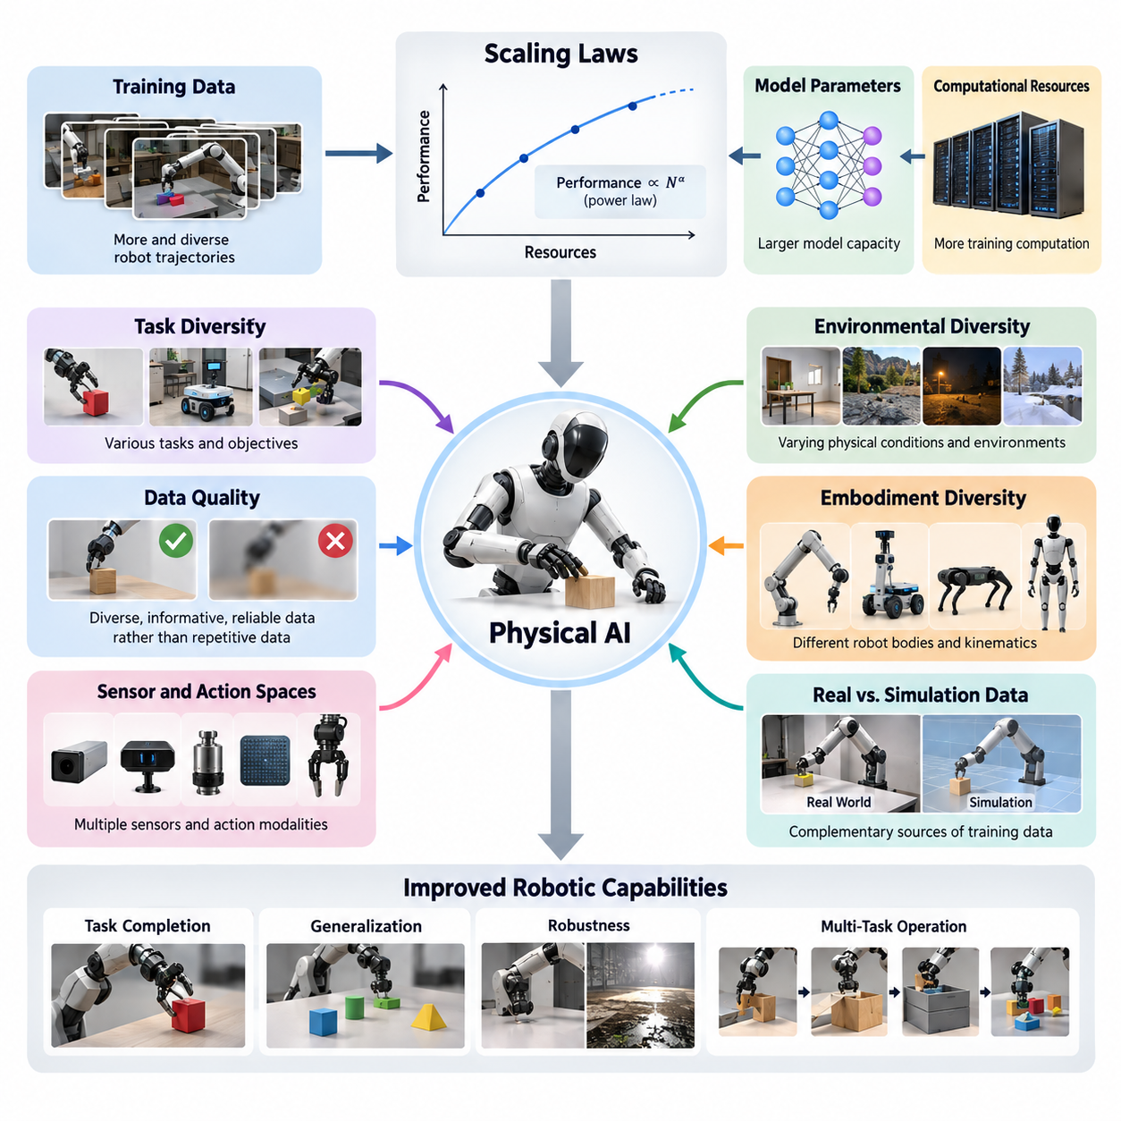
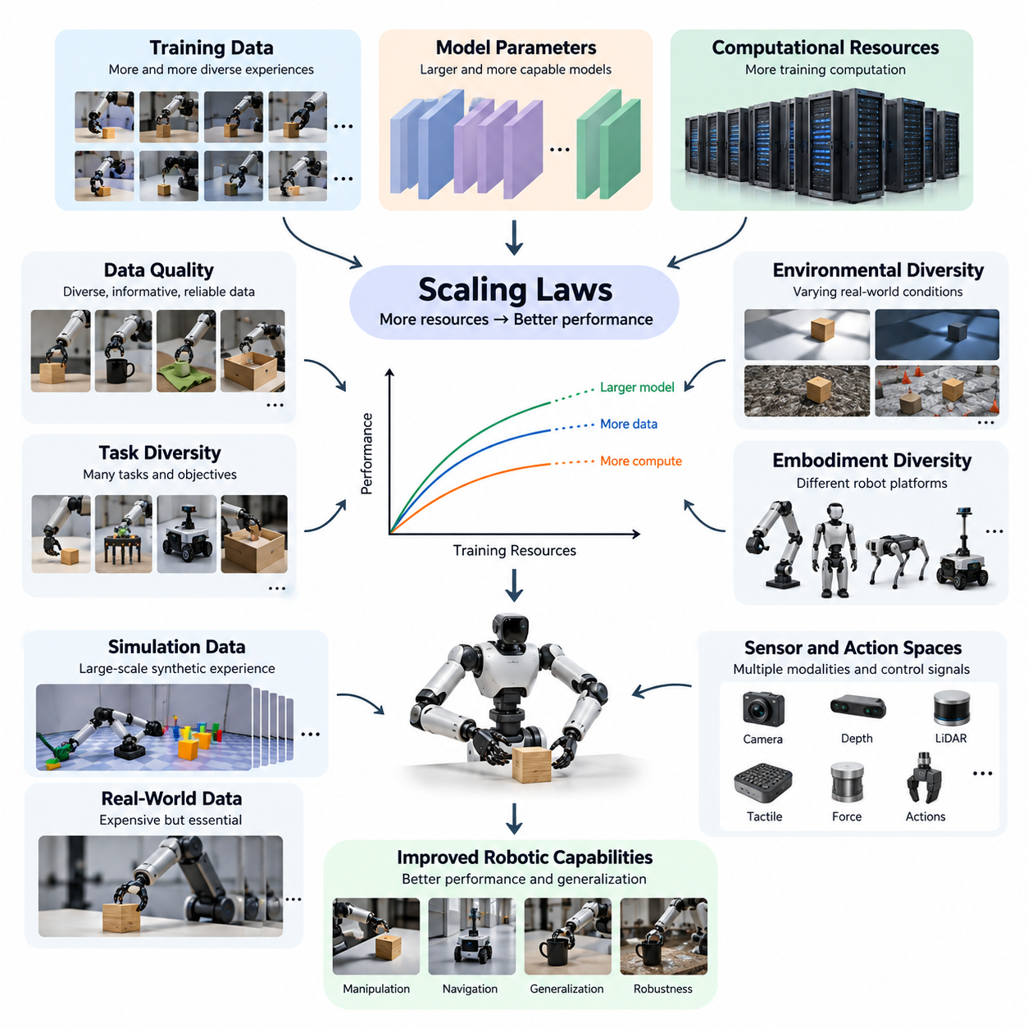
Scaling laws describe systematic relationships between the resources invested in artificial intelligence and the performance achieved by trained models. These relationships help researchers understand how improvements emerge as training data, model parameters, and computational resources increase. In Physical AI, scaling laws provide a framework for predicting how embodied intelligence may improve through larger and more diverse learning experiences.
The concept of scaling laws became prominent through research on large language models, where empirical studies demonstrated predictable performance improvements as model size, dataset size, and training computation increased. These relationships are often approximated by power-law functions over particular operating ranges. However, their mathematical forms and coefficients depend on the model architecture, training procedure, data distribution, and evaluation metric.
Physical AI extends scaling analysis beyond digital information processing into systems that perceive, reason, and act within physical environments. Unlike language models, robotic systems must interact with objects, surfaces, forces, and changing environmental conditions. Their performance depends not only on learned representations but also on sensing accuracy, actuator capabilities, control stability, and the physical consequences of executed actions.
A central question in Physical AI scaling is whether increasing training resources produces predictable improvements in robotic capabilities. Researchers investigate how additional demonstrations, longer interaction histories, broader task distributions, and larger policy models affect task completion and generalization. These relationships are especially important when developing robot foundation models intended to operate across many tasks and environments.
Traditional scaling analysis commonly considers three primary variables: dataset size, model capacity, and computational expenditure. Physical AI requires additional dimensions because embodied learning involves structured interaction with the world. The number of robot episodes, trajectory diversity, environmental complexity, object variation, embodiment diversity, and sensor configurations can influence learning outcomes independently of raw dataset volume.
Robot training data differs fundamentally from static digital datasets because observations and actions are causally connected through physical dynamics. A robotic trajectory contains sequences of sensor measurements, internal states, control commands, and resulting environmental changes. Scaling the number of trajectories therefore increases not only the quantity of observations but potentially the diversity of interactions, transitions, and consequences represented during learning.
The distinction between data quantity and data quality is particularly important in embodied intelligence. Millions of repetitive trajectories collected under nearly identical conditions may provide less useful learning information than a smaller collection covering diverse tasks and difficult situations. Effective scaling must therefore account for information density, behavioral diversity, demonstration reliability, and the representation of rare but operationally significant events.
Task diversity represents another critical scaling dimension. A robot trained exclusively to grasp one object under controlled conditions may achieve excellent performance without developing broadly transferable manipulation skills. Introducing different objects, grasping strategies, workspace arrangements, and task objectives can encourage more reusable representations. However, broader training distributions do not automatically guarantee successful transfer to unfamiliar tasks.
Environmental diversity also influences the relationship between dataset growth and robotic performance. Physical systems encounter variations in illumination, friction, geometry, temperature, surface conditions, and obstacle configurations. Training across these variations may improve robustness by exposing models to different operating conditions. Scaling studies must determine which environmental factors contribute meaningful generalization and which introduce unnecessary complexity.
Embodiment introduces a distinctive challenge because robots possess different mechanical structures, degrees of freedom, sensing arrangements, and action spaces. A manipulation policy trained on one robotic arm may not transfer directly to another with different kinematics or gripper geometry. Cross-embodiment scaling investigates whether shared representations can capture transferable task knowledge while preserving the mechanical constraints of individual robotic platforms.
The expansion of sensor and action spaces creates additional scaling considerations. Cameras, depth sensors, LiDAR, force sensors, tactile arrays, and proprioceptive measurements provide complementary information about the physical world. Combining these modalities can improve observability, but it also increases synchronization requirements and computational complexity. More sensors do not necessarily improve performance unless their information is relevant and properly integrated.
Real-world robot data is expensive because collecting physical experiences requires hardware, operators, maintenance, energy, and controlled operating environments. Unlike digital training examples, robotic interactions consume time and may cause equipment wear or physical damage. These constraints make data acquisition efficiency an essential scaling consideration and motivate approaches that extract greater learning value from each collected episode.
Simulation-generated data offers an alternative pathway for expanding robotic learning resources. Physics engines and procedural environments can produce large quantities of trajectories while varying object properties, robot configurations, and environmental conditions. Nevertheless, simulated experiences may contain modeling inaccuracies. Scaling synthetic datasets must therefore consider whether additional simulated interactions improve real-world performance rather than merely simulation benchmarks.
Human demonstration videos provide another potential source of scalable embodied knowledge. Large video collections contain examples of object manipulation, tool usage, navigation, and multistep activities. Although these recordings often lack explicit robot actions and force measurements, they can support learning of task structure and visual relationships. Their contribution depends on reliable interpretation and transfer from human behavior to robotic embodiment.
Scaling laws also influence decisions about pretraining and fine-tuning. Broad pretraining can expose robot models to many environments, objects, and behaviors, potentially producing reusable representations. Task-specific fine-tuning then adapts these representations to particular hardware or operational requirements. Understanding the relationship between pretraining diversity and adaptation data requirements is essential for developing economical robotic learning strategies.
Model capacity must be evaluated in relation to the complexity of embodied behavior. Larger neural networks may represent richer perceptual features, temporal dependencies, and action relationships, but increased parameter counts do not automatically produce better control policies. Performance improvements depend on sufficient training data, suitable architectures, effective optimization, and the ability to execute actions within real-time computational constraints.
Inference-time computation introduces another dimension of scaling. Robotic systems may allocate additional processing resources to planning, trajectory evaluation, uncertainty estimation, or predictive world modeling before selecting an action. Greater computational effort can improve decisions in some situations, but physical systems operate under strict latency constraints. Consequently, useful scaling must balance decision quality against response time and operational safety.
Long-horizon robotic tasks present difficulties that are not captured by isolated action accuracy. Completing an extended task requires maintaining context, coordinating subtasks, responding to unexpected changes, and recovering from errors. Even small per-step failure probabilities can accumulate across long action sequences. Scaling research must therefore examine complete task success, recovery capabilities, and temporal consistency rather than relying exclusively on short-horizon metrics.
Generalization is a primary objective of Physical AI scaling because practical robots must operate beyond the exact conditions represented during training. Researchers evaluate performance on unseen objects, unfamiliar environments, new task combinations, and different robotic platforms. Scaling curves measured only on familiar training distributions may overestimate practical capability, making carefully separated evaluation environments essential for interpreting progress.
Scaling relationships frequently exhibit diminishing returns as additional resources provide progressively smaller improvements. Such behavior may arise from redundant data, limited task coverage, insufficient model capacity, optimization difficulties, or hardware constraints. Identifying the dominant bottleneck helps determine whether future investment should prioritize additional demonstrations, improved data curation, greater model capacity, or more effective computational infrastructure.
Empirical scaling analysis requires controlled experiments that vary relevant resources while measuring performance consistently. Researchers may train multiple model configurations using different dataset sizes, task distributions, and computational budgets. The resulting measurements can reveal trends and support fitted scaling curves. However, extrapolating beyond observed experimental ranges introduces uncertainty, especially when evaluation conditions or system architectures change.
A useful scaling model must also distinguish statistical improvement from operational significance. A small reduction in prediction error may have little effect on a robot that already performs a simple task reliably. Conversely, a modest improvement in recovery behavior may substantially increase success during complex operations. Physical AI scaling should therefore connect learning metrics with measurable outcomes such as completion rates, intervention frequency, reliability, and execution efficiency.
The economics of scaling are equally important because embodied learning requires coordinated investments in data infrastructure, robotic hardware, simulation systems, and computing platforms. The optimal strategy is not necessarily the one that produces the largest model or dataset. Instead, effective development seeks the greatest improvement in validated robotic capability for a given resource budget while maintaining acceptable safety, reliability, and deployment costs.
Scaling laws ultimately provide a scientific framework for investigating how Physical AI capabilities evolve as learning resources expand. They are empirical relationships rather than universal guarantees of intelligence or autonomy. Their practical value comes from identifying measurable trends, exposing resource bottlenecks, and guiding experiments. Understanding these principles establishes the foundation for examining data, model, compute, diversity, embodiment, and generalization scaling in greater detail.

07.02. Data Model and Compute Scaling
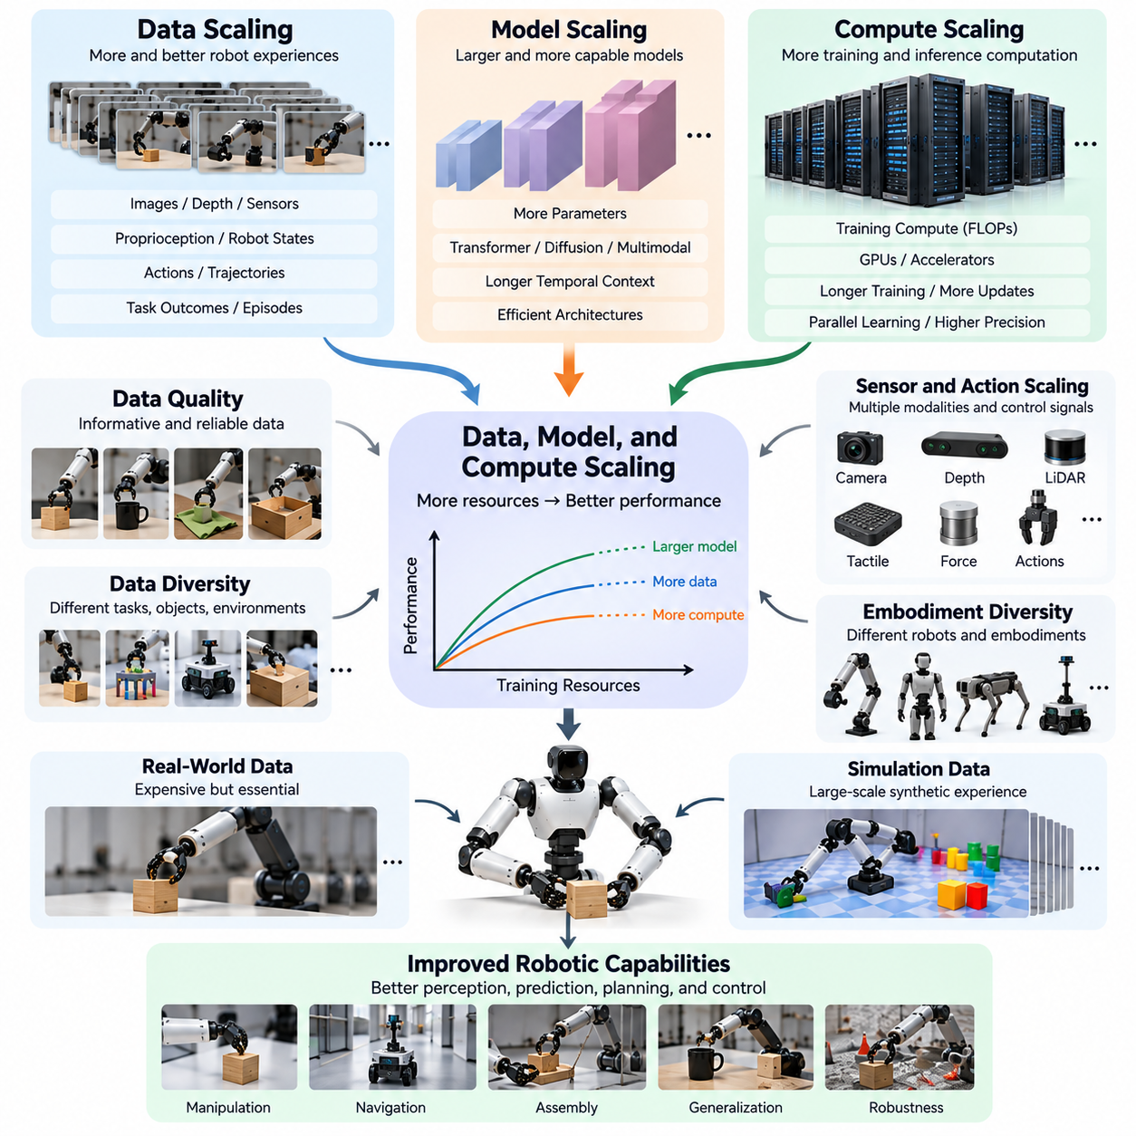
Data, model capacity, and computational resources form the three primary dimensions of artificial intelligence scaling. Data determines the range of experiences available for learning, model capacity determines the complexity of relationships that can be represented, and compute determines how extensively the model can be optimized. In Physical AI, these dimensions interact to influence perception, prediction, planning, and robotic control performance.
Data scaling examines how increasing the amount of training information affects learned capabilities. For robotic systems, training data includes camera images, depth measurements, proprioceptive states, control commands, object interactions, and task outcomes. Unlike static datasets, robotic data often consists of temporally connected trajectories. Increasing dataset size can improve performance when additional experiences contribute meaningful information.
The relationship between dataset size and model performance is frequently described through empirical scaling curves. Within certain experimental ranges, prediction error or training loss may decrease approximately according to a power-law relationship as data volume increases. However, these relationships depend on dataset quality, model architecture, and evaluation conditions. Physical AI requires additional validation because lower prediction loss does not always imply better robotic task execution.
Robot episodes represent a fundamental unit of data scaling. An episode typically contains observations, actions, state transitions, and outcomes associated with a particular interaction or task attempt. Increasing the number of episodes expands the available behavioral experience, but episode duration, task difficulty, and environmental variation also matter. Therefore, episode count alone is an incomplete measure of effective training data.
Model scaling investigates how increasing neural network capacity affects the ability to learn complex physical relationships. Larger models can potentially represent richer visual features, longer temporal dependencies, and more sophisticated action policies. Transformer architectures, diffusion-based policies, and multimodal networks provide different approaches to increasing representational capacity. Their effectiveness depends on sufficient data and appropriate training objectives.
Model parameter count is commonly used as a measure of network size, but it does not fully describe useful capacity. Architecture, attention mechanisms, temporal context, and action representation influence how efficiently parameters support robotic learning. A smaller model designed for structured control may outperform a larger general-purpose network on specific tasks. Consequently, scaling comparisons must consider architectural efficiency alongside parameter growth.
Compute scaling concerns the computational resources required to train and operate increasingly capable models. Training computation depends on parameter count, processed training examples, sequence length, numerical precision, and optimization procedures. Graphics processing units and specialized accelerators enable large-scale parallel learning. Nevertheless, increased computational expenditure improves performance only when the training process uses those resources effectively.
The interaction among data, model size, and compute creates important resource allocation problems. A large model trained on insufficient data may overfit or fail to utilize its representational capacity. Conversely, a small model trained on enormous datasets may reach a capacity limit. Compute-optimal scaling seeks an effective balance between model parameters and training information under a fixed computational budget.
Physical AI complicates compute-optimal scaling because training examples differ substantially in cost and information content. A short grasping demonstration may contain relatively few observations, while a long navigation episode includes extensive temporal dependencies. High-resolution video, tactile sensing, and multiple camera streams increase processing requirements. Computational budgets must therefore account for the structure and complexity of robotic experiences.
Data quality changes the effective relationship between dataset volume and learning performance. Repeated trajectories collected under identical conditions may provide diminishing additional information. In contrast, carefully selected examples involving difficult objects, unusual environments, or corrective actions can improve coverage. Quality-adjusted scaling considers whether new data contributes useful learning signals rather than merely increasing storage volume.
Data diversity is particularly important when training general-purpose robotic models. A dataset containing many manipulation episodes may still provide limited generalization if all episodes involve similar objects and workspaces. Expanding task categories, environmental conditions, and interaction strategies can expose models to broader physical relationships. However, diversity must remain compatible with the intended learning objectives and robot capabilities.
Model scaling also influences the integration of multiple sensor modalities. Vision-language-action models combine visual observations, linguistic instructions, and robotic action representations within shared learning architectures. Increasing model capacity may support more complex cross-modal relationships. However, successful multimodal scaling requires synchronized data, consistent representations, and training objectives that connect perception with executable behavior.
Temporal context introduces another relationship between model capacity and computational demand. Robotic decisions often depend on previous observations, earlier actions, and evolving environmental states. Increasing the context window can help models capture long-term dependencies, but it also increases memory consumption and processing cost. Efficient temporal representations are therefore essential for scaling models that perform extended physical tasks.
Pretraining provides an approach for utilizing large and diverse datasets before adapting models to particular robotic applications. Broad pretraining can establish reusable representations of objects, motion, and task relationships. Fine-tuning then specializes these representations using smaller task-specific datasets. The effectiveness of this strategy depends on the relevance of pretraining experiences and the compatibility between source and target environments.
Synthetic data can reduce some limitations associated with physical data collection. Simulation environments generate trajectories through controlled variations in objects, robot configurations, and environmental parameters. Large synthetic datasets may support extensive training without requiring equivalent real-world interaction time. However, scaling synthetic data must consider simulation fidelity and whether learned behaviors transfer successfully to physical hardware.
The combination of real and synthetic data creates a mixture optimization problem. Real-world trajectories provide direct evidence of physical interactions, while simulated trajectories can increase scenario coverage at lower marginal collection cost. Human demonstrations may contribute additional behavioral knowledge. Selecting effective proportions among these sources requires empirical evaluation because their relative usefulness depends on the target task and model.
Training compute must also be distinguished from inference compute. Training computation supports parameter optimization across datasets, whereas inference computation produces predictions and actions during operation. Large models may achieve improved capabilities but require more memory, processing power, and energy during deployment. Physical AI systems must satisfy real-time constraints, making inference efficiency an important consideration in model scaling.
Edge computing platforms introduce practical limitations on deployable model size. Mobile robots, manipulators, and autonomous machines often operate with restricted electrical power, thermal capacity, and onboard processing resources. Techniques such as quantization, pruning, distillation, and efficient attention can reduce inference requirements. These methods allow developers to pursue larger training models while maintaining practical deployment performance.
Scaling experiments should measure more than training loss or benchmark prediction accuracy. Robotic performance must be evaluated through task success rates, completion time, trajectory stability, intervention frequency, and recovery behavior. A model that achieves lower prediction error may still produce unsafe or ineffective physical actions. Consequently, empirical scaling curves should connect computational investment with measurable improvements in deployed robotic capabilities.
Diminishing returns emerge when additional data, parameters, or computation provide progressively smaller performance gains. Such behavior may indicate limited dataset diversity, insufficient model capacity, optimization inefficiency, or task-specific performance ceilings. Identifying these limitations helps determine whether further investment should expand data collection, improve training methods, modify architectures, or address hardware constraints.
A practical scaling study trains several model configurations using systematically varied dataset sizes and computational budgets. Each configuration is evaluated under consistent conditions to estimate performance trends. Researchers can then compare resource efficiency and identify promising operating regions. Reliable conclusions require repeated measurements, carefully controlled datasets, and evaluation environments that distinguish memorization from genuine generalization.
The economic implications of scaling are especially significant in Physical AI because data acquisition and computation have different cost structures. Collecting additional robot trajectories may require operators, equipment, maintenance, and physical operating time. Increasing model capacity may instead require accelerator infrastructure and greater energy consumption. Resource allocation should therefore consider total development cost rather than computational expenditure alone.
Data, model, and compute scaling ultimately form an interconnected optimization framework for Physical AI development. Increasing one dimension without considering the others can produce inefficient learning or limited capability improvements. Effective scaling requires coordinated investment in informative data, suitable model architectures, computational efficiency, and rigorous physical evaluation. This balance provides the foundation for developing increasingly capable, adaptable, and reliable robotic intelligence.

07.03. Why Physical AI Scaling is Different
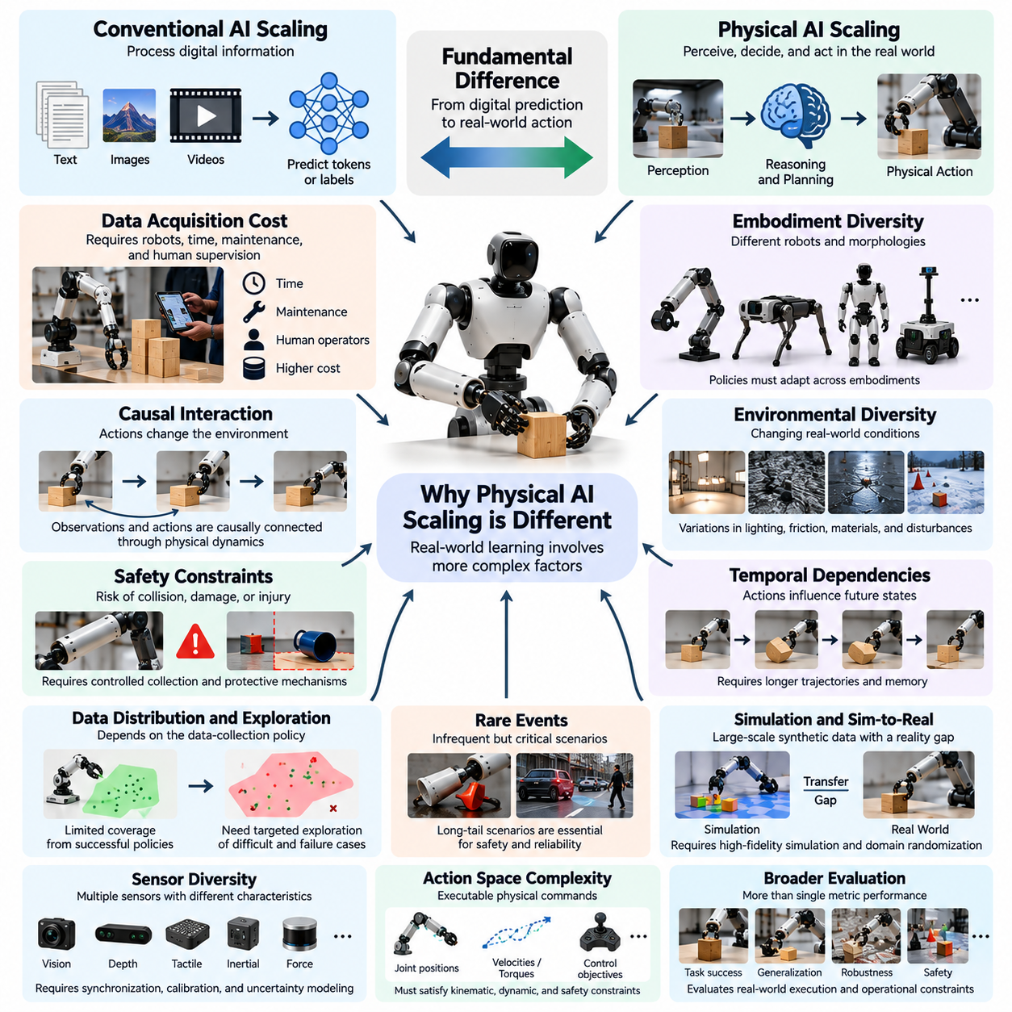
Physical AI scaling differs fundamentally from conventional artificial intelligence scaling because learning must produce reliable behavior in the physical world rather than accurate predictions in digital environments. Language and image models primarily process information, while embodied systems must perceive, decide, and act through physical mechanisms. Their performance depends on the interaction among learned intelligence, hardware capabilities, environmental dynamics, and operational constraints.
In conventional AI, training examples can often be collected, duplicated, processed, and evaluated without affecting the external environment. Physical AI data emerges from interactions involving motion, contact, force, and changing physical states. Every action may alter the environment and influence subsequent observations. Consequently, robotic learning requires understanding causal relationships between actions and outcomes rather than relying exclusively on statistical correlations.
The cost of acquiring training data represents one of the most significant differences. Digital datasets can often be expanded through automated collection and processing, whereas robotic demonstrations require physical platforms, operating time, maintenance, and sometimes human supervision. A single manipulation episode may involve preparation, execution, resetting, and verification. These operational requirements make physical data scaling considerably more expensive and time-consuming.
Physical interaction introduces safety constraints that are largely absent from conventional offline learning. Robots can collide with obstacles, damage objects, injure people, or destabilize themselves during exploration. Collecting diverse experiences therefore requires controlled procedures and protective mechanisms. Unsafe actions cannot simply be treated as inexpensive training failures, making unrestricted exploration impractical for many real-world robotic applications.
Embodiment diversity creates another fundamental scaling challenge. Robots differ in morphology, actuator arrangements, degrees of freedom, sensor placement, and control interfaces. A policy trained on one manipulator may not directly operate another robot with different kinematic properties. Scaling across embodiments requires representations that preserve transferable task knowledge while adapting actions to the mechanical capabilities and constraints of each platform.
Physical environments also exhibit continuous variability that is difficult to capture completely. Lighting, friction, surface geometry, material properties, object placement, and external disturbances can change unexpectedly. Even apparently identical tasks may produce different outcomes because of subtle environmental differences. As a result, Physical AI scaling must emphasize environmental coverage and robustness rather than assuming that larger datasets automatically provide sufficient generalization.
Temporal dependencies are especially important in robotic learning because actions influence future states. A grasping error may cause an object to slip, while an incorrect navigation decision may lead to an unrecoverable position. Successful behavior requires maintaining information about previous actions, current observations, and expected consequences. Scaling therefore involves longer trajectories and structured interaction histories, not merely increasing the number of independent examples.
The distribution of robotic data is strongly influenced by the behavior of the data-collection policy. Unlike passive digital datasets, robot observations depend on which actions the robot or operator chooses to execute. Successful policies may repeatedly visit familiar states while avoiding difficult situations. This creates coverage limitations and motivates active exploration, corrective demonstrations, and targeted collection of unfamiliar or failure-prone scenarios.
Rare events present a particularly difficult scaling problem. Industrial robots and autonomous vehicles may operate successfully for long periods while encountering occasional hazardous or unusual situations. These events are statistically infrequent but operationally critical. Simply collecting more routine data may not provide sufficient examples. Effective scaling requires deliberate identification, simulation, and evaluation of long-tail scenarios that influence safety and reliability.
Simulation offers an important mechanism for overcoming physical data limitations, but it introduces a distinctive transfer challenge. Simulated environments can generate large numbers of interactions efficiently, yet their dynamics and sensory outputs may differ from reality. Increasing synthetic data volume does not guarantee improved real-world behavior. Physical AI scaling must therefore consider simulation fidelity, domain randomization, and empirical sim-to-real transfer performance.
Sensor diversity further distinguishes embodied learning from conventional model scaling. Robots combine visual, depth, tactile, inertial, proprioceptive, and sometimes force measurements to estimate physical states. These modalities operate at different frequencies and exhibit different noise characteristics. Scaling multimodal robotic datasets requires accurate synchronization, calibration, and representation of sensor uncertainty to preserve meaningful relationships between observations and actions.
Action spaces introduce additional complexity because robotic outputs must correspond to executable physical commands. Language models generate symbolic tokens, whereas robots may produce joint positions, velocities, torques, trajectories, or high-level control objectives. These actions must satisfy kinematic, dynamic, and safety constraints. Consequently, larger models must learn not only appropriate decisions but also physically feasible and temporally consistent execution.
Real-time operation creates another limitation on model scaling. A robotic controller must often respond within strict deadlines to maintain stability and avoid collisions. Increasing model parameters or inference computation may improve prediction quality while introducing unacceptable latency. Physical AI systems therefore require careful coordination between model capacity, computational hardware, control frequency, and deployment architecture.
The relationship between model accuracy and task success is also more complex in Physical AI. A small prediction error can produce a large physical consequence when operating near obstacles or manipulating fragile objects. Conversely, some prediction errors may have little practical effect when control policies are robust. Scaling evaluations must therefore examine complete task outcomes, trajectory quality, recovery behavior, and operational safety rather than relying exclusively on prediction loss.
Long-horizon tasks amplify these differences because successful execution requires many coordinated decisions. A robot performing assembly, inspection, or household assistance may need to complete numerous dependent subtasks. Errors can accumulate, and a single failure may invalidate earlier progress. Scaling robotic intelligence consequently requires improvements in planning, memory, feedback control, and error recovery alongside improvements in individual action prediction.
Hardware limitations establish performance boundaries that additional training cannot always overcome. A robot with insufficient actuator torque cannot lift an object beyond its mechanical capability, regardless of model size. Limited sensor resolution, restricted reachability, battery capacity, and thermal constraints similarly affect achievable behavior. Physical AI scaling must distinguish limitations arising from learning from those imposed by the physical platform.
Cross-robot data sharing introduces opportunities and difficulties for large-scale learning. Data collected from multiple robots can increase task coverage and behavioral diversity, but differences in coordinate systems, sensor configurations, control frequencies, and action representations complicate integration. Effective scaling requires standardized metadata, compatible representations, and methods for separating transferable knowledge from embodiment-specific behavior.
Data quality has an unusually strong influence on robotic scaling because incorrect action labels or misaligned sensor measurements can directly teach unsafe behavior. Missing timestamps, inaccurate calibration, inconsistent demonstrations, and corrupted trajectories may undermine learning. Increasing dataset volume without addressing these problems can reduce effective information content. Robust data engines must therefore integrate validation, filtering, and quality-aware sampling.
Physical AI scaling also depends on feedback from deployed systems. Robots operating in factories, warehouses, farms, and public environments encounter situations that cannot be fully anticipated during development. Field observations reveal weaknesses in perception, planning, and control. These experiences can support iterative improvement through data collection, retraining, evaluation, and controlled redeployment, creating a fleet-scale learning process.
Economic constraints further differentiate Physical AI scaling because expanding robotic datasets often requires additional machines, facilities, operators, and maintenance resources. Computational infrastructure remains important, but physical experimentation introduces substantial operational costs. Efficient development must balance real-world data acquisition, simulation, model training, and deployment expenses while prioritizing improvements that deliver measurable operational value.
Another important distinction is that robotic capabilities may not improve smoothly with increasing training resources. Performance can remain limited until a model acquires sufficient coverage of particular interactions or learns reliable coordination among multiple subtasks. Apparent capability transitions may depend on task structure, evaluation thresholds, and hardware conditions. Such behavior requires careful empirical investigation rather than assuming universal scaling relationships.
Ultimately, Physical AI scaling is a multidimensional engineering problem involving data, models, computation, embodiment, environments, and physical interaction. Larger datasets and networks remain valuable, but their benefits depend on coverage, transferability, hardware compatibility, and real-world reliability. Understanding these differences is essential for designing scaling strategies that transform increasing learning resources into safe, adaptable, and effective robotic capabilities.

07.04. Episode and Trajectory Scaling
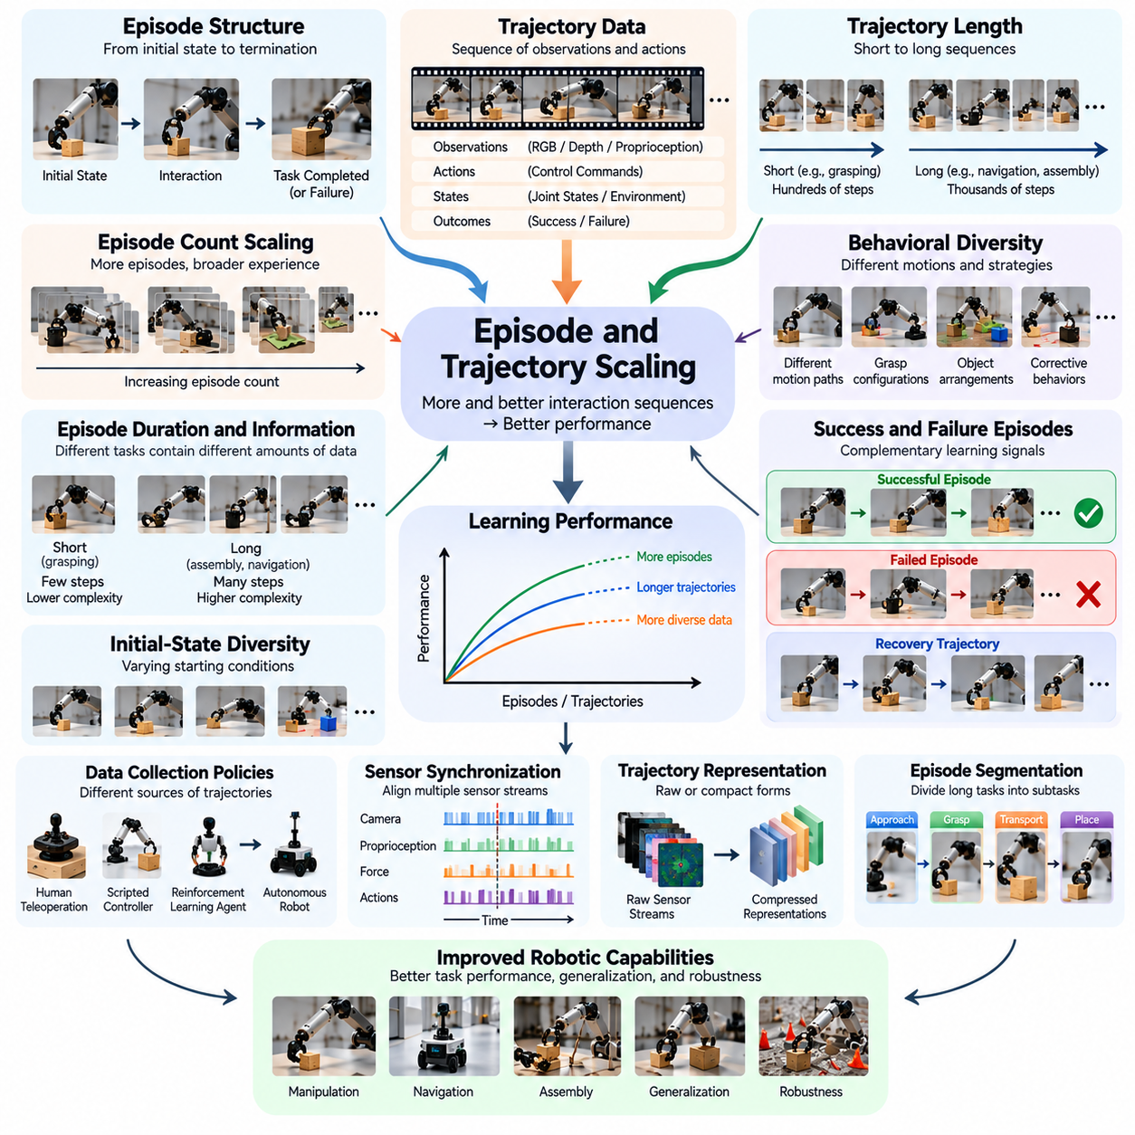
Episode and trajectory scaling examines how increasing the number, length, and diversity of robotic interaction sequences influences learning performance. Unlike conventional datasets composed of independent examples, Physical AI datasets contain temporally connected experiences. Each episode represents an interaction with an environment, while trajectories describe the evolving sequence of observations, actions, states, and outcomes generated during execution.
A robot episode typically begins from an initial state and continues until a task is completed, interrupted, or terminated by a predefined condition. During this interval, the robot records sensory observations, proprioceptive measurements, control commands, and environmental changes. These records preserve the relationship between decisions and their physical consequences, allowing learning systems to analyze complete behaviors rather than isolated actions.
Trajectory scaling focuses on expanding the collection of state-action sequences available for training. A trajectory may contain hundreds or thousands of time steps, depending on the task duration and control frequency. Increasing trajectory volume exposes models to additional motion patterns, object interactions, and state transitions. However, the resulting learning benefit depends on whether new trajectories introduce meaningful behavioral information.
Episode count is a convenient measure of dataset size, but it does not fully represent the amount of learning experience. Ten thousand short grasping attempts differ substantially from ten thousand extended assembly operations. Episode duration, sampling frequency, action complexity, and task structure determine the actual information contained in each sequence. Effective scaling therefore requires more detailed measurements than episode count alone.
Trajectory length introduces an important dimension because robotic behavior develops over time. Short trajectories may capture individual actions such as reaching or grasping, while longer trajectories represent navigation, manipulation sequences, and multistep tasks. Increasing sequence length can help models learn temporal dependencies and delayed consequences. Nevertheless, longer recordings also increase storage, memory, and computational requirements.
The relationship between trajectory length and useful information is not necessarily linear. Long episodes may contain repeated observations, stationary periods, or routine movements that contribute little additional learning value. Conversely, a brief recovery maneuver following an unexpected disturbance may contain highly informative state transitions. Scaling strategies should therefore distinguish informative interaction segments from redundant temporal data.
Behavioral diversity is a critical factor in episode scaling. Repeated demonstrations of the same successful action can improve consistency, but they may provide limited exposure to alternative strategies or unexpected conditions. Including different motion paths, grasp configurations, object arrangements, and corrective behaviors expands the learned action distribution. This diversity supports more flexible policies capable of responding to changing physical situations.
Successful and unsuccessful episodes provide complementary learning signals. Successful demonstrations illustrate effective strategies and desired outcomes, while failed attempts reveal limitations, unsafe transitions, and conditions that require correction. Recovery trajectories are particularly valuable because they show how a robot can return from undesirable states. Balanced episode collections can therefore support both task competence and behavioral robustness.
Initial-state diversity influences the generalization achieved through trajectory scaling. A robot trained exclusively from identical starting positions may learn highly specialized movement sequences rather than adaptable control strategies. Varying initial poses, object locations, environmental configurations, and task conditions exposes the policy to broader state distributions. Such variation helps distinguish generalizable behavior from memorized execution patterns.
The distribution of trajectories also depends on the policy used to collect them. Human teleoperators, scripted controllers, reinforcement learning agents, and autonomous robots generate different behavioral patterns. Expert demonstrations often emphasize successful execution, whereas exploratory policies may encounter unfamiliar states and failures. Combining these sources can improve coverage, provided their differences are represented consistently during training.
Temporal synchronization is essential when scaling trajectory datasets across multiple sensors and control systems. Camera frames, joint encoders, force measurements, and action commands may operate at different sampling frequencies. Misaligned timestamps can distort the apparent relationship between actions and outcomes. Large-scale trajectory processing therefore requires reliable time alignment, calibration, and validation before sequences are used for model optimization.
Trajectory representation affects both learning efficiency and scalability. Raw sensor streams preserve detailed observations but require substantial storage and processing resources. Compressed representations, latent states, and action abstractions can reduce computational demands while retaining task-relevant information. The appropriate representation depends on whether the learning objective emphasizes perception, motion prediction, control, or long-horizon reasoning.
Episode segmentation provides a mechanism for organizing long interaction histories into meaningful units. Complex tasks may contain subtasks such as approaching an object, grasping it, transporting it, and placing it at a destination. Identifying these boundaries enables models to learn reusable behavioral components. However, segmentation must preserve relevant transitions because dependencies between subtasks can influence overall task success.
Trajectory scaling is closely connected to imitation learning, where models learn policies from recorded demonstrations. Increasing demonstration coverage can improve action prediction across familiar and unfamiliar states. Nevertheless, imitation learning may suffer from distribution shift when small errors move the robot into states absent from the training data. Corrective demonstrations and interactive data collection help address this limitation.
Reinforcement learning introduces a different scaling relationship because trajectories are generated through interaction with an environment and evaluated using rewards or other feedback signals. Larger collections of exploratory episodes can improve policy learning when they provide useful state coverage. However, inefficient exploration may generate substantial redundant data. Experience replay, curriculum design, and prioritized sampling can improve the value of collected trajectories.
Simulation enables large-scale episode generation without requiring equivalent physical robot operating time. Parallel environments can produce diverse trajectories by varying objects, dynamics, disturbances, and task configurations. This approach supports extensive exploration and controlled experimentation. However, simulated trajectory scaling must be evaluated against real-world performance because additional synthetic episodes may reinforce inaccurate physical assumptions.
Cross-task trajectory scaling investigates whether experience from multiple tasks improves shared robotic capabilities. Reaching, grasping, pushing, lifting, and placing involve overlapping perceptual and motor skills. Training across these behaviors may help models develop transferable representations of objects and interactions. The benefit depends on task compatibility, data balance, and the ability of the model to separate shared knowledge from task-specific requirements.
Cross-embodiment trajectory scaling extends this principle to datasets collected from different robotic platforms. Manipulators, mobile robots, humanoids, and quadrupeds produce trajectories with different state and action structures. Shared learning requires coordinate transformations, embodiment metadata, and compatible action representations. Without these mechanisms, increasing the number of robots may introduce inconsistencies rather than useful training diversity.
Long-horizon trajectory scaling presents additional challenges because errors can accumulate across extended action sequences. A policy may perform individual subtasks reliably while failing to complete an entire workflow. Learning from long episodes requires maintaining relevant context, predicting delayed outcomes, and recovering from intermediate failures. Evaluation should therefore measure complete task success rather than relying exclusively on local action accuracy.
Data curation becomes increasingly important as episode collections grow. Large datasets may contain duplicate trajectories, corrupted recordings, incomplete demonstrations, or inconsistent control signals. Automated quality checks can identify missing observations, invalid timestamps, abnormal actions, and unreliable outcomes. Filtering and targeted sampling help maintain useful training information while reducing unnecessary storage and computation.
Scaling curves can be estimated by training comparable models on progressively larger collections of episodes or trajectory transitions. Performance may be measured through task success rates, action prediction errors, recovery effectiveness, and generalization to unseen conditions. Experimental comparisons should control for trajectory quality and diversity. Otherwise, observed improvements may reflect changes in data composition rather than dataset size alone.
The economic efficiency of episode scaling depends on the cost of generating informative interactions. Teleoperation requires skilled operators, physical robots consume maintenance resources, and simulation requires computational infrastructure. Active data collection can prioritize states where models exhibit uncertainty or repeated failures. Such strategies may achieve greater performance improvements per collected episode than indiscriminate expansion.
Ultimately, episode and trajectory scaling is not simply the accumulation of longer recordings or larger interaction datasets. Its purpose is to expand the useful coverage of physical states, actions, transitions, and outcomes represented during learning. Effective scaling combines sufficient episode volume with behavioral diversity, temporal consistency, data quality, and targeted collection. These principles support increasingly reliable and generalizable Physical AI systems.

07.05. Task and Environment Diversity Scaling
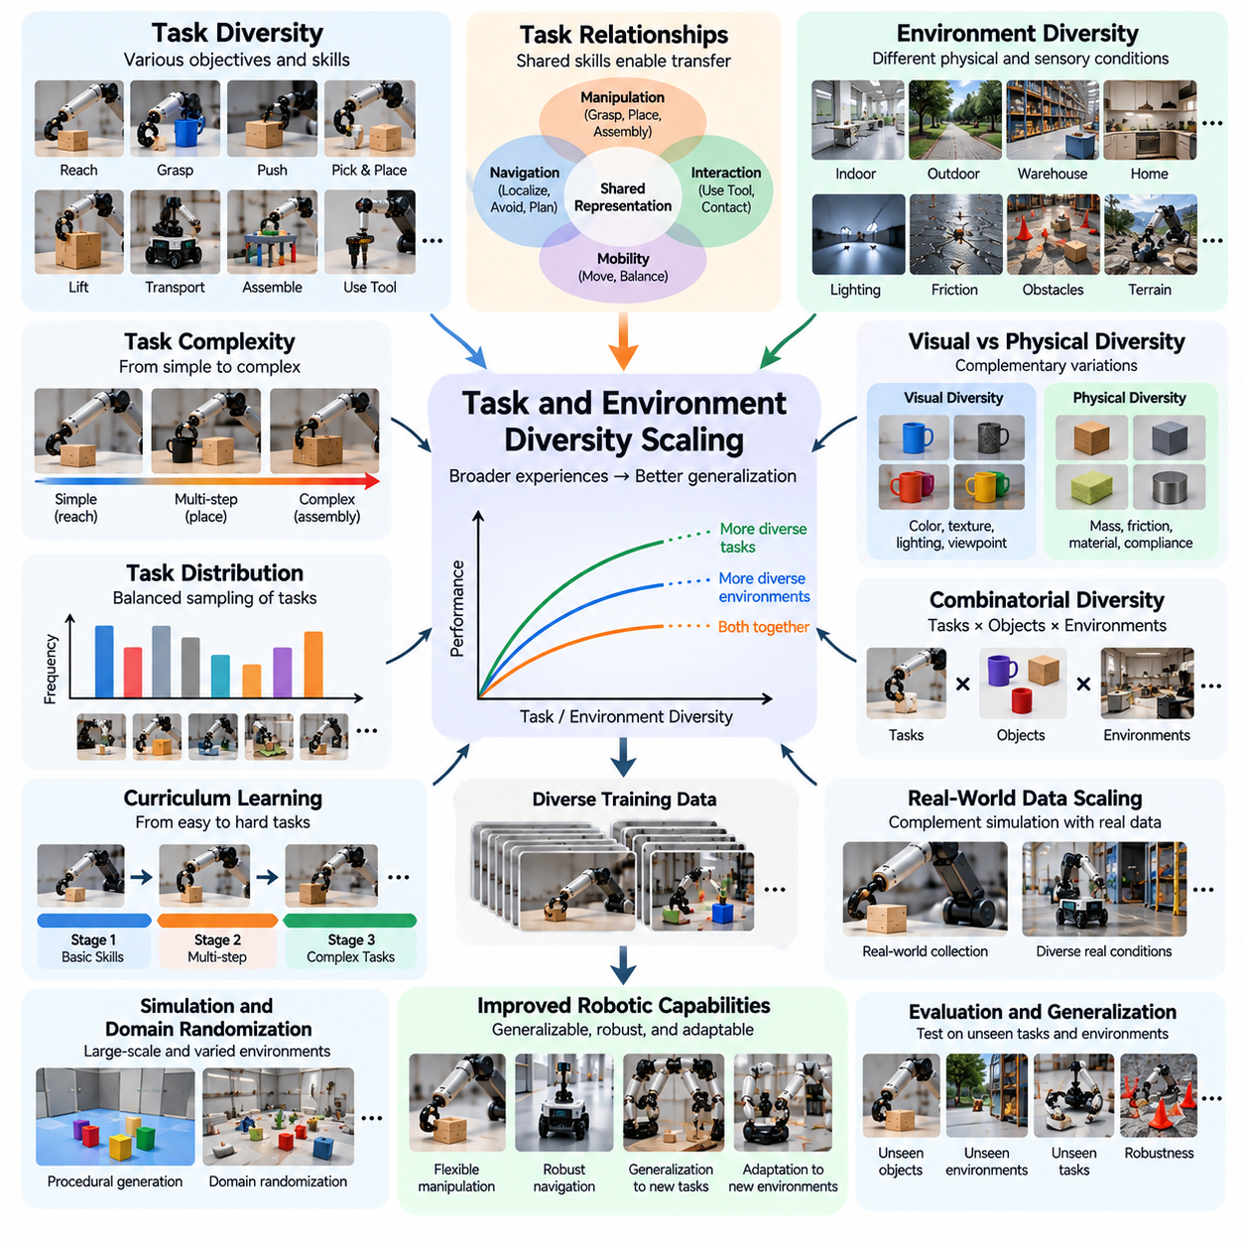
Task and environment diversity scaling examines how expanding the variety of robotic objectives and operating conditions influences learning, generalization, and adaptability. Unlike data scaling based solely on episode counts, diversity scaling emphasizes the range of experiences represented during training. Physical AI systems must learn reusable capabilities that remain effective across different tasks, environments, and interaction conditions rather than memorizing isolated behaviors.
Task diversity refers to the variation in objectives, action sequences, required skills, and success conditions represented in a training dataset. A robot may learn reaching, grasping, pushing, lifting, transporting, and assembling as separate activities. When these tasks share underlying physical principles, joint training can encourage transferable representations. However, the benefits depend on task relationships, model capacity, and balanced learning objectives.
Environment diversity describes variations in the physical and sensory conditions under which robotic tasks are performed. These variations include lighting, surface friction, workspace geometry, obstacle arrangements, object placement, and environmental disturbances. Exposure to different conditions can improve robustness by reducing dependence on a narrow operating distribution. Effective scaling requires environments that represent meaningful operational differences.
The relationship between task diversity and performance is not necessarily linear. Introducing additional tasks may improve shared representations when their underlying skills overlap. However, unrelated tasks can create competing optimization objectives and reduce performance on previously learned behaviors. This phenomenon, sometimes called negative transfer, demonstrates that expanding task counts does not automatically improve general-purpose robotic intelligence.
Task similarity provides an important organizing principle for diversity scaling. Manipulation tasks such as grasping, placing, and stacking share object perception, spatial reasoning, and motion control requirements. Navigation tasks share localization, obstacle avoidance, and path planning components. Grouping tasks according to common skills can improve learning efficiency while helping models distinguish transferable capabilities from task-specific constraints.
Task complexity introduces another dimension beyond task count. A simple reaching operation may require one continuous movement, while assembly involves perception, alignment, contact management, and sequential decision-making. Increasing the number of complex tasks expands the range of temporal and physical relationships that models must learn. Consequently, diversity measurements should consider task structure, difficulty, and required skill combinations.
Environmental variation affects the reliability of learned policies because physical interactions depend on local conditions. A grasp that succeeds on a rigid surface may fail when an object is slippery or deformable. Similarly, navigation policies trained in open corridors may struggle in crowded spaces. Diverse training environments expose models to these variations and can encourage policies that respond to changing conditions rather than fixed assumptions.
Visual diversity and physical diversity should be distinguished during dataset construction. Changes in color, texture, lighting, and camera viewpoint primarily affect perception, while variations in mass, friction, compliance, and contact geometry influence physical dynamics. Both forms are important, but their contributions differ. A model that generalizes visually may still fail when unfamiliar forces or material properties alter the required actions.
Combinatorial diversity emerges when tasks, objects, environments, and behaviors are varied together. A robot trained to grasp multiple objects in several workspace configurations encounters more combinations than one trained under fixed conditions. However, the number of possible combinations grows rapidly. Practical scaling therefore requires systematic coverage strategies rather than attempting to collect every conceivable interaction.
Procedural environment generation provides a scalable method for expanding environmental coverage. Simulation systems can vary room layouts, obstacle locations, object distributions, lighting conditions, and physical parameters automatically. These variations create controlled experiments for measuring robustness. Nevertheless, generated environments must remain physically plausible and relevant to deployment conditions to provide useful learning experiences.
Domain randomization is frequently used to expose robotic policies to broad environmental variation during simulation training. By changing visual appearances, dynamics parameters, sensor noise, and object properties, researchers attempt to reduce dependence on specific simulation conditions. This approach can support sim-to-real transfer, but excessive randomization may introduce unrealistic experiences that reduce learning efficiency or task performance.
Task distribution design determines how frequently different objectives appear during training. If simple tasks dominate the dataset, models may optimize for common behaviors while neglecting difficult or rare capabilities. Conversely, excessive emphasis on challenging tasks may slow acquisition of foundational skills. Balanced sampling, curriculum learning, and adaptive task selection can improve the allocation of learning resources across task categories.
Curriculum learning organizes training experiences according to increasing difficulty or strategically selected learning stages. A manipulation policy may first learn stable grasping before progressing to object reorientation and multistep assembly. Such sequencing can improve optimization when advanced tasks depend on foundational skills. However, curriculum effectiveness depends on the model, task dependencies, and transitions between learning stages.
Environment coverage must be evaluated relative to the intended deployment distribution. A warehouse robot requires experience with shelving arrangements, moving workers, pallet configurations, and varying floor conditions. An agricultural robot encounters plants, soil, weather, and seasonal changes. Training diversity should therefore reflect realistic operational uncertainty rather than maximizing variation without considering application requirements.
Generalization evaluation requires separating training environments from testing conditions. A model may perform well on familiar combinations of tasks and objects while failing on genuinely novel configurations. Researchers should evaluate unseen task compositions, environmental layouts, and physical parameters. These tests help determine whether diversity scaling produces transferable understanding or merely broader memorization of training examples.
Task and environment diversity also influence model capacity requirements. As training distributions expand, models must represent more objects, behaviors, dynamics, and contextual relationships. Insufficient capacity may cause interference between tasks or prevent accurate representation of diverse conditions. Larger models can potentially support broader capabilities, but improvements depend on training quality, architecture, and effective optimization.
Multimodal representations can support diversity scaling by connecting visual observations, language instructions, proprioceptive states, and action sequences. Language provides a flexible mechanism for describing different objectives, while sensory inputs specify current environmental conditions. Vision-language-action models can exploit these relationships to learn conditional behaviors. Their effectiveness depends on consistent task descriptions and reliable sensor-action alignment.
Data collection strategies should prioritize diversity that contributes measurable learning value. Repeated examples from already well-covered conditions may provide limited improvement, while new failure cases or unfamiliar object interactions can reveal important gaps. Active learning and uncertainty-based sampling can identify underrepresented regions of task and environment space. These methods help expand useful coverage without requiring indiscriminate dataset growth.
Diversity scaling can be analyzed through controlled experiments that vary the number of tasks, environments, or their combinations while holding other factors as consistent as possible. Performance should be measured on both familiar and unseen conditions. Such experiments can reveal whether additional diversity improves average success, worst-case robustness, or cross-task transfer. Results may differ substantially across robotic platforms and applications.
A major challenge is distinguishing beneficial diversity from distribution mismatch. Training on environments that are too narrow can cause overfitting, while training on irrelevant conditions may consume resources without improving deployment performance. Effective diversity scaling seeks a balance between broad physical experience and application-specific relevance. This balance must be established through empirical evaluation rather than assumed from dataset size.
Cross-task transfer represents one of the most important potential benefits of diversity scaling. Skills learned through pushing, grasping, and object placement may support unfamiliar manipulation tasks requiring similar physical interactions. Environmental variation can also encourage reusable perception and control strategies. However, successful transfer depends on shared structure between source and target tasks and the model's ability to exploit that structure.
The economic value of diversity scaling depends on how efficiently additional experiences improve operational capability. Collecting every possible task and environment combination is impractical because physical data acquisition is expensive. Simulation, targeted teleoperation, automated scenario generation, and fleet data mining can reduce collection costs. Resource allocation should prioritize diversity that improves task success, reliability, and adaptation under realistic conditions.
Ultimately, task and environment diversity scaling provides a foundation for developing generalizable Physical AI systems. The objective is not simply to maximize the number of tasks or environments but to construct learning distributions that capture transferable skills and meaningful physical variation. Effective diversity scaling combines systematic coverage, balanced sampling, realistic environments, and rigorous evaluation to support adaptable and reliable robotic intelligence.

07.06. Object and Behavior Diversity Scaling
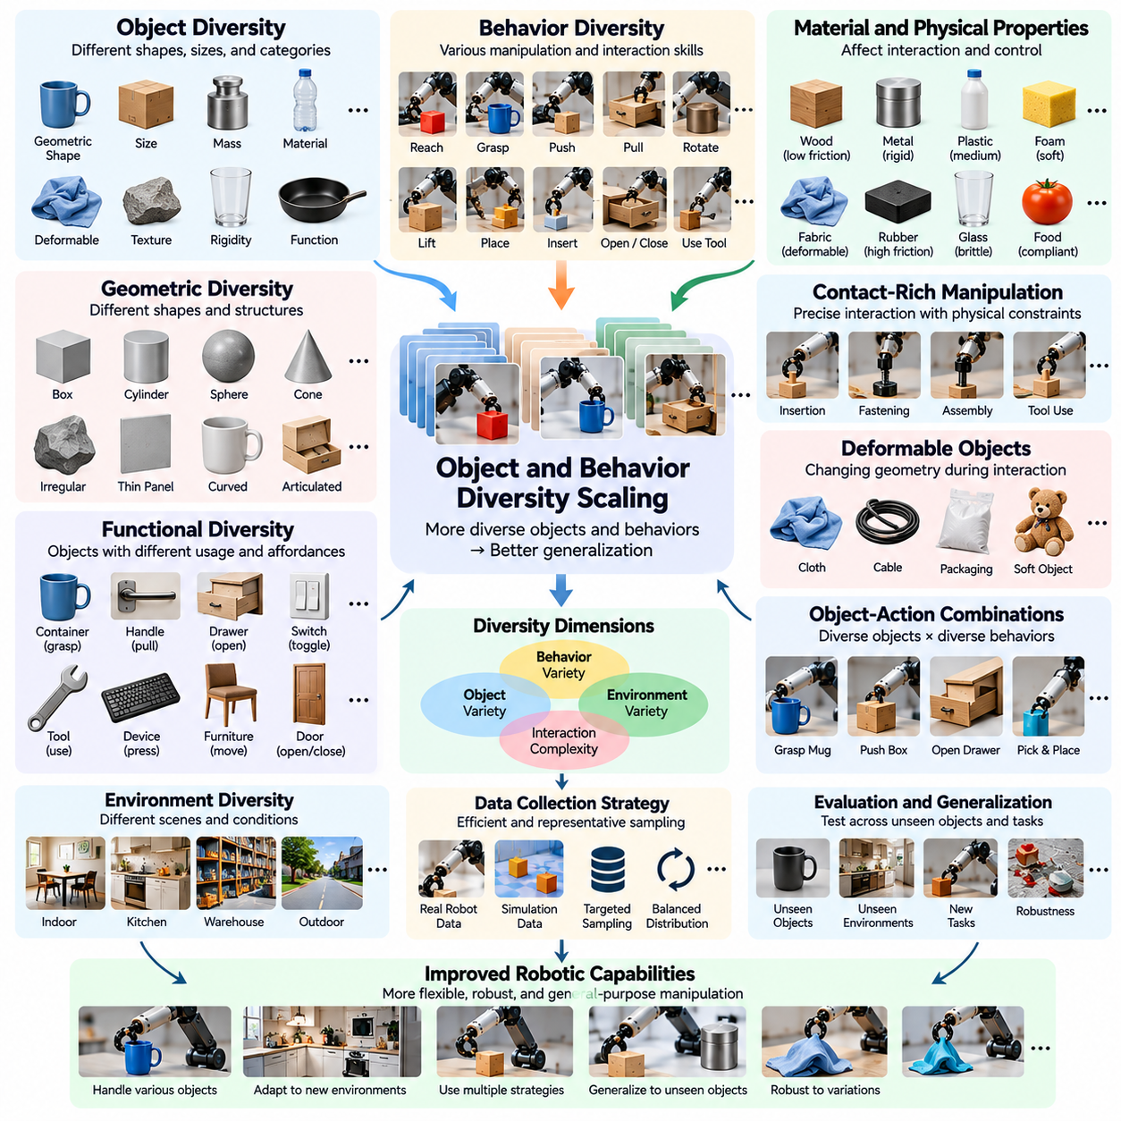
Object and behavior diversity scaling examines how increasing the variety of physical objects and robotic interaction patterns influences learning performance and generalization. Physical AI systems must operate on objects with different geometries, materials, functions, and mechanical properties. They must also execute multiple behaviors under changing conditions. Scaling these dimensions enables models to develop broader manipulation capabilities rather than memorizing actions associated with familiar objects.
Object diversity extends beyond the number of distinct items included in a dataset. Objects differ in shape, size, mass, texture, rigidity, friction, and deformability, all of which influence physical interaction. Two visually similar objects may require different grasping forces because their weights or surface properties differ. Effective scaling therefore requires representations that capture both observable appearance and interaction-relevant physical characteristics.
Behavior diversity describes the range of actions and interaction strategies represented in robotic training data. Common behaviors include reaching, grasping, pushing, pulling, rotating, lifting, placing, inserting, and manipulating articulated objects. Each behavior involves different combinations of perception, motion planning, force control, and feedback. Expanding behavioral coverage helps robots select appropriate actions across increasingly varied physical situations.
The relationship between object count and robotic capability is not necessarily proportional. Adding many objects with nearly identical shapes and mechanical properties may provide limited new information. Conversely, introducing a small number of objects with unusual geometry or contact behavior may significantly expand learning coverage. Object scaling should therefore consider physical diversity and interaction complexity rather than relying exclusively on category counts.
Geometric diversity plays a central role in manipulation learning because object shape determines feasible contact points and grasp configurations. Cylindrical containers, flat panels, irregular tools, and flexible packages require different manipulation strategies. Training across these geometries can improve spatial reasoning and grasp adaptation. However, models must learn generalizable geometric relationships rather than memorize object-specific poses or fixed contact locations.
Material diversity introduces additional challenges because interaction outcomes depend on physical properties that may not be directly visible. Metal, plastic, rubber, fabric, and glass exhibit different friction, compliance, and deformation characteristics. A manipulation policy must adapt contact forces and movement speeds accordingly. Learning these relationships requires combining visual observations with tactile, force, or motion feedback when such measurements are available.
Functional object diversity concerns how objects are intended to be used rather than only how they appear. Handles, switches, drawers, doors, and tools impose distinct interaction constraints and affordances. A robot must recognize which actions are possible and appropriate for each object. Scaling functional diversity encourages models to connect object structure with action opportunities, supporting more flexible and task-oriented behavior.
Behavioral diversity is particularly important when multiple strategies can achieve the same objective. An object may be repositioned through grasping, pushing, sliding, or controlled rotation. Different strategies involve different risks, precision requirements, and environmental dependencies. Training on alternative behaviors can help policies choose effective actions when preferred methods become unavailable or unsuitable.
Object and behavior diversity interact through the combinations of objects and actions represented during learning. A robot that grasps many objects but never pushes them may have limited understanding of pushing dynamics. Similarly, a robot trained to push only rigid blocks may struggle with deformable materials. Effective scaling must expand meaningful object-action combinations rather than increasing each dimension independently.
The number of possible object-action combinations grows rapidly as datasets become more diverse. Collecting every interaction across all objects, behaviors, and environmental conditions is generally impractical. Structured sampling can prioritize representative combinations based on geometry, material properties, task relevance, and expected learning value. Such approaches improve coverage while controlling the operational cost of physical data acquisition.
Affordance learning provides a useful framework for connecting object diversity with behavioral capabilities. An affordance describes an action opportunity supported by an object's properties and the robot's capabilities. A handle may support pulling, while a stable horizontal surface may support placing. Learning affordances across diverse objects helps robots predict feasible interactions without requiring an independent action rule for every object instance.
Contact-rich manipulation creates distinctive scaling challenges because small differences in geometry or force can change task outcomes. Insertion, fastening, folding, and tool use require precise coordination between motion and contact feedback. Training data must capture transitions between free motion, initial contact, sustained interaction, and release. Diverse contact experiences support policies that adapt to uncertain physical constraints.
Deformable objects introduce further complexity because their geometry changes during interaction. Cloth, cables, flexible packaging, and soft materials can bend, stretch, twist, or fold in response to applied forces. Their behavior often depends on interaction history and environmental constraints. Scaling deformable-object datasets therefore requires varied configurations, manipulation sequences, and observations that capture changing object states.
Articulated objects also require specialized coverage because their motion is constrained by joints, hinges, sliders, or linked components. Opening a drawer differs mechanically from rotating a door or operating a lever. Robots must infer movement constraints and apply forces along feasible directions. Exposure to different articulated mechanisms can improve generalization across unfamiliar objects with related kinematic structures.
Behavior diversity should include unsuccessful actions and recovery strategies alongside successful demonstrations. Failed grasps, slipping objects, unexpected collisions, and incomplete insertions reveal limitations that successful trajectories may not expose. Recovery behaviors demonstrate how to correct these situations without restarting the entire task. Such experiences improve robustness and help policies respond to unexpected physical outcomes.
Cross-object generalization measures whether a robot can apply learned behaviors to objects absent from its training dataset. Evaluation should include unfamiliar shapes, materials, dimensions, and functional configurations. Success on new object instances within familiar categories differs from success on entirely new object types. Distinguishing these evaluation conditions helps identify whether scaling produces transferable physical understanding or category-specific memorization.
Cross-behavior generalization examines whether previously learned interaction skills can support new combinations or sequences of actions. A robot familiar with grasping and rotation may be better prepared to manipulate unfamiliar tools or articulated mechanisms. However, combining known actions does not guarantee successful execution when contact dynamics or task constraints change. Evaluation must therefore include genuinely novel behavioral compositions.
Multimodal sensing can improve object and behavior diversity scaling by connecting appearance with physical interaction feedback. Vision estimates geometry and object identity, while tactile and force sensing provide information about contact, friction, and resistance. Proprioception records the robot's motion and configuration. Integrating these modalities helps models distinguish visually similar objects that require different manipulation strategies.
Simulation can expand object-action coverage by generating variations in geometry, mass, friction, stiffness, and contact conditions. Procedural asset generation and randomized physical parameters enable systematic experimentation across large interaction spaces. Nevertheless, simulated contact dynamics and deformable behavior may differ from reality. Real-world validation remains necessary to determine whether synthetic diversity improves physical manipulation performance.
Dataset balancing is important because frequently encountered objects and behaviors can dominate training. A model exposed mainly to rigid containers and simple grasps may perform poorly on flexible materials or precision insertion. Balanced sampling, targeted demonstrations, and difficulty-aware curricula can improve coverage of underrepresented interactions. The objective is not equal sampling in every case but sufficient exposure to operationally important capabilities.
Scaling experiments should distinguish the effects of object diversity, behavior diversity, and their interaction. Researchers can vary object categories while holding behaviors constant, then expand action types under comparable conditions. Performance should be evaluated on familiar and unseen object-action combinations. Such experiments reveal whether improvements arise from broader physical representations, richer behavioral skills, or their combined contribution.
Data quality becomes increasingly important as object and behavior diversity grows. Incorrect object attributes, inconsistent action labels, missing contact measurements, and poorly synchronized sensor streams can obscure meaningful relationships. Reliable metadata should describe object properties, interaction objectives, action representations, and observed outcomes. Quality-aware curation helps ensure that additional diversity contributes useful information rather than introducing contradictory training signals.
Ultimately, object and behavior diversity scaling aims to develop robotic intelligence that transfers physical knowledge across unfamiliar objects and interaction requirements. Increasing dataset size alone is insufficient when new examples repeat existing physical relationships. Effective scaling combines meaningful object variation, diverse action strategies, multimodal feedback, systematic coverage, and rigorous generalization testing to support adaptable and reliable Physical AI systems.

07.07. Robot and Embodiment Scaling
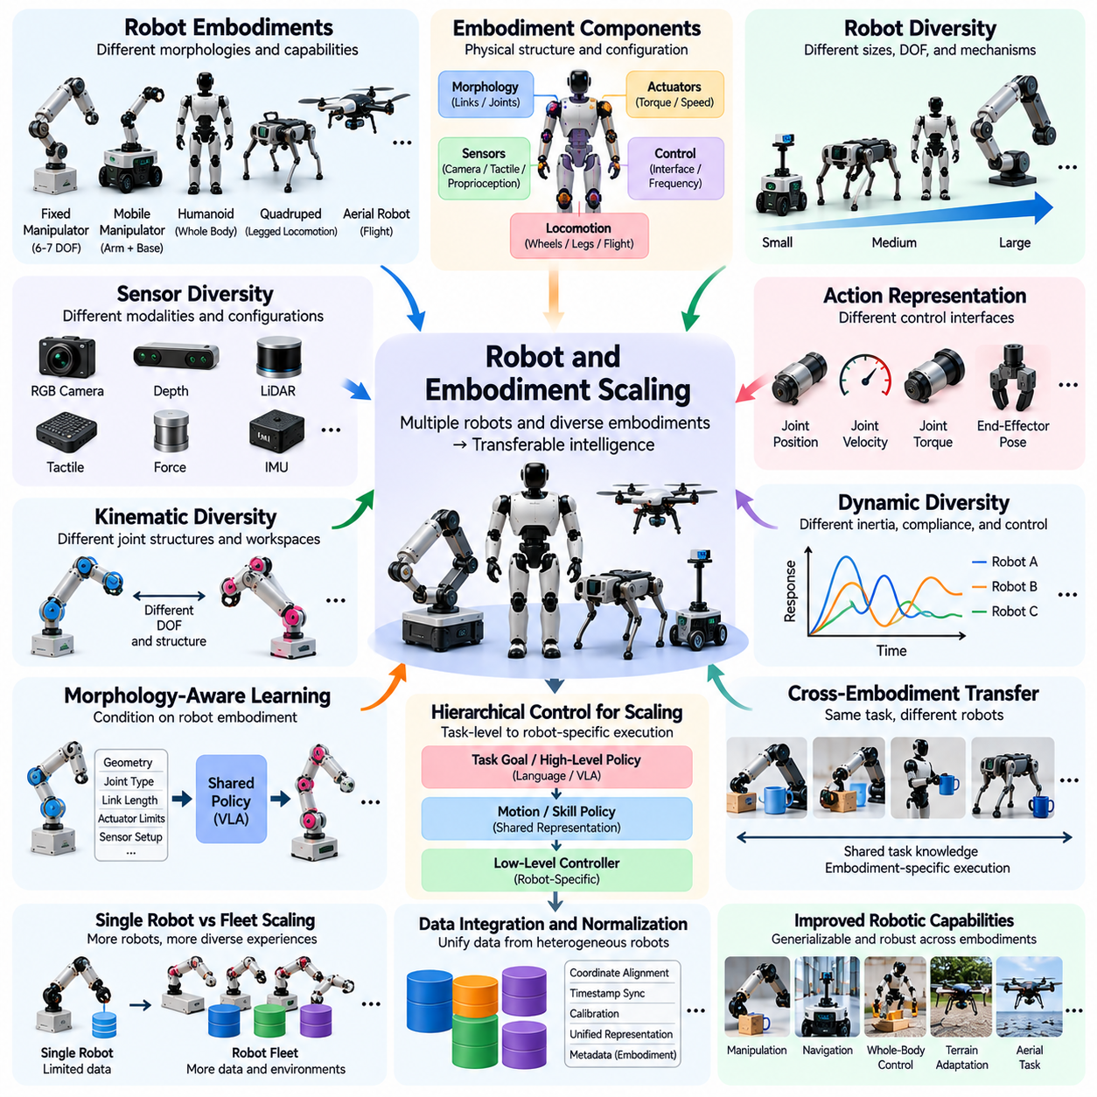
Robot and embodiment scaling examines how increasing the number and diversity of robotic platforms influences learning, generalization, and transferable intelligence. Unlike conventional AI systems operating through standardized digital interfaces, robots possess different physical structures and control mechanisms. Scaling across embodiments requires models to learn shared behavioral principles while respecting the mechanical constraints and operational characteristics of each robot.
Embodiment refers to the physical configuration through which an intelligent system perceives and interacts with its environment. It includes morphology, joint arrangements, actuators, sensors, locomotion mechanisms, and manipulation capabilities. A robot's embodiment determines which actions are physically possible and how those actions affect the environment. Consequently, learned intelligence cannot be separated completely from the body executing it.
Robot diversity introduces variations in size, mass, degrees of freedom, kinematic structure, and dynamic response. Industrial manipulators, mobile robots, humanoids, quadrupeds, and aerial robots operate through substantially different mechanical systems. Their observations and action spaces may also differ. Effective scaling must distinguish knowledge that can be shared across platforms from capabilities that depend on specific hardware configurations.
Increasing the number of robots contributing training data can expand the range of physical experiences available to a learning system. Multiple platforms may encounter different objects, tasks, environments, and failure conditions. Aggregating these experiences can improve coverage and reduce dependence on a single robot configuration. However, simply combining recordings does not guarantee useful transfer when their representations and control conventions are incompatible.
Cross-embodiment learning seeks representations that preserve common task knowledge despite differences in robot morphology. For example, two manipulators may perform the same object-placement task using different joint trajectories. A shared model should recognize the common objective while generating actions appropriate to each mechanism. This requires separating task-level intentions from embodiment-specific execution and control constraints.
Kinematic diversity is a fundamental challenge because robots possess different joint structures, link lengths, reachable workspaces, and motion constraints. A six-axis industrial arm cannot directly reproduce every configuration available to a seven-axis manipulator. Joint-space actions are therefore difficult to transfer without adaptation. Task-space representations and inverse kinematics can provide useful interfaces, although feasibility remains embodiment dependent.
Dynamic diversity introduces differences in inertia, actuator torque, friction, compliance, and control bandwidth. Robots with similar geometry may respond differently to identical commands because their mechanical and electrical properties differ. Policies must account for these characteristics to maintain stable and accurate motion. Scaling across dynamic systems therefore requires adaptation beyond simple coordinate transformations or geometric normalization.
Sensor diversity further complicates robot scaling because platforms may use different cameras, depth sensors, force sensors, tactile arrays, and proprioceptive measurements. Sensor placement, resolution, sampling frequency, and calibration influence the resulting observations. Shared learning requires representations that preserve relevant information despite these differences. Missing modalities must also be considered when deploying a model on robots with limited sensing capabilities.
Action representation is particularly important for cross-robot transfer. Some robots accept joint positions, while others require velocities, torques, end-effector poses, or high-level motion commands. A unified policy may use abstract action targets that are translated into robot-specific commands. Such interfaces can improve interoperability, but the translation must preserve timing, feasibility, and safety under each platform's control architecture.
Morphology-aware learning explicitly incorporates robot structure into the model's inputs or internal representations. Joint connectivity, link geometry, actuator properties, and sensor configuration can be encoded as embodiment descriptors. These descriptors allow a shared model to condition its predictions on the physical system being controlled. The objective is to learn reusable behavior without assuming that all robots possess identical bodies or action capabilities.
Robot scaling can also involve increasing the number of identical platforms rather than introducing new embodiments. A fleet of similar robots can collect parallel experiences across many locations and operating conditions. This improves data throughput and exposes the model to environmental variation. Nevertheless, fleet-scale learning still requires consistent calibration, software versions, logging conventions, and procedures for identifying hardware degradation.
Heterogeneous robot fleets provide broader experience but introduce additional integration complexity. A mobile manipulator may combine navigation and grasping, while a humanoid coordinates locomotion, balance, and dexterous manipulation. Combining their datasets requires explicit descriptions of task objectives, physical capabilities, and control interfaces. Without appropriate normalization, apparent behavioral differences may reflect hardware limitations rather than learning quality.
Cross-embodiment transfer can be organized through hierarchical control architectures. A high-level policy selects task goals or motion objectives, while lower-level controllers convert them into feasible robot-specific actions. This separation enables shared planning knowledge to operate across different mechanisms. However, high-level goals must remain achievable within each robot's workspace, stability limits, and available actuation capabilities.
Simulation provides an efficient environment for studying embodiment scaling because virtual robots can be modified without constructing new hardware. Researchers can vary link lengths, joint limits, actuator strengths, sensor placements, and body proportions. Training across these configurations may improve morphological robustness. However, simulation results must be validated on physical platforms because modeled dynamics and contact interactions can differ from reality.
Embodiment randomization extends domain randomization by varying robot morphology and mechanical parameters during training. A policy exposed to multiple configurations may learn behaviors that tolerate structural differences. This can improve transfer to related robots, particularly when variation remains within feasible mechanical ranges. Excessive randomization, however, may create incompatible control requirements and reduce learning efficiency.
Data standardization is essential when scaling learning across multiple robot platforms. Recorded trajectories should include robot identity, morphology metadata, coordinate frames, joint definitions, sensor calibration, action units, and control frequencies. Standardized schemas allow datasets to be interpreted consistently and reduce integration errors. They also support reproducibility when comparing learning outcomes across different embodiments.
Cross-robot generalization must be evaluated on platforms that were not included in training. Testing only additional units of familiar robot models measures fleet transfer rather than true embodiment transfer. Stronger evaluations introduce unfamiliar joint configurations, actuator characteristics, or sensing arrangements. Performance should be assessed through task completion, motion accuracy, safety, and adaptation requirements rather than action prediction alone.
Model capacity influences how effectively shared policies can represent multiple embodiments. A small model may struggle to accommodate conflicting action mappings or diverse physical constraints. Larger architectures may capture more reusable relationships, but additional parameters do not automatically resolve representation mismatches. Effective scaling depends on suitable conditioning mechanisms, balanced datasets, and optimization methods that prevent dominant platforms from overwhelming smaller groups.
Embodiment diversity can produce both positive and negative transfer. Shared experiences may improve perception, object understanding, and task planning, while incompatible motion patterns may interfere with control learning. These effects depend on how much structure the robots share and which model components are transferred. Separating universal task knowledge from embodiment-dependent control can reduce interference and improve training efficiency.
Few-shot adaptation offers a practical approach when deploying shared models on new robots. A pretrained policy may require a limited collection of demonstrations, calibration trials, or interaction episodes to adjust to unfamiliar hardware. Adaptation can involve fine-tuning, parameter conditioning, or learning a robot-specific control interface. Its effectiveness should be measured through the amount of new data and physical experimentation required.
Safety becomes increasingly important as policies transfer between embodiments. An action feasible for one robot may exceed another platform's torque limits, joint ranges, or stability margins. Shared models therefore require robot-specific safety constraints and execution monitoring. Validation should include collision avoidance, actuator limits, emergency stopping, and recovery behavior before deploying transferred policies in uncontrolled environments.
The economic benefits of embodiment scaling depend on whether shared learning reduces the cost of developing intelligence for additional robot platforms. Training a separate model for every morphology can duplicate data collection and computational effort. Shared representations may lower these costs, but integration, calibration, and adaptation introduce additional engineering requirements. Scaling strategies should evaluate transfer efficiency alongside operational reliability.
Ultimately, robot and embodiment scaling aims to transform experiences collected across diverse physical platforms into reusable robotic intelligence. Its success depends not merely on the number of robots or morphologies represented, but on the compatibility of data, representations, control interfaces, and physical capabilities. Effective scaling combines standardized datasets, morphology-aware models, adaptive control, and rigorous transfer evaluation to support reliable intelligence across heterogeneous robots.

07.08. Sensor and Action Space Scaling
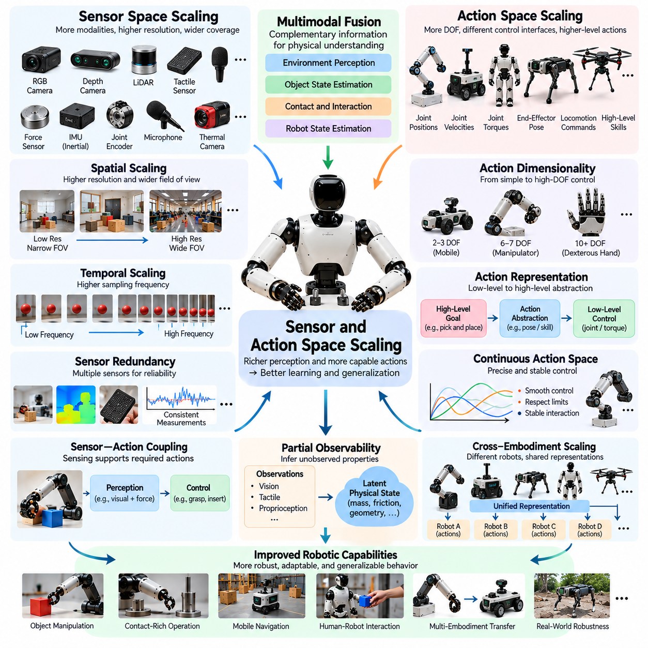
Sensor and action space scaling examines how expanding sensory inputs and executable actions influences the learning capacity, generalization, and control performance of Physical AI systems. Unlike conventional AI models that operate on relatively standardized digital representations, robots interact through heterogeneous sensors and physical actuators. Scaling these spaces requires balancing information richness, computational efficiency, physical feasibility, and real-time reliability.
Sensor space refers to the collection of measurements available to a robot for perceiving its environment and internal state. These measurements may include RGB images, depth maps, LiDAR point clouds, tactile signals, joint positions, inertial measurements, and force readings. Each modality captures different aspects of physical reality. Expanding sensor coverage can improve state estimation, but additional measurements do not automatically provide useful information.
Action space defines the set of commands through which a robot influences its physical environment. Depending on the platform, actions may represent joint positions, velocities, torques, end-effector poses, locomotion commands, or abstract task objectives. The dimensionality and structure of this space determine the complexity of policy learning. Larger action spaces increase flexibility while introducing additional constraints on control accuracy and stability.
Sensor scaling can occur through higher resolution, increased sampling frequency, additional modalities, or wider spatial coverage. High-resolution cameras reveal small geometric details, while tactile arrays capture local contact conditions. Additional sensors may improve perception under occlusion or uncertainty. However, increasing sensory bandwidth also raises requirements for communication, synchronization, memory, and inference computation.
Multimodal sensing is particularly valuable because different modalities provide complementary information. Vision estimates object geometry and scene structure, while tactile and force sensors reveal contact conditions and mechanical resistance. Proprioception provides information about joint configuration and robot motion. Combining these signals can improve physical state understanding, especially when individual sensors provide incomplete or ambiguous observations.
Sensor redundancy can improve reliability when multiple measurements describe the same physical phenomenon. Cameras and depth sensors may jointly estimate object position, while inertial and joint measurements support motion estimation. Redundant sensing can help detect faults and reduce uncertainty. Nevertheless, correlated sensor errors or inconsistent calibration may limit these benefits, making sensor fusion quality more important than sensor quantity alone.
Temporal resolution introduces another scaling dimension because physical interactions evolve at different speeds. Slow navigation decisions may tolerate relatively low observation frequencies, while contact-rich manipulation can require rapid feedback. High-frequency sensing captures short-duration events such as impacts, slips, and sudden force changes. Effective sensor scaling must therefore match sampling rates to the dynamics of the behaviors being controlled.
Sensor synchronization becomes increasingly difficult as modalities and sampling frequencies expand. Camera frames, tactile measurements, motor commands, and force readings may arrive with different delays. Incorrect alignment can make an action appear to precede or follow the wrong physical event. Accurate timestamps, clock synchronization, and latency compensation are essential for preserving meaningful observation-action relationships in large robotic datasets.
Action dimensionality strongly influences the difficulty of policy optimization. A mobile robot controlling forward and angular velocity has a relatively compact action space, while a dexterous robotic hand may coordinate many joints simultaneously. Higher-dimensional actions enable complex behavior but increase the number of possible control combinations. Learning therefore requires suitable representations, structured exploration, and constraints that reduce unnecessary complexity.
Action abstraction provides a mechanism for managing large control spaces. Instead of predicting every actuator command independently, a model may generate end-effector targets, motion primitives, or high-level skills. Lower-level controllers translate these abstractions into executable commands. This hierarchical approach can improve scalability, although abstract actions must remain compatible with the robot's kinematic and dynamic limitations.
Continuous action spaces introduce challenges that differ from discrete decision spaces. Small changes in torque, velocity, or position commands can produce substantially different physical outcomes near contact boundaries. Policies must learn smooth and stable control while respecting actuator limits. Action normalization, bounded outputs, and feedback control can help manage these requirements, but their effectiveness depends on the physical system.
Sensor and action spaces are coupled because the information required for control depends on the actions a robot performs. Precision insertion may require force feedback, while obstacle avoidance relies heavily on spatial perception. Adding action capabilities without corresponding sensing can create uncertainty and unsafe behavior. Effective scaling therefore considers whether sensory information is sufficient to support the intended control precision and interaction complexity.
Partial observability remains a central challenge even with extensive sensor coverage. Robots cannot always directly observe object mass, hidden geometry, friction, or internal mechanical states. These properties may need to be inferred through interaction histories and active probing. Scaling sensor inputs can reduce uncertainty, but memory, state estimation, and predictive models remain necessary for reliable decisions under incomplete information.
Active perception connects sensing and action by allowing robots to move specifically to acquire useful observations. A manipulator may reposition its camera to inspect an occluded object, while a mobile robot may change viewpoint to improve localization. Such behaviors demonstrate that sensing is not purely passive. Scaling action capabilities can expand perception opportunities, while better perception can guide more effective actions.
Representation learning helps manage the complexity of large sensor spaces by converting raw observations into compact task-relevant features. Visual encoders, point-cloud networks, and multimodal transformers can integrate different measurements into shared latent representations. These representations may reduce computational demands and improve transfer across tasks. However, excessive compression can remove details essential for precise contact or safety-critical control.
Action representation learning similarly seeks compact structures within complex motor commands. Models may learn reusable motion patterns, coordinated joint behaviors, or latent action codes from demonstrations. Such representations can simplify policy optimization and support transfer between related tasks. Their usefulness depends on whether the learned action structure preserves controllability, precision, and compatibility with the target robot.
Cross-robot scaling creates additional challenges because platforms often possess incompatible sensor configurations and action interfaces. One robot may use stereo cameras and joint torque control, while another relies on depth sensing and position commands. Shared models must account for missing modalities and different command semantics. Embodiment-aware conditioning and robot-specific adapters can improve transfer without requiring identical hardware.
Simulation provides a controlled environment for evaluating sensor and action space scaling. Researchers can vary sensor noise, resolution, sampling rates, actuator limits, and control frequencies while measuring task performance. Synthetic experiments can identify which modalities and action representations provide measurable benefits. Nevertheless, simulated sensor artifacts and actuator dynamics may differ from physical systems, requiring real-world validation.
Computational constraints become more significant as sensor bandwidth and action frequency increase. High-resolution visual streams, dense tactile measurements, and rapid control updates can overwhelm onboard processors. Model inference latency may compromise stability even when prediction accuracy improves. Efficient architectures must balance sensory detail, action precision, hardware acceleration, and deterministic execution deadlines.
Data quality is essential because scaling sensor and action dimensions increases opportunities for calibration errors, missing measurements, inconsistent units, and timestamp drift. Incorrect coordinate transformations or action labels can produce misleading training signals. Standardized schemas should describe sensor geometry, measurement units, action conventions, and timing information. Automated validation helps maintain consistency across large multimodal trajectory datasets.
Scaling experiments should distinguish the effects of sensor richness, action dimensionality, and their interaction. Researchers can compare models trained with different modality combinations while holding action representations constant, then evaluate alternative action spaces under comparable sensing conditions. Task success, control accuracy, robustness, latency, and safety provide complementary metrics. These comparisons reveal whether additional complexity produces meaningful capability improvements.
The economic efficiency of sensor and action scaling depends on the operational value gained from additional hardware and computation. More sensors increase equipment cost, calibration effort, data storage, and maintenance requirements. Higher-dimensional control may require more capable actuators and sophisticated safety mechanisms. System designers should prioritize configurations that improve measurable task performance rather than maximizing sensor counts or action dimensions.
Ultimately, sensor and action space scaling is a coordinated process of expanding what robots can observe and what they can physically execute. Larger sensory and control spaces create opportunities for more capable behavior, but their value depends on alignment, representation quality, computational feasibility, and closed-loop reliability. Effective scaling integrates multimodal perception, structured action representations, adaptive control, and rigorous evaluation to support increasingly capable Physical AI systems.

07.09. Real Synthetic and Human Data Scaling
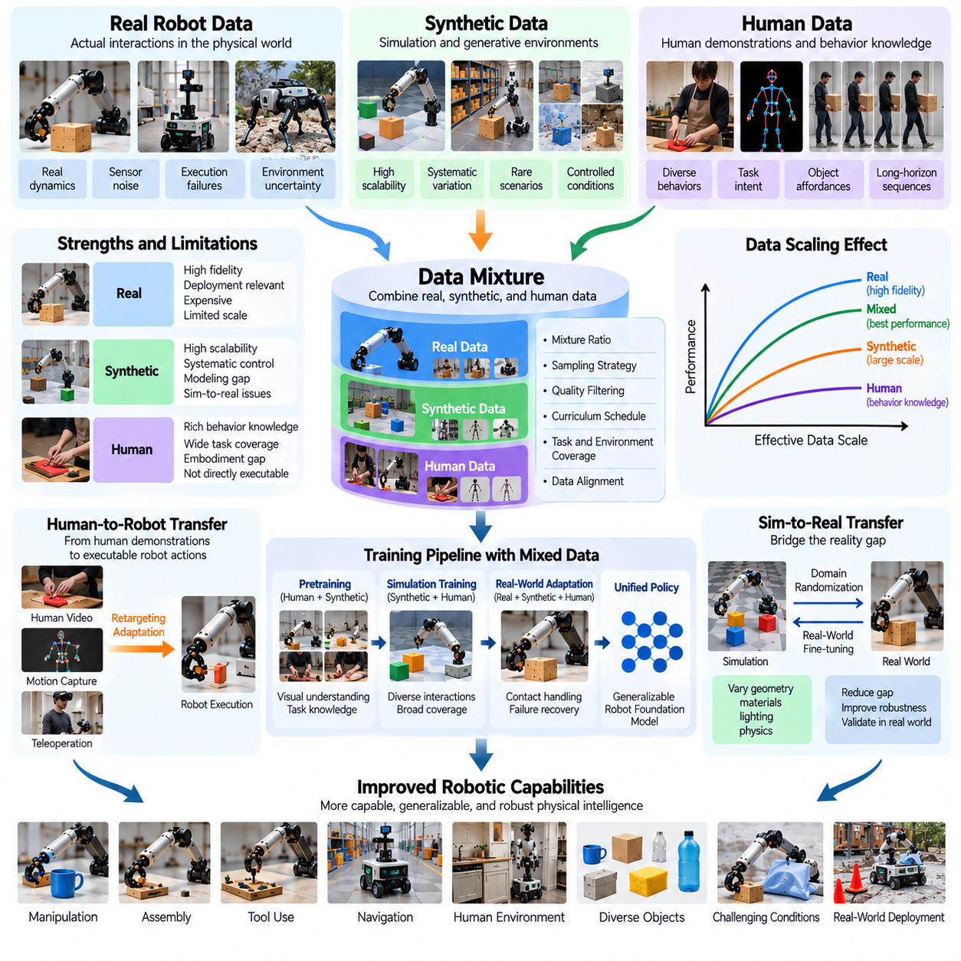
Real, synthetic, and human data scaling examines how different sources of physical experience contribute to the development of capable and generalizable robotic intelligence. Real robot data captures actual interactions, synthetic data provides controlled and scalable experiences, and human data introduces diverse behavioral knowledge. Effective Physical AI scaling requires understanding the strengths, limitations, and complementary roles of these sources.
Real robot data consists of observations, actions, and outcomes recorded during physical robot operation. It captures authentic contact dynamics, sensor noise, actuator limitations, environmental uncertainty, and execution failures. These properties make real data essential for grounding learned policies in physical reality. However, collecting large quantities of robot trajectories requires hardware, operators, maintenance, and substantial operational time.
Synthetic data is generated through simulation, procedural environments, physics engines, or learned generative models. It can represent diverse objects, tasks, lighting conditions, materials, and interaction scenarios without repeatedly operating physical robots. Synthetic generation offers high throughput and systematic control over experimental variables. Its primary limitation is the mismatch between generated experiences and real-world physical behavior.
Human data includes demonstrations, videos, motion capture recordings, wearable sensor measurements, and direct human control of robotic systems. Such data contains valuable information about task objectives, manipulation strategies, object affordances, and long-horizon behavior. Human activities cover a much wider range of everyday situations than most robot datasets. Nevertheless, human actions cannot always be transferred directly to robotic bodies.
The three data sources differ in cost, physical fidelity, behavioral diversity, and scalability. Real robot experiences offer strong deployment relevance but are expensive to acquire. Synthetic experiences are comparatively inexpensive to generate after infrastructure development but may contain modeling errors. Human demonstrations provide rich behavioral knowledge, although their action representations and embodiment characteristics often differ from those of robots.
Scaling laws for mixed data cannot be described accurately using total episode counts alone. One million simulated interactions may not provide the same learning value as an equivalent number of real robot trajectories. Similarly, human videos may improve visual understanding without supplying executable motor commands. Effective scaling analysis must consider the information content, physical relevance, and transferability of each data source.
Real data plays a particularly important role in learning contact-rich behaviors and validating deployment performance. Grasping, insertion, locomotion, and tool manipulation depend on mechanical properties that are difficult to reproduce perfectly. Physical recordings reveal unexpected friction, deformation, backlash, and sensor imperfections. These experiences help models correct assumptions acquired from simplified simulations or indirect observations.
Synthetic data is especially useful for expanding coverage of rare events, unfamiliar environments, and systematically varied physical conditions. Simulation can generate thousands of object configurations, obstacle arrangements, and task variations. Domain randomization introduces changes in geometry, mass, friction, lighting, and sensor characteristics. These variations can improve robustness when they approximate meaningful uncertainties encountered during deployment.
Human demonstrations contribute task-level knowledge that is difficult to acquire through autonomous robot exploration alone. Videos of cooking, assembly, cleaning, and object handling reveal sequences of purposeful actions. Models can learn object relationships, temporal structure, and possible interaction strategies from these observations. However, translating human motion into robotic control requires addressing differences in morphology, reachability, and physical constraints.
Cross-embodiment transfer is therefore central to human-to-robot data scaling. Human hands possess dexterity, compliance, and tactile capabilities that many robotic manipulators cannot reproduce. A robot may need to achieve the same objective using a different grasp, motion trajectory, or interaction strategy. Effective transfer separates task intent from embodiment-specific movement while preserving the physical requirements necessary for successful execution.
Data mixture design determines how real, synthetic, and human experiences contribute during training. Fixed mixture ratios are simple to implement but may not remain optimal as model capability increases. Early training may benefit from abundant synthetic and human observations, while later adaptation may require more targeted real robot interactions. The appropriate balance depends on task complexity, data quality, model architecture, and deployment conditions.
Curriculum learning provides a structured approach to combining these sources over time. A model may first acquire visual representations and broad task knowledge from human videos, then learn executable behaviors through simulation and robot demonstrations. Subsequent real-world interaction can refine contact handling and recovery strategies. This progression is useful when each stage addresses limitations that remain after the preceding stage.
Synthetic-to-real transfer depends on whether learned behaviors remain effective when simulation assumptions are violated. Visual differences, inaccurate friction models, actuator delays, and contact instability can produce performance degradation. Domain adaptation and real-world fine-tuning help reduce these discrepancies. Evaluation must measure actual robot performance rather than relying exclusively on simulated success rates or visual similarity.
Data provenance and quality control become increasingly important when combining heterogeneous sources. Every trajectory should identify its origin, embodiment, sensing configuration, action representation, and collection conditions. Synthetic records should preserve simulator parameters, while human demonstrations require clear interpretation of inferred actions. Consistent metadata enables source-aware sampling, reproducible experiments, and reliable assessment of transfer performance.
Duplicate information and distribution imbalance can distort scaling measurements. Large volumes of nearly identical simulated episodes may overwhelm smaller but highly informative real-world datasets. Human video collections may also overrepresent common activities while excluding difficult physical interactions. Quality-aware weighting and diversity-based sampling can reduce redundancy and preserve experiences that contribute distinctive learning signals.
Active data collection can improve scaling efficiency by selecting new experiences according to model uncertainty and observed failure patterns. Real robots can record difficult interactions, simulations can reproduce related scenarios, and human demonstrations can provide alternative strategies. This coordinated process directs resources toward weaknesses that existing datasets do not resolve. It also supports iterative improvement without requiring uniform growth across every data source.
Evaluation should distinguish improvements obtained from each source and from their combinations. Controlled experiments can compare real-only, synthetic-only, human-only, and mixed-data training under consistent model and compute budgets. Tests should include unseen objects, environments, behaviors, and physical conditions. Such comparisons reveal whether additional sources provide complementary knowledge or merely repeat information already represented.
Data scaling efficiency can be expressed through performance improvement relative to collection cost, training computation, and adaptation effort. Synthetic data may offer inexpensive volume, but extensive generation can become wasteful when transfer benefits saturate. Real data may remain valuable despite high acquisition costs because it directly reflects deployment conditions. Human data may provide exceptional breadth while requiring additional processing to produce usable supervision.
Privacy, licensing, and safety constraints also influence mixed-source scaling. Human recordings may contain identifiable individuals or sensitive environments, while externally acquired datasets can impose restrictions on reuse. Real robot collection introduces physical risks and equipment wear. Synthetic generation reduces some collection hazards but does not eliminate the need for validation. Responsible scaling requires traceable permissions, secure storage, and appropriate operational safeguards.
As models become more capable, the optimal data mixture may change. Broad pretraining benefits from diverse visual and behavioral experiences, whereas precision manipulation and reliable deployment require accurate physical feedback. Increasing model capacity may improve the ability to integrate heterogeneous observations, but incompatible labels and misleading dynamics can still cause negative transfer. Scaling strategies must therefore evolve alongside model capabilities and evaluation evidence.
Ultimately, real, synthetic, and human data scaling is not simply a process of accumulating more trajectories. It is the coordinated expansion of physical fidelity, behavioral diversity, and transferable knowledge. Effective Physical AI data engines combine real-world grounding, scalable synthetic exploration, and human behavioral understanding through quality-aware mixtures, adaptive collection, and rigorous deployment evaluation.

07.10. Pretraining vs Fine Tuning Data Scaling
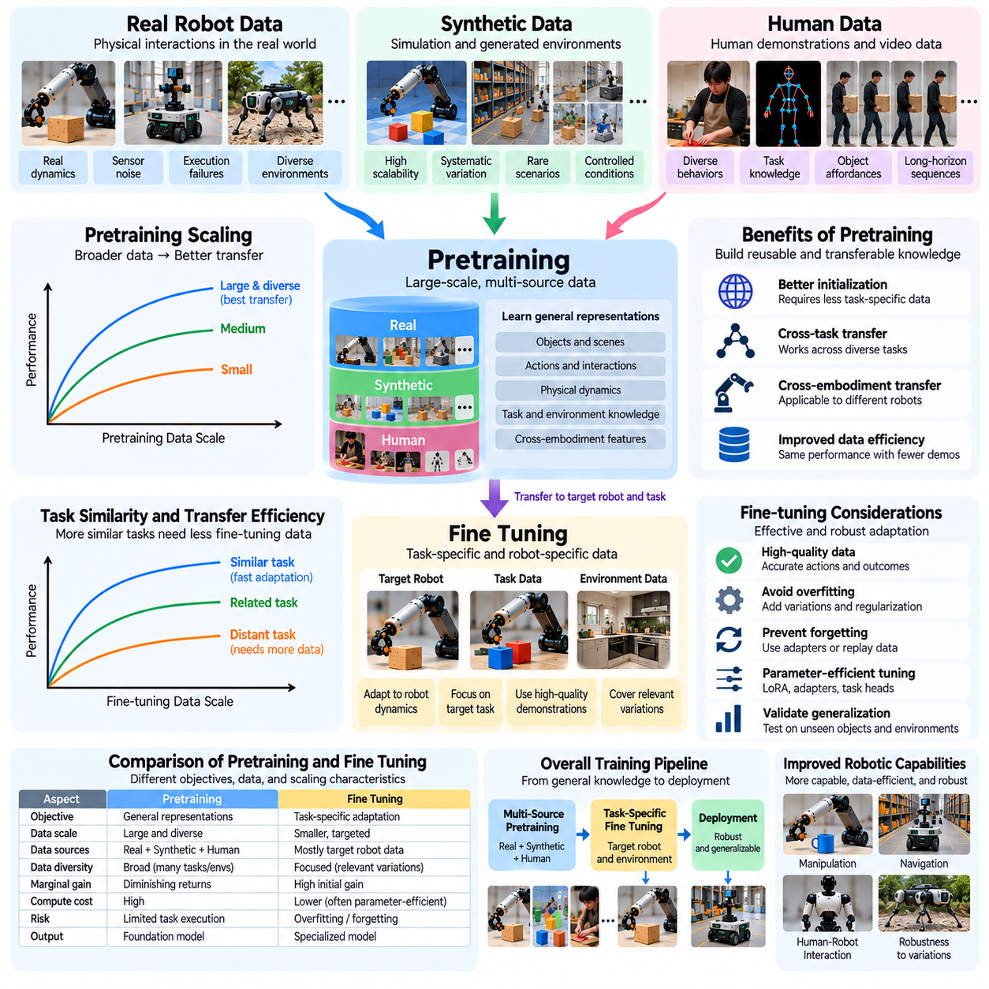
Pretraining and fine-tuning data scaling examines how the quantity, diversity, and quality of training experiences influence different stages of Physical AI development. Pretraining builds broad representations and reusable behavioral knowledge from large datasets, while fine-tuning adapts these capabilities to specific robots, tasks, and environments. Their scaling characteristics differ because they optimize different objectives and operate under different data constraints.
Pretraining typically uses heterogeneous datasets containing robot trajectories, human demonstrations, simulation experiences, images, videos, and language instructions. Its objective is to acquire transferable representations of objects, actions, environments, and physical interactions. Large-scale exposure helps models identify common structures across diverse experiences. However, broad coverage does not guarantee reliable execution of a particular robotic task.
Fine-tuning concentrates learning on narrower operational requirements, such as precision assembly, warehouse picking, or mobile manipulation. Training examples often originate from the target robot or closely related platforms. These datasets provide information about actuator behavior, sensor configuration, contact dynamics, and task-specific constraints. Fine-tuning transforms general knowledge into capabilities suitable for a defined deployment setting.
The relationship between pretraining data volume and downstream performance often exhibits diminishing returns. Initial increases in dataset size can substantially improve representation quality and task transfer. As coverage expands, additional examples may contribute progressively smaller improvements. The resulting scaling curve depends on model capacity, data diversity, optimization methods, and the similarity between pretraining experiences and downstream tasks.
Fine-tuning data frequently provides high marginal value because it directly addresses deployment requirements. A relatively small collection of accurate demonstrations may improve a specialized task more than a much larger collection of unrelated pretraining examples. Nevertheless, the benefit depends on the quality of the pretrained model. Weak foundational representations may require extensive adaptation data before acceptable performance becomes possible.
Pretraining and fine-tuning should therefore be evaluated as complementary investments rather than interchangeable sources of training volume. Pretraining reduces the amount of specialized experience needed for new tasks, while fine-tuning corrects limitations that remain after broad learning. The optimal allocation depends on how many downstream applications will reuse the same foundation model and how different their physical requirements are.
Transfer efficiency is a central metric for understanding the relationship between these stages. It measures how much task-specific data is required to achieve a defined performance level after pretraining. A stronger pretrained model should ideally reach the same target performance with fewer demonstrations or interaction episodes. Comparing adaptation curves across different pretraining scales reveals whether additional broad data produces practical savings.
Task similarity strongly influences fine-tuning efficiency. A model pretrained on grasping and object placement may adapt quickly to related warehouse manipulation tasks. Adapting the same model to dynamic locomotion or contact-intensive tool use may require substantially more data. Similarity should be evaluated through physical dynamics, action requirements, sensory information, and task structure rather than semantic labels alone.
Data quality plays different roles during pretraining and fine-tuning. Large pretraining datasets can tolerate some variability when useful patterns remain sufficiently represented. Fine-tuning datasets are often smaller, making incorrect actions, inconsistent labels, and synchronization errors more damaging. High-quality demonstrations, accurate calibration, and reliable outcome measurements are therefore especially important during task-specific adaptation.
Fine-tuning also introduces the risk of overfitting when limited demonstrations cover only a narrow range of conditions. A policy may perform well on familiar objects and initial configurations while failing under modest environmental changes. Data augmentation, regularization, and controlled variation can improve robustness. Evaluation should include unseen conditions that remain relevant to the intended deployment rather than measuring training-task success alone.
Catastrophic forgetting is another challenge because specialized adaptation may degrade capabilities acquired during pretraining. Updating model parameters for one robot or task can interfere with previously learned behaviors. Parameter-efficient adaptation, selective freezing, replay data, and modular architectures can reduce this interference. The appropriate method depends on whether the system must preserve broad generality or prioritize specialized performance.
Parameter-efficient fine-tuning can reduce computational requirements by updating only selected components of a pretrained model. Adapters, low-rank updates, and task-specific output heads allow shared representations to remain largely unchanged. This approach can support multiple robotic applications without maintaining a completely separate model for each task. However, limited adaptation capacity may restrict performance when substantial physical differences exist.
The ratio between pretraining and fine-tuning data should not be treated as a universal constant. Models with extensive pretraining may require fewer task-specific examples, but some precision tasks demand substantial real-world interaction regardless of foundation model scale. Contact dynamics, actuator characteristics, and safety constraints can create irreducible adaptation requirements. Optimal ratios must therefore be established empirically for each application family.
Simulation can contribute to both stages but serves different purposes. During pretraining, synthetic environments provide broad variation in objects, tasks, and physical conditions. During fine-tuning, simulation can reproduce deployment-specific scenarios and difficult failure cases. Targeted synthetic adaptation may reduce physical collection costs, although real-world validation remains necessary to detect simulation-to-reality discrepancies.
Human demonstrations can similarly support broad pretraining and specialized adaptation. Large video collections provide information about task intentions, object affordances, and action sequences. Direct teleoperation or carefully mapped demonstrations can supply more executable supervision for fine-tuning. The value of each source depends on how accurately its observations and actions correspond to the target robot's capabilities.
Compute allocation also affects the efficiency of the two stages. Pretraining generally requires substantial computational resources to process large heterogeneous datasets and optimize high-capacity models. Fine-tuning typically uses smaller datasets and fewer updates, although repeated adaptation across many robots can become expensive. Scaling analysis should consider total lifecycle computation rather than comparing individual training runs in isolation.
Joint optimization of pretraining and fine-tuning budgets can reveal more efficient development strategies. Increasing pretraining scale may reduce adaptation costs across many tasks, but the savings eventually diminish. Alternatively, investing in targeted fine-tuning data may produce faster improvements for a limited application portfolio. The economically preferred strategy depends on expected task reuse, deployment volume, and performance requirements.
Evaluation protocols should measure performance before and after fine-tuning across multiple downstream tasks. Useful metrics include zero-shot success, few-shot adaptation efficiency, final task success, robustness, and retained capabilities. Experiments should vary pretraining volume and fine-tuning volume independently whenever possible. This separation helps identify whether improvements originate from stronger general representations or additional specialized experience.
Active learning can improve fine-tuning efficiency by selecting examples that address the model's remaining weaknesses. Robots may collect demonstrations for uncertain states, repeated failures, or underrepresented object configurations. These experiences can be added to targeted adaptation datasets rather than expanding collection uniformly. The resulting feedback loop focuses expensive physical interaction on situations with high expected learning value.
Continual learning extends fine-tuning beyond a single adaptation stage. Deployed robots encounter new objects, environments, and operational constraints that were absent from their original datasets. Carefully curated field experiences can support periodic updates while preserving previously acquired capabilities. Version control, regression testing, and safety validation are necessary to prevent performance degradation during repeated deployment updates.
Scaling laws should ultimately describe performance as a function of pretraining data, fine-tuning data, model capacity, and computation. Controlled experiments can estimate how these variables interact and where additional investment yields diminishing returns. Such models are empirical approximations rather than universal guarantees. Their usefulness depends on consistent evaluation conditions and representative deployment tasks.
Ultimately, pretraining and fine-tuning data scaling concerns the efficient conversion of broad experience into reliable specialized behavior. Pretraining establishes reusable physical and behavioral knowledge, while fine-tuning aligns that knowledge with specific embodiments and operational demands. Effective Physical AI development balances both stages through quality-aware data selection, transfer evaluation, adaptive collection, and careful resource allocation.

07.11. Model Size and Robot Capability
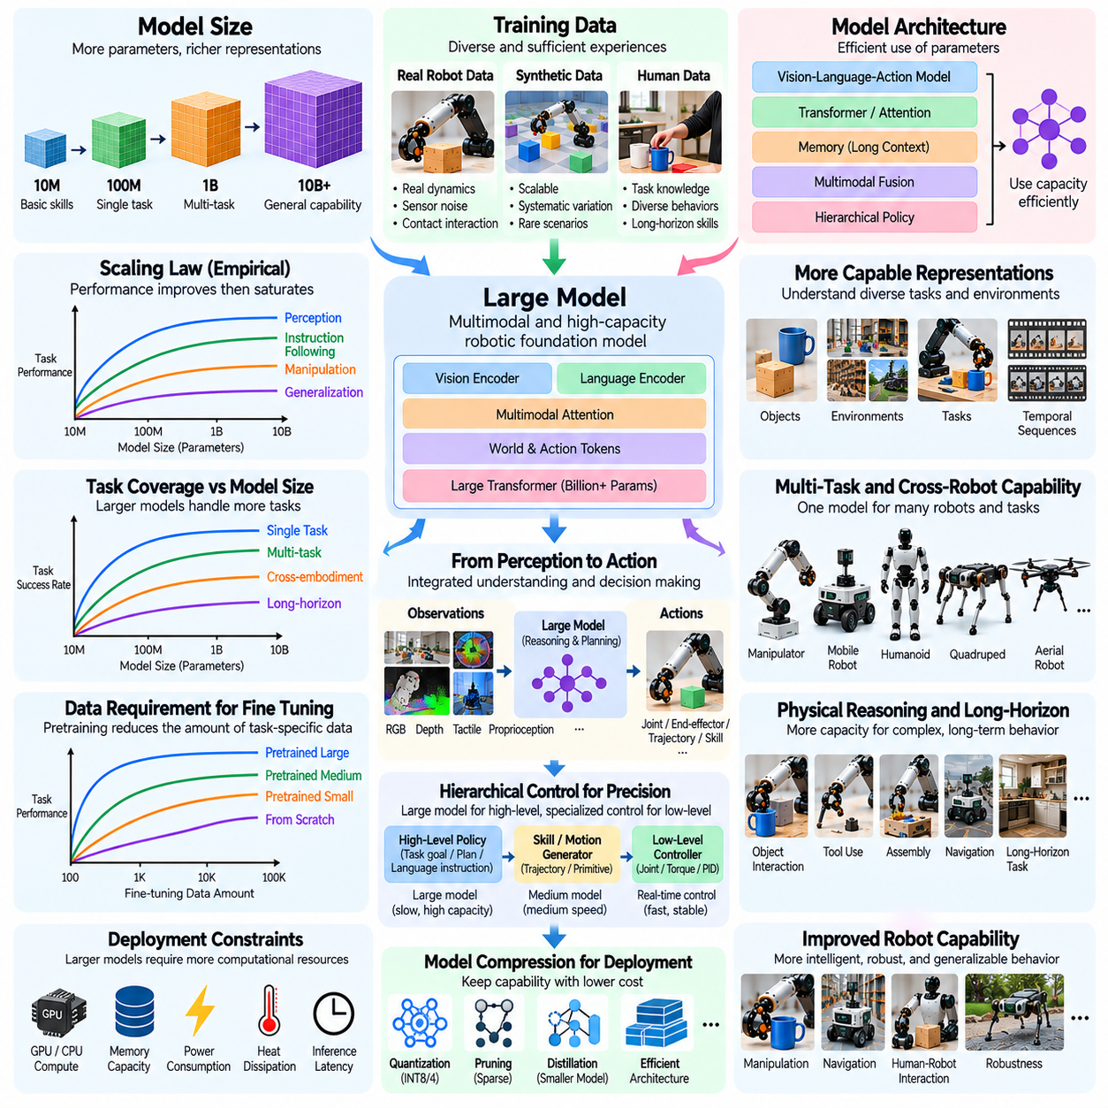
Model size and robot capability scaling examines how increasing neural network capacity influences the intelligence, adaptability, and physical performance of robotic systems. Larger models can represent more complex relationships among perception, language, motion, and environmental dynamics. However, parameter count alone does not determine robotic competence. Effective scaling depends on training data, model architecture, computational resources, and the physical constraints of deployment.
Model size is commonly measured by the number of trainable parameters, although parameter count provides only a partial description of computational capacity. Architecture, attention mechanisms, memory structures, and activation patterns influence how efficiently parameters represent knowledge. Two models with similar sizes may exhibit different robotic capabilities. Scaling analysis must therefore consider both parameter quantity and the functional organization of the model.
Larger models can improve representation learning by capturing relationships across diverse objects, tasks, environments, and robot embodiments. They may integrate visual observations, language instructions, proprioceptive signals, and action histories into shared representations. This capacity supports broader task understanding and more flexible behavior selection. Nevertheless, improvements depend on whether training experiences contain sufficient information to learn meaningful physical relationships.
The relationship between model size and task performance often follows empirical scaling trends, but these trends vary across robotic applications. Increasing parameters may initially improve prediction accuracy and task success before gains become smaller. Some capabilities may improve rapidly within particular model ranges. Such changes should be established through controlled experiments rather than assumed to represent universal thresholds or guaranteed emergent behavior.
Data availability strongly influences the benefits of increasing model capacity. Large networks trained on limited robotic trajectories may memorize demonstrations without developing transferable control strategies. Diverse data helps expose the model to different physical conditions and interaction outcomes. Consequently, model scaling should be coordinated with data scaling to avoid overfitting, inefficient computation, and poor generalization.
Model capacity also affects the ability to learn multiple robotic tasks within a shared architecture. Smaller policies may perform well on narrowly defined behaviors but struggle when required to represent many unrelated skills. Larger models can potentially share knowledge across manipulation, navigation, perception, and planning. However, competing objectives may still produce negative transfer when tasks require incompatible representations or control strategies.
Vision-language-action models illustrate how increased capacity can support integrated robotic intelligence. These architectures connect visual perception, linguistic instructions, and action generation within a common learning framework. Larger representations may improve semantic understanding and instruction following. Yet successful physical execution also requires accurate spatial reasoning, contact awareness, and compatibility with robot-specific action interfaces.
Long-horizon robotic tasks introduce additional demands on model capacity because successful execution requires maintaining information across multiple decisions. Assembly, cleaning, and mobile manipulation involve changing goals, intermediate states, and unexpected disturbances. Larger models may support richer task representations and planning. However, reliable long-horizon behavior also depends on memory, feedback, error recovery, and hierarchical control.
Physical reasoning presents a distinctive challenge because robots must predict the consequences of actions in environments governed by mechanics. Understanding friction, mass, compliance, and contact dynamics requires information beyond visual appearance. Larger models may represent more complex physical relationships, but parameter growth cannot compensate for missing interaction evidence. Accurate physical intelligence requires appropriately grounded training experiences.
The relationship between model size and control precision is not straightforward. A large policy may understand task objectives while producing actions that lack the timing or accuracy required for insertion and grasp stabilization. Low-level control depends on actuator characteristics, feedback frequency, and deterministic execution. Combining high-capacity models with specialized controllers can therefore be more effective than assigning every control decision to one network.
Inference latency becomes a major constraint as model size increases. Robotic systems must often generate actions within strict real-time deadlines, especially during dynamic movement and contact-rich manipulation. Larger networks may require more memory bandwidth and computational throughput. If inference delays exceed control requirements, additional model capacity can reduce operational performance despite improvements in offline prediction accuracy.
Onboard computing limitations further restrict practical model scaling. Mobile robots, drones, and compact manipulators operate under constraints involving processor capability, battery consumption, heat dissipation, and physical space. Cloud inference can provide additional computation but introduces communication latency and connectivity risks. Deployment architectures must balance model capacity with local autonomy, reliability, and energy efficiency.
Model compression offers one approach to preserving capabilities while reducing deployment costs. Quantization, pruning, knowledge distillation, and efficient attention mechanisms can decrease memory usage and computational requirements. A smaller deployed model may inherit useful representations from a larger teacher model. However, compression must be evaluated against task success, control stability, safety, and performance under unfamiliar physical conditions.
Mixture-of-experts architectures provide another scaling strategy by activating selected model components for particular inputs or tasks. This can increase total parameter capacity without requiring every parameter to participate in each inference step. Specialized components may represent different skills or perceptual domains. Nevertheless, routing errors, communication overhead, and inconsistent behavior across experts can complicate robotic deployment.
Model size can influence cross-task and cross-embodiment transfer by increasing the capacity to represent shared patterns. A sufficiently trained model may reuse object understanding and task planning across different robot platforms. However, differences in joint structures, sensors, and actuator dynamics still require explicit adaptation. Embodiment-aware representations and robot-specific control interfaces remain important even when the shared model becomes substantially larger.
Pretraining and fine-tuning interact with model capacity in important ways. Larger pretrained models may provide stronger initial representations and reduce the number of demonstrations needed for downstream adaptation. However, this advantage depends on the relevance and quality of pretraining data. Specialized fine-tuning may remain essential for precision tasks, unusual robot configurations, and deployment environments with distinctive physical constraints.
Scaling experiments should compare models under carefully controlled data and computational conditions. Researchers can vary parameter counts while maintaining consistent training distributions, evaluation tasks, and optimization procedures. Performance should be measured across familiar and unseen objects, tasks, and environments. These experiments help distinguish improvements caused by model capacity from gains attributable to additional data or computation.
Capability evaluation should extend beyond prediction loss and benchmark accuracy. Robotic intelligence must be assessed through task completion, physical precision, robustness, adaptation efficiency, safety, and recovery from unexpected events. A larger model that performs better on offline datasets may not necessarily achieve higher real-world success. Deployment-oriented metrics are therefore essential for determining the practical value of scaling.
The economic efficiency of model scaling depends on performance improvement relative to training and inference costs. Larger models require additional accelerators, memory, energy, and engineering resources. These investments may be justified when a shared model supports many robots or applications. For narrowly defined tasks, smaller specialized policies may provide better operational value. The optimal model size depends on workload, deployment scale, and reliability requirements.
Safety considerations become increasingly important as models acquire broader behavioral capabilities. High-capacity policies may generate actions that appear reasonable but violate physical limits or operational constraints. Increasing parameter count does not inherently guarantee safer decisions. Robot-specific safety filters, constrained controllers, monitoring systems, and systematic validation remain necessary regardless of model size.
A practical scaling strategy often separates high-level intelligence from time-critical physical control. Large models can interpret instructions, reason about task structure, and propose action objectives, while compact controllers execute precise movements using rapid sensor feedback. This division allows systems to benefit from greater representational capacity without sacrificing control responsiveness. The appropriate boundary depends on task dynamics and hardware capabilities.
Ultimately, model size and robot capability scaling is a multidimensional engineering problem rather than a simple relationship between parameters and intelligence. Larger models can enable broader representations, stronger transfer, and more complex behavior, but only when supported by suitable data and execution infrastructure. Effective Physical AI scaling coordinates model capacity, physical experience, efficient inference, adaptive control, and rigorous real-world evaluation.

07.12. Compute and Test Time Compute Scaling
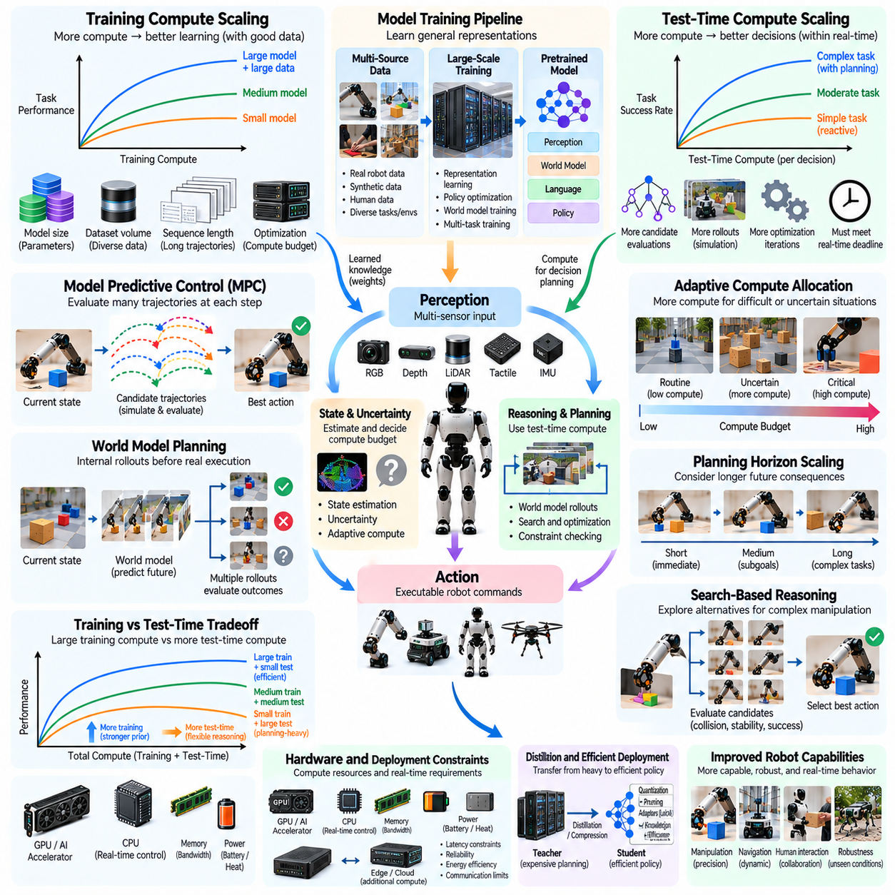
Compute scaling and test-time compute scaling examine how computational resources influence the learning, reasoning, and execution capabilities of Physical AI systems. Training compute determines how extensively models can learn from physical experiences, while test-time compute determines how much computation can be devoted to decisions during deployment. Effective scaling requires balancing model accuracy, planning quality, response latency, and operational reliability.
Training compute includes the processing required for representation learning, policy optimization, world model training, and simulation-based exploration. Its demand depends on model size, dataset volume, sequence length, and optimization procedures. Increasing compute can improve learning when sufficient informative data is available. However, additional computation cannot automatically compensate for poor demonstrations, missing physical interactions, or biased datasets.
Test-time compute refers to computational resources allocated after training to produce predictions, plans, or actions. A robot may use additional computation to evaluate candidate trajectories, simulate possible outcomes, or refine manipulation strategies. Unlike training compute, these resources are consumed during operation. Their usefulness depends on whether additional reasoning improves decisions before real-time deadlines are reached.
Physical AI differs from conventional language modeling because computation must interact with continuously evolving physical environments. A robot cannot indefinitely delay an action while considering alternatives. Moving objects, unstable grasps, and dynamic obstacles impose strict response requirements. Consequently, test-time scaling must account for elapsed time, environmental changes, and the physical consequences of delayed decisions.
Model predictive control provides a practical example of test-time computation. At each planning cycle, the robot predicts future states, evaluates candidate control sequences, and selects an action. Increasing the number of sampled trajectories or optimization iterations may improve decision quality. However, larger search budgets also increase latency, making computational efficiency essential for responsive control.
World models enable robots to perform internal rollouts before executing physical actions. These models estimate how environments may change under different control inputs. Additional rollouts can improve planning by revealing collisions, unstable contacts, or inefficient trajectories. Their value depends on prediction accuracy because extensive computation with an inaccurate world model can reinforce incorrect decisions.
Planning horizon is another important scaling variable. Longer horizons allow robots to consider delayed consequences and coordinate multiple actions toward distant objectives. Assembly and navigation tasks may benefit from anticipating future constraints. Nevertheless, prediction errors accumulate over extended horizons, while search complexity increases. Effective planning therefore balances horizon length, model uncertainty, and available computation.
Search-based reasoning can support complex manipulation by exploring alternative grasps, object placements, and motion sequences. Larger search budgets may discover solutions that simple reactive policies overlook. However, physical feasibility must be verified through collision constraints, joint limits, and contact stability. Search quality depends not only on the number of candidates but also on how accurately the system evaluates them.
Adaptive compute allocation improves efficiency by assigning different computational budgets to different situations. Routine movements may require only lightweight policy inference, while uncertain or unfamiliar conditions justify additional planning. A robot approaching a narrow insertion target may increase computation before contact. Such strategies allocate resources according to task difficulty, estimated uncertainty, and potential failure consequences.
Uncertainty estimation provides a mechanism for deciding when additional computation is valuable. Models can assess confidence in state estimates, predicted outcomes, or candidate actions. High uncertainty may trigger additional sensing, trajectory evaluation, or replanning. However, uncertainty estimates must be calibrated because excessive confidence can suppress necessary reasoning, while excessive caution can waste computational resources.
Training-time and test-time computation can sometimes substitute for one another. Extensive training may produce policies that generate effective actions with minimal inference, whereas smaller models may require additional online search. This tradeoff is task dependent. Highly repetitive operations often favor strong offline learning, while unfamiliar environments may benefit from flexible planning during deployment.
Distillation can transfer knowledge from computationally expensive planners into efficient reactive policies. A teacher system may generate high-quality trajectories using extensive simulation or optimization. A student policy then learns to reproduce useful decisions with fewer operations. This approach reduces deployment latency, although the student may struggle when encountering situations outside the teacher's training distribution.
Hardware architecture determines how effectively computational scaling can be implemented. GPUs and specialized accelerators support large neural networks, while CPUs and real-time controllers manage deterministic execution. Memory bandwidth, thermal limits, and power consumption constrain onboard processing. Distributed or cloud computation can extend capacity, but communication delays and connectivity failures must be considered.
Hierarchical architectures separate computationally intensive reasoning from time-critical control. High-level planners may operate at relatively low frequencies to determine goals and action sequences. Low-level controllers execute movements using rapid sensor feedback. This separation allows robots to perform sophisticated reasoning without interrupting stabilization or safety-critical responses. Coordination between layers remains essential.
Compute scaling also interacts with perception and sensor processing. Higher-resolution images, additional camera streams, and dense point clouds increase the cost of state estimation. More computation may improve scene understanding, but processing delays can make observations outdated. Efficient feature extraction, selective sensing, and asynchronous processing help preserve timely information for action generation.
Energy efficiency becomes particularly important for battery-powered robots. Additional inference and planning consume electricity and generate heat, potentially reducing operating duration. A computationally expensive strategy may improve individual decisions while lowering overall productivity. System-level optimization should therefore consider task success per unit of energy, total mission time, and the availability of onboard resources.
Safety imposes limits on how computational budgets can be expanded. Robots must maintain collision avoidance, force limits, and emergency responses even when complex planning is incomplete. Anytime algorithms can provide usable solutions early and improve them when additional time remains. Safe fallback policies and independent monitoring systems help prevent planning delays from compromising physical operation.
Evaluating test-time compute scaling requires controlled experiments across different inference and planning budgets. Researchers can measure task success, trajectory quality, latency, energy consumption, and recovery performance. Results should distinguish computational improvements from changes in model architecture or training data. Testing under real-time constraints is necessary because offline performance may overestimate deployment benefits.
Scaling curves may reveal diminishing returns as additional planning iterations provide progressively smaller improvements. In some cases, longer computation can even reduce performance when decisions become outdated or model errors accumulate. The optimal budget therefore depends on environmental dynamics and decision complexity. Adaptive stopping criteria can terminate reasoning when further computation is unlikely to improve outcomes.
Ultimately, compute and test-time compute scaling concerns the intelligent allocation of computational effort across learning and execution. Larger training budgets can strengthen representations and policies, while additional deployment computation can improve planning and adaptation. Reliable Physical AI systems coordinate both resources with physical dynamics, hardware constraints, uncertainty, and safety requirements to maximize real-world performance.

07.13. Scaling Generalization and Transfer
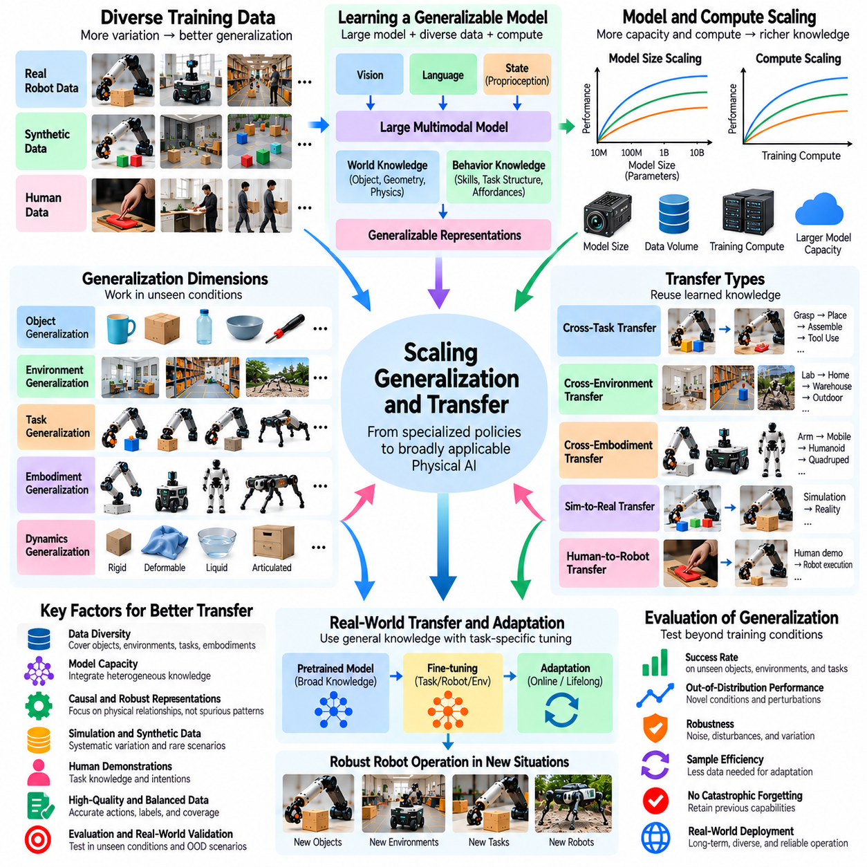
Scaling generalization and transfer examines how increasing data, model capacity, and computational resources improves a robot's ability to operate beyond its original training conditions. Generalization refers to successful behavior in previously unseen situations, while transfer describes the reuse of learned knowledge across tasks, environments, or robot platforms. Both capabilities are essential for transforming specialized robotic policies into broadly applicable Physical AI systems.
Traditional robot learning often produces policies optimized for narrowly defined environments and repetitive tasks. These systems may achieve high success rates under familiar conditions but fail when objects, lighting, geometry, or physical properties change. Scaling introduces broader experiences that can reduce dependence on specific training configurations. However, increasing dataset size does not automatically produce robust generalization when important variations remain unrepresented.
Generalization can be examined across several dimensions, including objects, environments, tasks, embodiments, and physical dynamics. Object generalization involves manipulating unfamiliar shapes and materials, while environmental generalization requires adapting to new layouts and operating conditions. Task generalization concerns new objectives or action sequences. Embodiment transfer extends learned capabilities across robots with different mechanical and sensing characteristics.
Data diversity is a major determinant of generalization performance because it exposes models to different relationships between observations, actions, and outcomes. Large datasets containing only repetitive demonstrations may provide limited transferable knowledge. In contrast, carefully selected experiences covering diverse interactions can improve robustness. Effective scaling therefore requires expanding meaningful variation rather than simply accumulating more trajectories.
Model capacity influences how effectively a system can integrate knowledge from heterogeneous experiences. Larger networks may learn shared representations of object affordances, spatial relationships, and physical interactions. These representations can support adaptation to unfamiliar situations. Nevertheless, increased parameter count cannot guarantee transfer when training data lacks relevant physical evidence or when the learned representations depend on misleading correlations.
Transfer learning allows robots to reuse knowledge acquired during pretraining or previous task execution. A manipulation policy trained on diverse grasping experiences may adapt more efficiently to new object categories. Similarly, navigation knowledge can transfer between environments that share geometric structures. The degree of transfer depends on the similarity of underlying physical requirements, not merely the semantic similarity of task descriptions.
Cross-task generalization requires models to understand reusable behavioral components rather than memorize complete action sequences. Skills such as reaching, grasping, placing, and obstacle avoidance can contribute to multiple tasks. Compositional learning enables these components to be combined into unfamiliar procedures. However, successful composition requires accurate state estimation, reliable skill transitions, and mechanisms for detecting and recovering from execution errors.
Cross-environment transfer presents challenges involving lighting, textures, object arrangements, floor conditions, and sensor characteristics. Policies trained in controlled laboratories may behave unpredictably in warehouses, homes, or outdoor environments. Domain randomization and environmental diversification can improve resilience to these changes. Yet transfer remains limited when deployment conditions introduce physical phenomena absent from the training distribution.
Cross-embodiment transfer is particularly difficult because robots differ in joint configurations, actuator dynamics, sensing capabilities, and reachable workspaces. A behavior learned on one manipulator may not be directly executable on another. Embodiment-aware representations can separate task objectives from robot-specific motion commands. Adaptation mechanisms then translate shared behavioral knowledge into actions compatible with each platform's physical constraints.
Simulation contributes to generalization by enabling systematic variation of environmental and physical parameters. Synthetic environments can expose policies to unfamiliar objects, disturbances, and task configurations at large scale. However, simulated diversity must reflect plausible real-world conditions. Excessive randomization or inaccurate contact models may introduce irrelevant experiences, making real-world validation necessary for determining actual transfer benefits.
Human demonstrations provide additional opportunities for transferring task knowledge across embodiments. Videos and motion recordings contain information about object use, manipulation sequences, and goal-directed behavior. Models can extract high-level intentions that remain useful despite differences between human and robotic motion. Converting these intentions into executable robot actions still requires physical grounding, embodiment adaptation, and appropriate feedback control.
Scaling generalization also depends on learning representations that distinguish causal physical relationships from superficial visual patterns. A robot should recognize that grasp stability depends on geometry, friction, and contact forces rather than background appearance. Training across varied conditions can reduce reliance on spurious correlations. However, causal robustness must be tested through controlled interventions and physical experiments rather than inferred from dataset diversity alone.
Out-of-distribution generalization evaluates performance when deployment conditions differ substantially from the training distribution. Such conditions may involve unfamiliar objects, unexpected disturbances, or combinations of known factors. Performance often declines as distribution shift increases, although the relationship depends on the model and task. Reliable systems must estimate uncertainty and recognize situations where learned behavior may no longer be dependable.
Few-shot adaptation provides a practical measure of transfer efficiency. A model with strong general representations should require fewer demonstrations or interaction episodes to learn a new task. Adaptation curves can quantify performance as additional task-specific data becomes available. Comparing these curves across model and dataset scales reveals whether broader pretraining reduces the cost of deploying robots in unfamiliar applications.
Continual learning extends transfer beyond initial deployment by allowing robots to incorporate new experiences over time. Field data can reveal recurring failures, novel object configurations, and environmental changes. Updating models with these experiences may improve future generalization. However, continual adaptation must prevent catastrophic forgetting and unintended degradation of previously reliable behaviors through replay, validation, and controlled model updates.
Generalization evaluation requires carefully designed training and testing partitions. Randomly separating episodes from the same environments may overestimate transfer because similar objects and configurations appear in both sets. Stronger protocols hold out entire object categories, task combinations, environments, or robot platforms. Such evaluation helps distinguish genuine generalization from memorization of familiar conditions and repeated experimental patterns.
Scaling curves for generalization should measure performance across increasing levels of distribution shift. Researchers can vary training data volume, task diversity, model size, and adaptation budgets while maintaining consistent evaluation conditions. Results may reveal that additional data improves familiar-task performance faster than unseen-task performance. These differences expose limitations that conventional aggregate success rates can conceal.
Negative transfer occurs when previously learned knowledge interferes with adaptation to a new task or embodiment. Shared representations may encode assumptions that are inappropriate for different contact dynamics or control interfaces. Increasing training diversity can reduce some conflicts but may also introduce competing objectives. Task-conditioned policies, modular architectures, and selective adaptation can help preserve useful shared knowledge while limiting harmful interference.
Safety becomes increasingly important when robots generalize beyond familiar operating conditions. A model may produce plausible actions without accurately predicting their physical consequences in unfamiliar situations. Confidence estimation, constrained control, runtime monitoring, and fallback procedures can reduce deployment risks. Generalization should therefore be evaluated alongside safety, recovery capability, and compliance with operational limits.
Ultimately, scaling generalization and transfer requires more than expanding datasets or neural networks. It requires identifying reusable physical knowledge, exposing models to meaningful variation, and measuring performance under genuine distribution shifts. Effective Physical AI systems combine diverse experience, transferable representations, embodiment-aware adaptation, uncertainty management, and rigorous real-world evaluation to achieve reliable behavior across changing tasks and environments.

07.14. Scaling Long Horizon and Emergent Behavior
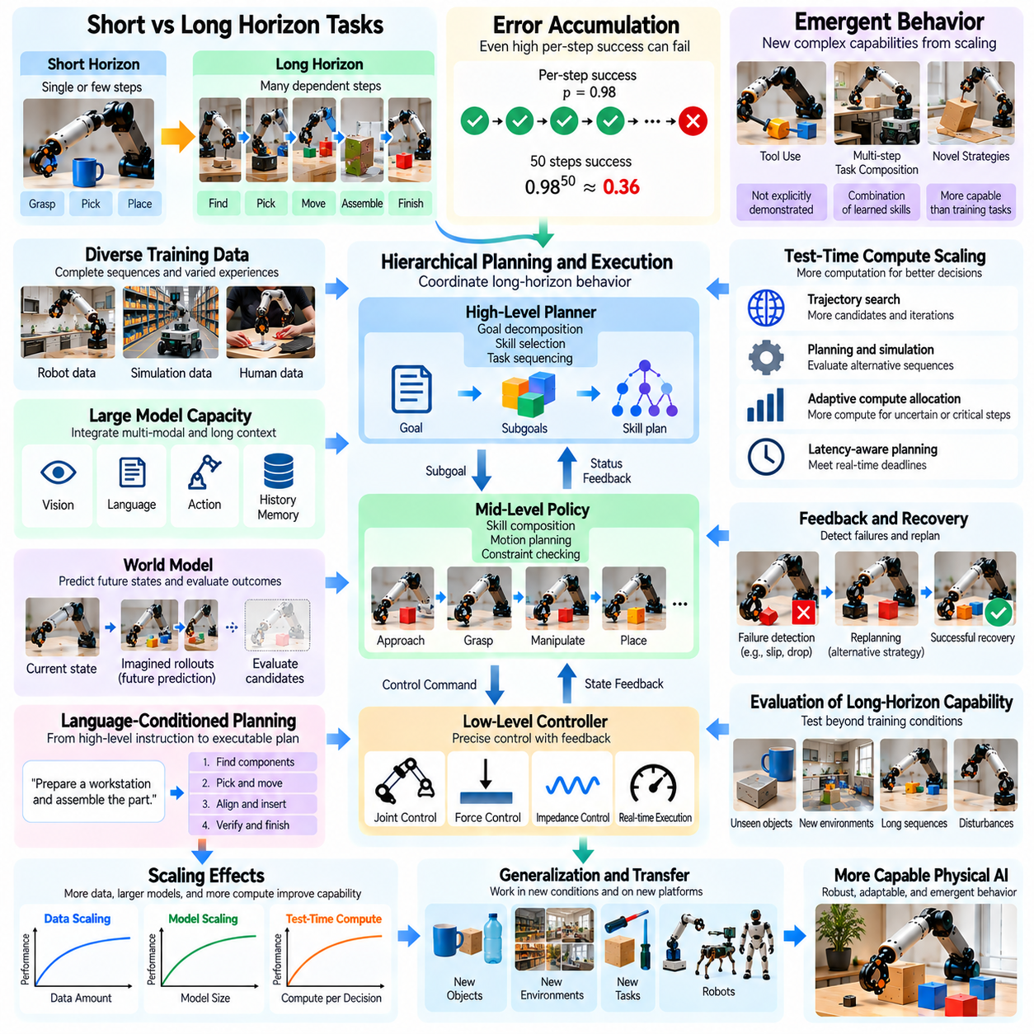
Scaling long-horizon and emergent behavior examines how increasing data diversity, model capacity, and computational resources influences a robot's ability to perform extended tasks and develop complex behavioral capabilities. Long-horizon behavior requires coordinating multiple actions over time, while emergent behavior refers to capabilities that become observable through interactions among learned representations and skills. Both are important indicators of progress toward general-purpose Physical AI.
Short-horizon robotic tasks involve relatively immediate objectives, such as grasping an object or moving toward a target. Long-horizon tasks require sequences of dependent actions, where early decisions influence later outcomes. Preparing a workspace, assembling components, and organizing objects may involve dozens of intermediate steps. Successful execution requires maintaining task context, tracking progress, and adapting plans when unexpected events occur.
Long-horizon performance is particularly sensitive to accumulated errors. Even when individual actions have high success probabilities, the probability of completing an extended sequence can decrease rapidly. For example, if each independent step succeeds with probability 0.98, a sequence of fifty required steps succeeds with probability approximately 0.36. This simplified calculation illustrates why reliable recovery and verification become increasingly important as task duration grows.
Scaling training data can improve long-horizon competence by exposing models to complete task sequences rather than isolated actions. Extended demonstrations reveal dependencies between subtasks, intermediate objectives, and successful recovery strategies. However, collecting long trajectories is expensive and often produces uneven coverage of failure conditions. Dataset design must therefore balance complete demonstrations with targeted examples of difficult transitions and recovery events.
Temporal representation learning helps robots identify relationships between actions separated by many time steps. Sequence models, recurrent architectures, and attention mechanisms can encode historical observations and evolving task states. Larger context windows may improve access to relevant information, but they also increase computational demands. Effective memory must distinguish important events from redundant observations rather than preserving every sensor measurement.
Hierarchical control provides a practical foundation for scaling extended behavior. High-level policies select goals or reusable skills, while low-level controllers execute precise movements using immediate feedback. A complex assembly task can be decomposed into locating components, grasping parts, aligning surfaces, and completing insertion. Hierarchical organization reduces planning complexity and allows successful subtasks to be reused across different applications.
Skill composition is central to the development of more complex robotic behavior. Models trained on reaching, grasping, placing, navigation, and tool use may learn to combine these capabilities into unfamiliar procedures. Such composition can appear emergent when the resulting task was not explicitly demonstrated as a complete sequence. Nevertheless, successful combinations require compatible skill interfaces, reliable state transitions, and accurate evaluation of intermediate outcomes.
Emergent behavior should be distinguished from improvements caused by additional training exposure or changes in evaluation methodology. A capability may appear suddenly when performance crosses a benchmark threshold, even if the underlying improvement is gradual. Genuine behavioral emergence requires evidence that new functional combinations or strategies arise beyond memorized examples. Controlled experiments are necessary to separate model scaling effects from data contamination and measurement artifacts.
Model capacity influences the ability to represent multiple goals, task dependencies, and alternative action strategies. Larger models may integrate visual observations, language instructions, physical constraints, and previous execution outcomes. This integration can support flexible planning across diverse situations. However, parameter growth alone does not guarantee coherent long-horizon behavior, particularly when training data lacks extended physical interactions.
World models can support long-horizon planning by predicting how actions affect future environmental states. A robot may simulate alternative manipulation sequences before selecting a strategy. Increasing the number or depth of imagined rollouts can improve anticipation of delayed consequences. However, prediction errors accumulate across simulated steps, so practical systems must combine model-based planning with frequent observation and corrective feedback.
Test-time computation offers another mechanism for improving extended task execution. Additional planning iterations can evaluate alternative subtask orders, recovery strategies, and resource constraints. Robots may allocate more computation when uncertainty increases or a critical decision approaches. Nevertheless, physical environments continue changing during reasoning, making latency-aware planning essential for maintaining responsiveness and operational safety.
Language-conditioned planning can help robots organize complex objectives into interpretable subgoals. Instructions such as preparing a workstation or sorting equipment imply multiple actions and ordering constraints. Large multimodal models may infer reasonable task decompositions from prior experience. However, generated plans must be checked against physical feasibility, available tools, workspace conditions, and the robot's actual capabilities.
Feedback and recovery mechanisms are essential for preventing small failures from terminating extended operations. Robots must detect unsuccessful grasps, misplaced objects, blocked paths, and unexpected contact events. Recovery may involve retrying an action, selecting an alternative strategy, or revising the overall plan. Training on both successful and failed trajectories can improve these responses, provided that outcomes and corrective actions are accurately represented.
Long-horizon learning also benefits from explicit representations of task progress. State machines, structured memories, and goal-conditioned policies can track completed subtasks and remaining requirements. These mechanisms reduce repeated actions and help prevent the loss of task context. Progress estimation must remain grounded in sensor observations because an internally predicted success does not necessarily correspond to a physically completed operation.
Behavioral diversity influences the emergence of reusable strategies. Exposure to different objects, environments, and task sequences may encourage models to discover common structures across activities. Skills such as clearing obstacles before manipulation or repositioning objects for access can transfer between tasks. However, apparent generality must be tested on genuinely unseen combinations to determine whether the model has learned transferable principles.
Curriculum learning can gradually increase task complexity during training. Robots may first master isolated actions, then short sequences, and eventually extended procedures involving multiple dependencies. This progression can improve optimization stability and reduce the difficulty of learning sparse rewards. Nevertheless, overly restrictive curricula may limit exploration, so training should eventually include diverse and imperfect execution conditions.
Evaluating emergent capabilities requires more than measuring aggregate task success. Researchers should examine novel skill combinations, adaptation to unexpected disturbances, recovery efficiency, and the ability to complete tasks with unfamiliar subgoal structures. Evaluation protocols must control training exposure and distinguish previously observed behaviors from genuinely new combinations. Repeated trials are necessary to assess reliability rather than isolated demonstrations.
Scaling curves for long-horizon behavior should consider task length, subtask complexity, model size, data volume, and planning computation. Performance may improve unevenly across these dimensions, with short-task success increasing faster than extended-task reliability. Measuring completion probability against sequence length can reveal compounding failure effects. Additional metrics should capture recovery frequency, execution time, and cumulative intervention requirements.
Safety challenges grow as robots execute increasingly autonomous and extended procedures. Small planning errors can propagate into hazardous physical states, particularly when tools, moving machinery, or human collaborators are involved. Runtime monitoring, constrained actions, and independent safety controllers help maintain operational boundaries. Long-horizon autonomy should therefore expand only when verification, interruption, and recovery mechanisms remain dependable.
Ultimately, scaling long-horizon and emergent behavior requires coordinated advances in data collection, representation learning, hierarchical planning, physical prediction, and feedback control. Larger models and datasets can support more complex behavioral organization, but reliable execution depends on controlling accumulated errors and maintaining physical grounding. Progress should be measured through repeatable, safe performance on extended tasks and genuinely novel behavioral combinations.

07.15. Data Quality Adjusted Scaling
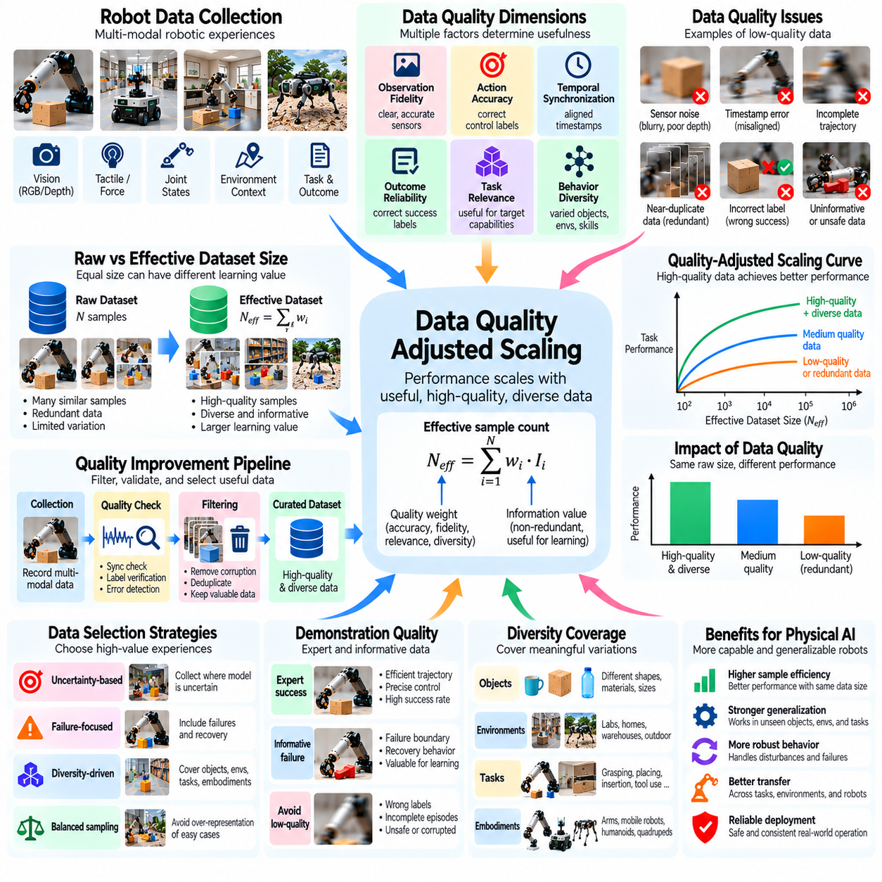
Data quality-adjusted scaling examines how the usefulness of training data influences the relationship between dataset size and Physical AI performance. Conventional scaling analysis often treats data volume as a primary variable, but robotic experiences differ substantially in accuracy, diversity, relevance, and reliability. Quality-adjusted scaling recognizes that equal numbers of demonstrations or trajectories may contribute very different amounts of useful learning information.
Physical AI datasets contain observations, actions, robot states, environmental conditions, and task outcomes. Their quality depends on whether these components accurately describe physical interactions. Sensor noise, timestamp errors, incomplete action records, and incorrect success labels can distort learned relationships. Consequently, increasing dataset volume without controlling measurement quality may produce limited improvements or even degrade policy performance.
A useful distinction exists between raw dataset size and effective dataset size. Raw size measures the number of episodes, trajectories, frames, or interaction steps collected. Effective size represents the amount of information that meaningfully contributes to learning. Repeated demonstrations of nearly identical behavior may add little new knowledge, while a smaller collection of diverse, accurately recorded interactions may produce stronger generalization.
Data quality can be represented through multiple dimensions rather than a single universal score. Important dimensions include observation fidelity, action accuracy, temporal synchronization, task relevance, behavioral diversity, and outcome reliability. Each dimension influences learning differently. For example, precise action labels support control learning, while diverse environments improve robustness against unfamiliar deployment conditions.
Quality-adjusted scaling can be conceptualized using an effective sample count that weights individual experiences according to their estimated usefulness. A simplified expression is N_eff = Σw_i, where w_i represents the quality weight of sample i. However, this formulation is only an approximation because correlated samples contribute overlapping information. Reliable estimation requires considering redundancy, coverage, task difficulty, and model-dependent learning value.
Demonstration quality strongly affects imitation learning because policies reproduce patterns contained in recorded behavior. Expert demonstrations may provide efficient trajectories and precise manipulation strategies, but they can omit recovery behaviors and exploratory actions. Less successful demonstrations may still contain valuable information about failure boundaries. Quality assessment should therefore distinguish informative failures from corrupted or misleading records.
Temporal consistency is especially important for robotic datasets because observations and actions are causally linked through physical dynamics. Incorrect timestamps can associate motor commands with the wrong sensor states, producing distorted control relationships. Even small synchronization errors may matter during fast manipulation or contact-rich operations. Quality control should verify sensor alignment, action timing, and consistency between recorded state transitions.
Trajectory completeness also influences learning effectiveness. Missing initialization states, interrupted recordings, and incomplete termination labels can obscure the relationship between goals and outcomes. Long-horizon tasks are particularly vulnerable because omitted transitions may remove essential dependencies. Dataset pipelines should preserve episode boundaries, task context, intervention records, and recovery events whenever these elements are necessary for interpreting behavior.
Diversity-adjusted quality evaluates whether collected experiences cover meaningful variations in tasks, objects, environments, and robot embodiments. A large dataset dominated by one operating condition may produce strong local performance but weak transfer. Balanced coverage can improve robustness, although uniform sampling is not always optimal. Difficult, safety-critical, or underrepresented situations may deserve greater representation than routine interactions.
Redundancy reduction can improve computational efficiency by removing repeated experiences that contribute little additional information. Near-duplicate frames, repetitive trajectories, and highly correlated demonstrations can dominate training without expanding behavioral knowledge. However, aggressive deduplication may eliminate useful variations in contact dynamics or execution timing. Effective filtering must preserve physically meaningful differences rather than relying only on visual similarity.
Uncertainty-based data selection prioritizes experiences where models lack confidence or encounter prediction errors. These samples may provide greater learning value than familiar examples already handled reliably. Active learning and targeted data collection can direct robots toward informative conditions. Nevertheless, uncertainty alone does not guarantee usefulness, since sensor corruption and fundamentally ambiguous observations may also produce high uncertainty.
Failure-focused sampling is particularly valuable for improving reliability. Rare collisions, unstable grasps, navigation deadlocks, and unsuccessful insertions reveal weaknesses that successful demonstrations may conceal. Including recovery trajectories helps models learn corrective behavior rather than merely avoiding observed failures. However, failure data must be accurately labeled and interpreted to prevent models from imitating unsafe actions without understanding their consequences.
Data provenance and annotation consistency support trustworthy scaling experiments. Records should identify collection platforms, sensor configurations, software versions, operator interventions, and labeling procedures. Without this context, apparent performance improvements may reflect hidden changes in collection methods. Versioned datasets and reproducible preprocessing make it possible to evaluate whether quality improvements genuinely affect learned capabilities.
Quality-adjusted scaling curves compare model performance against both raw data volume and estimated effective data volume. Researchers can train identical architectures using datasets with different filtering, weighting, or diversity characteristics. Improvements should be measured on independent evaluation tasks rather than the training distribution alone. Such experiments can reveal whether data curation produces greater gains than simply collecting additional episodes.
The relationship between quality and quantity is not always monotonic. Extremely strict filtering may produce clean datasets that exclude unusual but realistic operating conditions. Conversely, broad inclusion can introduce noise that overwhelms useful signals. Optimal curation balances measurement reliability with behavioral coverage. The appropriate balance depends on task complexity, model capacity, training objectives, and deployment requirements.
Quality-aware sampling can allocate training effort according to estimated learning value. Samples may receive different probabilities or loss weights based on difficulty, rarity, reliability, and relevance. This approach can improve utilization of limited computational resources. However, weighting schemes require validation because excessive emphasis on rare or difficult examples may distort the deployment distribution and reduce performance on common tasks.
Synthetic data introduces additional quality considerations because generated experiences may be abundant but physically imperfect. Simulation fidelity, contact modeling, sensor realism, and scenario diversity determine their usefulness. Synthetic trajectories can improve coverage of rare conditions, yet unrealistic dynamics may teach incorrect action consequences. Quality-adjusted scaling should therefore evaluate synthetic samples according to demonstrated transfer benefits rather than generation volume.
Human video and teleoperation datasets also require source-specific quality assessment. Human videos may contain rich task semantics but incomplete information about forces and robot-compatible actions. Teleoperation provides executable robot trajectories but may include operator delays, corrections, and inconsistent control styles. Combining these sources effectively requires preserving their strengths while accounting for differences in embodiment, observability, and action precision.
Ultimately, data quality-adjusted scaling shifts attention from how much robotic data is collected to how much useful physical knowledge that data provides. Reliable scaling requires accurate measurements, informative diversity, consistent annotations, careful filtering, and independent validation. As Physical AI systems expand across tasks and embodiments, improving effective data quality can become as important as increasing dataset size, model capacity, or computational resources.

07.16. Diminishing Returns and Data Bottlenecks
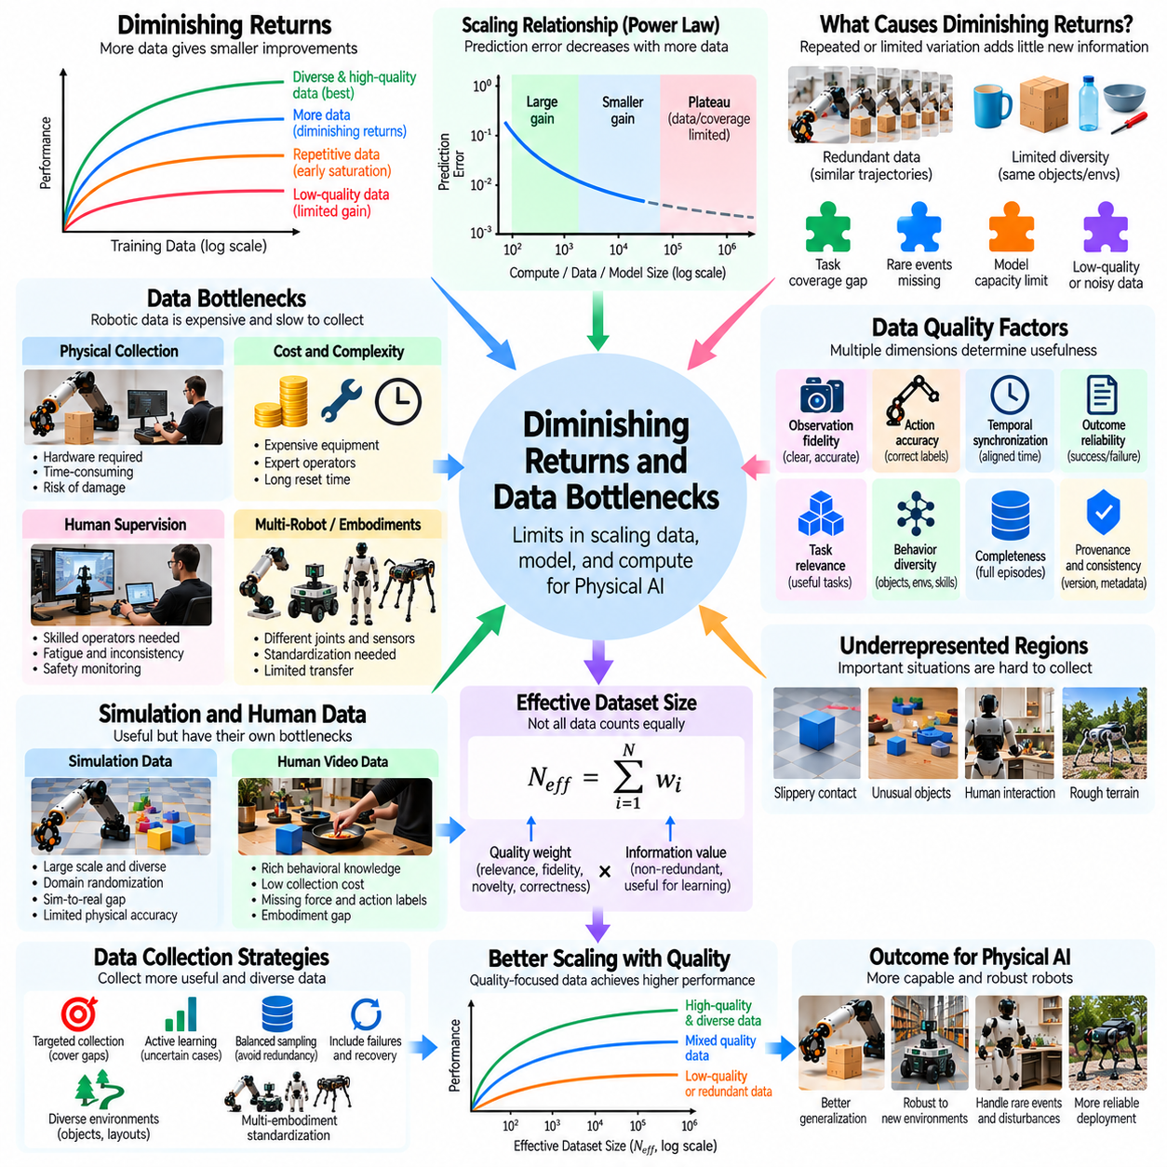
Diminishing returns and data bottlenecks describe the limits encountered when expanding Physical AI training datasets, model capacity, and computational resources. Early increases in data volume often produce substantial improvements because models acquire fundamental perception and control capabilities. As training progresses, additional data may contribute progressively smaller gains. Understanding these limitations is essential for designing efficient and sustainable robotic learning systems.
Diminishing returns occur when each additional unit of training data produces less performance improvement than previous units. This behavior can emerge as models master frequently encountered objects, environments, and action patterns. Repeated exposure strengthens existing capabilities but may provide little new information. Consequently, increasing dataset size does not necessarily improve performance on rare events, unfamiliar tasks, or difficult physical interactions.
Scaling relationships are often approximated using power laws, where prediction error decreases as training resources increase. However, empirical curves may flatten when data quality, task coverage, or model capacity becomes limiting. A plateau does not necessarily indicate that further scaling is impossible. Instead, it may reveal that the current data distribution or learning architecture cannot provide the information required for continued improvement.
Data bottlenecks arise when useful training experiences cannot be collected at the rate required by model development. Unlike internet-scale text, robotic data often requires physical hardware, controlled environments, human operators, and repeated experiments. Collection speed is constrained by robot motion, task duration, equipment availability, and maintenance. These factors make physical interaction data substantially more expensive to expand.
The cost of collecting demonstrations increases when tasks require precision, specialized equipment, or expert intervention. Contact-rich assembly, deformable object manipulation, and dynamic navigation may demand carefully supervised trials. Failures can damage hardware or require lengthy resets. As a result, collecting another thousand trajectories may involve much greater operational effort than simply recording additional sensor frames.
Data redundancy is a major cause of diminishing returns. Large collections of nearly identical trajectories may improve performance on familiar situations without expanding generalization. A robot repeatedly grasping the same object under similar conditions encounters limited behavioral variation. Effective scaling therefore depends on increasing informative diversity, including different objects, initial states, disturbances, and recovery outcomes.
Coverage bottlenecks occur when important regions of the task distribution remain underrepresented. Rare collisions, unusual object geometries, slippery contacts, and unexpected human interactions may be difficult to capture systematically. Models trained primarily on routine operations can become highly accurate in common conditions while remaining fragile elsewhere. Targeted collection is needed to address these gaps.
Long-horizon tasks create additional bottlenecks because complete demonstrations require many successful intermediate actions. A single failure can interrupt an episode and increase collection time. Successful trajectories may also underrepresent recovery behavior, leaving models unprepared for unexpected deviations. Collecting partial sequences, failure transitions, and corrective actions can improve coverage without requiring every example to contain a complete successful task.
Embodiment diversity introduces another constraint. Data collected from one robot may not transfer directly to platforms with different joints, sensors, actuators, or control frequencies. Building large datasets across multiple embodiments requires standardized representations and calibration procedures. Without these mechanisms, additional robot-specific data may increase storage and training costs while contributing limited reusable knowledge.
Sensor bandwidth and synchronization can become bottlenecks as recording systems grow. High-resolution cameras, depth sensors, tactile arrays, and joint-state streams generate substantial data volumes. However, storing more measurements does not guarantee more useful learning information. Poor synchronization, inconsistent calibration, and missing metadata may reduce the effective value of otherwise extensive recordings.
Human supervision creates a practical scaling limit. Teleoperation, demonstration labeling, quality inspection, and safety monitoring require skilled personnel. Operator fatigue and inconsistent control strategies can reduce data quality as collection expands. Automation can lower these costs, but autonomous collection must still detect failures and prevent unsafe behavior. Human effort should increasingly focus on difficult cases rather than routine repetitions.
Simulation offers a partial solution by generating large quantities of trajectories without consuming equivalent physical robot time. Domain randomization can broaden object, environment, and disturbance coverage. Nevertheless, simulation introduces its own bottlenecks through inaccurate contact dynamics, unrealistic sensing, and incomplete environmental models. Additional synthetic data may yield diminishing returns when the simulation-to-reality gap dominates learning performance.
Human video data can expand behavioral diversity at relatively low collection cost. Such data provides examples of object use, task sequencing, and environmental interactions. However, missing force measurements, uncertain action parameters, and differences between human and robot embodiments limit direct transfer. Increasing video volume alone may not resolve these physical grounding problems, making targeted robot interaction data necessary.
Model capacity can also constrain data scaling. Small models may lack sufficient representational power to integrate diverse experiences, causing performance to saturate despite additional data. Conversely, large models trained on narrow datasets may overfit recurring patterns. Effective resource allocation requires matching model size, data diversity, and training computation rather than increasing one component independently.
Compute bottlenecks emerge when larger datasets require longer training cycles, greater memory capacity, and more expensive optimization. Processing redundant or low-value experiences consumes resources that could support informative experiments. Data filtering, balanced sampling, and curriculum learning can improve computational efficiency. However, aggressive filtering may remove rare physical events that are important for deployment reliability.
Active learning and uncertainty-driven collection can reduce data bottlenecks by prioritizing experiences with high expected learning value. Robots may request demonstrations for unfamiliar objects or collect additional trials after prediction failures. These approaches direct limited resources toward weaknesses rather than repeating mastered tasks. Their effectiveness depends on calibrated uncertainty and reliable identification of genuinely informative situations.
Evaluating diminishing returns requires controlled scaling experiments. Researchers should compare performance across increasing dataset sizes while keeping model architecture, training procedures, and evaluation conditions consistent. Separate measurements are needed for familiar tasks, unseen environments, rare failures, and long-horizon execution. Aggregate success rates alone can conceal bottlenecks affecting safety or generalization.
Marginal learning efficiency provides a useful basis for resource decisions. It measures how much additional performance is obtained from extra data, computation, or collection cost. When marginal gains decline, investment may shift toward improved annotations, targeted exploration, better sensors, or architectural changes. Such decisions should consider real-world deployment value rather than benchmark accuracy alone.
Ultimately, diminishing returns and data bottlenecks reveal that Physical AI scaling is constrained by the availability of informative physical experience. Sustainable progress requires reducing redundancy, expanding difficult-case coverage, improving collection automation, and coordinating real, synthetic, and human-derived data. The objective is not unlimited data accumulation but maximizing transferable capability, reliability, and safety from available learning resources.

07.17. Estimating Physical AI Scaling Curves [w/Code]
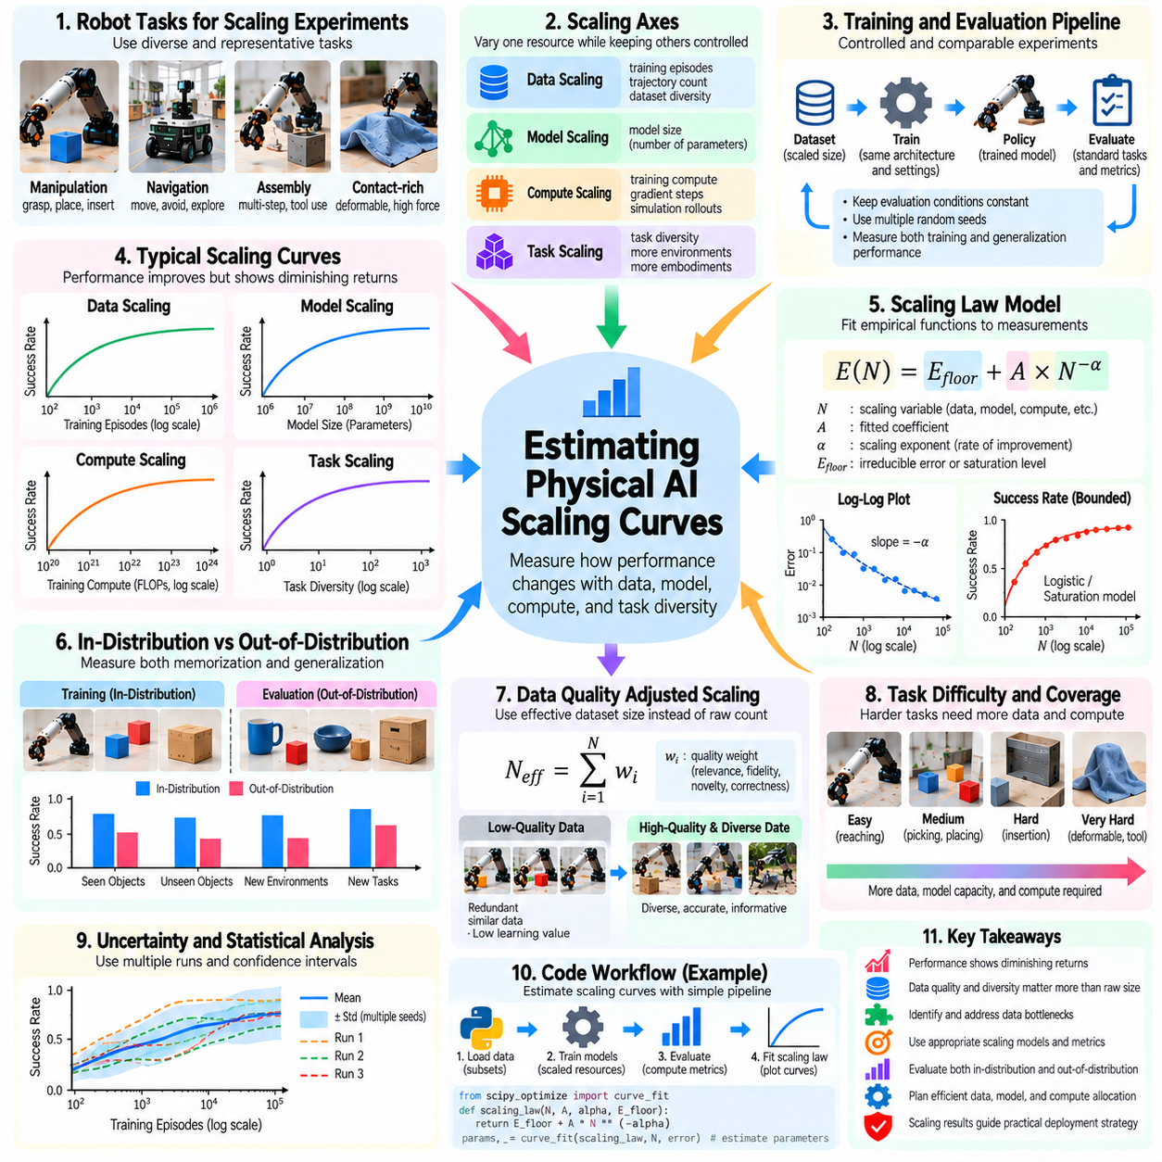
Estimating Physical AI scaling curves involves measuring how robotic learning performance changes with increasing data volume, model capacity, and computational resources. Unlike conventional AI benchmarks, robotic performance depends on physical interactions, task diversity, embodiment, and environmental conditions. Reliable scaling estimates therefore require carefully controlled experiments that connect training resources with measurable real-world capabilities.
A scaling curve describes the relationship between a resource variable and a performance metric. Common variables include training episodes, trajectory counts, model parameters, training compute, and task diversity. Performance may be measured through success rates, prediction errors, or execution efficiency. The objective is to identify systematic trends that support resource planning rather than assume that larger datasets always produce better robots.
Experimental design begins by selecting a representative collection of robotic tasks. Manipulation, navigation, assembly, and contact-rich operations may exhibit different scaling characteristics. Researchers should define training and evaluation conditions before collecting results. Holding evaluation procedures constant is essential because changing task difficulty, object distributions, or success criteria can create misleading improvements.
Data scaling experiments typically train identical model architectures using progressively larger datasets. Each dataset should preserve known sampling rules so that changes in performance can be attributed to additional training experiences. Multiple random seeds help estimate variability. When dataset composition changes with size, researchers should separately measure the effects of volume, diversity, and quality.
Model scaling experiments vary network capacity while controlling training data and optimization procedures. Increasing parameters may improve representation learning, but insufficient training compute can prevent larger models from reaching their potential. Conversely, small models may saturate despite additional data. Meaningful comparisons should report model size, training duration, computational budget, and convergence behavior.
Compute scaling experiments examine performance as training operations or optimization budgets increase. Researchers may vary gradient updates, simulation rollouts, or total accelerator usage. However, additional computation can improve results through longer optimization rather than larger models. Distinguishing these mechanisms is important for identifying efficient training configurations and understanding resource-dependent performance trends.
A common empirical approximation expresses error as E(N) = E_floor + A × N^(-α), where N represents a scaling variable, A is a fitted coefficient, α is the scaling exponent, and E_floor is an estimated irreducible error floor. This formulation describes diminishing improvements as resources increase. Its validity must be established experimentally because robotic learning curves may contain discontinuities, saturation, or regime changes.
Estimating scaling coefficients requires fitting candidate functions to measured observations. Logarithmic transformations can help visualize power-law relationships, while nonlinear regression can estimate parameters directly. Researchers should inspect residual errors and compare alternative functional forms. A curve that fits a narrow experimental range should not automatically be trusted for predictions far beyond the observed data.
Success rates require special treatment because they are bounded between zero and one. A simple power law may predict impossible values when extrapolated. Logistic functions, bounded saturation models, or transformations of failure probability may provide more appropriate descriptions. Model selection should reflect the mathematical properties of each metric and the expected behavior near performance limits.
Physical AI scaling curves should distinguish training performance from generalization performance. A robot may improve rapidly on familiar objects while making little progress on unseen environments or tasks. Separate curves for in-distribution and out-of-distribution evaluation reveal these differences. Cross-embodiment transfer and long-horizon execution may require additional measurements because their scaling behavior can differ substantially.
Task difficulty also changes the interpretation of scaling results. Simple reaching tasks may approach saturation with modest data, while deformable manipulation or complex assembly may require much broader experience. Combining all tasks into one average can conceal important differences. Difficulty-stratified evaluation helps identify which capabilities benefit from scaling and which remain limited by missing knowledge.
Data quality-adjusted scaling introduces effective dataset size as an alternative to raw sample count. Repeated trajectories, inaccurate labels, and poorly synchronized sensor streams may contribute less useful information than diverse, reliable interactions. Researchers can compare curves before and after filtering or reweighting. Such experiments help determine whether better data selection produces larger gains than additional collection.
Statistical uncertainty is essential when interpreting scaling estimates. Robot experiments exhibit variability from initial states, contact dynamics, sensor noise, and environmental disturbances. Confidence intervals and repeated trials help distinguish genuine improvements from random fluctuations. Hierarchical analysis may be needed when observations are grouped by task, environment, robot, or collection session rather than statistically independent.
Experimental budgets often prevent exhaustive evaluation across every model size and dataset scale. Carefully selected logarithmic resource levels can reveal trends efficiently. Pilot experiments may identify regions where performance changes rapidly or begins to saturate. Adaptive experimentation can then allocate additional trials to uncertain regions, improving curve estimates without requiring uniformly dense measurements.
Joint scaling analysis examines interactions among data, model capacity, and compute. Increasing one resource may provide limited benefit when another becomes the bottleneck. Researchers can fit multivariable response surfaces or compare controlled resource combinations. These analyses support compute-optimal and data-efficient training decisions, although interactions may vary across robotic tasks and embodiments.
Scaling curves can also estimate marginal learning efficiency. The slope of a performance curve indicates how much improvement is associated with additional resources. Flattening slopes suggest diminishing returns and motivate investment in task diversity, data quality, or architectural improvements. Cost-aware analysis should include robot operating hours, human supervision, hardware wear, and energy consumption.
Extrapolation is one of the most useful but riskiest applications of scaling curves. A fitted relationship may predict the resources required to reach a target success rate, yet future performance can depart from historical trends. New failure modes, distribution shifts, or architectural limitations may appear at larger scales. Predictions should therefore include uncertainty ranges and clearly state the experimental conditions supporting them.
A practical scaling study should maintain reproducible records of dataset versions, model configurations, training procedures, evaluation tasks, and computational costs. Automated experiment tracking reduces inconsistencies and supports comparison across research iterations. Independent validation datasets help prevent benchmark-specific overfitting. Periodic refitting allows estimates to incorporate new evidence as robotic capabilities improve.
Ultimately, estimating Physical AI scaling curves is an empirical process for understanding how learning resources translate into physical capabilities. Reliable conclusions require controlled experiments, appropriate mathematical models, uncertainty analysis, and realistic deployment evaluation. Rather than treating scaling laws as universal guarantees, researchers should use them as decision tools for identifying bottlenecks, forecasting resource needs, and guiding efficient robotic development.

