Volume 05. Simulation and Sim2Real Transfer

Chapter 05. Massive Parallel Simulation

05.01. Why Massive Parallel Simulation
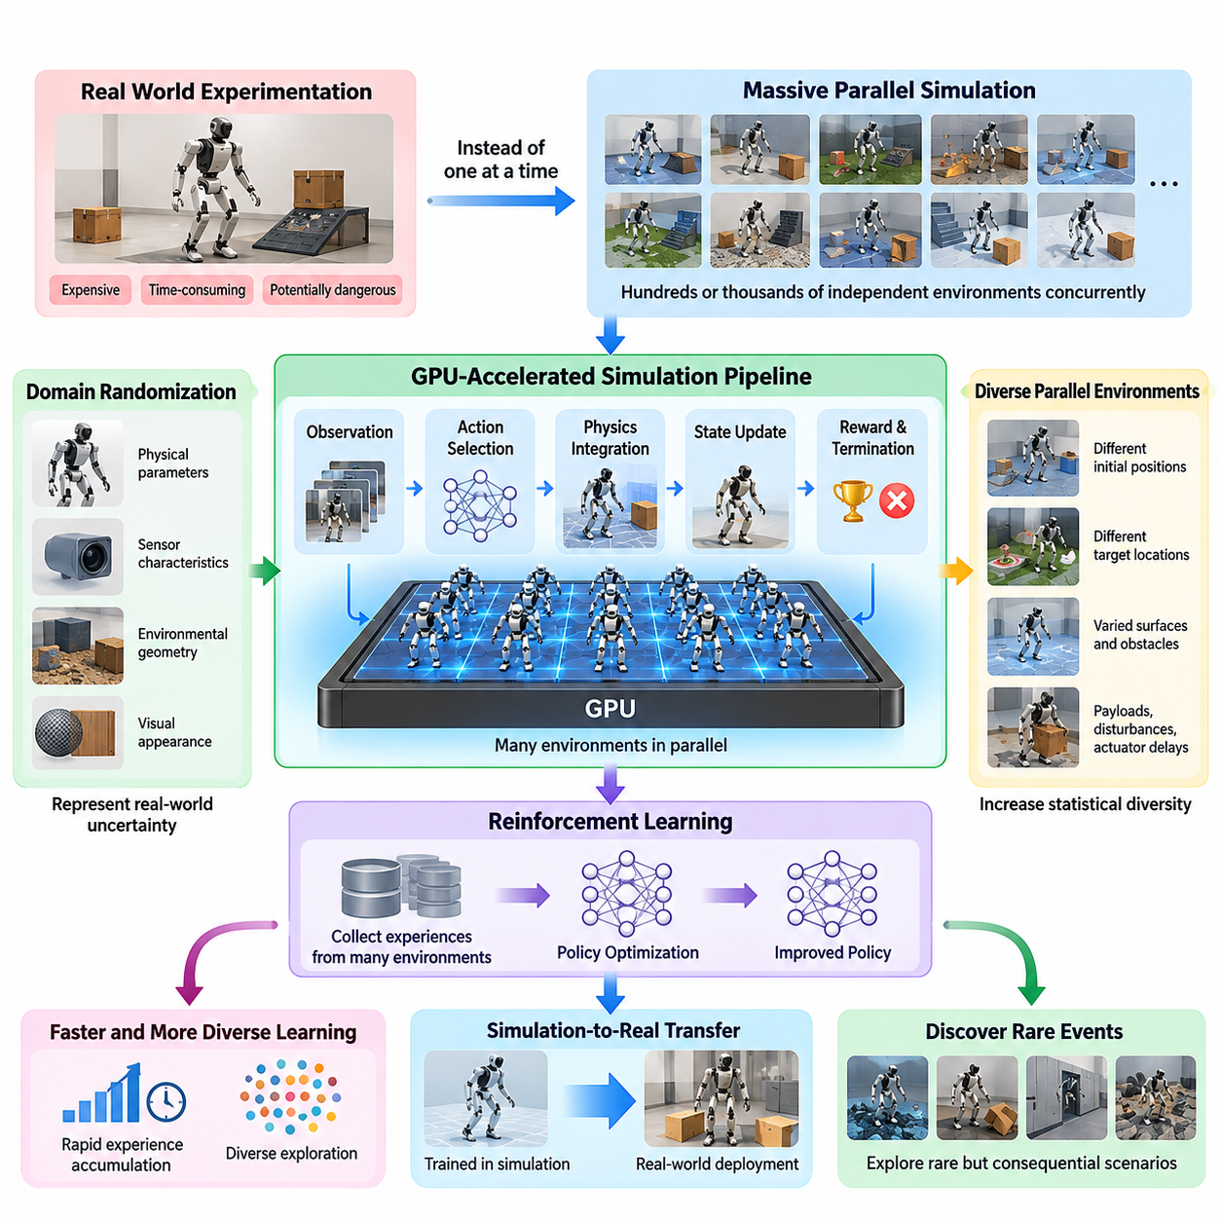
Massive parallel simulation is a foundational technology for scaling Physical AI training beyond the limitations of physical experimentation and sequential simulation. Instead of executing one robot environment at a time, it operates hundreds or thousands of independent environments concurrently. This approach enables robotic learning systems to accumulate diverse experiences rapidly while reducing the time required for policy development, testing, and optimization.
Physical robots interact with environments governed by complex dynamics, uncertain contacts, sensor imperfections, and unpredictable external disturbances. Learning reliable behavior requires exposure to many variations of these conditions. Collecting sufficient experience through physical hardware alone is expensive, time-consuming, and potentially dangerous. Massive parallel simulation provides a computational alternative by generating extensive interaction data without requiring equivalent numbers of real robots.
Traditional sequential simulation processes individual environments through repeated cycles of observation, action selection, physics integration, and state updates. Although this method is useful for debugging and detailed analysis, its throughput becomes insufficient when modern reinforcement learning algorithms require millions or billions of interaction steps. Parallel simulation addresses this limitation by distributing environment execution across multiple computational resources.
The fundamental advantage of massive parallel simulation is the separation between simulated experience generation and physical elapsed time. A single robot operating in the real world cannot experience more than one physical trajectory at a given moment. In contrast, thousands of simulated robot instances can explore different trajectories simultaneously, allowing a learning algorithm to collect experiences from many possible futures within a relatively short computational interval.
Reinforcement learning benefits particularly strongly from this architecture because policy optimization depends on repeated interaction between agents and their environments. Each simulated robot receives observations, executes actions, and produces rewards and state transitions. These experiences are aggregated into training batches that update a shared policy. Increasing the number of concurrent environments can accelerate data collection and improve exploration diversity.
Parallel execution also improves the statistical diversity of training experiences. Individual environments can initialize robots at different positions, assign different target locations, and introduce independent physical disturbances. Some instances may experience slippery surfaces, while others encounter obstacles, payload variations, or actuator delays. This simultaneous exposure helps learning systems develop policies that remain effective across changing operating conditions.
The relationship between massive parallel simulation and domain randomization is especially important for simulation-to-real transfer. Domain randomization modifies physical parameters, sensor characteristics, environmental geometry, and visual appearance to represent uncertainty in the real world. Parallel simulation makes it computationally practical to evaluate many randomized configurations concurrently, increasing the diversity of training conditions without requiring sequential execution.
Graphics processing units have transformed the practical scalability of simulation by providing thousands of computational execution units and high-bandwidth memory systems. GPU-oriented physics engines can process large batches of robot states, collision interactions, and numerical integration operations. When simulation data remains resident in GPU memory, expensive transfers between processors can be reduced, improving overall computational efficiency.
GPU-resident simulation becomes particularly valuable when the physics engine, observation processing, policy inference, and learning algorithm operate within a coordinated computational pipeline. Robot states can be represented as batched tensors, allowing thousands of environments to share optimized mathematical operations. This architecture reduces per-environment overhead and enables simulation throughput to increase substantially when workloads are sufficiently parallel.
Massive parallel simulation does not simply replicate identical environments. Each instance can maintain independent state variables, randomized parameters, task objectives, and termination conditions. A humanoid training system may simultaneously evaluate walking, balancing, recovery, and disturbance rejection across many instances. Similarly, autonomous mobile robots can explore navigation strategies under different obstacle layouts, traffic patterns, and surface conditions.
Parallel simulation is especially useful for contact-rich robotic tasks because learning stable contact behavior requires extensive experimentation. Robotic manipulation involves complex interactions among grippers, objects, frictional surfaces, and external forces. Legged locomotion introduces repeated foot-ground contacts and dynamic balance constraints. By executing numerous contact scenarios simultaneously, learning systems can discover control strategies across a broader range of physical configurations.
Another major motivation is the exploration of rare but consequential events. Real-world robotic failures may occur infrequently, making them difficult to capture through ordinary operational data. Simulation can deliberately generate unusual combinations of disturbances, sensor errors, obstacles, and actuator limitations. Parallel execution allows many such scenarios to be investigated concurrently, supporting the discovery of weaknesses before physical deployment.
The scalability of simulation also supports curriculum learning, in which robots gradually encounter tasks of increasing difficulty. Different environment groups can represent distinct training stages, ranging from simple movements to complex interactions. As learning progresses, the distribution of environments can be adjusted to emphasize challenging situations. Parallel execution allows easy and difficult scenarios to coexist within the same training process.
Beyond reinforcement learning, massive parallel simulation supports synthetic data generation for perception, planning, and multimodal robot intelligence. Simulated environments can produce camera images, depth measurements, LiDAR observations, robot states, and ground-truth annotations. Running many environments concurrently expands the range of generated scenes and behaviors, helping construct datasets for perception models, world models, and vision-language-action systems.
Large-scale simulation also changes how robotic algorithms are evaluated. Instead of testing a controller on a small collection of manually selected scenarios, researchers can execute standardized evaluations across thousands of independent trials. These trials can measure task completion, collision frequency, energy consumption, trajectory quality, and recovery performance. Large sample sizes provide stronger evidence about reliability, although statistical independence and scenario coverage remain essential.
Simulation throughput is commonly measured using environment steps per second, aggregate transitions per second, or simulated time relative to wall-clock time. These metrics describe different aspects of computational performance. A high aggregate step rate indicates substantial experience-generation capacity, but it does not automatically imply faster learning. Policy update costs, sample efficiency, synchronization overhead, and data quality also influence total training time.
The number of parallel environments must therefore be selected according to both computational capacity and learning requirements. Increasing environment count can improve hardware utilization, but excessive parallelism may introduce memory pressure, scheduling overhead, or inefficient training batches. Some reinforcement learning algorithms also require careful management of trajectory lengths and policy update frequency to prevent parallel experience collection from reducing optimization effectiveness.
Memory management is another central consideration because every simulated environment requires storage for robot states, joint variables, contact information, observations, and task-specific parameters. High-resolution visual sensors and complex physical scenes can substantially increase memory consumption. Efficient implementations share immutable assets, reuse geometric representations, and organize state data into compact structures suitable for parallel processing.
Parallel simulation introduces challenges associated with numerical stability and reproducibility. Independent environments may encounter different contact configurations, solver convergence behavior, or floating-point execution orders. Random seed management helps reproduce experimental configurations, but deterministic outcomes are not guaranteed across different hardware or simulation implementations. Reliable development therefore requires systematic logging, controlled experiments, and explicit validation procedures.
The computational architecture can extend beyond a single GPU through multi-GPU execution and distributed simulation clusters. Different processors or computing nodes can manage independent groups of environments while exchanging experience data with centralized or distributed learning systems. Such architectures provide additional scaling opportunities, although communication latency, workload balancing, synchronization, and infrastructure costs become increasingly important.
Cloud computing and on-premise clusters offer different deployment models for large-scale simulation. Cloud infrastructure provides elastic computational resources for temporary training campaigns and extensive evaluation workloads. On-premise systems offer direct hardware control and potentially predictable utilization costs. Selecting an architecture requires consideration of simulation intensity, GPU availability, dataset movement, security requirements, and long-term operational economics.
Massive parallel simulation also supports iterative development through rapid experimentation. Engineers can compare alternative reward functions, controller structures, observation spaces, and physical parameter distributions across many concurrent trials. This reduces the time between hypothesis formulation and empirical evaluation. Automated experiment management can further improve efficiency by identifying promising configurations and allocating additional computational resources to them.
Despite its advantages, massive parallel simulation cannot eliminate the simulation-to-real gap. Simulated environments necessarily approximate real physical behavior, and large quantities of inaccurate experience can reinforce undesirable control strategies. Increasing simulation scale without improving model fidelity or parameter coverage may produce policies that perform exceptionally well in simulation but fail under real-world conditions. Scale must therefore be combined with calibration and physical validation.
The most effective development process integrates massive parallel simulation with system identification, domain randomization, real-world testing, and continuous model refinement. Measurements from physical robots can update simulated dynamics and sensor models, while simulation can expose weaknesses that guide subsequent experiments. This feedback process transforms simulation from an isolated training tool into a continuously improving component of the Physical AI development lifecycle.
Massive parallel simulation ultimately changes the economics and methodology of robotic intelligence development. It enables researchers to explore more behaviors, evaluate more conditions, and generate more learning experiences than physical experimentation alone can reasonably provide. Its greatest value emerges when computational scale is combined with realistic modeling, efficient learning algorithms, reproducible evaluation, and disciplined simulation-to-real transfer.

05.02. Vectorized and Batched Environments
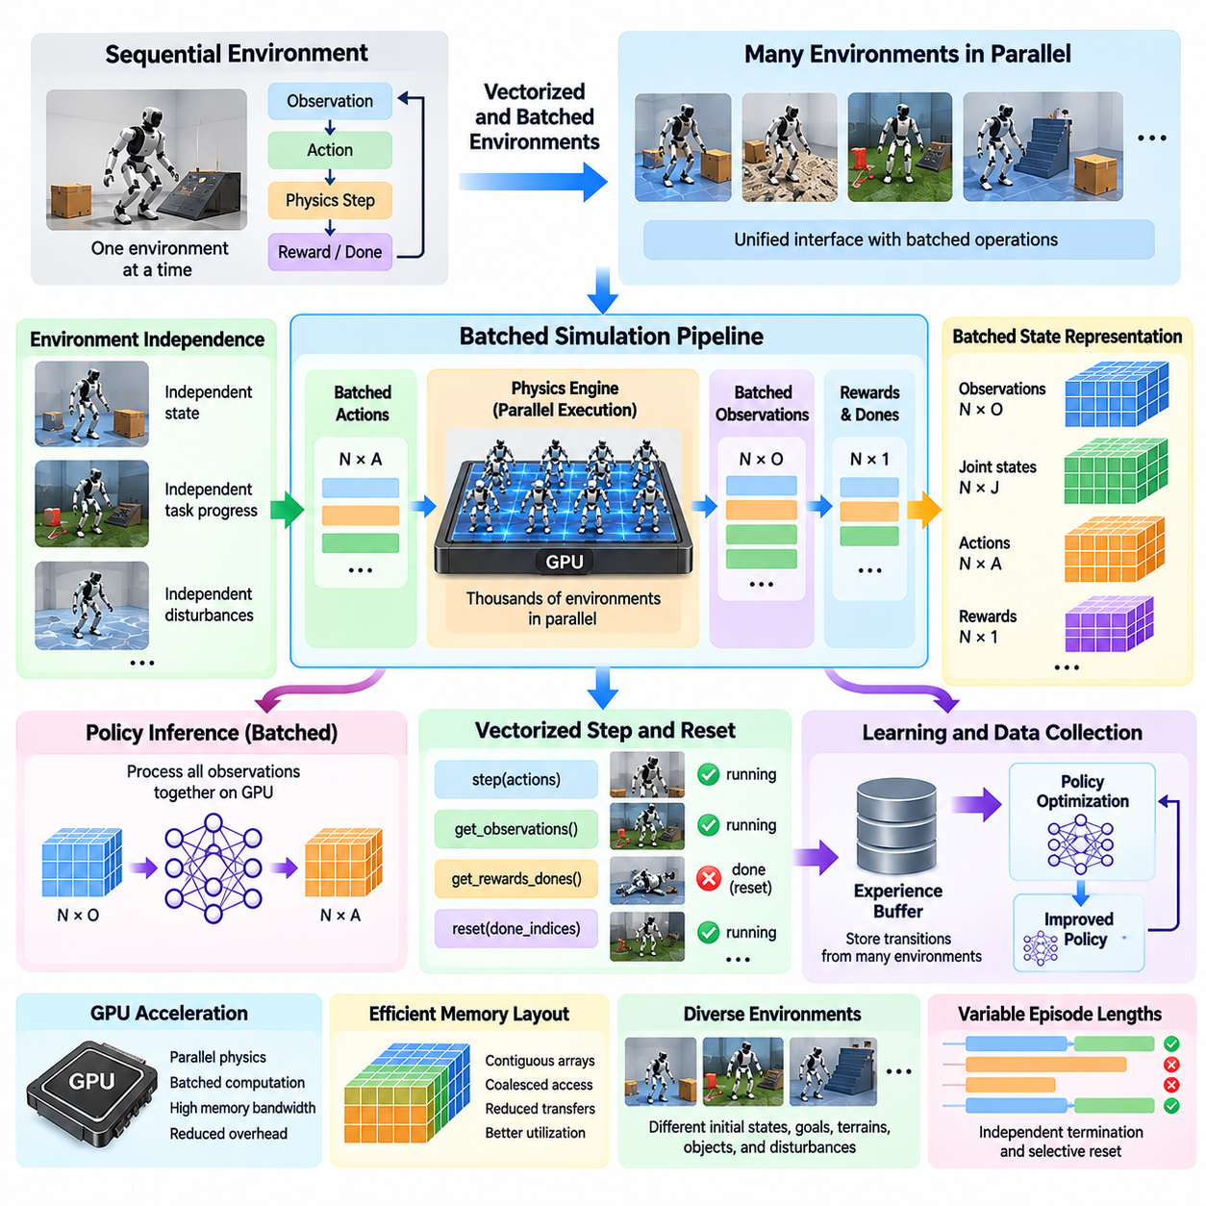
Vectorized and batched environments provide the computational foundation for massive parallel simulation in Physical AI. Rather than managing each simulated robot through an independent sequential execution loop, these environments organize multiple simulation instances into coordinated computational structures. This approach enables large numbers of robots to advance simultaneously while reducing software overhead and improving hardware utilization.
A conventional simulation environment typically maintains one robot state, processes one action, advances the physics engine, and returns one observation. When thousands of environments are executed independently, repeated function calls, memory transfers, and scheduling operations introduce substantial overhead. Vectorized environments address this limitation by exposing a unified interface that processes multiple environment instances through collective operations.
The fundamental principle of vectorization is to represent many independent environments as a single structured collection of states and actions. Instead of storing one robot position or velocity vector, the simulator maintains arrays containing corresponding values for all environments. Operations such as applying control commands, updating joint velocities, and calculating rewards can then be performed across the entire collection using optimized numerical routines.
A batched environment typically represents observations as tensors with a leading dimension corresponding to the number of parallel instances. For example, a system containing 4,096 robots with 48 observation features per robot may organize its observations into a tensor of shape 4,096 by 48. This representation allows neural networks to process observations collectively, improving inference efficiency and reducing repeated execution overhead.
The distinction between vectorization and batching is important. Vectorization describes an execution strategy that applies operations across multiple environments through a unified interface. Batching describes the organization of data or computations into groups processed together. Although the concepts frequently overlap, a vectorized interface does not necessarily guarantee simultaneous hardware execution, and batched computations may be used independently of environment management.
Vectorized simulation architectures commonly provide collective reset, step, observation, and reward operations. A single step request can submit actions for all active environments, advance their simulated dynamics, and return updated observations, rewards, termination indicators, and diagnostic information. This interface simplifies integration with reinforcement learning algorithms because experience collection follows a consistent structure regardless of environment count.
Environment independence remains essential even when execution is vectorized. Each simulated robot maintains its own position, velocity, actuator state, task progress, and environmental conditions. A collision in one environment should not directly modify the state of another unless explicit interaction is part of the simulation design. The vectorized architecture coordinates execution while preserving the logical separation of individual trajectories.
Batched state representation is particularly effective when environments share a common robot morphology and observation structure. Joint positions, joint velocities, actuator commands, and sensor measurements can be stored in dense tensors with consistent dimensions. This organization supports efficient memory access and allows physics calculations, control transformations, and reward evaluations to exploit parallel numerical operations.
Graphics processing units are especially well suited to batched simulation because they execute similar mathematical operations across many data elements. Thousands of robot instances can undergo state integration, actuator updates, and selected contact computations within parallel kernels. When the workload is sufficiently large and regular, GPU execution can substantially outperform sequential processing by reducing per-instance computational overhead.
Memory layout strongly influences vectorized simulation performance. Contiguous arrays and carefully organized tensor dimensions improve memory access efficiency, while fragmented structures and repeated allocations introduce unnecessary overhead. Simulation developers often organize data according to access patterns, balancing environment-oriented storage against component-oriented layouts to improve coalesced GPU memory operations.
The simulation step usually begins with a batch of actions generated by a shared policy network. These actions are mapped to the corresponding robot instances and applied to their actuators. The physics engine advances each environment through one or more integration steps, after which sensor observations and task-related quantities are updated. The resulting tensors are returned to the learning system for experience storage and policy optimization.
One practical challenge arises when environments terminate at different times. A robot may complete its task while another continues navigating or manipulating objects. Vectorized environments therefore require per-instance termination indicators and selective reset mechanisms. Completed or failed instances can be reinitialized without interrupting other environments, maintaining continuous experience generation and efficient utilization of computational resources.
Selective resetting also requires careful handling of trajectory boundaries. Observations associated with terminal states must be distinguished from observations generated after an automatic reset. Reinforcement learning algorithms depend on this distinction when computing returns, advantages, and bootstrap estimates. Incorrect termination handling can introduce training bias even when the underlying simulation and policy computations are otherwise correct.
Vectorized environments naturally support domain randomization by assigning different parameters to individual instances. Robot mass, friction coefficients, actuator strength, sensor noise, lighting conditions, and terrain characteristics can vary across the batch. Randomization parameters may be sampled during environment initialization or updated at specified intervals, allowing diverse physical conditions to be represented within a single simulation process.
Batched reward computation is another important optimization. Instead of evaluating reward functions through repeated environment-specific calls, the simulator computes reward components across state tensors. Tracking accuracy, energy consumption, collision penalties, stability measures, and task completion indicators can be evaluated through vectorized mathematical expressions. This reduces interpretation overhead and supports efficient reinforcement learning pipelines.
The relationship between batched environments and policy inference is particularly significant. A shared neural network can receive observations from thousands of robots in one forward pass and generate corresponding actions. This improves computational utilization compared with repeatedly evaluating the network for individual observations. However, inference batch size must be balanced against memory capacity, latency requirements, and the computational characteristics of the model.
Vectorized execution can be implemented through several architectures. CPU-based systems may use sequential vectorized interfaces, multiprocessing workers, or shared-memory communication. GPU-based systems can maintain simulation states directly in device memory and execute batched physics operations. Hybrid architectures combine CPU scene management with GPU acceleration, although communication between processing units may become a performance bottleneck.
CPU multiprocessing is useful when environments contain complex logic, irregular computations, or external software dependencies. Each worker can execute an independent simulation instance or a small group of environments. However, process synchronization, interprocess communication, and observation serialization can limit scalability. GPU-resident batching is generally more attractive when environments share regular computational structures and large numbers of instances are required.
A major advantage of GPU-resident environments is the ability to keep observations, actions, physics states, and rewards within the same memory space as the learning model. Eliminating unnecessary transfers between CPU and GPU reduces communication overhead and synchronization delays. This integrated architecture can support high-throughput experience collection, especially for reinforcement learning tasks dominated by numerical simulation.
Nevertheless, vectorization does not automatically produce linear performance scaling. Increasing the number of environments may eventually saturate computational units, memory bandwidth, or available device memory. Complex collision interactions and irregular contact patterns can also reduce execution efficiency. Performance must therefore be evaluated using aggregate simulation throughput, memory consumption, and end-to-end training time rather than environment count alone.
Load imbalance presents another challenge when individual environments require different amounts of computation. Some robots may move through empty spaces, while others experience numerous collisions or complex contact interactions. In synchronized execution models, slower instances can delay completion of a collective step. Efficient simulation engines attempt to minimize this effect through workload organization, optimized solvers, and appropriate environment grouping.
Vectorized environments also simplify systematic evaluation and benchmarking. Identical policies can be tested across many independently initialized scenarios while collecting standardized performance metrics. Task success, collision frequency, trajectory length, energy consumption, and recovery behavior can be measured across the batch. This provides a scalable foundation for comparing algorithms and estimating performance distributions under controlled conditions.
Reproducibility requires explicit management of random number generation and environment initialization. Each instance should receive a controlled random sequence or seed derived from an experiment configuration. Parallel execution order and hardware-dependent numerical behavior may still introduce variation, so experiments should record simulator versions, parameter distributions, random seeds, and relevant computational settings.
In practical Physical AI development, vectorized and batched environments connect physics simulation, domain randomization, reinforcement learning, synthetic data generation, and automated evaluation. Their effectiveness depends on selecting suitable tensor representations, minimizing synchronization costs, preserving independent environment states, and matching computational workloads to available hardware. These design principles enable simulation systems to scale from individual robotic experiments to large-scale learning infrastructure.

05.03. CPU vs GPU Parallel Simulation
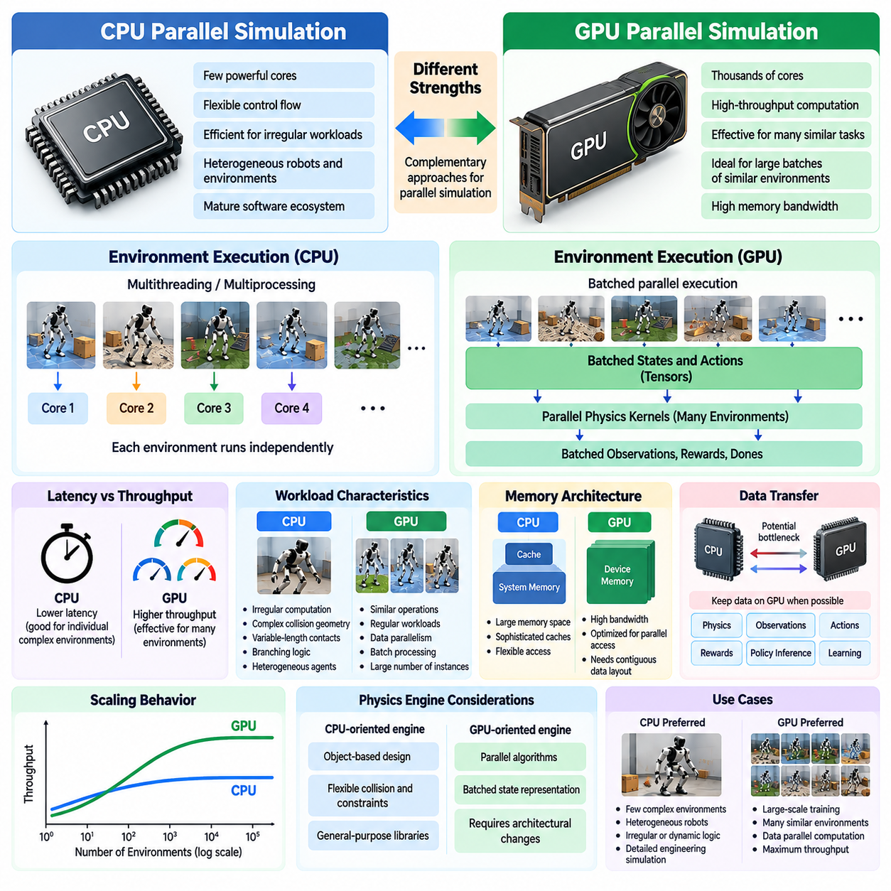
CPU and GPU parallel simulation represent two complementary approaches to accelerating physical environment execution for Physical AI. Central processing units emphasize flexible control flow, sophisticated scheduling, and efficient execution of irregular workloads, while graphics processing units emphasize high-throughput computation across many similar operations. Understanding their differences is essential for selecting simulation architectures that balance performance, accuracy, scalability, and development complexity.
CPU-based simulation traditionally relies on a relatively small number of powerful processing cores optimized for general-purpose computation. Each core can execute complex instructions, conditional branches, and dynamically changing workloads efficiently. This architecture is particularly suitable for robotic simulations involving heterogeneous agents, complicated environment logic, external software interfaces, and physics computations that cannot easily be organized into uniform parallel operations.
GPU-based simulation employs a different computational philosophy by distributing large numbers of similar operations across many lightweight execution units. Instead of optimizing the execution latency of individual tasks, GPUs emphasize aggregate throughput through extensive data parallelism. This makes them particularly effective when thousands of robot instances share similar state representations, physics calculations, control structures, and observation-processing requirements.
The distinction between latency and throughput is fundamental to CPU and GPU simulation design. Latency describes the time required to complete an individual operation or simulation step, whereas throughput measures the total amount of simulation work completed per unit time. CPUs may offer advantages for individual complex environments, while GPUs can deliver substantially higher aggregate throughput when large batches of similar environments execute concurrently.
CPU parallel simulation commonly uses multithreading, multiprocessing, or distributed execution to run independent environments. Each worker maintains its own simulation state and advances according to the scheduling mechanism. This approach is relatively straightforward to implement using established physics engines and operating-system facilities. However, synchronization overhead, memory duplication, and interprocess communication can become significant as environment counts increase.
GPU parallel simulation typically organizes robot states, actuator commands, contact information, and observations into structured arrays or tensors. Physics integration and related operations are executed through parallel kernels that process many environments simultaneously. This data-oriented architecture reduces repeated software overhead and exploits high memory bandwidth, although it requires careful attention to memory layout, kernel execution efficiency, and workload regularity.
One major advantage of CPU simulation is its ability to handle irregular computational structures. Complex collision geometries, variable-length contact lists, branching task logic, and heterogeneous robot models may produce substantially different workloads across environments. CPUs can adapt efficiently to these differences through flexible instruction execution and sophisticated control mechanisms, making them valuable for detailed engineering simulations and specialized robotic applications.
GPUs achieve their greatest efficiency when many computational threads execute similar instructions over independent data elements. Irregular branches and widely varying workloads can reduce this efficiency because execution resources may become underutilized. Contact-rich robotics presents particular challenges, since collision detection, constraint solving, and contact resolution can generate unpredictable computational patterns that complicate massively parallel execution.
Memory architecture introduces another important difference. CPUs generally access large system-memory spaces through sophisticated cache hierarchies, while GPUs rely on high-bandwidth device memory optimized for parallel access. GPU simulation performance depends strongly on arranging state variables and physical parameters into contiguous structures that support efficient memory transactions. Poor memory organization can eliminate much of the expected benefit of parallel execution.
Data transfer between CPU and GPU can become a substantial bottleneck in hybrid simulation pipelines. If physics calculations execute on the GPU but observations must repeatedly return to the CPU for processing, communication overhead may reduce overall throughput. GPU-resident simulation architectures address this limitation by keeping physics states, observations, actions, rewards, and neural-network computations within device memory whenever practical.
Physics engine architecture strongly influences whether CPU or GPU execution is more appropriate. Traditional engines often employ CPU-oriented collision detection, constraint solvers, and object-based data structures. GPU-oriented engines redesign these components around parallel algorithms and batched state representations. Consequently, GPU acceleration is not simply a matter of transferring existing CPU code to a graphics processor; substantial architectural changes may be required.
The number of simulated environments also affects the relative performance of each architecture. Small workloads may not provide enough parallelism to fully utilize a GPU, allowing CPU execution to remain competitive or even faster. As environment counts increase, GPU utilization can improve substantially until computational resources, memory bandwidth, or device capacity become saturated. The optimal crossover point depends on simulation complexity and hardware characteristics.
For reinforcement learning, GPU simulation offers significant advantages when experience collection involves thousands of similar robot instances. A shared policy network can process batched observations and generate actions directly on the GPU. The simulation engine then advances all environments and produces new training data without unnecessary processor transfers. This integrated pipeline can reduce experience-generation time and accelerate iterative policy optimization.
CPU simulation remains highly relevant for reinforcement learning tasks involving sophisticated environment logic, expensive rendering, or specialized external dependencies. Multiprocessing systems can distribute independent environments across available cores or computing nodes. Although their aggregate throughput may be lower for highly regular workloads, CPU architectures often provide greater flexibility when integrating legacy simulators, planning algorithms, middleware, and custom task components.
Rendering requirements can significantly change the CPU versus GPU tradeoff. High-fidelity camera simulation, ray tracing, and physically based rendering frequently benefit from GPU acceleration. However, rendering thousands of high-resolution observations can compete with physics and learning workloads for GPU memory and computational resources. Some systems therefore separate rendering, physics simulation, and neural-network training across different processors or devices.
Numerical precision and simulation fidelity must also be considered. CPU and GPU implementations may use different floating-point execution orders, solver algorithms, or precision settings. These differences can produce variations in contact dynamics, integration behavior, and constraint satisfaction. Neither architecture inherently guarantees greater physical accuracy; fidelity depends primarily on mathematical models, numerical methods, solver configuration, and validation against real measurements.
Determinism and reproducibility present additional challenges in parallel execution. CPU multithreading can introduce nondeterministic scheduling, while GPU kernels may produce different numerical results because of parallel reduction order or hardware-dependent execution. Reliable experiments require controlled random seeds, documented software configurations, and consistent evaluation procedures. Exact numerical reproducibility across architectures should not be assumed.
Energy efficiency is another factor influencing architectural decisions. GPUs can provide favorable energy consumption per simulated transition when processing large, regular workloads at high utilization. CPUs may be more efficient for small, irregular, or latency-sensitive tasks that cannot effectively occupy GPU resources. Meaningful comparisons should consider completed simulation work, total system power, memory usage, and the cost of maintaining computational infrastructure.
Scalability beyond a single processor introduces additional design considerations. CPU environments can be distributed across servers using multiprocessing and cluster scheduling, while GPU simulations can scale through multiple accelerators and distributed learning frameworks. Communication overhead, load balancing, memory replication, and synchronization become increasingly important. Effective scaling requires matching the simulation workload to the available computing topology.
Hybrid CPU-GPU architectures often provide the most practical balance for complex Physical AI systems. CPUs can manage scene construction, task orchestration, external communication, and irregular decision logic, while GPUs execute batched physics, sensor processing, and neural-network inference. The effectiveness of this arrangement depends on minimizing data transfers and ensuring that neither processing component repeatedly waits for the other.
Performance evaluation should therefore extend beyond raw simulation steps per second. Important measures include aggregate environment throughput, per-step latency, real-time factor, memory consumption, energy efficiency, and total policy-training time. Benchmarking should use equivalent robot models, physics settings, task conditions, and observation requirements to avoid misleading comparisons. Application-specific measurements provide stronger guidance than generalized CPU or GPU performance claims.
The choice between CPU and GPU parallel simulation ultimately depends on the structure and objectives of the robotic workload. CPU execution offers flexibility, mature software integration, and efficient handling of irregular computation. GPU execution provides substantial opportunities for high-throughput learning through large-scale data parallelism. Combining these capabilities within carefully designed simulation pipelines enables Physical AI systems to achieve both computational scalability and practical engineering reliability.

05.04. GPU Resident Physics and Rendering
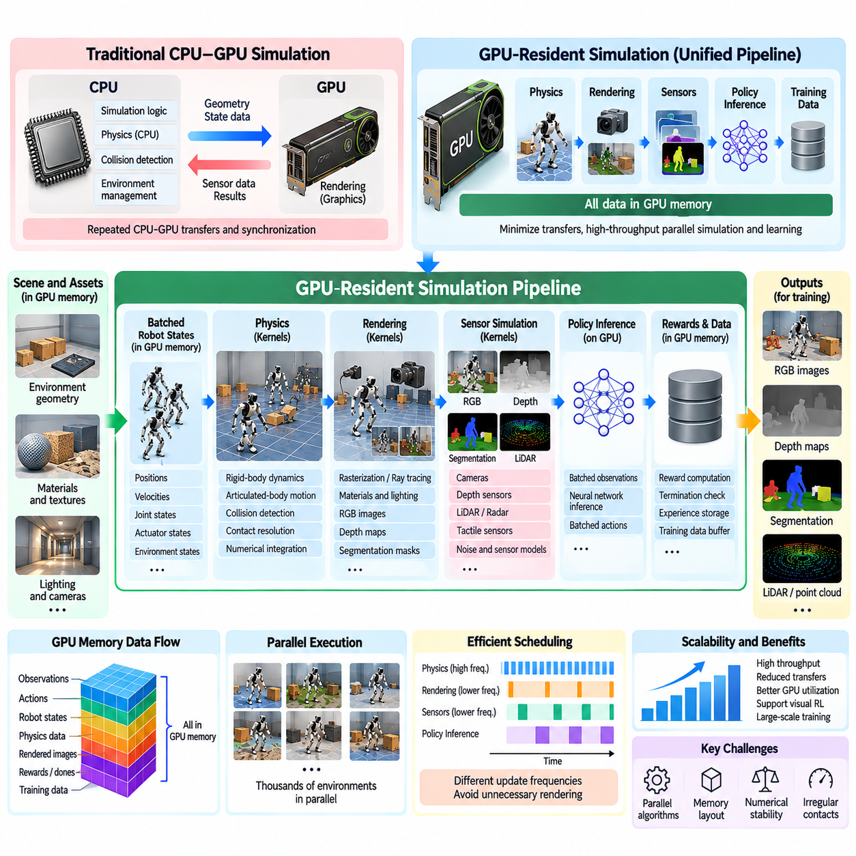
GPU-resident physics and rendering represent a major architectural advancement in massive parallel simulation for Physical AI. By keeping simulation states, physics computations, sensor rendering, and learning-related data within GPU memory, these systems minimize costly transfers between central and graphics processors. This integrated approach enables thousands of robotic environments to execute concurrently while supporting high-throughput experience generation and efficient neural-network training.
Traditional simulation architectures frequently divide responsibilities between CPUs and GPUs. The CPU manages physical states, collision detection, and simulation logic, while the GPU performs graphics rendering. This separation requires repeated synchronization and data transfers whenever updated geometry, sensor observations, or control commands cross processor boundaries. As environment counts increase, communication overhead can become a significant limitation on overall simulation throughput.
GPU-resident simulation addresses this bottleneck by organizing the computational pipeline around device memory. Robot positions, velocities, joint states, actuator commands, and contact information are stored in GPU-accessible structures. Physics kernels update these states directly, and subsequent rendering or observation-processing operations consume the resulting data without unnecessary transfers. The objective is to maintain a continuous computational workflow within the accelerator.
The physics component typically includes rigid-body dynamics, articulated-body motion, collision detection, contact resolution, and numerical integration. GPU implementations distribute these operations across many parallel execution units, allowing numerous robot instances to advance simultaneously. Efficient execution requires algorithms designed for data parallelism rather than simply transferring conventional CPU-oriented physics routines to GPU hardware.
State representation plays a central role in GPU-resident physics. Simulation data is commonly organized into dense arrays or tensors containing positions, orientations, linear velocities, angular velocities, joint coordinates, and actuator states. Similar variables across different environments can be processed through batched mathematical operations. This organization improves memory access efficiency and reduces the overhead associated with object-oriented simulation structures.
Collision detection presents an important computational challenge because contact interactions are irregular and highly dependent on scene geometry. Broad-phase collision detection identifies potentially interacting object pairs, while narrow-phase algorithms determine detailed contact information. GPU-oriented implementations attempt to parallelize these operations through spatial partitioning, batched geometric tests, and efficient management of candidate collision pairs.
Contact resolution and constraint solving introduce additional complexity. Robotic locomotion and manipulation frequently involve friction, joint constraints, impact forces, and simultaneous contacts. GPU solvers must manage these interactions while maintaining numerical stability and acceptable physical accuracy. Parallel constraint algorithms can improve throughput, but convergence behavior and synchronization requirements must be considered carefully, particularly in densely interacting scenes.
Rendering becomes GPU-resident when scene geometry, materials, lighting information, and camera parameters remain available to graphics pipelines without repeated CPU transfers. Rasterization, ray tracing, and physically based rendering can generate visual observations directly from simulated states. This architecture supports synthetic camera data generation and visual reinforcement learning while reducing communication between physics and graphics subsystems.
A major design objective is the efficient connection between physics simulation and sensor rendering. Updated robot poses and object transformations can be consumed directly by rendering kernels to generate RGB images, depth maps, segmentation masks, and other visual outputs. Avoiding unnecessary state duplication and memory transfers improves performance, especially when many cameras observe thousands of independently simulated environments.
GPU-resident sensor simulation extends beyond conventional RGB cameras. Depth sensors, LiDAR, radar, and selected tactile sensing models can benefit from parallel computation, depending on their physical complexity and implementation. Ray-based sensors are particularly suitable for GPU acceleration because many independent rays can be processed concurrently. However, realistic noise, multipath effects, and sensor-specific limitations may require additional modeling.
The integration of physics and rendering must account for different update frequencies. Physics solvers may advance through many small integration steps, while cameras and other sensors operate at lower sampling rates. Efficient systems schedule rendering only when observations are required rather than producing complete images at every physics step. This separation reduces unnecessary computation while preserving the timing relationships needed for robotic control.
GPU-resident simulation is particularly advantageous for reinforcement learning when the policy network also executes on the same accelerator. Observations generated from simulated states can be passed directly to neural-network inference, producing batched actions that return to the physics engine. Rewards, termination indicators, and trajectory data can also remain in device memory. This reduces processor synchronization and supports tightly integrated simulation-learning pipelines.
The computational benefits become especially significant when thousands of similar environments execute simultaneously. GPU kernels can update robot states, evaluate control commands, compute rewards, and generate observations through batched operations. Nevertheless, high throughput depends on maintaining sufficient parallel workload, minimizing kernel launch overhead, and avoiding excessive synchronization between simulation stages.
Memory capacity is one of the most important constraints in GPU-resident simulation. Every environment requires storage for physical states, collision structures, sensor outputs, and temporary solver data. High-resolution rendering can consume substantial memory, particularly when multiple cameras operate in each environment. Efficient implementations share static assets, reuse buffers, compress selected representations, and carefully manage intermediate data.
Memory bandwidth also influences overall performance. Even when GPU computational resources are abundant, frequent movement of large tensors or image buffers can limit execution speed. Data layouts should support coalesced memory access, and unnecessary copies between physics, rendering, and learning components should be avoided. Performance optimization therefore requires considering data movement as carefully as arithmetic computation.
Physics and rendering workloads may compete for the same GPU resources. Complex contact simulation requires substantial numerical computation, while high-fidelity rendering consumes graphics processing capacity and memory bandwidth. Neural-network training introduces additional demand for tensor computation and memory. Effective resource management may involve staged execution, asynchronous scheduling, workload partitioning, or distributing components across multiple GPUs.
Asynchronous execution can improve utilization when independent operations overlap safely. GPU streams and carefully designed synchronization mechanisms may allow selected rendering, preprocessing, and learning operations to proceed concurrently. However, dependencies between physics states and sensor observations must remain correct. Reading partially updated states or reusing buffers prematurely can produce inconsistent training data and difficult-to-diagnose errors.
Simulation fidelity remains a critical concern despite computational acceleration. GPU-oriented physics engines may adopt simplified contact models, approximate solvers, or reduced numerical precision to improve throughput. These choices can affect friction behavior, constraint satisfaction, and dynamic stability. Consequently, GPU-resident simulation must be validated against physical measurements, particularly when policies will control real robots.
Determinism and reproducibility are also challenging in massively parallel GPU execution. Floating-point reductions, atomic operations, parallel scheduling, and solver ordering can introduce numerical differences between runs. Controlled random seeds and consistent software configurations improve experimental repeatability, but exact deterministic behavior may not always be achievable. Statistical evaluation across multiple trials is therefore important.
GPU-resident architectures can support domain randomization by assigning different masses, friction coefficients, actuator characteristics, lighting parameters, and sensor properties to individual environments. These variations can be applied through batched parameter updates without repeatedly reconstructing entire scenes. Combining randomized physics and rendering conditions enables training across diverse simulated domains and supports more robust simulation-to-real transfer.
The architecture also provides an efficient foundation for synthetic data generation. Thousands of simulated scenes can produce images, depth measurements, segmentation labels, object poses, and robot trajectories. Because the simulator maintains access to internal physical states, accurate annotations can often be generated automatically. This supports scalable dataset construction for robotic perception, manipulation, navigation, and multimodal learning.
Performance evaluation should consider more than aggregate simulation steps per second. Relevant metrics include physics throughput, rendered frames per second, sensor-generation latency, GPU memory consumption, synchronization overhead, and total training time. Measurements should reflect realistic workloads because performance observed with simple rigid-body scenes may not generalize to complex robots with multiple sensors and contact-rich interactions.
GPU-resident physics and rendering ultimately transform simulation into an integrated computational engine for Physical AI development. Their value arises from combining high-throughput physical interaction, efficient sensor generation, and direct integration with learning algorithms. By minimizing processor communication, optimizing memory organization, and balancing fidelity against computational cost, these architectures enable scalable robotic training and evaluation while supporting practical simulation-to-real development.

05.05. Parallel Robot and Scene Instances
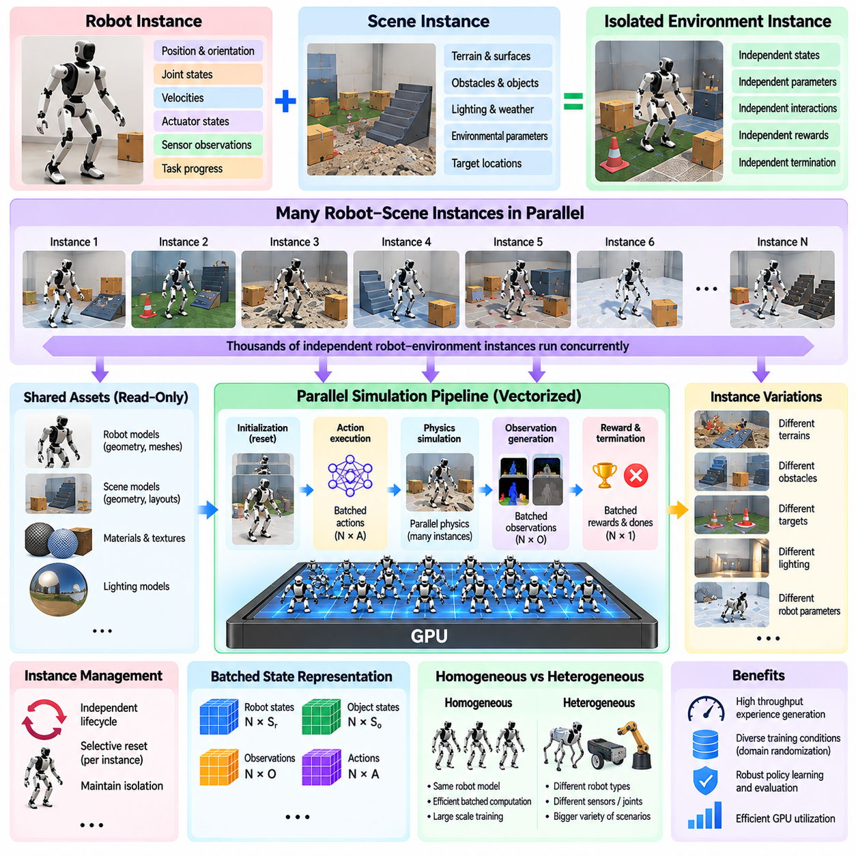
Parallel robot and scene instances form a fundamental building block of massive parallel simulation for Physical AI. Instead of executing a single robot within one simulated world, the simulation platform creates numerous independent robot-environment combinations that operate concurrently. Each instance maintains its own physical state, task conditions, and interaction history, enabling large-scale experience collection and systematic evaluation across diverse operating scenarios.
A robot instance represents an independently simulated embodiment with its own position, orientation, joint configuration, velocities, actuator states, and sensor observations. A scene instance represents the surrounding environment, including terrain, obstacles, objects, lighting, and environmental parameters. Combining robot and scene instances creates isolated simulation environments in which each robot can interact with a distinct configuration of the physical world.
The architecture separates shared simulation assets from instance-specific states. Robot geometry, collision meshes, material definitions, and static environment models can be reused across many instances. Dynamic properties such as robot poses, joint velocities, object positions, and contact forces remain independent. This separation reduces memory duplication while preserving the behavioral independence required for parallel learning and evaluation.
Scene replication is particularly effective when many environments share a common structural layout. A warehouse simulation may reproduce the same floor geometry, shelving structures, and robot models across thousands of instances. Each replica can then introduce different obstacle positions, target locations, payload configurations, and traffic conditions. This approach supports controlled experimentation without repeatedly constructing complete environments from scratch.
Parallel robot instances may represent identical robots or heterogeneous robotic platforms. Homogeneous simulation uses the same robot morphology, actuator configuration, and observation structure across environments, enabling efficient batched computation. Heterogeneous simulation introduces different robot types, joint structures, or sensing capabilities, expanding experimental coverage but requiring more complex state management and computational scheduling.
Instance isolation is essential for maintaining independent physical interactions. Each environment must preserve its own collision relationships, contact constraints, object ownership, and simulation state. A robot colliding with an obstacle in one scene should not affect another scene unless cross-environment interaction is explicitly intended. Simulation engines typically enforce isolation through scene identifiers, collision filtering, or separate physics contexts.
Spatial organization provides another mechanism for managing multiple instances. Some simulation systems place independent environments in separated regions of a larger simulation world, using sufficient spatial offsets and collision filtering to prevent unintended interactions. Other systems maintain logically independent scenes within a shared computational framework. The appropriate strategy depends on physics engine capabilities, memory organization, and rendering requirements.
Parallel scene instances enable extensive variation in environmental conditions. Terrain slope, surface friction, object density, lighting direction, weather effects, and obstacle geometry can differ between instances. Such variation allows learning algorithms to experience a broad distribution of operating conditions simultaneously. It also provides a practical foundation for domain randomization and robustness-oriented training.
Robot-specific randomization further expands the range of simulated experiences. Individual instances can vary in mass distribution, joint friction, actuator strength, control latency, sensor calibration, and payload characteristics. These differences approximate manufacturing tolerances, component aging, and environmental uncertainty. Training across varied robot parameters helps policies become less dependent on a single idealized physical configuration.
The lifecycle of each instance typically begins with initialization, followed by repeated action execution, physics updates, observation generation, and reward calculation. Instances may terminate when tasks are completed, failures occur, or maximum episode lengths are reached. Selective reset mechanisms allow completed environments to restart independently while other instances continue, maintaining continuous experience generation without unnecessary global synchronization.
Efficient instance management requires structured indexing and state mapping. Every robot, object, joint, and sensor must be associated with the correct environment instance. Batched state tensors commonly use environment indices to organize positions, velocities, actions, and observations. Consistent indexing prevents accidental state mixing and enables simulation kernels to process corresponding components across many environments efficiently.
Shared assets significantly reduce the memory cost of large-scale scene replication. Geometry buffers, textures, material descriptions, and robot model definitions can be referenced by multiple instances rather than duplicated. Only mutable states and instance-specific parameters require separate storage. This design becomes especially important when thousands of scenes contain complex robots, articulated mechanisms, and visually detailed objects.
However, asset sharing does not eliminate all memory constraints. Each active instance still requires storage for dynamic states, collision information, solver variables, sensor buffers, and task-specific data. Contact-rich manipulation environments may consume substantially more memory than simple navigation scenes. Simulation capacity therefore depends on both instance count and the computational complexity of each robot-environment combination.
GPU-based parallel simulation benefits from regular instance structures because similar robots can share optimized computation kernels. Joint dynamics, actuator updates, reward calculations, and observation processing can be performed across batched arrays. When instances have different numbers of joints or objects, padding, grouping, or specialized kernels may be necessary to maintain efficient execution and avoid excessive computational divergence.
Scene complexity directly influences achievable parallelism. Simple environments containing a mobile robot and a small number of obstacles may support thousands of concurrent instances. Complex scenes involving articulated manipulators, deformable objects, dense contacts, or multiple cameras require more computation and memory per instance. Consequently, the maximum practical instance count must be determined through workload-specific performance measurements.
Rendering parallel scenes introduces additional architectural considerations. Cameras must observe the correct scene instance without capturing objects from neighboring environments. Rendering systems may use scene-specific visibility masks, isolated render contexts, or spatial separation to preserve visual independence. Efficient batched rendering can generate observations for many cameras, although image resolution and rendering fidelity strongly influence resource consumption.
Parallel instances are particularly valuable for reinforcement learning because each environment generates independent trajectories under a shared policy. Different robots may encounter different initial conditions, disturbances, and task outcomes during the same training iteration. Their observations, actions, rewards, and termination indicators can be collected into batched experience buffers, supporting high-throughput policy optimization and broader behavioral exploration.
The same architecture supports systematic evaluation and benchmarking. A candidate controller can be deployed across thousands of scene configurations to estimate success rates, collision frequencies, energy consumption, and recovery performance. Controlled variations allow researchers to isolate the effects of individual parameters, while randomized scenarios reveal sensitivity to combined uncertainties. Repeated trials improve statistical confidence when sampling procedures are properly designed.
Parallel scene generation also enables automated search for difficult and rare scenarios. Environment parameters can be sampled to create unusual obstacle arrangements, unstable contact conditions, or sensor degradation patterns. Instances that expose policy weaknesses can be recorded and reproduced for further analysis. This capability supports adversarial testing, safety evaluation, and targeted refinement of robotic control policies.
Reproducibility depends on consistent instance initialization and random seed management. Each environment should receive independently controlled random sequences, while experiment configurations record robot parameters, scene variations, and task conditions. Parallel scheduling and numerical execution may still introduce nondeterministic differences. Reliable evaluation therefore combines controlled configurations with repeated statistical measurements rather than assuming identical outcomes across every execution.
Multi-GPU and distributed simulation architectures extend instance management beyond a single accelerator. Groups of robot and scene instances can be assigned to different GPUs or computing nodes, each maintaining local physics states and observations. Experience data and evaluation results can then be aggregated by a learning or orchestration system. Efficient distribution requires balancing computational loads and minimizing unnecessary communication between devices.
In practical Physical AI development, parallel robot and scene instances transform simulation from isolated virtual experiments into scalable experience-generation infrastructure. Their effectiveness depends on asset sharing, environment isolation, structured state management, efficient physics execution, and controlled scenario diversity. By coordinating thousands of independent robot-world interactions, this architecture supports robust learning, systematic validation, and scalable simulation-to-real development.

05.06. Parallel RL Experience Collection
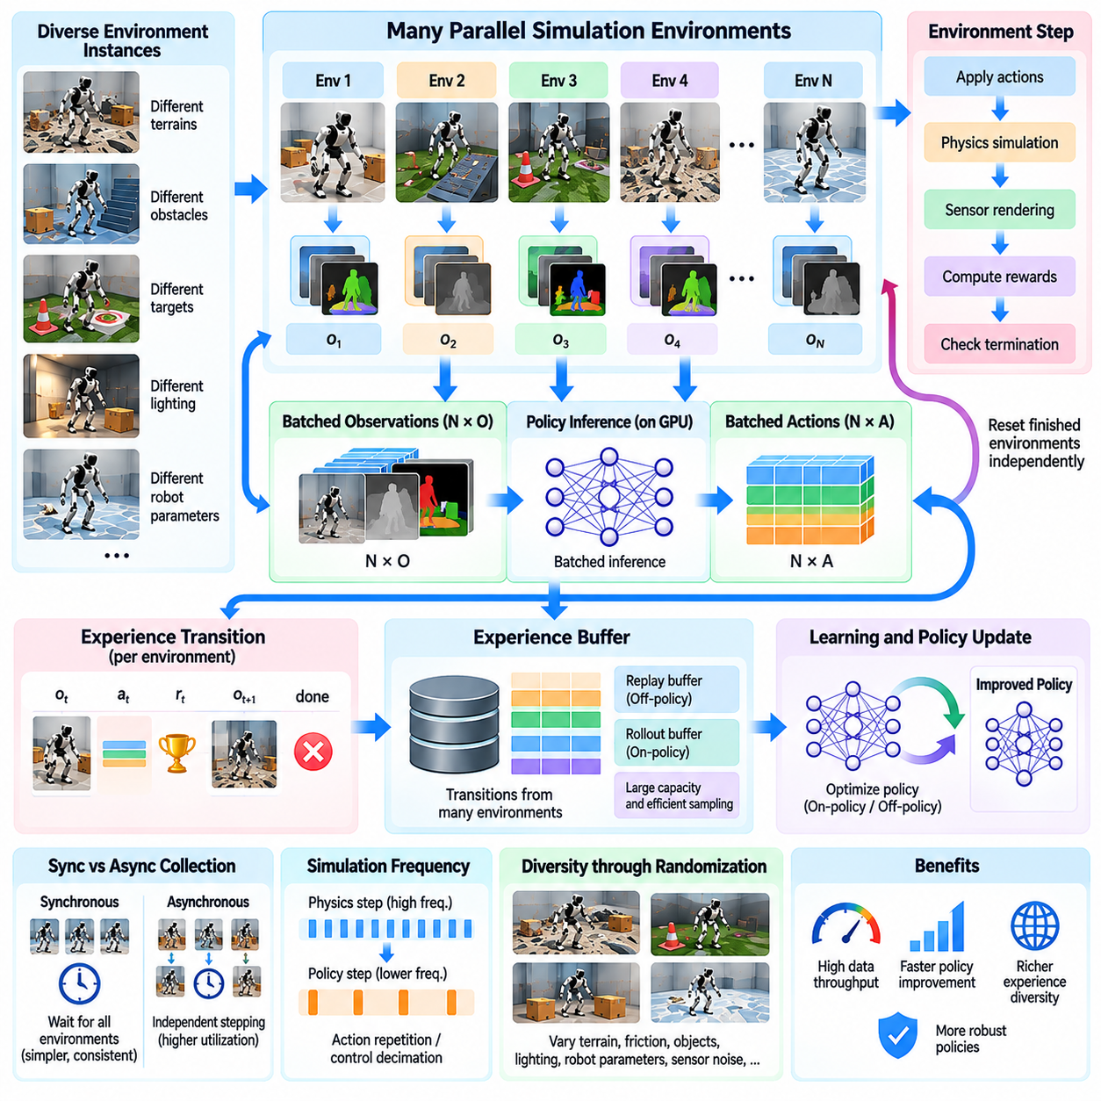
Parallel reinforcement learning experience collection enables Physical AI systems to gather large volumes of interaction data from many simulated robots simultaneously. Instead of relying on a single environment that produces transitions sequentially, parallel execution distributes experience generation across numerous independent environments. This architecture increases data throughput, accelerates policy improvement, and exposes learning agents to diverse physical conditions during each training cycle.
In reinforcement learning, an experience transition typically contains an observation, an action, a reward, the next observation, and a termination indicator. These elements describe how an agent interacts with its environment over one decision interval. Parallel collection extends this process by generating multiple transitions concurrently, allowing learning algorithms to construct large datasets without waiting for individual simulation episodes to finish.
A parallel rollout architecture consists of simulation environments, policy inference components, experience buffers, and learning processes. Each environment maintains an independent physical state while sharing a policy or receiving parameters from a common learner. Observations are collected into batches, processed by the policy network, and converted into actions. The resulting transitions are stored for subsequent optimization or immediate learning updates.
Vectorized environments provide a practical foundation for parallel experience collection. When thousands of environments expose compatible observation and action spaces, their states can be represented as batched tensors. A policy network processes these observations through parallel inference operations, producing one action for each environment. This arrangement reduces repeated software overhead and improves accelerator utilization during simulation and training.
GPU-resident simulation further improves efficiency by keeping observations, actions, rewards, and physical states within device memory. Physics kernels advance robot environments, while neural-network inference generates control commands without unnecessary CPU transfers. Reward calculations and termination checks can also execute on the GPU. This integrated design minimizes synchronization overhead and supports high-frequency experience generation.
The relationship between simulation steps and policy decisions is important for efficient collection. Physics engines may execute several integration steps for every policy action, particularly when stable contact dynamics require small time increments. Action repetition and control decimation determine how frequently the policy receives observations and updates commands. These settings influence data throughput, control responsiveness, and the temporal characteristics of learned behavior.
Parallel environments rarely complete their episodes simultaneously. Some robots reach goals quickly, while others encounter failures or continue operating until a time limit is reached. Independent episode management allows terminated environments to reset without interrupting active instances. Reset operations restore initial states, randomize selected conditions, and restart experience collection, preserving high utilization across the simulation batch.
Experience buffers organize collected transitions for learning. On-policy algorithms generally store trajectories generated by the current policy and use them for a limited number of optimization updates. Off-policy algorithms can retain transitions in replay buffers and reuse historical experiences. Parallel collection increases buffer insertion rates, making memory capacity, data organization, and sampling efficiency important design considerations.
Proximal Policy Optimization is commonly combined with vectorized simulation because it benefits from batched rollout collection. Multiple environments generate fixed-length trajectory segments, which are assembled into training batches. Advantage estimates and returns are calculated using rewards, value predictions, and termination information. The learner then performs policy updates before collecting another rollout, maintaining a structured interaction between simulation and optimization.
Off-policy methods such as Soft Actor-Critic can also exploit parallel experience collection. Independent environments generate transitions that enter a shared replay buffer, while the learning process samples minibatches for optimization. Collection and learning may proceed concurrently, subject to resource availability. However, the relationship between data generation speed and gradient update frequency must be managed to maintain stable learning.
Synchronous collection waits for a defined group of environments to complete each rollout step before advancing the batch. This approach simplifies tensor organization, policy version consistency, and reproducibility. However, slow environments can delay faster ones, producing synchronization overhead. The problem becomes more significant when scene complexity, contact interactions, or sensor-processing requirements vary substantially between instances.
Asynchronous collection allows environment workers to advance independently and submit experiences whenever they become available. This can improve resource utilization when workloads are heterogeneous or distributed across multiple computing devices. Nevertheless, asynchronous systems must manage policy staleness, variable collection rates, and delayed communication. Learning algorithms should account for differences between the policy that generated an experience and the policy currently being optimized.
Experience diversity is a major advantage of parallel simulation. Individual environments can vary in terrain, friction, robot mass, actuator strength, sensor noise, obstacle placement, and task objectives. These variations expose policies to a broader distribution of states and transitions within each training iteration. Carefully designed domain randomization can reduce dependence on idealized simulation conditions and improve robustness during deployment.
Parallel collection also supports curriculum learning by assigning environments different levels of task difficulty. Some instances may practice basic stabilization or navigation, while others encounter challenging terrain, disturbances, or complex manipulation tasks. Difficulty distributions can change as learning progresses. This enables the training system to maintain useful learning signals while gradually expanding the range of required capabilities.
Collecting more transitions does not automatically guarantee better learning. Highly correlated experiences, repetitive initial conditions, and insufficient exploration can reduce the informational value of large datasets. Parallel environments should therefore provide meaningful variation rather than simply duplicate identical trajectories. Exploration strategies, randomized resets, and balanced scenario sampling help improve experience quality alongside collection speed.
Reward computation becomes a critical component when thousands of environments execute concurrently. Reward functions must efficiently evaluate task progress, energy consumption, safety constraints, and undesirable behaviors using batched operations. Poorly designed rewards can encourage unintended strategies regardless of simulation throughput. Reward definitions should therefore be validated against intended physical behavior before large-scale training begins.
Termination and truncation conditions require equally careful treatment. A termination may represent task success, collision failure, or another genuine episode-ending event, while truncation often indicates an externally imposed time limit. Learning algorithms may handle these cases differently when estimating future returns. Incorrect treatment can bias value estimates and degrade policy performance, especially when episodes have widely varying durations.
The interaction between simulation throughput and learning throughput determines overall training efficiency. Generating experiences faster than the learner can process them creates memory pressure and potentially stale data. Conversely, an underutilized learner may spend substantial time waiting for new rollouts. Effective systems balance environment count, rollout length, policy inference speed, and optimization workload to minimize total training time.
Performance monitoring should distinguish raw simulation speed from useful learning progress. Important measures include environment steps per second, transitions collected per second, policy inference latency, replay-buffer utilization, and time required to reach a target success rate. High experience throughput is valuable only when it contributes to stable optimization and improved task performance. Training efficiency should therefore be evaluated using both computational and behavioral metrics.
Distributed experience collection extends parallel reinforcement learning beyond a single GPU or computing node. Multiple simulation workers can generate trajectories independently and transmit them to centralized or distributed learners. Parameter synchronization, network communication, and workload balancing influence scalability. Efficient architectures minimize unnecessary data movement while ensuring that collected experiences remain compatible with the learning algorithm.
Reproducibility and data integrity remain essential at scale. Each environment should use controlled random seeds, consistent observation definitions, and reliable episode identifiers. Experience records must preserve the correspondence between observations, actions, rewards, and terminal states. Numerical nondeterminism may still arise from parallel execution, making repeated evaluations and statistical reporting important for comparing training configurations.
Parallel reinforcement learning experience collection ultimately connects massive simulation capacity with scalable robotic intelligence development. Its effectiveness depends on efficient environment execution, batched policy inference, reliable experience storage, meaningful scenario diversity, and balanced optimization. When these components operate together, Physical AI systems can learn from extensive simulated interaction while systematically improving robustness, generalization, and readiness for simulation-to-real transfer.

05.07. Multi GPU and Distributed Simulation
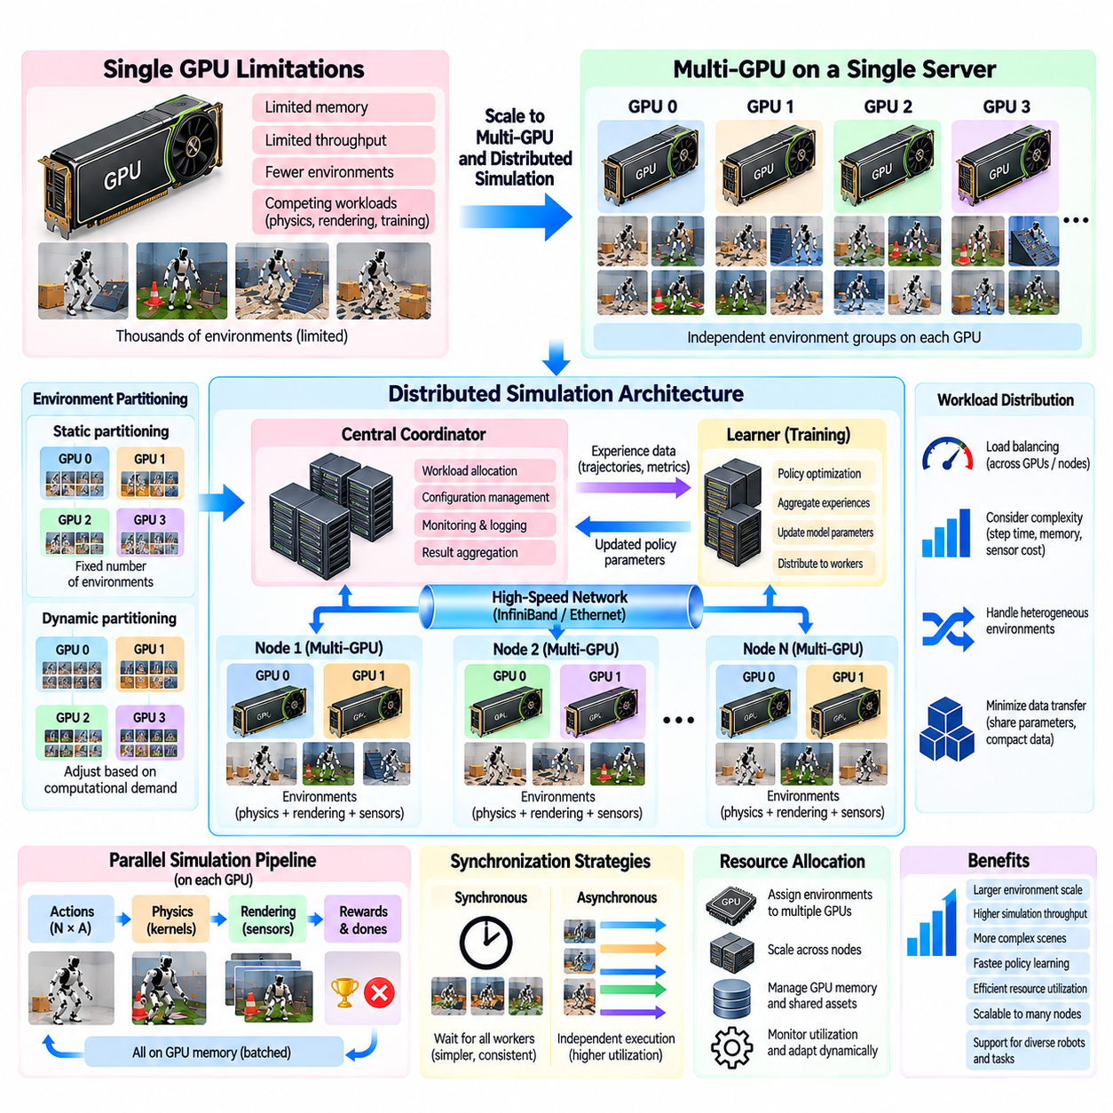
Multi-GPU and distributed simulation extend Physical AI training beyond the computational limits of a single accelerator. By dividing simulation workloads across multiple graphics processors and computing nodes, these architectures enable larger environment populations, more complex robotic scenes, and higher experience-generation throughput. Their effectiveness depends on workload partitioning, communication efficiency, synchronization, and coordinated management of simulation resources.
A single GPU can execute thousands of parallel environments, but its memory capacity and computational throughput eventually become limiting factors. Complex articulated robots, contact-rich interactions, high-resolution cameras, and neural-network training compete for available resources. Multi-GPU simulation addresses these constraints by assigning independent groups of environments to different accelerators, allowing aggregate simulation capacity to increase without requiring every environment to share one device.
The simplest multi-GPU architecture uses environment-level partitioning, where each GPU maintains a separate collection of robot and scene instances. Physics calculations, observations, rewards, and episode resets occur locally within each partition. Because independent environments rarely require direct interaction, this approach minimizes communication between accelerators and provides a natural foundation for scaling reinforcement learning and synthetic data generation.
Distributed simulation extends the same principle across multiple computing nodes connected through a network. Each node may contain several CPUs and GPUs, with local simulation workers responsible for assigned environment groups. A central coordinator or distributed orchestration system manages workload allocation, configuration, monitoring, and result aggregation. This architecture allows simulation infrastructure to expand beyond the memory and processing capacity of individual servers.
Workload partitioning is a fundamental design decision in distributed simulation. Static partitioning assigns a predetermined number of environments to each device, simplifying implementation and reproducibility. Dynamic partitioning adjusts assignments according to measured computational demand. Although dynamic allocation can improve utilization, migrating active environments may require transferring substantial physical states, scene parameters, and intermediate simulation data.
Load balancing becomes increasingly important when environments differ in computational complexity. A simple navigation scene may advance much faster than a manipulation scene containing articulated objects and dense contacts. Assigning equal numbers of environments to every GPU does not necessarily produce equal workloads. Effective scheduling considers simulation-step latency, memory consumption, sensor requirements, and the variability of physical interactions.
Communication architecture strongly influences distributed performance. Within a server, GPUs may exchange data through high-speed interconnects such as PCI Express or NVLink, depending on hardware support. Across servers, communication relies on network infrastructure and distributed communication libraries. The appropriate design minimizes frequent transfers of large state tensors and instead communicates compact policy parameters, aggregated statistics, or selected experience batches.
In distributed reinforcement learning, simulation workers typically generate trajectories while one or more learner processes update policy parameters. Workers execute policy inference using locally available model weights and submit experience data for optimization. The learner periodically distributes updated parameters to workers. This separation enables independent scaling of simulation and learning resources, although communication frequency and policy consistency require careful management.
Synchronous distributed training coordinates workers around common rollout and optimization boundaries. Each worker collects a specified amount of experience before contributing to a global training batch. This structure simplifies policy-version management and supports consistent update procedures. However, the slowest worker can delay the entire system, particularly when hardware performance, scene complexity, or network conditions differ across nodes.
Asynchronous architectures allow simulation workers to generate experiences continuously without waiting for global synchronization. Learners consume available trajectories or replay-buffer samples while workers operate independently. This approach can improve utilization and reduce idle time, but experiences may originate from older policy versions. Managing policy staleness, replay distributions, and update frequencies is therefore essential for maintaining learning stability.
Multi-GPU systems may also separate simulation, rendering, and neural-network training across specialized devices. One group of accelerators can execute physics simulations, another can generate camera observations, and additional devices can perform policy optimization. Such functional partitioning is useful when workloads have different computational characteristics. Nevertheless, the benefits must exceed the communication and synchronization costs introduced by transferring data between devices.
GPU memory management remains critical as simulation infrastructure expands. Each accelerator requires storage for local environment states, collision structures, sensor buffers, and temporary solver variables. Shared assets can reduce duplication within a device, but copies may still be necessary across separate GPUs. Memory-aware scheduling should consider both the number of environments and the complexity of their physical and visual representations.
Distributed rendering introduces additional bandwidth challenges because image observations can be substantially larger than compact physical state vectors. Transmitting high-resolution images between nodes may consume significant network capacity and increase learning latency. Systems can reduce this burden through local visual preprocessing, feature extraction, selective compression, or placing perception inference near the rendering process.
Fault tolerance becomes an important requirement when simulations run across many devices for extended periods. Individual workers may fail because of hardware faults, memory exhaustion, software errors, or network interruptions. A resilient orchestration system detects failures, restarts affected workers, and restores configurations without terminating the entire experiment. Checkpointing policy parameters and experiment metadata helps preserve training progress.
Reproducibility requires coordinated random seed management across workers and environment instances. Each simulation partition should receive distinct, traceable random sequences to prevent unintended duplication of trajectories. Configuration records should identify device assignments, physics settings, software versions, and scenario parameters. Dynamic scheduling and asynchronous execution may still introduce nondeterminism, making repeated statistical evaluation necessary.
Performance scaling should be measured using both strong scaling and weak scaling concepts. Strong scaling evaluates how execution time changes when a fixed workload is distributed across additional devices. Weak scaling examines whether throughput increases as workload size grows proportionally with available resources. These measurements reveal different bottlenecks and help determine whether additional GPUs produce meaningful improvements in simulation efficiency.
Scaling efficiency generally decreases when communication, synchronization, and orchestration overhead grow faster than useful computation. A system with twice as many GPUs will not necessarily deliver twice the simulation throughput. Network congestion, uneven workloads, parameter synchronization, and learner saturation can reduce performance gains. Identifying these limitations requires detailed profiling of computation, communication, memory usage, and worker idle time.
Distributed simulation is also valuable for large-scale evaluation and scenario exploration. Independent workers can test different robot controllers, environmental conditions, and random seeds simultaneously. Results are aggregated to estimate success rates, failure distributions, and robustness across operating domains. Because evaluation workloads are often independent, they can scale efficiently with relatively limited communication between workers.
Scenario-level distribution supports rare-event discovery by assigning different environment configurations to separate computing partitions. Workers can search for unusual collisions, unstable contacts, navigation failures, or sensor degradation conditions. Promising failure cases can be retained for targeted replay and analysis. This architecture enables broader safety testing than would be practical through sequential simulation.
Cloud and on-premise infrastructure introduce different operational considerations. On-premise clusters offer direct control over hardware configuration, network topology, and data governance, while cloud resources provide flexible capacity for temporary computational demand. Hybrid deployments can combine these advantages, but differences in device performance, network latency, storage access, and operating costs must be considered when distributing workloads.
Cost efficiency should be evaluated alongside raw throughput. Additional accelerators increase hardware expenditure, energy consumption, cooling requirements, and infrastructure management complexity. A useful comparison considers completed simulation transitions, successful training runs, or validated scenarios per unit cost. Optimizing utilization and reducing unnecessary communication may provide greater benefits than simply increasing the number of computing devices.
Observability and orchestration are essential for reliable distributed operation. Monitoring systems should track environment throughput, GPU utilization, memory pressure, communication latency, worker failures, and policy-training progress. Centralized experiment metadata allows results from different nodes to be compared consistently. Automated scheduling and health checks help maintain stable execution across long-running simulation campaigns.
Multi-GPU and distributed simulation ultimately transform parallel robotics simulation into scalable computational infrastructure for Physical AI. Their value comes from coordinating independent environment execution, efficient data exchange, robust learning pipelines, and systematic performance monitoring. When partitioning, synchronization, fault tolerance, and resource allocation are carefully designed, distributed architectures enable larger experiments and more comprehensive simulation-to-real validation.

05.08. On Premise and Cloud Simulation Clusters
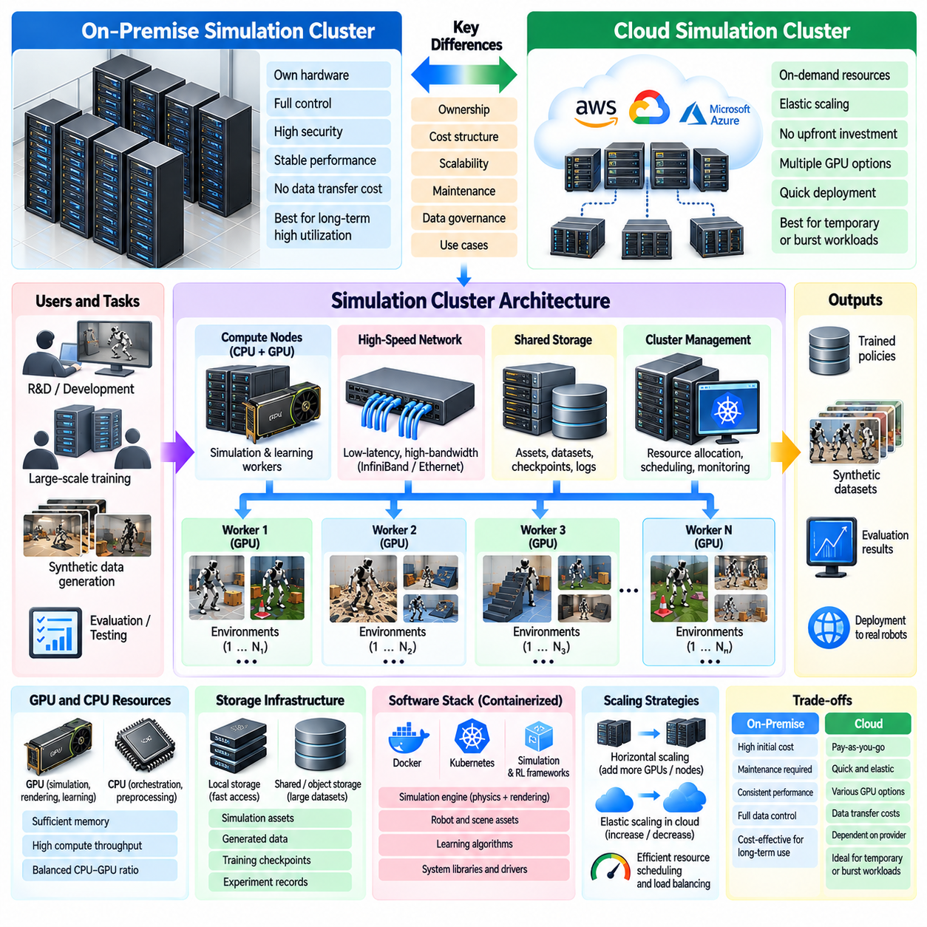
On-premise and cloud simulation clusters provide the computational infrastructure required to execute massive parallel simulation workloads for Physical AI. These clusters combine CPUs, GPUs, memory, storage, networking, and orchestration software to support large populations of simulated robots. Infrastructure selection influences simulation throughput, resource availability, operating costs, data governance, and the ability to scale experiments from individual prototypes to production-level training systems.
An on-premise simulation cluster consists of computing resources installed and operated within an organization's own facilities. Dedicated GPU servers, high-speed networks, shared storage, and centralized management systems form the primary infrastructure. This approach provides direct control over hardware configuration, software environments, security policies, and operational schedules, making it suitable for organizations with sustained simulation demand and strict infrastructure requirements.
Cloud simulation clusters provide computing resources through remotely managed infrastructure that can be provisioned according to workload requirements. Virtual machines, GPU instances, container services, and managed storage allow simulation teams to deploy computational environments without purchasing dedicated hardware. Cloud platforms are particularly useful for temporary training campaigns, rapidly expanding workloads, and projects requiring access to different accelerator configurations.
The fundamental architectural difference concerns resource ownership and provisioning. On-premise clusters require organizations to purchase, install, maintain, and eventually replace computing equipment. Cloud clusters convert much of this responsibility into service consumption, where resources are allocated through provider interfaces. Neither model is universally superior, because their relative value depends on utilization patterns, operational expertise, performance requirements, and long-term cost structures.
GPU selection is a critical infrastructure decision for both deployment models. Simulation workloads may require substantial device memory, high floating-point throughput, efficient tensor operations, or specialized graphics capabilities. Contact-rich physics, photorealistic rendering, and reinforcement learning place different demands on accelerator hardware. Cluster design should therefore evaluate complete simulation pipelines rather than relying exclusively on theoretical GPU performance specifications.
CPU resources remain important even when physics and learning execute primarily on GPUs. Host processors manage scene initialization, environment orchestration, data preprocessing, communication, and system services. Insufficient CPU capacity can prevent accelerators from operating efficiently, particularly when simulation environments contain complex initialization logic. Balanced cluster configurations must account for CPU-to-GPU ratios, memory bandwidth, and workload-specific scheduling demands.
Network topology strongly influences distributed simulation performance. On-premise clusters can employ dedicated high-speed interconnects with predictable latency and bandwidth characteristics. Cloud clusters provide configurable networking capabilities, although actual performance depends on instance placement and service configuration. Communication-sensitive workloads benefit from keeping tightly coupled simulation and learning processes close together within the network architecture.
Storage infrastructure must support simulation assets, experiment configurations, generated datasets, training checkpoints, and evaluation results. High-performance local storage can accelerate frequently accessed data, while shared or object-based storage supports collaboration and persistence. Large synthetic image datasets can create substantial storage and transfer demands. Effective architectures distinguish temporary working data from long-term experiment records and reusable simulation assets.
Containerization provides a practical mechanism for maintaining consistent software environments across cluster nodes. Simulation engines, physics libraries, rendering dependencies, learning frameworks, and application code can be packaged into reproducible execution environments. Container orchestration platforms can schedule workloads according to available CPU, GPU, and memory resources. However, driver compatibility, GPU access, and specialized graphics requirements still require careful configuration.
Cluster scheduling determines how simulation jobs compete for computational resources. Interactive development, large-scale policy training, synthetic data generation, and automated evaluation may have different priorities and execution durations. Scheduling systems can allocate GPUs, enforce resource quotas, and queue workloads when capacity is limited. Effective scheduling improves utilization while preventing large experiments from disrupting latency-sensitive development activities.
Elastic scaling is one of the principal advantages of cloud infrastructure. Computing resources can be increased during intensive simulation campaigns and reduced when demand declines. This flexibility is valuable when experiments require thousands of environments for short periods. Nevertheless, provisioning delays, resource quotas, accelerator availability, and data movement costs can limit practical elasticity, especially for specialized GPU configurations.
On-premise infrastructure offers advantages when workloads remain consistently high over extended periods. Dedicated accelerators can operate without recurring cloud instance charges, and locally stored datasets avoid repeated external transfers. However, equipment depreciation, electricity, cooling, maintenance, staffing, and hardware replacement contribute to total ownership costs. Economic comparisons must include these factors rather than considering purchase prices alone.
Cloud cost models introduce different optimization challenges. Compute charges may depend on accelerator type, instance duration, storage consumption, and network traffic. Idle instances and inefficiently configured workloads can increase expenditure without improving training results. Automated shutdown policies, workload consolidation, and appropriate instance selection help control costs. Interruptible capacity can reduce expenses for jobs capable of recovering from unexpected termination.
Hybrid simulation clusters combine local infrastructure with cloud resources to accommodate variable demand. Routine development and predictable training workloads may execute on dedicated servers, while temporary large-scale experiments use additional cloud accelerators. Such arrangements require compatible software environments, coordinated authentication, and reliable data transfer mechanisms. Hybrid operation is most effective when workload placement reflects both computational requirements and data locality.
Data governance and security requirements also influence deployment decisions. Simulation datasets may contain proprietary robot designs, facility layouts, operational recordings, or commercially sensitive models. On-premise infrastructure provides direct control over physical storage and network access, while cloud services offer configurable security and compliance capabilities. Both approaches require encryption, identity management, access controls, audit logging, and clear data retention policies.
Operational reliability depends on monitoring and automated recovery mechanisms. GPU failures, exhausted memory, storage interruptions, network faults, and software crashes can disrupt long-running simulation campaigns. Cluster management systems should track hardware health, job status, resource consumption, and training progress. Checkpointing and restart procedures allow interrupted experiments to resume without repeating all previously completed simulation work.
Experiment reproducibility becomes more challenging when workloads execute across heterogeneous infrastructure. Differences in GPU architectures, driver versions, physics libraries, and numerical execution can influence simulation outcomes. Consistent container images, versioned configurations, controlled random seeds, and recorded hardware metadata improve traceability. Statistical evaluation remains necessary because identical software configurations do not always guarantee numerically identical parallel execution.
Performance evaluation should consider the entire simulation workflow rather than isolated hardware benchmarks. Useful measures include environment steps per second, GPU utilization, rendered observations per second, data transfer latency, training completion time, and energy consumption. Infrastructure efficiency can also be expressed as useful simulation transitions or validated scenarios per unit cost. Such measurements support more reliable decisions about cluster sizing and deployment strategies.
Capacity planning begins by estimating the number of environments, robot complexity, sensor requirements, and expected training duration. These factors determine approximate GPU memory demand, processing requirements, storage growth, and network traffic. Pilot benchmarks should measure representative workloads before large infrastructure investments. Planning must also account for peak demand, concurrent users, maintenance periods, and future expansion.
Multi-tenant operation introduces additional complexity when multiple research teams share a simulation cluster. Resource quotas, job priorities, project isolation, and storage permissions help prevent interference between experiments. Shared infrastructure can improve overall utilization, but poorly coordinated workloads may cause unpredictable performance. Transparent accounting and centralized monitoring support fair allocation and allow teams to understand the computational costs of their experiments.
Automation transforms simulation clusters from collections of computing devices into repeatable experimentation platforms. Infrastructure provisioning, container deployment, scenario generation, training execution, checkpoint storage, and evaluation reporting can be coordinated through defined workflows. Automated pipelines reduce manual configuration errors and support systematic comparison across experiments. They also make large simulation campaigns easier to reproduce and maintain.
The optimal infrastructure strategy often changes as Physical AI development progresses. Early research may prioritize flexible access to diverse hardware, while mature training programs may benefit from dedicated capacity and predictable operating costs. Organizations should periodically reassess workload intensity, hardware requirements, security constraints, and resource utilization. Infrastructure decisions should remain aligned with evolving simulation and learning objectives.
On-premise and cloud simulation clusters ultimately provide complementary foundations for scalable Physical AI development. Their effectiveness depends on balanced hardware selection, efficient scheduling, reliable storage, secure data management, and continuous performance measurement. By matching infrastructure capabilities to simulation workloads, organizations can support large-scale robotic learning, synthetic data generation, and systematic simulation-to-real validation with sustainable computational resources.

05.09. Throughput Real Time Factor and Performance
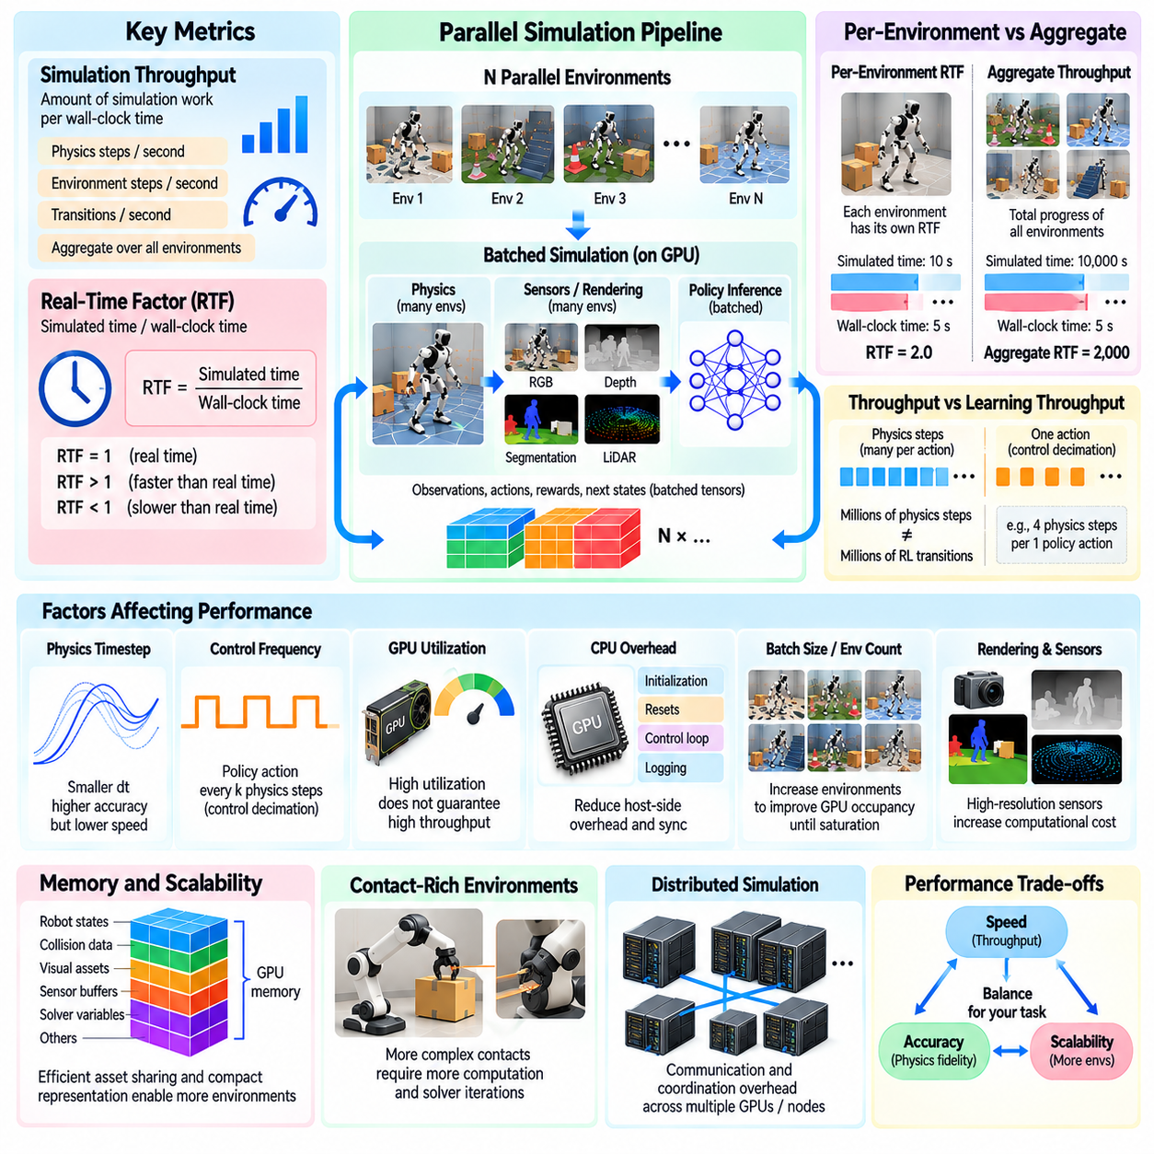
Simulation throughput and real-time factor are fundamental performance measures for massive parallel simulation in Physical AI. They describe how efficiently computational resources reproduce physical interactions and generate useful training data. Although both metrics relate simulated progress to computational effort, they capture different aspects of system behavior. Understanding their relationship is essential for designing scalable simulation architectures and evaluating infrastructure investments.
Simulation throughput measures the amount of simulation work completed during a specified wall-clock interval. It is commonly expressed as physics steps per second, environment steps per second, or generated transitions per second. In parallel systems, aggregate throughput represents the combined progress of all active environments. However, comparisons require consistent definitions of a step, including physics integration frequency and policy execution intervals.
The real-time factor, or RTF, compares elapsed simulated time with actual wall-clock execution time. An RTF of one indicates that simulation progresses at the same rate as physical time, while values above one indicate faster-than-real-time execution. Values below one indicate slower execution. For example, simulating one hundred seconds of physical activity in ten seconds of wall-clock time produces an RTF of ten.
In massive parallel simulation, real-time factor requires careful interpretation because many environments advance simultaneously. A single environment may operate slower than real time while the aggregate system generates thousands of simulated seconds during each wall-clock second. Aggregate simulated-time throughput can therefore be high even when individual environments have modest RTF values. Reporting both per-environment RTF and aggregate throughput avoids misleading comparisons.
Physics timestep selection directly affects simulation performance and numerical accuracy. Smaller timesteps improve the resolution of fast dynamics and contact interactions but require more integration operations. Larger timesteps reduce computational demand but may introduce instability or inaccurate collision responses. Performance evaluation must therefore consider physical fidelity alongside execution speed, rather than treating the highest possible step rate as the primary objective.
Control frequency introduces another distinction between physics throughput and learning throughput. A robot controller may issue one action for several physics integration steps, a configuration often called control decimation. Consequently, millions of physics steps do not necessarily correspond to millions of reinforcement learning transitions. Benchmark reports should identify both the physics timestep and policy decision interval to make experience-generation rates interpretable.
GPU utilization is an important indicator of computational efficiency, but high utilization alone does not guarantee useful throughput. Simulation kernels may be limited by memory bandwidth, instruction dependencies, synchronization, or inefficient data access. A heavily occupied GPU can still perform poorly if execution involves unnecessary calculations. Profiling should connect utilization measurements with completed simulation work and actual training progress.
CPU overhead can substantially reduce the benefits of GPU-accelerated simulation. Scene initialization, environment resets, Python control loops, logging, and data preparation may interrupt accelerator execution. Frequent synchronization between CPU and GPU forces otherwise parallel operations to wait for completion. Reducing host-side intervention and combining small operations into larger batches can improve throughput without increasing hardware capacity.
Batch size and environment count strongly influence parallel performance. Small batches may underutilize GPU resources because launch overhead dominates computation. Increasing the number of environments generally improves occupancy until computational, memory, or scheduling limits are reached. Beyond this point, additional instances may produce diminishing returns or reduce performance. Optimal batch sizes must therefore be established through representative workload measurements.
Rendering and sensor simulation can change performance characteristics dramatically. State-based reinforcement learning often requires relatively compact observations, whereas vision-based policies may depend on high-resolution cameras, depth maps, or segmentation images. Rendering consumes GPU processing capacity, memory, and bandwidth that could otherwise support physics execution. Performance studies should distinguish physics-only throughput from complete sensor-enabled simulation throughput.
Memory capacity and bandwidth frequently determine the maximum practical number of parallel environments. Robot states, collision structures, visual assets, sensor buffers, and temporary solver data compete for device memory. Excessive allocation may cause execution failures or expensive transfers between memory locations. Efficient asset sharing, compact representations, and careful buffer management can improve scaling without sacrificing essential physical detail.
Contact-rich environments create additional computational variability. Manipulation tasks involving multiple rigid bodies, frictional contacts, and articulated mechanisms require more complex constraint solving than simple free-space motion. Solver iteration counts and collision complexity can influence execution time. Benchmark scenarios should therefore include representative contact conditions rather than relying exclusively on simplified environments that produce unusually favorable results.
Distributed simulation introduces communication and coordination overhead beyond local computation. Workers may exchange policy parameters, experience batches, evaluation results, and synchronization signals across devices or nodes. Network latency and bandwidth limitations can reduce scaling efficiency, especially when frequent communication interrupts simulation. Measuring communication time separately from physics and learning execution helps identify opportunities for architectural improvement.
Strong scaling and weak scaling provide complementary methods for evaluating multi-GPU performance. Strong scaling measures how execution time decreases when a fixed simulation workload is distributed across more devices. Weak scaling evaluates whether aggregate throughput increases when workload size grows proportionally with computing resources. Both approaches reveal synchronization costs, load imbalance, and infrastructure limitations that may remain hidden in single-device benchmarks.
The relationship between experience collection and policy optimization determines end-to-end reinforcement learning performance. A simulation system may generate transitions faster than the learner can process them, creating buffer pressure or delayed updates. Conversely, a powerful learner may remain idle while waiting for rollouts. Balancing simulation workers, inference capacity, and optimization frequency is essential for reducing the total time required to train a successful policy.
Wall-clock training time is often more meaningful than raw simulation throughput when comparing reinforcement learning systems. A configuration that generates more transitions may still require additional optimization steps or produce lower-quality experiences. Learning efficiency depends on exploration diversity, reward design, algorithm stability, and data relevance. Performance analysis should therefore relate computational throughput to achieved policy quality and task success rates.
Latency measurements complement throughput metrics by revealing delays in individual operations. Relevant quantities include physics-step latency, policy inference latency, sensor rendering latency, environment reset time, and communication delay. Average latency alone may conceal occasional expensive operations that interrupt synchronized batches. Percentile measurements and latency distributions provide a more complete picture of runtime behavior under variable workloads.
Performance profiling should identify the relative cost of physics integration, collision detection, rendering, reward computation, neural inference, and data transfer. Timeline analysis can reveal idle intervals, repeated synchronization, inefficient kernel launches, and uneven device workloads. Optimization should target measured bottlenecks rather than presumed limitations. Improvements to minor components may have little effect when another stage dominates total execution time.
Benchmark reproducibility requires consistent hardware configurations, software versions, simulation parameters, and measurement procedures. GPU warm-up, compilation overhead, initialization time, and caching behavior can distort short experiments. Reliable benchmarks should distinguish startup costs from steady-state performance and repeat measurements across multiple runs. Recording environment counts, timestep settings, sensor configurations, and device characteristics supports meaningful comparison.
Performance optimization must preserve the physical validity of simulation results. Increasing timestep size, reducing solver iterations, simplifying collisions, or disabling sensor effects can improve execution speed while altering learned behavior. Such changes should be evaluated against task-specific fidelity requirements and real-world validation results. The appropriate optimization objective is not maximum computational speed but the fastest reliable generation of physically useful experiences.
Cost-normalized performance provides another perspective for infrastructure planning. Simulation throughput per GPU, per watt, or per unit of operating cost can reveal differences between hardware configurations and deployment strategies. Energy consumption, accelerator utilization, and infrastructure overhead influence the economic sustainability of large training campaigns. A system with lower peak throughput may offer better overall value when its operational efficiency is higher.
Throughput, real-time factor, and performance analysis ultimately connect computational scalability with practical Physical AI development. Effective evaluation combines aggregate simulation progress, per-environment execution speed, resource utilization, latency, physical fidelity, and learning outcomes. By measuring these dimensions consistently, engineers can identify bottlenecks, optimize parallel architectures, and build simulation systems that accelerate robotic training and simulation-to-real validation.

05.10. Memory Asset and GPU Optimization
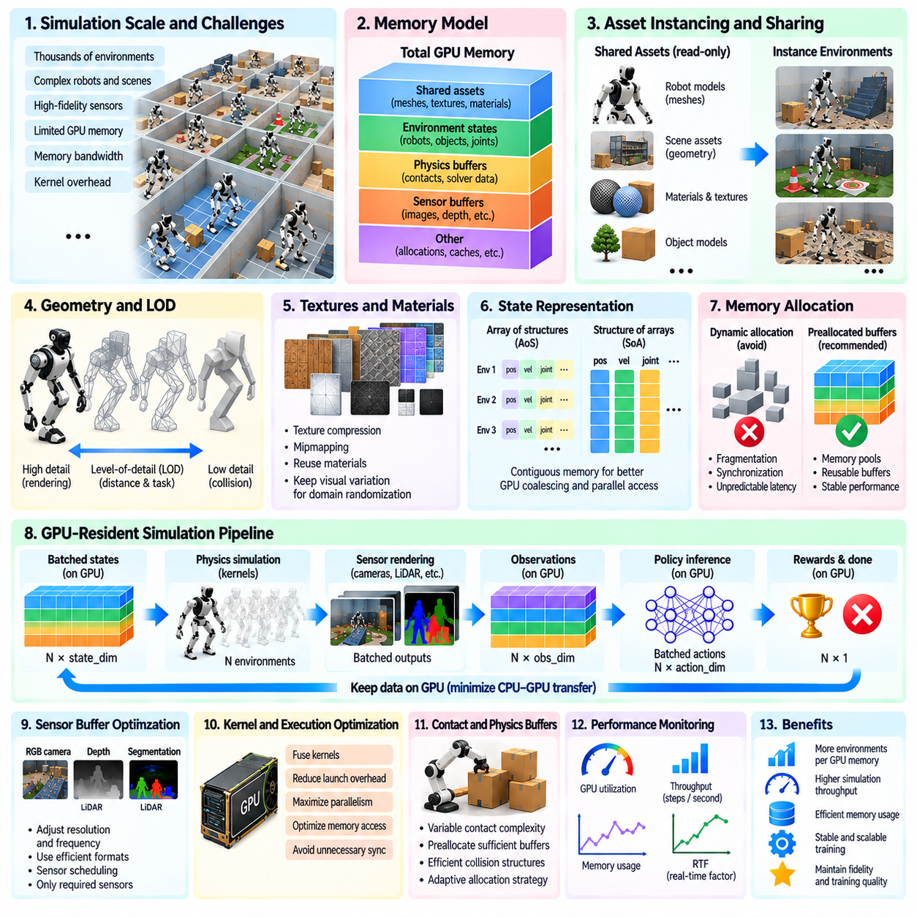
Memory, asset, and GPU optimization are essential for scaling Physical AI simulation to thousands of concurrent robot environments. As simulation populations grow, device memory, memory bandwidth, and computational resources become major constraints. Efficient optimization requires coordinated management of physical states, geometric assets, sensor buffers, and GPU execution. The objective is to maximize useful simulation throughput while preserving physical fidelity and training quality.
GPU memory consumption increases with the number of environments, robot complexity, and enabled simulation features. Each instance requires storage for rigid-body states, joint coordinates, velocities, contact information, and temporary solver variables. Rendering adds geometry, materials, textures, and image buffers. Understanding these memory categories allows engineers to estimate capacity requirements and identify which components dominate resource consumption.
A useful memory model separates shared assets from environment-specific state. Shared assets include robot meshes, collision geometries, material definitions, and reusable scene descriptions. Environment-specific data contains poses, velocities, joint states, contact constraints, and randomized parameters. Storing immutable assets once while maintaining compact per-instance state reduces duplication and supports larger simulation batches within limited GPU memory.
Asset instancing is particularly effective when thousands of environments contain identical robot models or repeated objects. Instead of loading separate copies of every mesh and material, the simulation system references common asset definitions through instance-specific transforms. This approach reduces geometry storage and initialization overhead. Its effectiveness depends on whether the physics and rendering engines support efficient sharing across independent simulation environments.
Geometry complexity influences both memory consumption and computational performance. Detailed visual meshes may contain millions of polygons, while collision detection often requires simpler geometric representations. Separating visual geometry from collision geometry allows realistic rendering without unnecessarily expensive contact calculations. Primitive shapes, convex approximations, and simplified collision meshes can improve efficiency when their physical behavior remains sufficiently accurate.
Level-of-detail techniques reduce rendering costs by selecting geometric representations appropriate to viewing distance and task requirements. Objects that occupy only a few image pixels rarely require the same geometric detail as nearby manipulation targets. However, simplification must preserve visual features important for perception learning. Adaptive detail selection should therefore consider camera resolution, object visibility, and the information required by the robotic policy.
Texture and material management can consume substantial GPU memory in photorealistic simulation. High-resolution textures, normal maps, and physically based material parameters increase visual realism but also expand memory demand. Texture compression, mipmapping, and reuse of material definitions reduce unnecessary storage. Optimization should retain appearance variations relevant to domain randomization while avoiding redundant copies of visually identical resources.
Physics state representations should be organized for efficient parallel memory access. Structure-of-arrays layouts often improve GPU coalescing because neighboring threads access contiguous values of the same physical quantity. Array-of-structures layouts may be convenient for software organization but can produce inefficient memory transactions. The preferred representation depends on kernel access patterns, solver architecture, and the operations performed during each simulation step.
Memory allocation strategy affects both execution stability and throughput. Repeated allocation and deallocation during simulation can introduce synchronization overhead, fragmentation, and unpredictable latency. Preallocated buffers and reusable memory pools reduce these costs by reserving storage for recurring operations. Dynamic workloads still require capacity planning, particularly when contact counts, sensor outputs, or active object populations vary between environments.
Contact simulation creates temporary memory requirements that can change substantially during execution. Collision detection generates candidate pairs, contact points, constraint data, and solver intermediates. Dense interactions involving many articulated bodies can produce sudden increases in buffer demand. Conservative capacity limits improve reliability, while adaptive allocation strategies may improve utilization when contact complexity varies significantly across simulation instances.
Sensor buffers represent another important optimization target. RGB cameras, depth sensors, segmentation outputs, and event-based sensors generate data with different memory and bandwidth characteristics. Rendering every sensor at maximum resolution and frequency may waste resources when the control policy requires less information. Sensor scheduling should align acquisition rates and output formats with actual perception and control requirements.
GPU-resident data pipelines minimize transfers between device memory and host memory. Physics states, observations, actions, rewards, and termination flags can remain on the GPU throughout simulation and learning. Direct tensor interfaces allow policy networks to consume simulation outputs without unnecessary serialization or copying. Avoiding repeated CPU-GPU synchronization is especially important when thousands of environments advance at high frequency.
Kernel launch overhead becomes significant when simulation operations are divided into many small GPU tasks. Combining compatible computations can reduce launch frequency and improve execution efficiency. Reward calculations, observation transformations, and termination checks are often suitable for batched processing. However, excessive kernel fusion can increase register pressure and reduce occupancy, so optimization should be guided by profiling rather than applied indiscriminately.
GPU occupancy depends on the number of active threads, register usage, shared memory consumption, and hardware scheduling limits. High occupancy can help hide memory latency, but maximum occupancy does not always produce maximum throughput. Computational intensity and memory access efficiency remain equally important. Engineers should evaluate kernel execution time, achieved bandwidth, and instruction efficiency instead of relying on utilization percentages alone.
Memory bandwidth optimization requires minimizing redundant reads and writes during physics and rendering operations. Frequently accessed state variables should use layouts that support coalesced transactions and appropriate caching. Temporary tensors should be eliminated when calculations can operate directly on existing buffers. Reducing memory traffic can produce substantial improvements in simulation workloads where arithmetic operations are relatively inexpensive.
Mixed-precision computation can reduce memory consumption and improve throughput for selected neural-network and rendering operations. Lower-precision formats are particularly useful when supported by specialized accelerator hardware. However, physics integration, contact resolution, and constraint solving may be sensitive to numerical precision. Precision choices should be validated against stability, energy conservation, contact accuracy, and long-horizon simulation behavior.
Environment initialization and reset operations also influence performance. Reconstructing complete scenes after every episode wastes computation when only a subset of state variables must change. Efficient resets restore positions, velocities, joint configurations, and randomized parameters without repeatedly loading immutable assets. Batched reset procedures allow completed environments to restart independently while preserving continuous execution across the remaining simulation population.
Memory fragmentation becomes more problematic during long-running experiments with changing environment configurations. Variable-sized allocations and repeated asset loading can leave unusable gaps in available device memory. Stable allocation patterns, memory pools, and predictable asset lifecycles reduce fragmentation risks. Monitoring peak allocation and reserved memory helps distinguish actual capacity shortages from inefficient memory management.
Multi-GPU simulation introduces additional asset and memory considerations. Each accelerator generally requires local copies of the data needed by its assigned environments, even when assets are shared within individual devices. Large visual resources can therefore be duplicated across GPUs. Workload partitioning should account for asset locality, device memory capacity, and communication costs rather than distributing environments solely by instance count.
Profiling tools provide the evidence needed to prioritize optimization work. Memory timelines, allocation statistics, kernel traces, bandwidth measurements, and GPU utilization reveal different bottlenecks. A simulation may appear computationally limited while actually spending substantial time transferring data or waiting for synchronization. Representative benchmarks should include realistic robot complexity, contact conditions, sensor configurations, and environment counts.
Optimization decisions must preserve the intended simulation behavior. Simplifying collision geometry, reducing sensor resolution, lowering numerical precision, or decreasing solver iterations may improve throughput while changing the data used for learning. These modifications should be evaluated against task-specific accuracy requirements and real-world validation results. Performance gains are valuable only when the resulting simulation remains suitable for its intended training and testing objectives.
Memory, asset, and GPU optimization ultimately determine how effectively massive parallel simulation converts hardware capacity into useful Physical AI experience. Efficient asset sharing, compact state representations, GPU-resident pipelines, controlled allocation, and carefully profiled kernels support higher environment density and faster execution. A balanced optimization strategy improves scalability while maintaining reliable physics, meaningful sensor observations, and robust simulation-to-real transfer.

05.11. Reproducibility and Seed Management
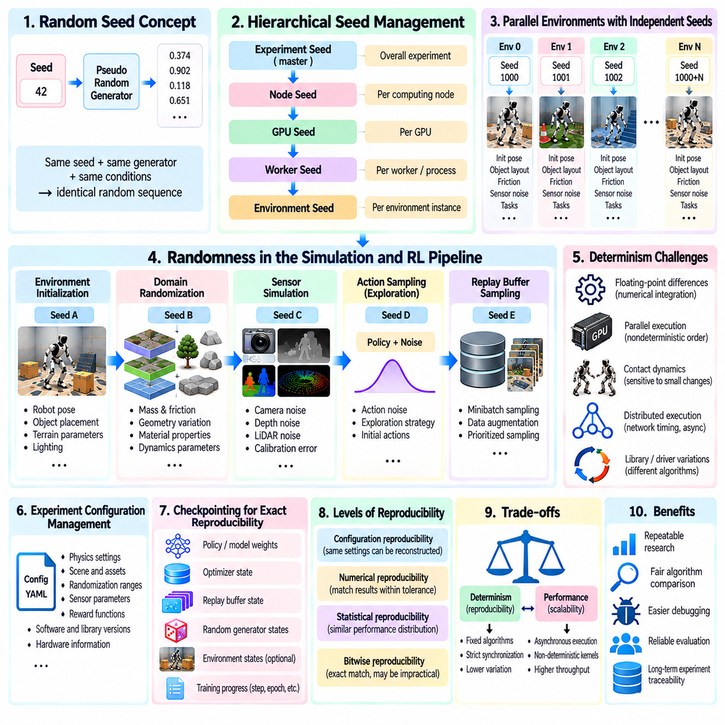
Reproducibility and seed management are fundamental requirements for reliable massive parallel simulation in Physical AI. They allow researchers to repeat experiments, compare learning algorithms, and investigate unexpected robot behavior under controlled conditions. As simulation expands across thousands of environments and multiple GPUs, maintaining consistent experimental conditions becomes increasingly difficult. Reproducibility therefore requires coordinated control of randomness, software configurations, and execution records.
A random seed initializes a pseudorandom number generator that produces deterministic sequences under specified conditions. Simulation systems use these sequences to randomize robot poses, object locations, friction coefficients, sensor noise, and task parameters. Recording the seed allows the same random sequence to be regenerated when the generator and execution order remain unchanged. However, identical seeds alone do not guarantee identical simulation outcomes.
Massive parallel environments require more sophisticated seed management than single-instance simulations. Assigning one shared random generator to all environments can introduce dependencies between their execution sequences. When environments reset at different times, the order of random-number consumption may change. Independent random streams help isolate these effects, allowing each environment to generate reproducible variations without depending on unrelated simulation instances.
A hierarchical seed strategy can organize randomness across experiments, computing nodes, GPUs, workers, and individual environments. A master experiment seed establishes the overall configuration, while derived seeds identify independent random streams. Stable identifiers should determine seed derivation so that changing worker scheduling does not unintentionally alter scenario generation. The derivation procedure must also avoid accidental collisions and preserve traceability.
Counter-based random-number generators provide an alternative to sequential random streams. Random values can be derived from explicit identifiers such as environment number, episode index, simulation step, and sampling purpose. This approach reduces dependence on execution order and is useful for asynchronous simulation. Carefully designed counter assignments allow parallel workers to reproduce specific random events without replaying every preceding operation.
Randomness should be separated according to its functional role within the simulation pipeline. Environment initialization, domain randomization, sensor noise, exploration actions, and replay-buffer sampling may each require distinct generators. Such separation prevents changes in one component from unexpectedly altering another component's random sequence. It also simplifies debugging because individual sources of stochastic behavior can be reproduced independently.
Deterministic environment initialization is essential for meaningful experiment comparison. Initial robot configurations, object placements, velocities, and task conditions should be generated from documented procedures. When evaluating different control policies, using matched initial scenarios can reduce unnecessary comparison variance. Evaluation seeds should remain separate from training seeds to limit overfitting to repeatedly encountered conditions.
Physics simulation introduces additional reproducibility challenges because numerical integration and contact solving depend on floating-point operations. Small rounding differences may accumulate over time, particularly in chaotic or contact-rich environments. Parallel collision processing can change the order in which constraints are evaluated. Consequently, two executions may begin from identical states yet gradually diverge even when their random seeds match.
GPU execution can introduce nondeterminism through parallel scheduling, atomic operations, and reduction ordering. Floating-point addition is not generally associative, so different operation orders can produce slightly different results. Some accelerated libraries also select algorithms according to hardware and runtime conditions. Deterministic execution modes may reduce variation, but they can increase memory consumption or reduce computational throughput.
Distributed simulation adds uncertainty through communication timing and asynchronous worker execution. Different network delays can change when trajectories arrive, when policies are updated, and which experiences enter training batches. Reproducing exact execution order may require strict synchronization and deterministic scheduling. Such controls improve repeatability but can reduce the scalability advantages of asynchronous architectures.
Reproducibility should be evaluated at multiple levels rather than treated as a single property. Configuration reproducibility means that identical experimental settings can be reconstructed. Numerical reproducibility requires matching computed values within defined tolerances, while statistical reproducibility concerns consistent performance distributions across repeated runs. Bitwise reproducibility is stricter and may not be practical across heterogeneous GPU systems.
Experiment configuration management provides the foundation for reconstructing simulation conditions. Records should include physics timesteps, solver settings, robot models, environment counts, sensor parameters, reward definitions, and randomization distributions. Software versions, driver configurations, and hardware characteristics must also be preserved. Version-controlled configuration files help prevent undocumented changes from influencing experimental results.
Checkpointing must capture more than neural-network parameters when exact training continuation is required. Optimizer states, learning-rate schedules, replay-buffer contents, random-generator states, and training counters may affect subsequent updates. For simulation continuation, relevant environment states and episode progress must also be restored. Incomplete checkpoints can resume execution successfully while producing a different learning trajectory.
Scenario identifiers provide an additional mechanism for traceable simulation experiments. Each generated scenario can receive a stable identifier associated with its seed, physical parameters, object arrangement, and task definition. Failure cases can then be stored and replayed for targeted investigation. This approach is particularly useful when thousands of environments generate rare collisions, unstable contacts, or unexpected policy behaviors.
Logging systems should record sufficient information to reconstruct the relationship between experiments and their outcomes. Important metadata includes experiment identifiers, seed assignments, software revisions, simulation settings, training checkpoints, and evaluation results. Logging every physical state may be impractical at massive scale, so selective trajectory recording and event-triggered capture provide a more efficient compromise.
Reproducibility testing should begin with small deterministic scenarios before expanding to large parallel workloads. A single environment can establish reference trajectories for fixed actions and initial conditions. Tests can then compare results across repeated executions, multiple environment counts, and different GPU configurations. Divergence measurements help identify whether differences originate from randomization, numerical integration, or parallel execution.
Statistical evaluation remains essential when exact trajectory reproduction cannot be guaranteed. Policies should be tested across multiple independent seeds and sufficiently diverse scenarios. Reporting mean performance, variability, confidence intervals, and failure frequencies provides stronger evidence than presenting one successful run. The number of evaluation repetitions should reflect observed variance and the reliability requirements of the intended robotic application.
Seed selection must avoid introducing hidden experimental bias. Repeatedly tuning an algorithm against the same small collection of seeds can produce misleading improvements. Training, validation, and final evaluation should use appropriately separated random scenarios. When comparing methods, shared evaluation seeds support paired comparisons, while additional unseen seeds help determine whether observed advantages generalize beyond familiar conditions.
Deterministic replay is especially valuable for debugging safety-critical failures. A recorded initial state, action sequence, and scenario configuration can reproduce many failure conditions, although numerical nondeterminism may prevent exact trajectories. Capturing intermediate states allows replay to begin near the event of interest. Such mechanisms support systematic investigation of collisions, unstable control, and rare environmental interactions.
Performance and reproducibility often involve tradeoffs. Deterministic algorithms may require fixed execution ordering, additional synchronization, or less efficient computational kernels. Conversely, aggressive parallel optimization can introduce execution variability. Engineering teams should define the required reproducibility level for each workflow, distinguishing exploratory training from benchmark evaluation, regression testing, and safety validation.
Automated experiment management can enforce consistent seed policies and configuration tracking across simulation clusters. Job schedulers can assign unique identifiers, generate independent random streams, and preserve execution metadata. Continuous testing can detect unexpected numerical changes after software or hardware updates. These practices transform reproducibility from an individual researcher responsibility into a systematic infrastructure capability.
Reproducibility and seed management ultimately support trustworthy Physical AI development by connecting simulation results to clearly defined experimental conditions. Reliable systems combine independent random streams, versioned configurations, structured checkpoints, scenario identifiers, and statistical evaluation. Although perfect determinism may be unattainable in large distributed simulations, disciplined experiment management enables meaningful comparisons, effective debugging, and dependable simulation-to-real validation.

05.12. Parallel Evaluation and Data Generation
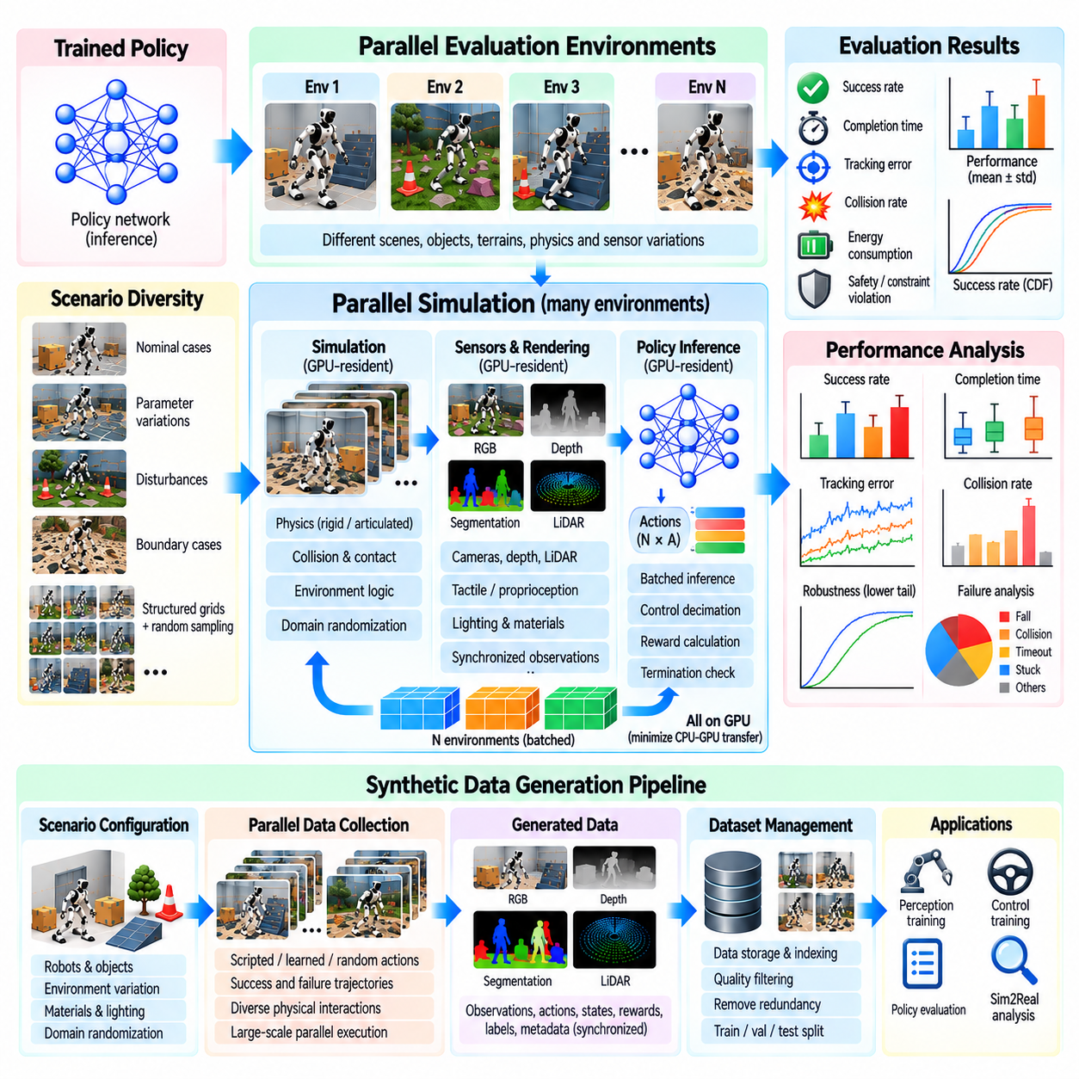
Parallel evaluation and data generation are essential capabilities of massive parallel simulation for Physical AI. They allow robotic systems to be tested across thousands of scenarios while producing large volumes of structured training data. Unlike sequential simulation, parallel execution evaluates many environment configurations simultaneously. This approach accelerates policy validation, expands scenario coverage, and supports systematic analysis of robot performance under diverse physical conditions.
Parallel evaluation measures how reliably a trained policy performs across independent simulation environments. Each environment may contain different object arrangements, terrain conditions, friction coefficients, payloads, or sensor disturbances. Executing these scenarios concurrently reduces evaluation time while preserving broad coverage. The resulting measurements reveal both average task performance and the variability of behavior across operating conditions.
Evaluation environments should remain logically independent even when they share computational resources. Each instance requires its own physical state, episode progress, randomization parameters, and outcome records. Shared policy inference can improve GPU efficiency without coupling the simulated trajectories. Proper isolation prevents one environment's termination, reset, or failure from unintentionally influencing the behavior of other environments.
Scenario diversity is critical for estimating policy generalization. Evaluation workloads should include nominal operating conditions, parameter variations, environmental disturbances, and challenging boundary cases. Random sampling provides broad coverage, while structured scenario grids enable controlled comparisons. Combining both methods helps identify whether performance degradation results from specific physical parameters or complex interactions among multiple factors.
Parallel evaluation must distinguish training scenarios from validation and final test scenarios. Reusing the same environments and random seeds throughout development can create overly optimistic performance estimates. Independent evaluation distributions help determine whether a policy generalizes beyond familiar conditions. Fixed benchmark scenarios support repeatable comparisons, while additional unseen scenarios reveal weaknesses that standardized tests may overlook.
Performance metrics should reflect the intended robotic application rather than relying exclusively on cumulative reward. Relevant measurements include task success rate, completion time, tracking error, collision frequency, energy consumption, and recovery capability. Safety-sensitive applications may also require minimum separation distances and constraint violation rates. Parallel evaluation enables these metrics to be estimated over sufficiently large and diverse populations.
Statistical reliability improves as independent evaluation episodes accumulate, although correlated scenarios can reduce effective sample diversity. Mean performance alone may conceal rare but severe failures. Reporting distributions, confidence intervals, lower-tail outcomes, and failure categories provides a more informative assessment. Evaluation design should allocate additional trials to conditions where uncertainty or operational risk remains high.
Parallel simulation also supports large-scale synthetic data generation for perception, planning, and control. Simulated cameras, depth sensors, proprioceptive measurements, and contact sensors can produce synchronized observations with known underlying states. Unlike many real-world datasets, synthetic environments can automatically provide accurate object poses, segmentation labels, and physical parameters without extensive manual annotation.
A synthetic data pipeline begins with scenario configuration and controlled variation of simulation parameters. Robot models, object assets, lighting, materials, and sensor properties are selected according to the intended learning task. Parallel environments then execute scripted behaviors, learned policies, or randomized actions. Each trajectory produces observations, actions, state transitions, and metadata suitable for downstream training or evaluation.
Data quality depends on more than the total number of generated samples. Thousands of nearly identical trajectories may provide less useful information than a smaller collection covering diverse physical interactions. Dataset construction should consider scene diversity, action coverage, contact conditions, task outcomes, and failure examples. Sampling strategies can emphasize underrepresented states while avoiding excessive duplication of common situations.
Domain randomization expands dataset coverage by varying physical and visual properties across simulation instances. Mass, inertia, friction, actuator response, camera exposure, lighting, and texture appearance can be sampled from defined distributions. Parallel execution makes these variations computationally practical at scale. However, randomization ranges should remain physically plausible and relevant to the intended deployment environment.
Data generation can incorporate both successful demonstrations and informative failures. Successful trajectories provide examples of effective task execution, while failed attempts reveal unsafe actions, unstable control, and difficult environmental configurations. Recovery trajectories are particularly valuable for learning robust behavior after disturbances. Preserving failure context allows training systems to distinguish recoverable mistakes from terminal task failures.
GPU-resident data processing reduces overhead when simulation and machine learning share accelerator resources. Observations, actions, rewards, and labels can remain in device memory until selected samples require storage or transfer. Batched inference and vectorized transformations improve processing efficiency. Nevertheless, image rendering, trajectory recording, and compression may become bottlenecks when data production exceeds storage-system capacity.
Dataset storage requires careful balancing of fidelity, throughput, and accessibility. High-resolution images and dense state trajectories can generate substantial data volumes during long simulation campaigns. Compression, selective recording, and configurable sampling frequencies reduce storage demand. Metadata should preserve scenario identifiers, simulation versions, random seeds, and sensor settings so that generated samples remain traceable and reproducible.
Asynchronous data collection allows simulation workers to continue producing experiences while separate processes perform validation, compression, and storage. Queues and buffering mechanisms absorb temporary differences between production and consumption rates. Backpressure becomes necessary when downstream systems cannot keep pace. Without resource controls, excessive buffering can exhaust memory or cause important samples to be dropped unpredictably.
Parallel evaluation and data generation can be integrated into a closed-loop improvement process. Evaluation identifies weak operating conditions, which are converted into targeted simulation scenarios. Additional trajectories are generated for those conditions and incorporated into subsequent training. Updated policies are then evaluated against both the targeted scenarios and broader benchmark distributions to determine whether improvements generalize.
Active scenario selection can make parallel computation more informative. Instead of allocating equal resources to every environment configuration, the system can prioritize uncertain predictions, low-success regions, or scenarios near safety boundaries. Adaptive sampling directs additional simulation effort toward conditions where new evidence is most valuable. This approach improves data efficiency while retaining sufficient exploration of the wider operating domain.
Rare-event evaluation benefits from parallel execution because dangerous or unusual outcomes may occur infrequently under ordinary sampling. Large scenario populations increase the opportunity to observe collisions, unstable contacts, perception failures, and recovery limitations. Importance sampling and targeted parameter searches can further concentrate evaluation on difficult conditions. Results must account for altered sampling distributions when estimating real-world failure probabilities.
Reproducibility remains essential when thousands of environments generate results concurrently. Independent random streams, stable scenario identifiers, versioned configurations, and structured experiment logs enable repeated evaluation. Numerical differences between hardware platforms may prevent exact trajectory matching, but statistical consistency can still be assessed. Reproducible evaluation protocols make performance comparisons more credible across algorithms and infrastructure configurations.
End-to-end efficiency should be measured using completed evaluations and usable data samples rather than raw simulation steps alone. Physics throughput may be high while rendering, labeling, transfer, or storage limits the overall pipeline. Similarly, rapid evaluation is valuable only when metrics and scenario coverage are sufficient for reliable conclusions. Profiling the complete workflow reveals whether additional GPUs, better batching, or improved data management will provide the greatest benefit.
Parallel evaluation and data generation ultimately connect simulation scalability with trustworthy Physical AI development. By combining diverse scenario execution, statistically meaningful assessment, automated labeling, and targeted data collection, engineers can evaluate robotic policies and construct training datasets efficiently. Well-designed pipelines transform large-scale computational capacity into actionable performance evidence and high-quality experiences that support robust simulation-to-real transfer.

05.13. Rare Event and Scenario Search at Scale
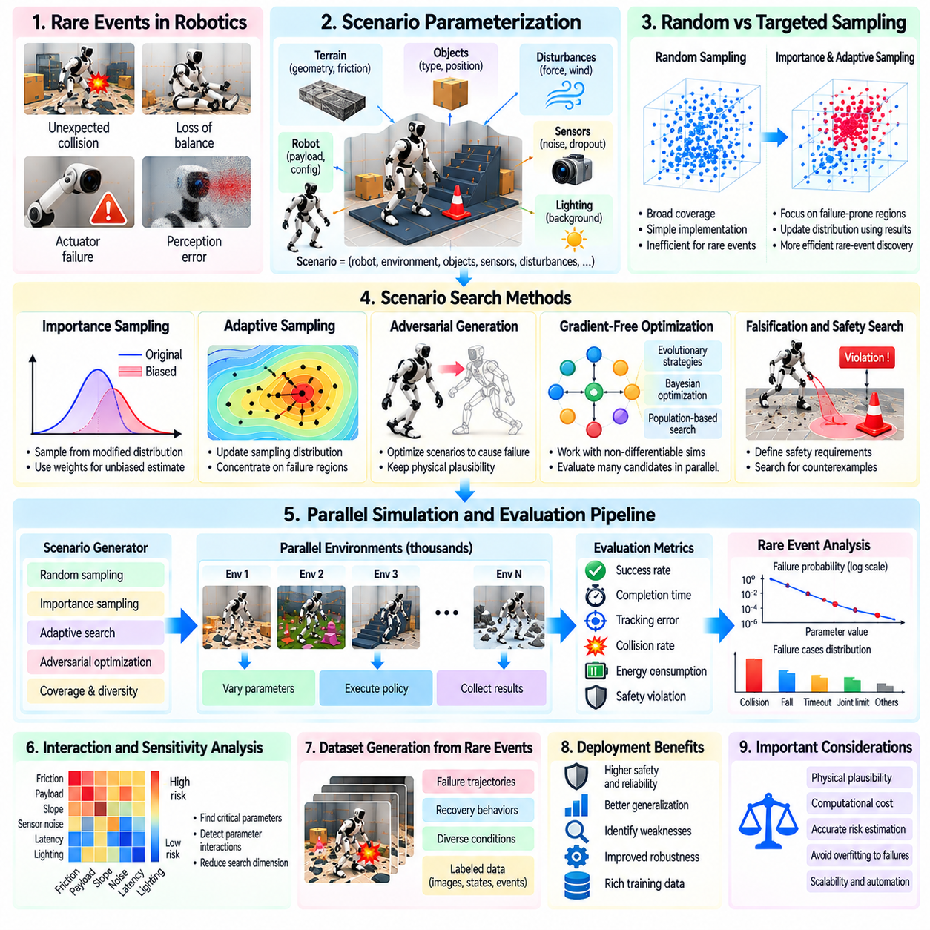
Rare-event analysis and scenario search are essential capabilities of massive parallel simulation for Physical AI. Robotic systems may operate successfully under ordinary conditions while remaining vulnerable to uncommon combinations of disturbances, sensor failures, and environmental constraints. Such events are difficult to observe through conventional testing. Large-scale simulation enables systematic exploration of low-probability conditions before robots encounter them in physical environments.
Rare events include unexpected collisions, unstable contacts, actuator failures, perception errors, and loss of balance under unusual operating conditions. Their importance depends not only on occurrence probability but also on potential consequences. A low-frequency event involving minor performance degradation may be acceptable, while an equally unlikely event causing serious damage requires attention. Risk assessment must therefore consider both event likelihood and severity.
Ordinary random sampling becomes inefficient when critical failures occur extremely infrequently. Millions of simulation episodes may be required to observe a small number of relevant incidents. Massive parallel execution reduces the wall-clock time needed to accumulate trials, but computational scale alone does not guarantee efficient discovery. Targeted search methods are necessary to direct simulation resources toward informative and potentially hazardous conditions.
Scenario parameterization provides the foundation for systematic rare-event exploration. A scenario can be described through robot configuration, payload, terrain geometry, friction, obstacle motion, sensor noise, and external disturbances. Each parameter should have physically meaningful limits and documented relationships. Structured representations allow search algorithms to modify conditions while preserving plausible environmental behavior.
Random scenario generation establishes broad coverage of the operating domain. Independent simulation environments sample parameter combinations from defined probability distributions and execute the same robotic policy under different conditions. This approach reveals unexpected interactions that manual test design may overlook. However, uniform sampling across parameter ranges may waste computation on unrealistic configurations or repeatedly explore low-risk regions.
Importance sampling improves rare-event estimation by deliberately generating scenarios where failures are more likely. Samples are drawn from a modified proposal distribution, and statistical weights correct for the difference from the original operating distribution. This can increase the number of observed failures without automatically inflating estimated risk. Reliable probability estimates require valid weighting and adequate coverage of relevant failure regions.
Adaptive importance sampling updates the proposal distribution using results from previous simulation batches. Regions associated with collisions, instability, or safety violations receive additional sampling attention. The search gradually concentrates computational effort on conditions that contribute most strongly to risk estimates. Care is needed to avoid excluding undiscovered failure modes or producing overly narrow distributions that distort uncertainty.
Adversarial scenario generation searches for environmental conditions that expose weaknesses in a robotic policy. Optimization algorithms may vary obstacle trajectories, surface properties, sensor disturbances, or initial robot states to maximize a failure objective. Unlike arbitrary perturbations, adversarial scenarios should respect physical feasibility and operational constraints. Otherwise, discovered failures may provide limited information about real-world reliability.
Search objectives must represent meaningful safety and performance requirements. Candidate measures include collision severity, minimum obstacle distance, joint-limit violations, tracking error, and loss of stability. A continuous risk score can provide useful gradients even when complete task failure is rare. Combining multiple measures requires careful scaling so that optimization does not overlook critical hazards while maximizing less important numerical objectives.
Gradient-free optimization methods are useful when simulation outcomes are discontinuous or difficult to differentiate. Evolutionary strategies, Bayesian optimization, and population-based search can explore scenario parameters without requiring analytic derivatives. Parallel simulation evaluates many candidates simultaneously, reducing the cost of iterative search. Method selection depends on parameter dimensionality, simulation expense, and the structure of the failure landscape.
Falsification techniques attempt to identify trajectories that violate explicitly defined system requirements. Temporal specifications can describe constraints such as maintaining safe separation, avoiding excessive forces, or reaching a target within a deadline. Search procedures then minimize a robustness measure associated with each requirement. Negative robustness values can indicate violations, providing interpretable evidence for debugging and verification.
Scenario search should account for interactions between environmental variables. Moderate changes in friction, payload, and sensor latency may be harmless individually but dangerous when combined. Pairwise testing, structured parameter sweeps, and adaptive exploration help identify such interactions. High-dimensional searches benefit from sensitivity analysis that identifies influential parameters and reduces unnecessary evaluation of weakly relevant dimensions.
Rare-event discovery and rare-event probability estimation are related but distinct objectives. An optimization method may efficiently find severe failures without revealing how frequently they occur under normal operating conditions. Conversely, statistically valid estimation may require extensive sampling beyond the most dangerous scenarios. Evaluation reports should distinguish discovered failure severity from estimated occurrence probability and associated statistical uncertainty.
Parallel execution introduces practical challenges when scenario complexity varies significantly. Some environments terminate quickly after a failure, while others require long trajectories before an outcome becomes clear. Asynchronous scheduling and independent resets can improve hardware utilization. However, early termination rules must be documented because stopping scenarios prematurely may conceal delayed failures or bias probability estimates.
Failure clustering converts large collections of unsuccessful trajectories into interpretable categories. Similar incidents can be grouped according to contact geometry, environmental conditions, control actions, or sensor behavior. Clustering helps distinguish repeated manifestations of one underlying weakness from genuinely different failure mechanisms. Representative scenarios from each category can then become targeted regression tests and training examples.
Reproducibility is essential for investigating failures discovered through large-scale search. Every scenario should preserve its parameter configuration, random seed, robot model version, policy checkpoint, and relevant execution metadata. Recording initial conditions and critical trajectory segments enables repeated analysis. Numerical nondeterminism may prevent exact replay, so tolerance-based comparisons and repeated trials may be necessary.
Rare-event scenarios can support targeted policy improvement when incorporated into training. Failure trajectories reveal weak control strategies, while successful recovery examples demonstrate robust responses to disturbances. Curriculum learning can gradually increase scenario difficulty as performance improves. Nevertheless, excessive training on adversarial cases may reduce nominal performance or encourage behavior optimized for unrealistic conditions.
Validation must use scenarios that remain independent of the search and training process. A policy that succeeds on previously discovered failures may still be vulnerable to new combinations of disturbances. Separate evaluation distributions, unseen parameter combinations, and real-world testing provide evidence of broader robustness. Improvements should be measured across ordinary operation, challenging conditions, and safety-critical boundary cases.
Computational efficiency should be evaluated through informative failures discovered per unit of time or cost, not simulation throughput alone. High episode counts provide limited value when search repeatedly visits similar scenarios. Coverage measures, failure diversity, and uncertainty reduction offer complementary indicators. Efficient systems balance broad exploration with focused investigation of high-risk regions and underrepresented operating conditions.
Scenario libraries provide a persistent foundation for safety validation across software and hardware revisions. Each stored case can include its operating conditions, expected outcomes, failure classification, and associated safety requirements. Automated regression testing can replay representative scenarios whenever policies, controllers, or simulation components change. This creates a traceable connection between discovered weaknesses and subsequent engineering improvements.
Rare-event analysis at scale transforms massive parallel simulation from a high-speed testing tool into a systematic mechanism for discovering operational vulnerabilities. By combining structured scenario representations, adaptive sampling, adversarial search, statistical estimation, and reproducible failure analysis, engineers can examine conditions rarely encountered in ordinary testing. These capabilities strengthen Physical AI safety evaluation and support more reliable simulation-to-real deployment.

05.14. Massive Parallel Simulation Pipeline [w/Code]
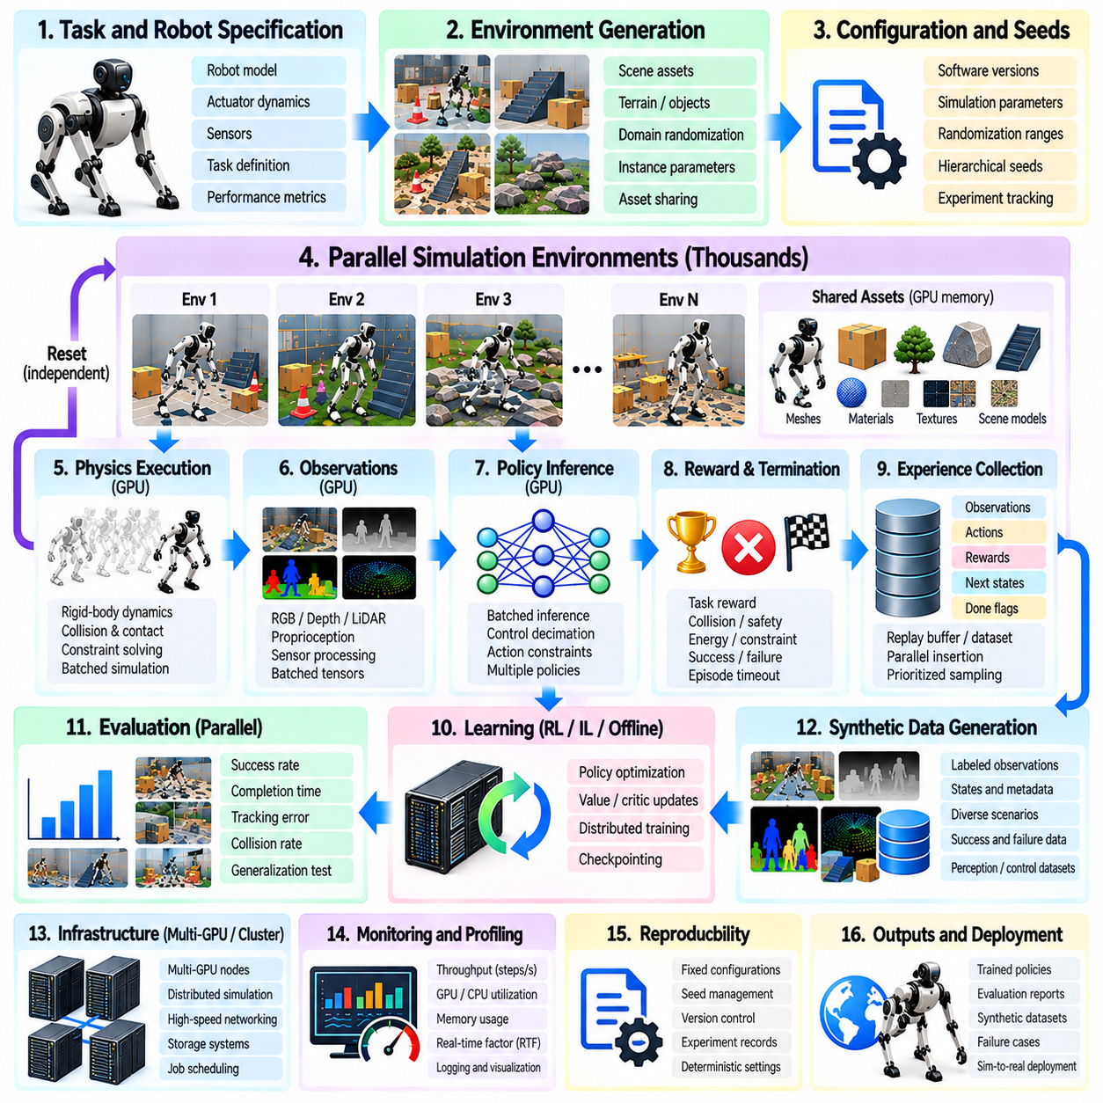
A massive parallel simulation pipeline integrates environment generation, physics execution, policy inference, experience collection, and performance evaluation into a unified Physical AI workflow. Its purpose is to execute thousands of robotic scenarios concurrently while maintaining reliable physical behavior and efficient resource utilization. A well-designed pipeline transforms computational capacity into reproducible training experiences, meaningful evaluation results, and actionable evidence for simulation-to-real transfer.
Pipeline design begins with explicit definitions of robotic tasks, operating conditions, and computational requirements. Engineers specify robot morphology, actuator dynamics, sensor configurations, environment geometry, and expected task outcomes. Simulation timesteps, control frequencies, and accuracy requirements establish the execution constraints. These specifications determine how environments are instantiated, how resources are allocated, and which performance metrics must be monitored.
The environment generation stage constructs reusable simulation templates containing robot models, collision geometry, materials, and scene assets. Thousands of independent instances can reference shared immutable resources while maintaining separate physical states. Instance-specific parameters introduce variations in object placement, terrain, friction, payload, and disturbances. Efficient asset sharing reduces memory duplication and allows larger simulation populations within available GPU capacity.
Configuration management provides a consistent foundation for large-scale execution. Each simulation campaign should preserve software versions, robot descriptions, physics parameters, randomization distributions, and experiment identifiers. Hierarchical seed assignment creates independent random streams for individual environments and workers. Stable configurations and traceable seeds allow failed scenarios to be reconstructed and experimental results to be compared across repeated runs.
The physics execution stage advances robot and environment states through numerical integration, collision detection, and constraint solving. GPU-resident physics engines process many environments in parallel using batched state representations. Contact-rich tasks may require smaller timesteps or additional solver iterations to maintain stability. Execution settings must balance computational throughput with sufficient accuracy for manipulation, locomotion, and dynamic interaction.
Policy inference converts observations into control actions for each active environment. Batched inference allows neural-network policies to process thousands of robot states efficiently on GPU accelerators. The control frequency may be lower than the physics integration frequency, requiring multiple physics steps between consecutive policy decisions. Coordinating these rates ensures that simulated actuator commands and learned control behavior remain physically meaningful.
Observation generation combines simulated sensor outputs with robot state information. Proprioceptive measurements, contact signals, camera images, and depth observations may be produced at different sampling frequencies. GPU-resident preprocessing can normalize observations and construct policy inputs without unnecessary host transfers. Sensor scheduling should reflect actual control requirements because excessive rendering can reduce overall simulation throughput.
The experience collection stage records observations, actions, rewards, next states, and episode termination information. Parallel environments generate trajectories independently, allowing completed episodes to reset without interrupting other simulations. Experience buffers organize these transitions for reinforcement learning, imitation learning, or offline analysis. Buffer capacity and sampling policies must prevent data accumulation from exceeding available memory resources.
Reward computation and termination logic are central to the training pipeline. Vectorized reward functions evaluate task progress, energy consumption, collisions, and constraint violations across many environments. Termination conditions identify successful completion, unsafe states, and episode time limits. These calculations should remain consistent across training and evaluation configurations to prevent misleading performance comparisons.
The learning stage consumes collected experiences and updates policy parameters through optimization algorithms. On-policy methods typically synchronize rollout collection with policy updates, while off-policy methods may reuse transitions stored in replay buffers. Distributed learners can process large experience batches across multiple accelerators. Efficient scheduling balances simulation throughput, inference capacity, and optimization speed to reduce total training time.
Domain randomization introduces controlled variations in physical and visual properties during training. Mass, inertia, friction, actuator response, lighting, textures, and sensor noise can be sampled independently across environments. Randomization distributions should represent plausible deployment conditions rather than arbitrary extremes. Tracking sampled parameters enables later analysis of policy sensitivity and performance under specific environmental variations.
Parallel evaluation operates alongside or separately from policy training to measure generalization and reliability. Independent evaluation environments test trained policies across nominal conditions, parameter variations, and challenging scenarios. Metrics include task success, completion time, tracking error, collision frequency, and recovery performance. Evaluation datasets should remain sufficiently distinct from training scenarios to provide credible evidence of generalization.
Synthetic data generation extends the pipeline beyond reinforcement learning. Simulated cameras and sensors produce labeled observations, object poses, segmentation masks, and state trajectories. Automated labeling reduces dependence on manual annotation, while parallel rendering increases data production capacity. Selective recording, compression, and metadata management are necessary to prevent storage and transfer operations from becoming dominant bottlenecks.
Rare-event search provides targeted exploration of conditions that ordinary sampling may rarely encounter. Parallel workers can evaluate unusual obstacle configurations, sensor failures, unstable contacts, and extreme but plausible disturbances. Adaptive sampling and adversarial scenario generation concentrate computation on informative failure regions. Discovered incidents become reproducible regression scenarios and potential sources of targeted training data.
Pipeline orchestration coordinates simulation workers, learning processes, evaluation jobs, and storage services. A scheduler assigns workloads according to GPU memory capacity, computational demand, and communication requirements. Asynchronous execution improves utilization when individual environments have variable episode lengths. However, queue limits and backpressure controls are necessary to prevent uncontrolled memory growth and delayed processing.
Multi-GPU and distributed execution expand the pipeline beyond a single accelerator. Environment groups can be partitioned across devices, while policy parameters and training data are exchanged through communication mechanisms. Scaling efficiency depends on workload balance, network bandwidth, and synchronization frequency. Strong and weak scaling measurements reveal whether additional devices produce meaningful improvements in aggregate throughput.
Memory and GPU optimization are necessary throughout pipeline execution. Shared assets, compact state tensors, reusable buffers, and efficient memory access patterns reduce resource consumption. GPU-resident observations and rewards minimize CPU-GPU synchronization. Kernel profiling identifies inefficient operations, excessive memory transfers, and underutilized compute resources. Optimization should preserve physical fidelity rather than maximizing raw simulation speed alone.
Monitoring systems measure physics steps per second, environment transitions per second, real-time factor, GPU utilization, memory consumption, and operation latency. Aggregate throughput must be distinguished from per-environment execution speed. End-to-end measurements should also include training progress, usable data production, and evaluation completion rates. These indicators reveal whether bottlenecks originate in physics, rendering, inference, communication, or storage.
Checkpointing and reproducibility mechanisms protect long-running simulation campaigns. Checkpoints preserve policy weights, optimizer states, random-generator states, training counters, and relevant environment configurations. Structured logs connect simulation outcomes with scenario identifiers and software revisions. Automated regression testing detects unexpected changes after updates to physics engines, robot models, or learning components.
A practical implementation should progress from a validated single environment to increasingly large parallel workloads. Initial tests establish correct physics, sensor behavior, reward logic, and policy interfaces. Subsequent scaling experiments introduce vectorized execution, GPU-resident data processing, and distributed workers. Performance profiling and statistical evaluation guide each expansion, ensuring that computational gains do not compromise correctness or reliability.
The complete pipeline forms a continuous improvement cycle connecting simulation, learning, evaluation, and deployment. Evaluation failures generate targeted scenarios, additional simulation produces relevant experiences, and updated policies undergo renewed validation. Real-world observations can refine physics parameters and randomization distributions. This feedback process enables massive parallel simulation to support scalable, reproducible, and increasingly reliable Physical AI development.

