Volume 05. Simulation and Sim2Real Transfer

Chapter 08. Sim2Real Gap Analysis

08.01. Defining the Sim2Real Gap
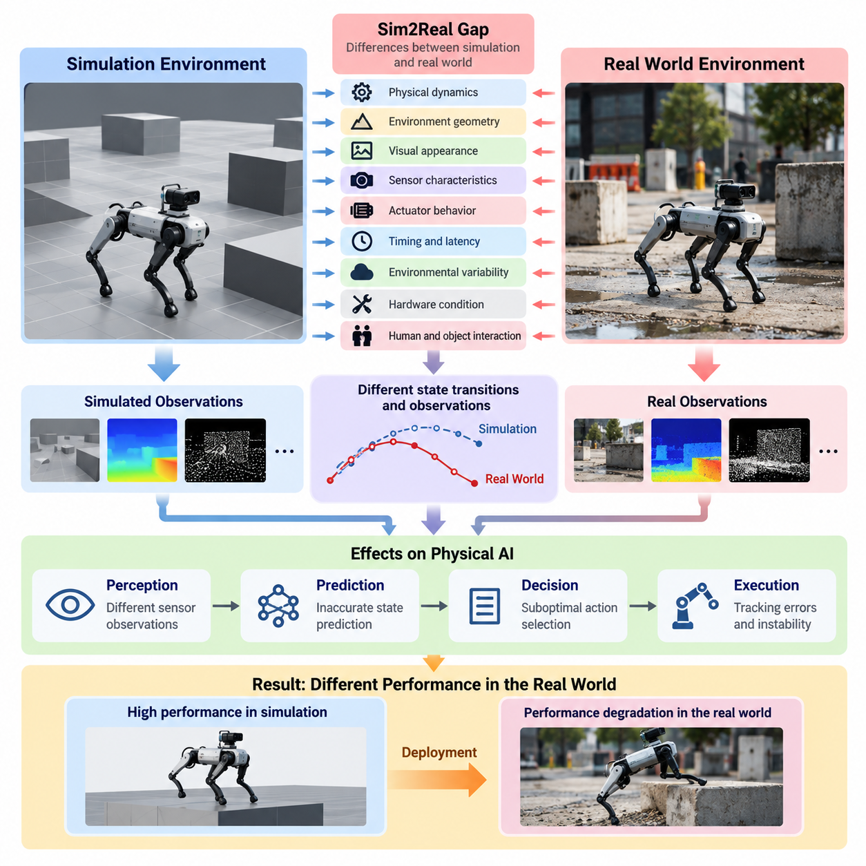
The Sim-to-Real (Sim2Real) gap refers to the differences between simulated environments and physical reality that cause artificial intelligence models or robotic control policies to behave differently after deployment. Although simulation provides a controlled, scalable, and cost-effective environment for training and evaluation, it cannot perfectly reproduce the complexity, uncertainty, and variability of real-world physical systems.
In Physical AI, the Sim2Real gap represents more than a mismatch between virtual images and real sensor observations. It includes differences in physical dynamics, environmental geometry, actuator behavior, sensor characteristics, communication latency, and interactions with humans or objects. These discrepancies influence how a robot perceives its surroundings, predicts future states, makes decisions, and executes physical actions.
A simulation environment approximates reality through mathematical models, numerical solvers, digital assets, and predefined assumptions. Every approximation introduces potential errors because the physical world contains nonlinear interactions, uncertain parameters, and disturbances that may not be represented accurately. Even highly sophisticated simulation platforms must balance physical fidelity, computational efficiency, and the diversity of simulated scenarios.
The Sim2Real gap becomes particularly important when a robot learns its behavior primarily from simulated experience. A control policy may achieve excellent performance under simulated conditions while failing to maintain stability, accuracy, or safety in a real environment. This performance degradation occurs because the policy has learned relationships that depend on simulation-specific characteristics rather than robust physical principles.
One fundamental source of the gap is the difference between simulated and actual physical dynamics. Simulation engines estimate motion using equations describing mass, inertia, friction, contact forces, elasticity, and damping. However, real systems exhibit complex interactions such as tire deformation, joint backlash, structural vibration, and irregular surface contact that may be simplified or omitted from the simulation model.
Visual and geometric discrepancies also contribute significantly to the Sim2Real gap. Simulated scenes may differ from real environments in lighting, shadows, textures, reflections, object dimensions, and spatial arrangements. These differences can affect computer vision models trained to recognize objects, estimate depth, or identify navigable regions, particularly when visual features learned in simulation do not generalize to real observations.
Sensor discrepancies introduce another layer of uncertainty. Simulated cameras, LiDAR sensors, radar systems, inertial measurement units, and tactile sensors often produce idealized measurements unless realistic imperfections are explicitly modeled. Physical sensors experience calibration errors, measurement noise, distortion, interference, missing observations, and environmental sensitivity, all of which can alter the information available to perception and control algorithms.
Actuator and control differences create additional challenges during deployment. Simulated motors and drive systems may respond immediately and precisely to control commands, whereas real actuators exhibit torque limitations, thermal effects, mechanical backlash, saturation, and response delays. These characteristics can significantly influence trajectory tracking, manipulation accuracy, locomotion stability, and coordinated multi-joint movements.
Timing discrepancies are especially important in real-time robotic systems. Simulation environments frequently operate with deterministic update cycles, while physical robots must handle variable computation times, sensor synchronization errors, communication delays, and operating-system scheduling effects. Small timing differences can accumulate within feedback control loops and produce oscillations, tracking errors, or unstable behavior.
Environmental variability further increases the complexity of Sim2Real transfer. Real-world operating conditions change with temperature, humidity, weather, terrain, lighting, and human activity. A mobile robot trained on predictable surfaces may encounter unexpected friction variations, obstacles, or pedestrian movements. Such conditions expose the limitations of simulated training distributions and challenge the robustness of learned policies.
Robot morphology and hardware condition also influence the Sim2Real gap. Manufacturing tolerances, assembly differences, component wear, payload changes, and aging can cause individual robots to behave differently from their digital representations. A simulation calibrated for one robotic platform may therefore become less accurate when transferred to another unit or when the original hardware experiences gradual mechanical degradation.
The Sim2Real gap can be understood through differences in state transitions, observations, and task outcomes. In simulation, an action produces a predicted next state according to the modeled dynamics, while the same action in reality may produce a different result. Likewise, identical physical situations may generate different sensor observations. These mismatches affect both the internal decision process and the external behavior of Physical AI systems.
A useful conceptual distinction exists between observation gaps and dynamics gaps. Observation gaps describe differences in how simulated and real environments are perceived, whereas dynamics gaps describe differences in how physical systems respond to actions. These categories are closely connected because inaccurate observations influence action selection, while inaccurate dynamics alter the consequences of those actions and subsequent sensor measurements.
The magnitude of the Sim2Real gap depends on the task, robot architecture, operating environment, and evaluation criteria. A small visual discrepancy may be irrelevant for a controller relying primarily on joint encoders but critical for a vision-based manipulation system. Similarly, minor friction errors may have limited effects during slow navigation yet become decisive during high-speed motion or precision contact operations.
Quantifying the gap requires systematic comparison between simulated and real-world behavior under comparable conditions. Relevant measurements include trajectory deviation, state estimation error, contact-force differences, task completion rates, energy consumption, and control stability. Distribution-based metrics can additionally compare sensor observations or learned feature representations, revealing discrepancies that are not immediately visible through individual task outcomes.
The relationship between simulation fidelity and transfer performance is not always straightforward. Increasing graphical realism does not necessarily improve physical control, and highly detailed physics models may still fail when important parameters are incorrect. Effective simulation design therefore requires identifying which physical and perceptual characteristics materially influence the target task rather than attempting to reproduce every aspect of reality.
A central objective of Sim2Real analysis is to identify the discrepancies responsible for performance degradation and determine which can be reduced through improved modeling, calibration, or learning. Domain randomization exposes policies to diverse simulated conditions, while domain adaptation aligns representations or behaviors across environments. System identification estimates physical parameters from measurements to improve the accuracy of simulation models.
Digital twins provide an additional mechanism for understanding and reducing the Sim2Real gap. By incorporating real-world telemetry, calibrated physical models, and operational observations, a digital twin can maintain a more representative description of a robot or facility. Continuous comparison between predicted and observed behavior helps identify model drift, parameter uncertainty, and emerging differences caused by environmental or hardware changes.
However, eliminating every discrepancy between simulation and reality is generally impractical. Physical environments contain uncertainty, unmodeled interactions, and rare events that cannot be represented exhaustively. The practical goal is therefore to develop policies that remain reliable across relevant differences, while ensuring that residual modeling errors do not create unacceptable operational risks or undermine task performance.
For safety-critical Physical AI applications, the Sim2Real gap must be considered throughout training, validation, and deployment. Simulation-based success alone cannot establish real-world reliability because unexpected physical interactions may produce unsafe outcomes. Progressive testing, controlled deployment, uncertainty monitoring, and runtime safety mechanisms are necessary to evaluate whether learned behavior remains acceptable under actual operating conditions.
Ultimately, defining the Sim2Real gap establishes the foundation for systematic transfer analysis across perception, dynamics, control, sensing, timing, and environmental interaction. Rather than treating simulation failure as a single modeling problem, Physical AI engineering must examine interconnected sources of discrepancy and their effects on task performance. This perspective enables targeted improvements and more dependable deployment of intelligent physical systems.

08.02. Visual and Appearance Gap
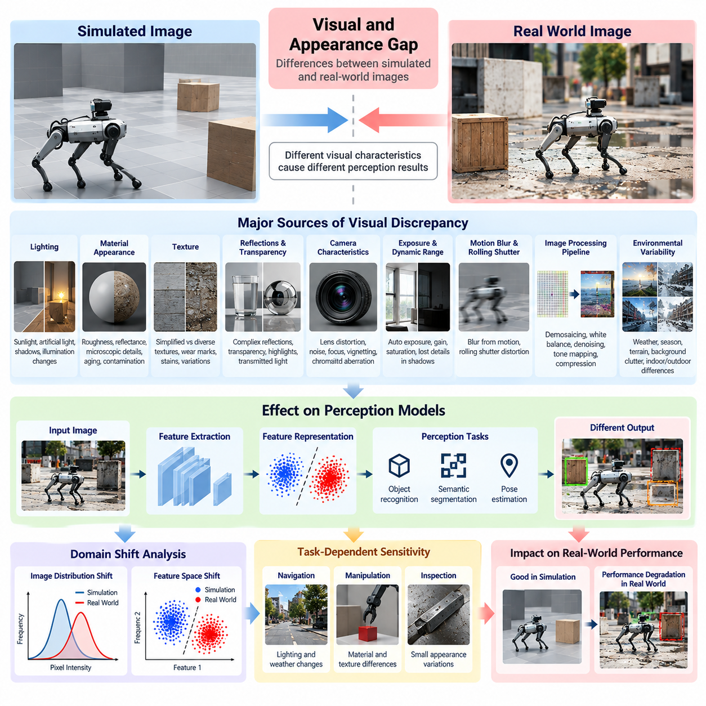
The visual and appearance gap refers to differences between images generated in simulation and visual observations captured in real-world environments. These differences arise from imperfect representations of lighting, materials, textures, reflections, camera characteristics, and environmental conditions. In Physical AI, such discrepancies can significantly influence the reliability of perception models trained using synthetic visual data.
Simulation environments generate visual observations through rendering pipelines that approximate the interaction of light with virtual objects and surfaces. Although modern rendering technologies can produce highly realistic images, visual similarity does not guarantee identical statistical characteristics. Small differences in color distributions, contrast, surface appearance, and image artifacts may cause learned perception models to respond differently during real-world deployment.
Lighting is one of the most influential sources of visual discrepancy. Simulated environments often use predefined light sources, simplified illumination models, or controlled exposure conditions. Real environments contain changing sunlight, artificial lighting, indirect illumination, shadows, and reflections. These variations affect object visibility, feature extraction, and the consistency of visual representations used by robotic perception systems.
Material appearance introduces additional differences between simulated and real scenes. Virtual materials are commonly represented through parameters describing surface color, roughness, metallic properties, and reflectance. However, actual materials may contain microscopic irregularities, contamination, scratches, aging, and complex light-scattering behavior. These characteristics can produce visual patterns that are difficult to reproduce accurately.
Texture representation also contributes to the appearance gap. Synthetic textures may be cleaner, more repetitive, or less diverse than real-world surfaces. Physical environments contain manufacturing variations, stains, wear marks, and unpredictable surface details. A perception model trained on simplified textures may learn artificial correlations that reduce its ability to recognize objects or estimate their properties under real conditions.
Reflections and transparency create particularly challenging visual discrepancies. Glass, polished metal, transparent plastic, and reflective floors interact with light in complex ways. Rendering engines may approximate these effects differently from physical reality, producing incorrect highlights, reflections, or transmitted light. Such differences can interfere with object detection, depth estimation, and robotic manipulation involving reflective or transparent objects.
Camera characteristics form another major component of the visual gap. Simulated cameras often use idealized projection models, while physical cameras exhibit lens distortion, chromatic aberration, vignetting, sensor noise, and imperfect focus. Differences in focal length, aperture, field of view, and optical alignment can alter the geometry and appearance of captured images, affecting downstream perception algorithms.
Exposure and dynamic range differences can substantially influence visual transfer. Real cameras continuously adapt to changing illumination through exposure control, gain adjustment, and image processing. Bright regions may become saturated, while dark regions lose detail. Simulated rendering pipelines that do not reproduce these effects accurately may generate observations that differ significantly from real camera outputs.
Motion blur and rolling shutter effects further complicate visual consistency. When cameras or objects move, physical image sensors integrate light over finite exposure periods. Rolling shutter sensors additionally capture different image rows at slightly different times. These mechanisms can distort moving objects and alter apparent geometry, creating discrepancies that affect visual tracking, localization, and motion estimation.
Image processing pipelines also introduce differences between simulation and reality. Real cameras commonly apply demosaicing, white balance, denoising, sharpening, tone mapping, and compression. These operations modify the statistical properties of images before they reach perception models. Synthetic images generated without comparable processing may exhibit unrealistic sharpness, color consistency, or noise characteristics.
Environmental appearance varies across locations, seasons, and operating conditions. Outdoor robots encounter rain, fog, dust, snow, changing vegetation, and variable atmospheric visibility. Indoor robots experience different lighting fixtures, floor materials, wall colors, and background clutter. Simulation environments that represent only a narrow range of appearances may fail to capture the diversity encountered during deployment.
The visual gap becomes especially important for deep learning models that rely on image-based feature extraction. Neural networks may learn correlations between visual patterns and target labels that are valid only within the simulated environment. When these patterns change in reality, feature representations may shift, reducing object recognition accuracy, semantic segmentation quality, or pose estimation reliability.
Visual domain shift can be examined through differences in image distributions and learned feature spaces. Pixel-level comparisons reveal changes in brightness, color, texture, and contrast, while feature-level analysis measures differences in representations extracted by neural networks. However, visual similarity metrics alone cannot fully determine whether a discrepancy will affect robotic task performance.
Task-dependent sensitivity is therefore essential when evaluating the appearance gap. A navigation system may tolerate moderate texture differences if geometric boundaries remain detectable, while a precision grasping system may depend strongly on subtle object edges and surface reflections. The significance of visual discrepancies must be evaluated according to their influence on perception accuracy and downstream robotic behavior.
Photorealistic rendering provides one approach to reducing visual discrepancies. Physically based rendering, ray tracing, accurate material models, and calibrated lighting can improve the correspondence between synthetic and real observations. Nevertheless, increasing rendering fidelity introduces computational costs and does not necessarily eliminate domain shift when real-world variability remains insufficiently represented.
Domain randomization addresses the appearance gap by deliberately varying visual characteristics during simulation-based training. Lighting intensity, texture patterns, material colors, camera parameters, and background conditions can be randomized across training episodes. This approach encourages perception models to rely on stable task-relevant features rather than visual details specific to individual simulated scenes.
Domain adaptation provides another strategy by aligning synthetic and real visual representations. Image translation techniques can modify simulated images to resemble real camera observations, while feature-level adaptation reduces discrepancies within learned representations. Self-supervised adaptation can additionally exploit unlabeled real-world observations to improve model robustness without requiring extensive manual annotation.
Combining synthetic and real visual data can further improve transfer performance. Synthetic datasets provide scalable annotations and controlled scenario generation, while real datasets capture authentic sensor characteristics and environmental variability. Carefully designed training mixtures can reduce dependence on simulation-specific patterns and improve generalization across different deployment conditions.
Visual gap analysis should also consider the interaction between appearance and geometry. Incorrect shadows, reflections, or surface textures may influence perceived depth and object boundaries even when the underlying simulated geometry is accurate. Consequently, visual discrepancies can propagate into localization, mapping, obstacle detection, and manipulation decisions, creating operational errors beyond image recognition alone.
A systematic evaluation process compares synthetic and real observations under matched camera poses, lighting conditions, and scene configurations whenever feasible. Relevant measurements include image statistics, feature distribution differences, perception accuracy, and task success rates. Controlled experiments help distinguish appearance-related failures from errors caused by geometry, dynamics, calibration, or control.
Ultimately, reducing the visual and appearance gap requires balancing rendering realism, visual diversity, sensor fidelity, and task-specific robustness. The objective is not merely to produce synthetic images that appear convincing to human observers, but to generate training conditions that support reliable machine perception. Effective visual gap analysis strengthens the transfer of Physical AI systems from simulated environments into complex and changing physical environments.

08.03. Geometric and Scene Gap
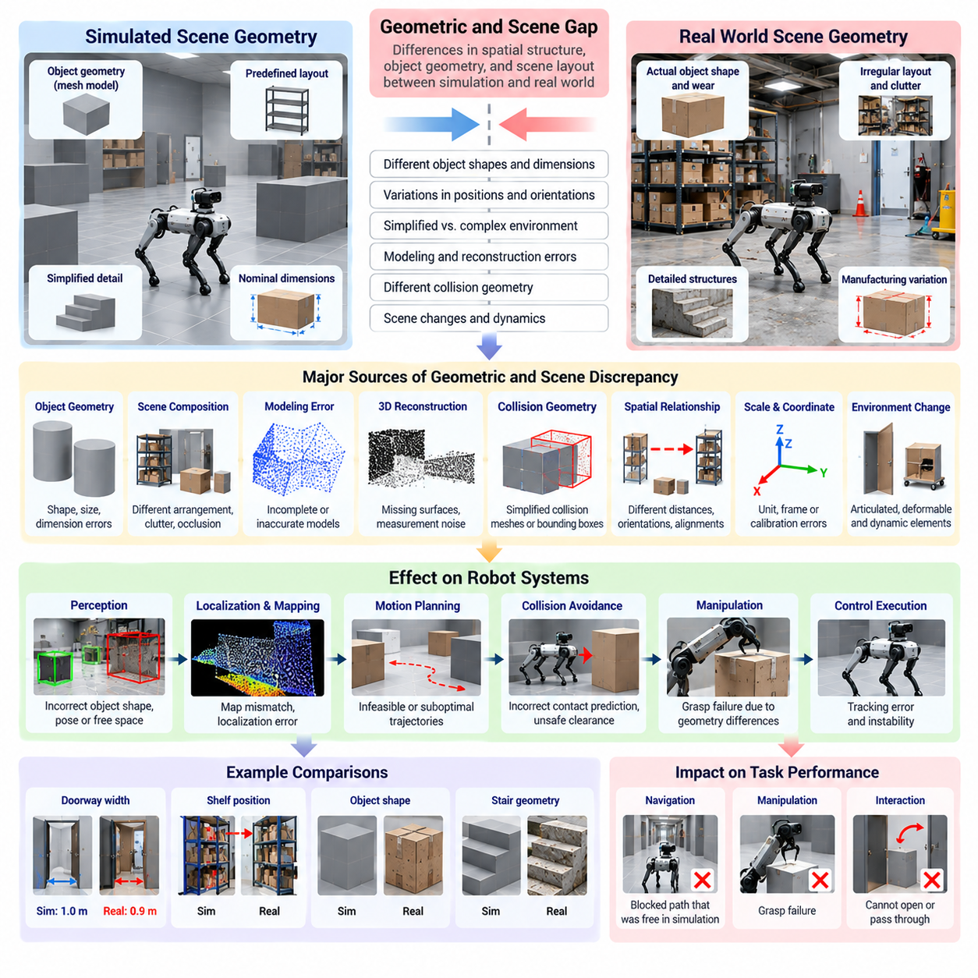
The geometric and scene gap refers to differences between the spatial structure of simulated environments and the actual geometry of physical environments. These discrepancies include variations in object dimensions, positions, orientations, surface shapes, and spatial relationships. In Physical AI, geometric inconsistencies can directly affect perception, localization, collision avoidance, motion planning, and robotic manipulation performance.
Simulation environments represent physical spaces through geometric models such as meshes, primitives, point clouds, and structured scene descriptions. These representations approximate the dimensions and arrangements of real objects but may omit small details or simplify complex structures. Consequently, a robot trained in simulation may encounter unexpected geometric features that alter its interpretation of free space and physical accessibility.
Geometric fidelity depends on the accuracy of object shapes, dimensions, and relative positioning. Small errors in the width of a doorway, the height of a platform, or the location of an obstacle can significantly influence robotic navigation. For manipulation systems, slight differences in object geometry may affect grasp selection, contact positioning, and the feasibility of planned movements.
Scene composition introduces another source of discrepancy. Simulated environments often contain carefully arranged objects, predefined obstacle locations, and simplified background structures. Real environments exhibit irregular object placement, clutter, partial occlusion, and unexpected spatial configurations. These differences can reduce the reliability of perception and planning systems that depend on assumptions learned from structured simulation scenes.
Geometric modeling errors frequently originate from incomplete or inaccurate measurements. Computer-aided design models may represent nominal dimensions rather than actual manufactured geometry, while reconstructed environments may contain missing surfaces or measurement noise. Differences between design specifications and physical installations can therefore create spatial inconsistencies that become important during precise robotic operations.
Three-dimensional reconstruction introduces additional uncertainty into simulated scene geometry. Photogrammetry, LiDAR scanning, and depth sensing generate spatial representations from measured observations. However, reconstruction quality depends on sensor resolution, calibration, viewing angles, and environmental conditions. Occluded surfaces, reflective materials, and insufficient measurements may produce incomplete or distorted geometric models.
Collision geometry represents a particularly important component of the geometric gap. Simulation engines frequently use simplified collision meshes or bounding volumes to reduce computational complexity. These approximations may differ from the detailed visual geometry of objects and robots. As a result, simulated collision detection may predict contact earlier or later than actual physical interaction, affecting motion planning and safety margins.
The distinction between visual geometry and collision geometry is essential for understanding simulation accuracy. Visual meshes determine how objects appear, while collision representations determine how simulated physical interactions are calculated. A visually accurate object may still have an inaccurate collision model, causing a robot to misjudge available clearance, contact locations, or the feasibility of manipulation trajectories.
Spatial relationships between objects also influence Sim2Real transfer. Relative distances, orientations, alignments, and containment relationships determine how robots navigate and interact with their surroundings. A simulated warehouse may contain perfectly aligned shelves and regularly spaced obstacles, whereas a real facility may exhibit installation tolerances, displaced equipment, and temporary obstructions.
Scene scale and coordinate consistency are fundamental requirements for reliable geometric transfer. Errors in measurement units, coordinate transformations, reference frames, or sensor extrinsic calibration can introduce systematic spatial distortions. Even when individual object models are accurate, incorrect transformations between robot, sensor, and world coordinates may produce substantial localization and planning errors.
The geometric gap also affects mapping and localization algorithms. Simulated environments often provide precise ground-truth maps and idealized structural features, while real robots must estimate geometry from noisy and incomplete observations. Differences in wall positions, landmark locations, and surface structures can degrade scan matching, visual localization, and simultaneous localization and mapping performance.
For autonomous mobile robots, geometric discrepancies can alter navigable space and obstacle clearance. A route that appears feasible in simulation may become inaccessible when real-world obstacles occupy slightly different positions. Narrow corridors, ramps, door thresholds, and loading areas are particularly sensitive to geometric uncertainty because small spatial differences can change whether a robot can safely complete a planned trajectory.
Robotic manipulation is similarly sensitive to geometric accuracy. Grasp planning relies on estimates of object shape, pose, surface orientation, and available contact regions. When simulated objects differ from their physical counterparts, a grasp that appears stable in simulation may fail because contact points, finger clearances, or object boundaries are incorrectly represented.
Geometric differences become more complex in articulated and deformable environments. Doors, drawers, cables, flexible containers, and movable equipment introduce geometry that changes during interaction. Static simulation models may not capture these changes accurately, leading to incorrect predictions of accessible regions, collision constraints, and object configurations throughout a robotic task.
Human presence introduces dynamic scene geometry that is difficult to represent exhaustively. People continuously change posture, orientation, and position while interacting with surrounding objects. Simulated human models may use simplified body shapes or predefined motion trajectories. These approximations can create discrepancies in obstacle prediction, safe navigation, and human-robot interaction.
Scene semantics and geometric structure are closely related. Robots often associate spatial configurations with functional meanings, such as identifying shelves as storage areas or open floor regions as navigable pathways. If simulated scenes contain unrealistic object arrangements, learned models may develop incorrect assumptions about how geometry relates to tasks, accessibility, and environmental affordances.
Quantifying the geometric gap requires comparing simulated and real spatial representations under consistent reference frames. Relevant measurements include dimensional errors, point-cloud distances, surface reconstruction accuracy, object pose deviations, and collision-clearance differences. Metrics such as Chamfer distance and intersection over union can characterize geometric similarity, although their relevance depends on the target robotic task.
Task-level evaluation is necessary because geometric similarity alone does not guarantee successful transfer. A small reconstruction error may be insignificant for navigation through a large open space but critical for inserting a component into a narrow fixture. Geometric gap analysis should therefore connect spatial discrepancies to operational outcomes such as collision frequency, path feasibility, grasp success, and positioning accuracy.
Improving geometric fidelity begins with accurate measurement and model calibration. CAD verification, three-dimensional scanning, sensor calibration, and coordinate-frame validation can reduce differences between digital representations and physical environments. Combining design models with measured geometry is particularly useful when nominal specifications do not fully represent manufacturing tolerances or installation conditions.
Procedural scene generation and geometric randomization provide complementary strategies for improving robustness. Object dimensions, positions, orientations, obstacle arrangements, and scene layouts can be varied during simulation-based training. By exposing robotic policies to diverse spatial configurations, these methods reduce dependence on idealized geometry and encourage generalization to previously unseen environments.
Digital twins can support continuous geometric gap reduction by incorporating updated spatial measurements from operating robots and facility sensors. Changes in equipment placement, structural modifications, and newly introduced obstacles can be reflected in the virtual environment. However, maintaining geometric consistency requires reliable data association, coordinate alignment, and mechanisms for handling uncertain or outdated observations.
Ultimately, geometric and scene gap analysis connects the accuracy of virtual spatial representations with the reliability of physical robotic behavior. Effective Sim2Real transfer requires more than detailed three-dimensional models; it demands appropriate geometric uncertainty, realistic scene diversity, and task-aware validation. Addressing these factors improves navigation, manipulation, localization, and safe operation across changing real-world environments.

08.04. Physics Dynamics and Contact Gap
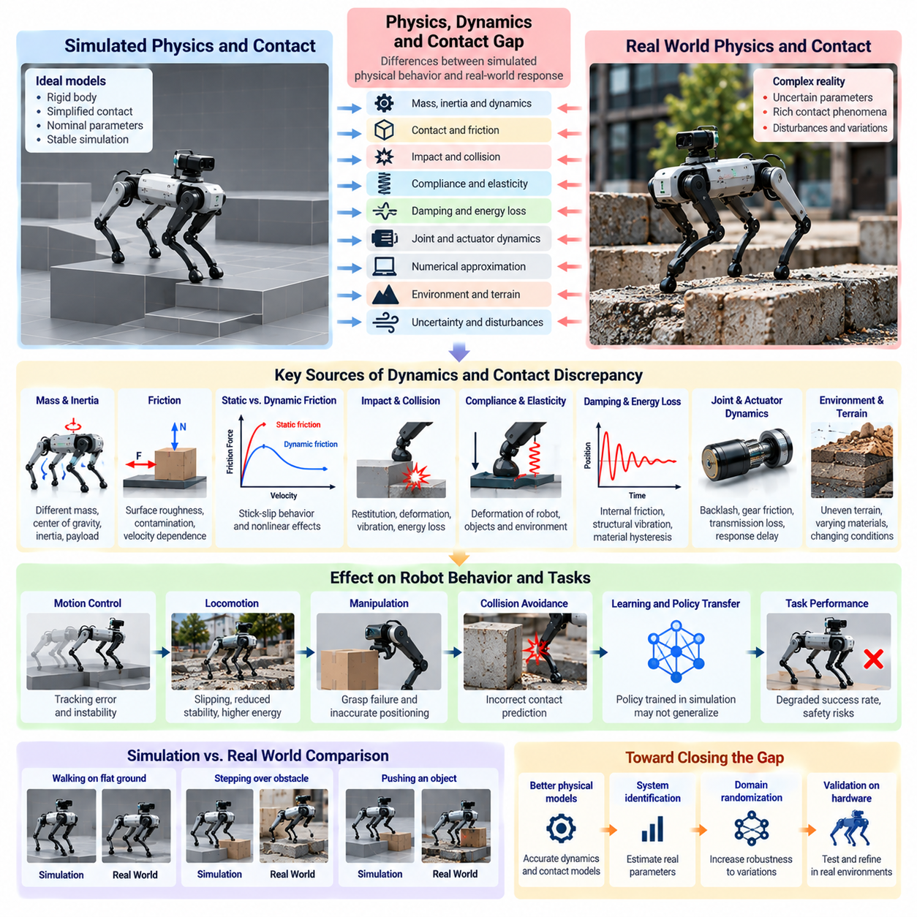
The physics, dynamics, and contact gap refers to differences between simulated physical behavior and the actual response of robotic systems interacting with the real world. These discrepancies arise from simplified mathematical models, uncertain physical parameters, numerical approximations, and incomplete representations of contact phenomena. In Physical AI, such differences can significantly affect motion stability, manipulation accuracy, and task reliability.
Physics simulation engines approximate physical systems using equations of motion, constraint models, and numerical integration methods. Although these techniques reproduce many fundamental mechanical behaviors, they cannot represent every physical interaction with perfect accuracy. Real robotic systems exhibit nonlinear effects, material variations, structural flexibility, and unpredictable disturbances that may be absent from simulated environments.
Dynamic discrepancies often originate from inaccurate estimates of mass, inertia, center of gravity, and mechanical coupling. Even small parameter errors can alter acceleration, rotational motion, and load distribution. A robot controller trained using nominal dynamic parameters may therefore produce unexpected behavior when deployed on hardware with different payloads, component tolerances, or mechanical configurations.
Contact modeling represents one of the most challenging aspects of Sim2Real transfer. Physical contact involves complex interactions between surfaces, including deformation, friction, impact, adhesion, and energy dissipation. Simulation engines typically approximate these phenomena through simplified contact constraints and force models. Such approximations may reproduce general behavior while failing to capture detailed contact transitions.
Friction discrepancies are particularly important for locomotion and manipulation. Simulated friction models often assume constant coefficients or simplified relationships between normal and tangential forces. Real friction depends on surface roughness, contamination, temperature, sliding velocity, and contact pressure. These variations can cause unexpected slipping, inaccurate force predictions, and reduced stability during physical interaction.
Static and dynamic friction introduce additional complexity. Static friction resists the initiation of motion, while dynamic friction governs resistance during sliding. The transition between these regimes may exhibit nonlinear effects such as stick-slip behavior and velocity-dependent friction. Simplified simulation models may fail to reproduce these transitions accurately, leading to errors in precision positioning and force-controlled manipulation.
Impact and collision dynamics also contribute to the physics gap. Simulated collisions are often calculated using restitution coefficients, impulse models, and numerical contact solvers. However, real impacts involve local deformation, vibration, acoustic energy loss, and material-dependent dissipation. Differences in collision response can affect grasping, object placement, walking stability, and interactions with obstacles.
Compliance and elasticity are essential for modeling realistic contact behavior. Physical components deform under applied forces, even when they are nominally rigid. Robot structures, tires, grippers, joints, and contacted objects exhibit varying degrees of compliance. Rigid-body simulation may overlook these effects, producing unrealistic contact forces, motion trajectories, or predictions of mechanical stability.
Damping and energy dissipation introduce further discrepancies. Real mechanical systems lose energy through internal friction, structural vibration, material hysteresis, and fluid resistance. Simulation environments often represent these mechanisms using simplified damping coefficients. Incorrect damping parameters can produce excessive oscillations, unrealistic settling behavior, or inaccurate predictions of energy consumption and control response.
Joint dynamics and mechanical transmission behavior influence the transfer of learned control policies. Real joints may exhibit backlash, bearing friction, gear compliance, and torque transmission losses. These effects modify the relationship between commanded actuator effort and resulting motion. When simulation assumes ideal joints or transmissions, learned policies may become sensitive to mechanical imperfections during deployment.
Numerical integration introduces errors that are separate from physical modeling inaccuracies. Simulation engines advance system states using discrete time steps and numerical solvers. Large time steps, insufficient solver iterations, or poorly conditioned constraints may generate unstable or inaccurate contact behavior. Increasing numerical precision can reduce certain errors but also increases computational requirements.
Contact solver architecture influences the simulated behavior of robotic systems. Different engines may use penalty-based methods, impulse-based formulations, or constraint optimization techniques. Each approach makes different assumptions about penetration, contact forces, and constraint satisfaction. Consequently, identical robot models can exhibit different physical responses across simulation platforms.
Wheel-ground interaction illustrates the practical significance of dynamics and contact discrepancies. Mobile robots depend on accurate representations of rolling resistance, traction, lateral slip, and load transfer. Simplified wheel models may perform adequately on smooth surfaces but fail on uneven terrain or under heavy payloads. Such errors can degrade trajectory tracking, braking performance, and maneuvering stability.
Legged robots are especially sensitive to contact modeling because locomotion depends on repeated transitions between support and flight phases. Small errors in ground reaction forces, foot friction, or impact timing can alter balance and gait stability. Policies trained with inaccurate contact dynamics may struggle when encountering compliant terrain, irregular surfaces, or unexpected disturbances.
Robotic manipulation introduces similarly demanding contact conditions. Grasping, pushing, insertion, and assembly require accurate predictions of contact location, force distribution, and object motion. A simulated grasp may appear stable because of simplified friction or collision geometry, while the corresponding physical grasp fails through slipping, misalignment, or unexpected deformation.
Multi-contact interactions increase modeling complexity further. Humanoid robots, mobile manipulators, and coordinated robotic systems may simultaneously contact floors, objects, fixtures, and other structures. Contact forces are coupled through the mechanical system, making their distribution sensitive to geometry, compliance, and solver assumptions. Small modeling errors can propagate into substantial differences in whole-body behavior.
The physics gap is also influenced by environmental and material uncertainty. Floors, tires, packaging materials, flexible objects, and mechanical interfaces change their properties through wear, moisture, temperature, and repeated loading. A simulation calibrated for one operating condition may therefore become inaccurate as the environment or robot hardware evolves over time.
Quantifying the physics and contact gap requires comparing simulated predictions with measurements from physical experiments. Relevant variables include joint trajectories, acceleration, contact forces, slip ratios, impact responses, and energy consumption. Controlled experiments can isolate individual parameters, while task-level tests reveal how accumulated modeling errors affect stability, accuracy, and successful task completion.
System identification provides a systematic method for reducing dynamic discrepancies. By applying known inputs and measuring physical responses, engineers can estimate mass properties, friction parameters, damping coefficients, and actuator characteristics. These estimates can improve simulation fidelity, although some parameters remain difficult to identify because of limited observability or interactions between different physical effects.
Domain randomization offers a complementary approach when exact physical modeling is impractical. Mass, inertia, friction, restitution, compliance, and damping parameters can be varied across simulated training episodes. This exposes control policies to diverse physical conditions and encourages robustness against uncertain dynamics. Randomization ranges must remain physically plausible to avoid training on unrealistic behavior.
Hybrid modeling can combine analytical physics with data-driven residual models. Analytical equations represent known mechanical relationships, while learned components approximate unmodeled effects using experimental observations. This approach can improve predictions of complex contact behavior without requiring complete physical reconstruction, although learned corrections must be validated outside their training conditions.
Ultimately, physics, dynamics, and contact gap analysis is essential for transferring Physical AI capabilities from virtual training environments to reliable physical operation. Effective reduction requires calibrated mechanical models, appropriate numerical methods, realistic contact representations, and robust control policies. The objective is not perfect physical replication, but sufficiently accurate and resilient behavior under real-world uncertainty.

08.05. Actuator and Control Gap
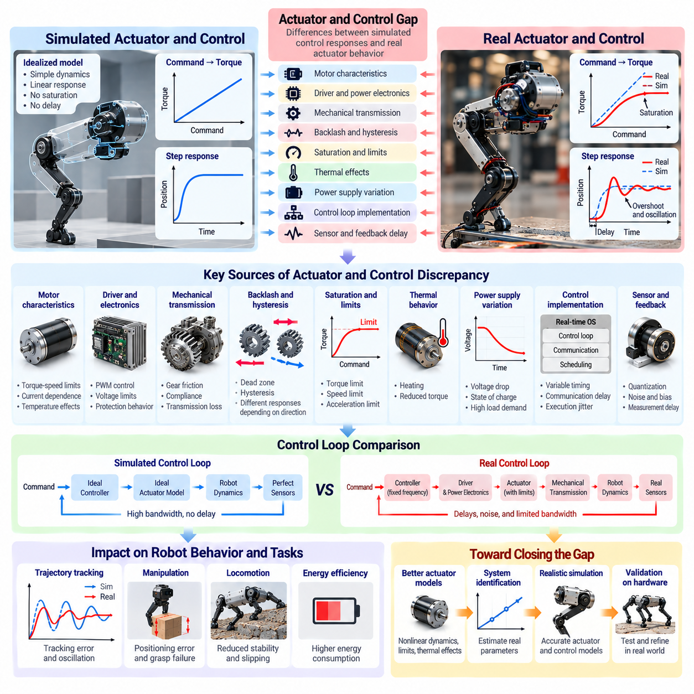
The actuator and control gap refers to differences between simulated control responses and the actual behavior of robotic actuators and control systems. These discrepancies arise from imperfect actuator models, mechanical limitations, electrical characteristics, feedback delays, and hardware-specific constraints. In Physical AI, the gap directly influences motion accuracy, dynamic stability, energy efficiency, and the reliability of learned control policies.
Simulation environments frequently represent actuators using simplified relationships between control commands and generated forces or torques. Real actuators exhibit nonlinear responses, saturation, friction, temperature dependence, and manufacturing variations. Consequently, identical control commands may produce different physical outputs in simulation and reality, creating systematic errors in trajectory tracking and motion execution.
Electric motor characteristics are a major source of actuator discrepancies. Motor torque depends on current, rotational speed, winding resistance, magnetic flux, and operating temperature. Simplified simulation models may assume constant torque capability or ideal current regulation. Real motors operate within torque-speed envelopes and thermal limits, which can substantially change their response under demanding operating conditions.
Motor drivers and power electronics introduce additional differences. Current controllers, pulse-width modulation, switching behavior, voltage limitations, and protection mechanisms influence actuator performance. Simulation environments may neglect these internal processes or approximate them using idealized response models. Such simplifications can produce unrealistic acceleration, braking, and torque delivery during dynamic robotic operations.
Mechanical transmissions further increase the actuator gap. Gearboxes, belts, chains, harmonic drives, and screw mechanisms introduce backlash, compliance, friction, and transmission losses. These characteristics modify the relationship between motor output and joint motion. A simulated actuator with ideal transmission efficiency may therefore respond more precisely than its physical counterpart, especially during reversals or rapid load changes.
Backlash and mechanical hysteresis are particularly important in precision control. Backlash creates a region of motion where changes in motor position do not immediately produce corresponding output movement. Hysteresis causes actuator response to depend on previous loading or motion history. These effects can generate positioning errors, oscillations, and inconsistent behavior that simplified actuator models fail to reproduce.
Actuator saturation represents another fundamental source of discrepancy. Real motors and hydraulic or pneumatic systems cannot generate unlimited force, torque, speed, or acceleration. When commanded outputs exceed physical limits, actuators saturate and no longer follow the assumed control relationship. Policies trained without realistic saturation constraints may request infeasible actions and experience substantial performance degradation after deployment.
Thermal behavior influences actuator performance over extended operating periods. Motor windings, power electronics, gearboxes, and braking components generate heat during operation. Rising temperatures can increase resistance, reduce efficiency, and trigger protective derating. A simulation that assumes constant actuator characteristics may therefore predict stable performance even when real hardware experiences progressively reduced output capability.
Power supply limitations also contribute to the control gap. Battery voltage changes with state of charge, current demand, temperature, and internal resistance. Shared power buses may experience voltage drops when multiple actuators accelerate simultaneously. If simulation assumes an ideal power source, it may overestimate available torque, acceleration, and sustained performance during demanding multi-actuator operations.
Control loop implementation introduces discrepancies beyond actuator physics. Simulated controllers often execute at fixed frequencies with deterministic timing and direct access to accurate system states. Physical controllers operate through embedded processors, sensor interfaces, communication networks, and real-time scheduling mechanisms. Execution jitter, delayed measurements, and asynchronous updates can alter closed-loop behavior.
Feedback quality is another critical factor. Simulated encoders and state estimators may provide nearly perfect position, velocity, and acceleration information. Real sensors contain quantization, noise, bias, calibration errors, and filtering delays. These imperfections affect feedback control accuracy and may produce unstable or oscillatory responses when controller gains are tuned using idealized simulation measurements.
Controller architecture determines how actuator discrepancies influence system behavior. Position, velocity, torque, and impedance controllers respond differently to modeling errors and disturbances. A policy trained with direct torque control may behave differently when deployed through a commercial drive implementing internal position or velocity loops. Hidden control dynamics can significantly alter the effective action interface.
Control gain mismatch creates additional transfer challenges. Proportional, integral, and derivative gains may be optimized for simulated inertia, friction, and actuator bandwidth. When applied to real hardware, these gains can produce overshoot, excessive settling time, oscillation, or poor disturbance rejection. Controller tuning must therefore account for the actual mechanical system and available actuator performance.
Command latency and actuator bandwidth influence the accuracy of dynamic control. Real systems require finite time to receive commands, regulate current, develop torque, and produce mechanical motion. These delays introduce phase lag and reduce achievable control bandwidth. Simulation models that assume instantaneous responses may generate policies that are overly aggressive or unstable when executed on physical hardware.
Actuator behavior also depends on external loading conditions. Payload variations, gravitational forces, contact interactions, and mechanical constraints change the torque or force required to execute a movement. A mobile manipulator carrying different payloads may exhibit altered acceleration and braking characteristics. Without load-dependent actuator models, simulated policies may underestimate control effort and tracking errors.
For wheeled mobile robots, actuator and control gaps appear in drive torque, steering response, braking dynamics, and wheel-speed regulation. Motor controller limits, steering gearbox backlash, and load-dependent traction affect vehicle maneuverability. These discrepancies become particularly important for heavy autonomous mobile robots operating with high payloads, tight turning requirements, or coordinated steering and drive systems.
Legged robots and humanoids present additional challenges because multiple actuators must coordinate under rapidly changing loads. Joint torque limits, compliance, communication delays, and motor bandwidth influence balance and locomotion stability. Small actuator discrepancies can propagate through whole-body control, causing differences in foot placement, ground reaction forces, and recovery behavior.
Robotic manipulators are especially sensitive to actuator errors during precision assembly and contact-rich operations. Joint positioning errors, transmission compliance, and torque estimation inaccuracies affect end-effector motion and contact forces. A trajectory that succeeds in simulation may produce misalignment, excessive insertion force, or unstable contact when executed with real actuator dynamics.
Quantifying the actuator and control gap requires systematic comparison of commanded inputs and measured physical responses. Relevant measurements include torque tracking error, position deviation, velocity response, rise time, settling time, overshoot, control latency, and energy consumption. Frequency-response analysis and controlled excitation experiments can reveal bandwidth limitations, nonlinearities, and hidden dynamics.
System identification provides a practical approach to improving actuator models. Engineers can apply controlled commands while recording motor current, voltage, torque, speed, temperature, and joint motion. These measurements support estimation of friction, inertia, response delays, transmission efficiency, and actuator limits. Calibrated models can then replace idealized assumptions within the simulation environment.
Domain randomization improves robustness when actuator characteristics cannot be modeled precisely. Training environments can vary torque limits, motor gains, friction, control delays, transmission efficiency, and sensor feedback quality. Exposure to these variations encourages policies to tolerate hardware uncertainty. However, randomization ranges should reflect physically plausible behavior and measured operating limits.
Hardware-in-the-loop testing provides an intermediate validation stage between pure simulation and full robotic deployment. Real controllers, motor drivers, or actuators interact with simulated mechanical systems, allowing engineers to evaluate timing, communication, and control behavior. This approach can expose implementation discrepancies before complete integration, although it cannot reproduce every physical interaction.
Ultimately, reducing the actuator and control gap requires accurate hardware characterization, realistic simulation models, robust control design, and progressive physical validation. The objective is to ensure that commands learned or optimized in simulation remain feasible, stable, and effective on actual robotic hardware. Addressing these discrepancies strengthens the reliability of Physical AI systems across changing loads, operating conditions, and deployment environments.

08.06. Sensor Noise and Calibration Gap
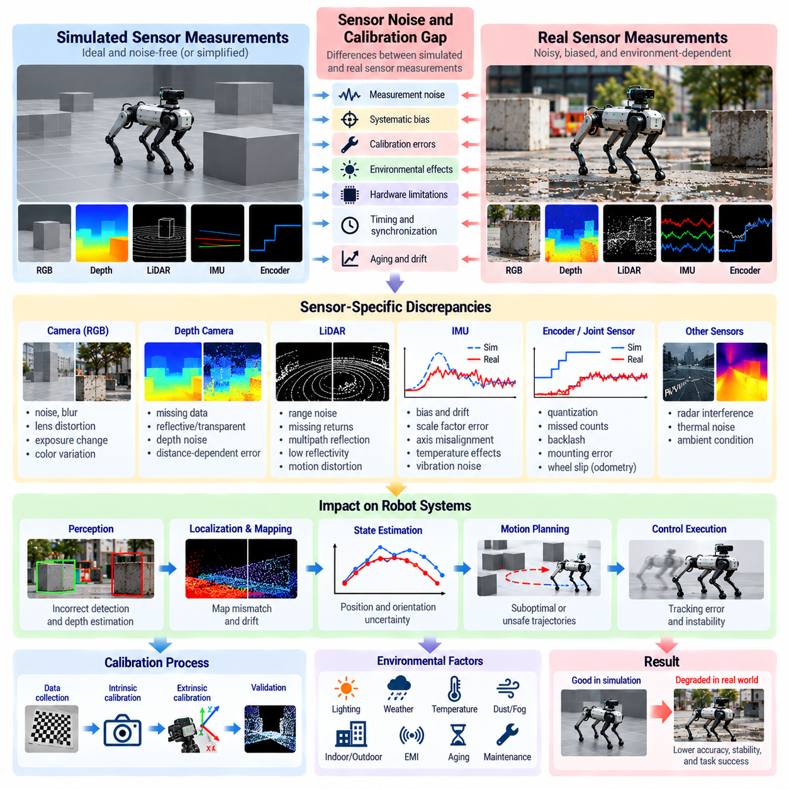
The sensor noise and calibration gap refers to differences between simulated sensor measurements and observations obtained from physical robotic systems. These discrepancies arise from measurement noise, systematic bias, calibration errors, environmental interference, and hardware limitations. In Physical AI, inaccurate sensor modeling can degrade perception, localization, state estimation, motion planning, and the reliability of learned policies.
Simulation environments frequently provide idealized sensor outputs generated from exact geometric and physical states. Real sensors measure the environment through imperfect optical, electrical, and mechanical processes. Their outputs contain uncertainty that varies with operating conditions and sensor characteristics. Consequently, algorithms trained on ideal observations may become unreliable when exposed to physical measurements.
Sensor noise includes random variations that affect measurements even when the underlying physical state remains unchanged. Common sources include electronic noise, photon fluctuations, mechanical vibration, and quantization effects. Noise may follow approximately Gaussian distributions under certain conditions, but real measurements often exhibit correlated, asymmetric, or heavy-tailed errors that simplified models fail to reproduce.
Systematic bias differs from random noise because it introduces persistent measurement offsets or scale errors. An inertial sensor may report a nonzero angular velocity while stationary, while a distance sensor may consistently overestimate range. Such errors can accumulate through state estimation and integration processes, causing substantial divergence between simulated predictions and actual robotic behavior.
Camera sensors introduce complex discrepancies involving image noise, lens distortion, exposure, focus, and color response. Simulated cameras often generate clean images with accurately defined projection parameters. Physical cameras exhibit rolling shutter effects, motion blur, sensor saturation, and imperfect optical alignment. These characteristics can reduce the accuracy of visual perception and feature tracking.
Depth cameras and structured-light sensors introduce additional uncertainty because depth measurements depend on surface reflectivity, distance, viewing angle, and illumination. Transparent, reflective, or dark materials may generate missing or distorted measurements. Simulated depth sensors that return complete geometric information can therefore create unrealistic assumptions about spatial perception.
LiDAR measurements are affected by range uncertainty, angular resolution, beam divergence, reflectivity, and atmospheric conditions. Real point clouds may contain missing returns, multipath reflections, and motion-induced distortions. Simplified simulated LiDAR often produces geometrically consistent measurements without these effects, potentially overestimating the reliability of obstacle detection and mapping.
Inertial measurement units combine accelerometers and gyroscopes to estimate motion and orientation. Their outputs are influenced by bias instability, scale-factor errors, axis misalignment, vibration, and temperature variation. Small errors can accumulate during numerical integration, producing orientation drift and position uncertainty. Realistic simulation must therefore consider both short-term noise and long-term drift.
Wheel encoders and joint position sensors also contribute to the sensor gap. Quantization, mechanical backlash, missed counts, and imperfect mounting can introduce discrepancies between measured and actual motion. Wheel odometry is additionally affected by slipping and changes in effective wheel radius. These errors can degrade localization and control even when the simulated mechanical model is accurate.
Calibration establishes the relationship between raw sensor measurements and meaningful physical quantities. Intrinsic calibration determines internal sensor parameters, while extrinsic calibration describes spatial transformations between sensors and robot coordinate frames. Incorrect calibration can introduce systematic geometric errors that persist even when measurement noise is relatively small.
Camera intrinsic calibration includes focal length, principal point, and lens distortion parameters. Errors in these quantities affect image projection and the reconstruction of three-dimensional geometry. Extrinsic calibration errors between cameras, LiDAR, and robot frames can produce misaligned observations, reducing the accuracy of sensor fusion, object localization, and spatial mapping.
Temporal calibration is equally important because sensors often operate at different sampling frequencies and communicate through independent processing pipelines. Timestamp offsets and synchronization errors can cause measurements from different moments to be combined incorrectly. For moving robots, even small temporal misalignments may produce significant spatial errors during perception and state estimation.
Sensor characteristics may change over time because of temperature, vibration, mechanical shock, aging, and maintenance activities. Camera mounts can shift, inertial biases can drift, and optical surfaces can become contaminated. A calibration that was accurate during initial deployment may gradually become unreliable, requiring periodic verification and recalibration.
Environmental conditions further influence measurement quality. Lighting variation affects cameras, precipitation and airborne particles affect optical ranging sensors, and electromagnetic interference can disrupt electronic measurements. Temperature changes may alter sensor response and calibration stability. Simulation environments that ignore these dependencies may underestimate uncertainty during real-world operation.
Sensor fusion systems combine information from cameras, LiDAR, inertial sensors, encoders, and other measurement sources. Their performance depends on accurate uncertainty models and consistent calibration. If simulated sensors provide unrealistically precise or independent measurements, learned fusion algorithms may assign inappropriate confidence to real observations and produce unstable state estimates.
Noise modeling should account for both statistical properties and physical measurement mechanisms. Independent Gaussian noise may be sufficient for preliminary experiments, but advanced simulation may require correlated noise, bias drift, dropout, outliers, and condition-dependent uncertainty. The appropriate complexity depends on sensor type, application requirements, and the sensitivity of downstream algorithms.
Quantifying the sensor gap requires collecting synchronized simulated and real measurements under comparable conditions. Useful metrics include measurement residuals, bias magnitude, variance, drift rate, calibration error, and detection reliability. Statistical distribution comparisons can identify differences in noise characteristics, while task-level evaluation reveals their effects on robotic performance.
Controlled calibration experiments provide a practical method for separating sensor errors from environmental and algorithmic effects. Reference targets, precision motion systems, and independently measured ground truth can establish measurement accuracy. Repeated experiments across different temperatures, distances, orientations, and operating conditions reveal how sensor uncertainty changes.
Domain randomization can improve robustness by varying sensor noise, bias, resolution, distortion, dropout probability, and calibration parameters during training. This exposes perception and control policies to diverse observation conditions. However, excessive randomization may introduce unrealistic measurements, so parameter ranges should reflect empirical sensor behavior whenever possible.
Sensor adaptation techniques can reduce discrepancies between synthetic and physical observations. Calibration refinement, filtering, normalization, and learned measurement correction can compensate for certain systematic differences. Data-driven adaptation may improve performance when sufficient real measurements are available, but corrections must be evaluated for stability and generalization.
Uncertainty-aware perception and control provide additional protection against sensor discrepancies. Probabilistic state estimation, confidence-weighted sensor fusion, and robust planning can account for imperfect measurements. Rather than assuming that every observation is accurate, these methods explicitly represent uncertainty and adjust robotic decisions according to measurement reliability.
Ultimately, reducing the sensor noise and calibration gap requires realistic measurement models, accurate spatial and temporal calibration, empirical validation, and continuous monitoring of sensor performance. Effective Sim2Real transfer depends not only on producing realistic observations but also on developing algorithms that remain reliable when measurements are incomplete, biased, noisy, or temporarily unavailable.

08.07. Latency Communication and Timing Gap
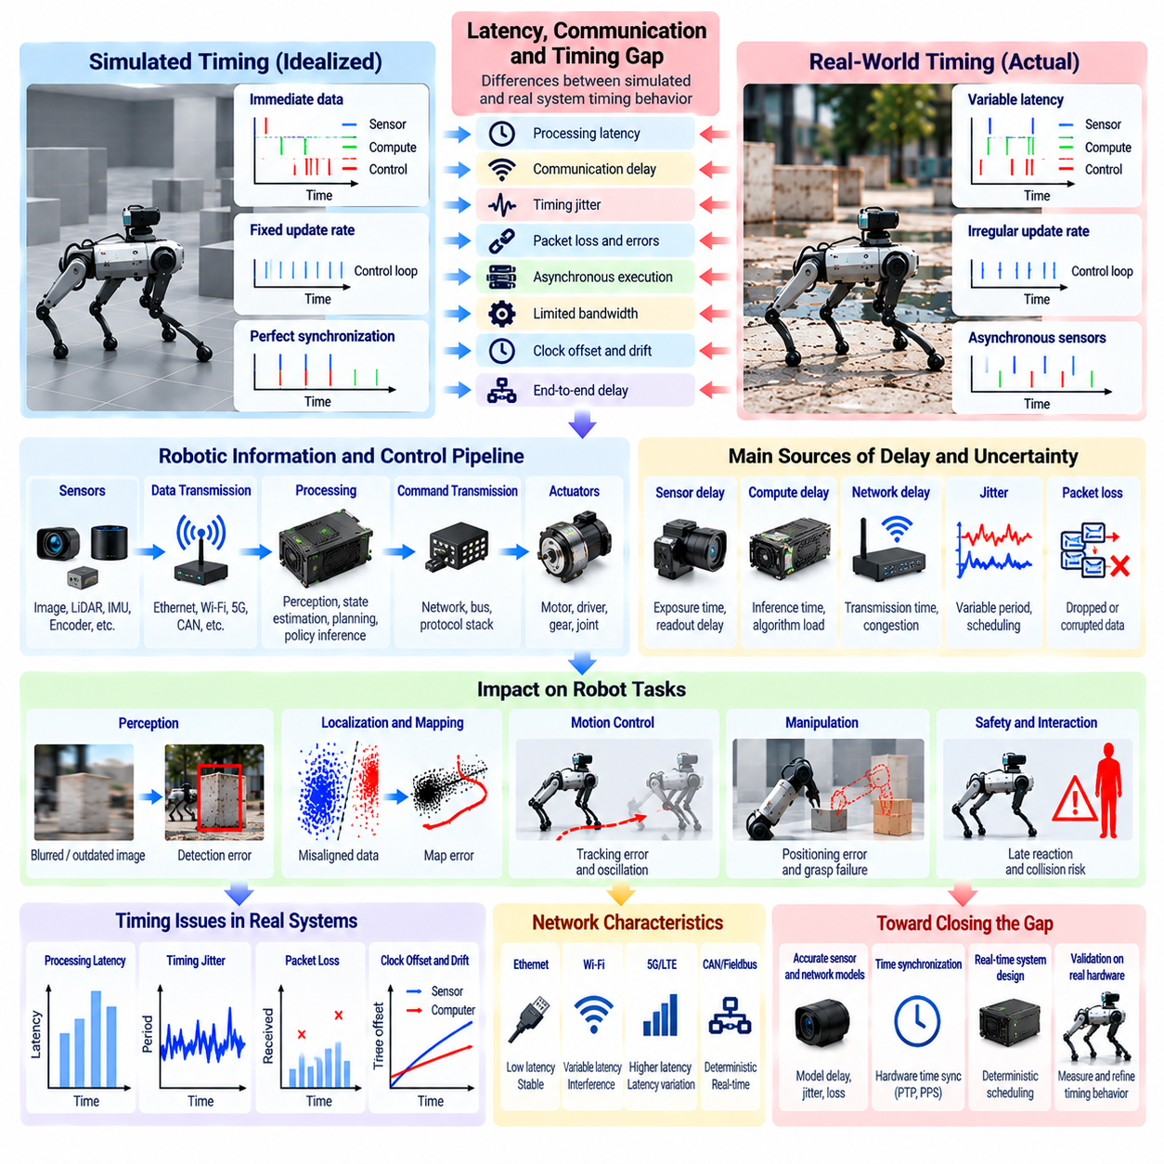
The latency, communication, and timing gap refers to differences between simulated information exchange and the temporal behavior of real robotic systems. Simulation environments often assume deterministic execution, immediate data availability, and precisely synchronized components. Physical AI systems operate with processing delays, communication uncertainty, and asynchronous hardware, creating discrepancies that affect perception, planning, control, and operational safety.
Latency represents the elapsed time between an event, its observation, and the corresponding system response. In robotic systems, delays arise during sensor acquisition, data transmission, computation, decision-making, and actuator execution. These delays accumulate across the control pipeline. A policy trained with instantaneous observations and actions may therefore respond too late when deployed on physical hardware.
Communication delays introduce additional uncertainty into distributed robotic architectures. Sensors, embedded controllers, edge computers, and cloud services exchange information through networks with finite bandwidth and variable transmission times. Ethernet, wireless connections, and industrial communication buses exhibit different timing characteristics. Simplified simulation models may overlook these variations and overestimate system responsiveness.
Timing determinism is another important distinction between simulation and reality. Simulation engines frequently execute operations according to fixed time steps and predictable scheduling rules. Real computing platforms experience operating-system scheduling delays, processor contention, interrupts, and background workloads. These factors introduce execution jitter, causing control updates and sensor processing to occur at irregular intervals.
Control loop frequency strongly influences robotic stability and tracking accuracy. A controller designed for a fixed update rate assumes that observations and commands arrive at predictable intervals. When actual execution periods vary, numerical calculations and feedback corrections may become inconsistent. Such timing deviations can produce oscillation, degraded trajectory tracking, and reduced disturbance rejection.
Sensor acquisition timing introduces discrepancies that are often hidden by idealized simulation. Cameras, LiDAR units, inertial sensors, and encoders operate at different sampling frequencies and acquisition delays. Their measurements may represent different physical moments even when delivered together. Without accurate timestamps and synchronization, sensor fusion algorithms can combine observations that do not describe the same system state.
Temporal synchronization is essential for multi-sensor perception and state estimation. Clock offsets, clock drift, and inconsistent timestamp conventions can misalign measurements from independent devices. These errors become particularly significant when robots move rapidly or observe dynamic objects. Simulation environments that provide perfectly synchronized sensor streams may underestimate the resulting localization and perception errors.
Communication jitter refers to variations in message delivery time rather than a constant transmission delay. Network congestion, packet scheduling, wireless interference, and retransmission mechanisms can produce unpredictable arrival times. A controller may tolerate a fixed delay but become unstable under variable latency. Realistic simulation should therefore represent both average delay and its temporal variability.
Packet loss and message corruption introduce further communication discrepancies. Wireless networks and overloaded communication channels may drop messages or deliver incomplete information. Robotic software must detect missing data, handle communication timeouts, and maintain safe operation during temporary interruptions. Simulations that assume perfect message delivery may produce policies that depend on uninterrupted feedback.
Bandwidth limitations affect systems that transmit high-resolution images, point clouds, and frequent control messages. When communication demand exceeds available capacity, buffering, compression, or message dropping becomes necessary. These mechanisms can increase latency or reduce information quality. The resulting perception and control behavior may differ substantially from simulation environments with unlimited data transfer.
Distributed computing architectures introduce timing dependencies between processing locations. Edge processors may execute time-critical perception and control, while on-premises servers or cloud platforms perform computationally intensive planning and learning. Communication between these layers adds variable delay. Tasks requiring immediate physical responses must therefore remain compatible with local processing and communication constraints.
End-to-end latency is more informative than examining individual processing delays in isolation. The complete response path includes sensor exposure, data transfer, preprocessing, inference, planning, command transmission, and actuator response. Delays accumulate, and pipeline buffering can increase data age. Measuring the entire observation-to-action interval helps identify whether a robotic system can satisfy its operational timing requirements.
Inference latency is particularly important for learning-based robotic control. Deep neural networks may require substantial computation, depending on model size, hardware acceleration, input resolution, and concurrent workloads. Simulation training can assume rapid policy evaluation, while deployed systems face finite processing capacity. Variable inference time may reduce control frequency and create outdated action decisions.
Asynchronous processing can improve computational efficiency but complicates temporal consistency. Perception, mapping, planning, and control modules may operate independently at different frequencies. Messages can arrive out of order, and downstream modules may consume stale information. Without explicit data-age management, a robot may execute actions based on environmental states that are no longer valid.
Timing discrepancies become especially critical during high-speed or contact-rich operations. Rapid manipulation, dynamic grasping, legged locomotion, and emergency obstacle avoidance require tightly coordinated sensing and actuation. Even modest delays can alter contact timing, destabilize feedback control, or increase stopping distance. The acceptable latency depends on robot dynamics, task speed, and safety requirements.
Multi-robot systems face additional synchronization and communication challenges. Fleet coordination, shared mapping, cooperative manipulation, and traffic management depend on timely information exchange. Network delays can cause robots to act on inconsistent representations of shared environments. Reliable coordination therefore requires explicit handling of delayed updates, message ordering, and temporary communication failures.
Real-time operating systems and deterministic communication protocols can reduce timing uncertainty. Priority scheduling, bounded execution times, synchronized clocks, and reserved communication resources help maintain predictable operation. However, deterministic infrastructure does not eliminate every delay. Hardware limitations, software complexity, and unexpected workloads must still be considered during system design and validation.
Quantifying the timing gap requires measuring latency distributions, execution jitter, communication throughput, packet loss, and synchronization accuracy. Average latency alone is insufficient because rare delays may determine safety-critical performance. Percentile latency, worst-case observations, deadline-miss rates, and message age provide a more complete description of temporal behavior under realistic operating conditions.
Controlled experiments can identify timing bottlenecks and their effects on robotic performance. Engineers may inject artificial delays, vary network loads, or introduce communication interruptions while recording system responses. Comparing simulation and hardware measurements reveals whether modeled timing characteristics are representative. Task-level metrics connect these discrepancies to tracking error, collision risk, and completion reliability.
Latency randomization provides a practical strategy for improving Sim2Real robustness. Training environments can vary sensor delays, action delays, communication jitter, and control update intervals. This encourages policies to tolerate imperfect timing rather than relying on instantaneous feedback. Randomization distributions should reflect measured hardware behavior and plausible communication conditions.
Delay-aware control methods explicitly incorporate timing uncertainty into robotic decision-making. State prediction, timestamp-based compensation, buffering strategies, and model predictive control can reduce the impact of delayed observations. Controllers may estimate the current state from historical measurements and known dynamics. Their effectiveness depends on prediction accuracy and the magnitude of timing variability.
Hardware-in-the-loop testing provides an important bridge between ideal simulation and physical deployment. Real processors, communication interfaces, and controllers can interact with simulated robots while preserving implementation-specific timing characteristics. Such testing reveals scheduling conflicts, interface delays, and communication failures that pure simulation may overlook, although complete physical validation remains necessary.
Ultimately, reducing the latency, communication, and timing gap requires realistic temporal modeling, synchronized sensing, reliable communication, and timing-aware control design. Successful Sim2Real transfer depends not only on matching physical dynamics but also on ensuring that information and actions arrive when needed. Robust Physical AI systems must maintain predictable and safe behavior despite variable computation, network conditions, and execution delays.

08.08. Environment Weather and Human Behavior Gap
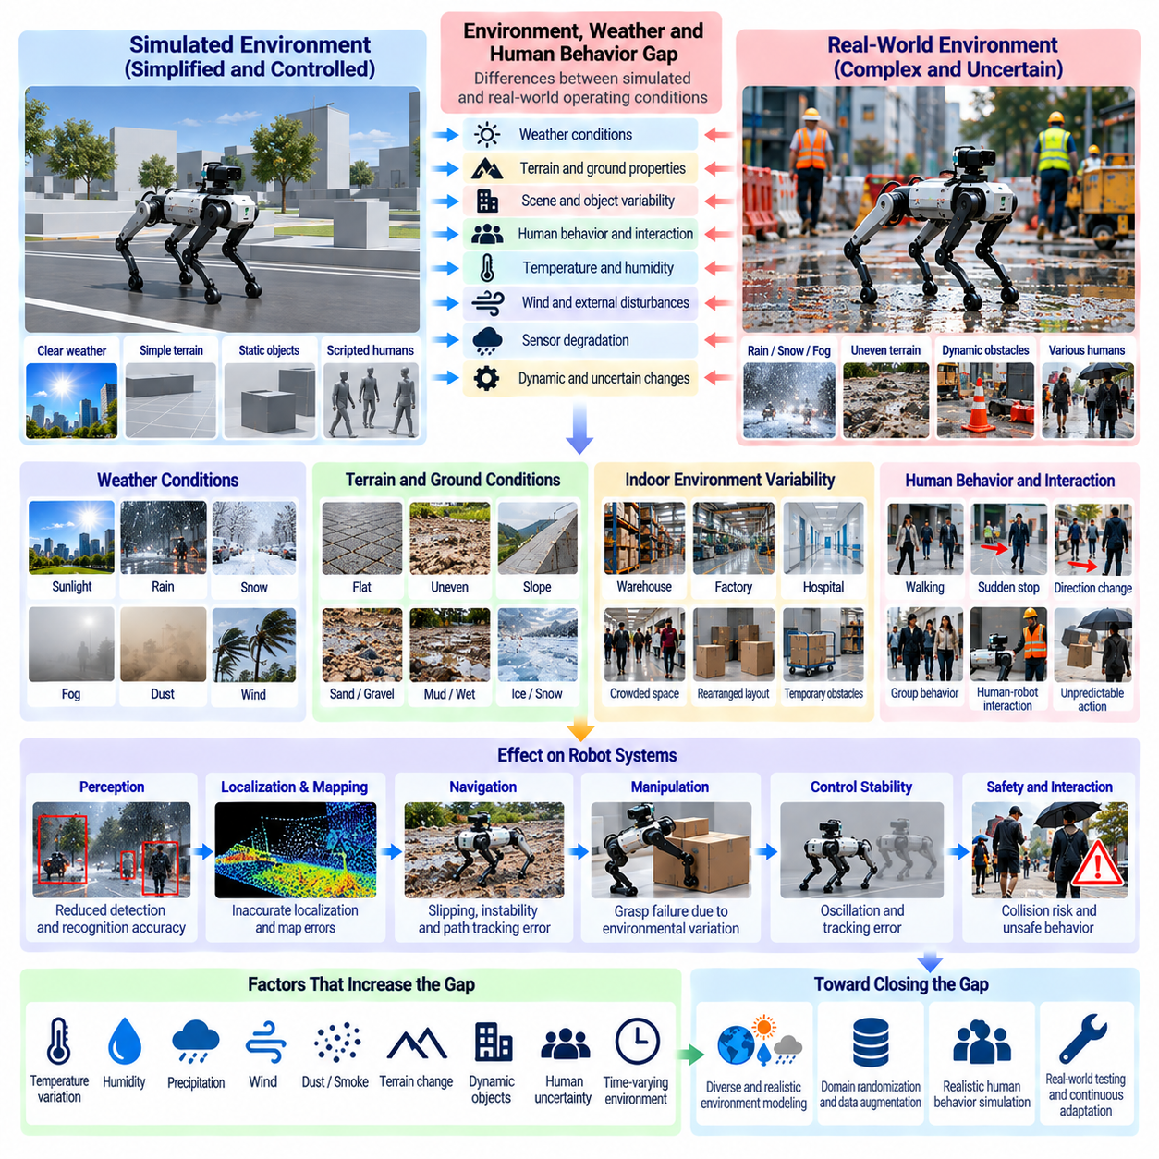
The environment, weather, and human behavior gap refers to differences between simulated operating conditions and the complex, changing circumstances encountered by physical robots. Simulation environments often represent simplified weather, predictable surroundings, and predefined human activities. Real environments contain interacting uncertainties that influence perception, mobility, manipulation, decision-making, and operational safety.
Environmental variability arises from changes in lighting, temperature, humidity, terrain, surface conditions, and surrounding objects. These factors may vary across locations, seasons, and operating periods. A robot trained in a stable simulated environment may perform poorly when environmental properties change unexpectedly. Reliable Sim2Real transfer requires exposure to conditions beyond nominal operating assumptions.
Weather introduces physical and perceptual disturbances that are difficult to reproduce completely. Rain, snow, fog, wind, and extreme temperatures influence sensor measurements and mechanical interactions. Precipitation can reduce visibility, while wind generates external forces that affect mobile and aerial robots. Simplified weather models may underestimate the combined effects of these disturbances.
Rain and moisture influence robotic operation through several mechanisms. Wet surfaces change friction and traction, while water droplets on camera lenses distort visual observations. Moisture may also affect electrical connections and exposed mechanical components. A navigation policy trained on dry surfaces may therefore experience unexpected slipping, inaccurate obstacle detection, or reduced control stability.
Snow and ice create additional challenges because they alter both environmental geometry and surface properties. Snow accumulation can obscure road markings, pathways, obstacles, and terrain boundaries. Ice reduces available traction and changes braking behavior. Simulations that represent winter conditions only through visual appearance may fail to capture the corresponding changes in contact dynamics and mobility.
Fog, dust, smoke, and airborne particles affect optical sensing and environmental interpretation. Cameras may experience reduced contrast, while LiDAR measurements can contain scattering, attenuation, and false returns. These disturbances vary with particle density, distance, and illumination. Sensor models that assume clear atmospheric conditions may produce unrealistic confidence in perception and localization.
Wind introduces dynamic disturbances that influence different robotic platforms in distinct ways. Aerial robots experience aerodynamic forces that affect attitude, position, and energy consumption. Mobile robots may encounter wind-driven debris or unstable lightweight objects. Outdoor manipulators can experience changing contact conditions. Realistic evaluation should consider wind intensity, direction, variability, and task sensitivity.
Temperature and humidity affect sensors, actuators, batteries, and mechanical components. Low temperatures may reduce battery performance and change lubricant properties, while high temperatures can trigger thermal protection. Humidity can influence condensation and material behavior. Environmental simulation should account for these dependencies when evaluating long-duration operation and performance across seasonal conditions.
Terrain and ground conditions introduce another important source of environmental discrepancy. Real surfaces contain unevenness, loose materials, slopes, potholes, and changing friction characteristics. Simplified simulation terrain may not reproduce local deformation or irregular contact. These differences influence wheel slip, legged locomotion, stability, and the energy required to complete navigation tasks.
Indoor environments also exhibit substantial variability despite being protected from weather. Warehouses, factories, hospitals, and commercial facilities contain moving equipment, temporary obstacles, changing layouts, and unpredictable activities. A robot trained in a fixed digital environment may struggle when objects are relocated or pathways become blocked. Scene diversity is therefore essential for robust deployment.
Human behavior introduces uncertainty that differs fundamentally from static environmental variation. People make decisions based on goals, attention, social conventions, and changing circumstances. Their movements are not always predictable from geometry or current velocity alone. Simulated human agents following fixed trajectories may fail to represent hesitation, sudden direction changes, or unexpected interactions.
Human motion prediction is especially important for robots operating in shared spaces. Pedestrians may stop abruptly, change walking speed, form groups, or cross a robot's intended path. Their behavior also changes in response to the robot itself. Simulation environments that treat people as passive moving obstacles may overlook these reciprocal interactions and underestimate navigation complexity.
Social navigation requires robots to consider more than collision avoidance. Appropriate behavior depends on interpersonal distance, passing conventions, right-of-way expectations, and contextual awareness. These expectations differ across locations and situations. Policies trained using simplified pedestrian models may satisfy geometric safety constraints while producing uncomfortable or socially inappropriate movements.
Human-robot collaboration introduces additional behavioral uncertainty. Workers may approach equipment unexpectedly, modify task sequences, or intervene during robotic operations. Communication may occur through speech, gestures, body posture, or implicit coordination. Simulated interactions based on predefined scripts may not capture misunderstanding, delayed responses, or variations in individual behavior.
Environmental and human uncertainties frequently interact. Rain may cause pedestrians to move faster or choose different routes, while crowded spaces can alter obstacle visibility and navigation options. Lighting changes can affect the recognition of human gestures and intentions. Evaluating these factors independently may overlook compound situations that create greater operational difficulty.
Modeling human behavior requires balancing realism, diversity, and computational efficiency. Agent-based simulation, probabilistic motion models, and learned behavioral policies can generate varied pedestrian interactions. However, these methods depend on assumptions about human decisions and social behavior. Their outputs should be evaluated against representative observations rather than treated as complete descriptions of reality.
Domain randomization can improve environmental robustness by varying weather intensity, illumination, terrain properties, obstacle placement, and human activity patterns. Training across diverse conditions reduces dependence on idealized scenarios. Nevertheless, randomization should preserve meaningful relationships between variables, such as the connection between precipitation, visibility, and surface friction.
Scenario-based testing complements randomization by examining specific operational challenges. Examples include navigating crowded corridors, crossing wet floors, avoiding wind-driven obstacles, and responding to sudden pedestrian movements. Scenarios can combine environmental disturbances with human interactions. This approach helps identify failures that may remain hidden during ordinary simulation training.
Quantifying the environment and human behavior gap requires measurements that connect simulated conditions with physical observations. Environmental metrics may include visibility, traction, temperature, and sensor reliability. Human interaction metrics can include prediction error, minimum separation distance, intervention frequency, and social compliance. Task success and safety outcomes provide essential complementary evidence.
Real-world data collection supports more representative environmental and behavioral models. Sensor recordings, weather observations, operational logs, and anonymized movement trajectories can reveal conditions missing from simulation. These datasets should cover different locations, operating periods, and activity levels. Privacy protection and appropriate data governance are particularly important when collecting human behavior information.
Digital twins can incorporate changing environmental conditions and operational activity into virtual testing environments. Updated maps, weather information, equipment states, and observed movement patterns help maintain simulation relevance. However, digital twins cannot predict every unexpected event. Their value depends on timely updates, uncertainty representation, and validation against actual operating conditions.
Ultimately, reducing the environment, weather, and human behavior gap requires diverse simulation scenarios, realistic disturbance models, adaptive perception, and safety-aware decision-making. Successful Sim2Real transfer depends on handling unfamiliar conditions rather than reproducing a single ideal environment. Robust Physical AI systems must maintain reliable behavior while responding to environmental change and unpredictable human activity.

08.09. Robot Morphology Wear and Aging Gap
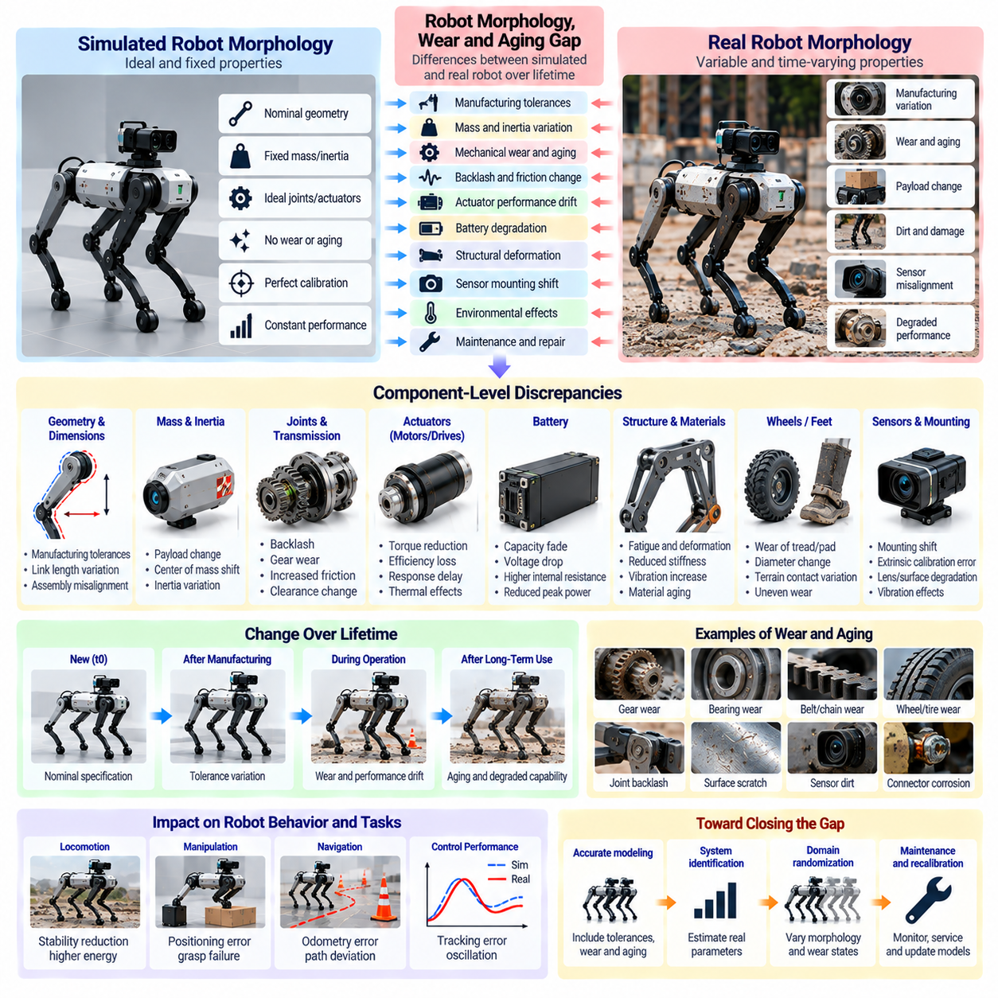
The robot morphology, wear, and aging gap refers to differences between the structural and mechanical properties assumed in simulation and those of physical robots throughout their operational lifetime. Simulated robots typically retain fixed geometry, mass distribution, joint characteristics, and actuator performance. Real systems experience manufacturing variation, mechanical wear, deformation, and material aging that gradually alter their behavior.
Robot morphology defines the physical arrangement of links, joints, actuators, sensors, and supporting structures. These characteristics determine the robot's kinematics, dynamics, reachable workspace, and interaction capabilities. Simulation models commonly represent morphology using nominal design parameters. However, manufactured robots rarely match their digital descriptions perfectly because of tolerances, assembly variation, and component differences.
Manufacturing tolerances introduce geometric discrepancies even before a robot begins operation. Link lengths, joint positions, mounting angles, and mechanical clearances may differ slightly from their intended values. These deviations can accumulate across kinematic chains, producing end-effector positioning errors. A controller calibrated to ideal geometry may therefore exhibit systematic inaccuracies when transferred to physical hardware.
Mass distribution and inertia properties also vary between simulated and real robots. Wiring, fasteners, protective covers, batteries, and manufacturing differences can shift the center of mass or alter rotational inertia. Such changes affect acceleration, balance, and required actuator torque. Their consequences become especially important in dynamic manipulation, legged locomotion, and high-speed mobile robotics.
Mechanical wear develops through repeated motion, loading, friction, and contact. Bearings, gears, belts, wheels, and joint interfaces gradually change their mechanical characteristics. Wear can increase backlash, friction variability, vibration, and positioning uncertainty. Simulation models that preserve constant mechanical parameters may become progressively less representative of robots operating over extended periods.
Backlash and mechanical clearance are particularly important in articulated robotic systems. Repeated loading can enlarge gaps between transmission components, producing delayed motion or direction-dependent positioning errors. These effects may create hysteresis and reduce control precision. Simplified rigid-joint models often fail to reproduce the resulting differences between commanded and actual movement.
Friction characteristics evolve as surfaces wear, lubrication changes, and contaminants accumulate. Static friction, dynamic friction, and velocity-dependent resistance may vary with temperature and operating history. A controller trained using fixed friction coefficients can experience unexpected tracking errors or oscillation. Realistic long-term simulation should represent plausible friction variation and parameter drift.
Actuator aging changes the relationship between commanded input and mechanical output. Electric motors may experience bearing degradation, thermal stress, or changes in electrical resistance. Gearboxes and transmission mechanisms can lose efficiency through wear. These processes may reduce torque delivery, increase energy consumption, and alter response dynamics, creating discrepancies that nominal actuator models cannot capture.
Battery aging introduces additional performance variation in mobile and autonomous robots. Repeated charging cycles, temperature exposure, and operating conditions gradually affect available capacity and internal resistance. Voltage sag under load can reduce actuator performance and available computing power. Simulations that assume constant battery characteristics may overestimate endurance, acceleration capability, and operational consistency.
Structural fatigue and deformation can alter robot morphology over time. Repeated stress cycles may produce microscopic damage, while sustained loading can cause permanent deformation in certain components. Flexible structures may also exhibit changing stiffness or damping. These effects influence vibration, positioning accuracy, and contact behavior, particularly in lightweight manipulators and compliant robotic platforms.
Wheel and tire wear significantly affect mobile robot dynamics. Changes in wheel diameter, tread condition, and material stiffness influence odometry, traction, and rolling resistance. Uneven wear across wheels may introduce systematic steering deviations. Robots using differential drive or independently steered wheel modules can therefore experience navigation errors even when their control software remains unchanged.
Legged robots face morphology-related changes involving foot materials, joint transmissions, and load-bearing structures. Foot wear modifies contact geometry and friction, while joint degradation changes motion accuracy and force transmission. Small asymmetries between limbs can influence gait stability and energy consumption. Policies trained on perfectly symmetric simulated bodies may become sensitive to these accumulated differences.
Manipulation systems experience aging effects at grippers, fingertips, and contact interfaces. Repeated grasping can change surface texture, compliance, and friction properties. Mechanical wear may also alter finger alignment and gripping force distribution. These changes affect grasp stability, object handling, and force control, especially when manipulating fragile or irregularly shaped objects.
Sensor mounting structures can change because of vibration, mechanical shock, and repeated maintenance. Small shifts in camera, LiDAR, or inertial sensor placement alter extrinsic calibration and coordinate transformations. Structural deformation can produce similar effects during loading. Consequently, morphology changes may propagate into perception and localization errors rather than remaining isolated mechanical discrepancies.
Environmental exposure accelerates certain aging processes. Temperature cycling, humidity, dust, corrosion, and chemical contamination can influence materials, connectors, seals, and mechanical interfaces. Outdoor robots and industrial platforms may experience different degradation patterns from laboratory systems. Simulation models should reflect relevant operating environments when evaluating long-term reliability and maintenance requirements.
The morphology gap also includes variation between nominally identical robot units. Two robots manufactured from the same design may exhibit different friction, alignment, actuator efficiency, and structural stiffness. A policy that performs well on one unit may require adjustment on another. Fleet-scale deployment therefore benefits from evaluating both unit-to-unit variation and changes occurring within each robot over time.
Quantifying morphology and aging discrepancies requires measurements of geometry, mass properties, joint response, friction, stiffness, and actuator performance. Useful indicators include positioning error, backlash magnitude, torque efficiency, vibration levels, and energy consumption. Repeated measurements across operating hours or duty cycles reveal trends that distinguish gradual degradation from ordinary measurement variability.
System identification can update simulation parameters using observations collected from physical robots. Joint excitation tests, load measurements, motion tracking, and actuator response analysis help estimate changing mechanical properties. These estimates can improve digital model accuracy and support controller recalibration. However, identification procedures must consider measurement uncertainty and avoid unsafe excitation of degraded hardware.
Domain randomization provides a complementary approach by exposing policies to variations in link dimensions, mass distribution, friction, joint stiffness, backlash, and actuator efficiency. Training across plausible parameter ranges can improve tolerance to manufacturing differences and aging. Randomization should remain physically consistent and avoid combinations that violate structural or operational constraints.
Morphology-aware control adapts robotic behavior to changes in physical structure and mechanical capability. Adaptive control, online parameter estimation, and robust optimization can compensate for moderate variations. In learning-based systems, policies may incorporate estimated hardware condition or recent motion history. Such adaptation can extend useful operation but cannot replace maintenance when degradation exceeds safe limits.
Predictive maintenance connects morphology monitoring with operational decision-making. Trends in vibration, temperature, motor current, positioning error, and energy consumption can indicate developing mechanical problems. Condition-based maintenance strategies use these observations to schedule inspection or component replacement. Integrating maintenance information with simulation can improve estimates of remaining performance and operational risk.
Ultimately, reducing the robot morphology, wear, and aging gap requires accurate initial modeling, periodic parameter identification, realistic degradation assumptions, and adaptive control strategies. Sim2Real transfer should account for robots as evolving physical systems rather than fixed mechanical structures. Reliable Physical AI deployment depends on maintaining performance and safety as components wear, materials age, and mechanical characteristics change.

08.10. Unmodeled Dynamics and Parameter Error
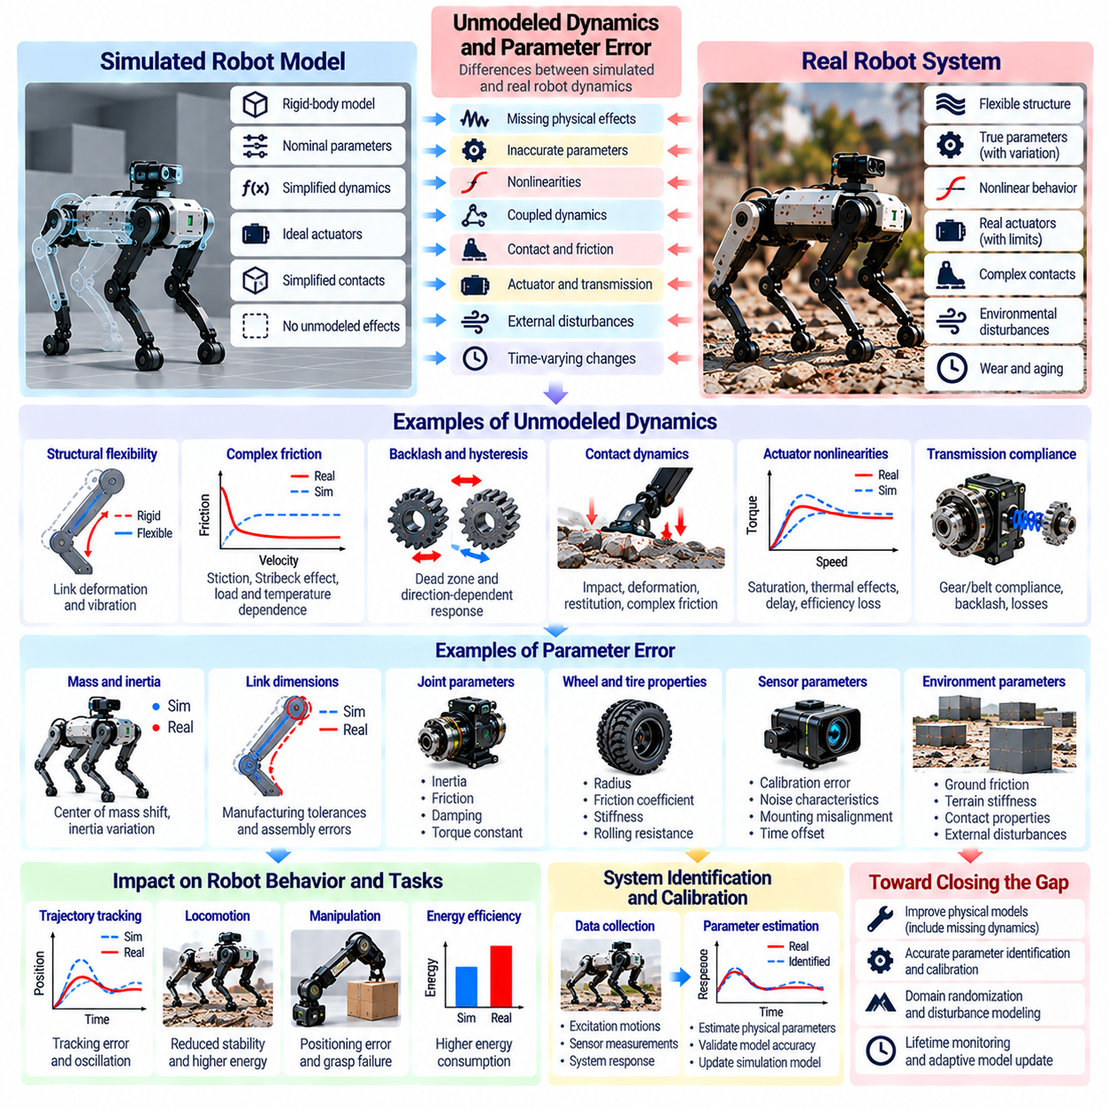
Unmodeled dynamics and parameter error represent major sources of discrepancy between simulated robots and physical systems. Simulation models approximate mechanical behavior using mathematical equations and estimated parameters, but real robots contain effects that are difficult to identify or reproduce. These discrepancies influence motion prediction, control stability, contact behavior, and the reliability of policies transferred from simulation.
Unmodeled dynamics refer to physical phenomena that are omitted or insufficiently represented in a simulation model. Examples include structural flexibility, complex friction, mechanical backlash, actuator nonlinearities, and vibration. Even when the governing equations are theoretically correct, neglected interactions can produce substantial prediction errors during rapid motion, high loading, or contact-rich manipulation.
Parameter error occurs when a simulation includes the appropriate physical mechanisms but assigns inaccurate numerical values. Mass, inertia, friction coefficients, stiffness, damping, and actuator constants may differ from their physical counterparts. Such errors can alter acceleration, energy consumption, trajectory tracking, and contact forces. Their effects depend on the robot configuration and operating conditions.
The distinction between unmodeled dynamics and parameter error is important for selecting corrective strategies. Parameter errors may be reduced through calibration and system identification, while missing physical mechanisms require changes to model structure. Adjusting numerical parameters cannot always compensate for omitted dynamics. Accurate gap analysis must therefore consider both structural and parametric uncertainty.
Rigid-body simulation is widely used because it provides computationally efficient representations of robotic motion. However, physical structures deform under loading, and flexible components store and release elastic energy. These effects can introduce oscillation, delayed responses, and unexpected contact forces. Robots with lightweight links or compliant transmissions may exhibit behavior that rigid-body models cannot adequately reproduce.
Friction is a particularly challenging source of modeling error because its behavior depends on velocity, load, temperature, lubrication, and surface condition. Simple Coulomb or viscous friction models may not capture stiction, the Stribeck effect, or hysteresis. As a result, simulated joints can move more smoothly than real joints, creating errors in low-speed positioning and force-sensitive operations.
Contact dynamics introduce additional uncertainty through impact, deformation, restitution, and frictional interactions. Numerical contact solvers approximate these phenomena using discrete time steps and simplified constraints. Real contacts may involve microscopic surface irregularities and nonlinear material behavior. Small modeling differences can significantly change grasp stability, collision responses, and legged locomotion.
Actuator models also contain uncertainties that influence system dynamics. Electric motors, hydraulic systems, and pneumatic actuators exhibit saturation, thermal effects, internal delays, and nonlinear responses. Simplified torque or force sources may ignore these characteristics. Consequently, simulated controllers can command actions that physical actuators cannot reproduce accurately or consistently.
Mechanical transmissions introduce further discrepancies through gear compliance, backlash, efficiency losses, and load-dependent friction. Belts, gearboxes, and harmonic drives may exhibit different responses during acceleration, reversal, and sustained loading. These effects influence torque transmission and positioning accuracy. Their omission can produce unrealistic assumptions about control bandwidth and mechanical responsiveness.
Parameter uncertainty can originate from manufacturing tolerances, incomplete specifications, measurement limitations, and changing operating conditions. A robot's center of mass or joint inertia may differ from design estimates because of wiring, attachments, or payload variation. Even carefully calibrated parameters may change over time. Static simulation parameters therefore cannot always represent the full range of physical behavior.
Dynamic coupling between robot components can amplify modeling discrepancies. Motion at one joint may influence other joints through inertial forces, structural deformation, or shared power limitations. Simplified models sometimes neglect weak coupling terms to improve computational efficiency. However, these neglected interactions can become significant during coordinated high-speed movement or manipulation of heavy objects.
External disturbances represent another source of prediction error. Uneven terrain, unexpected contact, vibration, airflow, and moving payloads can introduce forces absent from nominal simulation models. Disturbance rejection depends on both controller design and the accuracy of state estimation. Policies trained without realistic disturbances may become sensitive to relatively small environmental changes.
Model mismatch can accumulate over time through repeated prediction and control cycles. Small errors in acceleration or angular velocity may produce increasingly inaccurate estimates of position and orientation. In model predictive control, incorrect dynamics can cause planned trajectories to diverge from actual motion. The resulting feedback corrections may increase energy consumption, tracking error, or instability.
System identification provides a systematic approach to estimating unknown physical parameters from measured robot behavior. Controlled excitation, motion tracking, force measurement, and actuator response analysis can reveal mass properties, friction, damping, and dynamic response. However, parameter identifiability depends on the available measurements and excitation conditions. Different parameter combinations may produce similar observed behavior.
Residual dynamics modeling can complement analytical simulation by learning discrepancies between predicted and measured transitions. Neural networks or other regression models can estimate corrections for unmodeled effects. Hybrid approaches combine physical equations with learned residuals to improve prediction accuracy. Nevertheless, learned corrections require validation because they may generalize poorly beyond the training conditions.

08.11. Distribution and Feature Space Gap Metrics
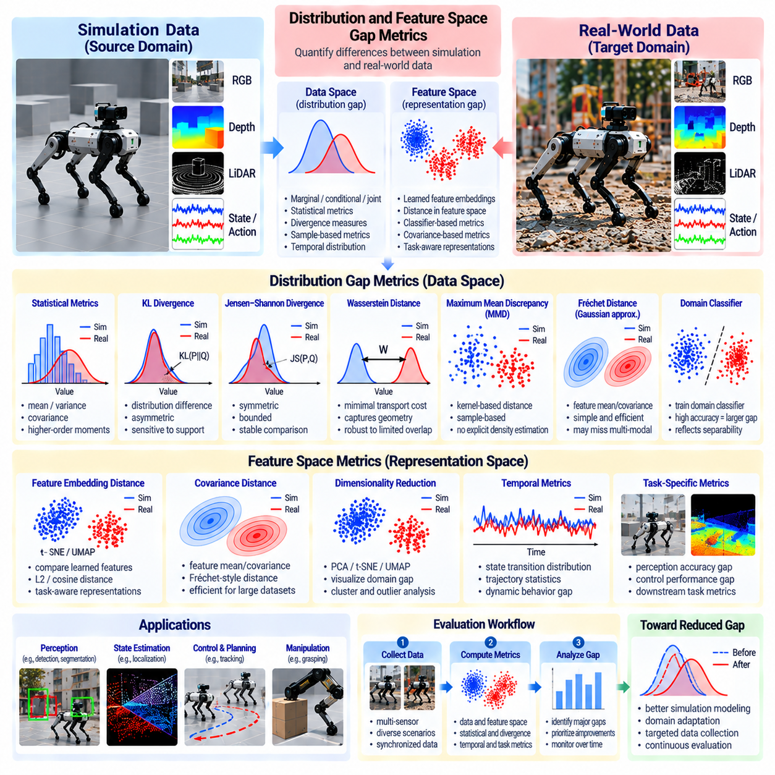
Distribution and feature space gap metrics quantify differences between simulated and real-world data used in Physical AI systems. Rather than comparing only visual appearance or physical parameters, these metrics examine how observations, states, actions, and learned representations differ statistically. Their purpose is to identify domain discrepancies, estimate transfer difficulty, and support systematic evaluation of Sim2Real performance.
The distribution gap arises when simulated and real observations follow different probability distributions. Differences may involve sensor noise, lighting, object geometry, motion patterns, contact forces, or environmental conditions. Even when individual samples appear similar, their statistical properties can differ substantially. Measuring these differences helps determine whether simulation data adequately represents the conditions encountered during deployment.
A useful distinction exists between marginal, conditional, and joint distribution gaps. Marginal differences describe changes in individual variables, while conditional differences concern relationships between observations, actions, and outcomes. Joint distribution differences capture interactions across multiple variables. Evaluating only marginal statistics may overlook important dependencies that determine robotic behavior.
Feature space metrics compare representations extracted from simulated and real observations. Features may include visual embeddings, geometric descriptors, motion estimates, tactile measurements, or latent states learned by neural networks. By transforming raw observations into meaningful representations, feature-based analysis can reveal discrepancies relevant to perception and control rather than differences caused by irrelevant appearance variations.
The choice of feature representation strongly influences gap measurement. Features trained only on synthetic data may emphasize simulation-specific patterns, while features trained on real data may contain different biases. Task-aware representations can improve relevance by emphasizing information needed for robotic decisions. However, feature extractors should be validated to ensure that measured distances reflect meaningful domain differences.
Simple statistical metrics provide an initial assessment of distribution mismatch. Differences in means, variances, covariance matrices, and higher-order moments can reveal changes in measurement characteristics. These statistics are computationally efficient and interpretable. However, they may fail to distinguish complex multimodal distributions or nonlinear relationships between observations and robot states.
Kullback–Leibler divergence measures how one probability distribution differs from another. It can quantify discrepancies between estimated simulation and real-data distributions, but it is asymmetric and may become undefined or infinite when probability support differs. Reliable estimation is difficult in high-dimensional spaces. Consequently, KL divergence requires careful density estimation and interpretation.
Jensen–Shannon divergence provides a symmetric comparison derived from Kullback–Leibler divergence. It is bounded and can be useful when comparing probability distributions with different characteristics. However, it may provide limited information about geometric distances between separated distributions. Its effectiveness depends on how distributions are represented and estimated from available samples.
Wasserstein distance measures the cost of transforming one probability distribution into another under a selected ground distance. It incorporates geometric relationships between samples and can remain informative when distributions have limited overlap. In robotics, it can compare state distributions, trajectories, or feature embeddings. Computational cost and feature scaling must be considered when applying it.
Maximum Mean Discrepancy compares distributions through differences in their representations within a reproducing kernel Hilbert space. It can be estimated directly from samples without explicitly fitting probability density functions. Kernel selection determines which discrepancies are emphasized. MMD is useful for evaluating domain adaptation, representation alignment, and differences between synthetic and physical sensor observations.
Feature distribution comparison can also use covariance-based distances and Gaussian approximations. Fréchet-style distances summarize differences in feature means and covariance structures. These approaches are convenient for comparing large observation datasets, particularly image embeddings. However, Gaussian assumptions may conceal multimodal behavior, rare events, and discrepancies in task-critical regions.
Domain classifiers provide an alternative method for estimating distribution separability. A classifier is trained to distinguish simulated samples from real samples using selected features. High discrimination accuracy suggests detectable domain differences, while performance near chance may indicate limited separability. Nevertheless, classifier capacity, data leakage, and sampling imbalance can distort conclusions.
Dimensionality reduction methods help visualize distribution differences in complex feature spaces. Principal component analysis, t-SNE, and UMAP can project high-dimensional observations into lower-dimensional representations. These visualizations may reveal clusters, outliers, and domain separation. However, projection distortions mean that visual overlap alone cannot establish statistical equivalence or transfer readiness.
Temporal distribution metrics are particularly important for robotic systems because observations form sequences rather than independent samples. Two domains may have similar individual states but different transition probabilities, motion correlations, or action-response delays. Comparing trajectories, temporal features, and state transitions can reveal discrepancies that static observation metrics fail to detect.
Task-conditioned gap analysis evaluates differences within specific operating situations. A navigation system may require separate comparisons for open corridors, crowded intersections, and obstacle avoidance. Manipulation tasks may distinguish free motion, initial contact, and sustained grasping. Conditioning measurements on task phases helps identify discrepancies that are diluted by aggregate statistics.
Rare-event distributions deserve special attention because safety-critical failures may occur outside common operating conditions. Collisions, sensor dropouts, unstable contacts, and unexpected human movements can be underrepresented in both simulation and real datasets. Tail-sensitive metrics and scenario-specific evaluation help identify these gaps. Average distribution similarity does not guarantee adequate coverage of hazardous events.
Dataset quality directly affects the validity of gap measurements. Simulation and real datasets should use consistent sensor definitions, coordinate frames, units, timestamps, and preprocessing procedures. Differences caused by data handling can be mistaken for physical domain discrepancies. Representative sampling and transparent dataset documentation are therefore essential for meaningful comparison.
Statistical confidence is necessary when interpreting estimated distribution distances. Finite datasets introduce sampling uncertainty, especially in high-dimensional feature spaces. Bootstrap analysis, confidence intervals, and repeated experiments can help distinguish genuine domain gaps from estimation variability. Comparisons should also account for unequal sample sizes and dependencies between observations.
Distribution metrics should be connected to downstream robotic performance. A large feature distance does not necessarily imply poor task execution, while a small average distance may conceal important control failures. Correlating gap measurements with success rate, tracking error, safety violations, and recovery performance helps establish practical relevance. Task performance remains essential for validating metric usefulness.
Domain adaptation and simulation refinement can use gap metrics as optimization signals. Parameters controlling rendering, sensor noise, friction, and environmental variability may be adjusted to reduce measured discrepancies. Feature alignment methods can also encourage shared representations across domains. However, minimizing a statistical distance alone may produce misleading improvements if task-relevant dynamics remain inaccurate.
A comprehensive gap evaluation combines complementary metrics rather than relying on a single numerical score. Statistical distances, feature separability, temporal consistency, scenario coverage, and task-level outcomes describe different aspects of Sim2Real discrepancy. The resulting evaluation framework should support diagnosis, comparison, and prioritization while preserving uncertainty about unobserved operating conditions.
Ultimately, distribution and feature space gap metrics provide a quantitative foundation for understanding simulation-to-reality differences. Their value depends on representative data, appropriate feature selection, statistically sound estimation, and demonstrated relationships with robotic behavior. Effective Physical AI evaluation uses these metrics to guide simulation improvement while recognizing that statistical similarity alone cannot guarantee successful real-world transfer.

08.12. Behavior and Task Performance Gap
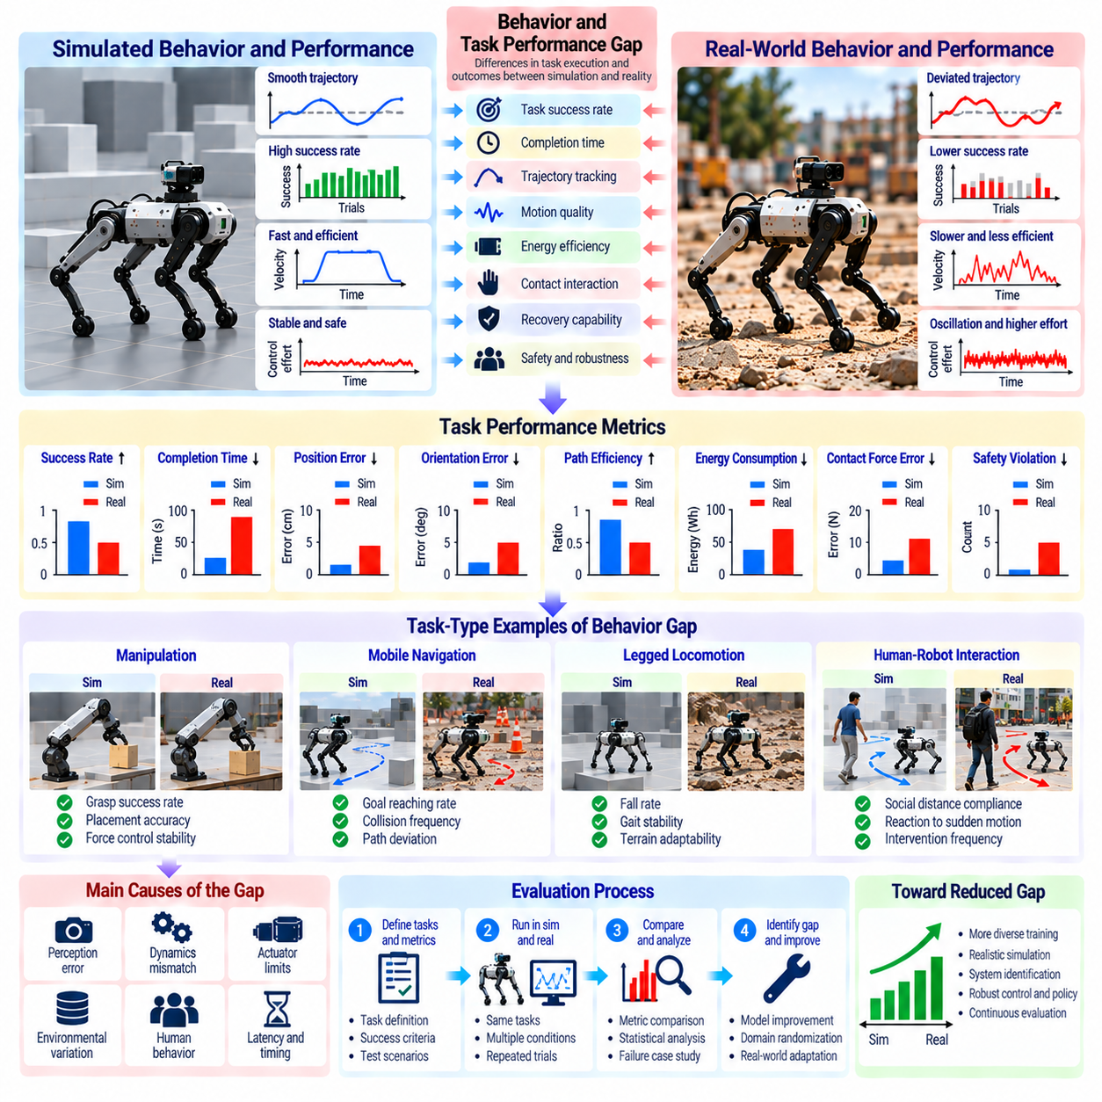
The behavior and task performance gap describes differences between how robots execute actions in simulation and how they perform equivalent tasks in physical environments. While sensor and dynamics gaps explain individual sources of mismatch, behavioral gaps reveal their combined consequences. These differences affect task success, motion quality, operational efficiency, recovery capability, and safety during real-world deployment.
Behavioral discrepancies emerge when identical policies produce different action sequences or outcomes across simulated and real environments. A robot may follow a smooth trajectory in simulation but hesitate, oscillate, or deviate when operating physically. Such differences can arise from perception errors, inaccurate dynamics, actuator limitations, or delayed feedback. Their combined effects are often more important than any isolated modeling error.
Task performance gaps quantify differences in measurable outcomes rather than internal system representations. Common indicators include task success rate, completion time, positioning accuracy, energy consumption, and intervention frequency. These metrics provide practical evidence of whether a simulation-trained policy transfers successfully. However, their interpretation requires consistent task definitions and comparable operating conditions.
Task success rate is a fundamental measure of Sim2Real effectiveness. It represents the proportion of attempts that satisfy predefined completion criteria. A manipulation task may require stable object placement, while navigation may require reaching a destination without collision. Comparing success rates across domains reveals deployment limitations, but binary outcomes alone cannot explain the causes of failure.
Completion time provides another perspective on behavioral differences. Physical robots may execute tasks more slowly because of conservative safety constraints, actuator saturation, uncertain perception, or repeated corrections. Simulation policies may exploit unrealistically fast responses or idealized motion. Comparing task duration distributions helps distinguish consistent slowdowns from occasional delays caused by difficult scenarios.
Trajectory tracking metrics evaluate differences between desired and executed motion. Position error, orientation error, velocity deviation, and path smoothness describe how accurately robots follow planned trajectories. Simulated tracking performance may deteriorate when real friction, backlash, or control latency becomes significant. Temporal alignment is necessary to distinguish genuine tracking errors from timing differences.
Motion quality includes characteristics that conventional success metrics may overlook. Excessive vibration, abrupt acceleration, unstable contact, and repeated corrective movements can indicate poor transfer even when tasks are completed. These behaviors may increase mechanical wear, reduce user confidence, or create safety concerns. Evaluating smoothness, stability, and control effort provides a more complete assessment.
Energy efficiency is an important indicator of behavioral transfer quality. A policy may achieve similar task success in both domains while consuming substantially more electrical or mechanical energy on real hardware. Differences can result from friction, actuator efficiency, trajectory corrections, or inaccurate payload models. Energy measurements should account for task duration, operating mode, and comparable workloads.
Contact-rich manipulation exposes behavioral gaps that are difficult to detect through free-space motion tests. Grasping, insertion, pushing, and assembly depend on precise force regulation and contact transitions. Small errors in friction, compliance, or object geometry can produce slipping, jamming, or excessive force. Evaluation should therefore examine contact stability, force profiles, and successful completion of interaction phases.
Mobile robot navigation introduces performance gaps associated with localization, obstacle avoidance, and motion planning. A robot that navigates efficiently in simulation may experience path deviations, unnecessary stops, or collisions in real facilities. Sensor uncertainty, dynamic obstacles, and wheel-ground interactions contribute to these differences. Relevant metrics include route completion, collision frequency, path efficiency, and localization accuracy.
Legged locomotion presents additional challenges because stability depends on continuous interaction between the robot and the ground. Simulated walking policies may achieve high speed or low energy consumption but fail on real terrain because of contact uncertainty and actuator limitations. Performance evaluation should consider falls, gait stability, terrain adaptability, recovery success, and the frequency of safety interventions.
Recovery behavior is particularly important when robots encounter unexpected conditions. A simulation-trained policy may perform well during nominal execution but fail to recover from slips, grasp failures, localization loss, or temporary obstructions. Recovery success rate, recovery time, and intervention requirements provide valuable measures of robustness. These metrics distinguish reliable autonomy from performance limited to ideal conditions.
Behavioral robustness should be evaluated across diverse operating scenarios rather than a single standardized test. Variations in lighting, payload, surface friction, obstacle density, and task complexity may reveal weaknesses hidden by average performance. Scenario-conditioned evaluation helps identify where transfer succeeds and where it deteriorates. Performance distributions are often more informative than isolated mean values.
Safety-related behavior requires separate evaluation because successful task completion does not guarantee safe execution. Excessive contact forces, near collisions, unstable movements, and violations of operational boundaries may occur without immediate task failure. Safety metrics should capture both actual incidents and precursor conditions. Real-world testing must also respect hardware limits and human safety requirements.
The performance gap can be expressed through differences in expected task reward, success probability, or operational cost between simulation and reality. However, reward functions may combine several objectives and obscure specific failure mechanisms. Decomposing performance into accuracy, efficiency, stability, and safety improves interpretability. Consistent normalization is necessary when comparing heterogeneous tasks or robot platforms.
Statistical evaluation is essential because robotic outcomes vary across trials. Repeated experiments, confidence intervals, and matched scenario comparisons help determine whether observed performance differences are meaningful. Small datasets may exaggerate apparent success or failure, especially when rare events dominate risk. Evaluation protocols should document environmental conditions, hardware configuration, and policy versions.
Behavioral gap analysis should connect observed failures to underlying simulation discrepancies. Excessive trajectory error may indicate actuator mismatch, while grasp instability may suggest inaccurate contact modeling. Repeated navigation corrections may reveal perception or localization problems. Combining behavioral metrics with sensor logs, control signals, and physical measurements supports systematic error attribution.
Closed-loop evaluation is necessary because robotic policies continuously influence the observations they receive. Small initial discrepancies can alter subsequent actions, producing different trajectories and environmental interactions. Open-loop prediction accuracy alone cannot establish behavioral equivalence. Evaluating complete perception-action cycles reveals how errors accumulate, propagate, or are corrected during autonomous operation.
Simulation refinement can use behavioral performance differences to prioritize modeling improvements. If navigation failures arise primarily from wheel slip, improving terrain friction models may provide greater benefit than increasing visual realism. If manipulation failures involve contact transitions, detailed compliance and force modeling may be more valuable. Task-driven refinement focuses computational resources on discrepancies that affect outcomes.
Ultimately, the behavior and task performance gap represents the operational significance of Sim2Real mismatch. Reliable Physical AI systems require evaluation that extends beyond visual similarity, parameter accuracy, or isolated motion tests. By combining task success, trajectory quality, efficiency, robustness, recovery, and safety measurements, developers can determine whether simulated capabilities translate into dependable real-world behavior.

08.13. Sensitivity Analysis and Error Attribution
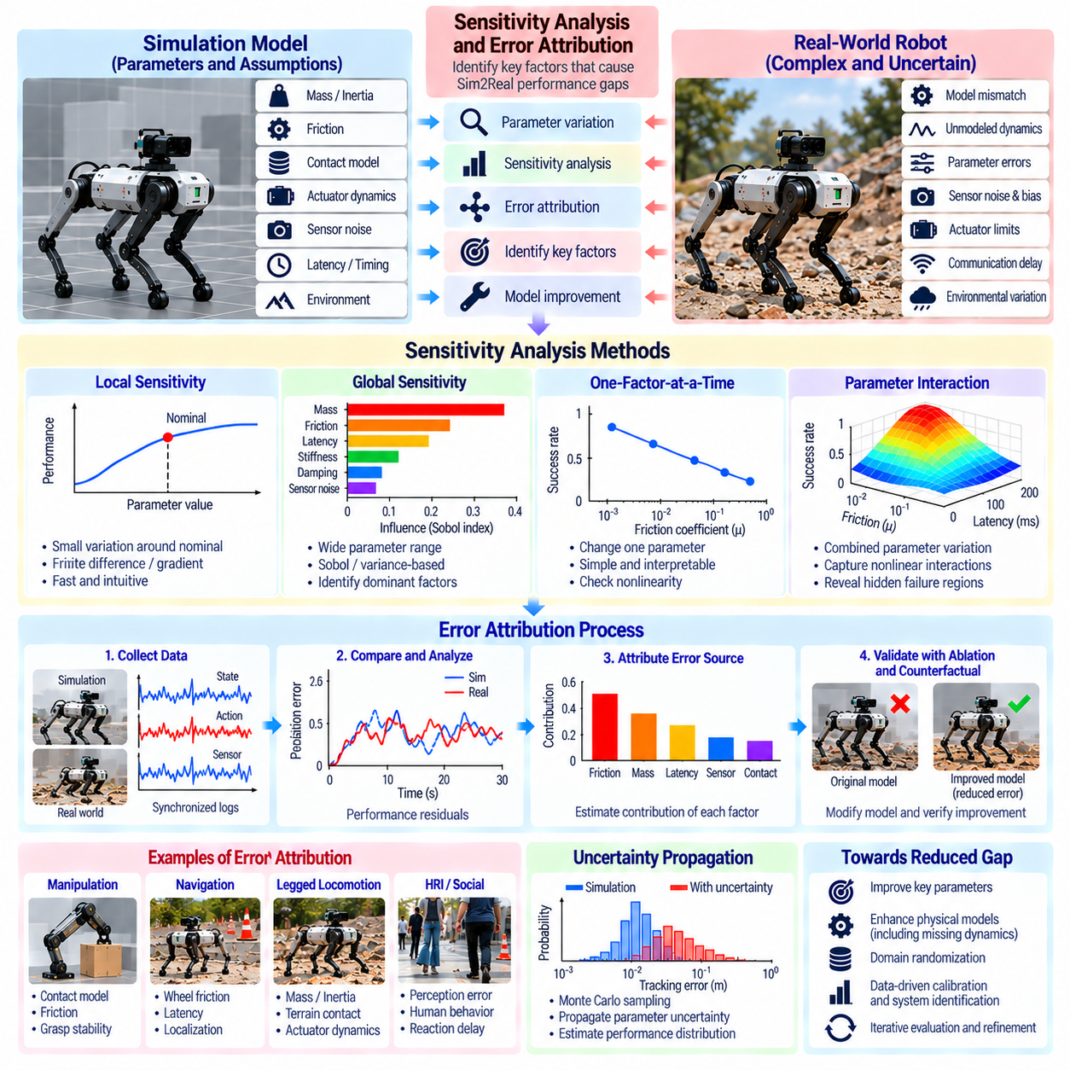
Sensitivity analysis and error attribution are essential methods for identifying which simulation discrepancies most strongly influence real-world robotic performance. Sim2Real gaps often arise from interacting errors in perception, dynamics, control, and environmental modeling. Rather than treating all discrepancies equally, these methods quantify their influence on task outcomes and help prioritize improvements that deliver measurable operational benefits.
Sensitivity analysis examines how changes in model parameters or operating conditions affect robotic behavior. Parameters may include mass, inertia, friction, actuator delay, sensor noise, contact stiffness, and communication latency. By systematically varying these quantities, developers can identify which uncertainties produce the largest changes in performance. This process distinguishes influential parameters from those with relatively minor effects.
Local sensitivity analysis evaluates the response of a system to small changes around a nominal operating point. Finite differences or analytical derivatives can estimate how performance metrics change with individual parameters. This approach is computationally efficient and useful for calibration. However, local sensitivities may not represent behavior under large disturbances, nonlinear transitions, or operating conditions far from the nominal configuration.
Global sensitivity analysis evaluates parameter influence across broader ranges of uncertainty. Methods such as variance-based decomposition, Sobol indices, and Morris screening can identify dominant parameters and interactions. These approaches are particularly useful when robotic behavior is nonlinear or highly dependent on operating conditions. Their main limitation is the computational expense of evaluating many simulation configurations.
One-factor-at-a-time analysis varies a single parameter while keeping others fixed. It provides an intuitive way to examine how friction, payload mass, or actuator response influences task performance. However, robotic systems frequently contain coupled uncertainties, and changing one parameter independently may conceal important interactions. Consequently, single-factor experiments should be complemented by methods that evaluate combined parameter variation.
Parameter interactions can produce performance degradation that is not predictable from individual sensitivities. Moderate sensor latency may be acceptable under nominal friction, but the same latency combined with wheel slip can destabilize navigation. Similarly, small geometric errors and contact stiffness mismatch may jointly cause manipulation failures. Interaction analysis reveals these compounded effects and supports more realistic simulation refinement.
Error attribution seeks to determine which underlying discrepancies explain observed differences between simulated and real robot behavior. A navigation failure may involve localization drift, inaccurate wheel dynamics, delayed obstacle detection, or control saturation. Identifying the dominant contributor requires more than observing the final outcome. Relevant evidence includes synchronized sensor measurements, actuator commands, state estimates, and environmental conditions.
A structured attribution process begins by defining measurable performance residuals. These residuals may represent differences in position, velocity, contact force, task duration, or energy consumption. Comparing simulated predictions with physical measurements reveals when and where discrepancies emerge. Residual patterns can suggest particular mechanisms, although similar patterns may result from multiple underlying causes.
Temporal error analysis examines how discrepancies develop during robotic operation. An error that appears immediately after contact may indicate inaccurate collision or compliance modeling, while gradual trajectory drift may suggest friction or odometry mismatch. Delayed oscillations may indicate actuator dynamics or control latency. Aligning simulation and real-world timelines is essential for interpreting these patterns correctly.
Spatial error analysis identifies where discrepancies occur within a robot's workspace or operating environment. Positioning errors may increase near joint limits, while navigation failures may cluster on slippery surfaces or narrow passages. Mapping errors against configuration, location, and environmental conditions helps expose systematic weaknesses. Such patterns can guide targeted calibration and scenario-specific model improvements.
Ablation experiments isolate the contribution of selected model components by removing, replacing, or modifying them. Developers may compare rigid and compliant contact models, ideal and realistic sensor noise, or simplified and detailed actuator dynamics. Changes in performance indicate whether additional modeling complexity is beneficial. However, ablation results depend on experimental controls and may not establish unique causal explanations.
Counterfactual simulation explores how observed failures might change if specific model discrepancies were corrected. For example, a recorded navigation failure can be replayed with improved wheel friction estimates while other conditions remain fixed. If performance improves consistently, friction mismatch becomes a stronger explanatory candidate. Counterfactual conclusions nevertheless depend on the fidelity of the replay environment.
Uncertainty propagation connects parameter variation to uncertainty in predicted robotic outcomes. Monte Carlo sampling, polynomial chaos expansion, and surrogate modeling can estimate distributions of tracking error, contact force, or task success. These techniques reveal whether small parameter uncertainties produce large operational risks. They also support confidence bounds for simulated performance predictions under uncertain conditions.
Sensitivity estimates can be misleading when parameters are correlated or poorly identifiable. Friction and actuator efficiency may produce similar effects on motion, while sensor bias and geometric misalignment can create comparable positioning errors. Without sufficiently informative experiments, attributing discrepancies to one parameter may be unreliable. Identifiability analysis and carefully designed excitation tests help reduce this ambiguity.
Ultimately, sensitivity analysis and error attribution transform Sim2Real evaluation from descriptive comparison into systematic diagnosis. Their effectiveness depends on representative scenarios, reliable measurements, controlled experiments, and explicit treatment of uncertainty. By identifying dominant error sources and their interactions, developers can prioritize simulation updates, calibration procedures, and controller improvements that most effectively enhance real-world reliability.

08.14. System Identification for Gap Reduction
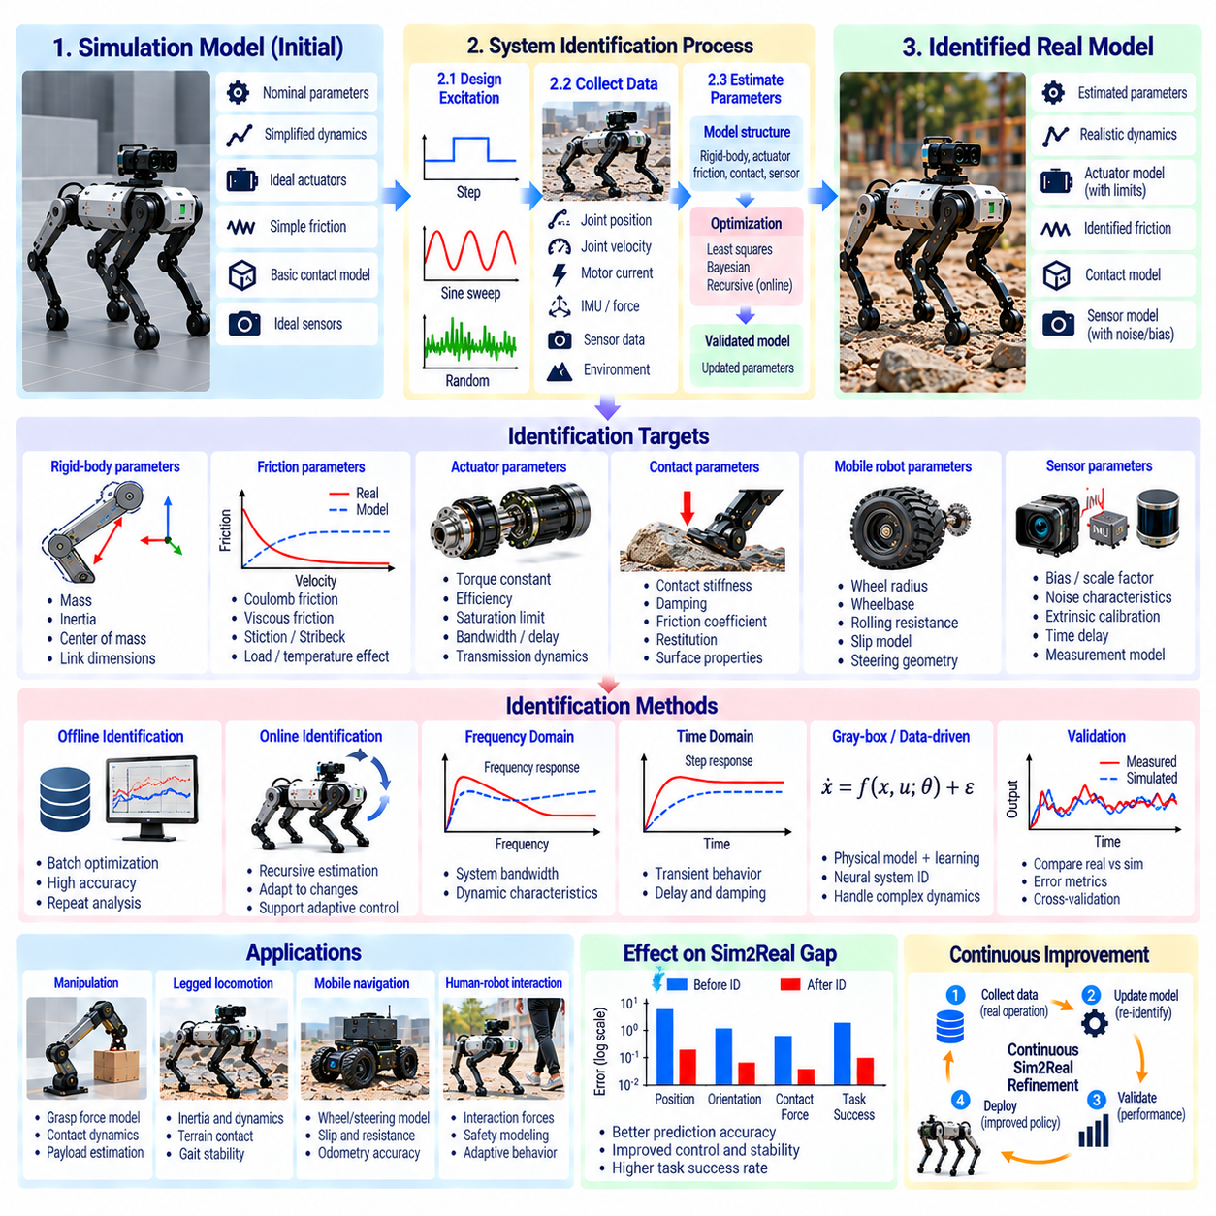
System identification is a fundamental method for reducing the Sim2Real gap by estimating the physical parameters and dynamic characteristics of real robotic systems. Simulation models frequently rely on nominal specifications that differ from actual hardware behavior. By collecting measurements and fitting mathematical models to observed responses, system identification improves simulation fidelity, control accuracy, and the reliability of policies transferred to physical robots.
The identification process begins by defining a model structure that represents relevant robot dynamics. This structure may include rigid-body motion, actuator behavior, friction, contact interactions, and sensor characteristics. Unknown parameters are then estimated from experimental observations. Model selection must balance physical realism with computational efficiency, since excessive complexity can make parameters difficult to identify reliably.
Parameter identification focuses on quantities such as mass, inertia, joint friction, damping, stiffness, actuator gain, and response delay. These values influence acceleration, trajectory tracking, energy consumption, and contact forces. Even small inaccuracies can produce significant behavioral differences during dynamic tasks. Accurate estimation therefore provides a practical foundation for reducing simulation prediction errors.
Experimental excitation is necessary to reveal how physical systems respond under different conditions. Joint movements, velocity sweeps, controlled accelerations, and load variations can expose important dynamic properties. Excitation signals should cover the operating range relevant to deployment. However, aggressive experiments must be avoided when they could exceed actuator limits, destabilize the robot, or damage mechanical components.
Data collection quality strongly influences identification accuracy. Joint positions, velocities, motor currents, forces, temperatures, and control commands should be recorded with consistent timestamps. Sensor calibration and synchronization are essential because measurement bias or timing errors can be mistaken for dynamic effects. Reliable identification requires representative datasets containing both transient responses and steady-state behavior.
Offline system identification estimates model parameters using previously recorded experimental data. Optimization algorithms minimize differences between measured trajectories and model predictions. This approach supports computationally intensive analysis and repeated validation without exposing hardware to additional risk. However, offline estimates may become inaccurate when operating conditions, payloads, or mechanical properties change.
Online system identification continuously updates parameter estimates during robot operation. Recursive least squares, adaptive observers, and Bayesian estimation can track changes in friction, actuator efficiency, or payload characteristics. These methods support adaptive control and evolving digital twins. Their implementation must prevent noisy measurements or temporary disturbances from causing unstable parameter updates.
Structural identifiability determines whether unknown parameters can theoretically be distinguished from available measurements. Practical identifiability considers whether finite, noisy observations provide enough information for reliable estimation. Different combinations of inertia, friction, and actuator gain may generate similar motion responses. Carefully designed experiments are therefore necessary to separate correlated parameter effects.
Rigid-body parameter identification commonly estimates link masses, centers of mass, and inertia tensors. These quantities influence the relationship between joint torque and acceleration. Measurements collected across multiple configurations help reveal their combined effects. Some parameters are identifiable only through specific combinations, so physically plausible constraints and independent measurements may be needed.
Friction identification is challenging because friction depends on velocity, load, temperature, and operating history. Coulomb friction, viscous friction, stiction, and Stribeck behavior may require different model components. Low-speed experiments and direction reversals are particularly informative. A friction model calibrated under one temperature or load condition may not remain accurate across the full operating range.
Actuator identification characterizes how electrical or hydraulic commands produce mechanical motion and force. Relevant parameters include motor constants, transmission efficiency, saturation limits, bandwidth, and internal delays. Step responses, frequency sweeps, and controlled load tests can reveal these properties. Accurate actuator models prevent simulation policies from relying on unrealistic torque delivery or instantaneous responses.
Contact parameter identification estimates friction, compliance, damping, restitution, and surface interaction characteristics. Controlled pushing, indentation, grasping, and impact experiments provide useful observations. Contact models must account for material properties and operating conditions. Because contact behavior is nonlinear and sometimes discontinuous, parameter estimates may vary considerably between experimental scenarios.
Mobile robot identification includes wheel radius, wheelbase, steering geometry, rolling resistance, and slip characteristics. Encoder measurements, inertial sensors, and external position references can reveal systematic motion errors. Experiments should include straight motion, turning, acceleration, and different surface conditions. Identified parameters improve odometry, trajectory prediction, and navigation performance.
Sensor system identification addresses measurement bias, noise, scale factors, timing offsets, and extrinsic calibration. Camera, LiDAR, IMU, and wheel encoder errors can distort estimated robot states even when mechanical dynamics are accurately modeled. Calibration experiments and reference measurements help separate sensor errors from physical parameter mismatch. Accurate sensing models are essential for meaningful simulation comparison.
Optimization-based identification minimizes a loss function describing disagreement between predicted and observed behavior. Least squares, maximum likelihood, and gradient-based optimization are common approaches. The objective may combine position, velocity, force, and energy errors with appropriate weighting. Regularization and physical constraints help prevent implausible estimates that fit experimental noise rather than actual dynamics.
Bayesian system identification represents unknown parameters using probability distributions instead of single fixed estimates. Prior knowledge from specifications or previous experiments can be combined with new observations. Posterior distributions quantify uncertainty and reveal ambiguous parameters. This approach is valuable when limited data, noisy measurements, or changing environments prevent precise identification.
Validation must use experiments that are independent of the data employed for parameter estimation. Identified models should predict trajectories, forces, and task outcomes across different loads, speeds, and operating scenarios. A model that fits calibration data closely may still generalize poorly. Cross-condition testing and residual analysis help determine whether the identified dynamics capture meaningful physical behavior.
Simulation parameter updates should follow a controlled and traceable workflow. Estimated values, uncertainty ranges, hardware configurations, and calibration dates should be recorded with model versions. Automated regression tests can detect performance degradation after updates. This process supports reproducibility and prevents improvements in one operating condition from introducing failures elsewhere.
System identification can be combined with domain randomization to address residual uncertainty. Identified parameters define realistic central values, while confidence intervals guide plausible variation ranges. Policies trained across these ranges may tolerate unit-to-unit differences and gradual hardware changes. This combination improves robustness without requiring the simulation to reproduce every physical detail perfectly.
Ultimately, system identification reduces the Sim2Real gap by replacing uncertain assumptions with experimentally supported models. Its effectiveness depends on informative excitation, reliable measurements, identifiable parameters, independent validation, and continuous model maintenance. Integrated with simulation refinement and adaptive control, it enables Physical AI systems to achieve more predictable, robust, and reliable behavior in real environments.

08.15. Zero Shot and Few Shot Sim2Real Evaluation
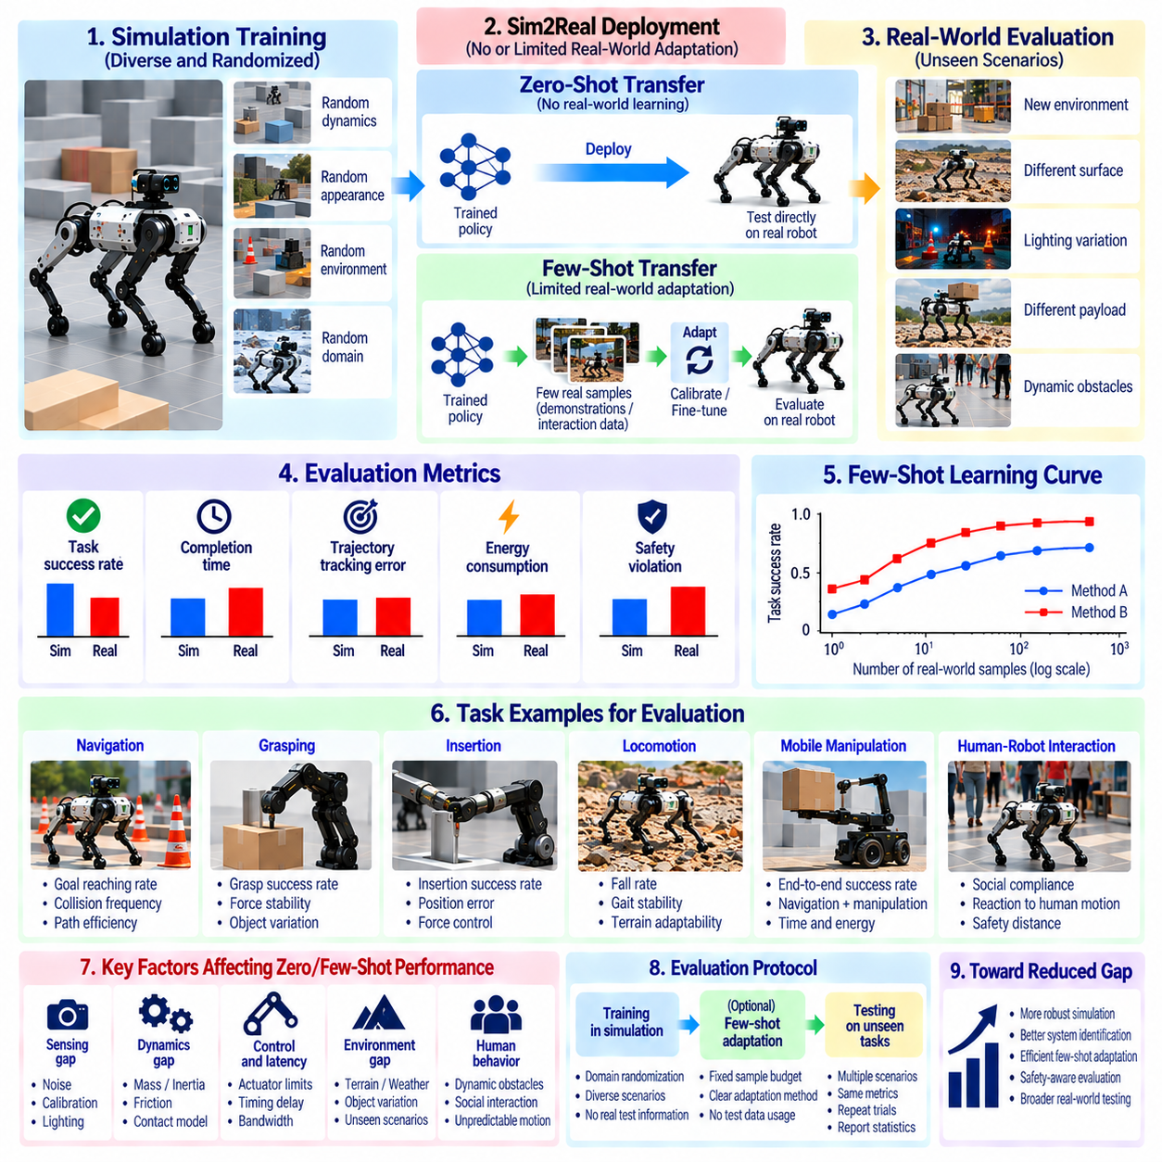
Zero-shot and few-shot Sim2Real evaluation examines how effectively robotic policies transfer from simulation to physical environments with no adaptation or only limited real-world experience. These evaluation methods measure generalization beyond simulated training conditions. They are essential for determining whether Physical AI systems can achieve reliable performance without extensive hardware-specific retraining, calibration, or data collection.
Zero-shot Sim2Real transfer occurs when a policy trained entirely in simulation is deployed on a physical robot without additional learning from real-world task data. The policy must handle differences in sensing, dynamics, contact behavior, and environmental conditions. Successful zero-shot transfer indicates that simulation training has produced sufficiently robust behavior. However, success in a limited demonstration does not establish broad operational reliability.
Few-shot Sim2Real transfer allows a small amount of real-world experience to improve a simulation-trained policy. Adaptation may involve collecting a limited number of trajectories, demonstrations, or interaction episodes. These observations can support parameter calibration, policy fine-tuning, or representation alignment. The objective is to achieve meaningful performance improvements while minimizing physical experiments, operational disruption, and hardware risk.
The distinction between zero-shot and few-shot evaluation depends on the adaptation protocol. Zero-shot testing prohibits task-specific policy updates using real-world evaluation data, although predefined safety checks may still be necessary. Few-shot testing permits a specified adaptation budget before final evaluation. Both settings require clear documentation of what information was available to the system and when it was used.
Evaluation protocols should separate simulation training, real-world adaptation, and final testing into distinct stages. Training data must not contain information derived from held-out physical test scenarios. Few-shot adaptation datasets should be fixed before final performance measurement. This separation reduces data leakage and prevents evaluation results from overstating the generalization capabilities of the transferred policy.
Task selection strongly influences the interpretation of Sim2Real evaluation. Navigation, grasping, insertion, locomotion, and mobile manipulation involve different physical uncertainties. A policy may transfer successfully during free-space movement but fail when contact forces become important. Evaluation suites should therefore include tasks with varying dynamics, perception requirements, environmental complexity, and interaction intensity.
Zero-shot performance is commonly measured using task success rate, completion time, trajectory tracking error, energy consumption, and safety violations. These indicators reveal whether simulated capabilities remain effective on physical hardware. Performance should be compared against simulation results under equivalent task conditions. Absolute success alone is insufficient when the simulated baseline or task difficulty differs substantially.
Few-shot evaluation additionally measures how performance changes as real-world adaptation data increases. Learning curves can relate task success or control accuracy to the number of physical trials, demonstrations, or collected transitions. This reveals sample efficiency and the practical cost of adaptation. A method that improves rapidly with limited experience may be preferable to one requiring extensive physical interaction.
Adaptation budgets must be defined consistently across competing methods. A fixed number of trajectories may represent very different amounts of experience when episode durations vary. Evaluation can therefore report interaction time, number of transitions, hardware operating hours, and human supervision requirements. Computational resources used for fine-tuning should also be documented to support fair comparisons.
Few-shot adaptation may update different components of the robotic system. Some methods adjust simulation parameters or actuator calibration while preserving the original policy. Others fine-tune neural network weights, adapt perception features, or learn residual dynamics models. These strategies have different computational and operational costs. Evaluation should identify which components were modified and how adaptation affected safety.
Domain randomization is a common preparation strategy for zero-shot transfer. During simulation training, physical parameters, sensor characteristics, lighting, and environmental conditions are varied across plausible ranges. This encourages policies to tolerate uncertainty rather than depend on a single idealized model. Evaluation must nevertheless determine whether robustness extends beyond the randomized conditions encountered during training.
System identification can support few-shot transfer by estimating physical parameters from limited robot observations. Short excitation experiments may reveal friction, actuator response, payload characteristics, or sensor offsets. These estimates can update simulation models or controller parameters before deployment. However, identification accuracy depends on whether the limited observations sufficiently excite the relevant system dynamics.
Robustness evaluation should include operating conditions that differ from both simulation training and few-shot adaptation datasets. Changes in payload, surface friction, lighting, object geometry, or obstacle behavior can reveal overfitting to limited real-world experience. Testing across multiple scenarios helps distinguish genuine adaptation from improvements restricted to a narrow calibration environment.
Safety constraints are particularly important during zero-shot and few-shot experiments because initial physical performance may be uncertain. Speed limits, force thresholds, emergency stopping, and supervised operating regions can reduce experimental risk. Safety interventions should be recorded as evaluation outcomes rather than ignored. A policy requiring frequent human intervention cannot be considered fully autonomous merely because tasks eventually succeed.
Statistical reliability requires repeated trials across tasks, environments, and robot units. Success rates from a small number of demonstrations can be misleading, especially when outcomes depend on random initial conditions. Confidence intervals and repeated adaptation runs help quantify uncertainty. Evaluation should distinguish variation caused by policy initialization, environmental conditions, and limited adaptation samples.
Negative transfer occurs when adaptation using limited real-world data reduces performance instead of improving it. Overfitting, noisy observations, incorrect parameter updates, or catastrophic forgetting can degrade previously successful behaviors. Few-shot evaluation should therefore compare performance before and after adaptation across both familiar and unseen scenarios. Improvement on adaptation tasks alone does not establish successful transfer.
The relationship between adaptation efficiency and operational cost is central to practical deployment. Physical experiments consume time, energy, equipment lifetime, and engineering supervision. Few-shot methods should be assessed not only by final task performance but also by the resources required to reach that performance. Efficient adaptation reduces commissioning effort and supports deployment across multiple robot configurations.
Cross-platform evaluation examines whether policies transfer across nominally identical robots or different hardware variants. Manufacturing tolerances, actuator differences, sensor placement, and mechanical wear can create distinct physical domains. Zero-shot testing measures immediate portability, while few-shot testing measures how efficiently each platform can be calibrated. These evaluations are valuable for fleet-scale Physical AI deployment.
Evaluation results should distinguish policy generalization from external system support. A robot may succeed because of manually tuned controllers, carefully selected operating conditions, or extensive preprocessing rather than robust policy transfer. Reporting calibration effort, software modifications, human assistance, and excluded failures improves transparency. Reproducible protocols help establish whether claimed zero-shot or few-shot capabilities are meaningful.
Ultimately, zero-shot and few-shot Sim2Real evaluation measures the practical adaptability of simulation-trained Physical AI systems. Zero-shot testing emphasizes robustness without real-world policy learning, while few-shot testing emphasizes rapid improvement from limited physical experience. Reliable assessment combines task performance, adaptation efficiency, statistical confidence, safety, and cross-domain robustness to determine deployment readiness.

08.16. Sim2Real Gap Analysis Pipeline [w/Code]
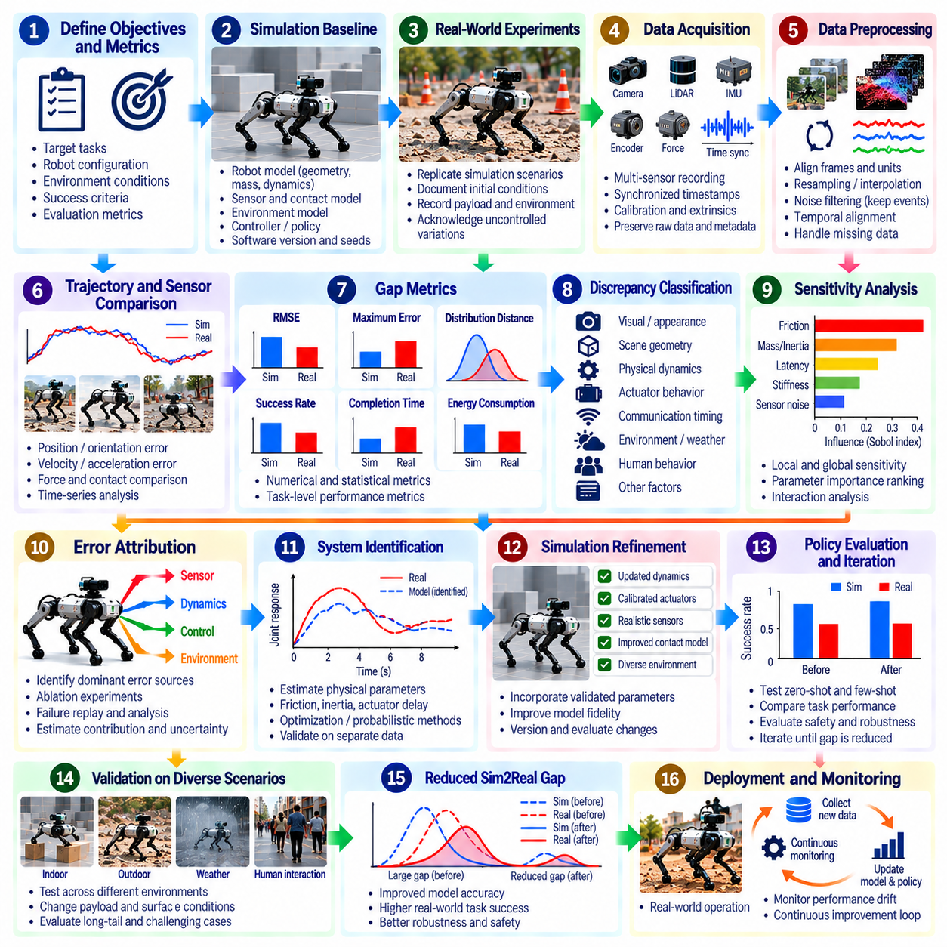
The Sim2Real gap analysis pipeline provides a systematic framework for identifying, measuring, diagnosing, and reducing discrepancies between simulated and physical robotic systems. Rather than treating simulation validation as a single experiment, the pipeline organizes evaluation into repeatable stages. It connects model fidelity, policy behavior, task performance, and deployment readiness through measurable evidence and continuous improvement.
The pipeline begins by defining operational objectives and acceptance criteria. Target tasks, robot configurations, environmental conditions, and expected performance levels must be specified before testing. Relevant metrics may include positioning accuracy, trajectory error, task success rate, completion time, energy consumption, and safety violations. Clear requirements ensure that gap analysis focuses on discrepancies affecting practical deployment.
A simulation baseline establishes expected robot behavior under controlled conditions. The baseline includes robot geometry, mass properties, actuator dynamics, sensor models, contact parameters, and environmental representations. Software versions, controller settings, random seeds, and initial conditions should be recorded. This configuration becomes the reference against which physical measurements and subsequent simulation updates are evaluated.
Real-world experiments should reproduce simulation scenarios as closely as practical. Initial positions, payloads, motion commands, obstacle layouts, and operating conditions must be documented. Perfect equivalence is rarely achievable because physical environments contain uncontrolled variations. These differences should be measured or acknowledged so that experimental results are not incorrectly attributed to simulation model errors.
Data acquisition integrates measurements from cameras, LiDAR, IMUs, encoders, motor controllers, force sensors, and external reference systems. Sensor streams must be synchronized to a common time base whenever possible. Accurate timestamps, calibration records, and coordinate transformations are essential. Missing samples, communication delays, and measurement uncertainty should be preserved as metadata rather than silently discarded.
Data preprocessing prepares simulated and physical observations for meaningful comparison. Coordinate frames, units, sampling frequencies, and signal conventions must be aligned. Filtering may reduce measurement noise, but excessive smoothing can conceal dynamic discrepancies. Interpolation and temporal alignment should preserve important events such as collisions, actuator saturation, emergency stops, and rapid changes in contact force.
The first analytical stage compares state trajectories and sensor outputs between simulation and reality. Position, orientation, velocity, acceleration, and force residuals reveal differences in predicted system behavior. Time-series comparisons identify transient errors, accumulated drift, and steady-state bias. These measurements establish quantitative evidence before attempting to explain the underlying causes of performance degradation.
Gap metrics should capture both numerical similarity and operational consequences. Root mean square error, maximum deviation, distribution distance, and temporal correlation describe different aspects of mismatch. Task-level metrics reveal whether those differences affect success, efficiency, or safety. A small average trajectory error may still conceal a brief but critical collision or loss of stability.
Discrepancy classification organizes observed errors into meaningful categories. Visual appearance, scene geometry, physical dynamics, actuator response, sensor calibration, communication timing, and environmental variability represent distinct sources of mismatch. Classification prevents unrelated symptoms from being combined into a single score. It also guides the selection of diagnostic experiments and appropriate corrective methods.
Sensitivity analysis determines which uncertain parameters have the greatest influence on observed performance. Friction, inertia, sensor latency, actuator bandwidth, and contact stiffness can be varied within plausible ranges. Local perturbations provide efficient initial screening, while global methods reveal nonlinear interactions. Parameters with strong effects on safety or task success should receive higher diagnostic priority.
Error attribution investigates whether dominant discrepancies arise from model assumptions, measurement problems, controller behavior, or environmental disturbances. Controlled ablation experiments and failure replay can isolate competing explanations. Correlation alone does not establish causation, particularly when parameters interact. Attribution conclusions should therefore include uncertainty and evidence from independent experiments.
System identification converts diagnostic findings into improved model parameters. Experimental data can estimate friction coefficients, actuator delays, inertial properties, wheel slip, and sensor biases. Optimization or probabilistic estimation methods fit these quantities to observed behavior. Identified parameters should be checked for physical plausibility and validated using experiments not included in the estimation dataset.
Simulation refinement incorporates validated corrections into robot and environment models. Updates may involve more accurate contact dynamics, realistic sensor noise, calibrated actuators, or improved scene geometry. Each change should be versioned and evaluated separately before combining multiple modifications. This controlled approach helps determine whether improved fidelity actually reduces task-relevant Sim2Real discrepancies.
Policy evaluation follows model refinement to determine whether simulation improvements translate into better physical performance. Zero-shot tests measure transfer without real-world policy learning, while few-shot tests assess adaptation from limited physical experience. Both require consistent task definitions and independent evaluation scenarios. Better model accuracy is valuable only when it supports reliable behavior under relevant operating conditions.
Regression testing verifies that correcting one discrepancy does not introduce new failures elsewhere. Evaluation should cover nominal operation, boundary conditions, disturbances, and previously observed failure scenarios. Automated simulation batches can test many configurations before physical trials. Critical safety cases must still receive appropriate real-world validation because simulation alone cannot establish physical safety.
Uncertainty management is necessary throughout the pipeline. Measurement noise, parameter ambiguity, environmental variation, and limited test coverage all affect confidence in conclusions. Confidence intervals and repeated trials help quantify these limitations. Unresolved uncertainty can guide domain randomization and robust control design, reducing dependence on a single supposedly exact simulation model.
A closed-loop improvement process connects failure detection, diagnosis, model updates, policy evaluation, and renewed testing. Each iteration should produce traceable evidence showing which discrepancy was addressed and whether performance improved. When results fail to meet acceptance criteria, the pipeline returns to the relevant diagnostic stage. This structure prevents arbitrary model changes and supports cumulative engineering progress.
Fleet-scale deployment introduces additional requirements for continuous gap monitoring. Robots may differ because of manufacturing tolerances, payload changes, component aging, or maintenance history. Operational telemetry can reveal systematic deviations from validated models. Periodic recalibration and targeted identification experiments help maintain simulation relevance without requiring complete redevelopment for every robot.
Pipeline governance ensures reproducibility and accountability across engineering teams. Dataset versions, simulation configurations, calibration parameters, test procedures, and acceptance decisions should be maintained in a common record. Automated reports can summarize residual errors, task performance, uncertainty, and unresolved risks. Traceability is particularly important when simulation evidence supports safety-critical deployment decisions.
Ultimately, the Sim2Real gap analysis pipeline transforms simulation from an isolated development tool into a continuously validated engineering system. Its effectiveness depends on representative experiments, synchronized measurements, quantitative diagnostics, causal investigation, and independent validation. By connecting physical evidence to systematic model and policy improvements, the pipeline supports more robust, predictable, and trustworthy Physical AI deployment.

