Volume 05. Simulation and Sim2Real Transfer

Chapter 03. Domain Randomization

03.01. Why Domain Randomization Works
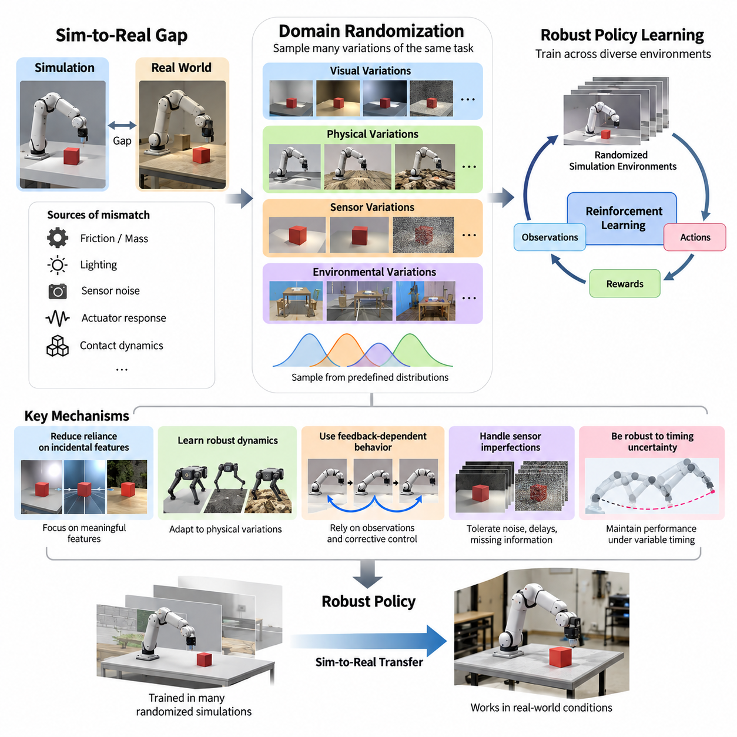
Domain randomization is a fundamental technique for transferring artificial intelligence policies from simulated environments to physical robots. Its central principle is that a learning system should experience many variations of the same underlying task rather than depend on one perfectly modeled environment. By exposing the system to diverse conditions during training, domain randomization encourages behaviors that remain effective when real-world conditions differ from simulation.
The simulation-to-reality gap emerges because digital environments cannot reproduce every physical property, sensor imperfection, or environmental interaction encountered by real robots. Even carefully calibrated simulations contain inaccuracies in friction, mass distribution, lighting, actuator response, and contact dynamics. A policy trained under fixed assumptions may exploit these inaccuracies and fail when deployed on physical hardware, despite achieving excellent simulated performance.
Domain randomization addresses this limitation by deliberately modifying simulation parameters across training episodes. Instead of assuming that one simulated configuration accurately represents reality, the training process samples configurations from predefined probability distributions. These variations expose the learning algorithm to a family of related environments, allowing it to develop behaviors that tolerate uncertainty in physical and perceptual conditions.
The theoretical motivation is closely related to robust optimization and statistical generalization. Conventional learning minimizes expected error under a particular training distribution, whereas domain randomization expands that distribution to include plausible environmental variations. The resulting policy is encouraged to perform well across multiple conditions rather than optimize exclusively for a narrow simulation configuration that may not correspond to physical reality.
A useful mathematical interpretation considers a family of simulated environments parameterized by a vector representing uncertain physical and environmental properties. During training, parameter values are sampled from a distribution, and the policy maximizes its expected cumulative reward across those samples. This objective promotes average performance over the sampled environment family, although it does not automatically guarantee satisfactory performance under every possible condition.
The effectiveness of domain randomization depends partly on whether the real environment lies within, or sufficiently resembles, the range of conditions represented during training. When relevant physical variations are covered, the learned policy can encounter familiar patterns even in previously unseen configurations. However, unrealistic distributions, missing physical phenomena, or insufficient parameter coverage can produce policies that remain vulnerable to deployment failures.
One important mechanism is the reduction of dependence on incidental features. In visual perception, a neural network trained with constant lighting, textures, and backgrounds may associate task success with superficial appearance rather than meaningful object geometry. Randomizing these visual properties makes such associations less reliable, encouraging the network to identify features that remain informative across changing scenes and observation conditions.
This mechanism is particularly valuable for robotic manipulation, where object recognition and grasp planning must remain reliable despite changes in illumination, surface appearance, camera position, and surrounding clutter. A grasping system exposed to diverse simulated observations may learn to prioritize object shape, spatial relationships, and grasp-relevant geometry. Such representations can support transfer to physical objects that differ visually from their simulated counterparts.
Domain randomization also operates through physical dynamics rather than visual appearance alone. Variations in mass, inertia, friction, restitution, damping, and joint resistance alter the relationship between commanded actions and resulting movements. Training across these variations encourages control policies to accommodate uncertain dynamics, reducing their dependence on exact physical parameters that may be difficult to measure or reproduce.
For example, a quadruped robot trained with a single ground friction coefficient may develop a gait that works efficiently in simulation but becomes unstable on unfamiliar surfaces. Randomizing friction, terrain properties, actuator strength, and body mass exposes the controller to different stability requirements. The resulting policy may develop more conservative foot placement, adaptive balance responses, and recovery strategies that improve physical robustness.
Another mechanism involves learning feedback-dependent behavior instead of memorized action sequences. In a deterministic simulation, an agent may succeed by repeating precisely timed actions without adequately responding to observations. Randomized dynamics disrupt this strategy because identical commands can produce different outcomes. The agent must increasingly rely on sensory feedback, state estimation, and corrective control to maintain task performance under changing conditions.
This distinction is essential for Physical AI systems operating in partially observable environments. Real robots rarely possess perfect knowledge of their physical state or surrounding conditions. Sensor measurements contain noise, delays, calibration errors, and occasional missing information. Randomizing these characteristics during training can encourage policies to tolerate imperfect observations and make decisions using information that remains dependable across different sensing conditions.
Domain randomization can also improve resistance to timing uncertainty. Physical control systems experience communication delays, asynchronous sensor updates, computational scheduling variations, and actuator response latency. A controller optimized for perfectly synchronized simulation may become unstable when deployed on hardware. Introducing bounded timing variations during training helps reveal sensitivity to delays and encourages behavior that remains stable under realistic execution constraints.
The method is especially compatible with reinforcement learning because simulated environments can generate large quantities of interaction experience without exposing physical equipment to repeated training failures. Each episode can begin with a different combination of randomized parameters, producing diverse state transitions and rewards. Over many episodes, the learning algorithm encounters a broader collection of situations than would be practical through direct physical experimentation alone.
Massively parallel simulation further strengthens this approach by allowing numerous randomized environments to execute simultaneously. Different robot instances can experience distinct terrain conditions, sensor configurations, payloads, and dynamic parameters while contributing experience to a shared learning process. This parallel diversity improves training coverage and can accelerate policy development, provided that the simulation infrastructure maintains sufficient physical consistency and numerical stability.
However, domain randomization does not work simply because greater variation is always beneficial. Excessively broad parameter ranges may create environments that are physically implausible or substantially harder than the intended deployment task. The learning algorithm may respond by developing overly cautious behavior, sacrificing precision, efficiency, or task completion. Effective randomization therefore requires balancing environmental diversity against task relevance and achievable learning objectives.
The probability distribution used to sample parameters is as important as the range itself. Uniform sampling provides broad coverage but may overrepresent unlikely operating conditions, while distributions informed by physical measurements can emphasize realistic variability. Correlations between parameters also matter because independently sampled combinations may violate physical constraints. Carefully designed distributions help the policy learn from meaningful uncertainty rather than arbitrary simulation artifacts.
Randomization can be introduced progressively through curriculum learning. Early training may use limited parameter variation so that the agent can acquire basic task competence under manageable conditions. As performance improves, the randomization range expands to include more demanding environmental and dynamic variations. This progression can reduce optimization difficulty while gradually developing the robustness needed for real-world deployment.
Adaptive domain randomization extends this concept by adjusting parameter distributions according to observed policy performance. Training can emphasize conditions where the current policy exhibits weaknesses, rather than repeatedly sampling scenarios it already handles successfully. Adversarial approaches go further by searching for challenging but valid environment configurations. These methods can improve robustness when the selected challenges remain representative of relevant deployment risks.
The relationship between domain randomization and photorealistic simulation illustrates an important design tradeoff. Photorealism attempts to reproduce the appearance of the physical world with high visual fidelity, whereas randomization deliberately introduces appearance diversity. These approaches are not mutually exclusive. Physically meaningful rendering can provide a credible baseline, while randomized illumination, materials, camera properties, and scene arrangements expand the range of observations available for learning.
A similar relationship exists between domain randomization and system identification. System identification estimates physical parameters from measured robot behavior, providing a more accurate nominal simulation model. Domain randomization then introduces controlled uncertainty around these estimates to represent manufacturing tolerances, environmental changes, and modeling errors. Combining calibrated models with appropriate variability can provide stronger transfer foundations than relying exclusively on either precise modeling or broad randomization.
The benefits of domain randomization must ultimately be demonstrated through real-world evaluation. High performance across randomized simulations is not sufficient evidence of successful transfer if important physical effects remain unmodeled. Evaluation should examine task success, stability, safety, recovery behavior, and performance degradation under changing operating conditions. Comparing randomized and non-randomized training policies helps determine whether the additional variability produces measurable deployment improvements.
Real-world failures can also guide refinement of the randomization process. If a robot struggles with slippery surfaces, unexpected payloads, or sensor exposure changes, these observations can reveal missing variability or inaccurate parameter assumptions. Engineers can update simulation models and sampling distributions, retrain the policy, and repeat physical validation. This creates an iterative development cycle in which deployment experience progressively improves simulation coverage and training effectiveness.
Domain randomization is therefore best understood as a method for managing uncertainty rather than eliminating the simulation-to-reality gap entirely. Its success depends on selecting meaningful variables, defining credible distributions, preserving essential physical relationships, and evaluating performance beyond the training environment. When integrated with physics simulation, synthetic data generation, system identification, and real-world testing, it provides a practical foundation for developing Physical AI systems capable of reliable behavior under environmental and operational variation.

03.02. Domain Randomization vs Photorealism
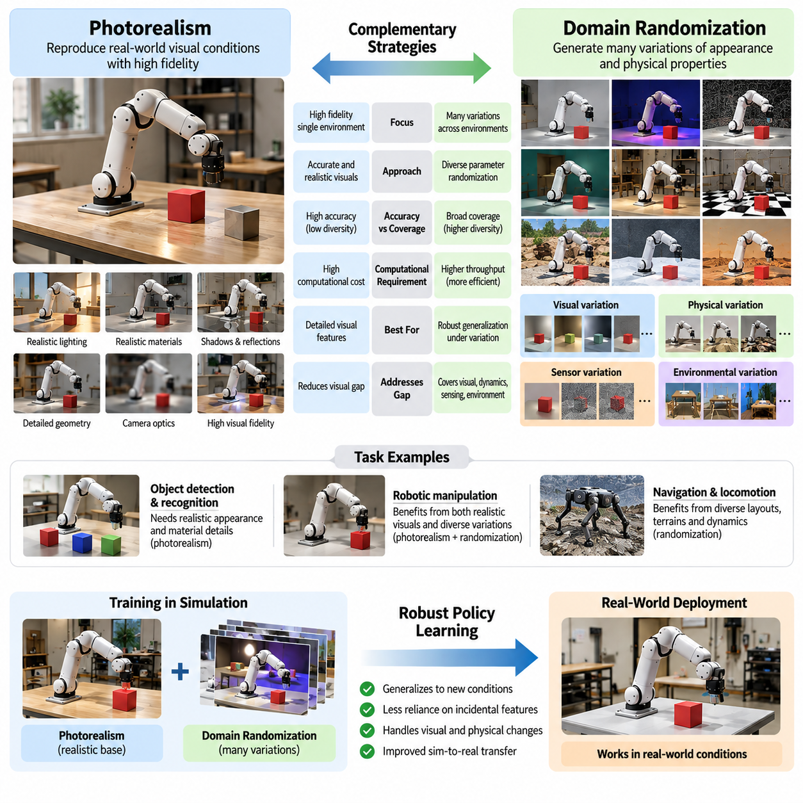
Domain randomization and photorealism represent two complementary strategies for reducing the simulation-to-reality gap in Physical AI. Photorealism attempts to reproduce real-world visual conditions with high fidelity, while domain randomization deliberately introduces variations across simulated environments. Both approaches seek to improve real-world performance, but they differ in how they address uncertainty, visual representation, computational requirements, and generalization.
Photorealistic simulation focuses on creating synthetic observations that closely resemble images captured by physical sensors. Advanced rendering techniques reproduce lighting, shadows, reflections, surface materials, camera optics, and environmental geometry. The underlying assumption is that reducing visual differences between simulated and real observations allows perception models and control policies to transfer more effectively without requiring extensive real-world retraining.
Domain randomization follows a different principle. Rather than reproducing one realistic environment as accurately as possible, it generates many variations of environmental appearance and physical properties. Textures, illumination, camera positions, object arrangements, and sensor characteristics may change between training episodes. This diversity encourages learning systems to identify task-relevant features that remain useful across different conditions.
The distinction can be understood through the relationship between accuracy and coverage. Photorealism emphasizes the accuracy of individual simulated observations, whereas domain randomization emphasizes coverage across a distribution of possible observations. A highly realistic scene may closely match one physical environment but fail to represent unexpected variations. Conversely, a visually simplified environment with extensive randomization may support stronger generalization despite lower image-level realism.
Photorealistic rendering is particularly valuable when task performance depends on subtle visual information. Object detection, material recognition, surface inspection, and precision manipulation may require accurate representation of texture, illumination, transparency, and reflections. When synthetic images preserve these characteristics, perception systems can learn features that resemble those encountered during deployment, potentially reducing the amount of labeled real-world data required.
However, high visual fidelity does not automatically guarantee successful simulation-to-reality transfer. A rendering system may reproduce realistic lighting and materials while overlooking sensor artifacts, environmental diversity, or unusual operating conditions. Neural networks can also exploit correlations specific to a carefully constructed scene. Consequently, photorealistic training data may produce excellent results under familiar conditions but weaker performance when the deployment environment changes.
Domain randomization attempts to reduce this dependence on scene-specific correlations. By changing backgrounds, colors, textures, and lighting independently of task labels, it discourages models from relying on incidental visual patterns. A robot learning to recognize an object across many appearances may develop greater sensitivity to geometry, spatial relationships, and other stable features. The effectiveness of this process depends on whether the randomized variations preserve meaningful task information.
A practical example involves a robotic grasping system trained to identify and manipulate objects on a workbench. A photorealistic simulation may accurately reproduce the workbench material, factory lighting, and camera characteristics. Domain randomization instead exposes the robot to changing backgrounds, object colors, illumination angles, and camera configurations. Combining both methods can produce realistic baseline observations while expanding the conditions under which grasping remains reliable.
The two strategies also differ in computational requirements. High-quality photorealistic rendering may require ray tracing, complex material models, detailed geometry, and advanced lighting calculations. These operations can consume substantial GPU resources, particularly when generating large datasets. Simplified rendering combined with domain randomization may achieve higher simulation throughput, allowing more training episodes within a fixed computational budget.
Nevertheless, domain randomization is not computationally free. Generating diverse environments requires parameter sampling, asset variation, scene management, and repeated simulation execution. Complex randomized scenes may introduce additional memory consumption and processing overhead. Furthermore, learning across a wider distribution can require more training experience. The appropriate comparison therefore considers total training cost rather than rendering cost alone.
The relative importance of visual fidelity depends strongly on the target task. For navigation based on geometric obstacles, randomized layouts and sensor noise may contribute more to generalization than detailed surface textures. For visual inspection of manufacturing defects, realistic illumination and material appearance may be essential. For robotic manipulation, both geometric accuracy and appearance diversity can influence perception, contact planning, and task execution.
Photorealism and domain randomization also address different aspects of the simulation-to-reality gap. Photorealistic rendering primarily reduces discrepancies in visual observations, although broader simulation fidelity may include sensor and physical models. Domain randomization can cover visual appearance, dynamics, actuation, sensing, and environmental conditions. Randomizing friction, mass, latency, or actuator response targets uncertainties that improved image rendering alone cannot resolve.
A hybrid simulation strategy combines physically based rendering with controlled randomization. Realistic materials, calibrated cameras, and plausible lighting establish a credible visual foundation. Randomized illumination, textures, object configurations, and sensor parameters then introduce diversity around that foundation. This approach avoids treating realism and variation as competing objectives and instead uses each technique to address different sources of deployment uncertainty.
The effectiveness of a hybrid strategy depends on the design of randomization distributions. Arbitrary changes can generate visually inconsistent or physically implausible scenes that provide limited training value. For example, independently modifying material reflectance and illumination without preserving realistic relationships may produce observations unlike those encountered by physical cameras. Constrained randomization maintains plausible combinations while providing sufficient diversity for generalization.
Real-world measurements can improve both rendering accuracy and randomization design. Camera calibration, illumination measurements, material characterization, and sensor noise analysis provide information for constructing realistic nominal simulation conditions. Statistical variation around these measurements can represent manufacturing differences, environmental changes, and measurement uncertainty. This combination creates synthetic observations grounded in physical evidence rather than unrestricted procedural variation.
An important design consideration is whether the learning system should become invariant or adaptive to environmental changes. Visual domain randomization often encourages invariance to irrelevant appearance variations, such as background color. However, some environmental properties directly influence the correct action. A robot should not ignore friction differences when selecting movement strategies. Instead, it must learn to adapt its behavior using observations that reveal the underlying physical conditions.
This distinction becomes particularly important for vision-based robotic control. Lighting variation may be irrelevant to a manipulation objective, but object orientation, contact geometry, and material properties can determine successful actions. Excessive randomization that obscures these relationships may reduce performance. Effective training preserves causal information needed for control while varying nuisance factors that should not determine task outcomes.
Evaluation should compare photorealistic training, randomized training, and combined training under identical real-world conditions. Relevant measurements include task success rate, perception accuracy, robustness to environmental changes, inference stability, and performance under previously unseen scenarios. Computational cost, synthetic data generation throughput, and training efficiency should also be measured to determine whether improvements justify the additional simulation complexity.
Controlled experiments can reveal which simulation properties contribute most strongly to transfer performance. For example, researchers may compare models trained with fixed textures, randomized textures, realistic lighting, and combined variations. Similar comparisons can evaluate camera noise, geometry, and physical parameters. Such ablation studies help distinguish improvements caused by greater realism from those produced by environmental diversity.
The choice between photorealism and domain randomization should therefore be guided by deployment requirements rather than a universal preference. Applications requiring detailed visual discrimination may benefit from high-fidelity rendering, while systems operating across diverse environments may require extensive randomization. Many Physical AI applications benefit from both, provided that the simulation represents task-critical physical relationships and relevant uncertainty.
As simulation platforms evolve, the distinction between realism and randomization is becoming less restrictive. Modern synthetic data pipelines can generate physically plausible scenes while varying geometry, lighting, materials, sensors, and dynamics at scale. Automated scene generation and parallel simulation make it possible to combine high-quality observations with broad environmental coverage, although computational constraints and data quality remain important considerations.
Ultimately, photorealism improves the resemblance between simulated and physical observations, while domain randomization improves exposure to environmental variability. Neither approach independently guarantees reliable real-world performance. Their greatest value emerges when realistic modeling establishes meaningful physical structure and carefully designed randomization develops robustness to uncertainty. Together, they provide a practical foundation for scalable simulation-based learning and dependable Physical AI deployment.

03.03. Visual Appearance Randomization
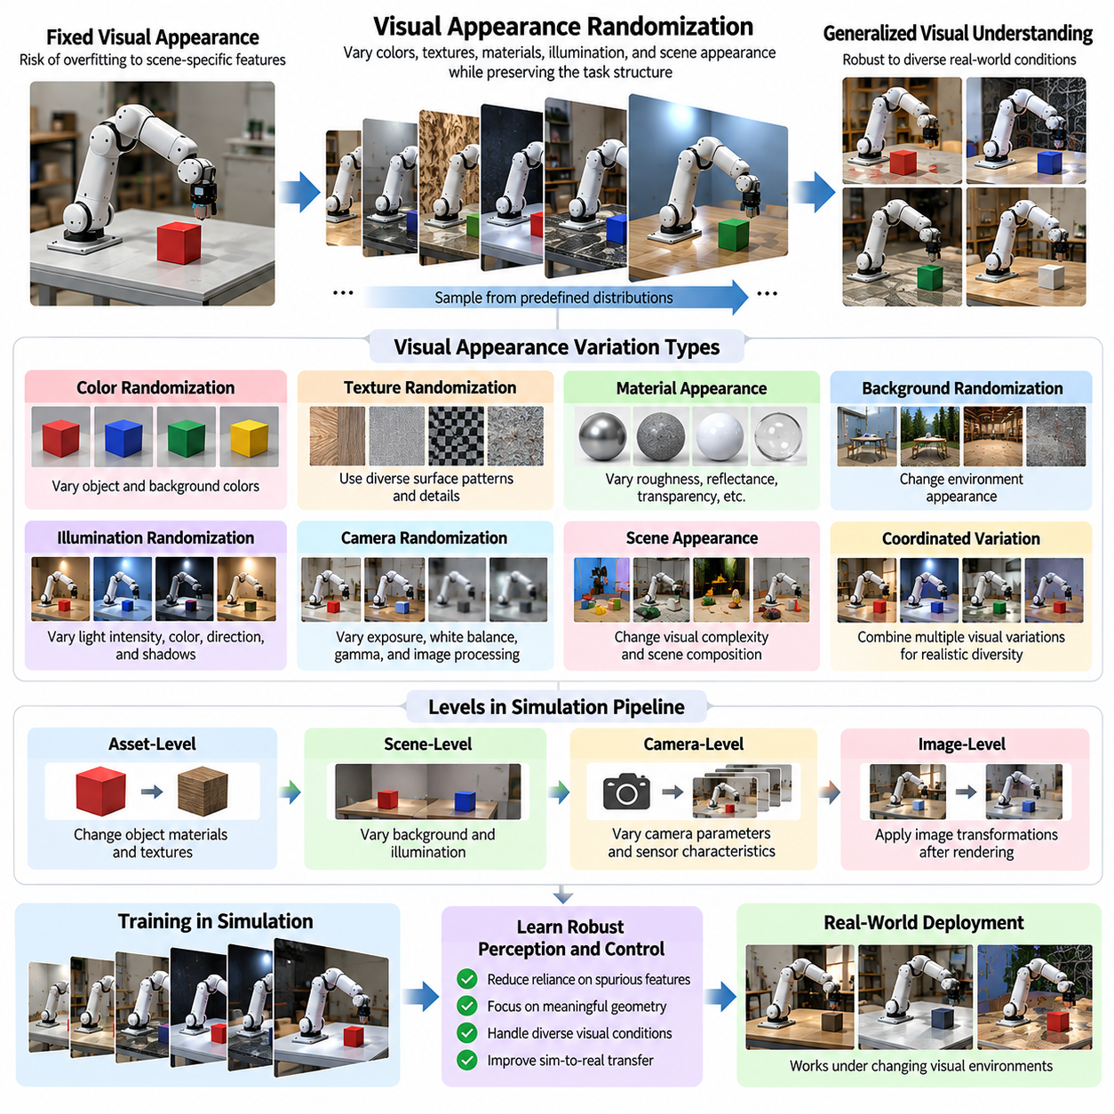
Visual appearance randomization is a domain randomization technique that improves the ability of Physical AI systems to operate across changing visual environments. It introduces controlled variations in colors, textures, materials, illumination, and scene appearance during simulation-based training. Rather than learning from a fixed visual configuration, perception models and robotic policies encounter diverse observations that encourage generalization beyond the synthetic environments used during development.
The fundamental motivation is that visual conditions in physical environments are rarely constant. Objects may appear different because of illumination changes, surface wear, reflections, camera exposure, or environmental contamination. Even identical objects can produce substantially different images under changing observation conditions. A model trained exclusively on one visual configuration may become dependent on appearance patterns that are unreliable during real-world deployment.
Visual appearance randomization addresses this problem by modifying rendering parameters while preserving the underlying task structure. Object colors, surface textures, material properties, and background appearances can be sampled from predefined distributions. The resulting images represent multiple visual interpretations of similar physical situations. This process encourages learning algorithms to distinguish meaningful task information from incidental appearance characteristics.
The central learning mechanism involves reducing dependence on spurious visual correlations. When a particular object always appears with the same color or background, a neural network may associate recognition with those features rather than the object's geometry or functional identity. Randomizing appearance weakens these shortcuts and encourages representations that remain useful across different scenes, provided that the variations do not eliminate information essential to the task.
Color randomization is one of the simplest forms of visual appearance variation. Object colors, background colors, and surface color distributions can be modified during training without changing object geometry. This technique is particularly useful when color is not essential to identifying an object or selecting an action. However, tasks involving color-based sorting, warning indicators, or material identification require preserving color information that carries operational meaning.
Texture randomization introduces variations in surface patterns, spatial frequencies, roughness appearance, and image details. Simulated objects may receive different procedural textures or sampled material patterns across training episodes. This prevents perception models from relying exclusively on specific surface appearances. For robotic manipulation, texture diversity can encourage attention to object boundaries, shape, and spatial configuration rather than memorized visual patterns.
Material appearance randomization extends beyond simple color and texture changes. Physically based rendering systems represent properties such as metallic response, surface roughness, reflectance, transparency, and subsurface scattering. Varying these parameters changes how objects interact visually with illumination. Such variations are valuable when robots encounter products manufactured from different materials or surfaces affected by wear, coatings, and environmental exposure.
However, visual material parameters must be distinguished from physical contact properties. Changing the rendered roughness of a surface does not necessarily change its friction coefficient in the physics engine. A visually metallic object may also have physical dynamics inconsistent with its apparent material. When visual cues are relevant to control decisions, appearance and physical parameters should be coordinated to preserve meaningful relationships between observation and behavior.
Background randomization is particularly effective for reducing environmental dependence. A robotic perception model trained in one warehouse or laboratory may associate object identity with surrounding furniture, walls, or equipment. Changing background textures, colors, and visual complexity helps prevent these associations. The model becomes more likely to recognize task-relevant objects independently of the specific environment in which they appear.
Scene appearance also depends on illumination and shadow formation. Variations in light intensity, color temperature, direction, and spatial distribution alter object contrast and visible surface details. Although lighting randomization is often treated as a separate category, it interacts directly with material and texture appearance. Coordinated changes in illumination and surface properties can generate a broader range of plausible visual observations.
Camera image formation introduces another source of appearance variation. Exposure, white balance, gamma response, color sensitivity, and image processing pipelines influence the final appearance of rendered scenes. Randomizing these characteristics can improve robustness when transferring models between simulated cameras and physical imaging systems. The selected variations should reflect realistic camera behavior rather than arbitrary image transformations that distort essential information.
Visual appearance randomization can operate at several levels of a simulation pipeline. Asset-level randomization modifies object materials and textures before rendering, while scene-level randomization changes environmental appearance and illumination. Image-level augmentation applies transformations to rendered observations after image generation. These approaches can be combined, although image transformations alone cannot reproduce every physical interaction between materials, geometry, and lighting.
A major advantage of appearance randomization is its compatibility with automatic synthetic data generation. Simulation engines can produce large collections of images while retaining exact annotations for object identity, segmentation, depth, pose, and spatial relationships. Since visual parameters change without necessarily modifying the underlying geometry, many annotations remain valid. This supports scalable training of detection, segmentation, tracking, and robotic perception models.
For autonomous mobile robots, appearance randomization can improve perception across different warehouses, corridors, factories, and service environments. Floor colors, wall textures, equipment surfaces, and background clutter may vary substantially between deployment sites. Training with diverse appearances can reduce sensitivity to these changes while preserving geometric and semantic information required for obstacle detection, localization, and navigation.
In robotic manipulation, visual appearance diversity is particularly important when the same manipulation task involves objects with different packaging, coatings, or manufacturing finishes. A grasping policy trained on visually varied objects may learn to rely more strongly on geometric features and spatial relationships. Nevertheless, transparent, reflective, and deformable objects may require specialized rendering and sensing models because simple appearance randomization cannot reproduce their full observational complexity.
Humanoid and service robots encounter additional appearance variability in human-centered environments. Clothing, furniture, household objects, interior decoration, and illumination differ across locations and users. Visual randomization can broaden training coverage without requiring every possible real environment to be reconstructed. However, task-critical semantic cues, human safety indicators, and meaningful object attributes must remain distinguishable throughout the training process.
The effectiveness of visual appearance randomization depends on how parameter distributions are selected. Uniform sampling across unrestricted color and material ranges may produce unrealistic combinations that rarely occur in deployment. More structured distributions can preserve plausible material characteristics, illumination relationships, and environmental contexts. Measurements from real images can guide these distributions and reduce the risk of training on irrelevant visual variations.
Randomization intensity also influences learning difficulty. Small variations may fail to provide sufficient diversity, leaving the model vulnerable to unfamiliar visual conditions. Excessively aggressive variations may obscure object boundaries, destroy useful visual cues, or create scenes that are difficult even for a well-trained perception system. Effective training therefore requires balancing appearance diversity with visibility, task relevance, and the preservation of meaningful information.
Curriculum-based appearance randomization can address this tradeoff by increasing visual complexity as learning progresses. Initial training may use simple backgrounds, moderate color variation, and consistent illumination. Later stages can introduce stronger material changes, clutter, reflections, and camera variations. This progression allows models to establish basic recognition and control capabilities before learning to handle more challenging visual conditions.
Adaptive appearance randomization offers another strategy by adjusting visual parameter distributions according to model performance. If recognition accuracy decreases under particular illumination or texture conditions, training can emphasize those cases. Adversarial approaches may search for difficult but plausible visual configurations that expose model weaknesses. Such methods can improve robustness when challenging examples remain consistent with realistic deployment requirements.
Evaluating appearance randomization requires testing on real images and physical tasks rather than relying exclusively on synthetic validation. Useful measurements include recognition accuracy, segmentation quality, object pose estimation error, task success rate, and robustness under changing visual conditions. Controlled comparisons between fixed-appearance training, randomized training, and photorealistic training can reveal whether appearance diversity produces meaningful transfer improvements.
Visual appearance randomization should ultimately be integrated with geometry, sensor, and physics randomization rather than treated as an isolated solution. Reliable Physical AI systems must understand both how the world appears and how it behaves. By combining realistic rendering foundations with carefully selected visual variability, simulation-based training can produce perception models and control policies that remain effective across diverse real-world environments.

03.04. Lighting Texture and Background Randomization
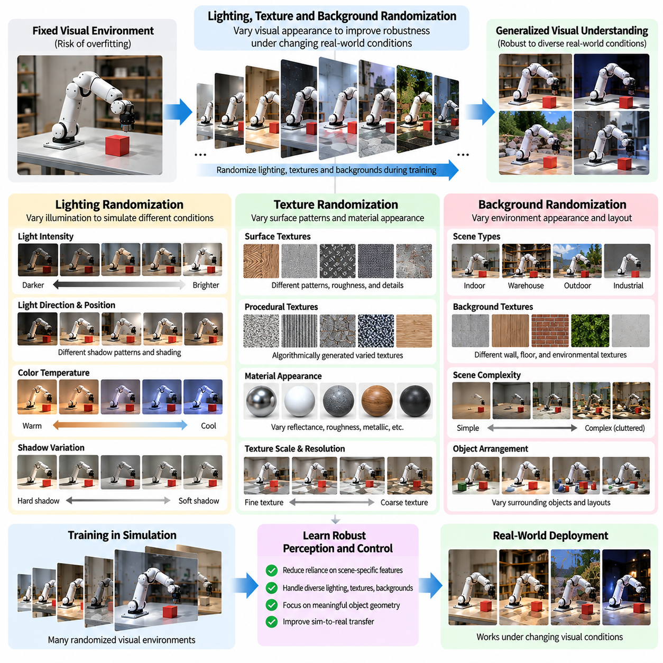
Lighting, texture, and background randomization are essential components of visual domain randomization for Physical AI systems. These techniques introduce controlled variations in simulated scene appearance to improve robustness against changing real-world visual conditions. By modifying illumination, surface patterns, and environmental backgrounds during training, perception models and robotic policies can learn representations that remain effective beyond the specific visual configurations encountered in simulation.
Lighting randomization addresses the substantial influence of illumination on visual perception. Identical objects can appear dramatically different under changes in light intensity, direction, color temperature, and shadow distribution. A perception model trained under fixed lighting may become dependent on particular brightness patterns or surface reflections. Randomizing illumination exposes the model to diverse appearances and encourages recognition based on features that remain reliable under changing lighting conditions.
Light intensity randomization modifies the brightness of simulated light sources across training episodes. Variations may represent daylight changes, artificial lighting differences, or partially illuminated environments. Exposure to different intensity levels helps perception systems tolerate brightness fluctuations and reduced contrast. However, intensity ranges should remain physically plausible because extreme illumination can eliminate important image information and create conditions that are unsuitable for meaningful learning.
Light direction and position randomization alter how surfaces receive illumination and where shadows appear. Moving virtual light sources changes shading gradients, object boundaries, and visible geometric details. These variations are particularly important for robotic manipulation and object recognition, where shadow patterns may influence shape interpretation. Training across multiple lighting configurations reduces dependence on fixed shadow locations and encourages more stable geometric understanding.
Color temperature randomization changes the spectral characteristics of illumination, producing warmer or cooler visual appearances. Industrial facilities may use different artificial lighting systems, while outdoor robots experience changes in natural illumination throughout the day. Simulating these differences can improve color constancy and perception robustness. Nevertheless, tasks requiring precise color discrimination must preserve the relationship between object properties and observed color information.
Shadow randomization introduces variations in shadow intensity, softness, direction, and spatial extent. Shadows can provide useful geometric information but may also create misleading edges or obscure important object features. Training with diverse shadow configurations helps models distinguish actual object boundaries from illumination artifacts. Physically consistent shadow generation is preferable to arbitrary image modifications because it preserves relationships between geometry, lighting, and visibility.
Texture randomization modifies the visual patterns associated with simulated surfaces. Objects, floors, walls, and equipment may receive different procedural textures or sampled material images during training. These changes reduce dependence on specific surface patterns that may not appear in real environments. By encountering varied textures, perception models can learn to prioritize object geometry, spatial relationships, and semantic information over incidental visual details.
Procedural texture generation provides a scalable method for producing diverse surface appearances. Algorithms can vary spatial frequency, pattern orientation, color distribution, and local contrast without requiring large libraries of manually created assets. Procedural textures can represent rough surfaces, repeated patterns, or irregular visual structures. Their usefulness depends on generating variations that resemble plausible physical materials rather than arbitrary noise unrelated to deployment conditions.
Material-aware texture randomization preserves meaningful relationships between surface appearance and material identity. Metallic objects, painted surfaces, fabrics, and concrete exhibit different reflection and texture characteristics. Randomization should account for these distinctions when they affect perception or manipulation. For example, a robot identifying slippery surfaces may require consistent relationships between visual material cues and the physical friction properties represented in simulation.
Texture resolution and scale also influence visual perception. A surface pattern that appears realistic at one viewing distance may become misleading when applied at an inappropriate spatial scale. Randomizing texture scale can improve robustness to changes in object size and camera distance, but unrealistic scaling may distort material appearance. Effective simulation maintains consistency between texture dimensions, object geometry, camera resolution, and expected observation distances.
Background randomization reduces dependence on environmental context that is unrelated to the target task. A model trained to recognize objects against a fixed laboratory background may perform poorly in warehouses, homes, or outdoor environments. Changing wall colors, floor textures, surrounding objects, and environmental layouts exposes the model to broader visual contexts. This encourages recognition based on object-specific features rather than memorized scene characteristics.
Background complexity is another important variable. Simple backgrounds may support efficient early learning, while complex scenes introduce visual clutter, partial occlusion, and competing patterns. Randomizing the number, appearance, and arrangement of background objects helps perception systems operate in crowded environments. However, background variations should preserve realistic spatial relationships and avoid creating impossible object placements or misleading task conditions.
The interaction between lighting, textures, and backgrounds is more important than treating each variable independently. A textured surface changes appearance under different illumination, while background materials influence reflections and indirect lighting. Randomizing these properties together can produce more diverse and realistic observations. However, unconstrained combinations may generate physically inconsistent scenes, making structured parameter sampling essential for effective training.
Physically based rendering provides a useful foundation for coordinated appearance randomization. Material parameters, light sources, and scene geometry are represented through models that approximate real optical interactions. Randomization can then modify these parameters while maintaining plausible rendering behavior. This approach combines environmental diversity with physical consistency, reducing the risk that learning systems exploit unrealistic visual artifacts.
Camera characteristics must also be considered when evaluating lighting and texture variation. Exposure control, white balance, dynamic range, motion blur, and sensor noise can significantly change how randomized scenes appear in the final image. A lighting configuration that is visually acceptable in the renderer may become overexposed or underexposed after camera processing. Coordinated camera and appearance randomization therefore provides more representative synthetic observations.
The design of randomization distributions determines which environmental conditions the learning system experiences. Uniform sampling offers broad variation but may overrepresent unusual combinations. Distributions informed by real-world measurements can emphasize common operating conditions while retaining coverage of important edge cases. Correlations between lighting, materials, and backgrounds should be preserved when necessary to maintain realistic visual relationships.
Curriculum-based randomization gradually increases visual difficulty during training. Initial stages may use moderate illumination changes, simple textures, and uncluttered backgrounds to establish basic perception capabilities. Later stages introduce stronger shadows, complex surface patterns, reflections, and environmental clutter. This progression can improve training stability while developing robustness to increasingly challenging visual conditions encountered during deployment.
Adaptive randomization adjusts environmental variation according to observed model performance. If a perception system consistently fails under low illumination or visually complex backgrounds, the training process can increase exposure to those conditions. Performance-guided sampling concentrates computational resources on weaknesses rather than uniformly repeating familiar scenarios. Such adaptation requires safeguards against overemphasizing unrealistic or excessively difficult configurations.
For autonomous mobile robots, lighting, texture, and background randomization support operation across warehouses, factories, corridors, and outdoor facilities. Floor materials, wall appearances, lighting installations, and surrounding equipment differ between deployment sites. Training across these variations can improve obstacle detection, semantic perception, and visual localization. Nevertheless, geometric consistency and sensor calibration remain necessary for reliable navigation.
Robotic manipulators benefit from appearance randomization when handling objects with different packaging, surface finishes, and surrounding workspaces. Changes in illumination and texture can influence object segmentation, pose estimation, and grasp-point detection. Randomized training encourages models to remain effective despite these differences. Precision manipulation still requires accurate geometric information and appropriate physical models because visual robustness alone cannot guarantee successful contact interactions.
Evaluation should measure whether randomized appearance conditions improve performance on real images and physical robotic tasks. Relevant metrics include detection accuracy, segmentation quality, pose estimation error, task success rate, and robustness under unfamiliar lighting and backgrounds. Controlled experiments can isolate the effects of lighting, texture, and background variation before examining their combined contribution to simulation-to-reality transfer.
Lighting, texture, and background randomization ultimately provide a practical mechanism for expanding the visual experience available during simulation-based learning. Their effectiveness depends on realistic parameter ranges, meaningful environmental diversity, and preservation of task-critical visual information. When integrated with physically based rendering, sensor modeling, and real-world validation, these techniques help Physical AI systems maintain reliable perception and control across changing operating environments.

03.05. Object Pose Scale and Scene Randomization
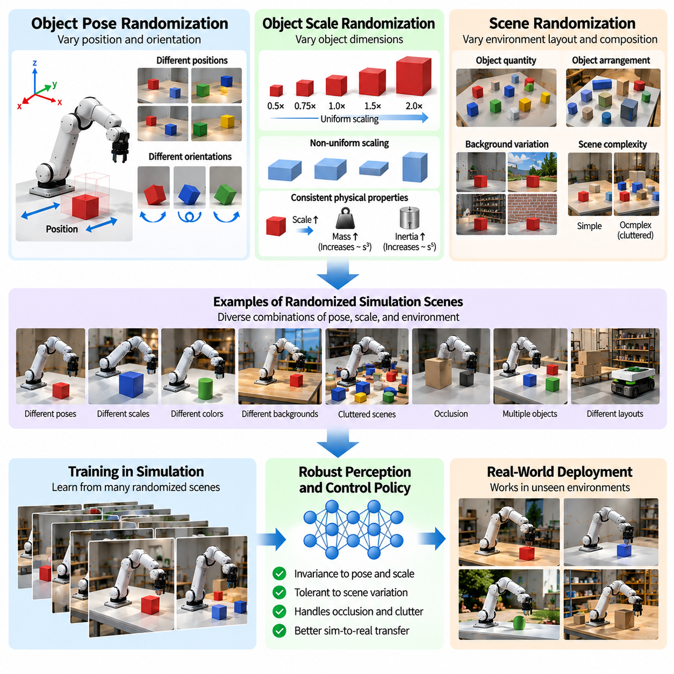
Object pose, scale, and scene randomization are essential techniques for improving the generalization of Physical AI systems trained in simulated environments. These methods introduce variations in object positions, orientations, dimensions, and spatial arrangements during training. By exposing perception models and robotic control policies to diverse geometric configurations, simulation can reduce dependence on fixed layouts and improve performance in unfamiliar physical environments.
Object pose randomization modifies the position and orientation of objects within a simulated scene. Position changes may occur along horizontal and vertical axes, while orientation changes involve rotations around multiple axes. These variations expose learning systems to different viewing angles, contact configurations, and spatial relationships. The objective is to develop perception and control capabilities that remain effective regardless of an object's initial placement.
Pose randomization is particularly important for robotic manipulation because grasping success depends strongly on object orientation and accessibility. A robotic arm trained with objects placed in identical configurations may memorize specific grasp trajectories rather than learn general manipulation strategies. Randomizing object poses encourages the policy to estimate current object geometry, identify feasible grasp locations, and generate actions appropriate to the observed configuration.
Object orientation can be represented using Euler angles, rotation matrices, or quaternions. During simulation initialization, orientation parameters are sampled from predefined distributions and applied to object transformations. Uniform orientation sampling may be appropriate for freely rotating objects, while constrained distributions are preferable when objects normally rest on supporting surfaces. The sampling method must reflect physically possible configurations to avoid generating unrealistic training examples.
Object position randomization changes the spatial coordinates of target objects and surrounding elements. In manipulation environments, objects may appear at different locations within a robot's reachable workspace. In navigation environments, obstacles may occupy different positions along possible travel paths. These variations prevent policies from depending on memorized coordinates and encourage decisions based on current sensor observations and spatial relationships.
Scale randomization modifies object dimensions to represent differences in product sizes, manufacturing tolerances, and geometric variability. A perception model trained with multiple object scales can become more robust to changes in apparent size and viewing distance. For robotic manipulation, scale variation also influences grasp width, reachability, and collision constraints. Consequently, geometric scaling should remain consistent with the physical characteristics required for successful task execution.
Uniform scaling changes all object dimensions by the same factor, preserving the original shape proportions. Nonuniform scaling modifies dimensions independently and can generate more diverse geometries. However, excessive nonuniform scaling may distort objects beyond realistic manufacturing variations. Appropriate scale distributions should reflect the target object category, expected size differences, and physical constraints of the robot's operating environment.
Scale randomization must also consider its relationship with mass, inertia, and collision geometry. Enlarging a simulated object without updating its physical properties can produce inconsistent dynamics. For geometrically similar objects with constant density, mass increases with the cube of the scale factor, while rotational inertia increases with the fifth power. Coordinating geometric and physical parameters helps maintain plausible interactions between robots and randomized objects.
Scene randomization extends beyond individual objects to modify the overall spatial organization of simulated environments. Object quantities, placement patterns, obstacle configurations, furniture arrangements, and workspace layouts may vary between episodes. These changes expose learning systems to diverse environmental structures and encourage behavior that adapts to current conditions rather than relying on a single predefined scene.
In warehouse robotics, scene randomization can vary shelf locations, pallet arrangements, aisle widths, and obstacle distributions. Autonomous mobile robots must then identify navigable regions and plan collision-free paths under changing layouts. Training across multiple configurations can improve navigation generalization, particularly when deployment facilities differ from the environments used during simulation development.
For robotic manipulation, scene randomization can introduce variations in object clutter, stacking arrangements, and target accessibility. Objects may partially overlap, obstruct one another, or appear in different orientations within bins and workspaces. Such conditions require perception models to handle occlusion and control policies to select feasible manipulation strategies. Randomized scenes therefore support learning beyond isolated object interactions.
Occlusion randomization is an important consequence of varying object placement and scene composition. Partial visibility occurs when foreground objects block portions of target objects or when camera viewpoints limit observable surfaces. Training under diverse occlusion conditions can improve object detection, segmentation, and pose estimation. However, scenarios must retain sufficient information for the intended task or provide alternative sensing and exploration strategies.
Scene complexity can be controlled through the number of objects, spatial density, obstacle diversity, and geometric irregularity. Simple scenes are useful for establishing basic perception and control capabilities, while complex scenes introduce realistic planning challenges. Gradually increasing scene complexity through curriculum learning can improve training stability and help policies acquire advanced behaviors without becoming overwhelmed by difficult initial conditions.
Randomized object placement must satisfy physical and task-specific constraints. Objects should not intersect supporting surfaces, occupy impossible positions, or appear outside the robot's operational workspace unless such conditions are intentionally part of the task. Collision checking, stability evaluation, and reachability analysis can filter invalid configurations. Constraint-aware sampling improves training quality by ensuring that generated scenarios remain physically meaningful.
The probability distributions used for pose, scale, and scene randomization strongly influence training effectiveness. Uniform sampling provides broad coverage but may generate many unlikely configurations. Distributions derived from real-world measurements can emphasize common operating conditions while preserving exposure to important edge cases. Correlations between object categories, dimensions, and placement patterns should be maintained when they represent meaningful environmental structure.
Domain randomization should also preserve semantic relationships between objects. In a kitchen, utensils typically appear near work surfaces, while industrial components occupy locations consistent with manufacturing processes. Completely arbitrary arrangements may create unrealistic scenes and weaken task learning. Semantic constraints allow geometric diversity while maintaining the contextual relationships necessary for meaningful perception, planning, and interaction.
Pose and scene randomization can be integrated with visual appearance randomization to create broader training diversity. Object positions and orientations may change alongside lighting, textures, materials, and camera viewpoints. This combination prevents learning systems from associating specific geometries with fixed visual appearances. However, the randomization process must preserve consistency between object geometry, rendered observations, and physical interactions.
Massively parallel simulation enables thousands of randomized geometric configurations to be evaluated simultaneously. Each environment instance may contain different object poses, scales, and scene layouts while sharing the same learning policy. This approach accelerates experience collection and increases coverage of possible operating conditions. Efficient scene generation, collision initialization, and memory management are necessary to maintain high simulation throughput.
Adaptive randomization can concentrate training on configurations where the current policy performs poorly. If a manipulation policy struggles with rotated objects or heavily cluttered scenes, the sampling process can increase exposure to those conditions. Similarly, navigation policies can be challenged with more difficult obstacle arrangements. Performance-guided sampling improves learning efficiency when challenging scenarios remain feasible and representative of deployment requirements.
Evaluation should examine whether geometric randomization improves performance under previously unseen object poses, dimensions, and environmental layouts. Relevant metrics include object detection accuracy, pose estimation error, grasp success rate, collision frequency, navigation completion rate, and task execution time. Controlled experiments comparing fixed and randomized training configurations can reveal the contribution of each geometric variation to real-world performance.
Real-world validation remains necessary because geometric diversity alone cannot reproduce every physical uncertainty. Object deformation, contact friction, sensor limitations, actuator behavior, and environmental dynamics may still differ from simulation. Combining pose, scale, and scene randomization with physics calibration and sensor modeling provides a more comprehensive foundation for simulation-to-reality transfer and reliable robotic deployment.
Ultimately, object pose, scale, and scene randomization expand the geometric experience available to Physical AI systems during simulation-based training. Their effectiveness depends on realistic parameter distributions, physically valid configurations, semantic consistency, and appropriate task difficulty. When integrated with visual and physical randomization, these techniques help perception and control policies generalize across changing objects, workspaces, and operational environments.

03.06. Camera and Sensor Randomization
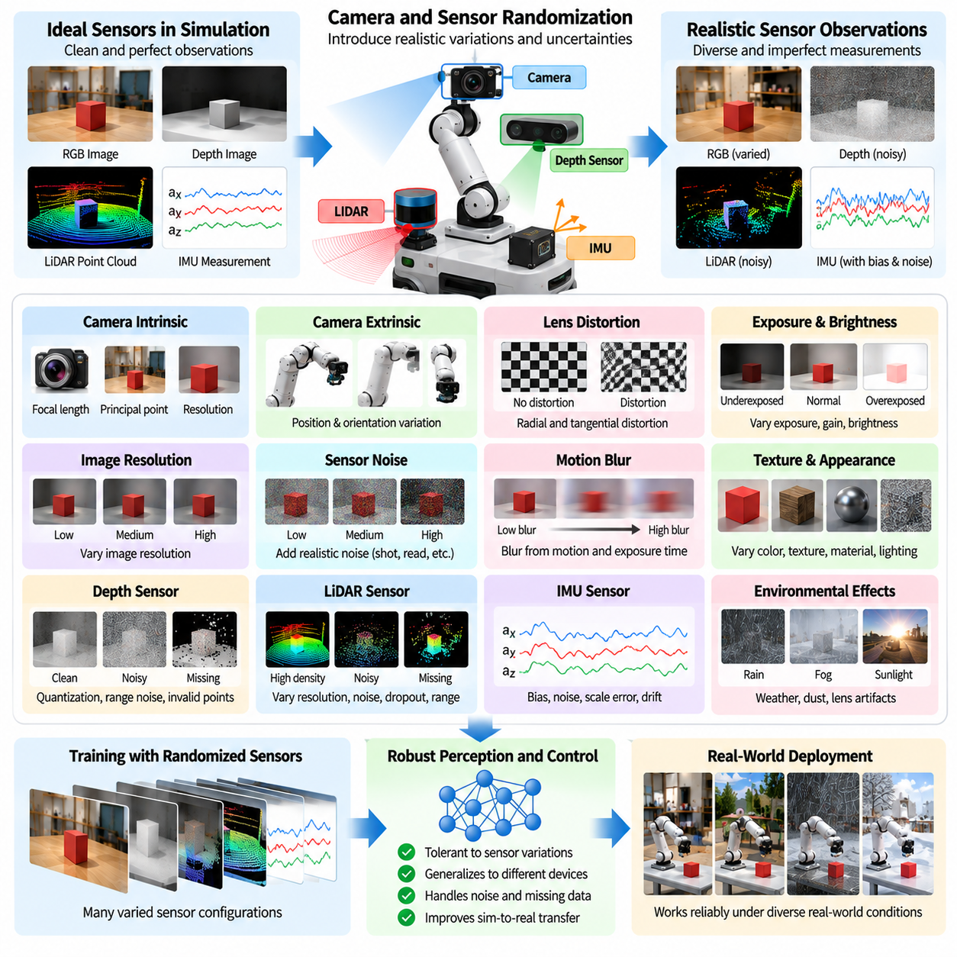
Camera and sensor randomization is a fundamental technique for reducing the simulation-to-reality gap in Physical AI systems. Simulated sensors often generate idealized observations that differ from measurements produced by physical hardware. Randomizing camera parameters, measurement noise, calibration errors, and sensing conditions exposes learning systems to realistic uncertainty. This improves the ability of perception and control policies to operate reliably across different devices and environments.
The primary objective of sensor randomization is to prevent robotic policies from depending on perfect or fixed observations. Real sensors experience measurement noise, limited resolution, distortion, environmental interference, and hardware variation. A policy trained exclusively with ideal sensor outputs may fail when deployed on physical robots. Introducing controlled sensor variability during simulation encourages learning algorithms to extract reliable information despite imperfect measurements.
Camera intrinsic randomization modifies parameters that determine how three-dimensional scenes are projected into images. These parameters include focal length, principal point, pixel aspect ratio, and image resolution. Small changes can represent manufacturing tolerances, calibration uncertainty, or differences between camera models. Training across varied intrinsic configurations improves robustness to changes in image geometry and reduces dependence on one precisely calibrated virtual camera.
Camera extrinsic randomization changes the position and orientation of sensors relative to the robot or surrounding environment. Physical cameras may be installed with small alignment errors, experience vibration, or shift during maintenance. Randomizing sensor translation and rotation exposes perception models to different viewpoints and coordinate transformations. This is particularly important for mobile robots and manipulators that rely on accurate spatial relationships between sensors and actuators.
Lens distortion randomization simulates optical imperfections that affect image geometry. Radial distortion causes straight lines to appear curved, while tangential distortion results from imperfect lens alignment. These effects can influence object detection, feature matching, and geometric reconstruction. Introducing realistic distortion parameters helps perception systems tolerate differences between simulated cameras and physical optical assemblies without assuming ideal perspective projection.
Image resolution randomization modifies the spatial detail available to perception algorithms. Lower resolutions reduce computational requirements but may obscure small objects and fine geometric features. Higher resolutions provide additional detail while increasing processing costs. Training with multiple resolutions and realistic resampling methods can improve robustness to camera configuration changes, although essential task information must remain observable at the selected resolutions.
Exposure and brightness randomization reproduce variations in camera response to changing illumination. Automatic exposure systems may adjust image brightness differently across scenes, producing underexposed or overexposed regions. Randomizing exposure time, gain, and brightness response helps perception models handle these conditions. The simulation should also represent sensor saturation and limited dynamic range when these effects are relevant to real-world operation.
Sensor noise randomization introduces uncertainty into measured image values. Common camera noise sources include photon shot noise, electronic read noise, and signal amplification effects. Noise characteristics often depend on illumination and sensor gain rather than following a single constant distribution. Physically informed noise models can therefore provide more representative training observations than arbitrary independent pixel perturbations applied without regard to camera behavior.
Motion blur randomization models image degradation caused by movement during exposure. Mobile robots and robotic manipulators frequently operate while cameras or observed objects are moving. Exposure duration, relative velocity, and camera motion determine the resulting blur patterns. Training with realistic motion blur can improve perception under dynamic conditions, while excessively strong blur may remove information necessary for accurate localization and object recognition.
Depth sensor randomization is essential for robots using stereo cameras, structured-light sensors, or time-of-flight cameras. Real depth measurements contain quantization errors, missing pixels, range-dependent noise, and failures near reflective or transparent surfaces. Randomizing depth uncertainty and invalid measurements helps models tolerate imperfect three-dimensional observations. Sensor-specific characteristics should be represented because different depth technologies exhibit distinct error mechanisms.
LiDAR randomization models variations in laser ranging and point-cloud acquisition. Relevant parameters include angular resolution, range noise, beam divergence, detection probability, and maximum sensing distance. Environmental conditions and surface reflectivity can produce missing or inaccurate returns. Training with randomized LiDAR observations improves robustness in obstacle detection, mapping, and localization, particularly when physical sensor characteristics differ from those assumed during simulation.
Inertial measurement unit randomization addresses uncertainty in accelerometer and gyroscope outputs. Physical inertial sensors exhibit measurement noise, bias, scale-factor errors, and temperature-dependent drift. Simulating these effects helps estimation and control algorithms operate under imperfect motion measurements. Bias processes should evolve over time rather than being represented exclusively as independent random errors, because temporal correlation strongly influences inertial navigation performance.
Wheel encoder and joint sensor randomization extends sensor uncertainty modeling to robot motion feedback. Encoder measurements may contain quantization, missed counts, calibration offsets, and timing irregularities. Joint position and velocity measurements can also be affected by noise and mechanical compliance. Introducing these variations helps control policies remain effective when actual motion differs slightly from reported measurements, especially during precise manipulation and mobile navigation.
Temporal sensor randomization modifies observation frequency, latency, timestamp accuracy, and synchronization. Real robotic systems combine sensors operating at different sampling rates, often with communication delays and processing jitter. A policy trained with perfectly synchronized observations may become unstable when deployed on distributed hardware. Randomizing temporal characteristics encourages robustness to delayed and asynchronous measurements while preserving physically meaningful timing relationships.
Sensor dropout randomization simulates temporary measurement loss or communication interruption. Cameras may fail to deliver frames, LiDAR scans may contain missing regions, and networked sensors may experience packet loss. Training with controlled dropout encourages policies to use redundant information or maintain short-term estimates when observations become unavailable. However, safety-critical systems must still define explicit failure handling rather than relying entirely on learned robustness.
Multi-sensor randomization considers interactions between cameras, LiDAR, inertial sensors, and proprioceptive measurements. Independent perturbations may be insufficient when sensor errors share common causes such as vibration, temperature, or timing instability. Coordinated randomization can reproduce correlated disturbances and calibration uncertainty. This supports more realistic training of sensor fusion systems that combine complementary measurements to estimate robot state and environmental structure.
Randomization distributions should reflect the specifications and measured behavior of intended hardware. Uniformly sampling arbitrary errors may produce unrealistic conditions or overlook important failure modes. Calibration datasets, manufacturer specifications, and experimental measurements can guide parameter ranges. Separating typical operating variation from rare disturbances helps balance training efficiency, physical plausibility, and robustness against exceptional sensing conditions.
Curriculum-based sensor randomization gradually increases measurement uncertainty during learning. Initial training may use accurate observations to establish fundamental perception and control behaviors. Later stages introduce noise, distortion, latency, and intermittent sensor failures. Adaptive randomization can emphasize conditions associated with poor policy performance. This progression helps develop robustness without exposing an immature policy to excessive uncertainty from the beginning.
Evaluation should examine performance under both simulated perturbations and real sensor measurements. Relevant metrics include detection accuracy, pose estimation error, localization drift, tracking stability, task success rate, and control robustness. Ablation studies can isolate the contribution of camera geometry, noise, timing, and sensor dropout. Testing on multiple physical devices provides stronger evidence that randomization improves hardware generalization rather than merely synthetic benchmark performance.
Camera and sensor randomization must also respect the information requirements of each robotic task. Excessive perturbations can make observations ambiguous or eliminate critical safety information. Randomization cannot replace accurate calibration, reliable hardware, or fault detection. Instead, it complements these engineering measures by preparing learning systems for uncertainty within realistic operating limits and encouraging graceful degradation when sensing quality decreases.
Ultimately, camera and sensor randomization expands the range of measurement conditions experienced during simulation-based training. Its effectiveness depends on realistic sensor models, appropriate uncertainty distributions, temporal consistency, and validation against physical hardware. When combined with visual, geometric, and physics randomization, it supports robust perception, state estimation, and control policies capable of transferring more reliably from simulation to real robotic systems.

03.07. Mass Inertia Friction and Physics Randomization
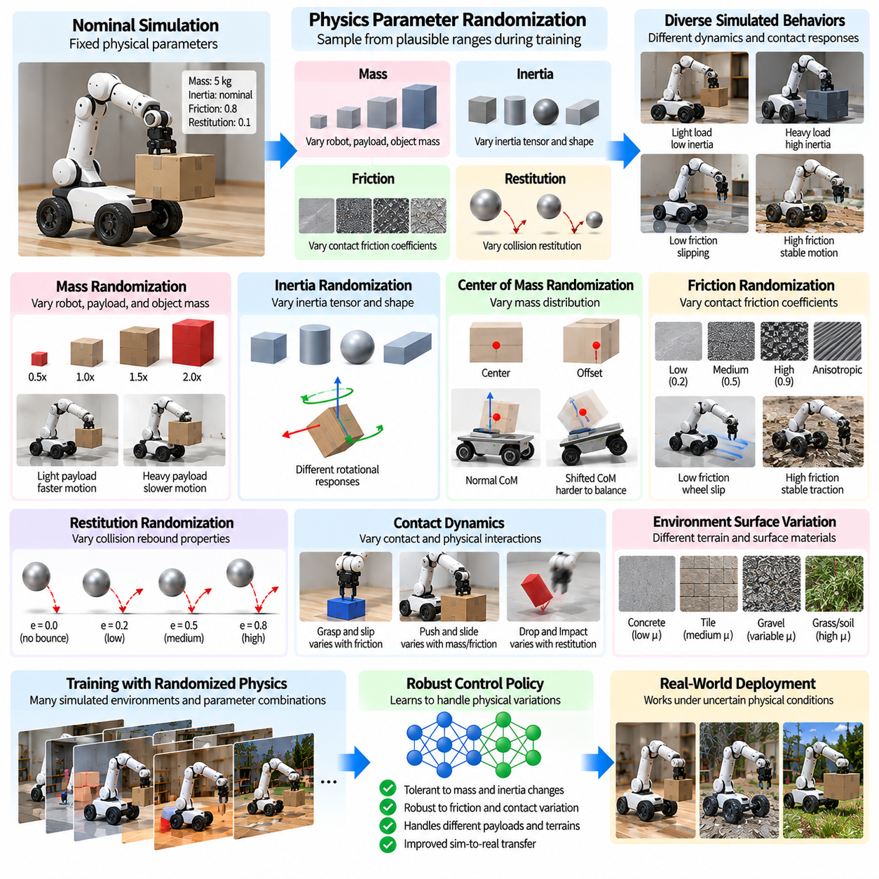
Mass, inertia, friction, and physics randomization are essential techniques for improving the robustness of Physical AI systems trained in simulation. Real robots operate under uncertain mechanical properties, variable contact conditions, and imperfect physical models. Randomizing these parameters during training exposes control policies to diverse dynamic behaviors. This reduces dependence on a single nominal model and supports more reliable transfer from simulated environments to physical hardware.
Physics randomization addresses discrepancies between simulated dynamics and actual robot behavior. Even carefully calibrated simulators cannot perfectly reproduce material properties, mechanical tolerances, wear, or environmental interactions. Small modeling errors can accumulate during complex movements and contact-rich tasks. Introducing controlled physical variations encourages policies to adapt to uncertainty rather than exploiting assumptions that hold only within the simulation engine.
Mass randomization modifies the weight-related dynamic properties of robots, payloads, and manipulated objects. Manufacturing variations, interchangeable tools, and changing payloads can alter the effective mass of a robotic system. During training, mass parameters are sampled within plausible operating ranges. This encourages controllers to maintain stable motion and accurate manipulation when the actual load differs from the nominal configuration used during development.
Payload mass variation is particularly important for mobile manipulators, industrial robots, and autonomous transport platforms. A robot carrying different loads experiences changes in acceleration, braking distance, motor effort, and structural response. Randomizing payload mass allows policies to encounter these differences before deployment. However, sampled loads must remain within the robot's mechanical capacity and actuator limits to avoid training on physically infeasible operating conditions.
Inertia randomization modifies the resistance of rigid bodies to changes in rotational motion. The inertia tensor depends on mass distribution, geometry, and the location of the center of mass. Two objects with identical mass can respond differently to rotation when their internal mass distributions differ. Training with varied inertia properties helps robotic controllers handle uncertain rotational dynamics during grasping, balancing, locomotion, and object transportation.
Center-of-mass randomization introduces changes in the effective balance point of a robot or payload. Unevenly distributed cargo, different tool attachments, and imperfect assembly can shift the center of mass away from its nominal location. Such changes influence tipping stability, joint torques, and dynamic balance. Simulating plausible center-of-mass offsets encourages control policies to compensate for variations in load distribution and maintain stable operation.
Mass and inertia parameters must remain physically consistent. Arbitrarily sampling inertia tensor components can generate impossible rigid-body properties or unstable simulation behavior. Physically valid inertia tensors must satisfy symmetry, positive definiteness for nondegenerate bodies, and constraints associated with realizable mass distributions. Parameter generation based on geometry, density, and bounded mass redistribution provides more credible dynamic variations.
Friction randomization models uncertainty in contact forces between interacting surfaces. Real friction depends on material composition, surface condition, contamination, temperature, and contact mechanics. A robot operating on different floors or manipulating objects with varying finishes may experience substantial changes in traction and resistance. Randomizing friction coefficients helps policies learn behaviors that remain effective across a wider range of contact conditions.
Static friction determines the resistance to the initiation of relative sliding, while kinetic friction governs resistance during sliding motion. These properties influence grasp stability, wheel traction, and object manipulation. Simulation engines often use simplified friction models that cannot capture every microscopic interaction. Varying friction parameters within plausible ranges can compensate for some modeling uncertainty while encouraging robust contact-aware control.
For wheeled robots, friction randomization directly influences acceleration, braking, turning, and slip behavior. Different floor materials and environmental conditions change the available tire-ground traction. A navigation controller trained with a single friction coefficient may perform poorly on polished concrete, wet surfaces, or uneven terrain. Randomizing traction conditions helps controllers develop safer velocity regulation and improved stability under uncertain ground contact.
Legged robots are especially sensitive to friction and contact dynamics because locomotion depends on repeated interactions between feet and supporting surfaces. Variations in friction affect foothold stability, propulsion, and recovery from slipping. Training across different contact parameters can improve walking and balancing policies. However, the simulation must represent realistic contact constraints so that learned behaviors do not rely on impossible ground reaction forces.
Restitution randomization modifies the energy returned during collisions between objects. The coefficient of restitution influences rebound velocity and impact response. This parameter is relevant for object dropping, dynamic manipulation, and contact-rich interactions. Training with varied restitution values helps policies tolerate uncertain collision outcomes, although restitution must be modeled consistently with impact velocity, contact materials, and the assumptions of the physics engine.
Contact stiffness and damping randomization address differences in how surfaces deform and dissipate energy during interaction. Rigid-body simulators often approximate contact through penalty forces, constraints, or compliant contact models. Variations in stiffness and damping can significantly affect penetration depth, impact forces, and numerical stability. Appropriate randomization improves robustness while avoiding parameter combinations that produce unrealistic oscillations or unstable integration.
Joint friction and mechanical damping introduce additional uncertainty into robot dynamics. Bearings, transmissions, seals, and mechanical interfaces generate resistance that may change with temperature, wear, and operating speed. Randomizing viscous damping, Coulomb friction, and related parameters helps control policies tolerate differences between simulated joints and physical mechanisms. These effects are particularly relevant for precision motion and low-speed manipulation.
Gravity randomization can be used to introduce controlled variations in effective gravitational acceleration. Although Earth's gravity changes only slightly across ordinary deployment locations, modest randomization may compensate for model uncertainty or improve robustness in selected training settings. Excessive gravity variation can distort the intended task dynamics. Therefore, gravity distributions should reflect the application rather than being treated as unrestricted sources of diversity.
Physics engine parameters can also influence the dynamics experienced by learning policies. Integration time steps, solver iterations, contact tolerances, and numerical approximations affect simulated motion and collision response. Varying selected numerical settings can reveal sensitivity to simulation artifacts. However, numerical randomization should not replace accurate physical modeling, and unstable solver configurations should be excluded from training.
Parameter distributions determine the effectiveness of physics randomization. Uniform sampling provides broad coverage but may assign excessive probability to unlikely mechanical configurations. Distributions informed by component specifications, experimental measurements, and system identification can better represent expected uncertainty. Correlations between mass, inertia, friction, and geometry should be preserved when they arise from shared physical causes.
Curriculum-based physics randomization gradually increases dynamic uncertainty during training. Initial stages may use nominal mechanical parameters to establish fundamental control behaviors. Later stages introduce wider mass distributions, friction variation, and contact uncertainty. This progression can improve learning stability while developing robust policies. Adaptive approaches can further emphasize parameter combinations associated with poor performance or repeated task failures.
Massively parallel simulation makes it possible to train policies across many physical parameter combinations simultaneously. Each simulated robot instance can receive different masses, inertia tensors, friction coefficients, and contact properties. The shared policy then learns from a diverse collection of dynamic experiences. Efficient parameter sampling and stable simulation execution are necessary to maintain computational throughput and meaningful learning signals.
Evaluation should measure robustness across both randomized simulation conditions and physical hardware experiments. Relevant metrics include task success rate, trajectory tracking error, energy consumption, slip frequency, collision response, and stability margins. Controlled comparisons can isolate the contribution of mass, inertia, friction, and contact randomization. Testing near realistic operating limits provides valuable evidence about policy reliability under uncertain physical conditions.
Physics randomization must be coordinated with actuator, sensor, and control-system modeling. Changes in mass and friction alter required motor torques, while sensor delays and actuator saturation influence how the controller responds. Randomizing these effects independently without considering their interactions may produce misleading training scenarios. Integrated dynamic modeling helps preserve consistency between physical uncertainty, available actuation, and observed robot behavior.
Ultimately, mass, inertia, friction, and physics randomization prepare Physical AI systems to operate under uncertain real-world dynamics. Their effectiveness depends on physically valid parameter ranges, realistic correlations, stable numerical simulation, and systematic hardware validation. When combined with visual, geometric, and sensor randomization, these techniques provide a stronger foundation for robust robotic control and reliable simulation-to-reality transfer.

03.08. Actuator Control and Latency Randomization
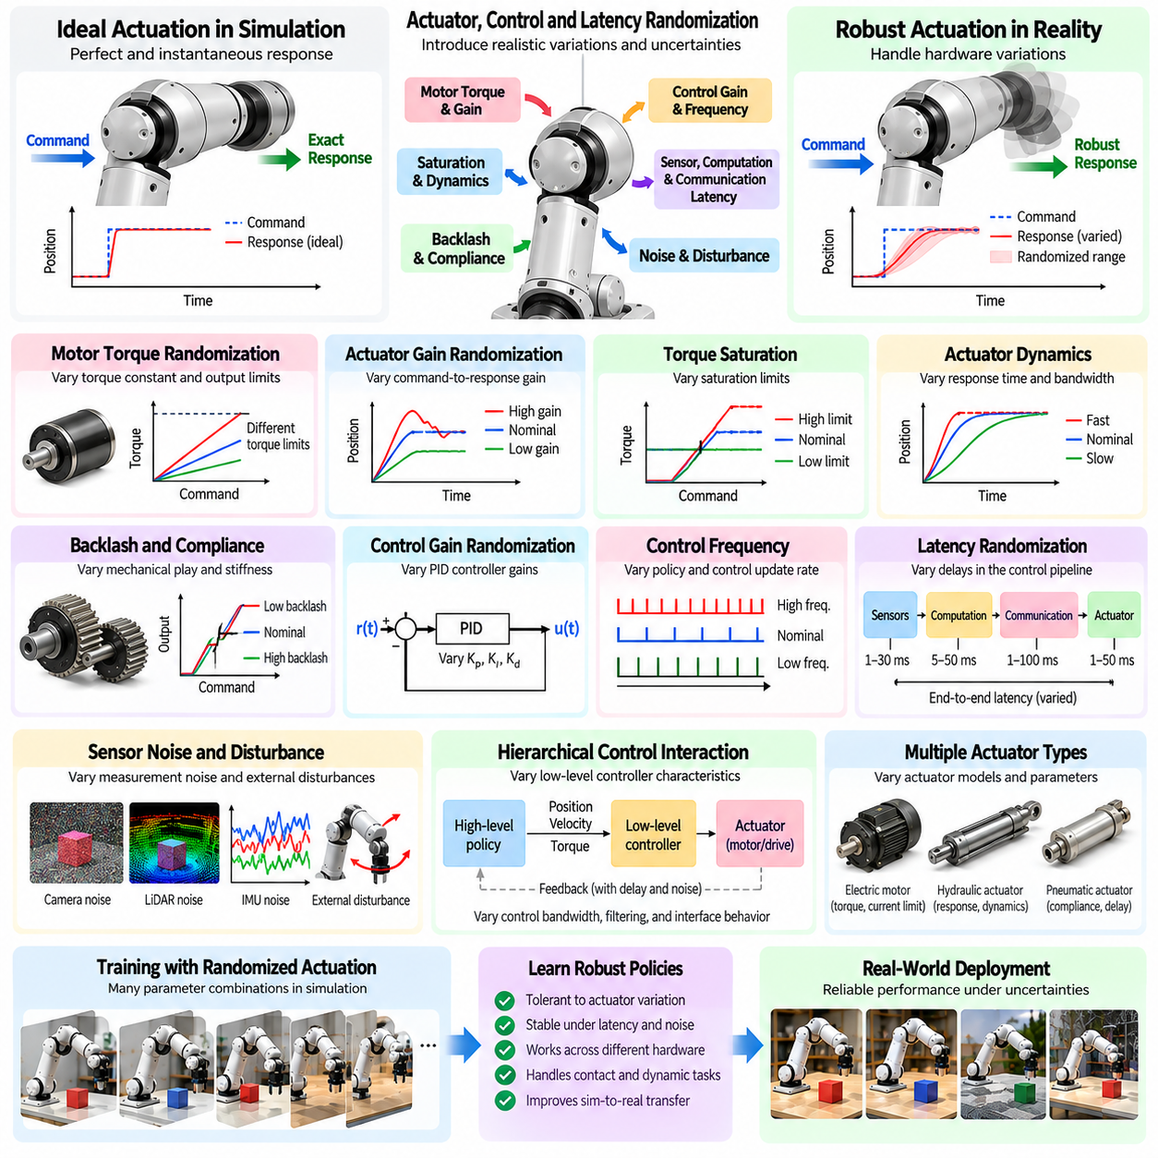
Actuator, control, and latency randomization are essential techniques for improving the transfer of robotic policies from simulation to physical hardware. Real actuators rarely respond exactly as idealized simulation models predict, while control systems experience timing variations and communication delays. Randomizing these characteristics during training exposes Physical AI systems to realistic execution uncertainty and encourages stable behavior across different hardware configurations and operating conditions.
Actuator randomization addresses differences between commanded actions and actual mechanical responses. Motors, transmissions, hydraulic systems, and pneumatic devices exhibit nonlinear behavior, manufacturing tolerances, and performance variation. A controller trained with perfect actuation may depend on instantaneous and precise command execution. Introducing realistic actuator uncertainty encourages policies to compensate for imperfect responses and maintain task performance despite hardware limitations.
Motor torque randomization modifies the relationship between control commands and generated mechanical torque. Actual torque depends on motor characteristics, current limits, temperature, supply voltage, and drive electronics. Sampling plausible torque constants and output limits allows policies to experience different actuation capabilities. This is particularly important for robots performing dynamic locomotion, heavy manipulation, or rapid acceleration under changing mechanical loads.
Actuator gain randomization changes how strongly a motor or servo responds to control inputs. Differences in amplifier gain, drive calibration, and mechanical transmission efficiency can alter the resulting motion. Randomizing these gains prevents policies from relying on one exact command-to-response relationship. However, gain ranges must remain compatible with realistic hardware behavior to avoid creating control conditions that cannot occur during deployment.
Torque saturation randomization represents the physical limits of motors and drive systems. When commanded torque exceeds available capacity, the actuator cannot deliver the requested output. Saturation may become more restrictive because of thermal protection, current limiting, or reduced supply voltage. Training under varied saturation limits encourages controllers to respect available actuation and avoid strategies that require consistently unrealistic motor performance.
Actuator dynamics introduce delays and transient responses between commands and mechanical motion. Electric motors, hydraulic valves, and pneumatic systems respond according to their internal electrical, mechanical, or fluid dynamics. Simplified first-order or higher-order models can approximate these effects. Randomizing response time constants and bandwidth helps policies remain effective when real actuators react more slowly or differently than nominal simulation models.
Mechanical backlash and transmission compliance create additional differences between commanded and realized motion. Gearboxes may contain dead zones, while belts, shafts, and flexible couplings introduce elastic deformation. These effects can influence positioning accuracy, force transmission, and oscillation. Randomizing backlash, stiffness, and damping parameters helps controllers tolerate mechanical imperfections, especially during precision manipulation and direction reversals.
Control gain randomization modifies parameters used by feedback controllers, including proportional, integral, and derivative gains. Different gain settings influence tracking accuracy, response speed, overshoot, and stability margins. Randomizing gains within validated ranges can improve the adaptability of learned policies interacting with conventional control loops. However, unstable controller configurations should be excluded because they can generate misleading training behavior and unsafe dynamics.
The interaction between learned policies and low-level controllers is especially important in hierarchical robotic architectures. A high-level policy may generate target positions, velocities, or torques, while embedded controllers execute these commands. Differences in control bandwidth, filtering, and command interpretation can change the resulting behavior. Randomizing relevant interface characteristics encourages policies to remain robust across realistic controller implementations.
Control frequency randomization introduces variations in how often policies and feedback controllers update their commands. Real systems may experience scheduling jitter, processor load changes, and differences between nominal and effective update rates. A policy trained at one perfectly fixed frequency may become sensitive to timing deviations. Training across bounded frequency variations encourages more stable responses while preserving the temporal requirements of the physical system.
Latency randomization models delays between observation, decision, communication, and actuation. A robotic control pipeline includes sensor acquisition, data transfer, perception processing, policy inference, command transmission, and actuator execution. Each stage contributes to end-to-end delay. Randomizing these delays helps policies learn to act using observations that may describe slightly earlier states rather than assuming instantaneous access to the physical world.
Observation latency affects the accuracy of state information available to a controller. Camera frames, LiDAR scans, and proprioceptive measurements may arrive after the corresponding physical events have occurred. Delayed observations can produce tracking errors or inappropriate corrective actions during fast motion. Training with realistic observation delays encourages policies to use temporal context, state estimation, and predictive behavior when current measurements are unavailable.
Action latency introduces a delay between issuing a command and observing its physical effect. Network communication, motor controllers, command queues, and mechanical response dynamics contribute to this delay. Randomizing action latency exposes policies to variations in command execution timing. This is particularly important for balancing robots and high-speed manipulators, where even modest delays can significantly influence stability and trajectory accuracy.
Communication jitter randomization represents variations in message delivery times across distributed robotic systems. Ethernet networks, wireless connections, field buses, and middleware introduce timing uncertainty under changing computational loads. Unlike constant latency, jitter produces irregular intervals between observations and actions. Training with realistic jitter distributions helps policies tolerate asynchronous execution without assuming perfectly periodic communication.
Packet loss and command dropout randomization simulate temporary interruptions in control communication. Commands may be delayed, discarded, or replaced by previously received values depending on the communication architecture. These events can affect motion continuity and tracking performance. Randomized training can improve tolerance to limited communication failures, but safety-critical systems still require explicit watchdogs, timeout handling, and independent protective mechanisms.
Temporal consistency is essential when randomizing control and latency parameters. Independent random delays applied without respecting command order can create unrealistic execution sequences. Simulation should represent timestamp relationships, buffering behavior, and actuator command scheduling accurately. Delay distributions may include constant components, bounded jitter, and occasional longer disturbances, reflecting the characteristics of the intended robotic platform.
Actuator and latency randomization should be coordinated with physical dynamics. A robot carrying a heavy payload may accelerate more slowly, while limited motor torque and delayed feedback further influence its response. Randomizing these effects together exposes policies to coupled uncertainties encountered during real operation. Physically consistent combinations are more useful than arbitrary parameter variations that violate hardware capabilities or system architecture.
Parameter distributions should be informed by motor specifications, controller measurements, communication benchmarks, and experimental identification. Uniform sampling can provide broad coverage, but realistic operating conditions often exhibit structured variation. Temperature-dependent performance loss, voltage fluctuations, and processing delays may follow distinct distributions. Data-driven parameter selection improves the relevance of randomized training scenarios and reduces unnecessary computational effort.
Curriculum-based randomization gradually introduces actuator uncertainty and timing disturbances. Initial training may use nominal actuator responses and stable control frequencies to establish fundamental behaviors. Later stages introduce torque limitations, response delays, gain variations, and communication jitter. Adaptive randomization can emphasize conditions associated with poor tracking or unstable behavior, provided that the sampled configurations remain feasible and physically meaningful.
Massively parallel simulation enables training across many actuator and timing configurations simultaneously. Different robot instances can experience distinct torque limits, response bandwidths, control frequencies, and latency profiles while sharing a common policy. This increases the diversity of control experiences and supports robust policy optimization. Efficient simulation scheduling and accurate temporal modeling are necessary to prevent numerical artifacts from influencing learned behavior.
Evaluation should examine trajectory tracking error, settling time, overshoot, energy consumption, task success rate, and stability under delayed control. Hardware-in-the-loop testing can expose learned policies to real controllers and communication interfaces before full deployment. Controlled experiments should compare nominal and randomized training across realistic latency and actuator limits. These measurements help determine whether robustness improvements translate into reliable physical performance.
Ultimately, actuator, control, and latency randomization prepare Physical AI systems for the imperfect execution conditions of real robotic platforms. Their effectiveness depends on realistic hardware models, bounded parameter distributions, accurate timing relationships, and systematic validation. When integrated with sensor and physics randomization, these techniques support control policies that maintain stable, efficient, and reliable behavior despite uncertainty in actuation and communication.

03.09. Terrain Weather and Environment Randomization
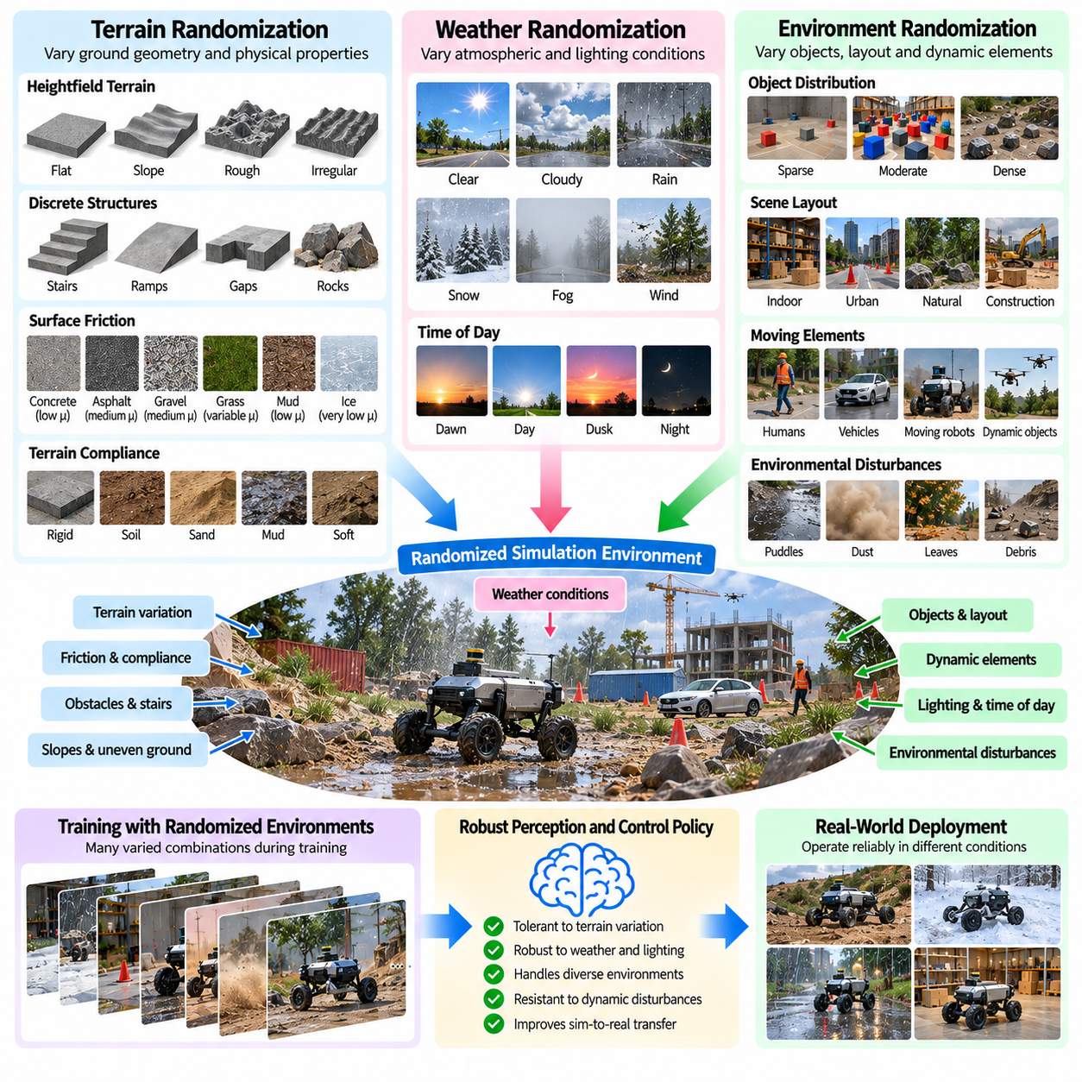
Terrain, weather, and environment randomization are essential components of robust Physical AI training because real robots operate in conditions that rarely match a fixed simulation. Ground surfaces, atmospheric conditions, obstacles, and environmental disturbances influence perception and motion. Randomizing these factors exposes robotic policies to diverse operating conditions and improves their ability to transfer from controlled virtual environments to unpredictable physical settings.
Terrain randomization modifies the geometric and mechanical characteristics of surfaces encountered by mobile and legged robots. Real environments contain slopes, steps, cracks, bumps, and uneven ground that affect locomotion and stability. Training exclusively on flat surfaces can produce policies that fail when terrain geometry changes. Introducing controlled terrain variation encourages robots to develop adaptable movement strategies and maintain balance across different surface configurations.
Terrain heightfield randomization generates surfaces with varying elevations, slopes, and local irregularities. Heightfields provide an efficient representation for large-scale terrain generation in physics simulation. Parameters such as elevation amplitude, spatial frequency, and surface roughness determine terrain complexity. Sampling these parameters allows policies to experience gradual slopes, irregular ground, and challenging transitions while maintaining physically meaningful terrain geometry.
Procedural terrain generation extends randomization beyond simple heightfields by introducing stairs, gaps, obstacles, ramps, and discrete surface structures. These features require different locomotion and navigation strategies. Randomizing obstacle dimensions, spacing, and orientation creates diverse movement challenges. Terrain generation should preserve feasible traversal paths and realistic geometric constraints so that training emphasizes adaptive behavior rather than impossible navigation tasks.
Surface friction randomization represents differences in traction caused by materials and environmental conditions. Concrete, asphalt, gravel, soil, grass, and wet surfaces exhibit different contact properties. These variations influence acceleration, braking, turning, and slipping. Randomizing friction coefficients together with terrain geometry helps controllers learn stable movement strategies under uncertain ground contact, particularly when rapid maneuvers or heavy payloads increase traction demands.
Terrain compliance randomization models differences in surface deformation and mechanical support. Soft soil, sand, mud, and flexible flooring respond differently to applied forces than rigid surfaces. Contact stiffness, damping, and penetration resistance influence wheel mobility and legged locomotion. Simulating plausible compliance variations helps policies tolerate changes in ground support, although highly deformable terrain may require specialized contact or granular material models.
Weather randomization introduces atmospheric conditions that affect robotic perception, mobility, and operational reliability. Rain, snow, fog, wind, and changing illumination can alter sensor measurements and physical interactions. These conditions may occur independently or together, creating complex environmental uncertainty. Training across representative weather scenarios helps robots maintain task performance beyond ideal laboratory conditions and reduces sensitivity to specific deployment environments.
Rain randomization models the effects of precipitation on visibility, surface traction, and sensor reliability. Raindrops can obscure camera images, create reflections, and interfere with certain optical measurements. Wet surfaces may reduce friction and increase braking distances. Realistic rain simulation should connect visual effects with corresponding physical changes, allowing policies to learn appropriate responses to both degraded perception and altered ground contact.
Snow and ice randomization introduces changes in terrain appearance, surface friction, and obstacle geometry. Snow accumulation may conceal boundaries, reduce visible landmarks, and modify traversable surfaces. Ice can substantially decrease available traction, increasing the risk of slipping or losing control. Randomizing snow coverage, surface conditions, and associated friction parameters helps policies prepare for winter environments while respecting realistic vehicle and robot operating limits.
Fog and atmospheric visibility randomization modify the distance and clarity with which environmental features can be observed. Scattering and attenuation reduce image contrast and can affect optical sensing technologies. Visibility conditions influence obstacle detection, localization, and navigation planning. Training with different fog densities encourages perception systems to operate under reduced information quality, although sensor-specific attenuation and measurement errors should be modeled consistently.
Wind randomization introduces external forces and moments that disturb robotic motion. Aerial robots are particularly sensitive to wind speed, direction, gusts, and turbulence, while mobile manipulators and lightweight platforms may also experience noticeable disturbances. Randomizing wind fields helps control policies develop disturbance rejection capabilities. Wind models should consider spatial and temporal correlations because realistic gusts do not behave as independent random forces at every simulation step.
Environmental illumination randomization represents variations caused by sunlight, cloud cover, shadows, and time of day. Outdoor robots may encounter rapidly changing brightness, strong directional lighting, and low-contrast conditions. These effects influence camera observations and visual localization. Combining illumination variation with terrain and weather changes creates more realistic training scenarios, provided that lighting conditions remain consistent with the simulated environment.
Dynamic obstacle randomization introduces moving people, vehicles, animals, and other agents into simulated environments. Their positions, velocities, trajectories, and interaction patterns can vary between training episodes. This exposes navigation policies to uncertain and evolving surroundings. Realistic motion constraints and collision avoidance requirements should be preserved so that robots learn safe responses to dynamic obstacles rather than exploiting artificial movement patterns.
Environmental clutter randomization changes the number, arrangement, and characteristics of objects occupying the workspace. Warehouses, construction sites, agricultural fields, and public environments contain varying levels of clutter and temporary obstacles. Randomizing these conditions improves perception and path planning robustness. Object placement should remain semantically and physically plausible, preserving accessible routes and meaningful task configurations.
Environmental disturbance randomization also includes vibration, ground motion, dust, and mechanical interference. Industrial robots may experience vibrations from nearby machinery, while field robots encounter airborne particles and unstable supporting surfaces. These disturbances can affect sensor measurements and control accuracy simultaneously. Coordinated randomization helps represent coupled environmental effects that cannot be captured through independent visual or mechanical perturbations.
Seasonal and geographical randomization expands the range of environmental conditions represented during training. Different regions exhibit variations in terrain composition, vegetation, precipitation, temperature, and daylight patterns. Seasonal changes can modify both scene appearance and physical interaction properties. Sampling representative environmental combinations helps policies generalize across deployment locations without assuming that every possible condition is equally likely.
Environmental randomization must preserve relationships between weather, terrain, and physical dynamics. Heavy rain may increase surface moisture, while freezing temperatures can change traction and material behavior. Independent sampling without considering these relationships may generate implausible combinations. Conditional distributions and environment-specific constraints provide more coherent scenarios and encourage policies to learn responses to realistic combinations of disturbances.
Randomization distribution design determines how frequently different terrain and weather conditions appear during training. Uniform sampling can provide broad coverage but may overrepresent rare or extreme scenarios. Climate records, terrain surveys, operational requirements, and field measurements can guide realistic parameter ranges. Separating normal operating conditions from exceptional disturbances helps balance task performance, robustness, and training efficiency.
Curriculum-based environment randomization gradually increases terrain complexity and environmental uncertainty. Early training may begin on smooth surfaces under favorable visibility conditions. Later stages introduce rough terrain, reduced traction, dynamic obstacles, and adverse weather. Adaptive curricula can emphasize scenarios associated with policy failures. This progression supports stable learning while preparing robots for increasingly challenging deployment conditions.
Massively parallel simulation enables simultaneous training across thousands of terrain and environmental configurations. Each simulated robot instance can experience different surface geometry, friction, illumination, weather, and obstacle arrangements. Shared policies learn from diverse environmental interactions and develop broader operating capabilities. Efficient procedural generation and physically consistent simulation are essential for maintaining training throughput and useful learning signals.
Evaluation should examine performance across representative terrain classes, weather conditions, and environmental disturbances. Relevant metrics include task success rate, traversal stability, slip frequency, localization accuracy, collision rate, energy consumption, and recovery performance. Testing on held-out environments helps measure generalization beyond training distributions. Physical field experiments remain necessary to determine whether simulated robustness translates into reliable real-world operation.
Ultimately, terrain, weather, and environment randomization prepare Physical AI systems for the diversity and uncertainty of real deployment conditions. Their effectiveness depends on realistic environmental models, coherent parameter relationships, appropriate sampling distributions, and systematic validation. When integrated with physics, sensor, and actuator randomization, these techniques support robotic policies capable of maintaining reliable perception, navigation, and control across changing environments.

03.10. Robot Morphology and Payload Randomization
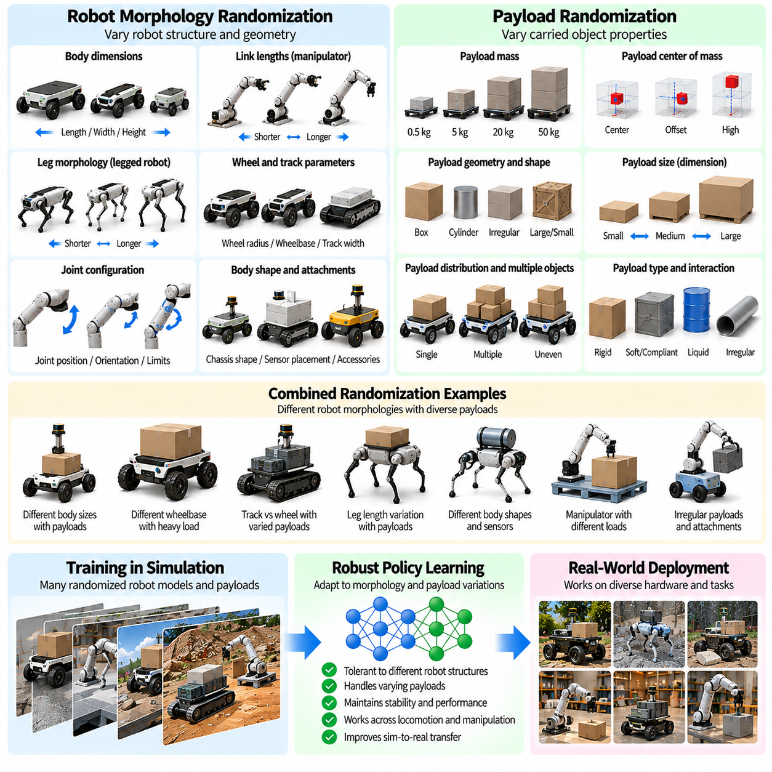
Robot morphology and payload randomization are important techniques for improving the adaptability of Physical AI systems trained in simulation. Real robotic platforms exhibit variations in geometry, mechanical configuration, component dimensions, and carried loads. These differences influence motion, stability, sensing, and control. Randomizing robot structure and payload characteristics during training helps policies remain effective across hardware variations and changing operational requirements.
Robot morphology describes the physical structure and arrangement of components that determine how a robot interacts with its environment. Relevant characteristics include body dimensions, limb lengths, joint locations, wheel spacing, and actuator placement. Even robots manufactured from the same design may exhibit small geometric differences. Morphology randomization exposes learning policies to these variations and reduces dependence on one precisely defined mechanical configuration.
Geometric morphology randomization modifies dimensions such as body length, width, height, and component proportions. These parameters influence clearance, reachability, turning radius, and collision geometry. A mobile robot with different wheelbase dimensions may require different steering behavior, while a manipulator with altered link lengths experiences changes in workspace geometry. Training across plausible dimensions helps controllers adapt to mechanical differences without requiring complete retraining.
Joint configuration randomization changes selected joint positions, orientations, limits, and mechanical relationships. Joint placement determines kinematic structure, while motion limits constrain reachable configurations. Randomizing these properties can improve adaptability across robot variants and manufacturing tolerances. However, changes must preserve valid kinematic chains and feasible motion ranges, because arbitrary joint modifications can produce mechanically impossible structures.
Limb and link randomization is particularly relevant for legged robots and manipulators. Variations in link length, segment mass, and joint spacing affect reach, balance, and movement efficiency. Longer limbs may increase reachable workspace while also changing torque requirements and dynamic response. Training with multiple plausible limb configurations encourages policies to recognize how mechanical structure influences motion and to adjust control behavior accordingly.
Wheel and track morphology randomization addresses variations in mobile robot locomotion systems. Wheel radius, wheelbase, track width, and contact geometry affect speed, turning behavior, obstacle traversal, and traction. Differences in wheel dimensions also influence encoder interpretation and velocity estimation. Randomizing these parameters helps navigation and motion control policies remain effective across platform configurations while respecting steering and drivetrain constraints.
Robot body shape randomization modifies structural geometry that affects collision avoidance and environmental interaction. Changes in chassis dimensions, protective covers, and mounted accessories can alter obstacle clearance and accessible pathways. For manipulation systems, body geometry also influences self-collision and reachable workspace. Training with realistic shape variations helps policies maintain collision awareness and adapt movement planning to different physical configurations.
Morphology randomization must maintain consistency between geometry, mass, inertia, and actuation. Increasing link length without updating inertia or torque requirements can create unrealistic dynamic behavior. Similarly, changing wheel radius affects both contact geometry and the relationship between rotational speed and linear velocity. Physically consistent parameter updates ensure that simulated robots represent plausible mechanical systems rather than disconnected combinations of randomized properties.
Payload randomization introduces variation in the mass, dimensions, position, and mechanical characteristics of carried objects. Robots used in logistics, manufacturing, and service applications frequently handle loads that differ between tasks. These variations affect acceleration, braking, balance, and energy consumption. Training with randomized payloads encourages policies to maintain reliable performance when operating conditions change during deployment.
Payload mass randomization is particularly important for mobile transport robots and robotic manipulators. Increasing payload mass raises the forces and torques required for acceleration and deceleration. Heavy loads may reduce achievable speed or require more conservative motion planning. Randomizing payload mass within rated operating limits helps policies learn appropriate control responses while avoiding strategies that depend on unrealistically high actuator capability.
Payload center-of-mass randomization represents uneven or changing load distribution. A payload positioned away from the robot's geometric center can create additional moments and modify tipping stability. For manipulators, an offset load changes joint torque requirements throughout the workspace. Randomizing payload placement and mass distribution encourages policies to compensate for these effects and maintain stable motion under different loading configurations.
Payload geometry randomization modifies object dimensions, shapes, and contact interfaces. A large payload may obstruct sensor visibility, restrict maneuverability, or increase collision risk. Irregular shapes can also change grasp stability and contact behavior. Training across realistic payload geometries helps robotic systems adapt their manipulation and navigation strategies while accounting for differences in object size and spatial arrangement.
Payload attachment randomization models variations in how loads connect to robotic structures. Grippers, mounting brackets, hooks, and transport fixtures introduce different mechanical constraints. Attachment stiffness, alignment, and allowable movement can influence load stability. Simulating these differences helps policies tolerate attachment uncertainty, although attachment configurations must remain mechanically feasible and consistent with intended operating procedures.
Morphology and payload variations influence actuator requirements and control authority. A longer manipulator link increases leverage and may demand greater joint torque, while a heavier mobile robot requires more effort to accelerate and stop. Randomizing structural and loading conditions together exposes policies to coupled mechanical uncertainty. Actuator limits and thermal constraints should remain consistent with each configuration to prevent unrealistic training outcomes.
Morphology-aware observations can improve adaptation across different robot structures. Policies may receive joint locations, link dimensions, mass estimates, or payload information as additional inputs. These descriptors help distinguish changes in physical configuration from unexpected disturbances. When explicit morphology information is unavailable, recurrent policies or online estimation methods can infer relevant properties from motion history and observed control responses.
Parameterized robot models provide an efficient foundation for morphology randomization. A common robot description can generate multiple mechanically valid variants by adjusting dimensions, joint locations, and physical properties. Procedural generation tools can update collision meshes, inertia tensors, and actuator mappings consistently. This approach supports systematic exploration of robot variations while reducing the engineering effort required to construct separate simulation models.
Randomization distributions should reflect manufacturing tolerances, product variants, payload specifications, and expected operating conditions. Excessively broad distributions may include configurations that are unlikely or physically impossible. Narrow distributions may fail to provide sufficient robustness against real variation. Structured sampling based on engineering constraints helps balance generalization, training efficiency, and realistic representation of the intended robot family.
Curriculum-based morphology randomization gradually expands the range of structural and payload variations during training. Initial stages may use a nominal robot configuration with limited payload uncertainty. Later stages introduce broader link dimensions, wheel parameters, mass distributions, and attachment variations. Adaptive curricula can emphasize configurations associated with poor performance, helping policies improve robustness without introducing excessive complexity at the beginning of training.
Massively parallel simulation enables simultaneous learning across many morphology and payload configurations. Different robot instances can vary in body geometry, joint parameters, wheel dimensions, and carried loads while sharing a common policy. This exposes the learning system to diverse mechanical behaviors and supports cross-configuration generalization. Efficient model generation and stable physics simulation are essential for maintaining computational throughput.
Evaluation should examine performance across both familiar and previously unseen robot configurations. Relevant metrics include task success rate, trajectory tracking error, stability margin, energy consumption, collision frequency, and payload handling accuracy. Testing with held-out morphology and payload combinations helps determine whether a policy has learned transferable control principles. Physical experiments are necessary to verify that simulated adaptability extends to real hardware variations.
Morphology and payload randomization also support modular and reconfigurable robotic platforms. Robots may change tools, attachments, wheel assemblies, or structural modules to perform different tasks. Training across compatible configurations can reduce the need to develop a separate policy for every hardware arrangement. However, substantial structural changes may require updated observation representations, action mappings, or additional policy adaptation.
Ultimately, robot morphology and payload randomization expand simulation-based learning beyond a single fixed robotic body. Their effectiveness depends on mechanically valid configurations, consistent dynamic properties, realistic parameter distributions, and systematic hardware validation. When combined with physics, sensor, and actuator randomization, these techniques help Physical AI systems develop robust control policies capable of adapting to structural differences and changing payload conditions.

03.11. Randomization Distribution Design
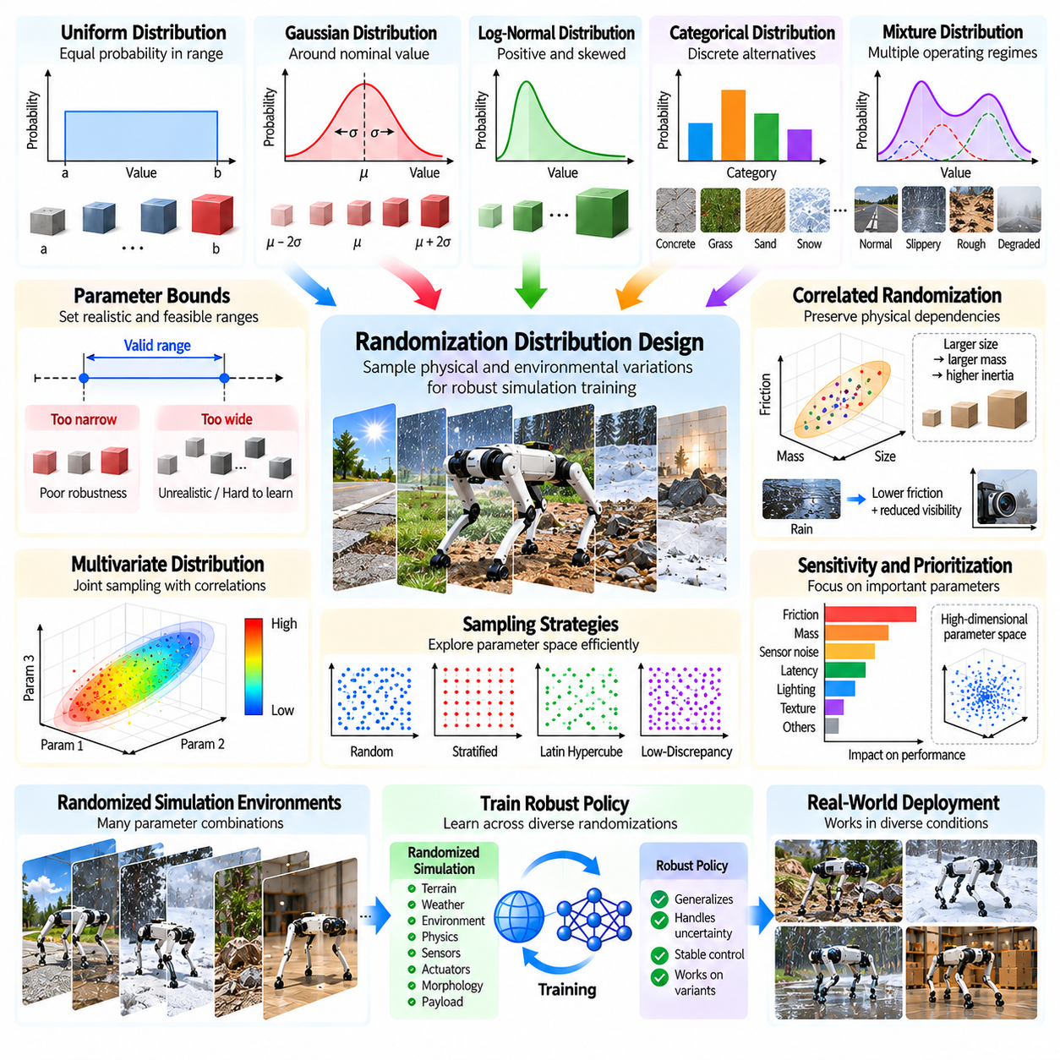
Randomization distribution design determines how physical and environmental variations are sampled during simulation-based training. In Physical AI, the objective is not simply to maximize randomness but to expose learning policies to uncertainty that supports reliable real-world operation. The selected distributions influence training efficiency, policy robustness, and simulation-to-reality transfer. Poorly designed distributions can produce unrealistic experiences or leave important deployment conditions insufficiently represented.
A randomization distribution defines the probability of selecting particular values for simulation parameters. These parameters may include mass, friction, lighting, sensor noise, actuator response, and environmental conditions. Each parameter can be represented by a probability distribution with specified bounds and statistical properties. The resulting training environment becomes a collection of related dynamic systems rather than a single fixed simulation configuration.
Uniform distributions are frequently used because they are simple to implement and provide broad parameter coverage. Every value within a specified interval receives equal probability density. This approach is useful when limited information exists about real-world variability. However, uniform sampling may assign excessive probability to extreme conditions while underrepresenting typical operating states. Its effectiveness therefore depends strongly on selecting physically meaningful parameter boundaries.
Gaussian distributions provide an alternative when parameter variations cluster around nominal values. Manufacturing tolerances, calibration errors, and some measurement uncertainties can often be approximated by normal distributions. The mean represents the expected parameter value, while the standard deviation controls variability. Truncated Gaussian distributions are useful when physical limits must be respected, preventing samples from exceeding feasible operating ranges.
Log-normal distributions are appropriate for strictly positive parameters exhibiting asymmetric variation. Certain friction-related quantities, noise magnitudes, and response time constants may be modeled using positive skewed distributions when supported by measurements. These distributions permit occasional larger values while concentrating probability near typical conditions. Their parameters should be estimated carefully because long tails can generate extreme samples that destabilize training.
Categorical distributions represent discrete alternatives rather than continuous parameter variations. Surface materials, sensor models, actuator types, and weather categories can be sampled from predefined sets. Each category may activate a corresponding collection of physical and visual parameters. This hierarchical approach supports realistic scenario generation by linking discrete environmental choices with continuous properties instead of randomizing every parameter independently.
Parameter bounds establish the range of uncertainty represented during training. Bounds that are too narrow may produce policies that fail under modest real-world variation, while excessively broad bounds can make learning unnecessarily difficult. Engineering specifications, calibration records, and field measurements provide useful starting points. Bounds should also respect physical feasibility, actuator capability, and the safety constraints associated with the intended application.
Correlated randomization is essential when simulation parameters share physical causes. Increasing object dimensions may alter mass and inertia, while rain can affect visibility and surface friction simultaneously. Independent sampling can break these relationships and create physically inconsistent scenarios. Joint probability distributions, conditional sampling, and structured parameter models preserve meaningful dependencies and improve the realism of generated training environments.
Multivariate distributions allow several continuous parameters to be sampled together while maintaining specified correlations. Covariance matrices can describe relationships between uncertain quantities, such as actuator gain and response bandwidth. However, linear covariance models may not capture nonlinear dependencies or complex physical constraints. More structured probabilistic models may be required when parameter relationships depend on geometry, operating state, or environmental categories.
Mixture distributions combine multiple probability models to represent distinct operating regimes. A robot may operate primarily under normal conditions but occasionally encounter slippery surfaces, unusual payloads, or degraded sensors. A mixture model can assign substantial probability to ordinary operation while preserving coverage of challenging cases. This provides a flexible way to represent multimodal uncertainty without assuming that all deployment conditions follow one simple distribution.
Sampling strategies determine how efficiently randomization distributions are explored. Independent random sampling is straightforward but may leave portions of a high-dimensional parameter space poorly covered. Stratified sampling and Latin hypercube sampling can improve coverage across selected dimensions. Low-discrepancy sequences may also support systematic exploration. The appropriate strategy depends on parameter dimensionality, simulation cost, and the learning algorithm.
High-dimensional randomization introduces additional challenges because the number of possible parameter combinations grows rapidly. Randomizing every available property can increase training complexity without improving practical robustness. Sensitivity analysis helps identify parameters that strongly influence task outcomes. Prioritizing these variables allows computational resources to focus on meaningful uncertainty while retaining limited variation in less influential parameters.
Distribution calibration uses real-world measurements to improve the correspondence between simulated and physical conditions. Data collected from robot hardware, sensors, terrain tests, and operational environments can estimate parameter ranges and statistical relationships. System identification methods can infer uncertain dynamics from observed responses. Updated distributions should reflect measurement uncertainty and avoid treating limited datasets as complete descriptions of deployment variability.
Distribution mismatch occurs when training randomization differs substantially from the conditions encountered during deployment. A policy may perform well across simulated variations yet fail because the real environment contains unmodeled dependencies or disturbances. Evaluating the difference between training and deployment distributions helps identify coverage gaps. Additional data collection and targeted parameter adjustments can reduce these gaps without indiscriminately increasing randomization strength.
Robust optimization provides a framework for designing distributions around difficult operating conditions. Instead of optimizing only average training performance, learning objectives can emphasize poor outcomes or high-risk parameter regions. Risk-sensitive criteria and worst-case evaluations can reveal weaknesses hidden by mean success rates. Nevertheless, excessive emphasis on extreme conditions may reduce performance during normal operation, requiring a deliberate balance between robustness and efficiency.
Adaptive distribution design modifies sampling probabilities based on observed policy performance. Conditions associated with frequent failures can receive increased attention, while well-mastered scenarios may be sampled less often. This approach directs learning toward unresolved weaknesses. Adaptation should retain sufficient coverage of the original operating distribution to prevent catastrophic forgetting or excessive specialization to a small collection of difficult scenarios.
Curriculum-based distribution design gradually expands the range and complexity of randomized conditions. Early training may emphasize nominal parameters and moderate uncertainty to establish fundamental task competence. Later stages introduce broader distributions, stronger disturbances, and more challenging combinations. The progression can be scheduled manually or adjusted using performance feedback. Appropriate pacing improves learning stability without sacrificing eventual robustness.
Distribution design should distinguish epistemic uncertainty from aleatoric variability. Epistemic uncertainty arises from incomplete knowledge of system parameters and may decrease through measurement or identification. Aleatoric variability reflects inherent randomness in observations or operating conditions. These sources may require different modeling and sampling approaches. Recognizing the distinction helps determine whether additional data collection or broader policy training is the more effective response.
Validation requires evaluating policies on parameter combinations that were not directly encountered during training. Held-out distributions, shifted parameter ranges, and rare but plausible scenarios reveal whether learned behavior generalizes beyond sampled conditions. Performance should be measured using task success, stability, tracking accuracy, energy consumption, and recovery behavior. Physical experiments remain necessary because simulation coverage alone cannot establish real-world reliability.
Distribution design also involves balancing simulation fidelity against computational cost. Complex probabilistic models and highly detailed physical variations may increase simulation overhead. Simplified distributions can be effective when they capture the uncertainties most relevant to control performance. Ablation studies can determine whether additional randomized parameters produce measurable benefits. Efficient design prioritizes useful variability rather than maximizing the number of randomized dimensions.
Massively parallel simulation enables large numbers of distribution samples to be evaluated simultaneously. Different robot instances can experience distinct combinations of physical properties, sensor characteristics, and environmental conditions. Statistical analysis of training outcomes can reveal sensitivity patterns and underrepresented failure regions. These results can guide iterative distribution refinement, connecting simulation-generated experience with systematic improvements in policy robustness.
Ultimately, randomization distribution design provides the statistical foundation for effective domain randomization in Physical AI. Successful distributions combine realistic parameter ranges, physically consistent dependencies, efficient sampling, and feedback from hardware validation. Rather than relying on arbitrary variation, carefully designed uncertainty models expose policies to representative and challenging conditions. This supports more efficient training, stronger generalization, and more reliable simulation-to-reality transfer.

03.12. Curriculum and Adaptive Domain Randomization
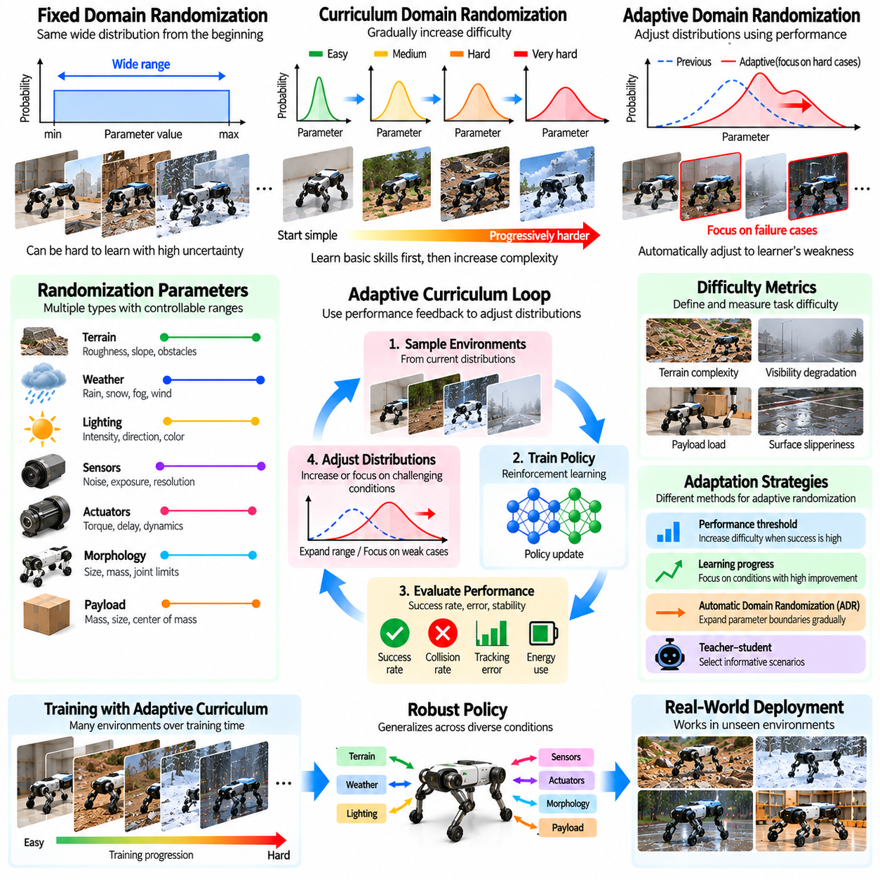
Curriculum and adaptive domain randomization are training strategies that regulate the difficulty and diversity of simulated environments as robotic policies develop. Conventional domain randomization samples uncertain parameters from predefined distributions, often without considering the learner's current capabilities. Curriculum methods introduce complexity progressively, while adaptive methods adjust randomization using performance feedback. Together, they improve learning stability, efficiency, and robustness.
Curriculum domain randomization organizes training conditions into a progression from relatively simple scenarios to more challenging environments. Early stages typically use nominal robot parameters, moderate disturbances, and predictable surroundings. As the policy becomes competent, the training process expands parameter ranges and introduces additional uncertainty. This progression helps robots acquire fundamental control behaviors before confronting difficult combinations of physical and environmental variations.
The motivation for curriculum learning arises from the difficulty of optimizing robotic policies under excessive uncertainty. If actuator dynamics, friction, sensor noise, and terrain complexity vary dramatically from the beginning, successful experiences may become rare. Sparse rewards and unstable trajectories can slow learning or prevent convergence. A carefully designed curriculum maintains achievable challenges while gradually increasing the diversity of training experiences.
Curriculum difficulty can be defined through physical parameters, environmental complexity, or task requirements. Examples include increasing terrain roughness, expanding payload ranges, reducing visibility, and introducing stronger actuator delays. Difficulty should reflect actual task demands rather than parameter magnitude alone. A small change in friction may be more challenging than a large change in lighting, depending on the robot's sensors, dynamics, and objectives.
A staged curriculum divides training into discrete levels with predefined randomization settings. Each level specifies parameter ranges, disturbance magnitudes, and scenario complexity. Policies advance when performance exceeds a selected threshold, such as a target success rate or stability criterion. This structure is straightforward to implement and interpret, but fixed thresholds may cause premature advancement or prolonged training when performance estimates are noisy.
Continuous curriculum randomization modifies parameter distributions gradually rather than switching between fixed stages. Distribution widths, means, and sampling probabilities can evolve with training progress. This produces smoother transitions between difficulty levels and reduces sudden changes in the learning environment. Continuous schedules may depend on training iterations, accumulated experience, or measured competence, although time-based schedules cannot guarantee that a policy is ready for harder conditions.
Performance-driven curricula adjust difficulty according to observed learning outcomes. Task success, tracking error, collision frequency, recovery ability, and energy consumption can indicate whether the policy is mastering current conditions. When performance is consistently strong, randomization becomes more challenging. When failures increase substantially, difficulty may remain unchanged or decrease temporarily. Reliable decisions require averaging performance over sufficient evaluation episodes.
Adaptive domain randomization extends curriculum learning by modifying sampling distributions automatically. Instead of following a fixed progression, an adaptive mechanism identifies parameter regions where the policy performs poorly or lacks experience. Training then allocates more simulation episodes to those conditions. This feedback-driven process concentrates computational resources on unresolved weaknesses while maintaining exposure to representative operating environments.
Automatic Domain Randomization, often abbreviated ADR, provides one approach to adaptive training. The system begins with relatively narrow parameter ranges and expands selected boundaries when the policy demonstrates adequate performance near those limits. Boundary evaluations determine whether new conditions should be included. Expansion continues as competence improves, creating an increasingly diverse training distribution without requiring every final parameter range to be introduced initially.
ADR requires careful management of expansion criteria and parameter interactions. Evaluating one parameter boundary while holding others near nominal values may underestimate the difficulty of combined disturbances. Conversely, expanding many dimensions simultaneously can destabilize learning. Structured boundary tests, joint parameter evaluations, and conservative expansion rates help maintain meaningful progress. Physical feasibility constraints must remain active throughout the adaptation process.
Teacher-student frameworks offer another approach to curriculum generation. A teacher mechanism selects training environments, while a student policy learns to perform robotic tasks within them. The teacher may optimize learning progress, failure discovery, or expected improvement. By choosing informative scenarios rather than uniformly sampling all possibilities, the framework can improve data efficiency. However, the teacher must avoid generating impossible tasks or repeatedly exploiting transient student weaknesses.
Learning progress provides a useful signal for selecting curriculum conditions. Scenarios that are already mastered contribute limited new information, while tasks that are consistently impossible may produce uninformative failures. Conditions near the boundary of current competence often generate valuable training experiences. Adaptive sampling can therefore emphasize environments where performance is improving, although occasional exposure to easy and difficult cases remains important for maintaining broad capability.
Failure-driven randomization focuses training on scenarios associated with unsuccessful behavior. Simulation logs can identify combinations of friction, payload, sensor degradation, and control delay that frequently cause instability. These combinations can receive higher sampling probabilities during subsequent training. This approach resembles targeted hard-example mining, but failure frequency must be interpreted carefully because rare events and noisy evaluations can distort difficulty estimates.
Curriculum design must consider dependencies between randomized parameters. Increasing terrain difficulty while simultaneously reducing traction and increasing payload mass may create challenges that exceed the robot's physical capabilities. Conditional distributions can maintain realistic relationships between environment properties and robot dynamics. Coordinated adaptation also prevents the curriculum from generating inconsistent combinations that teach policies to respond to simulation artifacts rather than physical behavior.
Multi-dimensional curricula manage several sources of uncertainty with separate or coupled progression schedules. Visual randomization may expand independently of actuator uncertainty, while payload variation may be linked to terrain difficulty. This flexibility allows training to target different capabilities at appropriate stages. However, independently mastered dimensions do not guarantee robustness to their combinations, so joint evaluation is necessary before declaring a policy ready for deployment.
Reward design influences the effectiveness of adaptive randomization. Rewards should encourage task completion, stability, safety, and efficient behavior without creating incentives to exploit easier scenarios. If curriculum adaptation depends only on reward magnitude, changes in reward scale may be mistaken for changes in competence. Task-specific metrics and independent evaluation conditions provide more reliable indicators of progress than training reward alone.
Catastrophic forgetting is a potential risk when adaptive sampling concentrates heavily on difficult scenarios. A policy may improve under newly introduced conditions while losing performance on previously mastered tasks. Maintaining a mixture of nominal, historical, and challenging environments reduces this risk. Periodic evaluation across earlier curriculum stages helps detect regressions and supports balanced competence across the intended operating distribution.
Parallel simulation makes curriculum and adaptive randomization particularly effective for Physical AI. Thousands of simulated robot instances can experience different difficulty levels and parameter combinations simultaneously. Performance statistics can be aggregated to update sampling distributions and curriculum boundaries. This supports rapid adaptation, although synchronization, statistical reliability, and computational overhead must be managed to avoid unstable or excessively frequent updates.
Curriculum evaluation should separate learning efficiency from final policy robustness. Faster convergence does not necessarily imply better generalization, and a policy trained through progressive difficulty may still fail on unseen combinations. Evaluation should include fixed benchmark scenarios, held-out parameter distributions, and extreme but feasible conditions. Comparing against static domain randomization helps determine whether adaptive scheduling provides measurable improvements.
Sim-to-real validation is essential because simulation-based difficulty estimates may not match real hardware behavior. Conditions considered challenging in simulation may be easy in practice, while unmodeled actuator effects or sensor failures can create unexpected difficulties. Hardware measurements and deployment observations can guide curriculum refinement. Updating the training distribution with real evidence helps align simulated learning challenges with operational requirements.
Safety-aware curricula distinguish useful training difficulty from physically hazardous or infeasible conditions. Payload limits, actuator saturation, collision constraints, and stability margins should remain consistent with robot specifications. Simulation can explore failures that would be unsafe to reproduce directly on hardware, but resulting policies still require controlled validation. Safety constraints should govern both curriculum expansion and the acceptance of newly trained policies.
Ultimately, curriculum and adaptive domain randomization transform simulation training from static uncertainty sampling into a structured learning process. Progressive difficulty establishes fundamental competence, while performance-driven adaptation directs experience toward unresolved weaknesses. Their effectiveness depends on meaningful difficulty measures, realistic parameter dependencies, reliable evaluation, and safeguards against forgetting. Integrated with large-scale simulation and hardware feedback, these methods support efficient and robust Physical AI learning.

03.13. Adversarial Domain Randomization
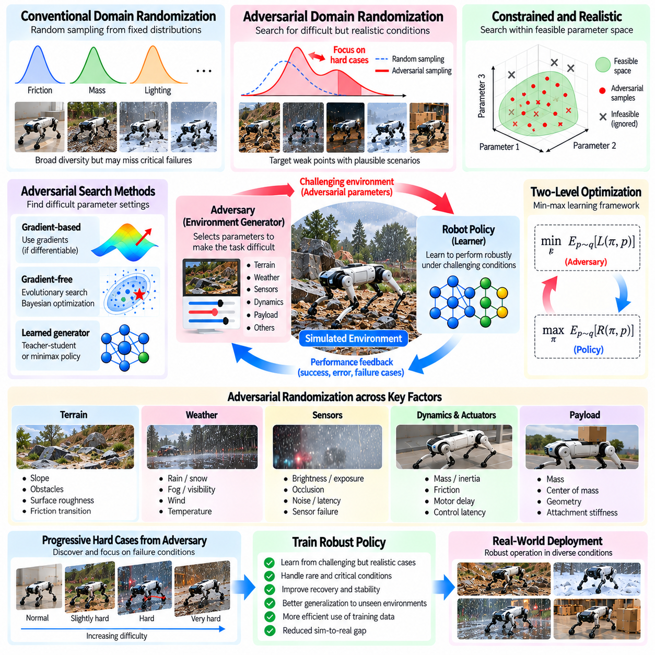
Adversarial domain randomization extends conventional simulation training by deliberately generating conditions that expose weaknesses in robotic policies. Instead of sampling environmental and physical parameters only from fixed distributions, an adversarial mechanism searches for difficult but plausible scenarios. These scenarios challenge perception, planning, and control while remaining consistent with physical constraints. The objective is to improve robustness against uncertainties that ordinary random sampling may overlook.
Conventional domain randomization increases training diversity by varying friction, mass, sensor noise, lighting, and other simulation properties. However, random sampling may rarely encounter combinations that cause critical failures. Adversarial randomization addresses this limitation by selecting parameter values that reduce policy performance. The resulting training process emphasizes vulnerable operating regions rather than treating every possible environment configuration as equally informative.
Adversarial domain randomization can be formulated as a two-level optimization problem. An adversary selects simulation parameters that make a task difficult, while the robotic policy attempts to maximize task performance under those conditions. The adversary may minimize expected reward or maximize a defined failure metric. Alternating between these objectives creates a competitive learning process in which environmental challenges evolve alongside the policy's capabilities.
The adversary typically operates within a constrained parameter space representing physically feasible environments. It may modify terrain friction, payload distribution, actuator latency, sensor degradation, or obstacle placement. Each parameter must remain within engineering limits and realistic operating ranges. Without these restrictions, the adversary may generate impossible scenarios that provide little useful information about real-world deployment and undermine the training objective.
Adversarial parameter selection differs from arbitrary worst-case disturbance generation. The most damaging simulated condition is not necessarily relevant to the intended deployment environment. A physically impossible combination of actuator failure, extreme payload, and negligible friction may guarantee failure without teaching useful recovery behavior. Effective adversarial training therefore balances scenario difficulty with plausibility, operational relevance, and meaningful opportunities for adaptation.
Gradient-based adversarial optimization can identify difficult simulation parameters when the environment and performance objective are differentiable. Gradients indicate how parameter changes influence policy performance and guide the search toward challenging conditions. However, contact dynamics, collision events, and discrete simulation choices often introduce discontinuities. Gradient-free optimization may therefore be preferable for many robotic applications.
Gradient-free adversarial methods include evolutionary search, Bayesian optimization, and population-based parameter exploration. These techniques evaluate candidate environments and use performance results to guide subsequent sampling. They can handle nonlinear dynamics and discrete scenario variables without requiring differentiable simulators. Their main limitation is computational cost, because discovering informative failures may require evaluating many simulated episodes.
An adversarial environment generator can be implemented as a separate policy that selects randomization parameters. This generator observes training statistics and proposes scenarios intended to challenge the robotic controller. The controller then learns from interactions within those scenarios. Such teacher-student or minimax formulations support adaptive difficulty, but the generator must be constrained to avoid repeatedly selecting impossible tasks or exploiting simulation defects.
Adversarial terrain randomization searches for surface configurations that reveal locomotion weaknesses. The adversary may vary slope angles, obstacle spacing, friction transitions, and local surface irregularities. For legged robots, difficult combinations can expose balance limitations or unstable foot placement. For wheeled platforms, they may reveal insufficient traction or steering instability. Terrain constraints must preserve feasible traversal and realistic contact behavior.
Adversarial sensor randomization targets weaknesses in perception and state estimation. Camera exposure changes, occlusions, depth noise, timing errors, and temporary sensor degradation can be selected to disrupt task performance. The objective is not simply to corrupt observations but to identify realistic sensing conditions that cause systematic errors. Training on these cases can improve recovery strategies, sensor fusion, and tolerance to incomplete environmental information.
Adversarial dynamics randomization focuses on uncertain physical interactions and actuator behavior. Variations in mass, inertia, friction, motor response, and control latency may be combined to reveal unstable operating regions. These conditions are especially important for high-speed movement and manipulation near performance limits. The adversary should respect coupled physical relationships so that difficult scenarios represent plausible hardware and environmental variations.
Adversarial payload randomization identifies loading configurations that challenge stability and control authority. Changes in payload mass, center of mass, attachment stiffness, and object geometry can alter dynamic response. An adversary may discover configurations that produce large tracking errors or reduced stability margins. Such scenarios are valuable when they remain within rated load limits and reflect conditions that could occur during actual robotic operations.
Adversarial obstacle generation creates challenging navigation and manipulation environments by adjusting obstacle positions, dimensions, and movement patterns. Dynamic agents may follow trajectories that require timely avoidance or replanning. The adversary should not create unavoidable collisions or violate realistic movement constraints. Useful scenarios are those that reveal weaknesses in decision-making while preserving at least one feasible strategy for successful task completion.
Robust optimization provides a mathematical foundation for adversarial randomization. The training objective may seek a policy that performs well under the most challenging admissible parameters rather than maximizing average performance alone. Risk-sensitive objectives can emphasize low-performing episodes or unfavorable outcome distributions. However, optimizing exclusively for worst-case conditions may produce overly conservative behavior and reduce efficiency during normal operation.
Distributionally robust optimization extends this perspective by considering uncertainty in the probability distribution of operating conditions. Instead of assuming one exact randomization distribution, training evaluates performance across a set of plausible distributions. An adversary can emphasize distributions associated with poor outcomes while respecting statistical constraints. This approach helps address uncertainty about how frequently difficult conditions will occur during deployment.
Adversarial training must avoid overfitting to a narrow collection of failure scenarios. If the adversary repeatedly selects similar conditions, the controller may become highly specialized while losing general performance. Maintaining a mixture of nominal, randomly sampled, and adversarial environments preserves diversity. Periodic evaluation on independent scenarios helps determine whether adversarial training improves broad robustness rather than only performance against the current generator.
Curriculum learning can regulate the strength of adversarial randomization. Early training may restrict the adversary to moderate disturbances so that the controller can establish basic competence. As performance improves, the adversarial search space can expand toward more challenging parameter combinations. This progressive approach reduces training instability and prevents the generator from overwhelming an immature policy with scenarios that are consistently impossible to solve.
Safety constraints are essential when adversarially generated policies are intended for physical robots. Simulated scenarios may explore dangerous conditions, but training must distinguish recoverable disturbances from violations of hardware limits. Actuator saturation, structural loading, tipping risk, and collision boundaries should be explicitly represented. Policies trained under adversarial conditions still require controlled testing before deployment because simulated robustness does not guarantee physical safety.
Massively parallel simulation makes adversarial domain randomization more practical by evaluating many candidate environments simultaneously. Parallel robot instances can test different parameter combinations and report task failures, stability margins, and recovery outcomes. The adversarial mechanism can use these results to prioritize informative scenarios. Efficient evaluation, scenario diversity, and careful allocation of computational resources are important for sustaining training progress.
Evaluation should compare adversarially trained policies against those trained with conventional and adaptive domain randomization. Relevant measures include task success, worst-case performance, collision frequency, stability, recovery capability, and performance under unseen parameter combinations. Held-out adversarial scenarios can reveal whether robustness generalizes beyond the training generator. Hardware experiments are required to confirm that improvements persist under real disturbances and modeling errors.
Ultimately, adversarial domain randomization transforms simulation uncertainty into an active mechanism for discovering and correcting policy weaknesses. Its effectiveness depends on physically meaningful constraints, informative failure metrics, balanced scenario sampling, and stable optimization. When combined with curriculum learning, realistic physics, and systematic validation, adversarial training can strengthen Physical AI systems against difficult operating conditions that conventional randomization may fail to expose.

03.14. Domain Randomization Pipeline [w/Code]
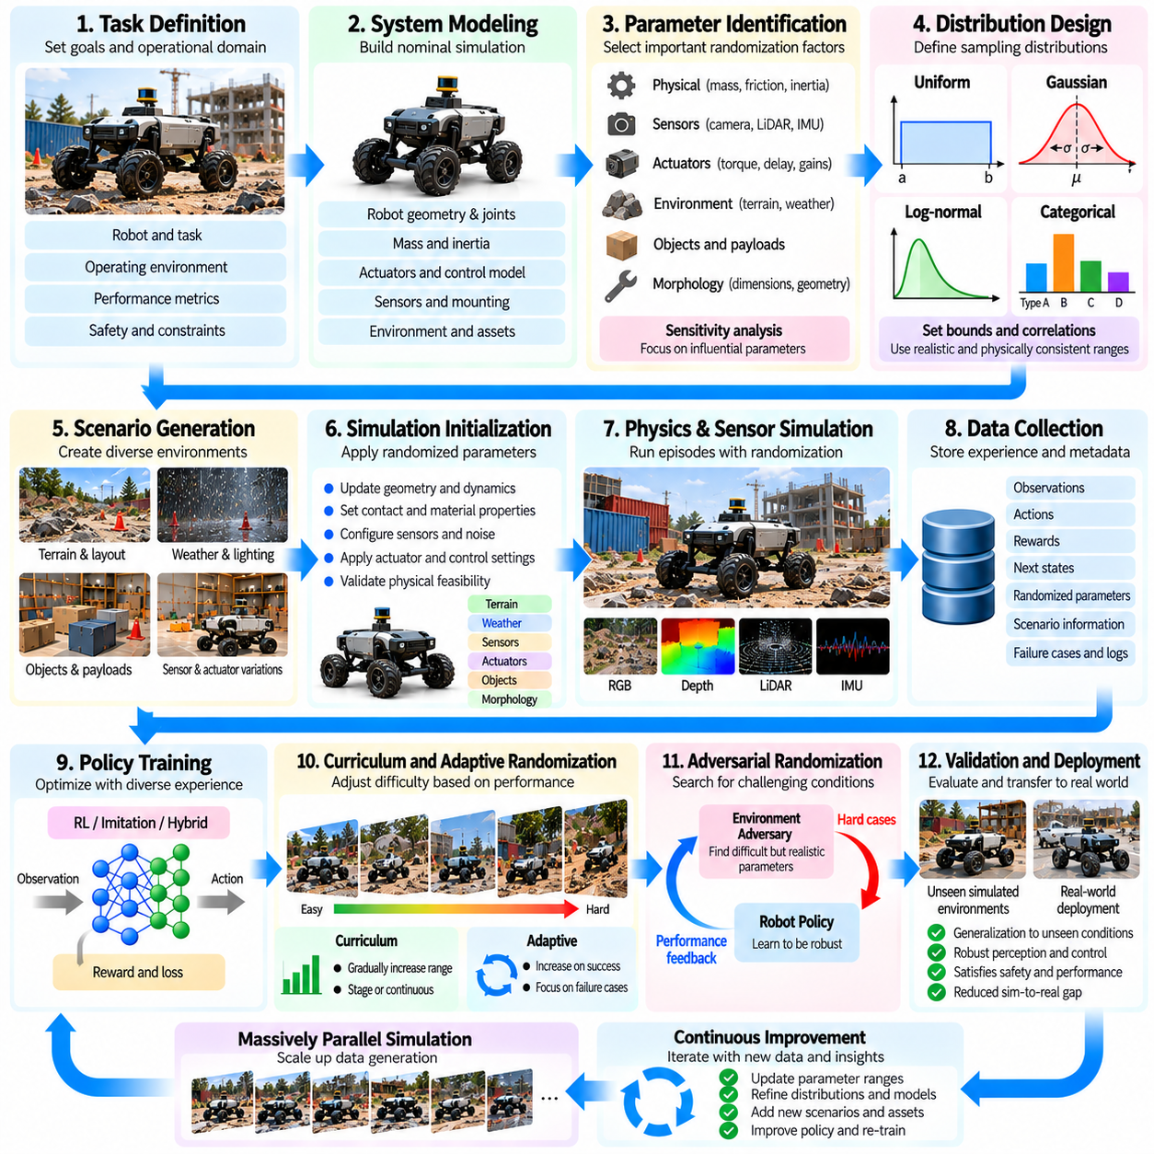
A domain randomization pipeline is a systematic framework for generating diverse simulation environments and training robust Physical AI policies. It integrates parameter definition, probability distribution design, scenario generation, physics simulation, data collection, policy optimization, and validation. Rather than applying arbitrary variations independently, an effective pipeline coordinates uncertainty across visual, mechanical, sensor, and environmental domains to improve simulation-to-reality transfer.
The pipeline begins by defining the target robotic task and its operational design domain. Robot configuration, workspace geometry, environmental conditions, performance requirements, and safety limits establish the boundaries of relevant uncertainty. A warehouse transport robot requires different randomization priorities from an aerial inspection robot. Clearly defining the intended deployment conditions prevents unnecessary simulation complexity and focuses training on realistic operational challenges.
System modeling establishes the nominal simulation environment before randomization is introduced. Robot geometry, joint configurations, mass properties, actuator characteristics, sensors, and environmental assets must be represented consistently. Baseline simulation behavior should be compared with hardware measurements whenever possible. A poorly calibrated nominal model can produce systematic errors that randomization alone cannot reliably compensate for.
Parameter identification determines which simulation properties should vary during training. Candidate parameters include friction coefficients, object masses, actuator delays, camera intrinsics, lighting conditions, terrain geometry, and payload distributions. Sensitivity analysis can identify variables that strongly influence task performance. Prioritizing influential parameters reduces unnecessary computational expense while preserving uncertainty that matters for real-world robustness.
Randomization distribution design specifies how parameter values are sampled. Uniform, Gaussian, categorical, and mixture distributions can represent different forms of uncertainty. Distribution boundaries should reflect engineering specifications, measured variability, and expected deployment conditions. Correlations between parameters must also be preserved, because independent sampling can generate physically inconsistent combinations that reduce the usefulness of training experiences.
Scenario generation converts sampled parameters into executable simulation environments. Procedural tools may modify terrain surfaces, object placement, material properties, lighting, sensor configurations, and robot payloads. Each generated scenario should satisfy geometric, mechanical, and task-specific constraints. Validity checks help reject impossible configurations, unreachable objectives, and environmental combinations that violate the intended operating assumptions.
Simulation initialization applies the selected randomization parameters to each training instance. Geometry, inertia tensors, contact properties, actuator settings, and sensor models must be updated consistently. Some parameters can change at episode boundaries, while others may vary during execution to represent disturbances. The timing of these changes should reflect physical behavior and avoid artificial discontinuities that could distort policy learning.
Physics and sensor simulation execute the generated scenarios while producing observations and state transitions. Contact dynamics, actuator response, sensor noise, and environmental effects interact to determine robotic behavior. Simulation fidelity should be sufficient to capture task-relevant mechanisms without introducing unnecessary computational overhead. Stable numerical integration and consistent timing are essential for generating reliable training experiences.
Data collection records observations, actions, rewards, state transitions, and relevant simulation metadata. Metadata should identify randomized parameter values, scenario configurations, software versions, and random seeds. These records support failure analysis, reproducibility, and targeted evaluation. Structured logging also enables engineers to determine whether specific combinations of physical uncertainty are associated with unstable behavior or poor task performance.
Policy training uses the collected simulation experience to optimize robotic behavior across randomized conditions. Reinforcement learning, imitation learning, or hybrid approaches may be employed depending on task requirements. Training objectives should balance task completion, control accuracy, efficiency, and safety. The policy must learn behaviors that remain effective across parameter variations rather than memorizing a small set of favorable simulation configurations.
Curriculum mechanisms can regulate randomization difficulty throughout the pipeline. Early training may use narrow parameter ranges and relatively simple environments to establish basic competence. As performance improves, distributions can expand to include stronger disturbances and more complex scenarios. Adaptive methods may adjust sampling probabilities based on observed failures, directing additional training toward conditions where the policy remains vulnerable.
Adversarial scenario generation provides an additional mechanism for discovering difficult operating conditions. An adversarial process searches within feasible parameter bounds for combinations that reduce policy performance. These scenarios can expose weaknesses that ordinary random sampling rarely encounters. Integrating adversarial cases with nominal and randomly generated environments helps improve robustness without allowing training to become dominated by unrealistic worst-case conditions.
Massively parallel simulation increases pipeline throughput by executing many randomized environments simultaneously. Different robot instances may experience distinct terrain properties, sensor characteristics, actuator dynamics, and payload configurations while sharing a common policy. Efficient environment generation, memory management, and GPU utilization determine practical scalability. Parallel execution should preserve independent random sampling and reliable performance statistics.
Pipeline orchestration coordinates environment generation, simulation execution, policy updates, evaluation, and data storage. Automated scheduling can distribute computational workloads and manage experiment configurations. Version-controlled assets, parameter definitions, and training settings help maintain consistency across repeated experiments. Monitoring systems should track simulation failures, resource consumption, policy convergence, and changes in performance across randomized conditions.
Quality assurance verifies that generated scenarios remain physically meaningful and computationally stable. Automated checks can detect invalid geometry, unrealistic inertia values, unstable contacts, sensor configuration errors, and impossible task conditions. Statistical monitoring can confirm that sampled parameters follow intended distributions. These controls prevent simulation defects from becoming hidden learning signals that encourage policies to exploit modeling artifacts.
Evaluation should use environments and parameter combinations that are separated from the training distribution. Fixed benchmark scenarios provide consistent performance comparisons, while held-out randomization ranges test generalization. Relevant metrics include task success rate, collision frequency, stability margin, tracking error, energy consumption, and recovery capability. Evaluation should examine average performance and difficult operating conditions rather than relying on a single aggregate score.
Ablation studies help determine which randomization components contribute meaningfully to policy robustness. Engineers can remove or restrict selected parameter groups and compare resulting performance. This reveals whether visual, dynamic, sensor, or environmental variations provide measurable benefits. Sensitivity analysis and ablation results can guide distribution refinement, reduce unnecessary simulation complexity, and improve the efficiency of subsequent training cycles.
Hardware validation connects simulation results with actual robotic operation. Controlled experiments should compare predicted and observed behavior under representative payloads, surfaces, sensor conditions, and actuator settings. Differences between simulation and hardware reveal modeling errors and missing uncertainty sources. The validation process should begin with safe operating conditions and expand gradually as confidence in the learned policy increases.
Feedback from hardware experiments supports iterative pipeline improvement. Measured friction, actuator response, sensor noise, and task failures can update simulation parameters and randomization distributions. Newly observed failure conditions may be incorporated into targeted training scenarios. This closed-loop process transforms domain randomization from a one-time configuration step into an evolving system that responds to real deployment evidence.
Reproducibility and traceability are essential for reliable pipeline operation. Random seeds, simulator versions, robot models, training datasets, distribution definitions, and policy checkpoints should be recorded for each experiment. Deterministic execution may not always be achievable across parallel hardware, but controlled configurations improve comparability. Traceable experiment histories support debugging, regression testing, and systematic policy development.
Deployment readiness requires demonstrating acceptable performance across the intended operational design domain. Validation should consider nominal conditions, plausible disturbances, rare but relevant failures, and hardware safety constraints. Policies that perform well in simulation may still require conservative operating limits and runtime monitoring. Clear acceptance criteria help distinguish successful training from sufficient evidence for dependable physical operation.
Ultimately, a domain randomization pipeline integrates uncertainty modeling, simulation generation, learning, evaluation, and hardware feedback into a continuous development process. Its effectiveness depends on physically consistent scenarios, realistic probability distributions, scalable computation, and rigorous validation. When these components operate together, Physical AI systems can develop policies that generalize beyond individual simulation configurations and perform more reliably in changing real-world environments.

