Volume 05. Simulation and Sim2Real Transfer

Chapter 00. Introduction

00.01. Why Simulation Matters for Physical AI
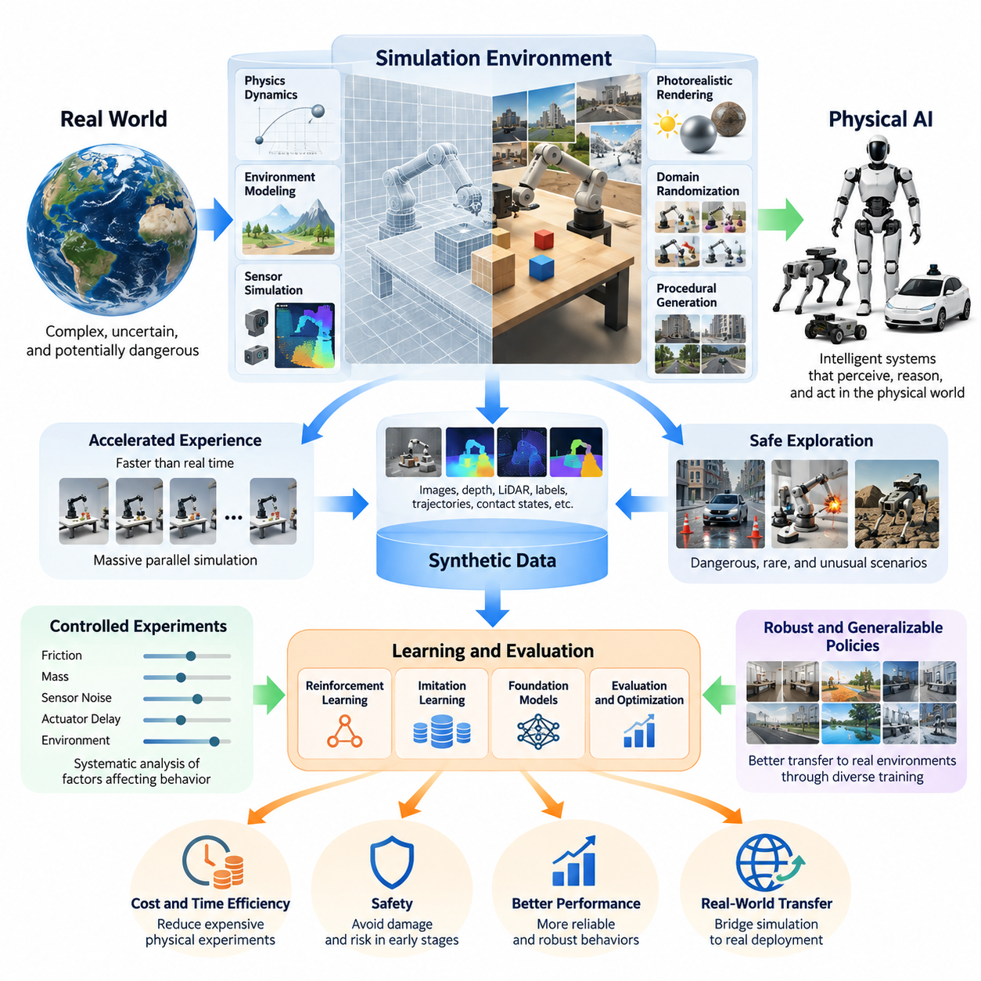
Physical AI represents a fundamental shift from artificial intelligence that processes digital information toward intelligent systems that perceive, reason, and act within the physical world. Unlike purely digital applications, Physical AI must operate under the constraints of gravity, friction, inertia, uncertainty, and real-time interaction. Simulation provides a computational environment in which these physical relationships can be explored before intelligent machines encounter actual operating conditions.
The importance of simulation arises from the difficulty of learning directly in the physical world. Robots, autonomous vehicles, and intelligent machines require extensive experience to develop reliable behaviors, yet physical experimentation is expensive, time-consuming, and potentially dangerous. Every unsuccessful experiment may damage equipment, interrupt operations, or create safety risks. Simulation reduces these limitations by allowing repeated experimentation without exposing real systems to unnecessary hazards.
Traditional robot development relied heavily on analytical models, manually designed controllers, and controlled laboratory experiments. Modern Physical AI increasingly incorporates reinforcement learning, imitation learning, foundation models, and adaptive decision-making. These approaches often require enormous quantities of interaction data. Simulation transforms the development process by generating virtual experiences that support learning, evaluation, and optimization across diverse operating conditions.
A simulation environment represents selected aspects of physical reality through mathematical models and computational procedures. It may reproduce robot kinematics, rigid-body dynamics, collisions, contact forces, actuator responses, and sensor measurements. Depending on the application, the environment can also model lighting, materials, terrain, weather, and human activity. The objective is not necessarily perfect realism but sufficient accuracy for the intended engineering and learning tasks.
One major advantage of simulation is the ability to accelerate experience collection beyond the limitations of physical time. A real robot must execute movements sequentially while respecting mechanical and operational constraints. Simulated robots can operate faster than real time when computational resources permit. Thousands of independent environments can also run simultaneously, producing large quantities of training trajectories and enabling more efficient exploration of alternative control strategies.
Massive parallel simulation is particularly important for reinforcement learning, where an intelligent agent improves through repeated interactions with its environment. Each simulated episode provides observations, actions, rewards, and resulting states. By collecting experience from many environments simultaneously, learning systems can encounter diverse situations more rapidly. This capability makes simulation an important computational foundation for developing increasingly capable Physical AI policies.
Simulation also enables systematic exploration of dangerous or unusual situations that would be difficult to reproduce safely in reality. Autonomous vehicles can encounter sudden obstacles, unexpected pedestrian movements, or degraded road conditions. Industrial robots can experience component failures, unexpected contact, or abnormal payload behavior. Such scenarios support the development of recovery strategies and safety mechanisms without requiring hazardous physical experiments.
Another essential contribution is the generation of synthetic training data. Virtual environments can produce camera images, depth measurements, LiDAR point clouds, radar observations, inertial measurements, and robot state information. Because the underlying simulated world is known, accurate annotations can be generated automatically. Object positions, semantic labels, segmentation masks, trajectories, and contact states can therefore be obtained without extensive manual labeling.
Synthetic data becomes especially valuable when real-world observations are expensive, rare, or difficult to annotate. Physical AI systems frequently require examples covering different object configurations, lighting conditions, environments, and sensor characteristics. Simulation can systematically vary these factors while preserving precise ground-truth information. This capability supports perception training, multimodal learning, and the development of robust models that must operate under changing conditions.
However, simulation is not simply a mechanism for producing more data. It also provides a controlled experimental environment in which individual variables can be modified independently. Researchers can investigate how changes in friction, mass, sensor noise, actuator delay, or environmental geometry affect system behavior. Such controlled experiments improve understanding of failure mechanisms and help distinguish limitations of learning algorithms from inaccuracies in physical models.
Domain randomization extends this principle by deliberately varying simulation parameters during training. Instead of exposing an intelligent agent to a single virtual environment, the training process presents many possible versions of physical reality. Variations in appearance, dynamics, geometry, and sensor behavior encourage policies to rely on more generalizable information. The resulting robustness can improve transfer to real environments, although successful transfer still requires empirical verification.
Photorealistic rendering provides another important dimension of simulation by reproducing visual observations that resemble real sensor measurements. Realistic lighting, reflections, shadows, surface materials, and camera characteristics can improve the relevance of synthetic visual data. Nevertheless, visual realism alone does not guarantee physical accuracy. A convincing virtual scene may still contain incorrect contact dynamics, actuator behavior, or sensor timing that adversely affects real-world performance.
The distinction between visual fidelity and physical fidelity is therefore fundamental. Visual fidelity concerns the similarity between rendered observations and real sensor outputs, while physical fidelity concerns the accuracy of simulated motion, forces, and interactions. Different applications require different combinations of these properties. A perception system may emphasize realistic image formation, whereas a locomotion controller may depend more strongly on contact mechanics and actuator dynamics.
Simulation further supports digital twins, which connect computational representations with actual physical assets and operating environments. A digital twin can incorporate geometry, physical parameters, sensor information, and operational telemetry to represent the state and behavior of a real system. When properly synchronized and calibrated, it can support performance analysis, fault investigation, predictive maintenance, and evaluation of proposed operational changes before physical implementation.
Despite these advantages, simulated environments inevitably differ from reality. The resulting simulation-to-reality gap, commonly called the Sim2Real gap, may arise from inaccurate dynamics, incomplete environmental models, sensor imperfections, unmodeled disturbances, or differences in computational timing. A policy that performs successfully in simulation may therefore behave unexpectedly after deployment. Understanding this gap is essential for interpreting simulation results and designing reliable transfer strategies.
Reducing the Sim2Real gap requires coordinated use of physical modeling, system identification, domain randomization, domain adaptation, and real-world validation. Measurements from actual robots can be used to calibrate simulation parameters, while discrepancies between predicted and observed behavior reveal modeling weaknesses. This iterative process creates a feedback relationship in which simulation supports physical experimentation and real-world evidence continuously improves simulation quality.
Simulation is equally important for testing and validation throughout the Physical AI lifecycle. Developers can evaluate navigation accuracy, manipulation success, locomotion stability, collision avoidance, and recovery behavior using repeatable scenarios. Standardized benchmark environments make it possible to compare alternative algorithms under consistent conditions. Nevertheless, simulation-based results should complement rather than replace physical testing, particularly when safety-critical behavior must be demonstrated.
The value of simulation extends beyond individual robots to complex systems involving multiple autonomous agents. Warehouses, factories, transportation networks, and coordinated robot fleets contain interactions that are difficult to analyze through isolated experiments. Simulation allows engineers to investigate traffic congestion, task allocation, communication delays, resource conflicts, and collective behavior before deploying large numbers of physical machines into shared environments.
Simulation also changes the economics of Physical AI development. Although high-quality virtual environments require substantial investment in modeling, software infrastructure, computation, and validation, they can reduce repeated hardware experimentation and accelerate development cycles. Their economic value depends on model reuse, computational efficiency, and predictive usefulness. A simulation platform becomes particularly valuable when it supports many algorithms, robot configurations, and deployment scenarios.
The long-term significance of simulation lies in its transformation from an engineering verification tool into an integrated learning and experience infrastructure. Physical AI systems can use simulated environments to acquire skills, evaluate decisions, explore unfamiliar situations, and refine behavior before deployment. Combined with real-world data collection and continuous validation, simulation provides a scalable foundation for developing intelligent machines that interact safely, efficiently, and adaptively with physical reality.

00.02. From Robot Simulation to AI Training Environment
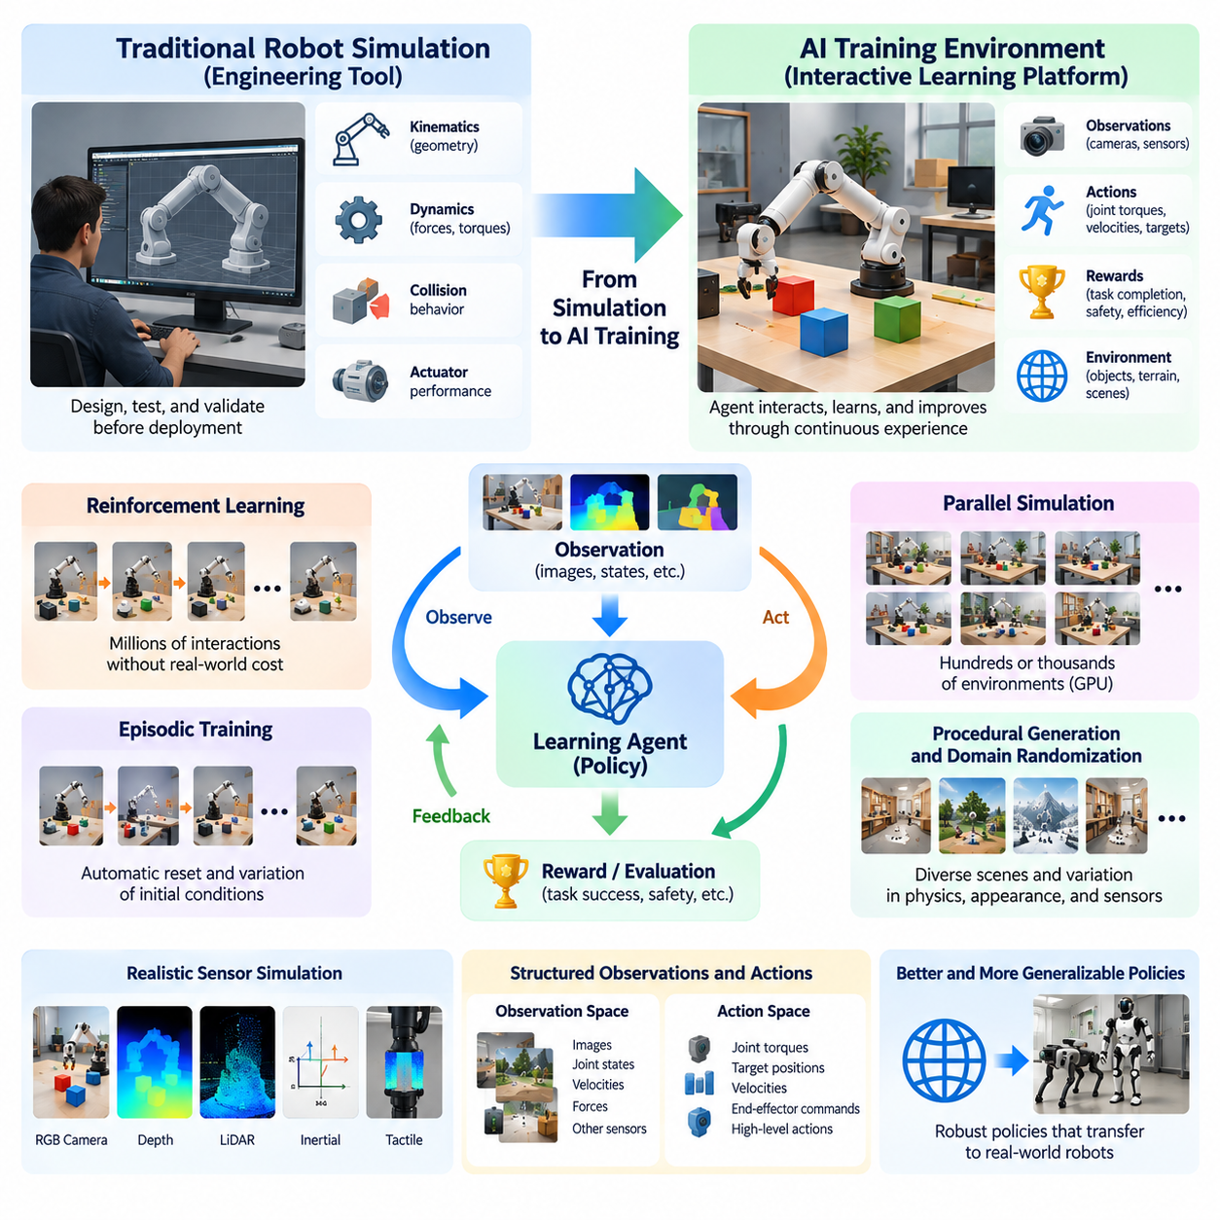
Robot simulation has traditionally served as an engineering tool for designing, testing, and validating robotic systems before physical deployment. Engineers used virtual models to examine mechanical structures, joint movements, actuator performance, and collision behavior. These environments primarily supported deterministic analysis and predefined motion sequences. The emergence of Physical AI has expanded simulation into a dynamic training environment where intelligent agents acquire capabilities through continuous interaction.
Traditional robot simulators were developed around mathematical descriptions of physical systems. Kinematic models represented geometric relationships between robot components, while dynamic models described forces, torques, and resulting movements. Engineers could verify whether a manipulator reached a target position or whether a mobile robot followed a planned trajectory. However, these applications generally assumed that control strategies had already been designed rather than learned through autonomous experience.
The transition toward AI training environments fundamentally changes the role of simulation. Instead of merely reproducing the expected behavior of a robot, the simulator becomes an interactive world in which an agent observes conditions, selects actions, and learns from consequences. This interaction creates a feedback process between perception, decision-making, and physical behavior. The environment must therefore support not only accurate dynamics but also repeated exploration, learning signals, and measurable task outcomes.
An AI training environment typically contains a simulated robot, a representation of the surrounding world, an observation system, an action interface, and a mechanism for evaluating behavior. The robot may receive camera images, joint positions, velocities, force measurements, or other sensory information. Based on these observations, a learning algorithm generates actions that influence the simulated world. The resulting state changes provide new information for subsequent decisions and learning updates.
Reinforcement learning has been a major driver of this transformation because it requires extensive interaction between an agent and its environment. During training, an agent performs actions, receives rewards or penalties, and gradually improves its policy. A simulation environment can generate millions of interactions without consuming equivalent physical robot operating time. This makes it possible to investigate complex control behaviors that would be expensive, slow, or unsafe to learn directly on real hardware.
The design of reward functions is an important distinction between conventional simulation and AI-oriented training. Traditional simulation evaluates whether a predefined trajectory or controller produces acceptable results. Reinforcement learning environments instead provide numerical feedback that guides behavioral improvement. Rewards may represent task completion, energy efficiency, movement stability, collision avoidance, or manipulation accuracy. Poorly designed rewards can produce unintended behavior, making reward engineering a critical development activity.
Modern training environments also require structured definitions of observations and actions. Observation spaces determine what information the agent receives, while action spaces specify the commands it can generate. Actions may represent joint torques, target velocities, end-effector positions, or higher-level behavioral decisions. The selection of these representations strongly influences learning efficiency, control performance, and the ability to transfer learned policies to physical robotic platforms.
Another major development is the introduction of episodic training and automated environment resetting. A learning episode begins from an initial configuration and continues until a task is completed, a failure occurs, or a termination condition is reached. The simulator then resets the robot and environment to begin another experience. Automated resets enable continuous training without human intervention and support systematic variation of initial states, object arrangements, and operating conditions.
Parallel execution further distinguishes modern AI training environments from conventional engineering simulators. Instead of operating a single virtual robot, a training platform can maintain hundreds or thousands of independent simulation instances. Each instance generates different experiences while sharing a common learning algorithm. GPU acceleration and vectorized computation can significantly increase experience throughput, allowing reinforcement learning systems to explore large behavioral spaces within practical development periods.
The evolution of simulation has also introduced procedural environment generation. Rather than manually constructing every training scene, developers can automatically generate rooms, warehouses, terrain, obstacles, objects, and task configurations. Procedural generation expands the diversity of experiences available to an intelligent agent. It also reduces dependence on a limited collection of handcrafted scenarios that might otherwise encourage memorization rather than generalizable behavior.
Domain randomization complements procedural generation by introducing controlled variation in simulation parameters. Robot mass, friction coefficients, actuator characteristics, sensor noise, lighting conditions, and object properties can change between training episodes. Such variation exposes learning systems to uncertainty resembling differences encountered in physical environments. The objective is to develop policies that remain effective across a range of conditions instead of depending on one idealized simulation configuration.
The integration of realistic sensor simulation has made AI training environments increasingly relevant to perception-driven robotics. Virtual cameras can reproduce RGB images, depth measurements, motion blur, and lighting effects, while simulated LiDAR and inertial sensors provide complementary observations. These data streams enable the training of perception and control systems within a shared virtual environment. However, their usefulness depends on whether simulated measurements adequately represent the characteristics of actual sensors.
AI training environments are also expanding beyond reinforcement learning to support imitation learning and demonstration-based training. Expert trajectories can be recorded in simulation through scripted controllers, optimization methods, or virtual teleoperation. These demonstrations provide examples of successful behavior that learning systems can imitate. Combining demonstrations with interactive learning can reduce exploration requirements and accelerate the acquisition of complex manipulation, navigation, and locomotion skills.
The emergence of robot foundation models and vision-language-action models creates additional requirements for simulation infrastructure. These models integrate visual observations, language instructions, and physical actions to perform diverse tasks. Simulation can provide controlled scenarios in which language-conditioned behaviors are practiced and evaluated. It can also generate multimodal training examples that associate task descriptions, environmental observations, action sequences, and execution outcomes.
An important consequence of this evolution is the convergence of simulation and data engineering. Modern training platforms must record observations, actions, rewards, trajectories, failures, and environmental parameters in structured formats. These records support dataset construction, offline learning, performance analysis, and reproducible experimentation. Simulation therefore becomes both an interactive learning environment and a scalable source of synthetic experience for Physical AI development.
Despite increasing sophistication, AI training environments cannot eliminate the differences between virtual and physical systems. Contact dynamics, material deformation, actuator delays, sensor imperfections, and unpredictable environmental interactions may be represented inaccurately. Policies trained exclusively in simulation can exploit modeling errors that do not exist in reality. Consequently, simulation development must incorporate calibration, system identification, uncertainty modeling, and real-world performance evaluation.
The relationship between simulation and physical experimentation is increasingly bidirectional. Real-world robot measurements can update simulated dynamics and sensor models, while simulation can identify promising policies and potentially dangerous operating conditions before deployment. Failures observed during physical operation can be reconstructed virtually and incorporated into future training. This iterative exchange establishes a continuous improvement process connecting simulated experience with real-world evidence.
Digital twin technology strengthens this relationship by connecting virtual models with operational robotic systems. A digital twin may incorporate physical geometry, actuator characteristics, sensor measurements, and real-time telemetry to represent an actual robot or facility. Such models can support scenario evaluation, operational optimization, and failure analysis. When integrated with learning infrastructure, they provide opportunities to adapt training environments using information collected from deployed machines.
The transformation from robot simulation to AI training environments also changes how robotic intelligence is evaluated. Traditional simulation often emphasized trajectory accuracy, mechanical feasibility, and controller stability. AI-oriented platforms must additionally measure task success, learning efficiency, generalization, robustness, and recovery from unexpected events. Standardized benchmarks and reproducible evaluation procedures are necessary to determine whether improved simulation performance translates into meaningful physical capabilities.
Ultimately, simulation is evolving from a passive representation of robotic behavior into an active computational infrastructure for developing embodied intelligence. Its purpose now extends beyond verifying engineering designs to generating experience, supporting autonomous learning, evaluating generalization, and improving deployment readiness. By combining physical modeling, scalable computation, synthetic data, and real-world feedback, AI training environments provide a foundation for increasingly adaptive and capable Physical AI systems.

00.03. Simulation in the Physical AI Lifecycle
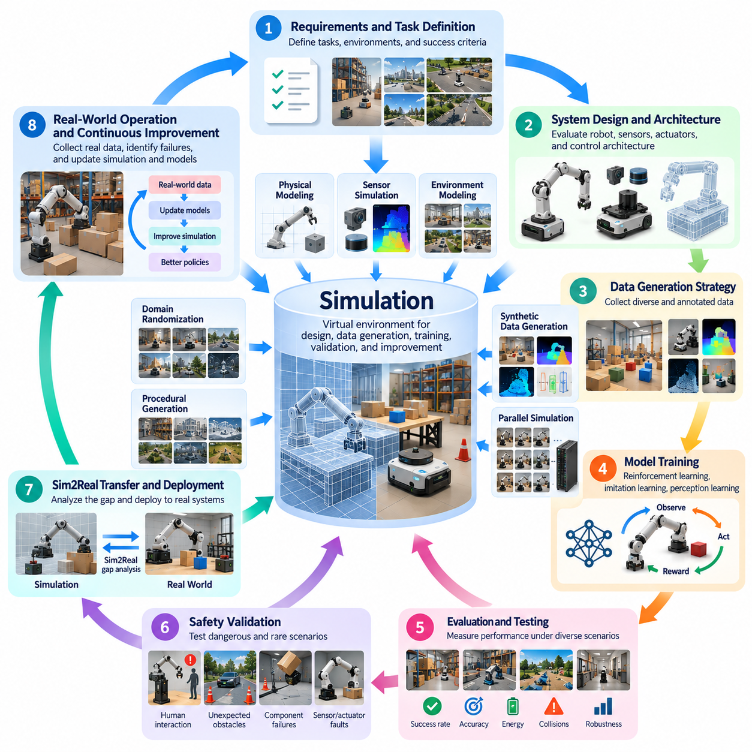
Simulation plays a central role throughout the Physical AI lifecycle, connecting system design, data generation, model training, validation, deployment, and continuous improvement. Unlike conventional software development, Physical AI must account for interactions between intelligent algorithms and physical environments. Simulation provides a controlled computational foundation for examining these interactions before real-world execution, reducing development risks while accelerating experimentation and system refinement.
The Physical AI lifecycle begins with defining operational requirements, target environments, and expected behaviors. Engineers must identify the tasks a robot will perform, the physical constraints it will encounter, and the performance criteria that determine success. Simulation supports this initial phase by allowing alternative system concepts to be explored virtually. Early experiments can reveal whether proposed capabilities are technically feasible before substantial investments in hardware and integration.
During system architecture design, simulation helps evaluate relationships between mechanical structures, sensors, actuators, computing platforms, and control algorithms. Engineers can compare robot configurations, examine reachable workspaces, estimate motion requirements, and identify potential design limitations. This virtual evaluation supports hardware-software co-design, allowing physical components and intelligent control strategies to be optimized together rather than developed independently.
Physical modeling forms an essential foundation for lifecycle simulation. Robot geometry, mass distribution, joint constraints, contact properties, actuator dynamics, and environmental characteristics must be represented with sufficient accuracy. These models allow developers to predict how physical systems respond to commands and external disturbances. Their usefulness depends on calibration quality, numerical stability, and whether the modeled phenomena are relevant to the intended application.
Sensor simulation becomes important when Physical AI systems depend on perception and environmental understanding. Virtual cameras, LiDAR sensors, radar systems, inertial measurement units, and tactile sensors can generate observations corresponding to simulated conditions. Developers can investigate how sensing configurations influence object detection, localization, mapping, and control. This enables early evaluation of sensor placement and perception algorithms before physical prototypes are fully available.
Simulation also supports the development of data collection strategies. Physical AI requires observations, actions, trajectories, environmental states, and task outcomes for training and evaluation. Virtual environments can generate these records systematically while providing automatic ground-truth annotations. By controlling scene composition and operating conditions, developers can create datasets covering common situations, difficult interactions, and rare events that would otherwise require extensive real-world experimentation.
During model training, simulation becomes an interactive experience-generation environment. Reinforcement learning agents can explore actions, receive rewards, and improve policies through repeated episodes. Imitation learning systems can use simulated demonstrations to acquire useful behaviors, while perception models can learn from synthetic sensor observations. These approaches allow training to begin before complete hardware availability and can reduce the amount of physical experimentation required.
Massive parallel simulation further accelerates the training stage by executing many independent environments simultaneously. GPU-based physics engines and vectorized simulation architectures can generate large volumes of experience within practical timeframes. Different robot states, task configurations, and environmental conditions can be explored concurrently. However, computational throughput must be balanced against physical accuracy, memory requirements, and the complexity of simulated interactions.
Domain randomization contributes to lifecycle training by exposing learning systems to variations in appearance, dynamics, and environmental conditions. Friction coefficients, object masses, lighting, sensor noise, actuator delays, and terrain properties can change between training episodes. This variability encourages policies to remain effective beyond a single idealized environment. Carefully designed randomization distributions can improve robustness, although excessive or unrealistic variation may reduce learning efficiency.
After training, simulation provides a repeatable environment for evaluating learned behavior. Developers can measure task completion rates, trajectory accuracy, energy consumption, collision frequency, recovery performance, and control stability. Standardized scenarios enable meaningful comparisons between different algorithms and model versions. Repeated evaluation under controlled conditions helps identify weaknesses that might otherwise remain hidden during limited physical testing.
Safety validation represents another critical lifecycle stage. Physical AI systems may operate near people, equipment, infrastructure, and unpredictable obstacles. Simulation allows potentially dangerous conditions to be examined without exposing real environments to unnecessary risks. Emergency stops, sensor failures, actuator faults, communication interruptions, and unexpected interactions can be introduced systematically. These experiments support safety engineering but cannot independently establish complete real-world safety.
The transition from simulation to physical deployment requires careful analysis of the Sim2Real gap. Differences between simulated and actual systems may arise from contact dynamics, sensor calibration, mechanical wear, actuator behavior, latency, and environmental uncertainty. A policy that performs well virtually may behave differently on real hardware. Developers must therefore compare simulation predictions with physical measurements and identify discrepancies that affect operational reliability.
System identification and calibration provide mechanisms for reducing these discrepancies. Measurements from physical robots can be used to estimate masses, friction parameters, actuator response characteristics, sensor noise distributions, and communication delays. Updated parameters improve the relevance of simulated experiments. This process is often iterative because operating conditions and hardware characteristics can change over time, requiring models to be periodically reassessed.
Physical deployment is not the end of simulation's contribution. During commissioning, simulation can support configuration testing, operational planning, and evaluation of expected workloads. Engineers may examine alternative navigation routes, manipulation sequences, or task schedules before applying changes to actual machines. This approach is particularly useful in industrial environments where interruptions, collisions, or unexpected behavior can produce significant operational consequences.
Digital twins extend lifecycle simulation into ongoing operations by connecting virtual representations with measurements from deployed systems. Robot telemetry, sensor observations, equipment status, and environmental information can update the virtual model. When synchronization and model fidelity are sufficient, the digital twin can support condition monitoring, performance analysis, failure investigation, and evaluation of proposed operational changes without immediately affecting physical processes.
Operational data collected from real deployments creates opportunities for continuous learning. Failures, unusual observations, unexpected contacts, and difficult task configurations can be reconstructed in simulation. Developers can generate additional training scenarios around these events and evaluate revised policies before redeployment. This feedback loop transforms simulation into a continuously evolving component of the Physical AI development process rather than a tool used only before initial deployment.
Fleet-scale Physical AI introduces additional lifecycle requirements. Multiple robots may share environments, communicate with centralized services, and coordinate tasks under changing operational conditions. Simulation can reproduce fleet interactions, traffic congestion, resource conflicts, and communication constraints. These experiments help developers evaluate scheduling strategies, coordination algorithms, and infrastructure changes before applying them across large operational deployments.
Lifecycle simulation also supports software updates and regression testing. New perception models, planning algorithms, or control policies may improve some behaviors while unintentionally degrading others. Automated simulation tests can replay previously identified failure cases and standardized operational scenarios. Comparing performance across software versions provides evidence of behavioral changes and helps determine whether an update is ready for controlled physical evaluation.
Effective lifecycle integration requires consistent data management, version control, and reproducible experimentation. Simulation assets, physical parameters, randomization settings, model checkpoints, evaluation scenarios, and performance metrics should be traceable across development stages. Without this discipline, differences between experiments may become difficult to interpret. Reproducibility enables engineering teams to investigate failures, compare alternatives, and maintain confidence in development decisions.
The long-term value of simulation lies in connecting design assumptions, learning processes, physical evidence, and operational improvements within a unified engineering workflow. Each lifecycle stage produces information that can refine subsequent simulation models and development decisions. By integrating virtual experimentation with real-world validation, Physical AI organizations can accelerate innovation while improving robustness, traceability, and deployment readiness across increasingly complex intelligent physical systems.

00.04. Real World vs Simulated World
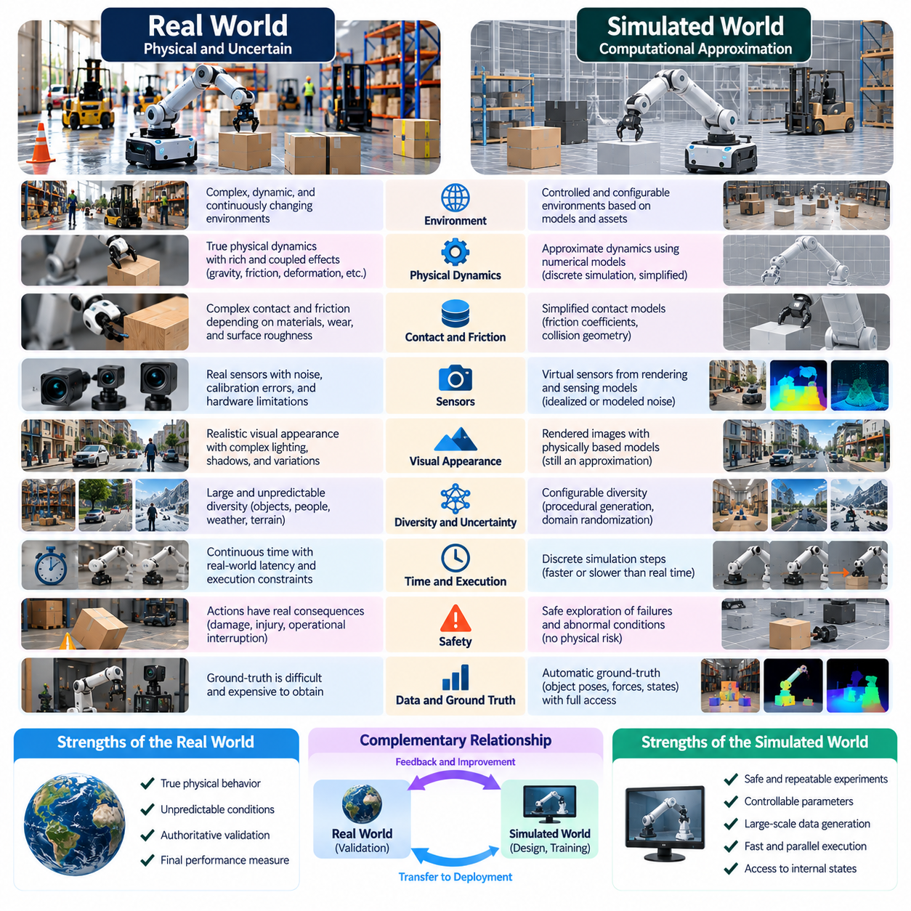
The real world and the simulated world represent two fundamentally different environments for developing Physical AI. The real world is governed by complex physical processes, uncertain conditions, and continuously changing interactions. The simulated world is a computational approximation constructed from mathematical models, digital assets, and numerical algorithms. Understanding their differences is essential for designing reliable intelligent systems that can transfer learned capabilities from virtual environments into physical operation.
The real world contains an enormous range of interacting physical phenomena that cannot be represented completely in a computational model. Gravity, friction, deformation, vibration, temperature, humidity, and material properties influence the behavior of robotic systems. These effects frequently interact in nonlinear and unpredictable ways. Simulation simplifies selected phenomena to achieve practical computational performance while preserving the characteristics considered most important for a particular application.
Physical environments also exhibit uncertainty that arises from incomplete information and natural variability. A robot operating in a warehouse may encounter unexpected obstacles, changing floor conditions, moving workers, or variations in payload weight. Outdoor robots face additional uncertainty from weather, terrain, illumination, and environmental disturbances. Simulated environments can reproduce selected uncertainties, but their variability is ultimately determined by the models and distributions used during construction.
One major distinction concerns the representation of physical dynamics. Real robots operate through continuous interactions between mechanical structures, actuators, contact surfaces, and external forces. Simulators approximate these interactions using discrete numerical integration and simplified physical equations. Although modern physics engines can reproduce many behaviors accurately, numerical approximations, contact solvers, and parameter errors may produce differences that become significant during demanding robotic tasks.
Contact and friction illustrate the difficulty of reproducing physical reality. In the real world, contact behavior depends on surface roughness, material compliance, temperature, wear, and microscopic deformation. Simulated contact models commonly rely on simplified friction coefficients, collision geometries, and constraint equations. These approximations may be sufficient for basic navigation but inadequate for precision manipulation, dynamic locomotion, or tasks involving deformable materials.
The representation of sensors introduces another important difference. Physical cameras, LiDAR sensors, radar systems, and inertial measurement units are affected by noise, calibration errors, temperature variation, vibration, and hardware limitations. Simulated sensors generate measurements from virtual geometry and rendering or sensing models. Although noise and imperfections can be introduced computationally, reproducing the complete statistical behavior of physical sensors remains difficult, particularly under unusual environmental conditions.
Visual appearance can differ substantially between simulated and physical environments. Real images contain complex lighting interactions, reflections, shadows, motion blur, exposure variations, and material imperfections. Photorealistic rendering attempts to reproduce these effects using physically based models and advanced graphics techniques. However, visually convincing images do not necessarily guarantee that the underlying geometry, physical dynamics, or sensor characteristics accurately represent reality.
Environmental diversity represents another fundamental challenge. Real operating environments contain objects, people, structures, and events that may not appear in available simulation datasets. Even carefully constructed virtual worlds can omit uncommon configurations or unexpected interactions. Procedural scene generation and domain randomization expand simulated diversity, but they cannot guarantee complete coverage of the situations encountered during deployment. Generalization therefore remains a central requirement for Physical AI.
Time and computational execution also distinguish the two worlds. Physical systems evolve continuously, while simulators update states through discrete computational steps. Simulation may run faster or slower than real time depending on model complexity and available hardware. Control frequency, communication latency, sensor synchronization, and numerical integration intervals can influence behavior. Policies trained under unrealistic timing assumptions may exhibit instability or reduced performance when deployed on physical robots.
The real world imposes direct consequences on every action. Incorrect commands can damage equipment, injure people, or interrupt operations. Simulation provides a safer environment for exploring unsuccessful actions, aggressive maneuvers, and abnormal conditions. Nevertheless, virtual safety does not imply physical safety. A controller that avoids simulated collisions may still fail when confronted with unmodeled obstacles, sensing errors, or unexpected mechanical behavior in reality.
Simulation offers advantages that the real world cannot easily provide. Developers can reset environments, repeat identical experiments, modify physical parameters, and observe internal states that would otherwise be difficult to measure. Ground-truth information such as exact object positions, contact forces, and simulated trajectories can be accessed directly. These capabilities support controlled experimentation, reproducibility, and efficient learning, making simulation an important complement to physical testing.
The real world, however, provides authoritative evidence of actual system performance. Physical experiments reveal effects that simulation models may overlook, including mechanical backlash, structural flexibility, actuator saturation, electrical interference, and environmental disturbances. Measurements collected during deployment can expose discrepancies between predicted and observed behavior. Such evidence is essential for determining whether simulated capabilities remain reliable under genuine operating conditions.
The differences between the two environments are collectively described as the simulation-to-reality gap, or Sim2Real gap. This gap may involve visual appearance, geometry, physical dynamics, sensor characteristics, actuator behavior, timing, and task performance. Its magnitude depends on the robot, environment, simulation architecture, and evaluation criteria. A small visual discrepancy may be unimportant for one task but critical for another that depends on precise visual recognition.
Reducing the Sim2Real gap requires selecting appropriate modeling fidelity rather than attempting to reproduce every aspect of reality. Navigation systems may prioritize geometry, obstacle motion, and sensor characteristics, while manipulation systems may require accurate contact dynamics and object properties. Locomotion controllers may depend strongly on friction, compliance, and actuator response. Simulation design should therefore emphasize the physical and perceptual factors that most strongly influence task success.
Domain randomization addresses uncertainty by exposing learning systems to many simulated variations instead of a single nominal environment. Physical parameters, lighting, textures, sensor noise, object configurations, and actuator characteristics can be sampled from predefined distributions. This approach encourages policies to tolerate differences between simulation and reality. However, randomization ranges must be chosen carefully because unrealistic variation can complicate learning without improving real-world robustness.
Domain adaptation provides a complementary approach by reducing differences between simulated and real data distributions. Visual representations, sensor features, dynamics models, or learned policies can be adjusted using information collected from physical environments. Depending on the application, adaptation may occur during training, before deployment, or during controlled operation. Its effectiveness depends on the availability and quality of real-world observations and the stability of the adaptation process.
System identification establishes a direct connection between physical measurements and simulation models. Engineers can estimate masses, friction coefficients, actuator parameters, sensor characteristics, and other quantities from experimental data. These estimates are incorporated into the simulator to improve predictive accuracy. Repeated calibration allows virtual models to evolve as hardware characteristics change, although some physical effects may remain difficult to identify or represent accurately.
Digital twins further strengthen the relationship between real and simulated worlds by maintaining computational representations linked to physical systems. Operational telemetry, sensor measurements, and equipment states can update a virtual model, enabling analysis of current conditions and evaluation of alternative actions. When synchronization and fidelity are sufficient, digital twins support operational planning, fault investigation, and performance optimization. Their accuracy still depends on model quality and reliable data integration.
The relationship between the real and simulated worlds should therefore be understood as complementary rather than competitive. Simulation enables scalable experimentation, synthetic data generation, and systematic exploration, while physical environments provide empirical validation and reveal modeling limitations. A reliable Physical AI development process combines both through repeated training, testing, calibration, and deployment feedback. This continuous exchange transforms simulation from an isolated virtual representation into an evolving engineering foundation for real-world intelligence.

00.05. Fidelity Abstraction and Computational Cost
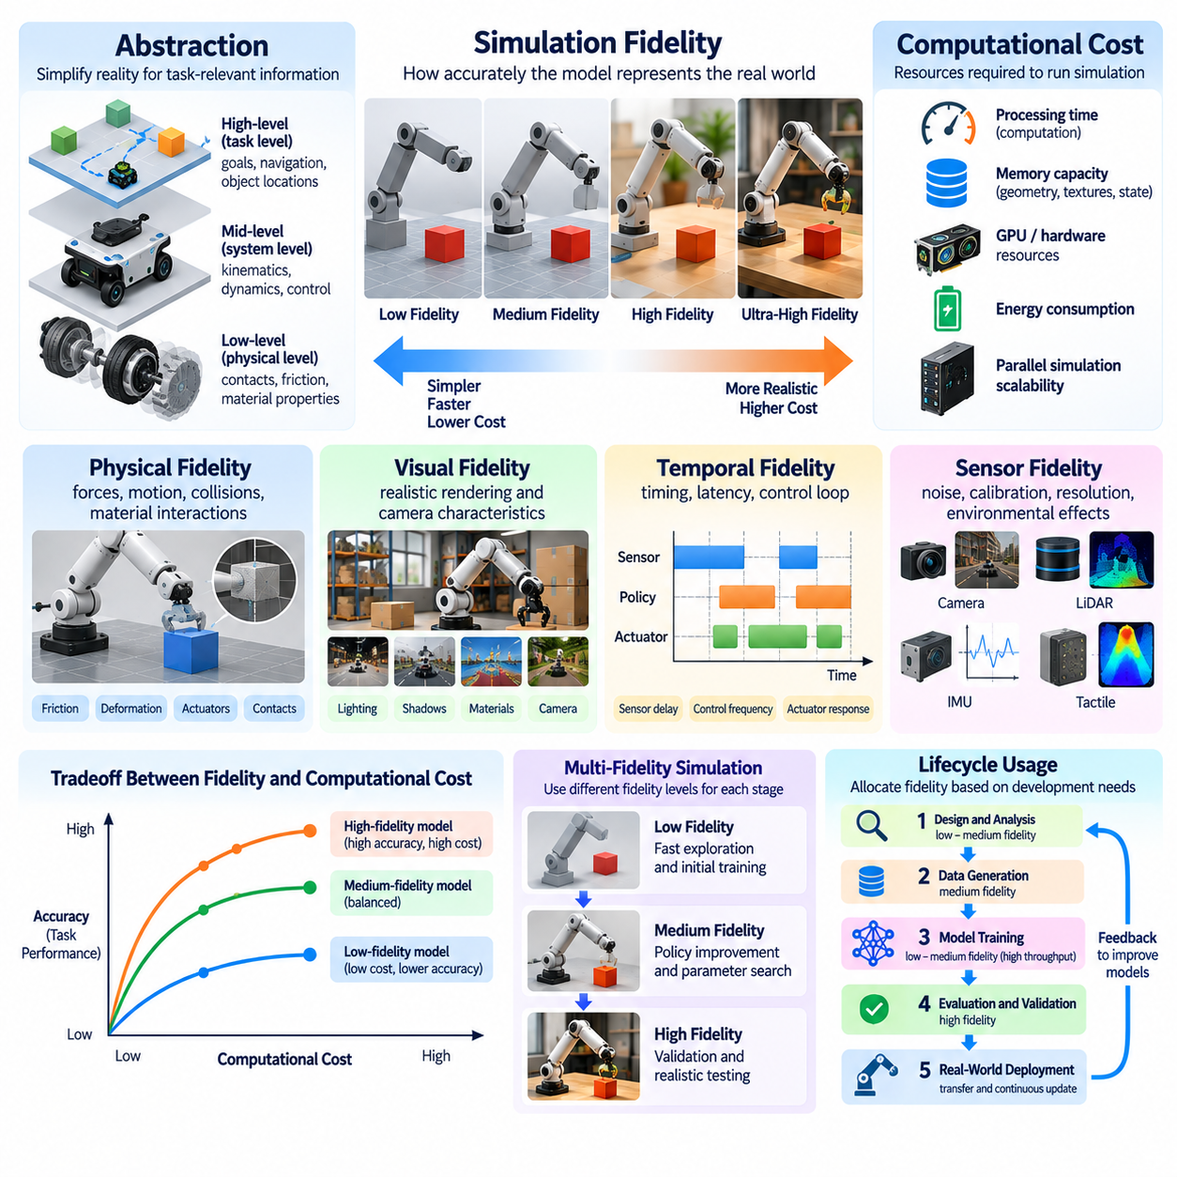
Simulation fidelity describes how accurately a computational model reproduces the behavior and characteristics of a physical system. In Physical AI, fidelity influences whether simulated experiences provide useful information for learning, testing, and deployment. Higher fidelity can improve the representation of important physical phenomena, but it generally requires additional computation. Selecting an appropriate fidelity level is therefore a fundamental engineering decision rather than a pursuit of maximum realism.
Abstraction is the process of simplifying physical reality while preserving the information necessary for a specific task. A simulation does not need to reproduce every microscopic interaction to support useful learning. For example, a mobile robot navigating a warehouse may require accurate obstacle geometry and motion dynamics without detailed molecular descriptions of floor materials. Effective abstraction reduces computational complexity while retaining the relationships that influence intelligent behavior.
The relationship between fidelity and abstraction depends strongly on the intended application. A robotic manipulator performing precision assembly may require detailed contact mechanics, joint compliance, and actuator dynamics. An autonomous mobile robot may prioritize navigation geometry, wheel-ground interaction, and sensor measurements. Aerial robots may depend on aerodynamic forces and environmental disturbances. Each application requires a different balance between physical detail and computational efficiency.
Physical fidelity concerns the accuracy of simulated forces, motion, collisions, and material interactions. High-fidelity physics models may incorporate nonlinear friction, elastic deformation, complex contact constraints, and detailed actuator characteristics. Such models can improve predictions of demanding physical interactions. However, their computational requirements may limit simulation speed, especially when many bodies, contacts, or deformable structures must be evaluated simultaneously.
Visual fidelity refers to the similarity between rendered images and observations produced by physical sensors. Photorealistic rendering can reproduce lighting, shadows, reflections, material textures, and camera effects. These characteristics are important for perception systems that depend on visual information. Nevertheless, high visual fidelity does not guarantee accurate physical dynamics, and sophisticated rendering may provide limited benefits when training policies based primarily on proprioceptive measurements.
Temporal fidelity describes how accurately a simulator represents the timing of physical processes and control interactions. Real robots operate through continuous dynamics, discrete sensor updates, communication delays, and actuator response times. Simulation uses numerical integration steps and scheduled computations to approximate these processes. Inaccurate timing can produce unrealistic control behavior, making temporal fidelity especially important for high-speed manipulation, locomotion, and safety-critical control.
Sensor fidelity represents the accuracy of simulated measurement processes. Cameras, LiDAR systems, inertial sensors, and force sensors exhibit noise, calibration errors, limited resolution, and environmental sensitivity. High-fidelity sensor models attempt to reproduce these characteristics through optical, geometric, and statistical representations. However, increasing sensor complexity also raises computational costs, particularly when multiple high-resolution sensors operate simultaneously.
Computational cost includes the processing time, memory capacity, energy consumption, and hardware resources required to execute simulation. Detailed physics models demand numerical calculations, while realistic rendering requires substantial graphics processing. Large environments increase memory usage through geometry, textures, and state information. These requirements become particularly significant when Physical AI training involves thousands of parallel simulation instances.
Simulation throughput measures how much simulated experience can be generated within a given amount of computation time. Reinforcement learning often benefits from high throughput because policies improve through repeated interactions. A simplified environment may generate substantially more training episodes than a highly detailed simulation. However, greater throughput is not necessarily beneficial if inaccurate dynamics cause the learning algorithm to acquire behaviors that fail in physical environments.
The tradeoff between fidelity and computational cost is therefore not purely technical but also strategic. Developers must determine which simulated phenomena contribute most strongly to task performance and transfer reliability. Computational resources should be concentrated on these critical factors while less influential details are simplified. This task-oriented approach can produce more useful training environments than uniformly increasing model complexity without considering practical learning objectives.
Multi-fidelity simulation addresses this challenge by combining models with different levels of detail. Low-fidelity environments can support rapid exploration, initial policy training, and broad parameter searches. Higher-fidelity environments can subsequently evaluate promising policies under more realistic conditions. This progression allows computational resources to be allocated according to development needs while reducing dependence on expensive simulation throughout the entire learning process.
Hierarchical abstraction provides another mechanism for controlling simulation complexity. At a high level, robot behavior may be represented through task states, navigation decisions, or simplified motion models. Lower levels may include joint dynamics, actuator control, and contact interactions. Different abstraction levels can be activated according to the information required by a particular experiment. This architecture supports efficient reasoning while preserving detailed physical analysis when necessary.
Adaptive fidelity extends the concept by changing simulation detail dynamically during execution. A simulator may use simplified dynamics during free motion and more detailed contact calculations when objects interact. Rendering quality can also vary according to sensor relevance or training objectives. Such adaptive strategies can improve efficiency, although transitions between fidelity levels must be carefully managed to avoid numerical instability or inconsistent physical behavior.
The numerical integration time step is a major determinant of both accuracy and computational cost. Smaller time steps can improve the representation of rapid dynamics and contact events but require more calculations per simulated second. Larger time steps reduce computational demands but may introduce instability or inaccurate motion. Selecting a suitable integration interval requires considering system dynamics, solver characteristics, and the control frequencies used by the learning agent.
Collision detection and contact resolution frequently dominate the computational workload of robotic simulation. Complex geometric models require extensive intersection testing, while contact solvers must calculate forces that satisfy physical constraints. Simplified collision shapes can reduce computational requirements without substantially affecting some tasks. However, excessive simplification may distort grasping behavior, wheel-ground interactions, or locomotion stability when accurate contact geometry is essential.
GPU acceleration and parallel computing can reduce the practical cost of detailed simulation by processing many calculations simultaneously. GPU-resident physics engines minimize data transfers between processors and support large batches of independent environments. Nevertheless, memory bandwidth, synchronization requirements, and irregular contact computations can limit scaling efficiency. Hardware acceleration therefore complements model simplification rather than eliminating the need for careful abstraction.
The influence of fidelity on Sim2Real transfer is particularly important. A visually realistic environment may still produce poor transfer if actuator dynamics or contact mechanics are inaccurate. Conversely, a relatively simple simulator may support successful transfer when it accurately captures the variables governing the target behavior. Fidelity should therefore be evaluated according to its effect on real-world performance rather than solely through visual appearance or model complexity.
Sensitivity analysis helps identify which simulation parameters deserve greater modeling accuracy. Developers can vary friction, mass, latency, sensor noise, and other characteristics to measure their influence on policy performance. Parameters with strong effects on task outcomes may require detailed calibration, while less influential variables can be represented approximately. This evidence-based allocation of modeling effort improves computational efficiency and supports more reliable engineering decisions.
Validation is necessary to determine whether a chosen abstraction preserves the essential behavior of the physical system. Simulated trajectories, forces, sensor measurements, and task outcomes should be compared with experimental observations. Discrepancies reveal where additional fidelity may be necessary or where existing complexity provides little practical benefit. Repeated validation allows simulation models to evolve alongside hardware changes, learning objectives, and operational requirements.
Ultimately, effective Physical AI simulation requires balancing fidelity, abstraction, and computational cost within a unified development strategy. Maximum realism is neither universally achievable nor always desirable. The most valuable simulator reproduces the phenomena that matter for learning and deployment while generating experience at a practical computational cost. This balance enables scalable training, meaningful validation, and reliable transfer from simulated environments to intelligent physical systems.

00.06. Simulation for Training Testing and Validation
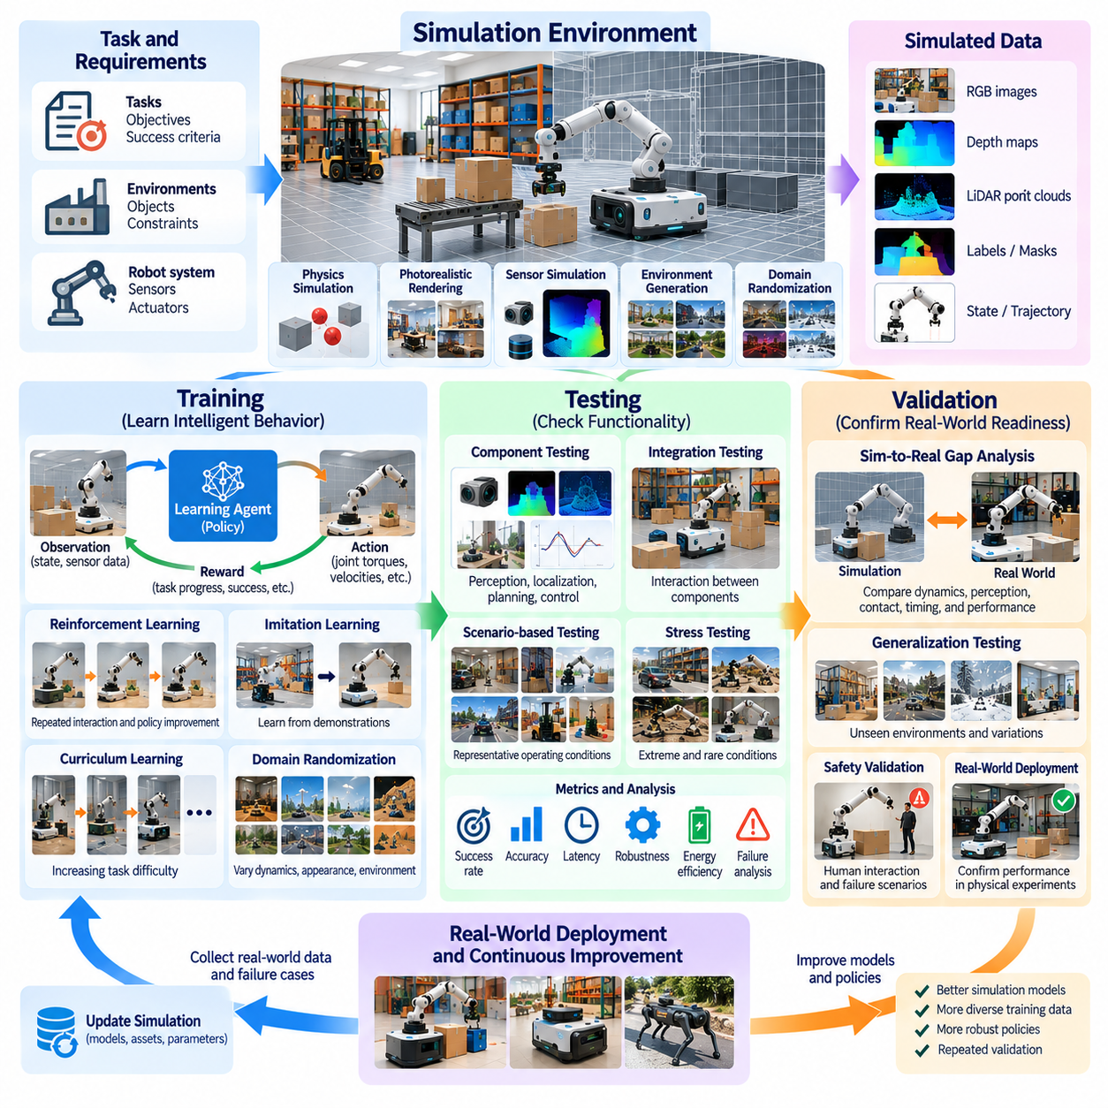
Simulation supports three closely related but distinct activities in the Physical AI lifecycle: training, testing, and validation. Training develops intelligent behavior through experience, testing examines whether system components and policies function as intended, and validation determines whether the resulting capabilities satisfy operational requirements. Although these activities share virtual environments and computational infrastructure, they require different objectives, experimental procedures, and evaluation criteria.
During training, simulation provides an interactive environment in which robots can acquire perception, planning, and control capabilities. Learning agents observe environmental states, execute actions, and receive feedback about their performance. Repeated interactions allow models to improve without requiring continuous physical experimentation. This approach is especially valuable for complex tasks involving large action spaces, uncertain environments, and behaviors that would be expensive or dangerous to explore directly.
Reinforcement learning uses simulation to generate experiences through repeated interaction between agents and environments. A policy selects actions based on observations, while reward functions evaluate progress toward task objectives. Episodes can be restarted automatically, allowing extensive exploration of alternative behaviors. Training effectiveness depends on reward design, environment diversity, physical modeling accuracy, and the computational throughput available for experience generation.
Imitation learning provides another simulation-based training approach by using demonstrations of desired behavior. These demonstrations may originate from expert controllers, human teleoperation, recorded robot trajectories, or scripted simulation procedures. Learning algorithms extract behavioral patterns from observation-action sequences and reproduce them in new situations. Simulation enables demonstrations to be repeated, modified, and expanded while reducing dependence on costly physical data collection.
Synthetic data generation supports the training of perception models and multimodal Physical AI systems. Simulated cameras, depth sensors, LiDAR devices, and tactile sensors can produce observations accompanied by precise annotations. Object identities, segmentation masks, poses, distances, and contact states can be obtained automatically. Such datasets improve training scalability, although their usefulness depends on whether simulated observations represent the variations encountered during real-world deployment.
Curriculum learning organizes training scenarios according to increasing difficulty. A robot may initially learn basic motion in an obstacle-free environment before progressing to cluttered spaces, moving obstacles, or complex manipulation tasks. Simulation makes it possible to control this progression systematically. By adapting task difficulty to learning performance, curriculum strategies can improve training stability and help agents acquire capabilities that are difficult to learn through unrestricted exploration.
Domain randomization strengthens training by varying physical parameters and environmental conditions across episodes. Friction, mass, lighting, sensor noise, actuator delays, object placement, and terrain characteristics can be sampled from selected distributions. This process discourages excessive dependence on a single simulated configuration. However, randomization must remain relevant to plausible operating conditions, because unrealistic variability can reduce learning efficiency without improving physical robustness.
Testing begins when developers systematically examine whether specific components or integrated behaviors operate according to their specifications. Unlike training, testing should primarily measure existing capabilities rather than optimize them. Simulation enables repeatable execution of predefined scenarios, making failures easier to reproduce and investigate. Separating training and testing conditions is important because repeated exposure to evaluation scenarios can produce misleading estimates of generalization.
Component-level testing examines individual functions such as perception, localization, trajectory planning, and low-level control. Virtual sensor streams can test object detection algorithms, while simulated robot states can evaluate motion controllers and safety monitors. Engineers can isolate components and introduce controlled disturbances to identify failure mechanisms. This approach supports early debugging before complete hardware integration and reduces the cost of identifying software defects.
Integration testing evaluates interactions between components operating as a complete robotic system. Perception errors may affect planning decisions, while control delays can change the outcome of otherwise valid trajectories. Simulation reproduces these dependencies through coordinated sensor, computation, and actuator models. Developers can investigate interface mismatches, timing problems, and unexpected system interactions before conducting equivalent tests on physical hardware.
Scenario-based testing evaluates robot behavior under representative operating conditions. Autonomous mobile robots may encounter narrow passages, crossing pedestrians, unexpected obstacles, and changing floor surfaces. Manipulators may face object misalignment, uncertain grasp points, or variable payloads. Carefully designed scenarios reveal how systems respond to realistic operational challenges. Test coverage should include normal activities, difficult conditions, and plausible abnormal events.
Stress testing extends scenario-based evaluation toward operational limits. Developers may increase robot speed, environmental density, payload variation, sensor degradation, or communication latency to examine system resilience. Simulation makes these experiments safer and more repeatable than physical testing alone. Stress testing can reveal performance degradation, unstable control behavior, and resource bottlenecks, but simulated failures and successes must still be interpreted in light of model limitations.
Fault injection testing deliberately introduces abnormal conditions into simulated systems. Sensor dropout, actuator saturation, network interruption, localization errors, and unexpected contact events can be reproduced systematically. Developers can assess whether fault detection, recovery procedures, and emergency responses behave as designed. Such testing supports safety engineering and resilience assessment, although it cannot independently establish that a physical system is safe under every possible failure condition.
Validation differs from testing because it asks whether the complete Physical AI system is suitable for its intended real-world purpose. A robot may pass individual functional tests while still failing to satisfy operational requirements. Validation therefore considers task success, reliability, safety, efficiency, and environmental suitability. Simulation contributes controlled evidence, but final validation normally requires physical experiments that confirm whether simulated performance transfers to actual operating conditions.
Quantitative metrics provide a foundation for comparing training outcomes and evaluating system performance. Task completion rate, collision frequency, localization error, trajectory deviation, energy consumption, and recovery time are common examples. Metrics must be aligned with the intended application and measured consistently across scenarios. A single aggregate score may conceal important weaknesses, making distributions, failure categories, and performance under difficult conditions valuable complements.
Statistical evaluation is necessary because Physical AI behavior may vary with initial conditions, environmental disturbances, and stochastic policies. Repeated simulation trials can estimate average performance, variability, and confidence intervals. Evaluations should cover multiple random seeds and representative scenario distributions. Large sample counts improve statistical precision, but they do not eliminate systematic bias arising from inaccurate simulation models or incomplete test coverage.
Regression testing protects system performance as models and software evolve. Updates to perception networks, planning algorithms, or control policies may unintentionally introduce new failures. Automated simulation pipelines can replay established scenarios and compare results with previous versions. Changes in task success, safety-related metrics, or computational performance can trigger further investigation. This practice helps maintain behavioral consistency throughout continuous development.
Simulation-based validation becomes more credible when virtual predictions are compared with measurements from physical experiments. Engineers can examine differences in motion trajectories, contact forces, sensor outputs, task outcomes, and response times. Discrepancies identify modeling weaknesses and guide recalibration or additional testing. This iterative comparison strengthens the relationship between simulated evidence and real-world behavior without assuming that the two environments are identical.
A complete evaluation strategy combines training environments, independent test suites, physical validation, and deployment feedback. Training generates capabilities, testing identifies defects and performance limitations, and validation establishes evidence of operational suitability. Field observations can then reveal new failure modes that become future simulation scenarios. This continuous cycle allows Physical AI systems to improve while maintaining traceable evidence of reliability, robustness, and deployment readiness.

00.07. Simulation as a Data and Experience Engine
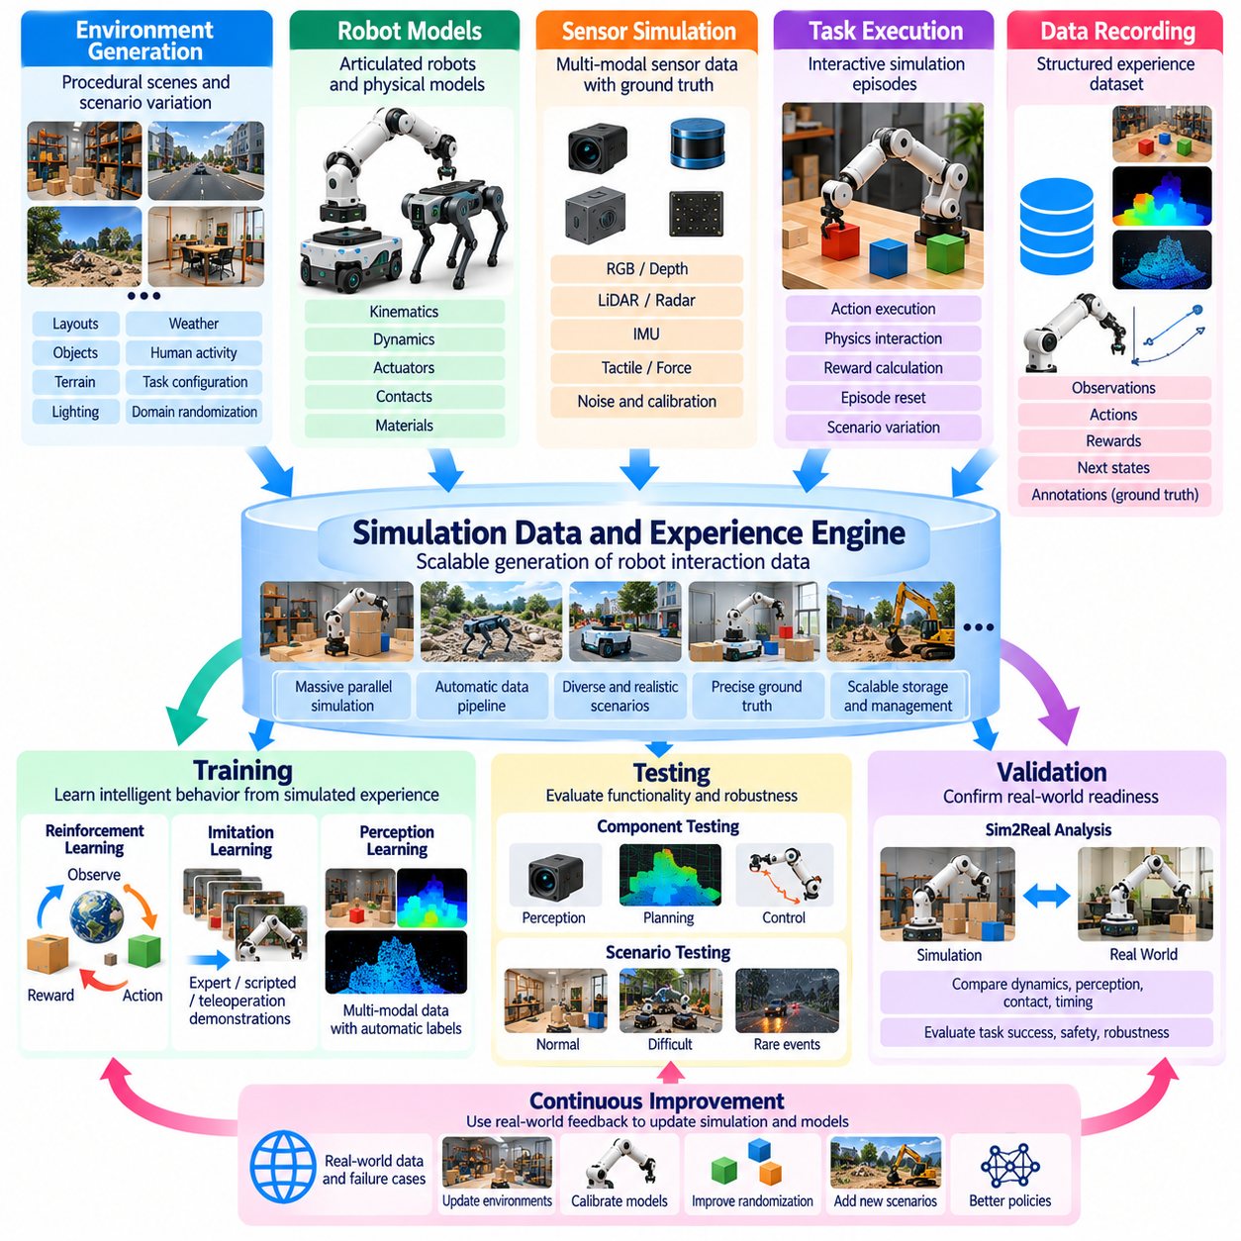
Simulation is evolving from a tool for reproducing physical behavior into a scalable data and experience engine for Physical AI. Intelligent robots require extensive interaction histories to learn perception, planning, and control. Collecting these experiences exclusively in physical environments is expensive, time-consuming, and potentially unsafe. Simulation provides a computational infrastructure that generates structured observations, actions, rewards, and outcomes through controlled virtual interactions.
A simulation-based data engine combines environment generation, robot models, sensor emulation, task execution, and automated recording into a unified pipeline. Each simulated episode produces information about the robot, surrounding objects, environmental conditions, and task results. These records can be stored as reusable training assets. By connecting data generation directly with learning workflows, simulation transforms computational experiments into continuously expanding resources for intelligent behavior development.
Experience generation differs from conventional synthetic data creation because it captures the consequences of actions over time. A static rendered image may support object recognition, but an interactive simulation episode reveals how an object moves after contact or how a robot responds to disturbances. These temporal relationships are essential for learning control and decision-making. Experience datasets therefore include state transitions, action sequences, feedback signals, and task outcomes.
Reinforcement learning demonstrates the importance of simulation as an experience engine. Agents repeatedly execute policies, observe resulting states, and receive rewards that indicate progress toward objectives. Millions of interactions may be required before complex behaviors emerge. Simulation enables automated resets, parallel execution, and systematic exploration without continuously operating physical robots. The quality of generated experience depends on task design, physical accuracy, and environmental diversity.
Massive parallel simulation increases experience production by executing thousands of independent environments simultaneously. Each environment can contain different robot configurations, object arrangements, initial conditions, and disturbances. GPU-based physics engines and vectorized execution architectures improve throughput by processing large batches of interactions. This scalability allows learning systems to explore broader behavior distributions within practical development times.
Synthetic sensor data represents another major output of simulation-driven data engines. Virtual cameras, depth sensors, LiDAR systems, and tactile sensors generate observations associated with known environmental states. Automatic annotations can include object identities, segmentation masks, depth maps, poses, velocities, and contact information. These labels reduce manual annotation requirements and support supervised learning, perception benchmarking, and multimodal model development.
The ability to generate precise ground-truth information distinguishes simulation from many real-world collection methods. Physical measurements often contain noise, occlusion, calibration errors, and incomplete observations. A simulator can expose internal variables such as exact object poses, joint states, collision events, and applied forces. These records support model training and diagnostic analysis, although their accuracy relative to reality remains limited by the underlying simulation assumptions.
Procedural environment generation expands the range of experiences available for learning. Scene layouts, object categories, lighting conditions, terrain properties, and task configurations can be created automatically from parameterized descriptions. This reduces dependence on manually constructed virtual environments. Procedural diversity helps expose policies to unfamiliar combinations of conditions, but meaningful coverage requires careful control of scene plausibility and task relevance.
Domain randomization complements procedural generation by varying physical and perceptual parameters across episodes. Friction coefficients, object masses, actuator delays, camera positions, material textures, and sensor noise can be sampled from defined distributions. Such variation produces experience datasets containing multiple possible realizations of the same task. Learning from these distributions can improve robustness against uncertainty encountered during physical deployment.
Experience engines must also generate difficult and uncommon situations rather than concentrating exclusively on successful routine operations. Rare collisions, unstable grasps, unexpected obstacles, and recovery maneuvers may provide valuable learning signals. Simulation enables targeted creation of these events without deliberately exposing real equipment to dangerous conditions. However, synthetic failure scenarios should remain physically plausible to avoid teaching behaviors based on unrealistic assumptions.
Curriculum learning organizes experience generation according to the evolving capabilities of an agent. Initial environments may emphasize simple movements, predictable objects, and limited disturbances. As performance improves, the engine introduces more complex tasks and uncertain conditions. Automated curriculum mechanisms can adjust difficulty using success rates or other learning indicators. This creates a feedback relationship between model performance and the distribution of newly generated experiences.
Imitation learning can also benefit from simulation-generated demonstrations. Expert controllers, scripted planners, optimization algorithms, and teleoperated virtual robots can produce trajectories illustrating desired behaviors. These demonstrations provide observation-action pairs for supervised policy learning. Simulation makes it possible to modify initial conditions, replay successful examples, and generate variations, expanding demonstration datasets without proportionally increasing physical collection costs.
Experience quality is as important as experience quantity. Large datasets containing redundant, unrealistic, or incorrectly labeled interactions may provide limited learning benefits. Automated filtering can remove invalid trajectories, numerical instabilities, incomplete episodes, and duplicated records. Quality assessment may consider task relevance, behavioral diversity, physical consistency, and annotation correctness. Effective curation ensures that increased simulation throughput produces useful information rather than unnecessary storage demands.
Data diversity and coverage require explicit measurement. Developers can analyze distributions of robot states, object configurations, action frequencies, environmental parameters, and failure categories. Coverage gaps indicate situations that remain insufficiently represented in training data. Targeted simulation can then generate additional episodes addressing these weaknesses. This closed-loop process turns dataset analysis into an active mechanism for directing future experience collection.
Real-world deployment provides essential feedback for improving simulation-based data engines. Physical robots encounter environmental conditions, mechanical variations, and interaction patterns that virtual models may not anticipate. Recorded failures and unusual observations can be reconstructed as simulation scenarios. Developers can update models, generate related experiences, and retrain policies. This connection between physical operation and virtual generation helps reduce systematic differences between simulated and real-world data.
Active learning further improves efficiency by selecting experiences according to their expected training value. Rather than generating episodes uniformly, the engine can prioritize uncertain states, poorly performing tasks, or underrepresented environmental conditions. Model predictions and evaluation results guide subsequent simulation configurations. This approach concentrates computational resources on informative interactions, although estimating experience value accurately remains a significant challenge.
A scalable data engine requires reliable infrastructure for storage, indexing, versioning, and retrieval. Simulation outputs may include images, point clouds, trajectories, actions, rewards, metadata, and environment parameters. Consistent schemas and synchronized timestamps enable these modalities to be combined during training. Tracking simulator versions, random seeds, asset configurations, and policy checkpoints supports reproducibility and helps identify the origins of unexpected learning outcomes.
Simulation-generated experience can support foundation models and generalist robot policies when data spans diverse tasks, environments, and robot embodiments. Multimodal datasets may connect visual observations, language instructions, proprioceptive states, and action trajectories. Such information supports learning transferable representations and task-conditioned behavior. Nevertheless, simulated scale alone does not guarantee generalization across hardware platforms or unfamiliar real-world situations.
Evaluation must remain independent from experience generation used for training. Policies repeatedly exposed to the same simulated scenarios may achieve high virtual performance without developing transferable capabilities. Separate evaluation environments, held-out configurations, and physical tests help identify overfitting. Measuring real-world task success alongside simulation metrics establishes whether additional generated experience produces meaningful improvements beyond the virtual training distribution.
Ultimately, simulation as a data and experience engine connects environment generation, interaction, learning, evaluation, and real-world feedback into a continuous development cycle. Its value lies not merely in producing large datasets but in generating diverse, relevant, and physically meaningful experiences. When supported by systematic curation and physical validation, this approach provides a scalable foundation for improving the adaptability, reliability, and generalization of Physical AI systems.

00.08. Core Challenges of Sim2Real
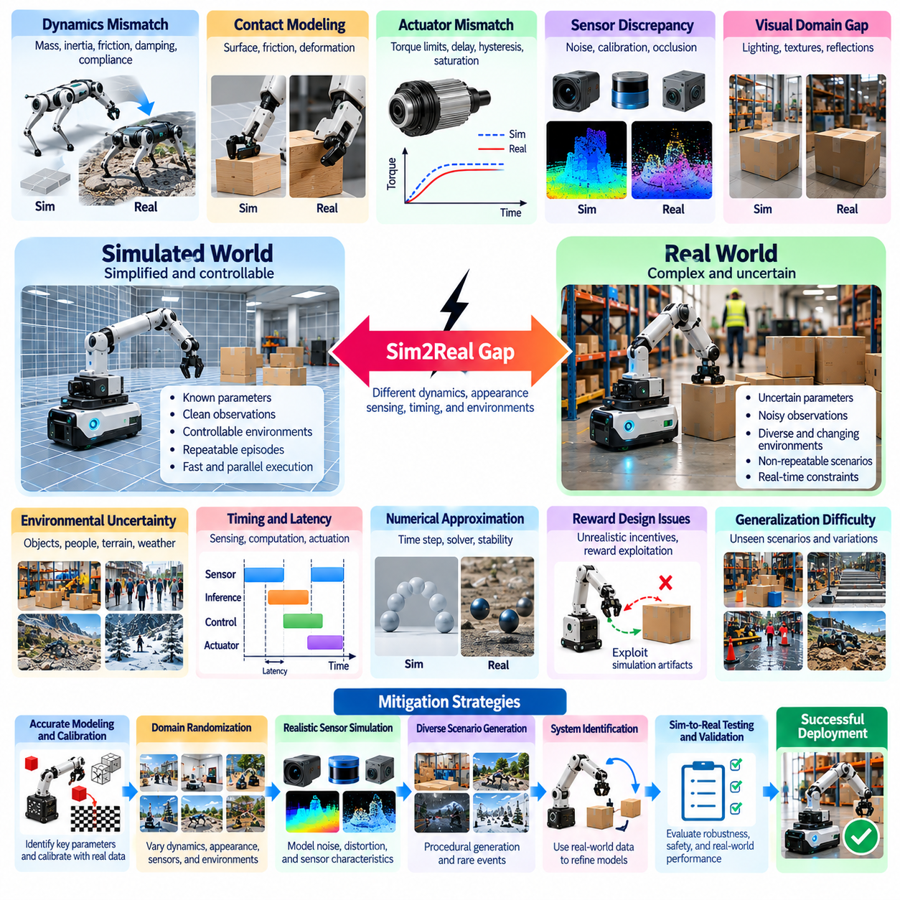
Sim2Real transfer is the process of transferring capabilities developed in simulated environments to physical robotic systems. Its central challenge is that simulation represents reality through approximations, while real-world behavior emerges from complex and uncertain interactions. Even policies that achieve excellent virtual performance may fail after deployment. Understanding the sources of this discrepancy is essential for developing Physical AI systems that operate reliably beyond controlled training environments.
The simulation-to-reality gap originates from differences in physical dynamics, sensing, actuation, environmental conditions, and computational execution. These differences rarely occur independently because errors in one component can influence the behavior of others. A small perception error may produce an incorrect planning decision, while an inaccurate actuator model may destabilize an otherwise effective controller. Successful transfer therefore requires a system-level understanding of interconnected uncertainties.
Dynamics mismatch represents one of the most persistent Sim2Real challenges. Simulators approximate mass distribution, inertia, friction, damping, joint compliance, and external forces using mathematical models. Physical robots exhibit additional effects such as backlash, vibration, wear, and manufacturing tolerances. Small parameter errors can accumulate during repeated interactions, producing substantial differences between predicted and actual trajectories, especially in dynamic locomotion and manipulation.
Contact modeling introduces particularly difficult transfer problems. Real contact depends on surface roughness, material deformation, frictional transitions, and microscopic interactions that are expensive to reproduce computationally. Simplified contact solvers may generate unrealistic forces or stable grasps that fail physically. Tasks involving grasping, pushing, walking, or deformable objects are especially sensitive to these inaccuracies because successful behavior depends directly on contact dynamics.
Actuator mismatch creates another source of deployment failure. Real motors and transmissions exhibit torque limits, saturation, hysteresis, thermal effects, response delays, and nonlinear efficiency characteristics. Simulation models may represent actuators through idealized torque or position commands that respond immediately. Policies trained under these assumptions can demand physically impossible movements. Accurate actuator characterization and realistic command constraints are therefore important for reliable transfer.
Sensor discrepancies affect how robots interpret their surroundings. Real cameras, LiDAR systems, inertial sensors, and force sensors experience noise, calibration drift, occlusion, interference, and environmental sensitivity. Simulated observations may be cleaner and more consistent than physical measurements. Policies that depend on precise virtual observations can become fragile when exposed to imperfect real-world signals, making realistic sensing models and robust perception essential.
The visual domain gap is especially important for camera-based Physical AI. Simulated images may differ from real observations in illumination, reflections, shadows, textures, exposure, and motion blur. Even photorealistic rendering cannot guarantee complete agreement with physical camera characteristics. Perception networks may learn shortcuts associated with synthetic appearances rather than meaningful object properties, reducing their ability to recognize unfamiliar scenes during deployment.
Environmental uncertainty extends beyond sensor and dynamics differences. Real operating spaces contain unexpected obstacles, changing surfaces, moving people, object variability, and disturbances that may not exist in training simulations. A policy can overfit to simplified environmental assumptions and fail when encountering unfamiliar configurations. Procedural generation and domain randomization improve coverage, but no finite simulated dataset can represent every possible real-world situation.
Timing and latency mismatches can significantly affect closed-loop control. Simulators often execute sensing, policy inference, and actuation under idealized synchronization conditions. Physical systems experience communication delays, variable computation times, asynchronous sensors, and actuator response limitations. These effects can destabilize high-frequency controllers or reduce reaction speed. Sim2Real development must therefore consider the complete timing behavior of the deployed control pipeline.
Numerical approximation introduces additional discrepancies. Physics engines use finite integration steps, approximate collision detection, and iterative constraint solvers. Their accuracy depends on time-step selection, solver settings, and the complexity of simulated interactions. Increasing numerical precision may improve realism but also increases computational cost. Developers must identify which numerical errors materially affect policy behavior rather than assuming that finer simulation is always necessary.
The reality gap also creates challenges for reinforcement learning reward design. Simulated rewards may encourage behaviors that exploit imperfections in the environment model. An agent might discover unrealistic contact forces, unstable motion patterns, or shortcuts that are impossible on physical hardware. Such reward exploitation can produce impressive training results without transferable competence. Careful reward formulation and physical feasibility checks help reduce these failures.
Domain randomization is a widely used response to uncertain simulation parameters. Training environments vary friction, mass, lighting, sensor noise, actuator characteristics, and object configurations across episodes. The objective is to produce policies that tolerate a range of plausible physical conditions. However, selecting effective randomization distributions is difficult. Narrow ranges may miss reality, while excessively broad ranges can slow learning or produce unnecessarily conservative behavior.
System identification attempts to reduce uncertainty by estimating simulation parameters from physical measurements. Experimental trajectories, motor responses, contact observations, and sensor recordings can inform model calibration. Nevertheless, parameter identification may be ambiguous because different parameter combinations can produce similar observed behavior. Models can also become outdated as hardware wears or operating conditions change, requiring periodic recalibration and uncertainty assessment.
Domain adaptation addresses differences between simulated and real data representations. Visual features, observation distributions, dynamics models, or policies may be adjusted using physical data. Adaptation can improve transfer when representative real-world samples are available, but obtaining those samples may be costly or risky. Poorly controlled adaptation can also degrade previously reliable behavior, making evaluation and deployment safeguards necessary.
The scarcity of real-world training data remains a practical limitation. Physical experiments require equipment, supervision, maintenance, and operational time, while failures may damage hardware or create safety hazards. This limits the number of interactions available for calibration and adaptation. Efficient Sim2Real methods must therefore extract maximum information from limited physical experience through targeted experiments, active learning, and carefully selected validation scenarios.
Safety introduces constraints that cannot be ignored during transfer. Exploration strategies that are acceptable in simulation may be dangerous on physical robots. Unexpected contact, unstable movement, or incorrect perception can threaten people and equipment. Deployment procedures should include conservative operating limits, emergency responses, monitoring, and staged testing. Simulation contributes valuable evidence, but physical safety must be established through appropriate real-world verification.
Evaluation itself presents a significant challenge because strong simulation performance does not establish successful transfer. Policies should be assessed across multiple physical conditions, hardware variations, and representative tasks. Metrics may include task success, robustness, collision frequency, energy consumption, and recovery behavior. Comparisons between simulated and physical results help identify systematic discrepancies, while repeated trials reveal variability that single demonstrations cannot capture.
Hardware diversity complicates the transfer of learned policies across robotic platforms. Differences in morphology, joint configuration, actuator capacity, sensor placement, and control interfaces can change the meaning of identical commands. A policy trained for one robot may not generalize directly to another, even when both perform similar tasks. Morphology-aware representations and adaptable control architectures can improve transfer, but cross-platform reliability still requires validation.
Continuous feedback between simulation and physical deployment provides a practical path toward reducing these challenges. Real-world failures can be recorded, reconstructed virtually, and incorporated into revised training scenarios. Updated physics models, sensor distributions, and policies can then be evaluated before redeployment. This iterative process transforms Sim2Real from a one-time transfer problem into an ongoing engineering cycle driven by physical evidence.
Ultimately, the core challenge of Sim2Real is not eliminating every difference between simulation and reality, but ensuring that remaining differences do not undermine task performance or safety. Effective solutions combine appropriate model fidelity, uncertainty-aware training, calibration, domain adaptation, and rigorous physical validation. By treating simulation as an evolving approximation rather than a perfect substitute for reality, Physical AI systems can achieve more reliable and scalable real-world deployment.

00.09. Roadmap of Simulation and Sim2Real
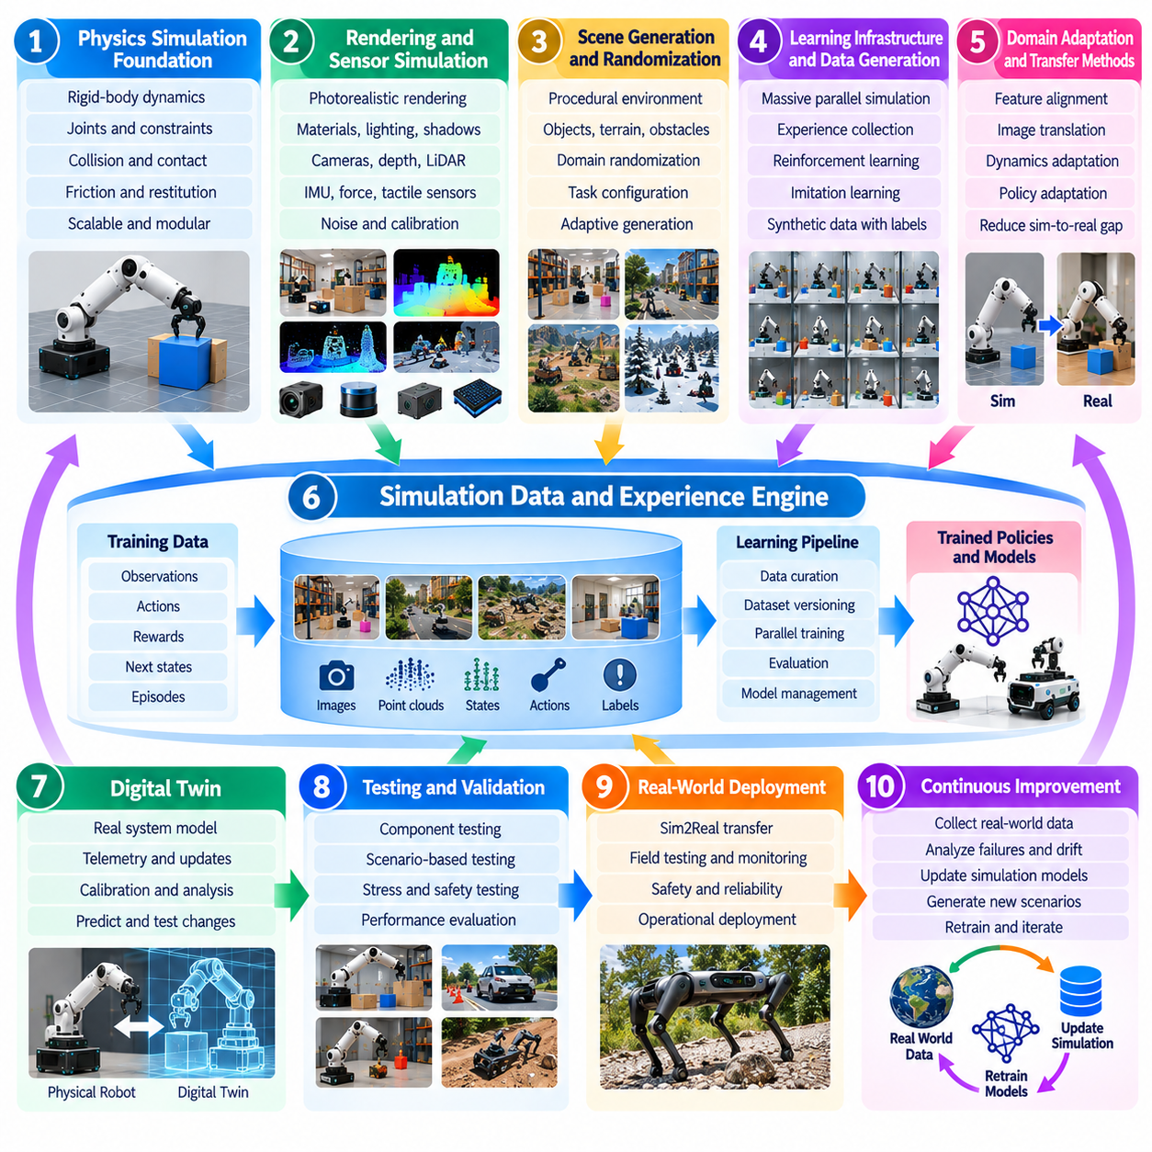
The roadmap of Simulation and Sim2Real for Physical AI describes the progressive development of virtual environments, learning infrastructure, transfer methods, and real-world validation. Its objective is to connect increasingly capable simulation technologies with reliable robotic intelligence. Rather than treating simulation as an isolated engineering tool, this roadmap positions it as a continuous foundation for designing, training, evaluating, and improving autonomous physical systems.
The first foundation is accurate and computationally efficient physics simulation. Rigid-body dynamics, joint constraints, collision detection, contact response, friction, and restitution determine how robots interact with their environments. These models must capture task-relevant physical behavior without unnecessary computational complexity. Selecting appropriate simulation fidelity requires balancing numerical stability, physical accuracy, execution speed, and the requirements of downstream learning algorithms.
Physics simulation development increasingly emphasizes modularity and scalable execution. Different robotic tasks require different levels of detail, from simplified mobile robot dynamics to complex manipulation involving repeated contact. Modern simulation architectures separate physical models, solver configurations, and control interfaces. This flexibility allows developers to adjust accuracy and computational cost while maintaining consistent interfaces between virtual robots and learning systems.
Photorealistic rendering forms the next major capability in simulation infrastructure. Physically based materials, realistic illumination, shadows, reflections, and camera optics help generate observations resembling physical sensor measurements. Such rendering is important for vision-based perception and multimodal robotic learning. However, visual realism must be evaluated according to its contribution to downstream task performance rather than judged exclusively by subjective image quality.
Sensor simulation extends rendering into a broader representation of robotic perception. Virtual cameras, depth sensors, LiDAR, inertial measurement units, force sensors, and tactile devices generate synchronized observations. Realistic noise, calibration errors, occlusions, and timing effects should be represented when relevant. Combining these modalities supports training systems that must interpret complex environments through multiple sources of imperfect information.
Domain randomization introduces controlled diversity into simulation-based learning. Physical parameters, object arrangements, lighting conditions, sensor characteristics, and actuator properties can vary across training episodes. This encourages policies to learn behaviors that remain effective under uncertainty. The roadmap progresses from manually selected randomization ranges toward data-driven distributions informed by physical measurements and observed deployment failures.
Procedural scene generation complements randomization by producing large collections of environments and task configurations. Objects, obstacles, terrain, and robot starting conditions can be arranged automatically according to defined constraints. These capabilities expand training coverage beyond manually constructed scenarios. Future systems increasingly benefit from adaptive generation mechanisms that target underrepresented conditions and difficult interactions discovered during evaluation.
Domain adaptation addresses remaining differences between synthetic and physical observations. Feature alignment, image translation, representation learning, and discrepancy minimization can reduce distribution shifts between simulation and reality. Adaptation may operate at the pixel, feature, dynamics, or policy level. Effective methods must preserve task-relevant information while avoiding transformations that introduce physically inconsistent observations or degrade previously learned behavior.
Simulation throughput becomes a central consideration as learning workloads increase. Massive parallel simulation allows many robot instances and environments to execute simultaneously, generating experience for reinforcement learning and policy optimization. GPU acceleration, vectorized computation, and automated environment resets improve efficiency. Scaling experience generation must nevertheless preserve sufficient physical fidelity and meaningful diversity to support reliable transfer.
Parallel experience collection requires coordinated infrastructure for observations, actions, rewards, episode termination, and policy updates. Learning systems must handle large volumes of interaction data without creating excessive synchronization or communication overhead. Efficient pipelines can separate simulation execution from optimization while maintaining reproducible experiments. Throughput alone is insufficient unless collected experiences contribute useful information to policy improvement.
Digital twins provide a bridge between generic simulation environments and specific physical systems. A digital twin represents the configuration, operating state, and relevant dynamics of an actual robot or facility. Physical measurements can update its parameters, while virtual experiments can predict possible outcomes. This relationship supports calibration, operational analysis, fault investigation, and the evaluation of changes before they are applied to physical equipment.
The roadmap toward effective digital twins includes increasing synchronization between simulated and physical states. Robot telemetry, sensor measurements, maintenance records, and environmental observations can inform model updates. The required synchronization frequency depends on the application and available infrastructure. A useful digital twin does not need perfect correspondence with reality, but it must maintain sufficient accuracy for its intended engineering decisions.
Synthetic data generation expands simulation beyond interactive policy training into perception and foundation model development. Virtual environments can produce images, depth maps, point clouds, segmentation labels, object poses, and action trajectories. Automatic annotation reduces the cost of constructing large datasets. Effective synthetic data pipelines combine procedural generation, diversity assessment, quality filtering, and validation against representative physical observations.
Data engines connect synthetic generation with physical data collection and continuous learning. Real-world failures can identify missing simulation scenarios, while virtual experiments can generate additional examples addressing those weaknesses. Dataset versioning, metadata management, and reproducible configurations support systematic improvement. This closed-loop architecture transforms simulation into an active component of the broader Physical AI development lifecycle.
Sim2Real gap analysis becomes increasingly important as policies approach deployment. Developers must quantify differences in dynamics, perception, actuation, timing, and environmental interactions. Controlled physical experiments provide reference measurements for comparison with simulation predictions. Identified discrepancies guide model calibration, domain randomization, and adaptation. Transfer readiness should be evaluated through measurable task outcomes rather than simulation performance alone.
Benchmark environments establish consistent methods for evaluating progress across simulation technologies and learning algorithms. Standardized tasks, scenario distributions, performance metrics, and reproducible configurations enable meaningful comparisons. Benchmarks should examine task success, robustness, safety, efficiency, and transfer performance. Their limitations must also be recognized because strong results on standardized environments do not necessarily imply reliable operation in unfamiliar physical settings.
Safety and validation must develop alongside simulation capability. Virtual testing can reproduce collisions, sensor failures, communication interruptions, and abnormal operating conditions without exposing physical systems to equivalent risks. However, simulation evidence cannot independently establish physical safety. Staged hardware experiments, operational constraints, monitoring, and emergency mechanisms remain essential before autonomous systems are deployed in environments involving people or valuable equipment.
Case studies provide the practical evidence needed to connect simulation methods with operational outcomes. Mobile navigation, robotic manipulation, locomotion, and industrial automation illustrate different requirements for physics fidelity, rendering, randomization, and adaptation. Comparative studies can reveal which modeling improvements produce measurable transfer benefits. They also expose engineering tradeoffs involving development time, computational resources, reliability, and maintenance.
The long-term direction is toward integrated simulation platforms that combine physics, rendering, procedural generation, parallel learning, digital twins, and automated evaluation. These platforms can use physical feedback to refine models and generate targeted training experiences. Advances in learned world models and adaptive simulation may further improve efficiency, although their predictions require independent verification. Integration should prioritize interoperability, traceability, and dependable performance.
Ultimately, the Simulation and Sim2Real roadmap advances from accurate virtual modeling toward continuously improving Physical AI systems grounded in physical evidence. Each capability contributes to a shared objective: developing robotic intelligence that generalizes beyond its training conditions. Progress depends on combining scalable computation with realistic uncertainty, systematic evaluation, and responsible deployment. Simulation becomes most valuable when its predictions and experiences produce demonstrable improvements in real-world autonomy.

