Volume 05. Simulation and Sim2Real Transfer

Chapter 02. Photorealistic Rendering

02.01. Rendering for Physical AI
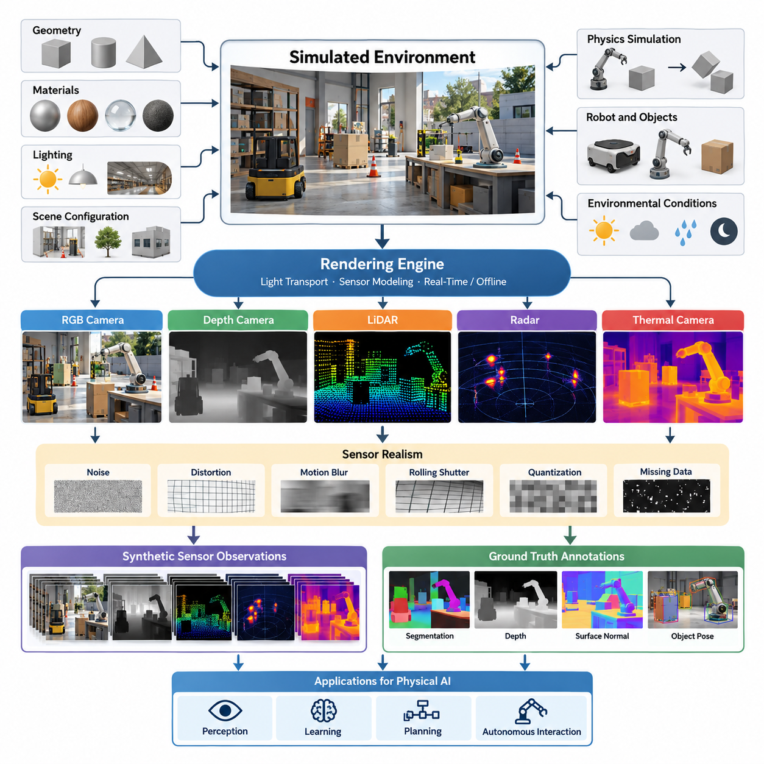
Rendering for Physical AI is the process of generating synthetic visual observations that approximate how intelligent machines perceive the physical world. Unlike conventional computer graphics, which primarily emphasizes visual presentation, rendering for Physical AI supports perception, learning, planning, and autonomous interaction. Its purpose is to transform simulated environments into sensor observations that are sufficiently realistic and informative for developing intelligent physical systems.
Physical AI systems depend on visual information to understand objects, surfaces, obstacles, spatial relationships, and environmental conditions. Autonomous mobile robots, manipulators, humanoids, and autonomous vehicles use camera observations to estimate their surroundings and select appropriate actions. Rendering provides a controlled method for reproducing these observations without requiring continuous access to physical hardware or real-world environments.
The rendering process begins with a virtual representation of the environment containing geometric models, materials, lighting sources, cameras, and scene configurations. A rendering engine calculates how light interacts with surfaces and how these interactions appear from a particular sensor viewpoint. The resulting images represent simulated observations that can be supplied directly to perception algorithms, learning systems, and robotic control architectures.
Photorealistic rendering seeks to reproduce visual characteristics that closely resemble those captured by real cameras. These characteristics include surface reflections, shadows, transparency, illumination variation, texture detail, and atmospheric effects. Realistic rendering becomes particularly important when artificial intelligence models depend on subtle visual features, such as object boundaries, material appearance, depth cues, and surface conditions.
Rendering fidelity is not determined solely by the visual attractiveness of an image. For Physical AI, the most important criterion is whether simulated observations preserve the information required for successful real-world behavior. A visually impressive image may still produce misleading sensor characteristics, while a simplified rendering may adequately support a specific task. Rendering quality must therefore be evaluated in relation to downstream perception and control performance.
A central distinction exists between rendering for human visualization and rendering for machine perception. Human observers often tolerate small geometric inconsistencies or unrealistic camera effects, whereas machine learning models may respond strongly to such differences. Changes in texture statistics, illumination distributions, image noise, or object appearance can alter learned representations and reduce the reliability of models transferred from simulation to physical environments.
Rendering is closely connected to physics simulation, although the two processes serve different purposes. Physics engines calculate motion, contact, forces, and interactions between objects, while rendering engines generate observations of the resulting simulated states. Their synchronization enables a robot to perceive consequences of its actions, allowing visual feedback to participate in closed-loop learning, decision-making, and control.
Accurate geometric representation provides the foundation for meaningful visual simulation. Three-dimensional models describe object shapes, spatial dimensions, surface orientation, and structural relationships. In robotic applications, geometry must also correspond to collision models and physical interaction boundaries. Significant inconsistencies between rendered geometry and physical geometry can create misleading visual evidence during manipulation or navigation tasks.
Material representation determines how virtual surfaces interact with incident light. Metallic objects, transparent materials, painted surfaces, rubber components, and rough industrial structures exhibit different reflection and absorption characteristics. Physically based material models help reproduce these differences using parameters associated with roughness, reflectance, transparency, and other optical properties relevant to machine vision.
Lighting strongly influences the appearance of simulated environments and the information available to visual algorithms. Directional illumination, artificial lighting, indirect reflections, and environmental light produce different image distributions. Shadows may reveal object geometry and spatial relationships, but they can also introduce ambiguities. Realistic lighting simulation helps train perception systems to operate across varying illumination conditions.
Camera modeling connects the virtual scene to the observation characteristics of actual robotic sensors. A simulated camera must account for intrinsic parameters, image resolution, field of view, lens distortion, and sensor orientation. Additional effects such as exposure, dynamic range, motion blur, and rolling shutter behavior may become important when robots move rapidly or operate under challenging environmental conditions.
Rendering for Physical AI extends beyond conventional RGB images. Depth cameras, LiDAR systems, radar sensors, and thermal cameras require different models of environmental interaction and measurement generation. Depth rendering estimates visible surface distances, while LiDAR simulation models range measurements along emitted sensing directions. These sensor representations enable the development of multimodal perception systems within virtual environments.
Sensor realism requires the simulation of imperfections rather than ideal measurements alone. Real sensors experience noise, calibration errors, missing measurements, saturation, and environmental interference. Synthetic observations that omit these effects may create unrealistic expectations during model training. Introducing calibrated sensor imperfections helps reduce discrepancies between simulated observations and measurements obtained from physical robotic platforms.
One of the most important applications of rendering is synthetic training data generation. Simulated scenes can produce large collections of images accompanied by accurate annotations, including segmentation masks, object poses, bounding boxes, depth maps, and semantic labels. These annotations are generated directly from scene information, reducing manual labeling requirements and supporting scalable training of computer vision and robotic perception models.
Rendering also supports systematic variation of environmental conditions. Developers can modify illumination, camera viewpoints, object arrangements, material properties, and background appearances while preserving task objectives. Such controlled variation enables models to encounter diverse visual situations during training. It also provides a foundation for domain randomization, which aims to improve robustness against previously unseen real-world conditions.
The relationship between photorealism and generalization is complex. Increasing visual realism can reduce some differences between simulated and real images, but it does not automatically guarantee successful transfer. Models may still depend on artificial correlations or encounter environmental conditions absent from training. Effective simulation strategies therefore combine realistic rendering, calibrated sensor models, environmental diversity, and real-world validation.
Rendering performance introduces an important engineering tradeoff. Advanced lighting calculations and physically accurate optical effects may require substantial computational resources. However, reinforcement learning and large-scale synthetic data generation often demand thousands of simultaneous simulation instances. Rendering architectures must balance visual fidelity, computational throughput, memory consumption, and the observation requirements of individual learning tasks.
Rasterization, ray tracing, and path tracing represent different approaches to image generation. Rasterization efficiently converts scene geometry into image pixels, making it suitable for high-throughput applications. Ray tracing models selected light transport effects, including reflections and shadows. Path tracing can reproduce more comprehensive global illumination behavior, although its computational requirements are generally higher.
Modern simulation platforms increasingly combine multiple rendering techniques within unified environments. High-fidelity rendering may be used to generate training datasets or evaluate difficult perception scenarios, while faster rendering configurations support large-scale policy learning. This separation allows developers to allocate computational resources according to the objectives of each simulation stage rather than requiring identical rendering quality everywhere.
Rendering must also preserve temporal consistency when supporting robotic learning. Sequential observations should correspond to physically plausible object motion, camera movement, illumination changes, and sensor timing. Inconsistent visual transitions can distort motion estimation, visual tracking, and action-conditioned prediction. Synchronization between simulation time, physics updates, rendering frames, and control commands is therefore essential.
Realistic scene construction is particularly important in industrial and logistics applications. Warehouses, manufacturing facilities, and construction environments contain complex arrangements of machinery, reflective surfaces, transparent barriers, repetitive structures, and moving equipment. Reproducing these characteristics enables developers to examine perception failures and evaluate robotic behavior under conditions resembling intended deployment environments.
Validation of rendering quality requires comparison with observations collected from real sensors. Developers can compare image statistics, feature distributions, depth measurements, and task-specific perception results. Calibration procedures adjust scene parameters, material properties, lighting configurations, and camera models to reduce meaningful discrepancies. The ultimate objective is not merely image similarity but improved reliability during real-world operation.
Rendering becomes more valuable when integrated with automated simulation and data-generation pipelines. Scene generation tools can create environments, configure sensors, execute simulated trajectories, and export synchronized observations with ground-truth annotations. Automated quality checks can identify invalid images, inconsistent labels, and unrealistic sensor outputs, enabling repeatable experimentation across large datasets and simulation campaigns.
The future of rendering for Physical AI involves closer integration between graphics engines, physical simulation, neural representations, and learning-based scene generation. Neural rendering and generative techniques may help reconstruct complex environments or create diverse visual experiences. Nevertheless, their outputs must remain geometrically, temporally, and physically consistent when used to train systems that interact with real objects.
Ultimately, rendering for Physical AI functions as a bridge between virtual environments and physical perception. Its effectiveness depends on accurate scene representation, realistic sensor behavior, computational efficiency, and alignment with robotic learning objectives. When combined with physics simulation, synthetic data generation, and systematic Sim2Real validation, rendering becomes a foundational capability for developing reliable and adaptable intelligent machines.

02.02. Rasterization Ray Tracing and Path Tracing
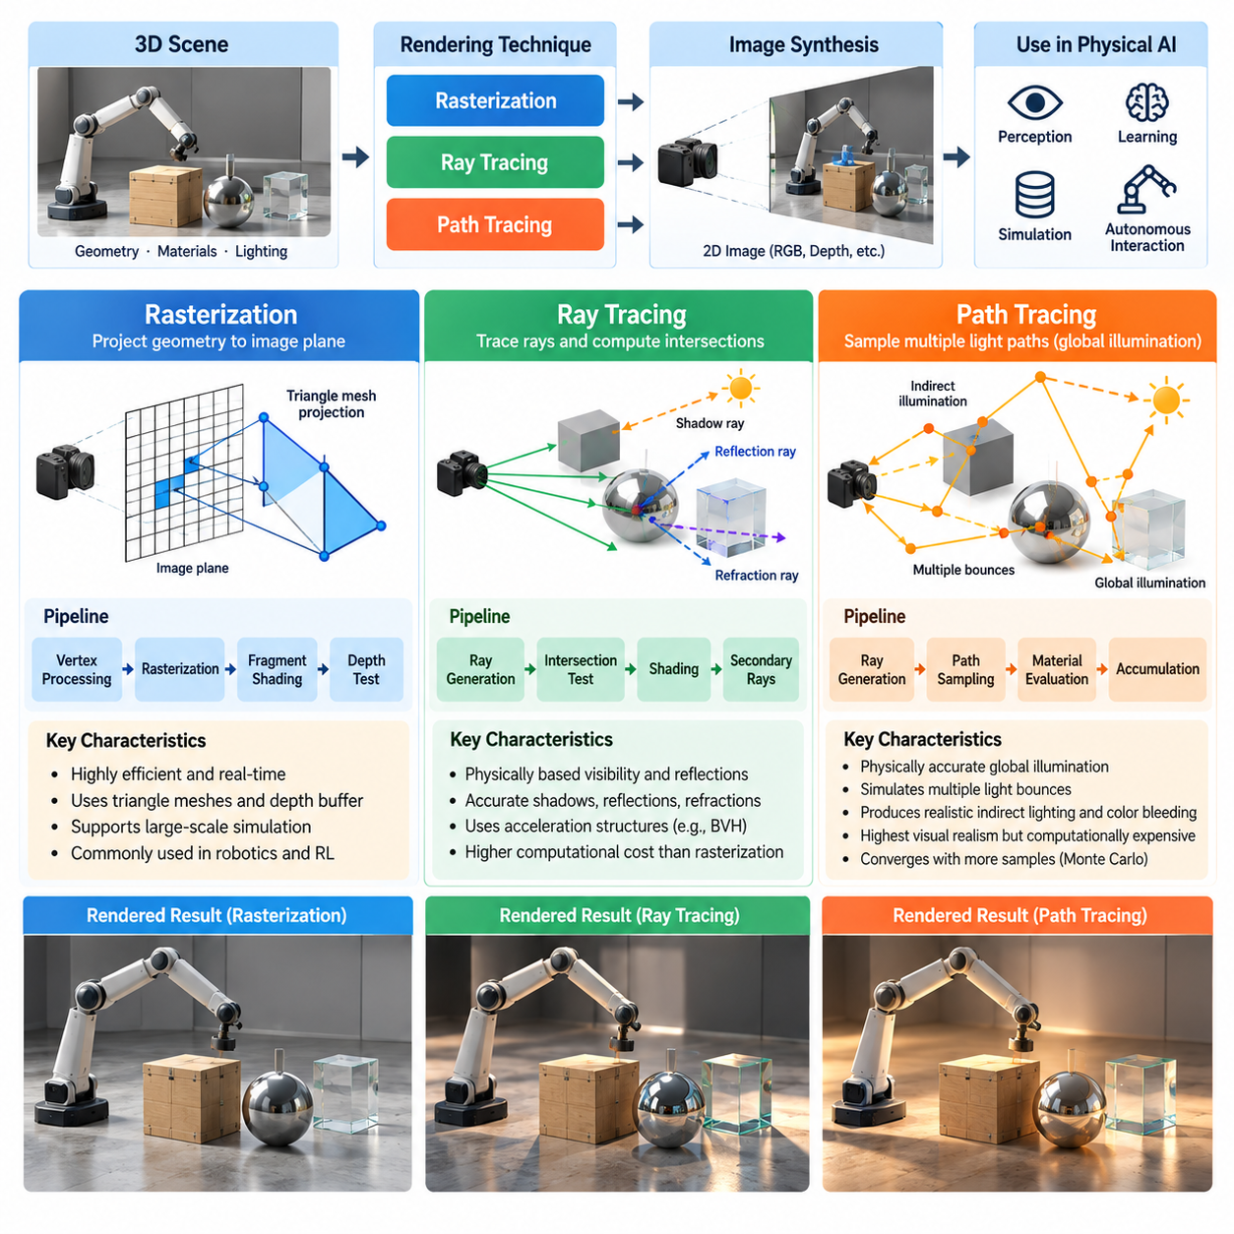
Rasterization, ray tracing, and path tracing are three fundamental rendering techniques used to transform three-dimensional scenes into visual observations for Physical AI systems. Each technique follows a different computational approach to determining how geometry, materials, and illumination contribute to image formation. Understanding their characteristics is essential for selecting rendering architectures that balance visual realism, computational efficiency, and robotic learning requirements.
Rasterization is a graphics technique that projects three-dimensional geometric primitives onto a two-dimensional image plane. Objects are typically represented as triangular meshes, which are transformed through camera projection and converted into pixel fragments. Visibility is determined using depth information, allowing the renderer to identify surfaces closest to the camera. This approach is highly efficient and forms the foundation of many real-time graphics pipelines.
The rasterization pipeline typically includes geometric transformation, primitive assembly, clipping, rasterization, fragment shading, and framebuffer operations. Vertex shaders transform object coordinates into camera and projection spaces, while fragment shaders calculate surface appearance. Depth buffers resolve visibility between overlapping surfaces. Modern graphics processors execute these operations in parallel, enabling high frame rates even in geometrically complex environments.
Rasterization is particularly valuable for Physical AI applications requiring rapid generation of visual observations. Reinforcement learning environments may simulate thousands of robots simultaneously, making rendering throughput a critical requirement. Rasterization can generate RGB images, depth maps, segmentation masks, and other visual representations efficiently. Its predictable computational structure makes it suitable for large-scale simulation and repeated policy training.
However, conventional rasterization does not directly simulate complete light transport. Reflections, indirect illumination, refraction, and soft shadows often require approximations or additional rendering techniques. Screen-space reflections, shadow maps, ambient occlusion, and environment maps can improve realism, but their accuracy depends on implementation assumptions. These limitations may become significant when robotic perception relies on complex optical effects.
Ray tracing approaches image generation by following simulated light rays through a virtual environment. In common camera-based implementations, rays originate from the camera and travel into the scene to identify intersections with geometric surfaces. At each intersection, the renderer evaluates material properties and illumination contributions. Additional rays may be generated to estimate shadows, reflections, or refractions, producing more physically consistent visual effects.
A primary advantage of ray tracing is its ability to model visibility and optical interactions using geometric ray intersections. Reflections from metallic surfaces, refraction through transparent objects, and shadows produced by complex geometry can be represented more accurately than with many conventional rasterization approximations. These capabilities are important in industrial environments containing polished machinery, glass barriers, reflective floors, and transparent components.
Efficient ray tracing depends heavily on acceleration structures that reduce the number of geometric intersection tests. Bounding volume hierarchies organize scene geometry into spatially related groups, allowing rays to bypass large regions that cannot contain relevant intersections. Modern graphics processors also provide specialized hardware acceleration for ray traversal and intersection calculations, making real-time ray tracing increasingly practical.
Despite these improvements, ray tracing generally requires more computation than conventional rasterization for comparable scene complexity and image resolution. Each pixel may require multiple rays, and reflective or transparent surfaces can introduce additional ray interactions. Performance depends on scene geometry, material complexity, ray depth, sampling strategy, and acceleration structure efficiency. These factors must be considered when designing robotic simulation pipelines.
Path tracing extends ray-based rendering by estimating the transport of light through multiple interactions with scene surfaces. Instead of evaluating only selected optical effects, path tracing samples possible light propagation paths involving reflection, transmission, and indirect illumination. By accumulating contributions from many sampled paths, it approximates solutions to the rendering equation and produces images with physically plausible global illumination.
The rendering equation describes how outgoing radiance depends on emitted light and incoming radiance reflected from surrounding directions. Path tracing evaluates this relationship numerically using Monte Carlo integration. Randomly sampled paths approximate complex lighting interactions that would otherwise require prohibitively expensive deterministic calculations. As the number of samples increases, the estimated image generally converges toward the expected lighting solution.
Path tracing can reproduce subtle visual phenomena such as color bleeding, diffuse interreflection, soft shadows, and complex indirect illumination. These effects influence how objects appear under realistic environmental conditions. In robotics, such details may affect object recognition, surface classification, pose estimation, and visual navigation, especially when perception models depend on illumination-sensitive features or reflective materials.
The principal limitation of path tracing is its computational cost. High-quality images may require many samples per pixel, particularly in scenes containing indirect lighting, glossy surfaces, or difficult illumination configurations. Insufficient sampling produces stochastic image noise, which can interfere with visual perception algorithms. Increasing sample counts improves image quality but reduces rendering throughput and simulation scalability.
Denoising techniques help address the computational burden of path tracing by reconstructing cleaner images from relatively small numbers of samples. Temporal accumulation, spatial filtering, and neural denoising can suppress sampling noise while preserving important visual structures. However, denoising may introduce artifacts, remove fine details, or alter image statistics. Such effects require careful evaluation when rendered images are used for machine learning.
The distinction between ray tracing and path tracing is primarily related to the scope and sampling of light transport. Ray tracing is a general technique for evaluating ray interactions with geometry, while path tracing is a stochastic light transport algorithm built upon ray tracing operations. A ray-traced renderer may calculate selected reflection and shadow effects, whereas a path tracer typically estimates broader global illumination through sampled light paths.
Hybrid rendering combines rasterization and ray tracing to balance computational efficiency and visual fidelity. Rasterization handles primary visibility and much of the scene shading, while ray tracing provides selected reflections, shadows, or indirect illumination. This architecture can achieve realistic observations without the full computational expense of path tracing. Hybrid approaches are particularly useful when Physical AI systems require interactive simulation with improved optical realism.
Rendering technique selection should reflect the requirements of the target robotic task. Navigation systems operating in ordinary indoor environments may perform adequately with rasterized images and calibrated sensor models. Manipulation systems handling transparent or reflective objects may benefit from ray-traced optical effects. High-fidelity synthetic dataset generation may justify path tracing when accurate illumination is more important than rendering speed.
Different rendering methods also influence the characteristics of synthetic training data. Rasterization may produce systematic visual approximations, while ray tracing and path tracing can introduce more realistic optical interactions. Nevertheless, physically sophisticated rendering does not automatically guarantee better learning performance. Geometry accuracy, camera calibration, sensor noise, material parameters, and environmental diversity remain essential components of simulation realism.
For reinforcement learning, rendering efficiency directly influences experience collection throughput. If every simulation step requires an expensive rendering operation, the number of training transitions generated per second may decrease substantially. Many robotic policies therefore use simplified visual observations during early training and higher-fidelity rendering during evaluation or targeted fine-tuning. This strategy allocates computational resources according to learning objectives.
Rendering pipelines must also support accurate synchronization between physics simulation and visual observation generation. Object positions, camera poses, articulated robot configurations, and environmental states should correspond to the same simulation timestamp. Motion blur and rolling shutter effects may require sampling scene states across exposure intervals. These considerations apply regardless of whether rasterization, ray tracing, or path tracing generates the final image.
Synthetic sensor generation introduces additional requirements beyond ordinary visual rendering. Depth cameras require accurate geometric distance measurements, while RGB cameras require realistic optical and electronic response characteristics. Segmentation outputs must preserve object identities independently of appearance. Ray-based methods can support geometric sensing, but realistic LiDAR, radar, and thermal simulation requires additional sensor-specific physical models.
Rendering fidelity can be evaluated by comparing synthetic images with measurements collected from real environments. Image intensity distributions, reflection patterns, shadow boundaries, feature descriptors, and perception model outputs provide complementary indicators of similarity. Task-level evaluation is particularly important because improvements in visual appearance do not necessarily translate into better robot behavior or successful Sim2Real transfer.
Computational architecture strongly influences the practical deployment of rendering techniques. GPU memory capacity, scene complexity, parallel execution efficiency, and data transfer overhead determine achievable simulation throughput. Large-scale Physical AI platforms may employ rasterization for massive parallel environments while reserving ray tracing or path tracing for selected high-fidelity scenarios. Such configurations support both scalability and detailed validation.
Emerging neural rendering methods provide additional opportunities to improve efficiency and scene reconstruction. Learned representations can approximate complex appearance or reconstruct environments from captured observations. Neural techniques may complement conventional rasterization and ray-based rendering, although maintaining geometric consistency, temporal stability, and physically meaningful sensor outputs remains challenging. Their usefulness depends on measurable improvements in downstream robotic tasks.
Ultimately, rasterization, ray tracing, and path tracing should be understood as complementary technologies rather than competing universal solutions. Rasterization provides efficient image generation, ray tracing improves the representation of selected optical interactions, and path tracing offers comprehensive stochastic light transport simulation. Their strategic combination enables Physical AI developers to construct scalable, realistic, and task-appropriate visual simulation environments.

02.03. Physically Based Rendering
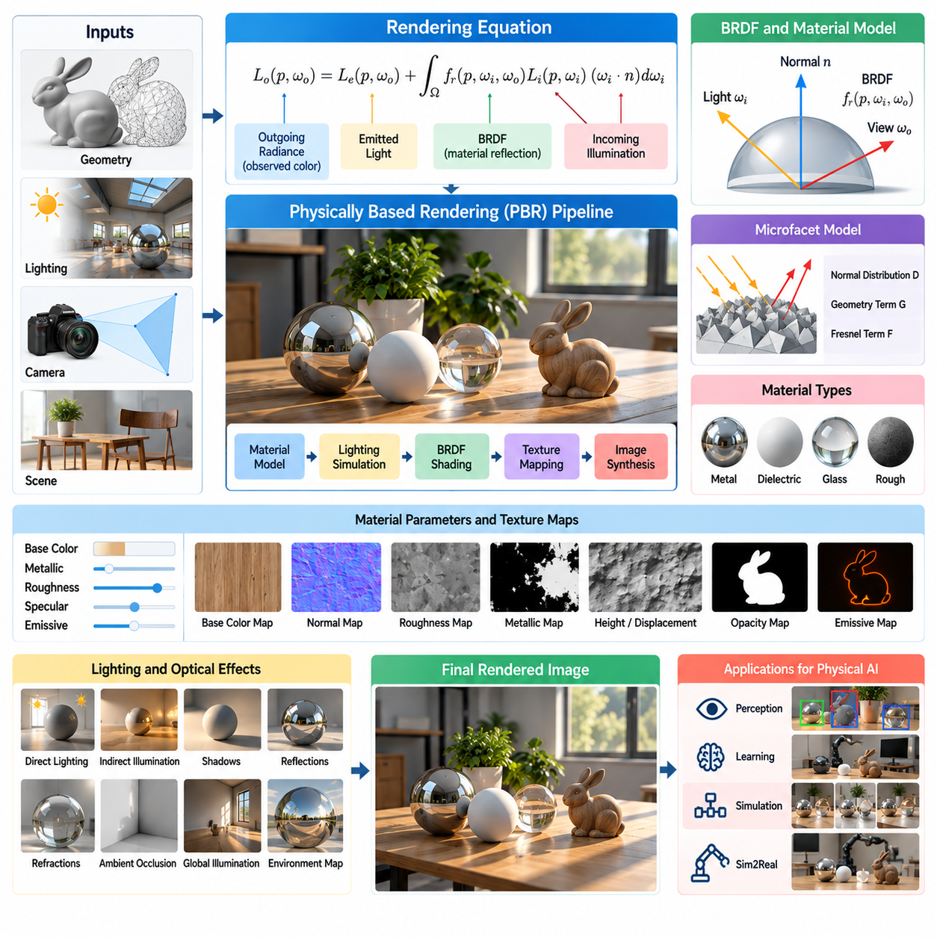
Physically Based Rendering (PBR) is a rendering methodology that uses principles of optics and material physics to generate realistic visual representations of three-dimensional environments. Rather than relying primarily on artistic approximations, PBR models how light interacts with surfaces through reflection, absorption, and transmission. For Physical AI, this approach provides consistent visual observations that support perception training, synthetic data generation, and simulation-to-reality transfer.
The fundamental objective of PBR is to reproduce the relationship between illumination, material properties, surface geometry, and observed appearance. A material should respond consistently when lighting conditions or camera viewpoints change. This consistency is particularly important for robotic systems operating across diverse environments, where perception algorithms must recognize objects despite variations in illumination, orientation, and surrounding visual conditions.
PBR is closely associated with the rendering equation, which describes the balance of light arriving at and leaving a surface. Outgoing radiance consists of emitted light and reflected contributions from incoming illumination. The reflected component depends on surface orientation, incident light direction, viewing direction, and material reflectance. Rendering algorithms approximate this relationship to calculate physically plausible pixel intensities.
A central component of PBR is the Bidirectional Reflectance Distribution Function (BRDF), which describes how incident light is reflected toward different viewing directions. The BRDF captures directional reflection behavior and provides a mathematical foundation for material shading. Different BRDF models represent diffuse, glossy, and metallic surfaces with varying levels of accuracy and computational complexity.
Physically plausible BRDF models generally follow energy conservation and reciprocity. Energy conservation prevents a passive surface from reflecting more energy than it receives, while reciprocity expresses symmetry when incident and outgoing light directions are exchanged. These properties help maintain consistent material behavior across illumination conditions and prevent unrealistic brightness changes in rendered observations.
Microfacet theory provides a widely used foundation for modern PBR material models. Instead of treating a surface as perfectly smooth, microfacet models represent it as a distribution of microscopic reflective facets. The orientation distribution of these facets determines the appearance of highlights and reflections. Rough surfaces scatter reflected light broadly, while smooth surfaces produce concentrated specular reflections.
The microfacet reflection model commonly combines a normal distribution function, a geometric visibility term, and a Fresnel reflection term. The normal distribution function describes microscopic surface orientation, while the geometry term accounts for masking and shadowing between microfacets. The Fresnel term describes how reflectance changes with viewing angle, particularly near grazing directions.
Surface roughness is one of the most influential parameters in physically based material representation. Low roughness produces sharp reflections and concentrated highlights, while high roughness creates broad reflections and visually diffuse appearances. In robotic perception, roughness affects feature visibility, object recognition, and material classification. Accurate roughness modeling is especially important for polished machinery, metallic tools, and industrial floors.
Metallic and dielectric materials exhibit fundamentally different reflection characteristics. Metals typically produce wavelength-dependent specular reflections and absorb much of the transmitted light. Dielectrics, including plastics, ceramics, and glass, generally exhibit surface reflections together with absorption or transmission within the material. PBR workflows often represent these differences through metallic and roughness parameters combined with base color information.
The metallic-roughness workflow provides a practical method for authoring physically based materials. Base color describes diffuse reflectance for nonmetals and contributes to specular coloration for metals. Metallic values distinguish conductive and dielectric behavior, while roughness controls the distribution of reflected light. This compact parameterization supports efficient material creation across large simulated environments.
An alternative material representation uses specular and glossiness parameters. Specular information describes reflection strength and color, while glossiness expresses surface smoothness. Although both workflows can represent similar appearances, their parameter definitions and authoring procedures differ. Consistent material conversion is necessary when transferring assets between rendering engines or robotic simulation platforms.
Texture maps introduce spatial variation into material properties. Base color maps represent surface coloration, normal maps modify shading orientation, roughness maps control local reflection behavior, and metallic maps describe conductive regions. Additional maps may represent displacement, opacity, or emissive properties. These textures allow simulated objects to exhibit realistic details without requiring excessively complex geometry.
Normal mapping is particularly useful for representing small surface features such as scratches, grooves, and manufactured textures. By modifying the shading normal independently of geometric shape, a renderer can reproduce detailed lighting variations at relatively low computational cost. However, normal maps do not necessarily modify physical collision geometry, creating potential inconsistencies between visual appearance and actual contact behavior.
Lighting and material models must operate within compatible radiometric assumptions. Light intensity, spectral characteristics, exposure, and color transformations influence the final rendered image. PBR materials cannot produce physically meaningful appearances if illumination values are inconsistent or arbitrary. Consequently, realistic rendering requires coordinated calibration of light sources, environment illumination, camera response, and material parameters.
Image-based lighting provides an effective mechanism for reproducing complex environmental illumination. High-dynamic-range environment maps capture directional lighting information from real or synthetic surroundings. These maps can illuminate virtual objects with realistic reflections and ambient contributions. For Physical AI, image-based lighting helps recreate factories, warehouses, outdoor environments, and other operational settings.
PBR also supports the simulation of transparent and translucent materials, although these require models beyond simple opaque surface reflection. Refraction, absorption, transmission, and internal scattering influence the appearance of glass, liquids, and polymers. Such materials present challenges for robotic vision because object boundaries and depth cues may become ambiguous. Accurate optical modeling can improve synthetic observations for transparent-object manipulation.
Subsurface scattering describes the transport of light beneath a material surface before it exits at another location. This phenomenon contributes to the appearance of skin, wax, certain plastics, and biological materials. Although computationally expensive, subsurface scattering can be relevant to humanoid robotics, healthcare environments, and human-centered perception systems where realistic biological appearance influences visual interpretation.
For Physical AI, PBR must be integrated with accurate geometry and sensor simulation. A physically plausible material alone does not guarantee realistic camera observations. Lens distortion, exposure, sensor noise, dynamic range, and image processing can significantly alter recorded appearance. Rendering pipelines must therefore connect optical surface models with calibrated camera models to reproduce the observations received by deployed robotic systems.
Material calibration is an important step in reducing the visual Sim2Real gap. Real objects can be photographed under controlled illumination, allowing developers to estimate reflectance, roughness, and color characteristics. These parameters can then be assigned to corresponding virtual assets. Comparisons between real and rendered images help identify discrepancies caused by lighting, geometry, camera response, or material assumptions.
PBR contributes directly to synthetic data generation by enabling consistent material behavior across diverse scenes. A virtual object can be rendered under different illumination conditions, viewpoints, and environmental configurations while preserving its underlying optical properties. This capability supports training datasets that expose perception models to realistic appearance variation without requiring repeated physical data collection.
However, increasing physical realism does not always improve machine learning performance. Incorrect material parameters, simplified geometry, limited lighting diversity, or unrealistic camera processing can still produce substantial domain gaps. Moreover, highly realistic synthetic datasets may contain systematic biases absent from real environments. Effective training therefore combines PBR with domain randomization, real-world calibration, and task-specific evaluation.
Computational efficiency remains an important consideration when integrating PBR into large-scale simulation. Complex BRDF evaluations, multiple light sources, environment reflections, and advanced transmission effects increase rendering costs. Real-time engines commonly use approximations, precomputed lighting, and simplified material models. High-fidelity offline rendering may employ path tracing when accurate light transport is more important than simulation throughput.
The appropriate level of PBR complexity depends on the robotic task and its sensitivity to optical effects. Navigation policies may require consistent surface appearance and shadow behavior without detailed spectral rendering. Industrial manipulation systems handling reflective or transparent components may benefit from more sophisticated material models. Rendering fidelity should therefore be selected according to measurable perception and control requirements.
Validation of PBR for Physical AI should extend beyond subjective image quality. Useful measurements include reflectance consistency, material classification accuracy, feature matching performance, object detection reliability, and real-world task success. Controlled comparisons can determine whether improved material realism reduces perception errors or enhances Sim2Real transfer. Such evaluations connect rendering quality directly to robotic system performance.
Ultimately, Physically Based Rendering provides a systematic foundation for reproducing material appearance through physically motivated optical models. By combining BRDF formulations, microfacet theory, material textures, calibrated illumination, and realistic sensor processing, PBR enables more consistent synthetic visual observations. Its greatest value in Physical AI emerges when physical plausibility, computational efficiency, and real-world robotic performance are optimized together.

02.04. Materials Textures and Surface Properties
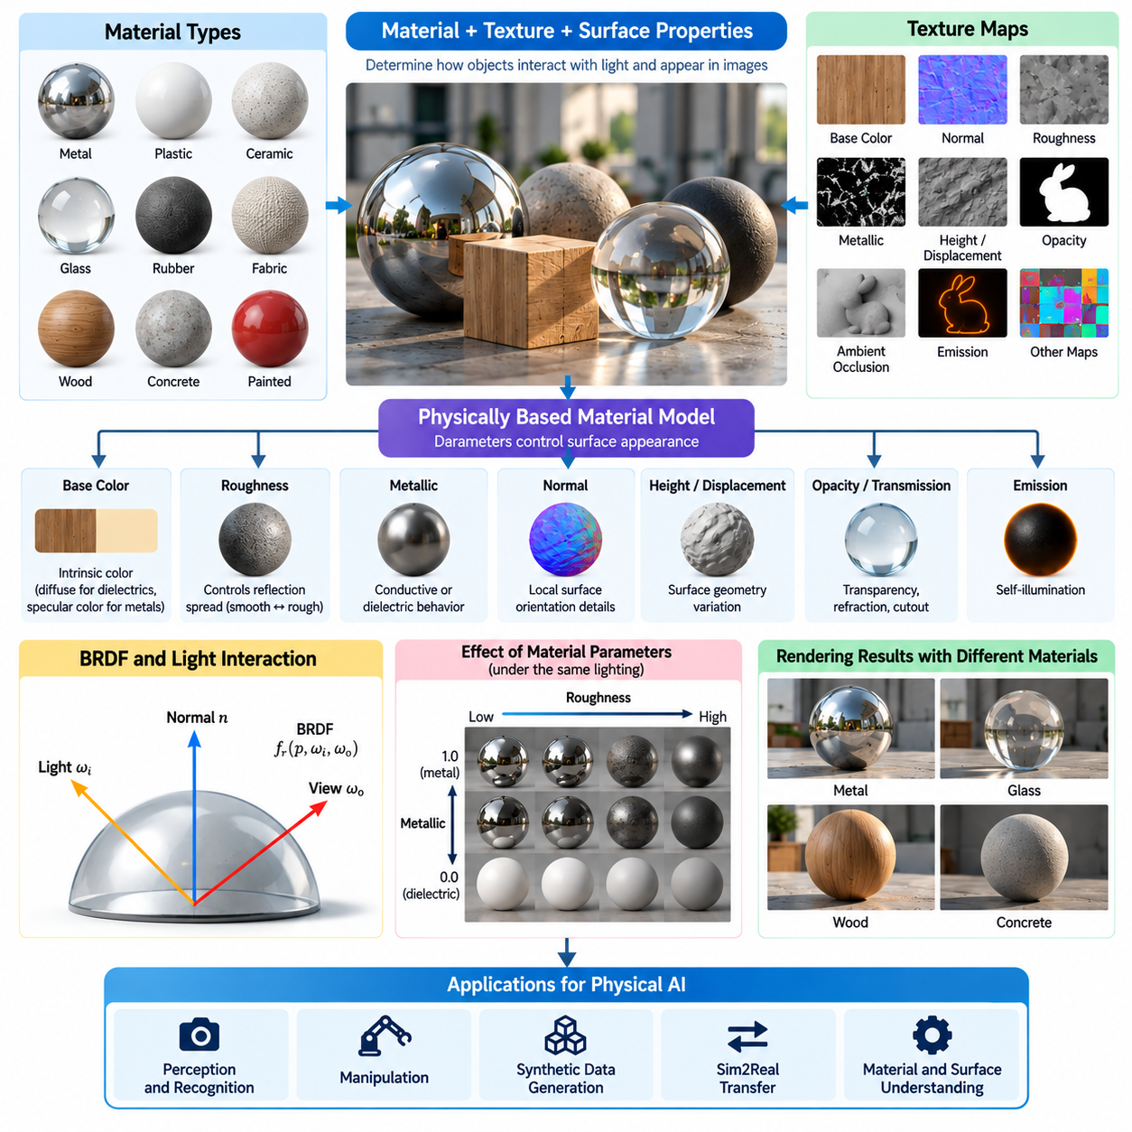
Materials, textures, and surface properties are fundamental components of photorealistic rendering for Physical AI. They determine how virtual objects interact with illumination and how their visual appearance changes across viewing conditions. Accurate representation of these characteristics enables synthetic environments to reproduce important visual cues found in real-world robotics, supporting perception training, object recognition, manipulation, and reliable Sim2Real transfer.
A material describes the optical behavior of a surface, including its reflection, absorption, transmission, and scattering characteristics. Different materials respond differently to incident light because of their physical composition and microscopic structure. Metals, plastics, ceramics, glass, rubber, and fabrics exhibit distinctive appearances. Rendering systems represent these differences through parameterized material models that approximate real optical interactions.
Textures provide spatial variation within a material by assigning different properties to locations across an object's surface. A texture may describe color, roughness, metallic behavior, transparency, or local surface orientation. Without textures, complex objects often appear artificially uniform. Detailed texture information allows simulated environments to reproduce scratches, stains, manufacturing patterns, wear, and other features that influence robotic visual perception.
Surface properties connect the optical appearance of materials to their geometric and physical characteristics. Roughness, reflectance, transparency, and microscopic surface structure influence image formation, while friction, compliance, and adhesion influence physical interaction. Although visual and mechanical properties are modeled separately in many simulation engines, their consistency is important when robots learn to associate visual observations with expected contact behavior.
Physically Based Rendering provides a systematic framework for representing material appearance through parameters motivated by optical physics. Common material models use base color, metallicity, roughness, and surface normal information. These parameters interact with illumination and camera orientation to produce realistic shading. Consistent material definitions help preserve object appearance when virtual assets are transferred between simulation scenes.
Base color represents the intrinsic coloration associated with a material under a defined rendering convention. For dielectric surfaces, it commonly describes diffuse reflectance, while metallic materials use color information to characterize wavelength-dependent specular reflection. Base color should not contain baked shadows or illumination artifacts when physically based lighting is expected to calculate those effects independently.
Roughness determines how microscopic surface irregularities distribute reflected light. Smooth surfaces produce concentrated highlights and sharp reflections, while rough surfaces scatter reflections across wider angular regions. Roughness strongly affects the appearance of polished metal, painted machinery, concrete, and industrial flooring. In Physical AI, accurate roughness representation helps perception systems distinguish objects and interpret surface conditions.
Metallic properties distinguish conductive materials from dielectric materials in common rendering workflows. Metallic surfaces exhibit colored specular reflections and generally lack the diffuse reflection characteristic of nonmetallic surfaces. Dielectric materials such as plastic, wood, and ceramics exhibit different reflection behavior. Correct metallic classification prevents unrealistic appearances and improves the consistency of synthetic training images.
Normal maps encode local variations in surface orientation without changing the underlying geometric mesh. They allow renderers to reproduce small scratches, grooves, embossed patterns, and manufactured surface details efficiently. These features influence highlights and local shading, which can affect visual feature extraction. However, normal mapping does not automatically modify collision geometry or the physical contact characteristics of a simulated object.
Bump mapping and displacement mapping provide additional methods for representing surface detail. Bump mapping modifies shading calculations to approximate small height variations, while displacement mapping changes actual geometric surface positions. Displacement can improve silhouettes, occlusion, and geometric realism but requires additional computational resources. Selecting the appropriate technique depends on whether visual appearance or physical geometry is important for the robotic task.
Texture coordinates establish the relationship between two-dimensional texture images and three-dimensional object surfaces. UV mapping assigns texture locations to mesh vertices and determines how material details appear across geometry. Poor UV layouts may introduce stretching, discontinuities, or inconsistent texture resolution. Such artifacts can create unrealistic visual patterns that interfere with perception models trained on synthetic images.
Texture resolution influences both visual fidelity and computational performance. High-resolution textures preserve fine details but increase GPU memory consumption and data transfer requirements. Lower-resolution textures reduce resource demands but may remove features important for recognition or inspection. Mipmapping and texture filtering help manage resolution changes across viewing distances while reducing aliasing and improving rendering stability.
Surface reflectance is often described using a Bidirectional Reflectance Distribution Function, which relates incoming illumination to reflected radiance. Different reflectance models reproduce diffuse, glossy, or specular behavior. Physically plausible models enforce energy conservation and represent directional reflection characteristics. These principles help maintain consistent material appearance under varying illumination and camera viewpoints.
Transparent materials introduce additional rendering challenges because light may pass through, reflect from, or refract within the material. Glass panels, transparent containers, protective covers, and liquids can create complex visual observations. Their appearance depends on refractive index, absorption, surface roughness, and surrounding geometry. Accurate modeling is important for robots handling transparent objects or navigating environments containing glass barriers.
Translucent and subsurface-scattering materials require models that account for light entering a surface and emerging from nearby locations. Skin, wax, certain plastics, and biological materials exhibit these effects. Such materials can influence visual recognition in humanoid robotics and healthcare applications. Simplified approximations may be sufficient for some tasks, while detailed optical models are useful when appearance strongly affects perception.
Surface wear and environmental contamination introduce variations that are frequently encountered in real robotic deployments. Scratches, dust, oil, corrosion, fingerprints, and moisture can modify reflectance and texture appearance. Simulated materials should represent these variations when they affect target tasks. Including realistic wear patterns helps perception systems handle objects that differ from idealized manufacturing models.
Procedural textures generate surface patterns algorithmically rather than relying exclusively on stored image files. Noise functions, mathematical patterns, and rule-based generators can reproduce concrete, wood, terrain, corrosion, and other material variations. Procedural approaches support large-scale environment generation and controlled diversity. They are particularly useful when creating many simulation instances with different surface appearances.
Material randomization provides a mechanism for improving robustness during synthetic data generation. Developers can vary base color, roughness, texture patterns, reflectance, and surface contamination while preserving task-relevant object properties. These variations expose learning models to broader appearance distributions. However, randomization ranges should remain physically plausible when unrealistic combinations could produce misleading training signals.
Material libraries and asset management systems help maintain consistency across complex simulation environments. Standardized material definitions can be reused across robots, objects, buildings, and industrial equipment. Metadata may include optical parameters, texture references, physical material categories, and calibration information. Version-controlled material assets improve reproducibility and reduce inconsistencies between training and evaluation environments.
Visual surface properties should be coordinated with physics simulation parameters whenever robotic behavior depends on material interaction. A visually rough surface may suggest high friction, but actual friction depends on the contacting materials and environmental conditions. Similarly, visually soft materials may have different mechanical stiffness values. Simulation pipelines should explicitly maintain relationships between optical appearance and physical contact properties.
Material calibration involves estimating rendering parameters from observations of real surfaces. Controlled photography, reflectance measurements, and calibrated illumination can provide reference information for base color, roughness, and reflection behavior. These measurements support the creation of digital material representations that resemble physical assets. Calibration reduces systematic visual differences between simulated and real robotic environments.
Synthetic material realism must also account for camera and sensor characteristics. Exposure, white balance, lens effects, image processing, and sensor noise can alter how material properties appear in captured images. A physically accurate surface model may still produce unrealistic observations if camera response is incorrect. Consequently, material rendering and sensor simulation should be validated together rather than treated as independent components.
Material quality can be evaluated through image similarity, reflectance consistency, feature stability, and downstream perception performance. Comparisons between rendered and real observations can identify incorrect texture statistics, unrealistic highlights, or missing surface variations. Task-level metrics are particularly important because improved visual appearance does not necessarily guarantee better robotic behavior. Evaluation should prioritize the visual characteristics that influence operational success.
Computational constraints influence how material complexity is implemented in large-scale Physical AI simulation. Detailed texture maps, complex shading models, and advanced optical effects increase memory and rendering costs. Efficient systems may use texture compression, material instancing, simplified shaders, and level-of-detail strategies. These techniques help preserve useful visual information while supporting high-throughput simulation and synthetic data generation.
Ultimately, materials, textures, and surface properties provide the connection between virtual geometry and realistic visual perception. Their accurate representation requires coordinated optical models, texture information, geometric detail, physical interaction parameters, and sensor calibration. When combined with systematic validation and controlled variation, these components enable scalable synthetic environments that support robust perception, effective learning, and reliable deployment of Physical AI systems.

02.05. Lighting Shadows and Environment Illumination
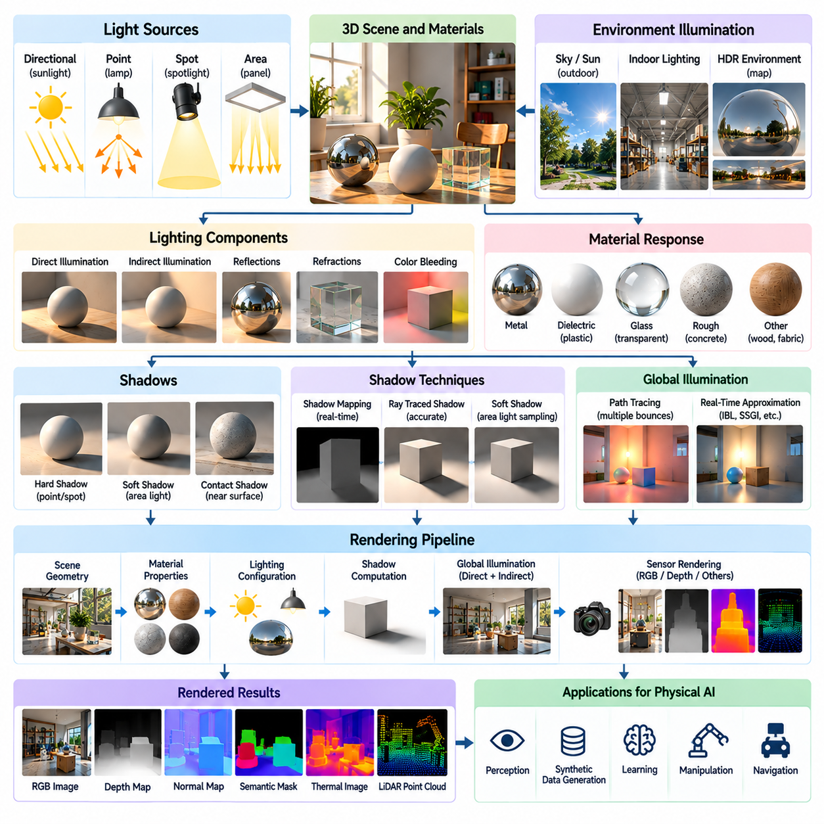
Lighting, shadows, and environment illumination are essential components of photorealistic rendering for Physical AI. They determine how light interacts with objects, surfaces, and surrounding geometry to produce visual observations. Realistic illumination is important because robotic perception depends on brightness, contrast, reflections, and shadow patterns. Accurate lighting simulation supports synthetic data generation, perception training, and reliable Sim2Real transfer.
Lighting simulation aims to reproduce the physical behavior of illumination in real environments. Light propagates from sources, interacts with materials, and reaches virtual cameras after reflection, absorption, or transmission. The resulting image depends on source intensity, direction, spectral composition, and surrounding geometry. Physically motivated lighting models help preserve consistent appearance when robots operate under changing environmental conditions.
Light sources in rendering systems are commonly represented as directional, point, spot, and area lights. Directional lights approximate distant sources such as sunlight, while point lights emit illumination from a localized position. Spotlights concentrate energy within a defined angular region. Area lights represent extended emitting surfaces and produce more realistic illumination gradients and soft shadows.
Directional lighting is particularly useful for simulating outdoor robotic environments. Sunlight can be approximated using a nearly parallel light field because of the sun's large distance from the scene. Its direction changes with geographic location, time of day, and season. Accurate solar positioning influences shadow orientation, object contrast, and illumination intensity, which can affect outdoor navigation and visual localization.
Point lights and spotlights are commonly used to represent artificial illumination in factories, warehouses, laboratories, and indoor service environments. Their intensity generally decreases with distance according to geometric spreading. Real fixtures may also exhibit directional emission patterns and nonuniform spectral characteristics. Modeling these properties improves the realism of simulated inspection and manipulation tasks.
Area lighting provides a more physically plausible representation of extended light sources such as ceiling panels, windows, and industrial luminaires. Unlike idealized point sources, area lights illuminate objects from multiple directions. This produces gradual brightness transitions and soft shadow boundaries. Such effects are important when robotic vision systems must identify object edges and surface features under realistic indoor lighting.
The intensity of illumination should be expressed using consistent photometric or radiometric quantities. Radiometric measurements describe physical electromagnetic energy, while photometric measurements account for human visual sensitivity. Rendering engines may use radiance, irradiance, luminous intensity, or illuminance depending on their architecture. Consistent unit conversion and calibration are necessary when reproducing measured lighting conditions.
Light color and spectral composition influence the observed appearance of materials. Daylight, fluorescent lamps, LEDs, and industrial lighting systems can exhibit different spectral power distributions. Two light sources with similar perceived color may produce different camera responses when illuminating particular materials. Spectral modeling can therefore be important for robotic inspection, color classification, and material recognition.
Shadows are formed when objects obstruct light traveling toward other surfaces. They provide visual information about geometry, spatial relationships, object contact, and illumination direction. Hard shadows typically result from small apparent light sources, while extended sources produce penumbrae and gradual shadow transitions. Accurate shadow representation helps perception algorithms interpret object boundaries and three-dimensional structure.
Shadow mapping is a widely used technique for generating shadows in real-time rasterization pipelines. The scene is rendered from the light source to construct a depth representation, which is compared with camera-visible surfaces. Although computationally efficient, shadow mapping can introduce aliasing, incorrect self-shadowing, and resolution-dependent artifacts. Filtering and bias adjustment reduce these limitations but require careful configuration.
Ray-traced shadows determine light visibility through geometric intersection tests between surfaces and light sources. This approach can produce more accurate occlusion and naturally represent soft shadows when extended light sources are sampled. However, multiple visibility queries increase computational cost. Hybrid rendering systems often combine rasterization with ray-traced shadows to improve visual fidelity without sacrificing real-time performance.
Direct illumination describes light reaching a surface directly from an emitting source. Indirect illumination results from light reflecting or transmitting through other surfaces before reaching the observed location. Both components contribute to realistic scene appearance. Indirect illumination can brighten regions outside direct light paths and introduce color bleeding between nearby surfaces with different reflectance characteristics.
Global illumination models the combined effects of direct and indirect light transport throughout an environment. Path tracing estimates these interactions by sampling multiple light paths, while real-time systems often employ approximations or precomputed lighting. Global illumination improves spatial coherence and material appearance, particularly in enclosed environments containing reflective surfaces and complex geometry.
Ambient occlusion approximates the reduction of environmental illumination in geometrically enclosed regions. It emphasizes contact areas, corners, crevices, and closely spaced surfaces, improving perceived depth. Screen-space ambient occlusion provides an efficient approximation but may produce artifacts or omit geometry outside the camera view. Ambient occlusion should not be treated as a complete substitute for physically modeled indirect illumination.
Environment illumination represents light arriving from the surrounding world rather than individual local fixtures. Outdoor environments receive contributions from the sky, atmosphere, terrain, and nearby structures. Indoor environments receive reflected illumination from walls, floors, ceilings, and equipment. Modeling these contributions is necessary for reproducing realistic brightness distributions and reflections across complex robotic scenes.
Image-based lighting uses environment maps to represent directional illumination captured from real or synthetic surroundings. High-dynamic-range images preserve bright light sources and subtle environmental contributions. These maps can illuminate virtual objects while generating realistic reflections and shading. Image-based lighting is particularly useful when reconstructing real operational environments for synthetic data generation.
Sky and atmospheric models support realistic outdoor illumination across different environmental conditions. Solar elevation, atmospheric scattering, cloud cover, haze, and weather influence the distribution of daylight. Changes in these factors alter image contrast, shadow sharpness, and color temperature. Outdoor robotic simulation benefits from representing these variations when training perception systems for changing weather and lighting conditions.
Dynamic lighting introduces temporal changes caused by moving light sources, changing weather, artificial lighting controls, and moving objects. Robots may encounter flickering lamps, passing vehicle headlights, or sudden transitions between indoor and outdoor spaces. Such variations can affect exposure control and feature tracking. Simulation should reproduce relevant temporal lighting behavior when robustness to illumination changes is a training objective.
Lighting interacts strongly with camera exposure, dynamic range, and image processing. Bright regions may saturate sensors, while poorly illuminated areas may contain substantial noise or insufficient detail. Automatic exposure and white balance can modify the apparent brightness and color of the scene. Consequently, lighting realism must be evaluated together with camera and sensor models rather than through rendered images alone.
Lighting randomization is an important technique for improving the generalization of Physical AI perception models. Training environments can vary source positions, intensities, colors, shadow patterns, and environmental illumination. Controlled variation helps models learn features that remain stable across lighting conditions. However, unrealistic illumination distributions may reduce training relevance, making physically plausible parameter ranges important.
Accurate lighting simulation also supports robotic manipulation and inspection. Shadows and highlights can reveal surface curvature, object orientation, and contact relationships. Conversely, strong reflections or insufficient illumination may obscure important features. Synthetic datasets should include both favorable and challenging lighting configurations so that perception systems can handle realistic operational variability.
Lighting calibration involves comparing simulated illumination with measurements from real environments. Reference photographs, calibrated cameras, light meters, and measured fixture characteristics can support parameter estimation. Developers can adjust source intensity, position, spectral properties, and environment maps to reduce discrepancies. Calibration is especially valuable when synthetic images must reproduce a specific factory, warehouse, or inspection station.
Rendering performance imposes practical limits on lighting fidelity in large-scale simulation. Multiple dynamic lights, shadow calculations, indirect illumination, and complex reflections increase GPU workload. Real-time systems may use light culling, shadow caching, precomputed illumination, and simplified shading models. High-fidelity rendering can be reserved for targeted validation or synthetic dataset production when computational cost is justified.
Lighting quality should be evaluated through both image-level and task-level measurements. Image comparisons can examine brightness distributions, shadow boundaries, color consistency, and reflection patterns. Robotic evaluations can measure object detection accuracy, localization stability, manipulation success, and robustness under changing illumination. These measurements help determine whether improved lighting realism produces meaningful gains in Sim2Real performance.
Ultimately, lighting, shadows, and environment illumination form an integrated system that determines how virtual environments are visually perceived. Their realistic simulation requires coordinated light source models, shadow generation, global illumination, environment maps, and camera response. By combining physical accuracy with computational efficiency and controlled variation, Physical AI developers can create visual environments that support robust perception and reliable real-world robotic operation.

02.06. Camera Optics and Lens Modeling
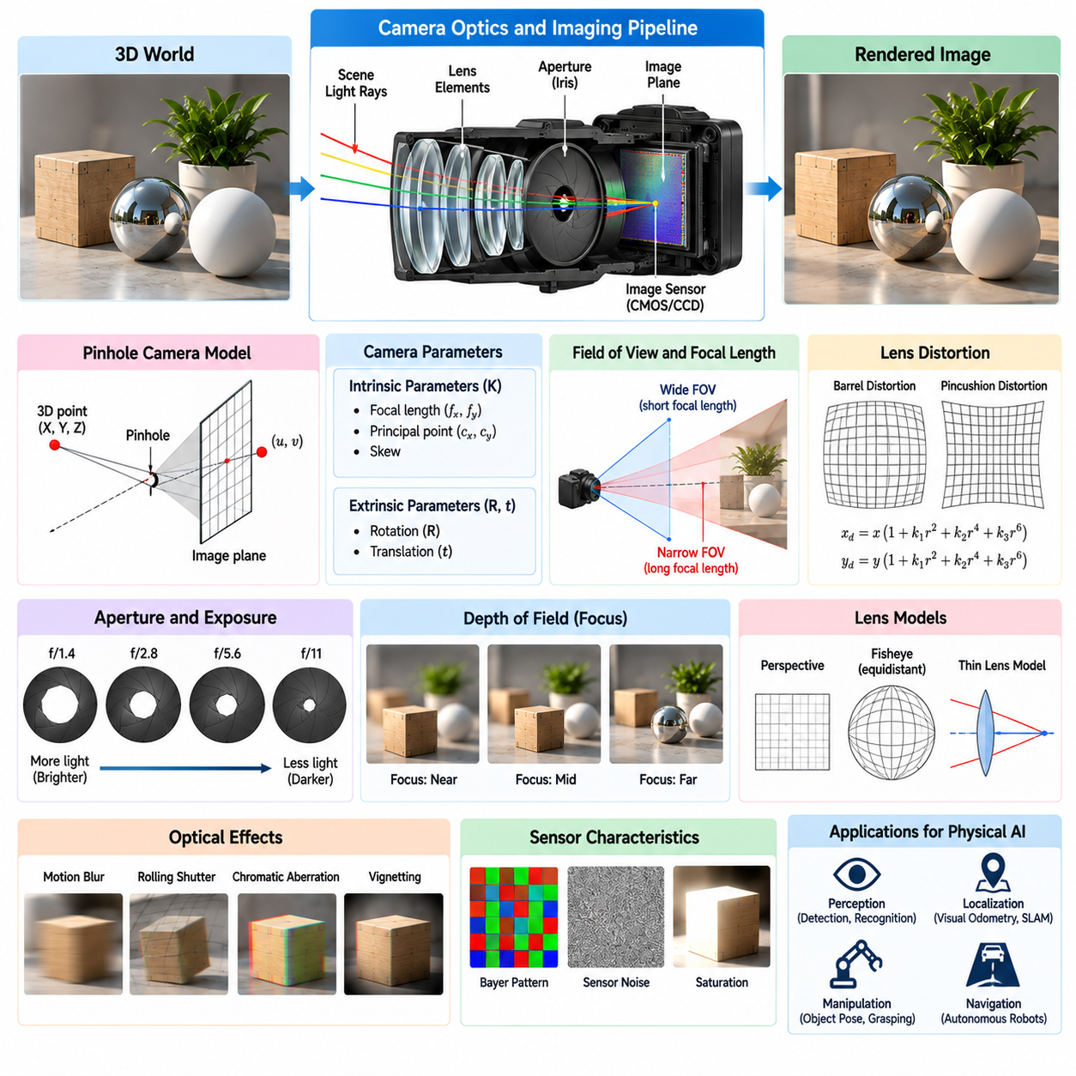
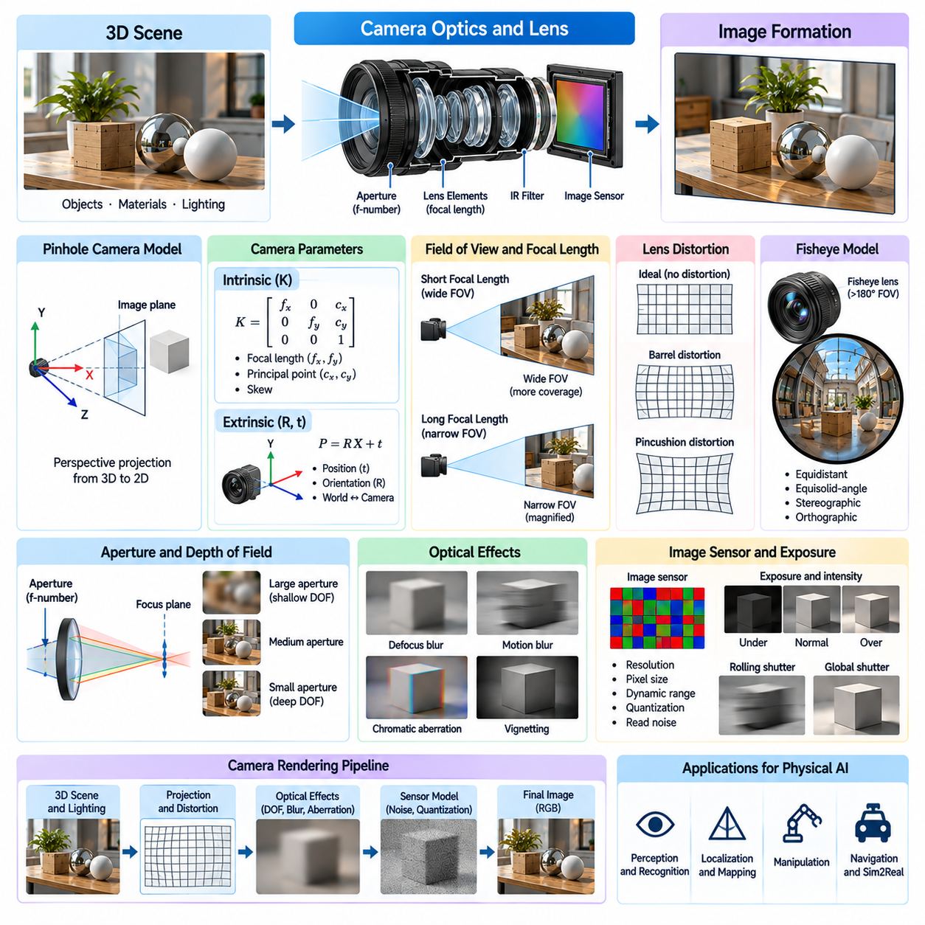
Camera optics and lens modeling are essential components of photorealistic rendering for Physical AI. Virtual cameras must reproduce how real optical systems project three-dimensional environments onto image sensors. Their characteristics influence geometry, sharpness, brightness, and image distortion. Accurate camera simulation enables synthetic visual observations to resemble real robotic sensor data, supporting perception training, visual localization, manipulation, and Sim2Real transfer.
A camera forms an image by collecting light from a scene and directing it toward a photosensitive sensor. The resulting observation depends on lens geometry, focal length, aperture, sensor dimensions, and optical alignment. Simplified rendering cameras often use idealized projection models, while physical cameras introduce additional optical effects. Understanding these differences is necessary when designing realistic robotic vision simulation pipelines.
The pinhole camera model provides a mathematical foundation for perspective projection. It assumes that light passes through a single idealized point before reaching the image plane. Three-dimensional scene coordinates are projected into two-dimensional image coordinates using camera intrinsic and extrinsic parameters. Although computationally efficient, this model does not directly represent lens distortion, defocus, or other physical optical imperfections.
Camera intrinsic parameters describe the internal geometric relationship between incoming light and image coordinates. They typically include focal lengths expressed in pixels, principal point coordinates, and sometimes skew. These parameters are commonly organized into a camera intrinsic matrix. Accurate intrinsic calibration is important for image rectification, three-dimensional reconstruction, visual odometry, and geometric consistency between simulated and real observations.
Extrinsic parameters describe the position and orientation of a camera relative to a world or robot coordinate frame. They define the rigid transformation between scene geometry and the camera reference frame. In robotic systems, camera extrinsics may change as joints move or mobile platforms navigate. Accurate transformation management ensures that rendered images remain synchronized with robot kinematics and simulated environmental geometry.
Focal length determines the relationship between scene depth and projected image scale. Short focal lengths generally produce wider fields of view, while longer focal lengths provide narrower viewing angles and greater image magnification. The actual field of view also depends on sensor dimensions. Matching focal length and sensor size is necessary when synthetic images must reproduce the geometric characteristics of a deployed robotic camera.
Field of view determines how much of the environment can be observed in a single image. Wide-angle cameras provide broad spatial coverage but may introduce stronger distortion and reduced detail per angular region. Narrow-angle cameras offer greater spatial resolution for distant objects but cover smaller regions. Camera selection and simulation should therefore reflect the perception range, navigation requirements, and manipulation workspace of the target robot.
Lens distortion causes deviations from ideal perspective projection. Radial distortion produces barrel or pincushion effects, while tangential distortion can arise from lens and sensor misalignment. These effects alter the apparent positions of image features and straight lines. Distortion models commonly use polynomial coefficients that can be estimated through camera calibration and applied to synthetic images.
Wide-angle and fisheye lenses require specialized projection models because their angular coverage may exceed the practical range of conventional perspective cameras. Equidistant, equisolid-angle, stereographic, and orthographic fisheye mappings describe different relationships between incident ray angle and image radius. Correct model selection is important for panoramic perception, mobile robot navigation, and omnidirectional sensing.
Lens aperture controls the amount of light reaching the image sensor and influences depth of field. A larger aperture generally admits more light but produces a shallower depth of field, while a smaller aperture increases the range of distances that appear acceptably sharp. Aperture is commonly expressed through the f-number, which relates focal length to entrance pupil diameter. Realistic aperture modeling supports accurate image brightness and defocus simulation.
Depth of field describes the range of object distances that appear sufficiently sharp for a given focus setting. Objects outside this range produce defocus blur, often represented through a circle of confusion. Depth of field depends on focal length, aperture, focus distance, and sensor geometry. In robotic perception, defocus can influence feature detection, object boundaries, and the reliability of depth estimation.
Thin-lens models extend ideal pinhole projection by representing image formation through a finite aperture and simplified focusing geometry. Rays passing through different aperture positions converge near the focal plane, while points outside the focal plane form blurred image regions. This approach provides a practical balance between optical realism and computational cost. More detailed lens models may trace rays through multiple refractive elements.
Real photographic lenses contain multiple optical elements designed to control aberrations and improve image quality. Their performance depends on element curvature, refractive index, spacing, coatings, and mechanical alignment. Detailed optical simulation can reproduce complex lens behavior, but it requires additional calibration data and computation. For many robotic tasks, simplified calibrated models provide sufficient accuracy.
Chromatic aberration occurs because different wavelengths of light refract by different amounts within optical materials. This can produce color fringes near high-contrast edges or changes in focus across color channels. Longitudinal and lateral chromatic aberrations affect image formation differently. Although often subtle, these effects may influence high-precision inspection and feature matching when synthetic imagery is compared with real camera measurements.
Other optical aberrations include spherical aberration, coma, astigmatism, and field curvature. These imperfections cause spatially varying blur, asymmetric point images, or differences in sharpness across the sensor. Their visibility depends on lens design, aperture, focus distance, and image position. Modeling relevant aberrations can improve the realism of simulated cameras used in demanding visual inspection or localization applications.
Vignetting describes the reduction of image brightness toward the edges of the field of view. It may result from geometric light falloff, optical obstruction, or sensor angular response. Vignetting creates spatial intensity variations even when observing a uniformly illuminated surface. Synthetic camera models can reproduce this behavior through calibrated attenuation functions, improving consistency with real image measurements.
The point spread function describes how an optical system represents an ideal point source on the image sensor. It captures the combined influence of diffraction, aberrations, and defocus on image sharpness. Spatially varying point spread functions can model changes in optical quality across the image. Related measures, such as the modulation transfer function, characterize how effectively an optical system preserves contrast at different spatial frequencies.
Diffraction imposes a fundamental limit on optical resolution because light behaves as a wave when passing through finite apertures. Very small apertures increase depth of field but can reduce sharpness through diffraction blur. This creates a tradeoff between focus tolerance and spatial detail. For robotic cameras performing precision measurement, optical resolution must be evaluated together with sensor pixel size and image processing.
Sensor dimensions and pixel pitch influence the sampling of projected optical information. Smaller pixels can capture finer spatial variations when sufficient optical resolution and illumination are available, but they may also collect fewer photons per exposure. Camera simulation should account for the relationship between lens resolution, pixel sampling, and image noise. Ignoring these interactions may produce unrealistically sharp synthetic observations.
Focus mechanisms introduce additional variation into camera behavior. Fixed-focus cameras maintain a predetermined focus setting, while autofocus systems adjust lens position according to scene content or control algorithms. Focus transitions may temporarily change image sharpness and feature visibility. Simulating these effects can be useful for robotic systems that inspect objects at varying distances or operate with adjustable optical assemblies.
Camera calibration connects mathematical projection models with the behavior of physical imaging systems. Calibration procedures estimate intrinsic parameters, distortion coefficients, and camera pose using known geometric references. Reprojection error provides an indicator of model agreement with measured observations. However, low calibration error does not guarantee that all optical effects are accurately represented, particularly under changing focus or temperature conditions.
Camera optics must also be coordinated with exposure, shutter behavior, and sensor processing. Lens transmission influences the light reaching the sensor, while exposure time and electronic gain determine recorded brightness. Rolling shutter, motion blur, and noise can interact with optical distortion and focus. A realistic synthetic camera therefore requires an integrated imaging pipeline rather than an isolated geometric projection model.
Multi-camera robotic systems introduce additional calibration requirements. Stereo cameras, surround-view systems, and camera arrays depend on accurate relative poses and synchronized observations. Small errors in baseline, orientation, or lens distortion can affect triangulation and depth reconstruction. Simulation should preserve these relationships when generating synthetic data for stereo matching, visual navigation, and sensor fusion.
Validation of camera optics should compare simulated and real observations under controlled geometric and illumination conditions. Calibration targets, edge patterns, point sources, and representative operational scenes can reveal differences in projection, distortion, sharpness, and brightness. Task-level evaluation should also measure effects on detection, localization, and reconstruction accuracy. These comparisons help prioritize optical effects that materially influence robotic performance.
Ultimately, camera optics and lens modeling establish the connection between virtual scene geometry and realistic image formation. Accurate simulation requires coordinated projection models, lens distortion, aperture, focus, optical aberrations, sensor sampling, and calibration. By balancing physical fidelity with computational efficiency, Physical AI developers can generate synthetic camera observations that support robust perception and reliable real-world robotic operation.

02.07. Exposure Dynamic Range and Motion Blur
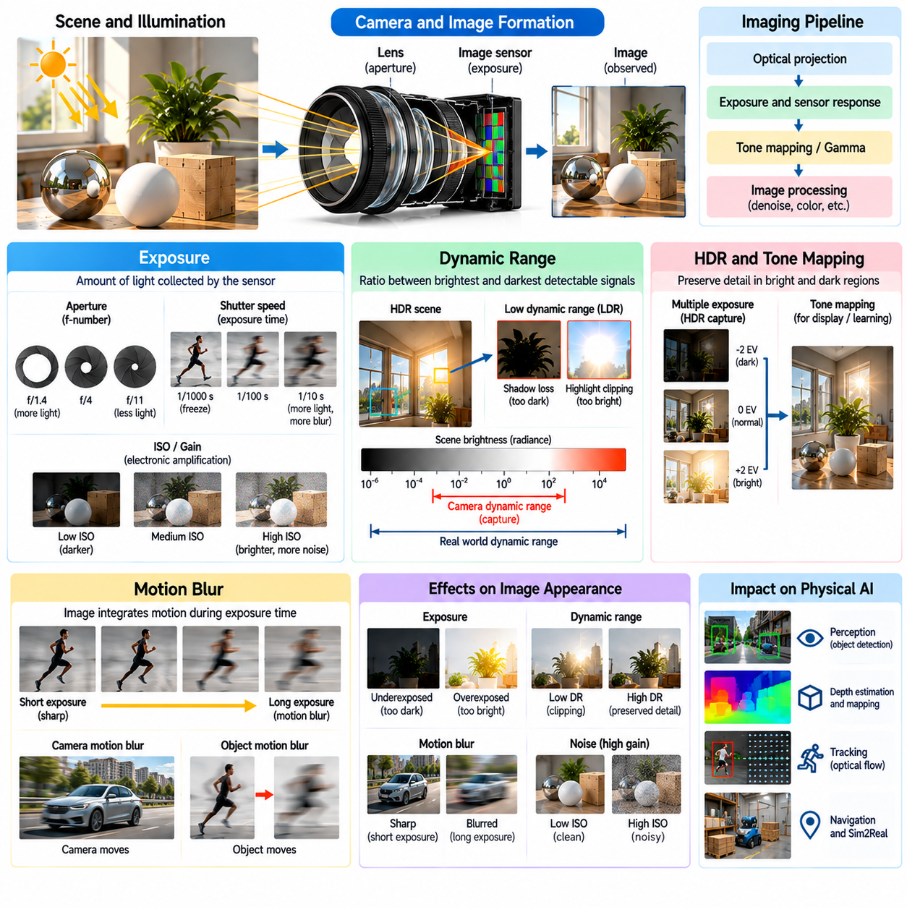
Exposure, dynamic range, and motion blur are fundamental characteristics of camera image formation that strongly influence visual observations in Physical AI. They determine how light is accumulated, how brightness variations are recorded, and how movement appears in captured images. Realistic simulation of these effects is essential for generating synthetic camera data that supports robust perception, visual tracking, robotic navigation, and reliable Sim2Real transfer.
Exposure describes the amount of light accumulated by an image sensor during image acquisition. It depends primarily on exposure time, lens aperture, and scene illumination, while electronic gain affects the recorded signal brightness. Correct exposure determines whether image features remain visible across different lighting conditions. In robotic systems, exposure settings directly influence object detection, feature extraction, and visual localization accuracy.
Exposure time defines the duration over which the sensor integrates incoming photons. Longer exposure times increase the collected light signal but also increase the likelihood of motion blur when objects or cameras move. Shorter exposures reduce motion-related image degradation but may produce darker observations with lower signal-to-noise ratios. This tradeoff is particularly important for mobile robots, drones, and high-speed manipulation systems.
Lens aperture controls the quantity of light reaching the sensor by adjusting the effective opening of the optical system. A larger aperture generally increases light collection while reducing depth of field. A smaller aperture increases the range of distances appearing sharp but may require longer exposure times or higher electronic gain. Camera simulation should reproduce these interactions rather than treating image brightness as an independent rendering parameter.
Electronic gain amplifies the sensor signal after photon collection and can increase the apparent brightness of recorded images. However, gain does not increase the number of collected photons and may amplify existing noise. Analog and digital gain can affect image statistics differently. Realistic synthetic camera models should distinguish optical exposure from electronic amplification when reproducing low-light robotic observations.
Dynamic range describes the ratio between the largest and smallest detectable light signals that a camera can represent with useful detail. Real environments frequently contain both bright and dark regions, creating significant challenges for image sensors. Limited dynamic range can cause highlight clipping or loss of shadow detail. These effects influence robotic perception when objects appear near windows, reflective machinery, or poorly illuminated spaces.
High Dynamic Range imaging extends the range of scene brightness that can be represented in a final image. Cameras may combine multiple exposures, use specialized sensor architectures, or apply computational reconstruction techniques. HDR processing can preserve details in shadows and highlights, but it may introduce artifacts when objects move between exposures. Simulation must reproduce the relevant acquisition and processing mechanisms.
Tone mapping converts high-dynamic-range radiometric information into values suitable for display or downstream image processing. Global tone mapping applies a common transformation across the image, while local operators adapt to spatial brightness differences. These transformations affect contrast, color appearance, and feature visibility. Synthetic images should use tone mapping behavior consistent with the target robotic camera pipeline.
Gamma correction and color transfer functions further influence the relationship between physical scene brightness and encoded pixel values. Linear radiometric values should not be confused with nonlinear image representations. Incorrect color-space handling can distort brightness relationships and alter training data statistics. Maintaining consistent transformations is essential when comparing rendered observations with real camera measurements.
Automatic exposure control adjusts camera settings in response to changing scene brightness. Algorithms may analyze average luminance, image histograms, selected regions, or exposure priorities. Sudden transitions between bright and dark environments can produce temporary overexposure or underexposure. Modeling exposure adaptation helps prepare robotic perception systems for realistic illumination changes during operation.
Exposure adaptation also introduces temporal behavior into image sequences. Camera brightness may change gradually as control algorithms update exposure time or gain. These transitions influence feature matching, optical flow, and visual odometry. Synthetic sequences generated with fixed exposure may fail to reproduce these effects. Time-dependent exposure models therefore improve realism for robots navigating dynamic lighting environments.
Motion blur occurs when scene content moves relative to the camera during the exposure interval. Instead of recording a single instantaneous configuration, the sensor integrates light from multiple positions over time. The resulting image contains spatially distributed intensity patterns along the direction of apparent motion. Motion blur can obscure edges, reduce texture contrast, and degrade the accuracy of visual perception algorithms.
Camera motion and object motion produce different sources of blur. Translational and rotational camera movement can affect large portions of an image, while independently moving objects may produce localized blur. The magnitude and direction of blur depend on exposure duration, relative velocity, scene depth, and projection geometry. Accurate simulation requires motion information from both the robot and its surrounding environment.
Motion blur can be modeled by integrating rendered radiance across multiple timestamps within an exposure interval. A renderer samples intermediate scene states and combines their contributions according to the shutter response. Increasing temporal sample counts generally improves accuracy but increases computational cost. Simplified post-processing methods may approximate blur efficiently, although they can fail near occlusions and rapidly changing geometry.
Global shutter cameras expose all image pixels over approximately the same time interval. This produces a consistent temporal reference across the image, although motion blur can still occur during exposure. Global shutter sensors are often useful for high-speed robotics because they avoid many geometric distortions associated with sequential sensor readout. Their simulation should still account for finite exposure duration and sensor response.
Rolling shutter cameras expose or read out different image rows at different times. During camera or object motion, this temporal offset can produce skew, bending, stretching, or other geometric distortions. Rolling shutter effects are particularly noticeable during rapid rotation or vibration. Accurate simulation requires associating image regions with their corresponding acquisition times rather than rendering the entire image at one timestamp.
Rolling shutter distortion and motion blur are related but distinct phenomena. Motion blur results from integrating light over a finite exposure interval, while rolling shutter distortion results from differences in acquisition timing across the image. A rolling shutter camera can exhibit both effects simultaneously. Separating these mechanisms in simulation is important for evaluating visual odometry, feature tracking, and geometric reconstruction.
The shutter response function describes how incoming light is weighted during exposure. An ideal rectangular shutter integrates light uniformly, while practical electronic or mechanical shutters may exhibit different temporal characteristics. Shutter timing also interacts with frame rate and sensor readout duration. These parameters determine the temporal structure of captured observations and should be represented when accurate camera dynamics are required.
Motion blur interacts with depth of field, optical aberrations, and sensor sampling. Defocused regions may exhibit different blur characteristics from sharply focused objects, while image processing can modify the appearance of motion trails. Downsampling and compression may further suppress fine details. Realistic camera simulation should consider these combined effects when generating training data for visually demanding robotic tasks.
Exposure and motion blur also influence the reliability of depth estimation and multi-camera perception. Stereo matching depends on consistent image features across camera views, while visual SLAM relies on stable correspondences over time. Excessive blur or exposure mismatch can reduce matching accuracy and increase localization uncertainty. Synthetic evaluation should reproduce these conditions to identify perception failures before real-world deployment.
Lighting flicker introduces additional temporal complexity into camera observations. LED drivers, fluorescent lighting, and periodically modulated light sources may create brightness variations that interact with exposure and rolling shutter timing. These interactions can produce banding or inconsistent illumination across frames. Simulating relevant flicker frequencies and acquisition timing helps evaluate robots operating under industrial lighting systems.
Exposure randomization can improve robustness by varying shutter duration, aperture, gain, brightness response, and dynamic range during synthetic data generation. Motion blur randomization can introduce different camera velocities, object motions, and temporal integration settings. However, parameter combinations should reflect plausible camera hardware behavior. Physically constrained variation is more useful than arbitrary image degradation when preparing models for deployment.
Camera calibration should include radiometric and temporal characteristics in addition to geometric parameters. Exposure response curves, saturation limits, noise behavior, shutter timing, and readout duration can be estimated through controlled measurements. These values provide reference parameters for synthetic camera models. Calibration helps reduce systematic differences between rendered image sequences and observations captured by real robotic cameras.
Validation should compare synthetic and real images across controlled illumination, exposure, and motion conditions. Useful measurements include intensity distributions, highlight saturation, shadow visibility, blur extent, rolling shutter deformation, and feature tracking stability. Task-level testing can assess object detection, visual localization, and navigation performance. These evaluations determine whether simulated camera effects improve practical Sim2Real transfer.
Computational constraints influence the fidelity of exposure and motion blur simulation. Accurate temporal integration may require rendering multiple scene states for each output frame, increasing GPU workload and memory traffic. Large-scale reinforcement learning environments may use simplified approximations, while high-fidelity synthetic datasets can justify more detailed models. Rendering complexity should be allocated according to the sensitivity of downstream robotic tasks.
Ultimately, exposure, dynamic range, and motion blur connect optical image formation with the temporal and electronic behavior of real camera sensors. Their accurate simulation requires coordinated modeling of illumination, aperture, exposure control, sensor response, shutter timing, and scene motion. Integrating these effects into Physical AI rendering pipelines produces more realistic visual observations and supports robust robotic perception under challenging real-world conditions.

02.08. RGB and Depth Camera Simulation
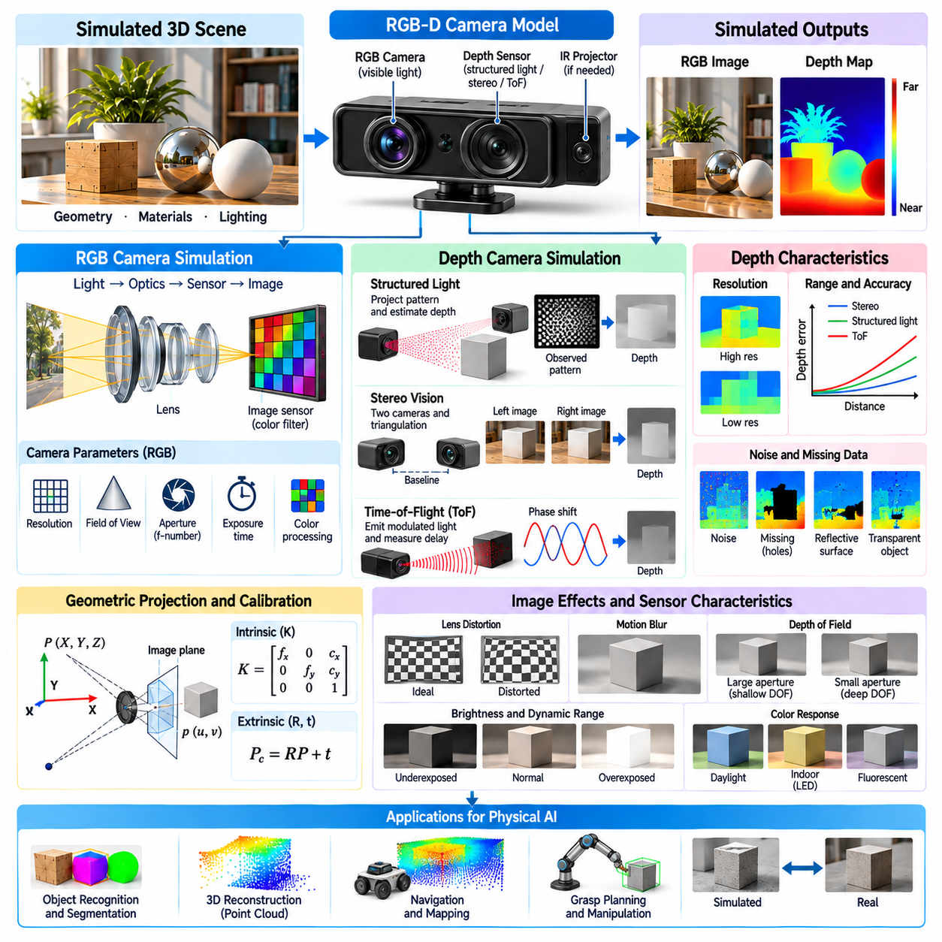
RGB and depth camera simulation is a fundamental component of photorealistic rendering for Physical AI. RGB cameras capture visual appearance, while depth cameras estimate the spatial distance between sensors and observed surfaces. Together, they provide complementary information for robotic perception, navigation, and manipulation. Accurate simulation must reproduce geometric projection, optical behavior, sensor limitations, and environmental interactions to support reliable Sim2Real transfer.
RGB camera simulation models the formation of color images through interactions among illumination, materials, optics, and image sensors. Rendered observations depend on surface reflectance, lighting conditions, camera exposure, and color processing. Physically based rendering provides a foundation for generating realistic RGB data. However, visual realism alone does not guarantee correspondence with actual robotic cameras unless sensor-specific characteristics are also represented.
Depth cameras generate measurements describing the three-dimensional structure of observed environments. Unlike RGB images, which primarily encode appearance, depth images associate pixels with geometric distance measurements. Depending on the sensor model, depth may represent distance along the optical axis or range along a viewing ray. This distinction is important when converting simulated measurements into point clouds or comparing them with real sensor outputs.
RGB-D cameras combine color and depth sensing within a coordinated imaging system. Their outputs support object segmentation, three-dimensional reconstruction, pose estimation, and robotic grasp planning. Simulated RGB-D observations must preserve geometric alignment between color pixels and depth measurements. Inaccurate calibration or synchronization can introduce inconsistencies that reduce the effectiveness of perception models trained on synthetic data.
Perspective projection is commonly used to simulate RGB cameras and many depth sensors. Camera intrinsic parameters determine focal length, principal point, and pixel coordinate relationships. Extrinsic parameters define camera position and orientation relative to the robot or environment. Consistent projection models ensure that simulated images, depth maps, and geometric annotations correspond to the same physical scene configuration.
Depth rendering can be implemented using rasterized depth buffers or ray-based geometric intersection calculations. Rasterization efficiently estimates visible surface depth during conventional graphics rendering. Ray casting determines the intersection distance between sensor rays and scene geometry. Both approaches can produce idealized depth measurements, but additional processing is required to reproduce the behavior and limitations of physical depth cameras.
Structured-light depth cameras project known illumination patterns onto surfaces and infer depth from observed pattern deformation. Their performance depends on projector geometry, camera calibration, surface reflectance, and ambient illumination. Highly reflective, transparent, or dark materials may reduce measurement reliability. Realistic simulation should represent pattern projection, visibility, correspondence estimation, and potential reconstruction failures.
Stereo depth cameras estimate distance by identifying corresponding image features across two camera views. Disparity between matched features is converted into depth using camera focal length and stereo baseline. Accuracy depends on calibration, image texture, lighting, and matching algorithms. Textureless surfaces, repetitive patterns, and occlusions can produce uncertain or invalid depth estimates that should be represented in synthetic observations.
Time-of-Flight cameras estimate distance from the travel time or phase shift of emitted and reflected light. Direct Time-of-Flight systems measure photon arrival timing, while indirect systems commonly estimate phase differences in modulated illumination. Their measurements depend on signal strength, integration time, reflectivity, and ambient interference. Simulating these mechanisms improves realism beyond ideal geometric depth rendering.
Depth sensor resolution determines the spatial density of available distance measurements. Lower-resolution depth maps may miss narrow structures, small objects, or detailed surface geometry. Sensor sampling also interacts with camera field of view and distance, causing spatial coverage to vary across the scene. Realistic depth simulation should reproduce the resolution and sampling characteristics of the intended hardware.
Depth accuracy and precision generally vary with measurement distance and sensing technology. Stereo depth uncertainty often increases rapidly with distance because small disparity errors produce larger depth errors. Time-of-Flight and structured-light systems exhibit different range-dependent error patterns. Synthetic depth generation should use technology-specific uncertainty models rather than assuming uniform measurement accuracy throughout the observable volume.
Depth noise can arise from photon statistics, electronic circuitry, correspondence errors, multipath reflections, and reconstruction algorithms. Noise characteristics may depend on distance, material properties, viewing angle, and illumination. Simple Gaussian perturbations provide an initial approximation but rarely capture all physical effects. More realistic models introduce spatially varying noise, correlated errors, quantization, and invalid measurements.
Missing depth measurements are common near reflective surfaces, transparent objects, dark materials, and occlusion boundaries. Sensors may return invalid values when reflected signals are insufficient or ambiguous. These missing regions create characteristic patterns in depth images. Simulation should reproduce plausible measurement dropout instead of assigning perfect depth to every visible surface, particularly when training models for real-world manipulation.
Depth discontinuities introduce additional challenges at object boundaries. A sensor pixel may observe contributions from surfaces at different distances, creating mixed measurements or unstable reconstruction. Filtering algorithms can further modify edge positions and generate smoothing artifacts. Accurate boundary modeling is important for robotic grasping, obstacle detection, and segmentation because these applications depend on reliable geometric separation.
Multipath interference occurs when emitted light reaches a sensor after reflecting from multiple surfaces. The resulting signal may represent a mixture of different optical paths rather than the direct surface distance. This phenomenon can produce systematic depth errors in corners, reflective environments, and enclosed spaces. Time-of-Flight simulation may require additional light transport modeling when multipath behavior materially affects the target application.
Ambient illumination influences depth sensing differently across technologies. Strong sunlight can interfere with active infrared systems, while insufficient visible texture can degrade passive stereo matching. Artificial lighting and reflective materials may introduce additional interference. Simulated environments should therefore connect depth sensor behavior with lighting and material models instead of treating depth acquisition as independent of scene appearance.
RGB and depth cameras may operate at different resolutions, frame rates, and exposure settings. Their measurements can also originate from physically separated optical centers. Registration transforms depth samples into the RGB camera coordinate system or vice versa. Accurate simulation requires preserving camera intrinsics, relative extrinsics, and temporal synchronization to prevent artificial alignment errors or unrealistically perfect correspondence.
Temporal behavior is important when simulating RGB-D sensors mounted on moving robots. Camera motion, object movement, rolling shutter, and processing latency can cause discrepancies between color and depth observations. Depth reconstruction may introduce additional delays or filtering effects. Synchronization models should represent these characteristics when synthetic sequences are intended for visual tracking, mapping, or dynamic manipulation.
Point clouds can be reconstructed from depth images using camera calibration and geometric back-projection. Each valid depth pixel contributes a three-dimensional point in the sensor coordinate frame. Transformations then express these points relative to the robot or world. The resulting geometry supports collision avoidance, object reconstruction, and scene understanding. Depth noise and missing measurements propagate directly into point cloud quality.
Synthetic RGB-D data can provide automatically aligned annotations for supervised learning. Object identities, segmentation masks, surface normals, poses, and geometric relationships can be extracted from the simulation scene. These annotations support training for semantic segmentation, pose estimation, grasp prediction, and three-dimensional perception. Their usefulness depends on consistent coordinate frames and realistic sensor observations.
Domain randomization improves RGB-D model robustness by varying illumination, materials, camera parameters, object arrangements, and sensor noise. RGB and depth perturbations should remain physically consistent whenever they originate from shared environmental conditions. For example, changing surface reflectance may affect both image brightness and active depth reliability. Independent randomization can otherwise generate unrealistic combinations that weaken Sim2Real transfer.
Sensor calibration connects simulated RGB-D measurements with physical hardware. Calibration procedures estimate intrinsic parameters, lens distortion, relative camera poses, depth scale, and systematic measurement biases. Controlled reference scenes can reveal deviations in depth accuracy and registration. Hardware measurements should guide simulation parameters whenever a specific sensor model is targeted for robotic deployment.
Validation requires comparing synthetic and real RGB-D observations across representative scenes and operating conditions. Image-level evaluation can examine color distributions, depth errors, invalid-pixel patterns, edge artifacts, and alignment quality. Task-level evaluation measures object detection, pose estimation, mapping accuracy, and grasp success. These comparisons help identify which simulation improvements contribute meaningful gains in robotic performance.
Computational efficiency is a major consideration when generating RGB-D observations for large-scale Physical AI training. Rasterized depth buffers offer fast geometric measurements, while detailed structured-light or Time-of-Flight simulation requires additional processing. Hybrid pipelines can combine efficient depth rendering with calibrated sensor effects. Rendering fidelity should be selected according to application requirements, available hardware, and validation objectives.
Ultimately, RGB and depth camera simulation connects visual appearance with measurable three-dimensional geometry. Realistic implementation requires coordinated modeling of projection, optics, depth sensing principles, noise, calibration, and temporal behavior. By integrating physically plausible sensor imperfections with accurate scene rendering, Physical AI systems can generate synthetic RGB-D data that improves perception robustness and supports reliable operation in real environments.

02.09. LiDAR Radar and Thermal Simulation
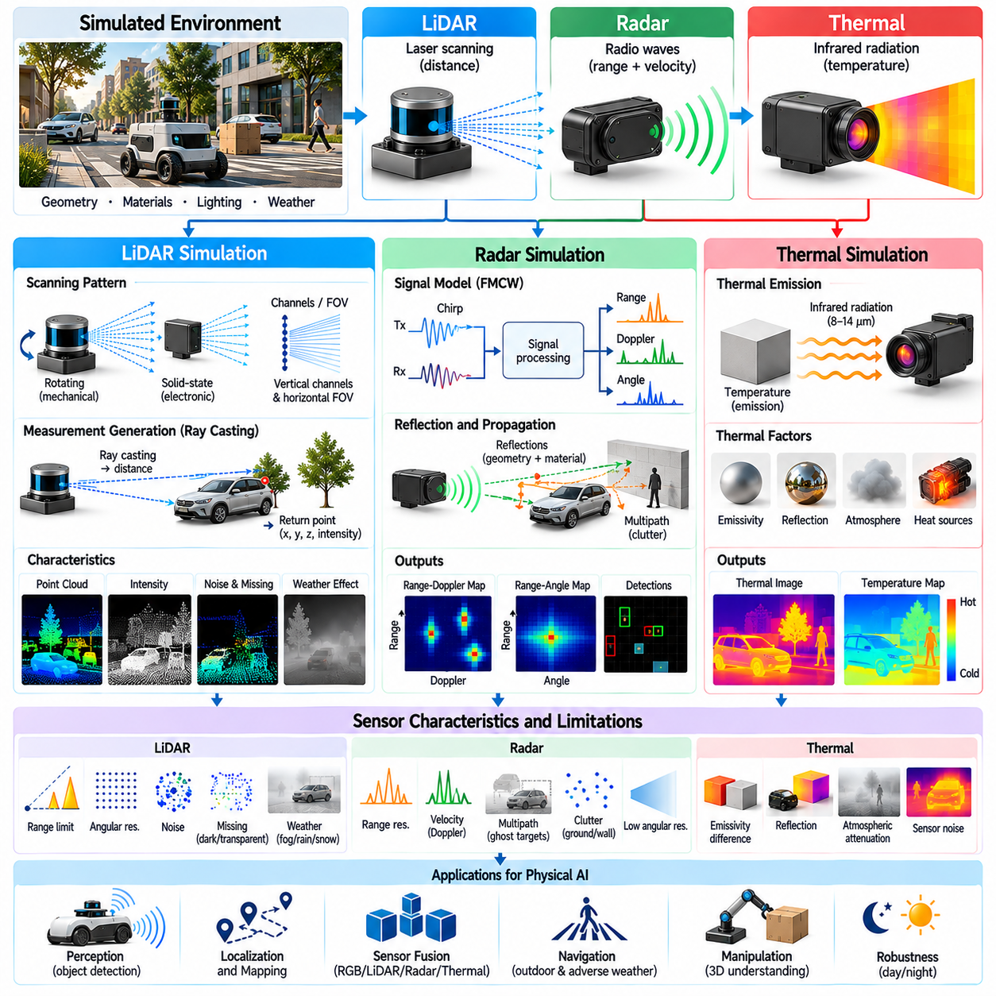
LiDAR, radar, and thermal simulation extend Physical AI perception beyond conventional RGB and depth imaging. These sensors observe geometric, electromagnetic, and thermal properties that visible-light cameras cannot fully capture. Their complementary measurements improve environmental awareness under darkness, adverse weather, and complex operating conditions. Realistic simulation supports sensor fusion, autonomous navigation, object detection, and reliable Sim2Real transfer.
LiDAR measures distance by emitting laser energy and detecting reflected signals from surrounding surfaces. Most robotic LiDAR systems estimate range using pulse travel time or related optical measurement techniques. Repeated measurements across different directions produce spatial representations of the environment. Simulated LiDAR must reproduce scanning geometry, beam propagation, surface interaction, and measurement uncertainty rather than generating ideal point clouds alone.
LiDAR scanning patterns depend on sensor architecture and mechanical or electronic beam steering. Rotating scanners generate repeated angular sweeps, while solid-state devices may use fixed or programmable scanning patterns. Angular resolution, vertical channel arrangement, field of view, and scanning frequency determine point distribution. These characteristics influence obstacle detection, localization accuracy, and the visibility of small environmental features.
Ray casting provides a computationally efficient foundation for LiDAR simulation. Each simulated laser beam intersects scene geometry to determine the distance to visible surfaces. The resulting measurements can be converted into three-dimensional points using sensor calibration and coordinate transformations. However, ideal geometric intersections do not reproduce intensity variation, beam divergence, multipath effects, or material-dependent detection failures.
Laser reflection depends on surface reflectance, incidence angle, wavelength, and material structure. Dark surfaces may return weak signals, while highly reflective materials can produce strong returns or receiver saturation. Transparent and specular surfaces may redirect or transmit laser energy. Physically plausible LiDAR simulation should represent these interactions when they affect obstacle detection, mapping, or robotic manipulation.
LiDAR intensity measurements provide additional information beyond geometric distance. Return intensity depends on transmitted energy, propagation losses, target reflectivity, and receiver characteristics. Different sensors may apply proprietary normalization or automatic gain adjustments. Simulated intensity values should therefore be calibrated against the intended hardware rather than treated as universal material reflectance measurements.
LiDAR noise includes range uncertainty, angular error, quantization, missed detections, and spurious returns. Measurement quality often changes with distance, incidence angle, and received signal strength. Beam divergence can cause multiple surfaces to contribute to a single measurement, especially near object boundaries. Realistic noise models improve the usefulness of synthetic point clouds for perception training and localization testing.
Atmospheric conditions introduce additional LiDAR limitations. Fog, rain, snow, dust, and airborne particles can scatter or attenuate laser energy before it reaches the intended target. These interactions may reduce detection range or create false returns. Weather-aware simulation should consider particle properties, wavelength, and propagation distance, while avoiding overly simplified assumptions that all adverse conditions affect every LiDAR sensor equally.
Radar operates by transmitting radio-frequency electromagnetic waves and analyzing signals reflected from objects. Unlike optical sensors, radar can provide range and radial velocity information through propagation delay and Doppler frequency shifts. Its longer wavelengths can improve operation under certain visibility limitations. Radar simulation is particularly valuable for autonomous vehicles, mobile robots, and outdoor perception systems.
Frequency-modulated continuous-wave radar commonly estimates target distance from the frequency difference between transmitted and received chirps. Doppler processing provides radial velocity, while antenna arrays support angular estimation. Range resolution depends strongly on signal bandwidth, whereas angular resolution depends on antenna aperture and processing. Accurate simulation should reflect these physical and signal-processing relationships.
Radar reflections depend on target geometry, material electromagnetic properties, surface orientation, and operating frequency. Radar cross section describes how strongly an object scatters energy toward the receiver under specified conditions. Metallic structures may generate strong reflections, while other materials exhibit frequency-dependent penetration or attenuation. Radar simulation must account for these effects to reproduce realistic target visibility.
Radar measurements are influenced by multipath propagation, clutter, interference, and limited angular resolution. Reflections from floors, walls, and nearby structures can create ghost targets or ambiguous detections. Small objects may be difficult to distinguish from surrounding clutter. Synthetic radar data should represent these limitations rather than assuming every geometric object produces a precise and independent detection.
Radar outputs may include range-Doppler maps, range-angle representations, detection lists, or sparse point clouds. These formats represent different stages of signal processing and contain different information. Simulation can operate at the electromagnetic signal level or approximate processed detections. The appropriate abstraction depends on whether the objective is waveform development, perception training, or system-level robotic validation.
Thermal cameras measure infrared radiation associated with the temperature and emissivity of observed surfaces. Unlike conventional RGB cameras, they do not require visible illumination to produce images. Thermal observations depend on emitted radiation, reflected environmental radiation, atmospheric transmission, and sensor response. Their simulation is valuable for nighttime navigation, equipment inspection, human detection, and industrial monitoring.
Thermal radiation is governed by physical relationships between temperature, wavelength, and emitted energy. Planck's law describes spectral radiance, while the Stefan-Boltzmann law relates total emitted power to temperature for ideal blackbody surfaces. Real materials behave differently according to spectral emissivity. Accurate thermal rendering must therefore distinguish surface temperature from apparent infrared brightness.
Surface emissivity determines how efficiently a material emits thermal radiation relative to an ideal blackbody. Painted surfaces, metals, glass, and polymers can exhibit substantially different emissivity characteristics. Low-emissivity materials may reflect surrounding thermal radiation and appear misleadingly warm or cold. Thermal simulation should account for these effects when generating synthetic inspection or detection imagery.
Temperature distributions across objects depend on heat generation, conduction, convection, radiation, and environmental exposure. Motors, batteries, electronic components, and mechanical joints may develop characteristic thermal patterns during operation. Thermal rendering becomes more realistic when surface temperatures are derived from thermal models or measured data rather than assigned as arbitrary colors.
Thermal sensor behavior includes detector noise, limited spatial resolution, calibration drift, and nonuniform pixel response. Infrared cameras may perform nonuniformity correction and temperature-dependent signal processing. Their outputs can represent radiometric measurements or contrast-enhanced imagery. Simulated thermal images should reproduce the relevant sensor pipeline, including saturation, noise, and image processing artifacts.
Environmental conditions influence thermal observations through atmospheric absorption, humidity, reflected radiation, and background temperature. Outdoor surfaces may retain heat after sunset, while indoor machinery creates localized thermal gradients. Rain, wind, and changing ambient temperatures alter heat transfer and apparent contrast. Realistic thermal simulation should consider these temporal and environmental dependencies.
Multimodal simulation combines LiDAR, radar, thermal cameras, and conventional imaging sensors within a shared virtual environment. Each modality observes different physical properties and may respond differently to the same object. Consistent geometry, materials, motion, and environmental conditions are necessary for coherent synthetic observations. This consistency supports sensor fusion algorithms that exploit complementary information.
Sensor placement and calibration determine how multimodal measurements relate spatially. Extrinsic transformations define relative sensor positions and orientations, while intrinsic parameters describe modality-specific measurement geometry. Incorrect calibration can create inconsistent object locations across point clouds, radar detections, and thermal images. Simulation should preserve these relationships while allowing controlled calibration errors for robustness testing.
Temporal synchronization is equally important because sensors operate at different frequencies and acquisition patterns. A rotating LiDAR accumulates measurements over time, radar processing integrates signals across chirps, and thermal cameras capture frames with finite exposure intervals. Moving objects can therefore appear at different positions across modalities. Accurate simulation should reproduce timestamps, latency, and motion-related acquisition effects.
Domain randomization can improve multimodal perception robustness by varying environmental conditions, material properties, sensor noise, and hardware parameters. However, variations should preserve physical relationships between modalities. For example, changing surface temperature affects thermal emission but does not automatically imply a corresponding change in radar reflectivity. Physically constrained randomization helps prevent unrealistic training correlations.
Validation requires comparing simulated sensor outputs with measurements from representative real environments. LiDAR evaluation may examine range errors, return intensity, point density, and dropout patterns. Radar evaluation can assess detection probability, range-Doppler characteristics, clutter, and false alarms. Thermal evaluation can examine radiometric consistency, temperature contrast, and spatial noise. Task-level testing determines whether these similarities improve robotic performance.
Computational efficiency requires selecting appropriate levels of physical detail. Ray-based LiDAR rendering is relatively efficient, while waveform-level radar simulation and coupled thermal modeling can be substantially more expensive. Hybrid pipelines may combine geometric rendering with calibrated statistical sensor models. Detailed physical simulation should be concentrated on scenarios where simplified approximations fail to reproduce important operational behavior.
Ultimately, LiDAR, radar, and thermal simulation enable Physical AI systems to perceive environments through complementary sensing principles. Realistic implementation requires coordinated models of wave propagation, material interaction, sensor electronics, environmental effects, and temporal behavior. By balancing physical fidelity with computational scalability, multimodal simulation supports robust perception, reliable sensor fusion, and safer robotic operation under challenging real-world conditions.

02.10. Sensor Noise and Imperfection Modeling
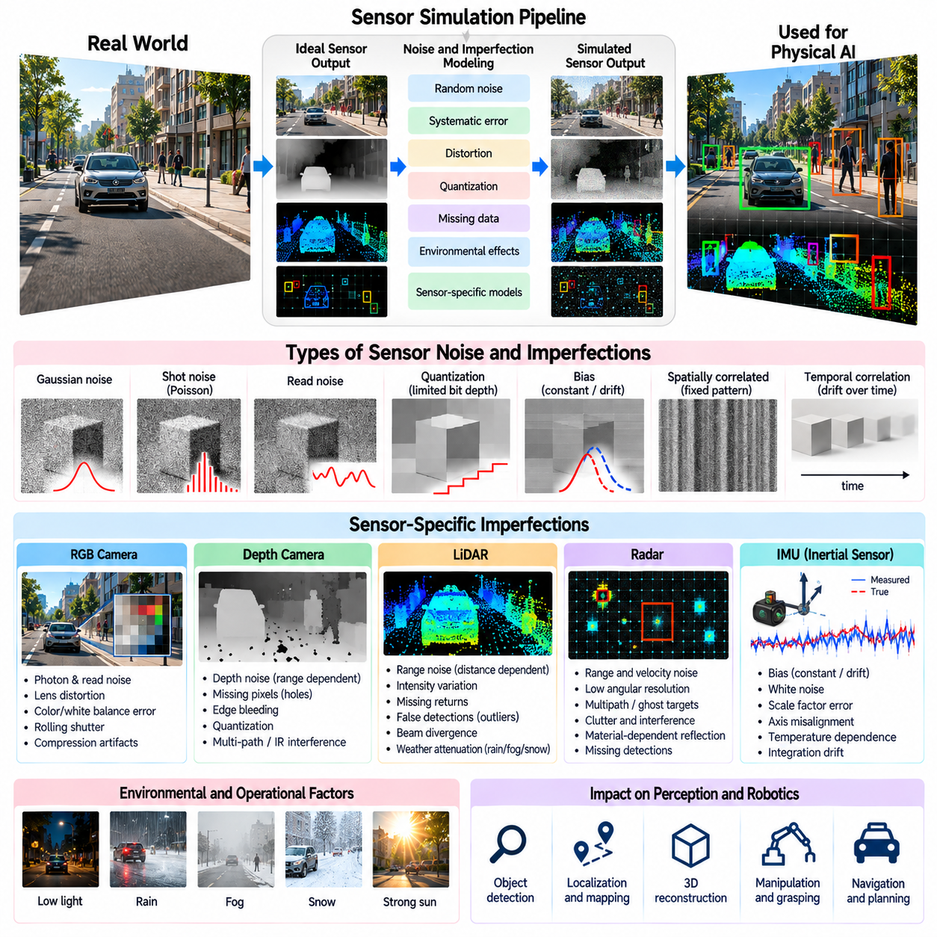
Sensor noise and imperfection modeling is essential for producing realistic observations in Physical AI simulation. Real sensors introduce uncertainty, distortion, delay, and measurement failures that are absent from ideal rendering pipelines. These imperfections influence perception, localization, mapping, and control performance. Accurate simulation must represent both stochastic noise and systematic errors to improve robustness and support reliable Sim2Real transfer.
Sensor imperfections arise from physical sensing mechanisms, electronic components, manufacturing tolerances, environmental conditions, and signal processing. Their effects vary across cameras, LiDAR, radar, inertial sensors, and force sensors. Some errors fluctuate randomly, while others remain correlated over time or operating conditions. Understanding these distinctions is necessary for constructing realistic sensor models rather than applying arbitrary perturbations.
Random noise represents unpredictable measurement variations caused by processes such as photon arrival statistics, thermal agitation, and electronic interference. It is often approximated using Gaussian distributions, although actual sensor noise may be asymmetric, signal-dependent, or heavy-tailed. Appropriate models should reflect the underlying sensing physics and observed measurement statistics instead of assuming identical noise characteristics for every sensor.
Systematic errors introduce repeatable deviations between measured values and true physical quantities. Examples include calibration offsets, scale-factor errors, geometric distortion, and temperature-dependent bias. Unlike independent random noise, systematic errors can persist across many measurements and produce accumulated estimation errors. Simulation should represent these effects explicitly when evaluating long-duration robotic operation.
Bias describes a persistent displacement of sensor measurements from their expected true values. A depth camera may consistently overestimate distance, while an inertial sensor may report nonzero angular velocity when stationary. Bias can remain approximately constant or change gradually with temperature and time. Realistic models should distinguish fixed bias, slowly varying bias, and transient calibration errors.
Gaussian noise is widely used because it provides a computationally efficient approximation for many measurement processes. Its magnitude is typically characterized by variance or standard deviation. However, realistic uncertainty may depend on signal intensity, measurement range, viewing angle, or sensor temperature. Heteroscedastic noise models allow uncertainty to change with operating conditions and often reproduce physical measurements more accurately.
Shot noise arises from the statistical variation in the number of detected photons or other discrete events. In image sensors, photon counts approximately follow Poisson statistics under suitable conditions. Consequently, noise magnitude changes with illumination and exposure. Simulating shot noise helps reproduce low-light image degradation and prevents synthetic cameras from producing unrealistically clean observations.
Read noise originates from electronic circuits involved in converting sensor signals into digital measurements. It may include amplifier noise, reset noise, and analog-to-digital conversion effects. Unlike photon shot noise, some read-noise components remain significant even when little light reaches the sensor. Camera simulation should combine these contributions with exposure and gain models to reproduce realistic image statistics.
Quantization introduces errors when continuous physical measurements are represented using finite digital resolution. Analog-to-digital converters map signal amplitudes into discrete values, potentially losing subtle variations. Limited bit depth can produce banding, reduced dynamic range, or small measurement discontinuities. Quantization models should reflect the resolution and encoding characteristics of the target sensor hardware.
Spatially correlated noise occurs when neighboring measurements share common error sources. Image sensors may exhibit fixed-pattern noise, row-dependent offsets, or column artifacts. Depth cameras can produce locally correlated reconstruction errors, while LiDAR measurements may share calibration inaccuracies. Independent pixelwise noise cannot reproduce these structures, making correlation modeling important for realistic synthetic data.
Temporal noise correlation describes dependencies between measurement errors across successive observations. Sensor drift, thermal changes, filtering, and electronic instability can generate slowly evolving errors. A first-order stochastic process or random-walk model may approximate these behaviors. Temporal correlation is particularly important for robotic localization because persistent errors can accumulate rather than cancel through repeated measurements.
Inertial measurement units exhibit characteristic imperfections in accelerometer and gyroscope outputs. These include white noise, bias instability, scale-factor errors, axis misalignment, and temperature sensitivity. Integrated acceleration and angular velocity errors can cause substantial position and orientation drift. Realistic IMU simulation is therefore critical for evaluating state estimation, sensor fusion, and autonomous navigation.
LiDAR noise depends on range, reflectivity, incidence angle, atmospheric conditions, and receiver sensitivity. Measurements may contain range fluctuations, missing returns, false detections, and angular inaccuracies. Beam divergence can introduce mixed measurements near object boundaries. A realistic LiDAR model should combine geometric ray interactions with probabilistic detection and calibrated error distributions.
Depth camera imperfections differ according to sensing technology. Stereo systems experience correspondence errors and disparity uncertainty, structured-light systems suffer from pattern detection failures, and Time-of-Flight cameras may exhibit multipath interference and phase-related errors. Depth uncertainty frequently changes with distance and material properties. Sensor-specific modeling is more effective than applying uniform noise to ideal depth maps.
Radar measurements contain uncertainty associated with range estimation, Doppler processing, angular resolution, clutter, and multipath propagation. Reflections may create ghost targets or false detections, while weak objects can remain undetected. Noise models should distinguish signal-level effects from errors introduced during target extraction. This distinction is important when simulating radar point clouds or processed detection lists.
Thermal cameras exhibit detector noise, nonuniform response, calibration drift, and temperature-dependent measurement uncertainty. Pixel sensitivity differences may create fixed-pattern artifacts, while nonuniformity correction can introduce additional processing effects. Apparent temperature also depends on emissivity and reflected environmental radiation. Thermal simulation should distinguish sensor imperfections from physical variations in observed radiation.
Measurement dropout occurs when a sensor fails to provide valid information for a particular location or time. Causes include insufficient signal strength, occlusion, saturation, communication failures, and reconstruction instability. Dropout may be spatially clustered or temporally persistent rather than independent. Realistic simulation should preserve these patterns because missing observations directly influence robotic decision-making.
Outliers represent measurements that deviate substantially from the expected error distribution. They can arise from incorrect feature matching, multipath reflections, interference, or sensor processing failures. Although relatively infrequent, outliers can destabilize estimation algorithms that assume Gaussian uncertainty. Synthetic testing should include physically plausible outlier mechanisms to evaluate robust filtering and fault rejection.
Sensor saturation occurs when physical signals exceed the measurable range of a device. Camera pixels may clip under intense illumination, force sensors may reach load limits, and inertial sensors may exceed acceleration or angular-rate ranges. Saturation produces nonlinear errors that cannot be represented by ordinary additive noise. Simulated sensors should enforce realistic measurement limits and report clipped values appropriately.
Timing imperfections include latency, sampling jitter, timestamp errors, and synchronization offsets. Different sensors may report observations corresponding to different physical moments. These discrepancies become particularly important during rapid robot motion or dynamic object interaction. Accurate simulation should model acquisition time separately from processing and delivery time to evaluate synchronization-sensitive perception and control.
Calibration uncertainty affects the relationship between sensor measurements and physical coordinate systems. Intrinsic parameter errors can distort projection geometry, while extrinsic errors introduce spatial misalignment between sensors. Small calibration deviations may produce significant fusion errors at long distances. Simulation can introduce controlled parameter uncertainty to assess calibration sensitivity and online correction algorithms.
Environmental factors influence sensor noise through temperature, humidity, vibration, electromagnetic interference, and contamination. Camera lenses may accumulate dust, LiDAR windows may become obstructed, and mechanical vibration may affect inertial measurements. These effects often change gradually and interact with operating conditions. Environmental imperfection models should therefore represent plausible dependencies rather than arbitrary degradation.
Noise parameters should be estimated from empirical measurements whenever representative hardware is available. Calibration datasets can characterize bias, variance, spatial correlation, temporal drift, and failure probabilities. Controlled experiments across temperature, distance, illumination, and motion conditions reveal operating-dependent behavior. Statistical fitting and validation help ensure that simulated imperfections remain consistent with physical observations.
Domain randomization can extend calibrated noise models by varying parameters within plausible uncertainty ranges. Different simulated sensor instances may exhibit distinct biases, sensitivities, and failure characteristics. However, excessive randomization can generate unrealistic observations that reduce training effectiveness. Parameter distributions should reflect manufacturing variation, environmental uncertainty, and expected deployment conditions.
Validation should compare real and synthetic sensor outputs using statistical and task-level metrics. Useful measures include error distributions, autocorrelation, spatial covariance, dropout frequency, outlier rates, and calibration residuals. Downstream evaluation should examine localization drift, mapping consistency, detection accuracy, and control stability. Matching noise statistics is valuable, but improved robotic performance remains the ultimate objective.
Ultimately, sensor noise and imperfection modeling transforms ideal simulation outputs into observations that better approximate physical hardware. Effective models combine stochastic processes, systematic biases, environmental dependencies, temporal behavior, and failure mechanisms. By calibrating these effects against real measurements and balancing fidelity with computational efficiency, Physical AI simulation can improve perception robustness, uncertainty awareness, and reliable real-world deployment.

02.11. Asset Scene and Environment Realism
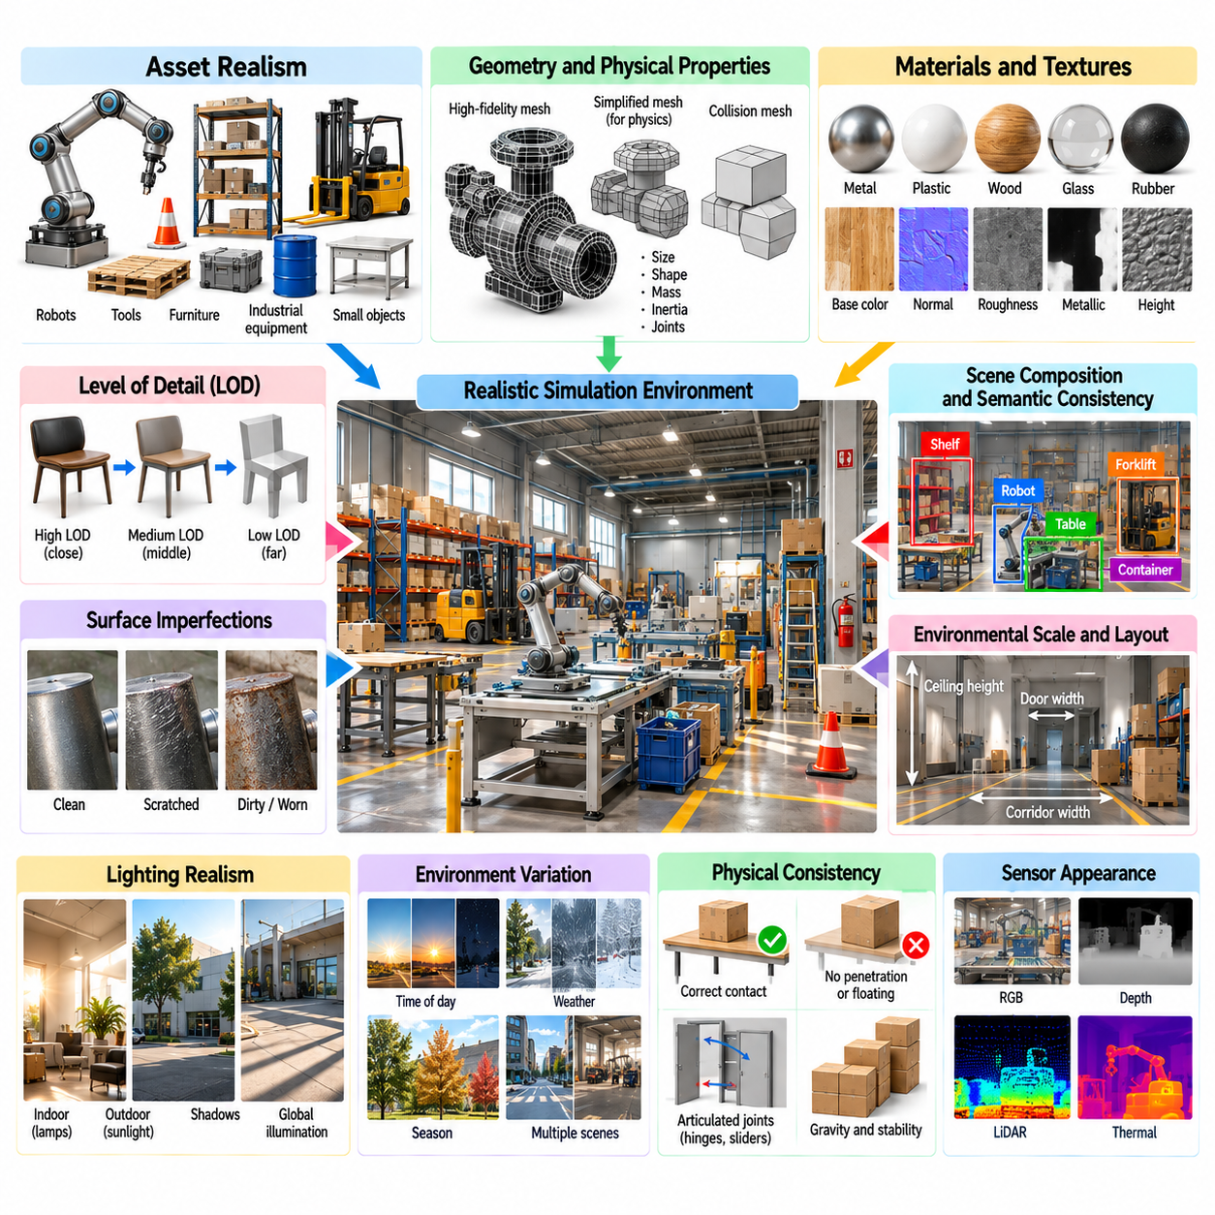
Asset, scene, and environment realism determines how accurately simulated worlds represent the physical conditions encountered by autonomous robots. Realistic environments require more than visually convincing objects because geometry, materials, spatial organization, and physical interactions jointly influence perception and behavior. High-quality simulation assets support reliable synthetic data generation, robotic training, evaluation, and Sim2Real transfer across diverse operational settings.
Digital assets represent the objects, structures, surfaces, and equipment that populate virtual environments. Their realism depends on geometric accuracy, material properties, physical dimensions, and functional characteristics. A visually detailed model may still be unsuitable for robotics if its collision geometry or mass distribution is incorrect. Asset development should therefore consider both rendering fidelity and the physical behavior required by downstream robotic tasks.
Geometric fidelity describes how closely a digital model reproduces the shape and dimensions of its physical counterpart. Important features include surface curvature, edges, gaps, joints, and contact regions. Small geometric differences can substantially affect grasp planning, collision detection, and navigation through confined spaces. Simulation assets should preserve task-relevant geometric details while avoiding unnecessary complexity that increases computational cost.
Mesh topology and geometric resolution influence rendering quality and simulation stability. High-resolution meshes capture detailed appearance but increase memory consumption and processing requirements. Simplified meshes improve efficiency but may remove important contact features or visual landmarks. A practical asset pipeline often separates visual meshes from collision meshes, allowing each representation to satisfy its specific accuracy and performance requirements.
Level-of-detail techniques adjust geometric complexity according to viewing distance and task requirements. Distant objects can use simplified representations, while nearby manipulation targets may require detailed geometry. However, abrupt transitions between detail levels can introduce visual artifacts or unstable perception features. Consistent level-of-detail management improves rendering scalability without unnecessarily compromising robotic observation quality.
Material realism is essential because surface properties determine how objects interact with light and sensors. Physically based materials describe characteristics such as roughness, metallic response, reflectance, transparency, and surface normals. These properties influence RGB appearance and may affect depth, LiDAR, radar, and thermal measurements. Material definitions should therefore remain consistent with the sensing modalities used in the simulated environment.
Texture maps provide spatial variation in color, roughness, surface relief, and other material properties. High-quality textures can reproduce scratches, stains, manufacturing patterns, and natural irregularities. However, excessive texture detail may create unrealistic visual statistics or obscure task-relevant features. Texture resolution and appearance should reflect the intended camera distance, sensor resolution, and environmental conditions.
Surface imperfections contribute significantly to perceived environmental realism. Real objects exhibit wear, dust, fingerprints, corrosion, deformation, and manufacturing variation. These details influence visual recognition and sometimes physical contact behavior. Procedural variation can generate diverse asset appearances without manually creating every instance. Such variation should remain physically plausible and appropriate to the object's operational context.
Scene composition determines how individual assets form coherent operational environments. Object placement, orientation, scale, and spatial relationships should reflect realistic usage patterns. Industrial facilities contain organized workstations, storage areas, and movement corridors, while domestic spaces exhibit different arrangements. Accurate scene composition helps robots learn meaningful contextual relationships rather than relying on arbitrary object distributions.
Semantic consistency ensures that simulated objects appear in locations and configurations compatible with their functions. Tools should be positioned near relevant work areas, containers should support plausible contents, and doors should connect accessible spaces. Semantic relationships influence task planning, object search, and language-conditioned robotic behavior. Realistic environments must therefore represent functional context in addition to visual appearance.
Physical consistency requires assets to obey appropriate constraints involving gravity, support, collision, and mechanical articulation. Objects should rest on supporting surfaces without unintended penetration or floating. Hinges, sliders, and movable components must follow plausible kinematic relationships. Inconsistent physical configurations can produce misleading training examples and reduce the transferability of learned manipulation policies.
Environmental scale and spatial layout directly affect robotic navigation and interaction. Corridor widths, doorway dimensions, ceiling heights, and obstacle clearances determine feasible movement. Incorrect scale can distort sensor observations and motion planning requirements. Simulation environments should use consistent physical units and dimensions derived from representative operational settings whenever accurate deployment correspondence is required.
Lighting realism interacts strongly with asset and scene realism. Surface appearance changes according to illumination direction, intensity, spectrum, and shadow formation. Indoor environments may combine daylight, artificial lighting, and reflective surfaces, creating complex visual conditions. Realistic scene generation should coordinate material definitions with lighting configurations to reproduce the appearance variations encountered by physical cameras.
Environmental dynamics introduce changes that cannot be captured by static scene models alone. People, vehicles, machinery, doors, and movable objects create time-dependent spatial configurations. Dynamic assets should follow plausible trajectories and interaction rules. Realistic motion patterns are important for obstacle avoidance, prediction, and human-robot interaction because robots must respond to evolving environments rather than fixed arrangements.
Weather and atmospheric conditions modify both environmental appearance and sensor behavior. Rain, fog, snow, dust, and changing sunlight can alter visibility, surface reflectance, and ground conditions. Wet surfaces may produce different reflections and friction characteristics from dry surfaces. Environment simulation should connect visual weather effects with relevant physical and sensor-level consequences.
Terrain realism is particularly important for mobile robots operating outdoors or across uneven surfaces. Ground geometry may include slopes, steps, gravel, mud, vegetation, and irregular obstacles. These features influence wheel traction, suspension response, and locomotion stability. Terrain models should represent both visible structure and mechanical properties, enabling meaningful evaluation of mobility and navigation performance.
Asset diversity supports generalization by exposing robots to multiple object shapes, sizes, colors, and material variations. A single canonical model rarely captures the variability encountered in real deployments. Procedural generation and asset libraries can introduce controlled diversity while preserving semantic and physical constraints. The objective is to represent plausible environmental variation rather than maximizing randomness without regard to realism.
Procedural scene generation enables scalable creation of virtual environments from configurable rules and asset collections. Parameters may control room dimensions, object arrangements, lighting conditions, clutter density, and operational layouts. Constraint-based generation prevents physically impossible or semantically inconsistent configurations. Such pipelines are valuable for producing large training datasets and systematic evaluation scenarios.
Digital twins provide a higher level of correspondence between simulated environments and specific physical facilities. Their assets and layouts may be derived from CAD models, architectural plans, laser scans, or photogrammetry. Digital twins support robot deployment preparation, workflow optimization, and operational testing. Maintaining realism requires updating the virtual representation when physical equipment, layouts, or operating conditions change.
Photogrammetry and three-dimensional scanning can reconstruct real-world geometry and appearance from measured observations. These techniques provide detailed environmental assets but may introduce incomplete surfaces, noisy geometry, or inconsistent material estimates. Additional processing is often necessary to create collision models and physically meaningful properties. Reconstructed assets should be validated before use in robotic training or safety-critical testing.
Scene realism also depends on accurately representing clutter, occlusion, and environmental complexity. Real workplaces contain cables, packaging, tools, temporary obstacles, and partially visible objects. These elements challenge perception and motion planning but are frequently omitted from simplified simulations. Controlled clutter generation can expose robotic systems to realistic ambiguity while maintaining reproducible experimental conditions.
Asset and environment validation should compare simulated scenes with representative physical settings. Geometric measurements, material appearance, object distributions, lighting statistics, and sensor observations provide useful evaluation criteria. Task-level comparisons can examine grasp success, navigation efficiency, collision frequency, and perception accuracy. Validation helps distinguish improvements in visual appearance from changes that genuinely enhance robotic performance.
Computational efficiency remains a major consideration when constructing detailed virtual worlds. Large asset collections, complex materials, dynamic objects, and high-resolution geometry increase rendering and physics workloads. Asset instancing, spatial partitioning, texture streaming, and selective simplification can reduce these costs. Simulation fidelity should be allocated according to task sensitivity and the expected contribution of each environmental detail.
Domain randomization and realism should be treated as complementary strategies rather than competing objectives. Realistic baseline scenes establish plausible geometry, materials, and functional relationships, while controlled randomization expands environmental coverage. Excessive variation can produce impossible configurations, whereas insufficient variation encourages overfitting. Balanced scene generation supports both physical credibility and robust generalization.
Ultimately, asset, scene, and environment realism connects detailed virtual content with the physical and semantic structure of real robotic workplaces. Effective simulation integrates accurate geometry, materials, lighting, dynamics, spatial relationships, and environmental variability. By combining validated assets with scalable procedural generation and task-aware fidelity management, Physical AI systems can develop stronger perception, planning, and control capabilities for reliable real-world operation.

02.12. Visual Fidelity vs Rendering Performance
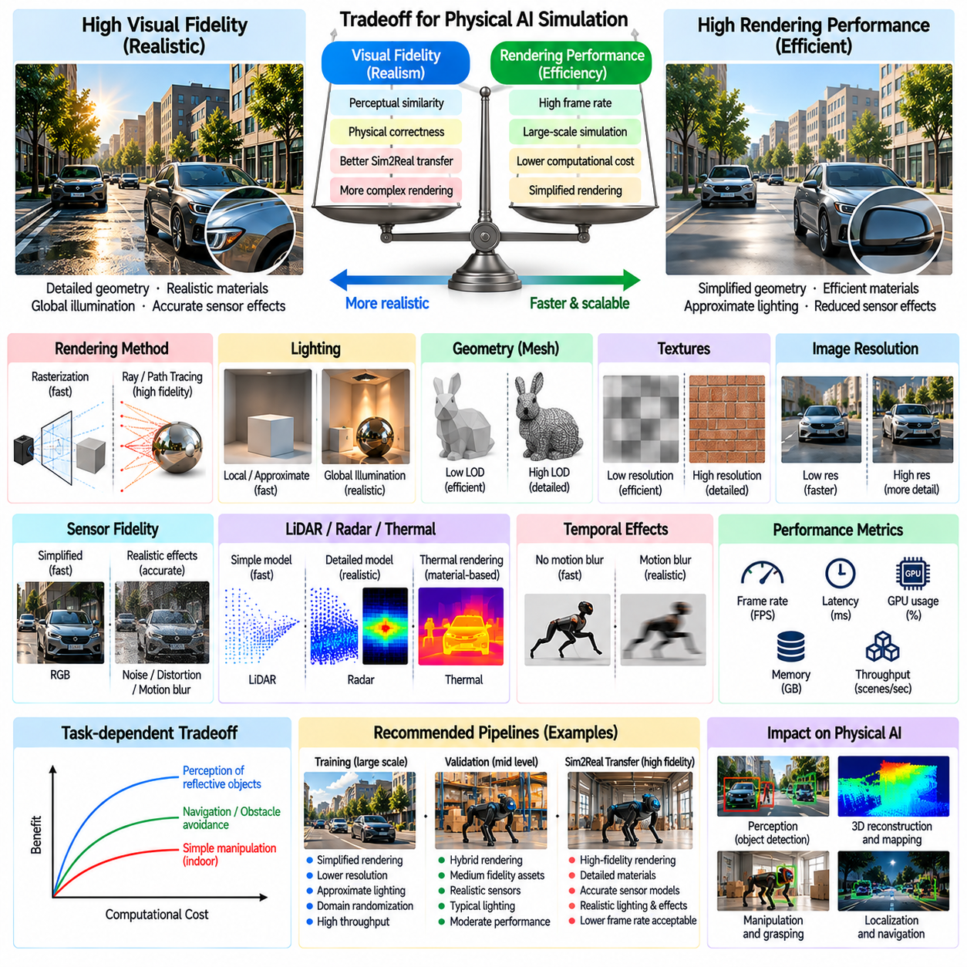
Visual fidelity and rendering performance represent a fundamental tradeoff in Physical AI simulation. High-fidelity rendering reproduces complex lighting, materials, geometry, and sensor effects, while high-performance rendering enables rapid observation generation and large-scale training. The appropriate balance depends on robotic tasks, perception requirements, and computational resources. Maximizing visual realism does not always produce the most effective simulation pipeline.
Visual fidelity describes how closely synthetic images resemble observations captured by physical sensors. It includes geometric accuracy, material appearance, illumination, shadows, reflections, and sensor imperfections. However, perceptual similarity alone is insufficient for evaluating simulation quality. A rendering feature becomes valuable when it improves the accuracy of robotic perception, decision-making, or transfer to real environments.
Rendering performance is commonly measured through frame rate, frame latency, GPU utilization, memory consumption, and simulation throughput. These metrics describe different aspects of computational efficiency. High frame rates may be achieved with limited scene complexity, while large-scale training requires consistent throughput across many parallel environments. Performance evaluation should therefore reflect the complete simulation workload.
Rendering complexity increases as geometric detail, texture resolution, lighting accuracy, and sensor fidelity improve. Ray tracing and path tracing can reproduce sophisticated light transport but often require greater computational resources than rasterization. The additional cost may be justified for tasks involving reflective surfaces, complex shadows, or optical sensor behavior. Other tasks may benefit more from simplified rendering with higher simulation throughput.
Rasterization provides an efficient foundation for real-time robotic simulation. It converts scene geometry into image-space fragments and supports rapid depth testing, shading, and visibility calculations. Modern rendering pipelines combine rasterization with physically based materials and approximate global illumination. Although some optical effects remain simplified, rasterization can provide sufficient fidelity for many navigation and manipulation applications.
Ray tracing models light propagation through geometric intersections and supports accurate reflections, refractions, and shadows. Path tracing extends this approach by sampling multiple light transport paths to estimate global illumination. These methods can generate highly realistic images but introduce sampling noise and substantial computational expense. Their value depends on whether the additional optical realism influences downstream robotic learning.
Hybrid rendering combines efficient rasterization with selected ray-traced effects. Primary visibility may be computed through rasterization, while reflections, shadows, or indirect lighting receive more detailed treatment. This approach concentrates expensive calculations where they contribute meaningful visual information. Hybrid pipelines offer a practical compromise between physically based realism and real-time simulation requirements.
Lighting fidelity strongly influences both image appearance and rendering cost. Direct illumination can often be computed efficiently, whereas indirect illumination requires additional approximations or ray sampling. Dynamic lights, soft shadows, and complex reflections increase workload. Simulation designers should determine which lighting effects are essential for the target perception algorithms instead of reproducing every optical interaction at maximum quality.
Geometric complexity affects rendering throughput through vertex processing, visibility testing, and memory access. High-resolution meshes preserve fine surface details but increase computational demands. Level-of-detail techniques replace distant objects with simplified geometry while retaining detailed representations near important interaction regions. Task-aware geometric simplification can improve performance without sacrificing relevant perception or collision information.
Texture resolution influences memory consumption, bandwidth requirements, and surface appearance. High-resolution textures improve close-range detail but may offer limited benefits when objects occupy only a few image pixels. Texture compression, mipmapping, and streaming reduce memory pressure and improve rendering efficiency. Appropriate texture fidelity should be selected according to camera resolution, viewing distance, and the visual features required by the robotic task.
Image resolution introduces another important performance tradeoff. Higher resolutions provide finer spatial detail and may improve small-object detection or precise manipulation. However, rendering cost, memory traffic, and neural network processing requirements generally increase with pixel count. Lower resolutions support faster simulation and larger training batches. Resolution selection should reflect the spatial precision required by the intended perception pipeline.
Sensor fidelity also contributes significantly to computational workload. Simulating camera noise, lens distortion, rolling shutter, motion blur, and depth measurement errors requires additional processing. LiDAR ray casting, radar signal modeling, and thermal rendering introduce modality-specific costs. Not every training scenario requires full physical sensor simulation, making calibrated approximations useful for balancing realism and scalability.
Temporal rendering effects are particularly expensive when multiple scene states must be evaluated for each observation. Motion blur may require temporal sampling, while rolling shutter simulation needs different acquisition times across image regions. Dynamic objects and moving cameras increase the complexity of these calculations. Efficient approximations can reduce overhead when exact temporal integration provides limited task-level benefits.
Simulation throughput is critical for reinforcement learning, where policies may require millions or billions of interaction steps. Rendering every observation at maximum fidelity can substantially reduce the number of training experiences generated per unit time. Lightweight visual pipelines often accelerate policy optimization. Higher fidelity can then be introduced selectively during fine-tuning, evaluation, or transfer preparation.
Parallel simulation changes the relationship between rendering quality and computational efficiency. Multiple environments may share GPU resources for physics, rendering, and neural network inference. Increasing visual complexity can reduce the number of environments processed simultaneously. Efficient scheduling, batched rendering, and resource isolation help maintain throughput. System-level optimization must consider contention between simulation and learning workloads.
GPU memory is frequently a limiting resource in large-scale rendering pipelines. Geometry buffers, textures, acceleration structures, framebuffers, and neural network parameters compete for available capacity. Excessive memory consumption can force smaller batches or expensive data transfers. Asset instancing, memory pooling, compression, and selective caching help improve resource utilization without fundamentally reducing scene diversity.
Rendering latency differs from aggregate throughput and becomes especially important in closed-loop robotic control. A simulator may generate many frames per second overall while introducing delays in individual observations. Such delays can affect control stability and timing-sensitive perception. Real-time and hardware-in-the-loop systems should prioritize predictable frame delivery and bounded latency rather than maximizing average throughput alone.
Asynchronous rendering can overlap image generation with physics updates, data transfer, or neural network computation. Proper pipeline scheduling reduces idle time and improves hardware utilization. However, asynchronous execution introduces synchronization challenges and may produce stale observations if timestamps are mishandled. Accurate temporal coordination is essential when evaluating closed-loop behavior or transferring policies to physical robots.
Adaptive rendering allocates computational resources according to scene importance and task sensitivity. Regions containing manipulation targets, obstacles, or uncertain visual features may receive greater detail than irrelevant background areas. Adaptive sampling can increase ray counts where image variance is high. Such methods improve efficiency by concentrating fidelity on information that affects robotic decisions.
Foveated rendering and region-of-interest processing provide additional opportunities for selective computation. High-resolution rendering can focus on task-relevant image regions while peripheral areas receive simplified treatment. This strategy resembles attention-based perception but must preserve enough context for navigation and object discovery. Its effectiveness depends on whether relevant regions can be identified reliably before detailed rendering.
Domain randomization introduces another dimension to the fidelity-performance tradeoff. Varying materials, lighting, geometry, and camera parameters increases environmental diversity without necessarily requiring photorealistic rendering. Simplified but diverse environments can support robust learning in some applications. However, excessive simplification may remove important visual cues, so randomization should complement rather than replace task-relevant physical realism.
Multi-fidelity simulation uses different rendering quality levels across training and evaluation stages. Low-cost environments can support initial exploration and large-scale policy learning, while detailed environments provide targeted refinement and validation. This staged approach reduces total computational expense. Transitions between fidelity levels should be managed carefully to avoid introducing unexpected observation distribution shifts.
Performance profiling identifies the operations responsible for rendering bottlenecks. GPU timing, memory bandwidth analysis, shader profiling, and frame breakdowns reveal whether geometry, lighting, sensor processing, or data transfer dominates execution time. Optimization should target measured bottlenecks rather than assumed sources of cost. Repeatable benchmarks are essential for comparing rendering configurations under equivalent simulation workloads.
Visual fidelity should be validated using both image-level and task-level metrics. Image comparisons can evaluate structural similarity, color statistics, depth consistency, and lighting behavior. Robotic metrics include detection accuracy, localization error, grasp success, navigation reliability, and Sim2Real transfer performance. A visually superior renderer is not necessarily preferable if its additional cost produces negligible improvement in downstream outcomes.
The optimal rendering configuration can be formulated as a constrained optimization problem. Simulation designers seek to maximize task performance and training efficiency while respecting limits on GPU memory, computation time, latency, and energy consumption. Different robotic applications require different operating points. A warehouse navigation system may prioritize throughput, while precision manipulation may justify higher geometric and optical fidelity.
Ultimately, visual fidelity and rendering performance must be optimized together rather than treated as independent objectives. Effective Physical AI simulation combines task-aware rendering, calibrated sensor models, adaptive computation, and systematic performance measurement. By allocating computational resources to visual effects that materially improve robotic learning and validation, simulation platforms can achieve scalable training and reliable real-world transfer.

02.13. Synthetic Sensor Rendering Pipeline [w/Code]
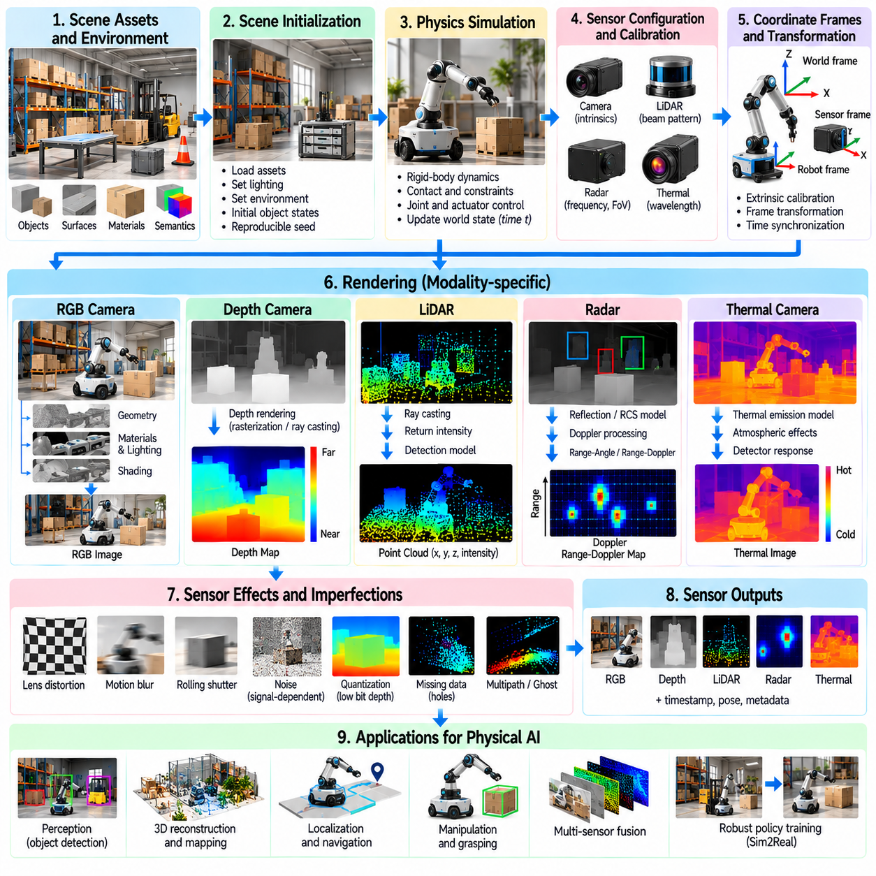
A synthetic sensor rendering pipeline converts simulated physical environments into observations that approximate measurements produced by real robotic sensors. It connects scene geometry, materials, illumination, physics, sensor configuration, and signal processing into a coordinated workflow. The resulting data supports perception training, localization, mapping, and control. Pipeline accuracy depends on preserving physical consistency while maintaining sufficient computational throughput.
The pipeline begins with a structured representation of the simulated world. Scene assets define objects, surfaces, environmental boundaries, and movable components. Each asset may contain visual geometry, collision geometry, material properties, and semantic annotations. Consistent coordinate systems and physical units are essential because rendering errors can originate from incorrect scene transformations rather than sensor models.
Scene initialization establishes the environment state before observations are generated. This process loads geometry, textures, lighting configurations, physical properties, and environmental parameters. Static objects remain fixed, while dynamic entities receive initial positions and velocities. A reproducible initialization process allows identical scenes to be reconstructed for debugging, benchmark evaluation, and controlled experimentation.
Physics simulation updates the state of robots and environmental objects over time. Rigid-body dynamics, contact interactions, joint constraints, and actuator commands determine object motion. Sensor rendering must use the appropriate physical state for each acquisition timestamp. Inconsistent synchronization between physics and rendering can produce observations that do not correspond to the robot's actual simulated configuration.
Sensor configuration defines the characteristics of each virtual measurement device. Camera models require focal length, image resolution, field of view, distortion parameters, and exposure settings. LiDAR systems require beam patterns, angular resolution, range limits, and scanning frequency. Radar and thermal sensors introduce additional modality-specific parameters. These configurations should correspond to the intended physical hardware.
Coordinate transformations connect the world frame, robot body frame, and individual sensor frames. Extrinsic calibration determines sensor position and orientation relative to the robot, while intrinsic calibration defines internal measurement geometry. Transformation errors can create systematic misalignment between modalities. A robust pipeline maintains explicit frame relationships and applies timestamp-consistent transformations.
The rendering stage determines which environmental elements contribute to each sensor observation. Visibility calculations account for geometry, occlusion, viewing direction, and sensor range. Rasterization efficiently generates image-space observations, while ray tracing supports detailed geometric intersections and light transport. Different sensing modalities may require separate rendering methods while sharing a common scene representation.
RGB camera rendering combines geometric projection with material shading and illumination. Physically based rendering estimates surface appearance using reflectance, roughness, light sources, and environmental illumination. Shadows, reflections, and exposure influence the resulting image. Camera-specific processing then introduces optical and electronic characteristics to approximate observations captured by physical imaging hardware.
Depth rendering estimates distances between sensing devices and visible environmental surfaces. Rasterized depth buffers provide efficient geometric depth, while ray-based methods can represent alternative sensing arrangements. Sensor-specific processing introduces quantization, missing measurements, range-dependent uncertainty, and multipath effects where applicable. Depth values must be expressed using consistent conventions and coordinate frames.
LiDAR rendering simulates emitted beams and their interactions with surrounding geometry. Ray casting determines candidate intersections, while material and incidence-angle models influence return intensity and detection probability. Scanning patterns establish the temporal and spatial distribution of measurements. Additional processing introduces range uncertainty, angular imperfections, missing returns, and realistic point-cloud characteristics.
Radar rendering requires modeling electromagnetic interactions at a level appropriate to the application. Simplified pipelines may generate detections using object geometry, relative velocity, radar cross section, and probabilistic visibility. More detailed approaches approximate propagation, multipath, and signal processing. The selected fidelity determines whether outputs represent raw signals, range-Doppler measurements, or processed detections.
Thermal rendering estimates infrared radiation received from environmental surfaces. Object temperature, emissivity, reflected radiation, and atmospheric effects influence apparent thermal intensity. Temperature fields may be assigned procedurally or updated through thermal models. Detector response, nonuniformity, and measurement noise are subsequently applied to generate observations resembling thermal camera outputs.
Optical effects are introduced according to the physical characteristics of the target camera. Lens distortion modifies projected coordinates, while depth of field depends on focus and aperture. Motion blur integrates information over exposure intervals, and rolling shutter creates row-dependent acquisition times. These effects must be applied in a physically meaningful order to avoid unrealistic combinations of sensor artifacts.
Noise and imperfection modeling converts ideal sensor measurements into more realistic observations. Random noise, systematic bias, quantization, saturation, and dropout represent different error mechanisms. Their parameters may depend on illumination, range, temperature, and operating conditions. Calibrated noise models are preferable to arbitrary perturbations because they preserve meaningful relationships between physical signals and measurement uncertainty.
Temporal synchronization is essential when multiple sensors observe a dynamic environment. Each measurement should have an acquisition timestamp reflecting its simulated capture time. Cameras may expose images over finite intervals, while scanning LiDAR accumulates points sequentially. Synchronization logic must distinguish acquisition time from processing and delivery latency. Accurate timing supports reliable multimodal fusion and closed-loop control.
Multimodal sensor rendering allows RGB cameras, depth sensors, LiDAR, radar, and thermal cameras to observe the same simulated world. Shared geometry and object motion establish physical consistency across modalities. However, each sensor retains distinct visibility, material-response, and noise characteristics. Proper cross-modal alignment enables realistic perception fusion while preserving differences between sensing mechanisms.
Ground-truth generation provides information that may be unavailable or uncertain in real sensor measurements. Simulators can produce segmentation masks, object identities, depth maps, surface normals, optical flow, poses, and motion vectors. These annotations support supervised learning and quantitative evaluation. Ground truth should be derived from authoritative simulation states rather than inferred from noisy rendered observations.
Semantic annotations connect sensor observations to object categories, instances, and functional attributes. Stable identifiers allow the same object to be tracked across frames and sensing modalities. Instance segmentation distinguishes individual objects, while semantic segmentation groups pixels or points by category. Annotation consistency is essential for training datasets that combine detection, tracking, scene understanding, and robotic manipulation.
Domain randomization expands the diversity of synthetic sensor outputs by varying scene and sensor parameters. Materials, illumination, object placement, camera poses, environmental conditions, and noise characteristics may change between episodes. Randomization distributions should preserve plausible physical relationships. Controlled variation helps reduce overfitting to specific rendering conditions and improves robustness during real-world deployment.
Dataset generation organizes rendered observations into synchronized sequences or independent samples. Each record may include sensor measurements, timestamps, calibration parameters, robot states, scene metadata, and annotations. Consistent schemas support automated training and evaluation workflows. Dataset provenance should identify simulation versions, asset configurations, randomization parameters, and generation settings.
Pipeline validation compares synthetic observations with measurements collected from representative physical sensors. Image statistics, depth error distributions, point-cloud density, radar detection characteristics, and thermal responses provide modality-specific evidence. Task-level evaluation measures whether synthetic training improves perception and control. Validation should identify systematic discrepancies and guide targeted refinement of rendering models.
Computational optimization improves the scalability of synthetic sensor generation. Batched rendering, GPU acceleration, asset instancing, and asynchronous processing reduce execution overhead. Selective fidelity allocation concentrates expensive calculations on important sensing effects. However, optimization must preserve synchronization, annotation correctness, and reproducibility. Throughput improvements are valuable only when generated data remains trustworthy.
Reproducibility requires explicit management of random seeds, simulation versions, scene configurations, and sensor parameters. Deterministic execution is useful for debugging, regression testing, and controlled comparisons, although some parallel GPU operations may introduce nondeterminism. Recording configuration metadata allows generated datasets to be traced to their production conditions. Repeatable pipelines support reliable benchmarking and continuous development.
A modular pipeline separates scene management, physics updates, sensor rendering, noise processing, annotation generation, and dataset export. Standardized interfaces allow individual components to be replaced without redesigning the entire system. This architecture supports new sensor types and multiple rendering backends. Modular design also simplifies profiling, calibration, testing, and integration with robotic learning infrastructure.
Ultimately, a synthetic sensor rendering pipeline provides the operational foundation for scalable Physical AI data generation. Its effectiveness depends on accurate scene representation, synchronized physics, calibrated sensor models, consistent annotations, and efficient computation. By integrating these components into a validated and reproducible workflow, simulation platforms can produce diverse observations that support robust robotic perception, learning, and Sim2Real transfer.

