Volume 05. Simulation and Sim2Real Transfer

Chapter 04. Domain Adaptation

04.01. Source Target Domains and Domain Shift
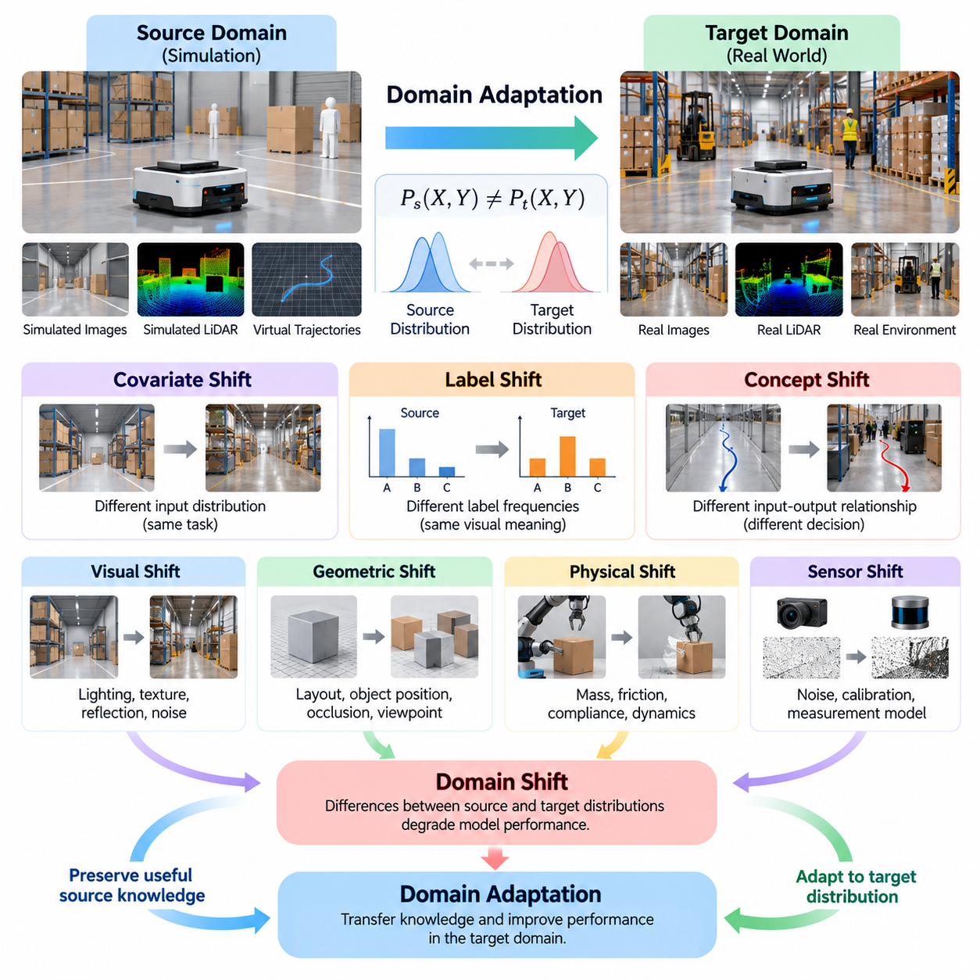
Domain adaptation is a fundamental mechanism for transferring artificial intelligence capabilities between environments that exhibit different statistical, visual, or physical characteristics. In Physical AI, a model trained under controlled simulation conditions must often operate in real environments where sensor measurements, object properties, environmental dynamics, and interaction patterns differ. Understanding these differences begins with defining source domains, target domains, and the distribution shifts separating them.
A source domain represents the environment or dataset from which an AI model initially acquires knowledge. It includes observations, labels, state transitions, physical parameters, and task-specific experiences used during training. In simulation-based robotics, the source domain may contain synthetic camera images, simulated LiDAR measurements, virtual robot trajectories, and accurately labeled object states. These resources provide scalable training opportunities without requiring extensive physical experimentation.
A target domain represents the operational environment in which the trained model is expected to perform. For Physical AI, this commonly includes actual robots, physical sensors, industrial facilities, warehouses, roads, and outdoor environments. Unlike simulation, target environments contain unpredictable disturbances, hardware imperfections, changing illumination, material variations, and complex human activities. Their statistical characteristics may therefore differ substantially from those encountered during training.
Domain shift occurs when the probability distributions governing source-domain observations or interactions differ from those in the target domain. A model may achieve excellent performance on simulated data yet experience degraded accuracy, stability, or reliability after deployment. This discrepancy arises because learned representations often encode characteristics specific to the training environment rather than universally transferable properties of the underlying physical task.
A formal domain representation can be expressed through an input space, an output space, and a joint probability distribution over observations and labels. The source domain follows a distribution P_s(X,Y), while the target domain follows P_t(X,Y). Domain adaptation becomes necessary when these distributions differ sufficiently to affect prediction or decision quality. The objective is to preserve useful source-domain knowledge while improving performance under the target distribution.
Covariate shift describes situations in which the distribution of input observations changes while the conditional relationship between inputs and outputs remains approximately stable. For example, a robotic object detector may encounter different lighting, textures, or camera characteristics without changes to the underlying object categories. Although the semantic task remains consistent, visual features learned from simulation may become unreliable when applied to real camera images.
Label shift occurs when the relative frequencies of output categories differ between source and target environments. A warehouse robot trained in simulation may encounter balanced examples of pallets, workers, and vehicles, while its real deployment environment contains substantially different object frequencies. Such differences can influence prediction confidence and decision thresholds, even when the visual characteristics associated with individual categories remain relatively stable.
Concept shift describes changes in the relationship between observations and their corresponding outputs. In Physical AI, this can occur when identical sensor observations imply different actions because environmental conditions, operational requirements, or physical constraints have changed. A navigation policy trained for unobstructed corridors may require different decisions in crowded facilities. Unlike purely visual differences, concept shift can demand modifications to learned behavior.
Visual domain shift is among the most recognizable challenges in simulation-to-reality transfer. Synthetic images may differ from real images in illumination, reflections, shadows, texture statistics, optical distortion, exposure, and sensor noise. Even photorealistic rendering cannot reproduce every characteristic of physical image formation. Consequently, visual perception networks may depend on simulated appearance patterns that do not remain consistent during real-world operation.
Geometric domain shift arises when spatial structures, object dimensions, layouts, or viewpoint distributions differ between training and deployment environments. A manipulation system trained with precisely positioned objects may encounter irregular placement, partial occlusion, and manufacturing tolerances. Similarly, an autonomous mobile robot may face corridor geometries and obstacle configurations absent from its simulated maps. These differences influence perception, localization, planning, and collision avoidance.
Physical domain shift extends beyond visual appearance into the dynamics governing robot-environment interactions. Simulated mass, inertia, friction, damping, compliance, and contact behavior rarely match physical systems perfectly. A grasping policy may succeed with idealized contact parameters but fail when actual objects slip or deform. Locomotion controllers can experience similar difficulties when real terrain properties differ from those represented by their training environments.
Sensor domain shift results from differences between simulated measurement models and actual sensing hardware. Physical cameras introduce electronic noise, exposure fluctuations, calibration errors, and motion-dependent artifacts. LiDAR systems exhibit range uncertainty, reflectivity-dependent measurements, and incomplete returns. Inertial sensors experience bias, drift, and vibration. These effects modify observation distributions and can propagate through perception, state estimation, and control pipelines.
Actuator and control domain shifts occur when commanded actions produce different physical responses across environments. Real motors exhibit torque limitations, nonlinear friction, backlash, thermal effects, and communication delays that simplified simulation models may overlook. Consequently, identical control commands can generate different trajectories. Adaptation must therefore account for discrepancies in action execution as well as differences in the observations used to select those actions.
Temporal domain shift concerns changes in timing, synchronization, and the evolution of system behavior. Simulation environments often operate with deterministic update intervals, whereas physical systems experience variable processing latency, asynchronous sensor measurements, and network delays. These discrepancies are particularly important for high-frequency control, dynamic obstacle avoidance, and coordinated manipulation, where small timing errors can produce substantial behavioral differences.
Domain shift may also emerge from differences in robot morphology and hardware configuration. Policies developed for one robot may encounter altered joint limits, actuator capabilities, sensor placements, payload capacities, or kinematic structures when transferred to another platform. Such changes modify both the observation and action spaces. Cross-robot adaptation therefore requires representations that distinguish transferable task knowledge from hardware-specific assumptions.
A useful distinction exists between domain adaptation and domain randomization. Domain randomization deliberately varies simulation parameters during training to expose models to diverse environmental conditions. Domain adaptation instead seeks to reduce performance discrepancies between a source domain and a particular target domain, often using information collected from that target. The approaches are complementary, and randomized source environments can provide stronger initial representations for subsequent adaptation.
The availability of target-domain information strongly influences adaptation strategy. Some systems have access to labeled real-world observations, while others possess only unlabeled sensor recordings or limited operational demonstrations. In more restrictive settings, adaptation must occur without direct access to target data before deployment. These differences motivate supervised, semi-supervised, unsupervised, and online adaptation approaches, each offering distinct tradeoffs in data requirements and operational complexity.
Domain shift can be investigated through statistical comparisons between source and target observations. Feature distributions, embedding distances, classification confidence, and task-specific error patterns provide evidence of discrepancies. Techniques such as maximum mean discrepancy, distribution divergence, and domain-classification accuracy can quantify selected aspects of distribution mismatch. However, statistical similarity alone does not guarantee successful physical behavior or safe control.
For robotic systems, evaluating domain shift requires examining complete task performance rather than perception accuracy alone. Relevant measures include navigation success, trajectory tracking error, grasp stability, collision frequency, energy consumption, and recovery behavior. A relatively small sensor discrepancy may produce significant downstream failures when combined with closed-loop decision making. Evaluation should therefore connect measurable distribution differences to operational consequences.
The relationship between source and target domains is rarely static. Real environments evolve through lighting changes, equipment wear, seasonal conditions, sensor recalibration, and modifications to facility layouts. A target domain observed during initial deployment may differ from the environment encountered months later. This creates a continuing adaptation challenge in which models must remain robust to gradual distribution drift without losing previously acquired capabilities.
Effective domain adaptation begins with identifying which environmental properties influence task performance most strongly. For visual perception, these may include illumination, camera calibration, and object appearance. For manipulation, contact mechanics and actuator response may dominate. For autonomous navigation, geometry, sensor characteristics, and moving obstacles can be critical. Prioritizing influential discrepancies helps allocate simulation fidelity, data collection, and adaptation resources efficiently.
Source-domain diversity also determines how much adaptation may be required. A model trained on a narrow collection of synthetic scenes may develop fragile representations tied to particular textures, viewpoints, or physical parameters. Training across varied conditions can improve robustness, but excessive variation may introduce unrealistic experiences or weaken task-specific learning. Successful transfer therefore depends on balancing environmental diversity with meaningful coverage of plausible target conditions.
Domain adaptation introduces important safety considerations because changes intended to improve target performance can also modify established behavior. An adapted controller may become more effective under unfamiliar conditions while exhibiting unexpected responses elsewhere. Reliable deployment requires controlled evaluation, operational boundaries, fallback mechanisms, and monitoring of performance degradation. Adaptation should be treated as a verified system update rather than an unrestricted optimization process.
In practical Physical AI development, source-target analysis establishes the foundation for selecting adaptation methods and designing validation procedures. Engineers characterize simulation assumptions, collect representative real-world observations, identify distribution discrepancies, and determine their effects on downstream tasks. The resulting evidence guides feature alignment, appearance adaptation, dynamics calibration, and policy refinement. This process transforms domain adaptation from an abstract learning problem into a structured engineering activity.
Ultimately, understanding source domains, target domains, and domain shift is essential for developing Physical AI systems that transfer reliably from simulation into physical operation. The central challenge is not to make simulated and real environments identical, but to identify which differences matter and develop representations and behaviors that remain effective despite them. This perspective provides the conceptual foundation for robust Sim2Real transfer, domain generalization, and continuously improving robotic intelligence.

04.02. Supervised Semi Supervised and Unsupervised Adaptation
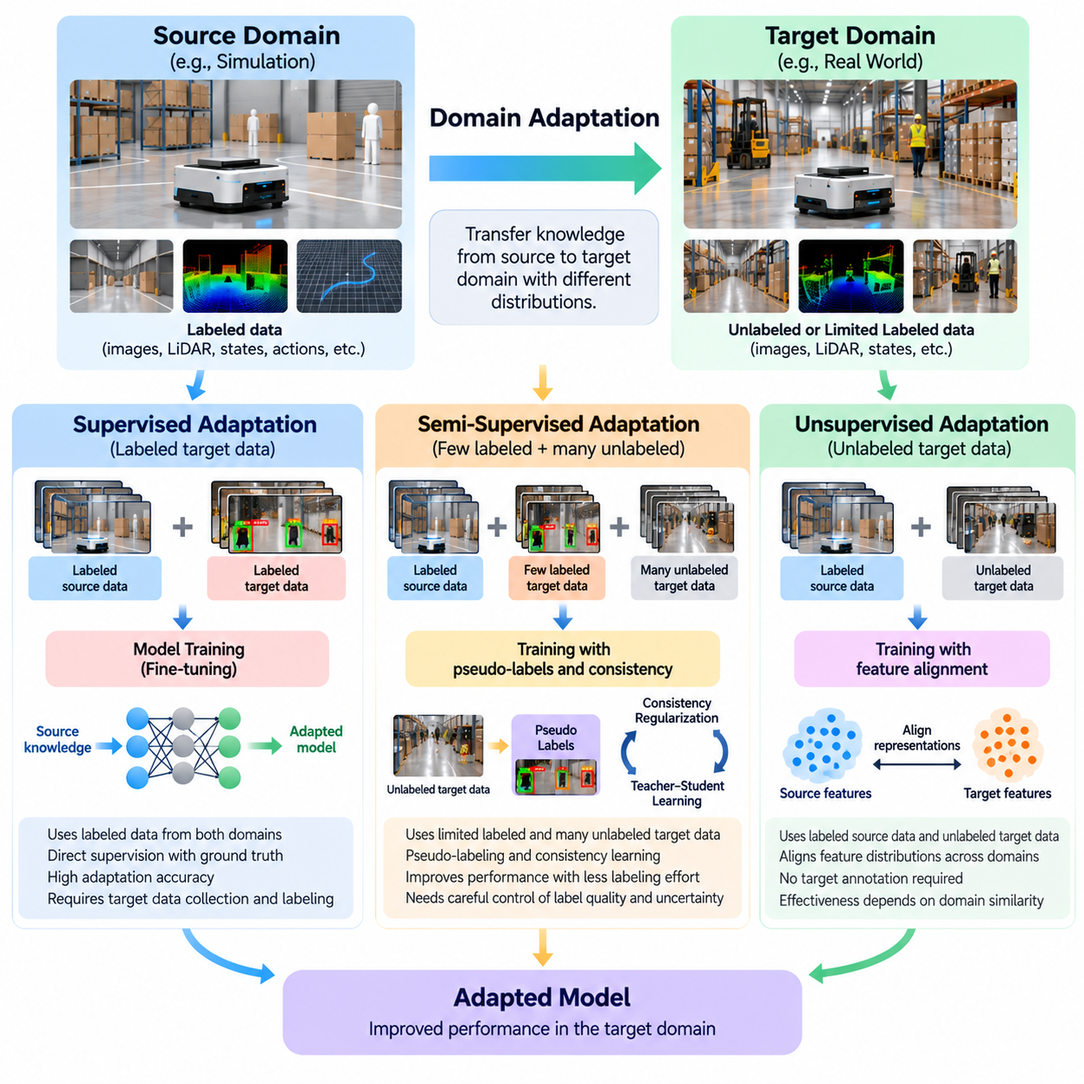
Domain adaptation methods can be classified according to the availability of labeled target-domain data and the degree of supervision used during learning. Supervised, semi-supervised, and unsupervised adaptation represent three major approaches for transferring knowledge from a source environment to a target environment. In Physical AI, these approaches determine how simulation-trained perception models, control policies, and robotic intelligence systems can improve their performance under real-world conditions.
Supervised domain adaptation assumes that labeled data are available from both source and target domains. A model initially trained using simulated observations can be fine-tuned with real-world examples containing verified ground-truth annotations. These annotations may describe object categories, segmentation masks, robot poses, grasp outcomes, or control targets. Direct supervision provides reliable information about the target task but requires additional data collection and labeling resources.
In robotic perception, supervised adaptation is commonly implemented through fine-tuning pretrained neural networks on representative real-world datasets. A detector trained using synthetic warehouse images may be updated with labeled images captured by physical cameras. During optimization, the model adjusts its internal representations to accommodate differences in illumination, textures, sensor noise, and object appearance while retaining useful features acquired from simulation.
The effectiveness of supervised adaptation depends strongly on the quality and coverage of target-domain annotations. A small labeled dataset may improve performance under familiar conditions while failing to represent rare events, unusual viewpoints, or changing environmental conditions. Careful sampling is therefore necessary to capture operational diversity. Excessive fine-tuning on limited target data can also cause overfitting and reduce the generalization capabilities developed during source-domain training.
Supervised adaptation can be formulated as minimizing a weighted combination of source-domain and target-domain learning objectives. The source objective preserves previously learned knowledge, while the target objective encourages accurate predictions under deployment conditions. Weighting these objectives determines the balance between knowledge retention and specialization. Regularization, selective layer freezing, and controlled learning rates can help prevent destructive changes to useful representations.
Semi-supervised domain adaptation addresses situations where only a limited number of labeled target samples are available alongside a larger collection of unlabeled target observations. This setting closely matches many Physical AI deployments because robots can continuously record sensor data, but obtaining accurate annotations remains expensive. Semi-supervised methods exploit both labeled examples and the underlying structure of unlabeled data to improve target-domain performance.
A typical semi-supervised adaptation pipeline begins with a model pretrained on labeled simulation data and a small labeled real-world dataset. The model generates predictions for additional unlabeled target observations, and reliable predictions may be used as pseudo-labels. These pseudo-labels provide supplementary training signals that expand the effective target dataset. However, inaccurate predictions can reinforce existing model errors if confidence and data quality are not carefully controlled.
Consistency regularization is another important mechanism in semi-supervised adaptation. The model is encouraged to produce compatible predictions when the same target observation undergoes realistic transformations, such as moderate lighting changes, image perturbations, or sensor noise. This encourages stable representations that are less dependent on incidental appearance characteristics. Transformations must preserve task-relevant information, particularly when geometry or physical state determines the correct action.
Teacher-student learning provides a practical framework for exploiting unlabeled target data. A teacher model produces supervisory predictions, while a student model learns from labeled examples and selected teacher outputs. The teacher may be updated using an exponential moving average of student parameters to improve prediction stability. In robotics, this framework can support object detection, semantic segmentation, depth estimation, and other perception tasks involving large volumes of unlabeled observations.
Semi-supervised adaptation requires careful management of label uncertainty and distribution imbalance. High-confidence predictions may disproportionately represent familiar objects or easy operating conditions, leaving difficult examples underrepresented. Confidence thresholds, class-aware sampling, uncertainty estimation, and periodic human verification can reduce these effects. The objective is not simply to increase training volume but to extract trustworthy learning signals from otherwise unlabeled operational data.
Unsupervised domain adaptation assumes that labeled source-domain data are available while target-domain observations contain no task labels. This setting is especially attractive for simulation-to-reality transfer because simulation can generate extensive ground-truth annotations automatically, whereas labeling physical robot data may require substantial human effort. The central challenge is to transfer predictive knowledge without directly observing correct target-domain outputs during adaptation.
Feature alignment is a widely used strategy for unsupervised adaptation. Neural networks learn representations that preserve task-relevant information while reducing measurable differences between source and target feature distributions. If successful, a prediction model trained on source features can operate more reliably on target features. Alignment may be encouraged through statistical discrepancy objectives, shared encoders, or domain-invariant representation learning.
Adversarial domain adaptation introduces a domain discriminator that attempts to distinguish source-domain features from target-domain features. A feature extractor is simultaneously trained to make these representations difficult to distinguish while supporting the original task. This competing optimization process encourages domain-invariant features. Nevertheless, aligning feature distributions does not guarantee that different object categories or control states remain correctly separated.
Discrepancy-based adaptation reduces statistical differences between source and target representations using measures such as maximum mean discrepancy or covariance alignment. These techniques provide explicit objectives for matching selected distribution properties without requiring target labels. Their effectiveness depends on the chosen feature space and assumptions about shared task structure. Matching global statistics may be insufficient when class relationships or environmental dynamics differ significantly.
Image-level adaptation provides another approach to reducing visual domain differences. Synthetic observations can be transformed to resemble real camera images, or real observations can be mapped toward a synthetic visual style. Image translation and generative models can modify textures, illumination, and appearance statistics. For Physical AI, geometric consistency is essential because transformations that alter object boundaries, spatial relationships, or contact locations can corrupt the supervision associated with synthetic data.
Self-supervised learning can strengthen unsupervised adaptation by extracting training signals directly from target observations. Temporal consistency, masked reconstruction, contrastive learning, and multimodal correspondence provide objectives that do not require manually assigned task labels. Robot trajectories offer additional structure through sequential observations and action histories. Such signals can improve representation quality, although they do not automatically guarantee correct task predictions or safe physical behavior.
The three adaptation approaches differ primarily in annotation requirements, supervision quality, and deployment cost. Supervised adaptation offers direct target-task feedback but depends on sufficient labeled data. Semi-supervised adaptation combines limited annotations with abundant unlabeled observations, while unsupervised adaptation avoids target labeling entirely. No single approach is universally superior because performance depends on domain similarity, task complexity, annotation reliability, and available computational resources.
For autonomous mobile robots, supervised adaptation may use labeled real-world obstacle images and navigation examples. Semi-supervised adaptation can extend these datasets using recorded camera and LiDAR observations collected during operation. Unsupervised adaptation may align simulated and real sensor representations without manual target labels. Each approach addresses different operational constraints, and practical systems may combine them as additional data become available.
Robotic manipulation introduces further complications because successful transfer depends on physical interaction rather than appearance alone. Target labels may describe grasp success, contact state, object displacement, or trajectory quality. These labels can be expensive to obtain because they require physical trials and reliable measurement. Semi-supervised and unsupervised methods may reduce annotation requirements, but adaptation must still account for differences in friction, compliance, actuator response, and contact dynamics.
Control-policy adaptation requires particular caution because incorrect predictions can directly influence physical actions. Unlike passive perception tasks, exploratory updates may generate unsafe trajectories or unstable behavior. Offline adaptation using recorded target-domain data can reduce immediate deployment risk. Subsequent online refinement should operate within verified safety constraints, with monitoring and fallback control mechanisms available when performance becomes uncertain.
Evaluation protocols must separate adaptation data from independent target-domain test data. Performance should be measured using task-relevant metrics such as detection accuracy, navigation success, grasp completion, tracking error, and collision frequency. Comparisons should also account for the number of target labels, computational requirements, and adaptation time. Without consistent evaluation conditions, apparent improvements may reflect additional supervision rather than genuinely more effective adaptation.
Negative transfer occurs when adaptation reduces performance because source and target knowledge are incompatible or incorrectly aligned. This can happen when domains contain different class distributions, physical constraints, or relationships between observations and actions. Unsupervised methods are particularly vulnerable when distribution alignment obscures meaningful task distinctions. Detecting negative transfer requires monitoring both target-domain improvements and degradation of previously reliable capabilities.
A practical adaptation strategy often evolves as the deployment system accumulates experience. Initial models may rely on unsupervised alignment or robust simulation training when target labels are unavailable. Limited verified examples can subsequently support semi-supervised learning, while larger annotated datasets enable more targeted supervised refinement. This progression allows engineering teams to improve deployed models without assuming that extensive real-world supervision is available from the beginning.
The choice of adaptation method should reflect the operational consequences of prediction errors. Low-risk perception tasks may tolerate broader experimentation with unlabeled data, whereas safety-critical manipulation and navigation require stronger validation and controlled updates. Data governance, annotation quality, model versioning, and reproducible evaluation are therefore integral to adaptation design. Reliable improvement depends on both the learning algorithm and the engineering processes surrounding it.
Ultimately, supervised, semi-supervised, and unsupervised domain adaptation provide complementary mechanisms for bridging simulation and real-world operation. Their shared objective is to preserve transferable knowledge while reducing the influence of domain-specific differences. By selecting supervision strategies according to data availability, task requirements, and safety constraints, Physical AI developers can build robotic systems that adapt more efficiently and maintain reliable performance across changing physical environments.

04.03. Weakly Supervised Domain Adaptation
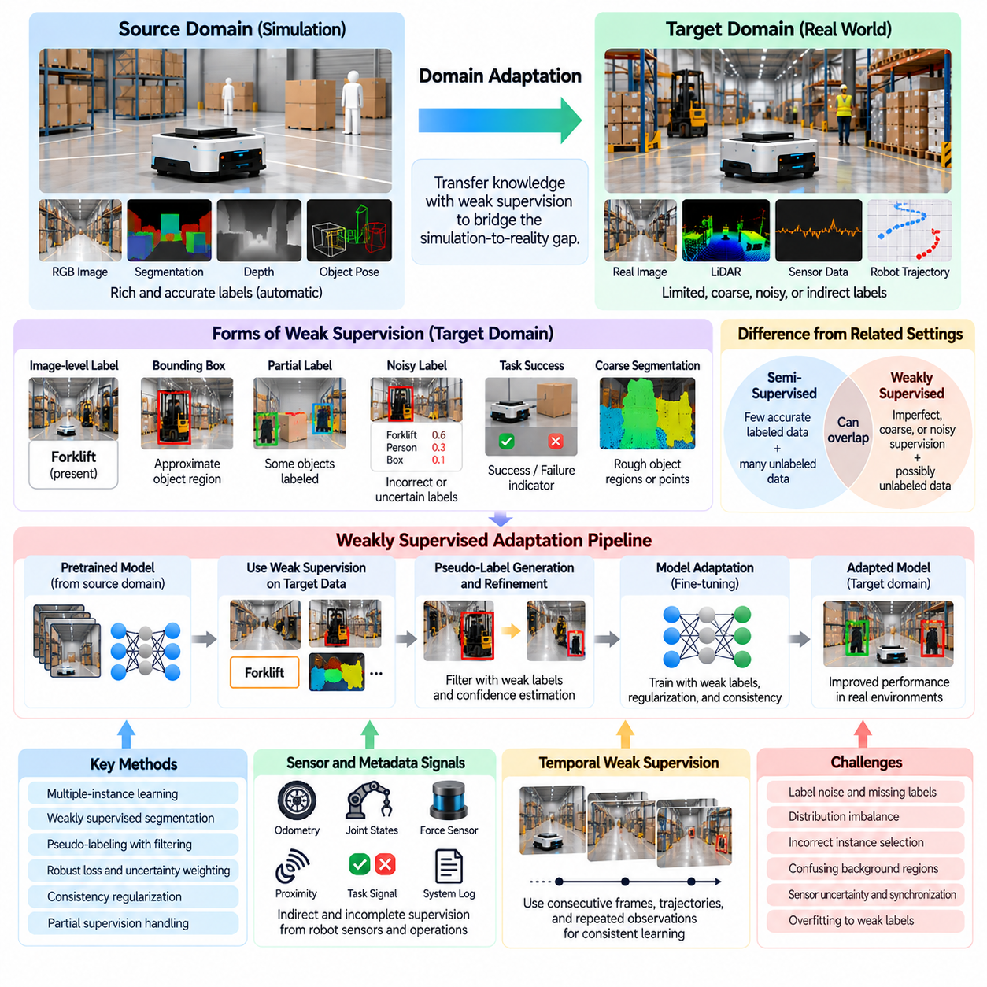
Weakly supervised domain adaptation provides a practical framework for transferring machine learning models between source and target environments when complete target-domain annotations are unavailable. Unlike fully supervised adaptation, which requires accurate labels for individual training samples, weak supervision relies on incomplete, coarse, noisy, or indirectly generated information. In Physical AI, this approach helps bridge simulation and reality while reducing the cost of collecting and labeling physical robot data.
The motivation for weakly supervised adaptation arises from the substantial difference between synthetic data generation and real-world annotation. Simulation environments can automatically provide precise object poses, segmentation masks, depth maps, contact states, and action outcomes. Real environments require sensors, human annotators, calibration procedures, or physical experiments to obtain comparable information. Weak supervision allows adaptation to proceed using less expensive but informative target-domain signals.
Weak supervision can take several forms depending on the information available during training. Image-level labels may indicate that an object exists without specifying its exact location. Bounding boxes may identify approximate object regions without providing pixel-level segmentation. Robot trajectories may contain task success indicators without detailed action annotations. These signals are less precise than full supervision but can still guide the adaptation of learned representations.
A fundamental distinction exists between weakly supervised and semi-supervised domain adaptation. Semi-supervised adaptation typically combines a limited collection of accurately labeled target samples with a larger collection of unlabeled observations. Weakly supervised adaptation instead emphasizes the use of imperfect or lower-resolution supervision. The two approaches can overlap when a system combines sparse verified annotations, noisy labels, automatically inferred targets, and unlabeled operational data.
In robotic perception, weak supervision can substantially reduce the annotation requirements associated with real-world object detection and semantic segmentation. A model trained with detailed synthetic labels may adapt using real images annotated only with object categories or approximate bounding boxes. The learning system must connect coarse target information with detailed representations acquired from simulation. This enables improvements in visual recognition without requiring exhaustive pixel-level annotation.
Multiple-instance learning provides one mechanism for extracting useful information from coarse annotations. Instead of assigning labels to every image region, the system treats an image or observation sequence as a collection of candidate instances. A positive image-level label indicates that at least one relevant instance is present. The model learns to identify likely regions while adapting to target-domain appearance. However, inaccurate instance selection can produce localization errors.
Weakly supervised semantic segmentation illustrates the relationship between source-domain precision and target-domain annotation efficiency. Synthetic scenes can provide dense segmentation masks for every visible object, while real images may contain only category labels, sparse points, or rough object regions. Adaptation methods combine source-domain segmentation knowledge with weak target constraints to improve real-world predictions. Spatial consistency and boundary preservation are essential for maintaining useful geometric information.
Pseudo-label generation is frequently incorporated into weakly supervised adaptation pipelines. A source-trained model produces predictions for real-world observations, and weak target annotations are used to filter, refine, or validate those predictions. For example, an image-level object label can reject predicted categories that are inconsistent with the available annotation. Confidence estimation helps determine which predictions should contribute to training and which require additional verification.
Label noise is a central challenge because weak annotations may contain incorrect categories, missing objects, inaccurate boundaries, or uncertain task outcomes. Training directly on unreliable labels can reinforce systematic errors and reduce target-domain performance. Robust loss functions, confidence weighting, sample filtering, and uncertainty-aware optimization can reduce the influence of questionable supervision. The effectiveness of these methods depends on assumptions about how annotation errors are distributed.
Partial supervision provides another useful approach when only selected elements of an observation are labeled. A robotic dataset may contain accurate annotations for important obstacles while leaving background objects unspecified. Similarly, manipulation demonstrations may include reliable grasp outcomes without complete contact-state measurements. Learning algorithms must distinguish missing labels from negative labels. Treating unannotated regions as confirmed background can introduce substantial training bias.
In Physical AI, weak supervision can also originate from robot sensors and operational metadata rather than human annotation. Odometry, joint encoders, force sensors, proximity measurements, and task completion signals can provide indirect evidence about environmental states. These signals may be incomplete or affected by measurement uncertainty, but they can constrain learning when combined with simulation-derived knowledge. Sensor calibration and temporal synchronization influence their reliability.
Temporal weak supervision exploits relationships between observations collected during robot operation. Consecutive video frames, motion trajectories, and repeated object interactions provide constraints on identity, movement, and physical consistency. A robot may observe an object across multiple frames without receiving detailed annotations for every observation. Tracking consistency can help propagate sparse labels, although occlusion, motion blur, and tracking failures may introduce additional uncertainty.
Weak supervision is particularly relevant to robotic manipulation because detailed contact annotations are difficult to obtain. A robot may know whether a grasp succeeded without measuring exact contact locations, friction coefficients, or force distributions. Such outcome-level supervision can support adaptation of grasp prediction models and manipulation policies. However, successful task completion does not uniquely identify the physical mechanisms responsible for success, limiting what can be inferred.
For autonomous mobile robots, weak target labels may describe traversable regions, obstacle presence, or navigation outcomes without complete environmental maps. A human operator might identify unsafe areas through rough markings, while robot logs provide collision events or route completion records. These signals can help adapt perception and traversability models to unfamiliar facilities. Care is required because successful navigation does not necessarily imply that every traversed location is safe under different conditions.
Feature-level adaptation can incorporate weak target labels to preserve task-relevant structure while reducing source-target distribution differences. Purely unsupervised feature alignment may incorrectly combine representations belonging to different categories or physical states. Weak category information, approximate spatial labels, or task-level constraints can guide alignment toward semantically compatible regions. This additional information can reduce negative transfer when source and target distributions differ substantially.
Contrastive learning offers another mechanism for exploiting weak supervision. Observations believed to represent the same object, location, or physical state can be treated as related examples, while dissimilar observations provide contrasting signals. Weak associations may originate from temporal proximity, robot localization, or shared task outcomes. Because these relationships are not always reliable, training objectives must tolerate uncertain positive and negative pairs.
Weakly supervised adaptation can benefit from combining multiple annotation sources with different reliability levels. Human-provided category labels, automatic object tracking, sensor-derived measurements, and simulation predictions may contribute complementary information. A learning system can assign different confidence weights to these signals or estimate their consistency. Combining independent evidence can improve supervision quality, although correlated errors may remain difficult to detect.
Active learning can complement weak supervision by identifying observations where additional human annotation would be most valuable. Rather than requesting detailed labels for every target sample, the system prioritizes uncertain predictions, unfamiliar environments, or safety-critical events. Human experts may then provide precise corrections for selected cases while the remaining dataset retains weaker annotations. This approach can improve annotation efficiency when labeling resources are limited.
The relationship between weak supervision and domain adaptation must be evaluated carefully because improved training efficiency does not automatically imply better transfer performance. Weak labels may guide the model toward relevant target features, but incorrect constraints can distort representations. Adaptation quality depends on annotation coverage, label reliability, source-target similarity, and task complexity. Performance should therefore be compared against supervised, semi-supervised, and unsupervised alternatives under consistent conditions.
Evaluation of weakly supervised adaptation should include both task performance and annotation efficiency. Relevant perception metrics include detection accuracy, segmentation quality, localization error, and calibration performance. For robotic control, evaluation may consider task completion, grasp stability, trajectory tracking, and failure frequency. Annotation time, human effort, and the number of verified target samples should also be measured to determine whether weak supervision provides meaningful practical advantages.
Safety considerations become especially important when weak supervision influences physical actions. An incorrect obstacle label, unreliable traversability estimate, or misleading grasp outcome can propagate into unsafe decisions. Adapted models should undergo independent validation using reliable target-domain measurements. Confidence monitoring, conservative action selection, operational constraints, and fallback controllers can limit the consequences of uncertain learned representations during deployment.
A practical weakly supervised adaptation workflow begins with a model trained on richly annotated simulation data. Engineers collect representative target-domain observations and identify inexpensive supervisory signals that can be extracted from images, sensor logs, robot trajectories, or operational records. Weak annotations are then combined with source-domain knowledge through appropriate learning objectives. Iterative validation identifies unreliable labels and determines where additional supervision is necessary.
Weakly supervised adaptation becomes increasingly valuable as robotic systems operate across multiple facilities, environments, and hardware configurations. Collecting complete annotations for every deployment domain is often impractical, while limited operational feedback is frequently available. By exploiting coarse labels, indirect measurements, and task outcomes, adaptation systems can reuse simulation-trained knowledge across changing conditions. Nevertheless, transfer reliability depends on continuously assessing supervision quality and environmental differences.
Ultimately, weakly supervised domain adaptation offers a middle ground between annotation-intensive supervised learning and fully unlabeled adaptation. Its central contribution is the ability to transform imperfect target-domain information into useful guidance for knowledge transfer. When combined with robust representation learning, uncertainty estimation, selective human verification, and systematic validation, weak supervision can reduce adaptation costs while supporting more reliable Physical AI deployment in complex real-world environments.

04.04. Feature Level Domain Adaptation
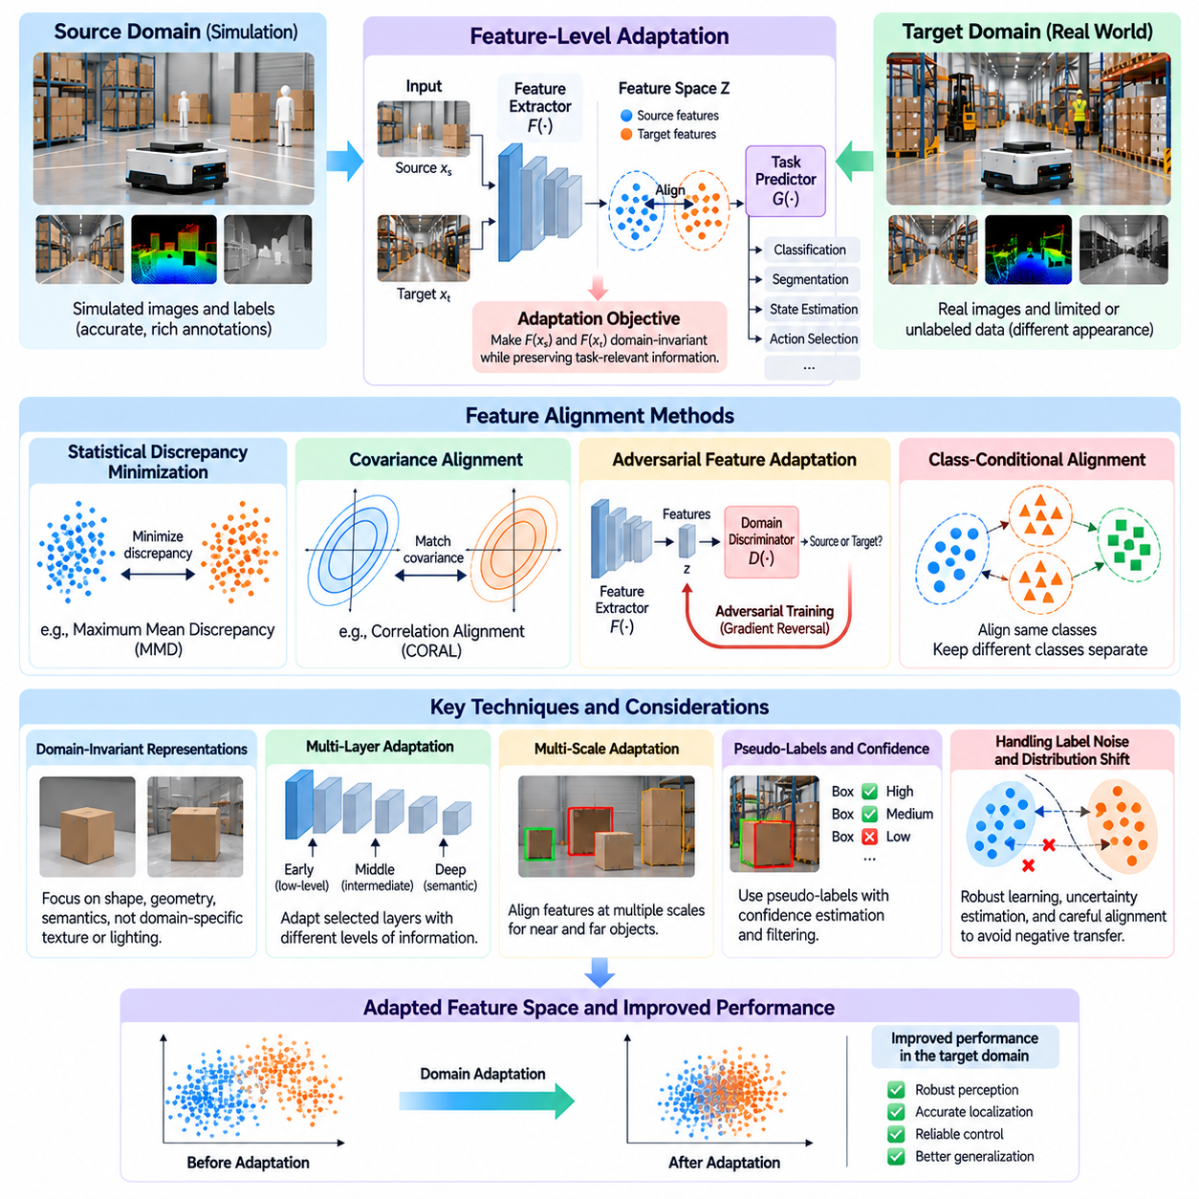
Feature-level domain adaptation is a fundamental approach for transferring machine learning models between source and target environments by aligning their internal feature representations. Instead of modifying raw sensor observations, this method operates on intermediate representations extracted by neural networks. In Physical AI, feature-level adaptation enables perception and control systems trained in simulation to recognize meaningful patterns in real-world environments despite differences in appearance, sensing conditions, and physical characteristics.
The central assumption behind feature-level adaptation is that source and target observations may differ substantially while sharing underlying task-relevant information. A simulated camera image and a real camera image may exhibit different textures, illumination, and noise characteristics but represent the same object geometry or semantic category. By learning representations that emphasize shared properties, adaptation methods seek to reduce dependence on domain-specific variations.
A typical feature-level adaptation architecture consists of a feature extractor, a task prediction module, and an adaptation objective. The feature extractor transforms input observations into latent representations, while the prediction module performs object recognition, segmentation, state estimation, or action selection. The adaptation objective encourages source and target representations to become statistically compatible without eliminating information required for accurate task execution.
Feature alignment can be formulated by considering source observations sampled from a distribution P_s(X) and target observations sampled from P_t(X). A feature extractor F maps these observations into a shared representation space Z. The adaptation objective seeks to reduce differences between the distributions of F(X_s) and F(X_t). However, successful alignment also requires preserving the relationships between features and task outputs, since matching marginal distributions alone may produce incorrect predictions.
Domain-invariant representation learning aims to identify features that remain useful across different operating environments. For robotic vision, these features may encode object shapes, spatial relationships, motion patterns, and semantic structure rather than specific textures or lighting conditions. For control applications, transferable representations may describe relative positions, velocities, contact conditions, and task progress. The challenge is determining which characteristics are genuinely invariant and which must remain domain-dependent.
Statistical discrepancy minimization provides one family of feature-level adaptation techniques. These methods introduce objectives that measure differences between source and target feature distributions and encourage the feature extractor to reduce them. Maximum mean discrepancy is a representative example that compares distributions through their embeddings in a reproducing kernel Hilbert space. Its effectiveness depends on the selected kernel, feature representation, and assumptions about distribution similarity.
Covariance alignment offers another approach by matching second-order statistics of source and target features. Correlation alignment methods encourage feature covariance matrices to become similar, reducing differences in how learned dimensions vary together. Such techniques can be computationally convenient and do not necessarily require adversarial training. Nevertheless, matching covariance does not guarantee that complex multimodal distributions or task-specific relationships are aligned correctly.
Adversarial feature adaptation introduces a domain discriminator that attempts to identify whether extracted features originate from the source or target domain. The feature extractor is trained to confuse this discriminator while retaining predictive performance on the original task. Gradient reversal layers provide one practical implementation of this competing optimization process. The resulting features may become less domain-specific, although unstable training and inappropriate alignment remain possible.
A major limitation of global feature alignment is that statistical similarity does not necessarily imply semantic consistency. Features representing different object categories or physical states may become mixed when source and target distributions have different class proportions. This can reduce classification accuracy and introduce negative transfer. Class-conditional alignment addresses the problem by encouraging corresponding semantic categories to align while maintaining separation between unrelated categories.
Class-aware adaptation becomes particularly important when target-domain labels are limited or unavailable. Source labels provide reliable semantic structure, while target predictions can estimate probable category assignments. Confidence-weighted pseudo-labels may guide alignment between corresponding source and target feature clusters. However, incorrect pseudo-labels can reinforce classification errors, making uncertainty estimation and selective sample inclusion essential for stable learning.
Multi-layer feature adaptation recognizes that different neural network layers encode different levels of information. Early layers often represent local edges, textures, and low-level sensor patterns, while deeper layers capture semantic concepts and task-dependent relationships. Domain differences may affect these layers differently. Aligning selected intermediate representations can therefore provide greater flexibility than applying a single adaptation objective to the final feature layer.
Multi-scale adaptation is especially useful for robotic perception tasks involving objects of different sizes and distances. Autonomous robots must recognize nearby obstacles, distant structures, small components, and partially occluded objects. Feature pyramid networks and hierarchical representations provide multiple spatial resolutions for alignment. Adaptation across these scales can improve robustness, but excessive constraints may suppress features needed for precise localization or boundary estimation.
Spatially aware feature alignment preserves geometric information while reducing domain differences. For object detection and segmentation, global feature statistics may overlook discrepancies concentrated around object boundaries, contact regions, or small obstacles. Region-level alignment and attention-based weighting can emphasize operationally important areas. These approaches help maintain the spatial precision required for robotic interaction while improving transfer between synthetic and real observations.
Feature-level adaptation can also be applied to multimodal sensor representations. Physical AI systems frequently combine RGB cameras, depth sensors, LiDAR, inertial measurements, and proprioceptive signals. Each modality exhibits distinct domain shifts, and their relationships may change after deployment. Modality-specific encoders can first learn suitable representations, followed by shared alignment objectives that preserve cross-modal consistency and complementary information.
For autonomous mobile robots, feature adaptation can improve the transfer of obstacle detection, semantic mapping, and traversability estimation from simulated environments to actual facilities. Synthetic training scenes may provide extensive annotations, while real environments introduce changing illumination, reflective surfaces, and unfamiliar layouts. Aligning meaningful geometric and semantic features can reduce perception errors without requiring complete reconstruction of the target environment.
Robotic manipulation presents additional challenges because visual features must often support accurate physical interaction. A grasping model may depend on object shape, orientation, surface characteristics, and contact geometry. Feature adaptation can reduce differences between synthetic and real observations, but appearance-invariant representations alone cannot correct inaccurate friction or actuator dynamics. Reliable transfer therefore requires coordination between perceptual adaptation and physical system calibration.
Feature adaptation for reinforcement learning focuses on representations used by control policies rather than only supervised prediction networks. A policy trained in simulation may receive observations through an encoder that maps visual or proprioceptive inputs into a latent state. Aligning latent representations can reduce observation differences between simulation and reality. However, the same latent representation must retain sufficient information for selecting actions under target-domain dynamics.
Temporal feature alignment extends adaptation beyond individual observations by considering sequential consistency. Robot trajectories contain information about motion, object persistence, state transitions, and action consequences. Representations can be encouraged to remain consistent across corresponding temporal patterns in source and target environments. This is particularly valuable for tracking, navigation, and dynamic manipulation, where isolated observations may not reveal the full physical state.
Self-supervised objectives can complement feature alignment by encouraging representations to capture stable environmental structure. Contrastive learning, masked reconstruction, temporal prediction, and cross-modal correspondence provide additional training signals from unlabeled target observations. These objectives can reduce reliance on source-specific appearance patterns. Their effectiveness depends on selecting transformations and prediction tasks that preserve information necessary for downstream robotic behavior.
The optimization of feature-level adaptation requires balancing task performance against domain alignment. Excessive emphasis on distribution matching can remove discriminative information, while insufficient alignment may leave source-specific biases unchanged. Training objectives therefore commonly combine supervised source-task losses with adaptation losses and optional target-domain consistency terms. Their relative weights influence stability, representation quality, and final target-domain performance.
Feature-level adaptation must also account for the possibility of partial or open-set domain differences. The target environment may contain objects, states, or operating conditions absent from the source training distribution. Forcing these unfamiliar observations into existing source feature clusters can produce confident but incorrect predictions. Unknown-category detection, uncertainty estimation, and selective alignment can reduce the risk of transferring inappropriate source-domain assumptions.
Evaluating feature-level adaptation requires more than measuring statistical similarity between learned representations. Domain-classification accuracy, feature discrepancy metrics, and embedding visualizations can provide diagnostic information, but operational performance remains the primary criterion. Relevant metrics include object detection accuracy, segmentation quality, navigation success, grasp completion, tracking error, and robustness under environmental variation.
Practical implementation also involves computational and deployment constraints. Adaptation objectives may increase training cost, while complex feature extractors can introduce inference latency on embedded robotic hardware. Offline adaptation can use substantial computing resources without affecting real-time operation, whereas online adaptation requires careful resource management. Model compression, selective parameter updates, and efficient encoders can help maintain deployment feasibility.
Safety and reliability are essential because feature representations directly influence downstream robotic decisions. An adapted perception model may improve average accuracy while introducing failures under rare lighting, unusual materials, or unexpected sensor disturbances. Independent target-domain validation, uncertainty monitoring, and fallback mechanisms are therefore necessary. Feature alignment should be accepted only when improvements are demonstrated under representative operational and safety-critical conditions.
A practical feature-level adaptation workflow begins by training a source-domain model using richly annotated simulation data. Representative target observations are collected, and discrepancies in intermediate feature distributions are analyzed. Engineers then select suitable alignment objectives, determine which network layers require adaptation, and optimize the model while preserving task performance. Independent real-world evaluation identifies remaining weaknesses and guides further refinement.
Ultimately, feature-level domain adaptation provides a powerful mechanism for bridging simulation and reality by learning representations that preserve task-relevant information across changing environments. Its effectiveness depends not merely on making source and target features statistically similar, but on maintaining semantic meaning, geometric precision, temporal consistency, and control relevance. When integrated with careful evaluation and physical system calibration, it supports more robust and transferable Physical AI systems.

04.05. Pixel and Appearance Level Adaptation
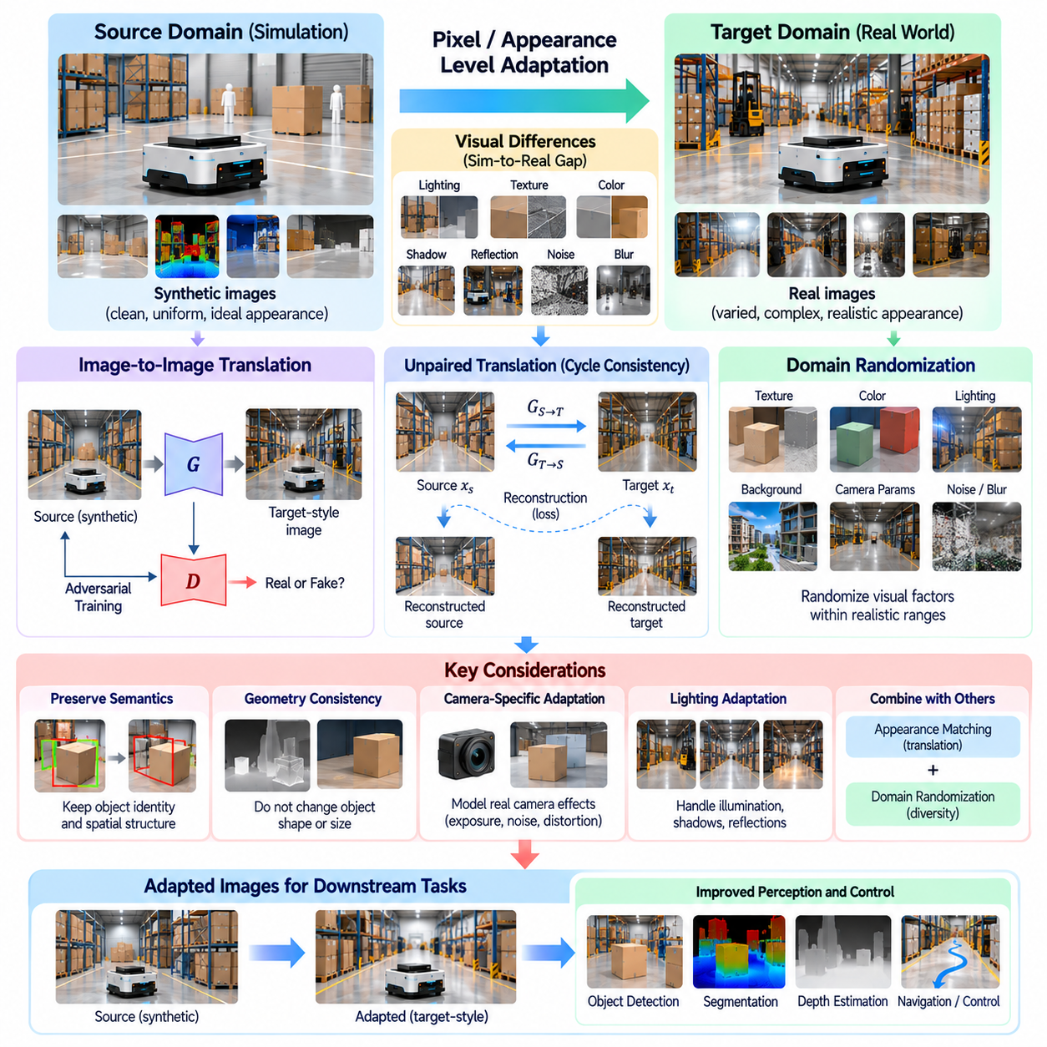
Pixel-level and appearance-level adaptation addresses the visual differences between simulated and real environments by modifying image characteristics while preserving task-relevant information. Unlike feature-level adaptation, which aligns internal neural representations, this approach operates directly on images or their visible properties. In Physical AI, it enables models trained on synthetic observations to perform more reliably under real camera conditions.
The simulation-to-reality gap is often visible through differences in lighting, textures, shadows, reflections, colors, and sensor noise. Simulation engines can generate geometrically accurate scenes, but their visual appearance may not fully reproduce physical environments. These discrepancies can cause perception models to learn synthetic-specific patterns that fail during deployment. Appearance adaptation reduces this dependency by making training observations more representative of real conditions.
Pixel-level adaptation generally transforms images from one visual domain into another while attempting to preserve their semantic content. A synthetic warehouse image may be converted into a realistic camera-like observation without changing object identities or spatial arrangements. Conversely, real images may be transformed toward a simplified synthetic style. Both directions seek to reduce visual distribution differences, although their practical advantages depend on the training pipeline.
A common approach uses image-to-image translation models to map source images into the appearance of target-domain observations. Generative adversarial networks can learn realistic texture, color, and illumination transformations from collections of synthetic and real images. A generator produces adapted observations, while a discriminator evaluates whether their appearance resembles the target domain. Training encourages visual realism without necessarily requiring paired images.
Unpaired image translation is valuable because obtaining precisely corresponding simulated and real images is often difficult. Cycle-consistent adversarial networks introduce reconstruction constraints that encourage translated images to retain information from their original inputs. An image translated into the target style can be mapped back toward its source appearance. However, cycle consistency alone does not guarantee preservation of object geometry or task-critical details.
Appearance adaptation must distinguish between visual properties that can safely change and physical information that must remain stable. Illumination intensity, color balance, and surface texture may be modified without affecting object identity. In contrast, changing object boundaries, obstacle dimensions, grasp contact points, or spatial relationships can invalidate training annotations. Geometry preservation is therefore a central requirement for reliable Physical AI applications.
Semantic consistency constraints help prevent image translation from altering task-relevant content. A segmentation model or object detector can compare predictions before and after appearance transformation to encourage stable semantic interpretation. Perceptual losses may preserve higher-level visual structure, while identity losses discourage unnecessary changes. These objectives reduce harmful transformations but cannot guarantee correctness without independent validation.
Photorealistic rendering provides another strategy for reducing appearance differences before adaptation. Physically based rendering models light transport, material response, reflections, and shadows using approximations of physical optics. Accurate camera models can further reproduce exposure, lens distortion, motion blur, and sensor noise. Although high rendering fidelity can improve realism, it may increase computational cost and still leave important domain differences unresolved.
Domain randomization offers an alternative to matching one particular target appearance. Instead of generating images that resemble a specific real environment, simulation varies textures, colors, lighting directions, backgrounds, and camera parameters across a broad range. The objective is to expose models to sufficient visual diversity that real-world observations become less unfamiliar. Randomization must remain physically plausible and preserve meaningful task structure.
Appearance matching and domain randomization can also be combined. Randomized synthetic images provide broad visual coverage, while target-oriented translation introduces characteristics observed in actual deployment environments. This combination may improve robustness when the target domain contains both predictable appearance patterns and unexpected variations. However, excessive randomization or unrealistic translations can introduce unnecessary complexity and reduce training effectiveness.
Camera-specific adaptation is particularly important for robotic systems that use different imaging hardware in simulation and deployment. Real cameras introduce sensor-dependent color responses, exposure behavior, rolling-shutter effects, compression artifacts, and noise distributions. Simulated observations may omit these characteristics or reproduce them inaccurately. Camera-aware transformations can reduce such discrepancies while maintaining geometric and temporal consistency.
Lighting adaptation addresses changes caused by illumination intensity, direction, spectrum, and environmental conditions. Industrial robots may operate under fluorescent lighting, sunlight, shadows, or reflective surfaces that differ substantially from simulated scenes. Adaptation can modify brightness, contrast, shadow appearance, and color temperature to approximate these conditions. Careful validation is necessary because lighting changes can obscure small objects or alter important visual boundaries.
Texture adaptation focuses on differences in material appearance between simulated objects and their physical counterparts. Synthetic surfaces may appear unusually smooth, repetitive, or uniform, whereas real materials exhibit wear, contamination, manufacturing variation, and irregular reflections. Texture translation can introduce realistic appearance statistics while preserving object shape. For manipulation tasks, however, visual texture must not be treated as a reliable substitute for measured friction or material properties.
Spatially selective appearance adaptation modifies different image regions according to their semantic or geometric roles. Background surfaces may tolerate extensive texture changes, while small obstacles, object boundaries, and grasp regions require stronger preservation constraints. Segmentation masks, depth maps, and attention mechanisms can guide region-specific transformations. This approach reduces the risk that visually convincing images become unsuitable for precise robotic perception.
Temporal consistency becomes essential when appearance adaptation is applied to robot video rather than isolated images. Independent frame transformations can produce flickering textures, unstable shadows, or inconsistent object colors. Such artifacts may interfere with tracking, visual odometry, and motion estimation. Video adaptation methods therefore incorporate temporal constraints or motion-aware transformations to preserve coherent appearance across consecutive observations.
Appearance adaptation can support object detection, semantic segmentation, depth estimation, and visual localization. Synthetic annotations remain useful when translated images preserve their original geometry and semantic labels. This allows large automatically labeled simulation datasets to provide supervision for visually realistic training examples. Nevertheless, image realism does not necessarily imply improved task performance, so evaluation must focus on downstream accuracy.
For autonomous mobile robots, pixel-level adaptation can reduce visual differences between simulated corridors, warehouse aisles, and real operating facilities. Adapted images may reproduce floor reflections, wall textures, lighting variations, and camera artifacts encountered during deployment. Such transformations can improve visual obstacle recognition and scene understanding. However, navigation reliability also depends on geometry, localization accuracy, and sensor fusion beyond visual appearance.
In robotic manipulation, appearance adaptation can help models recognize objects under realistic lighting, surface finishes, and cluttered backgrounds. A grasp prediction model trained on rendered objects may benefit from realistic camera observations while retaining synthetic grasp annotations. Yet successful manipulation also depends on contact dynamics, object mass, friction, and actuator behavior. Visual adaptation should therefore complement rather than replace physical calibration and dynamics adaptation.
Multimodal Physical AI systems require careful coordination between appearance adaptation and other sensor channels. RGB images may undergo style transformations, while depth, LiDAR, and proprioceptive measurements retain their original physical interpretations. Cross-modal consistency must be maintained so that transformed visual boundaries correspond to measured geometry. Misalignment between modalities can undermine sensor fusion and produce unreliable state estimates.
The quality of adapted images can be assessed using visual similarity measures, distribution comparisons, and human inspection. Metrics based on feature distributions may indicate whether synthetic images resemble real observations, but they do not establish semantic correctness. Task-based evaluation should measure detection accuracy, segmentation quality, tracking stability, and operational success. Geometry preservation and annotation consistency must be evaluated separately from visual realism.
Negative transfer may occur when appearance transformations introduce artifacts or remove information that the original model requires. A translation model might alter small components, suppress low-contrast obstacles, or generate misleading reflections. These errors can remain unnoticed when evaluation emphasizes visual attractiveness rather than physical correctness. Conservative transformations, uncertainty estimation, and independent real-world testing help reduce such risks.
A practical adaptation pipeline begins with synthetic observations and their automatically generated annotations. Representative real images are collected to characterize target-domain appearance, after which suitable translation, rendering, or randomization methods are selected. Adapted images are checked for geometric and semantic consistency before being used for model training. Performance is then evaluated on independent real-world data, with problematic transformations refined or rejected.
Ultimately, pixel-level and appearance-level adaptation reduces the visual component of the simulation-to-reality gap by making synthetic training data more compatible with real sensor observations. Its success depends on preserving physical geometry, semantic meaning, annotation validity, and temporal coherence while modifying appearance. Combined with feature adaptation, sensor calibration, and systematic validation, it supports more reliable visual perception in Physical AI systems.

04.06. Adversarial and Discrepancy Based Adaptation
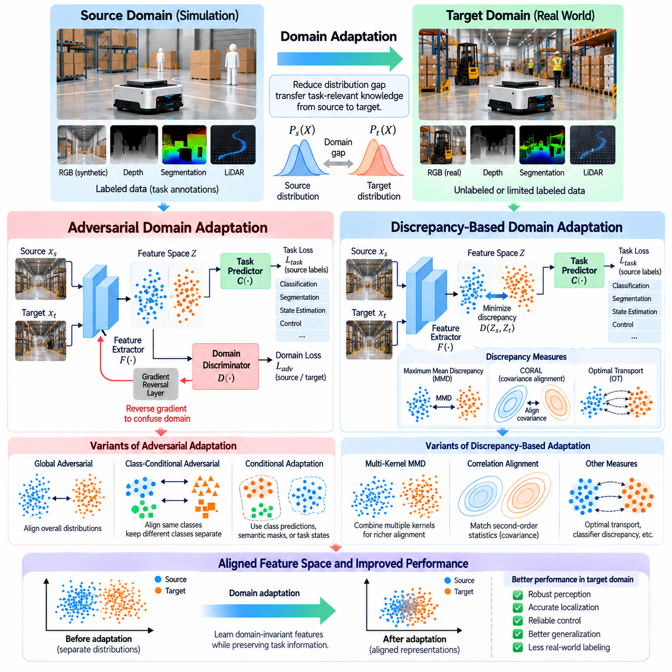
Adversarial and discrepancy-based domain adaptation are two major approaches for reducing distribution differences between simulation and real-world environments. Both methods seek to transfer task-relevant knowledge from a labeled source domain to a target domain with limited or unavailable annotations. In Physical AI, they support the adaptation of robotic perception, state estimation, and control systems without requiring extensive real-world labeling.
The fundamental challenge is that source and target observations often follow different statistical distributions. Synthetic images may contain idealized lighting and textures, while real sensors introduce noise, reflections, and calibration errors. Even when both domains represent identical objects or physical tasks, neural networks may extract different features. Adaptation methods attempt to reduce these differences while preserving information essential for correct predictions.
Adversarial domain adaptation introduces a competition between a feature extractor and a domain discriminator. The feature extractor converts source and target observations into latent representations, while the discriminator predicts which domain produced each representation. The feature extractor is optimized to make this distinction difficult. Simultaneously, a task predictor learns from source-domain annotations to preserve useful semantic and operational information.
Domain-adversarial neural networks commonly implement this process using a gradient reversal layer. During forward propagation, the layer passes features unchanged to the domain discriminator. During backpropagation, it reverses the discriminator gradient before passing it to the feature extractor. This mechanism encourages domain confusion while allowing ordinary gradient-based optimization. Its effectiveness depends on balancing task learning and domain alignment.
The adversarial objective combines source-task prediction loss with a domain discrimination objective. The task component encourages accurate recognition or control predictions, while the adversarial component discourages features that reveal domain identity. A weighting parameter controls the strength of adaptation. Excessive adversarial pressure can remove task-relevant information, whereas insufficient pressure may leave substantial simulation-specific biases in the learned representation.
Adversarial alignment is attractive because it does not require an explicit mathematical model of the difference between feature distributions. A sufficiently expressive discriminator can detect complex distinctions between source and target representations. However, adversarial optimization may be unstable, especially when the discriminator becomes too strong or too weak. Learning-rate scheduling, regularization, and careful monitoring are important for reliable convergence.
Global adversarial alignment can fail when source and target domains contain different category proportions or physical states. A discriminator may encourage overall distribution similarity while mixing features belonging to unrelated semantic classes. This can cause negative transfer and reduce target-domain accuracy. Class-conditional adversarial adaptation addresses this limitation by aligning corresponding categories or task states rather than treating every observation as equivalent.
Conditional adaptation may incorporate class predictions, semantic masks, or task-specific representations into the discriminator. In robotic vision, object categories can guide the alignment of corresponding visual features. In control systems, estimated motion states or interaction conditions can provide additional structure. When target labels are unavailable, pseudo-labels may approximate these relationships, although incorrect predictions can reinforce alignment errors.
Discrepancy-based domain adaptation approaches the same transfer problem through explicit statistical measures. Instead of training a discriminator, it computes differences between selected properties of source and target feature distributions. The learning objective encourages these discrepancies to decrease while preserving source-task performance. This approach often provides more interpretable optimization signals and can avoid some difficulties associated with adversarial competition.
Maximum mean discrepancy is a widely used statistical criterion for comparing feature distributions. It measures the distance between distribution embeddings in a reproducing kernel Hilbert space. By minimizing this distance, a neural network can learn representations whose source and target statistics become more similar. Kernel selection and feature-layer placement influence the sensitivity of the method to different types of distribution shifts.
Multi-kernel maximum mean discrepancy extends this approach by combining kernels with different characteristics. This allows adaptation to capture distribution differences across multiple scales and statistical patterns. For robotic perception, such flexibility can help address variations in texture, illumination, and sensor response. However, distribution similarity alone does not guarantee that object categories, geometric relationships, or action-relevant states remain correctly separated.
Correlation alignment reduces domain differences by matching covariance structures of source and target features. The method encourages learned feature dimensions to exhibit similar relationships across domains. It can be integrated into neural network training without introducing a separate adversarial discriminator. Nevertheless, matching second-order statistics may overlook complex nonlinear differences, multimodal structures, or rare operating conditions.
Other discrepancy measures include optimal transport distances and classifier disagreement objectives. Optimal transport seeks a correspondence between source and target feature distributions while minimizing a transport cost. Classifier disagreement methods identify target observations where independently trained predictors produce inconsistent outputs. These techniques can reveal regions of poor transfer, but their effectiveness depends on meaningful feature geometry and reliable prediction structure.
Adversarial and discrepancy-based methods can be combined within a single adaptation architecture. Adversarial learning can reduce complex domain distinctions, while statistical discrepancy objectives provide additional alignment constraints. Class-aware losses and consistency regularization may further preserve semantic structure. Such combinations can improve transfer under challenging conditions, although additional objectives increase computational complexity and require careful weight selection.
Multi-layer alignment recognizes that domain differences occur at different levels of neural representation. Early layers may encode sensor noise, colors, and textures, while deeper layers capture object identities and task semantics. Applying adaptation losses at selected layers can address both low-level appearance differences and higher-level representation shifts. Excessive alignment across every layer may constrain useful domain-specific information.
For autonomous mobile robots, these methods can support the transfer of obstacle detection, semantic mapping, and traversability estimation from simulation to deployment environments. Source data may contain accurate obstacle annotations, while target observations include unfamiliar lighting, reflective floors, and sensor artifacts. Domain alignment can improve perception robustness, but navigation safety must still be evaluated through real-world operational testing.
Robotic manipulation introduces additional complexity because successful actions depend on physical interactions as well as visual observations. Adversarial or discrepancy-based alignment can improve representations of object shape, pose, and contact-related visual cues. However, feature alignment cannot independently correct differences in friction, compliance, actuator response, or contact dynamics. Physical calibration and dynamics adaptation remain necessary for reliable manipulation transfer.
Control-policy adaptation requires preserving the relationship between observations, actions, and resulting state transitions. Aligning observation features may help a simulation-trained policy interpret real sensor inputs, but identical-looking representations can correspond to different physical dynamics. Adaptation must therefore consider task outcomes and control stability. Unsafe exploratory updates should be avoided through offline validation and verified operational constraints.
Evaluation should distinguish successful domain alignment from genuine improvements in robotic performance. Domain discriminator accuracy, maximum mean discrepancy, and covariance differences provide useful diagnostic measurements. However, reduced statistical discrepancy does not necessarily imply improved target-task accuracy. Independent testing should measure detection performance, navigation success, grasp completion, trajectory tracking, and failure frequency under representative conditions.
Negative transfer is a major concern when alignment forces incompatible source and target observations into similar representations. This risk increases under class imbalance, missing target categories, changing sensor configurations, or significant differences in physical dynamics. Selective alignment, uncertainty estimation, and unknown-category detection can reduce inappropriate transfer. Monitoring both target improvements and degradation of previously reliable capabilities is essential.
Practical implementation must account for training stability, computational requirements, and deployment constraints. Adversarial methods introduce discriminator networks and potentially unstable optimization, while discrepancy methods may require costly distribution comparisons. Mini-batch sampling, efficient feature encoders, and selective layer adaptation can reduce resource demands. Offline adaptation is generally easier to validate than continuous online updates in safety-critical robotic systems.
A practical development workflow begins with a model trained on richly annotated simulation data and a representative collection of real-world observations. Engineers analyze domain differences, select adversarial or discrepancy-based objectives, and optimize feature representations while maintaining source-task accuracy. Independent target-domain evaluation identifies remaining weaknesses. Additional labels, conditional alignment, or physical calibration may be introduced when transfer remains insufficient.
Ultimately, adversarial and discrepancy-based adaptation provide complementary mechanisms for learning transferable representations across simulated and physical environments. Their effectiveness depends on reducing irrelevant distribution differences without destroying semantic, geometric, or control-related information. When integrated with uncertainty management, careful optimization, and systematic real-world validation, these methods can strengthen the reliability of Physical AI systems operating beyond their original training domains.

04.07. Self Training and Pseudo Labeling
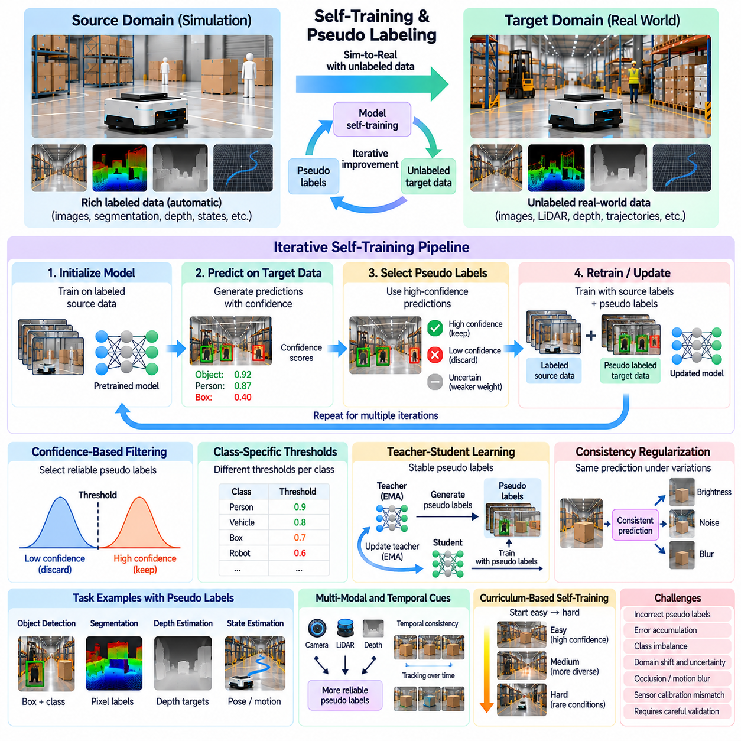
Self-training and pseudo-labeling are widely used domain adaptation techniques that enable models trained in simulation to improve through unlabeled real-world observations. Self-training repeatedly uses a model's predictions as additional supervision, while pseudo-labeling assigns provisional labels to previously unlabeled samples. In Physical AI, these methods reduce dependence on expensive manual annotation and support continuous improvement of robotic perception systems.
The central motivation is the imbalance between abundant labeled simulation data and limited annotated real-world data. Simulation engines can automatically generate object identities, segmentation masks, depth maps, and robot states, while physical deployments produce large volumes of unlabeled sensor recordings. Self-training exploits these observations by converting sufficiently reliable predictions into training targets, gradually expanding the available supervision.
A typical self-training pipeline begins with a source model trained on richly annotated synthetic data. The model processes target-domain observations and generates predictions with associated confidence estimates. Selected predictions become pseudo-labels for subsequent training iterations. The updated model then produces new predictions, allowing the process to repeat. Each iteration should be evaluated to prevent accumulated errors from degrading performance.
Pseudo-label quality is the most important factor influencing successful self-training. Incorrect predictions can become false training targets, reinforcing existing biases and producing confirmation errors. A model that consistently misidentifies reflective objects or small obstacles may repeatedly assign incorrect labels to similar observations. Without appropriate safeguards, additional training can increase confidence in incorrect predictions rather than improve accuracy.
Confidence-based filtering is a common mechanism for selecting pseudo-labels. Predictions exceeding a predefined confidence threshold are accepted, while uncertain predictions are excluded or assigned reduced weights. This approach limits exposure to unreliable supervision but may favor familiar objects and simple environmental conditions. Threshold selection must balance label precision against the diversity and coverage of the target dataset.
Class-specific confidence thresholds can address differences in prediction reliability across semantic categories. Common objects may receive accurate predictions at relatively moderate confidence levels, while rare or visually ambiguous classes require stricter selection. Adaptive thresholds can also change as the model improves. Such mechanisms help reduce class imbalance, although confidence scores must be calibrated to reflect actual prediction reliability.
Teacher-student learning provides a structured implementation of self-training. A teacher model generates pseudo-labels from unlabeled target observations, while a student model learns using source annotations and selected teacher predictions. The teacher can be updated through an exponential moving average of student parameters. This approach stabilizes pseudo-label generation by reducing sensitivity to individual optimization steps and noisy mini-batches.
Consistency regularization strengthens pseudo-label learning by requiring compatible predictions across different versions of the same observation. A robot image may undergo realistic brightness changes, moderate noise, or geometric transformations that preserve object identity. The model is encouraged to maintain consistent semantic predictions despite these variations. Transformations must be chosen carefully because excessive changes can invalidate spatial labels or physical relationships.
Weak and strong augmentation strategies are frequently combined in teacher-student frameworks. The teacher generates pseudo-labels from lightly modified observations, while the student learns to reproduce those labels under stronger appearance perturbations. This encourages robustness to target-domain variability. However, geometric transformations must be applied consistently to labels, particularly for object detection, segmentation, and pose estimation.
Self-training can operate at multiple prediction levels depending on the robotic task. Object detection uses pseudo bounding boxes and class labels, while semantic segmentation uses predicted pixel categories. Depth estimation may generate provisional depth targets, and state estimation may use inferred positions or motion states. Each task requires suitable confidence measures because prediction uncertainty has different meanings across output types.
Temporal information provides valuable constraints for pseudo-label generation in robotic environments. Consecutive video frames often contain the same objects under changing viewpoints, allowing predictions to be compared across time. Object tracking and motion consistency can help identify stable labels and reject isolated errors. Nevertheless, occlusion, motion blur, and tracking drift can propagate incorrect pseudo-labels if temporal associations are unreliable.
Multimodal sensor fusion can improve pseudo-label reliability by combining evidence from cameras, LiDAR, depth sensors, and proprioceptive measurements. A visual obstacle prediction may be checked against geometric measurements, while estimated robot motion can be compared with odometry. Agreement between independent modalities increases confidence in inferred labels. However, shared calibration errors or synchronization failures can produce misleading agreement.
Curriculum-based self-training gradually introduces more difficult target-domain samples as model reliability improves. Initial training may emphasize clear objects, stable lighting, and high-confidence predictions. Later stages incorporate challenging viewpoints, cluttered scenes, and uncertain observations. This progression can reduce early error accumulation, although excluding difficult examples for too long may limit adaptation to operationally important conditions.
Distribution imbalance presents another challenge because high-confidence pseudo-labels often overrepresent familiar source-domain categories. Rare obstacles, unusual materials, and unexpected operating conditions may remain poorly represented. Class-balanced sampling, diversity-aware selection, and targeted human verification can improve coverage. The objective is to obtain informative supervision rather than simply maximize the number of generated labels.
For autonomous mobile robots, self-training can adapt obstacle detection, traversability estimation, and semantic mapping to unfamiliar facilities. A simulation-trained perception model processes recorded camera and LiDAR data from real navigation sessions. Reliable predictions are selected as pseudo-labels and incorporated into subsequent training. Independent validation is necessary because incorrect free-space predictions can create serious navigation hazards.
Robotic manipulation introduces additional difficulties because task outcomes depend on physical interaction. Pseudo-labels may represent object poses, grasp candidates, contact states, or estimated manipulation success. Visual predictions can be refined using force measurements and observed object motion. However, an apparently successful grasp prediction does not guarantee stable physical contact, making verified outcome measurements particularly valuable.
Self-training for control policies requires greater caution than adaptation of passive perception models. Incorrect pseudo-actions or estimated value targets can encourage unsafe behavior when used for policy optimization. Offline training with recorded trajectories reduces immediate physical risk, while conservative policy updates limit deviation from validated behavior. Safety constraints and independent testing are essential before deploying adapted control policies.
Pseudo-label uncertainty should be represented explicitly whenever possible. Prediction probabilities, ensemble disagreement, temporal instability, and sensor inconsistency can provide complementary uncertainty indicators. Samples with high uncertainty may be excluded, down-weighted, or prioritized for human review. Reliable uncertainty estimation is particularly important when errors can affect collision avoidance, grasp stability, or robot localization.
Human-in-the-loop verification can substantially improve self-training efficiency without requiring complete dataset annotation. Engineers review selected uncertain samples, correct systematic prediction errors, and provide verified labels for rare operating conditions. These corrections can update confidence thresholds and improve subsequent pseudo-label generation. Active learning methods help identify samples where limited human effort produces the greatest benefit.
Negative transfer occurs when pseudo-labels reinforce source-domain assumptions that do not hold in the target environment. A model trained on idealized simulation textures may confidently misclassify unfamiliar real materials. Repeated self-training can amplify these errors and reduce performance. Monitoring class-level accuracy, uncertainty trends, and performance on independent target-domain test sets helps identify harmful adaptation.
Evaluation should distinguish the quantity of pseudo-labels from their actual contribution to task performance. Useful measurements include pseudo-label precision, coverage, class balance, and stability across iterations. Downstream metrics should assess detection accuracy, segmentation quality, navigation success, grasp completion, and failure frequency. Comparisons must account for additional human labels, training resources, and computational cost.
A practical self-training workflow begins with source-domain pretraining and representative target-domain data collection. The model generates predictions, applies confidence and consistency checks, and constructs a curated pseudo-labeled dataset. Training then combines verified source labels with selected target supervision. Each updated model undergoes independent evaluation, and unsuccessful iterations are rejected rather than automatically deployed.
Operational deployment requires model versioning, data provenance, and reproducible evaluation. Pseudo-labels should retain information about their generating model, confidence scores, sensor conditions, and validation status. This allows engineers to investigate failures and prevent unreliable predictions from contaminating future training datasets. Controlled release procedures and fallback models provide additional protection during iterative adaptation.
Ultimately, self-training and pseudo-labeling transform unlabeled real-world observations into progressively useful supervision for simulation-to-reality transfer. Their effectiveness depends on controlling prediction errors, preserving dataset diversity, and validating improvements against independent operational evidence. When combined with uncertainty estimation, multimodal consistency, selective human verification, and safety-aware deployment, they support scalable adaptation of Physical AI systems.

04.08. Self Supervised Domain Adaptation
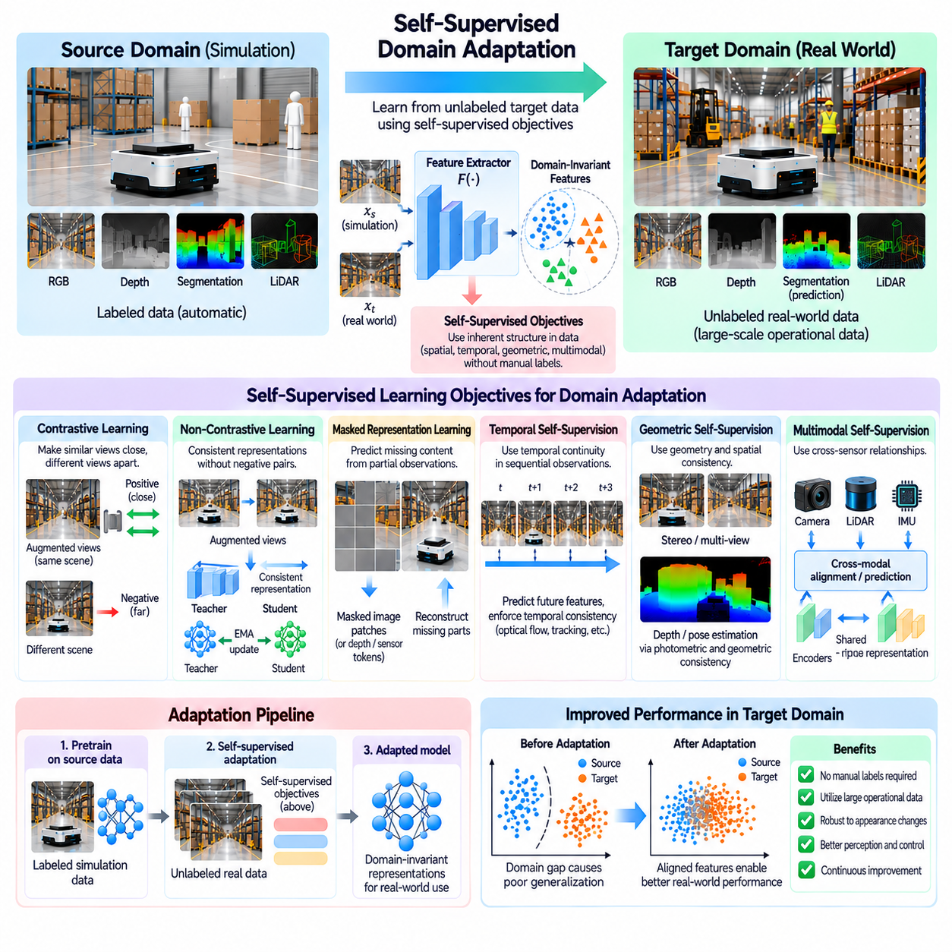
Self-supervised domain adaptation enables robotic learning systems to transfer knowledge from simulation to reality by extracting training signals directly from unlabeled observations. Unlike supervised adaptation, it does not require manually assigned target-domain labels. Instead, it exploits relationships within images, sensor sequences, and physical interactions. In Physical AI, this approach makes large volumes of real-world operational data useful for representation learning.
The central principle is that meaningful supervision can be constructed from the structure of the data itself. A robot continuously observes visual scenes, motion, object interactions, and environmental changes. These observations contain spatial, temporal, and physical relationships that can support learning without explicit annotations. Self-supervised objectives encourage models to discover representations that remain useful across synthetic and real environments.
Self-supervised adaptation typically begins with a model pretrained on simulated data. The model may already recognize objects, estimate depth, or predict robot states, but its representations can remain sensitive to synthetic appearance characteristics. Unlabeled target-domain observations are then used to refine the feature extractor through auxiliary learning objectives. The objective is to improve real-world generalization while retaining capabilities acquired during simulation training.
Contrastive learning is a widely used self-supervised technique for learning transferable representations. It encourages representations of related observations to become similar while separating representations of unrelated observations. Positive pairs may consist of different augmented views of the same image or temporally related sensor measurements. Negative pairs can represent unrelated scenes, although careless selection may incorrectly separate semantically equivalent observations.
Contrastive objectives can reduce sensitivity to lighting, texture, and sensor noise when these characteristics vary between paired observations. A robot camera image may be transformed through realistic color changes, cropping, or moderate noise injection. The network learns to preserve information shared across the resulting views. However, augmentations must respect task requirements because excessive cropping or geometric distortion may remove obstacles or alter important spatial relationships.
Non-contrastive self-supervised methods provide an alternative that does not explicitly require negative sample pairs. These approaches encourage consistent representations between differently augmented observations while using architectural constraints or prediction mechanisms to avoid representation collapse. Teacher-student architectures and stop-gradient operations are common components. Their effectiveness depends on maintaining informative features rather than producing identical representations for every input.
Masked representation learning trains models to reconstruct missing information from partially observed inputs. Image patches, depth measurements, or segments of sensor sequences can be hidden during training. The network must infer the missing content from surrounding context, encouraging the acquisition of spatial and structural knowledge. This approach can support adaptation when synthetic and real observations share underlying geometry despite differing visual appearances.
Masked image modeling is particularly useful for learning visual representations from large collections of unlabeled robot images. By predicting missing image regions or latent features, the model learns relationships among objects, surfaces, and scene layouts. Reconstruction targets must be selected carefully because pixel-level objectives can overemphasize textures and illumination. Feature-level reconstruction may encourage greater emphasis on semantic and geometric structure.
Temporal self-supervision exploits the continuity of robotic observations across time. Consecutive frames typically contain related objects and environmental structures, even as the camera or robot moves. Models can learn by predicting future representations, estimating temporal correspondence, or enforcing consistency between neighboring observations. These objectives help preserve motion-related information and can improve adaptation to real-world operating conditions.
Video-based adaptation can incorporate optical flow, object tracking, and motion consistency to create additional training signals. A feature associated with a stationary object should remain identifiable as the robot changes viewpoint. Temporal correspondence helps distinguish persistent physical structures from transient visual artifacts. However, occlusion, dynamic objects, and inaccurate motion estimation can introduce misleading supervision if temporal relationships are not validated.
Geometric self-supervision is especially valuable because physical geometry often remains more stable across domains than visual appearance. Stereo image pairs, camera motion, and depth observations can provide constraints for learning spatial representations. Photometric reconstruction and geometric consistency objectives are commonly used for depth and pose estimation. Their reliability depends on assumptions about visibility, camera calibration, and scene motion.
Multimodal self-supervision uses relationships between different sensor channels to learn shared representations. Cameras, LiDAR, inertial sensors, wheel encoders, and proprioceptive measurements observe complementary aspects of the same physical environment. Cross-modal prediction or alignment can encourage features that reflect common geometry and motion. Accurate synchronization and calibration are essential because inconsistent sensor measurements can corrupt the learning signal.
For robotic manipulation, self-supervised learning can exploit object motion, contact events, and action outcomes. A robot may learn representations by predicting how objects move after commanded actions or by comparing visual observations before and after contact. Force and tactile measurements provide additional information about interaction states. These objectives connect perception with physical consequences, although unsafe exploration must be restricted during data collection.
Action-conditioned prediction extends self-supervision beyond passive observation. A model receives the current observation and an executed action, then predicts the next state or latent representation. Differences between predictions and measured outcomes provide a learning signal. Such objectives can improve representations of controllable dynamics and support simulation-to-reality transfer, but they must account for uncertainty and discrepancies in actuator behavior.
A major challenge is preventing self-supervised adaptation from degrading task-specific knowledge acquired during source-domain training. Auxiliary objectives may favor representations that reconstruct observations accurately without supporting object recognition or control decisions. Combining self-supervised losses with source-task supervision, feature regularization, or replay data can reduce catastrophic forgetting. The balance between adaptation and retention should be validated empirically.
Self-supervised adaptation can also support continual learning from operational robot data. Recorded navigation sessions, manipulation attempts, and routine sensor measurements provide a growing collection of unlabeled target observations. Periodic offline training can incorporate these observations into updated representations. Data selection should account for environmental diversity, rare conditions, and sensor quality rather than relying exclusively on recording volume.
Evaluation must distinguish improvements in self-supervised objectives from improvements in robotic task performance. Lower reconstruction error or stronger representation consistency does not necessarily imply safer navigation or more accurate manipulation. Independent real-world tests should measure perception accuracy, localization stability, task completion, and failure frequency. Robustness under changing lighting, sensor noise, and unfamiliar environments is particularly important.
Ultimately, self-supervised domain adaptation transforms the inherent structure of unlabeled robotic observations into useful training information. Contrastive learning, masked modeling, temporal prediction, geometric consistency, and multimodal alignment provide complementary mechanisms for reducing simulation-to-reality differences. Combined with task-aware regularization and systematic validation, these methods support scalable and reliable adaptation of Physical AI systems.

04.09. Test Time and Online Adaptation
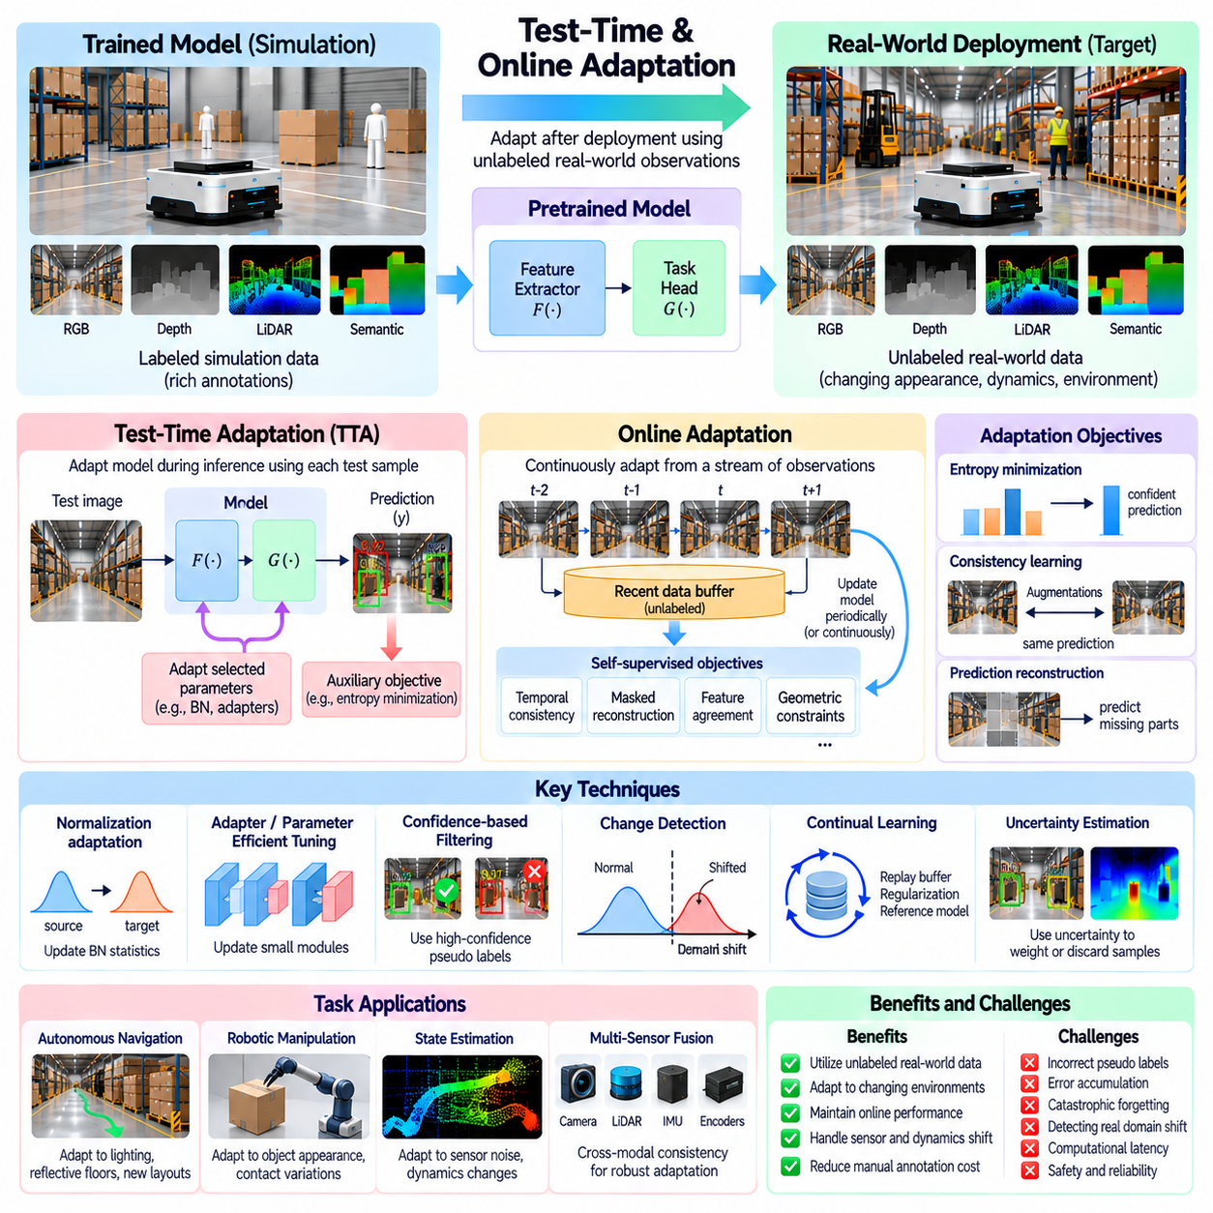
Test-time and online adaptation enable Physical AI systems to adjust their learned models after deployment when real-world observations differ from simulation training conditions. Test-time adaptation updates selected model components during inference, while online adaptation incorporates information from sequential operational data. Both approaches aim to maintain reliable perception and decision-making under changing environments without requiring complete retraining.
The motivation arises from the dynamic nature of physical environments. Lighting conditions, sensor characteristics, object appearances, and operating surfaces may change after deployment. A model trained on synthetic observations can experience declining accuracy when these changes alter its input distribution. Adaptation during operation offers a mechanism for responding to such shifts, although uncontrolled updates can introduce new safety and reliability risks.
Test-time adaptation typically uses unlabeled target observations to modify a pretrained model through auxiliary objectives. Unlike conventional domain adaptation, it may operate without access to the original source dataset. The adaptation process can update normalization statistics, selected network parameters, or lightweight adaptation modules. Restricting the number of adjustable parameters helps reduce computational cost and limits unintended changes to established capabilities.
Entropy minimization is a common test-time adaptation strategy for classification and perception models. It encourages the network to produce confident predictions on target-domain observations by reducing predictive uncertainty. This can improve performance when distribution changes are moderate and the original model remains reasonably accurate. However, minimizing entropy may reinforce incorrect predictions when the model encounters unfamiliar objects or severe domain shifts.
Normalization-based adaptation adjusts statistical properties of intermediate network activations. Batch normalization layers, for example, may use target-domain statistics to compensate for changes in sensor response or visual appearance. Such adjustments can be computationally efficient because they do not require extensive network retraining. Nevertheless, small batches, correlated observations, and abrupt environmental changes can produce unreliable statistics.
Online adaptation extends model adjustment across a continuous stream of observations. Rather than treating each input independently, it accumulates information from recent robot experiences and updates model parameters or internal statistics over time. This can support gradual adaptation to persistent environmental changes. However, streaming observations are often temporally correlated, and their statistical properties may change faster than the model can adapt.
A central design decision concerns the adaptation frequency and update magnitude. Updating after every observation can provide rapid responsiveness but may increase computational load and amplify noise. Periodic updates using accumulated observations can improve statistical stability but introduce adaptation delays. Practical systems must balance responsiveness, inference latency, energy consumption, and the reliability of available training signals.
Self-supervised objectives provide useful learning signals when target-domain labels are unavailable. Temporal consistency, masked reconstruction, feature agreement, and geometric constraints can guide online representation updates. A robot may compare consecutive camera observations or predict sensor measurements from estimated motion. These objectives should preserve task-relevant information rather than optimize reconstruction quality at the expense of operational performance.
Continual adaptation introduces the risk of catastrophic forgetting, where improvements in current conditions degrade performance on previously encountered environments. A robot adapting to dim lighting may lose accuracy under bright illumination if updates become excessively specialized. Replay buffers, parameter regularization, and reference models can help preserve earlier capabilities. Evaluation should therefore cover both recent conditions and previously validated operating scenarios.
Change detection is important for deciding when adaptation is necessary. Distribution-shift indicators, prediction uncertainty, sensor residuals, and task-performance trends can reveal departures from expected operating conditions. An adaptation controller may activate updates only when evidence of a persistent shift exceeds a defined threshold. This approach reduces unnecessary model changes, although distinguishing genuine domain shifts from transient disturbances remains challenging.
Uncertainty-aware adaptation can prevent unreliable observations from dominating model updates. Samples with inconsistent predictions, severe sensor corruption, or unfamiliar semantic content may receive reduced weights or be excluded. Model ensembles and temporal consistency checks can provide additional confidence estimates. However, confidence alone is insufficient because neural networks can produce highly confident predictions for incorrect or out-of-distribution inputs.
For autonomous mobile robots, test-time adaptation can address changing illumination, reflective floors, camera contamination, and unfamiliar indoor environments. Perception modules may update selected representations to maintain obstacle detection and semantic understanding. Adaptation must not compromise collision avoidance or localization stability. Safety-critical navigation functions should remain protected by independently validated constraints and fallback mechanisms.
Robotic manipulation presents additional challenges because adaptation affects decisions involving physical contact. Changes in object appearance, camera placement, or sensor noise may justify updating perception models. However, altered friction, payload properties, and actuator dynamics require physical identification rather than visual adaptation alone. Online updates must preserve grasp safety, force limits, and predictable controller behavior during uncertain interactions.
A safe architecture separates adaptive learning components from verified control and safety functions. Updated perception features may inform task planning, while independent monitors enforce collision constraints, velocity limits, and emergency stopping conditions. Candidate updates can be evaluated in shadow mode before influencing active decisions. Rollback mechanisms allow the system to restore previously validated parameters when performance deteriorates.
Evaluation must account for adaptation speed, accuracy, computational overhead, and operational safety. Useful measurements include recovery time after domain shifts, performance across changing conditions, parameter-update frequency, and degradation on earlier environments. Testing should include gradual drift, abrupt sensor changes, and unexpected observations. Successful adaptation requires sustained task performance rather than merely improved confidence or reduced auxiliary loss.
Ultimately, test-time and online adaptation provide mechanisms for maintaining Physical AI performance as deployment conditions evolve. Their value depends on reliable shift detection, conservative updates, task-aware learning objectives, and protection against forgetting and unsafe behavior. When combined with uncertainty monitoring, independent safety constraints, and reversible deployment procedures, these approaches support more resilient robotic operation beyond simulation.

04.10. Sensor and Multimodal Domain Adaptation
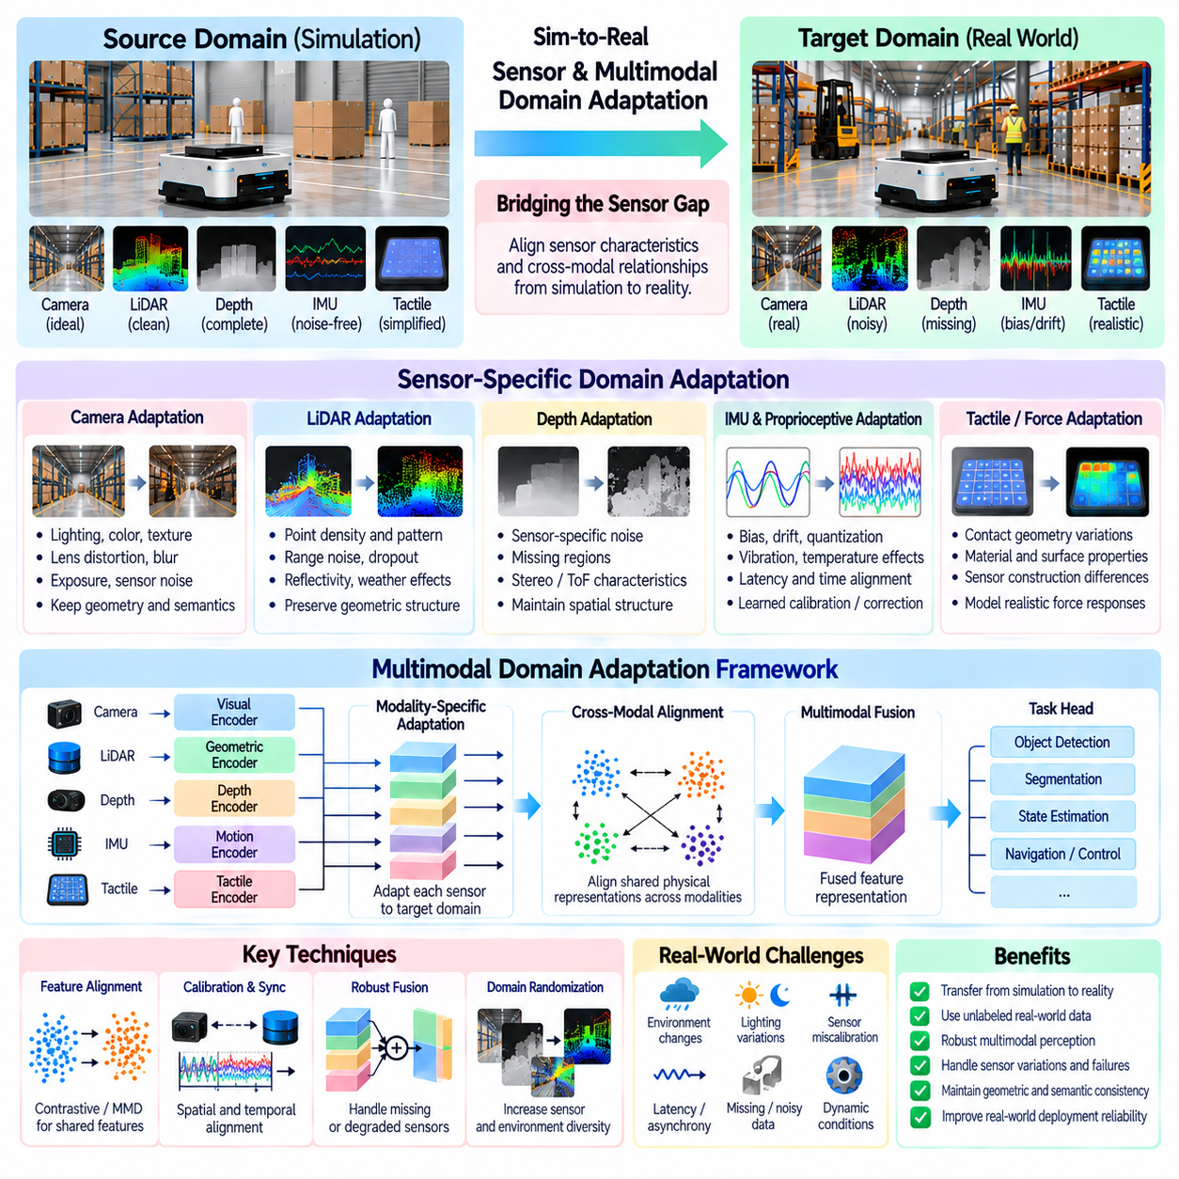
Sensor and multimodal domain adaptation addresses differences between simulated and real sensing systems by aligning information from cameras, LiDAR, depth sensors, inertial units, tactile sensors, and proprioceptive measurements. Unlike adaptation focused on a single visual domain, multimodal adaptation considers the relationships among several observation channels. In Physical AI, this approach supports reliable perception and decision-making when sensor characteristics change across environments.
The simulation-to-reality gap arises because simulated sensors rarely reproduce every characteristic of physical measurement devices. Real sensors introduce noise, bias, latency, quantization, calibration errors, and environmental interference. These effects vary across sensor types and operating conditions. A model trained on idealized synthetic measurements may therefore misinterpret real observations even when the underlying physical environment remains unchanged.
Camera domain adaptation addresses differences in image formation, illumination, lens distortion, exposure, and sensor noise. Synthetic images may appear geometrically accurate but lack realistic motion blur, reflections, or color response. Adaptation methods can modify image appearance or align learned visual features. However, transformations must preserve object boundaries, spatial relationships, and semantic information required for robotic perception and control.
LiDAR domain adaptation focuses on differences in point density, angular resolution, range accuracy, reflectivity, and measurement dropout. Simulated point clouds often contain cleaner surfaces and more uniform sampling than physical sensors. Real LiDAR measurements may be affected by transparent materials, reflective objects, weather, and multipath effects. Adaptation must preserve geometric structure while accounting for sensor-specific uncertainty.
Depth sensors introduce additional challenges because measurement errors depend on sensing technology and surface properties. Stereo cameras, structured-light sensors, and time-of-flight devices produce different noise patterns and missing-data regions. Synthetic depth maps may contain unrealistically complete geometry. Depth adaptation can introduce realistic uncertainty or align geometric representations, but it should not fabricate reliable measurements where physical sensing is inherently ambiguous.
Inertial and proprioceptive sensors require adaptation of temporal and statistical characteristics rather than visual appearance. Accelerometers, gyroscopes, wheel encoders, and joint sensors exhibit bias, drift, quantization, and mechanical coupling. Simulation models may omit temperature effects, vibration, or actuator-related disturbances. Realistic sensor modeling and learned correction mechanisms can reduce discrepancies in state estimation and motion prediction.
Tactile and force sensors present particularly complex domain differences because their outputs depend on physical contact. Sensor responses vary with material stiffness, contact geometry, friction, loading direction, and sensor construction. Simulated contact measurements may simplify deformation and force distribution. Adaptation must therefore account for both sensor behavior and underlying interaction dynamics to support reliable grasping and manipulation.
Multimodal adaptation extends beyond correcting individual sensor distributions. It must preserve the physical relationships among observations produced by different modalities. Camera pixels, LiDAR points, depth measurements, and inertial signals may describe the same object or motion from different perspectives. Effective adaptation aligns these complementary representations without eliminating modality-specific information needed for accurate interpretation.
Cross-modal feature alignment learns representations that capture information shared across sensor channels. Visual and geometric encoders may be trained to produce compatible features for corresponding objects or spatial regions. Contrastive learning, consistency objectives, and distribution alignment can support this process. However, forcing all modalities into identical representations may discard useful information about uncertainty, material properties, or measurement limitations.
Sensor calibration is a fundamental prerequisite for multimodal adaptation. Extrinsic calibration determines the spatial relationships between sensors, while intrinsic calibration describes their internal measurement characteristics. Time synchronization ensures that observations correspond to compatible physical states. Calibration errors can appear similar to domain shifts, making it difficult for learning algorithms to distinguish sensor misalignment from genuine environmental variation.
Temporal alignment becomes critical when modalities operate at different sampling frequencies and latencies. Cameras may produce relatively slow image streams, while inertial sensors provide high-frequency measurements. LiDAR scans and tactile observations introduce additional timing characteristics. Adaptation architectures must account for asynchronous data and delayed measurements because incorrect temporal correspondence can distort motion estimates and sensor fusion results.
Modality-specific adaptation allows each sensor encoder to compensate for its own distribution changes before multimodal fusion. A visual encoder may adapt to lighting variations, while a LiDAR encoder handles point-cloud sparsity and an inertial encoder compensates for measurement drift. Shared fusion layers then integrate the adapted features. This modular strategy can improve interpretability and reduce unnecessary changes to unaffected sensor channels.
Robust multimodal systems must also handle missing or degraded modalities. Cameras may fail under poor illumination, LiDAR measurements may become unreliable on certain surfaces, and tactile sensors may lose contact information. Modality dropout during training can prepare models for partial sensor availability. Confidence-aware fusion can reduce the influence of unreliable channels, although uncertainty estimates must be validated against actual sensor failures.
For autonomous mobile robots, multimodal adaptation supports obstacle detection, localization, mapping, and traversability estimation. Cameras provide semantic information, LiDAR supplies geometric measurements, and inertial sensors support motion estimation. Domain adaptation can reduce discrepancies across these channels when robots move from simulated facilities to real warehouses or outdoor environments. Reliable operation still requires independent safety monitoring and sensor fault detection.
Robotic manipulation benefits from combining visual, depth, tactile, and force information during adaptation. Vision estimates object pose and appearance, while tactile sensing reveals contact conditions and force sensors measure interaction loads. Cross-modal consistency can improve grasp-state estimation when individual sensors are uncertain. Nevertheless, changes in friction, compliance, and actuator dynamics require physical modeling beyond sensor distribution alignment.
Evaluation should measure both individual sensor adaptation and the performance of the complete fusion system. Useful tests include sensor noise variation, calibration perturbations, timing errors, partial sensor failures, and environmental changes. Metrics should cover perception accuracy, localization stability, grasp success, and uncertainty calibration. Improved feature alignment is insufficient unless it produces measurable gains in real robotic tasks.
Ultimately, sensor and multimodal domain adaptation connects simulated sensing models with the complex behavior of physical measurement systems. Its effectiveness depends on preserving geometry, temporal correspondence, cross-modal consistency, and sensor-specific uncertainty while reducing irrelevant distribution differences. Combined with realistic simulation, calibration, robust fusion, and systematic validation, it strengthens the reliability of Physical AI across diverse operating environments.

04.11. Dynamics and Control Domain Adaptation
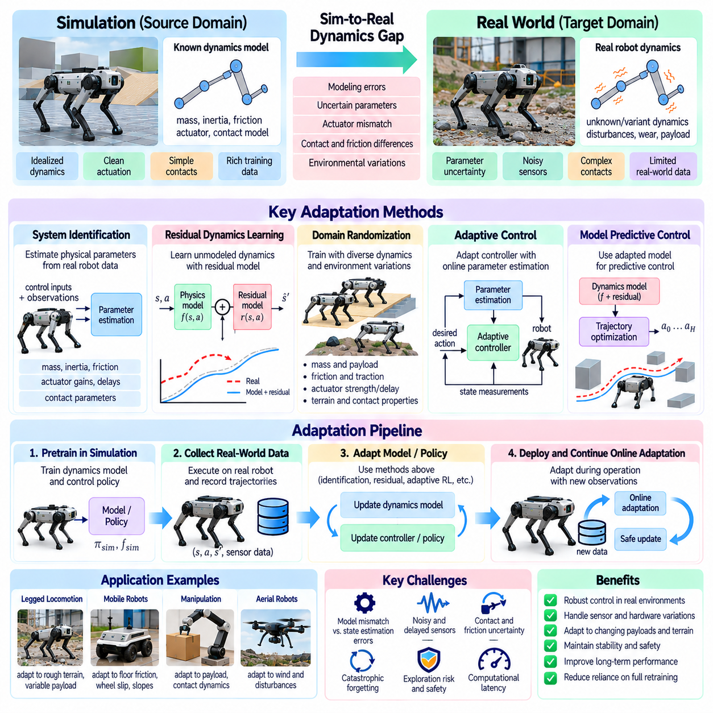
Dynamics and control domain adaptation addresses differences between simulated and real robotic motion, actuation, and physical interactions. Even when perception models transfer successfully, control policies may fail because simulated dynamics do not accurately reproduce hardware behavior. Adaptation aims to preserve stable and effective control despite discrepancies in mass, friction, actuator response, contact forces, and environmental conditions.
The dynamics gap arises from imperfect physical models and uncertain system parameters. Simulators approximate inertia, damping, joint compliance, transmission losses, and external disturbances using simplified equations. Real robots exhibit manufacturing tolerances, mechanical wear, temperature-dependent behavior, and nonlinear effects. These discrepancies can accumulate during repeated actions and produce substantial differences between predicted and observed trajectories.
System identification provides a foundation for dynamics adaptation by estimating physical parameters from measured robot behavior. Known control inputs and recorded state transitions can reveal actuator gains, friction coefficients, inertial properties, and response delays. Parameter estimation may use optimization, filtering, or learned models. Reliable identification requires informative excitation while respecting operational limits and avoiding unsafe exploratory movements.
Residual dynamics learning improves approximate simulation models by learning the difference between predicted and measured state transitions. A nominal physics model captures known mechanical relationships, while a residual network estimates unmodeled effects. This combination can represent friction nonlinearities, actuator lag, and contact discrepancies without replacing established physical knowledge. Residual predictions must remain bounded to prevent unstable control behavior.
Domain randomization prepares control policies for uncertainty by varying physical parameters during simulation training. Robot mass, center of gravity, joint friction, actuator strength, surface traction, and control delays can be sampled from plausible ranges. Policies exposed to diverse dynamics may generalize better to real hardware. However, excessively broad randomization can reduce performance, while unrealistic parameter combinations may produce misleading training experiences.
Adaptive control modifies controller behavior as estimates of system dynamics change. Online parameter estimation can update model-based controllers or adjust feedback gains within verified operating boundaries. This approach is especially useful when payloads, friction, or actuator characteristics vary during operation. Stability guarantees depend on the adaptation law, available measurements, excitation conditions, and assumptions about disturbances.
Model predictive control can incorporate adapted dynamics models into short-horizon trajectory optimization. At each control cycle, the controller predicts future states, evaluates constraints, and selects an action sequence. Updating the prediction model can improve tracking accuracy under changing loads or surface conditions. Nevertheless, model uncertainty and computational delays must be managed to preserve feasibility, responsiveness, and safety.
Reinforcement learning policies can also be adapted through real-world experience after simulation pretraining. Fine-tuning may improve locomotion, navigation, or manipulation performance under hardware-specific dynamics. However, collecting exploratory interactions on physical robots is costly and potentially hazardous. Conservative policy updates, offline datasets, and safety-constrained exploration can reduce risk while supporting gradual performance improvement.
Actuator adaptation addresses discrepancies in torque generation, motor response, saturation, backlash, and command latency. Simulated actuators often respond more consistently than physical motors and transmissions. Learned actuator models or calibrated response curves can improve command prediction and tracking. Adaptation should also consider thermal limits, current constraints, and degradation that develops during extended operation.
Contact dynamics present major challenges because friction, impact, compliance, and deformation are difficult to simulate precisely. Small modeling errors can cause large changes in grasp stability, foot placement, or wheel traction. Contact-aware adaptation can use force measurements, tactile feedback, and observed slip to refine interaction models. These updates must distinguish sensor uncertainty from genuine changes in physical contact conditions.
For mobile robots, dynamics adaptation can compensate for variations in payload, tire properties, floor friction, and wheel slip. A controller trained on uniform simulated surfaces may perform poorly on ramps, polished floors, or uneven terrain. Online traction estimation and motion-model correction can improve path tracking and stability. Safety constraints should prevent aggressive maneuvers when available traction or localization confidence becomes uncertain.
Robotic manipulators require adaptation to changing payload inertia, joint friction, flexible components, and end-effector contact conditions. Incorrect dynamics estimates can produce tracking errors, excessive forces, or unstable grasp interactions. Combining model-based compensation with force feedback and bounded adaptive terms can improve precision. Physical limits on joint torque, speed, and contact force must remain enforceable independently of learned corrections.
A critical challenge is separating dynamics mismatch from perception and state-estimation errors. Incorrect velocity estimates, delayed observations, or calibration drift may appear as unexpected mechanical behavior. Updating a dynamics model to compensate for faulty measurements can degrade control performance. Joint monitoring of sensor quality, prediction residuals, and actuator responses helps identify the source of discrepancies before adaptation begins.
Safe deployment requires a structured adaptation process with explicit validation boundaries. Candidate dynamics models or controller parameters can first be evaluated through replay, simulation, or shadow-mode prediction. Runtime monitors should detect excessive tracking error, unstable oscillations, constraint violations, and abnormal actuator loads. When adaptation becomes unreliable, the system should revert to validated control parameters or enter a safe operating state.
Evaluation should measure trajectory tracking, disturbance rejection, energy efficiency, contact stability, and task completion under varied physical conditions. Tests should include payload changes, friction variation, actuator delays, and modeling errors not encountered during training. Adaptation speed and computational overhead are also important. Performance improvements must be assessed alongside stability margins, safety violations, and robustness to unexpected disturbances.
Ultimately, dynamics and control domain adaptation connects simulated control policies with the uncertain mechanics of physical robots. System identification, residual learning, randomized training, adaptive control, and cautious policy fine-tuning offer complementary solutions. Their successful integration depends on accurate measurements, bounded updates, explicit safety constraints, and systematic real-world validation across changing operating conditions.

04.12. Cross Robot and Cross Embodiment Adaptation
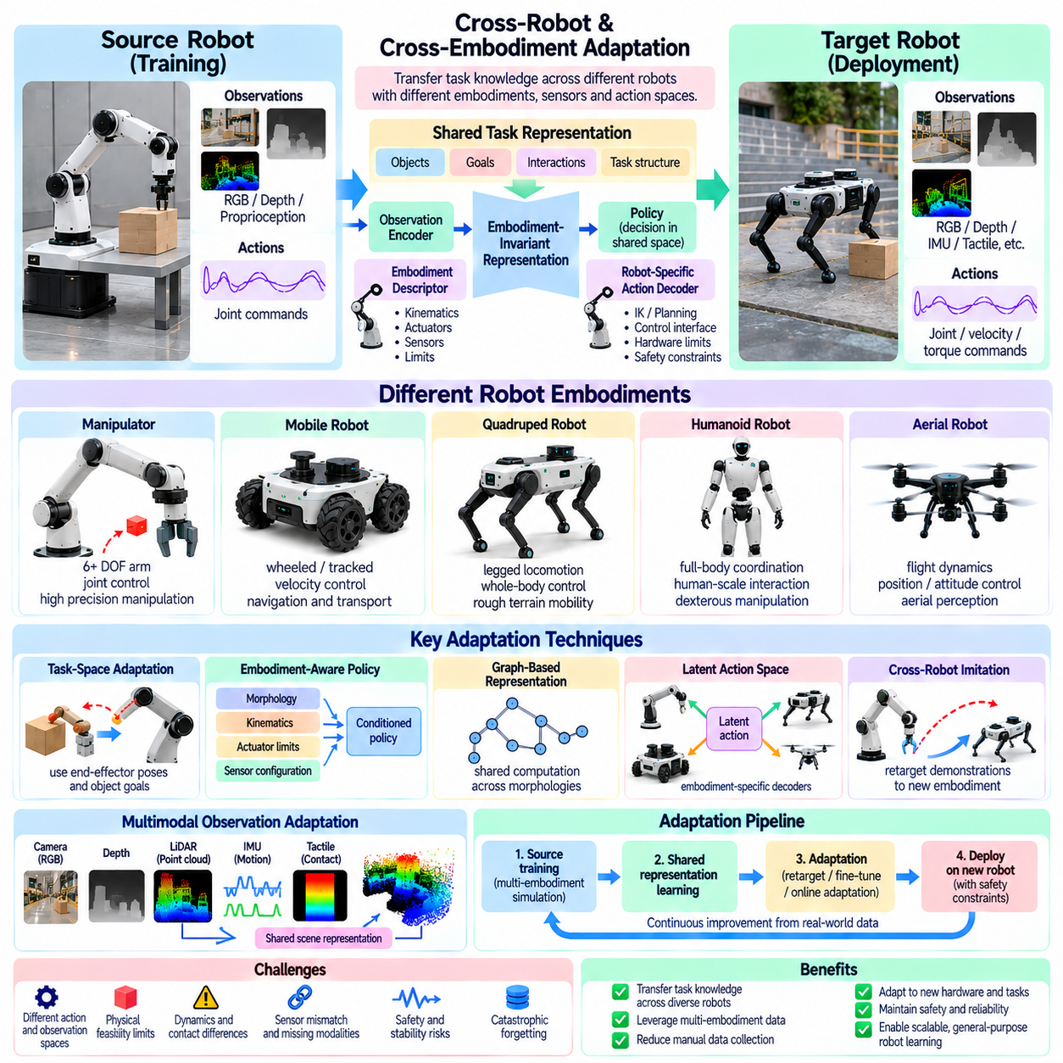
Cross-robot and cross-embodiment adaptation enables Physical AI systems to transfer learned capabilities between robots with different mechanical structures, sensors, actuators, and control interfaces. A policy trained on one robot may not operate directly on another because their action spaces and physical constraints differ. Adaptation seeks to preserve transferable task knowledge while accounting for the unique embodiment and operating characteristics of each robotic platform.
Robot embodiment determines how an intelligent system perceives, moves, and interacts with its environment. Differences in joint configuration, link dimensions, degrees of freedom, payload capacity, and actuator performance affect feasible behaviors. Even robots performing identical tasks may require different motion strategies. Cross-embodiment adaptation must therefore distinguish general task objectives from platform-specific mechanisms used to accomplish them.
A central challenge is the mismatch between observation and action spaces across robotic platforms. One manipulator may provide joint positions and torque commands, while another exposes Cartesian velocity or position control. Mobile robots may differ in steering geometry and motion constraints. Directly transferring numerical commands can produce invalid or unsafe actions. Adaptation requires mappings that preserve physical meaning across heterogeneous interfaces.
Shared representation learning provides a foundation for transferring knowledge between different embodiments. Instead of encoding every task exclusively through robot-specific joint coordinates, models can represent objects, goals, spatial relationships, and interaction outcomes. These representations support policies that reason about task requirements independently of hardware details. Embodiment-specific modules then translate shared intentions into executable actions.
Task-space adaptation expresses desired behavior using end-effector poses, object trajectories, contact states, or other physically meaningful variables. A manipulation task can be defined by the required object displacement rather than a particular sequence of joint angles. Inverse kinematics and motion planning convert these objectives into platform-specific commands. Transfer remains constrained by reachability, collision geometry, and actuator capabilities.
Embodiment-aware policy architectures explicitly condition decisions on robot morphology and hardware properties. Inputs may include joint topology, link lengths, mass distribution, actuator limits, and sensor placement. A shared policy can use these descriptors to select actions appropriate for different platforms. Such architectures require sufficiently diverse training examples to avoid overfitting to a narrow collection of robot designs.
Graph-based representations are useful because robotic mechanisms naturally form connected structures of links and joints. Graph neural networks can encode local relationships while sharing computational rules across different morphologies. This supports variable numbers of joints and alternative kinematic arrangements. However, structural flexibility does not automatically guarantee transfer when contact dynamics, control bandwidth, or sensing capabilities differ substantially.
Cross-robot imitation learning transfers behavioral knowledge from demonstrations collected on another platform. Demonstrations can be expressed as object motions, end-effector trajectories, or task outcomes instead of raw motor commands. Retargeting algorithms convert these demonstrations into feasible motions for the receiving robot. Retargeting must respect joint limits, workspace boundaries, collision constraints, and differences in manipulation capability.
Simulation provides a controlled environment for developing transferable policies across multiple embodiments. Training can expose models to robots with varied geometries, actuator strengths, sensor configurations, and payload limits. This diversity encourages learning of reusable task structure rather than dependence on one mechanical design. Nevertheless, simulated embodiment variation must remain physically plausible and include realistic control limitations.
Latent action representations offer another mechanism for connecting heterogeneous robots. A model can encode actions into a shared abstract space representing intended movement or interaction effects. Robot-specific decoders then convert latent commands into valid control signals. The quality of transfer depends on whether the shared space preserves task-relevant meaning without hiding critical differences in physical capability.
Cross-embodiment adaptation must also account for differences in sensor availability and placement. Robots may observe the same environment through wrist cameras, fixed cameras, depth sensors, or tactile arrays. Multimodal encoders can align observations into shared scene representations. However, missing viewpoints, occlusion, calibration differences, and unequal sensing precision can limit the information available to transferred policies.
Physical feasibility is a fundamental boundary of knowledge transfer. A policy learned from a highly dexterous manipulator cannot automatically reproduce its behavior on a simpler gripper. Differences in reach, payload, torque, speed, and contact geometry may make certain tasks impossible. Adaptation should therefore evaluate capability compatibility and modify task strategies when direct behavioral reproduction is infeasible.
Safety becomes especially important when transferring policies between robots with different dynamics. Actions that are stable on one platform may cause excessive forces, collisions, or instability on another. Adaptation should incorporate hardware-specific constraints, verified motion limits, and independent safety supervision. Candidate policies can be tested in simulation and restricted physical trials before receiving operational authority.
Evaluation should distinguish task-level transfer from mechanical imitation. Successful adaptation means that the receiving robot achieves the intended objective, not necessarily that it reproduces the source robot's movements. Metrics may include task success, transfer efficiency, trajectory feasibility, energy consumption, and safety violations. Testing across unfamiliar embodiments helps determine whether learned representations capture genuinely transferable knowledge.
Ultimately, cross-robot and cross-embodiment adaptation supports the development of reusable Physical AI capabilities across heterogeneous robotic systems. Shared task representations, morphology-aware policies, demonstration retargeting, and latent action mappings provide complementary transfer mechanisms. Their effectiveness depends on respecting embodiment constraints, preserving physical meaning, and validating performance on each target platform.

04.13. Domain Generalization
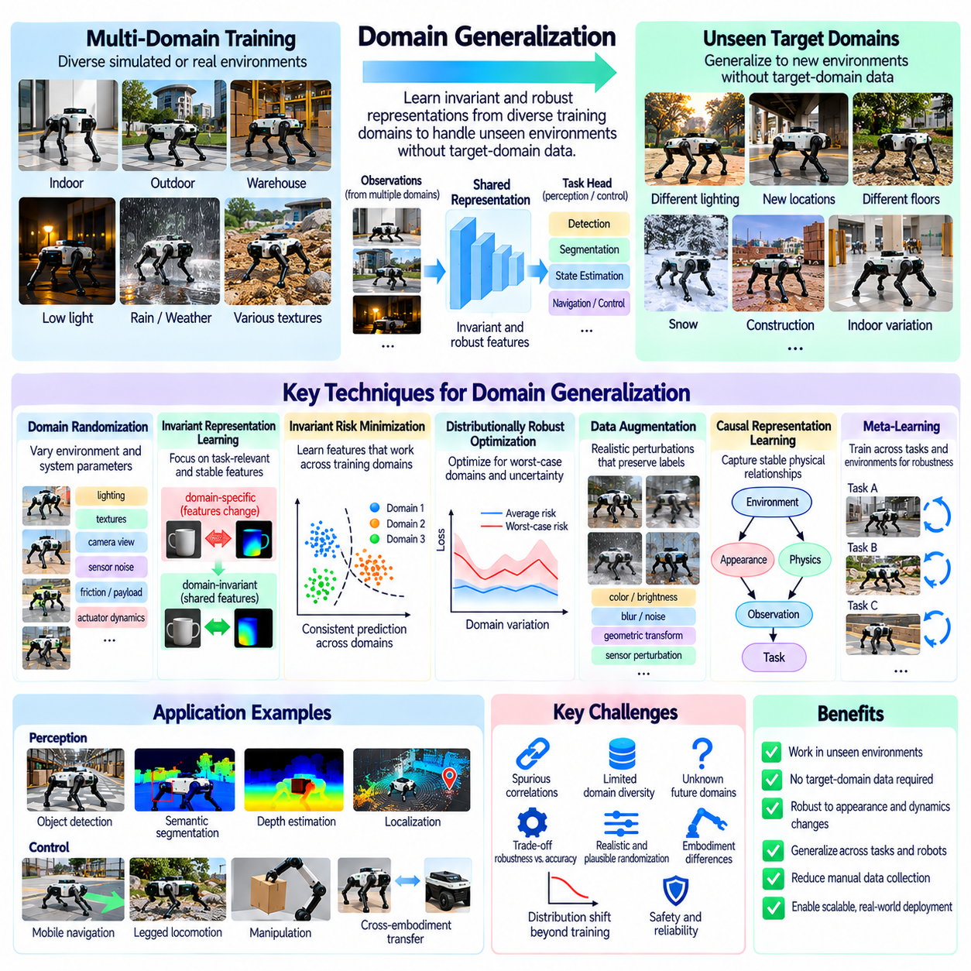
Domain generalization enables Physical AI systems to perform reliably in environments that were not encountered during training, without requiring access to target-domain data. Unlike domain adaptation, which uses information from a specific deployment environment, domain generalization learns representations and policies that remain effective across unknown conditions. This capability is essential for robots operating in diverse and unpredictable physical environments.
The central challenge is that training environments contain correlations that may not hold in deployment. A perception model may associate particular textures, colors, or lighting patterns with objects rather than learning their underlying structure. Similarly, a control policy may depend on specific friction or actuator characteristics. Domain generalization seeks to reduce reliance on these incidental relationships while preserving information that supports robust task execution.
Multi-domain training is a fundamental approach to domain generalization. Models are trained using observations collected from multiple simulated or real environments with different visual, geometric, and physical properties. Exposure to diverse domains encourages learning of shared patterns that remain useful across conditions. However, diversity alone does not guarantee generalization if important deployment variations are absent from the training distribution.
Domain randomization expands training diversity by varying environmental and system parameters. Lighting, textures, camera viewpoints, object arrangements, sensor noise, friction, payloads, and actuator response can be randomized within plausible ranges. The objective is to prevent policies from depending on a narrow collection of simulation characteristics. Randomization distributions must remain physically meaningful because unrealistic combinations can reduce learning efficiency.
Invariant representation learning attempts to identify features that preserve task-relevant meaning across environments. For visual perception, object geometry and spatial relationships may be more transferable than background textures or illumination. For control, physical constraints and action consequences may be more stable than particular actuator parameters. Learning invariance requires care because some environmental variations directly affect the correct action.
Invariant risk minimization encourages models to identify predictive relationships that remain effective across training domains. Rather than optimizing average performance alone, the objective favors representations supporting consistent predictions under environmental changes. In practice, optimization can be difficult, and apparent invariance may not extend to unseen conditions. Strong evaluation is therefore necessary before interpreting learned features as genuinely domain-independent.
Distributionally robust optimization addresses uncertainty by improving performance under unfavorable shifts in data distribution. Instead of minimizing only average training loss, it considers difficult domains or plausible alternative distributions. This can reduce vulnerability to rare operating conditions and underrepresented environments. Excessive emphasis on worst-case performance, however, may sacrifice efficiency or accuracy in common situations.
Data augmentation provides another mechanism for improving generalization without collecting entirely new environments. Images can undergo realistic changes in color, brightness, blur, and noise, while sensor measurements can be perturbed according to device characteristics. Augmentations should preserve task labels and physical relationships. Transformations that remove obstacles or distort contact geometry may create incorrect training signals.
Causal representation learning seeks to distinguish stable physical relationships from superficial correlations. A robot should recognize that object motion depends on applied forces and contact conditions rather than background appearance. Causal reasoning may help transfer knowledge across environments with different visual characteristics. Nevertheless, identifying causal structure from observational data alone is difficult and often requires interventions or physical assumptions.
Meta-learning can support domain generalization by training models across collections of related tasks and environments. During training, models repeatedly experience changes in conditions and learn parameters that support robust behavior across these variations. Some methods simulate domain shifts between training subsets to encourage transferable knowledge. The effectiveness of meta-learning depends on whether these simulated shifts resemble meaningful deployment challenges.
For robotic perception, domain generalization supports object detection, semantic segmentation, depth estimation, and localization across unfamiliar environments. Training should include variation in illumination, weather, scene geometry, and sensor characteristics. Models should prioritize stable spatial and semantic information. Evaluation must consider whether performance remains reliable when several unfamiliar conditions occur simultaneously.
For robotic control, generalization requires policies that tolerate uncertain dynamics, payload changes, surface friction, and external disturbances. Robust control objectives and randomized simulation can expose policies to a broad range of physical conditions. However, no policy can safely compensate for unlimited variation. Explicit operating boundaries and fallback controllers remain necessary when conditions exceed validated capabilities.
Cross-embodiment generalization extends these principles to robots with different mechanical structures and sensing configurations. Shared task representations can encode goals independently of specific joint arrangements, while morphology-aware policies incorporate hardware constraints. Training across multiple robot designs may improve transfer to unfamiliar platforms. Physical feasibility must still be verified because different embodiments may not support identical behaviors.
Evaluation should use held-out domains that differ meaningfully from the environments used during training. Tests may vary lighting, sensor noise, object materials, robot dynamics, and combinations of disturbances. Metrics should include task success, worst-domain performance, failure frequency, and safety violations. Random train-test splits are insufficient when similar environments appear in both sets, because they can conceal dependence on domain-specific shortcuts.
Ultimately, domain generalization aims to develop Physical AI systems that remain capable when deployment conditions differ from expectations. Multi-domain learning, randomization, invariant representations, robust optimization, and causal reasoning provide complementary strategies. Their effectiveness depends on realistic training diversity, preservation of physical constraints, and systematic evaluation under genuinely unfamiliar conditions.

04.14. Domain Adaptation Example [w/Code]
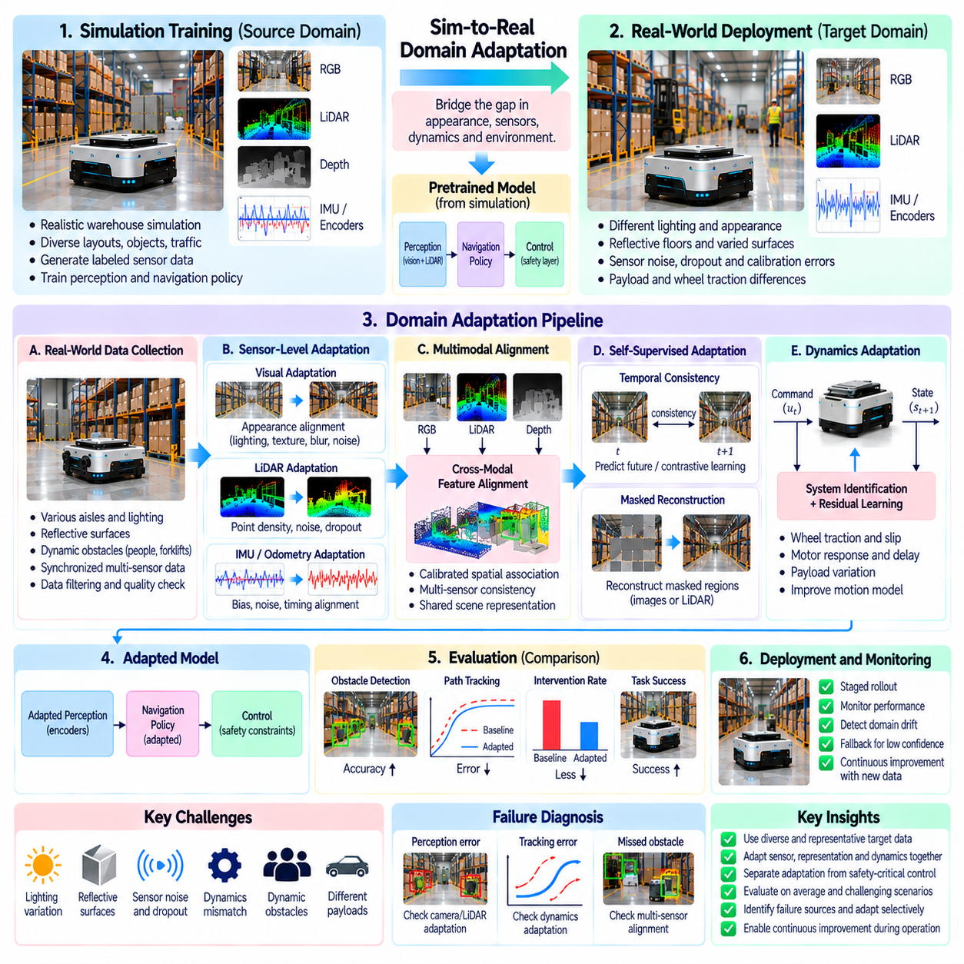
A practical domain adaptation example can be developed around an autonomous mobile robot trained in simulation and deployed in a real warehouse. The robot uses RGB cameras, LiDAR, wheel encoders, and inertial sensors to navigate aisles and avoid obstacles. Although its navigation policy performs well in simulation, real deployment introduces differences in lighting, floor reflectivity, sensor noise, and wheel traction that can reduce reliability.
The initial simulation environment represents warehouse geometry, shelving, pallets, mobile equipment, and pedestrian traffic. Synthetic sensor observations are generated while the robot follows planned routes under varied operating conditions. The training process produces perception and navigation models capable of recognizing obstacles and estimating traversable space. However, the simulator cannot perfectly reproduce every characteristic of the physical warehouse.
Before adaptation, a baseline evaluation establishes how the simulation-trained system performs on real hardware. The robot executes controlled navigation trials while recording camera images, LiDAR scans, localization estimates, control commands, and safety events. Measurements include obstacle detection accuracy, path tracking error, intervention frequency, and task completion. These results provide a reference for assessing subsequent adaptation improvements.
Data collection focuses on representative target-domain conditions rather than recording volume alone. The robot observes different aisles, illumination levels, reflective surfaces, loading configurations, and pedestrian movements. Sensor streams are synchronized and associated with robot poses and operating states. Data quality checks identify corrupted measurements, calibration errors, and incomplete recordings before the observations enter the adaptation pipeline.
Visual domain adaptation addresses the differences between rendered warehouse images and real camera observations. Synthetic images may contain uniform lighting and simplified surface textures, while real scenes include shadows, glare, and motion blur. Image-level transformations can increase visual similarity, while feature-level alignment encourages domain-invariant representations. Adaptation must preserve obstacle boundaries and spatial relationships.
LiDAR adaptation addresses differences in point density, range noise, reflectivity, and missing measurements. Real scans may contain sparse returns from dark surfaces or unreliable observations around reflective materials. The simulation model can introduce realistic dropout and measurement uncertainty. A geometric feature encoder may also be adapted using unlabeled real scans, provided that structural information remains consistent across domains.
Multimodal alignment ensures that visual and geometric representations describe compatible physical structures. Camera features can be associated with LiDAR points through calibrated spatial transformations. Cross-modal consistency objectives encourage corresponding observations to support similar obstacle and free-space interpretations. Accurate timestamp alignment is essential because robot motion can otherwise create apparent disagreement between sensors.
Self-supervised adaptation uses unlabeled warehouse observations to refine learned representations. Consecutive images provide temporal correspondence, while LiDAR geometry supports spatial consistency constraints. The robot may learn to predict future features or reconstruct masked sensor information. These auxiliary objectives reduce dependence on manual annotation, although their improvements must be verified against actual navigation performance.
Dynamics adaptation addresses discrepancies between simulated wheel motion and real vehicle behavior. Variations in payload, floor friction, motor response, and wheel slip can produce tracking errors even when perception is accurate. Controlled motion trials provide data for estimating effective traction and actuator response. Updated motion models can improve trajectory prediction while maintaining conservative speed and acceleration limits.
The adaptation architecture separates perception updates from safety-critical motion control. Visual and geometric encoders may be fine-tuned offline using collected target-domain data. Candidate models are then evaluated through recorded-data replay and simulation before deployment. The verified navigation controller retains independent collision constraints, emergency stopping functions, and fallback behavior when perception confidence becomes insufficient.
A staged deployment process reduces the risk of introducing unvalidated model behavior. Initial trials occur in controlled warehouse sections with limited traffic and defined operating boundaries. Adapted models are compared against the original baseline under equivalent conditions. Performance is monitored for improvements and unexpected regressions, including failures that occur only under rare lighting or sensor conditions.
Evaluation considers both average performance and difficult operating scenarios. Test conditions include bright reflections, dim aisles, partially occluded obstacles, changing payloads, and slippery surfaces. Metrics cover obstacle detection, localization stability, path tracking, intervention frequency, and collision-related safety events. Separate held-out routes help determine whether adaptation generalizes beyond the data used for training.
The example also illustrates why adaptation must remain selective. If perception errors arise from camera exposure, updating wheel dynamics will not solve the underlying problem. Similarly, poor path tracking caused by wheel slip cannot be corrected through visual feature alignment alone. Diagnostic analysis should identify whether observed failures originate from sensing, representation learning, state estimation, or physical control.
After successful validation, the warehouse robot can incorporate additional operational data through a controlled improvement cycle. New observations are filtered, categorized, and used for periodic offline adaptation. Each updated model is compared against established performance and safety criteria before release. Version tracking and rollback procedures preserve the ability to restore previously validated behavior if unexpected degradation appears.
Ultimately, this warehouse navigation example demonstrates domain adaptation as an integrated engineering process rather than a single learning algorithm. Visual alignment, sensor modeling, self-supervised learning, dynamics identification, and controlled deployment address different aspects of the simulation-to-reality gap. Reliable transfer depends on selecting appropriate adaptation mechanisms, preserving safety boundaries, and verifying improvements through representative real-world tests.

