Volume 05. Simulation and Sim2Real Transfer

Chapter 09. Benchmark Environments

09.01. Benchmark Environment Design Principles
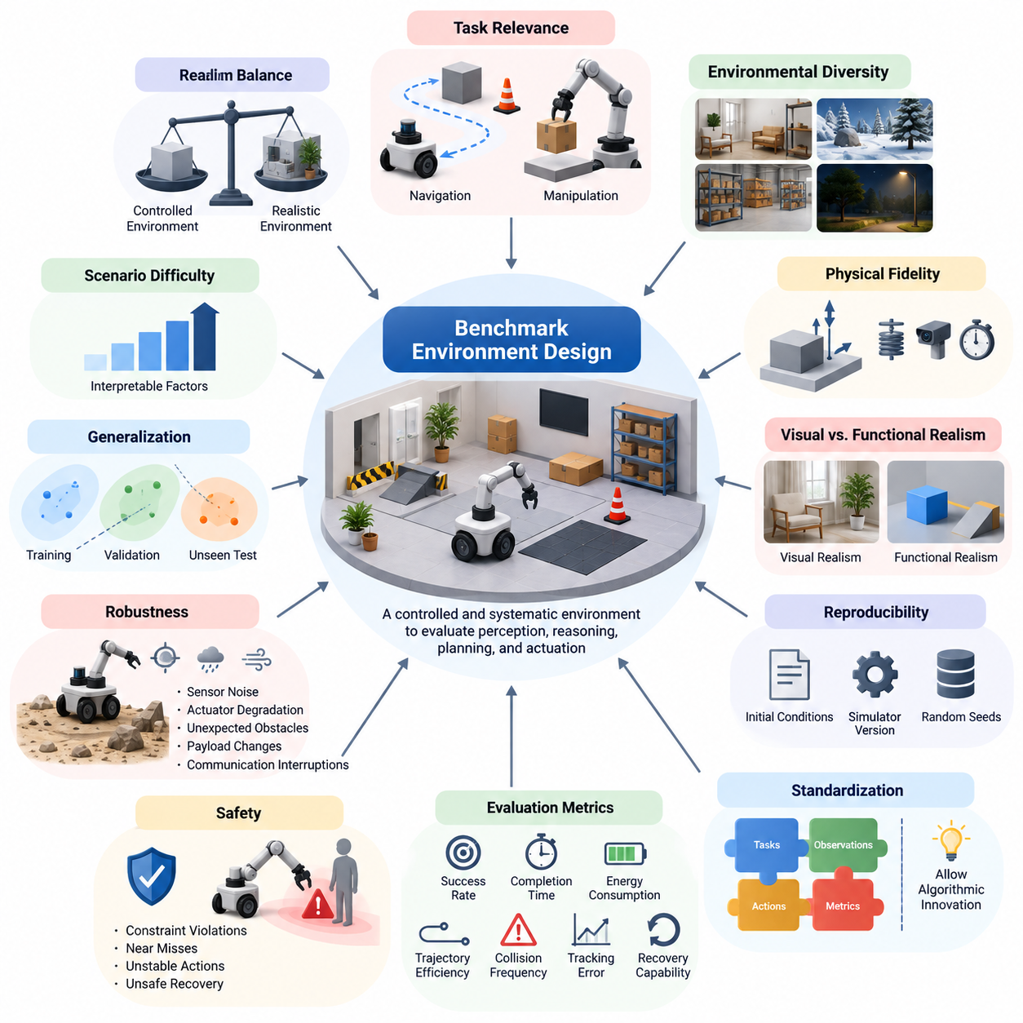
Benchmark environment design is a foundational discipline in Physical AI because evaluation results are meaningful only when tasks, conditions, and measurement procedures are clearly defined. A benchmark environment provides a controlled framework for examining how intelligent physical systems perceive, reason, plan, and act. Its purpose extends beyond measuring task completion to understanding reliability, adaptability, efficiency, and operational limitations.
A well-designed benchmark must balance scientific reproducibility with the complexity of real-world operation. Highly controlled environments make comparisons easier but may exclude important physical uncertainties. Realistic environments capture richer interactions but introduce variability that complicates interpretation. Effective benchmark design therefore combines standardized experimental conditions with carefully selected variations that represent meaningful deployment challenges.
Task relevance is the first major design principle. Benchmark tasks should reflect capabilities required in practical applications rather than reward behaviors that exploit artificial simulation conditions. Navigation benchmarks may evaluate obstacle avoidance, route planning, and localization, while manipulation benchmarks examine grasping, placement, and contact-rich interactions. Each task must connect measurable outcomes to a clearly defined physical capability.
Environmental diversity is essential for evaluating generalization. Physical AI systems encounter changing layouts, materials, lighting, terrain, obstacles, and human activities. A benchmark should incorporate these variations systematically without making comparisons arbitrary. Structured diversity allows researchers to determine whether a policy has learned transferable behavior or merely memorized recurring configurations encountered during training.
Physical fidelity determines whether benchmark outcomes accurately represent the consequences of actions. Relevant models may include rigid-body dynamics, friction, collision response, actuator limitations, sensor imperfections, and communication delays. Fidelity requirements should follow the task being evaluated. A grasping benchmark demands accurate contact behavior, whereas a navigation benchmark may prioritize geometry, perception, and motion constraints.
Benchmark environments must distinguish between visual realism and functional realism. Photorealistic rendering can improve the evaluation of vision-based systems, but realistic appearance alone does not guarantee meaningful physical behavior. Conversely, simplified rendering may be sufficient for evaluating certain control algorithms. Designers should allocate simulation fidelity according to the physical mechanisms and information channels that influence task outcomes.
Reproducibility requires precise control over initial conditions, random seeds, simulator versions, robot configurations, and evaluation procedures. Two systems should encounter equivalent experimental conditions when their performance is compared. Benchmark specifications must also document software dependencies, physical parameters, sensor configurations, and termination criteria. Without these controls, observed performance differences may reflect experimental inconsistencies.
Standardization should preserve fairness without unnecessarily restricting algorithmic innovation. A benchmark can define common tasks, observations, action interfaces, and performance measures while allowing different learning architectures and control strategies. When systems use different sensors or computational resources, those differences should be explicitly documented. Fair comparison requires transparent experimental assumptions rather than identical internal implementations.
Evaluation metrics must capture multiple dimensions of physical intelligence. Task success rate provides an intuitive measure but cannot fully describe system quality. Completion time, energy consumption, trajectory efficiency, collision frequency, tracking error, and recovery capability provide complementary information. Metrics should be selected according to operational objectives and reported together to prevent misleading conclusions based on a single performance indicator.
Safety is a fundamental requirement because successful task execution does not necessarily imply acceptable behavior. A robot may reach its destination while approaching obstacles dangerously or applying excessive force during manipulation. Benchmark environments should record constraint violations, near misses, unstable actions, and unsafe recovery attempts. Safety-related measurements must remain visible even when a system achieves high aggregate task success.
Robustness evaluation requires controlled disturbances and uncertainty. Sensor noise, actuator degradation, unexpected obstacles, payload changes, and communication interruptions can reveal weaknesses that nominal tests overlook. Disturbance intensity should be measurable and progressively adjustable. By examining performance across increasing difficulty levels, benchmark designers can identify operational boundaries rather than reporting only average outcomes under favorable conditions.
Generalization testing must separate familiar evaluation conditions from genuinely unseen situations. Training environments, validation scenarios, and final test configurations should be managed independently to reduce information leakage. Unseen object arrangements, terrain properties, lighting distributions, and task combinations can expose overfitting. Strong benchmark protocols measure whether learned capabilities transfer beyond the particular examples used during development.
Scenario difficulty should be organized around interpretable factors rather than arbitrary complexity. Navigation difficulty may depend on obstacle density, route ambiguity, or dynamic traffic, while manipulation difficulty may depend on object geometry, contact uncertainty, and precision requirements. Parameterized difficulty enables systematic performance analysis. It also supports curriculum-based development without confusing training progression with independent final evaluation.
Benchmark design must account for differences in robot morphology and embodiment. Wheeled mobile robots, manipulators, quadrupeds, humanoids, and aerial robots possess distinct capabilities and physical constraints. Identical tasks may not represent equivalent difficulty across platforms. Cross-embodiment evaluation should therefore distinguish common functional objectives from embodiment-specific execution requirements, ensuring that comparisons remain meaningful.
Observation and action interfaces are another critical consideration. Benchmarks should clearly define available sensory information, coordinate systems, sampling frequencies, control commands, and actuator limits. Privileged simulator information must not unintentionally enter policies intended to operate with real sensors. Explicit interface specifications help separate improvements in perception, decision-making, and control from advantages caused by inaccessible information.
Simulation performance influences benchmark scalability and experimental validity. Large-scale evaluations may require thousands of episodes across varied scenarios, making computational efficiency important. However, increasing simulation throughput must not introduce unacceptable numerical errors or altered physical behavior. Benchmark designers should document simulation time steps, solver settings, execution hardware, and real-time factors when these characteristics affect evaluation results.
Statistical reliability requires repeated experiments and transparent uncertainty reporting. Performance measured from a small number of episodes may be dominated by random initial conditions or rare events. Multiple seeds, representative scenario distributions, and confidence intervals provide stronger evidence of system capability. Benchmark reports should distinguish statistically meaningful improvements from fluctuations caused by sampling variation or experimental noise.
Sim2Real relevance is particularly important for benchmarks intended to support physical deployment. Simulation results should be compared with corresponding real-world experiments whenever practical. Differences in perception, dynamics, latency, and task outcomes can reveal whether the benchmark predicts deployment performance. A useful benchmark does not simply reward simulation success; it helps identify the conditions under which simulation-derived conclusions remain valid.
Failure analysis should be integrated into benchmark design rather than treated as an optional postprocessing activity. Recording trajectories, observations, control actions, contact events, and termination causes enables detailed diagnosis. Failures can be categorized according to perception errors, planning mistakes, control instability, environmental uncertainty, or safety violations. Such classifications transform benchmark results into actionable information for system improvement.
Long-horizon tasks introduce additional requirements because small errors can accumulate across extended sequences of actions. A robot may successfully complete individual navigation or manipulation operations while failing during their coordinated execution. Benchmark environments should evaluate task dependencies, recovery behavior, state consistency, and sustained operation. These measurements reveal capabilities that short isolated episodes cannot adequately characterize.
Human interaction introduces another layer of complexity. Physical AI systems deployed in shared environments must respond to unpredictable movement, communication, and behavioral variation. Benchmarks involving humans should represent realistic interaction patterns while protecting safety and privacy. Evaluation criteria may include collision avoidance, responsiveness, task coordination, and appropriate behavior under ambiguous instructions or changing human intentions.
Benchmark governance is necessary to preserve long-term credibility. Scenario definitions, scoring rules, simulator updates, and dataset revisions should be version controlled and publicly documented when appropriate. Hidden evaluation scenarios can reduce overfitting, but their construction and governance must remain trustworthy. Transparent maintenance procedures help prevent benchmark scores from becoming disconnected from genuine advances in physical intelligence.
A modular benchmark architecture supports continuous expansion without sacrificing comparability. Robot models, environment assets, task definitions, sensor configurations, and evaluation modules can be maintained as separate components with stable interfaces. This structure facilitates the introduction of new embodiments and scenarios while retaining established reference tests. Modular design also simplifies integration with automated testing and simulation pipelines.
Ultimately, benchmark environment design should establish a reliable connection between experimental evidence and real-world capability. Effective benchmarks combine task relevance, controlled diversity, physical fidelity, reproducibility, safety, and statistical rigor. Their greatest value lies not in producing rankings alone but in revealing strengths, limitations, and transferability. This foundation enables systematic development and trustworthy evaluation of increasingly capable Physical AI systems.

09.02. Reproducibility and Standardized Scenarios
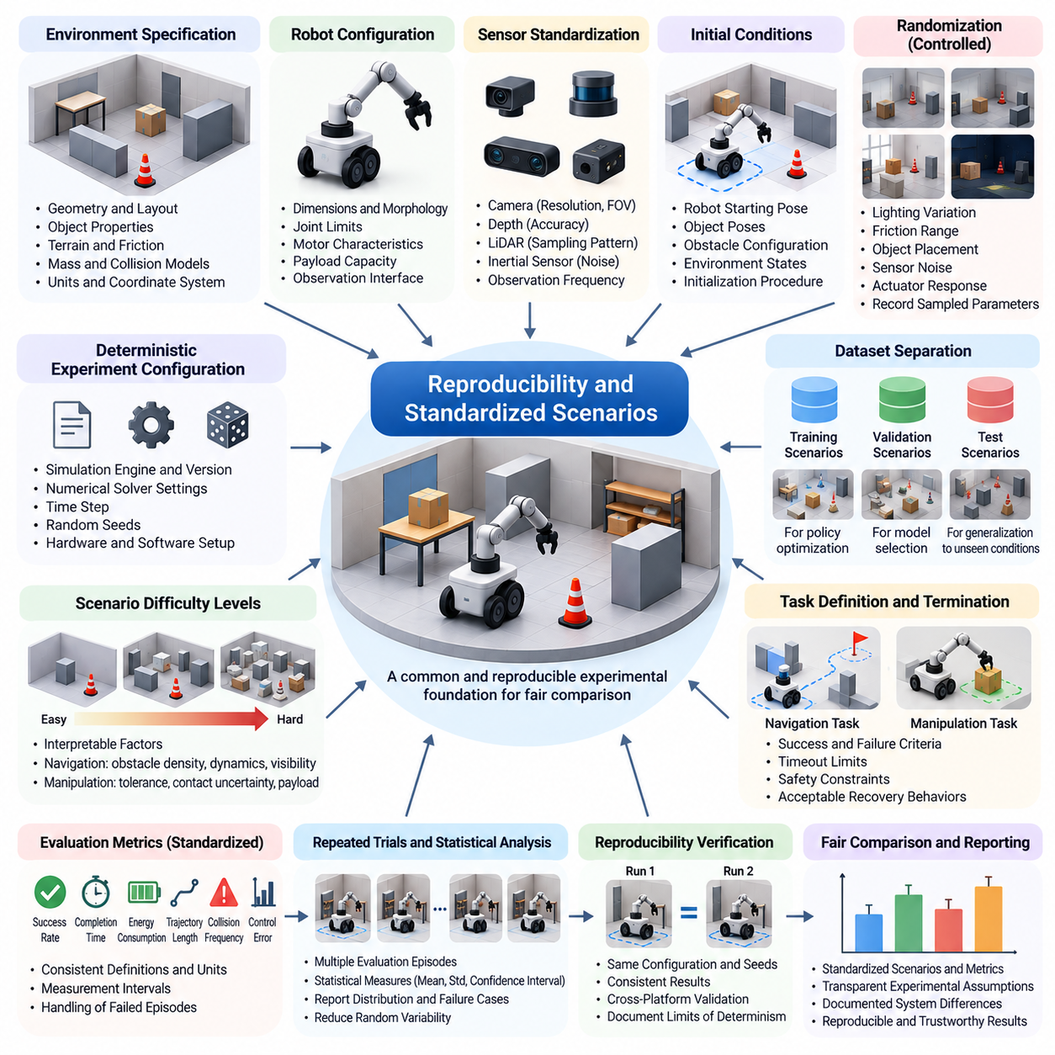
Reproducibility is a fundamental requirement for trustworthy Physical AI benchmarking because experimental results must remain consistent when equivalent conditions are repeated. A reproducible benchmark allows researchers to distinguish genuine improvements in perception, planning, and control from variations introduced by simulation settings. Standardized scenarios provide the common experimental foundation needed to compare different algorithms, robot platforms, and learning methods.
A standardized scenario defines the physical environment, robot configuration, task objective, initial conditions, and evaluation procedure. These specifications establish a shared reference against which system behavior can be measured. Without consistent scenario definitions, differences in obstacle placement, object properties, sensor configurations, or termination conditions may produce misleading performance comparisons between otherwise similar systems.
Reproducibility begins with deterministic experiment configuration. Simulation engines, numerical solvers, integration time steps, and random number generators must be configured consistently across evaluation runs. Random seeds should be recorded and controlled to reproduce environment initialization and stochastic events. However, deterministic settings alone do not guarantee identical results across different hardware architectures or software implementations.
Scenario standardization requires explicit definitions of environmental geometry and physical properties. Terrain profiles, object dimensions, surface friction, mass distributions, and collision boundaries should be documented using consistent units and coordinate systems. These specifications enable independent researchers to reconstruct equivalent conditions while reducing uncertainty caused by incomplete descriptions of the simulated physical environment.
Robot configuration is equally important because differences in morphology, actuator capabilities, and sensor placement directly influence task difficulty. Benchmark specifications should identify robot dimensions, joint limits, motor characteristics, payload restrictions, and observation interfaces. When multiple robot embodiments are supported, standardized capability categories can preserve meaningful comparisons without requiring every platform to share identical hardware.
Sensor standardization ensures that evaluated systems receive clearly defined information. Camera resolution, field of view, depth accuracy, LiDAR sampling patterns, inertial sensor noise, and observation frequency can significantly influence performance. Benchmark protocols should distinguish raw sensor observations from privileged simulator states. This separation prevents algorithms from gaining unintended advantages through information unavailable during real-world deployment.
Initial conditions must be specified carefully because small differences can change task outcomes. Robot starting positions, object poses, obstacle configurations, and environmental states should follow documented initialization procedures. Fixed scenarios support direct comparison, while controlled randomization introduces measurable diversity. Both approaches are useful when their purposes are clearly separated within the benchmark evaluation protocol.
Randomization should follow standardized probability distributions rather than arbitrary parameter selection. Variations in lighting, friction, object placement, sensor noise, and actuator response must be bounded by documented ranges. Recording sampled parameters allows experiments to be reconstructed and analyzed. Standardized randomization also helps determine whether performance differences arise from algorithm quality or unequal exposure to environmental difficulty.
A robust benchmark distinguishes training, validation, and testing scenarios. Training scenarios support policy optimization, while validation scenarios guide model selection and development decisions. Independent test scenarios provide evidence of generalization to previously unseen conditions. Maintaining this separation reduces evaluation leakage and discourages algorithms from memorizing specific environments instead of learning transferable physical behaviors.
Scenario difficulty should be organized into interpretable levels based on measurable physical and operational factors. Navigation complexity may increase through obstacle density, dynamic movement, or reduced visibility. Manipulation complexity may increase through tighter tolerances, uncertain contact properties, or changing payloads. Standardized difficulty levels allow researchers to evaluate performance degradation systematically rather than relying on isolated success measurements.
Task definitions must include unambiguous success and failure criteria. A navigation task may require reaching a specified region without collision, while manipulation may require placing an object within defined position and orientation tolerances. Timeout limits, safety constraints, and acceptable recovery behaviors must also be specified. Clear termination rules prevent different implementations from interpreting the same task outcome inconsistently.
Evaluation metrics should be calculated through standardized procedures. Success rate, completion time, energy consumption, trajectory length, collision frequency, and control error must use consistent definitions and measurement intervals. Metrics should also specify whether failed episodes contribute to aggregate statistics. Without these conventions, identical robot behaviors can produce different reported scores depending on the evaluation implementation.
Repeated trials are necessary because stochastic environments and learning algorithms introduce statistical variability. Benchmark protocols should define the number of evaluation episodes, seed selection procedures, and aggregation methods. Reporting means, dispersion measures, and confidence intervals provides a more reliable representation of performance. Statistical analysis helps distinguish meaningful algorithmic improvements from random fluctuations in experimental outcomes.
Software version control is essential for preserving reproducibility over time. Physics engines, rendering libraries, robot models, environment assets, and evaluation scripts may change between releases. Even minor updates can alter contact dynamics, numerical stability, or sensor outputs. Benchmark releases should therefore maintain identifiable versions, dependency specifications, and documented changes that could influence previously reported experimental results.
Hardware differences can introduce additional reproducibility challenges. CPU and GPU architectures, parallel execution strategies, floating-point precision, and scheduling behavior may affect simulation outcomes. These differences become especially important in large-scale parallel reinforcement learning environments. Benchmark documentation should record relevant hardware configurations and identify tolerances within which results are considered equivalent rather than assuming universal numerical identity.
Simulation timing must be standardized to preserve meaningful physical comparisons. Physics integration frequency, sensor update intervals, controller execution rates, and communication delays influence system behavior. A policy evaluated with different control frequencies may experience substantially different dynamics. Explicit timing specifications ensure that observed improvements reflect algorithmic capabilities rather than unintended differences in simulation or control execution.
Standardized logging provides the evidence required to reproduce and diagnose experimental outcomes. Benchmark systems should record scenario identifiers, configuration parameters, random seeds, robot states, observations, actions, rewards, and termination causes. Time-synchronized logs support trajectory replay and detailed failure analysis. Consistent data formats also enable automated comparison across experiments conducted by different research groups.
Automated benchmark execution reduces human intervention and procedural inconsistencies. Evaluation pipelines can initialize scenarios, deploy policies, execute trials, collect measurements, and generate reports using predefined configurations. Automated validation should verify that required assets, software versions, and robot interfaces match benchmark specifications. This approach improves experimental repeatability while supporting large-scale evaluation across many scenarios.
Scenario coverage must extend beyond nominal operating conditions to include disturbances and rare events. Unexpected obstacles, sensor failures, actuator degradation, and communication interruptions can reveal vulnerabilities hidden by routine testing. These events should be generated through documented mechanisms with controlled severity. Standardized disturbance scenarios make robustness comparisons more interpretable and support systematic identification of operational limits.
Real-world reproducibility introduces challenges that cannot be eliminated through software configuration alone. Physical robots experience variations in wear, calibration, temperature, battery condition, and environmental interaction. Benchmark protocols should document calibration procedures, maintenance conditions, and measurable environmental factors. Repeated physical trials and controlled experimental preparation help establish comparable conditions without assuming that the real world is perfectly deterministic.
Sim2Real evaluation requires paired simulation and physical scenarios with clearly defined correspondence. Robot configurations, task objectives, environmental geometry, and measurement procedures should be aligned wherever practical. Differences between simulated and physical outcomes can then be attributed more systematically to modeling errors or deployment uncertainties. Standardized paired experiments provide a stronger foundation for assessing transfer performance than unrelated simulation and real-world tests.
Benchmark governance is necessary to maintain comparability as scenarios and technologies evolve. Changes to task definitions, scoring methods, physical parameters, or evaluation assets should be documented and versioned. Historical results should remain associated with the benchmark versions under which they were obtained. Transparent governance prevents silent changes from invalidating comparisons and supports the long-term credibility of published benchmark results.
Ultimately, reproducibility and standardized scenarios transform Physical AI benchmarking from isolated demonstrations into a systematic experimental discipline. Clear specifications, controlled randomness, consistent metrics, versioned software, and transparent reporting establish a common basis for evaluating intelligent physical systems. This foundation supports reliable scientific comparison, meaningful Sim2Real analysis, and continuous improvement of increasingly capable robotic technologies.

09.03. Standard Robots Sensors Tasks and Metrics
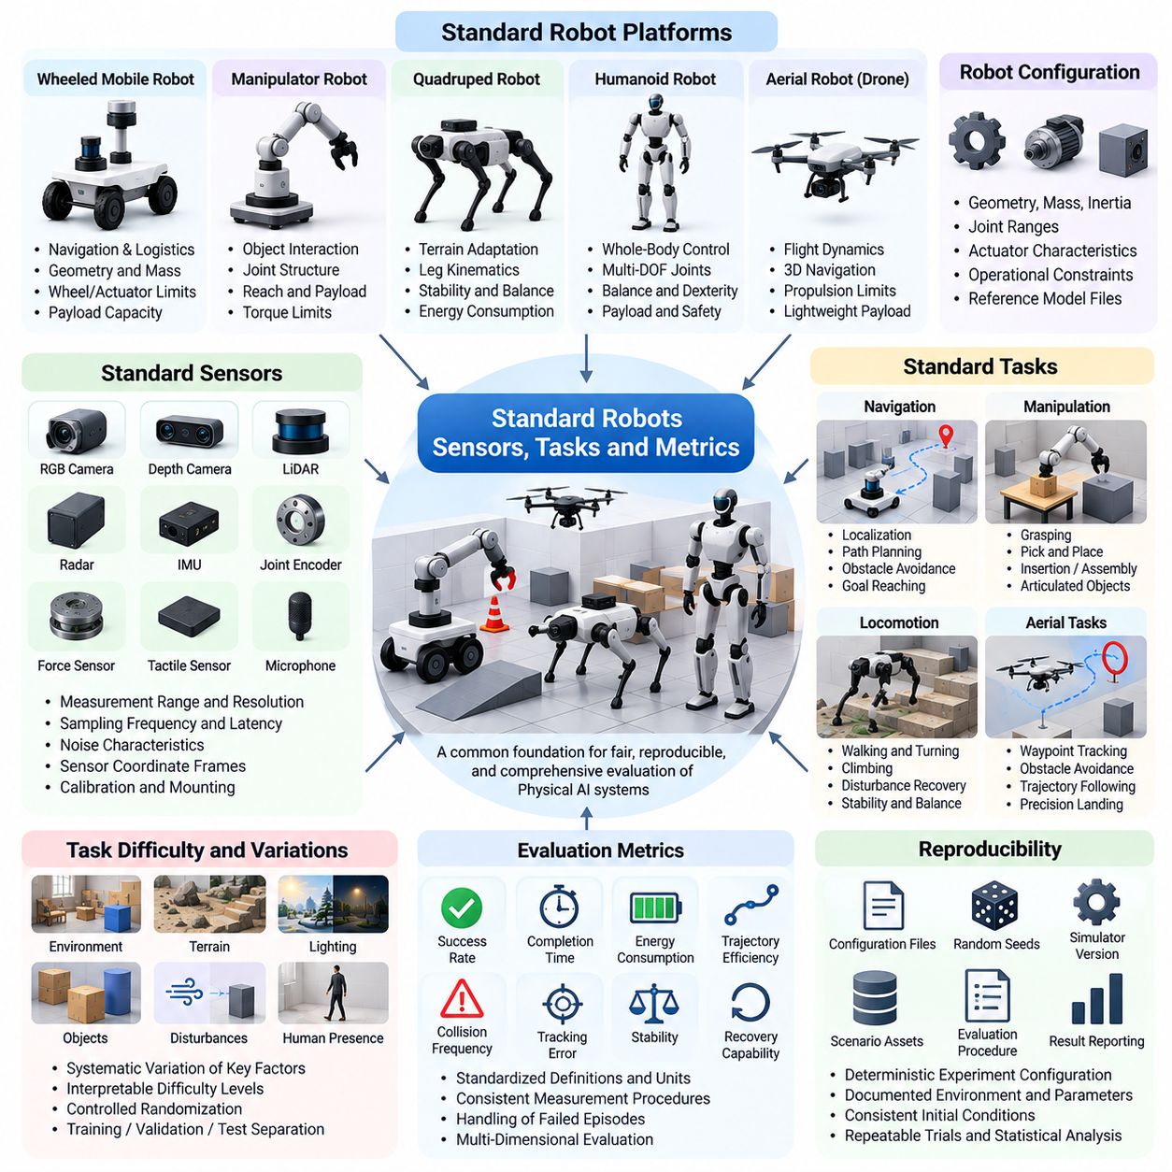
Standard robots, sensors, tasks, and metrics establish a common foundation for evaluating Physical AI systems under comparable experimental conditions. Without standardized reference configurations, performance differences may reflect hardware advantages or inconsistent measurement procedures rather than algorithmic improvements. A well-structured benchmark defines representative robotic platforms, observation capabilities, task objectives, and evaluation criteria while preserving sufficient flexibility for technological innovation.
Standard robot models provide consistent physical embodiments for testing perception, planning, learning, and control algorithms. These models specify geometry, mass, inertia, joint structures, actuator characteristics, and operational constraints. Reference platforms reduce uncertainty when comparing methods developed by different research groups. They also enable repeatable experiments across simulation engines, although numerical and modeling differences must still be documented.
Robot selection should reflect the diversity of Physical AI applications. Wheeled mobile robots represent navigation and logistics, manipulators represent object interaction, quadrupeds represent terrain adaptation, and humanoids represent whole-body coordination. Aerial robots introduce flight dynamics and three-dimensional navigation. Each platform category requires representative configurations that capture its essential capabilities without unnecessarily increasing benchmark complexity.
Robot morphology directly influences benchmark difficulty and achievable performance. Wheel dimensions, joint ranges, manipulator reach, payload capacity, and actuator torque determine the actions available to a system. Standard configurations should therefore include physical limits and relevant dynamic parameters. When alternative embodiments are evaluated, performance comparisons must account for differences in mobility, dexterity, stability, and energy requirements.
Sensor standardization defines the information available to intelligent agents during evaluation. Common sensing modalities include RGB cameras, depth cameras, LiDAR, radar, inertial measurement units, joint encoders, force sensors, and tactile arrays. Each sensor model should specify measurement range, resolution, sampling frequency, latency, and noise characteristics. Consistent specifications prevent differences in observation quality from being mistaken for improvements in algorithmic intelligence.
Observation interfaces should distinguish realistic sensor measurements from privileged simulation information. Ground-truth object poses, perfect velocity estimates, and exact contact forces may be useful for debugging or training but are not always available during deployment. Benchmarks should explicitly define which information channels are accessible to evaluated policies. This separation supports fair comparisons and strengthens the relevance of simulation results to physical systems.
Sensor placement and calibration are as important as sensor type. Camera orientation, LiDAR mounting height, inertial sensor alignment, and force sensor location influence perception and control performance. Reference configurations should document sensor coordinate frames and calibration transformations. Standardized mounting and calibration procedures reduce unintended differences between implementations while supporting reliable reconstruction of observations across experimental platforms.
Task standardization connects robot capabilities to measurable objectives. A benchmark task should specify the initial state, target condition, allowed actions, environmental constraints, and termination rules. Navigation tasks may require reaching a destination, while manipulation tasks may involve grasping, transporting, or assembling objects. Explicit task definitions ensure that different algorithms solve equivalent problems rather than superficially similar activities.
Navigation benchmarks typically evaluate localization, path planning, obstacle avoidance, and motion execution. Standard scenarios may include structured corridors, cluttered warehouses, outdoor terrain, and environments containing moving obstacles. Performance depends on successful goal completion as well as route efficiency and collision avoidance. Scenario specifications should control map availability, obstacle distributions, and permissible localization information.
Manipulation benchmarks evaluate how robots interact with objects through physical contact. Representative tasks include grasping, pick-and-place operations, insertion, stacking, and articulated object manipulation. Object geometry, mass, friction, and placement tolerances must be defined consistently. Evaluation should distinguish successful task completion from unstable grasps, excessive contact forces, or actions that damage objects or surrounding equipment.
Locomotion benchmarks require task definitions suited to legged and humanoid robots. Walking, turning, balancing, climbing, and recovering from disturbances reveal different aspects of embodied control. Standardized terrain geometry, friction conditions, and disturbance profiles support meaningful comparisons. Metrics should capture stability, progression, energy efficiency, and recovery performance rather than relying exclusively on distance traveled.
Aerial robot benchmarks introduce additional considerations related to flight dynamics and environmental constraints. Tasks may include waypoint tracking, obstacle avoidance, trajectory following, and precision landing. Reference models should specify vehicle mass, propulsion limits, aerodynamic assumptions, and sensor configurations. Wind disturbances, communication delays, and limited onboard energy can be introduced systematically to evaluate operational robustness.
Task difficulty should be parameterized to support progressive and interpretable evaluation. Obstacle density, object complexity, terrain roughness, sensor degradation, and time constraints provide measurable difficulty dimensions. Standardized difficulty levels help identify where performance begins to deteriorate. They also enable comparisons between specialized systems and generalist policies across increasingly demanding physical conditions.
Evaluation metrics translate observed robot behavior into quantitative evidence. Task success rate remains a fundamental measure, but it should be complemented by completion time, trajectory length, tracking accuracy, energy consumption, and safety indicators. Metrics must have explicit mathematical definitions and consistent measurement procedures. A benchmark should avoid reducing multidimensional performance to a single score without preserving underlying measurements.
Efficiency metrics are particularly important for physical systems operating under resource constraints. Energy consumed per completed task, computational latency, actuator utilization, and execution time influence deployment feasibility. A robot that completes tasks reliably but requires excessive power or computation may be unsuitable for practical operation. Standardized efficiency measurements reveal tradeoffs between intelligence, hardware capability, and operational cost.
Safety metrics measure whether task execution respects physical and operational constraints. Collision frequency, minimum obstacle clearance, excessive force events, joint-limit violations, and loss-of-stability incidents provide useful indicators. Safety evaluation should distinguish minor deviations from hazardous failures. Reporting safety performance independently from task success prevents high completion rates from concealing unacceptable physical behavior.
Robustness metrics quantify performance under disturbances and uncertain conditions. Sensor noise, actuator errors, payload variations, friction changes, and unexpected obstacles can be introduced through controlled experimental protocols. Performance degradation relative to nominal conditions provides a measure of sensitivity. Recovery time and successful continuation after disturbances further characterize a system's ability to maintain reliable operation.
Generalization metrics evaluate whether learned capabilities transfer across environments, objects, tasks, and robot configurations. Standardized testing should include scenarios that differ systematically from training distributions. Cross-environment and cross-embodiment comparisons can reveal whether policies depend on narrow assumptions. Generalization results should identify the dimensions of variation being tested rather than presenting a single unrestricted transfer score.
Statistical reporting is necessary to interpret benchmark metrics reliably. Multiple evaluation episodes, controlled random seeds, and representative scenario distributions reduce dependence on individual outcomes. Mean performance, variability, confidence intervals, and failure frequencies provide complementary evidence. Evaluation reports should identify sample sizes and aggregation procedures so that differences between algorithms can be interpreted with appropriate statistical caution.
Standard robot, sensor, task, and metric specifications must also support reproducibility across software and hardware platforms. Model versions, calibration parameters, control frequencies, physics settings, and scoring implementations should be documented. Automated validation can detect configuration mismatches before evaluation begins. These practices reduce experimental ambiguity and make benchmark results easier to reproduce, audit, and compare over time.
Sim2Real benchmarking benefits from maintaining correspondence between simulated reference configurations and physical test platforms. Robot geometry, sensor characteristics, actuator limits, and task conditions should be aligned wherever practical. Differences between simulated and real-world metrics can then reveal modeling inaccuracies and deployment uncertainties. Such comparisons help determine whether benchmark performance predicts practical robotic capability.
Ultimately, standardized robots, sensors, tasks, and metrics create a shared experimental language for Physical AI development. Their purpose is not to impose identical designs on every intelligent machine but to establish transparent reference conditions for meaningful evaluation. By combining representative embodiments, realistic observations, well-defined tasks, and multidimensional measurements, benchmarks support scientific comparison, reliable Sim2Real transfer, and continuous improvement of intelligent physical systems.

09.04. Navigation and AMR Benchmarks
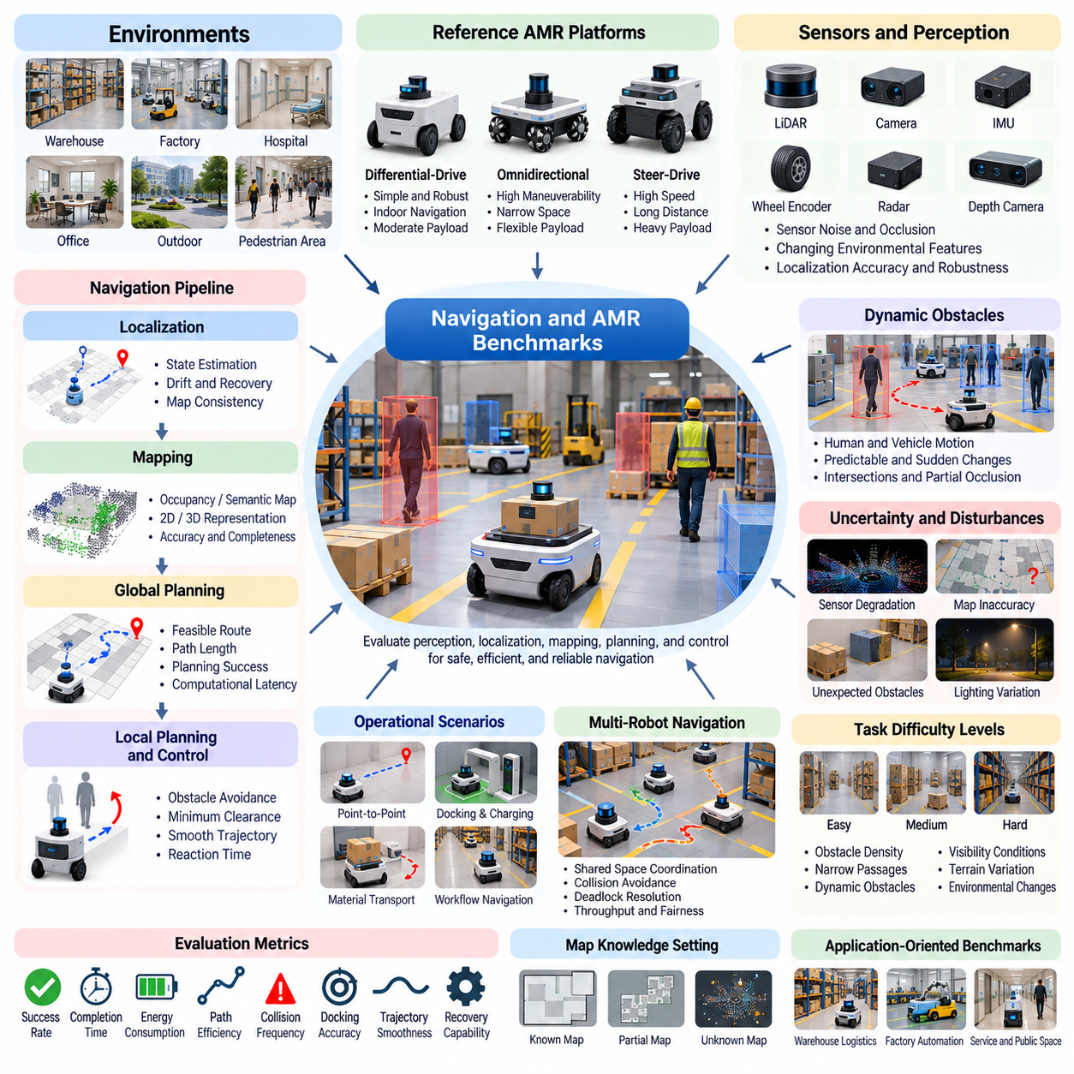
Navigation and Autonomous Mobile Robot (AMR) benchmarks provide standardized methods for evaluating how intelligent robots move through physical environments while maintaining safety, efficiency, and reliability. These benchmarks examine perception, localization, mapping, path planning, obstacle avoidance, and motion control as interconnected capabilities. Their primary purpose is to determine whether navigation systems can perform consistently across realistic operating conditions rather than succeed only in simplified demonstrations.
A comprehensive navigation benchmark must represent the diversity of environments encountered by mobile robots. Warehouses, factories, hospitals, offices, outdoor facilities, and mixed pedestrian areas impose different operational constraints. Narrow passages, intersections, uneven surfaces, and dynamic obstacles influence navigation difficulty. Standardized environment configurations allow researchers to evaluate whether algorithms generalize across layouts and operational contexts.
Reference AMR platforms establish consistent physical assumptions for benchmark experiments. Robot dimensions, wheel configurations, payload capacity, maximum velocity, acceleration limits, and turning capabilities determine feasible motion. Differential-drive, omnidirectional, and steer-drive robots exhibit different kinematic constraints. Benchmark specifications should document these differences and avoid comparing platforms without accounting for their physical capabilities.
Navigation evaluation begins with reliable localization and environmental understanding. Robots may use LiDAR, cameras, inertial sensors, wheel encoders, and localization maps to estimate their positions. Benchmark scenarios should introduce controlled sensor noise, partial occlusion, and changing environmental features. Localization accuracy, drift, recovery time, and map consistency help characterize the robustness of perception and state estimation.
Mapping benchmarks evaluate how effectively robots construct and maintain representations of their surroundings. Occupancy grids, semantic maps, and three-dimensional representations support different navigation strategies. Standardized mapping scenarios should include repeated structures, temporary obstacles, and partially observable regions. Map accuracy, completeness, update efficiency, and consistency provide complementary measures of environmental understanding.
Global path planning benchmarks examine whether robots can identify feasible routes between specified locations. Evaluation scenarios may include alternative corridors, restricted zones, blocked passages, and changing destination requirements. Path length, computational latency, route feasibility, and planning success rate reveal algorithmic performance. Benchmarks should distinguish planning quality from limitations introduced by localization errors or low-level control behavior.
Local planning and obstacle avoidance benchmarks focus on immediate motion decisions. Robots must respond to nearby obstacles while respecting acceleration limits, stopping distances, and collision constraints. Dynamic environments introduce moving pedestrians, forklifts, and other mobile robots. Evaluation should consider minimum clearance, collision frequency, reaction time, and trajectory smoothness, ensuring that successful navigation does not conceal unsafe behavior.
Dynamic obstacle scenarios require realistic motion patterns rather than purely random movement. Human walking trajectories, vehicle turning behavior, and interactions at intersections create structured uncertainty. Benchmarks should include predictable movement, sudden changes, and partially occluded obstacles. These conditions reveal whether navigation policies anticipate future motion or rely exclusively on reactive obstacle avoidance.
Navigation under uncertainty is particularly important for real-world AMR deployment. Sensor degradation, localization ambiguity, map inaccuracies, and unexpected environmental changes can undermine otherwise successful planning algorithms. Standardized disturbance profiles allow systematic testing of these limitations. Robust navigation systems should recognize uncertainty, adjust motion conservatively, and recover when reliable state estimates become available.
Warehouse and industrial AMR benchmarks should reflect operational workflows rather than isolated point-to-point movement. Robots may transport materials between storage locations, production stations, and loading areas while sharing space with equipment and personnel. Evaluation should consider mission completion, route congestion, docking accuracy, and payload-dependent motion. Such scenarios connect navigation performance with practical logistics productivity.
Docking and precision positioning represent specialized navigation capabilities. AMRs frequently need to align with charging stations, conveyors, racks, or robotic workstations. Small positioning errors can prevent successful mechanical or electrical interfaces. Benchmarks should define target pose tolerances, approach constraints, and acceptable correction behavior. Docking success rate, final alignment error, and completion time provide relevant evaluation measures.
Multi-robot navigation benchmarks introduce coordination and shared-space constraints. Multiple AMRs may compete for narrow corridors, intersections, charging stations, and task destinations. Congestion, deadlock, and communication delays can reduce fleet performance even when individual robots navigate successfully. Standardized fleet scenarios should evaluate throughput, waiting time, collision avoidance, fairness, and recovery from coordination failures.
Navigation benchmarks must account for different levels of environmental knowledge. Some systems operate with complete prior maps, while others must explore unknown spaces or adapt to changing layouts. These conditions should be evaluated separately to avoid unfair comparisons. Exploration efficiency, coverage, information gain, and successful return to known locations provide additional metrics for autonomous operation in unfamiliar environments.
Terrain and surface conditions influence navigation beyond geometric path feasibility. Floor friction, slopes, thresholds, debris, and uneven ground affect traction, stability, and energy consumption. Outdoor AMRs may additionally encounter gravel, mud, and weather-related disturbances. Benchmark environments should model these factors according to platform capabilities and report motion failures caused by physical constraints rather than planning errors.
Energy efficiency is an important navigation benchmark dimension because mobile robots operate with limited battery capacity. Route selection, acceleration profiles, stopping frequency, and payload weight influence energy consumption. A shorter path may not always minimize energy expenditure. Benchmarks should measure energy per mission, energy per distance, and productivity under battery constraints while maintaining consistent assumptions about robot hardware.
Safety evaluation must remain independent of navigation success. A robot may reach its destination while passing dangerously close to people or violating restricted zones. Benchmark metrics should capture collisions, near misses, emergency stops, excessive speed, and minimum separation distances. Safety-critical scenarios should also test behavior during sensor failures, unexpected obstacles, and loss of communication with supervisory systems.
Long-horizon navigation benchmarks evaluate sustained autonomy across multiple missions. Robots may need to navigate repeatedly, update maps, manage battery resources, recover from blocked routes, and respond to changing task priorities. Errors that appear insignificant during individual journeys can accumulate over extended operation. Mission completion rate, intervention frequency, recovery effectiveness, and operational availability reveal long-term system reliability.
Simulation-based navigation benchmarks support large-scale experimentation with controlled variations. Thousands of scenarios can be generated by changing obstacle arrangements, traffic patterns, lighting, sensor noise, and physical parameters. Parallel simulation accelerates evaluation but requires consistent timing and physics configurations. Standardized seeds and scenario definitions enable reproducible comparisons across navigation algorithms and learning methods.
Sim2Real navigation benchmarks connect simulation results with physical AMR performance. Corresponding scenarios should align robot geometry, sensor configurations, environmental layouts, and operational constraints. Differences in localization accuracy, collision avoidance, tracking error, and mission completion reveal transfer limitations. Real-world validation is necessary to determine whether simulation success predicts dependable navigation under actual operating conditions.
Benchmark reporting should combine task success with efficiency, robustness, safety, and statistical reliability. Evaluation protocols should specify scenario difficulty, trial counts, random seeds, termination conditions, and metric definitions. Results should be separated by environment type and disturbance level to expose performance limitations. Aggregate scores can support comparisons, but detailed measurements are essential for identifying practical deployment risks.
Ultimately, navigation and AMR benchmarks establish a systematic framework for evaluating autonomous mobility as an integrated Physical AI capability. Their value extends beyond comparing path planning algorithms to assessing perception, physical constraints, operational efficiency, and sustained reliability. By combining standardized environments, representative robot platforms, multidimensional metrics, and Sim2Real validation, these benchmarks support the development of safer and more dependable autonomous mobile systems.

09.05. Manipulation and Mobile Manipulation Benchmarks
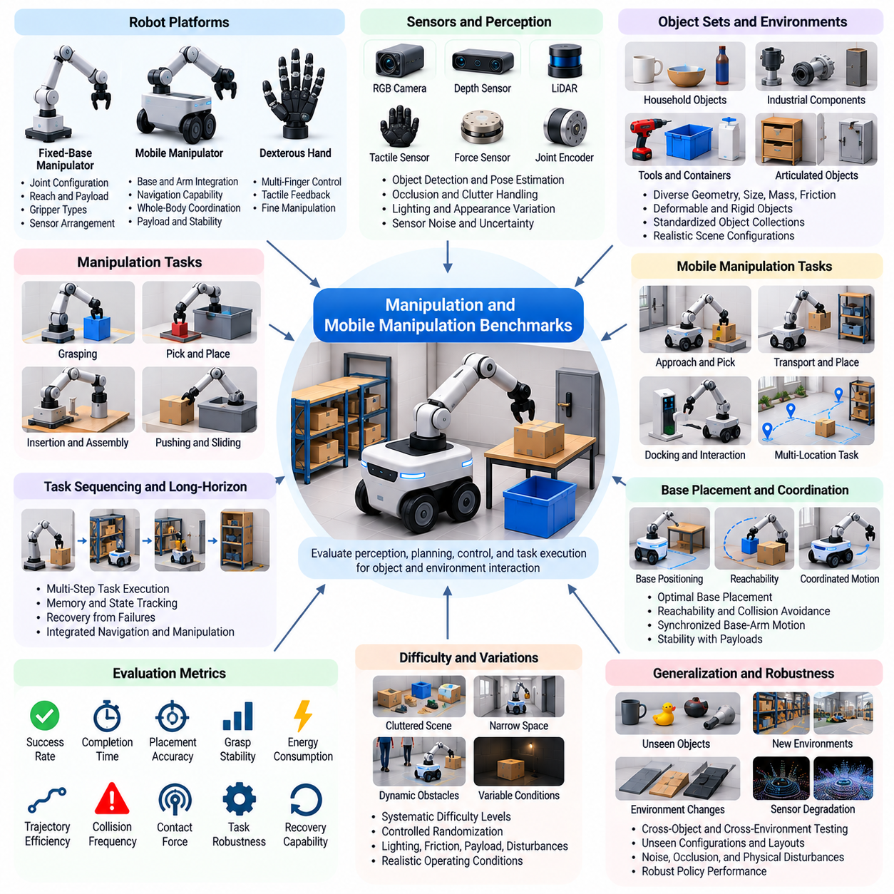
Manipulation and mobile manipulation benchmarks provide standardized frameworks for evaluating how Physical AI systems interact with objects and perform purposeful actions in physical environments. These benchmarks examine perception, grasp planning, motion generation, contact control, and task execution. Mobile manipulation extends these capabilities by combining navigation with robotic arm operation, requiring coordinated decisions across mobility and object interaction.
A comprehensive manipulation benchmark must represent diverse objects, tasks, and environmental conditions. Industrial components, household objects, tools, containers, and articulated mechanisms introduce different geometric and physical challenges. Object size, shape, mass, friction, and deformability influence manipulation difficulty. Standardized object collections and scene configurations allow researchers to compare algorithms under consistent yet representative operating conditions.
Reference robot platforms establish common assumptions for manipulation evaluation. Fixed-base manipulators provide controlled conditions for studying arm motion and object interaction, while mobile manipulators introduce base positioning and whole-system coordination. Benchmark specifications should define joint configurations, reachability, payload limits, gripper characteristics, and sensor arrangements. These parameters determine the feasible action space and influence task performance.
Manipulation benchmarks depend on accurate perception and object state estimation. Robots must identify objects, estimate their poses, understand geometric relationships, and recognize relevant interaction regions. RGB cameras, depth sensors, tactile arrays, and force sensors provide complementary information. Evaluation scenarios should include occlusion, clutter, lighting variation, and uncertain object placement to measure perception robustness under realistic conditions.
Grasping benchmarks evaluate whether robots can establish stable and useful contact with objects. Representative tasks include parallel-jaw grasping, suction grasping, precision grasping, and handling objects with irregular geometry. Grasp success depends on contact placement, friction, force distribution, and object properties. Benchmark metrics should distinguish initial grasp acquisition from sustained stability during lifting, transport, and placement.
Pick-and-place benchmarks examine the complete sequence of detecting, grasping, transporting, and releasing objects. Standardized scenarios may include sorting, bin picking, stacking, and transferring components between workstations. Successful execution requires collision-free motion and accurate placement. Evaluation should measure task completion, placement error, execution time, object drops, and unintended contacts rather than reporting grasp success alone.
Contact-rich manipulation introduces challenges that cannot be captured through geometric motion planning alone. Insertion, assembly, pushing, sliding, and surface following require precise regulation of interaction forces. Small errors in alignment or contact dynamics may cause jamming, instability, or damage. Benchmarks should specify contact properties, tolerances, and force limits while measuring task success, interaction stability, and excessive-force events.
Dexterous manipulation benchmarks assess coordinated control of multi-fingered hands and complex object interactions. Tasks may involve reorienting objects, manipulating tools, opening mechanisms, or performing fine adjustments. These activities require accurate finger coordination, tactile feedback, and continuous state estimation. Standardized evaluation should account for object motion, contact transitions, manipulation precision, and recovery from unstable grasps.
Articulated object manipulation evaluates interaction with doors, drawers, cabinets, valves, and mechanical joints. Robots must infer movement constraints and apply appropriate forces along permitted directions. Task difficulty depends on joint friction, handle geometry, accessibility, and mechanism uncertainty. Benchmark scenarios should measure successful operation, applied force, trajectory quality, and the ability to adapt when articulation properties differ from expectations.
Mobile manipulation benchmarks combine navigation, base positioning, arm planning, and object interaction within a single task. A robot may need to approach a workstation, align its base, reach an object, manipulate it, and move to another location. Errors in navigation or positioning can reduce manipulation success. Evaluation should therefore examine integrated task completion rather than treating mobility and arm control as independent capabilities.
Base placement is a critical factor in mobile manipulation because it determines arm reachability and collision constraints. A mobile robot must select positions that support stable and efficient manipulation while respecting surrounding obstacles. Benchmark scenarios should include constrained workspaces, narrow approaches, and variable object locations. Metrics may capture base positioning accuracy, reachability success, repositioning frequency, and overall execution efficiency.
Whole-body coordination becomes important when mobile bases and manipulators move simultaneously. Coordinated motion can extend reach, reduce execution time, and improve adaptability, but it introduces dynamic coupling and stability constraints. Benchmarks should evaluate synchronized base-arm trajectories, collision avoidance, balance, and control smoothness. These considerations are especially relevant for heavy payloads, extended reaches, and dynamically changing environments.
Task sequencing and long-horizon manipulation require robots to complete multiple dependent actions. A system may need to open a cabinet, retrieve an object, transport it, and place it at a destination. Individual action success does not guarantee completion of the full sequence. Benchmarks should measure planning consistency, intermediate state verification, recovery behavior, and final task success across extended execution horizons.
Manipulation under uncertainty requires robust responses to imperfect perception and unpredictable contact. Object pose errors, unknown friction, payload variation, and sensor noise can cause planned actions to fail. Standardized disturbance scenarios should introduce controlled uncertainty and evaluate adaptation. Recovery strategies such as regrasping, repositioning, and force adjustment provide important indicators of practical manipulation intelligence.
Simulation fidelity is particularly important for contact-intensive tasks. Friction models, collision geometry, compliance, actuator dynamics, and numerical solver behavior influence manipulation outcomes. Simplified physics may produce unrealistic grasp stability or insertion success. Benchmark environments should document relevant physical parameters and validate critical contact behaviors against experimental observations when practical, ensuring that simulation scores remain meaningful.
Synthetic data and domain randomization can expand manipulation benchmark coverage. Object appearances, poses, masses, friction coefficients, lighting conditions, and sensor noise can be varied systematically. These variations help evaluate whether learned policies generalize beyond specific training configurations. Test distributions should remain independent from training scenarios, and randomization parameters should be recorded to preserve reproducibility and meaningful performance comparisons.
Safety evaluation must consider both robot behavior and the physical consequences of object interaction. Excessive gripping forces, unexpected arm motion, collisions, unstable payloads, and dropped objects may create operational hazards. Benchmarks should record force-limit violations, collision events, emergency stops, and object damage. Safety metrics should be reported separately from task success to prevent efficient but hazardous manipulation strategies from appearing superior.
Efficiency metrics connect manipulation performance with practical deployment requirements. Cycle time, motion distance, energy consumption, computational latency, and successful operations per hour influence industrial productivity. Mobile manipulation additionally requires consideration of travel distance and base repositioning. Benchmark reports should preserve these measurements individually because optimizing task speed may increase energy use, mechanical stress, or safety risk.
Sim2Real manipulation benchmarks compare simulated performance with corresponding physical robot experiments. Robot geometry, actuator limits, sensor calibration, object properties, and task conditions should be aligned wherever possible. Differences in grasp success, contact forces, placement accuracy, and execution time reveal transfer limitations. Physical validation is especially important for contact-rich tasks where small modeling errors can significantly change outcomes.
Statistical reliability requires repeated trials across representative objects, initial conditions, and difficulty levels. Benchmark protocols should specify success criteria, random seeds, episode counts, and aggregation procedures. Reporting average performance, variability, failure categories, and confidence intervals supports meaningful algorithm comparisons. Results should also distinguish perception failures, planning errors, grasp instability, and control limitations to guide system improvement.
Ultimately, manipulation and mobile manipulation benchmarks establish a systematic foundation for evaluating Physical AI systems that act directly upon their environments. Their value lies in measuring not only isolated grasping or movement skills but also coordinated perception, planning, contact control, mobility, and recovery. Standardized tasks, representative robot platforms, realistic physics, and multidimensional metrics support reliable comparison and the development of adaptable robotic manipulation systems.

09.06. Quadruped and Locomotion Benchmarks
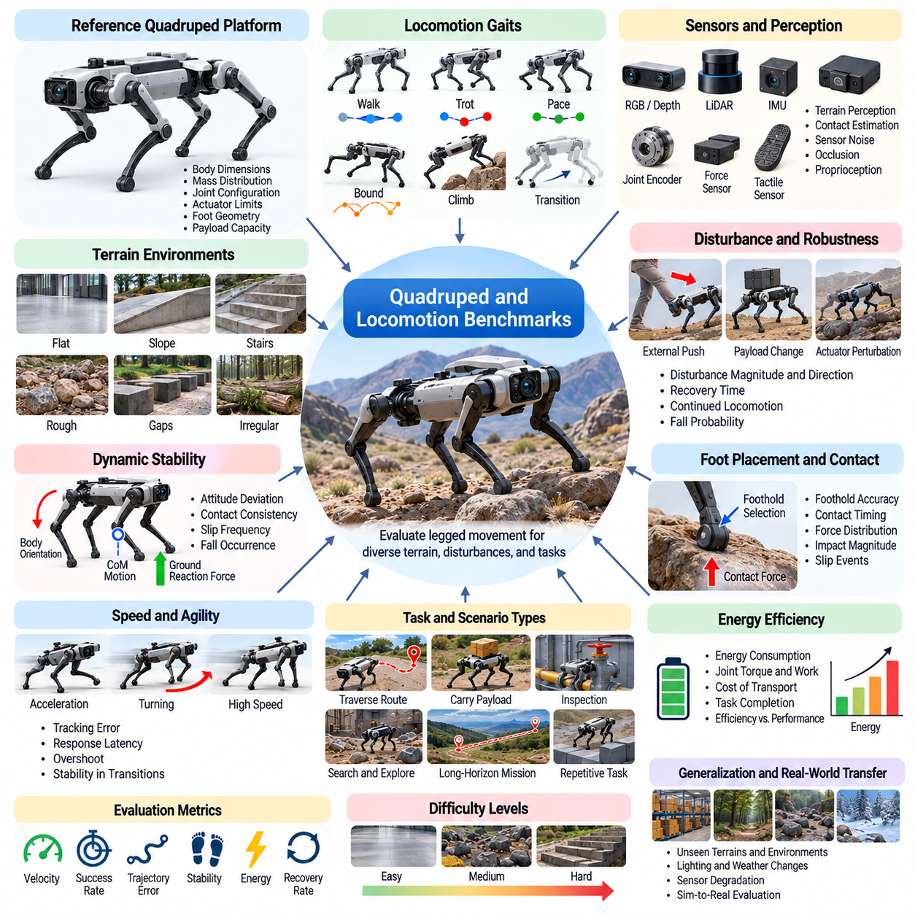
Quadruped and locomotion benchmarks provide standardized methods for evaluating how legged robots move, maintain balance, and adapt to physical environments. Unlike wheeled navigation, legged locomotion involves intermittent ground contact, dynamic stability, and coordinated joint control. These benchmarks assess whether robotic systems can achieve reliable mobility across varying terrain, disturbances, and operating conditions while maintaining efficiency and safety.
Quadruped robots are particularly suitable for locomotion benchmarking because their four-legged morphology supports diverse gait patterns and terrain interactions. Walking, trotting, pacing, bounding, and climbing require different coordination strategies. Reference platforms should specify body dimensions, mass distribution, joint configurations, actuator limits, and foot geometry. Consistent robot models enable meaningful comparisons between classical controllers and learned policies.
Locomotion benchmark environments must represent the physical diversity of real operating conditions. Flat surfaces provide baseline measurements, while slopes, stairs, rocks, gaps, and irregular terrain introduce increasing complexity. Surface friction, compliance, and obstacle dimensions influence locomotion performance. Standardized terrain parameters allow researchers to isolate the effects of environmental difficulty from differences in control algorithms.
Gait evaluation examines the coordination of leg movements and ground contact patterns. Different gaits produce distinct tradeoffs between speed, stability, energy consumption, and mechanical loading. Benchmarks should measure forward velocity, stride consistency, duty factor, foot clearance, and gait transition behavior. These measurements help determine whether locomotion policies generate efficient movement while respecting physical constraints.
Dynamic stability is a central consideration in quadruped locomotion evaluation. Robots must regulate body orientation, center-of-mass motion, and ground reaction forces during movement. Stability cannot be represented adequately by a single measurement because different locomotion modes require different balance strategies. Benchmark protocols should combine body attitude deviation, contact consistency, slip frequency, and fall occurrence.
Terrain adaptation benchmarks evaluate how robots modify their movement in response to changing ground conditions. Uneven surfaces, variable friction, loose materials, and unexpected height differences require adjustments in foot placement and body posture. Evaluation should measure traversal success, speed degradation, slip events, and recovery actions. These scenarios reveal whether controllers generalize beyond the terrain distributions encountered during training.
Disturbance rejection benchmarks assess the ability to maintain locomotion when unexpected forces affect the robot. External pushes, sudden payload changes, and actuator perturbations can disrupt gait stability. Standardized disturbance magnitude, direction, duration, and timing are necessary for reproducible comparisons. Recovery time, maximum body deviation, continued locomotion, and fall probability provide useful robustness indicators.
Foot placement and contact control are essential for reliable legged mobility. Robots must select feasible footholds while accounting for terrain geometry, friction, and body dynamics. Inaccurate contact timing or excessive impact forces can produce instability and mechanical stress. Benchmarks should evaluate foothold accuracy, contact force distribution, impact magnitude, and unintended slipping during challenging terrain traversal.
Speed and agility benchmarks examine the ability to execute rapid movements while maintaining control. Acceleration, deceleration, turning, and directional changes introduce dynamic constraints beyond steady walking. Standardized trajectories and velocity commands enable consistent comparisons. Tracking error, response latency, overshoot, and stability during transitions indicate whether controllers can perform agile maneuvers without compromising safety.
Energy efficiency is particularly important because legged robots require continuous actuator effort to support and propel their bodies. Joint torque, angular velocity, mechanical work, and electrical power consumption influence operating endurance. Cost of transport provides a useful normalized efficiency measure when consistently defined. Benchmarks should also report task completion and stability to prevent energy optimization from rewarding ineffective movement.
Payload locomotion benchmarks investigate how additional mass and altered load distribution affect robot behavior. Carrying tools, inspection equipment, or transported materials changes inertia, joint loading, and balance requirements. Standardized payload configurations should specify mass, mounting position, and center-of-mass displacement. Evaluation should measure traversal success, speed, energy consumption, and stability across different loading conditions.
Perception-aware locomotion benchmarks integrate environmental sensing with movement planning. Depth cameras, LiDAR, and proprioceptive sensors help robots estimate terrain geometry and contact conditions. Scenarios may include limited visibility, sensor noise, occlusion, and uncertain surface properties. Evaluation should distinguish failures caused by inaccurate terrain perception from those resulting from motion planning or low-level control limitations.
Long-horizon locomotion benchmarks evaluate sustained movement across extended routes and repeated tasks. Small tracking errors, thermal effects, battery depletion, and mechanical limitations can accumulate during prolonged operation. Benchmark scenarios should include varied terrain segments and operational interruptions. Distance traveled, intervention frequency, mission completion, and recovery effectiveness reveal sustained autonomy beyond short demonstrations.
Simulation-based locomotion benchmarks support large-scale training and evaluation through parallel physics environments. Thousands of robot instances can experience randomized terrain, friction, mass, actuator characteristics, and external disturbances. Consistent simulation settings and controlled random seeds are essential for reproducibility. Evaluation scenarios should remain separate from training distributions to avoid overstating generalization performance.
Physics fidelity strongly influences quadruped benchmark validity. Contact solvers, friction models, joint damping, actuator dynamics, and integration time steps affect simulated locomotion behavior. Simplified contact models may produce unrealistic stability or excessive traction. Benchmark specifications should document these assumptions and compare important dynamic responses with physical measurements whenever practical.
Sim2Real locomotion benchmarks assess whether policies trained or evaluated in simulation remain effective on physical quadruped robots. Differences in actuator response, sensor latency, contact friction, and structural compliance can degrade transferred performance. Matched simulation and hardware trials should compare gait stability, tracking accuracy, energy consumption, and recovery behavior. Such evaluations identify transfer gaps and guide model refinement.
Safety benchmarks must examine both locomotion failures and their physical consequences. Falls, excessive joint loading, foot collisions, uncontrolled motion, and instability near obstacles may create hazards. Evaluation protocols should define safe operating boundaries and termination conditions. Safety metrics should remain distinct from traversal success because a robot may complete a route while exposing itself or nearby personnel to unacceptable risk.
Statistical evaluation requires repeated trials across representative terrain types, initial conditions, and disturbance levels. Benchmark reports should specify robot configurations, control frequencies, trial counts, and success criteria. Mean performance, variability, confidence intervals, and categorized failure events support meaningful comparisons. Results should identify whether limitations arise from perception, planning, actuator capability, or dynamic control.
Ultimately, quadruped and locomotion benchmarks establish a systematic foundation for evaluating embodied mobility under realistic physical constraints. Their purpose extends beyond measuring walking speed to understanding stability, adaptability, efficiency, robustness, and operational safety. Standardized robot models, terrain scenarios, disturbance protocols, and Sim2Real validation enable reliable comparison and support the development of increasingly capable legged robotic systems.

09.07. Humanoid Benchmarks
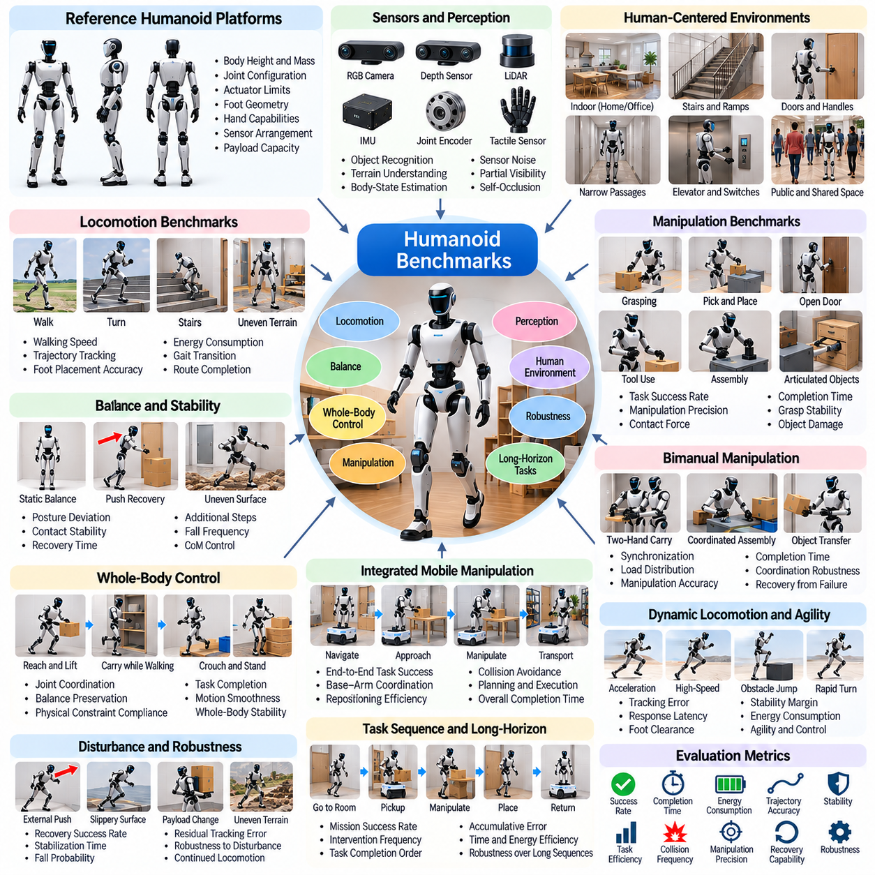
Humanoid benchmarks establish standardized methods for evaluating robots designed to operate with human-like body structures and movement capabilities. Unlike specialized industrial robots, humanoids combine bipedal locomotion, upper-body manipulation, balance, and environmental interaction. These benchmarks assess whether integrated Physical AI systems can perform reliably in human-centered environments while maintaining safety, adaptability, and operational efficiency.
Reference humanoid platforms provide consistent physical assumptions for comparing control and learning algorithms. Important specifications include body height, mass distribution, joint configurations, actuator limits, foot geometry, and hand capabilities. Differences in morphology strongly influence achievable performance. Benchmark protocols should document these characteristics and distinguish algorithmic improvements from advantages introduced by mechanical design.
Humanoid locomotion benchmarks evaluate walking, turning, stopping, and navigating environments designed for people. Standard scenarios may include corridors, doorways, ramps, stairs, and uneven surfaces. Bipedal motion requires continuous coordination between body dynamics and intermittent foot contacts. Evaluation metrics should include walking speed, trajectory tracking accuracy, foot placement precision, energy consumption, and successful route completion.
Balance and posture control represent fundamental humanoid capabilities. Robots must regulate their center of mass, body orientation, and contact forces while standing or moving. Static balance tests provide baseline measurements, while dynamic scenarios introduce pushes, uneven support surfaces, and changing body configurations. Recovery time, posture deviation, contact stability, and fall frequency reveal the effectiveness of balance controllers.
Whole-body control benchmarks examine coordinated movement across the legs, torso, arms, and head. Humanoids often need to maintain balance while reaching, lifting, carrying, or interacting with objects. Arm movements can significantly alter the overall center of mass and contact requirements. Evaluation should measure task completion, balance preservation, joint coordination, and the ability to respect physical constraints during complex actions.
Humanoid manipulation benchmarks assess object interaction using hands and upper-body mechanisms. Representative tasks include grasping tools, opening doors, moving containers, and operating human-designed equipment. Task difficulty depends on object geometry, contact conditions, reachability, and hand dexterity. Benchmarks should distinguish successful object interaction from excessive force, unstable grasping, or unintended environmental contact.
Bimanual manipulation introduces coordination requirements beyond single-arm operation. Humanoids may need to hold an object with one hand while manipulating it with the other or distribute loads across both arms. Standardized tasks should include carrying, assembly, object transfer, and coordinated tool use. Evaluation metrics may capture synchronization, manipulation precision, load distribution, completion time, and recovery from coordination failures.
Locomotion and manipulation integration is essential for practical humanoid autonomy. A robot may approach a workstation, reposition its feet, reach for an object, and transport it while maintaining balance. These operations require continuous coordination between navigation, contact planning, and manipulation control. Integrated benchmarks should measure complete task success rather than evaluating walking and grasping as unrelated capabilities.
Human-centered environments create additional challenges because their geometry and organization assume human proportions and behavior. Stairs, handles, switches, furniture, and narrow passages impose specific accessibility constraints. Benchmarks should represent these features using consistent dimensions and interaction requirements. Performance evaluation must account for reachability, maneuverability, collision avoidance, and successful operation of everyday infrastructure.
Perception benchmarks for humanoids evaluate the interpretation of complex environments during movement and interaction. Cameras, depth sensors, inertial measurements, joint encoders, and tactile sensors provide complementary information. Dynamic viewpoints and self-occlusion complicate state estimation. Standardized scenarios should assess object recognition, terrain understanding, body-state estimation, and robustness to sensor noise or partial visibility.
Disturbance recovery benchmarks test how humanoids respond to unexpected physical interactions. External pushes, slipping contacts, uneven terrain, and sudden load changes can threaten balance. Recovery may require stepping, adjusting posture, or changing support contacts. Benchmark protocols should standardize disturbance magnitude, direction, and timing while measuring recovery success, stabilization time, additional steps, and fall probability.
Dynamic locomotion benchmarks extend beyond steady walking to rapid changes in movement. Acceleration, deceleration, turning, obstacle negotiation, and gait transitions introduce demanding coordination requirements. Standardized motion commands allow meaningful controller comparisons. Tracking error, response latency, foot clearance, stability margins, and energy consumption reveal tradeoffs between agility, precision, and physical robustness.
Long-horizon humanoid benchmarks evaluate sustained execution of multiple dependent activities. A robot may navigate between rooms, retrieve objects, manipulate equipment, and return to a designated location. Errors in perception, planning, or balance can accumulate across the sequence. Evaluation should measure overall mission completion, intervention frequency, recovery effectiveness, task sequencing accuracy, and operational availability.
Simulation-based humanoid benchmarks enable large-scale experimentation with complex whole-body dynamics. Parallel environments can vary terrain, object placement, friction, actuator parameters, and external disturbances. However, humanoid simulation requires careful treatment of contact mechanics and joint constraints. Standardized physics configurations, controlled random seeds, and consistent evaluation protocols are essential for reproducible results.
Contact modeling is especially important because humanoids frequently transition between multiple support conditions. Foot-ground interaction, hand-object contact, and occasional hand-supported balance introduce discontinuities in system dynamics. Friction, compliance, collision geometry, and numerical integration influence simulated stability. Benchmark specifications should document these assumptions and validate critical contact behaviors against physical measurements when feasible.
Sim2Real humanoid benchmarks assess whether simulated control policies remain effective on physical hardware. Differences in actuator response, sensor latency, structural compliance, and contact friction can significantly affect walking and manipulation. Matched simulation and hardware experiments should compare task success, tracking accuracy, balance recovery, and energy use. These comparisons identify transfer limitations and guide improvements in models and controllers.
Safety evaluation is particularly important because humanoids operate near people and interact with human-designed infrastructure. Falls, unexpected arm movements, excessive contact forces, and unstable object handling can create serious hazards. Benchmark protocols should define operational boundaries, emergency stopping conditions, and acceptable interaction forces. Safety metrics must remain separate from task success to prevent hazardous behavior from receiving favorable scores.
Energy and computational efficiency influence the practical deployment of humanoid systems. Whole-body control requires continuous sensing, state estimation, planning, and actuator coordination. Electrical power consumption, computational latency, thermal behavior, and task execution time affect endurance and reliability. Benchmark reports should evaluate these factors alongside task performance to expose tradeoffs between intelligence, physical capability, and operating cost.
Generalization benchmarks examine whether humanoid policies adapt to unfamiliar objects, environments, and task combinations. Variations in floor conditions, object properties, obstacle arrangements, and interaction requirements reveal dependence on narrow training distributions. Evaluation should separate previously encountered scenarios from unseen configurations. Successful generalization requires maintaining coordinated mobility and manipulation despite changes in environmental conditions.
Statistical reporting should include repeated trials across representative tasks, difficulty levels, and disturbance conditions. Robot configurations, control frequencies, success criteria, and evaluation seeds must be documented. Mean performance, variability, confidence intervals, and categorized failures support reliable comparisons. Reports should distinguish limitations arising from perception, locomotion, manipulation, balance, and high-level planning.
Ultimately, humanoid benchmarks provide a systematic framework for evaluating integrated embodied intelligence in human-centered environments. Their purpose extends beyond demonstrating human-like movement to measuring dependable task execution, whole-body coordination, adaptability, safety, and sustained autonomy. Standardized platforms, realistic scenarios, multidimensional metrics, and Sim2Real validation support the development of increasingly capable and reliable humanoid robotic systems.

09.08. Aerial Robot Benchmarks
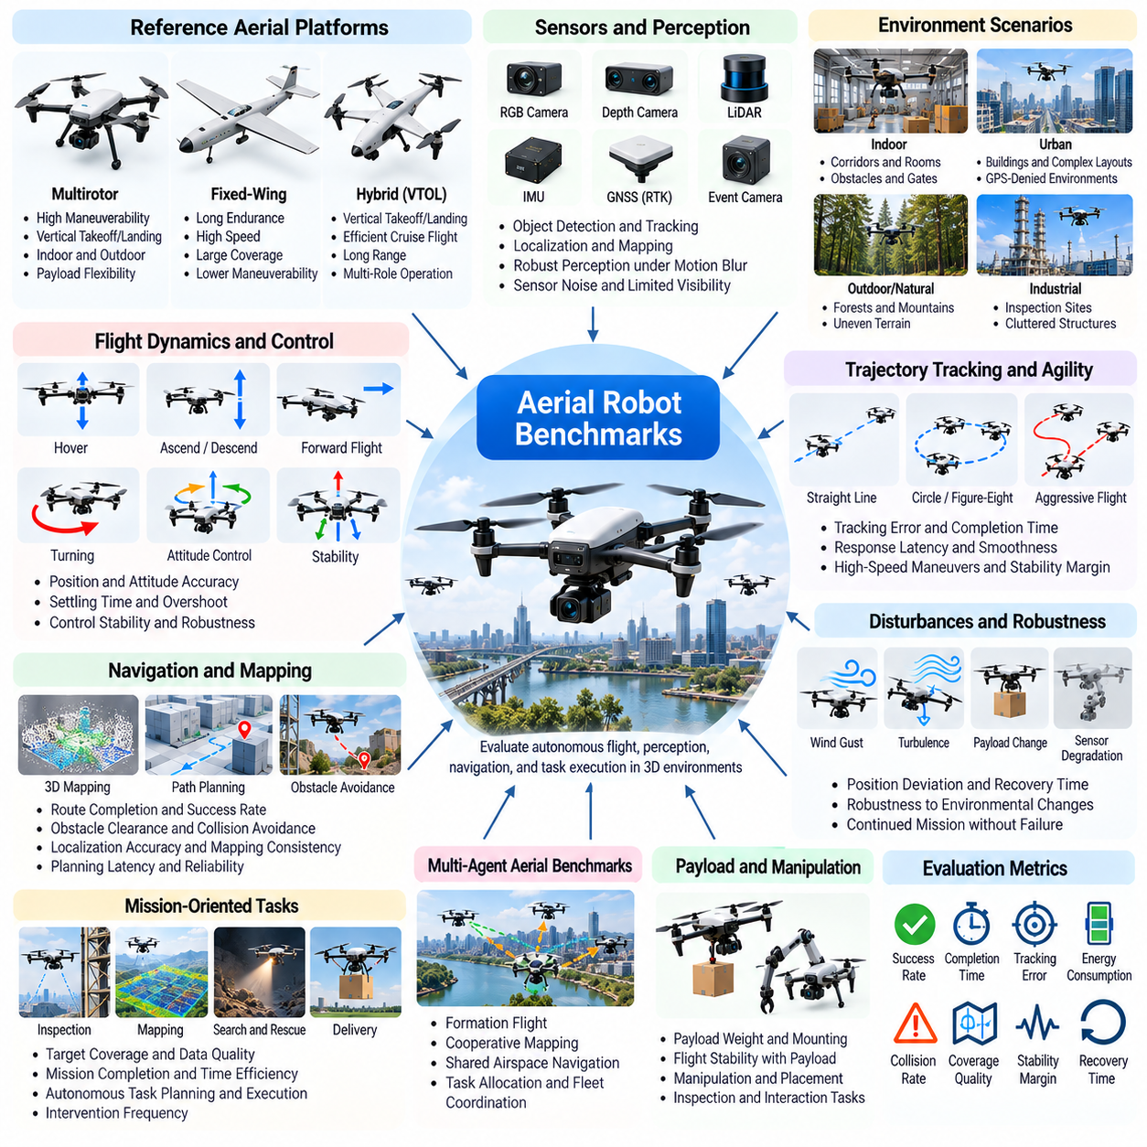
Aerial robot benchmarks establish standardized methods for evaluating autonomous flight, perception, navigation, and control in three-dimensional environments. Unlike ground robots, aerial systems must continuously manage aerodynamic forces, attitude, and propulsion while performing assigned tasks. These benchmarks measure flight stability, trajectory accuracy, environmental awareness, energy efficiency, and operational safety under reproducible conditions.
Reference aerial platforms provide consistent physical assumptions for comparing flight algorithms. Multirotor, fixed-wing, and hybrid aircraft exhibit different maneuverability, endurance, and control constraints. Benchmark specifications should define vehicle mass, inertia, propulsion characteristics, actuator limits, aerodynamic parameters, and sensor configurations. Platform differences must be documented to separate algorithmic improvements from hardware advantages.
Flight dynamics benchmarks evaluate the accuracy and responsiveness of attitude and position control. Standardized scenarios include hovering, vertical ascent, descent, forward flight, and coordinated turning. Controllers must regulate thrust and rotational motion while respecting actuator limitations. Evaluation metrics should include position error, attitude deviation, settling time, overshoot, and control stability across operating conditions.
Trajectory tracking benchmarks examine whether aerial robots can follow predefined spatial paths. Reference trajectories may include straight segments, circular paths, figure-eight patterns, and complex three-dimensional maneuvers. Difficulty can be increased through higher velocities, sharper turns, and tighter spatial constraints. Tracking error, completion time, acceleration smoothness, and constraint violations provide complementary performance measurements.
Aerial navigation benchmarks assess autonomous movement through environments containing obstacles and restricted regions. Indoor corridors, industrial facilities, forests, and urban structures introduce different geometric challenges. Robots must combine localization, mapping, path planning, and collision avoidance. Standardized scenarios should evaluate route completion, obstacle clearance, planning latency, and navigation reliability.
Perception benchmarks examine how aerial robots interpret their surroundings while experiencing rapid viewpoint changes and platform motion. Cameras, depth sensors, LiDAR, inertial measurement units, and positioning systems provide complementary observations. Motion blur, limited visibility, and sensor noise can degrade perception. Evaluation should measure localization accuracy, obstacle detection, mapping consistency, and robustness under degraded sensing.
Visual-inertial odometry and simultaneous localization and mapping are important benchmark components for autonomous flight. Rapid rotations, low-texture surfaces, repetitive structures, and illumination changes can challenge state estimation. Standardized datasets and simulated flight sequences should include ground-truth trajectories. Position drift, orientation error, tracking loss, and recovery time reveal estimator performance.
Obstacle avoidance benchmarks evaluate real-time decisions under strict flight dynamics and sensing constraints. Aerial robots must identify feasible trajectories while accounting for vehicle dimensions, braking capability, and limited reaction time. Dynamic obstacles introduce additional uncertainty. Collision rate, minimum separation distance, response latency, and successful avoidance maneuvers provide important safety and performance indicators.
Agility benchmarks assess the ability to perform rapid maneuvers near dynamic and physical limits. High-speed turns, sudden acceleration, obstacle passages, and aggressive trajectory changes require coordinated perception and control. Standardized flight courses should specify gate dimensions, waypoint tolerances, and velocity requirements. Performance measurements must consider both maneuver completion and stability margins.
Environmental disturbance benchmarks evaluate flight robustness under changing atmospheric and operational conditions. Wind gusts, turbulence, variable air density, and aerodynamic interactions can disrupt planned motion. Disturbance profiles should specify magnitude, direction, frequency, and duration. Position deviation, recovery time, energy consumption, and mission continuation indicate whether flight controllers maintain reliable operation.
Payload benchmarks investigate how additional equipment affects aerial vehicle dynamics and mission performance. Cameras, inspection sensors, delivery packages, and manipulators alter mass distribution, inertia, and propulsion requirements. Standardized payload configurations should define weight, mounting location, and aerodynamic effects. Evaluation should measure stability, tracking accuracy, endurance, and successful task execution.
Mission-oriented aerial benchmarks extend beyond isolated flight control. Inspection, mapping, search, delivery, and environmental monitoring require coordinated perception, planning, and execution. Standardized missions should specify target coverage, observation requirements, time limits, and completion criteria. Mission success, coverage quality, operational efficiency, and intervention frequency provide integrated performance measures.
Multi-agent aerial benchmarks examine coordination among multiple autonomous aircraft. Cooperative mapping, formation flight, distributed inspection, and shared airspace navigation introduce communication and collision-avoidance challenges. Standardized scenarios should control fleet size, communication delays, and task allocation requirements. Evaluation metrics include mission throughput, coordination efficiency, separation violations, and resilience to individual vehicle failures.
Energy efficiency is a fundamental aerial benchmark dimension because flight endurance is constrained by onboard power. Hovering, acceleration, payload transport, and wind compensation impose different energy demands. Benchmarks should measure electrical energy consumption, flight duration, distance traveled, and useful work completed. Comparisons must account for vehicle configuration and battery characteristics to avoid misleading efficiency conclusions.
Safety benchmarks evaluate whether aerial robots remain within acceptable operational boundaries. Loss of localization, propulsion degradation, communication interruptions, and unexpected obstacles may require emergency responses. Evaluation protocols should define restricted regions, altitude limits, safe landing conditions, and termination rules. Safety metrics should include boundary violations, collision events, recovery success, and controlled landing performance.
Long-horizon flight benchmarks assess sustained autonomy over extended missions. Aerial robots must manage navigation uncertainty, energy reserves, changing environmental conditions, and mission priorities. Repeated maneuvers may accumulate localization drift or expose thermal and mechanical limitations. Mission completion, intervention frequency, energy reserve, and operational reliability reveal performance beyond short flight demonstrations.
Simulation-based aerial benchmarks enable large-scale evaluation without exposing physical aircraft to unnecessary experimental risk. Parallel environments can vary terrain, obstacle placement, wind conditions, sensor noise, and vehicle parameters. Reproducibility requires standardized simulation settings, controlled random seeds, and consistent scenario definitions. Training and evaluation environments should remain sufficiently separated to measure generalization.
Aerodynamic and propulsion fidelity strongly influence benchmark validity. Rotor thrust models, motor response, aerodynamic drag, ground effect, and numerical integration affect simulated flight behavior. Simplified models may overestimate stability or maneuverability. Benchmark specifications should document physical assumptions and validate critical dynamic responses against experimental measurements when feasible.
Sim2Real aerial benchmarks compare simulated policies with corresponding physical flight experiments. Differences in aerodynamic behavior, sensor latency, actuator response, and environmental disturbances can reduce transferred performance. Matched scenarios should compare trajectory tracking, disturbance rejection, energy consumption, and mission success. Physical validation helps determine whether simulation performance predicts reliable autonomous flight.
Statistical evaluation requires repeated trials across representative environments, vehicle configurations, and disturbance levels. Benchmark reports should document flight conditions, controller frequencies, random seeds, success criteria, and failure categories. Mean performance, variability, confidence intervals, and safety incidents support meaningful comparisons. Results should distinguish perception failures, planning limitations, control instability, and hardware constraints.
Ultimately, aerial robot benchmarks provide a systematic foundation for evaluating autonomous intelligence in three-dimensional physical environments. Their purpose extends beyond measuring flight speed or trajectory accuracy to understanding perception, adaptability, robustness, efficiency, and safety. Standardized platforms, realistic flight scenarios, multidimensional metrics, and Sim2Real validation support the development of dependable aerial robotic systems.

09.09. Perception and Control Benchmarks
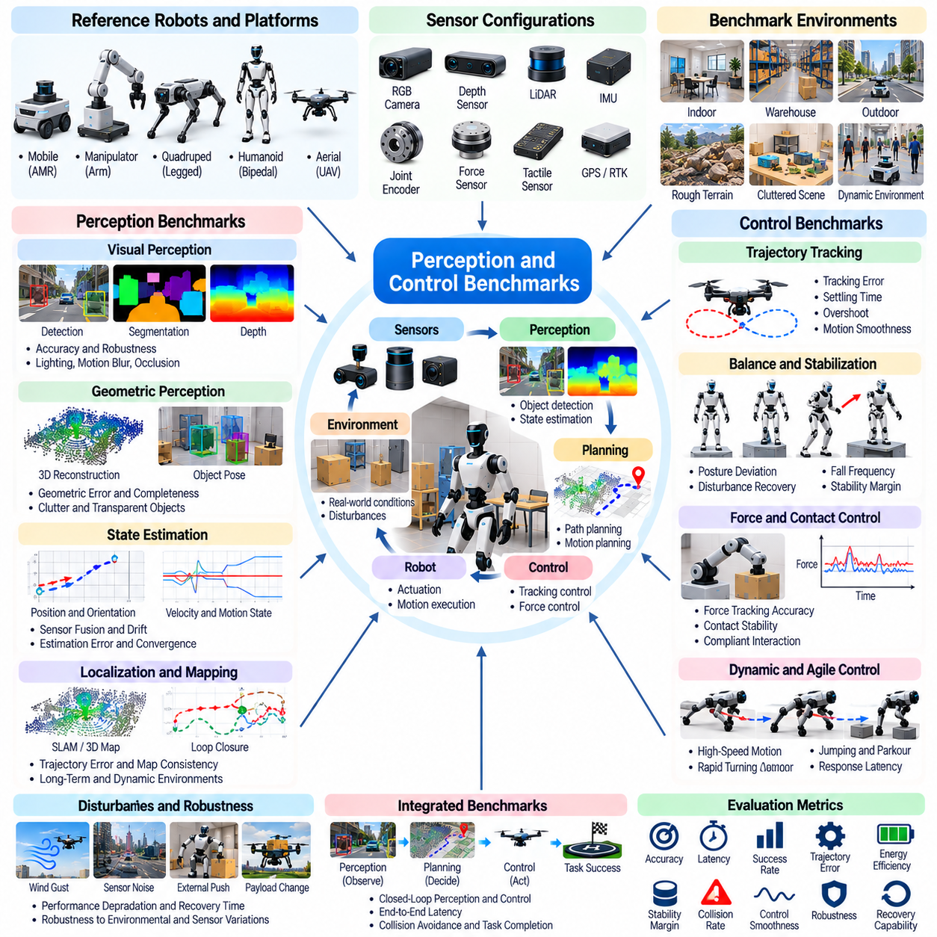
Perception and control benchmarks establish standardized methods for evaluating how Physical AI systems interpret sensor information and convert it into reliable physical actions. Perception estimates environmental and robot states, while control determines actions that achieve desired objectives. These benchmarks assess accuracy, responsiveness, robustness, and safety across representative operating conditions, connecting individual algorithm performance with real-world robotic behavior.
Benchmark design should distinguish perception quality, control performance, and their interaction within closed-loop systems. A perception model may achieve high accuracy on recorded data yet fail when its predictions influence robot movement. Similarly, a controller may perform well with perfect state information but degrade under realistic sensing uncertainty. Integrated evaluation is therefore necessary to reveal dependencies between observation, estimation, planning, and action.
Reference environments provide consistent conditions for comparing perception and control algorithms. Standardized robot models, sensor configurations, coordinate systems, and task definitions reduce experimental ambiguity. Scenarios should include both simple baseline conditions and progressively challenging disturbances. Reproducibility requires documented simulation parameters, initialization procedures, evaluation datasets, and clearly defined success criteria.
Visual perception benchmarks evaluate the interpretation of camera observations for robotic decision-making. Representative tasks include object detection, semantic segmentation, depth estimation, pose estimation, and scene understanding. Image quality may vary because of lighting, motion blur, reflections, and occlusion. Evaluation should consider prediction accuracy, uncertainty calibration, inference latency, and consistency across changing viewpoints.
Depth and geometric perception benchmarks examine the reconstruction of spatial relationships from cameras, LiDAR, and other range sensors. Robots must estimate obstacle locations, surface geometry, free space, and object dimensions. Standardized scenes should contain reflective materials, transparent objects, clutter, and partial observations. Geometric error, reconstruction completeness, detection reliability, and computational cost provide complementary evaluation measures.
State estimation benchmarks assess how accurately robots infer position, velocity, orientation, and other internal variables from noisy measurements. Sensor fusion may combine inertial data, joint encoders, cameras, and external positioning systems. Bias, drift, delayed measurements, and intermittent sensor failures introduce uncertainty. Evaluation metrics include estimation error, convergence time, uncertainty consistency, and recovery after measurement loss.
Localization and mapping benchmarks evaluate the ability to maintain spatial awareness during extended operation. Simultaneous localization and mapping systems must manage accumulated drift, loop closure, and changing environments. Benchmark sequences should include repetitive structures, dynamic objects, and limited visual features. Trajectory error, map consistency, relocalization success, and computational requirements reveal practical system limitations.
Sensor robustness benchmarks investigate perception performance under degraded operating conditions. Noise, calibration errors, missing measurements, occlusion, and environmental interference can reduce observation reliability. Standardized perturbation profiles should control disturbance magnitude and duration. Performance degradation, confidence calibration, recovery time, and failure detection accuracy indicate whether perception systems remain dependable beyond ideal conditions.
Control benchmarks evaluate the ability to regulate robot motion and interaction while respecting physical constraints. Position, velocity, torque, and force control represent different levels of actuation. Standardized reference commands should include steady-state targets, transient responses, and changing trajectories. Tracking error, settling time, overshoot, control effort, and constraint violations provide quantitative comparisons across controller designs.
Trajectory tracking benchmarks measure how accurately robots follow desired paths in joint space or Cartesian space. Reference motions may include smooth curves, rapid transitions, and contact-dependent actions. Dynamic limits, actuator saturation, and model uncertainty affect achievable accuracy. Evaluation should report tracking deviation, motion smoothness, completion time, and stability while distinguishing feasible commands from physically unrealistic demands.
Force and contact control benchmarks examine robot behavior during physical interaction with objects and surfaces. Assembly, grasping, pushing, and compliant manipulation require appropriate regulation of contact forces. Incorrect force estimates or delayed control responses can cause instability or damage. Benchmarks should measure force tracking accuracy, contact stability, interaction smoothness, and compliance with predefined safety limits.
Closed-loop perception-control benchmarks evaluate how sensing errors propagate into physical behavior. A robot may detect an obstacle, estimate its position, plan a response, and execute avoidance within a limited time. Delays or inaccuracies at any stage can affect task success. Integrated metrics should capture end-to-end response latency, collision frequency, tracking performance, and recovery behavior rather than relying only on isolated subsystem scores.
Latency and real-time performance are critical because robotic systems interact with continuously changing physical environments. Sensor acquisition, inference, communication, planning, and actuation each contribute to response delay. Benchmark protocols should measure both average latency and worst-case execution behavior. Deadline violations, timing jitter, and control stability under computational load reveal whether systems satisfy operational requirements.
Disturbance rejection benchmarks assess controller robustness when unexpected forces or modeling errors affect robot dynamics. External pushes, payload variations, friction changes, and actuator uncertainty can disrupt intended motion. Standardized disturbance profiles enable reproducible comparisons. Maximum deviation, recovery time, residual tracking error, and failure probability provide meaningful indicators of robustness under physical uncertainty.
Adaptive control benchmarks examine whether systems adjust their behavior when operating conditions change. Variations in payload, joint friction, actuator performance, or environmental dynamics may invalidate fixed model assumptions. Benchmark scenarios should introduce controlled changes during operation. Adaptation speed, post-change tracking accuracy, stability preservation, and computational overhead indicate whether adaptive strategies improve practical reliability.
Learning-based perception and control benchmarks compare data-driven methods with conventional estimation and control approaches. Neural perception models, reinforcement learning policies, and learned dynamics models may offer flexibility but can introduce unpredictable failure modes. Evaluation should use common observations, action limits, and task conditions. Comparisons must account for training data, computational resources, and generalization to unseen scenarios.
Simulation-based benchmarks support systematic evaluation through controlled variations in sensor and physical parameters. Parallel environments can introduce randomized lighting, noise, friction, mass, and actuator dynamics. Ground-truth states enable precise error measurement and failure analysis. However, unrealistic sensing or physics assumptions may inflate performance, making simulation fidelity and independent evaluation scenarios essential.
Sim2Real perception and control benchmarks measure how algorithms transfer from simulated environments to physical robots. Differences in sensor calibration, timing, contact dynamics, and actuator response can create substantial performance gaps. Matched simulation and hardware trials should compare perception accuracy, trajectory tracking, response latency, and task completion. These measurements help identify which modeling assumptions most strongly influence transfer reliability.
Safety benchmarks examine whether perception and control systems recognize hazards and maintain acceptable operating boundaries. False obstacle detection, missed hazards, unstable commands, and delayed emergency responses can create physical risks. Evaluation protocols should define safe states, intervention thresholds, and termination conditions. Safety metrics should include constraint violations, collision events, emergency response effectiveness, and unsafe action frequency.
Statistical evaluation requires repeated trials across representative tasks, environmental conditions, and disturbance levels. Reports should document sensor specifications, controller frequencies, random seeds, hardware configurations, and success criteria. Mean performance, variability, confidence intervals, and categorized failure events support reproducible comparisons. Separate subsystem and end-to-end results help identify whether failures originate in sensing, estimation, planning, or control.
Ultimately, perception and control benchmarks provide a unified framework for evaluating the reliability of robotic intelligence in physical environments. Their purpose extends beyond measuring prediction accuracy or trajectory error to understanding the complete relationship between sensing, decision-making, and action. Standardized scenarios, integrated metrics, robustness testing, and Sim2Real validation support the development of dependable Physical AI systems.

09.10. RL and Imitation Learning Benchmarks
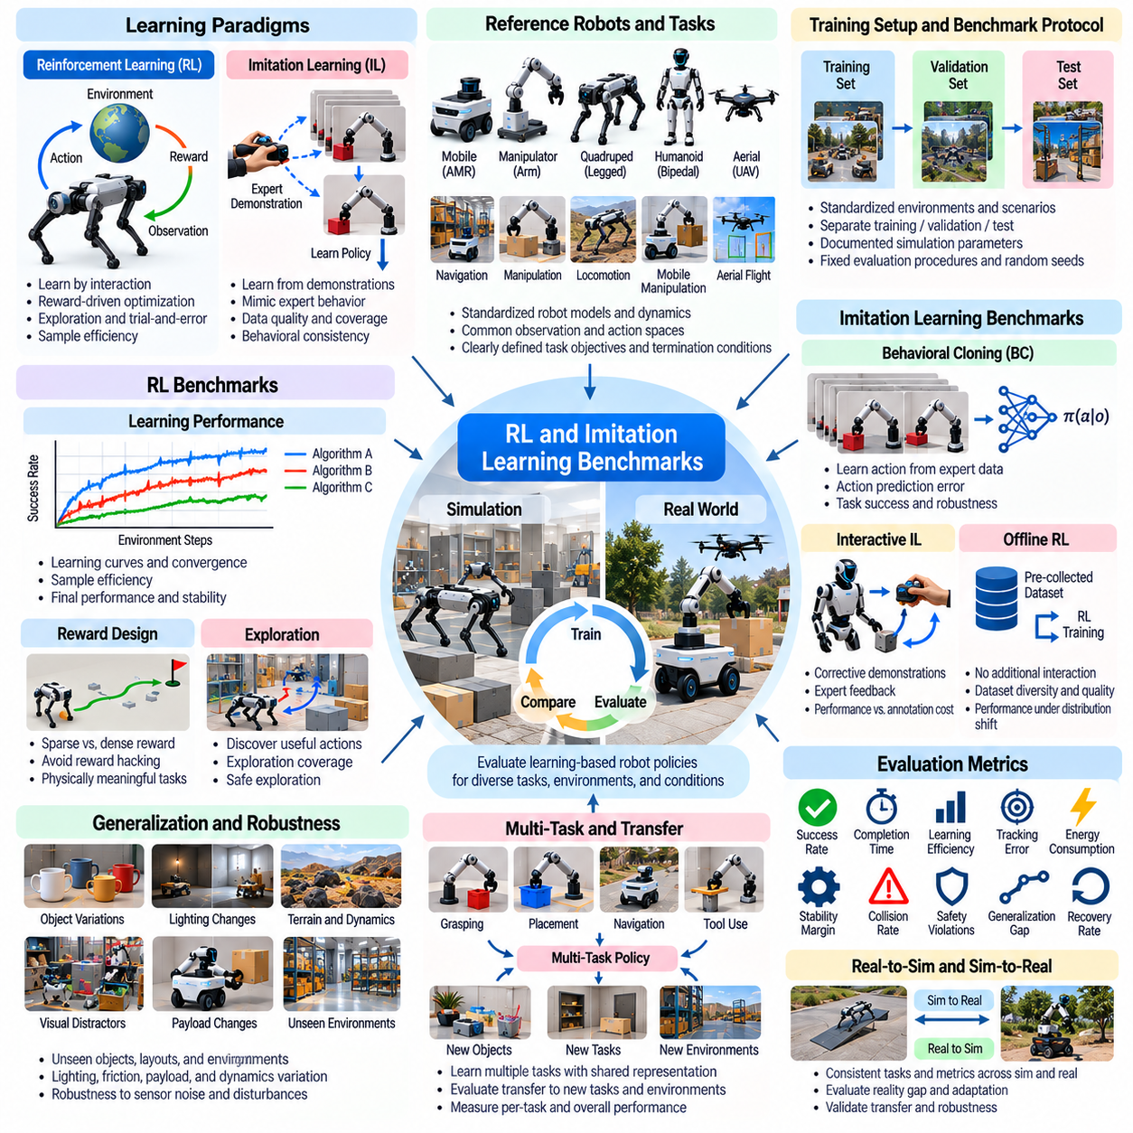
Reinforcement learning and imitation learning benchmarks provide standardized methods for evaluating how robots acquire physical skills through interaction and demonstration. Reinforcement learning optimizes behavior using rewards from environmental feedback, while imitation learning reproduces patterns observed in expert data. These benchmarks assess learning efficiency, task success, generalization, robustness, and safety under consistent experimental conditions.
Benchmark design must account for fundamental differences between learning paradigms. Reinforcement learning depends on exploration, reward design, and environmental interaction, whereas imitation learning depends on demonstration quality, coverage, and behavioral consistency. Direct comparisons require equivalent task objectives and evaluation conditions. Training resources and data availability should be reported separately to avoid misleading conclusions.
Reference environments establish common foundations for evaluating learning algorithms across robotic tasks. Standardized robot models, observation spaces, action spaces, reward definitions, and termination conditions reduce experimental ambiguity. Representative tasks include locomotion, grasping, object manipulation, navigation, and mobile manipulation. Benchmark specifications should distinguish training configurations from independent evaluation scenarios.
Reinforcement learning benchmarks measure how efficiently policies improve through repeated interaction with simulated or physical environments. Learning curves describe performance as a function of environment steps, training time, or computational resources. Sample efficiency is particularly important when physical interaction is expensive. Evaluation should report convergence behavior, final task performance, learning stability, and variability across random seeds.
Reward design strongly influences reinforcement learning performance and benchmark validity. Sparse rewards emphasize task completion but may create difficult exploration problems, while dense rewards provide intermediate guidance. Poorly designed rewards can encourage unintended shortcuts or physically undesirable behavior. Benchmark protocols should document reward functions and distinguish genuine task achievement from reward exploitation.
Exploration benchmarks evaluate how effectively agents discover useful actions in unfamiliar environments. Contact-rich manipulation, complex navigation, and multi-stage tasks often require sequences of actions before meaningful rewards appear. Exploration strategies should be tested under controlled task difficulty and interaction budgets. Evaluation metrics include discovery time, successful exploration coverage, and the frequency of unsafe interactions.
Imitation learning benchmarks evaluate the ability to reproduce expert behavior from recorded demonstrations. Demonstrations may originate from teleoperation, kinesthetic teaching, human motion capture, or previously trained controllers. Dataset specifications should document observation modalities, action representations, trajectory lengths, and demonstration quality. Evaluation should distinguish behavioral similarity from actual task success in closed-loop execution.
Behavioral cloning benchmarks examine supervised learning of actions from expert observations. Although behavioral cloning can provide efficient policy initialization, prediction errors may accumulate when the robot encounters states absent from the demonstration dataset. Standardized evaluation should include both familiar and shifted initial conditions. Action prediction error, task completion, recovery capability, and distribution sensitivity reveal practical limitations.
Interactive imitation learning benchmarks address the mismatch between expert demonstration distributions and states encountered by learned policies. Methods that collect corrective demonstrations or expert feedback can reduce accumulated execution errors. Benchmark protocols should measure the amount and type of additional supervision. Performance improvements must be evaluated against annotation cost, interaction requirements, and final policy robustness.
Offline reinforcement learning benchmarks investigate policy improvement using previously collected datasets without additional environment interaction during training. Dataset composition, behavioral diversity, and action coverage strongly influence achievable performance. Standardized datasets should include successful, unsuccessful, and intermediate-quality trajectories. Evaluation should measure task performance, sensitivity to dataset quality, and behavior outside observed distributions.
Demonstration quality benchmarks examine how expert consistency and dataset diversity influence imitation learning. Highly successful demonstrations may provide precise guidance but insufficient coverage of recovery situations. Diverse demonstrations can improve generalization while introducing inconsistent actions. Benchmark scenarios should vary demonstration quantity, expertise, and task coverage to identify relationships between data characteristics and learned performance.
Multi-task learning benchmarks evaluate whether a single policy can perform several related robotic tasks. Shared representations may support transfer between grasping, placement, navigation, and manipulation behaviors. However, differences in task objectives and action requirements can create interference. Evaluation should report per-task success, average performance, negative transfer, and adaptability to new task combinations.
Generalization benchmarks examine whether learned policies remain effective under unfamiliar environmental conditions. Changes in object geometry, friction, lighting, payload, terrain, and robot dynamics can expose dependence on narrow training distributions. Evaluation scenarios should separate interpolation within known variations from extrapolation to unseen conditions. Success rates, performance degradation, and recovery behavior indicate generalization capability.
Robustness benchmarks introduce disturbances during policy execution to assess reliability beyond nominal conditions. Sensor noise, delayed observations, actuator uncertainty, unexpected contacts, and external forces may disrupt learned behavior. Standardized perturbations should specify magnitude, duration, and application timing. Evaluation metrics include task continuation, recovery time, stability, and failure probability across disturbance levels.
Safety is particularly important because reinforcement learning exploration may produce unpredictable physical actions. Excessive joint torque, collisions, unstable contact, and unsafe trajectories can damage hardware or create hazards. Benchmark environments should define operational constraints, safety monitors, and termination conditions. Safety evaluation should include constraint violations, hazardous exploration events, and successful completion without unsafe behavior.
Long-horizon learning benchmarks evaluate policies that must complete multiple dependent actions over extended periods. Tasks such as navigating to an object, grasping it, transporting it, and placing it require coordinated decision-making. Small errors can accumulate and invalidate later stages. Evaluation should measure complete task success, subtask dependencies, recovery frequency, and the ability to resume progress after unexpected events.
Simulation-based benchmarks enable large-scale reinforcement learning through parallel environment execution. Thousands of simulated robots can collect experiences under randomized initial states, physical parameters, and task conditions. This improves experimental throughput but introduces sensitivity to simulator fidelity. Benchmark reports should document environment versions, physics settings, parallelization levels, and computational resources.
Sim2Real benchmarks assess whether learned policies retain performance when transferred from simulation to physical robots. Differences in contact mechanics, sensor latency, actuator dynamics, and environmental variability can cause substantial degradation. Matched simulation and hardware evaluations should compare task success, trajectory behavior, energy consumption, and safety outcomes. Transfer performance should be reported separately from simulation-only results.
Evaluation fairness requires consistent treatment of training data, computational budgets, and prior knowledge. Some methods benefit from extensive demonstrations, pretrained representations, or large-scale simulated interaction. Comparing final success rates alone may conceal these advantages. Benchmark reports should disclose pretraining sources, demonstration counts, environment steps, optimization settings, and hardware requirements.
Statistical reporting is essential because learning algorithms often exhibit substantial variation across training runs. Multiple random seeds, repeated evaluation episodes, and confidence intervals support reliable comparisons. Learning curves should include variability rather than only best-performing runs. Failure analysis should distinguish insufficient exploration, poor demonstrations, optimization instability, distribution shift, and control limitations.
Ultimately, reinforcement learning and imitation learning benchmarks provide a systematic framework for measuring how Physical AI systems acquire and generalize robotic skills. Their purpose extends beyond final task success to understanding data efficiency, learning stability, transferability, robustness, and safety. Standardized environments, transparent resource reporting, independent evaluation, and Sim2Real validation support reproducible progress toward adaptable robotic intelligence.

09.11. World Model and VLA Benchmarks
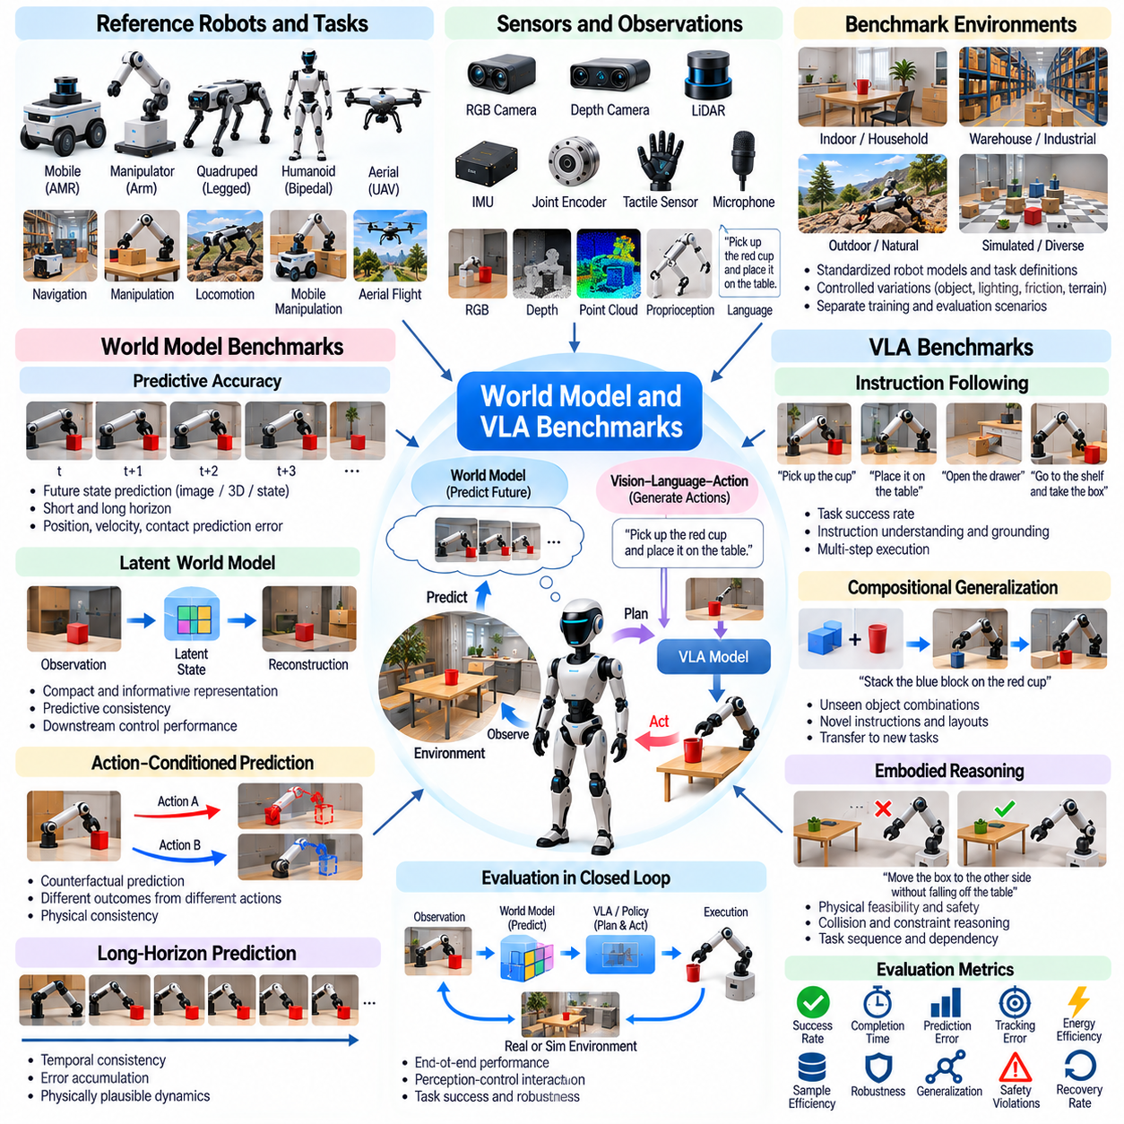
World model and Vision-Language-Action (VLA) benchmarks establish standardized methods for evaluating robotic systems that predict environmental dynamics, interpret multimodal information, and generate physical actions. World models represent how environments evolve under different actions, while VLA models connect visual observations and language instructions to robot behavior. These benchmarks assess prediction quality, task execution, generalization, robustness, and safety.
World model benchmarks evaluate whether learned representations capture the physical structure and temporal evolution of robotic environments. Models may predict future observations, latent states, object motion, or contact outcomes from current conditions and candidate actions. Accurate predictions should preserve relationships between robot movements and environmental changes. Evaluation must distinguish visually plausible predictions from physically consistent dynamics.
Reference benchmark environments should provide standardized robot configurations, object properties, observation modalities, and task definitions. Manipulation, navigation, locomotion, and mobile manipulation scenarios expose different requirements for predictive reasoning. Controlled variations in geometry, friction, lighting, and object placement support systematic testing. Training environments and evaluation scenarios must remain separate to assess generalization reliably.
Predictive accuracy benchmarks measure how closely world model outputs match observed future states. Evaluation may compare predicted object positions, robot configurations, velocities, and contact events against ground-truth trajectories. Prediction horizons should range from immediate transitions to extended action sequences. Error growth over time reveals whether models maintain useful physical predictions beyond short-term observation matching.
Latent world model benchmarks examine representations that compress high-dimensional sensor observations into compact internal states. Effective latent representations should preserve information necessary for prediction, planning, and control. Reconstruction quality alone is insufficient because visually accurate representations may omit important physical variables. Evaluation should measure predictive consistency, task relevance, representation stability, and downstream control performance.
Action-conditioned prediction benchmarks assess whether world models correctly represent the consequences of alternative robot actions. Identical initial observations may lead to different outcomes depending on applied forces, motion commands, or contact decisions. Standardized counterfactual scenarios should vary actions while controlling initial conditions. Evaluation should compare predicted outcomes with executed trajectories and identify physically inconsistent responses.
Long-horizon prediction benchmarks investigate whether models maintain coherent environmental dynamics across extended time intervals. Small prediction errors can accumulate, producing unrealistic object motion, incorrect contact states, or unstable simulated trajectories. Benchmark protocols should measure temporal consistency, error accumulation, and preservation of physical constraints. Results should distinguish short-horizon accuracy from sustained predictive reliability.
Planning-oriented world model benchmarks evaluate whether learned dynamics improve action selection and task completion. Robots may simulate candidate trajectories, estimate future outcomes, and select actions that satisfy task objectives. A model with moderate prediction error may still support effective planning if relevant consequences are represented accurately. Evaluation should include planning success, computational cost, prediction uncertainty, and real execution performance.
VLA benchmarks examine how robotic systems translate visual observations and natural-language instructions into executable actions. Representative tasks include object retrieval, placement, tool use, navigation, and multi-step manipulation. Instructions may specify target objects, spatial relationships, and operational constraints. Evaluation should measure instruction understanding, action grounding, task completion, and consistency between requested goals and executed behavior.
Language grounding benchmarks assess whether VLA models associate linguistic expressions with the correct objects, locations, and actions. Ambiguous descriptions, relational instructions, and multiple similar objects create challenging conditions. Standardized scenarios should vary vocabulary, object arrangement, and linguistic complexity. Evaluation metrics should distinguish semantic misunderstanding from visual recognition errors and physical execution failures.
Compositional generalization benchmarks test whether models can combine previously learned concepts into unfamiliar task configurations. A robot may understand individual actions such as opening, grasping, and placing but struggle when these actions appear in new sequences. Evaluation should include unseen object combinations, novel instructions, and rearranged environments. Success rates reveal whether models learn transferable relationships rather than memorized demonstrations.
Embodied reasoning benchmarks examine whether model predictions and language understanding remain grounded in physical feasibility. Instructions may require reasoning about reachability, object support, collision risks, or manipulation order. Correct language interpretation does not guarantee executable behavior. Benchmark scenarios should assess whether generated actions respect geometric constraints, contact conditions, actuator limits, and task dependencies.
Multimodal integration benchmarks evaluate how visual, linguistic, proprioceptive, and tactile information contribute to robotic decisions. Missing observations, conflicting sensor signals, and delayed feedback can expose weaknesses in learned representations. Standardized perturbations should vary modality availability and reliability. Evaluation should measure task degradation, uncertainty awareness, and recovery when individual information sources become unreliable.
Closed-loop VLA benchmarks assess whether models adapt their actions using feedback from ongoing execution. Open-loop action sequences may fail when objects move unexpectedly or contact outcomes differ from predictions. Closed-loop evaluation should introduce controlled disturbances and changing task states. Recovery success, correction latency, action consistency, and final task completion indicate whether policies can respond effectively to environmental feedback.
Long-horizon VLA benchmarks evaluate complex tasks requiring multiple dependent decisions and sustained context understanding. A robot may navigate to a workstation, identify equipment, manipulate several objects, and verify completion. Errors in grounding or action execution can propagate across the sequence. Evaluation should measure complete mission success, subtask ordering, intervention frequency, and recovery from intermediate failures.
Data efficiency benchmarks investigate how world models and VLA policies improve with increasing training data. Robot demonstrations, human videos, simulated trajectories, and language annotations provide different forms of supervision. Dataset size alone does not determine learning quality because diversity and physical relevance also matter. Benchmark reports should relate performance to data volume, coverage, annotation requirements, and computational resources.
Simulation-based benchmarks support controlled testing of predictive models and multimodal policies across diverse environments. Randomized objects, lighting, physical parameters, and task instructions enable systematic generalization studies. Ground-truth states allow detailed analysis of prediction and action errors. However, unrealistic physics or simplified language tasks can inflate results, making benchmark realism and independent testing essential.
Sim2Real benchmarks assess whether world models and VLA policies remain effective when deployed on physical robots. Sensor characteristics, contact dynamics, actuator behavior, and environmental variability may differ from simulation. Matched evaluation scenarios should compare prediction accuracy, instruction following, task completion, and recovery behavior. Physical trials reveal whether simulated reasoning translates into dependable embodied action.
Safety benchmarks evaluate whether models recognize physical risks and avoid generating hazardous actions. Incorrect predictions, ambiguous instructions, and overconfident decisions may cause collisions, excessive forces, or unsafe task execution. Benchmark protocols should include constraint violations, uncertainty-sensitive decisions, and emergency intervention scenarios. Safety performance must be reported independently from task success.
Evaluation fairness requires transparent reporting of training sources, pretrained components, robot embodiments, and computational budgets. Large multimodal models may benefit from extensive external datasets unavailable to smaller systems. Benchmark datasets should control contamination and identify overlapping training examples where possible. Comparisons should distinguish model capability from advantages in data access, hardware, and prior knowledge.
Statistical reporting should include repeated trials across task categories, difficulty levels, and environmental variations. Prediction errors, task success rates, uncertainty calibration, latency, and failure categories provide complementary evidence. Confidence intervals and evaluation seeds support reproducibility. Reports should distinguish failures originating in prediction, language grounding, planning, perception, and physical control.
Ultimately, world model and VLA benchmarks provide a unified framework for evaluating predictive and instruction-driven Physical AI. Their purpose extends beyond accurate future observations or language-conditioned actions to measuring physically grounded reasoning, adaptive execution, generalization, and safety. Standardized environments, integrated evaluation, transparent reporting, and Sim2Real validation support progress toward reliable general-purpose robotic intelligence.

09.12. Sim2Real and Domain Generalization Benchmarks
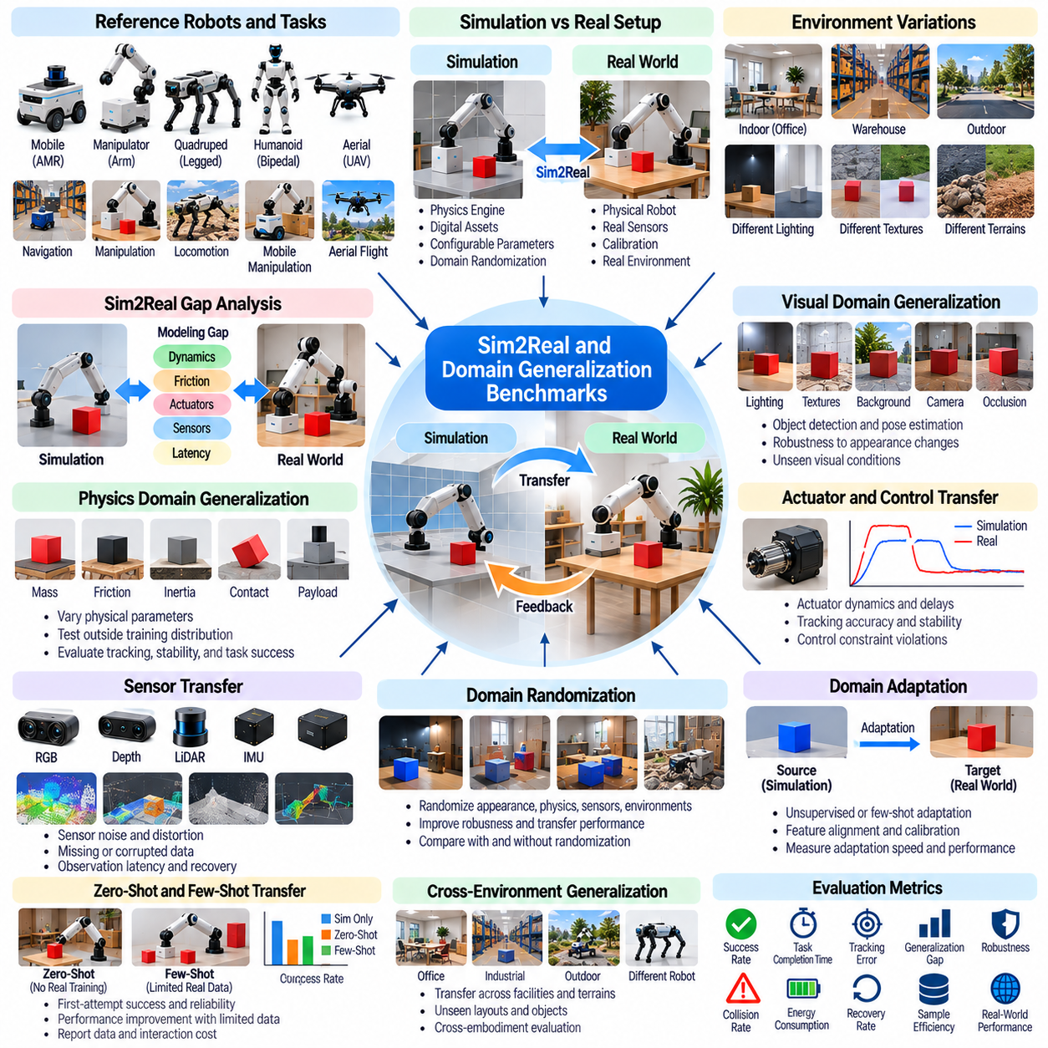
Sim2Real and domain generalization benchmarks establish standardized methods for evaluating whether robotic systems trained in simulation can operate reliably in physical environments and unfamiliar conditions. Sim2Real measures performance transfer between simulated and real systems, while domain generalization examines robustness across changing environments. These benchmarks assess transfer accuracy, task success, adaptability, and safety beyond controlled training conditions.
Benchmark design should distinguish simulation fidelity, transfer effectiveness, and generalization capability. A robot may perform successfully in a high-fidelity simulator yet fail on physical hardware because of unmodeled dynamics or sensing differences. Conversely, a policy trained with simplified physics may generalize effectively through robust representations. Evaluation must therefore measure real-world outcomes rather than assuming that simulation accuracy guarantees successful transfer.
Reference benchmark environments should define consistent robot platforms, sensor configurations, task objectives, and physical operating conditions. Representative tasks include navigation, manipulation, locomotion, and mobile manipulation. Each task should provide corresponding simulation and hardware configurations whenever feasible. Standardized initialization, calibration, termination criteria, and evaluation procedures reduce ambiguity when comparing transfer methods.
Simulation-to-reality gap benchmarks quantify differences between simulated predictions and physical observations. These gaps may originate from geometry, mass distribution, friction, contact dynamics, actuator response, sensor noise, or communication latency. Matched experiments should apply comparable commands under equivalent initial conditions. Trajectory deviation, force error, timing differences, and task performance provide complementary measurements of model mismatch.
Visual domain generalization benchmarks evaluate whether perception systems remain effective across changing appearance conditions. Lighting, textures, reflections, backgrounds, camera properties, and object appearances may differ substantially between simulation and deployment. Evaluation should separate familiar visual variations from previously unseen conditions. Detection accuracy, localization error, uncertainty calibration, and downstream task success indicate practical generalization.
Physics domain generalization benchmarks examine robustness to changes in mechanical and environmental parameters. Variations in mass, inertia, friction, restitution, joint damping, and contact compliance affect robot behavior. Benchmark scenarios should include parameter combinations outside the training distribution. Tracking accuracy, stability, energy consumption, and task completion reveal whether learned policies depend excessively on nominal physical assumptions.
Actuator and control transfer benchmarks assess whether simulated control commands produce comparable physical responses. Real actuators exhibit torque limits, backlash, thermal effects, dead zones, and response delays that may be simplified in simulation. Standardized command sequences should include acceleration, reversal, sustained loading, and transient disturbances. Evaluation should measure response error, tracking stability, control effort, and actuator constraint violations.
Sensor transfer benchmarks investigate discrepancies between synthetic observations and real sensor measurements. Camera exposure, lens distortion, depth noise, LiDAR returns, inertial bias, and synchronization errors can influence perception and control. Controlled sensor degradation enables systematic comparison. Evaluation should consider estimation accuracy, inference stability, observation latency, and recovery from missing or corrupted measurements.
Domain randomization benchmarks evaluate whether training across diverse simulated conditions improves physical deployment. Randomized parameters may include lighting, object geometry, friction, payload, sensor noise, and actuator dynamics. Randomization ranges should reflect plausible uncertainty while permitting controlled stress testing. Benchmark reports should compare transfer performance against randomization coverage, computational cost, and training stability.
Domain adaptation benchmarks assess methods that adjust models using information from a target environment. Adaptation may involve feature alignment, sensor calibration, parameter identification, or limited real-world fine-tuning. Evaluation should distinguish unsupervised adaptation from methods requiring labeled data or expert intervention. Adaptation speed, target-domain performance, data requirements, and retained source-domain capability provide useful comparisons.
Zero-shot transfer benchmarks examine whether policies can operate on physical robots without task-specific real-world adaptation. This setting tests whether simulation training has produced sufficiently robust behavior for immediate deployment. Evaluation should strictly document any hardware calibration or prior real-world information. First-attempt success, safety interventions, performance degradation, and repeated-trial reliability indicate the strength of zero-shot transfer.
Few-shot adaptation benchmarks evaluate how efficiently robotic systems improve after limited physical experience. A small number of real-world demonstrations, calibration trials, or interaction episodes may correct simulation-induced errors. Benchmark protocols should establish explicit adaptation budgets. Performance gains should be reported against physical interaction time, data volume, computational resources, and safety risks during adaptation.
Cross-environment generalization benchmarks investigate performance across facilities, terrains, workspaces, and operating conditions. A navigation policy trained in one warehouse may encounter different aisle layouts, lighting, obstacles, and floor surfaces elsewhere. Manipulation policies may face unfamiliar objects or fixtures. Evaluation should measure task success across distinct environments while documenting the degree of overlap with training conditions.
Cross-robot generalization benchmarks assess whether learned capabilities transfer between different robotic embodiments. Differences in kinematics, actuator characteristics, sensor placement, and payload capacity can invalidate assumptions embedded in a policy. Benchmark tasks should identify shared objectives while respecting platform-specific constraints. Transfer success, required adaptation, performance retention, and safety provide indicators of embodiment generalization.
Compositional generalization benchmarks evaluate whether robots can handle unfamiliar combinations of previously encountered conditions. A system may tolerate unusual lighting or altered friction separately but fail when both occur simultaneously. Benchmark matrices should include controlled combinations of visual, physical, and task variations. Performance across combined shifts reveals interactions that isolated robustness tests may overlook.
Long-horizon Sim2Real benchmarks examine whether transfer reliability persists during extended task execution. Small errors in localization, contact estimation, or actuator response can accumulate across repeated actions. Representative scenarios include continuous navigation, multi-object manipulation, and sustained locomotion. Evaluation should measure mission completion, accumulated error, intervention frequency, and recovery from unexpected events.
Safety and failure recovery benchmarks evaluate robotic behavior when transfer assumptions become invalid. Unexpected collisions, unstable contact, sensor failures, and actuator saturation may create hazardous conditions. Standardized tests should define safe operating limits, intervention mechanisms, and termination procedures. Safety metrics include constraint violations, near misses, recovery time, and successful transition to safe states.
Benchmark automation supports reproducible testing across many simulation parameters and physical operating conditions. Automated pipelines can configure environments, deploy policies, execute trials, collect telemetry, and generate standardized reports. Hardware testing additionally requires calibration checks and controlled reset procedures. Version tracking should associate every result with simulator settings, robot configuration, policy checkpoints, and evaluation datasets.
Statistical evaluation should use repeated trials across independent random seeds, environmental variations, and physical test sessions. Average success rates alone may conceal rare but consequential failures. Reports should include variability, confidence intervals, worst-case outcomes, and categorized failure mechanisms. Comparisons should also disclose training budgets, adaptation data, simulator versions, and differences in hardware calibration.
A comprehensive benchmark framework should separate simulation-only performance, direct physical transfer, post-adaptation performance, and unseen-domain generalization. These categories represent distinct capabilities and should not be combined into a single score without transparent weighting. Performance matrices across tasks and domain shifts reveal where methods succeed or fail. Such reporting supports meaningful comparisons between simulation strategies and transfer algorithms.
Ultimately, Sim2Real and domain generalization benchmarks provide a systematic foundation for evaluating whether Physical AI systems remain dependable beyond their training environments. Their purpose extends beyond minimizing simulation error to measuring reliable behavior under physical uncertainty and distribution shift. Standardized paired experiments, independent domain testing, transparent reporting, and safety validation support scalable deployment of adaptable robotic intelligence.

09.13. Safety Robustness and Long Horizon Benchmarks
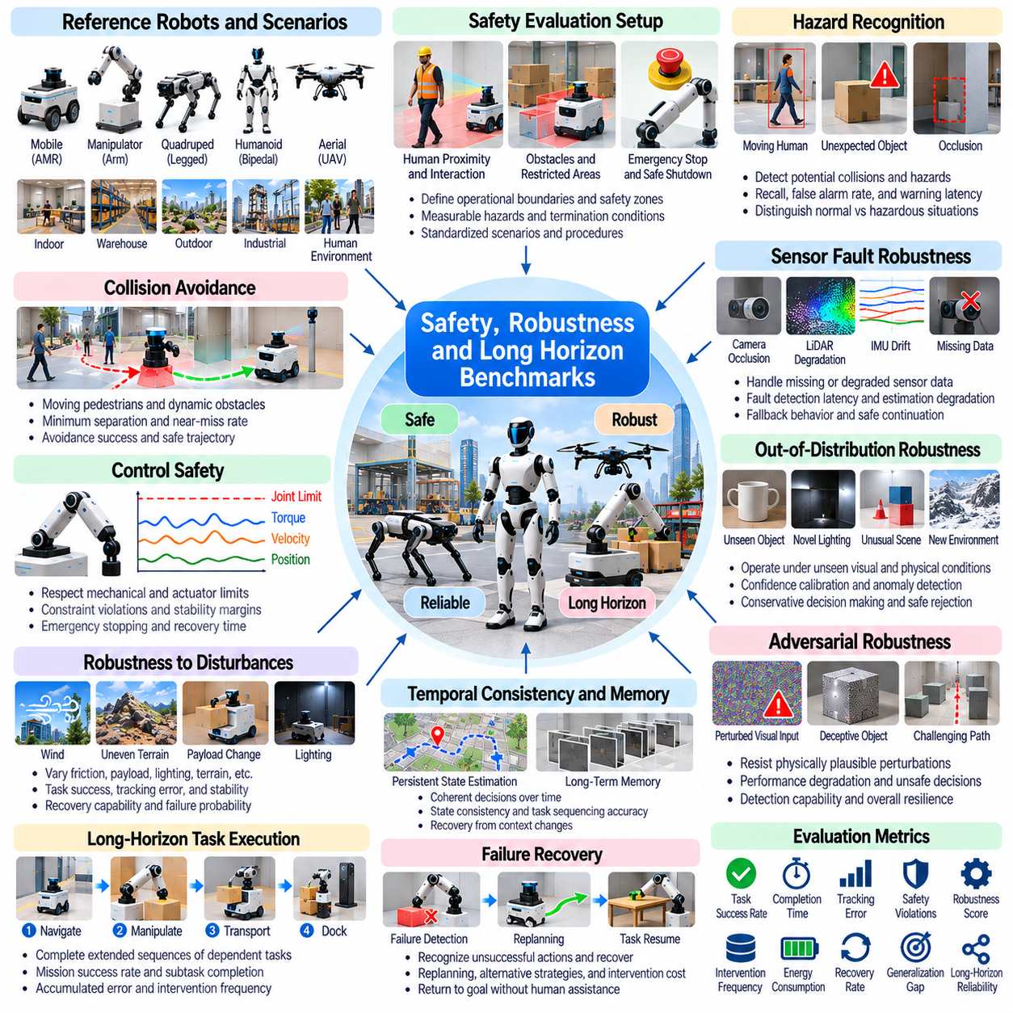
Safety, robustness, and long-horizon benchmarks establish standardized methods for evaluating whether Physical AI systems can operate reliably under uncertainty, disturbances, and extended execution periods. Safety concerns the prevention of unacceptable harm, robustness measures resistance to changing conditions, and long-horizon evaluation examines sustained task performance. Together, these benchmarks assess dependable robotic behavior beyond short demonstrations.
Benchmark design should distinguish nominal performance from behavior under abnormal or hazardous conditions. A robot may achieve high task success in controlled environments yet fail when sensors degrade, obstacles move unexpectedly, or control errors accumulate. Evaluation must therefore include representative disturbances, rare events, and extended operating scenarios. Success metrics should be accompanied by safety violations, recovery outcomes, and failure severity.
Safety benchmark environments should define explicit operational boundaries, protected regions, and acceptable interaction forces. Robot configurations, actuator limits, sensor coverage, and emergency mechanisms must be documented. Standardized scenarios may involve human proximity, obstacle encounters, contact-rich manipulation, and navigation through constrained spaces. Each test should specify measurable hazards, termination conditions, and intervention procedures.
Hazard recognition benchmarks evaluate whether robots detect situations that could lead to collisions, instability, or equipment damage. Perception systems must distinguish ordinary environmental changes from conditions requiring preventive action. Occlusion, sensor noise, ambiguous objects, and unexpected movement increase difficulty. Detection recall, false alarm rates, warning latency, and missed critical events provide complementary safety indicators.
Collision avoidance benchmarks assess whether robots maintain safe separation from people, equipment, and environmental obstacles. Dynamic scenarios should include moving pedestrians, intersecting trajectories, restricted passages, and sudden obstacle appearances. Evaluation must consider relative velocity, stopping distance, and available maneuvering space. Collision frequency, minimum separation, near-miss events, and avoidance success quantify protective behavior.
Control safety benchmarks examine whether generated actions remain within mechanical and operational constraints. Excessive joint torque, unstable acceleration, actuator saturation, and uncontrolled contact can create hazardous conditions. Standardized tests should introduce challenging commands and controlled disturbances. Constraint violations, maximum force, stability margins, emergency stopping behavior, and recovery time indicate controller safety.
Robustness benchmarks evaluate performance when environmental or system parameters deviate from nominal assumptions. Variations in friction, payload, lighting, terrain, communication delay, and actuator response may affect robot behavior. Disturbance levels should increase systematically to reveal performance limits. Task success, tracking error, stability, recovery capability, and failure probability characterize robustness across operating conditions.
Sensor fault benchmarks investigate whether robotic systems remain dependable when observations become unreliable. Camera occlusion, LiDAR degradation, inertial drift, missing measurements, and synchronization errors can undermine perception and control. Fault injection should specify onset time, severity, and duration. Evaluation should measure fault detection latency, estimation degradation, fallback behavior, and safe continuation or shutdown.
Out-of-distribution benchmarks examine robot behavior under conditions not represented adequately in training data. Unfamiliar objects, unusual lighting, unexpected human actions, and novel physical interactions may expose hidden weaknesses. Evaluation should distinguish uncertainty recognition from successful task execution. Confidence calibration, anomaly detection, conservative decision-making, and safe rejection rates reveal how systems handle unfamiliar situations.
Adversarial robustness benchmarks investigate sensitivity to deliberately challenging observations or environmental configurations. Perturbations may involve misleading visual patterns, deceptive object placement, or difficult navigation geometry. Tests should remain physically plausible and avoid assuming that digital attacks directly translate into real-world failures. Evaluation should measure performance degradation, unsafe decisions, detection capability, and resilience to controlled perturbations.
Long-horizon benchmarks evaluate whether robots can sustain reliable behavior across extended sequences of dependent tasks. A mobile manipulator may navigate between stations, identify objects, execute manipulation, and verify completion repeatedly. Minor errors can accumulate and disrupt later operations. Evaluation should include complete mission success, subtask completion, accumulated deviation, and intervention frequency over time.
Temporal consistency benchmarks assess whether robot decisions remain coherent as environmental conditions and task context evolve. Long missions require persistent state estimation, memory management, and reliable transitions between behaviors. Incorrect assumptions about earlier actions may cause repeated failures or skipped operations. State consistency, task sequencing accuracy, memory reliability, and context recovery provide important evaluation measures.
Failure recovery benchmarks measure whether robots can recognize unsuccessful actions and restore operational progress. Examples include failed grasps, blocked navigation paths, localization loss, and incomplete docking. Recovery strategies may involve retrying, replanning, recalibration, or requesting assistance. Evaluation should report recovery success, time to resume, repeated failure frequency, and whether corrective actions preserve safety constraints.
Human intervention benchmarks examine how effectively robotic systems request and incorporate assistance during uncertain or hazardous situations. Intervention may involve remote supervision, task clarification, manual recovery, or emergency stopping. Excessive dependence on operators reduces practical autonomy. Benchmark protocols should measure intervention frequency, response time, operator workload, and the proportion of missions completed without assistance.
Reliability benchmarks evaluate sustained operation through repeated trials and extended missions. Component degradation, thermal effects, calibration drift, and intermittent communication failures may emerge only after prolonged use. Testing should record operating hours, mission cycles, failure events, and recovery actions. Mean time between failures, availability, mission completion rate, and accumulated downtime support operational reliability assessment.
Energy and resource robustness benchmarks examine whether robots maintain performance under constrained power and computational conditions. Battery depletion, processor overload, thermal throttling, and communication congestion can affect mission execution. Standardized scenarios should introduce resource limitations gradually. Evaluation should measure energy consumption, deadline violations, degraded-mode performance, and safe transition to charging or standby states.
Multi-robot safety benchmarks evaluate coordinated operation when several autonomous agents share workspaces and infrastructure. Congestion, conflicting routes, communication delays, and inconsistent task priorities can create hazards. Standardized scenarios should include intersecting paths, shared docking stations, and temporary network failures. Collision avoidance, deadlock resolution, coordination latency, and fleet mission completion provide system-level metrics.
Simulation-based safety testing enables controlled exposure to rare or dangerous scenarios that would be difficult to reproduce physically. Parameterized disturbances, randomized initial conditions, and automated fault injection support broad scenario coverage. However, unrealistic physics or incomplete hazard models may conceal real risks. Simulation results should therefore be complemented by carefully controlled hardware validation.
Sim2Real safety benchmarks assess whether protective behavior demonstrated in simulation remains effective on physical robots. Differences in braking response, contact dynamics, sensor timing, and actuator limitations may invalidate simulated safety margins. Matched tests should compare stopping distance, intervention latency, obstacle clearance, and recovery behavior. Physical validation must use appropriate safeguards and predefined termination conditions.
Statistical evaluation should capture both frequent operational failures and rare high-severity events. Repeated trials, scenario coverage, confidence intervals, and severity-weighted reporting improve interpretability. Average task success alone cannot establish safety or reliability. Benchmark reports should distinguish collision events, constraint violations, recoverable faults, mission failures, and conditions requiring human intervention.
Ultimately, safety, robustness, and long-horizon benchmarks provide a comprehensive framework for evaluating dependable Physical AI systems. Their purpose extends beyond successful isolated tasks to understanding how robots respond to uncertainty, preserve safety boundaries, recover from failures, and sustain operation over time. Standardized scenarios, systematic fault testing, transparent reporting, and physical validation support trustworthy robotic deployment.

09.14. Benchmark Automation [w/Code]
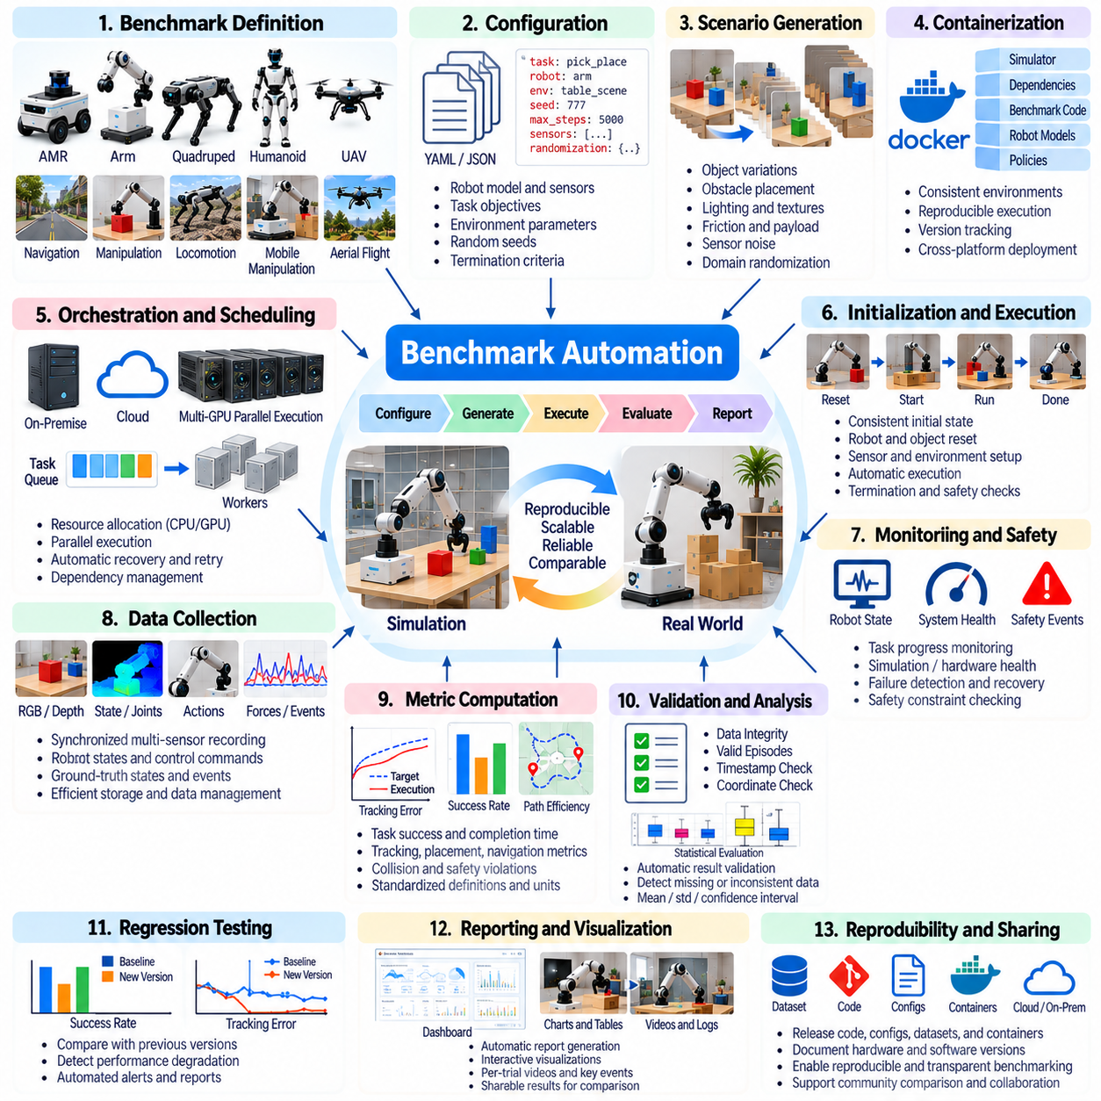
Benchmark automation provides a systematic framework for executing, monitoring, and evaluating robotic experiments with minimal manual intervention. In Physical AI, automated benchmarking connects simulation environments, robot controllers, evaluation metrics, and reporting systems into a reproducible workflow. Its primary objectives are experimental consistency, scalable testing, reliable comparison, and early detection of performance regressions across different algorithms and robot configurations.
An automated benchmark architecture typically separates experiment configuration, execution management, data collection, metric computation, and result reporting. Each component should operate through clearly defined interfaces to reduce dependencies between simulation platforms and evaluation tools. This modular organization enables researchers to replace policies, robot models, or scenarios without redesigning the entire pipeline, supporting long-term maintenance and extensibility.
Experiment configuration defines the conditions under which each benchmark is executed. Configuration files should specify robot models, sensor parameters, environment assets, task objectives, initial states, random seeds, and termination criteria. Machine-readable formats such as YAML or JSON support automated validation and version tracking. Explicit configurations prevent undocumented changes from affecting comparisons between experiments or software releases.
Scenario generation automates the creation of diverse testing conditions from predefined templates and parameter distributions. Variables may include obstacle placement, object geometry, lighting, friction, payload, sensor noise, and environmental disturbances. Controlled randomization produces repeatable scenario variations while expanding test coverage. Scenario identifiers and random seeds should be recorded so that individual failures can be reproduced precisely.
Benchmark orchestration coordinates experiment scheduling, resource allocation, execution, and recovery. An orchestration service may launch simulation instances, assign robot policies, monitor execution status, and collect results. Parallel execution improves throughput when sufficient computing resources are available. Scheduling mechanisms should account for GPU memory, CPU utilization, simulator limitations, and dependencies between experiments to avoid resource conflicts.
Containerization supports consistent benchmark execution across development workstations, laboratory servers, and cloud infrastructure. Container images can preserve software dependencies, simulation libraries, evaluation scripts, and runtime configurations. However, GPU drivers, hardware interfaces, and kernel dependencies may remain platform-specific. Reproducibility therefore requires recording container versions together with host operating systems, accelerator drivers, and relevant hardware specifications.
Automated simulation initialization ensures that every trial begins from a defined state. Robot poses, joint configurations, object placements, sensor settings, and environment parameters must be reset consistently. Residual velocities, cached observations, or incomplete physics resets can introduce hidden experimental differences. Initialization verification should confirm that required conditions are satisfied before benchmark execution begins.
Execution monitoring tracks robot behavior and simulator health throughout each trial. Relevant signals include task progress, robot state, controller frequency, sensor availability, computational load, and safety events. Automated monitors should identify simulation crashes, stalled policies, communication failures, and exceeded execution limits. Distinguishing infrastructure failures from algorithm failures is essential for accurate benchmark interpretation.
Telemetry collection provides the evidence required for detailed performance analysis. Recorded information may include sensor observations, robot trajectories, control commands, estimated states, ground-truth states, collision events, and task outcomes. All measurements should use consistent timestamps and coordinate conventions. Data collection systems must balance recording completeness against storage consumption and interference with real-time execution.
Metric computation transforms recorded trajectories and events into standardized performance indicators. Navigation benchmarks may calculate path efficiency and collision frequency, while manipulation benchmarks evaluate grasp success and placement accuracy. Control benchmarks measure tracking error and stability, whereas learning benchmarks assess task success and sample efficiency. Metric definitions must specify units, aggregation methods, and treatment of incomplete trials.
Automated validation checks whether benchmark results satisfy predefined quality requirements. Validation rules may detect missing telemetry, invalid timestamps, inconsistent coordinate frames, incomplete episodes, or impossible physical measurements. Failed validation should produce explicit diagnostic information rather than silently excluding data. Separating data-quality failures from task-performance failures improves transparency and prevents misleading aggregate statistics.
Statistical evaluation aggregates repeated trials across random seeds, scenario variations, and algorithm configurations. Mean values, standard deviations, confidence intervals, and failure distributions provide complementary evidence. Automated analysis should preserve individual trial results alongside aggregate summaries. Comparing complete distributions helps identify unstable algorithms whose average performance appears acceptable despite occasional severe failures.
Regression testing determines whether changes to robot software, simulation assets, or learned models degrade previously established performance. Reference results provide baselines for evaluating new versions. Automated comparison should apply consistent scenarios and predefined acceptance thresholds. Changes in success rates, latency, safety violations, or tracking accuracy can trigger further investigation before updated software is approved for deployment.
Continuous integration pipelines can execute selected benchmark suites whenever software or model changes are introduced. Lightweight tests may verify configuration validity, interface compatibility, and basic task execution, while larger suites evaluate robustness and generalization. Computationally expensive experiments can be scheduled separately. Benchmark outcomes should support development decisions without assuming that passing simulation tests guarantees physical safety.
Failure replay enables engineers to investigate unsuccessful trials using preserved configurations, telemetry, and simulator states. A replay system should reconstruct initial conditions and reproduce relevant action sequences whenever deterministic execution is supported. Event timelines can reveal whether failures originated in perception, planning, control, or infrastructure. Repeated replay under modified parameters supports diagnosis and corrective testing.
Simulation determinism is an important consideration because identical random seeds do not always guarantee identical results. Parallel execution, floating-point operations, asynchronous sensors, and physics solver behavior may introduce nondeterministic differences. Benchmark systems should document reproducibility limits and control sources of variation where practical. Statistical repetition remains necessary when exact replay cannot be guaranteed.
Sim2Real benchmark automation extends the evaluation pipeline from virtual environments to physical robot platforms. Hardware trials require calibration verification, safety supervision, controlled initialization, and reliable telemetry synchronization. Automated procedures may deploy policies, execute approved test sequences, and collect comparable measurements. Physical experiments should retain independent emergency stopping and operator intervention capabilities.
Safety automation continuously checks operational constraints during benchmark execution. Monitoring may include joint limits, actuator temperatures, collision distances, contact forces, and emergency states. Constraint violations should be recorded with timestamps, severity classifications, and relevant system context. Automated termination can reduce exposure to hazardous conditions, but protective mechanisms must remain independent of experimental software when required.
Result reporting converts benchmark outputs into interpretable evidence for researchers and system engineers. Standardized reports should present experiment identifiers, software versions, task configurations, performance metrics, statistical summaries, and categorized failures. Trend analysis can reveal gradual performance degradation across development cycles. Traceable reports allow reviewers to connect conclusions with original measurements and reproducible experiments.
Benchmark governance defines how scenarios, metrics, datasets, and reference baselines are maintained over time. Version-controlled specifications should identify approved changes and preserve historical evaluation conditions. Access permissions and data retention policies protect experimental integrity. Benchmark updates must distinguish genuine algorithm improvements from changes in task difficulty, simulator behavior, or metric implementation.
Ultimately, benchmark automation transforms isolated robotic experiments into a repeatable engineering process. Its value extends beyond reducing manual effort to improving reproducibility, traceability, statistical confidence, and development efficiency. By integrating scenario generation, orchestration, telemetry, validation, regression testing, and Sim2Real evaluation, automated benchmarking supports systematic verification and continuous improvement of dependable Physical AI systems.

