Volume 10. Physical AI Safety and Alignment

Chapter 00. Introduction

00.01. Why Safety is Fundamental to Physical AI
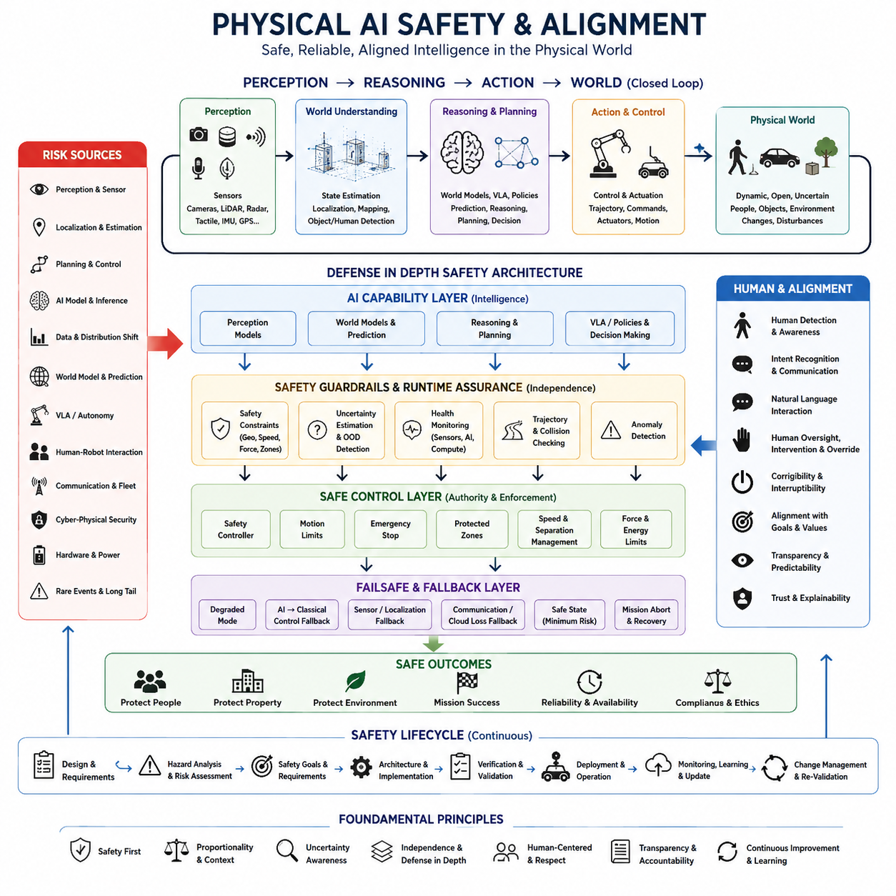
Physical AI differs fundamentally from conventional digital AI because its decisions are converted into motion, force, heat, electrical power, and other physical effects. An incorrect prediction in a software service may produce inaccurate information, but an incorrect decision by an autonomous machine can create collisions, injuries, equipment damage, or environmental hazards. Safety must therefore be treated as a fundamental system property rather than an optional feature.
A Physical AI system continuously closes the loop between perception, reasoning, action, and the physical environment. Cameras, LiDAR, radar, tactile sensors, localization systems, and other sensors estimate the current state of the world, while learned models interpret that state and select actions. Actuators then change the environment, producing new observations and decisions. Errors can consequently propagate through this closed loop and become physical consequences.
The safety challenge becomes more difficult because Physical AI operates in environments that cannot be completely predicted during design or training. People move unexpectedly, objects change position, surfaces become slippery, sensors become obstructed, communication links fail, and unfamiliar situations appear. A safe system must therefore handle uncertainty and distribution shift while recognizing when its own knowledge or perception is insufficient for reliable action.
Traditional automation commonly relies on deterministic logic, predefined operating conditions, and carefully engineered safety boundaries. Physical AI increasingly introduces learned perception, world models, reinforcement learning, foundation models, and Vision-Language-Action models. These components can improve adaptability and generalization, but their behavior may not always be represented by simple deterministic rules. Safety engineering must therefore coexist with learned and probabilistic behavior.
Safety cannot be assigned to the AI model alone because physical harm normally emerges from interactions among multiple subsystems. A perception error may corrupt localization, localization uncertainty may distort planning, and an unsafe trajectory may then be executed by the controller. Mechanical limits, actuator faults, network delays, thermal conditions, or human behavior may further amplify the problem. Physical AI safety must consequently be addressed as a system-level property.
A useful safety architecture separates intelligent capability from the authority to produce unrestricted physical action. AI may generate predictions, plans, trajectories, or commands, while independent mechanisms verify whether those outputs remain inside defined safety constraints. Motion limits, protected zones, collision checks, safety controllers, emergency stops, and runtime monitors can restrict unsafe behavior even when the primary intelligent system produces an incorrect or uncertain decision.
Uncertainty is particularly important because a Physical AI system must distinguish between situations it understands and situations where its internal models are unreliable. Confidence estimation, out-of-distribution detection, sensor-health monitoring, prediction consistency, and anomaly detection provide evidence about whether normal autonomous operation should continue. When uncertainty becomes excessive, conservative behavior such as slowing, stopping, replanning, or requesting human assistance becomes part of intelligent operation.
Safety also requires explicit consideration of failure rather than assuming that every component will remain available. Sensors can fail, localization can degrade, AI inference can exceed timing limits, processors can overheat, batteries can approach critical levels, and communication with cloud or fleet infrastructure can disappear. Robust Physical AI therefore needs degraded operating modes, fallback controllers, minimum-risk conditions, mission-abort strategies, and clearly defined safe states.
Human interaction creates another essential dimension of safety. Robots frequently operate near workers, passengers, patients, pedestrians, operators, or other users whose intentions cannot be perfectly predicted. The machine must detect and track people while respecting separation, speed, force, and workspace constraints. It should also communicate its own intentions clearly so that humans can anticipate motion and intervene when necessary instead of being surprised by autonomous behavior.
Alignment extends this problem beyond collision avoidance. A physically capable AI system must translate human goals and instructions into actions that remain compatible with physical, operational, social, and safety constraints. A command may be technically achievable while still being unsafe in the current context. Physical alignment therefore requires the system to reason not only about what action can accomplish a goal, but also whether that action should be executed under existing conditions.
Runtime assurance becomes increasingly important as autonomy grows. Verification before deployment cannot enumerate every combination of environment, human behavior, model uncertainty, component degradation, and rare event that may occur during operation. Independent runtime monitoring can continuously evaluate perception health, system resources, trajectories, safety envelopes, world-model consistency, and AI confidence, allowing protective mechanisms to intervene when behavior approaches unacceptable boundaries.
Safety must also persist throughout the system lifecycle. Training data, model updates, software revisions, sensor replacements, environmental changes, and continual learning can alter behavior after initial validation. Logging, traceability, scenario-based testing, field evidence, change management, and repeated verification are therefore necessary to demonstrate that safety assumptions remain valid. Certification of adaptive Physical AI ultimately depends on maintaining evidence as the system evolves.
The fundamental objective is not to eliminate intelligence in order to obtain safety, but to make increasing intelligence compatible with controlled physical authority. Perception, prediction, reasoning, world models, VLA policies, and autonomous learning can expand what machines are capable of doing, while safety architectures determine the conditions under which those capabilities may act. Physical AI becomes trustworthy when intelligence, uncertainty management, runtime assurance, fallback behavior, and human oversight operate as one integrated system.

00.02. From AI Error to Physical Harm
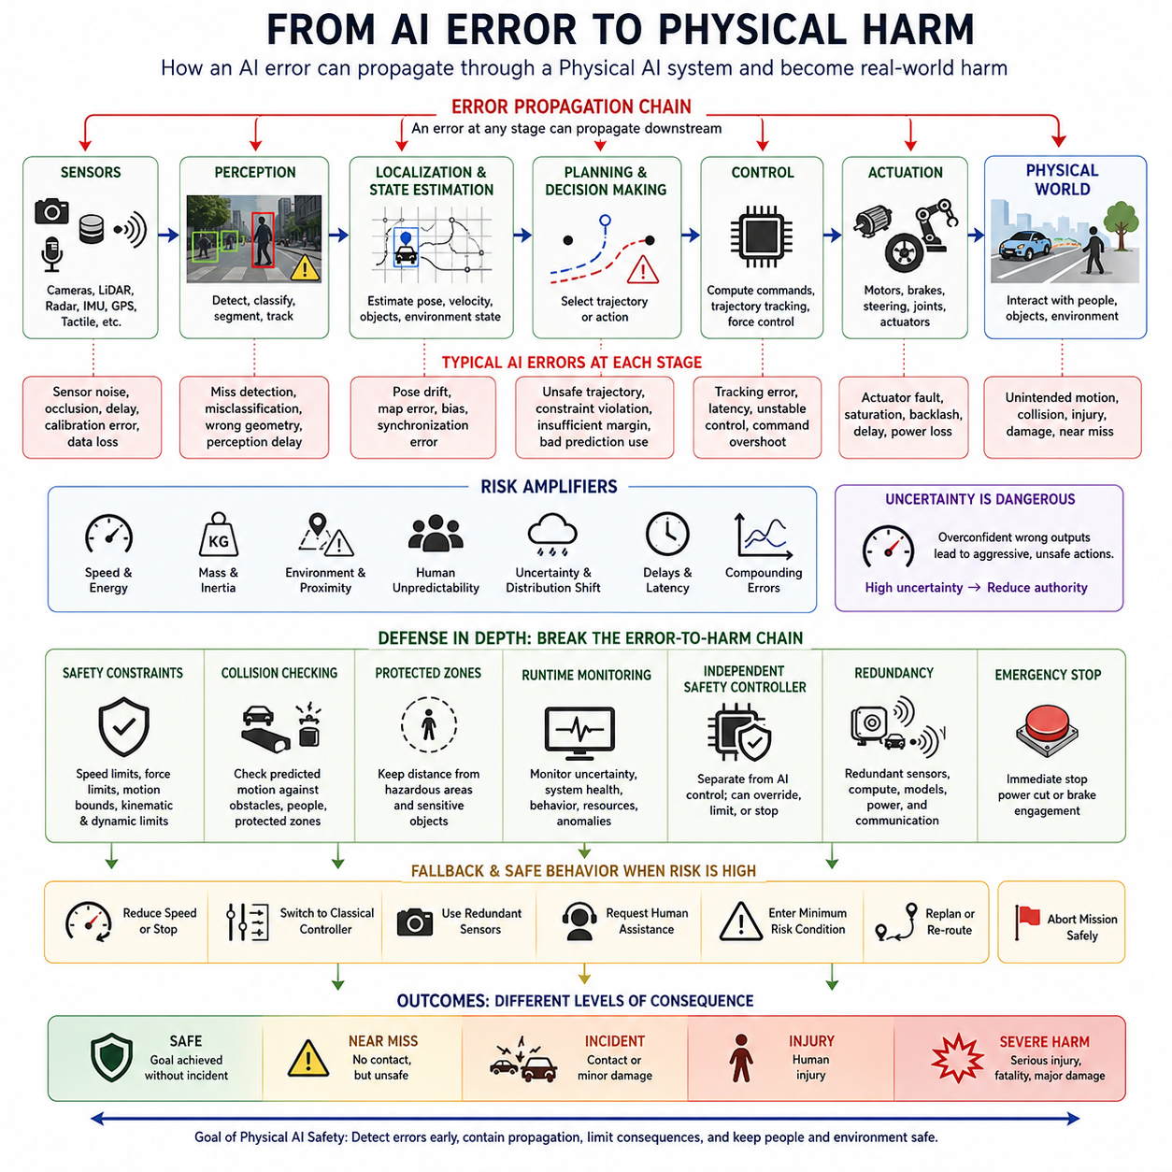
An AI error becomes fundamentally different when intelligence is connected to a physical system. In a digital application, an incorrect classification, prediction, or generated response may remain an informational failure. In Physical AI, the same type of computational error can influence motors, wheels, manipulators, vehicles, or other actuators. Information therefore becomes physical action, creating a direct pathway from model error to real-world harm.
The transition from error to harm usually occurs through a chain rather than through a single isolated failure. A sensor produces observations, perception models interpret them, localization estimates the system state, planning selects a trajectory or action, and control converts that decision into actuator commands. An error introduced at any stage can propagate downstream. Safety analysis must therefore examine complete causal chains instead of evaluating individual AI components independently.
Perception errors provide a clear example of this propagation. A vision model may fail to detect a pedestrian, incorrectly classify an obstacle, or estimate the geometry of an object inaccurately. The planner may then construct a trajectory under the false assumption that the path is clear. If no independent safety mechanism detects the discrepancy, the controller can execute a technically valid command that produces an unsafe physical motion.
Localization and state-estimation errors create another pathway from computation to physical danger. A robot may incorrectly estimate its position, orientation, velocity, or relationship to nearby objects because of sensor degradation, map errors, poor synchronization, or environmental ambiguity. Even when the planner and controller operate correctly according to their inputs, an incorrect estimated state can cause the resulting motion to violate real physical boundaries.
Planning errors can transform an otherwise accurate understanding of the environment into unsafe behavior. A planner may select a trajectory that passes too close to a person, violates a speed constraint, enters a restricted area, or leaves insufficient braking distance. Learned planners and generalist policies may introduce additional uncertainty because their decisions can depend on patterns learned from data rather than exclusively on explicitly programmed safety rules.
Control and actuation determine whether an unsafe decision becomes actual physical energy. Errors in trajectory tracking, actuator commands, force control, timing, or low-level control can cause deviations from intended behavior. Mechanical inertia, vehicle mass, manipulator payload, speed, and actuator power determine how serious those deviations may become. Physical harm therefore depends not only on whether an error occurs, but also on the energy and authority available to the system.
The physical environment can amplify small computational errors. A modest localization offset may be insignificant in an open area but dangerous beside a staircase, machine, vehicle, or person. A short perception delay may have little consequence at low speed but become critical during high-speed operation. Risk is therefore contextual: the same AI error can produce radically different outcomes depending on exposure, environment, operating speed, system mass, and proximity to hazards.
Errors can also compound over time. A world model may slightly mispredict another agent's motion, causing the planner to choose a suboptimal trajectory. The resulting movement changes subsequent observations, which may further increase prediction uncertainty and produce additional planning errors. In closed-loop Physical AI, repeated small inaccuracies can accumulate into significant divergence between the system's internal representation and the actual physical world.
Uncertainty becomes dangerous when the system treats an unreliable estimate as if it were certain. AI models may produce confident outputs for unfamiliar environments, unusual objects, degraded sensor inputs, or situations outside their training distribution. A safety-oriented system must therefore evaluate not only the predicted answer but also the reliability of that prediction. High uncertainty should reduce physical authority rather than encourage aggressive autonomous action.
Human interaction makes error propagation particularly important because people are dynamic, diverse, and difficult to predict precisely. A robot may correctly detect a person but incorrectly infer their intention, future motion, or awareness of the robot. Safe behavior therefore requires margins that account for prediction error and human unpredictability. Slower motion, greater separation, explicit communication, and conservative planning can prevent uncertain interpretations from becoming harmful interactions.
Not every AI error should be allowed to reach the actuator. Defense-in-depth architectures introduce independent barriers between intelligent decisions and physical execution. Safety constraints, collision checking, protected zones, speed limits, force limits, runtime monitors, and independent safety controllers can reject or modify unsafe commands. These mechanisms break the causal chain so that a failure in the primary AI does not automatically become a failure of the entire physical system.
When normal autonomous operation can no longer be trusted, the system requires controlled fallback behavior. Depending on the situation, this may include reducing speed, stopping motion, switching from AI control to a simpler classical controller, using redundant sensors, requesting human assistance, or entering a predefined minimum-risk condition. The objective is to prevent uncertainty, degradation, or component failure from continuing unchecked until physical harm occurs.
Understanding the path from AI error to physical harm changes the meaning of AI safety. Accuracy alone is insufficient because two models with similar error rates may create very different physical risks. Safety depends on where errors occur, whether they can propagate, how much physical authority the system possesses, what hazards are exposed, and which barriers can interrupt the sequence. Evaluation must therefore connect model performance to system behavior and real-world consequences.
Physical AI safety can ultimately be understood as the engineering discipline of controlling this error-to-harm pathway. Perception, localization, prediction, planning, control, hardware, humans, and the environment form one interconnected causal system. The goal is not to assume that errors can be eliminated completely, but to detect them, contain their propagation, limit their physical consequences, and maintain safe behavior when intelligence becomes uncertain or fails.

00.03. Safety Security Reliability and Alignment
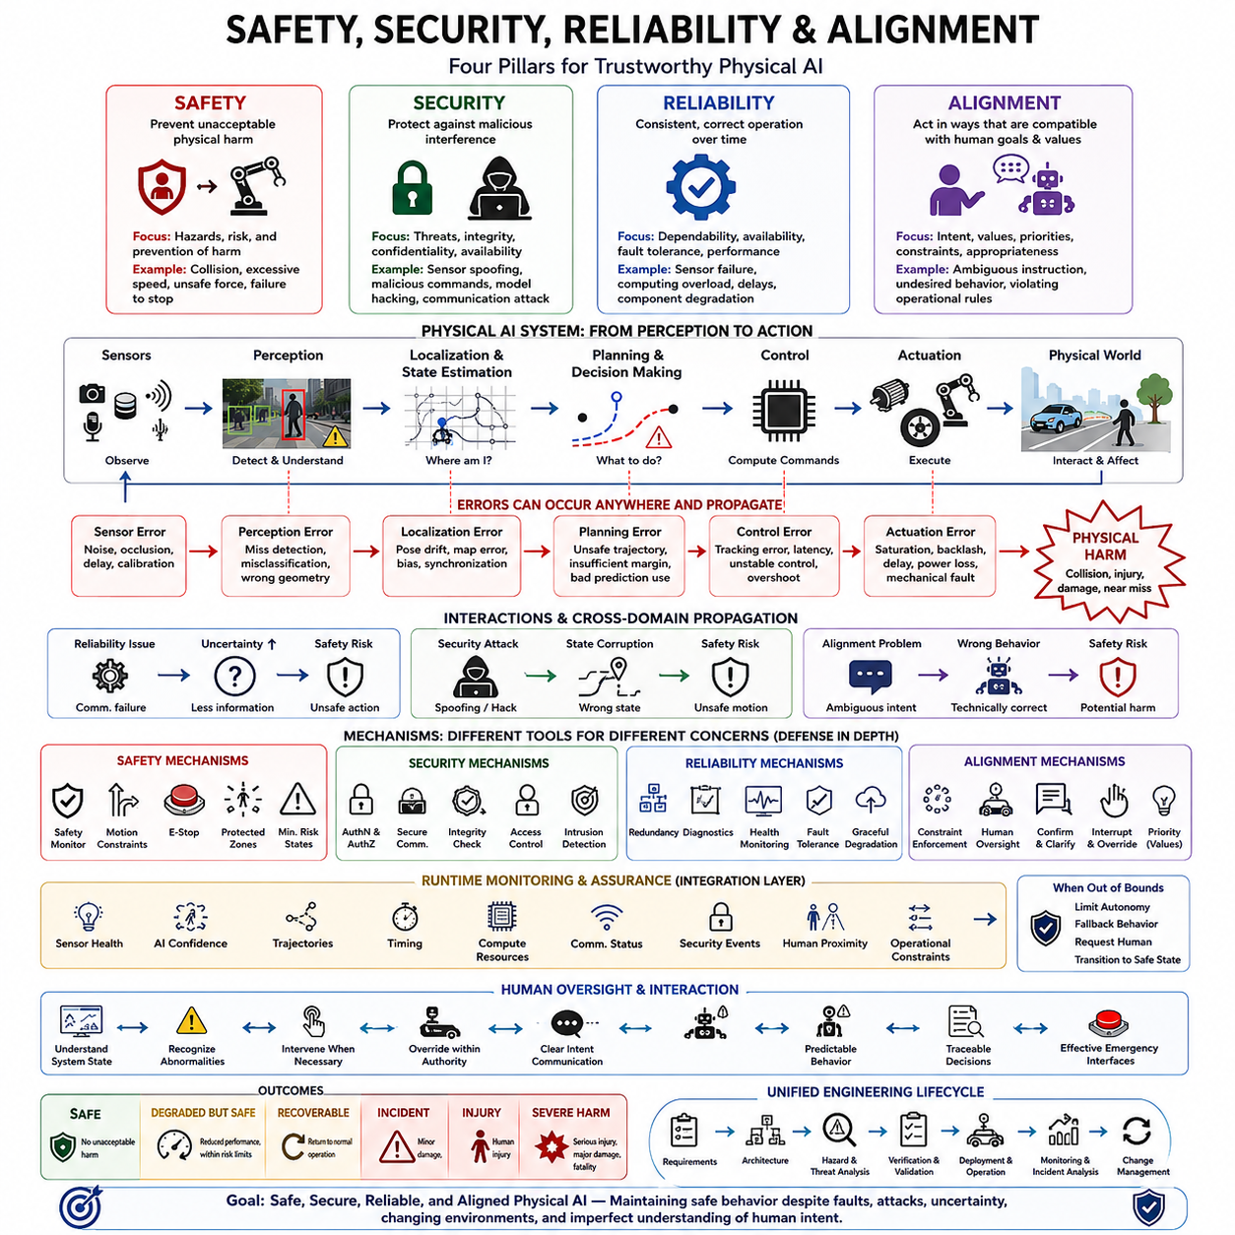
Safety, security, reliability, and alignment are closely related but distinct properties of Physical AI systems. Safety concerns preventing unacceptable physical harm, security protects the system against malicious interference, reliability concerns consistent and correct operation over time, and alignment ensures that autonomous behavior remains compatible with human goals and constraints. A trustworthy Physical AI architecture must address all four simultaneously rather than treating them as interchangeable concepts.
Safety focuses primarily on the consequences of system behavior in the physical world. A robot may create danger through excessive speed, unexpected motion, collision, unstable manipulation, unsafe force, or failure to stop when required. Safety engineering therefore identifies hazards, evaluates exposure and severity, establishes acceptable risk levels, and introduces mechanisms that prevent faults or AI errors from producing unacceptable physical consequences.
Security addresses intentional threats that can compromise the integrity, confidentiality, or availability of the Physical AI system. Attackers may manipulate sensor inputs, communication channels, software, models, maps, commands, or fleet infrastructure. Because compromised information can ultimately influence actuators, cybersecurity in Physical AI becomes cyber-physical security. A digital intrusion may therefore progress beyond data loss and directly create dangerous motion or physical disruption.
Reliability describes the ability of the system to perform its intended functions consistently under specified operating conditions and over an expected period of operation. Sensors, processors, communication links, power systems, software, AI models, and mechanical components must remain sufficiently dependable. Reliability engineering addresses failures, degradation, timing problems, resource exhaustion, environmental stress, and component lifetime before they accumulate into mission failure or unsafe behavior.
Safety and reliability overlap, but they are not identical. A system can be unreliable without being unsafe if every failure causes a controlled stop, while a highly reliable system can still contain a design flaw that repeatedly produces dangerous behavior. Reliability reduces the frequency of failures, whereas safety controls their consequences. Physical AI therefore requires both dependable operation and mechanisms that preserve acceptable risk when dependable operation cannot be guaranteed.
Security and safety are similarly interconnected. A safety mechanism designed only for accidental faults may be ineffective when an intelligent adversary deliberately attempts to bypass it. Spoofed localization, manipulated camera inputs, malicious commands, compromised model updates, or denial of communication can create conditions that resemble ordinary failures while having different causes. Safety analysis must therefore consider security threats capable of violating physical safety assumptions.
Alignment introduces a different question: even if the system is functioning correctly, securely, and reliably, is it pursuing the right objective in the right way? A robot can execute an instruction accurately while violating an unstated human expectation, social constraint, operational rule, or safety priority. Physical alignment requires autonomous systems to interpret human intent within the context of physical consequences rather than treating task completion as the only measure of success.
Alignment becomes especially important when Physical AI uses foundation models, Vision-Language-Action models, learned policies, or autonomous reasoning. Natural-language instructions can be ambiguous, incomplete, or conflicting, while learned policies may discover actions that technically satisfy a goal without respecting its intended constraints. The system therefore needs hierarchical priorities in which safety requirements and operational boundaries can override lower-level task objectives.
The four properties also differ in their characteristic failure questions. Safety asks whether an action can cause unacceptable harm. Security asks whether an unauthorized actor can manipulate the system or its information. Reliability asks whether the system will continue to perform its intended function correctly. Alignment asks whether the intended function and resulting behavior remain consistent with human goals, values, instructions, and contextual expectations.
These properties interact strongly during real operation. A communication failure may begin as a reliability problem, remove access to fleet coordination, increase uncertainty, and eventually become a safety risk. A cyberattack may corrupt localization, causing the planner to generate an unsafe trajectory. An ambiguous instruction may create an alignment problem that becomes a safety problem when executed physically. Classification by category is therefore useful, but system analysis must also examine cross-domain propagation.
A robust architecture assigns different mechanisms to these different concerns. Safety may use independent monitors, motion constraints, emergency stops, protected zones, and minimum-risk states. Security may use authentication, authorization, secure communication, integrity verification, access control, and intrusion detection. Reliability may use redundancy, diagnostics, health monitoring, fault tolerance, and graceful degradation, while alignment may use constraint enforcement, human oversight, command confirmation, and interruptibility.
Independence between protection mechanisms is important because a single intelligent component should not be responsible for both creating an action and declaring that action safe. An AI planner may propose a trajectory, while an independent safety controller verifies speed, separation, collision, and motion constraints. Security mechanisms protect the integrity of both components, reliability mechanisms maintain their availability, and alignment mechanisms ensure that accepted actions remain consistent with authorized human objectives.
Runtime monitoring provides a common integration layer across all four domains. The system can continuously observe sensor health, AI confidence, trajectories, timing, computational resources, communication status, security events, human proximity, and operational constraints. When monitored variables move outside acceptable boundaries, runtime assurance mechanisms can restrict autonomy, invoke fallback behavior, request human intervention, or transition the machine toward a predefined safe state.
Human oversight connects safety and alignment particularly strongly. Operators must be able to understand important system states, recognize abnormal behavior, intervene when necessary, and override autonomous decisions within appropriate authority boundaries. Predictable robot behavior, clear intent communication, traceable decisions, and effective emergency interfaces help humans maintain meaningful supervisory control without requiring continuous manual operation of the autonomous system.
The relationship among safety, security, reliability, and alignment can therefore be understood as a layered foundation for trustworthy Physical AI. Reliability helps the system continue operating correctly, security protects it against intentional compromise, alignment guides autonomous capability toward acceptable human objectives, and safety limits unacceptable physical consequences when any of the other properties are imperfect. None of these dimensions can substitute completely for another.
As Physical AI systems become more autonomous, adaptive, connected, and physically capable, these four disciplines must converge within a unified engineering lifecycle. Requirements, architecture, hazard analysis, threat analysis, reliability assessment, AI evaluation, verification, runtime monitoring, incident analysis, and change management must reinforce one another. Trustworthy Physical AI emerges when safe behavior remains protected despite faults, attacks, uncertainty, changing environments, and imperfect understanding of human intent.

00.04. Traditional Robot Safety vs AI Safety
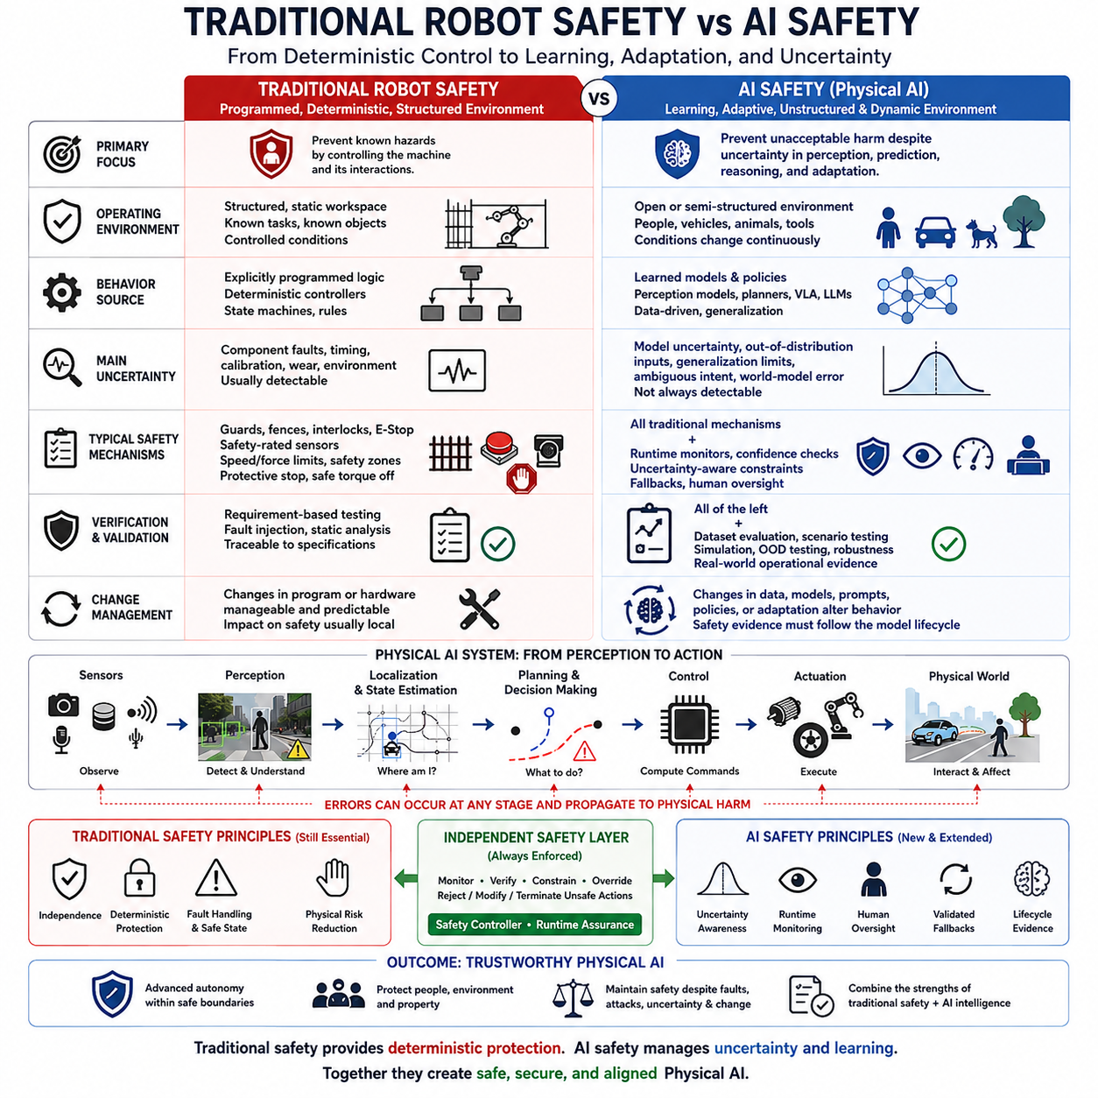
Traditional robot safety was developed primarily for machines whose behavior could be constrained by predefined programs, deterministic controllers, fixed workspaces, and known operating procedures. Hazards were managed by limiting human access, restricting motion, defining safety zones, monitoring hardware faults, and forcing the machine into a safe state when predefined conditions were violated. This approach remains essential, but Physical AI introduces behaviors that cannot always be described completely in advance.
Industrial robots traditionally achieve safety by controlling the relationship between the machine and its environment. Guards, fences, interlocks, emergency stops, safety-rated sensors, speed limits, force limits, and separation monitoring reduce exposure to dangerous motion. When operating conditions are well defined, engineers can identify hazardous states and implement deterministic mechanisms that prevent or terminate them before unacceptable physical consequences occur.
Traditional safety engineering assumes that the behavior of the control system can be analyzed through specifications, state machines, failure modes, timing constraints, and predictable responses to faults. Verification can demonstrate whether defined requirements are satisfied under specified conditions. Even complex control software is generally expected to produce repeatable behavior for equivalent inputs, making traceability between requirements, implementation, testing, and safety evidence comparatively direct.
AI safety introduces a different source of uncertainty because learned behavior is derived partly from data rather than entirely from explicitly programmed rules. A perception model may generalize differently across environments, a learned planner may encounter situations outside its training distribution, and a VLA policy may interpret an instruction differently depending on context. The safety problem therefore includes uncertainty about what the model has learned and how it will behave in unfamiliar situations.
This distinction is particularly important for perception. Traditional safety functions often rely on sensors with explicitly characterized detection capabilities and failure responses. AI-based perception may recognize complex objects and situations far beyond simple threshold logic, but its failure boundaries can be difficult to specify exhaustively. Occlusion, lighting, weather, unusual objects, sensor artifacts, and distribution shift can change model performance without producing a conventional hardware fault.
AI models can also fail while the computing system appears technically healthy. The processor may operate normally, memory may contain no detectable fault, communication may remain available, and all sensors may produce valid data, yet the model can still generate an incorrect classification, prediction, trajectory, or action. Conventional diagnostics designed to detect component faults are therefore insufficient for identifying every unsafe AI behavior.
Traditional robot safety frequently separates humans from hazardous machinery or allows collaboration only under carefully constrained conditions. Physical AI increasingly operates in open or semi-structured environments where people, vehicles, animals, equipment, and environmental conditions change continuously. Safety boundaries consequently become dynamic rather than purely geometric, requiring the system to reason about motion, intent, uncertainty, predicted interaction, and changing levels of exposure.
Deterministic safety mechanisms nevertheless remain indispensable in AI-enabled robots. Emergency stops, safe torque off, speed limits, force limits, protective stops, safety zones, and independent safety controllers provide constraints that do not depend entirely on the correctness of the AI. Physical AI safety should therefore extend traditional robot safety rather than replace it, preserving proven protective mechanisms while adding methods capable of supervising learned and adaptive behavior.
A key architectural principle is separation between AI control and safety control. The AI system may optimize navigation, manipulation, task execution, or interaction, but an independent safety layer can enforce non-negotiable physical constraints. If an AI-generated trajectory exceeds speed limits, violates separation requirements, predicts collision, or leaves an approved operational boundary, the safety layer should restrict, modify, reject, or terminate the requested action.
AI safety also requires explicit treatment of uncertainty. Traditional control logic commonly produces a defined result from a defined state, whereas learned models often produce estimates with varying confidence. A Physical AI system should recognize low-confidence perception, out-of-distribution inputs, inconsistent world-model predictions, and anomalous actions. Increasing uncertainty should progressively reduce autonomy or physical authority rather than remaining invisible until a failure becomes obvious.
Runtime assurance therefore becomes a major bridge between traditional safety and AI safety. Instead of relying exclusively on pre-deployment verification, runtime monitors continuously evaluate whether the AI remains within an acceptable safety envelope. They can observe sensor health, model confidence, trajectories, timing, computational resources, localization consistency, environmental conditions, and operational constraints while independent mechanisms intervene when boundaries are approached or violated.
Verification methods must also evolve. Traditional robot safety can often validate explicitly specified functions through requirement-based testing and fault injection. AI-enabled systems additionally require dataset evaluation, scenario-based testing, simulation, rare-event analysis, robustness assessment, out-of-distribution testing, uncertainty calibration, and real-world operational evidence. No finite test set can demonstrate every possible behavior of an adaptive system operating in an open environment.
Change management becomes more difficult because AI behavior can change when training data, model weights, prompts, policies, foundation models, or adaptation mechanisms change. A modification that improves average task performance may alter rare safety-critical behavior. Safety evidence must therefore follow the model lifecycle, connecting data provenance, model versions, validation results, deployment configuration, runtime observations, incidents, and subsequent updates.
The distinction between traditional robot safety and AI safety should therefore not be understood as a replacement of old engineering by new AI techniques. Traditional safety provides deterministic protection, independence, fault handling, and physical risk reduction. AI safety adds mechanisms for learned-model failure, uncertainty, generalization, adaptive behavior, world-model error, and autonomous reasoning. Physical AI requires these two traditions to operate together as complementary layers.
The resulting safety philosophy combines predictable protective mechanisms with intelligent but continuously supervised autonomy. AI can provide perception, reasoning, prediction, adaptation, and general-purpose behavior, while conventional safety engineering establishes boundaries that intelligence cannot freely violate. Trustworthy Physical AI emerges when advanced autonomy is surrounded by independent monitoring, constrained physical authority, verified fallback behavior, and lifecycle evidence capable of maintaining safety even when learned behavior is imperfect.

00.05. Deterministic Control vs Learned Behavior
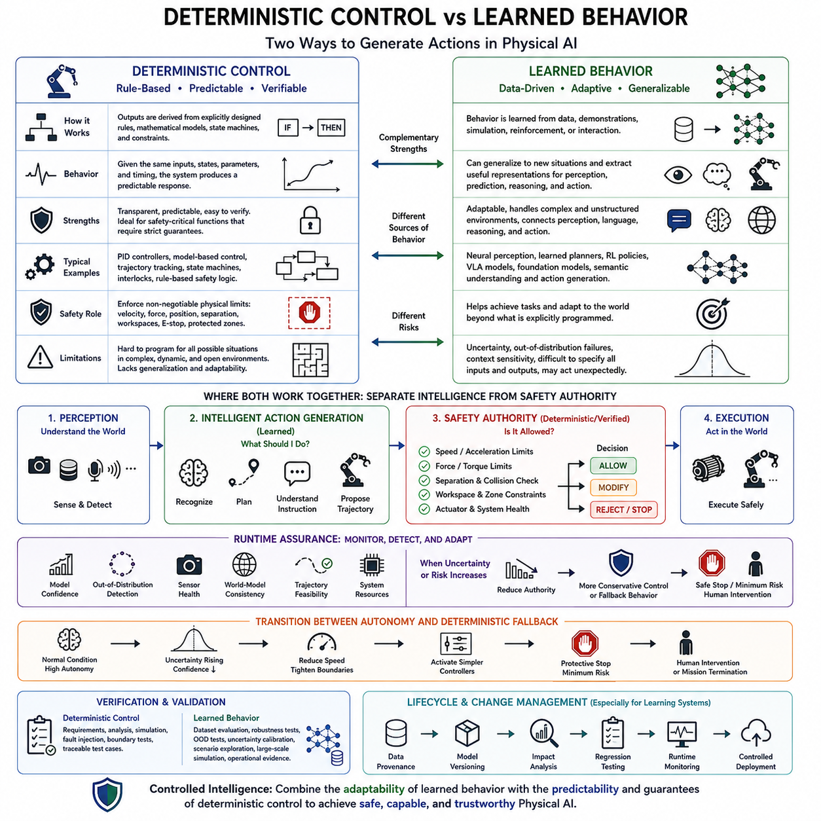
Deterministic control and learned behavior represent two fundamentally different ways of generating actions in Physical AI. Deterministic controllers derive outputs from explicitly designed rules, mathematical models, state machines, and constraints, while learned systems derive behavior from patterns captured in data or experience. Modern robots increasingly combine both approaches because predictability and adaptability are simultaneously required for safe operation.
In deterministic control, engineers explicitly define how the system should respond to measurable states and inputs. Given equivalent initial conditions, sensor values, controller parameters, and timing assumptions, the system is expected to produce a predictable response. PID controllers, model-based controllers, trajectory trackers, state machines, interlocks, and rule-based safety logic exemplify this philosophy, making behavior comparatively transparent and suitable for systematic verification.
This predictability is particularly valuable for safety-critical functions. Maximum velocity, acceleration, steering angle, joint position, actuator force, braking behavior, protected zones, and emergency-stop responses can be represented as explicit constraints. Engineers can analyze whether these limits are satisfied and determine how the controller reacts when they are violated. Deterministic mechanisms therefore provide strong foundations for enforcing non-negotiable physical boundaries.
However, deterministic control becomes increasingly difficult when the environment contains complexity that cannot be represented efficiently through predefined rules. A mobile robot operating among people, vehicles, obstacles, changing terrain, and unfamiliar objects may encounter an enormous number of possible situations. Explicitly programming an appropriate response for every combination produces rapidly increasing complexity and still cannot anticipate every condition encountered in an open world.
Learned behavior addresses this limitation by allowing models and policies to extract useful representations and action strategies from data, demonstrations, simulation, reinforcement signals, or interaction. Neural perception models can recognize complex objects, learned planners can evaluate high-dimensional situations, and Vision-Language-Action models can connect semantic instructions with physical actions. This enables generalization beyond the narrow conditions explicitly encoded by engineers.
The advantage of learned behavior is therefore adaptability, but adaptability introduces uncertainty. A model may perform well on its training distribution while responding unexpectedly to unfamiliar objects, unusual lighting, rare human behavior, sensor degradation, or new environments. Unlike a conventional software fault, the model may remain computationally healthy while producing an incorrect decision. The boundary between normal and unsafe behavior can consequently become difficult to specify completely.
Learned behavior can also be probabilistic or context dependent. Small differences in observations, model state, prompts, memory, or environmental context may alter predictions and actions. Foundation models and VLA policies further expand this behavioral space by combining perception, language, reasoning, and action generation. Their flexibility is valuable for general-purpose robotics, but it makes exhaustive specification of every possible input-to-action relationship impractical.
The distinction between deterministic and learned systems should not be reduced to a choice between old and new technology. Deterministic control is strongest where requirements can be explicitly specified and strict guarantees are required, while learned behavior is strongest where perception, prediction, semantic understanding, adaptation, and generalization dominate. Physical AI architectures can assign different responsibilities to each approach according to their strengths.
A useful architecture therefore separates intelligent action generation from safety authority. Learned models may recognize the environment, predict future states, select goals, or propose trajectories, while deterministic or independently verified mechanisms enforce physical constraints. The AI can answer what action appears effective, but a safety controller determines whether that action is permissible within speed, force, separation, workspace, collision, and operational limits.
This separation becomes especially important when AI confidence decreases. A learned planner may propose a trajectory even when perception is uncertain or the environment is outside its training distribution. Runtime assurance can monitor confidence, out-of-distribution conditions, sensor health, world-model consistency, trajectory feasibility, and system resources. When uncertainty rises, the architecture can reduce the authority granted to learned behavior and move toward more conservative control.
The transition between learned autonomy and deterministic fallback should itself be carefully engineered. Under normal conditions, the AI may receive substantial freedom to optimize performance and adapt to complex situations. When confidence, system health, or environmental conditions deteriorate, speed can be reduced, operating boundaries tightened, or simpler controllers activated. Severe violations may trigger protective stopping, minimum-risk behavior, human intervention, or mission termination.
Verification also differs between the two approaches. Deterministic controllers can often be evaluated against explicit requirements using analysis, simulation, fault injection, boundary testing, and traceable test cases. Learned behavior additionally requires dataset evaluation, robustness testing, uncertainty calibration, out-of-distribution testing, scenario exploration, simulation at scale, and operational evidence because correct behavior cannot be inferred solely from source code or control equations.
The distinction becomes more complex when learning continues after deployment. Online adaptation, continual learning, policy updates, new foundation models, or changing prompts can modify behavior without changing the mechanical system. A previously validated operating assumption may therefore become invalid. Model versioning, data provenance, change impact analysis, regression testing, runtime monitoring, and controlled deployment become essential parts of the safety lifecycle for adaptive Physical AI.
Ultimately, deterministic control and learned behavior should form complementary layers rather than competing architectures. Learning expands what the robot can perceive, understand, predict, and accomplish, while deterministic and independently assured mechanisms constrain how that intelligence may affect the physical world. This combination allows Physical AI to gain adaptability without granting unrestricted authority to behavior whose complete response space cannot be known in advance.
The central design principle is therefore controlled intelligence: increase learning and autonomy where they provide meaningful capability, while preserving explicit boundaries around safety-critical physical actions. A trustworthy Physical AI system does not require every intelligent behavior to be deterministic. Instead, it ensures that uncertain learned behavior operates inside an architecture capable of monitoring, constraining, overriding, degrading, and safely terminating physical action when necessary.

00.06. Open World and Uncertainty Challenges
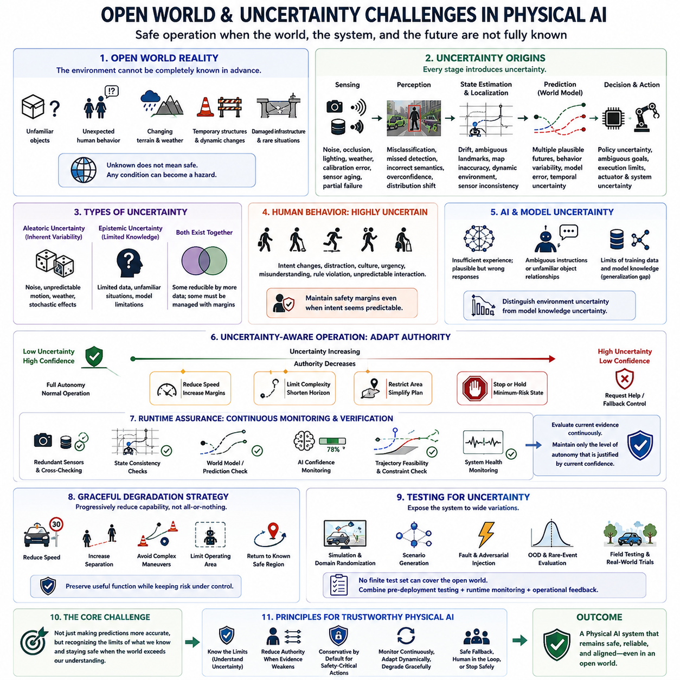
Physical AI operates in an open world where the environment cannot be completely specified before deployment. Unlike a controlled industrial cell, an autonomous robot may encounter unfamiliar objects, unexpected human behavior, changing terrain, weather, temporary structures, damaged infrastructure, or situations absent from its training data. Safety must therefore address not only known hazards, but also uncertainty about conditions the system has never experienced.
An open-world environment differs from a closed-world assumption because the system cannot assume that every relevant object, event, or state belongs to a predefined set of possibilities. A robot may encounter new object categories, unusual combinations of familiar objects, unexpected obstacles, or previously unseen interactions. The absence of a recognized label cannot be interpreted as the absence of danger, making unknown conditions an explicit part of Physical AI reasoning.
Uncertainty begins at sensing because every measurement represents the physical world imperfectly. Cameras are affected by lighting, glare, darkness, weather, and occlusion; LiDAR and radar contain noise and environmental artifacts; localization sensors can drift or lose references. Calibration errors, synchronization problems, sensor aging, contamination, and partial failure further influence observations. Physical AI must reason from incomplete and imperfect evidence rather than from an exact representation of reality.
Perception models introduce additional uncertainty when converting sensor measurements into semantic understanding. A model may incorrectly classify an object, miss a partially visible person, misunderstand unusual geometry, or assign high confidence to an unfamiliar input. Distribution shift is especially important because operational environments rarely reproduce the statistical conditions of training data exactly. Reliable perception therefore requires awareness of both prediction quality and the limits of model knowledge.
State estimation and localization add another layer of uncertainty. Position, orientation, velocity, object tracks, occupancy, and environmental state are estimates rather than absolute truths. Errors can arise from GNSS degradation, SLAM drift, ambiguous landmarks, dynamic scenes, imperfect maps, or inconsistent sensors. Planning based on a single apparently precise state can consequently be dangerous when the underlying estimate actually contains substantial uncertainty.
Prediction extends uncertainty into the future. Physical AI must often anticipate where pedestrians, vehicles, robots, or manipulated objects will move and how the environment may change. Future behavior is inherently uncertain because multiple outcomes can be plausible from the same observation. A safe world model should therefore represent alternative futures, confidence, and temporal uncertainty rather than assuming that one predicted trajectory will necessarily occur.
Human behavior creates particularly difficult open-world uncertainty. People can change direction suddenly, ignore expected traffic patterns, misunderstand robot intentions, enter restricted areas, or interact with machines in unanticipated ways. Their behavior is influenced by context, attention, culture, urgency, and individual decisions that may not be directly observable. Physical AI must consequently maintain safety margins even when human intent appears predictable.
Learned policies and foundation models introduce epistemic uncertainty about the capabilities of the AI itself. A model may have insufficient experience with a situation, yet still generate a plausible-looking response. Vision-Language-Action models can also face ambiguous instructions, unfamiliar object relationships, or tasks requiring knowledge beyond their training. The system must distinguish between uncertainty in the environment and uncertainty caused by limitations in its own learned representation.
Aleatoric uncertainty and epistemic uncertainty provide a useful conceptual distinction. Aleatoric uncertainty arises from inherent variability or noise in the world, such as unpredictable pedestrian motion or noisy measurements. Epistemic uncertainty arises from incomplete knowledge, limited training data, inadequate models, or unfamiliar situations. Additional observations may reduce epistemic uncertainty, while some aleatoric uncertainty must instead be managed through conservative decisions and safety margins.
Out-of-distribution detection is therefore important but cannot solve the open-world problem alone. A system may identify that an observation differs from its training distribution, but determining whether that difference is dangerous remains another challenge. Unknown situations can also appear gradually rather than as obvious anomalies. Physical AI needs multiple indicators, including model confidence, sensor agreement, prediction consistency, novelty detection, and runtime behavioral monitoring.
Uncertainty should influence the authority granted to autonomous behavior. When perception is reliable and environmental conditions remain within validated boundaries, the system may operate with normal autonomy. As uncertainty increases, speed, force, planning horizon, operating region, or maneuver complexity can be reduced. If uncertainty exceeds acceptable limits, the system can stop, enter a minimum-risk condition, request human assistance, or transfer control to a verified fallback mechanism.
Runtime assurance is essential because open-world conditions cannot be fully validated before deployment. Runtime monitors can compare redundant sensors, detect inconsistent state estimates, evaluate world-model predictions, monitor AI confidence, verify trajectory feasibility, and observe system health. Rather than assuming that the AI remains trustworthy continuously, the architecture repeatedly evaluates whether current evidence still supports the level of autonomy being exercised.
Open-world safety also requires graceful degradation rather than a binary choice between full autonomy and complete failure. Loss of one sensor, degraded localization, uncertain perception, communication failure, or unfamiliar terrain may justify progressively restricted operation. The robot can reduce speed, enlarge separation margins, avoid complex maneuvers, limit its operating area, or return to a known region. Degradation becomes a deliberate safety strategy for preserving useful capability without accepting uncontrolled risk.
Testing must reflect this uncertainty rather than focusing only on nominal scenarios. Simulation, domain randomization, scenario generation, fault injection, adversarial conditions, rare-event exploration, out-of-distribution evaluation, and field testing can expose the system to broader variation. However, no finite validation program can enumerate the complete open world. Safety evidence must therefore combine pre-deployment testing with runtime monitoring and operational feedback.
The fundamental challenge of open-world Physical AI is not simply making predictions more accurate, but enabling the system to recognize the limits of what it knows. Intelligence must include awareness of uncertainty, mechanisms for reducing authority when evidence becomes weak, and safe responses to situations that cannot be confidently interpreted. A trustworthy system is therefore not one that assumes it can understand everything, but one that remains safe when the world exceeds its understanding.

00.07. Defense in Depth for Physical AI
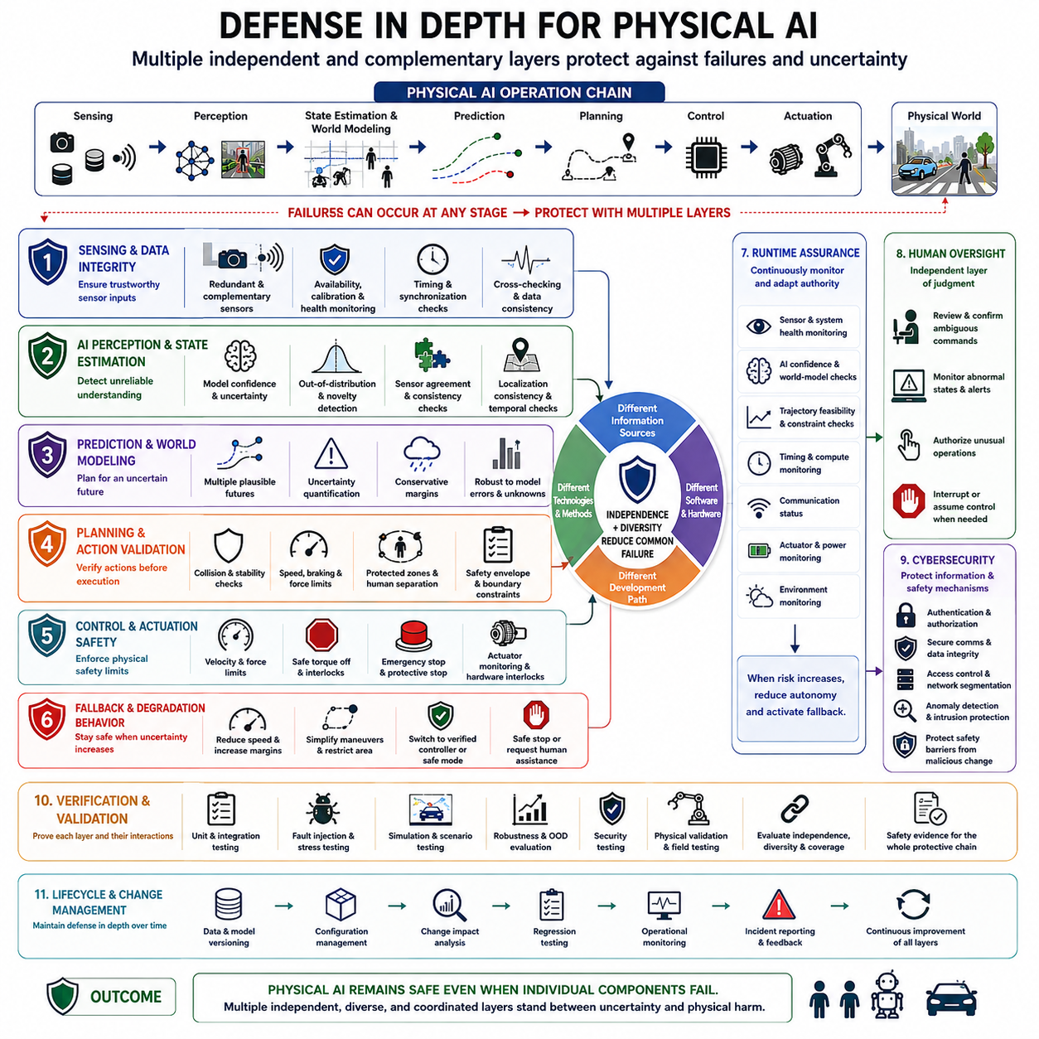
Defense in depth for Physical AI is the principle that no single model, controller, sensor, or safety mechanism should be trusted as the only barrier against physical harm. Autonomous systems operate through chains of perception, prediction, planning, control, and actuation, so failures can arise at many points. Multiple independent and complementary protection layers are therefore needed to detect, contain, and interrupt unsafe behavior before it reaches the physical world.
The need for layered protection becomes stronger as robots incorporate learned perception, world models, foundation models, VLA policies, and adaptive planning. These components provide powerful capabilities but can fail in ways that conventional hardware diagnostics do not detect. A model may be computationally healthy while misunderstanding the environment. Defense in depth assumes that intelligent components will sometimes be wrong and designs the surrounding system to remain safe despite those errors.
The first defensive layer begins with sensing and data integrity. Cameras, LiDAR, radar, tactile sensors, localization systems, and other inputs should be monitored for availability, calibration, timing, consistency, and degradation. Redundant or complementary sensing can provide independent evidence about important hazards. Cross-checking measurements reduces the probability that one corrupted, obstructed, delayed, or failed sensor becomes the sole basis for a safety-critical physical decision.
A second layer addresses AI perception and state estimation. Model confidence, out-of-distribution detection, sensor agreement, localization consistency, novelty detection, and temporal consistency can reveal conditions in which the system's internal representation may be unreliable. The objective is not to prove that every perception is correct, but to recognize when available evidence is too weak or contradictory to justify normal autonomous authority.
Prediction and world modeling require another protective layer because future states are inherently uncertain. A robot may incorrectly predict pedestrian motion, vehicle trajectories, object dynamics, or the consequences of its own actions. Safety-aware prediction should represent multiple plausible futures and evaluate uncertainty rather than relying entirely on one forecast. Conservative margins can protect the system when future evolution cannot be estimated with sufficient confidence.
Planning provides an additional opportunity to prevent unsafe behavior before commands reach low-level control. Candidate trajectories and actions can be checked against collision constraints, speed limits, braking distance, protected zones, stability conditions, human separation, and operational boundaries. Learned planners may propose flexible solutions, but an independent validation mechanism should determine whether the proposed action remains inside an acceptable safety envelope.
Control and actuation require protections that remain effective even if higher-level intelligence fails. Deterministic safety controllers, safe torque off, velocity and force limits, emergency stops, protective stops, actuator monitoring, and hardware interlocks can restrict physical energy directly. These mechanisms are particularly valuable because they can provide a final barrier between erroneous software decisions and dangerous motion, force, or mechanical interaction.
Independence between layers is a central requirement of effective defense in depth. If the same AI model generates an action, evaluates its own confidence, and decides whether the action is safe, a common failure may defeat all three functions simultaneously. Important safety decisions should therefore use sufficiently independent mechanisms, information sources, software paths, hardware resources, or engineering principles so that one failure does not automatically compromise every protective barrier.
Diversity complements independence by reducing common-mode failures. A neural perception system can be cross-checked by geometric constraints, a learned trajectory planner can be supervised by deterministic collision checking, and a semantic world model can be compared with direct sensor measurements. Different technologies have different failure characteristics. Combining them carefully makes it more difficult for a single erroneous assumption to propagate through the complete system without detection.
Runtime assurance connects these layers during actual operation. Continuous monitoring can evaluate sensor health, localization, AI confidence, world-model consistency, trajectory feasibility, computational timing, communication status, actuator health, and environmental conditions. When one or more indicators deteriorate, runtime assurance can progressively restrict the autonomy granted to the primary AI rather than waiting for a catastrophic failure to become visible.
Fallback behavior forms another critical defensive layer. When normal autonomy cannot be justified, the system should have predefined alternatives such as reducing speed, increasing separation, simplifying maneuvers, switching to a verified controller, restricting the operating area, stopping safely, or requesting human assistance. The fallback itself must be validated because an emergency transition that introduces unstable or unpredictable behavior cannot serve as a credible safety barrier.
Human oversight provides protection for situations that automated mechanisms cannot confidently resolve. Operators may confirm ambiguous commands, review abnormal system states, authorize unusual operations, interrupt autonomous behavior, or assume control under defined conditions. Human intervention should not compensate for weak engineering, but it can provide an additional independent layer when uncertainty, novelty, conflicting objectives, or unexpected environmental conditions exceed automated capabilities.
Cybersecurity must also participate in defense in depth because compromised information can bypass otherwise sound safety logic. Authentication, authorization, secure communication, integrity checking, trusted software updates, access control, network segmentation, and anomaly detection protect the information on which physical decisions depend. Safety barriers themselves must be protected against malicious modification so that attackers cannot simply disable or manipulate the mechanisms intended to prevent harm.
Defense in depth extends beyond runtime architecture into verification and lifecycle management. Individual layers should be tested independently and in combination through scenario testing, fault injection, simulation, robustness evaluation, security testing, and physical validation. Engineers must examine whether one layer truly catches failures escaping another and whether common dependencies create hidden single points of failure. Safety evidence should demonstrate the effectiveness of the complete protective chain.
Updates to data, models, policies, software, sensors, or hardware can change the relationships among defensive layers. A new perception model may alter confidence characteristics, while a planner update may generate trajectories that stress existing safety checks differently. Configuration management, regression testing, model versioning, change impact analysis, operational monitoring, and incident feedback are therefore necessary to preserve defense in depth throughout the system lifecycle.
The central philosophy is that Physical AI should remain safe even when individual components are imperfect. Intelligence may fail, sensors may degrade, communications may disappear, models may encounter unfamiliar situations, and humans may behave unexpectedly. Trustworthy Physical AI emerges when independent sensing, monitoring, constraints, safety control, fallback behavior, cybersecurity, human oversight, and lifecycle assurance form multiple barriers between uncertainty and physical harm.

00.08. Roadmap of Physical AI Safety and Alignment
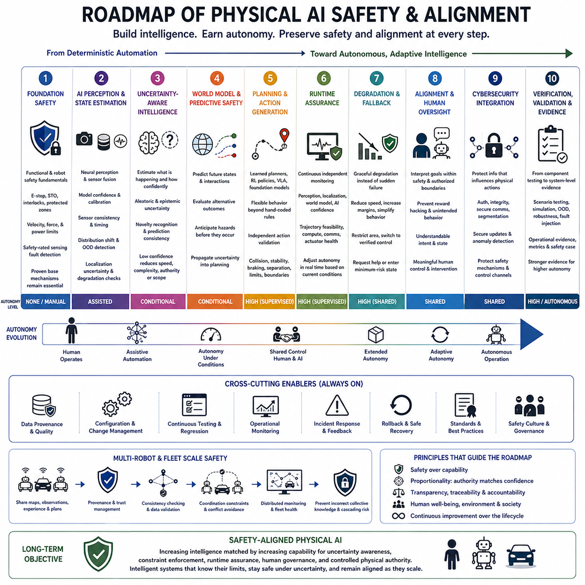
The roadmap of Physical AI safety and alignment describes how protection must evolve as robots move from deterministic automation toward adaptive, reasoning, and increasingly autonomous systems. Safety can no longer be treated as a final protective layer added after intelligence is developed. It must mature together with perception, world modeling, planning, learning, physical capability, and autonomy so that increasing intelligence does not produce uncontrolled physical authority.
The starting point is conventional functional and robot safety, where hazards are controlled through deterministic mechanisms with well-defined behavior. Emergency stops, safe torque off, interlocks, protected zones, velocity limits, force limits, safety-rated sensing, and fault monitoring establish the physical foundation. These mechanisms remain important throughout the roadmap because advanced AI should inherit proven safety barriers rather than replace them with learned behavior.
The next stage extends safety into AI-enabled perception and state estimation. Autonomous machines increasingly depend on neural networks to detect people, classify objects, estimate traversability, understand scenes, and fuse multimodal sensor information. Safety engineering must therefore evaluate model confidence, sensor consistency, distribution shift, calibration, timing, localization uncertainty, and perception degradation rather than relying only on conventional hardware diagnostics.
As autonomy expands, uncertainty-aware intelligence becomes a central requirement. Physical AI must estimate not only what is happening but also how confidently it understands the current situation. Aleatoric and epistemic uncertainty, out-of-distribution detection, novelty recognition, prediction consistency, and sensor agreement become inputs to operational decisions. Low confidence should progressively reduce speed, maneuver complexity, operating authority, or the permissible scope of autonomous action.
World models introduce the ability to reason about temporal evolution rather than responding only to the present observation. Robots can predict future states, evaluate alternative outcomes, anticipate interactions, and estimate the consequences of candidate actions. Safety must evolve accordingly from reactive protection toward predictive safety, where potential hazards are identified before they enter immediate collision or control boundaries and uncertainty is propagated into planning decisions.
Planning and action generation form the next critical transition. Learned planners, reinforcement-learning policies, foundation models, and Vision-Language-Action models can generate flexible behavior that cannot be exhaustively specified in advance. Their outputs should therefore pass through independent action validation. Collision constraints, stability, braking distance, human separation, force limits, operational boundaries, and safety envelopes determine whether an intelligent proposal is permitted to become physical action.
Runtime assurance becomes increasingly important as systems operate beyond conditions that can be completely validated before deployment. Independent monitors continuously evaluate perception health, localization consistency, world-model predictions, AI confidence, trajectory feasibility, computation, communication, and actuator status. Runtime assurance transforms safety from a static certification activity into a continuous process that determines how much autonomy can safely be exercised under current conditions.
The roadmap must also develop graceful degradation and fallback behavior. A trustworthy robot should not move directly from full autonomous capability to uncontrolled failure when sensors degrade, localization becomes uncertain, communication disappears, or AI confidence collapses. Instead, it can progressively reduce speed, increase margins, simplify behavior, restrict its operating region, switch to verified control, request human assistance, or enter a minimum-risk state.
Alignment becomes more important as Physical AI progresses from executing predefined tasks toward interpreting goals and generating its own intermediate actions. A system may satisfy the literal form of an instruction while violating safety requirements, operational rules, social expectations, or the user's actual intention. Physical alignment therefore requires objectives to be interpreted within a hierarchy in which safety constraints and authorized boundaries remain superior to task optimization.
Human oversight must evolve alongside autonomy rather than disappearing as machines become more capable. Early systems may require frequent supervision, while advanced systems may operate independently for long periods but escalate ambiguous, novel, or high-risk situations. Meaningful human control requires understandable system states, clear robot intent, appropriate authorization, traceable decisions, effective intervention mechanisms, and well-defined transitions between autonomous and supervised operation.
Cybersecurity becomes inseparable from safety as robots become connected to fleet systems, on-premise infrastructure, cloud services, remote operators, and shared models. Compromised commands, maps, sensor streams, model updates, or policies can directly influence physical behavior. Authentication, authorization, integrity protection, network segmentation, secure updates, anomaly detection, and protected safety channels must therefore mature together with autonomous capability.
Verification and validation must similarly progress from component testing toward system-level evidence. Deterministic functions can often be evaluated against explicit requirements, while learned systems require dataset analysis, scenario testing, simulation, robustness evaluation, fault injection, out-of-distribution testing, uncertainty calibration, and operational evidence. Increasing autonomy demands stronger evidence that interactions among AI, control, hardware, humans, and environments remain acceptably safe.
Adaptive and continually learning systems create a further stage in the roadmap because safety cannot be assumed to remain unchanged after deployment. New data, model versions, policies, prompts, environments, and learned experiences can modify behavior. Data provenance, configuration management, regression testing, change impact analysis, controlled deployment, runtime monitoring, incident feedback, and rollback capability are required to maintain a traceable safety case throughout continuous evolution.
At higher levels of autonomy, safety and alignment must become properties of the overall intelligence architecture rather than isolated engineering functions. Perception, world models, semantic reasoning, planning, learning, control, runtime assurance, cybersecurity, and human governance must exchange information about confidence, constraints, risk, and authority. Intelligence management must determine not only what the system can do, but how much autonomy should be granted under each operational condition.
For multi-robot and fleet-scale Physical AI, the roadmap expands from individual safety toward collective safety. Robots may share maps, observations, learned experience, world-state information, and coordinated plans. A local error can therefore influence other agents if shared information is trusted without verification. Fleet architectures require provenance, trust management, consistency checking, coordination constraints, distributed monitoring, and mechanisms that prevent incorrect collective knowledge from producing coordinated physical harm.
The long-term objective is safety-aligned Physical AI in which increasing intelligence is matched by increasingly capable mechanisms for uncertainty awareness, constraint enforcement, runtime assurance, human governance, and controlled physical authority. Progress should therefore be measured not only by how independently a robot can perceive, reason, learn, and act, but by whether it can recognize its limits, preserve safety under uncertainty, and remain aligned as its capabilities expand.

