Volume 11. Physical AI Evaluation and Benchmarking

Chapter 00. Introduction

00.01. Why Physical AI Evaluation is Different
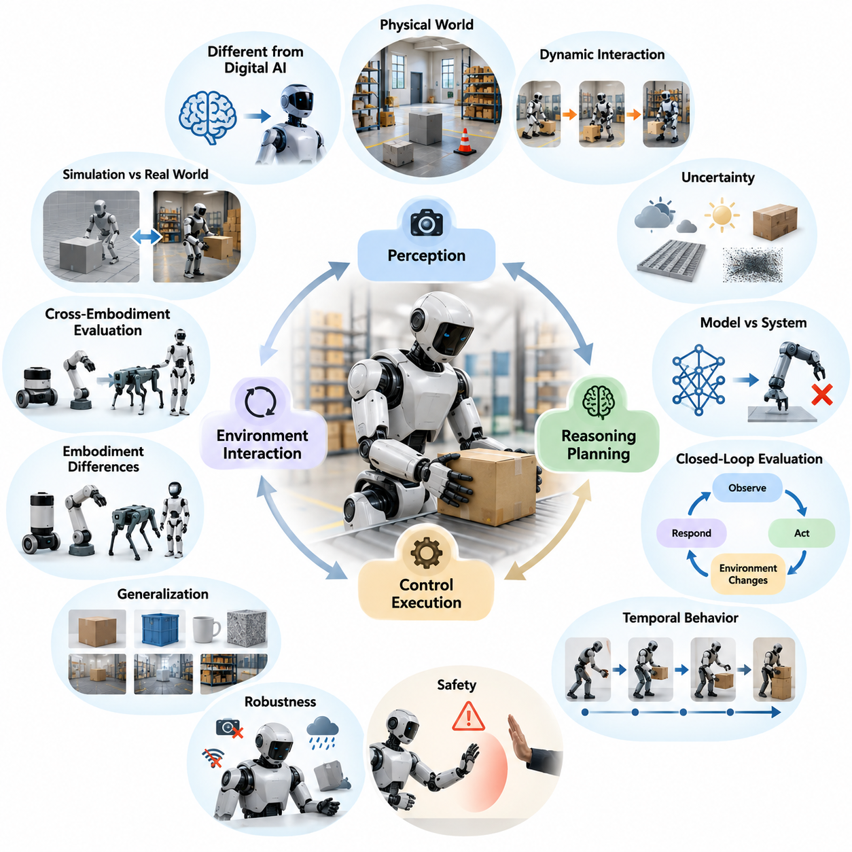
Evaluating Physical AI is fundamentally different from evaluating conventional digital artificial intelligence because intelligent decisions must produce reliable outcomes in the physical world. A digital model may be assessed through prediction accuracy or response quality, whereas a physical system must perceive its surroundings, make decisions, execute actions, and respond to environmental changes. Its performance therefore depends on the interaction between intelligence, hardware, and physical reality.
Traditional machine learning benchmarks generally assume that evaluation inputs are fixed and that model outputs can be compared against predefined references. Physical AI operates in environments where actions change subsequent observations and influence future decisions. A robot moving through a warehouse, for example, changes its position, encounters new obstacles, and creates additional control requirements. Evaluation must therefore capture dynamic behavior rather than isolated predictions.
The physical environment introduces uncertainty that cannot be fully represented by static datasets. Lighting conditions, surface friction, object geometry, sensor noise, human movement, and mechanical disturbances can affect system performance. Even when two robots execute identical commands, their trajectories may differ because of variations in hardware and environmental conditions. Consequently, physical AI evaluation requires repeated experiments under controlled and variable conditions.
Another important distinction concerns the relationship between model-level performance and system-level effectiveness. A perception model may achieve excellent object detection accuracy while the robot using that model fails to complete a manipulation task. Detection errors, processing delays, inaccurate calibration, and actuator limitations can interact throughout the execution pipeline. Evaluating individual components is necessary, but it cannot replace measuring the behavior of the integrated physical system.
Physical AI evaluation must account for closed-loop interaction between perception, reasoning, planning, and control. In open-loop testing, predictions or actions are examined without allowing their consequences to influence subsequent decisions. Closed-loop evaluation instead measures how the system responds to the evolving environment. This distinction is essential because small errors can accumulate, trigger corrective actions, or produce failures that remain invisible in offline testing.
Temporal behavior is another defining characteristic of physical intelligence. Many practical tasks require continuous operation over extended periods rather than successful execution of a single action. A mobile manipulator may need to navigate to a workstation, identify an object, grasp it, transport it, and place it accurately. Evaluation must consider intermediate progress, accumulated uncertainty, recovery behavior, and the probability of completing the entire sequence without intervention.
Safety creates additional evaluation requirements that are less prominent in many conventional software benchmarks. Physical AI systems can exert forces, collide with objects, damage equipment, or endanger nearby people. A task cannot be considered successful solely because its intended objective was achieved. The system must also respect operational constraints, maintain appropriate separation distances, limit unsafe forces, and transition toward safe behavior when unexpected conditions arise.
Robustness must be distinguished from nominal task performance. A robot that succeeds repeatedly under ideal laboratory conditions may fail when sensors become partially obstructed, communication is interrupted, or environmental conditions change. Robustness evaluation therefore examines performance degradation under disturbances and component failures. It also investigates whether the system can recognize uncertainty, adjust its behavior, recover from errors, or safely discontinue an operation.
Generalization presents a particularly difficult challenge because physical environments contain enormous variation. Objects differ in shape, weight, material, and appearance, while workspaces vary in geometry, illumination, and accessibility. A robot trained on familiar configurations may perform poorly when encountering unseen combinations. Meaningful evaluation must determine whether learned capabilities transfer beyond training conditions rather than merely measuring success on previously encountered scenarios.
The embodiment of a physical agent also influences what constitutes successful performance. Wheeled mobile robots, robotic manipulators, quadrupeds, humanoids, and aerial vehicles possess different sensing capabilities, kinematic constraints, and actuation mechanisms. Their operating environments and task requirements may differ substantially. Evaluation frameworks must therefore distinguish general intelligence capabilities from performance characteristics that depend on a particular robotic embodiment.
Cross-embodiment evaluation becomes increasingly important as foundation models and generalist policies are applied across different robotic platforms. A shared policy may generate actions for robots with different degrees of freedom, motion ranges, and control interfaces. Direct comparison of raw trajectories or actuator commands may be misleading. Evaluation should instead consider task outcomes, capability-normalized performance, adaptation requirements, and the preservation of learned knowledge.
Simulation provides a valuable environment for evaluating physical AI because experiments can be repeated, automated, and conducted without exposing real equipment to unnecessary risks. Simulated benchmarks support controlled disturbances, large-scale scenario generation, and rare-event testing. However, simulation results depend on the fidelity of physical dynamics, sensing, contact interactions, and environmental representations. Strong simulated performance does not automatically establish real-world reliability.
Real-world testing remains essential because physical systems encounter phenomena that simulation may represent imperfectly. Mechanical backlash, actuator heating, material deformation, sensor interference, and unexpected human behavior can alter operational outcomes. Laboratory experiments provide controlled measurements, while field trials reveal challenges associated with deployment conditions. Combining simulation, laboratory testing, and field evaluation creates a more credible understanding of practical capabilities.
Performance measurement must also extend beyond binary task success. Two robots may complete the same mission while differing significantly in execution time, energy consumption, trajectory smoothness, computational requirements, or physical interaction quality. A comprehensive evaluation framework therefore considers efficiency, precision, reliability, resource utilization, and execution quality. These dimensions reveal operational tradeoffs that a single success-rate metric cannot adequately describe.
Uncertainty and statistical variability complicate the interpretation of evaluation results. A robot may succeed in several trials because environmental conditions happen to be favorable, while another system may demonstrate more consistent behavior across diverse scenarios. Reliable comparisons require sufficient repetitions, clearly specified experimental conditions, and appropriate statistical analysis. Confidence intervals and failure distributions help distinguish genuine capability improvements from random variation.
Reproducibility is especially challenging because physical experiments depend on hardware configuration, calibration procedures, environmental conditions, and operational protocols. Differences in sensor placement, firmware versions, actuator characteristics, or test surfaces can influence measured performance. Benchmark specifications must document these factors sufficiently to support meaningful replication. Standardized procedures improve comparability while preserving the information needed to interpret platform-specific results.
Evaluation must also consider the consequences of failure rather than treating all unsuccessful trials as equivalent. A robot that safely stops before reaching its destination differs substantially from one that collides with an obstacle or loses control. Failure analysis should identify the initiating conditions, affected subsystems, severity of consequences, and effectiveness of recovery mechanisms. Such distinctions help connect benchmark outcomes to engineering improvements and operational risk management.
Human interaction introduces another dimension that cannot be captured through purely mechanical measurements. Physical AI systems often share environments with operators, pedestrians, patients, or other users whose behavior may be unpredictable. Successful operation requires appropriate responses to human presence, instructions, and interventions. Evaluation must therefore consider interaction quality, operator workload, intervention frequency, and the system's ability to maintain safe and understandable behavior.
The operational design domain defines the conditions under which a physical AI system is intended to function. These conditions may include terrain characteristics, environmental exposure, object categories, operating speeds, human proximity, and communication availability. Performance claims are meaningful only when interpreted within a clearly specified domain. Evaluation should identify both the conditions where a system operates reliably and the boundaries beyond which its capabilities deteriorate.
Long-term autonomy introduces reliability questions that short experiments cannot adequately answer. A system may complete individual tasks successfully yet experience frequent interruptions during continuous operation. Evaluation must examine cumulative error, memory consistency, planning stability, maintenance requirements, and recovery from unexpected events. Measures such as autonomy duration, intervention frequency, and mission completion reliability provide insight into whether intelligent behavior remains sustainable over time.
Physical AI benchmarking must ultimately balance scientific comparability with practical relevance. Highly standardized experiments enable repeatable comparisons, but excessively simplified tasks may fail to represent deployment challenges. Conversely, realistic field experiments provide operational insight while introducing variability that complicates direct comparison. Effective evaluation frameworks combine controlled benchmarks with representative scenarios and clearly documented measurement procedures.
As Physical AI progresses toward general-purpose autonomous systems, evaluation must evolve from isolated algorithmic metrics toward multidimensional assessments of embodied competence. The central question is not simply whether a model produces correct predictions, but whether an integrated agent can achieve intended goals safely, efficiently, and consistently under physical uncertainty. This perspective establishes the foundation for meaningful benchmarking, capability comparison, and trustworthy deployment.

00.02. From Model Metrics to System Level Performance
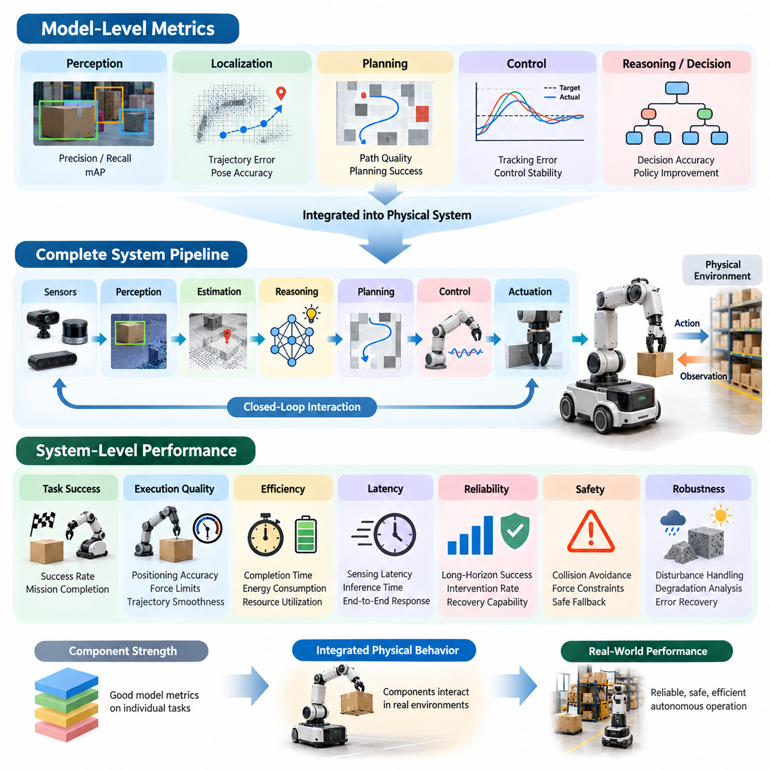
Evaluating Physical AI requires a fundamental transition from measuring isolated model accuracy to assessing the performance of complete autonomous systems. Conventional machine learning benchmarks emphasize prediction accuracy, classification scores, or loss functions. Although these metrics remain valuable, they cannot fully describe how intelligent machines operate in physical environments. System-level evaluation must examine whether perception, reasoning, planning, control, and actuation collectively achieve reliable physical outcomes.
Model-level metrics provide essential information about individual algorithmic capabilities. Object detection models may be evaluated using precision, recall, and mean average precision, while localization algorithms may use trajectory error or pose estimation accuracy. Planning models can be assessed through predicted path quality, and control policies through tracking error. However, these measurements describe specific components rather than the overall effectiveness of an autonomous physical system.
A central limitation of component-based evaluation is that strong individual performance does not necessarily translate into successful task execution. A robot may possess highly accurate visual perception but still fail to grasp an object because of calibration errors, delayed control commands, or insufficient actuator precision. Similarly, a navigation algorithm may generate an optimal path that the physical platform cannot follow reliably. System performance emerges from interactions among components.
Physical AI systems typically operate through interconnected perception, estimation, decision-making, planning, and control processes. Sensor measurements are transformed into environmental representations, which guide decisions and generate actuator commands. Each stage introduces uncertainty, computational delay, and potential errors. Evaluating the complete pipeline therefore requires understanding how local inaccuracies propagate and influence the final physical outcome.
The transition toward system-level evaluation changes the fundamental unit of measurement. Instead of examining individual predictions, evaluation increasingly focuses on complete actions, tasks, and missions. For example, a warehouse robot should not be judged solely by its ability to detect obstacles or estimate its position. Its practical performance depends on whether it can transport goods to the correct destination while maintaining safety, efficiency, and operational reliability.
Task success rate is a useful starting point for system-level assessment because it measures whether the intended objective was achieved. However, binary success alone provides limited information about execution quality. Two robots may complete the same task while exhibiting substantial differences in completion time, positioning accuracy, energy consumption, or recovery behavior. A meaningful evaluation framework must therefore combine outcome-based metrics with measurements of the execution process.
Execution quality becomes particularly important when robots physically interact with objects and environments. A manipulator may successfully place an object at its destination while applying excessive force, producing unstable motion, or damaging surrounding materials. Such behavior may satisfy a simplified success criterion but fail operational requirements. System-level evaluation should therefore incorporate force limits, trajectory smoothness, contact stability, precision, and compliance with task constraints.
Latency represents another critical connection between algorithmic performance and physical behavior. A perception model may produce accurate predictions but require excessive processing time, making its outputs unsuitable for fast-moving systems. Delayed observations can cause controllers to react to outdated environmental states. Consequently, evaluation must consider sensing latency, inference time, communication delays, control frequency, and end-to-end response time rather than isolated computational benchmarks.
Hardware characteristics further complicate the relationship between model metrics and system performance. Actuator bandwidth, sensor resolution, mechanical compliance, payload capacity, and onboard computing resources determine which behaviors can be executed reliably. A policy that performs well on one robot may degrade when deployed on another platform. Evaluation must therefore document hardware configurations and distinguish algorithmic limitations from physical implementation constraints.
Closed-loop evaluation is essential because the consequences of an action influence subsequent observations and decisions. Small perception errors may cause imperfect movements, which alter the robot's position and generate new sensing conditions. A capable system can compensate through feedback, replanning, and corrective control. Offline model evaluation cannot fully reveal these dynamics because it does not reproduce the continuous interaction between the agent and its environment.
System-level performance also depends on the coordination of multiple timescales. Low-level motor controllers may operate at high frequencies, while perception models, motion planners, and task-level reasoning modules update more slowly. These processes must exchange information without creating unstable or inconsistent behavior. Evaluation should examine timing synchronization, command execution, state consistency, and the system's ability to maintain coordinated operation.
Reliability becomes increasingly important as evaluation expands from individual tasks to extended missions. A robot may demonstrate high success rates on short actions but fail frequently during sequences requiring navigation, manipulation, and environmental interaction. Errors can accumulate across stages, and failures may propagate through dependent tasks. System-level benchmarks should therefore measure mission completion probability, interruption frequency, recovery effectiveness, and sustained autonomous operation.
Safety must be integrated into performance assessment rather than treated as an independent afterthought. A system that completes tasks rapidly but repeatedly violates collision constraints cannot be considered operationally superior. Safety-related metrics may include minimum separation distance, collision frequency, excessive contact force, emergency stop behavior, and response to hazardous conditions. These measurements ensure that performance improvements do not conceal unacceptable physical risks.
Robustness evaluation extends system-level assessment beyond ideal operating conditions. Real environments introduce variations in lighting, friction, object placement, sensor quality, and communication reliability. A complete system must maintain acceptable behavior despite disturbances and partial failures. Measuring performance degradation under controlled perturbations helps determine whether the integration of intelligent components produces resilient behavior rather than fragile task-specific success.
Generalization must also be assessed at the system level because successful predictions on unfamiliar data do not guarantee successful physical interaction. A robot may recognize an unseen object but lack the manipulation strategy needed to handle its geometry or weight. Likewise, a navigation system may identify unfamiliar terrain without being able to traverse it safely. System-level generalization therefore measures the transfer of complete operational capabilities across tasks and environments.
Efficiency introduces additional tradeoffs that are often invisible in model-centered benchmarks. Increasing model complexity may improve prediction accuracy while consuming more computing power, memory, or energy. For battery-powered robots, these costs can reduce operating duration and mission productivity. Evaluation should therefore consider computational efficiency, energy per completed task, throughput, and the relationship between intelligence quality and available physical resources.
Human intervention provides another important indicator of practical autonomy. A system may report a high task completion rate while relying heavily on remote operators to resolve failures or guide difficult actions. Such assistance can conceal limitations in autonomous decision-making. System-level evaluation should explicitly record intervention frequency, assistance duration, operator workload, and the conditions requiring human involvement to distinguish autonomous capability from assisted performance.
Simulation and real-world testing provide complementary methods for connecting model metrics with operational results. Simulation enables controlled comparisons, repeated trials, and detailed examination of internal system behavior. Physical experiments reveal limitations caused by imperfect dynamics, hardware variation, and environmental uncertainty. Comparing results across these settings helps identify whether performance differences originate from learned models, system integration, or simulation-to-reality discrepancies.
Statistical rigor is necessary because system-level outcomes are influenced by many interacting variables. Performance can change with environmental conditions, hardware calibration, task difficulty, and random disturbances. Reliable evaluation requires repeated trials, clearly defined success criteria, representative scenarios, and appropriate uncertainty reporting. Confidence intervals and performance distributions provide stronger evidence than isolated demonstrations or selectively reported successful executions.
A multidimensional evaluation scorecard offers a practical way to organize system-level measurements. Such a scorecard can combine task success, execution quality, safety, robustness, generalization, latency, energy efficiency, and autonomy. These dimensions should remain interpretable because a single aggregate score may conceal critical weaknesses. Weighting and aggregation methods must reflect the intended operational domain without allowing strong performance in one dimension to obscure unacceptable failures elsewhere.
The progression from model metrics to system-level performance ultimately reflects the purpose of Physical AI itself. Intelligent machines are developed not merely to generate accurate predictions but to perform useful actions in uncertain physical environments. Effective evaluation must therefore connect algorithmic competence with embodied execution, operational constraints, and mission outcomes. This integrated perspective provides the foundation for comparing autonomous systems and determining their readiness for practical deployment.

00.03. Open Loop vs Closed Loop Evaluation
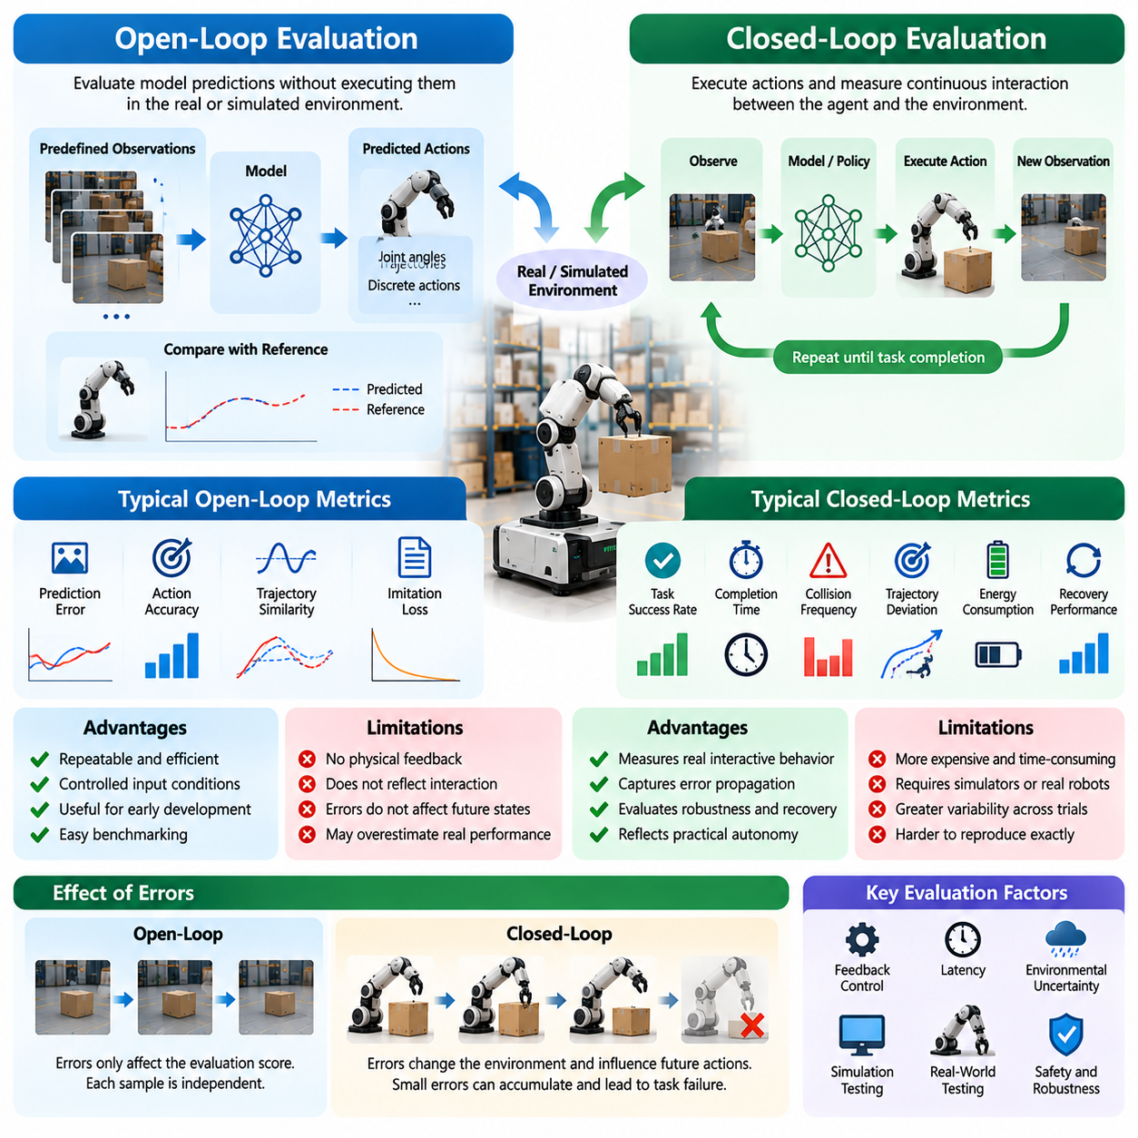
Open-loop and closed-loop evaluation represent two fundamentally different approaches to measuring Physical AI performance. Open-loop evaluation examines model predictions or proposed actions without allowing them to influence subsequent observations. Closed-loop evaluation measures how an intelligent system interacts continuously with its environment. Understanding this distinction is essential because predictive accuracy does not necessarily translate into reliable autonomous behavior.
In open-loop evaluation, a model receives predefined observations and produces outputs that are compared against reference values or recorded expert actions. The evaluation process does not execute these outputs within the environment. For example, a robot manipulation policy may predict joint movements from recorded camera images, while its accuracy is measured against demonstrated trajectories. This approach isolates model behavior and supports efficient experimentation.
Open-loop testing is particularly useful during early algorithm development because it enables repeatable comparisons under identical input conditions. Researchers can evaluate different architectures, training strategies, and model configurations using fixed datasets. Since model predictions do not alter future observations, experiments remain relatively inexpensive and reproducible. However, this convenience comes at the cost of excluding physical feedback and interaction dynamics.
Closed-loop evaluation introduces continuous interaction between an autonomous agent and its environment. The system observes its surroundings, selects an action, executes that action, and receives updated observations reflecting its consequences. This feedback cycle continues until the task is completed, interrupted, or terminated. Performance therefore depends not only on individual decisions but also on how effectively the system responds to changing conditions over time.
The distinction becomes especially important when errors influence future states. In open-loop testing, an incorrect prediction may simply contribute to an evaluation score without affecting subsequent samples. In closed-loop operation, the same error can change the robot's position, modify object configurations, or create unexpected environmental conditions. These changes may produce additional errors, resulting in compounding deviations from the intended behavior.
A navigation example illustrates the practical consequences of this difference. An autonomous mobile robot may predict accurate steering commands when evaluated against recorded trajectories. However, small steering errors during actual movement can gradually shift the robot away from its planned route. Closed-loop evaluation reveals whether localization, obstacle avoidance, and corrective control can compensate for these deviations before they cause navigation failure.
Manipulation tasks demonstrate similar limitations of open-loop assessment. A robotic arm may predict joint trajectories that closely match expert demonstrations while failing to grasp objects in physical execution. Small variations in object position, friction, or contact timing can significantly influence the outcome. Closed-loop testing determines whether the robot can detect contact changes, adjust its grip, and recover from unsuccessful manipulation attempts.
Open-loop metrics commonly include prediction error, action classification accuracy, trajectory similarity, and imitation loss. These measurements quantify how closely a model reproduces expected outputs under fixed observations. Although useful for comparing learned policies, they do not directly measure task completion or environmental consequences. A policy may achieve low prediction error while remaining unstable when deployed in a continuously changing environment.
Closed-loop metrics emphasize operational outcomes and interactive behavior. Task success rate, completion time, collision frequency, trajectory deviation, intervention rate, and recovery performance provide information about practical autonomy. Additional measurements may include control stability, energy consumption, and constraint violations. These indicators reveal whether intelligent decisions remain effective when their consequences influence subsequent observations and actions.
Feedback mechanisms are central to closed-loop performance because they allow autonomous systems to correct deviations from intended behavior. A robot may continuously compare its estimated state with a desired trajectory and adjust actuator commands accordingly. The effectiveness of this process depends on sensing accuracy, controller responsiveness, computational latency, and actuator dynamics. Closed-loop evaluation must therefore examine the complete feedback pathway rather than isolated algorithm outputs.
Latency can create substantial differences between open-loop and closed-loop results. A perception model may produce accurate predictions from recorded images but require too much computation for real-time operation. When deployed, delayed observations can cause decisions to reflect outdated environmental conditions. Closed-loop testing exposes these timing limitations by measuring how processing delays affect stability, responsiveness, and task execution.
Environmental uncertainty further increases the importance of interactive evaluation. Real-world robots encounter disturbances such as uneven terrain, moving obstacles, sensor noise, and unpredictable object interactions. Open-loop datasets can contain examples of these conditions, but they cannot fully represent how an agent's actions alter subsequent environmental states. Closed-loop experiments reveal whether the system can adapt its behavior while maintaining operational objectives.
Simulation provides an effective platform for closed-loop evaluation because it allows actions to influence simulated environments without exposing physical equipment to unnecessary risks. Researchers can repeatedly test policies under controlled disturbances, randomized environments, and difficult scenarios. However, simulated interaction depends on the accuracy of physics engines and sensor models. Consequently, simulation-based closed-loop success must be validated through appropriately designed real-world experiments.
Real-world closed-loop evaluation introduces challenges related to experimental control and reproducibility. Small differences in initial object placement, mechanical calibration, surface conditions, or sensor alignment can change execution outcomes. Repeated trials are necessary to characterize performance variability. Standardized starting conditions, calibrated measurement systems, and documented environmental parameters help ensure that comparisons remain scientifically meaningful.
Safety considerations are particularly important during closed-loop experiments because evaluated actions produce actual physical consequences. A poorly performing policy may generate collisions, excessive forces, or unstable movements. Testing environments should therefore include appropriate operational limits, emergency stopping mechanisms, and independent safety supervision. Evaluation protocols must distinguish successful task execution from behavior that achieves objectives through unacceptable risks.
Open-loop and closed-loop evaluation should not be treated as competing alternatives. Instead, they provide complementary evidence about model competence and system behavior. Open-loop tests identify prediction weaknesses, support rapid model iteration, and enable controlled comparisons. Closed-loop tests determine whether these capabilities translate into reliable physical actions. Combining both approaches produces a more complete understanding of autonomous system performance.
A practical evaluation workflow can begin with offline datasets and progress toward interactive simulation, controlled laboratory testing, and field deployment. Each stage introduces additional complexity and physical realism. Models that fail basic predictive requirements can be improved before expensive interactive experiments, while promising models can undergo progressively demanding closed-loop validation. This staged process improves evaluation efficiency without sacrificing operational relevance.
The relationship between open-loop and closed-loop performance also provides insight into generalization. A model may perform well on unseen recorded observations but struggle when its own actions generate unfamiliar states. Such failures reveal a distribution shift between training data and interactive operation. Evaluating both settings helps determine whether a policy has learned transferable control behavior or primarily reproduces patterns present in demonstration datasets.
Long-horizon autonomy makes closed-loop evaluation increasingly important because small errors can accumulate across extended sequences of actions. A robot may execute individual movements accurately while failing to complete a mission requiring navigation, manipulation, and repeated decision-making. Closed-loop benchmarks capture dependencies among successive actions, state estimation consistency, planning updates, and recovery mechanisms that isolated prediction tests cannot adequately represent.
Statistical interpretation is necessary when comparing the two evaluation approaches. Open-loop metrics are often calculated over fixed datasets, while closed-loop outcomes may vary with initial conditions and environmental randomness. Differences in experimental structure require careful reporting of trial counts, success distributions, uncertainty, and scenario coverage. Direct correlations between offline prediction scores and interactive success should be established empirically rather than assumed.
Ultimately, open-loop evaluation measures how accurately a Physical AI model responds to predefined observations, while closed-loop evaluation measures how effectively an autonomous system acts within an evolving physical environment. Both are essential, but they answer different questions about intelligence and reliability. A comprehensive benchmarking framework must connect predictive competence with interactive task performance, ensuring that strong model metrics correspond to meaningful physical capabilities.

00.04. Component System and Mission Level Evaluation
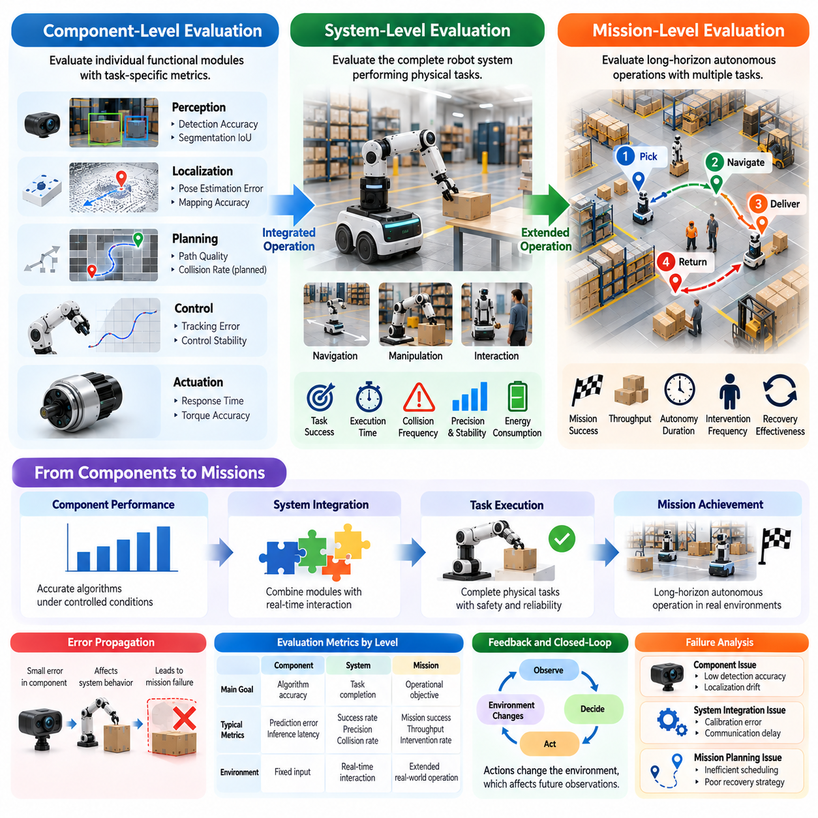
Physical AI evaluation requires a hierarchical framework that distinguishes component-level, system-level, and mission-level performance. Each level addresses different questions about intelligent physical behavior, from the accuracy of individual algorithms to the reliability of complete autonomous operations. These levels are interconnected, but success at one level does not guarantee success at another. Comprehensive evaluation must examine their relationships and identify how performance limitations propagate.
Component-level evaluation focuses on individual functional modules such as perception, localization, planning, control, sensing, and actuation. Each component is assessed using metrics appropriate to its technical purpose. Perception algorithms may be measured through detection accuracy, localization modules through pose estimation error, and controllers through trajectory tracking performance. Such measurements provide diagnostic evidence about the capabilities and limitations of specific subsystems.
The primary advantage of component-level testing is its ability to isolate performance characteristics under controlled conditions. Researchers can compare alternative algorithms using identical datasets, sensor inputs, or reference trajectories. This approach supports reproducible experimentation, efficient debugging, and targeted optimization. However, isolated component performance cannot fully predict behavior when multiple modules interact through real-time feedback and shared physical constraints.
System-level evaluation examines the integrated operation of hardware, software, sensing, computation, and control. Rather than testing individual modules independently, it measures whether their combined behavior achieves specified tasks. An autonomous mobile robot, for example, must integrate localization, mapping, path planning, obstacle avoidance, and motion control. Its success depends on the coordination of these capabilities under actual operating conditions.
Integration introduces performance limitations that may remain invisible during component testing. Communication delays, inconsistent coordinate frames, calibration errors, computational bottlenecks, and actuator saturation can reduce overall effectiveness. Even highly accurate modules may produce poor results when their timing or interfaces are incompatible. System-level evaluation therefore examines end-to-end latency, synchronization, stability, and the propagation of errors across subsystem boundaries.
Mission-level evaluation extends beyond individual task execution to assess complete operational objectives. A mission may involve multiple locations, sequential activities, changing priorities, and interactions with humans or other machines. For example, a warehouse robot may need to collect goods, navigate through shared corridors, deliver materials, and return for additional assignments. Mission performance depends on sustained coordination, adaptability, and operational continuity.
The distinction between system-level and mission-level evaluation is particularly important for long-horizon autonomy. A robot may reliably complete individual navigation or manipulation tasks but struggle when these actions must be combined into extended workflows. Errors can accumulate across task transitions, environmental conditions may change, and unexpected events may require replanning. Mission-level benchmarks reveal whether local capabilities remain effective during prolonged autonomous operation.
Task success provides a common measurement foundation across evaluation levels, but its interpretation changes with scope. At the component level, success may mean producing an accurate prediction or control output. At the system level, it means completing a physical task within defined constraints. At the mission level, success requires achieving an overall operational objective through multiple coordinated activities. Evaluation protocols must explicitly define these distinctions to avoid misleading comparisons.
Performance metrics should reflect the responsibilities of each evaluation level while preserving connections between them. Component metrics may include prediction error, inference latency, control tracking error, and actuator response. System metrics emphasize task completion, execution precision, collision frequency, and energy consumption. Mission metrics address mission success probability, throughput, autonomy duration, intervention frequency, and recovery effectiveness.
A hierarchical evaluation framework also supports structured failure analysis. When a mission fails, investigators can determine whether the cause originated in an individual component, emerged through system integration, or resulted from mission planning and coordination. For example, a delivery failure may arise from inaccurate localization, delayed obstacle avoidance, or ineffective task scheduling. Distinguishing these causes enables targeted engineering improvements rather than undirected optimization.
Dependencies among components create complex relationships between local accuracy and global outcomes. A small localization error may have little effect during open-space navigation but become critical when a robot approaches a narrow passage. Similarly, modest perception uncertainty may be acceptable during object identification but unacceptable during precision assembly. Evaluation must therefore consider how component errors interact with task difficulty, environmental constraints, and operational context.
Closed-loop interaction is essential for understanding performance across the hierarchy. Component tests often use predefined inputs, while system and mission evaluations increasingly depend on continuous feedback between actions and observations. A robot's movements alter its environment, generating new sensing conditions and planning requirements. Hierarchical evaluation should therefore combine offline measurements with interactive experiments that expose feedback dynamics and accumulated errors.
Safety requirements also change with evaluation scope. Component-level safety testing may examine sensor fault detection, actuator limits, or controller stability. System-level testing considers collisions, unsafe forces, emergency stopping, and coordinated protective behavior. Mission-level evaluation examines sustained risk exposure, operational rule compliance, human interaction, and safe recovery during extended activities. Safety must remain a constraint at every level rather than a separate performance category.
Robustness evaluation should similarly progress from isolated disturbances to complex operational uncertainty. Individual components may be tested against sensor noise, missing observations, or computational delays. Integrated systems must withstand combinations of disturbances while maintaining task performance. Missions introduce additional uncertainty through changing environments, equipment degradation, resource limitations, and unexpected interruptions. This progression reveals increasingly realistic failure modes.
Generalization must be evaluated at multiple levels because transferable component capabilities do not necessarily produce transferable operational behavior. A perception model may recognize unfamiliar objects, while the integrated robot cannot manipulate them successfully. A system may complete unfamiliar tasks individually but fail to coordinate them into a new mission. Hierarchical generalization testing therefore examines the transfer of knowledge, skills, and complete operational competence.
Resource efficiency becomes increasingly significant as evaluation expands toward complete missions. A component may minimize inference time while increasing memory usage, whereas an integrated system must balance computation, actuation, and sensing energy. Mission-level efficiency additionally depends on task scheduling, travel distance, charging requirements, and operational downtime. Evaluating these interactions helps identify whether local optimization produces meaningful improvements in overall productivity.
Human involvement provides another important distinction between evaluation levels. A component may require manual calibration, a system may depend on operator assistance during difficult tasks, and a mission may require periodic supervision or recovery intervention. These dependencies influence practical autonomy and operating costs. Evaluation should document the frequency, duration, and purpose of human assistance rather than treating externally supported completion as fully autonomous success.
Simulation, laboratory testing, and field experiments can support all three evaluation levels with different degrees of realism. Component testing benefits from controlled datasets and repeatable simulation inputs. System testing requires integrated hardware or sufficiently realistic interactive environments. Mission testing increasingly demands representative operational scenarios involving environmental variability and extended execution. A staged evaluation strategy balances experimental control, cost, safety, and practical relevance.
Statistical rigor becomes more challenging as evaluation complexity increases. Component benchmarks may involve thousands of independent predictions, while mission experiments are often expensive and produce correlated outcomes across sequential tasks. Reliable comparisons require appropriate sampling, repeated trials, documented conditions, and uncertainty estimates. Statistical analysis should account for the evaluation unit and avoid treating dependent observations as independent evidence.
A comprehensive scorecard can connect component, system, and mission results without reducing them to a misleading single number. Component measurements explain technical strengths and weaknesses, system measurements demonstrate integrated task capabilities, and mission measurements reveal operational effectiveness. Reporting these results together enables traceability between algorithmic improvements and practical outcomes while exposing tradeoffs that aggregate rankings might conceal.
Ultimately, hierarchical evaluation provides a structured pathway from algorithm development to dependable Physical AI deployment. Component-level testing establishes technical competence, system-level testing validates embodied execution, and mission-level testing demonstrates sustained operational value. Their combined interpretation determines whether intelligent capabilities remain effective under real physical constraints. This approach establishes a foundation for rigorous benchmarking, failure diagnosis, and deployment readiness assessment.

00.05. Simulation Lab and Field Evaluation
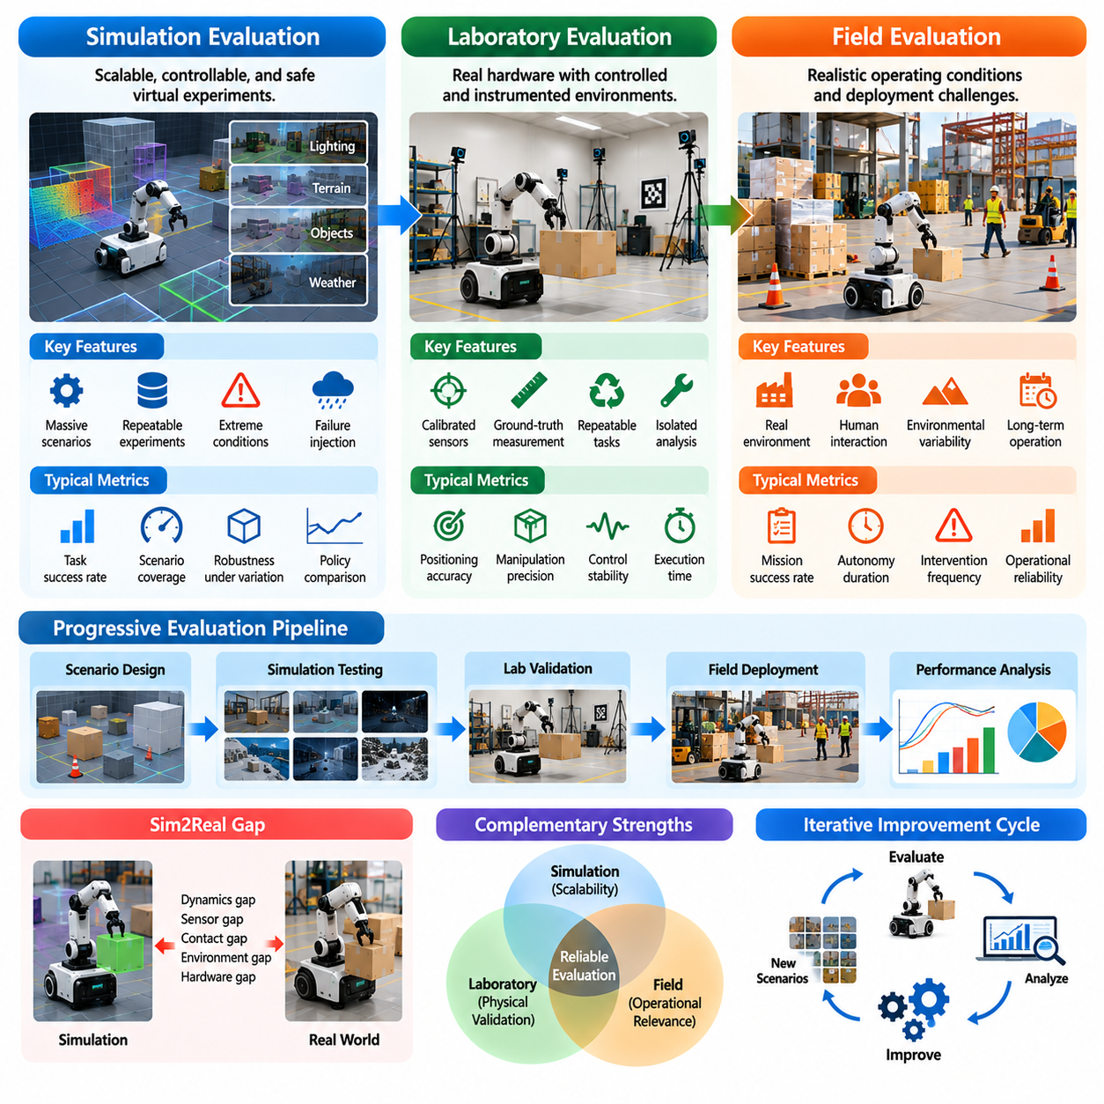
Physical AI evaluation requires complementary testing environments that balance experimental control, physical realism, safety, and operational relevance. Simulation, laboratory testing, and field evaluation provide different perspectives on autonomous system performance. Simulation enables scalable experimentation, laboratories support controlled physical validation, and field trials reveal deployment challenges. Together, these environments establish a progressive framework for assessing intelligent physical behavior.
Simulation-based evaluation uses computational environments to reproduce robot dynamics, sensing processes, object interactions, and environmental conditions. Virtual experiments allow researchers to examine perception, planning, control, and decision-making without requiring continuous access to physical hardware. Scenarios can be repeated under identical conditions or systematically modified to investigate performance sensitivity. This flexibility makes simulation valuable for early development and comparative benchmarking.
A major advantage of simulation is its ability to generate large numbers of evaluation episodes efficiently. Parallel simulation environments can execute thousands of scenarios involving different object placements, terrain properties, lighting conditions, or robot configurations. Such experiments support statistical analysis and systematic exploration of operating conditions. They also enable researchers to identify performance boundaries before conducting expensive physical tests.
Simulation provides opportunities to evaluate hazardous or unusual situations that would be difficult to reproduce safely in physical environments. Researchers can introduce sensor failures, actuator malfunctions, unexpected obstacles, and extreme environmental disturbances. These experiments reveal potential weaknesses in autonomous policies and recovery mechanisms. However, simulated failures must be interpreted carefully because their realism depends on the underlying physical and sensor models.
Simulation fidelity determines how accurately virtual experiments represent real physical behavior. Important factors include rigid-body dynamics, contact mechanics, friction, actuator response, sensor noise, and communication delays. High visual realism does not necessarily imply accurate physical interaction. A robot may successfully manipulate objects in simulation while failing in reality because of inaccurate contact modeling or unrepresented mechanical characteristics.
The simulation-to-reality gap represents differences between simulated performance and actual physical outcomes. These differences may originate from simplified dynamics, imperfect sensor representations, hardware variability, or environmental uncertainty. Evaluation should quantify how performance changes when policies move from virtual environments to physical robots. Understanding this gap helps determine which simulated results are predictive of deployment behavior and which require additional validation.
Laboratory evaluation introduces real hardware while maintaining substantial experimental control. Robots can be tested in instrumented environments with calibrated sensors, reference measurement systems, and repeatable task configurations. Researchers can measure positioning accuracy, contact forces, actuator behavior, and execution quality directly. Laboratory testing therefore provides an important intermediate stage between computational simulation and uncontrolled operational environments.
Controlled laboratory experiments are particularly valuable for identifying the physical causes of system performance limitations. A navigation robot may be tested on standardized surfaces with known obstacles, while a manipulator may perform repeated grasping tasks using objects with specified properties. These conditions allow researchers to isolate variables and investigate failure mechanisms. Repeated trials help distinguish systematic weaknesses from random execution variability.
Ground-truth measurement is essential for meaningful laboratory evaluation. External motion capture systems, calibrated cameras, force sensors, and precision measurement equipment can provide reference data independent of the robot's internal estimates. Such measurements support objective assessment of localization, trajectory tracking, manipulation accuracy, and physical interaction. Measurement uncertainty and calibration quality must also be documented to ensure credible conclusions.
Laboratory testing has limitations because controlled environments cannot reproduce every condition encountered during real deployment. Objects may be arranged predictably, surfaces may remain clean, and human activity may be restricted. A robot that performs consistently under these conditions may struggle with unexpected clutter, variable lighting, or changing workflows. Consequently, laboratory success should be interpreted as evidence of controlled physical competence rather than unrestricted operational readiness.
Field evaluation examines Physical AI systems under representative or actual deployment conditions. These environments may include warehouses, factories, construction sites, hospitals, agricultural areas, or outdoor transportation networks. Field trials expose autonomous systems to realistic variability in terrain, obstacles, weather, human behavior, and operational demands. Their primary purpose is to determine whether capabilities demonstrated in controlled environments remain effective during practical operation.
Field testing introduces uncertainty that is difficult to reproduce through standardized laboratory procedures. Environmental conditions can change during an experiment, and unexpected interactions may influence task execution. Human workers may alter routes, objects may appear in unfamiliar locations, and communication quality may fluctuate. These factors provide valuable evidence about robustness, adaptability, and the ability to maintain safe autonomous behavior.
Operational design domains provide an important framework for interpreting field evaluation results. A robot intended for indoor logistics may be evaluated under specified floor conditions, traffic densities, lighting ranges, and payload requirements. An outdoor robot may require additional testing across terrain types, weather conditions, and visibility levels. Clearly defining these boundaries prevents performance claims from being generalized beyond the conditions actually examined.
The relationship between simulation, laboratory, and field evaluation should be understood as complementary rather than strictly sequential. Simulation can identify difficult scenarios that guide laboratory experiments, while field failures can reveal missing conditions that should be incorporated into future simulations. Laboratory measurements can improve physical models and reduce simulation discrepancies. This iterative exchange strengthens evaluation validity and supports continuous system improvement.
Performance metrics should remain connected across testing environments whenever possible. Task success rate, completion time, trajectory accuracy, collision frequency, energy consumption, and intervention rate can provide common reference points. However, measurement methods and environmental constraints may differ between virtual and physical experiments. Benchmark reports should document these differences to avoid misleading comparisons between results obtained under incompatible conditions.
Statistical rigor becomes increasingly challenging as evaluation moves toward realistic field conditions. Simulation supports large sample sizes and controlled randomization, whereas physical experiments require more time, resources, and supervision. Field trials may contain correlated observations and changing environmental conditions. Reliable conclusions therefore require representative sampling, repeated experiments, uncertainty reporting, and careful documentation of the circumstances surrounding each result.
Safety requirements must guide the selection and progression of evaluation environments. High-risk behaviors can initially be investigated through simulation, followed by controlled physical testing with appropriate safeguards. Field trials should operate within defined safety constraints and include emergency stopping, monitoring, and intervention procedures. Successful progression between evaluation stages should depend on demonstrated evidence rather than assumptions about model capability.
Resource efficiency is another consideration when selecting evaluation environments. Simulation offers high experimental throughput but requires computational resources and model development effort. Laboratory testing involves physical equipment, instrumentation, and controlled facilities. Field evaluation introduces operational costs, logistical coordination, and potential disruption to real activities. An effective testing strategy allocates resources according to the uncertainty and risks that each environment can resolve.
Generalization evaluation benefits from combining all three environments. Simulation can generate broad variations in object properties, terrain, and environmental conditions. Laboratory testing can verify whether learned capabilities transfer to unfamiliar physical configurations. Field experiments determine whether these capabilities remain reliable under naturally occurring variability. Together, these approaches help distinguish narrow benchmark success from transferable physical competence.
Long-horizon autonomy requires evaluation beyond short experimental episodes. Simulation can accelerate repeated mission testing, laboratories can examine sustained operation under controlled conditions, and field trials can measure real operational continuity. Relevant indicators include mission completion probability, intervention frequency, recovery effectiveness, equipment degradation, and autonomy duration. These measurements reveal failures that may not appear during isolated task demonstrations.
A mature Physical AI evaluation framework integrates simulation, laboratory, and field evidence into a coherent assessment of deployment readiness. Each environment contributes distinct information about capability, reliability, safety, and generalization. No single testing environment can establish complete operational confidence. By connecting scalable virtual experimentation with controlled physical validation and realistic field performance, evaluation becomes a systematic process for developing trustworthy autonomous systems.

00.06. Performance Safety and Generalization
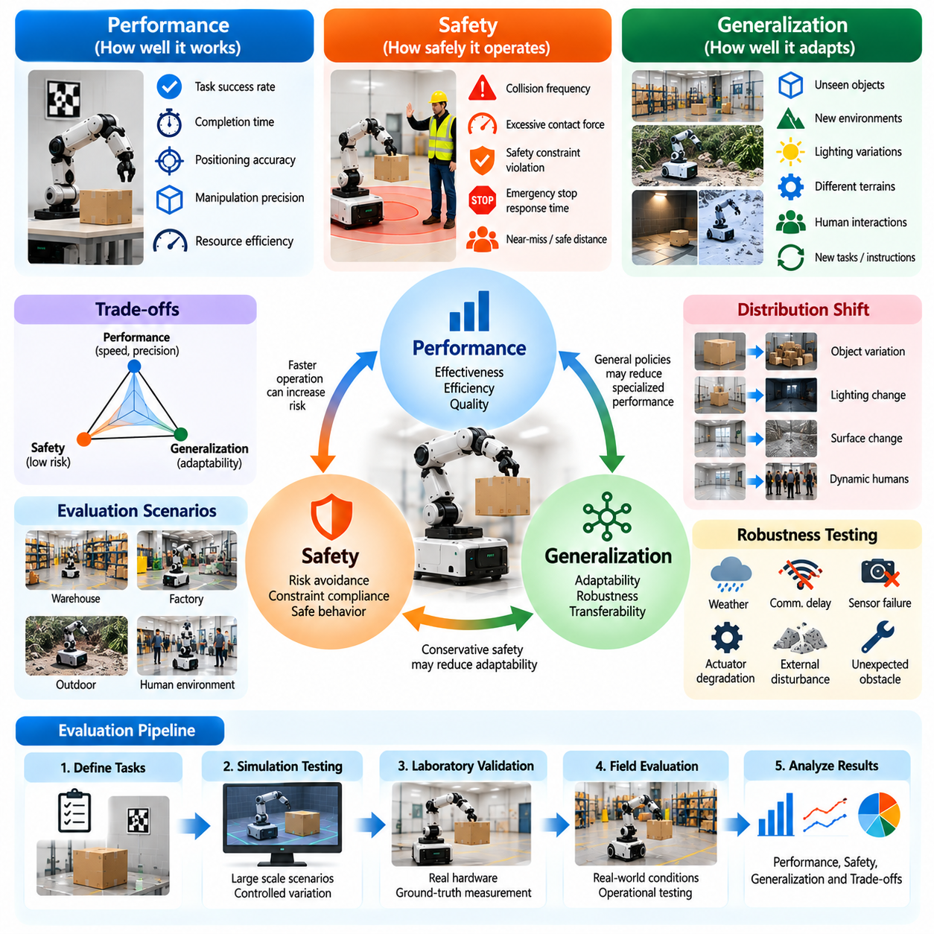
Performance, safety, and generalization are three essential dimensions of Physical AI evaluation that determine whether an autonomous system can operate effectively in real environments. Performance measures how well tasks are completed, safety examines whether actions remain within acceptable risk limits, and generalization assesses adaptability to unfamiliar conditions. These dimensions must be evaluated together because excellence in one area cannot compensate for fundamental weaknesses in another.
Performance evaluation focuses on measurable outcomes such as task success rate, completion time, positioning accuracy, manipulation precision, and resource efficiency. These metrics describe how effectively a Physical AI system achieves its intended objectives under specified conditions. However, high average performance may conceal occasional catastrophic failures or sensitivity to environmental changes. Evaluation must therefore examine performance distributions, failure cases, and operational constraints.
Safety evaluation addresses the potential consequences of autonomous actions for humans, equipment, infrastructure, and the surrounding environment. Relevant measurements include collision frequency, excessive contact forces, safety constraint violations, emergency stop activation, and hazardous state exposure. Safety cannot be established solely through successful task completion. A robot that completes its assignment while repeatedly approaching dangerous operating conditions may still be unsuitable for deployment.
Generalization evaluation measures whether learned capabilities remain effective beyond the environments, objects, tasks, and operating conditions encountered during training. A robot may demonstrate excellent performance in a familiar laboratory while struggling with unfamiliar lighting, object geometry, surface friction, or human behavior. Generalization testing therefore introduces controlled changes to task parameters and environmental conditions to identify the boundaries of transferable competence.
These three dimensions interact through important engineering tradeoffs. Increasing execution speed may improve productivity while reducing the time available for obstacle detection or corrective control. Conservative safety policies may decrease collision risk but increase task completion time. General-purpose policies may operate across diverse conditions while sacrificing precision on specialized tasks. Evaluation should make these tradeoffs explicit rather than hiding them within a single aggregate score.
Performance metrics should be selected according to the physical task and operational objectives. Navigation systems may emphasize route completion, path efficiency, localization accuracy, and collision avoidance. Manipulation systems may prioritize grasp success, placement precision, contact stability, and cycle time. Mobile manipulation systems require combined measures of navigation and physical interaction. Metrics must reflect meaningful operational outcomes rather than convenient algorithmic proxies.
Safety metrics should distinguish between observed incidents, hazardous conditions, and the effectiveness of protective mechanisms. A collision count measures realized events, while minimum separation distance or excessive force duration can reveal near misses. Emergency stop response time and recovery behavior provide evidence about mitigation capability. These measurements help characterize safety margins, although no finite collection of successful trials can establish the complete absence of risk.
Generalization requires careful separation between training conditions and evaluation conditions. Test scenarios should include variations that were not directly represented during model development, while avoiding unintended overlap between training and evaluation datasets. Researchers may vary object categories, robot payloads, environmental layouts, sensor characteristics, or task instructions. The resulting performance changes reveal whether the system has acquired robust capabilities or memorized familiar patterns.
Distribution shift is a central challenge connecting performance and generalization. Changes in sensor observations, environmental dynamics, or task requirements can invalidate assumptions learned during training. A perception model trained under consistent illumination may produce unreliable estimates under shadows or glare. These errors can propagate into planning and control, reducing task success and increasing safety risks. Evaluation should trace how distribution shifts affect the complete physical system.
Robustness testing complements generalization by examining performance under disturbances and uncertainty. Sensor noise, communication delays, actuator degradation, unexpected obstacles, and external forces can challenge autonomous behavior. Some disturbances fall within the intended operating domain, while others exceed design assumptions. Evaluation should distinguish ordinary operational variability from out-of-domain conditions and assess whether the system maintains performance, degrades gracefully, or transitions safely.
Safety and generalization become particularly important when autonomous systems encounter unfamiliar situations. A robot should not interpret every novel observation as an opportunity for unrestricted experimentation. When uncertainty exceeds acceptable limits, appropriate responses may include slowing down, requesting assistance, changing plans, or entering a safe state. Evaluation must examine whether uncertainty estimates and protective policies produce reliable decisions under unfamiliar conditions.
Closed-loop evaluation is necessary because performance, safety, and generalization depend on the consequences of executed actions. A model may produce accurate predictions from recorded observations while generating unstable behavior during physical interaction. Small control errors can alter future states and create new hazards. Interactive testing reveals whether perception, planning, and control remain coordinated when the environment changes in response to autonomous decisions.
Simulation enables broad exploration of performance and safety boundaries through controlled scenario generation. Researchers can vary environmental parameters, introduce failures, and repeat difficult situations without exposing physical equipment to unnecessary danger. Laboratory experiments then validate selected scenarios using real sensors, actuators, and contact dynamics. Field evaluation determines whether the resulting capabilities remain reliable under representative operational uncertainty.
Evaluation protocols should establish explicit acceptance criteria for each dimension. Performance requirements may specify minimum task success rates or maximum completion times. Safety requirements may define prohibited states, allowable forces, or mandatory protective responses. Generalization requirements may specify acceptable degradation across predefined environmental variations. These criteria should reflect the intended operational design domain and the consequences of failure.
Statistical analysis is essential because average scores alone cannot describe operational reliability. Evaluation should report variability, confidence intervals, failure frequencies, and performance across distinct scenario categories. Rare but severe safety events require particular attention because limited testing may not reveal their true occurrence rates. Scenario coverage, exposure duration, and the limitations of statistical evidence should be documented alongside observed results.
Multiobjective evaluation provides a framework for analyzing competing requirements without assuming that every dimension can be reduced to a common unit. Pareto analysis can identify systems that improve one objective without unnecessarily sacrificing another. However, safety-critical constraints should generally be treated as mandatory requirements rather than freely exchangeable performance penalties. This distinction prevents high productivity from concealing unacceptable physical risks.
Human interaction introduces additional evaluation requirements because autonomous systems frequently share environments with workers, operators, or members of the public. Performance must account for collaboration efficiency and operational interruptions, while safety must consider proximity, predictability, and emergency intervention. Generalization should examine different human behaviors and interaction patterns. Evaluation must also document the extent of human supervision required to achieve reported results.
Long-horizon evaluation reveals relationships that short tasks may overlook. Repeated actions can accumulate localization errors, mechanical wear, computational delays, or uncertainty in environmental models. A system that performs well during individual episodes may experience declining reliability during extended missions. Evaluating sustained performance, safety incidents, recovery effectiveness, and adaptation over time provides stronger evidence of operational readiness.
A comprehensive evaluation scorecard should report performance, safety, and generalization as distinct but connected dimensions. Task success and efficiency describe operational effectiveness, safety indicators characterize physical risk, and generalization measurements reveal adaptability. Scenario-specific results should accompany aggregate statistics so that strengths and weaknesses remain visible. This structure supports meaningful comparisons between systems with different capabilities and deployment objectives.
Ultimately, Physical AI evaluation must determine not only whether a system can accomplish a task, but whether it can do so safely and consistently across relevant operating conditions. Performance establishes functional value, safety defines acceptable physical behavior, and generalization determines the breadth of reliable capability. Integrating these dimensions creates a rigorous foundation for benchmarking, engineering decisions, and evidence-based deployment readiness.

00.07. Reproducibility Validity and Statistical Rigor
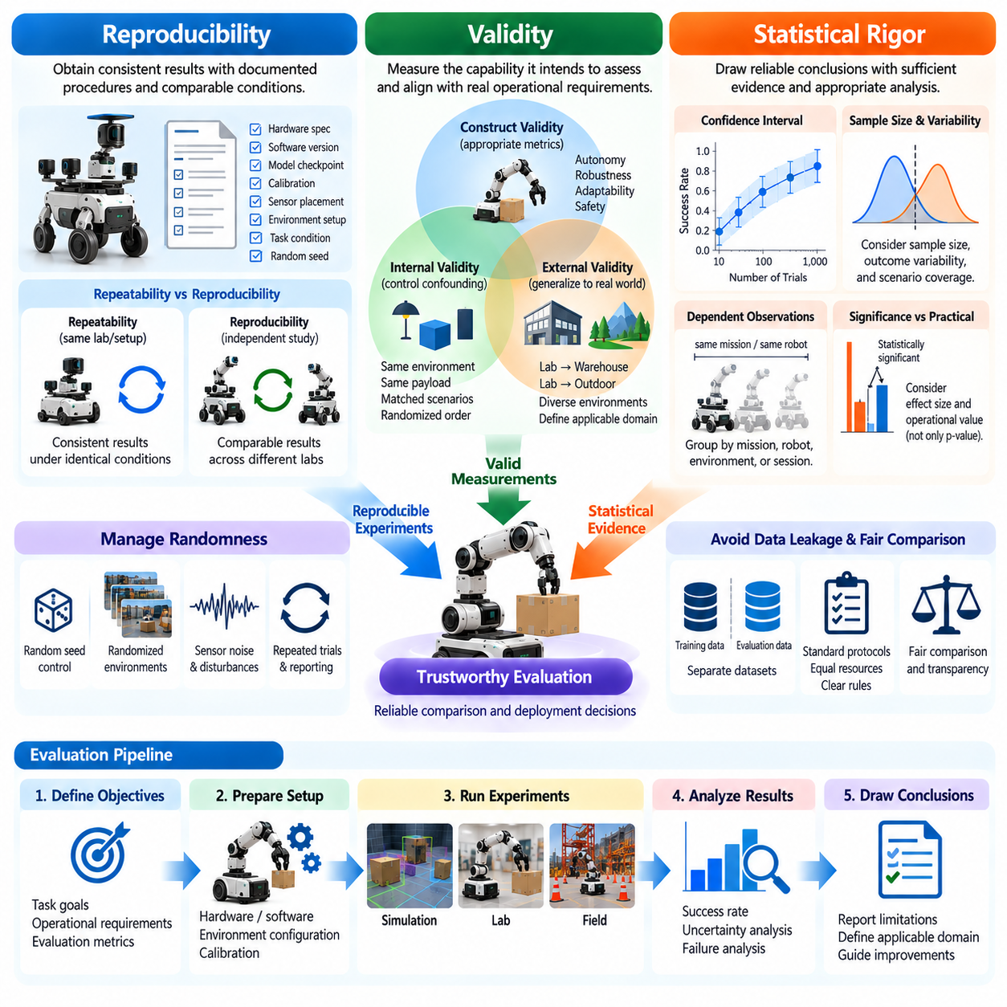
Reproducibility, validity, and statistical rigor are fundamental requirements for trustworthy Physical AI evaluation. Autonomous systems operate through complex interactions among algorithms, hardware, and environments, making experimental outcomes sensitive to numerous variables. Reliable benchmarking must therefore establish whether results can be repeated, whether measurements represent intended capabilities, and whether conclusions are supported by sufficient statistical evidence.
Reproducibility refers to the ability to obtain consistent findings when an evaluation is repeated using documented procedures and comparable conditions. In Physical AI, this requires more than preserving model weights or software configurations. Robot calibration, sensor placement, actuator characteristics, environmental geometry, and initial task conditions can all influence results. A reproducible experiment must identify and document these factors systematically.
Repeatability and reproducibility address related but distinct aspects of experimental reliability. Repeatability concerns obtaining consistent results under nearly identical conditions, often using the same equipment and evaluation team. Reproducibility examines whether comparable findings can be obtained through independently implemented or repeated studies. Both are necessary because consistent performance within one laboratory does not automatically establish broader scientific reliability.
Experimental protocols should define the complete evaluation procedure, including task objectives, starting conditions, environmental constraints, termination criteria, and measurement methods. Hardware specifications, software versions, controller parameters, and model checkpoints should also be recorded. Such documentation enables researchers to identify differences between experiments and determine whether observed performance changes reflect algorithmic improvements or altered testing conditions.
Randomness must be managed carefully because Physical AI experiments often involve stochastic policies, randomized environments, and variable physical interactions. Recording random seeds supports controlled computational comparisons, but identical seeds do not guarantee identical physical outcomes. Mechanical tolerances, sensor noise, and environmental disturbances may introduce additional variation. Evaluation should therefore combine controlled randomization with repeated trials and transparent reporting.
Validity concerns whether an evaluation actually measures the capability it claims to assess. A benchmark may produce highly repeatable results while remaining poorly aligned with real operational requirements. For example, accurate trajectory prediction does not necessarily demonstrate successful physical navigation. Evaluation validity requires clear relationships between measured indicators, task objectives, and the autonomous behaviors that matter during deployment.
Construct validity examines whether selected metrics adequately represent abstract capabilities such as autonomy, robustness, adaptability, or safety. A single task success rate may not capture recovery ability or dependence on human intervention. Similarly, low collision frequency may not demonstrate safe behavior if the robot rarely encounters challenging situations. Strong construct validity requires multiple complementary indicators that reflect the intended capability.
Internal validity addresses whether observed performance differences can reasonably be attributed to the evaluated method rather than uncontrolled factors. Comparing two robot policies under different lighting, payload, or calibration conditions may produce misleading conclusions. Controlled experimental designs should minimize confounding variables and use matched scenarios whenever possible. Randomized trial ordering can also reduce systematic effects caused by environmental changes over time.
External validity concerns whether evaluation findings generalize beyond the specific experimental conditions. A robot may perform reliably in a controlled laboratory but fail in crowded warehouses or changing outdoor environments. Representative scenario selection, environmental diversity, and field validation help establish the boundaries of applicability. Evaluation reports should clearly identify the operational domains within which their conclusions are supported.
Statistical rigor is essential because observed outcomes are samples from a broader distribution of possible operating conditions. A small number of successful trials cannot establish reliable performance across diverse environments. Researchers must consider sample size, outcome variability, scenario coverage, and uncertainty when interpreting results. Statistical methods should match the structure of the experiment rather than being applied mechanically to convenient summary scores.
Confidence intervals provide information about the uncertainty surrounding estimated performance metrics. For example, a reported task success rate should be accompanied by an interval reflecting the number of trials and observed outcomes. Two systems with similar average success rates may not differ meaningfully when uncertainty is considered. Reporting intervals alongside point estimates helps prevent excessive confidence in small or variable experimental results.
Physical AI experiments frequently contain dependent observations that complicate statistical analysis. Repeated actions within a mission, trials performed on the same robot, and measurements collected under shared environmental conditions may be correlated. Treating these observations as independent can underestimate uncertainty. Appropriate analysis may require grouping observations by mission, robot, environment, or experimental session.
Statistical significance should not be confused with practical importance. A small improvement in trajectory accuracy may be statistically detectable while producing no meaningful difference in task completion. Conversely, a modest reduction in collision risk may have substantial operational value. Evaluation should therefore report effect sizes, uncertainty, and operational consequences rather than relying exclusively on significance thresholds or isolated probability values.
Failure analysis provides essential information that aggregate performance metrics often conceal. Researchers should document unsuccessful trials, categorize failure mechanisms, and examine whether errors originate in perception, planning, control, hardware, or environmental interaction. Rare failures may reveal systematic weaknesses even when average performance remains high. Transparent failure reporting supports scientific comparison and directs engineering improvements toward consequential limitations.
Benchmark design must prevent data leakage and unintended advantages between competing methods. Training and evaluation datasets should be separated appropriately, while simulation scenarios should not be repeatedly optimized until test conditions become effectively memorized. Evaluation budgets, external information, and permitted human assistance should be documented. Fair comparisons require equivalent access to relevant resources and clearly defined testing rules.
Measurement systems introduce uncertainty that must be distinguished from actual robot performance. Motion capture errors, camera calibration inaccuracies, timing synchronization problems, and force sensor drift can distort evaluation results. Reference instruments should be calibrated, and measurement limitations should be quantified where possible. Without trustworthy measurement procedures, apparent differences between systems may reflect instrumentation errors rather than genuine capability differences.
Safety evaluation presents particular statistical challenges because severe incidents may be rare but consequential. Zero observed collisions during a limited number of trials does not prove that collision probability is zero. Evidence should include exposure duration, operating conditions, near-miss indicators, and the severity of potential outcomes. Risk assessments must recognize that finite testing cannot exhaustively establish safety across every possible physical situation.
Reproducible benchmarking benefits from standardized datasets, open evaluation protocols, version-controlled software, and documented hardware configurations. Automated logging can preserve observations, actions, timestamps, environmental states, and intervention events. These records support independent analysis and enable investigators to reconstruct failure sequences. However, standardization should not eliminate the environmental diversity necessary for meaningful generalization assessment.
A rigorous evaluation report should connect experimental objectives, procedures, measurements, and conclusions through a traceable evidence structure. Results should include trial counts, scenario definitions, performance distributions, uncertainty estimates, and identified limitations. Claims should remain proportional to the conditions actually tested. Transparent reporting allows other researchers to reproduce findings, evaluate alternative explanations, and compare systems fairly.
Ultimately, reproducibility establishes confidence that findings are not accidental, validity determines whether measurements represent meaningful Physical AI capabilities, and statistical rigor defines the strength of supporting evidence. These principles are mutually reinforcing and essential for credible benchmarking. Their integration transforms isolated demonstrations into scientifically defensible evaluations that support reliable engineering decisions and responsible autonomous system deployment.

00.08. Roadmap of Physical AI Evaluation
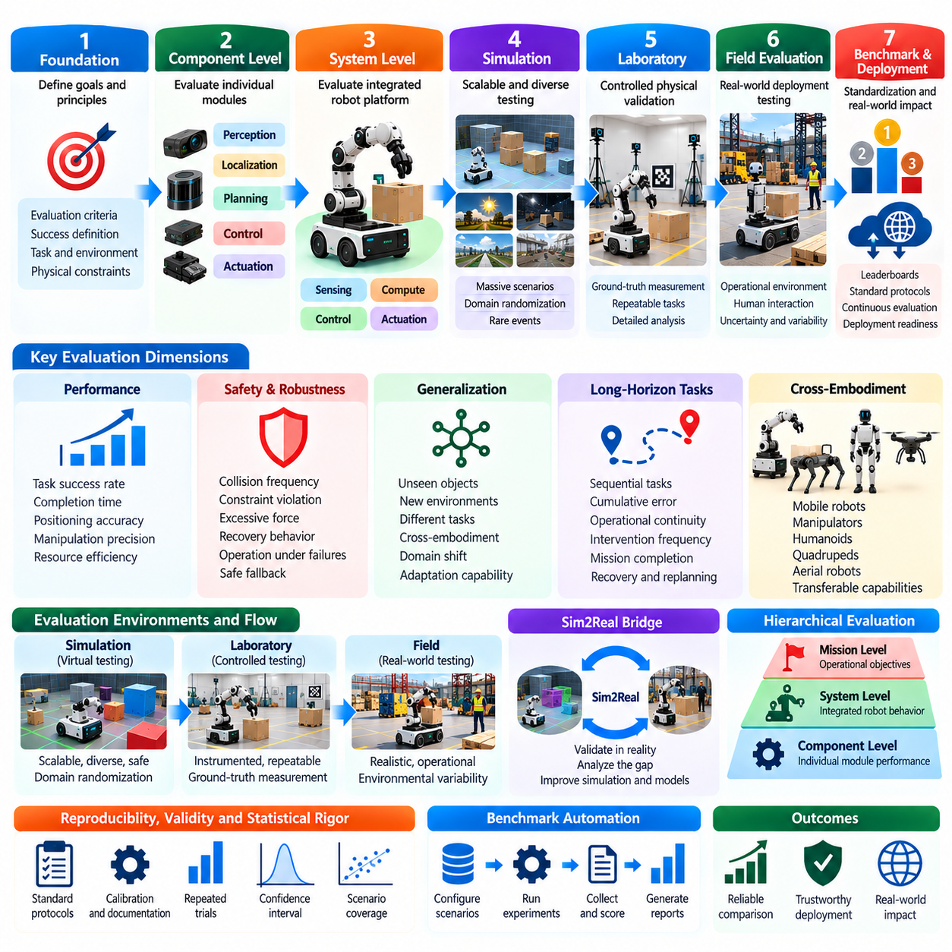
The roadmap of Physical AI evaluation establishes a systematic progression from isolated algorithm testing to comprehensive assessment of autonomous physical systems. As robots become more capable and operate in increasingly complex environments, evaluation must expand beyond conventional model accuracy. A mature framework connects component performance, interactive behavior, safety, generalization, and operational reliability through clearly defined benchmarks and evidence-based validation.
The first stage of this roadmap focuses on establishing fundamental evaluation principles and measurable objectives. Researchers must define what constitutes successful physical intelligence and distinguish predictive competence from effective autonomous behavior. Evaluation criteria should reflect task completion, environmental interaction, and physical constraints. These foundations ensure that subsequent benchmarks measure meaningful capabilities rather than convenient but incomplete algorithmic indicators.
Component-level evaluation provides the initial technical foundation by examining perception, localization, planning, control, and actuation independently. Standardized datasets and controlled experiments support reproducible comparisons between algorithms. Metrics such as prediction accuracy, trajectory error, inference latency, and control stability reveal individual strengths and limitations. These results guide early development but must eventually be connected to integrated system behavior.
System-level evaluation extends the assessment to complete robotic platforms operating through closed-loop interaction. Sensors, computational modules, controllers, and actuators must coordinate continuously while responding to environmental changes. End-to-end task success, execution accuracy, responsiveness, and recovery behavior become central indicators. This stage determines whether strong component capabilities translate into reliable physical performance under realistic operating constraints.
Simulation benchmarking provides a scalable environment for evaluating complex behaviors before extensive physical deployment. Researchers can generate diverse scenarios, introduce disturbances, and systematically vary environmental parameters. Simulation supports rapid experimentation, statistical comparisons, and investigation of difficult failure conditions. However, its predictive value depends on physical fidelity, sensor modeling, and the relationship between simulated and real-world outcomes.
Real-world benchmarking validates whether capabilities demonstrated in simulation remain effective when exposed to actual physical conditions. Laboratory experiments provide controlled measurements of positioning, manipulation, sensing, and interaction dynamics. Field trials introduce environmental variability, human activity, and operational uncertainty. Comparing results across these settings helps quantify the simulation-to-reality gap and establish the practical relevance of benchmark conclusions.
Generalization evaluation becomes increasingly important as Physical AI systems encounter unfamiliar objects, tasks, environments, and robot configurations. Benchmarks should distinguish memorized behavior from transferable competence by introducing controlled distribution shifts. Cross-task, cross-environment, and cross-embodiment testing reveal the breadth of learned capabilities. Evaluation must also identify conditions where performance degrades and determine whether systems can adapt without unsafe behavior.
Safety and robustness evaluation form a continuous requirement throughout the roadmap rather than a final testing stage. Autonomous systems must be assessed under sensor failures, actuator limitations, communication delays, unexpected obstacles, and hazardous interactions. Metrics should capture constraint violations, collision risks, recovery effectiveness, and safe fallback behavior. Safety evidence must accompany performance results so that task success cannot conceal unacceptable physical risks.
Long-horizon task evaluation examines whether autonomous capabilities remain reliable across extended sequences of interconnected actions. A robot may complete individual tasks successfully but fail during missions requiring repeated navigation, manipulation, planning, and recovery. Long-duration benchmarks measure cumulative error, operational continuity, intervention frequency, and mission completion. These assessments reveal limitations that short demonstrations and isolated task evaluations frequently overlook.
Cross-embodiment evaluation extends benchmarking across mobile robots, manipulators, humanoids, quadrupeds, and other physical platforms. Different embodiments possess distinct sensing, actuation, mobility, and interaction characteristics. Evaluation must identify which capabilities are platform-specific and which transfer across hardware configurations. Shared task definitions and normalized metrics can support comparison while preserving the physical constraints unique to each embodiment.
Evaluation frameworks must also incorporate reproducibility, validity, and statistical rigor as foundational requirements. Standardized procedures, documented environments, calibrated instruments, and repeated trials help ensure that reported findings are credible. Statistical analysis should include uncertainty estimates, scenario coverage, and failure distributions. Benchmarks must establish whether measured differences are meaningful and whether conclusions extend beyond the particular conditions tested.
Benchmark automation represents an important direction for improving evaluation efficiency and consistency. Automated pipelines can configure scenarios, execute trials, collect telemetry, calculate metrics, and generate standardized reports. Continuous integration can detect performance regressions when algorithms or hardware configurations change. Nevertheless, automated scoring must remain transparent, and physical safety supervision must not be replaced by unverified evaluation software.
Leaderboards and standardized reporting can improve comparability across research groups and industrial developers. Public benchmarks should define task protocols, evaluation budgets, permitted assistance, and measurement procedures. Rankings should report multiple dimensions rather than compressing performance, safety, and generalization into a single misleading score. Transparent documentation and independent verification are necessary to prevent benchmark overfitting and unsupported claims of superiority.
Case studies provide a practical bridge between abstract evaluation principles and real engineering decisions. Navigation, manipulation, warehouse automation, construction robotics, and human-robot collaboration illustrate different performance requirements and failure mechanisms. Examining complete evaluation pipelines reveals how benchmark results influence system design, risk mitigation, and deployment decisions. These examples also demonstrate why evaluation methods must be adapted to operational context.
An effective roadmap should progressively connect offline testing, interactive simulation, controlled laboratory validation, and representative field deployment. Each environment resolves different uncertainties and introduces additional realism. Evaluation gates can establish whether a system has sufficient evidence to advance toward more demanding experiments. Failed tests should produce diagnostic information that guides model improvement, hardware redesign, or changes to operational constraints.
The evolution of Physical AI evaluation will increasingly require benchmarks that assess adaptive behavior rather than fixed task execution alone. Systems capable of learning from experience, updating plans, and recovering from unexpected conditions introduce new validation challenges. Evaluation must determine whether adaptation improves competence without destabilizing previously reliable behavior. This requires repeated testing across changing environments and careful monitoring of performance over time.
Foundation models and general-purpose robot policies create additional demands for evaluation standardization. Vision-language-action systems may interpret diverse instructions and generate actions across multiple tasks, but linguistic understanding does not guarantee physical execution. Benchmarks should separately examine instruction grounding, action feasibility, task completion, and safety. Broad capability claims require evidence across representative tasks, environments, and embodiments.
Deployment readiness assessment integrates technical benchmarks with operational requirements. A system may achieve excellent laboratory performance while remaining unsuitable for continuous use because of maintenance demands, human intervention, or unreliable recovery. Readiness evaluation should consider availability, resource consumption, failure handling, safety procedures, and operating-domain limitations. These factors connect research performance to the practical responsibilities of real-world deployment.
Future evaluation ecosystems will benefit from shared scenario libraries, interoperable metrics, standardized data formats, and independently maintained benchmark suites. Such infrastructure can reduce duplicated effort and support cumulative scientific progress. However, standardization must preserve sufficient diversity to discourage narrow optimization toward fixed tests. Benchmark suites should evolve as autonomous systems acquire new capabilities and encounter previously unrepresented operating conditions.
Ultimately, the roadmap of Physical AI evaluation leads from measuring isolated computational competence toward establishing trustworthy physical autonomy. Simulation benchmarks, real-world experiments, generalization tests, safety assessments, long-horizon missions, and cross-embodiment comparisons provide complementary evidence. Integrating these methods through reproducible protocols and transparent standards creates a foundation for meaningful progress, responsible deployment, and increasingly capable Physical AI systems.

