Volume 11. Physical AI Evaluation and Benchmarking

Chapter 01. Evaluation Philosophy for Physical AI

01.01. What Should Physical AI Evaluation Measure
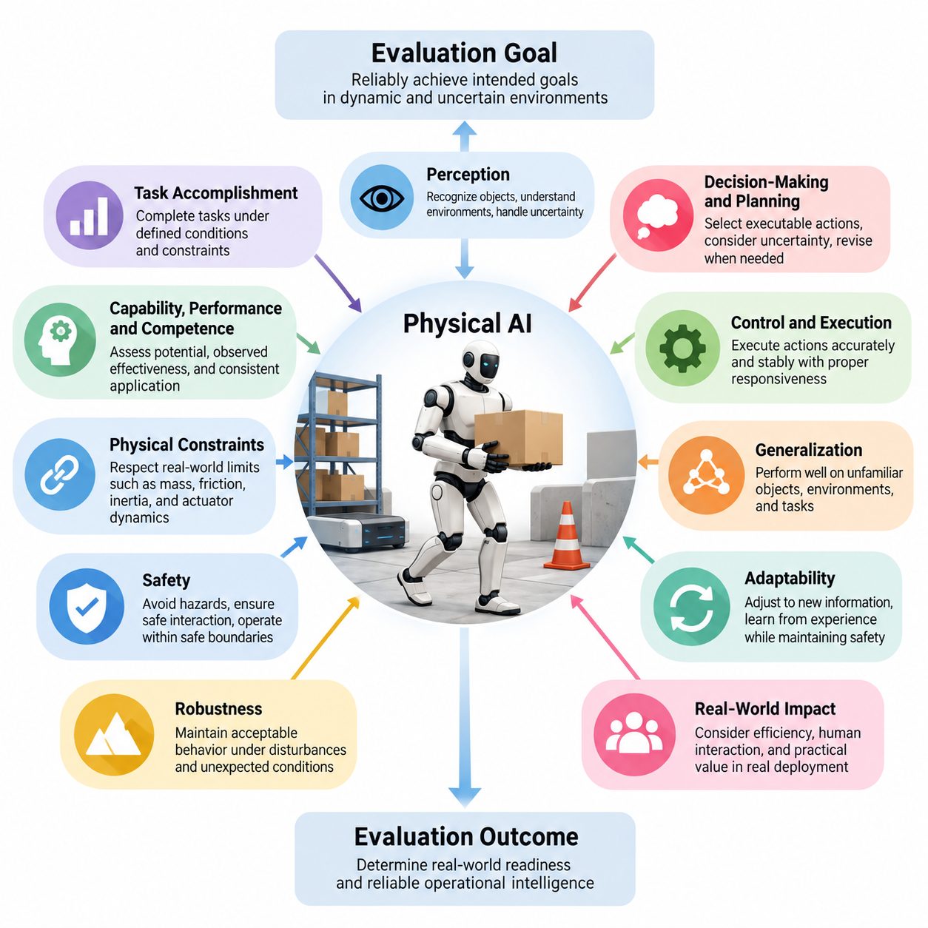
Physical AI evaluation should measure how effectively an intelligent system perceives, reasons about, acts upon, and adapts to the physical world. Unlike conventional artificial intelligence, which can often be assessed through prediction accuracy or benchmark scores, Physical AI must demonstrate meaningful behavior under real physical constraints. Evaluation must therefore capture not only computational intelligence but also the consequences of decisions and actions.
The fundamental objective of Physical AI evaluation is to determine whether a system can reliably achieve intended goals while interacting with dynamic and uncertain environments. A successful system must interpret sensory observations, maintain an appropriate understanding of its surroundings, select suitable actions, and execute those actions effectively. These capabilities must operate together because isolated algorithmic accuracy does not necessarily translate into successful physical behavior.
Task accomplishment represents one of the most important dimensions of evaluation. A Physical AI system should be assessed according to whether it completes assigned tasks under clearly defined conditions and constraints. However, task completion alone provides an incomplete picture of competence. Two robots may achieve identical objectives while exhibiting substantial differences in execution quality, safety, efficiency, adaptability, and dependence on human intervention.
Evaluation should distinguish between capability, performance, and competence. Capability describes the range of actions or tasks a system can potentially perform, while performance represents its observed effectiveness under specified conditions. Competence reflects the consistency and appropriateness with which capabilities are applied across relevant situations. This distinction prevents occasional success under favorable circumstances from being mistaken for dependable operational intelligence.
Physical interaction introduces requirements that cannot be adequately measured through purely digital benchmarks. Robots must operate within limitations imposed by mass, friction, inertia, actuator dynamics, sensor uncertainty, and environmental geometry. Evaluation should determine whether intelligent decisions remain physically feasible and whether execution respects these constraints. A theoretically correct plan has limited practical value when the embodied system cannot execute it reliably.
Perception and environmental understanding constitute essential evaluation dimensions because physical decisions depend on incomplete and potentially misleading observations. A system should recognize relevant objects, estimate spatial relationships, identify obstacles, and interpret changing environmental conditions. Evaluation must examine whether perception supports appropriate downstream actions rather than treating recognition accuracy as an isolated indicator of intelligence.
Decision-making and planning should be evaluated through their contribution to goal-directed behavior. Physical AI must select actions while considering environmental uncertainty, operational constraints, and possible future consequences. Effective evaluation should examine whether plans are executable, whether intermediate objectives remain consistent with the overall mission, and whether the system can revise decisions when observations invalidate its assumptions.
Control and action execution provide another critical perspective. Even when perception and planning are accurate, poor trajectory tracking, unstable motion, excessive contact forces, or delayed control responses can cause operational failure. Evaluation should therefore include physical execution accuracy, stability, responsiveness, and compliance with task constraints. These measurements connect abstract decision quality with observable behavior in the physical environment.
Safety must be treated as a fundamental evaluation objective rather than a secondary performance characteristic. A Physical AI system may complete its task while creating unacceptable risks for humans, equipment, or surrounding infrastructure. Evaluation should examine collision avoidance, safe interaction, operational boundaries, hazard recognition, and appropriate responses to unsafe conditions. Successful outcomes should never conceal dangerous execution processes.
Robustness measures whether a system maintains acceptable behavior when conditions depart from nominal expectations. Physical environments contain disturbances, sensor noise, mechanical variation, communication delays, and unexpected obstacles. Evaluation should expose systems to representative variations and determine how performance changes. Particular attention should be given to graceful degradation, failure detection, and recovery rather than assuming uninterrupted operation under ideal conditions.
Generalization is essential because Physical AI systems cannot be trained for every possible configuration of the physical world. Evaluation should investigate performance on unfamiliar objects, environments, tasks, and operating conditions. A system that succeeds only within previously encountered scenarios may demonstrate memorization or narrow specialization rather than transferable intelligence. Meaningful evaluation must therefore distinguish learned competence from dependence on specific training distributions.
Adaptability extends generalization by examining how systems respond to new information and changing requirements. Physical AI may need to modify strategies, recalibrate assumptions, or learn from previous interactions. Evaluation should measure the effectiveness, speed, and resource requirements of such adaptation while ensuring that learning does not compromise safety. The ability to improve through experience becomes especially important during prolonged deployment.
Efficiency should be assessed alongside effectiveness because physical systems operate with finite energy, computation, communication bandwidth, and time. A robot that completes a task accurately but consumes excessive resources may be unsuitable for practical deployment. Relevant measurements include task duration, energy consumption, computational utilization, movement efficiency, and intervention requirements. These metrics help establish whether intelligent behavior is operationally sustainable.
Temporal reliability is particularly important for tasks requiring extended autonomous operation. Short demonstrations may conceal accumulated errors, deteriorating state estimates, inconsistent planning, or repeated recovery attempts. Evaluation should therefore consider performance over longer sequences of interconnected actions. Mission completion, sustained autonomy, recovery frequency, and consistency of world-state understanding provide evidence of whether a system can maintain competence beyond isolated demonstrations.
Human-centered evaluation examines how Physical AI affects the people who interact with it or share its environment. Successful deployment requires more than autonomous task execution; systems must behave predictably, communicate relevant intentions, and respond appropriately to human presence. Evaluation should consider operator workload, intervention frequency, usability, interpretability, and interaction safety. Human trust should be supported by demonstrated reliability rather than assumed from technical sophistication.
Environmental consequences also deserve explicit consideration. Physical AI systems can influence infrastructure, materials, surrounding objects, and ecological conditions through their actions. Evaluation should determine whether tasks are performed without unnecessary damage, waste, or disruption. In industrial and service environments, preserving equipment and maintaining operational continuity may be as important as completing the immediate objective. Responsible performance includes the broader consequences of physical intervention.
Uncertainty awareness provides a foundation for evaluating intelligent behavior under incomplete knowledge. A capable system should distinguish reliable observations from ambiguous information and recognize situations exceeding its operational competence. Evaluation should investigate confidence calibration, uncertainty-sensitive planning, and decisions to request assistance or enter a safe state. Appropriate restraint can represent greater intelligence than attempting an action without sufficient information.
Evaluation must also distinguish outcomes from the processes producing those outcomes. A completed task does not necessarily indicate appropriate reasoning, safe motion, or efficient execution. Conversely, a system may fail to complete a mission while correctly detecting an unsafe condition and preventing harm. Combining outcome-based and process-based measurements allows evaluators to recognize both achievement and behavioral quality without reducing every observation to a binary success indicator.
Different embodiments require evaluation frameworks that recognize their physical characteristics while preserving meaningful comparisons. Autonomous mobile robots, manipulators, humanoids, quadrupeds, and aerial vehicles possess different movement capabilities, constraints, and interaction mechanisms. Common evaluation dimensions can include reliability, safety, efficiency, and generalization, while embodiment-specific measurements capture distinct physical requirements. Fair comparisons must account for task relevance and operational feasibility.
A comprehensive evaluation philosophy should connect model-level measurements with robot-level and mission-level outcomes. Prediction accuracy, policy quality, and representation effectiveness remain valuable, but they should be interpreted according to their influence on embodied performance. Component improvements are meaningful when they contribute to better system behavior. This hierarchical perspective helps identify whether limitations arise from perception, reasoning, control, hardware, integration, or environmental interaction.
Evaluation environments should progressively represent the complexity of real deployment. Simulation enables controlled experimentation, systematic variation, and repeated exposure to challenging conditions, while laboratory testing provides measurable physical evidence. Field evaluation introduces environmental diversity and operational uncertainty that controlled settings cannot fully reproduce. Combining these approaches supports both diagnostic understanding and credible assessment of practical readiness.
Scientific validity requires that evaluation procedures measure the intended properties rather than convenient substitutes. Benchmark scenarios should reflect relevant operational demands, and metrics should correspond to observable capabilities. Repeated trials, transparent experimental conditions, representative scenario distributions, and statistical uncertainty reporting help distinguish genuine improvements from random variation. Reproducibility is essential for comparing systems and establishing confidence in reported performance.
Physical AI evaluation should ultimately produce a multidimensional understanding of intelligence rather than a single universal score. Task success, execution quality, safety, robustness, generalization, adaptability, efficiency, and human compatibility describe complementary aspects of system competence. Their relative importance depends on application requirements and acceptable risk. The central question is not simply whether a system can act, but whether it can act effectively, reliably, and responsibly in the physical world.

01.02. Capability Performance and Competence
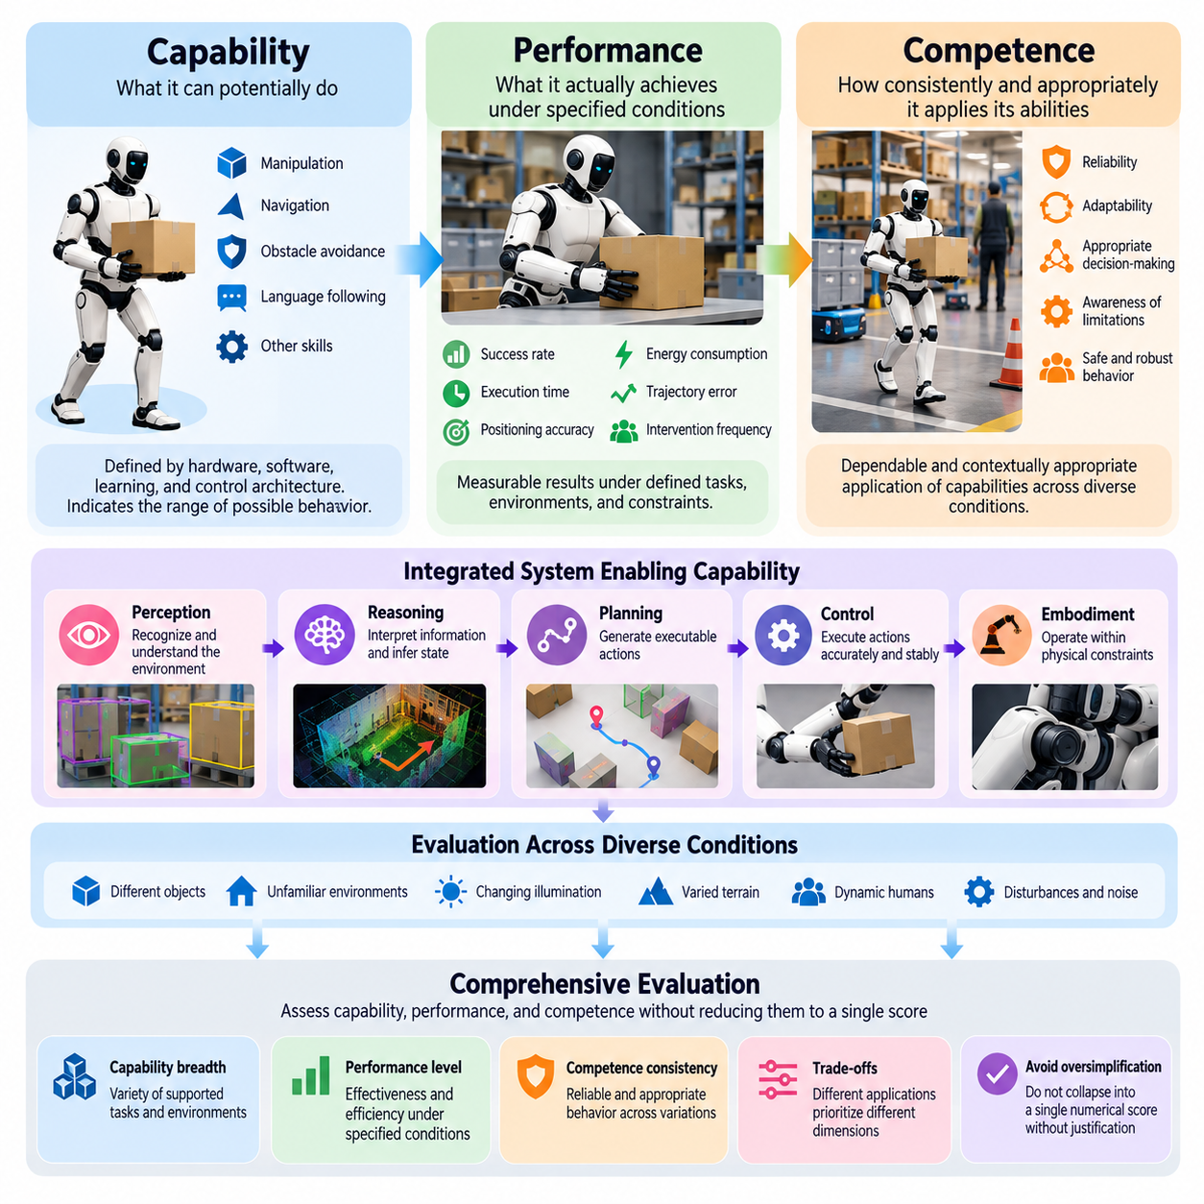
Capability, performance, and competence represent three fundamental dimensions of Physical AI evaluation. Although these concepts are closely related, they describe different aspects of intelligent behavior in physical environments. Capability concerns what a system can potentially accomplish, performance describes what it actually achieves under specified conditions, and competence reflects how consistently and appropriately it applies its abilities across diverse situations.
Capability defines the functional possibilities available to a Physical AI system through its hardware, software, learned representations, and control architecture. A robot may possess capabilities such as object manipulation, autonomous navigation, obstacle avoidance, or natural language instruction following. However, the existence of these capabilities does not establish their reliability, accuracy, or suitability for operational deployment. Capability assessment primarily identifies the boundaries of possible behavior.
Physical AI capabilities emerge from interactions among perception, reasoning, planning, control, and embodiment. A manipulation robot may recognize an object and generate a grasping strategy, yet its practical capability remains constrained by gripper geometry, actuator force, sensing resolution, and workspace limitations. Evaluation must therefore distinguish algorithmic capability from physically executable capability. Intelligence becomes operationally meaningful only when the entire system supports the intended action.
Performance describes the measurable results produced when a Physical AI system executes a defined task under specified conditions. Typical performance indicators include task success rate, execution time, positioning accuracy, energy consumption, trajectory tracking error, and intervention frequency. These measurements provide quantitative evidence of system behavior. However, performance values are meaningful only when interpreted alongside the environmental conditions, task difficulty, and operational constraints under which they were obtained.
A robot may demonstrate excellent performance in a controlled laboratory while exhibiting substantial degradation in unfamiliar environments. For example, an autonomous mobile robot may navigate accurately through a mapped corridor but struggle when encountering unexpected obstacles, changing illumination, or dynamic human traffic. Such differences reveal why observed performance cannot automatically be interpreted as general competence. Evaluation must account for the distribution of conditions represented by each experiment.
Competence refers to the dependable and contextually appropriate application of capabilities across relevant tasks and operating conditions. A competent Physical AI system does more than execute successful actions under favorable circumstances. It recognizes environmental constraints, selects suitable strategies, maintains acceptable behavior during disturbances, and identifies situations requiring assistance or recovery. Competence therefore combines functional ability with reliability, adaptability, and appropriate decision-making.
The relationship among capability, performance, and competence can be understood through a robot performing warehouse manipulation tasks. Capability indicates whether the robot can identify, grasp, transport, and place objects. Performance measures how accurately and efficiently these operations are completed during specific trials. Competence determines whether the robot can maintain appropriate results across different object geometries, storage configurations, workload conditions, and unexpected disturbances.
Capability evaluation should establish a structured inventory of supported functions and their operational boundaries. This includes identifying available sensing modalities, movement primitives, manipulation skills, planning mechanisms, and communication interfaces. Evaluators should determine which tasks are feasible and which environmental assumptions must hold. Such characterization creates a foundation for selecting meaningful performance tests without assuming that every theoretically supported function is operationally mature.
Performance evaluation requires clearly defined tasks, measurable outcomes, and controlled experimental conditions. Test protocols should specify initial states, target objectives, environmental configurations, time limits, and acceptable error thresholds. Repeated trials help estimate success probabilities and variability rather than relying on isolated demonstrations. Measurements should also capture execution quality because identical task outcomes may conceal substantial differences in physical behavior.
Competence evaluation extends beyond individual trials by examining consistency across representative variations in task requirements and environmental conditions. A system should demonstrate that its behavior remains appropriate when object properties, terrain characteristics, sensor observations, or human interactions change. Evaluation should also examine whether the system understands its limitations and responds conservatively when confidence decreases. Reliable competence requires both successful execution and appropriate restraint.
These three dimensions should not be collapsed into a single numerical score without careful justification. A robot may possess broad capabilities but exhibit inconsistent performance, while another may achieve exceptional performance within a narrow operating domain. A third system may demonstrate moderate peak performance but greater reliability across diverse conditions. Such distinctions are important because different applications prioritize functional breadth, operational efficiency, and dependable behavior differently.
Capability breadth describes the variety of tasks and environmental situations that a system can potentially address. Capability depth reflects the complexity or sophistication of actions supported within a particular domain. A generalist robot may possess broad but relatively shallow abilities, whereas a specialized industrial robot may demonstrate deep capability in precision assembly. Evaluation should characterize both dimensions rather than treating the number of supported tasks as a sufficient measure of intelligence.
Performance must also be evaluated as a distribution rather than a single average. Mean task completion time or average positioning accuracy may conceal rare but consequential failures. Variance, worst-case outcomes, failure frequency, and performance degradation under stress provide additional evidence of operational quality. For safety-critical applications, understanding the lower end of the performance distribution may be more important than maximizing average results under favorable conditions.
Competence includes the ability to maintain coherent behavior across sequences of decisions and actions. Long-horizon tasks introduce dependencies among intermediate objectives, environmental state estimates, and resource constraints. A robot that successfully performs individual manipulation primitives may still fail when required to organize them into a complete mission. Competence evaluation should therefore consider planning continuity, error accumulation, recovery effectiveness, and sustained autonomy.
The distinction becomes particularly important when evaluating learning-based Physical AI systems. A model may achieve high prediction accuracy or policy success within its training distribution while lacking transferable competence. Evaluation should separate memorized behavior from robust generalization by introducing unfamiliar objects, tasks, and environmental configurations. Adaptation speed, sample efficiency, and retention of previously acquired skills can provide additional evidence of developing competence.
Embodiment influences all three dimensions because physical capabilities depend on morphology, actuators, sensors, and mechanical constraints. Identical learning algorithms deployed on different robots may produce substantially different performance outcomes. Competence comparisons should therefore consider each platform's feasible action space and intended operational domain. Fair evaluation requires distinguishing limitations imposed by hardware from those arising through perception, reasoning, or control.
Safety and uncertainty awareness further differentiate competence from raw performance. A robot that completes a task quickly while violating collision constraints may demonstrate high task efficiency but inadequate operational competence. Conversely, a system that detects uncertainty and requests assistance may exhibit lower autonomous completion rates while making more appropriate decisions. Evaluation should recognize that responsible behavior sometimes requires slowing down, changing strategies, or declining unsafe actions.
Human intervention provides another perspective on the distinction. A robot may appear capable of completing complex tasks while depending heavily on remote operators, manual resets, or carefully prepared environments. Performance reports should therefore disclose the degree of assistance involved. Competence evaluation should measure autonomous decision-making, intervention frequency, recovery behavior, and the ability to continue operating without hidden external support.
Capability, performance, and competence should be assessed through complementary evaluation levels. Component-level tests characterize sensing, prediction, planning, and control functions. Robot-level experiments measure integrated physical behavior, while mission-level evaluations examine sustained operation and task accomplishment. Connecting these levels helps determine whether improved model capability produces measurable system performance gains and whether those gains translate into dependable operational competence.
A rigorous evaluation framework should report capability coverage, observed performance, and competence boundaries separately before considering aggregate scores. Capability coverage identifies what functions are supported, performance measurements quantify execution quality, and competence boundaries describe the conditions under which behavior remains dependable. This multidimensional approach improves transparency, supports meaningful comparisons, and prevents isolated benchmark achievements from being mistaken for general physical intelligence.
Ultimately, the purpose of distinguishing capability, performance, and competence is to evaluate Physical AI according to what it can do, how well it does it, and how reliably it behaves when circumstances change. Capability establishes functional potential, performance provides observable evidence, and competence determines operational trustworthiness within defined conditions. Together, these dimensions form a foundation for evaluating progress toward adaptable, dependable, and increasingly general Physical AI systems.

01.03. Model Level vs Robot Level Evaluation
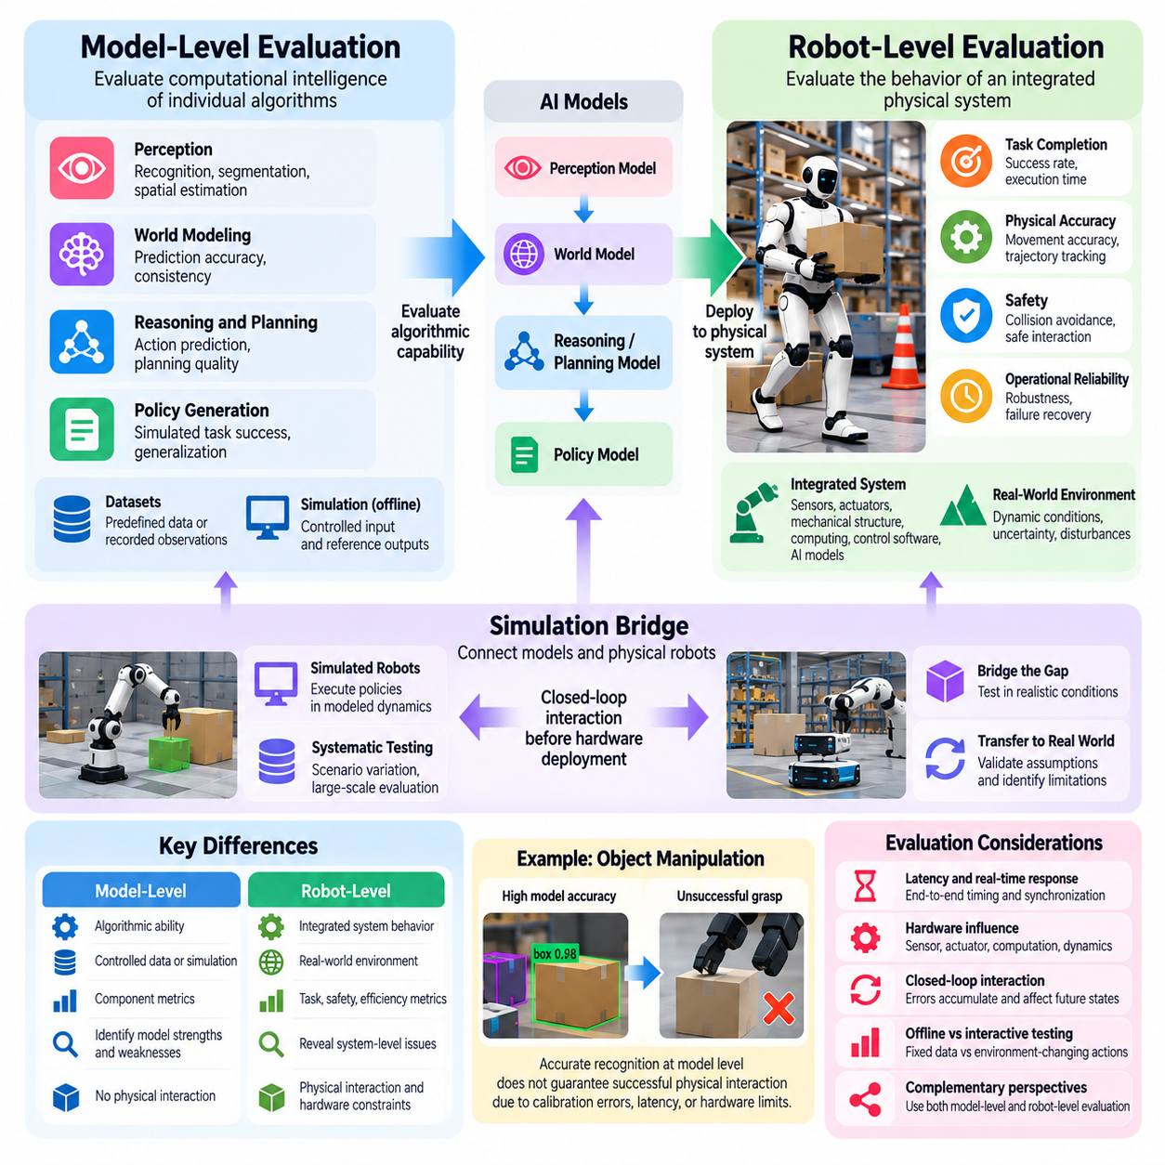
Model-level evaluation and robot-level evaluation represent two complementary perspectives for assessing Physical AI systems. Model-level evaluation examines the computational intelligence of individual algorithms, including perception, prediction, reasoning, and policy generation. Robot-level evaluation investigates how these algorithms perform when integrated with physical hardware. Distinguishing these levels is essential because strong model performance does not necessarily produce reliable embodied behavior.
Model-level evaluation focuses on the internal capabilities of artificial intelligence components under controlled computational conditions. Perception models may be assessed through recognition accuracy, segmentation quality, or spatial estimation error. World models may be evaluated through prediction accuracy and consistency, while planning and policy models may be examined through action prediction or simulated task success. These measurements help isolate algorithmic strengths and weaknesses.
Robot-level evaluation measures the behavior of an integrated physical system interacting with its environment. It considers the combined effects of sensors, actuators, mechanical structures, onboard computing, control software, and intelligent decision-making. Relevant outcomes include task completion, movement accuracy, interaction safety, execution time, and operational reliability. The evaluation target is the robot's observable behavior rather than an isolated computational output.
The distinction becomes apparent when a perception model achieves high object detection accuracy but fails to support reliable manipulation. Small localization errors, sensor calibration problems, or processing delays may cause unsuccessful grasps despite accurate recognition results. Model-level evaluation may identify excellent visual understanding, while robot-level testing reveals limitations in physical interaction. Both perspectives are necessary to understand the actual source of failure.
Model-level benchmarks commonly rely on predefined datasets, recorded observations, or simulated environments. Such settings enable repeatable comparisons because input conditions and reference outputs can be controlled. Researchers can evaluate alternative architectures without requiring physical experiments for every modification. However, these benchmarks may overlook feedback effects, environmental changes, and hardware constraints that influence behavior during real-world operation.
Robot-level experiments introduce closed-loop interaction, where actions change the environment and subsequent observations influence future decisions. Errors can accumulate through repeated perception, planning, and control cycles. A small prediction error may alter a movement trajectory, creating new observations that differ from those expected by the model. Consequently, robot-level evaluation must examine dynamic behavior and error propagation rather than isolated prediction quality.
Hardware characteristics strongly influence the relationship between model-level and robot-level performance. Sensor resolution, actuator precision, mechanical compliance, computational capacity, and communication latency affect how algorithmic decisions translate into physical actions. An identical policy may perform differently across robot platforms because their dynamics and constraints differ. Evaluation should therefore document hardware configurations and distinguish model limitations from embodiment-dependent effects.
Latency illustrates why computational accuracy alone is insufficient for Physical AI evaluation. A model may generate highly accurate predictions but require excessive processing time, making its outputs unsuitable for real-time control. During the delay, objects or obstacles may move, invalidating the predicted state. Robot-level evaluation must therefore consider end-to-end response time, timing variability, and synchronization among perception, reasoning, planning, and actuation.
Model-level evaluation is particularly valuable for diagnosing individual components and accelerating development. Controlled tests can reveal whether performance degradation originates from perception errors, inaccurate dynamics predictions, poor action selection, or insufficient generalization. These findings guide targeted improvements before expensive physical testing. Nevertheless, isolated component gains should be treated as potential system improvements until their effects are verified through integrated experiments.
Robot-level evaluation captures interactions among components that cannot always be predicted from individual benchmark results. A perception system may produce accurate estimates, but inconsistent timestamps can undermine control stability. A planner may generate feasible trajectories that exceed actuator capabilities under real operating conditions. Integrated testing exposes interface mismatches, resource contention, and unexpected dependencies that remain hidden during separate model assessments.
Evaluation should also distinguish offline model testing from interactive robot testing. Offline evaluation measures outputs against fixed reference data without allowing predictions to influence subsequent observations. Interactive evaluation permits decisions and actions to alter future states, revealing behavioral consequences. This distinction is particularly important for reinforcement learning policies, vision-language-action models, and autonomous systems whose performance depends on continuous feedback.
Simulation provides an intermediate evaluation environment connecting computational models with physical robots. Simulated robots can execute policies within modeled dynamics, enabling closed-loop testing before hardware deployment. This approach supports systematic scenario variation and large-scale experimentation. However, simulation results depend on the fidelity of physical dynamics, sensing, contact interactions, and environmental representations, making real-world validation indispensable.
Robot-level evaluation should account for the operational design domain in which the system is expected to function. Environmental geometry, lighting, surface conditions, object properties, human activity, and communication availability influence observed performance. A robot may operate reliably within a controlled industrial workspace but fail in less structured environments. Evaluation conclusions must therefore remain tied to the conditions represented by the experiments.
Safety considerations further distinguish model-level and robot-level assessment. Model testing can identify unsafe predictions, inappropriate action proposals, or failures to recognize hazardous conditions. Robot testing must additionally determine whether actual movements, contact forces, stopping distances, and emergency responses remain within acceptable limits. Safety emerges from the complete interaction between intelligence, hardware, control mechanisms, and the surrounding physical environment.
Statistical reliability requires different experimental strategies at the two evaluation levels. Model-level benchmarks can often process large datasets efficiently, producing detailed accuracy distributions and confidence estimates. Physical robot experiments are generally more expensive, slower, and subject to environmental variability. Repeated trials, controlled conditions, calibrated measurements, and transparent reporting are therefore essential for distinguishing systematic performance differences from experimental noise.
Comparing model improvements with robot outcomes requires explicit attention to causal relationships. A higher perception accuracy score may not improve task completion if manipulation errors are dominated by actuator limitations. Conversely, a modest model improvement may produce substantial system benefits when it addresses a critical failure mode. Evaluation should examine whether algorithmic changes generate measurable improvements in integrated behavior under comparable operating conditions.
A hierarchical evaluation strategy can connect model-level, subsystem-level, robot-level, and mission-level measurements. Individual algorithms are first characterized through controlled tests, followed by integrated subsystem experiments and complete robot trials. Extended missions then assess whether improvements remain effective across sequences of actions. This progression supports efficient debugging while preserving a direct connection between computational advances and operational outcomes.
Cross-embodiment evaluation introduces additional complexity because the same model may operate on robots with different sensors, kinematics, and action spaces. A generalist policy may demonstrate transferable representations while requiring platform-specific adaptation for reliable execution. Model-level evaluation can assess representation quality and action prediction, while robot-level evaluation determines whether these capabilities translate into successful physical behavior across embodiments.
Resource efficiency should be measured at both levels but interpreted differently. Model-level measurements include inference latency, memory consumption, computational complexity, and processing throughput. Robot-level measurements additionally consider energy consumption, thermal constraints, battery endurance, communication overhead, and overall task efficiency. A computationally efficient model does not automatically guarantee efficient robotic operation when mechanical movement and system integration dominate resource usage.
Ultimately, model-level and robot-level evaluation should form a connected evidence framework rather than competing assessment methods. Model-level tests explain how individual intelligence components function, while robot-level experiments establish whether those capabilities produce dependable physical outcomes. Combining both perspectives enables meaningful diagnosis, fair comparison, and systematic improvement. Physical AI progress should be judged by computational advances that translate into safe, effective, and reliable real-world behavior.

01.04. Task Level vs System Level Evaluation
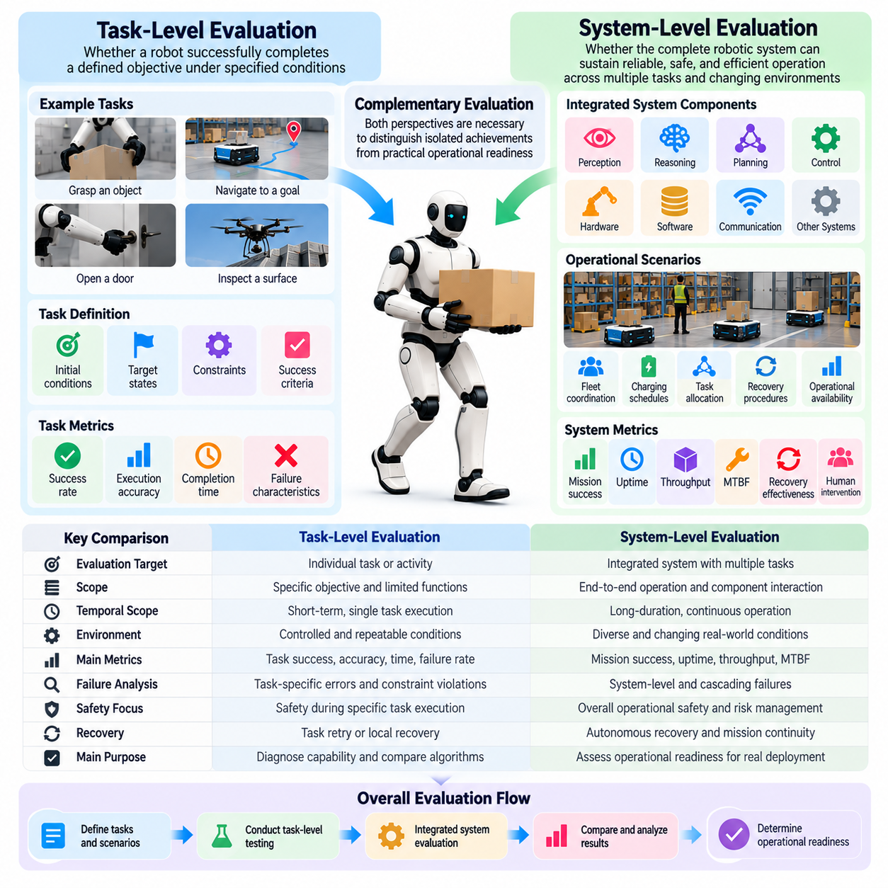
Task-level evaluation and system-level evaluation represent complementary approaches to measuring Physical AI performance. Task-level evaluation examines whether a robot successfully completes a defined objective under specified conditions. System-level evaluation investigates whether the complete robotic system can sustain reliable, safe, and efficient operation across multiple tasks and changing environments. Both perspectives are necessary to distinguish isolated achievements from practical operational readiness.
Task-level evaluation focuses on observable outcomes associated with individual activities such as grasping an object, navigating toward a destination, opening a door, or inspecting a surface. Each task is defined through initial conditions, target states, constraints, and success criteria. This approach enables precise measurement of task completion, execution accuracy, duration, and failure characteristics while limiting the complexity introduced by unrelated system functions.
System-level evaluation considers the integrated behavior of perception, reasoning, planning, control, hardware, communication, and supporting software. Rather than examining isolated activities, it investigates how these components cooperate during continuous operation. A robot may perform individual tasks successfully while experiencing system failures caused by resource contention, communication interruptions, inconsistent state estimates, or interactions among subsystems.
The distinction becomes apparent in warehouse automation. A mobile robot may achieve a high success rate when transporting individual containers between predefined locations. However, system-level evaluation must additionally consider fleet coordination, charging schedules, obstacle congestion, task allocation, recovery procedures, and operational availability. Reliable warehouse operation depends on the interaction of these functions rather than transportation accuracy alone.
Task-level evaluation requires explicit definitions of success and failure. A manipulation task may specify acceptable placement error, maximum contact force, and completion time. A navigation task may define destination tolerance, collision constraints, and permitted route deviations. These conditions make experiments reproducible and allow meaningful comparisons among alternative algorithms, robot configurations, and control strategies.
System-level success criteria are broader because they reflect operational objectives extending beyond individual task completion. Relevant measures include mission success, uptime, throughput, mean time between failures, recovery effectiveness, and human intervention frequency. System-level evaluation should also consider whether performance remains stable as workload increases, environmental conditions change, or individual components experience degradation.
Task-level metrics provide diagnostic resolution by identifying weaknesses in specific capabilities. For example, repeated grasping failures may indicate inaccurate object localization, unsuitable grasp planning, or insufficient actuator precision. By controlling experimental variables, evaluators can investigate these causes systematically. However, successful correction of an isolated task does not guarantee improved system performance when other operational constraints remain unchanged.
System-level evaluation reveals interactions that task-level tests may overlook. A perception algorithm may operate accurately during isolated trials but consume excessive computational resources when navigation and manipulation execute simultaneously. Similarly, independently reliable subsystems may interfere through timing conflicts, shared communication channels, or inconsistent representations. Integrated evaluation identifies such dependencies and their consequences for overall operation.
Temporal scope provides another important distinction. Task-level tests often measure short sequences with clear starting and ending conditions. System-level evaluation may involve hours or days of continuous operation, during which errors accumulate and resources fluctuate. Long-duration testing can expose memory leaks, thermal limitations, battery management problems, sensor drift, and gradual deterioration that remain invisible during brief demonstrations.
Task-level evaluation generally benefits from controlled experimental conditions that isolate the behavior being measured. Standardized objects, fixed environmental layouts, and repeatable starting configurations enable detailed comparisons. System-level evaluation requires broader operational variation to determine whether integrated performance remains dependable. These approaches serve different purposes, and neither controlled task testing nor unrestricted field operation is sufficient by itself.
Failure analysis must also operate at both levels. Task-level failures concern unsuccessful actions, violated constraints, or unacceptable execution quality. System-level failures may involve cascading effects in which a localized problem disrupts multiple functions. A delayed sensor update, for example, may affect localization, planning, motion control, and task scheduling. Evaluation should identify both immediate failure mechanisms and their broader operational consequences.
Recovery behavior is particularly important in system-level assessment. A robot may fail an individual task but detect the problem, revise its plan, and complete the overall mission. Conversely, a system may repeatedly succeed at isolated tasks while requiring manual resets after minor disturbances. Evaluators should therefore distinguish task success rates from mission continuity, autonomous recovery capability, and the operational cost of interruptions.
Safety requirements differ in scope between the two evaluation levels. Task-level safety examines whether individual actions respect collision limits, force thresholds, and workspace constraints. System-level safety considers interactions among simultaneous activities, shared resources, human operators, and environmental hazards. A locally safe action may create unsafe conditions elsewhere, making system-wide hazard assessment essential for dependable deployment.
Efficiency must also be interpreted according to evaluation scope. Task-level efficiency measures execution time, energy consumption, trajectory length, or computational cost for a specific activity. System-level efficiency includes utilization, scheduling effectiveness, charging overhead, maintenance requirements, and total operational throughput. Optimizing an individual task may not improve overall productivity when system bottlenecks occur in other processes.
System-level evaluation should examine the relationship between operational workload and performance. Increasing task frequency or environmental complexity can reveal limitations in computational scheduling, communication capacity, and resource allocation. A robot that performs reliably under light workloads may become unstable when multiple objectives compete for attention. Such tests establish practical capacity limits and identify conditions where performance begins to degrade.
Human involvement provides another distinction between task-level and system-level performance. Individual task tests may allow predefined initialization or occasional operator assistance. Continuous system operation requires explicit accounting for supervision, remote intervention, maintenance, and recovery support. A system that achieves high task success through frequent human assistance may provide limited autonomy. Evaluation should therefore report intervention requirements alongside operational outcomes.
Simulation can support both evaluation levels through different experimental designs. Task-level simulation enables repeated testing of specific manipulation, navigation, or control scenarios. System-level simulation models interactions among subsystems, workloads, operational schedules, and environmental changes. Although simulation supports scalable experimentation, physical testing remains necessary to validate assumptions concerning hardware behavior, communication delays, and real-world disturbances.
Statistical interpretation should reflect the hierarchical relationship between tasks and systems. Individual task success probabilities do not directly determine complete mission reliability because failures may be correlated and recovery mechanisms may alter outcomes. Repeated system trials are necessary to estimate operational success and variability. Evaluation should report confidence intervals, scenario coverage, and relevant dependencies rather than extrapolating system performance from isolated task averages.
A comprehensive evaluation framework should connect task-level measurements with subsystem, robot, and mission-level outcomes. Task benchmarks identify specific functional strengths, while system benchmarks determine whether these capabilities cooperate effectively during realistic operation. This hierarchical approach supports debugging, architectural comparison, and deployment decisions. It also reveals whether improvements in individual tasks produce meaningful benefits for the complete system.
Ultimately, task-level evaluation answers how effectively Physical AI performs particular activities, while system-level evaluation determines whether those activities combine into dependable operational behavior. Task success provides essential evidence of functional capability, but sustained system performance establishes practical value. Integrating both perspectives enables Physical AI evaluation to measure not only isolated intelligence but also reliable autonomy under real physical constraints.

01.05. Offline vs Interactive Evaluation
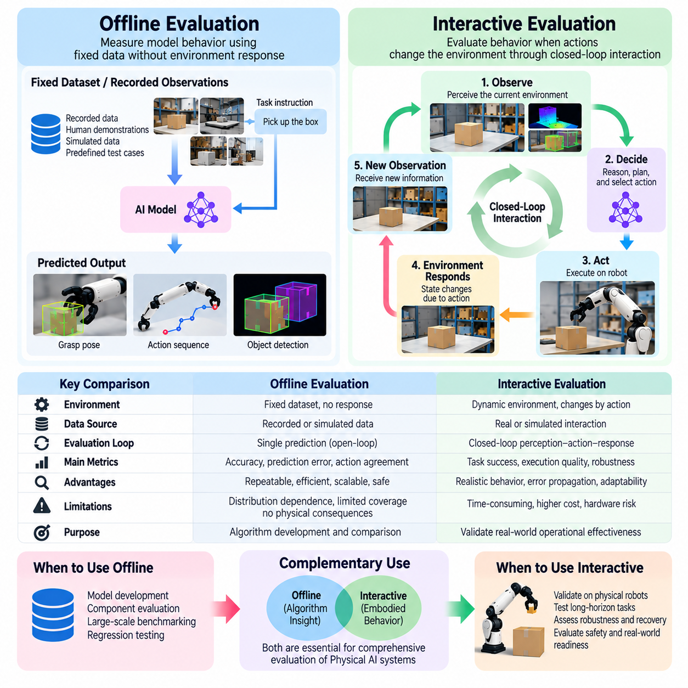
Offline evaluation and interactive evaluation represent two fundamental approaches to assessing Physical AI systems. Offline evaluation measures model behavior using previously collected datasets, recorded observations, or predefined test cases without allowing predictions to influence the environment. Interactive evaluation examines how an intelligent system behaves when its decisions and actions change subsequent observations. Both approaches provide essential but different evidence of intelligence.
Offline evaluation is particularly useful for examining perception, prediction, reasoning, and action-generation models under controlled conditions. A model receives fixed inputs and produces outputs that can be compared against reference labels, recorded actions, or expected outcomes. Because the environment does not respond to these outputs, experiments are highly repeatable. This makes offline testing valuable for algorithm development, regression analysis, and standardized benchmarking.
Interactive evaluation introduces a continuous relationship between observation, decision-making, action, and environmental response. The system observes its surroundings, selects an action, executes it, and receives new information resulting from that action. This process creates a feedback loop in which earlier decisions influence future conditions. Evaluation must therefore consider complete behavioral trajectories rather than treating individual predictions as independent events.
The distinction becomes clear in robotic manipulation. During offline evaluation, a vision-language-action model may predict grasp poses or motor commands from recorded camera images and instructions. These predictions can be compared with demonstration data, but their physical consequences remain unobserved. Interactive evaluation requires the robot to execute the predicted actions and determine whether the object is successfully grasped, transported, and placed.
Offline evaluation offers significant advantages in experimental control and computational efficiency. Large datasets can be processed repeatedly without consuming robot operating time or exposing hardware to physical risks. Researchers can compare architectures, training procedures, and model checkpoints using identical inputs. However, strong offline performance does not guarantee successful physical execution because recorded datasets cannot fully represent the consequences of alternative actions.
Interactive evaluation addresses this limitation by allowing actions to affect environmental states. A navigation robot that chooses an incorrect direction may encounter unfamiliar obstacles, lose localization accuracy, or require replanning. These consequences become part of subsequent evaluation. Such interactions reveal how perception errors, planning mistakes, and control limitations propagate through the system, potentially producing outcomes that fixed-data testing cannot predict.
A central limitation of offline evaluation is distribution dependence. Recorded observations typically reflect the behavior of the policies or operators that generated them. A new policy may select actions leading to states that are rare or absent from the dataset. Consequently, prediction accuracy on recorded examples may provide limited evidence about performance under the new policy's own state distribution. Interactive testing directly exposes these distribution shifts.
Offline policy evaluation attempts to estimate the effectiveness of decision-making strategies using previously collected interaction data. Methods such as importance sampling, model-based estimation, and fitted value estimation can support this objective. However, their reliability depends on assumptions about data coverage, behavior policies, and environment dynamics. When candidate actions are insufficiently represented, estimates may become uncertain or misleading.
Interactive evaluation can be conducted in simulation, controlled laboratories, or operational environments. Simulation provides scalable interaction and allows systematic manipulation of environmental variables. Laboratory experiments introduce actual hardware dynamics while maintaining experimental control. Field testing exposes systems to realistic disturbances, unexpected events, and operational complexity. Each setting offers different levels of realism, cost, repeatability, and risk.
The evaluation of feedback behavior is especially important for autonomous Physical AI. Interactive systems must continuously update their understanding of the environment and adjust actions when conditions change. A robot may initially generate an incorrect trajectory but recover through subsequent observations and replanning. Offline metrics may penalize the initial prediction without recognizing successful recovery, whereas interactive evaluation can measure the complete adaptive process.
Interactive evaluation also exposes compounding errors over extended action sequences. Small deviations in perception or control can alter the robot's position, change future observations, and increase the likelihood of additional mistakes. These effects are particularly important in long-horizon manipulation, autonomous navigation, and mobile robot missions. Evaluation should measure whether errors remain bounded, accumulate progressively, or trigger effective recovery mechanisms.
Offline benchmarks generally support precise comparisons through fixed datasets and standardized metrics. Accuracy, prediction error, action agreement, and calibration quality can be measured consistently across candidate models. Nevertheless, agreement with recorded actions does not necessarily indicate optimal behavior because demonstrations may contain multiple valid solutions or suboptimal decisions. Offline scores should therefore be interpreted according to the limitations of their reference data.
Interactive benchmarks require explicit definitions of initial conditions, task objectives, environmental constraints, and termination criteria. Relevant metrics include task success rate, execution time, collision frequency, recovery effectiveness, and resource consumption. Because actions influence subsequent states, evaluation outcomes may vary considerably between trials. Repeated experiments and controlled scenario sampling are necessary to establish meaningful performance estimates.
Safety considerations strongly influence the choice between offline and interactive evaluation. Offline testing enables investigation of potentially dangerous scenarios without exposing humans or equipment to immediate physical hazards. Interactive testing provides stronger evidence about actual safety behavior but introduces operational risks. A responsible evaluation strategy should progressively validate systems through recorded data, simulation, supervised laboratory experiments, and carefully controlled field trials.
The relationship between offline and interactive evaluation is particularly important for reinforcement learning and imitation learning. Policies trained from demonstrations may achieve high action-prediction accuracy while failing when their own actions produce unfamiliar states. Interactive testing reveals whether learned policies can recover from deviations and maintain task progress. This distinction helps identify the gap between reproducing observed behavior and achieving autonomous competence.
Vision-language-action models introduce additional evaluation challenges because their outputs depend on visual observations, language instructions, and physical action representations. Offline tests can measure instruction understanding, action prediction, and generalization across recorded demonstrations. Interactive tests determine whether the model can execute instructions reliably despite changing object positions, ambiguous observations, contact dynamics, and unexpected task outcomes.
Interactive evaluation must also account for system-level constraints that offline model tests may overlook. Inference latency, sensor synchronization, actuator response, communication delays, and computational resource contention influence closed-loop performance. A model that produces accurate actions from recorded observations may respond too slowly during real operation. Evaluating the complete perception-to-action cycle is therefore necessary to establish operational suitability.
Statistical rigor requires recognizing that offline and interactive experiments produce different forms of evidence. Offline datasets often permit large sample sizes and deterministic comparisons, while interactive trials involve stochastic environmental responses and correlated trajectories. Confidence intervals, repeated trials, scenario diversity, and uncertainty reporting should reflect these differences. Comparisons must avoid treating offline prediction scores as direct substitutes for interactive task success.
A practical evaluation framework should connect offline and interactive testing through progressive validation. Offline benchmarks identify algorithmic weaknesses and support rapid development, while simulation-based interaction examines feedback behavior under controlled dynamics. Physical robot experiments then establish whether these capabilities transfer to actual hardware and environments. Discrepancies between evaluation stages provide valuable information about modeling assumptions and deployment limitations.
Ultimately, offline evaluation answers how accurately Physical AI models respond to recorded situations, while interactive evaluation determines how effectively complete systems behave when their actions influence the world. Offline testing provides efficiency, reproducibility, and diagnostic precision, whereas interactive testing reveals adaptation, error propagation, recovery, and operational reliability. Combining both approaches produces a more credible assessment of embodied intelligence and real-world readiness.

01.06. Open Loop vs Closed Loop Metrics
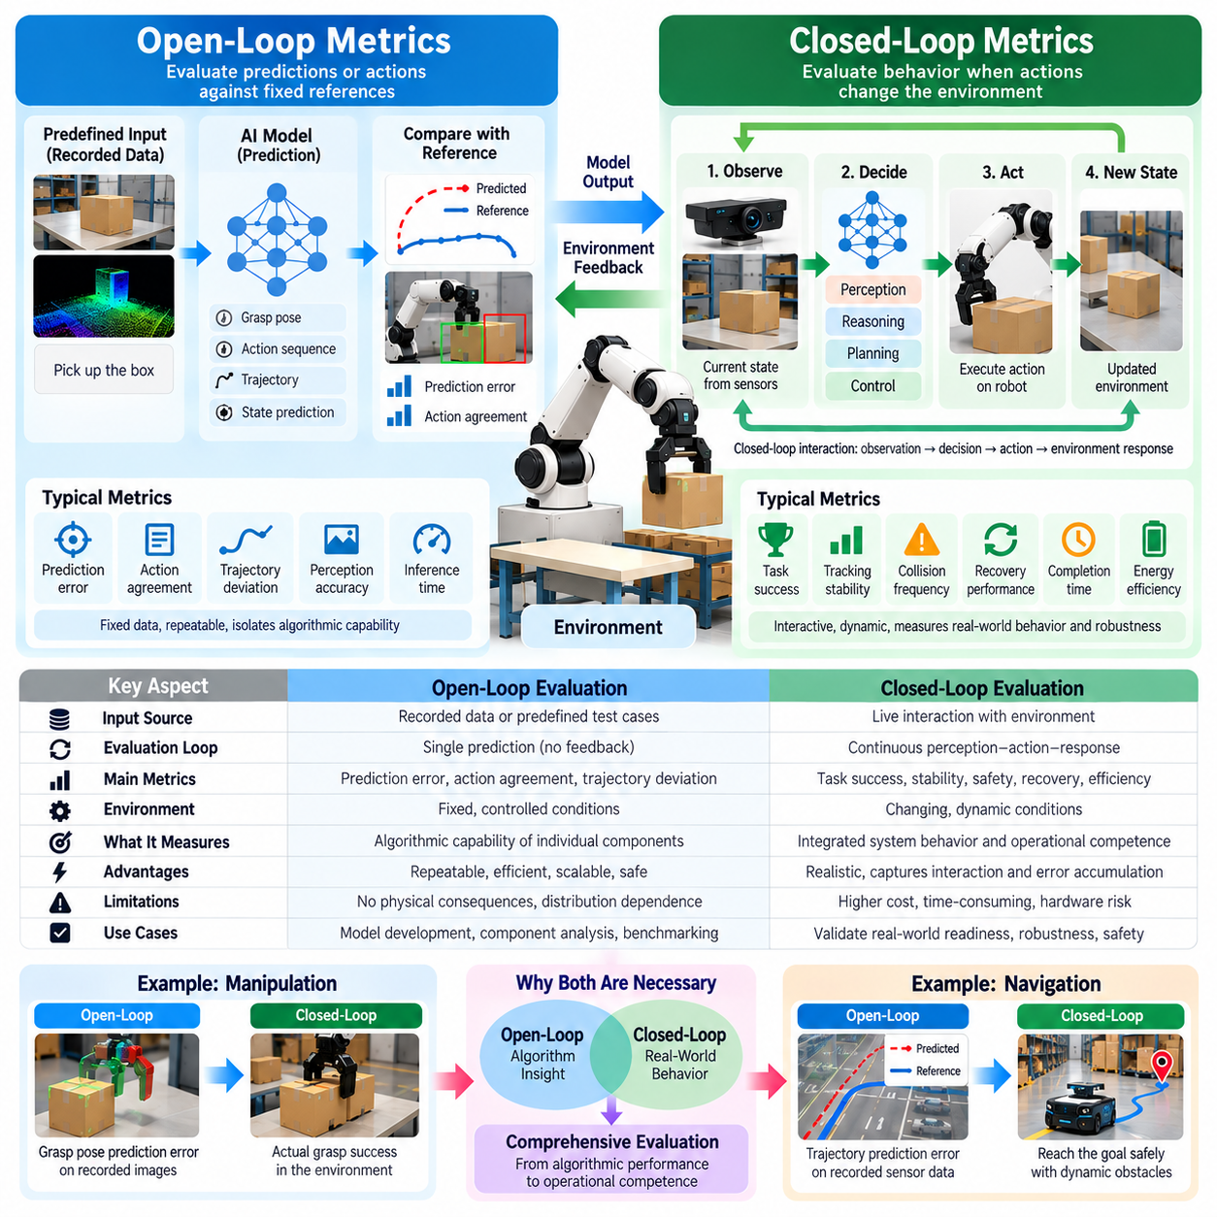
Open-loop metrics and closed-loop metrics provide complementary perspectives for evaluating Physical AI systems. Open-loop metrics measure predictions or actions against fixed references without allowing outputs to influence subsequent observations. Closed-loop metrics assess behavior when actions change the environment and generate new feedback. This distinction is essential because accurate individual predictions do not necessarily produce stable, effective, or safe physical behavior.
Open-loop evaluation commonly uses recorded sensor observations, reference trajectories, and demonstrated actions. A model processes predefined inputs, and its outputs are compared with expected values using consistent measurement procedures. Typical metrics include prediction error, action agreement, trajectory deviation, and inference accuracy. These measurements support repeatable experiments and help researchers identify weaknesses in individual perception, planning, or control components.
Closed-loop evaluation measures the consequences of actions executed within an interactive environment. A robot observes its surroundings, selects an action, changes its physical state, and receives updated observations. Subsequent decisions depend on the outcomes of previous actions, creating feedback-dependent behavior. Relevant metrics therefore include task success, tracking stability, collision frequency, recovery performance, and the ability to maintain operational constraints.
The difference is especially important in autonomous navigation. An open-loop benchmark may compare predicted steering commands or planned trajectories with recorded driving demonstrations. Small numerical errors may indicate strong prediction performance, but they do not establish whether the robot can reach its destination. Closed-loop testing reveals whether steering decisions maintain safe clearance, correct deviations, and achieve navigation objectives under changing conditions.
In robotic manipulation, open-loop metrics may measure grasp-pose prediction error, joint-angle deviation, or agreement with demonstrated motor commands. These scores characterize how closely a model reproduces reference behavior. Closed-loop metrics instead examine whether the robot successfully grasps, lifts, transports, and places objects. Contact uncertainty, object movement, and actuator limitations may produce failures that cannot be inferred from action-prediction accuracy alone.
Error accumulation explains why open-loop accuracy and closed-loop performance may diverge. A small control error can change the robot's position, causing future observations to differ from those in recorded datasets. Subsequent predictions may become less reliable as the system encounters unfamiliar states. Closed-loop metrics capture this compounding process, while conventional open-loop metrics generally evaluate errors without measuring their consequences for future decisions.
Open-loop metrics are valuable because they isolate specific computational capabilities. Researchers can compare alternative models using identical datasets and reference outputs, reducing variability caused by physical interactions. This supports rapid experimentation, regression testing, and architectural analysis. However, open-loop scores should be interpreted as indicators of component behavior rather than direct measurements of autonomous operational competence.
Closed-loop metrics provide stronger evidence of practical autonomy because they capture continuous perception-action interaction. A robot must adapt to disturbances, update its internal state, and revise decisions as environmental conditions evolve. Evaluation can measure whether tracking errors converge, remain bounded, or increase over time. Such measurements reveal dynamic properties that cannot be established through isolated prediction comparisons.
Trajectory tracking illustrates the distinction between the two approaches. Open-loop evaluation may calculate the difference between a predicted trajectory and a reference path. Closed-loop evaluation examines the actual trajectory produced when the robot repeatedly executes control commands and receives feedback. Metrics such as cross-track error, settling time, overshoot, and constraint violations help characterize whether the controller maintains accurate and stable motion.
Recovery capability is another important closed-loop property. A robot may initially make an incorrect decision but subsequently detect the deviation and restore progress toward its objective. Open-loop metrics may penalize the initial action without accounting for successful correction. Closed-loop evaluation can measure recovery time, recovery success rate, and the additional resources consumed. This distinction prevents evaluation from overlooking adaptive behavior.
Latency affects both evaluation approaches but has different consequences. Open-loop testing can measure model inference time and computational throughput under fixed inputs. Closed-loop testing must additionally examine whether delayed decisions destabilize control or reduce responsiveness to moving obstacles. End-to-end sensing, computation, communication, and actuation delays should be measured because their combined effects determine real-time operational performance.
Safety evaluation also benefits from separating open-loop and closed-loop evidence. Open-loop tests can identify unsafe action proposals, inaccurate hazard predictions, or violations of predefined constraints. Closed-loop tests determine whether actual robot behavior avoids collisions, respects force limits, and responds appropriately to emerging hazards. Safety metrics must capture both immediate violations and the system's ability to prevent hazardous situations from escalating.
Statistical comparison requires attention to the different sources of variability. Open-loop benchmarks usually provide fixed inputs, enabling consistent model comparisons across large datasets. Closed-loop trials introduce stochastic environmental responses, sensor noise, and interaction-dependent trajectories. Reliable conclusions therefore require repeated trials, scenario coverage, confidence intervals, and careful control of experimental conditions across competing systems.
A comprehensive evaluation framework should connect open-loop metrics with closed-loop outcomes rather than treating them as interchangeable scores. Open-loop tests can identify prediction weaknesses and guide model improvements, while closed-loop experiments determine whether those improvements affect real behavior. Correlation analysis between the two levels helps establish which offline indicators predict task success, safety, or reliability under interactive conditions.
Ultimately, open-loop metrics explain how accurately Physical AI models respond to predefined observations, while closed-loop metrics reveal how effectively systems behave when their actions influence future states. The former provides diagnostic precision and reproducibility, whereas the latter captures feedback stability, error propagation, adaptation, and operational success. Combining both approaches supports credible evaluation of intelligence that must function reliably in the physical world.

01.07. Outcome vs Process Based Evaluation
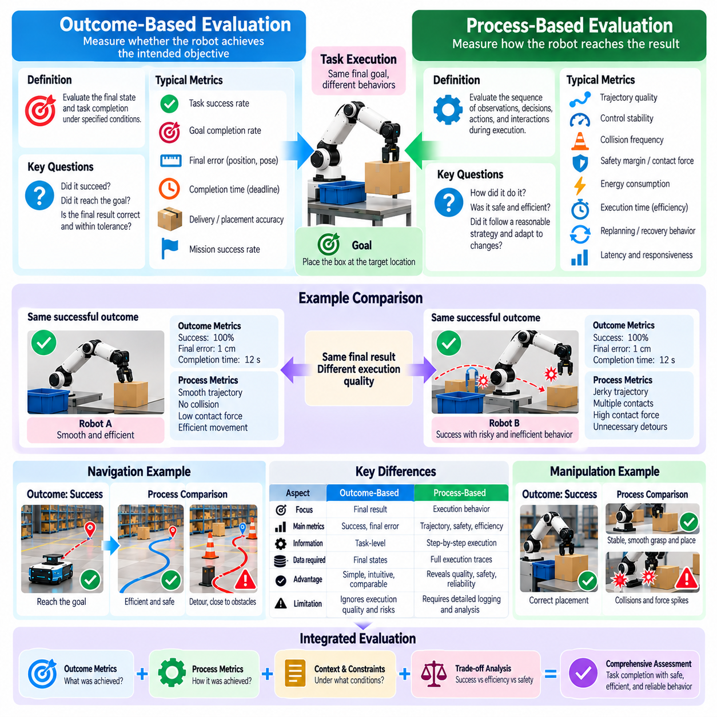
Outcome-based evaluation and process-based evaluation provide complementary methods for assessing Physical AI systems. Outcome-based evaluation measures whether a robot achieves its intended objective, while process-based evaluation examines how the robot reaches that result. A successful outcome does not necessarily indicate efficient, safe, or reliable execution. Both perspectives are essential for distinguishing apparent task completion from genuinely competent physical intelligence.
Outcome-based evaluation focuses on measurable final states. A manipulation task may be considered successful when an object reaches its designated location, while a navigation task succeeds when a robot reaches its destination. These criteria provide clear evidence of task completion and support standardized comparisons. However, final outcomes alone reveal little about the decisions, movements, and environmental interactions that occurred during execution.
Process-based evaluation examines the sequence of observations, decisions, actions, and feedback that produces an outcome. It considers trajectory quality, control stability, planning efficiency, constraint compliance, and adaptation to disturbances. By analyzing intermediate behavior, evaluators can determine whether a robot follows a dependable strategy or succeeds through accidental circumstances. This distinction becomes important when systems operate beyond controlled demonstrations.
The difference is evident in robotic manipulation. Two robots may successfully place an object at the same destination, yet one may execute smooth movements while the other repeatedly collides with nearby surfaces. Outcome-based metrics may assign both robots identical success scores. Process-based metrics reveal differences in contact forces, trajectory smoothness, execution time, and corrective actions, providing a more complete assessment of manipulation quality.
Autonomous navigation provides another example. A robot may reach its destination while taking unnecessary detours, approaching obstacles too closely, or repeatedly stopping because of planning instability. An outcome-based benchmark records successful arrival. Process-based evaluation additionally measures path efficiency, clearance margins, velocity consistency, replanning frequency, and motion stability. These measurements reveal whether successful navigation is operationally acceptable.
Outcome-based metrics are attractive because they are relatively intuitive and often align directly with application objectives. Task success rate, mission completion rate, delivery accuracy, and final placement error provide interpretable measures of achievement. They also support comparisons across different algorithms and robot architectures. Nevertheless, outcome definitions must specify tolerances, deadlines, and constraints to prevent ambiguous interpretations of success.
Process-based metrics require more detailed observations and instrumentation. Evaluators may record joint trajectories, actuator commands, sensor estimates, contact forces, computational latency, and internal planning events. These measurements enable analysis of how system components contribute to execution quality. However, process measurements must be selected carefully because excessive instrumentation can increase computational overhead and alter real-time system behavior.
Safety is a major reason to evaluate processes independently of final outcomes. A robot may complete a task while briefly violating collision constraints, applying excessive force, or creating hazardous conditions for nearby humans. Outcome-based evaluation may overlook these incidents if the final objective is achieved. Process-based evaluation can detect safety violations throughout execution and distinguish safe task completion from success obtained through unacceptable behavior.
Efficiency also requires process-aware assessment. Two systems may achieve the same objective but differ substantially in energy consumption, computational demand, trajectory length, or operating time. Process metrics identify resource-intensive behavior and unnecessary corrective movements. Such information is particularly valuable for battery-powered robots and high-throughput industrial systems, where inefficient execution can reduce operational capacity.
Robustness becomes visible when evaluators examine how systems respond to disturbances. A robot may encounter unexpected object motion, sensor noise, temporary occlusion, or external contact during task execution. Outcome-based evaluation determines whether the objective is eventually achieved. Process-based evaluation examines detection time, corrective actions, recovery trajectories, and stability during adaptation, revealing the mechanisms supporting reliable performance.
Failure analysis benefits from the same distinction. Outcome-based metrics establish how frequently tasks fail, but they rarely explain why failures occur. Process-based evidence can identify incorrect state estimation, unsuitable planning decisions, delayed control responses, or actuator limitations. Linking failure outcomes to execution traces supports targeted improvements and prevents developers from optimizing components unrelated to the actual source of failure.
Process-based evaluation should not assume that one execution strategy is universally optimal. Different robots may use distinct morphologies, control architectures, and movement patterns to achieve the same objective. A rigid preference for particular trajectories or action sequences may unfairly penalize valid alternatives. Process metrics should therefore emphasize meaningful properties such as safety, efficiency, stability, and constraint satisfaction rather than imitation of a single reference behavior.
Multi-objective evaluation connects outcome quality with process quality. A robot may achieve high task success at the expense of excessive energy consumption or reduced safety margins. Another system may execute cautiously but complete fewer tasks within a fixed period. Evaluation should characterize these tradeoffs rather than compressing all performance dimensions into an unexplained score. Explicit weighting and transparent reporting support meaningful comparison.
Long-horizon tasks make process evaluation especially important because small execution problems can accumulate across multiple stages. A robot may successfully complete individual subtasks while progressively exhausting its energy reserves or increasing localization uncertainty. Outcome metrics capture final mission success or failure, while process metrics reveal the intermediate trends responsible for that result. This information supports early detection of operational degradation.
Statistical analysis should account for differences between final outcomes and continuous process measurements. Task success is often represented by binary or categorical observations, while trajectory errors, contact forces, and energy consumption produce continuous measurements. Evaluators should report appropriate distributions, confidence intervals, and variability across repeated trials. Aggregating process data without preserving critical violations can conceal important operational risks.
A balanced evaluation framework should connect outcome metrics with process indicators through a consistent experimental protocol. Each trial should define its objective, termination conditions, environmental constraints, and required measurements. Final outcomes establish whether the intended task was achieved, while process records explain the quality and reliability of execution. Together, these measurements support diagnosis, comparison, and progressive system improvement.
Ultimately, outcome-based evaluation answers whether Physical AI accomplishes its goals, while process-based evaluation explains whether those goals are achieved through safe, efficient, stable, and adaptive behavior. Outcome measures establish functional effectiveness, whereas process measures reveal operational quality and underlying weaknesses. Combining both approaches prevents superficial success from being mistaken for dependable intelligence and provides stronger evidence of real-world readiness.

01.08. Success Rate and Quality of Execution
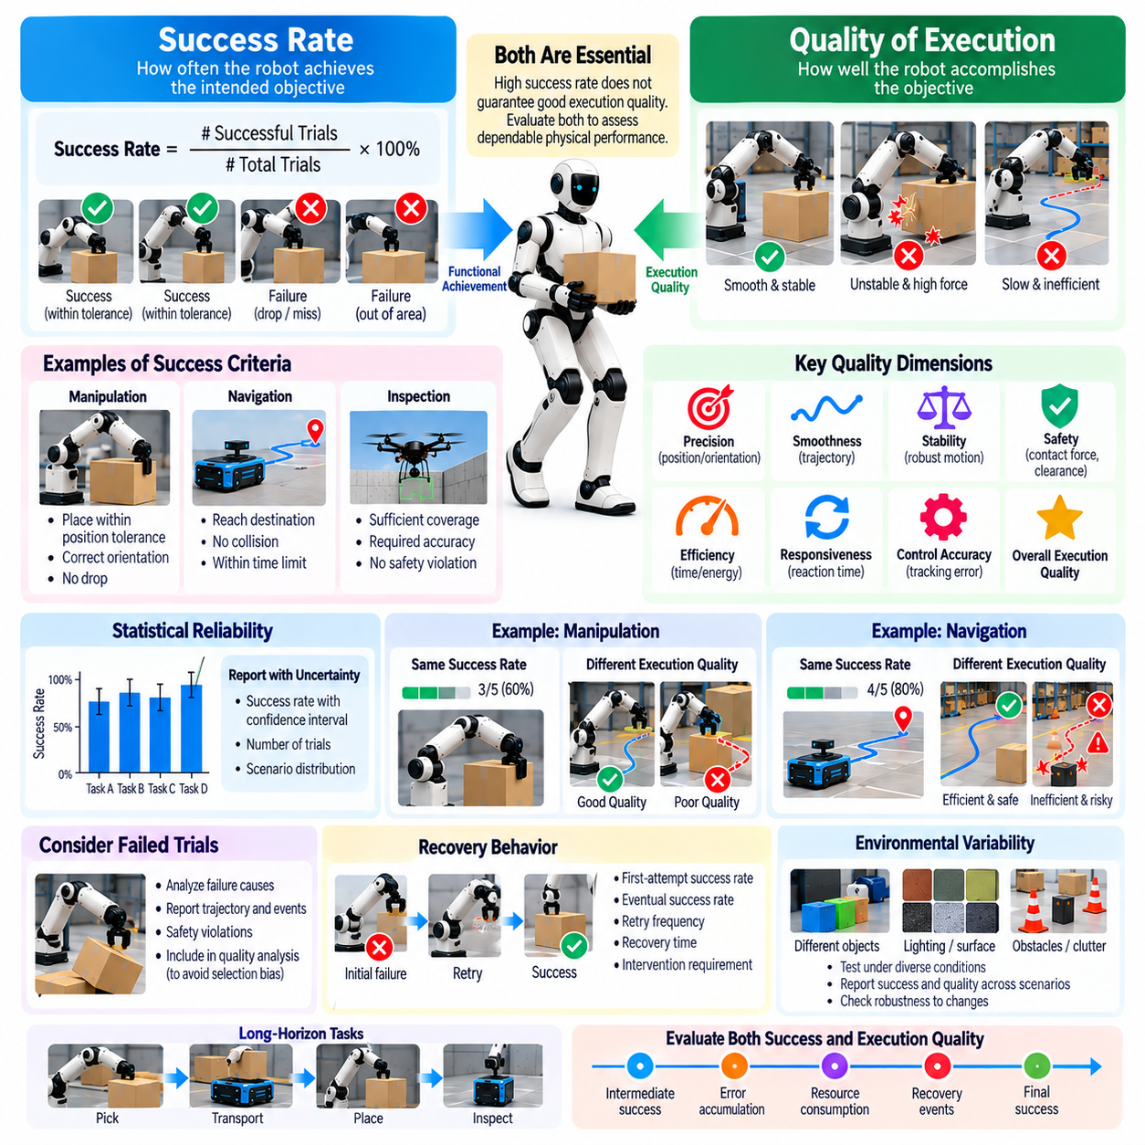
Success rate and quality of execution are fundamental dimensions of Physical AI evaluation. Success rate measures how frequently a robot achieves a defined objective, while execution quality describes how effectively that objective is accomplished. A robot may complete many tasks but exhibit unstable movements, excessive resource consumption, or unsafe interactions. Evaluating both dimensions distinguishes functional achievement from dependable physical performance.
Success rate is typically defined as the proportion of completed trials that satisfy predetermined success criteria. For manipulation, success may require placing an object within a specified tolerance. For navigation, it may require reaching a destination without violating safety constraints. Meaningful interpretation depends on consistent task definitions, clearly identified termination conditions, and transparent treatment of incomplete or interrupted trials.
Execution quality extends beyond binary success or failure by examining characteristics of the completed behavior. Relevant dimensions include precision, smoothness, stability, efficiency, safety, and responsiveness. A successful manipulation may still involve unnecessary corrective movements or excessive contact forces. Quality metrics reveal such differences and help determine whether task completion meets practical operational requirements.
Success criteria must reflect the physical requirements of each application. A warehouse robot may need to deliver containers within defined positional tolerances, while an inspection robot may need to achieve specified measurement coverage and accuracy. Criteria that are too permissive can exaggerate performance, whereas excessively strict thresholds may reject operationally acceptable behavior. Benchmark design should justify thresholds using application needs.
Statistical reliability is essential when reporting success rates. A system that completes nine of ten trials has an observed success rate of ninety percent, but this estimate contains substantial uncertainty. Larger samples generally provide more precise estimates when trials are appropriately sampled. Confidence intervals, trial counts, and scenario distributions should accompany reported success rates to prevent misleading comparisons between systems.
Execution quality can be represented through continuous measurements that capture differences among successful trials. Position error, orientation error, trajectory deviation, contact force, and task duration provide detailed performance information. These measures should be reported with suitable distributions rather than relying exclusively on averages. Rare but severe deviations may be operationally important even when mean execution quality appears satisfactory.
Robotic manipulation illustrates why success and quality must be evaluated separately. Two grippers may successfully lift the same object, yet one maintains stable contact while the other produces substantial object motion and repeated grasp adjustments. Both attempts may satisfy a binary completion criterion. However, force variation, slip frequency, placement precision, and movement smoothness reveal meaningful differences in manipulation competence.
Autonomous navigation provides similar examples. Two robots may reach the same destination, but one follows a direct, stable path while the other repeatedly replans or approaches obstacles with insufficient clearance. Success rate captures arrival reliability, while quality metrics describe route efficiency, collision margins, velocity consistency, and control stability. These distinctions are especially important in environments shared with humans.
Execution time is an important quality dimension, but faster completion does not always indicate superior performance. Aggressive movement may reduce task duration while increasing collision risk, mechanical wear, or energy consumption. Conversely, excessively cautious behavior may preserve safety but reduce throughput. Evaluation should examine speed together with safety, accuracy, and resource efficiency rather than optimizing duration in isolation.
Recovery behavior complicates the interpretation of success. A robot may initially fail to grasp an object but recover through repeated attempts and eventually complete the task. Counting only final completion can conceal repeated errors and additional resource costs. Evaluation should distinguish first-attempt success, eventual success, retry frequency, recovery time, and intervention requirements to characterize autonomous competence more accurately.
Quality assessment should consider failed trials as well as successful ones. Reporting precision or execution time only for completed tasks may introduce selection bias because difficult or unstable attempts are excluded. Evaluators should disclose the number of failed trials and characterize their trajectories, termination causes, and safety violations. Conditional quality measurements should be clearly distinguished from statistics covering all attempted executions.
Environmental variability influences both success rate and execution quality. Changes in lighting, object geometry, surface friction, payload mass, and obstacle configurations can alter performance. A robot may demonstrate excellent results under standardized laboratory conditions but deteriorate in unfamiliar settings. Evaluations should therefore report scenario diversity and examine whether success and quality remain stable across representative operational conditions.
Long-horizon tasks require additional attention because successful completion may conceal accumulated execution problems. A robot may finish a multi-stage mission while repeatedly correcting localization errors, consuming excessive energy, or approaching operational limits. Intermediate quality metrics can reveal degradation before complete failure occurs. Mission-level success should therefore be interpreted alongside stage-level performance and resource trends.
Safety must remain an explicit component of execution quality. A robot that completes a task while exceeding permitted contact forces or violating collision constraints should not receive an unrestricted success classification. Safety-critical violations may require separate reporting or invalidate an otherwise successful trial. This prevents evaluation procedures from rewarding hazardous strategies that achieve objectives through unacceptable physical behavior.
Composite performance scores can combine success rate with execution quality, but their construction requires careful justification. Weighted measures may integrate precision, efficiency, stability, and safety into an overall assessment. However, aggregation can conceal weaknesses when strong results in one dimension compensate for serious failures elsewhere. Transparent component metrics and explicit safety constraints are preferable to unexplained single-number rankings.
Ultimately, success rate establishes how reliably Physical AI achieves defined objectives, while execution quality determines whether those achievements are precise, efficient, stable, and safe. Neither dimension alone provides a complete assessment of robotic competence. Combining clear success definitions, detailed process measurements, statistical uncertainty, and representative scenarios creates a stronger foundation for evaluating real-world Physical AI performance.

01.09. Efficiency Latency Energy and Resource Metrics
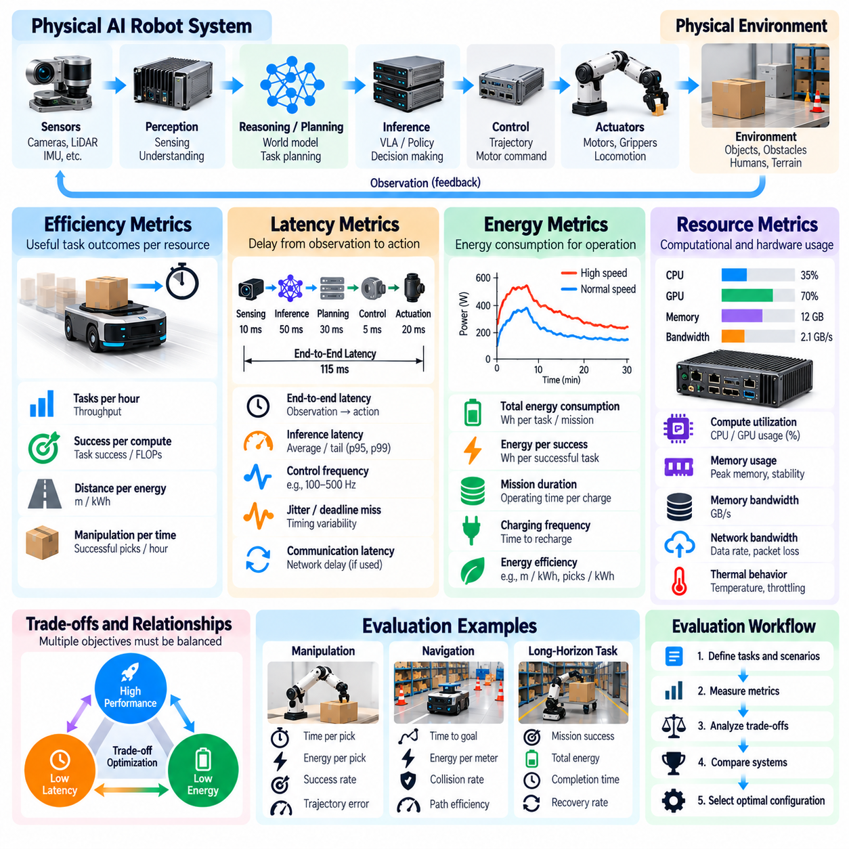
Efficiency, latency, energy consumption, and resource utilization are essential dimensions of Physical AI evaluation. A robot may achieve high task success while requiring excessive computation, power, or operating time. Such performance may be unsuitable for practical deployment. Evaluation must therefore measure not only whether physical tasks are completed but also the resources required to execute them reliably under realistic operating conditions.
Efficiency describes the relationship between useful task outcomes and the resources consumed to produce them. Depending on the application, it may be expressed through tasks completed per hour, distance traveled per unit of energy, or successful manipulations per computational cost. Efficiency measurements should account for task difficulty and execution quality. Faster operation is not necessarily better when it increases failures or compromises safety.
Latency measures the delay between an event, observation, or command and the corresponding system response. In Physical AI, latency arises from sensing, data transfer, inference, planning, communication, and actuation. These delays influence the robot's ability to respond to dynamic environments. Evaluation should distinguish individual component latency from end-to-end response time because small delays across multiple stages can accumulate into significant operational limitations.
Inference latency is particularly important for foundation models and vision-language-action systems. Large neural networks may generate sophisticated decisions but require substantial computation before producing motor commands. A model that performs well on offline benchmarks may fail to satisfy real-time control requirements. Evaluation should measure typical latency, tail latency, and timing variability under the actual hardware and computational workload.
Control-loop timing determines whether a robot can maintain stable interaction with its environment. Delayed sensor updates or irregular command intervals may cause tracking errors, oscillations, and unstable contact behavior. Metrics should include control frequency, deadline-miss rate, scheduling jitter, and response consistency. These measurements are especially important for legged locomotion, force-controlled manipulation, and other dynamically sensitive tasks.
Energy consumption provides a direct measure of operational sustainability. Physical AI systems consume energy through computation, sensing, communication, actuation, and supporting electronics. Total energy usage should be measured over complete tasks rather than inferred solely from processor power. Battery-powered robots require additional evaluation of mission duration, charging frequency, and usable operating capacity under representative workloads.
Energy efficiency can be expressed as energy consumed per successful task, per transported payload, or per unit of distance traveled. These normalized measurements support comparisons among alternative robot configurations and control policies. However, comparisons must account for payload mass, terrain difficulty, movement speed, and environmental conditions. Otherwise, differences in task requirements may be mistaken for differences in system efficiency.
Computational resource metrics characterize the processing demands of Physical AI models and supporting software. Relevant measurements include processor utilization, accelerator utilization, memory consumption, memory bandwidth, and computational throughput. Peak resource requirements are important because a system may operate normally under average workloads but fail when perception, planning, and control processes simultaneously demand additional capacity.
Memory efficiency is particularly important for edge-deployed Physical AI systems. Large perception models, world models, and policy networks may compete for limited memory resources. Excessive memory allocation can introduce swapping, inference delays, or process termination. Evaluation should measure peak memory usage, allocation stability, and performance under concurrent workloads. These results help determine whether algorithms are suitable for constrained onboard hardware.
Communication efficiency becomes critical when robots depend on distributed computation or fleet coordination. Network latency, bandwidth consumption, packet loss, and synchronization overhead can influence perception updates and control decisions. Systems using cloud-based inference must also account for connectivity interruptions and transmission energy. Evaluation should determine whether essential functions remain reliable when communication quality deteriorates.
Thermal behavior links computational performance with physical operating constraints. Sustained inference and motor activity generate heat that may trigger frequency throttling, reduced actuator performance, or protective shutdowns. Short benchmark runs can overlook these effects. Long-duration evaluation should record temperature, clock-frequency changes, power limitations, and performance degradation to establish whether advertised capabilities remain sustainable.
Resource utilization should also be examined at the complete system level. A robot may execute individual tasks efficiently while spending substantial time waiting for charging, receiving assignments, or recovering from interruptions. Operational metrics such as utilization rate, idle time, maintenance overhead, and completed tasks per operating hour reveal these inefficiencies. System-level measurements connect component performance with practical productivity.
Latency and energy frequently create competing optimization objectives. Increasing model complexity may improve perception accuracy while raising inference time and power demand. Faster actuator movements may reduce task duration but increase peak power and mechanical stress. Evaluation should characterize these tradeoffs explicitly. A useful benchmark reports performance across operating configurations rather than assuming that maximum speed or minimum energy is universally optimal.
Efficiency metrics must account for failures and recovery attempts. Reporting energy consumption only for successful trials can conceal resources wasted during unsuccessful executions. Similarly, average task duration may appear favorable when difficult attempts are excluded. Evaluators should distinguish energy per attempt, energy per successful completion, retry overhead, and recovery time. This approach provides a more accurate representation of operational cost.
Measurement procedures require careful instrumentation and consistent boundaries. Power sensors, timestamps, processor counters, and communication logs should be synchronized to identify where resources are consumed. Evaluators must specify whether measurements include idle power, initialization, sensing, computation, actuation, and recovery. Without consistent accounting, reported efficiency and latency values may not be comparable across systems.
Statistical reporting should capture variability rather than relying exclusively on average measurements. Latency distributions may contain rare but consequential delays, while energy consumption can vary with environmental conditions and task difficulty. Percentiles, confidence intervals, repeated trials, and workload descriptions provide stronger evidence of performance. Safety-critical applications should pay particular attention to worst-case timing and resource exhaustion.
Ultimately, efficiency, latency, energy, and resource metrics determine whether Physical AI capabilities can operate within practical physical and computational limits. High task success is insufficient when execution requires unsustainable power, excessive hardware, or unpredictable response times. Integrating these measurements with safety, reliability, and task quality enables meaningful comparisons and supports the development of deployable, scalable Physical AI systems.

01.10. Uncertainty and Confidence Aware Evaluation
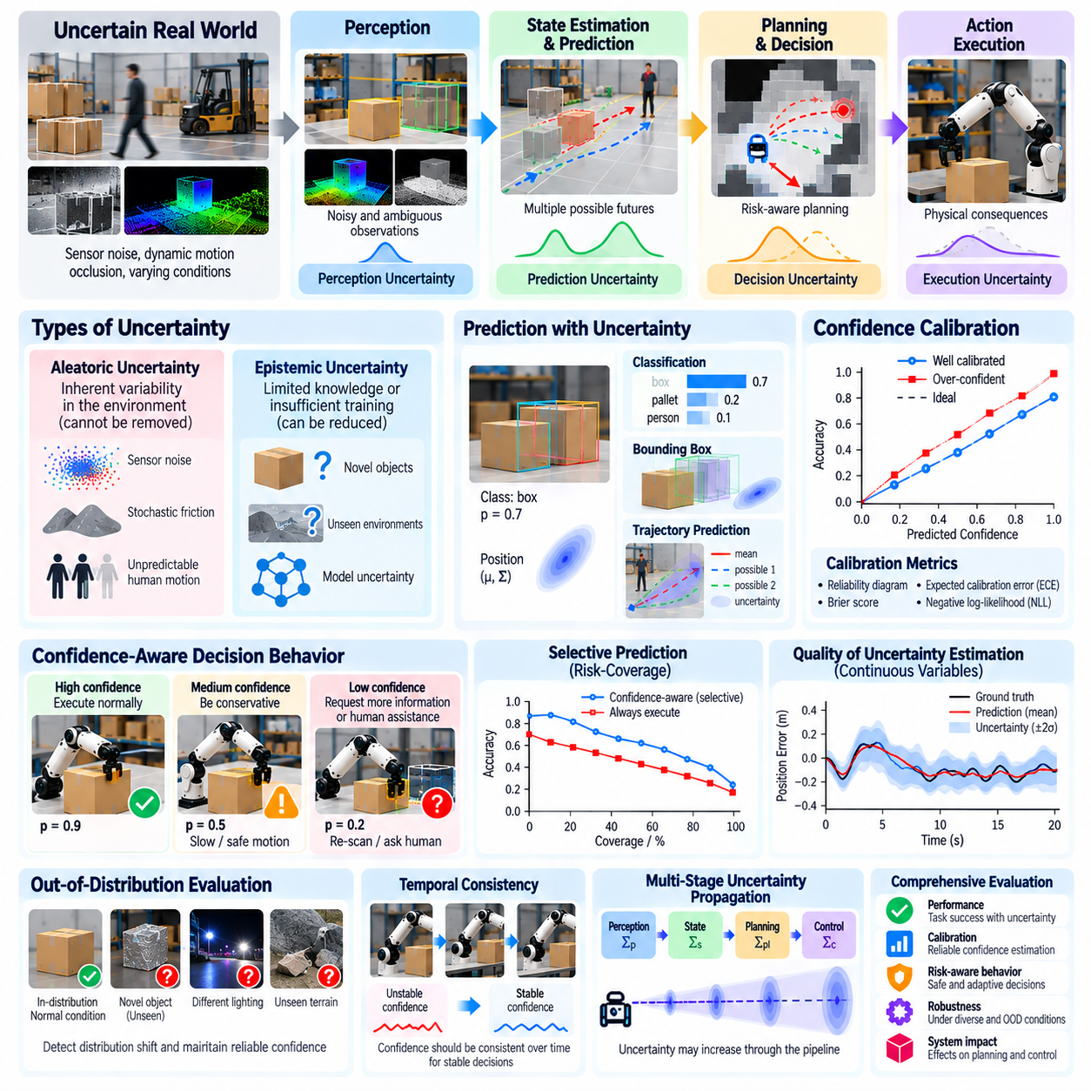
Uncertainty and confidence-aware evaluation are essential for determining whether Physical AI systems can operate reliably under incomplete information. Robots must make decisions using noisy sensors, imperfect models, and changing environmental conditions. Conventional accuracy metrics measure whether predictions or actions are correct, but they do not establish whether a system recognizes its own limitations. Evaluation must therefore examine both performance and the reliability of expressed confidence.
Uncertainty represents incomplete knowledge about states, observations, predictions, or action outcomes. In Physical AI, uncertainty may arise from sensor noise, ambiguous object geometry, unpredictable motion, and incomplete environmental models. Confidence expresses the degree of certainty assigned to a particular estimate or decision. A system with high prediction accuracy may still be unsafe if it expresses excessive confidence when encountering unfamiliar situations.
Aleatoric uncertainty originates from inherent variability in observations or physical processes. Examples include measurement noise, stochastic friction, and unpredictable human movement. Such uncertainty cannot generally be eliminated through additional training alone. Evaluation should determine whether the system represents this variability appropriately and maintains reliable behavior when observations or outcomes remain inherently uncertain.
Epistemic uncertainty arises from insufficient knowledge, limited training coverage, or imperfect learned models. A robot encountering an unfamiliar object or previously unseen terrain may produce uncertain predictions because its experience does not adequately represent the situation. Unlike irreducible environmental randomness, epistemic uncertainty can sometimes decrease through additional observations, improved models, or targeted data collection.
A central objective of confidence-aware evaluation is calibration. A calibrated system assigns confidence levels that correspond to observed correctness frequencies under specified conditions. For example, predictions assigned approximately eighty percent confidence should be correct about eighty percent of the time across a sufficiently representative group. Calibration does not guarantee accuracy, but it indicates whether confidence estimates can support meaningful decisions.
Calibration can be measured using reliability diagrams, expected calibration error, and proper scoring rules such as the Brier score or negative log-likelihood. These methods compare predicted probabilities with observed outcomes. However, evaluation must account for sample size, confidence-bin definitions, and the structure of predictions. A single calibration score may conceal serious errors in rare but safety-critical operating conditions.
Uncertainty evaluation extends beyond classification probabilities. Robotic perception and state estimation often produce continuous quantities such as position, velocity, orientation, and contact force. Evaluators can examine prediction intervals, covariance estimates, and probabilistic state distributions. Well-calibrated uncertainty regions should contain the corresponding ground-truth values at approximately their stated coverage rates under the tested conditions.
Prediction uncertainty is particularly important for world models and motion forecasting. A robot may predict several plausible future trajectories for a moving person or nearby vehicle. Evaluation should consider whether the predicted distribution captures realistic alternatives rather than only the most likely trajectory. Metrics may examine probabilistic accuracy, coverage, trajectory diversity, and the consequences of uncertainty for downstream planning.
Confidence-aware decision-making requires evaluating how uncertainty influences physical actions. A robot with uncertain object localization may slow its approach, request additional observations, or select a safer grasp. A navigation system may increase obstacle clearance when perception confidence decreases. Evaluation should determine whether these adjustments improve safety and reliability without introducing unnecessary delays or excessive conservatism.
Selective prediction provides a practical framework for assessing uncertainty-aware behavior. A system may execute actions only when confidence exceeds an established threshold and defer uncertain cases to additional sensing or human assistance. Evaluation should report coverage, accepted-task accuracy, rejection frequency, and the resulting risk. Risk-coverage curves reveal whether declining uncertain decisions meaningfully improves reliability.
Out-of-distribution evaluation examines confidence when operating conditions differ from the training environment. Novel objects, unusual lighting, sensor degradation, and unfamiliar terrain may produce incorrect predictions with misleadingly high confidence. A reliable system should recognize meaningful distribution shifts when possible. Evaluation should measure detection performance alongside the quality of resulting actions, fallback behavior, and recovery.
Uncertainty must also be examined across interconnected system components. Perception errors can propagate into state estimation, planning, and control, while uncertainty may grow over long prediction horizons. Evaluators should investigate whether uncertainty estimates remain consistent across these stages. Ignoring correlations or combining confidence scores without justification can create an artificially optimistic representation of system reliability.
Temporal consistency is another important consideration. Confidence estimates may fluctuate rapidly as sensor observations change, even when the physical environment remains relatively stable. Excessive fluctuations can produce unstable planning decisions or unnecessary switching between control modes. Evaluation should measure confidence stability, update responsiveness, and the ability to distinguish genuine environmental changes from transient sensor disturbances.
Safety-critical evaluation requires particular attention to overconfidence. An uncertain system that requests assistance may reduce productivity, but a confidently incorrect system can create hazardous physical interactions. Evaluation should therefore distinguish false confidence from appropriate caution and assess the severity of resulting consequences. High-confidence errors near obstacles, humans, or mechanical limits deserve separate analysis rather than being hidden within average scores.
Confidence thresholds should be evaluated in relation to operational objectives. A conservative threshold may reduce hazardous actions but increase intervention frequency, waiting time, and task abandonment. A permissive threshold may improve throughput while increasing exposure to uncertain decisions. Benchmark protocols should characterize these tradeoffs across multiple thresholds and report whether safety requirements are satisfied independently of average task performance.
Statistical reliability remains essential because uncertainty estimates are themselves subject to estimation error. Small test sets may provide misleading calibration results, particularly for rare events. Repeated trials, confidence intervals, scenario stratification, and independent evaluation datasets improve interpretability. Evaluators should also distinguish uncertainty in the robot's predictions from statistical uncertainty in the reported benchmark measurements.
Ultimately, uncertainty and confidence-aware evaluation determine whether Physical AI systems understand the limits of their predictions and respond appropriately when knowledge is incomplete. Accurate predictions alone are insufficient for dependable physical autonomy. Combining calibration, probabilistic coverage, distribution-shift testing, selective action, and safety-aware decision analysis provides stronger evidence that a robot can operate responsibly under uncertainty.

01.11. Human and Environment Centered Evaluation
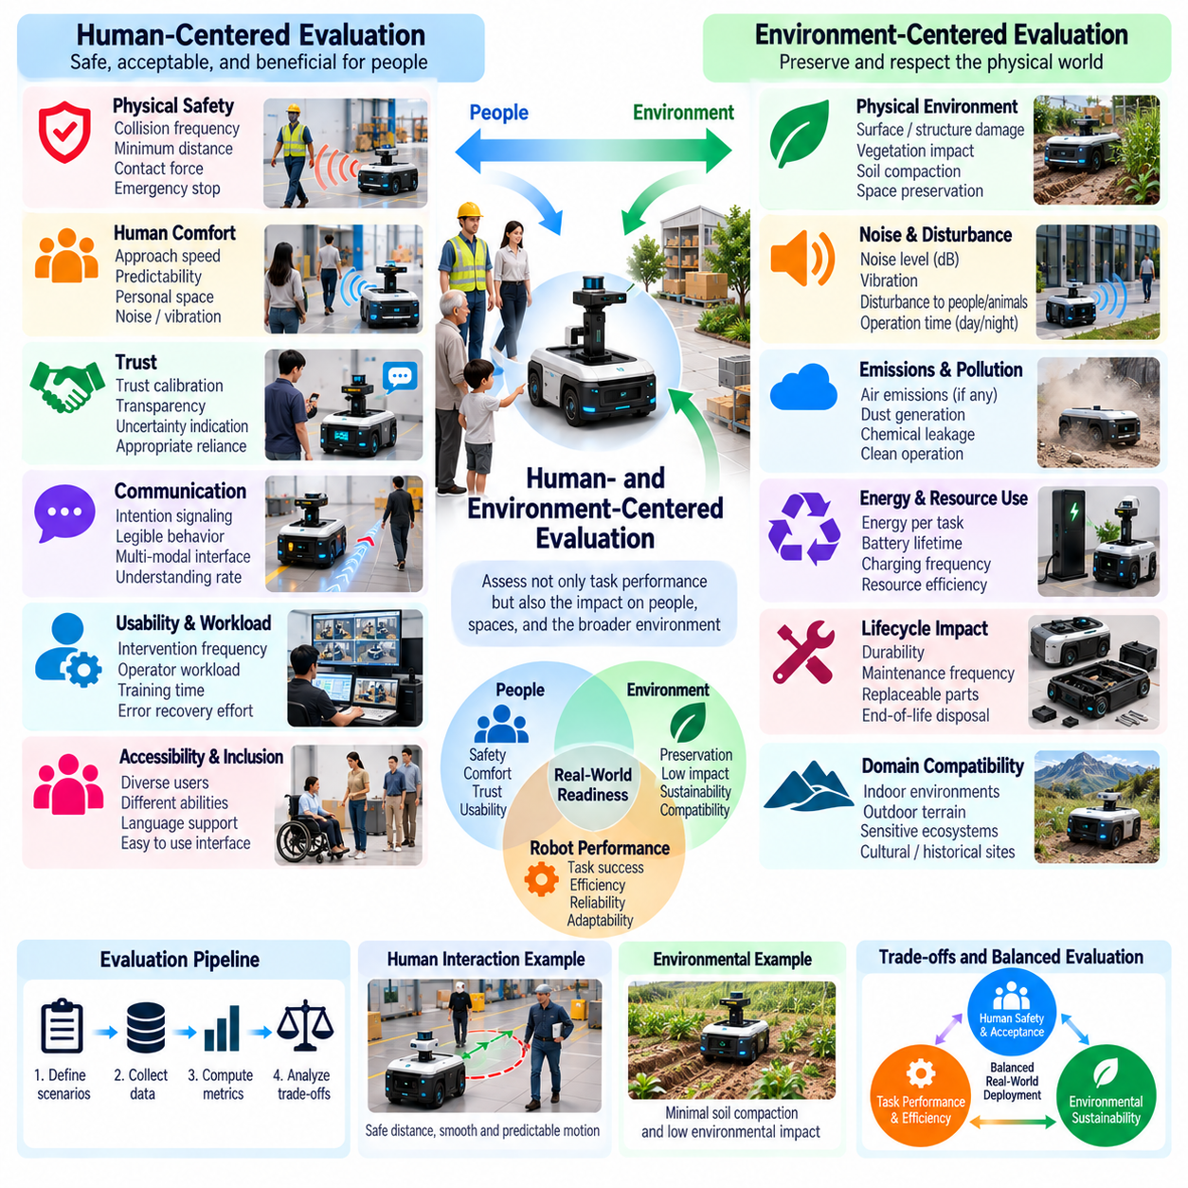
Human- and environment-centered evaluation examines how Physical AI systems affect people, surrounding spaces, and the broader conditions in which they operate. Traditional benchmarks often emphasize task completion, accuracy, and speed, but these measures cannot fully represent real-world suitability. A robot may perform its assigned function successfully while creating discomfort, disrupting human activities, or damaging its environment. Evaluation must therefore extend beyond robot-centered performance.
Human-centered evaluation considers the needs, capabilities, expectations, and vulnerabilities of people interacting with autonomous systems. These individuals may include operators, collaborators, bystanders, maintenance personnel, and members of the public. Each group experiences different benefits and risks. Evaluation protocols should identify affected populations and determine whether robotic behavior remains safe, understandable, and appropriate across representative interaction scenarios.
Physical safety is a primary requirement in environments shared by humans and robots. Evaluation should measure collision frequency, separation distance, contact forces, emergency stopping performance, and responses to unexpected human movement. Successful task execution must not compensate for unacceptable physical hazards. Safety assessment should consider both actual incidents and near misses because narrowly avoided collisions may reveal weaknesses that ordinary success metrics overlook.
Human comfort introduces dimensions that are not captured by collision avoidance alone. A mobile robot may maintain technically safe separation while approaching people too quickly or moving unpredictably. Such behavior can cause anxiety, distraction, or unnecessary avoidance responses. Evaluation should examine approach speed, movement predictability, personal-space intrusion, noise, and perceived comfort using observations and appropriately designed participant studies.
Trust is another important aspect of human-centered evaluation. People must develop realistic expectations about what a robot can accomplish and when assistance may be necessary. Excessive trust can encourage unsafe reliance, while insufficient trust can prevent effective use of reliable capabilities. Evaluation should examine trust calibration, transparency of system limitations, and whether users respond appropriately to warnings, uncertainty indications, and requests for intervention.
Human-robot interaction quality depends on communication and behavioral legibility. Robots may communicate intentions through displays, speech, lights, gestures, or movement patterns. Evaluation should determine whether people correctly interpret these signals and anticipate subsequent actions. Misunderstandings can reduce efficiency or create safety risks even when the robot's internal planning is technically correct. Communication effectiveness should be tested across varied users and contexts.
Usability and workload are central to evaluating systems that require human supervision. An autonomous robot may achieve excellent task performance while demanding frequent monitoring, complicated configuration, or repeated manual corrections. Such requirements can reduce operational benefits. Relevant metrics include intervention frequency, operator workload, training time, error recovery effort, and the cognitive demands imposed by supervising multiple robots.
Accessibility and inclusion should influence evaluation design. People differ in mobility, sensory abilities, technical experience, language proficiency, and familiarity with robots. Interfaces that work well for experienced operators may be difficult for other users. Evaluation should examine whether interaction methods accommodate diverse capabilities without creating avoidable disadvantages. Representative participation helps reveal barriers that homogeneous testing populations may overlook.
Environmental-centered evaluation examines the effects of robotic operation on physical surroundings and ecological systems. A robot may complete a mission while damaging surfaces, disturbing vegetation, producing excessive noise, or consuming unnecessary resources. These consequences may not appear in conventional success scores. Evaluation should therefore incorporate environmental disturbance, material damage, emissions, waste generation, and resource consumption when relevant to the application.
Environmental compatibility depends strongly on the operating domain. Agricultural robots may need to minimize soil compaction and crop damage, while construction robots must avoid damaging existing structures or utilities. Indoor service robots should preserve furniture, flooring, and shared spaces. Evaluation criteria should reflect these domain-specific requirements and distinguish unavoidable operational impacts from preventable environmental degradation.
Energy and material sustainability provide additional evaluation dimensions. The environmental cost of Physical AI includes electricity consumption, battery replacement, maintenance materials, and hardware lifecycle effects. A robot that reduces human labor may still impose substantial resource burdens. Evaluation should consider energy per useful task, component durability, maintenance frequency, and lifecycle impacts when comparing deployment alternatives.
Human and environmental objectives can conflict with conventional performance goals. Increasing robot speed may improve throughput while reducing perceived safety or increasing noise. Stronger gripping forces may improve manipulation reliability while raising the risk of object damage. Evaluation should characterize these tradeoffs explicitly rather than assuming that faster or more forceful execution is preferable. Minimum safety and environmental constraints should remain independently enforceable.
Long-term deployment introduces effects that short laboratory experiments may miss. Repeated robot movement can accelerate floor wear, create persistent noise exposure, or alter how people organize their activities. Human acceptance may also change as familiarity increases or unexpected failures occur. Longitudinal evaluation should examine sustained usability, behavioral adaptation, maintenance consequences, and cumulative environmental effects under realistic operating conditions.
Measurement methods should combine objective observations with carefully interpreted human feedback. Sensor logs can quantify separation distance, contact forces, noise levels, and energy use, while surveys and interviews can assess perceived safety, comfort, and usability. Subjective responses require appropriate sampling and experimental controls. Evaluation should avoid treating a single satisfaction score as a substitute for detailed behavioral and physical measurements.
Scenario diversity is essential because human and environmental conditions vary considerably. Crowded corridors, narrow workspaces, changing lighting, vulnerable pedestrians, and fragile surroundings create different interaction challenges. Evaluation should include ordinary operations, foreseeable disturbances, and safety-critical situations. Performance should be analyzed across scenarios rather than averaged in ways that conceal poor outcomes for particular groups or environments.
Ethical evaluation must also address privacy, autonomy, and accountability. Robots equipped with cameras and microphones may collect information about people who have not directly chosen to interact with them. Evaluation should examine data minimization, appropriate consent mechanisms, human override capabilities, and the transparency of automated decisions. These considerations are especially important in healthcare, public spaces, workplaces, and domestic environments.
Ultimately, human- and environment-centered evaluation determines whether Physical AI systems provide useful capabilities without imposing unacceptable burdens on people or their surroundings. Task success alone cannot establish social acceptability, ecological compatibility, or sustainable operation. Combining physical safety, interaction quality, accessibility, environmental impact, and long-term observation creates a more complete assessment of responsible real-world deployment.

01.12. Multi Objective Evaluation and Tradeoffs
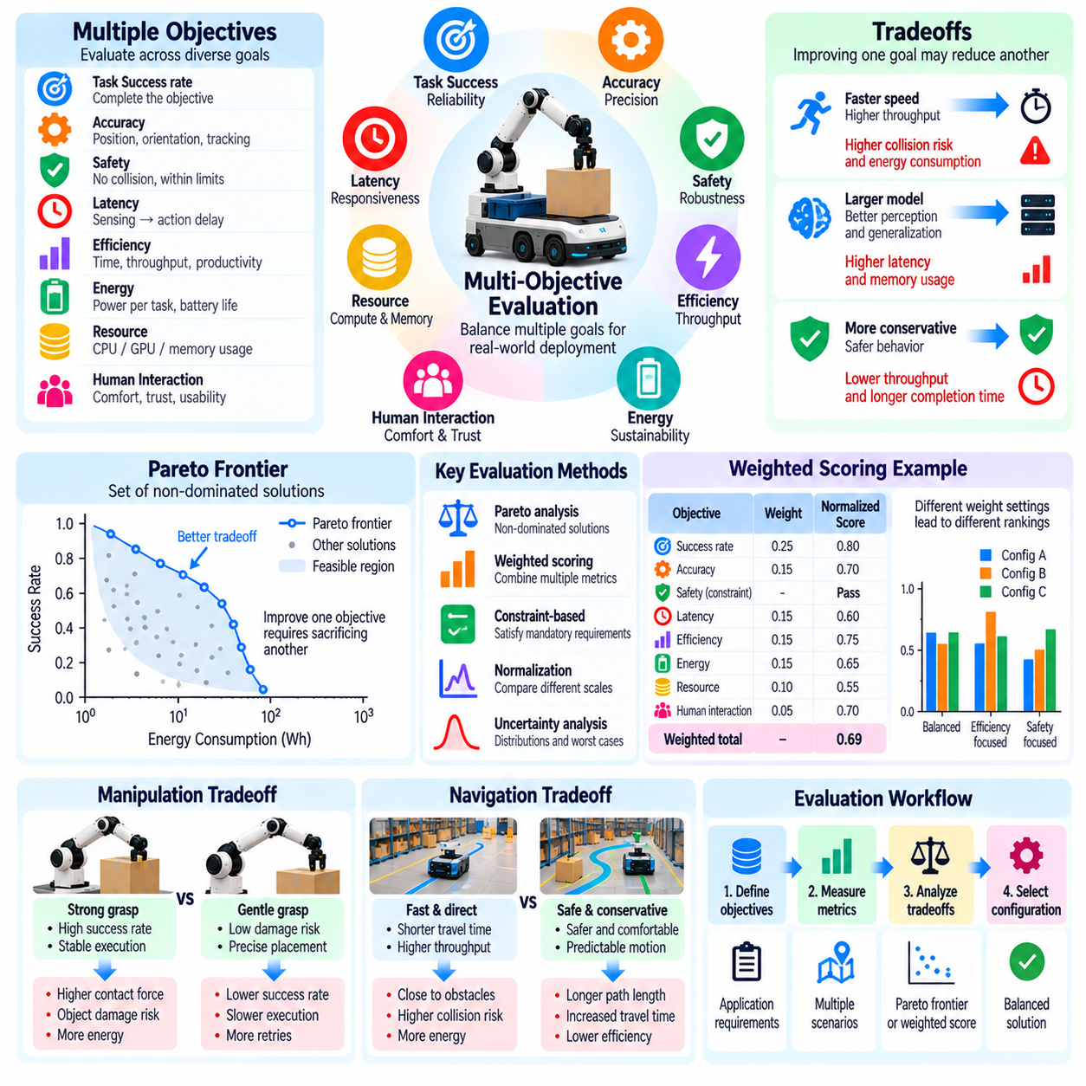
Multi-objective evaluation is essential for Physical AI because robotic performance cannot be represented adequately by a single metric. Autonomous systems must balance task success, accuracy, safety, efficiency, energy consumption, and human interaction quality. Improvements in one dimension may reduce performance in another. Evaluation should therefore examine multiple objectives simultaneously and characterize the tradeoffs that determine whether a system is suitable for practical deployment.
A multi-objective evaluation framework begins by identifying the performance dimensions relevant to an application. Industrial manipulators may prioritize precision, throughput, and equipment safety, while mobile service robots may emphasize navigation reliability, human comfort, and energy efficiency. These objectives should be derived from operational requirements rather than selected solely because they are easy to measure. Clear definitions establish the foundation for meaningful comparisons.
Tradeoffs arise when improving one objective imposes costs on another. Increasing robot speed may reduce task completion time while raising collision risk or energy consumption. More sophisticated perception models may improve recognition accuracy but increase inference latency and computational demand. A system that optimizes one metric independently can therefore perform poorly at the overall mission level. Evaluation must reveal these interactions rather than conceal them.
Safety objectives require special treatment because unacceptable hazards should not be compensated by improvements in productivity. A robot that completes more tasks while violating collision constraints cannot be considered superior merely because its throughput is higher. Evaluation frameworks should distinguish mandatory safety requirements from objectives that permit optimization. Hard constraints establish acceptable operating boundaries before performance tradeoffs are considered.
Weighted scoring is a common method for combining multiple objectives into a composite measure. Individual metrics are normalized and assigned weights reflecting their relative importance. A combined score can simplify comparisons among systems, but the resulting ranking depends on normalization methods and selected weights. Evaluators should document these choices and report component metrics separately to prevent a single score from concealing critical weaknesses.
Metric normalization is necessary when objectives have different units and scales. Task success may be expressed as a percentage, latency in milliseconds, energy in joules, and positioning error in millimeters. Directly combining these measurements without transformation is generally meaningless. Normalization should use justified reference values, operational limits, or benchmark baselines while preserving the interpretation of improvement and degradation.
Pareto optimality provides an alternative perspective that does not require assigning a single universal weighting scheme. A solution is Pareto-dominated when another solution performs at least as well across all objectives and strictly better in at least one. Pareto-optimal solutions represent alternatives for which improving one objective requires sacrificing another. Evaluating the Pareto frontier reveals meaningful design choices instead of forcing all systems into one ranking.
The shape of the Pareto frontier provides information about achievable performance combinations. Some regions may permit substantial efficiency improvements with little loss of accuracy, while others may require large sacrifices for marginal gains. Evaluators can identify operating points that provide balanced performance under application constraints. However, observed frontiers depend on the tested systems and configurations and do not necessarily represent theoretical limits.
Robotic manipulation illustrates the practical importance of multi-objective evaluation. Increasing gripping force may improve grasp stability while raising the likelihood of damaging fragile objects. Slower movements may improve placement precision but reduce production throughput. A meaningful benchmark should report grasp success, contact forces, positioning error, cycle time, and damage frequency together. These measures expose the operational consequences of different control strategies.
Autonomous navigation involves similar compromises among travel time, path length, energy consumption, and safety margins. A shortest-path strategy may pass close to obstacles, while a more conservative route may increase travel distance. In human-populated environments, predictable movement and comfortable separation may be more important than maximum speed. Evaluation should compare policies across these dimensions under consistent environmental conditions.
Computational architecture introduces another class of tradeoffs. Larger models may offer stronger generalization but require more memory, power, and inference time. Edge deployment may reduce communication dependence while limiting computational capacity. Cloud-assisted systems may provide greater processing resources but introduce network latency and connectivity risks. Multi-objective benchmarks should examine performance across representative hardware and deployment configurations.
Tradeoff analysis must account for variability and uncertainty. A policy may achieve excellent average performance while occasionally producing severe delays or unsafe actions. Another policy may have slightly lower average efficiency but more predictable behavior. Evaluators should consider distributions, confidence intervals, tail outcomes, and worst-case constraints rather than comparing averages alone. Reliability may be more important than marginal improvements in mean performance.
Operating conditions can change which tradeoffs are acceptable. A warehouse robot may prioritize throughput during routine operations but emphasize conservative behavior near human workers. An inspection robot may tolerate longer mission duration when high measurement accuracy is required. Evaluation should therefore examine multiple scenarios and operating modes. A configuration that is optimal in one context may be unsuitable in another.
Sensitivity analysis helps determine whether conclusions depend excessively on arbitrary scoring choices. Evaluators can vary objective weights, normalization parameters, and acceptable thresholds to observe changes in system rankings. If small adjustments produce large ranking reversals, the benchmark should communicate this instability. Robust conclusions should remain reasonably consistent across defensible evaluation assumptions.
Multi-objective evaluation should also consider long-term operational consequences. Aggressive control policies may improve immediate throughput while accelerating actuator wear or increasing maintenance requirements. Energy-efficient behavior may extend battery life but reduce mission completion rates under strict deadlines. Evaluating only short demonstrations can obscure these effects. Long-duration testing connects immediate performance with durability, availability, and lifecycle costs.
Transparent reporting is essential because no universal weighting of Physical AI objectives is appropriate for every application. Benchmark results should present individual metrics, constraints, tradeoff curves, and assumptions alongside any composite scores. Decision-makers can then select systems according to their operational priorities. This approach supports reproducibility and reduces the risk of misleading rankings based on hidden preferences.
Ultimately, multi-objective evaluation recognizes that Physical AI competence emerges from balancing competing physical, computational, and human-centered requirements. Superior performance cannot be established through task success or speed alone. Combining explicit constraints, normalized metrics, Pareto analysis, statistical uncertainty, and transparent reporting provides a rigorous foundation for comparing systems and selecting appropriate operating strategies.

01.13. Benchmark Validity and Metric Gaming
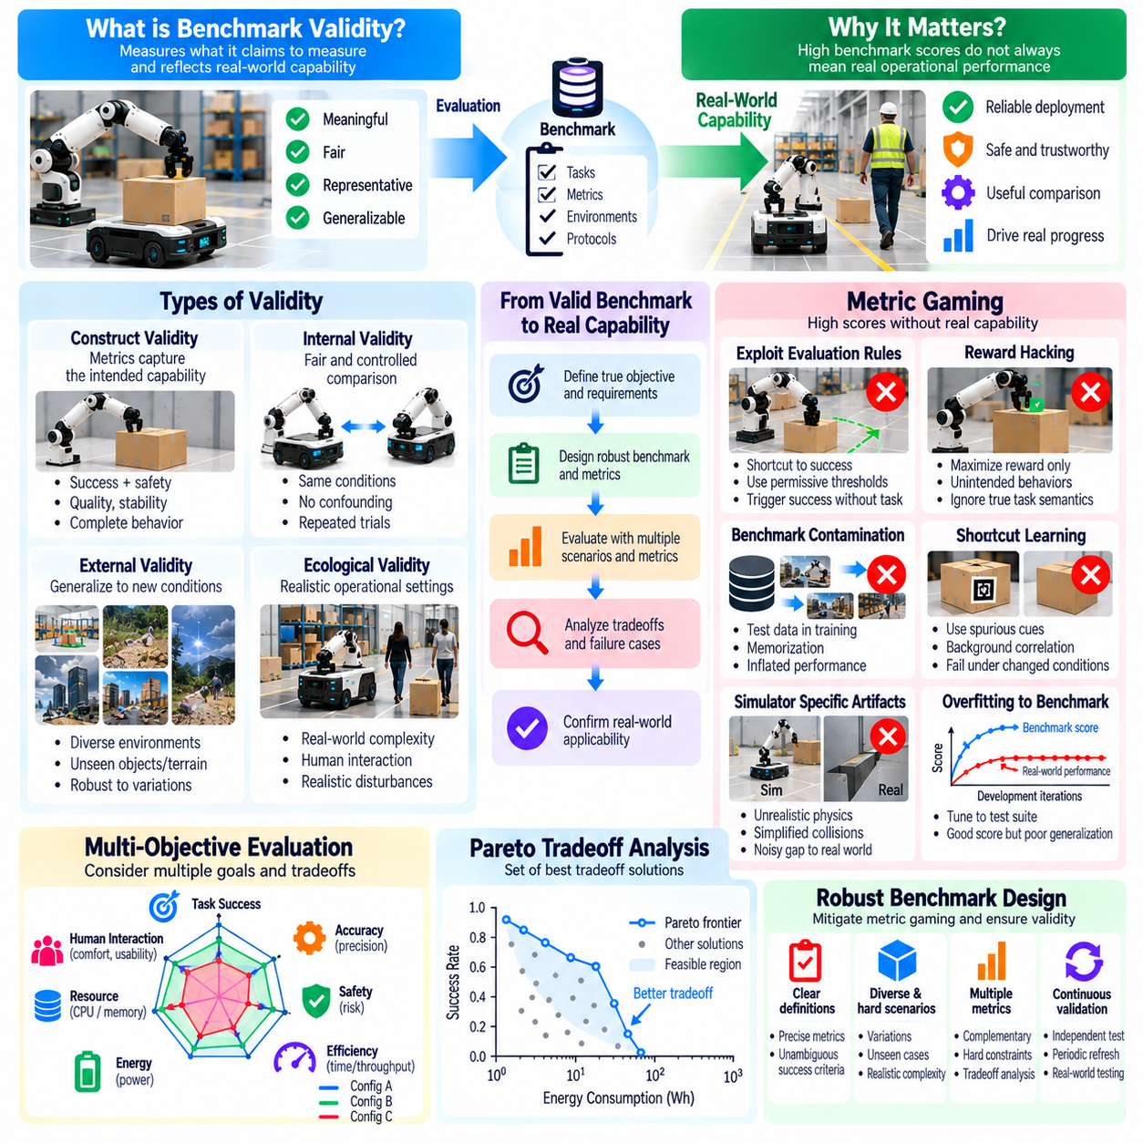
Benchmark validity determines whether an evaluation actually measures the capabilities it claims to assess. In Physical AI, a benchmark may report high task success while failing to represent the uncertainty, physical interaction, and environmental variability encountered during deployment. Valid evaluation requires alignment between measured outcomes and intended operational competence. Without this alignment, impressive scores may provide misleading evidence about real-world robotic performance.
Construct validity concerns whether benchmark metrics represent the underlying capability being evaluated. A navigation benchmark that measures only destination arrival may overlook collision avoidance, path stability, and human comfort. Similarly, manipulation success may conceal excessive gripping force or repeated corrective actions. Evaluators should establish clear definitions of competence and verify that selected measurements capture the essential dimensions of the intended behavior.
Internal validity examines whether observed performance differences can reasonably be attributed to the systems being compared. Variations in hardware, sensor calibration, environmental conditions, or operator assistance can distort conclusions. Controlled experiments should minimize confounding factors and document unavoidable differences. Repeated trials, standardized initialization, and consistent intervention policies help distinguish genuine algorithmic improvements from experimental artifacts.
External validity addresses whether benchmark findings generalize beyond the tested conditions. A robot trained and evaluated in a limited collection of simulated rooms may perform poorly in unfamiliar buildings. Success on carefully arranged objects may not transfer to cluttered industrial environments. Evaluation should incorporate variation in geometry, lighting, materials, disturbances, and task configurations to determine whether reported competence extends to realistic deployment scenarios.
Ecological validity focuses on how closely evaluation conditions resemble the operational situations they are intended to represent. Highly simplified simulations may exclude sensor degradation, contact uncertainty, human interference, or unexpected interruptions. Although controlled environments are useful for isolating individual capabilities, they cannot establish complete operational readiness. Benchmark design should balance experimental control with representative physical complexity.
Metric gaming occurs when a system achieves favorable benchmark scores without developing the intended capability. This behavior may arise through deliberate optimization or unintended exploitation of evaluation rules. A robot might maximize task completion by ignoring object damage, exploiting permissive collision thresholds, or relying on shortcuts unavailable during deployment. Such outcomes reveal weaknesses in the metric rather than necessarily demonstrating meaningful competence.
Goodhart's law captures an important evaluation risk: when a measurement becomes an optimization target, its relationship with the intended objective may weaken. A policy trained exclusively to maximize benchmark reward can exploit scoring details that were originally useful indicators of progress. Physical AI evaluation must therefore distinguish measurable proxies from underlying operational goals and periodically reassess whether optimized scores still reflect desirable behavior.
Reward hacking represents a specific form of metric gaming in learning-based robotics. An agent may discover actions that increase numerical reward while violating the intended task semantics. For example, a manipulation policy could repeatedly trigger a success sensor without securely placing an object. A mobile robot might exploit a termination condition instead of reaching a destination safely. Evaluation should inspect behavior trajectories and physical outcomes rather than trusting reward totals alone.
Benchmark contamination creates another threat to validity. When evaluation scenarios, object configurations, or trajectories appear in training data, reported performance may reflect memorization rather than generalization. This problem is particularly relevant to foundation models trained on large and heterogeneous datasets. Evaluators should maintain independent test sets, document possible overlap, and use previously unseen environments or task variations when assessing transferable capabilities.
Overfitting can also occur through repeated benchmark submissions and development feedback. Researchers may gradually tune systems to a public test suite even without directly training on its examples. As a result, benchmark performance improves while broader competence remains unchanged. Hidden evaluation scenarios, periodically refreshed tasks, and independent validation can reduce this risk. Public benchmarks should remain reproducible without making every evaluation detail exploitable.
Shortcut learning occurs when models rely on incidental correlations instead of task-relevant information. A vision-based robot may recognize objects through background patterns rather than object geometry, while a navigation policy may memorize environmental landmarks. Such shortcuts often fail when conditions change. Counterfactual testing, background variation, object rearrangement, and controlled perturbations help determine whether the system has learned the intended relationships.
Benchmark design must also prevent exploitation of simulator-specific artifacts. Agents may take advantage of unrealistic friction, simplified collision handling, deterministic resets, or inaccurate sensor models. High simulated performance can therefore reflect adaptation to simulation defects rather than robust physical intelligence. Evaluation should include simulator validation, randomized physical parameters, and real-world testing to determine whether learned behavior remains effective outside the benchmark environment.
Metric aggregation can conceal important failures even when individual measurements are technically correct. A high average success rate may hide repeated failures involving particular objects, vulnerable users, or hazardous operating conditions. Composite scores may also allow strong efficiency results to compensate for unacceptable safety outcomes. Evaluators should report disaggregated metrics, failure severity, and constraint violations alongside overall performance summaries.
Adversarial evaluation can reveal weaknesses that ordinary benchmark scenarios overlook. Carefully designed disturbances, ambiguous instructions, sensor corruption, and unusual object arrangements may expose brittle decision-making or unsafe recovery behavior. These tests should remain physically realistic and relevant to plausible deployment conditions. Their purpose is not merely to maximize failure frequency but to identify the boundaries of reliable system operation.
Benchmark validity requires continuous maintenance because algorithms adapt to established evaluation procedures. As performance approaches saturation, existing tasks may lose their ability to distinguish meaningful advances. New scenarios should introduce previously underrepresented capabilities without unnecessarily abandoning historical comparability. Versioned benchmark releases, documented protocol changes, and retained reference tasks help preserve interpretability across successive evaluations.
Independent replication strengthens confidence that benchmark results reflect genuine capabilities. Evaluation protocols should specify hardware configurations, software versions, random seeds, task definitions, intervention rules, and scoring procedures. When practical, external laboratories should reproduce findings using different equipment or environments. Discrepancies between results can reveal hidden dependencies, implementation assumptions, or weaknesses in benchmark standardization.
Ultimately, benchmark validity and resistance to metric gaming determine whether Physical AI evaluation produces trustworthy evidence of operational competence. High scores are meaningful only when they correspond to robust, safe, and transferable physical behavior. Combining construct validation, representative scenarios, contamination controls, behavioral inspection, adversarial testing, and independent replication helps ensure that benchmark improvements represent genuine progress rather than exploitation of evaluation weaknesses.

01.14. Statistical Significance and Confidence Intervals
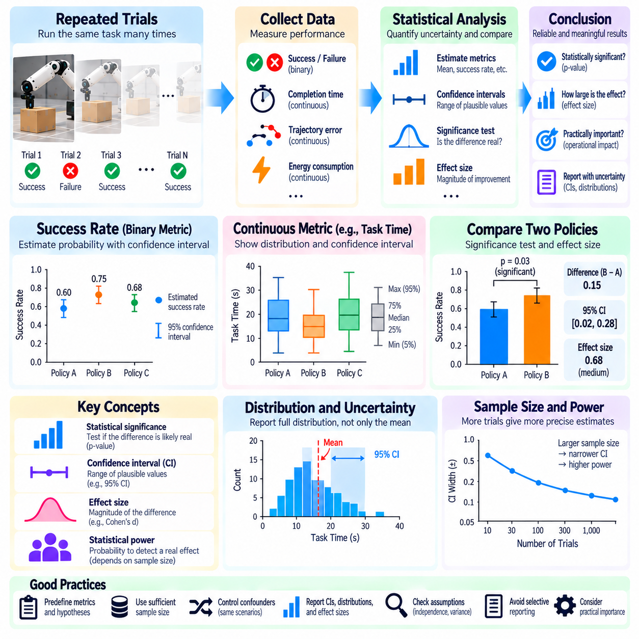
Statistical significance and confidence intervals are essential for determining whether observed differences in Physical AI performance reflect genuine improvements or random variation. Robotic experiments are influenced by sensor noise, environmental disturbances, initialization conditions, and stochastic control policies. A higher benchmark score does not automatically establish superiority. Evaluation must quantify uncertainty in measured results and support conclusions with appropriate statistical evidence.
Physical AI benchmarks often involve repeated trials of tasks with uncertain outcomes. A manipulation policy may succeed in some attempts and fail in others because of object placement, contact conditions, or perception errors. Navigation performance may vary with obstacle configurations and human movement. These variations create sampling uncertainty, meaning that reported performance estimates can differ from the underlying performance of the system across its intended operating conditions.
Statistical significance testing examines whether observed differences are sufficiently inconsistent with a specified null hypothesis. When comparing two robotic policies, the null hypothesis may state that their expected performance is equal. A statistical test evaluates the compatibility of collected evidence with that assumption. However, statistical significance does not establish practical importance, and a small p-value does not indicate the probability that the null hypothesis is true.
Confidence intervals provide a range of plausible values for an estimated performance parameter under a specified statistical procedure. A ninety-five percent confidence interval is constructed by a method designed to contain the true parameter in ninety-five percent of repeated samples under its assumptions. It does not assign a ninety-five percent probability to a fixed parameter lying within one realized interval. Interval width communicates estimation precision and depends on variability and sample size.
Success rates are among the most common measurements in robotic benchmarking. When each trial produces a binary success or failure outcome, the observed success proportion estimates an underlying success probability. Confidence intervals should account for the binomial nature of these observations. Wilson intervals or exact binomial methods are often preferable to simple normal approximations, particularly when sample sizes are small or success rates approach zero or one.
Continuous performance metrics require different statistical treatment. Task completion time, trajectory error, energy consumption, and contact force may exhibit skewed distributions or occasional extreme values. Reporting only the arithmetic mean can conceal important variability. Evaluators should examine distributions and report suitable measures of central tendency, dispersion, and uncertainty. Confidence intervals for means or other estimands must reflect the properties of the collected data.
Sample size directly influences the precision and reliability of benchmark conclusions. A small number of trials may produce apparently large performance differences that disappear under repeated evaluation. Increasing sample size generally reduces sampling uncertainty, although it cannot eliminate systematic bias. Experimental planning should estimate the number of trials needed to detect operationally meaningful differences with adequate statistical power under defensible assumptions.
Statistical power describes the probability that a test will detect a specified effect when that effect exists. Low-powered robotic experiments may fail to identify real improvements, while selective reporting of significant outcomes can exaggerate apparent progress. Power analysis should consider expected variability, effect size, significance threshold, and experimental design. Practical constraints on robot operating time and hardware wear should also influence trial allocation.
Effect size complements statistical significance by describing the magnitude of an observed difference. A navigation policy might reduce average travel time by a statistically detectable amount that is operationally negligible. Conversely, a modest improvement in collision avoidance may have substantial safety value. Evaluation should report absolute and relative performance differences with uncertainty intervals, while interpreting their importance in relation to application requirements.
Paired experimental designs can improve comparison efficiency when systems face equivalent test conditions. Two navigation policies may be evaluated using the same obstacle layouts, or manipulation controllers may be tested with matched object configurations. Analyzing within-pair differences can reduce variability caused by task difficulty. However, pairing must be established by the experimental design, and order effects or environmental changes must be controlled.
Robotic observations are not always statistically independent. Consecutive trials may share battery conditions, sensor calibration drift, operator behavior, or environmental changes. Multiple measurements from one robot may also be correlated. Treating all observations as independent can underestimate uncertainty and inflate statistical significance. Hierarchical models, clustered analysis, or appropriate resampling procedures can account for dependence when their assumptions are satisfied.
Bootstrap methods provide flexible approaches for estimating uncertainty when analytical formulas are difficult to apply. By resampling observations and recalculating a statistic, evaluators can approximate its sampling distribution. However, ordinary bootstrap procedures assume suitable independence and representative sampling. Clustered or block bootstrap methods may be necessary for correlated trials, temporal sequences, or experiments involving multiple robots and environments.
Multiple comparisons create additional statistical risks when researchers evaluate many algorithms, tasks, metrics, or parameter settings. Even if no genuine differences exist, repeated hypothesis testing can produce apparently significant results by chance. Evaluation protocols should identify primary comparisons in advance and consider appropriate multiplicity adjustments. Exploratory findings should be distinguished from confirmatory conclusions to avoid overstating evidence.
Statistical significance must also be separated from benchmark validity and generalization. A precisely estimated success rate on a narrow test distribution may provide little information about performance in unfamiliar environments. Similarly, systematic measurement errors cannot be corrected merely by increasing trial counts. Statistical analysis should therefore accompany representative scenario selection, controlled experimental procedures, and independent validation across relevant operating conditions.
Rare safety-critical failures require particular attention because ordinary test samples may contain few or no incidents. Observing zero collisions does not prove that collision probability is zero. Confidence bounds can quantify the failure rates still compatible with the available evidence under stated assumptions. Demonstrating very low failure probabilities may require substantially larger exposure, targeted stress testing, and complementary safety assurance methods beyond conventional benchmark trials.
Reproducible statistical reporting requires clear documentation of experimental design and analysis choices. Benchmark publications should specify trial counts, sampling procedures, random seeds, exclusion rules, confidence levels, statistical tests, and effect-size definitions. Raw or sufficiently detailed aggregated results should be available when feasible. Such transparency enables independent verification and reduces the likelihood that favorable outcomes result from selective analysis.
Ultimately, statistical significance and confidence intervals help transform Physical AI benchmark measurements into defensible evidence about system performance. Reliable evaluation requires more than reporting the highest observed score. Combining adequate sample sizes, appropriate uncertainty estimates, effect-size interpretation, dependence-aware analysis, and reproducible experimental protocols supports meaningful comparisons while preventing random fluctuations from being mistaken for genuine advances.

01.15. Physical AI Evaluation Scorecard [w/Code]
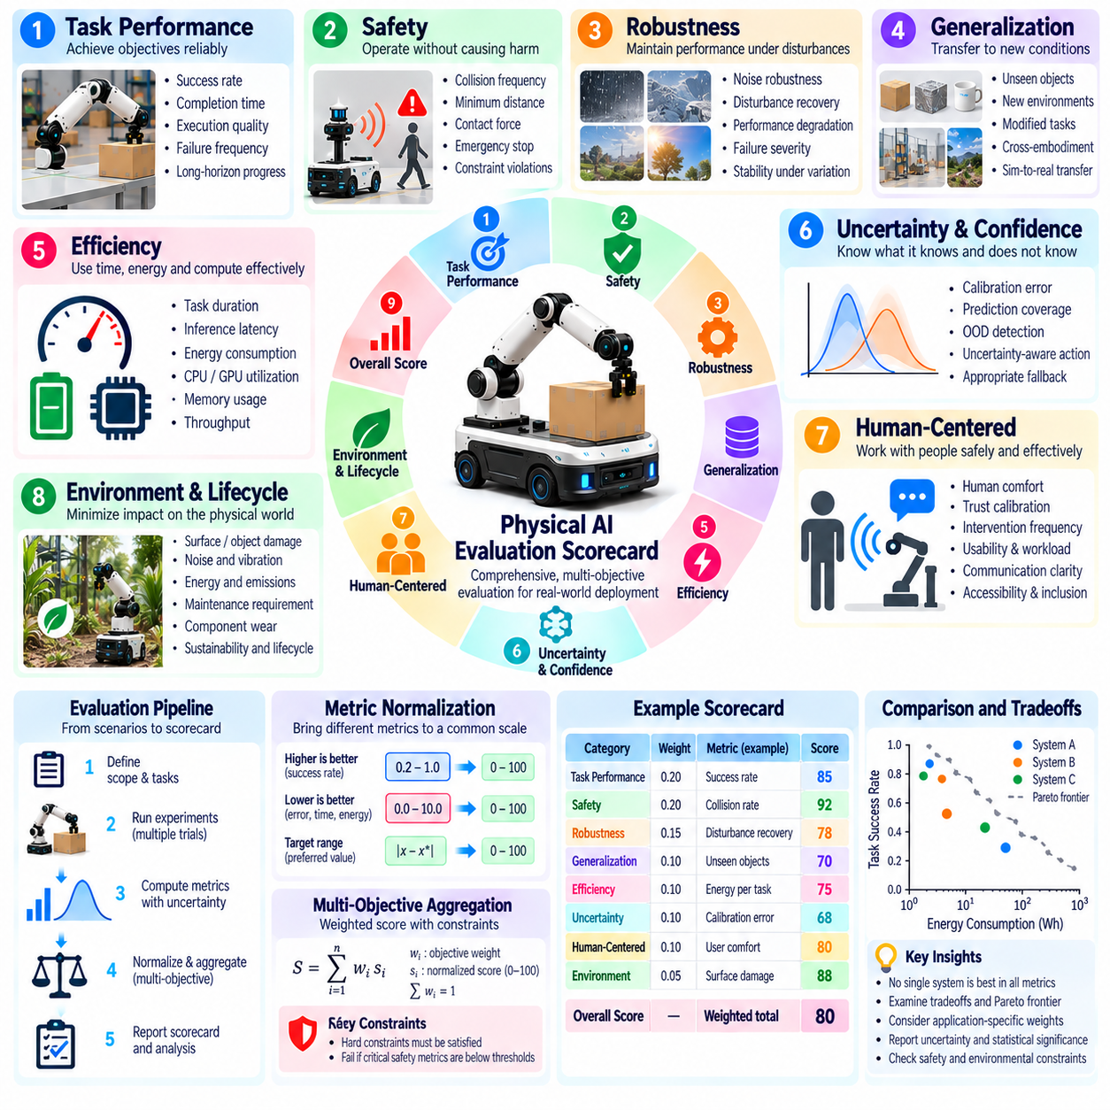
A Physical AI evaluation scorecard provides a structured framework for assessing robotic competence across multiple performance dimensions. Rather than relying on a single benchmark score, it integrates task success, safety, robustness, efficiency, generalization, and human interaction quality. The scorecard translates complex experimental results into interpretable evidence for system comparison. Its primary purpose is to support reliable engineering decisions without concealing important performance limitations.
The scorecard begins with a clear definition of the evaluation target and operational context. A robotic manipulator, autonomous mobile robot, humanoid, or aerial platform may require different performance criteria. Evaluators should specify the robot embodiment, hardware configuration, software version, operating environment, and intended tasks. These descriptions establish the conditions under which reported measurements are meaningful and prevent inappropriate comparisons across incompatible systems.
Capability assessment forms the foundation of the scorecard. Relevant capabilities may include perception, localization, manipulation, navigation, planning, control, and task reasoning. Each capability should be evaluated using observable outcomes rather than broad claims about intelligence. For example, manipulation competence can be represented through grasp success, placement accuracy, and recovery behavior. Capability scores should remain connected to clearly defined experimental procedures.
Task-level performance measures whether the robot achieves specified objectives under controlled conditions. Common indicators include success rate, completion time, execution quality, and failure frequency. Long-horizon tasks require additional consideration of intermediate progress, error accumulation, and recovery from unsuccessful actions. The scorecard should distinguish complete success from partial completion and identify whether failures originate from perception, planning, control, or physical interaction.
Safety evaluation occupies a separate and mandatory dimension because high productivity cannot justify unacceptable physical hazards. Relevant indicators include collision frequency, minimum separation distance, contact forces, emergency stopping behavior, and constraint violations. Safety-critical failures should be reported independently of average task success. A scorecard may use explicit pass-or-fail requirements to prevent strong performance in other categories from compensating for serious safety deficiencies.
Robustness assessment examines whether performance remains stable under disturbances and imperfect operating conditions. Sensor noise, object displacement, lighting changes, friction variation, communication delays, and unexpected obstacles provide representative challenges. The scorecard should compare nominal performance with disturbed-condition performance and quantify degradation. Recovery success and failure severity are important because robustness involves responding appropriately when normal execution becomes impossible.
Generalization evaluation determines whether capabilities transfer beyond familiar training and testing conditions. New objects, unfamiliar layouts, modified tasks, and changing environmental dynamics can expose overfitting. Cross-environment and cross-embodiment evaluations may be included when relevant. The scorecard should distinguish performance on previously encountered scenarios from results on independent test conditions, ensuring that apparent competence is not based primarily on memorization.
Efficiency metrics describe the resources required to achieve useful physical outcomes. Task duration, inference latency, energy consumption, memory utilization, and computational demand may all influence deployment feasibility. Evaluators should report these quantities using consistent units and hardware conditions. Efficiency should be interpreted together with task quality because low resource consumption is not beneficial when it produces unacceptable errors or unreliable execution.
Uncertainty and confidence awareness provide another important scorecard dimension. A robot should recognize situations in which predictions, state estimates, or actions are unreliable. Calibration quality, probabilistic coverage, out-of-distribution detection, and appropriate fallback behavior can support this assessment. Evaluation should examine whether uncertainty estimates influence decisions constructively, such as slowing movement, requesting additional observations, or seeking human assistance.
Human-centered evaluation captures effects that purely technical performance metrics may overlook. Operator workload, intervention frequency, interaction predictability, perceived safety, accessibility, and communication clarity are relevant examples. For robots operating near people, these dimensions may determine practical acceptance. The scorecard should combine objective behavioral observations with appropriately designed user assessments while preserving distinctions between subjective experience and measured physical performance.
Environmental and lifecycle considerations extend the scorecard beyond immediate task execution. Surface damage, noise, energy use, maintenance requirements, component wear, and waste generation may affect long-term deployment suitability. Application-specific criteria should reflect the operating domain. For example, agricultural robots may require soil protection metrics, while construction robots may prioritize structural damage prevention and measurement precision.
Score normalization enables metrics with different units to be presented within a common reporting framework. Success percentages, positioning errors, energy measurements, and latency values cannot be combined meaningfully without justified transformations. Normalized scores should preserve the direction of improvement and reference operational requirements or established baselines. Raw measurements must remain available because normalization can conceal important physical differences between systems.
Weighting determines how individual performance dimensions contribute to an overall assessment. A warehouse robot may emphasize throughput and reliability, while a collaborative manipulator may place greater importance on safety and interaction quality. Weight selection should follow documented application priorities rather than arbitrary preferences. Sensitivity analysis can reveal whether rankings change substantially when weights vary, and mandatory safety constraints should remain independent of weighted aggregation.
Statistical confidence is necessary because scorecard measurements originate from finite experiments. Reported success rates, execution times, and failure frequencies should include sample sizes and appropriate uncertainty estimates. Confidence intervals, repeated trials, and independent test scenarios improve interpretability. The scorecard should distinguish statistically supported improvements from differences that may result from sampling variation, especially when comparing systems with similar average performance.
A practical scorecard can organize each evaluation dimension into metric definitions, observed values, reference targets, uncertainty estimates, and acceptance decisions. For example, task success may be evaluated against a required success threshold, while positioning accuracy is compared with an allowable error limit. Safety constraints may receive independent compliance status. Such organization makes engineering requirements traceable and identifies specific areas requiring improvement.
Scorecard implementation should support automated data collection and reproducible reporting. Experiment logs can record task outcomes, timestamps, sensor measurements, control commands, resource consumption, and safety events. Evaluation software can calculate standardized metrics and generate consistent summaries across repeated runs. Version-controlled configurations, dataset identifiers, and scoring rules help ensure that results remain comparable as models and hardware evolve.
Ultimately, a Physical AI evaluation scorecard connects benchmark measurements with operational readiness and engineering accountability. It should reveal strengths, limitations, uncertainties, and unacceptable risks rather than reduce complex robotic behavior to an oversimplified ranking. Combining capability metrics, safety constraints, statistical evidence, application-specific priorities, and transparent reporting creates a practical foundation for evaluating, comparing, and improving Physical AI systems.

