Volume 11. Physical AI Evaluation and Benchmarking

Chapter 08. Leaderboards and Standardization

08.01. Why Physical AI Needs Common Benchmarks
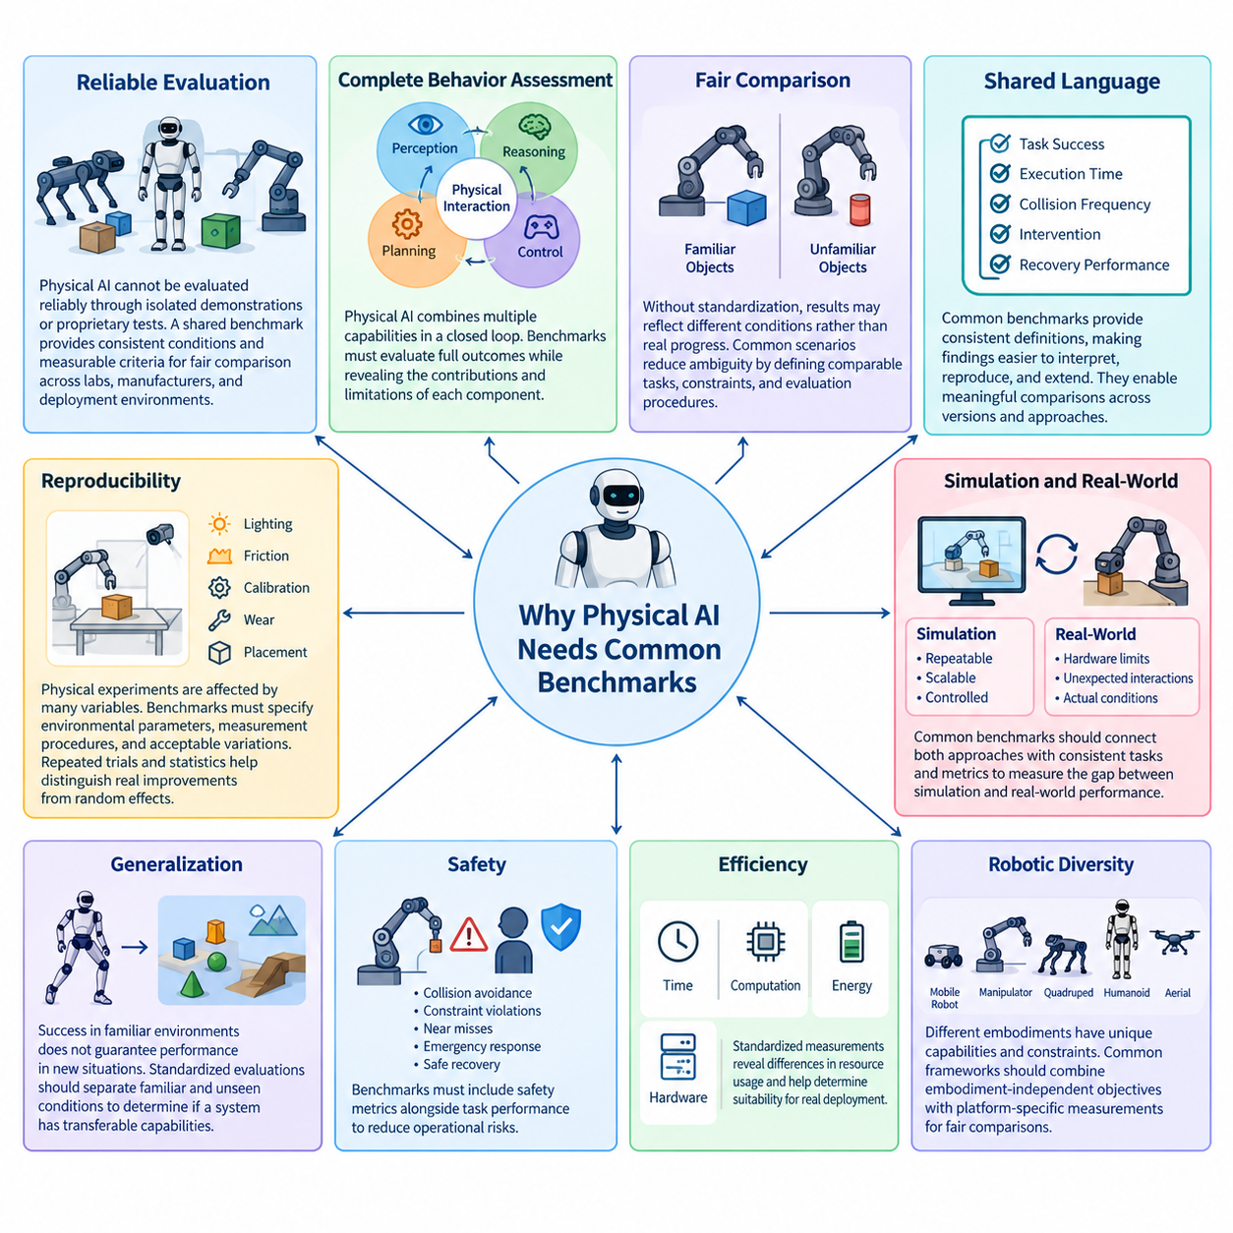

Physical AI requires common benchmarks because intelligent behavior in the physical world cannot be evaluated reliably through isolated demonstrations or proprietary testing procedures. Robots operate under different environmental conditions, hardware configurations, and task definitions, making direct performance comparisons difficult. A shared benchmarking framework establishes consistent evaluation conditions and measurable criteria for comparing systems across research laboratories, manufacturers, and deployment environments.
Unlike conventional machine learning, Physical AI combines perception, reasoning, planning, control, and physical interaction within a closed-loop system. Performance depends not only on prediction accuracy but also on execution quality, response latency, mechanical capabilities, and environmental uncertainty. Common benchmarks must therefore evaluate complete behavioral outcomes while preserving sufficient information to identify the contributions and limitations of individual system components.
Without standardized benchmarks, reported achievements may reflect differences in experimental conditions rather than genuine advances in intelligence. A manipulation system tested with familiar objects cannot be compared fairly with another system evaluated using unfamiliar objects and randomized configurations. Similarly, navigation performance measured in an empty laboratory does not establish competence in crowded environments. Standardized scenarios reduce these ambiguities by defining comparable tasks, constraints, and evaluation procedures.
Common benchmarks provide a shared language for describing Physical AI capabilities. Researchers can communicate results using consistent definitions of task success, execution time, collision frequency, intervention requirements, and recovery performance. These definitions make experimental findings easier to interpret, reproduce, and extend. They also enable meaningful comparisons between successive model versions and competing approaches without depending entirely on subjective demonstrations.
Reproducibility is particularly important because physical experiments are influenced by numerous uncontrolled variables. Lighting conditions, surface friction, sensor calibration, actuator wear, and object placement can significantly affect robot behavior. A benchmark must specify relevant environmental parameters, measurement procedures, and acceptable variations. Repeated trials and statistical reporting help distinguish systematic performance improvements from random fluctuations or favorable experimental circumstances.
Physical AI benchmarking must also address the distinction between simulation and real-world execution. Simulation provides repeatable conditions, scalable experimentation, and controlled exposure to rare events, while physical testing reveals hardware limitations and unexpected environmental interactions. Common evaluation frameworks should connect these complementary approaches through consistent task definitions and comparable metrics, allowing researchers to quantify simulation-to-reality performance differences.
Generalization represents another fundamental motivation for common benchmarks. A robot that succeeds repeatedly in a familiar environment may fail when encountering new objects, layouts, terrains, or instructions. Standardized evaluations should distinguish performance on familiar conditions from performance on previously unseen conditions. Carefully separated training and testing scenarios help determine whether a system has acquired transferable capabilities or merely adapted to a narrow experimental distribution.
Safety considerations make standardization especially important for Physical AI. Physical systems can damage equipment, disrupt operations, or injure people when perception, planning, or control fails. A benchmark focused exclusively on task completion may reward aggressive behavior that increases operational risk. Common evaluation protocols should therefore incorporate collision avoidance, constraint violations, near misses, emergency responses, and safe recovery behavior alongside conventional measures of task performance.
Efficiency must also be considered because physical intelligence operates under practical resource constraints. Two systems may achieve identical task success rates while requiring substantially different execution times, computational resources, or energy consumption. Standardized measurements of latency, power usage, motion efficiency, and hardware utilization reveal these differences. Such metrics help determine whether an approach is suitable for embedded deployment, continuous operation, or large-scale robotic fleets.
The diversity of robotic embodiments introduces additional benchmarking challenges. Autonomous mobile robots, manipulators, quadrupeds, humanoids, and aerial robots possess different movement capabilities, action spaces, and physical constraints. A universal benchmark cannot assume identical hardware or execution mechanisms. Instead, common frameworks should combine embodiment-independent objectives with platform-specific measurements, allowing meaningful comparisons without ignoring the physical characteristics that determine feasible behavior.
Task specifications form the foundation of reliable benchmarking. Each evaluation should define the initial conditions, available observations, permitted actions, completion criteria, time limits, and failure conditions. Ambiguous instructions can produce inconsistent results even when systems perform similar behaviors. Explicit scenario definitions and reference implementations reduce interpretation differences and enable independent organizations to reproduce experiments under equivalent conditions.
A common benchmark should measure both successful outcomes and the processes through which those outcomes are achieved. A robot may complete a task after repeated collisions, excessive retries, or substantial human assistance, while another system completes the same task autonomously and efficiently. Recording intermediate events, interventions, trajectory quality, and recovery actions provides a more informative representation of competence than binary success alone. These observations also support failure analysis and system improvement.
Long-horizon tasks further demonstrate why isolated performance measurements are insufficient. A robot may execute individual manipulation or navigation skills reliably but fail when required to coordinate them across an extended mission. Small errors accumulate, environmental assumptions become outdated, and unexpected events require replanning. Common benchmarks should therefore evaluate sustained autonomy, subgoal completion, memory consistency, intervention frequency, and recovery across complete operational sequences.
Standardized leaderboards can accelerate research by providing transparent comparisons of methods under shared evaluation conditions. However, rankings become meaningful only when submissions follow compatible protocols and disclose relevant experimental assumptions. Differences in training data, computational budgets, hardware configurations, and permitted adaptation can influence results. Benchmark organizers should document these factors and distinguish directly comparable submissions from evaluations conducted under materially different conditions.
Benchmark standardization also reduces the risk of misleading optimization. When researchers repeatedly tune systems against a fixed public test set, improvements may reflect benchmark-specific adaptation rather than broader competence. Hidden evaluation scenarios, controlled submission procedures, periodically refreshed test distributions, and independent validation can mitigate this problem. These mechanisms encourage the development of robust capabilities instead of solutions optimized primarily for predictable scoring conditions.
Statistical rigor is necessary because physical performance measurements often exhibit substantial variability. Reporting only the highest observed success rate or a small number of favorable demonstrations can exaggerate reliability. Common protocols should establish appropriate trial counts, sampling procedures, confidence intervals, and uncertainty reporting. Statistical comparisons should account for differences in task difficulty and environmental variability, particularly when performance differences between competing systems are small.
Benchmark governance is equally important for maintaining scientific credibility. Shared datasets, evaluation software, scoring rules, and scenario specifications require documented ownership, access policies, and change management. Version control allows researchers to identify which benchmark configuration produced a particular result. Transparent governance also supports error correction, community participation, and long-term maintenance as robotic technologies and evaluation requirements evolve.
Open benchmark infrastructure promotes accessibility and collaborative progress by allowing researchers to inspect task definitions, reproduce scoring procedures, and contribute improvements. Nevertheless, unrestricted access to evaluation scenarios may increase the possibility of test-set contamination. A balanced architecture can provide open development environments while reserving selected test conditions for independent assessment. This combination supports reproducibility without sacrificing the integrity of comparative evaluation.
Industry adoption creates another strong motivation for common benchmarks. Organizations purchasing or deploying Physical AI systems need evidence that advertised capabilities translate into operational performance. Standardized evaluations can support procurement decisions, deployment planning, reliability assessment, and technical acceptance testing. Although benchmark results cannot replace site-specific validation, they provide a consistent foundation for comparing candidate systems before conducting more expensive field trials.
Common benchmarks can also support the development of capability levels for Physical AI. Rather than assigning a single intelligence score, evaluation frameworks may characterize competence across perception, manipulation, mobility, generalization, safety, and sustained autonomy. Capability profiles can indicate which tasks a system performs reliably and under what conditions those capabilities remain valid. Such profiles provide more actionable information than broad claims of general-purpose intelligence.
Ultimately, Physical AI needs common benchmarks to transform isolated technical achievements into cumulative scientific and engineering progress. Shared task definitions, reproducible experiments, multidimensional metrics, transparent leaderboards, and coordinated governance make performance claims more credible and comparable. Standardization should not eliminate experimentation or restrict innovation; it should provide a stable reference through which increasingly capable physical intelligence can be evaluated, understood, and responsibly deployed.

08.02. Benchmark Task and Scenario Specification
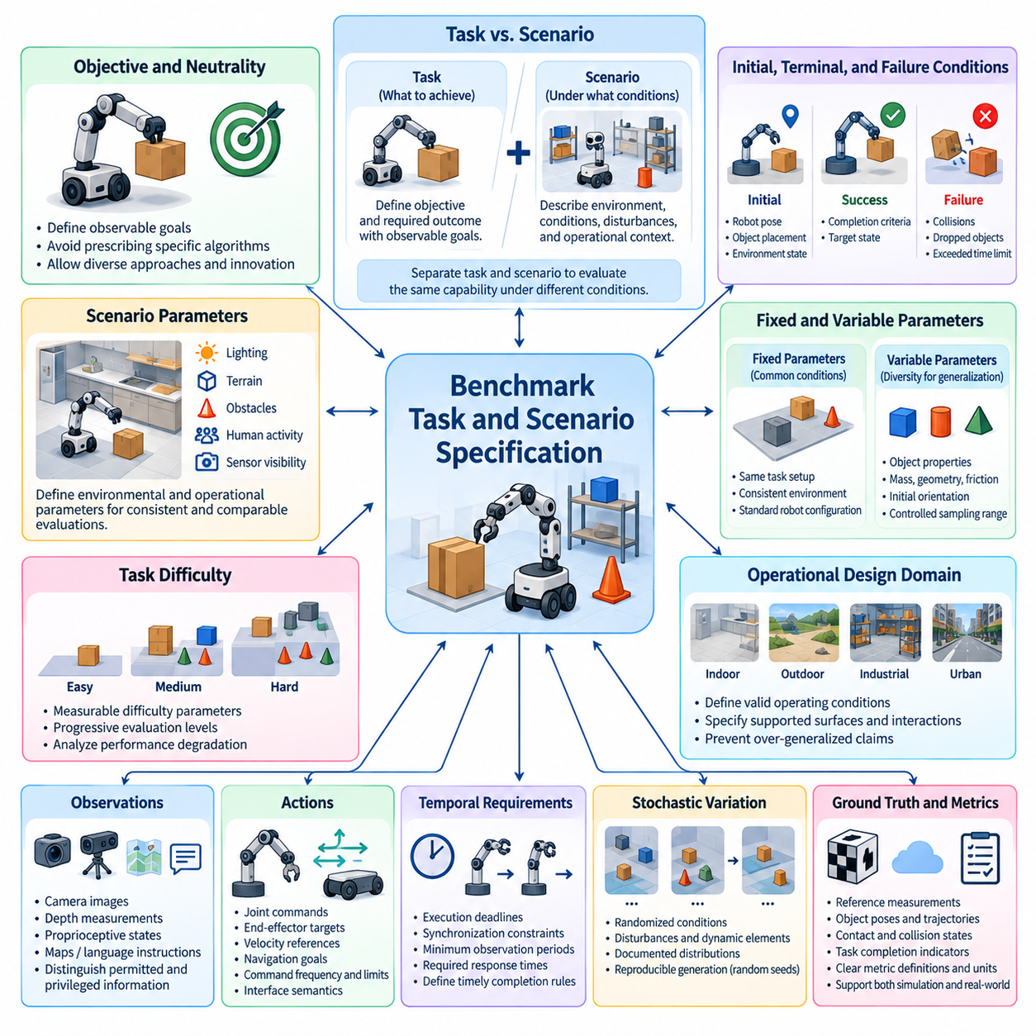
Benchmark task and scenario specification provides the foundation for consistent, reproducible, and meaningful evaluation of Physical AI systems. A task defines the intended objective and required outcome, while a scenario describes the conditions under which the task must be performed. Separating these concepts allows researchers to evaluate the same capability across different environments, disturbances, and operational constraints without changing the fundamental objective.
A benchmark task should describe observable goals rather than prescribe a particular algorithm or control strategy. For example, a mobile robot may be required to transport an object from one location to another while avoiding obstacles and respecting safety constraints. The specification should define what constitutes successful delivery without requiring a specific navigation planner, perception architecture, or motion controller. This preserves methodological neutrality and encourages innovation.
Task specifications must establish clear initial conditions, terminal conditions, and failure criteria. Initial conditions include robot pose, object placement, environment configuration, and relevant system states. Terminal conditions identify when successful execution has occurred, while failure criteria describe unacceptable outcomes such as collisions, dropped objects, or exceeded time limits. Explicit definitions prevent inconsistent interpretations across independent implementations.
Scenario specifications extend task definitions by describing environmental and operational context. Relevant parameters may include lighting, terrain, obstacle density, object properties, human activity, and sensor visibility. In simulation, these conditions can be generated programmatically, while real-world evaluations require controlled setup procedures and documented measurements. Consistent scenario descriptions enable comparisons between virtual and physical testing environments.
A well-designed benchmark distinguishes fixed parameters from variable parameters. Fixed parameters establish common evaluation conditions, whereas variable parameters introduce controlled diversity to assess adaptability and generalization. For example, a manipulation benchmark may maintain the same task objective while varying object mass, geometry, friction, or initial orientation. The permitted parameter ranges and sampling procedures must be documented to support fair comparisons.
Task difficulty should be represented through measurable characteristics rather than subjective labels alone. Navigation difficulty may depend on route length, obstacle density, passage width, and environmental dynamics. Manipulation difficulty may involve object complexity, grasp accessibility, required precision, and contact uncertainty. Explicit difficulty parameters allow benchmark designers to construct progressive evaluation levels and analyze performance degradation as challenges increase.
Operational design domains define the boundaries within which benchmark results are intended to remain valid. A robot evaluated on smooth indoor floors should not automatically be considered competent on uneven outdoor terrain. Scenario specifications should therefore identify supported surfaces, environmental conditions, interaction types, and operational restrictions. These boundaries prevent benchmark scores from being interpreted as evidence of unrestricted real-world capability.
Observation specifications determine what information an evaluated system may access during execution. Inputs may include camera images, depth measurements, proprioceptive states, maps, language instructions, and external localization signals. The benchmark must distinguish permitted observations from privileged information available only to the evaluation infrastructure. This distinction prevents unfair advantages and supports meaningful comparisons between different perception and decision-making approaches.
Action specifications describe the interface through which a Physical AI system interacts with its environment. Depending on the platform, actions may consist of joint commands, end-effector targets, velocity references, navigation goals, or high-level skill requests. Benchmark protocols should document action frequency, command limits, latency assumptions, and interface semantics. These details are essential because differences in control authority can substantially influence observed performance.
Temporal requirements form another important component of task specification. Physical tasks may involve execution deadlines, synchronization constraints, minimum observation periods, or required response times. A robot that completes a task correctly but too slowly may be unsuitable for its intended application. Benchmark definitions should therefore distinguish task completion from timely completion and establish consistent rules for measuring execution duration and temporal violations.
Scenario design must account for stochastic variation without sacrificing reproducibility. Randomized object placement, environmental disturbances, and dynamic obstacles can expose weaknesses that deterministic scenarios fail to reveal. However, randomness must follow documented distributions, bounded parameter ranges, and reproducible generation procedures. Recording random seeds and scenario configurations allows experiments to be repeated while preserving statistical diversity.
Ground-truth definitions are necessary for determining whether benchmark objectives have been achieved. Reference measurements may include object poses, robot trajectories, contact events, collision states, and task completion indicators. In simulation, ground truth may be obtained directly from the environment model, whereas physical experiments require calibrated measurement systems. Benchmark designers should document measurement accuracy, synchronization, and uncertainty to avoid misleading performance estimates.
Safety constraints must be incorporated directly into task and scenario specifications rather than treated as optional evaluation additions. A robot may be required to maintain separation distances, respect force limits, avoid restricted regions, or stop when uncertainty becomes excessive. These requirements should be expressed as measurable conditions with clearly defined violation criteria. Successful task execution should not compensate for unacceptable safety behavior.
Human involvement must also be specified when benchmarks include collaborative or interactive tasks. Human participants may provide instructions, manipulate shared objects, introduce disturbances, or intervene during failures. Evaluation protocols should define participant roles, permitted assistance, communication channels, and intervention recording. Without these controls, variations in human behavior may dominate measured system performance and undermine reproducibility.
Long-horizon benchmark tasks require explicit descriptions of subgoals, dependencies, and acceptable execution sequences. A warehouse robot may need to identify an item, navigate to storage, retrieve the item, transport it, and complete delivery. Some subtasks may have strict ordering constraints, while others may permit alternative strategies. Specifications should distinguish mandatory outcomes from flexible execution paths to evaluate autonomous planning fairly.
Cross-embodiment benchmarking introduces the challenge of defining equivalent tasks for robots with different physical capabilities. A mobile manipulator and a humanoid may achieve the same delivery objective using different locomotion and manipulation strategies. Benchmark specifications should preserve common functional goals while documenting embodiment-specific constraints and available action interfaces. This approach supports capability comparisons without imposing artificial mechanical equivalence.
Scenario coverage determines how comprehensively a benchmark represents its intended operational domain. A small collection of favorable conditions may produce high success rates without revealing important failure modes. Designers should include representative nominal conditions, boundary cases, environmental disturbances, and plausible rare events. Coverage documentation should explain which variations are included, which are excluded, and how the selected scenarios relate to expected deployment conditions.
Benchmark specifications should distinguish development scenarios from evaluation scenarios. Public development environments allow researchers to debug implementations and understand task requirements, while reserved evaluation scenarios provide stronger evidence of generalization. Excessive exposure to fixed test conditions can encourage benchmark-specific optimization. Controlled scenario generation and independent evaluation procedures help preserve the credibility of reported results.
Machine-readable specifications can improve consistency and enable automated benchmark execution. Structured configuration files may describe task identifiers, environment parameters, robot interfaces, success conditions, and scoring requirements. Validation tools can detect missing fields, incompatible settings, or invalid parameter ranges before experiments begin. Such infrastructure reduces manual setup errors and supports large-scale evaluation across different simulation engines and robotic platforms.
Versioning is essential because changes to task definitions or scenario distributions can alter benchmark difficulty and invalidate historical comparisons. Each benchmark release should identify its specification version, supported interfaces, scenario configurations, and evaluation rules. Modifications should be documented with clear explanations of their expected impact. Maintaining reproducible historical configurations allows researchers to distinguish genuine algorithmic improvements from changes in evaluation conditions.
Ultimately, rigorous task and scenario specification transforms Physical AI benchmarking from loosely defined demonstrations into systematic experimental evaluation. Clear objectives, controlled conditions, documented interfaces, measurable constraints, and reproducible scenario generation establish the basis for trustworthy performance comparisons. These specifications also support automated scoring, transparent leaderboards, statistical analysis, and the gradual development of interoperable evaluation standards across the Physical AI ecosystem.

08.03. Dataset and Test Set Governance
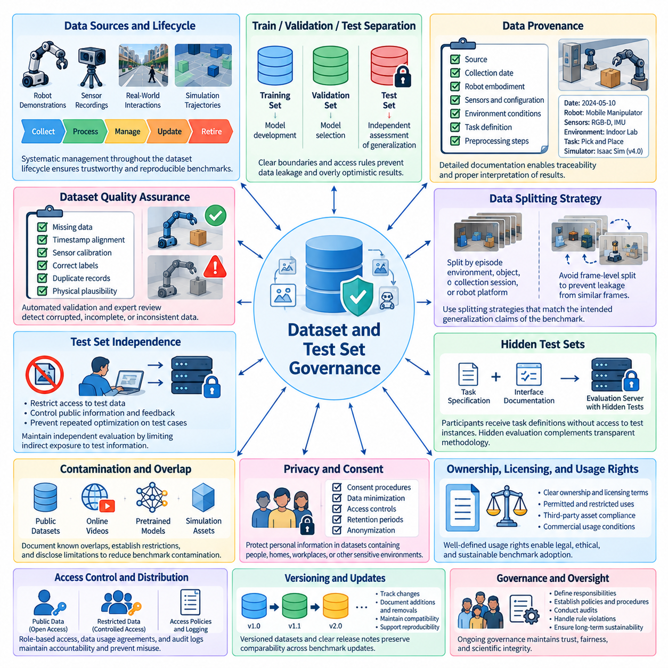
Dataset and test set governance establishes the rules, responsibilities, and procedures required to maintain trustworthy Physical AI benchmarks. Because physical systems learn from diverse sources, including robot demonstrations, sensor recordings, simulation trajectories, and real-world interactions, benchmark datasets require systematic management throughout their lifecycle. Effective governance defines how data is collected, documented, stored, accessed, validated, updated, and retired while preserving evaluation integrity and scientific reproducibility.
A fundamental principle of benchmark governance is the clear separation between training, validation, and test data. Training datasets support model development, validation datasets guide model selection, and test datasets provide an independent assessment of generalization. When information from the test set enters training or repeated optimization, reported performance may become overly optimistic. Governance procedures should therefore establish explicit data boundaries, access permissions, and rules governing how each dataset may be used.
Physical AI datasets present challenges that are less prominent in conventional digital machine learning. Sensor observations and robot trajectories depend on physical environments, hardware configurations, control policies, and interaction histories. Two datasets may appear different while containing nearly identical underlying scenes or trajectories. Governance must therefore consider relationships between recordings, repeated demonstrations, environmental configurations, and task instances rather than relying exclusively on file-level separation.
Data provenance provides the foundation for traceable evaluation. Each dataset should document its source, collection date, recording equipment, robot embodiment, sensor configuration, environmental conditions, task definition, and relevant preprocessing operations. Simulation datasets should additionally identify the simulator, physics configuration, asset versions, and scenario-generation procedures. Such information allows researchers to determine whether a dataset represents the intended operational domain and whether differences in results may arise from data collection rather than model capability.
Dataset quality assurance is essential because corrupted, incomplete, or inconsistently labeled data can undermine benchmark validity. Governance procedures should define checks for missing observations, timestamp misalignment, sensor calibration errors, incorrect task labels, duplicate records, and physically implausible measurements. Automated validation can identify many technical defects, while expert review may be necessary for ambiguous interactions or complex failure cases. Quality requirements should be documented consistently so that dataset revisions remain auditable.
Data splitting should reflect the generalization claims that a benchmark is designed to evaluate. Randomly dividing individual frames from the same recording between training and testing can produce severe leakage because neighboring frames often share nearly identical visual and physical information. More reliable procedures may separate entire episodes, environments, objects, collection sessions, or robot platforms. The appropriate splitting strategy depends on whether the benchmark targets generalization to new scenes, unfamiliar objects, different embodiments, or broader operational conditions.
Test set independence requires more than assigning separate folders to training and evaluation files. Developers may indirectly expose test information through public demonstrations, downloadable trajectories, repeated leaderboard submissions, or detailed evaluation feedback. Benchmark governance should define which information is public, which remains restricted, and how repeated access is controlled. These measures reduce the likelihood that systems become specialized for known evaluation examples rather than developing transferable physical capabilities.
Hidden test sets can strengthen benchmark independence by reserving selected scenarios, trajectories, or environmental configurations for controlled evaluation. Participants may receive the task specification and interface documentation without gaining direct access to the underlying test instances. An evaluation server can execute submitted systems against these hidden cases and return standardized results. However, hidden evaluation should complement transparent methodology rather than replace it, because researchers still need enough information to understand the benchmark's scope and interpret reported performance.
Dataset governance must also address benchmark contamination caused by overlapping sources. Public robotics datasets, online videos, pretrained models, and simulation assets may contain information related to evaluation scenarios. Complete prevention of contamination can be difficult, particularly when datasets are assembled from large and heterogeneous collections. Governance should document known overlaps, establish reasonable restrictions on evaluation data use, and disclose relevant limitations so that benchmark results are interpreted with appropriate caution.
Privacy and consent are particularly important when datasets contain people, homes, workplaces, or other sensitive environments. Camera recordings, audio, location traces, and human interaction logs may reveal personal information even when names are removed. Governance should define appropriate consent procedures, data minimization practices, access controls, retention periods, and anonymization requirements. Where necessary, sensitive records should be restricted or transformed before publication, while preserving the information required for valid scientific evaluation.
Ownership, licensing, and usage rights determine whether benchmark datasets can be redistributed, modified, or used commercially. Data collected by research institutions, industrial partners, contractors, or human participants may be subject to different legal and contractual restrictions. Governance documentation should specify applicable licenses, attribution requirements, permitted uses, and redistribution limitations. Clear rights management reduces uncertainty for researchers and organizations that intend to build upon published benchmarks.
Physical AI datasets may also contain safety-critical information, including hazardous robot behaviors, collision events, actuator failures, and interactions near people. Such records are valuable because they reveal limitations that successful demonstrations may conceal. Governance should preserve failure data when appropriate, label hazardous conditions accurately, and establish access controls where unrestricted distribution could create risks. Removing every unsuccessful trial would distort the evaluation distribution and encourage misleading conclusions about system reliability.
Dataset representativeness is another major governance concern. Collections dominated by a single robot platform, geographic region, lighting condition, object category, or operating procedure may fail to represent the diversity of intended deployment environments. Governance reviews should examine coverage across relevant environmental and operational dimensions, identify underrepresented conditions, and document known limitations. Representation should be assessed relative to the benchmark's stated purpose rather than an unrealistic expectation that every dataset must cover all possible physical situations.
Class imbalance and uneven scenario frequency can influence benchmark results even when dataset labels are correct. A test set containing mostly easy tasks may produce high average success rates while providing little evidence about difficult or safety-critical conditions. Governance should document scenario frequencies, sampling methods, and any weighting procedures used during evaluation. Stratified reporting can reveal whether a system performs consistently across conditions or derives its overall score from a narrow subset of favorable cases.
Dataset versioning and change management are necessary because corrections, new recordings, revised labels, and expanded scenario coverage can alter evaluation outcomes. Each release should identify its version, data contents, preprocessing rules, known limitations, and changes from previous releases. When a test set changes materially, benchmark organizers should explain whether historical scores remain directly comparable. Preserving previous versions where practical enables researchers to reproduce earlier results and distinguish genuine model improvements from changes in the evaluation data.
Access governance should balance scientific openness with the need to protect independent evaluation. Public training data and development datasets can support broad participation, while restricted test sets can reduce direct exposure to evaluation examples. Access policies should define eligibility, authentication requirements, submission limits, and procedures for handling misuse. These controls should be proportionate to the benchmark's risks and should not create unnecessary barriers for legitimate research teams.
Governance also requires clear institutional responsibilities. Benchmark maintainers should define who approves dataset changes, reviews quality issues, manages access requests, responds to reported errors, and resolves disputes about evaluation procedures. Independent oversight can improve confidence when benchmark results influence research funding, commercial procurement, certification discussions, or public claims about robotic capabilities. Documented decision processes help ensure that governance decisions remain consistent and transparent.
Data retention and retirement policies support the long-term sustainability of benchmark infrastructure. Some records may need to be removed because of expired permissions, privacy concerns, security risks, or irreparable quality problems. Other datasets may remain valuable for historical comparison even after newer versions become available. Governance should define retention criteria, archival procedures, and deprecation policies so that benchmark evolution does not unnecessarily destroy the ability to reproduce previous experiments.
Automated governance tools can enforce dataset rules at scale. Validation pipelines may verify file integrity, schema compliance, metadata completeness, duplicate detection, access permissions, and version consistency before a dataset is released or used for scoring. Machine-readable manifests and audit logs can record the origin of each evaluation artifact and the transformations applied to it. Automation reduces administrative errors, although human review remains important for ethical judgments, ambiguous labeling, and disputed data rights.
Effective dataset and test set governance ultimately connects data management with scientific integrity. Clearly separated datasets, traceable provenance, reliable quality controls, appropriate privacy protections, transparent licensing, and controlled test access make Physical AI evaluations more credible. By treating benchmark data as a governed scientific resource rather than an unstructured collection of files, the research community can improve reproducibility, reduce evaluation leakage, support fair comparisons, and build a more dependable foundation for measuring physical intelligence.

08.04. Hidden Test Sets and Evaluation Servers
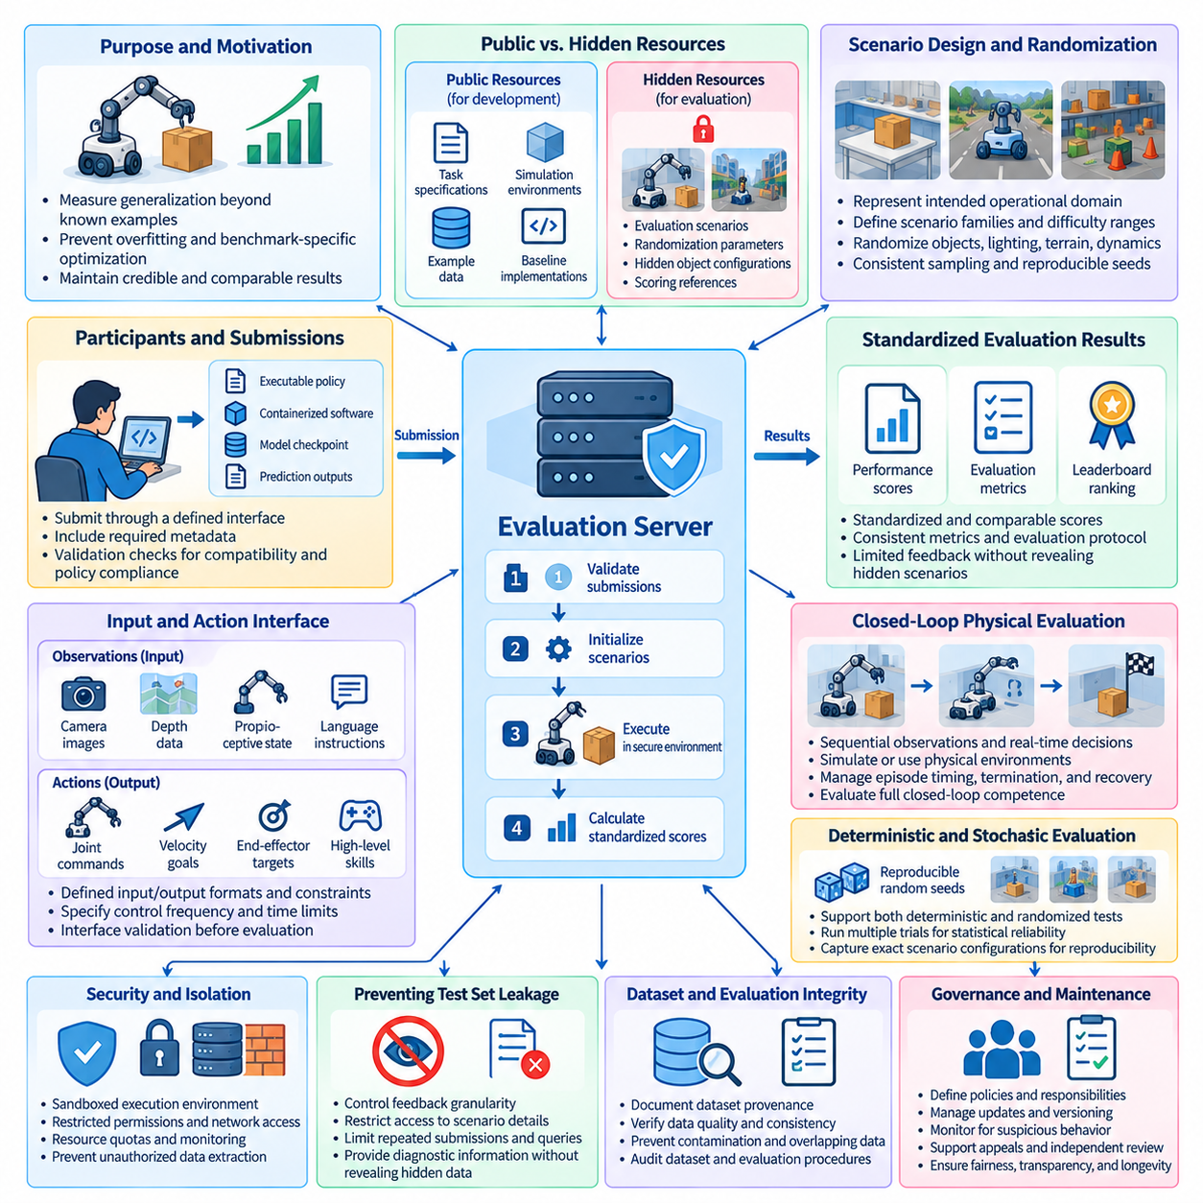
Hidden test sets and evaluation servers are essential mechanisms for maintaining the credibility of Physical AI benchmarks. Public benchmarks enable reproducible development, but unrestricted access to evaluation examples can encourage overfitting and benchmark-specific optimization. Hidden test sets preserve independent assessment by withholding selected scenarios, trajectories, and environmental configurations. Evaluation servers provide controlled execution and standardized scoring, allowing researchers to compare systems without directly accessing protected test data.
The primary purpose of a hidden test set is to measure generalization beyond conditions explicitly available during development. When researchers repeatedly inspect test scenarios, models may become specialized for those examples rather than acquiring transferable capabilities. This problem is particularly significant in Physical AI because robot behavior depends on object geometry, environmental dynamics, sensor characteristics, and interaction histories. Hidden evaluation reduces direct exposure to these details while preserving a common basis for comparison.
A robust benchmark architecture separates public development resources from restricted evaluation resources. Public resources may include task specifications, simulation environments, example trajectories, reference interfaces, and baseline implementations. Restricted resources contain evaluation scenarios, randomization parameters, hidden object configurations, and scoring references. This separation enables participants to understand benchmark requirements while preventing direct optimization against the complete evaluation distribution.
Evaluation servers act as trusted intermediaries between submitted systems and protected test environments. Participants may submit executable policies, containerized software, model checkpoints, or standardized prediction outputs, depending on the benchmark architecture. The server validates submissions, initializes evaluation scenarios, executes the required tests, and calculates performance metrics. Centralized execution improves consistency by reducing differences in software dependencies, scenario configurations, and scoring implementations.
Submission interfaces must be clearly defined to support fair evaluation. A Physical AI benchmark may require systems to receive camera images, proprioceptive measurements, language instructions, or structured observations and return actions through a specified interface. Input formats, output constraints, control frequencies, and execution time limits should be documented. Interface validation should reject incompatible submissions before expensive evaluation begins, reducing operational failures unrelated to model capability.
Physical AI evaluation servers face challenges beyond those encountered in conventional machine learning benchmarks. Interactive robot policies require sequential observations, real-time decisions, and continuous interaction with dynamic environments. Evaluation infrastructure must therefore manage simulation state, action timing, episode termination, and failure recovery. A server that evaluates only static predictions cannot fully characterize closed-loop competence, particularly when planning errors or delayed actions influence subsequent physical states.
Hidden scenarios should represent the intended operational domain rather than arbitrary undisclosed challenges. Benchmark organizers must define scenario families, difficulty ranges, environmental variations, and evaluation objectives without revealing individual test instances. Participants should understand which capabilities are being measured and which constraints apply. This balance between transparency and secrecy prevents hidden evaluation from becoming an unpredictable competition disconnected from practical Physical AI requirements.
Scenario randomization can strengthen hidden evaluation by generating multiple valid instances from controlled distributions. Object positions, lighting conditions, terrain properties, obstacle movements, and physical parameters may vary across episodes. Randomization reduces dependence on memorized configurations and exposes weaknesses in adaptation. However, sampling procedures must remain consistent across submissions, and evaluation records should preserve the exact scenario configurations used for reproducibility.
Deterministic execution is useful for debugging and controlled comparison, but stochastic evaluation is often necessary to measure robust behavior. Physical AI systems encounter uncertainty from sensors, contact dynamics, actuator variation, and environmental disturbances. Evaluation servers should support reproducible random seeds while collecting results across multiple independent trials. This approach enables statistical comparisons without assuming that a single successful execution represents reliable performance.
Security is a fundamental requirement when evaluation servers execute externally submitted software. Untrusted code may attempt unauthorized file access, network communication, resource exhaustion, or extraction of hidden evaluation information. Sandboxed execution, restricted permissions, resource quotas, and network isolation can reduce these risks. Security controls must also protect evaluation infrastructure from accidental failures while allowing legitimate robotic policies to access the computational resources required for execution.
Preventing test set leakage requires attention to both direct and indirect information channels. Hidden scenarios may be exposed through detailed error messages, downloadable logs, visualization outputs, or repeated submissions that reveal scoring patterns. Evaluation servers should control feedback granularity and restrict access to protected scenario details. Public diagnostic information can remain useful, but it should not enable participants to reconstruct the hidden test distribution through systematic probing.
Submission limits help preserve benchmark independence by reducing opportunities for repeated optimization against hidden results. A leaderboard may restrict evaluation frequency, require registration, or separate development submissions from official submissions. Such policies should be transparent and applied consistently. Excessively restrictive access can discourage participation, while unlimited submissions can transform hidden evaluation into an indirect training process. Governance must balance accessibility with evaluation integrity.
Scoring protocols should remain independent of submitted implementations. The evaluation server must apply consistent definitions of task success, execution time, collisions, constraint violations, and intervention requirements. For multi-objective Physical AI benchmarks, performance should be reported across relevant dimensions rather than compressed into a single unexplained score. Standardized scoring implementations reduce opportunities for inconsistent interpretation and improve confidence in leaderboard comparisons.
Hardware diversity introduces additional complexity into hidden evaluation. Some benchmarks evaluate policies on standardized simulated robots, while others assess complete physical systems with different sensors, actuators, and mechanical capabilities. Evaluation servers should record embodiment characteristics and distinguish algorithmic performance from hardware-dependent advantages. Where direct comparison is inappropriate, results may be grouped by platform class or normalized using clearly documented capability constraints.
Real-world hidden evaluation requires specialized procedures because physical environments cannot always be reset or reproduced perfectly. Independent test facilities may use undisclosed object arrangements, randomized task sequences, or controlled disturbances while maintaining documented safety conditions. Human operators may supervise execution and record interventions. Unlike purely digital evaluation, physical testing also requires equipment maintenance, calibration, emergency stopping procedures, and consistent environmental preparation.
Evaluation infrastructure should preserve detailed execution records for auditing and scientific analysis. Relevant artifacts include software versions, model identifiers, scenario configurations, random seeds, timestamps, action trajectories, sensor summaries, failure events, and scoring outputs. These records enable benchmark maintainers to investigate unexpected results and verify reported rankings. Sensitive hidden information should remain protected, while sufficient metadata should be available to support reproducibility and dispute resolution.
Statistical reliability is essential when leaderboard positions depend on small performance differences. Evaluation servers should execute enough trials to estimate success probabilities and variability across scenarios. Confidence intervals, standard deviations, and stratified performance summaries can reveal whether apparent ranking differences are meaningful. Benchmark organizers should avoid presenting unstable ordering as definitive evidence of superiority, particularly when physical interactions produce high outcome variability.
Evaluation servers must also support version control and benchmark lifecycle management. Changes to simulation engines, physics parameters, hidden scenarios, scoring logic, or hardware configurations can alter reported performance. Every official result should therefore reference a specific benchmark version and evaluation protocol. When substantial changes occur, organizers may need to establish a new leaderboard or reevaluate previous submissions to preserve comparability.
Transparency remains important even when test instances are confidential. Benchmark documentation should explain evaluation objectives, supported interfaces, metric definitions, scenario coverage, submission requirements, and governance policies. Independent audits can verify that hidden evaluations follow published procedures without exposing protected examples. This distinction between transparent methodology and confidential test content is central to establishing trust in standardized Physical AI evaluation.
Automated evaluation servers can accelerate research by reducing the administrative burden of benchmark execution. Continuous integration pipelines may validate submissions, allocate computational resources, schedule evaluation episodes, aggregate metrics, and publish approved leaderboard results. Automated monitoring can detect execution failures, abnormal resource consumption, and inconsistent outputs. Human oversight remains necessary for security incidents, disputed results, exceptional hardware failures, and changes to evaluation policy.
Ultimately, hidden test sets and evaluation servers provide the infrastructure required to distinguish genuine Physical AI competence from performance optimized for familiar examples. Their effectiveness depends on carefully designed scenario distributions, secure execution, controlled feedback, reproducible scoring, statistical rigor, and transparent governance. By combining independent testing with accessible development resources, these mechanisms support trustworthy leaderboards and more credible assessments of physical intelligence across diverse robotic systems.

08.05. Metric Definitions and Scoring Protocols
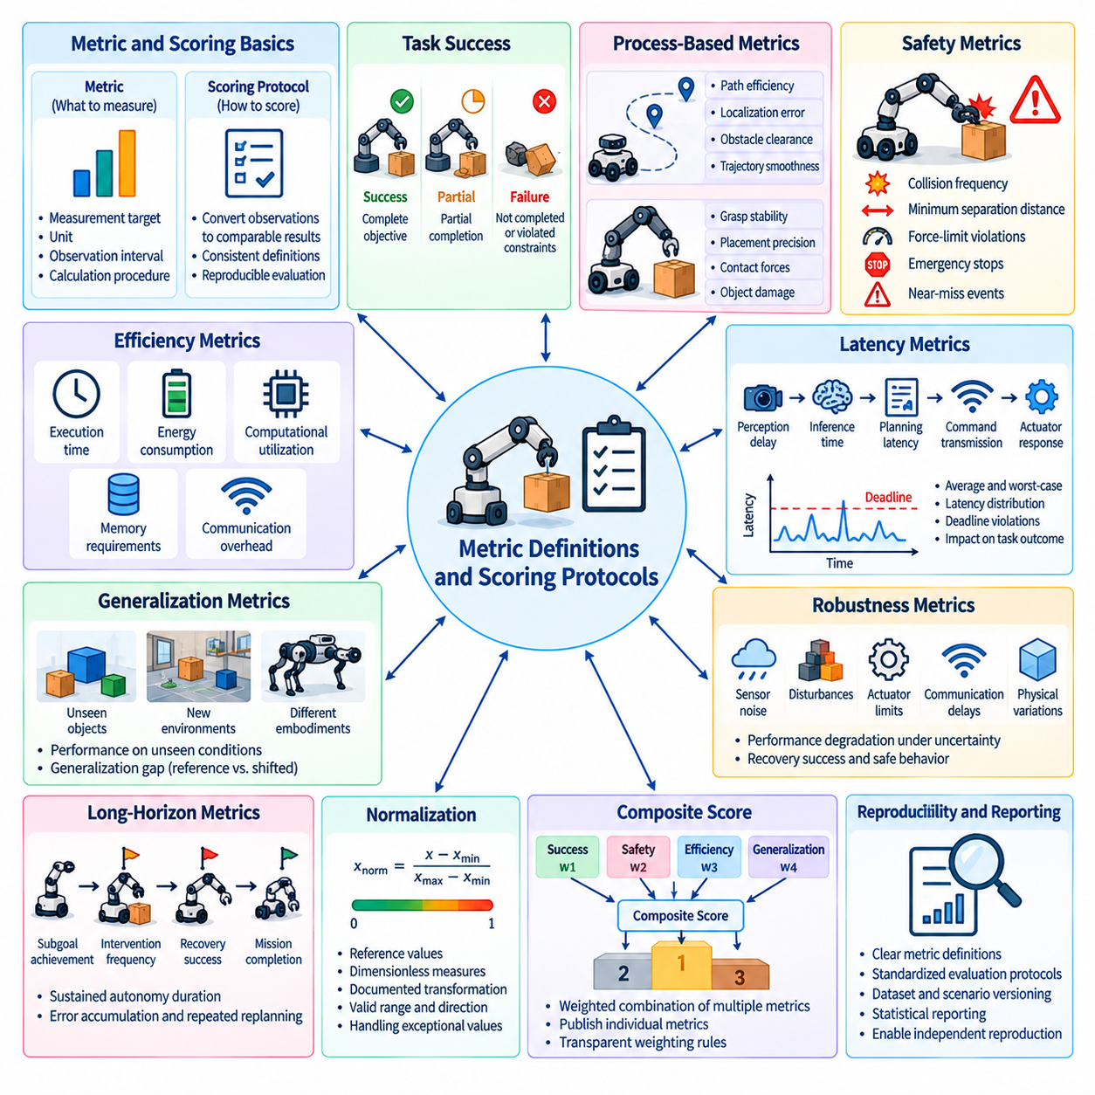
Metric definitions and scoring protocols establish the quantitative foundation for reliable Physical AI benchmarking. A metric specifies what aspect of system behavior is measured, while a scoring protocol determines how observations are converted into comparable results. Without consistent definitions, identical robot behaviors may receive different scores across laboratories or evaluation platforms. Standardization ensures that reported performance reflects actual capability rather than differences in measurement or interpretation.
A well-defined metric must identify its measurement target, unit, observation interval, and calculation procedure. For example, task success rate requires an explicit definition of successful completion and the number of valid trials included in the denominator. Execution time must specify when measurement begins, when it ends, and whether initialization or recovery periods are included. These details prevent ambiguity and allow independent evaluators to reproduce reported results.
Task success is a fundamental metric, but binary completion alone provides limited information about execution quality. A robot may achieve its objective while requiring excessive retries, producing unstable movements, or violating operational constraints. Scoring protocols should distinguish complete success, partial completion, and failure when such distinctions are meaningful. Partial credit must follow predefined criteria rather than subjective judgments introduced after observing results.
Process-based metrics complement outcome-based evaluation by describing how a task was performed. Navigation benchmarks may measure path efficiency, localization error, obstacle clearance, and trajectory smoothness. Manipulation benchmarks may evaluate grasp stability, placement precision, contact forces, and object damage. These measurements reveal differences between systems that achieve similar final outcomes but exhibit substantially different operational characteristics.
Safety metrics require particularly precise definitions because unacceptable physical behavior cannot be treated as an ordinary performance tradeoff. Collision frequency, minimum separation distance, force-limit violations, emergency stops, and near-miss events should be measured using documented thresholds. Scoring rules must distinguish minor deviations from hazardous failures and specify whether certain violations invalidate an entire trial regardless of task completion.
Efficiency metrics describe the resources required to achieve a specified outcome. Execution duration, energy consumption, computational utilization, memory requirements, and communication overhead may all influence deployment feasibility. Comparisons should account for differences in task workload and hardware configuration. Normalized measures, such as energy per completed task or computation per successful episode, can improve interpretability when their denominators and measurement conditions are clearly specified.
Latency metrics are essential for evaluating closed-loop Physical AI systems. Perception delay, inference time, planning latency, command transmission, and actuator response collectively influence the ability to react to changing environments. Average latency alone may conceal dangerous delays during difficult interactions. Scoring protocols should therefore consider latency distributions, worst-case behavior, deadline violations, and the relationship between response timing and task outcomes.
Generalization metrics determine whether a system maintains performance beyond familiar training conditions. Evaluation may compare results across unseen objects, environments, tasks, sensor configurations, or robot embodiments. A generalization gap can describe performance degradation between reference and shifted conditions. However, meaningful interpretation requires consistent task definitions and documented distribution changes so that increased difficulty is not mistaken for an inherent failure of generalization.
Robustness metrics characterize performance under disturbances, uncertainty, and component degradation. Scenarios may introduce sensor noise, actuator limitations, unexpected obstacles, communication delays, or variations in physical parameters. Evaluation should measure both performance degradation and the ability to recover safely. A system that maintains task completion but repeatedly violates safety constraints should not receive the same robustness assessment as one that preserves acceptable behavior throughout disturbances.
Long-horizon evaluation requires metrics that capture behavior across extended sequences rather than isolated actions. Relevant measurements include mission completion rate, subgoal achievement, intervention frequency, recovery success, and sustained autonomy duration. Error accumulation and repeated replanning can reveal weaknesses that short episodes conceal. Scoring protocols should specify whether temporary failures, human assistance, or partial mission completion affect the final result.
Metric normalization enables comparisons across tasks with different scales and operating conditions. Distance, time, energy, and precision measurements may require reference values or dimensionless transformations before aggregation. However, normalization can distort interpretation if reference conditions are poorly selected. Every transformation should document its mathematical definition, valid range, direction of improvement, and treatment of exceptional values.
Composite scores combine multiple performance dimensions into a single summary, but their construction requires careful justification. Weighted combinations of success, safety, efficiency, and generalization may simplify leaderboard ranking while concealing important tradeoffs. Benchmark designers should publish individual metric values alongside aggregate scores. Weight selection should reflect explicit evaluation objectives, and sensitivity analysis should determine whether small weighting changes substantially alter rankings.
Scoring protocols must define how invalid trials and exceptional events are handled. Simulation crashes, hardware faults, communication interruptions, operator mistakes, and environmental setup failures may affect evaluation outcomes differently. Excluding unsuccessful trials without predefined rules can introduce systematic bias. Protocols should distinguish legitimate task failures from infrastructure failures while preserving transparent records of exclusions, retries, and interrupted evaluations.
Statistical reporting is necessary because Physical AI performance varies across trials, environments, and hardware conditions. Mean values should be accompanied by appropriate measures of dispersion and uncertainty, such as standard deviations or confidence intervals. Success rates require sufficient sample sizes to support meaningful interpretation. Paired evaluation conditions and repeated measurements can improve comparison quality when systems experience similar scenario distributions.
Scoring implementations should be deterministic whenever identical evaluation records are processed under the same protocol. Automated evaluators can calculate task outcomes, constraint violations, timing measurements, and aggregate statistics using predefined rules. Reference implementations and validation tests help identify inconsistencies between scoring environments. Human judgment may remain necessary for ambiguous outcomes, but adjudication procedures should be documented and independently reviewable.
Ground-truth quality directly influences metric reliability. Position error, collision detection, contact force, and task completion may depend on calibrated sensors or simulation reference states. Measurement uncertainty, synchronization errors, and missing observations can propagate into final scores. Benchmark protocols should document reference measurement accuracy and define how uncertain or unavailable ground truth affects evaluation validity.
Cross-embodiment scoring requires a distinction between universal objectives and platform-dependent capabilities. Different robots may complete equivalent tasks using different movement strategies, sensing configurations, and actuation mechanisms. Shared metrics can assess functional success and safety, while embodiment-specific metrics describe mechanical efficiency or execution quality. Direct rankings should be limited to conditions where the comparison remains physically and operationally meaningful.
Metric design must also consider incentives created by scoring rules. A benchmark emphasizing speed may encourage aggressive movement, while one rewarding only successful completion may overlook excessive energy consumption or human intervention. Poorly designed metrics can therefore promote behavior that performs well numerically but fails operational expectations. Benchmark designers should examine potential metric gaming and ensure that critical constraints cannot be bypassed through optimization.
Version control is essential because changes to thresholds, normalization rules, aggregation weights, or failure definitions can alter leaderboard results. Each official score should reference a specific metric specification and scoring implementation. Historical comparisons should identify whether the same protocol was applied. When substantial scoring changes occur, previous submissions may require reevaluation or separation into different benchmark versions.
Ultimately, metric definitions and scoring protocols transform Physical AI observations into reproducible evidence of system capability. Precise measurement rules, transparent aggregation, safety-aware scoring, statistical rigor, and validated implementations enable trustworthy comparisons across models and robotic platforms. A strong evaluation framework preserves multidimensional performance information while providing consistent summaries, supporting scientific progress, engineering decisions, and responsible deployment of Physical AI systems.

08.06. Single Metric vs Multi Dimensional Scorecards
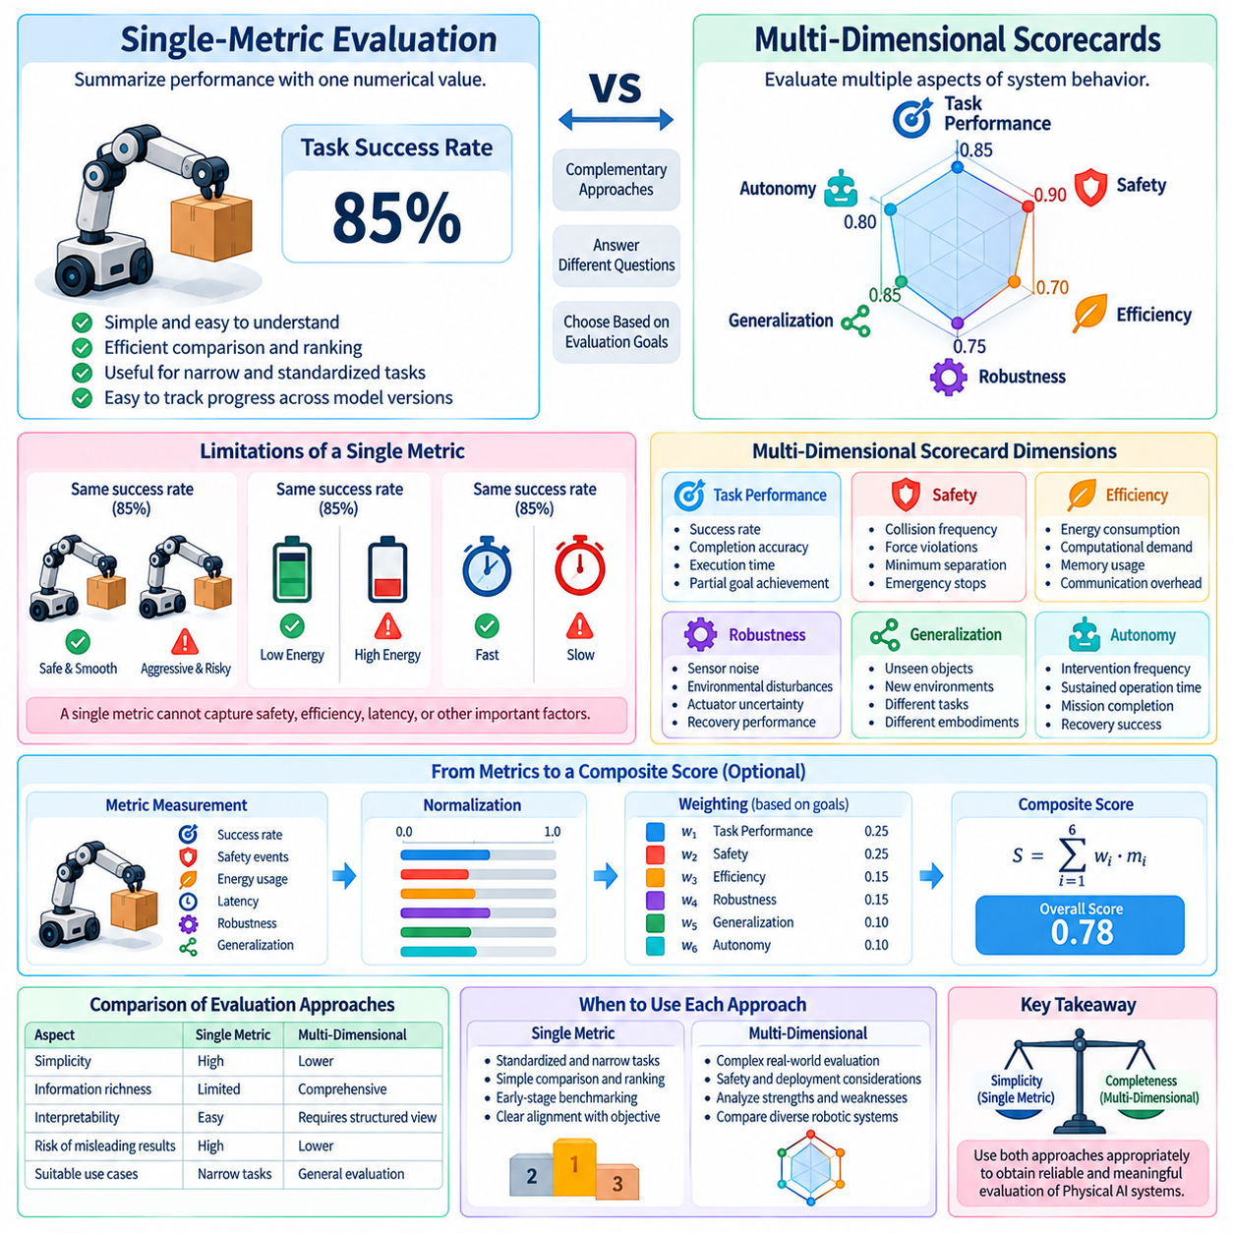
Single-metric evaluation and multi-dimensional scorecards represent two complementary approaches to measuring Physical AI capabilities. A single metric summarizes performance through one numerical value, while a multi-dimensional scorecard preserves several distinct aspects of system behavior. Both approaches support benchmarking, but they answer different questions. Selecting an appropriate evaluation structure requires understanding how numerical simplicity, interpretability, safety, and operational relevance influence comparisons between robotic systems.
Single-metric evaluation offers a straightforward mechanism for comparing algorithms and ranking submissions. Measures such as task success rate, average completion time, or cumulative reward can summarize experimental outcomes efficiently. A single value is easy to communicate, track across model versions, and display on public leaderboards. This simplicity is particularly useful when evaluation objectives are narrow, task conditions are standardized, and the chosen metric closely represents the capability being investigated.
However, a single metric rarely captures the full complexity of physical intelligence. Two robots may achieve identical success rates while exhibiting substantial differences in safety, energy consumption, response latency, and recovery behavior. A robot that completes tasks quickly through aggressive movements may receive a favorable score despite creating operational risks. Such examples demonstrate that numerical performance alone cannot establish whether a system is suitable for deployment in dynamic physical environments.
Multi-dimensional scorecards address these limitations by evaluating several capability dimensions independently. A typical Physical AI scorecard may include task performance, safety, efficiency, robustness, generalization, and autonomy. Each dimension contains measurable indicators derived from standardized evaluation procedures. Rather than reducing every observation to one number, the scorecard preserves a structured representation of strengths, weaknesses, and operational tradeoffs across different robotic systems.
Task performance remains a central scorecard dimension because robots must accomplish meaningful objectives. Relevant indicators include task success rate, completion accuracy, execution time, and partial goal achievement. These measures establish whether the system can perform its intended function under specified conditions. However, task performance should be interpreted alongside other dimensions because successful completion does not necessarily imply efficient, safe, or reliable operation.
Safety constitutes a separate dimension that should not be concealed within an aggregate performance score. Collision frequency, force-limit violations, minimum human separation, emergency interventions, and hazardous failure rates provide evidence about physical risk. In safety-critical applications, certain violations may represent disqualifying conditions rather than penalties that can be offset by faster execution. A scorecard makes such constraints visible and supports explicit safety acceptance criteria.
Efficiency measures the resources consumed while performing useful work. Energy per completed task, computational demand, memory usage, communication overhead, and execution duration can reveal important deployment constraints. Systems with similar success rates may differ substantially in battery endurance or hardware requirements. Reporting efficiency independently helps distinguish algorithmic capability from resource-intensive performance and supports comparisons relevant to practical deployment.
Robustness and generalization should also be represented as distinct dimensions. Robustness evaluates performance under disturbances, sensor noise, actuator uncertainty, and unexpected events. Generalization examines behavior across unfamiliar objects, environments, tasks, and embodiments. Although related, these capabilities are not identical. A system may tolerate disturbances in familiar environments while performing poorly in novel settings, making separate reporting essential.
Autonomy and long-horizon competence introduce additional dimensions that short-task success metrics cannot adequately represent. Intervention frequency, sustained operation time, recovery success, subgoal completion, and mission-level reliability describe whether a system can operate independently over extended periods. A robot may perform individual actions accurately yet require frequent human assistance during complex missions. Multi-dimensional reporting exposes these limitations without obscuring short-term strengths.
The main challenge of multi-dimensional scorecards is maintaining interpretability as the number of indicators increases. Excessive metrics can create fragmented reports, overlapping measurements, and difficulty identifying meaningful improvements. Scorecard designers should organize indicators into coherent capability categories and avoid unnecessary duplication. Each dimension should have a clear operational interpretation, documented measurement procedures, and a defined relationship to the benchmark's objectives.
Metric normalization is necessary when scorecard dimensions use different measurement units and numerical ranges. Success rates, energy consumption, latency, and positioning error cannot be combined directly without appropriate transformations. Normalization may map measurements to common scales using documented reference conditions or acceptable performance thresholds. However, transformations must preserve the direction of improvement and avoid exaggerating small differences between systems.
Weighting introduces an additional design decision when several dimensions are combined into a composite score. A benchmark may assign greater importance to safety in human-facing robotics or to efficiency in resource-constrained mobile platforms. These weights reflect application priorities rather than universal measures of intelligence. Consequently, scorecards should disclose weighting rules and retain raw metric values so that readers can evaluate whether rankings remain meaningful under different operational assumptions.
A composite score can provide a convenient summary while preserving multi-dimensional evaluation underneath. For example, benchmark organizers may publish an overall ranking together with detailed scores for performance, safety, robustness, and efficiency. This layered approach supports rapid comparison without sacrificing technical transparency. Nevertheless, aggregation should never permit unacceptable safety failures to be compensated automatically by high scores in unrelated dimensions.
Pareto analysis provides an alternative to forcing every system into a single numerical ranking. A robot is Pareto-dominated when another system performs at least as well across all considered dimensions and better in at least one. Systems on the Pareto frontier represent different tradeoffs that cannot be resolved without additional preferences. This perspective is valuable when comparing robots designed for different operational priorities, where no universally superior configuration exists.
Scorecard interpretation must account for measurement uncertainty and statistical variability. Small differences between systems may not indicate meaningful capability improvements when evaluation results vary across trials. Confidence intervals, repeated experiments, and scenario-level performance distributions provide context for reported values. Multi-dimensional uncertainty analysis is particularly important because apparent superiority in one dimension may disappear when evaluation conditions or sampling variability are considered.
Cross-embodiment evaluation further strengthens the case for multi-dimensional reporting. Wheeled robots, manipulators, legged platforms, and humanoid systems possess different physical capabilities and constraints. Shared indicators can describe functional success, safety, and reliability, while embodiment-specific indicators characterize locomotion efficiency, manipulation precision, or mechanical stability. A common scorecard framework can support comparison without pretending that every measurement is equally applicable to every platform.
Benchmark designers must also consider how scorecards influence system optimization. If a leaderboard emphasizes only one numerical objective, developers may improve that metric while neglecting unreported behavior. Publishing multiple dimensions encourages balanced development and makes undesirable tradeoffs more visible. However, even multi-dimensional scorecards can be manipulated if important constraints are omitted or evaluation conditions become predictable. Periodic metric reviews and hidden testing remain necessary.
Scorecard governance should establish consistent definitions, version control, and reporting requirements. Every indicator needs a documented calculation method, measurement unit, valid range, and interpretation. Changes to normalization rules, weighting schemes, or capability categories may alter historical rankings. Benchmark maintainers should therefore preserve versioned scorecard specifications and explain whether results generated under different protocols remain comparable.
Practical evaluation systems can use hierarchical scorecards that connect detailed measurements to broader capability categories. Individual metrics describe observable behavior, category scores summarize related competencies, and an optional overall score supports high-level communication. This hierarchy enables researchers to investigate specific failures while allowing engineers and decision-makers to assess deployment readiness. The structure should remain sufficiently transparent for independent reproduction and critical review.
Ultimately, single-metric evaluation and multi-dimensional scorecards should be viewed as complementary rather than competing approaches. Single metrics provide clarity and efficient ranking for narrowly defined objectives, while scorecards reveal the broader characteristics required for trustworthy Physical AI operation. Combining concise summaries with transparent, safety-aware, statistically grounded capability profiles creates a stronger foundation for benchmarking, system selection, and responsible deployment.

08.07. Performance Safety Efficiency and Generalization Scores
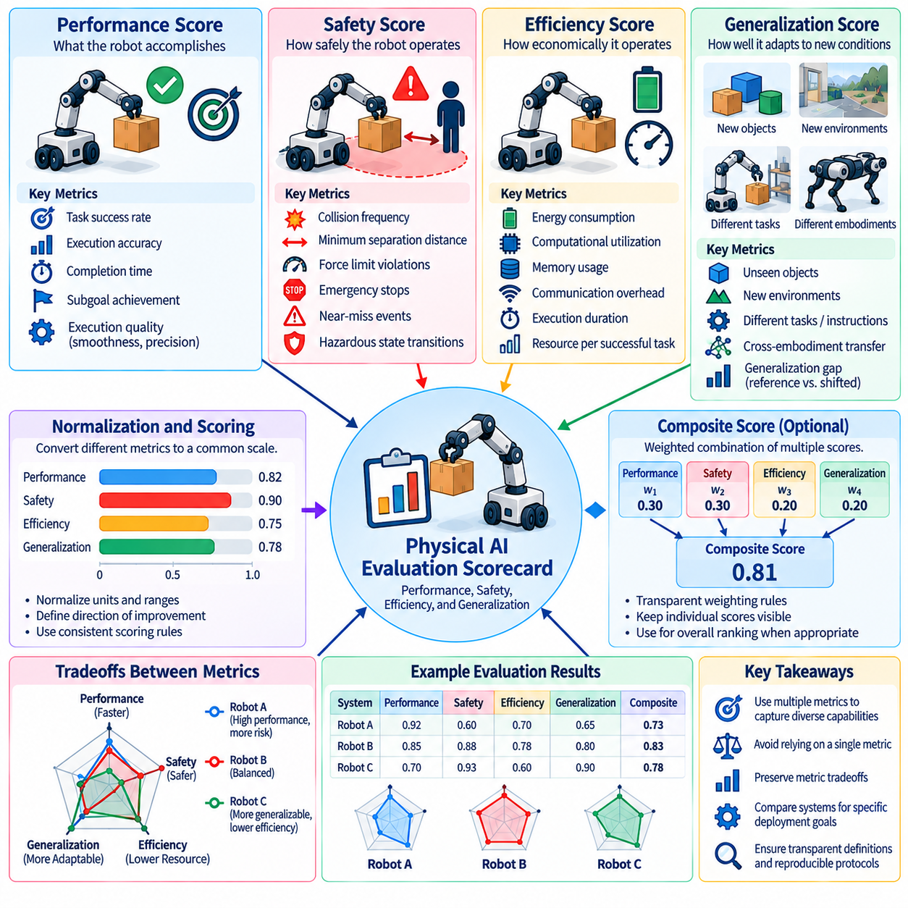
Performance, safety, efficiency, and generalization scores form a multidimensional foundation for evaluating Physical AI systems. Each score measures a distinct aspect of robotic capability, allowing benchmark results to represent more than task completion alone. Performance describes what a system accomplishes, safety measures the risks associated with its actions, efficiency evaluates resource consumption, and generalization examines adaptability. Together, these dimensions support meaningful comparisons across diverse robots and operational environments.
Performance scoring begins with explicit task objectives and measurable success criteria. Common indicators include task completion rate, execution accuracy, completion time, and progress toward intermediate goals. A manipulation system may be evaluated through grasp success and placement precision, while a mobile robot may be assessed through navigation accuracy and destination arrival. Performance metrics must distinguish successful outcomes from partial completion and failures using predefined scoring rules.
Task performance should also account for execution quality rather than relying exclusively on binary success. Two robots may complete identical tasks while exhibiting different trajectory smoothness, positioning errors, or recovery requirements. Quality-sensitive scoring can reveal these differences through continuous measurements. However, quality metrics should remain connected to operational objectives so that mathematically favorable behavior does not receive unnecessary rewards without practical benefits.
Safety scoring evaluates whether a Physical AI system operates within acceptable physical and operational constraints. Relevant indicators include collision frequency, excessive contact forces, minimum separation distances, emergency stops, and hazardous state transitions. Safety evaluation should consider both actual incidents and precursor events that indicate elevated risk. Explicit thresholds and standardized measurement procedures are essential because inconsistent definitions can produce misleading safety comparisons.
Safety scores should distinguish between minor constraint deviations and critical violations. A small positioning error may justify a limited penalty, while dangerous contact with a person may require immediate trial termination. Certain safety requirements should function as hard constraints rather than components that can be offset by high task performance. This approach prevents an unsafe system from achieving an acceptable overall evaluation merely through speed or completion accuracy.
Efficiency scoring measures how economically a robot converts computational and physical resources into useful work. Important indicators include energy consumption, execution duration, processor utilization, memory demand, and communication bandwidth. Resource measurements should be associated with clearly defined workloads and hardware configurations. Efficiency comparisons become meaningful when systems perform equivalent tasks under sufficiently comparable operating conditions.
Normalized efficiency measures can improve comparisons across different task durations and workload sizes. Energy per successful task, computation per completed episode, and distance traveled relative to an efficient reference path provide interpretable indicators. However, normalization must not conceal unsuccessful attempts or repeated recovery actions. Benchmark protocols should specify whether failed trials contribute to resource totals, preventing systems from appearing efficient by excluding costly failures.
Generalization scoring measures the ability to maintain competence when evaluation conditions differ from those encountered during training. Test scenarios may introduce unfamiliar objects, new environments, altered lighting, different physical properties, or changed task instructions. A system that performs well only on familiar configurations demonstrates limited generalization. Evaluation should therefore compare performance across explicitly defined reference and shifted distributions.
Generalization gaps provide one way to quantify performance changes between familiar and unfamiliar conditions. A small gap may indicate effective transfer, but it does not necessarily imply strong capability if performance is poor in both settings. Consequently, generalization scores should report absolute performance alongside relative degradation. This distinction prevents weak systems from receiving favorable evaluations merely because their already limited performance changes very little.
Generalization should be examined across multiple dimensions rather than treated as a single undifferentiated property. Object generalization concerns unfamiliar shapes and materials, environmental generalization addresses new scenes and disturbances, and task generalization evaluates changes in goals or instructions. Cross-embodiment generalization examines transfer between robot platforms. Separate reporting identifies where adaptation succeeds and where additional learning or engineering is required.
Performance, safety, efficiency, and generalization are interconnected, but improvements in one dimension do not guarantee improvements in others. Faster execution may increase collision risk, conservative behavior may reduce throughput, and highly specialized policies may outperform general-purpose systems on familiar tasks. Benchmark scorecards should preserve these relationships without assuming that every objective can be maximized simultaneously. Explicit tradeoff analysis supports application-specific decisions.
Score normalization enables different dimensions to be displayed on comparable numerical scales. Raw measurements such as collision counts, energy consumption, completion rates, and positioning errors have different units and directions of improvement. Transformation rules should specify reference values, acceptable ranges, and treatment of extreme outcomes. Normalized scores must remain traceable to their original measurements to prevent misleading interpretations.
Aggregate scoring can summarize multidimensional results, but its design must reflect clearly stated priorities. Weighted combinations may emphasize safety for human-interactive robots or efficiency for battery-powered platforms. However, weights represent evaluation preferences rather than universal definitions of physical intelligence. Publishing individual dimension scores alongside composite results allows researchers to examine whether rankings remain appropriate for their intended applications.
Safety-critical thresholds should be evaluated before applying ordinary score aggregation. A system that violates mandatory collision limits or human protection requirements may be classified as failing safety acceptance regardless of its other scores. Among systems satisfying these constraints, performance and efficiency can then support additional comparisons. This hierarchical approach preserves safety requirements while allowing meaningful differentiation between acceptable solutions.
Statistical uncertainty affects every scoring dimension. Task outcomes vary across scenarios, safety incidents may be rare, resource consumption fluctuates with workload, and generalization depends on sampled conditions. Reliable evaluation therefore requires repeated trials, documented sample sizes, and appropriate uncertainty estimates. Confidence intervals and distributional summaries help determine whether observed score differences reflect genuine capability improvements.
Scenario coverage is equally important because aggregate scores can conceal weaknesses in difficult operating conditions. A robot may achieve high average performance while failing under poor lighting, slippery surfaces, unusual objects, or unexpected disturbances. Stratified scoring should report results for relevant scenario categories and difficulty levels. This approach reveals whether high overall scores represent broadly reliable behavior or success concentrated in favorable conditions.
Cross-embodiment comparisons require careful interpretation of scoring dimensions. Manipulators, mobile robots, quadrupeds, and humanoids possess different mechanical structures, sensing capabilities, and energy requirements. Functional success and safety may support common evaluation principles, while efficiency and motion quality often require platform-specific references. Benchmark designers should distinguish transferable capabilities from advantages arising primarily from hardware configuration.
Score governance establishes the procedures needed to maintain consistency over time. Metric definitions, measurement equipment, normalization parameters, aggregation weights, and safety thresholds should be versioned and documented. Changes to these elements can alter leaderboard rankings even when underlying robot capabilities remain unchanged. Official reports should identify the applicable scoring protocol and preserve sufficient records for independent verification.
Automated scoring infrastructure can integrate these dimensions into reproducible evaluation pipelines. Task monitors determine completion outcomes, safety monitors detect violations, resource monitors collect efficiency measurements, and scenario managers organize generalization trials. A centralized scoring service can validate records, calculate dimension scores, and publish standardized reports. Human oversight remains necessary for ambiguous incidents, calibration problems, and disputed outcomes.
Ultimately, performance, safety, efficiency, and generalization scores provide complementary evidence about Physical AI capability and deployment readiness. Performance establishes functional competence, safety determines acceptable operation, efficiency reveals practical resource requirements, and generalization measures adaptability beyond familiar conditions. A trustworthy benchmark preserves these distinctions while supporting transparent aggregation, statistically reliable comparisons, and informed engineering decisions across robotic platforms.

08.08. Statistical Reporting and Uncertainty
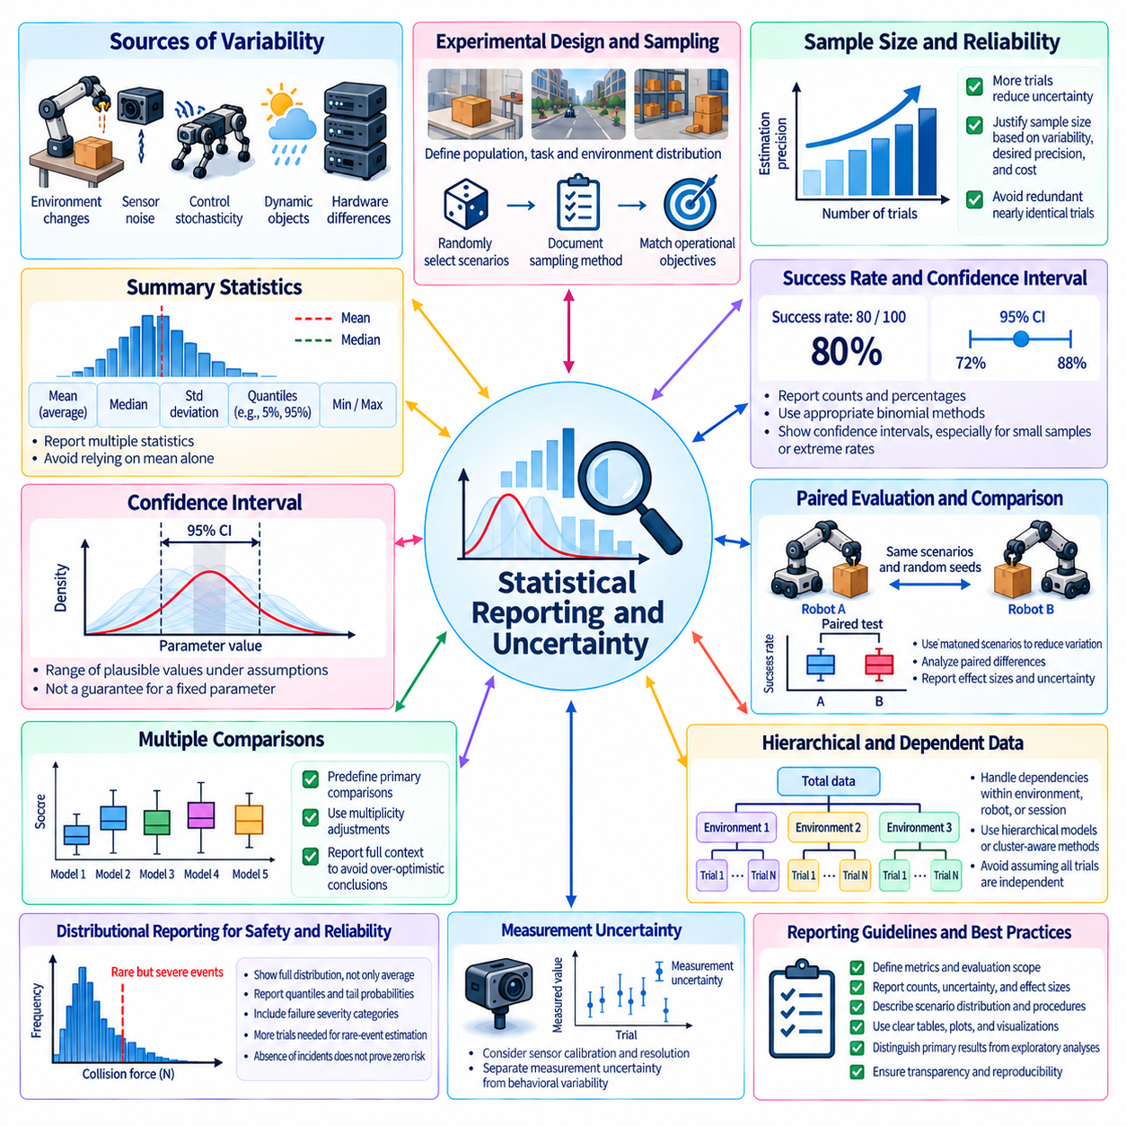
Statistical reporting and uncertainty analysis are essential for interpreting Physical AI benchmark results reliably. Robotic performance varies because of environmental conditions, sensor noise, control stochasticity, hardware differences, and interactions with dynamic objects. A single numerical score cannot adequately represent this variability. Statistical reporting therefore describes both estimated performance and the uncertainty surrounding that estimate, allowing researchers to distinguish genuine capability differences from experimental fluctuations.
The foundation of statistical evaluation is a clearly defined experimental population and sampling procedure. Benchmark trials should represent the tasks, environments, and operating conditions for which performance claims are intended. Randomly selected scenarios may improve coverage, but sampling must reflect the benchmark's operational objectives. Researchers should document scenario distributions, trial selection methods, and exclusion criteria so that reported statistics can be interpreted within a known evaluation scope.
Sample size strongly influences the reliability of benchmark conclusions. A robot achieving success in a small number of trials may appear highly capable even when its true success probability remains uncertain. Increasing the number of independent trials generally improves estimation precision, although repeated measurements from nearly identical conditions provide limited additional information. Benchmark protocols should justify trial counts using expected variability, desired precision, and practical evaluation costs.
Mean performance is widely reported because it provides a compact summary of experimental outcomes. Average completion time, positioning error, energy consumption, and cumulative reward are common examples. However, mean values can conceal extreme failures or highly variable behavior. Median values, standard deviations, quantiles, and minimum or maximum observations provide complementary information. The choice of summary statistics should reflect the distribution and operational significance of the measured variable.
Success rates require particular care because they estimate probabilities from discrete outcomes. Reporting eighty successful trials out of one hundred provides more information than reporting an eighty percent success rate alone. Confidence intervals communicate the uncertainty associated with the estimated probability. Appropriate binomial methods should be used, especially when sample sizes are small or observed success rates approach zero or one, where simple normal approximations may become unreliable.
Confidence intervals provide a range of plausible values for an estimated performance parameter under specified statistical assumptions. A ninety-five percent confidence interval does not mean that a fixed parameter has a ninety-five percent probability of lying inside the calculated interval. Instead, the procedure is designed to achieve the stated coverage over repeated sampling. Correct interpretation prevents uncertainty estimates from being presented as guarantees about future robotic behavior.
Physical AI experiments often involve hierarchical sources of variation. Multiple episodes may share the same environment, robot hardware, operator, or random seed family, making their outcomes statistically dependent. Treating every observation as independent can underestimate uncertainty and exaggerate confidence. Hierarchical models, cluster-aware bootstrap procedures, or aggregation at the environment or session level can account for this dependence when their assumptions are appropriate.
Paired evaluation improves comparisons when competing systems encounter the same scenarios and randomization conditions. Differences in outcomes can then be analyzed within matched trials, reducing variation caused by scenario difficulty. However, pairing must be preserved throughout statistical analysis, and shared seeds do not guarantee identical physical trajectories after policies diverge. Benchmark reports should explain the pairing strategy and distinguish matched comparisons from independent experiments.
Hypothesis testing can assess whether observed performance differences are compatible with a specified null hypothesis. Statistical significance alone, however, does not establish practical superiority. With enough trials, a very small improvement may become statistically detectable while remaining irrelevant to deployment. Reports should therefore include effect sizes, uncertainty intervals, and application-specific performance requirements rather than relying exclusively on probability values or significance thresholds.
Multiple comparisons introduce additional uncertainty when many models, metrics, and scenarios are examined simultaneously. Selecting the best result from numerous experiments can produce overly optimistic conclusions even without intentional manipulation. Benchmark organizers should distinguish predefined primary comparisons from exploratory analyses and consider appropriate multiplicity adjustments. Reporting the full evaluation context reduces the risk that isolated favorable outcomes are mistaken for general improvements.
Distributional reporting is particularly important for safety and reliability. Average collision frequency may conceal rare but severe incidents, while average execution time may hide unacceptable delays. Quantiles, tail probabilities, failure severity categories, and scenario-specific summaries can reveal operational risks that mean values overlook. Rare-event estimates often require substantially more exposure than ordinary success-rate measurements, and the absence of observed incidents does not demonstrate zero risk.
Uncertainty arises from measurement processes as well as stochastic behavior. Sensor calibration errors, timestamp misalignment, imperfect ground truth, and simulation approximations can introduce systematic or random errors into reported metrics. Repeated trials alone cannot eliminate systematic bias. Evaluation protocols should document measurement accuracy, calibration procedures, known biases, and relevant uncertainty propagation when calculating derived performance indicators.
Simulation and real-world experiments require distinct interpretations of uncertainty. Simulation permits controlled randomization and extensive repetition, but estimated variability may omit unmodeled physical effects. Real-world testing captures actual hardware and environmental interactions but may be expensive and difficult to reproduce. Reporting should separate uncertainty within each evaluation domain from discrepancies between simulation and reality, avoiding unsupported claims that simulated confidence intervals establish real-world reliability.
Generalization evaluation must account for uncertainty across unfamiliar conditions. Performance estimates may differ substantially between unseen objects, new environments, altered physical properties, and different robot embodiments. Reporting only an overall average can conceal important distribution-specific weaknesses. Stratified estimates and uncertainty intervals should describe each relevant condition, while aggregate results should document the weighting assigned to scenario categories.
Long-horizon tasks create additional statistical challenges because outcomes depend on sequences of correlated decisions. Mission completion, time to failure, recovery frequency, and intervention requirements may provide more useful evidence than isolated action accuracy. Censored trials, where evaluation ends before success or failure is observed, require explicit treatment. Survival analysis and time-to-event methods may be appropriate when the benchmark measures sustained autonomy or operational endurance.
Leaderboard rankings should reflect uncertainty rather than treating every numerical difference as definitive. Two systems with overlapping performance estimates may be difficult to distinguish, although interval overlap alone is not a formal test of their difference. Rank uncertainty, paired comparisons, and sensitivity analysis can provide stronger evidence about ordering. Benchmark maintainers should avoid implying that small score differences establish a stable hierarchy of Physical AI capability.
Reproducible statistical reporting requires access to evaluation protocols, metric definitions, sample counts, randomization procedures, and analysis methods. Where confidentiality permits, anonymized trial-level results and reference analysis code can support independent verification. Hidden test sets may require restricted disclosure, but benchmark organizers can still publish sufficient aggregated information to explain uncertainty. Versioned analysis pipelines help preserve comparability as benchmarks evolve.
Statistical planning should occur before evaluation rather than after results are observed. Researchers should define primary metrics, intended comparisons, minimum trial counts, stopping rules, and uncertainty estimation methods in advance. Sequential testing and adaptive sampling can reduce evaluation costs, but their statistical consequences must be addressed explicitly. Predefined procedures limit selective reporting and reduce incentives to continue experiments until favorable outcomes appear.
Automated evaluation infrastructure can improve statistical consistency by collecting standardized trial records and generating reproducible summaries. Evaluation servers may calculate confidence intervals, stratified statistics, effect sizes, and quality-control indicators using validated analysis pipelines. Automated checks can identify missing trials, unusual observations, and inconsistent metadata. Human review remains necessary when statistical assumptions fail or unexpected physical events complicate interpretation.
Ultimately, statistical reporting and uncertainty analysis transform benchmark scores into evidence that can support scientific and engineering decisions. Reliable evaluation requires representative sampling, sufficient trials, appropriate treatment of dependence, transparent measurement assumptions, and careful interpretation of performance differences. By reporting both capability estimates and their limitations, Physical AI benchmarks can support more credible leaderboards, safer deployment decisions, and reproducible progress across robotic platforms.

08.09. Reproducibility and Submission Requirements
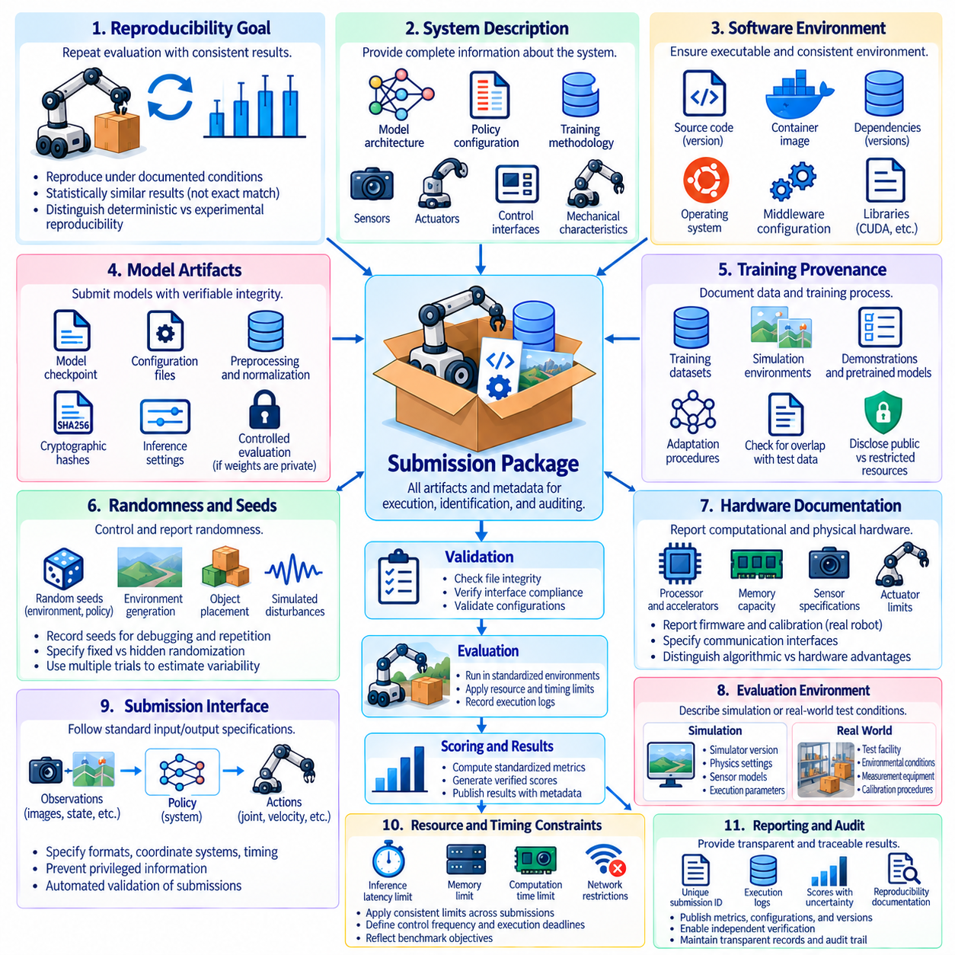
Reproducibility and submission requirements are fundamental to trustworthy Physical AI benchmarking. A benchmark result becomes scientifically meaningful when independent evaluators can verify how it was produced and determine whether comparable outcomes can be obtained. Physical AI introduces additional complexity because results depend on software, hardware, environments, and physical interactions. Standardized submission procedures establish the evidence needed to evaluate systems consistently.
Reproducibility means that an evaluation can be repeated under documented conditions with results consistent within expected uncertainty. Exact numerical duplication is not always possible because physical systems experience sensor noise, mechanical variation, and environmental disturbances. Consequently, reproducibility should be assessed through statistically comparable outcomes rather than identical trajectories. Benchmark protocols must distinguish deterministic replication from experimental reproducibility.
A valid submission begins with a complete description of the evaluated system. Required information may include model architecture, policy configuration, training methodology, software dependencies, and inference settings. For robotic systems, the description should also identify sensors, actuators, control interfaces, and relevant mechanical characteristics. This documentation allows evaluators to understand whether observed performance originates from the AI model, hardware advantages, or system integration.
Software reproducibility requires precise identification of the code and execution environment. Source revisions, dependency versions, operating systems, middleware configurations, and numerical libraries can influence results. Container images and environment specifications help reduce differences between evaluation machines. However, containers do not eliminate variation caused by hardware drivers, accelerator architectures, real-time scheduling, or external services, which must be documented separately.
Model artifacts should be submitted with sufficient information to verify their identity and intended execution behavior. Checkpoints, configuration files, preprocessing parameters, action normalization rules, and inference precision settings may all affect performance. Cryptographic hashes can establish artifact integrity and detect unintended changes. Where model weights cannot be disclosed, controlled execution environments or independent evaluation services may provide alternative verification mechanisms.
Training provenance is important because benchmark validity depends on separating training information from evaluation data. Submissions should describe training datasets, simulation environments, demonstrations, pretrained models, and adaptation procedures at an appropriate level of detail. Evaluators must identify potential overlap with protected test scenarios. Disclosure requirements should also distinguish permitted public resources from restricted information that could compromise hidden evaluations.
Randomness must be controlled and reported wherever it materially affects evaluation. Random seeds may govern environment generation, policy sampling, object placement, and simulated disturbances. Recording seeds supports debugging and repeated experiments, but identical seeds do not guarantee identical physical outcomes. Benchmark organizers should specify which randomization settings are fixed, which remain hidden, and how repeated trials are sampled to estimate variability.
Hardware documentation is particularly important for Physical AI because computational and mechanical capabilities influence observed performance. Submissions may need to report processor type, accelerator configuration, memory capacity, sensor specifications, actuator limits, and communication interfaces. For real-world testing, robot calibration and firmware versions may also matter. Hardware disclosure helps distinguish algorithmic improvements from differences in physical resources.
Evaluation environments require comparable documentation. Simulation submissions should identify simulator versions, physics settings, sensor models, and relevant execution parameters. Real-world submissions should describe test facilities, environmental conditions, measurement equipment, and calibration procedures. Standardized scenario specifications reduce uncontrolled variation, while environmental records provide context when exact physical replication is impossible.
Submission interfaces should define how systems receive observations and produce actions. Common interfaces may specify observation formats, coordinate conventions, action representations, timing constraints, and communication protocols. Clear interface contracts prevent accidental advantages from privileged information or incompatible control assumptions. Automated validation can detect malformed outputs, unsupported operations, and violations of execution limits before official scoring begins.
Resource and timing constraints must be applied consistently across submissions. Evaluation servers may impose limits on inference latency, memory usage, computation time, network access, and external dependencies. Physical robots may additionally require bounded control frequencies and emergency response behavior. These constraints should reflect benchmark objectives and be disclosed before submission, ensuring that rankings do not reward unrestricted resource consumption.
A submission package should contain the artifacts and metadata necessary for execution, identification, and auditing. Depending on benchmark policy, this may include executable code, model files, environment definitions, hardware descriptions, and standardized result manifests. Each submission should receive a unique identifier linked to its software and model versions. Immutable records prevent later modifications from being confused with previously evaluated configurations.
Automated pre-submission checks improve reliability and reduce evaluation costs. Validation procedures can verify package structure, dependency compatibility, interface compliance, resource limits, and basic execution behavior. Preliminary tests should use public or nonprotected scenarios to avoid exposing hidden evaluation data. Passing validation establishes technical eligibility, but it does not imply high task performance, generalization, or operational safety.
Official evaluations should follow predefined protocols that limit participant influence over test execution. Hidden scenarios, controlled randomization, and independent scoring services reduce opportunities for selective reporting. Evaluation logs should capture trial identifiers, outcomes, timing information, resource measurements, and relevant safety events. When testing occurs on physical robots, authorized operators should document interventions and deviations from the prescribed procedure.
Statistical reporting requirements should accompany every official submission. A leaderboard entry should provide sample counts, aggregate scores, uncertainty estimates, and relevant scenario-level results. Benchmark rules must specify whether failed trials, timeouts, aborted episodes, and safety violations contribute to scoring. Consistent treatment of incomplete observations prevents participants from improving reported results by selectively excluding unfavorable outcomes.
Reproducibility verification may involve independent reruns, artifact inspection, or comparisons between submitted logs and evaluation-server records. Large differences between repeated evaluations should trigger investigation into software changes, calibration drift, environmental variation, or statistical uncertainty. Verification procedures should distinguish ordinary experimental variability from protocol violations. A reproducibility claim must remain limited to the conditions actually examined.
Security and confidentiality requirements are necessary when submissions execute untrusted code or use protected evaluation resources. Sandboxed execution, restricted network permissions, access controls, and audit logging can reduce operational risks. Proprietary models may require confidential evaluation arrangements, but confidentiality should not eliminate accountability. Benchmark organizers should establish procedures for inspecting failures and resolving disputes without unnecessarily exposing protected intellectual property.
Submission governance should define eligibility, resubmission limits, disclosure obligations, and procedures for correcting errors. Excessive repeated submissions can encourage adaptation to hidden test sets, while undocumented changes undermine comparisons. Versioned submission rules and transparent review procedures help maintain fairness. Corrections to published results should preserve historical records and clearly identify the reasons for score revisions.
Cross-platform reproducibility requires particular caution because identical policies may behave differently across robot embodiments and hardware configurations. Evaluators should separate software-level reproducibility from system-level performance consistency. A policy that executes correctly on two platforms may still exhibit different control stability or task success. Reports should therefore identify the supported embodiments and avoid claiming universal reproducibility from limited testing.
Ultimately, reproducibility and submission requirements transform benchmark participation into a verifiable scientific process. Complete system descriptions, controlled execution, standardized interfaces, documented uncertainty, and independent verification establish confidence in reported results. By connecting each leaderboard entry to traceable evidence and a clearly defined evaluation protocol, Physical AI benchmarks can support credible comparisons, cumulative research, and responsible deployment decisions.

08.10. Leaderboard Design and Ranking
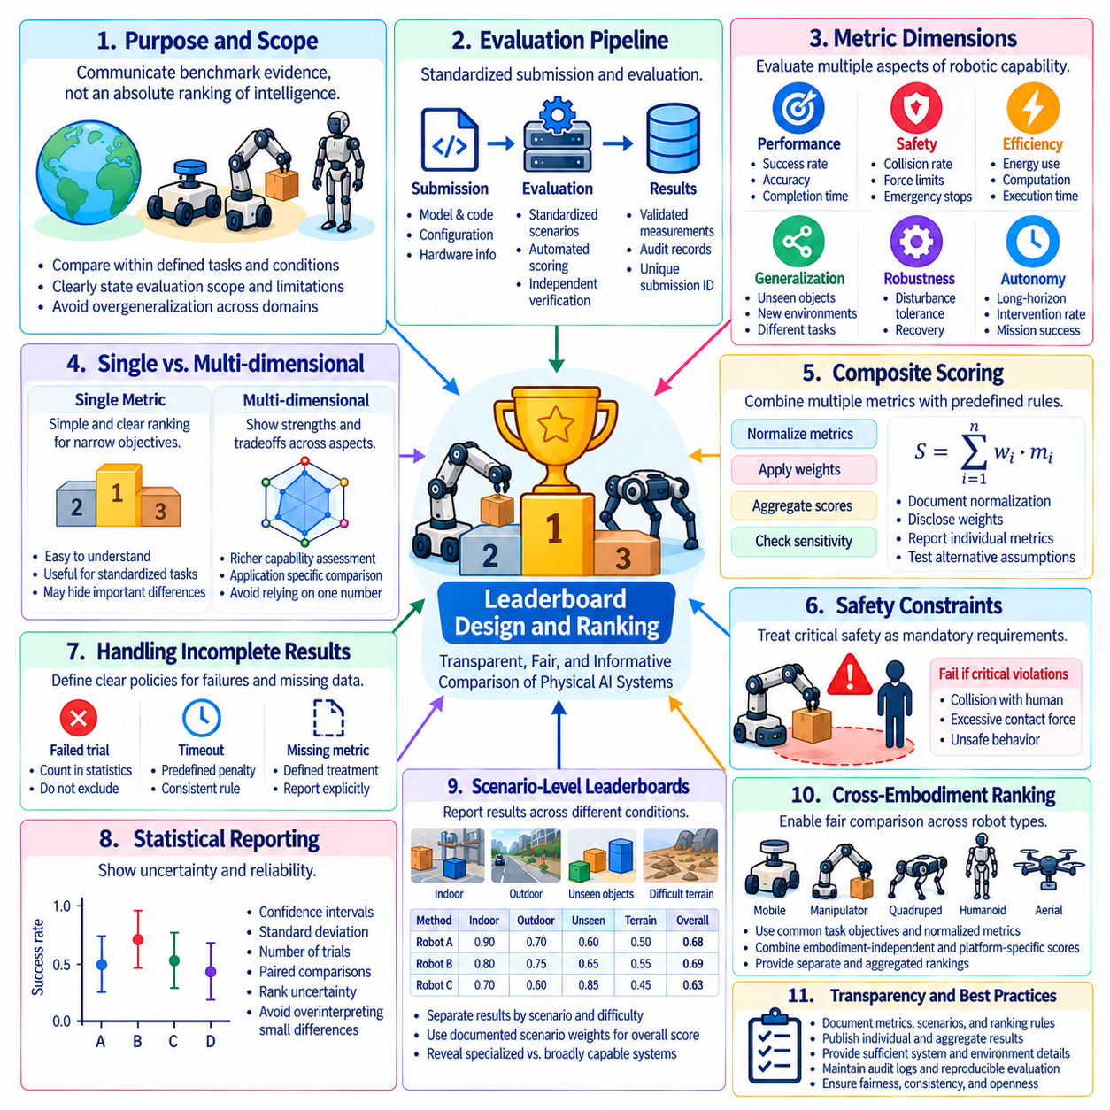
Leaderboard design and ranking are central to transforming Physical AI benchmark results into meaningful comparisons of robotic capability. A leaderboard organizes evaluation outcomes so researchers, developers, and system operators can identify strengths, weaknesses, and measurable progress. Unlike conventional software benchmarks, Physical AI leaderboards must account for physical interactions, safety constraints, hardware differences, and environmental variability. Effective design therefore requires transparent scoring rules and clearly defined evaluation objectives.
The primary purpose of a leaderboard is to communicate benchmark evidence rather than establish an absolute hierarchy of intelligence. Rankings summarize performance within specified tasks, scenarios, and operating conditions. A robot ranked first in warehouse navigation may not outperform another system in outdoor mobility or manipulation. Consequently, leaderboard descriptions should define the capabilities being evaluated and explain the limits of generalizing results beyond the benchmark's operational scope.
Leaderboard architecture begins with a standardized submission and evaluation pipeline. Each participating system should be identified by a unique submission record containing model version, software configuration, hardware information, and evaluation protocol. Official scores should originate from validated measurements rather than unverified self-reports. Automated evaluation services can calculate metrics consistently, while independent verification and audit records support confidence in published rankings.
A leaderboard may use a single primary metric when the benchmark objective is narrow and well defined. Task success rate, navigation completion, manipulation accuracy, or mission success can provide straightforward ranking criteria. However, reliance on one metric may conceal important differences in safety, efficiency, and generalization. Physical AI benchmarks should therefore publish supporting indicators even when a single value determines the displayed ranking.
Multidimensional leaderboards provide a broader representation of system capability. Performance, safety, efficiency, robustness, autonomy, and generalization can be presented as separate score categories. This approach allows users to compare systems according to their operational priorities instead of relying exclusively on an overall rank. A platform with moderate task performance but exceptional safety may be preferable for human-facing applications requiring conservative behavior.
Composite ranking methods combine several dimensions into a numerical score using predefined aggregation rules. Weighted averages, normalized utility functions, and hierarchical scoring structures are possible approaches. However, aggregation weights must reflect explicit evaluation objectives and should not be presented as universal measures of robotic intelligence. Benchmark organizers should disclose normalization procedures, weights, and sensitivity to alternative ranking assumptions.
Safety requirements may need to function as eligibility constraints rather than ordinary ranking components. A system that violates critical collision limits or human protection requirements should not automatically compensate for these failures through faster execution. Leaderboards can distinguish safety-qualified systems from submissions that fail mandatory acceptance criteria. Rankings among qualified systems can then emphasize performance and efficiency without weakening essential safety requirements.
Ranking policies must address missing measurements, incomplete evaluations, and unsuccessful trials. Excluding failed episodes can artificially improve reported performance, while assigning arbitrary scores to unavailable dimensions may distort comparisons. Benchmark protocols should define treatment of timeouts, aborted missions, invalid submissions, and unavailable metrics before evaluation. Clear rules ensure that all participants face consistent consequences for incomplete or unsuccessful execution.
Statistical uncertainty should be visible in leaderboard reporting because small numerical differences may not represent meaningful capability differences. Confidence intervals, trial counts, standard deviations, and paired comparisons can help users assess ranking reliability. A leaderboard may display numerical ordering while indicating that neighboring systems are statistically difficult to distinguish. Rank uncertainty and sensitivity analysis can further reveal whether the ordering remains stable across evaluation samples.
Ties and near-ties require explicit ranking policies. Systems with identical displayed scores may differ at higher numerical precision, but excessive precision can imply unsupported certainty. Organizers should establish rounding conventions, tie-breaking rules, and minimum meaningful differences. Where evidence is insufficient to distinguish systems, shared ranks or statistically informed ranking groups may communicate results more accurately than an artificially strict ordering.
Scenario-level leaderboards help expose performance differences hidden by aggregate scores. Separate views may report results for familiar environments, unseen objects, difficult terrain, sensor degradation, and long-horizon missions. Stratified reporting reveals whether high overall performance reflects broad competence or success concentrated in favorable conditions. Aggregate scores should document scenario weights so that changes in scenario composition do not silently alter ranking interpretations.
Cross-embodiment ranking introduces additional challenges because robotic platforms possess different physical capabilities and operating constraints. Manipulators, mobile robots, quadrupeds, and humanoids cannot always be compared through identical task metrics. Common functional objectives may support limited comparisons, while embodiment-specific categories preserve meaningful engineering distinctions. Leaderboards should avoid presenting hardware-dependent advantages as evidence of universally superior AI capability.
Hardware-aware leaderboards can improve transparency by reporting computational resources, actuator specifications, sensor configurations, and energy requirements. Separate ranking categories may distinguish unrestricted systems from resource-constrained deployments. This prevents comparisons between systems operating under fundamentally different computational budgets from being interpreted as purely algorithmic achievements. Hardware metadata also supports analysis of performance relative to practical deployment costs.
Submission frequency and evaluation access must be governed to prevent excessive adaptation to benchmark tests. Unlimited attempts against hidden evaluation servers can reveal information through repeated score feedback. Submission limits, evaluation quotas, controlled result disclosure, and periodic test refreshes can reduce this risk. Organizers should distinguish exploratory development submissions from official leaderboard entries and maintain transparent participation rules.
Leaderboard integrity depends on reliable identity management, result provenance, and auditability. Each published entry should link to a specific system configuration, evaluation version, and verified result record. Corrections should preserve historical information rather than silently overwrite earlier scores. Automated anomaly detection may identify suspicious submissions, inconsistent metadata, or unexpected performance changes, but disputed outcomes require documented review procedures.
Benchmark versioning is essential because tasks, environments, scoring rules, and evaluation infrastructure evolve. A score obtained under one benchmark version may not be directly comparable with a score produced under another. Leaderboards should clearly identify protocol versions and maintain historical snapshots when substantial changes occur. Migration procedures may include reevaluating reference systems to establish continuity without implying equivalence between incompatible scoring protocols.
Public and private leaderboard views can serve different purposes. Public rankings encourage community participation and provide visible progress indicators, while restricted evaluation records protect hidden tests and sensitive system information. Some benchmarks may permit confidential submissions through controlled execution services. Regardless of disclosure level, official rankings should provide enough methodological information to support informed interpretation and procedural accountability.
Leaderboard presentation should prioritize clarity over visual complexity. Users should be able to identify primary scores, supporting dimensions, uncertainty estimates, evaluation versions, and hardware categories without ambiguity. Filtering and comparison functions can support application-specific analysis, while downloadable results enable independent research. Explanatory notes should clarify metric direction, eligibility conditions, and limitations of comparisons across categories.
Leaderboard governance requires sustained oversight by benchmark maintainers and participating communities. Policies should address metric changes, participant eligibility, appeals, conflicts of interest, and retirement of outdated evaluations. Transparent decision records help maintain trust when rankings change or submissions are disqualified. Community feedback can improve benchmark relevance, but modifications should follow documented procedures that preserve scientific consistency.
Ultimately, Physical AI leaderboard design should emphasize credible evidence rather than competition for isolated numerical positions. Reliable rankings combine standardized evaluation, transparent scoring, safety-aware qualification, statistical uncertainty, hardware disclosure, and versioned governance. By presenting both comparative results and their limitations, well-designed leaderboards can guide research priorities, support engineering decisions, and encourage responsible progress toward deployable robotic intelligence.

08.11. Preventing Overfitting and Benchmark Gaming
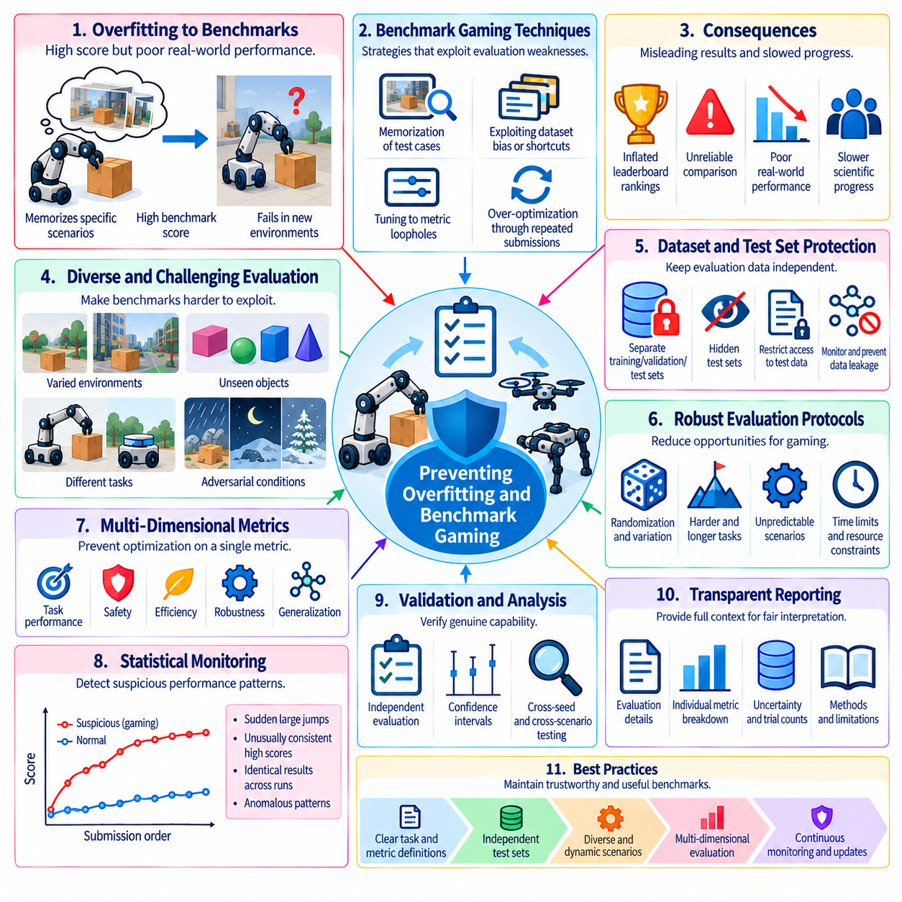
Preventing overfitting and benchmark gaming is essential for ensuring that Physical AI evaluations measure genuine robotic capability rather than adaptation to a particular test. Overfitting occurs when a system performs well on familiar benchmark conditions but fails under meaningful variations. Benchmark gaming arises when optimization exploits scoring rules or evaluation weaknesses without improving the intended capability. Both problems can produce misleading rankings and unreliable deployment decisions.
Physical AI benchmarks are especially vulnerable because tasks involve complex interactions among perception, control, hardware, and the environment. A robot may memorize object locations, exploit predictable obstacle patterns, or depend on simulator-specific dynamics. Such strategies can achieve impressive scores without demonstrating robust intelligence. Evaluation design must therefore distinguish task competence from familiarity with particular scenes, trajectories, and experimental configurations.
Repeated exposure to benchmark scenarios gradually transforms evaluation data into development information. Researchers may adjust models after observing public test results, even without directly accessing hidden examples. Over time, collective experimentation can produce community-level overfitting, where methods become specialized for widely used benchmarks. Maintaining independent test distributions and periodically introducing new scenarios helps preserve the ability to measure previously unseen capabilities.
Dataset contamination is another major threat to benchmark validity. Training corpora may contain evaluation images, robot demonstrations, environment maps, or task descriptions that overlap with protected tests. Foundation models trained on large heterogeneous datasets are particularly difficult to audit completely. Benchmark organizers should establish provenance requirements, contamination checks, and disclosure policies while recognizing that incomplete training records may limit definitive conclusions.
Hidden test sets reduce direct memorization but do not eliminate benchmark gaming. Repeated submissions can reveal information through aggregate scores, error messages, or detailed feedback. Participants may gradually infer which strategies succeed under protected conditions. Submission quotas, restricted feedback, and controlled evaluation access reduce this leakage. Hidden tests should complement broader evaluation diversity rather than serve as the only defense against overfitting.
Scenario diversity is one of the strongest protections against narrow specialization. Evaluations should vary object geometry, materials, lighting, terrain, sensor noise, obstacle arrangements, and interaction dynamics. Randomization must preserve task validity while introducing meaningful differences from training conditions. A benchmark that changes superficial appearances without modifying relevant physical challenges may overestimate generalization and encourage visually robust but physically fragile solutions.
Procedural generation can create large collections of evaluation scenarios while reducing dependence on fixed test instances. Parameterized environments may vary room layouts, object placements, motion patterns, and physical properties. However, procedural generators can themselves become predictable if their distributions are narrow or publicly replicated. Benchmark organizers should evaluate whether generated scenarios represent genuine task variation rather than merely different combinations of familiar templates.
Distribution shift testing measures how performance changes when evaluation conditions depart from development assumptions. In-distribution results should be complemented by tests involving unseen objects, unfamiliar environments, altered dynamics, and sensor degradation. Performance degradation curves can reveal capability boundaries more effectively than a single aggregate score. Evaluation reports should distinguish expected operational variation from deliberately extreme conditions outside the intended deployment domain.
Metric gaming occurs when a system optimizes the measured quantity while neglecting the underlying objective. A navigation policy might minimize travel time by taking unsafe shortcuts, while a manipulator might trigger a success detector without completing the intended physical operation. Such failures arise when scoring functions are incomplete proxies for task quality. Metrics should incorporate independent outcome verification, safety constraints, and execution quality where relevant.
Reward hacking represents a related problem in learning-based robotic systems. An agent may discover unintended behaviors that maximize reward without satisfying human expectations. In simulation, these behaviors can exploit collision models, numerical approximations, or reset mechanisms. Evaluation protocols should inspect representative trajectories and verify physical task completion independently of training rewards. Successful reward optimization must not automatically be interpreted as successful task execution.
Safety-aware evaluation limits the possibility of exchanging unacceptable risk for higher performance scores. Mandatory collision constraints, force limits, workspace boundaries, and emergency-stop requirements should remain effective regardless of task completion. Safety violations should be recorded independently and may invalidate otherwise successful trials. This approach prevents aggressive policies from dominating rankings merely because their failures are inadequately penalized.
Cross-simulator evaluation can reveal dependencies on particular physics engines or rendering pipelines. A policy trained and tested in one simulator may exploit contact approximations, deterministic timing, or sensor artifacts. Testing across independently configured simulation environments provides evidence about transferability, although simulator agreement does not establish real-world validity. Physical experiments remain necessary when claims concern actual robotic deployment.
Real-world evaluation provides an important defense against simulation-specific overfitting, but physical test sites can also become familiar. Repeated trials in the same laboratory may encourage memorization of floor conditions, object arrangements, and environmental landmarks. Rotating test configurations, varying equipment, and using independent facilities can reduce this dependence. Environmental variation must nevertheless remain controlled enough to support interpretable comparisons.
Cross-embodiment testing offers another way to examine whether learned capabilities depend on specific hardware configurations. Policies that transfer across different manipulators, mobile bases, or sensor arrangements may demonstrate broader representation learning. However, transfer should be evaluated against feasible tasks and documented adaptation budgets. Poor performance on physically incompatible platforms does not necessarily indicate benchmark overfitting or inadequate intelligence.
Benchmark gaming can also arise through selective reporting and experimental choices. Participants may publish only favorable random seeds, exclude difficult episodes, or report the best checkpoint from extensive evaluation attempts. Standardized trial counts, predefined stopping rules, and complete failure accounting reduce these opportunities. Official scores should be computed from controlled evaluation records rather than participant-selected subsets of results.
Statistical safeguards help prevent apparent improvements caused by random variation or repeated comparisons. Confidence intervals, paired evaluations, multiple-comparison adjustments, and independent replication can distinguish robust gains from accidental outcomes. Small score improvements should not be treated as meaningful when uncertainty remains substantial. Evaluation organizers should also monitor whether frequent leaderboard updates encourage optimization against statistical noise.
Adversarial and stress testing can identify strategies that perform well under normal conditions but fail when assumptions are challenged. Tests may introduce unexpected obstacles, delayed observations, communication interruptions, or unusual object interactions. These scenarios should target plausible failure mechanisms rather than arbitrary difficulty. The objective is to reveal weaknesses in decision-making and control while maintaining clear relationships to operational risks.
Benchmark governance must evolve as systems become increasingly specialized. Test-set refreshes, versioned protocols, independent audits, and documented submission policies help preserve evaluation integrity. New benchmark versions should introduce meaningful challenges while retaining enough reference measurements to interpret progress. Organizers must avoid changing evaluation rules solely to disadvantage particular participants, since fairness and scientific consistency are essential to community trust.
Ultimately, preventing overfitting and benchmark gaming requires combining diverse scenarios, protected evaluations, rigorous metrics, statistical controls, and independent verification. No single safeguard can guarantee that high benchmark scores represent general robotic competence. Strong evaluation systems continuously examine whether measured improvements transfer beyond familiar conditions. Their purpose is to reward reliable Physical AI capabilities rather than mastery of isolated scoring procedures.

08.12. Benchmark Versioning and Lifecycle
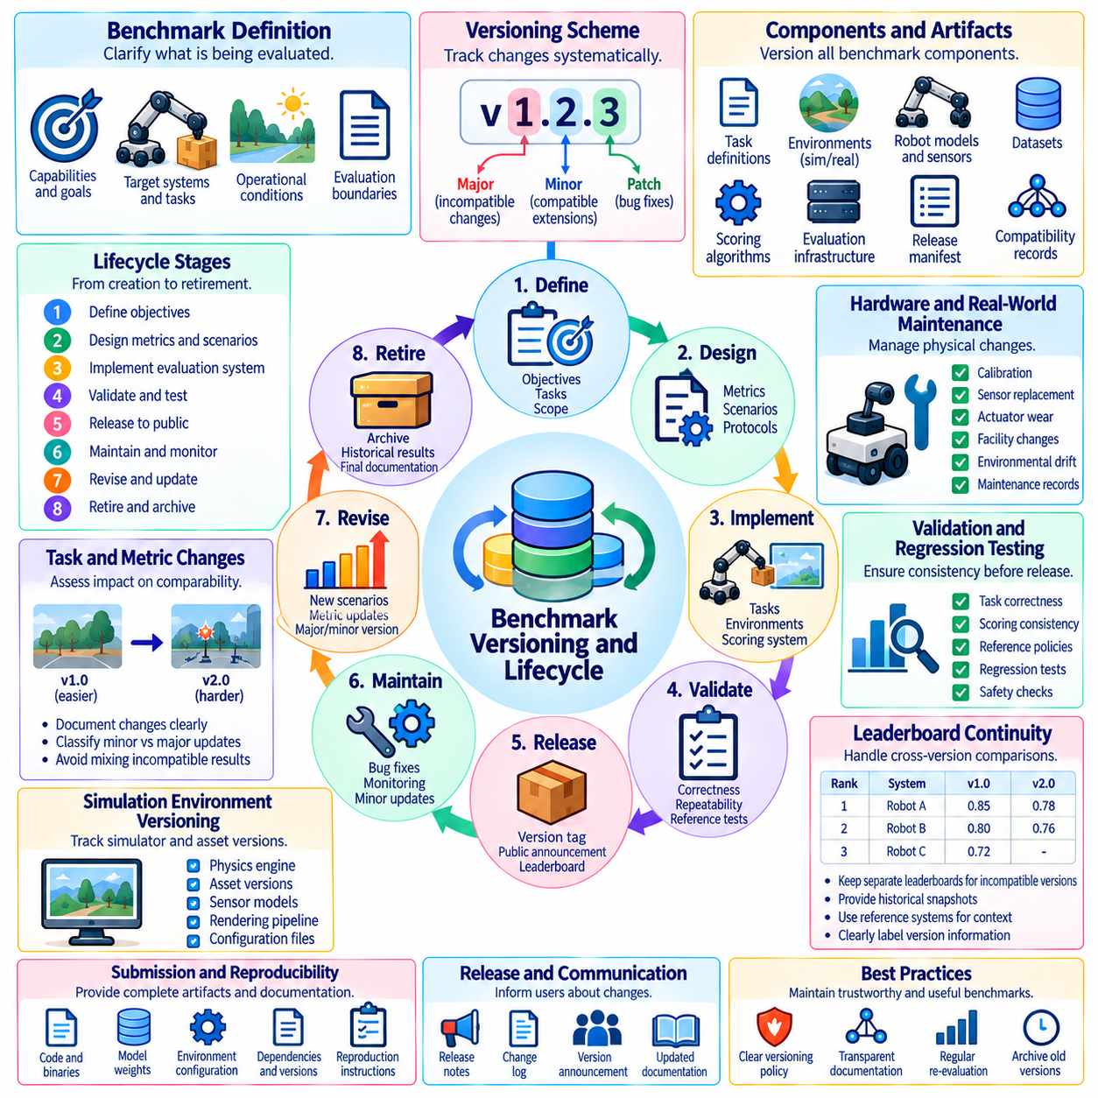
Benchmark versioning and lifecycle management are essential for maintaining the scientific validity and long-term usefulness of Physical AI evaluations. Benchmarks must evolve as robotic capabilities, simulation technologies, hardware platforms, and operational requirements change. However, uncontrolled modifications can invalidate historical comparisons and undermine leaderboard credibility. A structured lifecycle ensures that evaluation improvements remain traceable, reproducible, and consistent with established objectives.
A benchmark lifecycle begins with defining its intended capabilities, target systems, operational conditions, and evaluation boundaries. Developers should identify the tasks being measured, expected sources of variability, and assumptions underlying scoring procedures. These specifications establish a reference against which future modifications can be assessed. Without a stable initial definition, subsequent changes may alter the meaning of benchmark scores without clear documentation.
Benchmark development typically progresses through design, implementation, validation, release, maintenance, revision, and eventual retirement. During design, evaluation objectives and metrics are established. Implementation converts specifications into executable tasks and scoring services. Validation examines correctness, repeatability, and sensitivity to relevant capabilities. Public release introduces controlled participation, while maintenance addresses defects and emerging evaluation needs.
Version identifiers provide a systematic way to distinguish benchmark configurations. A semantic versioning approach may classify changes as major, minor, or corrective, although the exact convention should be defined by benchmark governance. Major versions may introduce incompatible scoring rules or task distributions. Minor versions may extend compatible evaluation coverage, while corrective releases address implementation defects without intentionally changing the measured construct.
Versioning must extend beyond software code because Physical AI benchmarks depend on multiple interconnected components. Relevant artifacts include scenario definitions, simulation environments, robot models, sensor configurations, datasets, scoring algorithms, and evaluation infrastructure. Each component should have an identifiable revision and documented compatibility relationship. A benchmark release manifest can connect these revisions into a reproducible evaluation configuration.
Changes to task definitions require careful assessment because they may modify the capabilities being measured. Increasing navigation difficulty, changing manipulation tolerances, or introducing new safety constraints can alter benchmark outcomes even when scoring software remains unchanged. Such modifications should be classified according to their effect on comparability. If the task distribution changes substantially, historical scores should not be treated as directly interchangeable.
Metric versioning is equally important because scoring definitions determine how observed behavior becomes numerical evidence. Modifying success thresholds, normalization methods, penalty weights, or aggregation formulas may change rankings without changing robot performance. Benchmark maintainers should document each metric revision and evaluate its impact using reference submissions. When scoring semantics change, a new score series or benchmark version is generally necessary.
Simulation environments introduce additional version dependencies. Updates to physics engines, collision handling, rendering pipelines, or sensor models can affect robotic behavior. Even changes intended to improve realism may invalidate earlier comparisons. Evaluation teams should maintain simulator compatibility records and perform regression tests using representative policies. Significant changes require controlled revalidation rather than assuming numerical continuity.
Real-world benchmarks face lifecycle challenges involving physical equipment and environmental drift. Robot wear, sensor recalibration, actuator replacement, facility modifications, and changing surface conditions can alter measured performance. Maintenance records should identify these changes and determine whether reference measurements remain valid. Periodic calibration and standardized inspection procedures help distinguish genuine system improvements from changes in the evaluation apparatus.
Benchmark validation should occur before every official release. Test procedures should verify task correctness, scoring consistency, interface compatibility, statistical behavior, and safety controls. Reference systems representing different performance levels can reveal unexpected ranking changes. Validation must also examine whether new scenarios introduce unintended shortcuts or impossible conditions. Release approval should depend on documented evidence rather than successful execution alone.
Regression testing provides continuity across benchmark revisions. A stable collection of reference policies and test scenarios can detect changes in outcomes caused by software updates or environment modifications. Differences should be investigated before publishing revised scores. However, regression tests cannot prove full equivalence between versions, especially when evaluation distributions change. Their purpose is to identify unexpected behavior and support informed compatibility decisions.
Leaderboard continuity requires explicit policies for comparing results across versions. Scores generated under incompatible protocols should be displayed separately or clearly labeled as historical. Re-evaluating selected reference systems can provide contextual links between releases, but conversion formulas should not be assumed valid without evidence. Historical leaderboard snapshots preserve research records and allow users to understand progress within each evaluation regime.
Test-set refreshes are necessary when benchmarks become saturated or vulnerable to overfitting. New scenarios can restore evaluation difficulty and reduce dependence on widely memorized examples. However, refresh procedures should preserve the benchmark's intended construct rather than introduce arbitrary novelty. Organizers may maintain protected holdout sets, rotate scenario families, or introduce new challenge tracks while documenting the resulting changes in evaluation scope.
Backward compatibility can reduce adoption costs when changes do not affect essential evaluation semantics. Stable submission interfaces, documented migration paths, and transitional support allow researchers to update existing systems. Nevertheless, compatibility should not prevent necessary improvements in safety, validity, or measurement quality. Benchmark maintainers should distinguish interface compatibility from score comparability, since an unchanged interface does not guarantee equivalent evaluation outcomes.
Deprecation policies establish how outdated benchmark versions are phased out. A deprecated version may remain accessible for historical reproduction while no longer accepting official submissions. Organizers should announce retirement schedules, identify replacement versions, and preserve essential documentation. When possible, archived evaluation environments and reference artifacts should remain available. Security, licensing, and infrastructure limitations may constrain long-term execution support.
Lifecycle governance requires clear ownership and documented decision-making authority. Maintainers should define procedures for proposing changes, reviewing technical evidence, approving releases, and resolving disputes. Community participation can identify emerging capabilities and benchmark weaknesses, while independent review can reduce conflicts of interest. Version changes should follow published criteria rather than respond selectively to particular leaderboard participants.
Change documentation is essential for scientific traceability. Release notes should explain modified tasks, metrics, environments, interfaces, and scoring procedures, together with their expected effects. Machine-readable manifests can support automated compatibility checks and archival workflows. Every published score should reference the exact benchmark configuration used during evaluation. This connection allows future researchers to reconstruct the conditions under which reported performance was obtained.
Long-term benchmark maintenance also requires monitoring relevance. A benchmark may become less informative when most systems approach perfect scores, when tasks no longer reflect deployment needs, or when emerging robot architectures exceed its original scope. Capability coverage analysis, failure-pattern reviews, and stakeholder feedback can guide revisions. Retirement may be preferable when continued modifications would fundamentally transform the benchmark's original purpose.
Ultimately, benchmark versioning and lifecycle management balance scientific continuity with technological progress. Stable identifiers, controlled releases, regression testing, transparent governance, and historical archives preserve the meaning of evaluation results. At the same time, planned updates allow benchmarks to address new Physical AI capabilities and operational risks. A well-managed lifecycle ensures that leaderboards remain credible records of progress rather than collections of incomparable scores.

08.13. Open vs Closed Benchmark Infrastructure
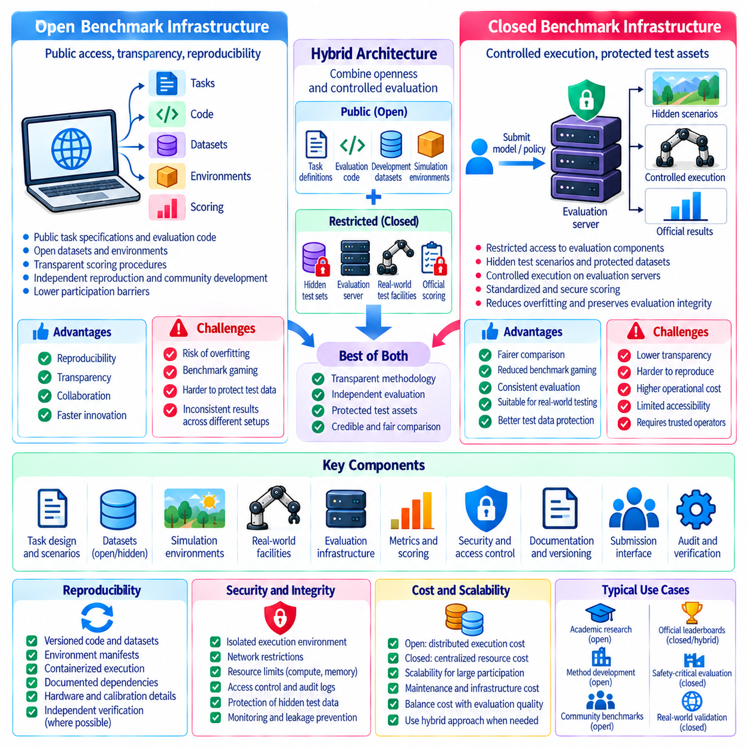
Open and closed benchmark infrastructures represent different approaches to organizing, executing, and governing Physical AI evaluations. Open infrastructure emphasizes accessibility, transparency, and independent reproduction, while closed infrastructure emphasizes controlled execution, protected test assets, and evaluation integrity. Neither approach is universally superior. Their suitability depends on benchmark objectives, safety requirements, intellectual property constraints, and the degree of trust required for official performance claims.
Open benchmark infrastructure typically provides public access to task specifications, evaluation code, simulation environments, datasets, and scoring procedures. Researchers can inspect implementation details, reproduce experiments, and develop compatible evaluation tools. This openness encourages collaboration and accelerates methodological improvements. However, unrestricted access to evaluation materials may also increase the risk of overfitting and benchmark-specific optimization.
Closed benchmark infrastructure restricts access to selected evaluation components, including hidden test scenarios, protected datasets, execution environments, or scoring services. Participants may submit models or executable policies to a controlled evaluation server without observing the complete test configuration. This arrangement helps preserve independent assessment and limits direct memorization. Nevertheless, restricted access can reduce transparency and complicate external verification.
The distinction between open and closed infrastructure is not necessarily binary. A benchmark may publish task definitions and scoring algorithms while protecting final evaluation scenarios. Another may release development datasets but retain private hardware facilities for official testing. Hybrid architectures combine transparent methodology with controlled test execution. Their design should specify which components are public, restricted, independently auditable, or available only to authorized operators.
Reproducibility is a major advantage of open benchmark systems. Public software repositories, versioned datasets, environment manifests, and documented dependencies allow independent groups to reconstruct evaluation conditions. Containerized execution and standardized interfaces further reduce configuration differences. However, reproducibility requires more than code availability. Hardware assumptions, random seeds, calibration procedures, and simulator versions must also be documented.
Closed evaluation systems can support reproducibility through controlled execution and rigorous internal records. Identical infrastructure configurations, fixed scoring procedures, and standardized submission interfaces reduce variability among participants. Independent auditors may verify implementation integrity without receiving unrestricted access to protected assets. Such arrangements provide procedural reproducibility, although they cannot fully replace publicly inspectable experimental evidence.
Benchmark security becomes increasingly important when official rankings influence research funding, procurement decisions, or commercial adoption. Open test materials may enable participants to optimize directly against evaluation instances. Closed systems reduce this exposure but introduce risks involving unauthorized access, information leakage, and infrastructure compromise. Security policies should address submission isolation, access permissions, audit logging, and protection of confidential evaluation assets.
Hidden evaluation servers offer a common implementation of controlled benchmark infrastructure. Participants upload trained models, policies, or executable containers that are evaluated against protected scenarios. The server computes standardized metrics and returns approved results. Execution environments should enforce resource limits, network restrictions, and deterministic configuration where appropriate. These controls help prevent unauthorized data extraction and inconsistent evaluation conditions.
Physical AI introduces infrastructure challenges that extend beyond conventional machine learning benchmarks. Robotic evaluation may require real-time control, physics simulation, sensor synchronization, actuator interfaces, and physical safety monitoring. A centralized evaluation platform must support these requirements without introducing systematic advantages for particular architectures. Hardware compatibility and timing constraints should therefore be treated as explicit benchmark design parameters.
Real-world closed testing facilities can provide standardized robotic equipment and controlled operational environments. Independent laboratories may evaluate submitted systems using calibrated sensors, consistent task arrangements, and supervised safety procedures. Such facilities are valuable when direct physical interaction determines performance. However, limited facility capacity, equipment costs, geographic accessibility, and scheduling constraints can restrict participation and slow evaluation cycles.
Open infrastructure can reduce participation barriers by enabling local experimentation and decentralized testing. Researchers with modest resources may evaluate algorithms using publicly available simulators and reference tasks. Distributed contributions can improve scenario coverage and identify implementation defects. Nevertheless, differences in computing hardware, simulator configurations, and physical equipment can produce inconsistent results unless conformance requirements and validation procedures are enforced.
Cost and scalability strongly influence infrastructure selection. Open benchmarks distribute execution costs across participants but may require substantial maintenance of documentation and software compatibility. Closed benchmarks centralize evaluation expenses, including computing resources, storage, security, and operational support. Physical testing adds equipment maintenance and personnel costs. Sustainable governance should establish funding models that preserve evaluation quality without creating unnecessary barriers.
Transparency and confidentiality must be balanced when evaluating proprietary robotic systems. Commercial participants may be unwilling to disclose model weights, control software, or detailed hardware designs. Closed execution environments can protect sensitive submissions while producing independently verified results. However, confidentiality should not prevent disclosure of essential evaluation conditions, metric definitions, or limitations. Public claims require sufficient evidence for meaningful interpretation.
Fairness depends on consistent access rules and equivalent evaluation opportunities. Closed infrastructures should publish submission limits, eligibility requirements, evaluation schedules, and appeal procedures. Open infrastructures should document supported configurations and acceptable deviations from reference implementations. Both approaches must prevent privileged participants from receiving undisclosed information or preferential treatment. Independent governance can strengthen confidence in the neutrality of evaluation operations.
Data governance introduces additional considerations involving licensing, privacy, intellectual property, and retention policies. Open datasets require clear redistribution rights and documentation of collection conditions. Closed datasets require secure storage, authorized access, and defined retention periods. Physical AI recordings may contain information about people, facilities, or sensitive operational environments. Benchmark infrastructure should incorporate appropriate access controls and data minimization practices.
A practical hybrid architecture may separate development, qualification, and official evaluation stages. Public simulation tasks support algorithm development and preliminary comparison. Restricted validation scenarios assess robustness and detect benchmark-specific overfitting. Official evaluation then uses protected test distributions or supervised physical experiments. This layered approach encourages reproducibility while maintaining independent evidence for final rankings.
Infrastructure interoperability is important for long-term benchmark adoption. Standardized submission interfaces, machine-readable metadata, common metric schemas, and portable execution packages allow evaluation systems to exchange results and artifacts. Compatibility with established robotics middleware and simulation formats can reduce integration costs. However, interface standardization should not obscure differences in physical embodiment, resource budgets, or evaluation assumptions.
Ultimately, open and closed benchmark infrastructures should be selected according to the evidence they must produce and the risks they must control. Open systems promote accessibility, transparency, and collaborative improvement, while closed systems protect independent testing and sensitive evaluation assets. Hybrid designs can combine these advantages through public specifications, controlled execution, and independent auditing. Credible Physical AI benchmarking depends on clearly documented boundaries, consistent procedures, and trustworthy governance.

08.14. Standards Organizations and Community Benchmarks
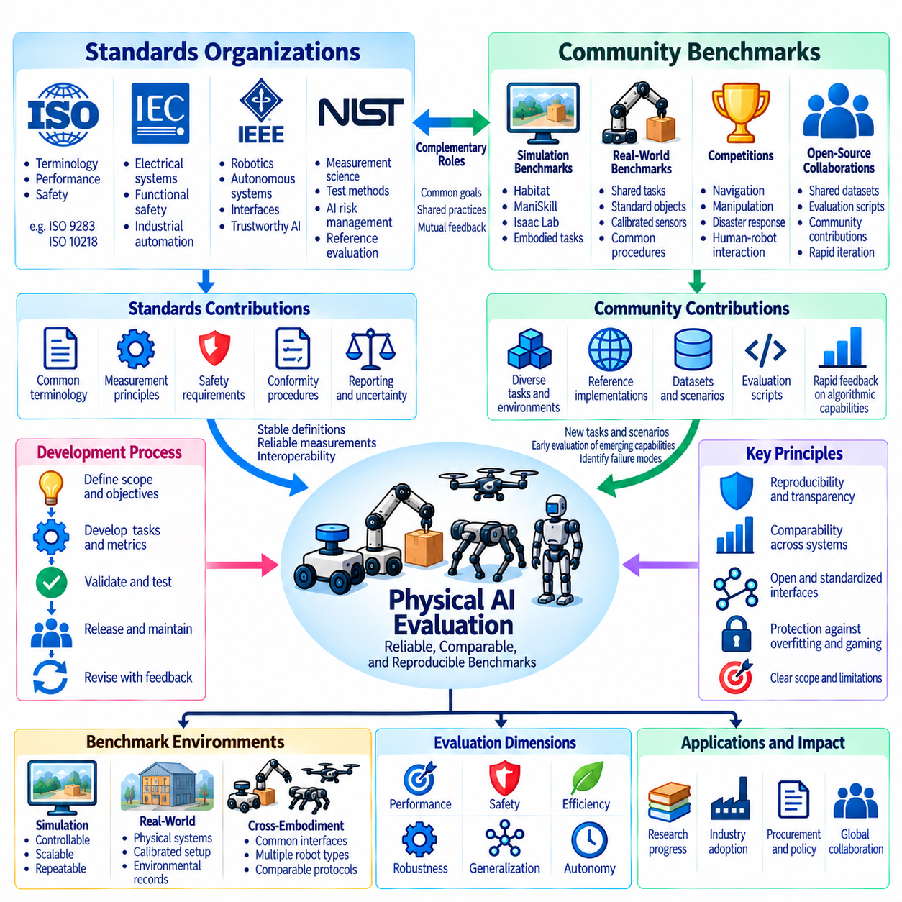
Standards organizations and community benchmarks play complementary roles in establishing credible evaluation practices for Physical AI. Standards organizations develop shared terminology, measurement principles, safety requirements, and conformity procedures, while research communities create experimental tasks and rapidly evolving benchmark suites. Their collaboration can transform isolated research results into comparable evidence of robotic capability across institutions, platforms, and deployment environments.
Standardization is particularly important because Physical AI combines artificial intelligence with mechanical systems, sensing, actuation, and environmental interaction. Evaluation results depend on hardware configurations, operational conditions, and experimental procedures as well as learned algorithms. Without common definitions, identical metric names may represent different measurements. Standards provide a foundation for specifying evaluation boundaries, test conditions, uncertainty, and reporting requirements.
The International Organization for Standardization, or ISO, develops standards relevant to industrial and service robotics, including terminology, safety, and performance measurement. ISO 9283 addresses performance criteria and related test methods for industrial robots, while ISO 10218 concerns industrial robot safety. These standards do not constitute comprehensive AI intelligence benchmarks, but they illustrate how repeatable physical measurements and safety requirements can support systematic robotic evaluation.
The International Electrotechnical Commission, or IEC, contributes standards involving electrical systems, functional safety, and industrial automation. ISO and IEC also collaborate through joint technical structures addressing artificial intelligence and related technologies. For Physical AI, these activities provide important connections between algorithmic evaluation and dependable system operation. Benchmark designers should distinguish compliance with established standards from experimental evidence of learned robotic competence.
The Institute of Electrical and Electronics Engineers, or IEEE, contributes standards and technical initiatives involving robotics, autonomous systems, software engineering, and trustworthy AI. IEEE activities can help establish common interfaces, terminology, and evaluation principles across heterogeneous systems. Their relevance depends on the specific standard and application domain. Benchmark developers should identify applicable published requirements rather than treating organizational affiliation as evidence of formal certification.
The National Institute of Standards and Technology, or NIST, contributes measurement science, reference methods, and evaluation frameworks relevant to robotics and artificial intelligence. Its work on robot performance measurement, test methods, and AI risk management demonstrates the value of reproducible procedures and documented uncertainty. Such frameworks can inform Physical AI benchmarks without replacing task-specific validation. Independent measurement methods are especially valuable when benchmark results influence procurement or deployment decisions.
Standards organizations and academic benchmark communities generally operate on different development timescales. Formal standards require structured review, stakeholder consensus, and controlled revision, while community benchmarks can introduce new tasks as research advances. Rapid experimentation is valuable for emerging capabilities, but unstable protocols can weaken comparability. A productive relationship allows community experiments to identify useful measurement methods before selected practices mature into standardized procedures.
Community benchmarks frequently emerge from universities, research laboratories, open-source collaborations, and robotics competitions. They provide shared environments, task definitions, reference implementations, and evaluation scripts that reduce duplication across research groups. Public participation enables rapid identification of difficult scenarios and algorithmic weaknesses. However, community popularity alone does not establish measurement validity, statistical reliability, or suitability for safety-critical applications.
Simulation benchmark ecosystems such as Habitat, ManiSkill, and Isaac Lab illustrate different approaches to evaluating embodied navigation, manipulation, and robotic learning. Their environments support repeatable experiments and structured task variation, although their objectives and scoring conventions differ. Benchmark comparisons must therefore account for simulation assumptions, embodiment constraints, and dataset composition. Results from one ecosystem should not automatically be interpreted as equivalent to results from another.
Real-world community benchmarks introduce additional challenges involving physical reproducibility and experimental resources. Shared manipulation tasks, standardized objects, calibrated sensors, and common trial procedures can improve comparisons across laboratories. Nevertheless, differences in robot wear, lighting, floor conditions, and operator intervention can affect results. Community protocols should record these factors and establish acceptable tolerances so that performance differences can be interpreted with appropriate confidence.
Robotics competitions provide another mechanism for developing evaluation practices. Challenges involving autonomous navigation, manipulation, disaster response, and human-robot interaction expose systems to complex operational conditions. Competitive events can reveal failure modes that controlled laboratory tests overlook. However, competition scores may reflect event-specific constraints, hardware investment, or tactical optimization. Their value as scientific benchmarks depends on transparent rules and reproducible evaluation evidence.
A central standardization challenge is defining common metrics without suppressing differences among robot embodiments. Success rate, completion time, collision frequency, energy consumption, and intervention count can provide useful shared measurements. Yet their interpretation depends on task difficulty, payload, mobility configuration, and operational context. Standards should specify measurement semantics and reporting requirements while permitting application-specific thresholds and embodiment-aware evaluation categories.
Interoperability between benchmark infrastructures can be improved through common data schemas, machine-readable task descriptions, standardized submission interfaces, and explicit metadata requirements. Shared representations of trajectories, observations, actions, failures, and environmental conditions facilitate cross-platform analysis. However, common formats do not guarantee equivalent physical meaning. Coordinate conventions, control frequencies, sensor calibration, and actuator limits must remain explicit to prevent misleading comparisons.
Governance determines whether community benchmarks remain credible as participation increases. Transparent policies should address dataset access, submission limits, metric revisions, conflict resolution, and benchmark retirement. Independent review committees can evaluate proposed changes and investigate irregular results. Standards organizations may provide procedural guidance, while research communities contribute practical implementation experience. Effective governance requires clear authority without unnecessarily restricting open participation.
Benchmark certification and formal conformity assessment should be distinguished from ordinary leaderboard participation. A high score demonstrates performance under specified evaluation conditions but does not automatically establish compliance with safety regulations or technical standards. Formal conformity claims require applicable requirements, documented evidence, and appropriate assessment procedures. Physical AI evaluation frameworks should clearly separate research performance rankings, engineering qualification, and regulatory compliance.
International collaboration can reduce fragmentation among regional and institutional benchmarking initiatives. Shared terminology, reference tasks, reporting templates, and calibration procedures make results easier to interpret across laboratories. Cross-institutional replication can reveal hidden assumptions and measurement biases. However, global coordination must accommodate different regulatory environments, available hardware, and application priorities. Common principles are often more sustainable than enforcing a single universal benchmark.
Future standardization efforts will increasingly need to address adaptive policies, foundation models, vision-language-action systems, and long-horizon autonomous behavior. Traditional robot performance measurements remain necessary but cannot fully characterize learning, generalization, recovery, or decision-making under uncertainty. Community benchmarks can explore these emerging dimensions through experimental protocols. Mature methods may subsequently support broader standardization when their validity, repeatability, and operational relevance are established.
Ultimately, trustworthy Physical AI evaluation requires both the stability of formal standards and the adaptability of community benchmarks. Standards contribute consistent terminology, measurement discipline, safety expectations, and governance principles. Community initiatives contribute challenging tasks, open experimentation, and rapid methodological innovation. Their integration can establish an evaluation ecosystem in which benchmark scores become reproducible, interpretable, and useful evidence for responsible robotic development.

08.15. Toward Physical AI Capability Levels
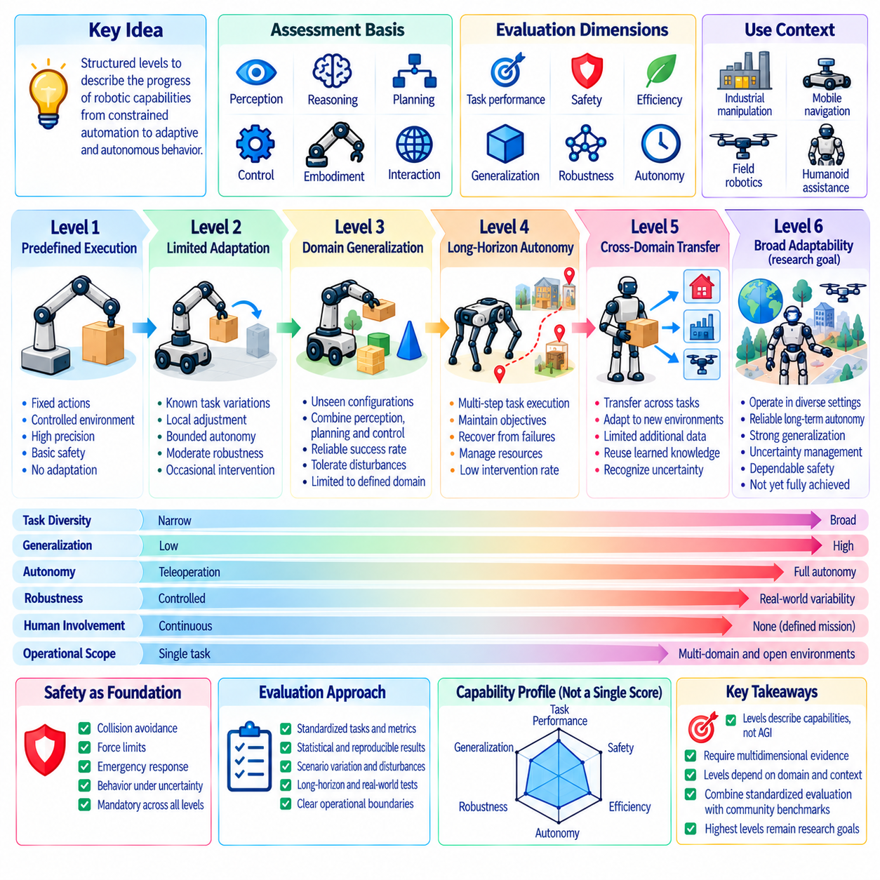
Physical AI capability levels provide a structured approach to describing how robotic systems progress from narrowly constrained automation toward increasingly adaptive and autonomous behavior. Unlike conventional performance rankings, capability levels aim to characterize the scope, reliability, and independence of demonstrated competence. A useful framework must connect measurable evaluation outcomes with operational meaning while avoiding unsupported claims about general intelligence.
Capability classification is challenging because robotic intelligence depends on perception, reasoning, planning, control, embodiment, and physical interaction. A system may demonstrate advanced manipulation while remaining limited in navigation or environmental understanding. Consequently, capability levels should not be inferred from a single benchmark score. They require evidence across multiple dimensions, including task diversity, generalization, safety, autonomy, and operational robustness.
A capability framework should begin by defining its assessment domain and intended deployment context. Industrial manipulation, mobile navigation, field robotics, and humanoid assistance impose different physical requirements. Common evaluation principles can support comparison, but identical thresholds may not be appropriate across embodiments. Each capability designation should identify the tasks, environments, hardware assumptions, and operational boundaries under which it applies.
An illustrative initial level may describe systems that execute predefined actions under tightly controlled conditions. Such systems rely on fixed trajectories, structured workspaces, or explicit human supervision. They can achieve high precision and repeatability without demonstrating substantial adaptation. Evaluation at this level emphasizes deterministic execution, basic safety compliance, and reliable completion of narrowly specified tasks.
A subsequent level may represent systems capable of limited adaptation within known task families. These robots can respond to moderate variations in object placement, environmental geometry, or sensor observations without complete reprogramming. Their autonomy remains bounded by predefined procedures and recovery options. Benchmarks should measure variation tolerance, successful local adjustments, and the frequency of required human intervention.
An intermediate capability level may describe robots that generalize across unfamiliar configurations within a defined operational domain. Such systems can combine perception, planning, and feedback control to handle previously unseen task instances. Evaluation should include held-out environments, changed object properties, and disturbances that were not explicitly represented during development. Success must remain statistically reliable rather than depend on favorable examples.
Higher capability levels may involve long-horizon autonomy and coordinated execution of multiple interdependent tasks. Robots must maintain objectives, monitor progress, recover from local failures, and manage resources over extended operation. Evaluation should examine mission completion, intervention frequency, recovery effectiveness, and accumulated risk. Strong short-duration performance alone cannot establish competence in continuous autonomous operation.
A more advanced level may characterize systems that transfer knowledge across task families, environments, or compatible embodiments. Such robots could reuse learned representations, adapt policies with limited additional data, and recognize when prior knowledge is insufficient. Transfer performance should be measured using explicit adaptation budgets and previously unseen conditions. Generalization claims must distinguish genuine knowledge transfer from extensive retraining or hidden task-specific engineering.
The highest proposed capability categories may concern broadly adaptable robotic systems that operate across diverse physical situations while maintaining dependable safety and autonomy. These categories remain research objectives rather than established universal certifications. Evaluation would require extensive evidence of task transfer, uncertainty management, recovery, and operational reliability. No current benchmark suite should be assumed sufficient to demonstrate unrestricted physical intelligence.
Capability levels should be understood as multidimensional profiles rather than a rigid ladder of intelligence. A robot may exhibit high autonomy in navigation but limited manipulation generalization, or excellent safety performance with restricted task diversity. Reporting separate capability dimensions preserves these distinctions. Composite levels may be useful for communication, but their aggregation rules and minimum qualification requirements must be transparent.
Safety should function as a foundational qualification requirement across every capability level. Increasing autonomy expands the consequences of incorrect decisions, unsafe interactions, and inadequate recovery mechanisms. Evaluations must therefore consider collision avoidance, force limitations, emergency responses, and behavior under uncertainty. Higher task success cannot compensate automatically for unacceptable risk, and capability advancement should require evidence of dependable safety controls.
Human involvement provides an important indicator of operational independence. Systems may require continuous teleoperation, occasional supervisory commands, exception handling, or no intervention during a defined mission. Capability assessment should distinguish these forms of assistance and record their frequency, duration, and operational significance. A robot that succeeds through frequent human corrections should not receive the same autonomy designation as one that independently completes equivalent tasks.
Generalization boundaries are equally important when assigning capability levels. Evaluation should vary task instances, object properties, environmental conditions, and disturbance patterns while preserving operational relevance. Hidden tests and independent facilities can reduce benchmark-specific specialization. Capability claims should specify where performance has been demonstrated and where evidence remains insufficient. A defined operational envelope is more informative than an unrestricted autonomy label.
Statistical qualification prevents isolated demonstrations from being mistaken for stable capability. Each level should require sufficient trials, uncertainty estimates, and repeatability across relevant scenarios. Confidence intervals and failure distributions can support threshold decisions, particularly near classification boundaries. Independent replication strengthens confidence that observed performance reflects system competence rather than favorable evaluation conditions or experimental selection.
Capability assessment should also account for hardware constraints and embodiment differences. Sensor quality, actuator performance, computing resources, and mechanical morphology influence achievable behavior. Classification protocols should disclose these factors and avoid attributing all observed performance to learned intelligence. Domain-specific capability tracks may provide fairer comparisons while maintaining common reporting principles for autonomy, safety, robustness, and adaptation.
A practical qualification process can combine simulation screening, controlled physical testing, and extended operational trials. Simulation supports broad scenario coverage and repeatable stress testing, while physical experiments establish evidence of real-world interaction. Long-duration trials reveal accumulated failures and intervention requirements. Advancement between levels should depend on meeting documented criteria across these stages rather than achieving a single impressive demonstration.
Governance is necessary to prevent capability labels from becoming marketing claims disconnected from evidence. Standards organizations, benchmark maintainers, independent laboratories, and application stakeholders can contribute to defining qualification criteria. Versioned protocols should document changes in tasks, thresholds, and assessment procedures. Capability certificates, where formally established, must remain distinct from research leaderboard rankings and regulatory safety approvals.
Ultimately, Physical AI capability levels should translate complex benchmark evidence into interpretable descriptions of operational competence. Their value depends on measurable criteria, multidimensional reporting, explicit safety requirements, and clearly bounded generalization claims. As robotics advances, classification frameworks must evolve through independent validation and transparent governance. The objective is not to assign universal intelligence labels, but to communicate what robotic systems can reliably accomplish under specified physical conditions.

08.16. Automated Leaderboard and Scoring [w/Code]
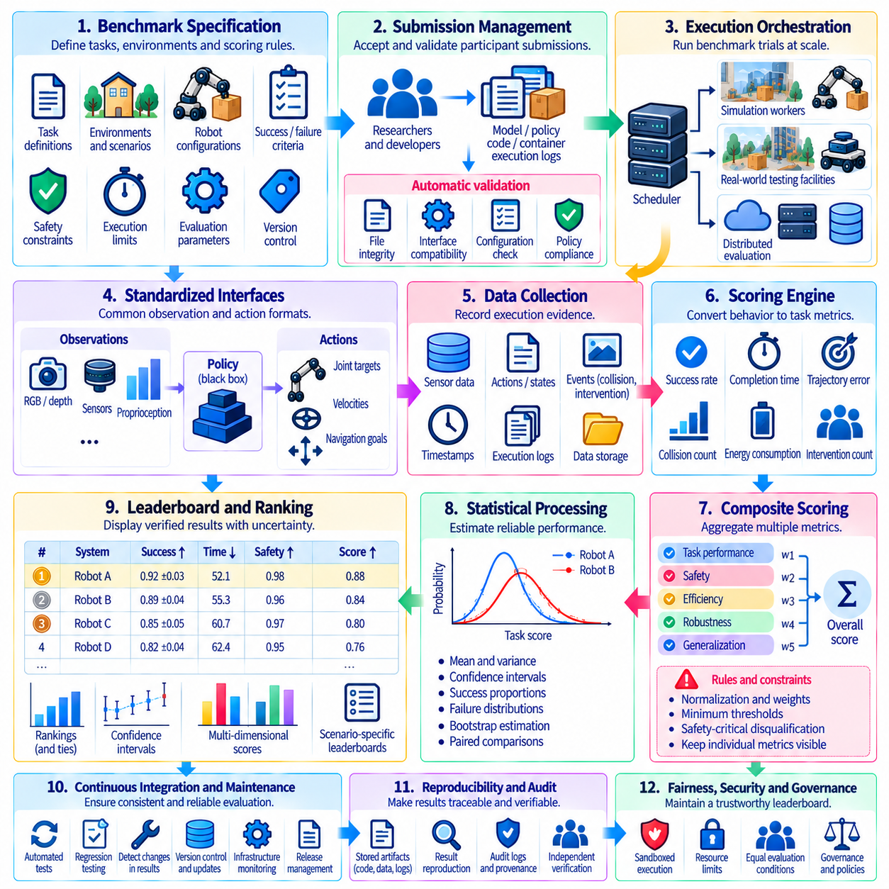
Automated leaderboard and scoring infrastructure provides a systematic foundation for evaluating Physical AI systems at scale. It transforms robotic execution records into standardized performance measurements, verified scores, and continuously maintained rankings. Automation reduces manual calculation errors and improves consistency across submissions. However, trustworthy results require more than automated computation; evaluation protocols, data integrity, statistical validity, and governance must remain explicitly defined.
An automated evaluation pipeline begins with a formal benchmark specification describing tasks, environments, robot configurations, and scoring criteria. Each task should define initial conditions, completion requirements, failure conditions, safety constraints, and execution limits. Machine-readable specifications allow evaluation services to interpret these requirements consistently. Version identifiers ensure that submitted results remain associated with the exact benchmark configuration used during testing.
Submission management establishes the entry point for participating systems. Researchers may provide trained models, executable policies, software containers, or verified execution logs, depending on benchmark requirements. Each submission should include metadata identifying the algorithm, software dependencies, hardware assumptions, and permitted computational resources. Automated validation checks file integrity, interface compatibility, configuration completeness, and compliance with submission policies before evaluation begins.
Execution orchestration coordinates benchmark trials across simulation environments or physical testing facilities. A scheduler assigns tasks, initializes environments, launches policies, and records execution outcomes. Distributed workers can evaluate independent scenarios concurrently, improving throughput for large benchmark suites. However, scheduling policies must prevent resource contention, timing interference, and unequal computational conditions from introducing systematic advantages among participants.
Standardized execution interfaces separate robotic policies from benchmark infrastructure. Observation messages may contain camera images, depth measurements, proprioceptive states, and environmental information. Action interfaces specify commands such as joint targets, velocities, forces, or navigation goals. Interface contracts should define coordinate systems, control frequencies, timing requirements, and error handling. These specifications enable heterogeneous algorithms to participate under comparable conditions.
Automated data collection captures the evidence required for scoring and independent verification. Evaluation records may include sensor observations, issued actions, robot states, collision events, task transitions, timestamps, and intervention logs. Structured event schemas support consistent interpretation across scenarios. Raw records should be retained when practical, while derived summaries reduce storage requirements. Data provenance connects every reported score to its underlying execution evidence.
The scoring engine converts recorded behavior into measurable task outcomes. Success rates, completion times, trajectory errors, collision frequencies, energy consumption, and intervention counts can be calculated from standardized event streams. Each metric requires a precise definition, including measurement units, valid ranges, normalization rules, and treatment of failures. Scoring implementations should be deterministic whenever possible and independently tested against known reference cases.
Composite scoring combines multiple evaluation dimensions when a benchmark requires an overall performance indicator. Normalized task scores may be aggregated using predefined weights, minimum thresholds, or hierarchical rules. Safety-critical failures may trigger disqualification rather than ordinary numerical penalties. Aggregation procedures should preserve access to individual metrics so that composite rankings do not conceal important weaknesses. Weight selection must reflect declared evaluation objectives.
Automated scoring must handle incomplete and abnormal executions consistently. Timeouts, communication failures, simulator crashes, policy exceptions, and emergency stops require distinct status classifications. Some failures represent system limitations, while others indicate infrastructure faults requiring controlled reruns. Evaluation policies should define these distinctions before testing. Unsuccessful trials must not disappear from score calculations merely because their execution records are incomplete.
Statistical processing transforms repeated trial outcomes into reliable performance estimates. Mean scores, success proportions, variance, confidence intervals, and failure distributions can be calculated automatically. Paired scenarios and controlled random seeds improve comparisons between systems. Bootstrap estimation may support uncertainty analysis when appropriate. Leaderboard services should report sample sizes and uncertainty rather than treating small numerical differences as definitive evidence of superiority.
Ranking services organize validated results according to published leaderboard rules. A primary metric may determine ordering, while secondary dimensions describe safety, efficiency, robustness, and generalization. Ties and statistically indistinguishable results require transparent treatment. Separate ranking categories may distinguish simulation performance, real-world testing, hardware budgets, and robot embodiments. Every displayed rank should remain traceable to the evaluation protocol and verified score record.
Continuous integration enables benchmark infrastructure to evolve without silently changing evaluation behavior. Automated tests should validate scoring functions, submission interfaces, scenario definitions, and execution environments after software updates. Reference policies can detect unexpected metric changes through regression testing. Release pipelines should block publication when critical validation checks fail. Benchmark versioning preserves historical comparability and separates incompatible score series.
Security controls are essential when participants submit executable code to centralized evaluation servers. Sandboxed containers, restricted network access, resource quotas, and permission boundaries reduce the risk of unauthorized access or data extraction. Hidden test scenarios should remain isolated from participant-controlled processes. Submission rate limits and controlled feedback can reduce benchmark gaming. Security monitoring should generate audit records without exposing protected evaluation assets.
Physical testing requires additional safeguards beyond those used in simulation. Automated controllers must respect actuator limits, collision boundaries, emergency-stop systems, and supervisory authority. Human operators may need to authorize execution or intervene when unsafe conditions arise. Evaluation infrastructure should record such interventions and distinguish safety shutdowns from ordinary task failures. Automated scoring must never override independent physical safety mechanisms.
Leaderboard publication connects verified evaluation outcomes to accessible research information. A dashboard may display system identifiers, benchmark versions, primary scores, confidence intervals, safety indicators, and evaluation dates. Filtering and downloadable result records support independent analysis. Public views should exclude confidential models, protected test details, and sensitive operational data. Historical snapshots allow users to examine progress without confusing results obtained under different protocols.
Governance mechanisms maintain fairness and accountability throughout automated evaluation. Submission eligibility, evaluation quotas, appeals, score corrections, and benchmark updates should follow documented policies. Automated anomaly detection can identify suspicious score changes, inconsistent metadata, or unusual execution patterns. However, consequential decisions such as disqualification should permit appropriate human review. Auditability is necessary to explain how each official result was produced.
A practical implementation can separate submission services, execution workers, scoring modules, result databases, and leaderboard presentation into independently maintained components. Standardized APIs and machine-readable schemas connect these services. Containerized workers support scalable simulation, while specialized adapters integrate physical robots and laboratory equipment. Modular architecture simplifies maintenance, but end-to-end validation remains necessary to ensure consistent results across the complete pipeline.
Ultimately, automated leaderboard and scoring systems should transform Physical AI benchmarking into a reproducible and continuously verifiable evaluation process. Their credibility depends on standardized execution, precise metrics, statistical safeguards, secure infrastructure, and transparent governance. Automation enables larger evaluation campaigns and faster research feedback, but cannot replace careful benchmark design. The objective is to produce trustworthy evidence of robotic competence rather than merely generate numerical rankings.

