Volume 11. Physical AI Evaluation and Benchmarking

Chapter 09. Case Studies

09.01. AMR Navigation and Mobility Benchmark
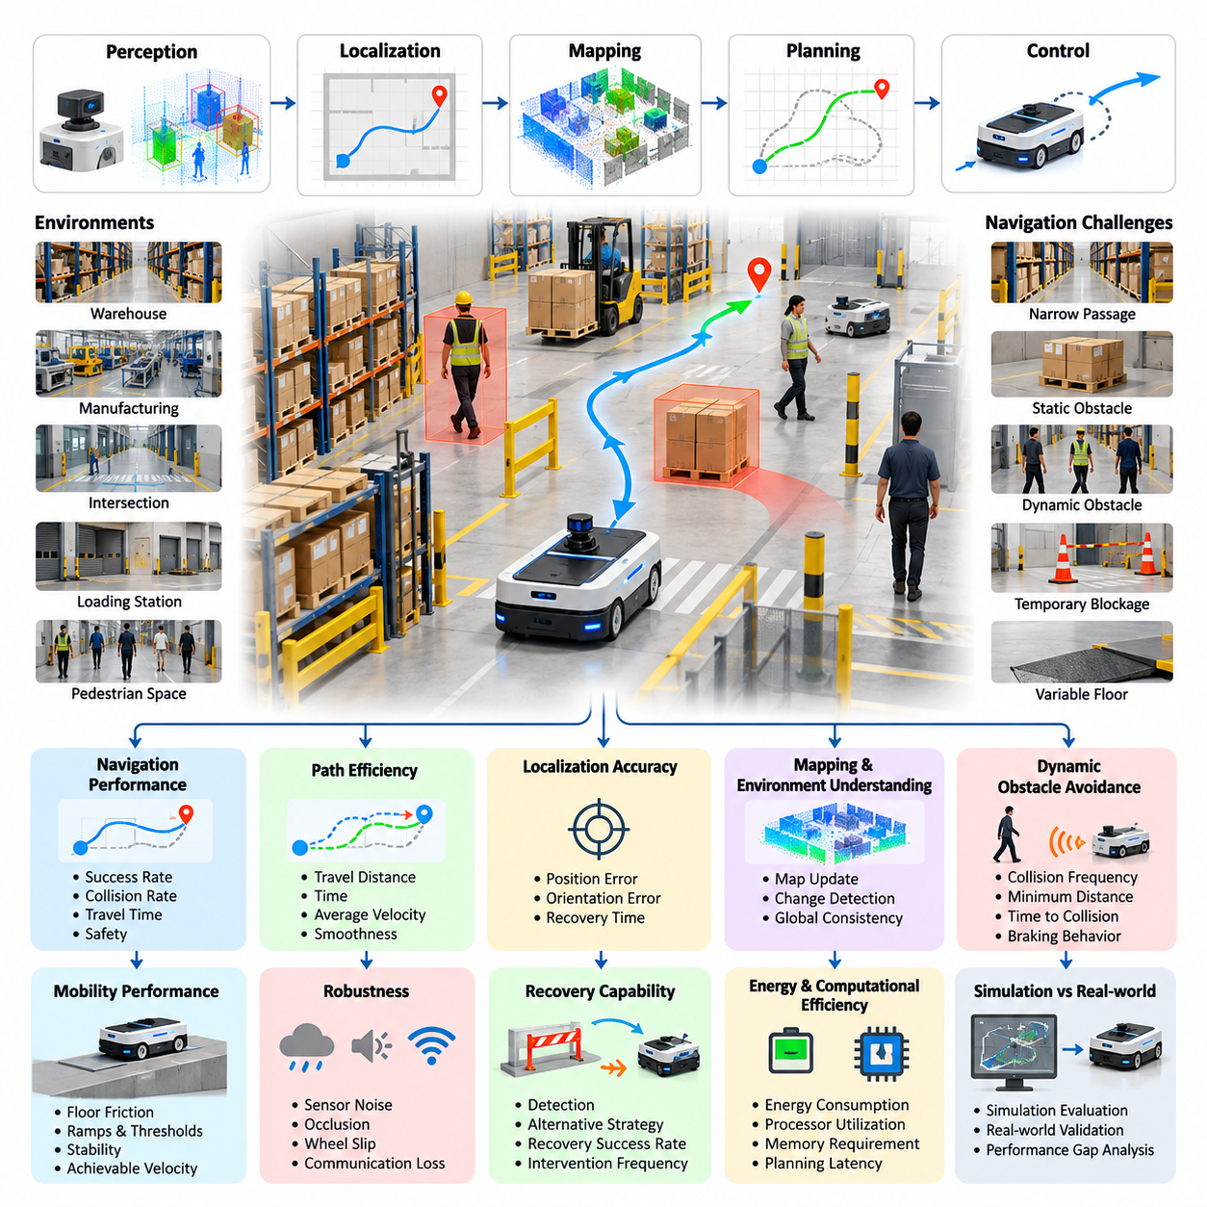
Autonomous Mobile Robot (AMR) navigation and mobility benchmarking evaluates how effectively a robotic platform perceives its surroundings, estimates its position, plans feasible routes, and executes safe movement under operational constraints. Unlike isolated algorithm testing, an AMR benchmark examines the complete closed-loop system, where perception errors, localization uncertainty, planning decisions, and actuator behavior jointly determine mission outcomes.
A representative benchmark environment includes warehouse aisles, manufacturing corridors, intersections, loading stations, and shared pedestrian spaces. These environments introduce navigation challenges involving narrow passages, static obstacles, moving personnel, temporary blockages, and variable floor conditions. The benchmark must represent both predictable operating situations and disturbances that require the robot to adapt its behavior without compromising safety.
The evaluation begins by defining the operational design domain, including permitted surfaces, maximum travel speeds, obstacle characteristics, lighting conditions, and pedestrian activity. Each test scenario specifies an initial robot pose, destination, environmental configuration, and completion criteria. These definitions establish comparable testing conditions while ensuring that measured performance corresponds to realistic deployment requirements.
Navigation capability is evaluated through repeated point-to-point missions in which the AMR must reach designated destinations without collisions or unauthorized intervention. Mission success rate represents the proportion of trials completed within specified tolerances and time limits. However, successful arrival alone is insufficient because a robot may reach its destination through inefficient, unstable, or potentially unsafe movement patterns.
Path efficiency measures the relationship between the distance traveled by the robot and an appropriate reference path. The reference may represent the shortest collision-free route or a feasible route satisfying the robot's kinematic constraints. Additional measurements include travel time, average velocity, stopping frequency, unnecessary detours, and trajectory smoothness, providing a multidimensional assessment of navigation quality.
Localization accuracy is a fundamental component of AMR benchmarking because navigation depends on reliable estimates of position and orientation. Reference measurements may be obtained through motion capture, surveyed landmarks, laser tracking, or independently validated positioning systems. Absolute trajectory error, relative pose error, orientation deviation, and localization recovery time reveal how accurately the robot maintains spatial awareness during movement.
Mapping and environmental understanding are evaluated by introducing changes between initial map construction and subsequent navigation trials. Temporary storage pallets, relocated equipment, blocked corridors, and newly accessible passages test whether the AMR can distinguish persistent environmental structure from transient obstacles. Effective systems update local representations and adjust routes while maintaining consistency with the global navigation objective.
Dynamic obstacle avoidance introduces pedestrians, other mobile robots, and moving industrial equipment into controlled scenarios. The benchmark measures collision frequency, minimum separation distance, time to collision, braking behavior, and the ability to resume progress after an obstacle clears. Evaluation should distinguish legitimate safety stops from excessive hesitation that unnecessarily reduces operational throughput.
Mobility performance also depends on the interaction between the robot's mechanical configuration and the surrounding terrain. Floor friction, surface transitions, ramps, thresholds, and uneven ground influence traction, braking distance, stability, and achievable velocity. Testing across these conditions helps identify whether navigation failures originate from planning algorithms, motion control, mechanical limitations, or interactions among these subsystems.
Robustness testing introduces controlled disturbances such as sensor noise, partial occlusion, wheel slip, temporary communication loss, and degraded localization confidence. Each disturbance is applied at documented severity levels to measure performance degradation. A robust AMR should recognize uncertainty, modify its operating behavior, and enter an appropriate safe state when reliable navigation cannot be maintained.
Recovery capability is assessed through scenarios involving blocked routes, localization loss, unexpected obstacles, and interrupted missions. The evaluation records whether the robot detects the problem, identifies an alternative strategy, and resumes progress without external assistance. Recovery success rate, recovery duration, intervention frequency, and repeated-failure behavior help distinguish resilient autonomous navigation from systems dependent on operator supervision.
Energy and computational efficiency provide additional dimensions of mobility performance. Measurements include energy consumption per completed mission, energy per traveled distance, processor utilization, memory requirements, and planning latency. These metrics reveal whether improved navigation performance requires disproportionate computational or electrical resources, particularly for battery-powered AMRs operating continuously in industrial facilities.
Simulation-based evaluation enables extensive scenario coverage before physical deployment. Digital environments can reproduce facility layouts, obstacle trajectories, sensor configurations, and mobility constraints while systematically varying environmental parameters. Nevertheless, simulated performance must be compared with real-world trials because imperfect friction models, sensor artifacts, actuator dynamics, and human behavior can produce significant simulation-to-reality gaps.
Real-world validation uses controlled laboratory courses and representative operational facilities to verify simulation findings. Repeated trials should preserve essential experimental conditions while introducing documented variations in traffic density, payload, illumination, and route complexity. Hardware configuration, software version, calibration status, and environmental measurements must be recorded to support reproducibility and meaningful comparisons between navigation systems.
Statistical analysis is necessary because navigation outcomes vary across routes, environmental conditions, and repeated executions. Benchmark reports should include sample sizes, success proportions, confidence intervals, and distributions of completion time and path efficiency. Stratified results reveal performance differences between simple corridors, congested intersections, narrow passages, and disturbance scenarios that aggregate scores might otherwise conceal.
A practical AMR benchmark scorecard combines mission success, localization accuracy, path efficiency, collision avoidance, recovery capability, energy consumption, and operational reliability. Safety-critical violations should be reported independently rather than hidden within a weighted performance score. This approach prevents improvements in speed or efficiency from compensating for unacceptable collision risks or failures to maintain safe separation.
Generalization is examined by evaluating the same navigation system in previously unseen layouts, altered obstacle configurations, and different operating conditions. Performance differences between familiar and unfamiliar environments indicate the system's dependence on specific maps, traffic patterns, or environmental assumptions. Zero-shot trials and adaptation trials should be reported separately to distinguish immediate transfer capability from improvement through additional calibration or learning.
Long-duration evaluation extends individual navigation trials into continuous operational missions involving repeated deliveries, charging cycles, changing traffic conditions, and accumulated localization uncertainty. Measurements include mission completion consistency, autonomous operating duration, mean time between interventions, and failure recovery effectiveness. Such testing reveals reliability problems that may remain invisible during short, isolated demonstrations.
The resulting benchmark provides an evidence-based foundation for comparing AMR navigation architectures, identifying system weaknesses, and establishing deployment readiness. Its principal value lies not in producing a single ranking but in explaining where, how, and under which conditions autonomous mobility succeeds or fails. Standardized scenarios, transparent metrics, and reproducible procedures transform navigation testing into a systematic engineering process.

09.02. Outdoor Robot Generalization Benchmark
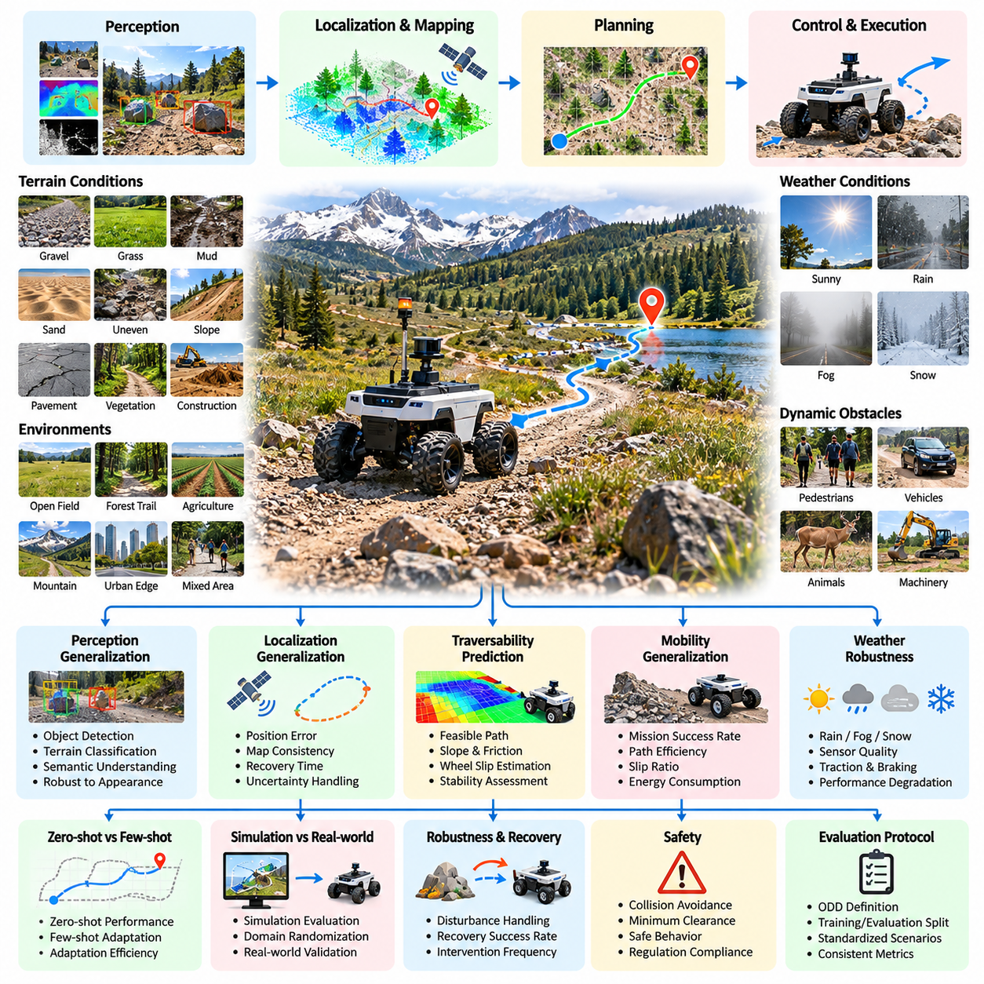
Outdoor robot generalization benchmarking evaluates whether autonomous robotic systems can maintain reliable performance across unfamiliar environments, terrain conditions, weather patterns, and operational scenarios. Unlike controlled indoor navigation, outdoor autonomy must address substantial environmental variability. The central objective is to measure how effectively learned perception, planning, and control capabilities transfer beyond the conditions represented during development.
Outdoor environments introduce complex variations in geometry, appearance, and physical interaction. Robots may encounter gravel roads, grass, mud, sand, uneven pavement, slopes, vegetation, and irregular obstacles. Each surface presents different traction, stability, and traversability characteristics. A meaningful benchmark must therefore examine whether the robot adapts its mobility decisions to changing environmental conditions rather than relying on memorized routes.
The benchmark begins by defining an operational design domain that specifies permitted terrain, weather conditions, visibility, speed limits, and expected obstacle categories. Test environments are divided into familiar development conditions and previously unseen evaluation conditions. This separation enables researchers to distinguish performance within the training distribution from genuine generalization to novel environmental configurations.
Scenario design should incorporate variations in terrain geometry, surface friction, obstacle density, illumination, and environmental dynamics. Test routes may include open fields, forest trails, construction areas, agricultural paths, and mixed pedestrian environments. Each scenario requires clearly defined starting positions, destinations, environmental constraints, and success criteria to support consistent comparisons across different robotic platforms.
Perception generalization is evaluated by exposing the robot to unfamiliar visual appearances and sensing conditions. Changes in sunlight, shadows, precipitation, dust, vegetation density, and seasonal appearance can substantially alter sensor observations. Evaluation measures whether object detection, terrain classification, obstacle recognition, and semantic understanding remain reliable despite differences from previously observed environments.
Localization and mapping generalization examine whether robots can maintain accurate spatial awareness when familiar landmarks are unavailable or environmental structure changes. Outdoor navigation may involve degraded satellite positioning, repetitive vegetation, moving foliage, and poorly defined boundaries. Position estimation error, map consistency, localization recovery time, and uncertainty calibration provide important evidence of spatial robustness.
Traversability prediction is a critical component of outdoor robot evaluation because visually similar surfaces may possess different mechanical properties. Dry soil, wet soil, loose gravel, and compacted ground can produce substantially different mobility outcomes. The benchmark assesses whether the robot correctly predicts feasible paths while accounting for terrain slope, surface compliance, wheel slip, ground clearance, and stability constraints.
Mobility generalization evaluates the ability to execute movement across terrain conditions not encountered during training. Performance measurements include mission completion rate, distance traveled, path efficiency, slip ratio, stability, and energy consumption. Tests should distinguish failures caused by perception or planning from limitations imposed by the robot's mechanical design, actuator capabilities, or available traction.
Weather robustness introduces controlled or naturally occurring variations in rain, fog, wind, temperature, and surface moisture. These factors affect sensor quality, traction, braking behavior, and environmental visibility. Performance should be reported separately for different weather conditions because a system that operates reliably in clear weather may exhibit substantial degradation under adverse environmental conditions.
Dynamic outdoor scenarios introduce pedestrians, vehicles, animals, moving machinery, and unexpected obstacles. The robot must predict potential interactions, maintain appropriate separation distances, and modify its trajectory when necessary. Evaluation considers collision avoidance, response latency, minimum clearance, unnecessary stopping, and recovery after disturbances while preserving mission progress and operational safety.
Generalization testing requires a carefully controlled separation between training, validation, and evaluation environments. Geographic locations, terrain configurations, visual textures, and obstacle arrangements should be partitioned to reduce information leakage. Repeated exposure to evaluation environments can unintentionally convert unseen scenarios into familiar ones, weakening the benchmark's ability to measure genuine transfer capability.
Zero-shot generalization measures performance when a robot encounters a new environment without additional training or adaptation. Few-shot adaptation evaluates improvement after limited observations, demonstrations, or calibration procedures. These evaluation modes should remain separate because immediate transfer and adaptation efficiency represent different capabilities. Reporting both provides a clearer understanding of the system's ability to operate beyond its original training conditions.
Simulation-based benchmarking enables systematic variation of terrain geometry, material properties, illumination, weather, and obstacle distributions. Domain randomization can expose robotic policies to combinations of conditions that are difficult to reproduce consistently in physical experiments. However, simulation results require real-world validation because terrain deformation, wheel-ground interaction, vegetation contact, and sensor degradation may be imperfectly represented.
Real-world field trials provide direct evidence of generalization under authentic environmental uncertainty. Test sites should include multiple geographic locations and terrain categories, with repeated trials conducted under documented conditions. Reference positioning systems, onboard telemetry, environmental measurements, and operator observations support accurate assessment of navigation performance, physical interaction, and failure mechanisms.
Robustness analysis examines how performance changes as environmental difficulty increases. Terrain slope, obstacle density, surface irregularity, sensor degradation, and visibility can be varied independently where practical. Performance degradation curves reveal operational boundaries and identify conditions where success rates decline sharply. Such analysis is more informative than evaluating robots exclusively under favorable or average conditions.
Uncertainty-aware evaluation determines whether the robot recognizes situations beyond its reliable operating capability. Perception confidence, localization uncertainty, traversability uncertainty, and predicted collision risk should correspond meaningfully to observed outcomes. A well-calibrated system can reduce speed, request assistance, select an alternative route, or enter a safe state when environmental uncertainty exceeds acceptable limits.
Safety evaluation considers collisions, rollovers, excessive slip, uncontrolled movement, and hazardous interactions with humans or equipment. Safety-critical outcomes must be reported independently of navigation efficiency and mission success. The benchmark should also measure fallback effectiveness, emergency stopping behavior, and recovery capability to determine whether generalization failures are managed without creating unacceptable physical risks.
Statistical evaluation requires sufficient trials across independent environments and environmental conditions. Reports should include success rates, confidence intervals, performance distributions, and differences between familiar and unfamiliar scenarios. Hierarchical analysis can separate variation associated with geographic location, terrain type, weather, and individual trials, reducing the risk of drawing conclusions from a narrow collection of favorable examples.
A comprehensive outdoor generalization scorecard combines navigation success, perception reliability, localization accuracy, traversability prediction, mobility efficiency, robustness, safety, and adaptation capability. Results should be organized by environmental category and difficulty level rather than compressed into a single aggregate score. This structure makes it possible to identify both transferable capabilities and specific weaknesses requiring further development.
The resulting benchmark establishes a systematic framework for evaluating outdoor robotic intelligence beyond controlled demonstrations. By combining unseen environments, diverse physical conditions, rigorous measurement, and real-world validation, it reveals whether robotic autonomy remains dependable when environmental assumptions change. Its ultimate purpose is to characterize generalization boundaries and support safer, more reliable deployment across diverse outdoor applications.

09.03. Manipulator Task Benchmark
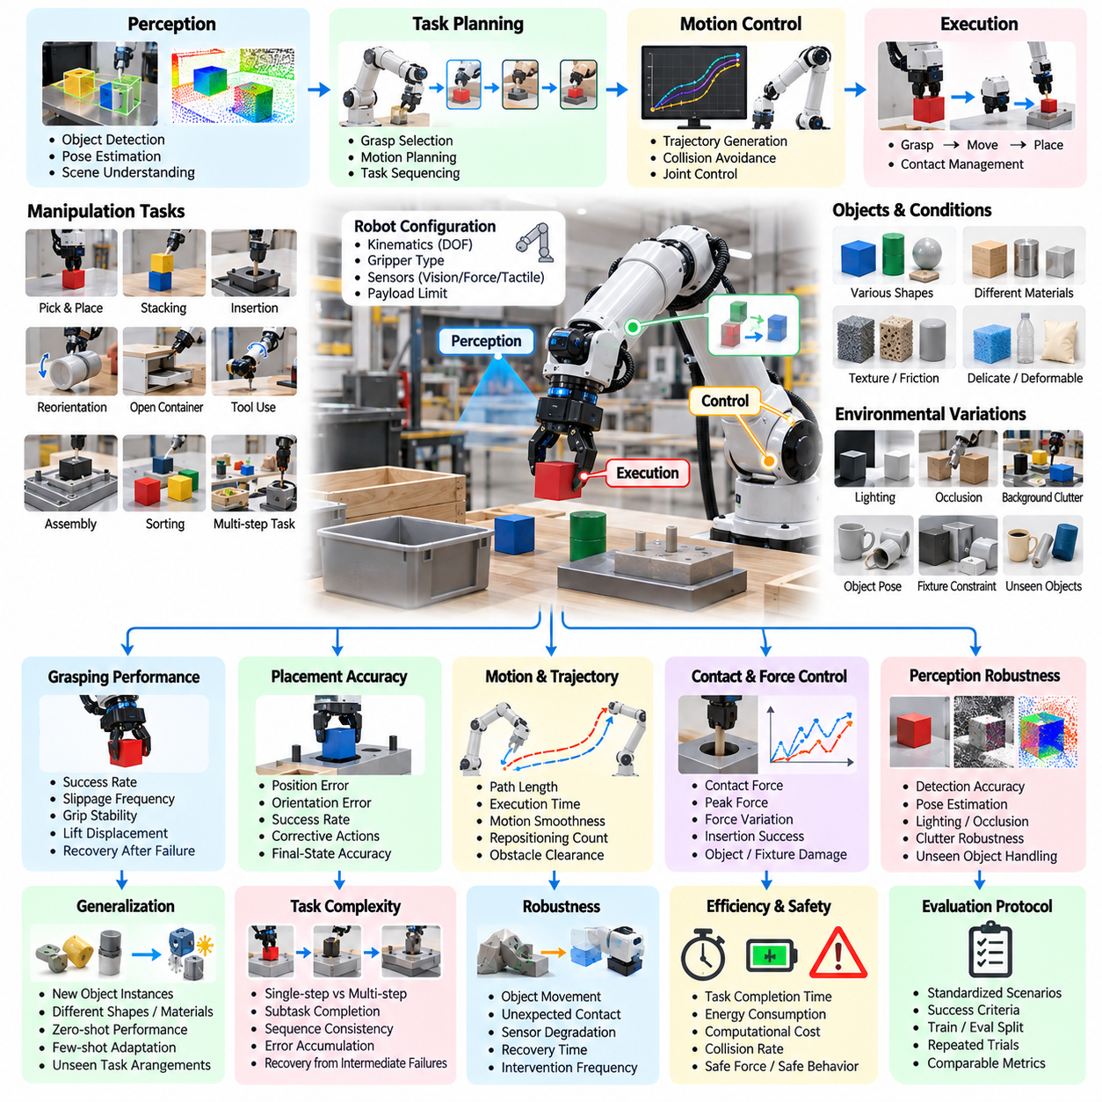
Manipulator task benchmarking evaluates how reliably and accurately a robotic manipulator performs physical tasks involving object detection, grasping, movement, placement, and interaction with the environment. Rather than measuring isolated motion accuracy alone, the benchmark assesses the complete manipulation process, including perception, task planning, motion control, contact management, and successful completion under realistic operational constraints.
A representative benchmark includes object picking, placement, stacking, insertion, reorientation, opening containers, tool use, and assembly operations. These tasks require different combinations of geometric reasoning, force control, dexterity, and environmental understanding. A well-designed benchmark should cover both simple repetitive operations and tasks involving uncertain object positions, constrained access, delicate materials, or complex sequences of physical interaction.
The benchmark begins by defining the robot configuration, including arm kinematics, degrees of freedom, gripper type, available sensors, and payload limits. Task specifications describe the initial scene, target objects, required final states, and permitted actions. Standardizing these conditions enables meaningful comparisons between manipulation systems while preserving the physical constraints that determine whether a task is feasible for a particular robotic platform.
Grasping performance is evaluated by measuring whether the manipulator securely acquires an object and maintains control throughout subsequent movement. Relevant measurements include grasp success rate, object displacement during lifting, slippage frequency, grasp stability, and recovery after failed attempts. Evaluation should account for object geometry, mass, surface friction, compliance, and orientation because these properties strongly influence grasp feasibility.
Placement accuracy measures whether an object reaches its intended destination within specified positional and rotational tolerances. Tasks may require placing components into fixtures, arranging objects on shelves, or positioning items within narrow containers. Measurements include translational error, angular deviation, placement success rate, and the number of corrective actions. Final-state accuracy should be assessed independently from the speed of execution.
Manipulation quality also depends on trajectory planning and motion execution. The benchmark measures path length, movement duration, joint motion smoothness, unnecessary repositioning, and proximity to obstacles. Efficient movement should minimize avoidable motion while respecting joint limits, collision constraints, and task-specific requirements. These metrics help distinguish accurate manipulation from behavior that achieves the same result through inefficient or unnecessarily complicated trajectories.
Contact-rich tasks require the robot to manage forces and physical constraints during interaction. Examples include inserting connectors, fitting components, tightening mechanisms, and manipulating objects that must remain in contact with a surface. Evaluation may measure contact force, peak force, force variation, insertion success, and damage to objects or fixtures. Successful execution requires sufficient force to complete the task without producing excessive pressure or unstable contact.
Force and tactile sensing are particularly important when visual observations cannot fully reveal the physical state of an interaction. A benchmark may introduce variations in friction, object stiffness, insertion resistance, or contact location to determine whether the robot adjusts its actions appropriately. Performance should reflect not only task completion but also the ability to detect contact events, respond to unexpected resistance, and maintain controlled interaction.
Perception robustness is assessed by varying object appearance, lighting, occlusion, background clutter, and object placement. The manipulator may encounter previously unseen objects or familiar objects presented in unfamiliar orientations. Evaluation measures whether the system identifies relevant object properties, estimates poses accurately, and selects suitable grasp configurations. Perception errors should be recorded separately from failures caused by planning, control, or mechanical limitations.
Generalization testing examines whether manipulation policies remain effective when object instances, task arrangements, or environmental conditions differ from those encountered during training. Changes in object size, shape, material, texture, and position can expose overdependence on memorized configurations. Zero-shot trials should be distinguished from tests involving additional demonstrations, calibration, or fine-tuning because these represent different levels of generalization and adaptation capability.
Task complexity should increase from isolated manipulation primitives to multi-step operations requiring coordinated actions. A simple benchmark may evaluate picking and placing a single object, whereas a more demanding scenario may require selecting components, aligning them, inserting them, and verifying the completed assembly. Long sequences reveal whether errors accumulate, whether intermediate states are maintained correctly, and whether the robot can recover when an earlier action fails.
Robustness evaluation introduces disturbances such as object movement, unexpected contact, partial sensor failure, and small changes in fixture geometry. The benchmark records task completion, recovery time, repeated failure frequency, and dependence on human intervention. A robust manipulator should detect when its current strategy is no longer appropriate, revise its actions when feasible, and avoid continuing movements that could damage equipment or create unsafe conditions.
Efficiency metrics include task completion time, energy consumption, motion distance, grasp attempts, and computational latency. These measurements are important in manufacturing, logistics, and service applications where productivity and resource utilization affect operational viability. However, efficiency should not be optimized independently of precision, reliability, and safety, since faster execution may increase object damage, placement errors, or failure rates.
Simulation-based evaluation supports large-scale testing across object geometries, material properties, initial configurations, and task variations. Simulated environments allow researchers to repeat experiments under controlled conditions and identify difficult cases before physical testing. Nevertheless, contact dynamics, friction, deformation, tactile sensing, and actuator behavior may differ between simulation and reality, requiring physical validation before benchmark results can support deployment decisions.
Real-world testing should use repeatable experimental procedures and accurately documented hardware and software configurations. Trials should record object properties, environmental conditions, robot calibration, sensor status, and task outcomes. Repeated executions across multiple objects and configurations help distinguish consistent capability from occasional success and provide evidence for reproducibility across different laboratories and robotic platforms.
Statistical reporting should include success rates, confidence intervals, sample sizes, and distributions of execution time and accuracy. Results should be separated by task category, object characteristics, and difficulty level to prevent aggregate scores from concealing important weaknesses. For example, high performance on uncomplicated pick-and-place operations should not obscure poor reliability during precision insertion or delicate contact-rich manipulation.
Safety evaluation considers excessive contact forces, dropped objects, collisions, damage to fixtures, and hazardous interactions with nearby humans. Safety-critical failures should be reported independently from ordinary task failures and efficiency metrics. The benchmark should also assess emergency stopping, controlled release, and recovery behavior when unexpected contact or unstable object handling creates a potential hazard.
A comprehensive manipulator benchmark combines task success, grasp reliability, placement accuracy, trajectory quality, force regulation, generalization, efficiency, and safety. Results should be presented as a multidimensional performance profile rather than relying exclusively on a single ranking. This approach reveals the conditions under which a system performs well, the tasks that remain difficult, and the trade-offs between speed, precision, adaptability, and reliability.
The resulting benchmark provides a systematic foundation for comparing manipulation algorithms, robotic hardware configurations, and learning-based policies. By combining standardized tasks, controlled variations, repeated physical trials, and transparent metrics, it supports rigorous evaluation beyond isolated demonstrations. Its ultimate purpose is to establish whether a manipulator can perform useful physical work reliably, safely, and efficiently across the range of conditions expected in practical deployment.

09.04. Mobile Manipulator Benchmark
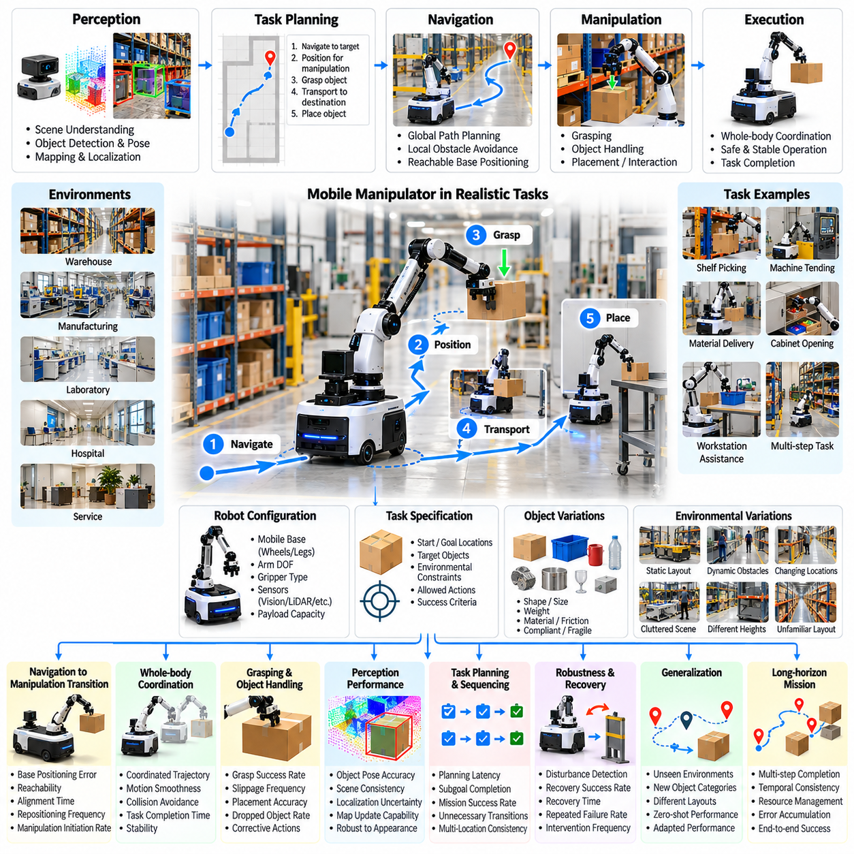
Mobile manipulator benchmarking evaluates the ability of a robotic system to combine autonomous navigation with physical manipulation in a coordinated and reliable manner. Unlike fixed-base manipulators or standalone mobile robots, mobile manipulators must continuously manage interactions between locomotion, positioning, perception, and object handling. Evaluation therefore focuses on complete task execution rather than treating navigation and manipulation as independent capabilities.
A representative benchmark environment includes warehouses, manufacturing facilities, laboratories, hospitals, and service environments where objects must be transported, retrieved, or manipulated across multiple locations. Typical tasks include shelf picking, machine tending, material delivery, cabinet opening, and workstation assistance. These scenarios require the robot to navigate toward a target, establish a suitable manipulation pose, perform physical interaction, and continue its mission.
Benchmark design begins by defining the mobile platform, manipulator configuration, sensor arrangement, payload capacity, and operational constraints. The specification includes wheel or leg mobility, arm degrees of freedom, gripper characteristics, and available perception modalities. Task definitions establish starting conditions, target locations, object properties, environmental restrictions, and success criteria, ensuring that comparisons account for differences in robotic embodiment.
Navigation-to-manipulation transition is a central evaluation component because successful object interaction depends on accurate positioning of the mobile base. The robot must select a base pose that provides sufficient arm reachability, collision clearance, and manipulation stability. Relevant measurements include base positioning error, target reachability, alignment time, repositioning frequency, and the probability of successfully initiating manipulation after navigation.
Whole-body coordination evaluates how effectively the mobile base and robotic arm operate as an integrated system. Some tasks require the platform to remain stationary while the arm moves, whereas others benefit from simultaneous base and arm motion. Benchmark metrics include coordinated trajectory accuracy, execution smoothness, collision avoidance, and task completion time. Evaluation should identify whether coordinated control improves performance without compromising stability or safety.
Perception performance is assessed across navigation and manipulation phases because the robot must maintain consistent environmental understanding at different spatial scales. Global mapping supports route planning, while local perception enables object localization, grasp selection, and contact management. The benchmark measures object pose estimation accuracy, scene consistency, localization uncertainty, and the ability to update spatial representations when the robot changes position.
Grasping and object handling are evaluated under conditions where mobile-base positioning errors influence manipulation accuracy. The benchmark measures grasp success rate, object slippage, placement precision, dropped-object frequency, and corrective action requirements. Object characteristics such as geometry, weight, surface friction, and compliance should vary systematically to determine whether the robot can compensate for uncertainty in both navigation and manipulation.
Task planning evaluation examines how the robot sequences navigation, positioning, grasping, transportation, and placement actions. A successful system must select feasible intermediate goals while respecting environmental and mechanical constraints. Metrics include planning latency, subgoal completion rate, unnecessary transitions, and overall mission success. Complex scenarios reveal whether the robot can maintain task consistency across multiple spatial locations and physical interactions.
Mobile manipulation introduces additional stability challenges because arm movements and payload changes can alter the robot's center of mass and load distribution. Evaluation should consider base displacement, body inclination, wheel traction, and stability margins during lifting, reaching, and transportation. Tasks involving elevated shelves or extended arm configurations are particularly useful for identifying mechanical and control limitations.
Dynamic environments introduce moving pedestrians, other robots, temporary obstacles, and changing object locations. The benchmark evaluates whether the mobile manipulator can adjust navigation routes, update manipulation targets, and resume interrupted operations. Collision avoidance, replanning latency, recovery success, and intervention frequency provide evidence of adaptability under realistic operational uncertainty.
Generalization testing examines performance across unfamiliar facility layouts, object categories, shelf configurations, and task sequences. A system trained on particular workstations may struggle when target objects appear at different heights or when access geometry changes. Zero-shot and adapted performance should be reported separately to distinguish immediate transfer capability from improvements achieved through additional demonstrations or calibration.
Robustness evaluation introduces controlled disturbances such as localization drift, partial sensor occlusion, grasp failure, unexpected object movement, and temporary communication loss. The robot should recognize unsuccessful actions and select appropriate recovery strategies. Evaluation measures disturbance detection, recovery duration, repeated failure frequency, and the proportion of missions completed without external assistance.
Long-horizon benchmarking combines multiple navigation and manipulation operations into extended missions. A representative sequence may require retrieving objects from several storage locations, transporting them to designated workstations, and verifying final placement. Performance measures include complete mission success, subtask consistency, cumulative positioning error, autonomous operating duration, and the number of human interventions required.
Efficiency evaluation considers travel distance, manipulation duration, energy consumption, computational latency, and unnecessary repositioning. Mobile manipulators must balance efficient navigation with accurate physical interaction, making optimization more complex than in single-function robots. Benchmark results should identify trade-offs between movement speed, manipulation precision, payload handling, and operational reliability.
Simulation-based evaluation enables systematic testing of facility layouts, object configurations, robot dynamics, and environmental disturbances. Digital environments can generate repeated trials and support comparisons between planning and control strategies. However, simulated contact dynamics, wheel-ground interaction, payload effects, and sensor behavior may differ from physical conditions, requiring careful validation of simulation-to-reality transfer.
Real-world validation should use repeatable tasks and documented experimental conditions. Measurements may combine external tracking systems, calibrated reference objects, onboard sensor logs, and independent observations. Repeated trials across different locations and task configurations provide evidence of reproducibility while revealing practical limitations associated with hardware calibration, environmental variability, and accumulated system errors.
Safety evaluation addresses collisions, unstable payload handling, excessive contact forces, dropped objects, and unsafe interactions with nearby personnel. Safety-critical outcomes must be reported independently from task efficiency and completion scores. Emergency stopping, controlled object release, protective separation, and safe recovery behavior should be evaluated to determine whether the robot maintains acceptable risk during integrated operation.
Statistical reporting should include mission success rates, confidence intervals, completion-time distributions, intervention frequency, and failure classifications. Results should distinguish navigation failures, manipulation failures, coordination failures, and environmental disturbances. This separation prevents a single aggregate score from concealing weaknesses and supports more precise comparisons between different mobile manipulation architectures.
A comprehensive mobile manipulator scorecard combines navigation accuracy, manipulation success, whole-body coordination, stability, efficiency, robustness, safety, and generalization. Performance should be reported across task difficulty levels and environmental categories. Multidimensional evaluation reveals whether improvements in one subsystem translate into meaningful gains in complete mission performance or introduce new limitations elsewhere.
The resulting benchmark establishes a systematic foundation for evaluating integrated robotic autonomy in practical environments. By combining standardized tasks, coordinated motion assessment, long-horizon missions, controlled disturbances, and real-world validation, it measures capabilities beyond isolated navigation or grasping demonstrations. Its ultimate purpose is to determine whether mobile manipulators can perform useful physical work reliably, safely, and efficiently across diverse operational conditions.

09.05. Quadruped Locomotion Benchmark
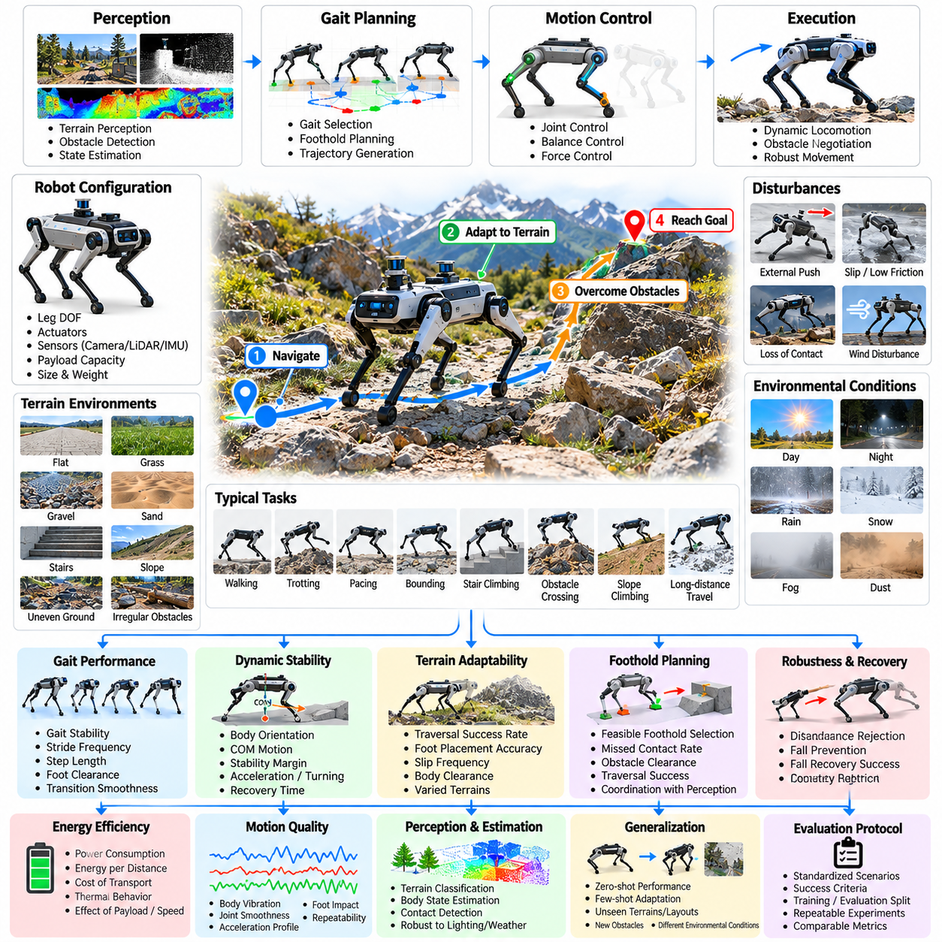
Quadruped locomotion benchmarking evaluates the ability of four-legged robotic systems to move reliably, efficiently, and safely across diverse terrain and environmental conditions. Unlike wheeled robots, quadrupeds must coordinate multiple articulated limbs while maintaining dynamic balance and managing intermittent ground contact. Evaluation therefore examines not only movement speed but also stability, terrain adaptability, energy efficiency, and recovery from disturbances.
A representative benchmark includes flat surfaces, slopes, stairs, gravel, grass, sand, uneven ground, and irregular obstacles. Each environment introduces different requirements for foothold selection, body stabilization, and gait adaptation. Testing should progress from controlled laboratory conditions to increasingly complex outdoor scenarios, allowing researchers to identify locomotion limitations and distinguish fundamental control capabilities from environment-specific performance.
Benchmark design begins by defining robot morphology, leg configuration, joint degrees of freedom, actuator characteristics, sensor placement, and payload capacity. Operational constraints include permitted velocities, terrain categories, environmental conditions, and safety boundaries. Standardized task descriptions specify starting positions, target destinations, route geometry, and completion criteria, enabling reproducible comparisons while accounting for differences in robotic embodiment.
Gait performance is evaluated through walking, trotting, pacing, bounding, and other locomotion patterns supported by the robot. Measurements include gait stability, stride frequency, step length, foot clearance, and transition smoothness. The benchmark should determine whether the robot selects appropriate movement patterns for different speeds and terrain conditions while maintaining coordinated limb motion and avoiding unnecessary oscillation or loss of balance.
Dynamic stability is a central evaluation dimension because quadruped locomotion frequently involves changing support configurations and rapid redistribution of body forces. Relevant measurements include body orientation, angular velocity, center-of-mass motion, foot contact timing, and stability margins. Performance should be assessed during acceleration, deceleration, turning, and sudden changes in terrain rather than only during steady movement.
Terrain adaptability measures whether the robot can modify its locomotion strategy when encountering changes in surface geometry and mechanical properties. Slopes, loose materials, slippery surfaces, and irregular footholds introduce different traction and balance requirements. Evaluation considers successful traversal, foot placement accuracy, slip frequency, body clearance, and the ability to maintain forward progress without excessive corrective movements.
Foothold planning is evaluated by introducing obstacles, gaps, stepping stones, and uneven support surfaces. The robot must identify feasible contact locations while respecting leg reachability, joint limits, and body stability constraints. Metrics include foothold selection accuracy, missed contacts, obstacle clearance, and traversal success. These tests reveal how effectively perception, planning, and low-level control cooperate during complex terrain negotiation.
Disturbance rejection is assessed through controlled external forces, unexpected terrain changes, and temporary loss of foot contact. The benchmark measures body displacement, recovery time, corrective stepping, and the probability of maintaining balance. Disturbances should be introduced at documented intensities under appropriate safety precautions, allowing researchers to characterize robustness boundaries without exposing equipment or personnel to unnecessary hazards.
Fall prevention and recovery represent distinct aspects of locomotion robustness. A robot may maintain balance under moderate disturbances but fail when encountering larger perturbations or unexpected obstacles. Evaluation should distinguish successful disturbance rejection from controlled falling and autonomous standing recovery. Recovery success rate, time to regain a stable posture, and external assistance requirements provide important indicators of operational resilience.
Energy efficiency is particularly important because legged locomotion requires continuous actuator coordination and repeated mechanical work. Measurements include electrical power consumption, energy per traveled distance, cost of transport, and thermal behavior. Results should account for robot mass, payload, speed, and terrain difficulty because direct comparisons without normalization can misrepresent differences between locomotion architectures.
Motion quality is evaluated through body vibration, joint velocity smoothness, acceleration profiles, and foot impact characteristics. Excessive oscillation can reduce sensor performance, increase mechanical wear, and compromise payload stability. The benchmark should therefore examine whether locomotion remains controlled and repeatable across different movement speeds and terrain conditions, even when the robot successfully reaches its destination.
Perception and state estimation are evaluated by introducing variations in lighting, surface appearance, sensor visibility, and terrain structure. Quadrupeds often rely on cameras, inertial sensors, joint encoders, and contact estimation to maintain situational awareness. Measurements include terrain classification accuracy, body-state estimation error, contact detection reliability, and performance degradation when sensing information becomes uncertain or incomplete.
Generalization testing examines whether locomotion policies transfer to terrain configurations, obstacle arrangements, and environmental conditions not encountered during training. Zero-shot performance should be distinguished from results obtained after adaptation or additional calibration. Testing across multiple terrain categories reveals whether a controller has learned broadly useful locomotion strategies or depends heavily on specific surface characteristics and familiar geometric patterns.
Payload evaluation measures how additional mass and changes in load distribution influence locomotion stability and efficiency. Test conditions may include different payload weights, mounting positions, and center-of-mass offsets. Performance measurements include speed degradation, joint torque demand, body inclination, energy consumption, and traversal success. Such evaluation is essential for quadrupeds intended to carry sensors, inspection equipment, or operational supplies.
Simulation-based benchmarking enables large-scale evaluation across randomized terrain, friction coefficients, actuator parameters, and external disturbances. Parallel simulation can expose locomotion policies to diverse scenarios before physical deployment. However, simulated contact mechanics, actuator dynamics, compliance, and terrain deformation may differ from reality. Real-world testing is therefore required to determine whether simulated robustness translates into dependable physical locomotion.
Real-world validation should use repeatable obstacle courses, calibrated terrain measurements, and documented environmental conditions. Reference tracking systems, onboard telemetry, force measurements, and video observations can support performance analysis. Repeated trials across different routes and terrain categories help establish reproducibility while revealing hardware limitations, controller inconsistencies, and failure mechanisms that may remain hidden in simulation.
Long-horizon evaluation extends isolated traversal tasks into continuous missions involving repeated terrain transitions, changing speeds, accumulated mechanical stress, and battery depletion. Metrics include mission completion rate, autonomous operating duration, intervention frequency, thermal stability, and mean time between locomotion failures. These tests reveal whether short-term agility and balance performance remain reliable during sustained operation.
Safety evaluation considers falls, collisions, uncontrolled movement, excessive joint loading, and hazardous interactions with nearby humans. Safety-critical failures should be reported independently of traversal speed and efficiency. Emergency stopping, safe posture transitions, actuator protection, and recovery procedures must be assessed to determine whether the robot maintains acceptable risk under challenging terrain and disturbance conditions.
Statistical reporting should include traversal success rates, confidence intervals, speed distributions, energy measurements, and failure classifications. Results should be separated by terrain category, difficulty level, gait type, and disturbance intensity. A multidimensional scorecard combining mobility, stability, robustness, efficiency, generalization, and safety provides a more informative assessment than a single aggregate locomotion score.
The resulting quadruped locomotion benchmark establishes a systematic foundation for comparing legged control algorithms, mechanical designs, and learning-based policies. By combining standardized terrain challenges, controlled disturbances, energy measurements, and physical validation, it evaluates capabilities beyond isolated demonstrations. Its ultimate purpose is to determine whether quadruped robots can sustain reliable, adaptive, and safe mobility across realistic operating environments.

09.06. Humanoid Generalist Task Benchmark
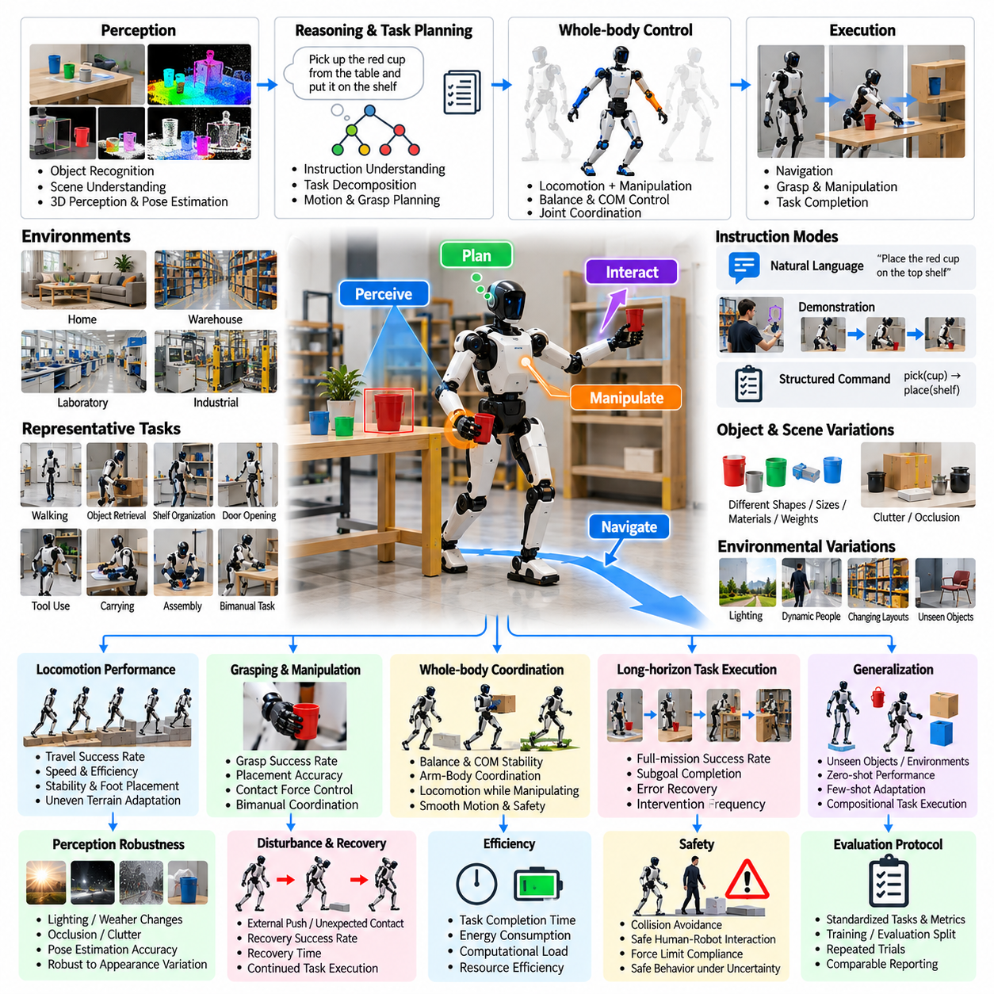
Humanoid generalist task benchmarking evaluates whether a humanoid robot can perform diverse physical tasks across changing environments without requiring a separately engineered controller for every activity. Unlike benchmarks focused exclusively on locomotion or manipulation, generalist evaluation examines the integration of perception, reasoning, planning, whole-body control, and interaction. The objective is to measure transferable competence rather than isolated task proficiency.
A representative benchmark includes walking, object retrieval, shelf organization, door opening, tool handling, carrying, and basic assembly. These activities combine mobility, dexterity, spatial understanding, and sequential decision-making. Evaluation environments may include homes, warehouses, laboratories, and industrial workspaces. Task diversity should reflect meaningful differences in physical requirements rather than superficial changes in object appearance.
Benchmark design begins by defining humanoid morphology, joint degrees of freedom, actuator capabilities, hand configuration, sensor modalities, and operational limitations. Each task specifies an initial scene, target outcome, permitted resources, and success conditions. Robot-specific physical constraints must be documented so that comparisons distinguish differences in intelligence and control from differences in reachability, payload capacity, or mechanical dexterity.
Generalist capability is evaluated through a task portfolio containing multiple skill categories and difficulty levels. Individual tasks may require navigation, grasping, bimanual coordination, object placement, or tool manipulation. More complex tasks combine these skills into complete workflows. Performance should be reported by category and across the full portfolio to determine whether a system demonstrates broad competence or exceptional performance in only a narrow subset.
Instruction following is an important evaluation dimension because generalist humanoids may receive goals through natural language, visual demonstrations, or structured commands. The benchmark measures whether the robot interprets task intent, identifies relevant objects, and converts instructions into executable actions. Ambiguous instructions, unfamiliar terminology, and multi-step requests can reveal weaknesses in grounding, contextual understanding, and action planning.
Perception evaluation examines the robot's ability to recognize objects, estimate spatial relationships, and maintain environmental awareness during movement and manipulation. Changes in lighting, clutter, occlusion, and object arrangement test perceptual robustness. Metrics include object localization accuracy, scene understanding consistency, target identification success, and recovery from incorrect observations. Perception quality should be linked to its effects on downstream physical execution.
Whole-body coordination is essential because humanoids must maintain balance while moving their arms, shifting weight, reaching, and interacting with objects. Evaluation considers posture stability, center-of-mass control, foot placement, joint coordination, and manipulation accuracy. Tasks involving elevated shelves, low objects, or simultaneous walking and carrying reveal whether locomotion and manipulation operate as an integrated control system.
Bimanual manipulation evaluates how effectively two hands cooperate during physical interaction. Representative tasks include holding a container while opening it, transferring objects between hands, stabilizing components during assembly, and carrying bulky items. Measurements include coordination accuracy, grasp stability, contact force, task completion time, and object damage. These tasks expose limitations that may remain hidden in single-arm manipulation benchmarks.
Long-horizon task evaluation examines whether the humanoid can complete sequences requiring persistent context, intermediate goals, and coordinated physical actions. A representative mission may involve locating an object, retrieving it, transporting it, organizing a workspace, and confirming completion. Metrics include full-mission success, subgoal completion, error accumulation, intervention frequency, and recovery effectiveness across extended execution periods.
Generalization testing evaluates performance on unseen objects, environments, instructions, and task combinations. Training and evaluation scenarios should be separated to prevent memorized solutions from appearing as transferable intelligence. Zero-shot performance measures immediate capability, while few-shot adaptation measures improvement after limited additional experience. Both results are necessary to characterize the breadth and adaptability of a generalist humanoid policy.
Compositional generalization examines whether previously learned skills can be recombined to solve unfamiliar tasks. A robot capable of opening drawers, grasping objects, and placing items should be tested on workflows requiring these abilities in new sequences. Evaluation measures successful skill composition, planning efficiency, and recovery when intermediate actions fail. This approach distinguishes reusable behavioral competence from memorization of complete task demonstrations.
Robustness evaluation introduces object displacement, unexpected contact, partial sensor degradation, communication interruptions, and environmental changes. The humanoid must recognize deviations from expected outcomes and modify its behavior appropriately. Measurements include disturbance detection accuracy, recovery time, repeated failure frequency, and successful completion without assistance. Robustness should reflect the ability to continue safely rather than merely tolerate minor perturbations.
Efficiency assessment considers task completion time, energy consumption, computational requirements, movement economy, and unnecessary actions. Humanoid robots may achieve identical outcomes through substantially different motion strategies and resource expenditures. Evaluation should identify trade-offs between speed, precision, stability, and energy efficiency. Excessively rapid execution should not receive favorable scores when it increases physical risk or reduces reliability.
Human-robot interaction is evaluated through shared-workspace scenarios involving communication, coordination, and safe physical proximity. Tasks may require accepting instructions, yielding space, handing over objects, or responding to human intervention. Metrics include instruction compliance, handover success, response latency, minimum separation distance, and inappropriate contact frequency. Evaluation must account for human safety and task usability rather than treating people as static obstacles.
Simulation-based benchmarking supports large-scale testing across diverse task configurations, object properties, environmental layouts, and disturbance conditions. Parallel simulation can reveal failure patterns and compare generalist policies under controlled variations. However, simulated contact mechanics, balance dynamics, tactile feedback, and human interaction may differ from reality. Physical validation remains necessary before simulation results can establish operational readiness.
Real-world evaluation should employ repeatable tasks, calibrated measurement systems, and documented robot configurations. Independent observers and automated logs can record outcomes, intervention events, physical errors, and safety incidents. Trials should include multiple objects, environments, and task arrangements to assess reproducibility. Results must distinguish genuine autonomous completion from success achieved through hidden assistance or task-specific preparation.
Safety evaluation considers falls, collisions, excessive contact forces, unstable object handling, and unsafe interactions with humans. Safety-critical violations should be reported independently from task success and efficiency. Emergency stopping, protective behavior, controlled object release, and recovery from unstable postures require explicit testing. A generalist humanoid should demonstrate safe failure behavior even when it cannot successfully complete an unfamiliar task.
Statistical analysis should report task success rates, confidence intervals, completion-time distributions, intervention frequency, and failure classifications. Results should be separated by skill category, task complexity, environmental novelty, and adaptation conditions. Aggregate scores may summarize broad performance, but they should not conceal major weaknesses in manipulation, mobility, instruction following, or safety-critical behavior.
A comprehensive humanoid generalist scorecard combines task diversity, instruction understanding, perception, locomotion, manipulation, coordination, long-horizon reliability, generalization, efficiency, and safety. Category-level results should accompany any overall score, and tasks should be weighted according to transparent evaluation objectives. This structure supports meaningful comparisons without assuming that success on a limited benchmark proves unrestricted general intelligence.
The resulting benchmark establishes a systematic foundation for evaluating humanoid robots as integrated physical intelligence systems. By combining diverse tasks, unseen conditions, compositional challenges, long-horizon missions, and real-world validation, it measures capabilities beyond isolated demonstrations. Its ultimate purpose is to determine whether humanoid robots can transfer learned skills into reliable, adaptive, and safe behavior across practical operating environments.

09.07. Aerial Robot Benchmark
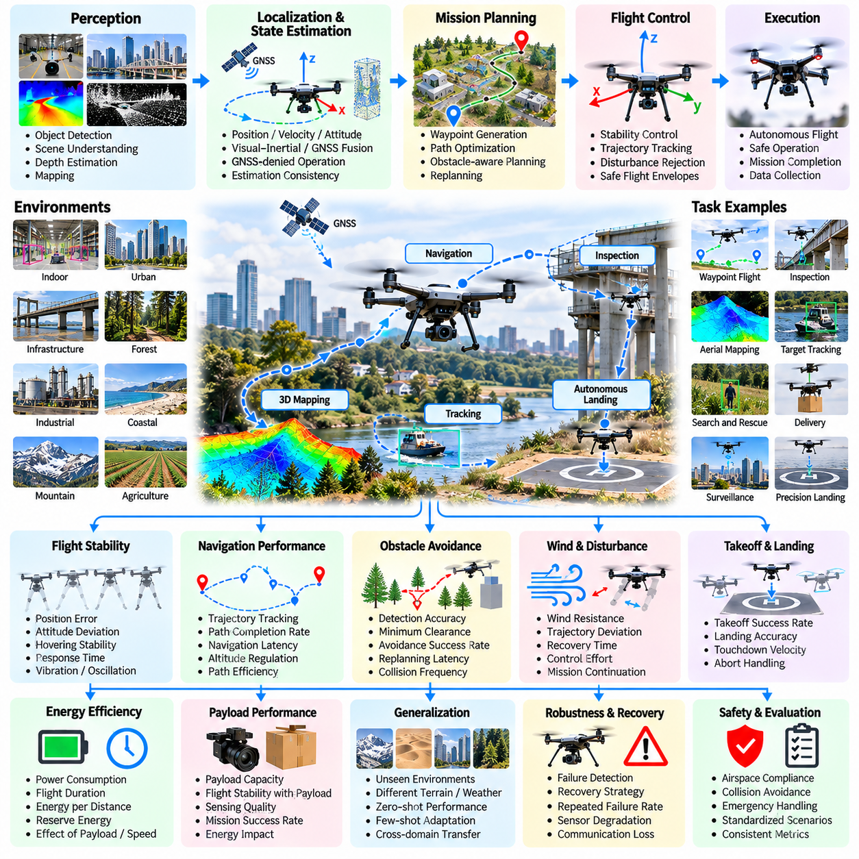
Aerial robot benchmarking evaluates the ability of autonomous flying systems to navigate, perceive, and complete missions safely under changing environmental conditions. Unlike ground robots, aerial platforms must continuously regulate three-dimensional motion while compensating for aerodynamic disturbances and limited energy reserves. Evaluation therefore considers flight stability, navigation accuracy, obstacle avoidance, mission reliability, and operational safety as interconnected capabilities.
A representative benchmark includes indoor navigation, outdoor waypoint following, infrastructure inspection, aerial mapping, target tracking, and autonomous landing. Test environments may contain narrow passages, elevated structures, vegetation, moving obstacles, and variable lighting. These scenarios introduce different requirements for perception, localization, flight control, and mission planning. Task diversity should reflect meaningful operational challenges rather than superficial environmental variations.
Benchmark design begins by specifying the aircraft configuration, propulsion system, sensor suite, payload capacity, and flight-control architecture. Multirotor, fixed-wing, and hybrid platforms have different maneuverability and endurance characteristics that must be considered during comparison. Standardized task descriptions define initial conditions, flight boundaries, environmental restrictions, target locations, and measurable completion criteria.
Flight stability is evaluated through hovering, acceleration, deceleration, turning, climbing, descending, and trajectory tracking. Measurements include position error, attitude deviation, angular velocity, oscillation amplitude, and settling time. Tests should examine both steady-state and transient behavior because an aircraft may maintain stable hovering while exhibiting significant control errors during aggressive maneuvers or sudden trajectory changes.
Three-dimensional navigation performance is assessed through waypoint tracking, corridor traversal, altitude regulation, and autonomous route execution. The benchmark measures trajectory deviation, path completion rate, navigation latency, and unnecessary route corrections. Complex routes may require the aircraft to coordinate horizontal movement, vertical transitions, and orientation changes while respecting obstacles, restricted regions, and vehicle dynamics.
Obstacle avoidance evaluation introduces static structures, narrow openings, suspended objects, and moving obstacles. The aircraft must detect hazards, estimate collision risk, and generate feasible avoidance trajectories within limited reaction time. Metrics include collision frequency, minimum obstacle clearance, avoidance success rate, and replanning latency. Evaluation should distinguish safe avoidance from excessive detours or unstable emergency maneuvers.
Localization and state estimation are critical because aerial robots depend on accurate position, velocity, and orientation estimates for stable flight. Benchmark conditions may include GNSS availability, GNSS-denied environments, visual degradation, and inertial sensor drift. Measurements include localization error, estimation consistency, recovery after tracking loss, and performance under sensor uncertainty. Results should reflect the effect of estimation errors on actual flight behavior.
Perception evaluation examines object detection, scene understanding, depth estimation, and environmental mapping during aerial motion. Rapid viewpoint changes, motion blur, changing illumination, and limited onboard computation can degrade perception quality. The benchmark measures detection accuracy, mapping consistency, obstacle recognition reliability, and perception latency. Perception performance should be evaluated together with downstream navigation and mission outcomes.
Wind resistance and disturbance rejection are evaluated through controlled airflow, gusts, turbulence, and changes in aerodynamic loading. Relevant measurements include trajectory deviation, attitude recovery time, control effort, and mission continuation success. Disturbance conditions should be documented and increased progressively within safe operating limits. These tests reveal whether the controller maintains stability without excessive energy consumption or unsafe corrective actions.
Autonomous takeoff and landing represent distinct safety-critical capabilities. Evaluation includes launch preparation, vertical ascent, landing-site identification, descent control, and touchdown stability. Landing scenarios may involve constrained platforms, uneven surfaces, or changing visual conditions. Metrics include landing position error, touchdown velocity, aborted landing frequency, and successful recovery when the designated landing area becomes unavailable.
Mission planning evaluates whether the aircraft can convert high-level objectives into feasible flight sequences while respecting endurance, airspace, and environmental constraints. Representative missions may involve visiting inspection points, collecting sensor measurements, and returning to a designated recovery location. Measurements include planning latency, waypoint coverage, mission completion rate, and the ability to revise plans when conditions change.
Energy efficiency and endurance are central evaluation dimensions because battery capacity directly limits aerial operating time. Measurements include electrical power consumption, flight duration, energy per traveled distance, and reserve energy at mission completion. Payload mass, flight speed, altitude changes, and wind conditions should be documented. Benchmark results must distinguish efficient flight strategies from approaches that achieve high performance through excessive energy expenditure.
Payload evaluation examines how additional equipment influences aircraft dynamics, maneuverability, and endurance. Representative payloads include cameras, inspection sensors, communication modules, and lightweight delivery packages. Measurements include stability degradation, control effort, flight-time reduction, and mission success. Testing different payload distributions helps identify whether the flight-control system can compensate for changes in mass and center-of-gravity location.
Generalization testing examines whether autonomous flight policies transfer to unfamiliar environments, obstacle configurations, lighting conditions, and disturbance patterns. Training and evaluation scenarios should remain separated to prevent memorized trajectories from being mistaken for adaptive navigation. Zero-shot performance and adaptation-assisted performance should be reported independently, revealing whether the system possesses transferable aerial autonomy.
Robustness evaluation introduces partial sensor failures, communication interruptions, localization uncertainty, unexpected obstacles, and changing weather conditions. The aircraft must recognize degraded operating conditions and select appropriate responses. Metrics include fault detection latency, safe mission termination, recovery success, and intervention frequency. Robustness should prioritize controlled behavior over uninterrupted mission completion when continued flight becomes unsafe.
Simulation-based benchmarking enables systematic testing across randomized environments, aerodynamic parameters, sensor noise, and disturbance conditions. Parallel simulation supports large-scale comparisons of navigation and control algorithms. However, simplified aerodynamic models, imperfect sensor representations, and uncertain environmental interactions can create simulation-to-reality gaps. Physical experiments remain necessary to validate the transfer of simulated performance.
Real-world validation should use documented flight environments, calibrated reference measurements, and repeatable mission procedures. Ground-truth tracking, onboard telemetry, environmental sensors, and synchronized video can support performance analysis. Repeated trials across different routes and operating conditions help establish reproducibility while revealing hardware limitations, environmental sensitivity, and failure mechanisms that simulations may overlook.
Long-horizon evaluation combines repeated navigation, sensing, inspection, and return operations into extended autonomous missions. Performance measures include mission completion rate, cumulative navigation error, energy reserve, intervention frequency, and successful return-to-home execution. These tests determine whether reliable short-duration flight behavior can be sustained across changing environmental conditions and progressively constrained energy availability.
Safety evaluation considers collisions, loss of control, uncontrolled descent, unsafe proximity to people, and violations of operational boundaries. Safety-critical outcomes must be reported independently from navigation efficiency and mission success. Emergency landing, geofencing, loss-of-link procedures, and controlled recovery should be explicitly tested. Evaluation must also respect applicable aviation regulations and authorized operating conditions.
A comprehensive aerial robot benchmark combines flight stability, navigation, perception, obstacle avoidance, disturbance robustness, endurance, generalization, and safety into a multidimensional scorecard. Statistical reporting should include success rates, confidence intervals, trajectory-error distributions, energy measurements, and failure classifications. The ultimate objective is to determine whether aerial robots can perform useful autonomous missions reliably and safely across realistic operational environments.

09.08. World Model Evaluation Case Study
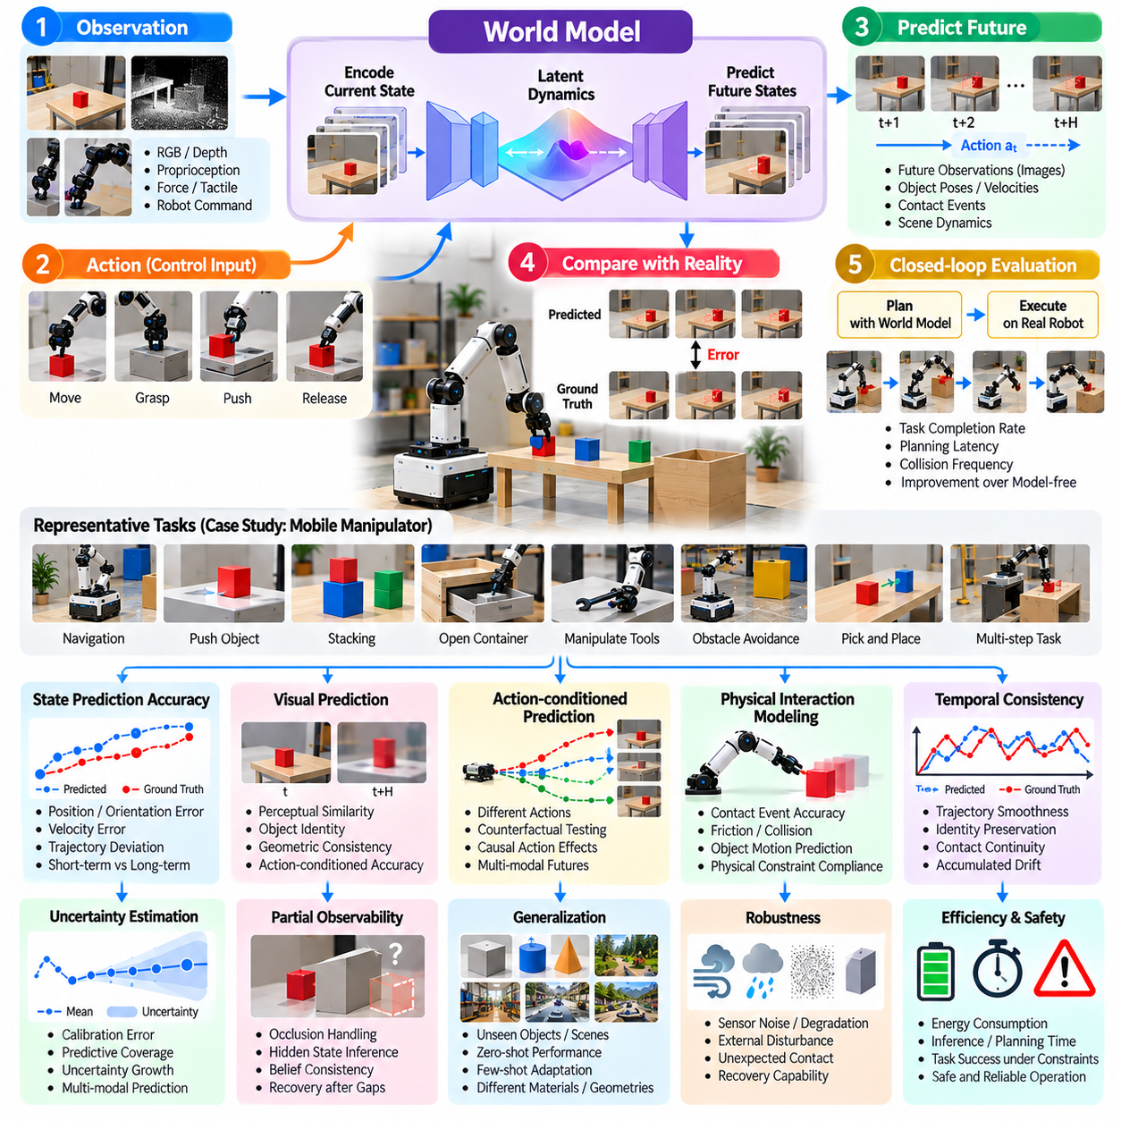
World model evaluation examines whether an intelligent robotic system can construct internal representations of its environment and predict how physical states evolve under actions. Unlike perception benchmarks that assess current observations, world model benchmarks evaluate predictive understanding, temporal consistency, and physical reasoning. The central objective is to determine whether learned dynamics support reliable planning and control beyond memorized visual patterns.
A representative case study involves a mobile manipulator operating in a workspace containing movable objects, obstacles, and changing task conditions. The robot observes the environment, predicts the consequences of candidate actions, and executes selected behaviors. Evaluation compares predicted future states with measured outcomes. Tasks include pushing objects, navigating around obstacles, manipulating containers, and responding to unexpected environmental changes.
Benchmark design begins by specifying observation modalities, action representations, prediction horizons, and environmental dynamics. Inputs may include images, depth measurements, proprioception, force signals, and robot commands. Outputs may represent future observations, object poses, contact events, or latent states. Standardized protocols define initial conditions, action sequences, prediction intervals, and reference measurements for reproducible evaluation.
State prediction accuracy measures how closely the world model estimates future positions, velocities, orientations, and interaction outcomes. Evaluation compares predicted trajectories with ground-truth measurements across multiple time horizons. Metrics may include position error, orientation error, velocity error, and trajectory deviation. Results should distinguish short-term prediction accuracy from long-term consistency because small modeling errors can accumulate over time.
Visual prediction evaluates whether generated future observations preserve object identity, scene geometry, and physically plausible motion. Pixel-level similarity alone is insufficient because visually convincing predictions may contain incorrect dynamics. Evaluation should combine perceptual similarity with object tracking, geometric consistency, and action-conditioned state accuracy. This approach prevents appearance quality from being mistaken for genuine physical understanding.
Action-conditioned prediction is essential because a useful world model must represent how different control inputs change future states. The benchmark evaluates predictions under alternative robot actions, including movement, grasping, pushing, and releasing objects. Counterfactual testing compares predicted outcomes for actions not executed in the observed trajectory. Such evaluation reveals whether the model captures causal action effects rather than passive temporal correlations.
Physical interaction modeling examines contact, friction, collision, gravity, and object motion. Representative tests include pushing objects across different surfaces, stacking items, opening articulated mechanisms, and manipulating objects with varying mass. Measurements include contact-event accuracy, motion prediction error, and violation of physical constraints. Performance should be evaluated across unfamiliar interaction conditions to assess transferable physical reasoning.
Temporal consistency measures whether successive predictions form coherent physical trajectories over extended horizons. A model may generate accurate individual frames while producing inconsistent object motion or sudden state changes. Evaluation considers trajectory smoothness, identity preservation, contact continuity, and accumulated prediction drift. Multi-horizon testing reveals the point at which predictions become unreliable for downstream decision-making.
Uncertainty estimation evaluates whether the world model recognizes ambiguity in observations and unpredictability in physical interactions. Probabilistic models may generate multiple plausible futures or estimate confidence intervals around predicted states. Metrics include calibration error, predictive coverage, and uncertainty growth across horizons. Reliable uncertainty estimates help planners avoid overconfident actions when the environment is partially observed.
Partial observability testing introduces occluded objects, limited camera viewpoints, delayed observations, and missing sensor measurements. The model must infer hidden states from previous observations while updating its beliefs when new evidence becomes available. Evaluation measures hidden-state prediction accuracy, belief consistency, and recovery after observation gaps. These tests distinguish persistent environmental understanding from immediate visual recognition.
Planning-oriented evaluation determines whether world model predictions improve action selection and task completion. The robot may use model predictive control or imagined rollouts to compare candidate action sequences. Benchmark results include task success rate, planning latency, collision frequency, and prediction-guided improvement over model-free baselines. Predictive accuracy should be linked to actual control benefits rather than reported as an isolated modeling achievement.
Generalization testing evaluates world model performance on unseen objects, geometries, materials, environments, and action sequences. Training and test conditions must be separated to prevent trajectory memorization or scene leakage. Zero-shot performance and adaptation-assisted performance should be reported independently. Systematic variations in physical properties reveal whether learned representations capture reusable dynamics or depend on familiar visual configurations.
Robustness evaluation introduces sensor noise, calibration errors, unexpected contacts, actuator uncertainty, and changes in environmental dynamics. The world model should update predictions when observations contradict expected outcomes. Measurements include prediction degradation, error detection latency, adaptation speed, and recovery of forecasting accuracy. Robustness is particularly important when inaccurate predictions could lead to unsafe physical actions.
Representation evaluation examines whether latent states preserve information necessary for prediction, planning, and physical interaction. Compact representations may improve computational efficiency but discard important geometric or dynamic details. Evaluation can use downstream state reconstruction, object tracking, contact prediction, and planning performance. The objective is not to maximize representation complexity but to retain task-relevant information across temporal horizons.
Simulation-based evaluation enables controlled experiments involving randomized physical parameters, object arrangements, and action sequences. Ground-truth simulator states provide precise references for analyzing prediction errors. However, a model may perform well under simulated dynamics while failing on real contact behavior or sensor characteristics. Simulation results should therefore be complemented by physical experiments that expose the simulation-to-reality gap.
Real-world validation should use calibrated sensors, synchronized action logs, reference tracking systems, and repeatable physical interactions. Each trial records observations, executed actions, predicted outcomes, and measured future states. Repeated experiments across different objects and environments help establish reproducibility. Evaluation should document model update frequency, computational latency, and hardware constraints that influence deployment feasibility.
Long-horizon evaluation examines whether a world model can maintain useful predictions across extended action sequences and changing environmental states. Representative missions may involve navigation, object retrieval, manipulation, and repeated interaction. Metrics include accumulated prediction error, planning success, state consistency, and intervention frequency. These tests reveal whether predictive representations remain useful when uncertainty compounds over time.
Safety evaluation examines the consequences of inaccurate predictions, unmodeled contacts, and excessive confidence in uncertain states. The benchmark should include collision-risk prediction, unsafe-action rejection, and fallback behavior when model confidence becomes insufficient. Safety-critical failures must be reported separately from average prediction accuracy. A useful world model should support conservative decisions when reliable physical forecasting is unavailable.
Statistical reporting should include prediction-error distributions, confidence intervals, calibration metrics, task success rates, and failure classifications. Results should be separated by prediction horizon, interaction type, environmental novelty, and disturbance intensity. Comparisons should use consistent observation budgets and computational constraints. This prevents differences in available information or processing resources from distorting conclusions about model quality.
A comprehensive world model scorecard combines state prediction, visual consistency, action conditioning, physical reasoning, uncertainty calibration, generalization, robustness, planning utility, and safety. No single metric can establish whether a model understands physical dynamics. The ultimate benchmark objective is to determine whether learned predictive representations enable robots to anticipate consequences, select effective actions, and operate reliably in unfamiliar physical environments.

09.09. VLA and Robot Foundation Model Benchmark
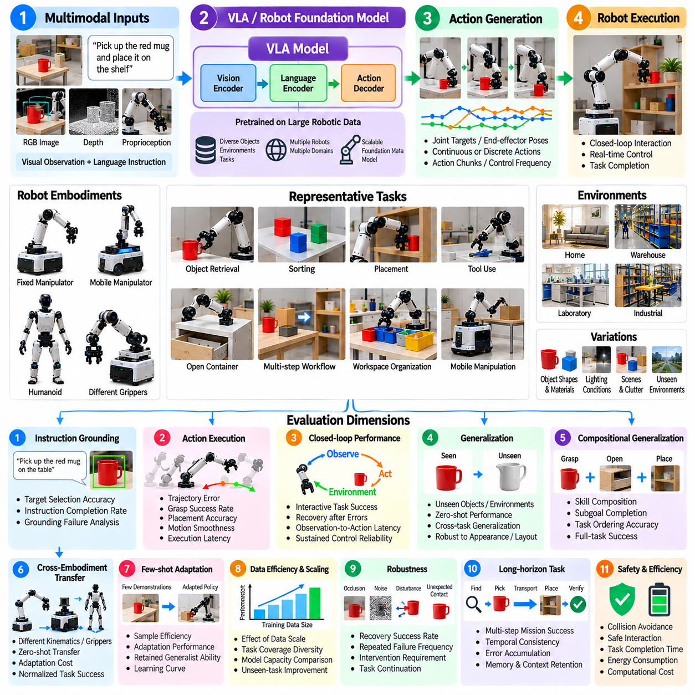
Vision-Language-Action (VLA) and robot foundation model benchmarking evaluates whether pretrained multimodal models can translate visual observations and language instructions into reliable physical actions. Unlike conventional robotic controllers designed for specific tasks, these models aim to transfer learned representations across objects, environments, and behaviors. Evaluation must therefore measure physical task success, generalization, adaptability, and safety rather than language understanding alone.
A representative benchmark involves robotic manipulators and mobile manipulators performing object retrieval, sorting, placement, tool handling, and multi-step workspace organization. Each task combines visual perception, instruction interpretation, and action execution. Test environments vary object categories, spatial arrangements, lighting, and physical properties. These variations reveal whether the model possesses transferable competence or relies on familiar training patterns.
Benchmark design begins by specifying the model architecture, observation modalities, action representations, robot embodiment, and inference configuration. Inputs may include RGB images, depth maps, proprioception, and natural-language commands. Outputs may consist of joint targets, end-effector poses, action tokens, or continuous control trajectories. Evaluation protocols must document control frequency, action horizon, preprocessing, and hardware constraints.
Instruction grounding measures whether the model correctly connects linguistic descriptions with physical objects, locations, and intended actions. Representative tasks include selecting an object by color, identifying a target through spatial relationships, and executing conditional instructions. Metrics include target selection accuracy, instruction completion rate, and grounding-related failures. Successful language interpretation must be verified through physical execution rather than textual responses.
Action generation evaluates whether predicted commands produce feasible, accurate, and stable robot movements. Different models may generate discrete action tokens, continuous actions, or temporally grouped action chunks. Measurements include trajectory error, grasp success, placement accuracy, action smoothness, and execution latency. Comparisons should account for action representation and control frequency because these choices strongly influence physical performance.
Closed-loop evaluation is essential because robotic actions change the environment and generate new observations. A model may perform well when predicting actions from recorded demonstrations but fail during autonomous execution. Benchmarking should therefore distinguish offline action prediction from interactive task success. Relevant metrics include recovery after execution errors, observation-to-action latency, corrective behavior, and sustained control reliability.
Generalization testing examines performance on unseen objects, environments, instructions, and task combinations. Training and evaluation distributions should be explicitly separated, with controlled variations in geometry, appearance, material, and spatial arrangement. Zero-shot performance measures immediate transfer without additional training. Results should identify whether success depends on memorized demonstrations or reusable perception-action representations.
Compositional generalization evaluates whether previously learned capabilities can be combined to solve unfamiliar instructions. A robot trained to grasp, transport, open, and place objects may be tested on new sequences involving those operations. Measurements include subgoal completion, task ordering accuracy, planning consistency, and full-task success. This evaluation distinguishes generalist behavior from memorization of complete action sequences.
Cross-embodiment transfer examines whether a foundation model can operate across robots with different kinematics, grippers, action spaces, and sensing configurations. Evaluation should distinguish direct zero-shot transfer from adaptation requiring additional robot-specific data. Metrics include normalized task success, calibration effort, adaptation cost, and performance degradation. Hardware capability differences must be documented to avoid misleading comparisons.
Few-shot adaptation evaluates how efficiently a pretrained model learns new tasks from limited demonstrations or interaction data. Benchmark protocols should specify demonstration counts, training steps, computational budgets, and permitted parameter updates. Performance is measured through adaptation curves, sample efficiency, and retained competence on previous tasks. This reveals whether task-specific improvement comes at the expense of broader generalist capabilities.
Data efficiency and scaling evaluation examine relationships between training diversity, model capacity, and downstream robotic performance. Comparisons may vary dataset size, task coverage, embodiment diversity, and demonstration quality. Evaluation should identify whether additional training data improves unseen-task success rather than merely familiar-task accuracy. Scaling conclusions require controlled experimental conditions and transparent reporting of training resources.
Robustness testing introduces visual occlusion, sensor noise, object displacement, ambiguous instructions, and unexpected contact. The model must recognize changes and revise its actions when initial predictions become inappropriate. Measurements include disturbance recovery, repeated failure frequency, intervention requirements, and task continuation success. Robustness should be evaluated during physical interaction rather than exclusively through static visual perturbations.
Long-horizon evaluation combines multiple perception, reasoning, and manipulation operations into extended missions. Representative tasks include locating several objects, reorganizing a workspace, and verifying completion conditions. Metrics include full-mission success, subgoal consistency, accumulated execution error, and intervention frequency. These tests reveal whether foundation models maintain task context and reliable behavior across extended action sequences.
Inference efficiency is important because large multimodal models may introduce substantial computational latency and memory requirements. Evaluation measures observation processing time, action generation latency, throughput, memory consumption, and energy usage. Edge deployment should be tested under realistic hardware limits. A model with high offline accuracy may remain unsuitable for physical control if its responses violate real-time operational constraints.
Safety evaluation examines unsafe action generation, collisions, excessive contact forces, unstable grasps, and failures to respect restricted regions. Safety-critical outcomes must be reported independently from task success. Runtime monitors, action constraints, emergency stopping, and fallback controllers should be evaluated as part of the complete system. High-level instruction compliance does not guarantee safe physical behavior.
Simulation-based benchmarking enables repeated testing across randomized objects, task layouts, robot configurations, and disturbances. Parallel environments support large-scale comparisons and systematic failure analysis. However, simulated contacts, tactile feedback, and actuator dynamics may differ from physical conditions. Real-world validation is therefore necessary to determine whether simulated improvements translate into reliable manipulation and autonomous task execution.
Real-world evaluation should use standardized objects, calibrated reference measurements, repeatable task procedures, and independently verified outcomes. Each trial should record instructions, observations, generated actions, intervention events, and final task states. Repeated testing across environments establishes reproducibility. Evaluation must disclose task-specific tuning, human assistance, and any training-data overlap that could influence reported performance.
Statistical reporting should include task success rates, confidence intervals, completion-time distributions, adaptation curves, and failure classifications. Results should be separated by task category, environmental novelty, embodiment, and evaluation mode. Model comparisons must account for observation budgets, control interfaces, and available computational resources. A single aggregate score cannot adequately represent the capabilities and limitations of a generalist robotic model.
A comprehensive VLA and robot foundation model scorecard combines instruction grounding, action accuracy, closed-loop performance, generalization, cross-embodiment transfer, adaptation efficiency, long-horizon reliability, computational efficiency, and safety. Category-level reporting prevents strong performance in familiar tasks from concealing critical weaknesses. The benchmark ultimately determines whether pretrained multimodal intelligence produces transferable, dependable, and safe physical behavior.

09.10. Long Horizon Autonomy Benchmark
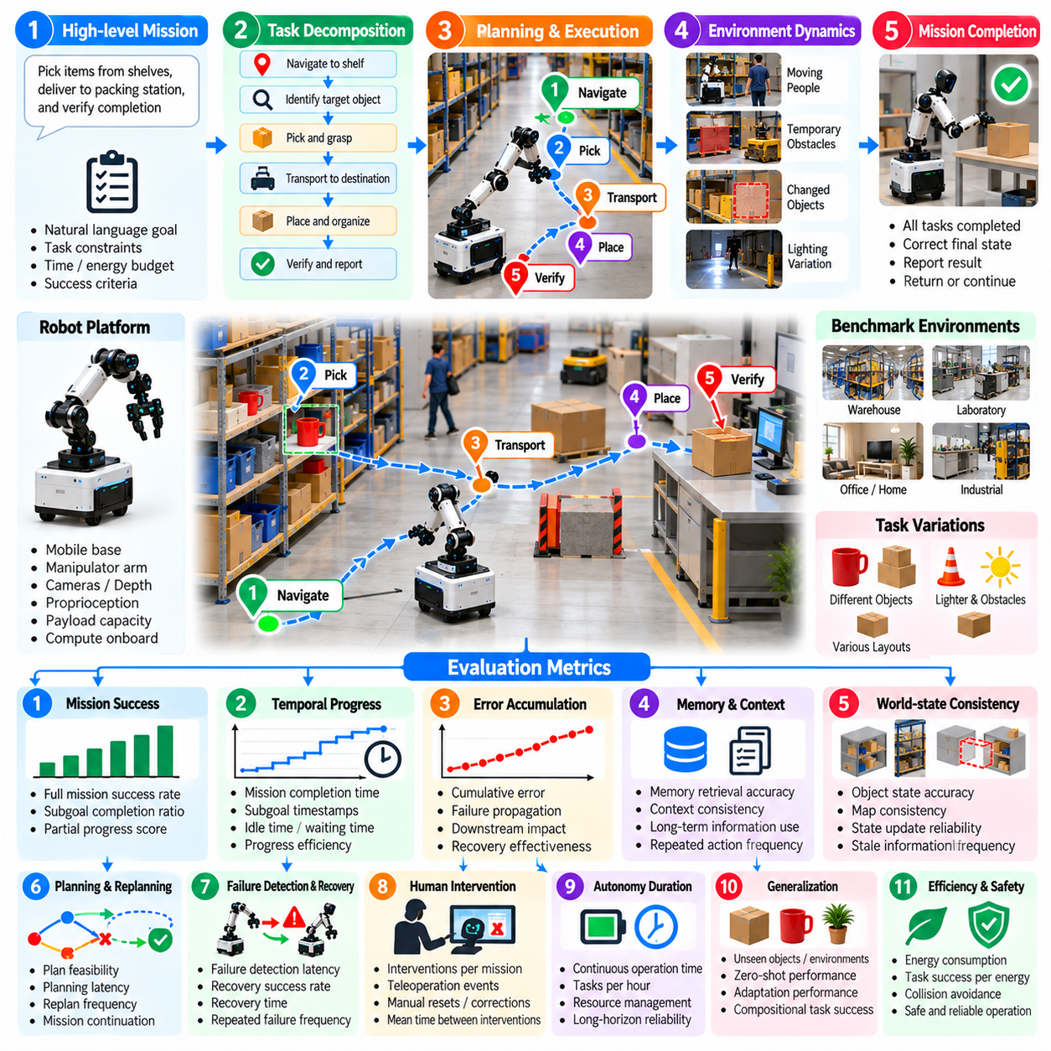
Long-horizon autonomy benchmarking evaluates whether a Physical AI system can sustain reliable decision-making and physical execution across extended missions. Unlike short-duration tests that measure isolated skills, long-horizon evaluation examines the accumulation of errors, changing environmental conditions, and dependencies between actions. Its central objective is to determine whether autonomous competence remains stable as task complexity and operating time increase.
A representative benchmark involves a mobile manipulator performing an extended warehouse mission that includes navigation, object identification, retrieval, transportation, placement, and verification. The robot must complete multiple dependent tasks without continuous human supervision. Evaluation environments introduce changing object locations, temporary obstacles, and operational interruptions to reveal whether the system can preserve mission objectives throughout execution.
Benchmark design begins by defining mission duration, task dependencies, operational boundaries, environmental variability, and acceptable intervention levels. A mission should contain measurable subgoals with explicit completion conditions. Standardized protocols specify initial states, resource limits, observation availability, and termination criteria. These definitions enable meaningful comparisons between systems with different planning and control architectures.
Task decomposition evaluation examines whether the robot can transform a high-level objective into an executable sequence of subgoals. The benchmark measures decomposition correctness, dependency satisfaction, and subgoal ordering accuracy. Tasks may require navigation before manipulation or inspection before delivery. Successful decomposition must reflect physical constraints rather than merely produce a logically plausible sequence of instructions.
Mission success is measured at both the complete-task and intermediate-subgoal levels. A robot may accomplish most subtasks but fail to deliver the final objective because of one unresolved dependency. Metrics include full-mission success rate, subgoal completion ratio, partial-progress score, and terminal-state correctness. Reporting intermediate progress separately prevents partial execution from being incorrectly classified as complete autonomy.
Temporal progress evaluation examines how efficiently a system advances toward its objectives throughout a mission. Measurements include elapsed mission time, subgoal completion timestamps, idle duration, and time spent recovering from failures. Progress curves reveal stagnation, repeated attempts, and inefficient execution patterns. Evaluation should distinguish deliberate waiting required by the task from unnecessary delays caused by planning or control failures.
Error accumulation is a defining challenge of long-horizon autonomy because small inaccuracies can propagate across dependent actions. Localization drift, grasping errors, incorrect object identification, and incomplete state updates may produce later failures. The benchmark tracks cumulative error, downstream failure propagation, and recovery effectiveness. These measurements identify whether the system detects and corrects deviations before they compromise mission completion.
Memory and context retention are evaluated through tasks requiring information collected earlier in the mission. The robot may need to remember object locations, completed inspections, temporary restrictions, or previously unsuccessful actions. Metrics include memory retrieval accuracy, context consistency, and repeated-action frequency. Long-horizon competence requires maintaining relevant information without allowing outdated observations to override current environmental evidence.
World-state consistency measures whether the robot maintains an accurate representation of its environment as objects move and tasks progress. Evaluation compares internal state estimates with independently measured conditions. Relevant metrics include object-state accuracy, map consistency, and stale-information frequency. A reliable autonomous system must revise its world representation when physical outcomes differ from predicted results.
Long-horizon planning evaluates whether the system can select action sequences that satisfy mission goals while respecting time, energy, and operational constraints. Unexpected obstacles, unavailable resources, or changed task priorities may require replanning. Metrics include planning latency, plan feasibility, replan frequency, and mission continuation success. Effective replanning should improve outcomes without producing excessive oscillation between competing strategies.
Failure detection and recovery are assessed by introducing controlled disturbances such as blocked routes, failed grasps, missing objects, and temporary sensor degradation. The robot must recognize unsuccessful execution and select an appropriate corrective action. Measurements include detection latency, recovery time, recovery success rate, and repeated failure frequency. Evaluation should distinguish autonomous recovery from interventions performed by human operators.
Human intervention is measured because nominal task completion does not necessarily indicate genuine autonomy. The benchmark records assistance requests, teleoperation events, manual resets, and operator corrections. Metrics include interventions per mission, interventions per operating hour, and mean time between interventions. Reports should distinguish safety-driven assistance from assistance required to overcome ordinary task execution failures.
Autonomy duration evaluates how long a robot can operate successfully without external assistance or mission-critical failure. Continuous-operation tests may involve repeated task cycles, changing workloads, and resource replenishment. Measurements include uninterrupted operating time, mean time between failures, and mission completion consistency. These metrics reveal reliability limitations that may remain invisible during isolated short trials.
Resource management becomes increasingly important during extended missions because energy, computation, storage, and communication availability may change. Evaluation measures energy consumption, charging decisions, computational utilization, and resource-related mission interruptions. The benchmark should determine whether the robot anticipates resource constraints and adjusts its plans before depletion prevents safe mission completion.
Robustness evaluation introduces environmental changes, uncertain observations, delayed communication, and unexpected human activity. The robot must preserve safe behavior while adapting to disturbances. Measurements include task degradation, disturbance recovery, and operational continuity. Testing should progressively increase difficulty within controlled safety limits to identify the boundaries of reliable autonomous performance.
Safety evaluation examines collisions, unsafe manipulation, restricted-area violations, and inappropriate continuation after critical failures. Safety events must be reported independently from mission completion and execution efficiency. Emergency stopping, safe fallback behavior, and controlled mission termination should be explicitly tested. A system that completes a mission through unsafe actions cannot be considered reliably autonomous.
Simulation-based benchmarking supports large numbers of long-duration trials across randomized task sequences, environmental conditions, and failure events. Parallel execution helps estimate rare failure probabilities and compare alternative planning strategies. However, simplified physical interactions and unrealistic disturbance distributions may distort reliability estimates. Real-world testing is necessary to validate whether simulated endurance transfers to operational environments.
Real-world validation should use repeatable mission definitions, synchronized logs, calibrated measurements, and documented intervention procedures. Each trial records task progress, robot state, resource consumption, environmental changes, and failure events. Repeated experiments across different mission lengths reveal how performance degrades over time. Statistical analysis should separate ordinary execution variability from systematic long-horizon failure patterns.
Benchmark reporting should include full-mission success, subgoal completion, autonomy duration, intervention rate, recovery performance, resource efficiency, and safety outcomes. Confidence intervals and failure distributions help distinguish meaningful improvements from experimental variation. Results should be stratified by mission length and difficulty. The ultimate objective is to establish whether Physical AI systems can sustain dependable autonomy throughout realistic, extended operations.

09.11. Heterogeneous Fleet Benchmark
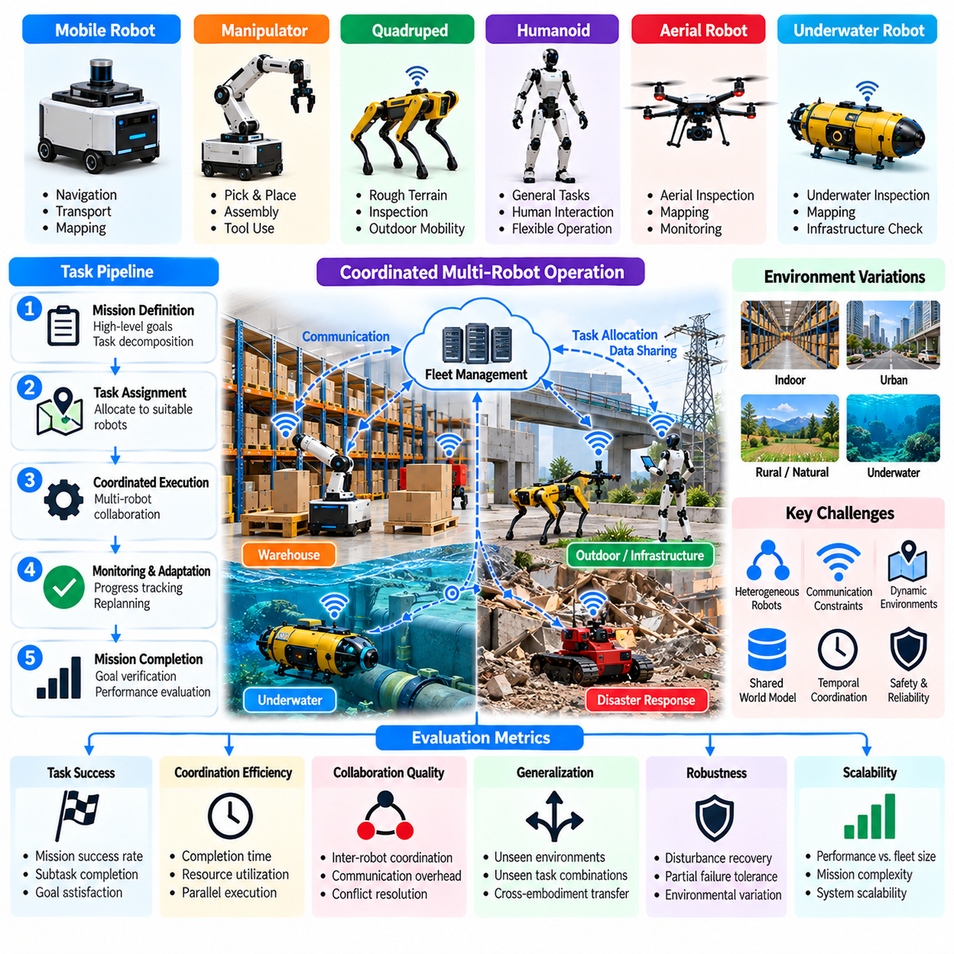
Heterogeneous fleet benchmarking evaluates whether robots with different physical capabilities can cooperate to complete shared missions efficiently, reliably, and safely. Unlike homogeneous fleets composed of similar platforms, heterogeneous systems combine mobile robots, manipulators, quadrupeds, aerial vehicles, and specialized machines. Evaluation must therefore consider individual competence, task allocation, coordination, communication, and collective mission performance.
A representative case study involves an industrial logistics facility where autonomous mobile robots transport materials, manipulators handle objects, and aerial robots inspect elevated structures. A quadruped may investigate areas inaccessible to wheeled platforms. The fleet must coordinate these activities while sharing operational space and information. Benchmark scenarios measure whether specialization improves mission outcomes beyond independent robot operation.
Benchmark design begins by defining fleet composition, robot capabilities, task dependencies, workspace constraints, and communication infrastructure. Each robot should have a documented capability profile describing mobility, payload, sensing, manipulation, and endurance. Standardized scenarios specify mission objectives, initial positions, resource availability, and completion conditions. These definitions establish comparable conditions across different fleet architectures.
Task allocation evaluation measures how effectively the fleet assigns activities according to robot capabilities, availability, and operational cost. Tasks may require specialized sensors, particular manipulators, or access to restricted environments. Metrics include assignment feasibility, allocation latency, task completion rate, and resource utilization. Evaluation should distinguish efficient specialization from excessive dependence on a small number of high-capability robots.
Coordination performance examines how multiple robots synchronize actions involving shared locations, objects, or sequential dependencies. A mobile robot may deliver materials before a manipulator can begin assembly, while an inspection robot verifies completion. Metrics include synchronization delay, dependency violations, waiting time, and coordinated task success. Effective coordination minimizes unnecessary idle periods without compromising operational safety.
Communication evaluation considers message delivery, network latency, bandwidth consumption, and information consistency across the fleet. Robots may exchange task status, object locations, environmental maps, and hazard notifications. Benchmark conditions introduce packet loss, delayed messages, and intermittent connectivity. Measurements include communication reliability, coordination degradation, and recovery after network interruptions.
Shared perception and mapping evaluation examines whether robots can combine observations into a consistent operational representation. Different sensing configurations may provide complementary information about obstacles, objects, and traversable regions. Metrics include map alignment accuracy, object-state consistency, information freshness, and shared-state update latency. Evaluation must identify whether information fusion improves decisions or introduces conflicting environmental estimates.
Heterogeneous navigation evaluates how robots with different locomotion mechanisms operate safely within shared spaces. Wheeled robots, legged platforms, and aerial vehicles may follow different routes while interacting at common transfer points. Metrics include collision frequency, traffic congestion, route completion, and spatial utilization. The benchmark should distinguish unavoidable physical constraints from coordination failures that reduce overall fleet efficiency.
Collaborative manipulation and handoff evaluation focuses on tasks requiring cooperation between platforms with different physical capabilities. A mobile robot may position a container for a stationary manipulator, or two robots may coordinate object transfer. Measurements include handoff success rate, alignment accuracy, synchronization error, and object damage frequency. Successful cooperation requires compatible interfaces and accurate estimates of shared task states.
Fleet-level planning evaluates whether a coordination system can convert mission objectives into feasible assignments and execution schedules. Planning must account for robot availability, travel time, energy reserves, and task dependencies. Metrics include scheduling efficiency, mission makespan, replanning latency, and deadline satisfaction. Evaluation should compare centralized, decentralized, and hybrid coordination strategies under equivalent operational constraints.
Dynamic reassignment evaluates the fleet's ability to redistribute tasks when robots become unavailable or mission priorities change. Benchmark scenarios may introduce equipment failures, charging requirements, blocked routes, or urgent inspection requests. Measurements include reassignment latency, recovered task coverage, mission delay, and workload balance. A resilient fleet should continue useful operations without relying on continuous human intervention.
Scalability evaluation examines how collective performance changes as fleet size, robot diversity, and task volume increase. Adding robots may improve throughput but also introduce communication overhead, congestion, and scheduling complexity. Metrics include throughput scaling, coordination latency, computational demand, and marginal productivity per added robot. Benchmark results should identify operating regions where additional robots no longer improve mission performance.
Resource efficiency evaluation measures fleet-wide energy consumption, charging utilization, equipment availability, and productive operating time. Different robot types have distinct energy profiles and maintenance requirements. Metrics include energy per completed task, fleet utilization, charging-related delays, and idle resource consumption. Evaluation should determine whether coordinated resource management improves efficiency compared with independent scheduling.
Robustness testing introduces sensor degradation, actuator failures, communication interruptions, and unexpected environmental changes. Failures may affect individual robots or propagate through shared dependencies. Metrics include mission degradation, fault isolation, recovery time, and remaining operational capacity. Testing should reveal whether the fleet can reorganize around failures while preserving essential services and safe operating conditions.
Human-fleet interaction evaluation examines how operators supervise multiple autonomous platforms and respond to exceptions. The benchmark measures intervention frequency, operator workload, alert clarity, and recovery effectiveness. Different autonomy levels may require different supervision arrangements. Evaluation should distinguish successful autonomous coordination from performance maintained through extensive human monitoring or manual task reassignment.
Safety evaluation considers inter-robot collisions, unsafe handoffs, shared-space conflicts, and hazardous interactions with people. Safety-critical events must be reported separately from throughput and mission completion. Emergency stopping, right-of-way rules, geofencing, and coordinated fallback behavior should be explicitly tested. Fleet safety requires evaluating interactions between robots rather than assessing each platform independently.
Simulation-based benchmarking supports large-scale testing of fleet composition, task demand, communication conditions, and failure scenarios. Parallel simulation enables repeated comparisons of allocation and coordination algorithms. However, simplified traffic behavior, physical interactions, and network models may distort performance estimates. Real-world experiments are necessary to verify that simulated improvements transfer to operational facilities.
Real-world validation should use documented fleet configurations, standardized task definitions, synchronized event logs, and independently measured outcomes. Each trial records robot assignments, task progress, communication events, interventions, and resource consumption. Repeated experiments across different workloads establish reproducibility. Evaluation should document hardware differences and environmental conditions that influence collective performance.
A comprehensive heterogeneous fleet scorecard combines mission success, task allocation, coordination efficiency, communication reliability, scalability, resource utilization, robustness, human intervention, and safety. Statistical reporting should include confidence intervals, workload-dependent performance curves, and failure classifications. The ultimate objective is to determine whether diverse robots can operate as a dependable coordinated system rather than merely as independent machines.

09.12. End to End Physical AI Benchmark Suite [w/Code]
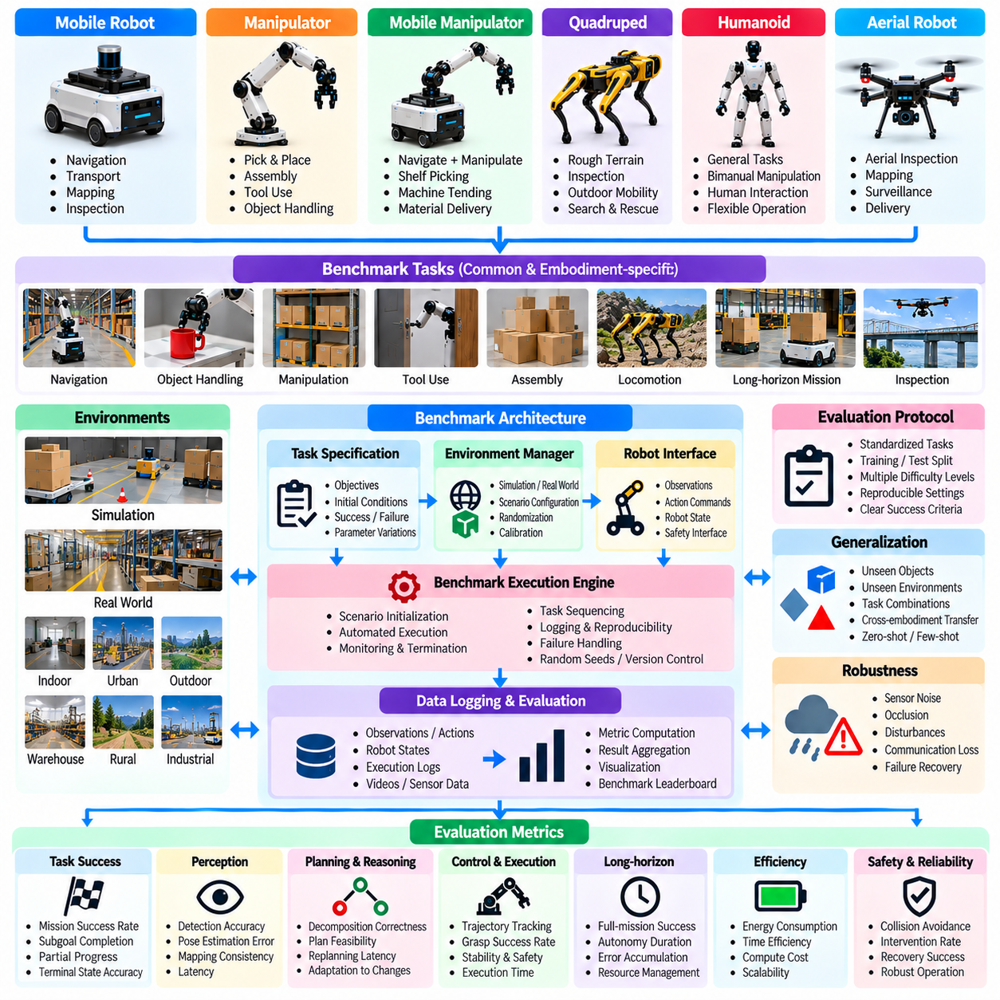
An end-to-end Physical AI benchmark suite evaluates the complete operational capability of intelligent robotic systems, from perception and reasoning to planning, control, and physical execution. Unlike isolated algorithm benchmarks, an integrated suite measures how individual components interact during realistic tasks. Its purpose is to establish reproducible evidence of task competence, generalization, robustness, efficiency, and safety across diverse embodiments.
The benchmark suite should cover autonomous mobile robots, manipulators, mobile manipulators, quadrupeds, humanoids, and aerial platforms. Each embodiment requires tasks reflecting its physical capabilities while sharing common evaluation principles. Representative scenarios include navigation, object handling, inspection, locomotion, and multi-step missions. This structure enables both platform-specific analysis and comparisons of general autonomous capabilities.
A standardized benchmark architecture separates task definitions, environment configurations, robot interfaces, evaluation controllers, data logging, and metric computation. Each layer should expose documented interfaces so different algorithms and hardware platforms can be evaluated consistently. The architecture must distinguish benchmark infrastructure from the system under test. This separation reduces hidden dependencies and improves reproducibility.
Task specifications define objectives, initial conditions, permitted actions, environmental constraints, and measurable completion criteria. Each task should include explicit success and failure conditions rather than relying on subjective operator judgments. Parameterized tasks allow systematic variation in object positions, obstacles, lighting, and physical properties. Difficulty levels should reflect measurable changes in complexity rather than arbitrary labels.
Environment management supports both simulation and real-world evaluation using consistent task semantics. Simulated environments provide repeatability, controlled disturbances, and large-scale testing, while physical environments reveal sensing errors, contact uncertainty, and hardware limitations. Calibration procedures align reference measurements across domains. Differences between simulated and physical outcomes should be recorded rather than concealed through score normalization.
Robot interface standardization enables different platforms to participate without requiring identical hardware or control architectures. Interfaces may expose observations, action commands, robot state, safety status, and execution feedback. Adapters translate these abstractions into platform-specific protocols. Evaluation must document action frequency, observation latency, sensor availability, and permitted control authority to ensure comparisons remain technically meaningful.
A benchmark execution engine manages scenario initialization, randomized trials, task sequencing, monitoring, and termination. Each run should record configuration identifiers, software versions, random seeds, and robot parameters. Automated execution reduces operator variability and supports repeated experiments. The engine must also detect invalid trials caused by infrastructure failures and distinguish them from legitimate system failures.
Perception evaluation measures object detection, localization, mapping, scene understanding, and state estimation under changing conditions. Metrics include detection accuracy, pose error, map consistency, and observation latency. However, component-level perception accuracy should be connected to downstream task outcomes. A perception model that performs well offline may still produce unsafe or ineffective decisions during physical interaction.
Planning and reasoning evaluation examines task decomposition, goal selection, constraint satisfaction, and adaptation to unexpected events. Scenarios may require sequential manipulation, navigation around blocked routes, or replanning after unsuccessful actions. Metrics include plan feasibility, subgoal completion, replanning latency, and mission success. Evaluation should verify actual execution outcomes instead of accepting plausible plans as successful behavior.
Control and physical execution evaluation measures whether planned actions produce accurate, stable, and safe movement. Relevant metrics include trajectory tracking error, grasp success, locomotion stability, collision frequency, and execution time. Control performance must be evaluated under realistic actuator limits, contact dynamics, and disturbances. The benchmark should identify whether failures originate in planning, perception, control, or their interactions.
Generalization testing separates training and evaluation distributions across objects, environments, tasks, and robot embodiments. Controlled novelty levels distinguish familiar conditions from unseen configurations. Zero-shot and adaptation-based results should be reported separately. Metrics include unseen-task success, performance degradation, adaptation data requirements, and cross-embodiment transfer. Transparent dataset boundaries are necessary to prevent misleading claims.
Robustness evaluation introduces sensor noise, occlusion, object displacement, communication interruptions, and actuator degradation. Each disturbance should have documented severity and reproducible application conditions. Measurements include recovery success, performance degradation, intervention frequency, and failure propagation. Robustness scores should reflect sustained task execution rather than accuracy under isolated perturbations alone.
Long-horizon evaluation combines multiple dependent tasks into extended missions requiring memory, state tracking, resource management, and autonomous recovery. Metrics include full-mission success, subgoal consistency, autonomy duration, and mean time between interventions. Extended trials reveal accumulated errors that short tests cannot expose. Mission progress should be logged continuously to distinguish partial completion from reliable autonomous operation.
Safety evaluation measures collisions, unsafe contact forces, restricted-zone violations, emergency stops, and failures to enter safe fallback states. Safety outcomes must remain visible even when task success is high. The suite should test protective mechanisms independently from nominal task execution. Evaluation protocols must define exposure limits and stop conditions so benchmark difficulty never overrides operational safety requirements.
Computational efficiency evaluation considers inference latency, control-loop timing, memory consumption, energy use, and hardware utilization. Measurements should include both algorithm-level costs and complete-system overhead. Real-time constraints vary across embodiments and tasks, making raw inference speed insufficient as a universal metric. Reports should document computational resources and identify whether performance remains acceptable under deployment conditions.
Statistical evaluation requires repeated trials, controlled randomization, confidence intervals, and explicit failure classification. Results should be stratified by task category, difficulty, embodiment, and environmental novelty. Aggregate scores may summarize performance but should not hide critical safety or reliability weaknesses. Missing trials, manual interventions, and unsuccessful runs must be reported transparently to prevent selective performance claims.
A practical benchmark suite can organize its implementation around reusable scenario files, robot adapters, execution scripts, event logs, and metric calculators. Machine-readable configurations specify tasks, environments, seeds, and evaluation settings. Automated pipelines validate configurations, execute trials, compute results, and generate reports. Versioned benchmark definitions ensure that algorithm improvements can be compared against stable experimental conditions.
Reproducibility requires preserving source code versions, model checkpoints, dataset references, calibration records, and hardware configurations. Benchmark results should include sufficient metadata for independent replication. Continuous integration can automate simulation regression tests, while physical validation follows controlled test schedules. Changes to task definitions or scoring procedures must be versioned because they may invalidate comparisons with earlier results.
A comprehensive Physical AI benchmark scorecard combines perception, planning, control, task success, generalization, robustness, long-horizon autonomy, efficiency, and safety. Category-level results should accompany any overall performance index. The ultimate objective is not merely to rank algorithms but to establish a trustworthy evaluation framework that connects laboratory measurements with dependable physical intelligence in real-world operations.

