Volume 11. Physical AI Evaluation and Benchmarking

Chapter 02. Simulation Benchmarks

02.01. Why Benchmark in Simulation
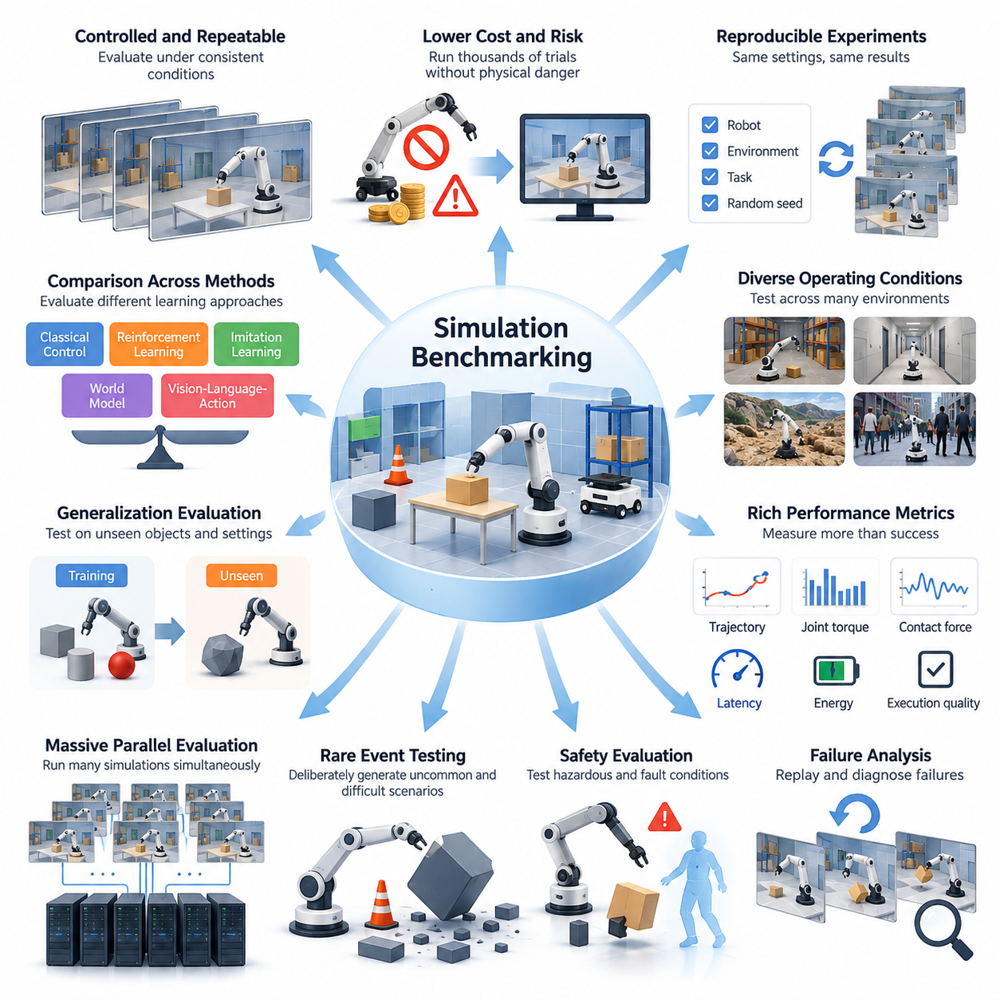
Simulation benchmarking provides a controlled and repeatable foundation for evaluating Physical AI systems before deployment in real environments. Unlike conventional software, Physical AI interacts with objects, surfaces, sensors, actuators, and dynamic surroundings. Simulation enables researchers to reproduce these interactions systematically while measuring performance, identifying limitations, and comparing alternative algorithms under consistent experimental conditions.
Real-world testing is essential for validating physical intelligence, but it introduces substantial costs, operational risks, and experimental variability. Hardware wear, environmental changes, human intervention, and limited testing facilities can restrict the number of trials. Simulation reduces these constraints by providing virtual environments in which robots can execute thousands of experiments without consuming physical equipment or exposing people to unnecessary hazards.
A major advantage of simulation benchmarking is experimental reproducibility. Researchers can initialize identical robot configurations, object arrangements, environmental conditions, and task objectives across repeated evaluations. By controlling random seeds and simulation parameters, experiments can be reproduced with high consistency. This makes it easier to distinguish improvements caused by an algorithm from variations introduced by uncontrolled environmental factors.
Simulation also supports systematic evaluation across diverse operating conditions. A robot navigation policy can be tested in warehouses, corridors, outdoor terrain, and crowded environments without constructing separate physical facilities. Manipulation algorithms can encounter different object shapes, masses, friction coefficients, and contact properties. Such variation enables benchmark designers to investigate whether an intelligent system performs reliably beyond a narrow collection of familiar scenarios.
Physical AI evaluation requires more than measuring whether a task reaches its intended goal. Simulation environments can record detailed trajectories, joint torques, contact forces, sensor observations, computational latency, and energy consumption. These measurements reveal how a task was completed rather than merely whether it succeeded. Consequently, simulation benchmarks can evaluate execution quality, resource efficiency, stability, and the physical consequences of autonomous decisions.
Closed-loop evaluation is particularly important because intelligent robots continuously modify their behavior in response to environmental feedback. A small perception error may influence motion planning, which subsequently changes sensor observations and future decisions. Simulation allows these feedback relationships to unfold throughout an entire task. This provides a more realistic assessment of interactive intelligence than evaluating isolated predictions against prerecorded datasets.
Simulation benchmarking also enables precise investigation of failure mechanisms. When a robot collides with an obstacle, loses balance, drops an object, or fails to complete a mission, the simulator can preserve the complete sequence of preceding states and actions. Researchers can replay the failure, modify selected conditions, and determine whether the underlying cause involves perception, planning, control, physical modeling, or interactions between subsystems.
Safety evaluation benefits significantly from simulated experimentation. Potentially hazardous situations, including unexpected human movement, sensor degradation, actuator malfunction, and unstable contact interactions, can be introduced without creating equivalent physical dangers. Simulation therefore provides a practical environment for examining collision avoidance, emergency responses, fallback strategies, and recovery behavior before exposing physical platforms to demanding operating conditions.
Rare events represent another important motivation for simulation benchmarks. Some failures occur so infrequently that collecting statistically meaningful real-world examples would require extensive operational time. Virtual environments can deliberately generate unusual obstacle configurations, extreme disturbances, unexpected interactions, and combinations of unfavorable conditions. This capability supports targeted stress testing and helps reveal vulnerabilities that ordinary evaluation scenarios might overlook.
Massive parallel simulation further expands the scale of Physical AI evaluation. Modern computing platforms can execute many independent robot environments simultaneously, allowing researchers to examine large combinations of tasks, configurations, and environmental parameters. Parallel benchmarking accelerates statistical analysis and enables systematic exploration of performance distributions rather than relying on a small number of successful demonstrations.
The ability to control environmental variation is especially valuable for measuring generalization. Benchmark designers can separate familiar scenarios from unseen objects, layouts, terrain conditions, and physical properties. Policies can then be evaluated on configurations excluded from their training environments. This distinction helps determine whether a system has acquired transferable physical capabilities or merely adapted to recurring patterns within a limited simulation dataset.
Simulation also enables comparative evaluation across different learning architectures. Classical controllers, reinforcement learning policies, imitation learning systems, world models, and vision-language-action models can be tested against common task specifications. Standardized observations, action interfaces, initialization procedures, and scoring protocols help establish meaningful comparisons while preserving the architectural differences that researchers intend to investigate.
However, simulation results cannot automatically be interpreted as real-world performance. Simulators approximate physical processes, and inaccuracies in contact dynamics, friction, deformation, sensor noise, and actuator response can produce misleading outcomes. A policy may achieve excellent virtual performance by exploiting unrealistic dynamics or simplified environmental assumptions. Therefore, benchmark conclusions must account for simulation fidelity and the limitations of the underlying physical models.
The simulation-to-reality gap is particularly important when evaluating manipulation, locomotion, and contact-rich behavior. Small differences in material properties, actuator delays, or collision modeling may substantially alter execution outcomes. Benchmark designers should identify which physical assumptions are critical to the intended application and evaluate sensitivity to those assumptions. Simulation fidelity should be judged by its relevance to evaluation objectives rather than visual realism alone.
Domain randomization offers one approach to addressing uncertainty in simulated environments. Instead of evaluating a policy under a single idealized configuration, benchmark designers vary parameters such as lighting, friction, object geometry, sensor noise, and actuator characteristics. Performance across these variations can reveal sensitivity to modeling assumptions and provide evidence about robustness, although successful randomized evaluation does not guarantee reliable deployment.
Another important consideration is the distinction between deterministic and stochastic evaluation. Deterministic scenarios support debugging, regression testing, and controlled comparisons by reproducing identical experimental conditions. Stochastic scenarios introduce uncertainty and variation that better reflect operational complexity. A comprehensive simulation benchmark should incorporate both approaches, allowing researchers to investigate repeatable failures while estimating performance across diverse possible outcomes.
Benchmark validity depends on whether simulated tasks represent capabilities that matter outside the benchmark itself. An environment may provide consistent measurements while emphasizing behaviors that have limited practical relevance. Similarly, algorithms may overfit to fixed layouts, predictable object distributions, or scoring rules. Effective benchmarking therefore requires carefully selected tasks, independent evaluation scenarios, transparent assumptions, and periodic revisions that discourage exploitation of benchmark-specific shortcuts.
Statistical rigor is necessary because performance can vary considerably across initialization conditions and random trials. A single successful episode provides little evidence of dependable physical intelligence. Simulation makes it feasible to report success distributions, confidence intervals, failure frequencies, completion times, and robustness trends across repeated experiments. Such reporting supports more defensible comparisons and prevents exceptional demonstrations from being mistaken for typical system behavior.
Simulation benchmarks also contribute to efficient development workflows. Engineers can use automated tests to detect regressions after changes to perception models, planning algorithms, control policies, or system integration. Standardized scenarios provide a common reference for development teams and support continuous evaluation throughout the software lifecycle. This transforms benchmarking from an occasional research activity into a repeatable engineering process.
Ultimately, simulation benchmarking should complement rather than replace laboratory and field evaluation. Virtual experiments provide scalability, controllability, detailed observability, and access to hazardous or unusual conditions, while physical testing establishes whether those findings remain valid under actual operating constraints. Combining these approaches creates a stronger evidence base for assessing capability, robustness, safety, and generalization in Physical AI systems.
The fundamental purpose of simulation benchmarking is therefore not simply to produce higher numerical scores, but to establish trustworthy evidence about how intelligent physical systems behave across controlled and variable conditions. When supported by realistic task definitions, rigorous measurement protocols, uncertainty analysis, and real-world validation, simulation becomes an essential foundation for developing Physical AI systems that are measurable, comparable, reliable, and progressively more capable.

02.02. Simulation Benchmark Design Principles
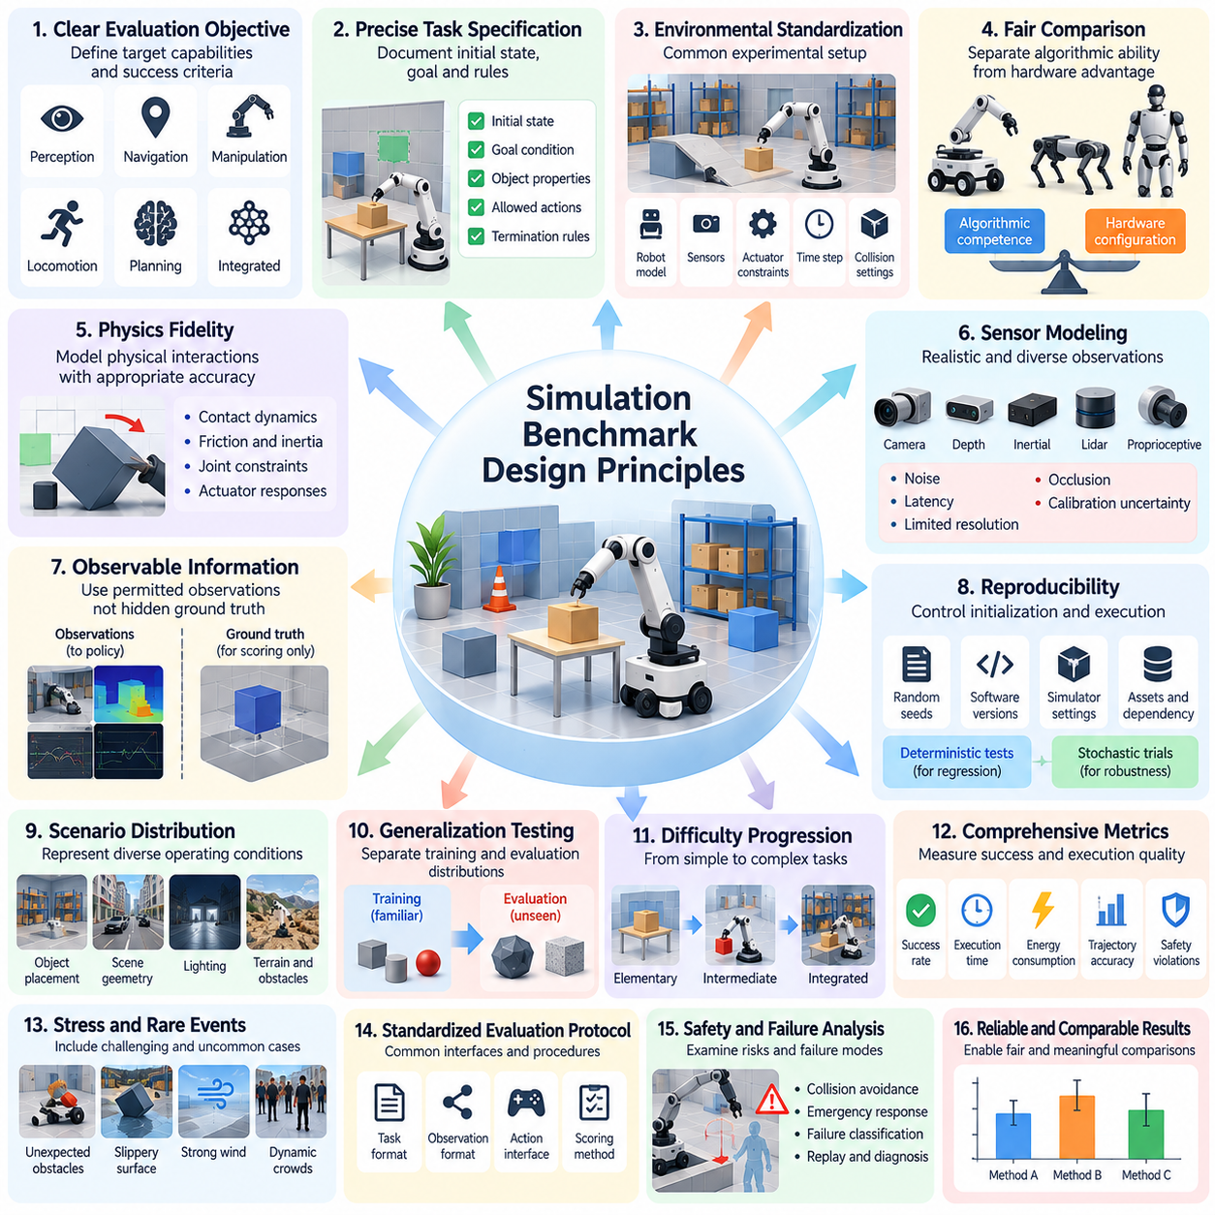
Simulation benchmark design begins with the principle that evaluation environments must measure meaningful Physical AI capabilities rather than merely produce convenient numerical scores. A well-designed benchmark connects task objectives, environmental conditions, robot behavior, and measurable outcomes. Its purpose is to provide reliable evidence about system competence while enabling fair comparisons between algorithms, architectures, and implementation strategies.
The first requirement is a clearly defined evaluation objective. Benchmark designers must identify whether the intended capability involves perception, navigation, manipulation, locomotion, planning, or integrated autonomous behavior. Each objective should correspond to observable performance criteria and explicit success conditions. Without this alignment, a benchmark may reward behaviors that improve scores without demonstrating the physical intelligence it was intended to measure.
Task specifications must be precise enough to support independent reproduction. Initial states, goal conditions, object properties, environmental boundaries, permitted actions, and termination rules should be documented consistently. Ambiguous instructions can introduce uncontrolled differences between implementations. A rigorous benchmark therefore separates the definition of the task from the particular algorithms or control strategies used to solve it.
Environmental standardization establishes a common experimental foundation. Robot models, coordinate systems, sensor configurations, actuator constraints, simulation time steps, and collision settings should be specified where relevant. These parameters influence the physical behavior of evaluated systems and may significantly affect reported performance. Standardization reduces unintended advantages while preserving the flexibility needed to investigate different intelligent architectures.
Fair comparison does not necessarily require identical robot hardware or action representations. Different embodiments may possess distinct mobility, manipulation, sensing, and control capabilities. Benchmark designers should determine which characteristics must remain fixed and which may vary according to the evaluation objective. Comparisons should distinguish algorithmic competence from advantages introduced by hardware configuration, privileged information, or unequal computational resources.
Physics fidelity is another fundamental design consideration. Contact dynamics, friction, inertia, joint constraints, and actuator responses must be represented with sufficient accuracy for the behaviors being evaluated. However, increasing simulation complexity does not automatically improve benchmark validity. The appropriate fidelity depends on the task, particularly whether performance is sensitive to physical interactions, timing, deformation, or environmental disturbances.
Sensor modeling requires similar attention because Physical AI policies depend on observations rather than perfect knowledge of simulated states. Camera images, depth measurements, inertial signals, lidar observations, and proprioceptive feedback should reflect the intended sensing configuration. Noise, latency, limited resolution, occlusion, and calibration uncertainty may need to be included to prevent unrealistic advantages from idealized virtual observations.
A fundamental distinction must be maintained between observable information and simulator ground truth. Ground-truth states are valuable for scoring, diagnostics, and failure analysis, but unrestricted access can invalidate evaluations intended to measure perception or autonomous reasoning. Benchmark interfaces should explicitly define permitted observations and prohibit hidden environmental information from entering policy inputs unless privileged access is an intentional experimental condition.
Reproducibility requires control over experimental initialization and execution. Random seeds, software versions, simulator settings, asset definitions, and dependency configurations should be recorded. Deterministic test cases enable precise regression analysis, while stochastic trials expose performance variation. Both are necessary because repeatability supports scientific comparison, whereas controlled randomness helps establish whether observed capabilities remain reliable under uncertainty.
Benchmark scenarios should represent a meaningful distribution of operating conditions rather than a collection of isolated demonstrations. Object placement, scene geometry, lighting, terrain, obstacle motion, and task complexity can vary systematically. Evaluation designers should document how scenarios are sampled and distinguish nominal conditions from challenging or unusual cases. This supports interpretable performance analysis across increasingly demanding environments.
Generalization testing requires separation between training and evaluation distributions. Unseen objects, unfamiliar layouts, altered physical parameters, and new task combinations help reveal whether a policy has learned transferable behavior. Hidden evaluation configurations can reduce direct optimization against test scenarios. Nevertheless, benchmark designers must ensure that distribution shifts remain relevant to the intended capability rather than introducing arbitrary difficulties unrelated to practical performance.
Difficulty progression provides another important design principle. Tasks should span elementary capabilities, intermediate interactions, and integrated challenges requiring multiple coordinated skills. Such progression makes it possible to identify where system performance begins to deteriorate. Difficulty should be defined through measurable factors, including environmental complexity, uncertainty, interaction requirements, and temporal dependencies, rather than subjective judgments alone.
Closed-loop interaction must be preserved whenever the evaluation concerns autonomous physical behavior. Policies should receive observations, generate actions, and experience the resulting changes in simulated environments. Evaluating only prerecorded action predictions can conceal errors that accumulate during execution. Interactive benchmarks reveal how perception, planning, control, and environmental feedback influence one another over time.
Metric design should reflect both task outcomes and execution quality. Success rate alone cannot distinguish efficient, stable behavior from slow or potentially unsafe completion. Depending on the application, additional measurements may include completion time, trajectory deviation, collision frequency, contact force, energy consumption, control smoothness, and intervention requirements. Metrics must be operationally defined so that independent implementations produce comparable results.
Multi-objective evaluation is necessary because Physical AI performance involves competing requirements. A robot may improve task completion by consuming more energy, accepting higher collision risk, or requiring greater computational resources. Combining these dimensions into a single score can obscure important tradeoffs. Benchmark designers should preserve individual measurements and explain any weighting or aggregation procedure used to construct composite performance indicators.
Safety and robustness should be incorporated into benchmark construction rather than treated as optional extensions. Disturbances, sensor degradation, unexpected obstacles, and actuator limitations can expose weaknesses that remain invisible under nominal conditions. Evaluation scenarios should examine not only whether systems complete tasks but also whether they recognize failures, maintain operational constraints, and transition toward appropriate recovery or fallback behavior.
Statistical reliability requires sufficient repeated trials across representative scenarios. Reported results should include measures of variability, confidence intervals where appropriate, and transparent descriptions of sampling procedures. Small performance differences may be meaningless when trial-to-trial variation is substantial. Benchmark protocols should therefore specify evaluation budgets and statistical reporting requirements that support defensible conclusions.
Scalability and computational efficiency influence practical benchmark adoption. Evaluation environments should support automated execution, parallel processing, standardized logging, and machine-readable results. At the same time, benchmark designers must account for differences in simulation speed, hardware acceleration, and resource availability. Computational convenience should not compromise physical validity or create hidden advantages for particular implementations.
Benchmark integrity depends on preventing overfitting and metric exploitation. Fixed scenarios, predictable initialization patterns, and poorly designed scoring rules may encourage policies that exploit simulator artifacts rather than solve intended tasks. Independent test configurations, controlled benchmark updates, and diagnostic evaluation can reduce these risks. Transparent documentation should describe known limitations and distinguish demonstrated competence from benchmark-specific optimization.
Finally, simulation benchmark design must maintain a clear relationship with real-world validation. Representative physical experiments can reveal modeling errors, unrealistic assumptions, and discrepancies between simulated and actual behavior. These findings should inform revisions to benchmark scenarios and fidelity requirements. A credible benchmark is therefore an evolving evaluation instrument that balances reproducibility, fairness, realism, statistical rigor, and practical relevance to Physical AI deployment.

02.03. Scenario Task and Environment Definition
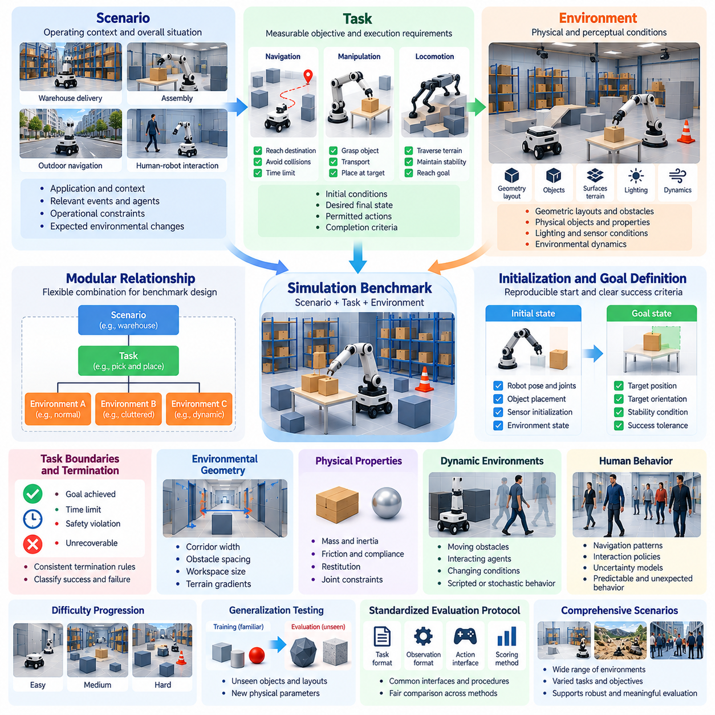
Scenario, task, and environment definitions form the structural foundation of simulation benchmarking for Physical AI. A scenario describes the operating situation, a task specifies the objective to be achieved, and an environment represents the physical and perceptual conditions under which execution occurs. Clearly separating these elements enables systematic evaluation, reproducible experiments, and meaningful comparisons across different robotic systems.
A scenario establishes the context in which autonomous behavior is evaluated. It may describe a warehouse delivery operation, robotic assembly procedure, outdoor navigation mission, or human-robot interaction. Beyond identifying the application, the scenario defines relevant events, participating agents, operational constraints, and expected environmental changes. This contextual information determines which capabilities the benchmark is intended to examine.
Task definition translates a scenario into measurable objectives and execution requirements. A navigation task may require reaching a specified destination without collisions, while manipulation may involve grasping, transporting, and placing an object. Each task should identify its initial conditions, desired final state, permitted actions, and completion criteria. Precise definitions prevent ambiguous interpretations of success and failure.
Environment definition specifies the virtual world in which tasks are performed. It includes geometric layouts, physical objects, surfaces, obstacles, lighting conditions, and environmental dynamics. For mobile robots, terrain properties and traversable regions may be essential, whereas manipulation benchmarks require accurate object geometry and contact characteristics. Environmental descriptions must reflect the capabilities and limitations being evaluated.
The relationship between scenarios, tasks, and environments should support modular benchmark construction. A single task can be evaluated across multiple environments, while one environment can support different task objectives. Similarly, a scenario may combine several tasks into a coordinated mission. This modularity enables systematic variation without redefining the entire benchmark whenever a particular experimental condition changes.
Initial-state specification is necessary for reproducible evaluation. Robot position, orientation, joint configuration, object placement, sensor initialization, and relevant environmental states should be defined explicitly. Initial conditions may be fixed for deterministic comparisons or sampled from controlled distributions. Recording initialization parameters ensures that observed performance differences can be interpreted within a consistent experimental framework.
Goal-state definition determines what constitutes successful task completion. Goals may involve spatial accuracy, object placement, stable locomotion, safe navigation, or completion of multiple dependent actions. Success criteria should use observable quantities and explicit tolerances. For example, placing an object within a target region may require constraints on position, orientation, stability, and allowable contact forces.
Task boundaries and termination conditions must also be specified. An episode may terminate when the goal is achieved, a time limit expires, a critical safety constraint is violated, or recovery becomes impossible. Without consistent termination rules, algorithms may receive unequal opportunities to complete tasks. Benchmark protocols should distinguish successful completion, timeout, unsafe termination, and other failure categories.
Environmental geometry strongly influences Physical AI performance. Corridor widths, obstacle spacing, workspace dimensions, object accessibility, and terrain gradients can determine task feasibility. Benchmark designers should document relevant geometric parameters and their variation ranges. These specifications allow researchers to identify whether performance limitations arise from reasoning, perception, control, or physical accessibility.
Physical properties must be represented alongside geometry. Object mass, inertia, friction, compliance, restitution, and joint constraints influence interactions between robots and their surroundings. In locomotion benchmarks, ground contact and surface friction affect stability and traction. In manipulation benchmarks, object dynamics and contact behavior determine grasp reliability. Relevant parameters should be defined consistently with the evaluation objectives.
Dynamic environments introduce temporal complexity that static scenes cannot represent. Moving obstacles, interacting agents, changing object states, and evolving environmental conditions require continuous perception and replanning. Scenario definitions should specify how dynamic entities behave and whether their actions are scripted, stochastic, or responsive to the evaluated robot. This distinction affects repeatability and the interpretation of closed-loop performance.
Human behavior requires particular attention in scenarios involving shared workspaces or social interaction. Virtual humans may move through navigation paths, approach robots, or perform collaborative tasks. Their behavior should be described through explicit motion rules, interaction policies, and uncertainty models. Evaluation should distinguish predictable human movement from unexpected actions that challenge perception, decision-making, and safety.
Scenario complexity should be controlled through identifiable difficulty factors. Increasing obstacle density, reducing available clearance, introducing sensor uncertainty, or extending task duration can create progressively demanding conditions. Difficulty levels should correspond to measurable environmental or task parameters rather than arbitrary labels. This approach supports performance curves and systematic identification of capability boundaries.
Task diversity is essential for assessing whether Physical AI systems generalize beyond narrow demonstrations. Benchmark collections should include variations in object categories, spatial configurations, environmental conditions, and goal specifications. However, diversity should remain connected to the intended operational domain. Arbitrary variations may increase benchmark complexity without providing meaningful evidence about practical competence.
Scenario sampling determines how evaluation cases are selected from the defined task and environment space. Uniform sampling may provide broad coverage, while stratified sampling can ensure representation of important difficulty categories. Risk-weighted sampling may emphasize safety-critical conditions. Benchmark documentation should describe sampling distributions, randomization procedures, and any intentional emphasis placed on particular operating situations.
Training and evaluation scenarios should be separated to measure generalization accurately. If policies repeatedly encounter identical object arrangements or environmental layouts during development, reported success may reflect memorization rather than transferable competence. Held-out scenarios, unseen combinations, and controlled distribution shifts provide stronger evidence of adaptability. Evaluation configurations should remain sufficiently independent from training procedures.
Observability must be defined as part of the environment specification. A simulator may contain complete information about object states and physical dynamics, but the evaluated policy should receive only the observations permitted by the benchmark. Sensor fields of view, measurement noise, update frequencies, and communication delays influence decision quality. Separating privileged simulator information from policy observations prevents unrealistic evaluation advantages.
Scenario definitions should also specify operational constraints and safety requirements. Speed limits, collision boundaries, force thresholds, restricted regions, and interaction permissions determine acceptable behavior. A task should not be considered successful solely because its final goal is reached if execution violates critical constraints. Explicit safety conditions allow benchmark results to distinguish effective autonomy from unsafe goal achievement.
Comprehensive benchmark specifications require standardized documentation and machine-readable configurations. Scenario identifiers, task parameters, environment assets, random seeds, simulator versions, and scoring rules should be recorded. Structured definitions support automated execution, distributed evaluation, and independent reproduction. Version control is particularly important when environmental assets or physical models change between benchmark releases.
Ultimately, precise scenario, task, and environment definitions transform simulation from an experimental demonstration platform into a rigorous evaluation framework. They establish what must be accomplished, under which conditions, and according to which measurable standards. By combining modular specifications, controlled variability, explicit constraints, and reproducible execution, simulation benchmarks provide credible evidence about Physical AI capability, reliability, and generalization.

02.04. Robot Sensor and Actuator Standardization
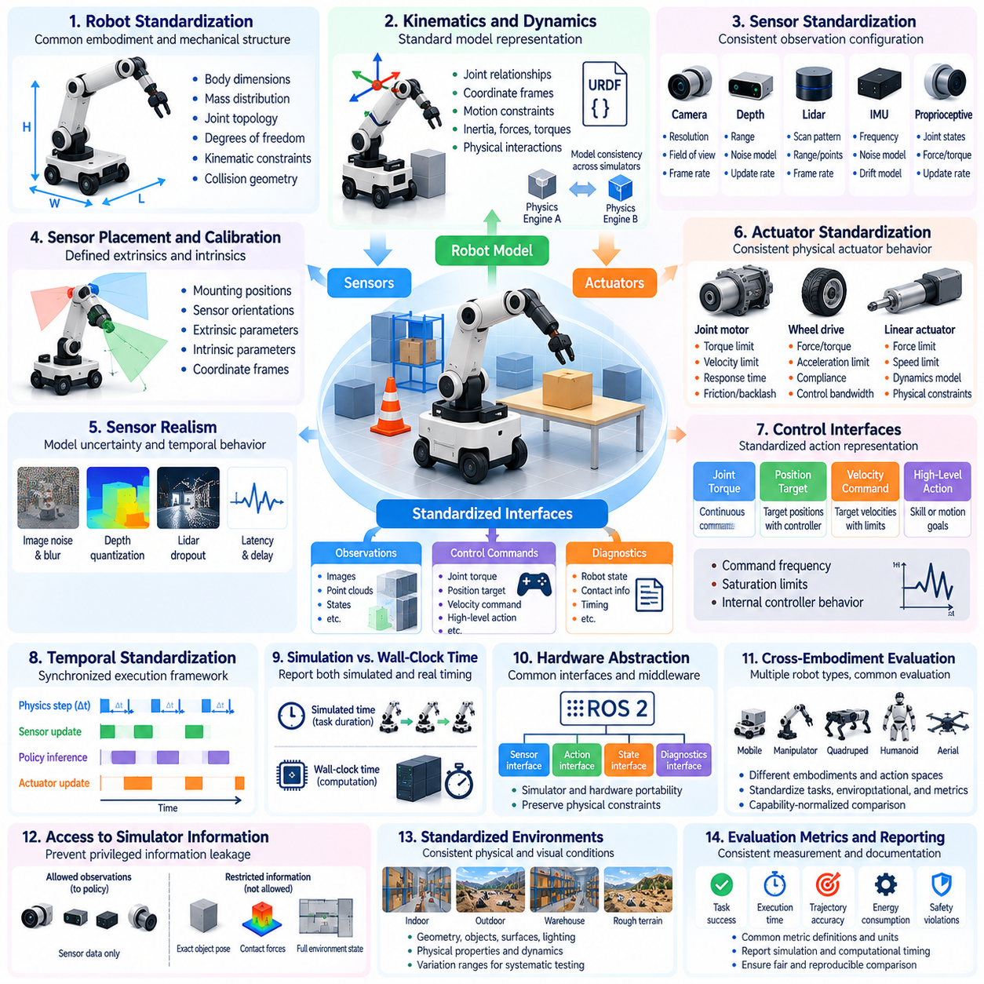
Robot, sensor, and actuator standardization is essential for establishing fair and reproducible simulation benchmarks in Physical AI. Differences in robot geometry, sensing capabilities, actuator dynamics, and control interfaces can significantly influence measured performance. Standardization defines common experimental conditions so that evaluation results reflect the capabilities of intelligent algorithms rather than uncontrolled variations in simulated hardware configurations.
Robot standardization begins with explicit descriptions of physical embodiment and mechanical structure. Relevant parameters include body dimensions, mass distribution, joint topology, degrees of freedom, kinematic constraints, and collision geometry. These properties determine how a robot moves and interacts with its surroundings. Consistent robot specifications allow researchers to reproduce experiments and distinguish algorithmic improvements from mechanical advantages.
Robot models should incorporate standardized kinematic and dynamic representations. Kinematic descriptions define joint relationships, coordinate frames, and motion constraints, while dynamic models represent inertia, forces, torques, and physical interactions. Formats such as URDF and related simulation descriptions support consistent model exchange. However, equivalent model files do not guarantee identical behavior across different physics engines.
Sensor standardization establishes consistent observation conditions for evaluated policies. Camera resolution, field of view, depth range, lidar scanning characteristics, inertial measurement frequency, and proprioceptive feedback must be documented. These parameters influence the information available for perception and decision-making. Without standardized sensing configurations, performance differences may result from unequal observation quality rather than superior intelligence.
Sensor placement and coordinate calibration are equally important. Camera mounting positions, lidar orientations, sensor baselines, and transformations between reference frames determine how environmental information is perceived. Even small configuration differences may affect object detection, localization, and manipulation accuracy. Benchmark specifications should therefore include sensor extrinsics, intrinsic calibration parameters, and coordinate-frame conventions.
Realistic sensor models must account for measurement uncertainty and temporal behavior. Image noise, depth quantization, motion blur, lidar dropout, inertial drift, and communication delays can influence autonomous decisions. Standardized noise distributions and update rates enable consistent evaluation under imperfect observations. Idealized sensors may remain useful for diagnostic experiments, but their use should be explicitly identified to prevent misleading comparisons.
Actuator standardization defines how control commands produce physical motion. Joint motors, wheel drives, hydraulic systems, and other actuators exhibit limits on torque, force, velocity, acceleration, and response time. Their behavior may also depend on friction, backlash, compliance, and control bandwidth. These characteristics must be represented consistently because actuator differences can alter stability, precision, and task completion.
Control interfaces require particular attention because different policies may operate through distinct action representations. Some algorithms generate joint torques, while others output position targets, velocity commands, or high-level motion goals. A benchmark must specify permitted control modes, command frequencies, saturation limits, and internal controller behavior. Otherwise, hidden differences in low-level control can create substantial evaluation advantages.
Temporal standardization connects sensing, computation, and actuation within a common execution framework. Physics integration steps, sensor sampling intervals, policy inference frequencies, and actuator update rates should be defined explicitly. Asynchronous operation may introduce delays and stale observations. Benchmark designers must determine whether timing is synchronized or event-driven and ensure that all evaluated systems follow compatible timing assumptions.
Simulation time and wall-clock time should be distinguished when reporting performance. A policy may complete a virtual task quickly while requiring substantial computation on actual hardware. Conversely, accelerated simulation may conceal real-time execution limitations. Standardized benchmarks should report simulated duration and relevant computational timing separately, particularly when evaluating policies intended for deployment on resource-constrained robotic platforms.
Hardware abstraction can improve portability across robot platforms and simulation environments. Standard interfaces for sensor observations, actuator commands, robot states, and diagnostic information reduce dependencies on particular simulators. Middleware systems such as ROS 2 can support interface consistency, although additional conventions remain necessary. Abstraction should preserve physically meaningful constraints rather than conceal differences that affect robot capabilities.
Cross-embodiment evaluation introduces additional standardization challenges. Mobile robots, manipulators, quadrupeds, humanoids, and aerial robots possess fundamentally different mechanical structures and action spaces. Identical hardware specifications are therefore neither possible nor desirable. Instead, benchmarks can standardize task objectives, environmental conditions, measurement definitions, and capability-normalized comparisons while preserving embodiment-specific characteristics.
Standardization must also address access to privileged simulator information. Policies should not receive exact object poses, contact states, or global environmental maps unless such information is explicitly permitted. Diagnostic systems may use ground-truth data for scoring and analysis, but policy observations should remain separated. This prevents algorithms from gaining unrealistic advantages through simulator-specific interfaces or hidden state information.
Model fidelity and parameter uncertainty should be documented alongside standardized configurations. Even nominally identical robot models may behave differently when friction coefficients, contact solvers, actuator delays, or numerical integration methods change. Benchmark designers should identify sensitive parameters and define acceptable tolerances. Where uncertainty is unavoidable, controlled parameter variation can help determine whether performance remains robust.
Calibration procedures provide a practical mechanism for maintaining consistency. Standard test motions, sensor reference targets, actuator response measurements, and contact experiments can verify whether simulated components satisfy expected behavior. Calibration results should be recorded with model versions and simulator settings. Such procedures help identify configuration errors before benchmark scores are interpreted as evidence of algorithmic competence.
Resource standardization is also relevant when comparing computationally demanding Physical AI policies. Differences in processor capability, GPU acceleration, memory availability, and inference scheduling can influence control latency and achievable action frequency. Benchmarks should document computational resources and establish evaluation budgets where appropriate. Comparisons must distinguish improvements in intelligent behavior from advantages obtained through additional computing capacity.
A robust benchmark should support both fixed-reference and configurable hardware evaluation. Fixed-reference configurations provide controlled comparisons using identical robot, sensor, and actuator models. Configurable evaluations allow researchers to examine adaptation to different hardware capabilities and operational constraints. Reporting these results separately preserves fairness while enabling investigation of transferability and hardware-software co-design.
Version management is necessary because changes to robot descriptions, sensor models, actuator parameters, or simulation engines may alter benchmark outcomes. Each evaluation should identify model versions, configuration files, software dependencies, and relevant calibration settings. Automated validation can detect incompatible changes and prevent accidental comparisons between different experimental conditions. Reproducible configuration management supports long-term benchmark credibility.
Ultimately, robot, sensor, and actuator standardization creates a common technical foundation for evaluating Physical AI systems. It establishes which physical characteristics, observation interfaces, control mechanisms, and timing assumptions are shared across experiments. By combining explicit specifications, calibrated models, controlled variability, and transparent reporting, simulation benchmarks can produce more reliable comparisons while preserving the diversity of robotic embodiments and intelligent control architectures.

02.05. Physics and Sensor Fidelity
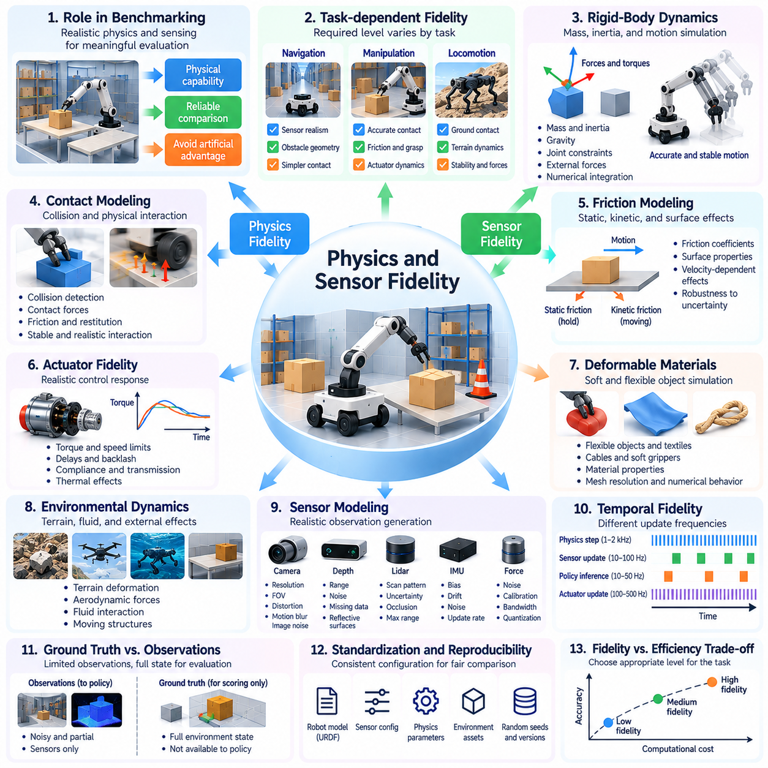
Physics and sensor fidelity are fundamental to the validity of simulation benchmarks for Physical AI. Physics fidelity describes how accurately a simulator reproduces mechanical interactions and dynamic behavior, while sensor fidelity concerns the realism of observations generated by virtual sensing systems. Both influence whether benchmark results represent meaningful physical capabilities or reflect artificial advantages introduced by simplified simulation models.
The required level of fidelity depends on the evaluation objective and the physical processes involved. Navigation tasks may tolerate simplified contact models but require realistic sensor visibility and obstacle geometry. Manipulation and locomotion tasks often demand accurate friction, contact forces, and actuator dynamics. Benchmark designers should prioritize physical and perceptual characteristics that directly influence the behaviors being measured.
Rigid-body dynamics provide the foundation for many robotic simulation environments. Accurate representations of mass, inertia, gravity, joint constraints, and external forces determine how robots and objects accelerate, rotate, and interact. Numerical integration methods approximate these dynamics over discrete time intervals. Integration errors or inappropriate solver settings can introduce instability and distort measured performance, particularly during rapid or contact-intensive motion.
Contact modeling is especially important because physical interaction frequently determines task success. Collision detection, contact penetration, normal forces, frictional forces, and restitution influence grasping, pushing, walking, and object placement. Simplified contact solvers may generate unrealistic stability or excessive energy dissipation. Benchmark specifications should therefore document contact algorithms and relevant solver parameters.
Friction modeling requires careful consideration because real surfaces exhibit complex interactions involving static friction, kinetic friction, and sometimes velocity-dependent effects. A robot may appear stable in simulation while slipping on real materials, or fail virtually despite possessing sufficient physical traction. Evaluations should examine sensitivity to friction coefficients and distinguish nominal performance from robustness under uncertain surface conditions.
Actuator fidelity connects simulated control commands to realistic mechanical responses. Motors and transmissions exhibit torque limits, speed constraints, delays, backlash, compliance, and thermal effects. Ignoring these characteristics can make aggressive control policies appear feasible when physical hardware cannot execute them. Simulated actuators should reproduce the dominant response characteristics relevant to the benchmark without introducing unnecessary complexity.
Deformable materials present additional challenges because rigid-body assumptions cannot capture every interaction. Flexible objects, cables, soft grippers, textiles, and compliant surfaces require representations of deformation and distributed contact. Their numerical behavior may depend strongly on mesh resolution and material parameters. Benchmark designers must determine whether simplified deformation models preserve the task characteristics needed for meaningful evaluation.
Environmental dynamics also contribute to physics fidelity. Terrain deformation, surface irregularities, aerodynamic forces, fluid interactions, and moving structures can affect robotic behavior. Their importance varies across mobile robots, aerial systems, underwater platforms, and manipulators. Simulation benchmarks should identify which environmental processes are modeled explicitly and which are approximated or excluded from the evaluation scope.
Sensor fidelity determines how realistically an autonomous system perceives its simulated environment. Virtual cameras, depth sensors, lidar units, inertial measurement systems, and force sensors convert simulated physical states into observations. Perfect observations can simplify perception and planning unrealistically. Meaningful benchmarks should model the sensing limitations that influence decision-making within the intended operational domain.
Camera fidelity involves more than producing visually convincing images. Resolution, focal length, field of view, exposure, lens distortion, rolling shutter, motion blur, and image noise influence computer vision performance. Photorealistic rendering can improve visual similarity, but appearance alone does not establish sensor accuracy. Benchmark designers should distinguish rendering realism from the statistical and geometric properties of camera measurements.
Depth and lidar fidelity require accurate treatment of range measurement characteristics. Angular resolution, measurement uncertainty, maximum sensing distance, reflective surfaces, occlusion, and missing returns can influence mapping and obstacle detection. Simplified ray-based sensing may omit important material-dependent effects. Evaluation protocols should specify whether these limitations are represented and how they affect the observations supplied to policies.
Inertial and proprioceptive sensing require realistic temporal and noise characteristics. Accelerometers, gyroscopes, joint encoders, and force sensors may exhibit bias, drift, quantization, filtering, and measurement delays. Such effects accumulate during localization and feedback control. Standardized sensor models should capture relevant uncertainty while maintaining consistent sampling rates and calibration assumptions across evaluated systems.
Temporal fidelity is essential because physical processes, sensor measurements, and control decisions occur at different frequencies. Simulation time steps, sensor update intervals, communication delays, and policy inference periods determine how information propagates through the system. Unrealistically synchronized observations can conceal timing-related failures. Benchmarks should explicitly represent latency and asynchronous behavior when these characteristics affect task execution.
Physics and sensor fidelity must also be considered jointly. Contact dynamics influence force measurements, robot motion changes camera observations, and vibration affects inertial sensing. Errors in one simulation component can propagate into others through closed-loop interaction. Evaluating physical dynamics and sensor models independently may therefore overlook important system-level discrepancies that emerge during autonomous operation.
Fidelity validation requires comparison against appropriate physical reference measurements. Robot trajectories, contact forces, actuator responses, sensor noise distributions, and timing behavior can be measured experimentally and compared with simulation outputs. Validation should emphasize quantities relevant to benchmark objectives. Agreement under a small number of nominal conditions does not establish accuracy across all possible operating situations.
Parameter calibration improves fidelity by adjusting simulated properties to match observed physical behavior. Mass distributions, friction coefficients, motor response parameters, sensor biases, and noise characteristics may be estimated from experiments. Calibration should use documented procedures and independent validation data. Excessive tuning to a narrow collection of observations can produce models that reproduce calibration experiments without generalizing to new conditions.
Sensitivity analysis helps determine which modeling errors materially affect benchmark conclusions. Researchers can vary uncertain physical and sensor parameters while observing changes in success rates, trajectories, stability, and safety outcomes. Parameters that produce large performance changes require greater modeling attention. This approach allocates simulation development effort according to evaluation relevance rather than pursuing uniform realism across every component.
High fidelity introduces computational tradeoffs. Detailed contact solvers, deformable-body models, advanced rendering, and realistic sensor processing can substantially reduce simulation throughput. Lower-fidelity environments may support large-scale statistical evaluation, while higher-fidelity configurations provide targeted validation of sensitive behaviors. A practical benchmark framework can employ multiple fidelity levels, provided their assumptions and results remain clearly distinguished.
The simulation-to-reality gap provides an important measure of fidelity limitations. Differences between simulated and physical task outcomes may arise from inaccurate dynamics, sensor models, environmental assumptions, or interactions among these factors. Benchmark designers should investigate these discrepancies systematically rather than assuming that visually realistic environments produce transferable results. Real-world validation remains necessary for establishing external credibility.
Ultimately, physics and sensor fidelity should be treated as measurable properties of an evaluation framework rather than abstract claims of realism. Their purpose is to preserve the physical and perceptual relationships that determine autonomous behavior. By combining calibrated models, explicit assumptions, sensitivity analysis, temporal consistency, and physical validation, simulation benchmarks can provide trustworthy evidence about Physical AI performance while acknowledging unavoidable modeling uncertainty.

02.06. Deterministic and Stochastic Benchmarking
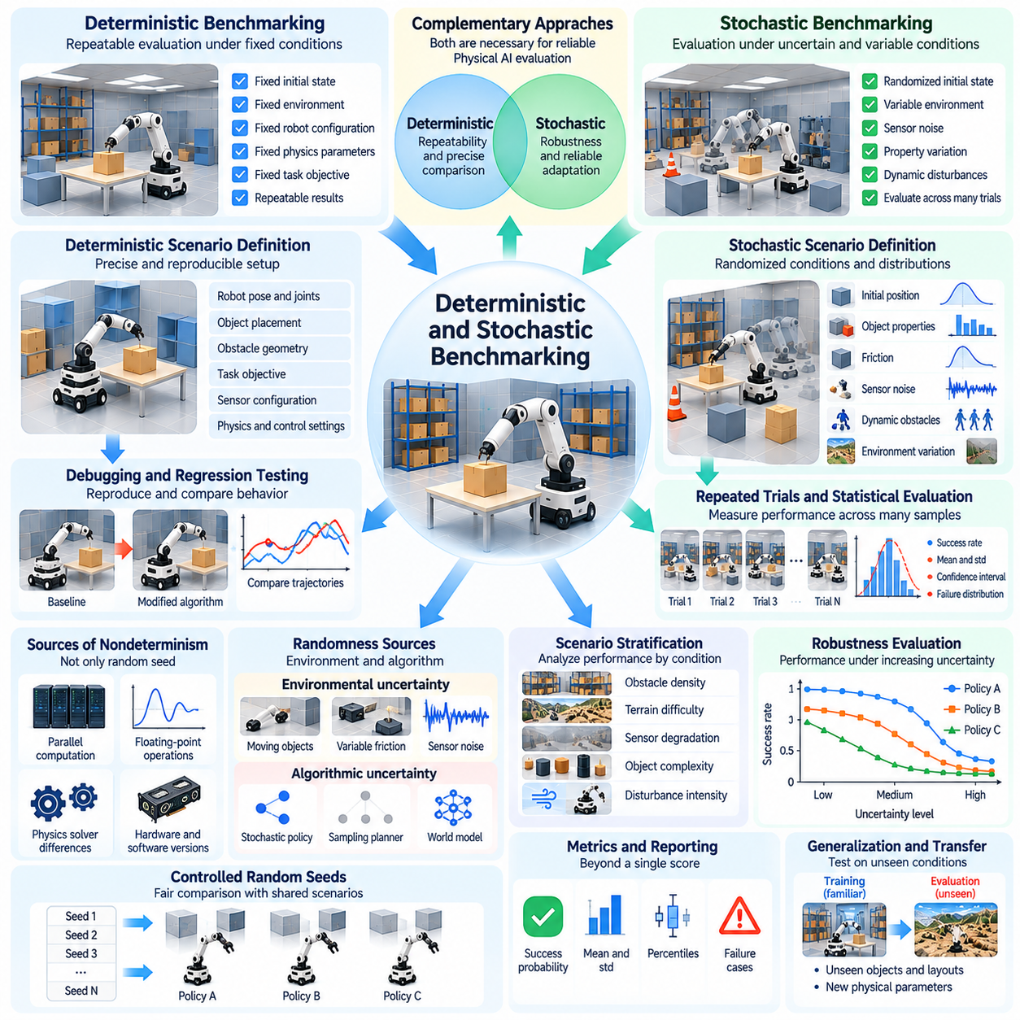
Deterministic and stochastic benchmarking provide complementary approaches for evaluating Physical AI systems in simulation. Deterministic evaluation emphasizes repeatability under fixed conditions, while stochastic evaluation examines performance across uncertain and variable situations. Both are necessary because reliable physical intelligence requires consistent behavior in known environments and robust adaptation when operating conditions cannot be predicted precisely.
Deterministic benchmarking establishes experimental conditions that produce repeatable outcomes when the same system executes identical actions. Robot configurations, initial states, environmental properties, and simulation parameters remain fixed. This approach enables controlled comparisons between algorithms and supports precise investigation of behavioral differences. Reproducibility depends on controlling all relevant sources of variation.
A deterministic scenario typically specifies robot position, joint states, object placement, obstacle geometry, and task objectives. Sensor configurations, physics integration settings, and control frequencies are also defined. When these conditions remain unchanged, researchers can compare alternative policies against a common reference. Such experiments are particularly valuable for identifying whether software modifications improve or degrade specific capabilities.
Deterministic evaluation supports debugging and regression testing throughout Physical AI development. When a robot fails to grasp an object or complete a navigation task, engineers can reproduce the same conditions and inspect the resulting trajectories. Repeated execution helps isolate perception errors, planning failures, and control instability. Automated regression tests can detect unintended performance changes after algorithm updates.
However, deterministic behavior is not guaranteed merely by fixing a random seed. Parallel computation, floating-point operations, asynchronous execution, and physics solver implementations may introduce nondeterministic differences. Hardware platforms and software versions can also influence numerical results. Benchmark designers must document execution environments and distinguish exact numerical reproducibility from statistically consistent behavior.
Stochastic benchmarking introduces controlled uncertainty into task execution and environmental conditions. Initial positions, object properties, sensor noise, obstacle movements, and physical parameters may be sampled from specified probability distributions. Rather than measuring performance in one fixed situation, stochastic evaluation estimates how a policy behaves across multiple possible conditions. This provides evidence about reliability beyond individual demonstrations.
Probability distributions are central to meaningful stochastic evaluation. Benchmark designers must specify which variables are randomized, their allowable ranges, and the relationships between them. Uniform distributions may provide broad coverage, while application-informed distributions can approximate expected operating conditions. Poorly selected distributions may create unrealistic scenarios or conceal important failure modes.
Randomness can enter Physical AI systems through both environmental processes and internal algorithms. Environmental uncertainty includes unpredictable object motion, variable friction, sensor disturbances, and human behavior. Algorithmic uncertainty may arise from stochastic action selection, sampling-based planning, or probabilistic world models. Evaluation protocols should distinguish these sources when interpreting performance variability.
Repeated trials are essential for estimating stochastic performance. Each trial samples a configuration or disturbance realization and produces measurable outcomes such as success, completion time, collision frequency, or energy consumption. Aggregating results across trials reveals average performance and variability. A sufficiently large and representative sample is needed to avoid conclusions dominated by favorable or unfavorable random outcomes.
Statistical reporting should extend beyond a single mean score. Success probabilities, standard deviations, confidence intervals, percentiles, and failure distributions provide complementary information about system behavior. Two policies may achieve similar average success rates while exhibiting very different worst-case outcomes. Benchmark reports should preserve these distinctions, especially when reliability and safety are important.
Controlled random seeds provide a practical bridge between deterministic and stochastic evaluation. A benchmark can generate diverse scenarios using predetermined seeds, allowing different algorithms to encounter the same sampled conditions. This supports paired comparisons while retaining environmental variability. However, repeated optimization against a fixed seed collection can produce overfitting, making independent evaluation seeds necessary.
Scenario stratification improves the interpretability of stochastic benchmarks. Trials can be grouped according to obstacle density, terrain difficulty, sensor degradation, object complexity, or disturbance intensity. Performance can then be analyzed within each category rather than only across the complete test distribution. This reveals which operating conditions cause degradation and helps identify capability boundaries.
Robustness evaluation often requires progressively increasing uncertainty. Sensor noise, actuator delay, friction variation, and external disturbances can be adjusted across controlled ranges. Performance degradation curves reveal how quickly an algorithm loses effectiveness as conditions become more demanding. Such analysis distinguishes policies that perform well under nominal assumptions from those that remain dependable under perturbations.
Rare-event evaluation presents a special challenge because ordinary random sampling may encounter critical failures too infrequently. Targeted scenario generation and importance sampling can increase exposure to hazardous or unusual conditions. These methods support failure discovery, but their sampling distributions must be considered when estimating real-world event probabilities. Stress-test failure rates should not automatically be interpreted as operational risk estimates.
Deterministic and stochastic benchmarks should also evaluate closed-loop behavior. Small differences in observations or physical states can change future actions and produce divergent trajectories. In stochastic environments, these effects may accumulate over long task horizons. Measuring only final success can conceal unstable control, repeated recovery attempts, or excessive corrective actions that reveal important weaknesses.
Fair comparisons require consistent uncertainty exposure across evaluated systems. Policies should be tested using equivalent scenario distributions, observation conditions, action constraints, and computational budgets. Common random numbers can reduce comparison variance when paired trials are appropriate. Benchmark protocols should also prevent unequal access to randomization parameters or hidden simulator states that could create artificial advantages.
The relationship between deterministic and stochastic evaluation is best understood as a layered methodology. Fixed scenarios establish baseline correctness and support debugging, while randomized scenarios assess variability, generalization, and robustness. Targeted stress tests then investigate challenging conditions and potential failure mechanisms. Each layer answers a different evaluation question and contributes distinct evidence about system competence.
Benchmark automation enables these evaluation layers to operate at scale. Standardized configuration files can define fixed test cases, randomization distributions, seed schedules, and scoring rules. Automated execution systems can collect trajectories, performance metrics, and failure records across many trials. Versioned configurations and structured logs support reproducibility, statistical analysis, and long-term comparison.
Simulation-to-reality validation remains necessary because deterministic repeatability and stochastic robustness within a simulator do not guarantee physical reliability. Real environments may contain unmodeled dynamics, correlated disturbances, and sensor imperfections outside simulated distributions. Comparing simulated performance distributions with physical test results helps identify modeling deficiencies and refine uncertainty assumptions.
Ultimately, deterministic and stochastic benchmarking should be integrated into a unified Physical AI evaluation framework. Deterministic tests establish repeatable reference behavior, while stochastic experiments characterize uncertainty, reliability, and performance variation. Together with statistical rigor, controlled randomization, stress testing, and real-world validation, these methods provide a stronger foundation for assessing autonomous physical intelligence.

02.07. Domain Randomized Evaluation
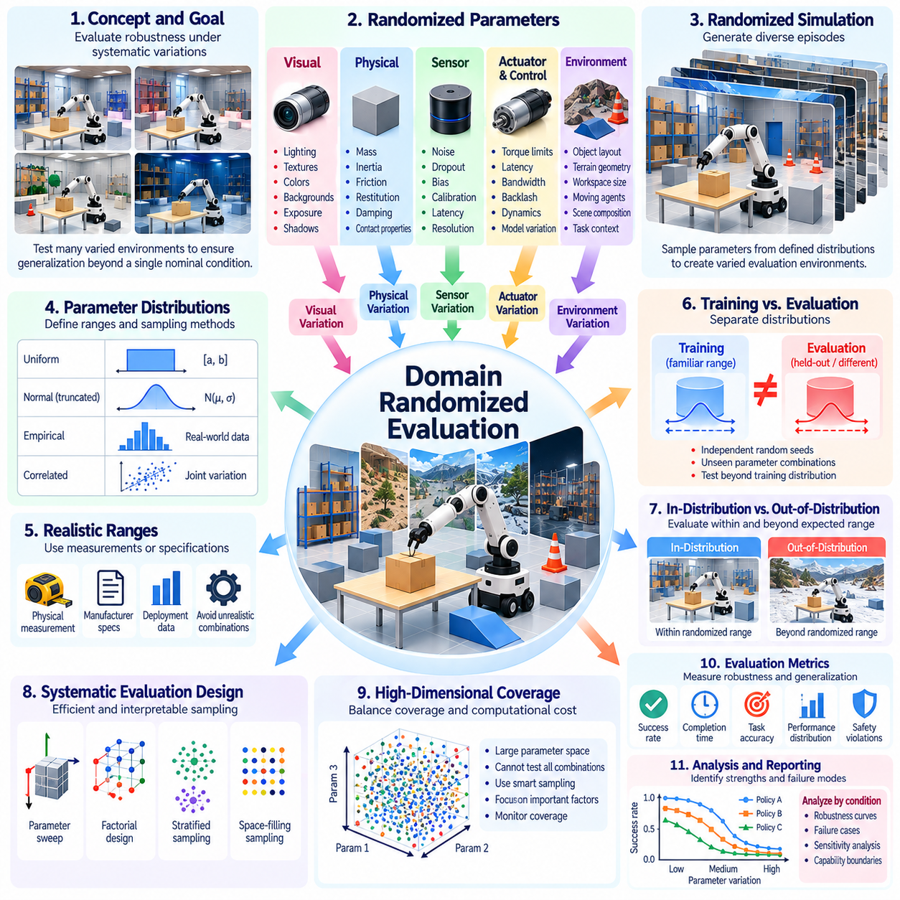
Domain-randomized evaluation examines how Physical AI systems perform when simulated operating conditions vary systematically across multiple dimensions. Rather than relying on a single nominal environment, this approach generates diverse combinations of physical, visual, and operational parameters. Its primary objective is to measure whether learned policies maintain reliable behavior under environmental variations that resemble or extend beyond expected deployment conditions.
Domain randomization differs from ordinary stochastic testing in its emphasis on structured variation across environment models. Randomized parameters may include object geometry, surface friction, lighting, sensor characteristics, actuator response, and scene composition. By changing these properties across evaluation episodes, researchers can investigate whether an algorithm depends on narrow simulation assumptions or develops capabilities that remain effective across different domains.
Visual domain randomization modifies the appearance of simulated environments without necessarily changing their underlying physical structure. Lighting intensity, shadow direction, textures, colors, backgrounds, and camera exposure may be varied. These modifications help evaluate whether perception systems rely on stable geometric and semantic information rather than superficial visual patterns. Excessive visual variation, however, may introduce conditions unrelated to realistic deployment.
Physical domain randomization changes parameters governing mechanical interaction and dynamic behavior. Mass, inertia, friction, restitution, joint damping, actuator strength, and contact properties can be sampled within defined ranges. These variations influence motion stability, manipulation accuracy, and control performance. Evaluation should determine whether policies tolerate plausible physical uncertainty rather than merely survive arbitrary parameter changes.
Sensor domain randomization introduces variation in measurement quality and observation characteristics. Camera noise, depth uncertainty, lidar dropout, inertial bias, calibration offsets, and sensing delays may be adjusted across trials. Such perturbations reveal whether perception and control systems depend on unrealistically precise measurements. Randomization ranges should reflect sensor specifications, empirical uncertainty, or clearly identified stress-testing objectives.
Actuator and control randomization evaluates sensitivity to hardware response differences. Motor torque limits, command latency, control bandwidth, backlash, and actuator dynamics may vary between simulated episodes. These conditions approximate manufacturing tolerances, component aging, and platform differences. Policies that remain effective under such variation may demonstrate greater hardware robustness, although simulated tolerance does not establish actual deployment reliability.
Environmental randomization extends beyond individual physical parameters to include scene structure and task context. Obstacle arrangements, object positions, terrain geometry, workspace dimensions, and moving-agent behavior can be modified. Such changes affect perception, planning, and physical interaction simultaneously. A well-designed benchmark distinguishes variations that preserve the intended task from those that fundamentally change its feasibility.
Randomization distributions determine which operating conditions receive emphasis during evaluation. Uniform sampling provides broad coverage, while truncated normal or empirically estimated distributions can represent expected variability. Correlations between parameters must also be considered because real conditions are rarely independent. For example, surface material, friction, reflectance, and sensor response may change together.
Parameter ranges should be justified through physical measurements, manufacturer specifications, deployment observations, or explicit experimental assumptions. Ranges that are too narrow may conceal brittleness, while excessively broad ranges may generate physically inconsistent environments. Benchmark documentation should identify nominal values, allowable intervals, sampling methods, and constraints that prevent invalid parameter combinations.
Training and evaluation randomization must be separated to avoid misleading generalization claims. A policy trained on randomized environments may perform well on the same parameter distributions without adapting to genuinely unfamiliar conditions. Evaluation should therefore include independent random seeds, held-out parameter combinations, and where appropriate, distributions that differ from training. This separation helps distinguish interpolation from broader robustness.
In-distribution evaluation measures performance within the randomization ranges anticipated during development. Out-of-distribution evaluation examines conditions beyond those ranges or introduces previously unseen combinations of environmental factors. Both provide useful but different evidence. Strong in-distribution performance indicates consistency under expected variability, whereas successful out-of-distribution behavior suggests a wider operational capability.
Systematic experimental design can improve the efficiency and interpretability of randomized evaluation. Independent parameter sweeps isolate individual effects, while factorial designs reveal interactions among variables. Stratified sampling and space-filling methods can improve coverage of multidimensional parameter spaces. Pure random sampling remains useful, but it may leave important combinations insufficiently represented.
High-dimensional randomization creates a substantial coverage challenge because the number of possible parameter combinations grows rapidly. Testing every configuration is generally impractical. Researchers must balance parameter diversity, trial count, and computational resources. Adaptive sampling can concentrate evaluations on uncertain or failure-prone regions, provided the resulting selection bias is considered when reporting aggregate performance.
Performance should be analyzed as a function of randomized conditions rather than reduced to one average score. Success probability, completion time, collision frequency, tracking error, and recovery behavior can be examined across parameter ranges. Conditional performance analysis identifies which environmental factors cause degradation. Robustness profiles and worst-region statistics provide information that global averages may conceal.
Causal interpretation requires particular care because correlated randomization can obscure the origin of performance changes. A navigation failure may arise from reduced visibility, altered friction, or their combined effect. Controlled ablation experiments can isolate individual factors and reveal interactions. These analyses help distinguish perception limitations, control weaknesses, and failures arising from integrated system behavior.
Domain randomization also supports evaluation of adaptation mechanisms. Some policies operate without modifying internal parameters, while others use online system identification, memory, or adaptive control to respond to changing conditions. Benchmarks should specify whether adaptation is permitted, how much observation history is available, and whether environment parameters remain fixed or change during an episode.
Dynamic domain randomization introduces changes while a task is being executed. Surface friction may shift, illumination may vary, sensor quality may deteriorate, or actuator response may change unexpectedly. Such experiments assess recovery and adaptation under nonstationary conditions. They should be distinguished from episode-level randomization, where parameters are sampled initially and remain constant throughout execution.
Reproducibility requires complete records of randomization configurations and sampled parameter values. Evaluation systems should store distribution definitions, random seeds, simulator versions, episode identifiers, and resulting performance measurements. Common scenario sets enable paired algorithm comparisons. Independent hidden evaluation sets can reduce overfitting while preserving the transparency needed for scientific verification.
Real-world validation is essential for determining whether randomized simulation conditions represent meaningful physical uncertainty. Measured sensor errors, friction variation, environmental diversity, and actuator responses can inform distribution design. Comparing simulated and physical performance across matched conditions helps identify missing factors. Domain randomization can improve robustness assessment, but it cannot guarantee transfer when important real-world effects remain unmodeled.
Ultimately, domain-randomized evaluation provides a structured method for measuring the environmental tolerance and generalization of Physical AI systems. Its value depends on physically justified distributions, adequate parameter coverage, independent evaluation conditions, and transparent statistical reporting. Combined with controlled benchmarks and real-world validation, it helps establish whether autonomous behavior remains dependable beyond a narrowly defined simulation environment.

02.08. Perception and State Estimation Benchmarks
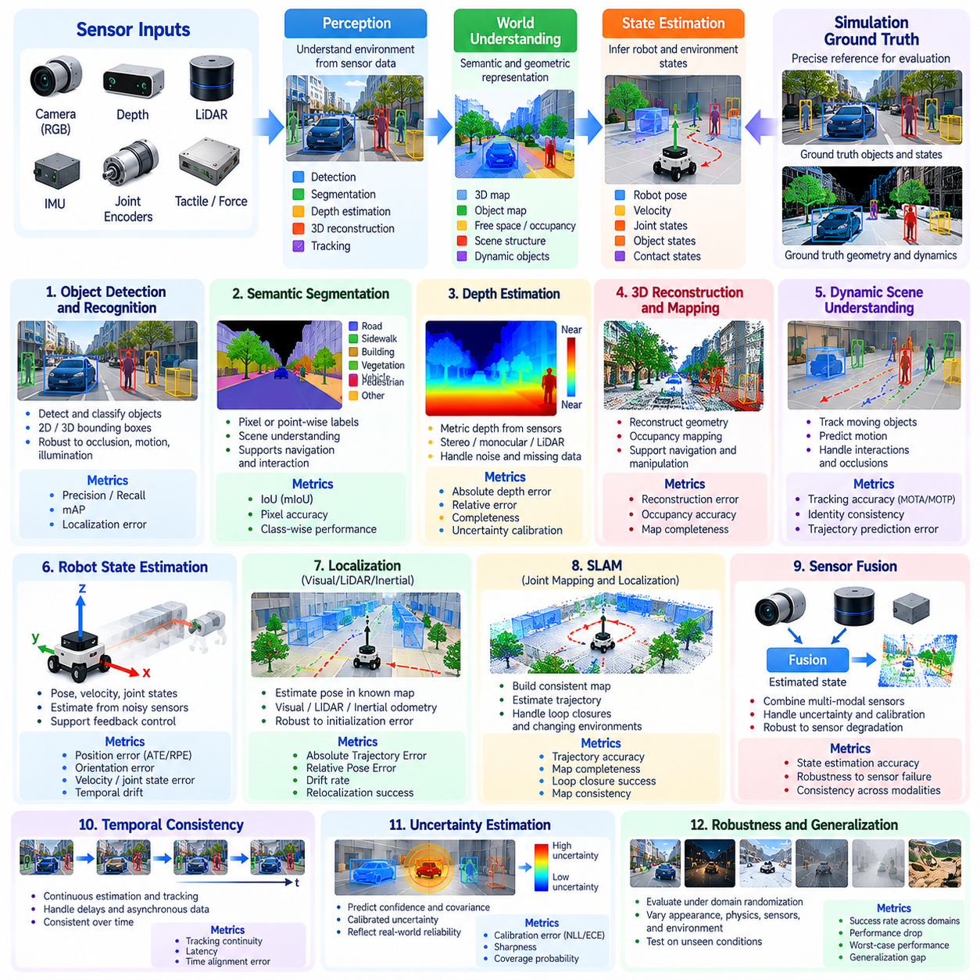
Perception and state estimation benchmarks evaluate how accurately Physical AI systems interpret sensory observations and infer the conditions of robots and their surroundings. Perception transforms raw sensor measurements into meaningful environmental representations, while state estimation reconstructs quantities that cannot be observed directly. Simulation provides controlled ground truth for measuring accuracy, uncertainty, temporal consistency, and robustness under diverse operating conditions.
Perception benchmarking begins by defining the information a robotic system must extract from its environment. Relevant tasks include object detection, semantic segmentation, depth estimation, surface reconstruction, obstacle recognition, and spatial relationship identification. Each task requires explicit input modalities and reference annotations. Benchmark design should reflect the information needed for physical interaction rather than visual recognition performance alone.
Object detection and recognition benchmarks measure whether robots identify relevant entities and determine their locations. Common metrics include precision, recall, average precision, and localization error. For robotic applications, detection quality should also be examined under partial occlusion, motion, unusual viewpoints, and changing illumination. A visually accurate detection is useful only when its spatial and temporal properties support reliable action.
Semantic and geometric perception benchmarks evaluate how systems reconstruct meaningful structure from sensory data. Semantic segmentation assigns categories to image regions or spatial points, while geometric reconstruction estimates surfaces, occupancy, and object boundaries. Intersection over Union, reconstruction error, and occupancy accuracy provide quantitative measures. These results should be connected to navigation clearance, collision avoidance, and manipulation feasibility.
Depth perception is particularly important because Physical AI systems must reason about three-dimensional space. Stereo cameras, depth sensors, lidar, and learned monocular models provide different estimates of scene geometry. Evaluation can measure absolute depth error, relative error, completeness, and uncertainty calibration. Benchmarks should distinguish errors in visible surfaces from failures involving reflective, transparent, distant, or occluded objects.
Robot state estimation reconstructs position, orientation, velocity, joint configuration, and other dynamic variables from imperfect measurements. These estimates support navigation, manipulation, locomotion, and feedback control. Simulation benchmarks can compare estimated states with precise reference trajectories. Position error, orientation error, velocity estimation error, and temporal drift help characterize estimator performance across different motion conditions.
Localization benchmarks assess the ability to determine robot pose within a known or partially known environment. Visual odometry, lidar odometry, inertial navigation, and sensor fusion approaches may be evaluated using trajectory-based metrics. Absolute Trajectory Error and Relative Pose Error measure different aspects of accuracy. Evaluation should also examine initialization sensitivity, accumulated drift, and recovery after temporary observation loss.
Simultaneous Localization and Mapping benchmarks evaluate the joint estimation of robot motion and environmental structure. Systems must construct consistent maps while maintaining estimates of their own trajectories. Map completeness, geometric alignment, trajectory accuracy, and loop-closure performance provide complementary evidence. Benchmarks should include repeated observations, ambiguous locations, and changing environments to expose mapping and localization weaknesses.
Sensor fusion benchmarks examine how information from multiple modalities is combined to improve state estimation. Cameras, lidar, inertial measurement units, wheel encoders, and force sensors offer different measurement characteristics. Fusion algorithms must account for uncertainty, calibration, and synchronization. Evaluation should determine whether combining sensors improves accuracy and robustness, particularly when individual modalities become unreliable.
Temporal consistency is essential because perception and state estimation operate continuously rather than through isolated predictions. Measurements arrive at different frequencies and may contain delays, missing observations, or asynchronous timestamps. Benchmarks should evaluate tracking continuity, estimation latency, and sensitivity to timing errors. A system that produces accurate individual estimates may still fail when its outputs are inconsistent over time.
Dynamic scene understanding introduces challenges beyond static environmental reconstruction. Moving people, vehicles, articulated objects, and manipulated items require continuous tracking and motion interpretation. Evaluation metrics may include tracking accuracy, identity consistency, velocity error, and trajectory prediction quality. Simulation enables controlled variation in object motion, interaction complexity, and occlusion duration.
Contact and interaction perception are important for manipulation and whole-body control. Robots may need to estimate contact locations, interaction forces, object stability, and whether grasping or placement has succeeded. Vision, tactile sensing, joint feedback, and force measurements can contribute to these estimates. Benchmarks should compare inferred contact states with simulated reference data while accounting for contact-model uncertainty.
Uncertainty estimation should be evaluated alongside prediction accuracy. Probabilistic perception and state estimation systems may output confidence scores, covariance matrices, or predictive distributions. Calibration measures whether reported uncertainty corresponds to observed estimation errors. Overconfident predictions are particularly dangerous because downstream controllers may treat inaccurate estimates as reliable information.
Robustness benchmarking introduces controlled sensor and environmental disturbances. Image noise, lighting variation, lidar dropout, inertial bias, motion blur, calibration errors, and temporary occlusions can degrade estimation quality. Performance should be measured across disturbance intensities rather than under a single nominal configuration. This reveals failure thresholds and identifies which sensing conditions most strongly affect reliability.
Ground-truth quality is critical even in simulation. Although simulators provide access to internal states, coordinate conventions, object definitions, interpolation methods, and timestamp alignment can introduce evaluation inconsistencies. Benchmark specifications should define reference frames, annotation procedures, and synchronization rules. Ground-truth information used for scoring must remain separate from observations available to evaluated algorithms.
Perception benchmarks should distinguish component-level accuracy from downstream task effectiveness. A small improvement in segmentation or localization error may not improve robotic behavior, while a modest perception error near an obstacle may cause failure. Task-aware evaluation can measure how estimated states influence planning, control, and physical interaction. This connects perception quality to operational consequences without replacing diagnostic metrics.
Generalization evaluation examines whether perception and estimation remain reliable across unfamiliar environments and sensing conditions. Changes in geometry, textures, object categories, sensor placement, and robot embodiment can expose learned dependencies. Held-out scenes and independently sampled disturbances help prevent evaluation overfitting. Results should distinguish adaptation to known variations from performance under genuinely unseen conditions.
Computational efficiency also influences practical perception performance. Inference latency, memory consumption, processing frequency, and hardware requirements determine whether an estimator can support real-time robotic control. Benchmarks should report computational resources alongside accuracy and robustness. High precision achieved through excessive processing delay may be unsuitable for rapidly moving robots or safety-critical interactions.
Automated evaluation pipelines can collect sensor streams, reference states, estimated trajectories, uncertainty outputs, and failure events across many simulated episodes. Standardized datasets and scoring procedures enable reproducible comparisons between algorithms. Detailed error analysis should identify systematic bias, temporal drift, and environment-dependent weaknesses. Versioned configurations help maintain consistency as simulation platforms and perception models evolve.
Ultimately, perception and state estimation benchmarks must assess more than isolated prediction accuracy. They should establish whether Physical AI systems construct reliable, timely, and uncertainty-aware representations of their physical surroundings. By combining geometric metrics, temporal analysis, robustness testing, computational evaluation, and downstream task measurements, simulation benchmarks provide a systematic foundation for evaluating perception-driven autonomous behavior.

02.09. Navigation and Mobility Benchmarks
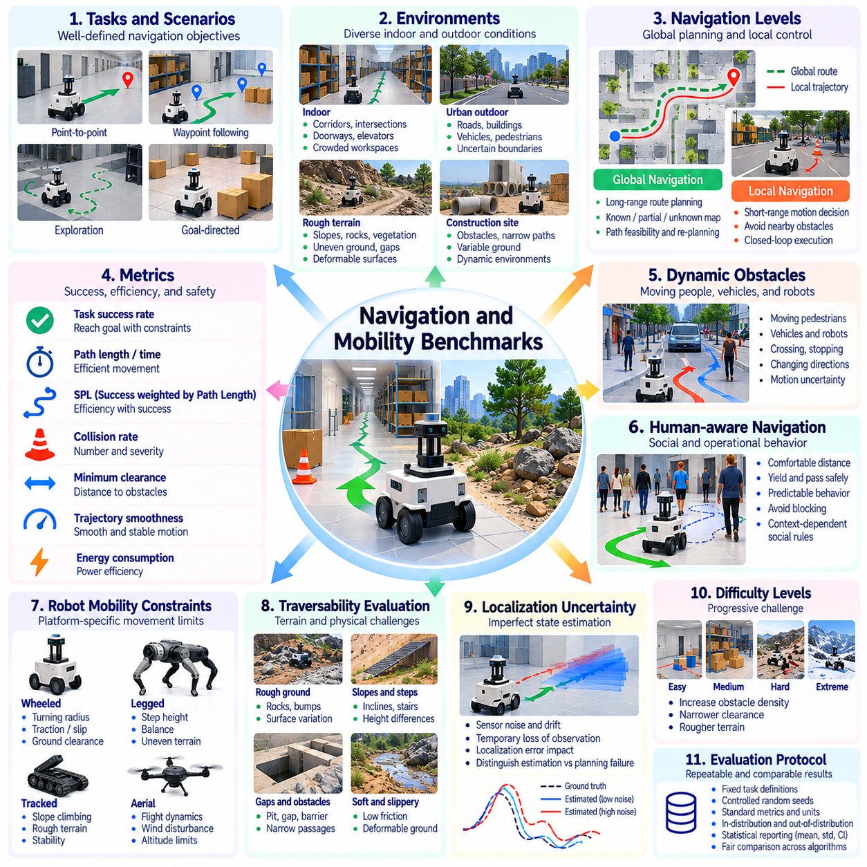
Navigation and mobility benchmarks evaluate how effectively Physical AI systems move through simulated environments while satisfying task objectives, physical constraints, and operational requirements. Navigation involves selecting feasible routes and avoiding obstacles, while mobility concerns the execution of movement across different surfaces and spatial configurations. Simulation enables repeatable assessment of task success, movement efficiency, collision avoidance, and adaptability.
Benchmark design begins with clearly defined navigation tasks and environmental conditions. Typical scenarios include point-to-point travel, waypoint following, corridor traversal, exploration, and goal-directed movement through unfamiliar spaces. Each scenario specifies starting positions, destination regions, obstacle configurations, and completion criteria. Consistent definitions ensure that measured performance reflects navigation capability rather than differences in task interpretation.
Navigation environments should represent diverse spatial structures and operational difficulties. Indoor scenarios may include narrow corridors, intersections, doorways, elevators, and crowded workspaces. Outdoor environments introduce uneven terrain, slopes, vegetation, and uncertain boundaries. Benchmark suites should distinguish geometric complexity from perceptual difficulty so that failures can be attributed to specific environmental challenges.
Global navigation evaluates the ability to select routes connecting distant locations. Algorithms may use known maps, partially observed environments, or continuously updated spatial representations. Evaluation measures route feasibility, path length, planning time, and responsiveness to changing conditions. A successful global planner should produce routes that remain compatible with robot dimensions, mobility limitations, and operational constraints.
Local navigation evaluates short-range motion decisions during continuous interaction with the environment. Robots must respond to nearby obstacles, moving objects, and unexpected changes while progressing toward their destinations. Benchmarks can measure collision frequency, clearance, trajectory smoothness, and control stability. Local planners should be evaluated through closed-loop execution rather than isolated path predictions.
Task success rate provides a fundamental navigation metric, but success requires precise definition. A robot may reach the goal while violating safety margins, exceeding time limits, or relying on repeated collisions. Benchmark protocols should define acceptable goal tolerance, orientation requirements, time constraints, and failure conditions. Successful completion should therefore be reported alongside execution quality and constraint violations.
Path efficiency measures how economically a robot reaches its destination. Common metrics include traveled distance, completion time, and Success weighted by Path Length. Reference paths should respect robot geometry and motion constraints rather than relying exclusively on geometric shortest distances. Efficiency comparisons must also account for situations where safer or more robust routes are intentionally longer.
Collision avoidance is central to navigation evaluation because physical contact may damage equipment or endanger nearby agents. Benchmarks should record collisions, minimum obstacle clearance, near misses, and constraint violations. Collision severity may depend on relative velocity, contact force, and object type. These measurements provide a richer assessment than binary collision counts and help distinguish cautious behavior from unsafe shortcuts.
Dynamic obstacle benchmarks examine navigation among moving people, vehicles, and robotic agents. Motion patterns may include crossing trajectories, sudden stops, changing directions, and partially predictable interactions. Evaluation should consider successful passage, collision avoidance, waiting behavior, and unnecessary detours. Simulation allows these encounters to be reproduced under controlled variations in density, speed, and motion uncertainty.
Human-aware navigation requires attention to social and operational expectations beyond geometric collision avoidance. Robots may need to maintain comfortable separation, yield appropriately, and avoid obstructing pedestrian movement. Benchmarks can evaluate interpersonal distance, path predictability, and interference with human activity. Such measurements should be interpreted within explicitly defined contexts rather than treated as universally applicable social rules.
Mobility benchmarking must account for the robot's physical movement capabilities. Wheeled platforms are constrained by turning radius, traction, ground clearance, and wheel dynamics, while other platforms may face different limitations. Simulated tests should enforce realistic kinematic and dynamic constraints. Otherwise, navigation algorithms may appear successful by generating trajectories that the intended hardware cannot execute.
Traversability evaluation measures whether a robot can move through terrain with varying geometric and physical characteristics. Surface roughness, slopes, steps, gaps, friction, and deformable ground influence movement feasibility. Benchmarks should measure successful traversal, progress, slippage, and loss of stability. Terrain difficulty should be parameterized so that performance can be compared across controlled levels of challenge.
Localization uncertainty introduces additional navigation challenges because planning depends on imperfect estimates of robot position and environmental structure. Sensor noise, accumulated drift, and temporary observation loss may cause route deviations or unsafe decisions. Evaluation should distinguish navigation failures caused by inaccurate state estimation from failures in planning or control. Integrated tests remain necessary because these components interact during execution.
Map availability and environmental knowledge should be explicitly controlled. Some benchmarks provide complete maps, while others require online mapping or exploration. Goal-directed navigation with privileged environmental information should not be compared directly with navigation based only on onboard observations. Reporting the permitted information and map initialization conditions prevents misleading claims about autonomous capability.
Exploration benchmarks assess movement when destinations, obstacles, or environmental structure are initially unknown. Robots must balance information gathering with progress toward operational objectives. Coverage, exploration efficiency, mapping completeness, and redundant travel provide useful metrics. Evaluation should also consider whether exploration strategies maintain safe access to known routes and avoid becoming trapped in poorly understood regions.
Recovery behavior is important because navigation failures do not always require immediate task termination. Robots may encounter blocked passages, temporary localization loss, wheel slip, or unexpected obstacles. Benchmarks should measure recovery success, recovery time, replanning frequency, and additional resource consumption. Repeated oscillation or excessive retries should be distinguished from effective autonomous recovery.
Robustness evaluation introduces systematic variation in obstacle placement, terrain properties, sensor quality, and environmental dynamics. Performance degradation across these conditions reveals sensitivity to uncertainty. Randomized scenarios should be separated from fixed reference tests to preserve interpretability. Independent evaluation environments help determine whether navigation policies generalize beyond familiar layouts and previously encountered obstacle patterns.
Computational and energy efficiency also influence navigation performance. Planning latency, control frequency, memory requirements, travel time, and estimated energy consumption affect practical deployment. Benchmarks should report these quantities alongside task success and movement quality. Comparisons should distinguish algorithmic efficiency from advantages caused by different hardware configurations or simplified actuator models.
Reproducible evaluation requires standardized robot models, coordinate frames, collision geometries, scenario definitions, and scoring procedures. Automated simulation pipelines can execute repeated navigation trials while recording trajectories, events, and performance metrics. Statistical summaries should include variability and failure distributions. Detailed logs support diagnosis of whether performance limitations arise from perception, planning, control, or environmental interactions.
Ultimately, navigation and mobility benchmarks should measure dependable movement rather than destination arrival alone. Effective evaluation combines goal achievement, path efficiency, collision avoidance, traversability, recovery, and resource consumption under controlled conditions. By incorporating static and dynamic environments, realistic physical constraints, uncertainty, and reproducible scoring, simulation benchmarks provide systematic evidence of Physical AI navigation competence.

02.10. Manipulation and Interaction Benchmarks
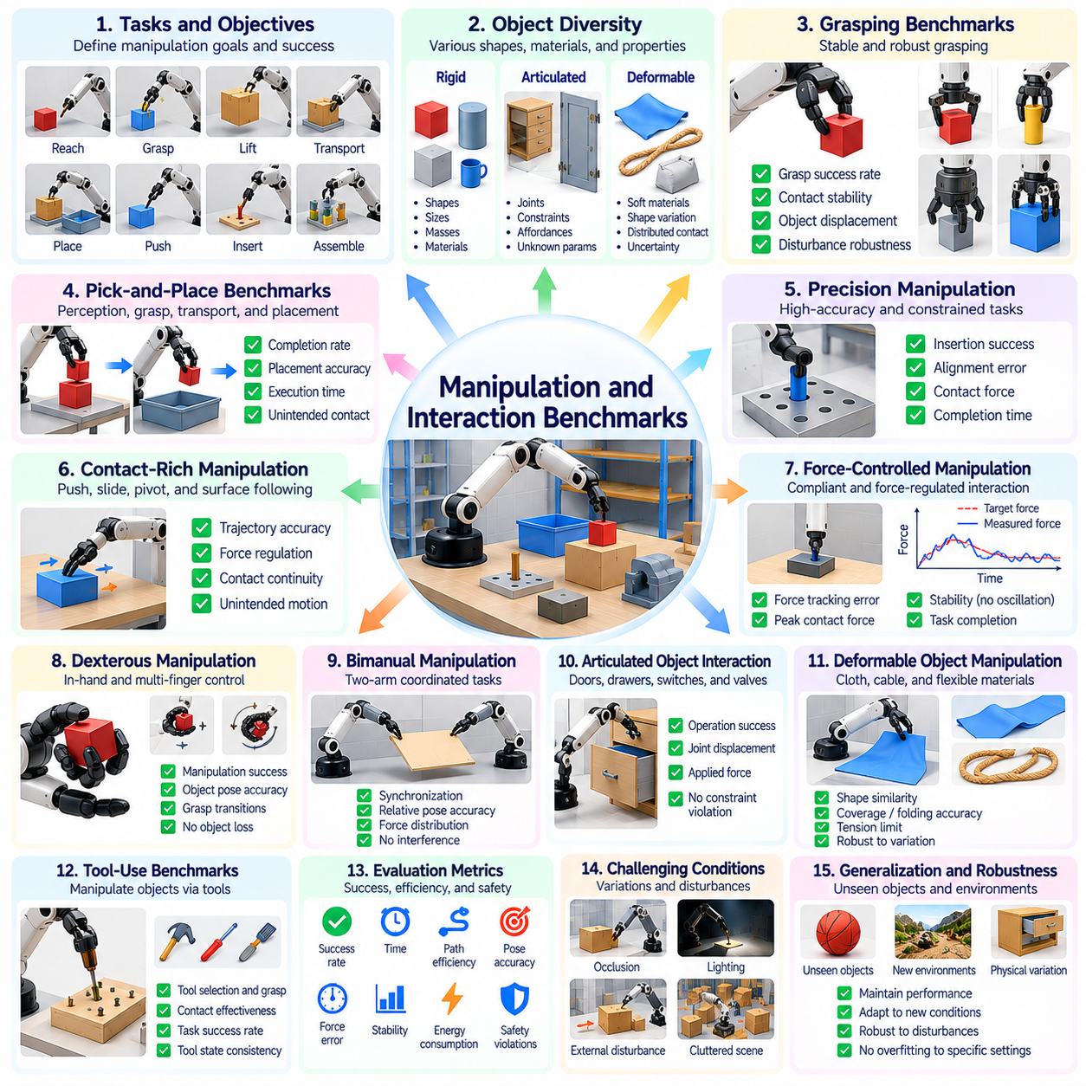
Manipulation and interaction benchmarks evaluate how effectively Physical AI systems control objects and establish purposeful contact with their surroundings. Unlike navigation, manipulation requires precise coordination between perception, motion planning, force regulation, and physical interaction. Simulation enables repeatable testing of grasping, placement, assembly, and tool use while providing reference measurements of object motion, contact forces, and task outcomes.
Benchmark design begins with explicit definitions of manipulation objectives and acceptable outcomes. Representative tasks include reaching, grasping, lifting, transporting, placing, pushing, pulling, inserting, and assembling objects. Each scenario specifies initial object configurations, robot capabilities, environmental constraints, and success criteria. Evaluation should distinguish completing a task from achieving it accurately, safely, and efficiently.
Object diversity is essential for assessing manipulation generalization. Benchmark environments should contain objects with different geometries, dimensions, masses, surface materials, and mechanical properties. Rigid, articulated, and deformable objects introduce different interaction challenges. Evaluation should determine whether a policy relies on memorized object characteristics or can adapt its behavior to unfamiliar physical properties and configurations.
Grasping benchmarks measure the ability to establish and maintain stable contact with objects. Evaluation may include grasp success rate, contact stability, object displacement, and resistance to external disturbances. Grasp quality depends on geometry, friction, contact distribution, and gripper configuration. Successful grasping should be distinguished from temporary object retention that fails during subsequent movement or manipulation.
Pick-and-place benchmarks evaluate coordinated perception, grasp planning, motion execution, and object release. Tasks may require transferring objects between surfaces, containers, shelves, or designated placement regions. Metrics include completion rate, placement accuracy, execution time, and unintended contact. Benchmarks should verify that objects remain stable after release rather than treating the commanded placement position as sufficient evidence of success.
Precision manipulation benchmarks examine tasks requiring small positional and orientation errors. Peg insertion, connector mating, component alignment, and constrained assembly provide representative examples. Evaluation measures insertion success, alignment error, contact force, and completion time. These tasks expose limitations in calibration, compliance, and contact reasoning that may remain hidden during unconstrained object transportation.
Contact-rich manipulation introduces complex interactions involving friction, impacts, deformation, and changing constraints. Pushing, sliding, pivoting, and surface following require continuous adjustment of motion and force. Benchmarks should measure trajectory accuracy, force regulation, contact continuity, and unintended object movement. Simulation fidelity is particularly important because inaccurate contact models can substantially alter observed policy performance.
Force-controlled manipulation evaluates whether robots regulate physical interaction rather than relying exclusively on position commands. Impedance control, admittance control, and hybrid force-position control may be tested during insertion, polishing, or compliant contact. Metrics include force tracking error, peak contact force, oscillation, and task completion. Evaluation should distinguish controlled compliance from instability or insufficient actuator authority.
Dexterous manipulation benchmarks examine coordinated control of multiple fingers and contact points. Tasks may involve object reorientation, in-hand rotation, precision grasp adjustment, and sequential finger repositioning. Performance depends on tactile information, contact planning, and fine motor coordination. Benchmarks should measure manipulation success, object pose accuracy, grasp transitions, and unintended object loss.
Bimanual manipulation evaluates coordinated interaction using two robotic arms or hands. Representative tasks include holding an object while operating a tool, transferring objects between hands, and assembling components with complementary actions. Evaluation should consider synchronization, relative pose accuracy, force distribution, and interference avoidance. Successful coordination requires maintaining task constraints while both manipulators move.
Articulated object interaction introduces mechanisms with constrained motion, including doors, drawers, switches, valves, and hinged components. Robots must identify relevant affordances and execute motions consistent with mechanical structure. Benchmarks may measure opening completion, joint displacement, applied force, and constraint violations. Evaluation should include unfamiliar articulation parameters to test generalization beyond fixed mechanisms.
Deformable object manipulation requires reasoning about shape changes and distributed physical interactions. Cloth folding, cable routing, flexible packaging, and soft-material handling are representative challenges. Success metrics may include shape similarity, coverage, tension limits, and final configuration accuracy. Because deformable simulation remains difficult, benchmark results should report material assumptions and uncertainty in physical modeling.
Tool-use benchmarks evaluate whether robots can manipulate objects indirectly through instruments and implements. Tasks may involve sweeping, fastening, cutting simulations, or using a lever to move another object. Evaluation should examine tool selection, grasp configuration, contact effectiveness, and task success. Such benchmarks distinguish basic object manipulation from understanding functional relationships among tools, targets, and environmental constraints.
Interaction planning benchmarks assess the ability to select action sequences that satisfy geometric and physical constraints. Robots may need to reposition obstacles, change grasps, stabilize objects, or coordinate multiple contact events. Evaluation should measure plan feasibility, execution success, replanning frequency, and accumulated error. Long interaction sequences reveal dependencies that cannot be captured by isolated grasping metrics.
Perception uncertainty strongly influences manipulation because small estimation errors can cause failed grasps or excessive contact forces. Benchmarks should vary object pose uncertainty, occlusion, depth noise, and calibration accuracy. Performance analysis can distinguish perception-related failures from motion planning and control limitations. Closed-loop evaluation is necessary to determine whether robots correct errors using updated sensory feedback.
Robustness evaluation introduces variations in object mass, friction, initial pose, actuator response, and external disturbances. Repeated trials across controlled parameter ranges reveal sensitivity to physical uncertainty. Recovery tests may include grasp slippage, unexpected object movement, or incomplete insertion. Benchmarks should record whether systems detect failure, adjust their strategies, and complete tasks without external intervention.
Safety and interaction quality require explicit evaluation alongside task success. Excessive contact force, unstable object motion, collisions, and unintended environmental changes may indicate unacceptable behavior. Metrics should capture force limits, impact severity, object damage proxies, and constraint violations. A manipulation policy should not receive a high evaluation score solely because it completes tasks through physically aggressive actions.
Computational efficiency and resource consumption also affect manipulation performance. Motion planning latency, control frequency, energy usage, and execution duration influence practical applicability. Benchmarks should report these measurements alongside accuracy and success rate. Comparisons must account for differences in robot morphology, actuator capacity, sensor availability, and computational hardware to avoid misleading conclusions.
Reproducible manipulation benchmarking requires standardized object models, contact parameters, robot configurations, task definitions, and scoring procedures. Simulation pipelines should record trajectories, contact events, force measurements, object states, and failure classifications. Multiple trials with independent random seeds support statistical analysis. Real-world validation remains necessary because simulated friction, compliance, and contact transitions may differ from physical behavior.
Ultimately, manipulation and interaction benchmarks should assess the complete ability to produce reliable physical changes in the environment. Effective evaluation combines grasp stability, placement precision, force control, task completion, robustness, safety, and resource efficiency. By integrating diverse objects, realistic contact dynamics, closed-loop execution, and reproducible protocols, simulation benchmarks provide systematic evidence of Physical AI manipulation competence.

02.11. Locomotion and Whole Body Benchmarks
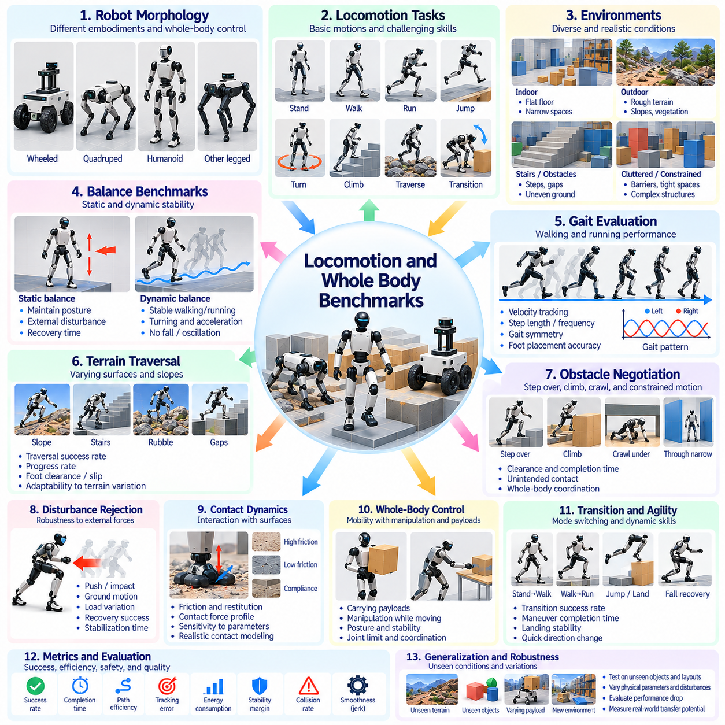
Locomotion and whole-body benchmarks evaluate how effectively Physical AI systems coordinate movement, maintain balance, and control physical interactions across diverse environments. Unlike conventional navigation, locomotion emphasizes the mechanical execution of movement through coordinated joints, contacts, and body dynamics. Simulation provides controlled conditions for measuring stability, agility, efficiency, and recovery while exposing robots to repeatable physical challenges.
Benchmark design begins by defining locomotion tasks, robot morphology, environmental conditions, and measurable outcomes. Representative tasks include standing, walking, running, climbing, turning, jumping, and traversing obstacles. Whole-body evaluation additionally considers coordinated arm, torso, and leg movements. Each scenario should specify initial states, target motions, permitted contacts, physical constraints, and objective criteria for successful execution.
Static balance benchmarks assess whether robots maintain stable configurations under gravity and external disturbances. Humanoid and legged robots must regulate body posture while managing contact forces and support geometry. Evaluation may measure center-of-mass displacement, body orientation error, joint motion, and recovery time. Tests should include different support conditions and perturbation directions to reveal limitations in balance control.
Dynamic balance evaluation examines stability during continuous motion and changing contact configurations. Walking, running, and rapid turning require coordinated adjustments of momentum, body posture, and ground reaction forces. Benchmarks should measure falls, trajectory tracking, body oscillation, and stability margins. Dynamic stability must be assessed during transitions because a robot may appear stable during steady movement but fail when accelerating or changing direction.
Gait evaluation measures the quality and adaptability of repeated locomotion patterns. Walking and running controllers may differ in step frequency, stride length, duty factor, and contact timing. Benchmarks can assess commanded velocity tracking, gait symmetry, foot placement accuracy, and unwanted slipping. Evaluation should consider whether a controller maintains consistent performance across different speeds, directions, and terrain conditions.
Terrain traversal benchmarks examine locomotion across surfaces with varying geometric and physical characteristics. Slopes, stairs, stepping stones, gaps, rubble, and uneven ground introduce different challenges. Metrics include traversal success, progress rate, foot clearance, slip frequency, and loss of balance. Terrain difficulty should be parameterized to distinguish genuine adaptability from performance on a small collection of memorized configurations.
Obstacle negotiation evaluates how robots modify body motion to overcome physical barriers. Tasks may require stepping over objects, ducking beneath structures, climbing ledges, or moving through constrained spaces. Whole-body coordination becomes important when arms and torso contribute to balance or environmental support. Benchmarks should measure clearance, unintended contacts, completion time, and successful transitions between movement strategies.
Disturbance rejection benchmarks assess robustness against unexpected external forces and environmental changes. Simulated pushes, impacts, ground motion, and sudden load variations can challenge balance controllers. Evaluation should record maximum recoverable disturbance, stabilization time, foot repositioning, and failure probability. Disturbance magnitude and direction should be controlled to establish meaningful recovery boundaries rather than relying on isolated demonstrations.
Contact dynamics strongly influence locomotion performance because movement depends on interactions between feet, wheels, limbs, and supporting surfaces. Friction, compliance, restitution, and contact timing affect stability and energy transfer. Benchmarks should examine sensitivity to contact-model parameters and numerical solver settings. Policies that exploit simulation artifacts may achieve high scores without demonstrating physically transferable behavior.
Whole-body control benchmarks evaluate coordinated regulation of multiple joints and physical objectives. Humanoid robots may need to maintain balance while reaching, carrying objects, or manipulating their surroundings. Evaluation should consider task-space accuracy, posture stability, contact constraints, and joint-limit violations. Successful whole-body behavior requires resolving competing objectives without sacrificing essential stability or physical feasibility.
Locomotion with payloads introduces changes in mass distribution, inertia, and contact requirements. Carrying boxes, transporting tools, or supporting external loads may alter gait and balance. Benchmarks should vary payload mass, location, and movement while measuring tracking error, stability, and task completion. These scenarios reveal whether controllers can compensate for physical changes without requiring extensive manual retuning.
Transition benchmarks assess movement between distinct locomotion modes and body configurations. Examples include standing to walking, walking to running, crouching to standing, and recovering from a fall. Transitions often expose weaknesses hidden by steady-state evaluation. Metrics should capture transition success, time, peak joint torque, and temporary stability loss. Reliable autonomy requires smooth and controlled switching between behaviors.
Agility benchmarks examine the ability to execute rapid, precise, and dynamically demanding movements. Sudden direction changes, acceleration, deceleration, jumping, and landing require accurate momentum regulation. Evaluation can measure maneuver completion, landing stability, tracking accuracy, and recovery after aggressive motions. High agility should not be rewarded when achieved through excessive joint loads or repeated loss of control.
Energy efficiency is important because locomotion can consume substantial actuator power. Benchmarks may report mechanical work, electrical energy, cost of transport, and distance traveled per unit energy. Comparisons should account for robot mass, speed, terrain, and actuator characteristics. Energy measurements derived from simplified simulation models should be identified clearly because they may not represent actual hardware consumption.
Actuator and structural constraints determine whether simulated locomotion remains physically executable. Joint torque limits, velocity limits, thermal behavior, compliance, and transmission dynamics influence feasible motion. Benchmarks should enforce these constraints and record saturation events or excessive loading. A controller that succeeds by demanding unrealistic torque or instantaneous responses should not be considered deployment-ready.
Perception-aware locomotion evaluates movement when terrain and contact conditions must be inferred from imperfect observations. Depth cameras, lidar, proprioception, and tactile feedback provide complementary information. Benchmarks should vary observation noise, occlusion, and terrain uncertainty while measuring stability and progress. Closed-loop tests reveal whether controllers can adapt foot placement and body motion when environmental estimates are inaccurate.
Generalization evaluation examines whether locomotion policies transfer across unseen terrain, physical parameters, and robot configurations. Changes in friction, slope, payload, actuator response, and morphology may reveal overfitting. Held-out scenarios and independent randomization distributions support stronger evaluation claims. Results should distinguish robustness within expected conditions from adaptation to genuinely unfamiliar environments.
Recovery and failure analysis should extend beyond binary fall detection. Robots may stumble, slip, collide, enter unstable postures, or temporarily lose commanded motion. Benchmarks should measure failure recognition, corrective action, recovery duration, and residual task capability. Controlled failure injection helps identify operational boundaries and whether recovery strategies remain effective without external intervention.
Reproducible benchmarking requires standardized robot models, contact definitions, actuator limits, terrain configurations, and evaluation protocols. Automated simulation can execute repeated trials while recording joint states, forces, trajectories, energy estimates, and failure events. Statistical reporting should include variability and worst-case outcomes. Physical validation remains necessary because simulated contact and actuator dynamics may differ from real hardware.
Ultimately, locomotion and whole-body benchmarks should assess reliable physical movement rather than isolated motion demonstrations. Comprehensive evaluation combines balance, gait quality, terrain traversal, disturbance recovery, coordinated control, energy efficiency, and physical feasibility. By integrating realistic dynamics, diverse environments, controlled perturbations, and reproducible metrics, simulation benchmarks provide systematic evidence of Physical AI locomotion competence.

02.12. World Model and Prediction Benchmarks
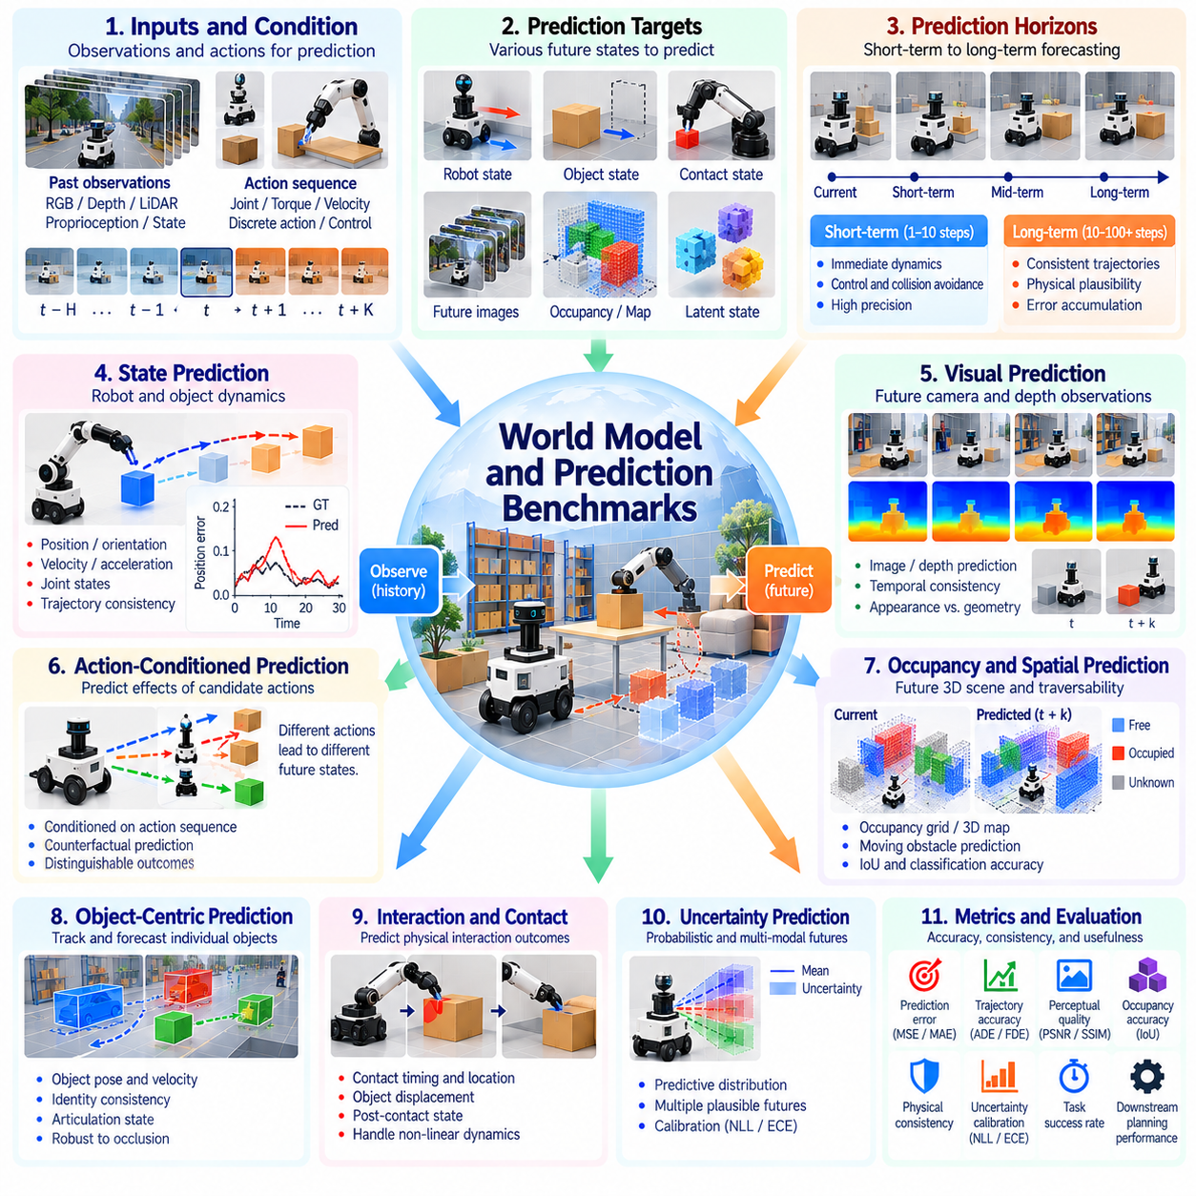
World model and prediction benchmarks evaluate how accurately Physical AI systems represent environmental dynamics and anticipate future physical states. A world model predicts how objects, robots, and surrounding conditions evolve over time, often in response to actions. Simulation provides controlled reference trajectories and observable physical states. Evaluation should measure predictive accuracy, temporal consistency, uncertainty, and usefulness for autonomous decision-making.
Benchmark design begins by defining prediction targets, observation histories, action inputs, and forecasting horizons. Targets may include robot states, object poses, velocities, contact events, occupancy maps, or future sensor observations. Each task requires explicit initial conditions and reference outcomes. Evaluation protocols should distinguish predictions conditioned on known future actions from forecasts generated without access to those actions.
State prediction benchmarks measure whether learned models reproduce the evolution of physical variables. Position, orientation, velocity, joint configuration, and object motion can be compared with simulated ground truth. Common metrics include mean squared error, absolute error, and trajectory deviation. These measurements should be normalized appropriately because different physical quantities have different units and operational significance.
Short-horizon prediction evaluates immediate changes in physical state following actions or environmental interactions. Accurate short-term forecasts support feedback control, collision avoidance, and rapid replanning. Benchmarks should examine prediction errors across different action magnitudes and contact conditions. Even small errors may become important when the robot operates near obstacles, joint limits, or unstable configurations.
Long-horizon prediction examines whether models maintain plausible trajectories across extended sequences of actions. Small errors in position, velocity, or contact estimation may accumulate and produce unrealistic future states. Evaluation should report error growth as a function of prediction horizon. Long-term performance should also consider whether generated trajectories preserve physical feasibility rather than merely minimizing average numerical error.
Action-conditioned prediction is central to world models used for robotic planning. A model receives candidate actions and estimates their consequences for the robot and environment. Benchmarks should test whether different actions produce distinguishable and physically consistent outcomes. Counterfactual action sequences can reveal whether a model has learned meaningful action-effect relationships or primarily extrapolates observed motion patterns.
Visual prediction benchmarks assess the generation of future images, depth maps, or other sensory observations. Evaluation may include reconstruction accuracy, perceptual similarity, geometric consistency, and temporal coherence. High visual fidelity does not necessarily imply accurate physical dynamics. Benchmarks should therefore separate appearance quality from object motion, contact behavior, and downstream planning effectiveness.
Latent world model benchmarks evaluate predictions represented in compressed feature spaces rather than directly observable physical coordinates. Latent dynamics may support efficient planning and representation learning, but their numerical errors can be difficult to interpret. Evaluation should examine predictive consistency, state information retention, and task relevance. Decoding or probing latent representations can help connect abstract predictions to measurable physical outcomes.
Occupancy and spatial prediction benchmarks examine how models anticipate changes in the surrounding environment. Future occupancy grids, bird's-eye-view representations, and three-dimensional scene states can describe moving obstacles and accessible regions. Metrics may include Intersection over Union, occupancy classification accuracy, and spatial displacement error. Evaluation should distinguish free space, occupied space, and uncertain regions.
Object-centric prediction benchmarks assess whether models track individual entities and forecast their behavior. Relevant quantities include object position, orientation, velocity, articulation state, and interaction relationships. Evaluation should consider identity consistency and prediction accuracy during occlusion or physical contact. Object-level analysis can expose failures hidden by aggregate image metrics or scene-wide reconstruction scores.
Interaction prediction evaluates whether world models anticipate physical consequences of contact between bodies. Pushing, grasping, sliding, collisions, and articulated motion involve discontinuities and changing constraints. Benchmarks should measure predicted contact timing, object displacement, force-related outcomes, and post-contact states. Simulator fidelity must be considered because inaccurate reference contact dynamics can distort evaluation conclusions.
Physical consistency is an essential evaluation dimension beyond statistical prediction accuracy. Predicted trajectories should respect geometric constraints, plausible dynamics, and relevant conservation principles. Benchmarks can detect object interpenetration, impossible joint motion, unrealistic acceleration, and inconsistent contact transitions. Physical plausibility checks help identify models that produce visually convincing but mechanically invalid futures.
Uncertainty-aware prediction benchmarks evaluate whether models represent ambiguity in future outcomes. Stochastic environments and incomplete observations may permit several physically plausible trajectories. Probabilistic models can express predictive distributions, confidence intervals, or multiple candidate futures. Evaluation should examine calibration, distributional coverage, and likelihood while avoiding penalties for valid alternatives to a single reference trajectory.
Multimodal prediction is important when several future outcomes are possible. A moving agent may turn, stop, or continue forward, while an object may slide or remain stationary depending on uncertain contact conditions. Benchmarks should assess whether models capture meaningful alternatives without generating physically implausible possibilities. Diversity must be evaluated together with probability calibration and outcome accuracy.
Generalization benchmarks examine prediction under unfamiliar objects, environments, actions, and physical parameters. Changes in mass, friction, geometry, actuator response, or interaction patterns may expose reliance on training-specific assumptions. Held-out scenarios and independent parameter distributions help measure transfer beyond familiar conditions. Results should distinguish interpolation within known dynamics from genuine extrapolation to new physical situations.
Robustness evaluation introduces observation noise, missing sensor data, delayed actions, and imperfect state estimates. World models must often predict from uncertain or incomplete information rather than exact simulator states. Benchmarks should measure degradation under controlled disturbances and identify failure thresholds. This reveals whether predictive capability remains useful when the model receives realistic inputs from perception systems.
Planning-oriented evaluation measures whether world model predictions improve action selection and task execution. A model with low prediction error may still rank candidate actions incorrectly or overlook critical failure states. Benchmarks should compare planning success, decision regret, constraint violations, and computational cost. Closed-loop execution provides stronger evidence of practical value than open-loop forecasting accuracy alone.
Computational efficiency determines whether predictive models can support real-time autonomous operation. Inference latency, memory usage, prediction horizon, and the number of candidate action sequences influence planning feasibility. Benchmarks should report these requirements alongside prediction quality. Efficient models may be preferable when they provide sufficiently accurate forecasts within strict control deadlines.
Reproducibility requires standardized observation interfaces, action definitions, reference trajectories, prediction horizons, and scoring procedures. Evaluation pipelines should preserve random seeds, simulator versions, model configurations, and complete prediction outputs. Statistical reporting should include horizon-dependent errors and failure distributions. Independent test scenarios reduce overfitting and support meaningful comparisons across world model architectures.
Ultimately, world model and prediction benchmarks should determine whether Physical AI systems anticipate future physical consequences reliably enough to guide action. Comprehensive evaluation combines state accuracy, temporal consistency, physical plausibility, uncertainty calibration, generalization, and planning effectiveness. Simulation provides a systematic foundation, but real-world validation remains necessary to establish whether predictive capabilities transfer to actual physical environments.

02.13. VLA and Generalist Policy Benchmarks
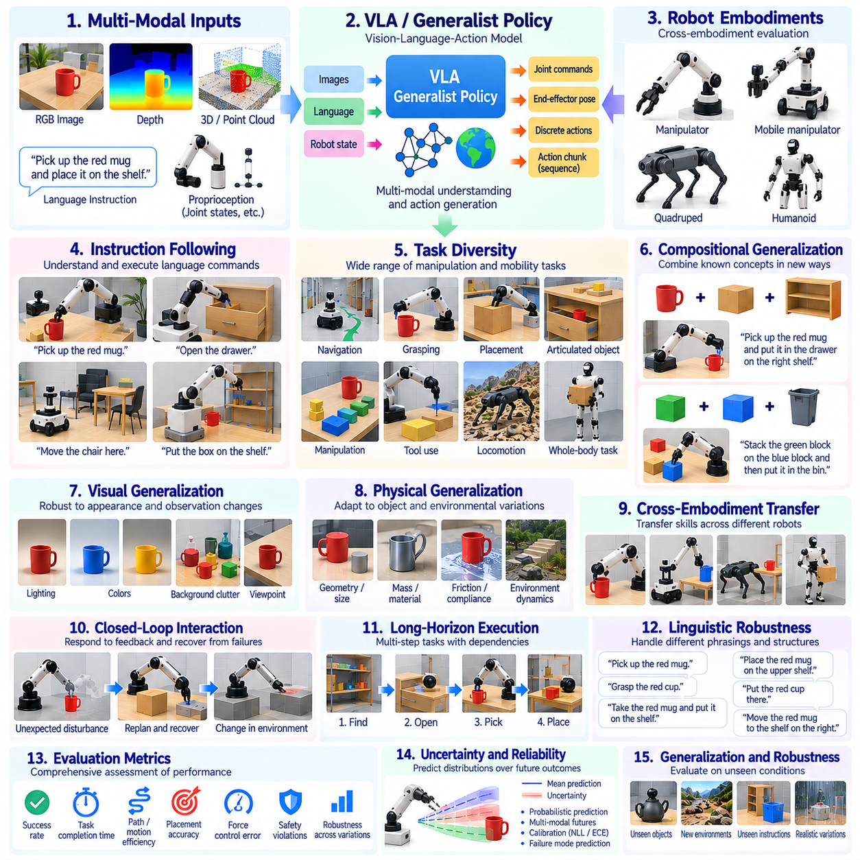
Vision-Language-Action (VLA) and generalist policy benchmarks evaluate how effectively Physical AI systems translate multimodal observations and natural-language instructions into physical actions. Unlike task-specific controllers, generalist policies aim to perform diverse tasks using shared representations and learned behaviors. Simulation enables systematic evaluation across objects, environments, instructions, and robot configurations while providing reproducible measurements of task execution.
Benchmark design begins with standardized definitions of observations, instructions, action spaces, and task objectives. VLA systems may receive camera images, depth measurements, proprioceptive states, and textual commands. Their outputs may include joint targets, end-effector poses, or action sequences. Evaluation protocols should specify input availability, control frequency, execution limits, and success conditions to ensure meaningful comparisons.
Instruction-following benchmarks assess whether policies correctly interpret natural-language commands and execute the intended physical behavior. Tasks may involve object selection, spatial relationships, sequential operations, and conditional instructions. Evaluation should distinguish linguistic understanding from physical execution capability. A policy may correctly identify the requested action yet fail because of inaccurate perception, planning, or motor control.
Language grounding benchmarks examine whether linguistic concepts correspond to observable objects, locations, and actions. Commands involving color, shape, relative position, function, or object identity require connections between language and physical scenes. Benchmarks should measure target selection accuracy, referential consistency, and action relevance. Ambiguous instructions should be evaluated separately from commands with uniquely identifiable targets.
Task diversity is fundamental to evaluating generalist capabilities. Benchmark suites should include navigation, grasping, placement, manipulation, articulated object interaction, and coordinated movement. Performance across task categories reveals whether a shared policy supports broad competence or primarily excels at familiar behaviors. Aggregate success rates should be accompanied by category-level results to prevent strong performance on easy tasks from concealing important limitations.
Compositional generalization evaluates whether policies combine previously learned concepts and skills in unfamiliar arrangements. A robot may understand individual objects, spatial relations, and manipulation primitives but struggle with new combinations. Benchmarks should introduce unseen instruction compositions, object pairings, and task sequences. Evaluation must distinguish recombination of known capabilities from memorization of complete training examples.
Long-horizon instruction execution requires maintaining objectives across multiple dependent actions. Tasks may involve locating objects, opening containers, retrieving components, and completing assembly sequences. Benchmarks should measure overall completion, intermediate progress, error accumulation, and recovery from unsuccessful steps. A policy that performs individual subtasks reliably may still fail when coordinating them over extended execution periods.
Visual generalization benchmarks assess robustness to changes in appearance and observation conditions. Lighting, camera viewpoint, texture, background clutter, and object color can be varied independently. Evaluation should determine whether policies recognize task-relevant features rather than exploiting visual correlations from training. Performance under unseen combinations of visual factors provides stronger evidence of transferable perception.
Physical generalization examines whether VLA and generalist policies adapt to changes in object properties and environmental dynamics. Variations in mass, friction, compliance, geometry, and contact conditions may alter action outcomes. Benchmarks should measure success and control quality across controlled parameter distributions. Such tests reveal whether multimodal reasoning is supported by physically grounded behavior rather than visual pattern recognition alone.
Cross-embodiment benchmarks evaluate whether shared policies transfer between robots with different morphologies and action interfaces. Manipulators, mobile manipulators, humanoids, and other platforms may differ in joint structure, reachability, sensing, and control limits. Evaluation should distinguish direct transfer from performance achieved through adaptation or additional training. Embodiment-specific constraints must be respected when comparing outcomes.
Action representation influences both generalization and execution quality. Policies may predict continuous joint commands, Cartesian targets, discrete action tokens, or temporally extended action chunks. Benchmarks should document action decoding, control interfaces, and execution frequency. Comparisons should consider latency, trajectory smoothness, physical feasibility, and the consequences of different action representations rather than task success alone.
Closed-loop interaction benchmarks assess whether policies respond appropriately to observations received during execution. Object displacement, grasp failure, unexpected obstacles, and incomplete actions require updated decisions. Evaluation should measure correction latency, replanning effectiveness, and recovery success. Open-loop demonstrations may overestimate capability when policies are tested only under predictable conditions without feedback-dependent adaptation.
Robustness to linguistic variation is necessary because users may express equivalent objectives using different wording. Benchmarks should include paraphrases, synonyms, alternative instruction structures, and variations in descriptive detail. Performance should remain consistent when the intended physical task is unchanged. Evaluation must also distinguish harmless linguistic variation from commands that genuinely modify task requirements.
Ambiguity and uncertainty benchmarks investigate how policies behave when instructions or observations are incomplete. Multiple matching objects, hidden targets, and conflicting contextual cues may prevent confident action selection. Evaluation should consider whether systems request clarification, gather additional observations, or avoid unsupported assumptions. Success should not reward arbitrary actions that happen to satisfy one interpretation of an ambiguous command.
Safety evaluation examines whether generalist policies respect physical and operational constraints while following instructions. Unsafe commands, obstructed workspaces, fragile objects, and human proximity can create competing objectives. Benchmarks should record collisions, excessive forces, prohibited actions, and unsafe recovery behavior. Instruction compliance must not override essential safety requirements, even when the requested task is otherwise achievable.
Data contamination and benchmark memorization present significant challenges for pretrained VLA models. Training corpora may contain task descriptions, simulated scenes, or demonstrations resembling evaluation scenarios. Benchmark protocols should separate training and testing distributions and disclose relevant data overlap when known. Procedural task generation and held-out combinations can reduce memorization risks, although they cannot guarantee complete independence.
Generalist policy evaluation should report performance distributions rather than relying exclusively on overall averages. Task success, execution time, action efficiency, intervention frequency, and safety violations provide complementary evidence. Results should be grouped by task difficulty, instruction complexity, and environmental variation. Statistical confidence intervals and repeated trials help distinguish reliable competence from occasional success.
Computational requirements influence whether VLA systems can operate on physical robots. Multimodal inference latency, memory consumption, action generation frequency, and hardware acceleration affect responsiveness. Benchmarks should measure these costs under realistic control deadlines. Large models may demonstrate strong semantic understanding while remaining unsuitable for time-sensitive manipulation without efficient execution architectures.
Reproducibility requires standardized task descriptions, simulator configurations, observation streams, action interfaces, and scoring procedures. Evaluation pipelines should preserve instruction variants, random seeds, trajectories, model versions, and failure classifications. Common benchmark conditions support comparisons, while explicit reporting of adaptations prevents misleading claims. Real-world validation remains necessary to establish transfer beyond simulated environments.
Ultimately, VLA and generalist policy benchmarks should assess whether multimodal intelligence produces reliable, adaptable, and safe physical behavior across diverse tasks. Comprehensive evaluation combines language grounding, task generalization, closed-loop control, physical robustness, safety, and computational efficiency. Simulation offers a scalable foundation for comparison, but genuine generality requires evidence across unfamiliar situations and physical deployments.

02.14. Stress Rare Event and Failure Injection
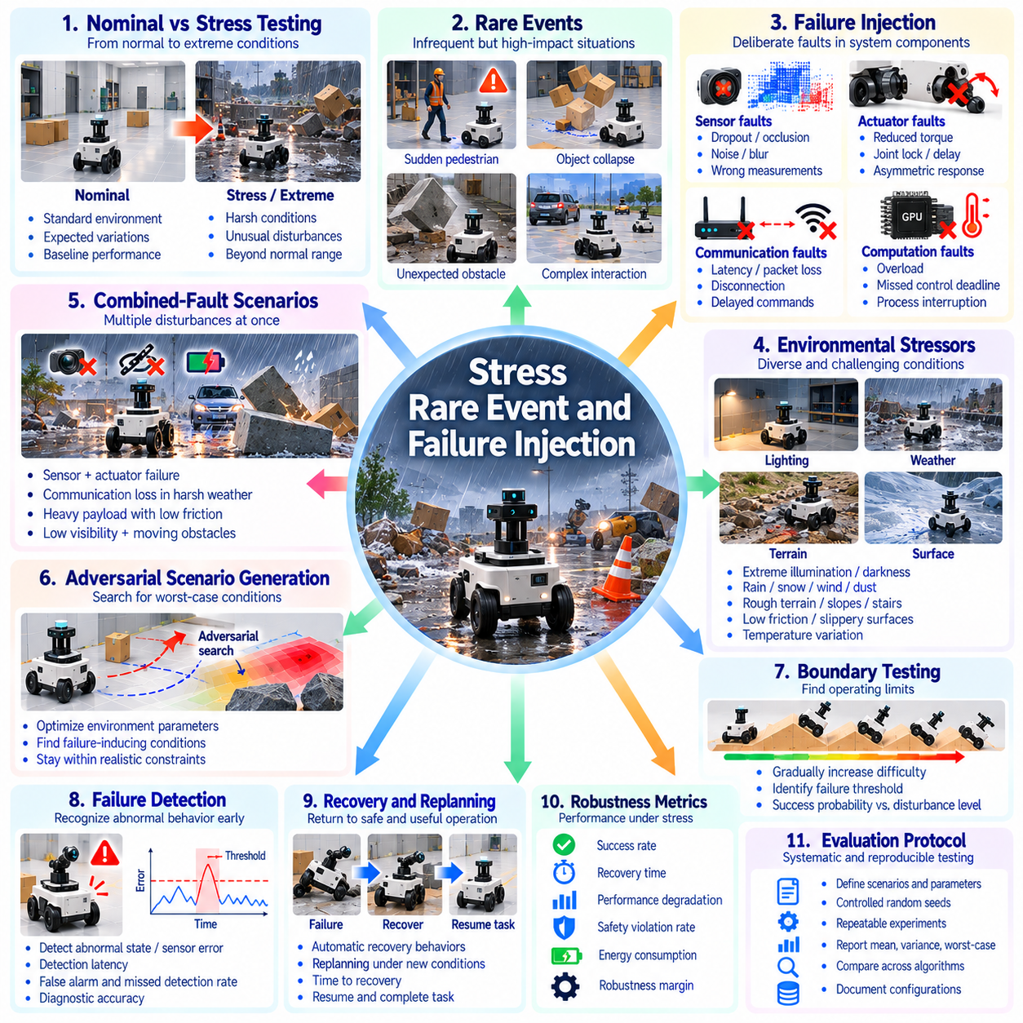
Stress testing, rare-event evaluation, and failure injection examine whether Physical AI systems remain reliable when operating conditions exceed normal expectations. Conventional benchmarks often emphasize average task success under familiar environments, leaving critical weaknesses undiscovered. Simulation enables controlled exposure to extreme conditions, unlikely events, and component failures. Evaluation should measure performance degradation, failure boundaries, recovery capability, and safety under adverse circumstances.
Stress benchmark design begins by identifying operational limits, environmental hazards, and plausible failure mechanisms. Scenarios may vary disturbance intensity, task complexity, sensor quality, actuator capacity, and environmental uncertainty. Each test should define nominal conditions, stress parameters, escalation procedures, and failure criteria. Systematic variation allows evaluators to distinguish gradual performance degradation from abrupt loss of functionality.
Rare-event benchmarks target situations that occur infrequently but may produce severe consequences. Examples include unexpected pedestrian movement, sudden obstacle appearance, unstable object collapse, and simultaneous equipment malfunctions. Simulation can generate such events repeatedly without exposing people or hardware to unnecessary danger. Evaluation should examine whether systems recognize unusual conditions and select appropriate protective or recovery actions.
Failure injection deliberately introduces faults into simulated components, observations, or communication channels. Sensor dropout, actuator degradation, delayed commands, corrupted measurements, and interrupted connectivity are representative cases. Fault parameters should specify onset time, duration, severity, and affected subsystem. Controlled injection helps isolate causal relationships between individual failures and resulting changes in robot behavior.
Sensor fault benchmarks evaluate robustness to incomplete, delayed, or misleading observations. Cameras may experience occlusion, motion blur, exposure changes, or temporary signal loss. Lidar and depth sensors may produce missing returns or distorted measurements. Evaluation should measure perception degradation, state estimation error, and downstream task performance. Systems should be tested for their ability to detect unreliable inputs rather than blindly trusting corrupted data.
Actuator failure benchmarks examine behavior when commanded motions cannot be executed as expected. Reduced torque, joint locking, response delays, and asymmetric motor performance can alter robot dynamics. Tests should evaluate stability, controllability, task completion, and emergency stopping behavior. Failure severity should increase gradually to identify operating boundaries and determine whether controllers can adapt to partial loss of actuation.
Communication and computational faults introduce additional operational risks. Network latency, packet loss, processor overload, missed control deadlines, and temporary computation interruptions can destabilize autonomous behavior. Benchmarks should reproduce these conditions while recording command age, response delay, and safety outcomes. Evaluation must distinguish graceful degradation from uncontrolled operation when communication or computation becomes unreliable.
Environmental stress testing evaluates robustness against conditions outside standard operating distributions. Extreme illumination, low friction, irregular terrain, strong wind, temperature variation, and unexpected moving obstacles may challenge perception and control. Scenario parameters should remain physically plausible and relevant to the intended deployment. Testing should establish the range of conditions under which task performance and safety remain acceptable.
Combined-fault scenarios are important because real failures rarely occur in complete isolation. A robot may encounter reduced visibility while carrying a heavy payload or experience communication delay during obstacle avoidance. Benchmarks should examine interactions between faults and environmental stressors. Compound disturbances can reveal nonlinear vulnerabilities that are not observable when each stress factor is evaluated independently.
Adversarial scenario generation searches for conditions that expose weaknesses in a policy or control system. Optimization methods may vary obstacle placement, initial states, disturbance timing, or environmental parameters to maximize failure likelihood. Generated scenarios should remain within clearly defined physical and operational constraints. Evaluation must distinguish meaningful safety vulnerabilities from unrealistic cases designed only to exploit simulator limitations.
Boundary testing identifies thresholds separating reliable operation from unacceptable behavior. Disturbance magnitude, obstacle density, sensor noise, and actuator degradation can be increased until performance fails specified requirements. Metrics should include critical stress thresholds, success probability, and safety margin. Repeated trials near identified boundaries are necessary because stochastic systems may exhibit variable outcomes under nearly identical conditions.
Failure detection benchmarks measure whether systems recognize abnormal behavior before it develops into a dangerous situation. Unexpected state deviations, inconsistent sensor readings, abnormal contact forces, and control saturation may provide early warning signals. Evaluation should measure detection latency, false alarm rate, missed detection rate, and diagnostic accuracy. Rapid detection is valuable only when it supports effective protective decisions.
Recovery benchmarks assess the ability to restore safe and useful operation following disturbances or component failures. Robots may need to stabilize posture, replan trajectories, release objects, switch controllers, or enter a safe state. Evaluation should measure recovery success, recovery time, residual capability, and additional hazards introduced during recovery. Not every failure permits task continuation, making safe termination an important outcome.
Safety-oriented stress testing evaluates whether systems respect critical constraints even when normal task objectives become unattainable. Collision avoidance, force limits, stability requirements, and protected workspace boundaries should remain enforceable. Benchmarks should distinguish task failure from safety failure because unsuccessful task execution may still represent appropriate behavior. A system should not be rewarded for completing tasks through unsafe actions.
Rare-event evaluation presents statistical challenges because severe failures may have extremely low probabilities. Uniform random sampling can require impractically many trials to observe meaningful numbers of critical events. Importance sampling, targeted scenario generation, and stratified evaluation can improve coverage. However, results from biased sampling distributions must not be interpreted directly as real-world failure probabilities without appropriate correction.
Scenario coverage should include different fault categories, severity levels, temporal patterns, and combinations. Short transient faults may produce different outcomes from persistent degradation or intermittent failures. Coverage metrics can describe tested parameter ranges, event diversity, and interactions among stress factors. Comprehensive coverage remains difficult, so benchmark reports should explicitly identify untested conditions and limitations.
Failure analysis requires detailed records of events preceding and following unsuccessful outcomes. Simulation logs should capture robot states, sensor observations, actuator commands, contact events, injected faults, and safety interventions. Temporal reconstruction helps distinguish initiating faults from secondary consequences. Consistent failure taxonomies support comparisons across policies and reveal recurring mechanisms that aggregate success rates may conceal.
Automated stress testing can combine parameter sweeps, randomized scenario generation, and targeted failure searches. Parallel simulation allows large numbers of trials across diverse initial conditions and disturbance configurations. Evaluation pipelines should automatically classify outcomes and preserve representative failure traces. Adaptive testing can prioritize unexplored regions near operational boundaries while retaining independent test sets for unbiased comparison.
Reproducibility requires documented fault models, scenario parameters, random seeds, simulator versions, and evaluation procedures. Results should report failure rates, uncertainty intervals, worst-case outcomes, and recovery characteristics. Comparisons must account for differences in exposure to stress conditions. Physical validation is essential because simulated faults, contact dynamics, and environmental extremes may not reproduce all real-world failure mechanisms.
Ultimately, stress, rare-event, and failure-injection benchmarks should determine whether Physical AI systems fail predictably, detect emerging hazards, and maintain safety under exceptional conditions. Effective evaluation combines systematic stress escalation, targeted rare events, controlled fault injection, recovery analysis, and statistical rigor. Simulation provides a scalable testing foundation, while real-world evidence remains necessary to establish operational reliability.

02.15. Massive Parallel Benchmarking
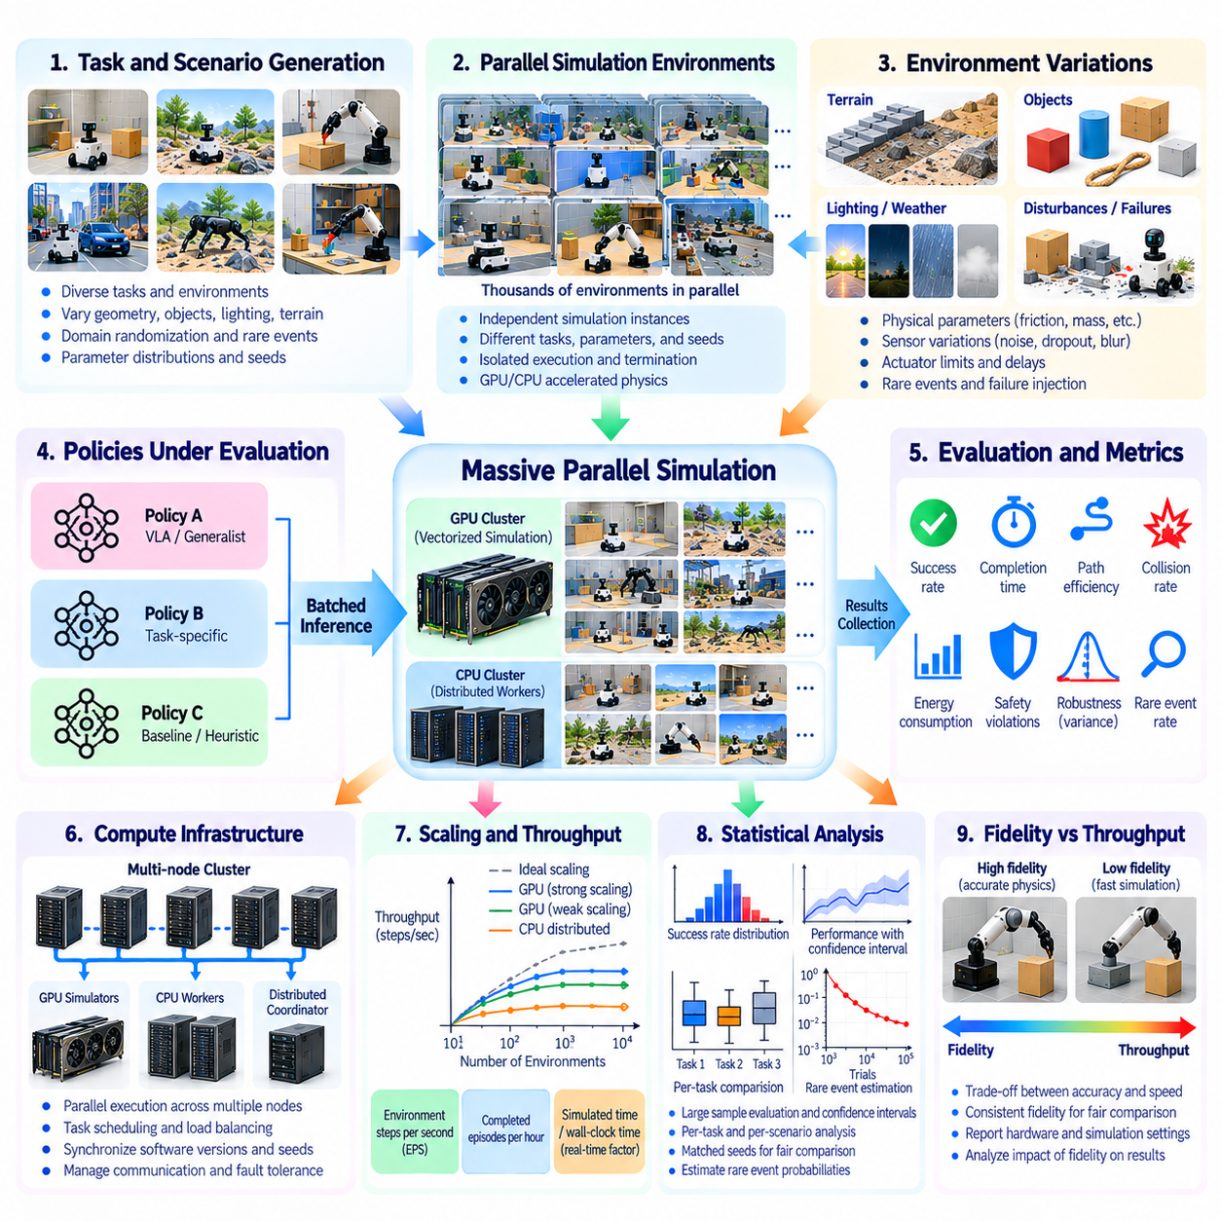
Massive parallel benchmarking evaluates Physical AI systems by executing large numbers of simulation trials simultaneously across diverse tasks, environments, and operating conditions. Unlike sequential evaluation, parallel execution increases experimental throughput and enables broader statistical coverage. This approach is particularly valuable for identifying rare failures, measuring robustness, and comparing policies. Reliable results require careful control of simulation fidelity, computational resources, and evaluation protocols.
Benchmark architecture begins with the organization of independent simulation environments into parallel execution groups. Each environment maintains its own robot state, task configuration, physical parameters, and termination conditions. A centralized evaluation system distributes policies and collects results without interfering with individual trials. Proper isolation prevents information leakage between environments and ensures that concurrent execution does not unintentionally alter benchmark outcomes.
GPU-accelerated simulation enables thousands of lightweight environments to execute concurrently when computational resources permit. Parallel physics engines can process rigid-body dynamics, collision detection, and contact calculations using vectorized operations. Performance depends on scene complexity, robot degrees of freedom, and sensor requirements. Benchmark reports should distinguish theoretical environment capacity from sustained execution throughput under realistic workloads.
CPU-based parallel benchmarking remains important for simulations requiring complex logic, specialized physics, or heterogeneous software components. Multiple processes or distributed workers can execute independent scenarios across available processor cores. Hybrid architectures may combine CPU-based task management with GPU-based physics and inference. Evaluation should account for communication overhead, memory contention, and scheduling delays that influence actual throughput.
Environment vectorization represents multiple simulation instances through batched state and action arrays. Policies receive observations from many environments and generate corresponding actions through a shared inference pipeline. Vectorized execution reduces repeated software overhead and improves accelerator utilization. However, benchmarks must preserve correct associations between observations, actions, rewards, and termination signals for every independent environment.
Distributed benchmarking extends parallel execution across multiple computers or computing nodes. A coordinator assigns scenarios, distributes model configurations, and aggregates evaluation records from remote workers. Distributed systems require synchronization of software versions, random seeds, and scoring procedures. Network communication, worker failures, and inconsistent hardware performance must be managed to prevent infrastructure differences from distorting policy comparisons.
Scenario diversity is a primary motivation for massive parallel evaluation. Thousands of environments can vary terrain geometry, object configurations, lighting, friction, payloads, and disturbances. Parameter distributions should reflect the intended evaluation objectives rather than arbitrary random variation. Structured scenario sampling helps determine whether a policy generalizes across meaningful physical conditions instead of merely achieving a high average score.
Random seed management is essential for reproducibility and fair comparisons. Each trial should receive a uniquely identified seed governing initial states, environmental variation, and stochastic events. When appropriate, competing policies should be evaluated on matched scenarios to reduce comparison variance. Benchmark systems must record seed assignments and prevent accidental reuse that could produce misleading statistical confidence.
Statistical efficiency improves when large numbers of independent trials provide reliable estimates of performance distributions. Success rates, completion times, collision frequencies, and energy consumption can be summarized with confidence intervals. Evaluation should also report variability across environments and task categories. Large sample counts alone do not guarantee valid conclusions if trials are correlated or scenario sampling is biased.
Rare-event estimation benefits from parallel execution because critical failures may require extensive testing to observe. Large-scale simulation can explore combinations of environmental stress, perception uncertainty, and actuator limitations. Targeted sampling may improve coverage of difficult conditions. However, oversampling dangerous scenarios changes the evaluation distribution, so estimated failure probabilities must account for the sampling procedure.
Computational throughput should be measured using clearly defined operational metrics. Environment steps per second, completed episodes per hour, and simulated physical time per wall-clock time describe different aspects of performance. Benchmarks should report the number of concurrent environments and available hardware resources. Throughput comparisons must use equivalent simulation fidelity and sensor configurations to avoid misleading efficiency claims.
Scaling efficiency describes how evaluation performance changes as additional environments or computing resources are introduced. Increasing concurrency may improve throughput until memory bandwidth, physics computation, or inference becomes saturated. Strong scaling and weak scaling experiments reveal different infrastructure limitations. Benchmark design should identify saturation points and avoid assuming that doubling hardware capacity necessarily doubles evaluation speed.
Simulation fidelity can decline when aggressive parallelization requires simplified dynamics or reduced sensor resolution. Contact modeling, collision handling, actuator dynamics, and rendering accuracy may differ between lightweight and high-fidelity configurations. Evaluation should document these compromises and test their influence on policy rankings. High throughput is not useful if simulation shortcuts systematically favor unrealistic control strategies.
Policy inference can become a computational bottleneck when many environments request actions simultaneously. Batched neural network execution improves utilization but may introduce latency or synchronization constraints. Benchmarks should measure inference time, action update frequency, and missed control deadlines. Comparisons must ensure that policies receive equivalent computational budgets and that batching does not change their intended control behavior.
Asynchronous execution allows environments to advance independently without waiting for the slowest simulation instance. This approach improves utilization when episode lengths or scene complexity vary substantially. Nevertheless, asynchronous scheduling can complicate deterministic replay and policy comparison. Evaluation systems should track environment-specific timing, preserve event ordering where required, and prevent incomplete episodes from biasing aggregated results.
Automated episode management supports reliable execution at large scale. Each simulation instance requires initialization, state reset, success detection, failure classification, and termination handling. Reset procedures must restore relevant physical and stochastic states without carrying unintended information between trials. Automated validation can detect corrupted simulations, numerical instability, or incomplete records before results enter the benchmark database.
Data collection becomes challenging when millions of simulation steps generate observations, trajectories, contact measurements, and diagnostic events. Recording every sensor frame may exceed storage and communication capacity. Benchmark pipelines should combine compact summary statistics with selective detailed traces. Failure episodes and representative trajectories can be retained for analysis, while metadata preserves the provenance of all reported results.
Benchmark scheduling should balance computational efficiency with scientific comparability. Scenario allocation may prioritize difficult tasks, underrepresented conditions, or uncertain performance regions. Adaptive evaluation can reduce unnecessary trials while improving confidence in critical measurements. However, final policy rankings should rely on predefined evaluation rules or statistically justified procedures to avoid selection bias and unfair comparisons.
Reproducibility requires versioned simulator configurations, robot models, task definitions, policy checkpoints, hardware descriptions, and execution logs. Parallel systems should verify that repeated trials produce consistent outcomes within expected numerical tolerances. Statistical reports should identify sample sizes, independent trials, confidence intervals, and excluded failures. Independent verification is especially important when results are aggregated across heterogeneous computing infrastructure.
Ultimately, massive parallel benchmarking should improve the breadth, precision, and reliability of Physical AI evaluation rather than simply maximize simulation speed. Effective systems combine scalable execution, controlled scenario generation, statistical rigor, fidelity validation, and automated failure analysis. By linking computational throughput with reproducible physical measurements, parallel benchmarking enables systematic comparison of policies across increasingly complex and diverse environments.

02.16. Simulation Benchmark Automation [w/Code]
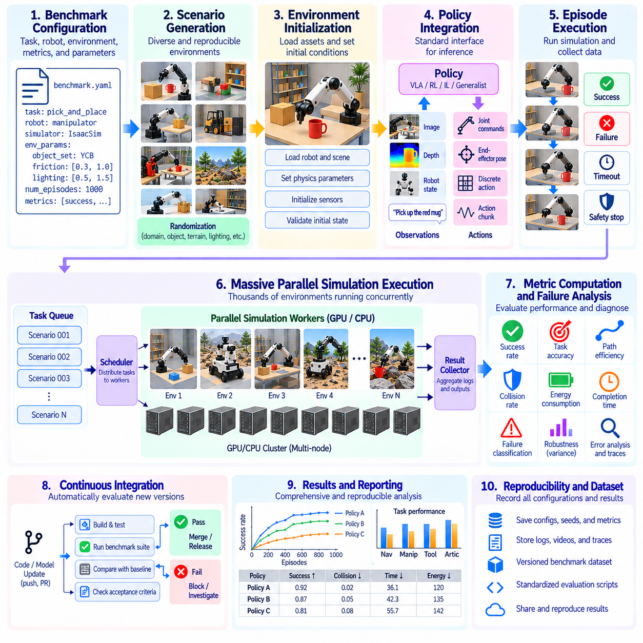
Simulation benchmark automation provides a systematic framework for evaluating Physical AI systems through repeatable, configurable, and continuously executable testing workflows. Manual evaluation becomes impractical as task diversity, simulation complexity, and policy versions increase. Automated pipelines coordinate scenario generation, environment initialization, policy execution, metric collection, and result analysis. Their primary objective is to produce reliable evidence of system performance with minimal human intervention.
Automation architecture begins with separating benchmark definitions from execution infrastructure. Task specifications describe objectives, initial conditions, robot configurations, environmental parameters, and success criteria. Execution services interpret these specifications and launch corresponding simulation instances. This separation enables the same benchmark to evaluate different policies and hardware configurations without modifying the underlying evaluation methodology.
Machine-readable benchmark configurations improve consistency and reproducibility. Structured files can define simulator versions, robot models, observation interfaces, action spaces, episode limits, and randomization parameters. Configuration validation should detect missing fields, incompatible settings, and unsupported combinations before execution. Version-controlled specifications allow experiments to be reconstructed and prevent undocumented changes from altering benchmark results.
Automated scenario generation creates diverse evaluation conditions from predefined parameter distributions. Initial robot poses, object arrangements, terrain properties, lighting, friction, and disturbances may be varied systematically. Scenario generators should preserve physical plausibility and task feasibility. Each generated instance requires a unique identifier and recorded parameters so that difficult or unsuccessful trials can be reproduced precisely.
Environment initialization must establish consistent starting conditions for every trial. Automated procedures load robot models, configure sensors, apply physical parameters, and position environmental objects. Initialization checks should verify valid geometry, collision states, actuator readiness, and sensor availability. Failed initialization must be classified separately from policy failure because infrastructure defects should not distort performance measurements.
Policy integration requires standardized interfaces between learning systems and simulation environments. Policies may consume images, depth maps, proprioceptive measurements, language instructions, or structured state observations. Their outputs may include joint commands, end-effector targets, or temporally extended actions. Interface adapters should enforce dimensional consistency, action limits, timing requirements, and clearly defined control frequencies.
Automated episode execution manages the complete lifecycle of each evaluation trial. A benchmark runner initializes the environment, obtains observations, requests policy actions, advances simulation, and checks termination conditions. Success, failure, timeout, and safety termination should be distinguished explicitly. Execution records must preserve the relationship between observations, actions, simulator states, and resulting physical events.
Metric computation should be implemented independently of policy logic whenever possible. Task completion, trajectory accuracy, collision frequency, energy consumption, execution time, and safety violations can be calculated from recorded simulation states. Metric definitions require consistent units, thresholds, and aggregation rules. Independent scoring reduces opportunities for policies to influence evaluation criteria or exploit implementation inconsistencies.
Automated failure classification improves the interpretability of benchmark results. A failed episode may involve perception error, planning failure, unstable control, collision, timeout, or simulator malfunction. Classification procedures can combine event logs, physical constraints, and task-specific conditions. Ambiguous outcomes should remain explicitly identified rather than being assigned unsupported causes. Detailed failure traces enable subsequent diagnosis and targeted improvement.
Parallel orchestration allows automated benchmarks to execute across multiple simulation environments and computing resources. A scheduler distributes scenarios to workers, tracks execution status, and collects completed results. Resource allocation should consider physics complexity, rendering requirements, and policy inference costs. Worker isolation and controlled retries prevent individual infrastructure failures from disrupting an entire evaluation campaign.
Continuous integration connects simulation benchmarking with software and model development workflows. Changes to policy checkpoints, perception modules, control algorithms, or simulator components can trigger predefined regression tests. Automated comparisons identify unexpected reductions in task success, robustness, or safety. Critical regressions should block promotion of a model until failures are investigated and acceptance criteria are satisfied.
Benchmark suites should distinguish rapid development tests from comprehensive release evaluations. Lightweight smoke tests verify interface compatibility and basic task execution, while regression suites examine previously established capabilities. Full benchmark campaigns provide broader coverage of environments, disturbances, and rare events. This layered approach balances feedback speed with statistical confidence and computational cost.
Statistical automation ensures that benchmark conclusions reflect repeated observations rather than isolated outcomes. Evaluation pipelines should calculate success rates, confidence intervals, variability, and relevant distributional statistics. Matched random seeds can support fair comparisons between policy versions. Automated reporting must disclose sample sizes and sampling assumptions, particularly when adaptive or targeted scenario selection changes the evaluation distribution.
Result storage requires structured records linking every outcome to its experimental context. Databases or artifact repositories should preserve benchmark identifiers, policy versions, simulator builds, scenario parameters, random seeds, and metric outputs. Detailed trajectories and sensor recordings may be retained selectively to control storage costs. Provenance tracking makes it possible to reconstruct results and investigate unexpected differences between evaluation runs.
Automated dashboards and reports transform raw simulation outputs into interpretable performance evidence. Visual summaries may compare policy versions, task categories, failure distributions, and robustness thresholds. Reports should distinguish aggregate performance from worst-case behavior and safety-critical failures. Clear reporting supports engineering decisions while preventing improvements in average scores from concealing regressions in important operating conditions.
Quality assurance must also examine the benchmark infrastructure itself. Automated checks should detect invalid resets, missing observations, numerical instability, inconsistent timestamps, and corrupted result files. Reference policies and known test cases can verify scoring implementations. Periodic validation against higher-fidelity simulations or physical experiments helps identify benchmark drift caused by software updates or modeling assumptions.
Security and isolation become important when evaluating externally supplied policies or executable models. Benchmark workers should restrict unauthorized file access, network communication, and modifications to scoring logic. Execution environments must prevent one policy from influencing another trial or accessing hidden reference states. These controls support trustworthy comparisons and reduce opportunities for accidental contamination or deliberate benchmark manipulation.
Reproducibility requires deterministic configuration management and explicit handling of stochastic behavior. Simulator versions, dependency packages, hardware characteristics, random number generators, and execution settings should be recorded. Exact replay may be limited by parallel scheduling or numerical differences across devices. Automated verification should therefore distinguish bitwise reproducibility from statistical consistency within documented tolerances.
Benchmark automation should support progressive evaluation from simulation to physical deployment. Policies that satisfy predefined simulation criteria may proceed to higher-fidelity testing, hardware-in-the-loop evaluation, and controlled real-world trials. Promotion gates should consider task performance, safety constraints, robustness, and unresolved failures. Automated workflows can organize this progression, but physical validation remains necessary before operational readiness is established.
Ultimately, simulation benchmark automation should transform Physical AI evaluation into a reproducible engineering process rather than a collection of isolated experiments. Effective systems integrate standardized specifications, automated execution, independent scoring, failure diagnosis, statistical analysis, and continuous regression monitoring. By connecting simulation evidence with development decisions and real-world validation, automated benchmarking supports reliable and measurable progress toward deployable Physical AI systems.

