Volume 11. Physical AI Evaluation and Benchmarking

Chapter 05. Safety and Robustness Evaluation

05.01. Safety vs Robustness Evaluation
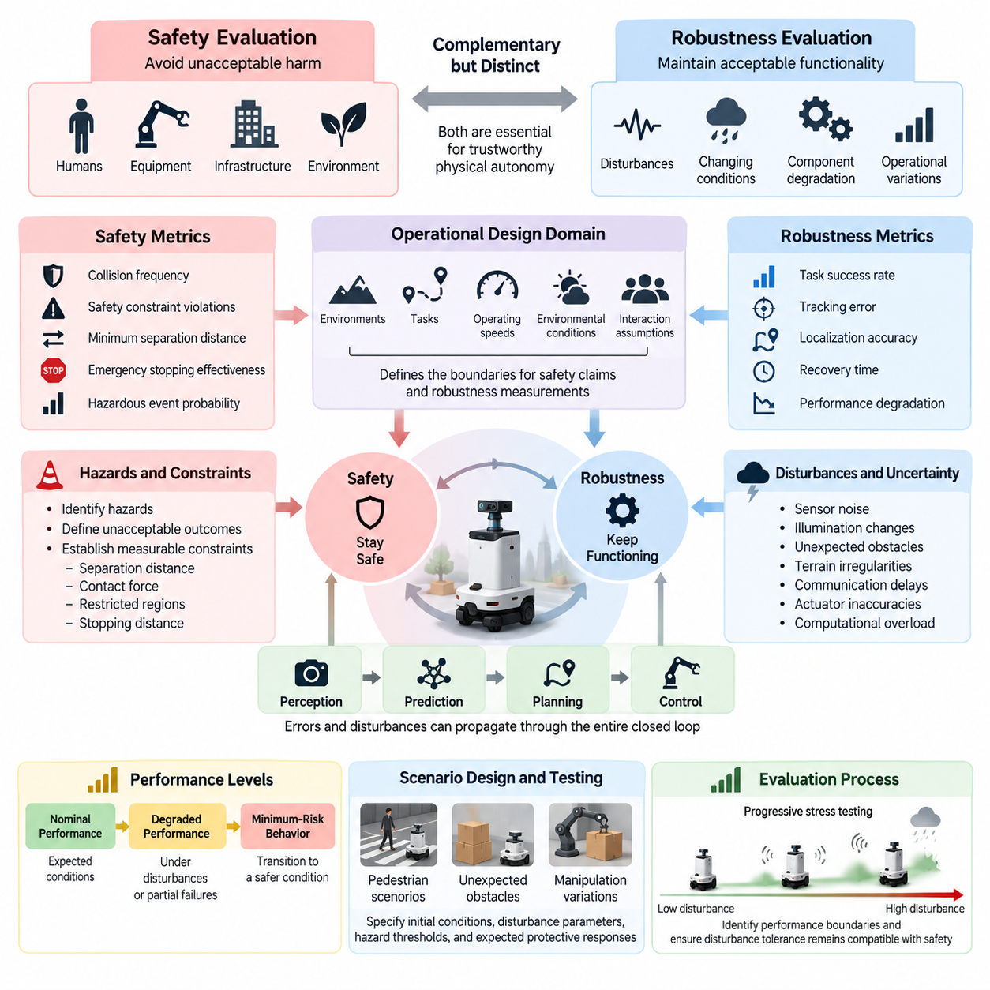
Safety and robustness evaluation are complementary but distinct dimensions of Physical AI assessment. Safety evaluation determines whether an autonomous system avoids unacceptable harm to humans, equipment, infrastructure, and the environment. Robustness evaluation measures whether the system maintains acceptable functionality when operating conditions change, disturbances occur, or components degrade. Both are essential for trustworthy physical autonomy.
The distinction becomes important because a robot can remain operational without being safe, or behave safely without completing its assigned task. A mobile robot that continues navigating despite inaccurate localization may demonstrate apparent robustness while creating collision hazards. Conversely, a robot that stops immediately after detecting uncertainty may preserve safety but exhibit limited operational robustness.
Safety evaluation begins with identifying hazards, defining unacceptable outcomes, and establishing measurable constraints. These constraints may include minimum human separation distances, maximum contact forces, restricted operating regions, and allowable stopping distances. Evaluation examines whether the system respects these boundaries during normal operation, foreseeable misuse, component failures, and abnormal environmental conditions.
Robustness evaluation focuses on performance degradation under uncertainty and disturbances. Relevant disturbances include sensor noise, illumination changes, unexpected obstacles, terrain irregularities, communication delays, actuator inaccuracies, and computational overload. A robust Physical AI system should tolerate specified variations while maintaining predictable behavior, acceptable task performance, and stable control responses.
The operational design domain provides a common foundation for both evaluations. It defines the environments, tasks, operating speeds, environmental conditions, and interaction assumptions under which a system is expected to function. Safety claims and robustness measurements must be interpreted within these boundaries. Performance demonstrated in a controlled warehouse cannot automatically establish equivalent reliability in crowded outdoor environments.
Safety metrics should represent exposure to hazards and the severity of possible consequences. Examples include collision frequency, safety constraint violations, minimum separation distance, emergency stopping effectiveness, and hazardous event probability. Near misses and unsafe trajectories are also important because successful task completion does not necessarily indicate safe execution throughout the entire operating sequence.
Robustness metrics characterize how system performance changes as disturbances become more severe. Task success rate, tracking error, localization accuracy, recovery time, and performance degradation provide complementary evidence. Evaluation should examine not only average performance but also variability, worst-case behavior within defined test conditions, and the disturbance levels at which functional capabilities begin to deteriorate.
A useful evaluation framework separates nominal performance, degraded performance, and minimum-risk behavior. Nominal performance describes operation under expected conditions, while degraded performance measures functionality under disturbances or partial failures. Minimum-risk behavior concerns the system's ability to transition toward a safer condition when continued task execution becomes unacceptable or cannot be supported by reliable information.
Safety and robustness interact through perception, prediction, planning, and control. Perception errors may cause incorrect obstacle detection, while prediction failures may lead to unsafe motion planning. Control disturbances can subsequently amplify these errors into physical hazards. Evaluation must therefore examine complete closed-loop behavior rather than relying exclusively on isolated component accuracy or offline model predictions.
Consider an autonomous mobile robot operating near pedestrians. Robustness testing may introduce noisy LiDAR measurements, partial camera occlusion, localization drift, or changing pedestrian trajectories. Safety testing examines whether the robot maintains appropriate separation, respects speed limits, and initiates protective stopping when necessary. The combined assessment determines whether disturbance tolerance remains compatible with human safety.
For robotic manipulators, robustness concerns variations in object geometry, payload mass, friction, and grasp uncertainty. Safety evaluation additionally considers unintended contact, excessive joint torque, dropped objects, and collisions with nearby workers. A manipulation policy may successfully recover from grasp errors yet still create unacceptable risk if recovery movements exceed permitted force or workspace constraints.
Safety-critical scenario design should prioritize situations in which disturbances can produce consequential failures. Examples include sudden pedestrian appearance, unexpected obstacle movement, emergency braking, unstable payloads, and loss of critical sensor information. Scenarios should specify initial conditions, disturbance parameters, hazard thresholds, and expected protective responses so that outcomes can be evaluated consistently.
Robustness stress testing progressively increases disturbance severity to reveal performance boundaries. Sensor noise, latency, external forces, and environmental uncertainty can be varied independently before introducing combined disturbances. Resulting degradation curves help identify whether failures occur gradually or abruptly. Abrupt transitions are particularly important because they may leave insufficient time for corrective action.
Failure injection provides a systematic method for examining system responses to component degradation. Controlled experiments may introduce camera dropout, delayed actuator commands, corrupted localization estimates, or temporary communication loss. Robustness assessment measures remaining functionality and recovery capability, while safety assessment determines whether the system detects hazardous conditions and executes appropriate protective actions.
Uncertainty estimation connects robustness assessment with safety decision-making. Physical AI models should recognize when observations differ substantially from training conditions or when predictions become unreliable. Evaluation can measure confidence calibration, out-of-distribution detection, and uncertainty-sensitive action selection. However, reliable uncertainty estimates contribute to safety only when appropriate control responses follow their detection.
Worst-case evaluation investigates combinations of conditions that challenge system assumptions. Adversarial observations, unusual obstacle configurations, and interacting component failures can reveal vulnerabilities overlooked by average-case benchmarks. Such tests should remain physically plausible and relevant to the intended operating domain. Their purpose is to expose credible failure mechanisms rather than generate arbitrary scenarios disconnected from deployment.
Runtime assurance mechanisms provide another evaluation dimension. Safety monitors, constraint checkers, independent protective controllers, and emergency stopping functions may intervene when learned policies approach unsafe states. Evaluation should measure detection coverage, intervention latency, false alarms, and successful hazard mitigation. A monitor that detects danger only after physical contact cannot provide adequate preventive protection.
Recovery behavior requires separate examination because returning to task execution is not always the safest response. Following a localization failure, a robot may need to stop, reacquire reliable positioning, request assistance, or enter a restricted operating mode. Robustness measures the ability to restore useful functionality, whereas safety evaluates whether the recovery sequence itself avoids introducing additional hazards.
Statistical rigor is essential because serious safety failures may be rare under ordinary testing. Repeated trials, controlled scenario sampling, confidence intervals, and exposure-normalized event rates improve interpretability. Rare-event simulation and targeted stress testing can provide additional evidence, but they cannot automatically establish real-world failure probabilities without justified assumptions about scenario frequency and representativeness.
Simulation supports broad exploration of disturbances and hazardous conditions without exposing people or equipment to unnecessary risks. Nevertheless, simulated safety and robustness results depend on the fidelity of physical dynamics, sensing, contact behavior, and environmental interactions. Laboratory experiments and controlled field trials are needed to investigate discrepancies and validate whether simulated failure responses transfer to actual hardware.
A comprehensive evaluation report should present safety and robustness results separately before analyzing their interactions. High task success under disturbances should not compensate for unacceptable safety violations through an unrestricted aggregate score. Safety constraints may instead function as mandatory acceptance criteria, while robustness metrics characterize operational capability within the region where those constraints are satisfied.
Ultimately, Physical AI evaluation must determine not only whether a system can continue operating under difficult conditions, but also whether continued operation remains justified. Robustness extends the range of conditions under which useful behavior is possible, while safety establishes boundaries that must not be crossed. Their integrated assessment supports defensible deployment decisions, transparent capability limitations, and continuous improvement of autonomous physical systems.

05.02. Hazard Based Testing
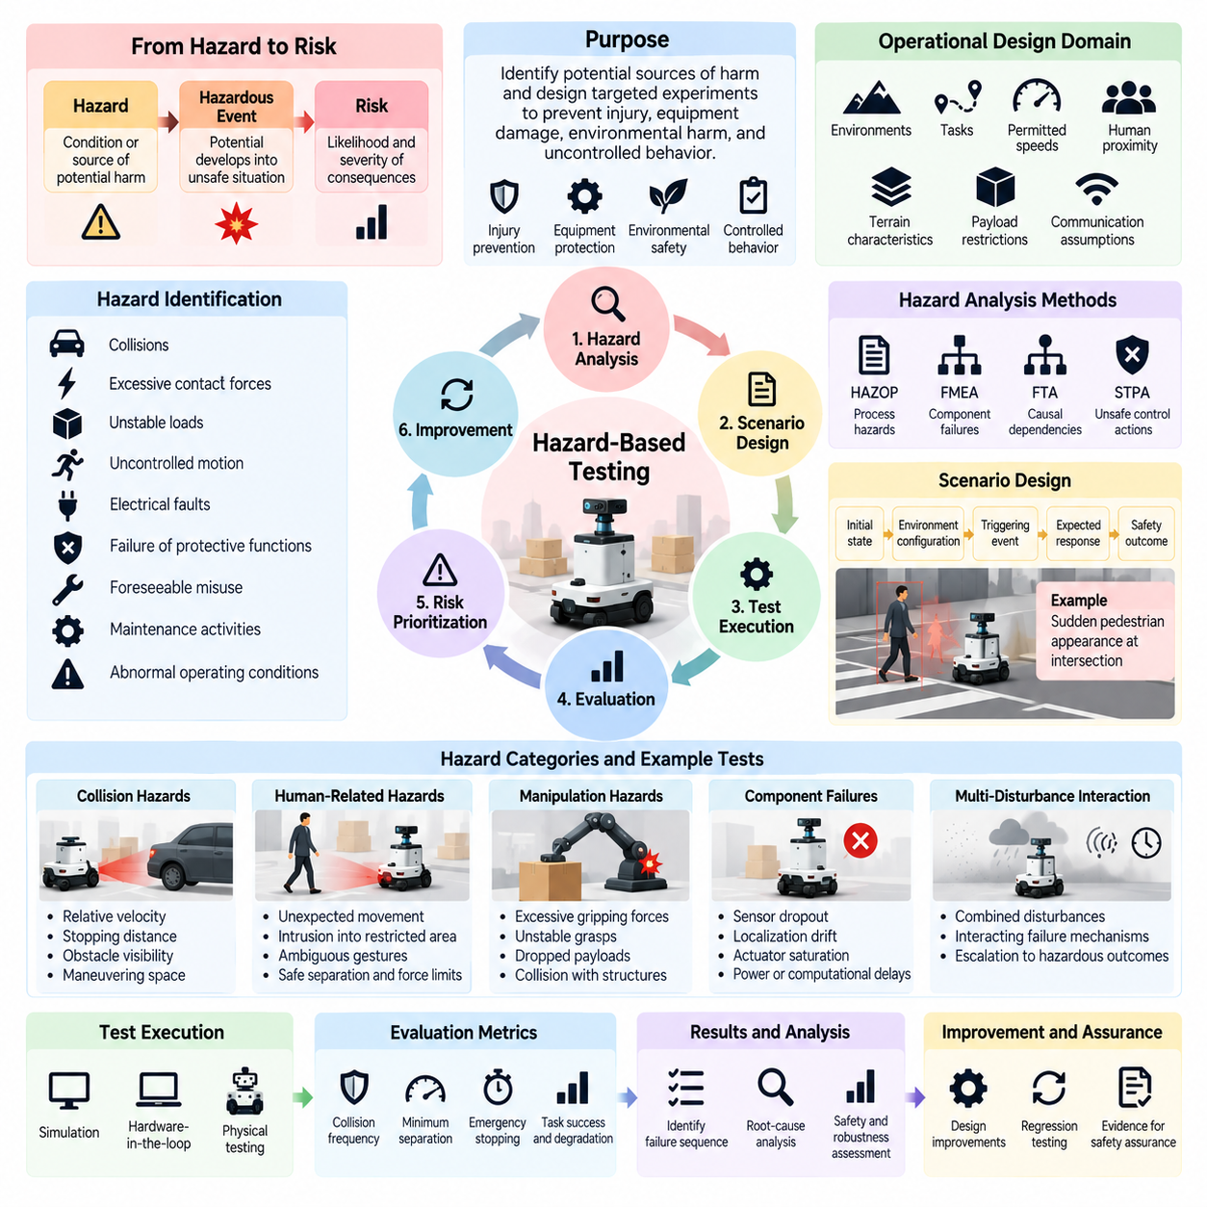
Hazard-based testing is a systematic approach to evaluating Physical AI systems by identifying potential sources of harm and designing experiments around the conditions that could produce hazardous outcomes. Unlike conventional performance testing, which emphasizes task completion and efficiency, hazard-based testing prioritizes the prevention of injury, equipment damage, environmental harm, and uncontrolled physical behavior during autonomous operation.
A hazard represents a condition or source of potential harm, while a hazardous event occurs when circumstances allow that potential to develop into an unsafe situation. Risk additionally considers the likelihood and severity of resulting consequences. These distinctions are essential because a robot may encounter hazardous conditions without causing an accident, yet repeated exposure to such conditions can reveal weaknesses in perception, planning, control, or protective mechanisms.
Hazard identification begins with understanding the robot's intended functions, operating environment, physical capabilities, and interactions with humans and other systems. Relevant hazards include collisions, excessive contact forces, unstable loads, uncontrolled motion, electrical faults, and failures of protective functions. The analysis should also consider foreseeable misuse, maintenance activities, and abnormal operating conditions rather than focusing exclusively on nominal tasks.
Structured hazard analysis methods provide a foundation for selecting meaningful tests. Hazard and Operability Study, Failure Mode and Effects Analysis, Fault Tree Analysis, and Systems-Theoretic Process Analysis can reveal different classes of failure mechanisms. These methods examine component faults, causal dependencies, unsafe control actions, and interactions among system elements, allowing test designers to identify scenarios that ordinary task benchmarks may overlook.
The operational design domain establishes the boundaries within which identified hazards must be evaluated. Environmental conditions, permitted speeds, human proximity, terrain characteristics, payload restrictions, and communication assumptions influence both hazard exposure and acceptable protective responses. Testing should distinguish hazards expected within the declared domain from conditions that require the system to restrict operation or transition into a minimum-risk state.
Hazard-based scenarios translate analytical findings into reproducible experiments. Each scenario should specify the initial system state, environmental configuration, triggering event, expected system response, and observable safety outcome. For example, a mobile robot approaching an intersection may encounter a suddenly appearing pedestrian, requiring timely detection, braking, and collision avoidance while maintaining defined separation constraints.
Scenario construction should examine the causal sequence connecting an initiating event to a hazardous outcome. A perception failure may produce an incorrect world representation, which influences trajectory planning and ultimately generates unsafe motion. By observing intermediate states and decisions, evaluators can distinguish the original fault from subsequent control failures and identify where protective mechanisms should interrupt the progression toward harm.
Risk prioritization helps allocate testing resources toward consequential hazards. Severity, exposure, controllability, and estimated occurrence likelihood may contribute to prioritization, depending on the applicable assessment framework. However, low observed frequency should not automatically justify excluding catastrophic hazards. Rare but severe events often require targeted scenarios because ordinary random testing may provide insufficient evidence about their associated failure mechanisms.
Collision hazards are particularly important for autonomous mobile robots, manipulators, humanoids, and aerial platforms. Evaluation should consider relative velocity, stopping distance, obstacle visibility, available maneuvering space, and contact geometry. A collision-free outcome alone is insufficient if the robot repeatedly approaches unsafe separation limits or relies on last-moment emergency responses that may fail under slightly different conditions.
Human-related hazards require special attention because human behavior is variable and difficult to predict. Tests may introduce unexpected pedestrian movement, worker intrusion into restricted zones, delayed human reactions, or ambiguous gestures. Evaluation examines whether the robot recognizes human presence, respects protective distances, limits physical interaction forces, and maintains safe behavior when human intentions cannot be inferred reliably.
Manipulation hazards arise from physical interaction with objects and surrounding structures. Excessive gripping forces, unstable grasps, dropped payloads, and unintended arm movements can damage equipment or injure nearby people. Hazard-based testing should evaluate force limitations, payload stability, collision monitoring, and controlled release behavior under changes in object mass, friction, geometry, and actuator performance.
Component failures provide another important source of hazardous conditions. Sensor dropout, localization drift, actuator saturation, power instability, and computational delays can undermine the assumptions used by autonomous controllers. Controlled failure injection allows evaluators to observe whether the system detects abnormal behavior, preserves essential safety functions, and prevents isolated faults from escalating into hazardous system-level outcomes.
Hazard-based testing must also investigate interactions between multiple disturbances. A partially obscured camera may be tolerable during slow movement, while the same condition combined with high speed and delayed braking can become dangerous. Such combinations reveal dependencies that isolated component tests may miss. Scenario selection should emphasize physically plausible interactions rather than arbitrary combinations of unrelated failures.
Safety constraints provide measurable acceptance criteria for hazardous scenarios. Examples include maximum allowable contact force, minimum separation distance, speed limits, stopping-time requirements, and prohibited workspace entry. Evaluation should record both violations and the margins separating observed behavior from established limits. Safety margins are important because a system operating consistently near a threshold may remain vulnerable to small uncertainties.
Protective response effectiveness is a central outcome of hazard-based evaluation. Safety monitors, emergency stops, collision avoidance controllers, and fallback policies should detect dangerous conditions and intervene before unacceptable consequences occur. Relevant measurements include hazard detection latency, intervention delay, stopping performance, false-negative detection, and successful transition into a defined minimum-risk condition.
Simulation enables systematic exploration of hazardous scenarios that would be expensive or unsafe to reproduce directly with physical hardware. Parameterized environments can vary obstacle motion, sensor degradation, surface friction, and actuator response while recording detailed internal states. Nevertheless, simulated results depend on model fidelity, so critical findings should be validated through appropriately controlled laboratory experiments and real-world testing.
Real-world hazard testing requires safeguards that prevent evaluation activities from creating unnecessary danger. Controlled test zones, physical barriers, emergency stopping provisions, surrogate obstacles, and trained personnel can support experiments involving potentially hazardous behavior. Test procedures should define termination conditions and escalation limits, ensuring that the search for system vulnerabilities does not compromise the safety of participants or surrounding equipment.
Statistical evaluation should distinguish observed safety performance from broader claims about operational risk. Repeated trials can estimate violation frequencies under specified scenarios, while confidence intervals communicate uncertainty. Rare-event methods and importance sampling may improve coverage of critical conditions, but results must account for sampling assumptions before being interpreted as estimates of real-world accident probability.
Traceability connects hazard identification, scenario design, experimental observations, and mitigation requirements. Each identified hazard should be associated with relevant initiating conditions, safety constraints, test cases, and recorded outcomes. This relationship allows engineers to determine which hazards have been evaluated, which protective mechanisms have demonstrated effectiveness, and where unresolved evidence gaps remain before deployment.
Hazard-based testing should continue throughout the Physical AI development lifecycle. Changes to perception models, learned policies, actuators, sensors, or operating environments may introduce new hazardous interactions even when nominal task performance improves. Regression testing and updated hazard analysis are therefore necessary after significant system modifications, particularly when foundation models or adaptive policies alter decision-making behavior.
Ultimately, hazard-based testing transforms abstract safety concerns into observable, measurable, and reproducible evaluation scenarios. Its purpose is not merely to demonstrate that accidents did not occur during testing, but to establish evidence that credible hazardous conditions are recognized, controlled, or mitigated. Integrated with robustness testing and runtime assurance, it provides a foundation for defensible safety claims and responsible Physical AI deployment.

05.03. Safety Critical Scenario Design
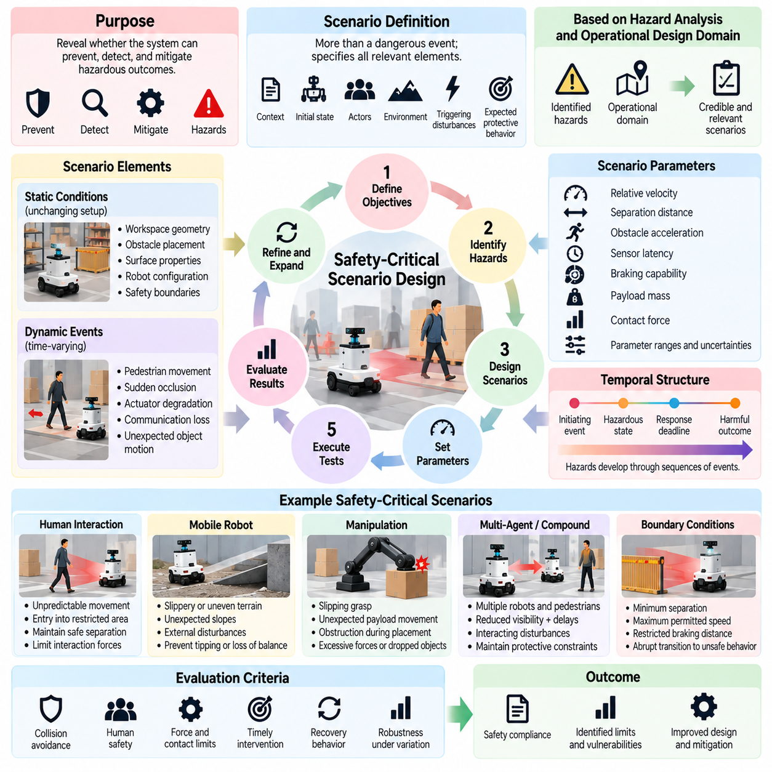
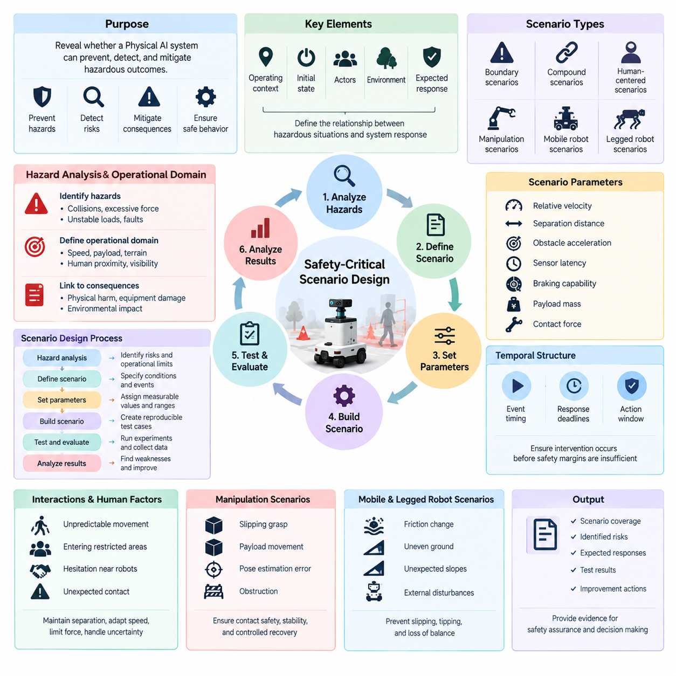
Safety-critical scenario design is the process of constructing test situations that reveal whether a Physical AI system can prevent, detect, and mitigate hazardous outcomes. Unlike ordinary task evaluation, which emphasizes successful execution under representative conditions, safety-critical testing concentrates on situations where perception errors, planning failures, environmental disturbances, or delayed control responses could produce unacceptable physical consequences.
A safety-critical scenario describes more than a dangerous event. It specifies the operating context, initial system state, relevant actors, environmental conditions, triggering disturbances, and expected protective behavior. These elements establish a reproducible relationship between a hazardous situation and the system's response. Well-defined scenarios enable evaluators to distinguish safe intervention from accidental avoidance or favorable environmental circumstances.
Scenario design begins with hazard analysis and the operational design domain. Identified hazards provide the potential consequences to investigate, while the operational domain defines where and how the robot is expected to operate. The resulting scenarios should reflect credible combinations of speed, payload, terrain, human proximity, visibility, and system limitations rather than arbitrary extreme conditions disconnected from intended deployment.
A useful scenario specification separates static conditions from dynamic events. Static conditions include workspace geometry, obstacle placement, surface properties, robot configuration, and safety boundaries. Dynamic events include pedestrian movement, sudden occlusion, actuator degradation, communication interruption, and unexpected object motion. This separation allows controlled variation while preserving the causal structure of the experiment.
Scenario parameters should represent measurable physical quantities whenever possible. Relative velocity, separation distance, obstacle acceleration, sensor latency, braking capability, payload mass, and contact force can define test conditions precisely. Parameter ranges should reflect operational assumptions and credible uncertainties. Explicit parameterization supports repeatability, systematic stress testing, and comparison across different Physical AI implementations.
Safety-critical scenarios frequently involve interactions between multiple agents. A mobile robot may encounter a pedestrian changing direction, another robot entering a shared corridor, or a worker unexpectedly crossing its planned route. Evaluation should examine whether the system recognizes conflicting intentions, predicts possible interactions, and maintains protective constraints without relying on unrealistic assumptions about human cooperation.
Temporal structure is essential because hazards develop through sequences of events rather than isolated observations. A delayed obstacle detection may be harmless at low speed but dangerous when combined with limited stopping distance. Scenario specifications should therefore describe event timing, response deadlines, and the interval available for protective action. Testing must capture whether interventions occur before safety margins become insufficient.
Scenario designers should distinguish initiating events, hazardous system states, and harmful outcomes. A camera failure is an initiating event, while continued high-speed movement without reliable obstacle detection may represent a hazardous state. Physical collision is a possible harmful outcome. Evaluating these stages separately helps identify whether detection, decision-making, or control mechanisms failed to interrupt the progression toward harm.
Boundary scenarios investigate conditions near the limits of safe operation. Examples include minimum allowable separation, maximum permitted velocity, restricted braking distance, and the threshold of reliable localization. Small parameter changes around these boundaries can reveal abrupt transitions from acceptable behavior to safety violations. Such tests are especially valuable for identifying fragile assumptions hidden by successful nominal operation.
Compound scenarios combine disturbances that may interact causally. Reduced visibility, slippery surfaces, delayed sensor updates, and unexpected pedestrian movement may individually remain manageable but collectively exceed the system's capabilities. Scenario construction should prioritize physically plausible combinations and document their dependencies. Arbitrary combinations may increase test difficulty without improving understanding of credible operational risks.
Human-centered scenarios require realistic representations of human behavior and vulnerability. Relevant situations include unpredictable walking trajectories, entry into restricted workspaces, hesitation near moving robots, and unexpected contact during collaborative manipulation. Evaluation should examine separation maintenance, speed adaptation, force limitation, and the ability to respond safely when human intentions remain uncertain.
Manipulation scenarios emphasize contact dynamics and object stability. A robot arm may experience a slipping grasp, unexpected payload movement, inaccurate object pose estimation, or obstruction during placement. These conditions can produce dropped objects, excessive forces, or unintended collisions. Test scenarios should specify contact constraints, payload characteristics, workspace boundaries, and acceptable recovery actions.
Mobile and legged robot scenarios introduce additional hazards associated with stability and terrain interaction. Sudden changes in friction, uneven ground, unexpected slopes, and external disturbances may cause slipping, tipping, or loss of balance. Safety-critical evaluation should consider whether the robot reduces speed, modifies its trajectory, stabilizes its posture, or transitions into a controlled protective state before instability becomes dangerous.
Failure injection expands scenario coverage by introducing controlled faults into sensors, actuators, communication systems, and computing resources. Examples include intermittent LiDAR dropout, corrupted localization estimates, delayed motor commands, and processor overload. The scenario should specify fault onset, duration, magnitude, and recovery conditions, allowing evaluators to determine whether safety functions remain effective despite degraded components.
Uncertainty-aware scenarios investigate situations where the system cannot confidently interpret its surroundings. Unfamiliar objects, ambiguous visual observations, incomplete maps, and unpredictable agent behavior can challenge learned perception and world models. Evaluation should examine whether uncertainty is detected and whether the robot appropriately slows down, requests assistance, replans, or enters a minimum-risk condition.
Expected system behavior must be defined independently of the policy being evaluated. Acceptance criteria may include collision avoidance, stopping before a protected boundary, maintaining force limits, or achieving a safe fallback state within a specified interval. This prevents evaluators from treating any successful task outcome as evidence of safety and supports consistent comparison between different algorithms and robotic platforms.
Scenario execution should record both final outcomes and intermediate system behavior. Relevant observations include sensor measurements, estimated states, predicted trajectories, planned actions, control commands, safety-monitor interventions, and physical responses. Time-synchronized records enable causal analysis of hazardous events and reveal whether apparent safety resulted from effective protection or favorable circumstances.
Simulation provides a scalable environment for exploring rare and dangerous situations. Parameter sweeps, randomized scenario generation, and targeted search can identify combinations that produce safety violations. However, scenario credibility depends on accurate representations of sensing, dynamics, contact, and agent behavior. Critical findings require validation through controlled physical experiments when safe and technically feasible.
Coverage analysis determines whether the scenario collection adequately represents identified hazards and operating conditions. Coverage should consider hazard categories, environmental parameters, failure modes, interaction patterns, and severity levels. Large numbers of similar tests do not necessarily provide broad safety evidence. Scenario diversity and traceability to hazard analysis are more informative than raw test volume.
Statistical evaluation must account for scenario selection and repeated execution. Violation rates, intervention latency, minimum safety margins, and recovery success can be reported with uncertainty estimates. Results from deliberately concentrated high-risk scenarios should not be interpreted directly as operational accident probabilities. The relationship between test distributions and real-world exposure must remain explicit.
Safety-critical scenario libraries should evolve as Physical AI systems change. Updated perception models, learned policies, robot morphology, hardware configurations, and deployment environments may introduce previously unrecognized hazardous interactions. Versioned scenarios and regression testing help preserve evaluation consistency while incorporating newly observed failures, near misses, and operational lessons.
Ultimately, safety-critical scenario design transforms hazard analysis into structured experimental evidence. Effective scenarios expose the conditions under which safety mechanisms succeed, degrade, or fail, while making the causal relationships between disturbances and outcomes observable. Combined with robustness evaluation, failure injection, and runtime assurance testing, this approach supports defensible safety boundaries and responsible deployment of Physical AI systems.

05.04. Collision and Separation Safety
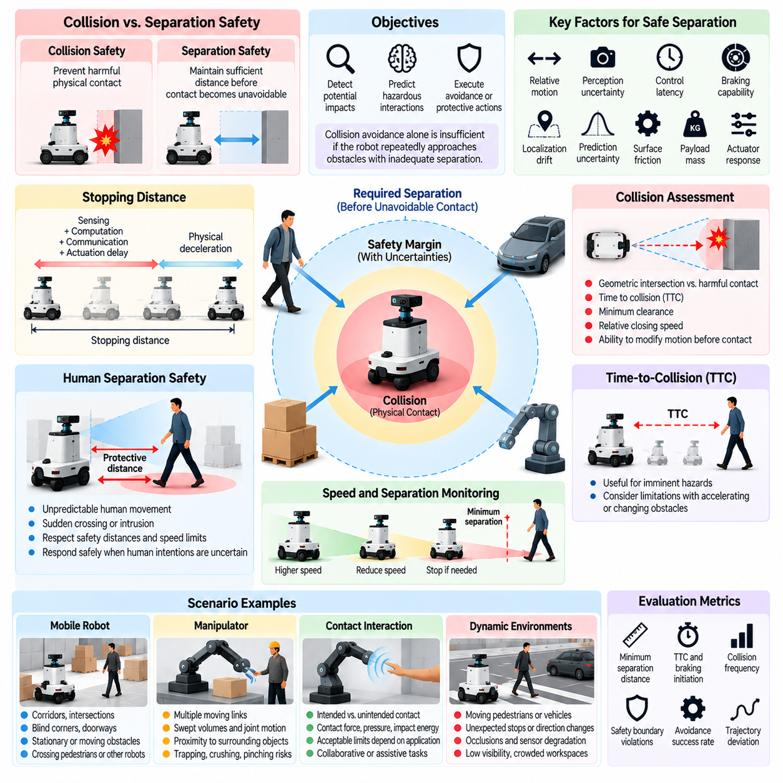
Collision and separation safety are fundamental dimensions of Physical AI evaluation because autonomous systems operate in environments containing humans, robots, equipment, and obstacles. Collision safety concerns preventing harmful physical contact, while separation safety focuses on maintaining sufficient distance before contact becomes unavoidable. Together, they establish measurable boundaries for safe motion and physical interaction.
Collision safety evaluation examines whether a robot can detect potential impacts, predict hazardous interactions, and execute appropriate avoidance or protective actions. Separation safety evaluates whether the system maintains required spatial margins under changing motion conditions. These objectives are closely related, but collision avoidance alone does not demonstrate adequate safety when a robot repeatedly approaches obstacles with insufficient stopping distance.
Safe separation depends on relative motion, perception uncertainty, control latency, and braking capability. A robot moving toward a stationary obstacle requires sufficient distance to recognize the hazard, process sensor information, generate a response, and decelerate. When both the robot and obstacle move, their relative velocities and possible future trajectories must be considered to determine whether the available separation remains adequate.
Stopping distance provides a practical foundation for separation safety assessment. It includes the distance traveled during sensing, computation, communication, and actuation delays, together with the distance required for physical deceleration. Evaluation should account for uncertainty in braking performance, surface friction, payload mass, and actuator response rather than assuming ideal stopping behavior under all operating conditions.
Safety margins extend beyond nominal stopping calculations by accounting for measurement errors and unpredictable environmental changes. Localization drift, obstacle position uncertainty, delayed sensor updates, and imperfect motion prediction can reduce the reliability of estimated separation. A robust safety evaluation examines whether protective boundaries remain effective when several uncertainty sources occur simultaneously.
Collision assessment should distinguish between geometric intersection and harmful physical contact. A predicted trajectory intersection indicates potential conflict, but actual collision risk depends on timing, relative velocity, object dimensions, and available avoidance actions. Evaluation should therefore examine predicted time to collision, minimum clearance, relative closing speed, and the ability to modify motion before contact becomes unavoidable.
Time-to-collision is a useful indicator for evaluating imminent hazards, particularly in mobile robotics and autonomous navigation. However, it depends on assumptions about future motion and may become unreliable when obstacles accelerate or change direction. Safety testing should investigate whether the robot recognizes these limitations and avoids relying exclusively on constant-velocity predictions in dynamic environments.
Human separation safety requires additional consideration because people can move unpredictably and may enter the robot's workspace without warning. Evaluation should examine pedestrian approach, sudden crossing, worker intrusion, and close-proximity collaboration. The robot must respond appropriately to human motion while respecting protective distances, speed restrictions, and applicable contact-force limitations.
Speed and separation monitoring provides a structured approach to human-robot interaction safety. Permitted robot speed can be adjusted according to the distance from a person, estimated human approach speed, stopping capability, and system response time. Evaluation should verify that the robot slows or stops before protective separation is violated, including situations involving sensor uncertainty and delayed control responses.
For autonomous mobile robots, collision and separation testing should include corridors, intersections, blind corners, doorways, and shared workspaces. Scenarios may involve stationary obstacles, crossing pedestrians, moving vehicles, or other robots following conflicting routes. Measurements should capture minimum separation, braking initiation, avoidance success, trajectory deviation, and violations of designated safety boundaries.
Manipulator safety introduces additional challenges because multiple moving links can create collision hazards even when the end effector follows a safe trajectory. Evaluation should consider the complete robot geometry, joint motion, swept volumes, and proximity to surrounding objects. Potential trapping, crushing, and pinching regions require particular attention because relatively small movements can produce hazardous contact.
Contact safety becomes important when physical interaction cannot be eliminated, as in collaborative manipulation or assistive robotics. In these situations, evaluation should distinguish intended contact from unintended collision and assess contact force, pressure, impact energy, and duration. Acceptable limits depend on the application, body region, contact geometry, and relevant safety requirements rather than a universal force threshold.
Collision safety also depends on the accuracy of perception and environmental representation. Cameras, LiDAR, depth sensors, and proximity detectors may experience occlusion, noise, reflective surfaces, or limited fields of view. Evaluation should examine whether sensor degradation causes missed obstacles, inaccurate distance estimates, or delayed protective responses, especially near the boundaries of the robot's sensing coverage.
Dynamic obstacle prediction introduces another source of uncertainty. Pedestrians may stop unexpectedly, vehicles may accelerate, and other robots may deviate from planned trajectories. Safety evaluation should test whether the system maintains conservative separation under multiple plausible future motions and whether uncertainty-aware planning prevents aggressive maneuvers based on unreliable predictions.
Multi-robot environments require collision avoidance mechanisms that account for distributed decision-making and communication delays. Two robots may independently select trajectories that appear safe but become conflicting when executed simultaneously. Evaluation should examine coordination failures, delayed state exchange, shared-space access, and emergency responses when communication is interrupted or predictions become inconsistent.
Safety-critical scenario design should progressively increase interaction complexity. Initial tests may involve static obstacles and predictable motion, followed by crossing trajectories, partial occlusion, sudden direction changes, and compound disturbances. Parameterized scenarios allow systematic variation of speed, separation, reaction time, and braking effectiveness, revealing the conditions under which safety margins begin to deteriorate.
Quantitative metrics should distinguish collision occurrence from proximity-related risk. Collision frequency, minimum separation distance, time-to-collision violations, protective stop success, and near-miss rates provide complementary evidence. Measurements should also include intervention latency and stopping margin because a collision-free result may conceal repeated situations in which the robot narrowly avoided harmful contact.
Simulation supports large-scale evaluation of collision and separation behavior under diverse environmental conditions. Parameter sweeps can vary obstacle trajectories, friction coefficients, sensing delays, and robot velocities while preserving reproducibility. Nevertheless, simulated contact dynamics and braking behavior may differ from physical hardware, requiring controlled laboratory validation before relying on results for deployment decisions.
Real-world testing should use controlled environments, protective barriers, surrogate obstacles, and independent emergency stopping provisions when hazardous interactions are possible. Test procedures must define safe operating limits and termination criteria. Human participants should not be exposed to uncontrolled collision experiments, particularly when the system's protective capabilities have not yet been demonstrated.
Runtime safety mechanisms can provide independent protection when autonomous planning becomes unreliable. Safety monitors, protective speed limits, collision prediction checks, and emergency stopping controllers may override nominal motion commands. Evaluation should measure their detection coverage, response latency, intervention reliability, and ability to maintain a minimum-risk condition after a hazardous situation is detected.
Statistical analysis should report collision and separation performance across repeated trials and clearly defined exposure conditions. Rare collisions may require targeted stress testing and confidence intervals to characterize uncertainty. A low observed collision count does not independently establish a low operational risk, particularly when test scenarios fail to represent challenging interactions or realistic environmental variability.
Ultimately, collision and separation safety evaluation determines whether Physical AI systems maintain adequate physical boundaries throughout autonomous operation. Effective assessment combines geometric clearance, motion prediction, braking performance, perception uncertainty, contact limitations, and protective intervention. These measurements support defensible safety claims and help establish operating conditions under which robots can interact responsibly with humans and their surroundings.

05.05. Human Robot Safety Evaluation
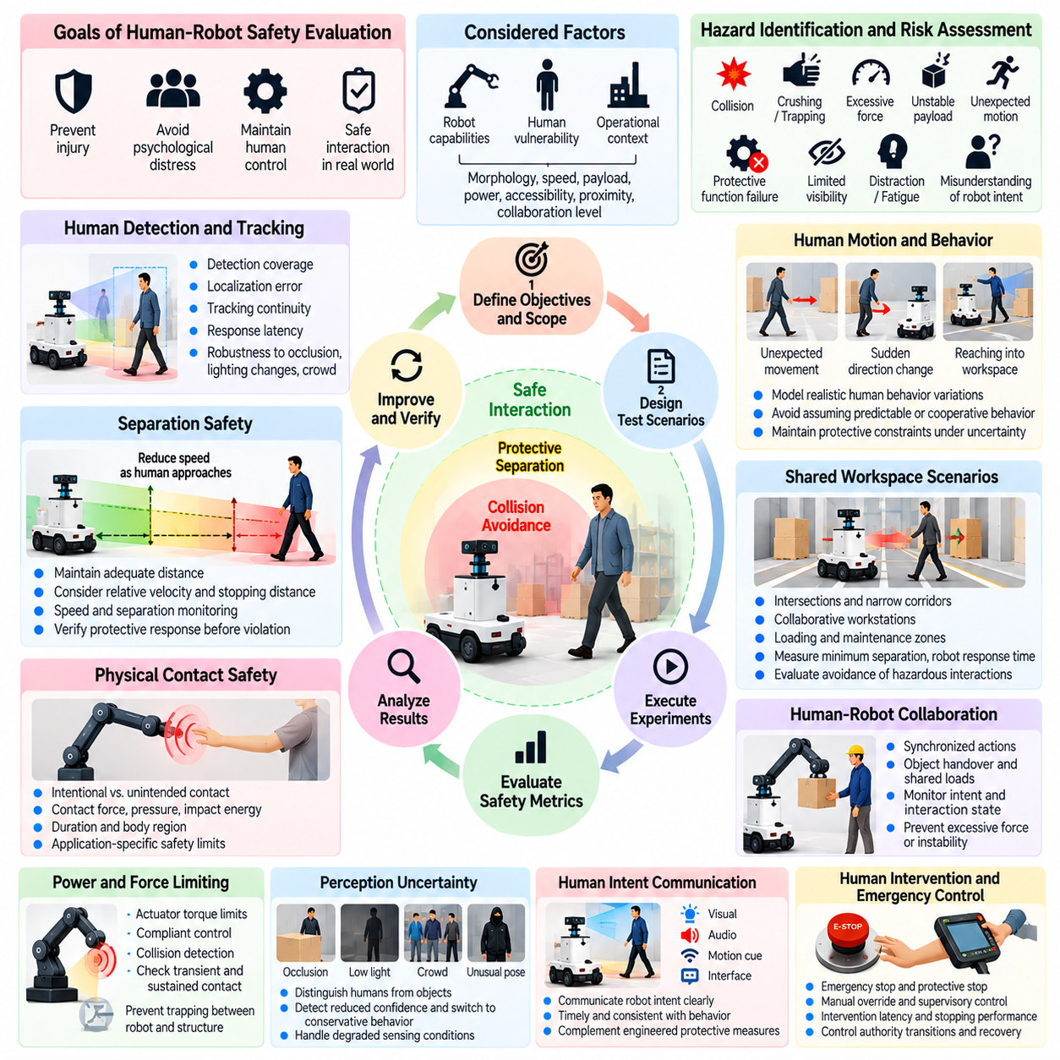
Human-robot safety evaluation examines whether Physical AI systems can interact with people without creating unacceptable risks of injury, psychological distress, or loss of human control. Unlike conventional robotic performance assessment, it considers both physical behavior and the conditions under which humans encounter autonomous machines. Evaluation must address predictable interactions, unexpected human actions, system failures, and changing environmental conditions.
Human-robot safety depends on the relationship between robot capabilities, human vulnerability, and the surrounding operational context. A robot operating behind protective barriers presents different hazards from a mobile manipulator sharing workspace with employees. Evaluation should therefore consider robot morphology, speed, payload, actuator power, accessibility, human proximity, and the degree of physical collaboration expected during normal operation.
A structured evaluation begins with hazard identification and risk assessment. Potential hazards include collisions, crushing, trapping, excessive contact forces, unstable payloads, unexpected movements, and failures of protective functions. Human factors such as limited visibility, distraction, fatigue, and misunderstanding of robot intentions may increase exposure. Test scenarios should connect these hazards to measurable safety requirements.
Human detection and tracking are essential components of interaction safety. Cameras, LiDAR, depth sensors, and proximity detectors may estimate human position, motion, and distance from hazardous robot components. Evaluation should measure detection coverage, localization error, tracking continuity, and response latency under occlusion, changing illumination, reflective surfaces, and crowded environments where reliable human recognition becomes difficult.
Separation safety evaluates whether a robot maintains adequate distance from people throughout its movements. Required separation depends on relative velocity, stopping capability, sensing uncertainty, and response delays. Speed and separation monitoring can reduce permissible robot velocity as humans approach hazardous regions. Evaluation should verify protective responses before separation boundaries are violated rather than relying solely on collision-free outcomes.
Physical contact safety becomes particularly important in collaborative robotics, assistive systems, and human-centered manipulation. Some applications require intentional contact, while others must prevent it. Evaluation should distinguish these situations and measure contact force, pressure, impact energy, duration, and affected body regions. Acceptable thresholds must be established through application-specific risk assessment and relevant safety requirements.
Power and force limiting provides a method for reducing injury risk when physical contact may occur. Evaluation should examine whether actuator torque limits, compliant control, mechanical design, and collision detection maintain contact conditions within established boundaries. Tests should consider both transient impacts and sustained contact, including situations where a person could become trapped between a moving robot and a fixed structure.
Human motion introduces uncertainty that cannot be fully represented by deterministic trajectories. People may stop unexpectedly, reverse direction, reach into workspaces, or move unpredictably around autonomous platforms. Safety evaluation should introduce realistic behavioral variations and determine whether the robot maintains protective constraints without assuming that humans consistently follow planned routes or respond immediately to warnings.
Shared workspace evaluation should include intersections, narrow corridors, collaborative workstations, loading areas, and maintenance zones. These environments create opportunities for unexpected encounters and conflicting movement intentions. Relevant measurements include minimum separation, protective stop frequency, human intrusion detection, robot response time, and successful avoidance of hazardous interactions during repeated operational trials.
Robot intent communication contributes to human safety by helping people anticipate autonomous behavior. Visual indicators, audible alerts, motion cues, and interface messages can communicate planned movement, operating state, or requests for assistance. Evaluation should determine whether these signals are understandable, timely, and consistent with actual robot behavior. Communication must complement rather than replace engineered protective measures.
Human intervention and emergency control require explicit evaluation. Emergency stop devices, protective stops, manual overrides, and supervisory controls should remain accessible and effective under relevant operating conditions. Testing should examine intervention latency, stopping performance, control authority transitions, and recovery procedures. The system must avoid unexpected motion when switching between autonomous and human-controlled operation.
Human-robot collaboration introduces hazards associated with coordinated physical tasks. A robot handing over an object, supporting a payload, or assisting assembly must synchronize actions with human movement and intention. Evaluation should consider premature release, unexpected force application, delayed response, and unstable shared loads. Safe collaboration requires reliable monitoring of both robot behavior and the evolving interaction state.
Perception uncertainty can become a direct safety concern when a robot cannot reliably distinguish humans from surrounding objects or predict their movements. Partial occlusion, unusual clothing, crowded scenes, and unfamiliar postures may degrade detection performance. Evaluation should examine whether the system recognizes reduced confidence and adopts conservative actions such as slowing, stopping, or requesting human assistance.
Learned policies and vision-language-action models introduce additional evaluation challenges because their responses may vary across semantically similar situations. Ambiguous instructions, conflicting goals, and unfamiliar human behavior can produce inappropriate physical actions. Safety testing should determine whether learned decision-making respects independent safety constraints and whether uncertainty or conflicting commands trigger appropriate protective responses.
Human trust and perceived safety provide complementary information but should not replace objective safety measurements. Sudden acceleration, unpredictable trajectories, and unclear robot intentions may cause discomfort even without physical contact. Controlled user studies can examine perceived predictability, workload, and confidence. Such findings should be interpreted alongside measured separation, force, intervention effectiveness, and actual hazardous events.
Vulnerable populations may require additional evaluation because physical capabilities, reaction times, and understanding of robot behavior differ among users. Children, older adults, and people with mobility limitations may face distinct interaction risks. Evaluation protocols should reflect the intended user population and avoid assuming a single representative human model. Protective requirements must remain appropriate for foreseeable users and operating contexts.
Failure injection helps determine whether human protection remains effective during component degradation. Sensor dropout, communication interruption, actuator faults, and delayed computation may compromise human detection or stopping performance. Controlled testing should establish whether independent protective mechanisms detect unsafe conditions and transition the robot into a minimum-risk state before hazardous contact occurs.
Simulation can support systematic exploration of human-robot encounters, including rare crossing patterns, occlusion events, and complex multi-agent interactions. Human behavior models allow controlled variation of walking speed, reaction time, and movement intention. However, simulated behavior cannot fully reproduce human unpredictability, so critical findings require validation through carefully controlled physical experiments.
Real-world human-robot safety testing must avoid exposing participants to uncontrolled hazards. Early experiments should use surrogate obstacles, instrumented test devices, protective barriers, and independent emergency stopping provisions. Human participation should occur only after appropriate protective capabilities have been demonstrated. Test protocols must define operational limits, supervision requirements, and immediate termination conditions.
Quantitative evaluation should combine collision frequency, near-miss rate, minimum separation, contact-force violations, intervention latency, and protective stop effectiveness. Repeated trials and confidence intervals help characterize uncertainty, while scenario coverage indicates which interaction conditions have been examined. A low accident count does not establish safety when exposure is limited or critical human behaviors remain untested.
Safety assurance should connect evaluation results to documented hazards, protective requirements, and operational restrictions. Changes to robot hardware, perception models, learned policies, or workspace configurations may invalidate previous assumptions. Regression testing and updated risk assessments are necessary to determine whether safety performance remains acceptable as systems evolve or deployment conditions expand.
Ultimately, human-robot safety evaluation must establish that autonomous physical systems recognize human presence, respect physical boundaries, respond appropriately to uncertainty, and preserve effective human intervention mechanisms. Reliable safety evidence requires integrating perception, motion control, contact mechanics, human factors, and protective system testing. This integrated approach supports responsible deployment in environments where humans and intelligent machines operate together.

05.06. Sensor Degradation and Failure Testing
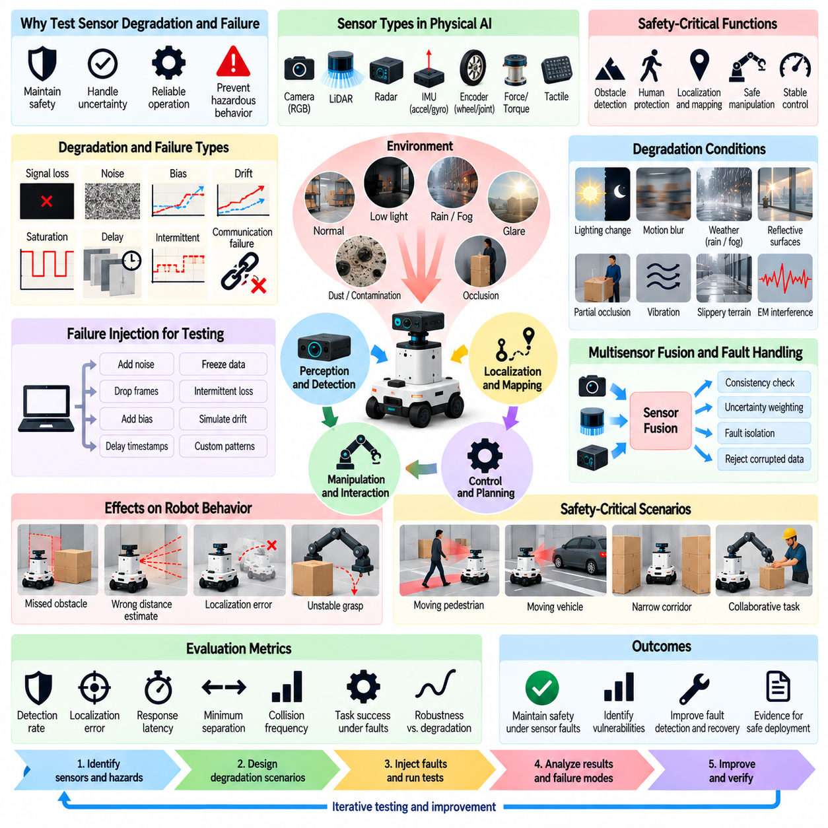
Sensor degradation and failure testing evaluates whether Physical AI systems remain safe when sensing capabilities become inaccurate, delayed, incomplete, or unavailable. Autonomous robots depend on sensors to estimate environmental conditions and internal states, making sensing reliability essential for physical safety. Evaluation must examine not only complete sensor failures but also gradual degradation that produces plausible yet misleading measurements.
Sensor failures can be classified according to their effects on measurement quality and availability. Common conditions include signal loss, excessive noise, bias, drift, saturation, delayed updates, and intermittent communication. Some failures are immediately observable, while others generate measurements that appear valid. Testing should distinguish detectable faults from subtle errors that can silently influence perception and control decisions.
A structured testing process begins by identifying safety-critical sensing functions and their dependencies. Cameras may support object recognition, LiDAR may estimate obstacle distance, inertial sensors may measure motion, and encoders may provide joint or wheel feedback. Evaluators should determine which safety functions depend on each sensor and identify the hazardous consequences of incorrect, missing, or outdated measurements.
Sensor degradation scenarios should reflect the physical mechanisms responsible for measurement errors. Cameras may experience glare, darkness, motion blur, or lens contamination. LiDAR performance may deteriorate under rain, fog, reflective surfaces, or partial obstruction. Inertial sensors may suffer bias drift and vibration effects, while wheel encoders may produce misleading motion estimates during slipping or mechanical faults.
Failure injection provides a controlled method for evaluating sensor-related vulnerabilities. Test systems can introduce synthetic noise, missing samples, timestamp errors, frozen measurements, or artificial biases into sensor streams. Fault parameters should specify onset, duration, magnitude, and temporal pattern. This enables reproducible experiments and supports systematic analysis of how different degradation levels affect robot behavior.
Gradual degradation deserves particular attention because its effects may remain hidden until safety margins become insufficient. Slowly increasing localization bias, declining image contrast, or progressive sensor contamination can undermine state estimation without triggering immediate fault alarms. Evaluation should determine whether monitoring mechanisms recognize these trends and initiate protective actions before hazardous conditions emerge.
Intermittent failures create challenges that differ from permanent sensor loss. A sensor may alternate between normal operation and corrupted measurements, causing unstable state estimates or repeated controller adjustments. Testing should vary fault frequency, burst duration, and recovery intervals. Evaluators should examine whether the system avoids oscillating between unsafe operating states and unnecessary protective interventions.
Timing failures can be as dangerous as incorrect measurements. Delayed sensor frames, inconsistent timestamps, synchronization errors, and irregular update rates may cause the robot to act on outdated environmental information. Evaluation should measure data age, processing latency, and temporal alignment across sensors. Safety mechanisms must account for uncertainty introduced by stale or temporally inconsistent observations.
Multisensor fusion can improve resilience, but it may also propagate errors when unreliable measurements receive excessive confidence. A faulty camera, LiDAR, or inertial sensor can distort the fused estimate of position, velocity, or obstacle location. Testing should examine consistency checks, uncertainty weighting, fault isolation, and the ability to reject corrupted observations without destabilizing the overall estimation process.
Redundant sensors do not automatically guarantee fault tolerance. Multiple devices may share power supplies, communication buses, mounting structures, or environmental vulnerabilities. Heavy rain may degrade several optical sensors simultaneously, while electrical interference may disrupt multiple sensing channels. Evaluation should include common-cause failures and determine whether the remaining sensing capability supports safe operation.
Perception model robustness must be evaluated separately from sensor hardware reliability. A sensor may operate correctly while producing observations that challenge a learned perception model. Unusual lighting, unfamiliar objects, occlusion, and distribution shifts can cause incorrect classifications or distance estimates. Testing should distinguish hardware faults, data-quality degradation, and model-level interpretation failures.
Sensor degradation can directly affect collision avoidance and human protection. Missed obstacles, underestimated closing speeds, or incorrect human localization may reduce protective separation margins. Safety-critical scenarios should combine sensing faults with moving obstacles, limited stopping distance, and unexpected human movement. Evaluation should determine whether the robot slows, stops, or changes behavior before unsafe proximity occurs.
Manipulation systems introduce additional sensing dependencies involving force, torque, tactile feedback, and joint position. A degraded force sensor may conceal excessive contact loads, while inaccurate joint feedback can distort end-effector positioning. Testing should examine grasp instability, unintended contact, payload release, and protective force limitation under sensor faults, including situations where several feedback channels disagree.
Fault detection and diagnosis mechanisms should be evaluated through measurable performance criteria. Detection latency, false-alarm rate, missed-fault rate, isolation accuracy, and minimum detectable fault magnitude provide complementary evidence. Evaluators should also measure how long unsafe estimates remain active after fault onset. A fault detector is insufficient if its response arrives too late to prevent hazardous physical behavior.
Recovery behavior is a critical component of sensor failure evaluation. Depending on the available sensing capability, a robot may continue at reduced speed, switch to redundant sensors, request human assistance, or enter a minimum-risk state. Tests should verify that these transitions preserve safety constraints and avoid unexpected motion. Recovery should occur only when restored measurements satisfy defined reliability conditions.
Simulation enables extensive exploration of sensor degradation through parameterized fault models. Noise distributions, dropout probabilities, latency profiles, and environmental disturbances can be varied across repeated scenarios. However, synthetic faults may not reproduce real sensor behavior, particularly correlated errors and hardware-specific artifacts. Physical measurements should therefore inform fault models whenever possible.
Hardware-in-the-loop testing bridges simulated faults and physical system responses. Real controllers can process modified sensor streams while robot dynamics or environmental interactions remain controlled. This approach helps reveal scheduling delays, interface failures, and unexpected software behavior. Test boundaries must prevent injected faults from creating uncontrolled physical hazards during experimental execution.
Real-world sensor testing should use controlled conditions and independent protective measures. Environmental chambers, lighting variation, artificial occlusion, vibration equipment, and calibrated reference instruments can expose sensing weaknesses. Ground-truth measurements are necessary to distinguish sensor error from actual environmental changes. Dangerous fault conditions should first be investigated without exposing humans or equipment to unnecessary risk.
Quantitative evaluation should connect sensor performance to downstream safety outcomes. Measurement error, detection coverage, estimation uncertainty, fault detection latency, collision risk, and protective intervention success should be analyzed together. A small average sensing error may conceal rare but severe failures. Tail distributions and worst-case operating conditions are therefore important complements to nominal accuracy metrics.
Scenario coverage should include individual faults, combined degradation, environmental stress, and failures occurring during critical actions. Testing should vary robot speed, payload, obstacle proximity, and operational phase to reveal interactions between sensing limitations and physical risk. Traceability from identified hazards to injected faults and observed responses helps determine whether the evaluation provides meaningful safety evidence.
Sensor failure evaluation must continue throughout the system lifecycle. Hardware replacement, calibration changes, software updates, and retrained perception models can alter fault sensitivity and recovery behavior. Versioned fault scenarios and regression tests help detect newly introduced vulnerabilities. Operational logs and near-miss reports should inform additional tests when previously unrecognized sensing weaknesses emerge.
Ultimately, sensor degradation and failure testing establishes whether Physical AI systems can recognize unreliable observations and maintain safe behavior despite incomplete environmental knowledge. Effective evaluation integrates physical fault modeling, controlled injection, multisensor consistency analysis, protective response measurement, and real-world validation. The objective is not uninterrupted task execution but dependable safety under degraded sensing conditions.

05.07. Localization and State Estimation Failures
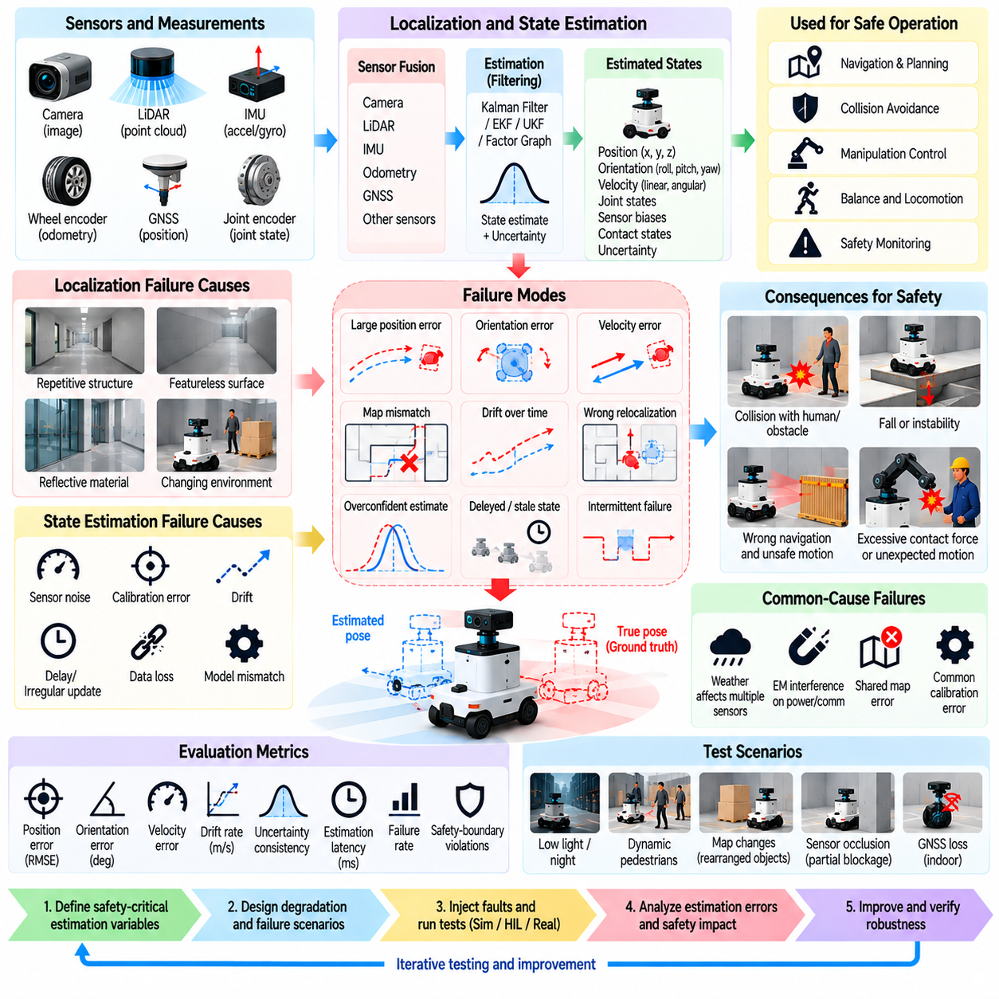
Localization and state estimation failures represent critical safety risks in Physical AI because autonomous robots depend on accurate knowledge of their position, orientation, velocity, and internal conditions. When these estimates become unreliable, navigation, manipulation, and protective control may operate on incorrect assumptions. Evaluation must determine whether estimation errors are detected before they produce hazardous physical behavior.
Localization estimates a robot's pose relative to a reference frame, while state estimation reconstructs additional variables such as velocity, acceleration, joint configuration, and sensor biases. These functions combine measurements with mathematical models and prior information. Failure testing should examine both incorrect numerical estimates and situations where the system expresses unjustified confidence in its estimated state.
Localization failures may arise from sensor noise, calibration errors, environmental ambiguity, map inconsistencies, and accumulated drift. Repetitive corridors, featureless surfaces, reflective materials, and changing surroundings can weaken position estimation. Evaluation should identify the conditions under which localization accuracy deteriorates and determine whether the resulting uncertainty affects safe motion decisions.
State estimation failures can propagate through multiple components of a robotic control system. An incorrect velocity estimate may distort stopping-distance calculations, while an erroneous orientation estimate can compromise balance or trajectory tracking. Testing should trace how estimation errors influence planning, collision avoidance, actuator commands, and runtime safety mechanisms rather than measuring estimator accuracy in isolation.
A systematic evaluation begins by defining the state variables required for safety-critical functions. Relevant quantities may include global position, local pose, heading, linear velocity, angular velocity, joint angles, and contact states. Each variable should have defined accuracy, latency, and confidence requirements. These requirements must reflect the consequences of estimation errors under realistic operating conditions.
Ground-truth measurements provide the reference needed to quantify localization and state estimation performance. Motion-capture systems, surveyed landmarks, precision tracking instruments, and calibrated encoders can support independent verification. Evaluation should account for reference-system uncertainty and coordinate-frame alignment. Without reliable ground truth, apparent estimator failures may be confused with measurement or synchronization errors.
Position and orientation errors should be evaluated using metrics appropriate to the robot's operating environment. Absolute trajectory error measures deviation from reference poses, while relative pose error captures local motion consistency. Drift rate, heading error, and maximum deviation provide additional information. Safety evaluation should emphasize error distributions and hazardous excursions rather than relying only on average accuracy.
Estimation uncertainty is as important as estimation accuracy. A robot may produce a biased pose estimate while reporting a narrow confidence interval, encouraging unsafe decisions. Consistency testing should compare predicted uncertainty with observed estimation errors. Calibration metrics and statistical consistency checks can reveal whether covariance estimates appropriately represent the actual reliability of the estimator.
Temporal failures occur when state estimates are delayed, irregularly updated, or associated with incorrect timestamps. Even geometrically accurate estimates can become unsafe when they describe outdated robot motion. Testing should vary sensing latency, computation delays, synchronization errors, and update frequency. Evaluation must determine whether control and safety functions account for state age and uncertainty accumulated during delays.
Sensor fusion failures deserve particular attention because localization often combines cameras, LiDAR, inertial measurements, wheel odometry, and satellite positioning. Incorrect sensor weighting or undetected measurement corruption can bias the fused estimate. Evaluation should test residual monitoring, innovation consistency, fault isolation, and estimator recovery when one or more measurement sources become unreliable.
Common-cause failures can defeat apparently redundant localization systems. Multiple estimators may share sensors, calibration parameters, maps, or assumptions about environmental geometry. A map error or severe wheel slip may therefore affect several estimation pipelines simultaneously. Testing should identify shared dependencies and examine whether independent evidence remains available to support safe decisions.
Localization loss and incorrect relocalization create distinct hazards. A robot may recognize that its position is unknown, or it may confidently associate observations with the wrong location. The latter can cause unexpected route selection and incorrect obstacle interpretation. Evaluation should examine localization-loss detection, false relocalization, recovery latency, and the safety of motion while location confidence remains insufficient.
Map-related failures should be evaluated under changing environmental conditions. Rearranged equipment, temporary barriers, construction activity, and altered landmarks can make previously valid maps inaccurate. Testing should determine whether the robot detects map inconsistency and avoids treating outdated spatial information as authoritative. Safe operation may require local obstacle sensing, map updates, or restricted movement.
Dynamic environments introduce additional estimation challenges because moving objects can be mistaken for stationary landmarks. Crowds, passing vehicles, and moving machinery may distort visual or LiDAR-based localization. Evaluation should examine whether dynamic-object filtering and robust data association prevent these observations from corrupting the robot's estimated pose, particularly near humans and hazardous equipment.
Mobile robots require localization accuracy appropriate to their speed, stopping capability, and available clearance. A small position error may be acceptable in an open area but hazardous in a narrow passage or near a protected boundary. Testing should combine localization disturbances with changing velocity, obstacle proximity, and limited braking distance to establish operationally meaningful safety thresholds.
Legged robots introduce state estimation challenges involving body orientation, contact detection, and terrain interaction. Foot slip, uncertain ground contact, and rapid body motion can distort estimated velocity and posture. Evaluation should determine whether these errors compromise balance, foothold selection, or recovery actions. Safety testing must consider transitions between stable locomotion, degraded control, and controlled protective behavior.
Manipulator systems depend on accurate joint states, end-effector pose, and contact estimates. Encoder errors, calibration drift, structural compliance, and uncertain payload motion can produce unintended contact or inaccurate placement. Evaluation should measure how state estimation errors affect workspace boundaries, collision avoidance, grasp stability, and force-limited interaction during safety-critical manipulation tasks.
Fault injection enables controlled examination of estimation-system vulnerabilities. Test conditions may include artificial pose offsets, increasing bias, delayed measurements, incorrect coordinate transforms, missing observations, and abrupt estimator resets. Fault magnitude, onset, duration, and recovery conditions should be parameterized. Repeated experiments can reveal thresholds where estimation degradation begins to violate safety requirements.
Protective behavior should be evaluated when estimation confidence deteriorates. Depending on the robot's capabilities, appropriate responses may include reducing speed, increasing clearance, switching estimation modes, stopping, or requesting assistance. Testing should verify that fallback decisions are triggered early enough and that transitions do not introduce additional hazards through abrupt or inconsistent control commands.
Simulation provides a scalable environment for evaluating rare localization failures and combinations of disturbances. Parameterized tests can vary sensor noise, map mismatch, drift, and timing errors while preserving reproducibility. However, synthetic faults may omit hardware-specific correlations and environmental effects. Hardware-in-the-loop experiments and controlled physical trials are needed to validate critical findings.
Quantitative assessment should connect estimation quality with downstream safety outcomes. Relevant metrics include pose error, drift rate, uncertainty consistency, localization-loss frequency, fault detection latency, recovery success, and safety-boundary violations. Reporting conditional performance across operating scenarios is essential because average accuracy may conceal rare errors that create disproportionate physical risk.
Ultimately, localization and state estimation failure evaluation determines whether Physical AI systems can recognize unreliable internal representations and preserve safe operation despite imperfect knowledge of their own motion and surroundings. Effective testing integrates reference measurements, uncertainty validation, fault injection, environmental stress, and protective response assessment to establish defensible limits for autonomous operation.

05.08. Actuator Control and Compute Failures
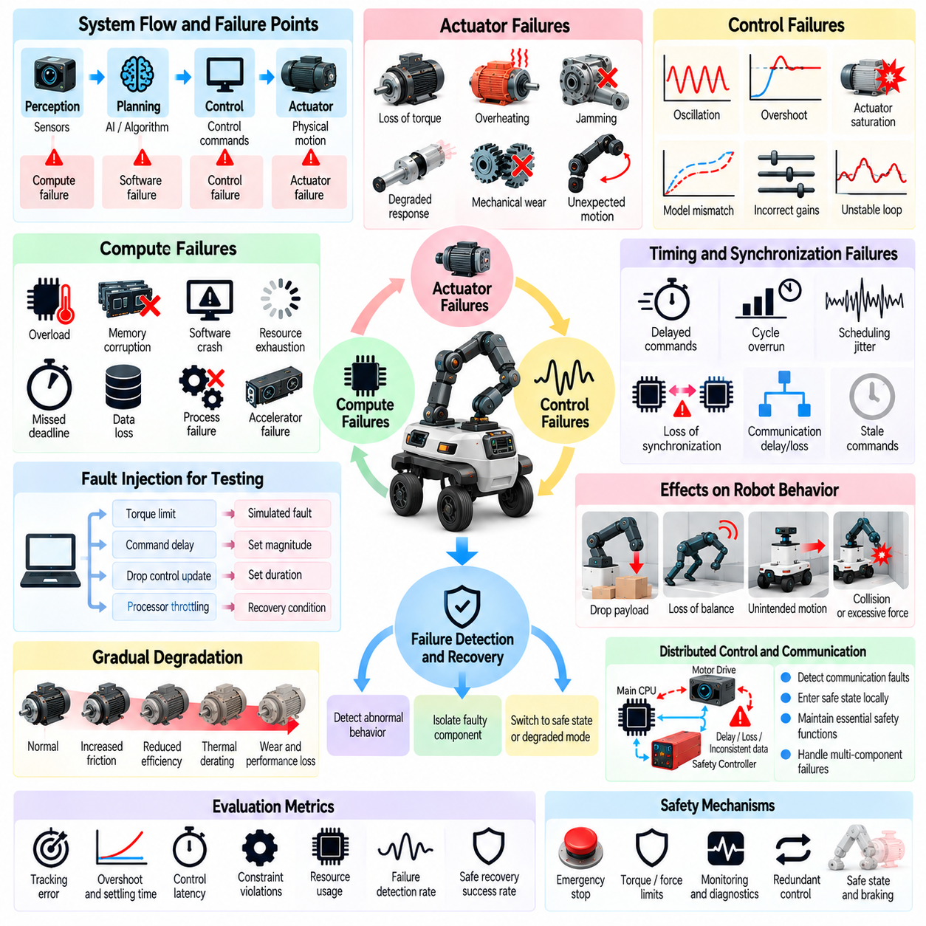
Actuator, control, and compute failures represent critical safety concerns in Physical AI because autonomous robots transform digital decisions into physical motion. Even when perception and planning operate correctly, failures in motors, controllers, processors, or execution pipelines can produce hazardous behavior. Evaluation must determine whether these failures are detected, contained, and managed before they compromise physical safety.
Actuator failures include loss of torque, unexpected motion, mechanical jamming, overheating, and degraded response characteristics. Electric motors, hydraulic systems, pneumatic devices, and transmission mechanisms exhibit different failure behaviors. Testing should identify how each failure affects movement, load support, stopping capability, and the robot's ability to maintain a safe configuration under operational stress.
Control failures arise when commanded actions no longer produce the intended physical response. Incorrect feedback gains, unstable control loops, actuator saturation, and model mismatch may generate oscillation, overshoot, or excessive force. Evaluation should examine whether the controller maintains stability and respects safety constraints when disturbances, parameter uncertainty, or unexpected physical interactions occur.
Compute failures affect the processing infrastructure responsible for perception, planning, estimation, and control. Processor overload, memory corruption, software crashes, and resource exhaustion can interrupt safety-critical execution. Testing should distinguish temporary performance degradation from complete computational failure and determine whether essential protective functions remain operational when noncritical workloads consume excessive resources.
Timing failures are especially important because physical control depends on predictable execution intervals. Missed deadlines, scheduling jitter, delayed commands, and asynchronous processing can destabilize feedback loops. Evaluation should measure worst-case execution time, control-cycle overruns, and command age. Safety mechanisms must prevent stale or delayed commands from producing unintended movement.
Fault injection provides a systematic method for evaluating actuator, control, and compute vulnerabilities. Experiments may introduce artificial torque limits, command delays, dropped control updates, processor throttling, or simulated component faults. Each fault should be parameterized by onset, duration, magnitude, and recovery conditions. Reproducible injection enables comparison of protective responses across different operating scenarios.
Actuator degradation often develops gradually rather than appearing as an immediate failure. Increasing friction, reduced motor efficiency, thermal derating, and mechanical wear can progressively alter response characteristics. Evaluation should determine whether monitoring systems detect these trends and adjust operating limits before control authority becomes insufficient to maintain stability or prevent hazardous contact.
Unexpected actuator motion requires particular attention because it can create immediate collision or crushing hazards. Faults in drive electronics, command interpretation, or feedback signals may cause unintended acceleration or movement in the wrong direction. Testing should verify that independent protective mechanisms can inhibit hazardous motion and that stopping functions remain effective when the nominal motion controller becomes unreliable.
Loss of actuation can be equally dangerous when a robot depends on continuous torque to support loads or maintain posture. A manipulator may drop a payload, while a legged robot may lose balance after joint torque disappears. Evaluation should consider gravity, stored mechanical energy, brake engagement, and passive stability. Safe behavior may require controlled load release, mechanical restraint, or a predefined protective posture.
Control-loop stability should be examined across realistic operating conditions rather than only under nominal parameters. Payload changes, varying friction, structural compliance, and external disturbances can alter system dynamics. Evaluation should measure tracking error, overshoot, settling time, oscillation amplitude, and constraint violations while identifying whether unstable behavior approaches hazardous physical limits.
Distributed control architectures introduce additional failure modes involving communication between processors, motor drives, and safety controllers. Delayed messages, inconsistent state updates, and lost synchronization can cause components to execute incompatible commands. Testing should determine whether communication faults are detected and whether local controllers enter safe states when coordinated control can no longer be guaranteed.
Real-time scheduling failures can arise when computational workloads compete for limited processing resources. High-resolution perception, neural network inference, mapping, and planning may interfere with time-sensitive control tasks. Evaluation should examine processor utilization, task priorities, memory pressure, and scheduling latency. Safety-critical functions should remain within validated timing bounds under representative peak workloads.
AI inference failures introduce challenges because learned policies may generate commands with variable latency or unexpected numerical outputs. Model execution can be disrupted by accelerator contention, memory exhaustion, or software exceptions. Evaluation should verify output validity, command freshness, and execution deadlines. Invalid, missing, or excessively delayed policy outputs must not be translated directly into unsafe actuator commands.
Numerical and software faults can propagate through control calculations without causing an obvious system crash. Overflow, invalid floating-point values, incorrect coordinate transformations, and corrupted parameters may produce extreme control outputs. Testing should examine input validation, numerical bounds, command plausibility, and independent safety checks that prevent invalid computations from reaching physical actuators.
Watchdog mechanisms and runtime monitors can detect stalled execution, missed control deadlines, and abnormal command patterns. However, their effectiveness depends on detection coverage, independence, and response speed. Evaluation should measure fault detection latency, missed-fault rates, false alarms, and protective intervention success. A watchdog that resets software without securing physical motion may not provide adequate safety.
Fallback control strategies should be evaluated according to the remaining actuator and computational capabilities. Depending on the platform, appropriate responses may include reduced-speed operation, controlled braking, torque limitation, load stabilization, or transition to a minimum-risk state. Testing must verify that fallback behavior is dynamically feasible and does not introduce additional hazards during mode transitions.
Emergency stopping requires careful evaluation because removing actuator power does not always produce the safest physical outcome. Uncontrolled coasting, gravity-driven motion, or sudden loss of support may increase risk. Tests should distinguish controlled stopping, power removal, mechanical braking, and safe torque inhibition. The selected response must reflect robot morphology, stored energy, and application-specific hazards.
Compound failures may expose weaknesses that remain hidden during isolated fault testing. Processor overload combined with actuator degradation can delay protective braking, while communication loss and stale state estimates may destabilize distributed control. Scenario design should prioritize credible causal combinations and examine whether safety mechanisms remain effective when multiple protective assumptions fail simultaneously.
Simulation and hardware-in-the-loop testing support controlled exploration of dangerous failures without immediately exposing physical equipment to unacceptable risks. Dynamic models can represent actuator faults, controller instability, and computational delays. However, simulated responses may omit thermal behavior, mechanical backlash, or hardware-specific timing effects. Critical results require carefully controlled physical validation.
Quantitative evaluation should connect component-level faults to system-level safety outcomes. Relevant metrics include control deadline violations, actuator response error, stopping distance, fault detection latency, recovery success, and safety-boundary violations. Repeated trials should examine worst-case conditions and uncertainty. A system may maintain average task performance while exhibiting rare failures with severe physical consequences.
Regression testing is essential because software updates, controller tuning, hardware replacement, and new AI models can alter failure behavior. Versioned fault scenarios should verify that previously established protective responses remain effective. Operational logs, diagnostic records, and near-miss reports can reveal additional vulnerabilities. Evaluation evidence must remain traceable to specific hardware, software, and operating configurations.
Ultimately, actuator, control, and compute failure evaluation determines whether Physical AI systems preserve physical safety when the mechanisms responsible for executing intelligent decisions become unreliable. Effective assessment integrates fault injection, dynamic stability analysis, real-time performance testing, independent protection, and recovery validation. The objective is dependable containment of hazardous motion rather than uninterrupted autonomous operation.

05.09. Communication and Connectivity Failures
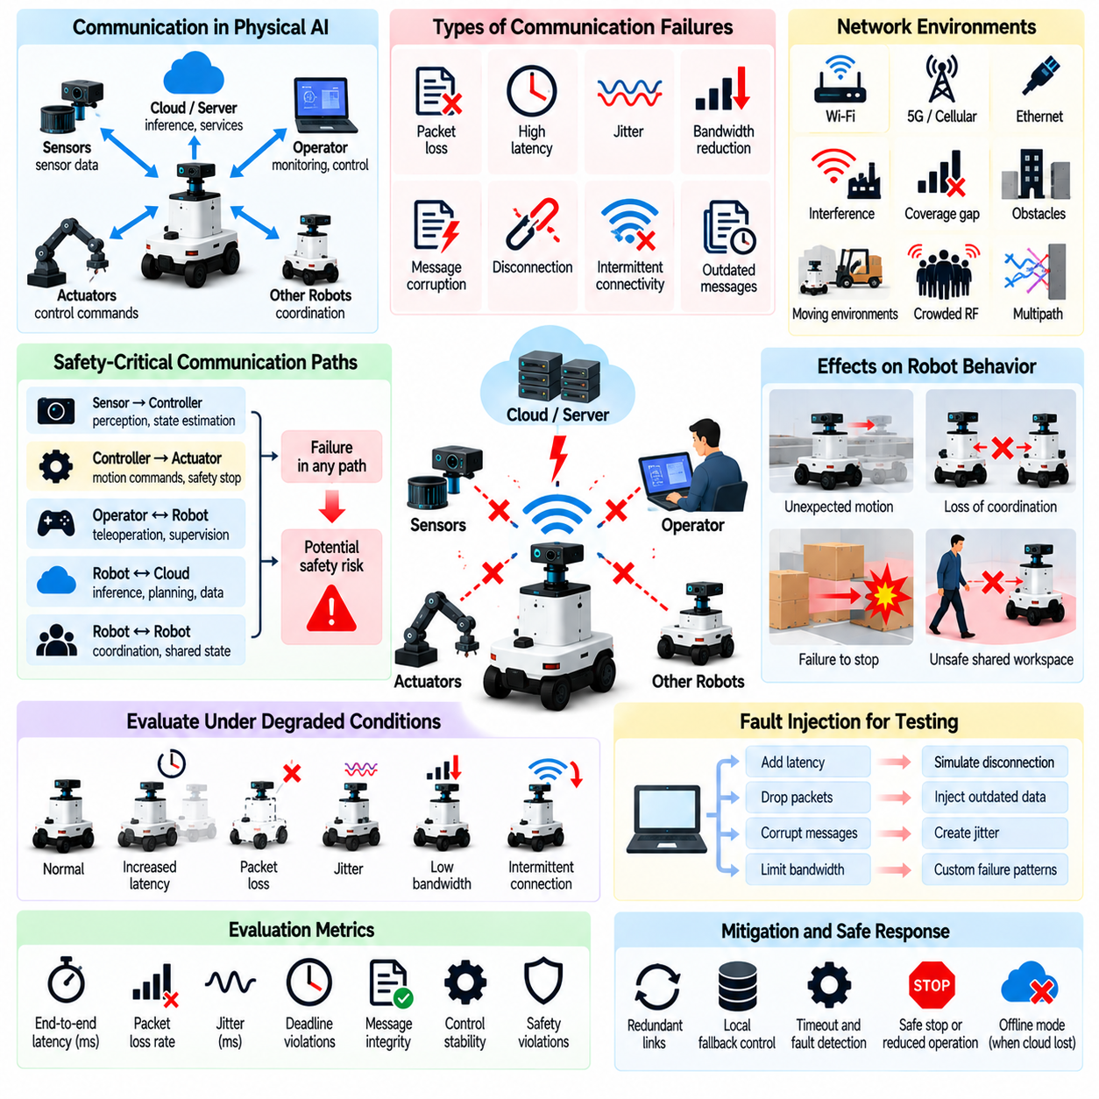
Communication and connectivity failures represent significant safety risks in Physical AI because autonomous robots depend on reliable information exchange between sensors, controllers, computing platforms, operators, and external services. Network disruptions can interrupt coordination or delay safety-critical decisions. Evaluation must determine whether communication degradation leads to hazardous motion, loss of control, or unsafe dependence on unavailable information.
Communication failures include packet loss, excessive latency, jitter, bandwidth reduction, message corruption, disconnection, and intermittent connectivity. Each condition affects robotic systems differently depending on network architecture and task requirements. Testing should distinguish complete communication loss from partial degradation that allows messages to arrive but makes their timing, integrity, or relevance unsuitable for safe operation.
A systematic evaluation begins by identifying communication paths that support safety-critical functions. These may include sensor-to-controller links, distributed motor control networks, operator interfaces, robot-to-robot communication, and edge-to-cloud connections. Evaluators should document message dependencies, update requirements, and failure consequences to determine which communication interruptions can directly affect physical safety.
Network latency can compromise closed-loop control when measurements or commands arrive after their intended execution intervals. Delayed feedback may cause unstable corrections, inaccurate trajectory tracking, or excessive stopping distances. Evaluation should measure end-to-end latency, worst-case delays, and deadline violations. Safety mechanisms must prevent outdated messages from being treated as valid control information.
Jitter introduces unpredictable variation in communication timing, even when average latency remains acceptable. Irregular sensor updates and control commands can disturb synchronization between distributed components. Testing should vary delay distributions, burst patterns, and scheduling interference. Evaluation must establish whether control stability and protective functions remain effective under realistic temporal variability.
Packet loss may interrupt feedback, command delivery, or shared state updates. Isolated losses can sometimes be tolerated, while consecutive missing messages may invalidate state estimates or coordination assumptions. Testing should examine random loss, burst loss, and prolonged dropout conditions. Evaluators should determine when missing information requires reduced operation, local fallback control, or protective stopping.
Intermittent connectivity creates repeated transitions between connected and disconnected states. Robots may receive delayed commands after reconnecting or resume tasks using outdated shared information. Evaluation should examine reconnection timing, session recovery, message ordering, and state synchronization. Systems must avoid executing obsolete commands or abruptly returning to unsafe operating conditions after communication is restored.
Message integrity failures occur when transmitted information is corrupted, truncated, duplicated, or incorrectly interpreted. Faulty commands and inconsistent status messages can produce unintended physical actions without complete network failure. Testing should verify error detection, sequence validation, message authentication where appropriate, and plausibility checks. Invalid communication data must not directly control hazardous actuator behavior.
Communication architecture strongly influences fault propagation. Centralized systems may lose critical capabilities when a single network connection fails, while distributed architectures may continue operating with inconsistent local states. Evaluation should identify single points of failure, shared communication dependencies, and common-cause disruptions. Redundant links should be tested for independence rather than assumed to guarantee availability.
Wireless communication introduces environmental vulnerabilities involving interference, attenuation, multipath propagation, and coverage gaps. Metal structures, moving machinery, crowded radio environments, and changing robot orientation can reduce link quality. Testing should reproduce representative operating conditions and measure how signal degradation affects control, coordination, and protective responses before connectivity becomes completely unavailable.
Remote operation and teleoperation depend on communication quality for timely human intervention. Video delays, command latency, and feedback loss may prevent operators from recognizing hazards or controlling motion accurately. Evaluation should examine round-trip delay, visual feedback freshness, command acknowledgment, and emergency intervention capability. Remote supervision must not be treated as an adequate safeguard when connectivity cannot support timely action.
Cloud-dependent Physical AI systems introduce additional risks because remote inference, planning, or fleet services may become unavailable. Network outages can interrupt task execution or delay high-level decisions. Testing should distinguish functions that require continuous connectivity from those supported locally. Essential safety mechanisms should remain effective without relying on uninterrupted cloud access.
Multi-robot systems face coordination failures when communication becomes unreliable. Delayed position updates, inconsistent task assignments, and missing intent messages can cause conflicting movements or resource contention. Evaluation should examine collision avoidance, shared-space access, and decentralized decision-making during partial network partitions. Robots must maintain safe separation even when collective coordination information becomes incomplete.
Network partitioning can create groups of robots or controllers that continue operating without consistent shared knowledge. Each partition may independently assume authority over tasks, routes, or resources. Testing should investigate conflicting leadership, duplicated commands, and inconsistent mission states. Recovery procedures must reconcile distributed information before coordinated operations resume, particularly when physical actions cannot be reversed.
Time synchronization failures can undermine communication-dependent sensing and control. Clock drift, timestamp inconsistency, and synchronization service interruptions may cause incorrect ordering of observations and commands. Evaluation should measure clock offsets, data age, and temporal alignment across distributed devices. Safety-critical functions must account for uncertainty when a common time reference cannot be maintained.
Communication fault injection enables controlled exploration of network vulnerabilities. Test environments can introduce packet loss, variable latency, bandwidth constraints, reordered messages, corrupted payloads, and simulated disconnections. Fault parameters should specify onset, duration, severity, and recovery patterns. Reproducible scenarios help identify thresholds at which communication degradation begins to compromise safety requirements.
Protective responses should depend on the role of the failed communication channel. A robot may continue autonomous operation after losing a nonessential monitoring connection but require immediate restriction when critical control feedback disappears. Testing should verify safe degradation, local autonomy boundaries, controlled stopping, and minimum-risk transitions. Recovery must not depend exclusively on the same failed network.
Communication recovery presents hazards beyond the original disconnection. Buffered commands, duplicated transactions, and inconsistent state updates may trigger unexpected actions when links return. Evaluation should verify stale-message rejection, sequence reconciliation, authority restoration, and safe task resumption. Reconnection should restore operational capability only after relevant system states and safety conditions have been validated.
Simulation and network emulation provide scalable methods for evaluating communication disturbances. Emulated delay, loss, and bandwidth limitations can be combined with robotic dynamics to examine downstream consequences. However, simplified network models may overlook hardware-specific interference and protocol behavior. Controlled laboratory experiments and field trials are needed to validate critical failure scenarios.
Quantitative evaluation should connect communication performance with physical safety outcomes. Relevant metrics include packet delivery ratio, latency distributions, jitter, outage duration, reconnection time, missed control deadlines, and protective intervention success. Measurements should also capture collision risk and safety-boundary violations. Average network performance alone cannot establish safety under rare but severe disruptions.
Regression testing is necessary because network configuration changes, software updates, firmware revisions, and infrastructure modifications can alter failure behavior. Versioned scenarios should verify that communication safeguards remain effective across system changes. Operational logs and near-miss reports can reveal previously unrecognized connectivity weaknesses. Evaluation results should remain traceable to specific architectures and deployment conditions.
Ultimately, communication and connectivity failure evaluation determines whether Physical AI systems can maintain safe physical behavior when information exchange becomes delayed, incomplete, inconsistent, or unavailable. Effective testing integrates network fault injection, timing analysis, distributed-state validation, protective fallback assessment, and real-world verification. The objective is dependable safety despite communication uncertainty rather than uninterrupted connectivity.

05.10. Environmental Perturbation and Stress Testing
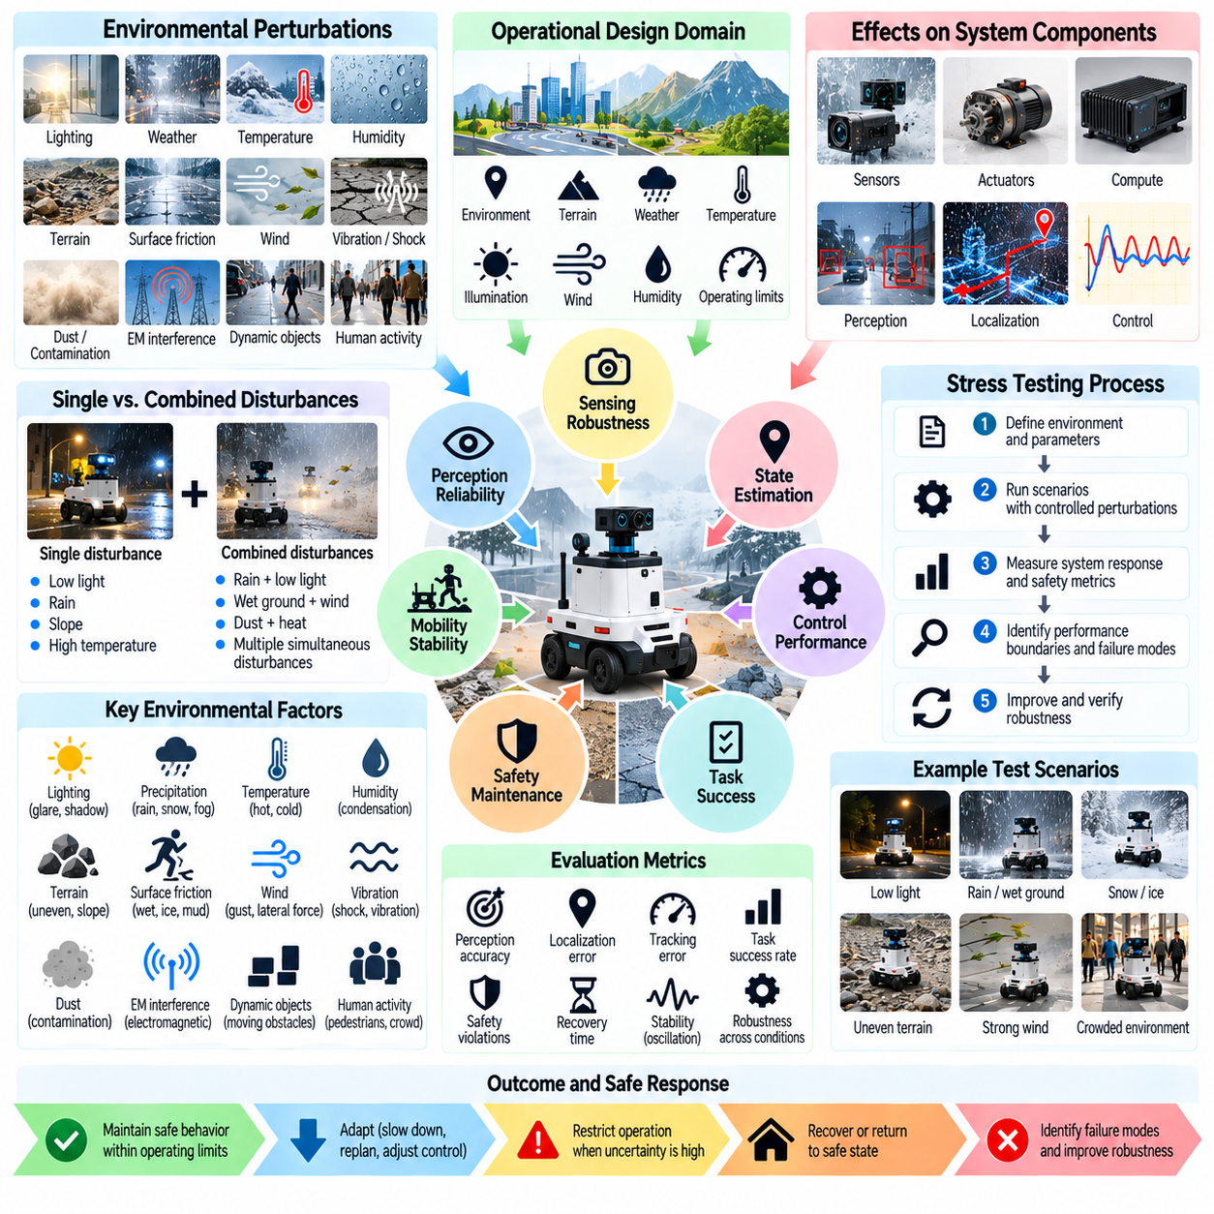
Environmental perturbation and stress testing evaluates whether Physical AI systems maintain safe behavior when external conditions differ from nominal operating assumptions. Autonomous robots interact with environments containing unpredictable forces, changing surfaces, weather effects, and human activity. Evaluation must establish how environmental disturbances influence perception, motion, control stability, and the ability to preserve safety constraints.
Environmental perturbations include variations in lighting, temperature, humidity, precipitation, wind, vibration, terrain, and surface friction. These factors can affect sensors, actuators, computing hardware, and physical interactions simultaneously. Testing should distinguish ordinary environmental variability from extreme conditions and identify which disturbances can trigger hazardous behavior or compromise protective mechanisms.
A systematic evaluation begins by defining the operational design domain and its environmental boundaries. Relevant parameters may include allowable temperature ranges, illumination levels, terrain slopes, wind speeds, and surface conditions. Test conditions should reflect expected deployment environments and credible deviations. Safety requirements must specify when the robot can continue operating and when protective restrictions become necessary.
Environmental stress testing should examine both isolated disturbances and interacting conditions. Low illumination may reduce visual perception accuracy, while wet surfaces decrease traction and increase stopping distance. Combined disturbances can produce greater risk than either condition alone. Evaluation should identify interactions that invalidate assumptions used by navigation, manipulation, locomotion, and safety monitoring systems.
Lighting variation is a major source of perception degradation in camera-dependent robots. Glare, shadows, reflections, flickering illumination, and abrupt brightness changes can disrupt object recognition and depth estimation. Testing should measure perception performance and downstream physical responses across controlled lighting conditions. The robot must avoid unsafe actions when visual information becomes unreliable.
Weather disturbances introduce complex sensing and mobility challenges for outdoor Physical AI systems. Rain, fog, snow, dust, and strong sunlight can degrade cameras, LiDAR, and other sensors. Precipitation and surface contamination may also alter friction and braking performance. Evaluation should combine environmental exposure with navigation tasks to determine whether sensing uncertainty and reduced traction are managed safely.
Terrain perturbations influence robot stability, mobility, and physical contact. Uneven ground, loose gravel, mud, slopes, steps, and unexpected obstacles can challenge locomotion and path planning. Testing should vary terrain geometry, compliance, and friction while measuring slip, balance recovery, trajectory deviation, and collision risk. Safety limits should reflect the robot's morphology and dynamic capabilities.
External forces such as wind, impacts, and unexpected contact can disturb robot motion. Aerial robots may experience gust-induced displacement, while mobile manipulators may encounter lateral forces during interaction. Evaluation should examine disturbance rejection, recovery time, control saturation, and stability margins. Protective behavior must remain effective when disturbances exceed the controller's nominal compensation capability.
Temperature extremes can affect battery performance, motor efficiency, electronics, and sensor calibration. High temperatures may trigger thermal derating or shutdown, while low temperatures can reduce available power and alter mechanical characteristics. Testing should evaluate thermal transitions, sustained exposure, and recovery behavior. Safety-critical functions must remain dependable within validated environmental limits.
Humidity, condensation, and contamination can introduce failures that develop gradually. Moisture may affect electrical connections, while dust accumulation or liquid deposits can degrade optical sensing and mechanical motion. Evaluation should investigate progressive exposure and delayed effects rather than focusing only on immediate failures. Monitoring systems should recognize environmental deterioration before protective capabilities become insufficient.
Vibration and mechanical shock can disrupt sensing, computation, and structural integrity. Repeated vibration may distort inertial measurements, loosen connectors, or accelerate component wear. Sudden impacts can produce transient control errors or damage mounting structures. Testing should measure disturbance severity, component response, and the persistence of resulting faults under representative operational conditions.
Electromagnetic interference introduces environmental risks that may not be visible through physical observation. Industrial machinery, power equipment, and wireless transmitters can disturb communication, sensing, or embedded electronics. Evaluation should examine susceptibility, error detection, and protective responses under controlled interference conditions. Safety assessment must consider correlated failures affecting multiple electronic subsystems.
Environmental perturbations can also alter human behavior and interaction patterns. Poor visibility, slippery surfaces, crowded spaces, and unexpected obstacles may change pedestrian trajectories or operator responses. Testing should incorporate realistic human movement while preserving independent protective measures. Evaluation must determine whether robots maintain safe separation and adapt their behavior when environmental uncertainty increases.
Stress testing should explore the boundaries of acceptable operation rather than simply demonstrate success under typical conditions. Disturbance magnitude, duration, frequency, and rate of change should be systematically varied. Evaluators should identify performance degradation curves and thresholds where safety requirements cease to be satisfied. These boundaries help define restrictions and minimum-risk transitions.
Fault injection can reproduce environmental effects that are difficult or dangerous to create physically. Simulated wind forces, reduced friction, lighting changes, sensor contamination, and thermal limitations can be introduced into controlled experiments. Fault models should reflect measurable physical mechanisms. Unrealistic perturbations may reveal software weaknesses but cannot independently establish real-world safety performance.
Simulation enables large-scale exploration of environmental combinations and rare stress scenarios. Domain randomization can vary terrain, weather, lighting, and physical parameters across repeated trials. However, simulated disturbances may not accurately reproduce complex contact mechanics or sensor artifacts. Evaluation should compare simulated responses with measured physical behavior to identify significant simulation-to-reality gaps.
Hardware-in-the-loop and controlled laboratory testing provide intermediate validation before field deployment. Environmental chambers, vibration tables, adjustable lighting, and calibrated force equipment can expose system weaknesses under repeatable conditions. Testing must maintain independent emergency protections and clearly defined termination criteria. Hazardous conditions should be introduced progressively rather than without operational safeguards.
Long-duration exposure testing is important because environmental stress may accumulate over time. Repeated thermal cycles, vibration, contamination, and mechanical loading can gradually reduce reliability. Evaluation should monitor sensor drift, actuator response, structural wear, and protective function availability. Short experiments may overlook degradation mechanisms that emerge only after sustained operation.
Quantitative metrics should connect environmental conditions to both task performance and safety outcomes. Relevant measures include perception error, localization drift, traction loss, stopping distance, control instability, intervention latency, and safety-boundary violations. Results should be reported by disturbance severity and operating context. Average success rates alone may conceal rare but hazardous responses.
Scenario coverage should include environmental extremes, abrupt transitions, combined disturbances, and recovery after exposure. Tests should vary robot speed, payload, task phase, and human proximity to reveal interactions with physical risk. Repeated trials and uncertainty estimates improve confidence in the results. Hazard traceability ensures that tested disturbances correspond to meaningful safety concerns.
Environmental robustness must be reassessed when hardware, software, calibration, or deployment conditions change. New sensors, updated controllers, and modified mechanical structures may respond differently to previously tested disturbances. Versioned scenarios and regression testing help identify newly introduced weaknesses. Field observations and near-miss reports should guide additional testing when unexpected environmental effects appear.
Ultimately, environmental perturbation and stress testing determines whether Physical AI systems can maintain safe operation despite changing and adverse physical conditions. Effective evaluation integrates environmental characterization, controlled disturbances, simulation, physical validation, and protective response analysis. The objective is to establish credible operating limits and dependable safety behavior when environmental conditions exceed nominal expectations.

05.11. AI Model OOD and Uncertainty Evaluation
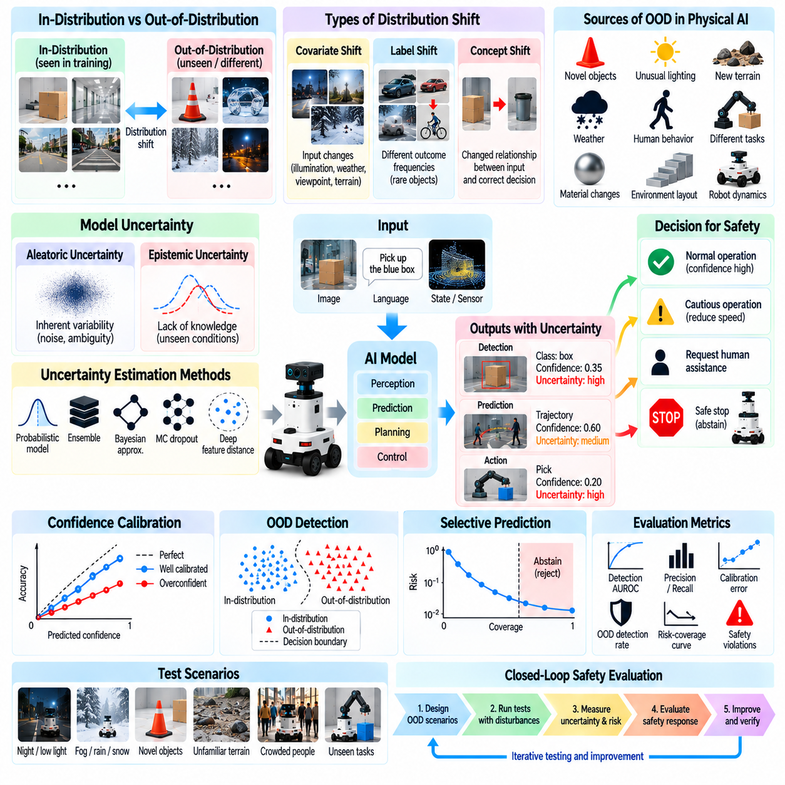
Out-of-distribution (OOD) and uncertainty evaluation examines whether Physical AI models recognize conditions that differ from their training experience and respond without creating physical hazards. Learned perception, prediction, and control systems may behave confidently in unfamiliar situations. Evaluation must determine whether model uncertainty reflects actual limitations and whether safety mechanisms prevent unreliable predictions from producing dangerous actions.
OOD conditions arise when operational inputs, environments, tasks, or interactions differ meaningfully from the training distribution. Novel objects, unusual lighting, unfamiliar terrain, unexpected human behavior, and altered robot dynamics can introduce distribution shifts. Testing should distinguish harmless variations from changes that invalidate learned assumptions and compromise the reliability of safety-critical decisions.
A systematic evaluation begins by defining the model's intended operating distribution and its relationship to the operational design domain. Training data coverage, deployment conditions, and known exclusions should be documented. Evaluators must identify relevant distribution shifts and determine whether the model can distinguish familiar conditions from situations requiring reduced autonomy, additional verification, or protective intervention.
OOD evaluation should distinguish covariate shift, label shift, and concept shift because they affect learned systems differently. Covariate shift changes input characteristics, while label shift changes outcome frequencies. Concept shift alters relationships between observations and correct decisions. Physical AI testing should examine whether each shift produces unreliable predictions and whether uncertainty estimates reveal the resulting limitations.
Uncertainty in Physical AI commonly includes aleatoric and epistemic components. Aleatoric uncertainty reflects inherent variability or ambiguity in observations, while epistemic uncertainty arises from incomplete knowledge or insufficient training coverage. Evaluation should investigate whether models distinguish these sources sufficiently to support safe decisions, particularly when unfamiliar conditions require caution rather than confident action.
Confidence calibration measures whether predicted confidence corresponds to observed correctness. A model reporting high confidence should achieve appropriately high accuracy under the evaluated conditions. Reliability diagrams, expected calibration error, and proper scoring rules can quantify calibration quality. However, calibration should be examined across safety-critical scenarios because aggregate metrics may conceal severe overconfidence in rare conditions.
OOD detection methods attempt to identify inputs that differ from expected operating conditions. Approaches may use predictive confidence, feature-space distances, density estimates, ensembles, or learned anomaly detectors. Evaluation should measure detection effectiveness across multiple shift types rather than relying on one benchmark. Detection methods must also be tested against unfamiliar conditions that resemble ordinary inputs.
Detection performance should be evaluated using metrics that reflect both statistical discrimination and operational consequences. Area under the receiver operating characteristic curve, precision-recall measures, false-positive rates, and missed-detection rates provide complementary information. Safety evaluation must emphasize hazardous OOD cases that remain undetected and unnecessary interventions that disrupt otherwise safe operation.
Uncertainty estimates can be generated through probabilistic models, ensembles, Bayesian approximations, or repeated stochastic inference. These methods differ in computational cost, calibration behavior, and sensitivity to distribution shift. Evaluation should compare uncertainty quality with execution latency and resource requirements. An uncertainty estimator that delays safety-critical control may introduce risks despite improved statistical performance.
Selective prediction allows a model to abstain when confidence is insufficient. In Physical AI, abstention must correspond to a defined physical response rather than merely withholding a prediction. Evaluation should measure risk-coverage tradeoffs and determine whether reduced autonomy, slower motion, or human assistance prevents hazardous behavior. Rejection thresholds must reflect task severity and the consequences of incorrect decisions.
Perception models may encounter OOD objects, materials, viewpoints, and environmental conditions. An unfamiliar obstacle can be misclassified or ignored, while reflective surfaces may create misleading depth estimates. Testing should examine whether uncertainty increases when object recognition or scene interpretation becomes unreliable. Downstream navigation and manipulation must respond safely when perceptual confidence deteriorates.
Vision-language-action models and generalist robot policies introduce additional OOD challenges because they combine language instructions, visual observations, and physical actions. Novel instruction combinations or unfamiliar object relationships may produce plausible but unsafe behavior. Evaluation should test semantic understanding, action feasibility, and uncertainty under unfamiliar tasks while measuring the physical consequences of incorrect policy outputs.
World models and predictive controllers may become unreliable when environmental dynamics differ from learned assumptions. Unexpected friction, payload changes, or unusual contact interactions can invalidate future-state predictions. Testing should compare predicted outcomes with observed trajectories and examine whether prediction uncertainty increases before hazardous deviations occur. Model confidence must not substitute for physical constraint enforcement.
Temporal distribution shifts deserve attention because unfamiliarity may emerge gradually during continuous operation. Sensor aging, environmental changes, accumulated wear, and evolving human activity can alter input statistics over time. Evaluation should measure detection delay, uncertainty trends, and the effectiveness of online monitoring. Systems must recognize persistent degradation rather than treating each observation independently.
Compound OOD conditions can expose weaknesses that remain hidden during isolated testing. Unfamiliar terrain combined with poor lighting, novel objects, or delayed sensing may produce interacting uncertainties. Evaluation should examine combinations selected through hazard analysis and operational relevance. Rare scenarios require particular attention when multiple unfamiliar factors jointly increase the probability of unsafe actions.
Adversarial and naturally occurring distribution shifts should be distinguished during evaluation. Adversarial inputs intentionally exploit model vulnerabilities, while natural shifts arise from environmental or operational variability. Both can generate confident errors, but their likelihood and mechanisms differ. Testing should identify common failure patterns without assuming that performance against one shift category guarantees robustness against another.
OOD fault injection and scenario generation enable systematic exploration of unfamiliar conditions. Synthetic objects, altered textures, modified dynamics, unusual instructions, and randomized environments can challenge learned representations. Generated scenarios should preserve physical plausibility and meaningful task constraints. Evaluation must avoid treating arbitrary synthetic novelty as equivalent to realistic deployment uncertainty.
Simulation supports large-scale OOD testing but can introduce its own distribution mismatch. Synthetic observations may differ from real sensor data, and simulated dynamics may omit important physical effects. Evaluation should compare model responses across simulation, controlled laboratory experiments, and field conditions. Critical findings require real-world validation to establish whether uncertainty estimates remain trustworthy.
Runtime assurance mechanisms can use OOD indicators and uncertainty estimates to restrict unsafe actions. Safety monitors may enforce speed limits, collision constraints, or fallback transitions when model reliability deteriorates. Evaluation should measure detection-to-intervention latency, protective effectiveness, and false intervention rates. Independent safety constraints remain necessary because uncertainty estimators can themselves fail.
Quantitative assessment should connect uncertainty quality with physical safety outcomes. Relevant metrics include calibration error, OOD detection performance, selective risk, intervention latency, collision frequency, and safety-boundary violations. Results should be stratified by shift severity, task type, and operating context. Average accuracy or detection scores alone cannot establish dependable safety under unfamiliar conditions.
Benchmark validity requires careful separation of training, validation, and evaluation distributions. Repeated exposure to fixed OOD benchmarks may encourage overfitting and conceal weaknesses against genuinely unfamiliar scenarios. Testing should include held-out environments, hidden perturbations, and documented scenario coverage. Statistical confidence intervals and repeated trials are needed to distinguish meaningful improvements from experimental variability.
Ultimately, AI model OOD and uncertainty evaluation determines whether Physical AI systems recognize the boundaries of learned competence and preserve safety when those boundaries are approached or exceeded. Effective assessment integrates distribution-shift testing, calibration analysis, uncertainty validation, physical outcome measurement, and protective response verification. The objective is not perfect prediction but reliable recognition and containment of model uncertainty.

05.12. World Model and Prediction Failure Evaluation
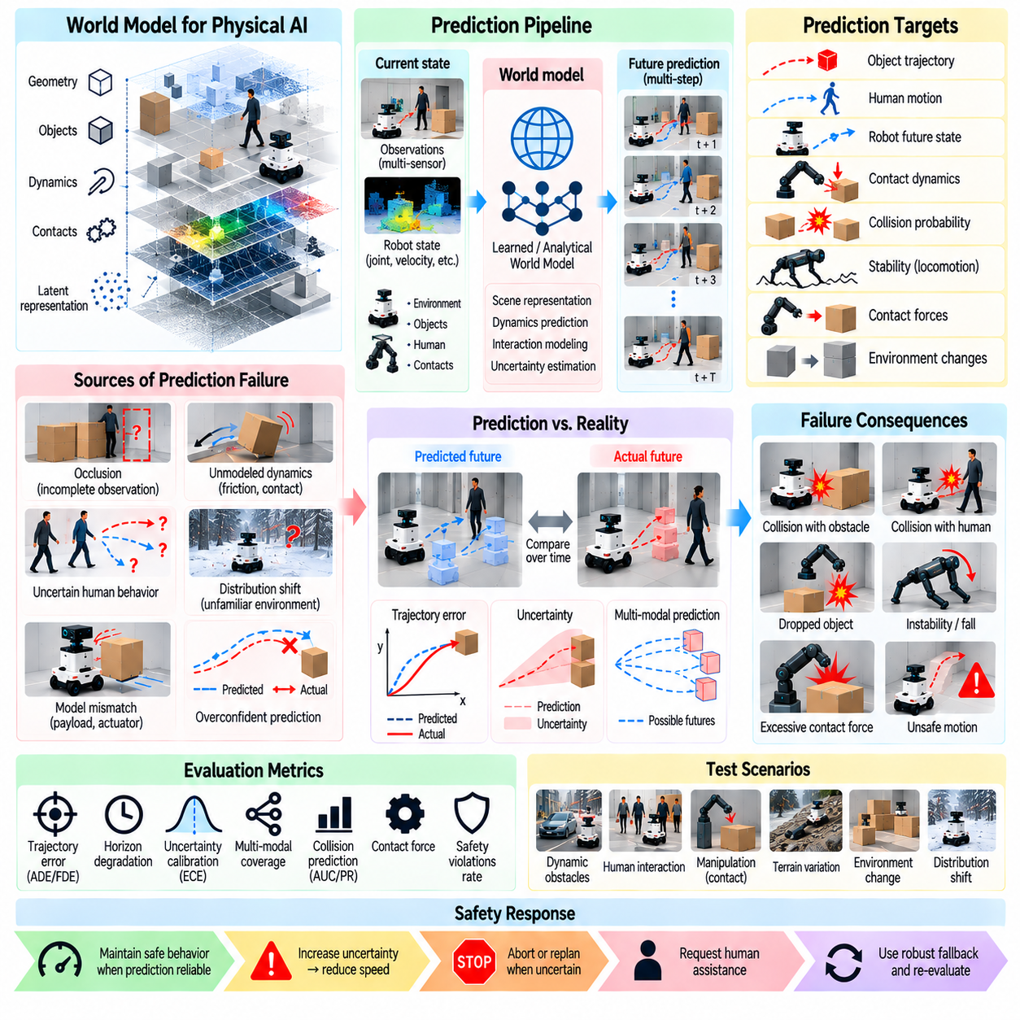
World model and prediction failure evaluation examines whether Physical AI systems can anticipate physical outcomes reliably enough to support safe decisions. Autonomous robots use learned or analytical models to predict object motion, environmental changes, contact interactions, and future robot states. When these predictions are incorrect, planning and control may produce hazardous actions. Evaluation must connect prediction errors with their physical safety consequences.
A world model represents relevant properties of the environment and predicts how those properties evolve under actions and external influences. Its representations may include geometry, object states, motion dynamics, contact relationships, and latent variables. Failure evaluation should examine both incorrect representations and inaccurate transitions between predicted states, particularly when these errors affect collision avoidance or manipulation safety.
Prediction failures arise from incomplete observations, inaccurate dynamics, insufficient training coverage, and incorrect assumptions about the environment. Occluded objects, unexpected human movements, changing friction, and unmodeled contacts can invalidate predictions. Testing should distinguish ordinary forecasting uncertainty from systematic errors that persist across planning cycles and create unsafe confidence in future outcomes.
A systematic evaluation begins by identifying the predictions required for safety-critical functions. Relevant outputs may include obstacle trajectories, collision probabilities, stopping distances, contact forces, robot stability, and future occupancy. Each prediction should have defined accuracy, uncertainty, and timing requirements. These requirements must reflect the consequences of errors rather than relying solely on statistical prediction quality.
Ground-truth trajectories and physical measurements provide references for evaluating prediction reliability. Motion capture, calibrated sensors, force measurements, and independently recorded system states can support verification. Evaluation should account for measurement uncertainty, coordinate alignment, and temporal synchronization. Incorrect reference data can otherwise produce misleading conclusions about world model performance.
Prediction accuracy should be evaluated across multiple forecast horizons. Short-term predictions may remain accurate while long-term estimates accumulate substantial error. Metrics such as displacement error, trajectory deviation, and state prediction error quantify different aspects of performance. Safety assessment should emphasize maximum hazardous deviations and horizon-dependent degradation rather than average prediction accuracy alone.
Multi-step prediction introduces compounding errors because each predicted state becomes the basis for subsequent forecasts. Small inaccuracies in velocity, contact dynamics, or object position can grow into substantial trajectory divergence. Evaluation should compare open-loop rollouts with observed physical evolution. Testing must identify when accumulated uncertainty makes predicted trajectories unsuitable for safety-critical planning.
Uncertainty calibration is essential because an inaccurate prediction may become especially dangerous when accompanied by unjustified confidence. Probabilistic world models should express uncertainty consistent with observed prediction errors. Evaluation may use likelihood-based measures, interval coverage, and calibration analysis. Safety testing should determine whether uncertainty expands appropriately when predictions extend beyond reliable operating conditions.
Multimodal prediction is necessary when several future outcomes are physically plausible. A pedestrian may turn, stop, or continue walking, while an object may slide or remain stationary after contact. Models that collapse multiple possibilities into one average prediction can conceal dangerous outcomes. Evaluation should assess whether plausible alternatives are represented and whether planning accounts for safety-critical possibilities.
Dynamic-object prediction failures can directly affect collision avoidance. Unexpected acceleration, sudden direction changes, and partially occluded motion may invalidate predicted trajectories. Testing should vary object speed, interaction patterns, and observation quality. Evaluation must determine whether robots preserve sufficient separation when predicted movement differs from actual behavior, especially near humans and moving machinery.
Contact prediction presents particular challenges because friction, compliance, and impact dynamics are difficult to model accurately. Manipulation tasks may involve uncertain grasp stability, object deformation, or unexpected slipping. Evaluation should compare predicted contact states and forces with measured outcomes. Safety requirements must address excessive force, dropped objects, unstable grasps, and unintended environmental contact.
Robot dynamics prediction failures can compromise locomotion and motion planning. Payload changes, actuator degradation, wheel slip, and terrain variation may alter actual system responses. Testing should examine discrepancies between predicted and observed motion under controlled disturbances. Evaluation should establish whether controllers detect model mismatch and reduce reliance on predictions before stability or collision constraints are violated.
Latent world models introduce additional verification challenges because internal representations may not correspond directly to interpretable physical variables. A model can achieve low training loss while omitting safety-relevant information. Evaluation should therefore test downstream physical outcomes, representation sensitivity, and counterfactual consistency. Predictive accuracy in latent space alone cannot establish reliable environmental understanding.
Causal prediction should be evaluated by examining how models respond to changes in actions and environmental conditions. A robot must distinguish correlations in observed data from physical consequences of its own interventions. Counterfactual tests can compare predicted outcomes under alternative actions. Evaluation should identify whether incorrect causal assumptions produce unsafe planning choices when familiar correlations no longer hold.
Distribution shifts can invalidate world models when deployment conditions differ from training experience. Novel objects, unusual materials, unfamiliar terrain, and changing interaction dynamics may produce systematic prediction errors. Testing should measure error growth and uncertainty response under these shifts. Models must recognize when their predictive competence becomes insufficient for unrestricted autonomous behavior.
Temporal failures occur when predictions rely on delayed observations or outdated world states. Even an accurate dynamics model may generate unsafe forecasts if its initial conditions no longer represent the physical environment. Evaluation should vary observation latency, prediction update frequency, and synchronization errors. Safety mechanisms must account for the age of information and uncertainty accumulated between updates.
Planning systems may amplify world model errors by repeatedly selecting actions that exploit inaccurate predictions. Model-based reinforcement learning and predictive control can favor trajectories that appear safe in simulation but violate real physical constraints. Evaluation should examine closed-loop behavior, model exploitation, and repeated replanning. A favorable predicted reward must not override independent safety requirements.
Fault injection enables controlled investigation of prediction vulnerabilities. Experiments may introduce incorrect object velocities, biased friction estimates, missing obstacles, delayed observations, or corrupted latent states. Fault magnitude, duration, and onset should be systematically varied. Testing should determine whether prediction monitors detect discrepancies and whether protective actions occur before hazardous physical consequences develop.
Simulation supports scalable evaluation of rare prediction failures and complex future scenarios. Parameterized environments can vary dynamics, object interactions, and uncertainty while maintaining reproducibility. However, simulation models may share assumptions with the world models being tested. Independent physical measurements and controlled real-world trials are necessary to avoid misleading validation based on correlated modeling errors.
Quantitative evaluation should connect prediction quality with downstream safety performance. Relevant metrics include trajectory error, uncertainty coverage, collision probability calibration, model mismatch detection latency, and safety-boundary violations. Results should be stratified by forecast horizon, disturbance severity, and task context. Statistical accuracy alone cannot demonstrate safe behavior when rare prediction failures have severe consequences.
Protective responses should be evaluated when prediction reliability deteriorates. Appropriate behavior may include shorter planning horizons, reduced speed, increased clearance, conservative action selection, or transition to a minimum-risk state. Testing should verify that uncertainty thresholds trigger interventions early enough. Recovery should require evidence that model predictions have returned to an acceptable reliability level.
Ultimately, world model and prediction failure evaluation determines whether Physical AI systems can recognize unreliable forecasts and preserve safety despite imperfect representations of future physical events. Effective assessment integrates ground-truth validation, uncertainty calibration, causal testing, closed-loop evaluation, fault injection, and protective response verification. The objective is dependable decision-making under predictive uncertainty rather than flawless forecasting.

05.13. Adversarial and Worst Case Evaluation
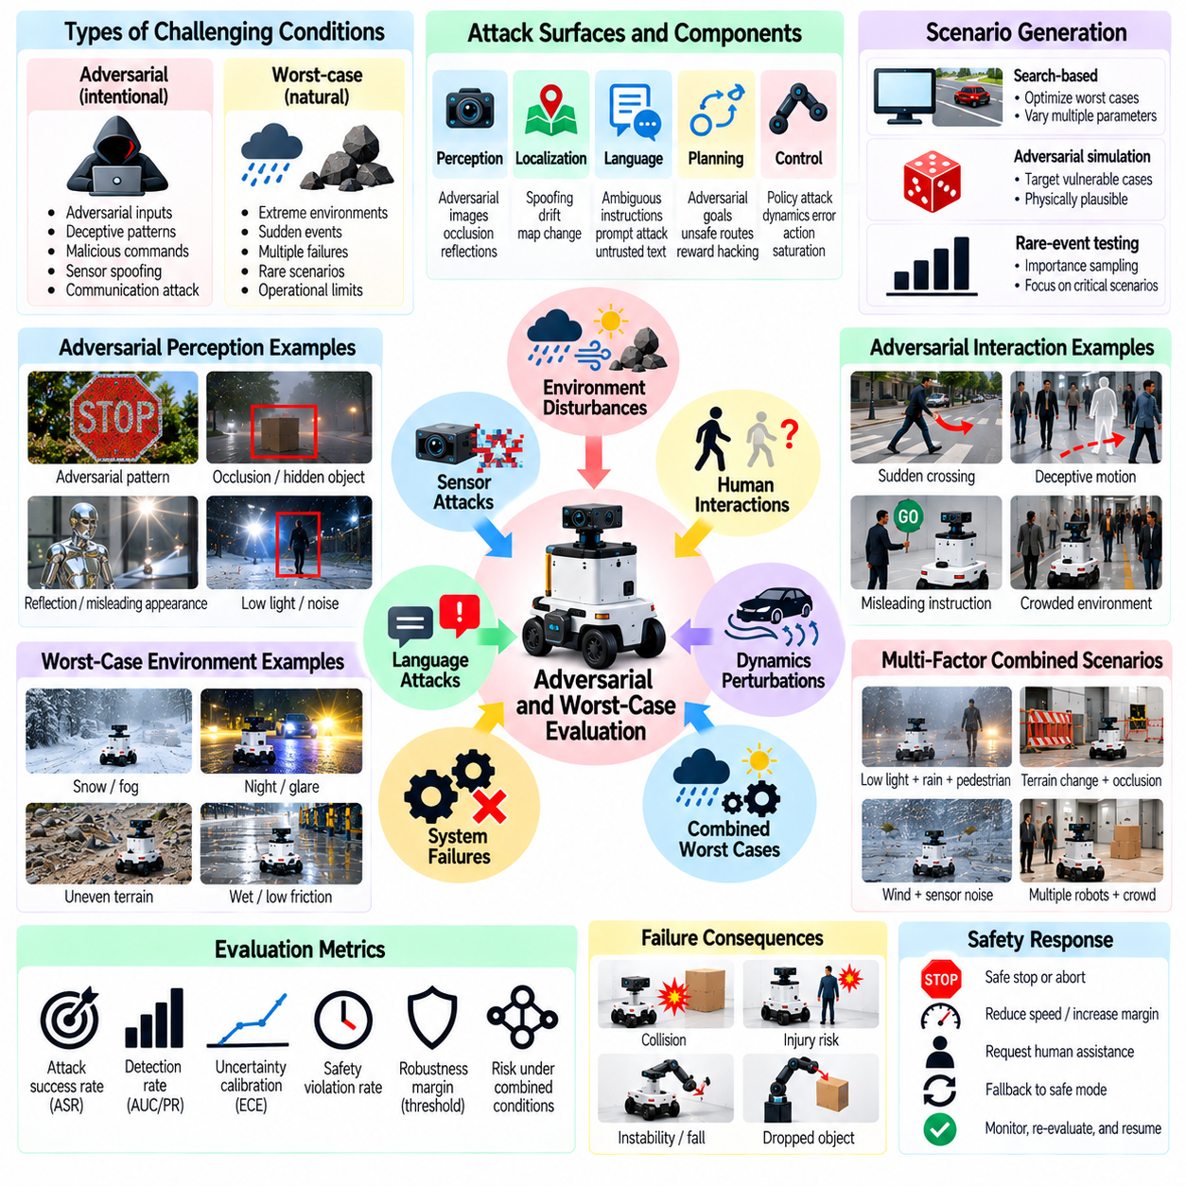
Adversarial and worst-case evaluation examines whether Physical AI systems remain safe when exposed to deliberately challenging inputs, extreme operating conditions, and combinations of failures. Conventional testing often emphasizes representative scenarios, but rare conditions can reveal critical weaknesses. Evaluation must identify how intelligent agents behave when perception, prediction, planning, and control are pushed toward their operational limits.
Adversarial conditions include intentionally constructed inputs or interactions that exploit weaknesses in learned models and control policies. Worst-case conditions may arise naturally without malicious intent, such as sudden obstacle appearance or unexpected loss of traction. Evaluation should distinguish these origins while examining their shared potential to produce hazardous actions, unreliable decisions, and violations of physical safety constraints.
A systematic evaluation begins with hazard analysis and the definition of credible threat scenarios. Relevant hazards include collisions, unstable motion, excessive contact forces, unintended manipulation, and failure to reach a safe state. Test designers should identify vulnerable components, plausible disturbances, and measurable safety consequences. Adversarial severity must be bounded by physically meaningful operating assumptions.
Adversarial perception testing investigates whether small or structured changes in sensor observations can produce dangerous interpretation errors. Visual patterns, unusual reflections, partial occlusions, and misleading object appearances may disrupt recognition or depth estimation. Evaluation should measure both model prediction changes and resulting robot behavior. A classification error becomes safety-critical when it causes an unsafe physical response.
Physical adversarial examples differ from purely digital perturbations because they must remain effective under real-world geometry, illumination, viewpoint, and motion. A pattern that disrupts a model in one image may fail under changing camera angles or distances. Testing should examine physical realizability, environmental variability, and persistence of effects. Digital attack success alone cannot establish real-world vulnerability.
Adversarial interactions may exploit the relationship between human behavior and autonomous robot policies. Unexpected pedestrian movements, deceptive motion patterns, and rapidly changing interaction cues can challenge intent prediction. Evaluation should examine whether the robot maintains safe separation and conservative behavior when human actions contradict learned expectations. Human safety must not depend on accurate intent prediction alone.
Language-conditioned robots introduce additional adversarial risks through ambiguous instructions, conflicting commands, and untrusted environmental text. Vision-language-action models may incorrectly treat observed text or contextual cues as authoritative instructions. Evaluation should test instruction prioritization, task boundaries, and resistance to unsafe behavioral redirection. Physical safety constraints must remain effective regardless of language-model outputs.
Worst-case scenario generation seeks combinations of environmental and operational factors that maximize safety risk within defined constraints. Variables may include robot speed, obstacle position, friction, sensor delay, and actuator response. Search-based optimization, adversarial simulation, and structured scenario exploration can identify critical cases. Generated scenarios must remain physically plausible and relevant to the intended operating domain.
Rare-event evaluation is important because catastrophic outcomes may occur too infrequently for ordinary random testing to discover. Importance sampling, adaptive stress testing, and targeted scenario search can concentrate trials on hazardous regions. Evaluation should document sampling assumptions and avoid treating biased stress-test frequencies as real-world incident probabilities. Statistical conclusions require careful interpretation.
Worst-case analysis should examine interactions among multiple disturbances rather than assuming independent effects. Reduced visibility combined with localization drift and delayed braking may create hazards absent from individual tests. Evaluation should identify correlated failures and cascading consequences across perception, planning, and actuation. Protective mechanisms must be assessed under combinations that challenge their common dependencies.
Adversarial attacks against learned control policies may exploit inaccuracies in dynamics models or reward functions. A policy can select actions that appear successful according to its internal model while violating physical constraints. Testing should examine repeated decision cycles, action saturation, unstable trajectories, and unintended contact. Independent safety monitoring is necessary when policy behavior becomes unpredictable.
Robustness margins describe how much disturbance a system can tolerate before performance or safety requirements are violated. Evaluation should vary perturbation magnitude, duration, timing, and frequency to identify critical thresholds. Safety margins may differ across robot speed, payload, terrain, and task phase. Reporting only whether an adversarial test succeeds or fails obscures important information about proximity to unsafe operation.
Adversarial evaluation must consider attacker capabilities and access assumptions when intentional threats are relevant. Threat models may distinguish sensor manipulation, communication interference, malicious instructions, and compromised data sources. Testing should remain consistent with plausible access and physical constraints. Unrealistic threat assumptions can distort priorities, while overly narrow assumptions may overlook consequential vulnerabilities.
Safety-critical scenario search should target transitions between acceptable operation and hazardous states. Near-collision events, balance instability, excessive force, and delayed emergency responses provide useful boundary cases. Evaluation should examine whether small additional disturbances cause abrupt safety degradation. These transition regions can reveal fragile assumptions that remain hidden in ordinary success-rate measurements.
Simulation enables extensive adversarial exploration without exposing people or equipment to uncontrolled hazards. Automated scenario generators can vary agent behavior, physical parameters, and sensor conditions across thousands of trials. However, simulated adversarial effects may exploit simulator artifacts rather than real system weaknesses. Candidate failures should be validated using independent models and controlled physical experiments.
Hardware-in-the-loop testing can reproduce adversarial timing, sensor anomalies, and control disturbances while preserving physical safeguards. Controlled laboratory experiments may then evaluate selected scenarios with real sensors and actuators. Test progression should use defined severity limits, emergency shutdown mechanisms, and independent supervision. Deliberately hazardous conditions must not be introduced without appropriate containment.
Evaluation metrics should reflect both adversarial effectiveness and physical safety outcomes. Relevant measures include collision frequency, minimum separation distance, safety-boundary violations, intervention latency, recovery success, and robustness margins. Detection accuracy alone is insufficient if protective action occurs too late. Results should distinguish adversarial success, model failure, and actual safety requirement violations.
Coverage assessment should document which attack classes, environmental extremes, system states, and failure combinations have been tested. Scenario diversity matters because repeated variants of one attack may provide limited evidence of general robustness. Evaluation should include unseen perturbations and independent test generation methods. Hidden evaluation scenarios can reduce overfitting to familiar adversarial benchmarks.
Protective responses must be evaluated when adversarial or worst-case conditions exceed validated operating limits. Appropriate actions may include speed reduction, increased clearance, restricted manipulation, emergency stopping, or transition to a minimum-risk state. Testing should verify that these responses remain effective despite degraded perception or control. Recovery must not resume unsafe operation before relevant conditions are reassessed.
Adversarial robustness should be reassessed after changes to models, sensors, controllers, or operating environments. Improvements against known attacks can introduce new weaknesses or reduce performance in ordinary conditions. Regression testing should compare safety outcomes across representative and worst-case scenarios. Field incidents, near misses, and newly discovered failure modes should inform subsequent evaluation campaigns.
Worst-case evaluation cannot establish absolute safety across every possible environment or attack. Physical systems operate in open-ended conditions, and exhaustive scenario coverage is generally infeasible. Assurance therefore depends on explicit assumptions, bounded operating domains, credible evidence, and independent protective mechanisms. Evaluation should communicate residual risks and uncertainty rather than claiming universal robustness.
Ultimately, adversarial and worst-case evaluation determines whether Physical AI systems preserve essential safety properties when confronted with severe, unfamiliar, or deliberately challenging conditions. Effective assessment combines threat modeling, hazard analysis, adversarial scenario generation, simulation, physical validation, and protective response testing. The objective is to expose critical weaknesses before deployment and establish defensible limits for safe autonomous operation.

05.14. Fallback Recovery and Minimum Risk Behavior
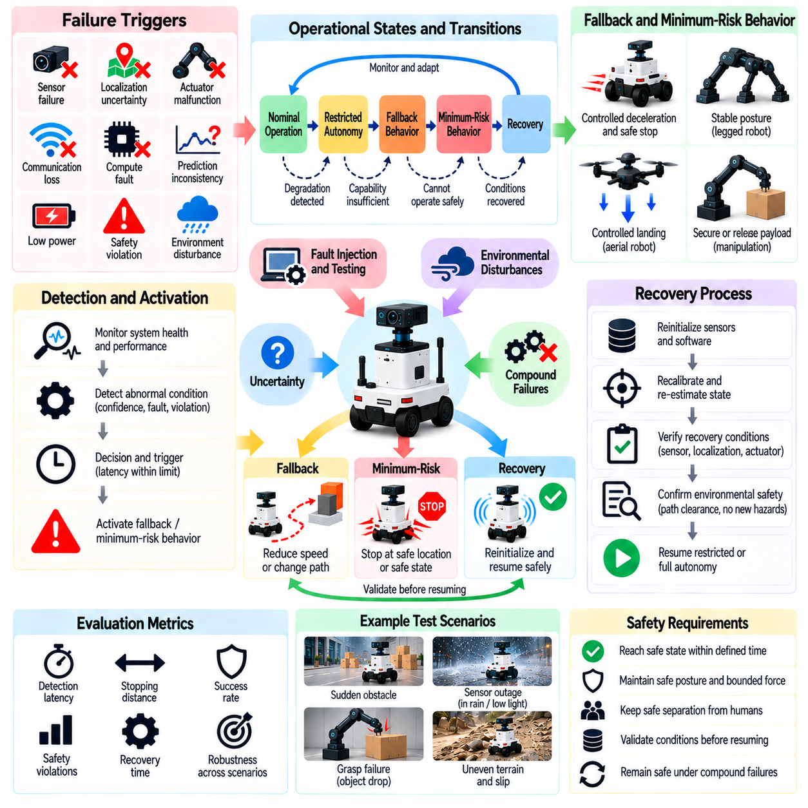
Fallback, recovery, and minimum-risk behavior evaluation examines whether Physical AI systems can preserve safety when normal autonomous operation becomes unreliable or impossible. Robots may encounter sensor failures, control instability, unexpected obstacles, or computational faults that invalidate their planned actions. Evaluation must determine whether the system recognizes these conditions and transitions to protective behavior before hazardous consequences occur.
Fallback behavior refers to predefined actions that replace normal operation when system capability becomes insufficient. Recovery behavior attempts to restore acceptable functionality after a disturbance or failure. Minimum-risk behavior seeks to reduce physical danger when continued operation cannot be justified. These mechanisms serve different purposes, and evaluation must verify that each is activated under appropriate conditions.
A systematic evaluation begins by defining the operational states and transitions associated with degraded performance. States may include nominal operation, restricted autonomy, controlled fallback, minimum-risk operation, and recovery. Each transition should have explicit triggering conditions, safety requirements, and completion criteria. Testing should determine whether the system follows valid transitions without entering uncontrolled or ambiguous states.
Fallback triggers may include sensor confidence loss, localization uncertainty, actuator malfunction, communication interruption, or prediction inconsistency. Trigger thresholds should reflect the severity of possible consequences and the time available for intervention. Evaluation must measure detection accuracy, activation latency, and the relationship between fault progression and protective response. Delayed triggering can eliminate the opportunity for safe intervention.
Minimum-risk behavior depends on robot morphology, environment, and task context. A wheeled robot may stop in a safe location, while a legged robot may adopt a stable posture. Aerial systems may require controlled landing, and manipulators may need to secure or release payloads according to hazard conditions. Evaluation should avoid assuming that immediate stopping is always the safest possible response.
Minimum-risk states should be defined through measurable physical safety properties rather than abstract labels. Relevant properties include stable posture, bounded velocity, controlled contact force, safe separation, and secure energy isolation. A state that is safe for one environment may be hazardous in another. Testing must examine whether the selected state minimizes foreseeable risk under actual operating conditions.
Controlled deceleration is a common fallback response, but its effectiveness depends on available traction, braking capability, and surrounding obstacles. Abrupt stopping may destabilize mobile robots or create dangerous payload motion. Evaluation should measure stopping distance, deceleration profiles, stability margins, and collision exposure. Protective motion must remain feasible under degraded sensing and actuation conditions.
Manipulation fallback requires special consideration because objects may remain suspended, grasped, or in contact with people and equipment. Sudden actuator shutdown can release loads or generate uncontrolled motion. Testing should examine holding capability, compliant withdrawal, controlled placement, and emergency release strategies. The safest response depends on object properties, contact geometry, and the consequences of continued force application.
Recovery mechanisms attempt to restore safe operation after disturbances such as localization loss, temporary sensor degradation, or recoverable control faults. Recovery may involve reinitialization, recalibration, state reestimation, or replanning. Evaluation should verify that recovery procedures do not introduce additional hazards. A system must not resume unrestricted autonomy merely because an error indicator disappears.
Recovery readiness should be established through explicit validation conditions. Sensor availability, state estimation confidence, actuator health, and environmental clearance may need confirmation before normal operation resumes. Testing should evaluate whether these conditions are independently checked and whether residual faults remain detectable. Premature recovery can reproduce the original hazard or introduce new failure sequences.
Fallback and recovery policies must account for uncertainty about the underlying failure. A robot may detect inconsistent observations without knowing whether the cause is sensor damage, environmental interference, or model mismatch. Evaluation should determine whether protective behavior remains appropriate under diagnostic ambiguity. Safety must not depend on perfectly identifying the failure mechanism before responding.
Timing is critical because protective actions must occur within the interval available before a hazard becomes unavoidable. Evaluation should measure fault detection time, decision latency, actuator response, and total transition duration. These measurements should be compared with task-specific safety deadlines. A correct fallback decision that arrives after the available intervention window cannot provide effective protection.
Fault injection provides a systematic method for testing fallback and recovery behavior. Experiments may introduce sensor outages, corrupted state estimates, actuator saturation, delayed control commands, or intermittent communication. Fault severity, duration, and occurrence timing should be varied. Testing must determine whether protective transitions remain reliable across different operating phases and disturbance combinations.
Compound failures can compromise both normal operation and the mechanisms intended to protect it. For example, localization loss combined with braking degradation may prevent a robot from reaching its preferred stopping location. Evaluation should examine shared dependencies, redundant capabilities, and alternative minimum-risk responses. Protective architectures must not rely entirely on components likely to fail together.
Human intervention may form part of fallback or recovery, but its availability cannot always be assumed. Remote operators may experience communication delays, incomplete situational awareness, or limited control authority. Evaluation should measure handover timing, operator workload, and the robot's ability to remain safe while assistance is unavailable. Human supervision should supplement rather than replace essential autonomous safeguards.
Runtime monitoring and safety supervision can coordinate transitions between nominal, degraded, and minimum-risk operation. Independent monitors may enforce motion limits, validate control commands, or override unsafe policies. Evaluation should test whether supervisory authority remains effective when primary AI components malfunction. Conflicting commands and unstable switching between control modes must be identified and prevented.
Repeated transitions can create additional hazards when a robot alternates rapidly between normal and fallback operation. Such oscillation may arise from noisy sensor confidence, unstable thresholds, or intermittent faults. Testing should examine transition hysteresis, minimum dwell times, and state consistency. Recovery logic should prevent repeated activation cycles from producing unpredictable movement or excessive mechanical stress.
Environmental and task conditions strongly influence fallback effectiveness. Narrow corridors, slopes, crowded workspaces, moving platforms, and unstable payloads may restrict available protective actions. Evaluation should include scenarios where the preferred minimum-risk state cannot be reached directly. The system must select feasible alternatives while respecting physical constraints and prioritizing human safety.
Quantitative metrics should connect protective decisions with actual safety outcomes. Relevant measures include fallback activation latency, transition success rate, minimum-risk state attainment, residual collision risk, recovery time, and unsafe restart frequency. Results should be reported across fault severity and operating context. Successful activation alone is insufficient if the resulting physical state remains hazardous.
Simulation enables broad exploration of fallback strategies and rare failure combinations before physical testing. Hardware-in-the-loop experiments can then validate timing and supervisory interactions, while controlled robot trials assess actual motion and contact behavior. Evaluation should progress from low-risk conditions toward more demanding scenarios. Independent emergency safeguards must remain available throughout testing.
Regression testing is necessary because changes to models, controllers, sensors, or recovery logic can alter protective behavior. Previously successful fallback transitions may become unreliable after software updates or hardware modifications. Versioned fault scenarios and repeatable acceptance criteria support ongoing verification. Field incidents and near misses should inform revisions to minimum-risk behavior requirements.
Ultimately, fallback, recovery, and minimum-risk behavior evaluation determines whether Physical AI systems can respond safely when their normal capabilities are degraded or lost. Effective assessment integrates state-transition verification, fault injection, timing analysis, physical outcome measurement, and recovery validation. The objective is to maintain defensible safety boundaries even when autonomous task completion must be interrupted or abandoned.

05.15. Runtime Assurance Effectiveness
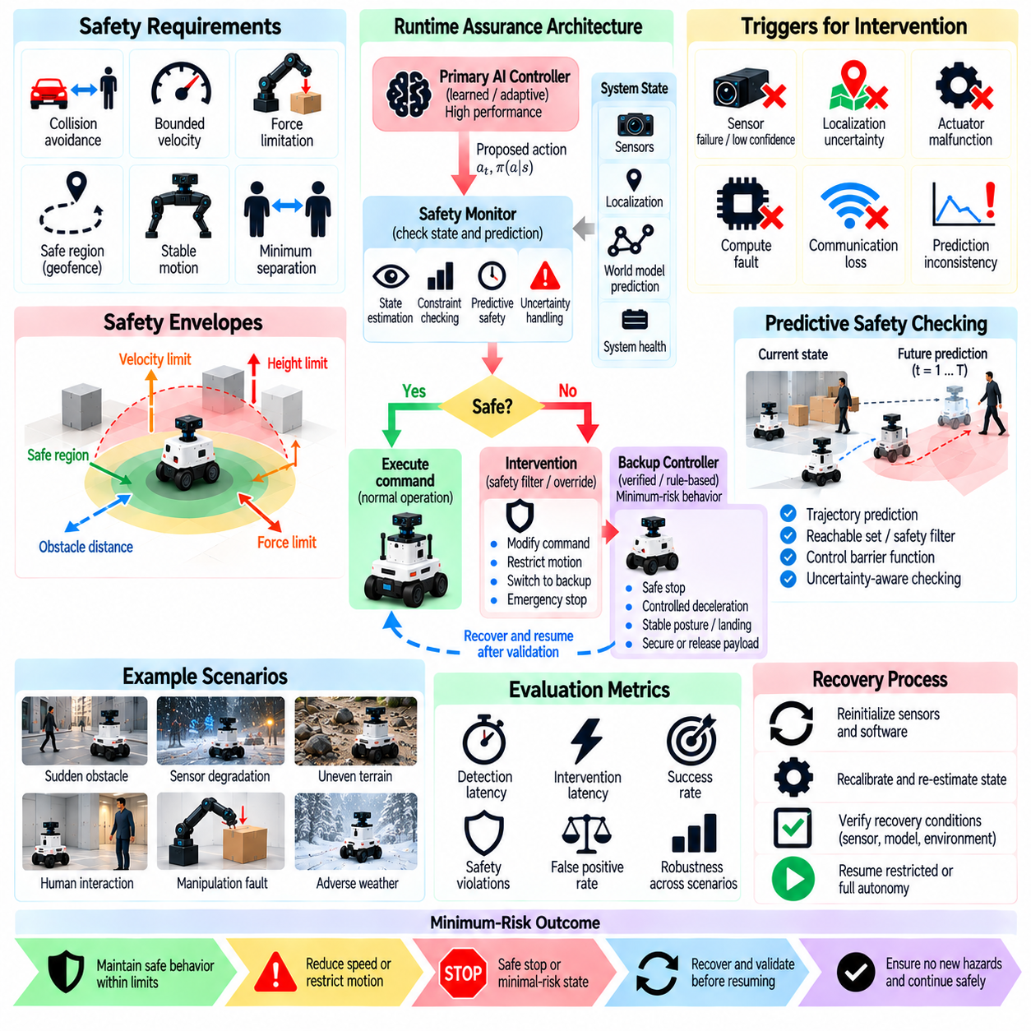
Runtime assurance effectiveness evaluates whether Physical AI systems can maintain safety while executing learned or adaptive behaviors in uncertain physical environments. Runtime assurance combines continuous monitoring, safety constraints, supervisory control, and protective intervention. Evaluation must determine whether these mechanisms recognize unsafe conditions and prevent hazardous actions without depending entirely on the correctness of the primary AI model.
Runtime assurance architectures typically separate high-performance autonomous control from independently justified safety functions. An advanced controller may optimize task performance, while a safety supervisor monitors operating boundaries and overrides unsafe commands. Evaluation should verify that this separation remains effective during model errors, software faults, and unexpected physical disturbances.
A systematic evaluation begins by defining the safety properties that runtime assurance must enforce. These properties may include collision avoidance, minimum separation, bounded velocity, force limitations, and stable motion. Each requirement should be expressed through measurable state variables and operating constraints. Testing must establish whether the monitoring and intervention mechanisms preserve these properties across relevant scenarios.
Safety monitors evaluate whether current or predicted system states approach unacceptable operating regions. Monitoring may rely on sensor observations, state estimates, dynamic models, and uncertainty bounds. Evaluation should measure the accuracy and timeliness of safety-state assessment. A monitor that correctly identifies a violation only after the robot enters a hazardous state provides insufficient protection.
Runtime assurance effectiveness depends on the reliability of the information used by safety monitors. Sensor noise, localization errors, delayed measurements, and inconsistent state estimates can distort safety assessments. Testing should introduce controlled information degradation and examine whether uncertainty is handled conservatively. Monitoring logic must not interpret unreliable measurements as evidence of safe operation.
Safety envelopes define regions of operation in which specified constraints are expected to remain satisfied. These envelopes may depend on robot speed, braking capability, obstacle proximity, actuator limits, and environmental conditions. Evaluation should verify that the envelopes reflect actual physical capabilities. Incorrectly optimistic safety boundaries can permit hazardous actions even when the monitoring logic operates as designed.
Predictive safety monitoring estimates whether proposed actions could violate constraints within a future time horizon. Methods may use reachable sets, trajectory prediction, control barrier functions, or model predictive safety filters. Evaluation should compare predicted safety margins with observed physical outcomes. Model uncertainty and computation delays must be considered when determining whether predicted safe regions remain trustworthy.
Intervention mechanisms may modify commands, restrict motion, replace unsafe actions, or transfer control to a verified backup controller. Their effectiveness depends on both the correctness of intervention decisions and the feasibility of resulting physical actions. Evaluation should measure intervention latency, control continuity, and safety constraint satisfaction. An override that creates instability may introduce a new hazard.
The Simplex architecture provides a representative runtime assurance pattern in which an advanced controller operates under supervision from a safety decision module. A verified or otherwise justified backup controller takes control when safety conditions require intervention. Evaluation should examine switching logic, backup controller capability, and recovery criteria. Safe switching must be demonstrated under realistic disturbances and timing constraints.
Control barrier functions can enforce safety conditions by constraining admissible control actions. Their effectiveness depends on valid system dynamics, feasible constraints, and accurate state information. Evaluation should examine whether safety filters remain effective under model mismatch, actuator saturation, and limited control authority. Mathematical feasibility must be supported by evidence that the physical system follows the filtered commands.
Runtime verification evaluates system execution against formally specified properties. Temporal logic, state invariants, and event-based conditions can describe acceptable behavior and prohibited transitions. Testing should examine monitor correctness, specification coverage, and response to ambiguous observations. Formal properties are valuable only when they capture relevant physical hazards and are connected to effective intervention mechanisms.
Detection-to-intervention latency is a central measure of runtime assurance effectiveness. Total response time includes sensing, state estimation, monitoring, decision-making, communication, and actuator execution. Evaluation should compare this delay with the time remaining before a hazard becomes unavoidable. Average response time is insufficient when rare latency spikes can cause safety violations.
False-positive interventions and missed detections create different operational risks. Excessive intervention can disrupt tasks, destabilize manipulation, or encourage unsafe recovery behavior. Missed detections can allow hazardous actions to proceed without restriction. Evaluation should examine both error types under representative operating conditions. Threshold selection must reflect the physical consequences of unnecessary and delayed intervention.
Runtime assurance must remain effective when primary AI models encounter out-of-distribution inputs or unreliable predictions. A learned controller may produce confident but unsafe commands under unfamiliar conditions. Evaluation should determine whether safety supervision identifies violations independently of model confidence. Protective mechanisms should enforce physical constraints even when the primary model cannot recognize its own limitations.
Compound failures can challenge the independence of runtime assurance components. A shared sensor failure, power disturbance, or communication fault may affect both the advanced controller and the safety monitor. Evaluation should identify common-cause dependencies and examine degraded supervision capability. Redundancy is valuable only when alternative components do not share the same critical failure mechanisms.
Safety intervention should be tested across different task phases and physical configurations. A robot carrying a heavy payload may require different protective actions from an unloaded robot. Manipulators interacting with humans may need controlled force reduction rather than abrupt shutdown. Evaluation must verify that intervention policies account for task context, robot dynamics, and the feasibility of minimum-risk transitions.
Repeated supervisory switching can produce oscillation between advanced and backup control modes. Such behavior may arise from noisy measurements, unstable thresholds, or rapidly changing environmental conditions. Testing should evaluate hysteresis, dwell-time constraints, and state consistency during transitions. Switching mechanisms must avoid introducing control discontinuities or excessive mechanical stress.
Fault injection enables systematic assessment of runtime assurance under abnormal conditions. Tests may introduce unsafe control commands, corrupted state estimates, delayed monitoring, actuator limitations, and unexpected obstacles. Fault magnitude, duration, and timing should be varied to reveal intervention boundaries. Evaluation must verify that protective mechanisms act before safety constraints are violated.
Simulation supports extensive runtime assurance testing across rare hazards and complex operating conditions. Hardware-in-the-loop experiments can validate timing, supervisory logic, and controller interactions. Controlled physical trials are necessary to confirm braking, contact forces, and recovery behavior. Evidence should progress from simulated correctness to demonstrated effectiveness on actual hardware.
Quantitative metrics should measure both protective performance and operational consequences. Relevant indicators include hazard detection rate, intervention latency, safety-boundary violation frequency, backup controller success, false intervention rate, and recovery reliability. Results should be stratified by fault severity and operating context. Aggregate success rates cannot establish assurance effectiveness when critical failures are concealed.
Runtime assurance evaluation must also examine specification validity and monitoring coverage. A supervisor may correctly enforce an incomplete safety specification while overlooking important hazards. Hazard analysis, scenario coverage, and independent review should identify missing constraints. Evaluation must distinguish implementation correctness from the adequacy of the safety requirements being enforced.
Ultimately, runtime assurance effectiveness determines whether independent monitoring and supervisory control can preserve essential safety properties despite failures in primary Physical AI components. Effective evaluation integrates formal requirements, fault injection, timing analysis, simulation, physical validation, and protective response assessment. The objective is demonstrable safety enforcement during operation, not merely the presence of a safety monitor.

05.16. Robustness Stress Testing Pipeline [w/Code]
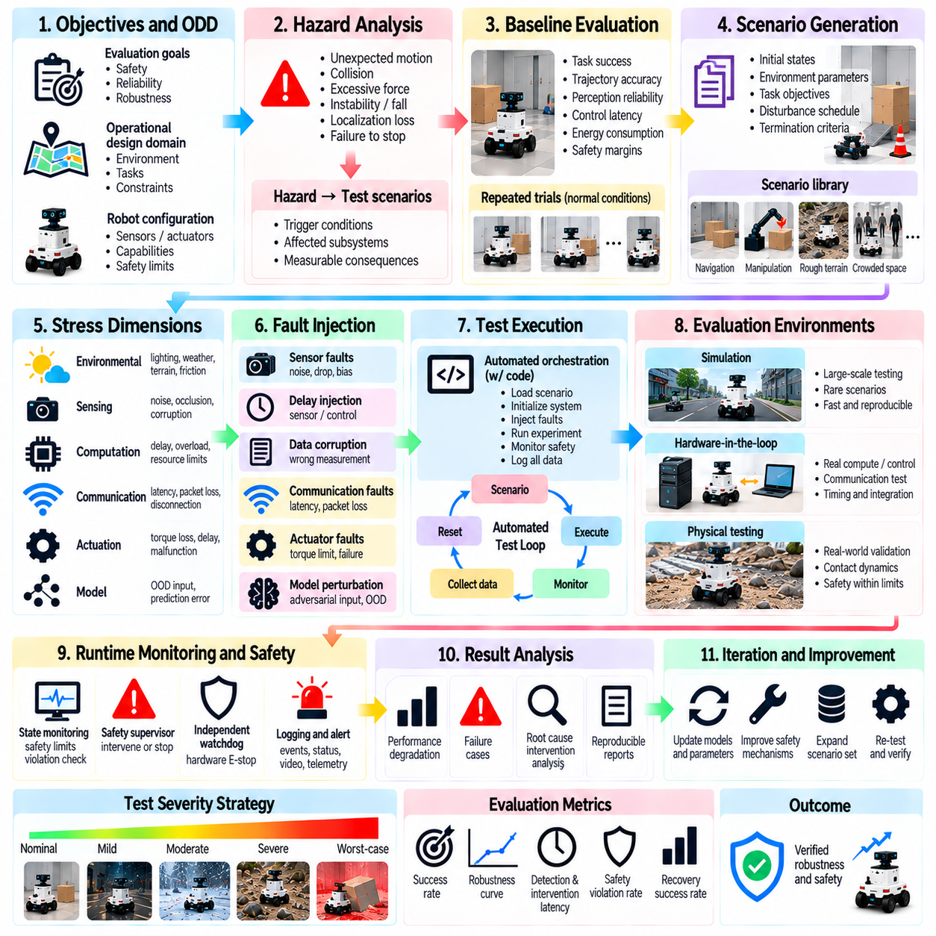
A robustness stress testing pipeline provides a systematic framework for evaluating whether Physical AI systems maintain safe and reliable behavior under disturbances, failures, and unfamiliar operating conditions. Unlike isolated tests, a pipeline integrates scenario design, fault injection, execution, measurement, and analysis. Its purpose is to identify operational limits, expose hidden vulnerabilities, and generate reproducible evidence of system robustness.
The pipeline begins with defining evaluation objectives and the operational design domain. Relevant objectives may include collision prevention, stable locomotion, safe manipulation, reliable perception, and fault-tolerant control. Environmental boundaries, task assumptions, robot capabilities, and safety constraints must be documented. These definitions establish which disturbances are meaningful and which outcomes constitute unacceptable system behavior.
Hazard analysis connects stress testing to physical safety requirements. Potential hazards include unexpected motion, excessive contact forces, unstable balance, loss of localization, and failure to stop safely. Each hazard should be associated with triggering conditions, affected subsystems, and measurable consequences. This traceability ensures that the pipeline evaluates realistic risks rather than arbitrary performance degradation.
A baseline evaluation establishes system performance under nominal operating conditions before disturbances are introduced. Baseline measurements may include task success, trajectory accuracy, perception reliability, control latency, energy consumption, and safety margins. Repeated trials characterize normal variability. Without a stable baseline, it becomes difficult to distinguish stress-induced degradation from ordinary experimental fluctuations.
Scenario generation translates identified hazards into executable test conditions. Scenarios should specify robot configuration, initial states, environmental parameters, task objectives, and disturbance schedules. Controlled variation enables comparison across experiments. Scenario descriptions must include expected safety boundaries and termination criteria so that automated testing does not introduce uncontrolled physical hazards.
Stress dimensions should cover environmental, sensing, computation, communication, actuation, and model-related disturbances. Examples include lighting changes, sensor noise, processing delays, packet loss, actuator degradation, and distribution shifts. Each dimension should have measurable severity parameters. Testing must distinguish independent perturbations from combined disturbances that produce interacting failure mechanisms.
Fault injection provides repeatable control over abnormal operating conditions. Software interfaces can introduce corrupted observations, delayed commands, missing measurements, or incorrect state estimates. Hardware experiments may reproduce physical disturbances through controlled loading or environmental exposure. Injection mechanisms should be validated to ensure that the intended fault actually reaches the relevant subsystem.
Stress severity should increase progressively from nominal conditions toward defined operating limits. Parameter sweeps can vary disturbance magnitude, duration, frequency, and onset timing. Adaptive search may concentrate trials near failure boundaries. The pipeline should identify degradation thresholds and critical transitions without unnecessarily exposing personnel or equipment to hazardous conditions.
Combined-stress scenarios are necessary because individual disturbances may appear manageable while their interactions produce serious failures. Reduced visibility combined with localization drift and communication delay may overwhelm navigation safeguards. Testing should prioritize combinations identified through hazard analysis. Exhaustive testing is rarely feasible, so scenario selection must balance coverage, severity, and operational relevance.
Simulation provides a scalable environment for exploring large scenario spaces and rare failure conditions. Automated execution can evaluate thousands of combinations while recording trajectories, sensor outputs, and controller decisions. However, simulated disturbances may not reproduce real contact dynamics or sensor artifacts. The pipeline must document simulator assumptions and validate critical findings against physical measurements.
Hardware-in-the-loop testing connects simulated disturbances with real computing hardware, control software, and communication interfaces. This stage reveals timing errors, resource contention, and supervisory failures that may remain hidden in software-only experiments. Evaluation should preserve deterministic test inputs where possible. Independent emergency protection is required when hardware outputs can influence physical actuators.
Controlled physical testing validates whether predicted robustness extends to real-world behavior. Laboratory trials may examine braking, stability recovery, contact forces, sensor degradation, and minimum-risk transitions. Test severity should progress within approved safety limits. Physical experiments must record environmental conditions and hardware configurations to support reproducibility and meaningful comparison with simulation results.
Automated orchestration coordinates scenario selection, system initialization, fault injection, execution, monitoring, and result collection. Each trial should use a defined configuration and record software versions, model checkpoints, calibration parameters, and random seeds. Automation reduces procedural inconsistency. Reliable reset mechanisms are essential because residual system states can contaminate subsequent experiments.
Runtime monitoring must remain active throughout stress testing. Independent safety monitors should detect boundary violations, unexpected motion, excessive force, and loss of control authority. Testing infrastructure must distinguish experimental fault injection from actual protective-system failures. Emergency termination conditions should take precedence over scenario completion or performance measurement objectives.
Data collection should capture synchronized observations, predictions, control commands, actuator responses, environmental states, and safety events. Accurate timestamps and consistent coordinate frames support causal reconstruction of failures. Logging should include fault injection timing and protective intervention records. Missing or misaligned data can prevent reliable diagnosis even when a hazardous event is observed.
Quantitative metrics should connect stress severity with task performance and physical safety outcomes. Relevant measures include task success rate, collision frequency, trajectory deviation, stopping distance, intervention latency, recovery success, and safety-boundary violations. Results should be stratified by disturbance type and severity. Average performance alone may conceal rare but unacceptable failures.
Robustness curves describe how system performance changes as disturbance intensity increases. A gradual decline may indicate predictable degradation, while sudden failure suggests fragile operating boundaries. Evaluation should identify critical thresholds and uncertainty around those estimates. Safety margins must be interpreted relative to the validated operating domain rather than generalized to all possible environments.
Failure analysis should reconstruct the sequence from disturbance introduction to system response and final outcome. Investigators should distinguish initiating faults, propagation mechanisms, detection failures, and ineffective protective actions. Root-cause analysis may reveal interactions across perception, prediction, planning, and control. Findings should be linked to corrective actions and repeatable regression scenarios.
Statistical confidence requires repeated trials, controlled comparisons, and explicit uncertainty estimates. Rare safety failures may not appear in small test samples, even when average success rates are high. Confidence intervals and targeted stress sampling can improve interpretation. Results from deliberately biased scenario searches must not be presented as direct estimates of real-world incident frequency.
Regression testing ensures that improvements do not introduce new robustness weaknesses. Updated models, controllers, sensors, and calibration procedures should be evaluated against versioned scenario suites. Previously discovered failures should remain part of the test library. Comparisons must account for changes in hardware, environmental conditions, and evaluation methodology before performance differences are attributed to system updates.
Pipeline outputs should support engineering decisions and safety assurance. Reports should document scenario coverage, tested operating limits, observed failure modes, protective response effectiveness, and unresolved risks. Acceptance criteria must be tied to explicit safety requirements. A successful evaluation demonstrates compliance within defined conditions rather than claiming immunity to every possible disturbance.
Ultimately, a robustness stress testing pipeline transforms fragmented safety experiments into a continuous and reproducible evaluation process. Effective implementation integrates hazard-driven scenario generation, progressive fault injection, simulation, hardware validation, automated measurement, and regression analysis. The objective is to establish credible robustness boundaries and provide actionable evidence for improving the safety of deployed Physical AI systems.

