Volume 11. Physical AI Evaluation and Benchmarking

Chapter 04. Generalization Metrics

04.01. What is Generalization in Physical AI
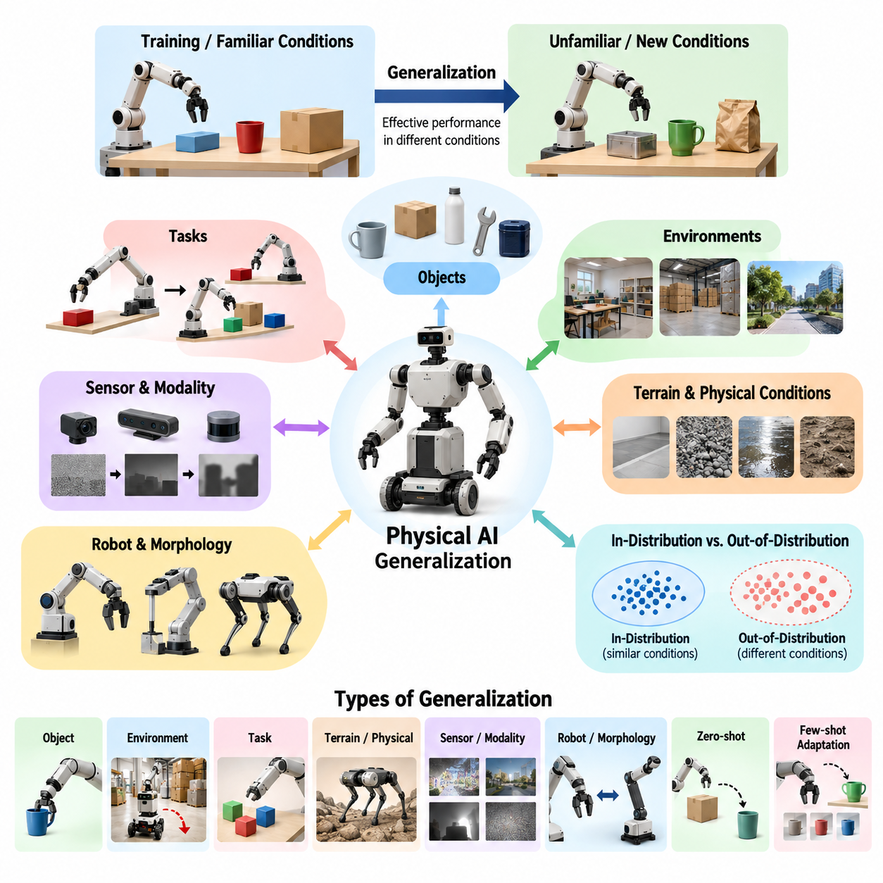
Generalization in Physical AI refers to the ability of an intelligent physical system to perform effectively in situations that differ from those encountered during training, development, or validation. Unlike conventional software, Physical AI must interact with uncertain environments through sensors, actuators, and physical dynamics. Generalization therefore requires successful adaptation to changes in both information and physical conditions.
A Physical AI system may achieve excellent performance in a controlled laboratory while failing when deployed in unfamiliar environments. A manipulation robot trained with specific objects may struggle with different shapes, materials, or surface properties. Similarly, an autonomous mobile robot may navigate accurately in a familiar warehouse but encounter difficulties when lighting, floor friction, obstacles, or spatial layouts change.
The fundamental objective of generalization evaluation is to determine whether a system has acquired transferable capabilities rather than memorized particular training conditions. A robot that succeeds only when objects occupy familiar positions demonstrates limited generalization. A more capable system recognizes underlying relationships between objects, actions, and goals, allowing it to respond appropriately when the configuration of its environment changes.
Generalization differs from ordinary task performance because it explicitly examines behavior beyond previously experienced conditions. Task performance measures how successfully a system completes a defined objective, whereas generalization measures how well that performance transfers across variations. Consequently, a meaningful evaluation must consider both the original operating conditions and the distribution of new conditions introduced during testing.
The distinction between in-distribution and out-of-distribution evaluation provides an essential foundation for understanding generalization. In-distribution evaluation examines conditions similar to the training data, while out-of-distribution evaluation introduces meaningful differences. These differences may involve unfamiliar objects, environments, tasks, sensor characteristics, robot configurations, or combinations of previously observed factors.
Generalization in Physical AI is inherently multidimensional because physical intelligence depends on several interacting capabilities. Perception must recognize unfamiliar visual and geometric patterns, reasoning must interpret new situations, planning must identify feasible actions, and control must execute those actions under changing dynamics. A system may generalize successfully in perception while remaining limited in manipulation or locomotion.
Object generalization concerns the ability to interact with objects that were not explicitly represented during training. A robotic gripper may encounter unfamiliar containers, tools, packages, or mechanical components. Successful behavior requires more than visual recognition because the robot must estimate relevant physical properties, identify appropriate contact regions, and adjust its manipulation strategy according to object geometry and interaction constraints.
Environment generalization evaluates whether a system can operate across unfamiliar scenes, layouts, and environmental conditions. Changes in illumination, texture, clutter, spatial organization, or obstacle distribution may influence perception and decision-making. For mobile robots, this capability is especially important because operational environments rarely remain identical to the configurations represented in training datasets.
Task generalization extends beyond recognizing unfamiliar physical conditions to executing new objectives. A robot trained to transport objects between fixed locations may be asked to reorganize materials according to unfamiliar instructions. Successful generalization requires interpreting the new goal, identifying relevant skills, and constructing an appropriate action sequence without relying exclusively on previously memorized task trajectories.
Terrain and physical-condition generalization are particularly important for mobile and legged robots. Variations in slope, friction, compliance, surface irregularity, and environmental disturbances can substantially alter system dynamics. A locomotion policy that performs reliably on smooth laboratory floors may fail on gravel, wet surfaces, or deformable ground unless it can adapt its motion to unfamiliar physical interactions.
Sensor and modality generalization addresses changes in the information available to the system. Camera exposure, sensor noise, calibration errors, partial occlusion, and changes in sensing hardware can affect the quality of observations. A generalizable Physical AI system should maintain useful performance under reasonable sensing variations while recognizing when insufficient information prevents reliable decision-making or safe execution.
Robot and morphology generalization examines whether learned capabilities transfer between physical platforms with different structures. A manipulation strategy developed for one robotic arm may require adaptation when transferred to another arm with different joint limits, reachability, or gripper characteristics. Cross-embodiment generalization is particularly challenging because identical task objectives may require substantially different physical actions.
Zero-shot generalization describes successful performance in an unfamiliar situation without additional task-specific training or adaptation. Few-shot adaptation instead permits a limited amount of new experience before evaluating performance. These capabilities represent different aspects of flexibility: zero-shot evaluation measures immediate transfer, while few-shot evaluation measures how efficiently a system can improve after encountering a new environment or task.
Compositional generalization involves combining previously learned concepts or skills in unfamiliar arrangements. A robot may independently learn to locate objects, open containers, and place items into designated regions. A new task requiring these capabilities in an unfamiliar sequence tests whether the system can recombine its knowledge rather than depend on complete action sequences reproduced from training examples.
Systematic and causal generalization require deeper understanding of relationships that remain meaningful across changing conditions. A system relying on superficial visual correlations may fail when object appearances change. A system that represents causal relationships between forces, contacts, motions, and outcomes can potentially select appropriate actions despite unfamiliar appearances, provided its learned physical assumptions remain applicable.
Generalization must also be distinguished from robustness, although the two concepts overlap. Robustness generally concerns maintaining acceptable performance under disturbances, uncertainty, or component degradation. Generalization emphasizes successful behavior across changes in the task or operating distribution. A system may tolerate substantial sensor noise yet fail on unfamiliar objects, demonstrating robustness without broad generalization.
The generalization gap provides a quantitative indication of how performance changes between familiar and unfamiliar evaluation conditions. It may be expressed as the difference between in-distribution and out-of-distribution success rates, although other measures are possible. A small gap can indicate successful transfer, but it must be interpreted alongside absolute performance because consistently poor performance can also produce a small difference.
Performance degradation curves provide additional information by examining how system behavior changes as evaluation conditions become increasingly different or difficult. For example, navigation success may be measured across progressively greater obstacle densities or localization disturbances. Such curves help identify the operating boundaries within which a Physical AI system maintains acceptable performance and where reliability begins to deteriorate.
A rigorous generalization benchmark must control the relationship between training and testing conditions. Test environments should contain genuinely unseen variations, and evaluation data must remain isolated from model development to prevent information leakage. Without these precautions, high benchmark scores may reflect repeated exposure, memorization, or benchmark-specific optimization rather than transferable physical intelligence.
Statistical reliability is essential because physical experiments are affected by randomness, environmental variability, and hardware uncertainty. Generalization claims should therefore rely on repeated trials across diverse scenarios, with uncertainty estimates and clearly defined success criteria. Reporting only average performance may conceal severe failures in particular environments, object categories, or operating conditions that matter for deployment.
Generalization evaluation should also examine efficiency, safety, and recovery behavior rather than task completion alone. A robot may eventually complete an unfamiliar task while consuming excessive energy, requiring repeated interventions, or producing unsafe motions. A comprehensive assessment considers execution quality, adaptation cost, failure frequency, and the ability to recognize situations beyond the system's reliable operating capabilities.
Simulation provides a scalable environment for evaluating generalization across many controlled variations. Domain randomization can systematically modify geometry, appearance, dynamics, and sensor characteristics to create diverse test conditions. However, simulation results must be interpreted carefully because simplified physical models may not reproduce the contact dynamics, material behavior, and unpredictable disturbances encountered in real environments.
Real-world evaluation remains necessary to determine whether apparent generalization translates into practical capability. Laboratory tests can establish controlled comparisons, while field experiments expose systems to naturally occurring variability. Combining simulation, laboratory testing, and operational deployment provides complementary evidence about the extent to which learned behaviors transfer beyond their original development conditions.
Generalization is especially important for vision-language-action models and generalist robot policies because these architectures aim to connect diverse observations, instructions, and physical actions. Their evaluation should distinguish linguistic understanding from successful physical execution. Correctly interpreting an unfamiliar instruction does not demonstrate complete generalization unless the robot can safely and effectively accomplish the corresponding task.
Ultimately, generalization defines a central dimension of progress toward broadly capable Physical AI. A truly generalizable system must transfer knowledge across objects, environments, tasks, sensing conditions, and physical embodiments while maintaining reliable interaction with the world. Measuring this capability requires multidimensional benchmarks that reveal not only where a system succeeds, but also the conditions under which its intelligence ceases to transfer.

04.02. In Distribution vs Out of Distribution Evaluation
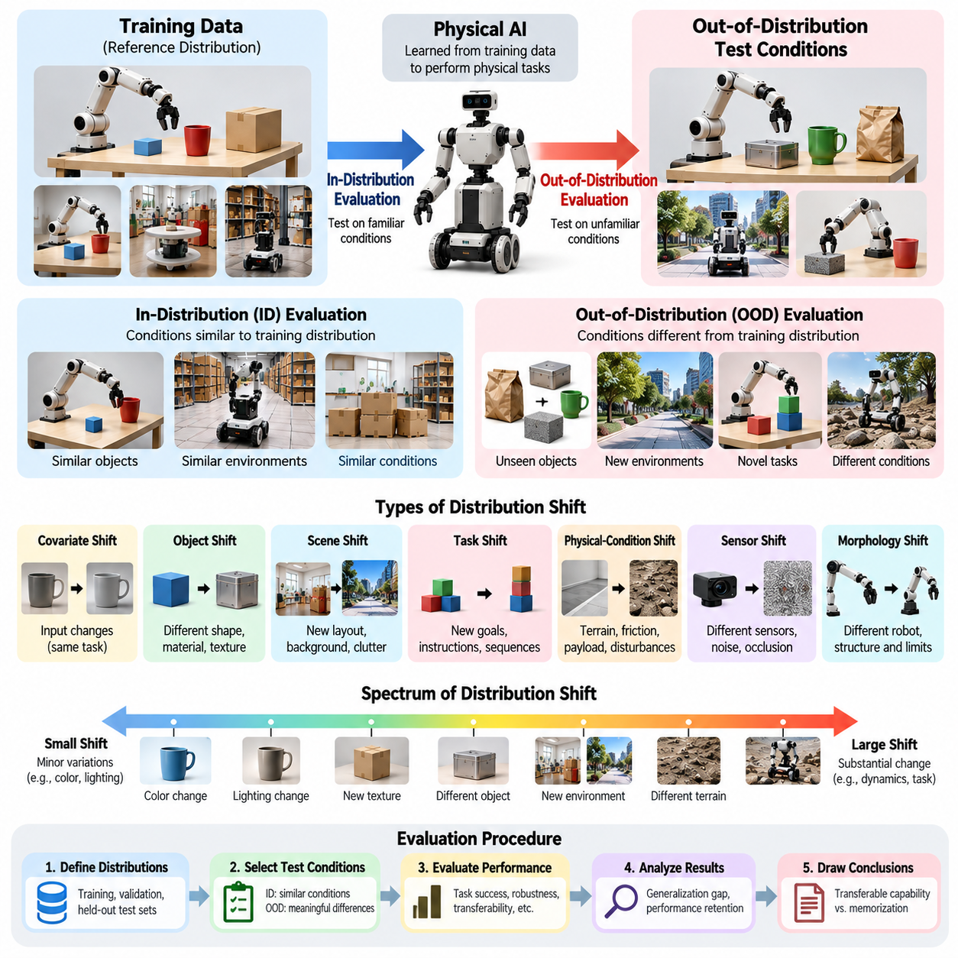
In-distribution and out-of-distribution evaluation are fundamental approaches for measuring how Physical AI systems perform under familiar and unfamiliar conditions. In-distribution evaluation examines scenarios statistically similar to those represented during training, while out-of-distribution evaluation introduces meaningful differences. Together, these approaches reveal whether a system has learned transferable physical capabilities or depends on specific training conditions.
In-distribution evaluation, commonly abbreviated as ID evaluation, measures performance within the expected range of training experiences. A warehouse robot trained on particular layouts, lighting conditions, and obstacle patterns may be tested using different configurations drawn from the same environment distribution. Such testing establishes baseline competence and helps determine whether the system has successfully learned its intended operational behaviors.
Out-of-distribution evaluation, commonly abbreviated as OOD evaluation, examines performance when test conditions differ from the training distribution. These differences may involve unfamiliar objects, new environments, altered sensor characteristics, unexpected physical properties, or novel task combinations. OOD evaluation is essential because real-world deployment frequently exposes Physical AI systems to situations that cannot be fully represented during development.
The distinction between ID and OOD conditions is not always absolute. Environmental differences exist along a continuum, ranging from minor variations to substantial changes in underlying dynamics or task requirements. A robot encountering a slightly different object color may experience a relatively small distribution shift, while interacting with an unfamiliar deformable object may require fundamentally different perception and control strategies.
Distribution shift refers to a change in the statistical properties of observations, actions, environmental states, or task outcomes between training and evaluation. In Physical AI, such shifts may affect visual appearance, geometry, contact dynamics, motion patterns, and sensor measurements. Evaluating these changes requires understanding not only the input data distribution but also the physical processes that generate observations and determine action consequences.
Covariate shift occurs when the distribution of input observations changes while the relevant conditional relationship between inputs and outcomes remains approximately stable. For example, a navigation system may encounter different lighting or visual textures without a corresponding change in the underlying navigation objective. Although the required behavior remains similar, altered observations may reduce perception accuracy and subsequently affect planning and control.
Other distribution shifts may change the relationship between observations, actions, and outcomes. A robotic manipulator operating with unfamiliar friction coefficients or object masses may experience different physical responses to previously successful actions. These changes cannot always be addressed through visual invariance alone because the system must account for altered dynamics, contact forces, and interaction constraints.
Object-level OOD evaluation investigates whether a robot can interact with objects excluded from its training experience. Evaluation objects may differ in shape, size, material, texture, or mechanical properties. A manipulation benchmark should distinguish superficial appearance changes from variations that alter grasp stability or required contact forces, since these conditions represent different levels of physical generalization difficulty.
Scene-level OOD evaluation examines unfamiliar spatial arrangements, background structures, obstacle configurations, and environmental complexity. A mobile robot trained in structured corridors may encounter crowded workspaces or irregular passages during testing. Successful performance requires maintaining reliable perception, localization, and navigation despite changes in the spatial patterns encountered during training.
Task-level OOD evaluation introduces unfamiliar objectives, instructions, or action sequences. A robot trained to pick and place individual objects may be asked to sort multiple objects according to new criteria. This evaluation determines whether the system can interpret new goals and recombine previously acquired capabilities rather than simply reproduce memorized task trajectories.
Physical-condition OOD evaluation addresses changes in terrain, friction, payload, compliance, temperature, and external disturbances. These variations are particularly important because physical systems must satisfy real mechanical constraints. A locomotion controller that succeeds on rigid laboratory surfaces may behave differently on slippery or deformable terrain, even when the visual appearance of the environment remains similar.
Sensor-level OOD evaluation considers changes in camera characteristics, calibration, noise, occlusion, and sensor availability. Such variations may arise from hardware replacement, environmental interference, or progressive sensor degradation. Testing should determine whether the system maintains acceptable performance, adapts to altered observations, or recognizes when insufficient information prevents reliable operation.
A rigorous evaluation protocol begins by defining the reference training distribution and the intended operational design domain. Researchers must identify which environmental factors, object properties, task configurations, and robot characteristics are represented during training. Without this information, claims about out-of-distribution performance become ambiguous because the degree of novelty cannot be established consistently.
Evaluation datasets should separate familiar and unfamiliar conditions while preventing leakage between training, validation, and testing. Merely assigning different random samples to each dataset does not guarantee meaningful OOD evaluation. If the same objects, environments, or underlying configurations appear across partitions, measured performance may reflect memorization rather than successful generalization.
Controlled distribution shifts provide a practical method for isolating generalization capabilities. Researchers can vary one factor, such as lighting intensity or object mass, while keeping other conditions approximately constant. This approach helps identify which changes cause performance degradation. However, combined shifts must also be tested because real environments frequently introduce several unfamiliar factors simultaneously.
OOD difficulty should be characterized systematically rather than treated as a single binary condition. Evaluation scenarios may be organized according to increasing novelty, environmental complexity, or physical difficulty. Performance measured across these levels reveals degradation patterns and helps distinguish systems that tolerate moderate changes from those capable of handling substantially unfamiliar operating conditions.
Task success rate is a common metric for comparing ID and OOD performance. The generalization gap can be calculated as the difference between success rates under familiar and unfamiliar conditions. For example, a system achieving 95 percent success in ID scenarios and 70 percent success in OOD scenarios exhibits a 25-percentage-point gap, indicating reduced reliability under the tested distribution shift.
Absolute OOD performance must be considered alongside the generalization gap. A system with low success rates in both conditions may exhibit a small gap without demonstrating meaningful competence. Conversely, a highly capable system may experience a measurable decline while still outperforming alternatives. Therefore, evaluation should report ID performance, OOD performance, and their relationship rather than relying on a single aggregate score.
Performance degradation curves extend this analysis by measuring outcomes across progressively stronger distribution shifts. A navigation benchmark may increase obstacle density, while a manipulation benchmark may vary object mass or friction. Such curves reveal how quickly performance deteriorates and provide evidence about the boundaries of reliable operation under increasingly unfamiliar conditions.
OOD evaluation should measure execution quality in addition to task completion. Relevant indicators include completion time, trajectory deviation, energy consumption, collision frequency, intervention rate, and recovery effectiveness. A robot may complete an unfamiliar task while exhibiting inefficient or unsafe behavior, making success rate alone insufficient for assessing practical generalization.
Uncertainty estimation is another important component of OOD evaluation. A Physical AI system should ideally recognize when observations or operating conditions differ substantially from its experience. Confidence calibration, novelty detection, and uncertainty-aware decision-making can help identify situations requiring cautious behavior, additional sensing, human assistance, or controlled fallback procedures.
Simulation enables scalable OOD testing by generating diverse environments and systematically modifying physical parameters. Domain randomization can produce variations in appearance, geometry, dynamics, and sensor behavior. Nevertheless, simulation-based OOD performance does not guarantee real-world generalization because simulated interactions may omit complex material properties, hardware imperfections, and unmodeled disturbances.
Real-world OOD evaluation provides stronger evidence of operational generalization by exposing systems to naturally occurring variability. Controlled laboratory experiments can isolate individual shifts, while field testing reveals interacting environmental factors. Combining both approaches allows researchers to investigate specific failure mechanisms and determine whether observed generalization extends to practical deployment conditions.
Statistical rigor is essential when comparing ID and OOD results. Repeated trials, representative scenario sampling, confidence intervals, and consistent experimental procedures help distinguish systematic degradation from random variation. Results should also be reported by shift category because aggregate scores can conceal severe weaknesses in particular objects, environments, or physical conditions.
Ultimately, ID and OOD evaluation provide complementary evidence about Physical AI capability. ID testing establishes competence within familiar conditions, while OOD testing examines transfer beyond those conditions. A comprehensive evaluation framework must characterize distribution shifts, quantify performance degradation, assess uncertainty and safety, and identify operational boundaries to support reliable deployment in changing physical environments.

04.03. Unseen Object Generalization
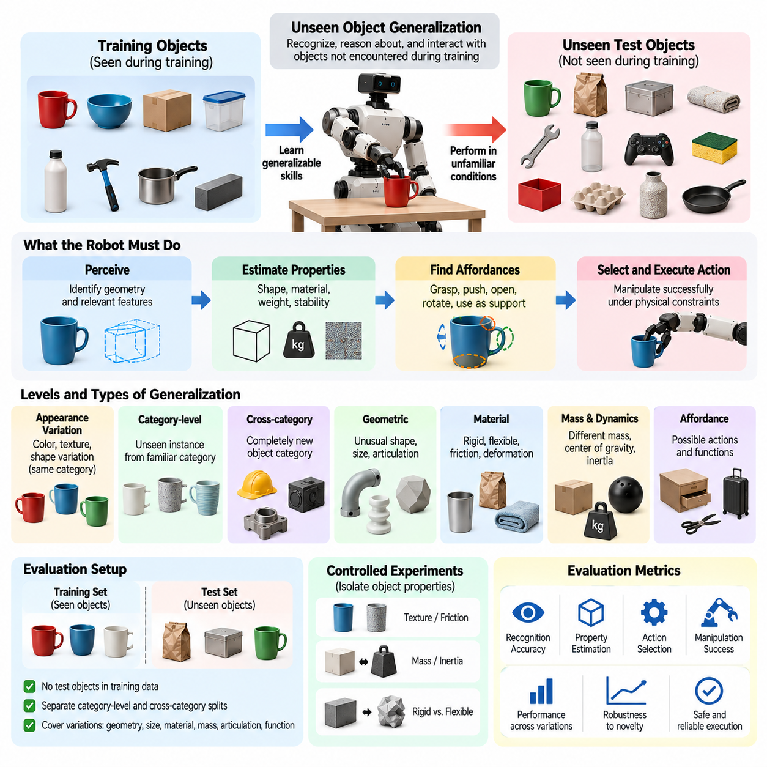
Unseen object generalization refers to the ability of a Physical AI system to recognize, reason about, and interact with objects that were not encountered during training. This capability is essential for robots operating in open environments where object identities, geometries, materials, and physical properties continuously vary. Evaluation must determine whether learned skills transfer to unfamiliar objects without relying on memorized appearances or predefined manipulation procedures.
Traditional robotic systems often depend on explicitly modeled objects or narrowly defined object categories. Such approaches can achieve high reliability in controlled environments but may struggle when encountering unfamiliar items. Generalist Physical AI aims to overcome this limitation by learning representations and interaction strategies that remain useful across diverse objects, including those excluded from the original training distribution.
Unseen object generalization involves more than recognizing a new object through visual perception. A robot must identify relevant geometric features, estimate physical properties, understand possible interactions, and select actions appropriate to the task. For example, successfully grasping an unfamiliar container requires estimating its shape, potential contact surfaces, weight distribution, and stability during lifting.
Object novelty can occur at several levels, ranging from appearance variations to fundamentally different physical structures. A familiar object category with an unfamiliar color represents a relatively limited shift, whereas an object with unusual geometry or deformation behavior introduces greater difficulty. Evaluation protocols should distinguish these novelty levels because they challenge different aspects of perception, reasoning, and physical control.
Category-level generalization examines whether a robot can handle previously unseen instances belonging to familiar semantic categories. A manipulation system trained with several types of cups may encounter a new cup with different dimensions, handle geometry, or surface texture. Successful performance indicates that the system has learned transferable category characteristics rather than memorizing individual training objects.
Cross-category generalization presents a more demanding challenge by introducing objects from semantic categories absent during training. A robot familiar with containers and household tools may be required to manipulate an unfamiliar industrial component. Successful interaction depends on identifying task-relevant physical properties and affordances rather than relying exclusively on previously learned semantic labels.
Geometric generalization concerns the ability to interpret unfamiliar shapes, dimensions, and spatial structures. Object geometry influences grasp selection, collision avoidance, placement stability, and manipulation trajectories. Evaluation should examine whether a robot can adapt its actions to irregular, asymmetric, articulated, or unusually proportioned objects while respecting physical constraints and maintaining task accuracy.
Material generalization addresses changes in surface properties, stiffness, friction, and deformation characteristics. Two objects with similar geometry may require substantially different manipulation strategies when one is rigid and the other is flexible. A robot must account for these differences through sensing, physical interaction, or learned predictions to avoid slipping, excessive deformation, or unstable contact.
Mass and inertia generalization are particularly important for dynamic manipulation. Objects with similar appearances may have different masses, centers of gravity, or rotational inertia. These differences influence required forces, acceleration limits, and motion stability. A generalizable controller should adjust its actions when unfamiliar objects respond differently from those represented in training.
Affordance generalization examines whether a system can infer possible actions from unfamiliar object properties. A robot may identify that an unknown object can be grasped, pushed, rotated, opened, or used as a support. Such reasoning connects perception with functional interaction and allows the system to select actions based on physical possibilities rather than object identity alone.
Unseen object evaluation should distinguish visual recognition from successful physical interaction. A system may correctly identify an unfamiliar object category while failing to grasp or manipulate the object. Conversely, a robot may successfully manipulate an object without knowing its semantic name. Therefore, benchmarks should separately measure recognition, property estimation, action selection, and execution outcomes.
A rigorous benchmark requires explicit separation between training objects and evaluation objects. Object instances reserved for testing should not appear in training demonstrations, synthetic datasets, or validation procedures. Category-level and cross-category splits should also be documented because an unseen instance from a familiar category represents a different generalization challenge from an entirely unfamiliar category.
Object datasets should cover meaningful variations in geometry, size, texture, material, mass, articulation, and functional properties. Randomly selecting objects without considering these characteristics may produce unbalanced evaluation conditions. A structured object taxonomy helps researchers identify which dimensions of novelty are being tested and whether the benchmark represents realistic deployment requirements.
Controlled experiments can isolate individual object properties while holding other conditions approximately constant. For example, researchers may compare objects with similar geometry but different surface friction or objects with similar mass but different shapes. Such experiments help determine whether performance degradation originates from perception, physical modeling, grasp planning, or feedback control.
Combined object variations are equally important because real environments rarely change one property at a time. An unfamiliar object may simultaneously exhibit unusual geometry, reflective surfaces, uncertain mass, and deformable components. Evaluating these combinations reveals whether a Physical AI system can coordinate perception, reasoning, and control under interacting sources of uncertainty.
Task success rate provides a basic measure of unseen object generalization. It can be calculated as the proportion of successful interactions across held-out evaluation objects. However, success criteria must be defined according to the task, such as stable grasping, accurate placement, successful tool use, or completion of an object assembly operation without damaging the object or surrounding environment.
The unseen object generalization gap compares performance on familiar training-distribution objects with performance on held-out objects. A large gap indicates that learned capabilities transfer poorly to unfamiliar object conditions. Nevertheless, absolute performance must also be reported because a small gap does not necessarily demonstrate strong generalization when both familiar and unfamiliar object success rates are low.
Execution quality provides additional evidence beyond binary task completion. Relevant measures include grasp stability, placement accuracy, contact force, object damage, task duration, energy consumption, and recovery attempts. A robot that successfully manipulates unfamiliar objects only through repeated unstable contacts may exhibit lower practical generalization than one that completes the same tasks efficiently and consistently.
Zero-shot unseen object generalization evaluates performance without additional object-specific training. Few-shot adaptation permits a limited number of demonstrations or interactions before testing. Comparing these settings reveals whether a system can immediately transfer existing knowledge or requires additional experience to estimate unfamiliar physical properties and develop effective manipulation strategies.
Active perception and exploratory interaction can improve generalization when object properties are uncertain. A robot may reposition its camera, inspect an object from multiple viewpoints, or apply a small controlled force to estimate compliance or mass-related behavior. Evaluation should consider whether such exploratory actions improve task success while remaining efficient and within appropriate safety limits.
Simulation provides a scalable method for generating diverse object variations and evaluating manipulation policies. Procedural geometry, material randomization, and physics-based interaction models can expose systems to combinations that are difficult to collect physically. However, simulated object behavior may differ from real contact dynamics, particularly for friction, deformation, and complex material interactions.
Real-world testing is therefore essential for validating unseen object generalization. Physical evaluation should include representative objects with measured properties, consistent experimental procedures, and repeated trials. Testing across different robot platforms and sensing configurations can further reveal whether observed generalization depends on a particular embodiment or reflects more transferable physical capabilities.
Statistical analysis should report performance across object categories, novelty levels, and physical property ranges. Aggregate success rates may conceal severe weaknesses involving transparent, reflective, deformable, or unusually shaped objects. Confidence intervals and repeated trials help distinguish systematic limitations from experimental variability and support meaningful comparisons between different Physical AI systems.
Ultimately, unseen object generalization is a central indicator of transferable physical intelligence. A capable Physical AI system must move beyond memorized object identities toward representations that capture geometry, material behavior, affordances, and interaction dynamics. Comprehensive evaluation should identify both successful transfer and failure boundaries, providing a foundation for reliable manipulation in diverse and continuously changing environments.

04.04. Unseen Scene and Environment Generalization
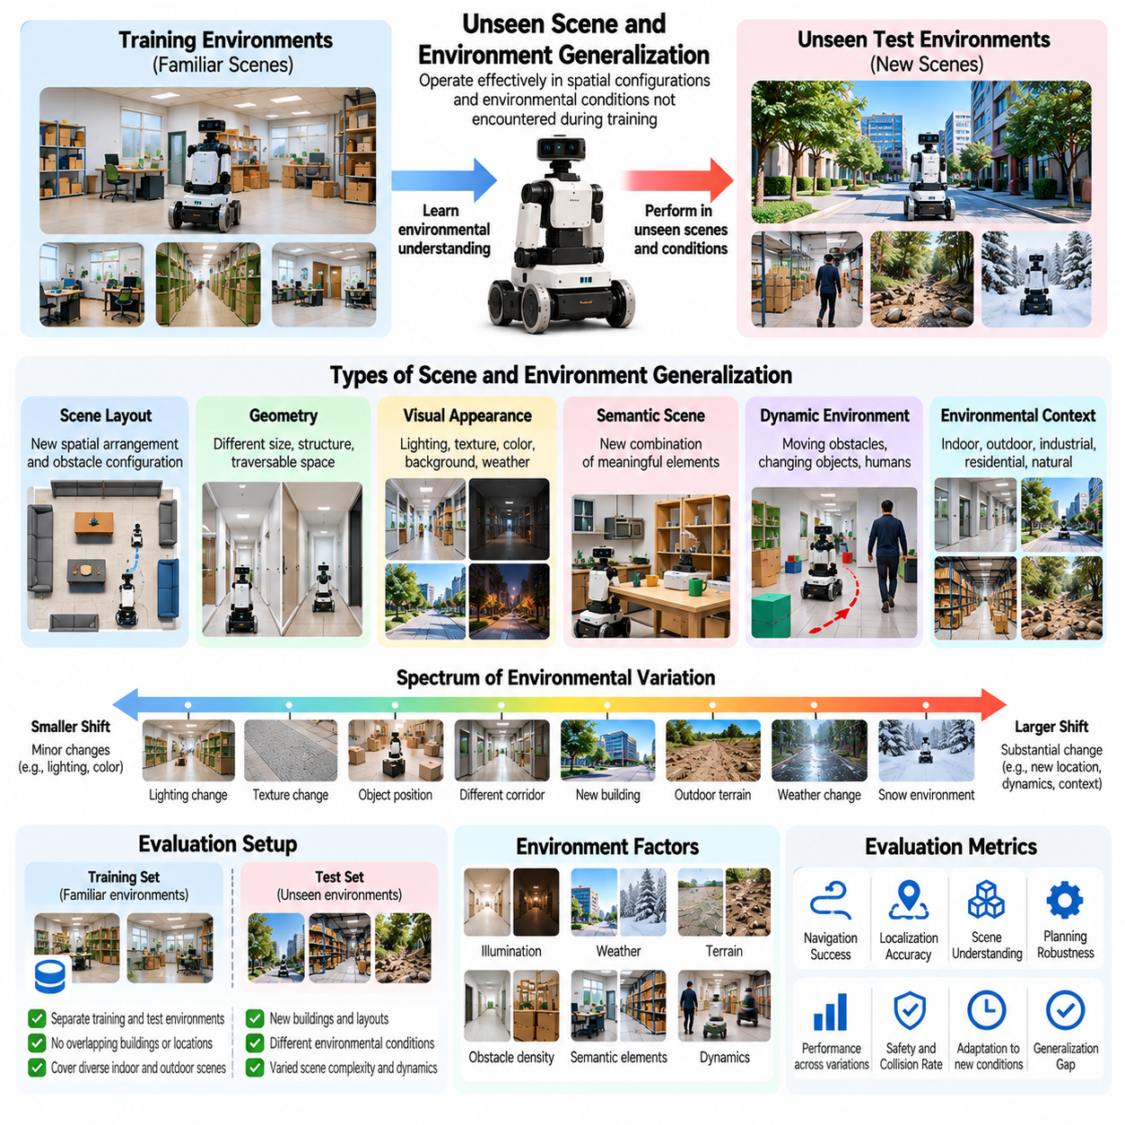
Unseen scene and environment generalization refers to the ability of Physical AI systems to operate effectively in spatial configurations and environmental conditions not encountered during training. Unlike object generalization, which focuses on unfamiliar items, environment generalization examines changes in entire scenes, including geometry, layout, appearance, obstacles, and contextual relationships. It is essential for deploying autonomous systems beyond controlled development settings.
A Physical AI system may achieve excellent performance in familiar environments while failing when deployed in a new building, warehouse, outdoor location, or industrial facility. Such failures often arise because learned policies depend on specific visual patterns or spatial arrangements. Generalization evaluation determines whether the system has acquired transferable environmental understanding rather than memorized maps, landmarks, or navigation trajectories.
Scene generalization involves recognizing and interpreting unfamiliar arrangements of otherwise familiar elements. A robot may encounter known objects positioned in unexpected locations, corridors with different dimensions, or workspaces with new obstacle configurations. Successful behavior requires understanding spatial relationships and physical constraints while adapting perception, planning, and control to the new arrangement.
Environment generalization extends beyond scene layout to variations in illumination, weather, surface appearance, background complexity, and operational context. A navigation policy trained in bright indoor conditions may experience reduced reliability under dim lighting or strong reflections. Evaluation should determine whether environmental changes affect perception alone or propagate into localization, decision-making, and physical execution.
Geometric generalization concerns the ability to interpret unfamiliar spatial structures and maintain accurate motion planning. Differences in corridor width, doorway dimensions, obstacle density, and workspace boundaries may require substantial behavioral adjustments. A generalizable robot must reason about traversability, collision constraints, and reachable regions without relying exclusively on previously encountered geometric configurations.
Visual appearance generalization evaluates sensitivity to changes in textures, colors, lighting, shadows, and background patterns. These variations may alter camera observations without changing the underlying physical structure. A system that relies on superficial visual correlations may fail despite unchanged task requirements, whereas a stronger system maintains representations that preserve task-relevant geometric and semantic information.
Semantic scene generalization examines whether a robot can interpret unfamiliar combinations of meaningful environmental elements. For example, a mobile manipulator may encounter a workstation containing familiar tools arranged in a previously unseen configuration. Successful generalization requires recognizing functional relationships between objects, surfaces, and accessible regions rather than reproducing memorized scene templates.
Dynamic environment generalization introduces moving obstacles, changing object positions, and unpredictable human activities. A robot operating in a warehouse may encounter temporary storage areas, mobile equipment, or unexpected pedestrian traffic. Evaluation must determine whether the system can continuously update its environmental representation and adapt its actions without depending on static assumptions.
Indoor environment generalization is particularly relevant to service robots, autonomous mobile robots, and industrial automation. Different buildings may exhibit unfamiliar floor plans, doorway arrangements, reflective surfaces, and navigation constraints. Evaluation should include buildings excluded from training, ensuring that successful navigation reflects transferable spatial reasoning rather than repeated exposure to specific locations.
Outdoor environment generalization introduces additional complexity through variable terrain, weather, vegetation, natural obstacles, and changing illumination. Autonomous ground vehicles and field robots must handle environments with less predictable structure than controlled indoor facilities. Evaluation should examine whether perception, localization, traversability estimation, and motion control remain reliable across unfamiliar outdoor scenes.
Unseen environment evaluation must distinguish between changes in appearance and changes in physical functionality. A corridor with different wall colors may present a visual distribution shift without altering traversability. Conversely, a visually familiar pathway with slippery flooring or unexpected obstacles may require different control decisions. These distinctions help identify which aspects of environmental novelty challenge the system.
A rigorous benchmark should explicitly separate training environments from evaluation environments. Different camera viewpoints within the same building do not necessarily constitute independent unseen environments. Stronger evaluation protocols reserve entire buildings, geographical locations, scene layouts, or procedurally generated environment families for testing, reducing the possibility of environmental memorization.
Scene diversity should be characterized through measurable factors such as spatial complexity, obstacle density, illumination range, semantic composition, and environmental dynamics. Randomly selecting test scenes without controlling these properties may create inconsistent difficulty levels. Structured environment taxonomies help researchers identify which dimensions of novelty are represented and whether evaluation conditions reflect intended deployment scenarios.
Controlled scene variation enables systematic investigation of individual generalization factors. Researchers may modify lighting while preserving geometry or rearrange obstacles while maintaining similar visual appearance. Such experiments help distinguish failures originating from perception, localization, planning, or control. Combined variations are also necessary because real deployments frequently introduce several unfamiliar conditions simultaneously.
Environment novelty should be evaluated across progressively increasing levels of difficulty. Initial tests may introduce minor visual changes, followed by unfamiliar layouts, increased clutter, and dynamic disturbances. Performance degradation across these levels reveals the limits of transferable environmental competence and helps identify conditions requiring additional training, adaptation, or operational restrictions.
Task success rate provides a fundamental measure of unseen environment generalization. For navigation, success may require reaching a destination without collisions or prohibited interventions. For manipulation, success may involve completing an operation in an unfamiliar workspace. Evaluation criteria must reflect the actual mission rather than relying exclusively on intermediate perception or localization accuracy.
The environment generalization gap compares performance in familiar scenes with performance in held-out environments. A substantial decline indicates that learned capabilities depend strongly on training conditions. However, absolute performance remains important because a small gap between two low success rates does not demonstrate meaningful generalization. Both familiar and unfamiliar environment results should therefore be reported.
Additional metrics provide a more complete understanding of environmental generalization. Navigation efficiency, path length, localization error, collision frequency, recovery time, energy consumption, and human intervention rate reveal execution quality. A robot may reach its destination in an unfamiliar building while requiring excessive detours or repeated recovery actions, indicating limited operational efficiency.
Zero-shot environment generalization measures performance without additional training or environment-specific adaptation. Few-shot adaptation permits limited exploration, demonstrations, or calibration before evaluation. Comparing these settings reveals whether a system can immediately transfer its environmental understanding or requires additional experience to construct useful representations and improve operational performance.
Active perception and online mapping can support generalization in unfamiliar environments. A robot may explore unknown regions, adjust sensor viewpoints, and update spatial representations as new information becomes available. Evaluation should distinguish legitimate online mapping from prior exposure to test environments, while measuring exploration cost, map consistency, uncertainty reduction, and the resulting improvement in task execution.
Simulation provides scalable opportunities to generate diverse scenes and environmental conditions. Procedural layout generation, domain randomization, and dynamic obstacle simulation can expose systems to configurations beyond available physical test sites. Nevertheless, simulated success does not guarantee real-world generalization because rendering, sensor behavior, contact dynamics, and environmental variability may differ from reality.
Real-world evaluation remains essential for establishing operational validity. Testing across independent buildings, facilities, and outdoor locations provides evidence that learned capabilities extend beyond development environments. Repeated trials under documented conditions help distinguish systematic weaknesses from incidental failures, while field testing reveals interactions between environmental factors that controlled experiments may overlook.
Statistical reporting should distinguish performance across environment categories, novelty levels, and operational conditions. Aggregate success rates can conceal weaknesses in reflective corridors, crowded workspaces, low-light environments, or irregular outdoor terrain. Confidence intervals, repeated trials, and clearly defined test partitions support reproducible comparisons and more reliable conclusions about environmental generalization.
Ultimately, unseen scene and environment generalization measures whether Physical AI systems can transfer spatial understanding and physical competence beyond familiar surroundings. Reliable systems must interpret unfamiliar geometry, recognize meaningful environmental relationships, adapt to dynamic changes, and execute tasks under uncertainty. Comprehensive evaluation identifies both successful transfer and operational boundaries, supporting deployment across diverse real-world environments.

04.05. Unseen Task and Goal Generalization
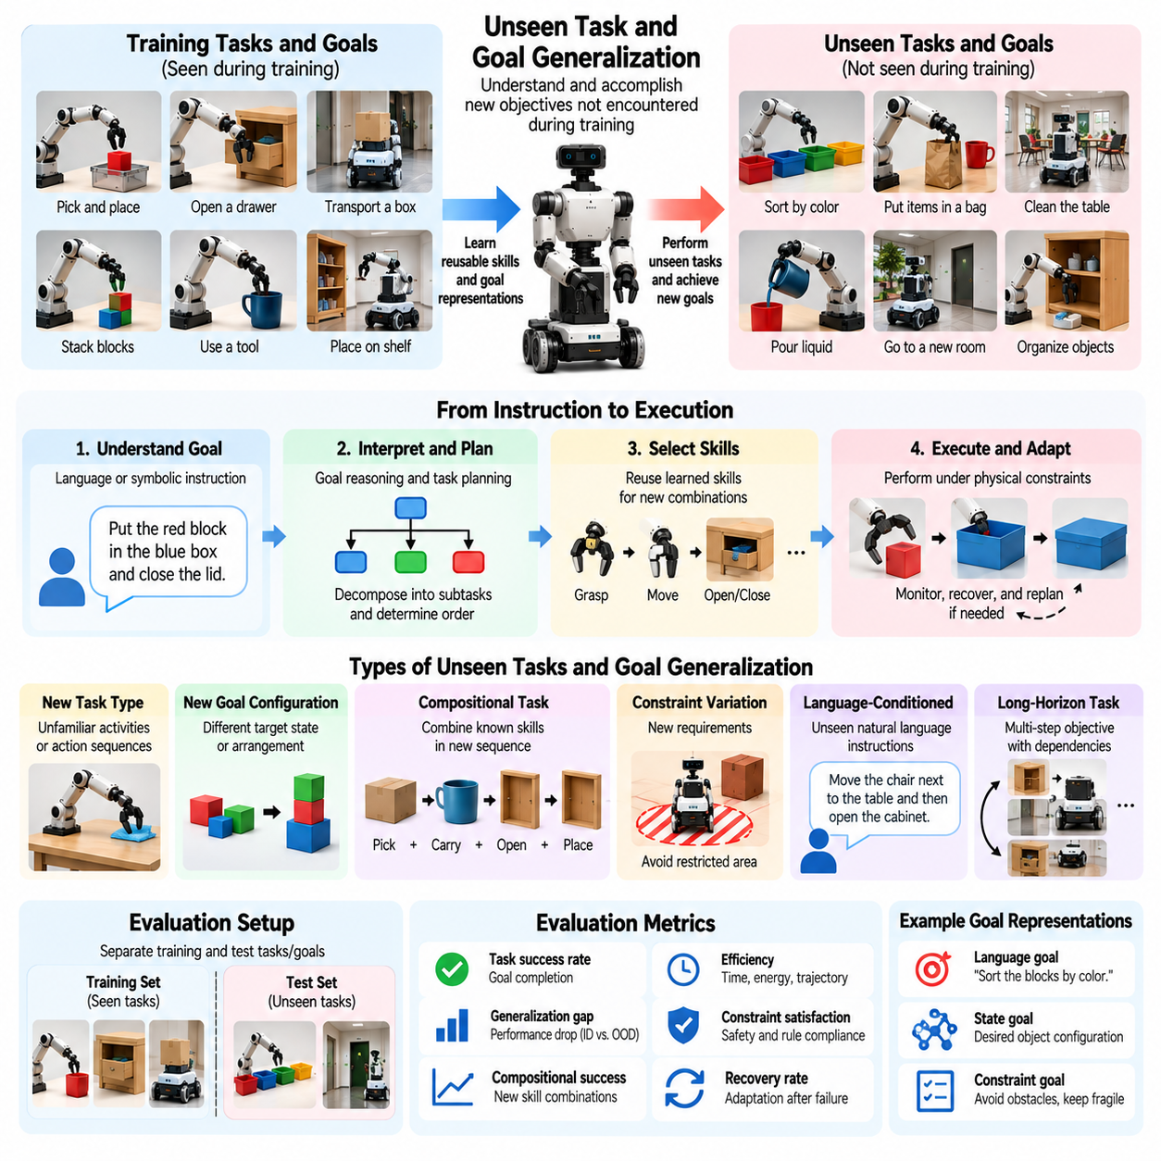
Unseen task and goal generalization refers to the ability of Physical AI systems to interpret and accomplish objectives that were not explicitly encountered during training. Unlike object or environment generalization, this capability focuses on changes in what the system must achieve rather than where or with which objects it operates. It is essential for developing autonomous agents capable of responding flexibly to evolving operational requirements.
Traditional robotic systems frequently rely on predefined task sequences, fixed objectives, and manually engineered control procedures. Such systems can perform reliably within their intended applications but often require substantial reprogramming when objectives change. Generalist Physical AI seeks to overcome these limitations by learning reusable skills, goal representations, and planning strategies that support unfamiliar tasks without complete retraining.
Task generalization and goal generalization are closely related but conceptually distinct. Task generalization concerns the ability to execute unfamiliar activities or action sequences, while goal generalization concerns achieving new desired states or outcomes. A robot may understand a familiar manipulation procedure but need to apply it toward an unfamiliar arrangement of objects, requiring flexible interpretation of the desired final state.
Unseen tasks may differ from training experiences in their required actions, temporal structure, dependencies, or environmental constraints. A robot trained to transport individual packages may be asked to organize packages according to priority and destination. Successful performance requires identifying relevant subtasks, determining their dependencies, and coordinating learned capabilities into a new execution strategy.
Goal novelty can arise even when the available action primitives remain unchanged. A manipulation robot may already know how to grasp, move, and place objects but encounter an unfamiliar target configuration. Generalization requires translating the new objective into appropriate action choices while respecting physical constraints, task dependencies, and the current state of the environment.
A central requirement is the ability to represent goals independently of specific demonstrations. Systems that associate instructions with memorized trajectories may fail when the same objective must be achieved through different actions. More generalizable systems represent desired outcomes, relevant constraints, and possible state transitions, allowing multiple action sequences to satisfy a common goal.
Language-conditioned task generalization enables robots to interpret previously unseen natural-language instructions. Vision-language-action models may connect linguistic descriptions with visual observations and physical actions. However, correctly understanding an instruction does not guarantee successful execution. Evaluation must separately examine semantic interpretation, action planning, and physical task completion.
Compositional generalization plays a major role in unfamiliar task execution. A robot may learn to locate objects, open containers, transport items, and close doors independently. An unseen task may require combining these capabilities in a new sequence. Successful composition demonstrates that learned skills can be reorganized according to changing objectives rather than reproduced only in familiar combinations.
Hierarchical planning supports generalization by decomposing unfamiliar objectives into manageable subtasks. High-level reasoning identifies desired outcomes and dependencies, while lower-level controllers execute physical actions. Evaluation should determine whether a system can construct valid task decompositions, select appropriate skills, and recover when an intermediate action fails or environmental conditions change.
Task generalization also depends on understanding preconditions and effects. Opening a cabinet may require moving an obstacle before accessing its handle, while placing an object may require clearing the destination surface. A capable system must reason about which actions are currently feasible and how their consequences affect subsequent steps, rather than executing a rigid sequence.
Causal reasoning contributes to task generalization by connecting actions with their physical consequences. A robot that understands how pushing, grasping, lifting, and releasing alter object states can potentially solve unfamiliar objectives through known interaction principles. Evaluation should examine whether successful behavior reflects meaningful action-outcome relationships rather than superficial correlations in training demonstrations.
Constraint generalization introduces unfamiliar requirements involving time, safety, resource availability, or task ordering. A robot may be asked to complete a familiar activity while avoiding restricted regions or preserving fragile objects. These changes can transform the planning problem even when the basic skills remain unchanged. Evaluation should measure both goal achievement and compliance with newly specified constraints.
A rigorous benchmark must distinguish genuinely unseen tasks from superficial variations of familiar instructions. Rephrasing a previously trained command does not necessarily create a new task. Stronger evaluation protocols reserve particular goal structures, action compositions, dependency patterns, or task families for testing, reducing the possibility that apparent generalization results from memorized examples.
Task and goal datasets should describe objectives using explicit initial states, desired final states, available actions, and relevant constraints. Such specifications make success criteria reproducible and help distinguish language understanding failures from planning or execution failures. Evaluation scenarios should include both familiar skill combinations and unfamiliar compositions requiring different degrees of reasoning.
Novelty can be organized according to increasing task complexity. Simple cases may change target objects or destinations, while more demanding cases introduce new action sequences, conditional dependencies, or multiple interacting goals. Evaluating performance across these levels reveals whether a system generalizes only to minor variations or can solve substantially different objectives.
Zero-shot task generalization measures whether a system can execute an unfamiliar objective without additional task-specific training. Few-shot adaptation permits limited demonstrations, corrections, or interactions before evaluation. Comparing these conditions reveals the extent of immediate skill transfer and the amount of experience required to acquire competence in unfamiliar tasks.
Task success rate remains a fundamental metric, but success must be defined according to the intended final outcome. For example, a sorting task should verify correct object placement rather than merely count completed grasp actions. Evaluation should also determine whether all required constraints were satisfied, since reaching a goal through prohibited or unsafe actions does not represent valid task completion.
The task generalization gap compares performance on familiar objectives with performance on held-out tasks. A large gap indicates limited transfer beyond the training distribution. However, absolute success rates and task difficulty must also be considered. A small gap may reflect uniformly weak performance, while a larger gap may occur when unfamiliar tasks require substantially more complex reasoning.
Execution quality provides additional information beyond binary success. Relevant measures include planning time, action efficiency, unnecessary movements, resource consumption, constraint violations, and recovery attempts. A robot that completes unfamiliar objectives through repeated trial and error may demonstrate weaker practical generalization than one that achieves the same outcomes efficiently and reliably.
Long-horizon task generalization introduces additional challenges because unfamiliar objectives may require extended sequences of dependent actions. Small planning or execution errors can accumulate over time, potentially preventing mission completion. Evaluation should examine subgoal consistency, progress tracking, replanning effectiveness, and the ability to maintain goal-directed behavior throughout extended operations.
Interactive adaptation can improve performance when an unfamiliar task exposes missing knowledge. A robot may request clarification, inspect relevant objects, test a safe action, or revise its plan after observing unexpected outcomes. Evaluation should measure whether these behaviors reduce uncertainty and improve task completion while limiting unnecessary interventions and maintaining operational safety.
Simulation enables large-scale evaluation of unfamiliar tasks through procedurally generated goals, action combinations, and environmental constraints. It supports controlled comparisons and systematic variation of task complexity. Nevertheless, simulated success may not transfer directly to physical environments where contact dynamics, sensing uncertainty, and execution failures introduce additional challenges.
Real-world evaluation is necessary to establish whether task and goal generalization produces reliable autonomous behavior. Physical experiments should include unfamiliar objectives, independently specified success conditions, repeated trials, and documented intervention requirements. Testing across different environments and robot platforms can further reveal whether learned task competence depends on particular physical configurations.
Statistical reporting should separate results by task novelty, goal complexity, planning horizon, and constraint difficulty. Aggregate success rates may conceal weaknesses in conditional planning, unfamiliar skill combinations, or long sequences. Confidence intervals, standardized evaluation procedures, and transparent task partitions support meaningful comparisons between Physical AI systems.
Ultimately, unseen task and goal generalization measures whether Physical AI can transform reusable knowledge into flexible goal-directed behavior. Systems with strong generalization must interpret new objectives, compose existing skills, reason about constraints, and adapt plans during physical interaction. Comprehensive evaluation identifies the boundaries of this flexibility and supports progress toward autonomous systems capable of handling diverse real-world missions.

04.06. Unseen Terrain and Condition Generalization
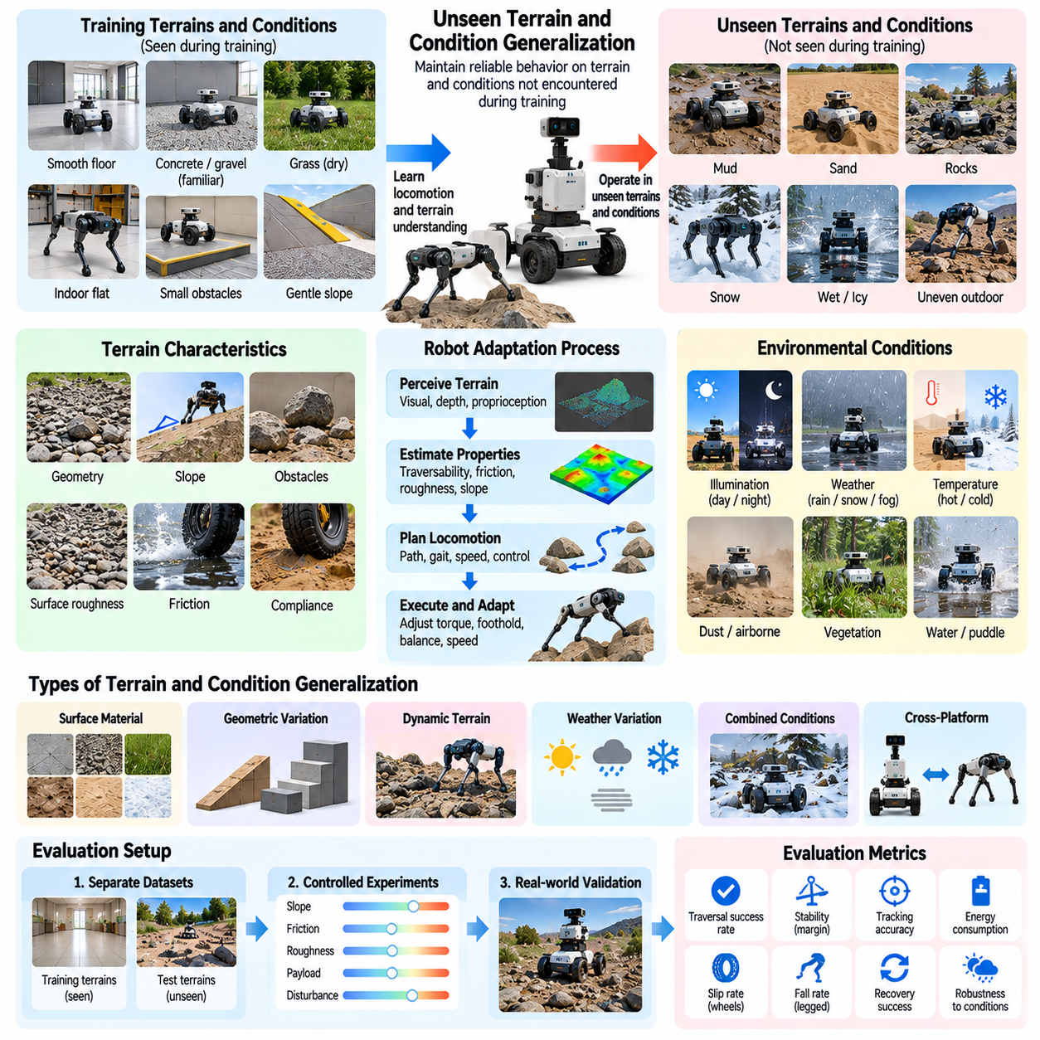
Unseen terrain and condition generalization refers to the ability of Physical AI systems to maintain reliable behavior when encountering ground surfaces and operating conditions absent from training. Terrain changes influence traction, stability, mobility, and energy consumption, while environmental conditions affect sensing and control. Evaluation determines whether a robot can adapt its physical behavior beyond familiar operating circumstances.
Terrain generalization is particularly important for autonomous mobile robots, legged robots, agricultural machines, and field robotics. A system trained on smooth indoor floors may struggle with gravel, mud, sand, grass, or irregular construction surfaces. Reliable deployment requires recognizing terrain characteristics and adjusting locomotion strategies rather than assuming that previously learned contact conditions remain valid.
Terrain novelty can involve surface geometry, material composition, friction, compliance, and structural stability. Two surfaces with similar visual appearances may produce different mechanical responses under load. Conversely, visually distinct surfaces may offer comparable traction. Evaluation must distinguish appearance-based recognition from the ability to predict actual physical interaction between the robot and terrain.
Geometric terrain generalization examines adaptation to unfamiliar slopes, steps, gaps, obstacles, and uneven ground. Such features alter feasible motion trajectories, ground clearance requirements, and stability margins. A capable robot must estimate traversability and select appropriate movements while respecting mechanical limitations, rather than reproducing locomotion patterns optimized for familiar terrain geometries.
Surface friction generalization concerns the ability to maintain effective movement when traction characteristics change. Wet flooring, loose gravel, polished concrete, and icy surfaces may introduce unexpected slipping or reduced braking capability. Evaluation should measure whether controllers detect traction changes, adjust acceleration and contact forces, and preserve stability without relying on fixed friction assumptions.
Terrain compliance introduces another important dimension of generalization. Soft soil, deformable sand, elastic flooring, and vegetation can respond differently to applied forces. Wheels may sink, feet may lose support, and contact geometry may change during movement. Generalizable locomotion requires estimating these effects and adapting force distribution, posture, or movement speed to maintain effective progress.
Environmental conditions can alter terrain behavior even when the underlying surface remains unchanged. Rain may reduce friction, freezing temperatures may create ice, and accumulated dust may affect wheel contact. A terrain classification system that recognizes only static surface categories may overlook these changes. Evaluation should therefore consider the interaction between terrain properties and changing environmental conditions.
Weather generalization examines robot performance under unfamiliar rain, wind, snow, fog, and temperature conditions. These factors can affect perception, mobility, thermal management, and mechanical reliability. A robot may need to reduce speed, modify its route, or suspend operations when environmental disturbances exceed safe limits. Successful generalization includes recognizing when continued execution is inappropriate.
Illumination and visibility conditions also influence terrain interpretation. Strong sunlight, shadows, darkness, reflections, and airborne particles may reduce the reliability of visual depth estimation. Evaluation should determine whether robots maintain traversability estimates through alternative sensing modalities or uncertainty-aware reasoning when camera observations become incomplete or misleading.
For wheeled robots, unseen terrain generalization involves adapting wheel torque, steering behavior, speed, and suspension response. Changes in rolling resistance and slip can alter path tracking accuracy and energy consumption. Evaluation should include both steady movement and demanding maneuvers such as braking, turning, and obstacle crossing, where unfamiliar surface properties may expose control limitations.
For legged robots, terrain generalization requires coordinating foothold selection, body posture, balance, and contact forces. Uneven rocks, compliant ground, and unexpected height variations can disrupt learned gait patterns. Evaluation should examine whether a robot can recover from imperfect contacts and maintain stable locomotion without depending on terrain-specific trajectories or extensive environment-specific tuning.
Terrain and condition generalization should be evaluated through explicit separation between training and testing distributions. Holding out only different photographs of familiar surfaces is insufficient for assessing physical transfer. Stronger protocols reserve distinct terrain materials, geometric configurations, weather conditions, or combinations of physical properties to establish whether the robot handles genuinely unfamiliar interactions.
Controlled terrain experiments help isolate the causes of performance degradation. Researchers may vary slope while maintaining surface material or modify friction while preserving geometry. Such tests distinguish failures in perception, terrain estimation, planning, and low-level control. Combined variations are equally important because real terrain frequently includes simultaneous changes in geometry, traction, and environmental disturbance.
Terrain difficulty should be characterized using measurable physical parameters wherever possible. Relevant variables include slope angle, obstacle height, surface roughness, friction coefficient, ground stiffness, and deformation depth. These measurements support reproducible testing and meaningful comparisons. Qualitative labels such as difficult or slippery should not replace documented physical conditions when quantitative characterization is feasible.
Traversal success rate provides a basic metric for terrain generalization, but success criteria must reflect operational requirements. Reaching a destination may be insufficient if the robot experiences repeated falls, excessive wheel slip, or unsafe contact forces. Evaluation should consider whether movement remains controlled, recoverable, and consistent with defined safety constraints throughout the traversal.
The terrain generalization gap compares performance on familiar surfaces with performance on held-out terrain conditions. Large differences indicate sensitivity to changes outside the training distribution. However, absolute performance and terrain difficulty must also be reported because challenging surfaces may impose fundamental mechanical limitations. Generalization metrics should not confuse unavoidable hardware constraints with failures of learned adaptation.
Performance degradation curves provide insight into how reliability changes as terrain difficulty increases. Success probability, tracking accuracy, or energy efficiency may be plotted against slope, roughness, friction, or obstacle size. Gradual degradation suggests predictable capability limits, while abrupt failure thresholds may reveal unstable control behavior or inadequate recognition of changing physical conditions.
Additional metrics include traversal time, path deviation, slip ratio, stability margin, energy per distance, recovery frequency, and intervention rate. For legged platforms, foot placement accuracy and fall frequency are particularly relevant. For wheeled systems, traction utilization and wheel slip provide important evidence. Metrics should be selected according to robot morphology and the intended operational task.
Zero-shot terrain generalization evaluates performance without additional training on unfamiliar surfaces. Few-shot adaptation permits limited exploration or controlled interaction before the main task. Comparing these settings reveals whether existing locomotion policies transfer immediately or require online identification of terrain properties. Adaptation cost and the safety of exploratory actions should be measured alongside subsequent performance.
Online adaptation can improve mobility by updating estimates of friction, compliance, or contact dynamics during operation. A robot may detect unexpected slip and reduce acceleration or modify its gait after observing unstable footholds. Evaluation should determine whether these adjustments improve performance without producing oscillatory control, excessive exploration, or dangerous behavior during the adaptation process.
Simulation offers scalable testing through procedural terrain generation, randomized physical parameters, and modeled environmental disturbances. Such environments can expose robots to slopes, obstacles, and surface combinations beyond available physical test facilities. Nevertheless, inaccurate contact models, simplified soil deformation, and imperfect sensor simulation may produce misleading estimates of real-world generalization.
Real-world testing is essential because terrain interaction depends on complex mechanical effects that are difficult to reproduce perfectly in simulation. Field experiments should include measured terrain properties, repeated traversals, and consistent environmental records. Testing across independent sites helps establish whether successful behavior transfers beyond a particular test track or carefully prepared surface configuration.
Statistical evaluation should report performance across terrain categories, physical difficulty levels, environmental conditions, and robot platforms. Aggregate success rates may conceal serious weaknesses on low-friction, deformable, or irregular surfaces. Confidence intervals, documented test partitions, and failure classifications improve reproducibility and help distinguish perception errors, control failures, and mechanical limitations.
Ultimately, unseen terrain and condition generalization measures whether Physical AI systems can preserve mobility, stability, and safety under unfamiliar physical interactions. Strong generalization requires integrating terrain perception, physical reasoning, adaptive control, and uncertainty management. Comprehensive evaluation identifies reliable operating regions and failure boundaries, supporting autonomous deployment across diverse and changing real-world conditions.

04.07. Sensor and Modality Generalization
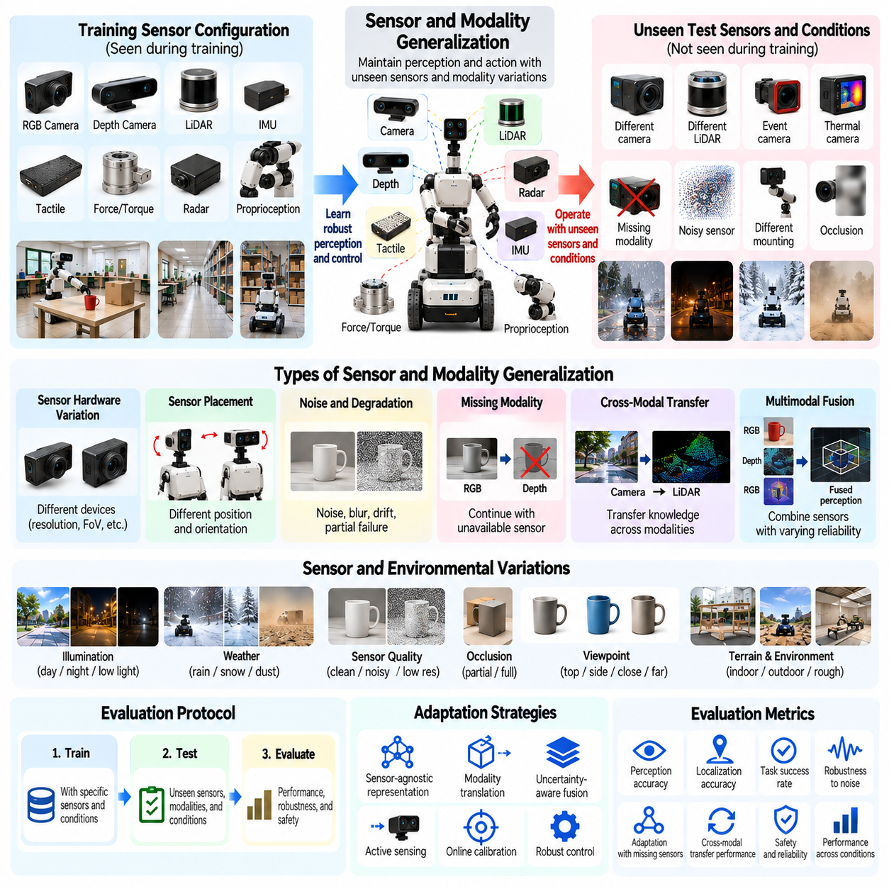
Sensor and modality generalization refers to the ability of Physical AI systems to maintain reliable perception and action when sensing configurations or information sources differ from those encountered during training. Changes may involve sensor types, placement, resolution, noise, or availability. Evaluation determines whether learned representations and control policies remain effective despite variations in how physical environments are observed.
Physical AI systems commonly integrate cameras, LiDAR, radar, depth sensors, tactile sensors, force sensors, and proprioceptive measurements. Each modality provides different information about geometry, motion, contact, and environmental conditions. Generalization requires extracting task-relevant information across these sources rather than depending exclusively on a fixed sensor configuration or a particular observation format.
Sensor generalization and modality generalization are related but distinct concepts. Sensor generalization concerns variations among devices measuring similar physical quantities, while modality generalization involves transferring capabilities across different forms of sensory information. Replacing one camera with another tests sensor robustness, whereas replacing visual depth estimation with LiDAR-based geometry introduces a modality-level challenge.
Sensor hardware variation can produce substantial differences in observation quality. Cameras may differ in resolution, field of view, exposure response, and lens distortion, while LiDAR devices may differ in scanning density and measurement range. Evaluation should examine whether Physical AI models preserve performance across unfamiliar devices without requiring extensive sensor-specific retraining or manual parameter adjustment.
Sensor placement generalization concerns changes in mounting position, orientation, and spatial relationship to the robot body. A camera mounted at a different height may observe familiar objects from unfamiliar perspectives. Such changes affect coordinate transformations, visibility, and geometric interpretation. Evaluation should distinguish genuine adaptation from performance maintained through previously calibrated configurations.
Noise generalization evaluates robustness to unfamiliar measurement disturbances. Image noise, depth uncertainty, inertial drift, and tactile measurement errors can alter sensory representations without changing the underlying physical environment. A generalizable system should distinguish meaningful environmental changes from observation artifacts and avoid unstable actions caused by corrupted or uncertain measurements.
Sensor degradation introduces more demanding conditions than ordinary measurement noise. Cameras may become partially occluded, LiDAR returns may disappear, and tactile sensors may exhibit drift or intermittent failure. Evaluation should determine whether a system detects degraded observations, adjusts confidence estimates, and maintains safe behavior instead of treating unreliable sensor measurements as accurate information.
Missing modality generalization examines whether a multimodal Physical AI system can continue operating when an expected information source becomes unavailable. A robot trained with both vision and depth sensing may temporarily lose its depth camera. Successful adaptation may involve relying on alternative measurements, reducing operational speed, or selecting tasks compatible with the remaining sensory information.
Cross-modal transfer concerns the ability to reuse knowledge acquired through one sensory modality when operating with another. Spatial understanding learned from camera observations may support interpretation of depth maps or point clouds. However, direct transfer is difficult because modalities differ in representation, coverage, uncertainty, and physical meaning. Evaluation must measure actual task transfer rather than superficial feature similarity.
Multimodal fusion generalization examines whether systems combine unfamiliar or degraded sensory inputs effectively. Fusion mechanisms may integrate visual appearance, geometric depth, contact forces, and joint measurements. Robust fusion should adjust the contribution of each modality according to its reliability and task relevance rather than assuming that all sensors remain equally informative under changing conditions.
Temporal sensor generalization addresses variations in sampling frequency, latency, synchronization, and communication delay. A controller trained with high-frequency observations may become unstable when measurements arrive less frequently or with irregular timing. Evaluation should test whether perception and control remain coordinated when observation intervals or sensor-to-action delays differ from training conditions.
Calibration generalization concerns robustness to changes in intrinsic and extrinsic sensor parameters. Small calibration errors can distort geometric reconstruction, coordinate alignment, and contact estimation. Evaluation should examine whether systems tolerate bounded errors, identify calibration inconsistencies, or perform appropriate recalibration before executing precision-sensitive tasks.
Active sensing can improve generalization when available measurements are insufficient. A robot may reposition its camera, move its manipulator, or establish controlled contact to obtain additional information. Such actions connect perception with decision-making. Evaluation should measure whether active sensing reduces uncertainty and improves task outcomes while respecting time, energy, and safety constraints.
A rigorous benchmark requires explicit separation between training and evaluation sensor conditions. Testing with the same hardware and slightly modified observations may not establish meaningful sensor generalization. Stronger protocols reserve unfamiliar devices, mounting configurations, noise distributions, or modality combinations to determine whether learned capabilities transfer beyond the original sensing setup.
Sensor variation should be characterized using measurable parameters whenever possible. Relevant factors include resolution, field of view, signal-to-noise ratio, sampling rate, latency, calibration error, and measurement dropout. Structured variation enables reproducible comparisons and helps identify which aspects of sensory novelty cause performance degradation across different Physical AI systems.
Controlled experiments can isolate individual sensing factors while preserving the physical task. Researchers may vary image resolution without changing camera placement or introduce artificial latency while maintaining observation content. Combined disturbances are also necessary because real deployments may simultaneously involve reduced visibility, sensor noise, calibration drift, and intermittent communication.
Perception accuracy provides an initial measure of sensor generalization but cannot fully represent physical competence. A system may maintain accurate object detection while producing unstable manipulation or navigation behavior. Evaluation should therefore connect sensory robustness to downstream localization, planning, control, and task completion rather than relying exclusively on intermediate perception benchmarks.
Task success rate measures whether a Physical AI system accomplishes its objectives under unfamiliar sensing conditions. Success criteria should account for operational safety and task-specific precision. For example, a manipulation robot may complete a grasp despite reduced visual quality, but excessive contact forces or object damage should prevent the trial from being classified as fully successful.
The sensor generalization gap compares performance under familiar sensing conditions with performance under held-out sensor configurations. Large differences indicate dependence on training-specific observations. However, absolute performance and information availability must also be considered because some sensor failures remove information that cannot be recovered through learning or adaptation alone.
Degradation curves reveal how system performance changes as sensing quality decreases. Researchers may evaluate success probability against image resolution, measurement noise, latency, or dropout frequency. Gradual degradation suggests predictable robustness limits, whereas abrupt failures may reveal brittle representations, unstable fusion, or insufficient uncertainty handling.
Additional metrics include localization error, detection reliability, calibration sensitivity, control stability, recovery time, computational cost, and intervention frequency. For multimodal systems, modality contribution and performance under sensor ablation are particularly informative. Metrics should reflect both sensing quality and the physical consequences of unreliable observations.
Zero-shot sensor generalization evaluates performance on unfamiliar configurations without additional training. Few-shot adaptation permits limited calibration data, demonstrations, or interactions before testing. Comparing these settings reveals whether sensory representations transfer immediately or require additional adaptation. Evaluation should also report the time, data, and computational resources consumed during adaptation.
Simulation supports scalable evaluation through sensor modeling, noise injection, modality dropout, and randomized mounting configurations. It enables systematic exploration of disturbances that may be expensive or unsafe to reproduce physically. Nevertheless, simulated sensing may not capture real optical artifacts, multipath reflections, hardware drift, or complex environmental interference.
Real-world validation should include multiple sensor devices, mounting arrangements, and operational environments. Repeated trials under documented conditions help identify hardware-specific weaknesses and distinguish systematic failures from measurement variability. Cross-platform testing can further reveal whether sensor generalization depends on particular robot embodiments or reflects transferable perceptual capabilities.
Ultimately, sensor and modality generalization measures whether Physical AI systems can preserve meaningful environmental understanding and reliable action despite changes in sensory information. Strong generalization requires robust representations, adaptive fusion, uncertainty estimation, and safe control under degraded observations. Comprehensive evaluation identifies sensing dependencies and operational boundaries, supporting reliable deployment across diverse hardware and environments.

04.08. Robot and Morphology Generalization
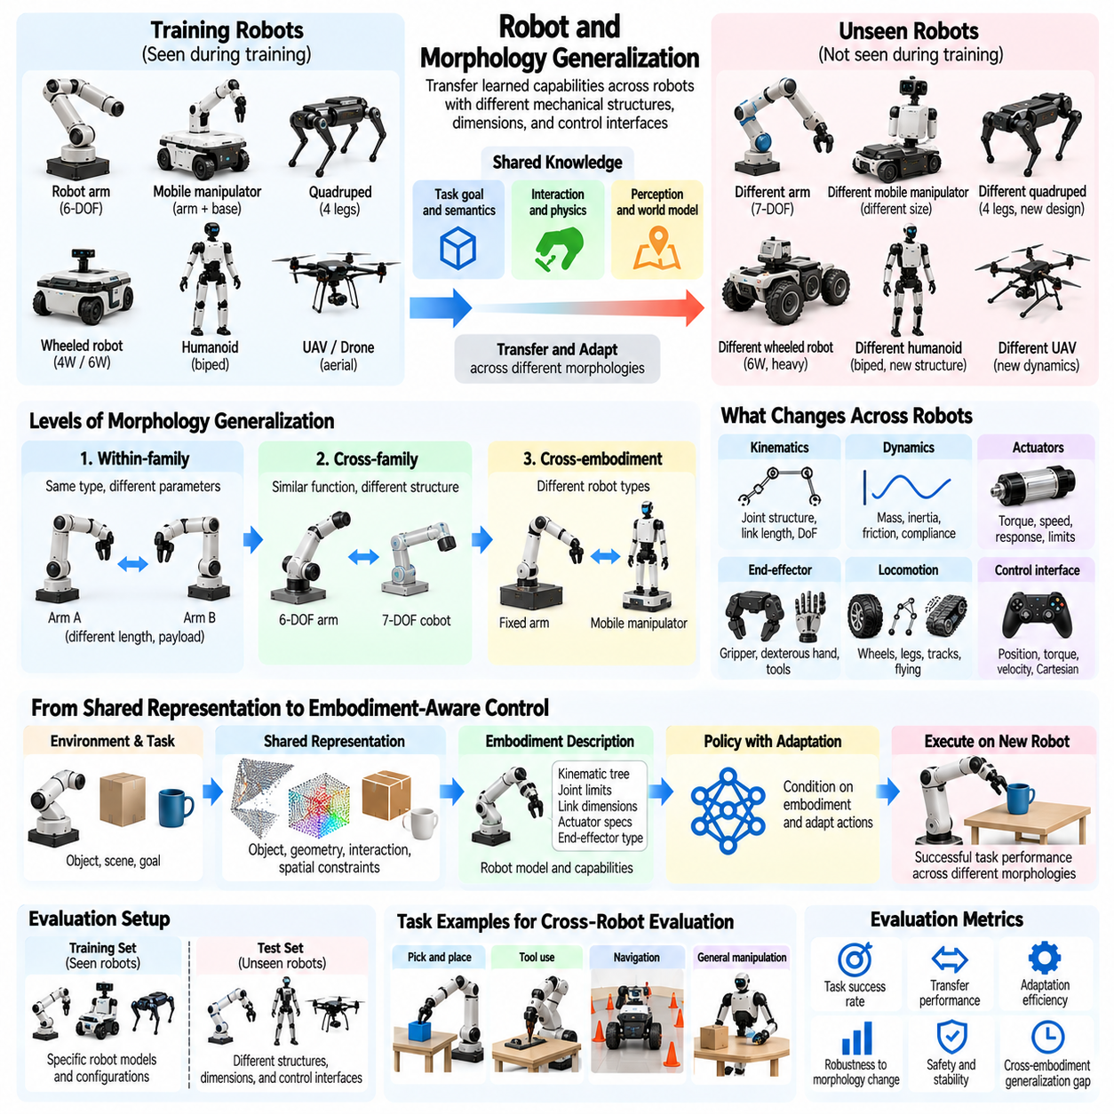
Robot and morphology generalization refers to the ability of Physical AI systems to transfer learned capabilities across robots with different mechanical structures, dimensions, actuators, and kinematic configurations. Unlike generalization across objects or environments, this capability concerns changes in the physical body executing actions. Evaluation determines whether learned intelligence extends beyond the embodiment used during training.
Robot morphology influences how an intelligent system perceives, moves, manipulates, and interacts with its surroundings. Differences in joint arrangements, limb lengths, wheel configurations, and actuator capabilities alter the relationship between commands and physical outcomes. A generalizable Physical AI system must account for these differences rather than assuming that identical control outputs produce equivalent behavior across platforms.
Morphology generalization can be examined at several levels of difficulty. The simplest cases involve robots with identical structures but different physical parameters. More demanding cases involve changes in joint configurations, degrees of freedom, or locomotion mechanisms. The strongest forms require transferring functional capabilities between fundamentally different embodiments, such as manipulators, mobile robots, and humanoid systems.
Within-family generalization evaluates transfer between robots belonging to the same morphological category. Two robotic arms may share similar kinematic structures but differ in link lengths, payload capacities, or joint limits. Successful transfer indicates that learned manipulation strategies can accommodate mechanical variation without requiring a completely independent policy for every robot configuration.
Cross-family generalization introduces more substantial structural differences. A manipulation policy developed for a six-axis industrial arm may be transferred to a seven-axis collaborative robot. Although both systems perform similar tasks, their joint spaces, redundancy, and reachable configurations differ. Evaluation must determine whether the policy adapts to these differences while maintaining task accuracy and safety.
Cross-embodiment generalization extends beyond related robot families. A system may transfer object manipulation knowledge from a fixed robotic arm to a mobile manipulator or humanoid robot. Such transfer requires separating task-level objectives from embodiment-specific execution. The receiving robot must translate shared functional knowledge into actions compatible with its mechanical structure and control capabilities.
Kinematic generalization concerns adaptation to different joint structures, link dimensions, and reachable workspaces. Changes in kinematics affect inverse kinematics, motion planning, collision avoidance, and end-effector positioning. Evaluation should determine whether a Physical AI system can preserve task performance when the mapping between desired movements and joint commands differs from training conditions.
Dynamic generalization addresses variations in mass distribution, inertia, friction, actuator strength, and mechanical compliance. Robots with similar kinematics may respond differently to identical control commands because their physical dynamics differ. Successful transfer requires adapting forces, accelerations, and feedback behavior while maintaining stability and avoiding excessive mechanical stress.
Actuator generalization examines whether learned controllers remain effective across different motor technologies, transmission mechanisms, torque limits, and response characteristics. Electric servomotors, hydraulic actuators, and compliant drives may exhibit different control dynamics. Evaluation should distinguish failures caused by inadequate policy transfer from limitations imposed by the available actuation hardware.
Locomotion morphology generalization is particularly challenging because movement strategies depend strongly on body structure. Wheeled robots, quadrupeds, bipeds, and tracked platforms interact with terrain through different contact mechanisms. Transferable intelligence may involve shared terrain understanding and navigation objectives, while low-level motion generation remains specific to each embodiment.
Manipulation morphology generalization involves differences in gripper design, finger count, joint arrangement, and end-effector capabilities. A parallel-jaw gripper and a dexterous robotic hand may achieve similar object-level goals through different contact strategies. Evaluation should measure whether shared manipulation knowledge can be translated into effective grasping and object interaction across these configurations.
A central challenge is identifying representations that remain meaningful across embodiments. Joint angles and motor commands are often robot-specific, whereas object poses, contact relationships, task goals, and spatial constraints can provide more transferable information. Generalization evaluation should examine whether learned representations capture functional relationships rather than memorizing embodiment-dependent action patterns.
Embodiment-aware policies explicitly incorporate robot descriptions into decision-making. Such descriptions may include kinematic trees, joint limits, actuator specifications, and geometric dimensions. Conditioning a policy on these properties can support adaptation to unfamiliar robots. However, evaluation must verify that performance reflects meaningful use of embodiment information rather than memorization of known robot identities.
Action-space differences create additional challenges for cross-robot transfer. One platform may use joint position commands, another joint torque commands, and another Cartesian velocity targets. Directly transferring numerical actions between these interfaces may be invalid or unsafe. Evaluation should specify whether transfer occurs through shared task-space commands, learned action mappings, or robot-specific controllers.
A rigorous benchmark requires explicit separation between training and evaluation embodiments. Testing different parameter settings on the same robot may measure robustness but not broad morphology generalization. Stronger protocols reserve robot models, kinematic structures, actuator configurations, or entire embodiment families for testing to determine whether learned capabilities extend beyond familiar physical designs.
Morphological diversity should be characterized through measurable properties such as degrees of freedom, link proportions, joint topology, payload capacity, workspace size, and actuator bandwidth. These parameters help quantify structural differences between robots. Evaluation should avoid treating all unseen embodiments as equally difficult because the degree of morphological novelty strongly influences transfer complexity.
Controlled experiments can isolate individual morphological changes while maintaining a common task. Researchers may vary arm length while preserving joint topology or modify actuator limits while retaining geometry. Such tests reveal sensitivity to specific mechanical parameters. Combined variations are also necessary because practical robot platforms often differ simultaneously in geometry, dynamics, sensing, and control interfaces.
Task success rate provides a fundamental measure of robot and morphology generalization. A manipulation benchmark may evaluate whether different robot arms complete the same placement task, while a navigation benchmark may assess equivalent destination-reaching objectives. Success criteria should be defined at the functional task level while respecting the physical capabilities and safety limits of each robot.
The morphology generalization gap compares performance on training embodiments with performance on held-out robot configurations. Large differences indicate limited transfer across physical structures. However, performance comparisons must account for unequal hardware capabilities. A smaller robot may fail a task because of insufficient reach or payload capacity rather than inadequate learned intelligence.
Normalized performance metrics can improve comparisons between heterogeneous platforms. Task completion time, energy consumption, tracking error, and control effort may be interpreted relative to robot-specific capabilities. Evaluation should report both absolute outcomes and normalized measures, ensuring that apparent differences in intelligence are not simply consequences of mechanical advantages or disadvantages.
Zero-shot morphology generalization evaluates whether a learned policy can operate on an unfamiliar robot without additional training. Few-shot adaptation allows limited demonstrations, calibration, or physical interactions before testing. Comparing these settings reveals the extent of immediate transfer and the resources required for adaptation. Safety during initial deployment must remain an explicit evaluation requirement.
Simulation provides scalable opportunities to evaluate policies across procedurally generated robot morphologies. Researchers can vary link dimensions, joint structures, actuator properties, and body configurations while maintaining controlled task conditions. However, simulated transfer may overestimate real-world performance when actuator dynamics, structural flexibility, or contact behavior are modeled inaccurately.
Real-world validation should include physically distinct robots, standardized functional objectives, and repeated trials. Experiments must document hardware specifications, controller interfaces, adaptation procedures, and task feasibility. Cross-platform testing helps determine whether observed performance reflects transferable physical intelligence or hidden dependence on particular mechanical and software configurations.
Statistical reporting should separate results by morphological distance, robot family, task category, and adaptation requirements. Aggregate success rates may conceal failures on highly unfamiliar embodiments or mechanically demanding tasks. Confidence intervals, documented evaluation splits, and failure classifications support reproducible comparisons and help distinguish representation failures from hardware constraints.
Ultimately, robot and morphology generalization measures whether Physical AI can transfer knowledge across different physical bodies. Strong generalization requires separating shared task understanding from embodiment-specific execution while adapting to kinematic, dynamic, and actuation differences. Comprehensive evaluation identifies transfer boundaries and supports the development of reusable intelligence across heterogeneous robotic platforms.

04.09. Zero Shot Generalization
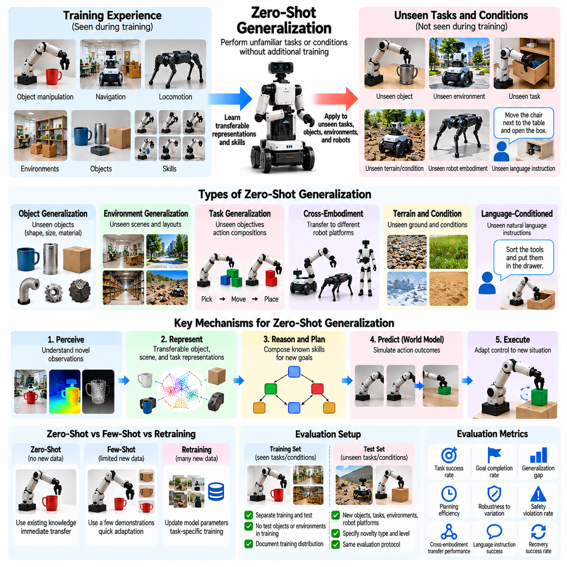
Zero-shot generalization refers to the ability of a Physical AI system to perform unfamiliar tasks or operate under unseen conditions without additional task-specific training. The system must rely on previously acquired knowledge, transferable representations, and existing control capabilities. Evaluation determines whether learned intelligence can support immediate adaptation to novel situations rather than depending on repeated demonstrations or retraining.
Zero-shot generalization is a critical indicator of flexibility in autonomous physical systems. Robots deployed in homes, factories, warehouses, and outdoor environments frequently encounter conditions that cannot be exhaustively represented during training. A system with strong zero-shot capabilities can interpret unfamiliar situations and select appropriate actions without requiring engineers to prepare a separate policy for every possible scenario.
The definition of zero-shot performance requires careful specification of what information is available before evaluation. A robot may receive a new task instruction, observe its surroundings, and use previously learned skills without violating the zero-shot condition. However, updating model parameters through additional demonstrations or task-specific optimization generally constitutes adaptation rather than strict zero-shot generalization.
Zero-shot generalization differs from few-shot adaptation in the amount of new experience permitted. Few-shot methods use limited demonstrations, interactions, or feedback to improve performance on unfamiliar conditions. Zero-shot evaluation instead measures the immediate transfer of existing capabilities. This distinction is important because systems that perform well after adaptation may still struggle when first encountering an unfamiliar physical situation.
Unseen object manipulation provides a representative zero-shot evaluation scenario. A robot trained on diverse household objects may be required to grasp an unfamiliar industrial component without additional examples. Successful performance requires identifying relevant geometry, estimating contact possibilities, and selecting a feasible grasp. The evaluation should determine whether these abilities transfer beyond memorized object identities.
Zero-shot environment generalization examines performance in previously unseen buildings, workspaces, and outdoor locations. A mobile robot may receive a destination instruction in an unfamiliar facility and must navigate using its existing perception and planning capabilities. Evaluation should distinguish permissible online mapping from prior environment-specific training while measuring navigation success, efficiency, and safety.
Unseen task generalization presents additional challenges because the robot must interpret objectives that were not explicitly demonstrated during training. A manipulation system may know how to grasp, transport, and place objects but encounter a new arrangement goal. Successful zero-shot behavior requires composing available skills and reasoning about the desired outcome without learning a new task policy.
Cross-embodiment zero-shot generalization examines whether knowledge transfers to unfamiliar robot platforms without additional policy training. Differences in joint structures, actuator limits, and control interfaces complicate direct action transfer. Evaluation should specify whether robot descriptions, calibration parameters, and pretrained low-level controllers are available, since these resources influence the meaning of zero-shot transfer.
Language-conditioned Physical AI offers an important setting for zero-shot generalization. Vision-language-action models can potentially interpret novel instructions by connecting language, perception, and action representations. However, linguistic understanding alone does not establish physical competence. Evaluation must verify that unfamiliar instructions produce successful, safe interactions rather than plausible but ineffective action sequences.
A central mechanism supporting zero-shot generalization is the learning of transferable representations. Object geometry, spatial relationships, physical constraints, and task goals may remain meaningful across unfamiliar situations. Representations based on these properties can support action selection beyond specific training examples. Evaluation should examine whether performance depends on general physical relationships rather than superficial visual correlations.
Compositional reasoning also supports zero-shot performance by reorganizing previously acquired skills into unfamiliar combinations. A robot may know how to open a drawer, retrieve an item, and place it on a table. A new instruction may require combining these actions in a different sequence. Successful execution demonstrates flexible reuse of existing knowledge, although genuinely novel physical skills may remain outside the system's capabilities.
World models can contribute to zero-shot generalization by predicting the consequences of candidate actions. A robot may simulate possible interactions internally before selecting a movement or manipulation strategy. Such prediction can reduce dependence on direct trial-and-error learning. Evaluation should determine whether predictive reasoning improves task success and whether inaccurate predictions create additional operational risks.
Zero-shot capability should not be confused with unlimited general intelligence. A system may generalize successfully across unfamiliar object appearances while failing on new materials, dynamics, or task structures. Generalization is therefore multidimensional and depends on the novelty being tested. Benchmarks should identify the specific distribution shifts involved instead of reporting a single unrestricted claim of zero-shot competence.
A rigorous evaluation protocol requires explicit separation between training experiences and test scenarios. Held-out tasks, objects, environments, and robot configurations should be documented. Researchers must also consider whether foundation-model pretraining introduced related examples. Without transparency about training exposure, apparent zero-shot success may reflect prior familiarity rather than meaningful transfer.
Data contamination is a particularly important concern when evaluating large pretrained Physical AI models. Training collections may include robot demonstrations, simulation trajectories, instructional videos, and benchmark-related materials. Exact or near-duplicate evaluation examples can inflate reported performance. Benchmark governance should therefore include contamination checks, controlled test access, and transparent reporting of known exposure.
Evaluation conditions must define which forms of inference-time computation and interaction are permitted. A system may perform planning, retrieve information from fixed internal memory, or inspect its environment without updating model weights. These activities can remain compatible with zero-shot evaluation if explicitly allowed. However, collecting demonstrations and optimizing a new policy changes the evaluation setting.
Zero-shot task success rate provides a basic measure of immediate generalization. It represents the proportion of unfamiliar evaluation tasks completed successfully without task-specific adaptation. Success criteria should include the intended physical outcome and relevant operational constraints. A robot that reaches its goal through unsafe contact, excessive force, or prohibited actions should not receive an unrestricted success classification.
The zero-shot generalization gap compares performance on familiar conditions with performance on held-out scenarios. A large gap indicates limited immediate transfer beyond the training distribution. However, absolute success rates must also be reported because a small gap can occur when performance is poor in both settings. Differences in task difficulty and hardware feasibility should be considered when interpreting the results.
Execution quality provides additional evidence beyond binary success. Relevant measures include completion time, action efficiency, trajectory quality, contact stability, energy consumption, recovery attempts, and intervention frequency. A system that completes unfamiliar tasks through inefficient or unstable behavior may demonstrate weaker practical zero-shot competence than one that performs consistently within defined operational limits.
Uncertainty estimation is especially important during zero-shot deployment because the system lacks direct experience with the evaluation conditions. A robot should recognize when its predictions or action choices are unreliable. Evaluation should measure confidence calibration, failure detection, and appropriate fallback behavior. Safe refusal or controlled termination may be preferable to attempting an infeasible or hazardous task.
Zero-shot evaluation should include progressively increasing novelty levels. Initial tests may introduce unfamiliar appearances or layouts, while more demanding scenarios involve new task compositions, physical properties, or embodiment structures. Measuring performance across these levels reveals whether generalization degrades gradually or fails abruptly when the system encounters conditions beyond its learned capabilities.
Simulation enables large-scale zero-shot testing through procedurally generated objects, tasks, environments, and physical disturbances. Hidden evaluation seeds and independently generated scenarios can reduce direct memorization. Nevertheless, simulation may underestimate real-world uncertainty or misrepresent contact dynamics. Physical testing is therefore necessary to validate whether apparent zero-shot competence survives realistic execution conditions.
Real-world benchmarks should include independent test locations, unfamiliar physical objects, repeated trials, and clearly documented adaptation restrictions. Evaluation must distinguish permitted online perception and planning from prohibited task-specific learning. Recording failures, human interventions, and environmental conditions helps determine whether zero-shot success is reproducible rather than dependent on favorable experimental circumstances.
Statistical reporting should separate results by novelty category, difficulty, robot platform, and task horizon. Confidence intervals and repeated trials help characterize uncertainty in measured success rates. Aggregate scores may conceal major weaknesses in unfamiliar dynamics or long-horizon execution. Transparent evaluation partitions and consistent protocols are essential for meaningful comparisons between Physical AI systems.
Ultimately, zero-shot generalization measures the immediate transferability of learned physical intelligence to unfamiliar situations. Strong performance requires reusable representations, compositional reasoning, predictive understanding, robust control, and uncertainty-aware decisions. Comprehensive evaluation must identify both successful transfer and capability boundaries, supporting the development of Physical AI systems that operate reliably beyond their training experiences.

04.10. Few Shot Adaptation
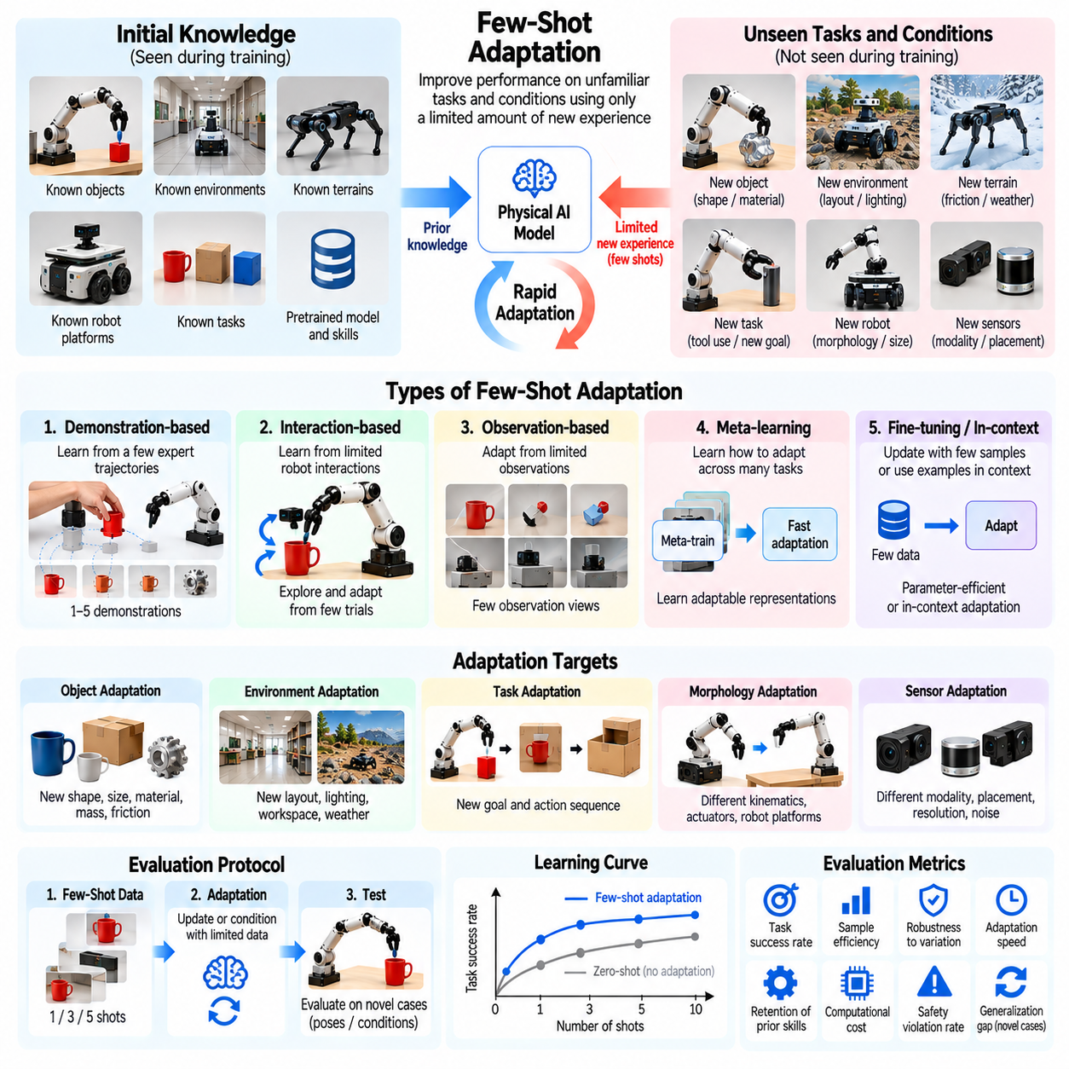
Few-shot adaptation refers to the ability of a Physical AI system to acquire or refine capabilities for unfamiliar tasks and conditions using only a limited amount of new experience. Unlike zero-shot generalization, few-shot adaptation permits carefully bounded demonstrations, observations, or interactions. Evaluation measures how efficiently a system converts scarce experience into improved physical performance without extensive retraining.
Few-shot adaptation is essential because physical environments contain variations that cannot be fully anticipated during initial training. Robots may encounter unfamiliar objects, materials, tools, or operating conditions requiring behavioral adjustments. A capable system should incorporate limited new information while preserving previously acquired skills, avoiding excessive computational demands, and maintaining operational safety.
The meaning of a shot must be explicitly defined in Physical AI evaluation. A shot may represent one expert demonstration, one completed trajectory, one labeled observation, or one interaction episode. These units are not equivalent because they contain different amounts of information. Benchmarks should specify the duration, supervision, and interaction content associated with each shot to support meaningful comparisons.
Few-shot adaptation differs from zero-shot evaluation because additional task-specific experience is permitted before final testing. It also differs from conventional retraining, which may require large datasets and extensive optimization. The central objective is rapid improvement under constrained data availability. Evaluation should distinguish adaptation through parameter updates from adaptation through memory, prompting, or online inference.
Demonstration-based adaptation allows a robot to learn from a small number of expert executions. For example, a manipulator may observe several successful grasps of an unfamiliar component before attempting independent operation. Evaluation should determine whether the system extracts transferable manipulation principles rather than memorizing demonstrated trajectories that may fail under slightly different initial conditions.
Interaction-based adaptation permits the robot to collect information through controlled physical experience. A mobile robot may test wheel traction on an unfamiliar surface, while a manipulator may estimate object stiffness through gentle contact. Such exploration can improve subsequent decisions. However, adaptation protocols must constrain interaction budgets and prevent unsafe experimentation in uncertain environments.
Observation-based adaptation uses limited sensory information without requiring full action demonstrations. A robot may inspect an unfamiliar workspace, observe object motion, or estimate environmental parameters before executing a task. This setting separates perceptual adjustment from policy learning. Evaluation should determine whether additional observations improve decisions and whether the resulting gains persist across varied situations.
Meta-learning provides one approach to few-shot adaptation by training systems across diverse tasks so they can adjust rapidly to new ones. Rather than learning only a fixed policy, a meta-learning system develops an adaptation mechanism. Evaluation should measure how effectively this mechanism transfers to held-out tasks and whether its apparent efficiency depends on similarities between training and testing distributions.
Fine-tuning offers another adaptation strategy by updating selected model parameters using limited task-specific data. Parameter-efficient methods may modify small adapters or specialized network components while preserving a pretrained backbone. Evaluation should report adaptation accuracy, computational cost, memory requirements, and training stability, particularly when updates must occur on resource-constrained robotic hardware.
In-context adaptation uses demonstrations or observations as temporary conditioning information without necessarily modifying model weights. Vision-language-action models may receive example trajectories or task descriptions before execution. This approach can reduce deployment complexity, but its effectiveness depends on context representation and retrieval quality. Evaluation should distinguish genuine adaptation from direct reproduction of supplied examples.
Few-shot object adaptation examines how quickly robots learn to manipulate unfamiliar shapes, textures, masses, or friction properties. A system may receive a small number of successful demonstrations involving a new object category. Evaluation should test performance on different poses and placements to determine whether adaptation produces robust understanding rather than narrow memorization of demonstrated conditions.
Few-shot environment adaptation concerns rapid adjustment to unfamiliar workspaces, terrain, lighting, or sensor conditions. A robot may use several observations or short interaction episodes to estimate local operating characteristics. Successful adaptation should improve navigation, localization, or control while remaining effective when environmental conditions change within the same deployment.
Few-shot morphology adaptation evaluates whether a learned policy can accommodate a new robot configuration using limited calibration or demonstration data. Differences in joint limits, actuator response, and kinematic structure may require adjustment. Evaluation should distinguish information needed for basic hardware initialization from adaptation experience used to improve task performance on the unfamiliar embodiment.
Adaptation efficiency is a central metric because the objective is improvement with minimal experience. Learning curves should report task performance against the number of demonstrations, interaction episodes, or observations. The area under the adaptation curve can summarize learning efficiency, while performance at fixed shot budgets enables direct comparisons between algorithms under equivalent information constraints.
The adaptation gain measures the difference between performance before and after limited experience. This metric reveals whether the adaptation process provides meaningful benefits beyond the zero-shot baseline. However, absolute post-adaptation performance must also be reported because large improvements from a very weak baseline may still produce an unreliable physical system.
Sample efficiency alone does not fully characterize adaptation quality. Two methods may achieve similar success rates using the same number of demonstrations but differ substantially in computational time, energy consumption, and physical interaction costs. Evaluation should therefore consider data efficiency, wall-clock adaptation time, processor utilization, and operational resources as complementary measures.
Adaptation stability examines whether performance improves consistently across different support examples and random initialization conditions. Few-shot learning can be sensitive to which demonstrations are selected, particularly when the available examples are unrepresentative. Repeated evaluations with independently sampled support sets help quantify variability and identify algorithms that depend excessively on favorable adaptation data.
Overfitting is a significant risk when adaptation relies on extremely small datasets. A robot may reproduce demonstrated actions accurately while failing when object poses, task sequences, or environmental disturbances change. Evaluation should separate adaptation examples from final test episodes and introduce controlled variations to determine whether the updated policy generalizes beyond the limited support data.
Catastrophic forgetting introduces another challenge when new adaptation updates interfere with previously acquired capabilities. A robot adapted to a new manipulation task may lose reliability on familiar operations. Evaluation should measure both new-task improvement and retained performance on representative earlier tasks, ensuring that local adaptation does not undermine broader operational competence.
Safety-aware adaptation is particularly important because physical learning involves real contact, motion, and potentially hazardous exploration. Robots should respect force limits, collision constraints, and uncertainty thresholds during adaptation. Evaluation should count unsafe attempts, emergency interventions, and constraint violations rather than treating adaptation trials as cost-free opportunities for learning.
A rigorous benchmark must standardize the adaptation budget and information access. Researchers should document the number of shots, demonstration quality, permitted interactions, parameter-update rules, and access to pretrained knowledge. Without these controls, systems receiving richer feedback or additional optimization opportunities may appear more capable despite operating under less restrictive conditions.
Simulation enables large-scale evaluation across adaptation budgets, task variations, and robot configurations. It supports controlled experiments and repeated support-set sampling while reducing physical costs. Nevertheless, simulated adaptation may not capture real actuator uncertainty, contact dynamics, or sensing imperfections. Real-world validation is necessary to determine whether adaptation efficiency transfers to practical deployments.
Real-world few-shot benchmarks should use unfamiliar objects, environments, or robot configurations with clearly separated adaptation and evaluation phases. Repeated trials should document hardware conditions, human assistance, and all collected interaction data. Results should include zero-shot baselines, adaptation curves, final success rates, and safety outcomes to characterize both learning progress and operational reliability.
Statistical reporting should distinguish adaptation performance across shot budgets, novelty categories, task difficulties, and robot platforms. Confidence intervals and multiple independently sampled adaptation sets reveal sensitivity to limited experience. Aggregate results may conceal weak performance under difficult conditions. Transparent protocols support reproducible comparisons and prevent misleading claims about rapid learning capabilities.
Ultimately, few-shot adaptation measures how efficiently Physical AI systems transform limited new experience into reliable physical competence. Strong adaptation combines transferable representations, efficient learning mechanisms, stable updates, and safety-aware interaction. Comprehensive evaluation must assess improvement, resource consumption, knowledge retention, and generalization after adaptation, establishing whether robots can learn effectively under realistic deployment constraints.

04.11. Compositional Generalization
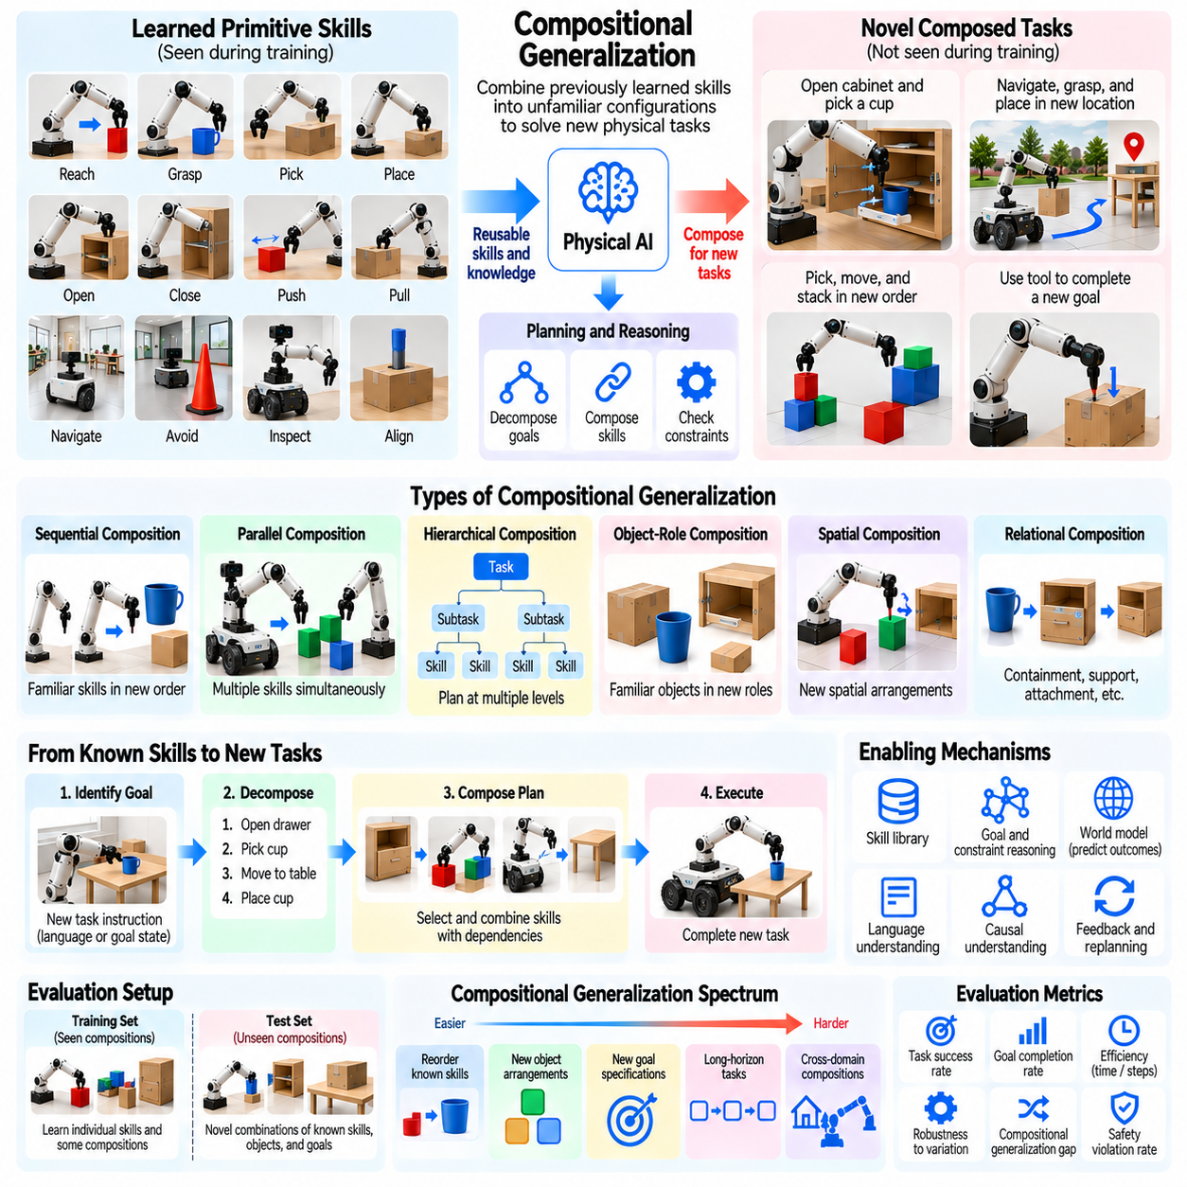
Compositional generalization refers to the ability of Physical AI systems to combine previously learned skills, concepts, and action patterns into unfamiliar configurations. Rather than memorizing complete task sequences, a generalizable system must understand how reusable components interact. Evaluation determines whether learned capabilities can be reorganized to solve new physical tasks without requiring separate training for every possible combination.
Physical environments naturally contain compositional structures. Complex activities such as assembling products, organizing warehouses, or preparing household items consist of simpler operations connected through spatial, temporal, and causal relationships. A Physical AI system with strong compositional generalization can reuse familiar operations while adapting their ordering, parameters, and dependencies to unfamiliar objectives.
Compositional generalization differs from ordinary task generalization because the novelty arises primarily from relationships among known elements. A robot may already understand grasping, moving, opening, and placing, yet encounter a task requiring these actions in a previously unseen sequence. Successful performance indicates that the system has learned transferable relationships rather than merely reproducing complete demonstrations.
Skill composition provides a fundamental mechanism for constructing complex behavior. Individual skills may represent reaching, grasping, lifting, navigating, aligning, or releasing objects. These skills can be organized into higher-level procedures when their preconditions and outcomes are compatible. Evaluation should examine whether the robot selects appropriate skills and coordinates their transitions under changing physical conditions.
Sequential composition concerns the execution of known skills in unfamiliar orders. A mobile manipulator may need to open a cabinet, retrieve a container, transport it, and place it at a specified destination. Although each operation may be familiar, the complete sequence may be novel. Evaluation should measure whether the robot maintains task dependencies and avoids errors that propagate through later actions.
Parallel composition involves coordinating multiple compatible activities simultaneously. A robot may adjust its mobile base while positioning a manipulator or monitor an object while executing another movement. Such coordination can improve efficiency but introduces resource conflicts and safety constraints. Evaluation should determine whether parallel execution preserves stability, collision avoidance, and task completion quality.
Hierarchical composition organizes primitive actions into reusable skills, subtasks, and mission-level plans. Higher-level reasoning determines which capabilities are needed, while lower-level controllers execute physical movements. Generalization requires coordination across these abstraction levels. Evaluation should identify whether failures originate from incorrect task decomposition, inappropriate skill selection, or unreliable physical execution.
Object-role composition examines whether robots understand functional relationships independently of particular object identities. A container may serve as a destination, a tool may enable manipulation, and a surface may provide support. Novel tasks can assign familiar objects to unfamiliar roles. Evaluation should determine whether the system reasons about these relationships instead of depending on memorized object-task associations.
Spatial composition concerns novel arrangements of familiar objects, obstacles, and target locations. A robot may need to place one object behind another, stack components in a new order, or navigate through a previously unseen obstacle configuration. Successful generalization requires interpreting spatial constraints and producing feasible actions rather than recalling specific geometric arrangements encountered during training.
Relational composition extends beyond spatial structure to include containment, support, attachment, ownership, and interaction dependencies. A robot may need to place a component inside a container before closing its lid. Such tasks require understanding relationships between objects and actions. Evaluation should test whether these relationships remain valid when objects, locations, or execution sequences change.
Language-conditioned composition enables Physical AI systems to interpret instructions containing unfamiliar combinations of familiar concepts. A command may specify several objects, destinations, constraints, and action sequences. Vision-language-action models can potentially map these descriptions into executable behavior. Evaluation must verify physical task completion rather than relying exclusively on linguistic interpretation accuracy.
Compositional planning requires reasoning about preconditions, effects, and dependencies between actions. A robot cannot reliably place an object inside a closed cabinet without first opening it. Planning systems must determine which operations enable subsequent steps and recognize incompatible action orders. Evaluation should measure logical consistency, physical feasibility, and successful execution of the resulting plans.
Causal understanding can strengthen compositional generalization by representing why actions produce particular outcomes. Moving a supporting object may destabilize an assembly, while applying force in the wrong direction may prevent insertion. A system that understands such dependencies can reorganize actions more reliably. Evaluation should distinguish causal reasoning from statistical familiarity with common action sequences.
A rigorous benchmark must separate training compositions from evaluation compositions while controlling exposure to individual components. The system may encounter every primitive skill during training but not the specific combinations used for testing. This distinction isolates compositional transfer from the acquisition of entirely new skills. Evaluation protocols should document which elements and relationships were previously observed.
Compositional novelty can be characterized by changes in action order, object roles, spatial relations, task constraints, and hierarchical structure. Different combinations produce different levels of difficulty. A benchmark should vary these dimensions systematically rather than treating all unseen sequences as equivalent. Such organization helps identify which forms of composition a Physical AI system can generalize successfully.
Controlled experiments should isolate individual compositional factors before combining them. Researchers may preserve objects and actions while changing their ordering, or maintain the sequence while modifying relational constraints. More demanding tests can vary multiple factors simultaneously. These experiments reveal whether performance depends on specific memorized patterns or general principles of task construction.
Task success rate provides a primary measure of compositional generalization, but complete success alone may conceal important weaknesses. A robot may execute most subtasks correctly before failing at a final dependency. Evaluation should therefore measure subtask completion, ordering accuracy, constraint satisfaction, and the correctness of intermediate physical states throughout execution.
Compositional generalization gaps compare performance on familiar task combinations with performance on held-out compositions. Large differences suggest dependence on previously observed task structures. However, comparisons should control for sequence length, physical difficulty, and execution time. Otherwise, reduced performance may reflect greater task complexity rather than a specific inability to recombine learned capabilities.
Long-horizon composition introduces additional challenges because small errors accumulate across connected actions. A misplaced object may prevent a later grasp, while an incorrect navigation decision may invalidate subsequent operations. Evaluation should measure error propagation, recovery success, replanning frequency, and the ability to preserve task objectives despite unexpected physical outcomes.
Zero-shot compositional generalization examines whether unfamiliar combinations can be executed without additional training or demonstrations. Few-shot adaptation permits limited experience with new combinations before testing. Comparing these conditions reveals whether learned skills are immediately reusable or require additional coordination learning. Adaptation costs should be reported separately from final task performance.
World models and predictive planning can support composition by estimating the consequences of proposed action sequences. A robot may evaluate whether a placement will obstruct later movements or whether an assembly remains stable. Such predictions can guide skill selection and ordering. Evaluation should determine whether predictive reasoning improves execution and reduces avoidable failures.
Simulation enables scalable testing of compositional tasks through procedural generation of objects, goals, constraints, and action sequences. Researchers can create held-out combinations while preserving consistent primitive skills. However, simulated success may not capture real contact uncertainty, actuator limitations, or environmental disturbances. Physical validation remains necessary for reliable conclusions.
Real-world benchmarks should include unfamiliar task combinations, documented initial conditions, and repeated execution trials. Evaluation should record intermediate states, failed dependencies, interventions, and recovery behavior. Tasks must remain physically feasible for the tested robot. These controls help distinguish limitations in compositional reasoning from failures caused by hardware constraints or unreliable primitive skills.
Statistical reporting should separate results by composition type, sequence length, relational complexity, and task difficulty. Aggregate success rates may conceal strong performance on simple reorderings but weak performance on hierarchical or causal compositions. Confidence intervals and transparent train-test partitions support reproducible comparisons and meaningful interpretation of generalization boundaries.
Ultimately, compositional generalization measures whether Physical AI systems can construct unfamiliar physical behaviors from reusable knowledge. Strong performance requires transferable skills, relational understanding, hierarchical planning, causal reasoning, and reliable execution. Comprehensive evaluation identifies which combinations can be handled without retraining and establishes the limits of flexible physical intelligence.

04.12. Systematic and Causal Generalization
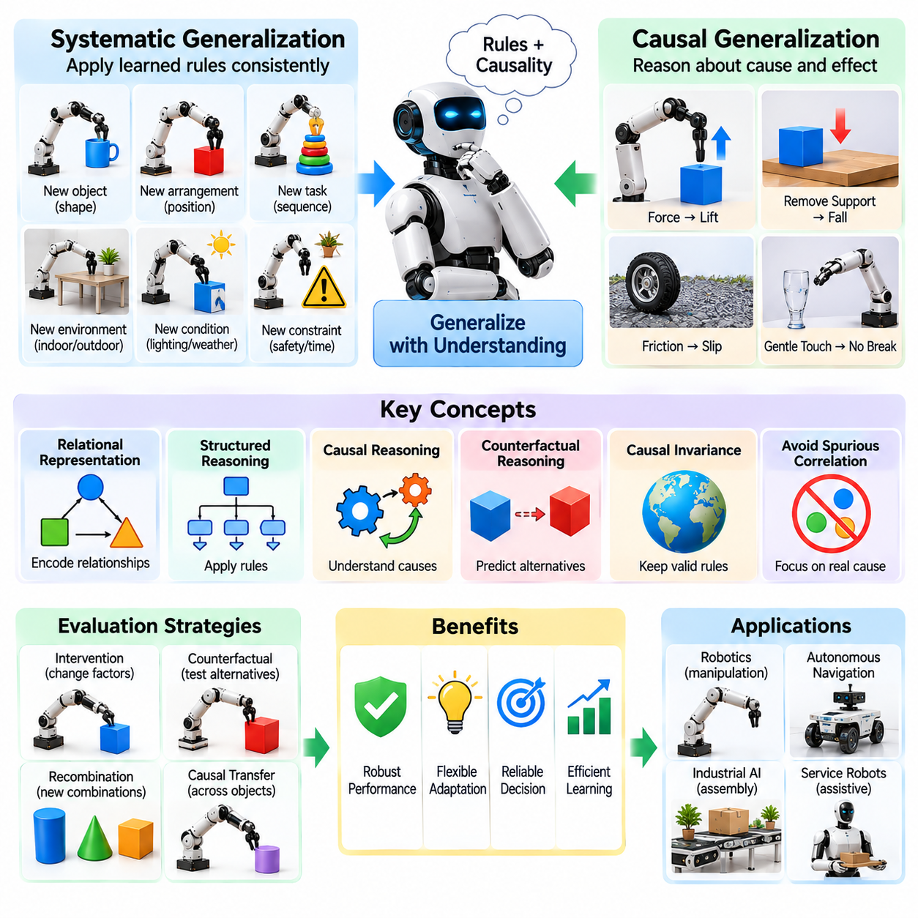
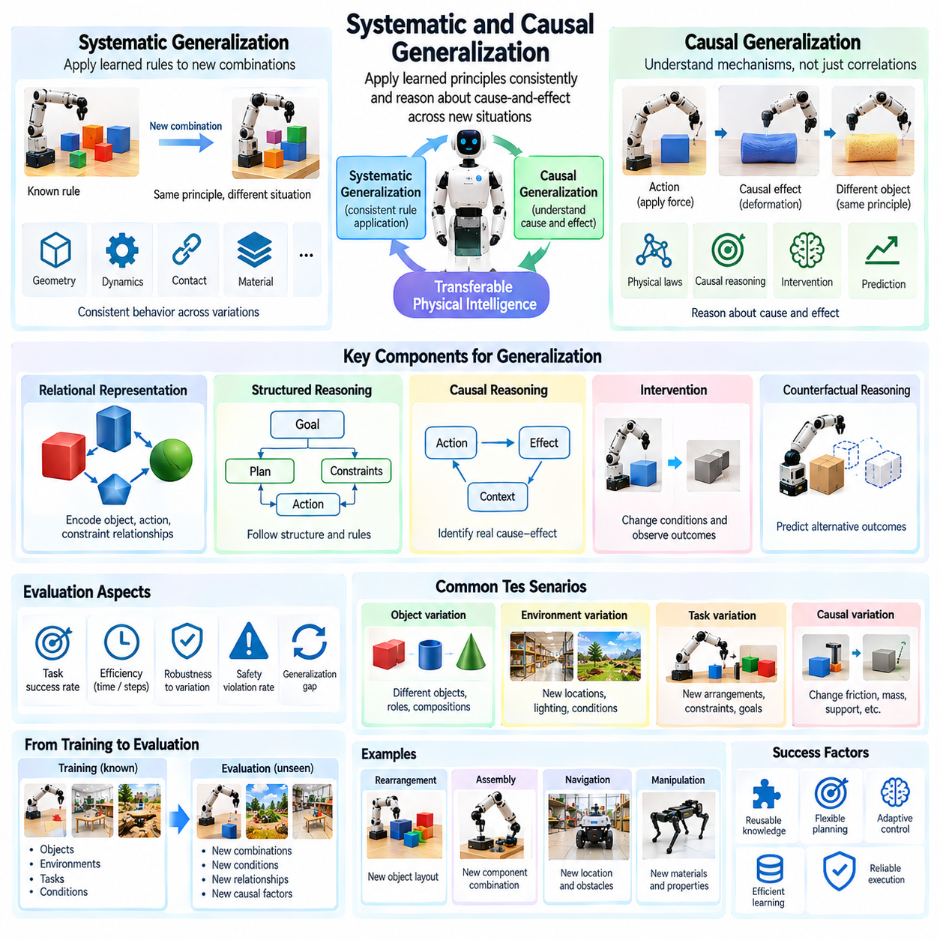
Systematic and causal generalization refers to the ability of Physical AI systems to apply learned principles consistently across unfamiliar combinations of conditions and to reason about cause-and-effect relationships. Rather than relying on memorized patterns, a generalizable system must recognize underlying rules governing physical interactions. Evaluation determines whether these principles remain valid when objects, environments, and task structures change.
Systematic generalization emphasizes the consistent application of learned rules to new situations. A robot that understands how object properties influence grasping should apply this knowledge across unfamiliar shapes and orientations. Successful generalization requires maintaining relationships between concepts and actions rather than learning isolated examples. Evaluation should test whether equivalent physical principles produce consistent behavior across diverse scenarios.
Causal generalization concerns the ability to understand how actions and environmental factors produce physical outcomes. A robot may recognize that increasing applied force changes object deformation or that removing support causes instability. Such understanding enables predictions beyond observed correlations. Evaluation should determine whether the system identifies meaningful causal mechanisms rather than relying on statistical associations that may fail under changing conditions.
Systematic and causal generalization are related but distinct capabilities. Systematic generalization concerns consistent application of structured knowledge, whereas causal generalization concerns understanding mechanisms that connect interventions with outcomes. A system may apply familiar rules reliably without identifying their causal origins. Conversely, causal knowledge may support adaptation when previously reliable patterns no longer hold.
Physical AI systems operate in environments governed by geometry, dynamics, contact mechanics, and material properties. These relationships create opportunities for generalization because many physical principles remain applicable across different objects and settings. However, practical systems must distinguish broadly transferable principles from assumptions that depend on specific materials, mechanisms, or operating conditions.
Relational representations can support systematic generalization by encoding connections between objects, actions, and environmental constraints. Instead of memorizing that a particular object belongs on a specific shelf, a robot may represent support, containment, and accessibility relationships. Evaluation should examine whether these representations remain useful when familiar objects occupy unfamiliar roles or appear in new configurations.
Structured reasoning enables systems to apply consistent procedures across varying task arrangements. A robot assembling unfamiliar components may identify attachment points, alignment requirements, and insertion constraints before acting. These relationships can guide action planning even when the exact assembly has not been demonstrated. Evaluation should measure whether the system follows relevant structural rules under novel configurations.
Causal reasoning requires distinguishing observation from intervention. Observing that an object moves when another object moves does not necessarily establish a direct causal relationship. A robot may need controlled interactions to determine whether contact, attachment, or external forces explain the observed motion. Evaluation should assess whether interventions improve causal understanding and subsequent action selection.
Intervention-based evaluation provides a direct method for testing causal generalization. Researchers may change friction, remove supporting structures, alter object mass, or modify actuator response while preserving other conditions. A causally informed system should predict how these changes influence task outcomes. Such experiments help distinguish genuine physical understanding from dependence on familiar visual patterns.
Counterfactual reasoning examines whether a system can predict what would happen under alternative actions or conditions. A robot may consider whether an object would remain stable if placed at a different location or whether a grasp would succeed with reduced force. Evaluation should compare these predictions against controlled physical outcomes, while accounting for uncertainty and incomplete knowledge.
Causal invariance is an important indicator of transferable physical understanding. A relationship may remain valid across changes in appearance, lighting, or background even when superficial correlations disappear. For example, gravitational effects persist across visually different environments. Evaluation should identify whether models rely on stable causal relationships or unstable features associated with the training distribution.
Spurious correlations create major obstacles to causal generalization. A robot may associate object color with weight because particular colors frequently appeared with certain materials during training. Such associations can fail when the relationship changes. Benchmarks should deliberately break these correlations while preserving relevant physical properties, revealing whether decisions depend on causal evidence or incidental patterns.
Systematicity can be evaluated through controlled recombination of familiar concepts. Researchers may vary object roles, spatial relationships, action order, and task constraints while retaining known components. Successful performance indicates that learned rules can be applied beyond memorized combinations. Evaluation should distinguish failures in relational reasoning from failures caused by unfamiliar primitive skills.
Causal transfer can be examined across different objects and environments sharing similar physical mechanisms. Knowledge about friction may support manipulation of unfamiliar surfaces, while understanding support relationships may transfer across different assemblies. However, transfer is limited when underlying mechanisms change. Evaluation should identify both the conditions where causal knowledge remains useful and where new learning becomes necessary.
World models provide a computational framework for representing physical state transitions and predicting action consequences. Causally structured world models may explicitly represent interactions among objects, forces, and constraints. Evaluation should determine whether these models predict outcomes under interventions rather than merely reproducing trajectories similar to their training examples.
A rigorous benchmark requires separation between training and evaluation distributions at the level of relationships and mechanisms. Holding out visual appearances alone may not adequately test causal generalization. Stronger protocols introduce unfamiliar combinations of causal factors, altered dependencies, or interventions that invalidate learned shortcuts while preserving physically meaningful evaluation tasks.
Controlled experiments should isolate individual causal variables before introducing combined changes. Researchers may modify object mass while keeping geometry constant or alter friction while preserving task goals. These experiments support attribution of performance differences to specific factors. Combined interventions are also necessary because real environments frequently involve interacting physical variables.
Prediction accuracy provides an initial measure of causal understanding but cannot fully establish physical competence. A system may correctly predict an object's motion while failing to select an appropriate manipulation strategy. Evaluation should connect causal predictions to planning quality, intervention selection, control stability, and task success under unfamiliar physical conditions.
Causal consistency measures whether predictions and actions remain compatible with the same underlying physical relationships across different scenarios. A system should not predict contradictory outcomes for equivalent interventions under equivalent conditions. Evaluation can examine consistency across repeated trials, transformed scenes, and related tasks, while accounting for stochastic dynamics and measurement uncertainty.
The systematic generalization gap compares performance on familiar rule applications with performance on held-out combinations. The causal generalization gap compares outcomes under familiar causal conditions with those under controlled interventions or altered dependencies. These metrics should be reported alongside absolute performance because small gaps may conceal uniformly poor task competence.
Robustness curves can reveal how performance changes as causal conditions depart from training experience. Researchers may progressively vary friction, mass, compliance, or disturbance magnitude while monitoring prediction error and task success. Gradual degradation suggests bounded transfer, whereas abrupt failures may indicate reliance on narrow assumptions or unstable causal representations.
Zero-shot causal generalization evaluates whether learned mechanisms support immediate performance under unfamiliar interventions. Few-shot causal adaptation permits limited observations or interactions to identify changed dynamics. Comparing these settings reveals whether the system transfers existing causal knowledge directly or requires additional system identification. Adaptation costs and safety constraints must be documented.
Simulation enables systematic manipulation of causal variables and generation of counterfactual scenarios. Researchers can control physical parameters, isolate interventions, and reproduce experiments at scale. However, simulation models may encode incorrect assumptions about contact, deformation, or actuator behavior. Real-world validation is necessary to determine whether causal conclusions remain reliable under actual physical uncertainty.
Real-world evaluation should include controlled physical interventions, repeated trials, and independently measured outcomes. Experiments must document manipulated variables, environmental conditions, and possible confounding factors. Statistical analysis should report uncertainty, causal prediction accuracy, intervention success, and task performance across distinct mechanisms, avoiding unsupported claims of general causal understanding.
Ultimately, systematic and causal generalization measures whether Physical AI systems can apply structured knowledge and physical cause-and-effect principles beyond familiar experiences. Strong performance requires relational representations, intervention-aware reasoning, predictive models, and reliable control. Comprehensive evaluation identifies stable transferable mechanisms, exposes spurious dependencies, and establishes the boundaries of causal physical intelligence.

04.13. Transfer and Domain Generalization
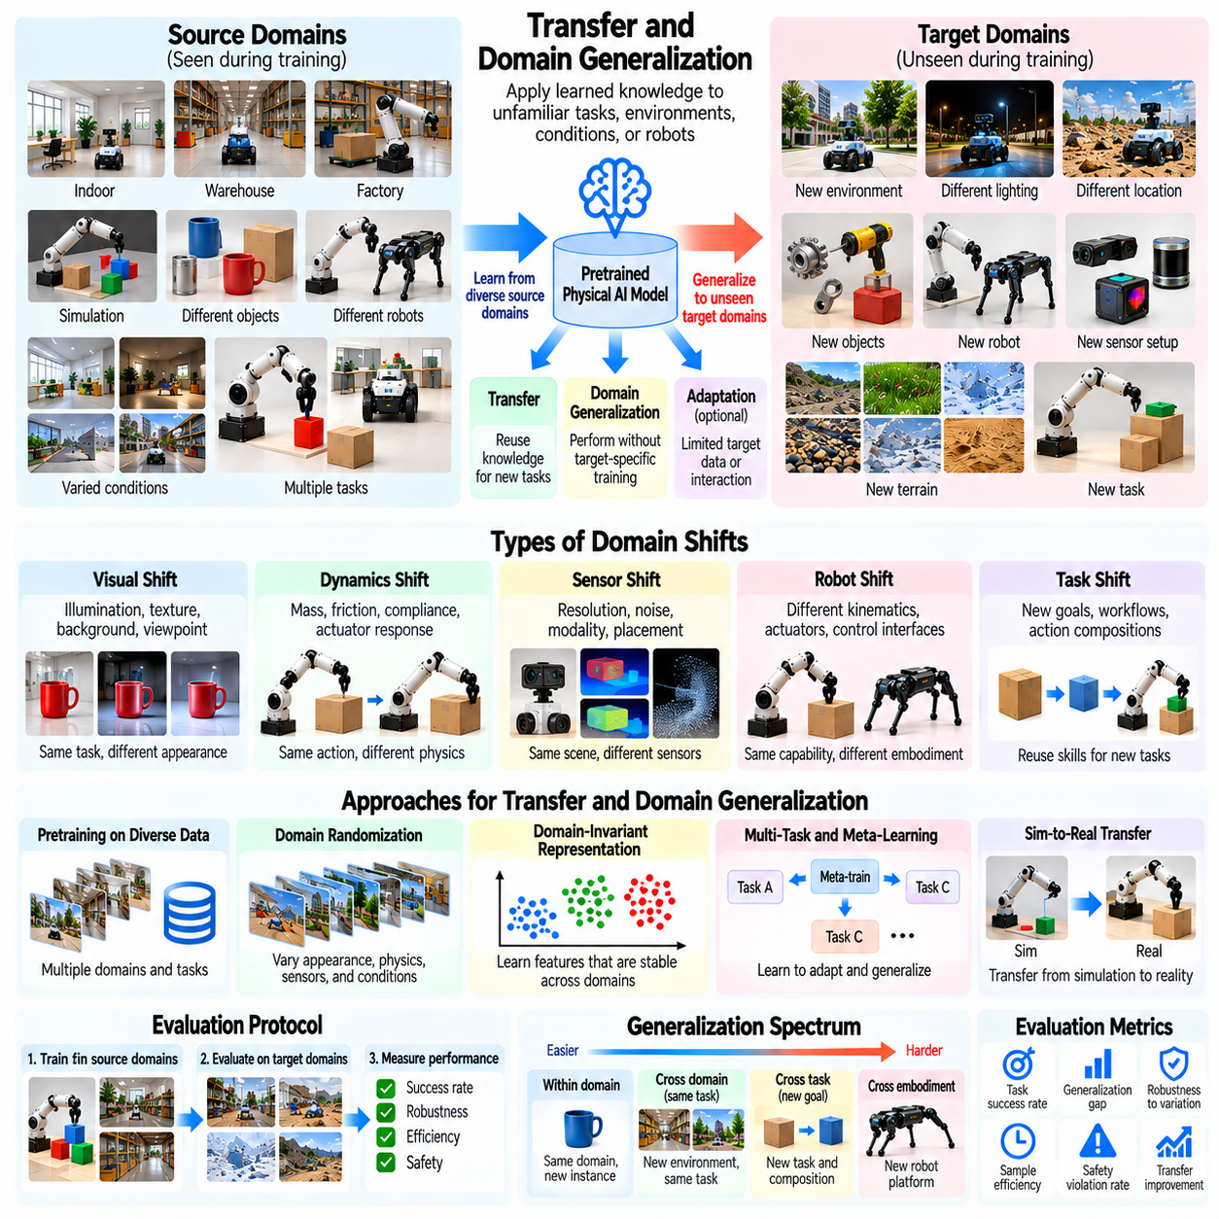
Transfer and domain generalization refers to the ability of Physical AI systems to apply knowledge learned in one set of tasks, environments, or operating conditions to unfamiliar situations. Transfer emphasizes the reuse of acquired capabilities across settings, while domain generalization focuses on performance in unseen domains without target-specific training. Evaluation determines whether learned representations and policies remain effective beyond their original training distributions.
A domain in Physical AI may be defined by environmental appearance, physical dynamics, sensor characteristics, robot configuration, or task distribution. Different factories, warehouses, outdoor locations, and simulation environments can represent distinct domains. Meaningful evaluation requires explicit domain definitions because superficial visual changes and fundamental changes in physical behavior create different generalization challenges.
Transfer learning allows a system to reuse pretrained representations, control policies, or learned dynamics when addressing a new task or environment. A robot trained to manipulate common objects may transfer grasping knowledge to unfamiliar industrial components. Evaluation should determine which capabilities remain reusable, how much additional adaptation is required, and whether transferred knowledge improves performance compared with learning from scratch.
Domain generalization differs from domain adaptation in the information available during deployment. Domain adaptation typically permits access to target-domain data for model adjustment, whereas domain generalization evaluates performance without such access. This distinction is essential for benchmark validity. Evaluation protocols must specify whether target observations, demonstrations, or online parameter updates are permitted before testing.
Source domains provide the training experiences from which transferable knowledge is acquired. These domains may differ in object appearance, workspace geometry, lighting, contact properties, or robot dynamics. Exposure to diverse source domains can encourage robust representations, but diversity alone does not guarantee generalization. Evaluation must examine whether learned principles remain useful under genuinely unfamiliar target conditions.
Target domains represent the unfamiliar operating conditions used to assess generalization. A target domain may introduce new materials, sensor noise patterns, terrain characteristics, or mechanical configurations. Evaluation should ensure that target-domain data does not unintentionally influence model development. Clear separation between source and target domains is necessary to prevent leakage and overestimated performance.
Visual domain shifts occur when appearance changes while underlying task requirements remain similar. Differences in illumination, texture, background, camera viewpoint, and object color may affect perception. A robot should recognize task-relevant structures despite these variations. Evaluation should distinguish failures caused by visual representation instability from failures involving physical reasoning or control.
Dynamics domain shifts involve changes in mass, friction, compliance, actuator response, or contact behavior. A manipulation policy trained under one set of physical parameters may perform poorly when transferred to another. Evaluation should measure whether the system preserves stability and task success under altered dynamics, particularly when familiar visual appearances conceal unfamiliar physical properties.
Sensor domain shifts arise from differences in camera calibration, resolution, field of view, latency, noise, or sensing modality. Policies trained with high-quality observations may become unreliable when deployed on different hardware. Evaluation should determine whether sensor representations remain transferable and whether the system can tolerate missing, degraded, or systematically biased measurements.
Cross-robot transfer examines whether learned knowledge can be reused across embodiments with different kinematics, actuators, and control interfaces. A manipulation strategy learned on one robotic arm may require adjustment for another arm with different joint limits or reachability. Evaluation should distinguish transferable task knowledge from embodiment-specific execution requirements and document any calibration or adaptation procedures.
Task-domain transfer concerns the reuse of learned capabilities across different objectives and operational workflows. A robot trained for sorting may transfer object recognition and grasping skills to assembly or packaging. However, shared components do not guarantee successful task execution. Evaluation should measure whether transferred representations support new planning requirements, action dependencies, and success conditions.
Representation transfer is central to generalization because learned features determine which information remains useful across domains. Robust representations should emphasize geometry, object relationships, affordances, and relevant physical properties rather than incidental appearance. Evaluation can compare frozen representations with adapted models to identify which capabilities transfer directly and which require further learning.
Domain randomization is a common strategy for improving transfer by varying simulation parameters during training. Lighting, textures, object masses, friction coefficients, and actuator characteristics may be randomized across episodes. The objective is to expose policies to diverse conditions before deployment. Evaluation should determine whether randomization improves performance on unseen domains rather than merely expanding coverage of familiar variations.
Domain-invariant learning attempts to identify features that remain stable across multiple source environments. Such features may improve generalization when target conditions differ from training data. However, complete invariance is not always desirable because some domain-specific information is necessary for safe physical control. Evaluation should examine whether learned invariances preserve task-relevant distinctions and physical sensitivity.
Simulation-to-reality transfer represents a particularly important form of domain generalization. Policies trained in simulation must operate under real sensing uncertainty, contact dynamics, actuator limitations, and environmental disturbances. Evaluation should compare simulated and physical performance under matched tasks. The resulting transfer gap reveals where simplified models or training assumptions fail to capture deployment conditions.
Negative transfer occurs when knowledge acquired in a source domain reduces performance in the target domain. A grasping policy optimized for rigid objects may fail when applied to deformable materials. Evaluation should compare transferred policies with appropriate target-domain baselines and identify conditions where inherited assumptions become harmful. Reporting only successful transfer cases can conceal important deployment risks.
A rigorous benchmark should include multiple source domains and carefully selected held-out target domains. Evaluation conditions should vary visual appearance, dynamics, sensing, and task structure independently where possible. Combined shifts are also necessary because real deployments rarely change only one factor. Benchmark design should prevent target-domain examples from influencing hyperparameter selection or model development.
Transfer performance should be measured through task success, execution quality, safety, and resource efficiency. A system may retain high success rates while requiring excessive time, energy, or corrective actions. Evaluation should therefore include completion time, trajectory quality, intervention frequency, and constraint violations alongside conventional success metrics to characterize practical transfer reliability.
The transfer gap measures the difference between performance in source conditions and performance in target conditions. A small gap suggests stable cross-domain behavior, but it must be interpreted alongside absolute performance. Transfer efficiency additionally measures the experience or computation needed when adaptation is permitted. These metrics distinguish immediate generalization from improvement achieved through target-specific learning.
Generalization degradation curves characterize how performance changes as target conditions increasingly differ from source domains. Researchers may progressively alter friction, illumination, sensor noise, or geometric complexity. Smooth degradation indicates a measurable operating boundary, whereas abrupt failure may reveal brittle representations. Such curves provide more information than a single average score across unrelated domains.
Few-shot transfer evaluation allows limited target-domain demonstrations or interactions after initial zero-shot testing. Adaptation curves can reveal how rapidly transferred knowledge supports improvement. Comparisons should use identical data and interaction budgets. This protocol separates the value of pretrained knowledge from the effectiveness of the subsequent adaptation mechanism.
Safety is essential when evaluating transfer because unfamiliar domains can invalidate assumptions about perception and physical dynamics. A robot transferred to a new environment may underestimate stopping distances or apply inappropriate contact forces. Evaluation should record unsafe actions, recovery attempts, emergency interventions, and uncertainty responses, ensuring that successful transfer does not conceal unacceptable operational risks.
Statistical evaluation should include multiple domain combinations, independent trials, and uncertainty estimates. Results should be reported separately for visual, dynamic, sensor, embodiment, and task shifts. Aggregate scores may hide severe failures in particular target domains. Transparent reporting of source-target relationships, training exposure, and adaptation permissions supports reproducible comparisons.
Real-world validation is necessary because laboratory benchmarks and simulations may not capture the full diversity of deployment environments. Field evaluations should document hardware configurations, environmental variability, task requirements, and human interventions. Repeated testing across distinct sites helps determine whether transfer performance reflects generalizable competence or favorable local conditions.
Ultimately, transfer and domain generalization measures whether Physical AI systems can extend learned capabilities beyond their original training environments. Strong performance requires transferable representations, robust policies, sensitivity to relevant physical changes, and reliable uncertainty handling. Comprehensive evaluation establishes where knowledge transfers successfully, where adaptation becomes necessary, and where deployment boundaries must be enforced.

04.14. Generalization Gap and Degradation Curves
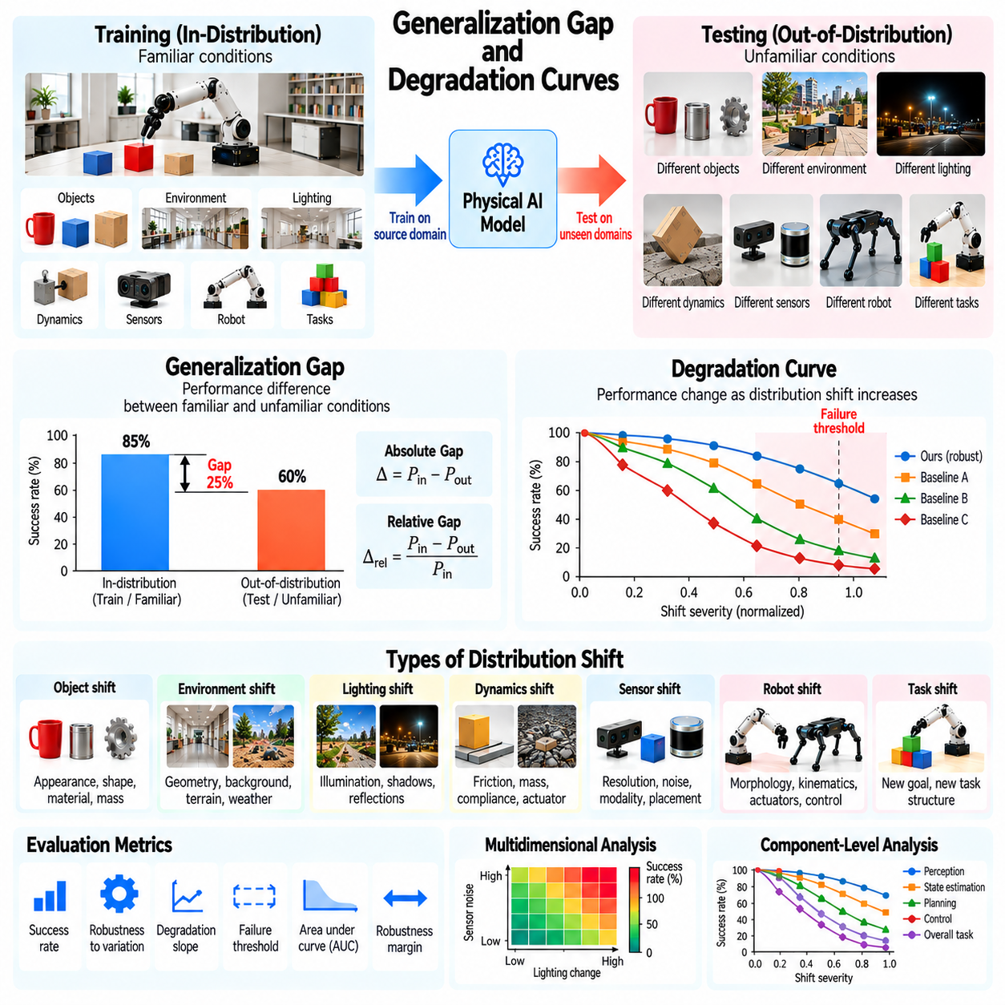
Generalization gaps and degradation curves provide quantitative methods for evaluating how Physical AI systems perform when operating conditions differ from their training environments. A generalization gap measures the performance difference between familiar and unfamiliar conditions, while a degradation curve describes how performance changes as distribution shift increases. Together, these metrics reveal robustness, transfer limitations, and operational boundaries.
A generalization gap is typically calculated by comparing performance on an in-distribution evaluation set with performance on an out-of-distribution test set. For success-based metrics, the gap can be expressed as the difference between familiar-condition success and unfamiliar-condition success. Larger positive gaps indicate greater performance deterioration, although interpretation depends on the metric direction and baseline competence.
Absolute and relative generalization gaps provide complementary information. An absolute gap expresses the difference in performance units, such as percentage points of task success. A relative gap normalizes this difference against reference performance, making proportional deterioration easier to interpret. However, relative gaps can become unstable when baseline performance approaches zero, so both measures should be reported with their definitions.
Generalization evaluation must distinguish performance degradation from inherent differences in task difficulty. An unfamiliar manipulation task may require more precise alignment or longer execution than its familiar counterpart. A lower success rate may therefore reflect increased physical complexity rather than distribution shift alone. Controlled benchmarks should match task requirements wherever possible and document unavoidable differences.
Distribution shift can occur across object appearance, environmental geometry, physical dynamics, sensor characteristics, robot morphology, and task structure. Each dimension introduces different sources of uncertainty. A comprehensive evaluation should report generalization gaps separately for these categories because a single aggregate score may conceal severe weaknesses in particular aspects of physical intelligence.
Degradation curves extend gap analysis by evaluating performance across multiple levels of distribution shift. Instead of comparing only familiar and unfamiliar conditions, researchers progressively modify a controlled variable. For example, increasing sensor noise or reducing surface friction may reveal how task success changes. The resulting curve characterizes both gradual performance deterioration and abrupt failure transitions.
The horizontal axis of a degradation curve represents a defined shift variable or severity level, while the vertical axis represents a performance metric. Suitable variables include illumination changes, object mass differences, localization error, terrain roughness, and actuator delay. The chosen severity scale must be physically meaningful and reproducible so that results can be compared across experiments.
Shift severity requires careful definition because different variables have incompatible physical units. A five-percent change in object mass cannot automatically be considered equivalent to a five-percent change in sensor noise. Researchers may use normalized severity indices for presentation, but the underlying physical values should remain available. Arbitrary normalization can otherwise create misleading comparisons.
The slope of a degradation curve indicates how sensitive system performance is to increasing shift severity. A shallow slope suggests that performance remains relatively stable across changing conditions, while a steep slope indicates greater vulnerability. However, slope estimates depend on the measurement interval and metric scale. Evaluation should avoid interpreting a single local slope as a universal robustness property.
Failure thresholds identify conditions where performance falls below an operationally acceptable level. A mobile robot may remain reliable until terrain roughness exceeds a certain range, while a manipulator may fail when positioning uncertainty becomes too large. These thresholds should be defined using application-specific requirements. Safety-critical systems may require substantially stricter limits than experimental prototypes.
The area under a degradation curve can summarize performance across a specified range of shift severities. Higher normalized area generally indicates stronger performance retention when larger metric values represent better outcomes. However, comparisons are meaningful only when systems share the same severity range, sampling procedure, and normalization. Curve summaries should not replace detailed failure analysis.
Robustness margins describe how far operating conditions can depart from a reference environment before performance violates a predefined requirement. Such margins may be expressed in physical units, including allowable sensor noise, mass variation, or localization uncertainty. Reporting margins helps translate benchmark results into deployment specifications and supports engineering decisions about acceptable operating conditions.
Multidimensional degradation analysis examines interactions between different shift variables. A robot may tolerate moderate sensor noise or moderate lighting changes independently but fail when both occur simultaneously. Evaluating combined disturbances reveals nonlinear interactions that single-variable experiments may miss. Such analysis is important because real environments rarely change along only one dimension.
Performance degradation should be examined at both task and component levels. Overall task failure may originate from perception errors, inaccurate state estimation, planning mistakes, or unstable control. Component-level metrics help explain why degradation occurs. A benchmark should connect observable failures to underlying subsystems without assuming that correlated errors necessarily establish causal responsibility.
Long-horizon tasks require additional attention because small performance losses can accumulate over many actions. A modest decrease in individual grasp success may produce a much larger reduction in complete assembly success. Evaluation should report intermediate task success, error propagation, recovery frequency, and final completion rates. These measurements reveal how local weaknesses affect extended physical behavior.
Generalization gaps should also be evaluated for execution quality rather than success alone. A robot may complete unfamiliar tasks while requiring longer trajectories, greater energy consumption, excessive contact forces, or repeated corrective actions. Such behavior represents meaningful degradation even when binary success remains unchanged. Evaluation should include efficiency, precision, safety, and interaction-quality metrics.
Uncertainty calibration provides another perspective on degradation. As operating conditions become unfamiliar, a reliable Physical AI system should recognize increasing uncertainty in its predictions and actions. Evaluation should compare confidence estimates with observed outcomes across shift severities. Overconfident failures are particularly concerning because they may prevent timely recovery or safety intervention.
Statistical confidence is essential because generalization gaps may vary across tasks, random seeds, and physical trials. Researchers should report confidence intervals, repeated measurements, and appropriate significance analyses. Paired evaluations can reduce variability when familiar and unfamiliar conditions share comparable task instances. Small apparent gaps should not be treated as meaningful without sufficient evidence.
Benchmark construction must prevent contamination between training and evaluation conditions. If models are repeatedly tuned using supposedly unseen severity levels, the evaluation no longer measures independent generalization. Researchers should maintain held-out conditions and document any adaptation performed during testing. Separate development and final evaluation sets help preserve the validity of reported degradation curves.
Simulation provides a practical environment for generating controlled degradation curves across extensive parameter ranges. Researchers can vary friction, object mass, sensor noise, and actuator dynamics while repeating identical tasks. However, simulated severity levels may not reproduce real physical effects accurately. Calibration against hardware experiments is necessary before interpreting simulated thresholds as deployment limits.
Real-world degradation testing introduces practical constraints involving equipment wear, environmental variability, and safety. Experiments should use controlled changes whenever feasible and record the actual physical conditions of each trial. Dangerous severity levels may require simulation or restricted testing instead of direct hardware execution. Evaluation protocols must prioritize safe experimentation over exhaustive stress testing.
Cross-platform comparisons require consistent tasks and clearly defined severity scales. Robots with different morphologies or sensors may experience the same disturbance differently. Consequently, identical environmental changes do not always create equivalent functional difficulty. Evaluation should report both common external conditions and platform-specific operating constraints to avoid misleading leaderboard rankings.
Degradation profiles can support system improvement by identifying the conditions responsible for the largest performance losses. Poor tolerance to lighting changes may motivate perception training, while sensitivity to friction may require better dynamics estimation or adaptive control. Repeated evaluation after modifications can verify whether improvements extend robustness without introducing regressions under previously reliable conditions.
Reporting should include reference performance, target-domain performance, gap definitions, severity ranges, degradation curves, failure thresholds, and statistical uncertainty. Researchers should also disclose adaptation permissions, hardware configurations, and evaluation protocols. Transparent reporting allows readers to distinguish broad generalization from robustness restricted to a narrow collection of test conditions.
Ultimately, generalization gaps and degradation curves transform unfamiliar-condition performance into measurable engineering evidence. Strong Physical AI systems should maintain useful performance across relevant distribution shifts, degrade predictably near capability boundaries, and respond safely when uncertainty increases. Comprehensive evaluation establishes realistic operating envelopes and identifies where further learning, adaptation, or protective constraints are necessary.

04.15. Capability Coverage and Boundary Testing
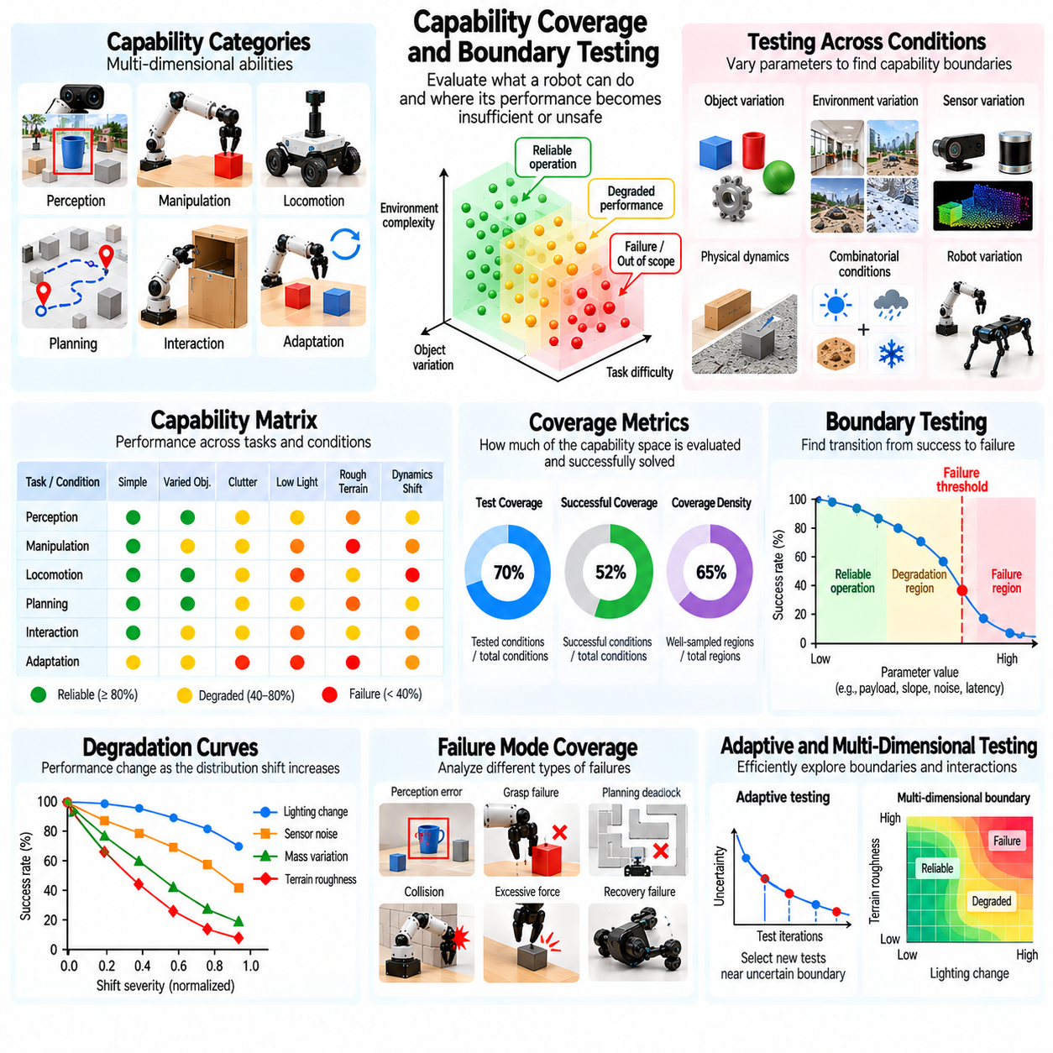
Capability coverage and boundary testing evaluates the range of tasks, environments, and physical conditions under which a Physical AI system can operate reliably. Capability coverage identifies what the system can accomplish, while boundary testing determines where performance becomes insufficient or unsafe. Together, these evaluations provide a structured understanding of operational competence beyond average benchmark scores.
Capability coverage should be defined across multiple dimensions, including perception, manipulation, locomotion, planning, interaction, and adaptation. Each dimension represents a family of abilities rather than a single task. A robot may demonstrate strong object recognition but limited manipulation precision, or reliable navigation but weak recovery behavior. Evaluation should expose these differences rather than combine them into one undifferentiated score.
A capability space represents the collection of conditions and tasks relevant to a robot's intended operation. Its dimensions may include object geometry, material properties, environmental complexity, sensor quality, task duration, and required precision. Defining this space establishes the scope of evaluation. Without explicit boundaries, claims of broad competence may reflect only a narrow selection of favorable scenarios.
Coverage metrics measure how much of a defined capability space has been evaluated or successfully demonstrated. Test coverage and successful capability coverage should be distinguished because attempting a task does not establish competence. A benchmark may report the proportion of tested conditions meeting a minimum success requirement. Such measurements should identify the tested domain rather than imply universal physical intelligence.
Capability matrices provide a structured representation of performance across task categories and operating conditions. Rows may represent capabilities such as grasping, navigation, or assembly, while columns represent environmental or difficulty variations. Each entry records performance under a defined condition. This organization helps reveal uneven capability development and supports systematic comparisons between Physical AI systems.
Boundary testing focuses on identifying transitions between reliable operation, degraded performance, and unacceptable failure. A manipulator may succeed with moderate positioning uncertainty but fail when object alignment errors exceed a threshold. A mobile robot may traverse smooth terrain reliably yet become unstable on steeper slopes. Evaluation should locate these transitions using controlled experiments.
Operational boundaries can be expressed through measurable physical parameters. Examples include maximum payload, allowable contact force, minimum obstacle clearance, sensor latency tolerance, and terrain inclination limits. These parameters translate abstract performance claims into engineering constraints. However, boundaries depend on task requirements and must not be treated as fixed properties independent of operating context.
Boundary discovery should begin with representative operating conditions and progressively increase task difficulty or environmental stress. Researchers may vary one parameter at a time to identify initial failure regions. Additional experiments should examine interactions between variables. This staged approach improves interpretability while avoiding unnecessary exposure to dangerous physical conditions.
Coverage density is important because a capability space may contain large regions that have never been tested. A benchmark with many trials concentrated around easy conditions can produce misleading confidence. Evaluation should document sampling density and identify untested combinations. Sparse regions should be treated as areas of uncertainty rather than automatically classified as successful operating conditions.
Boundary uncertainty arises because physical performance is affected by stochastic dynamics, sensor noise, and environmental variability. A robot may succeed and fail under nominally identical conditions. Consequently, capability boundaries should be represented using probabilistic performance estimates rather than single deterministic thresholds. Repeated trials and confidence intervals help quantify uncertainty near critical limits.
A capability boundary may be defined by a minimum acceptable success probability, precision requirement, or safety constraint. For example, an industrial manipulation system may require high task completion reliability within a specified positioning tolerance. Evaluation should establish acceptance criteria before testing. Otherwise, thresholds may be adjusted after observing results, creating biased interpretations.
Failure-mode coverage complements capability coverage by examining the variety of ways a system can fail. Failures may include incorrect perception, unstable grasping, planning deadlocks, collisions, excessive force, and unsuccessful recovery. Evaluating only successful outcomes leaves important operational risks unexplored. Failure-mode analysis should connect observed behavior with measurable system limitations.
Combinatorial boundary testing investigates conditions where several individually manageable challenges occur together. A robot may tolerate low lighting and moderate sensor noise separately but fail when both are present. Such interactions can create nonlinear capability boundaries. Evaluation should prioritize combinations that are plausible in deployment and potentially significant for operational safety.
Adaptive testing can improve evaluation efficiency by selecting new trials near uncertain capability boundaries. Instead of sampling every possible condition uniformly, researchers can focus on regions where performance changes rapidly or evidence remains insufficient. Adaptive procedures should preserve statistical validity and document test-selection rules to prevent biased estimates of overall capability coverage.
Coverage evaluation should account for task complexity and execution duration. A robot may reliably complete individual actions but struggle with extended sequences involving multiple dependencies. Long-horizon tasks introduce cumulative errors and recovery requirements. Evaluation should therefore include capability coverage across sequence length, subtask diversity, and planning complexity.
Generalization coverage measures whether demonstrated abilities extend beyond familiar training conditions. A robot may perform well across known objects yet fail on unfamiliar materials or configurations. Evaluation should separate in-distribution coverage from out-of-distribution coverage. This distinction reveals whether broad task performance reflects transferable competence or extensive exposure to similar training examples.
Cross-embodiment coverage examines whether capabilities remain available across robots with different morphologies, sensors, and actuation systems. A general-purpose Physical AI model may support several platforms but achieve different levels of precision and reliability. Evaluation should distinguish shared cognitive capabilities from embodiment-specific execution limits and avoid assuming identical performance across hardware.
Capability coverage should include safety and recovery behavior rather than task completion alone. A robot that successfully performs a task under nominal conditions may still be unsuitable for deployment if it cannot detect hazards or recover from disturbances. Evaluation should assess safe stopping, uncertainty recognition, fallback behavior, and human intervention requirements across the tested capability space.
Coverage scores require careful aggregation because different capabilities may have unequal importance. Averaging navigation, manipulation, and safety performance can conceal a critical weakness. Application-specific weighting may be useful, but weighting choices should be transparent. Reporting individual capability dimensions alongside aggregate summaries provides a more defensible interpretation of system readiness.
Simulation enables broad exploration of capability spaces through controlled variation of objects, environments, disturbances, and physical parameters. Automated scenario generation can identify potential boundary regions efficiently. However, simulated success does not guarantee real-world capability. Physical validation is necessary, especially near contact, stability, and safety boundaries where modeling errors may be consequential.
Real-world boundary testing should use carefully designed procedures that protect equipment, operators, and surrounding environments. Experiments may require protective fixtures, restricted workspaces, or emergency stopping mechanisms. Dangerous conditions should be investigated through simulation or controlled substitutes whenever possible. Safety constraints must govern the testing process itself.
Benchmark reporting should include capability definitions, sampled conditions, coverage density, acceptance thresholds, failure modes, and boundary uncertainty. Visual summaries such as capability matrices or performance maps can support interpretation, but the underlying measurements must remain accessible. Transparent reporting allows comparisons without obscuring differences in test scope or difficulty.
Capability coverage and boundary testing can guide system development by identifying underdeveloped skills and high-risk operating regions. Weak coverage in unfamiliar object manipulation may motivate additional training, while narrow stability margins may require hardware or control improvements. Repeated evaluation can verify whether changes expand reliable operating regions without weakening existing capabilities.
Deployment decisions should be based on demonstrated capability envelopes rather than broad claims of general intelligence. Operating policies can restrict robots to validated conditions and require intervention when uncertainty exceeds acceptable limits. Boundary monitoring during deployment can identify emerging deviations from tested assumptions. Such practices connect benchmark evaluation with practical operational assurance.
Ultimately, capability coverage and boundary testing establish what Physical AI systems can reliably accomplish and where their limitations become significant. Strong evaluation combines systematic sampling, probabilistic performance estimation, failure analysis, and safety-aware experimentation. These methods support measurable capability claims, responsible deployment boundaries, and targeted improvement toward more general physical intelligence.

04.16. Generalization Metric Suite [w/Code]
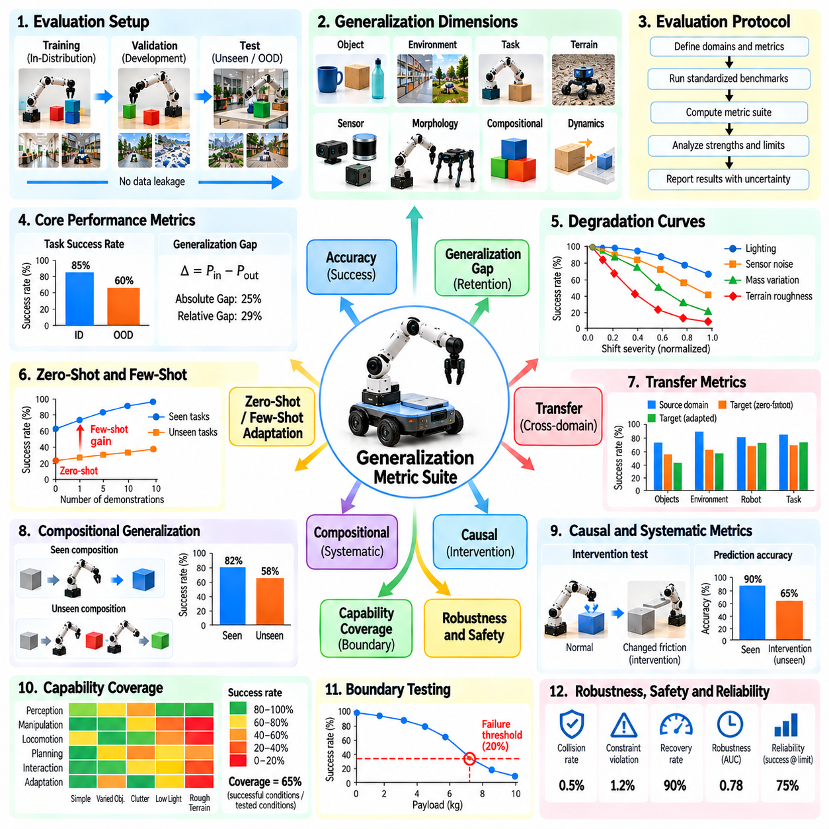
A generalization metric suite provides an integrated evaluation framework for measuring how Physical AI systems perform beyond familiar training conditions. Rather than relying on a single success rate, the suite combines metrics for distribution shifts, task novelty, transfer, adaptation, robustness, and operational boundaries. Its purpose is to characterize the breadth, reliability, and limitations of generalizable physical intelligence.
The suite should organize evaluation across clearly defined generalization dimensions. These may include unseen objects, unfamiliar environments, novel tasks, changing terrain, sensor variations, robot morphology, and compositional structures. Each dimension represents a distinct source of novelty. Separating them allows researchers to identify whether a system generalizes broadly or performs well only under particular types of distribution shift.
A standardized evaluation protocol begins by defining training, validation, and held-out test distributions. Training data establishes the experiences available to the model, while validation data supports development decisions. Held-out conditions assess performance on unfamiliar situations. Strict separation is necessary because exposure to evaluation examples can inflate reported generalization capabilities.
Task success rate provides a fundamental measure of generalization performance. It represents the proportion of evaluation episodes satisfying predefined completion criteria. Success definitions should include physical constraints such as object placement accuracy, collision avoidance, and task completion requirements. Reporting success separately for familiar and unfamiliar conditions establishes a foundation for subsequent metrics.
The generalization gap quantifies performance deterioration between reference and unfamiliar conditions. For success-based evaluation, the absolute gap equals the reference success rate minus the target success rate. Relative gaps express deterioration as a fraction of reference performance. Both should be reported because absolute differences and proportional losses provide complementary interpretations of generalization quality.
Performance retention measures how much reference capability remains under unfamiliar conditions. For positive performance metrics, retention can be expressed as the ratio of target performance to reference performance. Values near one indicate limited deterioration, while values below one indicate reduced performance. This metric requires careful interpretation when reference performance is very low or target performance improves.
Novelty-conditioned success rates characterize performance across different levels of unfamiliarity. Evaluation scenarios may be grouped by object novelty, environmental change, task complexity, or physical parameter variation. Reporting results within each category reveals where generalization weakens. Novelty definitions must remain consistent and should not depend solely on subjective judgments about task difficulty.
Degradation curves measure performance across progressively increasing distribution shifts. Researchers may vary sensor noise, object mass, friction, lighting, or terrain difficulty while recording task outcomes. Curve slope, area under the curve, and failure thresholds provide complementary measures of robustness. These summaries should always specify the severity range and physical meaning of the tested variations.
Zero-shot generalization metrics evaluate performance on unfamiliar conditions without additional task-specific training. Few-shot adaptation metrics assess improvement after a limited number of demonstrations or interactions. The suite should report zero-shot success, adaptation gain, sample efficiency, and final adapted performance separately. This distinction prevents additional learning resources from being mistaken for immediate generalization.
Transfer metrics examine how knowledge learned in source domains performs in target domains. Relevant measures include target-domain success, transfer gaps, adaptation cost, and negative transfer frequency. Cross-embodiment evaluation may additionally consider calibration requirements and platform-specific constraints. Reporting these factors reveals whether transferred knowledge provides practical benefits across different operating systems.
Compositional generalization metrics evaluate the reuse of familiar skills and concepts in unfamiliar combinations. Task success should be complemented by subtask completion, action ordering accuracy, and constraint satisfaction. Evaluation can compare familiar compositions with held-out sequences or relationships. Such metrics help distinguish flexible skill recombination from memorization of complete task demonstrations.
Systematic and causal generalization require metrics that examine consistency under structured changes and controlled interventions. Prediction accuracy, causal consistency, intervention success, and counterfactual evaluation may be included. These measures should assess whether learned relationships remain valid when superficial correlations are disrupted. Successful prediction alone does not establish reliable physical control.
Capability coverage measures the proportion of a defined task-condition space in which a system satisfies specified performance requirements. Coverage should be separated from the proportion of conditions merely tested. Boundary metrics identify operating limits such as maximum payload, acceptable sensor uncertainty, or terrain tolerance. Probabilistic boundaries are preferable when outcomes vary across repeated physical trials.
Safety-related generalization metrics capture behavior under unfamiliar and potentially hazardous conditions. Relevant measurements include collision frequency, constraint violations, unsafe contact forces, emergency interventions, and recovery success. Safety should not be hidden within average task performance. A system that generalizes successfully on routine tasks may still be unsuitable for deployment if failures become dangerous.
Execution quality provides additional evidence beyond binary task success. A robot may complete unfamiliar tasks while consuming excessive energy, producing longer trajectories, or requiring repeated corrections. The suite should include completion time, path efficiency, manipulation precision, control stability, and interaction quality. These measurements reveal degradation that conventional success metrics may overlook.
Uncertainty calibration evaluates whether confidence estimates remain aligned with observed performance under distribution shift. A reliable system should recognize conditions where predictions and actions become less trustworthy. Calibration error, failure detection performance, and selective execution behavior can support this assessment. Evaluation should pay particular attention to confident failures near operational boundaries.
Statistical reliability is necessary for meaningful metric interpretation. Each reported result should include appropriate trial counts, variability estimates, and confidence intervals. Repeated evaluation across independent task instances and random seeds reduces dependence on favorable samples. Paired comparisons are useful when systems are tested under matched conditions, although physical variability must still be considered.
Metric aggregation should preserve information about distinct generalization capabilities. A single weighted score may support comparison, but it can conceal severe weaknesses in safety, morphology transfer, or causal reasoning. The suite should report dimension-specific results alongside any composite index. Weighting rules, normalization procedures, and missing-data treatment must be defined before evaluation.
Benchmark automation improves consistency by standardizing scenario generation, execution logging, metric calculation, and report production. Each evaluation episode should record task identifiers, domain conditions, robot configuration, outcomes, and safety events. Automated validation can detect incomplete trials or inconsistent labels. Reproducible pipelines reduce manual errors and support repeated comparisons across model versions.
A practical implementation may represent evaluation records as structured data containing scenario metadata, reference conditions, measured outcomes, and novelty categories. Metric functions can calculate success rates, generalization gaps, retention ratios, and coverage estimates from these records. Modular software design allows additional metrics without changing the underlying protocol. Versioned definitions preserve comparability across experiments.
Simulation and real-world evaluations should share compatible metric definitions whenever possible. Simulation enables broad sampling of unfamiliar conditions, while physical experiments reveal hardware limitations and unmodeled interactions. Results should remain separated by evaluation environment rather than combined without qualification. Differences between simulated and real performance provide additional evidence about transfer limitations.
Metric validity depends on appropriate baselines and controlled comparisons. A generalization score should be interpreted relative to reference performance, task difficulty, and available information. Models receiving target-domain demonstrations or additional adaptation time should not be directly compared with strictly zero-shot systems without disclosure. Transparent protocols are essential for fair evaluation.
Reporting should include domain definitions, test partitions, novelty levels, success criteria, adaptation permissions, metric formulas, and statistical uncertainty. Results should also identify failure cases and conditions outside the tested capability space. Standardized reporting enables researchers to reproduce findings, compare systems responsibly, and distinguish verified capabilities from unsupported generalization claims.
The metric suite should support continuous evaluation throughout the Physical AI development lifecycle. New model versions can be tested against fixed reference scenarios and newly introduced challenge sets. Regression analysis identifies capabilities weakened by updates, while boundary testing reveals expanded operating regions. Longitudinal tracking connects algorithm improvements with measurable changes in deployment readiness.
Ultimately, a generalization metric suite transforms diverse physical performance observations into a coherent assessment of transferable intelligence. Strong evaluation integrates success, robustness, adaptation, causal consistency, safety, and capability coverage without obscuring their differences. A standardized and reproducible suite establishes credible evidence for generalization claims and supports safer deployment of Physical AI systems.

