Volume 12. Physical AI Business and Industry Applications

Chapter 00. Introduction

00.01. From Physical AI Technology to Industrial Value
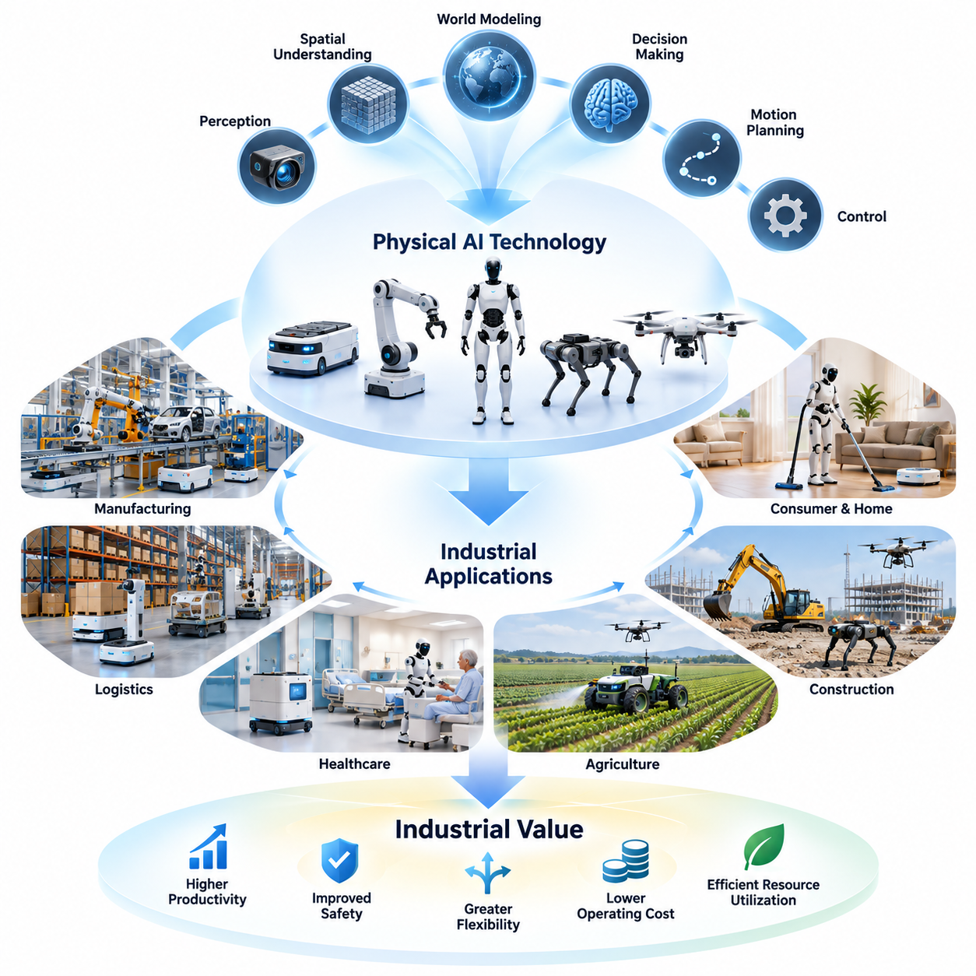
Physical AI represents a fundamental transition from artificial intelligence that primarily processes digital information to intelligent systems capable of perceiving, reasoning, and acting within the physical world. Its industrial significance emerges when these capabilities are transformed into measurable operational improvements, including higher productivity, improved safety, greater flexibility, and more efficient utilization of physical resources.
The technological foundation of Physical AI combines machine perception, spatial understanding, world modeling, decision-making, motion planning, and intelligent control. These capabilities operate through embodied systems such as autonomous mobile robots, manipulators, humanoids, quadrupeds, and aerial robots. Industrial value arises not from individual algorithms alone, but from their reliable integration into complete operational workflows.
Traditional industrial automation has historically depended on predefined sequences, structured environments, and relatively predictable operating conditions. Physical AI extends this approach by enabling machines to interpret changing environments, respond to unexpected situations, and adjust their behavior according to task requirements. This adaptability creates opportunities to automate activities that were previously difficult to address using conventional machinery.
The transition from technological capability to industrial value begins with identifying operational problems that justify intelligent automation. A robot capable of autonomous navigation does not automatically create economic benefits. Its value depends on whether it can reduce transportation delays, improve material availability, increase equipment utilization, or eliminate repetitive manual movements within an actual production or logistics environment.
Physical AI applications must therefore be evaluated through the relationship between technical performance and business outcomes. Perception accuracy, navigation reliability, manipulation success, and decision latency are important engineering measurements, but industrial customers ultimately evaluate throughput, operating cost, service availability, quality consistency, and return on investment. Successful commercialization connects these two measurement domains.
Manufacturing provides an important example of this transformation. Autonomous mobile robots can transport materials between production stations, while intelligent manipulators can perform machine tending, component handling, and flexible assembly. When connected to production management systems, these technologies can improve material flow, reduce interruptions, and support more adaptive manufacturing operations without requiring every production activity to be completely redesigned.
In logistics and warehouse operations, Physical AI creates value through autonomous transportation, intelligent picking, pallet handling, sorting, and coordinated fleet operations. The economic benefits depend on the relationship between robot utilization, order throughput, labor requirements, and infrastructure costs. Integration with warehouse management systems, enterprise resource planning, and fleet management platforms is essential for converting autonomous capabilities into operational performance.
Healthcare applications demonstrate that industrial value cannot always be measured through labor savings alone. Hospital delivery robots, assistive systems, rehabilitation devices, and autonomous inspection platforms may improve service consistency, reduce unnecessary staff movement, and support patient-centered workflows. Their adoption requires careful consideration of safety, privacy, clinical compatibility, human interaction, and evidence that the technology produces meaningful operational benefits.
Agriculture presents a different set of requirements because robots must operate in environments characterized by uneven terrain, variable weather, biological diversity, and seasonal demand. Autonomous harvesting, precision spraying, crop monitoring, and field transportation can potentially reduce repetitive labor and improve resource efficiency. However, economic feasibility depends on equipment utilization, crop characteristics, operating windows, and the reliability of outdoor autonomy.
Construction and infrastructure applications extend Physical AI into environments where physical conditions change continuously. Autonomous equipment, robotic surveying, aerial inspection, and quadruped platforms can support site monitoring, infrastructure assessment, and hazardous-area access. Their industrial value includes improved inspection coverage, reduced worker exposure, better project information, and potentially lower costs associated with delays, rework, and maintenance.
Consumer and home applications introduce additional considerations involving affordability, convenience, reliability, privacy, and social acceptance. Household robots must operate around people, furniture, pets, and unpredictable objects while delivering consistent performance. Unlike industrial facilities, homes rarely provide standardized operating conditions, making generalization and safe human interaction particularly important for creating products that customers will adopt and continue using.
The commercial potential of Physical AI depends strongly on the relationship between autonomy and operational reliability. A system that performs complex demonstrations but frequently requires human intervention may deliver limited economic value. Conversely, a robot with a narrower task capability can generate substantial benefits when it operates consistently, integrates with existing workflows, and maintains high availability over extended periods.
Deployment economics must account for more than the purchase price of robotic hardware. Total cost of ownership includes software licensing, installation, integration, charging infrastructure, maintenance, energy consumption, operator training, supervision, and eventual equipment replacement. These costs must be compared with measurable benefits across the expected operating life of the system rather than relying exclusively on initial productivity demonstrations.
The distinction between capital expenditure and operating expenditure also influences adoption. Direct equipment purchases require customers to commit capital and accept responsibility for asset ownership. Robot-as-a-Service models can distribute costs through recurring payments while shifting selected maintenance and operational responsibilities toward providers. Each approach creates different financial incentives, risk allocations, and requirements for service reliability.
Physical AI also changes the structure of industrial value chains. Hardware manufacturers provide mechanical platforms, actuators, sensors, and computing systems, while software developers contribute perception, planning, control, and learning capabilities. System integrators connect these technologies to customer operations, and service providers support deployment, monitoring, maintenance, and continuous improvement throughout the equipment lifecycle.
As Physical AI systems become more connected, operational data can become an additional source of value. Robot fleets generate information about task execution, environmental conditions, failures, interventions, and equipment performance. When appropriately governed and analyzed, these data can support model improvement, predictive maintenance, fleet optimization, and better deployment decisions, creating feedback between operational experience and technological development.
The ability to scale from a successful pilot to a commercially sustainable deployment is a critical challenge. Laboratory demonstrations often operate under controlled conditions, while production environments introduce unexpected obstacles, infrastructure limitations, changing workloads, and maintenance constraints. Scaling requires standardized interfaces, repeatable installation procedures, robust monitoring, dependable support services, and clearly defined operational responsibilities.
Safety and regulatory compliance form essential foundations for industrial adoption. Physical AI systems interact directly with equipment, infrastructure, workers, and sometimes vulnerable individuals. Their decisions can produce physical consequences, making risk assessment, protective mechanisms, fallback behavior, cybersecurity, and human oversight necessary components of system design. Commercial value must never depend on accepting uncontrolled operational risks.
Industrial adoption is also influenced by organizational readiness. Employees must understand how intelligent machines affect their responsibilities, while managers must establish procedures for supervision, exception handling, maintenance, and performance evaluation. Effective deployment frequently involves redesigning workflows rather than simply replacing individual human activities. Organizational adaptation is therefore closely connected to the technical success of Physical AI.
The most promising applications are not necessarily those requiring the highest level of general intelligence. Commercial opportunities often emerge where task requirements are sufficiently defined, operating conditions can be managed, and performance improvements are economically significant. Selecting an appropriate degree of autonomy allows organizations to balance technical complexity, deployment risk, and expected business value.
Over time, improvements in foundation models, multimodal perception, simulation, and cross-embodiment learning may reduce the engineering effort required to adapt robots to new tasks. However, broader intelligence does not eliminate the need for specialized hardware, operational integration, safety validation, and application-specific optimization. Industrial competitiveness will depend on combining reusable intelligence with reliable physical execution.
Physical AI business models may consequently evolve from standalone robotic products toward integrated systems, software platforms, managed fleets, and intelligence-enabled services. This transition can create recurring revenue opportunities while increasing the importance of lifecycle management and customer relationships. Sustainable business models must align pricing, service commitments, hardware costs, and operational performance with the economic value delivered to customers.
The central principle of industrial Physical AI is that technological sophistication becomes commercially meaningful only when it solves a practical problem at an acceptable cost and risk. Successful systems connect perception, intelligence, and physical action to measurable improvements in real operations. Understanding this connection provides the foundation for evaluating market opportunities, industry applications, business models, and commercialization strategies across the Physical AI ecosystem.

00.02. Why Physical AI Changes Industry
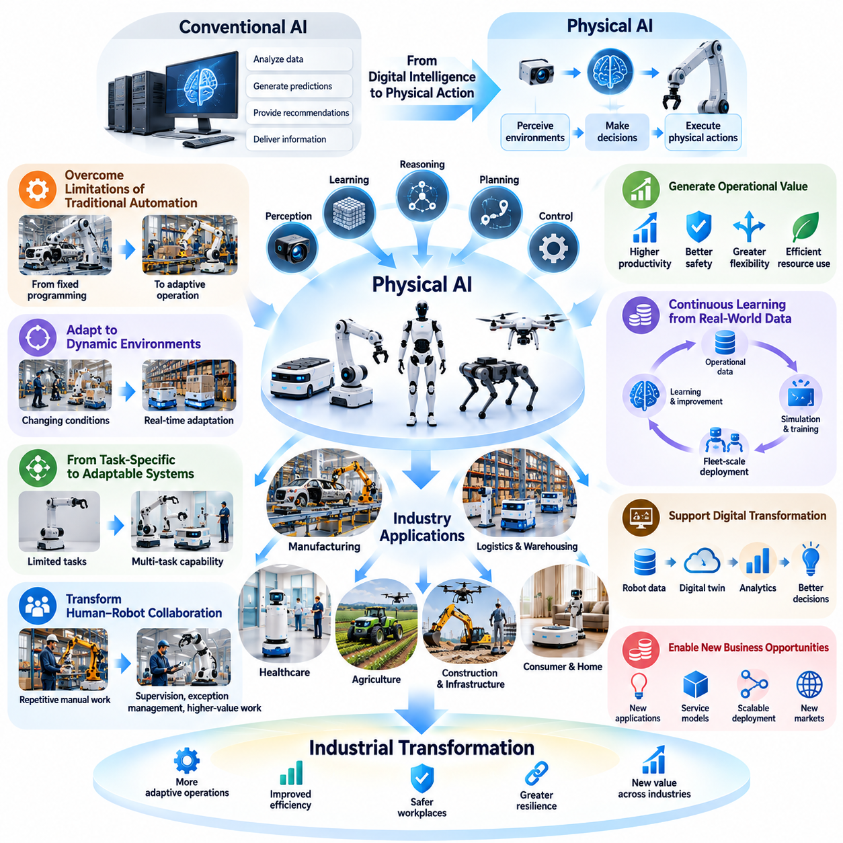
Physical AI changes industry by extending artificial intelligence beyond digital analysis into direct interaction with the physical world. Unlike conventional AI systems that primarily generate predictions, recommendations, or information, Physical AI enables machines to perceive environments, make decisions, and execute physical actions. This transformation creates new possibilities for industrial automation, operational flexibility, and intelligent resource utilization.
The significance of Physical AI lies in its ability to address limitations of traditional automation. Conventional industrial systems typically depend on predefined procedures, fixed equipment configurations, and predictable operating conditions. Physical AI introduces perception, learning, reasoning, and adaptive control, allowing machines to respond to environmental changes and perform tasks that cannot be completely specified through rigid programming.
Industrial environments are inherently dynamic because materials, equipment, workers, and operating conditions change continuously. Traditional automation often requires substantial engineering modifications when these conditions vary. Physical AI systems can interpret sensor information, update their understanding of surrounding environments, and adjust their actions accordingly. This capability reduces dependence on completely structured environments and expands the range of tasks suitable for automation.
One of the most important industrial implications is the transition from task-specific automation toward adaptable intelligent systems. Traditional robots are often designed to execute a limited sequence of repetitive operations. Physical AI introduces the possibility of reusing perception, planning, and control capabilities across multiple tasks. Although specialized engineering remains necessary, this adaptability can reduce the effort required to introduce new products, workflows, and operating procedures.
Physical AI also changes the relationship between human labor and machines. Instead of automating only highly repetitive activities, intelligent robotic systems can support material handling, inspection, transportation, equipment operation, and selected manipulation tasks. Human workers can increasingly focus on supervision, exception management, process improvement, and activities requiring complex judgment. The resulting transformation involves redesigning work rather than simply replacing individual workers.
Manufacturing illustrates how Physical AI can transform industrial operations. Autonomous mobile robots can coordinate material transportation, intelligent manipulators can adapt to variations in component placement, and perception systems can identify production abnormalities. When connected to manufacturing execution systems and production planning platforms, these capabilities support more responsive factories that can adjust operations according to changing production requirements.
In logistics and warehousing, Physical AI enables transportation and handling systems to respond dynamically to inventory movement, order demand, and changing facility conditions. Autonomous mobile robots, robotic picking systems, and intelligent forklifts can coordinate through fleet management platforms. Their combined operation can improve material flow, reduce unnecessary travel, and support more flexible warehouse configurations compared with automation dependent on fixed transportation infrastructure.
Healthcare demonstrates another dimension of industrial transformation. Intelligent delivery robots, assistive devices, rehabilitation systems, and autonomous monitoring platforms can support hospital operations and patient services. These technologies may reduce routine transportation workloads and improve service consistency. However, their effectiveness depends on clinical integration, safety assurance, privacy protection, and compatibility with established healthcare workflows.
Agriculture benefits from Physical AI because farming activities occur in environments that are difficult to standardize. Autonomous field vehicles, crop monitoring robots, intelligent harvesting systems, and precision treatment platforms can respond to variations in terrain, vegetation, and environmental conditions. These capabilities can support more selective resource application, improve operational consistency, and reduce dependence on manual labor during time-sensitive agricultural activities.
Construction and infrastructure industries face similar challenges involving changing physical environments and difficult working conditions. Physical AI enables autonomous inspection, robotic surveying, intelligent construction equipment, and mobile platforms capable of navigating complex sites. These technologies can improve information collection, support project monitoring, and reduce human exposure to hazardous locations while providing more frequent observations of infrastructure conditions.
Another important transformation involves the integration of physical operations with digital intelligence. Robots equipped with sensors continuously generate information about their environments, actions, equipment conditions, and operational results. This information can be connected to enterprise systems, digital twins, and analytics platforms. Consequently, physical activities become measurable data sources that support operational optimization and better management decisions.
Physical AI introduces continuous learning opportunities through operational data collection. Successful actions, failures, human interventions, and environmental variations can contribute to improving robotic behavior. When combined with simulation, data curation, and model training, these experiences can support iterative system development. Fleet-scale deployment may further accelerate learning by collecting diverse operational examples across multiple robots and environments.
The development of robot foundation models and vision-language-action architectures may increase the adaptability of industrial robotic systems. These approaches seek to connect visual perception, language instructions, and physical actions within reusable learning frameworks. Although current systems still face limitations in reliability and generalization, they offer a potential path toward reducing the amount of task-specific programming required for selected robotic applications.
Physical AI also transforms industrial system architecture by connecting edge computing, local control, enterprise platforms, and cloud-based intelligence. Time-critical motion control and safety functions generally require dependable local execution, while large-scale data processing and model development can benefit from centralized infrastructure. Effective architectural design balances communication latency, computing requirements, cybersecurity, operational continuity, and the reliability of physical actions.
Economic value remains a decisive factor in determining whether these technological changes lead to widespread industrial adoption. Improved autonomy does not automatically guarantee lower operating costs or higher productivity. Organizations must evaluate equipment investment, integration expenses, maintenance, energy consumption, utilization, and service availability. Physical AI becomes commercially meaningful when its operational benefits exceed the total costs and risks associated with deployment.
The introduction of Physical AI can also change industrial business models. Companies may purchase autonomous equipment, subscribe to intelligent software platforms, or adopt Robot-as-a-Service arrangements that combine hardware, software, maintenance, and operational support. These alternatives create different financial structures and responsibilities. They also encourage technology providers to focus on sustained customer outcomes rather than equipment delivery alone.
Industrial competitiveness may increasingly depend on the ability to combine intelligent machines with coordinated operational systems. A single autonomous robot can improve a particular activity, but connected fleets and integrated production platforms can optimize broader workflows. Task allocation, traffic coordination, resource scheduling, and operational monitoring become important mechanisms for translating individual robotic capabilities into system-level productivity improvements.
Nevertheless, Physical AI introduces challenges that differ from those of purely digital intelligence. Physical actions involve mechanical forces, moving equipment, environmental uncertainty, and direct interaction with people. Errors may cause equipment damage, production interruptions, or safety incidents. Industrial systems therefore require rigorous validation, predictable fallback behavior, functional safety mechanisms, cybersecurity protection, and appropriate human oversight.
The transformation also depends on organizational readiness and workforce adaptation. Successful deployment requires employees to understand robotic capabilities, operational limitations, and intervention procedures. Managers must establish responsibilities for maintenance, monitoring, performance assessment, and exception handling. Training and workflow redesign are essential because intelligent automation changes how people coordinate with machines and how operational decisions are distributed.
Physical AI does not imply that every industrial task requires a humanoid robot or a general-purpose autonomous system. Different applications demand different combinations of mobility, manipulation, sensing, payload capacity, precision, and intelligence. Autonomous mobile robots may be appropriate for internal logistics, manipulators for assembly, quadrupeds for difficult terrain, and aerial robots for inspection. Matching system capabilities to operational requirements remains fundamental.
The long-term industrial impact of Physical AI will depend on improvements in reliability, affordability, generalization, and deployment scalability. Advances in simulation, foundation models, hardware-software co-design, and fleet learning may gradually expand the range of economically viable applications. However, practical progress will require consistent performance under real operating conditions, manageable lifecycle costs, and evidence of measurable operational benefits.
Ultimately, Physical AI changes industry by transforming machines from rigid automation components into increasingly adaptive participants in physical operations. Its significance extends beyond individual robots to the redesign of workflows, industrial infrastructure, workforce responsibilities, and business models. The greatest value emerges when intelligent physical capabilities are integrated into reliable, safe, and economically sustainable operational systems.

00.03. Automation Autonomy and Intelligent Labor
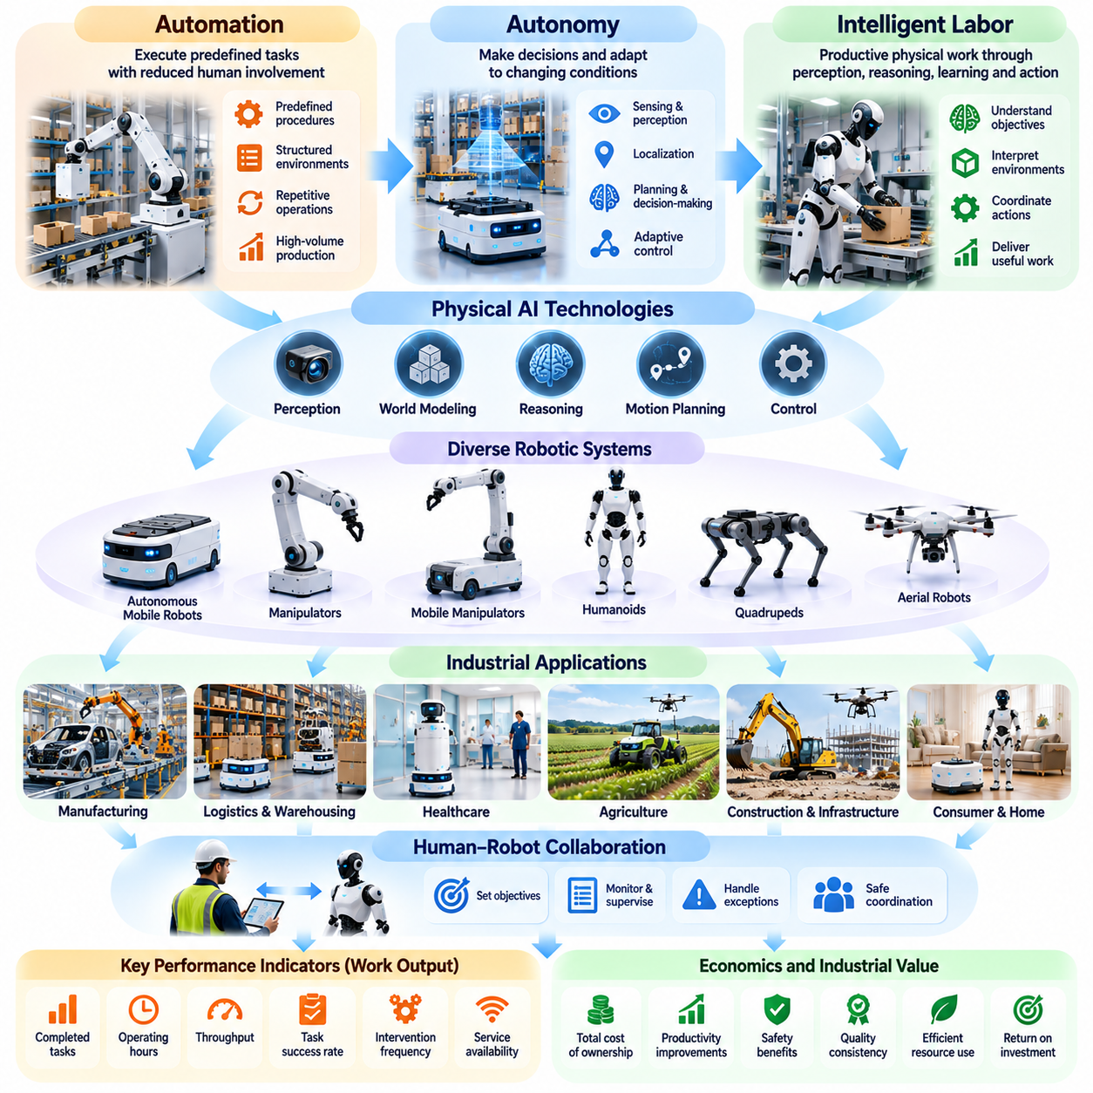
Automation, autonomy, and intelligent labor represent three interconnected dimensions of industrial transformation enabled by Physical AI. Automation focuses on executing predefined tasks with reduced human involvement, while autonomy introduces the ability to make decisions and adapt to changing conditions. Intelligent labor extends these capabilities toward performing productive physical work through perception, reasoning, learning, and coordinated action.
Traditional automation has improved industrial productivity by replacing repetitive manual operations with machines, programmable controllers, and robotic systems. These technologies perform exceptionally well when tasks are structured, predictable, and repeated at high volumes. However, their effectiveness often decreases when operating environments change, objects vary, or unexpected situations require decisions beyond predefined programming.
Autonomy extends automation by allowing machines to interpret environmental information and select appropriate actions without continuous human direction. Autonomous systems combine sensing, localization, perception, planning, and control to achieve operational objectives. Their independence is not absolute, because practical autonomy operates within defined safety constraints, operational boundaries, and human supervisory structures.
Physical AI enables a transition from fixed automation toward adaptive autonomy through learning-based perception and decision-making. Instead of depending exclusively on manually programmed rules, intelligent machines can use learned representations to interpret unfamiliar situations and adjust their behavior. This capability is particularly valuable in manufacturing, logistics, agriculture, healthcare, and infrastructure environments where conditions cannot be completely standardized.
The concept of intelligent labor describes productive physical activities performed by machines that combine mechanical capabilities with artificial intelligence. Unlike conventional equipment that simply executes commands, intelligent robotic systems can interpret task objectives, recognize relevant environmental conditions, and coordinate actions toward desired outcomes. Their economic significance depends on delivering useful work reliably rather than demonstrating intelligence alone.
Industrial labor consists of multiple interconnected activities, including transportation, manipulation, inspection, monitoring, maintenance, and operational decision-making. Different activities require different combinations of physical strength, dexterity, mobility, perception, and reasoning. Physical AI therefore does not imply a single universal robot architecture, but rather a diverse collection of intelligent machines optimized for particular operational requirements.
Autonomous mobile robots illustrate how intelligent labor can emerge from relatively specialized capabilities. These systems navigate facilities, transport materials, avoid obstacles, and coordinate movement with other equipment. When integrated with warehouse management systems and fleet management platforms, they can perform transportation services continuously while responding to changing task priorities and facility conditions.
Robotic manipulators extend intelligent labor into physical interaction with objects and equipment. Vision-guided manipulation enables robots to identify components, estimate object poses, and execute grasping or placement operations. Mobile manipulators combine transportation and manipulation, potentially supporting machine tending, order picking, and material replenishment across multiple locations rather than remaining restricted to fixed workstations.
Humanoid robots represent another approach to intelligent labor because their morphology may provide compatibility with environments designed around human movement and manipulation. However, human-like appearance does not guarantee superior industrial performance. Practical adoption depends on task success, payload capacity, reliability, safety, energy efficiency, and operating cost compared with specialized robotic alternatives.
The degree of autonomy required for industrial work varies significantly across applications. Some systems operate through deterministic control and predefined routes, while others require adaptive planning and continuous environmental interpretation. Higher autonomy may reduce routine supervision, but it also introduces greater requirements for validation, uncertainty management, exception handling, and operational accountability.
Human supervision remains important even as robotic autonomy improves. Operators may define objectives, authorize sensitive actions, resolve unexpected situations, and intervene when autonomous behavior becomes unreliable. Effective human-robot collaboration requires clear responsibility boundaries, understandable system states, appropriate intervention mechanisms, and interfaces that support safe coordination between people and intelligent machines.
Intelligent labor should be evaluated through measurable work output rather than the number of robots deployed. Relevant indicators include completed tasks, operating hours, throughput, intervention frequency, task success rate, and service availability. A highly autonomous machine may provide limited economic value if its utilization is low, while a simpler system can be commercially successful when it performs essential tasks consistently.
The economics of intelligent labor depend on the complete operating system surrounding the robot. Hardware acquisition, software licensing, charging infrastructure, integration, maintenance, supervision, and downtime contribute to total cost of ownership. Organizations must compare these expenses with productivity improvements, avoided delays, quality benefits, safety improvements, and the effective cost of alternative operating methods.
Physical AI also enables coordinated intelligent labor through multi-robot systems. Individual robots can share operational information, receive dynamically assigned tasks, and coordinate movement within common environments. Fleet management systems can distribute workloads according to robot availability, location, battery condition, and task priority, allowing organizations to optimize collective performance rather than isolated machine behavior.
Data-driven learning provides another distinction between conventional automation and emerging intelligent labor. Operational experiences can reveal recurring failures, environmental variations, and opportunities for performance improvement. When properly collected and validated, these data can support model refinement, simulation-based training, predictive maintenance, and improved task allocation across deployed robotic systems.
The introduction of foundation models and vision-language-action architectures may further expand the flexibility of intelligent labor. Such models seek to connect natural-language instructions, visual observations, and robotic actions within reusable learning systems. Their potential lies in reducing task-specific programming, although industrial deployment still requires reliable control, safety validation, and adaptation to physical hardware constraints.
Intelligent labor also changes organizational structures and workforce responsibilities. Human employees may increasingly supervise automated processes, manage exceptions, maintain robotic equipment, and improve workflows. This transformation requires technical training, revised operating procedures, and new methods of evaluating productivity. Successful adoption depends on integrating human expertise with machine capabilities rather than assuming complete workforce replacement.
Safety becomes especially important when autonomous machines perform physical work near people, vehicles, and valuable equipment. Intelligent labor systems must operate within appropriate mechanical, electrical, and behavioral constraints. Risk assessment, emergency stopping, collision avoidance, fallback control, cybersecurity, and operational monitoring remain essential even when advanced AI models provide high-level decision-making capabilities.
The transition toward intelligent labor will likely occur progressively rather than through immediate replacement of conventional automation. Structured, repetitive tasks can remain economically suited to deterministic systems, while variable or difficult-to-program activities may benefit from adaptive intelligence. Hybrid architectures combining traditional control, learned policies, and human supervision offer a practical path toward broader industrial autonomy.
Ultimately, automation provides repeatable execution, autonomy enables independent adaptation, and intelligent labor converts these capabilities into productive physical work. Physical AI connects these dimensions through embodied intelligence and operational integration. Its industrial significance lies in creating reliable systems that expand automation coverage, improve resource utilization, and support economically sustainable collaboration between humans and intelligent machines.

00.04. Product Service and Platform Perspectives
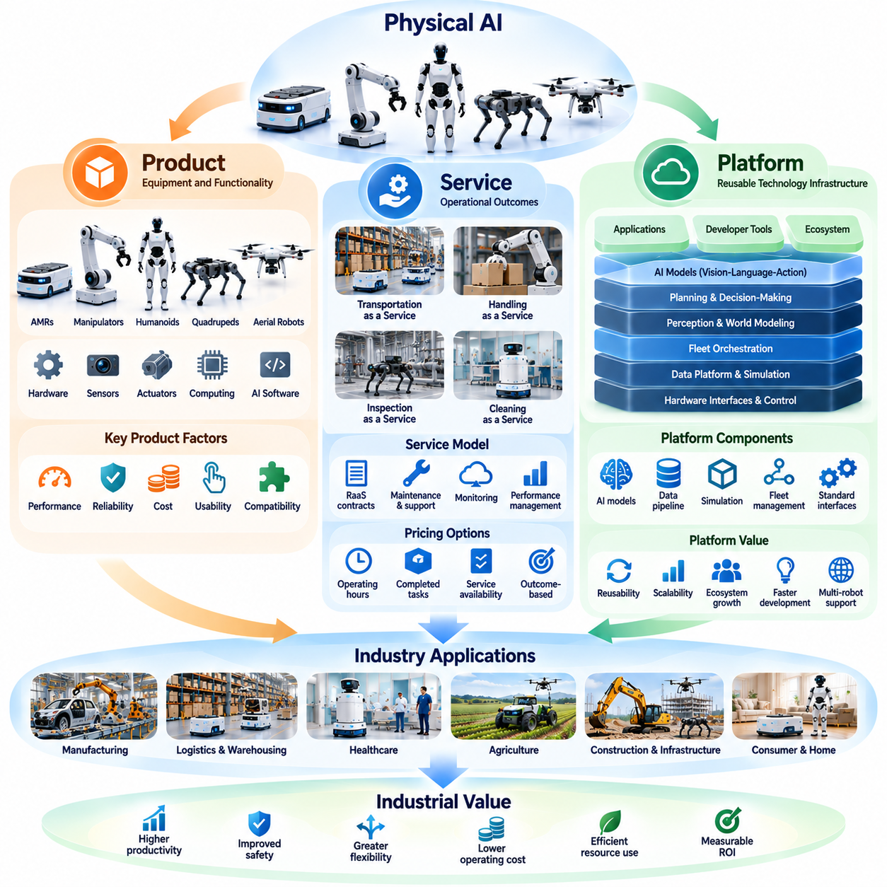
Physical AI can be understood through three complementary business perspectives: products, services, and platforms. Each perspective represents a different approach to delivering intelligent physical capabilities and capturing economic value. Product businesses emphasize equipment ownership and functionality, service businesses emphasize operational outcomes, and platform businesses provide reusable technologies that support multiple applications and participants.
The product perspective treats Physical AI as an integrated system combining mechanical hardware, sensors, actuators, computing resources, and intelligent software. Autonomous mobile robots, robotic manipulators, humanoids, quadrupeds, and aerial robots are representative examples. Their commercial value depends on technical performance, reliability, manufacturing cost, usability, and compatibility with customer environments.
Developing a successful Physical AI product requires balancing physical capabilities with operational requirements. Payload capacity, mobility, manipulation precision, battery endurance, processing performance, and safety must match the intended application. Excessive technical complexity can increase cost without improving customer value, while insufficient capability can limit productivity and reduce the practical usefulness of the product.
Product differentiation increasingly depends on software intelligence rather than mechanical specifications alone. Perception algorithms, autonomous navigation, manipulation policies, and adaptive control can improve the functionality of similar hardware platforms. Software updates may introduce new capabilities, correct operational limitations, and extend equipment usefulness, although physical constraints continue to define achievable performance boundaries.
The service perspective shifts attention from selling robotic equipment toward delivering measurable operational results. Customers may purchase transportation capacity, inspection coverage, cleaning performance, or automated handling services instead of owning the underlying machines. This approach aligns commercial value with completed work, service availability, and operational reliability rather than the number of robots installed.
Robot-as-a-Service models represent an important implementation of the service perspective. Providers may combine equipment, software, maintenance, monitoring, and technical support into recurring contracts. Customers can reduce initial capital commitments, while providers develop continuing revenue relationships. However, commercial sustainability depends on equipment utilization, maintenance expenses, financing costs, contract duration, and service performance.
Service-oriented Physical AI requires continuous operational management throughout the deployment lifecycle. Providers must monitor equipment health, manage software versions, coordinate maintenance, and respond to failures. Fleet management systems can support task allocation, remote diagnostics, utilization analysis, and service reporting, enabling providers to maintain consistent performance across multiple customer locations.
Service pricing can reflect equipment availability, operating hours, completed tasks, transported units, or verified operational outcomes. Each pricing structure distributes financial risk differently between customers and providers. Outcome-based arrangements may create strong alignment with customer objectives, but they require reliable measurement methods and clear agreements concerning environmental conditions, responsibilities, and performance limitations.
The platform perspective emphasizes reusable infrastructure that supports multiple robots, applications, customers, or developers. Physical AI platforms may provide perception models, navigation services, simulation environments, fleet orchestration, data pipelines, and software development interfaces. Their value comes from reducing duplicated engineering effort and enabling intelligent capabilities to be deployed across different physical systems.
A robot software platform typically includes multiple architectural layers connecting hardware interfaces, real-time control, perception, planning, application logic, and operational management. Standardized interfaces can separate application development from particular hardware implementations. This modularity supports software reuse, component replacement, system integration, and adaptation to changing operational requirements.
AI model platforms form another important category within the Physical AI ecosystem. Foundation models, vision-language-action architectures, and learned control policies may provide reusable intelligence for different robotic tasks. Their commercial potential depends on generalization, inference efficiency, deployment reliability, and the ability to adapt models to specific robot morphologies and industrial environments.
Data platforms support the collection, storage, processing, and analysis of physical interaction experiences. Robot observations, action trajectories, task outcomes, failures, and human interventions can contribute to model development and operational improvement. When combined with simulation and evaluation systems, these capabilities create structured learning pipelines that connect deployed robots with continuing intelligence development.
Fleet platforms extend the platform concept from individual machines to coordinated robotic operations. They can manage heterogeneous robots, assign tasks, coordinate traffic, monitor battery conditions, and connect robotic activities with enterprise applications. Their strategic value increases when customers operate multiple robot types or require integration with warehouse, manufacturing, and facility management systems.
The distinction between products, services, and platforms is not absolute. A single Physical AI company may manufacture robotic hardware, license autonomous software, provide managed fleet services, and operate a shared intelligence platform. These activities can reinforce one another, but they also introduce different requirements for capital investment, technical support, organizational capabilities, and revenue management.
Product businesses typically emphasize manufacturing efficiency, supply-chain management, hardware margins, and equipment sales volume. Service businesses emphasize utilization, contract profitability, operational uptime, and lifecycle costs. Platform businesses emphasize software adoption, ecosystem participation, integration efficiency, and recurring licensing revenue. Understanding these differences is essential when evaluating Physical AI business strategies.
The economics of each perspective depend on how costs and responsibilities are distributed. Product customers may assume ownership, maintenance, and depreciation risks, while service providers may retain responsibility for equipment performance. Platform operators often depend on compatibility, developer adoption, and sustained software value. Hybrid business models must carefully coordinate these responsibilities to avoid unclear service obligations.
System integrators play an important role in connecting all three perspectives. Industrial customers rarely deploy robots independently of existing infrastructure, software, and operating procedures. Integrators configure equipment, connect enterprise systems, validate safety requirements, and adapt workflows. Their expertise can determine whether technically capable products become reliable operational solutions.
Platform strategies can benefit from ecosystem effects when additional developers, hardware partners, and application providers increase the usefulness of shared infrastructure. Common interfaces, reusable software components, and established integration practices can reduce deployment effort. However, network effects are not automatic and depend on interoperability, governance, commercial incentives, and sustained participant engagement.
Customer requirements strongly influence which perspective is most appropriate. Organizations with established engineering teams may prefer equipment ownership and direct software integration. Customers seeking predictable operating expenses may favor managed services. Enterprises deploying diverse robotic fleets may prioritize interoperable platforms that provide centralized coordination, data management, and consistent operational visibility.
Safety, cybersecurity, and lifecycle responsibility remain essential across all business perspectives. Product manufacturers must establish reliable equipment behavior, service providers must maintain safe operations, and platform developers must support secure interfaces and dependable software updates. Shared responsibility becomes particularly important when multiple organizations contribute components to a single deployed Physical AI system.
The long-term evolution of Physical AI businesses may involve increasing separation between physical hardware, reusable intelligence, and operational service delivery. Standardized robotic platforms could support specialized applications, while shared AI infrastructure enables broader software reuse. Nevertheless, successful commercialization will continue to depend on integration quality, real-world reliability, customer economics, and clearly demonstrated operational value.
Ultimately, the product perspective defines what intelligent machines can physically accomplish, the service perspective defines the operational value delivered to customers, and the platform perspective determines how capabilities can be reused and scaled. Together, these perspectives provide a framework for designing commercially sustainable Physical AI businesses that connect technological innovation with practical industrial demand.

00.05. Industry Requirements for Physical AI
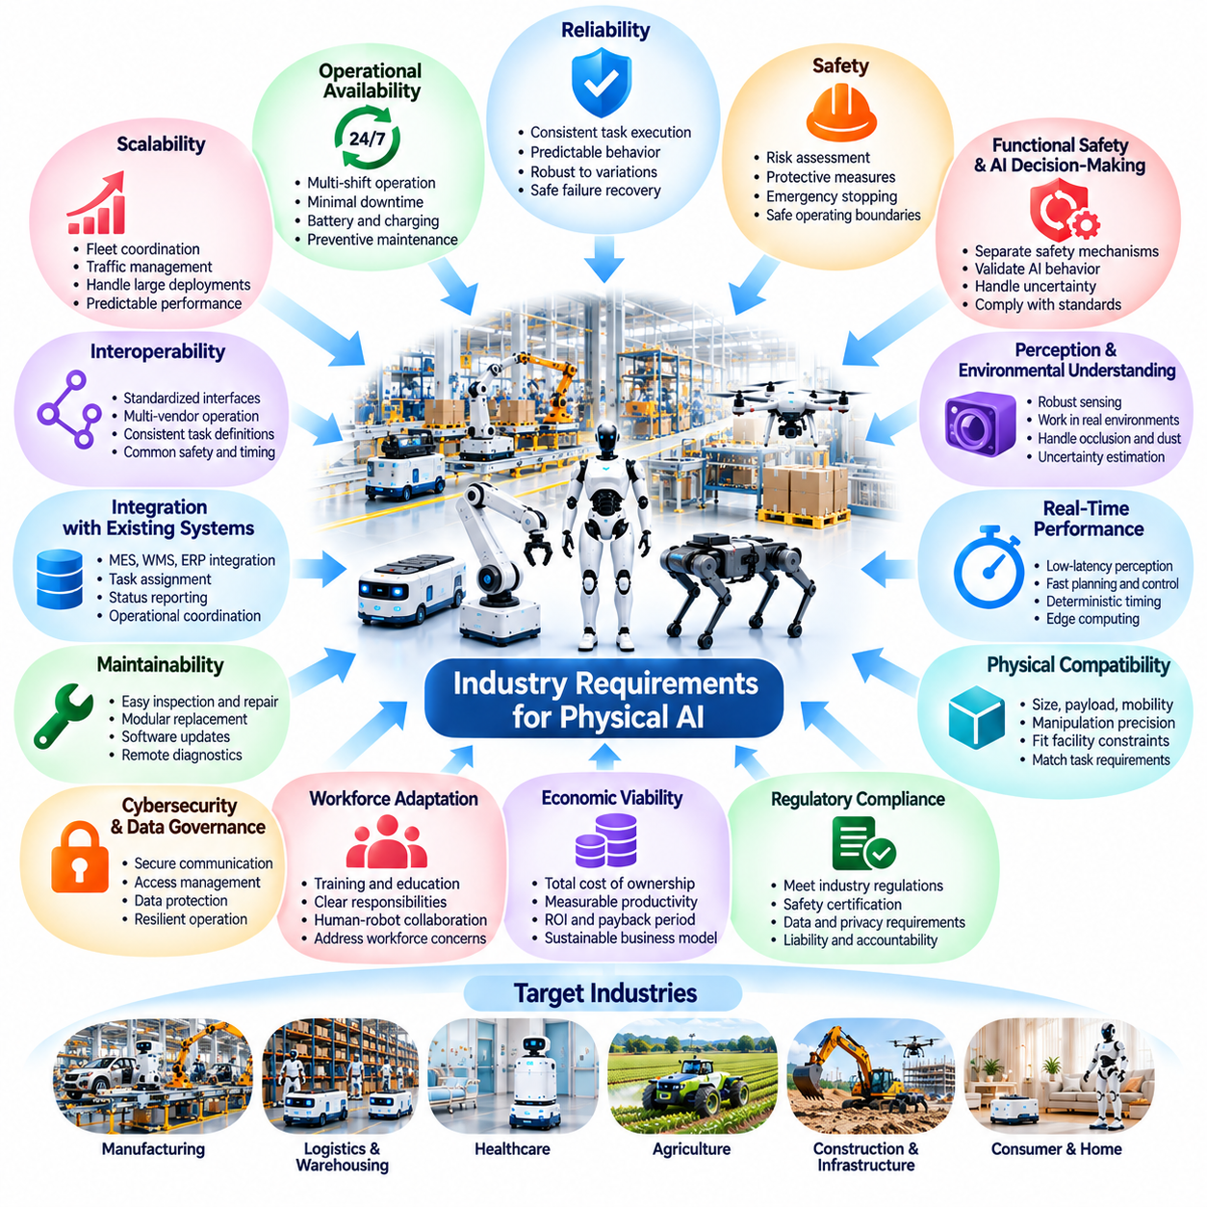
Industrial adoption of Physical AI requires more than advanced artificial intelligence or sophisticated robotic hardware. Industrial customers expect systems that operate reliably, safely, and economically within established production and service environments. Successful deployment therefore depends on satisfying technical, operational, organizational, and commercial requirements that extend well beyond laboratory demonstrations or isolated robotic capabilities.
Reliability is among the most important requirements for industrial Physical AI. Robots must perform assigned tasks consistently across extended operating periods despite environmental variations, component wear, and changing workloads. Reliability includes predictable behavior, repeatable task execution, controlled failure responses, and dependable recovery mechanisms. Even highly intelligent systems provide limited industrial value when frequent interruptions reduce operational continuity.
Operational availability determines whether Physical AI systems can support real production schedules. Industrial facilities may require continuous operation across multiple shifts, with limited opportunities for maintenance or unexpected downtime. System design must consider component durability, battery management, charging schedules, preventive maintenance, and rapid fault recovery. Availability targets should reflect actual customer requirements rather than theoretical equipment capabilities.
Safety is a fundamental requirement because Physical AI systems interact directly with people, machinery, materials, and infrastructure. Autonomous movement and manipulation introduce risks involving collisions, crushing, unexpected motion, and equipment damage. Industrial deployment requires systematic risk assessment, appropriate protective measures, emergency stopping, safe operating boundaries, and validated responses to hazardous or uncertain conditions.
Functional safety and AI decision-making must be addressed as related but distinct engineering concerns. Learned models may provide perception, planning, and behavioral flexibility, while independent safety mechanisms enforce critical operating constraints. This separation helps prevent uncertain AI outputs from directly creating unacceptable physical risks. Safety architecture must reflect application hazards, applicable standards, and the consequences of system failure.
Industrial environments also demand robust perception and environmental understanding. Lighting variations, reflective surfaces, dust, vibration, occlusion, and moving obstacles can degrade sensor performance. Physical AI systems must maintain adequate awareness under expected operating conditions and recognize situations where perception confidence becomes insufficient. Sensor redundancy, calibration, uncertainty estimation, and controlled fallback behavior can improve operational robustness.
Real-time performance is essential whenever intelligent decisions influence physical motion. Perception, planning, communication, and control introduce computational delays that can affect responsiveness and stability. Industrial systems must establish appropriate timing requirements for each function and ensure that critical control loops remain dependable. Edge computing and deterministic control architectures are often necessary to maintain predictable physical behavior.
Physical compatibility with the operating environment is equally important. Robot dimensions, payload capacity, mobility, reach, manipulation precision, and energy consumption must match actual tasks and facility constraints. Narrow passages, floor conditions, elevators, loading interfaces, and workspace geometry can determine deployment feasibility. Selecting an appropriate robot morphology is therefore a practical engineering decision rather than a purely technological preference.
Integration with existing industrial infrastructure is another major requirement. Physical AI systems rarely operate independently of manufacturing execution systems, warehouse management systems, enterprise resource planning, or fleet management platforms. Reliable interfaces are needed for task assignment, status reporting, resource coordination, and operational monitoring. Integration quality directly affects deployment complexity, productivity, and the ability to scale.
Interoperability becomes increasingly important when facilities operate equipment from multiple manufacturers. Standardized communication interfaces, consistent task representations, and well-defined system responsibilities can reduce dependence on proprietary integrations. However, interoperability requires more than compatible message formats. Different systems must also agree on operational semantics, timing expectations, safety boundaries, and exception-handling procedures.
Scalability requires Physical AI solutions to perform effectively beyond individual pilot installations. A system that works with one robot may encounter congestion, communication limitations, scheduling conflicts, and maintenance complexity when expanded to a large fleet. Scalable architectures must support coordinated task allocation, traffic management, centralized visibility, distributed execution, and predictable performance as operational demand increases.
Maintainability is essential for long-term industrial operation. Hardware components should support practical inspection, repair, replacement, and calibration, while software systems require controlled updates, diagnostics, and configuration management. Remote monitoring can reduce troubleshooting time, but physical maintenance remains unavoidable. Serviceability should therefore be considered during product design rather than after commercial deployment.
Cybersecurity and data governance are necessary because connected robots exchange operational information and may influence critical physical processes. Unauthorized access, compromised software, or manipulated sensor data can create both digital and physical risks. Industrial systems require secure communication, authentication, access control, update integrity, and appropriate data retention policies. Security responsibilities must remain clear across manufacturers, integrators, and operators.
Data quality is another important requirement for learning-enabled Physical AI. Training datasets must represent relevant tasks, environments, objects, and failure conditions. Incomplete or biased data can produce unreliable behavior when robots encounter unfamiliar situations. Data collection, labeling, filtering, versioning, and evaluation should be governed through systematic processes that support traceability and continuous improvement.
Generalization and adaptability are valuable only when their performance boundaries are understood. Industrial customers need evidence that a robot can handle expected variations in objects, layouts, workloads, and environmental conditions. Testing should distinguish demonstrated capabilities from unsupported assumptions about broader intelligence. When uncertainty exceeds validated limits, systems should request assistance, restrict operation, or transition to safer behaviors.
Human-robot interaction must support clear communication and practical operational control. Workers need to understand robot intentions, current states, task priorities, and intervention procedures. Interfaces should allow authorized personnel to pause operations, resolve exceptions, and restore normal service without unnecessary complexity. Human factors become particularly important in shared workspaces where robotic behavior affects employee safety and productivity.
Economic requirements strongly influence technology selection and deployment decisions. Customers must evaluate capital investment, software licensing, integration, energy consumption, maintenance, supervision, and equipment depreciation. These expenses should be compared with measurable improvements in throughput, labor productivity, quality, safety, and operational availability. Total cost of ownership and realistic return on investment are essential commercial evaluation criteria.
Industry-specific requirements can differ substantially despite sharing common technological foundations. Manufacturing prioritizes production continuity and precision, while logistics emphasizes throughput and coordinated mobility. Healthcare requires patient safety, privacy, and workflow compatibility. Agriculture demands environmental resilience and seasonal efficiency, whereas construction and infrastructure applications prioritize ruggedness, mobility, and reliable operation in changing conditions.
Validation and benchmarking provide the evidence needed to establish industrial readiness. Simulation testing can examine diverse conditions and rare failures, but real-world trials remain necessary to confirm operational performance. Evaluation should include task success, intervention frequency, recovery behavior, safety performance, availability, and economic outcomes. Acceptance criteria must reflect the intended application rather than generic demonstrations of robotic intelligence.
Organizational readiness is another condition for successful adoption. Companies must establish operational ownership, maintenance responsibilities, training procedures, and escalation mechanisms before deploying autonomous systems. Employees need sufficient understanding of system capabilities and limitations to work effectively alongside intelligent machines. Deployment success depends on coordinated changes to technology, workflows, management practices, and workforce skills.
Commercial deployment also requires clear lifecycle responsibilities among robot manufacturers, software providers, system integrators, and service operators. Contracts should define performance expectations, maintenance obligations, software support, warranty conditions, and procedures for handling failures. These arrangements become particularly important in Robot-as-a-Service models, where customers depend on continuing operational outcomes rather than equipment ownership.
Ultimately, industrial requirements transform Physical AI from an experimental technology into a dependable operational capability. Intelligence, autonomy, and adaptability must be combined with safety, reliability, interoperability, maintainability, and economic feasibility. The most successful Physical AI systems will not necessarily demonstrate the greatest technological complexity, but will consistently satisfy real industrial needs under practical operating conditions.

00.06. Economics Safety and Operational Reality
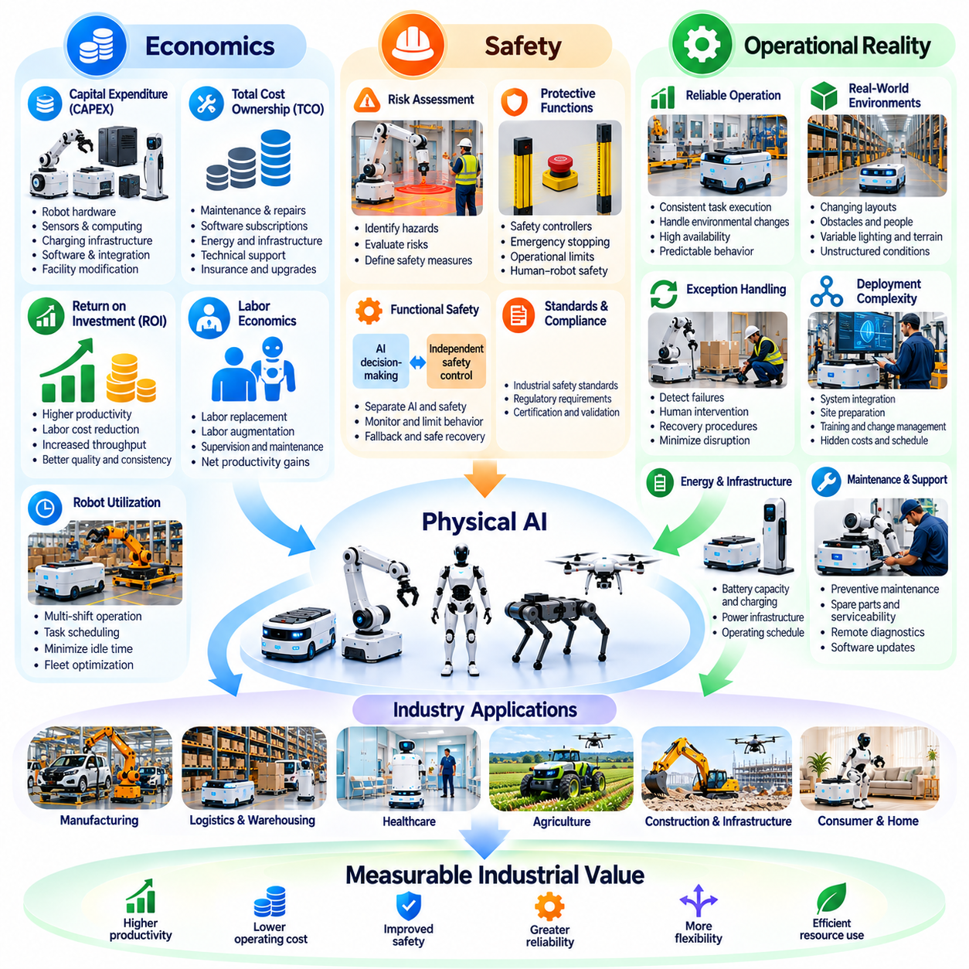
The economic viability of Physical AI depends on converting advanced robotic capabilities into measurable operational value. Technical performance alone does not guarantee commercial success, because industrial customers must consider investment costs, productivity improvements, safety obligations, and long-term operating conditions. Successful deployment requires balancing financial returns with dependable physical performance and practical organizational constraints.
Capital expenditure represents the initial financial commitment required to introduce Physical AI systems. Robot hardware, sensors, computing equipment, charging infrastructure, software licenses, facility modifications, and system integration can contribute to deployment costs. Organizations must also consider engineering validation, employee training, commissioning, and production interruptions that may occur before stable operations begin.
Total cost of ownership provides a broader economic perspective than equipment purchase price alone. Operating expenses include electricity, maintenance, replacement components, software subscriptions, technical support, insurance, and supervision. Battery replacement, component wear, cybersecurity management, and software upgrades may create additional lifecycle costs. Accurate economic analysis must account for these expenses throughout the expected service life.
Return on investment depends on the relationship between deployment costs and measurable operational benefits. Physical AI may reduce repetitive labor requirements, increase throughput, improve consistency, and extend productive operating hours. However, projected benefits must reflect realistic utilization, task completion rates, maintenance requirements, and operating constraints. Financial models based on ideal laboratory performance can substantially overestimate actual returns.
Labor economics requires particular attention because automation does not necessarily eliminate all human involvement. Autonomous robots may reduce direct manual work while creating responsibilities for supervision, maintenance, exception handling, and workflow coordination. Economic evaluation should distinguish labor replacement from labor augmentation and calculate net productivity improvements rather than assuming that every automated task produces equivalent labor savings.
Robot utilization strongly influences economic performance. Equipment that operates productively across multiple shifts can distribute fixed costs over more completed tasks, improving unit economics. Conversely, idle time, inefficient scheduling, charging delays, and limited task availability reduce financial efficiency. Fleet management and workload optimization can therefore be as important to profitability as individual robot performance.
Operational reliability directly affects financial outcomes. Unexpected failures can interrupt production, delay deliveries, damage materials, and require emergency intervention. Mean time between failures, mean time to repair, and operational availability provide useful measures of system dependability. Preventive maintenance, spare-part availability, remote diagnostics, and rapid recovery procedures help reduce the economic consequences of downtime.
Safety introduces essential requirements that cannot be treated simply as optional costs. Physical AI systems operate near people, vehicles, machinery, and valuable infrastructure, creating risks that differ from purely digital applications. Safety engineering requires hazard identification, risk assessment, protective functions, emergency stopping, and validated operational limits. Appropriate safeguards protect workers while supporting predictable industrial operations.
Functional safety should remain distinguishable from the probabilistic behavior of learning-based AI. Perception and planning models may produce uncertain outputs, especially under unfamiliar environmental conditions. Independent safety controllers, monitored operating boundaries, and fallback procedures can limit hazardous behavior. The required architecture depends on the application, applicable regulations, and the severity of potential physical consequences.
Operational reality frequently differs from controlled demonstrations. Industrial environments contain changing layouts, unpredictable human movement, damaged materials, communication interruptions, and variable environmental conditions. Robots must handle these disturbances without excessive intervention or unsafe behavior. Robust deployment requires systematic testing of ordinary operations, foreseeable exceptions, and realistic failure scenarios.
The economic importance of exception handling is often underestimated. A robot may achieve a high task success rate while still requiring frequent human assistance during difficult operations. Each intervention can introduce delays, labor costs, and workflow disruption. Evaluation should therefore consider intervention frequency, recovery time, and the cost of unresolved failures alongside conventional measures of autonomous task performance.
Deployment complexity can significantly influence the business case. Integration with manufacturing execution systems, warehouse management platforms, facility infrastructure, and existing operating procedures may require substantial engineering effort. Site preparation, network configuration, safety validation, and employee training can extend implementation schedules. Standardized interfaces and repeatable deployment methods help reduce these hidden costs.
Energy consumption and infrastructure requirements also affect long-term economics. Battery capacity, charging duration, peak power demand, and operating schedules determine how effectively robots can sustain productive work. Larger batteries may increase endurance but also add weight, cost, and maintenance requirements. Energy optimization must consider complete duty cycles rather than isolated measures of motor or processor efficiency.
Commercial arrangements influence how financial risks are distributed. Direct equipment purchases place substantial ownership and maintenance responsibility on customers, while Robot-as-a-Service models may shift these obligations toward providers. Subscription pricing can reduce initial investment barriers, but long-term costs depend on utilization, contract terms, service availability, and performance commitments. Neither model is universally superior.
Scaling Physical AI introduces additional operational and economic challenges. Increasing fleet size can improve capacity but may also create traffic congestion, charging competition, communication demands, and maintenance coordination problems. Marginal productivity gains can decline when shared infrastructure becomes constrained. Scalable deployment therefore requires capacity planning, fleet orchestration, and continuous analysis of system-level efficiency.
Workforce adaptation is another practical requirement. Employees must understand robotic capabilities, operational limitations, emergency procedures, and appropriate intervention methods. New responsibilities may emerge in fleet supervision, technical maintenance, data analysis, and process improvement. Organizations that invest in training and clear operational ownership are better positioned to capture productivity benefits without introducing unnecessary disruption.
Regulatory compliance, cybersecurity, and liability management can create substantial business obligations. Autonomous machines must satisfy applicable safety requirements while protecting operational data and connected infrastructure. Security incidents or unclear responsibility for accidents can undermine customer confidence and generate significant costs. Contracts should define maintenance duties, software support, incident response, and accountability among participating organizations.
Pilot projects provide an opportunity to evaluate economic and operational assumptions before large-scale investment. Effective pilots measure actual throughput, utilization, intervention frequency, downtime, safety performance, and integration effort. Results should be compared with established baseline operations under representative conditions. Expansion decisions should depend on demonstrated improvements rather than isolated technical achievements.
Economic feasibility also varies across industries and applications. Manufacturing may prioritize production continuity and quality, while logistics emphasizes transportation throughput and labor efficiency. Healthcare requires particularly careful safety and workflow integration, whereas agriculture and construction must accommodate environmental variability. Each application demands an economic model reflecting its operational constraints and value drivers.
The most practical adoption strategies often begin with clearly defined tasks that offer measurable benefits and manageable risks. Organizations can establish reliable operations, improve workflows, and expand autonomy as evidence accumulates. Hybrid systems combining conventional automation, learning-based intelligence, and human supervision may deliver stronger near-term value than attempting unrestricted autonomy from the beginning.
Ultimately, the industrial success of Physical AI depends on aligning economics, safety, and operational reality. Sustainable deployment requires realistic cost models, measurable productivity gains, reliable equipment, effective human oversight, and disciplined risk management. Physical AI creates lasting business value when intelligent machines perform useful work consistently, safely, and economically throughout their operational lifecycle.

00.07. Adoption Barriers and Deployment Challenges
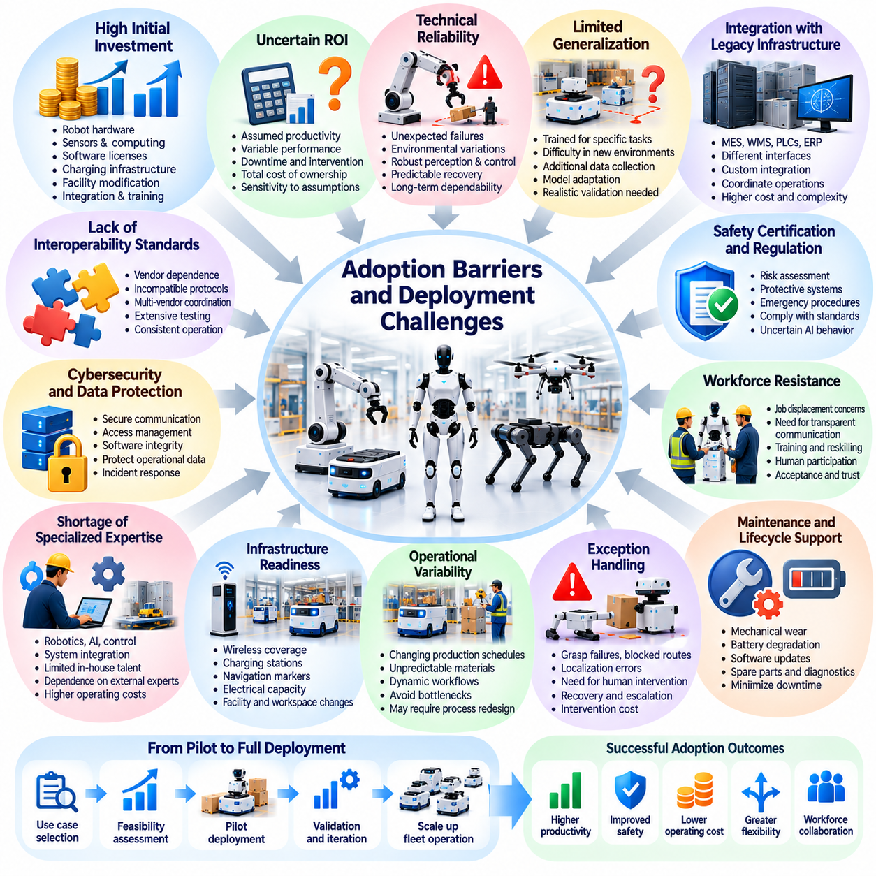
The adoption of Physical AI faces barriers that extend beyond the development of intelligent robotic capabilities. Industrial organizations must evaluate technological maturity, financial feasibility, operational compatibility, workforce readiness, and regulatory obligations before committing to deployment. Even promising systems may encounter difficulties when laboratory performance must be translated into reliable, scalable, and economically sustainable operations.
High initial investment remains a significant barrier to Physical AI adoption. Robot hardware, sensors, computing systems, software licenses, charging infrastructure, and facility modifications can create substantial capital requirements. Integration, testing, training, and commissioning introduce additional expenses. These costs are particularly challenging for organizations that cannot confidently estimate future productivity improvements or equipment utilization.
Uncertainty surrounding return on investment complicates purchasing decisions. Expected savings often depend on assumptions about labor requirements, throughput, operating hours, and task success rates. Actual performance may differ because of downtime, human interventions, or changing production conditions. Customers therefore need realistic financial models that include total cost of ownership, operational risks, and sensitivity to uncertain assumptions.
Technical reliability is another major obstacle. Robots that perform successfully in controlled demonstrations may encounter unexpected failures in industrial environments. Lighting variations, reflective objects, damaged materials, floor irregularities, and moving obstacles can reduce perception and control performance. Industrial customers require consistent task execution, predictable recovery behavior, and dependable operation over extended periods.
Limited generalization restricts the usefulness of many learning-based robotic systems. A model trained for particular objects, layouts, or operating conditions may struggle when transferred to unfamiliar environments. Additional data collection, model adaptation, and validation can increase deployment effort. Broad intelligence claims must therefore be distinguished from capabilities demonstrated under realistic operational conditions.
Integration with legacy infrastructure creates substantial engineering challenges. Existing manufacturing execution systems, warehouse management systems, programmable controllers, and enterprise applications may use different interfaces and data structures. Physical AI deployments must coordinate task assignments, equipment states, operational priorities, and safety requirements. Custom integration increases cost and can complicate future upgrades.
The absence of universal interoperability standards can create vendor dependence and fragmented robotic ecosystems. Equipment from different manufacturers may use incompatible communication protocols, navigation conventions, or task representations. Multi-vendor deployments require additional coordination layers and extensive testing. Standardized interfaces can reduce complexity, but practical interoperability also depends on consistent operational behavior.
Safety certification and regulatory compliance introduce additional adoption requirements. Autonomous robots may operate near workers, vehicles, machinery, and valuable infrastructure, creating potential physical hazards. Risk assessments, protective systems, emergency procedures, and validated safety functions must match the application. Learning-based decision-making adds complexity because model behavior may be difficult to predict under unfamiliar conditions.
Cybersecurity and data protection are increasingly important barriers. Connected robots exchange operational information, receive software updates, and interact with enterprise networks. Unauthorized access or compromised control systems can disrupt operations and create physical risks. Organizations must establish authentication, secure communication, access management, software integrity, and clear responsibilities for incident response.
Workforce resistance may arise when employees associate intelligent robots with job displacement, increased surveillance, or unfamiliar working conditions. Successful adoption requires transparent communication about operational objectives and changes in responsibilities. Training should help workers understand robotic capabilities, limitations, and intervention procedures. Human participation in deployment planning can improve acceptance and operational effectiveness.
A shortage of specialized engineering expertise can delay implementation. Physical AI requires knowledge of robotics, artificial intelligence, controls, embedded computing, industrial networking, safety engineering, and system integration. Organizations may lack personnel capable of maintaining these interconnected technologies. Dependence on external specialists can increase operating costs and create difficulties when urgent technical support is required.
Infrastructure readiness frequently determines whether a deployment is practical. Facilities may need improved wireless coverage, charging stations, navigation markers, electrical capacity, or modified workspaces. Narrow passages, uneven floors, elevator interfaces, and congested operating areas can restrict robot movement. These requirements must be identified during site assessment rather than after equipment installation.
Operational variability presents challenges that are difficult to eliminate through software improvements alone. Production schedules change, materials arrive in unexpected conditions, and workers modify workflows in response to immediate needs. Robots must operate within these changing processes without creating bottlenecks. Effective deployment often requires redesigning selected workflows while preserving flexibility for human operators.
Exception handling is a particularly important limitation of autonomous operations. Even a high task success rate can produce frequent disruptions when robots execute thousands of tasks daily. Failed grasps, blocked routes, localization errors, and unavailable equipment may require human intervention. Recovery mechanisms, escalation procedures, and intervention costs must be included in operational planning.
Scaling from pilot projects to production fleets introduces new difficulties. Multiple robots compete for shared routes, charging resources, network bandwidth, and workstations. Congestion and scheduling conflicts can reduce productivity despite increasing fleet size. Fleet management systems must coordinate tasks, traffic, battery conditions, and operational priorities while maintaining predictable system performance.
Maintenance and lifecycle support are essential but often underestimated during adoption planning. Mechanical wear, sensor misalignment, battery degradation, and software defects can gradually reduce performance. Organizations need spare parts, diagnostic tools, preventive maintenance schedules, and reliable technical support. Unclear maintenance responsibilities can cause prolonged downtime and weaken confidence in robotic operations.
Data availability and quality create further obstacles for learning-enabled Physical AI. Real industrial datasets may contain limited examples of rare failures, unusual objects, or hazardous conditions. Data collection can also face privacy, confidentiality, and ownership restrictions. Reliable learning pipelines require representative data, systematic labeling, version control, evaluation procedures, and appropriate governance.
Business model uncertainty can discourage both customers and technology providers. Equipment purchases, software subscriptions, and Robot-as-a-Service contracts distribute investment and operational risks differently. Customers may hesitate to accept long-term commitments without verified performance, while providers must finance equipment and continuing support. Clear service-level agreements and measurable acceptance criteria help reduce these uncertainties.
Organizational coordination is another critical deployment challenge. Engineering, operations, information technology, safety, procurement, and financial teams may evaluate Physical AI through different priorities. Projects can stall when ownership, decision authority, or performance expectations remain unclear. Cross-functional governance and defined deployment milestones are necessary to align technical implementation with business objectives.
Effective adoption strategies begin with realistic use cases and measurable operational targets. Pilot deployments should test representative workloads, environmental variations, intervention frequency, safety performance, and integration complexity. Results must be compared with existing operating methods. Incremental expansion allows organizations to improve processes, establish technical competence, and reduce uncertainty before committing to larger fleets.
Ultimately, overcoming adoption barriers requires coordinated progress across technology, economics, safety, infrastructure, and organizational readiness. Physical AI cannot succeed through improved algorithms or hardware alone. Sustainable deployment depends on reliable system integration, realistic performance validation, workforce participation, and clearly demonstrated business value under actual industrial operating conditions.

00.08. Roadmap of Business and Industry Applications
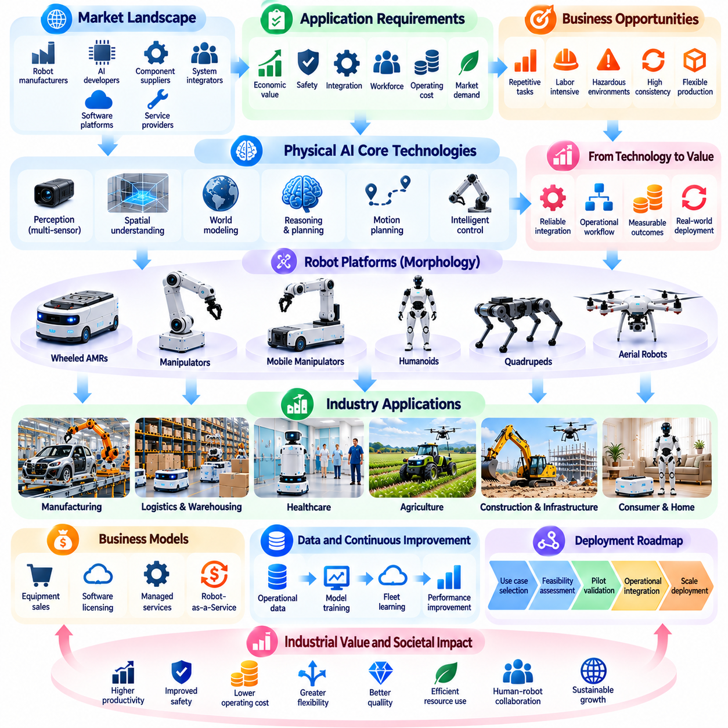
The roadmap of Physical AI business and industry applications connects technological capabilities with practical deployment opportunities across major economic sectors. It provides a structured perspective on how intelligent machines create value, which operational requirements determine adoption, and how successful implementations can expand. Understanding this roadmap requires examining market conditions, industry workflows, business models, and real-world deployment experiences.
Physical AI commercialization begins with identifying tasks where autonomous physical capabilities can produce measurable benefits. Suitable applications often involve repetitive operations, labor-intensive activities, hazardous environments, or processes requiring greater consistency. However, technical feasibility alone is insufficient. Organizations must evaluate customer demand, integration complexity, safety requirements, operating costs, and the availability of viable alternatives.
The Physical AI market landscape establishes the economic and competitive context for industrial adoption. It includes robot manufacturers, artificial intelligence developers, component suppliers, system integrators, software platforms, and service providers. Market development depends on technological maturity, customer investment priorities, workforce conditions, and the emergence of scalable solutions that address recurring operational problems.
Manufacturing represents a major application domain because industrial production already relies on extensive automation infrastructure. Physical AI can extend conventional robotics into flexible material handling, machine tending, visual inspection, assembly assistance, and adaptive manipulation. Its value increases when production environments require frequent changes, smaller batch sizes, or the handling of objects that are difficult to manage through fixed programming.
Successful manufacturing deployment requires integration with production equipment, manufacturing execution systems, and established quality procedures. Intelligent robots must satisfy requirements for precision, cycle time, equipment availability, and workplace safety. Their economic contribution should be evaluated through production throughput, reduced process interruptions, improved consistency, and the ability to accommodate changing manufacturing requirements.
Logistics and warehouse operations provide another important pathway for Physical AI adoption. Autonomous mobile robots, robotic picking systems, sorting equipment, and mobile manipulators can support material movement and order fulfillment. These applications benefit from coordinated task execution and continuous operational visibility. Their effectiveness depends on facility layout, workload variability, fleet scheduling, and integration with warehouse management systems.
Warehouse automation increasingly involves coordinated fleets rather than isolated robotic machines. Fleet management platforms can assign transportation tasks, manage traffic, monitor charging requirements, and balance workloads. Integration with inventory systems and order management processes connects robotic activities with broader logistics objectives. Scalable performance depends on managing shared infrastructure and minimizing operational bottlenecks.
Healthcare applications demonstrate how Physical AI can support environments where safety, reliability, and human interaction are especially important. Potential applications include hospital logistics, medical supply transportation, rehabilitation assistance, and selected clinical support tasks. Deployment requires careful consideration of patient safety, privacy, hygiene, accessibility, and compatibility with professional healthcare workflows.
Agriculture presents opportunities for intelligent machines that operate under substantial environmental uncertainty. Autonomous tractors, harvesting robots, crop monitoring systems, and precision spraying platforms can support agricultural productivity. These applications require robust perception, terrain mobility, and adaptation to changing weather, lighting, and crop conditions. Commercial viability must also reflect seasonal utilization and agricultural operating economics.
Construction and infrastructure applications extend Physical AI into environments characterized by changing layouts, heavy equipment, and demanding safety conditions. Autonomous inspection, surveying, material transportation, and selected construction activities may improve efficiency and reduce hazardous exposure. Practical deployment depends on rugged hardware, accurate localization, reliable communication, and coordination with human workers and existing machinery.
Consumer and home applications introduce different requirements from industrial environments. Domestic service robots, cleaning systems, assistive devices, and intelligent home platforms must operate in highly variable spaces with limited technical supervision. Affordability, ease of use, privacy, physical safety, and maintenance simplicity become central adoption factors. Customer acceptance depends on consistent usefulness rather than technological sophistication alone.
Across these sectors, robot morphology must match the intended physical task. Wheeled platforms may provide efficient transportation on prepared surfaces, while manipulators support object handling and quadrupeds address selected terrain challenges. Aerial robots can provide access to elevated or difficult locations. Humanoid configurations may offer advantages in human-designed environments, but their suitability must be demonstrated through operational performance.
Business model design connects technical solutions with sustainable commercial delivery. Equipment sales, software licensing, managed services, and Robot-as-a-Service arrangements provide different approaches to financing and operating robotic systems. Customers may prioritize ownership, predictable service costs, or guaranteed outcomes. Providers must balance revenue opportunities with hardware investment, maintenance responsibilities, deployment complexity, and continuing support.
Platform strategies can accelerate adoption by enabling reuse across multiple applications. Shared perception models, navigation software, simulation tools, data pipelines, and fleet orchestration systems reduce duplicated development effort. Interoperable interfaces also support integration with enterprise applications and heterogeneous robots. Platform value depends on reliability, ecosystem participation, developer accessibility, and the ability to support practical deployment requirements.
Data-driven improvement provides a connection between individual deployments and broader technological progress. Operational data can reveal task failures, environmental variations, equipment limitations, and opportunities for process optimization. When supported by appropriate governance and validation, these experiences can improve robotic models and operational policies. Fleet-scale learning may gradually expand the range of economically feasible applications.
Case studies are essential for understanding the difference between technical demonstrations and successful industrial implementation. Practical examples should examine initial operational problems, system architecture, deployment procedures, integration requirements, and measurable results. They should also identify failures, unexpected costs, human intervention needs, and lessons learned. Such evidence helps distinguish transferable solutions from highly specialized installations.
A practical adoption roadmap typically progresses from application selection to feasibility assessment, pilot validation, operational integration, and controlled expansion. Each stage should establish measurable acceptance criteria involving task performance, safety, reliability, utilization, and economic outcomes. Organizations should avoid scaling systems before validating their performance under representative workloads and environmental conditions.
Industry requirements shape the pace and direction of this progression. Manufacturing may emphasize cycle-time consistency, logistics may prioritize fleet throughput, and healthcare may demand stringent safety controls. Agriculture and construction often require stronger environmental resilience, while consumer applications emphasize affordability and usability. These differences explain why Physical AI adoption will not follow a uniform trajectory across industries.
The transition from isolated robotic applications to coordinated intelligent operations represents an important long-term development direction. Multiple machines may share information, coordinate tasks, and interact with enterprise planning systems. Increasingly capable AI models could reduce task-specific programming and support more adaptable behavior. Nevertheless, reliable physical execution, safety validation, and economic performance will remain fundamental constraints.
Ultimately, the roadmap of Physical AI business and industry applications connects market opportunities, sector-specific requirements, commercial strategies, and deployment evidence into a unified framework. Manufacturing, logistics, healthcare, agriculture, construction, and consumer environments provide distinct pathways for adoption. Sustainable growth will depend on matching intelligent robotic capabilities with measurable customer needs and repeatable operational value.

