Volume 12. Physical AI Business and Industry Applications

Chapter 05. Agriculture Applications

05.01. Physical AI in Agriculture
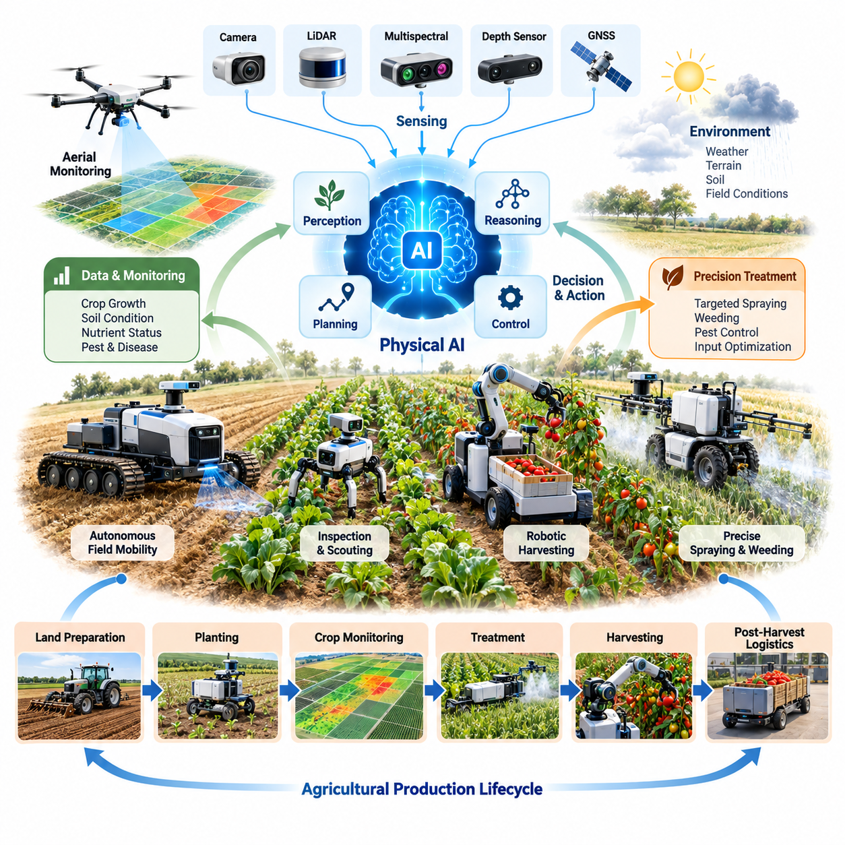
Physical AI in agriculture represents the integration of artificial intelligence, robotics, sensing, and autonomous control into agricultural production systems. Unlike conventional farm automation, which follows predefined operating sequences, Physical AI enables machines to perceive environmental conditions, interpret biological variability, make context-dependent decisions, and execute physical actions. This capability transforms agricultural equipment into adaptive systems capable of operating in complex and changing environments.
Agricultural environments present distinctive challenges for intelligent machines because crops, soil, terrain, weather, and biological processes continuously change. A robot operating in a field must distinguish crops from weeds, recognize obstacles, estimate ground conditions, and respond to unexpected events. These requirements make agriculture an important application domain for embodied intelligence, where perception, reasoning, locomotion, manipulation, and environmental interaction must function together.
The transition toward Physical AI is driven by labor shortages, rising production costs, increasing demand for food, and the need for more sustainable agricultural practices. Traditional mechanization improves productivity through powerful equipment and repetitive operations, but many agricultural activities still depend on human judgment and manual dexterity. Intelligent agricultural robots can extend automation into tasks requiring selective intervention, delicate handling, and continuous adaptation.
Physical AI applications span the agricultural production lifecycle, from land preparation and planting to crop monitoring, treatment, harvesting, and post-harvest logistics. Autonomous tractors and mobile robots provide field mobility, while robotic manipulators perform crop-specific interactions. Aerial platforms collect environmental observations, and coordinated robotic fleets distribute tasks across large production areas. These technologies collectively support more responsive agricultural operations.
Perception is a foundational capability because agricultural robots must interpret environments containing irregular shapes, variable illumination, overlapping vegetation, and partially hidden objects. Cameras, depth sensors, LiDAR, multispectral imaging, and positioning systems provide complementary observations. AI models transform these measurements into estimates of crop condition, object location, terrain accessibility, and operational risk, allowing robots to make decisions based on current field conditions.
Agricultural autonomy requires more than recognizing objects or navigating predefined routes. Intelligent systems must connect environmental understanding with task objectives and physical constraints. A harvesting robot, for example, must identify a mature fruit, estimate its accessibility, select a suitable grasping strategy, and avoid damaging surrounding branches. Successful execution depends on coordinated perception, motion planning, force control, and continuous feedback.
Autonomous field mobility introduces challenges that differ substantially from indoor robotics. Agricultural vehicles encounter uneven ground, mud, slopes, vegetation, irrigation infrastructure, and changing traction conditions. Localization and navigation systems must remain reliable when satellite positioning is degraded or visual landmarks are inconsistent. Physical AI combines geometric mapping, terrain classification, predictive control, and adaptive path planning to support robust movement.
Crop scouting and monitoring provide an important entry point for agricultural intelligence. Mobile robots and aerial platforms can collect repeated observations of plant growth, soil conditions, nutrient deficiencies, and potential disease symptoms. AI-based interpretation converts these observations into spatially organized information that supports targeted interventions. Continuous monitoring can improve the timeliness of agricultural decisions while reducing dependence on infrequent manual inspections.
Precision treatment demonstrates how agricultural perception can directly influence physical intervention. Rather than applying chemicals uniformly, intelligent systems can identify localized weeds, pests, or crop stress and determine where treatment is appropriate. Robotic sprayers then adjust nozzle activation, application position, or delivery rate according to detected conditions. This approach can reduce unnecessary inputs while maintaining treatment effectiveness when detection and application accuracy are sufficient.
Autonomous harvesting represents one of the most demanding agricultural applications because biological products vary in shape, maturity, position, and mechanical sensitivity. Robotic systems must combine visual recognition with compliant manipulation and task-specific end effectors. Harvesting performance depends not only on picking speed but also on successful detection, damage avoidance, accessibility, and recovery from unsuccessful attempts. These factors strongly influence commercial feasibility.
The morphology of agricultural robots must reflect the physical characteristics of their operating environments. Wheeled platforms offer efficient movement on accessible terrain, while tracked systems may provide improved traction on softer ground. Quadruped robots can potentially traverse irregular areas that constrain conventional vehicles. Manipulator configurations depend on crop geometry, working height, required reach, payload, and the mechanical properties of agricultural products.
Aerial robotics complements ground-based agricultural systems by providing rapid observation over large geographic areas. Drones equipped with imaging sensors can support crop assessment, irrigation analysis, and field mapping. Ground robots can subsequently use these observations to prioritize inspection or treatment locations. Combining aerial intelligence with terrestrial intervention creates opportunities for coordinated agricultural workflows that connect broad-area perception with localized physical action.
Multi-robot agricultural operations extend autonomy from individual machines to coordinated production systems. Different robots may specialize in scouting, spraying, harvesting, transport, or infrastructure inspection. Fleet coordination allocates tasks according to robot availability, location, energy reserves, and agricultural priorities. Shared maps and operational data allow individual machines to contribute to a common understanding of field conditions and work progress.
Agricultural environments also require adaptation across weather conditions and seasonal cycles. Rainfall changes soil bearing capacity, sunlight influences visual perception, and crop growth modifies navigable spaces. Seasonal transitions alter the tasks, tools, and operating parameters required by agricultural machines. Physical AI systems must therefore incorporate environmental uncertainty and support recalibration, policy adaptation, and operational restrictions when conditions exceed validated limits.
Learning-based approaches can improve agricultural robotics by using field observations and execution outcomes to refine perception and control. Data collected during successful operations, failures, and human interventions provides valuable information about agricultural variability. Simulation and synthetic data can supplement real-world training, although biological complexity and environmental uncertainty create significant simulation-to-reality challenges. Reliable deployment requires validation under representative field conditions.
Foundation models and vision-language-action architectures offer potential pathways toward more flexible agricultural robots. Such models may connect visual observations, natural-language instructions, and physical actions within a shared learning framework. However, agricultural deployment requires specialized adaptation to crop morphology, field conditions, manipulation constraints, and safety requirements. General-purpose intelligence alone cannot replace task-specific validation and reliable low-level control.
Farm data integration is essential for converting isolated robotic capabilities into coordinated agricultural management. Robot observations can be combined with geographic information, weather records, crop histories, and equipment telemetry. Digital twins may represent field geometry, crop development, machine status, and planned operations. These integrated representations support operational planning, resource allocation, performance analysis, and evaluation of alternative agricultural strategies.
Safety and reliability are particularly important because agricultural robots operate near workers, animals, valuable crops, and powerful machinery. Risk management must address collisions, unstable terrain, unintended chemical application, equipment malfunction, and unexpected human presence. Effective systems combine environmental monitoring, operational boundaries, emergency stopping, fault detection, and safe fallback behaviors. Human supervision remains necessary when autonomous capabilities are insufficient.
The economics of agricultural Physical AI depend on equipment utilization, labor substitution, operating costs, crop value, and seasonal demand. Unlike continuously operating industrial facilities, many farms experience concentrated periods of activity followed by lower utilization. Robot acquisition costs, maintenance, transportation, charging, and supervision must therefore be evaluated against achievable productivity improvements. Commercial viability depends on the complete operating model rather than robot performance alone.
Agricultural automation may be delivered through equipment ownership, leasing, managed services, or Robotics-as-a-Service arrangements. Service-based models can reduce initial investment requirements for farms that cannot justify purchasing specialized robots. However, providers must manage seasonal demand, transportation between sites, equipment maintenance, and operational support. Scalable business models require reliable technology together with sufficient utilization and economically sustainable service delivery.
The adoption of Physical AI will vary across agricultural sectors because operating conditions and economic incentives differ. Large-scale row-crop farming may prioritize autonomous mobility and precision treatment, while orchards and greenhouses may emphasize perception-guided manipulation. High-value crops can justify more sophisticated robotic systems when reduced damage or improved harvesting consistency generates sufficient value. Deployment strategies must reflect local farming practices and infrastructure.
Ultimately, Physical AI introduces a transition from mechanized agricultural equipment toward adaptive, data-driven agricultural systems. Its value lies in connecting environmental perception, intelligent decision-making, and reliable physical execution with measurable production outcomes. Progress will depend on robust field autonomy, biological understanding, affordable hardware, interoperable data platforms, and sustainable economics. Agriculture may become a major domain for demonstrating Physical AI operating beyond structured industrial environments.

05.02. Autonomous Field Mobility
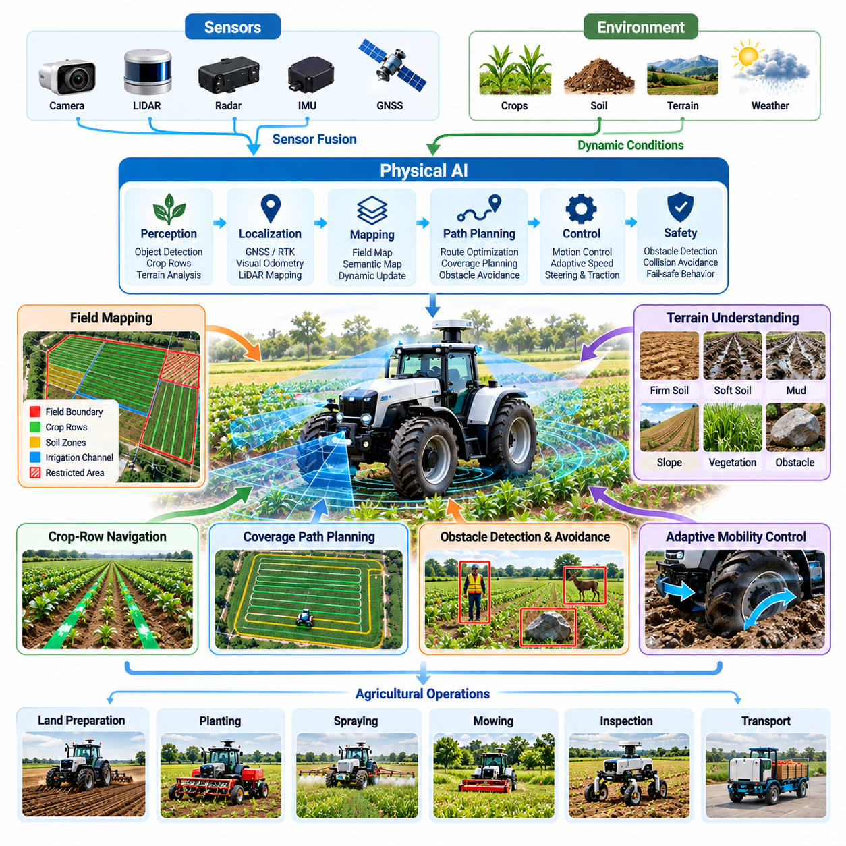
Autonomous field mobility refers to the ability of agricultural machines to navigate and operate across farmland without continuous human steering or direct control. Unlike autonomous mobility in structured factories, agricultural navigation must accommodate irregular terrain, changing soil conditions, vegetation, and uncertain boundaries. Physical AI combines environmental perception, localization, planning, and adaptive control to support reliable movement during agricultural operations.
Agricultural fields are highly variable operating environments where mobility performance depends on soil texture, moisture, slope, crop density, and weather conditions. A route that is traversable under dry conditions may become hazardous after rainfall. Autonomous machines must therefore continuously evaluate terrain accessibility rather than rely exclusively on predefined maps. This environmental adaptability distinguishes intelligent field mobility from conventional automated guidance.
The architecture of autonomous field mobility typically integrates sensing, localization, mapping, path planning, motion control, and safety supervision. Cameras, LiDAR, radar, inertial measurement units, and satellite positioning systems provide complementary observations. Sensor fusion combines these measurements to estimate vehicle position, orientation, surrounding obstacles, and terrain characteristics. The resulting environmental representation supports navigation decisions and vehicle control.
Localization is particularly important because agricultural robots frequently operate across large areas with limited artificial landmarks. Global Navigation Satellite Systems, including RTK-GNSS, can provide precise positioning when correction signals and satellite visibility are sufficient. However, tree canopies, terrain obstructions, and communication interruptions can degrade accuracy. Visual odometry, inertial navigation, and LiDAR-based localization provide complementary capabilities under challenging conditions.
Field mapping extends beyond representing geometric boundaries and obstacles. Agricultural navigation maps may include crop rows, irrigation channels, soil zones, slopes, access roads, and restricted areas. Semantic mapping associates these physical features with operational meaning, allowing robots to distinguish traversable corridors from sensitive crop regions. Dynamic map updates help maintain consistency between planned routes and actual field conditions.
Crop-row navigation is a fundamental capability for autonomous agricultural vehicles operating in orchards, vineyards, and row-crop fields. Robots must identify row geometry, maintain appropriate lateral alignment, and avoid damaging vegetation. Camera-based perception and LiDAR measurements can estimate corridor boundaries even when plant structures are irregular. Adaptive guidance algorithms compensate for row curvature, missing plants, and variations in spacing.
Terrain understanding is essential for preventing mobility failures caused by unstable ground or insufficient traction. Soil moisture, surface deformation, vegetation coverage, and wheel slip influence vehicle movement. Physical AI systems can estimate traversability using visual observations, geometric measurements, and vehicle response data. These estimates support decisions about speed, route selection, and whether particular terrain should be avoided.
Motion planning in agricultural environments must account for both navigation efficiency and agronomic constraints. The shortest route may not be suitable when it crosses planted areas, increases soil compaction, or violates machinery turning limitations. Intelligent planners consider field boundaries, crop-row structure, vehicle dimensions, turning radius, and implement configuration. Route optimization can reduce unnecessary travel while preserving crop integrity.
Coverage path planning is particularly important for agricultural tasks such as planting, spraying, mowing, and soil treatment. These operations require systematic traversal of designated areas with controlled overlap and minimal omission. Autonomous planners generate coverage patterns based on field geometry, implement width, and operational constraints. Effective coverage planning improves resource utilization while reducing repeated passes and unnecessary soil disturbance.
Vehicle dynamics significantly influence autonomous mobility because agricultural machines operate under variable loading and ground-contact conditions. Wheel slip, lateral drift, suspension movement, and changing payload distribution can affect tracking accuracy. Adaptive controllers adjust steering, propulsion, and operating speed according to estimated vehicle behavior. Model-based control and learning-based compensation can improve stability when environmental conditions differ from nominal assumptions.
Autonomous agricultural mobility must support different vehicle morphologies and propulsion configurations. Conventional tractors, compact wheeled robots, tracked platforms, and articulated vehicles exhibit different steering characteristics and terrain capabilities. Their navigation systems must incorporate vehicle-specific kinematics, dimensions, ground clearance, and traction limits. Physical AI provides a common perception and decision framework while allowing specialized control strategies.
Obstacle detection is essential because agricultural fields may contain workers, animals, equipment, fallen branches, rocks, and unexpected objects. Autonomous systems must identify obstacles and estimate whether they are stationary or moving. Perception models and tracking algorithms support collision avoidance through speed adjustment, stopping, or route modification. Safety-critical decisions require conservative behavior when object classification or environmental understanding is uncertain.
Weather and illumination create additional challenges for field perception and navigation. Strong sunlight, shadows, fog, rain, dust, and seasonal vegetation changes can reduce sensor reliability. Robust mobility systems combine complementary sensing modalities and monitor measurement confidence. When environmental conditions exceed validated operating limits, the robot should reduce speed, request assistance, or enter a safe operational state.
Field mobility also depends on effective interaction between navigation and agricultural implements. A tractor performing precision spraying must maintain a suitable trajectory while coordinating implement activation and application timing. Harvesting platforms must position themselves accurately relative to crop structures and robotic manipulators. Integrated planning considers vehicle motion, implement geometry, and task execution to achieve consistent agricultural performance.
Energy management becomes increasingly important as agricultural robots operate across large fields and remote locations. Battery-powered platforms must consider remaining energy, terrain resistance, travel distance, and charging accessibility. Autonomous scheduling can incorporate energy constraints into route planning and task allocation. For hybrid or combustion-powered machines, fuel consumption and operating efficiency similarly influence mission planning.
Multi-robot field mobility introduces coordination requirements when several autonomous machines share agricultural spaces. Robots must avoid conflicting routes, maintain safe separation, and coordinate access to narrow passages or service stations. Fleet management systems can distribute coverage areas and update assignments based on progress and machine availability. Shared localization and operational maps support coordinated movement without requiring continuous centralized control.
Simulation and digital twins provide useful environments for developing and evaluating autonomous agricultural mobility. Virtual fields can represent terrain geometry, crop layouts, obstacles, and vehicle dynamics. Developers can test navigation strategies across diverse operating conditions before physical deployment. However, soil deformation, vegetation interaction, and weather-dependent traction remain difficult to reproduce accurately, requiring extensive real-world validation.
Operational reliability depends on the ability to detect navigation failures and recover safely. Localization drift, blocked routes, wheel slip, sensor degradation, and communication loss can interrupt autonomous missions. Runtime monitoring identifies deviations between expected and observed behavior. Recovery strategies may include stopping, relocalization, route replanning, remote assistance, or controlled return to a designated safe location.
The economic value of autonomous field mobility depends on labor savings, equipment utilization, operational precision, and reduced downtime. Reliable navigation can extend operating hours and support more consistent agricultural workflows, provided safety and environmental conditions permit. However, sensor costs, positioning infrastructure, maintenance, supervision, and field preparation affect total ownership costs. Commercial adoption requires measurable improvements over conventional equipment operation.
Ultimately, autonomous field mobility provides the physical foundation for intelligent agricultural operations. Crop monitoring, precision treatment, harvesting, and field logistics all depend on reliable movement through complex outdoor environments. Advances in multimodal perception, terrain-aware planning, adaptive control, and fleet coordination will progressively expand agricultural autonomy. Successful systems must combine intelligent navigation with safety, operational robustness, and economically sustainable deployment.

05.03. Crop Scouting and Field Monitoring
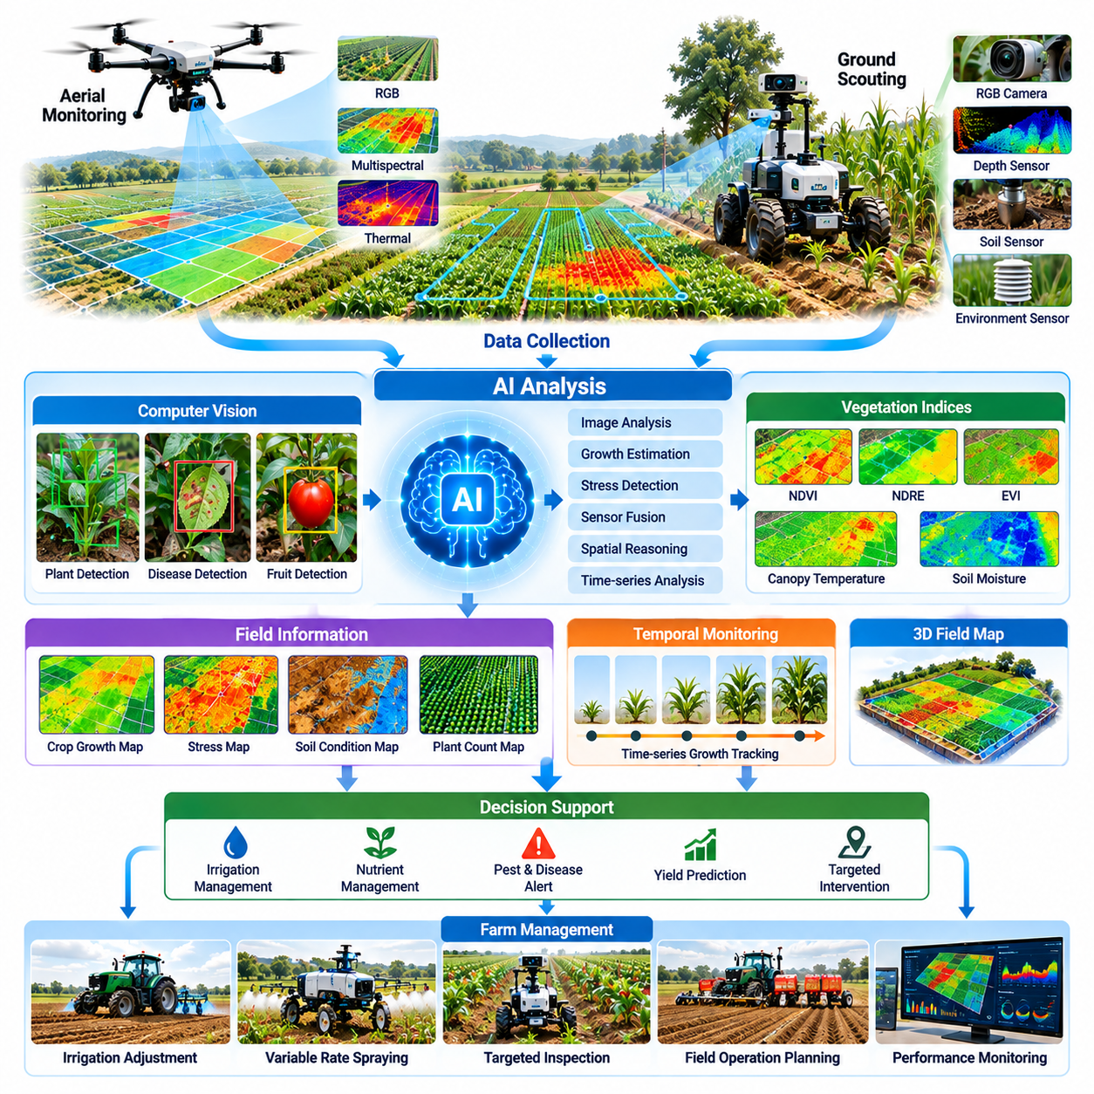
Crop scouting and field monitoring represent essential applications of Physical AI in agriculture, enabling continuous observation and intelligent assessment of crop conditions throughout the growing season. Traditional scouting depends on periodic human inspections, which may overlook localized problems or rapidly developing changes. Autonomous robots and intelligent sensing platforms provide systematic data collection, allowing farmers to identify emerging issues and make timely management decisions.
Agricultural monitoring requires understanding the complex relationships among crop growth, soil conditions, weather, irrigation, nutrients, pests, and diseases. These factors vary across locations and change throughout the production cycle. Physical AI combines mobile sensing, environmental interpretation, and spatial reasoning to transform raw field observations into actionable information. The objective is to support decisions that improve productivity, resource efficiency, and crop health.
Autonomous ground robots provide close-range observations that complement conventional field inspections. Equipped with cameras, depth sensors, environmental instruments, and positioning systems, these platforms navigate between crop rows while collecting detailed measurements. Their proximity to plants enables inspection of leaves, stems, fruits, and soil surfaces that may be difficult to observe from above. Repeated missions provide consistent records of crop development.
Aerial monitoring platforms extend agricultural observation across large geographic areas. Drones equipped with RGB, multispectral, or thermal cameras can collect imagery for assessing vegetation patterns, canopy temperature, and spatial variability. Aerial observations are particularly useful for identifying regions requiring closer investigation. Combining drone surveys with ground-based robotic inspection connects broad-area monitoring with detailed plant-level assessment.
Sensor selection depends on the biological characteristics of crops and the monitoring objectives. RGB cameras capture visible appearance, while multispectral sensors measure reflectance across selected wavelength bands. Thermal cameras estimate surface temperature, and soil sensors measure moisture or other environmental properties. Integrating complementary measurements improves the interpretation of crop conditions, although sensor calibration and environmental context remain essential.
Computer vision enables agricultural robots to identify plants, distinguish crop structures, and detect visible abnormalities. Object detection, semantic segmentation, and instance segmentation can locate individual plants, leaves, fruits, and suspected damaged regions. Deep learning models extract patterns from agricultural imagery, supporting automated assessment of crop development. Performance depends on representative training data and robustness to field variability.
Crop growth monitoring involves estimating plant height, canopy coverage, leaf area, growth stage, and population density. These indicators help characterize crop development and identify differences across production areas. Three-dimensional reconstruction and depth sensing can provide geometric measurements, while repeated visual observations reveal temporal changes. Reliable growth estimation requires consistent measurement procedures and consideration of crop-specific characteristics.
Vegetation indices provide useful indicators of plant reflectance patterns and potential physiological changes. The Normalized Difference Vegetation Index, for example, compares near-infrared and red reflectance to characterize vegetation response. However, index values may be influenced by soil background, illumination, canopy structure, and growth stage. Physical AI systems should interpret these measurements alongside environmental information rather than treat them as definitive diagnoses.
Early detection of crop stress is a major objective of intelligent field monitoring. Water limitations, nutrient imbalance, disease, pest activity, and temperature extremes may produce overlapping visual symptoms. AI models can identify abnormal patterns and prioritize suspicious regions for further inspection. Nevertheless, reliable diagnosis often requires additional measurements, agronomic knowledge, or laboratory confirmation to distinguish among possible causes.
Soil and irrigation monitoring connect crop observations with the environmental conditions influencing plant development. Mobile sensing platforms can collect measurements of soil moisture, temperature, and selected chemical properties. These observations may be combined with fixed sensor networks and irrigation records to estimate spatial variability. Intelligent monitoring supports more targeted water management while recognizing uncertainty in sensor coverage and soil conditions.
Georeferenced field monitoring transforms isolated observations into spatially organized agricultural information. GNSS positioning, visual localization, and mapping algorithms associate measurements with specific field locations. Geographic information systems can then represent crop conditions, detected anomalies, and inspection histories. Accurate spatial registration is important because positioning errors may cause observations to be assigned to incorrect plants or management zones.
Temporal monitoring adds another dimension by tracking changes across repeated observation cycles. Comparing measurements over time can reveal growth trends, emerging stress, and responses to agricultural interventions. Time-series analysis must account for seasonal development, changing illumination, sensor differences, and observation intervals. Physical AI can use historical context to distinguish persistent abnormalities from temporary environmental fluctuations.
Autonomous scouting missions require intelligent navigation and task planning. Robots must determine which areas to inspect, select accessible routes, and allocate sensing time according to monitoring priorities. Adaptive mission planning can increase inspection frequency in regions showing unusual conditions. This approach improves information collection efficiency compared with repeatedly surveying every location at the same resolution.
Active perception allows monitoring robots to adjust their sensing behavior according to uncertainty and task requirements. A robot may approach a suspicious plant, change its viewing angle, or collect additional measurements before making an assessment. This interaction between perception and physical movement distinguishes embodied agricultural monitoring from passive image analysis. The resulting observations can improve confidence while reducing unnecessary data collection.
Data quality management is essential because agricultural observations are affected by motion blur, occlusion, lighting variation, dust, and sensor degradation. Automated pipelines can evaluate image quality, detect missing measurements, and identify inconsistent timestamps or locations. Calibration records and metadata help preserve measurement reliability. Poor-quality observations should be flagged rather than silently incorporated into crop condition estimates.
Field monitoring data can support machine learning systems that improve through repeated agricultural operations. Human-verified observations, confirmed disease cases, and treatment outcomes provide valuable supervision for model development. Data curation must preserve variation across crop varieties, growth stages, seasons, and geographic regions. Models trained on narrow datasets may perform poorly when deployed under unfamiliar agricultural conditions.
Edge computing enables agricultural robots to process selected observations directly in the field. Onboard inference can identify obstacles, detect anomalies, and trigger additional inspection without continuous network connectivity. Cloud platforms can support large-scale analysis, historical storage, and model updates when communication is available. Effective architectures balance computational requirements, energy consumption, communication limitations, and operational latency.
Integration with farm management systems converts monitoring results into practical agricultural workflows. Detected anomalies can generate inspection requests, treatment recommendations, or prioritized work orders. Digital twins may combine crop observations with field geometry, weather records, and equipment activities. However, automated recommendations should include confidence estimates and remain subject to appropriate agronomic validation before physical intervention.
The economic value of crop scouting depends on monitoring coverage, inspection frequency, detection accuracy, and the usefulness of resulting decisions. Automated observation can reduce repetitive inspection labor and potentially limit losses through earlier intervention. However, equipment costs, data processing, maintenance, and false alarms influence overall value. Benefits should be evaluated against measurable improvements in crop outcomes and operational efficiency.
Ultimately, crop scouting and field monitoring establish an information foundation for intelligent agricultural automation. Reliable observations support precision treatment, autonomous harvesting, irrigation management, and coordinated farm operations. Physical AI transforms monitoring from periodic visual inspection into a continuous process of sensing, interpretation, and targeted action. Its long-term success depends on trustworthy data, robust autonomy, agronomic relevance, and demonstrable economic value.

05.04. Weed Pest and Disease Detection
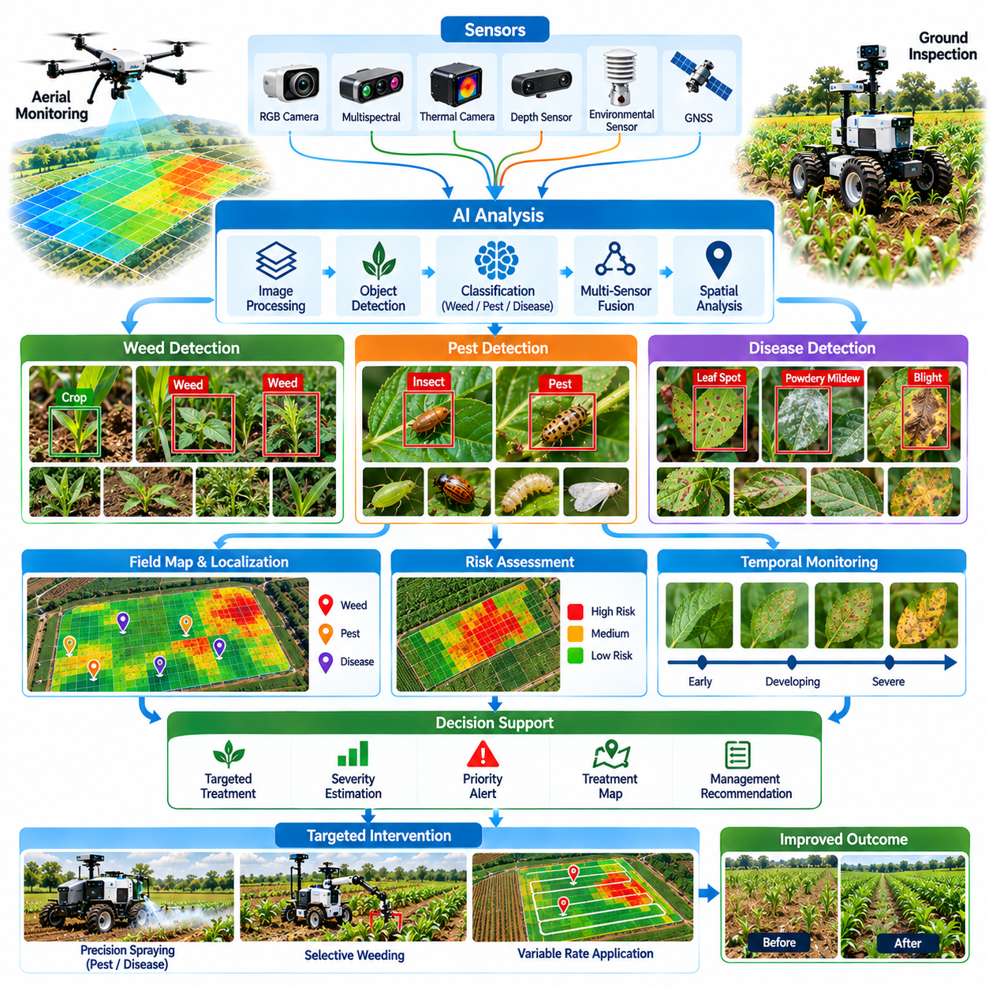
Weed, pest, and disease detection is a critical application of Physical AI in agriculture because biological threats can reduce crop productivity, quality, and economic value. Conventional monitoring often relies on visual inspection and periodic sampling, which may miss localized infestations or early symptoms. Intelligent sensing systems enable more frequent observation, spatial identification of abnormalities, and timely intervention based on field conditions.
Weeds compete with crops for sunlight, water, nutrients, and growing space, while pests and pathogens damage plant tissues or disrupt physiological processes. Their distribution is often irregular and changes with weather, crop development, and management practices. Physical AI integrates environmental perception, biological classification, and spatial reasoning to identify potential threats and support targeted agricultural decisions.
Automated weed detection requires distinguishing unwanted vegetation from cultivated crops under variable field conditions. Computer vision models analyze plant shape, color, texture, and spatial arrangement to classify vegetation. Deep learning methods can identify individual plants even when leaves overlap or growth stages differ. Accurate classification is essential because incorrect identification may result in crop damage or ineffective weed management.
Crop-row geometry provides useful contextual information for weed recognition in structured agricultural fields. Plants growing outside expected crop positions may be classified as potential weeds, although irregular planting and missing crops complicate this assumption. Combining geometric reasoning with visual classification improves detection reliability. Such systems must accommodate different planting patterns, crop varieties, and seasonal growth characteristics.
Pest detection presents additional challenges because insects and other organisms may be small, mobile, concealed, or visually similar to harmless species. High-resolution cameras, close-range robotic inspection, and automated monitoring traps can provide relevant observations. AI models identify candidate organisms and estimate their abundance or distribution. Reliable interpretation requires sufficient image quality and awareness of species-specific biological characteristics.
Disease detection focuses on identifying symptoms associated with fungal, bacterial, viral, and other plant disorders. Visible indicators may include discoloration, lesions, wilting, abnormal growth, or tissue deterioration. Computer vision systems can detect these patterns and estimate affected regions. However, similar symptoms may arise from nutrient deficiencies, environmental stress, or chemical injury, making definitive diagnosis more difficult.
Early-stage detection is particularly valuable because intervention opportunities may diminish as biological threats spread. Subtle changes in leaf appearance, canopy structure, or spectral response may indicate developing problems before severe damage becomes visible. Multispectral and hyperspectral imaging can provide additional information beyond conventional RGB cameras. Nevertheless, early indicators must be validated against biological observations to establish diagnostic reliability.
Thermal imaging offers another sensing modality for identifying potential crop stress associated with disease, pest activity, or water imbalance. Changes in leaf or canopy temperature may reflect altered transpiration and physiological function. These measurements can help identify regions requiring further inspection. Because temperature patterns are influenced by sunlight, wind, humidity, and irrigation, thermal anomalies should not be interpreted as disease confirmation alone.
Physical AI systems can combine multiple sensing modalities to improve threat detection under complex agricultural conditions. RGB imagery provides visual detail, spectral measurements reveal reflectance differences, and depth sensing captures plant geometry. Environmental sensors contribute information about humidity, temperature, and soil conditions. Multimodal fusion supports more informed assessments while reducing dependence on any single observation source.
Spatial localization transforms biological threat detection into actionable field intelligence. GNSS, visual odometry, and mapping algorithms associate detected weeds, pests, or symptoms with geographic coordinates. Field maps can represent infestation density, suspected disease clusters, and affected crop zones. Accurate localization enables targeted inspection and treatment, although positioning uncertainty must be considered when interventions require plant-level precision.
Detection systems must distinguish between the presence of a biological threat and its practical significance. A small number of weeds or insects may not justify immediate intervention, while rapidly spreading disease symptoms may require urgent investigation. Decision models can incorporate crop value, growth stage, estimated severity, and economic thresholds. These assessments should reflect established agronomic knowledge rather than rely solely on classification confidence.
Autonomous ground robots provide detailed observations by moving between crop rows and approaching suspicious plants. Their mobility allows sensors to inspect leaves, stems, and lower canopy regions that aerial platforms may not observe clearly. Robots can modify viewing angles or collect additional measurements when initial observations are uncertain. This active perception capability improves the quality of evidence available for biological threat assessment.
Aerial platforms complement ground-based detection by surveying large areas and identifying unusual vegetation patterns. Drone imagery can reveal spatial clusters of crop stress or abnormal growth that warrant closer examination. Ground robots or agricultural workers can then investigate selected locations. Coordinating aerial screening with terrestrial inspection improves monitoring coverage while allocating detailed sensing resources to priority regions.
Temporal analysis is important because weed growth, pest populations, and disease symptoms evolve over time. Repeated observations help distinguish persistent threats from temporary visual abnormalities. Time-series models can estimate changes in infestation extent or symptom severity and identify areas showing accelerated deterioration. Reliable trend analysis requires consistent sensing procedures and consideration of crop growth and environmental variation.
Machine learning performance depends heavily on the quality and diversity of agricultural training data. Datasets should represent different crops, weed species, pest organisms, disease symptoms, lighting conditions, and growth stages. Human-verified labels and confirmed biological diagnoses improve supervision quality. Models trained on limited environments may fail when encountering unfamiliar varieties, geographic regions, or previously unseen biological conditions.
Class imbalance creates a particular challenge because healthy plants and common weeds may dominate training datasets, while rare diseases and emerging pests have relatively few examples. Data augmentation, targeted sampling, and synthetic image generation can improve representation. However, artificial examples may not reproduce biological variability accurately. Field validation remains essential for assessing generalization and reducing misleading predictions.
Uncertainty estimation is necessary because agricultural detection systems inevitably encounter ambiguous symptoms and unfamiliar organisms. Confidence scores, anomaly detection, and out-of-distribution recognition can help identify cases requiring human review. Systems should avoid presenting uncertain classifications as confirmed biological diagnoses. Human experts remain important for validating critical findings and selecting appropriate treatment strategies.
Detection results can be integrated with precision spraying, mechanical weeding, and targeted crop treatment systems. Once a threat is identified and localized, robotic equipment may perform selective intervention under appropriate operational constraints. This connection between perception and physical action distinguishes Physical AI from conventional agricultural image analysis. Accurate timing, positioning, and treatment verification are necessary to prevent unintended damage.
The economic value of intelligent detection depends on avoided crop losses, reduced chemical consumption, lower inspection costs, and improved intervention timing. False positives can cause unnecessary treatment, while false negatives may allow biological threats to spread. Evaluation should therefore consider detection sensitivity, precision, operational coverage, and treatment outcomes. Commercial success requires measurable agronomic benefits relative to deployment and maintenance costs.
Ultimately, weed, pest, and disease detection provides an essential intelligence layer for precision agriculture. By combining multimodal sensing, biological understanding, autonomous mobility, and spatial decision-making, Physical AI can support more selective and responsive crop protection. Continued progress requires robust field datasets, reliable uncertainty management, agronomic validation, and integration with safe intervention systems that deliver sustainable agricultural value.

05.05. Precision Spraying and Treatment
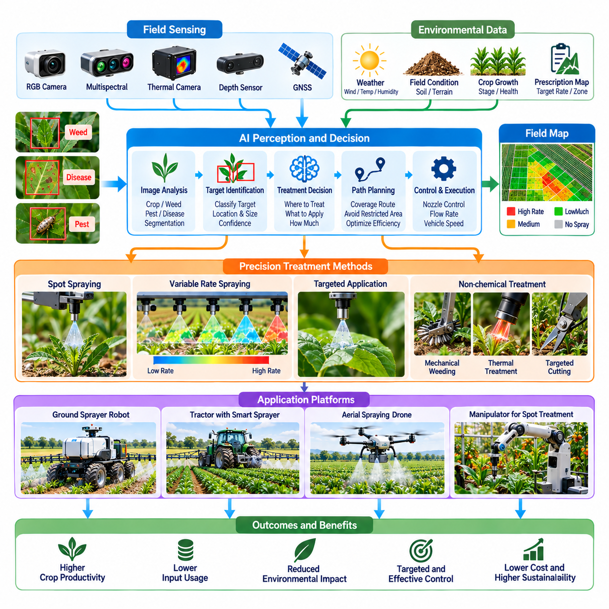
Precision spraying and treatment represent a major application of Physical AI in agriculture, enabling agricultural inputs to be delivered according to the actual needs of crops and field conditions. Conventional spraying frequently applies uniform treatment across large areas, regardless of local variability. Intelligent robotic systems combine perception, decision-making, and controlled actuation to deliver treatments selectively, improving resource efficiency while reducing unnecessary chemical exposure.
Precision treatment begins with identifying where intervention is required and determining the appropriate response. Crop health, weed distribution, pest pressure, disease symptoms, and environmental conditions influence treatment decisions. Physical AI connects sensing data with agronomic rules and operational constraints to generate location-specific actions. This approach transforms spraying from a repetitive mechanical process into an adaptive agricultural operation.
The architecture of an intelligent spraying system integrates environmental sensors, perception models, positioning, treatment planning, and application hardware. Cameras, multispectral sensors, GNSS receivers, and flow monitoring devices provide complementary information. AI algorithms interpret field conditions and generate treatment commands, while electronic controllers regulate valves, pumps, and nozzles. Feedback mechanisms verify whether commanded actions are executed correctly.
Selective spraying relies on accurately distinguishing target vegetation from crops and surrounding objects. Computer vision models identify weeds, crop structures, and treatment regions using object detection and segmentation techniques. The system must account for overlapping leaves, changing illumination, growth stages, and partial occlusion. Incorrect classification can result in missed treatment or unintended crop exposure, making reliable perception essential.
Spot spraying applies treatment only to selected locations rather than continuously across an entire field. Once a target is detected, the controller estimates its position relative to the spraying mechanism and activates the appropriate nozzle. Vehicle speed, sensor-to-nozzle distance, and actuation delay must be considered to maintain spatial accuracy. Precise synchronization between perception and spraying determines whether the treatment reaches the intended target.
Variable-rate application adjusts treatment quantity according to spatial differences in crop condition or management requirements. Prescription maps, sensor observations, and agronomic models can provide target application rates for different field zones. Controllers modify flow rate, pressure, or nozzle duty cycle within equipment capabilities. Successful implementation requires calibrated hardware and adherence to product-specific application restrictions.
Nozzle technology strongly influences treatment accuracy, droplet distribution, and environmental exposure. Different nozzle designs produce distinct spray patterns and droplet sizes under specified pressure conditions. Fine droplets may improve coverage in some applications but can increase drift risk. Intelligent spraying systems must coordinate nozzle selection, operating pressure, vehicle speed, and target characteristics to achieve appropriate deposition.
Spray drift is a critical operational concern because airborne droplets may move beyond the intended treatment area. Wind speed, wind direction, humidity, temperature, droplet size, and boom height influence drift behavior. Environmental monitoring can support decisions about whether spraying conditions are acceptable. Autonomous systems should suspend treatment when conditions exceed applicable safety limits or product-label requirements.
Physical AI can improve treatment planning by combining field maps with real-time observations. Georeferenced weed locations, crop boundaries, sensitive areas, and restricted zones help determine where application is permitted. Route planning algorithms coordinate vehicle movement with treatment coverage and operational efficiency. Accurate spatial registration is essential to prevent spraying outside designated areas or overlooking required treatment zones.
Autonomous ground platforms provide a flexible foundation for precision spraying in orchards, vineyards, greenhouses, and open fields. Mobile robots can carry treatment tanks, pumps, sensing equipment, and electronically controlled applicators. Their navigation systems maintain suitable positioning relative to crop rows and target vegetation. Platform design must consider payload capacity, terrain stability, energy consumption, and safe chemical handling.
Aerial spraying platforms offer alternative capabilities where ground access is difficult or rapid treatment is required. Agricultural drones can apply approved products over designated areas using controlled flight paths and application equipment. Their effectiveness depends on payload limitations, flight stability, droplet transport, and environmental conditions. Aerial application must comply with applicable regulations and product-label restrictions.
Robotic manipulators can extend precision treatment beyond conventional boom or broadcast spraying. Articulated arms may position specialized applicators near individual plants, branches, or localized treatment regions. This approach can improve access to complex crop structures while reducing unnecessary exposure of surrounding vegetation. However, manipulation speed, positioning accuracy, and mechanical complexity influence operational feasibility.
Precision treatment also includes nonchemical interventions such as mechanical weeding, targeted cutting, thermal treatment, and other approved physical methods. Physical AI can identify treatment targets and guide tools toward specific locations. The choice of intervention depends on crop sensitivity, weed characteristics, operating conditions, and safety constraints. Integrating different treatment methods enables more flexible agricultural management.
Closed-loop treatment control uses feedback to monitor application performance and detect deviations from expected operation. Flow sensors, pressure measurements, valve-state monitoring, and positioning data can reveal blocked nozzles, delivery errors, or synchronization failures. Controllers can respond by adjusting operating parameters or stopping treatment. Direct confirmation of biological treatment effectiveness may require later inspection.
Treatment verification connects immediate application records with subsequent crop observations. Robots can record target locations, commanded application rates, actual delivery measurements, and environmental conditions. Follow-up scouting evaluates whether the intended agricultural response occurred. These records support traceability, performance assessment, and improvement of future treatment decisions while distinguishing application completion from biological effectiveness.
Multi-robot coordination can improve precision treatment across large agricultural operations. Scouting robots identify potential problems, mapping systems organize treatment priorities, and specialized spraying robots execute approved interventions. Fleet management software allocates tasks according to equipment availability, location, remaining resources, and operational constraints. Shared information reduces duplicated coverage and supports coordinated field activities.
Data-driven learning can improve target recognition, application timing, and operational planning through accumulated field experience. Confirmed detection results, treatment records, and subsequent crop responses provide useful training information. However, treatment outcomes depend on weather, biological conditions, chemical properties, and application procedures. Models must be validated carefully before recommendations influence safety-critical agricultural operations.
Safety management must address chemical exposure, unintended application, equipment malfunction, and interactions with workers or nearby animals. Autonomous spraying systems require controlled operating boundaries, emergency stopping, fault detection, and appropriate human supervision. Chemical storage, mixing, handling, and disposal remain subject to established safety procedures. Intelligent autonomy must operate within approved agricultural practices and regulatory requirements.
The economic value of precision spraying depends on reduced input consumption, improved treatment effectiveness, labor efficiency, and avoided crop losses. Savings must be evaluated against equipment acquisition, maintenance, calibration, software, and operational supervision costs. False detections, missed targets, and application failures can reduce expected benefits. Commercial viability requires measurable improvements in cost per treated area and agricultural outcomes.
Ultimately, precision spraying and treatment connect agricultural perception directly with controlled physical intervention. Physical AI enables treatment decisions to reflect spatial variability, environmental conditions, and individual crop requirements rather than uniform assumptions. Continued progress in sensing, robotic actuation, closed-loop control, and agronomic validation can improve application efficiency. Successful deployment requires reliable performance, regulatory compliance, environmental responsibility, and sustainable economic value.

05.06. Autonomous Harvesting
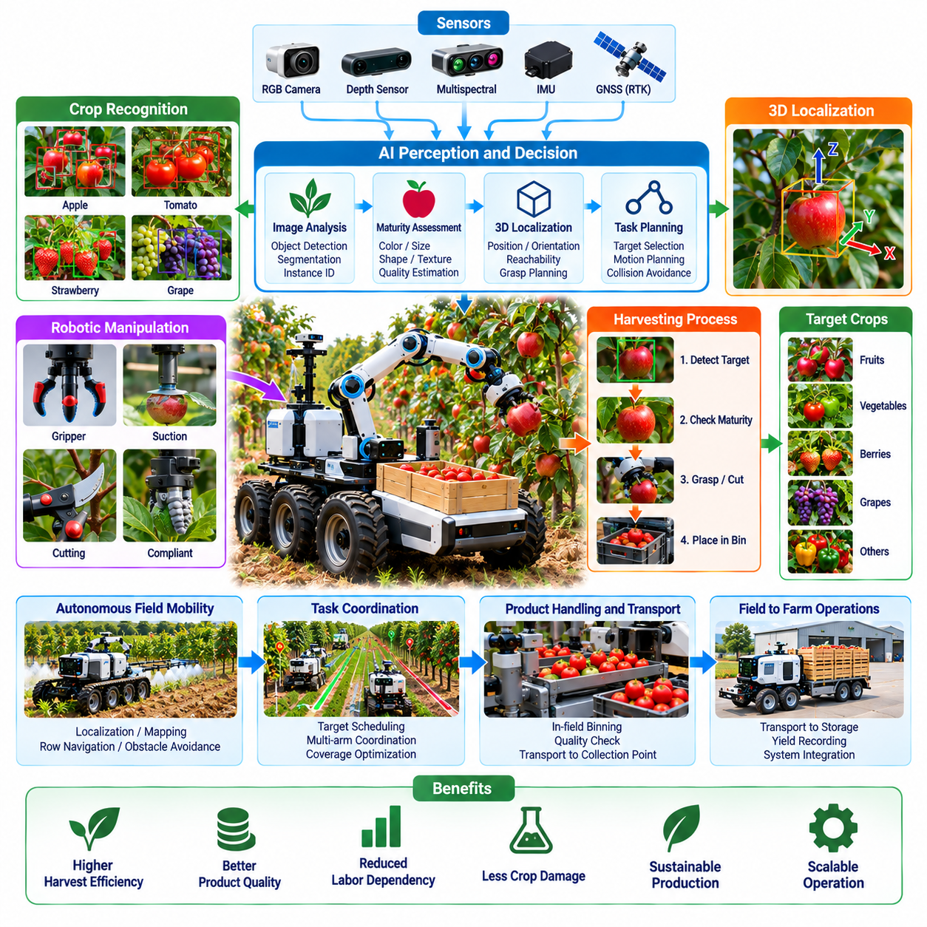
Autonomous harvesting is a major application of Physical AI in agriculture, integrating intelligent perception, robotic manipulation, and mobile autonomy to collect crops with reduced human intervention. Harvesting requires decisions about crop maturity, accessibility, and handling conditions. Unlike repetitive industrial operations, agricultural harvesting takes place in changing environments where plant geometry, fruit distribution, and product quality vary significantly.
The primary objective of autonomous harvesting is to identify harvestable crops and remove them efficiently without damaging plants or surrounding produce. Robots must recognize individual fruits, vegetables, or other agricultural products while estimating their maturity and physical condition. Successful operation requires coordination among visual recognition, motion planning, grasping, cutting, and product transportation within an integrated robotic workflow.
Harvesting strategies depend strongly on crop characteristics and production environments. Grain harvesting can use large autonomous machinery performing continuous field operations, while fruit and vegetable harvesting often requires selective manipulation. Orchards, vineyards, greenhouses, and open fields introduce different mobility and accessibility constraints. Physical AI systems must therefore adapt their sensing, mechanical structures, and control methods to specific agricultural tasks.
Crop perception begins with detecting harvest targets under complex natural conditions. RGB cameras, depth sensors, and multispectral imaging can provide information about appearance, geometry, and potential maturity indicators. Deep learning models identify individual products and estimate their locations. Reliable detection remains challenging because leaves, branches, shadows, and overlapping fruits frequently obscure important visual features.
Harvest readiness assessment involves determining whether a crop has reached an appropriate stage for collection. Visual color, size, shape, and surface texture may provide useful indicators, but these characteristics do not always correspond directly to internal quality. AI models can combine visual observations with crop-specific maturity criteria. Some applications require additional sensing or sampling to estimate firmness, sugar content, or other quality attributes.
Three-dimensional localization enables harvesting robots to estimate the position and orientation of target products relative to their manipulators. Stereo cameras, structured-light sensors, and depth estimation algorithms can reconstruct local crop geometry. Coordinate transformations connect sensor observations with robotic motion. Accurate localization is particularly important when harvesting occurs near branches, stems, neighboring fruits, or delicate plant structures.
Robotic manipulation is one of the most technically demanding components of autonomous harvesting. A manipulator must approach a target through cluttered vegetation while avoiding collisions and maintaining suitable positioning. Motion planning algorithms generate feasible trajectories under geometric and mechanical constraints. The robot must continuously account for uncertain plant geometry and potential movement caused by contact or environmental disturbances.
End-effector design determines how harvested products are physically contacted, detached, and transferred. Grippers may use compliant fingers, suction mechanisms, specialized cutting tools, or combinations of these approaches. The appropriate mechanism depends on crop size, shape, surface sensitivity, and attachment structure. Mechanical designs must balance reliable attachment with gentle handling to minimize bruising, tearing, or product deformation.
Force and tactile sensing improve harvesting performance by providing feedback during contact and detachment. Sensors can estimate gripping forces, detect slippage, and identify unexpected resistance. Closed-loop controllers adjust actuator behavior to maintain secure handling without excessive pressure. Such feedback is particularly valuable for delicate produce because visual information alone cannot reliably determine contact conditions.
Harvest detachment requires understanding how agricultural products connect to their plants. Some fruits can be removed through controlled twisting or pulling, while others require cutting at specific stem locations. Incorrect detachment may damage the product, plant, or nearby growth structures. Physical AI systems must coordinate perception, manipulation, and force control according to crop-specific harvesting requirements.
Mobile harvesting platforms must navigate agricultural environments while maintaining access to productive areas. Autonomous ground vehicles use localization, mapping, and obstacle avoidance to move between crop rows. Terrain irregularities, narrow passages, vegetation growth, and changing soil conditions complicate navigation. Platform stability and accurate positioning are necessary to support reliable manipulation during harvesting operations.
Whole-system coordination connects mobile navigation with robotic arm movement and harvesting execution. A robot may stop at a suitable location, identify reachable targets, perform harvesting actions, and reposition to access additional crops. Task scheduling algorithms determine the sequence of operations to reduce unnecessary movement. Coordinated control improves throughput while accounting for reachability, safety, and equipment limitations.
Multi-arm harvesting robots can potentially increase productivity by collecting several products within overlapping workspaces. However, simultaneous manipulation introduces collision risks, scheduling conflicts, and shared resource constraints. Coordinated planning must allocate targets among manipulators while preventing interference. Additional arms improve performance only when perception, product handling, and transportation systems can support the increased harvesting rate.
Harvested product handling extends beyond successful detachment. Robots must transfer collected crops into containers, conveyors, or storage compartments while preserving quality. Automated handling systems may classify products according to visible condition, size, or estimated grade. Gentle transfer mechanisms and controlled accumulation reduce mechanical damage. Product handling capacity can become a major limitation even when harvesting manipulation is reliable.
Autonomous harvesting performance is commonly evaluated through detection accuracy, successful picking rate, cycle time, crop damage, and operational availability. A high recognition rate does not guarantee effective harvesting if manipulation is slow or detachment frequently fails. Field evaluation should measure complete harvesting cycles rather than isolated perception results. Performance indicators must reflect commercial production requirements and crop-specific quality standards.
Environmental variability remains a major challenge for harvesting automation. Lighting changes, wind, rain, dust, and seasonal growth patterns affect sensing and manipulation. Crop structures also vary with cultivation methods, pruning practices, and plant maturity. Robust systems combine adaptive perception, feedback control, and conservative recovery strategies. Operations may need to pause when environmental conditions exceed validated capabilities.
Machine learning enables harvesting robots to improve perception and action selection using accumulated operational data. Successful picks, failed attempts, contact measurements, and human corrections provide useful training examples. Imitation learning and reinforcement learning may support manipulation policy development. However, learned behaviors require careful validation because agricultural interactions involve uncertain contact dynamics and potentially irreversible crop damage.
Human-robot collaboration provides a practical transition toward higher harvesting autonomy. Robots may perform routine picking while human workers handle inaccessible products, complex plant structures, and unusual conditions. Remote supervision and intervention mechanisms support recovery from uncertain situations. This collaborative approach can improve utilization while collecting operational experience needed to expand autonomous capabilities.
The economic feasibility of autonomous harvesting depends on labor availability, harvesting speed, equipment utilization, crop value, and seasonal operating duration. Capital investment must be evaluated alongside maintenance, energy consumption, supervision, and product loss. Harvesting robots may offer substantial benefits where labor shortages are persistent, but economic outcomes differ across crops and regions. Reliable throughput and product quality are central to commercial viability.
Ultimately, autonomous harvesting demonstrates how Physical AI integrates perception, mobility, manipulation, and decision-making within complex biological environments. Its development requires advances in crop recognition, dexterous handling, robust navigation, and operational coordination. Successful systems must deliver consistent harvesting quality under real field conditions. Long-term adoption will depend on technical reliability, agricultural compatibility, scalable deployment, and measurable economic value.

05.07. Fruit and Crop Manipulation
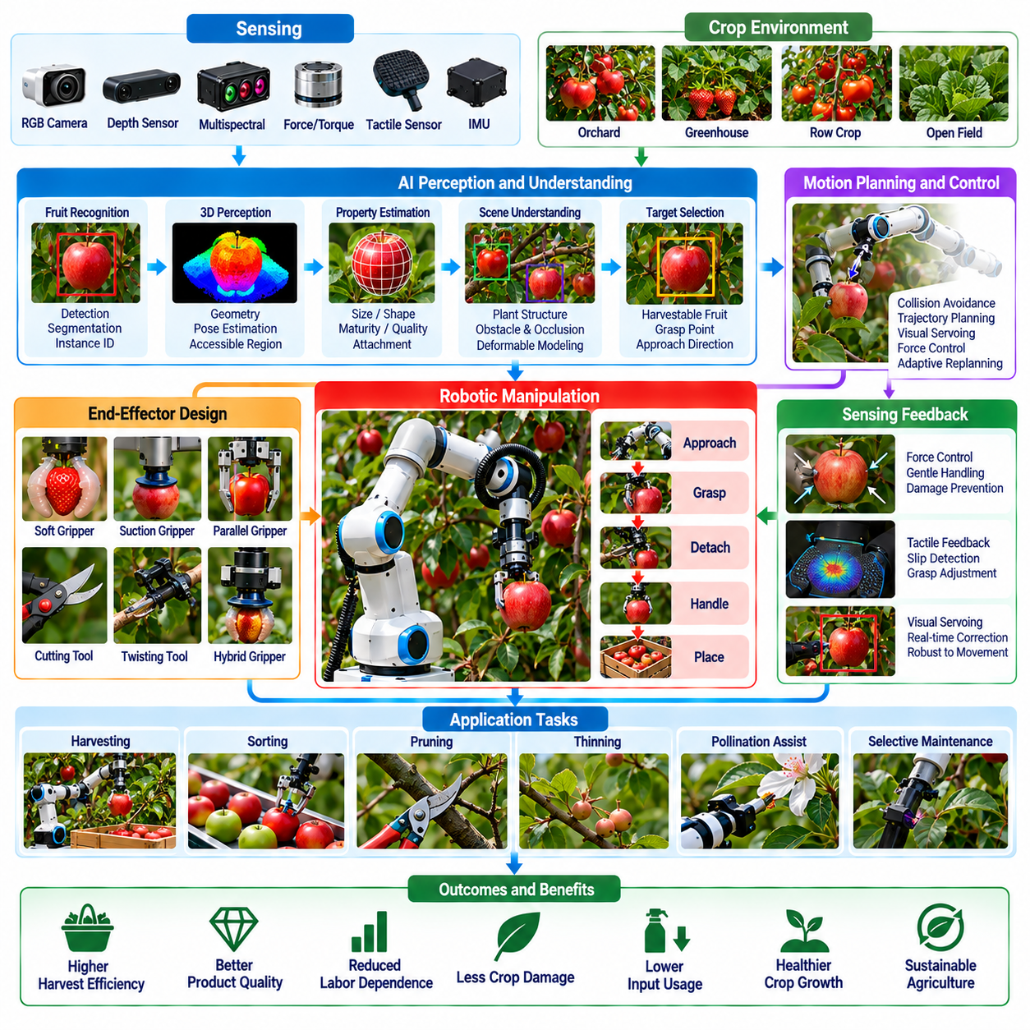
Fruit and crop manipulation is a fundamental capability of Physical AI in agriculture, enabling robots to interact directly with biological products during harvesting, sorting, pruning, and crop maintenance. Unlike standardized industrial objects, agricultural products exhibit substantial variation in shape, size, stiffness, and surface properties. Robotic manipulation must accommodate this variability while maintaining product quality and avoiding damage to surrounding plants.
Agricultural manipulation requires the integration of perception, motion planning, contact control, and task-specific mechanical design. A robot must identify the target, estimate its physical characteristics, select an appropriate interaction strategy, and execute the required movement. These processes operate under uncertainty because plant structures are flexible, partially occluded, and sensitive to external forces. Reliable manipulation therefore depends on continuous sensing and adaptive control.
Fruit recognition provides the foundation for robotic interaction with individual agricultural products. RGB cameras, depth sensors, and machine learning models can identify fruits, estimate their boundaries, and determine their spatial locations. Instance segmentation separates individual products even when multiple fruits overlap. However, shadows, leaves, branches, and changing illumination complicate recognition, requiring robust models and suitable sensor placement.
Three-dimensional perception enables robots to estimate fruit geometry and identify accessible grasping regions. Stereo vision, structured-light sensing, and depth reconstruction provide spatial information about products and surrounding vegetation. Point clouds can represent local plant structures and potential collision obstacles. Accurate geometric interpretation is necessary for selecting approach directions and generating manipulation trajectories within crowded agricultural environments.
Grasp planning determines how a robotic end effector should contact and secure an agricultural product. The selected grasp must provide sufficient stability while minimizing pressure on sensitive surfaces. Product geometry, mass distribution, attachment orientation, and surface friction influence grasp selection. AI-based planners can evaluate alternative contact configurations and choose actions that balance handling reliability, accessibility, and damage prevention.
End-effector design is particularly important because agricultural products vary widely in mechanical properties. Soft robotic grippers use compliant materials to distribute contact forces, while suction grippers provide attachment without conventional finger closure. Specialized mechanical fingers and hybrid gripping systems offer alternative capabilities. Selecting an appropriate mechanism requires consideration of product shape, fragility, contamination, and operational speed.
Soft robotics offers advantages when manipulating delicate fruits and vegetables. Flexible structures can conform to irregular surfaces and reduce localized contact pressure. Pneumatic actuators, elastomeric fingers, and variable-stiffness mechanisms can provide adaptable grasping behavior. However, soft grippers may introduce limitations in positioning accuracy, response speed, and force estimation, requiring careful integration with sensing and control systems.
Force and tactile sensing allow robots to monitor physical interactions during grasping and handling. Pressure sensors, force-torque sensors, and tactile arrays can detect contact conditions, slippage, and unexpected resistance. Closed-loop control adjusts gripping forces according to measured feedback. This capability is essential for products that bruise easily or deform under excessive pressure, where purely visual control may be insufficient.
Agricultural manipulation often involves interaction with deformable plant structures rather than isolated rigid objects. Leaves, stems, branches, and fruits may move when contacted, altering the geometry of the task environment. Robots must predict or observe these changes while maintaining safe contact. Deformable object modeling and compliant control help manage uncertain interactions, although accurate physical modeling remains computationally challenging.
Fruit detachment requires coordinated manipulation of the product and its connection to the plant. Different crops require pulling, twisting, bending, cutting, or combinations of these actions. The robot must identify suitable detachment locations and apply forces in appropriate directions. Incorrect execution can damage stems, branches, or harvested products. Crop-specific detachment strategies are therefore necessary for reliable automated harvesting.
Motion planning in agricultural manipulation must account for obstacles, limited access, and uncertain target positions. Robotic arms navigate through foliage while avoiding collisions with nearby fruits and plant structures. Sampling-based planners, optimization methods, and learned motion policies can generate feasible trajectories. Online replanning allows robots to respond when branches move or previously hidden obstacles become visible.
Visual servoing connects real-time image observations with robotic motion commands. Instead of relying exclusively on an initial target estimate, the robot continuously adjusts its trajectory according to updated visual measurements. This approach helps compensate for localization errors, plant movement, and manipulator positioning uncertainty. Combining visual servoing with force feedback provides greater robustness during final approach and physical contact.
Manipulation tasks extend beyond fruit harvesting to include thinning, pruning, pollination assistance, and selective crop maintenance. Each operation requires different tools, contact strategies, and biological constraints. Pruning involves precise cutting decisions, while thinning requires identifying and removing selected plant structures. Physical AI systems can share perception and motion-planning capabilities across these tasks, although specialized end effectors remain necessary.
Bimanual and multi-arm manipulation can improve performance when agricultural tasks require simultaneous stabilization and intervention. One manipulator may hold a branch or reposition foliage while another grasps or cuts a target. Coordinated control must prevent collisions and manage forces transmitted through connected plant structures. Multi-arm systems increase operational flexibility but introduce additional complexity in perception, scheduling, and mechanical coordination.
Product transfer and placement are important stages of agricultural manipulation. After detachment, robots must move products into containers, conveyors, or sorting systems without excessive impact or compression. Controlled release, compliant supports, and gentle transfer trajectories help preserve quality. Handling strategies must also consider product orientation, accumulation pressure, and the possibility of damage during repeated contact.
Learning-based manipulation can improve robotic performance through demonstrations and operational experience. Imitation learning uses human manipulation examples to develop action policies, while reinforcement learning explores strategies within controlled training environments. Simulation can support policy development, but biological materials are difficult to model accurately. Real-world validation is necessary to confirm that learned behaviors remain reliable across crop varieties and field conditions.
Data collection for agricultural manipulation should capture visual observations, robot configurations, contact forces, action sequences, and task outcomes. Successful and failed interactions provide information about grasp stability, detachment effectiveness, and product damage. Structured datasets support model training and performance analysis. Diversity across product maturity, geometry, environmental conditions, and manipulation strategies improves the potential for generalization.
Robotic manipulation performance should be evaluated using task success rate, cycle time, product damage, grasp stability, and recovery capability. A successful grasp does not necessarily indicate successful harvesting or acceptable product quality. Evaluation must consider the complete sequence from target identification to final placement. Consistent measurement procedures help compare alternative robotic designs and identify operational bottlenecks.
The economic value of fruit and crop manipulation depends on labor productivity, handling quality, equipment utilization, and compatibility with existing agricultural operations. Specialized manipulators may improve performance for particular crops but reduce flexibility across different products. Maintenance requirements, tool replacement, and seasonal utilization influence total ownership costs. Commercial deployment requires reliable operation at a competitive cost per handled product.
Ultimately, fruit and crop manipulation demonstrates the importance of embodied intelligence in agricultural robotics. Effective systems must combine visual understanding, geometric reasoning, compliant interaction, and adaptive control to handle biological variability. Continued advances in soft grippers, tactile sensing, learning-based control, and coordinated manipulation can expand agricultural automation. Long-term success depends on preserving crop quality while achieving reliable, scalable, and economically sustainable operation.

05.08. Heavy Payload and Field Logistics
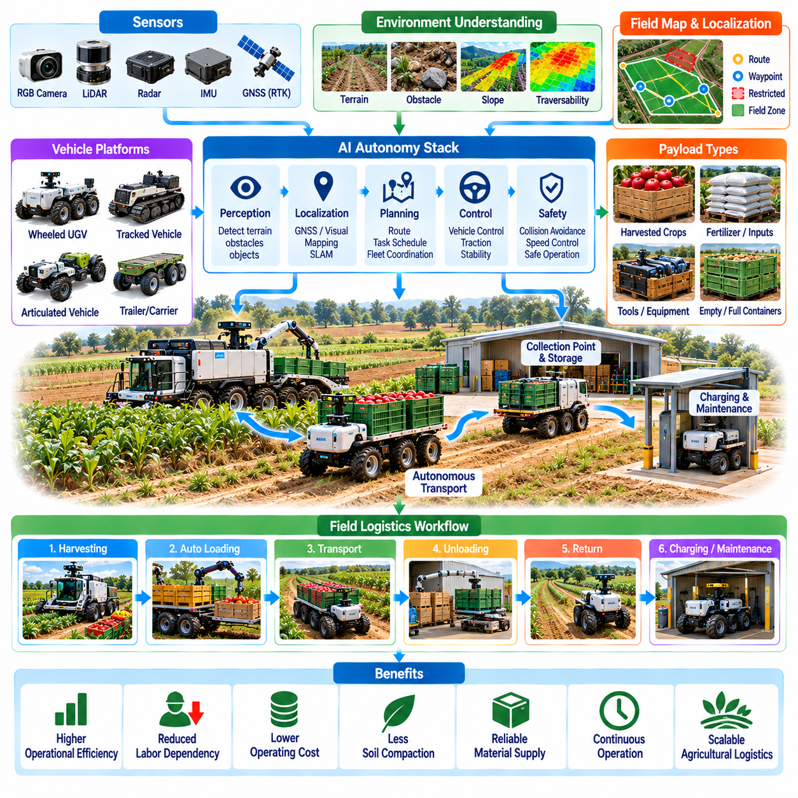
Heavy payload handling and field logistics are essential applications of Physical AI in agriculture, supporting the transportation of harvested crops, fertilizers, tools, equipment, and other materials across farming environments. Agricultural logistics frequently involves repetitive movement over long distances and irregular terrain. Autonomous transport systems can reduce manual handling requirements, improve operational continuity, and connect distributed agricultural activities.
Field logistics differs from conventional warehouse transportation because agricultural environments are largely unstructured and continuously changing. Uneven soil, slopes, mud, vegetation, drainage channels, and temporary obstacles create significant mobility challenges. Physical AI combines environmental perception, autonomous navigation, and vehicle control to transport heavy loads safely while adapting to terrain conditions and operational requirements.
Agricultural payload requirements vary according to crop type, production scale, and transportation objectives. Small mobile robots may carry harvesting containers or specialized tools, while larger autonomous vehicles transport bulk produce, fertilizer supplies, and agricultural equipment. Payload mass, dimensions, center of gravity, and loading configuration influence vehicle selection. Effective system design must balance transport capacity, mobility, stability, and energy efficiency.
Heavy payload transportation requires careful consideration of vehicle morphology and mechanical architecture. Wheeled platforms provide efficient movement on relatively firm surfaces, while tracked vehicles may improve traction on soft or uneven ground. Articulated chassis and specialized suspension systems help maintain contact with irregular terrain. The selected configuration must accommodate agricultural access constraints without causing excessive soil compaction or crop damage.
Terrain perception is fundamental to reliable autonomous field logistics. Cameras, LiDAR, depth sensors, and inertial measurement units provide information about obstacles, surface geometry, and vehicle motion. AI models can estimate traversability by interpreting soil appearance, vegetation density, slope, and terrain irregularities. However, visual information alone cannot reliably determine soil strength or traction, requiring feedback from vehicle dynamics and wheel-ground interactions.
Localization and mapping enable autonomous transport vehicles to navigate between harvesting zones, storage facilities, processing areas, and equipment stations. RTK-GNSS provides accurate outdoor positioning when satellite visibility is sufficient, while visual and LiDAR-based methods support localization under partial obstruction. Agricultural maps must represent routes, field boundaries, restricted areas, and temporary hazards. Reliable positioning is essential for safe movement and precise loading operations.
Route planning for heavy agricultural vehicles must consider more than travel distance. Payload weight, terrain slope, surface conditions, turning radius, vehicle width, and energy consumption influence route feasibility. A shorter path may be unsuitable when soil conditions cannot support the vehicle or when steep gradients create stability risks. Intelligent planners select routes that balance transport efficiency with safety, accessibility, and environmental impact.
Vehicle stability becomes particularly important when transporting large or elevated loads across uneven terrain. Changes in payload distribution can alter the center of gravity and increase rollover risk during turning, braking, or slope traversal. Stability-aware control systems monitor vehicle orientation, acceleration, and load conditions. Speed limitations and conservative trajectory planning help maintain safe operation under variable agricultural conditions.
Traction management is another critical requirement for heavy payload mobility. Wheel slip, soil deformation, and uneven ground contact can reduce propulsion efficiency and compromise navigation accuracy. Sensors monitoring wheel speed, motor torque, and inertial motion can identify abnormal traction conditions. Adaptive control strategies adjust acceleration, braking, and drive torque to reduce excessive slip while preserving mobility and limiting soil disturbance.
Loading and unloading operations connect autonomous transportation with agricultural production workflows. Robots may receive harvested containers from workers, harvesting machines, or automated transfer equipment. Accurate docking, platform alignment, and payload positioning are necessary for reliable material exchange. Mechanical interfaces must accommodate variation in container dimensions, loading height, and transfer mechanisms while preventing unintended movement during handling.
Automated payload handling can incorporate lifting mechanisms, conveyors, robotic arms, and interchangeable cargo platforms. These components enable agricultural vehicles to support different material transportation tasks without extensive manual intervention. However, additional handling equipment increases system mass, energy consumption, and mechanical complexity. Modular designs can improve flexibility when standardized containers and compatible transfer interfaces are available.
Harvest logistics requires coordinating transportation capacity with the output of harvesting operations. Autonomous carriers can collect filled containers and deliver them to designated collection points while harvesting equipment continues working. Poor coordination may cause harvesting delays or unnecessary vehicle waiting. Task scheduling systems estimate transport demand and allocate available vehicles according to production rates, travel distances, and loading requirements.
Multi-robot logistics enables coordinated transportation across large agricultural operations. Multiple autonomous carriers may share routes, collection stations, and charging facilities while serving different harvesting teams. Fleet management systems assign missions, monitor vehicle status, and resolve scheduling conflicts. Effective coordination reduces empty travel and congestion while improving equipment utilization, although communication limitations must be considered.
Energy management strongly influences the economics of heavy payload transportation. Vehicle mass, cargo weight, terrain resistance, travel speed, and auxiliary equipment determine power consumption. Battery-electric platforms require appropriate charging infrastructure and mission scheduling. Energy-aware planners can estimate remaining operating range and reserve sufficient capacity for safe return. Hybrid power systems may be considered where extended operating duration is required.
Field logistics systems must operate alongside agricultural workers, conventional machinery, and other autonomous equipment. Safety mechanisms include obstacle detection, controlled stopping, speed restrictions, and designated operating zones. Heavy vehicles require sufficient braking capability and safe separation distances, particularly on slopes or low-traction surfaces. Human supervision and emergency intervention procedures remain important when operating in shared agricultural environments.
Weather and seasonal variation significantly affect logistics reliability. Rain can reduce traction and increase soil deformation, while extreme temperatures may influence battery performance and electronic equipment. Harvest seasons may also introduce concentrated transportation demand over short periods. Physical AI systems must adapt operational plans to changing conditions and suspend missions when terrain or environmental risks exceed validated limits.
Data integration connects field logistics with broader agricultural management systems. Transport records can include payload weight, collection location, delivery time, route history, and equipment utilization. Digital farm platforms can combine these observations with harvesting schedules and storage capacity information. Such integration supports operational visibility, resource allocation, and analysis of logistics bottlenecks across agricultural production processes.
Simulation and digital twins can support the development of autonomous agricultural transport systems. Virtual environments represent field geometry, vehicle dynamics, payload configurations, and operational workflows. Engineers can evaluate route planning, fleet coordination, and energy consumption before physical deployment. Nevertheless, simulated soil interactions and terrain conditions may differ from reality, making field testing essential for reliable validation.
The economic value of heavy payload automation depends on transportation productivity, labor savings, equipment utilization, and reduced harvesting interruptions. Capital costs, maintenance, battery replacement, infrastructure, and supervision must be included in total ownership calculations. Performance can be evaluated through transported mass per hour, cost per delivery, vehicle availability, and energy consumption. Commercial feasibility requires consistent operational benefits under actual field conditions.
Ultimately, heavy payload handling and field logistics provide the physical transportation infrastructure connecting intelligent agricultural operations. By combining autonomous mobility, terrain-aware control, payload management, and fleet coordination, Physical AI can improve the continuity of harvesting and material distribution. Long-term adoption depends on safe load handling, robust field navigation, scalable coordination, and measurable improvements in agricultural logistics efficiency.

05.09. Quadruped and Rough Terrain Agricultural Robots
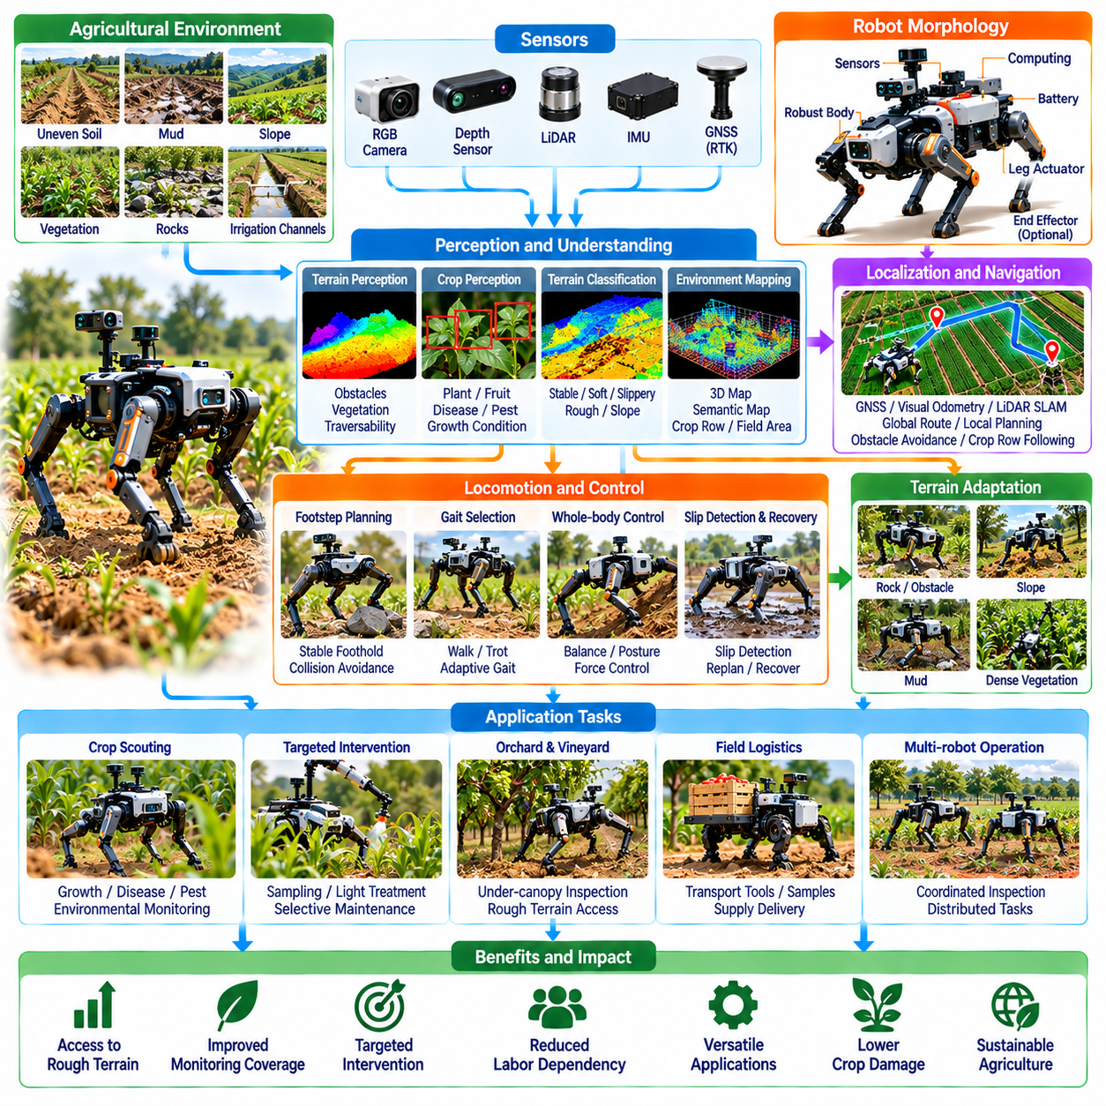
Quadruped and rough-terrain agricultural robots extend Physical AI into farming environments where conventional wheeled machines encounter mobility limitations. Their articulated legs enable controlled movement across uneven soil, slopes, vegetation, and irregular field surfaces. These robots can support crop inspection, environmental monitoring, and targeted agricultural interventions. Their practical value depends on combining terrain adaptability with reliable autonomy and operational efficiency.
Agricultural terrain presents challenges that differ substantially from structured industrial environments. Fields contain loose soil, mud, rocks, irrigation channels, crop residues, and changing ground elevations. Seasonal weather and cultivation activities continuously modify surface conditions. Robots operating in these environments must evaluate terrain accessibility, maintain balance, and adjust movement strategies while minimizing damage to crops and agricultural infrastructure.
Quadruped morphology provides four independently controlled legs that can adapt foot placement to local terrain geometry. Unlike wheels, legs can step over certain obstacles and selectively contact stable ground surfaces. Joint articulation enables changes in body height, posture, and walking configuration. However, legged locomotion introduces mechanical complexity, greater control requirements, and potentially higher energy consumption than efficient wheeled transportation.
Agricultural quadrupeds require perception systems capable of understanding both nearby obstacles and broader terrain conditions. RGB cameras, depth sensors, LiDAR, and inertial measurement units provide complementary environmental observations. AI-based perception models can identify vegetation, terrain discontinuities, obstacles, and potential footholds. Reliable perception is challenging when tall crops, shadows, dust, or changing illumination obscure the ground surface.
Terrain classification helps quadruped robots distinguish between stable surfaces, soft soil, slippery ground, and potentially hazardous areas. Visual appearance provides useful information, but it cannot always reveal subsurface conditions or actual load-bearing capacity. Contact feedback and proprioceptive measurements help estimate terrain properties during movement. Combining visual prediction with physical interaction enables more adaptive locomotion decisions.
Footstep planning determines where each leg should contact the ground while maintaining body stability and forward progress. Candidate footholds are evaluated according to surface geometry, expected traction, obstacle clearance, and reachability. Motion planners coordinate individual leg trajectories with the movement of the robot body. Agricultural applications require conservative planning because unstable soil or hidden vegetation can produce unexpected foot placement errors.
Gait selection influences locomotion speed, stability, and energy efficiency. Walking gaits generally provide greater control during careful movement, while faster gaits may improve travel speed on suitable terrain. Adaptive gait controllers adjust step length, timing, and body posture according to environmental conditions. Agricultural robots must prioritize dependable movement over maximum speed when operating near fragile crops, workers, or irrigation equipment.
Whole-body control coordinates leg forces, joint movements, and body orientation to maintain stability during terrain interaction. Model predictive control can optimize short-horizon motion while respecting actuator and contact constraints. Feedback from joint encoders, force sensors, and inertial measurements supports continuous correction. Robust control must accommodate uncertain ground contact, changing payloads, and disturbances caused by vegetation or uneven surfaces.
Slip detection and recovery are essential for reliable operation on wet or deformable agricultural terrain. A foot may sink into loose soil, slide on mud, or lose support near a drainage channel. Proprioceptive sensing can identify deviations between expected and actual motion. Recovery controllers may redistribute body weight, modify footholds, or retreat from unsafe areas. Severe uncertainty should trigger controlled stopping rather than continued movement.
Autonomous navigation connects local legged locomotion with agricultural missions spanning large areas. GNSS-based positioning, visual odometry, and LiDAR mapping can support localization across fields and orchards. Global planners identify routes between inspection points, while local planners handle immediate obstacles and terrain changes. Accurate navigation must account for crop rows, restricted areas, uneven ground, and temporary obstructions.
Crop scouting is a promising application because quadrupeds can carry sensors through areas that are difficult for conventional mobile platforms to access. Cameras and environmental instruments can collect information about crop growth, disease symptoms, and local conditions. Robots may inspect orchard floors, vineyard rows, or uneven cultivation areas. Sensor positioning and repeatable inspection routes are important for producing comparable agricultural observations.
Quadruped robots can also support targeted agricultural interventions when equipped with specialized payloads. Lightweight manipulators, sampling tools, or treatment devices may perform localized measurements and maintenance tasks. The robot must coordinate body posture with tool operation to maintain accuracy. Payload mass and manipulation forces affect balance and locomotion, making integrated mobility and manipulation control necessary for reliable field deployment.
Payload integration requires balancing sensing capability, battery capacity, and mechanical stability. Additional equipment increases total mass and can shift the center of gravity, especially when mounted above the robot body. Designers must consider actuator torque, structural loading, and available power. Modular payload interfaces can support different agricultural missions, but excessive equipment weight reduces endurance and may compromise mobility on difficult terrain.
Energy efficiency remains a major limitation for legged agricultural robots. Continuous joint actuation, terrain adaptation, and onboard computation consume energy during field operations. Battery capacity determines mission duration, while charging logistics influence practical utilization. Energy-aware navigation can favor routes and gaits that reduce unnecessary mechanical effort. Quadrupeds are most attractive where their terrain access advantages justify their additional energy requirements.
Weather resistance and environmental durability are critical for agricultural deployment. Dust, moisture, mud, fertilizers, and temperature fluctuations can affect sensors, actuators, connectors, and mechanical joints. Protective enclosures and appropriate sealing reduce exposure to contaminants. Maintenance procedures must address accumulated debris and component wear. Reliable operation requires validation under realistic agricultural conditions rather than laboratory environments alone.
Human-robot interaction is important because quadrupeds may operate near farmers, livestock, and conventional machinery. Their movement can be unfamiliar or unpredictable to nearby workers, particularly during posture adjustments or recovery actions. Safety systems should include obstacle detection, speed limitations, controlled stopping, and clear operating procedures. Agricultural deployments must also consider animal responses and the possibility of unexpected environmental interactions.
Multi-robot operations can combine quadrupeds with wheeled agricultural vehicles, drones, and fixed monitoring infrastructure. Aerial platforms provide broad environmental observations, while quadrupeds conduct detailed ground-level inspections in difficult areas. Wheeled vehicles can transport heavier equipment and collected materials. Coordinated task allocation allows each robot morphology to perform activities suited to its capabilities, improving overall operational efficiency.
Simulation and reinforcement learning can support the development of terrain-adaptive quadruped locomotion. Virtual environments allow controllers to experience varied slopes, obstacles, friction conditions, and disturbances. Domain randomization can improve robustness to uncertain physical parameters. However, simulated soil deformation and vegetation contact may differ significantly from reality. Field testing remains essential for validating locomotion safety and task performance.
Commercial evaluation should consider mission completion rate, terrain coverage, inspection quality, operating endurance, maintenance costs, and intervention frequency. Quadrupeds may provide unique access capabilities, but their economic value depends on tasks that conventional vehicles cannot perform efficiently. Acquisition cost, energy consumption, supervision, and seasonal utilization influence total ownership costs. Deployment decisions should compare complete operational outcomes rather than mobility capability alone.
Ultimately, quadruped and rough-terrain agricultural robots demonstrate how Physical AI can adapt robotic embodiment to challenging farming environments. Their combination of articulated mobility, terrain perception, adaptive control, and intelligent task execution enables operations beyond conventional vehicle access. Continued progress in energy efficiency, robust locomotion, autonomous navigation, and agricultural integration will determine their long-term practicality and commercial adoption.

05.10. Drones and Aerial Field Intelligence
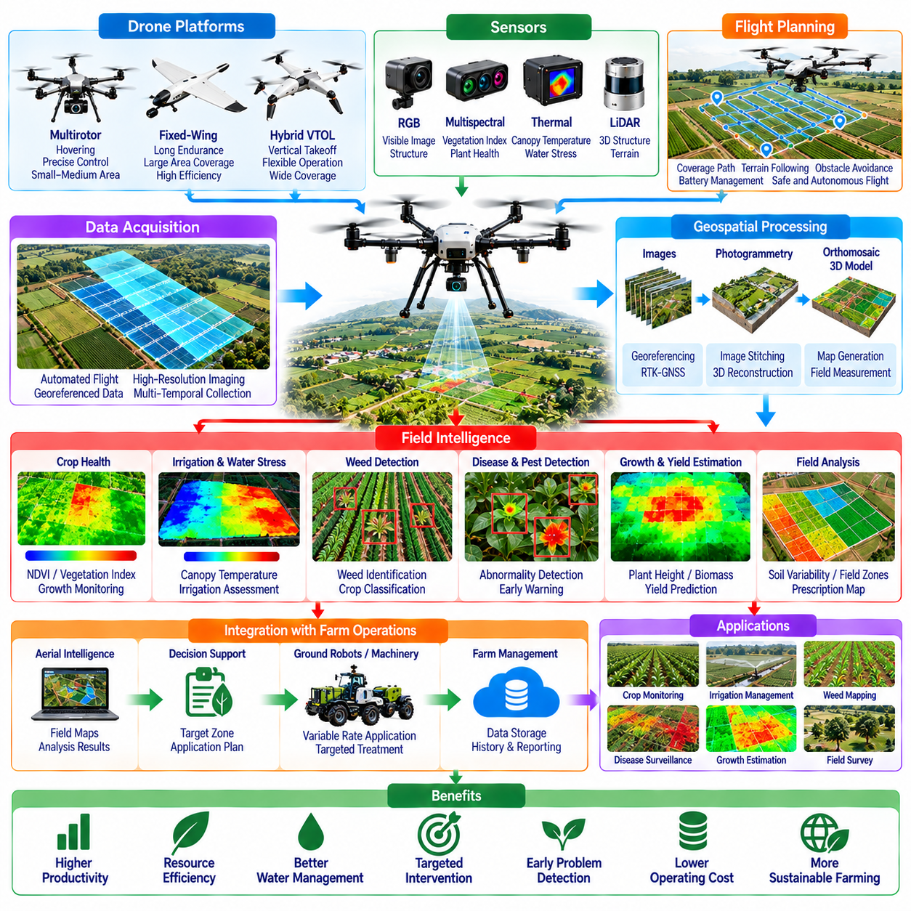
Drones and aerial field intelligence represent important applications of Physical AI in agriculture, enabling rapid observation, analysis, and monitoring across extensive farming environments. Unmanned aerial vehicles provide flexible access to fields, orchards, and agricultural infrastructure without direct ground contact. By combining autonomous flight, intelligent sensing, and data analytics, aerial systems can improve situational awareness and support more precise agricultural decisions.
Aerial agricultural intelligence extends beyond conventional drone photography by converting observations into actionable information. Physical AI systems integrate flight control, environmental perception, geospatial analysis, and machine learning to interpret agricultural conditions. These capabilities support crop health assessment, irrigation monitoring, disease detection, and operational planning. Their effectiveness depends on reliable data acquisition and meaningful integration with farming workflows.
Agricultural drones use different airframe configurations according to mission requirements. Multirotor platforms provide hovering, precise positioning, and flexible operation over localized areas, while fixed-wing aircraft offer greater coverage efficiency for large fields. Hybrid vertical takeoff and landing systems combine selected advantages of both architectures. Platform selection depends on field size, payload requirements, flight endurance, maneuverability, and operational constraints.
Autonomous flight planning determines how aerial robots inspect agricultural areas efficiently and safely. Coverage algorithms generate flight paths that account for field boundaries, sensor characteristics, altitude, and required image overlap. Terrain-following control helps maintain suitable observation distances across uneven landscapes. Mission planners must also consider obstacles, restricted airspace, battery reserves, and changing environmental conditions during flight operations.
Aerial sensing systems commonly include RGB cameras, multispectral sensors, thermal cameras, and positioning instruments. RGB imagery provides information about visible crop appearance and structural conditions, while multispectral measurements can reveal differences in vegetation reflectance. Thermal imaging may indicate canopy temperature variations associated with water stress. Sensor selection must reflect the agricultural question because no single modality reliably measures every crop condition.
Geospatial positioning is essential for connecting aerial observations with specific agricultural locations. GNSS receivers, inertial sensors, and camera-based estimation methods support flight navigation and image georeferencing. RTK positioning can improve coordinate accuracy when suitable correction services are available. Accurate spatial registration allows observations from different missions to be compared and supports targeted interventions by ground-based agricultural equipment.
Aerial image processing transforms individual observations into spatially organized representations of agricultural environments. Photogrammetry can combine overlapping images to generate orthomosaics, elevation models, and three-dimensional reconstructions. These products support crop mapping, field measurement, and structural analysis. Image quality depends on flight geometry, camera calibration, positioning accuracy, and the stability of environmental conditions during acquisition.
Crop health monitoring is a major application of aerial field intelligence. Machine learning models can analyze canopy appearance, vegetation patterns, and temporal changes to identify areas requiring attention. Vegetation indices derived from multispectral imagery provide indicators of plant reflectance characteristics. However, unusual spectral responses do not uniquely identify disease or nutrient deficiency, making field verification and contextual interpretation necessary.
Water stress and irrigation assessment can benefit from combining thermal observations with vegetation and environmental information. Canopy temperature differences may indicate changes in transpiration and plant water status under suitable measurement conditions. Aerial maps can help identify uneven irrigation distribution or potentially stressed regions. Reliable interpretation requires consideration of weather, crop development, soil characteristics, and sensor calibration.
Weed detection and crop classification enable aerial systems to identify spatial patterns that support precision agriculture. Computer vision models can distinguish crop rows, exposed soil, and unwanted vegetation when sufficient image resolution and training data are available. Generated weed maps may guide targeted ground treatment or variable-rate applications. Classification performance can decline when crop and weed appearances overlap or vegetation becomes densely mixed.
Disease and pest surveillance can use aerial imagery to detect abnormal crop patterns before they become obvious across an entire field. AI models may identify discoloration, canopy thinning, or irregular growth associated with possible biological stress. Nevertheless, similar visual symptoms can arise from multiple causes. Aerial intelligence should therefore support diagnostic prioritization rather than automatically treating image-based predictions as confirmed disease identification.
Aerial monitoring can also estimate crop growth and production characteristics. Repeated observations provide information about canopy development, plant density, and spatial variability throughout the growing season. Three-dimensional reconstruction may support estimates of plant height or canopy volume. Yield prediction models can combine aerial features with historical records and environmental measurements, although accuracy varies with crop type and growth stage.
Temporal analysis is particularly valuable because agricultural conditions evolve continuously. Comparing observations collected across multiple dates can reveal growth trends, emerging anomalies, and the effects of previous interventions. Consistent flight paths, sensor settings, and calibration procedures improve comparability. Physical AI systems can prioritize meaningful changes while accounting for seasonal development, illumination differences, and measurement uncertainty.
Autonomous aerial inspection can extend to agricultural infrastructure such as irrigation networks, drainage systems, fences, and greenhouse exteriors. High-resolution imagery and thermal observations may reveal visible damage, water distribution anomalies, or equipment conditions requiring investigation. These inspections can reduce manual surveying effort and improve maintenance planning. Close-range missions require careful obstacle avoidance and appropriate operational safeguards.
Edge computing enables some agricultural observations to be processed directly onboard drones. Embedded AI accelerators can perform image classification, object detection, and event recognition during flight. Local processing may reduce communication requirements and support immediate mission adjustments. However, onboard computation is constrained by payload mass, electrical power, thermal management, and available processing capacity, requiring careful hardware-software integration.
Cloud and farm management platforms provide additional capabilities for large-scale aerial data analysis. Flight records, imagery, geospatial layers, and AI-generated observations can be organized into agricultural information systems. Historical datasets support comparisons across fields, seasons, and management practices. Integration with ground robots and agricultural machinery allows aerial findings to inform scouting missions, localized treatment, and operational scheduling.
Cooperation between aerial and ground robots creates opportunities for more effective agricultural automation. Drones can rapidly identify regions of interest, while autonomous ground vehicles or quadrupeds perform detailed inspections and physical interventions. Shared maps and georeferenced task assignments connect aerial perception with ground execution. This division of responsibilities can reduce unnecessary field traversal and improve the utilization of specialized robotic platforms.
Operational safety remains essential because agricultural drones operate in shared airspace and changing outdoor environments. Wind, rain, visibility limitations, power loss, and communication interruptions can affect flight reliability. Safety mechanisms include geofencing, obstacle avoidance, battery monitoring, and emergency landing procedures. Operators must also comply with applicable aviation rules, airspace restrictions, and requirements governing agricultural aerial operations.
The economic value of aerial field intelligence depends on monitoring coverage, inspection frequency, actionable detection quality, and the costs of flight operations and data processing. Equipment acquisition, maintenance, trained personnel, software services, and regulatory compliance contribute to total ownership costs. Benefits arise when aerial observations lead to measurable improvements in resource allocation, crop protection, labor efficiency, or production outcomes.
Ultimately, drones and aerial field intelligence provide a scalable observation layer for Physical AI in agriculture. Their combination of autonomous flight, multimodal sensing, geospatial understanding, and intelligent analytics can transform field measurements into operational decisions. Continued progress in sensor reliability, AI interpretation, multi-robot coordination, and agricultural data integration will determine how effectively aerial intelligence supports sustainable and productive farming.

05.11. Multi Robot Farm Operations
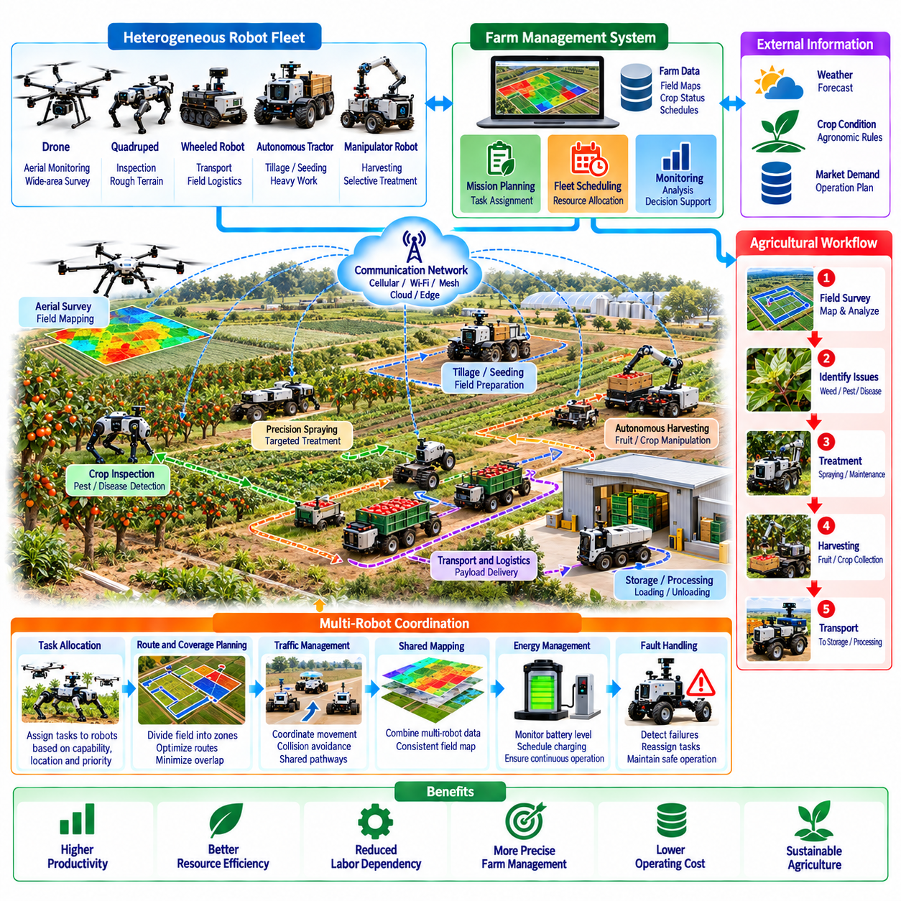
Multi-robot farm operations represent an important evolution of Physical AI in agriculture, enabling coordinated autonomous systems to perform complementary tasks across large and diverse farming environments. Instead of relying on individual machines operating independently, farms can deploy connected fleets for monitoring, treatment, harvesting, and transportation. Effective coordination improves resource utilization, operational continuity, and the ability to respond to changing agricultural conditions.
Agricultural robot fleets may include autonomous tractors, wheeled mobile robots, quadrupeds, aerial drones, and robotic manipulators. Each platform offers different capabilities in mobility, sensing, payload handling, and physical interaction. Drones provide broad environmental observations, while ground robots perform detailed inspections and agricultural interventions. Heterogeneous fleet architectures combine these capabilities to support integrated farming operations.
Multi-robot coordination requires a shared understanding of agricultural tasks, operating environments, and available resources. Farm management systems can define missions according to crop conditions, production schedules, and operational priorities. Individual robots receive assignments based on their capabilities, locations, and current status. Coordination mechanisms must account for task dependencies, equipment limitations, and the availability of human supervision.
Task allocation determines which robots should perform specific agricultural activities and when those activities should occur. Centralized scheduling systems can optimize assignments using estimated travel time, workload, battery capacity, and task urgency. Distributed approaches allow robots to negotiate responsibilities when communication or centralized control is limited. Effective allocation must adapt when equipment becomes unavailable or unexpected field conditions change mission requirements.
Agricultural workflows often contain dependencies that require careful sequencing between robots. Aerial scouting may identify crop stress before a ground robot performs detailed inspection or targeted treatment. Harvesting robots may depend on transport vehicles to remove filled containers and maintain productivity. Workflow orchestration coordinates these activities to prevent unnecessary waiting, resource conflicts, and interruptions across interconnected farming processes.
Shared mapping enables multiple agricultural robots to operate using consistent spatial information. Digital field maps can represent crop rows, access routes, irrigation structures, obstacles, and restricted zones. Individual robots contribute observations that update the shared environmental representation. However, differences in sensor accuracy, localization methods, and observation timing can introduce inconsistencies that must be managed through map alignment and uncertainty estimation.
Fleet-level localization combines information from GNSS, inertial sensors, cameras, and LiDAR systems to maintain reliable robot positioning. Accurate coordinates allow robots to exchange task locations and navigate toward common operational targets. RTK-GNSS can improve outdoor positioning when correction signals are available. Shared localization frameworks must also account for temporary satellite obstruction, sensor drift, and changing agricultural environments.
Communication infrastructure connects agricultural robots with fleet controllers, edge computing systems, and farm management platforms. Wireless networks may include cellular connections, local Wi-Fi, and other field communication technologies. Coverage limitations, interference, and network interruptions can affect coordinated operations. Robust architectures support local autonomy, buffered data exchange, and safe behavior when continuous communication cannot be guaranteed.
Collision avoidance becomes increasingly important when multiple robots share agricultural pathways and working areas. Vehicles may approach intersections, harvesting zones, charging stations, or narrow crop passages simultaneously. Fleet traffic management can reserve critical areas and coordinate movement priorities. Local safety controllers must independently detect nearby obstacles and stop safely because centralized scheduling alone cannot guarantee collision prevention.
Multi-robot systems can improve agricultural coverage by dividing large fields into smaller operational regions. Coverage planning algorithms assign zones according to robot capabilities, travel distances, and expected workload. Coordinated execution reduces unnecessary overlap while ensuring required areas receive attention. Dynamic replanning becomes necessary when robots encounter blocked routes, changing soil conditions, or unexpected differences in task duration.
Energy management influences fleet availability and operational scheduling throughout agricultural missions. Robots differ in battery capacity, power consumption, charging requirements, and mission endurance. Fleet controllers can schedule charging according to predicted workload and available infrastructure. Energy-aware task allocation reduces the likelihood of mission interruption while balancing productive operation against charging time and battery degradation.
Autonomous harvesting fleets require particularly close coordination between perception, manipulation, and logistics systems. Harvesting robots identify and collect mature products, while transport robots move filled containers to storage or processing locations. Fleet orchestration must match transport capacity with harvesting throughput. Poor synchronization can create bottlenecks even when individual robots demonstrate high task performance and reliable autonomy.
Precision agriculture benefits from coordinating observation robots with treatment platforms. Aerial drones and scouting vehicles collect information about weeds, disease symptoms, and crop conditions. AI systems transform observations into georeferenced treatment recommendations. Ground robots then execute localized spraying, mechanical weeding, or other interventions. Feedback from completed operations supports verification and refinement of subsequent agricultural decisions.
Human operators remain essential participants in many multi-robot farming systems. Workers may supervise missions, handle exceptional situations, replenish supplies, and perform maintenance. Human-machine interfaces should present fleet status, task progress, alerts, and intervention requirements clearly. Supervisory control must allow operators to modify priorities or suspend unsafe activities without introducing confusion or conflicting commands across the fleet.
Fleet data management provides a foundation for continuous improvement in agricultural automation. Robots generate information about routes, task outcomes, environmental conditions, equipment status, and operational interruptions. Centralized data platforms can organize these records for analysis and model development. Shared learning processes may improve navigation, crop recognition, and scheduling, provided differences between robot hardware and operating conditions are considered.
Simulation and digital twins support the design and evaluation of coordinated farm operations. Virtual farms can represent field layouts, robot capabilities, crop distributions, and changing environmental conditions. Engineers can test task allocation, traffic management, and logistics strategies before physical deployment. Simulation results must be validated against actual field performance because agricultural terrain, weather, and biological variability introduce substantial uncertainty.
Operational resilience requires multi-robot fleets to tolerate equipment failures, communication interruptions, and unexpected environmental changes. A failed robot should not necessarily stop the entire agricultural workflow. Fleet management systems can reassign tasks, modify routes, or request human intervention according to mission priorities. Reliable recovery depends on accurate status monitoring, well-defined fallback procedures, and safe transitions between autonomous and supervised operation.
Scalability introduces additional challenges as agricultural fleets expand across larger areas and multiple farms. Increasing robot numbers raises communication demand, traffic complexity, maintenance requirements, and scheduling overhead. Hierarchical coordination can distribute decisions between local robot groups and centralized farm management systems. Standardized interfaces and interoperable software architectures help integrate heterogeneous equipment while reducing deployment complexity.
The economic performance of multi-robot farming depends on fleet utilization, task completion rates, labor productivity, equipment availability, and operational costs. Adding robots does not automatically produce proportional productivity gains because shared infrastructure and workflow bottlenecks can limit throughput. Economic evaluation should include acquisition, maintenance, connectivity, supervision, and charging infrastructure. Coordinated fleets create value when system-level improvements exceed their additional complexity.
Ultimately, multi-robot farm operations transform individual agricultural machines into coordinated Physical AI systems capable of managing interconnected production activities. Shared perception, intelligent task allocation, autonomous mobility, and operational orchestration enable more flexible agricultural workflows. Long-term success depends on reliable interoperability, resilient communication, effective human supervision, and measurable improvements in productivity, sustainability, and economic efficiency.

05.12. Weather Terrain and Seasonal Adaptation
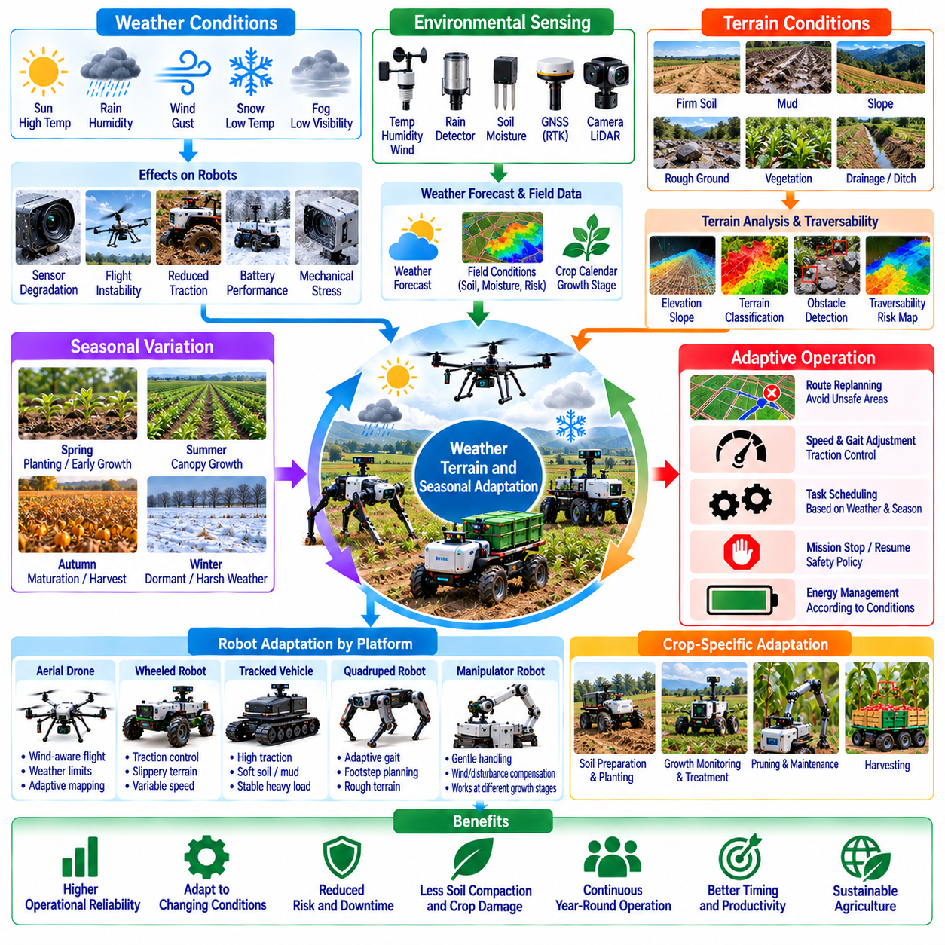
Weather, terrain, and seasonal adaptation are essential capabilities of Physical AI in agriculture because farming environments change continuously across time and location. Rainfall, temperature, sunlight, soil moisture, and crop development directly influence robotic perception, mobility, and task execution. Agricultural robots must operate beyond fixed laboratory conditions, adapting their behavior to environmental uncertainty while maintaining safety, productivity, and operational reliability.
Weather conditions influence nearly every aspect of agricultural robot operation. Rain can reduce visibility, alter soil traction, and interfere with optical sensors, while strong winds affect aerial platforms and exposed manipulators. Temperature extremes influence battery performance, electronics, and mechanical components. Physical AI systems require environmental awareness and adaptive operational policies to determine when missions should continue, change, or stop.
Environmental sensing provides the foundation for weather-aware agricultural autonomy. Temperature sensors, humidity sensors, rain detectors, anemometers, and soil moisture instruments supply measurements of local conditions. External weather forecasts can complement onboard observations by identifying potential changes during planned missions. Combining real-time sensing with predictive information enables robots to adjust schedules, routes, and task parameters before conditions become unsafe.
Terrain variability presents significant challenges for agricultural mobility. Fields contain compacted soil, loose ground, mud, gravel, vegetation, slopes, and drainage structures. Their physical properties change with rainfall, cultivation, and repeated machinery movement. Autonomous vehicles must estimate terrain traversability and select movement strategies that account for traction, ground clearance, load-bearing capacity, and the possibility of becoming immobilized.
Soil moisture strongly affects robot-ground interaction and agricultural operating constraints. Wet soil can increase wheel slip, reduce traction, and produce deep ruts under heavy machinery. Excessive traffic may also contribute to soil compaction and damage agricultural productivity. Physical AI systems can combine moisture measurements, terrain observations, and vehicle feedback to avoid unsuitable routes and reduce unnecessary disturbance of cultivated land.
Terrain-aware navigation integrates geometric mapping with estimates of surface properties. LiDAR, cameras, inertial sensors, and wheel or leg feedback help characterize slopes, obstacles, and contact conditions. Traversability models can assign risk estimates to different field regions. Route planners then balance travel distance, energy consumption, mobility limitations, and soil protection while adapting to environmental changes that invalidate previously selected paths.
Adaptive locomotion allows agricultural robots to respond to changing ground conditions during movement. Wheeled platforms can modify speed, acceleration, and drive torque to manage traction, while tracked vehicles distribute contact forces across larger surfaces. Legged robots can adjust footholds, body posture, and gait patterns. Each morphology offers different advantages, and control policies must reflect its mechanical constraints and environmental operating limits.
Seasonal variation introduces longer-term changes that affect agricultural robot configuration and mission planning. Plant height, canopy density, row accessibility, and field geometry evolve throughout the growing season. Robots that operate effectively during planting may encounter restricted visibility and movement during later growth stages. Adaptive perception and navigation systems must account for these changes rather than assuming static agricultural environments.
Crop growth stages also determine which robotic operations are appropriate. Early-season activities may emphasize soil preparation, planting, and weed monitoring, while later stages require crop inspection, selective treatment, and harvesting. Physical AI systems can incorporate crop calendars, phenological models, and field observations to select suitable tasks. Incorrect timing may reduce treatment effectiveness or cause unnecessary damage to developing plants.
Illumination variation creates additional challenges for visual perception. Direct sunlight, shadows, cloud cover, and changing solar angles alter image appearance throughout the day. Reflective leaves and wet surfaces can further complicate object recognition and depth estimation. Robust agricultural vision systems use suitable exposure control, sensor fusion, and training data diversity to maintain performance across changing lighting conditions.
Weather-aware perception requires recognizing when sensor measurements become unreliable. Rain droplets, dust accumulation, fog, and condensation can degrade cameras and LiDAR systems. Thermal and multispectral measurements are also influenced by environmental conditions and calibration quality. Physical AI systems should monitor sensor confidence and modify operational behavior when perception uncertainty exceeds acceptable thresholds.
Agricultural manipulation must adapt to environmental influences on biological materials. Fruits, stems, leaves, and branches change their mechanical behavior with maturity, hydration, and temperature. Wind can move target objects during grasping or cutting, while wet surfaces alter contact friction. Adaptive manipulators combine visual feedback, force sensing, and compliant control to maintain reliable interactions without damaging crops.
Aerial agricultural robots face particularly strong environmental constraints. Wind speed, gusts, precipitation, and visibility influence flight stability, sensor performance, and mission feasibility. Autonomous flight planners must account for weather forecasts, remaining battery energy, and safe recovery locations. Missions should be delayed or terminated when environmental conditions exceed validated aircraft capabilities or applicable operational restrictions.
Weather and seasonal adaptation also influence agricultural fleet coordination. Multiple robots may require different operating conditions because their mobility systems, payloads, and sensors have different limitations. Fleet management platforms can prioritize suitable missions, reassign tasks, and redistribute resources according to changing conditions. Coordinated adaptation reduces idle time while preventing equipment from entering environments beyond its safe operating envelope.
Predictive models can improve agricultural planning by anticipating environmental changes before they disrupt operations. Weather forecasts, soil measurements, historical field records, and crop development models provide information about future accessibility and task demand. AI-based scheduling can identify favorable operating windows for spraying, inspection, harvesting, or transportation. Prediction uncertainty must be considered when decisions involve safety or irreversible agricultural interventions.
Digital twins provide a framework for representing weather, terrain, and seasonal conditions within integrated agricultural systems. Virtual farm models can combine topography, soil characteristics, crop growth, equipment capabilities, and environmental observations. Simulation supports evaluation of navigation strategies and operational schedules under different conditions. However, simulated weather effects and soil interactions require validation against real agricultural measurements.
Learning-based adaptation can improve robot performance through repeated exposure to diverse agricultural conditions. Operational datasets may include sensor observations, weather measurements, terrain characteristics, control actions, and task outcomes. Models trained across multiple seasons and locations may become more robust to environmental variability. Nevertheless, rare events and unfamiliar conditions require uncertainty estimation, conservative behavior, and continued field validation.
Safety management must account for environmental hazards that change during agricultural operations. Flooded areas, unstable slopes, lightning, strong winds, and reduced visibility can create risks for robots, workers, and surrounding infrastructure. Runtime monitoring systems should compare observed conditions with validated operating limits. Safe fallback behaviors include reduced speed, mission suspension, controlled stopping, and return to designated recovery locations.
The economic consequences of environmental adaptation extend beyond immediate robot performance. Weather-related interruptions, seasonal utilization, equipment wear, and maintenance requirements influence operating costs and investment returns. Adaptive systems can improve productivity by selecting suitable operating windows and reducing avoidable failures. Economic evaluation should consider annual operating availability, completed tasks, environmental damage, and the cost of maintaining robust autonomous capabilities.
Ultimately, weather, terrain, and seasonal adaptation determine whether agricultural Physical AI can function reliably across real farming environments. Effective systems combine environmental sensing, terrain-aware mobility, adaptive manipulation, predictive planning, and operational safety management. Long-term agricultural autonomy requires robots that recognize changing conditions, adjust their behavior intelligently, and maintain dependable performance throughout diverse seasons and production cycles.

05.13. Farm Data and Digital Twin Integration
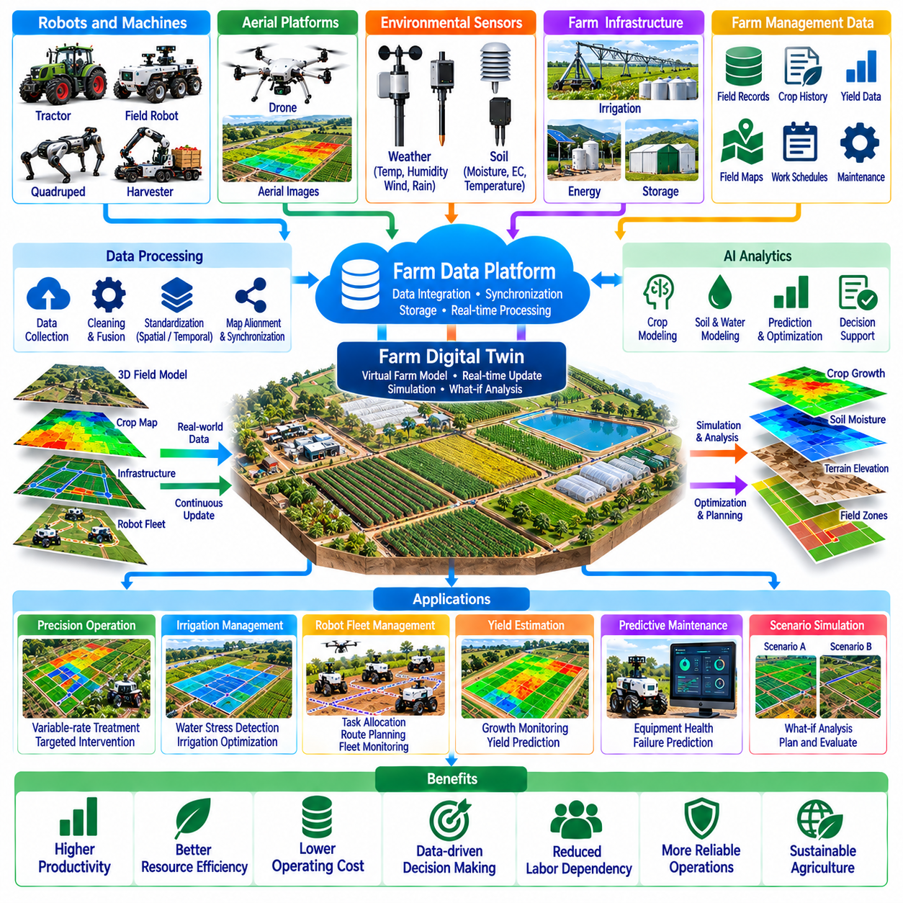
Farm data and digital twin integration provide a foundation for connecting Physical AI systems with agricultural planning, monitoring, and operational management. Modern farms generate information from robots, machinery, environmental sensors, aerial platforms, and production records. Integrating these sources creates a more complete representation of farming activities. Digital twins extend this capability by linking real-world observations with continuously updated virtual models.
Agricultural data integration begins with collecting information from heterogeneous devices and operational systems. Autonomous tractors, harvesting robots, irrigation controllers, weather stations, and drones produce different data formats and measurement frequencies. Unified data architectures organize these inputs into consistent structures. Effective integration requires standardized interfaces, reliable timestamps, spatial references, and clear descriptions of measurement conditions.
Farm data platforms commonly combine spatial, temporal, environmental, and operational information. Spatial datasets describe field boundaries, crop rows, soil zones, and infrastructure locations, while temporal records capture changes across growing seasons. Environmental measurements include temperature, rainfall, humidity, and soil moisture. Operational records document machine activity, resource consumption, completed tasks, and production outcomes.
Data synchronization is essential because agricultural observations originate from distributed systems operating under different communication conditions. Robots may collect information while disconnected from farm networks and upload records after returning to coverage areas. Synchronization mechanisms must preserve timestamps, data integrity, and event ordering. Conflict resolution procedures help reconcile inconsistent updates without losing important operational information.
Geospatial integration connects agricultural observations to physical locations and enables coordinated field operations. GNSS measurements, RTK positioning, aerial mapping, and robot localization systems provide location references for collected data. Geographic information systems organize these observations into spatial layers. Accurate coordinate transformations and map alignment are necessary when combining measurements from different sensors, platforms, and acquisition periods.
A farm digital twin is a computational representation of agricultural assets, environmental conditions, and operational processes. It may include virtual models of fields, crops, soil, irrigation networks, machinery, and robotic fleets. Unlike a static map, a digital twin incorporates updated measurements and operational states. Its usefulness depends on how accurately the virtual representation reflects the relevant behavior of the physical farm.
Digital twin architectures typically connect physical assets, sensing infrastructure, data services, simulation models, and operational applications. Field devices generate observations that update the virtual environment, while analytics estimate conditions that cannot be measured directly. Decision-support systems use these estimates to evaluate potential actions. Feedback from actual operations helps maintain consistency between the digital model and the physical environment.
Crop modeling is an important component of agricultural digital twins. Models can represent plant development, canopy growth, water demand, nutrient uptake, and responses to environmental conditions. Sensor observations and historical production records help update model parameters. Because biological processes are variable and only partially observable, crop digital twins must represent uncertainty rather than assuming perfectly predictable plant behavior.
Soil and water models provide additional information for agricultural decision-making. Digital representations can incorporate soil texture, moisture distribution, drainage characteristics, irrigation schedules, and weather conditions. These models help estimate water availability and identify regions requiring attention. Integrating physical measurements with predictive simulations can improve irrigation planning, although model accuracy depends on calibration and local environmental variability.
Robotic fleet digital twins represent the locations, capabilities, health, and operational status of agricultural machines. Virtual fleet models can track assigned tasks, planned routes, battery levels, equipment availability, and maintenance requirements. This information supports scheduling and resource allocation. Simulation can evaluate alternative fleet configurations and coordination strategies before implementing changes in active agricultural operations.
Data-driven decision support transforms integrated farm information into operational recommendations. AI models can analyze crop conditions, weather forecasts, soil measurements, and historical outcomes to prioritize agricultural interventions. Recommendations may include inspection schedules, irrigation adjustments, treatment locations, or harvesting priorities. Human operators should understand the assumptions, uncertainty, and expected consequences associated with these decisions.
Digital twins also support predictive maintenance and equipment lifecycle management. Robot telemetry can provide information about motor loads, battery health, actuator performance, vibration, and operating temperature. Analytical models may identify abnormal behavior and estimate maintenance needs. Linking equipment condition with agricultural schedules helps reduce unexpected downtime and coordinate servicing during periods of lower operational demand.
Simulation enables agricultural operators to examine potential decisions before applying them in physical environments. Virtual experiments can compare irrigation strategies, planting schedules, harvesting logistics, and robot deployment plans. Scenario analysis helps identify operational bottlenecks and resource constraints. However, simulation outcomes should be treated as conditional predictions because weather, biological variation, and unexpected events can alter actual results.
Edge and cloud computing play complementary roles in farm data integration. Edge systems process time-sensitive sensor information and support local robotic autonomy when network connectivity is limited. Cloud platforms provide scalable storage, historical analysis, model training, and cross-site comparisons. Hybrid architectures balance latency, bandwidth, reliability, and computing cost while maintaining essential operational capabilities during communication interruptions.
Interoperability is necessary when agricultural equipment originates from different manufacturers and software ecosystems. Data exchange interfaces must accommodate varying machine protocols, sensor schemas, coordinate systems, and operational terminology. Common information models and documented APIs reduce integration complexity. Modular architectures allow farms to introduce new robots, sensors, and analytics applications without rebuilding the entire digital infrastructure.
Data quality management determines whether integrated agricultural information can support reliable decisions. Missing measurements, sensor drift, incorrect timestamps, duplicated records, and inconsistent spatial references can distort analytical results. Validation pipelines detect anomalies and document data limitations. Metadata describing sensor calibration, acquisition conditions, and processing history improves traceability and helps users interpret model outputs appropriately.
Cybersecurity, privacy, and data governance are essential for connected agricultural platforms. Farm records may contain commercially sensitive information about production volumes, field performance, equipment utilization, and operating practices. Access controls, encryption, secure communications, and audit logs protect information and operational systems. Governance policies should define data ownership, permitted sharing, retention periods, and responsibilities across technology providers and farm operators.
Continuous learning connects digital twin integration with the broader Physical AI development cycle. Operational outcomes can be compared with model predictions to identify errors and improve future performance. Updated datasets support retraining of perception, planning, and forecasting models. Changes should undergo validation before deployment, especially when revised algorithms influence autonomous machinery, crop treatments, or other safety-critical agricultural activities.
The economic value of farm data integration depends on measurable improvements in decision quality, resource efficiency, equipment utilization, and agricultural productivity. Infrastructure costs include sensors, connectivity, data storage, software integration, model maintenance, and personnel training. Benefits may emerge gradually as historical information accumulates. Economic assessment should distinguish demonstrated operational savings from projected advantages that remain uncertain.
Ultimately, farm data and digital twin integration connect sensing, intelligence, simulation, and physical execution within a unified agricultural framework. Their value lies not simply in collecting more information but in maintaining trustworthy representations that support better decisions and coordinated actions. Continued progress in interoperability, model fidelity, data governance, and closed-loop learning will strengthen the role of digital twins in scalable agricultural Physical AI.

05.14. Economics Labor and Scalability
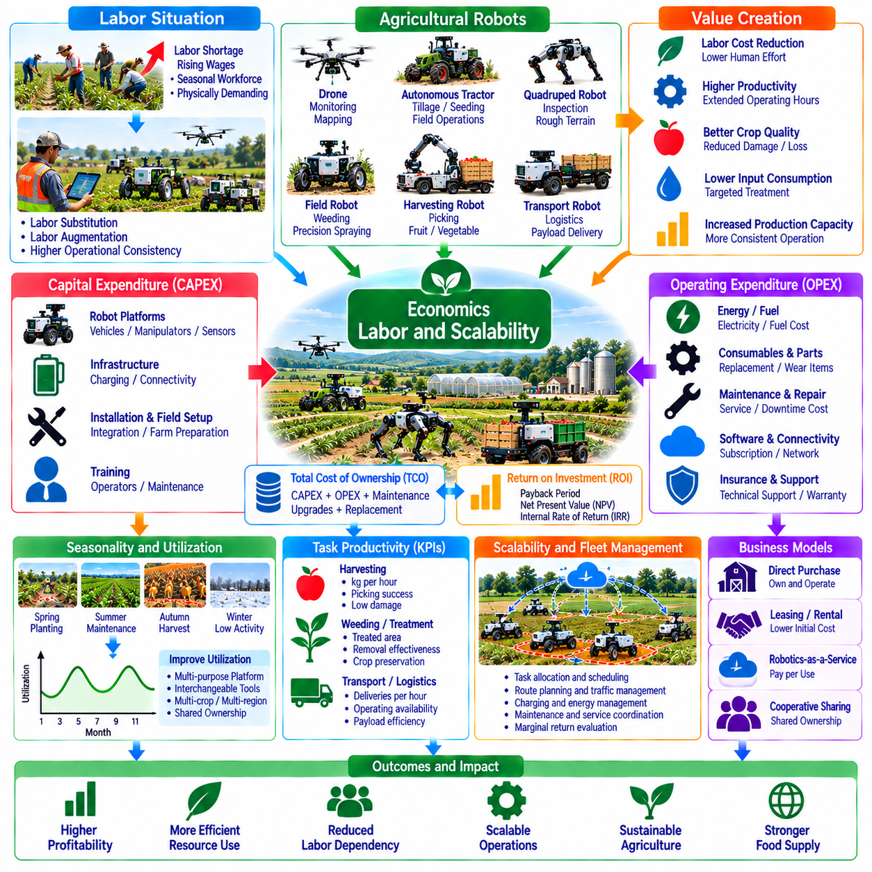
The economics of agricultural Physical AI depend on whether robotic systems can deliver measurable productivity gains while controlling investment, operating costs, and deployment risks. Agricultural automation must account for seasonal workloads, biological variability, and geographically distributed operations. Unlike continuous industrial production, farming often concentrates demand within limited operating windows. Economic viability therefore depends on matching robotic capabilities with actual agricultural needs.
Labor availability is a major driver of agricultural automation. Many farming operations depend on seasonal workers for planting, crop maintenance, harvesting, and transportation. Labor shortages, wage increases, and physically demanding working conditions can encourage robotic adoption. However, automation does not eliminate all human involvement. Workers remain necessary for supervision, maintenance, exception handling, and tasks that exceed current robotic capabilities.
Agricultural robots can create value through labor substitution, labor augmentation, and improved operational consistency. Substitution reduces direct human effort for repetitive tasks, while augmentation allows workers to supervise multiple machines or focus on complex activities. Automated systems may also extend operating hours when conditions permit. Economic assessments should distinguish actual labor hours saved from theoretical reductions that cannot be realized within existing staffing arrangements.
Capital expenditure represents a significant barrier to agricultural robot adoption. Initial investments may include robotic platforms, sensors, manipulators, batteries, charging infrastructure, connectivity, and software integration. Installation, field preparation, and operator training add further costs. Farmers must evaluate whether expected benefits justify these commitments over the equipment lifecycle, particularly when technology performance and future maintenance expenses remain uncertain.
Operating expenditure determines the continuing financial burden of agricultural automation. Electricity or fuel, consumables, replacement parts, software subscriptions, insurance, connectivity, and technical support contribute to recurring costs. Agricultural environments expose equipment to dust, moisture, vibration, and temperature extremes that can accelerate wear. Reliable cost models must include scheduled servicing, unexpected repairs, and productivity losses during downtime.
Total cost of ownership provides a broader measure of agricultural robot economics than purchase price alone. It combines acquisition, deployment, operation, maintenance, upgrades, and eventual replacement or disposal. The relevant evaluation period should reflect equipment durability, technological obsolescence, and farm investment horizons. Comparing ownership costs with conventional machinery and manual workflows helps identify situations where automation offers a sustainable financial advantage.
Return on investment depends on the relationship between economic benefits and the capital required to achieve them. Benefits may include labor savings, reduced input consumption, improved crop quality, lower losses, and increased production capacity. Net cash flows should account for recurring expenses and changing utilization. Payback period, net present value, and internal rate of return provide complementary perspectives, although their conclusions depend on realistic assumptions.
Seasonality creates one of the most important economic challenges for agricultural robotics. Harvesting machines may be highly productive during a short annual period but remain idle for much of the year. Utilization rates therefore strongly influence the cost per completed task. Multi-purpose platforms, interchangeable tools, and deployment across different crops or regions can improve annual usage, provided transportation and reconfiguration costs remain manageable.
Task productivity must be evaluated using meaningful agricultural performance indicators. Harvesting robots may be assessed through kilograms collected per hour, successful picking rates, crop damage, and product quality. Weeding systems can be evaluated through treated area, weed removal effectiveness, and crop preservation. Transport robots may be measured by completed deliveries and operating availability. These indicators connect technical performance with economic outcomes.
Agricultural robot reliability has a direct influence on financial performance. Failures during planting or harvesting windows can create losses that exceed the immediate repair cost. Mean time between failures, recovery time, spare-parts availability, and service response influence effective operating capacity. Economic planning should include contingency arrangements and evaluate the consequences of interruptions during time-critical agricultural activities.
Scalability requires more than increasing the number of deployed robots. Larger fleets introduce additional demands for charging, communication, traffic coordination, maintenance, and human supervision. Shared infrastructure can reduce unit costs, but operational bottlenecks may limit productivity improvements. Fleet-level optimization must evaluate marginal returns from additional robots rather than assuming that output increases proportionally with fleet size.
Farm size and production structure strongly influence automation economics. Large farms may distribute fixed infrastructure costs across extensive operating areas, while smaller farms may struggle to justify dedicated equipment. Cooperative ownership, equipment sharing, and agricultural robotics service providers offer alternative access models. Their effectiveness depends on scheduling flexibility, local service coverage, transport costs, and the concentration of seasonal demand.
Robotics-as-a-Service can reduce upfront investment requirements by converting equipment ownership into usage-based or subscription expenses. Providers may charge according to operating hours, treated hectares, harvested output, or contracted availability. This approach transfers some maintenance and technology risks to service operators. However, service pricing must reflect seasonal demand, equipment utilization, transportation, and the provider's responsibility for performance.
Labor transformation is an important consequence of agricultural automation. Demand may shift from repetitive manual activities toward robot supervision, equipment servicing, data interpretation, and technical coordination. Training programs must address both operational safety and digital competencies. Adoption strategies should consider workforce transition costs, local employment conditions, and the practical ability of farms to recruit or develop technically skilled personnel.
Economic performance also depends on how automation affects agricultural inputs and environmental outcomes. Precision spraying may reduce chemical consumption, while targeted irrigation can improve water efficiency under suitable conditions. Reduced soil disturbance and improved treatment timing may provide additional value. These benefits should be measured against actual baseline practices rather than assumed from technical capability alone.
Regional conditions influence the feasibility of agricultural Physical AI deployment. Labor costs, crop prices, land structure, weather, infrastructure, regulations, and financing availability differ across agricultural markets. A robot that is economically attractive in one region may not achieve similar results elsewhere. Deployment strategies require localized cost assumptions, field validation, and consideration of available maintenance and distribution networks.
Financing and investment risk can determine whether farms adopt automation even when projected returns are positive. High capital requirements, uncertain resale value, technological change, and unpredictable harvest outcomes may discourage investment. Leasing, shared ownership, performance-based contracts, and targeted financing can distribute risk. Economic models should test sensitivity to utilization, wages, crop prices, equipment lifetime, and operating reliability.
Scaling agricultural robotics from pilot projects to commercial deployment requires repeatable installation and support processes. Standardized hardware, modular software, remote diagnostics, and documented operating procedures reduce implementation effort. Local maintenance networks and accessible spare parts improve service continuity. Commercial scalability depends on maintaining consistent performance across farms without requiring extensive customization for every installation.
The broader economic impact of agricultural Physical AI includes changes in productivity, supply-chain resilience, workforce organization, and access to agricultural technology. Automation may help farms respond to labor constraints and improve operational predictability. Nevertheless, unequal access to financing, infrastructure, and technical expertise can limit adoption. Sustainable expansion requires business models that accommodate different farm sizes and production systems.
Ultimately, agricultural Physical AI becomes economically scalable when technical capability, labor organization, equipment utilization, and financial performance reinforce one another. Successful deployment requires realistic productivity measurements, lifecycle cost analysis, reliable service infrastructure, and adaptable commercial models. Long-term value will depend on delivering measurable benefits across diverse farming environments while managing operational uncertainty and supporting responsible workforce transitions.

05.15. Agricultural Robot Economics Model [w/Code]
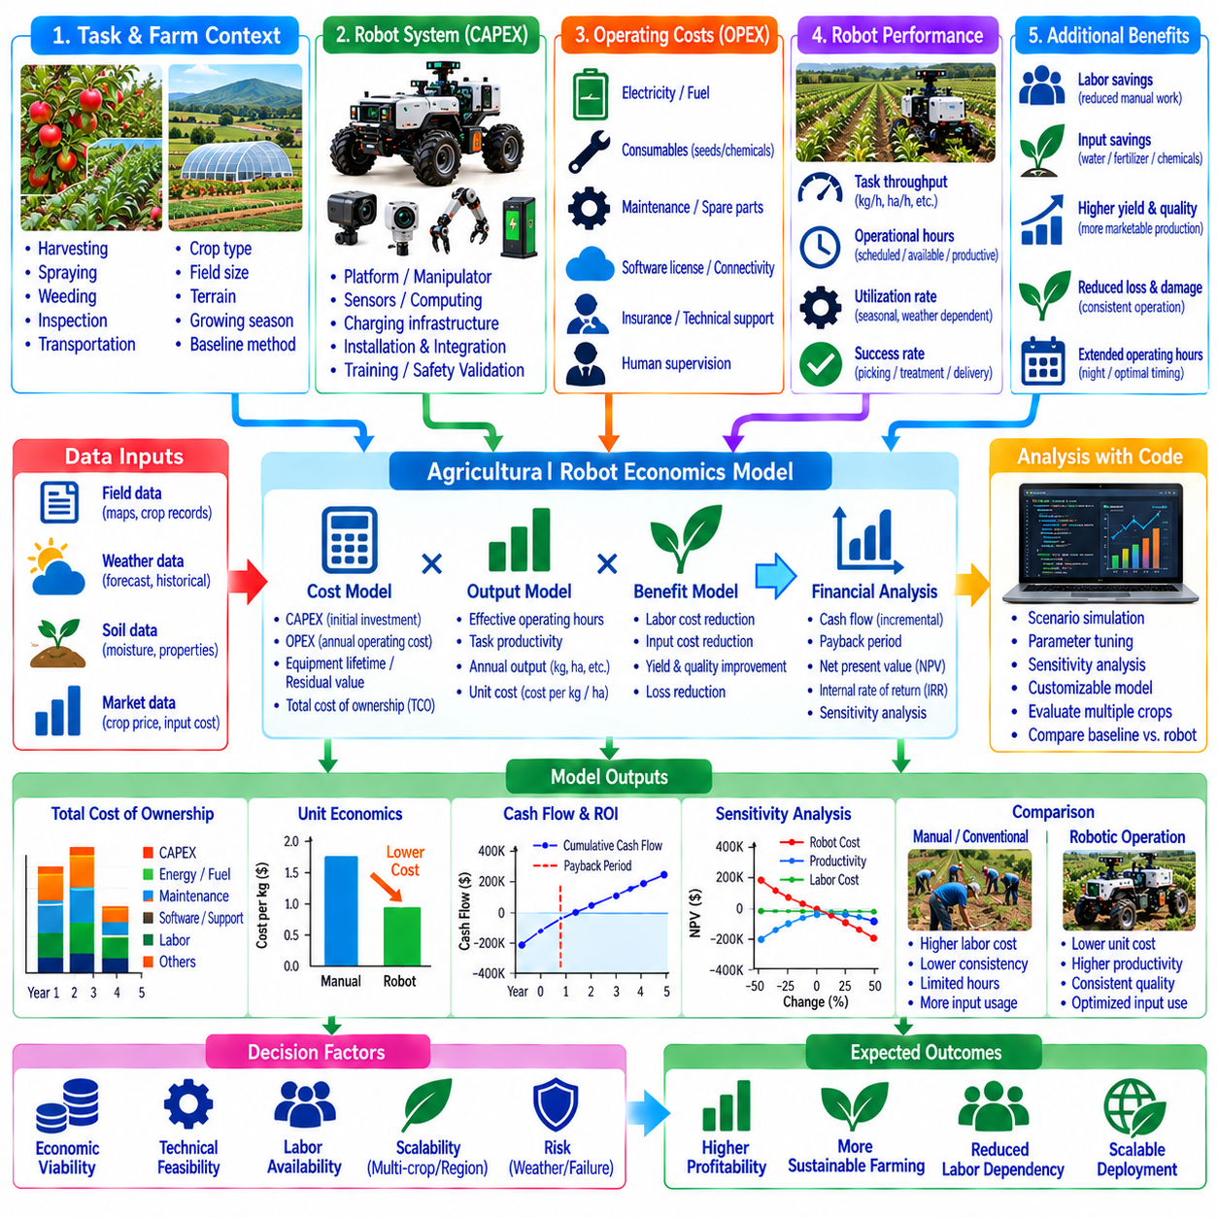
An agricultural robot economics model provides a structured framework for evaluating the financial feasibility of deploying Physical AI across farming operations. It connects robotic performance, labor requirements, equipment investment, and agricultural production outcomes. Unlike conventional machinery analysis, the model must account for autonomy reliability, seasonal utilization, and changing field conditions. Its purpose is to estimate economic value under realistic operating assumptions.
The model begins by defining the agricultural task, operating environment, and baseline production method. Harvesting, spraying, weeding, inspection, and transportation require different economic assumptions and performance indicators. Baseline costs may include manual labor, conventional machinery, agricultural inputs, and production losses. A credible comparison measures robotic operations against an equivalent task scope, quality requirement, and production period.
Capital expenditure includes the purchase and deployment costs of agricultural robotic systems. Relevant components may include mobile platforms, manipulators, sensors, computing hardware, batteries, charging stations, and communication equipment. Installation, software integration, safety validation, and personnel training contribute additional expenses. Capital costs should be allocated across the expected useful life of the equipment rather than treated as recurring annual payments.
Operating expenditure represents the costs incurred during routine robotic activities. Electricity, fuel, consumables, maintenance, spare parts, connectivity, software licenses, insurance, and technical support contribute to annual expenses. Operator supervision and remote intervention must also be included when human assistance remains necessary. Cost estimates should reflect actual operating hours, field conditions, and service requirements rather than ideal laboratory performance.
Robot productivity determines how effectively capital and operating expenses translate into completed agricultural work. Harvesting productivity may be expressed as kilograms per hour, while spraying and weeding systems are evaluated by hectares treated per hour. Transportation robots can be assessed through completed delivery cycles or material throughput. Productivity estimates should account for travel, repositioning, refilling, unloading, and other nonproductive activities.
Effective operating time is generally lower than scheduled operating time because robots experience charging, maintenance, interruptions, and environmental restrictions. A practical model separates scheduled hours, available hours, and productive task hours. Availability measures readiness for operation, while utilization reflects how much available capacity is actually used. These distinctions prevent optimistic projections based on continuous operation throughout the agricultural season.
Annual robotic output can be estimated by multiplying productive operating hours by effective task throughput. Productive hours depend on the number of workable days, daily operating schedules, equipment availability, and utilization. Throughput depends on crop density, terrain, task complexity, and robotic performance. Because these variables interact, the model should use validated field measurements and represent uncertainty through alternative operating scenarios.
Labor savings are calculated by comparing baseline labor requirements with the human effort remaining after automation. Agricultural robots may reduce direct manual work but still require supervisors, maintenance personnel, and exception handlers. Labor cost reductions should reflect actual staffing changes, overtime savings, or avoided seasonal recruitment. If displaced labor is reassigned to other productive activities, its economic value should be evaluated separately.
Input savings provide another source of economic benefit, particularly for precision agriculture applications. Targeted spraying may reduce chemical consumption, while precision irrigation can lower water and pumping requirements. Automated monitoring may improve treatment timing and reduce unnecessary field visits. Savings should be estimated using measured differences in input quantities and prices, with adjustments for any additional robotic consumables or processing costs.
Crop quality and yield improvements can contribute significantly to robotic economic value. Consistent harvesting, timely interventions, and reduced crop damage may increase marketable production. The financial benefit depends on the difference in saleable output and realized selling prices compared with baseline operations. Yield improvements should not be assumed automatically, because crop genetics, weather, soil conditions, and management practices also influence production.
Total cost of ownership combines initial investment with operating, maintenance, upgrade, and replacement costs over the evaluation horizon. Residual equipment value and end-of-life expenses should be considered where relevant. Annualized ownership cost can be estimated using depreciation or a capital recovery approach. The model should avoid double counting capital expenditure when calculating both annual operating profitability and discounted project cash flows.
Unit economics translate system-level financial performance into the cost of completing agricultural work. Cost per harvested kilogram, treated hectare, inspected field, or transported container can be calculated by dividing attributable costs by completed output. Comparable baseline costs should use the same quality and task boundaries. Unit costs often decline as utilization increases, although congestion, maintenance, and coordination overhead can limit economies of scale.
Investment returns should be evaluated through incremental cash flows rather than gross agricultural revenue alone. Annual net benefit equals additional revenue and avoided costs minus incremental operating expenses. Net present value discounts future net cash flows and subtracts initial investment, while internal rate of return identifies the discount rate associated with zero net present value. Payback period provides a simpler measure of investment recovery.
Sensitivity analysis identifies the assumptions that most strongly influence economic feasibility. Important variables include robot purchase price, productive throughput, annual utilization, labor cost, equipment availability, maintenance expense, and crop selling price. Testing favorable, expected, and adverse scenarios reveals financial exposure. Break-even analysis can estimate the minimum productive hours or completed output needed to cover annualized system costs.
Seasonal utilization requires particular attention because agricultural equipment may operate intensively during short production windows. A harvesting robot used for only several weeks may have high unit costs despite strong hourly productivity. Multi-crop operation, interchangeable tools, and deployment across regions can improve annual utilization. However, transportation, reconfiguration, calibration, and scheduling expenses must be included when evaluating these strategies.
Fleet economics extend the model from individual robots to coordinated agricultural systems. Additional robots may increase output, but charging capacity, field access, transportation support, and human supervision can become bottlenecks. Fleet-level models should estimate marginal productivity and incremental infrastructure requirements. Shared resources can reduce average costs, while poorly coordinated operations may increase waiting time and reduce effective utilization.
Alternative commercial models change how agricultural automation costs and risks are distributed. Direct ownership concentrates capital investment and maintenance responsibility on the farm, while leasing converts part of the investment into periodic payments. Robotics-as-a-Service may charge per operating hour, treated hectare, or harvested unit. Comparisons should account for contract terms, service availability, performance guarantees, and the allocation of operational risks.
Economic uncertainty arises from biological variability, weather disruptions, equipment failures, and changing agricultural markets. Delayed harvesting or missed treatment windows may create losses that exceed direct downtime expenses. Risk-adjusted scenarios should therefore include reduced operating days, lower task success rates, unexpected repairs, and price fluctuations. Contingency planning and reliable service support can reduce exposure to these events.
A practical implementation model should connect financial assumptions with measurable operational data. Robot telemetry, maintenance records, task completion logs, labor schedules, and agricultural production records provide evidence for updating estimates. Pilot deployments can establish baseline throughput, availability, and intervention requirements. Periodic recalibration helps distinguish genuine economic improvements from assumptions that were too optimistic during initial planning.
Ultimately, an agricultural robot economics model connects Physical AI capabilities with investment decisions and long-term farming performance. Its reliability depends on realistic baseline comparisons, complete lifecycle costs, validated productivity measurements, and explicit treatment of uncertainty. By linking technical metrics to cash flows, unit economics, and operational constraints, the model supports decisions about robot selection, fleet expansion, service contracts, and scalable agricultural automation.

