Volume 12. Physical AI Business and Industry Applications

Chapter 07. Consumer and Home Applications

07.01. Physical AI in Consumer Environments
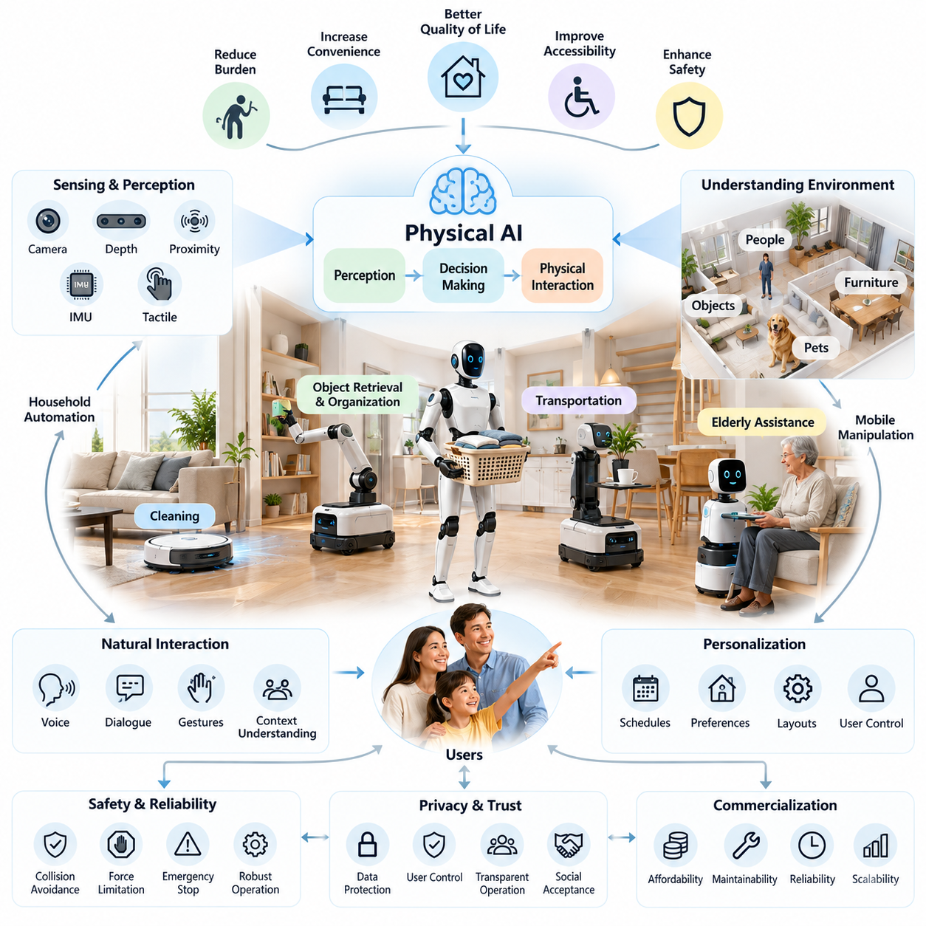
Physical AI in consumer environments represents the integration of intelligent perception, autonomous decision-making, and physical interaction into everyday living spaces. Unlike industrial automation, which operates under relatively controlled conditions, consumer Physical AI must function within dynamic, unpredictable environments shaped by human behavior, household objects, pets, furniture, and changing personal routines.
The primary objective of consumer Physical AI is to reduce the physical and cognitive burden associated with daily activities while improving convenience, accessibility, safety, and quality of life. Intelligent home robots may perform cleaning, transportation, object retrieval, monitoring, and personal assistance. Their practical value depends not only on technical capability but also on affordability, reliability, simplicity, and compatibility with household expectations.
Consumer environments introduce operational challenges fundamentally different from those encountered in factories and warehouses. Homes contain narrow passages, irregular furniture arrangements, reflective surfaces, temporary obstacles, and objects with diverse physical properties. Robots must continuously interpret these conditions while adapting their movements and manipulation strategies without requiring extensive environmental modifications.
Physical AI systems typically combine cameras, depth sensors, proximity sensors, inertial measurement units, and tactile feedback to understand their surroundings. Multimodal perception enables robots to recognize objects, estimate spatial relationships, identify traversable areas, and detect human activity. Sensor fusion improves environmental awareness, particularly when lighting, visibility, or object appearance changes during normal household operations.
Spatial intelligence is essential because household environments rarely remain static. Furniture may be rearranged, doors may open or close, and temporary obstacles can appear without warning. Simultaneous localization and mapping, semantic scene understanding, and dynamic obstacle detection allow autonomous systems to maintain useful environmental representations while navigating safely through occupied living spaces.
The transition from perception to physical action requires intelligent planning and adaptive control. A household robot must translate observations and user intentions into feasible movements while respecting geometric, mechanical, and safety constraints. Task planning determines the required sequence of operations, whereas motion planning and feedback control coordinate navigation, manipulation, and interaction with surrounding objects.
Household automation provides one of the most established commercial applications of consumer Physical AI. Robotic vacuum cleaners and floor-cleaning systems demonstrate how autonomous navigation, environmental sensing, and repetitive task execution can deliver measurable consumer value. More advanced systems increasingly incorporate object recognition, adaptive cleaning strategies, automatic maintenance functions, and personalized operational schedules.
Mobile manipulation extends household robotics beyond floor-based automation toward meaningful interaction with everyday objects. A mobile manipulator combines autonomous movement with robotic arms and end effectors capable of reaching, grasping, transporting, and positioning items. Potential applications include retrieving household supplies, organizing objects, carrying personal belongings, and assisting with repetitive domestic activities.
Humanoid robotics represents a potential approach to general-purpose household assistance because human environments are designed around human dimensions and capabilities. A humanoid robot may theoretically operate existing doors, cabinets, appliances, and furniture without substantial infrastructure changes. However, locomotion stability, dexterous manipulation, energy efficiency, operational safety, and production cost remain major commercialization challenges.
Consumer Physical AI also creates opportunities for elderly individuals and people with mobility limitations. Assistive robots may support object retrieval, indoor transportation, communication, and selected daily activities. Such systems should complement rather than automatically replace human assistance, particularly when tasks involve personal care, physical contact, medical judgment, or circumstances requiring emotional understanding.
Natural language interaction can make Physical AI more accessible to users without technical training. Voice commands, visual gestures, contextual dialogue, and multimodal interfaces allow people to express goals rather than specify detailed robotic instructions. Vision-language-action models may help connect human requests with environmental observations and executable actions, although reliable grounding and safety verification remain necessary.
Personalization is particularly important because household routines, preferences, physical layouts, and accessibility requirements vary substantially. Adaptive systems can learn preferred cleaning schedules, frequently used locations, object arrangements, and interaction patterns. Effective personalization must balance convenience with transparency, user control, and appropriate restrictions on the collection and retention of personal information.
Safety requirements become especially demanding when robots operate near children, elderly residents, pets, and fragile household objects. Consumer robots must account for unexpected contact, unstable surfaces, moving obstacles, and accidental interference. Collision avoidance, force limitation, emergency stopping, uncertainty-aware planning, and predictable fallback behaviors are essential elements of trustworthy physical interaction.
Privacy and cybersecurity represent equally important considerations because consumer Physical AI may continuously observe private living environments. Cameras, microphones, spatial maps, and behavioral records can reveal sensitive information about household members. Secure data processing, access control, encryption, selective data retention, and meaningful consent mechanisms are necessary to maintain trust throughout the product lifecycle.
The computational architecture of consumer Physical AI must balance local responsiveness with advanced intelligence. Edge processors support low-latency perception, navigation, and safety-critical control, while cloud infrastructure may provide model updates, computationally intensive learning, and optional connected services. Essential safety functions should remain operational when network connectivity becomes unavailable or unreliable.
Energy consumption and physical design strongly influence practical household deployment. Robots must operate within constraints involving battery capacity, charging availability, noise, heat generation, dimensions, and acceptable weight. Autonomous docking and charging can reduce user intervention, while efficient actuators, lightweight structures, and optimized computing workloads improve operating duration and household compatibility.
Commercial success depends on delivering recognizable benefits at an acceptable total cost of ownership. Consumers evaluate purchase price alongside installation effort, maintenance requirements, replacement parts, software support, and expected service life. A technically sophisticated robot may struggle commercially if its capabilities are difficult to understand, its operation requires frequent intervention, or its maintenance exceeds perceived value.
Reliability is particularly important because consumer users generally cannot provide specialized technical supervision. A household robot must recover from common disturbances, communicate problems clearly, and continue useful operation with minimal assistance. Product engineering therefore emphasizes robust hardware, simplified maintenance, diagnostic capabilities, software update management, and dependable customer support throughout the ownership period.
The consumer Physical AI ecosystem includes hardware manufacturers, AI model developers, semiconductor suppliers, software platforms, component providers, and service organizations. Integration with smart-home infrastructure may enable coordination among robots, connected appliances, sensors, and home automation systems. Interoperability and open interfaces can reduce fragmentation while expanding the range of useful consumer applications.
Market adoption is likely to progress through increasingly capable but economically justified applications rather than an immediate transition to fully autonomous household assistants. Specialized cleaning and monitoring systems provide established foundations, while mobile manipulation and general-purpose assistance introduce greater technical complexity. Adoption will depend on whether additional capabilities generate benefits that justify their costs and risks.
Evaluating consumer Physical AI requires metrics that extend beyond conventional robotic performance. Task completion rate, intervention frequency, navigation reliability, object-handling success, energy consumption, and operating availability measure technical effectiveness. User satisfaction, perceived safety, setup difficulty, maintenance burden, privacy confidence, and long-term engagement determine whether these capabilities translate into sustained household value.
Consumer deployment also introduces substantial diversity across housing types, cultural expectations, family structures, and economic conditions. Apartments, detached houses, shared residences, and assisted-living environments impose different constraints on navigation, manipulation, noise, and storage. Successful product strategies must therefore account for regional requirements, household demographics, accessibility needs, and differences in purchasing behavior.
The development of general-purpose home robots will require progress in foundation models, physical reasoning, dexterous manipulation, long-horizon planning, and learning from limited experience. Systems must transfer knowledge across unfamiliar homes while recognizing the limits of their competence. Combining generalized intelligence with constrained execution, human supervision, and continuous evaluation offers a practical pathway toward broader autonomy.
Ultimately, Physical AI in consumer environments should be understood as a human-centered technology platform rather than simply a new category of robotic appliances. Its long-term significance lies in transforming intelligent computation into dependable physical assistance within everyday life. Sustainable adoption will emerge when autonomous capability, safety, privacy, affordability, and user experience advance together to deliver consistent practical value.

07.02. Home Service Robot Evolution
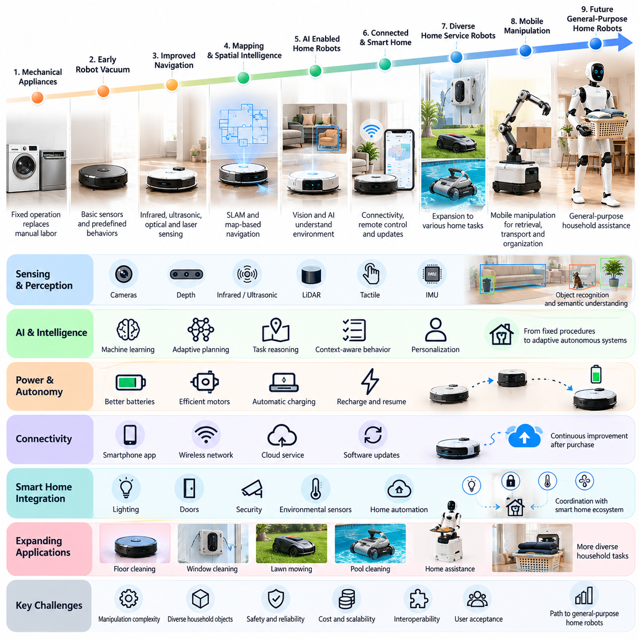
The evolution of home service robots reflects the transition from mechanical household appliances toward intelligent autonomous systems capable of perceiving, interpreting, and interacting with domestic environments. Early devices relied on fixed operating sequences and limited sensing, whereas modern robotic platforms increasingly combine environmental perception, adaptive planning, and machine learning to perform household tasks with reduced human intervention.
The earliest generation of household automation focused on replacing repetitive manual activities through specialized electromechanical devices. Washing machines, dishwashers, and automated cleaning equipment demonstrated the value of mechanizing domestic labor. However, these appliances generally operated within fixed physical configurations and lacked the mobility, environmental awareness, and autonomous decision-making associated with contemporary service robotics.
The emergence of robotic vacuum cleaners marked an important transition from stationary appliances to mobile autonomous household systems. Early models employed basic collision sensors, simple movement patterns, and predefined cleaning behaviors. Although their navigation capabilities were limited, they established a commercially recognizable category of domestic robots capable of operating independently within ordinary residential spaces.
Subsequent generations introduced more sophisticated navigation technologies, including infrared sensing, ultrasonic sensing, optical tracking, and laser-based distance measurement. These capabilities enabled robots to estimate their position, identify obstacles, and navigate household layouts more systematically. The transition from reactive movement toward map-based navigation significantly improved cleaning coverage, operational efficiency, and user confidence.
Simultaneous localization and mapping became a major technological milestone in domestic robotics. By constructing environmental maps while estimating their own position, household robots gained the ability to plan routes, remember room configurations, and avoid unnecessary repeated movement. Mapping also enabled room-specific cleaning, restricted zones, scheduled operations, and more consistent performance across increasingly complex residential environments.
Advances in computer vision further expanded the intelligence of home service robots beyond geometric navigation. Camera-based perception and machine learning enabled recognition of furniture, household objects, floor materials, and selected obstacles. Semantic understanding allowed robots to distinguish meaningful environmental features rather than treating every detected object as an anonymous geometric obstruction.
The integration of artificial intelligence transformed household robots from devices executing fixed procedures into systems capable of adapting their behavior to changing conditions. Learning-based perception, adaptive route planning, and contextual task selection improved flexibility in everyday operations. Nevertheless, practical autonomy continued to depend on reliable sensing, predictable control, and carefully engineered responses to unfamiliar situations.
Battery technology and autonomous charging systems played an equally important role in commercial development. Improved energy storage, efficient electric motors, and automated docking reduced the frequency of direct user intervention. Recharge-and-resume capabilities allowed robots to divide longer tasks into multiple operating sessions, making autonomous cleaning more practical in larger or more complicated homes.
Connectivity introduced another stage of development by linking household robots with smartphones, wireless networks, and cloud services. Users gained the ability to configure schedules, monitor operating status, manage environmental maps, and initiate tasks remotely. Software updates also allowed manufacturers to improve functionality after purchase, transforming household robots into continuously maintained software-enabled consumer products.
The development of smart-home ecosystems created opportunities for coordination between service robots and connected household infrastructure. Robots could potentially exchange information with doors, lighting systems, security devices, and environmental sensors. Such integration supports context-aware automation, although interoperability limitations, cybersecurity risks, and dependence on proprietary platforms can complicate deployment.
As navigation and cleaning technologies matured, developers began expanding household robotics toward more diverse physical tasks. Window-cleaning robots, robotic lawn mowers, pool-cleaning systems, and specialized maintenance devices demonstrated that autonomous service concepts could extend beyond indoor floor cleaning. Each application required different locomotion mechanisms, sensing configurations, safety strategies, and environmental adaptation capabilities.
The transition toward mobile manipulation represents a more fundamental expansion of home service robotics. Unlike cleaning robots that primarily move through environments, mobile manipulators must physically interact with objects of varying shapes, weights, and materials. Combining autonomous navigation with robotic arms, grasping systems, and force feedback enables potential applications involving retrieval, transport, organization, and household assistance.
Manipulation introduces challenges that are considerably more complex than navigation alone. Household objects may be transparent, deformable, fragile, articulated, or partially hidden from sensors. Successful interaction requires object recognition, pose estimation, grasp planning, contact control, and recovery from unsuccessful actions. These requirements make general-purpose household manipulation a demanding research and engineering problem.
Human-robot interaction has evolved alongside improvements in physical capability. Early systems depended primarily on buttons, remote controls, and predefined application commands. More recent interfaces incorporate speech recognition, natural language processing, visual gestures, and conversational assistance. These developments allow users to communicate desired outcomes more naturally, although ambiguous instructions still require clarification and contextual reasoning.
Vision-language models and vision-language-action architectures provide a potential foundation for the next generation of home service robots. By connecting visual observations with language instructions and physical actions, these models may support more flexible task interpretation. Their practical deployment requires reliable action grounding, computational efficiency, safety constraints, and robust performance under unfamiliar household conditions.
Humanoid robotics has emerged as another possible direction in the evolution of domestic service systems. Human-like body structures may provide compatibility with stairs, furniture, cabinets, and tools designed for people. However, humanoid robots face substantial challenges involving dynamic balance, dexterous manipulation, energy consumption, mechanical durability, and safe physical interaction in crowded residential environments.
The progression from specialized appliances toward general-purpose robots is not necessarily a linear replacement process. Task-specific machines often retain advantages in cost, reliability, energy efficiency, and operational simplicity. General-purpose platforms become economically attractive when their ability to perform multiple valuable activities compensates for greater hardware complexity, software requirements, and maintenance demands.
Safety engineering has become increasingly important as robots move from isolated cleaning activities toward direct interaction with household members. Advanced systems must detect people and pets, regulate contact forces, respond to unexpected movements, and enter safe states during failures. Functional safety, runtime monitoring, emergency stopping, and transparent user controls are essential for trustworthy domestic autonomy.
Privacy expectations have also changed as household robots incorporate cameras, microphones, spatial mapping, and cloud connectivity. Environmental observations may reveal personal routines, living arrangements, and sensitive household information. Responsible product development therefore requires secure processing, controlled data access, appropriate retention policies, and user choices concerning local and remote information handling.
The commercial evolution of home service robots has been influenced by manufacturing scale, component costs, distribution channels, and consumer expectations. Successful products must deliver consistent practical benefits without imposing excessive setup or maintenance requirements. Purchase affordability, replacement parts, repairability, software support, and long-term operational reliability are as important as demonstrations of advanced intelligence.
Service-based business models may gradually complement conventional hardware sales through maintenance subscriptions, software upgrades, extended support, and specialized functionality. However, recurring revenue depends on sustained consumer value rather than connectivity alone. Manufacturers must balance lifecycle service costs, customer retention, privacy obligations, and product longevity when designing economically sustainable offerings.
The next stage of home service robot evolution will likely involve stronger integration of perception, language understanding, manipulation, and adaptive planning. Robots may increasingly learn household preferences, coordinate with connected devices, and execute longer sequences of physical tasks. Progress will depend on robust generalization across different homes and the ability to recognize uncertainty before attempting potentially unsafe actions.
Ultimately, the evolution of home service robots illustrates a broader shift from automated household equipment toward embodied intelligence operating within human living spaces. Future success will depend less on isolated demonstrations of robotic sophistication than on dependable daily performance. Affordable, safe, maintainable, and genuinely useful systems will determine how rapidly domestic Physical AI becomes an established part of everyday life.

07.03. Cleaning and Household Automation
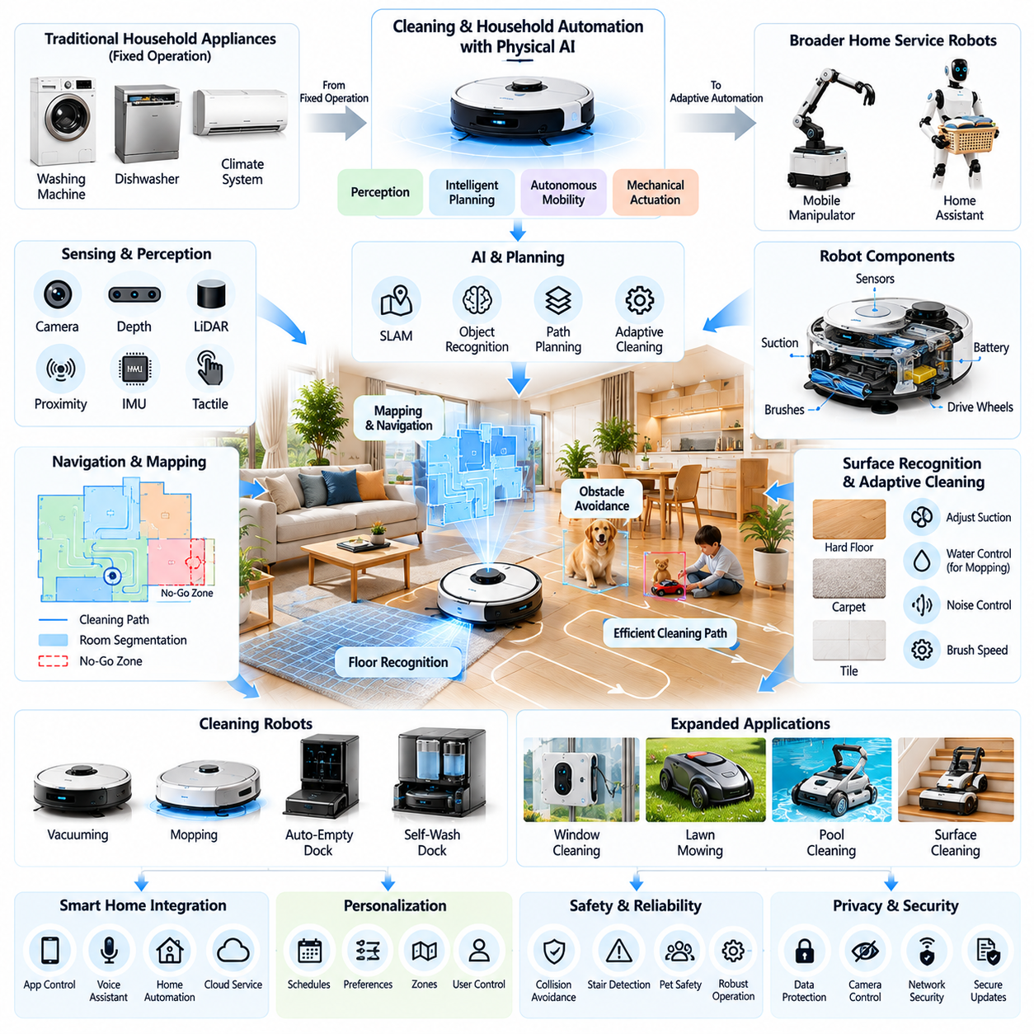
Cleaning and household automation represent some of the most commercially established applications of Physical AI in consumer environments. These technologies combine autonomous mobility, environmental perception, intelligent planning, and mechanical actuation to reduce repetitive domestic labor. Their development demonstrates how specialized robotic systems can deliver practical value while establishing the technological foundation for more capable home service robots.
Traditional household automation relies on appliances that execute predefined operations within controlled physical boundaries. Washing machines, dishwashers, and automated climate systems perform useful functions but generally lack independent mobility and contextual physical reasoning. Physical AI extends automation by enabling machines to perceive changing environments, select appropriate actions, and adapt their behavior to real-world conditions.
Robotic vacuum cleaners provide a representative example of autonomous household cleaning. Modern systems integrate mobile platforms, suction mechanisms, environmental sensors, and navigation algorithms to clean residential floors with limited supervision. Their operational effectiveness depends on coverage planning, obstacle avoidance, surface recognition, battery management, and the ability to recover from common navigation failures.
Navigation technology has progressed from reactive obstacle avoidance toward systematic spatial understanding. Simultaneous localization and mapping enables cleaning robots to construct environmental representations while estimating their position. These maps support room segmentation, route optimization, restricted zones, and targeted cleaning, improving coverage consistency while reducing unnecessary movement and repeated cleaning operations.
Environmental perception allows cleaning robots to distinguish obstacles, furniture, floor surfaces, and potentially hazardous objects. Cameras, depth sensors, laser scanners, and proximity sensors provide complementary information about surrounding conditions. Learning-based perception can identify cables, footwear, toys, and other household items, although recognition reliability varies with lighting, visibility, object appearance, and sensor limitations.
Intelligent cleaning requires more than successful navigation because different surfaces and contamination conditions demand different operating strategies. Robots may adjust suction power, brush speed, water delivery, or movement patterns according to detected floor characteristics. Adaptive cleaning policies seek to balance cleaning effectiveness, energy consumption, noise generation, and mechanical wear under changing household conditions.
Coverage planning is a central optimization problem in autonomous cleaning. The robot must determine how to visit accessible floor regions efficiently while accounting for furniture, narrow passages, temporary obstacles, and battery limitations. Effective planning combines global route generation with local obstacle avoidance and periodic replanning when environmental changes invalidate previously selected paths.
Wet-cleaning automation introduces additional complexity because liquid handling requires careful control of water distribution, surface contact, and contamination management. Robotic mopping systems may integrate water tanks, cleaning pads, pressure regulation, and automatic washing mechanisms. Reliable operation requires preventing excessive moisture, avoiding unsuitable surfaces, and managing dirty water without creating secondary hygiene problems.
Autonomous docking and maintenance systems reduce the operational burden associated with household cleaning robots. Charging stations may provide battery replenishment, dust collection, mop washing, drying, and water management. These functions extend unattended operating periods, although consumable replacement, waste disposal, mechanical cleaning, and periodic inspection remain necessary for dependable long-term performance.
Household automation extends beyond floor cleaning into specialized applications such as robotic window cleaning, lawn maintenance, pool cleaning, and selected surface-cleaning operations. Each application presents distinct physical constraints involving adhesion, terrain interaction, water exposure, weather conditions, and safety. Specialized robot morphology and task-specific sensing remain important because no single mechanical design efficiently addresses every cleaning environment.
Integration with smart-home platforms enables cleaning robots to coordinate with household schedules and connected devices. Users may initiate cleaning through mobile applications, voice assistants, or automated routines linked to occupancy and activity patterns. Such coordination can improve convenience, but interoperability, network reliability, access permissions, and cybersecurity must be addressed to maintain dependable operation.
Personalization allows household automation systems to adapt to individual preferences and recurring environmental patterns. Robots may learn preferred cleaning times, frequently contaminated areas, restricted rooms, and acceptable noise levels. Effective adaptation should preserve user control and provide understandable settings, particularly when learned behavior affects privacy, household access, or interactions with people and pets.
Safety is essential because cleaning robots operate in spaces shared with children, pets, furniture, and fragile objects. Collision avoidance, controlled movement speed, obstacle detection, and appropriate stopping behavior reduce operational risks. More capable systems must also address entanglement, liquid spills, stair edges, unstable objects, and unexpected human intervention during autonomous operation.
Privacy becomes increasingly relevant as cleaning robots incorporate cameras, microphones, spatial mapping, and cloud-connected services. Environmental data can reveal household layouts, occupancy patterns, and personal belongings. Responsible system design requires secure communication, access control, data minimization, transparent retention policies, and meaningful options for local processing and user-directed information management.
The economics of household automation depend on balancing product capability against acquisition and lifecycle costs. Consumers consider purchase price, cleaning performance, operating convenience, electricity consumption, consumables, repair expenses, and expected product lifetime. Manufacturers must optimize hardware complexity and software functionality while maintaining competitive pricing and reliable after-sales support.
Cleaning performance should be evaluated using measurable operational indicators rather than autonomous capability alone. Relevant metrics include surface coverage, cleaning effectiveness, task completion time, intervention frequency, energy consumption, navigation failures, and maintenance requirements. Long-term evaluation should also consider reliability across different floor materials, furniture configurations, and household activity patterns.
The development of household cleaning robots provides an important foundation for broader domestic Physical AI. Technologies involving localization, mapping, perception, autonomous docking, task scheduling, and user interaction can be adapted to other service applications. However, transferring these capabilities to object manipulation or general household assistance requires additional advances in physical reasoning, grasping, and contact-rich control.
Future household automation may combine specialized cleaning devices with mobile manipulators and intelligent home management systems. Coordinated robots could divide tasks according to their physical capabilities while sharing selected environmental information. Such systems may improve operational coverage and flexibility, although coordination complexity, equipment cost, interoperability, and household safety will influence practical adoption.
Artificial intelligence foundation models may further expand the adaptability of cleaning and household automation systems. Vision-language models can support contextual understanding of household conditions, while action-oriented models may help translate user instructions into executable tasks. Nevertheless, reliable deployment requires explicit safety constraints, uncertainty management, and validation across diverse residential environments.
Energy efficiency and sustainability are increasingly important considerations in consumer robotics. Efficient motors, optimized navigation, durable components, and intelligent charging strategies can reduce operational resource consumption. Product longevity, repairability, recyclable materials, and responsible battery management also influence the environmental impact of household automation throughout its lifecycle.
Commercial differentiation is shifting from basic autonomous movement toward integrated cleaning performance, reduced maintenance, intelligent adaptation, and dependable user experience. Manufacturers must demonstrate that additional sensors, AI capabilities, and automation features create recognizable benefits. Technological sophistication alone does not guarantee consumer acceptance when complexity increases ownership costs or reduces reliability.
Ultimately, cleaning and household automation illustrate how Physical AI can transform repetitive domestic activities into intelligent autonomous services. Their significance extends beyond labor reduction because they establish consumer expectations for robotic reliability, safety, affordability, and usability. Continued progress in perception, planning, manipulation, and system integration will support the gradual expansion from specialized cleaning machines toward more versatile household assistants.

07.04. Home Mobile Manipulation
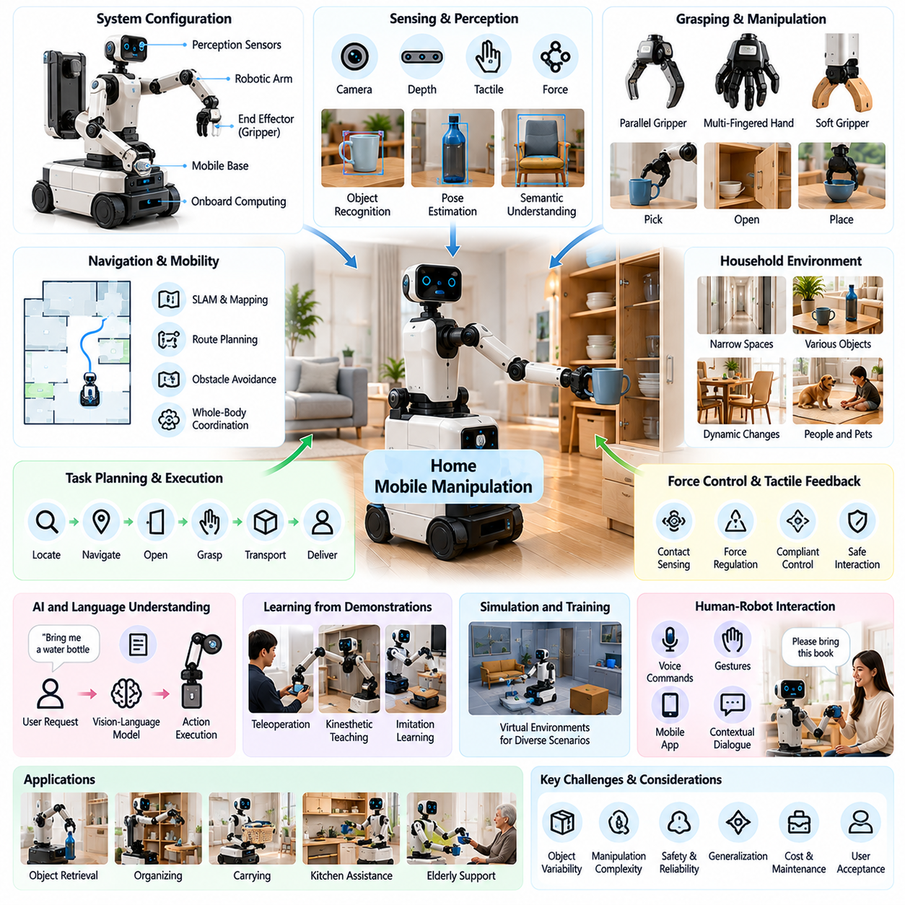
Home mobile manipulation represents a major advancement in consumer Physical AI by combining autonomous navigation with the ability to physically interact with household objects. Unlike conventional cleaning robots, mobile manipulators can approach, grasp, transport, and reposition items throughout residential environments. This capability expands domestic automation from movement-based services toward flexible assistance with everyday physical activities.
A home mobile manipulator typically integrates a mobile base, one or more robotic arms, end effectors, perception sensors, and onboard computing systems. The mobile platform provides movement between rooms, while the manipulator performs object handling and environmental interaction. Successful operation requires coordinated control of mobility and manipulation within the geometric and safety constraints of residential spaces.
Household environments create significant challenges because objects, furniture, and human activities change continuously. Narrow corridors, irregular surfaces, open doors, movable chairs, and temporary obstacles complicate navigation and manipulation. Robots must adapt to these variations without relying on the standardized layouts, fixed workstations, or controlled object arrangements commonly available in industrial facilities.
Perception is essential for identifying household objects and determining how they can be manipulated. Cameras, depth sensors, tactile sensors, and force measurements provide information about object geometry, location, orientation, and contact conditions. Semantic perception enables robots to distinguish functional categories such as cups, bottles, clothing, utensils, and storage containers while estimating appropriate interaction strategies.
Object manipulation requires accurate estimation of three-dimensional position, orientation, and physical properties. Household items vary widely in size, weight, material, rigidity, and surface friction. A robot must select suitable grasp points and contact forces while accounting for uncertainty in object geometry and mass distribution. Fragile, deformable, transparent, and articulated objects introduce additional complexity.
Mobile manipulation planning must coordinate navigation, base positioning, arm movement, and grasp execution. A robot may need to approach a cabinet, align its mobile platform, extend its arm, open a door, and retrieve an object. Each action changes the available workspace and may introduce new obstacles. Integrated task and motion planning helps maintain feasibility across these interconnected operations.
Whole-body coordination becomes important when the robot must reach objects outside the immediate workspace of its manipulator. Movement of the mobile base can extend reachability, improve arm configurations, and avoid collisions. Coordinated control must account for stability, joint limits, payload distribution, and dynamic interactions, particularly when carrying objects or manipulating furniture.
Grasping technology determines whether mobile manipulators can reliably handle diverse household items. Parallel grippers offer mechanical simplicity, while multi-fingered hands provide greater adaptability for complex shapes and dexterous tasks. Soft robotic grippers and compliant mechanisms can reduce contact forces and accommodate uncertainty. The appropriate design depends on task diversity, cost, reliability, and maintenance requirements.
Force and tactile feedback are particularly valuable during contact-rich household activities. Opening drawers, operating handles, placing dishes, and manipulating flexible materials require more than visual positioning. Contact sensing allows robots to detect resistance, regulate applied forces, and recognize unsuccessful interactions. Compliant control reduces the likelihood of damaging objects or creating unsafe contact with surrounding structures.
Household tasks often involve multiple sequential actions rather than isolated manipulation movements. Retrieving an item may require locating it, navigating toward it, opening storage furniture, grasping the object, transporting it, and delivering it to a user. Long-horizon task planning must manage dependencies, environmental changes, and recovery strategies when intermediate operations fail.
Artificial intelligence expands the adaptability of home mobile manipulation through learned perception, object understanding, and action selection. Vision-language models can interpret user requests and connect linguistic descriptions with observed household objects. Vision-language-action models may generate task-relevant robot behaviors, although practical execution requires physical feasibility checks, safety constraints, and reliable low-level control.
Learning from demonstrations provides a potential approach to acquiring household manipulation skills. Human teleoperation, kinesthetic teaching, and recorded interaction trajectories can supply examples of object handling and task execution. Imitation learning may reduce manual programming requirements, but differences between training conditions and actual homes can limit performance without adaptation and validation.
Simulation supports development by allowing manipulation policies to be tested across varied household layouts and object configurations. Virtual environments can generate examples involving different furniture arrangements, object properties, lighting conditions, and disturbances. However, simulation-to-reality transfer remains difficult because friction, contact dynamics, deformable materials, and sensing errors are challenging to reproduce accurately.
Human-robot interaction must accommodate users who have little technical knowledge of robotics. Natural language commands, gestures, mobile interfaces, and contextual dialogue can communicate task objectives. Robots should clarify ambiguous requests, explain limitations, and provide understandable status information. Predictable behavior and accessible emergency controls are especially important when robots operate near household members.
Safety requirements extend beyond collision avoidance because mobile manipulators apply forces to objects and environmental structures. Potential hazards include dropped objects, unstable payloads, pinching, tipping, and unexpected arm movement. Safe operation requires force limitation, collision monitoring, stability assessment, emergency stopping, and conservative behavior when perception or task understanding becomes uncertain.
Energy management strongly influences the practicality of home mobile manipulation. Navigation, arm actuation, sensing, and onboard AI computation compete for limited battery capacity. Manipulation tasks may involve high peak power demands, particularly during lifting or sustained holding. Efficient mechanical design, power-aware planning, and autonomous charging are necessary to support useful operating durations.
Hardware design must balance dexterity, reach, payload capacity, size, weight, and affordability. Larger manipulators can handle heavier objects but may increase power consumption and collision risk in confined spaces. Compact platforms improve household compatibility but restrict workspace and lifting capability. Hardware-software co-design helps optimize these tradeoffs for targeted consumer applications.
Reliability and maintainability are critical because household users cannot be expected to diagnose complex robotic failures. Mobile manipulators must tolerate common disturbances, recover from unsuccessful grasps, and identify conditions requiring human assistance. Modular components, remote diagnostics, software updates, and accessible maintenance procedures can reduce ownership burden and improve long-term usability.
Economic viability depends on whether mobile manipulation delivers sufficient value compared with specialized appliances or human assistance. Development costs include robotic arms, precision actuators, sensors, computing hardware, batteries, and safety systems. Commercial products must justify these expenses through useful task coverage, reduced intervention, reliable performance, and acceptable total cost of ownership.
Evaluation should measure complete household task performance rather than isolated navigation or grasping success. Relevant indicators include task completion rate, object handling success, intervention frequency, execution time, safety incidents, energy consumption, and recovery effectiveness. Testing across unfamiliar homes and diverse objects is essential for determining whether capabilities generalize beyond controlled demonstrations.
Personalization can improve usability by allowing robots to learn household layouts, preferred object locations, user routines, and individual assistance requirements. Persistent spatial memory and semantic object maps may support efficient task execution. However, learning must remain transparent and respect privacy, particularly when robots observe personal belongings, household activities, and sensitive living spaces.
Future home mobile manipulators may increasingly combine foundation models, multimodal perception, adaptive control, and reusable manipulation skills. Such systems could perform broader sequences of household activities while transferring knowledge across different objects and environments. Progress will depend on improving physical reasoning, contact-rich manipulation, uncertainty awareness, and safe adaptation to unfamiliar situations.
Ultimately, home mobile manipulation represents a critical transition from specialized domestic automation toward general-purpose physical assistance. Its commercial potential lies in connecting autonomous mobility with useful object interaction in environments designed for people. Widespread adoption will require reliable performance, intuitive interaction, robust safety, affordable hardware, and measurable improvements in everyday household convenience.

07.05. Humanoid Assistance in the Home
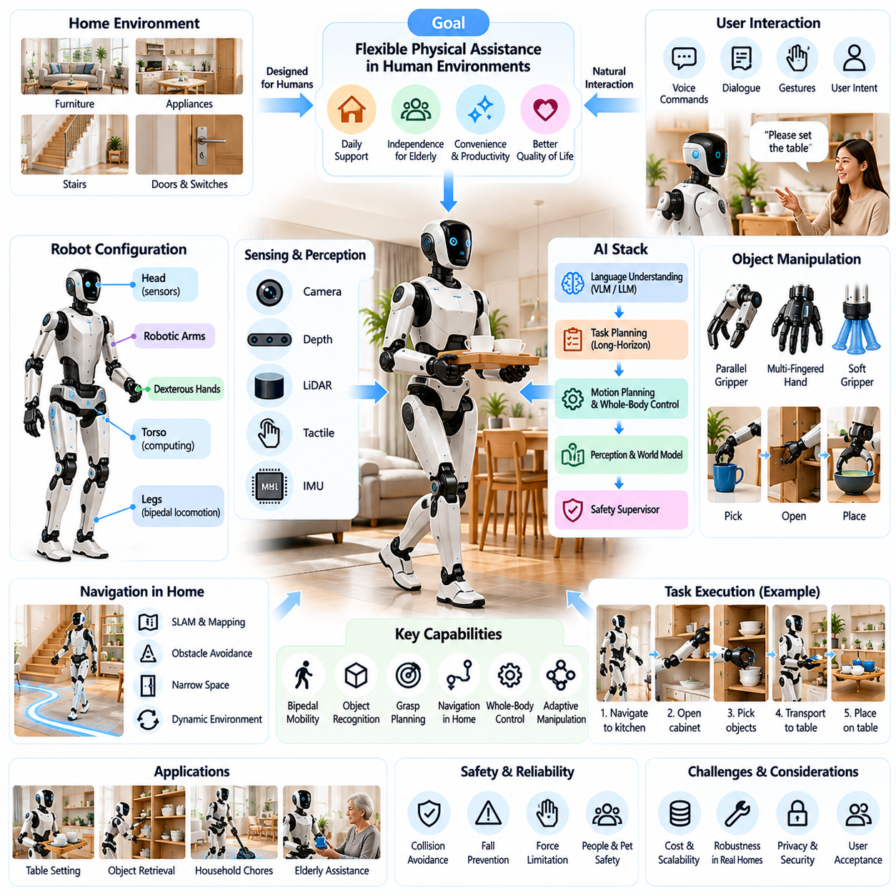
Humanoid assistance in the home represents an emerging direction of Physical AI that seeks to provide flexible physical support within environments designed for human activities. Unlike specialized household robots, humanoid systems use human-like body structures to interact with existing furniture, appliances, tools, and architectural features. Their long-term objective is to perform diverse domestic tasks without requiring extensive modifications to residential infrastructure.
The humanoid form offers potential advantages because household spaces are organized around human height, reach, mobility, and manipulation capabilities. Doors, cabinets, countertops, switches, and stairs reflect human physical characteristics. A humanoid robot may therefore access existing household infrastructure using familiar interaction patterns, although reproducing human versatility requires substantial advances in mechanical design, perception, and control.
Domestic humanoid robots typically integrate articulated legs, robotic arms, dexterous hands, multimodal sensors, and onboard computing platforms. These components must operate as a coordinated system capable of maintaining balance while performing physical tasks. Mechanical configuration strongly influences reachability, payload capacity, energy consumption, stability, and the ability to navigate narrow residential spaces.
Household mobility presents challenges involving carpets, thresholds, stairs, slippery surfaces, and unexpected obstacles. Bipedal locomotion can provide compatibility with human-oriented environments but introduces dynamic balance requirements and considerable control complexity. Humanoid systems must continuously estimate body state, ground contact, and environmental conditions while maintaining stable movement around people and household objects.
Whole-body control is essential because manipulation and locomotion are physically interconnected. Reaching into cabinets, lifting objects, or opening heavy doors can shift the robot's center of mass and alter contact forces. Coordinated control must regulate joint motion, balance, posture, and external interactions simultaneously. Stable task execution depends on accurate dynamics estimation and appropriate recovery strategies.
Dexterous manipulation determines whether humanoid robots can perform meaningful household activities beyond simple transportation. Domestic objects vary in geometry, weight, texture, rigidity, and fragility. Handling dishes, clothing, containers, and household tools requires reliable grasp planning, force regulation, tactile feedback, and object-specific manipulation strategies under uncertain physical conditions.
Perception systems must construct useful representations of dynamic household environments. Cameras, depth sensors, inertial measurements, and tactile sensing support object recognition, spatial mapping, human detection, and contact estimation. Semantic scene understanding enables robots to associate physical objects with functional roles, such as identifying a cup as an item to retrieve or a drawer as an accessible storage location.
Task planning becomes increasingly difficult when household instructions require multiple dependent actions. A request to prepare a table may involve locating objects, opening cabinets, retrieving utensils, navigating around furniture, and placing items accurately. Long-horizon planning must coordinate these operations while accounting for changing conditions, unavailable objects, execution failures, and human interruptions.
Natural language interaction offers an accessible interface for domestic humanoid assistance. Users may communicate goals through speech, gestures, or conversational instructions rather than specifying individual joint movements. Language models can help interpret intentions and generate task sequences, but physical execution requires grounding commands in observed conditions, available capabilities, and explicit safety constraints.
Vision-language-action models and robot foundation models may support broader task generalization by connecting visual observations, language instructions, and executable behaviors. These architectures can potentially reduce dependence on manually programmed routines. However, household deployment requires robust adaptation to unfamiliar objects, reliable action verification, uncertainty awareness, and separation between learned policies and safety-critical control.
Learning from human demonstrations provides a possible pathway toward acquiring diverse domestic skills. Teleoperation, motion capture, and recorded manipulation trajectories can illustrate how tasks are performed. Imitation learning may reproduce useful behaviors, while reinforcement learning and simulation can improve selected control policies. Differences between human and robotic bodies require careful adaptation before demonstrated movements become executable actions.
Simulation environments allow humanoid systems to practice locomotion, manipulation, and recovery without exposing household members to unnecessary risks. Physics-based training can vary furniture arrangements, object properties, surface friction, and external disturbances. Nevertheless, simulation-to-reality transfer remains challenging because contact dynamics, deformable objects, actuator limitations, and unexpected human behavior are difficult to model completely.
Safety is a defining requirement because humanoid robots combine substantial mass, multiple actuators, and potentially unstable locomotion near people. Hazards include falls, collisions, excessive contact forces, dropped objects, and unintended movements. Safe deployment requires mechanical safeguards, force limitation, collision monitoring, emergency stopping, fall-risk management, and conservative behavior when system confidence decreases.
Human-aware navigation and manipulation must account for the unpredictable movements of children, elderly residents, visitors, and pets. Robots should maintain appropriate separation distances, anticipate possible interference, and adjust their actions around occupied spaces. Socially acceptable behavior also requires predictable motion, clear communication of intentions, and the ability to pause or yield when people approach.
Assistive applications may provide value for individuals who experience difficulty performing routine physical activities. Humanoid robots could potentially retrieve objects, carry household supplies, support selected organizational tasks, and facilitate communication. However, direct physical caregiving, lifting people, and medically sensitive activities require substantially stronger validation, specialized safeguards, and appropriate human supervision.
Energy efficiency remains a major obstacle to practical domestic humanoid operation. Bipedal locomotion, balance control, arm manipulation, sensing, and onboard AI computation impose continuous demands on battery resources. High-power movements and sustained object holding can further reduce operating duration. Efficient actuators, lightweight structures, power-aware planning, and autonomous charging are therefore important design priorities.
Hardware affordability strongly influences the commercial feasibility of humanoid assistance. Multiple precision actuators, complex transmissions, dexterous hands, sensors, batteries, and computing systems contribute to substantial manufacturing costs. Reducing component complexity while preserving useful functionality requires hardware-software co-design, modular architectures, scalable production, and careful selection of target household tasks.
Reliability and maintainability are equally important because consumer environments cannot depend on frequent specialist intervention. Humanoid robots must recognize unsuccessful actions, recover from manageable disturbances, and communicate conditions requiring assistance. Diagnostic systems, software updates, replaceable components, and predictable maintenance procedures are necessary to support acceptable product ownership experiences.
Privacy and cybersecurity become critical when humanoid robots continuously perceive private living spaces and interact with connected household systems. Cameras, microphones, spatial maps, and behavioral records may expose sensitive personal information. Secure processing, controlled data access, encryption, transparent retention policies, and user-directed privacy settings should be incorporated into the system architecture.
Consumer acceptance depends on more than technical capability. People may evaluate humanoid robots according to appearance, movement predictability, noise, physical presence, trustworthiness, and perceived usefulness. Human-like design can improve compatibility with household infrastructure, but excessive anthropomorphic expectations may create misunderstandings about intelligence, emotional understanding, and actual functional limitations.
Economic value should be assessed through realistic household task performance rather than isolated demonstrations. Relevant measures include successful task completion, intervention frequency, operating availability, maintenance costs, energy consumption, and useful hours of assistance. Comparison with specialized appliances and conventional home services is necessary to determine whether humanoid versatility justifies additional complexity and ownership costs.
Near-term commercialization may favor constrained applications where humanoid capabilities provide identifiable advantages over simpler robotic platforms. Structured household tasks, controlled object transportation, and selected assistance functions may offer practical development pathways. Expanding toward general-purpose operation will require progressively stronger evidence of reliability, safety, task diversity, and economic sustainability.
Future domestic humanoid systems may combine multimodal foundation models, persistent spatial memory, adaptive manipulation, and long-horizon reasoning to perform increasingly complex household activities. Progress will depend on transferring learned skills across homes while maintaining reliable physical control. Continuous evaluation, human oversight, and clearly defined operating boundaries will remain essential during this transition.
Ultimately, humanoid assistance in the home represents an ambitious extension of Physical AI from specialized automation toward adaptable physical intelligence. Its potential lies in using human-compatible embodiment to support diverse everyday activities within existing living spaces. Widespread adoption will depend on achieving dependable performance, demonstrable safety, affordable operation, intuitive interaction, and meaningful improvements in household quality of life.

07.06. Elderly and Assistive Home Robotics
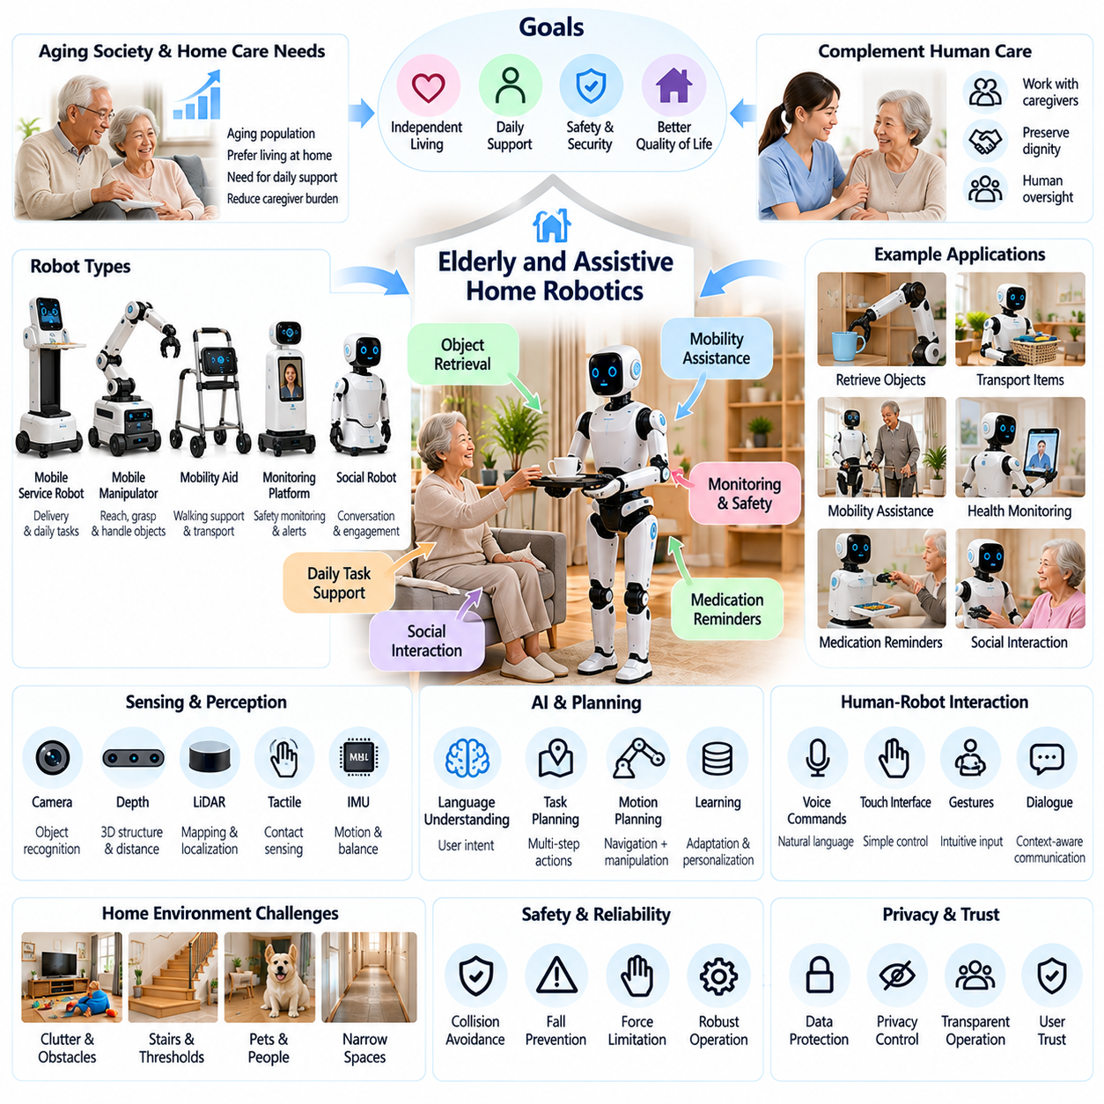
Elderly and assistive home robotics represent an important application of Physical AI focused on supporting independent living, daily functioning, and personal well-being. These systems combine environmental perception, autonomous mobility, physical assistance, and human-centered interaction to address practical challenges associated with aging and reduced functional ability. Their primary objective is to complement human care while preserving dignity, autonomy, and safety.
Population aging and increasing demand for home-based support create opportunities for assistive robotic technologies. Many older adults prefer remaining in familiar residential environments rather than relocating to institutional facilities. Robots may help reduce the burden of repetitive household activities, provide access to essential objects, and support communication with caregivers, although their capabilities must be matched carefully to individual needs.
Assistive home robotics encompasses several system categories, including mobile service robots, robotic manipulators, mobility aids, monitoring platforms, and socially interactive devices. Each category addresses different functional requirements and levels of physical interaction. Successful deployment depends on selecting appropriate robotic capabilities rather than assuming that a single general-purpose platform can satisfy every assistance requirement.
Daily living assistance focuses on activities such as retrieving objects, transporting supplies, organizing household items, and supporting routine tasks. Mobile manipulators may help users access objects that are difficult to reach or carry. These applications require reliable navigation, object recognition, grasping, and safe delivery, particularly when users have limited mobility, reduced strength, or difficulties maintaining balance.
Mobility assistance introduces additional mechanical and safety challenges because robotic devices may directly influence human movement. Intelligent walkers, powered mobility platforms, and robotic support systems can provide navigation assistance or controlled movement support. Their design must consider user stability, braking performance, terrain conditions, physical interaction forces, and the consequences of unexpected system failures.
Human-robot interaction must accommodate diverse sensory, cognitive, and physical abilities. Voice commands, touch interfaces, visual displays, and simplified controls can provide complementary communication channels. Effective systems adapt interaction speed, feedback clarity, and interface complexity to user requirements while avoiding unnecessary dependence on technical knowledge or complicated configuration procedures.
Personalization is particularly important because assistance requirements differ substantially among individuals and may change over time. Robots can adapt to preferred routines, household layouts, mobility patterns, and communication preferences. However, personalization should remain transparent and reversible, allowing users and authorized caregivers to adjust assistance levels without removing the individual's control over daily activities.
Environmental perception enables assistive robots to operate in residential spaces containing furniture, narrow passages, pets, and moving people. Cameras, depth sensors, proximity sensors, and spatial mapping support obstacle avoidance and task execution. Reliable perception must account for changing lighting, clutter, reflective surfaces, and unexpected objects while maintaining safe behavior when environmental understanding is uncertain.
Monitoring functions may support awareness of unusual household conditions, prolonged inactivity, or requests for assistance. Robotic platforms can combine movement, environmental sensing, and communication capabilities to provide contextual information. However, monitoring observations should not be treated as definitive medical assessments, and important alerts require appropriate verification, escalation procedures, and human oversight.
Fall-related assistance requires especially careful system design because falls can cause serious harm and detection technologies are imperfect. Robots may identify potential hazards, communicate warnings, or help summon assistance after a suspected incident. Physical lifting or recovery support introduces substantial biomechanical risks and should not be attempted without purpose-built equipment, validated safeguards, and appropriate professional supervision.
Medication-related assistance may involve reminders, schedule communication, and support for locating or transporting approved medication containers. These functions can improve routine adherence when properly configured. However, robots should not independently determine medication changes, dosages, or clinical treatment decisions. Medication management must preserve professional oversight and clear accountability for potentially harmful errors.
Social interaction can contribute to the perceived usefulness of assistive robots, particularly when systems facilitate communication and everyday engagement. Conversational interfaces may provide reminders, explain scheduled activities, or connect users with family members. Nevertheless, robotic companionship should complement rather than replace meaningful human relationships, and systems should avoid misleading users about emotional understanding or caregiving capabilities.
Artificial intelligence foundation models may improve the flexibility of assistive robots by interpreting natural language requests and recognizing contextual household situations. Vision-language models can associate spoken instructions with objects and environmental observations. Action-oriented models may support task execution, but safety-critical behaviors require explicit constraints, uncertainty management, and reliable verification of physical outcomes.
Learning from demonstrations and user feedback can help robots acquire practical assistance behaviors. Teleoperation, supervised examples, and recorded task trajectories provide information about object handling and preferred interaction patterns. Adaptation must account for differences among homes and users, while training data governance should protect sensitive information and prevent unsafe generalization from limited examples.
Safety engineering must consider both robotic hazards and the vulnerabilities of intended users. Potential risks include collisions, unstable objects, excessive interaction forces, blocked pathways, and incorrect task execution. Systems should incorporate speed limitation, force monitoring, emergency stopping, accessible manual overrides, and fail-safe behavior. Risk assessment must reflect realistic user capabilities and foreseeable misuse.
Privacy and informed consent are fundamental because assistive robots may operate continuously within highly personal living environments. Cameras, microphones, behavioral observations, and household maps can reveal sensitive information. Responsible deployment requires data minimization, secure processing, clear access permissions, understandable consent procedures, and mechanisms for users to review or restrict information sharing.
Caregiver integration can improve service effectiveness when responsibilities are clearly defined. Robots may communicate task completion, equipment status, assistance requests, or selected environmental alerts to authorized caregivers. Information should be relevant, proportionate, and configurable. Human caregivers must retain responsibility for decisions that require clinical judgment, personal care expertise, or complex interpretation of individual circumstances.
Reliability is essential because assistive technologies may become integrated into important daily routines. Unexpected shutdowns, communication failures, navigation errors, and mechanical breakdowns can disrupt access to assistance. Systems should provide understandable failure notifications, recovery procedures, maintenance schedules, and backup arrangements so that essential needs do not depend exclusively on robotic availability.
Accessibility and inclusive design should guide product development from the earliest stages. Interfaces must accommodate variations in hearing, vision, dexterity, mobility, and cognitive functioning. Adjustable interaction methods, readable displays, understandable language, and straightforward physical controls improve usability. Participatory design involving older adults, people with disabilities, and caregivers can reveal requirements overlooked by purely technical evaluations.
Economic feasibility depends on balancing useful assistance against equipment costs, installation, maintenance, and ongoing service expenses. Mobile platforms, manipulators, sensors, batteries, and support infrastructure can increase ownership costs. Commercial models may include direct purchase, subscription services, or managed deployment, but affordability must be evaluated alongside reliability, support availability, and measurable user benefits.
Performance evaluation should extend beyond isolated robotic demonstrations to real-world assistance outcomes. Relevant indicators include successful task completion, user intervention frequency, safety events, system availability, caregiver workload, and user satisfaction. Longer-term studies should assess whether robotic assistance meaningfully supports independence, reduces practical burdens, and remains acceptable as individual requirements evolve.
Deployment strategies should begin with clearly defined tasks and operating boundaries. Object delivery, household reminders, communication assistance, and selected mobility support may provide achievable initial applications. Expanding functionality requires systematic validation across diverse residential environments and user populations. Human supervision and fallback procedures remain necessary whenever failures could affect personal safety or essential care.
Future assistive home robotics may combine multimodal perception, adaptive manipulation, personalized interaction, and coordinated caregiver communication. More capable systems could provide increasingly flexible support across everyday activities while adapting to changing user needs. Progress will depend on robust safety engineering, affordable hardware, trustworthy AI, accessible interfaces, and evidence demonstrating meaningful benefits in actual homes.
Ultimately, elderly and assistive home robotics should be evaluated according to their contribution to independent living, personal dignity, and practical quality of life. Physical AI offers opportunities to reduce repetitive burdens and improve access to everyday assistance, but technical capability alone does not establish caregiving value. Sustainable adoption requires human-centered design, ethical governance, dependable operation, and continued collaboration with users and care professionals.

07.07. Personal Mobility and Carrying Assistance
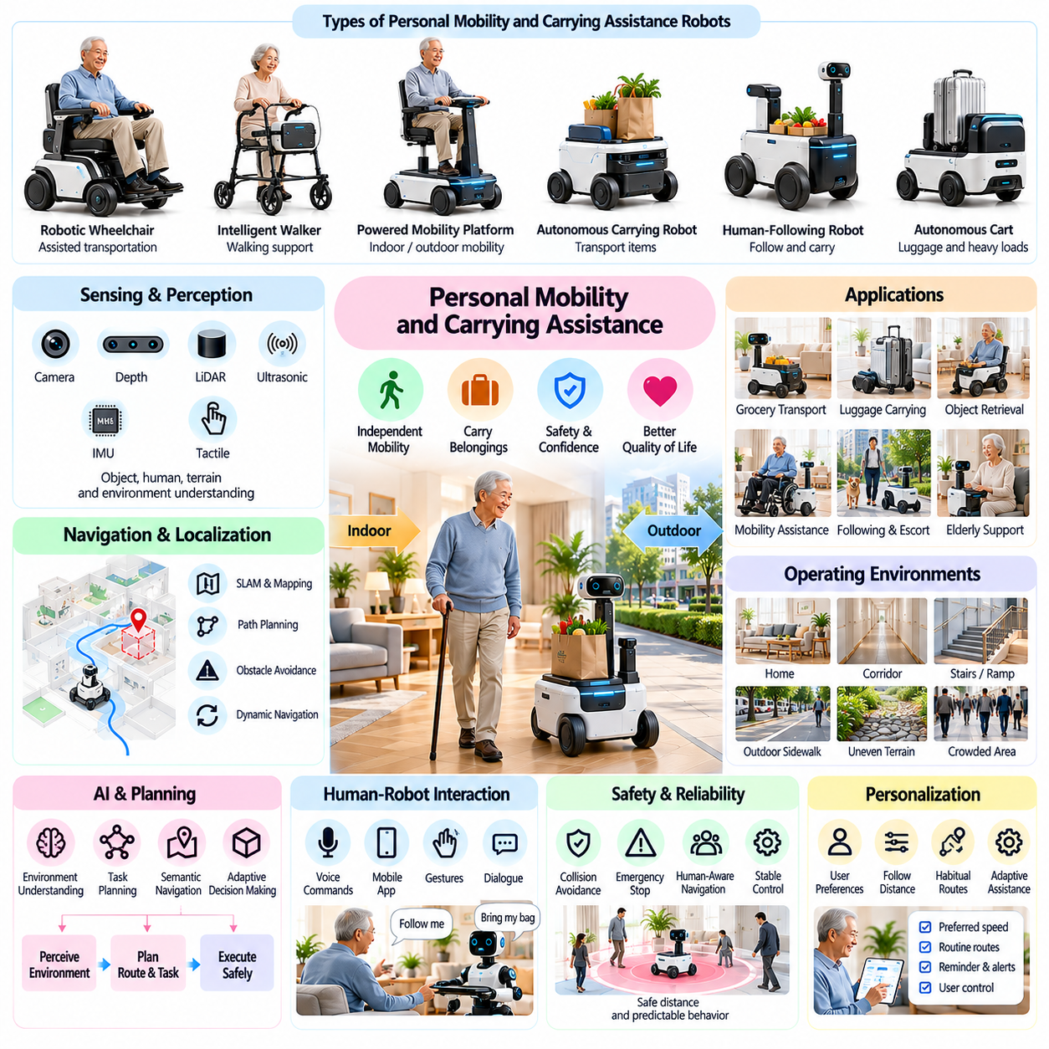
Personal mobility and carrying assistance represent important applications of Physical AI that extend autonomous robotics into everyday movement and transportation tasks. These systems help individuals move through residential and community environments while reducing the physical effort required to transport personal belongings. Their value emerges from combining intelligent navigation, human-aware interaction, mechanical support, and reliable operation.
Personal mobility assistance includes robotic wheelchairs, intelligent walkers, powered mobility platforms, and autonomous following devices. These systems address different levels of user mobility and physical capability. Some provide direct transportation, while others support walking or carry objects alongside the user. Selecting an appropriate architecture requires understanding individual needs, environmental constraints, and safety requirements.
Autonomous mobility platforms integrate perception sensors, localization algorithms, path planning, and motion control to navigate complex environments. Cameras, laser scanners, ultrasonic sensors, and inertial measurement units provide information about obstacles, terrain, and vehicle movement. Sensor fusion improves environmental awareness and supports reliable navigation under changing lighting, surface, and occupancy conditions.
Human-following robots represent a practical category of carrying assistance. These platforms maintain a controlled distance from a designated user while transporting groceries, luggage, tools, or household supplies. Their operation requires reliable person identification, continuous tracking, obstacle avoidance, and adaptive speed control. Tracking must remain robust when other people cross the robot's path or the user temporarily disappears.
Carrying assistance can reduce physical strain associated with transporting heavy or repetitive loads. Autonomous carts and compact mobile robots may accompany users between rooms, buildings, or nearby destinations. Their mechanical design must balance payload capacity, platform dimensions, maneuverability, and energy consumption. Stable load placement and secure retention are essential to prevent shifting cargo and unexpected tipping.
Navigation in residential environments introduces challenges involving narrow corridors, door thresholds, furniture, carpets, and irregular floor surfaces. Robots must identify traversable areas and adjust their trajectories to avoid collisions. Dynamic path planning enables movement around temporary obstacles, while local control algorithms regulate speed and turning behavior according to available clearance and environmental uncertainty.
Outdoor personal mobility creates additional complexity because sidewalks, ramps, slopes, curbs, and uneven terrain impose different mechanical requirements. Environmental conditions such as rain, sunlight, surface debris, and pedestrian congestion can affect sensing and traction. Reliable systems must recognize their operating limits and avoid routes that exceed available stability, braking, or obstacle-crossing capabilities.
Shared autonomy offers a practical compromise between manual control and fully autonomous operation. Users may specify destinations or movement directions while the robotic system manages obstacle avoidance and local trajectory adjustments. This approach preserves user authority while reducing operational workload. Effective shared control requires predictable transitions between human commands and automated assistance.
Human-robot interaction is central to mobility assistance because users must understand and trust robotic movement. Voice commands, mobile applications, physical controls, and gesture recognition may provide complementary interfaces. Robots should communicate navigation intentions, destination changes, and operational limitations clearly. Accessible controls are particularly important for users with reduced dexterity, vision, or mobility.
Safety engineering must address collisions, excessive speed, sudden braking, unstable loads, and unexpected system failures. Personal mobility devices that physically transport or support people require especially rigorous risk management. Emergency stopping, redundant braking where appropriate, obstacle monitoring, stability assessment, and fail-safe behavior are essential design considerations for dependable operation.
Human-aware navigation requires robots to account for the movement and intentions of nearby pedestrians. Personal mobility platforms should maintain appropriate separation distances, reduce speed in crowded areas, and yield when necessary. Predictive motion planning can help anticipate pedestrian trajectories, although uncertainty remains significant in environments containing children, pets, and unpredictable human behavior.
Localization and mapping technologies enable robots to understand their position relative to household layouts and surrounding infrastructure. Simultaneous localization and mapping can support operation where reliable positioning references are unavailable. However, changes in furniture arrangement, repetitive corridors, reflective surfaces, and crowded environments may degrade localization accuracy and require recovery mechanisms.
Artificial intelligence can improve mobility assistance through semantic environment understanding and adaptive decision-making. Learning-based perception may identify doors, elevators, ramps, pedestrians, and temporary obstacles. Vision-language models can potentially interpret destination requests and contextual instructions. Nevertheless, motion execution must remain constrained by verified safety limits and reliable low-level control.
Personalization allows mobility robots to adapt to walking speed, preferred following distance, habitual routes, and individual interaction preferences. Systems may learn frequently visited destinations and adjust navigation behavior accordingly. Such adaptation should remain understandable and configurable, particularly when automated decisions influence personal movement, accessibility, or exposure to environmental risks.
Energy management directly affects operating range, payload capability, and practical usability. Battery-powered mobility platforms must allocate energy among propulsion, sensing, computation, and auxiliary functions. Heavier loads, slopes, repeated acceleration, and difficult surfaces increase consumption. Power-aware route planning, efficient drive systems, and accessible charging arrangements can improve operating availability.
Mechanical architecture strongly influences the suitability of personal mobility and carrying robots. Differential-drive platforms offer simplicity and compact turning behavior, while omnidirectional systems provide greater maneuverability in confined spaces. Larger wheels and suspension mechanisms may improve obstacle traversal but increase size and cost. Design selection should reflect expected terrain, payload, and user interaction requirements.
Carrying assistance also introduces opportunities for coordinated manipulation and delivery. A mobile platform equipped with a robotic arm may retrieve objects, load supplies, or place items at accessible locations. These capabilities extend functionality beyond passive transportation but introduce additional sensing, grasping, and stability challenges. Practical implementations must justify increased mechanical complexity through measurable user benefits.
Privacy and cybersecurity are relevant because mobility robots may collect location histories, movement patterns, camera images, and user interaction records. Such information can reveal daily routines and personal activities. Responsible systems should minimize unnecessary collection, protect communications, restrict access, and provide transparent controls over stored information and data sharing.
Reliability is particularly important when users depend on mobility assistance for essential daily activities. Navigation failures, battery depletion, sensor faults, and mechanical breakdowns can interrupt transportation or leave users without expected support. Systems should communicate faults clearly, provide safe stopping behavior, support manual recovery, and establish backup arrangements for critical assistance functions.
Economic viability depends on matching useful capabilities with acceptable acquisition and operating costs. Sensors, batteries, drive motors, safety systems, and specialized mechanical structures influence product pricing. Manufacturers must consider maintenance, component replacement, service support, and expected lifetime. Subscription and managed-service models may reduce initial purchase barriers but introduce recurring financial commitments.
Performance evaluation should measure real-world assistance rather than navigation accuracy alone. Relevant indicators include task completion rate, following accuracy, collision avoidance, payload handling, travel efficiency, energy consumption, intervention frequency, and user satisfaction. Testing across varied indoor and outdoor environments is necessary to determine operational reliability and identify limitations affecting everyday adoption.
Future personal mobility systems may combine autonomous navigation, adaptive carrying assistance, multimodal interaction, and intelligent environmental understanding. Integration with smart buildings and connected infrastructure could support coordinated access to doors, elevators, and charging facilities. However, interoperability, accessibility, cybersecurity, and dependable operation will determine whether these capabilities provide practical value.
Ultimately, personal mobility and carrying assistance demonstrate how Physical AI can extend individual independence and reduce the burden of everyday transportation tasks. Their success depends on integrating autonomous movement with human-centered design, physical safety, reliable perception, and affordable operation. Continued development may transform specialized mobility devices into adaptable robotic companions that support movement and object transportation across diverse living environments.

07.08. Home Security and Monitoring
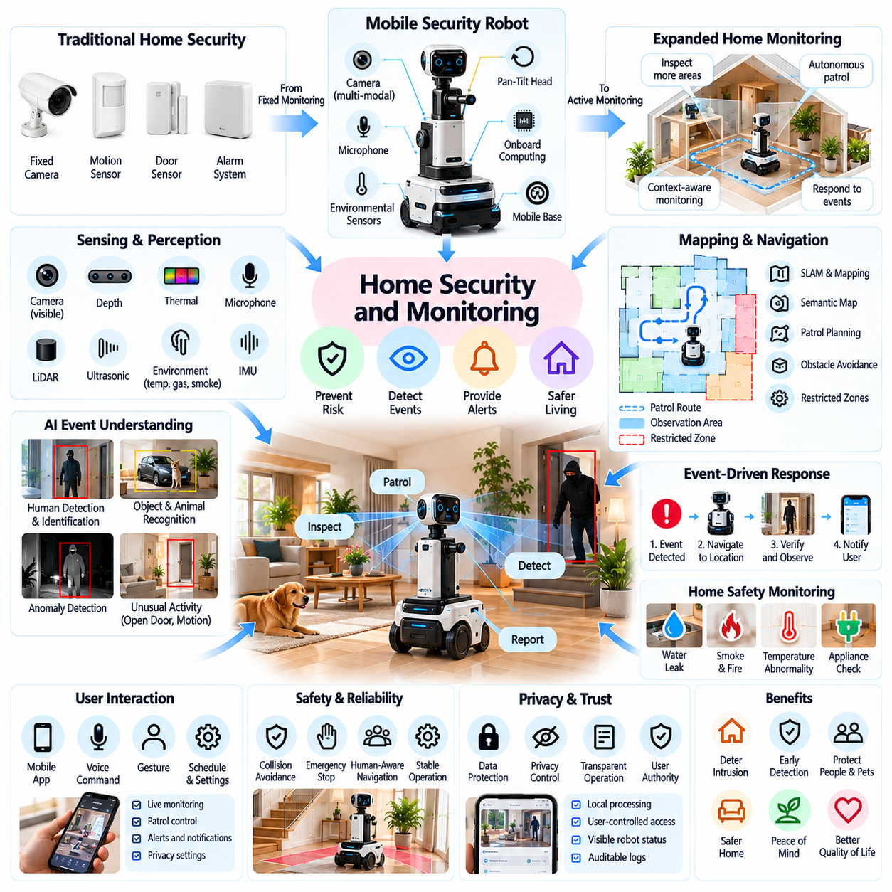
Home security and monitoring represent important applications of Physical AI that extend residential protection beyond conventional alarms and fixed surveillance cameras. Intelligent robotic systems combine environmental perception, autonomous mobility, event recognition, and communication to observe changing household conditions. Their objective is to improve situational awareness, identify potential risks, and support timely responses while respecting privacy and personal autonomy.
Traditional home security systems rely on stationary cameras, motion detectors, door sensors, and centralized alarm controllers. Although effective for predefined monitoring zones, these devices provide limited visibility into areas outside their installed coverage. Mobile security robots can reposition sensors, inspect selected locations, and gather additional contextual information when unusual events occur, expanding the flexibility of residential monitoring.
Autonomous security robots typically integrate mobile platforms, cameras, depth sensors, microphones, environmental sensors, and onboard computing systems. These components support navigation, observation, event classification, and remote communication. Effective integration requires balancing sensing capability, computational performance, battery endurance, and physical dimensions to ensure reliable operation within residential spaces.
Environmental mapping enables monitoring robots to understand household layouts and navigate between important observation points. Simultaneous localization and mapping supports position estimation and spatial representation in environments where external positioning signals are unavailable. Semantic maps may identify entrances, windows, corridors, storage areas, and restricted zones, allowing robots to associate monitoring tasks with meaningful household locations.
Intelligent perception distinguishes routine household activity from potentially unusual events. Computer vision algorithms may recognize human presence, moving objects, open doors, or unexpected changes in monitored spaces. However, event interpretation remains uncertain because ordinary activities can resemble security incidents. Reliable systems should combine multiple observations and avoid treating isolated detection results as definitive evidence of danger.
Human detection and identification introduce additional technical and ethical considerations. Security robots may distinguish household occupants from unfamiliar visitors using authorized identification methods or contextual information. Recognition performance can deteriorate under poor lighting, occlusion, or changing appearance. Systems should communicate uncertainty clearly and avoid making consequential accusations or interventions based solely on automated identification.
Autonomous patrol functionality allows mobile robots to inspect predefined routes or selected areas at scheduled intervals. Patrol planning must consider battery availability, navigation safety, household activity, and the relative importance of observation locations. Adaptive patrol strategies may prioritize areas associated with recent events, but movement should remain predictable and avoid unnecessary disturbance to residents.
Event-driven monitoring enables robots to respond when connected sensors report unusual conditions. A door sensor, motion detector, or environmental alarm may trigger navigation toward a relevant location for additional observation. The robot can collect contextual information and communicate findings to authorized users. Such responses should remain bounded by safe operating rules and must not interfere with emergency evacuation or human responders.
Home monitoring extends beyond intrusion detection to include environmental safety and property protection. Robots may support observation of water leaks, unusual temperatures, smoke-related alarms, or potentially unsafe appliance conditions when equipped with appropriate sensors. These capabilities should complement certified detection devices rather than replace them, particularly when delayed or incorrect detection could create serious hazards.
Multimodal sensor fusion improves monitoring by combining visual, acoustic, thermal, and environmental measurements. Information from multiple sources can help distinguish routine activity from conditions requiring attention. For example, a visual observation may provide context for a door sensor event. Nevertheless, sensor disagreement and missing data must be handled explicitly to prevent misleading conclusions or unnecessary alarms.
Artificial intelligence models can support contextual understanding of residential events and natural language reporting. Vision-language models may describe observed scenes, identify relevant objects, and summarize changes in household conditions. However, generated descriptions can contain errors or unsupported interpretations. Security-related decisions therefore require evidence tracking, confidence assessment, and appropriate human verification.
Anomaly detection offers a complementary approach when predefined event categories cannot capture every unusual situation. Learning-based systems may identify deviations from established household activity patterns, such as unexpected movement during normally unoccupied periods. However, unusual behavior does not necessarily indicate danger. Adaptive thresholds and contextual validation are necessary to manage false alarms and avoid excessive surveillance.
Human-robot interaction should provide clear and accessible mechanisms for controlling monitoring behavior. Residents may configure patrol schedules, observation zones, alert preferences, and privacy restrictions through mobile applications or voice interfaces. Robots should communicate their operating state and intended movements. Visible indicators of active recording can help occupants understand when sensing functions are enabled.
Remote monitoring allows authorized users to receive alerts and review selected observations while away from home. Secure communication channels may support event notifications, live video, and limited remote robot control. Remote operation introduces latency, connectivity, and access-control challenges. Systems must prevent unauthorized command execution and maintain safe local behavior when network communication becomes unavailable.
Privacy is a fundamental design requirement because household monitoring can reveal personal activities, relationships, routines, and sensitive living spaces. Continuous recording may create risks that exceed the security benefits of the system. Privacy-aware architectures should prioritize data minimization, local processing where practical, configurable recording policies, and restrictions on monitoring private areas.
Cybersecurity directly affects the trustworthiness of connected home security robots. Attackers who gain access to cameras, microphones, movement controls, or stored maps may compromise both privacy and physical safety. Protective measures include encrypted communication, secure authentication, software integrity verification, access logging, and timely vulnerability remediation. Security updates should remain available throughout the supported product lifetime.
Physical safety remains important because monitoring robots operate near people, pets, furniture, and household obstacles. Autonomous movement must incorporate collision avoidance, speed limitation, stable navigation, and emergency stopping. Robots should not physically confront suspected intruders or obstruct occupants attempting to leave. Their primary role should remain observation, communication, and assistance within clearly defined safety boundaries.
Reliability depends on the robot's ability to maintain monitoring functions despite environmental changes and component limitations. Low battery levels, sensor contamination, network outages, and navigation failures can reduce coverage. Autonomous charging, fault detection, recovery procedures, and transparent availability reporting improve operational continuity. Essential alarms should not depend exclusively on a single mobile platform.
Integration with smart-home infrastructure can improve coordination among cameras, locks, lighting systems, alarms, and robotic monitoring devices. Shared event information may help robots inspect locations associated with triggered sensors. However, interoperability introduces additional dependencies and security considerations. Access permissions should restrict robotic actions, especially those affecting door locks or other safety-relevant devices.
The economic value of robotic home security depends on whether mobility and contextual intelligence provide measurable advantages over fixed monitoring systems. Hardware costs include navigation sensors, computing platforms, batteries, communication modules, and maintenance components. Manufacturers must justify additional complexity through improved coverage, useful event verification, lower unnecessary alarm rates, and dependable service performance.
Performance evaluation should examine detection accuracy, false alarm frequency, monitoring coverage, event response time, navigation reliability, and communication availability. Privacy protection and cybersecurity resilience are equally important assessment dimensions. Testing should include changing lighting, moving occupants, pets, furniture rearrangement, and network interruptions to determine whether performance remains dependable in realistic homes.
Commercial deployment may initially focus on supplemental monitoring rather than complete replacement of existing security infrastructure. Mobile robots can provide targeted inspections, remote visual verification, and selected environmental observations. This approach allows specialized certified alarms to retain responsibility for critical detection functions while robotic systems contribute additional flexibility and contextual awareness.
Future home security robots may combine persistent spatial memory, multimodal perception, intelligent event analysis, and coordinated operation with connected household devices. More capable systems could adapt monitoring activities to changing occupancy and environmental conditions. Progress will require trustworthy AI, transparent decision-making, secure system integration, and strong protections against intrusive or excessive monitoring.
Ultimately, home security and monitoring demonstrate how Physical AI can transform residential observation into an adaptive, context-aware service. The greatest value lies in improving awareness and supporting informed human responses rather than replacing human judgment. Sustainable adoption will depend on balancing effective protection with privacy, cybersecurity, physical safety, reliability, affordability, and the rights of household occupants.

07.09. Natural Language and Multimodal Interaction
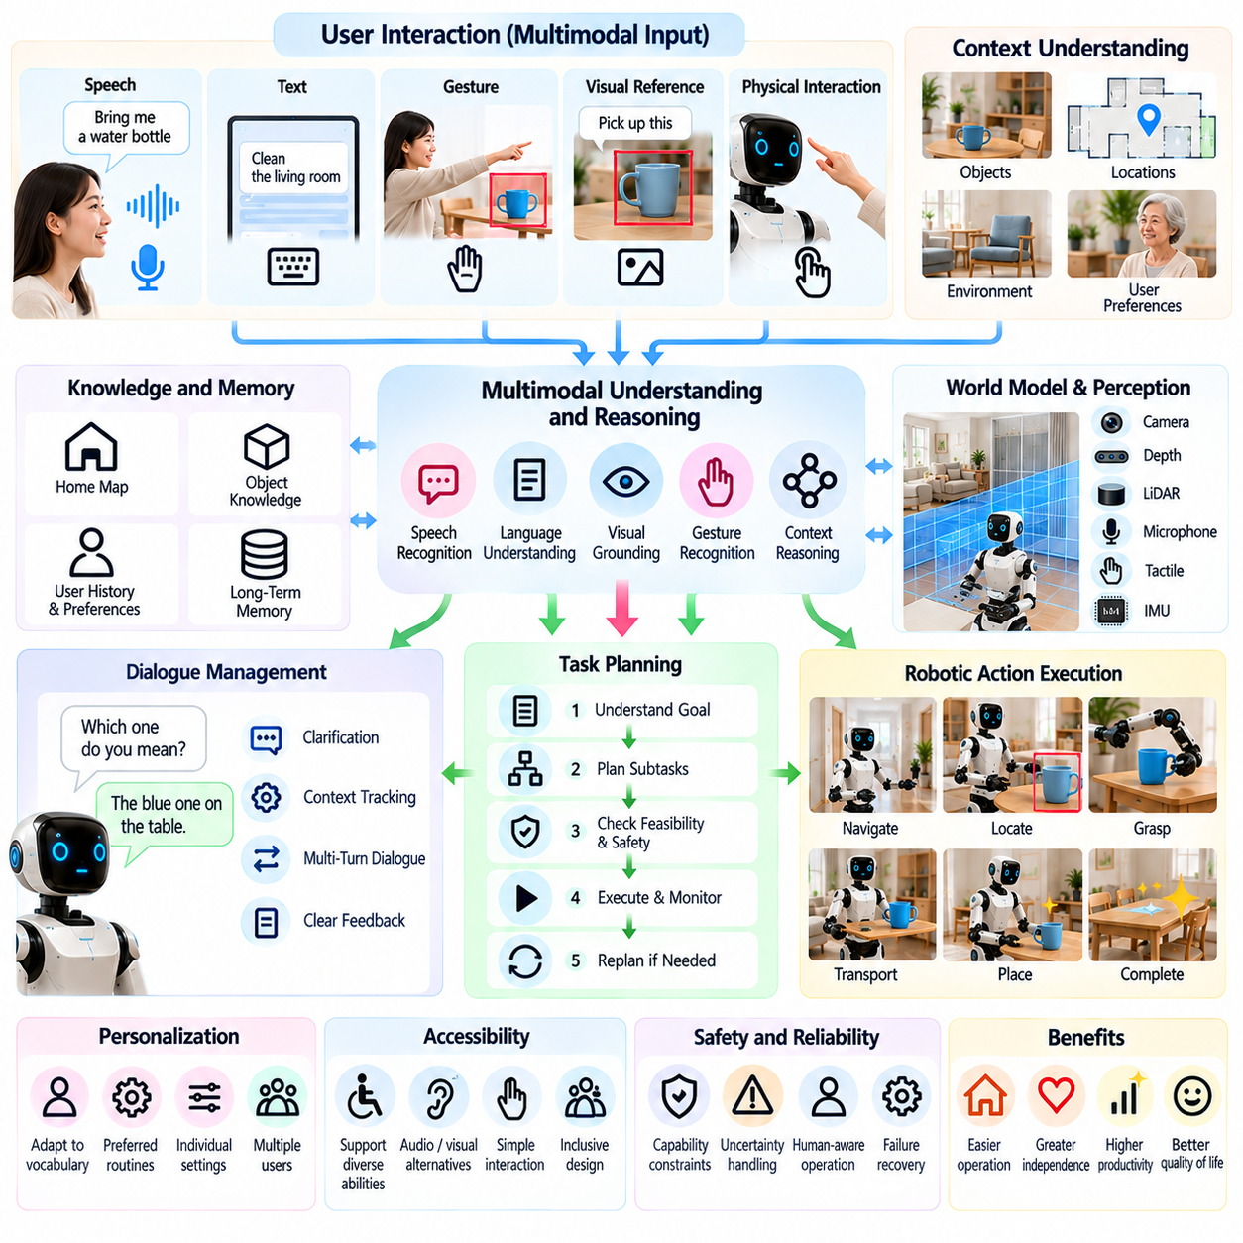
Natural language and multimodal interaction are essential capabilities of Physical AI in consumer and home environments. They allow users to communicate with robots through speech, text, gestures, visual references, and physical actions rather than specialized programming interfaces. By connecting human intentions with environmental perception and robotic execution, these technologies make intelligent home systems more accessible, flexible, and responsive.
Natural language interaction enables users to express goals through everyday instructions such as requesting an object, cleaning a room, or checking household conditions. Unlike fixed command interfaces, language-based systems must interpret different expressions of similar intentions. Effective understanding requires recognizing user goals, identifying relevant objects, resolving ambiguity, and translating instructions into executable robotic tasks.
Speech recognition provides a primary communication channel for household robots because spoken commands allow hands-free operation. Automatic speech recognition converts acoustic signals into text or structured representations for further processing. However, household noise, television audio, overlapping conversations, accents, and microphone placement can reduce recognition accuracy, requiring robust acoustic processing and uncertainty handling.
Natural language understanding extends beyond recognizing individual words to interpreting contextual meaning. A request such as bringing an item from another room requires identifying the intended object, destination, and relevant constraints. Language models can use conversation history and environmental observations to resolve references, but uncertain interpretations should trigger clarification rather than unsupported assumptions.
Multimodal interaction combines linguistic information with visual, spatial, auditory, and tactile observations. When a user points toward an object while saying a short instruction, the robot must associate the gesture with the correct physical target. This process requires synchronized perception, coordinate transformation, and contextual reasoning to connect human communication with objects and actions in the surrounding environment.
Vision-language models provide a foundation for linking natural language instructions with visual observations. These models can identify objects described by appearance, interpret spatial relationships, and answer questions about visible household scenes. However, visual grounding remains challenging when objects are partially hidden, visually similar, or located outside the robot's current field of view, requiring additional sensing or clarification.
Vision-language-action models extend multimodal understanding toward physical task execution. They associate visual inputs and language instructions with action representations that may guide robotic movement and manipulation. Although these models offer opportunities for flexible task generalization, their outputs must be constrained by robot capabilities, collision avoidance, and independently verified safety requirements.
Gesture recognition provides an intuitive communication mechanism when speech is inconvenient or insufficient. Hand pointing, waving, body orientation, and selected movements can convey commands or identify target locations. Reliable interpretation depends on camera positioning, visibility, individual movement differences, and cultural conventions. Systems should avoid executing potentially hazardous actions based on ambiguous gestures.
Dialogue management supports interactions that require multiple conversational turns. A household robot may ask which object the user intends, confirm a destination, or explain why a requested action cannot be completed. Maintaining dialogue context allows the system to connect follow-up instructions with earlier requests. Effective dialogue should remain concise, understandable, and consistent with the robot's actual capabilities.
Task planning transforms interpreted intentions into sequences of physical operations. A request to prepare a room may require navigating to several locations, identifying objects, manipulating items, and checking completion conditions. Hierarchical planning can organize these actions into manageable subtasks, while execution monitoring detects unexpected outcomes and supports replanning when the environment changes.
Grounding language in the physical world is particularly important because household instructions often contain implicit assumptions. Expressions such as placing an object nearby or moving something out of the way depend on spatial context and user preferences. Robots must connect linguistic concepts with measurable locations, object properties, and physical constraints rather than relying exclusively on textual reasoning.
Personalization can improve communication by adapting to individual vocabulary, preferred languages, speaking patterns, and interaction habits. A robot may learn commonly used object names or preferred forms of confirmation. However, personalization should remain configurable and should not silently override explicit instructions. Household systems must also distinguish between multiple users and respect different access permissions.
Accessibility is a major benefit of multimodal interaction because users have different sensory, cognitive, and physical capabilities. Speech interfaces may assist individuals with limited hand mobility, while visual or tactile feedback may support users who cannot rely on audio. Effective systems provide alternative interaction channels, adjustable feedback, and straightforward recovery procedures when communication fails.
Interaction latency directly affects perceived responsiveness and usability. Speech processing, visual interpretation, language-model inference, and robotic planning introduce computational delays. Edge computing can reduce dependence on remote connections, while cloud services may provide access to larger models. Hybrid architectures must balance response quality, privacy, energy consumption, network availability, and real-time safety constraints.
Uncertainty management is essential when robots interpret open-ended human instructions. Ambiguous language, incomplete observations, and conflicting sensor information can produce incorrect task interpretations. Systems should estimate confidence, request clarification when necessary, and avoid irreversible actions under uncertainty. Confirmation requirements should increase with the potential consequences of a misunderstanding.
Safety-aware interaction requires separating conversational intelligence from safety-critical motion control. A language model may propose an action, but independent control layers should verify workspace constraints, physical feasibility, and operational permissions. Emergency stopping and manual overrides must remain available regardless of dialogue state. Spoken requests must never bypass established safety restrictions.
Privacy considerations arise because multimodal robots may process speech, camera images, personal routines, and household conversations. Continuous sensing can expose information about occupants who have not directly interacted with the system. Responsible architectures should minimize unnecessary recording, protect stored data, provide clear microphone and camera indicators, and support understandable consent and access controls.
Trustworthy communication requires robots to describe their capabilities and limitations accurately. Systems should distinguish between observations, predictions, and uncertain interpretations rather than presenting generated explanations as verified facts. When a task fails, the robot should report the actual outcome and provide meaningful recovery options. Transparent communication supports realistic expectations and reduces unsafe reliance on automation.
Learning from interaction can improve language grounding and task execution over time. User corrections, successful demonstrations, and task feedback provide information about preferred objects, behaviors, and operating conditions. Such learning requires careful data governance and validation to prevent accidental reinforcement of errors. Updates should preserve safety constraints and allow users to correct inappropriate adaptations.
Evaluation of multimodal interaction must examine more than speech recognition accuracy or language-model performance. Relevant measures include instruction understanding, object grounding, clarification effectiveness, task completion, response latency, user intervention frequency, and safety outcomes. Testing should cover noisy rooms, multiple speakers, ambiguous requests, changing environments, and users with diverse communication abilities.
Commercial adoption depends on whether natural interaction reduces the effort required to operate household robots. Consumers expect systems to understand practical requests without extensive training or complicated configuration. Manufacturers must balance model capability with computational cost, energy efficiency, maintenance, and software reliability. Consistent everyday performance is often more valuable than impressive but unreliable demonstrations.
Future household robots may integrate persistent spatial memory, conversational reasoning, multimodal perception, and adaptive manipulation within unified interaction architectures. Users could specify goals through combinations of speech, pointing, demonstrations, and contextual references. Achieving this flexibility will require improved grounding, efficient inference, robust dialogue management, and dependable execution across changing household conditions.
Ultimately, natural language and multimodal interaction provide the communication foundation for practical home Physical AI. Their purpose is not merely to make robots conversational but to connect human intentions with safe and useful physical behavior. Sustainable progress depends on combining language understanding, environmental grounding, accessible design, uncertainty management, privacy protection, and reliable task execution into a coherent human-centered system.

07.10. Personalization and User Adaptation
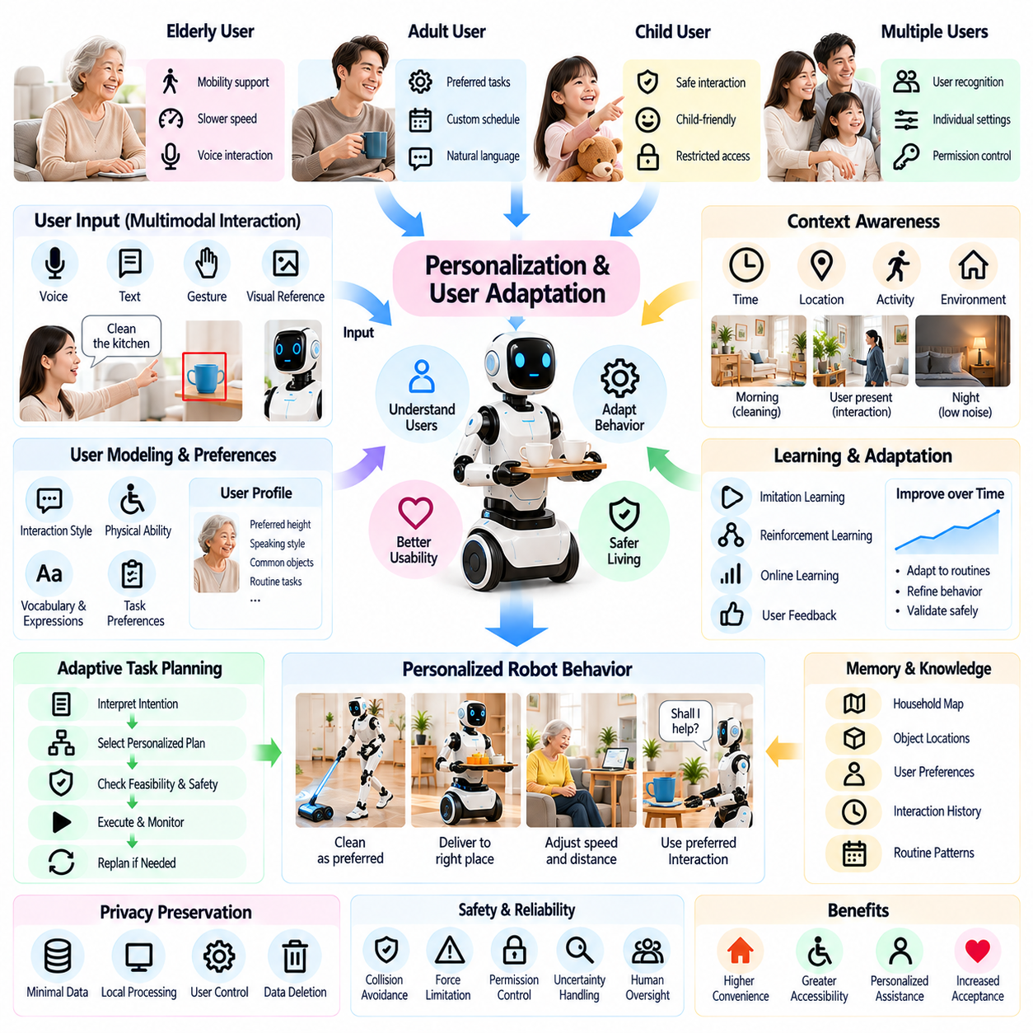
Personalization and user adaptation are essential capabilities of Physical AI in consumer and home environments, where individual preferences, household routines, and physical abilities vary significantly. Unlike industrial robots operating under standardized conditions, home robots must adjust their behavior to diverse users and changing circumstances. Effective personalization improves usability, task relevance, accessibility, and long-term acceptance without compromising safety.
Personalization begins with understanding user preferences, including preferred interaction methods, cleaning schedules, object locations, and assistance requirements. These preferences may be explicitly configured or gradually inferred from repeated interactions. However, inferred preferences should remain distinguishable from confirmed instructions. Users must be able to inspect, modify, or remove personalized settings whenever their needs or expectations change.
User modeling provides a structured representation of individual characteristics relevant to robotic assistance. Such models may include communication preferences, mobility limitations, habitual activities, and preferred task outcomes. A practical user model should contain only information necessary for useful adaptation. Excessive profiling increases privacy risks and may introduce inaccurate assumptions that negatively affect robotic decisions.
Context-aware adaptation allows robots to adjust behavior according to time, location, activity, and environmental conditions. A cleaning robot may reduce operating noise during sleeping hours, while a service robot may change its route when household members are present. Contextual reasoning requires reliable sensing and explicit operating constraints because inferred circumstances do not always represent the user's actual intentions.
Learning household routines can improve task scheduling and resource allocation. Robots may identify recurring patterns in cleaning requirements, object usage, or preferred delivery times. Predictive scheduling can reduce unnecessary interactions and improve convenience, but automated routines should remain reversible. Unexpected behavior changes must not cause robots to perform intrusive, disruptive, or potentially hazardous actions.
Natural language personalization enables robots to recognize familiar expressions, preferred vocabulary, and individual communication styles. Users may refer to household objects through informal names or provide instructions using abbreviated phrases. Language models can associate these expressions with known objects and tasks. Ambiguous references still require clarification, particularly when misunderstanding could result in physical damage or unsafe movement.
Multimodal adaptation extends personalization beyond speech to gestures, visual cues, touch interfaces, and physical interaction patterns. A robot may adjust its response to a user's preferred pointing gestures or interface settings. Supporting multiple communication channels improves accessibility across different abilities. Adaptation should avoid assuming that temporary behavior changes indicate permanent user preferences.
Physical assistance requires personalization of movement speed, interaction distance, object placement, and manipulation forces. A mobile assistant may approach slowly or deliver objects at a height suited to an individual user. These adjustments can improve comfort and usability, but they must remain within verified mechanical and safety limits. Learned preferences must never override collision avoidance or force restrictions.
Multi-user households introduce challenges because preferences and permissions may differ among family members, visitors, and caregivers. Robots must distinguish authorized users while avoiding unnecessary collection of biometric information. Conflicting requests require transparent priority rules and appropriate confirmation. Personalization systems should prevent one user's preferences from silently overriding another person's privacy or safety requirements.
Adaptive task planning connects user preferences with robotic decision-making. A robot may choose different cleaning sequences, delivery locations, or interaction methods depending on the intended user. Planning systems must combine personalized objectives with environmental constraints and task feasibility. Successful adaptation requires monitoring actual outcomes rather than assuming that previously preferred actions remain appropriate.
Online learning enables robots to improve behavior through continued operation and user feedback. Corrections, demonstrations, and task completion records can provide useful adaptation signals. However, unrestricted learning may introduce unstable behavior or reinforce incorrect patterns. Safe systems should validate proposed changes, preserve tested control policies, and provide mechanisms for reverting unsuccessful adaptations.
Reinforcement learning and imitation learning offer complementary approaches to personalized robotic behavior. Demonstrations can establish preferred actions, while carefully constrained feedback-based optimization may refine task execution. Training should account for limited household data and variations between users. Simulation and offline evaluation can reduce risks before updated behaviors are deployed in physical environments.
Long-term memory supports continuity across repeated interactions by preserving relevant preferences, task history, and environmental information. Spatial memory may record frequently used storage locations, while interaction memory may retain preferred confirmation methods. Memory systems should distinguish stable preferences from temporary instructions and outdated observations. Retention periods and deletion controls must remain understandable.
Privacy-preserving personalization is particularly important because household adaptation can reveal daily schedules, health-related limitations, relationships, and private activities. Edge processing can reduce unnecessary transmission of sensitive observations to remote services. Data minimization, encryption, access control, and clear retention policies should govern personalization. Users should understand which information is stored and why.
Transparency helps users develop appropriate expectations about adaptive robotic behavior. A robot should explain significant changes in scheduling, navigation, or task execution when those changes affect household routines. Users should be able to identify whether a decision resulted from explicit settings, learned preferences, or immediate environmental observations. Clear explanations make unexpected behavior easier to correct.
Human control remains fundamental even when robots become increasingly autonomous. Personalization should provide configurable autonomy levels, confirmation requirements, and manual override options. Users may prefer automatic execution for routine cleaning but explicit approval for moving valuable objects. Such distinctions allow automation to reflect individual comfort levels without weakening mandatory safety protections.
Reliability becomes more challenging when personalized behavior varies across users and environments. Adaptation may create interactions that were not fully represented during initial testing. Runtime monitoring, behavioral constraints, and systematic validation are necessary to detect unsafe changes. Software updates should preserve essential preferences while verifying compatibility with revised models, sensors, and control systems.
Accessibility-oriented adaptation can support users with different sensory, cognitive, and physical capabilities. Adjustable speech speed, interface complexity, notification methods, and assistance levels may improve practical usability. However, adaptive systems should avoid reducing user autonomy through excessive intervention. Inclusive design requires direct feedback from diverse users rather than relying entirely on inferred capability profiles.
Evaluation of personalization should measure whether adaptation produces meaningful improvements in everyday operation. Relevant indicators include task success, user correction frequency, preference recognition accuracy, interaction effort, safety events, and long-term satisfaction. Testing must consider changing preferences, multiple household members, and unfamiliar situations. Short demonstrations alone cannot establish sustainable adaptation quality.
Economic value emerges when personalization increases product usefulness and reduces the effort required for repeated configuration. Manufacturers may differentiate home robots through adaptive software, user profiles, and continuing service improvements. However, cloud subscriptions and advanced personalization features introduce recurring costs. Commercial strategies should prioritize measurable benefits, transparent data practices, and dependable support.
Interoperability with smart-home platforms can extend personalization across connected appliances, environmental controls, and robotic services. Shared preferences may coordinate lighting, cleaning schedules, and household assistance. Nevertheless, integration requires permission management and clear boundaries between devices. A personalized instruction for one system should not automatically authorize unrelated actions by another connected device.
Future home robots may combine foundation models, persistent spatial memory, multimodal perception, and continual learning to support increasingly sophisticated user adaptation. These capabilities could enable robots to understand changing routines and coordinate complex household tasks. Progress will depend on efficient learning from limited data, reliable preference interpretation, safety-constrained adaptation, and protection against unintended behavioral changes.
Ultimately, personalization and user adaptation transform home Physical AI from fixed-function automation into assistance tailored to individual needs and living environments. Their purpose is not unrestricted behavioral prediction but dependable cooperation between people and intelligent machines. Sustainable adoption requires balancing adaptive intelligence with transparency, privacy, user authority, accessibility, and consistently safe physical operation.

07.11. Privacy Trust and Social Acceptance
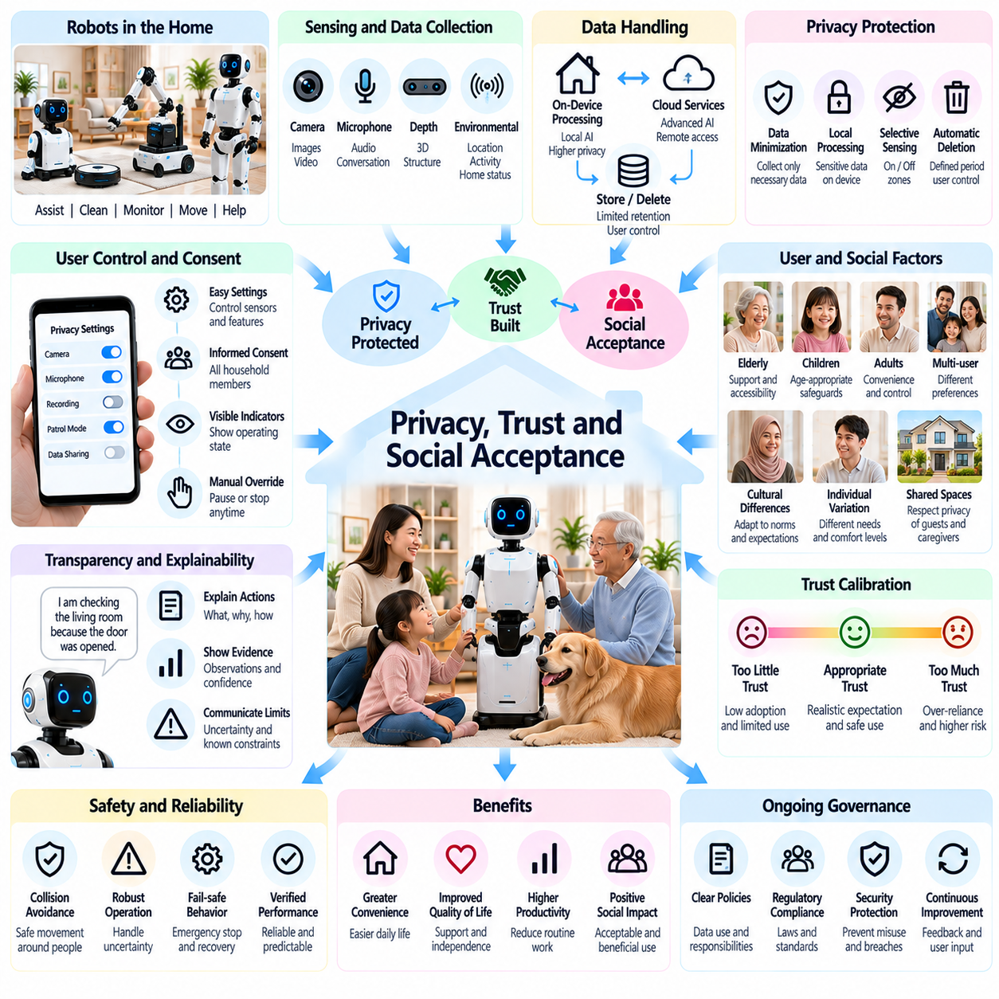
Privacy, trust, and social acceptance are fundamental conditions for the successful adoption of Physical AI in consumer and home environments. Unlike industrial robots, household robots operate within intimate spaces containing personal information, relationships, and daily routines. Their acceptance depends not only on technical performance but also on whether residents feel respected, protected, and capable of controlling robotic behavior.
Privacy challenges arise because home robots use cameras, microphones, depth sensors, and environmental monitoring to understand their surroundings. These sensors may capture conversations, personal activities, household layouts, and information about visitors. Even when collected for legitimate functions, such data can reveal sensitive behavioral patterns. Privacy protection must therefore be integrated into system design rather than added after deployment.
Data minimization provides a practical foundation for privacy-aware robotic systems. Robots should collect only information necessary for authorized tasks and retain it for clearly defined periods. Continuous recording should not become the default merely because sensing hardware supports it. Selective activation, temporary processing, and automatic deletion can reduce unnecessary exposure while preserving essential robotic capabilities.
Edge computing can support privacy by processing sensitive sensor information directly on household devices. Local perception and decision-making may reduce the transmission of images, audio, and behavioral records to remote servers. However, local processing does not eliminate security risks or guarantee confidentiality. Device protection, software integrity, and carefully controlled data access remain necessary throughout operation.
Cloud connectivity introduces additional concerns regarding data storage, third-party access, service dependencies, and cross-border information transfers. Remote AI services may improve recognition and reasoning capabilities but can also expand the exposure of household information. Responsible architectures should clearly distinguish local and remote processing, disclose relevant data flows, and provide meaningful choices about cloud-dependent functions.
Informed consent is particularly challenging in shared households because multiple individuals may interact with or be observed by the same robot. A primary purchaser cannot automatically represent the privacy preferences of family members, guests, or caregivers. Systems should provide understandable notices, configurable observation zones, and appropriate recording restrictions. Consent mechanisms must reflect the practical realities of shared living spaces.
User control is essential for establishing confidence in autonomous household systems. Residents should be able to pause monitoring, disable selected sensors, inspect stored information, and override robotic actions. Controls must be accessible through straightforward interfaces rather than hidden within complex settings. Physical privacy switches and visible operating indicators can provide additional reassurance when their behavior is technically verifiable.
Trust develops through repeated experiences of predictable, competent, and transparent robotic behavior. A robot that consistently completes tasks, communicates limitations, and responds appropriately to correction is more likely to earn user confidence. Conversely, unexpected movement, unexplained recording, or misleading explanations can rapidly undermine acceptance. Trust should reflect demonstrated reliability rather than exaggerated claims of intelligence.
Transparency requires robots to communicate what they are doing, why an action was selected, and which information influenced important decisions. Explanations should distinguish direct observations from predictions or uncertain interpretations. Users need not understand every computational detail, but they should understand consequential behavior. Clear reporting of failures and limitations supports realistic expectations and informed supervision.
Anthropomorphic design can make robots approachable by using humanlike voices, gestures, expressions, or body forms. However, excessive human resemblance may create unrealistic expectations about understanding, emotional awareness, or responsibility. Designers should avoid encouraging users to mistake simulated social responses for human judgment. Appropriate social cues should improve communication without obscuring the machine's actual capabilities.
Social acceptance varies across cultures, generations, household structures, and individual experiences with technology. Some users may welcome proactive assistance, while others prefer limited autonomy and minimal observation. Cultural expectations regarding personal space, politeness, and domestic responsibilities influence interaction preferences. Successful products require adaptable behavior rather than assuming a universal model of acceptable robotic conduct.
Children and vulnerable household members require particular attention because they may misunderstand robotic capabilities or have limited ability to manage privacy settings. Robots should avoid manipulative interaction patterns, misleading emotional claims, and unnecessary collection of personal information. Age-appropriate safeguards and accessible supervision controls can reduce risks. Assistance should strengthen human support rather than encourage inappropriate dependence.
Trust calibration is more important than maximizing user confidence. Excessive trust may cause residents to rely on robots beyond their verified abilities, while insufficient trust prevents useful adoption. Systems should communicate uncertainty, request assistance when necessary, and clearly identify tasks they cannot perform safely. Demonstrated performance and understandable limitations help users develop appropriate expectations.
Cybersecurity is inseparable from privacy and trust because compromised robots may expose household information or create physical hazards. Attackers could exploit cameras, microphones, remote-control interfaces, or stored spatial maps. Secure authentication, encrypted communication, software updates, and access logging reduce these risks. Security maintenance must continue throughout the product lifecycle rather than ending after initial installation.
Data governance establishes responsibilities for collecting, storing, sharing, and deleting information generated during robotic operation. Manufacturers should define retention policies, authorized access, incident response procedures, and mechanisms for user requests. Data used for model improvement requires appropriate permissions and safeguards. Clear accountability becomes especially important when information passes between device manufacturers, cloud providers, and service partners.
Social acceptance also depends on the robot's physical behavior within shared living spaces. Unpredictable navigation, excessive noise, inappropriate proximity, and repeated interruptions can create discomfort even when no technical failure occurs. Robots should respect personal boundaries, avoid obstructing household activities, and adapt interaction timing. Physical courtesy is therefore an important dimension of trustworthy embodied intelligence.
Reliability and maintainability strongly influence long-term confidence. Frequent software failures, connectivity interruptions, navigation errors, or unavailable support can make household robots feel burdensome rather than helpful. Predictable maintenance requirements, transparent fault reporting, and dependable recovery procedures improve ownership experiences. Trust must be sustained through everyday operation, not merely established during product demonstrations.
Economic fairness affects social acceptance because advanced home robotics may initially be accessible primarily to higher-income households. Purchase prices, subscription fees, repair expenses, and replacement cycles can create substantial barriers. Manufacturers should communicate total ownership costs and avoid making essential safety or privacy protections dependent on premium subscriptions. Affordable support and durable products can broaden practical accessibility.
Employment and social relationships introduce broader ethical considerations. Household robots may reduce repetitive domestic work and support independent living, but they can also alter expectations surrounding caregiving and human responsibility. Automation should complement meaningful human relationships rather than assume that social or emotional support can be fully replaced. Evaluation must consider both household convenience and wider social consequences.
Participatory design can improve acceptance by involving residents, caregivers, accessibility specialists, and other stakeholders throughout product development. Real-world feedback reveals concerns that controlled laboratory testing may overlook, including discomfort with sensing, confusing behavior, and conflicting household preferences. Iterative evaluation helps align robotic functions with actual needs and supports more inclusive design decisions.
Regulatory compliance and independent evaluation can strengthen confidence when they address privacy, cybersecurity, product safety, and consumer rights. Applicable requirements vary across jurisdictions and product categories, making careful assessment necessary before commercialization. Certifications and external audits may provide useful evidence, but they cannot replace continuous monitoring. Trustworthy deployment requires documented responsibilities and effective corrective action.
Performance assessment should include perceived privacy, trust calibration, user control, social comfort, and willingness to continue using the robot alongside technical metrics. Longitudinal studies are particularly valuable because attitudes may change after repeated interactions. Evaluation should include different ages, abilities, cultures, and household arrangements. Positive initial impressions alone cannot demonstrate lasting social acceptance.
Future household Physical AI systems may become increasingly autonomous, socially expressive, and capable of remembering personal context. These advances could improve convenience while intensifying concerns about surveillance, behavioral influence, and dependency. Responsible development will require privacy-preserving learning, explainable behavior, user-controlled memory, and strong safeguards against misuse. Greater intelligence must be accompanied by greater accountability.
Ultimately, privacy, trust, and social acceptance determine whether home Physical AI becomes a genuinely beneficial technology. Technical capability alone cannot justify intrusive sensing, opaque decisions, or reduced human control. Sustainable adoption requires systems that demonstrate practical value while respecting dignity, autonomy, security, and household diversity. The central objective is trustworthy cooperation between people and intelligent physical machines.

07.12. Safety in Unstructured Home Environments
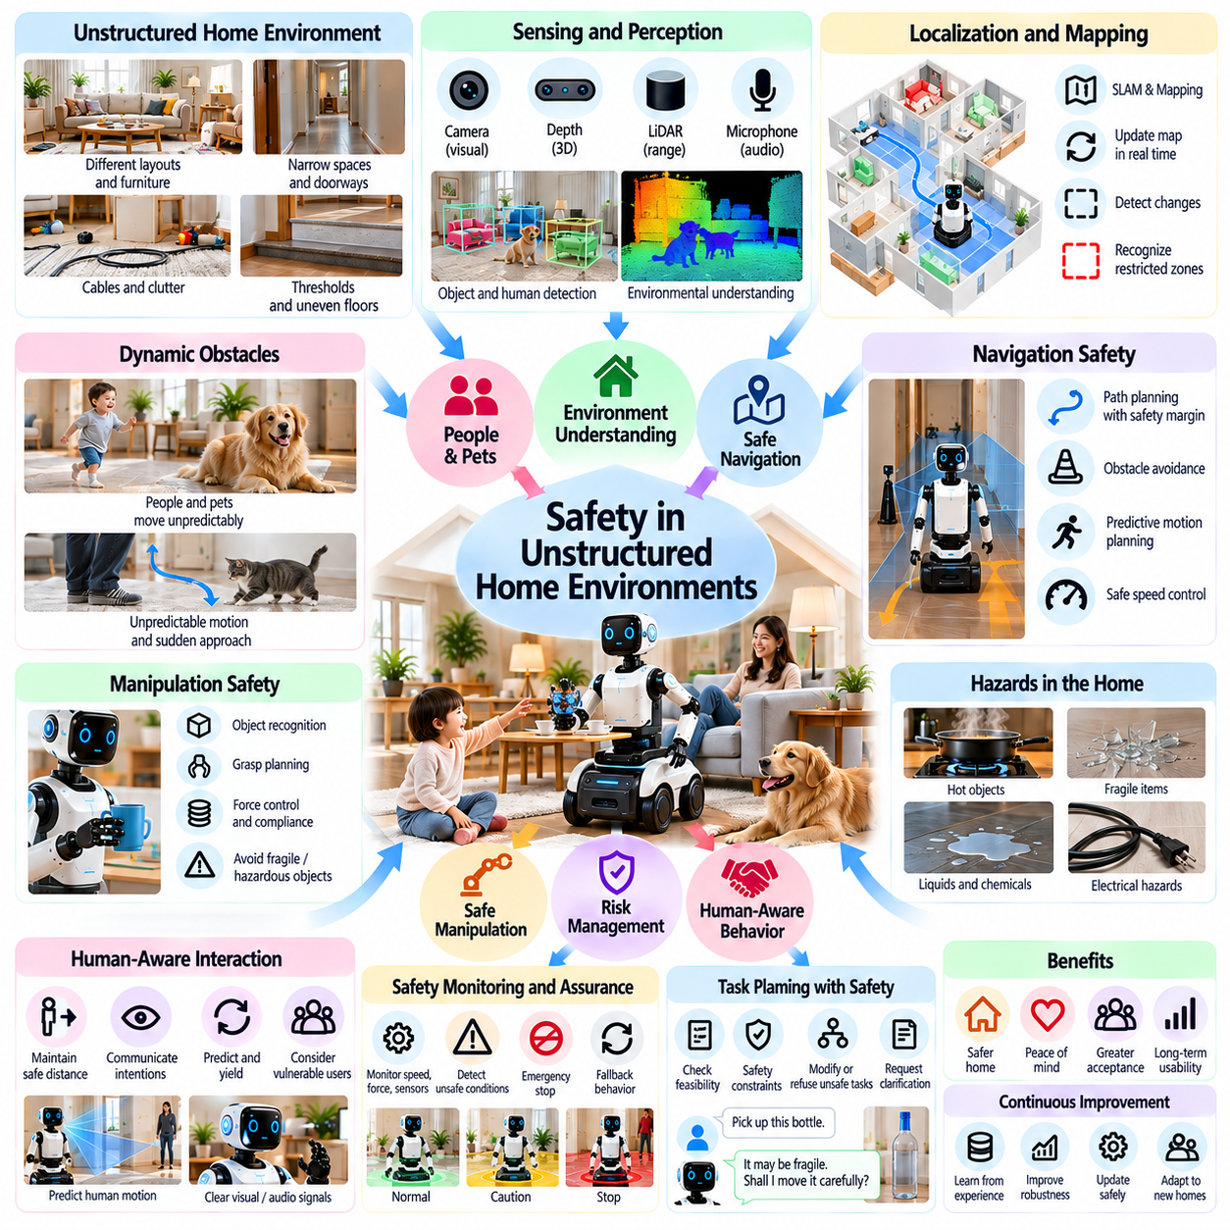
Safety in unstructured home environments is a fundamental requirement for deploying Physical AI in everyday living spaces. Unlike industrial facilities, homes contain unpredictable layouts, moving occupants, pets, and frequently changing obstacles. Robots must operate safely despite limited environmental control and incomplete information. Reliable domestic autonomy therefore requires continuous perception, adaptive planning, physical safeguards, and effective human supervision.
Household environments present substantial variation in room dimensions, furniture arrangements, floor materials, and available movement space. Narrow corridors, door thresholds, carpets, cables, and clutter can complicate navigation. A robot designed for one residence may encounter unfamiliar conditions in another. Safe operation requires robust environmental modeling and the ability to recognize when a location exceeds the robot's mobility capabilities.
Dynamic obstacles introduce additional uncertainty because people and animals move unpredictably. Children may suddenly approach a robot, while pets can enter its path or interact with moving components. Motion prediction can support collision avoidance, but predicted trajectories remain uncertain. Conservative speed limits, protective stopping distances, and continuous obstacle monitoring are essential when operating near vulnerable occupants.
Environmental perception combines cameras, depth sensors, lidar, proximity detectors, and contact sensors to identify hazards. Sensor fusion can improve coverage when individual sensing modalities become unreliable. Reflective surfaces, transparent objects, darkness, and occlusion may still create detection failures. Safety-critical systems must account for sensing limitations and avoid assuming that unobserved space is free of obstacles.
Localization and mapping support safe movement by maintaining an estimate of the robot's position and surrounding geometry. However, household maps can become outdated when furniture moves or temporary obstacles appear. Robots should update local environmental representations during operation and detect inconsistencies between stored maps and current observations. Uncertain localization should trigger reduced speed, recovery, or controlled stopping.
Navigation safety requires planning paths that account for robot dimensions, stopping capability, and surrounding activity. The shortest route may not be the safest route when narrow passages or occupied areas are involved. Risk-aware planners can favor wider clearances and predictable movement. Local controllers must continuously adjust trajectories while respecting collision constraints and maintaining stable motion.
Manipulation introduces risks beyond mobile navigation because robotic arms and grippers interact directly with household objects. Incorrect grasping may cause objects to fall, break, or strike nearby people. Safe manipulation requires object recognition, force control, grasp stability assessment, and collision monitoring. Robots should avoid handling unknown, fragile, sharp, or hazardous objects without appropriate capabilities and authorization.
Force and compliance control help reduce injury risks during physical interaction. Impedance control, torque sensing, and compliant mechanisms can limit excessive contact forces. Nevertheless, mechanical compliance alone cannot guarantee safety, particularly near pinch points or heavy payloads. Hardware limits, protective coverings, emergency stopping, and task-specific operating restrictions must complement intelligent control.
Stairs, elevated surfaces, and floor discontinuities create significant mobility hazards. Wheeled robots may encounter steps, gaps, or steep slopes that exceed their mechanical limits. Legged robots face different risks involving balance loss and unstable footholds. Terrain assessment should consider geometry, friction, load conditions, and recovery options. Robots must avoid transitions that cannot be traversed with adequate safety margins.
Household objects create diverse hazards because their properties are often unknown or difficult to estimate. Hot cookware, glass containers, electrical cables, liquids, and cleaning chemicals require different handling precautions. Semantic perception can identify potential object categories, but recognition confidence may be insufficient for safe manipulation. Robots should restrict actions when material properties or hazard conditions remain uncertain.
Human-aware behavior is essential because household occupants may not understand robotic motion or anticipate its next action. Robots should communicate intended movements through understandable signals and maintain appropriate interpersonal distances. Navigation near seated individuals, children, or people using mobility aids requires additional caution. Predictable behavior and accessible stopping controls can reduce both physical risk and user discomfort.
Safety-aware task planning must evaluate whether requested actions are physically feasible and acceptable under current conditions. Natural language commands may omit important constraints or request unsafe behavior. High-level AI models can propose task sequences, but independent safety mechanisms must validate executable actions. A robot should refuse, modify, or request clarification when instructions conflict with established safety requirements.
Runtime assurance provides continuous supervision of robotic behavior during task execution. Monitoring systems can evaluate speed, separation distance, actuator limits, sensor health, and localization confidence. When unsafe conditions are detected, supervisory controllers should override nominal plans and activate predefined protective responses. Such mechanisms should remain effective even when learning-based decision systems produce unexpected outputs.
Fail-safe design ensures that failures lead toward controlled and predictable states rather than uncontrolled movement. Loss of communication, processor faults, low battery conditions, and actuator abnormalities require defined recovery behavior. Depending on the hazard, safe responses may include stopping, lowering a carried object, or requesting assistance. Emergency functions should not depend exclusively on cloud connectivity or language-model decisions.
Functional safety engineering provides a systematic approach to identifying hazards and implementing protective measures. Hazard analysis considers severity, exposure, and the possibility of avoiding harm. Risk reduction may involve mechanical design, sensing redundancy, software monitoring, and user instructions. Applicable standards and regulatory requirements depend on product classification, operating conditions, and intended functions.
Cybersecurity also contributes to physical safety because connected robots may receive remote commands or software updates. Unauthorized access could alter movement, disable safeguards, or expose household information. Secure authentication, encrypted communication, software integrity checks, and controlled update procedures reduce these risks. Security failures affecting safety-related functions require explicit detection and recovery strategies.
Learning-based adaptation creates additional challenges because robot behavior may change after deployment. Policies trained in simulation or controlled demonstrations can perform unpredictably in unfamiliar homes. Updated models should undergo validation before controlling physical actions. Safety constraints must remain enforceable independently of learned policies, and rollback mechanisms should support recovery from unsuccessful software changes.
Simulation and digital environments enable systematic testing of hazardous scenarios without exposing household occupants to unnecessary risks. Developers can evaluate collisions, sensor failures, cluttered spaces, and unusual human movements across many configurations. However, simulation cannot fully reproduce physical contact, material variation, or human behavior. Real-world testing remains necessary to establish operational confidence.
Safety evaluation should measure collision frequency, protective stop performance, minimum separation distances, manipulation forces, navigation failures, and recovery success. Testing must include changing furniture arrangements, poor lighting, unexpected obstacles, and simultaneous human activity. Rare but severe incidents deserve particular attention. Aggregate task success rates alone cannot establish that household operation is acceptably safe.
User training and interface design influence safety because residents may misunderstand robot capabilities or intervene unexpectedly. Clear operating instructions, visible status indicators, accessible emergency controls, and understandable warnings support appropriate interaction. Manufacturers should communicate prohibited uses and maintenance requirements. Safety information must remain usable by people with different ages, abilities, and technical experience.
Reliability and maintenance are closely connected to long-term safety. Worn wheels, contaminated sensors, damaged cables, degraded batteries, and outdated software can gradually reduce protective performance. Preventive inspection, automated diagnostics, and fault reporting help identify deterioration before incidents occur. Robots should restrict operation when essential safety components cannot meet required performance levels.
Commercial deployment requires manufacturers to balance useful autonomy with acceptable residual risk. Higher capability does not automatically justify operating in every household condition. Clearly defined operating boundaries, conservative default behavior, and documented validation evidence support responsible commercialization. Insurance, product liability, service support, and incident reporting also influence the practical sustainability of home robotics.
Future household robots may combine multimodal perception, predictive world models, adaptive control, and more sophisticated human-motion understanding. These technologies could improve anticipation of hazards and coordination in crowded domestic spaces. Nevertheless, increasing intelligence also introduces new failure modes. Progress must prioritize verifiable safety mechanisms, transparent limitations, and robust operation under unfamiliar conditions.
Ultimately, safety in unstructured home environments depends on integrating intelligent perception and planning with dependable engineering safeguards. Household robots must recognize uncertainty, respect human proximity, and respond predictably when conditions exceed their capabilities. Sustainable Physical AI adoption requires safety to remain a continuous operational property rather than a feature demonstrated only during controlled testing.

07.13. Product Cost Reliability and Maintenance
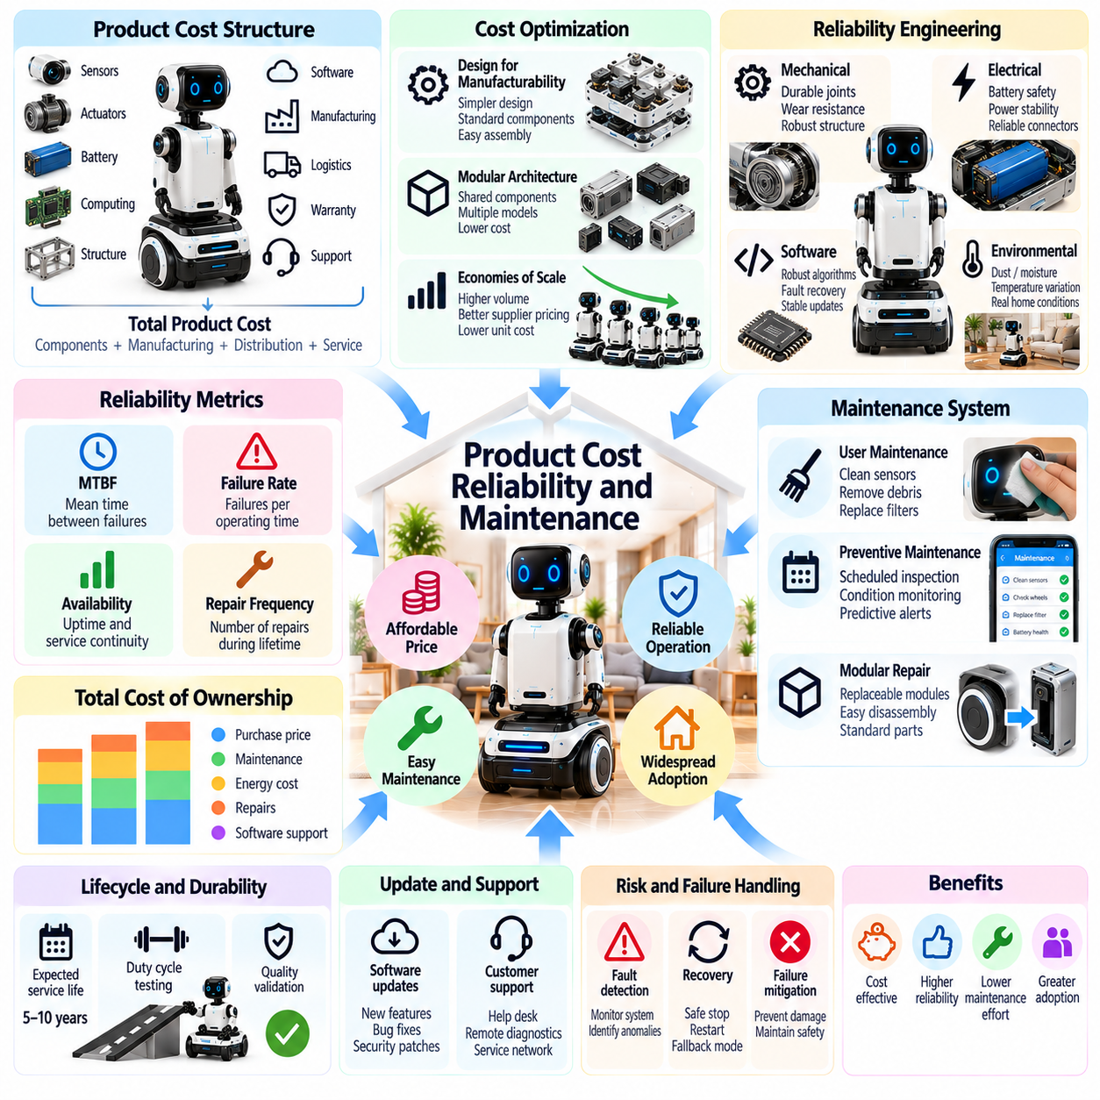
Product cost, reliability, and maintenance are critical factors determining whether Physical AI can achieve widespread adoption in consumer and home markets. Unlike industrial customers, households typically have limited budgets, technical expertise, and tolerance for equipment downtime. Successful home robots must deliver practical value at an acceptable purchase price while maintaining dependable operation throughout their expected service life.
Product cost begins with hardware components such as sensors, processors, actuators, batteries, mechanical structures, and communication interfaces. Advanced perception and manipulation capabilities often increase manufacturing expenses because they require precise components and complex integration. Cost-effective engineering must balance functional performance against component prices, assembly complexity, energy consumption, and long-term durability.
The bill of materials provides a structured foundation for estimating direct hardware costs. However, the final product price must also account for manufacturing labor, testing, logistics, distribution, warranties, software development, and customer support. Retail margins and regional compliance requirements introduce additional expenses. Manufacturers must therefore distinguish component cost from total production cost and sustainable selling price.
Design for manufacturability reduces production expenses by simplifying assemblies, standardizing components, and minimizing specialized manufacturing processes. Modular architectures can support shared components across different robot models. Nevertheless, excessive standardization may restrict performance or increase unnecessary hardware capacity. Effective product design balances manufacturing efficiency, functional requirements, repairability, and component availability.
Economies of scale can reduce unit costs through larger purchasing volumes, automated assembly, and improved supplier agreements. However, projected cost reductions depend on actual production volumes and stable demand. Early-stage manufacturers may face expensive tooling, low manufacturing yields, and inventory risks. Business planning should evaluate realistic production scenarios rather than assuming immediate mass-market pricing advantages.
Reliability refers to the ability of a robot to perform required functions consistently under specified operating conditions. Household robots experience repeated movement, variable floor surfaces, dust, moisture, and unpredictable user interactions. Mechanical wear and software failures can gradually reduce performance. Reliability engineering must address both individual component durability and the behavior of the integrated robotic system.
Mechanical reliability depends on the durability of motors, transmissions, wheels, joints, bearings, and structural components. Repeated acceleration, vibration, impact, and loading may produce fatigue or premature wear. Appropriate material selection, protective design, and conservative load ratings can improve service life. Engineering validation should reproduce realistic household duty cycles rather than relying exclusively on laboratory specifications.
Electrical reliability involves batteries, power distribution, connectors, charging interfaces, and embedded electronics. Temperature variation, electrical transients, connector degradation, and repeated charging cycles may cause operational failures. Battery management systems should monitor voltage, current, temperature, and health conditions. Protective circuits and controlled charging procedures help maintain safe and dependable power delivery.
Software reliability is equally important because home robots depend on perception, localization, navigation, task planning, and communication services. Unexpected inputs, resource exhaustion, network interruptions, and software updates may disrupt operation. Robust systems require fault detection, process isolation, recovery mechanisms, and systematic testing. Essential functions should remain predictable even when noncritical services become unavailable.
Reliability metrics provide measurable evidence of product performance. Mean time between failures, failure rate, repair frequency, and operational availability can support engineering decisions when defined consistently. Household usage patterns may differ significantly, making simple comparisons misleading. Manufacturers should combine laboratory testing, field failure records, and customer experience data to assess actual product dependability.
Maintenance requirements directly affect user satisfaction and total ownership cost. Routine activities may include cleaning sensors, removing debris, replacing filters, inspecting wheels, and maintaining charging contacts. Complex servicing should be minimized because most household users lack specialized tools. Clear maintenance instructions and accessible components reduce inconvenience and improve the likelihood of proper upkeep.
Preventive maintenance aims to address predictable deterioration before functional failures occur. Maintenance schedules can be based on operating hours, travel distance, battery cycles, or observed component conditions. Condition-based maintenance may use vibration, temperature, motor current, and diagnostic signals to identify emerging problems. However, diagnostic models must avoid excessive false alarms that unnecessarily burden users.
Modular repairability can reduce maintenance costs by allowing damaged components to be replaced without disassembling the entire robot. Replaceable batteries, sensor modules, wheels, and actuator assemblies can simplify servicing. Standardized connectors and documented procedures improve repair efficiency. Modular design must nevertheless consider additional connector costs, packaging constraints, and possible reliability tradeoffs.
Remote diagnostics and over-the-air software updates can improve service efficiency by resolving selected problems without physical repair visits. Secure telemetry may identify recurring faults, configuration errors, and software instability. Updates should undergo validation and support recovery from unsuccessful installation. Remote maintenance must also respect household privacy and avoid unnecessary transmission of personal information.
Service infrastructure becomes increasingly important as robot deployments expand. Manufacturers need spare-parts inventories, repair procedures, trained technicians, warranty systems, and customer communication channels. Poor service coverage can undermine confidence even when hardware performance is generally acceptable. Regional service capabilities and predictable repair turnaround times should therefore be considered during market expansion.
Warranty design connects engineering reliability with financial risk. Unexpected failure rates can create substantial replacement, transportation, and service expenses. Manufacturers should estimate warranty provisions using component reliability, expected usage, and field performance data. Clear coverage conditions reduce customer uncertainty. Warranty policies must align with applicable consumer protection requirements and practical repair capabilities.
Total cost of ownership extends beyond the initial purchase price to include electricity, consumables, replacement parts, repairs, subscriptions, and eventual disposal. A robot with a lower purchase price may become more expensive if maintenance is frequent or components are difficult to replace. Economic evaluation should consider expected service life and usage intensity. Transparent ownership costs help consumers assess genuine value.
Subscription-based services can provide continuing software improvements, cloud processing, and advanced assistance capabilities. However, recurring charges may reduce consumer acceptance when basic functionality depends on ongoing payments. Manufacturers should clearly distinguish essential functions from optional services. Long-term business sustainability requires balancing predictable service revenue with affordability, reliability, and customer expectations.
Product lifecycle management coordinates design, manufacturing, deployment, maintenance, upgrades, and end-of-life handling. Component obsolescence and discontinued cloud services can shorten usable product life even when hardware remains functional. Long-term software support and spare-parts planning improve durability. Lifecycle strategies should also address battery replacement, material recovery, and responsible electronic waste management.
Field data provides an important feedback mechanism for improving future product generations. Aggregated failure records, repair histories, operating conditions, and diagnostic trends can reveal recurring weaknesses. Engineering teams can use these findings to refine component selection, software architecture, and maintenance procedures. Data collection should remain proportionate, privacy-conscious, and focused on legitimate reliability objectives.
Commercial success requires balancing product affordability with dependable performance and sustainable support costs. Aggressive hardware cost reduction may increase failures, warranty expenses, and customer dissatisfaction. Conversely, excessive engineering complexity can place products beyond consumer budgets. Product optimization should evaluate lifecycle economics rather than minimizing the initial bill of materials alone.
Future home robots may benefit from lower-cost sensors, integrated computing platforms, improved battery technologies, and standardized robotic components. Advances in self-diagnostics and predictive maintenance could further reduce service requirements. Nevertheless, increasing autonomy and manipulation capability introduce additional wear and failure modes. Product maturity will depend on demonstrating consistent performance under real household conditions.
Ultimately, product cost, reliability, and maintenance determine whether home Physical AI becomes a practical household investment rather than an experimental technology. Consumers require robots that are affordable to purchase, straightforward to operate, and economical to maintain. Sustainable adoption depends on integrating cost-aware engineering, robust design, accessible servicing, transparent ownership economics, and long-term manufacturer responsibility.

07.14. Path to General Purpose Home Robots
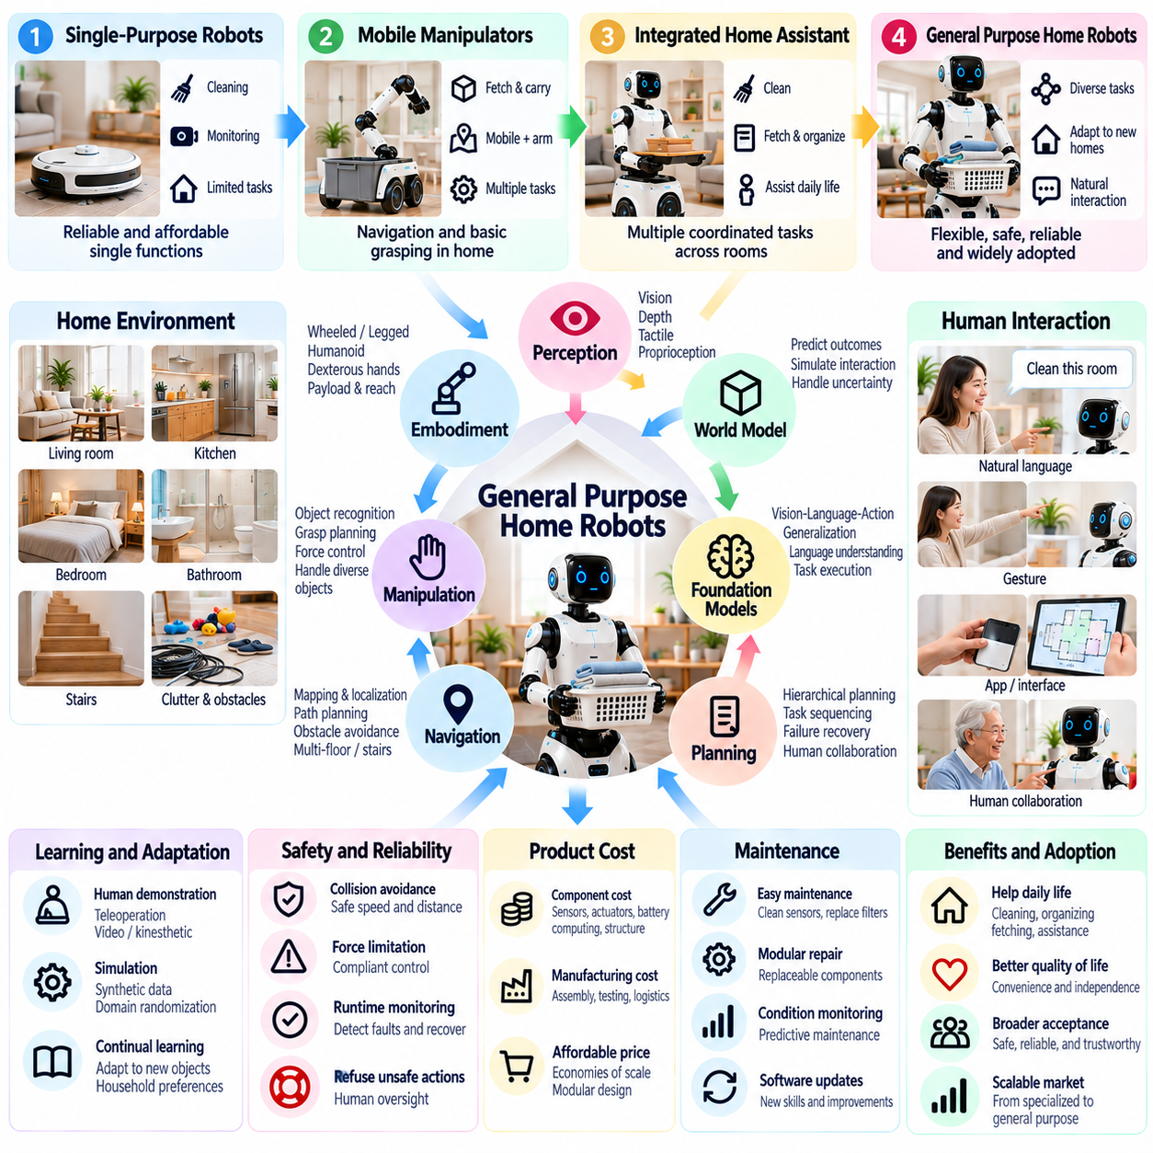
The path to general-purpose home robots represents a transition from specialized household automation toward adaptable Physical AI capable of performing diverse tasks in everyday environments. Current consumer robots typically focus on cleaning, monitoring, or limited assistance. General-purpose systems must combine mobility, manipulation, perception, reasoning, and human interaction while maintaining safety, affordability, and reliability across changing household conditions.
General-purpose capability does not require a robot to perform every conceivable domestic activity. A practical definition emphasizes the ability to execute multiple useful tasks across different rooms, objects, and user requirements without extensive reprogramming. Task diversity must be evaluated alongside completion quality and operational independence. Broad but unreliable functionality provides less value than a carefully selected range of dependable household services.
The development pathway begins with reliable single-purpose robots and progresses toward integrated mobile manipulation. Cleaning robots demonstrate mature navigation and scheduling, while mobile manipulators add the ability to transport and reposition objects. More advanced systems may coordinate cleaning, fetching, organizing, and basic household assistance. Each expansion introduces new requirements for sensing, control, task planning, and safety validation.
Robot morphology strongly influences the range of household tasks that can be performed. Wheeled platforms offer efficient movement on accessible floors, while legged and humanoid configurations may navigate environments containing stairs or human-oriented fixtures. Manipulator reach, payload capacity, dexterity, and physical dimensions determine practical usefulness. No single body configuration is optimal for every home, making embodiment a central design tradeoff.
Dexterous manipulation remains a major technical barrier because domestic objects vary widely in shape, material, weight, and fragility. Robots must recognize objects, estimate grasp stability, regulate contact forces, and recover from unsuccessful actions. Tasks such as folding clothing or handling flexible packaging involve complex physical interactions. Progress requires robust manipulation policies supported by tactile sensing and adaptable end effectors.
Multimodal perception provides the environmental understanding needed for flexible household operation. Cameras, depth sensors, tactile sensors, and proprioceptive measurements contribute complementary information about objects and robot state. Perception systems must remain effective under occlusion, changing lighting, clutter, and unfamiliar arrangements. Reliable operation also requires recognizing uncertainty rather than treating every perception result as correct.
Foundation models may improve generalization by connecting language instructions, visual observations, and action representations. Vision-language-action models can learn relationships between task descriptions and robotic behavior from diverse demonstrations. However, linguistic competence does not guarantee physical competence. High-level model outputs must be grounded in robot capabilities, environmental constraints, and independently enforced safety requirements.
World models can support household planning by predicting how objects and environments may change after robotic actions. Such predictions may help robots evaluate grasp attempts, navigation alternatives, and multi-step task sequences before execution. Yet household physics includes uncertain friction, deformable materials, and unexpected human intervention. Predictive models must therefore support continuous correction through real-world observation.
Hierarchical planning is essential for coordinating complex domestic activities. A request to prepare a room may require identifying misplaced objects, selecting storage locations, navigating between areas, and performing several manipulation steps. High-level planners can organize task objectives, while lower-level controllers execute verified movements. Continuous feedback allows the robot to detect failures, revise plans, and request assistance when necessary.
Learning from human demonstrations offers a practical method for acquiring household skills without manually programming every movement. Teleoperation, kinesthetic teaching, and video-based learning can provide examples of useful behavior. Nevertheless, differences between human bodies and robotic mechanisms complicate skill transfer. Training pipelines must adapt demonstrations to the robot's morphology and verify performance in physical environments.
Simulation and synthetic data can expand training coverage across household layouts, object configurations, and unusual events. Domain randomization helps expose learning systems to variations in lighting, friction, geometry, and sensor noise. However, simulated success does not establish reliable real-world performance. Physical validation remains essential, especially for contact-rich manipulation, human interaction, and rare safety-critical situations.
Continual learning enables home robots to adapt to new objects, household arrangements, and user preferences after deployment. Persistent memory can preserve spatial knowledge and previously successful task strategies. However, adaptation must avoid catastrophic forgetting, unstable policies, and unauthorized behavioral changes. Validated updates, controlled memory retention, and rollback mechanisms are necessary for dependable long-term operation.
Human-robot collaboration will remain important even as autonomy improves. Robots should recognize tasks requiring human judgment, assistance, or authorization rather than attempting unrestricted independent execution. Natural language, gestures, and accessible interfaces can support shared task planning. Effective collaboration depends on clear communication of capabilities, uncertainty, progress, and reasons for requesting intervention.
Safety engineering must advance alongside general-purpose capability because broader task coverage creates additional physical hazards. Robots may encounter children, pets, sharp objects, liquids, electrical equipment, and unstable furniture. Runtime monitoring, force limits, collision avoidance, and emergency stopping should operate independently of learned policies. Expanding autonomy requires evidence that protective mechanisms remain effective across diverse tasks.
Economic feasibility is another major constraint on general-purpose home robotics. Dexterous hands, multiple actuators, high-performance processors, and sophisticated sensors increase hardware costs and maintenance complexity. Manufacturers must evaluate whether additional capabilities generate sufficient household value. Modular components, efficient computing, scalable manufacturing, and serviceable mechanical designs can support more accessible product pricing.
Reliability must be demonstrated across extended periods rather than isolated task demonstrations. Household robots should tolerate repeated use, minor environmental changes, sensor contamination, software interruptions, and component wear. Useful metrics include autonomous task completion, intervention frequency, recovery success, and maintenance burden. Long-duration field trials are necessary to establish whether generalized capability remains dependable in everyday operation.
A phased commercialization strategy can reduce technical and financial risk. Initial products may concentrate on a limited collection of high-value tasks in relatively structured homes. Later generations can expand object diversity, manipulation complexity, and environmental coverage as performance improves. Clear operating boundaries help manufacturers establish realistic customer expectations while collecting evidence for broader deployment.
Interoperability with smart-home infrastructure can extend robotic usefulness beyond physical manipulation. Robots may coordinate with appliances, lighting systems, environmental sensors, and home automation platforms to complete compound tasks. Shared context can reduce unnecessary sensing and improve scheduling. However, integration must enforce device permissions, cybersecurity protections, and clear responsibility for automated actions.
User acceptance depends on more than technical versatility. Residents must trust robots operating near personal belongings, private spaces, and vulnerable household members. Personalization can improve interaction, but privacy protection and user control must remain central. Transparent limitations, predictable behavior, accessible maintenance, and understandable costs are necessary to convert technological capability into sustained household adoption.
Evaluation frameworks should measure generalization across tasks, objects, environments, and users rather than relying on selected demonstrations. Benchmarks need to distinguish familiar conditions from genuinely unfamiliar situations. Safety performance, intervention requirements, task quality, and resource consumption should accompany success rates. Standardized testing can support comparisons, but long-term household trials remain essential for validating practical utility.
The progression toward general-purpose robots is likely to involve multiple embodiments and capability levels rather than a single universal architecture. Compact mobile manipulators may serve accessible apartments, while larger platforms may address demanding household tasks. Software foundations could become increasingly reusable across different bodies. Morphology-aware control and hardware-specific validation will remain necessary despite shared intelligence models.
Future advances in embodied foundation models, tactile perception, adaptive manipulation, and robot data engines may accelerate household skill acquisition. Fleet learning could help improve models using diverse operational experiences when appropriate permissions and privacy safeguards exist. Nevertheless, broader datasets alone cannot resolve all physical uncertainties. Progress requires coordinated improvements in algorithms, hardware, testing, and lifecycle support.
Ultimately, the path to general-purpose home robots is an incremental process of expanding useful autonomy while preserving dependable operation. Success should be measured by the number of meaningful household needs addressed safely and economically, not merely by demonstrations of humanlike behavior. Sustainable Physical AI will emerge through the integration of generalizable intelligence, capable embodiment, rigorous safety engineering, and human-centered product design.

