Volume 12. Physical AI Business and Industry Applications

Chapter 06. Construction and Infrastructure Applications

06.01. Physical AI in Construction and Infrastructure
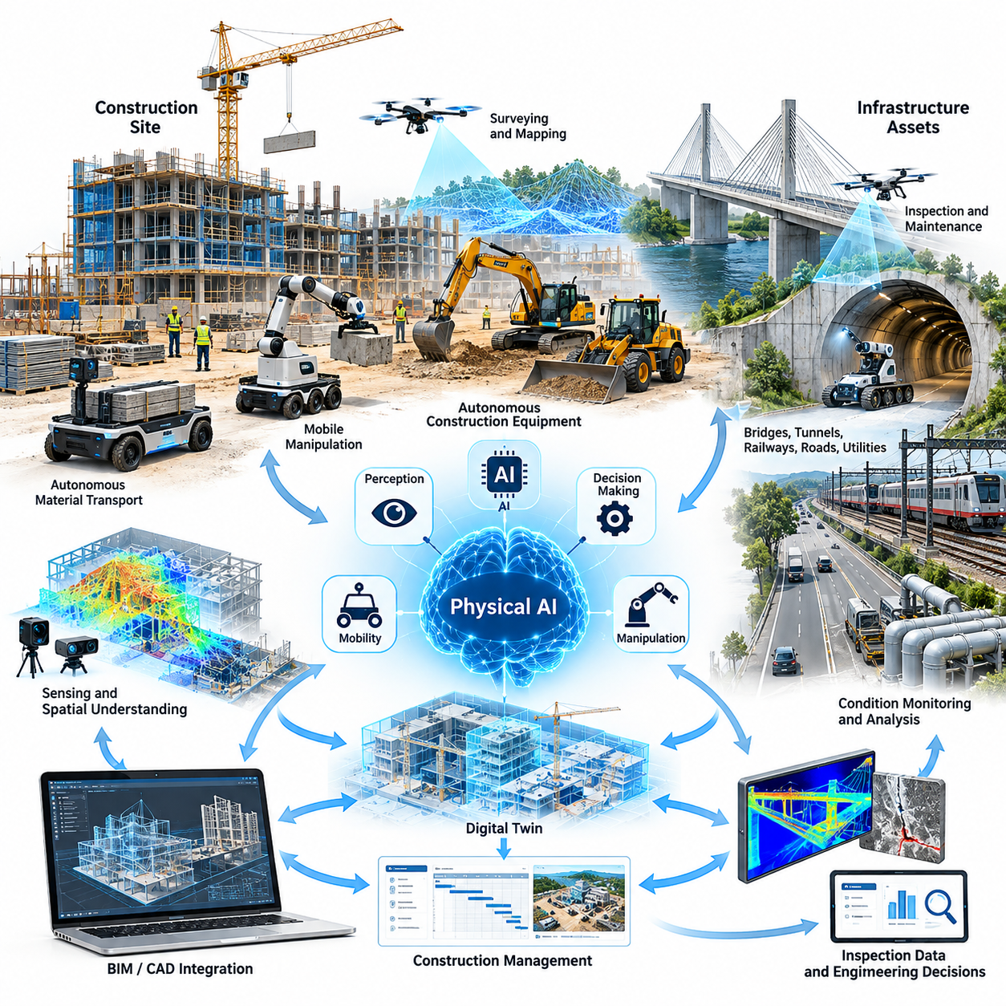
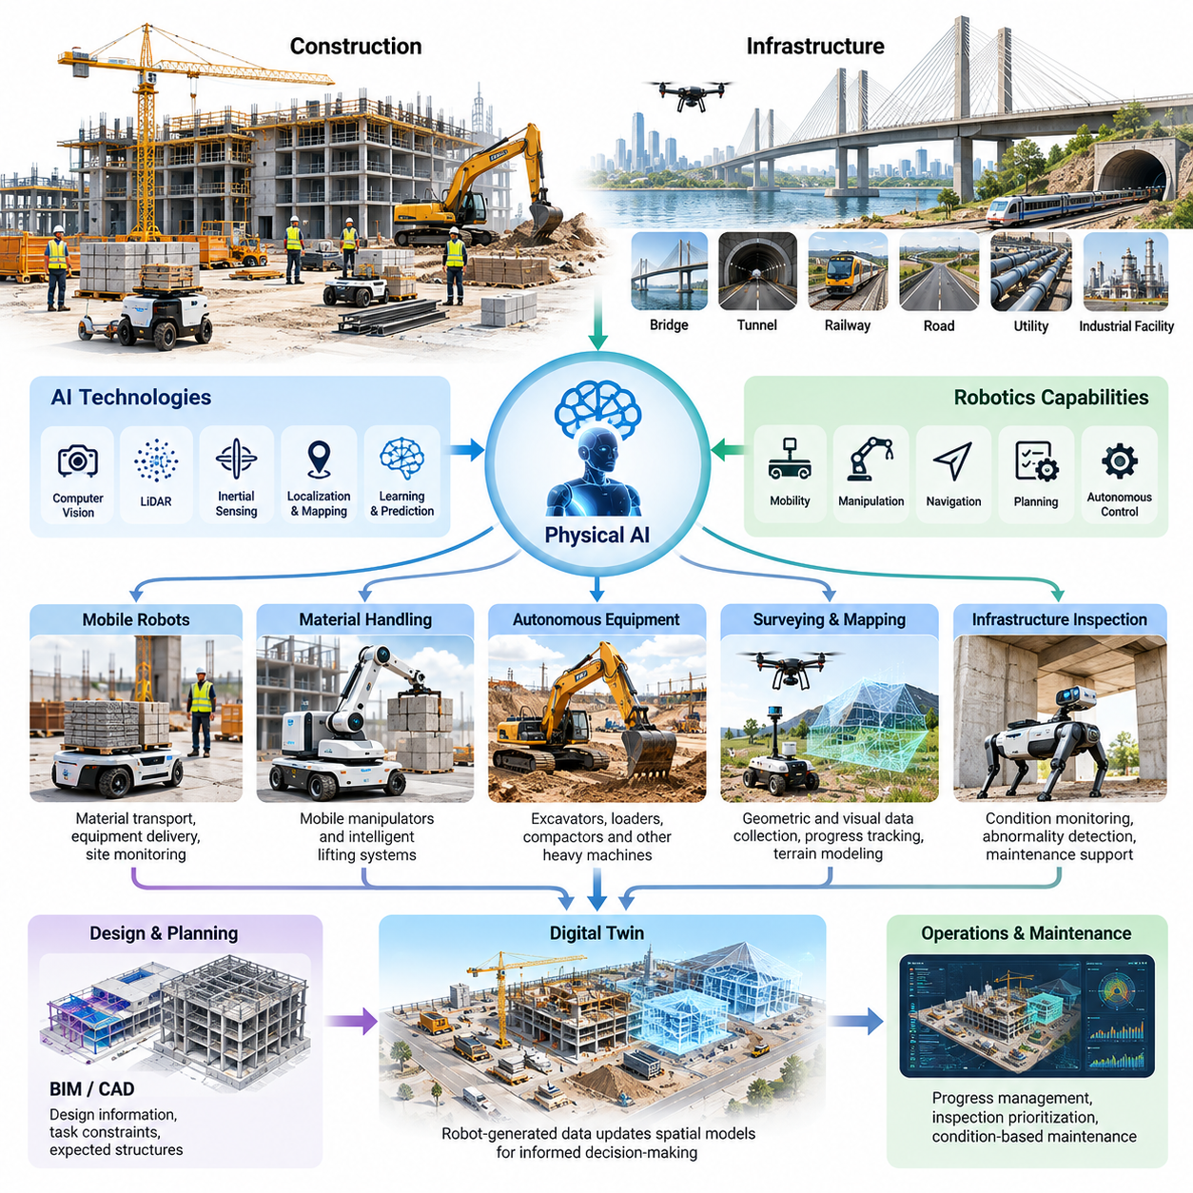
Physical AI represents a fundamental transformation in how construction projects and infrastructure assets are developed, operated, inspected, and maintained. By integrating artificial intelligence with robotic mobility, perception, manipulation, and autonomous decision-making, Physical AI enables machines to interact intelligently with complex physical environments rather than simply executing predefined mechanical operations.
Construction environments differ significantly from controlled manufacturing facilities because site layouts, terrain conditions, materials, and operational constraints change continuously. Autonomous systems must recognize temporary obstacles, uneven surfaces, moving equipment, and human activities while adapting their behavior to evolving conditions. These characteristics make construction a demanding application domain for embodied intelligence.
Infrastructure applications extend Physical AI beyond construction activities into the continuous monitoring and maintenance of bridges, tunnels, railways, roads, utilities, and industrial facilities. Intelligent robotic systems can collect physical measurements, identify structural abnormalities, and support condition-based maintenance decisions. Their value increasingly depends on connecting autonomous sensing with reliable engineering interpretation.
Traditional construction automation primarily focuses on mechanizing repetitive operations through specialized equipment. Physical AI introduces an additional layer of environmental understanding, adaptive planning, and intelligent control. Autonomous machines can interpret sensor information, estimate changing site conditions, and modify their actions within defined safety boundaries, reducing dependence on continuous manual intervention.
The technological foundation of construction Physical AI combines computer vision, LiDAR, inertial sensing, localization, mapping, motion planning, and robotic control. These capabilities allow machines to construct spatial representations of construction sites and infrastructure assets. When combined with learning-based perception and predictive models, they support navigation and task execution under uncertain environmental conditions.
Autonomous mobile robots provide an important entry point for construction applications because material transportation, equipment delivery, and site monitoring involve substantial movement between operational locations. Robots equipped with suitable mobility platforms can transport tools and supplies while coordinating with workers and construction machinery. Their effectiveness depends on payload capacity, terrain accessibility, and reliable navigation.
Construction material handling creates opportunities for mobile manipulators and intelligent lifting systems. These machines may combine autonomous movement with robotic arms, gripping mechanisms, or specialized handling attachments. Unlike conventional fixed automation, mobile manipulation must account for irregular objects, variable loading conditions, restricted working spaces, and the dynamic interactions between materials and surrounding structures.
Autonomous construction equipment represents another major application category. Excavators, loaders, compactors, and other heavy machines can incorporate perception, positioning, and automated control capabilities to support repetitive or geometrically constrained operations. However, reliable deployment requires careful management of ground conditions, equipment dynamics, operating boundaries, and interactions with personnel.
Surveying and mapping are particularly suitable for early Physical AI adoption because they generate measurable operational value without necessarily requiring direct manipulation of construction materials. Mobile robots and aerial platforms can acquire geometric and visual information across large sites. These observations support progress tracking, terrain modeling, dimensional verification, and the identification of deviations from planned construction conditions.
Digital twins provide a connection between physical construction activities and their computational representations. Robot-generated observations can update spatial models with information about completed structures, equipment locations, and changing site conditions. When synchronized with engineering data, these representations support more informed decisions regarding construction progress, inspection priorities, and operational coordination.
Building Information Modeling and computer-aided design systems establish important interfaces for construction Physical AI. Design information can provide geometric references, task constraints, and expected structural configurations. Conversely, robot-generated measurements can reveal differences between design intent and actual construction conditions, enabling scan-to-model workflows and improved verification of completed work.
Infrastructure inspection offers particularly strong opportunities because many assets are difficult, dangerous, or expensive to examine manually. Robots equipped with cameras, thermal sensors, ultrasonic devices, and other measurement instruments can collect condition information from accessible surfaces and designated inspection locations. AI-based analysis can assist inspectors by highlighting suspicious patterns and prioritizing areas requiring closer examination.
Bridges, tunnels, and railway infrastructure introduce specialized requirements involving confined spaces, structural geometry, vibration, environmental exposure, and operational access. Robotic inspection platforms must maintain reliable localization while collecting measurements with sufficient spatial accuracy. Their deployment must also respect traffic restrictions, railway operating procedures, and engineering requirements for inspection documentation.
Underground infrastructure presents additional challenges because conventional satellite-based positioning is often unavailable. Ground-penetrating radar, inertial navigation, LiDAR, and other sensing methods can contribute to subsurface investigation and asset localization. Physical AI systems must distinguish uncertain measurements from confirmed observations, particularly when detecting buried utilities, cavities, or potential structural defects.
Quadruped robots provide mobility advantages in certain construction and infrastructure environments containing stairs, debris, uneven surfaces, and restricted passages. Their articulated legs allow adaptation to terrain that may limit wheeled platforms. Nevertheless, practical deployment depends on stability, endurance, payload capacity, environmental protection, and whether their mobility benefits justify higher operational complexity.
Aerial robots complement ground-based systems by providing rapid access to elevated structures, roofs, façades, and geographically distributed assets. Equipped with appropriate sensing systems, they can capture images and spatial measurements for mapping and inspection. Flight duration, wind conditions, obstacle proximity, positioning reliability, and regulatory requirements determine their practical operating limits.
Multi-robot construction environments require coordination between autonomous vehicles, inspection robots, aerial platforms, and human-operated equipment. Shared maps, task allocation, communication networks, and fleet management systems can reduce operational conflicts. Effective coordination must account for changing work zones, temporary access restrictions, equipment priorities, and the safety requirements of mixed human-machine operations.
Worker safety is a central requirement rather than a secondary benefit of construction automation. Physical AI can reduce human exposure to hazardous locations, repetitive transportation, and certain inspection activities. However, autonomous machines introduce their own risks, including unexpected motion, sensing failures, communication interruptions, and unsafe interactions with heavy equipment or personnel.
Reliable construction autonomy therefore requires layered safety mechanisms combining operational rules, obstacle detection, motion constraints, emergency stopping, and human supervision. Learning-based decision systems should operate within validated safety boundaries appropriate to the application. Human operators must retain clear authority to intervene when environmental conditions exceed the robot's demonstrated capabilities.
Environmental robustness strongly influences deployment feasibility. Construction robots may encounter dust, rain, vibration, temperature variations, reflective surfaces, poor illumination, and intermittent connectivity. These conditions can degrade sensing, localization, communication, and mechanical performance. Successful systems require environmental protection, fault detection, recovery procedures, and realistic operational limitations.
The economic value of Physical AI depends on measurable improvements in productivity, quality, safety, and asset management. Construction applications may reduce transportation delays, repeated surveying effort, or inefficient equipment utilization. Infrastructure applications may improve inspection coverage and reduce certain access costs. These benefits must be evaluated against acquisition, integration, maintenance, supervision, and downtime expenses.
Project schedules introduce another important economic dimension because construction activities are highly interdependent. A robotic system that accelerates one operation may produce limited overall benefit if preceding or subsequent tasks remain constrained. Evaluation should therefore consider critical-path activities, resource coordination, equipment utilization, and the effect of automation on overall project completion rather than isolated task speed.
Infrastructure inspection economics differ from construction production economics because inspection value often includes avoided disruption, improved maintenance planning, and earlier identification of deterioration. Relevant performance measures include inspection cost per asset, coverage, measurement quality, operational availability, and the time required to produce actionable findings. Long-term value depends on consistent and trustworthy inspection results.
Data management becomes increasingly important as robotic systems operate across multiple construction sites and infrastructure assets. Sensor recordings, inspection observations, geometric models, and operational logs can support performance analysis and model improvement. Standardized data structures, traceability, version control, and secure integration with engineering systems help transform isolated robot operations into reusable organizational knowledge.
Commercial adoption is likely to progress through clearly defined tasks where technical feasibility and economic benefits can be demonstrated. Surveying, repetitive material movement, and structured inspection workflows provide potential starting points. Broader autonomy requires additional evidence of reliability, interoperability, workforce acceptance, and performance across diverse sites, equipment configurations, and environmental conditions.
Physical AI ultimately connects autonomous physical operations with the digital management of construction projects and infrastructure lifecycles. Its long-term significance lies not merely in replacing individual manual tasks but in creating adaptive systems that perceive changing conditions, coordinate physical activities, and continuously improve operational decisions while maintaining engineering accountability and human oversight.

06.02. Autonomous Site Mobility
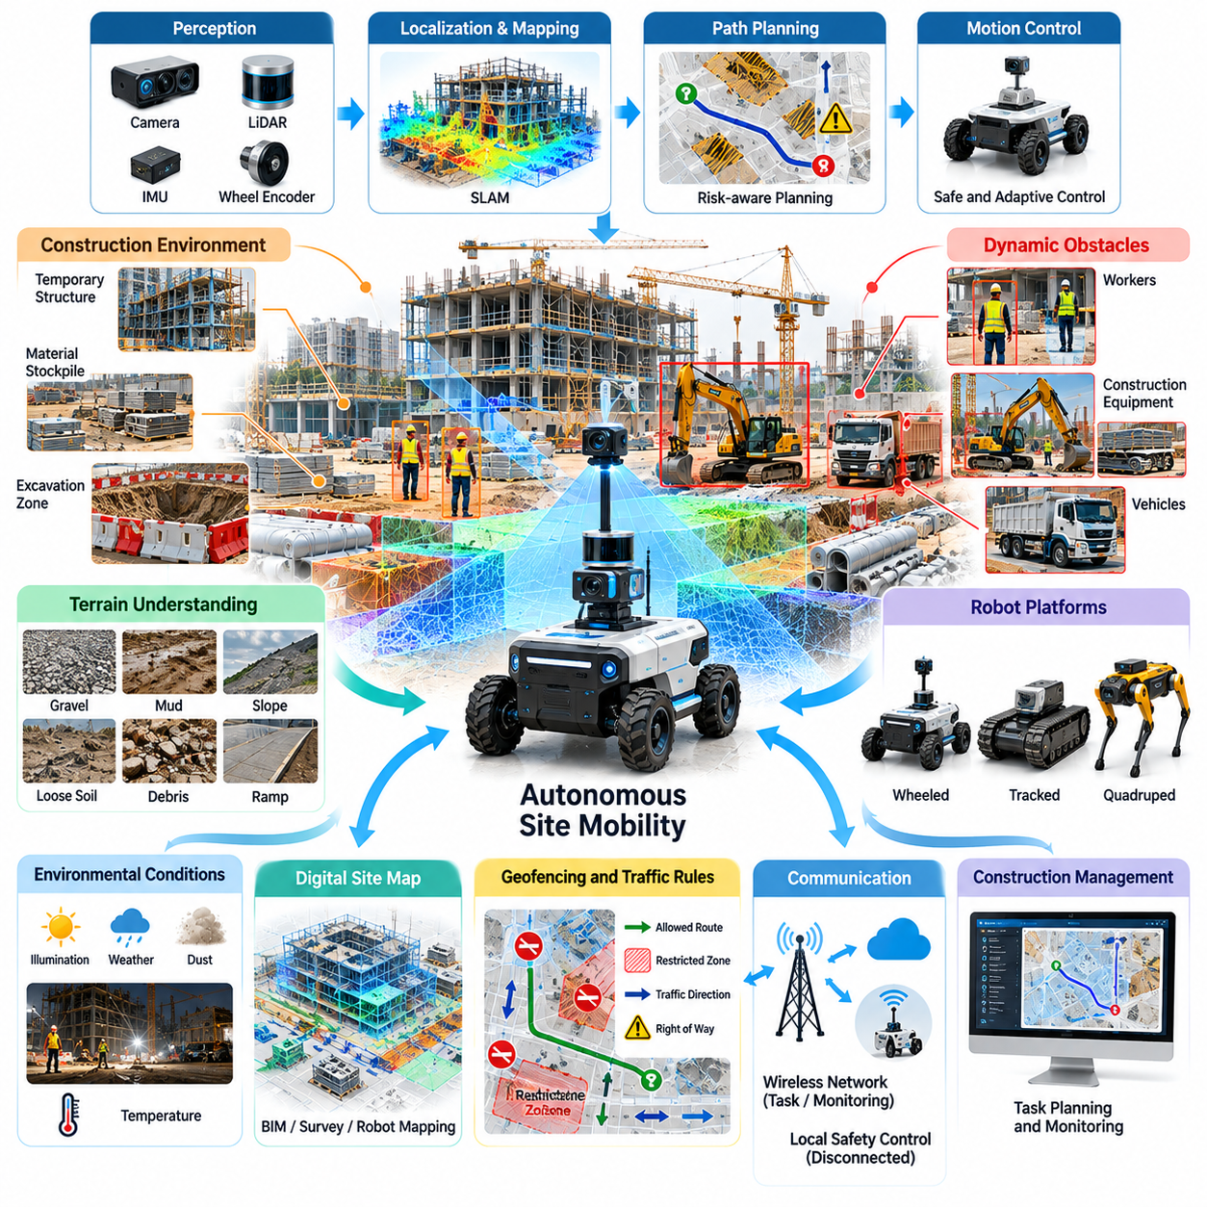
Autonomous site mobility represents a foundational capability of Physical AI in construction environments, enabling robotic systems to navigate dynamic worksites without continuous human control. Unlike structured factory floors, construction sites contain changing terrain, temporary pathways, moving equipment, and unpredictable obstacles. Autonomous mobility must therefore combine environmental perception, adaptive navigation, and operational safety.
Construction site navigation requires robots to understand both permanent structures and temporary environmental features. Excavation zones, material stockpiles, scaffolding, temporary barriers, and partially completed buildings continuously modify available routes. Autonomous systems must maintain updated spatial representations while distinguishing traversable surfaces from hazardous or inaccessible areas.
The mobility architecture typically integrates perception, localization, mapping, path planning, and motion control into a coordinated system. Cameras, LiDAR, inertial measurement units, and wheel encoders provide complementary observations of the surrounding environment. Sensor fusion improves localization reliability and enables robots to estimate their position even when individual sensing modalities become unreliable.
Simultaneous Localization and Mapping allows autonomous robots to construct environmental maps while estimating their positions within those maps. Construction environments introduce challenges because objects and structures may move, disappear, or change configuration between operating sessions. Robust mapping systems must identify stable environmental features while updating temporary obstacles and evolving site geometry.
Outdoor positioning often combines Global Navigation Satellite System measurements with inertial sensing and local perception. Real-Time Kinematic positioning can provide high-accuracy location estimates when satellite visibility and correction signals are adequate. However, tall structures, tunnels, equipment, and partially enclosed spaces may degrade satellite reception, requiring alternative localization methods.
Terrain understanding is essential because construction surfaces rarely provide the uniform conditions found in warehouses. Robots may encounter gravel, mud, slopes, loose soil, debris, drainage channels, and temporary ramps. Traversability estimation evaluates whether a surface can safely support movement by considering geometry, traction, ground stability, and the mechanical limitations of the robotic platform.
Autonomous path planning must account for both geometric accessibility and operational risk. The shortest route may cross unstable terrain, active excavation areas, or zones occupied by heavy machinery. Risk-aware planning evaluates alternative paths using terrain conditions, obstacle proximity, traffic activity, energy consumption, and operational restrictions to identify routes that balance efficiency and safety.
Dynamic obstacle avoidance becomes particularly important when autonomous robots operate alongside workers, trucks, excavators, and mobile construction equipment. Perception systems must detect moving objects, estimate their trajectories, and predict potential conflicts. Motion planners should continuously revise robot behavior while maintaining appropriate separation distances and respecting equipment operating zones.
Different robotic morphologies offer distinct advantages for construction mobility. Wheeled platforms generally provide efficient transportation across sufficiently firm surfaces, while tracked robots can improve traction on selected loose or uneven terrain. Quadruped robots may negotiate stairs and irregular obstacles, although their energy consumption, payload limitations, and mechanical complexity require careful consideration.
Payload conditions significantly influence mobility performance. Transporting tools, sensors, batteries, or construction materials changes vehicle mass, center of gravity, braking distance, and traction requirements. Autonomous controllers must account for these variations when selecting speeds, negotiating slopes, and executing turns. Load-aware navigation helps maintain stability under changing operating conditions.
Construction sites frequently contain narrow passages, temporary access routes, and areas shared by pedestrians and machinery. Autonomous navigation must incorporate site-specific traffic rules, designated corridors, restricted zones, and right-of-way priorities. Geofencing and digital access permissions can prevent robots from entering hazardous locations or interfering with scheduled construction activities.
Environmental conditions create additional challenges for perception and mobility. Dust can reduce camera visibility, rain may degrade optical sensing, and reflective surfaces can introduce measurement errors. Low illumination, vibration, and temperature variations further affect system performance. Robust operation requires sensor redundancy, environmental protection, uncertainty estimation, and appropriate fallback behavior.
Communication infrastructure supports coordination between mobile robots, supervisory systems, and construction personnel. Wireless networks may provide task assignments, traffic updates, and operational monitoring, but connectivity can become unreliable around steel structures or underground areas. Autonomous platforms should maintain essential safety functions locally and respond predictably when communication is interrupted.
Digital site maps can connect autonomous mobility with construction planning systems. Building Information Modeling data, survey measurements, and updated robot observations provide complementary information about site geometry and operational constraints. Integrating these sources enables robots to recognize planned construction changes and adjust navigation routes as the physical environment evolves.
Fleet management becomes necessary when multiple autonomous platforms share construction routes and operational resources. Centralized or distributed coordination can allocate transportation tasks, manage traffic intersections, and reduce congestion. Effective fleet orchestration must consider robot capabilities, battery levels, task priorities, route availability, and the movement of human-operated equipment.
Human-robot interaction is particularly important because construction workers may not be familiar with autonomous mobile systems. Robots should communicate their intended movement through understandable signals, predictable behavior, and clearly defined operating procedures. Supervisors require accessible mechanisms for stopping, redirecting, or recovering robots when unexpected site conditions arise.
Safety engineering must address collisions, rollovers, uncontrolled movement, localization failures, and hazardous interactions with construction equipment. Protective measures may include speed restrictions, obstacle monitoring, emergency stopping, operational design boundaries, and independent safety controls. Validation should demonstrate acceptable behavior under foreseeable environmental disturbances and system failures.
Operational reliability depends not only on successful navigation but also on recovery from unexpected situations. Robots may become immobilized in soft ground, encounter blocked routes, or lose localization confidence. Recovery strategies can include controlled repositioning, alternative route selection, safe stopping, and human assistance. Reliable systems must recognize when autonomous recovery is inappropriate.
Simulation and digital twins provide valuable environments for developing construction mobility algorithms before field deployment. Virtual construction sites can represent slopes, obstacles, moving equipment, and changing layouts. Domain randomization helps expose navigation policies to environmental variability, while physical testing remains necessary to evaluate traction, sensing limitations, and real-world safety performance.
Autonomous site mobility generates operational data that can support continuous system improvement. Robot trajectories, obstacle encounters, localization uncertainty, terrain observations, and intervention events reveal recurring operational limitations. Structured data collection enables developers to identify difficult locations, refine navigation models, and improve performance across different construction environments.
Energy management directly influences operational availability. Rough terrain, frequent acceleration, heavy payloads, and repeated obstacle avoidance can increase power consumption. Energy-aware planning considers remaining battery capacity, expected route difficulty, charging availability, and task urgency. Effective scheduling reduces unplanned interruptions while preserving sufficient energy for safe return or recovery.
The economic value of autonomous site mobility depends on the frequency, duration, and operational importance of movement-related activities. Automated transportation and inspection travel may reduce nonproductive labor time and improve resource utilization. However, financial evaluation must include robot acquisition, site preparation, integration, supervision, maintenance, charging infrastructure, and operational downtime.
Deployment strategies should begin with clearly defined operating areas and repeatable mobility tasks. Initial applications may use designated routes between material storage locations, inspection points, and construction work zones. As reliability improves, operating boundaries can expand to include more complex terrain and dynamic interactions, provided additional safety validation supports the increased autonomy.
Autonomous site mobility ultimately provides the movement infrastructure required for broader Physical AI applications in construction. Material transportation, mobile manipulation, surveying, inspection, and multi-robot coordination all depend on reliable physical navigation. By combining terrain awareness, adaptive planning, operational integration, and safety assurance, autonomous mobility enables construction robots to function as practical components of intelligent worksites.

06.03. Construction Material Transport
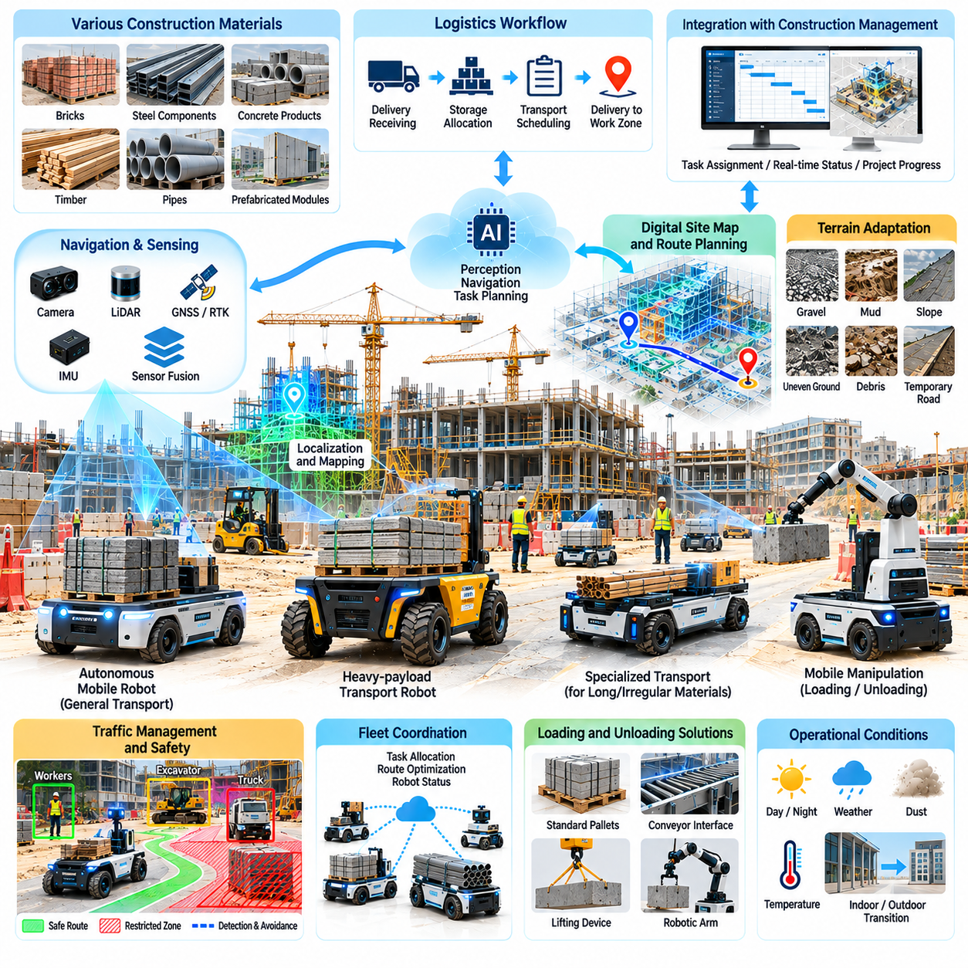
Construction material transport represents one of the most practical applications of Physical AI because construction projects depend on continuous movement of materials between storage areas, delivery points, and active work zones. Traditional transportation relies heavily on manual labor and operator-controlled equipment. Autonomous transport systems can improve material availability, reduce repetitive movement, and support more predictable construction workflows.
Construction materials present significant handling challenges because their dimensions, weights, shapes, and packaging vary considerably. Bricks, steel components, concrete products, timber, pipes, tools, and prefabricated assemblies require different transportation mechanisms. Physical AI systems must recognize these variations and select appropriate loading, securing, routing, and unloading strategies while maintaining operational safety.
Autonomous Mobile Robots provide a flexible transportation platform for construction sites where materials must move repeatedly between designated locations. These robots combine localization, obstacle detection, path planning, and motion control to navigate changing environments. Their practical effectiveness depends on payload capacity, terrain compatibility, positioning accuracy, and integration with construction logistics procedures.
Heavy-payload transport requires specialized robotic platforms capable of carrying substantial loads while maintaining stability and controllability. Load distribution, center of gravity, wheel configuration, suspension, and braking performance become critical design considerations. Autonomous control systems must account for changing vehicle dynamics and adjust acceleration, turning behavior, and operating speed according to actual loading conditions.
Construction terrain creates additional challenges compared with indoor warehouse transportation. Temporary roads, gravel surfaces, mud, slopes, debris, and uneven ground can significantly affect traction and mobility. Transport robots require terrain-aware navigation and robust mechanical designs to maintain reliable movement. Traversability assessment should consider both the robot's capabilities and the stability of the supporting ground.
Material transportation workflows typically begin with delivery scheduling, receiving, storage allocation, and assignment to construction activities. Physical AI can connect these processes through autonomous task execution and real-time status reporting. Robots may receive transportation requests from construction management systems and deliver designated materials to work zones according to project priorities and operational constraints.
Loading and unloading operations strongly influence the overall effectiveness of autonomous material transportation. Even when navigation is automated, dependence on manual loading can create operational bottlenecks. Integration with conveyors, lifting devices, robotic manipulators, and standardized material containers can improve workflow continuity. Interface compatibility between transport robots and handling equipment is therefore essential.
Mobile manipulation extends autonomous transportation by enabling robots to interact directly with construction materials. Robotic arms and specialized grippers may support picking, positioning, and transferring objects between storage locations and workstations. However, irregular geometry, uncertain material properties, and variable gripping conditions make construction manipulation more difficult than handling standardized industrial components.
Palletized materials and modular containers offer opportunities for standardizing autonomous transport operations. Consistent load interfaces simplify mechanical engagement, positioning, and securing procedures. Standardization also improves interoperability between autonomous robots, forklifts, cranes, and storage systems. Nevertheless, construction sites must accommodate materials that cannot be packaged into conventional handling units.
Transportation planning must consider material demand, delivery deadlines, route availability, and equipment utilization. Intelligent task allocation can prioritize critical construction activities while reducing unnecessary movement. Predictive scheduling may use project progress information and historical consumption patterns to anticipate material requirements, although reliable forecasts depend on accurate and continuously updated operational data.
Construction sites frequently experience congestion because transport vehicles, workers, and heavy equipment share limited access routes. Autonomous material transport must incorporate traffic management, designated corridors, intersection coordination, and restricted operating zones. Fleet management systems can distribute transportation tasks and reduce conflicts while adapting to temporary road closures and changing site layouts.
Multi-robot transportation systems introduce opportunities for coordinated material movement across large construction projects. Different robots may specialize in lightweight supplies, heavy components, or transportation through restricted spaces. Centralized or distributed fleet orchestration can assign tasks according to payload requirements, robot availability, battery condition, and route accessibility while maintaining safe separation.
Outdoor positioning and navigation require integration of multiple sensing technologies. GNSS, RTK positioning, LiDAR, cameras, and inertial sensors can provide complementary localization information. Satellite reception may deteriorate near tall structures or inside partially completed buildings. Robust transport systems therefore require localization strategies that remain effective across transitions between outdoor and indoor environments.
Safety requirements become particularly demanding when autonomous platforms carry heavy or unstable materials. Unexpected braking, sharp turns, uneven terrain, and load displacement can create rollover or falling-object hazards. Load monitoring, speed restrictions, stability estimation, obstacle detection, and emergency stopping mechanisms must operate together to maintain acceptable safety margins during transportation.
Human-robot coordination is necessary because construction workers may interact directly with autonomous transport platforms during material delivery and collection. Clear signaling, predictable stopping behavior, accessible emergency controls, and defined handover procedures help reduce operational uncertainty. Workers must understand robot operating boundaries and recognize situations requiring human intervention or manual assistance.
Environmental durability directly affects the commercial viability of construction transport robots. Dust, moisture, vibration, impact, and temperature variations can degrade sensors, actuators, electrical systems, and mechanical components. Protective enclosures, appropriate ingress protection, maintainable components, and diagnostic monitoring help improve reliability under demanding site conditions.
Battery capacity and energy consumption influence the number of transportation tasks a robot can complete during each operating period. Heavy payloads, steep slopes, soft ground, and frequent acceleration increase energy requirements. Energy-aware scheduling can coordinate charging with construction activity patterns, while battery monitoring helps prevent unexpected interruptions during critical material deliveries.
Integration with Building Information Modeling and construction management platforms can connect autonomous transportation with broader project execution. Digital models may provide location references, access constraints, and planned material destinations. Operational systems can communicate task priorities and delivery requirements, while robot-generated records provide evidence of completed transportation activities and actual resource movement.
Material traceability becomes increasingly valuable when construction projects involve numerous suppliers, subcontractors, and installation locations. Transport robots can associate delivery events with material identifiers, timestamps, destinations, and handling records. Integration with inventory systems improves visibility into material movement and may reduce misplaced supplies, duplicate deliveries, and uncertainty about worksite availability.
Operational performance should be evaluated through transportation throughput, delivery reliability, utilization, cycle time, and intervention frequency. Payload transported per operating hour provides one measure of productivity, while successful deliveries without human assistance indicate autonomy maturity. Additional indicators include energy consumption, equipment availability, route delays, and material handling errors.
The economic justification for autonomous material transport depends on transportation frequency, labor requirements, project duration, and site complexity. Savings may arise from reduced repetitive handling, improved material availability, and more efficient equipment utilization. However, total cost of ownership must include robot acquisition, infrastructure preparation, integration, maintenance, supervision, charging, and downtime.
Deployment should begin with transportation routes and material categories that offer predictable operating conditions and measurable value. Repetitive deliveries between storage areas and designated work zones provide suitable initial opportunities. Expansion into heavier payloads, irregular materials, and more complex terrain should follow demonstrated reliability, validated safety performance, and successful integration with existing construction operations.
Physical AI can also support adaptive transportation when construction schedules or material requirements change unexpectedly. Robots may receive revised assignments, select alternative routes, or redirect deliveries according to updated priorities. Such adaptability requires reliable communication between project management systems, fleet orchestration platforms, and local autonomous controllers, together with safeguards against conflicting instructions.
Construction material transport ultimately provides a foundation for increasingly connected and autonomous construction operations. By combining intelligent mobility, load-aware control, material tracking, fleet coordination, and project system integration, Physical AI can transform transportation from an isolated support activity into a coordinated operational capability that improves construction productivity, safety, and resource utilization.

06.04. Autonomous Construction Equipment
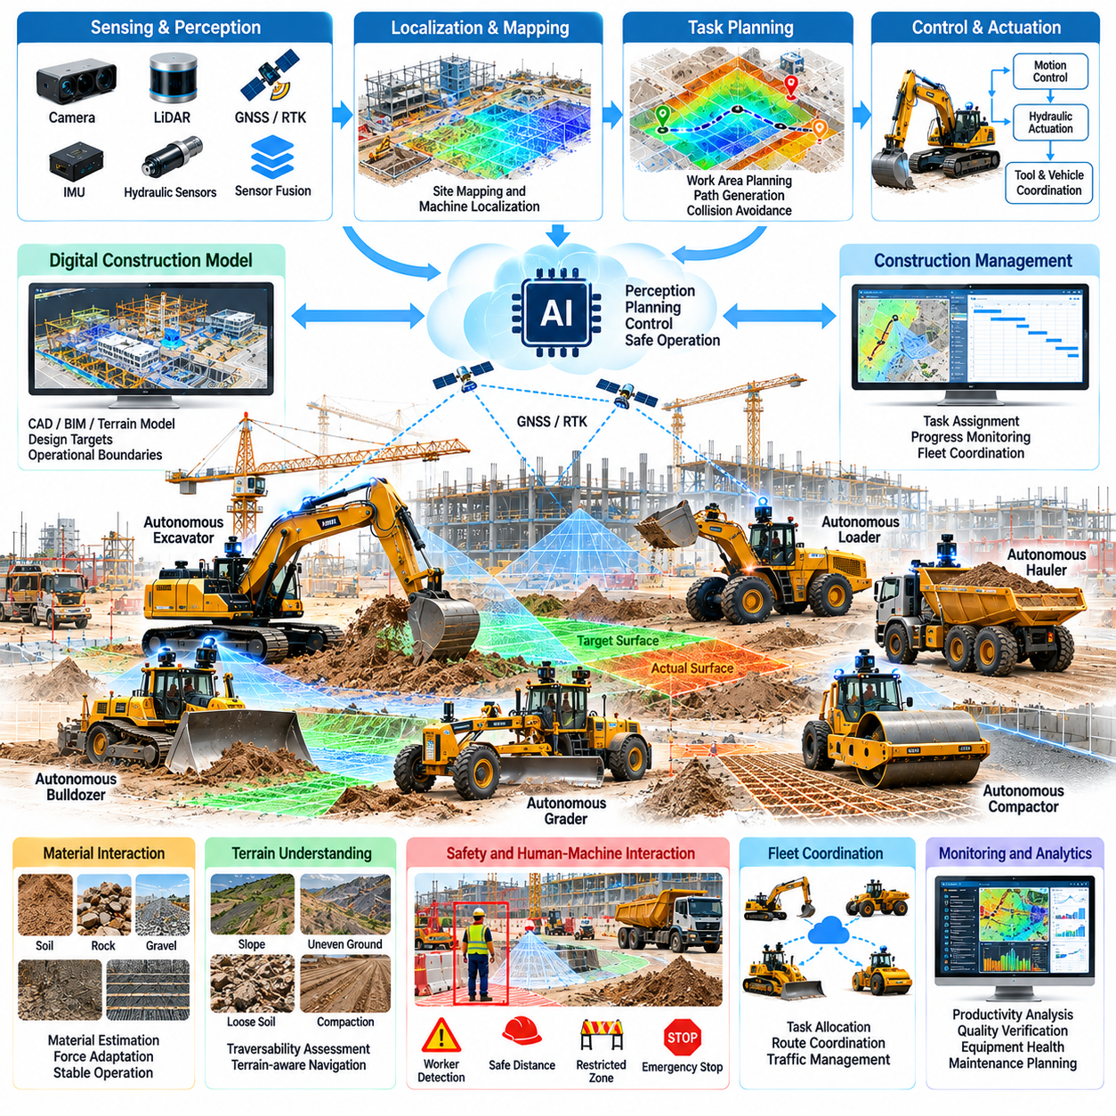
Autonomous construction equipment represents a major advancement in Physical AI, transforming conventional heavy machinery into intelligent systems capable of performing physical operations with reduced human intervention. Excavators, bulldozers, loaders, graders, and compactors can integrate perception, planning, and automated control to execute construction tasks while adapting to changing terrain, material properties, and operational conditions.
Traditional construction machinery relies on skilled operators who continuously interpret site conditions and control equipment movements. Autonomous systems transfer selected perception and decision-making functions to onboard computing platforms. This transformation requires machines to understand their surroundings, estimate operational risks, and coordinate mechanical actions while maintaining productivity, precision, and safety.
Autonomous equipment architecture combines environmental sensing, localization, task planning, motion control, and machine actuation. Cameras, LiDAR, GNSS receivers, inertial sensors, and hydraulic measurements provide information about machine position and operating conditions. Sensor fusion creates a consistent representation of the environment, enabling control algorithms to coordinate vehicle movement and construction implements.
Autonomous excavation illustrates the complexity of intelligent construction machinery because digging requires continuous interaction between equipment and deformable materials. Excavators must estimate bucket position, soil resistance, excavation geometry, and machine stability. Intelligent controllers can adjust digging trajectories and hydraulic commands according to observed conditions while respecting structural and operational constraints.
Earthmoving automation requires machines to understand terrain geometry and material distribution before modifying the environment. Bulldozers and graders can use digital terrain models to determine desired surface elevations and plan material movement. Repeated measurements allow controllers to compare actual terrain with design targets and refine operating trajectories to improve grading accuracy and reduce unnecessary rework.
Autonomous loaders combine mobility, material interaction, and transportation within a single operational cycle. A loader must approach a material pile, position its bucket, manage penetration forces, secure the load, and transport it to a designated destination. Automated loading strategies must account for material variability, vehicle traction, payload distribution, and the interaction between hydraulic forces and machine stability.
Compaction equipment provides opportunities for structured autonomy because many operations follow predefined coverage patterns and measurable surface requirements. Autonomous rollers can navigate designated paths while recording position, speed, vibration settings, and repeated passes. Integration with compaction measurement systems may support more consistent coverage, although material properties and field verification remain essential.
Machine localization is critical because construction equipment must operate relative to design coordinates, excavation boundaries, and surrounding infrastructure. GNSS and RTK positioning can provide accurate outdoor references under suitable reception conditions. LiDAR, inertial navigation, and local mapping complement satellite positioning when buildings, equipment, or terrain features obstruct signals.
Digital construction models connect autonomous machinery with engineering requirements. CAD files, terrain surfaces, and Building Information Modeling data can define target geometries, operational boundaries, and construction sequences. Autonomous equipment can compare measured site conditions with these references, allowing task execution to follow engineering specifications while identifying deviations that require correction.
Task planning for autonomous construction equipment involves translating project objectives into executable machine actions. A grading objective may require selecting work regions, planning passes, estimating material displacement, and coordinating equipment movements. Planning algorithms must consider machine capabilities, terrain conditions, operational priorities, and dependencies between construction activities.
Machine control introduces challenges because heavy equipment contains nonlinear hydraulic systems, substantial mechanical inertia, and variable external forces. Control algorithms must manage actuator delays, pressure limitations, joint dynamics, and changing loads. Model-based control and learning-assisted methods can improve performance, but safety-critical functions require predictable behavior and validated operating limits.
Physical interaction with soil, rock, and construction materials creates uncertainty that cannot be resolved through geometric planning alone. Material stiffness, friction, moisture, and compaction characteristics influence equipment behavior. Force estimation and adaptive control can help machines respond to changing resistance, while conservative operating limits reduce the likelihood of equipment overload or unstable movement.
Autonomous construction equipment must coordinate vehicle mobility with tool operation. Excavators combine upper-structure rotation, boom movement, arm articulation, and bucket control, while loaders coordinate steering, propulsion, and hydraulic lifting. Integrated motion planning is necessary to avoid mechanical conflicts, maintain stability, and execute efficient work cycles under varying payload conditions.
Safety engineering is particularly demanding because heavy construction machinery can generate large forces and operate near workers, vehicles, and partially completed structures. Autonomous systems require reliable obstacle detection, exclusion zones, emergency stopping, and operational supervision. Independent safety mechanisms should prevent hazardous actions even when perception or learning-based planning components behave unexpectedly.
Human supervision remains essential for managing exceptional conditions, approving operational changes, and responding to equipment faults. Supervisory interfaces can provide machine status, planned actions, sensor observations, and intervention controls. Remote operation may support recovery or specialized tasks, but communication delays and limited situational awareness must be considered before allowing remote control of heavy machinery.
Construction environments introduce severe reliability challenges through dust, vibration, moisture, temperature variation, and mechanical shock. Sensors and computing hardware must remain functional under these conditions, while hydraulic and mechanical systems require continuous condition monitoring. Fault detection and diagnostic systems can identify degraded performance before it develops into operational failure or unsafe behavior.
Multi-machine coordination extends autonomous construction beyond individual equipment capabilities. Excavators, loaders, haul trucks, and compactors may operate as an interconnected system in which material extraction, transportation, placement, and finishing depend on one another. Fleet orchestration can coordinate assignments and equipment availability while reducing congestion and unnecessary waiting.
Construction scheduling systems can provide operational priorities for autonomous machinery based on project progress and resource availability. Equipment-generated data can report completed work quantities, machine utilization, and operational delays. Integrating these records with project management platforms enables more accurate progress monitoring and supports adjustments when site conditions or construction priorities change.
Digital twins and simulation environments provide tools for developing and validating autonomous construction behavior. Simulated machines can practice excavation, grading, loading, and navigation under varied terrain and material conditions. However, differences between simulated and real soil behavior, hydraulic dynamics, and environmental sensing require careful validation before autonomous policies are deployed on actual equipment.
Operational data collected from construction machinery can support continuous improvement in planning, control, and maintenance. Hydraulic pressures, actuator positions, equipment trajectories, material interactions, and intervention events provide information about machine performance. Structured data pipelines allow developers to identify recurring limitations, refine predictive models, and evaluate improvements across different operating conditions.
Predictive maintenance becomes increasingly valuable as construction machinery incorporates extensive sensing and computing capabilities. Vibration, temperature, hydraulic pressure, and component operating histories can reveal emerging mechanical problems. Condition-based maintenance strategies may reduce unexpected downtime and improve equipment availability, although reliable predictions require representative operating data and validated diagnostic methods.
The economic value of autonomous construction equipment depends on utilization, productivity, labor requirements, quality improvement, and operational reliability. Automation may increase productive operating time, improve repeatability, and reduce certain forms of rework. Financial evaluation must also include equipment acquisition, retrofit costs, sensing infrastructure, software integration, supervision, maintenance, training, and operational downtime.
Deployment strategies should prioritize construction activities with clearly defined boundaries, measurable outcomes, and manageable environmental variability. Repetitive grading, controlled excavation, and structured compaction tasks may provide practical initial opportunities. Expansion into highly dynamic operations should follow demonstrated reliability, validated safety performance, and successful integration with existing site procedures.
Autonomous construction equipment ultimately connects intelligent perception and decision-making with large-scale physical transformation of the built environment. Its long-term significance extends beyond replacing manual machine control toward coordinating equipment, engineering models, operational data, and project objectives. Physical AI can thereby support construction systems that operate with greater precision, adaptability, safety, and resource efficiency.

06.05. Surveying Mapping and Digital Twin Capture
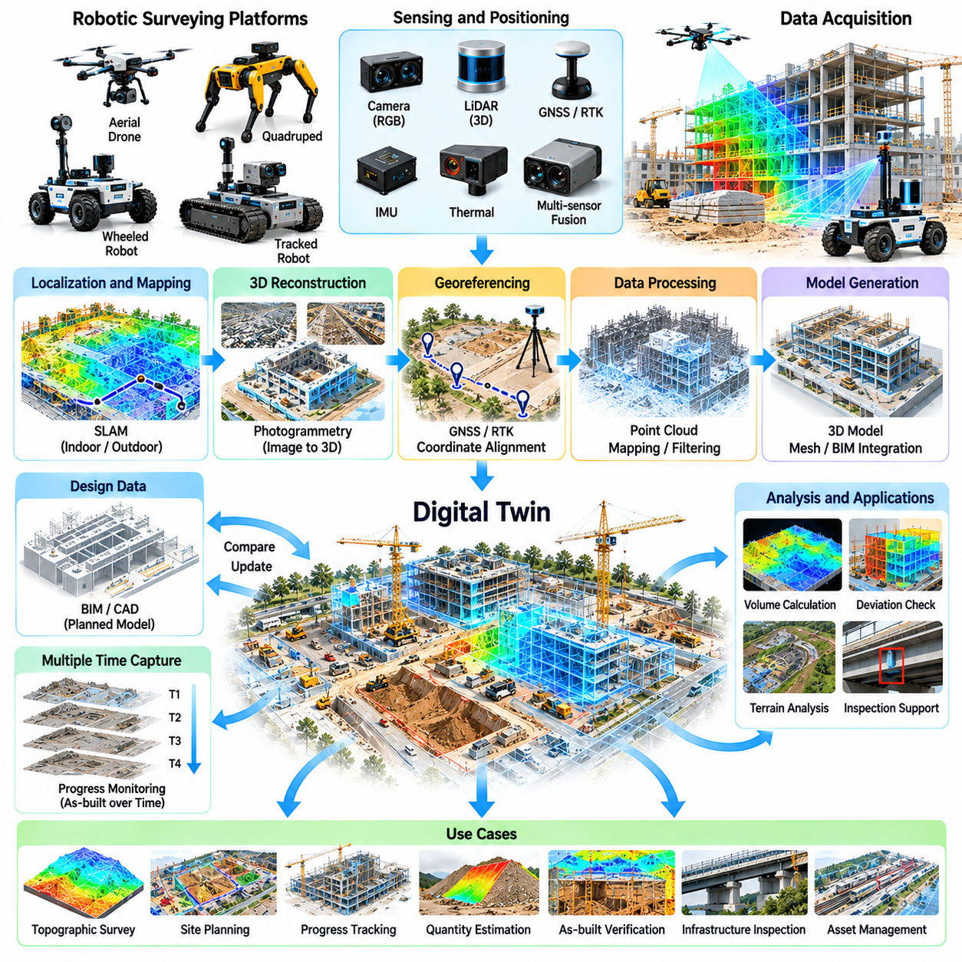
Surveying, mapping, and digital twin capture represent foundational applications of Physical AI in construction and infrastructure management. These technologies transform physical environments into measurable digital representations that support planning, execution, inspection, and maintenance. Autonomous robotic platforms can collect spatial information repeatedly, reducing manual surveying effort while improving the frequency and consistency of site observations.
Traditional construction surveying relies on specialized instruments and skilled personnel to establish coordinates, measure terrain, and verify structural geometry. Physical AI extends these capabilities through autonomous mobility, intelligent sensing, and automated data processing. Robotic systems can navigate designated areas, acquire measurements, and update digital site records while adapting to changing environmental conditions.
Autonomous surveying systems combine mobile platforms with LiDAR, cameras, GNSS receivers, inertial sensors, and other measurement instruments. Each sensor provides complementary information about geometry, appearance, and spatial position. Sensor fusion enables robots to generate coordinated observations while compensating for individual sensor limitations, supporting reliable mapping across complex construction environments.
LiDAR-based mapping provides three-dimensional measurements of terrain, structures, equipment, and surrounding objects. Laser returns generate point clouds that represent visible surfaces and geometric features. These datasets support terrain reconstruction, dimensional analysis, and structural inspection. Measurement accuracy depends on sensor calibration, positioning quality, scanning geometry, and environmental conditions.
Photogrammetry reconstructs spatial information from overlapping images captured by ground robots or aerial platforms. Image processing algorithms identify corresponding features and estimate camera positions to generate three-dimensional models. Photogrammetric outputs can provide detailed visual textures alongside geometric information, although reconstruction quality depends on illumination, image overlap, surface characteristics, and camera calibration.
Simultaneous Localization and Mapping enables robotic surveying when reliable external positioning is unavailable. SLAM algorithms estimate robot motion while constructing maps from sensor observations. Construction environments complicate this process because temporary structures, moving equipment, and changing material stockpiles can alter the scene. Robust systems must distinguish persistent landmarks from transient environmental features.
Outdoor surveying frequently uses GNSS and Real-Time Kinematic positioning to establish geographically referenced measurements. RTK corrections can improve positioning accuracy when satellite reception and correction availability are sufficient. However, urban canyons, tunnels, steel structures, and partially enclosed buildings may degrade performance. Hybrid localization combines satellite positioning with LiDAR, inertial sensing, and local mapping.
Coordinate system management is essential for integrating robotic measurements with engineering designs. Survey data may originate in local robot frames, site coordinate systems, or geographic references. Accurate transformation between these representations requires calibration, control points, and consistent reference definitions. Errors in coordinate alignment can propagate into construction verification, quantity estimation, and digital twin updates.
Autonomous aerial surveying provides efficient coverage of large construction sites and infrastructure corridors. Unmanned aerial vehicles can capture overhead imagery, terrain geometry, and structural observations from locations difficult to access from the ground. Flight planning must consider required resolution, image overlap, environmental conditions, obstacles, and regulatory restrictions while maintaining safe operational boundaries.
Ground-based mobile mapping complements aerial surveying by capturing surfaces and structural details that overhead sensors cannot observe effectively. Wheeled robots, tracked platforms, and quadrupeds can collect measurements along roads, inside buildings, and through accessible infrastructure passages. Platform selection depends on terrain conditions, sensor payload, measurement stability, and the accessibility of target inspection locations.
Digital twin capture extends conventional mapping by connecting measured geometry with structured information about physical assets. A digital twin may combine three-dimensional models, asset identifiers, construction status, inspection observations, and operational measurements. Its usefulness depends on maintaining correspondence between the physical environment and digital representation rather than simply generating visually detailed models.
Building Information Modeling provides a structured reference for interpreting robot-generated spatial measurements. BIM models describe planned geometry, component relationships, and construction information. Registered point clouds and reconstructed surfaces can be compared with these references to identify geometric deviations, missing components, and potential installation discrepancies. Reliable comparison requires consistent coordinates and suitable measurement tolerances.
Construction progress monitoring benefits from repeated surveying at defined intervals. Comparing successive scans allows project teams to observe changes in terrain, structural completion, and material placement. Automated change detection can highlight regions where physical conditions differ from previous observations or planned construction stages. Interpretation must distinguish actual progress from temporary equipment and measurement artifacts.
Earthwork measurement represents an important commercial application of robotic mapping. Three-dimensional terrain models can support calculations of excavation volumes, fill quantities, and surface elevation differences. Repeated surveys provide evidence of material movement and construction progress. Accuracy depends on terrain coverage, reference surfaces, point-cloud quality, and appropriate treatment of inaccessible or occluded regions.
Infrastructure inspection uses digital capture to establish geometric and visual records of bridges, tunnels, roads, and industrial facilities. Repeated measurements can support comparisons of surface conditions and structural geometry over time. However, geometric change alone does not establish structural integrity. Engineering assessment may require additional measurements, material testing, and interpretation by qualified specialists.
Data registration is necessary when combining observations from multiple robots, sensors, or surveying sessions. Point-cloud alignment and image registration techniques estimate transformations between overlapping datasets. Registration quality depends on stable reference features, sufficient overlap, and reliable calibration. Automated validation should identify uncertain alignments before the resulting data are incorporated into engineering records.
Digital twin updating requires more than transferring raw sensor measurements into storage systems. Processing pipelines must filter noise, classify relevant objects, reconstruct surfaces, and associate observations with existing assets. Semantic information allows users to distinguish structural components, temporary equipment, terrain, and construction materials. This transformation converts geometric data into operationally meaningful information.
Artificial intelligence can improve mapping workflows through object recognition, semantic segmentation, anomaly detection, and automated feature extraction. Learning-based models may identify construction elements or prioritize regions requiring further inspection. Nevertheless, their outputs must be evaluated for uncertainty and potential classification errors, particularly when used for engineering verification or safety-related decisions.
Cloud, edge, and on-premise computing architectures support different stages of digital twin capture. Edge systems can perform immediate sensor processing and navigation, while centralized computing resources handle large-scale reconstruction and historical comparison. Network limitations and data volumes influence where processing occurs. Efficient architectures balance latency, storage cost, computational demand, and data security.
Data governance is essential because construction scans may contain proprietary designs, worker imagery, equipment information, and sensitive infrastructure details. Access controls, encryption, retention policies, and traceable data ownership help protect these records. Version management and provenance tracking also ensure that engineering teams can identify when measurements were collected and which processing methods produced each model.
Survey quality assurance requires systematic evaluation of accuracy, completeness, repeatability, and consistency. Reference control points, calibration procedures, coverage analysis, and independent measurements can reveal systematic errors. Automated quality indicators should accompany generated maps so users understand measurement limitations. Critical engineering decisions must rely on validated data rather than visual appearance alone.
The economic value of autonomous surveying depends on measurement frequency, site size, labor requirements, and the importance of timely information. Repeated robotic capture may reduce fieldwork effort and accelerate progress reporting. Financial evaluation should include equipment acquisition, sensor calibration, processing infrastructure, software integration, supervision, and data management alongside potential productivity improvements.
Deployment should begin with clearly defined surveying objectives and measurable acceptance criteria. Initial applications may include terrain mapping, progress documentation, and repetitive inspection capture. More advanced digital twin workflows can be introduced after demonstrating reliable localization, coordinate alignment, measurement accuracy, and integration with engineering information systems.
Surveying, mapping, and digital twin capture ultimately establish the information foundation for intelligent construction operations. By connecting autonomous sensing, spatial reconstruction, engineering models, and continuous data updates, Physical AI enables construction organizations to maintain more accurate representations of changing physical environments. These capabilities support better coordination, verification, maintenance planning, and evidence-based project decisions.

06.06. CAD to Site and Scan to Model Workflows
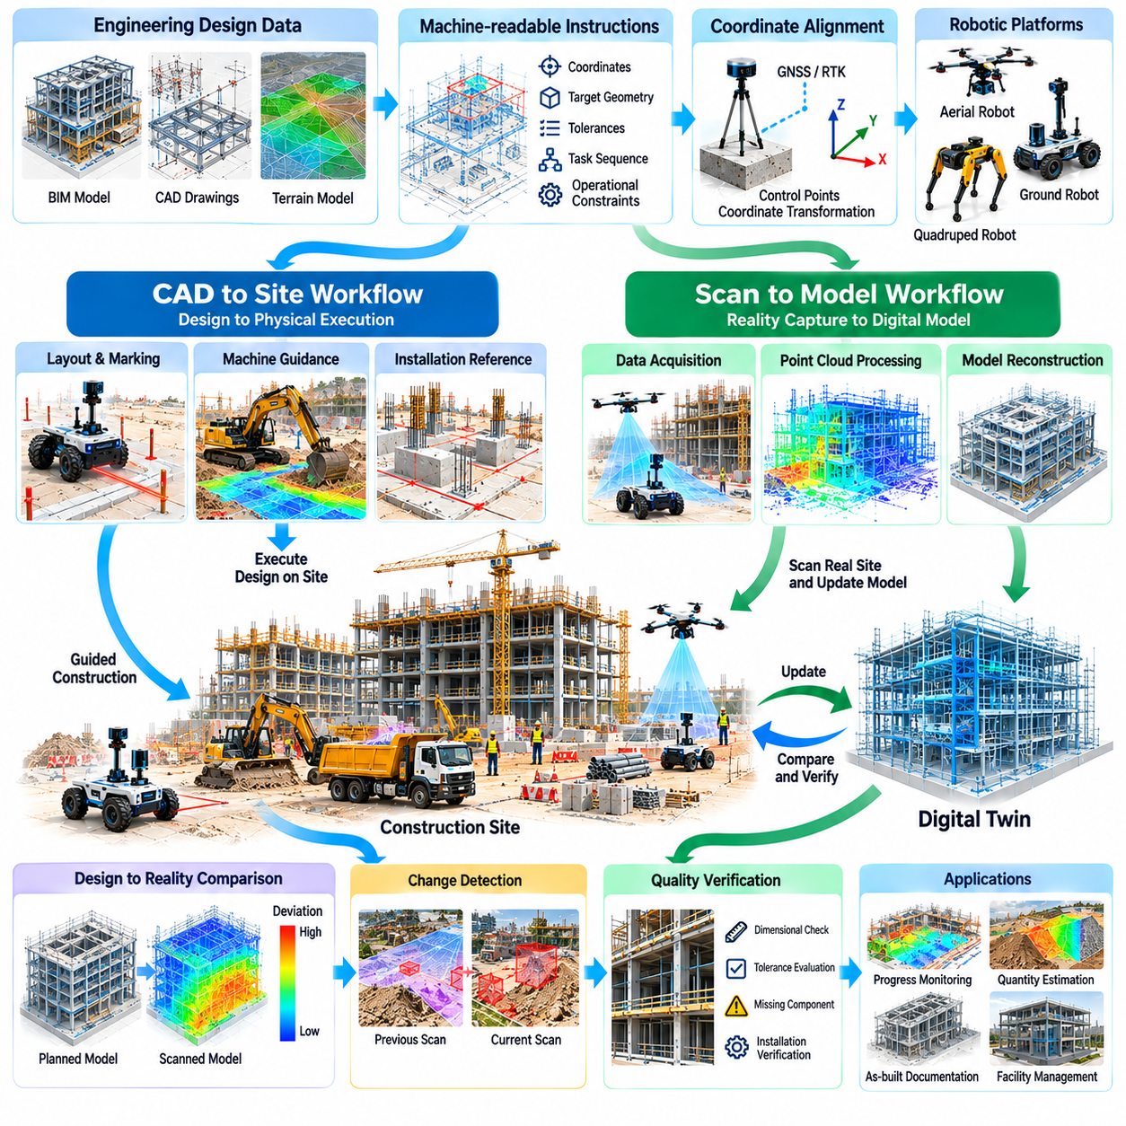
CAD-to-Site and Scan-to-Model workflows establish a bidirectional connection between digital engineering designs and physical construction environments. CAD-to-Site transfers planned geometry into executable field references, while Scan-to-Model converts measured site conditions into structured digital representations. Physical AI integrates these workflows through autonomous sensing, localization, geometric reasoning, and construction verification.
CAD-to-Site begins with engineering information contained in CAD drawings, terrain models, and Building Information Modeling systems. These sources define dimensions, elevations, component locations, and construction boundaries. Before robotic execution, design information must be transformed into machine-readable instructions that specify coordinate references, target geometries, allowable tolerances, and relevant operational constraints.
Coordinate alignment is fundamental because engineering models and robotic systems may use different spatial reference frames. Design coordinates must correspond accurately to physical control points and site positioning systems. Transformation errors can cause misplaced markings, incorrect excavation boundaries, or inaccurate component installation. Reliable workflows therefore require surveyed references, calibration procedures, and coordinate validation.
Autonomous construction robots can translate digital design information into physical layout operations. Mobile platforms equipped with positioning sensors and marking mechanisms may identify wall lines, equipment foundations, installation points, and construction boundaries. Automated layout reduces repetitive manual measurement, but its accuracy depends on localization quality, mechanical calibration, surface conditions, and verified design references.
CAD-to-Site workflows also support autonomous equipment guidance. Excavators, graders, and other construction machines can interpret digital terrain surfaces and target geometries to guide physical operations. Machine controllers compare measured positions with planned references and adjust movements accordingly. This connection enables design-driven execution while requiring continuous monitoring of operating limits and site conditions.
Scan-to-Model begins with physical measurements acquired through LiDAR, photogrammetry, structured-light sensing, or conventional surveying instruments. Ground robots and aerial platforms can capture geometry from different viewpoints. The resulting point clouds and images provide evidence of actual construction conditions, although raw measurements require registration, filtering, and interpretation before becoming useful engineering models.
Point-cloud processing transforms large collections of spatial measurements into consistent geometric datasets. Noise removal, outlier filtering, downsampling, and coordinate registration improve usability while preserving relevant details. Surface reconstruction can produce meshes or simplified geometric primitives. Processing parameters must reflect measurement objectives because excessive simplification may conceal important deviations.
Scan-to-Model reconstruction requires identifying meaningful construction elements within measured geometry. Structural columns, beams, walls, pipes, floors, and mechanical installations must be distinguished from temporary objects and background surfaces. Semantic segmentation and object recognition can assist this process. However, incomplete visibility and irregular site conditions can produce uncertain classifications requiring verification.
Model generation may involve fitting geometric primitives, reconstructing surfaces, and associating detected components with engineering attributes. Automated methods can estimate dimensions, orientations, and spatial relationships from scan data. Yet geometric reconstruction does not automatically establish material properties, design intent, or asset identity. These attributes require reliable references, metadata, or additional inspection information.
Design-to-reality comparison connects CAD-to-Site and Scan-to-Model into a continuous verification process. Registered measurements can be compared with planned geometry to identify dimensional differences, alignment errors, and missing components. Deviation analysis may calculate distances between measured surfaces and design references. Results must account for measurement uncertainty and applicable construction tolerances.
Construction tolerances determine whether observed differences represent acceptable variation or potential defects. Different structural and mechanical components require different acceptance criteria. A deviation that is insignificant for rough earthworks may be unacceptable for precision equipment installation. Automated verification systems must therefore apply component-specific requirements rather than treating every geometric difference as an error.
Change detection supports progress monitoring by comparing scans collected at different construction stages. Newly installed components, removed temporary structures, and modified terrain can be identified through spatial comparison. Temporal analysis helps distinguish construction progress from unexpected changes. Reliable interpretation requires consistent registration, sufficient scan coverage, and awareness of temporary site activities.
Physical AI enables robotic inspection routes to be planned directly from engineering models. Digital geometry can identify areas requiring measurement, inspection viewpoints, and accessible navigation corridors. Robots may select sensor positions to reduce occlusion and improve coverage. Adaptive planning can request additional measurements when uncertainty remains high or important structural features are insufficiently observed.
Occlusion presents a major challenge because construction environments contain overlapping structures, stored materials, and restricted access areas. A scan may capture only a portion of an installed component, making complete reconstruction uncertain. Multi-view sensing and repeated site visits can improve coverage. Digital models should explicitly distinguish observed geometry from inferred or unverified regions.
Interoperability between CAD, BIM, robotic mapping, and construction management systems is essential for scalable workflows. Different software platforms may represent geometry, coordinate systems, component identities, and metadata differently. Open exchange formats and standardized interfaces can reduce integration effort. Nevertheless, information loss and inconsistent model interpretation remain important implementation risks.
Digital thread architectures connect design revisions, robotic instructions, field measurements, and verification results through traceable information relationships. Each construction activity can be associated with a design version and corresponding observation records. This traceability helps teams understand whether a discrepancy originates from execution, measurement, or outdated design information.
Version control becomes critical when engineering designs change during construction. Robots operating from obsolete models may mark incorrect locations or execute outdated tasks. Updated design information must be validated, distributed, and associated with the correct work packages. Configuration management should prevent conflicting instructions and preserve historical records of approved construction changes.
Quality assurance requires more than visually comparing a point cloud with a CAD model. Measurement accuracy, calibration status, registration confidence, sensor coverage, and processing history must be evaluated. Independent reference measurements may be necessary for critical dimensions. Automated reports should communicate uncertainty and distinguish confirmed deviations from areas requiring further investigation.
Edge and cloud computing can distribute processing across robotic platforms and centralized engineering systems. Edge devices support localization, immediate measurement feedback, and basic deviation detection. Centralized resources can perform large-scale reconstruction, model comparison, and historical analysis. Data synchronization must maintain consistent coordinate references, timestamps, and model versions.
Artificial intelligence can automate repetitive tasks such as feature matching, component recognition, geometric fitting, and anomaly prioritization. Learning-based methods may accelerate conversion between unstructured scans and structured models. However, training data limitations and changing construction environments can reduce reliability. Human review remains important when automated interpretations influence engineering acceptance decisions.
Operational integration requires clear responsibilities among designers, surveyors, construction supervisors, and robotic system operators. Design teams define approved references, surveying personnel validate spatial control, and construction teams respond to detected discrepancies. Robotic platforms provide measurements and execution support, but engineering accountability must remain clearly assigned throughout the workflow.
Economic benefits may arise from reduced layout effort, earlier detection of installation errors, improved progress visibility, and lower rework costs. The value depends on project complexity, measurement frequency, integration quality, and the cost of correcting defects. Total cost evaluation must include sensing equipment, robotic platforms, software licenses, computing infrastructure, calibration, training, and ongoing maintenance.
Deployment should begin with limited workflows that have clear geometry, accessible measurement locations, and measurable acceptance criteria. Automated layout verification, floor-level mapping, and structural alignment checks provide practical examples. More advanced applications can expand toward autonomous equipment guidance and continuous digital twin updating after accuracy, interoperability, and operational reliability are demonstrated.
CAD-to-Site and Scan-to-Model ultimately create a closed information loop between engineering intent and physical construction outcomes. Digital designs guide robotic actions, while autonomous measurements update representations of actual site conditions. By integrating geometric alignment, intelligent sensing, model reconstruction, and quality verification, Physical AI supports more accurate, traceable, and adaptive construction processes.

06.07. Infrastructure Inspection
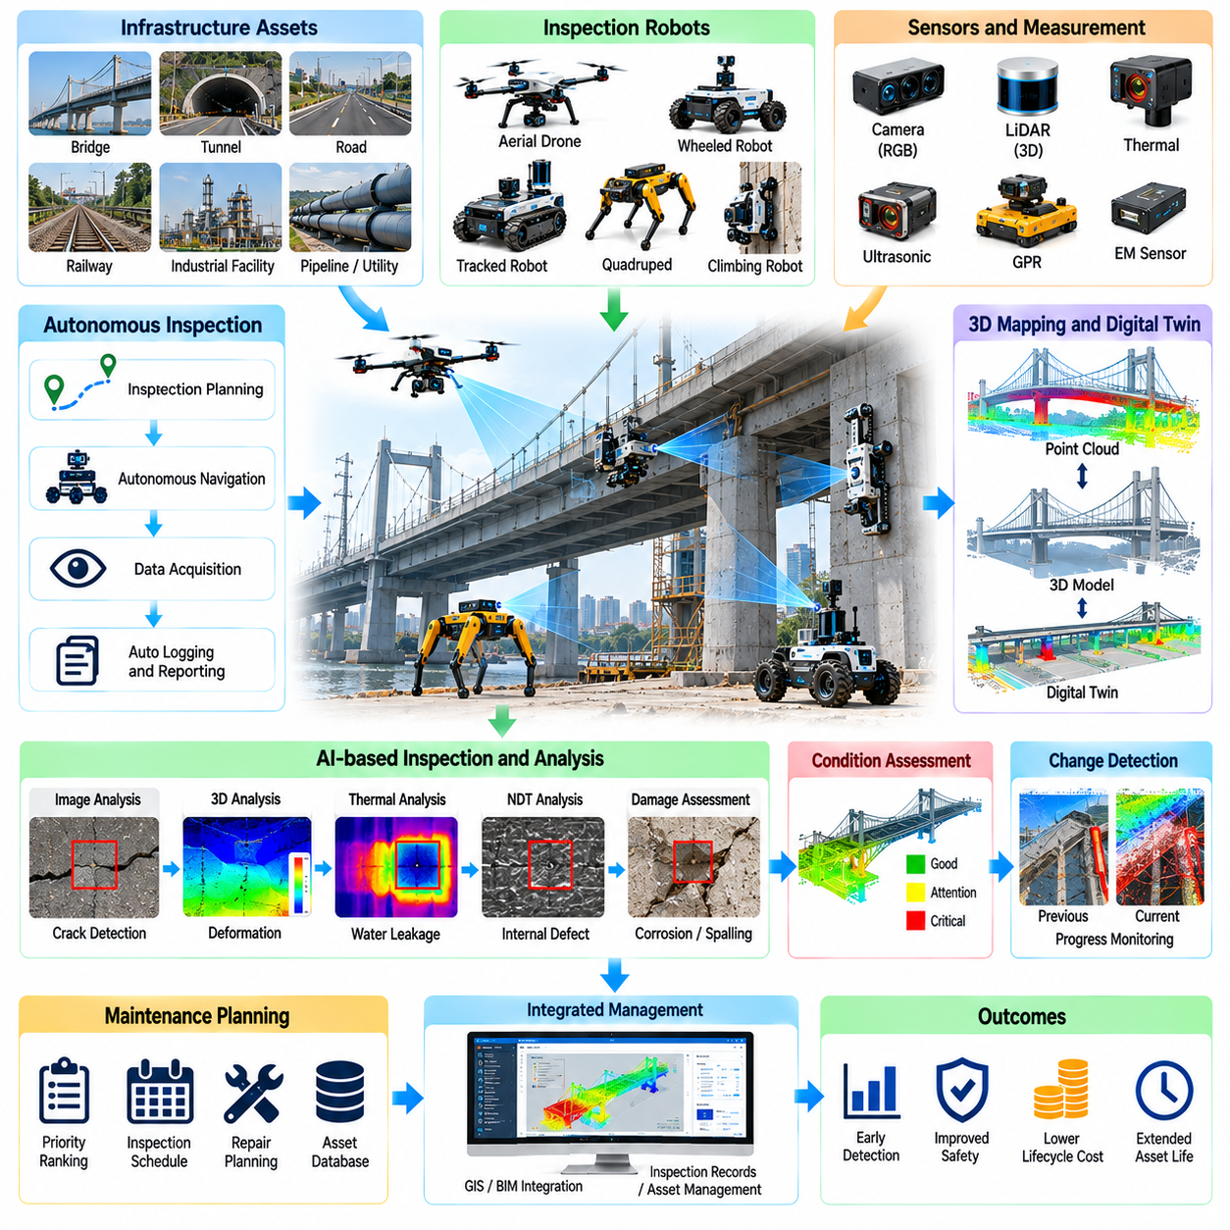
Infrastructure inspection is a critical application of Physical AI because bridges, tunnels, roads, pipelines, utilities, and industrial facilities require continuous assessment throughout their operational lifetimes. Traditional inspection relies heavily on human observation and specialized access equipment. Autonomous robotic systems can improve inspection frequency, reduce hazardous exposure, and provide consistent measurements for infrastructure condition assessment.
Infrastructure assets experience deterioration through environmental exposure, mechanical loading, corrosion, fatigue, vibration, and material aging. Inspection systems must identify visible defects and measurable changes that may indicate developing problems. Physical AI combines autonomous mobility, intelligent sensing, and data analysis to collect evidence of asset condition while supporting engineers responsible for maintenance and structural safety decisions.
Robotic inspection platforms include wheeled mobile robots, tracked vehicles, quadrupeds, aerial robots, and specialized climbing systems. Each platform offers different mobility and sensing capabilities. Ground robots can inspect accessible surfaces and enclosed passages, while aerial systems can observe elevated structures. Platform selection depends on asset geometry, access restrictions, environmental hazards, and measurement requirements.
Visual inspection remains an important foundation of infrastructure assessment. High-resolution cameras can capture cracks, corrosion, surface deformation, water leakage, and material deterioration. Computer vision algorithms may identify suspicious regions and classify visible anomalies. However, image-based observations depend on lighting, camera resolution, viewing angle, and surface conditions, requiring appropriate verification before engineering conclusions are established.
Three-dimensional sensing provides geometric information that complements visual inspection. LiDAR and photogrammetry can reconstruct infrastructure surfaces and measure spatial relationships between components. Repeated scans may reveal deformation, displacement, or changes in structural geometry. Measurement reliability depends on sensor calibration, coordinate registration, environmental conditions, and the stability of reference measurements.
Non-destructive testing extends inspection beyond visible surface characteristics. Ultrasonic sensing, thermal imaging, ground-penetrating radar, and electromagnetic methods can provide information about selected subsurface or material conditions. These techniques require application-specific calibration and interpretation. Robotic integration improves access and measurement repeatability but does not eliminate the limitations of individual sensing technologies.
Autonomous navigation is challenging because infrastructure environments frequently contain narrow passages, uneven surfaces, obstacles, and limited positioning references. Robots must estimate their locations while avoiding collisions and maintaining stable sensor operation. SLAM, inertial sensing, LiDAR, and visual localization can support navigation where satellite positioning is unavailable. Reliable recovery procedures are essential when localization confidence decreases.
Inspection planning determines which asset regions require observation and how robotic platforms should access them. Digital asset models, historical inspection records, and risk classifications can guide route generation and sensor placement. Coverage planning should account for structural complexity, measurement resolution, accessibility, and inspection priorities. Adaptive systems may revisit uncertain regions or request additional observations.
Defect detection algorithms can assist inspectors by identifying cracks, corrosion, spalling, leakage, and other visible deterioration patterns. Deep learning models can process large image collections and prioritize suspicious observations for review. Their performance depends on representative training data and consistent image quality. False detections and missed defects must be evaluated before automated outputs influence maintenance decisions.
Crack measurement illustrates the importance of connecting detection with quantitative assessment. Identifying a crack in an image does not automatically establish its physical width, depth, or structural significance. Accurate measurement requires geometric calibration, suitable imaging resolution, and appropriate viewing conditions. Structural interpretation must consider crack location, material properties, loading conditions, and historical development.
Repeated robotic inspections support temporal condition monitoring by comparing measurements collected over months or years. Changes in crack patterns, corrosion extent, surface geometry, and moisture indicators may reveal deterioration trends. Reliable comparison requires consistent measurement procedures and spatial alignment. Apparent changes caused by illumination, sensor noise, or environmental variation must be distinguished from actual asset deterioration.
Digital twins provide a framework for connecting inspection observations with infrastructure asset information. Geometric models can be associated with component identifiers, inspection histories, defect records, and maintenance activities. Robot-generated observations update these records and support spatial visualization of asset condition. Effective digital twins require traceable measurements and consistent relationships between physical components and digital representations.
Condition assessment transforms raw inspection data into information that supports maintenance planning. Detected anomalies may be categorized by location, severity indicators, progression, and potential operational consequences. Risk-based inspection strategies can prioritize assets with greater exposure or suspected deterioration. Nevertheless, automated condition scores should support rather than replace qualified engineering judgment.
Infrastructure inspection frequently involves environments that are hazardous or difficult for human personnel to access. Elevated structures, confined spaces, unstable surfaces, contaminated areas, and active industrial facilities create significant safety concerns. Robotic systems can reduce direct human exposure, but deployment still requires hazard assessment, emergency procedures, and compliance with applicable site safety requirements.
Remote inspection allows operators to supervise robotic platforms from safer locations while receiving sensor observations and operational status. Communication systems must support reliable control, data transmission, and emergency intervention. Underground facilities and reinforced structures may restrict wireless connectivity. Autonomous fallback behaviors and communication recovery procedures are therefore important for maintaining safe operation.
Sensor payload integration influences the inspection capabilities and operating duration of robotic platforms. High-resolution cameras, LiDAR, thermal sensors, and specialized testing instruments introduce weight, power, and calibration requirements. Payload design must balance measurement performance with mobility and endurance. Stable sensor mounting and synchronized data acquisition improve the reliability of multi-sensor inspection results.
Inspection data management becomes increasingly important when robotic systems generate large quantities of images, point clouds, and sensor measurements. Structured storage should associate observations with asset identifiers, timestamps, locations, and equipment configurations. Data quality controls can identify incomplete coverage or unreliable measurements. Traceable records enable engineers to review findings and compare inspection results over time.
Artificial intelligence can improve inspection efficiency through automated image filtering, anomaly detection, defect classification, and change analysis. Learning-based systems may reduce the effort required to review extensive inspection datasets. However, unusual damage mechanisms and limited training examples can create uncertainty. Human verification remains essential for critical findings and decisions affecting public safety.
Fleet-scale inspection introduces opportunities for coordinating multiple robotic platforms across distributed infrastructure assets. Inspection tasks can be assigned according to robot capabilities, asset accessibility, sensor requirements, and operational schedules. Centralized management systems may track mission completion, equipment condition, and collected data. Standardized reporting improves consistency across different inspection locations.
Quality assurance requires documented calibration, inspection coverage, measurement uncertainty, and repeatability. Reference measurements and independent verification can help establish confidence in robotic inspection results. Automated reports should distinguish confirmed defects from suspected anomalies and unobserved regions. Inspection completeness must be evaluated against defined requirements rather than assuming that successful robot navigation guarantees adequate coverage.
Maintenance integration connects inspection findings with asset management and work-order systems. Identified defects can trigger engineering review, additional testing, repair planning, or scheduled monitoring. Historical inspection information supports prioritization of limited maintenance resources. The value of Physical AI increases when inspection data lead to timely decisions rather than remaining isolated within technical databases.
The economic justification for robotic infrastructure inspection depends on inspection frequency, access costs, asset criticality, and the consequences of undetected deterioration. Potential benefits include reduced scaffolding requirements, shorter inspection interruptions, improved documentation, and lower exposure to hazardous environments. Total cost of ownership must include robotic equipment, sensors, software, operator training, maintenance, data processing, and engineering verification.
Deployment should begin with clearly defined inspection objectives, accessible assets, and measurable performance requirements. Pilot projects can compare robotic observations with established inspection methods to evaluate coverage, defect detection, and measurement accuracy. Expansion into complex or safety-critical infrastructure should follow demonstrated reliability, validated inspection procedures, and appropriate engineering acceptance.
Infrastructure inspection ultimately demonstrates how Physical AI can connect autonomous sensing with long-term asset management. Robots provide repeatable access and structured observations, while intelligent analysis helps transform measurements into actionable information. By integrating robotic mobility, multi-modal sensing, digital twins, and engineering workflows, infrastructure organizations can improve inspection consistency, maintenance planning, and operational resilience.

06.08. Bridge Tunnel and Railway Inspection
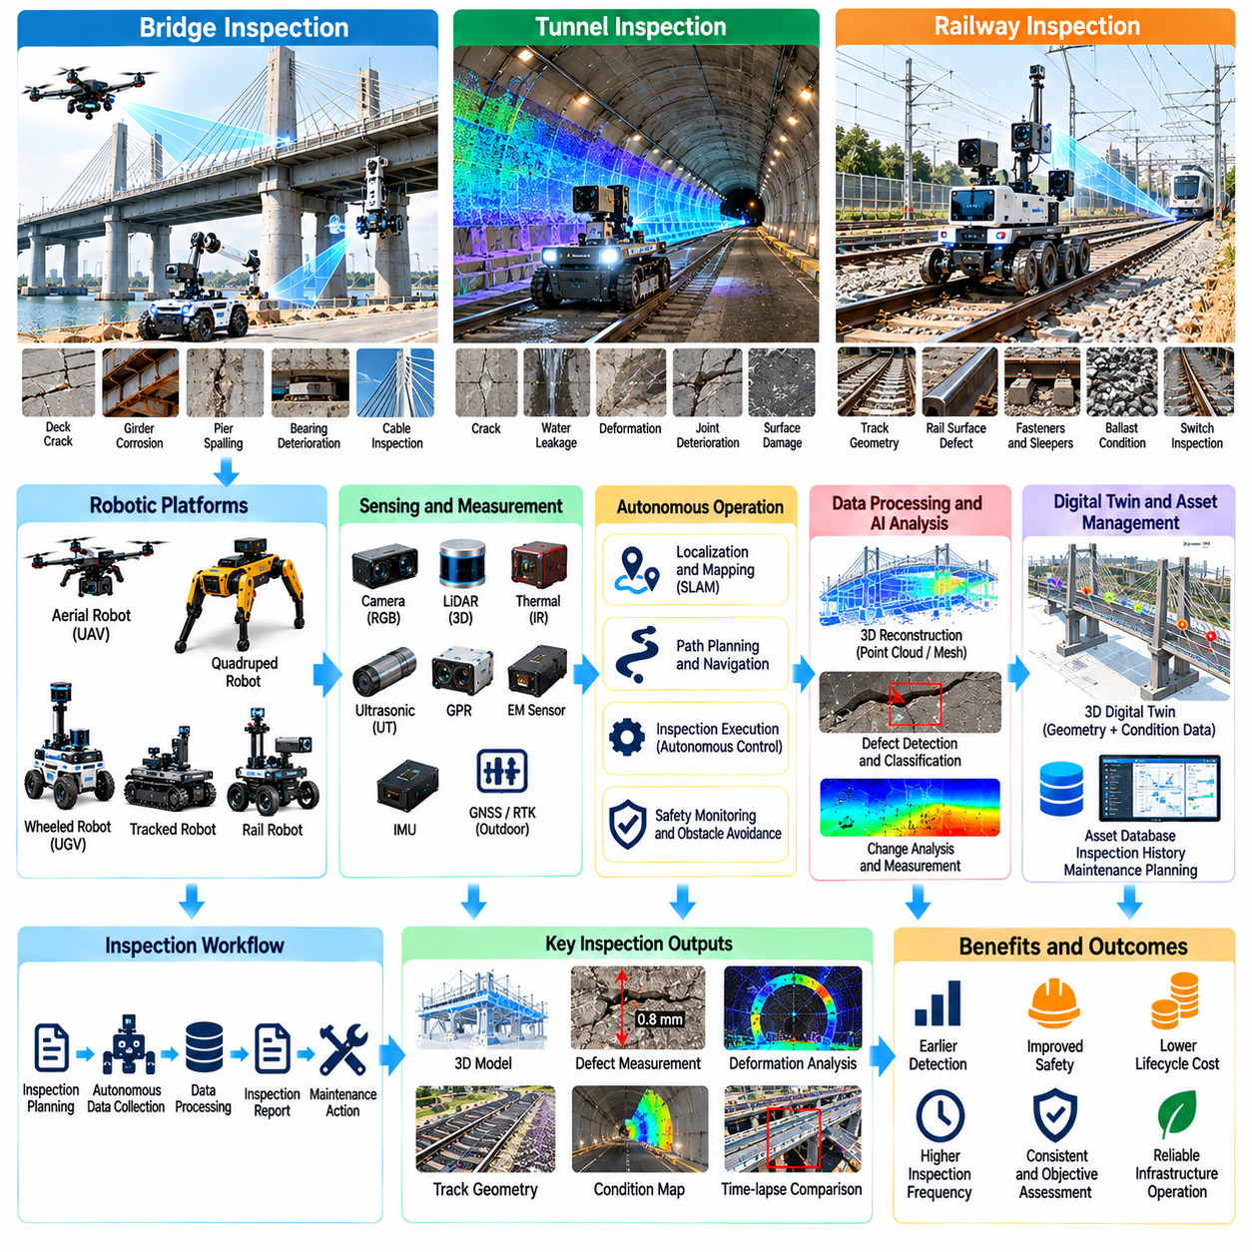
Bridge, tunnel, and railway inspection represents a critical application of Physical AI because these infrastructure systems support essential transportation networks and require continuous structural assessment. Aging materials, environmental exposure, repeated loading, and operational wear create deterioration risks. Autonomous robotic inspection can improve monitoring frequency, reduce hazardous human access, and provide consistent evidence for maintenance decisions.
Bridge inspection involves evaluating structural components such as decks, girders, piers, bearings, joints, cables, and foundations. Different components experience distinct deterioration mechanisms, including corrosion, fatigue cracking, concrete spalling, and displacement. Physical AI systems must combine appropriate sensing technologies with reliable positioning to document defects and associate observations with specific structural elements.
Aerial robots provide access to elevated bridge components and surfaces that are difficult to inspect using conventional equipment. Multirotor platforms can capture images of towers, cables, and selected underside regions while maintaining controlled observation distances. Flight stability, wind exposure, obstacle proximity, and satellite signal limitations influence inspection quality. Safe operations require appropriate clearance and validated flight procedures.
Ground robots and climbing platforms complement aerial inspection by examining bridge decks, support structures, and accessible enclosed spaces. Magnetic adhesion, mechanical gripping, or specialized locomotion may enable inspection of selected steel surfaces. These platforms can carry cameras, ultrasonic sensors, and other instruments. Their effectiveness depends on surface conditions, attachment reliability, payload capacity, and recovery provisions.
Bridge deck assessment may combine visual imaging, geometric measurement, and non-destructive testing to identify surface deterioration and potential internal defects. Cameras can document cracking and spalling, while ground-penetrating radar may provide information about subsurface features under suitable conditions. Interpretation requires calibration and engineering expertise because sensor anomalies do not necessarily establish structural damage.
Tunnel inspection presents different challenges because enclosed environments restrict satellite positioning, communication, and equipment access. Tunnel linings may exhibit cracks, water infiltration, deformation, joint deterioration, and localized material damage. Autonomous platforms must operate within confined geometries while maintaining reliable localization and consistent sensor coverage. Inspection procedures must also accommodate operational restrictions and emergency access requirements.
Mobile tunnel inspection systems may integrate LiDAR, high-resolution cameras, thermal sensors, and inertial navigation. Three-dimensional scans can reconstruct tunnel profiles and identify geometric irregularities, while imagery supports surface condition documentation. Repeated measurements can reveal changes over time. Reliable comparisons require consistent coordinate registration, sensor calibration, and awareness of environmental influences.
Water leakage is an important tunnel maintenance concern because persistent moisture can contribute to corrosion, material degradation, and operational hazards. Visual and thermal observations may help identify suspicious wet regions or temperature differences. However, temperature patterns depend on ventilation and environmental conditions. Confirming leakage sources often requires additional investigation and appropriate engineering assessment.
Tunnel navigation commonly relies on LiDAR-based SLAM, visual odometry, and inertial sensing because GNSS signals are unavailable underground. Repetitive tunnel geometry can create localization ambiguity, particularly in long corridors with limited distinctive features. Reference markers, surveyed control points, and sensor fusion can improve positioning reliability. Robots must also recognize restricted passages and unexpected obstacles.
Railway inspection focuses on track geometry, rail surfaces, fastening systems, sleepers, ballast, switches, and surrounding infrastructure. Repeated mechanical loading and environmental exposure can produce wear, deformation, and component deterioration. Physical AI platforms can collect measurements along railway corridors and support systematic condition monitoring. Inspection methods must reflect the operational and safety requirements of railway networks.
Track geometry measurement evaluates parameters such as gauge, alignment, longitudinal level, and crosslevel. Dedicated inspection vehicles and robotic platforms can combine position sensing with geometric measurement instruments. Deviations from applicable maintenance limits may indicate areas requiring attention. Reliable assessment depends on measurement accuracy, vehicle dynamics, operating speed, and the standards governing the specific railway system.
Rail surface inspection may use cameras, laser profiling, and specialized non-destructive testing to identify wear and potential defects. Computer vision can recognize selected visible anomalies, while ultrasonic or electromagnetic techniques may detect certain internal or near-surface conditions. No single sensor detects every defect type. Inspection strategies must combine complementary methods and qualified interpretation.
Railway fastening systems and sleepers require attention because their condition influences track stability and load transfer. Robotic imaging can identify missing fasteners, damaged components, and selected surface defects. Automated classification may prioritize suspicious observations for maintenance review. However, vegetation, contamination, shadows, and variations in component designs can reduce recognition reliability.
Ballast and trackbed conditions influence railway drainage, geometry retention, and structural support. Three-dimensional sensing and visual observations may reveal surface irregularities, fouling indicators, or localized deformation. Subsurface assessment may require additional sensing methods and engineering interpretation. Repeated surveys can support trend analysis, but observed surface changes do not independently establish underlying causes.
Railway corridor inspection extends beyond the track itself to bridges, tunnels, drainage structures, signals, and nearby vegetation. Mobile robotic systems can capture spatial information about clearance envelopes and potential obstructions. Integration with asset databases helps associate observations with specific infrastructure locations. Accurate georeferencing is essential when inspection findings must guide maintenance crews to precise sites.
Operational safety is particularly important when inspection robots operate near active railway lines or road traffic. Access permissions, protective procedures, exclusion zones, and coordination with infrastructure operators are essential. Autonomous systems must detect hazards and maintain safe behavior under communication or localization failures. Inspection scheduling should minimize disruption without compromising personnel or transportation safety.
Multi-modal sensing improves inspection completeness by combining visual, geometric, thermal, and material-related observations. Sensor fusion can connect detected anomalies with precise asset locations and supporting measurements. However, differences in sensor resolution, calibration, and observation conditions complicate interpretation. Quality assurance must verify that combined data remain spatially consistent and technically meaningful.
Digital twins provide a framework for organizing bridge, tunnel, and railway inspection information across asset lifecycles. Three-dimensional geometry can be linked with component identifiers, inspection histories, defect records, and maintenance actions. Repeated robotic observations update these representations. Effective digital twins require consistent asset references, documented measurement uncertainty, and reliable data versioning.
Artificial intelligence can support defect recognition, anomaly prioritization, condition classification, and temporal change detection. Learning-based models may reduce manual review effort across extensive inspection datasets. Nevertheless, unusual defects and limited training examples can produce missed detections or false alarms. Engineering validation remains necessary before automated findings are used to authorize repairs or operational restrictions.
Inspection planning should reflect asset criticality, deterioration history, accessibility, and operational constraints. Risk-based scheduling can prioritize locations with greater suspected deterioration or consequences of failure. Autonomous mission planning may optimize observation routes and sensor positioning while preserving required coverage. Uncertain findings should trigger additional measurements rather than unsupported conclusions.
Inspection data pipelines must preserve images, point clouds, sensor readings, timestamps, coordinates, and equipment configurations. Structured records support comparisons across inspection cycles and facilitate integration with maintenance management systems. Automated reports can summarize detected changes and identify areas requiring engineering review. Traceability is essential when findings influence safety-related decisions or long-term investment planning.
The economic value of robotic inspection depends on asset scale, inspection frequency, access costs, and operational disruption. Autonomous platforms may reduce reliance on scaffolding, specialized access vehicles, or extended closures for suitable tasks. Benefits also include improved documentation and repeatable measurements. Cost evaluation must account for equipment, sensing payloads, software, training, maintenance, supervision, and verification.
Deployment should begin with defined inspection targets and measurable performance requirements. Pilot studies can compare robotic measurements with established methods to assess defect detection, spatial accuracy, and coverage. Expansion into critical infrastructure requires validated safety procedures and demonstrated reliability. Human engineering oversight remains essential for interpreting findings and approving maintenance actions.
Bridge, tunnel, and railway inspection demonstrates how Physical AI can support safer and more systematic transportation infrastructure management. Autonomous mobility enables repeatable access, while intelligent sensing provides structured evidence of asset condition. By integrating robotic inspection, digital twins, and maintenance workflows, infrastructure operators can improve deterioration monitoring, resource allocation, and long-term operational resilience.

06.09. GPR and Underground Infrastructure Inspection
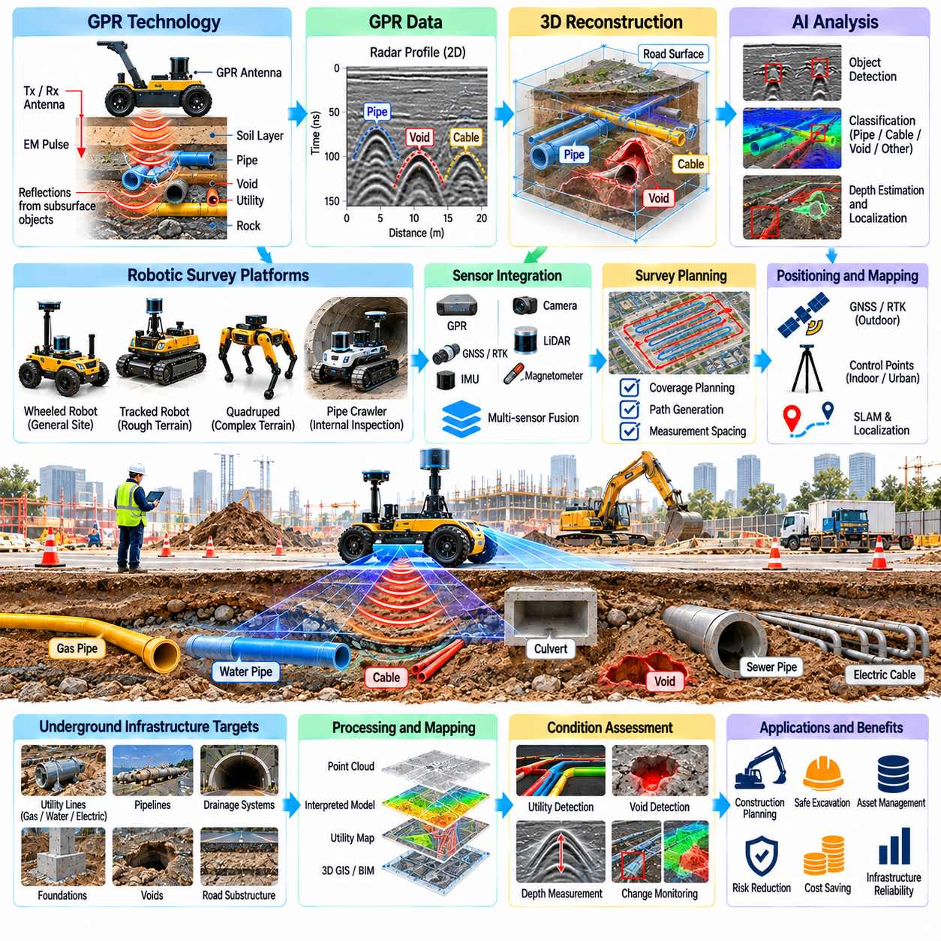
Ground-penetrating radar and underground infrastructure inspection are important applications of Physical AI because buried utilities, foundations, pipelines, and subsurface structures are difficult to assess directly. Conventional excavation is expensive, disruptive, and potentially hazardous. Autonomous robotic platforms equipped with geophysical sensors can collect subsurface measurements, improve asset documentation, and support safer construction and maintenance decisions.
Ground-penetrating radar, commonly called GPR, transmits electromagnetic pulses into the ground and records reflected signals from changes in material properties. Reflections may indicate buried objects, interfaces, voids, or variations in subsurface conditions. Signal interpretation depends on electromagnetic contrast, soil composition, moisture, and antenna frequency. GPR provides indirect evidence rather than a direct image of underground structures.
GPR systems typically include transmitting and receiving antennas, control electronics, positioning sensors, and data recording equipment. Antenna frequency influences the balance between spatial resolution and penetration depth. Higher frequencies generally provide finer detail but shallower penetration, while lower frequencies may reach greater depths with reduced resolution. Appropriate sensor selection depends on inspection objectives and expected ground conditions.
Physical AI enables GPR instruments to be integrated with autonomous mobile robots, tracked vehicles, and specialized field platforms. Robots can follow planned survey trajectories while maintaining controlled sensor movement and measurement spacing. Consistent motion improves data acquisition repeatability and supports systematic coverage. Platform design must consider terrain accessibility, sensor mounting height, vibration, and electromagnetic interference.
Underground utility detection is a major application because construction activities frequently encounter incomplete or outdated records of buried infrastructure. GPR surveys may reveal pipes, cables, conduits, and other subsurface objects when sufficient electromagnetic contrast exists. Detection performance varies with material composition and surrounding soil conditions. Non-detection does not establish that an area is free of buried utilities.
Utility mapping requires combining geophysical observations with accurate surface positioning. GNSS, real-time kinematic positioning, inertial navigation, and robotic localization can associate radar measurements with geographic coordinates. In environments with unreliable satellite signals, surveyed control points or local mapping systems may be necessary. Coordinate uncertainty must be documented because mapping errors can create excavation hazards.
GPR data are commonly represented as radar traces and two-dimensional profiles showing signal amplitude over travel time and survey distance. Buried objects may generate characteristic hyperbolic reflection patterns, although similar signatures can arise from other subsurface features. Processing techniques such as filtering, background removal, and migration can improve interpretation. Excessive processing may also introduce artifacts or suppress relevant signals.
Depth estimation requires knowledge of electromagnetic wave propagation velocity within the inspected material. Velocity depends strongly on dielectric properties and moisture conditions, which may vary across a construction site. Calibration using known targets, measured material properties, or suitable velocity estimation methods improves accuracy. Reported depths should include uncertainty rather than implying that radar measurements provide exact underground positions.
Three-dimensional subsurface reconstruction can be performed by combining multiple parallel or intersecting GPR survey lines. Spatial interpolation and volumetric processing may reveal patterns associated with buried structures or geological interfaces. Reconstruction quality depends on survey spacing, positioning accuracy, signal quality, and processing assumptions. Areas between measurement paths remain uncertain when coverage is insufficient.
Artificial intelligence can assist GPR interpretation through signal classification, hyperbola detection, anomaly localization, and pattern recognition. Machine learning models may reduce the manual effort required to examine extensive radar datasets. However, subsurface variability creates substantial differences between training and deployment conditions. Automated detections must be evaluated against verified field observations and measurement uncertainty.
Multi-sensor fusion improves underground inspection by combining GPR with electromagnetic utility locators, magnetometers, LiDAR, cameras, and positioning instruments. Each sensor provides different evidence about buried objects or surrounding conditions. Correlating observations can increase confidence in selected detections. Nevertheless, disagreement between sensors should be preserved as uncertainty rather than resolved through unsupported assumptions.
Underground infrastructure inspection also includes assessment of buried pipelines and drainage systems. Mobile robots may inspect accessible pipe interiors using cameras, LiDAR, or specialized sensing instruments. External GPR surveys can provide complementary information about surrounding soil and selected subsurface anomalies. Combining internal and external measurements supports broader condition assessment, although individual methods have different detection limits.
Void detection and ground stability assessment are important near roads, tunnels, foundations, and underground utilities. GPR may identify reflection patterns consistent with cavities, disturbed soil, or changes in material interfaces. Such patterns do not independently confirm the presence or dimensions of a void. Engineering interpretation may require complementary geophysical surveys, boreholes, or other ground investigation methods.
Autonomous survey planning determines measurement paths, sensor spacing, travel speed, and coverage requirements. Digital site maps and utility records can guide initial inspection routes. Adaptive planning may increase measurement density near suspicious anomalies or regions with insufficient data. Robots must account for surface obstacles, slopes, restricted areas, and changing terrain conditions while maintaining reliable data acquisition.
Inspection quality depends on maintaining consistent antenna coupling, sensor orientation, positioning accuracy, and acquisition parameters. Rough surfaces and varying antenna height can introduce measurement variability. Environmental conditions, including rainfall and soil moisture, may alter signal penetration and reflection characteristics. Quality assurance procedures should record equipment settings, calibration results, survey conditions, and coverage completeness.
Underground digital twins can integrate detected utilities, estimated depths, geological observations, and inspection histories into structured spatial models. These representations help construction teams understand potential subsurface constraints before excavation. Each mapped feature should include confidence levels, measurement sources, and relevant uncertainty. Digital twins must distinguish confirmed assets from inferred objects and unexplained radar anomalies.
Integration with CAD, BIM, and geographic information systems enables underground survey findings to support engineering design and construction planning. Detected infrastructure can be compared with proposed excavation boundaries, foundation locations, and utility installation routes. Potential conflicts may trigger design review or additional investigation. Accurate coordinate transformation and consistent asset identifiers are essential for reliable integration.
Construction safety is a central motivation for underground infrastructure inspection. Unexpected contact with buried electrical cables, gas pipelines, or pressurized utilities can create severe hazards. Robotic surveys may reduce uncertainty before excavation, but GPR alone cannot guarantee complete utility detection. Safe excavation requires appropriate records review, utility locating procedures, site controls, and physical verification where necessary.
Data management systems should preserve raw radar traces, processed profiles, positioning records, survey metadata, and interpretation results. Traceable datasets allow engineers to revisit uncertain findings and compare observations from different inspection campaigns. Automated reporting can summarize detected anomalies and recommended verification areas. Maintaining original measurements is important because processing methods and interpretation models may improve over time.
Fleet-scale deployment can coordinate multiple robotic survey platforms across construction sites, transportation corridors, and utility networks. Centralized systems may assign inspection tasks, monitor survey completion, and consolidate georeferenced datasets. Standardized acquisition procedures improve consistency between operators and locations. However, local soil conditions and asset configurations still require site-specific interpretation and validation.
Economic benefits may include reduced exploratory excavation, improved utility documentation, fewer construction interruptions, and earlier identification of subsurface risks. The value of autonomous inspection depends on survey area, ground conditions, required accuracy, and the consequences of missed detections. Total cost includes robotic platforms, GPR equipment, positioning systems, software, training, data processing, and field verification.
Deployment should begin with defined inspection objectives and representative ground conditions. Pilot surveys can compare robotic GPR results with known utilities, existing records, and independently verified measurements. Performance evaluation should consider detection probability, false alarms, localization error, coverage, and operational productivity. Expansion requires demonstrated reliability and procedures for handling uncertain or incomplete results.
GPR and underground infrastructure inspection demonstrate how Physical AI extends perception beyond directly visible environments. Autonomous mobility provides systematic survey coverage, while geophysical sensing and intelligent analysis generate evidence about hidden structures. By integrating uncertainty-aware interpretation, digital mapping, and engineering verification, these systems can support safer excavation, better infrastructure records, and more informed asset management.

06.10. Quadrupeds for Difficult Access Areas
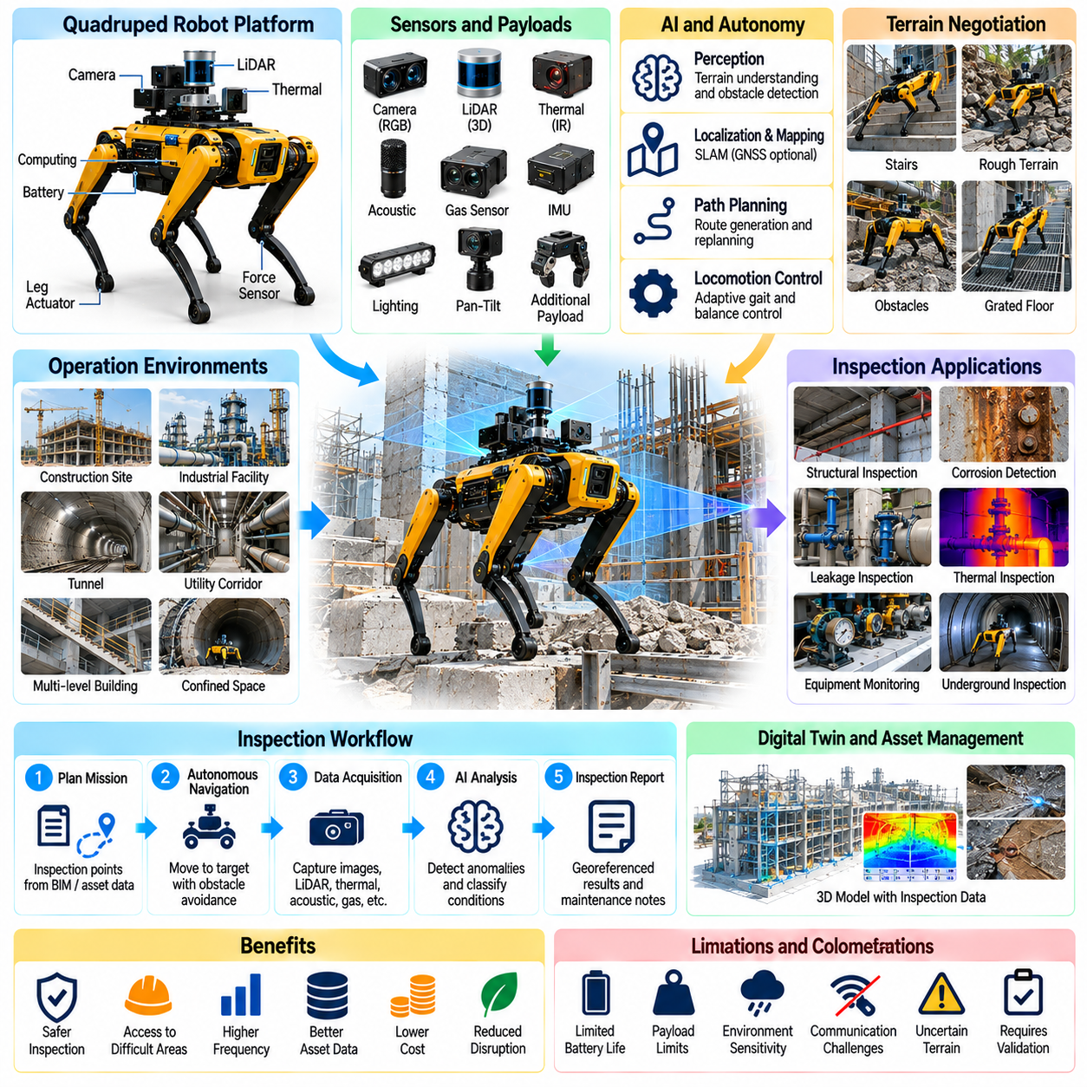
Quadruped robots provide an important Physical AI solution for inspecting construction and infrastructure environments where conventional wheeled platforms encounter mobility limitations. Their articulated legs enable movement across stairs, debris, uneven floors, and selected obstacles. By combining adaptive locomotion with autonomous perception, quadrupeds can extend robotic inspection into difficult-access areas while reducing direct human exposure to hazardous conditions.
Construction sites frequently contain temporary structures, loose materials, irregular surfaces, and changing access routes. These conditions make fixed-path automation and conventional mobile navigation difficult. Quadruped robots can adjust foothold placement and body posture to negotiate terrain variations. However, successful mobility depends on obstacle geometry, surface friction, payload weight, and the robot's mechanical and control capabilities.
Legged locomotion requires coordinated control of multiple joints while maintaining dynamic or quasi-static stability. Joint actuators, inertial sensors, force estimation, and motion controllers work together to regulate balance and movement. Physical AI can improve terrain interpretation and adaptive gait selection. Reliable operation also requires conservative limits on speed, joint loading, ground contact, and allowable body orientation.
Terrain perception is essential because difficult-access environments rarely provide uniform walking surfaces. LiDAR, stereo cameras, depth sensors, and inertial measurements can estimate local geometry and traversability. Perception algorithms identify steps, slopes, gaps, obstacles, and potential footholds. Uncertain surfaces or visually obscured hazards require cautious behavior because geometric appearance alone cannot guarantee adequate support.
Autonomous navigation integrates terrain maps with route planning and locomotion control. A high-level planner identifies accessible corridors and inspection targets, while local controllers adapt individual movements to nearby obstacles. Simultaneous Localization and Mapping supports navigation where satellite positioning is unavailable. Continuous replanning is necessary when construction materials, equipment, or personnel alter the environment.
Stair climbing is a distinctive capability of quadruped platforms in multi-level construction and industrial facilities. Robots can coordinate foot placement and body motion to ascend or descend suitable stairways without dedicated lifting equipment. Performance depends on step dimensions, traction, visibility, and available clearance. Stairway traversal must be validated for each platform rather than assumed from its general locomotion capabilities.
Quadrupeds can inspect tunnels, underground passages, utility corridors, and mechanical rooms where access is restricted. Their compact body configurations may allow movement through selected narrow routes and around equipment. Mounted cameras and environmental sensors provide remote observations. Nevertheless, confined-space deployment requires communication planning, atmospheric hazard assessment, emergency recovery procedures, and compliance with site access requirements.
Industrial infrastructure often contains elevated walkways, grated floors, cable trays, and complex piping networks. Quadrupeds may patrol accessible routes to inspect equipment and surrounding structures. Their ability to negotiate modest obstacles can reduce the need for extensive environmental modification. However, floor load limits, grating dimensions, exposed openings, and fall hazards must be evaluated before autonomous operation.
Inspection payloads can include high-resolution cameras, thermal imagers, acoustic sensors, gas detectors, and LiDAR systems. Visual sensors document corrosion, leakage, cracks, and equipment conditions, while thermal instruments identify temperature differences. Acoustic measurements may support selected machinery assessments. Each sensor has limitations, and abnormal readings require interpretation against operating conditions and validated inspection criteria.
Sensor integration introduces mechanical, electrical, and computational tradeoffs. Additional payload mass changes the robot's center of gravity, energy consumption, and locomotion performance. Vibration and body movement can degrade image quality or measurement stability. Payload design should account for mounting rigidity, calibration, synchronization, environmental protection, and the available power and computing resources.
Autonomous inspection missions can be generated from digital facility maps, construction models, and asset management databases. Inspection points are associated with equipment identifiers, required viewpoints, and sensing procedures. Quadrupeds navigate between locations and collect standardized observations. Mission planning should consider access restrictions, terrain difficulty, battery capacity, and the time required for reliable measurements.
Repeatable inspection is valuable because consistent observation positions support comparison across multiple inspection cycles. A quadruped can revisit equipment, structural connections, and designated monitoring locations using stored routes. Changes in visual appearance, temperature, or acoustic characteristics may indicate developing problems. Reliable trend analysis requires consistent sensor settings, operating context, and spatial registration.
Physical AI can support anomaly detection by analyzing images, thermal patterns, and other inspection measurements. Learning-based systems may identify suspicious conditions and prioritize observations for engineering review. However, unusual defects and limited training data can produce false alarms or missed detections. Automated findings should therefore include confidence information and remain subject to appropriate human verification.
Human supervision remains important when quadrupeds operate in unpredictable construction environments. Remote operators can monitor navigation status, sensor outputs, and detected hazards while intervening when necessary. Teleoperation provides an alternative when autonomous planning encounters uncertainty. Safe operation requires clearly defined control authority, emergency stopping mechanisms, and recovery procedures for immobilized robots.
Communication reliability can be difficult in reinforced structures, underground facilities, and large industrial complexes. Wireless signals may be weakened by concrete, steel, and equipment arrangements. Quadrupeds should maintain safe fallback behaviors when connectivity deteriorates. Depending on the environment, these behaviors may include stopping, remaining in a stable posture, or returning along a verified route.
Energy management influences inspection coverage and operational productivity. Legged locomotion generally requires significant actuator power, especially on stairs, slopes, and irregular terrain. Battery endurance varies with payload, gait, speed, and environmental conditions. Mission planning should reserve sufficient energy for return travel, unexpected obstacles, and recovery activities rather than relying solely on nominal operating duration.
Safety engineering must address falls, collisions, unstable footholds, and interactions with personnel. Robots should recognize exclusion zones and avoid routes that exceed validated mobility limits. Operational procedures must account for emergency access, moving machinery, and changing construction hazards. Functional safety mechanisms and human oversight are particularly important where robotic failures could create secondary risks.
Quadrupeds may operate alongside wheeled robots, aerial platforms, and human inspection teams. Wheeled systems can cover smooth corridors efficiently, aerial robots can observe elevated structures, and quadrupeds can access selected irregular routes. Multi-robot coordination can assign tasks according to mobility and sensing capabilities. Shared maps and standardized inspection records improve collaboration across heterogeneous platforms.
Digital twin integration connects quadruped inspection observations with three-dimensional facility representations and asset histories. Robot-generated images, point clouds, and sensor readings can be associated with precise inspection locations. Historical records support change detection and maintenance planning. Data pipelines should preserve timestamps, coordinate references, equipment configurations, and measurement uncertainty.
Operational performance should be evaluated using mission completion rate, inspection coverage, localization accuracy, traversal reliability, and intervention frequency. Additional metrics include battery consumption, inspection time, and sensor data quality. Successful walking alone does not establish inspection effectiveness. Evaluation must demonstrate that the platform consistently acquires useful measurements under representative environmental conditions.
Economic value arises when quadrupeds reduce hazardous access requirements, repeated manual inspection effort, or operational disruption. Benefits are strongest where conventional mobility systems cannot reach inspection targets without substantial modifications. Total cost of ownership includes robot hardware, sensing payloads, software, operator training, maintenance, communications, and engineering verification. Utilization and reliability strongly influence financial feasibility.
Deployment should begin with clearly defined routes, accessible recovery points, and measurable inspection objectives. Pilot programs can evaluate stair traversal, terrain adaptation, sensing performance, and communication reliability against established inspection procedures. Gradual expansion should follow demonstrated safety and operational consistency. Complex environments may require supervised autonomy before higher levels of independence become practical.
Quadrupeds for difficult-access areas demonstrate how embodied intelligence extends Physical AI beyond structured industrial floors. Their value comes from integrating legged mobility, terrain perception, autonomous planning, and repeatable sensing into practical inspection workflows. When combined with digital asset management and engineering oversight, quadrupeds can improve access, inspection consistency, and infrastructure maintenance efficiency.

06.11. Aerial Robots for Inspection and Mapping
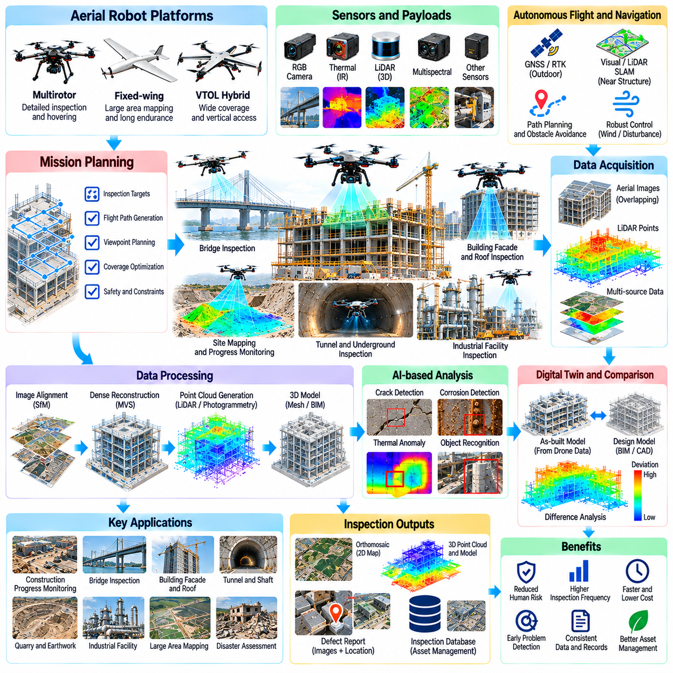
Aerial robots have become important Physical AI platforms for construction inspection and infrastructure mapping because they can access elevated, remote, and hazardous locations without extensive temporary structures. Unmanned aerial vehicles equipped with intelligent sensors can collect visual and spatial information across large sites. Their effectiveness depends on integrating flight control, environmental perception, autonomous planning, and reliable data processing.
Construction environments present inspection challenges involving cranes, towers, bridges, roofs, facades, and partially completed structures. Conventional inspection may require scaffolding, lifting equipment, or temporary access restrictions. Aerial robots can observe selected areas from flexible viewpoints while reducing direct human exposure. However, wind, obstacles, changing site layouts, and regulatory restrictions constrain operational feasibility.
Multirotor aerial platforms are commonly used for detailed inspection because they can hover and adjust their position near structural components. Fixed-wing aircraft are more suitable for covering extensive terrain where sustained forward flight is practical. Hybrid vertical takeoff and landing systems combine selected characteristics of both configurations. Platform selection depends on inspection distance, payload requirements, endurance, maneuverability, and site constraints.
Aerial inspection payloads may include RGB cameras, thermal imagers, LiDAR sensors, multispectral instruments, and specialized measurement devices. High-resolution imagery supports surface defect documentation, while LiDAR captures three-dimensional geometry. Thermal sensing may reveal temperature anomalies associated with selected material or equipment conditions. Each modality requires suitable observation geometry, calibration, and interpretation.
Autonomous flight relies on coordinated perception, localization, trajectory planning, and motion control. GNSS and inertial navigation provide positioning information in suitable outdoor environments. Visual odometry and LiDAR-based localization can improve operation near structures where satellite signals are degraded. Reliable autonomy requires continuous obstacle awareness and adaptation to changing environmental conditions.
Inspection mission planning defines flight paths, observation distances, camera orientations, and required coverage. Automated planners can generate viewpoints around structural surfaces while considering visibility and collision constraints. Close-range inspection requires careful control of stand-off distance and viewing angle. Mission feasibility must account for wind exposure, available clearance, communication quality, and emergency recovery options.
Photogrammetry converts overlapping aerial images into spatial representations through feature matching and geometric reconstruction. Structure-from-Motion estimates camera poses and sparse geometry, while multi-view stereo can generate denser surface models. Reconstruction accuracy depends on image overlap, texture, camera calibration, and survey control. Reflective surfaces, repetitive patterns, and occlusions may reduce model completeness.
Aerial LiDAR mapping uses laser range measurements to reconstruct terrain, buildings, vegetation, and infrastructure geometry. Unlike passive imaging, LiDAR directly measures distances and can provide useful geometric information under varying illumination. Point clouds require accurate sensor positioning and orientation for consistent registration. Dense vegetation, reflective materials, and limited viewing angles can still create incomplete observations.
Construction progress monitoring is a valuable application of repeated aerial surveys. Updated imagery and three-dimensional models can be compared with design information and previous site measurements. These comparisons help identify changes in earthworks, structural completion, and material placement. Meaningful progress assessment requires consistent coordinate systems and an understanding of measurement uncertainty.
Bridge inspection benefits from aerial access to towers, cables, girders, and selected underside surfaces. Robots can capture detailed images without placing personnel at every observation location. However, turbulent airflow, structural occlusion, and restricted positioning signals complicate flight near large bridges. Close-proximity operations require validated procedures, appropriate separation distances, and reliable contingency responses.
Building facade and roof inspection can identify visible cracks, surface deterioration, damaged components, and water-related anomalies. Aerial robots can systematically capture images across extensive exterior surfaces. Thermal imaging may supplement visual observations when environmental conditions support meaningful temperature contrast. Automated interpretation must distinguish genuine defects from shadows, reflections, and material variations.
Tunnel entrances, shafts, and selected underground cavities create opportunities for aerial inspection where conventional access is difficult. GNSS-denied environments require alternative localization methods and robust obstacle avoidance. Enclosed-space flights may also involve dust, poor illumination, limited communications, and restricted maneuvering space. Protective configurations and carefully designed recovery procedures are essential for suitable deployments.
Artificial intelligence supports aerial inspection through defect detection, object recognition, semantic segmentation, and anomaly classification. Learning-based models can identify candidate cracks, corrosion, spalling, or missing components in collected imagery. Detection reliability depends on training coverage, image quality, and environmental variation. Automated results should be treated as inspection evidence requiring appropriate engineering verification.
Change detection combines observations from different survey dates to identify geometric or visual differences. Registered point clouds may reveal surface displacement or changes in construction geometry, while image comparisons can highlight evolving conditions. Apparent differences may arise from illumination, sensor calibration, or registration errors. Reliable interpretation requires uncertainty analysis and appropriate comparison thresholds.
Digital twin integration connects aerial mapping outputs with engineering models, asset identifiers, and inspection histories. Georeferenced images, point clouds, and reconstructed surfaces can update representations of buildings and infrastructure. These datasets support design verification, maintenance planning, and collaborative review. Data governance must preserve coordinate references, acquisition metadata, model versions, and measurement limitations.
Aerial mapping can support earthwork measurement by estimating terrain surfaces and changes in material volumes. Repeated surveys provide information about excavation progress, stockpiles, and site grading. Volume estimates depend on surface reconstruction accuracy, ground control, and assumptions about reference surfaces. Vegetation, equipment, and temporary obstructions should be addressed before results are used for contractual or engineering decisions.
Operational safety requires attention to airspace restrictions, personnel exposure, equipment proximity, and changing construction activities. Flight authorization and applicable aviation requirements must be considered before deployment. Robots should maintain appropriate separation from workers and critical structures. Emergency landing procedures, geofencing, operational supervision, and documented risk assessments help reduce the consequences of flight failures.
Communication and energy constraints strongly influence aerial inspection productivity. Wireless connectivity may deteriorate behind structures or within enclosed environments, while battery endurance limits mission duration. Payload mass, wind, and flight maneuvering increase energy consumption. Mission planning should include return reserves, communication contingencies, and safe interruption procedures rather than relying on nominal performance specifications.
Multi-robot operations can combine aerial platforms with ground robots and quadrupeds to improve inspection coverage. Aerial robots map elevated structures and large areas, while ground systems capture detailed observations from accessible surfaces. Shared coordinate frames and inspection databases enable complementary measurements. Task allocation should consider sensor capabilities, mobility limitations, safety constraints, and operational priorities.
Inspection data pipelines organize images, flight trajectories, point clouds, defect annotations, and processing records into traceable datasets. Automated quality checks can identify missing coverage, blurred images, or inconsistent positioning. Structured reports connect detected anomalies with asset locations and recommended follow-up actions. Preserving raw measurements supports later verification and improvements in analytical methods.
Economic evaluation should consider reduced access equipment requirements, inspection duration, personnel exposure, and improved survey frequency. Aerial robots may reduce the need for scaffolding or prolonged closures in suitable applications. However, equipment acquisition, pilot training, maintenance, insurance, software, and data processing contribute to total cost. Financial value depends on utilization, inspection quality, and operational reliability.
Deployment should begin with representative inspection tasks and clearly defined performance criteria. Pilot programs can compare aerial measurements with established surveying and inspection methods. Evaluation should include spatial accuracy, defect detection performance, coverage completeness, flight safety, and processing time. Gradual scaling requires repeatable procedures, trained personnel, and demonstrated compliance with applicable requirements.
Aerial robots for inspection and mapping demonstrate how Physical AI combines autonomous mobility with intelligent sensing to transform infrastructure observation. Their principal contribution is efficient access to spatial information that is difficult or costly to obtain through conventional methods. Integration with digital twins, engineering workflows, and human verification can improve construction visibility, inspection consistency, and long-term infrastructure management.

06.12. Multi Robot Construction Sites
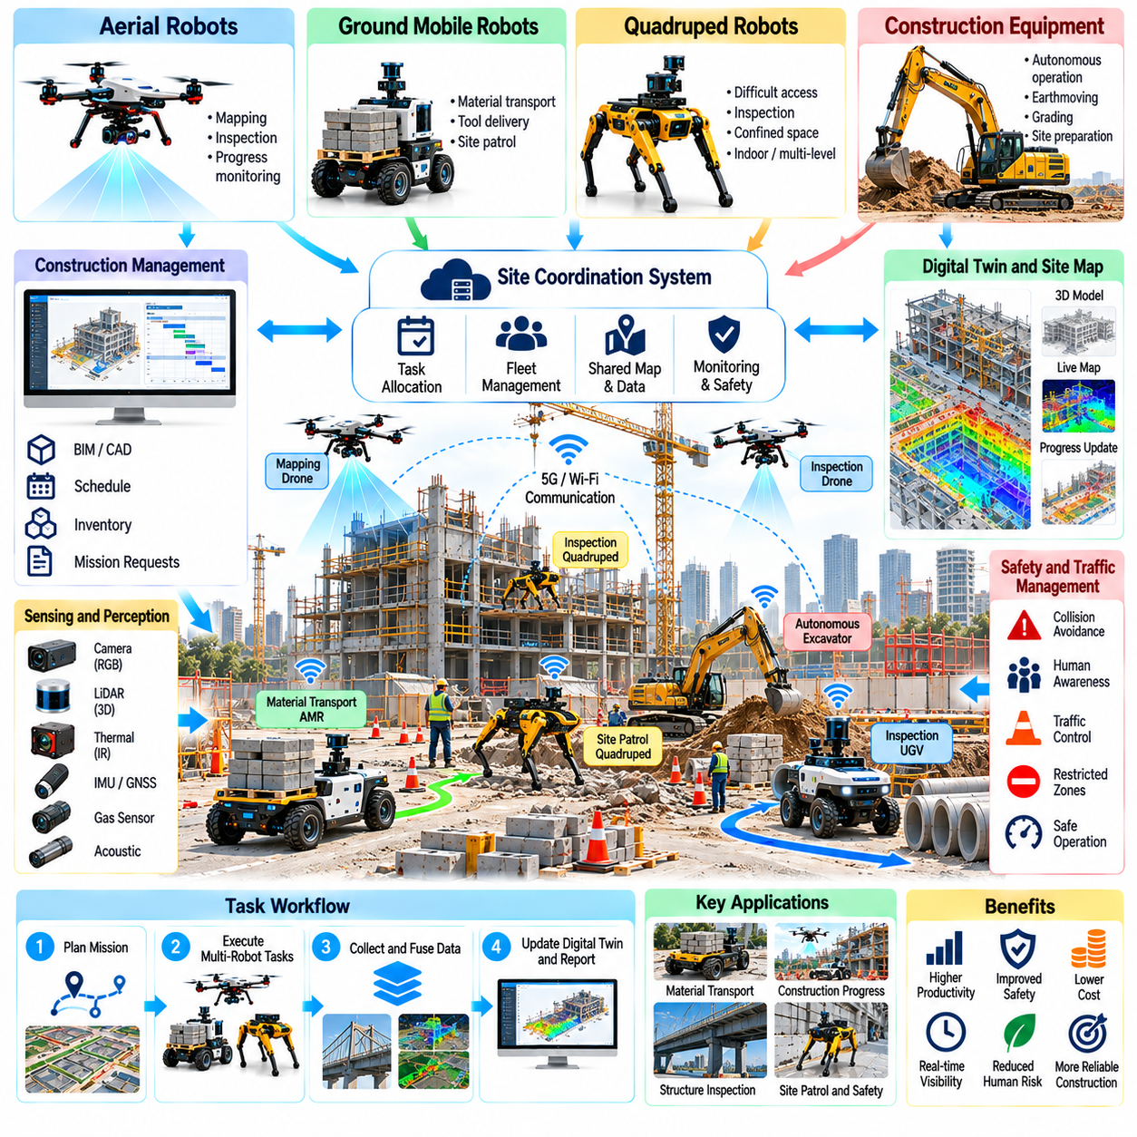
Multi-robot construction sites represent an advanced application of Physical AI in which autonomous machines coordinate transportation, inspection, mapping, and construction activities within a shared environment. Instead of operating as isolated systems, robots exchange information and cooperate through common planning and management frameworks. Their integration can improve productivity, resource utilization, and site visibility while introducing new coordination and safety challenges.
Construction environments require heterogeneous robotic platforms because tasks differ in mobility, payload, sensing, and manipulation requirements. Autonomous mobile robots transport materials, aerial robots capture site geometry, quadrupeds inspect difficult-access areas, and robotic equipment performs selected construction operations. Effective coordination assigns responsibilities according to each platform's capabilities while accounting for changing site conditions.
A multi-robot architecture typically combines onboard autonomy with site-level coordination services. Individual robots maintain local perception, navigation, obstacle avoidance, and safety functions. Centralized or distributed systems manage task allocation, shared maps, mission priorities, and operational status. This separation allows robots to respond immediately to nearby hazards without depending entirely on continuous communication with a central controller.
Task allocation determines which robot should perform each activity based on capability, location, availability, and operational priority. Scheduling algorithms may consider travel distance, payload capacity, battery state, and task deadlines. Dynamic reassignment becomes necessary when equipment fails or construction priorities change. Effective scheduling should optimize overall project performance rather than maximizing the utilization of individual robots.
Shared spatial awareness is essential because construction sites change continuously. Robots can contribute observations from cameras, LiDAR, positioning systems, and other sensors to a common site representation. Updated maps may include obstacles, temporary structures, material storage areas, and restricted zones. Data fusion requires consistent coordinate systems, timestamps, and uncertainty estimates to avoid conflicting interpretations.
Localization across heterogeneous platforms is challenging because aerial, wheeled, and legged robots use different sensors and movement models. GNSS, inertial navigation, visual odometry, and simultaneous localization and mapping may provide complementary positioning information. Shared reference frames enable robots to exchange meaningful locations and routes. Coordinate alignment errors can create navigation conflicts and compromise inspection accuracy.
Traffic management coordinates robot movements through corridors, intersections, loading areas, and temporary access routes. Reservation-based scheduling, priority rules, and local collision avoidance can reduce congestion. Narrow passages may require one-way operation or controlled access intervals. Traffic policies must also account for pedestrians, conventional vehicles, and equipment whose movements cannot be fully predicted.
Material transportation illustrates the benefits of coordinated robot fleets. Multiple autonomous mobile robots can deliver tools, components, and supplies between storage locations and active work zones. Fleet management systems assign missions according to demand, travel conditions, and robot availability. Integration with inventory and construction schedules helps reduce unnecessary movement, waiting time, and interruptions to work crews.
Collaborative inspection combines complementary sensing capabilities from different robotic platforms. Aerial robots document elevated structures, ground robots inspect accessible surfaces, and quadrupeds traverse selected irregular areas. Their observations can be integrated into common inspection records and spatial models. Coordinated coverage planning reduces duplicated measurements while identifying areas that remain insufficiently inspected.
Multi-robot construction operations may involve sequential or simultaneous activities that depend on one another. A mapping robot can update site geometry before an autonomous transporter enters a work zone. Inspection robots may verify completed work before subsequent construction stages begin. Such dependencies require explicit workflow management, reliable status reporting, and procedures for handling incomplete or uncertain results.
Communication infrastructure supports mission coordination, map updates, and operational supervision. Wireless networks may experience interference, obstruction, and temporary coverage gaps caused by changing structures. Edge computing can process time-sensitive information locally, while cloud services support broader analytics and historical storage. Robots must retain safe behavior when network connections are delayed or interrupted.
Interoperability is important when fleets contain machines from different manufacturers. Standardized interfaces can exchange mission requests, robot status, maps, and safety-related information. Middleware and application programming interfaces help connect fleet systems with construction management software. However, differences in coordinate conventions, task semantics, and safety capabilities require careful integration and validation.
Digital twins provide a shared information environment linking robot observations with design models, construction progress, and asset records. Updated spatial data can reveal discrepancies between planned and actual site conditions. Robots may use these representations for navigation and task planning, while project managers use them for progress monitoring. Model synchronization must distinguish verified measurements from estimates and outdated information.
Safety management becomes more complex when several autonomous machines operate near human workers. Robots must respect exclusion zones, speed restrictions, emergency access routes, and equipment operating boundaries. Site-wide coordination should complement independent onboard safety functions. Risk assessments must consider interactions between robots, people, moving machinery, and temporary construction hazards.
Human-robot collaboration requires clear operational responsibilities and understandable communication. Supervisors need visibility into robot assignments, locations, faults, and pending interventions. Workers should recognize robot movement intentions and understand applicable right-of-way procedures. Training and standardized operating practices reduce confusion when autonomous systems share spaces with conventional construction activities.
Resource management extends beyond assigning tasks to include battery charging, maintenance, payload availability, and communication capacity. Fleet schedulers can stagger charging sessions to maintain sufficient operational coverage. Predictive maintenance may identify deteriorating components before failures interrupt coordinated missions. Resource planning should consider peak demand periods and recovery capacity during unexpected disruptions.
Resilience is essential because construction environments are uncertain and operational failures are unavoidable. If one robot becomes unavailable, the coordination system may reassign compatible tasks or adjust schedules. Critical missions should have fallback procedures involving alternative equipment or human operators. Fault detection, recovery planning, and graceful degradation help prevent isolated failures from disrupting the entire site.
Cybersecurity and data governance are necessary when robots exchange operational information through shared networks. Unauthorized commands, compromised maps, or manipulated mission data could affect physical safety and project execution. Authentication, access control, secure communication, and software update management reduce exposure. Data records should preserve provenance, permissions, and traceability across participating systems.
Performance evaluation should measure fleet-level outcomes rather than isolated robot capabilities. Relevant indicators include task completion rate, transportation throughput, inspection coverage, waiting time, intervention frequency, and safety incidents. Energy consumption and equipment utilization provide additional operational insights. Evaluation must account for site variability and compare results against realistic conventional workflows.
Economic benefits may arise from improved equipment coordination, reduced idle time, fewer repeated inspections, and more predictable material delivery. However, integration costs can be substantial because robots require communication infrastructure, software interfaces, mapping systems, and operational support. Total cost of ownership includes maintenance, training, cybersecurity, and system upgrades. Financial value depends on utilization and sustained workflow improvements.
Deployment should begin with a limited number of robots performing well-defined tasks in controlled operating zones. Pilot programs can validate shared localization, traffic coordination, task allocation, and emergency procedures. Additional platforms and workflows should be introduced gradually after demonstrating reliable performance. Standardized interfaces and documented operating rules make expansion more manageable.
Multi-robot construction sites demonstrate how Physical AI can evolve from individual autonomous machines into coordinated operational ecosystems. Shared perception, intelligent scheduling, interoperable control, and digital integration enable robots to support complex construction workflows. Long-term success depends on reliable autonomy, human-centered safety, measurable economic value, and the ability to adapt as construction environments change.

06.13. Hazardous Environment and Worker Safety
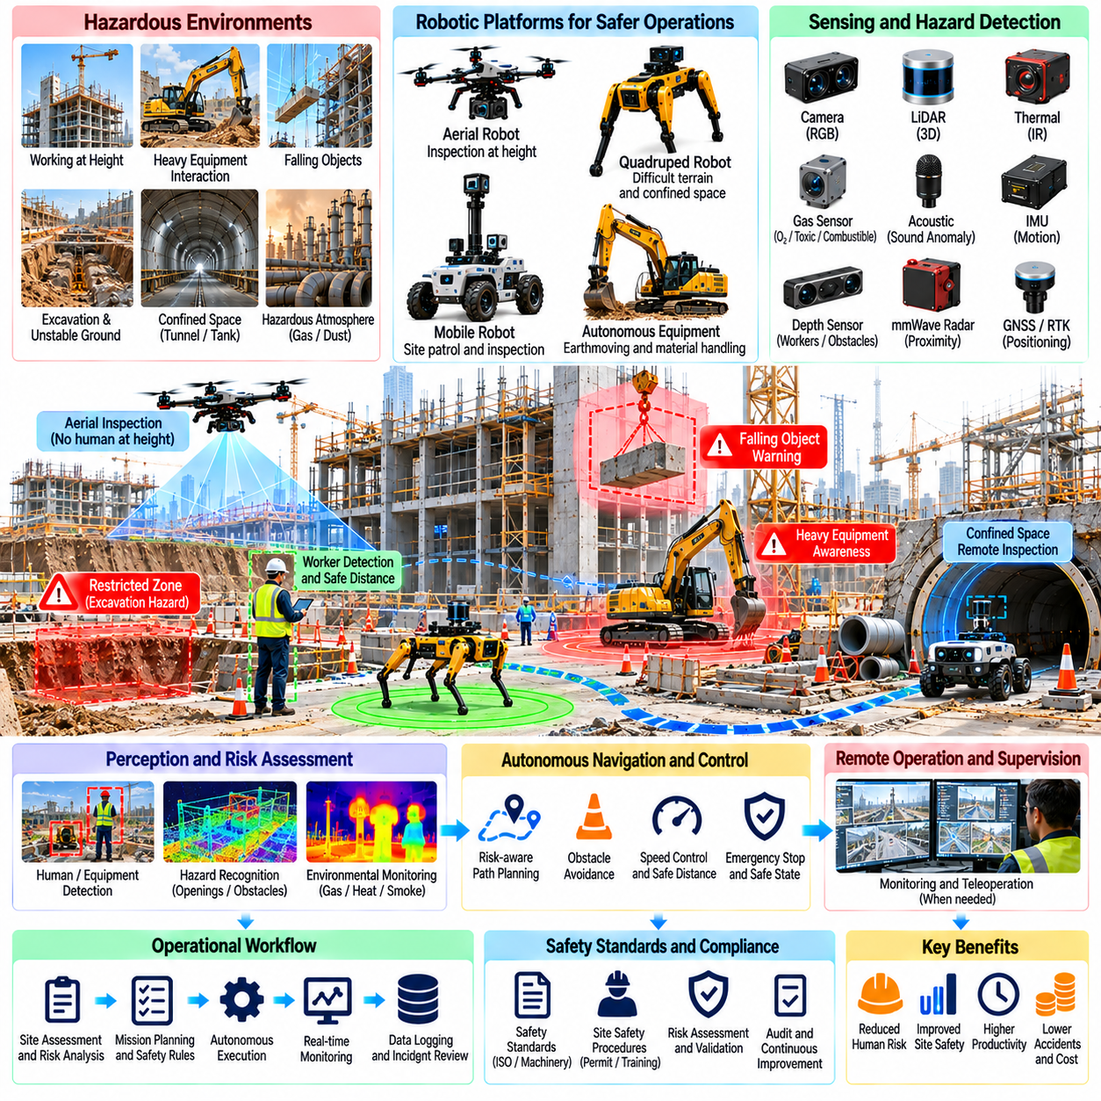
Hazardous environments and worker safety are central concerns in construction and infrastructure operations because workers encounter moving equipment, unstable structures, elevated locations, confined spaces, and potentially dangerous materials. Physical AI can reduce exposure by assigning selected hazardous tasks to autonomous robots. Its effectiveness depends on reliable perception, risk-aware planning, controlled interaction, and integration with established safety procedures.
Construction hazards change continuously as excavation, material handling, structural assembly, and equipment movement progress. Temporary barriers, incomplete floors, suspended loads, and changing access routes create unpredictable conditions. Autonomous systems must therefore assess both static and dynamic risks. Safety cannot depend solely on previously mapped environments because new hazards may appear between inspection and execution.
Robotic inspection can reduce the need for personnel to enter dangerous locations. Aerial robots observe elevated structures, quadrupeds traverse difficult terrain, and mobile platforms inspect selected industrial or underground areas. Remote sensing can provide early information about structural damage, gas accumulation, or unsafe access conditions. However, robotic measurements must be interpreted within their detection limits and verified when necessary.
Hazard identification begins with understanding the environment, intended robotic task, and possible failure consequences. Risk assessments examine collisions, falls, entrapment, electrical exposure, equipment interactions, and loss of control. Severity and likelihood estimates guide mitigation priorities. Assessments should be updated whenever site conditions, robot configurations, operating procedures, or task requirements change significantly.
Environmental perception combines cameras, LiDAR, depth sensors, thermal instruments, and other measurements to detect obstacles and potential hazards. Artificial intelligence can assist in recognizing workers, vehicles, open excavations, and restricted areas. Nevertheless, dust, smoke, poor illumination, occlusion, and sensor contamination may reduce detection reliability. Safety functions require validated performance under representative adverse conditions.
Human detection and collision avoidance are particularly important when robots share workspaces with construction personnel. Robots may estimate pedestrian positions, predict nearby movement, and adjust speed or trajectory. Protective separation distances should account for sensing uncertainty, stopping capability, and human unpredictability. Where necessary, physical barriers and controlled access provide additional protection beyond autonomous avoidance.
Heavy construction machinery introduces hazards involving large masses, limited visibility, and substantial stopping distances. Autonomous excavators, loaders, and transport vehicles require carefully defined operating zones and interaction rules. Personnel should not rely on visual recognition alone to determine whether machinery is safe to approach. Clear warning signals, controlled access, and reliable emergency stopping arrangements are essential.
Working at height presents risks of falling personnel, dropped objects, and unstable access equipment. Aerial robots and remotely operated inspection systems can perform selected observations without placing workers on elevated structures. However, drones introduce their own risks, including falling aircraft and rotor contact. Flight planning must consider exclusion zones, overhead obstacles, wind conditions, and emergency landing locations.
Confined spaces such as tunnels, tanks, shafts, and underground chambers may contain oxygen-deficient atmospheres, toxic gases, or restricted escape routes. Robots equipped with appropriate environmental sensors can support preliminary assessment before human entry. Their measurements do not automatically establish that entry is safe. Confined-space procedures, atmospheric testing, rescue planning, and applicable permit requirements remain necessary.
Hazardous atmosphere monitoring may involve oxygen sensors, combustible gas detectors, and instruments for selected toxic substances. Mobile robots can collect measurements across multiple locations while limiting worker exposure. Sensor placement, calibration, response time, and environmental compatibility influence measurement quality. Alarm thresholds and responses must reflect applicable safety requirements and the limitations of each instrument.
Structural instability creates additional challenges near damaged buildings, excavations, retaining walls, and aging infrastructure. Robots can document visible deformation, cracking, and selected changes in geometry without requiring immediate human access. LiDAR and imaging systems support repeated observations. Such measurements provide evidence for engineering assessment but do not independently establish structural stability or safe entry conditions.
Remote operation and supervised autonomy offer practical alternatives when fully autonomous behavior cannot be justified. Operators can direct robots through uncertain areas while monitoring camera feeds and sensor readings. Communication delay, restricted visibility, and incomplete situational awareness remain important limitations. Procedures should define when operations must stop and how robots can be recovered without exposing personnel to additional hazards.
Functional safety requires protective mechanisms that remain effective when software, sensors, communication links, or actuators fail. Emergency stopping, speed limitation, fault monitoring, and safe-state transitions can reduce hazardous consequences. Safety-related control functions must be designed and validated according to applicable machinery and robotic safety requirements. Learning-based autonomy should not replace independently justified protective controls.
Multi-robot construction environments require coordination between autonomous machines and conventional equipment. Shared traffic rules, restricted zones, and task scheduling can reduce conflicting movements. Each robot should maintain appropriate local protective functions even when a fleet management system coordinates operations. Centralized supervision improves visibility but should not become a single point of failure for immediate hazard response.
Digital site models can support safety planning by representing excavation boundaries, hazardous zones, temporary structures, and designated access routes. Robot observations may update these representations as construction progresses. Integrating spatial information with work permits and operational schedules helps identify potential conflicts. However, outdated maps and incorrect coordinates can create dangerous assumptions about site conditions.
Worker safety also depends on understandable human-robot interaction. Personnel need training on robot behavior, warning indicators, emergency procedures, and permitted access boundaries. Supervisors should clearly communicate operating schedules and changes to autonomous work zones. Workers must have reliable methods to report unsafe behavior and request intervention. Effective adoption requires attention to practical work practices rather than technology alone.
Cybersecurity contributes to physical safety because compromised control commands, positioning information, or operational data can influence robot behavior. Authentication, access restrictions, secure communication, and controlled software updates reduce exposure to unauthorized interference. Safety-critical configurations should be protected against unintended changes. Incident records and system logs support investigation, accountability, and corrective action.
Safety performance should be evaluated using both leading and lagging indicators. Leading indicators include hazard detection coverage, intervention frequency, protective-system tests, and corrective action completion. Lagging indicators include collisions, injuries, and equipment damage. Near-miss reporting provides additional evidence about emerging risks. Metrics should consider exposure levels and operational context rather than relying only on raw incident counts.
Robotic deployment may improve safety by reducing time spent in hazardous locations, supporting more frequent inspections, and identifying selected risks earlier. Nevertheless, robots can introduce new hazards through unexpected motion, falling equipment, battery failures, or operational confusion. Risk reduction must be demonstrated through systematic assessment and field validation. A successful deployment transfers dangerous work without creating unacceptable secondary risks.
Economic evaluation should consider avoided exposure, reduced access equipment requirements, operational continuity, and potential inspection efficiency. These benefits must be weighed against robot acquisition, maintenance, training, safety engineering, and supervision costs. Financial calculations should not assume that every identified hazard results in a preventable accident. Safety value is best assessed alongside operational performance and compliance obligations.
Implementation should begin with a defined hazardous task and a documented baseline risk assessment. Pilot deployments can validate sensing reliability, protective functions, communication behavior, and emergency procedures under controlled conditions. Workers and safety specialists should participate in operational reviews. Expansion should follow demonstrated performance, updated risk assessments, and clear responsibility for ongoing safety management.
Hazardous environment robotics demonstrates how Physical AI can support worker protection through remote access, intelligent sensing, and controlled autonomy. Its greatest contribution is reducing unnecessary human exposure while improving information about difficult operating conditions. Sustainable adoption requires engineering safeguards, human oversight, reliable procedures, and continuous evaluation as construction environments evolve.

06.14. Project Schedule Quality and Cost Impact
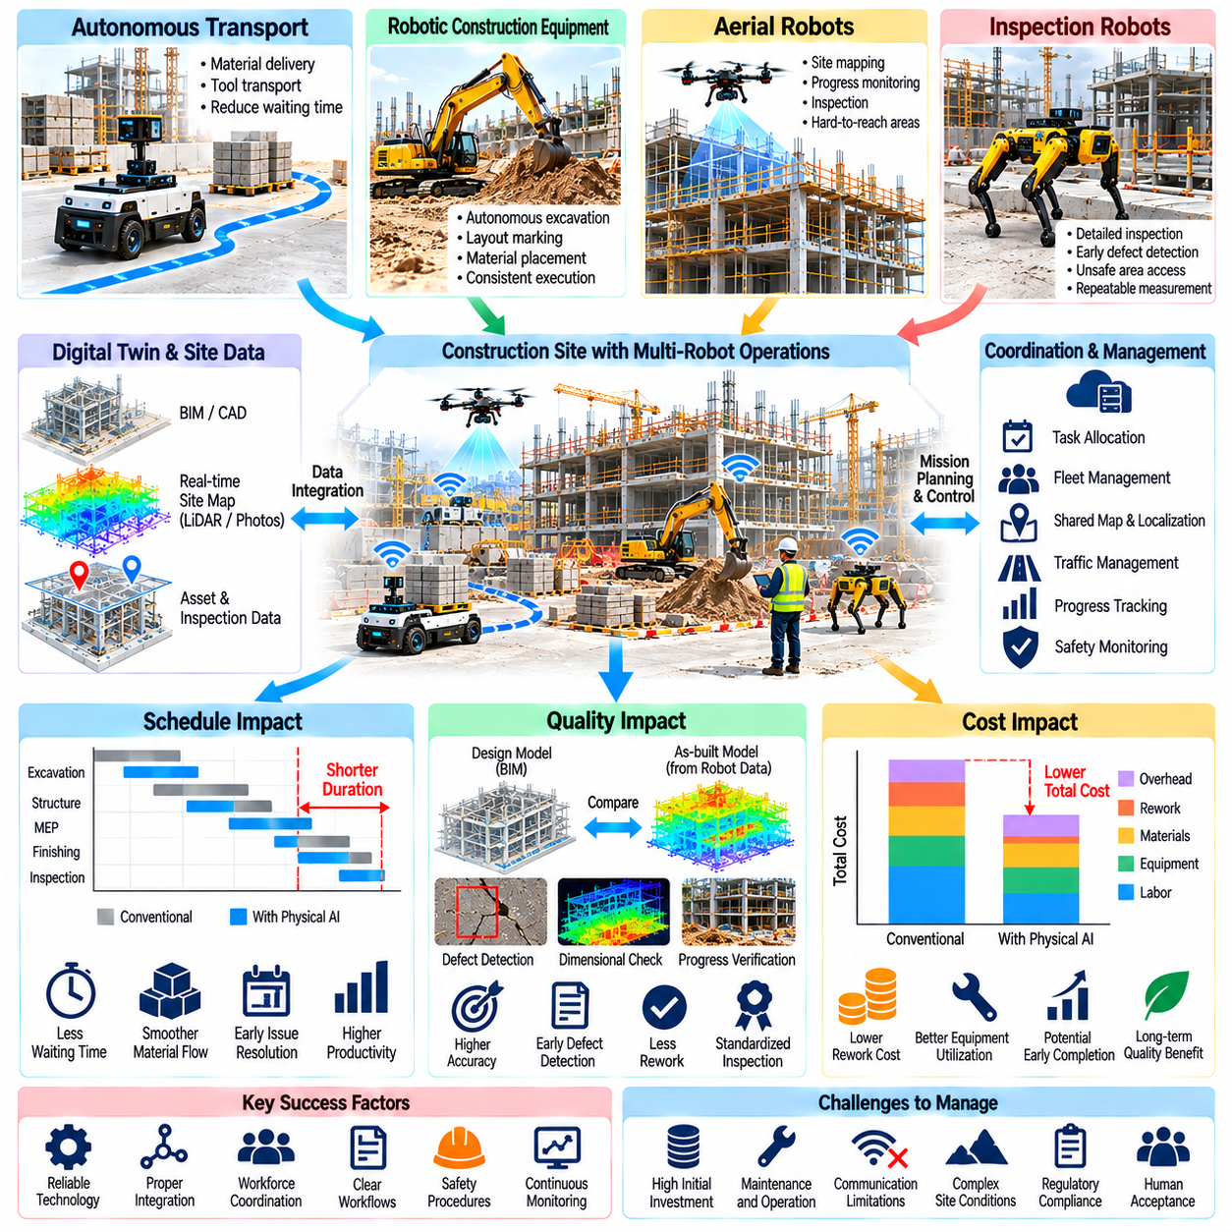
Physical AI can influence construction project schedules, quality, and costs by introducing autonomous sensing, material transportation, robotic equipment, and intelligent inspection into site operations. Its business value depends on measurable improvements across interconnected project activities rather than isolated robot performance. Effective evaluation must consider deployment complexity, workforce coordination, reliability, and the economic consequences of operational changes.
Construction schedules are determined by dependencies between excavation, material delivery, structural assembly, inspection, and finishing activities. Delays in one operation can affect multiple downstream tasks, particularly when the delayed activity lies on the critical path. Physical AI can improve schedule predictability through more consistent execution and timely information. However, faster individual tasks do not automatically shorten overall project duration.
Autonomous material transportation can reduce waiting time when construction crews depend on timely delivery of tools, components, and supplies. Mobile robots may perform repetitive deliveries between storage areas and active work zones. Their effectiveness depends on route availability, loading procedures, and coordination with human workers. Schedule benefits arise when transportation improvements eliminate actual workflow bottlenecks.
Robotic construction equipment can improve productivity in selected repetitive or well-defined operations. Autonomous excavation, layout marking, surface preparation, and material placement may achieve more consistent execution under suitable conditions. Actual productivity depends on task complexity, environmental variability, and setup requirements. Equipment utilization must include calibration, repositioning, maintenance, and intervention time.
Inspection automation can influence project schedules by identifying defects and construction discrepancies earlier. Aerial robots, ground platforms, and intelligent sensors can collect observations more frequently than some conventional inspection workflows. Early detection allows corrective actions before subsequent activities conceal or amplify problems. Nevertheless, inspection findings must be verified and integrated into timely engineering decisions.
Digital mapping and reality capture support schedule management by providing updated information about actual site conditions. LiDAR, photogrammetry, and robotic surveying can document geometry, material placement, and construction progress. Comparing measured conditions with design models helps identify deviations. The usefulness of these comparisons depends on spatial accuracy, data processing speed, and clear responsibility for resolving discrepancies.
Construction quality includes dimensional accuracy, material conformity, structural integrity, and compliance with specified workmanship requirements. Physical AI can support quality assurance through repeatable measurements and standardized inspection procedures. Robots may reduce variability caused by inconsistent observation positions or manual recording. However, automated measurements cannot replace engineering judgment or required acceptance testing.
Quality control becomes more effective when robotic observations are connected to specific assets, locations, and construction stages. Images, point clouds, and sensor readings can be linked to building information models and inspection records. This traceability supports defect investigation and verification of corrective work. Reliable integration requires consistent identifiers, calibrated sensors, and documented measurement uncertainty.
Rework is a major connection between construction quality and project economics. Errors discovered after subsequent activities have begun may require demolition, replacement, additional labor, and schedule adjustments. Robotic inspection can reduce some rework by detecting discrepancies earlier. The economic benefit depends on detection accuracy, response speed, and whether the identified problem would otherwise have remained unnoticed.
Project cost analysis should distinguish capital expenditure, operating expenditure, and integration costs. Robotic platforms, sensing equipment, charging systems, and supporting infrastructure contribute to initial investment. Maintenance, software, energy, training, supervision, and data processing create recurring expenses. A realistic financial model must also include commissioning, workflow redesign, and temporary productivity losses during deployment.
Labor economics require careful interpretation because robots rarely eliminate all human involvement. Autonomous systems may reduce repetitive transportation, hazardous access, or manual measurement activities while creating new responsibilities in supervision and maintenance. Labor savings depend on actual staffing changes, redeployment, and overtime reduction. Financial evaluations should avoid treating every automated task hour as an equivalent reduction in paid labor.
Schedule improvements can generate indirect financial benefits through reduced equipment rental periods, lower temporary facility expenses, and earlier project completion. However, these benefits occur only when robotic improvements affect activities that determine overall duration. Critical path analysis helps distinguish genuine schedule savings from local productivity gains. Contractual incentives, penalties, and resource constraints may further influence economic outcomes.
Construction quality improvements may reduce warranty claims, corrective work, material waste, and long-term maintenance requirements. Repeated robotic measurements can provide better evidence of installation conditions and completed work. These benefits are difficult to monetize without historical defect and rework data. Economic estimates should distinguish verified cost reductions from potential future savings and avoided risks.
A digital twin can connect schedule, quality, and cost information through a common representation of project progress. Planned activities, actual measurements, defect records, and resource consumption can be associated with spatial construction elements. This integration supports comparison between planned and actual performance. Its effectiveness depends on data governance, timely updates, and compatibility with existing project management systems.
Performance measurement should combine operational and project-level indicators. Robot utilization, mission completion rate, intervention frequency, and inspection coverage describe system performance. Schedule variance, rework rate, defect closure time, and cost variance describe broader project outcomes. Comparing these indicators helps determine whether robotic improvements translate into measurable construction value.
Baseline selection is critical for credible evaluation. Conventional workflows should be measured under representative site conditions before introducing robotic systems. Comparisons must account for differences in project complexity, weather, workforce availability, and construction phase. Controlled pilot studies or matched work packages can reduce misleading conclusions. Measurement methods and assumptions should remain consistent across alternatives.
Economic modeling can use net present value, return on investment, and payback period to evaluate deployment feasibility. Cash flow estimates should include acquisition costs, recurring expenses, productivity changes, and expected operating life. Discount rates reflect the time value of money and project risk. Sensitivity analysis is necessary because utilization, reliability, and labor assumptions can substantially change financial results.
Scenario analysis can compare conservative, expected, and optimistic deployment outcomes. Conservative scenarios may include slower adoption, frequent interventions, and limited schedule improvements. More favorable scenarios may assume stable operations and high utilization. Each scenario should use explicit assumptions rather than unsupported performance claims. Decision-makers can then evaluate whether investment remains acceptable under uncertainty.
Multi-robot coordination can create additional value when transportation, inspection, and construction activities are managed together. Shared scheduling may reduce congestion, idle equipment time, and duplicated observations. However, coordination software and communication infrastructure introduce integration costs and failure dependencies. System-level optimization must demonstrate improvements beyond those achieved by independently operated robots.
Risk-adjusted evaluation should include technical failures, safety incidents, cybersecurity exposure, regulatory constraints, and uncertain operating conditions. Robots may reduce some construction risks while introducing others. Contingency budgets and fallback procedures help manage deployment uncertainty. Financial models should avoid assigning precise monetary benefits to risks without credible evidence about their probability and consequences.
Deployment planning should prioritize tasks with clear bottlenecks, measurable quality requirements, or substantial hazardous exposure. Pilot projects can establish realistic productivity, accuracy, intervention, and maintenance data. Gradual expansion allows organizations to refine workflows and training before committing to larger investments. Procurement decisions should consider interoperability, service support, and lifecycle costs.
Project governance is necessary to connect robotic performance with construction management decisions. Project managers, engineers, safety personnel, and robot operators should agree on objectives, acceptance criteria, and reporting responsibilities. Regular reviews can identify whether expected benefits are materializing. Corrective actions may involve changing routes, modifying task assignments, improving data quality, or revising deployment scope.
The schedule, quality, and cost impact of Physical AI is best understood as an integrated project performance problem. Autonomous robots create value when they remove bottlenecks, detect defects early, improve information reliability, and support safer operations. Sustainable adoption requires evidence-based financial analysis, disciplined implementation, and continuous measurement of outcomes across the complete construction workflow.

06.15. Infrastructure Inspection ROI Model [w/Code]
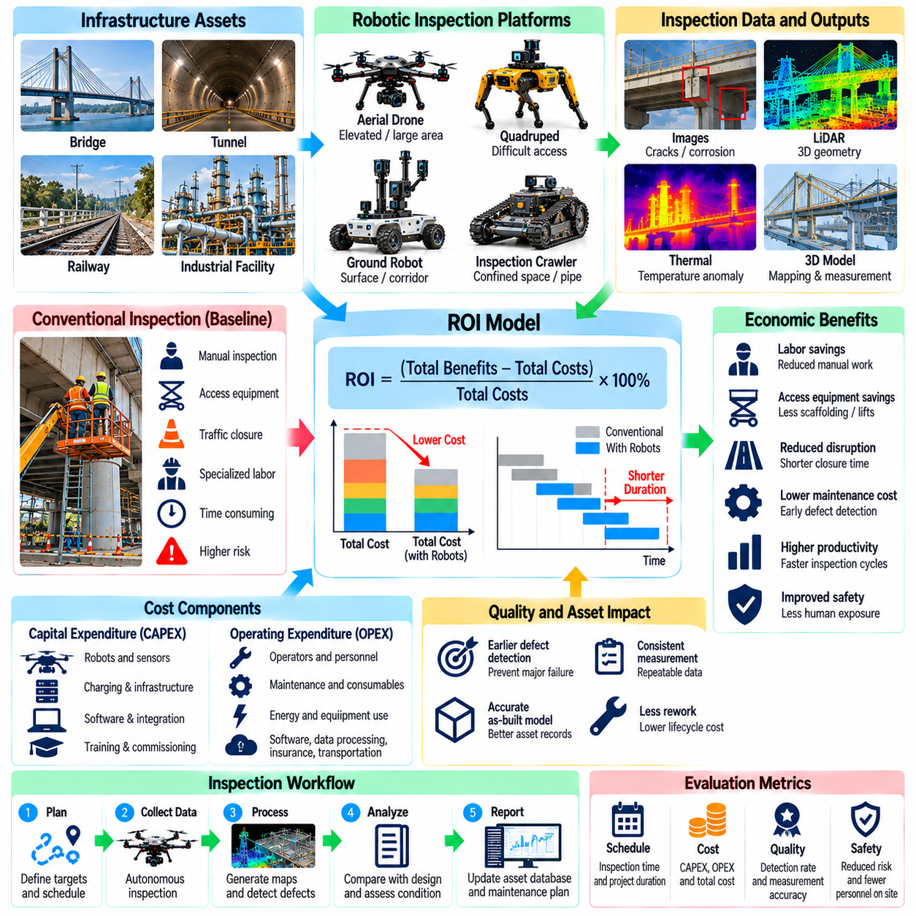
An infrastructure inspection return on investment model evaluates whether robotic inspection systems generate sufficient economic and operational benefits to justify their acquisition and deployment. Physical AI enables autonomous inspection of bridges, tunnels, railways, industrial facilities, and underground infrastructure. A credible ROI model compares robotic workflows with conventional methods while accounting for inspection quality, safety, asset condition, and lifecycle costs.
The economic baseline represents the cost and performance of existing inspection procedures before automation. Conventional inspections may require specialized personnel, access equipment, traffic restrictions, temporary closures, and manual documentation. Baseline measurements should include inspection frequency, labor hours, equipment rental, reporting time, and corrective actions. Without reliable baseline data, projected savings can be misleading.
Infrastructure characteristics strongly influence the financial feasibility of robotic inspection. Bridges may require elevated access equipment, while tunnels involve restricted operating windows and difficult communication conditions. Railways impose possession schedules and operational constraints. Underground assets may require confined-space procedures. The ROI model should distinguish these environments rather than applying a single cost assumption to every inspection mission.
Capital expenditure includes robotic platforms, sensors, navigation equipment, communication systems, charging infrastructure, and initial software integration. Aerial robots, quadrupeds, and ground inspection vehicles have different acquisition and operating requirements. Additional investments may include mapping software, data storage, and safety equipment. Initial deployment costs should also account for commissioning, calibration, and workforce training.
Operating expenditure includes inspection personnel, robot operators, maintenance, energy, software subscriptions, insurance, and data processing. Consumable components and sensor calibration create recurring expenses. Robots may also require transportation between inspection locations and periodic replacement of batteries or mechanical parts. Accurate operating cost estimates should reflect actual mission frequency and expected equipment utilization.
Inspection productivity can be evaluated through asset coverage per hour, mission completion rate, setup time, and reporting duration. Robotic systems may collect measurements more efficiently in repetitive or difficult-access environments. However, autonomous navigation failures, environmental restrictions, and manual verification can reduce effective productivity. The model should use completed and accepted inspections rather than raw robot operating hours.
Direct labor savings arise when robotic inspection reduces manual measurement, hazardous access, or repetitive documentation. These savings depend on whether personnel hours are actually eliminated, redeployed, or converted into higher-value activities. Human inspectors remain necessary for engineering interpretation and regulatory decisions. Financial models should avoid assuming that autonomous data collection completely replaces professional inspection responsibilities.
Access equipment savings can be substantial when robots reduce the need for scaffolding, lifts, rope access, or specialized inspection vehicles. Such savings depend on the asset geometry, inspection requirements, and whether physical access remains necessary for testing or repair. Some inspections still require personnel to reach the structure. The model should calculate avoided access costs separately for each inspection category.
Operational disruption costs are particularly important for transportation infrastructure. Bridge lane closures, railway possession windows, and tunnel restrictions can affect users and asset operators. Robotic inspections may reduce closure duration or enable selected observations during normal operations. Economic benefits should distinguish direct operator savings from broader societal impacts, avoiding double counting when calculating project-level ROI.
Inspection quality influences financial outcomes through defect detection, measurement consistency, and documentation reliability. High-resolution imaging, LiDAR, thermal sensing, and other instruments can support repeatable condition assessment. Earlier identification of deterioration may reduce some corrective maintenance costs. However, financial benefits require evidence that detected defects lead to timely intervention and improved asset outcomes.
False positives and missed defects must be considered when evaluating automated inspection performance. False alarms can increase verification costs and unnecessary maintenance activities. Missed defects may create additional safety and financial risks. Detection precision, recall, and measurement uncertainty should therefore influence economic assumptions. Inspection acceptance criteria must remain consistent with applicable engineering and regulatory requirements.
A practical cost model separates annual fixed expenses from variable mission expenses. Fixed costs may include depreciation, software licensing, insurance, and administrative support. Variable costs include labor, travel, energy, consumables, and mission-specific access arrangements. Total annual robotic inspection cost equals annual fixed cost plus the number of missions multiplied by average variable cost per mission.
Annual financial benefit can be estimated by combining verified labor savings, avoided access equipment costs, reduced operational disruption, and documented maintenance improvements. Additional benefits may include faster reporting and improved inspection frequency. Benefits should be expressed in consistent monetary units and evaluated over the same period. Nonfinancial safety and information benefits should be reported separately unless credible valuation methods exist.
Return on investment can be expressed as net financial benefit divided by the investment amount, multiplied by one hundred percent. Net benefit represents total attributable benefits minus relevant costs over the defined evaluation period. The model must state whether ROI is calculated annually or across the equipment lifecycle. Consistent treatment of capital expenditure and recurring costs is essential to avoid overstating returns.
Payback period estimates how long accumulated net operating benefits require to recover the initial investment. Under constant annual net savings, simple payback equals initial investment divided by annual net savings. This calculation is convenient but does not account for the time value of money. Discounted payback provides a more appropriate comparison when cash flows vary or investment horizons are long.
Net present value evaluates discounted future cash flows over the expected system lifecycle. Each year's net benefit is discounted using an appropriate rate, and initial investment is deducted from the resulting present value. A positive net present value indicates financial attractiveness under the selected assumptions. Replacement costs, residual value, and major software upgrades should be included when they materially affect lifecycle economics.
Robot utilization is a major determinant of inspection ROI because capital costs are distributed across completed missions. A robot used frequently across several infrastructure assets may achieve a lower cost per inspection than one deployed occasionally. Fleet sharing and service-based operating models can improve utilization. Nevertheless, travel time, weather restrictions, charging, and maintenance limit the number of missions realistically achievable.
Sensitivity analysis examines how financial outcomes change when uncertain assumptions vary. Important variables include inspection volume, labor rates, access costs, robot reliability, maintenance expenditure, and achievable productivity. Break-even analysis identifies the minimum annual mission volume or savings required to justify investment. These methods help distinguish robust business cases from projections dependent on optimistic assumptions.
Scenario analysis can compare conservative, expected, and optimistic operating conditions. Conservative scenarios may include low utilization, additional verification labor, and frequent equipment downtime. Expected scenarios should reflect measured pilot performance. Optimistic scenarios may assume stable operations and broader asset coverage. Explicit scenario assumptions make investment decisions more transparent and easier to revise.
A numerical example illustrates the calculation process without representing a universal industry benchmark. Suppose robotic inspection requires an initial investment of $200,000 and generates annual gross savings of $100,000 with additional annual operating costs of $40,000. Annual net savings equal $60,000, producing a simple payback period of approximately 3.33 years. The result excludes discounting, replacement costs, and residual value.
Safety benefits should be evaluated carefully because reduced worker exposure does not automatically translate into predictable financial savings. Robots may decrease time spent at heights, near moving traffic, or inside confined spaces. Relevant indicators include hazardous exposure hours and required access operations. Monetary valuation should rely on defensible evidence rather than assuming that every avoided exposure prevents an accident.
Implementation begins with selecting representative assets and collecting conventional inspection cost and performance data. Pilot deployments should measure mission duration, accepted inspection coverage, intervention frequency, detection quality, and operating expenses. These observations provide inputs for the financial model. Periodic reassessment is necessary as robot capabilities, maintenance requirements, and inspection demand evolve.
An infrastructure inspection ROI model provides a structured connection between Physical AI capabilities and asset management decisions. Economic value emerges from reduced inspection costs, improved access, operational efficiency, and potentially earlier maintenance intervention. Sustainable investment requires validated technical performance, transparent financial assumptions, and continuous comparison between expected and realized benefits.

