Volume 12. Physical AI Business and Industry Applications

Chapter 04. Healthcare Applications

04.01. Physical AI in Healthcare
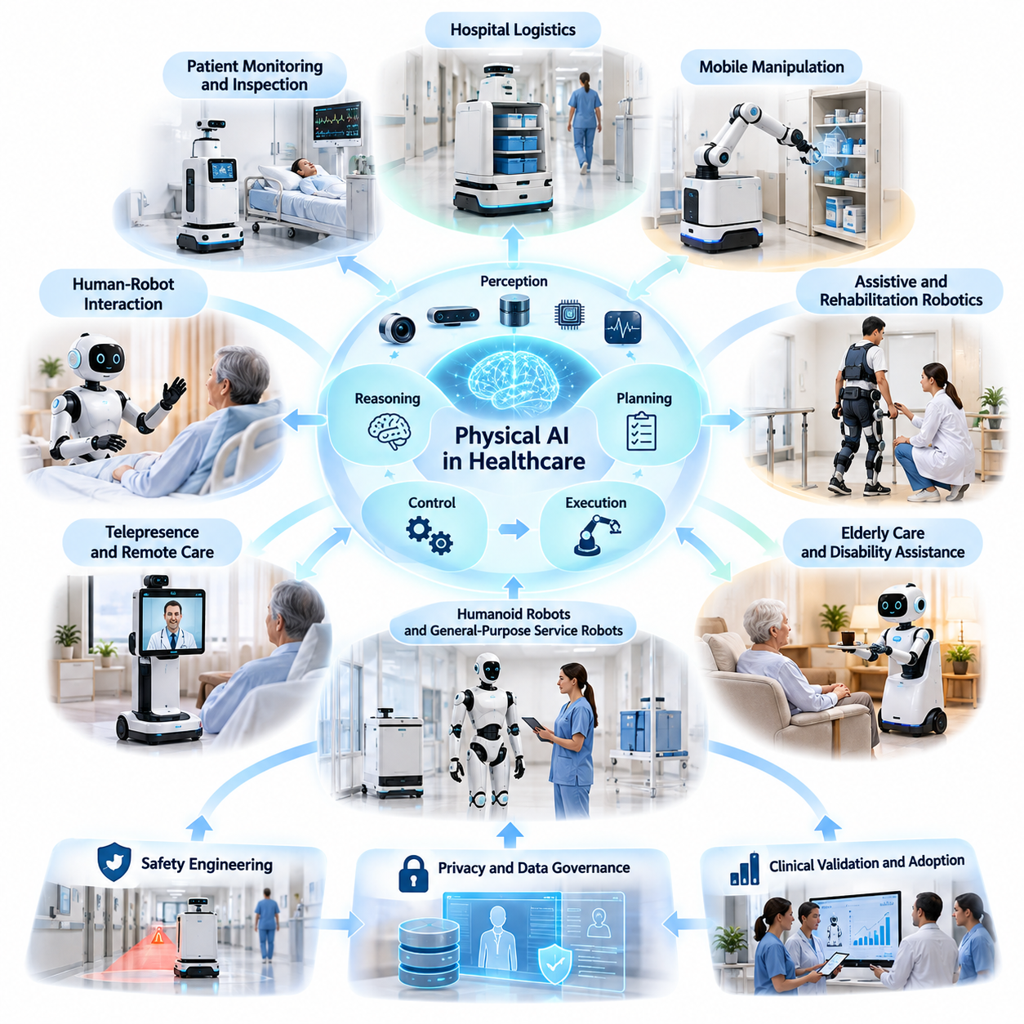
Physical AI in healthcare represents the integration of artificial intelligence, robotics, sensing, and autonomous control into medical and care environments. Unlike conventional healthcare AI, which primarily analyzes digital information, Physical AI interacts directly with patients, medical personnel, equipment, and physical surroundings. Its purpose is to transform intelligent computation into safe, useful, and measurable physical actions.
Healthcare environments present distinctive challenges for autonomous systems because they combine complex workflows, vulnerable individuals, strict safety requirements, and continuously changing conditions. Hospitals, rehabilitation centers, nursing facilities, and home-care environments require intelligent machines capable of navigating shared spaces, recognizing human activities, manipulating objects, and responding appropriately to unexpected situations.
The fundamental architecture of healthcare Physical AI integrates perception, reasoning, planning, control, and physical execution. Cameras, depth sensors, LiDAR, force sensors, and physiological monitoring devices provide information about the environment and relevant human conditions. AI models interpret these observations, estimate system states, and generate actions that are executed through mobile platforms, robotic manipulators, or assistive mechanisms.
Hospital logistics represents one of the most practical application areas because healthcare facilities require continuous movement of medicines, medical supplies, laboratory specimens, meals, linens, and equipment. Autonomous mobile robots can transport these materials between departments while reducing repetitive transportation duties. Successful deployment requires reliable navigation, secure payload handling, and coordination with existing hospital operations.
Mobile manipulation extends healthcare automation beyond transportation by enabling robots to interact with physical objects. A mobile manipulator combines autonomous mobility with robotic arms, grippers, and perception systems to perform tasks such as retrieving supplies, transferring containers, and preparing equipment. These capabilities require precise object recognition, collision avoidance, force control, and adaptation to changing workspace configurations.
Assistive and rehabilitation robotics applies Physical AI directly to human mobility, functional recovery, and daily activities. Robotic exoskeletons, intelligent rehabilitation devices, and assistive manipulators can provide controlled physical support based on individual needs. Adaptive control algorithms may adjust movement assistance according to measured performance, while clinicians retain responsibility for treatment decisions and appropriate supervision.
Elderly care and disability assistance represent additional opportunities for human-centered Physical AI. Intelligent mobility devices and service robots may support object retrieval, transportation, environmental interaction, and routine activities. Their design must accommodate variations in physical ability, communication preferences, and living conditions. Effective assistance should strengthen personal independence without unnecessarily replacing human relationships or caregiving.
Humanoid robots and general-purpose service robots offer the possibility of performing multiple activities within environments originally designed for people. Human-compatible morphology may help robots operate around conventional furniture, doors, workstations, and equipment. However, humanoid appearance alone does not establish practical value. Reliability, task performance, safety, maintainability, and operational cost determine whether such platforms are appropriate.
Patient monitoring and autonomous inspection introduce another dimension of healthcare Physical AI. Mobile systems equipped with environmental and medical sensing technologies may collect observations, inspect equipment conditions, or identify operational abnormalities. These functions require careful separation between automated observation and clinical interpretation. Medical conclusions and interventions must follow validated procedures and appropriate professional oversight.
Telepresence and remote-care robotics combine physical mobility with communication technologies to extend the reach of healthcare professionals. A remotely operated or partially autonomous platform can navigate clinical spaces and establish audiovisual connections between patients and caregivers. Such systems may improve access to consultations and routine communication, provided that privacy, connectivity, navigation safety, and human supervision are adequately maintained.
Human-robot interaction is particularly important because healthcare robots operate near individuals experiencing illness, pain, stress, or reduced mobility. Their behavior must be understandable, predictable, and respectful. Speech interfaces, visual indicators, gesture recognition, and multimodal interaction can improve communication, but critical commands require confirmation mechanisms. Robots must also recognize when uncertainty demands human intervention.
Safety engineering must address both conventional robotic hazards and healthcare-specific risks. Collision prevention, speed limitations, emergency stopping, safe manipulation, and fault recovery are essential technical capabilities. Additional concerns include infection prevention, contamination control, patient identification, and secure material handling. Risk assessment should consider the consequences of errors rather than relying exclusively on average task success.
Privacy and data governance become critical when robotic systems capture patient images, voices, locations, movements, or medical information. Healthcare Physical AI requires controlled data collection, appropriate consent or other lawful authorization, access restrictions, encryption, and auditable processing. Training and operational datasets should be governed according to their sensitivity, with clear policies for retention, secondary use, and responsible model improvement.
Integration with hospital information systems and operational workflows is necessary for sustainable deployment. Robots may need to exchange authorized information with scheduling systems, electronic health records, inventory platforms, building infrastructure, and fleet management software. Interoperability enables coordinated task execution, but system interfaces must preserve cybersecurity, data integrity, accountability, and continuity during communication failures.
Clinical validation and operational evaluation serve different but complementary purposes. Clinical validation examines whether a system is safe and effective for its intended medical use, whereas operational evaluation measures performance within everyday healthcare workflows. Relevant indicators include task completion, delivery accuracy, intervention frequency, availability, response time, staff workload, patient experience, and the occurrence of safety-related events.
The economic value of healthcare Physical AI depends on more than replacing individual manual tasks. Potential benefits include improved service availability, reduced transportation delays, more consistent logistics, and additional time for healthcare professionals to concentrate on patient care. These benefits must be compared with acquisition costs, integration expenses, maintenance, infrastructure modifications, training, cybersecurity, and ongoing technical support.
Adoption strategies should begin with clearly defined use cases, measurable requirements, and manageable operational risks. Repetitive logistics activities in structured environments may provide suitable initial deployment opportunities, while direct patient-contact applications generally demand more extensive validation. Pilot projects should establish performance baselines, document failure conditions, collect user feedback, and demonstrate dependable operation before expansion.
The long-term development of healthcare Physical AI will increasingly involve multimodal foundation models, adaptive robotic control, shared environmental understanding, and coordinated fleets of specialized machines. These technologies may improve flexibility across diverse healthcare tasks, but generalization must be demonstrated under realistic conditions. Reliable deployment will continue to depend on physical safeguards, validated behavior, and accountable human oversight.
Ultimately, healthcare Physical AI should be understood as an intelligent physical service infrastructure rather than merely a collection of autonomous robots. Its success depends on aligning technical capabilities with clinical priorities, human needs, operational requirements, and sustainable business models. The central objective is to support safer, more accessible, and more efficient healthcare while preserving human dignity, professional responsibility, and patient trust.

04.02. Hospital Logistics and Delivery Robots
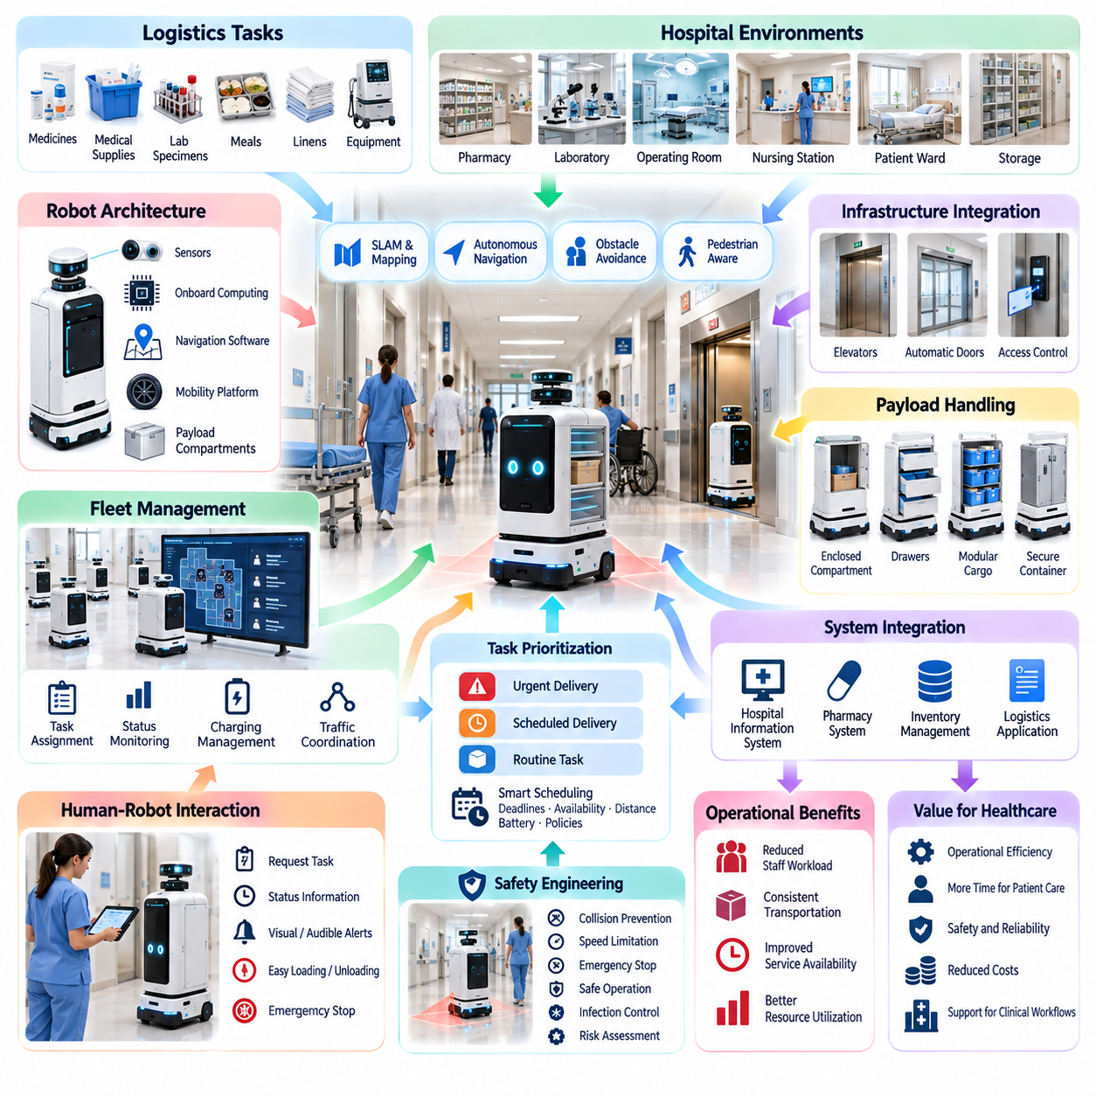
Hospital logistics and delivery robots represent one of the most commercially practical applications of Physical AI in healthcare. Hospitals operate complex internal transportation networks connecting pharmacies, laboratories, operating rooms, nursing stations, storage facilities, and patient wards. Autonomous delivery robots can automate repetitive material movements while improving transportation consistency, operational visibility, and the availability of healthcare personnel for clinical activities.
Traditional hospital logistics depends heavily on nurses, porters, technicians, and support personnel who transport materials between departments. These activities frequently involve repetitive walking, waiting, manual handling, and coordination across multiple locations. Physical AI introduces autonomous mobile robots capable of executing transportation requests, navigating shared corridors, and delivering supplies with reduced dependence on continuous human operation.
Hospital delivery robots typically employ autonomous mobile robot architectures integrating mobility platforms, environmental sensors, onboard computing, navigation software, and secure payload compartments. Their perception systems combine technologies such as LiDAR, depth cameras, ultrasonic sensors, and wheel odometry. These components enable localization, obstacle detection, path planning, and controlled movement through environments containing patients, visitors, and medical personnel.
Autonomous navigation in hospitals differs significantly from navigation in industrial warehouses. Hospital corridors contain wheelchairs, stretchers, medical carts, temporary equipment, and unpredictable pedestrian movements. Robots must continuously interpret these changing conditions while maintaining appropriate separation distances. Dynamic obstacle avoidance, pedestrian-aware motion planning, and conservative speed control are essential for dependable operation.
Simultaneous localization and mapping, commonly known as SLAM, provides a foundation for autonomous hospital mobility. Robots construct or use spatial maps representing corridors, intersections, doors, elevators, and designated delivery locations. Localization algorithms estimate robot position using sensor observations and map information. Reliable navigation also requires handling environmental changes, temporary obstructions, reflective surfaces, and areas with limited sensor visibility.
Hospital delivery operations often require robots to travel between multiple floors and restricted departments. Elevator integration allows autonomous systems to request elevator service, enter and exit safely, and continue navigation after reaching the destination floor. Automatic door interfaces and access-control systems enable movement through authorized areas. These integrations require coordinated communication between robotic software and hospital building infrastructure.
Payload handling is a defining requirement for healthcare logistics robots because transported materials may differ substantially in size, weight, sensitivity, and security requirements. Delivery platforms may incorporate enclosed compartments, removable containers, drawers, or modular cargo structures. Mechanical designs must prevent unintended opening, protect transported materials, and support ergonomic loading and unloading procedures.
Healthcare logistics includes transportation tasks with different operational priorities and handling requirements. Routine deliveries can be scheduled according to departmental demand, while urgent requests may require immediate task allocation. Intelligent scheduling systems evaluate delivery deadlines, robot availability, travel distance, battery condition, and operational restrictions. Priority management must remain consistent with hospital policies and established clinical workflows.
Fleet management systems coordinate multiple delivery robots operating across shared hospital environments. Centralized orchestration software assigns tasks, monitors robot status, manages charging schedules, and resolves potential traffic conflicts. Fleet-level intelligence can reduce redundant movements and improve resource utilization. Effective coordination also requires mechanisms for handling communication interruptions, unavailable robots, and unexpected congestion.
Traffic management becomes increasingly important as the number of autonomous robots grows. Narrow corridors, elevator entrances, loading stations, and busy intersections may become shared bottlenecks. Multi-robot coordination algorithms can regulate access to constrained spaces and prevent deadlocks. Traffic policies should prioritize pedestrian safety, emergency medical movements, and uninterrupted access to essential clinical facilities.
Hospital logistics robots must interact with human workers through intuitive and predictable interfaces. Staff members may request deliveries using touchscreen terminals, mobile applications, or integrated hospital systems. Robots can communicate their operating status through visual indicators, audible notifications, and digital messages. Clear interaction procedures reduce confusion during loading, unloading, emergency stopping, and manual intervention.
System integration determines whether autonomous delivery becomes part of normal hospital operations or remains an isolated automation experiment. Hospital information systems, inventory management platforms, pharmacy systems, and logistics applications may exchange authorized task information with robot fleet software. Standardized interfaces and event-based communication support automated request generation, delivery confirmation, inventory updates, and operational traceability.
Safety engineering is essential because delivery robots operate near vulnerable patients and critical medical equipment. Systems require collision prevention, protective stopping, speed limitation, obstacle detection, and emergency intervention capabilities. Safety mechanisms should remain effective even when perception or communication systems experience failures. Deployment procedures must also consider evacuation routes, infection-control practices, and emergency clinical access.
Cybersecurity and information governance are equally important when delivery robots connect to hospital networks. Secure authentication, encrypted communication, role-based access control, and software update management help protect robotic operations. Delivery records may contain sensitive information about departments, patients, or medical activities. Data collection and retention policies should minimize unnecessary exposure while maintaining appropriate operational accountability.
Operational reliability depends on more than successful navigation under ideal conditions. Robots must recover from blocked pathways, localization uncertainty, elevator delays, docking failures, and unexpected payload conditions. Recovery strategies may include route replanning, controlled waiting, remote assistance, or returning to a designated safe location. Reliable exception handling prevents isolated robot failures from disrupting broader hospital workflows.
Battery management and autonomous charging influence the practical availability of hospital delivery fleets. Robots must estimate remaining energy, anticipate transportation requirements, and schedule charging without compromising critical deliveries. Automatic docking systems reduce manual intervention, while fleet-level charging coordination prevents excessive simultaneous downtime. Battery health monitoring also supports preventive maintenance and lifecycle planning.
Performance evaluation should combine transportation efficiency with safety, reliability, and staff experience. Relevant indicators include completed deliveries per hour, average delivery time, task success rate, robot utilization, intervention frequency, and system availability. Additional measurements may assess waiting time, travel distance, energy consumption, and workflow disruption. These indicators should be evaluated against clearly defined predeployment baselines.
The economic justification for hospital delivery robots depends on the total cost of ownership and the measurable value of improved logistics. Acquisition costs, infrastructure integration, software licensing, maintenance, charging equipment, and technical support must be considered. Financial benefits may arise from reduced repetitive transportation work, improved service consistency, and better allocation of clinical personnel rather than direct workforce replacement.
Deployment strategies generally benefit from beginning with repetitive routes, predictable delivery schedules, and clearly designated loading stations. Pilot operations allow hospitals to validate navigation performance, staff acceptance, delivery reliability, and infrastructure compatibility. Gradual expansion across departments and floors provides opportunities to refine fleet scheduling, safety procedures, and exception management before introducing more complex operations.
Future hospital logistics platforms may incorporate advanced multimodal perception, predictive task scheduling, semantic navigation, and learning-based fleet optimization. Integration with mobile manipulators could eventually automate selected loading and unloading activities. However, broader autonomy must be supported by validated safety mechanisms and dependable workflow integration. The ultimate objective is a coordinated robotic logistics infrastructure that improves hospital efficiency while protecting patient care and operational continuity.

04.03. Medicine Linen and Supply Transport
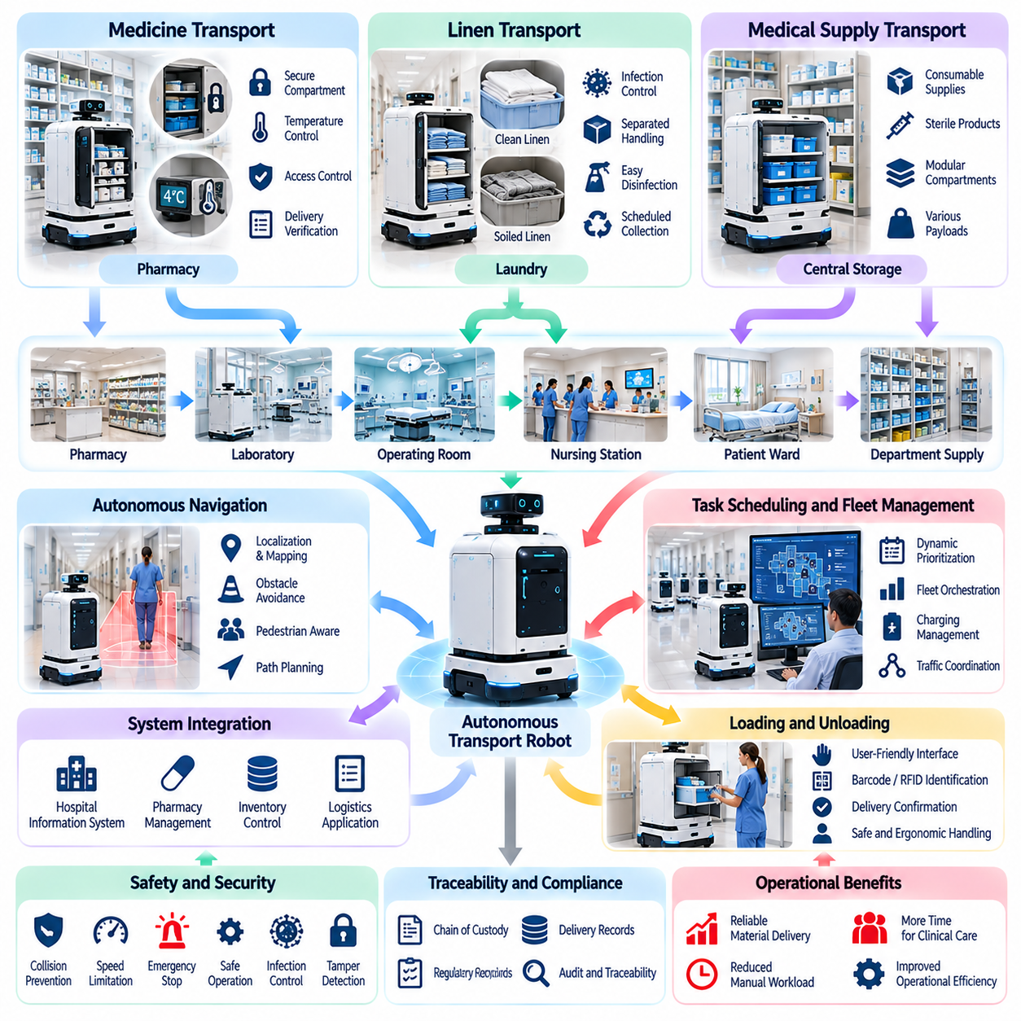
Medicine, linen, and medical supply transport represents a critical operational function within modern healthcare facilities. Hospitals continuously move pharmaceuticals, clean textiles, sterile instruments, disposable materials, and clinical equipment between storage areas and care departments. Physical AI enables these transportation activities to become more automated, traceable, and responsive to changing clinical demand.
Medicine transportation requires particularly strict control because pharmaceutical products may be sensitive to temperature, handling conditions, unauthorized access, and delivery delays. Autonomous mobile robots can transfer medication containers between hospital pharmacies and designated clinical locations. Secure compartments, controlled access, and delivery verification mechanisms help preserve material integrity and operational accountability.
Medication delivery workflows must distinguish routine pharmaceutical replenishment from urgent clinical requests. Scheduled deliveries may follow predefined routes, while time-sensitive orders require dynamic prioritization and rapid dispatch. Intelligent task allocation systems evaluate delivery urgency, robot availability, travel distance, and destination accessibility. These capabilities support more predictable pharmaceutical distribution.
Controlled substances and high-value medications introduce additional security requirements. Robotic transport systems may incorporate electronic locks, authenticated access, tamper detection, and detailed transaction records. Each transfer should maintain a documented chain of custody identifying authorized personnel and delivery events. Such controls must operate within applicable pharmaceutical regulations and hospital medication management policies.
Temperature-sensitive pharmaceuticals require environmental protection throughout transportation. Insulated compartments, temperature monitoring sensors, and specialized containers can help maintain specified storage conditions. Robotic systems may record temperature histories and generate alerts when acceptable limits are exceeded. Transport validation must account for delivery duration, environmental exposure, and the characteristics of individual pharmaceutical products.
Hospital linen transportation involves the continuous movement of clean bedding, patient garments, towels, surgical textiles, and used materials. Clean and soiled linen follow different handling procedures to reduce contamination risks. Autonomous transport robots can support scheduled collection and distribution between laundry facilities, storage rooms, nursing stations, and clinical departments while reducing repetitive manual movement.
Infection prevention is a central design consideration for linen transport automation. Clean and contaminated materials should remain physically separated through dedicated containers, compartments, or operational workflows. Robot surfaces must support appropriate cleaning and disinfection procedures. Route planning and loading practices should follow institutional infection-control policies to prevent unnecessary exposure and cross-contamination.
Medical supply transportation covers disposable gloves, masks, syringes, dressings, diagnostic accessories, and other consumable products. These materials are frequently distributed from central storage facilities to departmental supply rooms and treatment areas. Autonomous delivery platforms can replenish supplies according to scheduled demand or inventory-triggered requests, helping maintain material availability.
Sterile medical supplies require handling methods that protect packaging integrity and preserve their validated sterile condition. Robotic systems must avoid excessive vibration, crushing, moisture exposure, and inappropriate contact during loading and transportation. Enclosed cargo modules and controlled handling procedures can reduce environmental risks. Delivery processes should also verify that sterile packages remain undamaged.
Payload configuration significantly influences the suitability of autonomous transport platforms for different hospital materials. Medication carriers may prioritize security and environmental control, while linen platforms require larger cargo volumes. Supply delivery robots may benefit from modular shelving, removable bins, and adjustable compartments. Platform selection should consider payload mass, volume, loading ergonomics, and operational flexibility.
Autonomous navigation connects transportation functions with the broader hospital environment. Delivery robots must travel through corridors, elevators, automatic doors, and shared clinical spaces while avoiding patients, visitors, and medical equipment. Localization, obstacle detection, and dynamic path planning enable safe movement. Navigation policies must accommodate restricted areas, emergency traffic, and temporary operational changes.
Transport scheduling can be improved through demand-aware fleet orchestration. Hospital departments experience changing consumption patterns influenced by patient occupancy, clinical procedures, and daily operating schedules. Physical AI systems can combine delivery requests with available inventory and transportation capacity. Predictive scheduling may reduce unnecessary trips while maintaining appropriate replenishment frequency.
Integration with pharmacy management, inventory control, and hospital information systems supports automated material distribution. Authorized software interfaces can generate transportation requests, identify pickup and delivery locations, and update transaction records. Barcode scanning, RFID identification, and electronic confirmation may improve traceability. Integration must preserve data integrity and prevent unauthorized access to sensitive information.
Loading and unloading remain important operational considerations because transportation automation does not necessarily eliminate manual material handling. Staff members may place containers into robot compartments and retrieve them at designated destinations. Future mobile manipulation systems could automate selected transfer activities. However, automated handling requires reliable object recognition, grasp planning, force control, and validation of material-specific constraints.
Delivery verification provides evidence that transported materials reached the intended destination under appropriate conditions. Confirmation methods may include authenticated compartment opening, barcode scanning, electronic signatures, or integration with departmental receiving systems. Transaction records can identify delivery times, exceptions, and responsible personnel. Reliable verification supports inventory accuracy and operational accountability.
Exception handling is essential when deliveries encounter unavailable recipients, blocked routes, access restrictions, or equipment failures. Robots should detect abnormal conditions and execute predefined recovery procedures. Depending on material sensitivity, responses may include secure waiting, alternate routing, supervised intervention, or return to the originating department. Critical deliveries require clearly defined escalation procedures.
Fleet management systems coordinate transportation resources across medication, linen, and general supply workflows. Centralized scheduling can allocate robots according to payload compatibility, task urgency, location, and battery condition. Shared fleet operations may improve utilization, although incompatible materials must remain separated. Effective orchestration balances efficiency with security, infection prevention, and service reliability.
Operational performance should be evaluated using measurable transportation and service indicators. Relevant metrics include delivery completion rate, average transport time, material handling errors, intervention frequency, robot utilization, and system availability. Medication workflows may require additional security and temperature compliance measures. Linen and supply operations may emphasize throughput, replenishment reliability, and contamination prevention.
Economic benefits arise from reducing repetitive transportation activities, improving material availability, and supporting more efficient allocation of hospital personnel. Financial evaluation must include robot acquisition, infrastructure integration, software, maintenance, charging systems, and operational supervision. Total cost of ownership should be compared with measurable improvements in delivery consistency, staff workload, and logistics performance.
The long-term development of medicine, linen, and supply transport will involve increasingly integrated autonomous logistics platforms. Predictive demand models, intelligent fleet coordination, secure material tracking, and mobile manipulation may enable broader automation. Successful deployment will depend on validated safety procedures, reliable hospital system integration, and material-specific handling requirements that protect clinical operations and patient care.

04.04. Mobile Manipulation in Hospitals
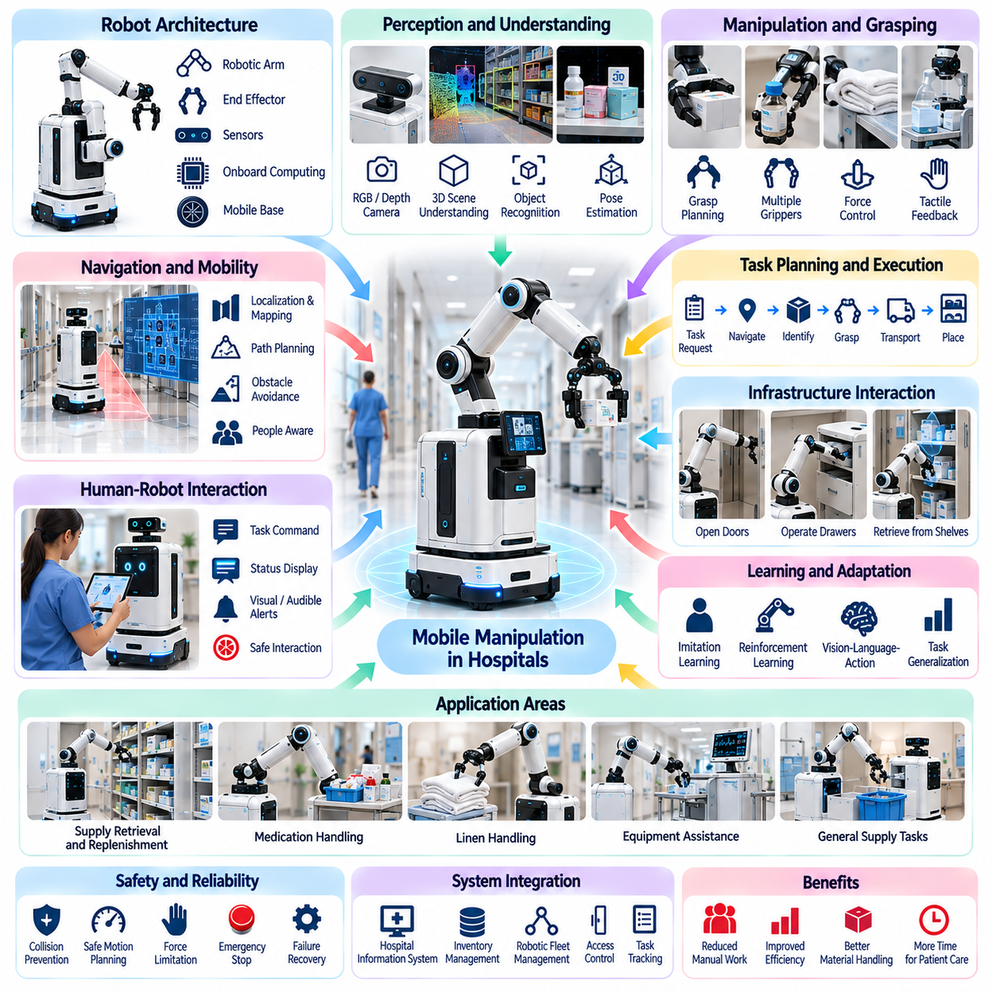
Mobile manipulation in hospitals combines autonomous mobility, robotic arms, intelligent perception, and adaptive control to perform physical tasks across healthcare environments. Unlike conventional delivery robots that primarily transport materials, mobile manipulators can interact directly with objects, equipment, and workstations. This capability extends hospital automation from transportation toward more flexible material handling and operational assistance.
A hospital mobile manipulator typically consists of an autonomous mobile base, one or more robotic arms, end effectors, environmental sensors, and onboard computing systems. The mobile platform provides navigation between departments, while the manipulator performs localized physical interactions. Coordinated control between mobility and manipulation enables the robot to approach workstations, position its arm, and execute tasks within constrained spaces.
Hospital environments introduce manipulation challenges that differ from those encountered in structured industrial facilities. Medical supplies vary in geometry, packaging, weight, and handling sensitivity, while workspaces frequently contain movable furniture and human activity. Robots must recognize objects, estimate their positions, and adapt grasping strategies to changing conditions without compromising safety or material integrity.
Perception systems provide the foundation for reliable mobile manipulation. RGB cameras, depth sensors, force sensors, and tactile feedback mechanisms help robots identify objects and estimate their spatial relationships. Three-dimensional scene understanding enables detection of shelves, containers, handles, and obstacles. Sensor fusion improves robustness when individual measurements are affected by occlusion, reflections, or environmental uncertainty.
Object recognition and pose estimation are particularly important for manipulating medical materials. A robot must distinguish between visually similar containers, identify appropriate grasping regions, and estimate object orientation before contact. Vision-language models may support semantic interpretation of task instructions, while geometric perception provides precise spatial information. Identification errors require explicit detection and recovery procedures.
Grasp planning determines how a robotic end effector should contact and securely hold an object. Hospital materials may include rigid containers, flexible packaging, cylindrical bottles, and irregularly shaped instruments. Different grippers and manipulation strategies may be necessary for these objects. Force-limited grasping and tactile feedback help prevent crushing, slipping, or damage during transportation and placement.
Whole-body coordination becomes essential when the mobile base and robotic arm must operate together. The robot may reposition its base to improve reachability, avoid collisions, or maintain stability during manipulation. Motion planning must consider joint limits, workspace constraints, payload mass, and the movement of nearby people. Coordinated planning allows the system to execute tasks that cannot be completed through arm motion alone.
Hospital mobile manipulators can support supply retrieval and replenishment by collecting approved materials from storage locations and placing them into designated containers or shelves. Such applications require integration with inventory records and accurate identification of storage positions. Automated replenishment can reduce repetitive handling, although reliable deployment depends on standardized packaging, accessible layouts, and verified placement procedures.
Medication-related manipulation requires additional safeguards because incorrect selection or placement can create serious clinical risks. Robots may handle sealed medication containers or transport trays under controlled conditions, but medication identification and authorization must remain independently verified. Secure access, traceable transactions, and human supervision are particularly important when tasks involve pharmaceuticals or restricted materials.
Linen and general supply handling provide opportunities for manipulating larger or less delicate objects. Mobile manipulators may transfer packaged linens, collect designated containers, or organize standardized supply bins. Flexible textiles remain challenging because their shapes change during grasping and movement. Reliable textile manipulation requires deformable-object perception, adaptive grasping, and careful control of contact forces.
Interaction with hospital infrastructure expands the practical usefulness of mobile manipulation. Robots may need to open compatible cabinet doors, operate designated handles, retrieve items from shelves, or interact with automated storage equipment. These activities require accurate alignment, force sensing, and awareness of mechanical constraints. Infrastructure interfaces should be designed to reduce unnecessary manipulation complexity.
Task planning connects high-level clinical support requests with executable robotic actions. A command such as retrieving a supply container must be decomposed into navigation, object identification, approach, grasping, transportation, and placement operations. Hierarchical planners can coordinate these stages while monitoring execution results. Failure detection and replanning are necessary when objects are missing or environments change.
Learning-based manipulation offers a potential method for handling diverse objects and tasks. Imitation learning can derive manipulation policies from human demonstrations, while reinforcement learning may improve selected behaviors through controlled simulation. Vision-language-action models can connect visual observations and language instructions with robotic actions. However, learned policies require extensive validation before use in safety-sensitive hospital environments.
Human-robot collaboration is central to mobile manipulation because robots frequently operate alongside nurses, technicians, pharmacists, and support personnel. Systems should communicate intended actions and recognize when human assistance is required. Shared workspaces demand predictable motion, conservative force limits, and accessible emergency controls. Human operators must retain the ability to interrupt or override autonomous behavior.
Safety requirements become more complex when a robot combines autonomous movement with physical manipulation. Hazards include unintended contact, dropped objects, unstable payloads, excessive gripping force, and collisions between the arm and nearby equipment. Risk reduction requires coordinated safety monitoring across the mobile base, manipulator, and end effector. Protective functions must remain effective during communication or perception failures.
Infection prevention and environmental compatibility are essential design considerations. Robotic surfaces, grippers, and payload interfaces should tolerate appropriate cleaning and disinfection procedures. Contact with sterile or contaminated materials requires clearly defined handling boundaries. Mechanical components should minimize difficult-to-clean regions, while operational workflows must prevent inappropriate transfers between clean and contaminated environments.
System integration enables mobile manipulators to participate in hospital operations rather than function as isolated robotic demonstrations. Task requests may originate from inventory management, logistics software, or authorized hospital applications. Fleet management platforms can coordinate robot availability, charging, and transportation assignments. Transaction records should capture task completion, intervention events, and relevant material movements.
Operational reliability depends on effective recovery from manipulation failures. Objects may shift unexpectedly, grasp attempts may fail, or target locations may become inaccessible. Robots should recognize these conditions and select safe responses such as retrying, repositioning, requesting assistance, or terminating the task. Recovery policies must prevent repeated unsafe actions and preserve accountability for incomplete operations.
Performance evaluation should measure both mobility and manipulation capabilities under realistic hospital conditions. Relevant indicators include task success rate, grasp reliability, placement accuracy, execution time, intervention frequency, and system availability. Safety events, material damage, and workflow disruption must also be recorded. Evaluation across diverse objects, departments, and operating conditions provides evidence of practical generalization.
The economic value of hospital mobile manipulation depends on whether additional manipulation capabilities justify their complexity and cost. Robotic arms, advanced sensors, computing hardware, integration, and maintenance increase total ownership expenses. Benefits may include reduced repetitive handling, improved supply availability, and greater operational flexibility. Deployment decisions should prioritize measurable workflow improvements rather than technological sophistication alone.
Future hospital mobile manipulators may combine general-purpose robotic foundation models, multimodal perception, dexterous hands, and adaptive whole-body control. These advances could expand the range of materials and workstations that robots can handle. Nevertheless, clinical safety, dependable operation, and human oversight will remain fundamental requirements. The long-term objective is to create flexible robotic assistants that support healthcare personnel while preserving patient safety and operational continuity.

04.05. Assistive and Rehabilitation Robotics
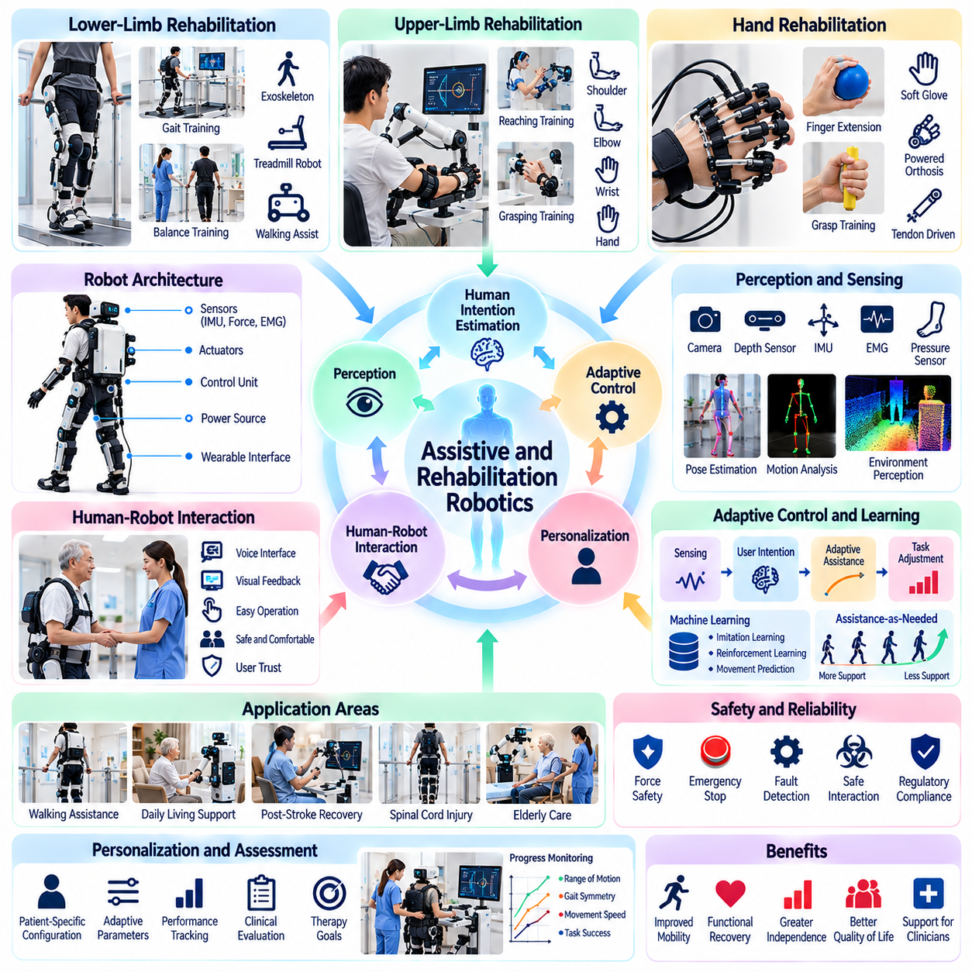
Assistive and rehabilitation robotics represents a major application of Physical AI that supports human mobility, functional recovery, and independent living. These systems combine robotic mechanisms, intelligent sensing, adaptive control, and human-centered interaction to provide physical assistance. Their primary objective is to enhance individual capabilities while supporting rehabilitation professionals and preserving patient safety, autonomy, and dignity.
Assistive robotics focuses on compensating for physical limitations, while rehabilitation robotics emphasizes restoring or improving functional abilities through structured therapeutic activities. Although their objectives differ, both domains rely on close interaction between humans and robotic systems. Physical AI enables assistance levels, movement trajectories, and control strategies to adapt according to individual needs and observed performance.
Robotic exoskeletons are among the most recognizable technologies in assistive and rehabilitation robotics. Wearable mechanical structures support or guide movements of the lower limbs, upper limbs, or specific joints. Actuators generate controlled forces and torques, while sensors measure joint positions, movement velocity, and interaction forces. Appropriate assistance depends on user capability, device alignment, and clinical objectives.
Lower-limb rehabilitation robots support walking practice, balance training, and repetitive gait exercises. These systems may use wearable exoskeletons, treadmill-based robotic devices, or mobile walking assistance platforms. Intelligent controllers adjust movement support according to gait phase, patient participation, and measured stability. Their effectiveness depends on appropriate patient selection, individualized therapy, and clinical supervision.
Upper-limb rehabilitation robotics addresses functional recovery of the shoulder, elbow, wrist, and hand. Robotic devices can guide reaching, grasping, lifting, and coordinated arm movements during structured exercises. Sensors capture movement accuracy, range of motion, and interaction forces. Adaptive assistance allows patients to participate actively while receiving support when movement becomes difficult or inconsistent.
Hand rehabilitation and assistive grasping systems require particularly precise interaction because human hands contain many joints and perform complex movements. Soft robotic gloves, tendon-driven mechanisms, and powered orthoses can support finger extension, flexion, and grasping. Control systems must accommodate differences in hand geometry, muscle strength, and joint mobility while avoiding excessive pressure or unintended movement.
Human intention estimation is a central capability of intelligent assistive robotics. Systems may interpret motion patterns, interaction forces, electromyography signals, or other physiological measurements to estimate intended actions. These observations can inform assistance timing and intensity. However, intention recognition remains uncertain, requiring conservative control strategies and mechanisms that allow users to reject or interrupt robotic actions.
Adaptive control enables rehabilitation devices to respond to changing patient capabilities during therapy. Assistance-as-needed strategies provide support when performance falls below defined thresholds while encouraging voluntary movement. Controllers may adjust force, impedance, trajectory guidance, or exercise difficulty. Adaptation must remain within clinically approved limits and should not substitute for professional assessment of rehabilitation progress.
Physical human-robot interaction requires careful management of mechanical contact between robotic devices and the human body. Force sensing, compliant actuation, impedance control, and mechanical safety limits help reduce injury risks. Soft interfaces and ergonomic attachment structures distribute contact pressure across appropriate anatomical regions. Safe operation also depends on correct fitting, calibration, and continuous monitoring of discomfort.
Personalization is essential because rehabilitation needs differ according to physical condition, body dimensions, movement capacity, and therapeutic goals. Physical AI systems can use patient-specific measurements to configure assistance parameters and exercise programs. Longitudinal performance data may reveal changes in movement quality or endurance. Nevertheless, personalization algorithms must distinguish meaningful improvement from measurement noise and temporary fluctuations.
Rehabilitation robotics increasingly incorporates multimodal perception to observe both patient behavior and environmental conditions. Cameras, inertial measurement units, pressure sensors, and wearable physiological sensors provide complementary information. Sensor fusion supports estimation of posture, gait symmetry, movement timing, and task execution. Reliable interpretation requires calibration and consideration of individual movement variability.
Machine learning offers opportunities to improve movement classification, assistance prediction, and rehabilitation task adaptation. Supervised learning can identify patterns in recorded movement data, while reinforcement learning may optimize selected control policies in simulation. Learning-based systems must be evaluated carefully because patient behavior, physical abilities, and interaction dynamics vary substantially across individuals and rehabilitation sessions.
Robot-assisted therapy can support repetitive training with measurable and consistent movement parameters. Repetition is important in many rehabilitation programs, but the clinical value of robotic assistance depends on active participation and meaningful therapeutic goals. Intelligent systems may vary task difficulty and provide performance feedback to encourage engagement. Robots should complement rather than independently determine clinical treatment strategies.
Assistive mobile robots extend physical support beyond wearable devices by helping users interact with their surroundings. Mobile manipulators may retrieve objects, transport personal belongings, or position items within accessible reach. Such systems combine navigation, object recognition, grasp planning, and user communication. Their effectiveness depends on reliable task execution and interfaces that accommodate different physical and cognitive abilities.
Home-based rehabilitation introduces opportunities for extending therapeutic activities beyond hospitals and specialized clinics. Compact robotic devices and remotely monitored systems may support prescribed exercises in familiar environments. Physical AI can provide feedback on movement execution and record selected performance indicators. Home deployment requires simplified operation, robust safety mechanisms, secure communication, and clearly defined clinical escalation procedures.
Clinical evaluation is necessary to determine whether assistive and rehabilitation robots produce meaningful benefits. Technical metrics such as tracking accuracy, assistance force, task completion, and device reliability should be combined with functional outcomes and patient-reported measures. Controlled studies may assess mobility, independence, comfort, and quality of life. Evidence must be interpreted according to patient populations, intervention duration, and study design.
Safety and regulatory requirements depend on device function, intended medical use, and the degree of physical interaction. Risk management must address excessive joint loading, mechanical misalignment, falls, skin pressure, actuator failures, and unintended movement. Emergency stopping, mechanical constraints, and supervised recovery procedures are important safeguards. Clinical deployment requires appropriate validation and compliance with applicable medical device regulations.
Data privacy and ethical considerations are particularly important because rehabilitation systems may collect sensitive information about movement, disability, physiological conditions, and treatment progress. Secure storage, access control, informed consent, and responsible data governance are necessary. Users should understand the capabilities and limitations of automated assistance. Human autonomy and the ability to decline robotic intervention must remain central design principles.
The economic value of assistive and rehabilitation robotics depends on clinical effectiveness, utilization, maintenance requirements, and integration into care delivery. Potential benefits include more consistent training, improved accessibility, and reduced physical demands on caregivers. However, equipment costs, fitting procedures, professional supervision, and technical support can be substantial. Adoption decisions should consider measurable patient outcomes alongside operational efficiency.
Future assistive and rehabilitation robots may integrate multimodal foundation models, advanced soft actuators, adaptive movement prediction, and personalized learning systems. These technologies could support more natural interaction and broader assistance across clinical and everyday environments. Nevertheless, dependable physical safety, demonstrated clinical benefit, and professional oversight will remain essential. The long-term objective is to strengthen human capability and independence through trustworthy robotic assistance.

04.06. Elderly and Disability Assistance
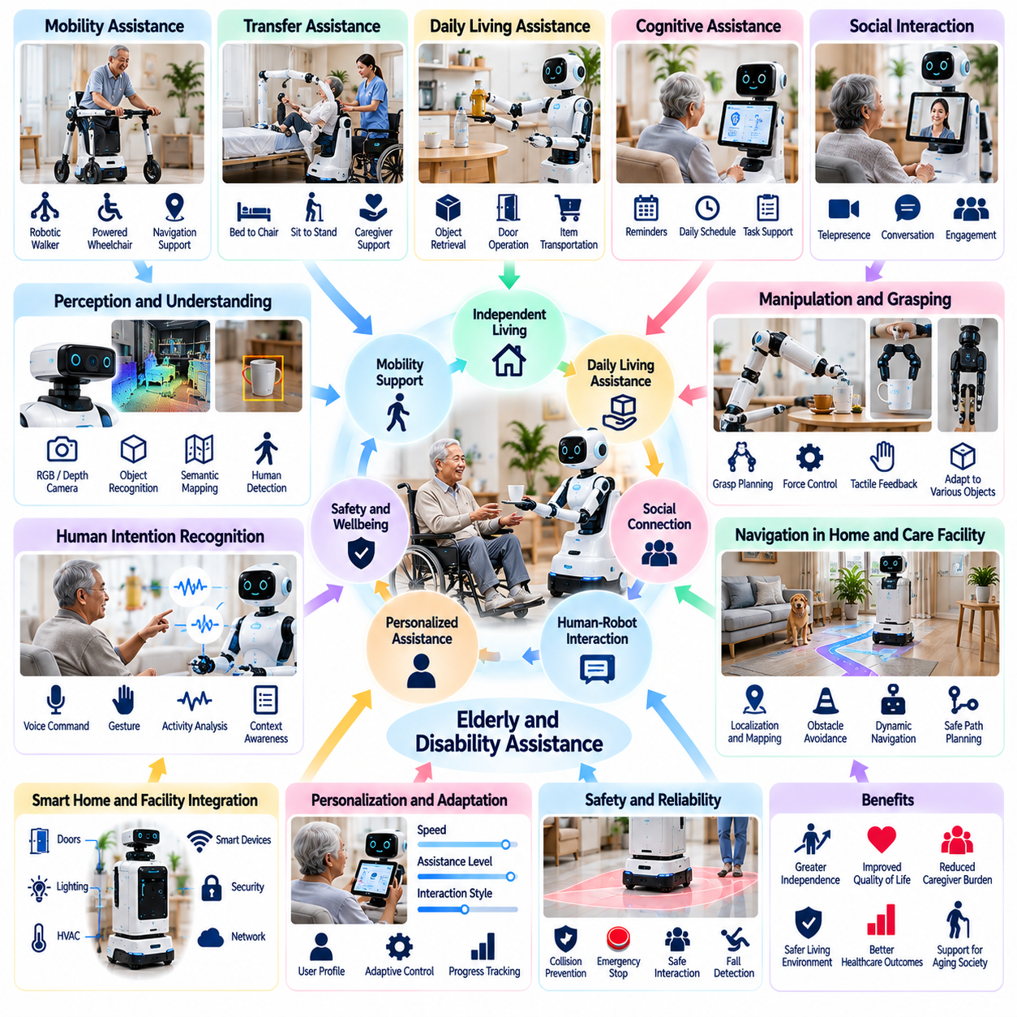
Elderly and disability assistance represents an important application of Physical AI that supports independent living, personal mobility, and daily activities. Aging populations and individuals with physical or cognitive limitations may require varying levels of assistance. Intelligent robotic systems combine perception, mobility, manipulation, and human-centered interaction to provide practical support while preserving personal autonomy and dignity.
Assistive robots are designed to complement caregivers rather than replace human relationships or professional care. Their functions may include retrieving objects, transporting personal items, providing mobility support, and facilitating communication. Effective assistance requires understanding individual preferences, physical capabilities, and environmental conditions. Robots must remain predictable, accessible, and responsive to user instructions.
Daily living assistance focuses on activities such as reaching household objects, carrying supplies, opening compatible doors, and organizing frequently used items. Mobile manipulators can navigate indoor environments and perform selected physical tasks through robotic arms and grippers. Reliable operation requires object recognition, grasp planning, obstacle avoidance, and careful management of contact forces near people.
Mobility assistance is particularly valuable for individuals experiencing reduced walking ability, balance difficulties, or limited endurance. Robotic walkers, powered mobility devices, and intelligent wheelchairs can support movement through homes and care facilities. Navigation systems may provide obstacle detection and route guidance, while shared control allows users to retain authority over movement decisions and destinations.
Transfer assistance addresses physically demanding movements between beds, chairs, wheelchairs, and other support surfaces. Robotic transfer devices may reduce caregiver workload and provide controlled mechanical support. However, safe transfers require careful assessment of body position, weight distribution, balance, and individual medical restrictions. Human supervision remains essential when movement presents significant injury risks.
Fall prevention and response are major concerns in elderly assistance because falls can lead to serious injuries and reduced independence. Robotic systems may combine environmental sensors, wearable devices, and movement analysis to identify potential hazards or unusual activity. Detection systems can generate alerts or initiate predefined assistance procedures. Their performance must be validated to reduce missed events and unnecessary alarms.
Personal assistance requires adaptation to diverse physical abilities, including reduced hand strength, restricted joint movement, impaired vision, and limited hearing. User interfaces may support voice commands, touch controls, gestures, or accessible communication devices. Multimodal interaction enables users to select suitable control methods. Interface design should accommodate fatigue, sensory limitations, and changes in functional capability.
Cognitive assistance can support individuals who experience memory difficulties, reduced attention, or challenges with daily task organization. Robots may provide reminders for scheduled activities, appointments, and routine household tasks. Context-aware systems can adapt notification timing and presentation to user preferences. Such assistance should avoid excessive prompting and must not independently make consequential medical decisions.
Socially assistive robots may facilitate communication, structured activities, and engagement with family members or caregivers. Conversational interfaces and telepresence functions can support remote interaction and access to assistance. However, perceived companionship should not be confused with human emotional understanding. Systems must communicate their capabilities transparently and avoid encouraging inappropriate emotional dependence.
Physical AI enables assistive robots to interpret complex indoor environments containing furniture, personal belongings, pets, and moving people. Semantic mapping identifies functional locations such as bedrooms, kitchens, and bathrooms. Dynamic navigation adapts to temporary obstacles and changing layouts. Robots must operate conservatively in narrow passages, crowded spaces, and areas where users may move unpredictably.
Human intention recognition can improve the responsiveness of assistive systems by interpreting spoken requests, gestures, movement patterns, and contextual information. A robot may infer that assistance is needed when a user repeatedly attempts to reach an inaccessible object. Nevertheless, inferred intentions remain uncertain. Systems should request confirmation before executing potentially intrusive or physically consequential actions.
Personalization is essential because assistance requirements differ substantially between individuals and may change over time. Robots can adapt movement speed, communication style, task priorities, and physical assistance levels according to user preferences. Longitudinal observations may reveal changes in activity patterns or task performance. Adaptation must remain transparent, reversible, and subject to user or caregiver authorization.
Integration with smart home infrastructure can extend robotic assistance through connected doors, lighting, environmental controls, and communication systems. Robots may coordinate with authorized devices to simplify routine activities and improve accessibility. Interoperability requires reliable communication protocols, secure authentication, and appropriate permission management. Critical functions should remain available when network connectivity is interrupted.
Care facilities introduce additional requirements because assistive robots may support multiple residents with different needs. Fleet coordination can allocate robots according to task urgency, location, and available capabilities. Staff interfaces should provide clear task status and intervention requests. Shared operation must protect personal information and prevent confusion between users, destinations, and assistance instructions.
Physical safety is fundamental when robots operate close to elderly individuals or people with disabilities. Potential hazards include collisions, unstable support, excessive contact forces, and unexpected movement. Safety engineering should incorporate compliant mechanisms, speed limits, obstacle detection, emergency stopping, and reliable fault handling. Assistance must respect individual vulnerability without unnecessarily restricting personal freedom.
Privacy and data governance are important because assistive robots may collect video, audio, location, movement, and behavioral information inside private living spaces. Data collection should be limited to legitimate assistance purposes and supported by informed consent. Secure storage, access controls, retention policies, and transparent monitoring practices help protect users. Sensitive observations should not be shared without appropriate authorization.
Reliability and maintainability strongly influence whether assistive robots can support everyday living. Devices must operate consistently across changing environments and recover safely from navigation, manipulation, or communication failures. Battery management, charging accessibility, cleaning, and technical support require practical planning. Users and caregivers should have straightforward methods to request assistance when automation fails.
Evaluation of elderly and disability assistance should emphasize meaningful improvements in independence, accessibility, comfort, and quality of life. Technical indicators include task success, navigation reliability, intervention frequency, and system availability. User satisfaction, caregiver workload, and sustained adoption provide additional evidence. Evaluations should involve diverse participants and realistic home or care environments.
Economic and organizational adoption depends on device affordability, installation complexity, training requirements, and ongoing service costs. Benefits may include reduced repetitive caregiver tasks, improved accessibility, and greater opportunities for independent activity. However, robots should not be evaluated solely through labor savings. Their value must also reflect user well-being, safety, autonomy, and equitable access to assistance.
Future elderly and disability assistance systems may integrate general-purpose robotic foundation models, multimodal perception, dexterous manipulation, and personalized adaptive control. These capabilities could enable more flexible support across homes, hospitals, and long-term care facilities. Successful deployment will require dependable safety, ethical data practices, accessible interfaces, and continued human oversight. The long-term objective is to empower individuals through trustworthy physical assistance.

04.07. Humanoid Assistants and Service Robots
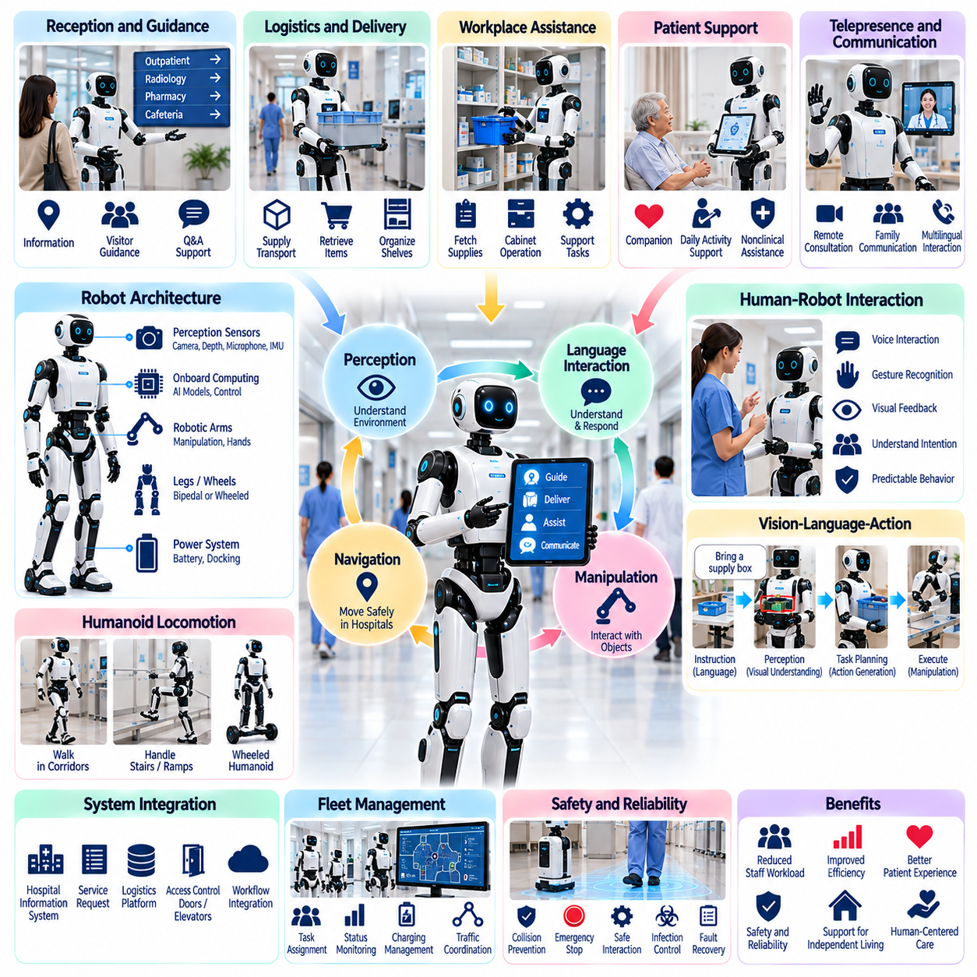
Humanoid assistants and service robots represent an emerging application of Physical AI in hospitals, combining autonomous mobility, perception, manipulation, and natural human interaction. These systems are intended to support healthcare personnel, patients, and visitors through practical service activities. Their value depends on performing useful tasks safely and reliably rather than merely reproducing human appearance or movement.
Humanoid morphology offers potential compatibility with environments originally designed for human workers. Hospital corridors, doors, elevators, counters, shelves, and workstations generally reflect human dimensions and accessibility requirements. Robots with articulated arms and human-scale reach may interact with existing infrastructure. However, humanoid embodiment introduces mechanical complexity, balance requirements, and substantial control challenges.
Hospital service robots can perform reception assistance, visitor guidance, information delivery, and selected logistical activities. A robot may provide directions to clinical departments, explain routine procedures, or escort visitors along approved routes. These applications require reliable localization, speech interaction, and awareness of surrounding people. Service boundaries must remain clear to prevent inappropriate clinical advice or unauthorized actions.
Humanoid assistants may support nonclinical tasks such as transporting lightweight supplies, retrieving standardized containers, and organizing designated work areas. Mobile manipulation enables interaction with shelves, cabinets, and service counters. Task selection should reflect demonstrated robot capabilities and environmental constraints. High-risk clinical procedures and direct patient handling require substantially stronger evidence and safeguards.
Perception systems allow humanoid robots to understand dynamic hospital environments. Cameras, depth sensors, microphones, and proprioceptive sensors provide information about objects, people, obstacles, and robot posture. Multimodal sensor fusion supports spatial awareness and interaction. Robust perception must accommodate crowded corridors, reflective surfaces, changing lighting, and partially occluded objects.
Natural language interaction provides an accessible interface for patients, visitors, and hospital staff. Speech recognition and language models can interpret requests, answer approved informational questions, and clarify task instructions. Multilingual support may improve accessibility in diverse healthcare environments. However, conversational systems must recognize uncertainty and avoid presenting generated responses as verified medical guidance.
Vision-language-action models offer a potential architecture for connecting verbal instructions and visual observations with robotic behavior. A command to retrieve an approved supply item may be translated into object identification, navigation, grasping, and delivery actions. Such systems require grounding in real environmental observations. Safety-critical actions must remain constrained by verified policies, permissions, and execution monitoring.
Humanoid locomotion presents significant challenges in healthcare settings. Bipedal robots must maintain balance while navigating floors, thresholds, ramps, and crowded spaces. Falls or unexpected movements can create hazards for vulnerable patients. Wheeled humanoid platforms may offer greater stability and energy efficiency for many hospital tasks. Morphology selection should follow operational requirements rather than visual resemblance to humans.
Manipulation capabilities determine whether humanoid assistants can perform meaningful physical work. Robotic hands and arms must handle objects with different shapes, weights, and surface properties. Grasp planning, force control, and tactile sensing help prevent slipping, crushing, and unintended contact. Hospital deployment benefits from standardized containers and workstations that reduce manipulation uncertainty.
Whole-body control coordinates locomotion, arm movement, posture, and balance during physical interaction. A humanoid robot may need to reposition its body while reaching toward shelves or carrying objects. Motion planning must consider joint limits, center of mass, payload distribution, and nearby people. Coordinated control becomes especially important when manipulation forces influence overall stability.
Human-robot interaction requires predictable behavior and clear communication of robot intentions. Visual indicators, speech messages, and controlled movement patterns can help people understand upcoming actions. Robots should recognize requests for assistance and respond appropriately to interruptions. Their behavior must account for patients with limited mobility, sensory impairments, or heightened sensitivity to unexpected motion.
Social interaction capabilities may support patient engagement and visitor assistance, but humanoid appearance can create unrealistic expectations. Users may assume that a robot possesses human judgment, empathy, or clinical competence. Responsible interface design should communicate the system's actual capabilities and limitations. Robots must not misrepresent automated responses as professional medical assessments.
Hospital workflow integration determines whether humanoid assistants contribute to operational efficiency. Service requests may originate from reception systems, logistics platforms, or authorized staff interfaces. Task management software can coordinate priorities, destinations, and completion records. Integration with hospital information systems requires appropriate access controls and careful separation of administrative and clinical functions.
Fleet management becomes relevant when multiple service robots operate across hospital departments. Central coordination can assign tasks according to robot capabilities, location, battery condition, and service urgency. Shared maps and traffic policies help reduce congestion. Humanoid robots may also operate alongside autonomous mobile robots, requiring interoperable scheduling and clearly defined operational responsibilities.
Physical safety is a primary requirement for humanoid deployment in clinical environments. Potential hazards include loss of balance, collisions, excessive contact forces, dropped objects, and unexpected arm movements. Protective measures may include speed restrictions, compliant actuation, collision monitoring, emergency stopping, and controlled recovery procedures. Safety validation must reflect actual hospital operating conditions.
Privacy and information security require special attention because service robots may process speech, images, location data, and personal requests. Patient information should be accessed only when necessary and explicitly authorized. Data minimization, encryption, authentication, and retention policies support responsible operation. Public-facing robots must prevent accidental disclosure of confidential information through speech or displays.
Operational reliability depends on consistent performance across changing hospital conditions. Robots must detect blocked routes, unavailable destinations, failed grasps, communication interruptions, and low battery conditions. Recovery strategies may involve replanning, requesting staff assistance, or safely terminating tasks. Clear escalation procedures are essential when service failures could disrupt hospital workflows.
Performance evaluation should distinguish technical demonstrations from sustained operational capability. Relevant measures include task completion rate, navigation success, manipulation reliability, interaction accuracy, intervention frequency, and system availability. Human acceptance, workflow disruption, and safety incidents also require assessment. Long-duration trials provide stronger evidence than isolated demonstrations in controlled environments.
Economic feasibility depends on the relationship between robot capabilities, acquisition costs, integration expenses, and measurable service benefits. Humanoid platforms may require expensive actuators, sensors, computing systems, and specialized maintenance. Hospitals should compare them with simpler wheeled robots or fixed automation solutions. Deployment is justified when additional flexibility produces meaningful operational value.
Future humanoid assistants may benefit from general-purpose robotic foundation models, improved dexterous manipulation, multimodal reasoning, and adaptive whole-body control. These technologies could expand the range of hospital service tasks performed by a common robotic platform. Nevertheless, progress must be supported by reliable safety engineering, clinical workflow validation, and human oversight.
The long-term role of humanoid assistants and service robots is to complement healthcare professionals by handling appropriate physical and informational tasks. Successful systems will combine useful autonomy with transparent limitations, dependable operation, and respect for patient needs. Rather than replacing clinical expertise, Physical AI should reduce avoidable workload and improve service accessibility while preserving human responsibility for patient care.

04.08. Patient Monitoring and Autonomous Inspection
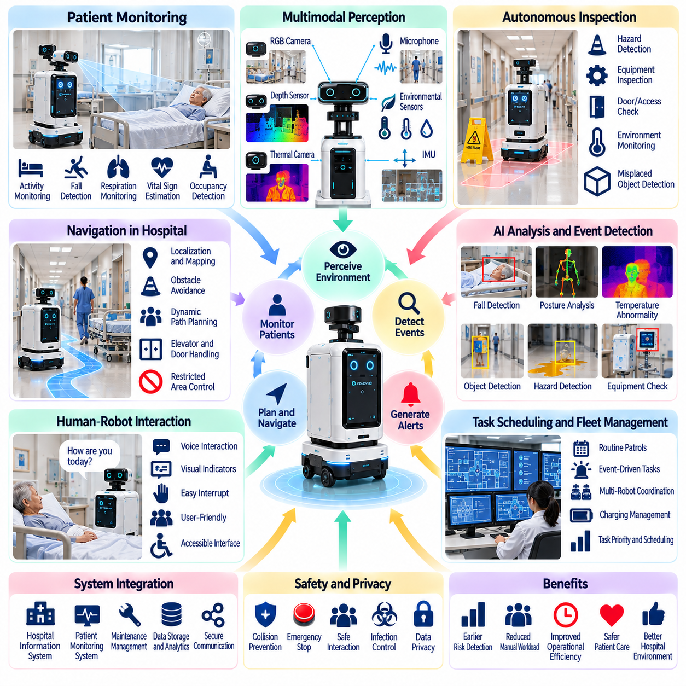
Patient monitoring and autonomous inspection represent important applications of Physical AI in healthcare environments. These systems combine mobile robotics, intelligent sensing, environmental perception, and automated analysis to support clinical observation and facility operations. Their purpose is to improve information availability, identify potential risks, and reduce repetitive inspection workloads while preserving clinical responsibility and patient safety.
Patient monitoring robots can collect selected observations through cameras, thermal sensors, depth sensors, and connected medical devices. Depending on their intended use, these systems may observe patient movement, posture, room occupancy, or environmental conditions. Robotic mobility enables measurements from different locations. However, observations must be interpreted within validated clinical workflows rather than treated as independent medical diagnoses.
Autonomous inspection extends robotic monitoring beyond individual patients to hospital rooms, corridors, equipment areas, and shared facilities. Mobile robots can follow scheduled routes to observe environmental conditions and identify operational abnormalities. Inspection activities may include detecting blocked passages, misplaced equipment, unattended objects, and unusual room conditions. These functions support preventive maintenance and operational awareness.
Multimodal perception provides the foundation for reliable patient monitoring and inspection. RGB cameras, depth sensors, thermal imaging, microphones, and environmental sensors capture complementary information. Sensor fusion helps distinguish relevant events from background activity. Reliable operation requires careful calibration and consideration of occlusion, lighting variation, reflective surfaces, sensor noise, and differences between clinical environments.
Patient movement monitoring can help identify changes in activity patterns, prolonged inactivity, or potentially unsafe attempts to leave a bed. Vision-based posture estimation and movement analysis may support predefined alert conditions. However, movement observations cannot reliably establish clinical causes without additional assessment. Alert thresholds should be validated for the intended population and coordinated with nursing procedures.
Fall detection and fall-risk monitoring are important applications because hospitalized patients may experience impaired mobility, weakness, or disorientation. Robotic systems may analyze movement trajectories, posture transitions, and unusual events to identify possible falls. Rapid notification can support timely staff response. Detection performance must be evaluated for false alarms, missed events, and variations in patient behavior.
Contactless physiological monitoring may estimate selected indicators such as respiratory motion or skin-surface temperature under suitable conditions. Cameras, radar sensors, and thermal imaging can provide noncontact observations without attaching additional devices. Measurement accuracy depends on sensor placement, environmental interference, and patient movement. Such systems require clinical validation before their outputs guide medical decisions.
Autonomous inspection robots can support hospital environmental safety by detecting spills, obstacles, open access points, or abnormal equipment conditions. Visual inspection may identify visible hazards, while specialized sensors can measure temperature, humidity, or air-quality indicators. Automated reporting allows maintenance personnel to prioritize corrective actions. Inspection robots should not be considered substitutes for required human safety checks.
Medical equipment inspection can involve observing external indicators, equipment locations, and selected operational states. Robots may identify misplaced devices, obstructed access, or visible warning signals. Integration with authorized equipment interfaces can provide additional status information. However, automated inspection cannot replace certified maintenance, calibration, or technical testing required for medical equipment.
Navigation reliability is essential because inspection robots operate near patients, clinical personnel, and sensitive equipment. Autonomous systems must navigate narrow corridors, doorways, and occupied rooms while avoiding collisions and unnecessary disruption. Localization, obstacle detection, and dynamic path planning support safe movement. Robots must respect restricted zones, emergency routes, and patient-care activities.
Inspection scheduling should reflect hospital priorities and operational conditions. Routine patrols may follow predefined intervals, while event-triggered inspections respond to reported abnormalities or specific service requests. Intelligent scheduling can consider location, urgency, robot availability, and battery condition. Time-sensitive monitoring tasks require clear rules for prioritization and escalation when resources are unavailable.
Event detection systems transform sensor observations into operationally meaningful information. Machine learning models may classify objects, recognize movement patterns, and identify deviations from expected conditions. Temporal analysis can distinguish persistent abnormalities from brief changes. Nevertheless, uncertain observations require confidence assessment and appropriate human verification before consequential actions are initiated.
Human-robot interaction is necessary when monitoring robots enter patient rooms or approach clinical workspaces. Robots should communicate their presence and intended activity through appropriate visual or audible signals. Patients and staff must understand what information is being collected and how to request assistance or interrupt an inspection. Interaction design should accommodate sensory impairments and patient preferences.
Integration with hospital information systems can connect monitoring observations with authorized clinical and operational workflows. Relevant alerts may be transmitted to nursing stations, maintenance systems, or designated response personnel. Data interfaces must preserve accurate timestamps, device identification, and event context. Clinical records should only be updated through validated and appropriately authorized processes.
Alert management is a critical design issue because excessive notifications can increase workload and contribute to alarm fatigue. Monitoring systems should prioritize events according to severity, confidence, and operational relevance. Escalation procedures must identify responsible personnel and expected responses. Performance evaluation should consider whether alerts improve timely intervention rather than merely increasing event detection.
Privacy protection is especially important because patient monitoring may involve continuous or repeated observation in sensitive clinical spaces. Video, audio, physiological measurements, and location information require appropriate safeguards. Data minimization, access controls, encryption, and retention policies help reduce unnecessary exposure. Monitoring practices must comply with applicable regulations and respect patient consent and dignity.
Cybersecurity is necessary to protect connected sensors, mobile robots, hospital networks, and monitoring platforms. Unauthorized access could expose sensitive information or interfere with robotic operations. Secure authentication, software updates, network segmentation, and event logging support system protection. Safety-critical functions should remain appropriately controlled during communication interruptions or suspected security incidents.
Operational reliability requires robots to recognize sensor failures, localization errors, blocked routes, and unavailable monitoring destinations. Recovery strategies may include recalibration, alternate navigation, supervised intervention, or safe task termination. Systems must distinguish incomplete inspections from verified observations. Clear fault reporting allows clinical and technical personnel to respond without assuming that missing information indicates normal conditions.
Clinical validation should establish whether monitoring functions are sufficiently accurate and useful for their intended purposes. Evaluation measures may include sensitivity, specificity, false-alert frequency, detection latency, and staff response time. Operational inspection metrics include route completion, inspection coverage, intervention frequency, and system availability. Studies should reflect realistic patient populations and hospital conditions.
Economic evaluation should consider robotic hardware, sensor integration, software, cybersecurity, maintenance, and staff supervision. Potential benefits include improved inspection consistency, earlier identification of operational problems, and reduced repetitive monitoring tasks. However, increased alert workload and integration complexity may offset expected savings. Adoption should depend on demonstrated clinical or operational value.
Future patient monitoring and autonomous inspection systems may combine multimodal foundation models, predictive analytics, mobile sensing, and adaptive task planning. These technologies could improve contextual understanding and enable more responsive inspection workflows. Nevertheless, uncertainty management, validated performance, privacy protection, and human oversight will remain essential. The long-term objective is to strengthen hospital situational awareness without replacing professional clinical judgment.

04.09. Telepresence and Remote Care
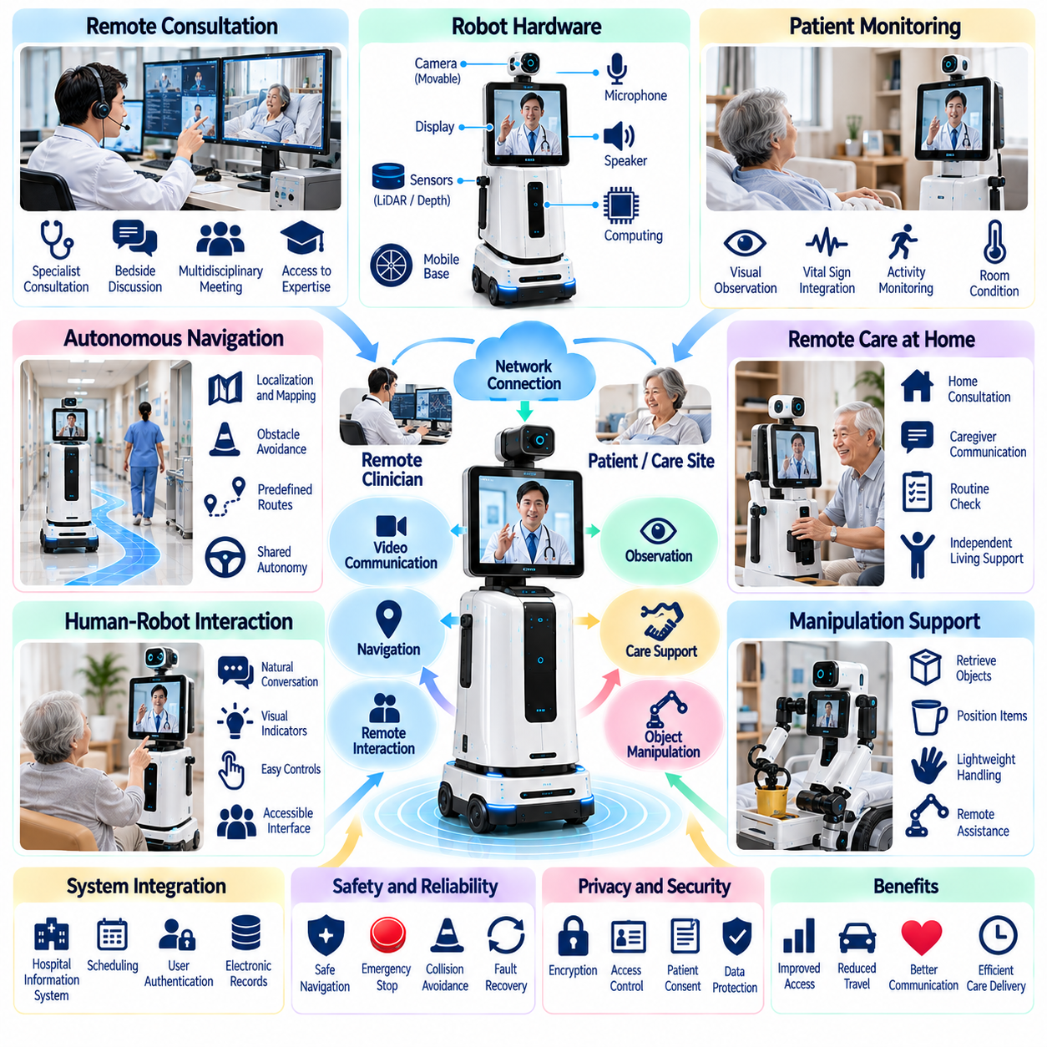
Telepresence and remote care represent important applications of Physical AI that extend healthcare services beyond the physical presence of medical professionals. Mobile robotic platforms combine video communication, autonomous navigation, environmental sensing, and remote interaction. These systems enable clinicians and caregivers to observe, communicate, and coordinate selected care activities across hospitals, rehabilitation centers, and residential environments.
Telepresence robots typically integrate a mobile base, cameras, microphones, speakers, displays, and network communication systems. Remote operators can establish audiovisual connections and navigate the robot through designated environments. Adjustable camera orientation and positioning improve visibility during interactions. Reliable operation requires stable connectivity, intuitive controls, and safe navigation around patients and clinical equipment.
Remote clinical consultation is a primary application of robotic telepresence. Physicians and specialists can communicate with patients and local healthcare personnel without traveling to the same location. Mobile platforms allow remote participants to view different areas and interact more naturally than stationary video terminals. However, remote consultations must remain within established clinical protocols and applicable professional requirements.
Hospital telepresence can support specialist consultations, multidisciplinary coordination, and communication between geographically separated departments. A remote specialist may participate in bedside discussions or observe selected clinical activities through authorized audiovisual channels. These capabilities can improve access to expertise. Nevertheless, telepresence cannot replace physical examinations or procedures requiring direct clinical contact.
Autonomous navigation reduces the operational burden associated with remotely controlling mobile telepresence platforms. Robots may travel between designated rooms, nursing stations, and consultation areas using predefined routes. Localization, obstacle detection, and dynamic path planning support safe movement. Remote operators should retain appropriate supervisory control and the ability to stop or redirect the robot when necessary.
Shared autonomy combines remote human control with local robotic intelligence. Operators may specify destinations or movement intentions while onboard systems handle obstacle avoidance and precise positioning. This approach reduces continuous manual steering and communication demands. Effective shared control requires predictable transitions between autonomous and operator-directed behavior, especially when network conditions deteriorate.
Communication latency is a major technical constraint in remote robotic operation. Delays between operator commands, robot movement, and visual feedback can reduce control precision and increase collision risks. Local safety controllers should manage immediate obstacle avoidance independently of network performance. Communication architectures must prioritize critical control signals while maintaining acceptable audiovisual interaction quality.
Remote patient observation can support selected monitoring activities when authorized by clinical personnel and patients. Telepresence platforms may provide visual access to patient posture, room conditions, and communication needs. Connected medical devices can supply additional measurements through approved interfaces. Remote observations should complement established monitoring systems rather than independently determine clinical status.
Telepresence applications extend into long-term care facilities and assisted living environments. Remote caregivers may communicate with residents, assess routine assistance requests, or coordinate in-person support. Mobile platforms can move between shared spaces and individual rooms under appropriate access policies. Their deployment must respect personal privacy, resident preferences, and the limitations of remote assessment.
Home-based remote care offers opportunities to support individuals with mobility limitations, chronic care needs, or restricted access to healthcare facilities. Robotic telepresence can facilitate scheduled consultations and communication with caregivers. Integration with authorized home sensors may provide contextual information. However, home operation requires reliable connectivity, accessible interfaces, and clearly defined emergency response procedures.
Human-robot interaction strongly influences the effectiveness of remote care systems. Patients should understand when a remote operator is connected, what information is being transmitted, and how to end an interaction. Clear audiovisual indicators and accessible controls support informed participation. Interface design must accommodate hearing impairment, visual limitations, cognitive differences, and individual communication preferences.
Telepresence systems may incorporate robotic manipulation to extend remote interaction beyond observation and communication. Mobile manipulators could retrieve lightweight objects, position communication devices, or perform approved support tasks. Such functions introduce additional safety and control requirements. Direct physical assistance involving patients requires validated mechanisms, appropriate supervision, and strict operational boundaries.
Integration with hospital information systems supports scheduling, user authentication, consultation records, and authorized communication workflows. Telepresence sessions may be initiated through clinical applications or coordinated by designated staff. Access permissions should reflect professional responsibilities and patient consent. System interfaces must protect sensitive information while preserving accurate records of remote interactions.
Cybersecurity and privacy protection are fundamental because telepresence platforms transmit audiovisual data and may access sensitive clinical environments. Encryption, authenticated sessions, role-based access control, and secure device management reduce exposure risks. Unauthorized camera activation or remote movement must be prevented. Data retention and recording policies should be transparent and consistent with applicable healthcare regulations.
Operational safety requires robots to navigate shared spaces without interfering with patient care or emergency activities. Potential hazards include collisions, blocked access routes, unexpected movement, and equipment contact. Speed limits, obstacle detection, emergency stopping, and restricted-zone management provide protective measures. Remote operation must not bypass local safety functions or established hospital access restrictions.
System reliability depends on effective responses to communication failures, depleted batteries, sensor faults, and unavailable destinations. Robots should enter a safe state when remote control becomes unreliable. Recovery procedures may include stopping movement, reconnecting communication, returning to a designated location, or requesting local assistance. Critical care workflows require alternatives when robotic telepresence becomes unavailable.
Fleet management becomes relevant when multiple telepresence robots serve different departments or care facilities. Centralized scheduling can coordinate consultation requests, robot availability, charging, and movement priorities. Task allocation may consider proximity, communication requirements, and service urgency. Shared operations must prevent unauthorized session access and conflicts between simultaneous requests.
Clinical validation should assess whether robotic telepresence improves access, communication quality, and care coordination for intended use cases. Relevant measures include consultation completion, connection reliability, interaction latency, patient satisfaction, and clinician acceptance. Operational evaluation should examine navigation success, intervention frequency, and system availability. Studies must distinguish improved communication access from demonstrated clinical outcomes.
Economic evaluation should consider robot acquisition, network infrastructure, software subscriptions, cybersecurity, maintenance, and staff support. Potential benefits include reduced travel requirements, improved specialist accessibility, and more flexible coordination across facilities. However, financial value depends on utilization, workflow integration, and reliable service delivery. Cost savings should be evaluated alongside care quality and patient experience.
Future telepresence and remote care platforms may integrate multimodal AI, autonomous navigation, intelligent task planning, and adaptive human-robot interaction. Improved perception and shared autonomy could reduce operator workload and support more responsive services. Nevertheless, clinical accountability, patient consent, cybersecurity, and dependable local safety will remain essential. The long-term objective is to extend human-centered healthcare through trustworthy robotic connectivity.

04.10. Human Robot Interaction in Clinical Environments
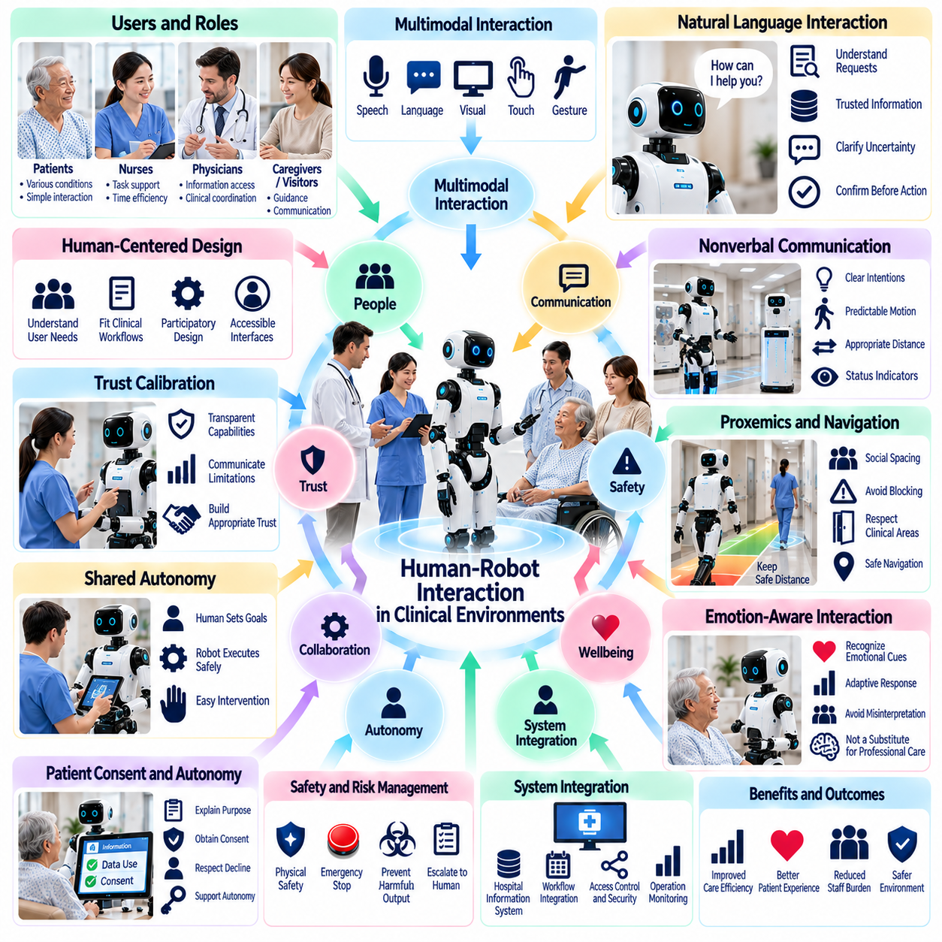
Human-robot interaction in clinical environments is a critical foundation for deploying Physical AI safely and effectively in healthcare. Robots must communicate and cooperate with patients, physicians, nurses, caregivers, and visitors under demanding operational conditions. Successful interaction requires more than natural conversation. It depends on predictable behavior, transparent intentions, appropriate autonomy, and respect for clinical responsibilities.
Clinical environments present unique interaction challenges because users differ in physical ability, medical condition, cognitive capacity, and emotional state. Patients may experience pain, fatigue, anxiety, or sensory impairments. Healthcare professionals often operate under time pressure. Robotic interfaces must adapt to these differences without creating additional confusion, unnecessary workload, or unsafe expectations.
Human-centered design begins with understanding the roles and needs of each participant. Nurses may require rapid task assignment, physicians may need access to verified information, and patients may prefer simple communication methods. Interaction workflows should reflect actual clinical procedures rather than forcing users to accommodate robotic limitations. Participatory design with healthcare personnel can reveal practical requirements.
Multimodal interaction combines speech, visual displays, gestures, touch interfaces, and environmental cues to support communication. Different modalities provide complementary benefits depending on the user and situation. Speech may enable hands-free requests, while visual interfaces can confirm task details. Systems should offer alternative interaction channels when noise, disability, language barriers, or clinical restrictions limit accessibility.
Natural language understanding enables robots to interpret requests expressed in ordinary clinical or conversational language. Language models may assist with task clarification, information retrieval, and dialogue management. However, generated responses must remain grounded in approved information sources. Robots should recognize ambiguous instructions, communicate uncertainty, and request confirmation before executing consequential actions.
Speech interaction in hospitals must account for background conversations, alarms, equipment noise, and privacy requirements. Automatic speech recognition may become unreliable when speakers wear masks or speak softly. Microphone placement, noise reduction, and contextual processing can improve recognition. Critical commands should use confirmation mechanisms or alternative interfaces when recognition confidence is insufficient.
Nonverbal communication is essential for robots moving through shared clinical spaces. Movement speed, stopping behavior, orientation, and approach distance communicate robotic intentions. Lights, displays, and simple gestures can indicate task status or upcoming movement. These signals should remain consistent and understandable. Unexpected motion or ambiguous behavior can undermine trust even when physical safety mechanisms function correctly.
Proxemics describes how people interpret interpersonal distance and spatial behavior during interaction. Robots must maintain appropriate separation from patients, staff, and medical equipment. Acceptable distances vary with clinical activities, room constraints, and individual preferences. Navigation planners should incorporate social spacing and avoid blocking access to beds, emergency equipment, or frequently used work areas.
Shared autonomy allows humans and robots to divide responsibilities according to their respective capabilities. Healthcare workers may specify goals while robots handle navigation or routine manipulation. Human intervention becomes necessary when situations exceed validated autonomous capabilities. Interfaces must clearly indicate who controls the system, which actions are permitted, and how control can be transferred or withdrawn.
Trust calibration is particularly important because users may overestimate or underestimate robotic capabilities. Humanlike appearance, fluent speech, or confident responses can create an exaggerated impression of intelligence. Conversely, unfamiliar movements may reduce confidence in reliable systems. Appropriate trust develops when robots communicate their capabilities, limitations, uncertainty, and operational status accurately.
Patient consent and personal autonomy must guide interactions involving monitoring, communication, or physical assistance. Patients should understand the robot's purpose and whether information is being recorded or transmitted. Where applicable, they should be able to decline participation or request human assistance. Special consideration is required when cognitive impairment, communication difficulties, or emergency circumstances affect informed consent.
Emotion-aware interaction may help robots respond appropriately to observable signs of discomfort or confusion. Facial expressions, speech characteristics, and behavioral cues can provide limited contextual information. However, inferred emotional states are uncertain and may vary across individuals and cultures. Robots should avoid presenting emotional predictions as established facts or substituting automated responses for professional psychological assessment.
Interaction safety includes both physical protection and prevention of harmful communication. Robots must avoid collisions, excessive contact forces, and unexpected manipulation. They must also prevent misleading medical statements, unauthorized disclosures, and inappropriate task execution. Safety architectures should separate conversational intelligence from verified control functions and provide immediate stopping and escalation mechanisms.
Clinical workflow integration requires robotic interactions to align with established responsibilities and communication channels. Service requests, task confirmations, and completion notifications should reach authorized personnel without duplicating existing work. Robots should recognize interruptions and changing priorities. Effective integration reduces unnecessary coordination while ensuring that clinical decisions remain under qualified human supervision.
Accessibility and inclusive design are essential for patients with diverse physical and cognitive abilities. Interfaces may require adjustable speech volume, readable text, simplified commands, multilingual communication, or assistive input methods. Interaction timing should accommodate slower responses and limited movement. Accessibility testing should involve representative users rather than relying exclusively on standardized laboratory demonstrations.
Privacy and cybersecurity influence how people interact with clinical robots. Voice recordings, camera observations, identity information, and interaction histories may contain sensitive patient data. Authentication, access controls, encryption, and data minimization should protect these resources. Robots must communicate recording and connection status clearly and prevent unauthorized users from accessing clinical functions.
Evaluation of human-robot interaction should combine technical performance with clinical usability and human factors. Relevant measures include task success, instruction recognition accuracy, interaction duration, user workload, perceived trust, and intervention frequency. Safety incidents, misunderstandings, and workflow disruptions also require assessment. Studies should involve realistic environments and representative patient and staff populations.
Training and organizational readiness strongly affect successful deployment. Healthcare personnel need practical instruction on robot capabilities, task assignment, emergency stopping, and failure recovery. Patients and visitors benefit from simple explanations of expected behavior. Clear operational procedures and designated support personnel reduce uncertainty. Continuous feedback can identify interface problems that laboratory testing may overlook.
Future clinical interaction systems may incorporate multimodal foundation models, personalized dialogue, context-aware reasoning, and adaptive robotic behavior. These capabilities could support more natural communication and flexible cooperation across healthcare tasks. Nevertheless, improved conversational fluency does not establish clinical competence. Validation, transparency, privacy protection, and human oversight must remain central design principles.
The long-term objective of human-robot interaction in clinical environments is to create dependable collaboration between people and intelligent machines. Physical AI should adapt to healthcare practices while preserving patient dignity, professional authority, and operational safety. Successful systems will be evaluated not by how humanlike they appear, but by how effectively they support care delivery, reduce workload, and improve the experience of patients and healthcare professionals.

04.11. Safety Privacy and Data Governance
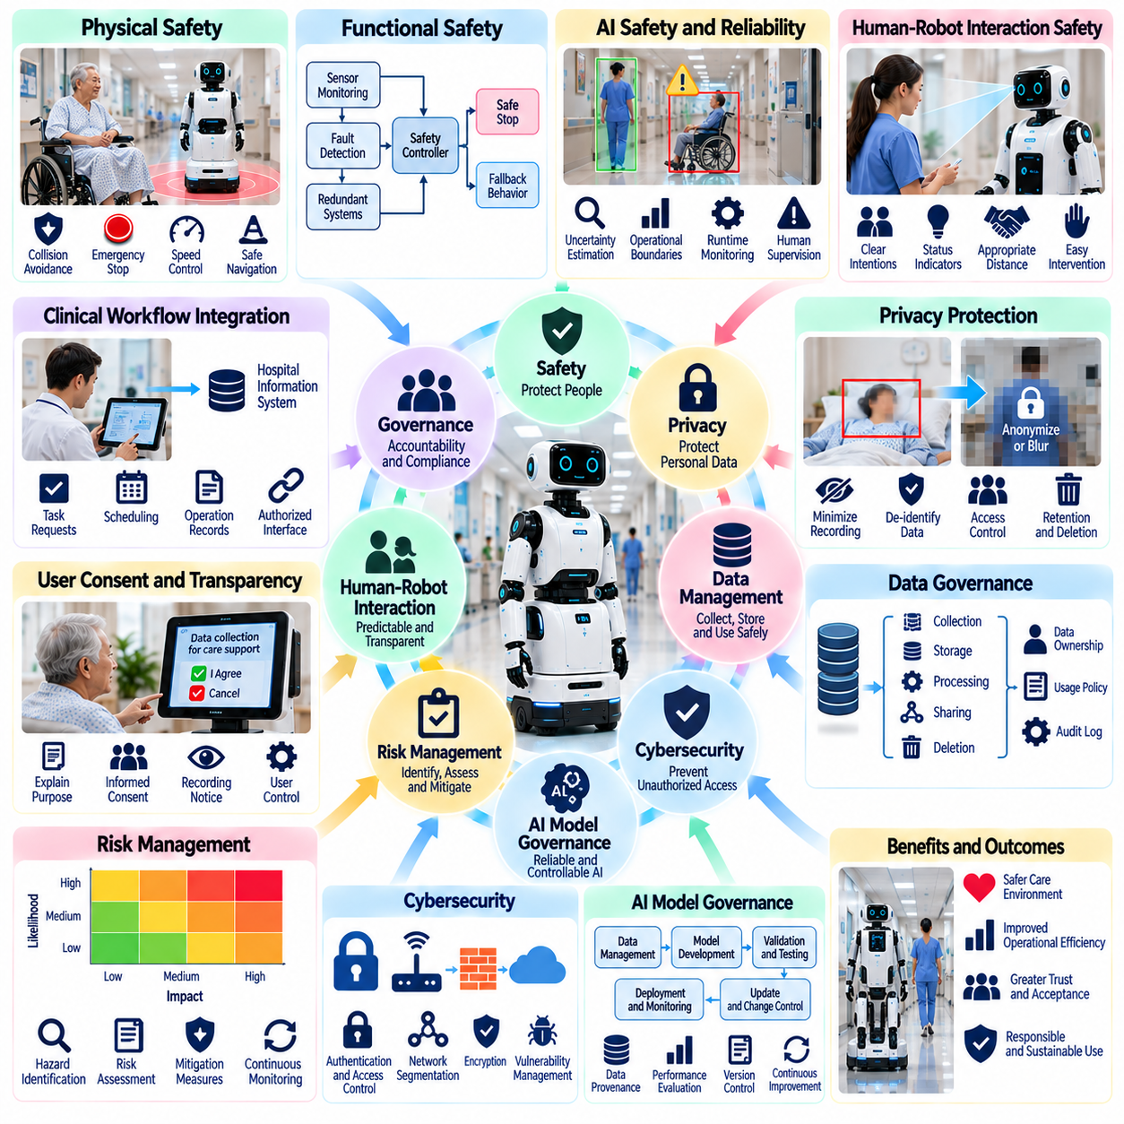
Safety, privacy, and data governance are fundamental requirements for deploying Physical AI in healthcare environments. Robots interact with patients, medical personnel, sensitive equipment, and confidential information, creating risks beyond those of conventional automation. Responsible deployment requires coordinated engineering, clinical oversight, cybersecurity, and organizational policies that protect human welfare throughout the robotic system lifecycle.
Physical safety begins with identifying hazards associated with autonomous navigation, manipulation, and human contact. Hospital robots may encounter vulnerable patients, crowded corridors, medical devices, and unpredictable movement. Risk assessments should consider collision forces, falling objects, unstable motion, and obstructed emergency routes. Protective measures must reflect the severity and likelihood of harm under realistic operating conditions.
Functional safety engineering establishes mechanisms that maintain acceptable risk when components or software fail. Safety-rated sensors, emergency stopping, speed restrictions, protective separation, and fault monitoring can reduce hazardous behavior. Independent safety functions should not depend entirely on probabilistic AI predictions. System validation must verify that protective mechanisms remain effective during foreseeable failures and abnormal conditions.
AI-specific safety introduces challenges involving perception errors, uncertain predictions, and unexpected decisions. Machine learning models may behave differently under unfamiliar lighting, unusual patient movement, or changing hospital layouts. Confidence estimation, operational boundaries, runtime monitoring, and conservative fallback actions help manage uncertainty. High-risk decisions should remain subject to verified rules and qualified human supervision.
Human-robot interaction safety requires robots to communicate intentions and respond predictably to people. Clear movement signals, accessible emergency controls, and appropriate interpersonal distances reduce confusion and physical risk. Patients with mobility limitations or cognitive impairments may require additional safeguards. Robots must recognize when assistance is needed and avoid assuming that silence or inactivity indicates consent.
Privacy protection is essential because healthcare robots may collect images, audio, physiological observations, identity information, and location histories. Such information can reveal sensitive details about patients, staff, and visitors. Data collection should be limited to legitimate operational or clinical purposes. Systems must avoid unnecessary recording and provide understandable explanations of what information is collected and why.
Patient consent and transparency are central to responsible robotic monitoring and interaction. Individuals should understand whether cameras, microphones, or connected sensors are active and how their information will be used. Consent procedures must reflect applicable legal and clinical requirements. Where appropriate, patients should have meaningful choices regarding participation, recording, and access to human alternatives.
Data governance defines responsibilities for collecting, processing, storing, sharing, and deleting information generated by robotic systems. Hospitals and technology providers must establish clear data ownership, access permissions, retention periods, and accountability. Governance frameworks should distinguish operational telemetry from identifiable clinical information. Every data-processing activity should have a documented purpose and authorized basis.
Data minimization reduces privacy exposure by collecting only information necessary for a defined task. A delivery robot may require destination and task status without accessing detailed patient records. On-device processing can limit transmission of raw video or audio when only event results are needed. De-identification and aggregation may reduce certain risks, although re-identification remains possible in some circumstances.
Cybersecurity protects robotic hardware, software, communication networks, and connected hospital systems from unauthorized access or manipulation. Potential threats include credential theft, malicious commands, ransomware, and compromised software updates. Secure authentication, encryption, network segmentation, and vulnerability management are essential controls. Security architecture should minimize the consequences of a compromised component.
Robotic data pipelines require protection across collection, transmission, storage, and analysis. Sensor recordings, task logs, model inputs, and operational metadata may contain confidential information. Access should follow least-privilege principles, with appropriate logging and auditability. Encryption and secure interfaces help preserve confidentiality and integrity. Data transfers to external services require explicit governance and contractual safeguards.
Cloud and edge computing introduce different governance considerations. Edge processing may reduce latency and unnecessary exposure of sensitive information, while cloud platforms can support fleet analytics and model improvement. Deployment architecture should account for data residency, network reliability, access control, and recovery requirements. Clinical safety functions must remain appropriately protected when cloud connectivity becomes unavailable.
AI model governance extends beyond protecting datasets to managing model development, validation, deployment, and updates. Training data provenance, dataset quality, model versions, and evaluation results should be documented. Models may require reassessment when operating environments or patient populations change. Automated updates must not introduce unverified behavior into safety-critical clinical workflows.
Bias and fairness are important because AI perception and interaction systems may perform differently across patient populations. Variations in age, mobility, appearance, language, and disability can influence model performance. Evaluation datasets should represent intended users and operating conditions. Performance disparities must be investigated and addressed before deployment, particularly when errors could affect access to care or patient safety.
Regulatory compliance depends on the robot's intended purpose, functions, and jurisdiction. A logistics robot, patient monitoring system, and robot performing medical interventions may face different requirements. Applicable medical-device regulations, privacy laws, cybersecurity obligations, and safety standards must be assessed. Compliance planning should begin during system design rather than after technical development.
Incident management establishes how organizations detect, report, investigate, and respond to safety or security failures. Relevant events may include collisions, unauthorized data access, incorrect alerts, and unexpected robotic actions. Audit logs and incident records support root-cause analysis and corrective measures. Reporting responsibilities and escalation procedures should be defined before routine deployment.
Human oversight remains essential when robotic actions may influence clinical decisions or patient well-being. Authorized personnel should understand system limitations, receive meaningful alerts, and retain the ability to intervene. Responsibility for decisions must not become ambiguous between hospitals, operators, and technology suppliers. Clear accountability supports safe operation and appropriate responses when automated systems fail.
Operational governance requires continuous monitoring of system reliability, safety performance, privacy compliance, and cybersecurity posture. Maintenance schedules, software patching, access reviews, and periodic risk reassessments should be integrated into hospital operations. Performance indicators may include safety incidents, intervention frequency, security events, and policy violations. Governance must evolve as robot capabilities and deployment scale increase.
Economic and organizational considerations influence the sustainability of safety and privacy programs. Compliance activities, cybersecurity infrastructure, clinical validation, staff training, and incident response generate ongoing costs. These expenditures should be included in total cost of ownership assessments. Underinvestment in governance can create operational disruptions, legal exposure, and loss of patient trust that outweigh short-term savings.
Future Physical AI systems may incorporate more autonomous decision-making, multimodal foundation models, and shared learning across robotic fleets. These capabilities will increase the importance of explainability, data lineage, runtime assurance, and controlled model updates. Privacy-preserving learning and secure computation may reduce some risks. Nevertheless, technical safeguards must operate within enforceable organizational and regulatory frameworks.
The long-term objective of safety, privacy, and data governance is to make healthcare robotics trustworthy, accountable, and clinically appropriate. Successful deployment requires balancing useful autonomy with human rights, patient dignity, and professional responsibility. Physical AI should improve healthcare operations without compromising confidentiality or safety. Sustainable adoption depends on verifiable protections, transparent governance, and continuous human oversight.

04.12. Hospital System and Workflow Integration
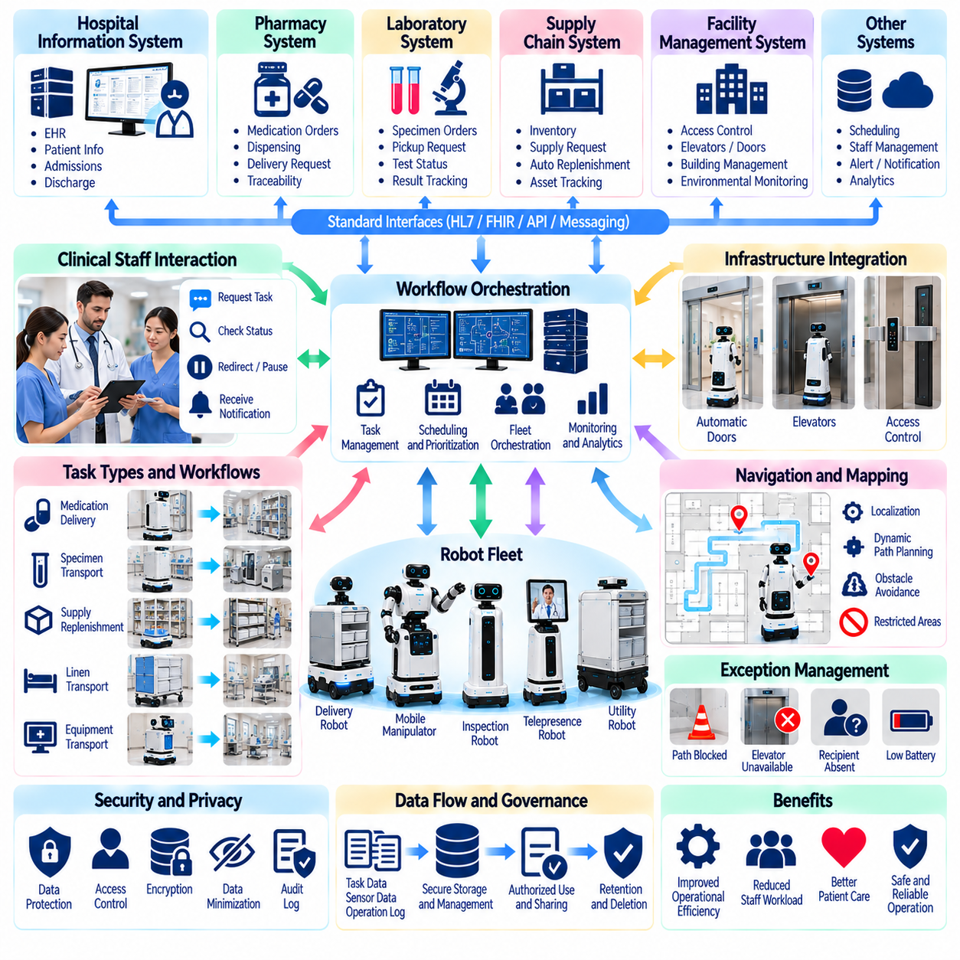
Hospital system and workflow integration is essential for transforming Physical AI robots from isolated automation tools into reliable components of healthcare operations. Robots must coordinate with clinical staff, information systems, facility infrastructure, and established procedures. Successful integration requires technical interoperability, operational alignment, and clear accountability. The objective is to improve service delivery without disrupting patient care.
Hospitals operate through interconnected clinical, administrative, and logistical workflows. Patient admissions, medication distribution, laboratory transport, equipment management, and discharge activities involve multiple departments. Robots must understand task dependencies and organizational priorities. Integration should reflect actual operational processes rather than introducing parallel procedures that increase staff workload or create communication gaps.
Hospital information systems provide the digital foundation for robotic workflow integration. Electronic health records, hospital information systems, laboratory systems, and pharmacy platforms manage different operational data. Robotic applications may exchange authorized task information through standardized interfaces. Access to clinical records should remain limited to what is necessary for the robot's approved function and operational responsibilities.
Interoperability enables robots to exchange information with existing hospital applications and devices. Application programming interfaces, messaging systems, and healthcare data standards support communication between heterogeneous platforms. Standards such as HL7 and FHIR may facilitate selected clinical information exchanges. However, integration requirements depend on the intended use case, system capabilities, and institutional governance policies.
Workflow orchestration connects clinical requests with robotic task execution. A nurse may request supply delivery, a laboratory system may initiate specimen transport, or a pharmacy workflow may trigger medication distribution. An orchestration platform translates approved requests into executable robot missions. Task status, completion confirmations, and exceptions should return to the originating system to maintain operational continuity.
Task prioritization is necessary because hospital activities differ in urgency and clinical importance. Routine linen transport should not interfere with time-sensitive laboratory deliveries or emergency operations. Scheduling systems may consider deadlines, robot availability, travel distance, and service requirements. Priority policies must be established by hospital operators and prevent autonomous optimization from overriding clinical safety or institutional procedures.
Integration with fleet management systems allows multiple robots to share operational resources. Centralized platforms can allocate missions, monitor robot availability, coordinate charging, and resolve traffic conflicts. Different robot types may require distinct task capabilities and operating restrictions. Fleet orchestration should support heterogeneous platforms while maintaining consistent reporting, authorization, and emergency management procedures.
Physical infrastructure integration is equally important for reliable hospital mobility. Robots may need authorized access to automatic doors, elevators, secured corridors, and designated storage areas. Building management systems and access control platforms can coordinate these interactions. Interfaces must prevent unauthorized movement and preserve emergency access. Infrastructure failures should trigger safe alternatives rather than uncontrolled robotic behavior.
Indoor localization and mapping must accommodate complex and frequently changing hospital environments. Temporary equipment, patient beds, cleaning operations, and construction activities can alter navigation conditions. Robots require maintained maps, reliable localization, and dynamic obstacle avoidance. Changes to permitted routes or restricted areas should be synchronized across relevant systems. Navigation performance must remain predictable during operational disruptions.
Medication and specimen workflows require additional traceability and security. Robots transporting pharmaceuticals, laboratory samples, or sensitive materials must preserve identification, custody, and delivery records. Secure compartments and authorized handover procedures may be necessary. Integration with pharmacy and laboratory systems should confirm the correct destination and recipient while supporting documented exception handling.
Mobile manipulation introduces further integration requirements when robots interact with cabinets, carts, instruments, or automated storage systems. Task execution depends on compatible physical interfaces, object identification, and validated manipulation procedures. Workflow software must distinguish successful actions from partial completion or failure. Human intervention should remain available when equipment conditions or environmental uncertainty exceed validated capabilities.
Human-robot collaboration requires interfaces that match the responsibilities of nurses, technicians, physicians, and support personnel. Task requests should be simple, while notifications should communicate relevant status without excessive interruptions. Staff must understand how to pause, redirect, or cancel missions. Robotic workflows should preserve existing clinical authority and avoid shifting hidden coordination responsibilities onto already busy healthcare workers.
Exception management is essential because hospital operations rarely follow perfectly predictable schedules. A destination may become unavailable, an elevator may fail, or a requested recipient may be absent. Robots should report exceptions through established communication channels and request appropriate assistance. Recovery procedures must distinguish operational inconvenience from clinically significant delays. Critical tasks require documented fallback workflows.
Cybersecurity and privacy controls must extend across every integration interface. Authentication, role-based authorization, encryption, and audit logging help protect clinical systems and robotic commands. Network segmentation can limit exposure between operational technology and hospital information networks. Integration services should minimize access to patient information. Security incidents must not permit unauthorized robot control or compromise essential clinical functions.
Data synchronization and operational observability support reliable coordination across systems. Mission identifiers, timestamps, robot status, delivery confirmations, and exception records should remain consistent. Monitoring dashboards can provide visibility into service performance and system availability. Data quality controls must detect missing, duplicated, or delayed events. Reliable records also support troubleshooting, operational analysis, and accountability.
Deployment should begin with detailed workflow mapping and controlled pilot operations. Hospitals must identify task owners, system dependencies, physical constraints, and measurable success criteria. Initial deployments should validate interfaces and human procedures before expanding autonomy or service coverage. Simulation and staged testing can reveal integration problems. Expansion decisions should depend on demonstrated operational reliability and clinical acceptance.
Performance evaluation should examine both robotic efficiency and hospital-wide workflow outcomes. Relevant measures include delivery completion, response time, staff intervention, equipment availability, and service disruptions. Improvements in robot utilization do not necessarily translate into better clinical operations. Evaluation should consider staff workload, patient experience, safety incidents, and the effects of automation on adjacent departments.
Long-term maintenance requires coordinated management of software versions, interfaces, infrastructure changes, and organizational procedures. Updates to hospital applications or access systems may disrupt robotic operations. Configuration management, regression testing, and documented change approval reduce integration risks. Responsibility for support must be shared clearly among hospital IT teams, clinical departments, facility operators, and robotic technology providers.
Economic value depends on the ability of integrated robotics to improve complete workflows rather than isolated tasks. Acquisition costs, integration engineering, infrastructure upgrades, training, maintenance, and cybersecurity contribute to total ownership costs. Potential benefits include reduced transport workload, faster material movement, and improved resource coordination. Financial assessments should account for utilization, reliability, and measurable operational outcomes.
Future hospital integration architectures may combine Physical AI, intelligent workflow orchestration, digital twins, and predictive resource management. Context-aware systems could coordinate robotic services with changing clinical demand and facility conditions. Nevertheless, autonomous optimization must remain constrained by verified safety rules, privacy requirements, and human authority. The long-term goal is a dependable hospital ecosystem in which robots operate as coordinated partners in healthcare delivery.

04.13. Clinical Validation and Operational Evidence
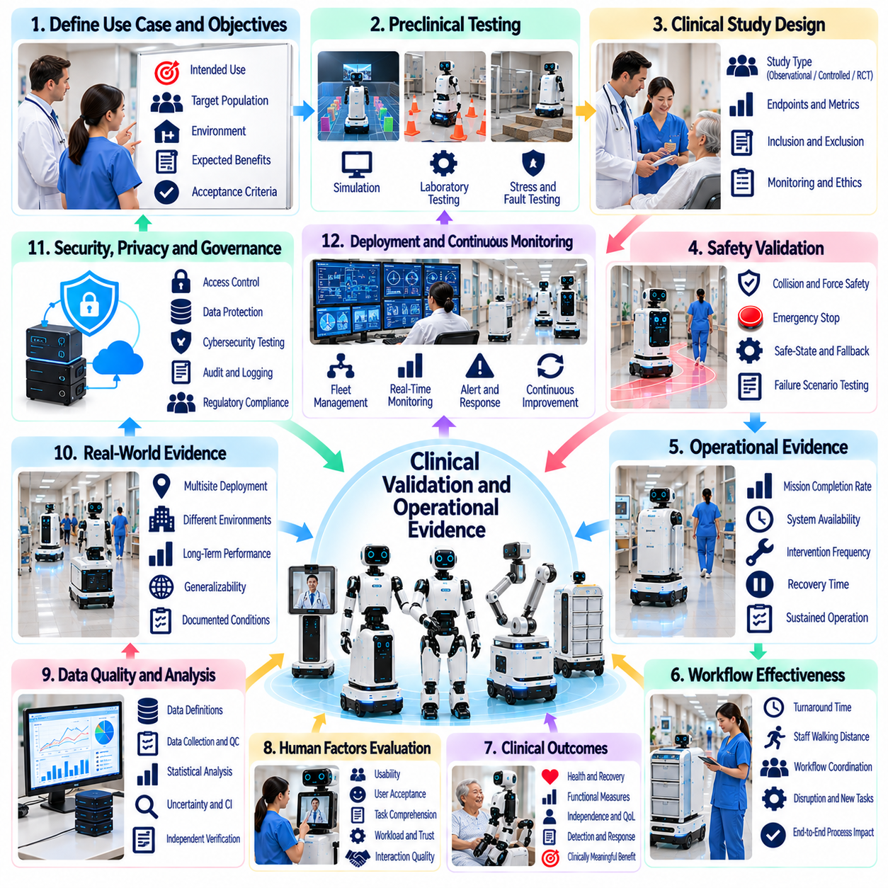
Clinical validation and operational evidence are essential for determining whether Physical AI systems deliver safe, effective, and measurable value in healthcare. Successful laboratory demonstrations do not establish clinical suitability. Robots must be evaluated under realistic conditions involving patients, healthcare professionals, equipment, and complex workflows. Evidence should connect technical performance with clinical needs, operational reliability, and patient safety.
Clinical validation begins by defining the intended use, target population, operating environment, and expected benefits of a robotic system. A hospital delivery robot requires different evidence from a rehabilitation robot or patient monitoring platform. Evaluation objectives must reflect the system's actual responsibilities. Clear acceptance criteria help distinguish technical feasibility from clinically meaningful performance and safe routine operation.
Preclinical testing provides an initial foundation before robots enter active healthcare environments. Simulation, laboratory experiments, and controlled trials can examine navigation, manipulation, perception, and fault recovery. Test scenarios should include foreseeable hazards and challenging operating conditions. However, simulated success cannot fully represent patient behavior, staff interruptions, environmental variability, or real clinical consequences.
Clinical study design should match the risks and claims associated with the intended application. Observational studies may establish feasibility and workflow characteristics, while controlled comparative studies can assess specific benefits. Randomized trials may be appropriate when evaluating interventions that affect patient outcomes. Study protocols should define endpoints, inclusion criteria, monitoring procedures, and methods for addressing confounding factors.
Safety validation examines both normal operation and reasonably foreseeable failures. Relevant hazards include collisions, excessive contact forces, incorrect deliveries, communication failures, and misleading system outputs. Testing should verify emergency stopping, protective separation, safe-state transitions, and human intervention mechanisms. Safety evidence must demonstrate that protective functions remain dependable when autonomous capabilities encounter uncertainty.
Operational evidence measures how robotic systems perform during sustained use rather than isolated demonstrations. Important indicators include mission completion rate, system availability, intervention frequency, recovery time, and service interruptions. Performance should be evaluated across different shifts, departments, and environmental conditions. Longitudinal monitoring can reveal reliability problems that short pilot programs fail to detect.
Workflow effectiveness is a central component of hospital robotics evaluation. Robots should improve complete service processes rather than merely execute individual tasks faster. Measurements may include delivery turnaround time, staff walking distance, task coordination effort, and workflow disruptions. Evaluation should also identify displaced work, hidden supervision requirements, and new responsibilities created by automation.
Clinical outcome evaluation becomes necessary when robotic systems claim to influence patient health or treatment effectiveness. Rehabilitation robots may be assessed through functional recovery measures, while assistive systems may be evaluated through independence and quality of life. Monitoring robots require evidence concerning detection performance and response workflows. Operational improvements should not be presented as proven clinical benefits without supporting data.
Human factors evaluation examines whether patients and healthcare professionals can understand, operate, and appropriately trust robotic systems. Relevant measures include usability, workload, task comprehension, perceived safety, and user acceptance. Testing should involve representative participants with different abilities and clinical responsibilities. Human-robot interaction failures may reduce effectiveness even when underlying robotic functions perform correctly.
Data quality and measurement validity strongly influence the credibility of clinical evidence. Sensors, operational logs, clinical records, and user surveys may produce incomplete or inconsistent observations. Evaluation protocols should specify data definitions, collection methods, and quality controls. Missing events, inconsistent timestamps, and selective reporting can distort conclusions. Independent verification strengthens confidence in reported performance.
Statistical analysis should distinguish meaningful improvements from random variation or operational confounding. Sample size, study duration, baseline performance, and outcome variability affect interpretation. Comparative evaluations should account for differences in staffing, patient populations, and hospital activity. Confidence intervals and sensitivity analyses can clarify uncertainty. Positive results from one facility may not generalize automatically to another.
Real-world evidence complements controlled studies by examining routine deployment across diverse clinical environments. Hospitals differ in architecture, staffing, information systems, and operational practices. Multisite evaluation can reveal whether robotic performance remains consistent under these variations. Evidence should document deployment conditions and implementation differences. Generalizability depends on the similarity between tested environments and intended applications.
Cybersecurity, privacy, and data governance also require validation during clinical deployment. Testing should assess access controls, communication protection, audit records, and responses to security incidents. Patient information must be handled according to applicable legal and institutional requirements. Data governance evidence should demonstrate appropriate collection, retention, and deletion practices. Technical performance cannot compensate for unacceptable privacy or security risks.
Regulatory evidence requirements depend on intended use, risk classification, and jurisdiction. Medical robots performing therapeutic or diagnostic functions may require formal clinical evaluation and regulatory authorization. Logistics and service robots may follow different assessment pathways. Developers should document design controls, risk management, verification, and validation activities. Regulatory compliance must be distinguished from broader evidence of operational value.
Economic evaluation determines whether observed benefits justify acquisition and operating costs. Relevant expenses include hardware, integration, maintenance, training, cybersecurity, and human supervision. Benefits may involve reduced transport workload, improved service availability, or more efficient resource utilization. Cost-effectiveness analysis should use measured outcomes and transparent assumptions. Short-term productivity gains may not reflect long-term ownership costs.
Pilot deployment provides a structured transition between controlled testing and routine operations. Initial studies should define limited service areas, responsible personnel, operational boundaries, and stopping criteria. Performance reviews can identify navigation failures, interface problems, and workflow conflicts. Expansion should follow documented evidence of safety and reliability. Pilot success should not be interpreted as unrestricted readiness for hospital-wide deployment.
Post-deployment monitoring is necessary because robotic performance may change as software, environments, and workflows evolve. Model updates, sensor degradation, infrastructure modifications, and changing patient needs can introduce new risks. Continuous monitoring should track safety events, operational performance, and emerging failure patterns. Significant changes may require renewed validation. Incident investigation and corrective actions should support continuous improvement.
Evidence transparency enables hospitals, regulators, clinicians, and technology providers to interpret evaluation results appropriately. Reports should describe intended use, study methods, operating conditions, limitations, and observed outcomes. Negative findings and operational failures are valuable for understanding deployment risks. Selective presentation of successful demonstrations can create misleading expectations. Reproducible methods and documented assumptions improve decision quality.
Future clinical validation may combine digital twins, simulation-based testing, automated safety monitoring, and fleet-scale operational analytics. These approaches could accelerate evidence collection and identify rare failure conditions. Nevertheless, synthetic evidence cannot fully replace observation in actual healthcare environments. Clinical claims will continue to require appropriate human-centered evaluation, regulatory consideration, and independent scrutiny.
The long-term objective of clinical validation and operational evidence is to establish trustworthy foundations for adopting Physical AI in healthcare. Successful systems must demonstrate not only technical capability but also sustained safety, workflow compatibility, and meaningful benefits. Evidence-based deployment protects patients, supports healthcare professionals, and guides responsible investment. Reliable clinical robotics will depend on continuous evaluation throughout the system lifecycle.

04.14. Healthcare Value and Adoption Framework
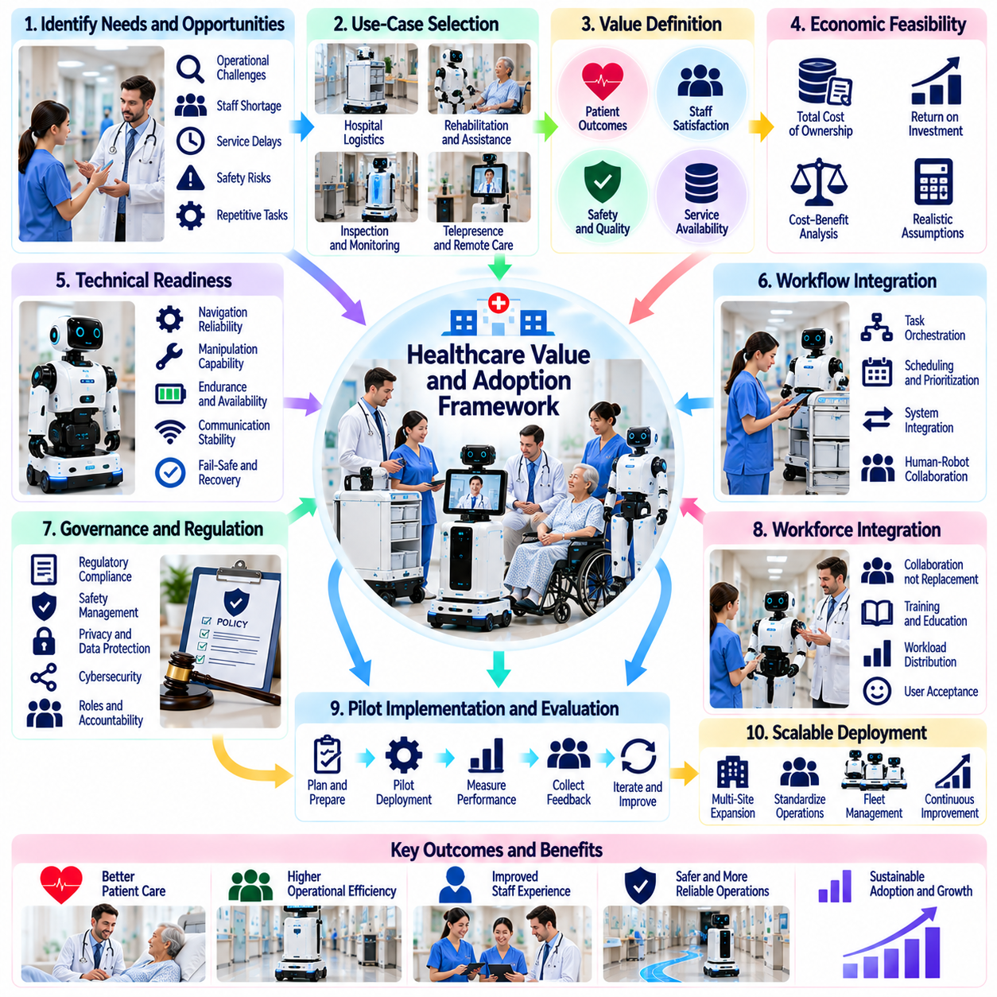
Healthcare value and adoption frameworks provide a structured approach for determining where Physical AI can deliver sustainable benefits across clinical and operational environments. Successful adoption requires more than advanced robotic capabilities. Hospitals must evaluate patient outcomes, workforce needs, financial feasibility, and organizational readiness. The central objective is to align robotic investment with measurable healthcare priorities and responsible service delivery.
Value creation begins with identifying operational problems that robotics can address effectively. Hospitals face challenges involving staff shortages, repetitive transport tasks, service delays, and increasing care complexity. Physical AI may reduce routine workload and improve resource coordination. However, each proposed application should demonstrate a clear connection between robotic functions, existing workflow limitations, and meaningful improvements in healthcare performance.
Healthcare value extends beyond direct financial savings. Robots may improve service availability, reduce physical strain on workers, and support more consistent task execution. Patient experience, staff satisfaction, safety, and continuity of care also contribute to overall value. Evaluation frameworks should recognize these multiple dimensions. A system that reduces operating costs but increases clinical risk or staff burden cannot be considered successful.
Use-case selection should prioritize tasks with clear requirements, sufficient frequency, and manageable operational risk. Hospital logistics, internal delivery, environmental inspection, and selected rehabilitation activities may offer different adoption opportunities. Each application requires assessment of task complexity, environmental variability, and human supervision. Early deployments should favor workflows where benefits can be measured without compromising patient safety.
Economic feasibility depends on the relationship between implementation costs and demonstrated operational benefits. Total cost of ownership includes robot acquisition, software, integration, maintenance, cybersecurity, training, and infrastructure modifications. Financial models should also account for downtime and supervisory labor. Return on investment estimates must use realistic utilization assumptions and avoid treating potential labor savings as automatic workforce reductions.
Operational productivity should be evaluated at the workflow level rather than through isolated robot performance metrics. Faster navigation does not necessarily improve hospital throughput when elevators, handovers, or scheduling create bottlenecks. Relevant indicators include task completion time, staff walking distance, service availability, and intervention frequency. Productivity gains become meaningful when they improve coordinated service delivery across departments.
Clinical value requires evidence appropriate to the robot's intended function. Rehabilitation systems may be assessed through functional improvement, while assistive robots may support independence and patient participation. Logistics robots primarily generate operational benefits unless clinical effects are independently demonstrated. Adoption decisions should distinguish technical performance, operational efficiency, and verified patient outcomes to prevent exaggerated value claims.
Organizational readiness is a major determinant of adoption success. Hospitals need leadership support, clearly assigned responsibilities, reliable IT infrastructure, and appropriate maintenance capabilities. Clinical departments must participate in workflow design and operational planning. Resistance may emerge when robots introduce unfamiliar procedures or unclear accountability. Early stakeholder engagement can improve acceptance and identify barriers before deployment.
Workforce integration should emphasize collaboration rather than simple labor replacement. Robots can assume repetitive transport or monitoring support tasks while healthcare professionals retain clinical judgment and interpersonal responsibilities. Training must explain robotic capabilities, limitations, intervention procedures, and expected workflows. Adoption strategies should measure changes in workload distribution and ensure that automation does not create hidden supervision demands.
Technology readiness must be assessed against actual hospital conditions. Navigation reliability, manipulation accuracy, battery endurance, communication stability, and system availability influence deployment feasibility. Robots should operate safely around patients, medical equipment, and changing obstacles. Technical evaluation must include recovery from failures and integration with existing infrastructure. Demonstrated laboratory capability alone is insufficient for routine adoption.
Interoperability affects both implementation cost and long-term scalability. Robotic platforms may need connections to hospital information systems, fleet management software, elevators, doors, and access control services. Standardized interfaces can reduce integration complexity and vendor dependence. Hospitals should evaluate data portability, upgrade compatibility, and operational continuity. Proprietary integration barriers can undermine economic value over time.
Governance and regulatory alignment are essential elements of an adoption framework. Requirements vary according to intended use, clinical risk, and jurisdiction. Safety management, privacy protection, cybersecurity, and patient consent must be addressed before operational expansion. Hospitals should establish clear accountability among technology providers, clinical users, and administrators. Governance mechanisms must remain effective as autonomy and deployment scale increase.
Procurement evaluation should consider lifecycle performance rather than purchase price alone. Vendor reliability, maintenance response, software support, spare parts availability, and cybersecurity practices affect long-term ownership costs. Service-level agreements can define availability targets and support responsibilities. Hospitals should request evidence from comparable deployments and examine contractual provisions concerning data ownership, system updates, and operational continuity.
Pilot programs provide a practical mechanism for reducing uncertainty before large-scale investment. Initial deployments should establish measurable objectives, limited operational boundaries, and defined responsibilities. Evaluation should capture task success, user acceptance, safety events, and integration difficulties. Expansion decisions must rely on observed performance rather than promotional demonstrations. Unsuccessful pilots can still provide valuable information for improving adoption strategies.
Scaling requires coordinated management of robotic fleets, infrastructure capacity, staff training, and operational policies. Performance achieved with one robot may not persist when dozens share elevators, corridors, and charging resources. Fleet-level scheduling and traffic management become increasingly important. Hospitals should evaluate congestion, maintenance demand, and exception handling as deployment expands. Standardized procedures support consistent service quality.
Business models influence how healthcare organizations distribute financial and operational risk. Direct purchasing provides asset ownership but requires upfront capital and internal support. Leasing and Robotics-as-a-Service arrangements may shift expenditures toward recurring payments and contracted services. Each model presents different responsibilities for maintenance, upgrades, cybersecurity, and performance. Selection should reflect utilization patterns and institutional financial constraints.
Value measurement should combine financial, operational, clinical, and human-centered indicators. Cost per completed mission, system uptime, staff time released, user satisfaction, and safety incidents provide complementary perspectives. Baseline measurements are necessary to establish credible comparisons. Longitudinal evaluation should identify whether benefits persist after initial deployment. Transparent reporting helps distinguish sustainable improvements from temporary implementation effects.
Adoption barriers include high integration costs, uncertain reimbursement, limited clinical evidence, cybersecurity concerns, and resistance to workflow changes. Fragmented hospital systems and inconsistent technical standards may further complicate deployment. Effective strategies address these obstacles through staged implementation, stakeholder participation, and realistic performance commitments. Risk reduction is often more important than maximizing autonomy during early adoption.
Future healthcare adoption may benefit from more capable Physical AI foundation models, shared robotic platforms, and intelligent workflow orchestration. Improved generalization could allow robots to perform broader task portfolios and increase utilization. Nevertheless, greater autonomy introduces additional validation and governance requirements. Economic advantages must be demonstrated through reliable real-world performance rather than assumptions about future technological capability.
A sustainable healthcare adoption framework connects clinical priorities, operational requirements, technical readiness, financial value, and responsible governance. Successful Physical AI deployment should improve healthcare delivery while protecting patient dignity and professional accountability. Adoption is best understood as continuous organizational transformation rather than a one-time technology purchase. Long-term success depends on measurable benefits, dependable operations, and sustained trust.

