Volume 12. Physical AI Business and Industry Applications

Chapter 08. Business Model Design

08.01. From Robot Product to Physical AI Business
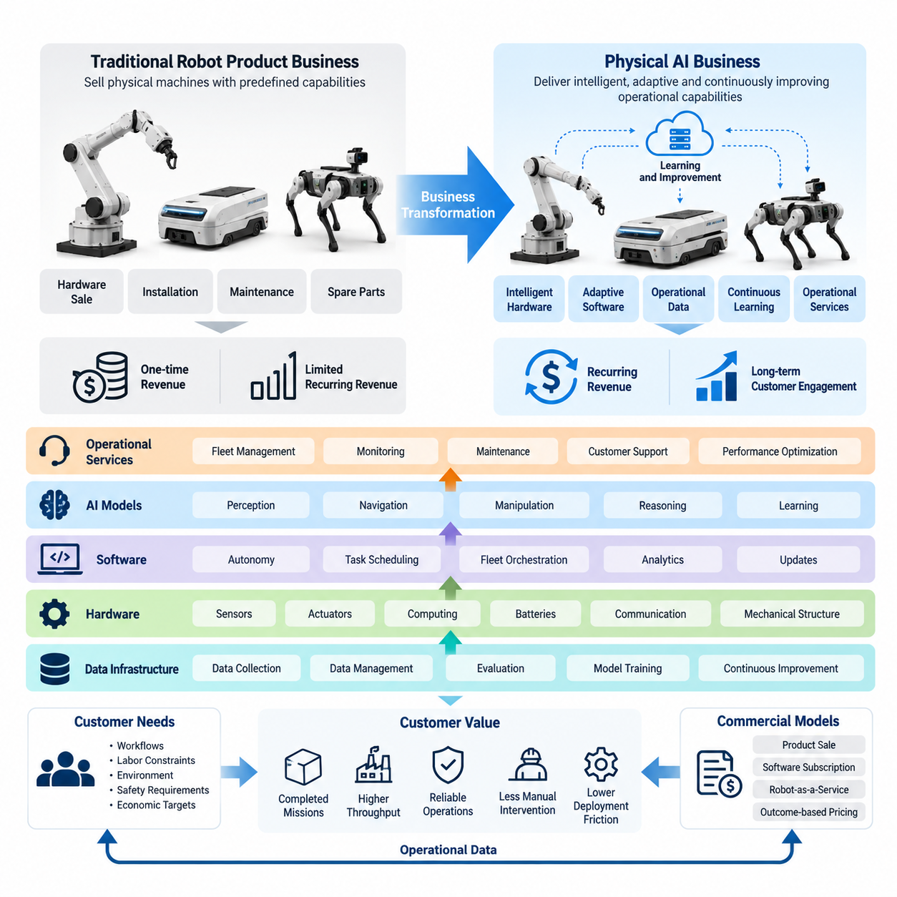
The transition from a conventional robot product business to a Physical AI business represents a fundamental change in how industrial automation creates, delivers, and captures economic value. Traditional robotics companies primarily commercialize physical machines with predefined capabilities, while Physical AI enterprises combine intelligent hardware, adaptive software, operational data, and continuous learning into integrated systems that improve throughout their deployment lifecycle.
In a conventional robotics business, commercial value is often concentrated at the point of equipment sale. Customers purchase robots based on specifications such as payload capacity, positioning accuracy, operating speed, and mechanical reliability. Additional revenue may come from installation, maintenance, and spare parts. Although this approach remains important, its dependence on hardware transactions can limit recurring revenue and long-term customer engagement.
Physical AI expands the commercial offering beyond equipment ownership by treating intelligence, autonomy, and operational performance as continuously deliverable capabilities. A robot becomes a physical execution platform connected to perception models, decision systems, learning infrastructure, and fleet management services. The business therefore shifts from selling isolated machines toward providing measurable operational outcomes supported by evolving software and intelligence.
This transformation changes the fundamental unit of customer value. Instead of evaluating a robot primarily by its technical specifications, customers increasingly assess the productive work it performs under actual operating conditions. Relevant outcomes include completed transport missions, successful manipulation tasks, production throughput, inspection coverage, service availability, and reductions in manual intervention. These operational metrics provide the foundation for sustainable Physical AI business models.
A Physical AI enterprise must distinguish technological capability from commercially valuable functionality. Advanced perception, autonomous navigation, manipulation intelligence, and multimodal reasoning have limited business significance unless they address identifiable operational problems. Successful commercialization therefore begins with understanding customer workflows, labor constraints, environmental conditions, safety requirements, and the economic consequences of automation performance.
The resulting value proposition combines physical execution with adaptable intelligence. Traditional automation often requires substantial engineering whenever workflows or operating conditions change. Physical AI seeks to reduce this dependency through reusable models, configurable behaviors, and learning-enabled adaptation. When implemented reliably, these capabilities can lower deployment friction, expand task coverage, and increase the productive lifetime of robotic equipment.
Hardware nevertheless remains a critical component of the business architecture. Sensors, actuators, computing systems, batteries, communication interfaces, and mechanical structures determine the physical limits within which intelligence operates. Commercial success requires balancing hardware cost, performance, durability, maintainability, and software compatibility. An advanced AI model cannot compensate economically for an unreliable or excessively expensive physical platform.
Software creates an additional layer of differentiation because many capabilities can be upgraded without replacing the underlying machine. Navigation improvements, perception updates, task scheduling algorithms, manipulation policies, and operational analytics may be delivered through controlled software releases. This enables vendors to maintain customer relationships after installation while offering functionality improvements, performance optimization, and new application capabilities.
The introduction of recurring software revenue changes the financial characteristics of robotics businesses. Subscription arrangements may cover autonomy software, fleet orchestration, analytics, cybersecurity updates, and advanced AI capabilities. Unlike one-time hardware revenue, recurring income can improve revenue visibility when customer retention is strong. However, sustainable profitability requires careful management of computing expenses, support obligations, software maintenance, and deployment complexity.
Robot-as-a-Service provides another commercialization mechanism by converting robot ownership into access to operational capabilities. Under this model, customers may pay recurring fees for equipment availability, software functionality, maintenance, and support. Providers retain varying degrees of asset ownership and operational responsibility. The model can reduce customers' initial capital requirements but introduces financing, utilization, maintenance, and residual-value risks for service providers.
A more advanced commercial arrangement links compensation directly to operational output. Customers may pay according to completed missions, transported materials, inspected assets, or other verified results. Such outcome-based pricing aligns supplier incentives with customer productivity, but it requires reliable measurement and clear contractual boundaries. Environmental variability, customer-controlled delays, exceptional conditions, and service exclusions must be considered when defining performance commitments.
Physical AI business architecture can therefore be understood as several interdependent economic layers. Hardware enables physical interaction, software enables autonomous functionality, AI models provide adaptable intelligence, and operational services maintain performance. Data infrastructure connects these layers through monitoring, evaluation, and improvement. Each layer creates potential revenue opportunities while introducing different cost structures, competitive pressures, and contractual responsibilities.
Operational data becomes particularly important as deployed robot fleets expand. Real-world execution produces information about task success, environmental variation, equipment conditions, interventions, and failure patterns. With appropriate permissions and governance, selected data can support model evaluation, software improvement, and preventive maintenance. The commercial value emerges from converting operational experience into validated improvements that benefit customers.
A fleet-based learning architecture may create cumulative advantages when improvements developed from one deployment can be transferred to others. Shared perception capabilities, reusable task policies, standardized interfaces, and common failure-recovery strategies can reduce repeated engineering work. Nevertheless, these advantages depend on data quality, compatible hardware configurations, representative operating conditions, and disciplined validation before updated capabilities are deployed.
The transition also changes the role of system integration. Physical AI solutions must interact with warehouse management systems, manufacturing execution systems, enterprise resource planning platforms, facility infrastructure, and existing automation equipment. Integration is not simply an installation activity; it determines whether robotic intelligence can participate effectively in customer workflows. Standardized interfaces and reusable deployment tools are essential for reducing project-specific engineering costs.
Customer economics must be evaluated across the complete operating lifecycle rather than through equipment acquisition prices alone. Total cost of ownership includes purchase or service fees, integration, infrastructure modifications, energy consumption, maintenance, software subscriptions, supervision, downtime, and eventual replacement. Economic benefits may include labor productivity, higher throughput, improved consistency, reduced operational risk, and extended operating availability.
For suppliers, unit economics must incorporate more than manufacturing gross margin. Deployment engineering, customer acquisition, field support, warranty obligations, cloud infrastructure, financing costs, and ongoing AI development influence profitability. A business that generates attractive revenue from individual robot installations may still struggle to scale if each customer requires extensive customization or continuous human supervision.
Fleet utilization is another decisive factor because productive operating time determines how effectively deployed assets generate economic value. Robots that remain idle, experience frequent interventions, or operate below expected capacity create financial inefficiency regardless of their technical sophistication. Physical AI companies must therefore optimize task allocation, uptime, charging schedules, maintenance planning, and human escalation procedures as part of their commercial operations.
Safety, reliability, and regulatory compliance are integral business requirements rather than secondary engineering concerns. Autonomous machines operate in environments where failures may damage equipment, interrupt production, or endanger people. Providers must define operational boundaries, validate performance, implement fallback mechanisms, and allocate responsibility among manufacturers, software developers, integrators, and operators. Trustworthy operation directly affects adoption, insurance, and long-term commercial viability.
Scaling from a pilot installation to a repeatable business requires a shift from demonstration-oriented engineering to standardized delivery. Early deployments frequently involve extensive customization, manual calibration, and close technical supervision. Commercial scalability depends on reducing these activities through modular hardware, reusable software configurations, automated commissioning, remote diagnostics, standardized training, and repeatable acceptance testing.
The organizational structure of a Physical AI company must evolve alongside its technology and revenue model. Hardware engineering, AI development, product management, customer operations, field service, and commercial teams need coordinated objectives. Product decisions must reflect both technical feasibility and lifecycle profitability. Feedback from deployed systems should inform engineering priorities, while financial performance should influence platform standardization and service design.
Strategic differentiation increasingly depends on the combination of reliable embodiment, transferable intelligence, deployment efficiency, and operational expertise. Hardware performance alone may become insufficient when competitors offer comparable mechanical capabilities. Companies can strengthen their positions through validated autonomy, proprietary workflow knowledge, efficient fleet operations, trusted customer relationships, and integration ecosystems that make their solutions difficult to replace.
The long-term objective is not necessarily to eliminate hardware sales but to establish a business in which physical products, intelligent software, and operational services reinforce one another. Different customer segments may prefer capital purchases, subscriptions, managed services, or hybrid arrangements. A flexible commercial architecture allows providers to address these preferences while maintaining consistent technology foundations and measurable performance standards.
Ultimately, the evolution from robot product to Physical AI business represents a shift from equipment-centered transactions toward intelligence-enabled operational value. Sustainable competitive advantage emerges when companies can repeatedly deploy reliable machines, improve their capabilities, demonstrate customer economic benefits, and capture an appropriate share of the resulting value. The strongest business models align technological advancement with measurable productivity, lifecycle economics, and scalable service delivery.

08.02. Problem Solution Fit and Use Case Selection
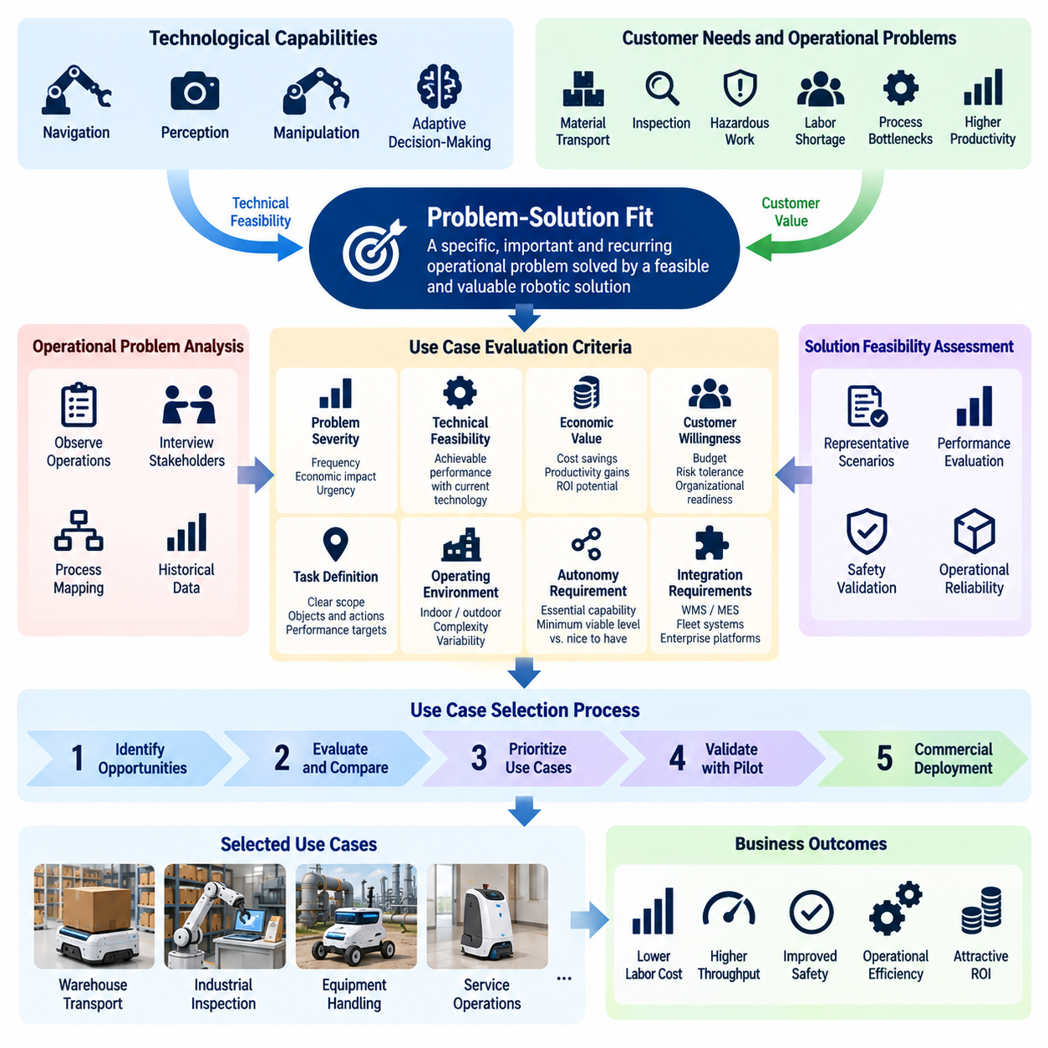
Problem-solution fit is the foundation of a commercially viable Physical AI business because technological sophistication alone does not guarantee customer adoption or economic value. It describes the degree to which an autonomous robotic solution addresses a specific, important, and recurring operational problem. Successful use case selection requires matching customer needs with technical feasibility, measurable business benefits, and realistic deployment conditions.
Physical AI companies frequently begin with advanced capabilities such as autonomous navigation, robotic manipulation, multimodal perception, or adaptive decision-making. However, customers generally purchase solutions to operational problems rather than technologies themselves. A robot capable of performing many impressive tasks may deliver less commercial value than a simpler system that reliably eliminates a costly bottleneck in a critical workflow.
Identifying suitable problems begins with a detailed understanding of existing operations. Companies must examine how work is performed, which resources are required, where delays occur, and why current processes underperform. Direct observation, operational interviews, process mapping, and historical performance records help distinguish genuine customer pain points from assumptions made during technology development.
A valuable operational problem typically exhibits sufficient frequency, economic significance, and organizational urgency. Repetitive material transport, labor-intensive inspection, hazardous maintenance, and unpredictable equipment handling are potential examples. However, the attractiveness of each application depends on actual task volumes, labor availability, environmental complexity, safety exposure, and the customer's willingness to change established procedures.
Problem severity should be evaluated independently from technological feasibility. A task may be technically straightforward but economically unimportant, while another may offer substantial value but require capabilities beyond current robotic systems. Effective opportunity selection identifies applications where operational importance and achievable automation performance overlap, creating a credible path toward practical deployment and customer acceptance.
Use case selection also requires defining the task boundary with sufficient precision. Broad objectives such as automating a warehouse or replacing manual inspection are too ambiguous for reliable engineering and financial evaluation. A useful definition specifies the objects handled, required actions, operating locations, environmental conditions, expected frequency, performance thresholds, and circumstances requiring human intervention.
The operational environment strongly influences solution feasibility. Structured factories and warehouses often provide predictable layouts, controlled traffic patterns, and repeatable tasks. Hospitals, construction sites, farms, and homes introduce greater variation in human activity, terrain, objects, and environmental conditions. These differences affect perception reliability, navigation performance, manipulation complexity, and the cost of maintaining safe autonomous operation.
Physical AI suitability depends on whether intelligence provides meaningful advantages over conventional automation. Fixed conveyors, industrial robots, and rule-based mobile platforms may already solve certain problems efficiently. Learning-enabled perception, adaptive planning, and generalized manipulation become commercially attractive when task variation, environmental uncertainty, or frequent workflow changes make traditional solutions excessively rigid or expensive.
A practical evaluation must distinguish essential autonomy from desirable functionality. Customers may require reliable navigation, obstacle avoidance, task execution, and recovery from predictable disturbances without needing unrestricted general-purpose intelligence. Defining the minimum viable autonomy level reduces unnecessary development complexity and allows engineering resources to concentrate on capabilities directly associated with operational value.
Technical feasibility should be assessed through representative operating scenarios rather than isolated demonstrations. Evaluation must include normal conditions, expected variations, difficult edge cases, and recovery situations. Relevant measures include task completion rate, cycle time, intervention frequency, localization reliability, manipulation success, and safety-related events. Performance must remain acceptable over sustained operation rather than during carefully prepared trials.
Economic feasibility requires establishing a credible baseline for the existing process. Labor hours, equipment utilization, production delays, error rates, safety incidents, and maintenance expenses provide reference values against which automation can be assessed. Expected benefits should be calculated using realistic operating assumptions, including partial automation, residual human supervision, and potential disruptions during implementation.
Customer willingness to pay is not identical to the theoretical economic value of automation. Purchasing decisions depend on budget ownership, capital approval procedures, operational risk tolerance, expected payback periods, and competing investment priorities. Even a technically successful application may encounter limited demand when the customer cannot capture sufficient benefits or lacks authority to reorganize the affected workflow.
Integration requirements represent another major selection criterion. A robot may perform its physical task successfully yet fail to generate operational value if it cannot exchange information with existing systems. Warehouse management, manufacturing execution, fleet coordination, and enterprise platforms often determine when tasks begin, how priorities change, and how completion is verified. Integration complexity must therefore be included in early feasibility assessments.
The organizational context can be as important as the physical environment. Automation changes responsibilities among operators, supervisors, maintenance personnel, and information technology teams. Successful adoption requires clear ownership of deployment decisions, operational support, exception handling, and performance evaluation. Applications with committed stakeholders and well-defined decision processes generally offer a more manageable path from pilot testing to production.
Use cases should be prioritized according to both commercial attractiveness and implementation risk. Commercial attractiveness reflects market demand, customer urgency, measurable savings, repeatability, and revenue potential. Implementation risk includes technical uncertainty, environmental variability, integration effort, safety requirements, and ongoing service costs. A balanced selection process avoids pursuing high-value opportunities that cannot be delivered reliably.
Scalability provides an additional distinction between an attractive engineering project and a sustainable business opportunity. A solution designed for one unusual facility may generate project revenue but require extensive customization elsewhere. More scalable applications share similar task structures, equipment interfaces, operating constraints, and performance expectations across multiple customers, allowing hardware, software, deployment procedures, and support resources to be reused.
A focused initial use case can establish the foundation for a broader Physical AI platform. For example, reliable autonomous material transport may lead to fleet coordination, inventory movement, machine tending, or mobile manipulation. Such expansion should follow demonstrated customer demand and technical compatibility rather than assumptions that every robotic capability will naturally translate into profitable adjacent markets.
Pilot projects should be designed to test explicit business and technical hypotheses. Before deployment, suppliers and customers should agree on baseline measurements, operating boundaries, acceptance criteria, and evaluation periods. A successful pilot demonstrates not only that the robot can perform a task but also that its performance is sufficiently reliable, economically meaningful, and operationally manageable to justify continued investment.
Failure analysis is essential during problem-solution validation. Unsuccessful missions, unexpected interventions, environmental disturbances, and integration failures reveal whether limitations arise from the technology, workflow design, or incorrect problem assumptions. These findings should inform decisions to improve the system, narrow the operational scope, modify the commercial proposition, or discontinue an unsuitable application.
The strongest evidence of problem-solution fit emerges when customers repeatedly use the solution, achieve measurable benefits, and demonstrate willingness to continue or expand deployment. Positive demonstrations and initial enthusiasm are insufficient without sustained operational results. Renewal decisions, additional robot orders, expanding task coverage, and reduced dependence on vendor support provide stronger indications of genuine commercial demand.
Ultimately, problem-solution fit and use case selection connect Physical AI innovation with practical industrial value creation. The objective is not to identify the most technologically ambitious robotic application, but to select problems where autonomous capabilities can deliver dependable and economically justified improvements. Disciplined selection establishes the basis for repeatable deployment, scalable business models, and long-term customer relationships.

08.03. Customer Value Proposition
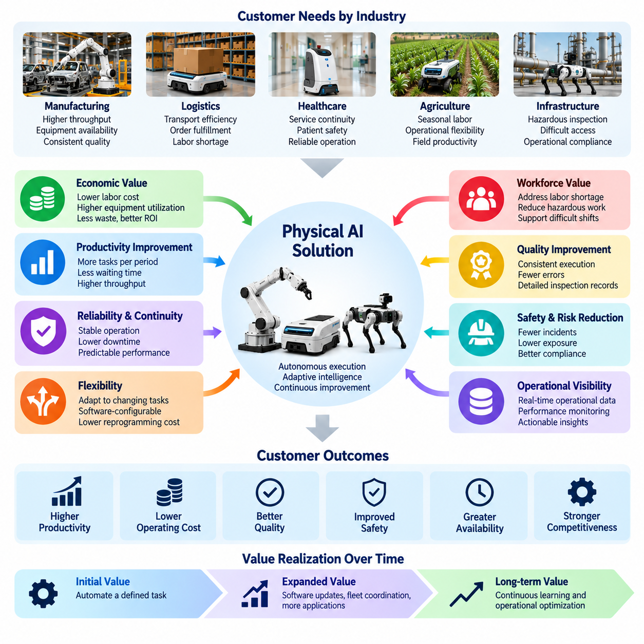
A customer value proposition defines the specific economic, operational, and strategic benefits that a Physical AI solution delivers to its intended customers. It explains why an organization should adopt intelligent robotic systems instead of continuing existing processes or purchasing conventional automation. An effective value proposition connects technological capabilities to measurable customer outcomes rather than emphasizing artificial intelligence as an isolated feature.
Physical AI creates customer value by combining autonomous physical execution with adaptive intelligence and continuous operational improvement. Unlike traditional equipment that performs narrowly predefined actions, intelligent robotic systems can potentially respond to environmental variation, changing task requirements, and operational uncertainty. These capabilities become commercially meaningful when they improve productivity, reliability, flexibility, or service quality under real operating conditions.
Customer value must be understood from the perspective of the organization purchasing and operating the solution. Manufacturing companies may prioritize production throughput and equipment availability, while logistics operators focus on transport efficiency and order fulfillment. Hospitals emphasize service continuity and patient safety, whereas agricultural businesses may value seasonal labor availability and operating flexibility. The same robotic technology can therefore support different value propositions across industries.
Economic value is often the most visible component of a Physical AI offering. Autonomous systems may reduce repetitive labor requirements, improve equipment utilization, extend operating hours, and decrease process-related waste. However, credible economic benefits must account for integration expenses, maintenance, energy consumption, software fees, and remaining human supervision. Customer value should be expressed through net operational improvement rather than gross automation potential.
Productivity improvement represents another central source of value. Physical AI can increase the number of tasks completed within a given period by reducing waiting time, coordinating equipment, and executing repetitive activities consistently. In manufacturing and logistics, productivity may be measured through units produced, missions completed, materials transported, or orders processed. The relevant metric should reflect the customer's actual operational bottleneck.
Reliability and operational continuity are particularly important in environments where interruptions create substantial financial consequences. Intelligent robots can contribute to stable operations through continuous monitoring, adaptive navigation, fault detection, and structured recovery procedures. Nevertheless, reliability must be demonstrated through sustained deployment evidence, including uptime, intervention frequency, mean time between failures, and recovery performance under representative operating conditions.
Flexibility creates value when customers face changing products, workflows, layouts, or demand patterns. Conventional automation frequently requires mechanical modification or extensive reprogramming to accommodate such changes. Physical AI may reduce adaptation costs through configurable task policies, reusable perception models, and software-defined behaviors. The resulting benefit is not unlimited generality but a lower cost of responding to operational variation within validated boundaries.
Workforce-related value extends beyond direct labor cost reduction. Physical AI can address persistent staffing shortages, support operations during difficult shifts, and reduce employee exposure to repetitive or physically demanding tasks. In hazardous environments, robotic systems may perform inspections or material handling activities that expose workers to elevated risks. These benefits should be evaluated alongside workforce training, supervision requirements, and organizational acceptance.
Quality improvement provides another important dimension of customer value. Intelligent robotic systems may deliver more consistent task execution, reduce handling errors, and generate detailed operational records. In inspection applications, AI-enabled perception can support repeatable defect identification and structured reporting. However, quality benefits depend on validated detection performance, controlled operating conditions, and effective procedures for managing uncertain or incorrect results.
Safety and risk reduction can strengthen the value proposition when robotic systems replace or assist dangerous activities. Applications include infrastructure inspection, hazardous material transport, difficult-access maintenance, and repetitive heavy-load handling. The economic benefit may involve fewer incidents, reduced exposure, and improved operational compliance. These claims require appropriate safety engineering, risk assessment, and evidence rather than assumptions that autonomy is inherently safer.
Customer value also emerges from improved visibility into physical operations. Connected robots generate information about task execution, equipment status, environmental conditions, and operational exceptions. When integrated with enterprise systems, these data can support performance monitoring, capacity planning, maintenance decisions, and process optimization. The value comes from actionable operational intelligence rather than data collection alone.
A strong value proposition distinguishes the immediate benefits of robot deployment from improvements that may develop over time. Initial value often comes from automating a clearly defined task, while subsequent value may arise from software updates, fleet coordination, expanded task coverage, and learning-based optimization. Customers should understand which benefits are available at installation and which depend on additional development, data collection, or operational maturity.
The value proposition must also address implementation effort and customer risk. Even economically attractive automation can encounter resistance when installation disrupts production, requires infrastructure modifications, or introduces uncertain maintenance obligations. Providers can reduce these barriers through standardized deployment procedures, transparent performance commitments, training, remote support, and clearly defined responsibilities for failures and exceptions.
Financial decision-makers and operational users frequently evaluate the same solution differently. Executives may focus on return on investment, scalability, and strategic competitiveness, while facility managers prioritize uptime, integration, and workflow stability. Operators may emphasize usability, safety, and reduced workload. Effective value proposition design accommodates these perspectives while maintaining a consistent explanation of the solution's overall business contribution.
Pricing should reflect the customer's realized value without exceeding the economic benefits that justify adoption. Hardware sales, software subscriptions, Robot-as-a-Service contracts, and outcome-based arrangements distribute costs and risks differently. The appropriate model depends on customer purchasing preferences, asset utilization, service responsibilities, and confidence in measurable performance. Value-based pricing requires a defensible connection between delivered outcomes and commercial compensation.
Customer value must be demonstrated through measurable evidence rather than promotional claims. Pilot deployments should establish baseline performance, define success criteria, and compare actual results against expected improvements. Relevant indicators include labor hours saved, throughput increases, task completion rates, operating availability, intervention requirements, and total operating costs. Evidence should account for representative conditions and sufficient observation periods.
A scalable value proposition must remain meaningful across multiple customers without requiring extensive redesign. Standardized hardware platforms, reusable software modules, common integration interfaces, and repeatable service processes help preserve customer benefits while controlling supplier costs. Industry-specific configurations may still be necessary, but excessive customization can weaken profitability and make commercial expansion difficult.
Competitive differentiation depends on delivering value that alternative solutions cannot reproduce easily or economically. Physical AI providers may differentiate through reliable autonomy, rapid deployment, low intervention requirements, flexible task adaptation, or integrated fleet services. The strongest differentiation is demonstrated through operational results that customers can verify, rather than through model complexity, sensor specifications, or generalized claims of intelligence.
Long-term customer relationships depend on maintaining the promised value throughout the deployment lifecycle. Software updates, preventive maintenance, operational analytics, and customer support must contribute to sustained performance. Providers should regularly review service outcomes, changing customer requirements, and opportunities for additional automation. Continuous improvement strengthens retention when customers can observe meaningful operational benefits.
Ultimately, the customer value proposition translates Physical AI capabilities into a clear business justification for adoption. Its purpose is to explain which customer problem is solved, how operational performance improves, what economic benefits are achievable, and why the proposed solution is preferable to available alternatives. A compelling proposition combines measurable outcomes, credible implementation assumptions, manageable risk, and a sustainable path toward long-term value creation.

08.04. Product vs Platform Business Models
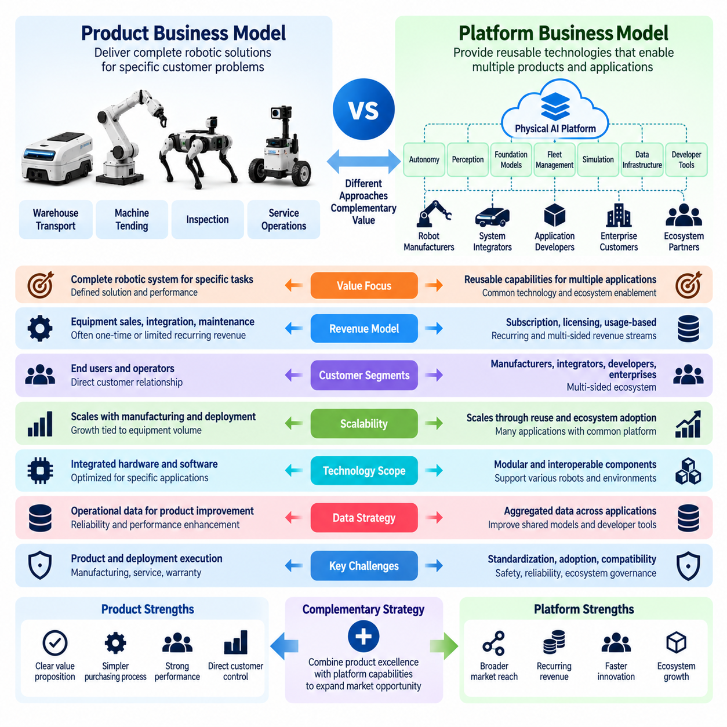
Product and platform business models represent two distinct approaches to commercializing Physical AI technologies. A product business focuses on delivering a defined robotic solution to a specific customer problem, while a platform business provides reusable technological capabilities that support multiple products, applications, or ecosystem participants. Understanding this distinction is essential for designing revenue structures, development strategies, and sustainable competitive advantages.
A product-oriented Physical AI company typically develops complete robotic systems for identifiable operational tasks. Examples include autonomous mobile robots for warehouse transport, robotic manipulators for machine tending, and inspection robots for industrial facilities. Commercial value is delivered through the performance of the finished solution, including its hardware, embedded intelligence, integration capabilities, and associated maintenance services.
Product business models generally offer clear customer accountability because one supplier is responsible for delivering a functioning system. Customers can evaluate specifications, operational performance, acquisition costs, and expected productivity improvements. This approach simplifies purchasing decisions and supports direct relationships with end users. However, growth may remain closely connected to manufacturing capacity, deployment resources, and equipment replacement cycles.
Platform-oriented Physical AI businesses concentrate on reusable infrastructure that enables multiple robotic applications. A platform may include autonomy software, perception models, robot foundation models, fleet management systems, simulation environments, data pipelines, and standardized interfaces. Instead of delivering only a finished robot, the provider supplies capabilities that other developers, manufacturers, integrators, or customers can incorporate into their solutions.
The central economic distinction concerns how value is created and scaled. Product businesses generate value by repeatedly manufacturing and deploying successful solutions, while platform businesses seek to distribute common capabilities across many implementations. A well-designed platform can reduce duplicated engineering, accelerate application development, and support multiple revenue streams. Nevertheless, platform scalability depends on interoperability, adoption, reliability, and continuing ecosystem participation.
Hardware economics strongly influence product-oriented strategies. Manufacturing costs, component procurement, inventory, quality assurance, warranty obligations, and logistics directly affect profitability. Higher production volumes may improve purchasing efficiency and manufacturing utilization, but physical equipment still requires capital and operational resources. Product companies must therefore balance competitive pricing with adequate margins and sufficient investment in software development.
Platform economics place greater emphasis on initial development investment and the marginal cost of serving additional users. Reusable software components can potentially support many customers without equivalent increases in hardware production. However, cloud computing, model inference, cybersecurity, technical support, customization, and infrastructure operations create continuing expenses. The financial advantages of software platforms emerge only when standardization limits incremental delivery costs.
Revenue models also differ between the two approaches. Product businesses commonly earn revenue from equipment sales, installation, integration, maintenance, and optional software upgrades. Platform businesses may charge subscription fees, licensing fees, usage-based payments, developer access fees, or enterprise support contracts. Hybrid companies combine equipment revenue with recurring payments for autonomy, fleet coordination, analytics, and advanced intelligence services.
Customer relationships reflect these different commercial structures. Product suppliers interact primarily with equipment buyers, operational managers, and maintenance organizations. Platform providers may serve robot manufacturers, application developers, system integrators, and enterprise technology teams. Consequently, platform businesses often require extensive documentation, software development kits, application programming interfaces, compatibility testing, and partner support programs.
The scope of technological ownership is another strategic consideration. A product company can optimize hardware and software together for a limited set of applications, achieving strong performance through integrated engineering. A platform company must support greater variation in sensors, actuators, computing systems, robot morphology, and operating environments. This flexibility increases market reach but introduces abstraction complexity and broader validation requirements.
Physical AI platforms face challenges beyond those encountered in conventional digital software businesses. Their outputs influence physical motion, manipulation, and interaction with people and infrastructure. Compatibility therefore involves more than software interfaces; it requires verified control behavior, timing constraints, safety boundaries, and hardware-specific performance. A platform cannot assume that an intelligent policy validated on one robot will operate safely on another embodiment.
Data architecture plays an important role in both models. Product companies collect operational information to improve reliability, diagnose failures, and enhance their own robotic systems. Platform providers may aggregate appropriately authorized data across different applications and robot configurations to improve shared models and development tools. Potential learning advantages depend on data governance, representation consistency, quality control, and the ability to transfer improvements across deployments.
Network effects may strengthen platform businesses when additional participants improve the value available to others. Developers can contribute applications, integrators can expand deployment coverage, and equipment manufacturers can increase compatible hardware choices. However, these effects are not automatic. They require stable interfaces, attractive commercial incentives, trustworthy governance, and sufficient interoperability to encourage continued ecosystem investment.
Product businesses can establish competitive advantages through mechanical performance, reliability, manufacturing efficiency, application expertise, and customer service. Platform businesses may differentiate through software maturity, model performance, developer productivity, ecosystem breadth, and integration efficiency. In both cases, defensibility ultimately depends on measurable customer outcomes rather than technological complexity or the number of supported features.
Market entry strategy often favors a focused product before broader platform expansion. A company can validate a specific application, establish customer relationships, and accumulate operational experience through an integrated robotic solution. Reusable software modules and standardized interfaces developed during this process may later become platform assets. This sequence reduces the risk of investing heavily in infrastructure before meaningful customer demand has been demonstrated.
Premature platform development can create substantial strategic risk. Companies may spend excessive resources building generalized architectures, developer tools, and compatibility layers without sufficient adoption. Broad technical flexibility can also compromise the performance of early applications. Effective platform strategy therefore requires identifying which capabilities are genuinely reusable, which customer segments share requirements, and which functions justify common infrastructure.
Hybrid product-platform models are particularly relevant to Physical AI because physical embodiment and intelligent software remain closely interconnected. A company may sell autonomous robots while operating a shared autonomy stack, fleet management platform, and continuous learning infrastructure. Standardized software supports multiple robot configurations, while deployed products generate operational feedback that informs future development and platform improvement.
The commercial architecture of a hybrid model must avoid unnecessary complexity. Customers should understand which capabilities are included in equipment purchases, which require subscriptions, and which services involve additional charges. Internally, companies must distinguish hardware margins, software revenue, deployment expenses, and support costs. Transparent allocation of costs and responsibilities helps determine whether the combined business creates sustainable profitability.
Platform governance becomes increasingly important as external participants depend on shared infrastructure. Providers must establish policies for interface changes, software compatibility, data access, intellectual property, cybersecurity, and operational responsibility. Clear governance reduces uncertainty for developers and customers while protecting system integrity. In safety-critical applications, platform updates also require controlled validation and deployment procedures.
Choosing between product and platform strategies requires evaluating organizational capabilities, market maturity, available capital, and customer expectations. Product models may offer faster commercialization when specific operational needs are well understood. Platform models may provide broader long-term opportunities when multiple customers require similar intelligence infrastructure. Neither approach is inherently superior, and both must demonstrate economically sustainable value creation.
Ultimately, Physical AI business design should treat product and platform models as complementary strategic options rather than mutually exclusive categories. Products translate intelligent technology into dependable physical outcomes, while platforms enable reuse, extensibility, and ecosystem development. The strongest commercial architecture aligns hardware differentiation, software scalability, customer adoption, and lifecycle economics with a realistic path from initial deployment to sustained business growth.

08.05. Robot as a Service RaaS
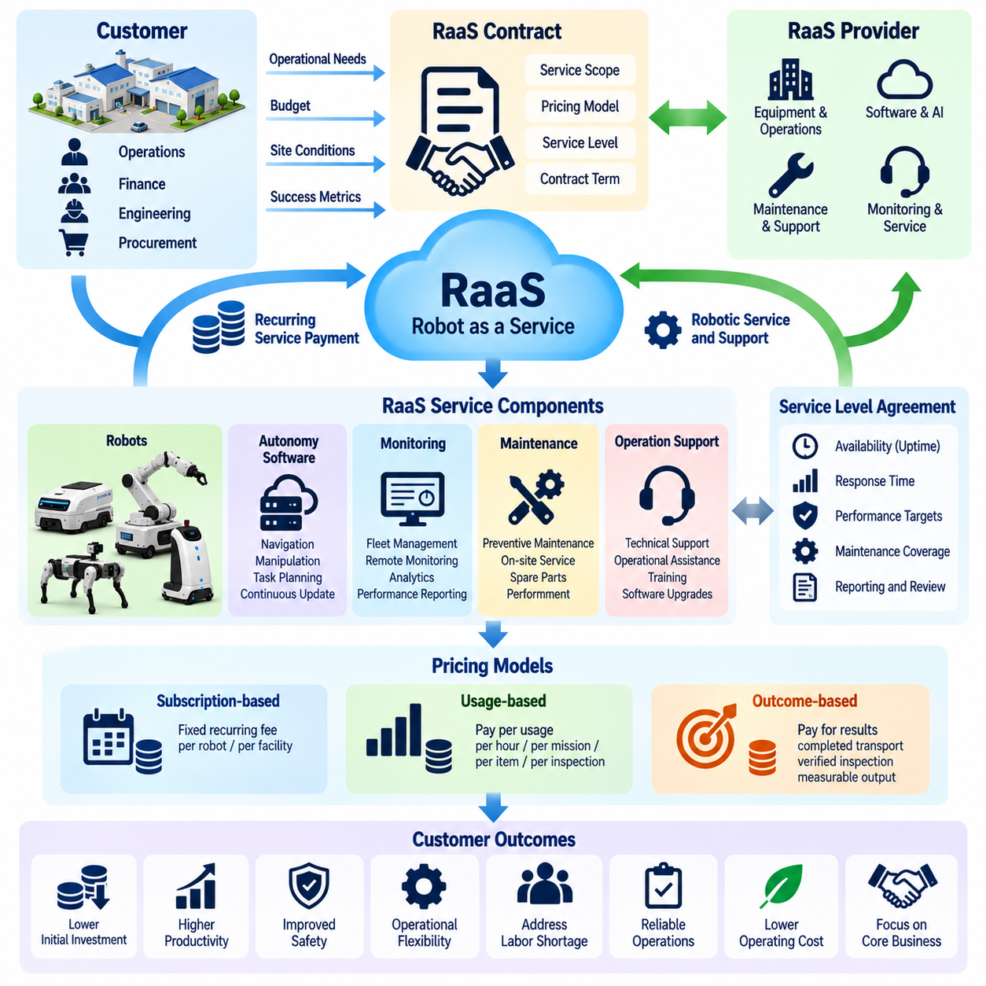
Robot-as-a-Service (RaaS) is a business model that provides access to robotic capabilities through recurring service payments rather than requiring customers to purchase and own equipment outright. It transforms robotics from a primarily capital-intensive equipment transaction into an ongoing operational service. In Physical AI, RaaS can combine intelligent hardware, autonomy software, maintenance, monitoring, and technical support within a unified commercial offering.
The central value of RaaS is its ability to align robotic automation costs with ongoing operational needs. Traditional robot purchases often require substantial upfront capital expenditure, integration investment, and internal maintenance resources. RaaS arrangements distribute payments over time and may transfer selected operational responsibilities to the provider. This structure can make automation more accessible to organizations with limited investment budgets or uncertain future demand.
A typical RaaS offering includes physical robots, embedded control software, autonomy functions, remote monitoring, and defined maintenance services. Depending on the contract, it may also cover installation, commissioning, software updates, replacement equipment, and operational assistance. The exact service boundary is commercially important because customers must understand which responsibilities remain internal and which are assumed by the provider.
RaaS differs from conventional equipment leasing because it can incorporate continuing operational performance obligations rather than merely financing asset access. A lease primarily establishes payment and ownership arrangements, while a service-oriented contract may include availability commitments, software functionality, preventive maintenance, and performance reporting. Nevertheless, some commercial offerings combine leasing and services, making contractual definitions more important than marketing terminology.
Subscription-based pricing is one of the most common RaaS structures. Customers pay a recurring fee per robot, per facility, or per contracted service capacity. Pricing may vary according to robot configuration, operating hours, maintenance coverage, software capabilities, and service response requirements. Predictable payments simplify budgeting, but contracts must clarify additional charges for integration, consumables, excessive usage, and exceptional support.
Usage-based pricing connects service fees to measurable robot activity. Charges may depend on operating hours, completed transport missions, handled items, inspected assets, or other verified outputs. This approach can improve alignment between customer costs and actual utilization. However, reliable metering, transparent reporting, and agreed definitions of successful task completion are necessary to prevent billing disputes and distorted operating incentives.
Outcome-based RaaS arrangements go further by linking compensation to delivered operational results. A logistics customer might pay for successfully completed material movements, while an inspection customer may purchase verified inspection coverage. Such agreements can strengthen customer confidence when providers accept greater performance responsibility. They also expose providers to demand fluctuations, environmental constraints, and factors outside their direct control.
For customers, RaaS can reduce initial financial barriers and accelerate automation adoption. Instead of committing substantial capital before operational benefits are demonstrated, organizations can evaluate robotic services through recurring operating budgets. Nevertheless, accounting classification depends on contract substance and applicable standards. A subscription label alone does not guarantee operating expense treatment or eliminate recognized lease liabilities.
The economic attractiveness of RaaS must be assessed over the complete contract period. Recurring payments may reduce initial expenditure while increasing total lifetime spending relative to direct ownership. Customers should compare service fees, expected utilization, maintenance coverage, downtime risk, technology upgrades, and contract flexibility. The appropriate decision depends on the value of risk transfer and operational support as well as direct financial cost.
For providers, RaaS fundamentally changes cash flow and capital requirements. Equipment manufacturing, procurement, deployment, and commissioning expenses may occur before sufficient subscription revenue has been collected. Providers must finance deployed assets while managing recurring maintenance and operating costs. Consequently, fleet growth can increase financing needs even when contracted revenue and customer demand are expanding.
RaaS unit economics depend on the relationship between recurring revenue and the complete cost of providing robotic services. Important expenses include equipment depreciation, financing, maintenance, field support, software infrastructure, insurance, connectivity, and eventual refurbishment. Profitability requires sufficient contribution margin over the asset lifecycle, while contract duration and customer retention determine how reliably initial investment can be recovered.
Robot utilization is a decisive factor in RaaS profitability. Equipment generating revenue during only a small fraction of available operating time may produce inadequate returns despite technically successful deployment. Providers must therefore monitor productive hours, completed missions, idle periods, charging time, and intervention frequency. Fleet optimization and effective customer demand planning can improve revenue efficiency without proportionally increasing installed equipment.
Service-level agreements establish measurable expectations between customers and RaaS providers. Contracts may specify robot availability, response times, maintenance procedures, software support, and escalation responsibilities. Performance commitments should distinguish provider-controlled failures from customer infrastructure problems, unavailable work, and exceptional environmental conditions. Clear definitions support accountability while limiting disputes over service performance.
Maintenance and lifecycle management become central operating capabilities under RaaS. Providers have direct financial incentives to improve equipment durability, diagnose faults remotely, and perform preventive maintenance before failures interrupt service. Modular components, standardized spare parts, and efficient repair procedures can reduce service costs. Asset refurbishment and redeployment may further improve lifecycle economics when equipment remains technically suitable.
Physical AI strengthens the RaaS proposition through software-defined functionality and continuous operational improvement. Navigation policies, perception systems, task scheduling, and fleet coordination can potentially be updated across deployed robots. Such improvements may increase productivity without replacing entire machines. However, software releases require compatibility testing, controlled deployment, and safety validation to prevent unexpected operational disruptions.
Remote operations infrastructure is particularly important for managing distributed RaaS fleets. Centralized monitoring can provide visibility into robot health, task completion, battery condition, connectivity, and operational exceptions. Remote diagnostics and structured intervention procedures may reduce on-site service requirements. Nevertheless, communication failures and uncertain autonomous behavior require local safety mechanisms and clearly defined fallback procedures.
Customer onboarding and deployment standardization strongly influence service profitability. Every installation may require site mapping, infrastructure integration, workflow configuration, operator training, and acceptance testing. Excessive customization increases deployment costs and delays revenue generation. Standardized robot platforms, reusable software configurations, and documented commissioning processes help providers scale service delivery across multiple facilities.
Contract design must address asset ownership, minimum service periods, termination rights, and responsibilities for damage or misuse. Providers may require minimum commitments to recover deployment costs, while customers often seek flexibility as operational demand changes. Agreements should also define equipment relocation, software access, data rights, cybersecurity obligations, and end-of-contract procedures. These provisions determine how commercial risk is distributed.
RaaS providers must carefully manage the relationship between growth and financial sustainability. Rapid deployment can increase recurring revenue while simultaneously expanding capital expenditure, working capital requirements, and service obligations. Financial planning should consider customer acquisition costs, deployment payback, equipment useful life, contract renewal probability, and asset residual value. Sustainable expansion requires balancing fleet growth with available financing capacity.
RaaS can also support broader Physical AI platform strategies. A shared software architecture may connect multiple robot types through common fleet management, monitoring, analytics, and learning infrastructure. As deployments expand, appropriately governed operational data can inform reliability improvements and reusable autonomy capabilities. These advantages depend on standardized interfaces, consistent data quality, and demonstrated transferability across operating environments.
Ultimately, Robot-as-a-Service converts robotic automation into a continuing commercial relationship centered on operational capability rather than equipment ownership alone. Its success depends on aligning customer value, service reliability, asset utilization, financing, and lifecycle profitability. A sustainable RaaS business must deliver measurable productivity while maintaining predictable service quality and sufficient economic returns throughout the deployed fleet's operating life.

08.06. AI and Software Subscription Models
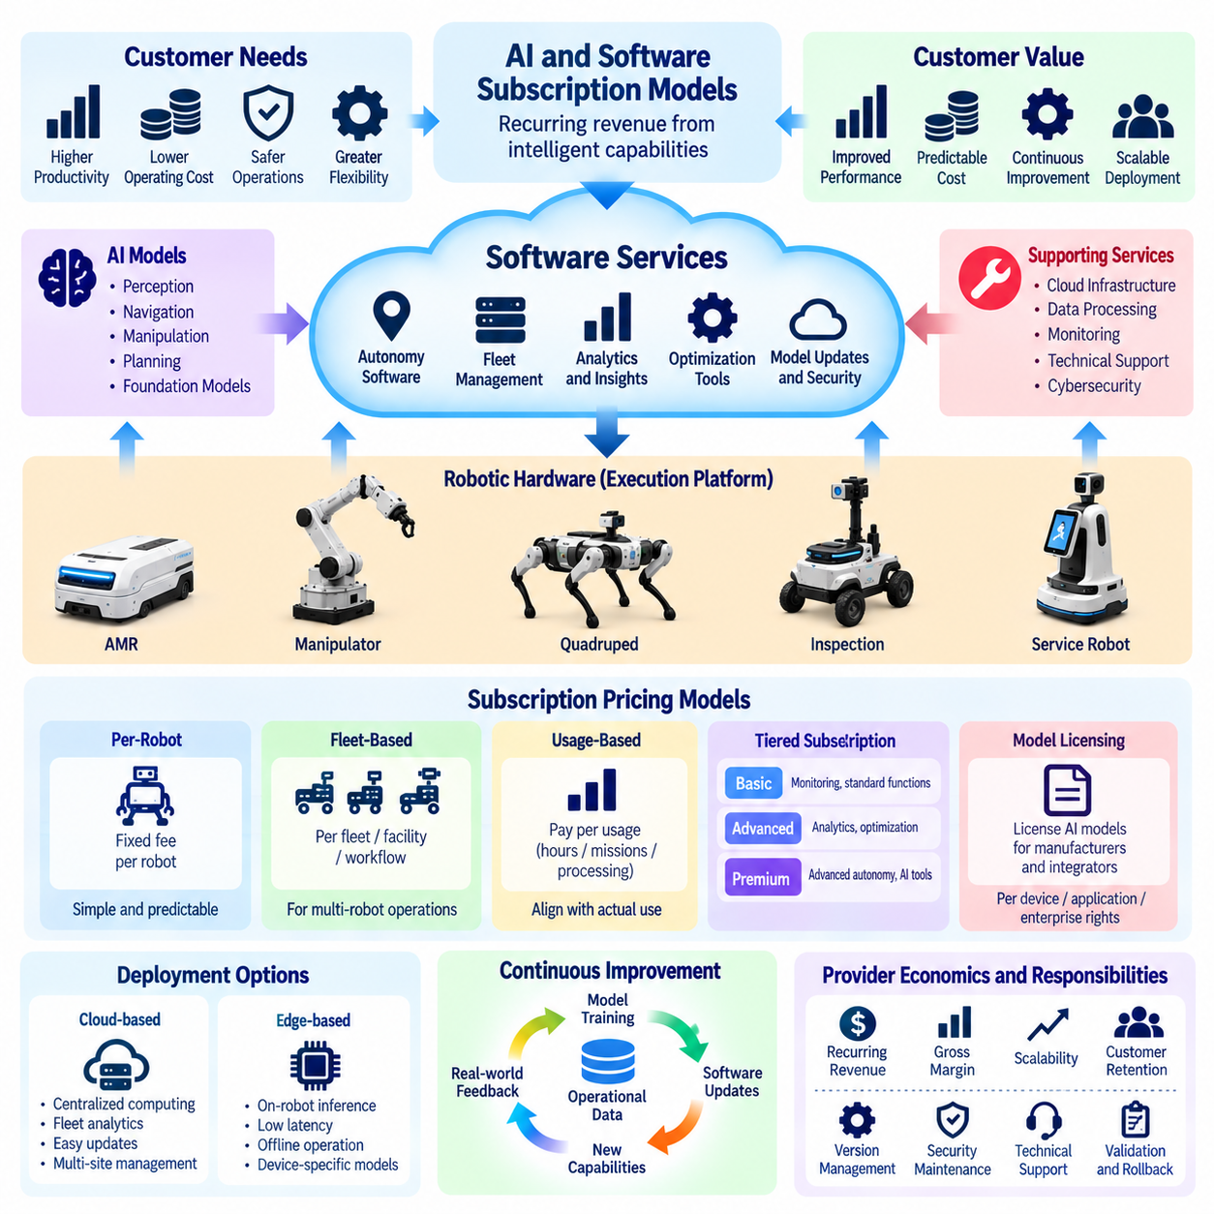
AI and software subscription models enable Physical AI companies to generate recurring revenue from intelligent capabilities rather than relying exclusively on robotic hardware sales. These models commercialize autonomy software, perception algorithms, fleet management, operational analytics, and continuous intelligence improvements. Their strategic importance lies in transforming software from a supporting component into an independently measurable source of customer value.
Traditional robotic systems often bundle software into the initial equipment purchase, with limited opportunities for recurring monetization. Physical AI introduces software capabilities that can evolve throughout the robot lifecycle through model updates, improved task policies, and additional functionality. Subscription arrangements allow providers to maintain these capabilities continuously while establishing predictable revenue relationships with customers.
The foundation of an effective subscription model is a clearly defined software service that customers consider valuable beyond basic robot operation. Essential safety functions and minimum operational capabilities should remain reliably available under the agreed product terms. Premium subscriptions may provide advanced autonomy, multi-robot coordination, optimization tools, predictive maintenance, or specialized application intelligence that delivers additional measurable benefits.
Per-robot subscription pricing charges customers according to the number of deployed robotic units using a software service. This structure is relatively simple to understand, administer, and forecast. However, robots may differ significantly in utilization, computing requirements, and commercial value. Providers must therefore determine whether uniform pricing accurately reflects service costs or whether differentiated tiers are needed for different equipment classes.
Fleet-based subscription models price software according to the scale or capabilities of an entire robotic operation. Customers may purchase management access for a defined number of robots, facilities, or coordinated workflows. This approach is suitable for fleet orchestration, traffic management, task allocation, and centralized monitoring. Its value becomes more apparent when coordinated operation improves overall system productivity.
Usage-based software pricing connects charges to actual consumption of intelligent services. Relevant measures include inference requests, cloud processing time, processed sensor data, autonomous operating hours, or completed optimization tasks. Usage-based models can align revenue with infrastructure consumption, but they require accurate metering and transparent billing. Unpredictable charges may discourage adoption unless customers receive spending controls and clear usage forecasts.
Tiered subscriptions allow customers to select software packages according to operational complexity and required functionality. A basic tier may include monitoring and standard fleet management, while advanced tiers provide analytics, predictive optimization, or specialized autonomy modules. Effective tier design separates genuinely differentiated capabilities without creating unnecessary complexity or withholding functionality essential to safe and dependable operation.
AI model licensing introduces additional commercial possibilities. Providers may license perception models, manipulation policies, navigation intelligence, or robot foundation models to equipment manufacturers and system integrators. Fees can depend on deployed devices, supported applications, software versions, or enterprise-wide rights. Licensing agreements must specify permitted usage, intellectual property ownership, model updates, redistribution restrictions, and responsibility for deployment validation.
Cloud-based subscription services provide centralized computing, fleet analytics, data processing, and model management. They can simplify updates and support customers operating robots across multiple facilities. However, physical robotic systems often require low-latency control and continued operation during connectivity interruptions. Commercial architectures should distinguish cloud-dependent intelligence services from safety-critical functions that must remain available locally.
Edge AI subscriptions offer another approach by licensing intelligent capabilities that execute directly on robotic hardware. Customers may pay for access to optimized perception, navigation, or manipulation models deployed on embedded computing systems. This architecture can reduce communication latency and cloud dependence, although it introduces device compatibility, software protection, update management, and hardware-specific performance challenges.
Continuous software improvement is a major justification for recurring subscription payments. Providers may deliver improved models, expanded task coverage, cybersecurity updates, and operational optimization throughout the contract period. Nevertheless, customers must distinguish routine defect correction from genuinely new functionality. Subscription value is strongest when improvements produce observable gains in productivity, reliability, flexibility, or operating efficiency.
Software subscriptions also create substantial responsibilities for providers. Reliable service delivery requires version management, technical support, cybersecurity maintenance, compatibility testing, and documented release procedures. Physical AI updates may alter robot behavior in real environments, making validation especially important. Providers must control deployment risks and establish rollback procedures when new software introduces unexpected performance problems.
Subscription economics depend on recurring revenue exceeding the complete cost of delivering and maintaining software services. Important expenses include cloud infrastructure, inference computation, data storage, model development, customer support, and ongoing engineering. Gross margins can improve as standardized software reaches more customers, but extensive customization and computationally expensive AI workloads may limit expected scalability.
Customer retention is essential because subscription profitability develops over repeated billing periods. Providers must monitor renewal rates, software adoption, active usage, service quality, and customer satisfaction. A customer who pays for advanced capabilities but rarely uses them may eventually cancel or downgrade. Effective subscription management therefore requires demonstrating continuing operational value rather than depending solely on contractual renewal mechanisms.
AI and software subscriptions can complement hardware sales and Robot-as-a-Service offerings. A robot manufacturer may sell equipment while charging separately for advanced fleet optimization or specialized intelligence. A RaaS provider may bundle essential software into its service fee and offer optional premium modules. Clear commercial boundaries are necessary to prevent duplicate charges and ensure that customers understand which capabilities each agreement includes.
Enterprise customers frequently require customized subscription terms addressing data security, deployment location, service availability, and system integration. Some organizations prefer on-premises software installations or private cloud environments because of operational confidentiality and regulatory requirements. Providers should design licensing and support structures that accommodate these constraints without creating excessive engineering fragmentation or unsustainable service obligations.
Data rights and model improvement policies are particularly important in subscription-based Physical AI services. Operational data may reveal production processes, facility layouts, equipment performance, or commercially sensitive activities. Contracts should define data ownership, permitted processing, retention periods, access controls, and whether customer information can contribute to shared model training. Trustworthy governance supports adoption and reduces legal uncertainty.
Value-based subscription pricing connects software fees to measurable operational improvements rather than feature availability alone. Advanced scheduling software may justify recurring charges through higher throughput, while predictive maintenance intelligence may create value through reduced downtime. Providers should establish baseline metrics and credible attribution methods. Pricing must reflect the customer's realized benefits while accounting for service delivery costs and competitive alternatives.
Subscription growth requires disciplined product management and a scalable software architecture. Standardized interfaces, modular services, automated deployment pipelines, and centralized monitoring reduce the cost of supporting diverse customers. Product roadmaps should prioritize features with broad demand and demonstrable value. Excessive customer-specific development can transform a subscription business into a labor-intensive integration operation.
Ultimately, AI and software subscription models establish recurring commercial relationships around the continuing intelligence of Physical AI systems. Their success depends on clear functionality, measurable customer outcomes, dependable software operations, transparent pricing, and sustainable unit economics. When properly designed, subscriptions support continuous technological improvement while enabling customers to obtain increasing operational value from deployed robotic assets.

08.07. Data and Intelligence as a Service
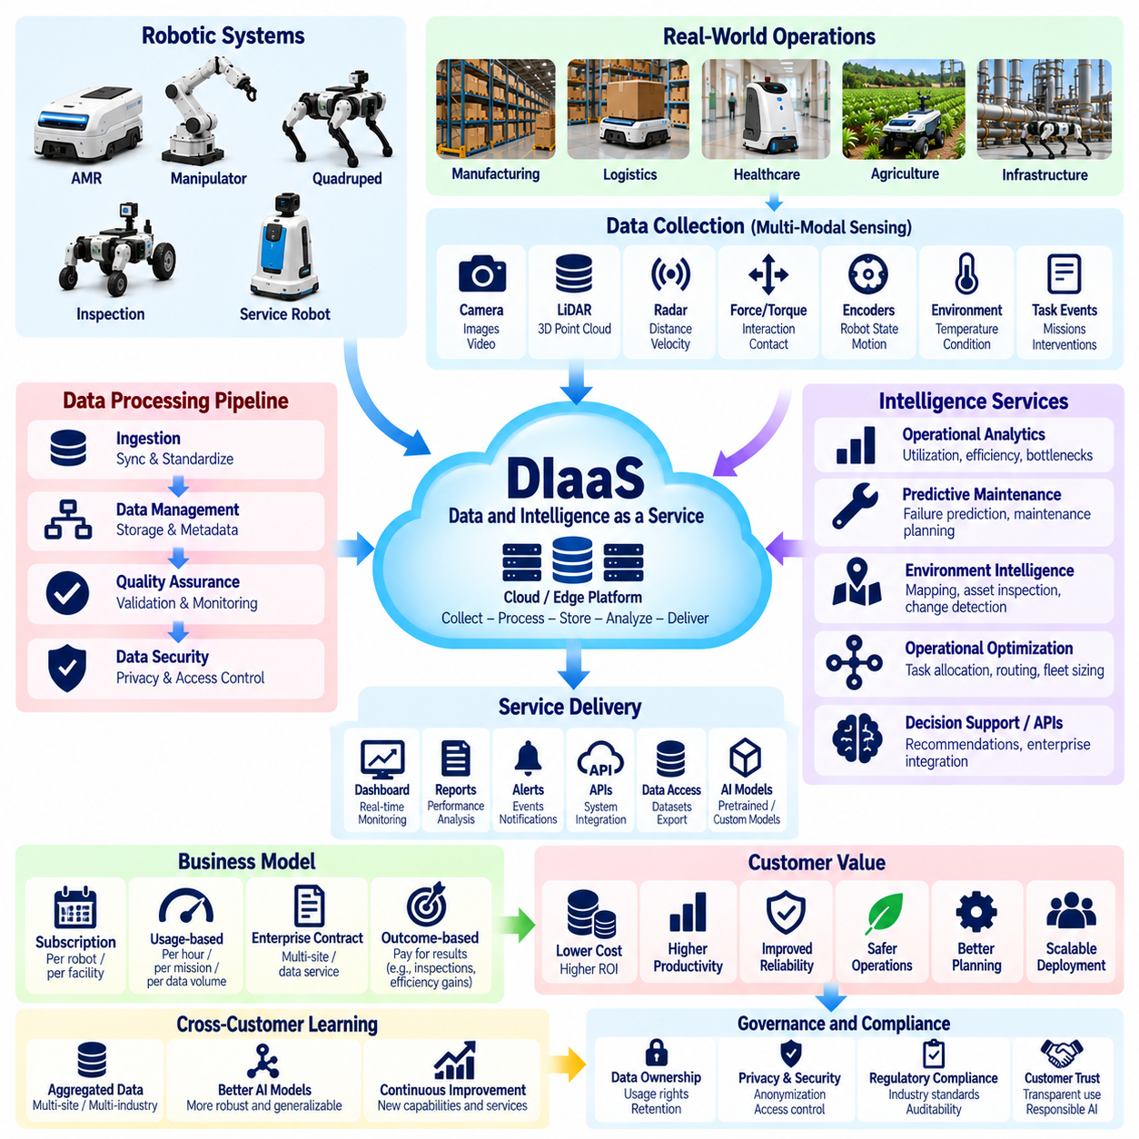
Data and Intelligence as a Service (DIaaS) represents a business model in which Physical AI providers commercialize operational data, analytical insights, and reusable intelligence capabilities as continuing services. Rather than generating revenue solely from robotic equipment or software licenses, providers deliver information and decision-support functions that improve customer operations. The commercial focus shifts from collecting data to producing measurable business outcomes.
Physical AI systems generate valuable information through continuous interaction with real environments. Cameras, lidar, force sensors, joint encoders, and operational controllers capture observations about objects, movement, equipment conditions, and task execution. When properly processed, these observations can reveal workflow inefficiencies, equipment degradation, environmental changes, and opportunities for operational optimization across industrial facilities.
The distinction between Data as a Service and Intelligence as a Service concerns the level of interpretation provided. Data services deliver structured information, historical records, and accessible datasets, while intelligence services transform observations into predictions, recommendations, or automated decisions. In Physical AI, both approaches may operate together, allowing customers to obtain reliable operational visibility and actionable recommendations from the same infrastructure.
A foundational requirement is a dependable data collection architecture connecting deployed robots, edge computing systems, and centralized information platforms. Sensor observations, robot states, task events, intervention records, and performance metrics must be synchronized and organized. Standardized schemas, accurate timestamps, and consistent metadata enable information from different robots and facilities to support meaningful analysis.
Data quality determines whether collected information can support commercially valuable intelligence. Incomplete sensor records, inconsistent event definitions, calibration errors, and inaccurate timestamps may produce misleading conclusions. Providers therefore require automated validation, anomaly detection, data lineage, and quality monitoring. Customers should receive information with documented limitations rather than assuming that large data volumes guarantee reliable insights.
Operational analytics is among the most practical DIaaS applications. Providers can offer dashboards and reports covering robot utilization, mission completion, travel efficiency, congestion, downtime, and intervention frequency. These services help facility managers identify bottlenecks and evaluate improvement opportunities. Their value increases when analytical results are connected to operational decisions and measurable productivity changes.
Predictive maintenance intelligence creates value by identifying emerging equipment problems before they cause significant interruptions. Models may analyze motor currents, vibration, temperature, battery behavior, and fault histories to estimate degradation or failure risk. Customers can use these predictions to schedule inspections and maintenance more effectively. Commercial performance depends on prediction accuracy, false alarm rates, and avoided downtime.
Environment intelligence extends beyond monitoring the robots themselves. Mobile platforms can collect observations about warehouse layouts, infrastructure conditions, obstacles, inventory locations, and changing workspaces. When authorized and appropriately validated, these observations can support facility mapping, asset inspection, and operational planning. This transforms deployed robotic fleets into distributed sensing infrastructure with additional commercial applications.
Intelligence services may also provide recommendations for task allocation, fleet sizing, route optimization, and resource scheduling. Analytical models can combine historical workload patterns with real-time operating conditions to identify more efficient configurations. However, recommendations must account for safety constraints, operational priorities, and uncertain demand. Automated optimization should remain subject to appropriate validation and human oversight.
Commercial delivery models can include recurring subscriptions, usage-based fees, enterprise data contracts, and outcome-linked service agreements. Customers may pay according to monitored robots, processed data volumes, analytical modules, or supported facilities. Intelligence services with demonstrable financial benefits may justify value-based pricing. Pricing structures should remain understandable and avoid charging customers repeatedly for the same underlying capabilities.
Data ownership and usage rights are central to the DIaaS business model. Robotic observations may expose production volumes, facility configurations, employee activities, and commercially sensitive processes. Contracts must specify ownership, collection permissions, processing purposes, retention periods, and permitted secondary uses. Providers cannot assume that operating a robot grants unrestricted rights to commercialize information collected at customer sites.
Privacy, cybersecurity, and confidentiality requirements directly influence service architecture. Sensitive information may require anonymization, access restrictions, encryption, local processing, or separation between customer environments. Data governance should also define auditability, deletion procedures, and incident responsibilities. Compliance requirements vary by jurisdiction and application, making contractual clarity and technical safeguards essential for trustworthy service delivery.
Cross-customer intelligence creates potential economies of learning when information can be combined lawfully and technically. Aggregated operational patterns may help providers improve failure prediction, navigation policies, and task optimization across deployments. However, differences in robot morphology, sensor configuration, and operating environments can limit transferability. Shared learning must respect customer permissions and prevent disclosure of confidential information.
Federated learning and privacy-preserving analytics can support intelligence development when raw customer data cannot be centralized. Models may be trained or adapted within separate environments while selected updates are combined under controlled conditions. These methods can reduce certain data-sharing requirements but do not automatically eliminate privacy or security risks. Their usefulness depends on model architecture, communication costs, and governance.
Data network effects may emerge as larger deployment fleets generate broader operational experience and improve shared intelligence services. Better models can increase customer value, supporting additional adoption and further data collection. Nevertheless, network effects require relevant data diversity, consistent quality, effective learning pipelines, and demonstrated improvements. More data does not necessarily produce better intelligence when observations are redundant or poorly governed.
Service reliability is particularly important when intelligence outputs influence physical operations. Incorrect predictions or optimization recommendations may cause inefficient scheduling, unnecessary maintenance, or unsafe operational decisions. Providers should monitor model accuracy, distribution shifts, uncertainty, and service availability. Critical decisions require defined safety boundaries, escalation mechanisms, and procedures for handling unreliable recommendations.
The economics of DIaaS depend on the balance between recurring revenue and the cost of collecting, processing, storing, and interpreting information. Major expenses include connectivity, cloud infrastructure, data engineering, model training, inference, security, and customer support. Standardized analytical products can improve margins, while customer-specific pipelines and expensive computational workloads may undermine scalability.
Successful commercialization requires separating raw data availability from higher-value intelligence outcomes. Customers may have limited willingness to pay for information they already possess, but stronger demand for insights that reduce downtime, improve throughput, or support better decisions. Providers should establish performance baselines and quantify operational improvements. The strongest services translate analytical accuracy into verifiable economic benefits.
DIaaS can complement robot sales, Robot-as-a-Service contracts, and software subscriptions without replacing their core functions. A provider may bundle basic operational reporting with equipment services while charging separately for predictive analytics or advanced optimization. Transparent service boundaries help prevent overlapping fees. Integration with enterprise resource planning, manufacturing execution, and warehouse management systems can increase practical usefulness.
Ultimately, Data and Intelligence as a Service extends the Physical AI business beyond executing physical tasks toward continuously improving customer operations through information and intelligence. Sustainable value depends on reliable data, responsible governance, effective analytics, measurable outcomes, and scalable delivery economics. The most defensible services convert real-world robotic experience into trusted operational decisions that customers can repeatedly use and justify economically.

08.08. Hardware Software Service Revenue Mix
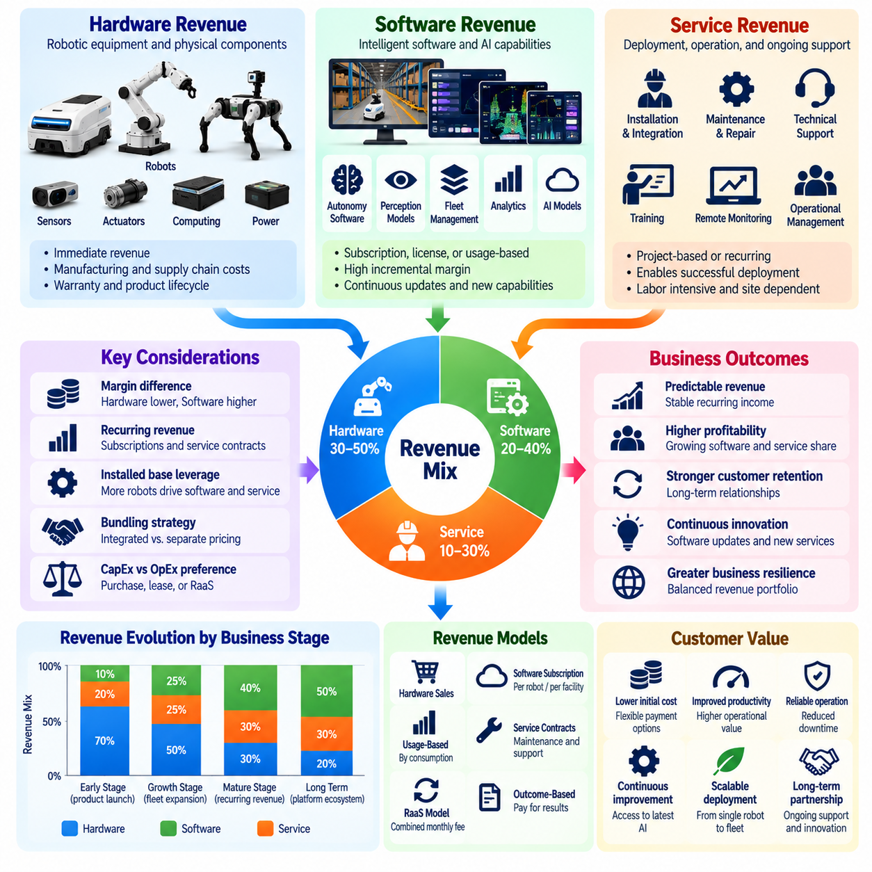
The hardware, software, and service revenue mix defines how a Physical AI company distributes its commercial income across robotic equipment, intelligent software, and continuing operational support. This composition influences profitability, cash flow, customer relationships, and long-term business resilience. An effective revenue strategy recognizes that each component creates value differently and carries distinct cost structures, growth characteristics, and financial risks.
Hardware revenue typically originates from robot sales, sensors, actuators, controllers, computing modules, and related equipment. It provides immediate income when systems are delivered and accepted, subject to contractual accounting requirements. However, hardware businesses face material costs, manufacturing expenses, inventory obligations, and warranty risks. Their profitability depends on production efficiency, component sourcing, product reliability, and competitive pricing.
Software revenue emerges from autonomy platforms, perception models, fleet management systems, analytics, and specialized AI capabilities. Companies may monetize these functions through licenses, subscriptions, usage-based fees, or software upgrades. Compared with hardware, standardized software can potentially generate higher gross margins because additional customers do not require equivalent manufacturing expenditure. Nevertheless, development, computing, and support costs remain significant.
Service revenue includes installation, system integration, commissioning, maintenance, technical support, training, and operational management. These activities enable customers to deploy robotic systems successfully and sustain performance throughout their operating lives. Service income may be project-based, recurring, or linked to performance commitments. Its profitability depends heavily on labor productivity, deployment standardization, and the frequency of customer interventions.
The relative contribution of these revenue categories changes as a Physical AI company matures. Early-stage businesses often depend on hardware sales and integration projects because customers initially purchase complete solutions. As the installed fleet expands, maintenance contracts, software subscriptions, and operational intelligence services can become more important. This transition creates opportunities for recurring revenue but requires disciplined investment in supporting infrastructure.
Revenue composition should be evaluated alongside gross margin rather than sales volume alone. Hardware may account for the largest share of revenue while contributing a smaller proportion of gross profit. Software subscriptions may generate less revenue initially but provide attractive incremental margins when delivery is standardized. Services can strengthen customer retention, although extensive on-site labor and customization may reduce their financial contribution.
Recurring revenue improves business visibility by creating predictable income streams from subscriptions, maintenance agreements, and managed services. However, recurring contracts do not automatically guarantee profitability or stable cash flow. Providers must consider renewal rates, customer concentration, service obligations, and operating expenses. Long-term contracts can also create financial exposure when fixed prices fail to reflect rising maintenance or infrastructure costs.
The installed base of deployed robots is a central driver of future software and service revenue. Each operational robot may create demand for software access, technical support, spare parts, maintenance, and performance analytics. Companies should measure revenue per deployed robot, software attachment rates, service contract penetration, and customer retention. These indicators reveal whether equipment deployment produces sustainable commercial relationships.
Hardware and software bundling is an important pricing decision. An integrated purchase price simplifies procurement and can reduce customer uncertainty about essential functionality. Separating advanced software into subscriptions creates recurring monetization opportunities and allows differentiated service levels. Nevertheless, providers must avoid charging separately for capabilities necessary to deliver the basic performance and safety promised with the equipment.
Service bundling presents similar tradeoffs. Including installation, commissioning, and initial training within the equipment price may accelerate customer adoption and simplify purchasing decisions. Separately priced integration and maintenance contracts can improve cost transparency and recover site-specific expenses. The appropriate structure depends on deployment complexity, customer expectations, competitive conditions, and the provider's ability to estimate service requirements accurately.
Revenue mix strategy must account for differences between capital expenditure and operating expenditure preferences. Some customers favor direct equipment ownership and separate maintenance agreements, while others prefer recurring payments that combine hardware access, software, and support. Robot-as-a-Service arrangements can satisfy the latter preference but shift asset financing and lifecycle responsibilities toward the provider. Commercial flexibility should not obscure the underlying economics.
Customer lifetime value provides a framework for assessing the combined contribution of hardware, software, and services. Initial equipment sales may establish the relationship, while subsequent subscriptions, maintenance renewals, upgrades, and fleet expansion generate additional income. Customer acquisition costs, deployment expenses, gross margins, retention, and discounting must be included. High lifetime revenue is not sufficient when ongoing service obligations consume most of the contribution.
The balance between standardized offerings and customized projects also shapes revenue quality. Custom engineering and integration may generate substantial short-term sales but require specialized personnel and repeated development effort. Standardized software modules and repeatable service packages can improve scalability. Companies should distinguish reusable product development from customer-specific engineering to understand which revenue streams support sustainable expansion.
Financial reporting should separate hardware, software, and service performance even when customers purchase integrated packages. Management needs visibility into segment revenue, direct costs, gross margins, deferred revenue, and contractual obligations. Appropriate allocation methods are necessary when multiple deliverables are sold together. Consistent reporting helps identify profitable offerings and prevents strong equipment sales from concealing losses in software or service delivery.
Pricing decisions should reflect the different value drivers of each component. Hardware pricing may depend on equipment specifications, manufacturing costs, and competitive alternatives. Software pricing can reflect functionality, fleet size, utilization, or measurable productivity gains. Service pricing should account for response requirements, operating environments, labor intensity, and performance commitments. A coherent structure connects customer value with sustainable supplier economics.
Revenue diversification can improve resilience when individual categories face different market pressures. Hardware demand may fluctuate with customer investment cycles, while maintenance and software subscriptions can provide continuity across the installed base. However, diversification introduces management complexity and potentially conflicting incentives. Companies must ensure that each revenue stream reinforces customer outcomes rather than encouraging unnecessary features or services.
Physical AI creates opportunities for software revenue to grow through continuous model improvement and expanded autonomy capabilities. A common intelligence platform may support multiple robot models and customer applications, reducing duplicated development. As deployed systems generate appropriately governed operational feedback, software performance may improve. Commercial benefits depend on validated functionality, customer willingness to pay, and effective distribution of updates.
Service profitability can improve through remote diagnostics, predictive maintenance, modular hardware, and automated fleet monitoring. These capabilities reduce unnecessary site visits and improve the efficiency of technical support. Nevertheless, service organizations require adequate staffing, spare parts availability, and escalation procedures. Providers should monitor support cost per robot, mean time to repair, field intervention frequency, and contract-level contribution margins.
An optimal revenue mix is not necessarily the combination with the highest software percentage or the greatest recurring revenue. It is the structure that produces sustainable cash flow, acceptable risk, competitive customer value, and sufficient returns on invested capital. Different applications may justify different compositions. Standardized warehouse robots, specialized industrial manipulators, and managed inspection fleets can require substantially different commercial architectures.
Ultimately, hardware, software, and service revenue should be designed as an integrated economic system rather than independent sales categories. Hardware establishes physical capability, software expands intelligence and adaptability, and services maintain dependable operational performance. A sustainable Physical AI business aligns these components with customer needs, transparent pricing, measurable lifecycle profitability, and a scalable path toward long-term growth.

08.09. System Integration and Project Business
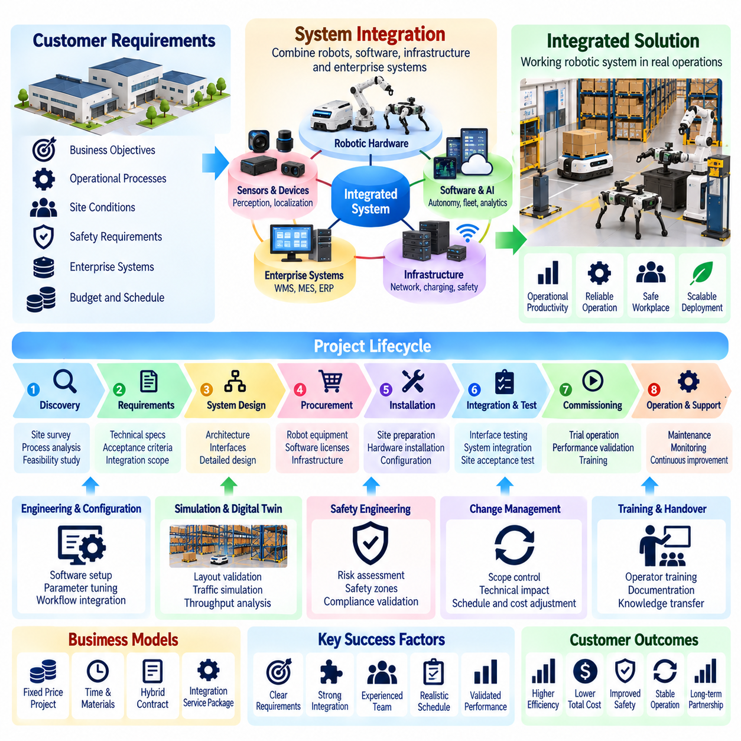
System integration and project-based business models enable Physical AI companies to deliver complete operational solutions rather than isolated robotic products. Customers typically require robots, software, infrastructure, and existing enterprise systems to function together reliably. Integration providers create value by converting technological capabilities into working industrial processes, accepting responsibility for deployment coordination, technical compatibility, and measurable operational outcomes.
Physical AI integration projects commonly involve robotic hardware, autonomy software, fleet management, communication networks, safety systems, and enterprise applications. A mobile robot deployment may require connections to warehouse management, manufacturing execution, or enterprise resource planning systems. Successful integration ensures that information, commands, and operational responsibilities move consistently across these components without disrupting established workflows.
Project development begins with understanding the customer's operating environment and business objectives. Site surveys examine facility layouts, material flows, equipment interfaces, network conditions, and safety requirements. Engineers identify operational constraints and determine whether proposed robotic capabilities can satisfy them. Accurate discovery reduces the likelihood of expensive redesign, unrealistic performance commitments, and disputes during final acceptance.
Requirements engineering translates customer expectations into verifiable technical and commercial specifications. These may include payload capacity, throughput, navigation accuracy, operating hours, system availability, and integration interfaces. Requirements should distinguish mandatory functions from optional improvements and identify dependencies on customer infrastructure. Clear acceptance criteria establish a shared definition of project completion and reduce contractual ambiguity.
System architecture determines how robotic subsystems interact with the customer's operational infrastructure. Integrators must define communication protocols, data interfaces, control responsibilities, and failure-handling mechanisms. Standardized APIs and modular architectures can reduce engineering effort across projects. However, legacy equipment and proprietary enterprise systems frequently require adapters, custom middleware, or specialized integration procedures.
Physical installation introduces challenges that cannot be resolved through software configuration alone. Charging stations, network equipment, safety devices, floor conditions, access controls, and mechanical interfaces may require modification. These site-specific activities influence deployment schedules and project costs. Integration plans should account for facility preparation, installation access, operational interruptions, and coordination with customer contractors.
Safety engineering is a fundamental responsibility in Physical AI integration. Robots must operate within environments containing workers, vehicles, machinery, and changing obstacles. Risk assessments should address collision hazards, emergency stopping, restricted zones, and interactions with existing equipment. Responsibility for safety validation must be clearly assigned among robot manufacturers, system integrators, facility operators, and other relevant parties.
Project execution generally progresses through design, procurement, configuration, installation, integration testing, commissioning, and acceptance. Each phase should have defined deliverables, dependencies, and approval responsibilities. Structured milestone management helps identify schedule deviations before they affect final delivery. Projects involving multiple suppliers require particularly careful coordination because delays in one subsystem can prevent completion of the entire installation.
Simulation and digital twins can improve project planning by evaluating robot routes, traffic interactions, workspace constraints, and expected throughput before physical deployment. These tools support layout decisions and early identification of integration problems. Nevertheless, simulated performance must be validated against real operating conditions. Differences in human activity, equipment behavior, and environmental variability can significantly affect actual results.
Testing should progress from individual components to complete operational workflows. Interface testing verifies communication between robots and external systems, while integrated testing evaluates coordinated task execution. Site acceptance testing confirms performance under agreed conditions. Testing procedures should include normal operation, foreseeable failures, recovery behavior, and safety responses rather than relying exclusively on successful demonstration scenarios.
Commercial contracts must define project scope, responsibilities, deliverables, payment milestones, and acceptance procedures. Fixed-price contracts provide customers with cost predictability but expose integrators to estimation errors and unexpected engineering effort. Time-and-materials contracts offer flexibility but create budget uncertainty. Hybrid arrangements may combine fixed prices for standardized components with separately controlled charges for uncertain integration work.
Scope management is essential because customer requirements often evolve during deployment. Additional interfaces, workflow changes, new safety constraints, and facility modifications can create substantial unplanned effort. Formal change-control procedures should document technical impacts, schedule consequences, and commercial adjustments. Without disciplined scope control, apparently profitable integration projects can become financially unsustainable.
Project profitability depends on more than the difference between equipment purchase prices and customer invoices. Direct costs include engineering labor, hardware procurement, software configuration, installation, travel, subcontractors, testing, and warranty provisions. Indirect expenses include project management, technical administration, and shared development resources. Accurate cost allocation is necessary to understand actual project contribution margins.
Cash flow management is especially important in large integration projects. Hardware purchases and engineering expenses may occur long before customer payments are received. Milestone billing, advance payments, procurement schedules, and working capital planning help reduce financing pressure. Providers should also consider retention payments and delayed acceptance. Strong reported project revenue does not necessarily indicate sufficient operating cash flow.
System integrators can differentiate themselves through industry expertise, reusable software connectors, standardized deployment methods, and proven operational reliability. Knowledge of manufacturing processes, warehouse operations, or healthcare workflows can be as valuable as robotics expertise. Repeatable engineering assets reduce delivery time and improve quality. Competitive advantage increasingly depends on combining domain understanding with scalable integration technology.
Partnership structures influence project delivery and commercial responsibility. Robot manufacturers may collaborate with local integrators, automation contractors, enterprise software vendors, and infrastructure specialists. Effective partnerships require clear boundaries for installation, configuration, maintenance, warranty support, and customer communication. Poorly defined responsibilities can create service delays and disputes when integrated systems fail to meet expectations.
The relationship between project business and recurring revenue deserves strategic attention. Initial integration generates deployment income, while maintenance, software subscriptions, fleet monitoring, and optimization services can provide continuing revenue. Providers should design integration architectures that support future expansion without excessive customization. A successful project becomes more valuable when it establishes a scalable installed base and a long-term customer relationship.
Project performance should be measured through schedule adherence, budget variance, acceptance success, system availability, throughput achievement, and customer satisfaction. Post-deployment reviews can identify recurring engineering problems and opportunities for standardization. Integrators should also track change-order frequency, support requirements, and realized project margins. These metrics help distinguish sustainable delivery capability from isolated project success.
Scaling a project-based Physical AI business requires reducing dependence on unique engineering solutions. Reference architectures, reusable interfaces, deployment templates, automated testing, and documented commissioning procedures can improve consistency. Standardization should preserve necessary customer flexibility while limiting uncontrolled customization. The objective is to transform accumulated project experience into repeatable delivery capabilities and predictable economics.
Ultimately, system integration and project business models connect Physical AI innovation with practical industrial adoption. Their success depends on accurate requirements, dependable architecture, disciplined execution, safety assurance, contractual clarity, and sustainable project economics. Companies that combine technical integration expertise with standardized delivery methods can convert complex robotic technologies into reliable customer operations while creating foundations for recurring services and long-term growth.

08.10. Fleet Service and Operations Business
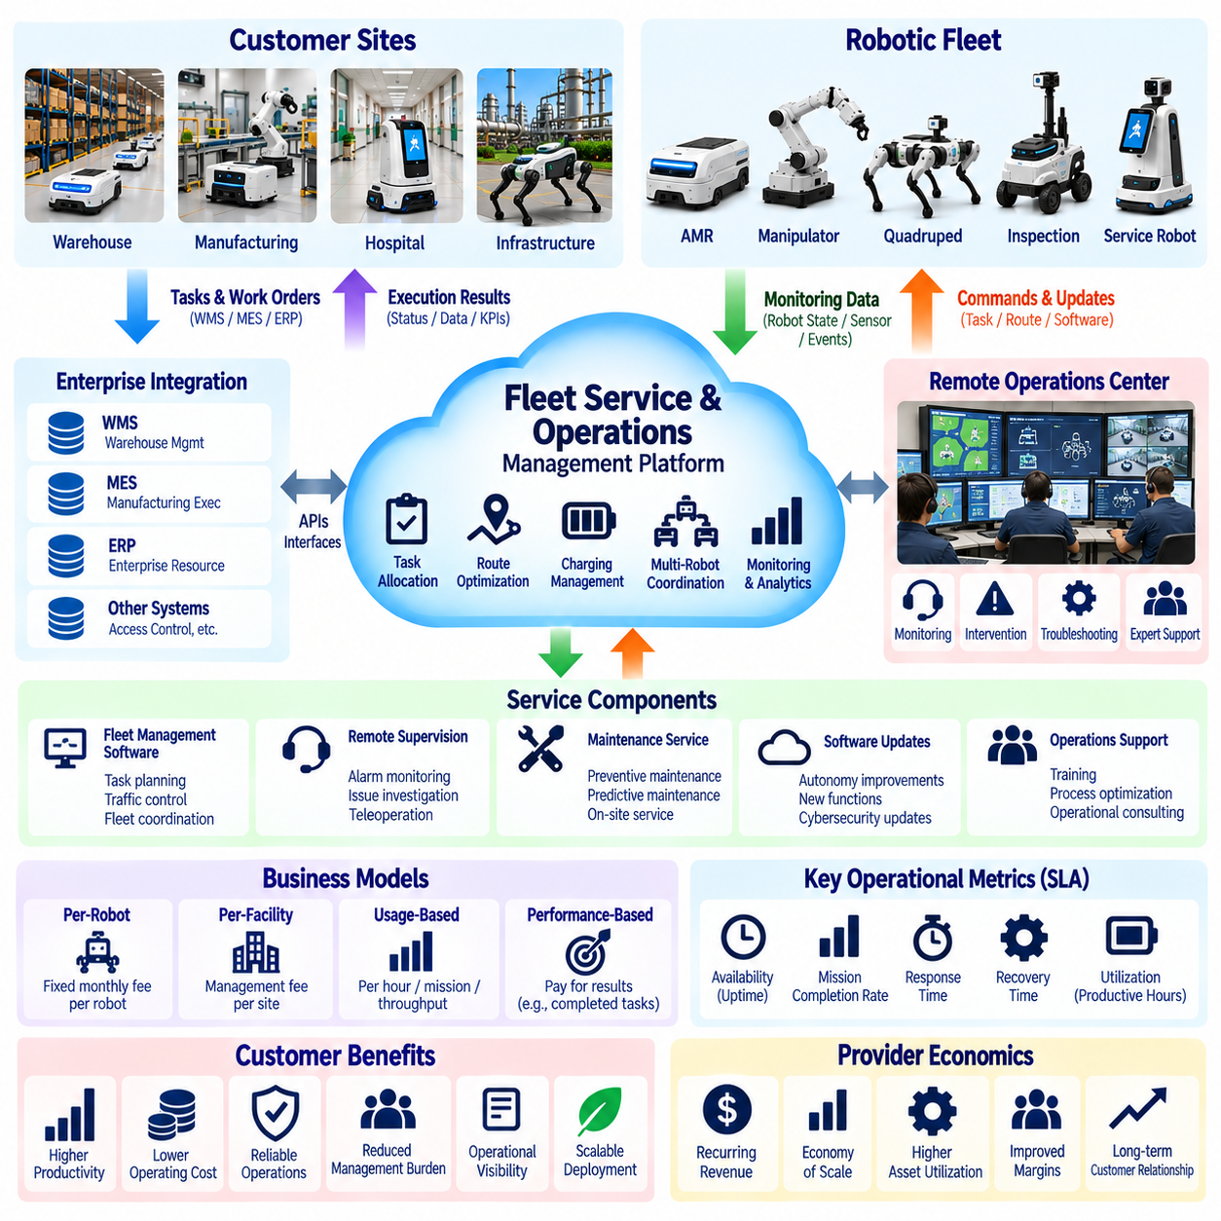
Fleet service and operations business models enable Physical AI providers to generate continuing revenue by managing deployed robotic fleets throughout their operational lifecycles. Rather than focusing exclusively on equipment delivery, these businesses assume responsibility for fleet availability, task execution, monitoring, and operational improvement. Their value depends on maintaining dependable robotic performance while reducing the management burden placed on customers.
A fleet operations service typically combines robotic hardware, fleet management software, remote supervision, technical support, and performance analytics. Customers may retain ownership of their robots or obtain equipment through leasing and Robot-as-a-Service agreements. The provider's commercial role is to ensure coordinated operation across multiple machines. Clear service boundaries distinguish fleet operations from basic software licensing and conventional maintenance contracts.
Fleet management platforms form the technological foundation of these services. They coordinate task allocation, traffic control, route planning, charging schedules, and robot status monitoring. Integration with warehouse management, manufacturing execution, and enterprise resource planning systems connects robotic activities to business workflows. Effective orchestration improves resource utilization and reduces operational conflicts among robots sharing the same environment.
Remote operations centers allow providers to supervise fleets distributed across multiple customer facilities. Operators can monitor alarms, investigate abnormal behavior, review mission failures, and coordinate recovery procedures. Centralized supervision may reduce the need for dedicated personnel at every site. However, staffing requirements depend on fleet complexity, intervention frequency, operating hours, and the consequences of delayed responses.
Human intervention remains important even when robots perform most tasks autonomously. Fleet service agreements should define when remote assistance, teleoperation, or on-site intervention is permitted and required. Providers must establish escalation procedures for navigation failures, blocked routes, equipment faults, and unexpected environmental conditions. Human oversight should support autonomous operations without creating hidden labor costs that undermine scalability.
Service-level agreements establish measurable expectations for operational performance. Common indicators include fleet availability, robot uptime, mission completion rates, incident response times, and recovery times. Contract terms should distinguish failures attributable to the provider from disruptions caused by customer infrastructure or external conditions. Clearly defined measurement methods reduce disputes and connect commercial obligations to operational reality.
Fleet availability and productive utilization are related but different measures. A robot may remain technically operational while spending significant time waiting for assignments, charging, or navigating inefficient routes. Providers should evaluate productive operating hours, completed tasks, throughput, and idle time alongside uptime. Revenue models based solely on equipment availability may overlook opportunities to improve actual customer productivity.
Commercial pricing may be structured per robot, per facility, per operating hour, or according to completed tasks. Fixed monthly management fees offer predictable billing, while usage-based arrangements connect charges more closely to operational activity. Performance-linked contracts may reward higher throughput or reduced downtime. Pricing must account for the provider's controllable responsibilities and avoid exposing either party to poorly defined operational risks.
Fleet service economics depend heavily on the relationship between managed fleet size and operational support costs. Revenue can increase as additional robots join a common management platform, but staffing, connectivity, maintenance, and infrastructure expenses also grow. Economies of scale emerge when standardized tools allow one operations team to supervise more robots without proportional increases in labor. Intervention rates are therefore a critical economic variable.
The ratio of managed robots to operations personnel provides a useful indicator of service scalability. However, a single staffing ratio cannot describe every deployment. Complex manipulation tasks, hazardous environments, and unpredictable public spaces may require more supervision than structured warehouse transport. Providers should calculate staffing requirements using observed intervention frequency, average handling time, shift coverage, and operational risk.
Operational data supports continuous improvement of fleet services. Mission histories, congestion events, battery cycles, charging delays, and failure records can reveal inefficient processes. Analytics may guide changes to robot allocation, routing policies, and maintenance schedules. Providers should establish feedback loops that convert operational observations into validated improvements while respecting customer data rights and security requirements.
Predictive maintenance strengthens fleet operations by reducing unexpected equipment failures. Monitoring battery health, motor conditions, sensor performance, and fault patterns can support proactive service planning. Maintenance activities should be coordinated with workload demand to minimize disruption. The commercial benefit depends on avoiding downtime without introducing excessive inspections, replacement costs, or false maintenance alarms.
Fleet operations must also address charging and energy management. Poor charging schedules can reduce available capacity during peak demand, while unnecessary charging interruptions may lower throughput. Intelligent scheduling considers battery state, task priority, charging infrastructure, and expected workloads. For large fleets, coordinated energy management can improve utilization and reduce infrastructure congestion without compromising battery safety.
Integration with customer workflows determines whether managed fleets deliver meaningful business value. Task requests may originate from production systems, warehouse applications, or facility management platforms. The operations provider must ensure that assignments, completion confirmations, and exceptions are communicated reliably. Changes to customer processes can affect fleet performance, making interface governance and coordinated change management essential.
Cybersecurity and operational resilience are central to remotely managed robotic fleets. Communication failures, unauthorized access, software defects, and cloud service interruptions can disrupt operations. Providers need secure authentication, network segmentation, monitoring, backup procedures, and appropriate local fallback capabilities. Safety-critical robot functions must remain protected even when centralized management services become unavailable.
Customer responsibilities must be clearly defined in managed fleet contracts. Facility operators may control floor conditions, wireless networks, pedestrian access, loading procedures, and production schedules. Providers may control fleet software, remote monitoring, robot configuration, and designated maintenance activities. Shared responsibility arrangements should specify incident reporting, access permissions, operating constraints, and procedures for resolving performance disputes.
Fleet expansion introduces additional operational and commercial complexity. Adding robots may increase throughput, but congestion, charging limitations, and shared resource conflicts can reduce marginal productivity. Providers should evaluate capacity through simulation, operational data, and controlled deployment tests. Expansion decisions should consider whether additional robots produce sufficient incremental value to justify equipment, software, and support expenses.
Financial management requires tracking recurring revenue, gross margin, customer retention, and support costs at both fleet and contract levels. Important measures include revenue per managed robot, intervention cost per mission, support labor per operating hour, and contract contribution margin. Providers should distinguish profitable fleet growth from expansion that increases revenue while disproportionately increasing service obligations.
Standardization is essential for scaling fleet operations across customers and locations. Common software interfaces, monitoring dashboards, incident classifications, recovery procedures, and training programs reduce operational complexity. Nevertheless, standardized services must accommodate legitimate differences in facility layouts, safety requirements, and task characteristics. Modular service packages provide flexibility without requiring entirely customized operating models.
Ultimately, fleet service and operations businesses transform Physical AI from a deployed technology into a continuously managed operational capability. Their long-term success depends on reliable autonomy, effective human supervision, measurable service performance, disciplined cost control, and scalable fleet orchestration. Providers that consistently improve customer productivity while maintaining sustainable service economics can build durable recurring revenue and long-term operational partnerships.

08.11. Maintenance Support and Lifecycle Revenue
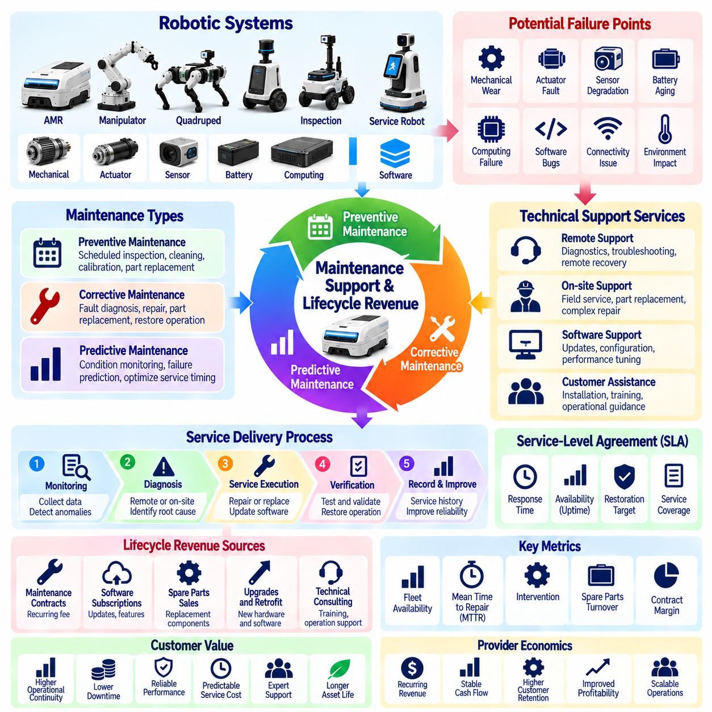
Maintenance, support, and lifecycle revenue represent essential components of sustainable Physical AI business models. Unlike one-time equipment sales, these activities generate continuing income by preserving robot performance, availability, and operational value throughout the installed system's useful life. Their commercial importance increases as deployed fleets expand and customers become more dependent on reliable autonomous operations.
Robotic maintenance includes preventive inspections, corrective repairs, component replacement, calibration, and software-related servicing. Physical AI systems combine mechanical structures, actuators, sensors, batteries, computing hardware, and intelligent software, creating multiple potential failure points. Effective maintenance programs address these interconnected elements while minimizing interruptions to customer workflows and avoiding unnecessary service expenditure.
Preventive maintenance follows scheduled intervals based on operating hours, usage cycles, manufacturer recommendations, and environmental conditions. Activities may include inspecting drive systems, checking electrical connections, cleaning sensors, and evaluating battery health. Standardized maintenance procedures improve consistency and reduce unexpected failures. However, excessive scheduled servicing can increase costs without delivering proportional reliability improvements.
Corrective maintenance restores functionality after faults or failures occur. Providers must establish diagnostic procedures, replacement strategies, repair responsibilities, and escalation mechanisms. Mean time to repair, spare parts availability, and technician response times directly influence service performance. Efficient corrective maintenance requires accurate fault identification and modular system designs that allow damaged components to be replaced without extensive disassembly.
Predictive maintenance uses operational data to identify potential equipment degradation before functional failure. Sensor measurements, motor currents, vibration patterns, battery characteristics, and fault histories can support condition monitoring. Statistical models and machine learning algorithms may estimate failure probabilities or remaining useful life. Predictions must be validated carefully because false alarms and missed failures can create substantial operational costs.
Technical support extends beyond physical repair to include software configuration, connectivity troubleshooting, navigation recovery, and fleet management assistance. Customers may require support during installation, routine operation, software upgrades, and unexpected incidents. Multilevel support organizations can separate basic troubleshooting from advanced engineering investigations. Clear escalation procedures improve response efficiency and prevent recurring problems from overwhelming specialized personnel.
Service-level agreements define maintenance and support obligations through measurable performance commitments. Contracts may specify response times, restoration targets, support availability, preventive maintenance schedules, and spare parts responsibilities. Premium service tiers can offer extended operating-hour coverage or faster intervention. Providers must price these commitments according to actual delivery capabilities, geographic coverage, and the financial consequences of service failures.
Lifecycle revenue begins with equipment deployment but can continue through maintenance contracts, software subscriptions, replacement components, upgrades, and technical consulting. A robot's installed life may include several generations of software and selected hardware improvements. Providers should map expected revenue and service costs across the entire ownership period. This approach reveals whether initial sales create profitable long-term relationships or expensive support obligations.
Spare parts management is particularly important for robotic fleets operating continuously. Providers must balance inventory availability against storage costs, component obsolescence, and working capital requirements. Critical components may require regional stocking or guaranteed supplier access. Demand forecasting should consider fleet size, operating intensity, historical failure rates, and product age. Poor inventory planning can increase downtime even when technicians are available.
Software maintenance introduces recurring responsibilities that differ from conventional mechanical servicing. Updates may address security vulnerabilities, compatibility problems, autonomy performance, or operational defects. Providers should maintain version control, regression testing, rollback capabilities, and deployment records. Updates affecting navigation, manipulation, or safety-related behavior require appropriate validation before release into customer environments.
Remote diagnostics can significantly improve support efficiency by allowing technicians to investigate faults without visiting customer sites. Secure access to logs, system health indicators, configuration data, and event histories enables faster problem identification. Remote recovery may resolve selected issues, but safety-critical interventions require controlled procedures. Remote support architectures must also protect customer confidentiality, access permissions, and operational security.
Lifecycle economics should distinguish recurring revenue from recurring profit. Maintenance contracts may generate predictable billing while producing uncertain labor, travel, replacement, and warranty costs. Providers should calculate contract contribution margins using expected intervention frequency, technician time, spare parts consumption, and infrastructure expenses. Underpriced service commitments can become increasingly unprofitable as the installed fleet ages.
Warranty management establishes the boundary between manufacturer obligations and separately purchased services. Contracts should clarify coverage periods, eligible defects, exclusions, customer responsibilities, and repair procedures. Extended warranties may create additional revenue but also introduce long-term financial exposure. Providers need reliable failure statistics and appropriate reserves to avoid treating warranty-related cash receipts as unrestricted profit.
Hardware upgrades offer additional lifecycle revenue when customers require greater capability or improved efficiency. Examples include sensor replacements, battery upgrades, computing modules, and improved manipulation components. Modular architectures can make these upgrades economically practical without replacing complete robots. Upgrade proposals should demonstrate measurable customer benefits and account for compatibility, installation costs, and remaining equipment life.
End-of-life planning is another important dimension of lifecycle service. Aging robots may experience rising failure rates, declining component availability, and increasing software compatibility challenges. Providers should establish policies for repair support, security updates, refurbishment, and product retirement. Transparent end-of-support schedules help customers plan replacements and reduce disputes arising from unexpected service discontinuation.
Refurbishment and remanufacturing can extend asset usefulness while creating secondary revenue opportunities. Returned robots may undergo inspection, component replacement, testing, and recertification before redeployment or resale. These activities can improve resource efficiency and reduce equipment acquisition costs. However, refurbished products require consistent quality standards, traceability, warranty policies, and realistic assessments of remaining useful life.
Customer retention is closely connected to maintenance and support quality. Reliable service reduces operational uncertainty and strengthens confidence in the provider's technology. Poor response times, recurring failures, or unclear responsibilities can undermine relationships even when the original equipment performs well. Service interactions also provide opportunities to identify emerging customer needs, recommend appropriate upgrades, and support future fleet expansion.
Maintenance performance should be monitored through equipment availability, mean time between failures, mean time to repair, first-time fix rates, and service cost per robot. Financial indicators should include maintenance contract renewal rates, spare parts margins, warranty expenses, and lifecycle contribution margins. Combining operational and commercial measurements helps management identify whether reliability improvements translate into sustainable economic value.
Scaling lifecycle services requires standardized diagnostics, technician training, modular replacement procedures, and reliable service information systems. Centralized knowledge bases can capture recurring failures and effective repair methods across customer sites. Regional service partners may expand geographic coverage, provided that technical quality and contractual accountability remain consistent. Automation should reduce repetitive support work without weakening safety or customer responsiveness.
Ultimately, maintenance, support, and lifecycle revenue transform robotic equipment into a long-term commercial relationship centered on dependable performance. Sustainable success requires balancing customer uptime, service responsiveness, asset longevity, and provider profitability. Physical AI companies that design maintainability into their products and manage lifecycle obligations systematically can establish recurring income while improving customer trust and operational continuity.

08.12. Pricing and Value Based Pricing
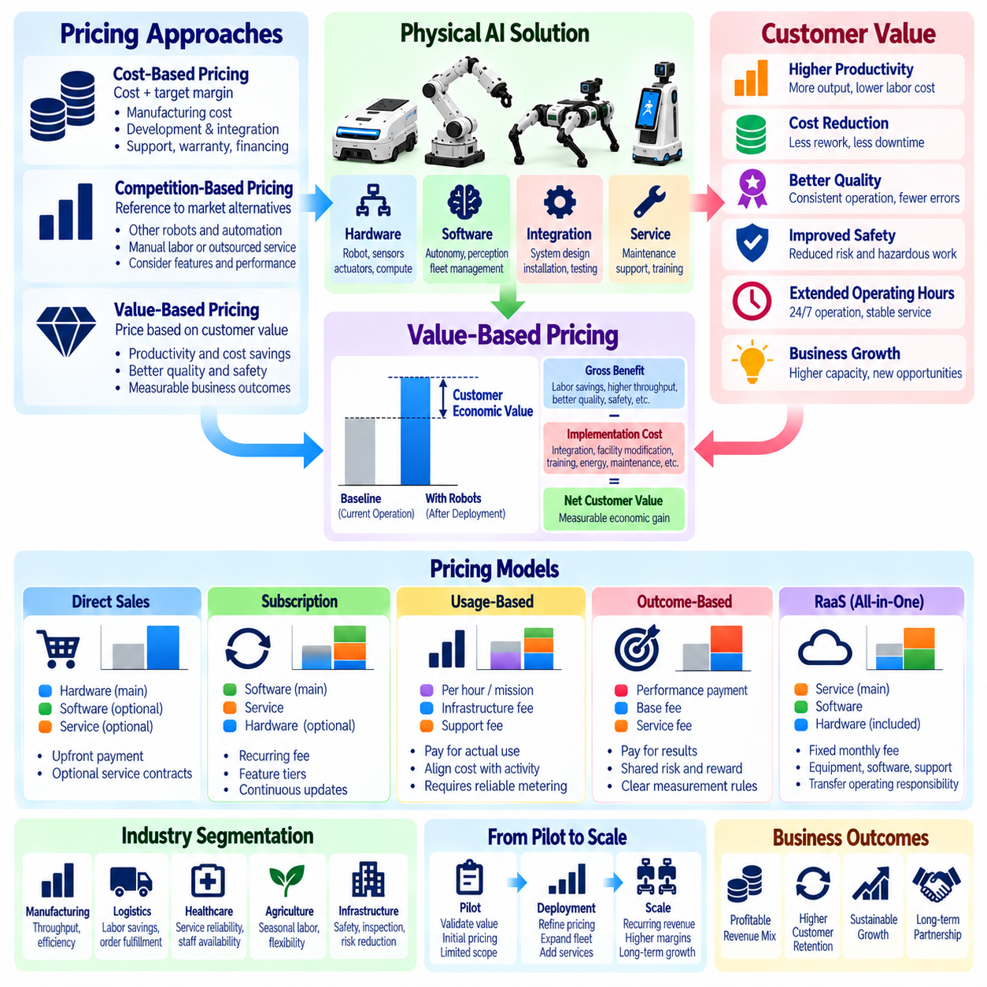
Pricing is a central strategic decision in Physical AI business models because it determines how technological capability is converted into commercial revenue and customer value. Unlike conventional equipment pricing, Physical AI pricing must account for hardware, intelligent software, integration, maintenance, and operational outcomes. An effective pricing strategy balances customer affordability, measurable economic benefits, competitive positioning, and sustainable supplier profitability.
Cost-based pricing establishes selling prices by adding a target margin to the estimated cost of delivering a robotic solution. Relevant costs include equipment manufacturing, software development allocation, deployment engineering, technical support, warranty provisions, and financing expenses. This approach provides a financial baseline but may overlook differences in customer value. A solution with identical delivery costs can produce substantially different economic benefits across applications.
Competition-based pricing uses alternative technologies and market offerings as reference points. Customers may compare autonomous robots with conventional automation, manual labor, outsourced services, or competing robotic platforms. These comparisons establish practical expectations regarding acquisition costs and recurring fees. However, direct price comparisons can be misleading when solutions differ in reliability, flexibility, deployment complexity, and operational performance.
Value-based pricing determines commercial charges according to the economic benefits a solution creates for customers rather than relying primarily on supplier costs. Physical AI can generate value through labor productivity, higher throughput, reduced errors, improved safety, and extended operating hours. Providers must translate these improvements into credible financial outcomes. Pricing becomes more defensible when customers can connect payments to measurable business results.
Customer value assessment begins by establishing a reliable operational baseline. Providers should document existing labor requirements, task volumes, cycle times, equipment utilization, error rates, and operating expenses. Expected robotic performance can then be compared against this baseline under realistic conditions. Without accurate reference data, projected savings may exaggerate the benefits of automation and weaken confidence in proposed pricing.
The economic value of Physical AI includes both direct savings and additional business benefits. Direct savings may arise from reduced repetitive labor, lower rework expenses, or decreased equipment downtime. Additional value may include increased production capacity, improved service consistency, and reduced exposure to hazardous tasks. These benefits should be evaluated carefully because not every operational improvement produces an immediate or independently measurable financial return.
Value-based pricing requires distinguishing gross operational benefits from net customer value. Implementation expenses, facility modifications, training, supervision, energy consumption, and continuing maintenance reduce the savings available to customers. Providers should calculate the customer's expected economic gain after these costs. A commercially sustainable price allows both the supplier and customer to capture an appropriate share of the value created.
Pricing structures differ according to the commercial delivery model. Direct robot sales typically combine an equipment purchase price with optional software and service contracts. Subscription models charge recurring fees for software capabilities or operational access. Robot-as-a-Service agreements may bundle equipment, maintenance, and support into periodic payments. Each structure distributes ownership, financing, utilization, and performance risks differently.
Usage-based pricing links customer payments to measurable consumption, such as robot operating hours, completed missions, transported units, or processed orders. This approach can reduce upfront commitments and align expenses with activity levels. However, providers must define measurement methods and distinguish productive usage from idle operation. Pricing should also account for fixed infrastructure and support costs that remain even when utilization declines.
Outcome-based pricing connects compensation to agreed operational results, including throughput improvements, reduced downtime, or successful task completion. Such contracts can strengthen alignment between provider incentives and customer objectives. Nevertheless, outcomes often depend on customer workflows, infrastructure, and demand conditions. Contracts should establish controllable performance variables, measurement boundaries, and procedures for addressing external disruptions.
Tiered pricing enables providers to serve customers with different operational requirements and willingness to pay. Basic packages may include essential autonomy, standard support, and limited analytics. Higher tiers can offer advanced fleet optimization, predictive maintenance, expanded integrations, and faster service response. Differentiation should reflect genuine value rather than artificially restricting functions necessary for safe and reliable operation.
Pricing segmentation recognizes that different industries assign different economic values to the same robotic capability. Warehouse operators may prioritize throughput and labor efficiency, while hospitals emphasize service reliability and staff availability. Industrial inspection customers may value reduced exposure to hazardous environments. Providers should adapt commercial packages to these priorities while maintaining transparent and consistent pricing principles.
Pilot pricing presents a particular challenge because early deployments involve uncertainty and substantial engineering effort. Free or heavily discounted pilots may encourage experimentation but can create unrealistic expectations for production pricing. Paid pilots can establish customer commitment and recover part of the validation cost. Agreements should specify evaluation objectives, deployment duration, acceptance criteria, and commercial conditions for subsequent expansion.
Discounting must be managed carefully as customers transition from pilot deployments to larger fleets. Volume discounts may reflect genuine economies of scale in manufacturing, installation, software administration, and technical support. However, larger fleets can also increase integration complexity and service obligations. Discounts should therefore depend on demonstrable cost efficiencies and long-term contract value rather than equipment quantity alone.
Pricing decisions must consider total cost of ownership and customer investment constraints. Customers evaluate acquisition expenses, recurring payments, maintenance, energy, staffing, and expected asset life when comparing alternatives. A lower purchase price may not represent better value if operational expenses remain high. Providers can improve commercial clarity by presenting lifecycle cost estimates alongside measurable productivity and reliability assumptions.
Willingness to pay depends on the customer's alternatives, financial priorities, perceived risk, and confidence in promised performance. Procurement teams may emphasize budget limits, while operations managers prioritize productivity and continuity. Financial executives often evaluate payback periods, cash flow, and investment returns. Successful pricing proposals connect these different perspectives through a consistent and evidence-based economic justification.
Pricing governance becomes increasingly important as Physical AI companies expand across products, customers, and regions. Standard price structures, approval procedures, discount policies, and contract templates help maintain commercial discipline. Management should monitor realized selling prices, gross margins, renewal rates, and customer profitability. Exceptions should be justified by measurable strategic or economic benefits rather than short-term sales pressure.
Continuous performance measurement supports pricing refinement after deployment. Actual task completion rates, operating hours, intervention costs, maintenance expenses, and customer productivity improvements reveal whether initial assumptions were accurate. Providers can use these observations to adjust future quotations and service packages. Existing contracts should be modified only according to agreed terms, preserving transparency and customer trust.
Pricing strategy should evolve as autonomy improves and deployment costs decline. Standardized hardware, reusable software modules, and remote support can reduce delivery expenses, while improved intelligence may increase customer value. Providers must decide how to distribute these gains between competitive price reductions and improved margins. Long-term advantage comes from combining measurable customer benefits with efficient and repeatable service delivery.
Ultimately, value-based pricing transforms Physical AI commercialization from selling robotic equipment into exchanging measurable operational improvements for sustainable revenue. Effective pricing integrates cost discipline, customer economics, performance evidence, contractual risk allocation, and competitive positioning. Companies that demonstrate credible value and price their offerings transparently can accelerate adoption while building profitable, scalable, and durable customer relationships.

08.13. CAPEX vs OPEX Customer Models
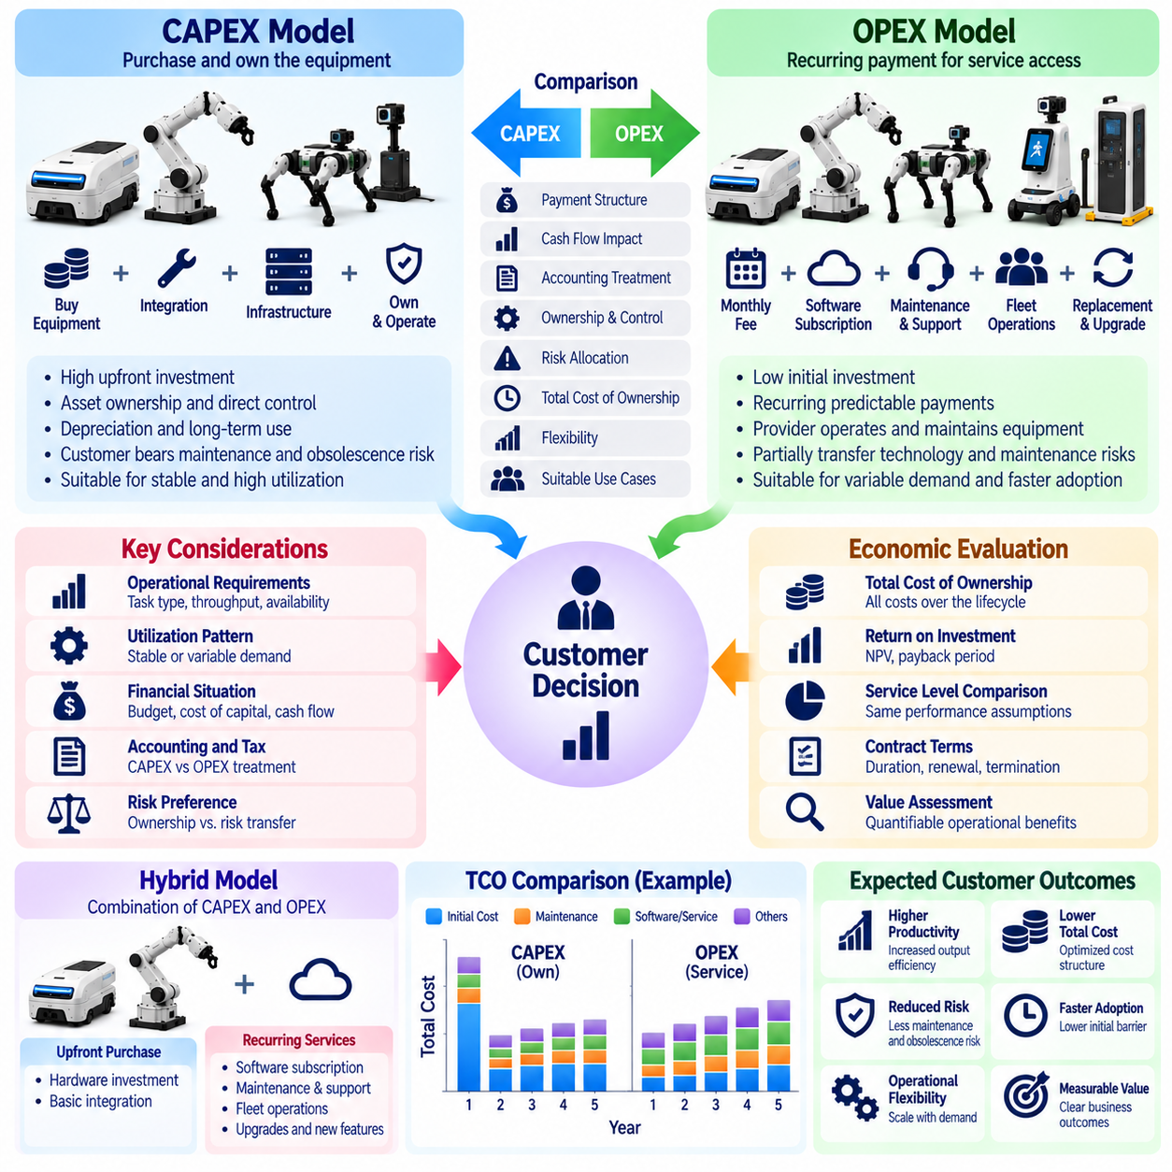
Capital expenditure and operating expenditure models represent two distinct approaches to financing and consuming Physical AI solutions. Capital expenditure, or CAPEX, generally involves purchasing robotic equipment and recognizing qualifying investments as assets. Operating expenditure, or OPEX, emphasizes recurring payments for services, subscriptions, or equipment access. The choice affects customer cash flow, financial reporting, risk allocation, and adoption decisions.
Under a CAPEX model, customers typically purchase robots, supporting infrastructure, and integration services through an initial investment. Equipment ownership provides direct control over asset deployment, maintenance policies, and long-term utilization. The customer assumes responsibility for financing and much of the asset-related risk. This structure can be attractive when operational requirements are stable and equipment will remain productive over an extended period.
CAPEX investments often require formal budgeting, capital approval, and financial justification before deployment. Customers may evaluate expected productivity improvements, equipment life, depreciation, and investment returns. Large initial payments can delay adoption even when automation promises substantial long-term savings. Physical AI providers must therefore support investment proposals with credible performance assumptions and clearly documented lifecycle costs.
OPEX-oriented models reduce initial purchasing requirements by converting access to robotic capabilities into recurring commercial payments. Robot-as-a-Service, managed fleet contracts, and software subscriptions can support this approach. Customers may pay monthly fees, usage charges, or task-based rates instead of purchasing complete systems. However, contractual payment structures do not automatically determine accounting classification under applicable standards.
The distinction between commercial OPEX pricing and accounting treatment is particularly important. A subscription or service contract may contain an embedded lease that requires recognition of a right-of-use asset and lease liability. Accounting outcomes depend on contractual control, identified assets, substitution rights, and applicable reporting standards. Providers should avoid promising off-balance-sheet treatment without qualified accounting assessment.
Customer cash flow differs significantly between upfront purchases and recurring payment arrangements. CAPEX generally concentrates cash requirements near deployment, while service-based models distribute payments across the contract term. Recurring charges may improve short-term liquidity but increase total payments over longer periods. Financial comparisons should consider financing costs, payment timing, residual asset value, and the customer's cost of capital.
Ownership and operational responsibility are central differences between these models. Under direct purchase arrangements, customers may own equipment and manage maintenance through internal teams or external contracts. Under managed service models, providers may retain ownership and assume defined operational obligations. Actual responsibility depends on contract terms, including insurance, repairs, software support, and equipment replacement.
Risk allocation can influence customer preference as strongly as payment structure. CAPEX customers face exposure to equipment obsolescence, unexpected repair expenses, and lower-than-expected utilization. Service agreements may transfer selected technology and maintenance risks to providers. However, minimum commitments, early termination charges, and performance exclusions can return substantial risks to customers. Contract transparency is therefore essential.
Physical AI providers must also evaluate the financial consequences of offering OPEX-oriented contracts. When suppliers retain equipment ownership, they may need to finance manufacturing, installation, and replacement assets before receiving recurring revenue. This creates working capital and funding requirements that differ from equipment sales. Sustainable service models depend on adequate financing, predictable collections, and disciplined asset management.
The economics of CAPEX and OPEX should be compared over a consistent evaluation horizon. Total cost of ownership analysis includes acquisition or subscription payments, installation, maintenance, software, energy, supervision, and end-of-life expenses. Net present value methods can account for differences in payment timing. Comparisons must use equivalent service levels, expected utilization, and clearly stated financial assumptions.
Customer utilization patterns strongly affect the relative attractiveness of each model. High and predictable robot usage may favor ownership when equipment costs can be distributed across substantial productive output. Variable or seasonal demand may favor flexible service arrangements. Nevertheless, minimum billing commitments can reduce this flexibility. Pricing should reflect actual utilization uncertainty and the provider's unavoidable fixed costs.
Contract duration also shapes financial and operational outcomes. Long-term agreements can lower periodic payments by spreading equipment recovery across more years, but they reduce customer flexibility. Shorter contracts may carry higher fees because providers face redeployment and residual value risks. Renewal options, purchase rights, and termination provisions should be evaluated alongside headline prices to understand the complete economic commitment.
Hybrid commercial models combine upfront investment with recurring services. Customers may purchase robotic hardware while subscribing to autonomy software, fleet orchestration, technical support, and predictive maintenance. Alternatively, providers may charge an initial deployment fee followed by ongoing operational payments. Hybrid structures can balance customer ownership preferences with the supplier's need for recurring revenue and continued service engagement.
Financing arrangements provide another alternative to a simple CAPEX-versus-OPEX decision. Equipment loans, finance leases, operating leases, and third-party financing can alter payment schedules and risk distribution. Their accounting and tax consequences depend on jurisdiction and contract substance. Physical AI suppliers may partner with financing institutions to support adoption without retaining all equipment-related funding obligations.
Tax considerations can influence customer decisions but should not determine the model independently. Depreciation allowances, deductible service expenses, financing interest, and investment incentives may affect after-tax economics. Eligibility and timing vary across jurisdictions and accounting circumstances. Providers should present tax-sensitive scenarios cautiously and encourage customers to obtain qualified advice rather than assuming universal financial advantages.
Procurement processes differ between capital purchases and recurring service commitments. CAPEX projects may involve engineering validation, investment committees, and multiyear budget planning. OPEX contracts may be reviewed through operating budgets, procurement departments, and service management functions. Approval thresholds and governance policies vary by organization. Commercial proposals should align with the customer's actual decision process.
Performance guarantees can strengthen either model when operational uncertainty limits adoption. Purchase contracts may include acceptance testing, warranty coverage, and optional maintenance commitments. Service agreements may establish uptime, throughput, and response-time obligations. Guarantees must define measurement methods, customer dependencies, remedies, and exclusions. Unrealistic commitments can undermine supplier profitability regardless of payment structure.
Providers should monitor different financial indicators across CAPEX and OPEX portfolios. Equipment sales emphasize order intake, delivery margin, cash collection, and warranty exposure. Recurring service contracts require attention to annual recurring revenue, contract margin, customer retention, asset utilization, and capital recovery. Comparing these indicators helps management evaluate growth quality rather than focusing exclusively on reported revenue.
As Physical AI markets mature, customer preferences may evolve from experimental equipment purchases toward standardized operational services. Greater deployment reliability, improved remote support, and reusable software can make recurring models more economical. Nevertheless, customers with specialized requirements may continue to prefer ownership. Providers benefit from offering flexible commercial structures supported by consistent operational and financial measurement.
Ultimately, CAPEX and OPEX customer models represent alternative ways to distribute investment, ownership, cash flow, and operational risk. Neither approach is universally superior. The appropriate structure depends on utilization, financing conditions, customer capabilities, accounting requirements, and expected lifecycle value. Physical AI companies that communicate these tradeoffs clearly can reduce adoption barriers while protecting sustainable long-term economics.

08.14. Total Cost of Ownership
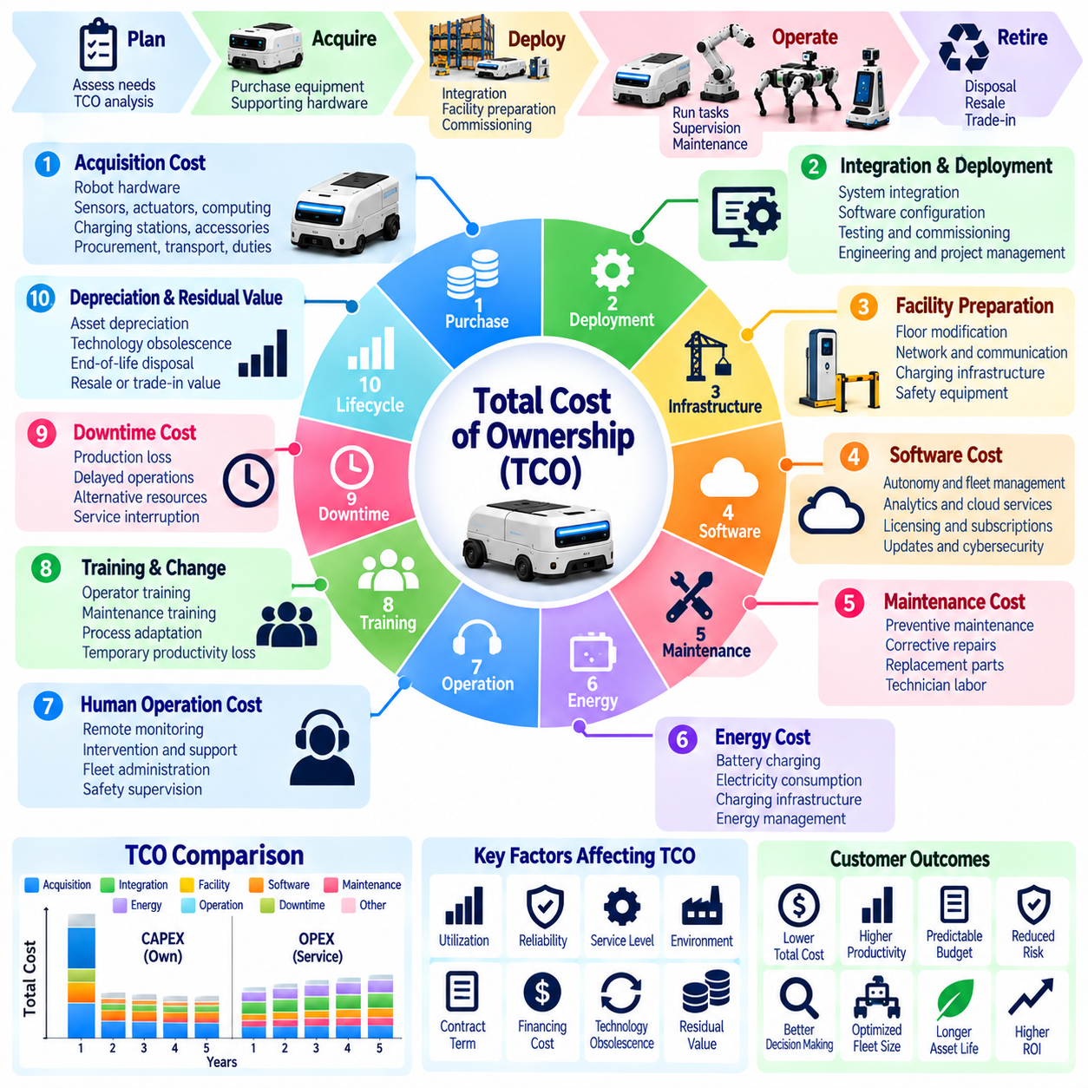
Total Cost of Ownership, or TCO, measures the complete economic cost of acquiring, deploying, operating, maintaining, and retiring a Physical AI system throughout its useful life. Unlike purchase price comparisons, TCO captures both visible expenditures and less obvious operational obligations. It provides a consistent financial framework for evaluating robotic investments, comparing deployment alternatives, and understanding the long-term consequences of automation decisions.
The initial acquisition cost includes robotic hardware, sensors, actuators, computing modules, batteries, and supporting equipment. Additional expenses may arise from charging stations, safety infrastructure, networking equipment, and specialized attachments. Procurement costs can also include transportation, import duties, and supplier qualification. Accurate TCO estimation requires identifying all components necessary for a functional deployment rather than considering robot prices alone.
Deployment and integration expenses often represent a substantial portion of ownership costs. Physical AI installations may require facility mapping, workflow redesign, software configuration, system interfaces, commissioning, and acceptance testing. Integration with warehouse management or manufacturing execution systems can increase engineering requirements. These costs should be estimated separately because deployment complexity varies considerably between customers and operating environments.
Facility preparation introduces additional investment requirements that may be overlooked during early planning. Floor modifications, wireless network improvements, charging locations, safety barriers, and electrical upgrades can affect deployment economics. Some environments also require changes to material handling processes or pedestrian traffic patterns. TCO analysis should include infrastructure changes directly attributable to robotic operation.
Recurring software costs form an important component of Physical AI ownership. Customers may pay for autonomy software, fleet management platforms, analytics, cybersecurity updates, and enterprise integrations. Subscription fees can depend on robot count, operating hours, enabled features, or service tiers. Long-term cost projections should account for contractual escalation, software compatibility, and potential changes in licensing requirements.
Maintenance costs include preventive servicing, corrective repairs, calibration, replacement parts, and technician labor. Mechanical wear, battery degradation, sensor contamination, and actuator failures can create recurring expenses. Service costs depend on operating intensity, environmental conditions, equipment design, and maintenance strategy. Reliable TCO estimates distinguish scheduled maintenance from unexpected failures and major component replacements.
Energy consumption contributes to operating costs, particularly for fleets running multiple shifts. Battery charging efficiency, idle power demand, computing workloads, and charging infrastructure losses influence electricity usage. Energy expenses should be calculated using realistic duty cycles and applicable electricity tariffs. Charging interruptions may also create indirect costs when they reduce available robot capacity during periods of high demand.
Human supervision remains a significant cost even when robots perform tasks autonomously. Operators may monitor missions, resolve navigation exceptions, assist with manipulation failures, and coordinate recovery procedures. Additional personnel may be required for fleet administration, safety oversight, and technical support. TCO models should reflect actual intervention frequency and staffing requirements rather than assuming completely unattended operation.
Training and organizational change also contribute to ownership costs. Employees may need instruction in robot operation, emergency procedures, maintenance routines, and software interfaces. Supervisors must adapt scheduling and performance management practices to automated workflows. Temporary productivity reductions during adoption should be considered. Effective training can reduce long-term errors and support expenses despite increasing initial implementation costs.
Downtime introduces indirect economic losses that are not always visible in accounting records. Robot failures, network interruptions, charging delays, and software defects may disrupt production or material movement. The financial impact depends on whether alternative equipment or personnel can maintain operations. TCO analysis should estimate downtime-related losses separately and avoid counting the same productivity effects more than once.
Reliability and availability strongly influence the economic efficiency of robotic assets. Two robots with similar purchase prices may have different ownership costs because of failure frequency, repair duration, and replacement component requirements. Mean time between failures and mean time to repair provide useful reliability indicators. Their financial significance depends on workload criticality, redundancy, and the operational consequences of service interruptions.
Fleet utilization determines how ownership costs are distributed across productive activity. Fixed costs remain even when robots are idle, making low utilization particularly expensive on a per-task basis. High utilization can improve cost efficiency but may accelerate component wear and increase maintenance requirements. TCO should therefore be evaluated alongside productive operating hours, completed missions, and cost per successful task.
Asset depreciation and residual value affect financial comparisons over the ownership period. Hardware may lose economic value because of physical wear, technological obsolescence, or changing customer requirements. At the end of deployment, robots may be resold, refurbished, redeployed, or recycled. Expected residual values should be conservative and supported by realistic secondary-market or refurbishment assumptions.
Financing and payment structures change the timing and composition of ownership costs. Direct purchases concentrate investment near deployment, while leases and service contracts distribute payments over time. Interest, financing fees, insurance, and contractual termination charges may alter the total financial burden. Comparisons should distinguish cash expenditures from accounting expenses and use consistent discounting assumptions when calculating present value.
Risk-related expenses should be incorporated where they can be estimated credibly. Insurance premiums, cybersecurity controls, safety compliance, regulatory inspections, and incident response capabilities may create continuing obligations. Unexpected accidents or security events can also generate financial exposure. Scenario analysis is often more appropriate than assigning unsupported precise costs to rare events with uncertain probabilities.
The TCO evaluation horizon should reflect the expected useful life and commercial purpose of the system. Short horizons may exaggerate the relative burden of upfront investments, while excessively long horizons may underestimate replacement and obsolescence risks. Sensitivity analysis can test alternative assumptions for utilization, maintenance, energy prices, labor requirements, and equipment lifespan. Transparent assumptions improve decision quality.
Comparative TCO analysis must evaluate alternatives under equivalent operational conditions. Manual operations, conventional automation, purchased robots, and Robot-as-a-Service contracts may differ in capacity, flexibility, service coverage, and risk allocation. Financial comparisons should normalize task volumes, operating hours, and required performance levels. Otherwise, an apparently cheaper solution may simply deliver a lower level of operational capability.
TCO should be connected to productivity and return-on-investment analysis without confusing costs with benefits. Cost reductions, increased throughput, improved quality, and avoided disruptions represent potential economic benefits rather than ownership expenses. A complete business case compares these benefits against lifecycle costs. Separating cost categories from value creation prevents double counting and produces more defensible investment conclusions.
Continuous TCO monitoring becomes important after deployment because actual costs frequently differ from initial forecasts. Providers and customers should track maintenance expenditure, energy consumption, support labor, software charges, downtime, and component replacement. Comparing actual results with budgeted assumptions reveals cost drivers and improvement opportunities. Fleet-level data can support more accurate estimates for subsequent deployments.
Ultimately, Total Cost of Ownership provides the economic foundation for sustainable Physical AI investment decisions. Its value lies in revealing the complete cost structure rather than identifying the lowest equipment price. Effective TCO analysis integrates acquisition, integration, operation, maintenance, financing, risk, and retirement costs within a consistent framework. Organizations that manage these factors systematically can improve deployment economics and make more reliable automation decisions.

08.15. ROI Payback and Productivity Modeling
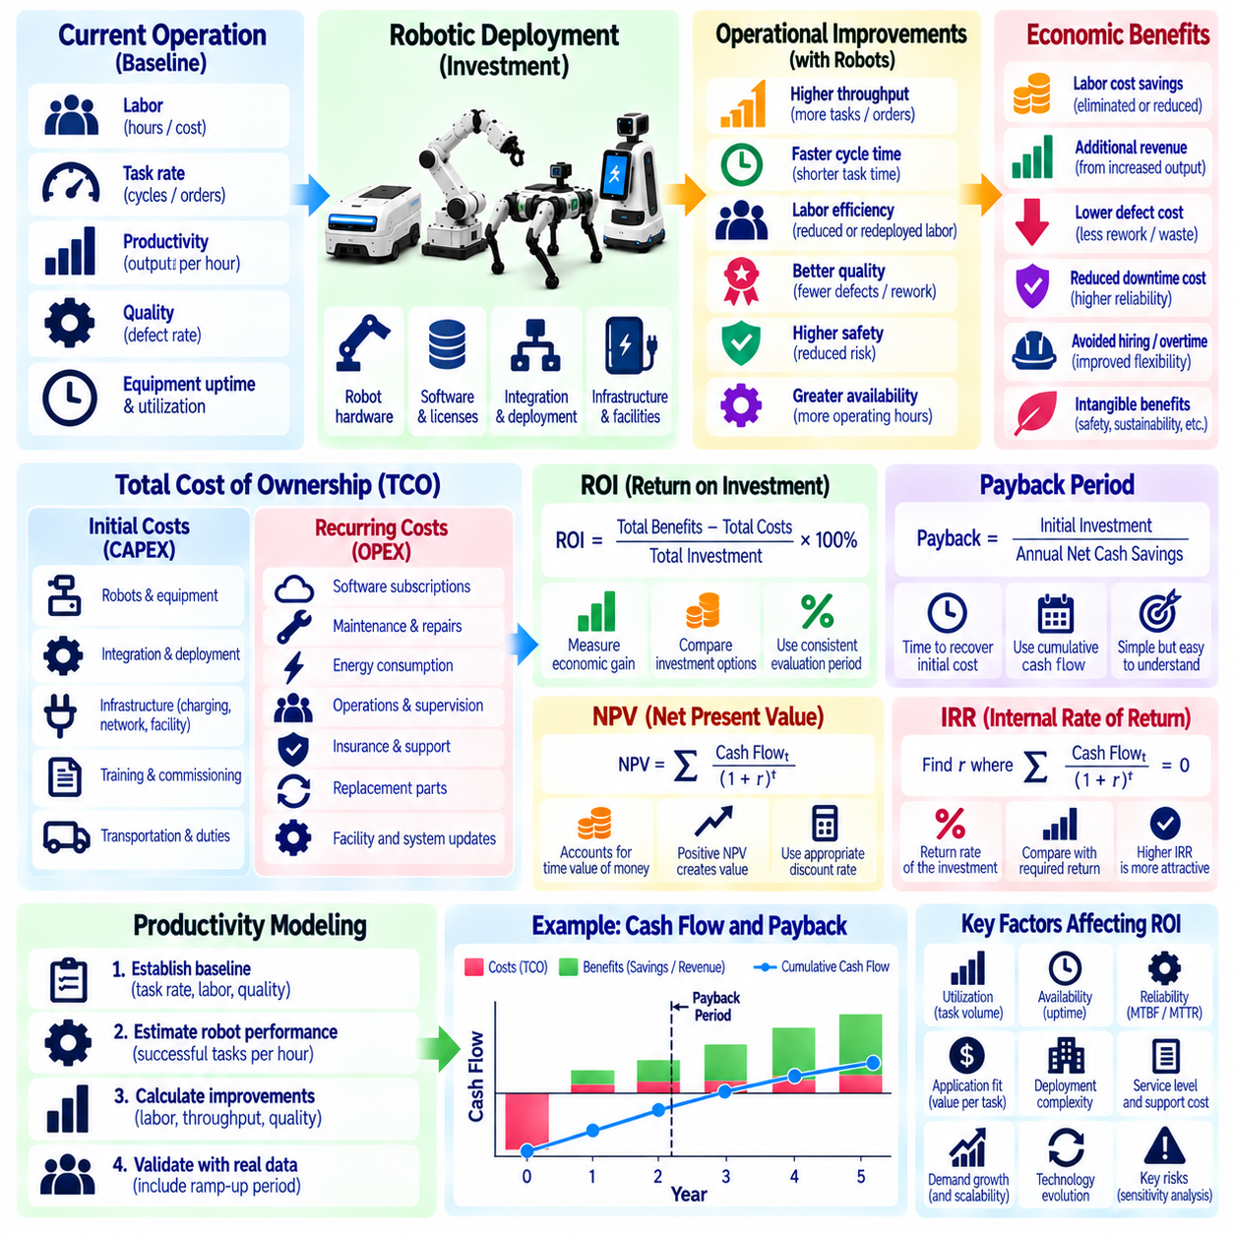
Return on investment, payback period, and productivity modeling provide the financial foundation for evaluating Physical AI deployment decisions. These methods translate robotic performance into measurable economic outcomes and help determine whether automation creates sufficient value. A reliable investment model connects technical capability, operational improvements, lifecycle costs, and financial returns using consistent assumptions and verifiable data.
Return on investment, or ROI, measures the economic gain generated relative to the resources invested. A basic calculation divides net investment benefit by total investment cost and expresses the result as a percentage. For Physical AI, benefits may include labor savings, additional throughput, reduced defects, and lower downtime. The calculation must specify its evaluation period and avoid mixing one-time investment costs with recurring annual benefits.
Payback period measures the time required for cumulative net cash benefits to recover the initial investment. Simple payback divides upfront investment by annual net cash savings when those savings remain approximately constant. More realistic models calculate cumulative cash flow across successive periods. Payback is easy to communicate but does not fully capture the time value of money or benefits occurring after investment recovery.
Discounted cash flow analysis provides a more complete assessment of long-term investment value. Net present value converts future net cash flows into present values using an appropriate discount rate. Internal rate of return identifies the discount rate at which net present value becomes zero. These methods account for payment timing and investment risk, although their reliability depends on realistic cash flow forecasts and justified discount assumptions.
Productivity modeling begins by establishing the current operating baseline before robotic deployment. Relevant measurements include task completion rates, cycle times, labor hours, equipment availability, and process interruptions. Baseline data should represent normal operating variability rather than isolated peak performance. Without reliable measurements, automation benefits may be overstated and investment conclusions may become misleading.
Robot productivity must be measured through useful completed work rather than nominal technical specifications. Maximum travel speed, manipulation frequency, or theoretical operating hours do not necessarily represent actual output. Real deployments involve charging, waiting, congestion, human intervention, and occasional failures. Effective productivity models estimate successful tasks per operating hour under representative workload and environmental conditions.
Labor productivity improvements are a common source of economic value, but reduced task time does not always produce direct payroll savings. Employees may be reassigned to higher-value activities rather than removed from the workforce. Financial models should distinguish eliminated labor expense, avoided future hiring, overtime reduction, and redeployed capacity. Only benefits supported by realistic organizational changes should be treated as realized cash savings.
Throughput improvements can generate additional revenue when customer demand and downstream capacity support higher output. A robotic system may increase completed orders, transported materials, or production cycles without proportionally increasing labor. However, additional throughput has limited financial value when demand is insufficient or other processes remain constrained. Models should use incremental contribution margin rather than gross revenue when estimating profit benefits.
Quality improvements can contribute to ROI by reducing defects, rework, material waste, and process variability. Physical AI systems may improve consistency through repeatable sensing, planning, and control. The economic benefit depends on existing defect rates, the cost of correction, and the reliability of automated execution. Quality-related savings should be measured separately from productivity gains to prevent overlapping benefit calculations.
Robot availability and utilization strongly influence realized financial performance. Availability describes whether equipment is capable of operating, while utilization measures how much available capacity performs productive work. A highly reliable robot may still deliver poor economic returns when task demand is low. Productivity models should therefore combine uptime, productive operating hours, mission success rates, and actual task volumes.
Investment cost modeling must include more than the robotic equipment purchase price. Initial expenditures may cover integration, charging infrastructure, facility changes, commissioning, training, and safety preparation. Recurring expenses include software subscriptions, maintenance, energy, supervision, insurance, and component replacement. Using lifecycle cost estimates prevents attractive but incomplete ROI calculations based only on hardware acquisition.
Deployment ramp-up should be reflected in financial forecasts because robotic productivity rarely reaches its steady-state level immediately. Early operations may involve mapping adjustments, workflow changes, operator training, and software tuning. Models should represent gradual improvements in utilization and task success rates. Ignoring ramp-up costs and temporary productivity losses can make payback estimates unrealistically optimistic.
Fleet-level productivity requires consideration of interactions between multiple robots. Adding robots may improve throughput initially, but congestion, shared charging resources, and traffic conflicts can reduce marginal gains. Fleet simulations and operational measurements help estimate capacity under different deployment sizes. Economic models should evaluate incremental productivity per additional robot rather than assuming output increases proportionally with fleet size.
Scenario analysis helps decision-makers understand uncertainty in investment outcomes. Conservative, expected, and optimistic cases can vary task demand, robot utilization, maintenance expenses, labor savings, and system availability. Sensitivity analysis identifies which assumptions have the greatest influence on ROI and payback. These methods are particularly valuable when deployment data is limited or operational conditions may change.
Risk-adjusted modeling should consider potential disruptions and unexpected costs without relying on unsupported precision. Equipment failures, integration delays, regulatory requirements, and changes in customer demand may alter expected returns. Financial models can incorporate contingency allowances and alternative operating scenarios. Transparent risk treatment improves investment credibility and supports decisions about deployment scale and contractual guarantees.
Pilot deployments provide an opportunity to validate the assumptions used in ROI and productivity models. Measured task completion, intervention frequency, charging behavior, maintenance needs, and labor interaction can replace preliminary estimates. Pilot results should be evaluated against predefined acceptance criteria. Scaling decisions should rely on representative evidence rather than demonstrations conducted under unusually favorable conditions.
Customer and supplier financial perspectives must remain distinct. Customers evaluate productivity benefits, avoided costs, and investment returns, while suppliers consider selling margins, service obligations, capital requirements, and contract profitability. A deployment may create substantial customer value without producing adequate supplier margins. Sustainable commercial agreements require an economically viable distribution of benefits and responsibilities.
Financial performance should be monitored continuously after deployment. Actual operating costs, completed tasks, labor allocation, downtime, and maintenance events should be compared with the original business case. Differences between forecast and realized performance reveal operational improvement opportunities and modeling weaknesses. Updated forecasts can guide fleet expansion, contract renewal, and future capital allocation decisions.
Productivity models should also recognize benefits that are difficult to monetize precisely. Improved workplace safety, reduced employee fatigue, greater operational flexibility, and enhanced service consistency may influence investment decisions. These outcomes can be documented using operational indicators and qualitative evidence. They should not be converted into arbitrary financial savings merely to improve reported ROI.
Ultimately, ROI, payback, and productivity modeling connect Physical AI engineering performance with business investment decisions. Their effectiveness depends on realistic operating baselines, complete cost accounting, measurable benefits, and transparent uncertainty. Organizations that validate assumptions through pilots and operational data can distinguish promising automation opportunities from economically weak deployments and scale investments with greater confidence.

08.16. Unit Economics and Fleet Economics
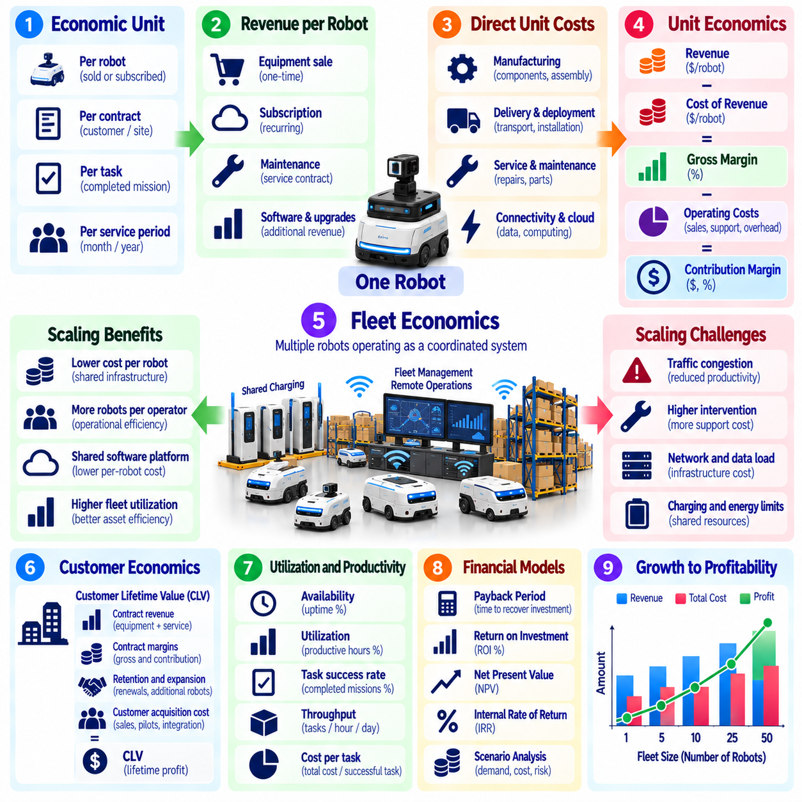
Unit economics and fleet economics provide essential frameworks for evaluating the financial sustainability of Physical AI businesses. Unit economics examines revenue, costs, and profitability associated with an individual robot or service contract. Fleet economics extends this analysis to multiple robots operating as a coordinated system. Together, these approaches reveal whether business growth improves profitability or merely increases revenue and operational complexity.
The economic unit must be defined before financial performance can be measured consistently. Depending on the business model, a unit may represent a robot sold, an active robot subscription, a customer installation, or a completed task. Different definitions produce different revenue and cost relationships. Providers should select units that reflect their commercial obligations and maintain consistent measurement across customers, deployments, and reporting periods.
Revenue per robot depends on pricing structure, utilization, contract duration, and service scope. Equipment sales generate revenue primarily at delivery, while subscription and Robot-as-a-Service models distribute revenue across operating periods. Additional income may arise from software upgrades, maintenance contracts, and technical support. Financial models should distinguish recognized revenue from cash receipts and contractual commitments.
Direct unit costs include manufacturing, purchased components, assembly, testing, transportation, and deployment activities attributable to each robot. Recurring service models also incur maintenance, connectivity, cloud processing, technical support, and asset replacement expenses. Accurate cost allocation is necessary to understand unit profitability. Shared corporate overhead should be distinguished from costs directly caused by individual deployments.
Gross margin measures the proportion of revenue remaining after deducting the applicable cost of revenue. Hardware gross margin reflects manufacturing and delivery economics, while service gross margin reflects the cost of fulfilling continuing obligations. A profitable equipment sale does not guarantee a profitable lifecycle relationship. Providers should analyze hardware, software, and service margins separately before evaluating combined contract profitability.
Contribution margin provides another perspective by subtracting variable and directly attributable operating costs from revenue. It helps determine whether adding another robot, customer, or contract contributes positively to covering shared expenses. A positive contribution margin is necessary for scalable growth but does not guarantee overall profitability. Fixed development, administration, and infrastructure costs must eventually be recovered.
Robot-as-a-Service unit economics require careful consideration of equipment financing and capital recovery. Providers may purchase or manufacture robots before receiving subscription payments, creating substantial initial cash requirements. Monthly revenue must support servicing costs and recover invested capital over the expected economic life. Asset depreciation, financing charges, residual value, and contract termination risk influence the overall investment return.
Customer acquisition cost measures the resources required to secure a new customer or deployment contract. Sales engineering, demonstrations, pilot support, procurement negotiations, and commercial onboarding can create substantial expenses. These costs should be compared with expected customer lifetime value. Long sales cycles and highly customized deployments may weaken economics even when individual robot contracts generate attractive recurring margins.
Customer lifetime value represents the expected economic contribution from a customer relationship over its duration. It depends on contract margins, retention, expansion opportunities, and future service obligations. Revenue alone is an insufficient basis for estimating lifetime value because support and capital costs may increase over time. Providers should use realistic renewal assumptions and avoid treating uncertain expansion revenue as guaranteed income.
Fleet economics introduces coordination effects that do not appear in single-robot calculations. Shared charging infrastructure, fleet management software, remote supervision, and maintenance resources can reduce average costs as fleet size increases. However, traffic congestion, communication demands, and operational intervention may also grow. Fleet profitability depends on whether shared efficiencies exceed the additional complexity created by expansion.
Fleet utilization is a critical determinant of economic performance. Robots generate greater value when available capacity is converted into productive work, but operating hours alone do not guarantee useful output. Providers should monitor completed missions, successful tasks, throughput, idle time, and charging delays. Cost per successful task provides a practical measure for comparing operational efficiency across fleet sizes and customer environments.
The marginal economics of adding robots must be evaluated independently from average fleet performance. An additional robot may improve throughput when demand exceeds existing capacity, but contribute little when workloads are limited. Shared bottlenecks can also reduce the productivity of existing robots. Expansion decisions should compare incremental revenue and customer value against incremental equipment, infrastructure, and support costs.
Human intervention strongly influences fleet service profitability. Remote operators may supervise many autonomous robots, but navigation failures, manipulation errors, and recovery events create labor requirements. The ratio of managed robots to support personnel depends on task complexity and intervention frequency. Providers should measure intervention cost per mission and evaluate whether operational staffing grows proportionally with fleet size.
Maintenance economics change as robotic assets age. Early deployments may experience limited component replacement, while older fleets can require more frequent repairs, battery replacement, and major servicing. Warranty coverage and customer service agreements determine which party bears these costs. Lifecycle profitability models should incorporate age-dependent maintenance expenses rather than assuming constant support costs throughout deployment.
Fleet-level fixed costs include management platforms, operations centers, monitoring infrastructure, cybersecurity systems, and specialized engineering resources. These investments can support many robots, creating opportunities for economies of scale. Nevertheless, capacity thresholds may require additional servers, personnel, or facilities. Financial models should represent these step changes instead of assuming fixed costs remain unchanged indefinitely.
Standardization improves unit economics by reducing engineering effort and operational variability. Reusable software modules, common hardware interfaces, automated deployment tools, and standardized maintenance procedures lower repeated delivery costs. Product customization can generate additional revenue but may increase integration and support expenses. Providers should evaluate whether customization premiums adequately compensate for the resulting lifecycle complexity.
Contract-level profitability requires combining revenue and cost information across the full service period. Important measures include revenue per active robot, contribution margin per contract, service cost per operating hour, and capital recovery time. Fleet-level analysis should additionally examine shared infrastructure utilization and supervisory labor efficiency. These indicators reveal whether growth creates sustainable economic returns.
Scenario analysis is necessary because unit and fleet economics depend on uncertain operating conditions. Changes in utilization, failure rates, component prices, contract renewals, and financing costs can materially affect profitability. Conservative and expected scenarios help identify financial exposure before large-scale deployment. Sensitivity analysis highlights the variables that deserve the greatest operational attention and commercial protection.
Scaling decisions should consider cash flow as well as accounting profitability. Rapid fleet expansion may require substantial investment in robots, spare parts, charging infrastructure, and deployment teams before corresponding revenue is collected. Profitable contracts can still create liquidity pressure when capital recovery is slow. Providers should align growth plans with financing capacity, customer payment terms, and expected deployment schedules.
Ultimately, unit economics and fleet economics connect individual robot performance with the financial viability of a scalable Physical AI business. Sustainable growth requires positive contribution margins, disciplined capital allocation, high productive utilization, efficient support operations, and predictable lifecycle costs. Companies that measure these relationships consistently can identify profitable applications, optimize fleet expansion, and build durable recurring revenue.

08.17. Hardware Gross Margin and Service Margin
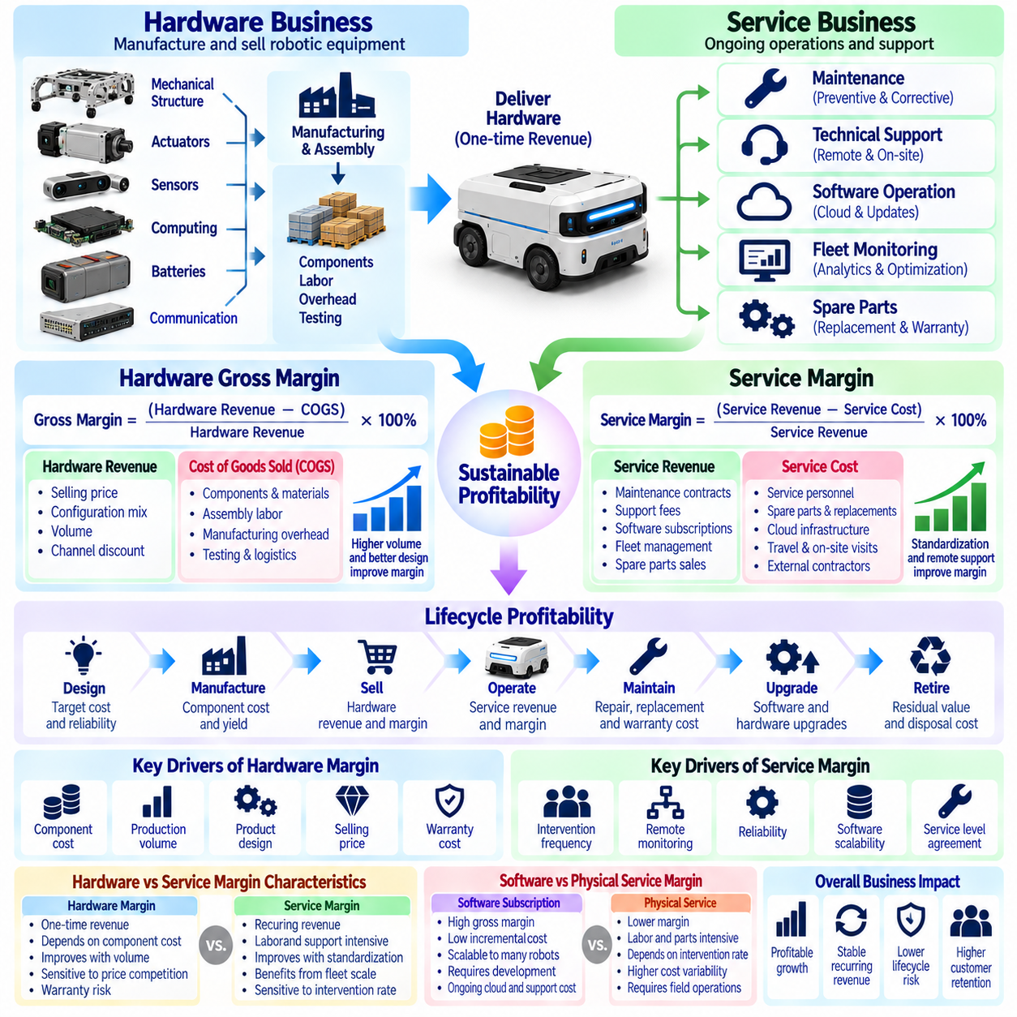
Hardware gross margin and service margin are fundamental indicators of profitability in Physical AI businesses. Hardware gross margin measures the profitability of manufacturing and selling robotic equipment, while service margin evaluates the economics of delivering ongoing operational support. These measures reveal different cost structures and business risks. Understanding their relationship is essential for developing sustainable pricing, product strategies, and recurring revenue models.
Hardware gross margin is calculated by subtracting the cost of goods sold from hardware revenue and dividing the result by hardware revenue. The cost of goods sold includes materials, purchased components, assembly labor, manufacturing overhead, and applicable production testing expenses. A positive margin indicates that equipment revenue exceeds its direct production costs. However, it does not necessarily cover research, development, sales, or corporate administration expenses.
Physical AI hardware typically combines mechanical structures, actuators, sensors, computing modules, batteries, and communication devices. Component costs vary according to performance requirements, supplier availability, production volume, and technical specifications. High-performance actuators and specialized sensing systems can represent substantial portions of manufacturing cost. Effective margin management requires detailed component-level cost visibility and disciplined engineering tradeoffs.
Manufacturing scale can improve hardware gross margin through volume purchasing, process optimization, and improved production yields. Higher production quantities may reduce component prices and distribute fixed manufacturing overhead across more units. Nevertheless, scaling also introduces inventory exposure, quality control requirements, and working capital demands. Margin projections should distinguish demonstrated manufacturing efficiencies from anticipated economies of scale.
Product architecture strongly influences manufacturing economics. Modular hardware designs, standardized interfaces, common components, and reusable subsystems can reduce assembly complexity and procurement costs. Design for manufacturability and design for assembly help minimize production steps and quality defects. Engineering decisions should balance cost reduction with reliability, maintainability, safety, and performance rather than optimizing manufacturing cost alone.
Hardware pricing must reflect market competition, customer value, product differentiation, and required profitability. Premium robotic capabilities may support higher selling prices when they create measurable operational benefits. However, aggressive discounting can reduce margins even when manufacturing efficiency improves. Providers should evaluate selling price, configuration mix, warranty exposure, and channel discounts together when establishing hardware profitability targets.
Service margin measures the profitability of recurring activities such as maintenance, technical support, software operations, fleet monitoring, and field servicing. It is generally calculated by subtracting the cost of delivering services from associated service revenue and dividing by service revenue. Service costs may include personnel, spare parts, cloud infrastructure, communications, and external contractors. Accurate classification is necessary for meaningful margin comparisons.
Service contracts can generate predictable recurring revenue, but profitability depends on the actual workload required to fulfill customer obligations. Unlimited support commitments, frequent site visits, and extensive customization can create unexpected expenses. Service-level agreements define response times, availability targets, and support responsibilities. Pricing should reflect these commitments and include sufficient allowance for expected maintenance and intervention requirements.
Maintenance service economics are closely connected to equipment reliability and lifecycle behavior. Robots operating in demanding environments may require more frequent inspections, component replacements, and corrective repairs. Battery degradation, actuator wear, and sensor failures can increase support costs as fleets age. Service margin forecasts should incorporate realistic failure distributions and replacement schedules rather than assuming constant maintenance expense.
Remote monitoring and predictive maintenance can improve service margins by reducing unnecessary site visits and identifying developing failures before major interruptions occur. Fleet telemetry, diagnostic analytics, and automated alerts support more efficient maintenance scheduling. However, these capabilities require software development, data infrastructure, and specialized personnel. Their economic value depends on whether avoided service costs exceed the expenses of implementation.
Software subscriptions often exhibit different margin characteristics from physical maintenance services. Once developed, software functionality may be delivered to additional robots at relatively low incremental cost, although cloud processing, cybersecurity, support, and licensing expenses remain. Shared software platforms can support scalable recurring revenue. Providers should separate software subscription margins from labor-intensive service margins to identify the underlying profitability drivers.
Warranty obligations create an important connection between hardware and service economics. Manufacturing defects or premature component failures may generate repair expenses after equipment delivery. Warranty provisions should reflect expected claims and applicable accounting requirements. Poor product quality can initially appear as acceptable hardware profitability while creating substantial future support liabilities. Integrated lifecycle analysis is therefore essential.
Hardware and service margins may be influenced by different revenue recognition and cost allocation practices. Equipment revenue is commonly recognized when contractual performance obligations are satisfied, while recurring service revenue is generally recognized over the service period. Bundled contracts require appropriate allocation of transaction prices and related costs. Consistent accounting treatment prevents misleading comparisons between hardware and service performance.
Robot-as-a-Service business models combine hardware investment with continuing service delivery. Providers retain significant equipment-related financial exposure while receiving revenue over time. Depreciation, financing costs, maintenance, and operational support must be incorporated into contract economics using consistent accounting and cash flow models. A positive reported service margin does not automatically imply that the underlying robot investment earns an adequate financial return.
Installed fleet size influences service profitability through shared infrastructure and operating efficiency. Centralized monitoring, standardized maintenance procedures, and common spare parts inventories can reduce average support costs. However, geographic dispersion, customer-specific requirements, and increasing fleet age may offset these benefits. Service margin analysis should therefore distinguish scale advantages from the additional complexity associated with fleet expansion.
Customer segmentation can reveal substantial differences in hardware and service margins. Large industrial customers may negotiate lower equipment prices but purchase extensive support contracts, while smaller customers may require higher onboarding effort per robot. Operating conditions, geographic location, contract duration, and customization requirements also affect profitability. Segment-level analysis helps providers identify attractive customer profiles and establish differentiated pricing strategies.
Margin optimization requires coordination between engineering, manufacturing, commercial, and service organizations. Reducing component costs may improve hardware margins but increase maintenance expenses if reliability declines. Conversely, more durable components may reduce immediate hardware profitability while improving lifecycle service economics. Cross-functional decisions should consider total contract contribution and customer value rather than maximizing individual margins independently.
Performance monitoring should track hardware gross margin by product configuration and service margin by contract, customer, and fleet. Useful operational indicators include component cost variance, manufacturing yield, warranty claims, service hours, repair frequency, and support cost per active robot. Comparing planned and realized margins reveals pricing weaknesses and operational inefficiencies. These measurements also support product redesign and more accurate future quotations.
Long-term profitability depends on balancing hardware competitiveness with sustainable service delivery. Excessively low equipment margins may require unrealistic future service earnings, while overpriced support contracts can discourage customer adoption. Providers should evaluate combined lifecycle margins, capital requirements, renewal probability, and customer retention. Transparent cost allocation and realistic assumptions are essential for maintaining financial discipline.
Ultimately, hardware gross margin and service margin provide complementary views of Physical AI business performance. Hardware margins reflect product design, sourcing, manufacturing, and pricing effectiveness, while service margins reflect operational reliability, support efficiency, and recurring delivery costs. Organizations that manage both within an integrated lifecycle framework can improve profitability, strengthen customer relationships, and support scalable business growth.

08.18. Utilization Uptime and Revenue Efficiency
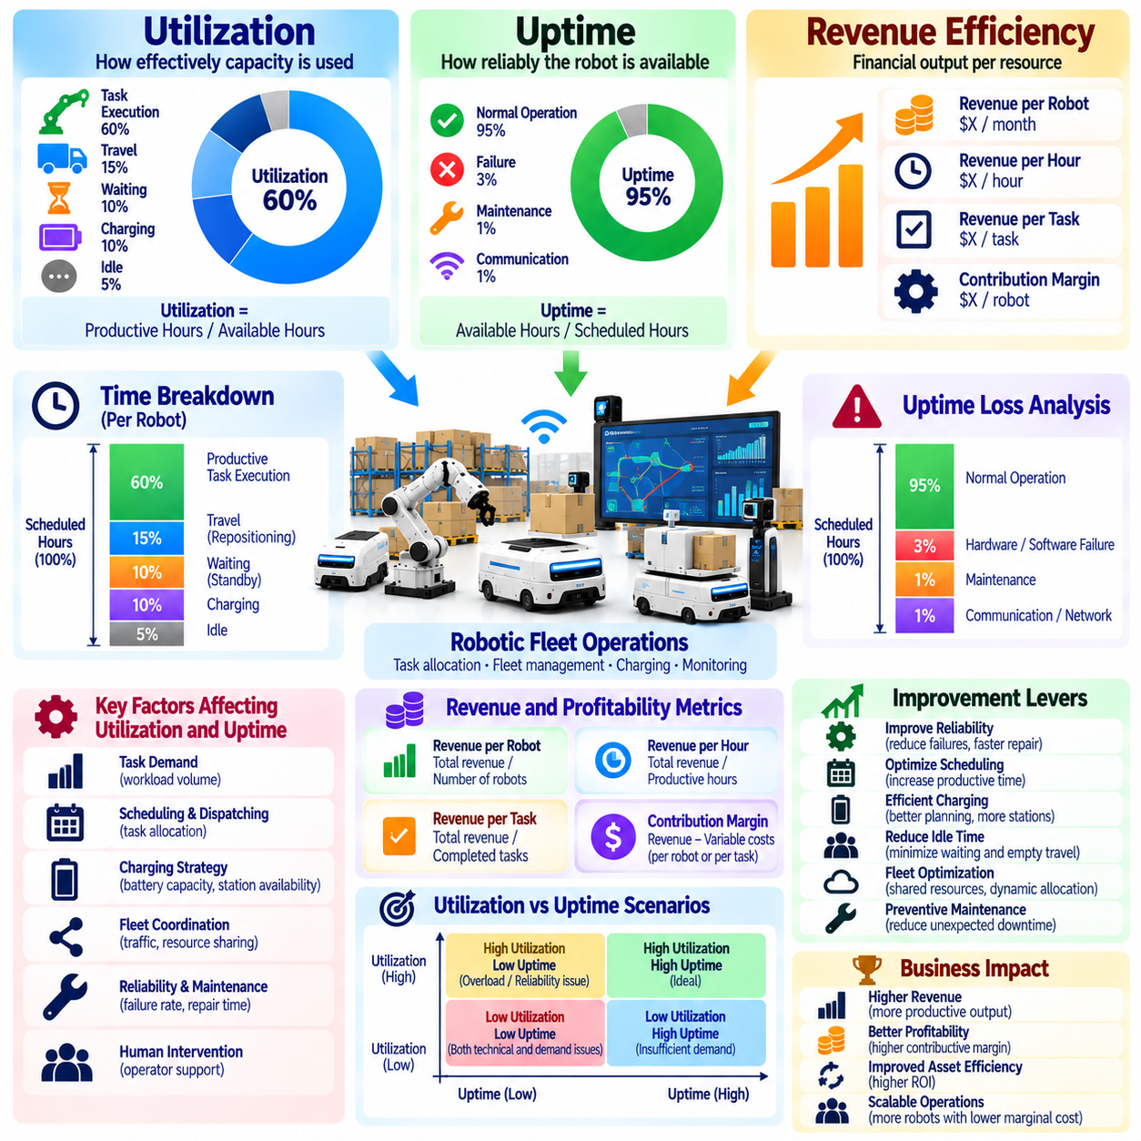
Utilization, uptime, and revenue efficiency are essential measures of economic performance in Physical AI operations. Utilization indicates how effectively robotic capacity is used, uptime measures operational availability, and revenue efficiency evaluates financial output relative to deployed resources. These indicators connect technical reliability with commercial performance. Their combined analysis helps providers identify whether robotic assets generate sufficient value throughout their operating lives.
Utilization measures the proportion of available operating time devoted to productive activities. A robot may remain powered on and technically available without completing economically valuable work. Waiting for assignments, traveling without payloads, and remaining idle between missions can reduce effective utilization. Accurate measurement requires distinguishing productive task execution from standby time, repositioning, charging, and other nonproductive activities.
Uptime describes the proportion of scheduled operating time during which a robot is capable of performing its intended functions. Hardware failures, software crashes, communication interruptions, and safety-related shutdowns can reduce uptime. High uptime is necessary for dependable service delivery but does not guarantee high productivity. A robot may achieve excellent technical availability while remaining underutilized because customer demand or task scheduling is insufficient.
Availability and utilization should be measured using clearly defined denominators. Scheduled operating hours, technically available hours, and productive operating hours represent different quantities. Availability can be calculated as available hours divided by scheduled hours, while utilization can be expressed as productive hours divided by available hours. Consistent definitions prevent misleading comparisons between robots, customer sites, and reporting periods.
Revenue efficiency measures the relationship between generated revenue and the resources required to produce it. Common indicators include revenue per active robot, revenue per productive hour, and revenue per completed task. These measures vary according to pricing models and customer contracts. Equipment sales, subscriptions, and usage-based services require different interpretations because revenue recognition and operational activity do not necessarily occur simultaneously.
Robot-as-a-Service business models depend particularly strongly on productive utilization. Providers often retain ownership of robotic assets while collecting recurring fees from customers. Fixed monthly subscriptions may produce stable revenue even when utilization fluctuates, but low activity can weaken customer retention and renewal prospects. Usage-based contracts directly connect revenue to completed work, making operational efficiency a critical determinant of financial performance.
The relationship between uptime and utilization creates a useful framework for diagnosing performance limitations. Low uptime indicates technical reliability or maintenance problems, while high uptime combined with low utilization suggests insufficient demand, poor scheduling, or workflow constraints. High utilization with frequent failures may indicate excessive operating intensity. Distinguishing these conditions allows providers to select appropriate operational and commercial improvements.
Task success rate is another important factor in revenue efficiency. Robots may spend considerable time executing missions that fail, require human intervention, or must be repeated. Such activity consumes energy, equipment life, and support resources without delivering proportional customer value. Effective productivity should therefore be measured using successfully completed tasks rather than attempted missions or total movement distance.
Charging behavior can significantly influence productive operating capacity. Battery capacity, charging duration, charging station availability, and scheduling strategies determine how much time robots can perform useful work. Poor charging coordination may create bottlenecks during peak demand periods. Fleet-level optimization can improve utilization by distributing charging activities across lower-demand periods while preserving sufficient energy reserves for reliable operation.
Fleet scheduling and task allocation influence both utilization and revenue generation. Intelligent dispatching can reduce idle time, unnecessary travel, and competition for shared resources. However, maximizing individual robot activity does not always maximize total system throughput. Coordinated fleet management should prioritize successful task completion, balanced workloads, and customer service requirements rather than keeping every robot continuously occupied.
Demand variability introduces additional complexity into utilization modeling. Warehouses, factories, hospitals, and service environments may experience changing workloads across shifts, weekdays, or seasons. Robots sized for peak demand can remain underutilized during quieter periods. Financial models should account for realistic demand profiles and evaluate whether flexible fleet allocation, shared capacity, or adjusted service contracts can improve asset efficiency.
Revenue per robot must be interpreted alongside operating costs and capital requirements. A robot generating substantial revenue may still produce weak financial returns if maintenance, supervision, energy, or financing expenses are excessive. Contribution margin per active robot provides a more informative measure of economic performance. Providers should connect revenue efficiency with lifecycle profitability rather than treating revenue growth as sufficient evidence of business success.
Marginal utilization becomes important when expanding a robotic fleet. Adding robots may increase total capacity without increasing demand proportionally, reducing average utilization. Conversely, insufficient fleet capacity can create missed orders, delayed missions, and service-level violations. Expansion decisions should compare incremental revenue opportunities against equipment investment and additional operating costs under realistic workload conditions.
Maintenance planning influences the balance between uptime and long-term reliability. Preventive maintenance requires scheduled interruptions but can reduce unexpected failures and expensive repairs. Delaying maintenance to maximize short-term uptime may increase future downtime and component replacement costs. Effective asset management evaluates maintenance timing according to total productive availability, operational risk, and lifecycle economic performance.
Human intervention affects both utilization and service profitability. Navigation exceptions, manipulation failures, and recovery procedures can interrupt productive operation and require supervisory labor. Remote assistance may restore service quickly, but frequent intervention increases operating costs. Providers should monitor intervention frequency, recovery duration, and support cost per successful mission to determine whether autonomy improvements generate measurable financial benefits.
Performance measurement requires reliable operational data. Fleet management systems can record robot states, mission assignments, task completion, charging periods, failures, and maintenance events. Integrating these records with contract and billing information enables revenue efficiency analysis. Data definitions should remain consistent across hardware generations, customer environments, and software versions to support meaningful comparisons.
Service-level agreements connect technical performance with commercial obligations. Contracts may specify availability targets, response times, mission completion requirements, or throughput commitments. Failure to meet these conditions can result in penalties, service credits, or customer dissatisfaction. Revenue efficiency models should consider the financial consequences of missed performance targets and the operational costs required to maintain contractual service quality.
Optimization efforts should avoid treating maximum utilization as an unconditional objective. Robots operating continuously may experience accelerated wear, insufficient maintenance windows, and reduced flexibility during demand surges. Some reserve capacity is valuable for handling unexpected tasks and equipment failures. The economically optimal utilization level balances productive output, reliability, customer responsiveness, and the marginal cost of additional activity.
Continuous improvement requires comparing expected and realized performance across the deployed fleet. Providers should examine utilization trends, downtime causes, successful task volumes, revenue per robot, and contribution margins. Differences between customer sites may reveal workflow limitations or opportunities for software improvements. These insights can guide fleet resizing, pricing adjustments, maintenance strategies, and future deployment planning.
Ultimately, utilization, uptime, and revenue efficiency translate robotic operating performance into measurable business outcomes. Uptime establishes technical readiness, utilization determines how effectively capacity is employed, and revenue efficiency evaluates the commercial value generated. Physical AI providers that manage these indicators together can improve asset productivity, strengthen contract profitability, and scale robotic services with greater financial discipline.

08.19. Data Network Effects and Learning Flywheels
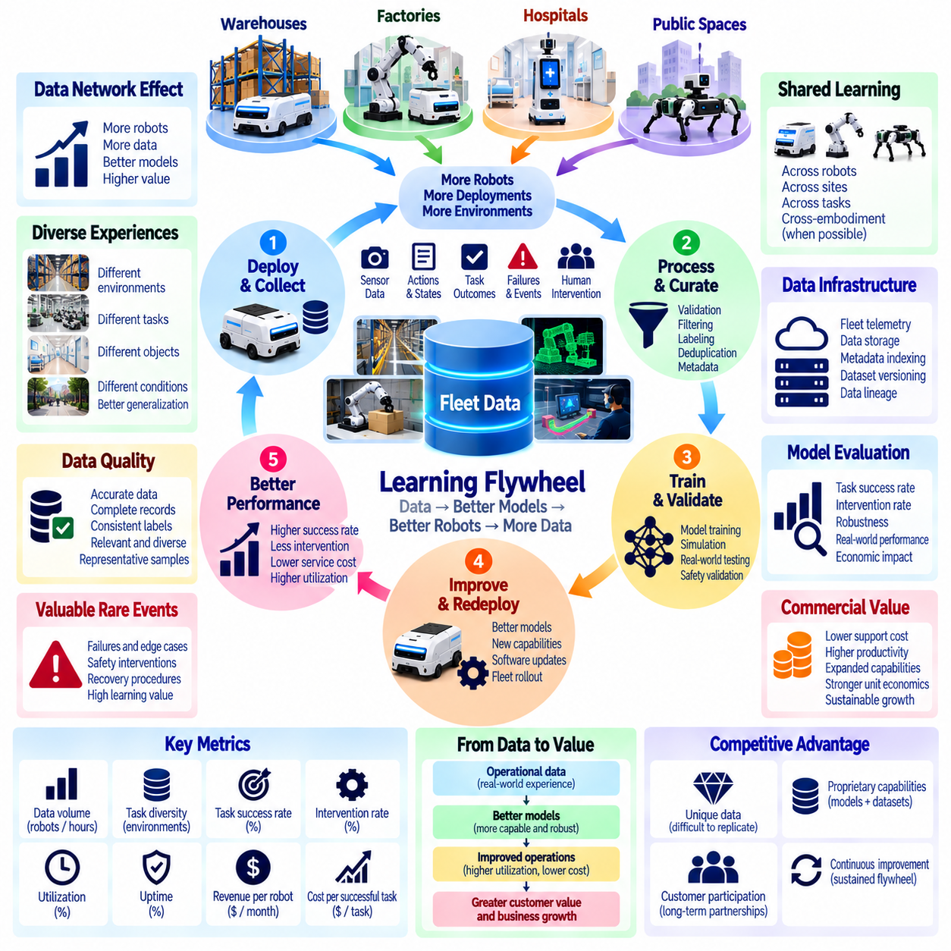
Data network effects and learning flywheels describe how Physical AI systems can improve through accumulated operational experience across deployed robots. As more robots perform tasks, they generate information about environments, objects, actions, failures, and human interactions. When this information improves shared intelligence, subsequent deployments may become more capable and efficient. The resulting feedback loop can create long-term competitive advantages.
A data network effect emerges when additional users, robots, or deployments increase the value of a shared intelligence system. Unlike conventional network effects, where value often depends on direct interactions between participants, Physical AI benefits primarily from improved models and operational knowledge. These effects are not automatic. Data must be relevant, accessible, sufficiently diverse, and effectively incorporated into learning processes.
The learning flywheel begins with real-world deployment. Robots execute missions while collecting sensor observations, control actions, task outcomes, and operational metadata. These records reveal both successful behaviors and limitations encountered under realistic conditions. Selected experiences are processed into training and evaluation datasets. Improved models are then validated and redeployed, generating new observations that support subsequent learning cycles.
Fleet-scale data collection expands the diversity of experiences available for model development. Robots operating in different facilities encounter variations in lighting, floor conditions, object geometry, human behavior, and workflow requirements. This diversity can improve generalization beyond a single deployment environment. However, collecting more data from nearly identical situations may provide limited additional learning value compared with capturing previously unseen conditions.
Data quality is as important as collection volume. Sensor synchronization errors, incomplete task records, inaccurate labels, and inconsistent metadata can reduce training effectiveness. Effective data engines use validation, filtering, deduplication, and quality scoring to identify reliable examples. A smaller collection of representative, well-structured experiences may contribute more to model improvement than a much larger dataset containing redundant or unreliable observations.
Rare events and failure cases often provide disproportionate learning value. Navigation deadlocks, unexpected obstacles, manipulation failures, safety interventions, and recovery procedures reveal weaknesses that successful routine missions may not expose. Capturing these events requires appropriate logging and event-triggered recording. Their inclusion in training and testing can improve robustness, provided that safety-critical behaviors undergo rigorous validation before deployment.
Human intervention creates another valuable source of learning signals. Teleoperation sessions, corrective demonstrations, and operator-assisted recovery can reveal appropriate actions when autonomous policies encounter uncertainty. These examples can support imitation learning, policy refinement, and improved exception handling. Nevertheless, operator actions must be evaluated for consistency and safety because human intervention data is not automatically suitable as a training target.
Shared learning across robot fleets depends on the compatibility of hardware, sensors, action representations, and software interfaces. Identical robots can often exchange experience more directly than heterogeneous platforms. Cross-embodiment learning may require normalization, task abstractions, or embodiment-conditioned models. A scalable data strategy should distinguish knowledge that transfers broadly from behaviors dependent on specific mechanical capabilities.
Data infrastructure enables operational experience to become reusable organizational intelligence. Fleet telemetry systems, episode storage, metadata indexing, and dataset versioning support the identification of useful training examples. Traceable data lineage connects observations to robot configurations, environments, and model versions. Without these capabilities, increasing fleet size may generate storage and processing costs without producing corresponding improvements in learning efficiency.
Model improvement must be measured against operational outcomes rather than training metrics alone. Higher prediction accuracy or lower training loss does not necessarily improve task completion, safety, or economic performance. Evaluation should examine mission success, intervention frequency, recovery capability, generalization, and performance under unfamiliar conditions. Controlled deployment comparisons help determine whether updated models create meaningful improvements in real environments.
Learning flywheels can improve commercial performance by reducing support costs and expanding automation capabilities. Better navigation and manipulation policies may decrease human interventions, failed missions, and maintenance-related disruptions. Improved autonomy can increase productive utilization and reduce service delivery costs. These benefits strengthen unit economics when model development and data infrastructure expenses remain proportionate to the operational value created.
The commercial advantage of accumulated data depends on its uniqueness and practical usefulness. Proprietary observations from demanding environments may be difficult for competitors to reproduce, particularly when they include rare failures and corrective actions. However, raw data ownership does not guarantee differentiation. Competitive value emerges when organizations transform distinctive experience into validated capabilities that customers recognize and are willing to purchase.
Customer participation is essential to fleet learning but introduces governance requirements. Industrial facilities may restrict the collection or transfer of images, production information, employee activity, and confidential operational records. Contracts should specify data ownership, permitted uses, retention periods, and access rights. Privacy-preserving processing, selective collection, and on-premise learning approaches can support improvement while respecting customer restrictions.
Data network effects may also encounter diminishing returns. Once common operating conditions are well represented, additional routine observations may contribute little new information. Learning performance can plateau because of model limitations, insufficient task diversity, or inconsistent data quality. Active learning and targeted data acquisition help identify information gaps. The objective is to maximize learning value per collected episode rather than data volume alone.
Simulation and synthetic data can reinforce the learning flywheel by extending coverage beyond observed deployments. Real-world failures can inform the creation of challenging simulated scenarios, while simulation can generate additional examples for training and evaluation. Domain randomization helps explore variations in environmental conditions. However, synthetic improvements must be verified against real-world performance because simulation assumptions may not capture every operational constraint.
Continuous deployment creates risks when model updates alter established robot behavior. A new policy may improve performance on common tasks while degrading reliability in specific environments. Version control, regression testing, staged rollout, and rollback mechanisms are therefore necessary. Safety-critical capabilities require additional validation and operational safeguards. A successful learning flywheel must improve intelligence without compromising deployment stability or customer trust.
Fleet growth can strengthen learning efficiency when data collection and model improvement are coordinated. Additional deployments increase opportunities to discover new tasks, environments, and failure patterns. Improved models can make future deployments easier, potentially reducing integration costs and increasing customer adoption. Yet this reinforcing cycle depends on effective data sharing, sufficient engineering capacity, and the ability to distribute validated improvements across the installed fleet.
The economics of learning flywheels require balancing development investment against fleet-wide benefits. Data ingestion, annotation, computing, model training, validation, and deployment infrastructure create substantial costs. Their returns depend on how many robots benefit from each improvement and how much operational value is generated. Shared models can produce attractive economies of scale when development costs are distributed across a growing installed base.
Strategic partnerships can expand the learning ecosystem beyond a single provider. Customers, system integrators, component suppliers, and software developers may contribute complementary operational knowledge. Standardized interfaces and agreed data governance can enable collaborative improvement. However, intellectual property rights, commercial incentives, and security responsibilities must be clearly defined to maintain sustainable cooperation.
Ultimately, data network effects and learning flywheels can transform Physical AI from a collection of deployed machines into an improving intelligence platform. Their strength depends on diverse operational experience, disciplined data engineering, validated model updates, and responsible governance. Organizations that connect fleet learning with measurable customer outcomes can improve autonomy, strengthen service economics, and establish durable competitive differentiation.

08.20. Platform Effects and Ecosystem Strategy
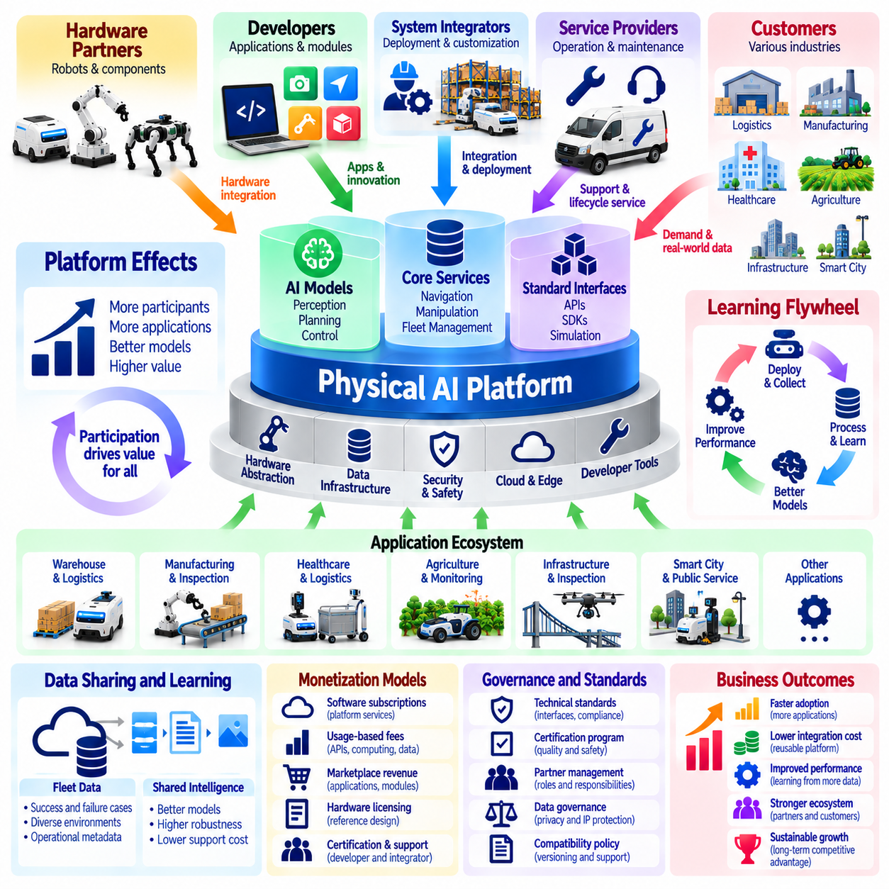
Platform effects and ecosystem strategy are central to building scalable Physical AI businesses beyond individual robot products. A platform connects hardware, software, artificial intelligence, developers, integrators, and customers through reusable technical capabilities. As participation increases, complementary solutions can expand the platform's usefulness. Sustainable platform value depends on interoperability, reliable operations, and economic benefits shared across participants.
A Physical AI platform differs from a conventional robot product because it supports multiple applications, deployments, and external contributors. Rather than delivering every function through proprietary development, platform providers establish common interfaces and reusable services. These foundations enable partners to create specialized capabilities. The business objective is to reduce repeated integration effort while increasing the range of customer problems addressed.
Platform effects emerge when additional participants improve the value available to existing participants. More developers can produce applications, more integrators can expand deployment coverage, and more customers can create demand for complementary services. These relationships may reinforce one another, but growth alone does not guarantee network effects. Participants must receive measurable benefits from the expanding ecosystem.
The technical foundation of a Physical AI platform includes robot operating interfaces, perception services, navigation capabilities, manipulation frameworks, and fleet management systems. Common application programming interfaces allow different modules to exchange commands and operational information. Standardized abstractions reduce dependence on specific hardware configurations. Reliable interfaces are essential because physical operations require predictable behavior and safety.
Hardware interoperability is particularly important for platforms supporting heterogeneous robotic fleets. Different robots may use distinct sensors, actuators, controllers, and communication protocols. Hardware abstraction layers and standardized capability descriptions can simplify application portability. Nevertheless, mechanical limitations and safety requirements remain embodiment-specific. Platforms must distinguish transferable software functions from behaviors requiring robot-specific validation.
Software development kits, documentation, simulation environments, and testing tools lower barriers to ecosystem participation. Developers can build applications without recreating foundational robotics capabilities. Consistent development workflows reduce integration time and improve software quality. Platform providers should maintain compatibility policies, versioning practices, and technical support channels that allow third-party solutions to evolve alongside core systems.
An application ecosystem can expand the commercial reach of Physical AI platforms. Industry-specific modules may support warehouse transport, manufacturing inspection, hospital logistics, agricultural monitoring, or infrastructure maintenance. Specialized developers contribute domain knowledge that platform owners may lack. A common foundation enables these solutions to share infrastructure while adapting to different operational requirements.
System integrators play a critical role in translating platform capabilities into working customer deployments. They connect robots with enterprise systems, facility infrastructure, safety procedures, and operational workflows. A strong integrator network can increase geographic reach and reduce the platform provider's direct deployment burden. However, inconsistent integration quality can damage customer trust, making certification and partner training important.
Ecosystem strategy requires clearly defined roles and commercial incentives. Platform providers may supply core software and intelligence, hardware partners may deliver robotic systems, and application developers may provide specialized functionality. Integrators and service organizations contribute deployment and lifecycle support. Revenue-sharing arrangements should reflect responsibilities, customer ownership, intellectual property, and the costs of maintaining shared infrastructure.
Platform monetization can combine software subscriptions, usage-based fees, developer services, certification programs, and marketplace transactions. Hardware licensing or reference architecture agreements may provide additional revenue opportunities. Different participants may require different pricing structures. Commercial design should encourage adoption without creating excessive participation costs that discourage innovation or limit ecosystem growth.
A marketplace can improve the discovery and distribution of compatible Physical AI applications. Customers may obtain validated software modules, industry workflows, and integration components through a common commercial channel. Developers benefit from access to a larger installed base. Marketplace success depends on application quality, transparent pricing, technical compatibility, and reliable mechanisms for handling updates, support, and disputes.
Data sharing can strengthen platform effects by improving common intelligence and operational services. Fleet observations may reveal recurring failure patterns, environmental variations, and opportunities for model improvement. Shared learning can benefit multiple participants when appropriate permissions and governance are established. However, customer confidentiality, intellectual property restrictions, and competitive concerns may limit unrestricted data exchange.
Platform governance establishes the rules that determine participation, technical compliance, and commercial conduct. Governance mechanisms may include interface standards, security requirements, application certification, and dispute resolution procedures. Excessive control can discourage external innovation, while insufficient oversight can create fragmentation and operational risk. Effective governance balances ecosystem openness with the reliability required for physical systems.
Security and safety requirements distinguish Physical AI ecosystems from many purely digital platforms. Third-party software may influence robot movement, manipulation, and interaction with people or equipment. Permission boundaries, runtime monitoring, secure updates, and controlled access are therefore essential. Platform providers should define responsibility for safety validation and incident response across hardware manufacturers, developers, integrators, and operators.
Platform architecture must support scalability without excessive complexity. Modular services, containerized applications, standardized communication protocols, and centralized lifecycle management can simplify deployment across many customers. Edge computing may handle time-critical functions, while cloud services support fleet analytics and software distribution. Architectural decisions should reflect latency, connectivity, cybersecurity, and customer infrastructure constraints.
Switching costs and ecosystem dependence can influence customer retention. Customers may invest in integrations, operational training, applications, and data structures built around a particular platform. These investments can encourage continued adoption but may also create concerns about vendor lock-in. Open interfaces, data portability, and transparent commercial terms can strengthen trust while preserving differentiation through service quality and technical capability.
Platform effects must be evaluated using operational and economic indicators rather than participant counts alone. Useful measures include active developers, deployed applications, partner-generated revenue, integration time, customer retention, and revenue per connected robot. Application adoption and deployment success reveal whether ecosystem activity produces practical value. These measures help distinguish genuine platform advantages from superficial growth in registrations or partnerships.
The transition from product business to platform business requires substantial investment. Providers must maintain developer infrastructure, documentation, compatibility testing, partner support, and ecosystem governance. These expenses may precede meaningful marketplace or licensing revenue. A phased strategy can begin with proven internal capabilities and selected partners before opening broader participation. Commercial sustainability depends on balancing platform investment with adoption and monetization.
Competitive differentiation emerges when ecosystem participants create complementary value that competitors cannot easily reproduce. A broad application portfolio, reliable integration tools, specialized partners, and accumulated operational expertise can reinforce customer preference. However, ecosystem size alone is insufficient if solutions lack quality or economic relevance. Platform leadership requires continuous improvement in technical foundations and participant outcomes.
Ultimately, platform effects and ecosystem strategy can transform Physical AI providers from equipment suppliers into coordinators of interconnected technologies and services. Successful platforms combine reusable architectures, aligned incentives, trusted governance, and measurable customer value. By enabling partners to innovate while maintaining operational reliability, Physical AI businesses can expand market coverage, diversify revenue, and establish durable competitive advantages.

08.21. Pilot to Production Scaling
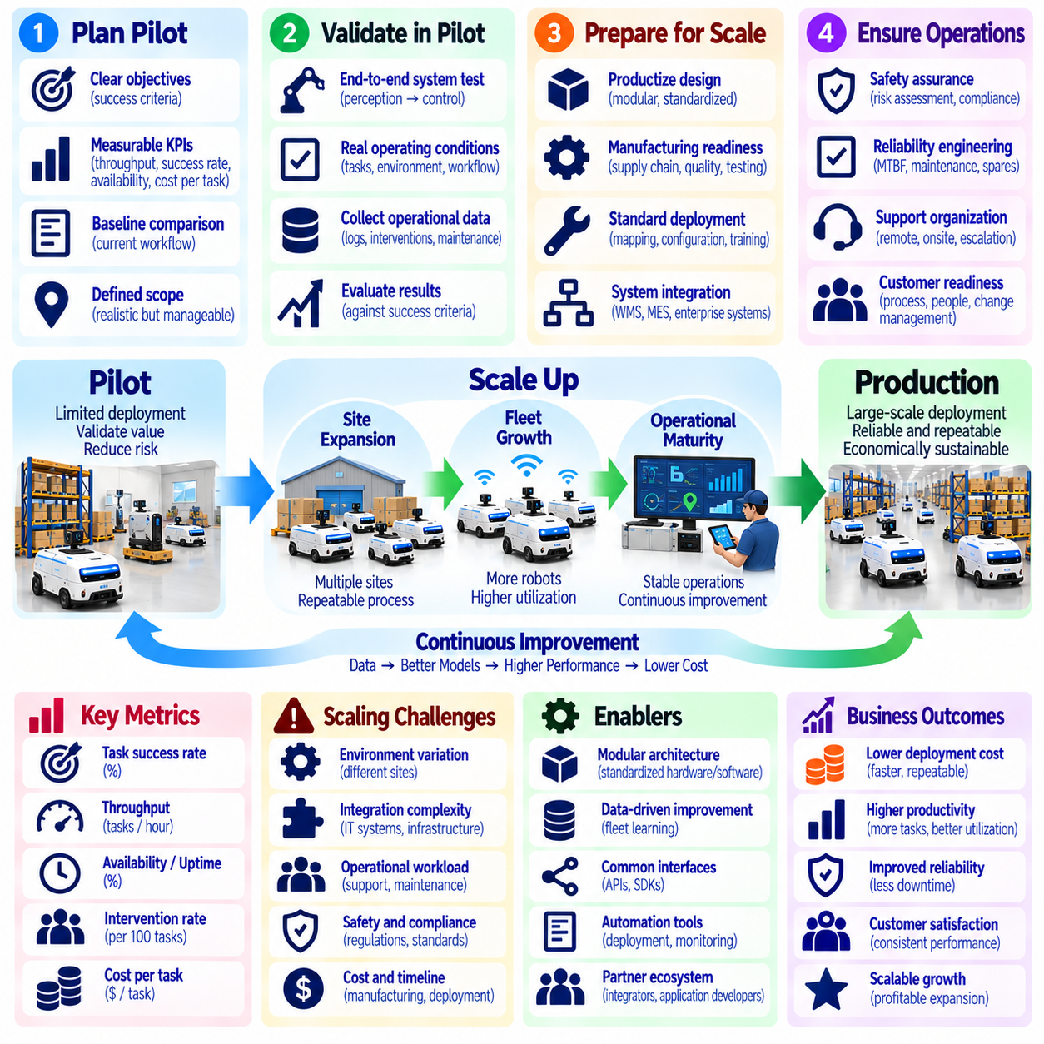
Pilot-to-production scaling is the process of transforming a limited Physical AI demonstration into a reliable, repeatable, and economically sustainable operational deployment. A pilot validates technical feasibility and initial customer value, while production requires consistent performance across larger workloads and multiple environments. Successful scaling depends on engineering maturity, operational readiness, organizational alignment, and a commercially viable delivery model.
A pilot should begin with clearly defined objectives and measurable acceptance criteria. These may include task completion rate, throughput, operational availability, safety performance, intervention frequency, and cost per successful task. Baseline measurements of existing workflows establish a reference for evaluating improvement. Without agreed success criteria, pilot results may demonstrate interesting technology without providing sufficient evidence for investment decisions.
Pilot scope must balance representative operating conditions with manageable implementation risk. Testing only under simplified conditions may produce misleading results, while attempting full operational complexity too early can overwhelm development resources. A suitable pilot includes realistic tasks, environmental variations, and normal workflow constraints. Its boundaries should be documented so that performance claims are not extended beyond the conditions actually evaluated.
Technical validation must examine the complete robotic system rather than individual algorithms alone. Perception, localization, planning, control, manipulation, communication, and safety mechanisms interact during operation. Strong performance in isolated demonstrations does not guarantee dependable end-to-end behavior. Production readiness requires integrated testing under expected workloads, including degraded conditions, recovery procedures, and foreseeable operational disturbances.
Operational data collected during pilots provides evidence for scaling decisions. Robot logs, mission records, intervention events, maintenance histories, and customer workflow measurements reveal recurring limitations. These observations should be organized into actionable engineering priorities. Failure patterns that appear insignificant during short demonstrations may become costly when repeated across hundreds of robots and thousands of operating hours.
Production scaling requires moving from prototype-oriented engineering toward standardized product architecture. Custom wiring, manually configured software, and site-specific modifications may be acceptable during early experimentation but create substantial deployment costs at scale. Modular hardware, controlled software releases, standardized interfaces, and documented configurations improve repeatability. Engineering teams should minimize unnecessary variation while preserving required application flexibility.
Manufacturing readiness becomes increasingly important as deployment volume grows. Suppliers must deliver consistent components, production processes must achieve predictable quality, and assembly procedures must support repeatable testing. Manufacturing documentation, inspection criteria, and traceability systems help identify defects before installation. Production capacity should expand according to validated demand rather than optimistic deployment forecasts alone.
Site deployment processes must become systematic and reproducible. Mapping, network configuration, safety assessment, workflow integration, charging infrastructure, and customer training should follow documented procedures. Automated configuration and commissioning tools can reduce installation time and human error. Deployment teams should measure commissioning duration, integration effort, and acceptance failures to identify opportunities for operational improvement.
Integration with customer infrastructure often determines whether a successful pilot can become a production system. Physical AI deployments may depend on warehouse management systems, manufacturing execution systems, enterprise software, access controls, and facility equipment. Interfaces must support reliable data exchange and exception handling. Integration responsibilities, maintenance ownership, and change management procedures should be agreed before large-scale rollout.
Safety assurance must evolve with deployment scale. A pilot operating under close engineering supervision may rely on controls that are impractical for routine production. Larger deployments require documented risk assessments, validated protective functions, operator training, and clear incident response procedures. Safety performance must remain consistent across different sites and operating conditions. Applicable regulatory and customer requirements should be incorporated into release decisions.
Reliability engineering is essential because small failure probabilities can create significant operational burdens across large fleets. Mean time between failures, recovery duration, component wear, and software stability should be evaluated using representative operating data. Preventive maintenance plans and spare parts strategies must reflect expected asset behavior. Reliability improvements often provide greater economic value than adding advanced functions that are rarely used.
The transition to production also requires a scalable support organization. Engineering teams cannot remain responsible for every routine deployment issue or customer intervention. Defined support tiers, remote diagnostics, service documentation, and escalation procedures enable predictable operations. Support capacity should be planned according to fleet size, failure rates, geographic distribution, and service-level commitments rather than robot count alone.
Customer organizational readiness is as important as technical readiness. Employees must understand how robotic systems change responsibilities, workflows, and exception handling. Operations managers need performance dashboards and clear ownership of daily decisions. Training, communication, and feedback mechanisms help reduce resistance and operational confusion. Successful production adoption requires the robotic system to become part of normal business processes rather than remain an isolated experiment.
Commercial validation should establish whether pilot benefits remain attractive under realistic production economics. Full deployment costs include equipment, integration, infrastructure, maintenance, supervision, software, and financing. Productivity improvements should be measured against actual operating baselines and sustained workload conditions. Return on investment, payback period, and contribution margin must account for utilization changes, service obligations, and lifecycle costs.
A staged rollout reduces the risks associated with rapid fleet expansion. Providers may progress from a single validated site to multiple robots, additional workflows, and geographically distributed deployments. Each expansion stage should confirm performance, reliability, safety, and economic assumptions before further investment. Defined decision gates allow organizations to pause, redesign, or accelerate deployment according to evidence rather than commercial pressure.
Scaling across multiple customers requires distinguishing reusable capabilities from site-specific engineering. Common robot software, deployment tools, and operational procedures should be packaged as standardized products. Customer-specific requirements may still require configuration or limited customization. Providers should monitor engineering hours per deployment and the percentage of functionality reused. These measures indicate whether business growth is becoming more efficient.
Fleet management infrastructure must accommodate increasing operational complexity. Larger fleets require coordinated task allocation, traffic management, charging schedules, software updates, and performance monitoring. Centralized visibility helps operators identify congestion, failures, and capacity imbalances. Infrastructure scalability should be tested before deployment volume exceeds system limits. Shared services must remain reliable as robot populations and customer environments expand.
Financial planning must account for the working capital required during production expansion. Robots, spare parts, installation teams, and support infrastructure may require investment before customer payments are received. Rapid growth can therefore create liquidity pressure even when individual contracts appear profitable. Providers should coordinate manufacturing commitments, customer payment milestones, inventory levels, and financing capacity with realistic rollout schedules.
Production performance should be continuously compared with pilot assumptions. Actual utilization, uptime, throughput, intervention costs, customer satisfaction, and contract margins may differ from initial projections. Structured performance reviews identify whether problems originate in technology, workflow design, customer demand, or service delivery. Feedback from deployed systems should guide product improvements and future commercial commitments.
Ultimately, pilot-to-production scaling is not simply an increase in robot quantity but a transition toward repeatable industrial capability. Technical validation must be combined with standardized engineering, dependable manufacturing, safe operations, scalable support, and disciplined financial management. Physical AI providers that establish evidence-based expansion processes can convert promising demonstrations into sustainable deployments and long-term customer value.

08.22. Channel Partner and System Integrator Strategy
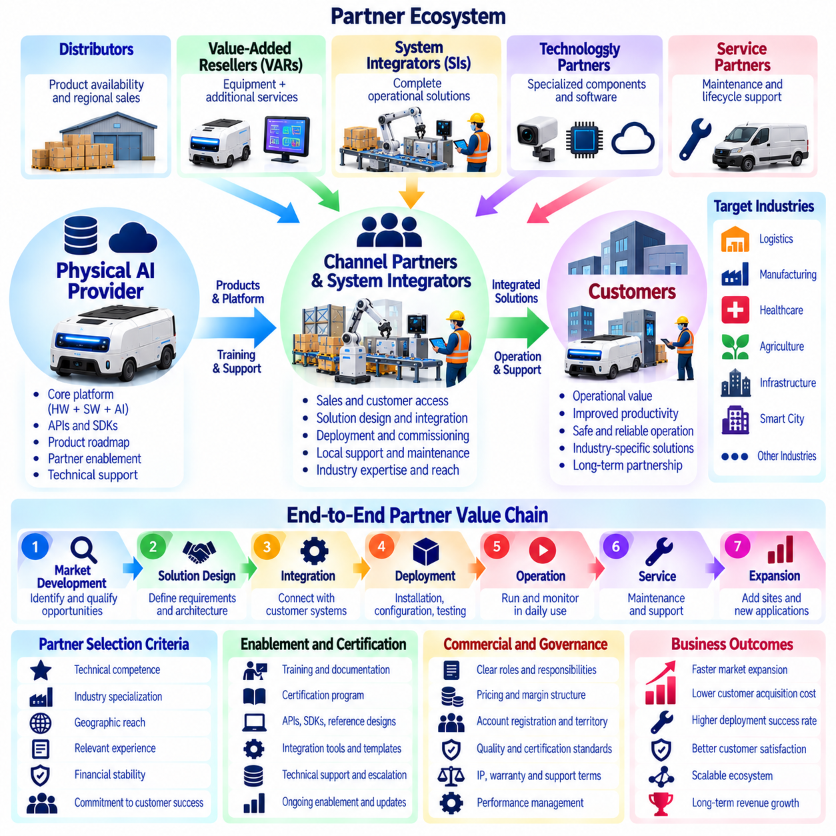
Channel partner and system integrator strategy determines how Physical AI providers expand market access, deliver complex solutions, and support customers beyond their direct organizational capacity. Channel partners connect products with potential buyers, while system integrators adapt robotic technologies to operational environments. A coordinated partner strategy can accelerate adoption, reduce deployment costs, and improve service coverage without requiring equivalent growth in internal resources.
Physical AI sales frequently involve complex purchasing decisions that extend beyond equipment specifications. Customers must evaluate operational compatibility, integration requirements, safety, workforce impacts, and financial returns. Channel partners with established industry relationships can identify qualified opportunities and communicate business value. Their knowledge of customer procurement processes may shorten sales cycles and reduce the provider's customer acquisition burden.
Different partner types contribute distinct capabilities to the commercialization process. Distributors manage product availability and regional sales, value-added resellers combine equipment with complementary services, and system integrators implement complete operational solutions. Technology partners supply specialized components or software, while service partners provide maintenance and support. Partner selection should reflect the requirements of target industries and deployment complexity.
System integrators are especially important because Physical AI solutions rarely operate independently of existing infrastructure. Robots may need connections to warehouse management systems, manufacturing execution systems, enterprise applications, and facility controls. Integrators translate customer workflows into technical requirements and coordinate interfaces between systems. Their effectiveness directly influences deployment reliability, customer satisfaction, and project profitability.
Partner strategy should begin with a clear division of responsibilities between the platform provider and external organizations. The provider may retain ownership of core robotics software, artificial intelligence models, safety architecture, and product roadmaps. Partners may manage customer acquisition, installation, workflow configuration, and local support. Explicit responsibility boundaries reduce duplicated effort, commercial disputes, and unresolved technical problems.
Selecting partners requires evaluating technical competence, industry specialization, geographic reach, and financial stability. A large sales network is not necessarily valuable if partners cannot support complex robotic deployments. Relevant experience with automation, industrial communication, safety procedures, and enterprise integration should receive significant consideration. Providers should prioritize partners capable of delivering repeatable customer outcomes rather than maximizing partner registrations.
Partner certification helps establish consistent deployment quality across different organizations. Certification programs may assess installation procedures, software configuration, safety practices, troubleshooting skills, and customer support capabilities. Training should include practical demonstrations and operational scenarios rather than documentation alone. Periodic reassessment is necessary as hardware generations, software releases, and regulatory requirements evolve.
Standardized integration architecture is essential for scaling partner-delivered solutions. Application programming interfaces, software development kits, reference configurations, and documented communication protocols reduce custom engineering requirements. Reusable connectors can simplify integration with common enterprise systems. Standardization improves deployment predictability while allowing controlled customization for industry-specific workflows and customer infrastructure.
Commercial agreements must align incentives between providers and partners. Distribution margins, referral fees, integration charges, recurring service revenue, and performance-based compensation can support different partner roles. Agreements should define pricing authority, customer ownership, warranty obligations, and support responsibilities. Poorly designed incentives may encourage equipment sales without sufficient attention to deployment success or long-term service quality.
Channel conflict becomes a significant concern when providers combine direct sales with partner-led distribution. Partners may hesitate to invest in market development if the provider competes for the same customers. Clear account registration, territory policies, opportunity ownership, and escalation procedures can reduce disputes. A balanced channel model should preserve strategic direct relationships while rewarding partners for measurable contributions to customer acquisition and delivery.
The economics of partner-led growth should be evaluated beyond headline revenue. Partner margins reduce the provider's direct revenue share but may lower sales, installation, and support expenses. Customer acquisition cost, integration cost, contribution margin, and service profitability should be compared across direct and indirect channels. The optimal model depends on deployment complexity, customer concentration, geographic coverage, and the degree of partner independence.
Regional expansion often benefits from partners familiar with local operating conditions. Regulations, industrial standards, language requirements, labor practices, and customer purchasing behavior can differ significantly between markets. Local integrators may provide faster installation and maintenance response than a centralized provider organization. However, geographic expansion should be supported by consistent technical standards, service processes, and contractual accountability.
After-sales support is a critical component of partner strategy because robotic systems require ongoing operational attention. Providers and partners must coordinate preventive maintenance, spare parts availability, remote diagnostics, software updates, and emergency recovery. Service-level agreements should identify response obligations and escalation paths. Unclear support ownership can increase downtime and damage customer relationships even when the underlying technology performs adequately.
Knowledge transfer enables partners to become productive without excessive dependence on the original engineering team. Technical documentation, deployment playbooks, troubleshooting databases, simulation tools, and structured training programs support independent execution. Providers should capture lessons from completed projects and distribute validated improvements across the partner network. This process converts deployment experience into reusable organizational capability.
Partner performance management requires measurable indicators covering commercial and operational outcomes. Relevant metrics include qualified leads, conversion rates, deployment duration, first-time acceptance, system availability, customer satisfaction, and recurring revenue retention. Integration defects and unresolved support incidents should also be monitored. Performance reviews can identify training needs, process weaknesses, and opportunities to expand successful partnerships.
A tiered partner ecosystem can accommodate organizations with different capabilities and commitments. Entry-level partners may focus on referrals or limited sales activities, while advanced partners perform certified integrations and regional service operations. Strategic partners may jointly develop industry solutions or support major enterprise accounts. Advancement criteria should be transparent and linked to demonstrated competence, customer outcomes, and investment in shared capabilities.
Joint solution development can strengthen differentiation in specialized markets. System integrators often understand operational problems that general-purpose robot providers cannot fully anticipate. Collaborative engineering can produce reusable workflows, application modules, and reference deployments. Intellectual property ownership, maintenance responsibility, and commercialization rights should be established early to prevent disputes as jointly developed solutions gain commercial value.
Partner dependency introduces strategic risks that require active management. A provider relying heavily on a single distributor or integrator may lose market access if that relationship deteriorates. Partners may also promote competing products, underinvest in technical training, or fail to maintain service standards. Diversification, contractual protections, direct customer visibility, and alternative support capabilities help reduce concentration risk without undermining productive partnerships.
Digital partner infrastructure can improve coordination as the ecosystem grows. Partner portals may provide product documentation, software releases, certification records, opportunity registration, service tickets, and performance dashboards. Shared information systems improve transparency and reduce administrative delays. Access controls and data governance remain important because partners may handle sensitive customer information, proprietary software, and operational records.
Ultimately, channel partner and system integrator strategy enables Physical AI businesses to scale through distributed commercial relationships and technical expertise. Successful ecosystems combine capable partners, standardized integration methods, aligned economic incentives, and accountable service delivery. Providers that invest in partner enablement and governance can expand market coverage, improve deployment consistency, and build sustainable revenue across diverse industries and regions.

08.23. Regulation Liability and Insurance
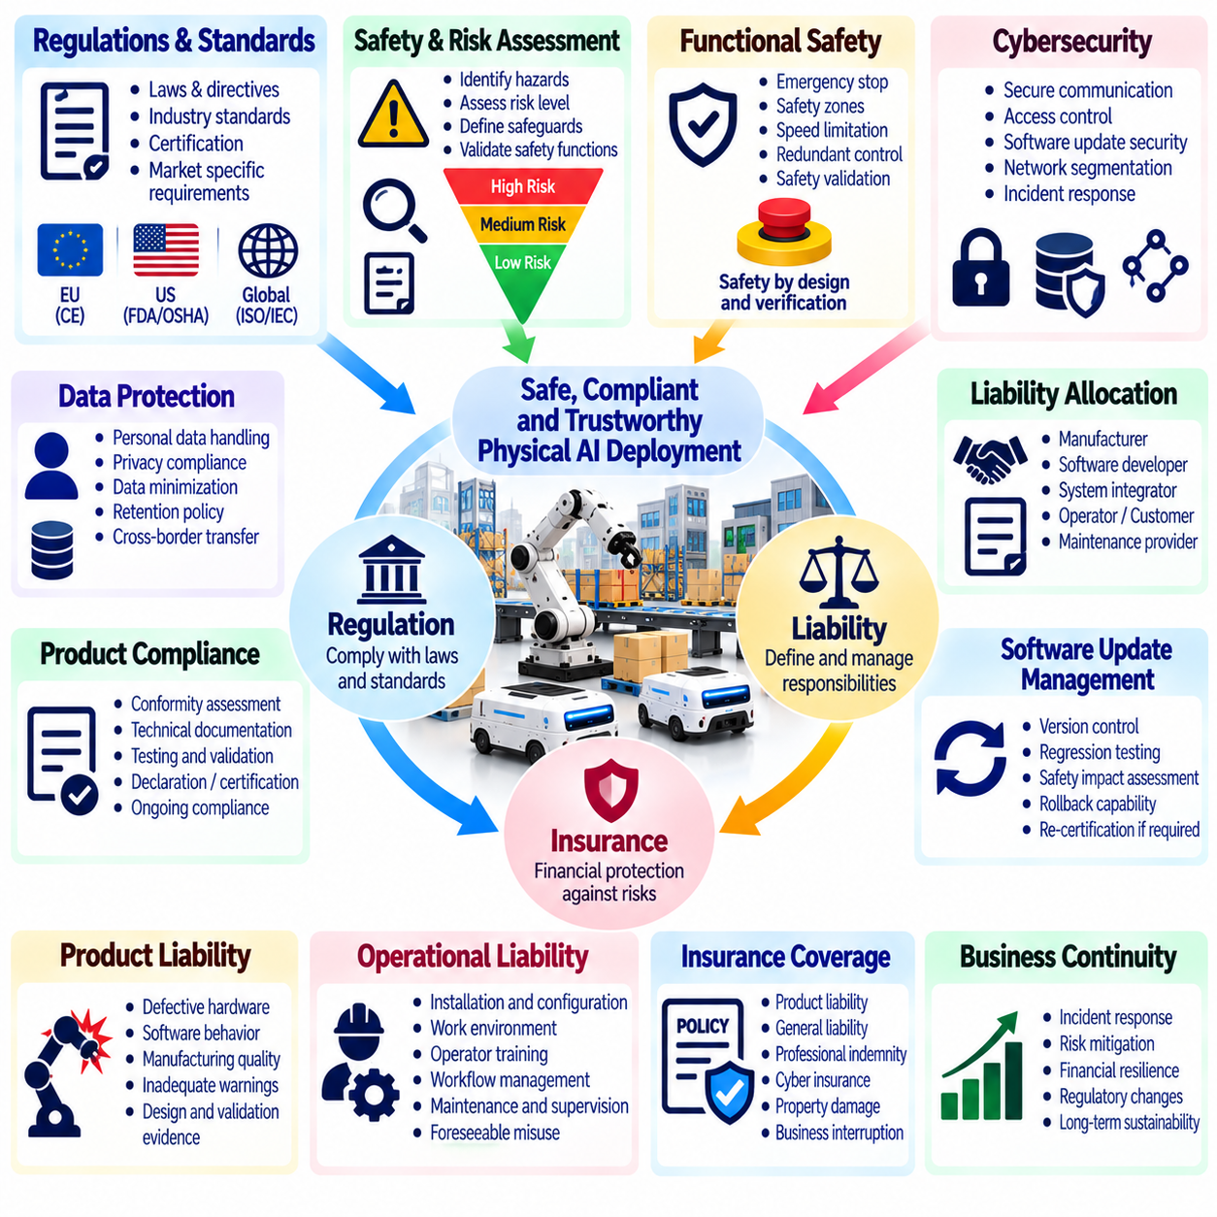
Regulation, liability, and insurance are essential components of sustainable Physical AI business models because autonomous systems operate in environments where technical failures can cause physical harm or financial loss. Unlike purely digital services, robotic systems interact directly with people, equipment, and infrastructure. Commercial success therefore requires regulatory compliance, clearly allocated responsibilities, and financial protection against operational risks.
Regulatory requirements vary according to robot type, application, operating environment, and geographic jurisdiction. Industrial manipulators, autonomous mobile robots, medical robots, agricultural machines, and aerial systems may face different safety obligations. Providers must identify applicable legislation, technical standards, and certification requirements before deployment. Regulatory planning should begin during product design rather than after commercial development is complete.
Functional safety is a central consideration for robotic systems operating near people or valuable equipment. Safety-related control functions may include emergency stopping, protective separation, speed limitation, and monitored operating zones. These functions must be designed and validated according to applicable risk levels and standards. Artificial intelligence capabilities should not replace independently verified protective mechanisms when predictable safety behavior is required.
Risk assessment provides the foundation for determining appropriate safeguards. Providers should identify foreseeable hazards, estimate their severity and likelihood, and evaluate possible mitigation measures. Risks may arise from mechanical motion, unstable payloads, sensor failures, communication interruptions, or unexpected human behavior. Assessments should cover normal operation, maintenance, foreseeable misuse, and emergency recovery rather than ideal operating conditions alone.
Product compliance may require conformity assessments, technical documentation, testing records, and formal declarations or certifications. Requirements depend on the intended market and regulatory classification of the equipment. Standards for machinery, industrial robots, mobile robots, and electrical systems can provide important compliance frameworks. Providers should distinguish legally mandatory requirements from voluntary standards that support evidence of safety.
Liability allocation becomes complicated when multiple organizations contribute to a Physical AI deployment. Robot manufacturers, software developers, system integrators, facility operators, and maintenance providers may each influence operational outcomes. A failure may involve defective hardware, inappropriate configuration, insufficient supervision, or unsafe workflows. Contracts should define responsibilities clearly, while recognizing that contractual terms cannot necessarily eliminate statutory liability.
Product liability concerns injuries or damage caused by defective products or inadequate safety information. Defects may involve mechanical design, manufacturing quality, software behavior, or insufficient warnings. Autonomous systems introduce additional complexity because performance can depend on environmental conditions and learned policies. Providers need traceable design decisions, validation evidence, and documented operating limitations to support product safety and accountability.
Operational liability concerns incidents arising from the way robotic systems are installed, configured, maintained, or used. A technically compliant robot may still create hazards if deployed in an unsuitable environment or operated outside approved conditions. Customers and integrators therefore share important responsibilities for site assessments, operator training, and workflow controls. Responsibility should follow actual authority over the relevant operational decisions.
Software updates create continuing compliance and liability considerations throughout the product lifecycle. Changes to perception, navigation, manipulation, or decision-making policies may alter system behavior and risk exposure. Update procedures should include version control, regression testing, safety impact assessment, and rollback capability. Significant modifications may require renewed evaluation under applicable regulations before deployment.
Cybersecurity is closely connected to physical safety and commercial liability. Unauthorized access, malicious commands, compromised software updates, or communication attacks can disrupt robotic operations. Secure authentication, access controls, network segmentation, monitoring, and vulnerability management reduce exposure. Providers should establish incident response procedures and clarify responsibility for cybersecurity across connected systems and organizational boundaries.
Data protection regulations may apply when robots collect images, audio, location information, or records of human activity. Workplace robots and service robots can process information relating to employees, customers, and visitors. Data minimization, access restrictions, retention policies, and lawful processing arrangements should be incorporated into system design. Cross-border data transfers and cloud-based analytics may introduce additional compliance obligations.
Insurance provides financial protection against selected losses that cannot be eliminated through engineering and operational controls. Relevant coverage may include product liability, general commercial liability, professional indemnity, cyber insurance, and property damage. Policy availability and exclusions depend on jurisdiction, insurer, and application. Providers should assess coverage against realistic incident scenarios rather than assuming conventional equipment insurance covers autonomous operations.
Insurance requirements can influence commercial contracts and customer purchasing decisions. Industrial customers may require minimum coverage limits, proof of insurance, and specific indemnification provisions before approving deployment. Robot-as-a-Service agreements may create different exposures because providers retain asset ownership and operational responsibilities. Insurance costs and deductibles should therefore be included in pricing, unit economics, and lifecycle financial models.
Incident investigation requires reliable records of system behavior and operational context. Sensor logs, command histories, software versions, intervention events, and maintenance records can help reconstruct failures. Accurate timestamps and protected evidence storage improve traceability. Logging systems should balance investigative requirements with privacy and cybersecurity obligations. Documented investigation procedures support corrective action and accountability.
Human oversight remains important even when robots operate autonomously. Operators need clear authority to stop equipment, intervene during abnormal conditions, and report hazards. Training should explain system limitations, emergency procedures, and situations requiring escalation. Excessive reliance on automation can create complacency, while unclear supervision can delay recovery. Human-machine responsibility must be designed as part of the operational system.
Regulatory compliance should be treated as an ongoing lifecycle activity rather than a one-time approval milestone. New software capabilities, additional applications, changed operating environments, and evolving legislation may affect compliance status. Providers should maintain technical files, change records, test evidence, and monitoring processes. Periodic reviews help ensure that deployed systems remain aligned with their intended use and applicable requirements.
International expansion introduces additional complexity because regulatory definitions, conformity procedures, and liability frameworks differ between markets. A robot approved for one jurisdiction may require modifications or additional documentation elsewhere. Local partners can assist with regulatory interpretation and customer requirements, but the provider must maintain control over product safety. Market entry planning should account for compliance costs and approval timelines.
Insurance and liability management also affect partnerships and ecosystem strategy. System integrators may modify configurations, third-party developers may supply applications, and service partners may perform maintenance. Each contribution can change operational risk. Agreements should establish qualification requirements, approved modification boundaries, incident notification duties, and appropriate insurance obligations. Shared governance reduces gaps in accountability across the delivery chain.
The economic impact of regulation extends beyond certification expenses. Safety engineering, testing, documentation, training, insurance premiums, legal support, and incident management contribute to total operating costs. Compliance delays can affect revenue timing, while serious incidents may interrupt operations and damage customer confidence. Financial planning should include these costs and evaluate the value of preventive investment against potential losses.
Ultimately, regulation, liability, and insurance establish the institutional foundations for trustworthy Physical AI commercialization. Effective providers integrate safety engineering, regulatory planning, contractual accountability, cybersecurity, and risk financing throughout the business lifecycle. By managing these obligations proactively, organizations can reduce uncertainty, strengthen customer confidence, and support responsible expansion into increasingly complex physical environments.

08.24. Market Entry and Go to Market
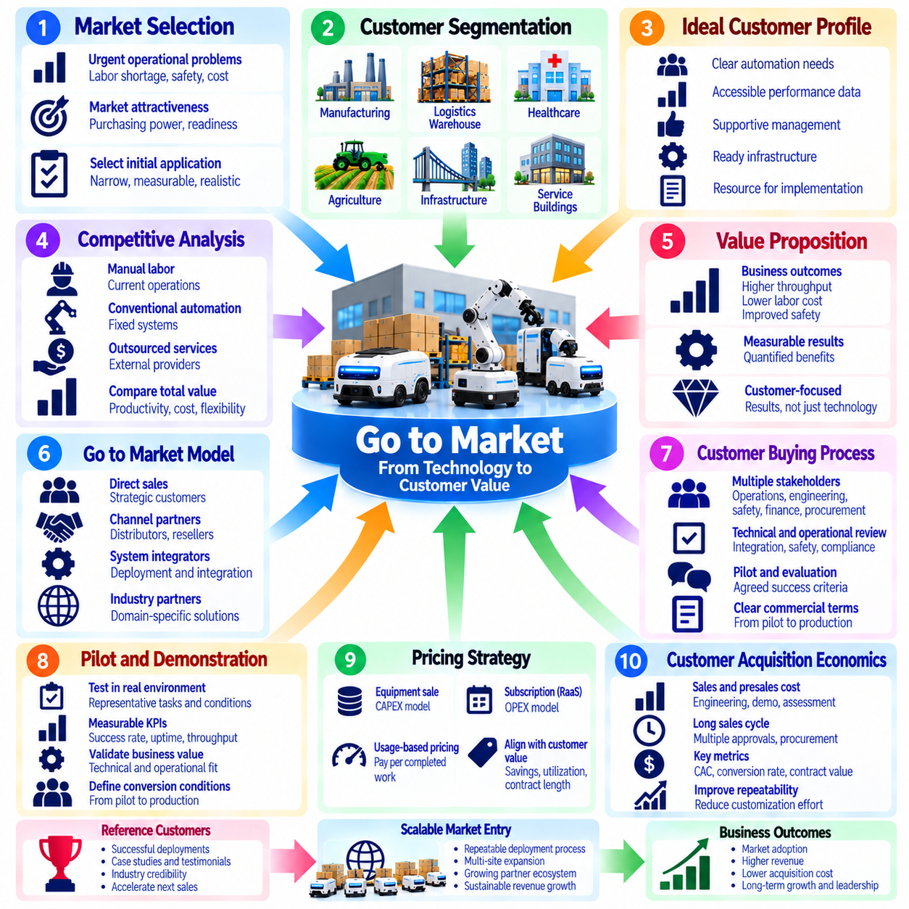
Market entry and go-to-market strategy determine how Physical AI providers convert technological capabilities into commercial adoption and sustainable revenue. Unlike conventional software products, robotic solutions require physical deployment, operational integration, and customer confidence in safety and reliability. Successful market entry therefore depends on selecting suitable applications, demonstrating measurable value, and establishing repeatable sales and delivery processes.
Market selection should begin with identifying industries where automation addresses urgent operational problems. Labor shortages, repetitive tasks, safety risks, productivity constraints, and rising operating costs can create demand for Physical AI solutions. However, market attractiveness depends on more than problem severity. Customers must possess sufficient purchasing capacity, operational readiness, and willingness to change existing workflows.
Customer segmentation helps providers distinguish opportunities with different technical and commercial requirements. Manufacturing facilities, warehouses, hospitals, agricultural operations, and service organizations vary in task complexity, purchasing processes, and deployment conditions. Segmentation should consider workload characteristics, facility infrastructure, automation maturity, and expected economic returns. Clearly defined segments enable more focused product development and marketing.
Early market entry benefits from selecting a narrow initial application with measurable customer value. A focused use case reduces engineering uncertainty, simplifies sales communication, and supports repeatable deployment. Providers should prioritize tasks with predictable workflows, sufficient operating volume, and manageable safety requirements. Broad general-purpose positioning may attract attention but can weaken execution when technical capabilities remain limited.
The ideal customer profile should reflect both operational needs and organizational readiness. Suitable early customers typically have clearly identified automation problems, accessible performance data, supportive management, and resources for implementation. Their facilities should permit meaningful testing without excessive customization. Early adopters can provide valuable feedback and reference deployments, but their requirements should not dictate an unsustainably customized product roadmap.
Competitive analysis should compare Physical AI solutions with existing operational alternatives rather than robotic competitors alone. Manual labor, conventional automation, outsourced services, and process redesign may all address similar customer problems. Providers must evaluate relative productivity, flexibility, safety, integration costs, and lifecycle economics. A compelling market proposition explains why the proposed solution creates superior value under realistic operating conditions.
The customer value proposition should translate technical capabilities into business outcomes. Navigation accuracy, manipulation performance, and artificial intelligence sophistication matter commercially when they improve throughput, reduce labor burdens, increase availability, or enhance safety. Quantified benefits should be supported by realistic assumptions and operational evidence. Messaging should emphasize customer results rather than relying on technological novelty.
Go-to-market models may combine direct enterprise sales, channel partners, system integrators, and industry-specific distributors. Direct sales provide close customer relationships and detailed market feedback but require substantial commercial resources. Partners can expand geographic reach and provide local integration expertise. Channel selection should reflect customer concentration, deployment complexity, service requirements, and the provider's organizational capabilities.
Enterprise purchasing processes often involve multiple stakeholders with different priorities. Operations managers evaluate productivity, engineering teams examine integration feasibility, safety personnel assess risks, and finance departments review investment returns. Procurement and information technology teams may introduce additional requirements. Successful sales processes align these stakeholders around measurable objectives, technical responsibilities, and acceptable commercial terms.
Demonstrations and pilot projects are important tools for reducing customer uncertainty. A structured pilot should test representative tasks, realistic operating conditions, and agreed performance indicators. Acceptance criteria may include successful task completion, uptime, intervention frequency, throughput, and safety performance. Providers should establish commercial conversion conditions before the pilot begins so that successful technical validation can lead to a production decision.
Pricing strategy must match the customer's financial preferences and perceived value. Equipment sales may suit organizations comfortable with capital expenditure, while Robot-as-a-Service subscriptions can reduce initial investment barriers. Usage-based pricing may align payment with completed work but introduces revenue variability. Providers should evaluate pricing against customer savings, service delivery costs, asset utilization, and expected contract duration.
Customer acquisition economics influence the sustainability of market expansion. Sales engineering, demonstrations, site assessments, proposal development, and pilot support can create substantial acquisition costs. Long purchasing cycles may delay revenue recognition and increase working capital requirements. Providers should monitor customer acquisition cost, sales conversion, contract value, and payback periods. Repeatable offerings improve economics by reducing customized presales effort.
Reference customers and documented case studies can accelerate adoption in risk-sensitive industries. Prospective buyers often require evidence that robotic systems operate reliably under conditions similar to their own. Verified performance data, customer testimonials, and operational benchmarks reduce perceived uncertainty. Reference deployments should represent commercially realistic configurations rather than heavily supervised demonstrations that cannot be reproduced economically.
Market education is frequently necessary because customers may misunderstand the capabilities and limitations of Physical AI. Providers should explain autonomy boundaries, human supervision requirements, integration dependencies, and expected operational changes. Transparent communication reduces unrealistic expectations and improves purchasing decisions. Technical workshops, industry demonstrations, and financial modeling can help customers evaluate appropriate applications.
Deployment capability must develop alongside commercial demand. Aggressive sales growth can damage customer relationships if installation teams, manufacturing capacity, spare parts, or technical support cannot keep pace. Go-to-market planning should coordinate sales forecasts with operational resources and delivery schedules. Standardized commissioning procedures and partner certification help maintain consistent quality as deployment volumes increase.
Geographic expansion requires evaluating market-specific regulations, infrastructure, customer expectations, and service availability. A solution successful in one country may require additional certification, language support, or integration modifications elsewhere. Local partners can reduce entry barriers but introduce coordination and governance requirements. Expansion should follow demonstrated product-market fit and sufficient capacity to maintain reliable customer service.
Strategic partnerships can improve credibility and accelerate access to established customer networks. Industrial equipment suppliers, automation integrators, software vendors, and facility service providers may offer complementary capabilities. Joint solutions can reduce customer integration burdens and strengthen differentiation. Partnership agreements should define commercial ownership, technical responsibilities, intellectual property rights, and ongoing support obligations.
Go-to-market performance should be evaluated using both commercial and operational indicators. Qualified opportunities, sales cycle duration, pilot conversion rate, deployment lead time, customer retention, and recurring revenue reveal commercial effectiveness. Operational metrics such as task success, uptime, intervention cost, and realized productivity indicate whether customer promises are being fulfilled. Integrated measurement prevents sales growth from concealing weak deployment economics.
A phased market expansion strategy reduces risk by linking investment to validated customer demand. Providers can begin with a focused application and a limited number of reference customers, then expand into adjacent workflows and industries. Each stage should demonstrate repeatable deployment, acceptable margins, and manageable support requirements. Expansion decisions should be based on evidence of product-market fit rather than market size projections alone.
Ultimately, market entry and go-to-market strategy connect Physical AI innovation with sustainable customer adoption. Effective providers select attractive applications, communicate measurable business value, coordinate sales with deployment capabilities, and build repeatable commercial processes. By combining technical reliability, disciplined pricing, trusted partnerships, and customer-centered execution, Physical AI businesses can establish market credibility and scale revenue responsibly.

08.25. Product Roadmap and Portfolio Strategy
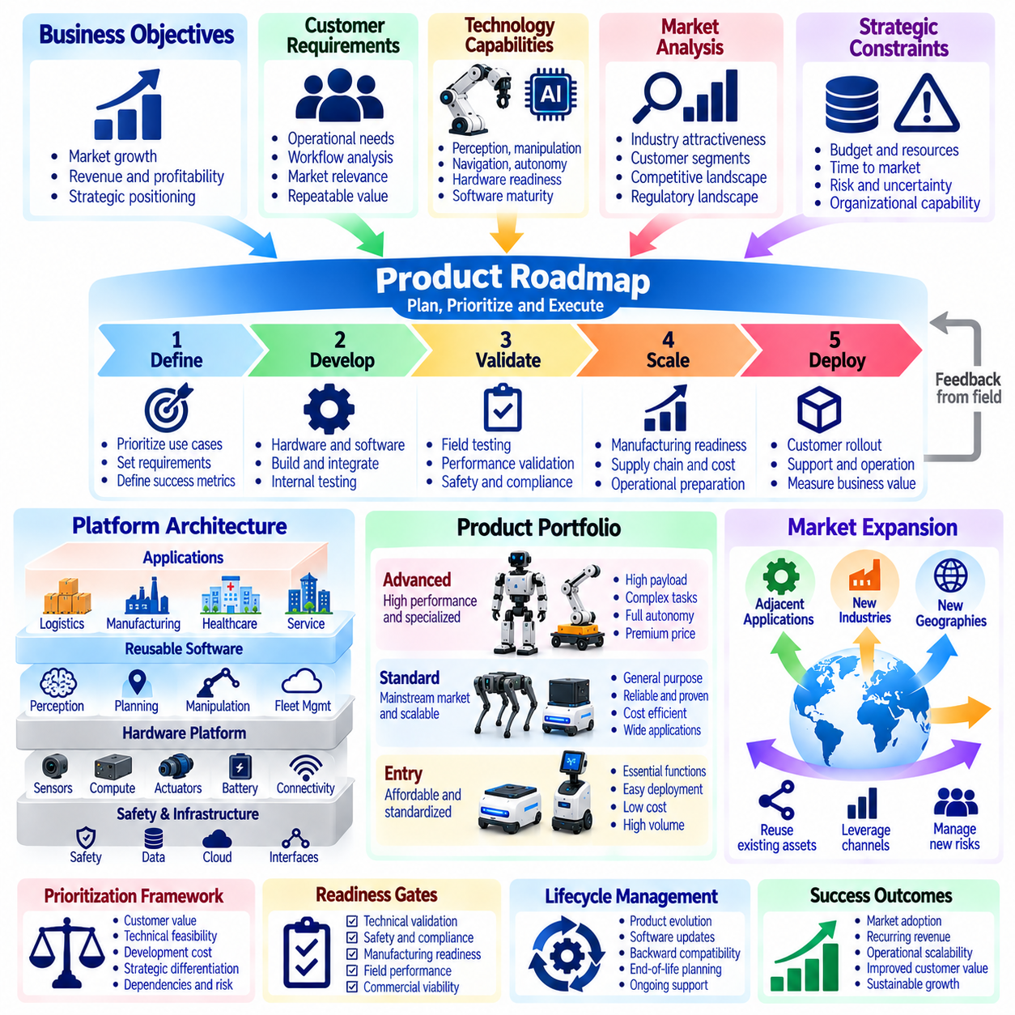
Product roadmap and portfolio strategy define how Physical AI providers evolve technical capabilities into commercially sustainable product families. A roadmap coordinates development priorities, investment timing, and customer requirements, while portfolio strategy determines which products, platforms, and services should coexist. Effective planning balances immediate market opportunities with long-term technology development, operational scalability, and financial sustainability.
Physical AI roadmaps must connect business objectives with engineering capabilities. Improvements in perception, manipulation, navigation, and autonomous decision-making should support measurable customer outcomes rather than isolated technical achievements. Roadmap decisions must consider hardware readiness, software maturity, deployment complexity, and customer adoption barriers. This alignment reduces the risk of investing in capabilities without sufficient commercial demand.
Customer requirements provide an essential foundation for roadmap planning. Providers should analyze operational workflows, performance limitations, service incidents, and requests from existing customers. However, individual customer demands should not automatically determine product priorities. Requirements must be evaluated according to market relevance, repeatability, implementation cost, and strategic value. The objective is to identify capabilities that benefit multiple customers and applications.
Portfolio architecture determines how common technologies are shared across different robotic products. A unified platform may provide reusable perception modules, motion planning, fleet management, safety interfaces, and data infrastructure. Product variants can then address specific payloads, mobility requirements, manipulation tasks, or operating environments. Shared architecture reduces duplicated engineering while supporting differentiated market offerings.
Hardware platform strategy should balance standardization with application-specific performance. Common controllers, sensors, communication interfaces, and software environments can simplify manufacturing and maintenance. However, excessive standardization may constrain payload capacity, environmental durability, or task efficiency. Providers should define modular hardware boundaries that preserve economies of scale without compromising essential operational requirements.
Software roadmaps should prioritize capabilities that improve autonomy, reliability, and deployment efficiency. These may include better perception under changing conditions, adaptive task execution, automated recovery, and simplified configuration. Software improvements can extend the useful life of deployed hardware and create recurring revenue opportunities. Compatibility testing is essential because new functionality must not destabilize existing customer operations.
Artificial intelligence development introduces uncertainty into product planning because model performance does not always improve predictably with investment. Training data quality, task diversity, simulation fidelity, and computing resources influence achievable capabilities. Providers should define measurable performance milestones and evaluate models under representative operating conditions. Research progress should enter commercial roadmaps only when supported by sufficient validation evidence.
A layered roadmap separates foundational technology from customer-facing applications. Foundational investments may include robot operating infrastructure, safety systems, data engines, and reusable autonomy components. Application layers translate these capabilities into warehouse transport, industrial inspection, material handling, or service tasks. This separation allows common technologies to evolve while limiting disruption to established commercial solutions.
Product portfolio segmentation can address customers with different budgets and operational requirements. Entry-level products may emphasize affordability and standardized functions, while advanced configurations provide higher payloads, greater autonomy, or specialized manipulation. Software and service tiers can introduce additional differentiation. Each offering should have a clearly defined target customer, value proposition, and economic contribution.
Portfolio expansion should follow evidence of product-market fit rather than technological possibility alone. Adjacent applications are attractive when they reuse existing hardware, software, distribution channels, or service infrastructure. Expansion into unrelated markets may require substantially different engineering and regulatory capabilities. Providers should estimate incremental revenue opportunities alongside the additional complexity and organizational resources required.
Roadmap prioritization requires balancing expected customer value, technical feasibility, development cost, and strategic differentiation. Features that reduce deployment time or maintenance burden may generate greater economic returns than highly visible autonomy demonstrations. Dependencies between hardware, software, and infrastructure must also be considered. Prioritization frameworks should make tradeoffs explicit and prevent excessive fragmentation of engineering resources.
Technology readiness and commercial readiness should be assessed independently. A prototype may demonstrate impressive performance without meeting production requirements for safety, reliability, manufacturability, and serviceability. Roadmap gates should therefore include technical validation, field testing, cost targets, and operational acceptance criteria. Advancing products prematurely can increase warranty expenses, customer dissatisfaction, and reputational risk.
Lifecycle management is an important component of portfolio strategy. Products progress through introduction, growth, maturity, and eventual replacement or retirement. Providers must plan component availability, software maintenance, spare parts, and customer migration pathways. End-of-life decisions should consider contractual obligations and installed fleet requirements. Predictable lifecycle policies strengthen customer confidence in long-term automation investments.
Backward compatibility helps protect customer investments and reduce adoption barriers for future upgrades. Software interfaces, fleet management systems, and integration protocols should remain stable where practical. Hardware changes may require migration tools or replacement components. Compatibility policies should distinguish mandatory safety updates from optional feature improvements. Clear version management reduces operational disruption across heterogeneous robot fleets.
Financial portfolio management evaluates products according to revenue potential, gross margin, development investment, and lifecycle support costs. Hardware profitability should be considered alongside software subscriptions, maintenance contracts, and service revenue. A product with modest initial margins may still create substantial lifetime value through recurring services. However, portfolio decisions must account for working capital, warranty exposure, and customer concentration risks.
Product differentiation should combine technical performance with measurable operational advantages. Reliability, deployment speed, integration simplicity, safety assurance, and service availability may matter more than isolated benchmark results. Providers should identify capabilities that competitors cannot easily reproduce through hardware substitution or software imitation. Proprietary data, validated workflows, and installed ecosystem relationships can strengthen long-term differentiation.
Roadmap governance requires coordination among engineering, product management, sales, operations, and finance. Engineering teams assess feasibility, commercial teams communicate market demand, and operations teams identify deployment constraints. Financial management evaluates investment capacity and expected returns. Regular portfolio reviews should reassess priorities using field performance, customer feedback, competitive developments, and changes in available technology.
Scenario planning helps providers manage uncertainty in Physical AI markets. Adoption rates, component prices, regulatory requirements, and artificial intelligence capabilities may evolve differently from initial forecasts. Roadmaps should therefore distinguish committed developments from exploratory initiatives. Modular architecture and staged investment allow organizations to respond to changing conditions without abandoning their entire product strategy.
A balanced portfolio should support current revenue generation while developing future capabilities. Mature products provide operational experience and financial stability, while emerging products explore adjacent markets and more advanced autonomy. Research initiatives may investigate longer-term opportunities without immediate commercialization commitments. Resource allocation should reflect technical uncertainty, strategic importance, and the organization's capacity to absorb development risk.
Ultimately, product roadmap and portfolio strategy connect Physical AI innovation with disciplined business growth. Successful providers build reusable platforms, prioritize validated customer needs, manage product lifecycles, and allocate resources across near-term and future opportunities. By coordinating technical progress with commercial readiness and financial performance, organizations can develop scalable product families that deliver lasting customer value.

08.26. Physical AI Business Case Model [w/Code]
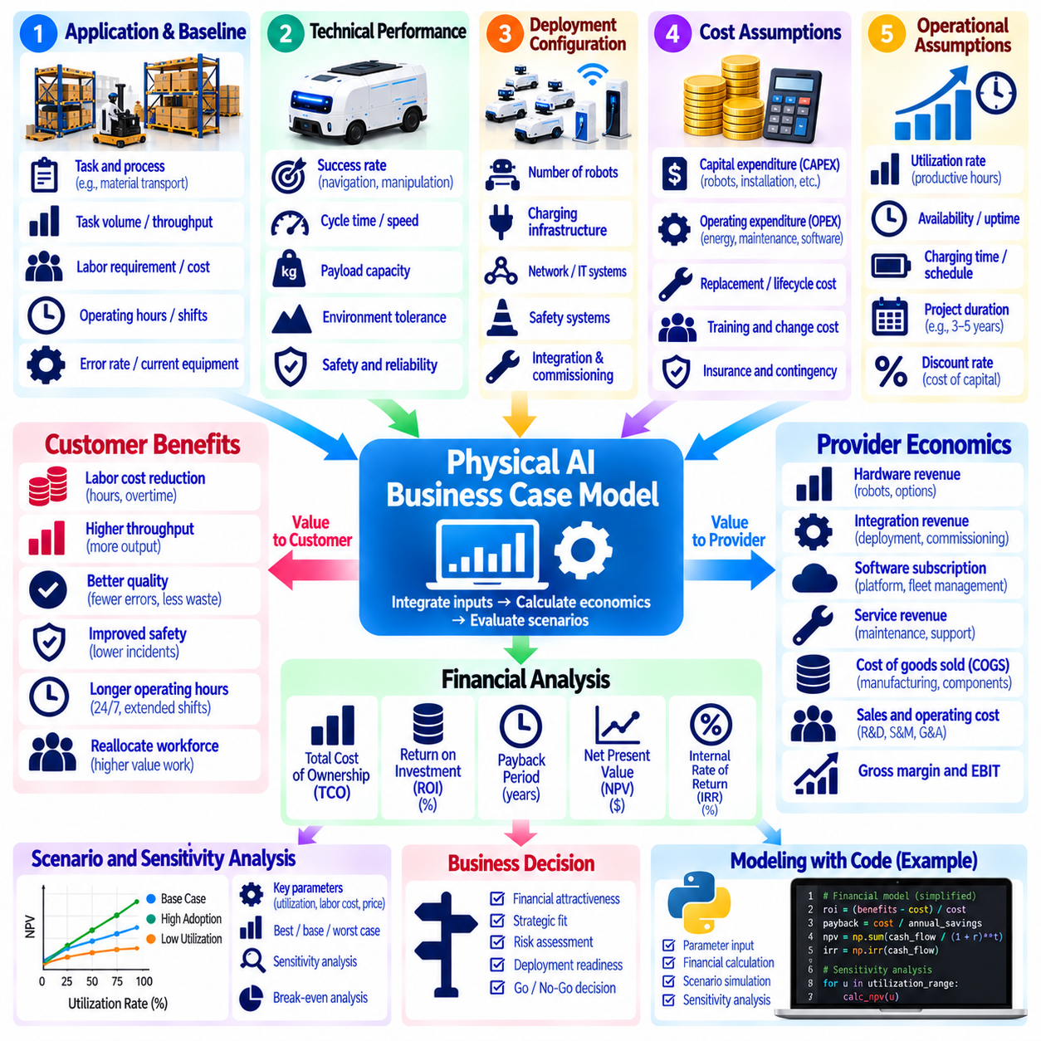
A Physical AI business case model provides a structured framework for evaluating whether robotic automation creates sufficient economic value to justify investment. It connects technical performance, operational requirements, deployment costs, and financial outcomes within a consistent analytical structure. The model should assess both customer benefits and provider profitability, recognizing that commercially attractive automation must deliver sustainable value to both parties.
The model begins by defining the target application, operating environment, and baseline process. Relevant inputs include task volume, labor requirements, operating hours, throughput, error rates, and existing equipment costs. Baseline measurements should reflect actual operating conditions rather than theoretical capacity. A reliable comparison requires documenting current performance before estimating the improvements expected from Physical AI deployment.
Technical feasibility determines whether projected financial benefits can realistically be achieved. Robot payload capacity, navigation accuracy, manipulation success, cycle time, and environmental tolerance influence operational performance. The model should translate these technical parameters into measurable productivity outcomes. Conservative assumptions are important because laboratory demonstrations may not represent performance under continuous industrial operation.
Deployment configuration establishes the physical resources required to achieve target productivity. The model should estimate robot quantity, charging infrastructure, networking equipment, safety systems, and integration requirements. Fleet sizing must consider task demand, travel distance, charging time, and operational congestion. Excessive capacity increases capital expenditure, while insufficient capacity reduces service quality and expected economic benefits.
Capital expenditure includes robot hardware, installation, commissioning, facility modifications, and initial software integration. Additional costs may arise from charging systems, safety equipment, employee training, and project management. The model should distinguish one-time investments from recurring expenses. Accurate investment estimates require supplier quotations, engineering assessments, and appropriate contingencies for deployment uncertainty.
Operating expenditure includes electricity, maintenance, software subscriptions, connectivity, insurance, and technical support. Consumable parts, periodic inspections, battery replacement, and unplanned repairs may create additional lifecycle costs. These expenses should be estimated over the intended operating period. Separating fixed and variable operating costs helps identify how profitability changes with utilization and deployment scale.
Labor economics frequently represent a major source of automation value. The model should estimate hours of work avoided, changes in staffing requirements, overtime reductions, and opportunities to reassign personnel. However, theoretical labor savings do not automatically become financial savings. Realized benefits depend on staffing flexibility, workload growth, labor agreements, and the organization's ability to convert released capacity into economic value.
Productivity improvements can generate benefits beyond direct labor reduction. Robots may increase throughput, improve process consistency, reduce material handling errors, and support longer operating hours. These effects can increase output or reduce waste without proportional increases in staffing. The model should quantify each benefit separately and avoid double counting when several performance improvements influence the same financial outcome.
Robot utilization and availability strongly influence economic performance. Utilization measures the proportion of available time spent performing productive work, while availability reflects readiness for operation. Charging, maintenance, waiting, and operational interruptions reduce effective capacity. Financial forecasts should use realistic utilization assumptions and include sensitivity analysis because small changes in productive operating hours can significantly affect returns.
A customer total cost of ownership model combines initial investment with ongoing operating and lifecycle expenses. Relevant categories include equipment, integration, software, maintenance, energy, training, downtime, and eventual replacement. Costs should be evaluated across a defined planning horizon. Comparing robotic and conventional operating models on an equivalent basis helps customers understand the true economic implications of automation.
Return on investment measures financial benefits relative to the resources committed. A simplified calculation divides net financial gain by the initial investment, although detailed evaluations should account for timing and recurring costs. Payback period estimates how long cumulative net savings take to recover the initial expenditure. These indicators are useful for screening projects but should not replace comprehensive discounted cash flow analysis.
Net present value evaluates future cash flows after applying a discount rate that reflects the time value of money and relevant risk. Positive net present value indicates that projected benefits exceed discounted costs under the selected assumptions. Internal rate of return provides another perspective on investment attractiveness. The model should report assumptions transparently because discount rates, project duration, and residual value can materially change results.
Provider economics must be evaluated separately from customer economics. Revenue may include hardware sales, integration fees, software subscriptions, maintenance contracts, and Robot-as-a-Service payments. Corresponding costs include manufacturing, deployment, support, cloud infrastructure, and warranty obligations. A commercially viable business case requires sufficient contribution margin after accounting for the actual cost of serving customers.
Robot-as-a-Service models introduce additional financial considerations because providers may retain ownership of deployed assets. Initial hardware expenditure is recovered through recurring customer payments over time. The model must account for financing costs, depreciation, contract duration, utilization, and customer default risk. Provider cash flow can remain negative during fleet expansion even when individual contracts appear profitable over their full lifecycle.
Fleet economics reveal how costs and revenues change as deployment volume increases. Shared software infrastructure, remote monitoring, standardized maintenance, and centralized support may reduce cost per robot. However, spare parts inventory, field service coverage, and customer onboarding can create new scaling expenses. The model should distinguish genuine economies of scale from costs that increase approximately in proportion to fleet size.
Sensitivity analysis tests how financial results respond to uncertainty in key assumptions. Important variables include robot purchase price, labor cost, task throughput, uptime, utilization, maintenance expense, and contract duration. Scenario analysis can compare optimistic, expected, and conservative operating conditions. These evaluations help identify the assumptions that most strongly determine whether a deployment remains financially attractive.
Risk-adjusted modeling should consider technical failures, deployment delays, customer adoption barriers, and regulatory obligations. Potential impacts include additional engineering work, lost production, warranty claims, and unexpected service costs. Risk allowances should reflect realistic exposure rather than arbitrary percentages. Explicit risk treatment improves investment decisions and prevents optimistic forecasts from concealing operational uncertainty.
A practical implementation can use a spreadsheet or Python-based financial model with separate input, calculation, and reporting layers. Input tables store technical parameters, deployment quantities, pricing, and cost assumptions. Calculation modules estimate productivity, cash flow, profitability, and investment returns. Automated scenario evaluation improves reproducibility, while validation checks help prevent inconsistent assumptions and formula errors.
Business case validation requires comparing projected outcomes with measured deployment results. Pilot data should capture task completion, intervention frequency, operating hours, maintenance effort, and realized productivity. Differences between forecasts and actual performance should update future assumptions. This feedback process improves model accuracy and supports more reliable pricing, fleet sizing, and customer investment proposals.
Ultimately, a Physical AI business case model connects engineering feasibility with customer value and provider financial sustainability. Its effectiveness depends on transparent assumptions, realistic operational data, complete lifecycle costs, and disciplined sensitivity analysis. By continuously validating economic forecasts against field performance, organizations can make better investment decisions, develop credible commercial proposals, and scale Physical AI deployments responsibly.

