Volume 12. Physical AI Business and Industry Applications

Chapter 01. Physical AI Market Landscape

01.01. Defining the Physical AI Market
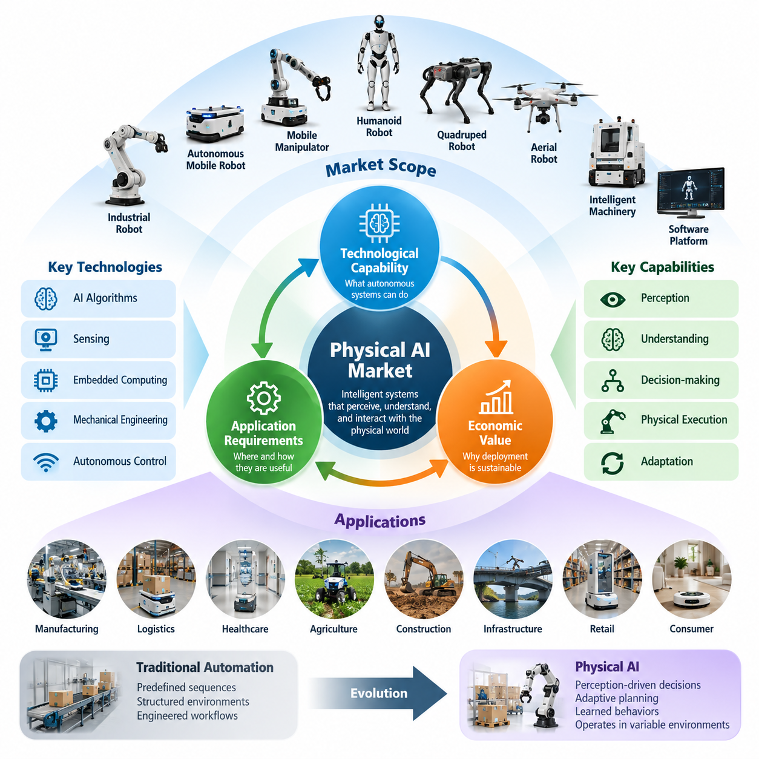
The Physical AI market encompasses the development, commercialization, deployment, and operation of intelligent systems capable of perceiving, understanding, and interacting with the physical world. Unlike conventional artificial intelligence markets centered on digital information processing, Physical AI creates economic value through autonomous movement, manipulation, inspection, transportation, and other actions performed within real environments.
Physical AI combines artificial intelligence, robotics, sensing technologies, embedded computing, mechanical engineering, and autonomous control into integrated operational systems. Its market boundaries extend beyond traditional industrial robots to include autonomous mobile robots, mobile manipulators, humanoid robots, quadrupeds, aerial robots, intelligent machinery, and software platforms that enable physical autonomy across different industries.
A defining characteristic of this market is the direct relationship between intelligent decision-making and physical execution. A Physical AI system must interpret environmental information, select appropriate actions, and execute those actions while respecting physical constraints. Consequently, commercial performance depends not only on algorithmic intelligence but also on mechanical capability, operational reliability, safety, energy efficiency, and environmental adaptability.
The market can be understood through three interconnected dimensions: technological capability, application requirements, and economic value creation. Technological capability determines what autonomous systems can accomplish, application requirements establish the conditions under which those capabilities are useful, and economic value determines whether deployment can be sustained commercially. Successful products must satisfy all three dimensions simultaneously.
Traditional automation generally operates through predefined sequences, structured environments, and carefully engineered workflows. Physical AI expands this model by introducing perception-driven decisions, adaptive planning, learned behaviors, and greater tolerance for environmental variation. The commercial distinction becomes particularly important when tasks involve changing objects, uncertain conditions, human interaction, or operational situations that cannot be completely programmed in advance.
However, Physical AI should not be defined simply as any machine containing an artificial intelligence algorithm. An AI-based inspection camera may provide valuable perception capabilities without independently performing physical actions. It becomes part of a broader Physical AI system when its outputs influence autonomous decisions and physical operations. This distinction helps separate enabling technologies from complete embodied systems while recognizing their economic interdependence.
The market includes both specialized autonomous systems and emerging general-purpose robotic platforms. Specialized systems perform relatively well-defined tasks such as warehouse transportation, industrial inspection, agricultural spraying, or automated material handling. General-purpose platforms seek to execute multiple tasks through adaptable hardware and reusable intelligence. These approaches differ in technical complexity, deployment readiness, customer expectations, and commercialization risk.
Autonomous mobile robots represent an important market category because transportation tasks are common across manufacturing, logistics, healthcare, and commercial facilities. Their value originates from reducing repetitive movement, improving material availability, and coordinating internal logistics. Advanced navigation, obstacle avoidance, fleet management, and integration with enterprise systems distinguish intelligent mobile operations from basic automated guided transportation.
Manipulators and mobile manipulators extend Physical AI from movement into physical interaction with objects. Their commercial applications include machine tending, picking, assembly, sorting, packaging, and laboratory automation. Combining mobility with manipulation introduces additional complexity involving object recognition, grasp planning, force control, and coordinated motion. Nevertheless, this combination can increase automation flexibility by allowing one platform to perform tasks across multiple workstations.
Humanoid robots constitute another market category, distinguished by their potential compatibility with environments originally designed for human workers. Their proposed applications include material handling, equipment operation, inspection, and selected service activities. Commercial feasibility depends on whether their versatility can compensate for the additional costs and technical challenges associated with balance, dexterity, power consumption, safety, and maintenance.
Quadruped robots and other field-oriented platforms address environments where conventional wheeled mobility may be insufficient. Industrial facilities, construction sites, agricultural terrain, and infrastructure corridors create opportunities for robots capable of negotiating irregular surfaces and obstacles. Their market value depends on terrain accessibility, sensing capability, inspection quality, payload capacity, endurance, and the operational cost of replacing or supporting human field activities.
Aerial robots extend the market into three-dimensional mobility, enabling inspection, surveying, mapping, monitoring, and selected logistics operations. Their commercial potential is shaped by payload limitations, flight endurance, environmental conditions, airspace regulations, and operational safety. Autonomous navigation and mission planning can improve productivity, but sustainable deployment also requires reliable ground infrastructure, maintenance procedures, and integration with customer workflows.
Physical AI also includes a substantial enabling technology market. Sensors, actuators, motor drives, batteries, embedded processors, communication modules, and mechanical components form the hardware foundation of intelligent machines. Their technical characteristics influence system cost, computational performance, accuracy, energy consumption, and durability. Component suppliers therefore participate in Physical AI commercialization even when they do not manufacture complete robotic products.
Software represents another major layer of the market, including perception systems, localization, mapping, motion planning, control, simulation, fleet orchestration, and operational monitoring. These capabilities may be delivered as embedded software, licensed modules, development platforms, or subscription services. Their economic significance increases when reusable software architectures reduce engineering effort across multiple robot models, customer sites, and application environments.
Robot foundation models, vision-language-action models, and learned control policies introduce an additional intelligence-oriented market segment. These technologies aim to improve task generalization, language-guided operation, and adaptation to unfamiliar situations. Their commercial value depends on demonstrated physical performance, efficient deployment, data requirements, safety validation, and compatibility with diverse robotic embodiments rather than model capability alone.
The Physical AI ecosystem also includes simulation platforms, digital twins, synthetic data generation, teleoperation systems, and data management infrastructure. These technologies support development, training, testing, and continuous improvement of autonomous behavior. Their importance arises from the difficulty and expense of collecting physical interaction data, especially for rare events, complex manipulation tasks, and safety-critical operating conditions.
System integrators and service providers occupy a critical position between technology suppliers and industrial customers. Physical AI products rarely operate independently of existing infrastructure, equipment, information systems, and workforce procedures. Integration services connect robots with manufacturing execution systems, warehouse management systems, enterprise resource planning platforms, and fleet management systems while adapting deployments to specific operational requirements.
Market demand is driven by several overlapping economic and operational pressures, including labor availability, productivity improvement, workplace safety, service continuity, and the need for flexible production. The relative importance of these factors varies by industry. A warehouse may prioritize throughput and operating hours, while a hospital may emphasize dependable delivery and staff assistance. An infrastructure operator may prioritize inspection coverage and reduced human exposure to hazardous locations.
Market adoption cannot be evaluated solely through robot shipment volumes or artificial intelligence investment. Installed systems, active deployments, utilization rates, recurring software revenue, service contracts, and customer retention provide complementary indicators. A robot purchased for experimentation does not represent the same commercial maturity as a platform operating continuously across multiple production facilities with measurable productivity improvements.
Economic evaluation requires consideration of the complete operating lifecycle. Acquisition cost represents only one component of total cost of ownership, alongside installation, integration, maintenance, energy, software licensing, supervision, infrastructure, and eventual replacement. Customers assess these expenses against labor savings, increased output, reduced downtime, improved quality, and other measurable benefits. Reliable financial performance ultimately determines whether pilot projects progress into larger deployments.
The Physical AI market is also characterized by significant differences in technological maturity. Structured industrial transportation and selected inspection applications can operate within established commercial frameworks, whereas highly dexterous general-purpose manipulation and broad household assistance remain more technically challenging. Market forecasts must therefore distinguish demonstrated operational capabilities from research achievements, prototype demonstrations, and anticipated future functionality.
Geographic and industrial differences further influence market development. Manufacturing concentration, labor economics, regulatory requirements, technology infrastructure, capital availability, and customer acceptance shape regional adoption. Industries with standardized processes and measurable automation benefits may adopt specialized solutions more readily, while highly variable environments require additional advances in perception, manipulation, reasoning, and operational robustness.
Competition occurs across several layers rather than within a single unified product category. Robot manufacturers compete through hardware performance and system reliability, software providers through intelligence and interoperability, and service organizations through deployment expertise and lifecycle support. Platform providers may seek competitive advantages through development ecosystems, reusable data infrastructure, integration partnerships, and continuous improvements generated from operational experience.
A practical market definition must therefore distinguish the direct market for autonomous physical systems from the broader ecosystem of enabling technologies and associated services. It must also avoid counting the same economic activity repeatedly across components, software, integration, and complete system sales. Clear segmentation by application, embodiment, autonomy level, customer industry, and revenue category enables more consistent market analysis.
Ultimately, Physical AI should be understood as an emerging industrial and technological market in which machine intelligence becomes economically valuable through reliable physical action. Its development will depend on the convergence of increasingly capable algorithms, affordable robotic hardware, scalable data infrastructure, and commercially sustainable operating models. The central measure of market progress is the ability to transform autonomous physical capabilities into repeatable, safe, and measurable industrial value.

01.02. Robotics AI and Automation Value Chains
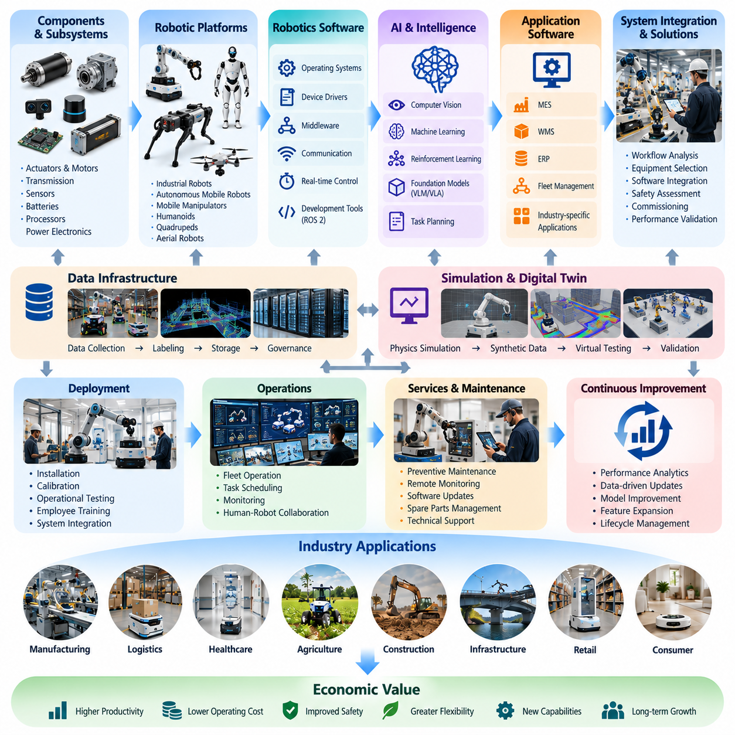
The Physical AI value chain connects robotics hardware, artificial intelligence, automation software, system integration, and operational services into a coordinated industrial ecosystem. Unlike conventional technology markets, where value may be delivered through standalone digital products, Physical AI requires multiple technological layers to function together. Economic value emerges when these layers enable reliable autonomous actions within real operational environments.
The value chain begins with foundational components, including mechanical structures, actuators, motors, transmissions, sensors, batteries, and embedded processors. These elements establish the physical capabilities and operating limits of robotic systems. Their performance influences payload capacity, positioning accuracy, mobility, energy efficiency, and durability, making component engineering an essential foundation for commercial Physical AI products.
Hardware suppliers contribute through specialized technologies that support sensing, computation, movement, and physical interaction. Cameras, LiDAR sensors, inertial measurement units, force sensors, and tactile sensors provide information about the surrounding environment. Motor controllers, power electronics, and communication interfaces translate computational decisions into physical actions while maintaining the responsiveness required for autonomous operation.
The next layer consists of robotic platforms that integrate mechanical components, electronics, embedded software, and control systems into functional machines. These platforms include autonomous mobile robots, manipulators, mobile manipulators, humanoids, quadrupeds, and aerial robots. Platform manufacturers must balance hardware capability, production cost, reliability, maintainability, and compatibility with higher-level intelligence software.
Robotics software provides the computational infrastructure required to operate physical platforms. Operating systems, device drivers, middleware, communication protocols, and real-time controllers coordinate sensors, actuators, and computing resources. Frameworks such as ROS 2 support modular software development and interoperability, although commercial deployments also require additional engineering for deterministic performance, cybersecurity, and functional safety.
Artificial intelligence introduces adaptive capabilities beyond conventional programmed automation. Computer vision, machine learning, reinforcement learning, and multimodal perception allow robots to interpret complex environments and respond to changing conditions. These technologies transform sensor measurements into meaningful representations of objects, locations, human activities, and operational situations that support autonomous decision-making.
Advanced intelligence platforms increasingly incorporate foundation models, vision-language models, and vision-language-action architectures. These models seek to connect natural language instructions, visual observations, and robotic actions within reusable learning frameworks. Their position in the value chain depends on whether they can deliver dependable task execution, generalization, and adaptation across different robotic embodiments and operating environments.
Data infrastructure forms another essential part of the Physical AI value chain. Robot operation generates sensor recordings, action trajectories, environmental observations, task outcomes, and failure information. Data collection, labeling, filtering, storage, and governance transform these records into resources for model development. High-quality datasets support improved perception, planning, control, and continuous adaptation of deployed systems.
Simulation and digital twin technologies connect algorithm development with physical deployment. Physics simulation, synthetic data generation, and virtual testing environments allow developers to evaluate robotic behavior before exposing equipment to real-world risks. These tools can reduce development costs and accelerate experimentation, although differences between simulated and actual environments require careful validation and adaptation.
Automation software connects robotic intelligence to industrial workflows. Manufacturing execution systems, warehouse management systems, enterprise resource planning platforms, and fleet management systems coordinate operational information and production requirements. Integration with these systems enables autonomous robots to receive assignments, report task completion, manage resources, and participate in broader organizational processes rather than functioning as isolated machines.
System integrators translate available technologies into customer-specific operational solutions. Their responsibilities include workflow analysis, equipment selection, facility preparation, software integration, safety assessment, commissioning, and performance validation. Because industrial environments vary significantly, integration expertise often determines whether technically capable robots can achieve reliable operation and measurable economic benefits.
Application developers occupy an important position between general-purpose robotic technology and industry-specific requirements. They configure perception, navigation, manipulation, and task planning capabilities for manufacturing, logistics, healthcare, agriculture, construction, and commercial services. Application specialization creates value by translating reusable technological capabilities into solutions that address identifiable customer problems.
The deployment layer includes installation, calibration, operational testing, employee training, and integration with existing equipment. Physical AI systems must function under actual environmental conditions involving obstacles, human movement, network limitations, and operational variability. Successful deployment requires more than demonstrating autonomous behavior; it requires predictable performance, safe operation, and compatibility with established production procedures.
Operational services extend the value chain beyond initial equipment delivery. Preventive maintenance, remote monitoring, technical support, software updates, fleet optimization, and replacement components contribute to long-term system availability. Service providers may generate recurring revenue while helping customers maintain productivity and reduce operational uncertainty throughout the equipment lifecycle.
Robot-as-a-Service business models connect technology ownership with ongoing operational performance. Under these arrangements, providers may retain responsibility for equipment availability, maintenance, software, and selected operating services. Customers obtain robotic capabilities through recurring payments rather than relying entirely on upfront capital investment. Commercial sustainability depends on utilization, service costs, reliability, contract structure, and the allocation of operational risks.
Value creation differs across the layers of the ecosystem. Component manufacturers capture value through hardware sales and technical differentiation, while software providers may monetize licenses, subscriptions, and development platforms. System integrators generate revenue through engineering projects, and service organizations capture lifecycle income. Platform manufacturers may combine several revenue streams depending on their degree of vertical integration.
Vertical integration occurs when one organization develops or controls multiple stages of the value chain, including hardware, artificial intelligence, software, deployment, and services. This approach can improve system optimization, product differentiation, and accountability for performance. However, it also increases capital requirements, engineering complexity, manufacturing responsibilities, and exposure to operational risks.
Horizontal specialization provides an alternative structure in which companies concentrate on particular technologies or services across multiple robotic platforms. Examples include sensor suppliers, actuator manufacturers, AI model developers, simulation providers, and fleet management software companies. Specialization can improve economies of scale and technological depth, but commercial success depends on interoperability, customer access, and sustainable competitive differentiation.
Open architectures and standardized interfaces influence how value is distributed throughout the ecosystem. Modular hardware, common communication protocols, reusable software components, and standardized data formats can reduce integration costs and supplier dependence. At the same time, proprietary technologies may offer performance advantages or differentiated functionality, creating strategic tradeoffs between openness, control, compatibility, and competitive positioning.
The value chain also contains important feedback mechanisms connecting deployed robots with research and product development. Operational data reveals failure modes, environmental variation, maintenance requirements, and opportunities for improved automation. When this information is systematically collected and incorporated into development processes, deployed systems become sources of continuous technological improvement rather than static products.
Economic performance must be evaluated across the complete value chain rather than at the level of individual components. Lower hardware prices do not necessarily produce lower operating costs if integration, maintenance, or supervision requirements remain high. Conversely, more expensive intelligent systems may deliver superior economic value when improved reliability, autonomy, and utilization reduce total cost of ownership and increase productive output.
The structure of the Physical AI value chain will continue evolving as intelligence becomes more reusable, hardware platforms become more standardized, and deployment services become more scalable. Competitive advantages may shift among component suppliers, platform manufacturers, AI developers, integrators, and service providers. Understanding these relationships is essential for identifying profitable market positions and building sustainable Physical AI businesses.

01.03. Hardware Software AI and Service Ecosystem
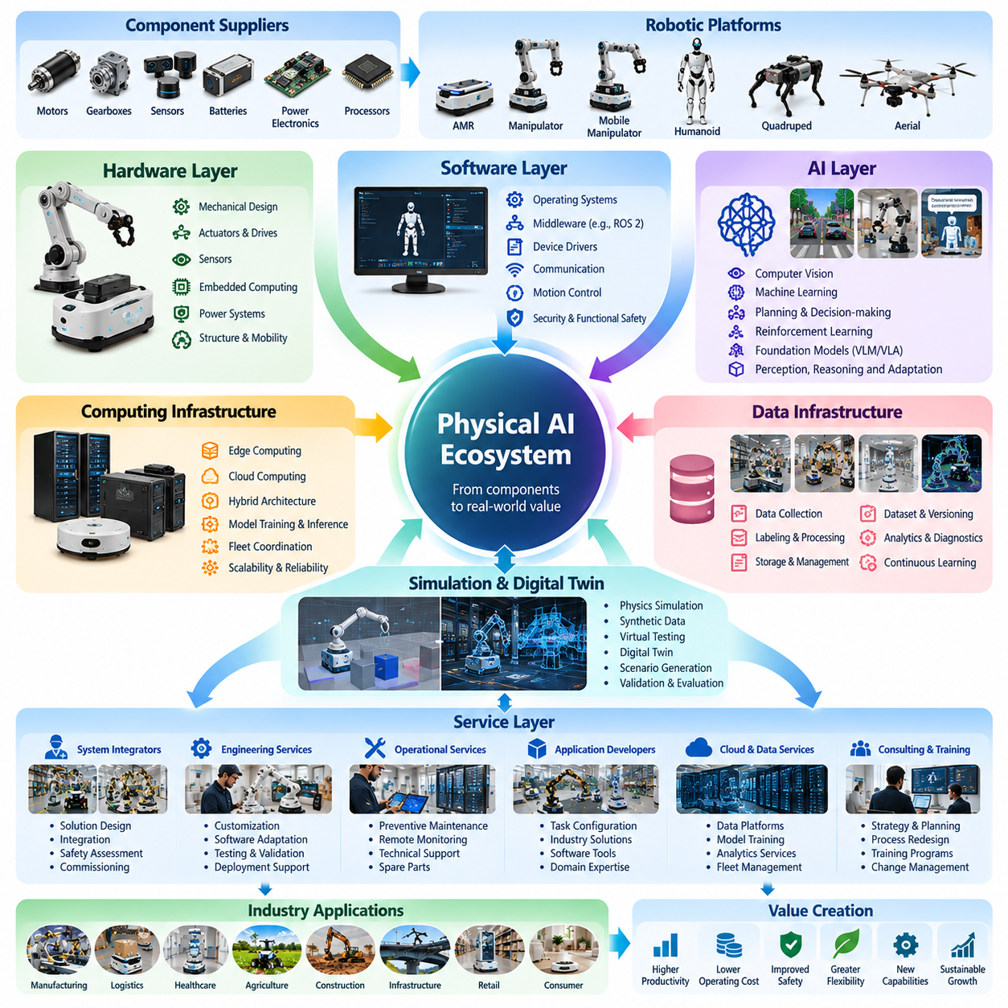
The Physical AI ecosystem consists of interconnected hardware, software, artificial intelligence, and service providers that collectively enable autonomous physical operations. Each layer contributes distinct capabilities, but commercial value emerges from their coordinated performance. A successful ecosystem must support the complete lifecycle of intelligent machines, including design, manufacturing, deployment, operation, maintenance, and continuous improvement.
Hardware forms the physical foundation of the ecosystem by providing structures, mobility mechanisms, manipulation devices, sensors, actuators, and computing equipment. Mechanical design determines the operating envelope of robotic systems, while electronic components enable sensing and control. Hardware architecture directly influences payload capacity, positioning accuracy, energy consumption, environmental resistance, and overall system reliability.
The hardware supply network includes manufacturers of motors, gearboxes, encoders, batteries, power electronics, cameras, LiDAR sensors, and embedded processors. Specialized suppliers often serve multiple robotic industries, allowing component technologies to benefit from production scale. However, component selection requires balancing technical specifications, procurement costs, availability, compatibility, and long-term maintenance requirements.
Robotic platform manufacturers integrate these components into complete machines designed for particular operating conditions. Autonomous mobile robots emphasize navigation and transportation, while manipulators prioritize precision and physical interaction. Humanoids, quadrupeds, and aerial robots introduce additional requirements involving balance, terrain adaptability, flight stability, or complex coordination. Platform architecture establishes the foundation for higher-level intelligence.
Software connects physical hardware with computational intelligence through operating systems, middleware, device drivers, communication interfaces, and control frameworks. These components manage data exchange, sensor synchronization, motion execution, and resource allocation. Modular architectures allow developers to replace or upgrade individual functions without redesigning the entire robotic system, supporting maintainability and product evolution.
Robotic middleware and development frameworks play an important role in ecosystem interoperability. ROS 2 provides communication mechanisms and reusable software structures for distributed robotic applications. Nevertheless, production systems require careful engineering for real-time responsiveness, cybersecurity, fault handling, and functional safety. Commercial software platforms therefore combine reusable frameworks with application-specific reliability and operational requirements.
Artificial intelligence provides the perception, reasoning, learning, and adaptation capabilities that distinguish Physical AI from conventional automation. Computer vision identifies objects and environmental features, while machine learning supports classification, prediction, and behavioral adaptation. Planning algorithms transform interpreted information into executable actions, allowing robots to respond to conditions that cannot be fully anticipated through fixed programming.
Advanced AI platforms increasingly incorporate foundation models, multimodal models, and vision-language-action architectures. These approaches seek to connect visual observations, natural language instructions, and physical actions within reusable computational models. Their ecosystem significance depends on practical performance, computational efficiency, safety, and the ability to transfer learned capabilities across different tasks, environments, and robotic embodiments.
Computing infrastructure connects AI algorithms with robotic execution. Edge processors provide low-latency perception and control, while cloud systems support large-scale training, simulation, analytics, and fleet coordination. Hybrid architectures distribute workloads according to timing, bandwidth, reliability, and privacy requirements. Effective computing strategies must balance processing performance, power consumption, thermal limitations, and operational continuity.
Data infrastructure supports the development and improvement of intelligent robotic behavior. Physical AI systems generate sensor streams, movement trajectories, task records, interaction histories, and failure observations. Data platforms organize these resources through storage, indexing, labeling, filtering, and version management. Reliable data pipelines enable model training, performance evaluation, operational diagnostics, and continuous improvement across deployed fleets.
Simulation providers contribute virtual environments for developing and validating robotic capabilities before physical deployment. Physics engines, digital twins, synthetic data generators, and automated testing platforms reduce dependence on expensive real-world experimentation. Their effectiveness depends on accurately representing physical dynamics, sensor behavior, environmental variation, and interaction constraints that influence real robotic performance.
The service ecosystem transforms technical capabilities into operational solutions. System integrators analyze customer requirements, configure robotic platforms, connect enterprise systems, and validate deployment performance. Engineering service providers support mechanical customization, software adaptation, safety assessment, and commissioning. Their expertise is particularly important when integrating autonomous machines into existing industrial facilities and complex operational workflows.
Operational service providers maintain system performance after installation through preventive maintenance, remote diagnostics, technical support, software updates, and fleet optimization. These activities reduce downtime and support predictable service quality. As deployments expand, lifecycle services become increasingly important because customers evaluate robotic systems through sustained productivity and reliability rather than initial technical demonstrations.
Robot-as-a-Service models create recurring commercial relationships between technology providers and customers. Instead of purchasing equipment outright, customers may pay for access to robotic capabilities, availability, or completed operations. Providers may retain responsibility for hardware, software, maintenance, and selected operational risks. Financial sustainability depends on equipment utilization, service efficiency, contract terms, and lifecycle cost management.
Ecosystem participants may adopt vertically integrated or horizontally specialized business strategies. Vertically integrated companies control multiple layers, potentially improving optimization and product consistency. Specialized providers focus on components, software, AI models, or services that support numerous platforms. Both approaches require coordination because the performance of a complete Physical AI solution depends on interactions among multiple technical and commercial participants.
Interoperability determines how efficiently ecosystem components can be combined and upgraded. Standard communication protocols, modular interfaces, common data structures, and reusable software components reduce integration complexity. Open architectures can encourage supplier diversity and innovation, while proprietary platforms may provide tightly optimized performance. Ecosystem development therefore involves balancing standardization, differentiation, compatibility, and commercial control.
Cybersecurity, functional safety, and data governance operate across every ecosystem layer. Hardware security, authenticated communication, software integrity, access management, and operational monitoring protect autonomous systems from failures and malicious interference. Safety engineering must address physical hazards arising from motion, manipulation, and human interaction. Regulatory requirements further influence product design, deployment procedures, and service responsibilities.
Industry applications shape ecosystem specialization. Manufacturing requires integration with production equipment and quality systems, while logistics emphasizes fleet coordination and throughput. Healthcare prioritizes dependable operation, privacy, and human interaction, whereas agriculture and construction demand environmental robustness. These differences encourage partnerships between general technology providers and organizations possessing detailed domain knowledge.
Partnership networks influence commercialization speed and market access. Hardware manufacturers collaborate with AI developers, software vendors, integrators, distributors, and service organizations to deliver complete solutions. Effective partnerships distribute engineering responsibilities and reduce development duplication. However, they also introduce dependencies involving technical compatibility, intellectual property, customer ownership, support obligations, and revenue sharing.
Economic value is distributed differently across ecosystem layers. Hardware suppliers generally depend on product margins and manufacturing efficiency, while software and AI providers may benefit from licensing, subscriptions, and platform adoption. Integrators generate project-based revenue, and service providers obtain recurring lifecycle income. Sustainable ecosystem development requires commercial arrangements that adequately compensate participants for their contributions and operational responsibilities.
Continuous learning creates feedback connections among hardware, software, AI, and service organizations. Operational data reveals mechanical limitations, software failures, perception errors, and changing customer requirements. These observations guide component redesign, algorithm improvements, software updates, and maintenance strategies. Organizations capable of coordinating such feedback can improve reliability and reduce deployment costs across successive product generations.
The long-term development of the Physical AI ecosystem will depend on increasingly capable intelligence, standardized hardware interfaces, scalable computing infrastructure, and mature service networks. As technologies become more reusable, competitive advantages may shift from individual components toward integrated performance and lifecycle value. Successful businesses will combine technical differentiation with dependable operations, ecosystem partnerships, and measurable customer outcomes.

01.04. AMR and Autonomous Mobility Market
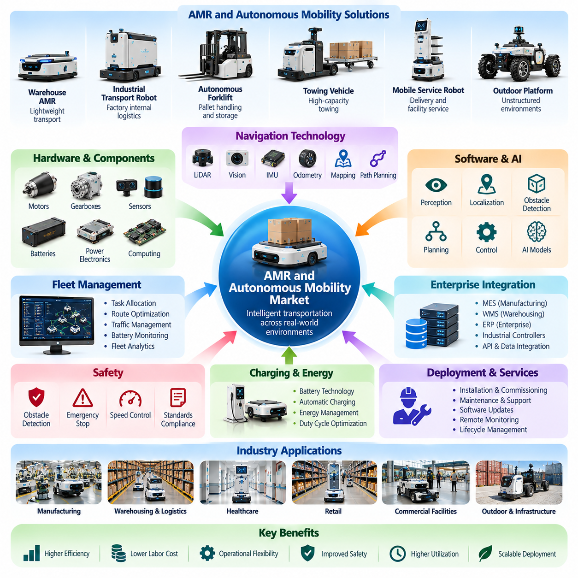
The autonomous mobile robot (AMR) and autonomous mobility market represents a major commercial segment of Physical AI, focused on intelligent machines capable of navigating and transporting materials through physical environments. Unlike fixed automation, autonomous mobility systems can adapt routes and respond to changing surroundings. Their economic value arises from improving transportation efficiency, reducing repetitive labor, and increasing operational flexibility.
The market encompasses warehouse AMRs, industrial transport robots, autonomous forklifts, towing vehicles, mobile service robots, and selected outdoor autonomous platforms. These systems differ in payload capacity, navigation technology, environmental requirements, and operational complexity. Market segmentation therefore requires distinguishing lightweight indoor transportation from heavy-duty industrial mobility and autonomous operation in unstructured environments.
Traditional automated guided vehicles (AGVs) typically rely on predefined routes, markers, or controlled navigation infrastructure. Modern AMRs increasingly employ simultaneous localization and mapping, sensor fusion, obstacle detection, and dynamic path planning. This transition enables more flexible deployment, although actual autonomy depends on environmental conditions, safety requirements, software capabilities, and the degree of human intervention required.
Manufacturing facilities represent an important application market for autonomous mobility. AMRs transport components, work-in-process materials, finished products, and production supplies between workstations. Their integration with manufacturing execution systems and production schedules can improve material availability and reduce transportation delays. Economic benefits depend on transport frequency, route complexity, equipment utilization, and production continuity.
Warehousing and distribution centers constitute another major demand segment. Autonomous robots support inventory movement, order fulfillment, goods-to-person operations, pallet transportation, and internal logistics. Their value increases when transportation tasks are frequent and predictable enough to support high utilization. Integration with warehouse management systems and warehouse execution systems enables robots to coordinate with inventory processes and fulfillment priorities.
Heavy-payload AMRs and autonomous industrial transporters address applications involving large components, machinery, pallets, and production assemblies. These platforms require stronger mechanical structures, higher-capacity drives, reliable braking, and precise load handling. Their commercial attractiveness depends on safely transporting substantial loads while maintaining positioning accuracy, maneuverability, equipment durability, and acceptable operating costs.
Autonomous forklifts extend intelligent mobility into pallet handling, storage, and vertical material movement. Compared with basic floor transportation, forklift autonomy introduces additional challenges involving load stability, mast control, pallet detection, and interaction with warehouse infrastructure. Successful commercialization requires dependable perception, precise positioning, safety validation, and compatibility with existing material-handling workflows.
Navigation technology is a major source of product differentiation within the AMR market. LiDAR-based localization, visual navigation, inertial sensing, wheel odometry, and environmental mapping provide complementary information about robot position and surroundings. Advanced systems combine these inputs to maintain reliable operation under changing conditions. Navigation performance directly influences deployment flexibility, operational safety, and productivity.
Fleet management software forms an essential commercial layer above individual robots. Fleet management systems allocate transportation tasks, coordinate routes, manage traffic, monitor battery conditions, and supervise operational status. As fleet size increases, centralized or distributed coordination becomes critical for avoiding congestion and balancing workloads. Software quality can therefore influence overall system productivity as strongly as individual robot performance.
Enterprise integration determines whether autonomous mobility creates measurable operational value. Interfaces with manufacturing execution systems, warehouse management systems, enterprise resource planning platforms, and industrial controllers allow transportation tasks to become part of coordinated workflows. Reliable integration reduces manual dispatching, improves traceability, and supports automatic responses to changing production or logistics requirements.
Safety requirements strongly influence AMR product design and market adoption. Autonomous platforms must detect obstacles, manage stopping distances, control speed, and interact safely with pedestrians and equipment. Safety engineering includes risk assessment, protective sensing, emergency stopping, and validated control functions. Industrial deployments must also consider applicable standards, facility conditions, and operational responsibilities.
Battery technology and charging infrastructure determine the practical availability of autonomous mobility systems. Battery capacity, energy consumption, charging time, and duty cycles influence how many robots are required to maintain continuous operations. Automatic charging and docking can reduce manual intervention, while fleet-level energy management supports efficient scheduling. These factors directly affect lifecycle costs and achievable utilization.
The economics of AMR deployment extend beyond equipment purchase prices. Total cost of ownership includes software, integration, charging infrastructure, maintenance, technical support, and operational supervision. Customers compare these expenses with labor savings, increased throughput, reduced transport delays, and improved workplace safety. Return on investment depends on sustained utilization and measurable improvements in operational performance.
Robot-as-a-Service models provide an alternative commercialization approach for autonomous mobility. Customers may obtain robotic transportation capacity through recurring payments rather than purchasing equipment outright. Providers can bundle hardware, fleet software, maintenance, and operational support into service contracts. This approach may reduce initial investment barriers but requires providers to manage asset utilization, reliability, financing, and lifecycle service costs.
The competitive landscape includes established industrial automation companies, specialized AMR manufacturers, autonomous forklift developers, robotics software providers, and system integrators. Competition involves hardware reliability, navigation performance, payload capability, integration flexibility, deployment speed, and service coverage. Differentiation increasingly depends on complete operational solutions rather than isolated robot specifications.
Market adoption varies according to industry structure and regional economic conditions. Facilities with high transportation volumes, standardized workflows, and significant labor constraints may achieve attractive deployment economics. Smaller operations or highly irregular environments can face greater integration challenges. Regional differences in wages, industrial infrastructure, safety regulation, and service availability further influence purchasing decisions.
Outdoor autonomous mobility expands the market beyond factories and warehouses into ports, industrial yards, campuses, agricultural facilities, and infrastructure sites. These environments introduce weather exposure, uneven terrain, changing illumination, and less predictable traffic. Commercial systems require robust localization, environmental perception, mobility hardware, and operational supervision appropriate to the complexity of their surroundings.
The development of mobile manipulation creates opportunities to combine transportation with physical handling. A mobile manipulator can navigate between workstations and interact with machines, containers, or products. This capability may expand the economic value of autonomous mobility by reducing dependence on fixed loading equipment. However, manipulation introduces additional requirements for perception, dexterity, force control, and coordinated motion.
Scalability is a central consideration for customers deploying large AMR fleets. Increasing robot numbers does not automatically produce proportional productivity improvements because traffic congestion, charging demand, and workflow bottlenecks can reduce efficiency. Effective scaling requires fleet orchestration, facility analysis, task optimization, and performance monitoring. Deployment planning must therefore consider the entire operating system rather than individual robots.
Operational data creates opportunities for continuous improvement in autonomous mobility systems. Robot fleets generate navigation histories, task completion records, traffic observations, battery information, and failure reports. Analyzing these datasets can improve route planning, predictive maintenance, fleet allocation, and operational reliability. Data-driven optimization becomes increasingly valuable as deployments expand across multiple facilities.
The future AMR market will be influenced by advances in perception, learning-based navigation, interoperable fleet platforms, energy management, and more affordable hardware. Greater autonomy may reduce deployment complexity and extend operation into less structured environments. Nevertheless, commercial success will continue to depend on safety, reliability, integration, and demonstrated economic performance rather than technological sophistication alone.
Ultimately, the AMR and autonomous mobility market illustrates how Physical AI converts intelligent perception and decision-making into measurable industrial productivity. Its development connects robotic hardware, navigation intelligence, fleet software, enterprise integration, and lifecycle services. Sustainable growth will depend on delivering dependable transportation capabilities that can be deployed repeatedly, operated efficiently, and justified through clear customer value.

01.05. Manipulator and Mobile Manipulator Market
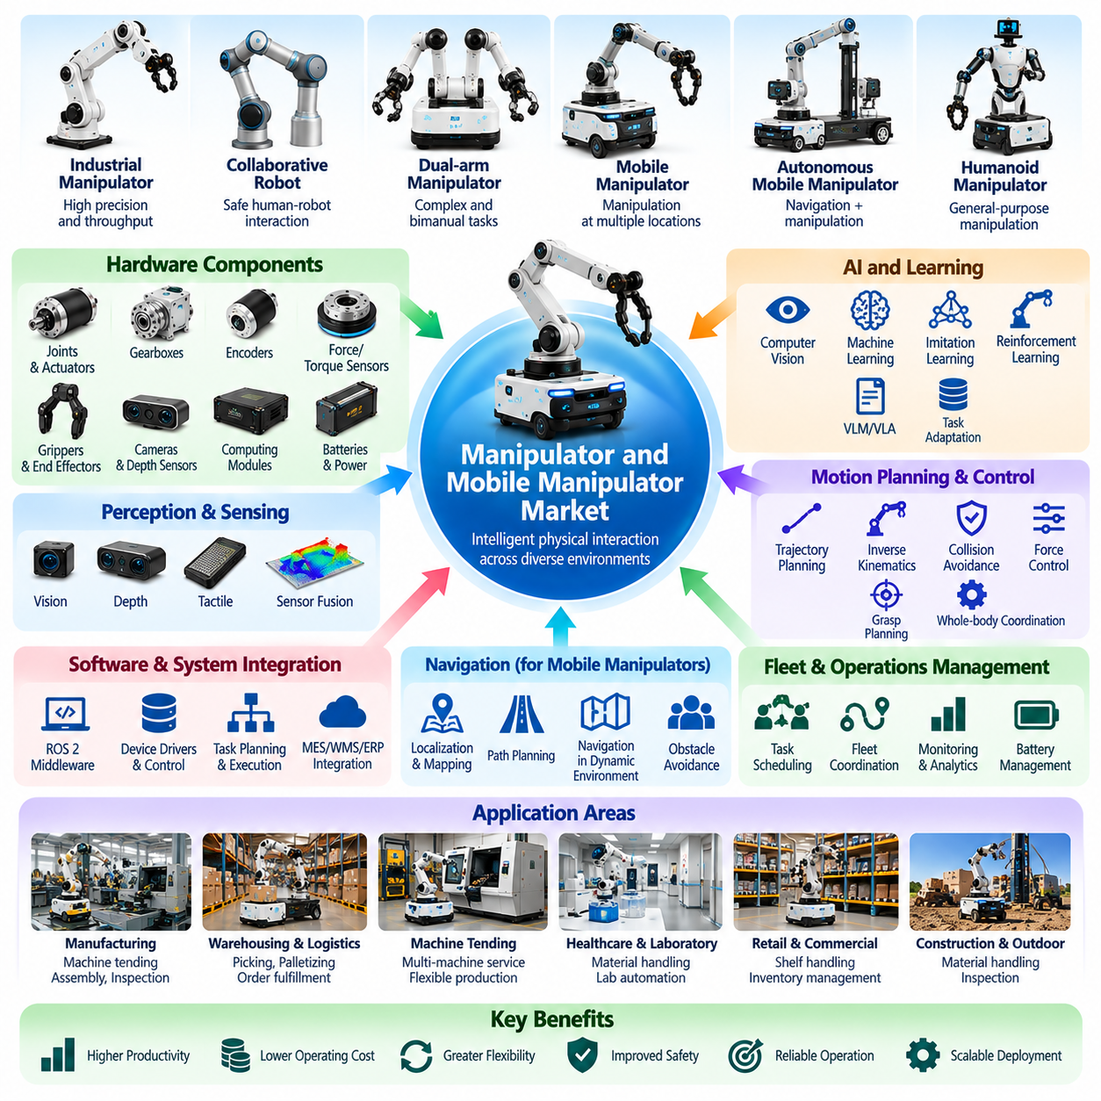
The manipulator and mobile manipulator market represents a major segment of Physical AI focused on intelligent systems capable of physically interacting with objects, tools, and industrial equipment. Manipulators provide controlled movement and object handling, while mobile manipulators combine robotic arms with autonomous mobility. Their economic value arises from automating repetitive tasks, improving production flexibility, and extending robotic capabilities across multiple workstations.
The market includes industrial robotic arms, collaborative robots, dual-arm manipulators, mobile manipulation platforms, and specialized handling systems. These products differ in payload capacity, reach, degrees of freedom, precision, and operational autonomy. Market segmentation must distinguish fixed industrial manipulation, human-robot collaboration, autonomous mobile manipulation, and emerging general-purpose robotic systems.
Traditional industrial manipulators operate primarily within structured production environments using programmed trajectories and predefined sequences. They provide high repeatability, positioning accuracy, and production throughput for tasks such as welding, assembly, and machine loading. Their commercial success depends on predictable operating conditions, reliable tooling, high utilization, and integration with established manufacturing processes.
Collaborative robots expand the manipulation market by supporting applications where humans and robots operate within shared workspaces. Their designs incorporate appropriate sensing, force limitations, and safety functions according to application requirements. Collaborative operation can reduce certain integration barriers, but actual safety depends on the complete robotic application, including tools, payloads, movement speeds, and surrounding equipment.
Mobile manipulators integrate robotic arms with autonomous mobile bases, enabling manipulation tasks at multiple physical locations. Unlike fixed robots, these systems can navigate between workstations and interact with machines, shelves, containers, and production materials. Their commercial potential comes from combining transportation and handling capabilities, although reliable operation requires coordination between navigation, positioning, manipulation, and safety systems.
Manufacturing represents an important application market for robotic manipulation. Industrial robots perform machine tending, assembly, material transfer, inspection, packaging, and precision handling. Mobile manipulators can support flexible production by servicing multiple machines or work cells. Their economic attractiveness depends on cycle time, production volume, changeover frequency, task variability, and the cost of integrating robotic operations into existing facilities.
Warehousing and logistics create growing opportunities for intelligent manipulation systems. Robotic arms support parcel sorting, palletizing, depalletizing, and order picking, while mobile manipulators can retrieve or place items across distributed storage locations. Commercial performance depends on object diversity, grasp success rates, handling speed, inventory accessibility, and integration with warehouse management and fulfillment systems.
Machine tending is a particularly relevant application because many industrial processes require repetitive loading, unloading, and equipment interaction. A mobile manipulator may service multiple CNC machines, inspection stations, or production cells according to changing schedules. This flexibility can improve equipment utilization, but dependable operation requires accurate docking, reliable gripping, machine interfaces, and predictable task execution.
Manipulation hardware forms a substantial part of the market ecosystem. Robotic joints, servo motors, gear reducers, encoders, force sensors, grippers, and end effectors determine physical performance. Their characteristics influence payload capacity, repeatability, stiffness, speed, energy consumption, and maintenance requirements. Hardware selection must balance mechanical capability with system cost, safety, and long-term operational reliability.
End effectors represent an important specialization within the manipulation market. Mechanical grippers, vacuum systems, magnetic tools, and adaptive hands enable robots to interact with different object categories. Their commercial value depends on grasp reliability, object compatibility, changeover time, and maintenance requirements. Advanced dexterous hands may expand task versatility but introduce additional complexity in sensing, control, and mechanical durability.
Perception technology enables manipulators to operate beyond precisely structured environments. Cameras, depth sensors, tactile sensors, and force-torque sensors provide information about object geometry, position, contact, and interaction forces. Computer vision and sensor fusion support object recognition, pose estimation, grasp planning, and visual servoing. Reliable perception is essential when objects vary in shape, orientation, placement, or material properties.
Artificial intelligence increasingly contributes to manipulation planning and adaptive control. Machine learning, imitation learning, reinforcement learning, and vision-language-action models can support task acquisition and behavioral adaptation. These approaches seek to reduce manual programming and improve generalization across objects and environments. Commercial adoption depends on consistent physical performance, safety validation, computational efficiency, and manageable training requirements.
Motion planning and control software connect intelligent decisions with physical execution. Inverse kinematics, trajectory optimization, collision avoidance, force control, and whole-body coordination determine how manipulators move and interact with their surroundings. Mobile manipulation introduces additional challenges because the robotic arm and mobile base must operate as a coordinated system while maintaining stability, positioning accuracy, and safe motion.
Dual-arm manipulation creates opportunities for handling large objects, coordinating assembly operations, and performing tasks requiring simultaneous interactions. Such systems may reproduce selected capabilities associated with human bimanual work. However, coordinated manipulation increases planning complexity, collision risks, sensing requirements, and hardware costs. Commercial viability depends on whether the additional flexibility produces sufficient productivity benefits.
The competitive landscape includes established industrial robot manufacturers, collaborative robot suppliers, mobile manipulator developers, gripper manufacturers, AI software companies, and system integrators. Competition involves hardware reliability, precision, payload capability, programming flexibility, integration complexity, and service availability. Emerging providers may differentiate through intelligent manipulation software and reusable task capabilities rather than mechanical performance alone.
System integration is a critical factor in commercial deployment. Manipulators must interface with production machines, conveyors, fixtures, safety systems, and enterprise software. Mobile manipulators additionally require navigation infrastructure, fleet coordination, and reliable docking procedures. Integration costs can become significant when facilities contain heterogeneous equipment or workflows that were not originally designed for robotic automation.
Safety requirements strongly influence manipulation system design and market acceptance. Industrial robots must manage collision risks, unexpected motion, tool hazards, and interactions with human workers. Safety engineering includes risk assessment, protective devices, emergency stopping, safe motion functions, and operational procedures. Mobile manipulators require additional consideration of combined movement, stability, payload handling, and changing environmental conditions.
The economics of robotic manipulation depend on more than acquisition prices. Total cost of ownership includes end effectors, programming, integration, maintenance, software, operator training, and production downtime. Customers evaluate these costs against labor savings, throughput improvements, quality consistency, and equipment utilization. Flexible systems may justify higher initial costs when they can perform multiple tasks or adapt to changing production requirements.
Robot-as-a-Service and subscription-based models may reduce initial investment barriers for manipulation automation. Providers can combine robotic hardware, intelligent software, maintenance, and operational support into recurring contracts. However, manipulation tasks often require substantial application customization, making service economics sensitive to integration costs, task variability, equipment utilization, and customer-specific operating requirements.
The future market will be influenced by advances in dexterous manipulation, multimodal perception, foundation models, adaptive control, and affordable robotic hardware. Improvements in generalization may reduce programming effort and expand applications beyond highly structured environments. Nevertheless, widespread commercialization requires dependable task completion, safe interaction, predictable maintenance, and measurable economic benefits.
Ultimately, the manipulator and mobile manipulator market demonstrates how Physical AI transforms perception, reasoning, and control into productive physical interaction. Fixed manipulators provide established industrial automation capabilities, while mobile manipulation extends flexibility across changing workspaces. Sustainable market growth will depend on combining reliable hardware, adaptable intelligence, efficient integration, and economically justified deployment.

01.06. Humanoid Robot Market
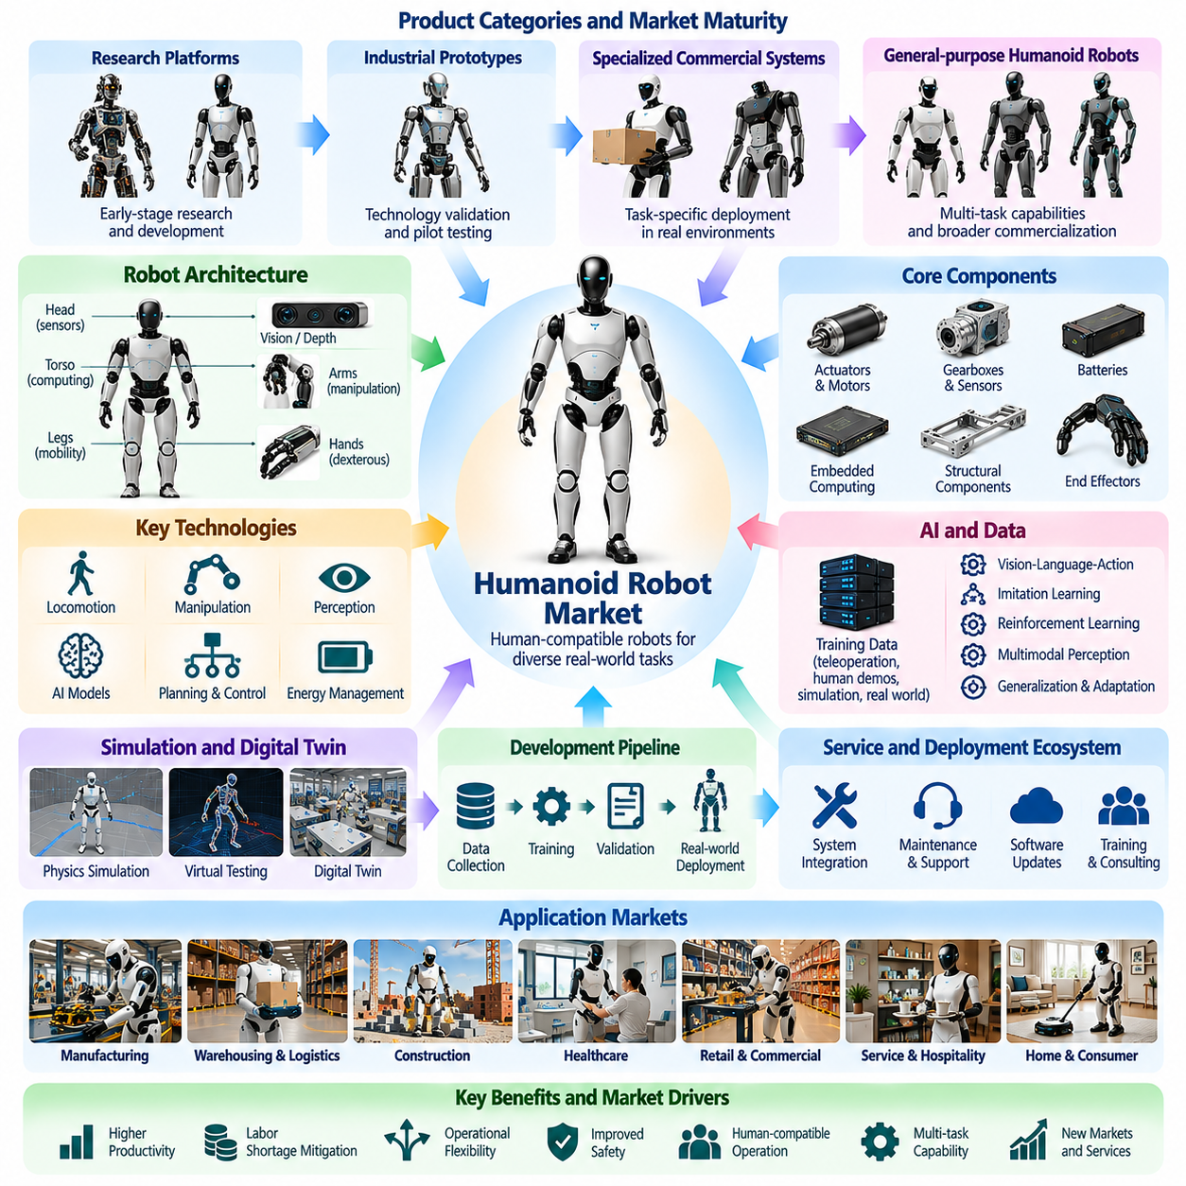
The humanoid robot market represents an emerging segment of Physical AI focused on robots designed to perform physical tasks within environments originally developed for humans. Humanoid systems combine mobility, manipulation, perception, and intelligent control within a human-inspired body structure. Their commercial potential arises from the possibility of automating diverse activities without requiring extensive modifications to existing workplaces.
Humanoid robots typically incorporate articulated legs, arms, hands, torso structures, and sensor-equipped heads or upper bodies. Their morphology enables interaction with stairs, doors, tools, shelves, and workstations designed around human dimensions. However, human-like appearance alone does not guarantee practical utility. Commercial performance depends on stability, manipulation capability, energy efficiency, safety, and reliable task completion.
The humanoid market includes research platforms, industrial prototypes, specialized commercial systems, and emerging general-purpose robotic products. These categories differ substantially in technological maturity, operational autonomy, payload capability, and deployment readiness. Market evaluation must therefore distinguish laboratory demonstrations and pilot programs from commercially validated systems capable of sustained operation.
Manufacturing represents a potential early market for humanoid robots because many factories contain tasks originally designed for human workers. Applications may include material handling, machine tending, component transportation, inspection, and repetitive assembly support. Humanoids could operate across multiple workstations, although their economic advantages must be compared with fixed manipulators, AMRs, and conventional automation.
Warehousing and logistics provide additional opportunities for humanoid deployment. Potential tasks include tote handling, parcel movement, shelf interaction, sorting, and loading assistance. Human-compatible morphology may allow operation within existing warehouse layouts, but practical performance requires reliable grasping, stable locomotion, and appropriate handling speed. Specialized logistics robots may remain more efficient for narrowly defined tasks.
The commercial justification for humanoid robots depends on their ability to perform multiple useful tasks within a shared hardware platform. General-purpose capability could reduce the need for separate machines dedicated to individual operations. Nevertheless, versatility introduces engineering complexity and may compromise performance on specific tasks. Customers must evaluate whether broader flexibility produces measurable economic benefits.
Locomotion technology is a central determinant of humanoid market maturity. Bipedal robots must maintain balance while walking, turning, stopping, carrying objects, and responding to disturbances. Uneven floors, stairs, obstacles, and unexpected contact increase control complexity. Reliable locomotion requires coordinated sensing, dynamic modeling, actuator control, and recovery strategies suitable for real operating environments.
Manipulation capability is equally important because many commercially valuable tasks require physical interaction rather than movement alone. Humanoid arms and hands must reach objects, generate appropriate forces, maintain stable grasps, and coordinate with body motion. Dexterous manipulation remains challenging when objects vary in shape, weight, and placement. Practical systems must balance hand complexity with durability and maintenance requirements.
Humanoid hardware architecture creates distinctive cost and reliability challenges. High-performance actuators, precision transmissions, joint sensors, embedded computers, and structural components must operate within strict weight and power constraints. Mechanical complexity increases assembly effort and potential maintenance requirements. Commercial scalability depends on improving component reliability, manufacturability, supply availability, and production economics.
Energy management strongly influences practical humanoid operation. Walking, balancing, lifting, and manipulation can require substantial electrical power, while onboard batteries impose limitations on operating duration and payload. Charging strategies, thermal management, and power-efficient control affect availability. Market adoption will depend partly on whether useful operating time can justify charging interruptions and infrastructure costs.
Artificial intelligence provides the perception, reasoning, planning, and adaptation capabilities required for flexible humanoid behavior. Vision-language-action models, imitation learning, reinforcement learning, and multimodal perception may support reusable task skills. However, successful demonstrations do not necessarily establish reliable generalization. Commercial systems require consistent performance across unfamiliar objects, environmental changes, and operational disturbances.
Training data represents a significant competitive resource in humanoid development. Teleoperation, human demonstrations, simulation, and real-world robot experience can provide examples of locomotion and manipulation behavior. Data quality, diversity, and embodiment compatibility influence model performance. Developers must establish efficient learning pipelines while managing the cost and complexity of collecting physical interaction data.
Simulation and digital twin technologies support humanoid development by enabling repeated experiments without exposing expensive hardware to every training failure. Virtual environments can accelerate locomotion learning, manipulation testing, and safety evaluation. Nevertheless, differences between simulated and physical systems remain important. Effective deployment requires validation under real-world contact dynamics, sensor uncertainty, and hardware limitations.
Safety engineering is particularly important because humanoids may operate near people while combining whole-body movement with object manipulation. Potential hazards include falls, unintended contact, dropped objects, and unexpected actuator behavior. Protective design, controlled motion, emergency stopping, and operational supervision are essential. Safety validation must consider the complete application rather than relying solely on robot-level capabilities.
The competitive landscape includes established robotics manufacturers, specialized humanoid developers, artificial intelligence companies, actuator suppliers, and industrial technology providers. Companies pursue different combinations of proprietary hardware, integrated software, foundation models, and manufacturing partnerships. Competitive differentiation involves task reliability, deployment readiness, hardware cost, autonomy, serviceability, and access to operational data.
Humanoid commercialization also requires a supporting service ecosystem. System integrators must configure work environments, connect enterprise applications, validate tasks, and establish operating procedures. Maintenance providers must address joint wear, actuator failures, battery replacement, and software updates. Reliable technical support becomes increasingly important as deployments move from supervised demonstrations toward sustained industrial operations.
Economic evaluation must account for total cost of ownership rather than robot purchase price alone. Relevant expenses include hardware, software, training, integration, supervision, maintenance, charging, and downtime. Customers compare these costs with productive operating hours, task completion rates, labor requirements, and flexibility. Economic feasibility depends on sustained performance under realistic conditions rather than theoretical labor substitution.
Robot-as-a-Service models may provide a commercial pathway for humanoid adoption by reducing initial customer investment. Providers could offer task capacity or robot availability through recurring contracts that include maintenance and software support. However, financial viability requires dependable utilization, predictable service costs, and clearly defined responsibilities. Immature hardware or frequent human intervention can undermine service profitability.
Market adoption is likely to progress through controlled environments and carefully selected applications before expanding into more unpredictable settings. Industrial pilots provide opportunities to measure reliability, safety, task performance, and integration requirements. Broader deployment will depend on repeatable operational results and improved economics. Market forecasts should distinguish announced production targets from verified deliveries and productive installations.
Humanoid robots face strong competition from alternative automation architectures. Fixed robotic arms may provide superior precision and throughput, while wheeled mobile manipulators often offer simpler mobility and lower energy consumption. Humanoid morphology becomes attractive when human-oriented infrastructure or task diversity provides meaningful advantages. The appropriate robotic form should therefore be selected according to operational requirements.
The long-term humanoid market will be shaped by advances in whole-body control, dexterous hands, foundation models, actuator technology, and scalable manufacturing. Improvements in learning and hardware efficiency may expand the range of economically viable applications. Nevertheless, general-purpose autonomy remains a demanding objective, and technological progress must be evaluated against safety, reliability, and sustained productivity.
Ultimately, the humanoid robot market illustrates both the ambition and commercial challenges of Physical AI. Human-compatible embodiment offers the possibility of performing diverse physical tasks within existing infrastructure, but versatility alone does not establish economic value. Sustainable growth will depend on converting advanced robotic capabilities into dependable, repeatable, and cost-effective operations that solve genuine customer problems.

01.07. Quadruped and Field Robot Market
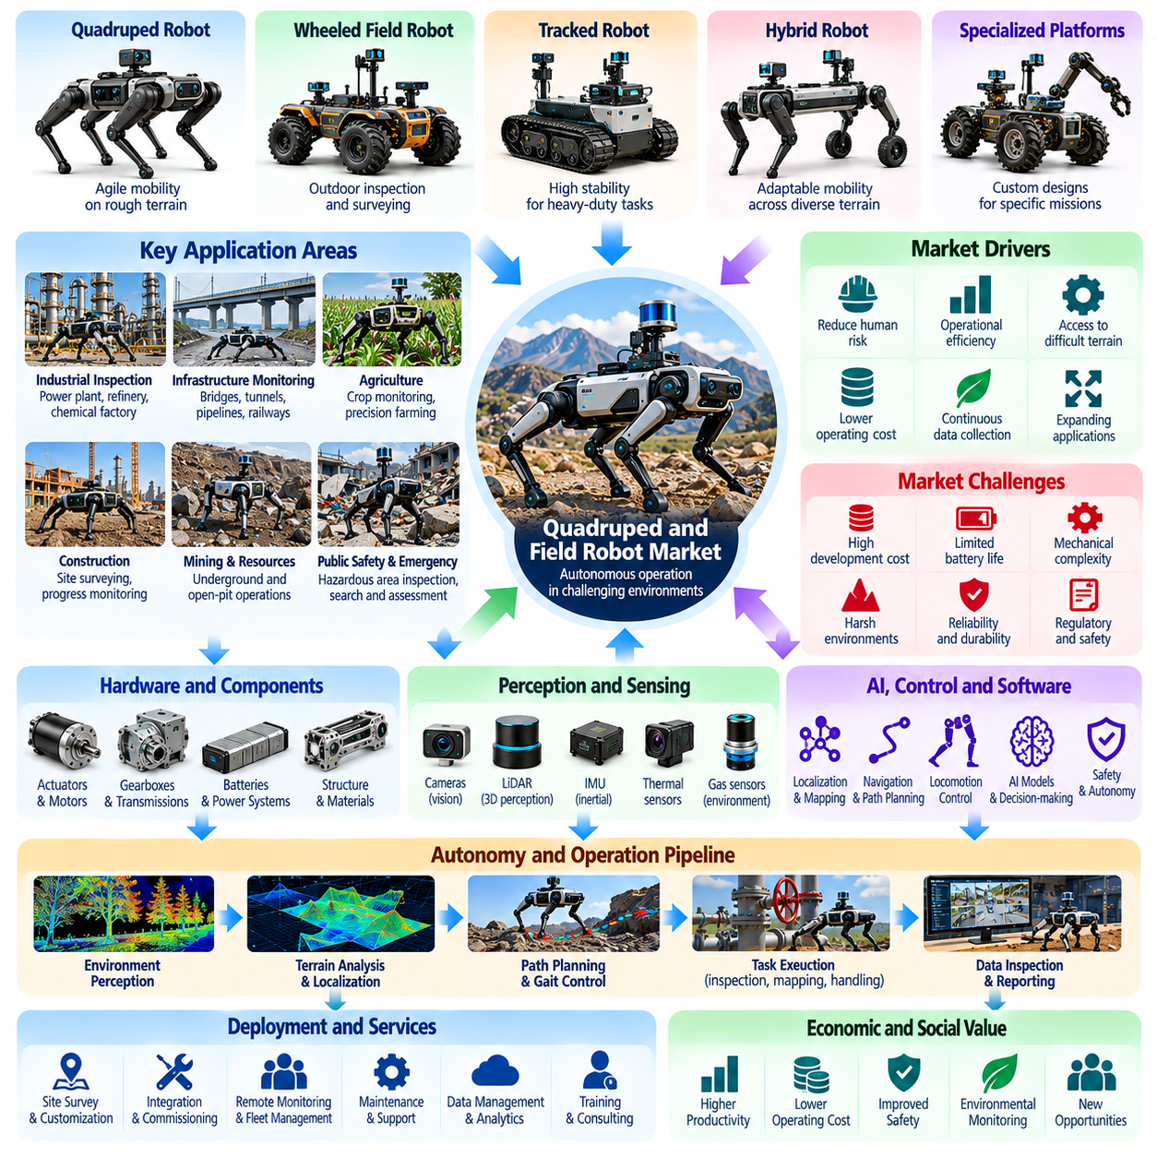
The quadruped and field robot market represents a specialized segment of Physical AI focused on autonomous operation in environments where conventional wheeled robots face mobility limitations. Quadruped robots use articulated legs to navigate uneven terrain, stairs, and obstacles, while field robots encompass broader platforms designed for outdoor and industrial tasks. Their commercial value arises from improved accessibility, reduced human exposure to hazards, and automated field operations.
The market includes quadruped inspection robots, agricultural robots, construction robots, mining platforms, infrastructure monitoring systems, and autonomous environmental survey vehicles. These systems differ in mobility architecture, payload capacity, environmental protection, and operational autonomy. Market segmentation must distinguish legged robotic platforms from wheeled, tracked, and hybrid field robots according to application requirements.
Quadruped robots offer distinctive mobility advantages through coordinated leg movement and adaptive foot placement. Their mechanical configuration allows traversal of irregular surfaces, narrow passages, and obstacles that may restrict wheeled platforms. However, legged locomotion introduces greater mechanical complexity, control requirements, and energy consumption. Commercial adoption depends on whether terrain accessibility justifies these additional costs.
Industrial inspection represents an important early market for quadruped robots. Facilities such as power plants, refineries, chemical factories, and industrial complexes require repeated inspection of equipment and infrastructure. Quadruped platforms can carry cameras, thermal sensors, acoustic instruments, and gas detectors to collect operational information. Their economic value depends on inspection frequency, data quality, safety improvements, and reduced manual effort.
Infrastructure monitoring creates opportunities for autonomous robots operating around bridges, tunnels, railways, pipelines, and utility installations. Field robots can collect visual, thermal, acoustic, and geometric information to identify abnormal conditions or maintenance requirements. Their effectiveness depends on environmental accessibility, localization accuracy, sensor reliability, and integration with asset management systems used by infrastructure operators.
Agriculture represents a broad application market for field robotics. Autonomous platforms can support crop monitoring, soil analysis, precision spraying, harvesting assistance, and transportation within agricultural environments. Wheeled and tracked vehicles remain attractive for many structured agricultural tasks, while legged robots may provide advantages in difficult terrain. Commercial viability depends on seasonal utilization, operating costs, and measurable improvements in agricultural productivity.
Construction sites introduce demanding conditions involving uneven ground, temporary obstacles, dust, weather exposure, and changing work layouts. Field robots can support site surveying, progress monitoring, material inspection, and selected transportation activities. Quadruped mobility may improve access to stairs and partially completed structures. However, dependable deployment requires robust perception, navigation, safety procedures, and adaptation to continuously changing environments.
Mining and resource extraction provide additional opportunities for autonomous field systems. Underground passages, remote extraction sites, and hazardous inspection areas can expose workers to significant operational risks. Robots equipped with mapping sensors, environmental detectors, and communication systems may support exploration and monitoring. Market adoption depends on ruggedness, reliable communication, autonomous navigation, and demonstrated safety benefits.
Public safety and emergency response represent specialized applications where field robots may enter dangerous or inaccessible locations. Potential missions include environmental assessment, remote inspection, and situational awareness in disaster-affected areas. Such deployments require robust mobility, reliable sensing, and effective human supervision. Their value is primarily associated with reducing personnel exposure and improving access to critical information.
Mobility hardware forms a major source of differentiation in the quadruped market. Joint actuators, transmissions, structural materials, foot mechanisms, and onboard batteries determine movement performance and durability. Design choices influence walking speed, payload capacity, obstacle negotiation, energy efficiency, and maintenance requirements. Manufacturers must balance mobility capability with mechanical simplicity, production cost, and operational reliability.
Locomotion control is a critical technological capability for quadruped robots. Dynamic balance, gait generation, terrain estimation, and contact planning enable coordinated movement across irregular surfaces. Advanced controllers may combine model-based optimization with learned policies to improve adaptability. Commercial systems must maintain predictable behavior despite uncertain ground conditions, payload changes, and unexpected disturbances.
Perception and localization technologies allow field robots to operate where conventional navigation infrastructure is unavailable. LiDAR, stereo cameras, inertial sensors, satellite positioning, and visual odometry provide complementary information about terrain and robot movement. Sensor fusion supports mapping, obstacle avoidance, and route planning. Reliable operation requires handling changing illumination, weather, vegetation, dust, and degraded positioning signals.
Autonomy levels vary considerably across field robotics applications. Some systems follow predefined inspection routes, while others perform adaptive navigation or respond to changing mission conditions. Human operators may remain responsible for mission approval, exception handling, and remote intervention. Commercial maturity should therefore be evaluated through actual autonomous operating performance rather than demonstrations of isolated navigation capabilities.
Payload integration expands the commercial usefulness of quadruped and field robots. Inspection sensors, environmental instruments, robotic arms, communication equipment, and specialized tools allow a common platform to support multiple missions. However, additional payloads affect balance, energy consumption, and mobility performance. Modular payload interfaces can improve flexibility while reducing customization and maintenance complexity.
Fleet management and remote operation platforms support coordinated deployment across large industrial sites. Operators can schedule inspection missions, monitor robot status, review collected data, and manage exceptions from centralized systems. Connectivity limitations may require onboard autonomy and local data storage. Effective fleet software reduces operational supervision requirements and improves the consistency of repeated field activities.
Environmental durability is essential for commercial field robotics. Robots may encounter rain, dust, temperature extremes, vibration, mud, and corrosive substances. Mechanical sealing, thermal management, protective materials, and reliable electrical systems influence service life. Environmental protection must be matched to the actual application because laboratory mobility performance does not necessarily translate into dependable field operation.
Safety and regulatory considerations influence deployment in industrial and public environments. Robots must manage collision hazards, unexpected motion, unstable terrain, and interactions with nearby personnel. Risk assessment, emergency stopping, operational boundaries, and remote supervision contribute to safe operation. Outdoor deployments may also involve site permissions, communications requirements, and industry-specific safety procedures.
The competitive landscape includes specialized quadruped manufacturers, agricultural automation companies, industrial inspection providers, autonomous vehicle developers, and robotics software suppliers. Competition involves mobility performance, sensor integration, operational endurance, reliability, software capability, and service support. Commercial differentiation increasingly depends on delivering complete application solutions rather than demonstrating exceptional locomotion alone.
Economic evaluation requires consideration of total cost of ownership, including robot hardware, sensors, integration, maintenance, batteries, communications, and operator supervision. Customers compare these costs with inspection labor, equipment downtime, safety exposure, and operational coverage. Return on investment is strongest when robots perform frequent, valuable tasks that would otherwise require substantial human effort or hazardous access.
Service-based business models may support adoption by providing inspection or field operation capabilities without requiring customers to own robotic equipment. Providers can combine robots, sensors, mission software, data analytics, and maintenance into recurring contracts. Financial sustainability depends on utilization, mission reliability, service logistics, and the ability to deliver actionable information rather than raw sensor recordings.
The future market will be influenced by improvements in legged locomotion, energy efficiency, multimodal perception, autonomous planning, and ruggedized hardware. Learning-based control may expand operation across unfamiliar terrain, while standardized payload interfaces can support additional applications. Nevertheless, practical growth will depend on reliable field performance, manageable maintenance, and clear economic advantages over alternative technologies.
Ultimately, the quadruped and field robot market demonstrates how Physical AI extends autonomous capabilities into complex physical environments. Quadrupeds provide specialized mobility, while broader field robots address diverse outdoor and industrial requirements. Sustainable commercialization will depend on matching robotic architecture to actual mission needs and delivering dependable, safe, and economically valuable operations.

01.08. Aerial and Autonomous Logistics Market
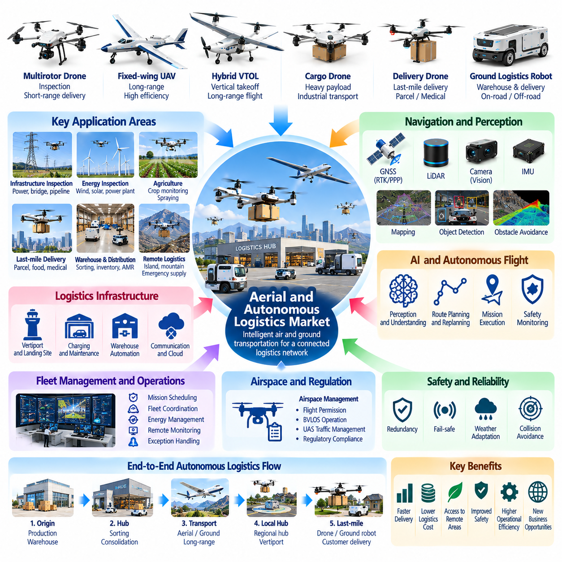
The aerial robotics and autonomous logistics market represents an expanding segment of Physical AI focused on intelligent transportation, inspection, and delivery across airborne and ground-based environments. Aerial robots provide mobility beyond conventional surface constraints, while autonomous logistics systems coordinate physical goods movement. Their commercial value arises from faster access, improved delivery flexibility, reduced operational labor, and more efficient logistics networks.
The market includes multirotor drones, fixed-wing unmanned aircraft, hybrid vertical takeoff platforms, autonomous delivery vehicles, warehouse robots, and integrated logistics systems. These platforms differ in payload capacity, flight endurance, operating range, infrastructure requirements, and autonomy. Market segmentation must distinguish aerial inspection, cargo transportation, last-mile delivery, and coordinated multimodal logistics operations.
Aerial robot morphology strongly influences commercial applications. Multirotor systems provide hovering and precise positioning, making them suitable for inspection and short-range transportation. Fixed-wing aircraft offer greater aerodynamic efficiency for longer missions, while hybrid platforms combine vertical takeoff with forward flight. Platform selection depends on payload requirements, operating distance, landing infrastructure, and environmental conditions.
Industrial inspection remains an established commercial application for aerial robotics. Drones equipped with visual cameras, thermal sensors, and specialized instruments can inspect power lines, wind turbines, industrial facilities, and infrastructure assets. Autonomous flight planning and repeatable data collection improve inspection consistency. Economic benefits depend on reduced access costs, inspection frequency, data quality, and operational safety.
Autonomous aerial delivery introduces opportunities for transporting parcels, medical supplies, replacement components, and time-sensitive materials. Such systems may improve accessibility in remote regions or locations with limited ground transportation infrastructure. However, delivery economics depend on payload weight, mission distance, weather availability, regulatory permissions, and the efficiency of loading and receiving operations.
Last-mile delivery represents a highly visible but operationally demanding market segment. Autonomous drones and ground delivery robots seek to reduce the cost and complexity of moving goods from distribution facilities to final destinations. Commercial feasibility depends on delivery density, customer accessibility, route predictability, and infrastructure compatibility. Human supervision and exception handling remain important cost factors.
Warehouse and distribution automation provides the foundation for broader autonomous logistics networks. AMRs, autonomous forklifts, robotic sorters, and conveyor systems coordinate inventory movement and order fulfillment. Aerial platforms may support inventory inspection or specialized transportation where appropriate. Effective logistics automation requires synchronization between storage systems, transportation assets, scheduling software, and enterprise operations.
Autonomous cargo drones target applications requiring transportation of heavier payloads across industrial sites, remote facilities, or geographically separated locations. Their development requires high-capacity propulsion, structural reliability, stable flight control, and dependable payload attachment. Commercial adoption depends on achieving sufficient transportation efficiency while managing energy consumption, maintenance requirements, and operational restrictions.
Navigation and localization technologies are essential for reliable aerial autonomy. Satellite positioning, inertial navigation, visual odometry, LiDAR, and environmental mapping provide complementary information about aircraft movement and surroundings. Advanced systems combine these inputs to support obstacle avoidance and trajectory planning. Navigation robustness becomes particularly important near buildings, vegetation, and areas with degraded positioning signals.
Artificial intelligence contributes to autonomous flight through perception, route planning, environmental understanding, and adaptive decision-making. Learning-based methods may improve obstacle recognition, landing-site assessment, and responses to changing conditions. However, commercial systems require predictable behavior under uncertainty. AI capabilities must therefore operate within validated flight control, safety monitoring, and mission management architectures.
Fleet management software connects individual aerial and ground robots into coordinated logistics operations. These platforms allocate missions, schedule vehicles, monitor energy availability, manage maintenance, and respond to operational exceptions. Mixed fleets introduce additional complexity because different vehicles have distinct payload capacities, speeds, and operating constraints. Effective orchestration improves asset utilization and delivery reliability.
Airspace management and regulatory compliance are major determinants of aerial market development. Commercial operations may require aircraft registration, operator authorization, flight permissions, and compliance with airspace restrictions. Beyond-visual-line-of-sight operations introduce additional requirements for risk management and operational assurance. Regulatory conditions vary across jurisdictions and influence deployment speed, service coverage, and business viability.
Safety engineering addresses hazards involving aircraft failures, collisions, falling payloads, and interactions with people or infrastructure. Commercial platforms require appropriate redundancy, emergency procedures, reliable communication, and fault detection. Ground delivery systems face different risks involving pedestrians, vehicles, and public pathways. Safety validation must consider the complete operating environment rather than individual robotic components alone.
Energy storage and propulsion technology strongly influence aerial logistics economics. Battery capacity, motor efficiency, aerodynamic design, and payload weight determine flight duration and useful operating range. Charging infrastructure and battery replacement strategies affect turnaround time and fleet availability. Higher payload capacity may increase transportation value but also creates additional energy, structural, and maintenance demands.
Weather resilience remains a significant limitation for many aerial applications. Wind, precipitation, temperature variation, and reduced visibility can restrict flight operations or increase energy consumption. Autonomous logistics services must account for these limitations when planning routes and promising delivery performance. Reliable commercialization requires realistic operating envelopes, contingency procedures, and alternative transportation arrangements.
Ground and aerial logistics systems can complement one another through multimodal transportation architectures. Ground robots provide efficient movement within facilities and accessible road networks, while aerial platforms may overcome geographical barriers or serve time-critical destinations. Coordinated operations require standardized handoff procedures, shared mission information, and compatible logistics infrastructure. Their value depends on reducing total network cost rather than maximizing individual vehicle autonomy.
Infrastructure requirements extend beyond robotic vehicles themselves. Autonomous logistics networks may need charging stations, docking facilities, landing zones, loading mechanisms, secure storage, and communications systems. These investments influence deployment economics and geographical coverage. Infrastructure standardization can reduce expansion costs, while highly customized installations may limit scalability and increase operational complexity.
The competitive landscape includes drone manufacturers, autonomous delivery developers, logistics technology companies, robotics software providers, infrastructure operators, and system integrators. Competition involves transportation cost, payload capability, operational reliability, regulatory readiness, and service coverage. Commercial differentiation increasingly depends on integrated logistics performance rather than aircraft specifications or autonomous navigation demonstrations.
Economic evaluation requires a comprehensive view of transportation costs. Total cost of ownership includes vehicles, batteries, charging equipment, software, infrastructure, maintenance, insurance, and operational supervision. Customers compare these expenses with delivery speed, service availability, labor requirements, and logistics efficiency. Financial viability depends on sustained utilization, appropriate mission selection, and reliable completion rates.
Service-based business models may accelerate adoption by allowing customers to purchase delivery or inspection outcomes rather than robotic equipment. Providers can combine vehicles, fleet software, operational personnel, maintenance, and data services into recurring contracts. However, profitability depends on mission density, asset utilization, regulatory compliance, and predictable service costs. Business models must reflect the practical limitations of autonomous operations.
The future aerial and autonomous logistics market will be influenced by advances in perception, energy efficiency, autonomous coordination, and regulatory frameworks. Improved interoperability may enable larger networks combining drones, ground robots, and automated distribution facilities. Nevertheless, sustainable expansion requires dependable operations, public acceptance, manageable infrastructure costs, and demonstrated economic advantages over conventional transportation.
Ultimately, the aerial robotics and autonomous logistics market illustrates how Physical AI extends intelligent mobility into interconnected transportation networks. Aerial platforms provide distinctive access and operational flexibility, while autonomous logistics systems coordinate goods movement across multiple environments. Long-term growth will depend on integrating reliable robotics, intelligent software, safe operations, and economically sustainable delivery services.

01.09. Robot Foundation Model and AI Platform Market
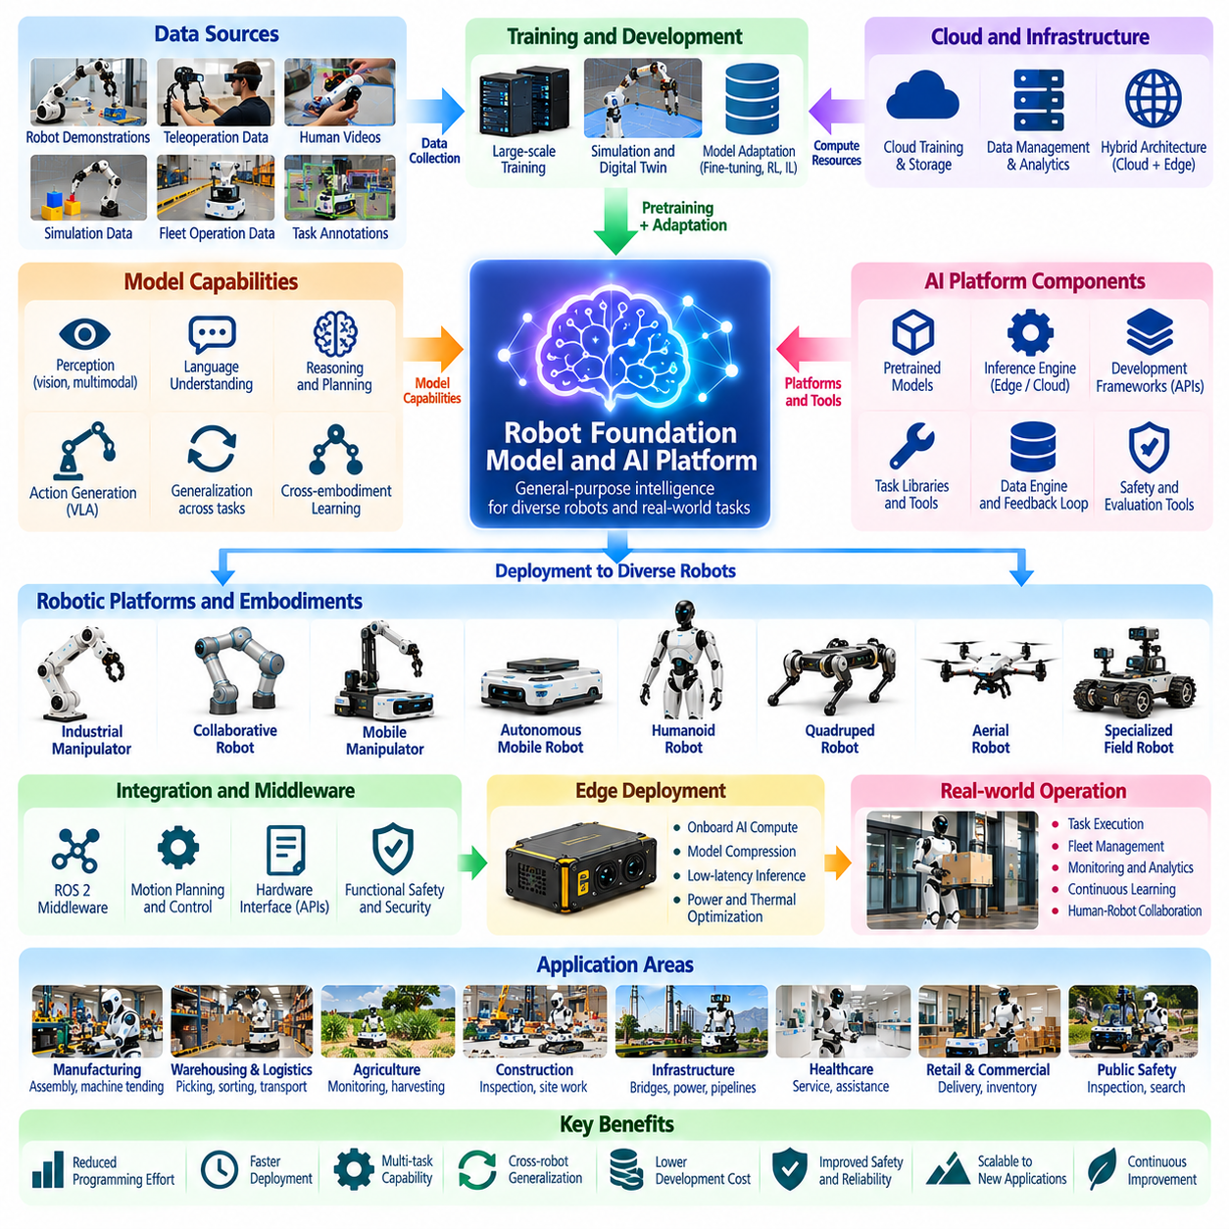
The robot foundation model and AI platform market represents an emerging software and intelligence layer within the Physical AI ecosystem. Unlike conventional robotics software designed for specific machines and tasks, foundation models seek to provide reusable capabilities across multiple robotic applications. Their commercial potential comes from reducing task-specific programming, accelerating deployment, and enabling more adaptable physical automation.
Robot foundation models are trained on diverse combinations of visual observations, language instructions, robot states, and action trajectories. These models aim to learn representations that support perception, reasoning, planning, and physical interaction. The market includes pretrained models, adaptable robot policies, inference engines, development frameworks, and integrated platforms connecting intelligent models with robotic hardware.
Vision-language-action models represent an important category within this market. They connect visual perception and natural-language instructions to executable robot actions, potentially enabling task specification without extensive manual programming. However, language understanding does not automatically guarantee physical competence. Commercial performance depends on accurate perception, action generation, control integration, and reliable execution under real-world constraints.
The market can be divided into foundation model developers, robotics AI platform providers, cloud infrastructure companies, simulation vendors, and robot manufacturers offering integrated intelligence stacks. Some suppliers provide general-purpose models, while others specialize in manipulation, mobility, or industrial workflows. Their competitive positions depend on model performance, data access, deployment compatibility, and customer integration requirements.
Generalist robot policies seek to perform multiple tasks using shared model parameters rather than separate controllers for every application. This approach may reduce engineering effort when introducing new objects, environments, or task variations. Nevertheless, broad task coverage can introduce performance tradeoffs. Commercial customers must determine whether generalized capability provides sufficient accuracy, speed, and reliability for their operational requirements.
Cross-embodiment learning is a strategically important capability because robotic platforms differ in geometry, sensors, actuators, and action spaces. A model trained across multiple embodiments may transfer useful representations between robot types. However, differences in kinematics, dynamics, and hardware limitations complicate direct transfer. Platform providers must support embodiment adaptation, calibration, and task-specific validation.
Training data forms a central competitive asset in the foundation model market. Robot demonstrations, teleoperation records, human videos, simulation trajectories, and operational fleet data contribute different forms of experience. Data diversity may improve generalization, but inconsistent labeling and incompatible action formats reduce usefulness. Commercial data platforms must therefore emphasize quality, synchronization, governance, and traceability.
Data engines create recurring relationships between deployed robots and AI development platforms. Operational systems collect execution results, failures, interventions, and environmental variations that can inform subsequent training. Effective feedback loops support continuous model improvement and targeted adaptation. However, data ownership, privacy obligations, customer permissions, and transfer costs influence the economic value of fleet-generated information.
Simulation platforms provide another important market layer by supporting synthetic data generation, policy training, and virtual evaluation. Physics simulation and digital twins can reduce dependence on expensive real-world experiments. Domain randomization and simulation-to-real transfer techniques help prepare models for physical deployment. Nevertheless, simulated success must be verified against real contact dynamics, sensor errors, and operational variability.
Model adaptation services address the gap between general pretrained capabilities and customer-specific requirements. Fine-tuning, imitation learning, reinforcement learning, and task-specific datasets can improve performance within particular environments. Adaptation costs depend on data availability, hardware compatibility, and validation effort. Suppliers that simplify these processes may create substantial value for system integrators and enterprise customers.
Edge deployment is a major commercial consideration because physical robots require timely decisions and reliable operation despite network interruptions. Onboard processors must execute perception, planning, and action models within power and thermal limits. Model compression, quantization, and optimized inference can reduce computational requirements. Platform value depends on achieving acceptable latency without sacrificing essential task performance.
Cloud computing supports large-scale model training, data management, simulation, and fleet analytics. Hybrid architectures distribute computation between onboard systems, local servers, and centralized cloud platforms. Time-critical control generally remains close to the robot, while less urgent learning and analysis can occur remotely. Commercial architecture decisions depend on latency, bandwidth, cybersecurity, operational continuity, and infrastructure cost.
Robot AI platforms must integrate with established robotics middleware, motion planning systems, and safety controllers. Standardized interfaces can connect high-level task reasoning to low-level execution while accommodating different hardware configurations. Compatibility with existing enterprise software also matters. Customers favor platforms that reduce integration effort and preserve investments in deployed equipment and operational infrastructure.
Safety and reliability represent fundamental barriers to commercialization. Foundation models may generate inappropriate actions when confronted with unfamiliar situations, ambiguous instructions, or misleading sensory information. Practical systems require constrained execution, uncertainty handling, runtime monitoring, and independent safety mechanisms. Model capability alone cannot replace application-level risk assessment and validation.
Evaluation and benchmarking influence purchasing decisions because model performance is difficult to compare across different robots and tasks. Useful metrics include task success rate, completion time, intervention frequency, generalization, and recovery performance. Evaluations should include unfamiliar objects and changing environments. Standardized testing can improve market transparency, although real deployment results remain essential.
The competitive landscape includes proprietary model providers, open-source communities, cloud AI companies, robotics manufacturers, and specialized software developers. Open models can reduce entry barriers and encourage experimentation, while proprietary platforms may offer integrated support and optimized performance. Competition increasingly involves ecosystem strength, developer accessibility, hardware compatibility, and access to high-quality training data.
Commercial business models include software licensing, API-based inference services, enterprise subscriptions, model customization, and managed robotics intelligence platforms. Pricing may depend on robot count, computational usage, supported capabilities, or deployment scale. Providers must align revenue with measurable customer value. Excessive recurring costs can weaken adoption when conventional automation already performs the required task economically.
Platform economics differ from conventional robot hardware sales because software capabilities may be distributed across many compatible systems. Reusable models and development tools can create economies of scale, while accumulated operational data may strengthen future products. However, training infrastructure, data acquisition, support, and model maintenance remain expensive. Sustainable profitability requires balancing development costs with deployment volume and customer retention.
Vendor lock-in and interoperability are important considerations for enterprise buyers. Proprietary action formats, model interfaces, and data pipelines may make migration between providers difficult. Open interfaces and portable deployment architectures can reduce dependence on individual suppliers. Customers must evaluate long-term upgrade paths, intellectual property rights, data ownership, and compatibility with future robotic hardware.
The market also faces uncertainty regarding how much intelligence can be shared across different physical tasks. Foundation models may generalize effectively within related domains while requiring substantial adaptation for unfamiliar manipulation or locomotion problems. Physical constraints cannot be eliminated through model scaling alone. Successful commercialization requires realistic expectations about generalization, reliability, and the continuing importance of specialized control.
Future growth will depend on improved multimodal learning, action representations, world models, and efficient inference architectures. Better integration between language reasoning, predictive physical models, and robot control may expand task flexibility. Fleet-scale learning could accelerate improvement as deployments increase. Nevertheless, progress must be demonstrated through repeatable physical performance rather than benchmark scores or isolated demonstrations.
Ultimately, the robot foundation model and AI platform market seeks to transform robotic intelligence from isolated application software into reusable infrastructure for Physical AI. Its strategic value lies in connecting data, learning, simulation, deployment, and operational improvement across robotic systems. Long-term market leadership will depend on delivering reliable intelligence, manageable integration costs, strong ecosystems, and measurable industrial productivity.

01.10. Component Compute and Sensor Ecosystem
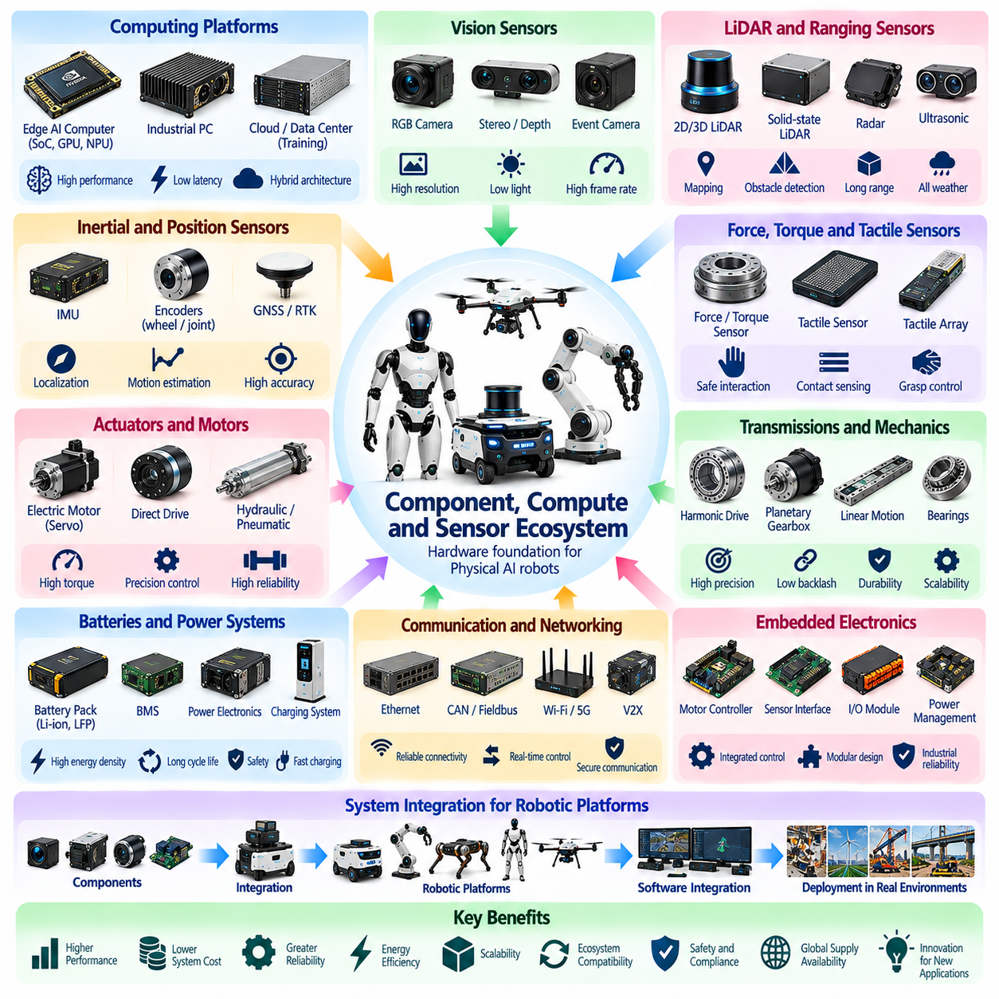
The component, compute, and sensor ecosystem forms the technological foundation of the Physical AI market by supplying the hardware required for perception, intelligence, motion, and physical interaction. Unlike software-only AI systems, physical robots depend on tightly integrated mechanical, electrical, and computational components. Commercial competitiveness therefore reflects not only AI performance but also component reliability, energy efficiency, manufacturing cost, and supply availability.
The ecosystem includes semiconductor manufacturers, sensor suppliers, actuator developers, transmission manufacturers, battery providers, embedded computing vendors, and industrial electronics companies. These suppliers occupy different positions within the robotics value chain and contribute to overall system performance. Their products influence robot capabilities, integration complexity, maintenance requirements, and the economics of large-scale deployment.
Computing platforms represent a critical market segment because Physical AI requires continuous processing of sensory information and real-time generation of actions. Robot computers may combine central processing units, graphics processors, neural processing units, and dedicated accelerators. Platform selection depends on computational throughput, memory capacity, latency, power consumption, and compatibility with robotics software frameworks.
Edge AI computing has become increasingly important as robots require autonomous operation without constant cloud connectivity. Embedded processors execute perception, localization, planning, and learned policies directly onboard the machine. This architecture reduces communication dependency and supports timely decisions. However, thermal limitations, battery constraints, and hardware cost create significant tradeoffs between computing performance and operational endurance.
Cloud and data center computing provide complementary capabilities for training foundation models, processing large datasets, running simulations, and managing robotic fleets. High-performance accelerators support computationally intensive learning and model development. Hybrid computing architectures distribute workloads between robots, local servers, and cloud infrastructure. Commercial value depends on efficient resource allocation, secure communication, and manageable operating costs.
Vision sensors form a major component category because cameras provide information about objects, people, workspaces, and environmental changes. RGB cameras, stereo vision systems, depth cameras, and event-based sensors support different perception requirements. Their selection depends on resolution, frame rate, depth accuracy, lighting tolerance, and processing requirements. Industrial reliability also depends on calibration stability and environmental protection.
LiDAR and ranging sensors are widely used for navigation, obstacle detection, mapping, and spatial understanding. Two-dimensional and three-dimensional LiDAR systems provide geometric measurements that support mobile robots and autonomous vehicles. Radar, ultrasonic sensors, and proximity detectors offer complementary capabilities under different environmental conditions. Sensor selection must balance range, accuracy, robustness, integration effort, and total system cost.
Inertial and position sensing components support robot localization, motion estimation, and dynamic control. Inertial measurement units, wheel encoders, joint encoders, and satellite positioning receivers provide information about movement and configuration. Sensor fusion combines measurements to improve estimation accuracy. Reliable operation requires calibration, synchronization, and algorithms capable of handling noise, drift, and intermittent measurement failures.
Force, torque, and tactile sensors enable robots to interact safely and precisely with physical objects. Joint torque sensors support compliant control, while wrist force sensors measure interaction loads during manipulation. Tactile arrays can provide contact distribution and grasp information. These components are particularly important for collaborative robots, dexterous hands, and humanoid systems where contact conditions change frequently.
Actuators convert control commands into mechanical motion and therefore represent a major source of differentiation across robotic platforms. Electric motors, servo drives, hydraulic actuators, and pneumatic systems offer different combinations of force, speed, precision, and efficiency. Selection depends on robot morphology and application requirements. High-performance actuation must balance power density, controllability, durability, and cost.
Precision transmissions and mechanical components strongly influence actuator performance. Harmonic drives, planetary gearboxes, cycloidal reducers, bearings, and linear motion systems determine torque transmission, backlash, stiffness, and service life. Their characteristics affect positioning accuracy and maintenance frequency. Component suppliers compete through mechanical performance, manufacturing consistency, reliability, and the ability to scale production economically.
Battery and power management technologies determine the operating duration and practical availability of mobile Physical AI systems. Lithium-based battery packs, battery management systems, power converters, and charging equipment must satisfy application-specific requirements. Energy density, cycle life, safety, and charging time influence system economics. Reliable power architecture also requires thermal management, protection circuits, and appropriate maintenance procedures.
Communication and industrial networking components connect sensors, controllers, actuators, and external systems. Ethernet, CAN-based networks, industrial fieldbuses, wireless connectivity, and time-sensitive communication technologies support different operating requirements. Real-time control depends on predictable data exchange and synchronization. Network architecture must also address cybersecurity, fault tolerance, electromagnetic compatibility, and system interoperability.
Hardware and software co-design increasingly shapes component selection as AI models place new demands on computing and sensing architectures. Larger perception models may require additional memory bandwidth, while advanced control algorithms demand predictable execution latency. Sensor placement and actuator characteristics also influence learning performance. Effective co-design reduces unnecessary hardware complexity while improving overall robot capability.
The supplier ecosystem differs across robot categories because each morphology creates distinct technical requirements. AMRs prioritize navigation sensors, drive systems, and batteries, while manipulators emphasize precision transmissions and joint control. Humanoids require compact actuators, distributed sensing, and high-density computing. Aerial robots place greater emphasis on lightweight structures, propulsion efficiency, and reliable flight electronics.
Component standardization can accelerate market development by reducing integration costs and simplifying replacement procedures. Common electrical interfaces, mechanical mounting standards, communication protocols, and software drivers improve compatibility across suppliers. However, highly optimized robots may require proprietary designs to achieve specific performance targets. Manufacturers must balance standardization benefits against differentiation and system-level optimization.
Supply chain resilience is an important commercial consideration because robotics production depends on specialized electronic and mechanical components. Limited supplier capacity, long lead times, and inconsistent quality can delay deployment and increase costs. Manufacturers may adopt multiple sourcing strategies, component qualification procedures, and inventory planning. Long-term competitiveness depends on dependable procurement and stable manufacturing partnerships.
The competitive landscape includes global semiconductor companies, industrial automation suppliers, specialized sensor manufacturers, precision mechanical component producers, and emerging robotics hardware startups. Established suppliers benefit from manufacturing scale and proven reliability, while specialized companies may introduce innovative designs. Competitive differentiation involves performance, pricing, technical support, product availability, and integration convenience.
Component economics directly influence the affordability and scalability of Physical AI products. Bill-of-materials costs, assembly labor, quality assurance, warranty exposure, and replacement expenses contribute to the final robot price. Higher-performance components may reduce operational failures but increase initial investment. Product designers must evaluate total lifecycle value rather than selecting components solely according to purchase price.
Manufacturing scale can reduce component costs through improved production processes, supplier agreements, and design simplification. However, projected cost reductions depend on actual production volume, yield, and demand stability. Robotics manufacturers must avoid assuming that prototype economics automatically translate into mass production. Commercial planning requires realistic estimates of tooling investment, quality control, and supply chain development.
Future market development will be influenced by more efficient AI accelerators, integrated sensing modules, compact actuators, advanced batteries, and intelligent power electronics. Improvements in component integration may reduce robot weight, energy consumption, and assembly complexity. Standardized hardware platforms could support broader software reuse. Nevertheless, technological progress must be evaluated through operational reliability and measurable system-level benefits.
Ultimately, the component, compute, and sensor ecosystem determines how effectively Physical AI intelligence can be translated into reliable physical action. Competitive robotic products require coordinated optimization across perception hardware, computing resources, actuation, power systems, and communication infrastructure. Sustainable market growth will depend on affordable components, resilient supply chains, manufacturing scalability, and dependable performance throughout the robot lifecycle.

01.11. System Integrators and Service Providers
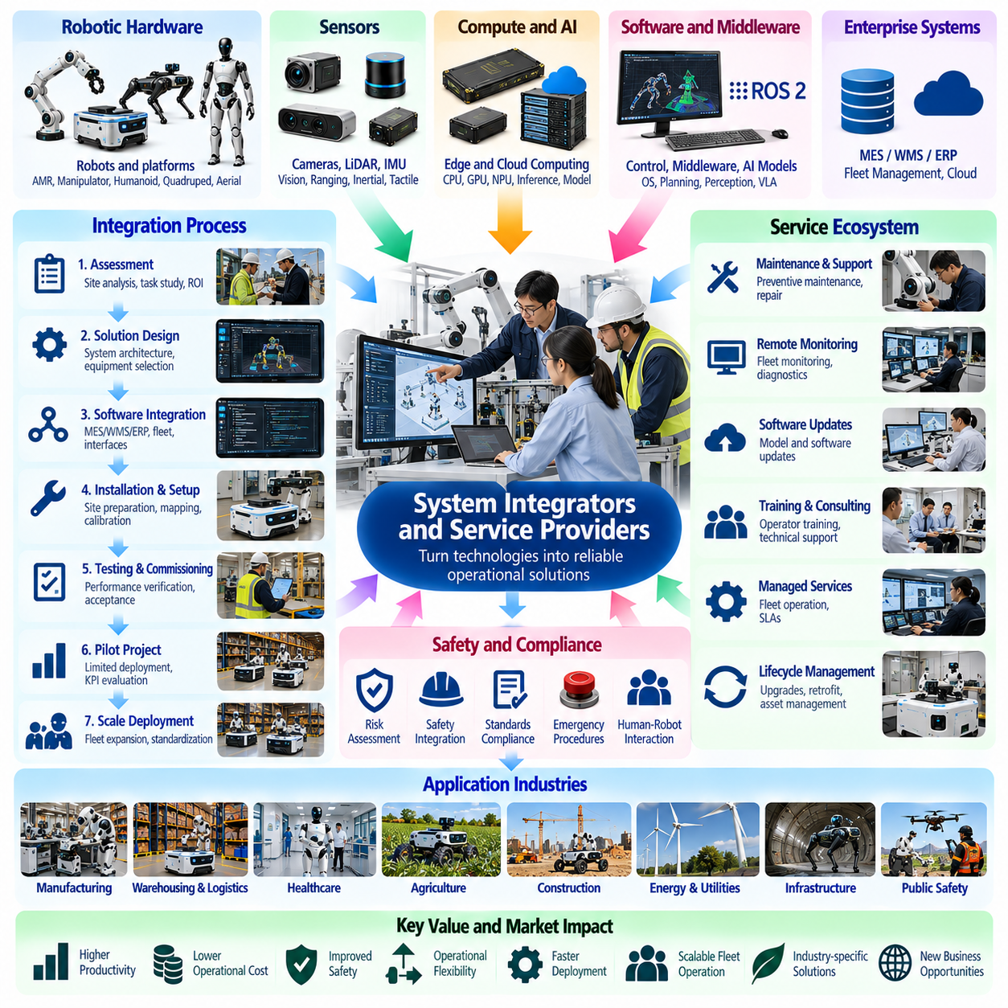
System integrators and service providers form a critical commercialization layer within the Physical AI market, connecting robotic technologies with practical industrial operations. Their primary role is to transform hardware, software, and AI capabilities into dependable customer solutions. Market value arises from engineering expertise, workflow adaptation, operational support, and the ability to deliver measurable productivity improvements.
System integration involves combining robots, sensors, computing platforms, control software, and enterprise applications into a functioning automation system. Individual components may perform well independently but require substantial engineering to operate together. Integrators address interface compatibility, communication protocols, safety requirements, and operational constraints, reducing the complexity customers face during deployment.
The service ecosystem includes robotics system integrators, automation engineering firms, software implementation partners, managed service operators, maintenance specialists, and technical consultants. These organizations differ in technical depth, industry specialization, and contractual responsibility. Some deliver complete automation projects, while others provide focused services such as fleet optimization, software integration, or equipment maintenance.
Industry-specific knowledge is a major competitive advantage for system integrators. Manufacturing facilities, warehouses, hospitals, farms, and construction sites operate under different physical constraints and performance requirements. Successful deployments require understanding customer workflows, equipment interfaces, labor practices, and safety obligations. Technical capability alone is insufficient without practical knowledge of the operating environment.
Customer engagement typically begins with operational assessment and feasibility analysis. Integrators examine existing processes, identify repetitive or hazardous activities, and determine whether robotics can improve performance economically. This stage includes evaluating site conditions, task variability, infrastructure readiness, and workforce requirements. Accurate assessment reduces the risk of investing in unsuitable automation solutions.
Solution architecture translates customer requirements into coordinated hardware and software configurations. Integrators select robotic platforms, sensing systems, computing resources, and communication infrastructure according to operational objectives. They also define interfaces between robots and existing equipment. Effective architecture must consider scalability, maintenance accessibility, safety, and future technology upgrades.
Software integration is particularly important because robotic systems rarely operate independently of enterprise infrastructure. Warehouse management systems, manufacturing execution systems, enterprise resource planning platforms, and fleet management software exchange operational information. Integrators develop interfaces that connect business instructions with robot execution. Reliable synchronization prevents task conflicts, inventory errors, and workflow interruptions.
Deployment engineering includes site preparation, installation, calibration, mapping, configuration, and operational testing. Mobile robots may require navigation maps and traffic rules, while manipulators need calibrated workspaces and validated motion sequences. Environmental changes can expose limitations not identified during laboratory development. Field engineering therefore represents a substantial component of deployment cost and project risk.
Safety integration establishes the relationship between robotic equipment, human workers, and surrounding infrastructure. Integrators assess hazards, implement protective measures, and verify emergency procedures according to applicable requirements. Physical AI introduces additional uncertainty when learned behaviors interact with changing environments. Safety engineering must therefore address both conventional machinery risks and AI-related operational limitations.
Testing and commissioning determine whether an integrated system satisfies contractual and operational expectations. Acceptance criteria may include task completion rates, throughput, positioning accuracy, uptime, and recovery performance. Factory acceptance testing and site acceptance testing provide structured verification stages. Clearly defined criteria reduce disputes and establish measurable evidence of deployment readiness.
Pilot projects are commonly used to evaluate Physical AI solutions before wider deployment. A limited installation allows customers to measure productivity, reliability, worker interaction, and integration complexity under realistic conditions. Pilot results should identify technical deficiencies and operational improvements. However, successful demonstrations do not automatically establish the economics or reliability of large-scale operations.
Scaling from pilot installations to production fleets creates additional engineering requirements. Larger deployments introduce traffic coordination, charging schedules, software version management, maintenance planning, and exception handling. Integrators must design systems that maintain performance as robot numbers increase. Standardized deployment procedures and reusable software interfaces can reduce expansion costs and improve consistency.
Managed robotics services extend integration responsibilities into continuous operations. Providers may monitor robot fleets, supervise missions, resolve incidents, update software, and coordinate maintenance activities. These services allow customers to access specialized technical expertise without maintaining large internal robotics teams. Their economic value depends on service reliability, operational efficiency, and clearly defined responsibilities.
Robot-as-a-Service models combine robotic equipment, software, maintenance, and support into recurring commercial agreements. Customers may prefer subscription or usage-based payments over substantial initial capital expenditure. Service providers assume responsibilities that can include equipment availability and lifecycle maintenance. Contract profitability depends on utilization, financing costs, component durability, and the ability to control operational expenses.
Maintenance and lifecycle services represent important recurring revenue opportunities. Preventive maintenance, diagnostics, spare parts management, battery replacement, and software updates help sustain robotic performance. Predictive maintenance systems may identify degradation before failures interrupt operations. Providers that maintain accurate service records and efficient spare parts networks can reduce downtime and improve customer retention.
Remote monitoring and fleet analytics create additional service opportunities by converting operational data into actionable insights. Providers can analyze utilization, task failures, intervention frequency, energy consumption, and equipment condition. These measurements support workflow optimization and maintenance decisions. Data access agreements, cybersecurity requirements, and customer confidentiality must be addressed within service contracts.
The competitive landscape includes global automation companies, regional engineering integrators, robotics manufacturers, specialized software firms, and emerging managed service providers. Large organizations may offer extensive delivery capacity and established customer relationships. Smaller specialists can compete through technical expertise, flexibility, and industry knowledge. Competitive differentiation increasingly depends on repeatable deployment results.
Commercial pricing varies according to project scope, technical complexity, service obligations, and customer risk allocation. Integration projects may use fixed-price contracts, engineering fees, milestone payments, or recurring service agreements. Providers must account for design work, installation labor, testing, training, and warranty exposure. Inaccurate project estimation can erode margins even when the underlying robotic technology performs successfully.
Service-level agreements establish measurable expectations for system availability, response times, maintenance responsibilities, and operational support. Performance guarantees require careful definition because customer workflows and environmental conditions influence results. Contracts should distinguish equipment failures from infrastructure problems and operational misuse. Transparent responsibility allocation supports sustainable relationships between customers and service providers.
Interoperability and vendor independence influence the strategic position of integrators. Customers operating mixed robotic fleets may prefer partners capable of connecting equipment from multiple manufacturers. Open interfaces and standardized communication reduce integration barriers. However, proprietary platforms can simplify support when supplied as complete solutions. Integrators must balance flexibility, accountability, and long-term maintenance requirements.
Workforce training and organizational change management are essential to successful automation adoption. Operators, technicians, supervisors, and safety personnel require appropriate knowledge of robotic behavior and operational procedures. Integrators often provide training, documentation, and transition support. Effective human-robot collaboration depends on clear responsibilities, practical user interfaces, and employee confidence in system reliability.
Ultimately, system integrators and service providers determine whether Physical AI technologies can deliver sustained industrial value beyond laboratory demonstrations. Their expertise connects robotics innovation with customer processes, safety requirements, enterprise systems, and lifecycle operations. Long-term market growth will favor organizations that combine repeatable engineering methods, dependable service delivery, and measurable customer outcomes.

01.12. Regional and Industry Adoption Patterns
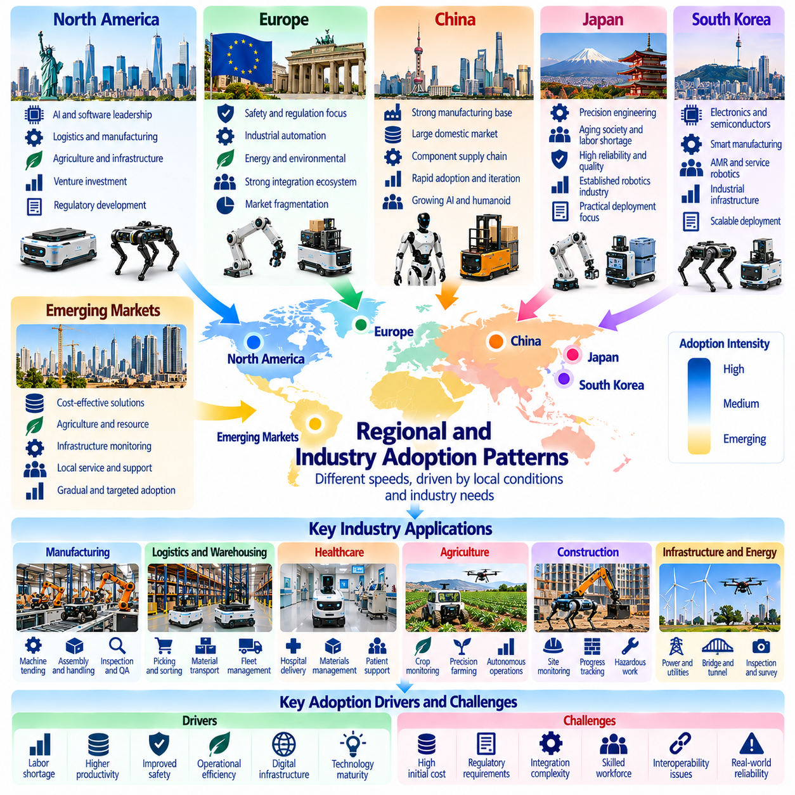
Regional and industry adoption patterns reveal how the Physical AI market develops at different speeds across economic environments and operational sectors. Adoption is influenced by labor availability, industrial structure, technology readiness, capital investment, and regulatory conditions. Rather than following a uniform global trajectory, Physical AI expands through applications where automation delivers measurable operational value and manageable implementation risk.
Regional differences reflect the interaction between manufacturing capacity, robotics research, digital infrastructure, and customer demand. Economies with established automation industries often possess stronger supplier networks and integration capabilities. Other regions may prioritize imported robotic solutions or specialized applications. Market development depends on local technical expertise, financing availability, service infrastructure, and institutional support.
North America represents an important market for robotics software, AI platforms, autonomous mobility, and advanced industrial automation. Research institutions, technology companies, and venture investment support innovation across multiple robotic categories. Commercial adoption is particularly relevant in logistics, manufacturing, agriculture, and infrastructure inspection. Deployment economics remain sensitive to labor costs, reliability, and regulatory requirements.
Europe has established capabilities in industrial robotics, precision engineering, automotive manufacturing, and automation integration. Regional adoption frequently emphasizes operational safety, equipment reliability, energy efficiency, and regulatory compliance. Manufacturing modernization and industrial digitalization create opportunities for Physical AI. However, market fragmentation, integration costs, and differing national conditions can influence deployment strategies.
East Asia is a major center of robotics manufacturing, component production, and industrial automation. Japan, South Korea, and China possess significant capabilities across different parts of the robotics value chain. Applications include factory automation, warehouse logistics, service robotics, and emerging humanoid systems. Regional competitiveness depends on production scale, supply chains, AI capabilities, and the integration of intelligent software with established hardware industries.
China's Physical AI ecosystem benefits from extensive electronics manufacturing, industrial supply networks, and a large domestic market. These conditions can support rapid hardware iteration and competitive component sourcing. Industrial automation, logistics robotics, and humanoid development attract substantial commercial attention. Nevertheless, technological demonstrations must be distinguished from sustainable deployments, profitable operations, and verified customer demand.
Japan's robotics market reflects longstanding strengths in industrial automation, precision components, and reliable mechanical engineering. Demographic pressures and labor shortages encourage interest in automation across manufacturing, logistics, and service environments. Adoption often emphasizes equipment durability, operational consistency, and integration with established workflows. Commercial expansion depends on balancing sophisticated engineering with practical deployment costs.
South Korea combines advanced electronics, semiconductor manufacturing, automotive production, and industrial automation capabilities. These strengths create opportunities for intelligent factories, autonomous mobile robots, service robotics, and AI-enabled manufacturing systems. Domestic adoption can benefit from concentrated industrial infrastructure and digital connectivity. Scaling requires interoperable platforms, skilled integration partners, and convincing economic results.
Emerging markets exhibit different adoption priorities because labor economics, infrastructure quality, and investment capacity vary substantially. Some regions may favor cost-effective warehouse automation, agricultural robotics, or infrastructure monitoring over highly sophisticated general-purpose robots. Local service availability and maintenance capabilities are particularly important. Affordable, robust solutions may achieve broader adoption than technically advanced but expensive systems.
Manufacturing remains a central industry for Physical AI adoption because production environments often contain repetitive tasks, structured workflows, and measurable performance requirements. Industrial robots and automation systems provide an established foundation for more adaptive capabilities. Opportunities include machine tending, inspection, material handling, and flexible assembly. Adoption depends on productivity improvement, process stability, and integration with existing equipment.
Logistics and warehousing represent another major adoption domain because material movement and order fulfillment involve frequent, measurable operations. Autonomous mobile robots, robotic picking systems, and intelligent fleet management can improve workflow flexibility. High utilization and predictable task demand support economic evaluation. However, facility layouts, software compatibility, and operational disruptions influence implementation complexity.
Healthcare adoption follows a different pattern because patient safety, clinical workflows, privacy, and institutional accountability impose additional requirements. Hospital delivery robots and logistics automation may offer clearer initial opportunities than complex patient-facing manipulation. Clinical environments demand dependable operation and careful human oversight. Adoption depends on validated benefits, regulatory obligations, and acceptance by healthcare personnel.
Agricultural Physical AI adoption is shaped by labor shortages, seasonal demand, crop diversity, and environmental variability. Autonomous tractors, field robots, drones, and precision treatment systems address different operational needs. Large farms may support higher equipment utilization, while smaller farms may prefer shared or service-based solutions. Economic feasibility depends on crop value, field conditions, operating seasons, and maintenance accessibility.
Construction and infrastructure applications face challenges involving changing worksites, uneven terrain, unpredictable obstacles, and demanding safety requirements. Autonomous equipment, inspection robots, and aerial mapping systems may improve productivity or reduce hazardous exposure. Adoption often begins with specialized tasks rather than fully autonomous construction processes. Commercial value depends on project duration, deployment flexibility, and measurable risk reduction.
Consumer and home robotics follow a distinct adoption trajectory because purchasing decisions depend on affordability, convenience, reliability, and user experience. Cleaning robots demonstrate the potential of narrowly defined household automation. More general domestic manipulation remains technically challenging because homes contain diverse objects and unpredictable conditions. Broad adoption requires dependable functionality, intuitive interaction, and acceptable maintenance costs.
Industry adoption patterns also differ according to organizational size and investment capacity. Large enterprises can finance pilot programs, integration teams, and long-term automation strategies. Small and medium-sized businesses often require standardized products, external technical support, and shorter payback periods. Subscription services and shared automation infrastructure may reduce entry barriers. Market expansion depends on solutions that fit diverse customer budgets.
Labor conditions influence adoption but do not determine it independently. High wages, worker shortages, hazardous environments, and repetitive tasks can strengthen the economic case for robotics. However, deployment requires training, process redesign, and continuing technical support. Workforce acceptance depends on perceived safety, operational usefulness, and organizational communication. Successful automation combines technological capability with realistic workforce planning.
Regulatory environments shape regional market opportunities through machinery safety rules, data protection obligations, workplace standards, and autonomous vehicle requirements. Aerial robotics and public-space mobility face particularly important location-specific restrictions. Regulatory uncertainty can delay investment or limit operational scope. Providers entering multiple markets must adapt certification, documentation, safety procedures, and service models to local conditions.
Infrastructure readiness creates additional differences between regions and industries. Reliable electricity, wireless connectivity, industrial networks, charging facilities, and technical maintenance services support robotic operations. Facilities with mature digital systems can integrate automation more efficiently. In less prepared environments, infrastructure upgrades may dominate initial project costs. Adoption strategies must account for the entire operating ecosystem.
Regional supply chains and system integration networks influence both deployment speed and long-term service quality. Local access to sensors, actuators, computing hardware, spare parts, and qualified technicians reduces operational uncertainty. Dependence on distant suppliers can increase maintenance delays and procurement risks. Manufacturers may establish regional partnerships to improve customer support, regulatory adaptation, and installation efficiency.
Future adoption will likely expand unevenly as AI capabilities improve and hardware costs evolve. Structured industrial environments may continue to support earlier commercial scaling, while complex service applications require stronger generalization and safety assurance. Regional leadership may differ across manufacturing, AI software, components, and deployment services. Market analysis should therefore distinguish technological capability from actual installed capacity and recurring revenue.
Ultimately, regional and industry adoption patterns demonstrate that Physical AI commercialization depends on the alignment of technology, economics, infrastructure, and institutional conditions. No single robotic architecture or business model will satisfy every market. Sustainable growth will emerge where providers adapt solutions to local requirements, establish reliable service ecosystems, and demonstrate measurable improvements in productivity, safety, and operational flexibility.

01.13. Cost Performance and Maturity Trends
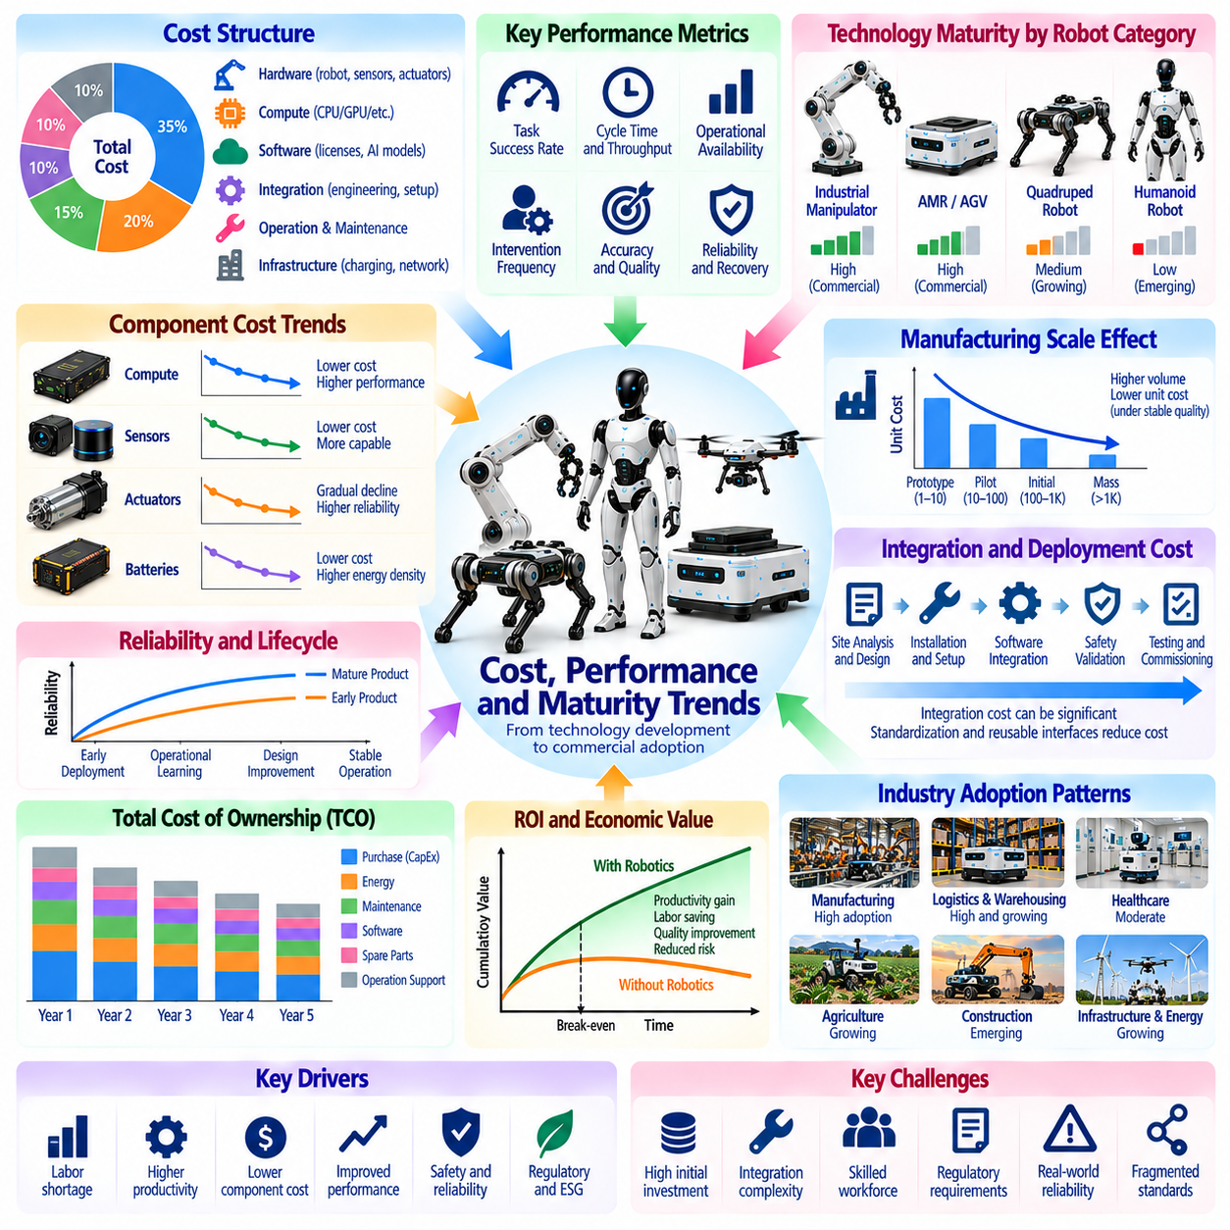
Cost, performance, and technological maturity determine whether Physical AI systems can progress from experimental prototypes to commercially sustainable products. Customers evaluate robotics investments through acquisition cost, operational productivity, reliability, and expected service life. Technological advancement creates market value only when improved capabilities translate into measurable economic benefits under realistic operating conditions.
The cost structure of Physical AI includes robotic hardware, computing systems, sensors, actuators, batteries, software, integration, and ongoing support. Hardware expenses are often visible during procurement, while engineering and lifecycle costs may be underestimated. A complete economic assessment must include installation, infrastructure modification, operator training, maintenance, software updates, and eventual equipment replacement.
Performance evaluation requires more than measuring robot speed, payload capacity, or AI model accuracy. Commercially relevant metrics include successful task completion, cycle time, operational availability, intervention frequency, and recovery capability. These measurements should reflect actual customer workflows rather than controlled demonstrations. Consistent performance across environmental variations is essential for dependable deployment.
Technological maturity varies substantially across robotic categories and application environments. Traditional industrial manipulators operate within established engineering and manufacturing ecosystems, while autonomous mobile robots have achieved commercial deployment in many structured facilities. General-purpose humanoids and highly adaptive manipulation systems remain less mature. Their commercial readiness depends on robust autonomy and repeatable field performance.
Manufacturing scale can reduce component costs through improved purchasing conditions, production efficiency, and design standardization. However, anticipated cost reductions are not guaranteed by increasing production volume alone. Manufacturing yield, component availability, quality assurance, and warranty exposure influence realized savings. Sustainable pricing requires production systems capable of maintaining consistent quality at scale.
Computing costs are increasingly important because advanced Physical AI relies on neural perception, planning, and learned control policies. More capable processors can support sophisticated autonomy but may increase power consumption, thermal requirements, and equipment prices. Hardware-software optimization can reduce these tradeoffs. Commercial designs must balance inference performance, response latency, energy efficiency, and upgrade flexibility.
Sensor economics involve balancing perception quality against hardware expense and integration complexity. Cameras, LiDAR, radar, tactile sensors, and force sensors provide complementary information, but additional sensing does not always produce proportional operational benefits. Effective sensor configurations depend on task requirements and environmental conditions. Calibration, durability, and replacement costs also influence total system economics.
Actuation and mechanical components represent substantial cost drivers in manipulators, humanoids, and mobile platforms. Precision transmissions, motors, bearings, and structural materials determine payload capability, movement quality, and equipment durability. High-performance components may increase initial prices while reducing failure rates or improving productivity. Cost optimization therefore requires evaluating mechanical performance over the complete service life.
Battery technology influences the economics of mobile robotics through energy capacity, charging frequency, replacement intervals, and operational availability. Larger batteries may extend operating time but increase weight and acquisition cost. Automated charging can reduce manual intervention while introducing infrastructure expenses. Energy management strategies should optimize useful working hours rather than battery capacity alone.
Integration costs can exceed expectations when robotic systems must operate within complex facilities and enterprise software environments. Site mapping, workflow redesign, safety validation, equipment interfaces, and operational testing require specialized engineering. Standardized interfaces and reusable deployment methods can reduce these expenses. Integration maturity is therefore a major determinant of commercialization readiness.
Reliability is a central economic variable because unexpected downtime can eliminate productivity gains and create additional labor requirements. Mean time between failures, mean time to repair, and operational availability provide useful indicators of equipment dependability. However, these measures must be interpreted alongside task success and intervention rates. Mature products demonstrate predictable performance over extended operating periods.
Total cost of ownership provides a broader framework than purchase price for comparing robotic alternatives. It includes capital expenditure, energy consumption, software subscriptions, maintenance, spare parts, insurance, and operational supervision. Economic evaluation should also consider productivity benefits and residual equipment value. A lower-cost robot may be less economical if it requires frequent intervention or replacement.
Return on investment depends on the relationship between deployment expenses and measurable operational improvements. Labor savings, higher throughput, improved quality, reduced waste, and safer operations may contribute to economic value. Benefits should be evaluated against actual utilization and operating constraints. Financial projections based on idealized continuous operation can significantly overstate commercial attractiveness.
Learning-based autonomy introduces a distinctive maturity challenge because performance depends on training data, environmental coverage, and generalization capability. A robot may perform reliably in familiar conditions while struggling with unfamiliar objects or unexpected disturbances. Evaluation must include rare events, recovery behavior, and human intervention requirements. Field evidence is more meaningful than isolated benchmark performance.
Commercial maturity also depends on organizational capabilities beyond the robot itself. Suppliers need manufacturing processes, technical documentation, spare parts networks, cybersecurity practices, and customer support infrastructure. System integrators must demonstrate repeatable installation and commissioning procedures. These supporting capabilities distinguish scalable products from research systems that require extensive engineering assistance.
The relationship between cost and performance differs across market segments. Warehouse robots may prioritize fleet utilization and operating cost per transport task, while manipulators emphasize cycle time and successful handling. Inspection robots may be evaluated through coverage and risk reduction. Humanoid systems require broader assessments of task diversity and intervention frequency. No single metric adequately represents the entire Physical AI market.
Cost-performance trends should be interpreted using consistent operational assumptions and comparable deployment conditions. Improvements in AI benchmark scores do not necessarily translate into lower cost per completed task. Likewise, falling component prices may be offset by integration, maintenance, or infrastructure expenses. Reliable market comparisons require transparent measurement methods and realistic workload definitions.
As technologies mature, market competition may shift from demonstrations of technical capability toward service quality, operational economics, and deployment scalability. Early adopters often accept higher costs to gain strategic experience, while mainstream customers demand predictable financial returns. Standardization and competition can improve affordability. However, advanced autonomy may introduce new costs associated with validation and lifecycle management.
Future progress will depend on coordinated improvements in AI models, computing efficiency, sensors, actuators, manufacturing methods, and system integration. Better generalization could reduce deployment customization, while improved hardware efficiency could lower operating expenses. These benefits must be demonstrated through sustained field performance. Technology roadmaps should distinguish research milestones from commercially validated capabilities.
Ultimately, Physical AI maturity is best understood as the convergence of technical performance, economic feasibility, operational reliability, and scalable service delivery. A system becomes commercially competitive when it consistently completes valuable tasks at an acceptable lifecycle cost. Sustainable market expansion will favor solutions that demonstrate measurable productivity, manageable risk, and predictable performance across real operating environments.

01.14. Physical AI Market Segmentation Framework
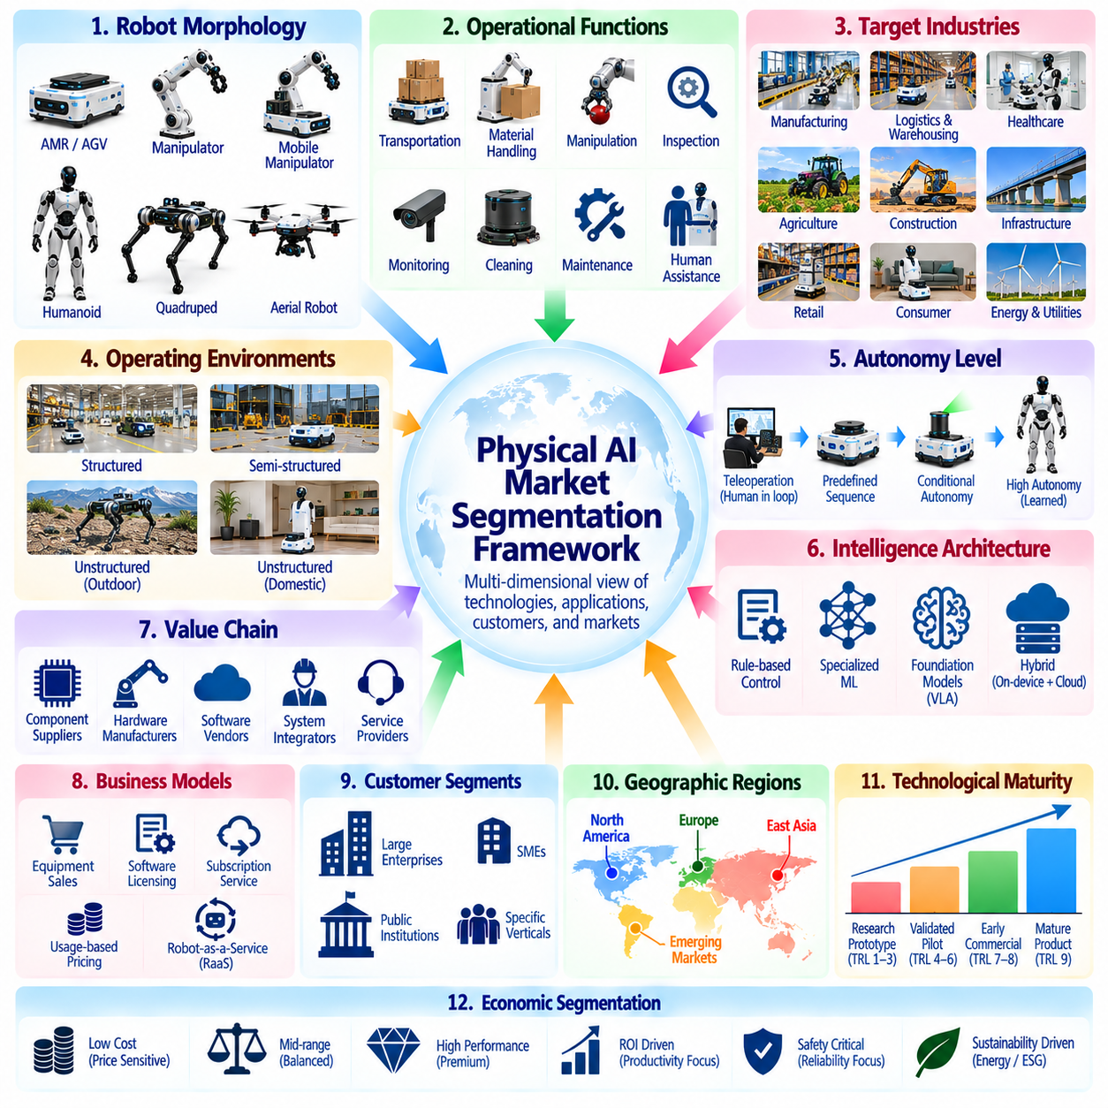
A Physical AI market segmentation framework provides a structured method for analyzing robotic technologies, customer requirements, commercial opportunities, and competitive dynamics. Because Physical AI combines hardware, software, intelligence, and physical operations, conventional robotics categories alone cannot fully describe the market. Effective segmentation must distinguish technological capabilities, application environments, business models, and deployment maturity.
The first segmentation dimension concerns robot morphology and physical architecture. Autonomous mobile robots, industrial manipulators, mobile manipulators, humanoids, quadrupeds, and aerial robots represent different hardware configurations. Each architecture creates distinct requirements for locomotion, manipulation, sensing, computing, and energy management. Morphology-based segmentation helps identify component demand, engineering complexity, and platform competition.
A second dimension classifies systems according to their primary operational functions. These include transportation, material handling, manipulation, inspection, monitoring, cleaning, maintenance, and human assistance. Functional segmentation emphasizes the economic activity performed rather than the robot's appearance. Different robotic architectures may compete within the same functional market when they deliver comparable operational outcomes.
Industry segmentation organizes Physical AI opportunities around manufacturing, logistics, healthcare, agriculture, construction, infrastructure, retail, and consumer applications. Each industry has distinct workflow requirements, purchasing processes, safety obligations, and economic priorities. Industry-specific analysis reveals where automation can create measurable value. It also identifies barriers that prevent technically capable systems from achieving commercial adoption.
Environmental segmentation distinguishes structured, semi-structured, and unstructured operating conditions. Structured factories and warehouses often provide predictable layouts and controlled workflows. Outdoor environments, construction sites, and domestic spaces introduce greater variability. Environmental complexity influences sensing requirements, autonomy performance, safety validation, and deployment costs. This dimension helps explain differences in technological maturity.
Autonomy level provides another important segmentation dimension. Some systems execute predefined sequences, while others navigate independently, adapt to disturbances, or perform tasks using learned policies. Human supervision may range from continuous teleoperation to occasional intervention. Classification should reflect demonstrated operational independence rather than marketing descriptions. Higher autonomy can increase flexibility but also introduces validation challenges.
The intelligence architecture dimension separates conventional control systems, specialized machine learning solutions, and foundation-model-based robotic platforms. Traditional systems may rely on deterministic planning and engineered rules. Learning-based systems can improve perception and task adaptation. Foundation models may support broader instruction understanding and behavioral generalization. Their commercial value depends on reliability, computing costs, and integration requirements.
Hardware and software value-chain segmentation identifies where companies capture revenue. Hardware suppliers provide robotic platforms, sensors, actuators, computing devices, and energy systems. Software vendors deliver perception, navigation, manipulation, fleet management, and AI development tools. System integrators connect these technologies to customer operations. Service providers generate additional value through maintenance, monitoring, training, and operational support.
Business-model segmentation distinguishes equipment sales, software licensing, subscription services, usage-based pricing, and Robot-as-a-Service arrangements. Each model allocates capital requirements, operational responsibilities, and financial risks differently. Equipment sales emphasize initial transactions, while recurring services depend on sustained performance. Comparing business models requires evaluating customer acquisition costs, utilization, service obligations, and lifecycle profitability.
Customer segmentation considers organizational size, technical readiness, operational scale, and purchasing authority. Large enterprises may demand extensive integration and multi-site deployment capabilities. Smaller organizations often prefer standardized products and simplified service agreements. Public institutions may face different procurement and accountability requirements. Understanding customer characteristics supports appropriate product positioning, pricing, and sales strategies.
Geographic segmentation evaluates regional demand, manufacturing ecosystems, labor conditions, infrastructure readiness, and regulatory requirements. North America, Europe, and East Asia exhibit different strengths across AI software, industrial automation, and hardware production. Emerging markets may prioritize affordable and maintainable solutions. Geographic analysis should distinguish technology development locations from manufacturing capacity and actual customer deployment.
Technological maturity segmentation separates research prototypes, validated pilots, early commercial products, and established production systems. These stages differ in operational evidence, manufacturing readiness, service infrastructure, and customer risk. A successful laboratory demonstration does not establish commercial maturity. Classification should consider sustained field performance, repeatable installation, maintenance capability, and verified economic outcomes.
Economic segmentation groups applications according to capital intensity, operating costs, utilization, and measurable return on investment. High-volume repetitive tasks may justify substantial automation expenditure through predictable productivity gains. Low-frequency tasks require flexible platforms or shared service arrangements. Economic attractiveness depends on cost per completed task, equipment availability, labor requirements, and lifecycle expenses rather than hardware price alone.
Competitive segmentation distinguishes platform manufacturers, component specialists, AI model developers, software providers, system integrators, and managed service operators. These participants may cooperate within one deployment while competing for control of customer relationships and recurring revenue. Market boundaries can overlap as suppliers expand vertically. Analysis must therefore separate product categories from company-level positioning and ecosystem influence.
A practical segmentation framework should combine multiple dimensions instead of relying on a single classification. For example, a warehouse mobile manipulator can be classified by morphology, material-handling function, logistics industry, structured environment, autonomy level, and subscription business model. This multidimensional approach exposes competitive alternatives and customer requirements that a hardware-only classification would overlook.
Market sizing requires consistent definitions to avoid double counting across overlapping segments. Robot hardware revenue, software subscriptions, integration fees, and managed services may all arise from the same deployment. Analysts should distinguish annual equipment sales, installed robotic fleets, recurring revenue, and total customer expenditure. Transparent accounting boundaries are essential for meaningful market comparisons and credible growth projections.
Segmentation should also distinguish addressable demand from commercially accessible opportunities. A task may be technically automatable but economically unattractive because of low utilization, high integration costs, or uncertain reliability. Regulatory barriers and limited service infrastructure can further restrict adoption. Market opportunity assessments should therefore evaluate technological feasibility, customer willingness to pay, and realistic deployment capacity.
The framework must remain adaptable because Physical AI technologies increasingly cross established category boundaries. Mobile manipulators combine transportation and manipulation, while humanoids may address tasks previously assigned to specialized equipment. Foundation models can enable software capabilities across multiple robot morphologies. Market classifications should accommodate convergence without assuming that general-purpose systems will replace specialized robots.
Ultimately, a Physical AI market segmentation framework connects technological classification with customer value, competitive structure, and commercial maturity. Its purpose is not merely to categorize robots but to identify where sustainable economic opportunities exist. Effective analysis integrates morphology, function, industry, environment, autonomy, value chain, business model, geography, and lifecycle economics into a coherent view of market development.

