Volume 12. Physical AI Business and Industry Applications

Chapter 03. Logistics and Warehouse Applications

03.01. Physical AI in Logistics
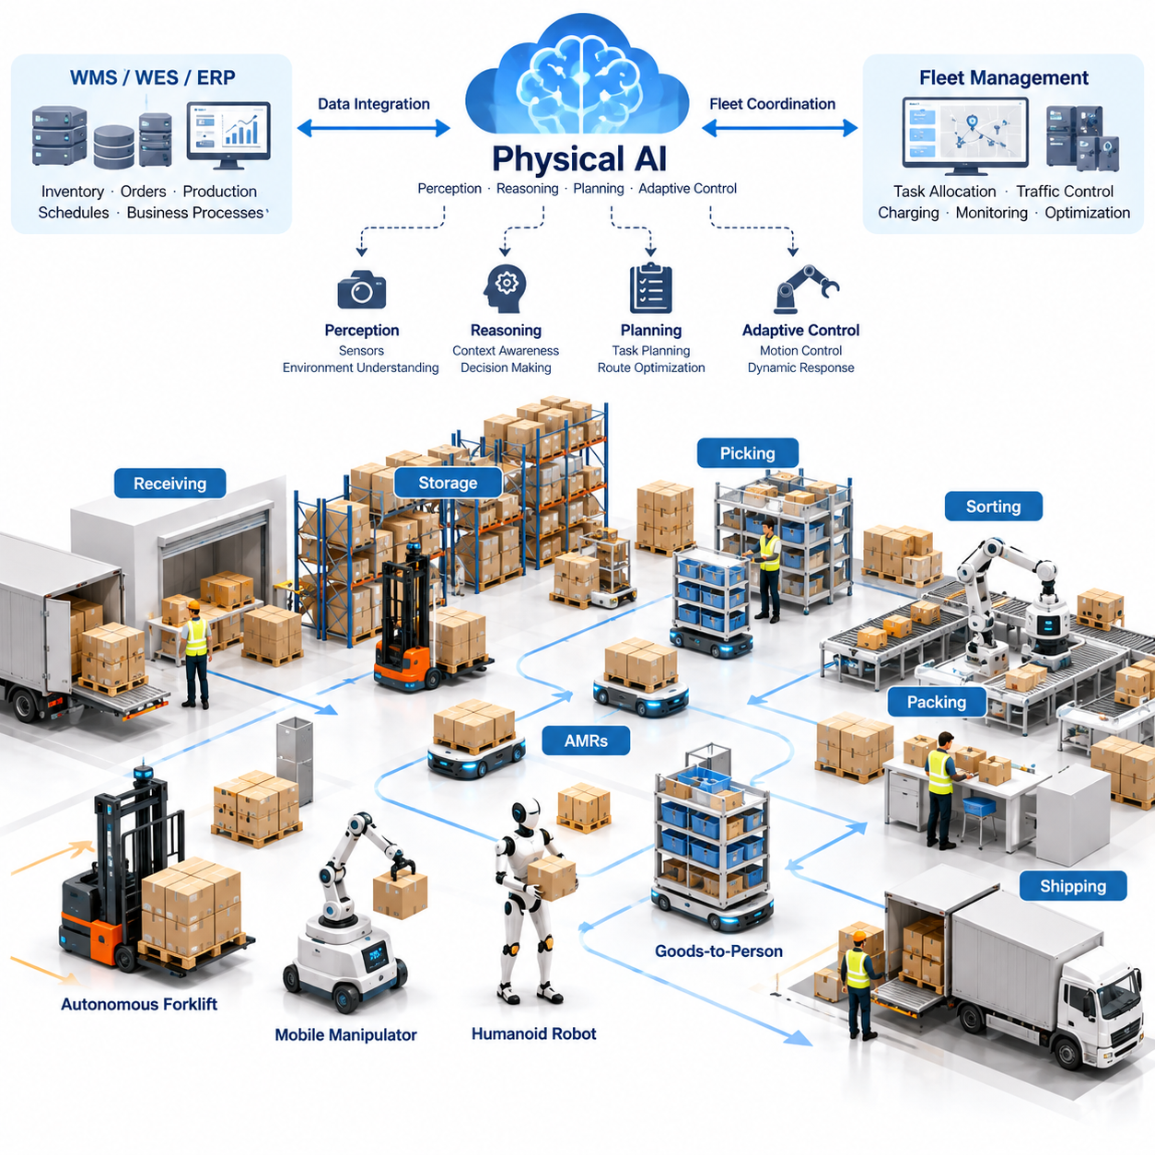
Physical AI represents a fundamental transformation in logistics by enabling intelligent machines to perceive, understand, and interact with physical environments. Unlike conventional automation systems that execute predefined sequences, Physical AI combines perception, reasoning, planning, and adaptive control to perform logistics operations under changing conditions. This capability extends automation beyond fixed infrastructure toward flexible and increasingly autonomous material flows.
Modern logistics environments contain interconnected activities involving receiving, storage, transportation, picking, sorting, packing, shipping, and distribution. These processes require continuous coordination among workers, equipment, inventory systems, and transportation resources. Physical AI introduces intelligent robotic systems capable of responding to operational variability while maintaining the efficiency, accuracy, and reliability required in industrial logistics.
Traditional warehouse automation relies heavily on conveyors, automated storage and retrieval systems, fixed robotic manipulators, and rule-based control architectures. Such systems deliver excellent performance in structured environments but often require significant infrastructure investment and operational standardization. Physical AI complements these technologies by introducing adaptive mobility, intelligent manipulation, and context-aware decision-making.
Autonomous Mobile Robots, commonly known as AMRs, are among the most established embodiments of Physical AI in logistics. These robots transport materials between receiving areas, storage locations, production lines, and shipping stations without requiring permanently installed guidance infrastructure. Their navigation capabilities combine environmental sensing, localization, mapping, obstacle avoidance, and motion planning to operate within dynamic facilities.
Physical AI expands the capabilities of AMRs beyond autonomous navigation. Intelligent mobile platforms can evaluate transportation requests, recognize temporary obstructions, adapt routes, and coordinate movements with other robots. By incorporating contextual information about inventory priorities, workstation availability, and operational constraints, these systems can contribute to logistics decisions rather than functioning exclusively as transportation devices.
Warehouse environments present substantial perception challenges because layouts, obstacles, and operational conditions continuously change. Pallets may occupy unexpected locations, workers may cross transportation corridors, and temporary storage areas may alter available pathways. Physical AI systems address these challenges through multimodal sensing, environmental interpretation, and continuous updates to internal representations of the surrounding workspace.
LiDAR, cameras, depth sensors, inertial measurement units, and wheel encoders provide complementary information for autonomous logistics robots. Sensor fusion improves localization, obstacle detection, and spatial understanding under varying environmental conditions. Advanced perception models can also recognize pallets, containers, shelves, forklifts, and human activities, allowing robotic systems to distinguish operationally meaningful objects from general geometric obstacles.
Manipulation represents another important dimension of Physical AI in logistics. Robotic arms and mobile manipulators can perform picking, placing, sorting, and material transfer operations involving objects with different shapes, dimensions, and physical properties. Vision-based grasp planning, force feedback, and adaptive motion control allow these systems to handle variations that would otherwise require extensive manual programming or specialized mechanical tooling.
Autonomous forklifts and pallet-handling robots extend Physical AI into heavier material transportation. These systems must reason about payload stability, fork alignment, load distribution, vehicle dynamics, and environmental clearance. Their operational requirements differ significantly from those of lightweight AMRs because elevated loads, substantial vehicle mass, and restricted visibility introduce additional safety and control challenges.
Goods-to-person automation illustrates how Physical AI can improve warehouse productivity without requiring every operation to become fully autonomous. Mobile robots transport inventory shelves, containers, or storage units to designated workstations, reducing unnecessary human walking. Intelligent orchestration determines which inventory resources should move, when they should arrive, and how transportation activities should be coordinated with human picking operations.
Humanoid robots introduce the possibility of performing logistics tasks within facilities originally designed for human workers. Their anthropomorphic structure may support interaction with existing shelves, carts, containers, and workstations. However, practical deployment depends on achieving sufficient manipulation reliability, energy efficiency, operational safety, and economic competitiveness compared with specialized robotic alternatives.
Multi-robot coordination is essential when autonomous logistics systems expand from individual robots to large operational fleets. Fleet Management Systems allocate transportation tasks, manage traffic, monitor robot availability, and coordinate charging activities. Physical AI can enhance these functions through predictive scheduling, congestion-aware routing, dynamic task assignment, and adaptive responses to unexpected operational disruptions.
Integration with Warehouse Management Systems, Warehouse Execution Systems, and Enterprise Resource Planning platforms connects physical robotic operations with broader business processes. Inventory information, order priorities, production schedules, and shipping deadlines provide context for autonomous decisions. Reliable integration requires consistent data interfaces, synchronized operational states, exception handling, and clear responsibility between enterprise software and robotic control systems.
Digital twins and simulation environments support the development and deployment of Physical AI in logistics. Virtual warehouse models allow engineers to evaluate traffic patterns, robot configurations, storage arrangements, and operational policies before modifying physical facilities. Simulation also supports robot learning, safety evaluation, and performance testing under scenarios that may be difficult or costly to reproduce during normal warehouse operations.
Data collected during logistics operations provides a foundation for continuous improvement. Robot trajectories, task completion records, perception observations, intervention events, and equipment conditions can reveal recurring inefficiencies and failure patterns. When properly curated and governed, these datasets support model refinement, predictive maintenance, operational optimization, and the gradual expansion of autonomous capabilities.
Safety remains a primary requirement because logistics robots frequently share environments with workers and conventional industrial vehicles. Safe deployment requires appropriate speed control, protective sensing, emergency stopping, collision avoidance, and validated operational boundaries. Learning-based intelligence must operate within dependable safety mechanisms, particularly when transporting heavy payloads or interacting with humans in constrained spaces.
The economic value of Physical AI depends on measurable improvements in operational performance rather than autonomy alone. Important indicators include transportation throughput, order fulfillment time, picking accuracy, equipment utilization, labor productivity, system availability, and cost per handled unit. Evaluation must also consider integration expenses, maintenance, energy consumption, infrastructure modifications, and the total cost of ownership throughout the deployment lifecycle.
Scalability requires logistics automation to remain effective as order volumes, product assortments, facility layouts, and fleet sizes change. Modular robotic platforms and interoperable software architectures can reduce the complexity of expansion. Nevertheless, increasing fleet size introduces coordination challenges, communication demands, charging constraints, and potential congestion that must be addressed through system-level planning.
Outdoor logistics environments extend Physical AI applications into distribution yards, ports, industrial campuses, and transportation terminals. These settings introduce weather exposure, uneven surfaces, variable lighting, larger vehicles, and more complex interactions with human-operated equipment. Autonomous logistics systems must therefore combine robust mobility with environmental awareness and operational coordination across indoor and outdoor boundaries.
Last-mile delivery and aerial cargo transportation represent additional opportunities for intelligent physical automation. Ground delivery robots and unmanned aerial systems can support selected transportation scenarios where infrastructure, regulations, payload characteristics, and operational economics permit. Their practical adoption requires reliable navigation, secure payload handling, remote supervision, and integration with existing distribution networks.
The transition toward Physical AI-enabled logistics is likely to occur through progressive integration rather than immediate replacement of established automation. Organizations can begin with well-defined transportation tasks, introduce intelligent picking and handling capabilities, and gradually connect these systems through coordinated fleet orchestration. Each deployment stage provides operational evidence and data that can guide subsequent investments and technical improvements.
Ultimately, Physical AI transforms logistics from a collection of isolated automated processes into an increasingly adaptive network of intelligent physical operations. Its long-term significance lies in connecting perception, mobility, manipulation, coordination, and enterprise decision-making within a unified operational framework. Successful implementation depends on balancing technological capability with safety, reliability, interoperability, workforce integration, and sustainable economic value.

03.02. Warehouse AMR and Internal Transport
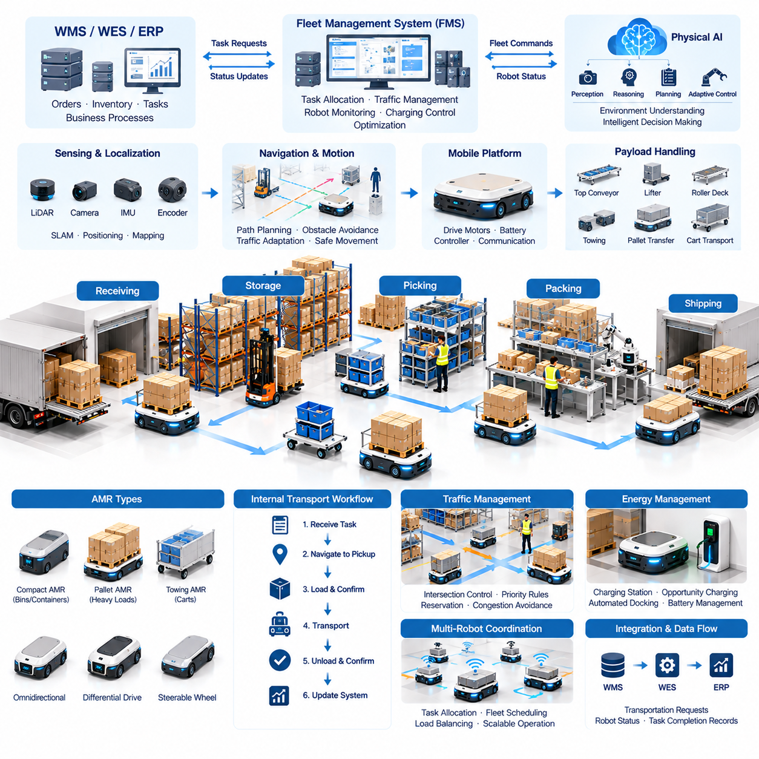
Autonomous Mobile Robots (AMRs) have become essential components of modern warehouse automation by enabling flexible and intelligent internal material transportation. Unlike traditional Automated Guided Vehicles (AGVs), which commonly follow predefined routes, AMRs use environmental perception, localization, and autonomous navigation to determine suitable paths. Their adaptability allows warehouses to modify transportation workflows without extensive changes to physical infrastructure.
Internal warehouse transportation connects receiving docks, storage locations, picking stations, packing areas, and shipping zones. These movements frequently involve repetitive material transfers that consume labor and create operational bottlenecks. AMRs automate transportation activities by moving pallets, containers, carts, and inventory units between designated locations while allowing human workers to concentrate on higher-value operational tasks.
The fundamental architecture of a warehouse AMR integrates a mobile platform, sensing systems, onboard computing, navigation software, and communication interfaces. Electric drive motors provide mobility, while batteries supply operational energy. Embedded controllers coordinate motion and safety functions, and higher-level computing platforms execute perception, localization, path planning, and task management algorithms required for autonomous operation.
Localization and mapping are critical capabilities for reliable warehouse navigation. Simultaneous Localization and Mapping (SLAM) enables robots to estimate their positions while constructing or updating environmental maps. LiDAR-based and vision-based localization methods are commonly employed depending on facility conditions. Accurate positioning allows AMRs to navigate narrow aisles, approach workstations, and reach designated loading or unloading locations.
Warehouse navigation requires continuous adaptation to dynamic obstacles and changing traffic conditions. Workers, forklifts, pallets, and other mobile robots may temporarily block planned routes. AMRs combine global path planning with local obstacle avoidance to maintain safe movement. Advanced navigation systems evaluate alternative routes, predict nearby motion, and adjust vehicle speed according to environmental constraints and operational priorities.
Different warehouse applications require different mobile platform configurations. Compact AMRs transport small containers and inventory bins, while larger platforms carry heavy pallets or industrial carts. Differential-drive, omnidirectional, and steerable-wheel configurations provide different maneuverability characteristics. Selecting the appropriate mobility architecture requires balancing payload capacity, turning radius, floor conditions, positioning accuracy, and operational cost.
Payload handling mechanisms determine how AMRs interact with warehouse materials. Common configurations include top-mounted conveyors, lifting platforms, roller decks, towing interfaces, and pallet transfer mechanisms. These attachments allow robots to exchange materials with stationary equipment or transport existing carts. Mechanical interface compatibility is essential for reliable transfers between robotic platforms and warehouse infrastructure.
Internal transportation workflows often involve repeated movements between fixed operational stations. An AMR may receive a transportation request from a warehouse management system, navigate to a pickup location, confirm material availability, and deliver the load to a destination. Task completion information is then transmitted to the supervising system. This coordinated workflow reduces manual transportation while maintaining traceability of material movements.
Fleet Management Systems (FMS) coordinate multiple AMRs operating within the same warehouse. These systems assign transportation tasks, monitor robot status, manage traffic, and coordinate charging schedules. Effective fleet management prevents unnecessary congestion and balances workload among available robots. Centralized coordination can also improve operational efficiency by considering transportation distances, task priorities, and robot availability.
Traffic management becomes increasingly important as warehouse fleets expand. Narrow corridors, intersections, elevators, and shared loading stations can create conflicts between robots. Reservation-based traffic control, priority rules, and congestion-aware routing help maintain predictable movement. Some systems employ distributed coordination, while others rely on centralized traffic management to ensure consistent operational behavior.
Warehouse AMRs must integrate with existing enterprise and automation systems. Warehouse Management Systems (WMS) provide inventory and order information, while Warehouse Execution Systems (WES) coordinate operational workflows. Enterprise Resource Planning (ERP) platforms connect warehouse activities with broader business processes. Standardized interfaces allow transportation requests, robot status, and task completion records to move between these systems.
Physical AI enhances warehouse AMRs by introducing more sophisticated environmental understanding and adaptive decision-making. Learning-based perception models can recognize operational objects and distinguish temporary obstacles from permanent structures. Predictive models can estimate traffic conditions and transportation delays. These capabilities allow autonomous robots to respond intelligently to operational changes rather than relying exclusively on fixed navigation rules.
Energy management directly affects warehouse fleet productivity. AMRs typically operate using rechargeable battery systems that require periodic charging. Opportunity charging allows robots to replenish energy during operational downtime, while automated docking supports unattended charging. Intelligent scheduling considers battery state, task urgency, charging station availability, and expected workload to reduce unnecessary interruptions.
Safety engineering is essential because warehouse AMRs frequently share workspaces with employees and conventional industrial vehicles. Protective sensors, emergency stopping mechanisms, speed limitations, and collision avoidance functions reduce operational risks. Safety-rated control systems must remain dependable even when higher-level AI algorithms encounter unexpected conditions. Appropriate validation and operational procedures are necessary for safe deployment.
Warehouse layouts strongly influence AMR performance. Aisle widths, floor quality, storage arrangements, workstation placement, and pedestrian traffic determine feasible transportation routes. Facilities designed for manual forklifts may require adjustments to support autonomous navigation. Simulation and digital twin technologies help evaluate route efficiency, traffic congestion, and fleet capacity before physical deployment.
The productivity benefits of AMRs depend on coordinated workflow design rather than robot speed alone. Reducing empty travel, minimizing waiting time, and improving task allocation can significantly increase effective transportation capacity. Warehouse operators should evaluate completed missions per hour, average delivery time, robot utilization, and system availability to understand whether autonomous transportation improves overall facility performance.
Fleet sizing requires balancing transportation demand against available robotic capacity. Too few robots create delivery delays and workstation starvation, while excessive fleet sizes increase capital expenditure and congestion. Analytical models and simulation can estimate required robot quantities using travel distances, loading times, task arrival rates, charging requirements, and expected operational availability.
Maintenance and reliability are important considerations for continuous warehouse operations. Drive components, wheels, batteries, sensors, and lifting mechanisms experience wear during repeated transportation cycles. Condition monitoring and predictive maintenance can identify developing problems before failures interrupt operations. Remote diagnostics, software updates, and structured maintenance procedures help sustain fleet availability over extended operating periods.
Deploying AMRs successfully requires close coordination between robotics engineers, warehouse operators, information technology teams, and safety personnel. Initial implementation typically focuses on repetitive transportation routes with clearly defined pickup and delivery points. Pilot deployments provide evidence about navigation reliability, integration performance, worker interaction, and operational economics before expansion into more complex workflows.
The economic assessment of warehouse AMRs should consider capital investment, integration expenses, maintenance, software licensing, energy consumption, and operational support. Benefits may include reduced manual transportation effort, improved material traceability, greater scheduling flexibility, and more consistent delivery performance. Total Cost of Ownership (TCO) and Return on Investment (ROI) analyses help determine whether deployment creates sustainable business value.
Future warehouse AMRs are expected to incorporate increasingly capable perception, predictive planning, and collaborative intelligence. Integration with mobile manipulators, automated forklifts, and heterogeneous robotic fleets may enable more comprehensive material handling automation. Shared environmental models and adaptive fleet orchestration could improve coordination across transportation, storage, and fulfillment activities.
Ultimately, warehouse AMRs transform internal transportation from a labor-intensive supporting activity into an intelligent and coordinated operational service. Their effectiveness depends on the integration of reliable mobility hardware, autonomous navigation, fleet management, enterprise software, and safety engineering. As Physical AI capabilities mature, these systems can become increasingly adaptive components of flexible, data-driven warehouse operations.

03.03. Towing and Heavy Payload Logistics
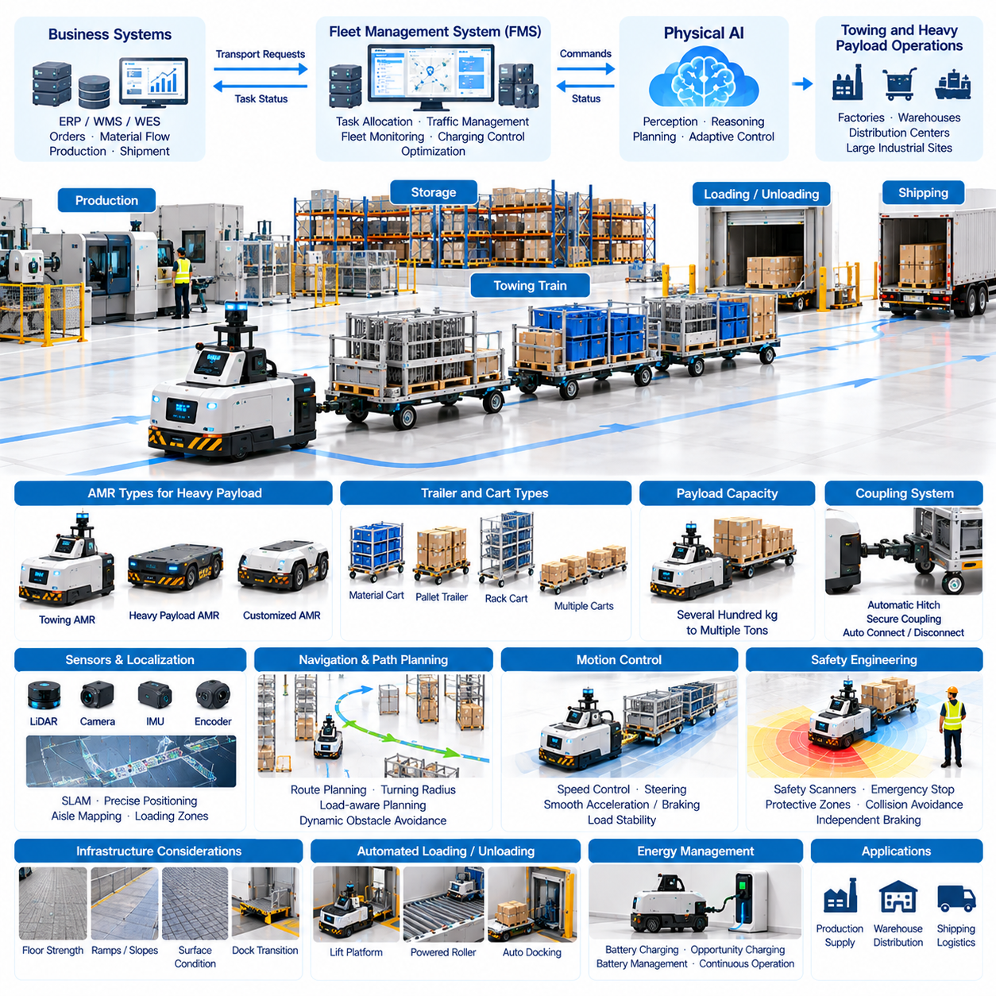
Towing and heavy payload logistics represent an important application of Physical AI in industrial warehouses, manufacturing facilities, and distribution centers. Unlike lightweight material transportation, heavy payload operations require robotic systems capable of moving large masses while maintaining stability, positioning accuracy, and operational safety. Intelligent towing robots and heavy-duty Autonomous Mobile Robots (AMRs) combine autonomous navigation with robust mechanical structures and advanced motion control.
Industrial towing systems transport carts, trailers, material racks, and wheeled containers between production areas, warehouses, and loading stations. A single autonomous towing vehicle may pull multiple connected carts, creating a transportation train that moves substantial quantities of materials. This approach can reduce repetitive forklift movements, consolidate transportation requests, and improve material flow efficiency across large industrial facilities.
Heavy payload AMRs are designed to transport loads that may range from several hundred kilograms to multiple tons, depending on their mechanical configuration. These platforms often employ reinforced chassis structures, high-torque drive motors, industrial gearboxes, and specialized wheel assemblies. Their design must account for structural deformation, load distribution, floor loading limits, and the dynamic forces generated during acceleration, braking, and turning.
Towing capacity differs from direct payload capacity because the transported mass is supported primarily by the wheels of the attached carts or trailers. The towing robot must generate sufficient tractive force to overcome rolling resistance, gradients, and acceleration demands. Consequently, allowable towing mass depends on wheel friction, floor conditions, coupling geometry, vehicle traction, and braking capability rather than motor power alone.
Vehicle dynamics become particularly important when towing heavy loads. Acceleration, deceleration, cornering, and emergency braking can generate significant forces throughout a connected trailer system. Articulated carts may exhibit off-tracking, oscillation, or jackknifing under unfavorable conditions. Physical AI systems must therefore consider the combined dynamics of the towing vehicle and its trailers when planning trajectories and controlling motion.
Mechanical coupling systems provide the physical connection between autonomous towing robots and transported carts. Common designs include automatic hitch mechanisms, drawbars, locking pins, and electronically monitored coupling interfaces. Reliable coupling requires accurate alignment, secure engagement, and confirmation that the connection remains intact. Automated coupling and decoupling can further reduce manual intervention in repetitive transportation operations.
Heavy-duty mobile platforms may employ differential-drive, four-wheel steering, omnidirectional, or independently driven wheel configurations. Each architecture provides different advantages regarding maneuverability, traction, and load handling. Four-wheel steering can support precise movement in confined spaces, while independently controlled drive modules may improve traction management and vehicle stability under changing payload conditions.
Accurate localization is essential for heavy payload transportation because large vehicles have limited maneuvering margins. LiDAR, cameras, inertial sensors, wheel encoders, and localization markers may be combined to estimate vehicle position and orientation. Mapping systems must represent aisle dimensions, turning clearances, loading zones, and restricted areas. Localization uncertainty should be considered when operating near obstacles or fixed infrastructure.
Path planning for heavy payload robots requires more than identifying the shortest route between two locations. Planning algorithms must account for vehicle dimensions, trailer articulation, minimum turning radius, stopping distance, and load stability. Routes that are feasible for unloaded robots may become unsuitable when towing long cart trains or carrying heavy loads. Load-aware planning improves operational reliability and reduces infrastructure conflicts.
Motion control systems regulate vehicle speed, steering, acceleration, and braking according to payload conditions. Heavy loads increase inertia and may substantially extend stopping distances. Adaptive controllers can adjust motion profiles using estimated payload mass, wheel traction, and vehicle dynamics. Smooth acceleration and deceleration are especially important when transporting unstable materials, precision equipment, or sensitive industrial components.
Safety engineering is a fundamental requirement for autonomous heavy payload logistics. High vehicle mass increases the potential severity of collisions and mechanical failures. Safety-rated scanners, emergency stopping systems, protective zones, and independent braking mechanisms help reduce operational risks. Safety functions must remain effective even when perception or high-level AI software experiences unexpected behavior or communication failures.
Warehouse infrastructure imposes additional constraints on heavy-duty robotic operations. Floor strength, surface flatness, expansion joints, ramps, drainage channels, and loading dock transitions influence vehicle performance. Heavy payload robots may require specialized wheels or suspension systems to distribute contact forces. Facility assessments should verify that both static loads and dynamic wheel loads remain within acceptable structural limits.
Automated loading and unloading are important for minimizing idle time in heavy payload transportation. Lift platforms, powered rollers, pallet interfaces, and automated docking mechanisms can transfer materials between robots and stationary equipment. Precise alignment is necessary to avoid mechanical interference and unstable load transfers. Sensors and interlocks should confirm load position, transfer completion, and safe departure conditions.
Fleet Management Systems (FMS) coordinate towing robots and heavy-duty AMRs across industrial facilities. Task assignment must consider payload requirements, robot capacity, transportation distance, battery condition, and equipment availability. Fleet orchestration can also coordinate traffic restrictions and loading station access. Heavy vehicles may require dedicated routes or scheduling priorities to prevent congestion and operational conflicts.
Integration with Warehouse Management Systems (WMS), Warehouse Execution Systems (WES), and Enterprise Resource Planning (ERP) platforms connects heavy material transportation with inventory and production workflows. Transportation requests can be generated from production schedules, replenishment requirements, or shipping operations. Status updates provide visibility into material location, delivery progress, and equipment utilization.
Physical AI can improve heavy payload logistics through predictive perception and adaptive planning. Learning-based models may identify changing traffic conditions, recognize load configurations, and estimate transportation delays. Predictive control can account for uncertain friction or payload characteristics when supported by appropriate sensing and validation. These capabilities complement deterministic safety systems rather than replacing established industrial control protections.
Energy consumption is a major consideration because heavy payload transportation requires substantial traction and acceleration power. Battery capacity, motor efficiency, drivetrain losses, and operating schedules determine achievable endurance. Regenerative braking may recover part of the vehicle's kinetic energy under suitable conditions. Intelligent charging strategies must balance transportation demand, battery health, charging infrastructure, and operational continuity.
Reliability and maintenance requirements increase with payload magnitude and operating intensity. Drive motors, gearboxes, wheel assemblies, bearings, braking systems, and coupling mechanisms experience repeated mechanical stress. Condition monitoring can track temperature, vibration, current consumption, and component wear. Predictive maintenance helps identify developing faults before they cause equipment downtime or compromise transportation safety.
Operational performance should be evaluated using completed transport missions, delivered payload mass, transportation cycle time, fleet utilization, and system availability. Additional indicators include energy consumption per transported ton-distance, empty travel ratio, and loading station waiting time. These metrics help distinguish genuine productivity improvements from increased robot deployment or higher nominal vehicle capacity.
Economic feasibility depends on the relationship between transportation demand, equipment investment, infrastructure requirements, and operational savings. Heavy-duty AMRs typically require more expensive mechanical components and safety engineering than lightweight robots. However, their ability to move substantial loads can reduce repetitive manual transportation and improve production continuity. Total Cost of Ownership (TCO) and Return on Investment (ROI) analyses should include maintenance, integration, energy, and lifecycle support costs.
Successful deployment generally begins with a detailed assessment of payload characteristics, route geometry, facility conditions, and transportation frequency. Pilot operations should validate traction, braking, docking accuracy, obstacle handling, and emergency behavior under representative maximum-load conditions. Gradual expansion allows operators to refine fleet scheduling, safety procedures, and system integration before introducing more complex transportation scenarios.
Future heavy payload logistics systems may incorporate shared environmental models, advanced predictive control, and coordinated operation among heterogeneous robot fleets. Intelligent towing robots, autonomous forklifts, and heavy-duty AMRs could cooperate within unified logistics networks. Increasing autonomy will depend on reliable mechanical design, validated safety architectures, interoperable software, and continuous operational learning.
Ultimately, towing and heavy payload logistics demonstrate how Physical AI extends autonomous mobility into demanding industrial transportation tasks. Their value emerges from integrating high-capacity mechanical platforms with perception, navigation, load-aware control, fleet coordination, and enterprise systems. When properly engineered and deployed, these technologies can improve material flow reliability, reduce transportation bottlenecks, and support scalable industrial automation.

03.04. Autonomous Forklifts and Pallet Handling
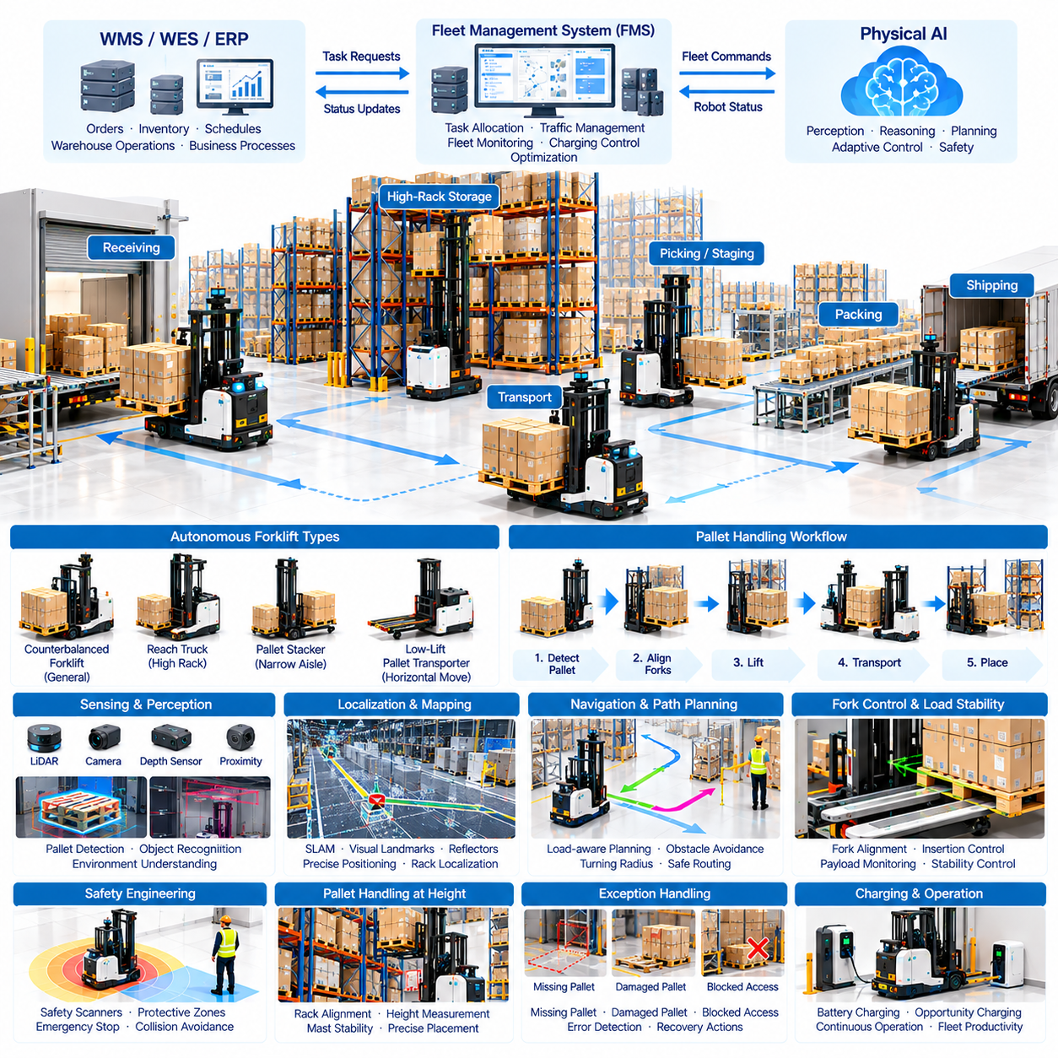
Autonomous forklifts represent an important advancement in Physical AI for warehouse and industrial logistics. These systems combine intelligent perception, autonomous navigation, precision manipulation, and vehicle control to transport pallets without continuous human operation. Unlike conventional forklifts, autonomous models can execute transportation missions while adapting to changing warehouse conditions, provided that their operating environments remain within validated safety limits.
Pallet handling is a fundamental activity in warehouses, distribution centers, and manufacturing facilities. Pallets carry raw materials, finished products, and intermediate inventory between receiving docks, storage racks, production areas, and shipping stations. Automating these movements can reduce repetitive manual driving, improve material traceability, and support more consistent transportation workflows across interconnected logistics operations.
Autonomous forklift architectures integrate industrial vehicle platforms with sensing, computing, communication, and control systems. Electric traction motors provide propulsion, while hydraulic or electromechanical lifting mechanisms control fork elevation. Onboard processors execute localization, perception, and planning algorithms, while embedded controllers regulate steering, braking, lifting, and other safety-critical vehicle functions.
Several forklift configurations support different logistics requirements, including counterbalanced forklifts, reach trucks, pallet stackers, and low-lift pallet transporters. Counterbalanced vehicles handle general pallet transportation, while reach trucks support elevated rack operations. Pallet stackers serve narrower storage environments, and low-lift vehicles emphasize horizontal movement. Vehicle selection depends on load dimensions, rack height, aisle geometry, and required throughput.
Environmental perception is essential because autonomous forklifts operate around pallets, racks, workers, and moving equipment. LiDAR, cameras, depth sensors, and proximity detectors provide information about obstacles and available space. Sensor fusion can improve object recognition and spatial understanding. Perception algorithms must distinguish pallet openings, rack structures, floor markings, and temporary obstructions to support reliable handling.
Localization and mapping enable autonomous forklifts to determine their positions within warehouse facilities. LiDAR-based localization, visual landmarks, reflectors, and Simultaneous Localization and Mapping techniques may be employed according to environmental requirements. Accurate positioning is particularly important near pallet pickup locations and storage racks, where small errors can cause fork misalignment or mechanical interference.
Pallet detection requires identifying the position, orientation, dimensions, and accessibility of the target load. Vision-based models can estimate pallet geometry, while depth sensing helps determine fork insertion locations. Detection becomes more difficult when pallets are damaged, partially obstructed, or positioned irregularly. Robust handling therefore requires uncertainty estimation and procedures for rejecting unsafe pickup attempts.
Fork alignment is a critical manipulation challenge because the vehicle must position its forks accurately relative to pallet entry openings. Autonomous controllers coordinate vehicle movement, steering angle, fork elevation, and insertion depth. Small positioning errors can damage pallets or destabilize loads. Closed-loop control using visual and geometric feedback improves alignment accuracy during pickup and placement operations.
Load stability directly influences safe autonomous forklift operation. Payload mass, center of gravity, lifting height, and vehicle acceleration affect tipping risk and braking behavior. Controllers must account for the combined center of gravity of the vehicle and its load. Excessive turning speed or sudden braking can create instability, particularly when carrying elevated or unevenly distributed materials.
Autonomous pallet transportation requires load-aware path planning rather than conventional point-to-point navigation alone. Vehicle dimensions, fork extension, load overhang, turning radius, and stopping distance influence route feasibility. Planning algorithms must avoid obstacles while preserving sufficient clearance around the transported pallet. Motion constraints become more restrictive when operating with tall or heavy loads.
High-rack pallet handling introduces additional positioning and control requirements. Reach trucks and stackers must align loads with elevated storage locations while maintaining mast stability. Rack geometry, shelf clearance, fork deflection, and load placement accuracy become increasingly important at greater heights. Automated operations may require rack localization, height measurement, and controlled lifting trajectories.
Automated pickup and placement workflows involve coordinated sequences of perception, positioning, fork insertion, lifting, transportation, and unloading. Each stage requires confirmation that the preceding action was completed correctly. Load-presence sensors, fork-position feedback, and visual inspection can support these checks. Exception handling is necessary when pallets are missing, damaged, inaccessible, or incorrectly positioned.
Physical AI enhances forklift autonomy through learned object recognition, adaptive motion planning, and context-aware decision-making. Machine learning models can identify pallet variations and estimate suitable handling strategies. Predictive algorithms may anticipate nearby traffic and adjust transportation plans. However, learning-based functions must remain constrained by validated safety controls and vehicle operating limits.
Fleet Management Systems coordinate autonomous forklifts with AMRs, warehouse transporters, and conventional material-handling equipment. Task allocation considers vehicle capacity, load requirements, destination availability, and transportation priority. Traffic coordination becomes particularly important at intersections, loading docks, and shared aisles. Integrated fleet orchestration can reduce waiting time and prevent conflicting vehicle movements.
Warehouse Management Systems and Warehouse Execution Systems provide operational instructions for autonomous pallet handling. Inventory records identify pallet locations, storage destinations, and shipment priorities. Integration interfaces exchange transportation requests, task status, and completion confirmations. Reliable synchronization is necessary to prevent inventory discrepancies when physical pallet movements differ from recorded warehouse transactions.
Safety engineering is particularly demanding because forklifts combine substantial vehicle mass with movable and potentially elevated loads. Safety-rated scanners, protective detection zones, emergency stopping, and controlled braking help mitigate collision hazards. Load monitoring and speed restrictions further reduce instability risks. Safety validation must consider both unloaded and loaded configurations across the intended operating environment.
Human-robot interaction remains important in facilities where autonomous forklifts share space with workers and manually operated vehicles. Pedestrian crossings, blind corners, and loading stations require predictable robot behavior. Visual indicators, audible warnings, controlled operating zones, and clear intervention procedures support safe coexistence. Operational policies must define responsibilities during abnormal conditions and manual recovery.
Warehouse infrastructure significantly affects autonomous forklift deployment. Floor flatness, rack alignment, pallet quality, aisle width, and lighting conditions influence navigation and handling performance. Facilities may require standardized pallet placement zones, improved floor markings, or communication infrastructure. Site preparation should be evaluated alongside robot capabilities because environmental consistency directly affects operational reliability.
Digital twins and simulation can evaluate autonomous forklift behavior before physical deployment. Virtual environments reproduce warehouse layouts, traffic patterns, pallet locations, and vehicle dynamics. Engineers can examine turning clearance, rack accessibility, fleet congestion, and transportation capacity. Simulation also supports testing of unusual situations, although physical validation remains necessary for safety-critical operations.
Energy management influences the availability and productivity of autonomous forklift fleets. Electric vehicles require battery systems capable of supporting traction, lifting, computing, and sensing loads. Automated charging and opportunity charging can reduce manual intervention. Charging schedules should consider battery condition, operational demand, mission duration, and charger availability to maintain sufficient transportation capacity.
Maintenance requirements include drive systems, steering mechanisms, hydraulic components, lifting masts, forks, sensors, and braking equipment. Repeated lifting and transportation cycles generate mechanical wear and potential alignment errors. Condition monitoring can identify abnormal vibration, temperature, hydraulic pressure, or electrical consumption. Preventive and predictive maintenance support reliable long-term operation.
Operational performance should be measured using pallet moves per hour, pickup success rate, placement accuracy, mission completion time, and fleet availability. Additional metrics include intervention frequency, rack handling errors, energy consumption, and safety-related stoppages. These indicators reveal whether autonomous forklifts improve warehouse productivity while maintaining reliable and predictable material-handling operations.
Economic feasibility depends on equipment cost, integration complexity, operating hours, labor requirements, and achievable utilization. Autonomous forklifts may reduce repetitive driving activities and improve transportation consistency, but deployment also introduces software, maintenance, and infrastructure expenses. Total Cost of Ownership and Return on Investment analyses should account for lifecycle costs, operational savings, and expected system availability.
Successful deployment begins with identifying suitable pallet-handling workflows and validating vehicle capabilities under representative operating conditions. Pilot projects should evaluate pallet detection, fork alignment, load stability, navigation reliability, and system integration. Gradual expansion allows operators to refine safety procedures, exception handling, and fleet coordination before automating more demanding warehouse activities.
Ultimately, autonomous forklifts connect intelligent mobility with precision pallet manipulation, extending Physical AI into essential warehouse material-handling operations. Their practical value depends on integrating reliable vehicle hardware, environmental perception, load-aware control, enterprise software, and validated safety systems. As these capabilities advance, autonomous pallet handling can become an increasingly adaptable component of integrated logistics automation.

03.05. Goods to Person and Order Fulfillment
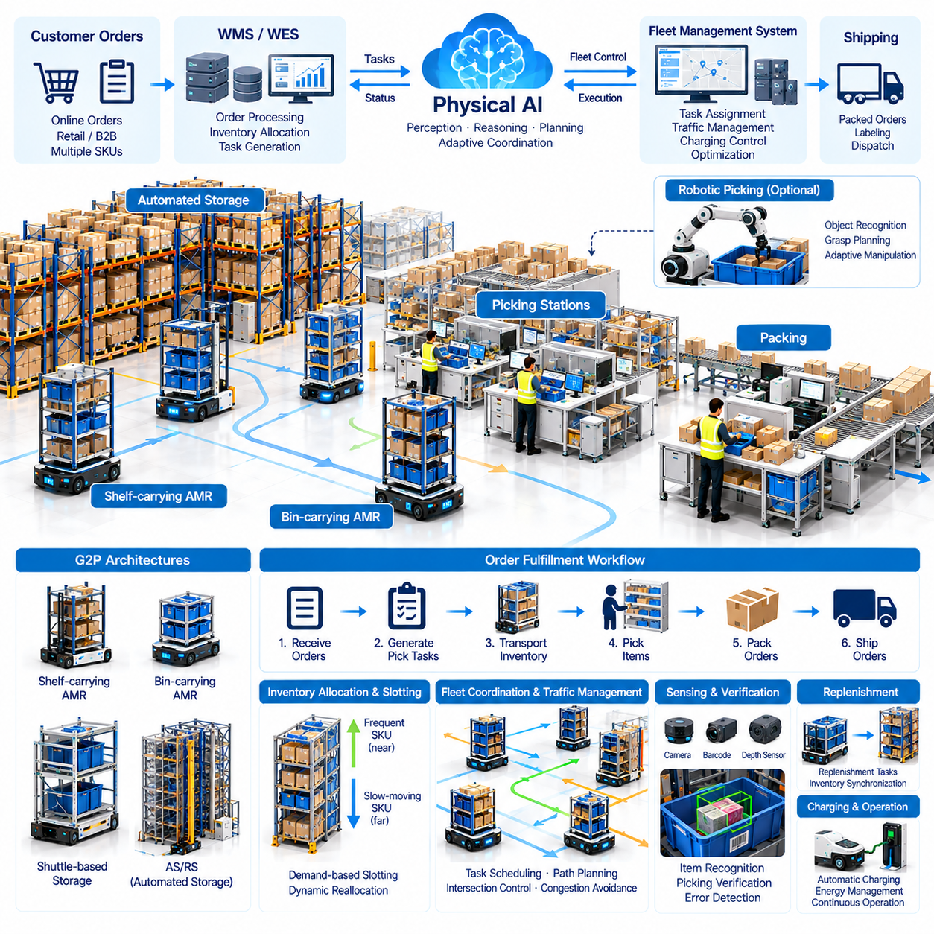
Goods-to-Person (G2P) automation transforms warehouse order fulfillment by bringing inventory directly to human operators or robotic picking stations. Instead of requiring workers to travel through storage aisles, intelligent transportation systems deliver shelves, bins, or containers to designated workstations. This approach reduces unnecessary walking, improves picking productivity, and enables more consistent fulfillment operations.
Traditional Person-to-Goods (P2G) workflows require warehouse employees to locate products, navigate storage areas, and manually retrieve inventory. These activities consume substantial time, particularly in facilities containing thousands of Stock Keeping Units (SKUs). Goods-to-Person systems reverse this movement pattern by coordinating automated storage, robotic transportation, and workstation operations around inventory demand.
Physical AI enhances G2P automation through environmental perception, autonomous mobility, intelligent scheduling, and adaptive coordination. Autonomous Mobile Robots (AMRs) transport inventory resources between storage locations and picking stations while responding to changing traffic conditions. Higher-level orchestration software determines which inventory units should move and when they should arrive to satisfy fulfillment priorities.
Several G2P architectures are used in modern warehouses, including shelf-carrying robots, bin transportation systems, shuttle-based storage, and automated storage and retrieval systems. Shelf-carrying AMRs lift and transport entire storage racks, while bin-based systems deliver individual containers. Each architecture offers different tradeoffs involving storage density, retrieval speed, infrastructure requirements, and operational flexibility.
Order fulfillment begins when customer orders are received and translated into executable warehouse tasks. Warehouse Management Systems (WMS) identify required products, quantities, and storage locations. Warehouse Execution Systems (WES) coordinate inventory retrieval and workstation activities. Fleet Management Systems (FMS) assign transportation missions to available robots according to task priority and operational constraints.
Inventory allocation strongly influences G2P system performance. Frequently requested products should remain accessible without excessive transportation, while slower-moving inventory can occupy less convenient storage locations. Intelligent slotting algorithms analyze demand frequency, product relationships, replenishment requirements, and storage capacity. Dynamic inventory placement can reduce retrieval distances and improve overall throughput.
Order batching is another essential optimization mechanism in automated fulfillment. Multiple customer orders may require overlapping products, allowing inventory containers to serve several orders during a single workstation visit. Intelligent batching algorithms group compatible orders according to product demand, deadlines, and workstation capacity. Effective batching reduces redundant inventory movements and improves picking efficiency.
Picking stations form the operational interface between automated inventory transportation and order preparation. Robots deliver shelves or containers to ergonomically designed workstations where operators identify and retrieve required items. Pick-to-light systems, barcode scanners, and visual guidance interfaces can improve accuracy. Workstation design must balance operator productivity, safety, replenishment access, and material flow.
Robotic picking introduces additional automation opportunities within G2P environments. Vision-guided manipulators can identify objects inside bins, estimate grasp configurations, and transfer selected items into order containers. Physical AI models support object recognition and adaptive grasp planning for diverse products. However, deformable packaging, reflective surfaces, and densely packed objects remain challenging for reliable autonomous picking.
Perception systems are essential for verifying inventory identity and handling accuracy. Cameras, barcode readers, depth sensors, and weight measurements can confirm product selection and detect discrepancies. Multimodal sensing improves confidence when labels are damaged or objects are partially obscured. Verification mechanisms reduce picking errors and support accurate inventory records throughout the fulfillment process.
Robot fleet coordination determines whether inventory arrives at workstations at the appropriate time. Excessive robot arrivals create congestion and workstation queues, while insufficient deliveries leave operators waiting. Fleet orchestration balances transportation assignments, route availability, workstation readiness, and robot charging requirements. Predictive scheduling can anticipate demand fluctuations and reduce operational interruptions.
Traffic management becomes increasingly important in high-density G2P facilities. Robots frequently share narrow corridors, storage intersections, and workstation approach lanes. Congestion-aware routing, intersection reservations, and coordinated movement policies help prevent deadlocks. Efficient traffic control must consider both individual robot travel time and overall system throughput rather than optimizing each mission independently.
Storage density and accessibility create important architectural tradeoffs. Compact storage arrangements increase space utilization but may require additional container reshuffling or retrieval movements. More accessible layouts reduce retrieval complexity while consuming greater floor area. Physical AI-assisted optimization can evaluate these competing objectives using inventory demand, robot capacity, facility geometry, and expected order profiles.
Replenishment operations must remain synchronized with order fulfillment to prevent inventory shortages. Incoming products are received, identified, and assigned to appropriate storage resources. Automated transportation systems move replenishment containers or shelves into available locations. Intelligent replenishment scheduling prioritizes critical inventory while minimizing interference with active picking and outbound transportation tasks.
Exception handling is essential because real warehouse operations rarely follow perfectly predictable sequences. Missing products, damaged packaging, incorrect inventory records, blocked routes, and unavailable workstations can interrupt fulfillment. Physical AI systems may detect abnormal conditions and recommend corrective actions. Reliable recovery procedures should distinguish situations suitable for autonomous resolution from those requiring human intervention.
Digital twins and simulation environments support G2P system design and operational optimization. Virtual warehouse models reproduce storage layouts, robot movements, workstation capacity, and order arrival patterns. Simulation can evaluate fleet size, inventory placement, batching policies, and congestion risks before physical deployment. Scenario testing also helps determine system behavior during demand peaks or equipment failures.
Scalability depends on maintaining coordinated performance as order volumes, inventory diversity, and robot fleet sizes increase. Adding robots does not automatically increase throughput when workstation capacity or storage accessibility becomes the limiting factor. System-level optimization must identify bottlenecks across transportation, retrieval, picking, packing, and replenishment. Modular architectures support gradual expansion when infrastructure permits.
Energy management influences the availability of robots performing continuous inventory transportation. Automated charging stations and opportunity charging strategies reduce manual battery handling. Charging schedules should consider robot utilization, anticipated demand, battery condition, and available charging capacity. Poorly coordinated charging can reduce transportation capacity during peak fulfillment periods.
Operational performance is evaluated through order lines picked per hour, picking accuracy, order cycle time, workstation utilization, and inventory retrieval latency. Additional indicators include robot utilization, empty travel distance, congestion delay, and system availability. These metrics reveal whether automation improves end-to-end fulfillment performance rather than merely increasing the speed of individual transportation activities.
Economic evaluation must consider robotic equipment, storage infrastructure, workstation installation, software integration, maintenance, and operational support. Benefits may include reduced walking time, improved inventory density, higher picking productivity, and more predictable order completion. Total Cost of Ownership (TCO) and Return on Investment (ROI) analyses should incorporate demand variability, labor requirements, and expected system utilization.
Human factors remain important even when inventory transportation is highly automated. Workstation ergonomics, operator training, visual guidance, and workload distribution influence productivity and employee well-being. Physical AI should support predictable human-robot interaction and avoid creating excessive work intensity. Effective deployment combines automation efficiency with practical working conditions and clear operational responsibilities.
Future G2P systems may combine mobile robots, robotic manipulators, predictive inventory models, and increasingly intelligent warehouse orchestration. Shared operational data could support continuous improvements in inventory placement, order batching, and task allocation. As perception and manipulation capabilities advance, more picking activities may become autonomous while human operators supervise exceptions and complex handling tasks.
Ultimately, Goods-to-Person automation demonstrates how Physical AI can transform warehouse fulfillment through coordinated movement of inventory, information, and robotic resources. Its effectiveness depends on integrating autonomous transportation, intelligent scheduling, accurate inventory management, reliable picking processes, and enterprise software. Successful implementations improve operational flexibility while supporting scalable and economically sustainable order fulfillment.

03.06. Mobile Manipulation for Picking
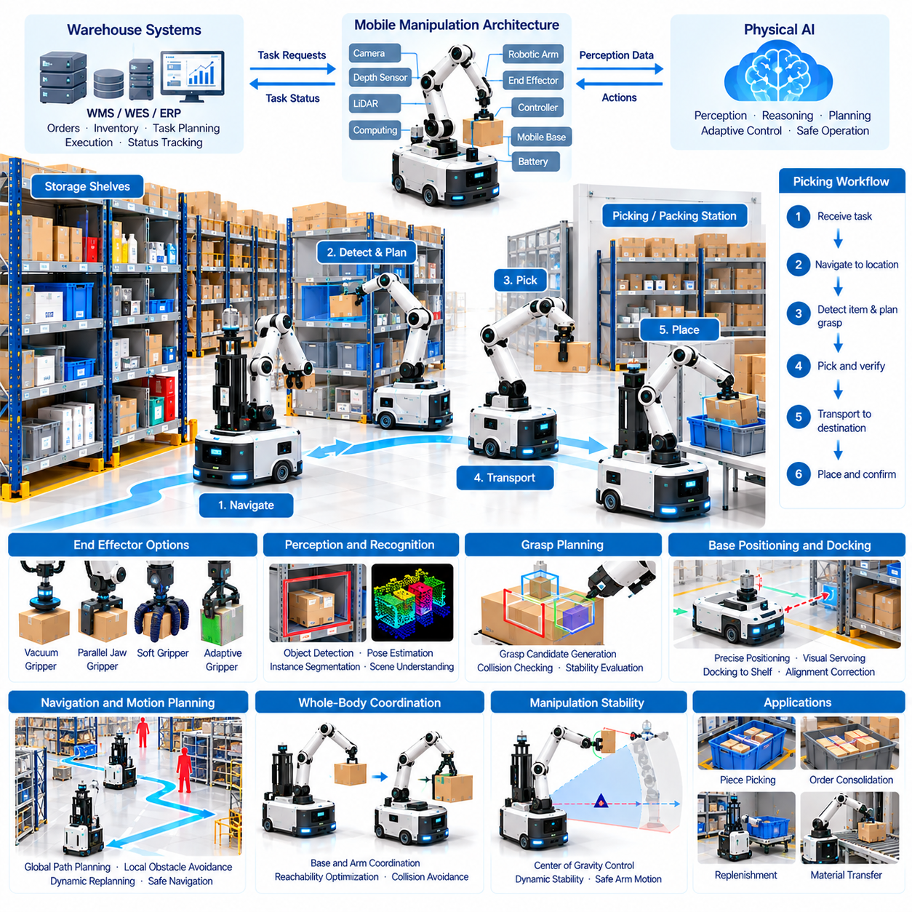
Mobile manipulation for picking combines autonomous mobility with robotic object handling to extend warehouse automation beyond transportation. A mobile manipulator typically integrates an Autonomous Mobile Robot (AMR), robotic arm, end effector, perception sensors, and onboard computing. This architecture enables robots to navigate between storage locations, identify target products, and retrieve items without requiring every picking operation to occur at a fixed workstation.
Traditional warehouse picking depends heavily on workers moving through aisles and manually collecting products from shelves, bins, or racks. Mobile manipulation changes this workflow by bringing robotic picking capabilities directly to inventory locations. Such systems can support piece picking, order consolidation, inventory replenishment, and material transfer while reducing repetitive travel and expanding automation coverage.
The mechanical architecture of a mobile manipulator must balance mobility, manipulation reach, payload capacity, and stability. The mobile base provides transportation, while the robotic arm positions the end effector within the workspace. Arm length, joint configuration, mounting height, and base dimensions determine accessible picking locations. Mechanical design must also consider vibration, structural deflection, and dynamic loads during manipulation.
Robotic arms used for warehouse picking commonly employ multiple articulated joints to reach objects from different directions. Six- or seven-degree-of-freedom manipulators can provide flexible positioning around shelves and containers. However, greater reach may increase structural complexity and reduce effective payload capacity. Selecting an appropriate arm requires matching workspace geometry, object characteristics, and required picking speed.
End effectors determine how reliably a mobile manipulator can grasp different products. Vacuum grippers are effective for many smooth and relatively rigid packages, while parallel-jaw grippers can handle objects with suitable grasping surfaces. Adaptive and soft grippers provide additional flexibility for irregular shapes. Tool selection must consider object mass, surface texture, fragility, packaging deformation, and release requirements.
Environmental perception allows mobile manipulators to identify shelves, bins, obstacles, and target products. RGB cameras, depth cameras, LiDAR, and proximity sensors provide complementary information about the surrounding workspace. Perception models estimate object categories, positions, orientations, and visible surfaces. Robust perception becomes difficult when products overlap, labels are obscured, or lighting conditions change.
Object recognition and pose estimation are central to autonomous picking. Vision models identify requested products and estimate their spatial relationships within storage compartments. Instance segmentation can distinguish individual objects in cluttered bins, while depth estimation supports three-dimensional localization. Confidence estimation is important because incorrect identification may result in picking errors or damage to neighboring products.
Grasp planning converts perception results into executable manipulation actions. Algorithms evaluate candidate contact locations, approach directions, collision risks, and expected grasp stability. Learning-based grasp prediction can improve performance across diverse product geometries. Nevertheless, grasp selection must account for physical constraints, including friction, object deformation, suction quality, and end-effector limitations.
Mobile base positioning significantly influences manipulation performance. Even when an arm has sufficient reach, inaccurate vehicle alignment may prevent successful grasping or create collisions with shelves. Localization and docking algorithms position the robot relative to the target storage structure. Visual servoing and closed-loop correction can compensate for small positioning errors before and during manipulation.
Whole-body coordination integrates mobile base motion with robotic arm movement. Instead of treating navigation and manipulation as completely separate tasks, coordinated planning can optimize base placement, arm reachability, and collision avoidance. Some platforms perform manipulation only after stopping, while others support carefully controlled motion during handling. The appropriate strategy depends on stability, task complexity, and safety requirements.
Manipulation stability becomes critical when a robotic arm extends beyond the mobile platform's support area. Arm movement and payload mass generate forces and moments that may reduce vehicle stability. Controllers must consider center-of-gravity changes, wheel contact conditions, and allowable acceleration. Heavy or elevated objects may require restricted arm configurations, reduced motion speed, or additional stabilization mechanisms.
Picking execution generally follows a sequence of navigation, target detection, approach planning, grasping, verification, and item transfer. Each stage provides feedback for subsequent decisions. Force sensing, vacuum pressure monitoring, and visual inspection can confirm successful grasp acquisition. If the object slips or cannot be reached, the system may attempt a different grasp or request human assistance.
Collision avoidance must address both navigation hazards and manipulation-specific obstacles. A robot arm may encounter shelf edges, neighboring products, storage containers, or nearby workers even when the mobile base remains stationary. Motion planning algorithms evaluate robot geometry and available clearance throughout the manipulation trajectory. Safety constraints must remain active during approach, grasping, withdrawal, and item placement.
Physical AI enhances mobile picking through multimodal learning, adaptive manipulation, and context-aware decision-making. Vision-Language-Action (VLA) models can connect task instructions with visual observations and robotic actions. Learning from demonstrations and operational experience may improve handling across diverse objects. However, learned policies require systematic validation and independent safety mechanisms before industrial deployment.
Warehouse task planning determines which products mobile manipulators should retrieve and in what sequence. Order priorities, inventory locations, robot capabilities, and travel distances influence task assignment. Intelligent scheduling can group nearby picking requests and reduce unnecessary movement. Integration with Warehouse Management Systems (WMS) and Warehouse Execution Systems (WES) maintains consistency between physical operations and inventory records.
Fleet Management Systems (FMS) coordinate multiple mobile manipulators and transportation robots within shared warehouse environments. Fleet scheduling considers robot availability, picking capabilities, battery condition, and workstation demand. Traffic management prevents conflicts at narrow aisles and intersections. Heterogeneous fleet coordination can assign difficult manipulation tasks to specialized robots while simpler transportation tasks remain with conventional AMRs.
Handling diverse inventory remains a major challenge for mobile manipulation. Products differ in shape, mass, packaging, rigidity, and surface properties. Transparent materials, reflective packaging, flexible bags, and tightly packed items complicate recognition and grasping. General-purpose picking therefore requires broad object coverage, robust sensing, adaptable grippers, and reliable strategies for recognizing unsupported conditions.
Human-robot collaboration provides a practical approach when full autonomy is not economically or technically justified. Robots can complete routine picking operations while workers handle unusual objects, damaged packaging, and difficult recovery situations. Remote assistance and teleoperation can resolve selected failures without requiring personnel at every robot location. Intervention records also provide valuable data for improving future autonomous performance.
Simulation and digital twins support development by reproducing warehouse layouts, storage structures, robot dynamics, and picking scenarios. Engineers can evaluate reachability, collision avoidance, grasp strategies, and fleet interactions before deployment. Synthetic data may expand perception training coverage. However, differences between simulated and real object behavior require physical testing and careful validation of learned manipulation policies.
Operational performance should be evaluated through successful picks per hour, grasp success rate, item damage rate, intervention frequency, and task completion time. Additional indicators include navigation efficiency, robot utilization, energy consumption, and system availability. Performance analysis should distinguish perception failures, grasp failures, navigation delays, and workflow interruptions to identify the actual sources of productivity loss.
Economic feasibility depends on robot hardware costs, integration requirements, achievable picking speed, operating hours, and inventory characteristics. Mobile manipulators can reduce repetitive manual picking and extend automation into existing storage environments. However, robotic arms, perception systems, grippers, and maintenance introduce additional costs. Total Cost of Ownership (TCO) and Return on Investment (ROI) analyses must reflect realistic picking success rates and intervention requirements.
Successful deployment begins with selecting product categories and storage locations that match the robot's manipulation capabilities. Pilot testing should evaluate object recognition, grasp reliability, base positioning, collision avoidance, and recovery procedures under representative conditions. Gradual expansion allows operators to improve inventory coverage, optimize task allocation, and validate operational safety before introducing more demanding picking activities.
Future mobile manipulation systems may combine foundation models, advanced tactile sensing, adaptive end effectors, and coordinated whole-body control. Improved generalization could reduce the need for product-specific programming, while fleet-scale learning may accelerate adaptation to new inventory. Progress will depend on combining data-driven intelligence with reliable hardware, physical reasoning, and validated industrial safety architectures.
Ultimately, mobile manipulation for picking represents a convergence of autonomous navigation, robotic manipulation, and intelligent warehouse orchestration. Its value lies in enabling robots to interact directly with inventory rather than merely transporting containers or shelves. As perception, grasping, and system integration improve, mobile manipulators can support more flexible, scalable, and increasingly autonomous warehouse fulfillment operations.

03.07. Sorting Packing and Parcel Handling
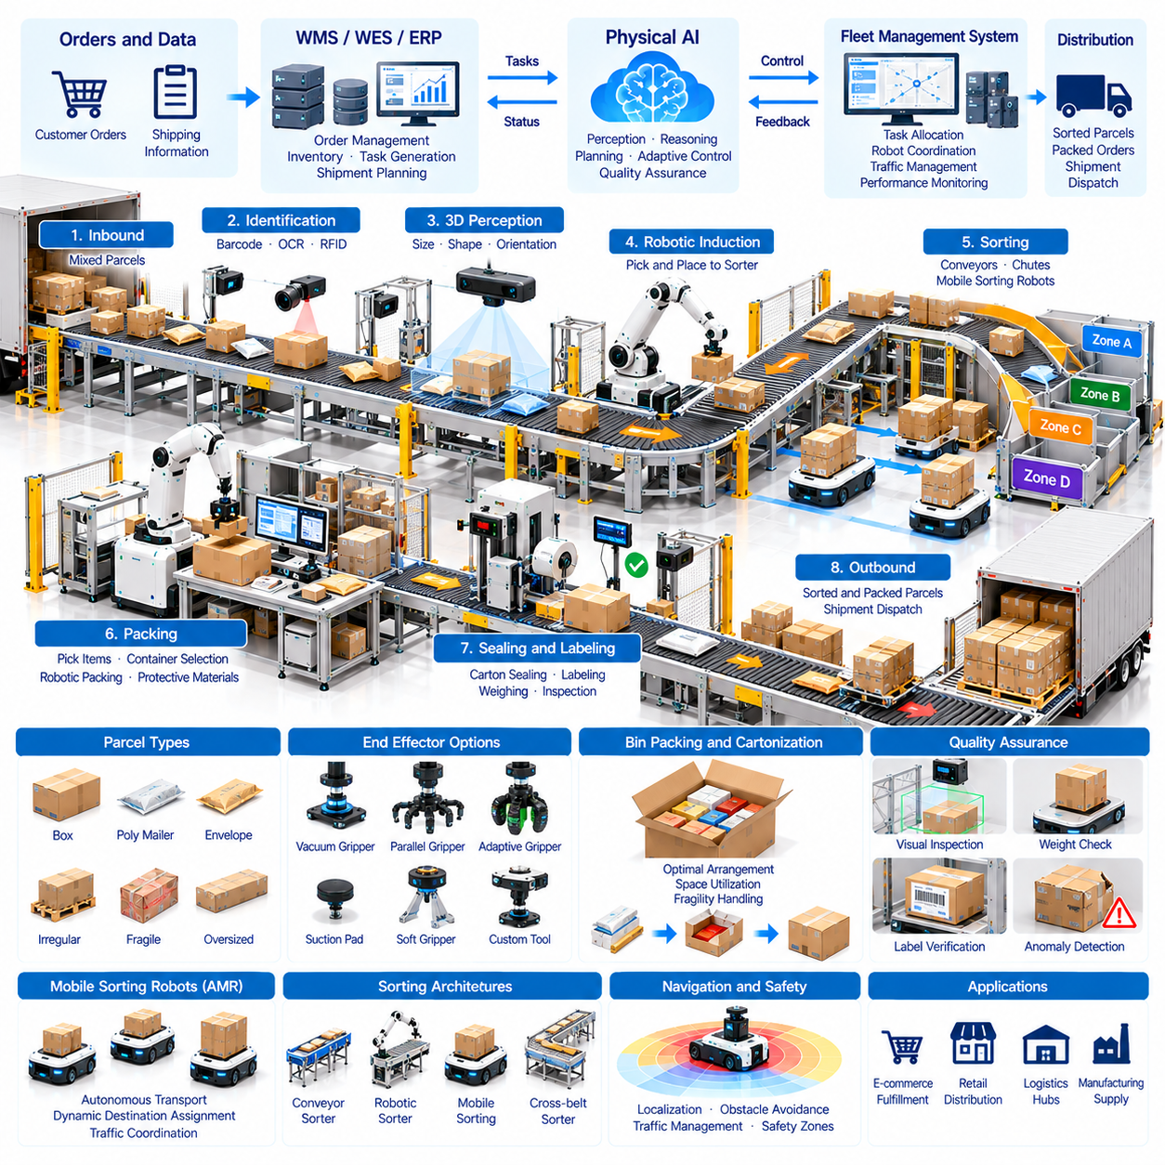
Sorting, packing, and parcel handling are essential stages of warehouse order fulfillment and distribution operations. These processes transform picked inventory into correctly classified, protected, and shipment-ready packages. Physical AI combines perception, robotic manipulation, autonomous transportation, and intelligent decision-making to automate repetitive activities while improving accuracy, throughput, and operational flexibility.
Parcel sorting determines the appropriate destination or processing route for each package based on shipping information, customer requirements, and distribution network conditions. Traditional systems rely on conveyors, barcode scanners, and mechanical diverters. Physical AI extends these capabilities through intelligent object recognition, adaptive routing, and robotic handling of parcels with varying dimensions, shapes, and packaging characteristics.
Automated sorting architectures include conveyor-based sorters, robotic induction stations, mobile sorting robots, and autonomous parcel transportation systems. Conveyor systems provide high throughput along fixed routes, while mobile robots offer flexible destination assignment and facility reconfiguration. Hybrid architectures combine fixed infrastructure with autonomous robots to balance processing capacity, operational adaptability, and investment requirements.
Parcel identification is a fundamental requirement for reliable sorting operations. Barcode readers, optical character recognition, cameras, and radio-frequency identification systems can extract shipment identifiers and routing information. Multimodal perception helps recognize damaged labels, irregular packaging, and partially obscured codes. Identification confidence must be monitored to prevent incorrect routing and shipment tracking errors.
Three-dimensional perception enables robotic systems to estimate parcel dimensions, orientation, and accessible grasping surfaces. RGB-D cameras, structured-light sensors, and depth estimation models provide geometric information for manipulation planning. Accurate dimension measurement also supports shipping classification and packaging decisions. Perception becomes challenging when parcels overlap, deform, or contain reflective and transparent materials.
Robotic parcel induction transfers incoming packages from mixed loading areas onto conveyors or sorting platforms. Manipulators must identify individual parcels, select suitable grasp locations, and place packages with appropriate spacing and orientation. Vacuum grippers and adaptive mechanical grippers support different packaging types. Reliable induction requires coordinated perception, motion planning, collision avoidance, and placement verification.
Sorting robots may transport individual parcels between induction points and destination chutes. Autonomous Mobile Robots (AMRs) navigate designated routes and deliver packages to assigned discharge locations. Their operations require accurate localization, traffic coordination, and synchronization with upstream processing equipment. Dynamic task allocation can redistribute sorting capacity as destination volumes and shipment priorities change.
Packing automation prepares selected products for safe transportation by choosing appropriate containers, arranging items, and applying protective materials. Intelligent packing systems analyze product dimensions, fragility, weight, and compatibility. Physical AI can support container selection, object placement, and packaging verification. Effective packing must balance material consumption, package protection, processing speed, and shipping cost.
Bin packing and cartonization represent important optimization problems in automated fulfillment. Algorithms determine how multiple products should be arranged inside a limited container volume. Geometric constraints, stacking strength, orientation restrictions, and damage sensitivity influence feasible arrangements. Learning-based methods may complement conventional optimization when handling irregular objects and uncertain physical properties.
Robotic packing requires precise manipulation of products with diverse shapes and mechanical characteristics. Rigid boxes are generally easier to grasp and position than flexible bags, fragile items, or irregular merchandise. Adaptive end effectors, force sensing, and compliant control can improve handling reliability. Complex packaging operations may require multiple manipulation stages, temporary fixtures, or coordinated robotic arms.
Automated sealing, labeling, and weighing complete important stages of parcel preparation. Carton sealing machines, label applicators, and integrated weighing systems can operate alongside robotic packing stations. Vision inspection verifies label placement, package closure, and visible damage. Data synchronization ensures that measured package characteristics and shipment identifiers correspond to the correct customer order.
Physical AI supports quality assurance through automated visual inspection and anomaly detection. Cameras and learned perception models can identify damaged cartons, incorrect labels, missing items, and irregular package geometry. Weight verification provides an additional method for detecting potential packing errors. Combining multiple verification signals improves reliability and reduces the number of defective shipments entering distribution networks.
Parcel handling systems must accommodate considerable variation in package size, mass, stiffness, and surface friction. Small envelopes, flexible mailers, rigid cartons, and oversized packages require different manipulation strategies. Robots should recognize when objects exceed their handling capabilities. Unsupported or uncertain cases must be redirected to suitable equipment or human operators rather than processed through unsafe actions.
Warehouse Execution Systems (WES) coordinate sorting, packing, and parcel movement according to order priorities and shipment deadlines. Warehouse Management Systems (WMS) maintain inventory and order records, while transportation systems provide carrier routing requirements. Integrated software exchanges package identity, destination, processing status, and completion confirmations to maintain consistency across fulfillment and shipping operations.
Fleet Management Systems (FMS) coordinate mobile sorting robots and parcel transportation platforms across shared facilities. Task assignment considers robot availability, destination demand, travel distance, and battery condition. Traffic management reduces congestion around induction stations, discharge locations, and narrow corridors. System-wide orchestration should optimize overall parcel flow rather than isolated robot travel efficiency.
Dynamic routing becomes important when shipment volumes fluctuate or processing equipment becomes unavailable. Predictive algorithms can estimate destination demand, queue growth, and expected processing delays. Sorting assignments may be adjusted to balance workload across available resources. Adaptive scheduling helps maintain service levels during seasonal peaks, carrier cutoff periods, and unexpected operational disruptions.
Safety engineering must address interactions among robotic arms, conveyors, mobile platforms, and human workers. Protective sensing, emergency stopping, controlled access zones, and equipment interlocks reduce collision and entanglement hazards. Moving parcels can create additional risks through falling objects or unstable stacking. Safety functions should remain independent of unverified learning-based decisions.
Exception handling is essential because parcels may arrive with unreadable labels, damaged packaging, incorrect dimensions, or inconsistent shipment records. Automated systems should detect these conditions and isolate affected packages without disrupting normal operations. Human review stations and recovery workflows provide controlled resolution. Exception data can also support continuous improvement of perception and handling algorithms.
Digital twins and simulation environments support the design of sorting and packing facilities. Virtual models reproduce conveyor capacity, robot movement, package arrival patterns, workstation processing times, and destination distributions. Engineers can evaluate congestion, equipment utilization, and throughput limitations before deployment. Simulation also supports capacity planning for demand peaks and equipment failure scenarios.
Energy management and maintenance influence the long-term availability of automated parcel handling systems. Mobile robots require coordinated charging, while conveyors, robotic arms, and packaging machines need regular inspection. Condition monitoring can identify motor overheating, abnormal vibration, gripper wear, and sensor degradation. Predictive maintenance reduces unexpected downtime and supports stable fulfillment operations.
Operational performance should be evaluated using parcels sorted per hour, packing cycle time, routing accuracy, shipment damage rate, and order completion time. Additional indicators include robot utilization, exception frequency, packaging material consumption, and equipment availability. End-to-end metrics are necessary because improvements in sorting speed may provide limited value when packing or shipping remains the primary bottleneck.
Economic feasibility depends on parcel volume, product diversity, facility configuration, labor requirements, and automation investment. High-throughput fixed sorting systems may be appropriate for stable processing patterns, while robotic solutions offer flexibility under changing demand. Total Cost of Ownership (TCO) and Return on Investment (ROI) analyses should include equipment, software integration, maintenance, energy, and operational savings.
Successful deployment begins by analyzing parcel characteristics, arrival rates, destination distributions, and existing workflow constraints. Pilot testing should validate identification accuracy, grasp reliability, sorting performance, packing quality, and exception recovery. Gradual expansion allows operators to refine system coordination and safety procedures while minimizing disruption to ongoing fulfillment activities.
Future sorting and packing systems may integrate Vision-Language-Action (VLA) models, advanced tactile sensing, adaptive grippers, and predictive warehouse orchestration. These technologies could improve handling of unfamiliar packages and support more flexible manipulation strategies. Fleet-scale learning may further enhance recognition and recovery capabilities, provided that operational safety and quality requirements remain independently validated.
Ultimately, sorting, packing, and parcel handling demonstrate how Physical AI can connect robotic perception and manipulation with intelligent logistics execution. Their value emerges from coordinating package identification, material handling, quality verification, transportation, and enterprise information systems. Effective integration can improve shipment accuracy, reduce processing bottlenecks, and support scalable, adaptable distribution operations.

03.08. Humanoid Robots for Logistics
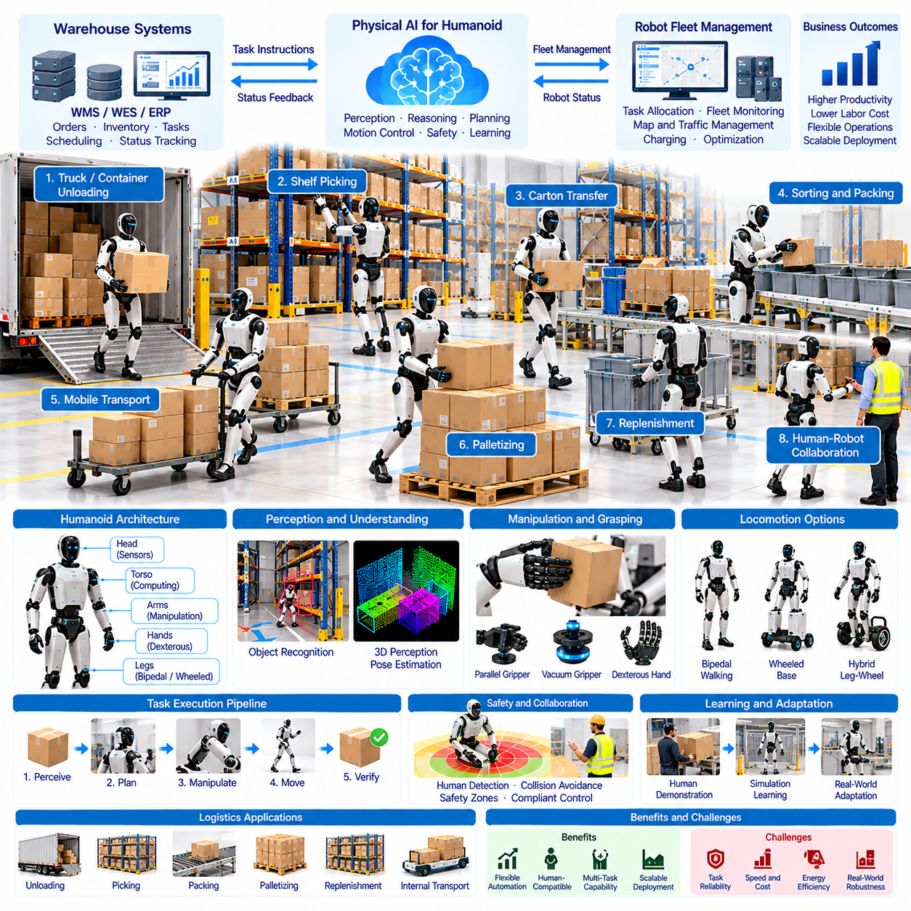
Humanoid robots represent an emerging approach to Physical AI in logistics environments designed primarily for human workers. Their human-like body structures combine bipedal mobility, articulated arms, dexterous hands, and integrated perception systems. Unlike specialized warehouse robots, humanoids aim to perform multiple physical tasks using existing facilities, tools, and workflows without requiring extensive infrastructure redesign.
Logistics facilities contain many activities that remain difficult to automate with conventional equipment. Workers unload containers, transfer cartons, retrieve products, replenish shelves, and handle irregular materials. Humanoid robots offer a potential platform for automating selected activities through general-purpose manipulation. Their practical effectiveness depends on task reliability, operating speed, payload capacity, and safety.
The mechanical architecture of a humanoid robot typically includes a torso, two arms, articulated hands, and a lower-body locomotion system. Multiple degrees of freedom enable the robot to reach objects, adjust posture, and interact with equipment at human-accessible heights. However, this flexibility introduces challenges involving structural complexity, actuator performance, balance control, and energy consumption.
Bipedal locomotion allows humanoid robots to navigate environments containing narrow passages, floor transitions, and obstacles originally designed around human movement. Dynamic walking requires continuous estimation of body posture, ground contact, and center-of-mass motion. Stable operation becomes more difficult when carrying objects because payload forces change the robot's balance and movement characteristics.
Some logistics humanoids may use wheeled lower bodies or hybrid locomotion architectures instead of conventional legs. Wheeled platforms generally provide better energy efficiency and stability on smooth industrial floors. Legged systems may offer advantages where terrain or access constraints prevent wheeled movement. Selecting an appropriate morphology requires evaluating facility conditions rather than assuming that human-like walking is always necessary.
Manipulation capability is central to the value of humanoid logistics robots. Dual robotic arms can coordinate object lifting, carton transfer, and placement operations. Dexterous hands may support interactions with handles, containers, tools, and irregular products. Effective manipulation requires appropriate grasp planning, force regulation, and coordinated arm motion, particularly when objects have uncertain weight distributions.
Whole-body control coordinates the robot's arms, torso, and lower body during physical tasks. When lifting a carton, the robot must adjust posture and contact forces to preserve balance. Motion planning should consider joint limits, actuator torque, collision avoidance, and payload stability. Coordinated control becomes particularly important during reaching, bending, turning, and transferring objects between different heights.
Environmental perception enables humanoid robots to recognize objects, people, equipment, and workspace conditions. Cameras, depth sensors, inertial measurement units, and force sensors provide complementary information. Perception models estimate object identity, location, orientation, and accessible grasp surfaces. Reliable performance requires handling occlusion, changing illumination, clutter, and unexpected object arrangements.
Vision-Language-Action (VLA) models offer a potential framework for connecting natural-language instructions with perception and robot behavior. A warehouse instruction such as moving selected cartons to a staging area can be decomposed into navigation, identification, grasping, and placement actions. Foundation models may improve task generalization, but physical execution still requires validated control policies and explicit safety constraints.
Learning from human demonstrations provides another approach to developing humanoid logistics capabilities. Teleoperation, motion capture, and imitation learning can generate examples of object handling and coordinated movement. Reinforcement learning and simulation may further refine control strategies. Nevertheless, differences between simulated and physical environments require careful testing before deploying learned behaviors in active warehouses.
Carton handling is a promising application because many logistics operations involve repetitive lifting and transferring of boxes. Humanoid robots may move cartons between conveyors, pallets, carts, and shelving locations. Performance depends on package geometry, weight, stacking arrangement, and available clearance. Reliable handling requires detecting unstable loads, maintaining secure grasps, and avoiding damage during placement.
Truck and container unloading presents a more demanding application. Packages may be tightly packed, irregularly stacked, or positioned beyond comfortable reach. Robots must identify accessible objects, determine safe removal sequences, and adapt to changing load configurations. Limited maneuvering space and uncertain package stability complicate automation, making supervised operation and structured task selection practical initial approaches.
Order picking and replenishment are additional opportunities for humanoid deployment. Robots may retrieve products from shelves, place items into containers, and restock inventory locations. Their human-compatible reach and manipulation capabilities can support existing storage infrastructure. However, specialized mobile manipulators or fixed robotic systems may outperform humanoids when workflows are highly repetitive and geometrically constrained.
Human-robot collaboration is important because humanoid robots are likely to share logistics facilities with workers and conventional equipment. Robots must maintain safe separation, communicate operational intentions, and respond predictably to nearby human activity. Safety-rated sensing, emergency stopping, and controlled movement limits remain necessary. General-purpose AI decision-making cannot replace independently validated protective functions.
Task planning determines how humanoid robots should prioritize and execute logistics activities. Warehouse Management Systems (WMS) and Warehouse Execution Systems (WES) provide inventory information, work orders, and operational priorities. Task orchestration software converts these requirements into executable robot missions. Effective planning must consider object accessibility, robot capabilities, transportation distance, and expected task duration.
Fleet Management Systems (FMS) may coordinate humanoids alongside Autonomous Mobile Robots (AMRs), autonomous forklifts, and other warehouse equipment. Humanoids can perform manipulation tasks while specialized mobile platforms transport heavy or repetitive loads. Coordinated scheduling reduces unnecessary walking and improves resource utilization. Heterogeneous fleet architectures may offer better overall efficiency than deploying humanoids for every task.
Energy efficiency remains a significant limitation for humanoid logistics applications. Walking, balancing, lifting, and continuous perception require substantial electrical power. Battery capacity influences operating duration, while actuator efficiency affects heat generation and sustained performance. Charging schedules and battery replacement strategies must account for workload intensity, thermal limits, and the availability of backup robots.
Reliability and maintenance are challenging because humanoids contain numerous actuators, joints, sensors, and mechanical interfaces. Repeated lifting and locomotion create wear across multiple components. Condition monitoring can detect abnormal temperatures, joint friction, vibration, and actuator performance degradation. Industrial deployment requires maintainable hardware, accessible spare parts, and predictable recovery procedures.
Operational performance should be measured using successful tasks per hour, manipulation success rate, intervention frequency, task completion time, and system availability. Additional metrics include energy consumption, payload limitations, safety-related stoppages, and object damage rates. These indicators should be evaluated against human workflows and specialized robotic alternatives to determine where humanoid deployment provides measurable advantages.
Economic feasibility depends on acquisition cost, maintenance, integration, operating hours, and achievable autonomous task coverage. A humanoid's ability to perform multiple tasks may improve equipment utilization, but general-purpose capability does not automatically guarantee economic superiority. Total Cost of Ownership (TCO) and Return on Investment (ROI) analyses should reflect realistic task speeds, supervision requirements, and operational reliability.
Successful deployment should begin with structured tasks that have predictable objects, limited environmental variation, and manageable safety risks. Pilot projects can evaluate carton handling, shelf replenishment, or workstation assistance under controlled conditions. Gradual expansion allows operators to collect failure data, improve manipulation policies, and establish recovery procedures before attempting complex or unsupervised operations.
Digital twins and simulation support humanoid development by modeling warehouse layouts, robot dynamics, object interactions, and task sequences. Virtual testing can evaluate reachability, balance, grasping, and collision avoidance across many scenarios. Synthetic demonstrations may improve learning efficiency. However, physical validation remains essential because contact forces, material properties, and unexpected disturbances are difficult to reproduce perfectly.
Future humanoid logistics systems may combine multimodal foundation models, tactile sensing, improved actuators, and fleet-scale learning. Shared experience across deployed robots could improve object handling and task adaptation. Greater autonomy will require progress in generalization, physical reasoning, safety assurance, and operational reliability. Specialized robots and humanoids will likely remain complementary rather than universally interchangeable.
Ultimately, humanoid robots for logistics illustrate the ambition of Physical AI to operate within human-centered industrial environments. Their potential lies in combining flexible mobility, general-purpose manipulation, intelligent perception, and adaptive task execution. Sustainable adoption will depend on demonstrating dependable performance, economic value, and validated safety while integrating effectively with existing warehouse systems.

03.09. Yard Port and Outdoor Logistics
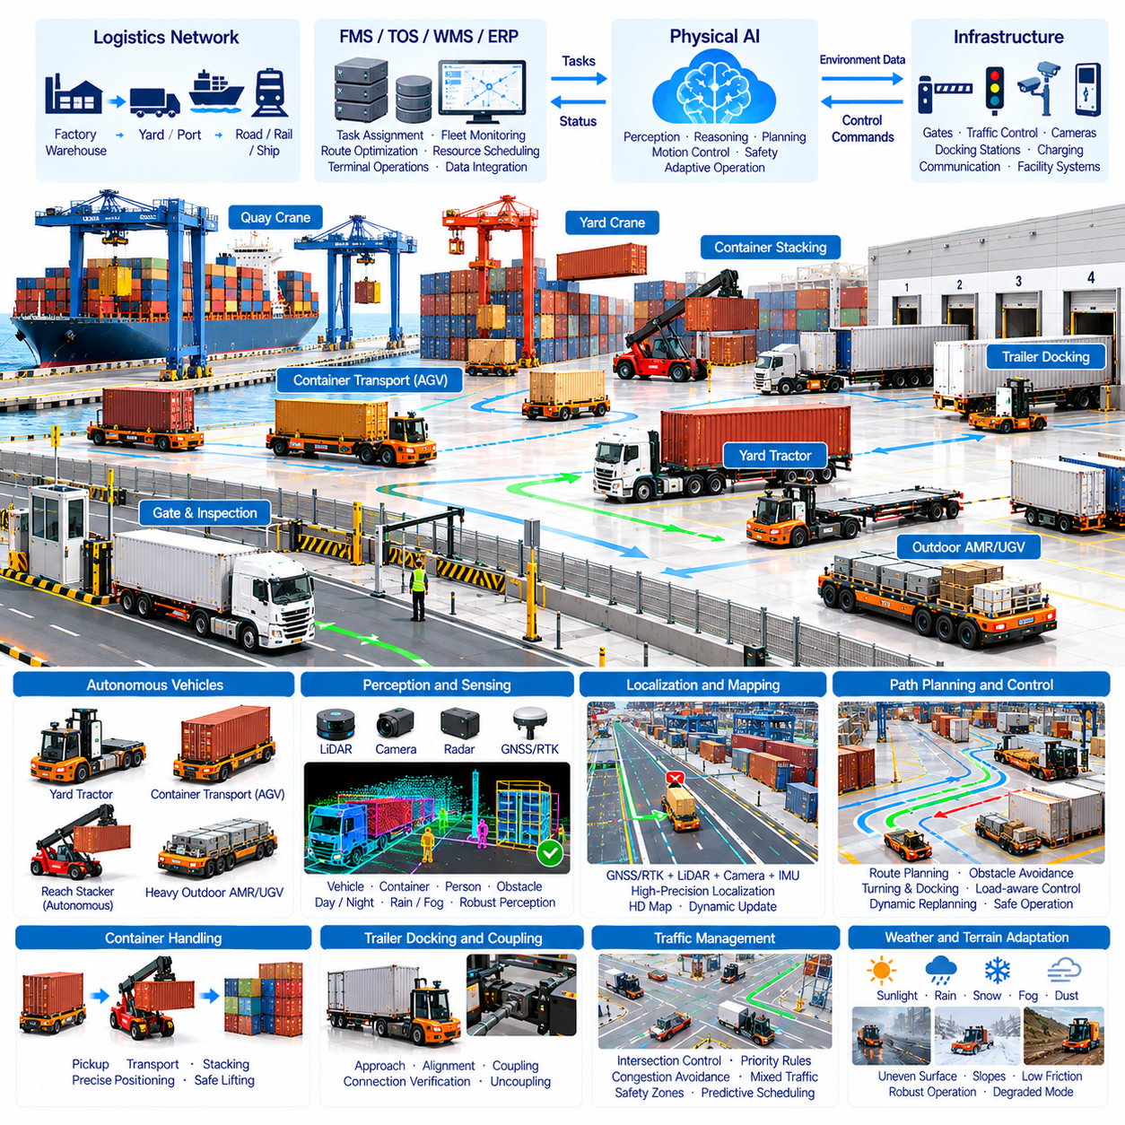
Yard, port, and outdoor logistics extend Physical AI beyond controlled warehouse environments into large industrial spaces with variable terrain, weather, and traffic conditions. These operations include container transportation, trailer movement, cargo handling, and equipment coordination. Autonomous systems can improve material flow, reduce repetitive driving, and support safer operations where conventional automation is difficult to deploy.
Logistics yards connect warehouses, distribution centers, and transportation networks through trailer staging, loading, unloading, and vehicle dispatch. Port terminals manage containers between ships, storage areas, trucks, and rail systems. Both environments require coordination among vehicles, lifting equipment, and human operators. Physical AI introduces perception-driven autonomy and intelligent scheduling to improve these interconnected workflows.
Autonomous yard tractors represent an important application of outdoor logistics automation. These vehicles move trailers between parking areas, loading docks, and inspection stations. Their navigation systems must account for trailer geometry, turning radius, coupling conditions, and restricted maneuvering spaces. Reliable automation requires precise positioning, obstacle detection, and coordination with dock operations.
Autonomous terminal tractors and container transport vehicles perform repetitive cargo movements across port facilities. Automated Guided Vehicles (AGVs) commonly follow structured routes, while more flexible autonomous platforms can adapt to changing traffic conditions. Vehicle selection depends on payload requirements, operating speed, infrastructure availability, and terminal layout. High-capacity transport requires robust braking and motion control.
Outdoor localization is more challenging than indoor warehouse positioning because environmental features and sensor conditions vary. Global Navigation Satellite Systems (GNSS), Real-Time Kinematic (RTK) positioning, LiDAR, cameras, and inertial sensors provide complementary information. Sensor fusion improves position estimation when satellite signals are obstructed by cranes, containers, buildings, or other large structures.
Environmental perception must recognize trucks, containers, pedestrians, equipment, road boundaries, and temporary obstacles. LiDAR and camera-based detection systems provide spatial and semantic information about surrounding activity. Outdoor robots must operate under sunlight, darkness, rain, fog, and dust. Reliable perception therefore requires sensor redundancy, uncertainty estimation, and performance validation across changing conditions.
Path planning for outdoor logistics must consider vehicle dimensions, turning constraints, surface conditions, and interaction with other traffic. Large vehicles require wider turning spaces and longer stopping distances than typical warehouse robots. Motion planners should evaluate obstacle clearance and vehicle stability throughout each maneuver. Dynamic replanning becomes necessary when routes are blocked or operational priorities change.
Container handling requires coordination between transport vehicles and lifting equipment such as quay cranes, yard cranes, and reach stackers. Autonomous transport platforms must arrive at transfer locations with accurate timing and positioning. Delays in one subsystem can reduce utilization across the terminal. Integrated scheduling helps synchronize container pickup, transportation, stacking, and loading activities.
Automated stacking cranes and robotic container handling equipment extend Physical AI into heavy-duty material manipulation. These systems identify container positions, monitor lifting conditions, and coordinate movement within storage blocks. Precise control is essential because container loads are heavy and operating clearances may be limited. Safety systems must independently supervise lifting limits and restricted work zones.
Trailer docking and coupling introduce additional manipulation and alignment challenges. Autonomous vehicles must approach trailers accurately and verify mechanical connections before transportation. Sensors may monitor coupling engagement, trailer position, and connection status. Automated docking systems also require reliable communication with warehouse doors, loading equipment, and facility control systems to prevent unsafe vehicle movement.
Outdoor logistics surfaces may contain slopes, potholes, uneven pavement, standing water, and loose materials. These conditions influence traction, braking distance, and vehicle stability. Autonomous controllers must estimate traversability and adjust speed according to available friction and payload conditions. Heavy-load operations require particular attention to rollover risk, load shifting, and stopping performance.
Weather adaptation is essential for maintaining outdoor operational reliability. Rain and snow can reduce visibility and tire traction, while fog and dust may degrade optical sensing. Extreme temperatures affect batteries, electronics, and hydraulic systems. Operational policies should define acceptable environmental conditions, degraded operating modes, and safe shutdown procedures when reliable autonomy cannot be maintained.
Traffic management coordinates autonomous vehicles, manually operated trucks, pedestrians, and industrial equipment within shared outdoor facilities. Intersections, loading zones, and narrow passages create potential conflicts. Centralized or distributed coordination systems can assign movement priorities and reserve critical areas. Safe operation requires clear traffic rules, predictable robot behavior, and reliable emergency response mechanisms.
Fleet Management Systems (FMS) assign transportation missions and coordinate vehicle availability, charging, and route selection. Terminal Operating Systems (TOS) provide container locations, vessel schedules, and handling priorities. Integration between these platforms enables transportation tasks to reflect real operational demand. Data consistency is essential because incorrect container assignments can disrupt downstream shipping processes.
Physical AI can support predictive scheduling by analyzing vessel arrivals, truck appointments, container dwell times, and equipment availability. Demand forecasts help determine where vehicles and handling equipment should be positioned. Dynamic task allocation can reduce empty travel and equipment waiting time. Effective orchestration must optimize terminal-wide throughput rather than maximizing individual vehicle utilization.
Multi-robot coordination becomes increasingly important as outdoor logistics fleets expand. Autonomous tractors, container carriers, inspection robots, and service vehicles may share roads and operational zones. Heterogeneous fleet management must account for differences in speed, payload, maneuverability, and task capabilities. Shared maps and traffic information improve coordination while reducing congestion and conflicting movements.
Safety engineering is particularly important because outdoor logistics involves heavy vehicles, suspended loads, and mixed human-machine traffic. Functional safety architectures should include emergency stopping, speed supervision, collision prevention, and safe-state transitions. Geofencing can restrict access to hazardous zones. Learned AI policies must operate within independently validated safety boundaries and established operational procedures.
Cybersecurity and communication reliability also influence autonomous yard and port operations. Vehicles exchange mission commands, position information, and operational status over wireless networks. Communication interruptions should trigger defined fallback behaviors rather than uncontrolled motion. Secure authentication, network segmentation, and event logging help protect fleet operations and support incident investigation.
Digital twins provide virtual representations of yard layouts, port equipment, traffic flows, and container movements. Simulation can evaluate route configurations, fleet sizes, crane utilization, and congestion before physical deployment. Scenario testing helps identify bottlenecks during vessel peaks or equipment failures. However, simulated performance must be validated against actual vehicle dynamics and environmental conditions.
Operational performance should be measured through container moves per hour, trailer transfer time, vehicle utilization, empty travel distance, and equipment waiting time. Additional indicators include energy consumption, safety-related stoppages, task completion reliability, and system availability. End-to-end metrics are necessary because faster vehicle movement does not automatically improve terminal throughput when crane capacity remains constrained.
Economic feasibility depends on cargo volume, facility layout, operating hours, infrastructure investment, and labor requirements. Autonomous vehicles may reduce repetitive driving and improve asset utilization, but integration and maintenance introduce significant costs. Total Cost of Ownership (TCO) and Return on Investment (ROI) analyses should include equipment, connectivity, infrastructure changes, safety engineering, and operational savings.
Deployment typically begins with controlled routes, predictable transfer points, and clearly defined operational boundaries. Pilot programs should validate localization, obstacle detection, docking accuracy, traffic interaction, and emergency procedures. Gradual expansion allows operators to evaluate reliability under different weather and workload conditions. Human supervision and structured exception handling remain important during operational transitions.
Future outdoor logistics systems may combine predictive world models, advanced sensor fusion, autonomous heavy equipment, and fleet-scale learning. Greater integration between vehicles, cranes, infrastructure, and enterprise systems could improve coordination across entire logistics networks. Progress will depend on robust perception, reliable control, interoperability, and independently verified safety under diverse environmental conditions.
Ultimately, yard, port, and outdoor logistics demonstrate how Physical AI can automate complex transportation and material handling beyond warehouses. Their value emerges from connecting autonomous mobility, heavy-load manipulation, intelligent scheduling, and industrial information systems. Successful implementation can improve cargo throughput, equipment utilization, operational resilience, and safety across large-scale logistics infrastructure.

03.10. Autonomous Last Mile and Campus Logistics
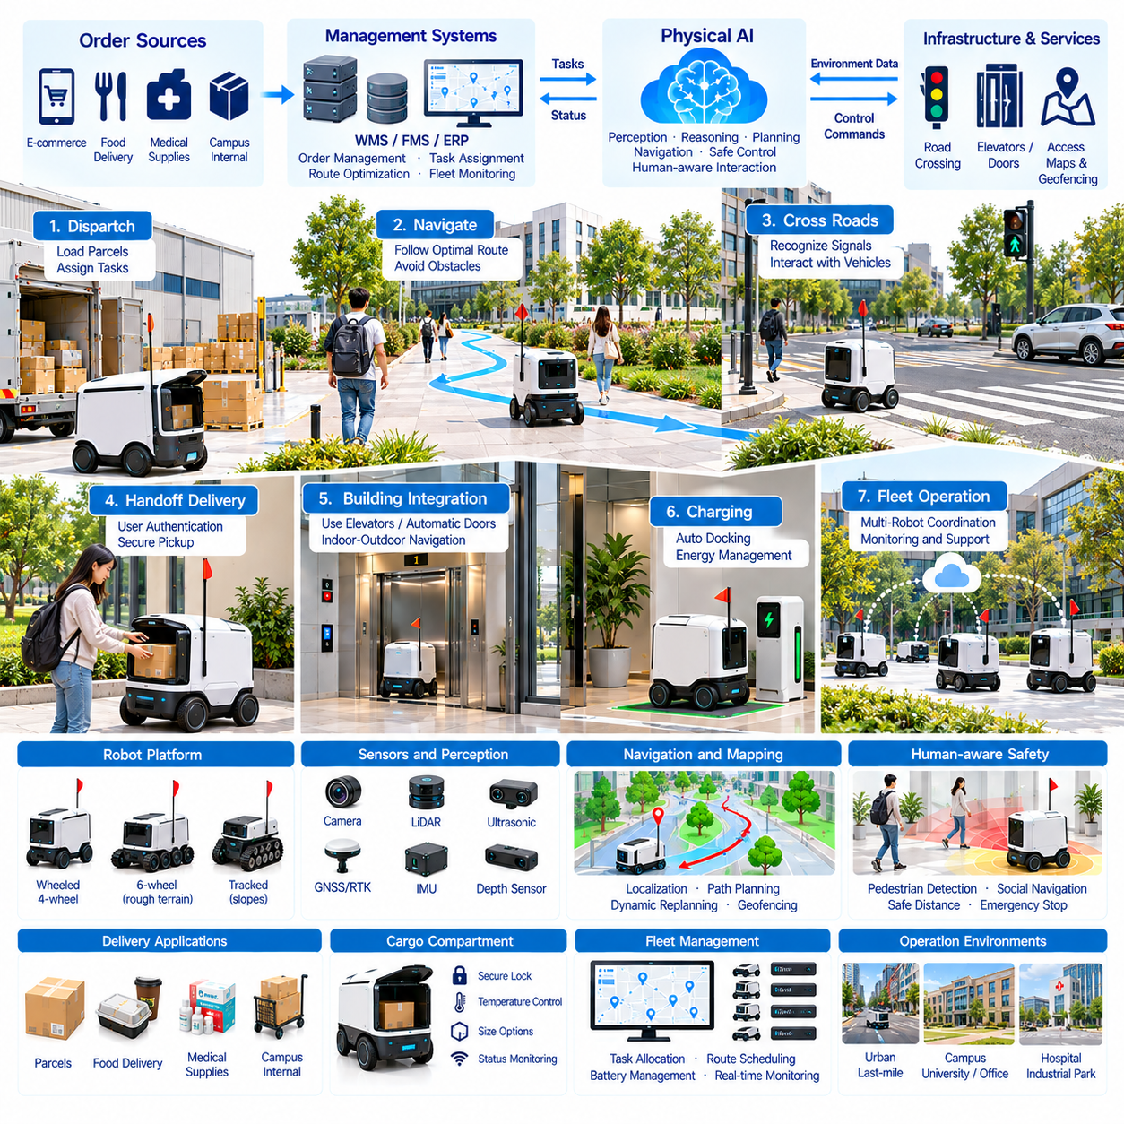
Autonomous last-mile and campus logistics extend Physical AI from warehouses and distribution centers into pedestrian-oriented environments. These applications involve transporting parcels, meals, medical supplies, and internal materials over relatively short distances. Autonomous delivery robots combine navigation, perception, task planning, and remote supervision to reduce repetitive transportation while improving service availability.
Last-mile delivery represents the final transportation stage between a distribution point and the recipient. Conventional delivery depends heavily on human couriers, especially for small orders and frequent destinations. Autonomous robots can serve selected routes where delivery density, infrastructure, and regulations are favorable. Their economic value depends on delivery frequency, travel distance, payload capacity, and successful handoff.
Campus logistics includes transportation within universities, hospitals, industrial parks, corporate facilities, and residential communities. These environments often contain recurring routes and predictable delivery destinations. Robots may connect buildings, reception areas, laboratories, dining facilities, and storage locations. Controlled access and coordinated infrastructure can simplify deployment compared with unrestricted urban delivery.
Ground delivery robots commonly use compact wheeled platforms with enclosed cargo compartments. Their mechanical design balances payload volume, maneuverability, stability, and energy efficiency. Four-wheel or six-wheel configurations may provide improved traction over uneven surfaces. Vehicle dimensions must accommodate pedestrian pathways, narrow passages, ramps, and designated crossing locations.
Environmental perception enables delivery robots to recognize pedestrians, bicycles, vehicles, curbs, and temporary obstacles. Cameras, LiDAR, ultrasonic sensors, and depth sensors provide complementary observations. Perception algorithms classify surrounding objects and estimate their motion. Reliable operation requires recognizing partially obscured obstacles and adapting to crowded or changing environments without creating unsafe interactions.
Localization and mapping are essential for navigating campuses and urban delivery routes. Global Navigation Satellite Systems (GNSS), visual odometry, LiDAR mapping, and inertial sensing can be combined through sensor fusion. Satellite positioning may become unreliable near tall buildings or covered walkways. Robust localization therefore requires alternative environmental references and continuous uncertainty monitoring.
Route planning must account for more than geometric distance. Pedestrian density, sidewalk width, surface quality, crossings, slopes, and restricted zones influence practical travel time. Global planners select feasible delivery routes, while local planners respond to moving obstacles. Adaptive navigation can reroute around temporary construction, crowded pathways, or blocked entrances while respecting operational boundaries.
Human-aware navigation is particularly important because delivery robots share space with pedestrians. Robots should maintain appropriate separation, limit speed near people, and avoid unpredictable maneuvers. Social navigation models can estimate pedestrian movement and common interaction patterns. However, learned behavior must remain constrained by independently verified collision prevention and emergency stopping functions.
Crossing roads and interacting with vehicles introduce additional safety challenges. Delivery robots must recognize traffic signals, approaching vehicles, and safe crossing opportunities. Some deployments restrict robots to supervised crossings or designated routes. Operational design should consider local traffic regulations, visibility limitations, and the consequences of delayed or incorrect crossing decisions.
Cargo compartments protect transported items and provide controlled recipient access. Electronic locks, authentication systems, and compartment sensors support secure delivery. Temperature-controlled compartments may be necessary for meals, pharmaceuticals, or sensitive materials. Package monitoring can detect unauthorized access, unexpected movement, or delivery completion, although security features must be balanced against cost and energy consumption.
Delivery handoff is a critical part of the service experience. Recipients may receive arrival notifications and unlock compartments using an application or authorized credential. Robots must verify that cargo has been collected before closing the task. Failed handoffs require procedures for waiting, rescheduling, returning items, or contacting support. Reliable customer interaction is as important as autonomous navigation.
Campus robots may integrate with elevators, automatic doors, access control systems, and building management platforms. Indoor-outdoor navigation requires transitions between different localization methods and environmental conditions. Elevator coordination introduces scheduling and communication requirements. Where building interfaces are unavailable, delivery workflows may use designated transfer points or human assistance.
Fleet Management Systems (FMS) coordinate multiple delivery robots across service regions. Task assignment considers delivery priority, robot location, battery state, cargo capacity, and expected travel time. Fleet scheduling can group compatible orders and balance demand between destinations. Congestion management and charging coordination become increasingly important as the number of operating robots grows.
Demand-aware logistics improves service efficiency by predicting order patterns across locations and time periods. Meal deliveries may peak around lunch, while campus supplies follow institutional schedules. Predictive algorithms can reposition available robots near expected demand. Dynamic task allocation reduces empty travel and waiting time, although prediction errors must not compromise service commitments or operational safety.
Remote supervision provides operational support when autonomous robots encounter unfamiliar conditions. Teleoperators may review blocked routes, localization failures, or difficult pedestrian interactions. Systems should distinguish between remote assistance, supervised autonomy, and direct teleoperation. Communication loss must trigger a defined safe response, and intervention records can support improvements to future autonomous performance.
Weather and terrain create significant challenges for outdoor delivery. Rain, snow, ice, puddles, and uneven pavement can affect traction and sensor reliability. Small robots are particularly sensitive to curbs, steep slopes, and surface discontinuities. Controllers must evaluate traversability and adjust operating speed. Severe conditions may require route restrictions, reduced service availability, or temporary suspension.
Energy management determines how long delivery robots can remain operational between charging sessions. Battery consumption depends on travel distance, payload mass, terrain, temperature, and onboard computing. Fleet scheduling should account for charging availability and reserve energy for safe returns. Battery health monitoring and preventive maintenance help maintain predictable service capacity across extended operating periods.
Physical AI can enhance delivery autonomy through multimodal perception, predictive world models, and adaptive decision-making. Vision-Language-Action (VLA) approaches may support interpreting contextual instructions and handling unusual delivery situations. Learning from fleet experience can improve route selection and obstacle responses. Nevertheless, model generalization must be validated against real-world safety requirements.
Safety, privacy, and cybersecurity influence public acceptance of autonomous delivery systems. Robots operating near people require dependable obstacle detection, controlled speeds, and accessible emergency procedures. Cameras and location records may capture sensitive information. Secure communication, data minimization, access control, and transparent operational policies help protect users and support responsible deployment.
Operational performance should be evaluated using successful deliveries per hour, average delivery time, on-time delivery rate, and autonomous completion rate. Additional indicators include intervention frequency, customer waiting time, energy consumption, and fleet availability. Service quality metrics should capture failed handoffs, cargo damage, and customer complaints because transportation efficiency alone does not determine delivery success.
Economic feasibility depends on robot acquisition cost, maintenance, supervision, charging infrastructure, and delivery demand density. High utilization can distribute fixed costs across more deliveries, while low order volume may weaken financial performance. Total Cost of Ownership (TCO) and Return on Investment (ROI) analyses should compare autonomous operations with conventional courier services under realistic workload assumptions.
Deployment typically begins in geographically limited environments with mapped routes and cooperative facility operators. Pilot programs validate pedestrian interaction, obstacle avoidance, localization, cargo security, and delivery handoff procedures. Gradual expansion enables performance evaluation under different traffic and weather conditions. Regulatory compliance and community acceptance should be addressed before increasing service coverage.
Future autonomous delivery networks may connect warehouses, micro-fulfillment centers, campus facilities, and neighborhood transfer points. Robots could coordinate with autonomous vehicles and other transportation platforms for multimodal delivery. Shared fleet intelligence may improve scheduling and route adaptation. Broader adoption will depend on interoperability, reliable autonomy, infrastructure access, and sustainable operating economics.
Ultimately, autonomous last-mile and campus logistics demonstrate how Physical AI can provide transportation services directly within human environments. Their value comes from combining safe autonomous mobility, secure cargo handling, intelligent fleet orchestration, and reliable customer interaction. Successful deployment can reduce repetitive delivery work, improve local logistics accessibility, and support scalable short-distance distribution.

03.11. Aerial and Cargo Robot Logistics
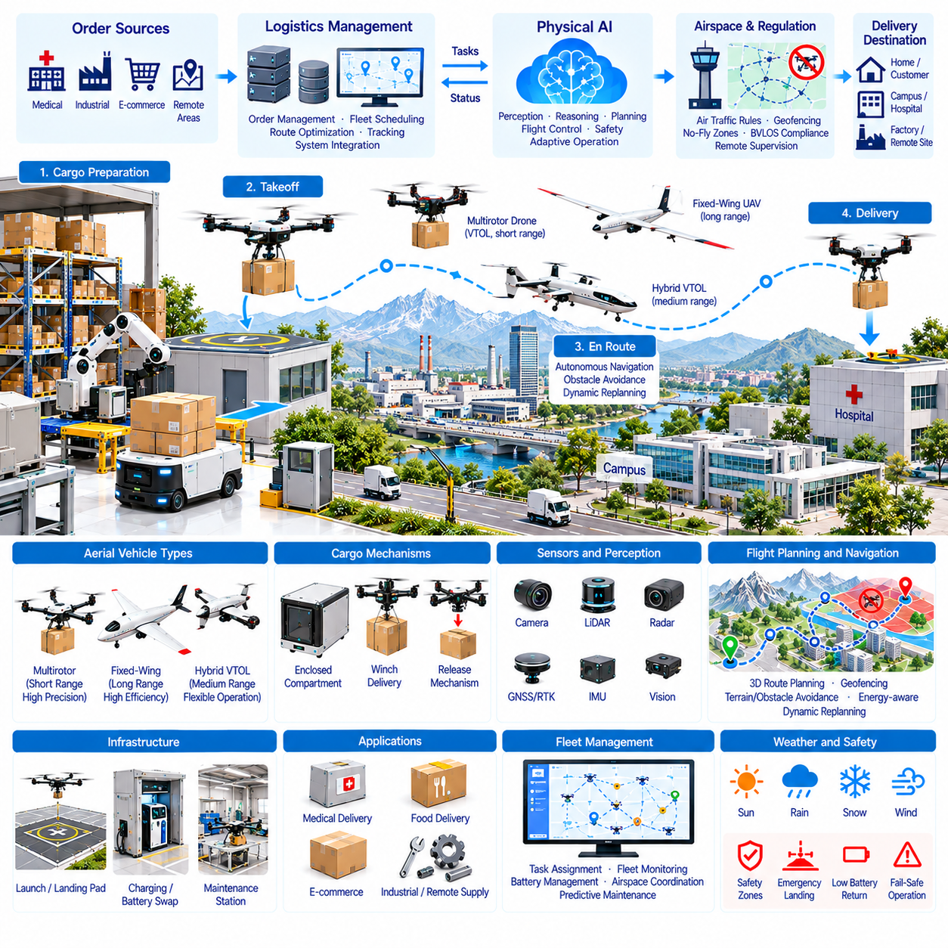
Aerial and cargo robot logistics extend Physical AI into three-dimensional transportation, enabling autonomous movement of goods across locations where conventional ground delivery may be slow or difficult. These systems combine unmanned aerial vehicles, intelligent cargo handling, navigation, and fleet coordination. Their applications include medical delivery, industrial transport, remote supply operations, and time-sensitive distribution.
Aerial logistics differs from ground transportation because vehicles must continuously manage lift, propulsion, stability, and energy consumption. Multirotor drones provide vertical takeoff, hovering, and precise positioning, while fixed-wing aircraft offer greater efficiency over longer distances. Hybrid vertical takeoff and landing platforms combine selected advantages of both configurations, although their mechanical complexity increases.
Payload capacity is a fundamental constraint in aerial cargo transportation. The total vehicle mass includes batteries, propulsion components, sensors, control electronics, cargo containers, and transported goods. Increasing payload generally reduces endurance or requires greater propulsion power. Effective system design must balance useful cargo mass, flight range, reserve energy, and structural safety margins.
Cargo attachment and release mechanisms are critical to reliable aerial delivery. Packages may be carried inside enclosed compartments, secured beneath aircraft, or lowered using controlled winch systems. Each configuration influences aerodynamic drag, center of gravity, and flight stability. Secure locking, load verification, and controlled release procedures are necessary to prevent unintended cargo separation.
Flight control systems maintain aircraft stability while responding to wind, changing payload mass, and environmental disturbances. Multirotor controllers regulate individual motor thrust to control position and orientation. Cargo movement can introduce additional dynamic forces, particularly when loads are suspended. Advanced control algorithms must account for these effects while respecting actuator and structural limits.
Autonomous navigation integrates Global Navigation Satellite Systems (GNSS), inertial measurement units, cameras, and other positioning sensors. Sensor fusion improves state estimation and supports accurate route following. Urban environments may produce satellite interference or restricted visibility. Reliable navigation requires monitoring localization uncertainty and maintaining safe fallback procedures when positioning quality deteriorates.
Aerial perception must identify buildings, vegetation, power lines, other aircraft, and unexpected obstacles. Cameras, radar, LiDAR, and cooperative tracking systems may provide complementary information depending on vehicle size and mission requirements. Detect-and-avoid capabilities are especially important beyond visual line of sight. Their performance must be validated under realistic environmental and operational conditions.
Flight planning considers airspace restrictions, terrain elevation, obstacle clearance, weather, and available emergency landing areas. Unlike ground robots, aerial vehicles must evaluate three-dimensional trajectories and continuous energy requirements. Mission planners should incorporate altitude limits, operational permissions, and reserve power. Dynamic replanning becomes necessary when weather or airspace availability changes.
Weather significantly affects aerial logistics reliability. Strong winds increase control effort and energy consumption, while rain, icing, and extreme temperatures may threaten aircraft performance. Payload mass and aerodynamic configuration further influence environmental tolerance. Operators must establish measurable weather limits and procedures for delaying, diverting, or terminating missions when safe flight cannot be maintained.
Delivery infrastructure includes launch pads, landing stations, charging facilities, cargo transfer points, and maintenance areas. Automated docking requires accurate positioning and reliable communication between aircraft and ground equipment. Some systems use battery swapping to reduce turnaround time. Infrastructure design should minimize handling delays while protecting personnel from propellers and moving machinery.
Medical and emergency logistics represent promising applications because delivery speed can be particularly valuable. Aerial robots may transport laboratory samples, medicines, blood products, or emergency supplies between authorized facilities. Mission planning must consider cargo integrity, temperature control, traceability, and delivery confirmation. Sensitive materials require additional handling procedures and compliance with applicable regulations.
Industrial cargo logistics can connect factories, warehouses, offshore facilities, and remote work sites. Drones may deliver lightweight spare parts, tools, or inspection equipment without requiring dedicated ground transportation. However, aircraft selection depends on payload, distance, landing access, and environmental exposure. Heavy cargo applications require substantially greater lifting capacity and stricter operational controls.
Cargo robots may also cooperate with ground-based Autonomous Mobile Robots (AMRs) and autonomous vehicles. Ground platforms can transport packages to aerial launch points, while drones complete selected delivery segments. Coordinated transfers reduce unnecessary handling and extend logistics coverage. Successful integration requires shared shipment identifiers, synchronized arrival times, and verified cargo handoff procedures.
Fleet Management Systems (FMS) coordinate aircraft assignments, battery availability, mission scheduling, and maintenance requirements. Multiple drones operating in the same region require separation management and conflict avoidance. Uncrewed Aircraft System Traffic Management (UTM) services may support airspace coordination where available. Fleet scheduling must consider both delivery demand and operational flight restrictions.
Demand-aware task allocation can improve aerial fleet utilization by predicting shipment volumes, delivery urgency, and regional service requirements. Algorithms may assign nearby aircraft to high-priority missions while preserving battery reserves. Consolidating compatible shipments can reduce unnecessary flights. However, optimization must respect payload limits, flight permissions, and safety constraints rather than focusing only on delivery speed.
Remote supervision remains important for handling uncertain or exceptional situations. Operators may review navigation anomalies, unexpected landing conditions, or mission interruptions. Communication links transmit telemetry, mission status, and control information between aircraft and ground stations. Loss of communication must trigger predefined contingency behavior, such as holding, returning, or landing when appropriate and safe.
Energy management determines achievable flight range, payload capacity, and mission frequency. Battery performance varies with temperature, discharge rate, aging, and repeated charging cycles. Flight planning must include sufficient reserves for deviations and contingencies. Predictive battery health monitoring can identify deteriorating performance and reduce the risk of unexpected power limitations during transportation missions.
Physical AI can enhance aerial autonomy through predictive world models, multimodal perception, and adaptive control. Learning-based systems may improve obstacle interpretation, landing-site assessment, and mission planning. Simulation supports testing under varied wind, payload, and sensor conditions. Nevertheless, learned components require rigorous validation because failures during flight can create hazards beyond the aircraft itself.
Safety engineering must address propulsion failures, navigation errors, cargo release faults, and unintended interactions with people or infrastructure. Redundant sensing, fault detection, emergency landing strategies, and operational geofencing can reduce risk. Cybersecurity protects communication and mission commands against unauthorized interference. Applicable aviation rules determine the operational approvals and limitations for deployment.
Operational performance should be measured through successful deliveries, flight completion rate, payload utilization, turnaround time, and energy consumed per shipment. Additional indicators include intervention frequency, maintenance downtime, weather-related cancellations, and cargo damage. Comparing aerial delivery with ground alternatives requires evaluating complete delivery workflows rather than considering flight time alone.
Economic feasibility depends on aircraft acquisition, battery replacement, maintenance, staffing, insurance, infrastructure, and regulatory compliance. Short flight times do not automatically produce lower delivery costs when supervision and operational restrictions are significant. Total Cost of Ownership (TCO) and Return on Investment (ROI) analyses should incorporate realistic utilization, payload demand, and service availability.
Deployment should begin with clearly defined routes, suitable landing areas, manageable payloads, and established operating procedures. Pilot programs can validate flight performance, cargo security, communication reliability, and emergency responses. Gradual expansion provides evidence across different weather conditions and operational demands. Regulatory authorization and demonstrated safety performance are prerequisites for broader commercial operations.
Future aerial logistics may combine larger cargo aircraft, autonomous ground vehicles, intelligent transfer stations, and coordinated transportation networks. Improvements in propulsion efficiency, batteries, sensing, and fleet intelligence could expand feasible applications. Greater autonomy may support more complex missions, but scalability will depend on airspace integration, dependable infrastructure, and consistently verified operational safety.
Ultimately, aerial and cargo robot logistics demonstrate how Physical AI can extend autonomous transportation beyond roads and conventional warehouse infrastructure. Their value lies in combining three-dimensional mobility, intelligent cargo management, adaptive mission planning, and coordinated fleet operations. Sustainable adoption requires matching aircraft capabilities to suitable logistics tasks while balancing safety, reliability, regulation, and economic performance.

03.12. Fleet Management and Warehouse Orchestration
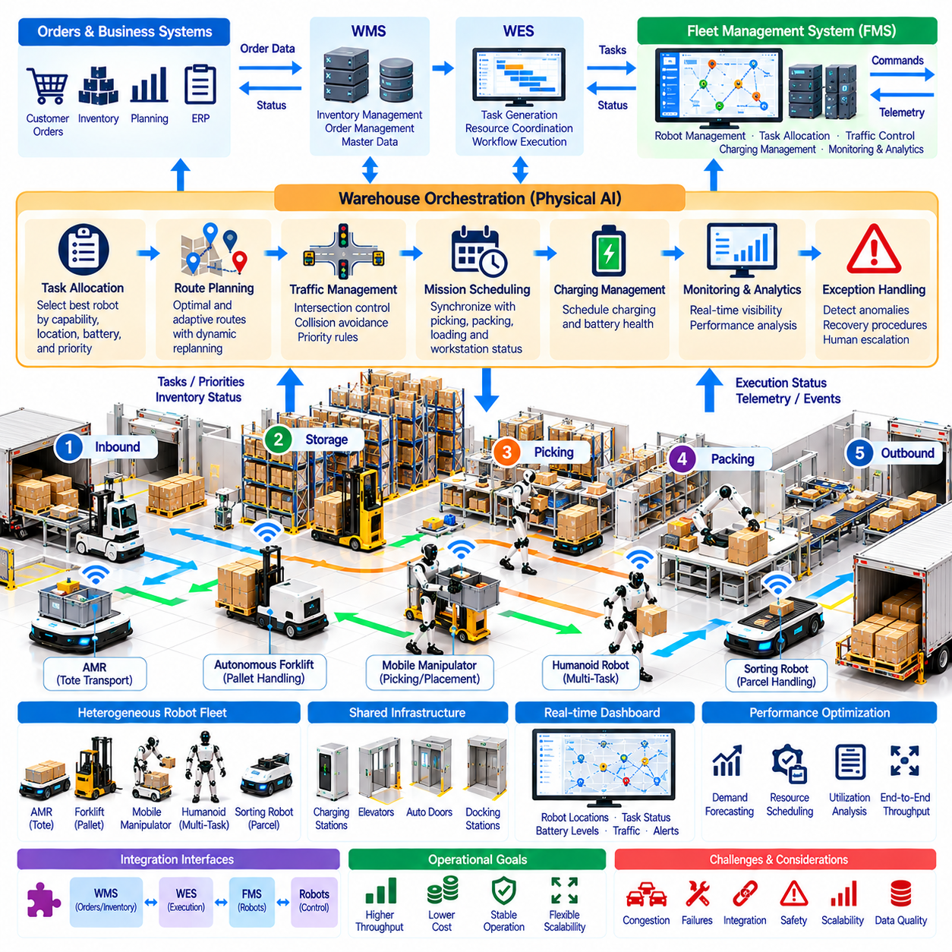
Fleet management and warehouse orchestration are essential for coordinating Physical AI systems across modern logistics facilities. As warehouses deploy Autonomous Mobile Robots (AMRs), autonomous forklifts, manipulators, and humanoids, individual robot intelligence must be integrated into a unified operational framework. Effective orchestration connects robot capabilities, transportation tasks, inventory movements, and warehouse priorities.
A Fleet Management System (FMS) supervises robot missions, availability, navigation, charging, and operational status. Warehouse orchestration extends beyond individual vehicles to coordinate complete material flows and interdependent processes. The distinction is important because optimizing robot movement alone does not guarantee improved warehouse throughput when picking, storage, and packing operations remain disconnected.
The orchestration architecture typically connects Warehouse Management Systems (WMS), Warehouse Execution Systems (WES), fleet controllers, and individual robots. WMS platforms maintain inventory and order information, while WES platforms coordinate operational execution. The FMS translates transportation requirements into robot missions, monitors execution, and returns status updates to higher-level systems.
Task allocation determines which robot should execute each transportation or manipulation request. Assignment algorithms consider robot location, payload capacity, battery state, equipment compatibility, and task priority. A nearby robot is not necessarily the best candidate if its remaining energy or handling capability is insufficient. Effective allocation balances immediate response time with fleet-wide productivity.
Warehouse environments increasingly contain heterogeneous robot fleets with different mobility and manipulation capabilities. AMRs transport totes, autonomous forklifts handle pallets, and mobile manipulators perform picking or placement tasks. Orchestration software must understand these functional differences and assign compatible missions. Shared interfaces reduce integration complexity while preserving robot-specific control requirements.
Traffic management prevents congestion and conflicts among robots operating in shared warehouse spaces. Intersections, narrow aisles, elevators, and loading stations create potential bottlenecks. Centralized coordination can reserve critical areas, regulate movement priorities, and adjust routes. Local obstacle avoidance remains necessary because human workers and unexpected objects may enter planned travel paths.
Dynamic route planning responds to changes in warehouse conditions and operational demand. A robot may encounter blocked aisles, equipment failures, or temporary safety restrictions. The orchestration system should identify alternative routes while considering traffic density and mission urgency. Replanning must maintain consistent map information and avoid creating new conflicts with other moving robots.
Mission scheduling coordinates transportation with upstream and downstream warehouse activities. A robot arriving before a workstation is ready may occupy valuable space without producing useful work. Conversely, delayed material delivery can interrupt picking or packing operations. Event-driven scheduling uses equipment readiness, order priorities, and task completion signals to synchronize interconnected processes.
Charging management directly influences fleet availability and sustained warehouse performance. Robots have different battery capacities, energy consumption patterns, and charging requirements. The FMS should schedule charging according to expected workload, battery health, and operational priorities. Opportunity charging during low-demand periods can reduce disruption, provided sufficient reserve capacity remains available.
Exception handling is necessary because real warehouses contain unpredictable operational disturbances. Robots may encounter inaccessible pickup points, missing containers, localization failures, or mechanical faults. The orchestration platform should classify exceptions, initiate recovery procedures, and escalate unresolved cases to operators. Clear ownership of recovery actions prevents isolated failures from disrupting broader workflows.
Real-time monitoring provides visibility into robot locations, mission progress, traffic conditions, and system availability. Operational dashboards can display task queues, battery levels, fault notifications, and equipment utilization. Historical event records support troubleshooting and performance analysis. Consistent timestamps and standardized status definitions are essential for interpreting events across multiple systems.
Physical AI can improve orchestration through predictive scheduling, demand forecasting, and adaptive resource allocation. Machine learning models may estimate task duration, congestion risk, and future transportation demand. These predictions help reposition robots and adjust mission priorities. However, optimization decisions must respect operational constraints, safety requirements, and the reliability of available data.
Warehouse orchestration should optimize end-to-end logistics performance rather than individual robot efficiency. A fleet with high utilization may still produce poor results if critical workstations experience material shortages. System-level optimization considers order completion, workstation throughput, inventory availability, and transportation delays. Coordinated decisions align robot activity with actual warehouse business objectives.
Integration reliability depends on well-defined communication interfaces and consistent operational semantics. APIs, event messages, and standardized mission states enable information exchange between WMS, WES, FMS, and robots. Duplicate commands, delayed acknowledgments, and network interruptions require explicit handling. Reliable orchestration therefore combines transactional consistency, fault recovery, and continuous system monitoring.

03.13. Demand Aware Task Allocation
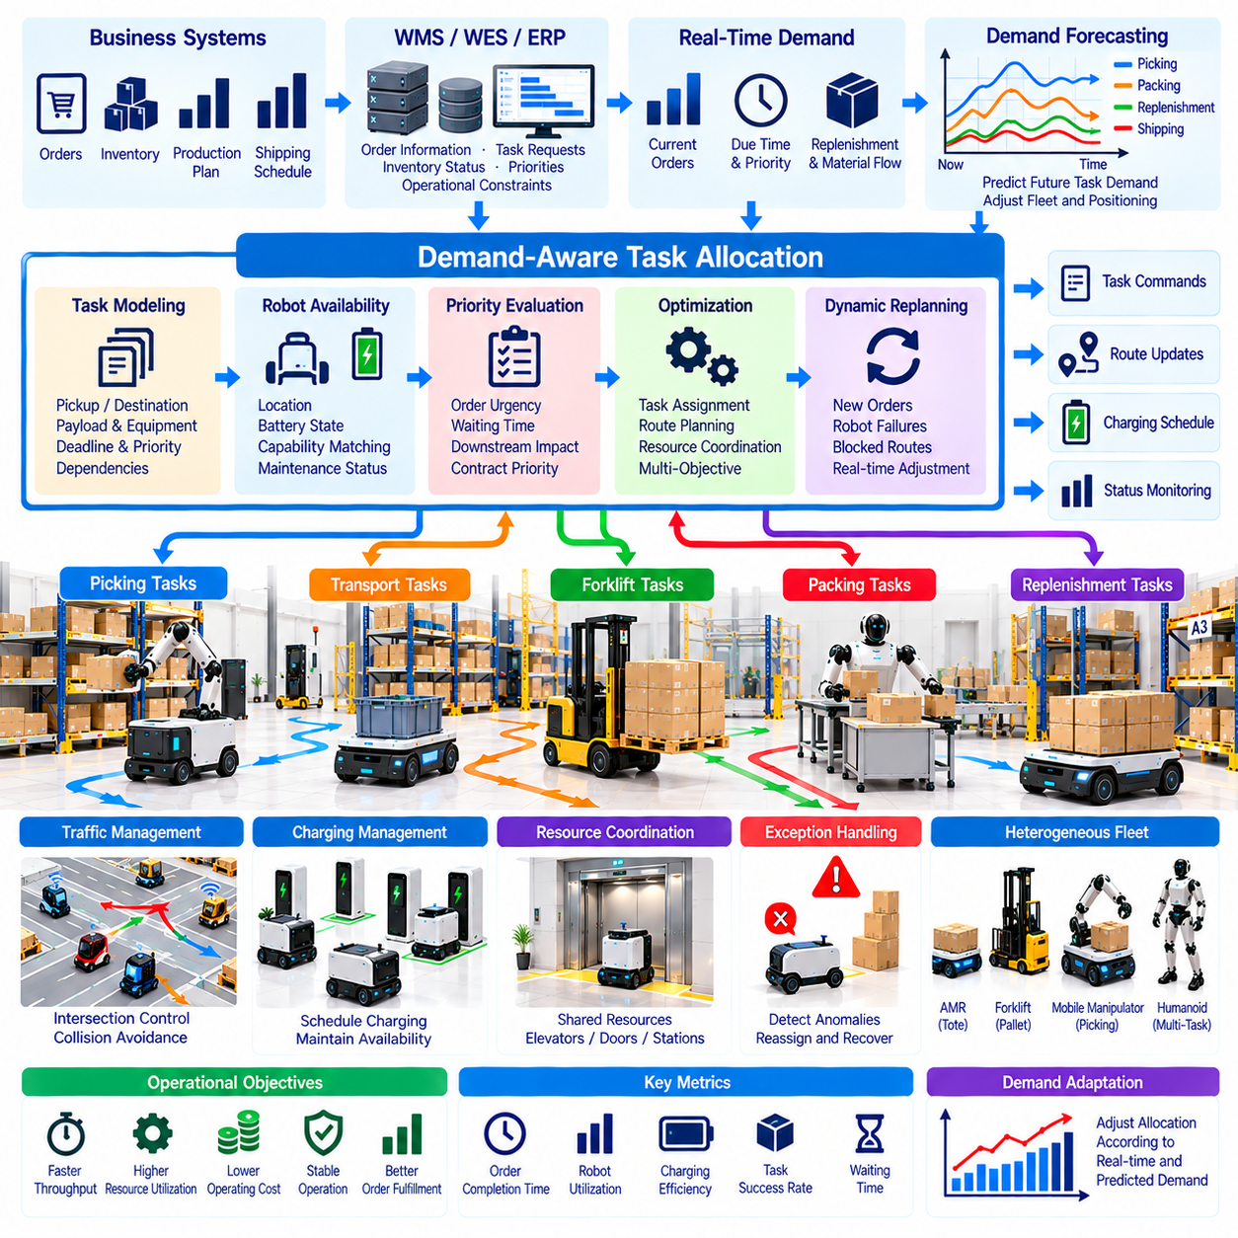
Demand-aware task allocation enables Physical AI logistics systems to assign work according to changing operational requirements rather than fixed schedules. Warehouse demand fluctuates with order arrivals, inventory movements, production cycles, and shipping deadlines. Intelligent allocation connects real-time demand information with robot availability, allowing transportation and handling resources to respond dynamically to warehouse priorities.
Traditional task allocation often relies on predefined rules, fixed zones, or first-come-first-served scheduling. These approaches are relatively simple but may perform poorly when workloads become uneven or urgent orders appear. Demand-aware allocation continuously evaluates task urgency, resource availability, and downstream requirements. Its objective is to improve overall logistics performance rather than merely minimize individual robot travel distances.
Demand information originates from Warehouse Management Systems (WMS), Warehouse Execution Systems (WES), Enterprise Resource Planning (ERP), and production control platforms. These systems provide order priorities, inventory requirements, replenishment requests, and expected shipment schedules. Fleet Management Systems (FMS) combine this information with robot status to generate executable assignments aligned with operational objectives.
Task demand can be represented through structured attributes describing pickup locations, delivery destinations, payload requirements, deadlines, and processing dependencies. Additional attributes may include customer priority, equipment compatibility, and expected handling duration. Standardized task descriptions allow allocation algorithms to compare heterogeneous requests and identify which assignments provide the greatest operational benefit.
Robot availability depends on more than whether a vehicle is currently idle. Relevant factors include location, battery state, payload capacity, mechanical condition, navigation accessibility, and scheduled maintenance. A robot may be physically available but unsuitable for a particular assignment. Demand-aware systems evaluate these constraints before selecting candidates, preventing assignments that cannot be completed reliably.
Task prioritization determines how competing logistics requests should share limited robotic resources. Urgent shipping orders, production-line replenishment, and safety-related material movements may require different service levels. Priority models can combine deadlines, waiting time, downstream impact, and contractual commitments. Dynamic prioritization must also prevent low-priority tasks from experiencing indefinite delays.
Demand forecasting extends allocation beyond immediate task queues by estimating future workload patterns. Historical order records, shift schedules, seasonal fluctuations, and production plans provide useful predictive signals. Machine learning models may estimate task arrival rates across warehouse zones. Forecast accuracy should be monitored because unexpected demand changes can reduce the effectiveness of predictive assignments.
Predictive robot positioning places available vehicles near locations where future tasks are likely to originate. For example, robots may move toward receiving docks before inbound shipments arrive or approach packing stations during expected order peaks. This strategy reduces response time when predictions are accurate. However, excessive repositioning creates unnecessary travel and energy consumption, requiring careful cost-benefit evaluation.
Dynamic task allocation can be formulated as an optimization problem involving robots, tasks, and operational constraints. Assignment costs may include travel time, energy consumption, deadline penalties, congestion exposure, and equipment suitability. Optimization methods include mathematical programming, auction-based coordination, and heuristic scheduling. Algorithm selection depends on fleet size, computational limits, and response-time requirements.
Multi-robot coordination becomes particularly important when tasks compete for shared routes, loading stations, elevators, or narrow aisles. Assigning several robots to the same destination may increase congestion despite reducing individual travel estimates. Demand-aware allocation should therefore incorporate traffic conditions and shared-resource availability. Coordinated scheduling helps avoid bottlenecks and improves effective warehouse throughput.
Task dependencies require allocation decisions to respect the sequence of warehouse operations. A packing task cannot proceed until the required items arrive, while production replenishment must occur before material shortages interrupt equipment. Dependency-aware scheduling identifies critical tasks within broader workflows. Allocating robots according to these relationships can reduce workstation idle time and improve order completion reliability.
Energy-aware allocation considers whether robots can complete assigned missions while maintaining sufficient battery reserves. High-priority tasks may justify selecting a robot with greater energy consumption if it can meet an urgent deadline. Charging schedules must also respond to predicted demand peaks. Integrating task assignment with energy management helps maintain fleet availability during periods of sustained operational activity.
Real-time replanning allows the allocation system to respond when operational conditions differ from expectations. New urgent orders, robot failures, blocked routes, and delayed workstations may require reassignment. Event-driven updates can modify task priorities and robot selections without rebuilding the entire schedule. Stability mechanisms are necessary to prevent excessive reassignment that disrupts ongoing missions.
Performance evaluation should consider order completion time, task waiting time, robot utilization, deadline compliance, and warehouse throughput. Additional metrics include empty travel distance, energy consumption, congestion delays, and assignment computation time. Improvements in individual metrics may conflict with system-level objectives. Effective demand-aware allocation therefore requires balanced evaluation across service quality, efficiency, and operational reliability.

03.14. Integration with WMS WES ERP and FMS
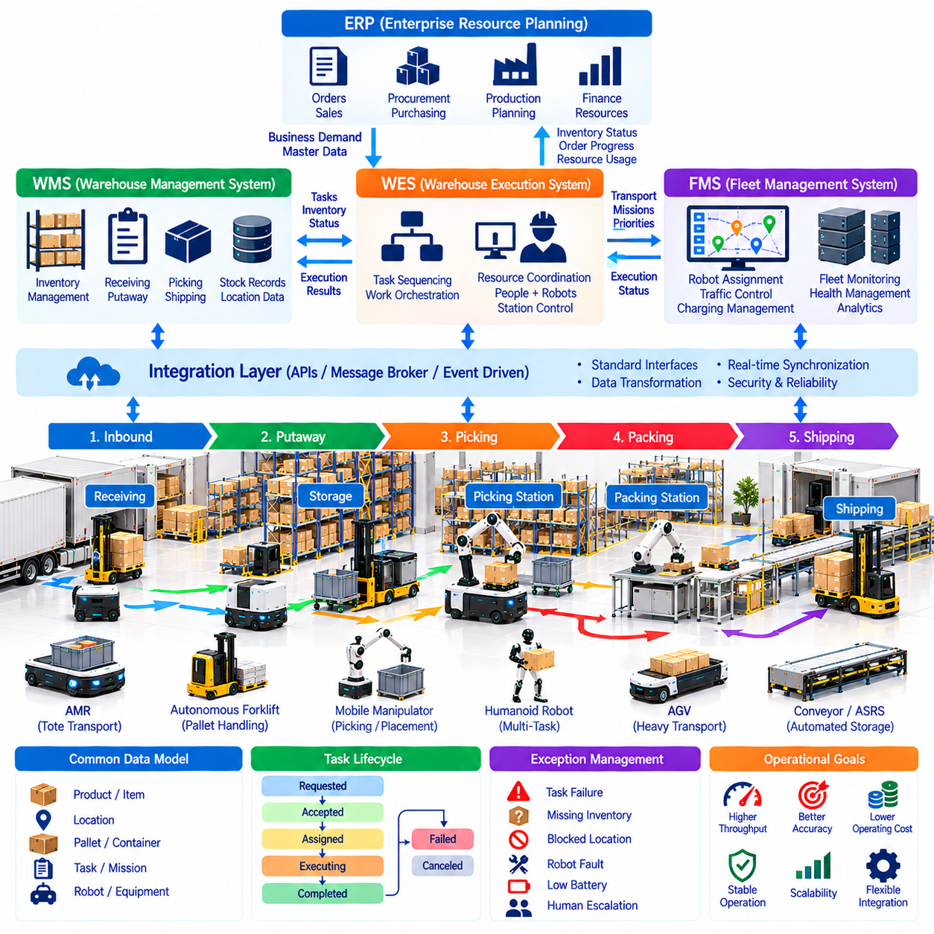
Integration with Warehouse Management Systems (WMS), Warehouse Execution Systems (WES), Enterprise Resource Planning (ERP), and Fleet Management Systems (FMS) establishes the digital foundation for Physical AI logistics. These platforms connect business planning, warehouse operations, and autonomous robot execution. Effective integration enables consistent information exchange, coordinated decisions, and reliable material movement across the logistics environment.
ERP platforms manage enterprise-level processes such as purchasing, sales, finance, production planning, and resource allocation. They provide business requirements that influence warehouse activities, including customer orders, procurement schedules, and inventory targets. Integration with warehouse systems ensures that autonomous logistics operations support broader organizational priorities rather than functioning as isolated automation projects.
WMS platforms manage inventory locations, stock quantities, receiving, putaway, picking, and shipping activities. They maintain the operational record of where materials are stored and how orders should be fulfilled. When integrated with robotic systems, the WMS generates transportation requirements and receives confirmation of inventory movements. Accurate synchronization prevents discrepancies between physical stock and digital records.
WES platforms coordinate the execution of warehouse workflows across people, robots, conveyors, and automated equipment. They translate warehouse priorities into operational sequences and balance workloads between processing stations. WES functionality may overlap with WMS or FMS depending on system architecture. Clear responsibility boundaries are therefore essential to avoid conflicting commands and duplicated scheduling decisions.
FMS platforms manage autonomous robot fleets by assigning missions, coordinating traffic, monitoring robot status, and scheduling charging. They translate transportation requests into executable robot actions while respecting vehicle capabilities and safety constraints. Integration with WES and WMS enables fleet operations to respond to changing warehouse priorities. Robot-level controllers remain responsible for local navigation and immediate safety responses.
A typical integration workflow begins when an ERP system records customer demand or production requirements. The WMS identifies inventory and generates warehouse activities, while the WES determines execution priorities and task sequences. The FMS selects suitable robots and supervises transportation missions. Completion events return through the integration layers, allowing inventory records and order status to remain synchronized.
System interfaces commonly use Application Programming Interfaces (APIs), message brokers, and event-driven communication. REST interfaces support structured requests, while asynchronous messaging enables systems to exchange status changes without continuous polling. Communication architecture should distinguish commands, acknowledgments, and operational events. Reliable interfaces require version control, authentication, and clearly defined message formats.
Standardized data models are necessary because enterprise and robotics platforms often describe the same objects differently. Product identifiers, pallet references, storage locations, robot missions, and equipment states must be mapped consistently. A shared information model reduces ambiguity between systems. Data transformation services can translate vendor-specific formats while preserving essential operational meaning and traceability.
Task lifecycle management defines how transportation requests progress from creation to completion. Typical states include requested, accepted, assigned, executing, completed, failed, and canceled. Each transition should have an authorized owner and a defined event record. Consistent lifecycle semantics prevent duplicate execution and enable recovery when systems restart or communication is interrupted during an active mission.
Real-time synchronization is particularly important when robots operate in dynamic warehouse environments. Inventory movements, workstation availability, robot locations, and equipment faults may change within seconds. Event-driven updates help orchestration platforms respond quickly to operational changes. However, not every enterprise transaction requires immediate synchronization, so interface design should match update frequency to business criticality.
Exception management coordinates recovery when warehouse and robotic processes do not proceed as expected. Missing pallets, blocked pickup locations, unsuccessful deliveries, and robot faults may require different corrective actions. Integration workflows should identify which system owns each exception and how recovery is confirmed. Escalation procedures prevent unresolved robotic failures from producing inaccurate inventory or order records.
Integration architecture must also support operational resilience and cybersecurity. Network interruptions, duplicated messages, delayed responses, and temporary system outages should not produce unsafe robot behavior or inconsistent transactions. Message persistence, idempotent processing, access control, and audit logging improve reliability. Safety-critical robot functions must remain effective independently of higher-level enterprise connectivity.
Scalable integration becomes increasingly important as facilities introduce heterogeneous robots and automation technologies. Standard interfaces can simplify connections among AMRs, autonomous forklifts, manipulators, conveyors, and storage systems. Modular adapters reduce dependence on proprietary vendor protocols. Effective interoperability allows organizations to expand automation capabilities without redesigning every enterprise connection.
Performance monitoring should connect robot-level metrics with warehouse and enterprise outcomes. FMS data describes mission duration, utilization, charging, and interventions, while WMS and WES data capture inventory accuracy, order completion, and workflow throughput. ERP information provides business context for costs and service commitments. Unified analytics supports optimization across operational and financial objectives.

03.15. Logistics KPIs TCO and Throughput
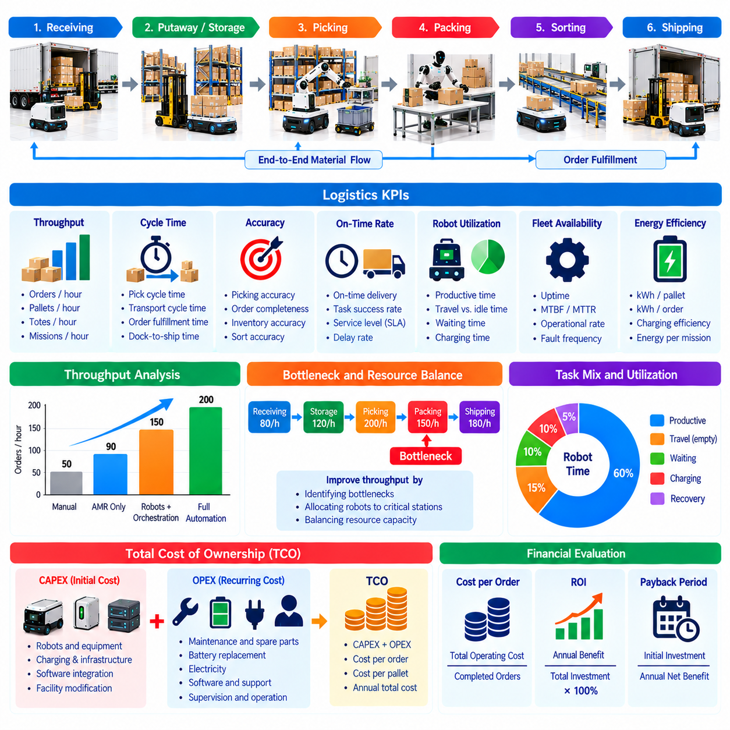
Logistics Key Performance Indicators (KPIs), Total Cost of Ownership (TCO), and throughput provide the quantitative foundation for evaluating Physical AI deployments. Autonomous Mobile Robots (AMRs), robotic forklifts, and automated handling systems must demonstrate measurable operational value. Evaluation should connect robot performance with warehouse productivity, service quality, financial sustainability, and long-term business objectives.
Logistics KPIs measure how effectively warehouse resources transform incoming materials and customer orders into completed operations. Common indicators include orders processed per hour, pallets transported, picking accuracy, delivery completion time, and equipment availability. Metrics should be defined consistently across facilities and operating periods. Clear measurement boundaries prevent misleading comparisons between manual and automated workflows.
Throughput represents the quantity of logistics work completed within a specified period. It may be measured as orders, cartons, totes, pallets, or transportation missions per hour. Robot mission throughput differs from warehouse throughput because individual movements do not necessarily produce completed customer orders. System evaluation must therefore distinguish transportation activity from actual fulfillment output.
Warehouse throughput is constrained by interconnected processing stages rather than robot speed alone. Receiving, storage, picking, transportation, sorting, and packing operate as dependent processes. A bottleneck at one workstation can limit total output even when other equipment remains underutilized. Physical AI orchestration should identify these constraints and allocate resources to improve end-to-end material flow.
Robot utilization measures the proportion of available operating time spent performing productive activities. High utilization may indicate efficient resource use, but excessive utilization can create congestion and reduce operational flexibility. Productive movement should be distinguished from empty travel, waiting, charging, and recovery. Balanced utilization provides reserve capacity for demand peaks and unexpected disruptions.
Cycle time measures the elapsed duration required to complete a defined logistics process. Transportation cycle time may include task assignment, travel to pickup, loading, loaded movement, unloading, and confirmation. Order fulfillment cycle time includes additional warehouse activities. Breaking cycle time into components helps identify whether delays originate from robot navigation, workstation availability, or system coordination.
Service quality KPIs evaluate whether automation fulfills operational commitments reliably. On-time delivery rate, task success rate, picking accuracy, and order completeness are important indicators. Exception frequency and human intervention requirements reveal weaknesses that throughput alone may conceal. Performance evaluation should consider service consistency during peak demand, shift transitions, and equipment disturbances.
Fleet availability reflects the percentage of scheduled operating time during which robots are capable of performing assigned missions. Availability is affected by mechanical failures, software faults, charging, maintenance, and communication interruptions. Mean Time Between Failures (MTBF) and Mean Time To Repair (MTTR) provide additional reliability information. High availability supports predictable capacity planning and service continuity.
Energy efficiency influences both operating costs and fleet productivity. Useful measures include energy consumed per transported pallet, completed order, or transportation mission. Battery charging losses, standby consumption, and environmental conditions should be included where relevant. Energy-aware scheduling can reduce unnecessary movement and charging conflicts, although savings must be evaluated against actual operational output.
Total Cost of Ownership (TCO) represents the cumulative cost of acquiring, deploying, operating, maintaining, and eventually replacing a logistics automation system. Initial costs include robots, charging stations, safety equipment, software integration, and facility modifications. Recurring expenses include maintenance, batteries, software subscriptions, supervision, electricity, insurance, and technical support.
TCO analysis should distinguish capital expenditure (CAPEX) from operating expenditure (OPEX). CAPEX generally includes equipment purchases, installation, infrastructure, and initial integration. OPEX includes ongoing labor, energy, repairs, software services, and operational support. Depreciation affects accounting results but is not an additional cash payment. Consistent treatment of costs prevents double counting in financial comparisons.
Cost per completed logistics unit connects financial expenditure with productive output. It can be calculated by dividing relevant operating costs by successfully completed orders, pallets, or missions during the same period. The denominator must represent equivalent service outcomes across alternatives. Low robot operating cost does not guarantee low fulfillment cost when supervision, infrastructure, or downstream delays remain significant.
Return on Investment (ROI) compares economic benefits with the resources committed to automation. Benefits may include reduced repetitive labor, increased throughput, fewer handling errors, and improved service availability. However, projected savings depend on achievable utilization and actual process redesign. Financial models should separate measurable cost reductions from productivity improvements that do not immediately generate cash savings.
Payback period estimates how long cumulative net cash benefits take to recover the initial investment. Discounted Cash Flow (DCF) analysis additionally considers the timing and risk of future cash flows. Net Present Value (NPV) can compare alternative deployment strategies over a defined planning horizon. Sensitivity analysis should examine demand variability, maintenance costs, labor assumptions, and equipment replacement intervals.

03.16. Logistics Fleet Economics Model [w/Code]
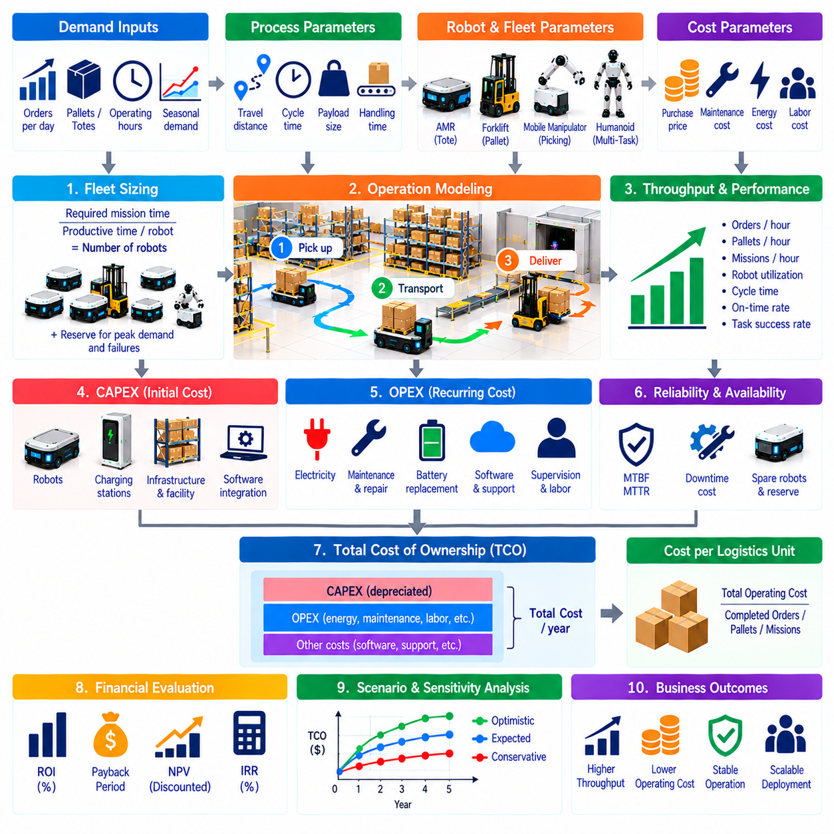
A Logistics Fleet Economics Model provides a quantitative framework for evaluating the financial and operational performance of Physical AI robot fleets. It connects robot acquisition costs, fleet capacity, labor requirements, maintenance expenses, and logistics throughput. The model supports investment decisions by estimating whether autonomous operations can deliver equivalent or improved service at a sustainable total cost.
Fleet economics begins with defining the operational workload that robots must support. Relevant inputs include daily transportation missions, operating hours, average travel distance, payload requirements, and seasonal demand fluctuations. The model should distinguish average workload from peak demand because fleet capacity must accommodate operational variability. Accurate demand assumptions are essential for avoiding overinvestment or insufficient capacity.
Robot fleet sizing translates logistics demand into the number of vehicles required for reliable operations. A basic estimate divides total required mission time by productive time available per robot. Productive time excludes charging, maintenance, waiting, and expected interruptions. Additional reserve capacity may be necessary to handle demand peaks and equipment failures. Fleet sizing should therefore reflect achievable utilization rather than theoretical maximum performance.
Mission cycle time is a central variable in fleet economics. It includes travel to pickup, loading, loaded transportation, unloading, confirmation, and expected waiting periods. Average cycle time multiplied by mission volume determines total transportation workload. Variability matters because congestion and workstation delays can increase cycle time during busy periods, reducing the effective capacity of the robot fleet.
Capital expenditure includes robot purchases, charging equipment, infrastructure modifications, safety systems, and initial software integration. Deployment costs may also include mapping, commissioning, operator training, and acceptance testing. These expenditures should be allocated to the appropriate investment categories. Fleet expansion scenarios must account for additional infrastructure capacity rather than assuming that every new robot operates independently.
Operating expenditure includes electricity, preventive maintenance, repairs, battery replacement, software subscriptions, connectivity, and technical support. Remote supervision and onsite intervention may create continuing labor expenses even when transportation is automated. Operating costs should be estimated using realistic duty cycles and equipment reliability. Separating fixed and variable expenses helps explain how fleet economics changes with utilization.
Labor economics requires comparing automated workflows with the actual human activities they replace or support. Robots may reduce repetitive transportation while leaving loading, unloading, exception handling, and supervision tasks unchanged. Labor savings should reflect recoverable working hours rather than simply multiplying robot count by employee wages. Redeployment, shift coverage, and service expansion may create benefits that require separate financial treatment.
Throughput economics measures the cost associated with completing useful logistics work. Cost per mission, cost per pallet movement, and cost per fulfilled order provide alternative perspectives. The selected unit must match the business process being evaluated. A low transportation cost per mission may have limited value if downstream operations remain constrained. End-to-end throughput should therefore remain a primary evaluation objective.
Fleet utilization influences the distribution of fixed costs across completed missions. Higher utilization generally reduces capital cost per task, but operating near maximum capacity can increase congestion and service delays. The model should evaluate utilization together with cycle-time variability and reserve requirements. Sustainable economics usually depends on maintaining sufficient productive activity without eliminating operational flexibility.
Battery and charging economics affect both capital requirements and productive capacity. Charging stations require investment, while charging time reduces robot availability. Battery aging creates replacement costs and may reduce usable operating hours. Opportunity charging and automated docking can improve fleet productivity when properly scheduled. The model should consider charging infrastructure as part of the complete operating system.
Reliability economics captures the financial consequences of failures, repairs, and operational interruptions. Mean Time Between Failures (MTBF) and Mean Time To Repair (MTTR) help estimate equipment availability. Unexpected downtime may require spare robots, manual transportation, or delayed fulfillment. Maintenance planning can reduce these risks, but reliability assumptions should be supported by operating evidence rather than optimistic vendor specifications.
Financial evaluation compares the autonomous fleet against a clearly defined baseline operating model. The baseline may represent manual transportation, existing automation, or a hybrid process. Incremental cash flows include avoided costs, additional expenses, and investments attributable to the proposed deployment. Payback period, Net Present Value (NPV), and Return on Investment (ROI) provide complementary measures of financial attractiveness.
Scenario analysis tests how economic results change under different operational conditions. Demand growth, labor cost increases, reduced robot availability, and higher maintenance expenses can substantially affect outcomes. Conservative, expected, and optimistic scenarios help expose uncertainty. Sensitivity analysis identifies which assumptions have the greatest influence on fleet size, cost per mission, and investment recovery.
A practical fleet economics model should integrate operational simulation with financial calculations. Simulation estimates mission completion, congestion, charging demand, and fleet availability under realistic workloads. These outputs become inputs for cost and cash-flow calculations. Continuous comparison with actual deployment data enables model calibration and more reliable investment planning as Physical AI logistics operations expand.

